
Electronic Communications Committee (ECC)
within the European Conference of Postal and Telecommunications Administrations (CEPT)

COMPATIBILITY BETWEEN GSM EQUIPMENT ON BOARD AIRCRAFT AND TERRESTRIAL NETWORKS

Lübeck, September 2006
Revised Nicosia, May 2008

ECC Report 93 History

Revision Note – Nicosia May 2007

In Lübeck, September2006, the ECC Report 93 “Compatibility between GSM equipment on board aircraft and terrestrial networks” was finally adopted by WGSE meeting after having completed public consultation. This study included the following terrestrial networks: GSM900, GSM1800, UMTS900, UMTS1800, UMTS in the 2 GHz FDD core-band and CDMA-450/FLASH-OFDM (CDMA2000/FLASH-OFDM at around 450 MHz).

Given the impending deployment of cellular networks in the 2.6 GHz band in Europe, WGSE tasked SE7 to carry out the compatibility study of the GSM on board aircraft system in the 2.6 GHz band. This study provides an extension of the analysis of the compatibility of the GSM onboard system and terrestrial networks to cover the technologies envisaged for the 2.6 GHz band. This work is reflected in the Annex G and with editorial changes in the ECC Report 93 to reflect the inclusion of the Annex G. The analysis proposed in Annex G follows the same approach used in the ECC Report 93.

Compatibility between GSM equipment on board aircraft and terrestrial networks

EXECUTIVE SUMMARY
This report considers the technical impact on terrestrial mobile networks of introducing a GSM service onboard aircraft (GSMOB) operating at a height of at least 3000 m above ground level in the 1800 MHz band (1710-1785 MHz for uplink (terminal transmit, base station receive) / 1805-1880 MHz for downlink (base station transmit, terminal receive)).

The GSMOB system considered in the report consists of a Network Control Unit (NCU), to ensure that signals transmitted by terrestrial mobile systems are not visible within the cabin, and an aircraft BTS (ac-BTS) to provide connectivity. Combined they are designed to ensure that the mobile stations on board the aircraft (ac-MS) only transmit at the minimum level of 0 dBm nominal value with a 0 dBi antenna gain. The parameters for the NCU and ac-BTS were derived from theoretical models.

The following terrestrial networks have been addressed: GSM900, GSM1800, UMTS900, UMTS1800, UMTS in the 2 GHz FDD core-band and CDMA-450/FLASH-OFDM (CDMA2000/FLASH-OFDM at around 450 MHz). In addition, an extension of the analysis of the compatibility of the GSM onboard system and terrestrial networks to cover the technologies envisaged in the 2.6 GHz band is presented in Annex G.

The report does not address the regulatory and operational aspects of GSMOB or its EMC issues related to the aircraft avionics.

For estimation of impact on the terrestrial systems, two different methodologies have been used: the worst-case methodology MCL (Minimum Coupling Loss) and simulations with SEAMCAT, which took into account random distribution of aircraft around a terrestrial station. The free space propagation model was used between the aircraft and terrestrial networks for all interference scenarios. Inside the cabin, a leaky feeder antenna was assumed to be used in GSMOB.

The studies have considered both the reference values of network equipment parameters (extracted from the standards) as well as typical values, whenever available (as provided by manufacturers and operators). The conclusions of the report are based on typical values of network parameters.

To avoid harmful interference to terrestrial networks (using the criterion I/N<-6 dB), the e.i.r.p. per channel of the signals radiated outside the aircraft by the GSMOB system and the ac-MS, should not exceed the limits given in Table 1.

Minimum operational height above ground  (m) | Maximum permitted e.i.r.p. produced by ac-MS, defined outside the aircraft (dBm/  200 kHz) | Maximum permitted e.i.r.p. produced by NCU/aircraft-BTS, defined outside the aircraft in dBm / channel, with victim receiver directly below aircraft
Minimum operational height above ground  (m) |  | Ac-BTS | NCU
Minimum operational height above ground  (m) |  | 1800 MHz | 450 MHz | 900 MHz |  | 1800 MHz |  | 2GHz |  | 2.6 GHz
Minimum operational height above ground  (m) |  | (dBm/  200 kHz) | (dBm/  1250 kHz) | (dBm/  200 kHz) | (dBm/  3840 kHz) | (dBm/  200 kHz) | (dBm/  3840 kHz) | (dBm/  3840 kHz) |  | (dBm/  4750 kHz)
3000 | -3.3 | -13.0 | -17.0 | -19.0 | -6.0 | -13.0 | 0.0 | 1 | 1.9
4000 | -1.1 | -10.5 | -14.5 | -16.5 | -3.5 | -10.5 | 2.5 | 3.5 | 4.4
5000 | 0.5 | -8.5 | -12.6 | -14.5 | -1.5 | -8.5 | 4.5 | 5.4 | 6.3
6000 | 1.8 | -6.9 | -11.0 | -12.9 | 0.0 | -6.9 | 6.1 | 7.0 | 7.9
7000 | 2.9 | -5.6 | -9.6 | -11.6 | 1.4 | -5.6 | 7.4 | 8.3 | 9.3
8000 | 3.8 | -4.4 | -8.5 | -10.5 | 2.5 | -4.4 | 8.6 | 9.5 | 10.4
Table 1: Maximum permitted e.i.r.p. of GSMOB emitting entities, defined outside the aircraft

The studies have demonstrated that the maximum values of radiation from GSMOB, in order to protect ground networks, depend on the elevation angle at which the ground victim receiver sees the interfering aircraft. Since the elevation angle changes as the aircraft flies, the worst-case elevation angles were assumed when deriving radiation limits, i.e. when the victim terminal is directly below the aircraft or the victim base station is close to the horizon as seen from the aircraft.

The values in Table 1 have been derived using following assumptions:
- Characteristics of the ground base stations, antenna and terminals are based on typical performance of state-of-the-art equipment (based on data supplied by mobile operators) for the stringent case of a noise-limited network;
- Characteristics of the terrestrial base station antennas are based on the Recommendation ITU-R F.1336-1 patterns and values commonly used in deployed terrestrial networks; antenna gain and patterns are estimated to be representative of antennas in existing GSM or UMTS networks;
- The e.i.r.p., outside the aircraft, of GSMOB entities inside the aircraft depends on the characteristics of the leaky feeder, the input power to the leaky feeder, and the effective signal attenuation due to the aircraft.

The studies have shown that there is no significant increase of the level of interference due to GSMOB emissions from multiple aircraft because:
- The dominant source of interference to a terminal on the ground is the GSMOB in closest aircraft;
- Provided that sufficient spectrum is available, the ac-BTSs in different aircraft can operate on different frequencies.
Table 2 shows minimum required effective attenuation due to the aircraft, using a cylinder model and assuming a leaky feeder antenna for the ac-BTS/NCU. The result of one theoretical study shows that the maximum level of interference is received by mobile stations on ground from aircraft at 37° elevation and may be representative of other results.

The required attenuation due to the aircraft describes proportion of the total power passing through the aircraft fuselage, either from inside or from outside, and is a function of the aircraft radiation gain relative to an isotropic antenna in the direction under consideration, and of suitable mitigating factors. For the GSMOB system not to cause harmful interference to terrestrial networks, the attenuation due to the aircraft must not be less than the minimum values in the Table 2, for the minimum height at which the GSMOB system can be operated. The values were derived for a single wide body aircraft, which is the most critical case.

Minimum height above ground  (m) | Minimum required effective attenuation of signals to and from the ac-MS (dB) | Minimum required effective attenuation of the signals from sources transmitting from a radiating cable
Minimum height above ground  (m) |  | Ac-BTS | NCU
Minimum height above ground  (m) |  | 1800 MHz  (dB) | 450 MHz  (dB) | 900 MHz  (dB) | 1800 MHz  (dB) | 2000 MHz (dB)
3000 | 3.3 | 10.6 | 16.5 | 6.8 | 0.0 | 0.0
4000 | 1.1 | 8.1 | 13.8 | 4.1 | 0.0 | 0.0
5000 | 0.0 | 5.6 | 11.1 | 1.4 | 0.0 | 0.0
6000 | 0.0 | 2.7 | 7.9 | 0.0 | 0.0 | 0.0
7000 | 0.0 | 0.3 | 5.4 | 0.0 | 0.0 | 0.0
8000 | 0.0 | 0 | 5.5 | 0.0 | 0.0 | 0.0
Table 2: Minimum required attenuation due to the aircraft
(assuming leaky feeder solution and maximum radiation at -37° degrees elevation angle)

The attenuation due to the aircraft is a crucial factor for compatibility studies of GSMOB systems, in particular when considering how the emission limits outside the aircraft should relate to the actual parameters of the GSMOB system equipment (notably output power for NCU/ac-BTS and their antenna type and radiation characteristics). However this factor is highly dependant on the individual aircraft features such as:
  - the aircraft size and type;
  - the characteristics of the aircraft RF isolation;
  - propagation characteristics within the cabin;
  - the installation of the GSMOB system.
This report describes a number of theoretical and practical studies of the isolation of the aircraft cabin for signals entering or leaving the cabin. These studies have shown quite a large spread of results, hence it was not possible to define a single typical value or angular distribution for cabin isolation. Therefore it was deemed impractical to find a single precise relationship (analytical or empirical), which would be applicable to the broad range of possible aircraft types.

In conclusion, this report has defined the conditions under which GSMOB can be operated, more than 3000 m above ground level without causing harmful interference to terrestrial networks (either in GSM1800 band or in other bands in which the NCU operates), provided that care is taken on the installation and operation of the system.

For information, the SEAMCAT files used for the calculations in this study are available in a zip-file at the www.ero.dk (ERO Documentation Area) next to this Report.
Table of contents

0 EXECUTIVE SUMMARY 3
1 INTRODUCTION 9
1.1 Scope of this report 9
1.2 Terrestrial frequency bands and systems covered in this report 9
1.3 Connectivity bands 10
1.4 Controlled bands not covered in this report 10
1.5 Other aspects 10
2 ACRONYMS, ABBREVIATIONS and DEFINITIONS 10
3 DESCRIPTION OF SERVICE AND ENVIRONMENT 11
3.1 Service description 11
3.2 Service environment 12
4 End-to-end Description of a GSMOB system using A NCU 12
4.1 Introduction 12
4.2 General architecture 12
4.3 System components of the airborne section 13
4.3.1 Cabin Antenna 13
4.3.2 AGS – Aircraft GSM Server 13
4.3.3 GSMOB Control panel 13
4.3.4 CIDS: Cabin Intercommunication Data System 13
4.3.5 AC Data: Aircraft Data 13
4.3.6 Onboard Satellite components 13
4.3.7 Network Control Unit (NCU) 13
4.3.8 The GSMOB connectivity component (ac-BTS) 14
4.3.9 Aircraft Mobile Station (ac-MS) 14
5 IDENTIFICATION OF SCENARIOS 15
5.1 Scenario 1: Impact of g-BTS/NodeB on ac-MS/UE (GSMOB not active) 16
5.2 Scenario 2: Impact of ac-MS/UE on g-BTS/NodeB (GSMOB not active) 17
5.3 Scenario 3: GSMOB impact on the terrestrial communication link (g-BTS/NodeB to g-MS/UE (downlink)) from a single aircraft 18
5.4 Scenario 4: GSMOB impact on the terrestrial communications link (g-BTS/NodeB to g-MS/UE (downlink)) from multiple aircraft 19
5.5 Scenario 5: GSMOB impact on the terrestrial communications link (g-MS/UE to g-BTS/NodeB (uplink)) from a single aircraft 21
5.6 Scenario 6: GSMOB impact on the terrestrial communication link (g-MS/UE to g-BTS/NodeB (uplink)) from multiple aircraft 22
6 INPUT PARAMETERS USED FOR MODELLING 24
6.1 Terrestrial network reference parameters used for modelling of GSM900, GSM1800 and UMTS 2 GHz 24
6.2 UMTS900 and UMTS1800 25
6.3 CDMA 450 MHz and FLASH-OFDM 25
6.4 Terrestrial antennas assumed in the studies 26
6.4.1 g-BTS/NodeB antennas 26
6.4.2 g-MS/UE antennas 27
6.5 Attenuation due to the aircraft 27
6.6 Aircraft cabin environment 28
6.6.1 E.i.r.p. values of GSMOB transmitters 28
6.6.2 Antenna profiles of onboard transmitters 28
6.7 Aircraft Distribution 28
6.8 Distribution of Narrow body and Wide body aircraft 29
6.9 Probability of GSMOB transmitting in the same frequency 30
6.9.1 Probability of GSMOB transmitting over terrestrial GSM-900 and 1800 MHz, and UMTS 900 MHz and 2 GHz network channels 31
6.9.2 Probability of GSMOB transmitting over terrestrial UMTS 1800 MHz networks 31
7 MODELLING TECHNIQUES 32
7.1 Terrestrial network modelling 32
7.1.1 GSM modelling 33
7.1.2 UMTS modelling 33
7.2 Modelling of the different scenarios 34
7.2.1 Scenario 1 (MCL) 34
7.2.2 Scenario 2 (MCL) 34
7.2.3 Scenario 3 (MCL) 35
7.2.4 Scenario 3 and 4 (SEAMCAT) 35
7.2.5 Scenario 5 (MCL) 36
7.2.6 Scenarios 5 and 6 (SEAMCAT) 36
7.3 Propagation models 37
7.3.1 Propagation model for the path between aircraft and victim receivers on the ground 37
7.3.2 Propagation model for the path between g-BTS/NodeB and g-MS/UE 37
7.3.3 Propagation model for the path between ac-BTS and ac-MS 37
7.4 Multiple aircraft modelling 37
7.4.1 Modelling actual number of interferers in the different scenarios 38
7.5 Modelling of the GSMOB system 38
7.5.1 The ac-MS 38
7.5.2 The ac-BTS and the NCU 39
8 MODELLING RESULTS 41
8.1 Analysis of received signal strengths when GSMOB is not in operation 41
8.1.1 Results of received terrestrial signal into aircraft (Scenario 1) 42
8.1.2 Results of ac-MS/UE signal received at g-BTS/NodeB (Scenario 2) 43
8.2 Analysis of the GSMOB impact on terrestrial networks (from single aircraft) 44
8.2.1 Impact of ac-BTS/NCU to terrestrial networks for a single aircraft (Scenario 3) 44
8.2.2 Impact of ac-MS to terrestrial networks for a single aircraft (Scenario 5) 48
8.3 Analysis of the GSMOB impact on terrestrial networks from multiple aircraft 48
8.3.1 Impact of ac-BTS/NCU to terrestrial networks for multiple aircraft (Scenario 4) 49
8.3.2 Impact of ac-MS to terrestrial networks for multiple aircraft (Scenario 6) 51
8.4 Calculation of limiting parameters for the GSMOB operation 52
8.4.1 Interference criteria 52
8.4.2 Impacts on the analysis parameters of varying the minimum height for service operation 52
8.4.3 Analysis of required attenuation due to the aircraft for ac-MS signals (Scenario 5 and 6) 53
8.4.4 Analysis of required attenuation due to the aircraft for ac-BTS signals (Scenarios 3 and 4) 53
8.4.5 Analysis of required attenuation due to the aircraft for the NCU 900 MHz signals (Scenarios 3 and 4) 54
8.4.6 Analysis of required attenuation due to the aircraft for the NCU 1800 MHz signals (Scenarios 3 and 4) 54
8.4.7 Analysis of required attenuation due to the aircraft for the NCU 2 GHz signal (Scenarios 3 and 4) 55
8.4.8 Analysis of required attenuation due to the aircraft for the NCU 450 MHz signal(Scenarios 3 and 4) 55
8.4.9 Summary of the limiting parameters for the GSMOB 56
8.4.10 Angle dependency of the attenuation due to the aircraft requirements 57
9 OTHER MITIGATION FACTORS AND ADDITIONAL CONSIDERATIONS 60
9.1 Mitigation factors 60
9.1.1 Frequency hopping 60
9.1.2 GSMOB system’s GSM1800 frequency span 60
9.1.3 Reduced ac-BTS and NCU output power 60
9.1.4 RF shielding of the fuselage 61
9.1.5 Mitigation of window array effects 61
9.2 Additional considerations 61
9.2.1 Probability that a vulnerable g-MS has line-of-sight (LOS) to an aircraft 61
9.2.2 Human body shielding effect 62
9.2.3 Distribution of aircraft 62
9.2.4 Voice activity factor 62
9.2.5 Depolarization loss 62
10 CONCLUSIONS 62
ANNEX A: SIMULATION RESULTS FOR SCENARIOS 1 – 6 65
ANNEX B: OTHER APPROACHES FOR ANALYSING THE TERRESTRIAL RF EFFECTS OF THE ONBOARD LEAKY FEEDER 151
ANNEX C: SYNTHESIS OF MEASUREMENT CAMPAIGNS PRESENTED DURING THIS STUDY 164
ANNEX D: DETAILED DESCRIPTION ON THE NCU 175
ANNEX E: CHARACTERISTICS OF G-BTS/NodeB 181
ANNEX F: EFFECTIVENESS OF AIRCRAFT RF SHIELDING AND SUBSEQUENT IMPACT ON THE ABILITY FOR AN AIRBORNE MOBILE TO ACQUIRE TERRESTRIAL CDMA NETWORKS 187
ANNEX G: COMPATIBILITY BETWEEN GSM EQUIPMENT ON BOARD AIRCRAFT AND TERRESTRIAL NETWORKS USING THE 2.6 GHZ BAND 194

Compatibility between GSM equipment on board aircraft and terrestrial networks

INTRODUCTION

Scope of this report
This report considers the technical impact of introducing GSM services onboard aircraft (GSMOB). The purpose of this study was to investigate the compatibility between GSM equipment (and some required additional equipment) used onboard an aircraft and terrestrial networks. Specifically, this report addresses the impact of the GSMOB system on terrestrial GSM, UMTS (WCDMA (UTRA FDD)), FLASH-OFDM and CDMA2000 technologies. The GSMOB system is assumed to operate in the GSM1800 MHz band. Given that nowadays many mobile terminals are multi-band or multimode terminals, and considering that some preliminary studies have shown that interactions between mobile terminals located onboard aircraft and terrestrial networks are possible, this report addresses GSM900, GSM1800, UMTS900, UMTS1800, UMTS in the 2GHz FDD core band and CDMA450 (CDMA2000 at around 450 MHz) terrestrial networks.
The following picture shows an example of such a GSMOB system: an onboard cell is linked to the backbone terrestrial networks via a satellite link

:

Figure 1: Overview of the GSMOB system and associated terrestrial components

Terrestrial frequency bands and systems covered in this report
The study assumes that the GSMOB system covers the following terrestrial frequency bands to connect the mobile terminals located onboard an aircraft (ac-MS/ac-UE) to onboard picocell (connectivity band) and to prevent interaction with terrestrial systems (controlled bands):

Connectivity band: 1710-1785 MHz and 1805-1880 MHz (GSM1800)
Controlled bands: 921-960 MHz (GSM900 (incl. GSM-R) and WCDMA (UMTS 900) downlink band)
1805-1880 MHz (GSM1800 and WCDMA (UMTS1800) downlink band)
2110-2170 MHz (WCDMA (UMTS) 2 GHz FDD core band downlink)
460-470 MHz (CDMA450 / FLASH-OFDM downlink band)
2500-2690 MHz (WCDMA, WiMAX)

The report addresses the operation of the GSMOB system considering a minimum operational height of 3000 m above ground. Below that altitude the GSMOB system is assumed to be not transmitting.

The report is limited to consideration of the above mentioned frequency bands and systems.
  - Connectivity bands
The report only deals with GSM1800 band for connectivity. The reason of this choice, proposed by potential GSMOB operators, is mainly technical, e.g. the minimum transmit power of the terminal is lower than in the GSM900 band. In addition, the path loss is higher for the 1800 MHz band. These factors result in less interference to terrestrial networks for a GSM1800 onboard BTS than for GSM900.

However, the use of the GSM900 could be envisaged as a connectivity band in future studies.
  - Controlled bands not covered in this report
Other frequency bands or systems could potentially be affected by a GSMOB system depending on flight routes, capabilities of terminals carried onboard and future terrestrial network deployments. These include:
- CDMA-PAMR;
- UTRA-TDD in the 2 GHz TDD bands;
- Other IMT-2000 systems operated in IMT-2000 frequency bands (e.g.: CDMA2000);
- PMR/PAMR services in the 870-876/915-921 MHz band.
  - Other aspects
The report does not cover the impact of terrestrial networks on the GSMOB system.
Furthermore the study does not include consideration of regulatory and operational aspects of GSMOB, or its compatibility with the aircraft avionics.
The unwanted emission requirements for the GSMOB system are neither covered in this report. It is expected that the unwanted emission and other EMC requirements will be part of the harmonized standard developed by ETSI for GSMOB compliance with the article 3.2 of the R&TTE directive.

For information, the SEAMCAT files used for the calculations in this study are available in a zip-file at the www.ero.dk (ERO Documentation Area) next to this Report.

ACRONYMS, ABBREVIATIONS and DEFINITIONS
ac- | aircraft- (prefix)
ac-BTS | GSM base station located onboard
ac-MS | GSM mobile station located onboard
ac-UE | UMTS User Equipment located onboard
AGS | Aircraft GSM Server
Antenna pattern | refers to the modelling of formulas (e.g.: an ITU-R recommendation)
Antenna diagram | refers to real characteristics (e.g.: measurements)
BS | Base Station
BTS | Base Transceiver Station
BCCH | GSM carrier which contains the broadcast control channel
CDMA | Code Division Multiple Access
CDF | Cumulative Distribution Function
CIDS | Cabin Intercommunication Data System
dRSS | desired Received Signal Strength (SEAMCAT)
DTX | Discontinuous transmission
E-UTRA | Enhanced UMTS Terrestrial Radio Access
e.i.r.p. | Equivalent Isotropically Radiated Power
FDD | Frequency Division Duplex
FLASH-OFDM | A mobile technology employing Orthogonal Frequency Division Multiplexing
g- | ground (prefix)
g-BS | CDMA2000 base station located on the ground
g-BTS | GSM Base Station located on the ground
g-MS | GSM Mobile Station located on the ground
g-Node B | UMTS base station located on the ground
g-UE | UMTS User Equipment located on the ground
GPRS | General Packet Radio Service
GSM | Global System for Mobile communications
GSMOB | GSM onboard aircraft (system)
IMT-2000 | International Mobile Telecommunications for year 2000
iRSS | interfering Received Signal Strength (SEAMCAT)
Leaky feeder | A coaxial cable that is intended to act as an antenna by radiating RF power along its length. Also referred to as a radiating cable
LTE | Long Term Evolution
LOS, LoS | Line-Of-Sight
MCL | Minimum Coupling Loss
MIMO | Multiple Input Multiple Output antenna
MMDS | Multichannel Multipoint Distribution Service
MS | Mobile Station
NA | Not Applicable
NATS | National Air Traffic Services
NCU | Network Control Unit located onboard
OFDM | Orthogonal Frequency Division Multiplexing
PAMR | Public Access Mobile Radio
PMR | Private land Mobile Radio
R&TTE | Radio and Telecommunication Terminal Equipment (directive)
Receiver Noise Figure (dB) | Receiver noise figure is the noise figure of the receiving system referenced to the receiver input. (According to official 3GPP Vocabulary TR21.905 )
Receiver Sensitivity (dBm) | This is the signal level needed at the receiver input that just satisfies the required Eb/(No+Io). According to official 3GPP Vocabulary TR21.905.
SEAMCAT | Spectrum Engineering Advanced Monte-Carlo Analysis Tool (free software tool available from www.ero.dk/seamcat)
SGSN | Serving GPRS Support Node
SMS | Short Message Service
Terminal | General term given to a handheld device capable of connecting to a public mobile network
TDD | Time Division Duplex
UE | User Equipment
Visibility | Ability of a terminal to decode the system information from a base station
VMSC | Visited Mobile Switching Center
UMTS | Universal Mobile Telecommunications System
UTRA | UMTS Terrestrial Radio Access
WCDMA | Wide Band CDMA (UTRA FDD)
WiMAX | Worldwide Interoperability for Microwave Access
3GPP | Third Generation Partnership Project
Table 3: Acronyms, Abbreviations and Definitions

DESCRIPTION OF SERVICE AND ENVIRONMENT

Service description
GSMOB mobile services would allow airline passengers to use their personal mobile terminals during approved stages of flight. Passengers can make and receive calls, send and receive SMS text messages and use GPRS functionality. The system provides a mobile visited network access.
  - Service environment
GSMOB mobile telephony services are to be deployed in aircraft intended for both national and international flights. Various terrestrial networks are deployed in those countries. It is highlighted that:
- The frequency band used for onboard communications is the GSM1800 band;
- The vast majority of GSM1800 user terminals are multi-band or multimode, so they are able to transmit in other frequency bands and / or technologies (GSM900, UMTS 2 GHz, etc.).
The system adopted for GSMOB is therefore designed to ensure that user terminals on an aircraft are unable to attempt to communicate with terrestrial networks, whilst providing onboard connectivity. When there is no onboard service, passengers must switch off their mobile terminal in order to prevent communication with ground networks. Terminals that can operate in European bands for which there is no control are assumed to be switched off during entire flight.
There are several technical and operational methods by which the electromagnetic isolation between the ac-MS/UE and the terrestrial networks can be achieved. One of these consists of using a “Network Control Unit” (NCU), which is described in section 4. Other potential technical or operational methods which could achieve the electromagnetic isolation requirements are listed in section 9 of this report.

End-to-end Description of a GSMOB system using A NCU
  - Introduction
The GSMOB system provides visited network access for GSM subscribers wishing to make or receive mobile communications during approved stages of flight. In this section, an example implementation of a system using a NCU is described.
This section focuses on one possible implementation of a GSMOB system. Other possible implementations of the GSMOB could be deployed by operators in order to achieve GSM coverage of an aircraft by using for example multiple leaky feeder configurations.
  - General architecture
The GSMOB BTS (ac-BTS) and the NCU are operational during the top of ascent, cruise and commencement of descent phases of the flight. These are the stages of the flight where the aircraft is not less than 10000 feet (3000 m) above ground level.
The complete GSMOB system including terrestrial elements typically consists of an airborne and a ground segment, subdivided in two domains, see figure 2.

Figure 2: Overall end-to-end architecture of a complete GSMOB system

The airborne segment consists of the local access domain and the cabin network domain:
- The local access domain contains the ac-BTS providing GSM access for passengers’ mobile terminals (ac-MS) and the NCU. The purpose of the NCU in conjunction with the GSM pico-cell is to prevent ac-MS/UE from accessing terrestrial networks and to control the radio frequency emissions of all ac-MS/UE transmitting in GSM and WCDMA/UMTS in 900 MHz band, GSM and WCDMA/UMTS in 1800 MHz band, WCDMA/UMTS in 2 GHz band and CDMA in 450 MHz band;
- The cabin network domain contains an Aircraft GSM Server (AGS) which is the interface between the main modules onboard, i.e. the ac-BTS, the NCU and the Sat-Modem.

The ground segment consists of a service provider domain and the public network domain:
- The service provider domain hosts communication controller functions that act together with the AGS functions in the aircraft. For this purpose, a Ground Gateway (GGW), and GSM visited network components (VMSC and SGSN) are required. Their main features are to perform the routing towards the aircraft, and to connect the aircraft traffic with terrestrial backbone networks of the Public Network Domain;
- The public network domain provides the interconnection of the call, data or signalling communication to the relevant public network end points.

The satellite transport link connects the airborne and the ground segments.
Note that the system description only describes the elements related to the GSMOB and does not include aircraft systems, such as the avionics, as these are out of scope of this report.

System components of the airborne section
The following describes the main components of the GSMOB system installation onboard aircraft.

Cabin Antenna
The cabin antenna is used to transmit and receive the RF signals within the cabin. The antenna is typically a leaky feeder, installed along the entire cabin behind the ceiling panels. The ac-BTS and NCU share the same antenna.

AGS – Aircraft GSM Server
The AGS is in charge of handling the transmission and reception of the data streams between the ac-BTS and the ground. The AGS manages the satellite link communication, controls the ac-BTS, monitors the NCU output power level and manages the Operations and Maintenance (O&M) functions.

GSMOB Control panel
The GSMOB control panel is the physical interface where the GSMOB system can be manually accessed for control functions. The control panel will display relevant system information, including the status indication (on/off, major or minor failure).

CIDS: Cabin Intercommunication Data System
CIDS is the Cabin Intercommunication Data System on board the aircraft including but not limited to cabin lights, seatbelt signs, and passenger announcements.

AC Data: Aircraft Data
The aircraft data contains aircraft information for the GSMOB system including but not limited to altitude, aircraft position and flight phase.

Onboard Satellite components
The on board satellite components consist of the satellite modem and the external aircraft satellite antenna. The satellite antenna receives and transmits the signals from/to the satellite.

Network Control Unit (NCU)
The NCU is designed to ensure that ac-MS/UE within the cabin can not access terrestrial networks and that they do not transmit any signal without being controlled by the GSMOB system by raising the noise floor inside the cabin.
The NCU is assumed to have the following characteristics:
- No transmissions below 3000 m above ground;
- The signal generated is a band-limited noise;
- The NCU transmits at dedicated minimum power to screen terrestrial networks inside the aircraft and only transmitted above a certain altitude (power value dependent on frequency band and altitude);
- The power level may be reduced with increased altitude because of the decreased signal strength received in the aircraft from terrestrial networks;
- Covers entire GSM, UMTS and CDMA2000 BTS/Node B/BS to Mobile (downlink) bands:
    - GSM- and WCDMA/UMTS-900 (921-960 MHz);
    - GSM- and WCDMA/UMTS-1800 (1805-1880 MHz);
    - UMTS UTRA-FDD 2GHz (2110 – 2170 MHz);
    - CDMA-450/FLASH-OFDM (460 - 470 MHz).

An example of the noise power radiated by a NCU prototype in the 900 MHz, 1800 MHz and 2 GHz bands is shown in Figure 3. Further details are provided in Annex D.
Figure 3: Spectral characteristics of a NCU prototype

The GSMOB connectivity component (ac-BTS)
The GSMOB connectivity component is the ac-BTS, which provides the communication access to the ac-MS and supports all necessary system features like radio access and radio resource management. Given that the NCU transmits contiguously across the whole band, the ac-BTS will have to transmit at a higher power level per channel.
The ac-BTS is assumed to have the following characteristics:
- Support of standard GSM and GPRS services;
- Operating in the 1800 MHz frequency band over Europe;
- Operating at a sufficient power level (at least 9 dB over the NCU power level per channel ).

Aircraft Mobile Station (ac-MS)
The ac-MS are the onboard Mobile Terminals able to operate with the ac-BTS; They have the following characteristics:
- GSM access in the 1800 MHz frequency bands for communication;
- Nominal radiated power (uplink) set to the minimum possible power level, i.e. 0 dBm.

IDENTIFICATION OF SCENARIOS
The considered GSMOB system is designed to ensure that ac-MS/UE are unable to attempt to communicate with terrestrial networks, whilst providing onboard connectivity to ac-MS in the GSM1800 frequency band.
Therefore, this report studies the impact of the:
- NCU emissions in the Terrestrial Downlink (base station transmit → mobile station receive link);
- ac-BTS emissions in the Terrestrial Downlink (base station transmit → mobile station receive link), at 1800 MHz only;
- ac-MS emissions in the Terrestrial uplink (mobile station transmit → base station receive link).

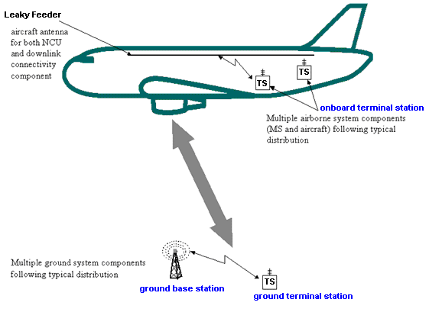
Figure 4: GSMOB and terrestrial cellular system interference scenario

The following six scenarios were studied:
- Scenario 1: Impact of g-BTS to the ac-MS/UE. This scenario, using MCL approach, assessed in which conditions the ac-MS/UE will have visibility of the terrestrial networks. Note that the NCU/ac-BTS are not taken into account in this scenario.
- Scenario 2: Impact of the ac-MS/UE to g-BTS. This scenario, using both MCL approach and SEAMCAT analysis, assessed in which conditions the ac-MS/UE will have the ability to connect to terrestrial networks. Note that the NCU/ac-BTS are not taken into account in this scenario.
- Scenarios 3 and 4: Impact of onboard NCU and ac-BTS emissions to the Downlink of terrestrial networks, for single (Scenario 3) and multiple (Scenario 4) aircraft respectively;
- Scenarios 5 and 6: Impact of ac-MS emissions to the uplink of terrestrial networks, for single (Scenario 5) and multiple (Scenario 6) aircraft respectively.

Scenario # | Interferers | Interfered system
1 | g-BTS | ac-MS/UE
2 | ac-MS/UE | g-BTS
3 | NCU and ac-BTS | Terrestrial network downlink
4 | Multiple aircraft  NCU and ac-BTS | Terrestrial network downlink
5 | ac-MS | Terrestrial network uplink
6 | Multiple aircraft  ac-MS | Terrestrial network uplink

The SEAMCAT scenario definition and elements had been used to define the scenarios necessary to assess the impacts between the two systems (terrestrial vs. GSMOB), as shown in Fig. 5.

Figure 5: SEAMCAT Scenario Definition

Scenario 1: Impact of g-BTS/NodeB on ac-MS/UE (GSMOB not active)
This scenario assesses in which conditions the ac-MS/UE will have visibility of the terrestrial networks, by using MCL calculations. It was identified as a starting point for the study and the results will be used as inputs for Scenarios 3 and 4.
The scenario assumed one g-BTS/NodeB (using various cellular bands), and GSMOB system is disregarded, i.e. both ac-BTS and NCU are inactive.
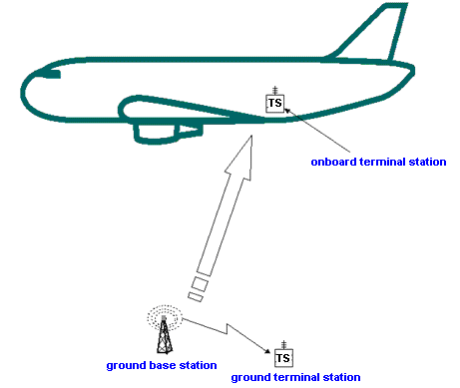
Figure 6: Scenario 1 where g-BTS signal is received by onboard mobile terminals

Number of aircraft | 1
Altitude of the aircraft above ground level | 3000 m to 10000 m
Elevation | Various angles from g-BTS/NodeB
Interfering transmitter | 1 g-BTS/NodeB
Position of transmitter | Static
Transmitter frequencies | 450 MHz, 900 MHz, 1800 MHz, 2 GHz
Technologies | GSM, UMTS (WCDMA) and CDMA2000
Path loss between aircraft and ground networks | Free space path loss
Victim receiver | 1 ac-MS/UE
Criteria | Received power by ac-MS/UE from g-BTS compared to ac-MS/UE sensitivity as function of altitude
Aim | Assess if an onboard terminal will have visibility of terrestrial networks
Modelling approach | MCL
Simulation cases | 1) GSM900  2) GSM1800  3) UMTS2GHz  4) UMTS900  5) UMTS1800  6) CDMA450
Table 4: General summary of Scenario 1

Scenario 2: Impact of ac-MS/UE on g-BTS/NodeB (GSMOB not active)
This scenario assesses in which conditions the onboard ac-MS/UE will have the ability to connect to terrestrial networks, by using both MCL calculations and SEAMCAT simulations. The scenario consists of one victim link (terrestrial uplink), and a single onboard ac-MS/UE, with GSMOB system disregarded, i.e. both ac-BTS and NCU inactive.

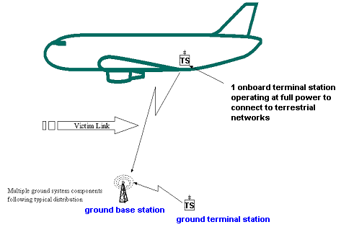
Figure 7: Scenario 2 where ac-MS/UE signal is received by g-BTS/NodeB (no NCU)

Number of aircraft | 1
Altitude of the aircraft above ground level | 3000 m to 10000 m
Elevation | Various angles from a g-BTS
Interfering Transmitter | 1 ac-MS/UE
Interfering Transmitter power | Full power depending on the frequency band
Transmitter frequency | 450 MHz, 900 MHz, 1800 MHz, 2 GHz
Path loss between aircraft and ground networks | Free space path loss
Victim receiver | 1 g-BTS
Criteria | Received power by a g-BTS from ac-MS/UE (GSM or UMTS) compared to the g-BTS’s sensitivity
Aim | Assess whether an ac-MS/UE can communicate with the terrestrial network
Modelling approach | MCL, SEAMCAT
Simulation cases: | 1) GSM900  2) GSM1800  3) UMTS 2GHz  4) UMTS900  5) UMTS1800  6) CDMA450
Table 5: General summary of Scenario 2

Scenario 3: GSMOB impact on the terrestrial communication link (g-BTS/NodeB to g-MS/UE (downlink)) from a single aircraft
This scenario assesses the impact of onboard NCU (and ac-BTS) emissions on the terrestrial g-MS/UE receivers, by using both MCL calculations and SEAMCAT simulations. This scenario consists of a single interfering link (the NCU and ac-BTS emissions directed to ac-MS/UE) whose emissions could impact a single victim link (terrestrial Downlink). NCU is operating and there is onboard connectivity (at 1800 MHz).

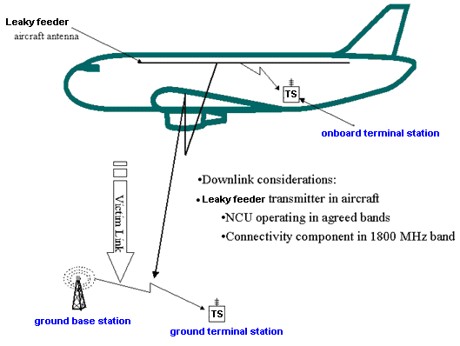
Figure 8: Scenario 3: GSMOB interfering terrestrial victim Downlink (g-BTS/NodeB to g-MS/UE)
from a single aircraft

Number of aircraft | 1
Altitude of the aircraft above ground level | 3000 m to 10000 m
Elevation | Various angles from terrestrial link
Interfering Transmitter (1) | ac-BTS (Leaky cable)
Transmitter frequency (1) | 1800 MHz
Interfering Transmitter (2) | NCU (Leaky cable)
Transmitter frequency (2) | 450 MHz, 900 MHz, 1800 MHz, 2 GHz
Victim receiver | 1 g-MS/UE
Wanted transmitter | 1 g-BTS/NodeB
Victim link | g-BTS/NodeB to g-MS/UE
Position of victim receiver | Typical outdoor distribution illustrating noise-limited network (rural area)
Path loss between aircraft and ground networks | Free space path loss
Criteria | Interference criterion I: C/(N+I)  Interference criterion II: (I/N)
Aim | To determine the probability of the ac-BTS interfering with the g-BTS/NodeB to g-MS/UE communication link.  To determine the probability of the NCU interfering with the g-BTS/NodeB to g-MS/UE communication link.
Modelling approach | MCL, SEAMCAT
Simulation cases | 1) NCU Interferer on g-BTS → g MS GSM900  2) NCU Interferer on g-BTS → g-MS GSM1800  3) Ac-BTS Interferer on g-BTS → g-MS GSM1800  4) NCU Interferer on g-Node B → g-UE UMTS900  5) NCU Interferer on g-Node B → g-UE UMTS1800  6) NCU Interferer on g-Node B → g-UE UMTS 2GHz  7) NCU Interferer on g-BS → g-MS CDMA450
Table 6: General summary of Scenario 3

Scenario 4: GSMOB impact on the terrestrial communications link (g-BTS/NodeB to g-MS/UE (downlink)) from multiple aircraft
This scenario assesses the impact of GSMOB in several aircraft, resulting from their onboard NCU (and ac-BTS) emissions, on the terrestrial g-MS/UE receiver, by using SEAMCAT simulations.
The scenario consists of multiple GSMOB interfering links (multiple aircraft) where emissions of their NCU and/or ac-BTS could impact a victim link (terrestrial Downlink). NCUs are operating and there is onboard connectivity (at 1800 MHz) in all modelled aircraft.

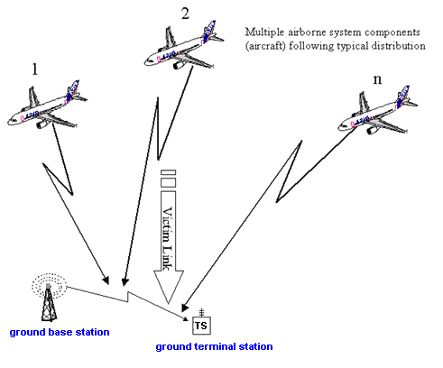
Figure 9: Scenario 4: GSMOB interfering terrestrial victim Downlink (g-BTS/NodeB to g-MS/UE)
from multiple aircraft

Number of aircraft | Airport distribution
Altitude of the aircraft above ground level | Altitude, position and direction distribution
Elevation | Various angles from terrestrial link
Interfering Transmitter (1) | ac-BTS (Leaky cable)
Transmitter frequency (1) | 1800 MHz
Interfering Transmitter (2) | NCU (Leaky cable)
Transmitter frequency (2) | 450 MHz, 900 MHz, 1800 MHz, 2 GHz
Victim receiver | Single g-MS/UE
Position of victim receiver | Typical MS/UE distribution
Wanted transmitter | g-BTS/NodeB
Position of wanted receiver | Typical outdoor distribution illustrating noise-limited network (rural area)
Victim link | g-BTS/NodeB to g-MS/UE
Path loss between aircraft and ground networks | Free space path loss
Criteria | Interference criterion I: C/(N+I)  Interference criterion II: (I/N)
Aim | To determine the probability of the ac-BTS interfering with the g-BTS/NodeB to g-MS/UE communication link for multiple aircraft.
Modelling approach | SEAMCAT
Simulation cases | 1) NCU Interferers on g-BTS → g-MS GSM900  2) NCU Interferers on g-BTS → g-MS GSM1800  3) Ac-BTS Interferers on g-BTS → g-MS GSM1800  4) NCU Interferers on g-Node B → g-UE UMTS 2GHz  5) NCU Interferers on g-Node B → g-UE UMTS900  6) NCU Interferers on g-Node B → g-UE UMTS1800  6) NCU Interferers on g-BS → g-MS CDMA450
Table 7: General summary of Scenario 4

Scenario 5: GSMOB impact on the terrestrial communications link (g-MS/UE to g-BTS/NodeB (uplink)) from a single aircraft
This scenario assesses the impact of onboard ac-MS emissions on the terrestrial g-BTS/NodeB receiver, by using both MCL calculations and SEAMCAT simulations.
This scenario considers ac-MS as an interferer whose emissions could have impact on a single victim link (terrestrial uplink). NCU is operating and there is onboard connectivity (at 1800 MHz).

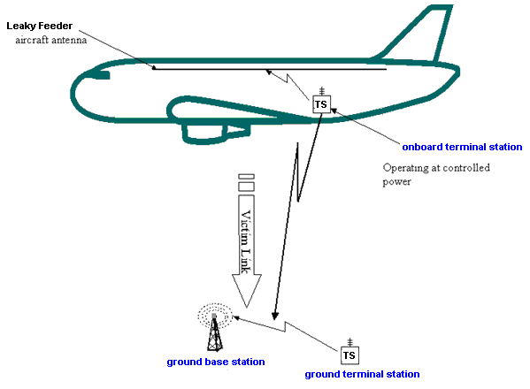
Figure 10: Scenario 5: GSMOB interfering terrestrial uplink (g-MS/UE to g-BTS/NodeB)
from a single aircraft

Number of aircraft | 1
Altitude of the aircraft above ground level | 3000 m to 10000 m
Elevation | Various angles from terrestrial link
Interfering Transmitter | Single ac-MS
Transmitter frequency | 1800 MHz
Victim receiver | 1 g-BTS/NodeB
Position of victim receiver | Fixed
Wanted transmitter | 1 g-MS/UE
Position of wanted transmitter | Typical distribution illustrating noise-limited network (rural area)
Victim link | g-MS/UE to g-BTS/NodeB
Path loss between aircraft and ground networks | Free space path loss
Criteria | Interference criterion I: C/(N+I)  Interference criterion II: (I/N)
Aim | To determine the probability of the ac-MS interfering with a g-MS to g-BTS and g-UE to g-Node B communication link
Modelling approach | MCL, SEAMCAT
Simulation cases | ac-MS Interferer on g-MS → g-BTS GSM1800  ac-MS Interferer on g-UE → g-Node B UMTS1800
Table 8: General summary of Scenario 5

Scenario 6: GSMOB impact on the terrestrial communication link (g-MS/UE to g-BTS/NodeB (uplink)) from multiple aircraft
This scenario assesses the impact of onboard ac-MS emissions on the terrestrial g-BTS/NodeB receivers, by using SEAMCAT simulations.
The scenario consists of a multiple interfering links (multiple aircraft) where emissions of their ac-MSs could impact a victim link (terrestrial uplink).

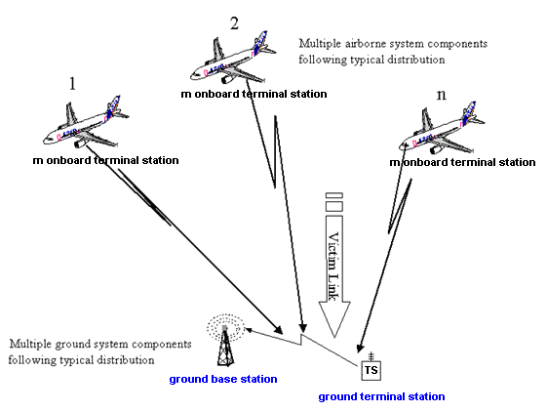
Figure 11: Scenario 6: GSMOB interfering terrestrial uplink (g-MS/UE to g-BTS/NodeB) from multiple aircraft

Number of aircraft | Airport distribution
Altitude of the aircraft above ground level | Altitude, position and direction distribution
Elevation | Various angles from terrestrial link
Interfering Transmitters | Assumed average number of mobiles transmitting per aircraft: 4
Transmitter frequency | 1800 MHz
Victim receiver | 1 g-BTS/Node B
Position of victim receiver | Fixed
Wanted transmitter | 1 g MS/g-UE
Position of wanted transmitter | Typical distribution illustrating noise-limited network (rural area)
Victim link | g-MS to g-BTS and g-UE to g-Node B
Path loss between aircraft and ground networks | Free space path loss
Criteria | Interference criterion I: C/(N+I)  Interference criterion II: (I/N)
Aim | To determine the probability of the ac-MS interfering with the g-MS to g-BTS and g-UE to g-Node B communication links for multiple aircraft near an airport.
Suggested modelling approach | SEAMCAT
Simulation cases | ac-MS Interferers on g-MS → g-BTS GSM1800  ac-MS Interferers on g-UE → g-Node B UMTS1800
Table 9: General summary of Scenario 6

INPUT PARAMETERS USED FOR MODELLING
The reference values used in the study were taken from the specifications for the terrestrial systems. In some cases, typical values for deployed base stations and terminals were also used.

Terrestrial network reference parameters used for modelling of GSM900, GSM1800 and UMTS 2 GHz
The following table provides the parameters used in the studies:

Parameter |  | GSM900 |  | GSM1800 |  | UMTS 2 GHz
 |  | MS | BS | MS | BS | UE | Node B
Antenna input Power | dBm / channel | 33 | 43 | 30 | 43 | 21/24*** | 33*
Receiver bandwidth | kHz | 200 | 200 | 200 | 200 | 3840 | 3840
Masking factor ** | dB | 0 | NA | 0 | NA | 21 | NA
Reference System noise figure (taken from values quoted in standards) | dB | 12 | 8 | 12 | 8 | 9 | 5
Typical System noise figure (operator quoted “typical” values) | dB | 7 | 4 | 7 | 4 | 7 | 4
Reference Noise level (taken from values quoted in standards) | dBm / channel | -109 | -113 | -109 | -113 | -99 | -103
Typical Noise level (“typical” operator values) | dBm / channel | -114 | -117 | -114 | -117 | -101 | -104
Reference Receiver Sensitivity (taken from values quoted in standards) | dBm / channel | -102 | -104 | -102 | -104 | -117 | -121
Typical; Receiver Sensitivity  (“typical” operator values) | dBm / channel | -105 | -108 | -105 | -108 | -119 | -122
Interference criterion I (C/(N+I) ) | dB | 9 | NA | 9 | 9 | NA | NA
Interference criterion II (I/N) | dB | -6 | NA | -6 | -6 | -6 | NA
Channel Spacing | kHz | 200 | 200 | 200 | 200 | 5000 | 5000
Maximum antenna gain | dBi | 0 | 15 | 0 | 18 | 0 | 18
Table 10: Parameters used in the studies
Notes:
* Value quotes typical operator power levels for the UMTS pilot channel = max Input power (43 dBm) -10 dB = 33dBm. Note that in order to effectively screen against terrestrial UMTS network recognition for the mobiles in the aircraft only the pilot channel needs to be screened in the onboard environment.

** Masking factor: the additional power by which the inserted noise has to exceed the received terrestrial signals in order to remove visibility of terrestrial networks in the cabin, see section 6.1.ii.

*** Maximum UE transmit powers values quoted to be used for the following simulations:
- Maximum UE transmission power for an onboard UE = 24 dBm;
- Maximum terrestrial UE transmission power value for simulations on the impacts for the support of voice service = 21 dBm (assumes UE power class 4);
- Maximum terrestrial UE transmission power value for simulations on impacts for the support of non voice service = 24 dBm.
The reference values taken from standards documentation are based on the 3GPP specifications and ITU-R Recommendation M.2039, as well as from the technical reports 3GPP TR 45.050, 3GPP TR 25.942.

Definition of the interference criteria
Two interference criteria have been applied in this report:
- Interference criterion I: C/(N+I) = 9 dB for terrestrial GSM networks to support speech;
- Interference criterion II: I/N = -6 dB, which is equivalent of a 1 dB increase over the thermal noise floor.

Masking factor definition
The masking factor is defined as the ratio by which the inserted noise has to exceed the received terrestrial signals in order to remove visibility of terrestrial networks in the cabin:
- For GSM systems a value for a net C/I = 0 dB is used. According to 3GPP GERAN this value is believed to be sufficient to cover future developments in mobile receiver sensitivities, assuming the NCU uses white noise as its screening signal;
- For UMTS /CDMA systems the masking factor has to take into consideration the processing gain inherent in those systems. Thus the masking factor results in a net Eb/No = 0 dB:
- For WCDMA this equates to an additional 21 dB (for the common pilot channel);
- For CDMA450 this equates to an additional 20 dB (for the pilot channel).

UMTS900 and UMTS1800
The following table provides the parameters required to study these technologies.
Parameter |  |  | UMTS900* |  |  |  | UMTS1800*
 |  | UE |  | Node B |  | UE |  | Node B
Antenna input Power | dBm |  | 21/24*** |  | 33** |  | 21/24*** |  | 33**
Noise level | dB/channel |  | -96 |  | -103 |  | -96 |  | -103
Receiver Sensitivity (Reference) | dBm/channel |  | -114 |  | -121 |  | -114 |  | -121
Channel Spacing | kHz |  | 5000 |  | 5000 |  | 5000 |  | 5000
Receiver Bandwidth | kHz |  | 3840 |  | 3840 |  | 3840 |  | 3840
Maximum antenna gain**** | dBi |  | 0 |  | 15 |  | 0 |  | 18
Table 11: Parameters used for the analysis of UMTS 900 and 1800 MHz networks
Notes:
* Assumed “typical” values given awaiting commercial product information.
** Typical operator power levels for the UMTS pilot channel = max Input power (43 dBm) -10 dB = 33 dBm as per UMTS defined testing procedures.
***Maximum UE transmit powers values quoted to be used for the following simulations:
- Maximum UE transmission power for an onboard UE = 24 dBm;
- Maximum terrestrial UE transmission power value for simulations on the impacts for the support of voice service = 21 dBm (assumes UE power class 4);
- Maximum terrestrial UE transmission power value for simulations on impacts for the support of non voice service = 24 dBm
****The same maximum antenna gain is assumed for UMTS as for GSM.

The reference values taken from standards documentation are based on the 3GPP specifications.

CDMA 450 MHz and FLASH-OFDM
The following table provides the parameters required to study this technology.

Parameter | Unit | CDMA450 / FLASH-OFDM
 |  | MS | BTS
Tx Frequency band | MHz | 450-460 | 460-470
Tx Antenna input Power | dBm/channel | 23 | 43
Receiver bandwidth | MHz | 1.25 | 1.25
Reference System noise figure (taken from values quoted in standards) | dB | 7 | 4
Typical Noise level (“typical” operator values) | dBm /channel | -106 | -109
Channel Spacing | MHz | 1.25 | 1.25
Typical antenna |  | Omni | 3 sector
Polarisation |  | Vertical | Vertical or cross-pol.
Antenna gain | dBi | 0 | 15 at horizon
CDMA 450 pilot channel power | dBm / channel | NA | 34.8
Mask required over noise floor to remove mobile’s ability to read pilot channel, Ec/No = 0 | dB | 20 | NA
Flash OFDM 450 pilot channel power | dBm/channel | NA | 43
Mask required over noise floor to remove mobile’s ability to read pilot channel, Ec/No = 0 | dB | 12 | NA
Table 12: Parameters used for the analysis of CDMA450/FLASH-OFDM networks

Analysis of the characteristics of FLASH-OFDM and CDMA450 parameters results in the same power required to remove visibility to terrestrial networks (i.e. Ec/Io screening threshold -12 dB for FLASH-OFDM relative to 43 dBm max “pilot transmit power” and -20 dB for CDMA 450 relative to 35 dBm max pilot power transmit power). Given the same noise level used for the mobile receiver for both CDMA450 and FLASH-OFDM in the 450 MHz band, then the interference results shown for the CDMA450 analysis will be identical for FLASH-OFDM.
The reference values taken from standards documentation are based on the 3GPP2 specifications.

Terrestrial antennas assumed in the studies
There were two terrestrial antenna types considered in the compatibility study:
- g-BTS/NodeB antennas;
- g-MS/UE antennas.

g-BTS/NodeB antennas
The characteristics of antennas used in the studies of this report differ depending on which modelling approach is carried out. The following sections highlight the antenna patterns and gains used for the Minimum Coupling Loss (MCL) and the SEAMCAT modelling approaches.

g-BTS/NodeB antenna characteristics used for MCL analysis
The MCL study assumed a three-sector cell site with uniform gain in the horizontal plane:
- G-BTS/NodeB antenna patterns used:
  - Vertical pattern derived from ITUR F.1336-1 using agreed input parameters, see Annex E.
    - Note that the off-axis gain is calculated on the basis of a maximum antenna gain of 15 dBi (at 450 MHz and 900 MHz) and 18 dBi (at 1800 MHz and 2 GHz).
  - Horizontal pattern: omni-directional in the horizontal plane within opening angle 120 degrees.
  - Downtilt angle: 0 degrees.
- Terrestrial antenna height: 0 m.

g-BTS/NodeB antenna characteristics used for SEAMCAT analysis
The SEAMCAT study assumed a three-sector rural cell site with uniform gain in the horizontal plane:
- Antenna patterns:
  - Vertical pattern derived from ITUR F.1336-1 using agreed input parameters, see Annex E.
    - Note that the off-axis gain is calculated on the basis of a maximum antenna gain of 15 dBi (450 and 900 MHz) and 18 dBi (1800 MHz and 2 GHz).
  - Horizontal pattern: Omni directional in the horizontal plane within opening angle 120 degrees.
  - Downtilt angle 2 degrees.
- Terrestrial antenna height: 30 m.

g-MS/UE antennas
The study assumed an isotropic antenna for all g-MS/UE with a gain of 0 dBi and an antenna height of 1.5 m.

Attenuation due to the aircraft
The attenuation effects of the aircraft to RF signals has been given various names, including “hull attenuation”, “aircraft attenuation” and “attenuation due to the fuselage”. A number of interpretations of the physical explanation and appropriate measurements have been discussed.

For the purposes of this report the term used is "attenuation due to the aircraft" and this parameter aims to express the difference in dB, between either:
- the field radiated (or received) by a mobile in free space and from (or to) a mobile within an aircraft (ac-MS signal attenuation in Table 13)
or
- the field radiated by a leaky feeder in free space and from an aircraft with the same leaky feeder within it (ac-BTS/NCU, connected to a leaky feeder, signal attenuation in Table 13),

Different measurement campaigns have been analysed and the figures were found to be quite heterogeneous. A summary of these can be found in annexes C and F. In addition a theoretical analysis of the possible array-effect of the leaky feeder antenna radiating out of the fuselage windows is contained in annex B.2. Both measurements and theoretical analysis show that the attenuation varies with both horizontal and vertical angle between the aircraft fuselage and the line of sight to the observation position. The results provided in this report are however not based on angle-dependency of attenuation, but instead a range of non-angle dependent values that is believed to capture the variation of the actual figures.

The following values have therefore been used in the analysis:

Case | ac-MS signal attenuation | ac-BTS/NCU signal attenuation
A (low) | 1 | 5
B (medium) | 5 | 10
C (high) | 9 | 15
Table 13: Values of “Attenuation due to the aircraft”
- For the MCL calculations cases A, B and C were used;
- For the SEAMCAT analysis Case B was used as the reference attenuation case. However, given the variation of values an aircraft attenuation sensitivity analysis is required for each of the relevant (SEAMCAT) scenarios:
  - Scenarios 3 and 4: Sensitivity analysis of -9 dB (Case A: reduced attenuation) and + 9 dB (Case C: increased attenuation). This corresponds to the combination of the attenuation due to the aircraft of the terrestrial signal entering the cabin (+/- 4 dB) and the attenuation due to the aircraft of the signal from the ac-BTS/NCU leaving the aircraft (+/- 5 dB);
  - Scenarios 5 and 6: Sensitivity analysis of -4 dB (Case A: reduced attenuation) and + 4 dB. (Case C: increased attenuation). This corresponds to the attenuation due to the aircraft of the signal from the ac-MS leaving the cabin (+/- 4 dB).

Aircraft cabin environment

E.i.r.p. values of GSMOB transmitters
The aircraft cabin environment covers a number of parameters in order to simulate the effective e.i.r.p. of the aircraft seen from the ground. The three transmitting GSMOB entities in the aircraft are: the NCU, the pico-cell BTS (ac-BTS) and the ac-MSs:
- The NCU: The maximum required e.i.r.p. value of the NCU is calculated by using the worst case configuration regarding the elevation angle obtained from Scenario 1, for each control frequency band (see section 5 and 7.2);
- Pico-cell (ac-BTS): e.i.r.p. for GSM 1800 MHz connectivity = The NCU 1800 MHz e.i.r.p. value (dBm) + C/I onboard connectivity margin (dB);
- The transmit power of ac-MS for GSM 1800 MHz = 0 dBm, with an assumed isotropic antenna, i.e. of gain equal to 0 dBi.
Note that the actual radiated power could differ from the nominal value: 0 dBm. The tolerance of the ac-MS radiated power which is of the order of +/- 5 dB under normal conditions and +/- 6 dB under extreme conditions (See ETSI EN 301 511) has not been taken into account.
The actual modelling approach used for calculating the NCU and ac-BTS e.i.r.p. values from the received g-BTS/NodeB signals is defined in section 7.

C/I onboard connectivity margin definition
The C/I onboard connectivity margin determines the additional power that must be produced by the ac-BTS over the NCU value. This figure is calculated as:
- C/(N+I) to support GSM voice service = 9 dB;
- Additional noise due to the combination of NCU and terrestrial signal in cabin = 3 dB;
- Resulting C/I = 12 dB.

Antenna profiles of onboard transmitters
There are three types of GSMOB transmitters considered in the compatibility study, each with an antenna:

NCU antenna
Given that the length of the aircraft is considerably smaller than the distance to the ground, the aircraft is therefore assumed to behave as a point source with 0 dBi antenna gain.

ac-BTS antenna
Given that the length of the aircraft is considerably smaller than the distance to the ground, the aircraft is therefore assumed to behave as a point source. The associated gain is 0 dBi.

ac-MS/UE antennas
The study assumes 0 dBi antenna gain for all ac-MS/UEs.

Aircraft Distribution
The maximum numbers of potential interferers for Scenarios 4 and 6 are based on snapshots from two radar surveillance plots of the London area in busy air traffic hours from UK National Air Traffic Services (NATS).

The snapshot containing the largest number showed that 146 aircraft were airborne at least 3000 m above sea level within a radius of 98 km around Heathrow airport. A more typical busy-hour figure shown in a number of snapshots is around 80 simultaneous aircraft above 3000 m above sea level and within 100 km radius. The height distribution at the busiest moment during the day of each of these analyses is shown in the following table:

Altitude above sea level  (m) | Percentage  during busy hours of busy days | Percentage  during busy hours of normal days
3000 – 4000 | 25% | 28%
4000 – 5000 | 12% | 21%
5000 – 6000 | 11% | 18%
6000 – 7000 | 8% | 6%
7000 – 8000 | 6% | 8%
8000 – 9000 | 9% | 5%
9000 – 10 000 | 11% | 5%
10 000 – 11 000 | 8% | 4%
11 000+ | 10% | 6%
Total | 100% | 100%
Total Number of aircraft simultaneously present | 146 | 80
Table 14: Typical height distribution and total number of aircraft simultaneously present

Note that 10% of the aircraft identified above are non-commercial aircraft. Furthermore the 90% aircraft identified as commercial consist of both cargo and passenger commercial aircraft. Finally the assumption that all aircraft will possess a GSMOB system is probably beyond the reality. Therefore the number of aircraft taken from the NATS distributions is 70% of the total number. The 30% drop is due to the following:
- 10% non commercial aircraft, and
- 20% of aircraft that are either cargo or aircraft that will never be equipped with GSMOB systems, due to the aircraft’s size/age, or airlines simply not wishing to add this system to their aircraft.
The number of aircraft constituting potential interferers for the terrestrial receivers was then calculated by assuming a uniform density within the actual radius applicable to the type of receiver.
These assumptions represent a safe upper bound for the maximum number of interferers.
  - Distribution of Narrow body and Wide body aircraft
Within this report the representation of the transmit power of the leaky feeder (NCU and ac-BTS) is calculated via the so called “Cylinder model” (see section 7 Modelling Techniques). This model requires the characteristics of a typical aircraft to be taken into account. The following table provides the typical characteristics of a narrow body and wide body aircraft:

 | Narrow Body aircraft | Wide Body aircraft
Length (m) | 30 | 50
Diameter (m) | 4 | 7
Table 15: Types of aircraft

For multiple aircraft analysis an average distribution of narrow body and wide body aircraft were necessary.
Two distributions of aircraft types were used, the first from the Airbus orders, deliveries and in-circulation figures and the second from Boeing on the analysis of worldwide aircraft deployed:
- Taking the sum of Airbus orders, deliveries and in-circulation figures (available on website) the following values were obtained:
- 2403 wide body aircraft;
- 10909 narrow body aircraft;
- 13312 total number of Airbus aircraft;
- Percentage of wide body aircraft to narrow body of Airbus commercial aircraft = 2403 / 13312 = 18%.
This assumes therefore that one in five aircraft above any location is a wide body aircraft.
- The Boeing, worldwide, distribution suggests the following:
- 3864 wide body or very wide body aircraft;
- 10248 narrow body aircraft;
- 2688 private jet;
- 16800 aircraft in circulation (all types);
- Thus a ratio of wide body aircraft to narrow body aircraft, required for the compatibility analysis, gives the following figures:
  - 27% wide body aircraft;
  - 73% narrow body aircraft.
This distribution assumes that at the worst case almost one in three aircraft is a wide body aircraft.

The report consequently took the worst case figure (27% of wide body aircraft) in its analysis of the effects of multiple aircraft.
  - Probability of GSMOB transmitting in the same frequency
The calculations to derive the probability of GSMOB emitters on the aircraft transmitting in the same frequency for multiple aircraft assume the following conditions:
- Minimum number of GSM1800 channels available onboard = 10 GSM channels;
- Maximum number of GSM1800 channels available onboard = 50 GSM channels;
- 27% of aircraft are wide body aircraft (justification in section 6.7 above);
- Potential support of two operators per aircraft:
  - Narrow body aircraft have 2 carriers ( 2 BCCHs);
  - Wide body aircraft have 5 carriers (2 BCCHs);
- Weighted average frequency allocated (assuming 27% wide body aircraft)
  - for GSM terrestrial network analysis = (0.27 * (5*200) + 0.73 * (2*200) ) kHz = 562 kHz;
  - for UMTS terrestrial network analysis = (0.27 * 5 + 0.73 * 2) = 2.8 GSM carriers;
- Frequency re-use factor = frequency allocated / spectrum pool available:
  - For GSM1800 MHz terrestrial network analysis:
    - Min = 562/2000 = 28.1%
    - Max = 562/10000 = 5.62%
  - For UMTS 1800 MHz terrestrial network analysis:
    - Min = 100%
    - Max = 3840 / 10000 = 38.4%
- DTX of carriers for ac-BTS = assume worst case BCCH carriers overlap = 100%;
- DTX of carriers for ac-MS = 100%;
- Occupancy of carriers for ac-BTS with BCCH = assume worst case BCCH carriers overlap = 100%;
- Occupancy of carriers for ac-BTS without BCCH = 50%;
- Occupancy of carriers for ac-MS = 50%.

The probabilities for transmission on coinciding frequencies are presented in tables in the following sub-sections. For UMTS networks in the 1800 MHz probabilities are presented separately, given the different assumptions behind the probability of simultaneous transmission within the larger UMTS receive band.

Probability of GSMOB transmitting over terrestrial GSM-900 and 1800 MHz, and UMTS 900 MHz and 2 GHz network channels
The probability that GSMOB in multiple aircraft configuration are transmitting at the same time using the same frequency is calculated in the table below.
 | NCU | Ac-BTS 1800 MHz | Ac-MS 1800 MHz
Number of GSM channels available onboard (min) | NA | 10  (Total = 2 MHz) | 10  (Total = 2 MHz)
Number of GSM channels available onboard (max) | NA | 50  (Total =10 MHz) | 50  (Total =10 MHz)
Frequency re-use based on 10 carriers | 100% | 28.1% | 28.1%
Frequency re-use based on 50 carriers | 100% | 5.62% | 5.62%
Discontinuous Transmission (DTX) | 100% | 100% | 100%
Occupancy of carrier | 100% | 100% BCCH  50 % Non BCCH | 50%
Probability factor for 10 carriers | 100% | 26 % | 14 %
Probability factor for 50 carriers | 100% | 5 % | 3%
Number of coincident interferers per aircraft for 10 carriers | 1 | 0.26 | 0.14
Number of coincident interferers per aircraft for 50 carriers | 1 | 0.5 | 0.3
Table 16: Probability that GSMOB in multiple aircraft are transmitting at the same time and at the same frequency for CDMA450, GSM-900 and 1800 MHz, and UMTS 900 MHz and 2GHz

Probability of GSMOB transmitting over terrestrial UMTS 1800 MHz networks
The probability of a GSMOB interfering signal falling into the 3840 MHz bandwidth of the UMTS1800 signal is higher than the probability of an GSMOB interfering signal falling into a GSM carrier. The bandwidth of the spectrum pooled (2 MHz and 10 MHz) needs to be considered when calculating the total number of GSM mobiles simultaneously transmitting within the UMTS receiver bandwidth.

 | NCU | Ac-BTS1800 | Ac-MS1800
Number of GSM1800 channels available onboard (min) | NA | 10  (Total = 2 MHz) | 10  (Total = 2 MHz)
Number of GSM1800 channels available onboard (max) | NA | 50  (Total = 10 MHz) | 50  (Total = 10 MHz)
Average number of carriers per aircraft (Ratio of large aircraft to small aircraft (0.73*2 + 0.27*5) | NA | 2.8 | 2.8
Probability of transmitting at the same time (assumes each carrier is 50 % loaded) | 100 % | 50 % | 50 %
Probability that all GSM carriers are in the same UMTS carrier (10 carriers) | 100 % | 100 % | 100 %
Probability that all GSM carriers are in the same UMTS carrier (50 carriers) | 100 % | 3840/10,000 = 38.4 % | 3840/10,000 = 38.4 %
Average number of coincident interferers per aircraft within UMTS receiver bandwidth (10 carriers) | 1 | 1.4 | 1.4
Average number of coincident interferers per aircraft within UMTS receiver bandwidth (50 carriers) | 1 | 0.54 | 0.54
Table 17: Calculation of the number of GSMOB interferers for Scenarios 4 and 6 for GSMOB connectivity impact over a UMTS 1800 terrestrial network

MODELLING TECHNIQUES
In this section the methodology used to represent the different systems and events under study is described. This includes the basic considerations on the scope and method of modelling together with more detailed information on the parameter definition used for the simulations. Two methods were used for analysing the impact of interference from GSM onboard aircraft: manual Minimum Coupling Loss (MCL) calculations and automatic calculations by the SEAMCAT v.3 tool (version which is capable to simulate CDMA technology).

This report contains results in 3 categories:
- Cat A) MCL calculations: typically given worst-case figures, i.e. the nominal (mean) power values of the interference in the worst geometry for the aircraft - victim receiver scenario, and on the limit conditions for the victim link. The result is typically given as “Increase of the noise floor compared to thermal noise”.
- Cat B) Simulations of representative air traffic (e.g. speed, altitude and density) typically estimate the probability of the interference level exceeding a chosen limit. This type of figures gives an indication of how often a disturbance may occur, but they assume that the terrestrial link is of the most vulnerable type (the interference level is compared to the thermal noise floor). Results of this category are obtained from SEAMCAT by choosing I/N defined in this report as Criterion II.
- Cat C) Applying a representative distribution for the terrestrial network conditions, it estimates the real experienced level of interference, since it combines the probability of the interfering signals exceeding a certain limit, and the probability that the victim links are sufficiently vulnerable. Results of this category are obtained from SEAMCAT by using the C/(N+I) defined in this report as Criterion I.
Descriptions of category A and B are general and not dependent on the actual network layout, the current traffic or the service types supported. For example, there could be cases where a relatively high probability for a certain I/N to be exceeded would not be detectable at all due to intra system interferences already present, while in other cases the same I/N distribution may cause a severe degradation.

Category C avoids this uncertainty, provided that the reference terrestrial network can be agreed as representative. In fact, if the situation described for category A and B is true, it means that there are large differences between the terrestrial networks, and hence there could be similar difficulties to agree on typical reference values.

Terrestrial network modelling
The challenge of any modelling is to get a representation of real life that is sufficiently accurate to illustrate the effects under consideration. The approach taken when modelling the terrestrial network in order to assess the possible interference was to use an a priori knowledge of the most vulnerable parts of networks and communication situations.
The most vulnerable cases are typically found in lightly loaded systems where no internal interference (or interference from other sources) is present. In more heavily loaded networks the performance of a link is already influenced by interference (i.e. the noise floor is higher) so the effect of an additional interfering signal of a certain value is less. A network designed for coverage (e.g. in rural areas, i.e. with a more relaxed availability) is therefore more vulnerable to external interference than a high-quality network (e.g. in urban areas, i.e. with large capacity) when looking at the probability of interference for an arbitrary connection.

However, independent of the terrestrial system design, it is important to consider that the interference probability is not experienced equally by all users within a cell. In any cellular network, the communication quality experienced by users follows a probability distribution due to different distance from the base station, shadowing due to buildings or other structures, terrain, etc. Those users closer to their operating limit (i.e. C/(N+I) threshold) are more easily driven below that limit by external interference and consequently have a higher probability of interference than those already operating well above their operating limit. Therefore, in a scenario where the overall interference probability appears acceptable, some users within a cell may be severely impacted while others see little or no effect. This argument pertains specifically to a SEAMCAT interference criterion based on C/(N+I), such as that used in Category C. Category B, which uses I/N as an interference metric for SEAMCAT, circumvents this concern by eliminating the user variability due to non-uniform coverage within the network

GSM modelling
A single cell approach was used to represent the terrestrial GSM network.
By studying the effect on a pure noise-limited cell and not taking into account possible handovers, the most vulnerable case is considered. For MCL calculations this simply means that the highest g-BTS output power and the lowest receiver noise figure (both for BTS and MS) are assumed.

MCL calculations were used to:
- Determine the highest signal value from a terrestrial cell received by an ac-MS/UE at a certain height (Scenario 1). This level was then used to calculate the needed emitted power of both the NCU and ac-BTS to be used in Scenarios 3 and 4.
- Illustrate the maximum increase of noise floor in a terrestrial receiver as result of interference from one aircraft in the worst-case position for Scenarios 3 and 5.
- SEAMCAT simulations were used to illustrate the typical influence in a vulnerable cell. For GSM, the influence of the interference is quantified by the parameter C/(N+I), i.e. the probability that the C/(N+I) is below a limit given by the performance specification. The victim system cell radius was calculated by using the SEAMCAT “noise limited network” option (the other option is “traffic limited network”), using the availability target of 95%, which is typical for similar CEPT studies. Only voice-service simulation is possible in SEAMCAT, therefore the C/(N+I) (criterion I) was set to 9 dB.
- Calculate the effect of one or more interfering links on each of the victim links, while storing every signal calculation in an array. It was then possible to calculate different statistical parameters based on the input data. The characteristics of the calculated signals (dRSS - wanted signal and “IRSS”- interfering signal) were recorded and are included in the section 8 of this report as well as in the annex A. It was assumed that in a GSM network the uplink is the most sensitive part of the link, therefore uplink was used as reference for defining the cell radius
The modelling methodology used reflects the typical situations where the g-BTS is using a sectorized antenna with 120° horizontal 3dB opening angle; hence both the g-MS (connected to the g-BTS) and the aircraft (with potential interfering transmitters) must be within the same horizontal opening angle when seen from the g-BTS (Scenario 6). The sector-antenna pattern is typically described through its horizontal and vertical pattern, down-tilt and the maximum gain.

The inherent SEAMCAT design makes some compromises necessary in order to get a realistic model. In particular it is difficult to model a horizontal sector and ensure that both the wanted transmitters and the interfering transmitters are within that sector, and still with random direction and distance. It was therefore decided to disregard the real horizontal variations of antenna pattern, and use an average value (maximum value minus 0.9 dB) for the gain in the horizontal plane. The actual antenna-pattern and gain-values used are described in section 6. Hence in the modelling process, the theoretical cell is assumed to be circular with no variations of the antenna gain in the horizontal direction. In this way random horizontal angles may be used for all positioning of entities.

UMTS modelling
The use of CDMA for distinguishing between channels or connections in UMTS makes a huge difference from GSM. First of all it is less meaningful to speak about a pure noise-limited system, since by nature a number of users are sharing the same frequency channel; hence a CDMA system always has an intrinsic interference. In practice one may however consider a light-loaded CDMA system as noise-limited when the number of users is so small that the resulting rise of noise floor in the receiver is insignificant, in the uplink mode. It therefore makes sense also for UMTS to compare the power of the interfering signal with the thermal noise floor of the victim receivers, and consider the possible rise of that noise floor as an indication of the consequence of the interference. Note that in the downlink, there are always control channels present which are normally much stronger than the thermal noise. Therefore the assumption to compare the interference to the thermal noise is conservative for the downlink.

Just as for the GSM-case, MCL calculations in Scenario 1 were performed, in order to assess the maximum power levels received by an in-cabin mobile at different heights and in different frequency bands. Those levels were then used for defining the output power levels of the NCU at different bands. MCL calculations further showed worst-case values for the levels received by terrestrial mobiles as a result of NCU transmissions for Scenario 3.

However, in UMTS, the effect of the whole network is not easily deduced from a study of an “isolated” noise-limited cell. Soft handovers, traffic-dependent coverage and other issues make the study much more complicated. Unfortunately due to inconsistent results of SEAMCAT analysis of CDMA networks, the UMTS network analysis only modelled the received interferer signal strength and the corresponding rise to the thermal noise limit.
For UMTS terrestrial networks a similar approach was made for the NCU analysis for both single and multiple interferers. Additional consideration is required for UMTS deployment in GSM bands including NCU impact to terrestrial UMTS networks and the interference due to ac-BTS/ac-MS when flying over a terrestrial network using UMTS1800 MHz. The latter requires a different probability for coincident GSM carrier transmission in the larger bandwidth of UMTS, see section 6.9.2.

Modelling of the different scenarios

Scenario 1 (MCL)
Based on the methodology described above and the description of the scenario in section 5, the interference power level (I_{g-BTS_to_ac-MS}) received by ac-MS/UE from g-BTS/NodeB is given by:

 | $P_{{\text{rec}}_{\text{ac}}−\text{Ms}}={\text{EIRP}}_{g−\text{BTS}}−L_{\text{prop}}−L_{\text{Aircraft}}+G_{\text{ac}−\text{MS}}$(dBm) | (Equation 1)
${\text{EIRP}}_{g−\text{BTS}}$: | e.i.r.p. of the signal radiated by the g-BTS/NodeB, in the direction of the aircraft. It already considers the antenna gain, which follows the ITU F.1336, Peak, as described in section 6, (dBm)
$L_{\text{prop}}$: | Propagation Loss between g-BTS/NodeB and the aircraft (dB)
$L_{\text{Aircraft}}$: | Attenuation due to the aircraft (dB)
$G_{\text{ac}−\text{MS}}$: | Antenna gain of the ac-MS/UE, (dBi)

The resulting margin at the ac-MS/UE receiver is given by:

 | (dB) | (Equation 2)
: | Receiver sensitivity (dBm)
: | Received power at onboard ac-MS/UE (dBm)

Scenario 2 (MCL)
Based on the methodology described above and the description of the scenario in section 5, the power from aircraft ac-MS/UE received at g-BTS/NodeB is given by:

 |  | $P_{{\text{rec}}_{g}−\text{BTS}}={\text{EIRP}}_{\text{ac}−\text{MS}}−L_{\text{Aircraft}}−L_{\text{prop}}+G_{g−\text{BTS}}$ (dBm) |  | (Equation 3)
${\text{EIRP}}_{\text{ac}−\text{MS}}$: |  | e.i.r.p. (dBm)of the signal radiated by the ac-MS/UE, considering that there is no control system (NCU) active onboard
$L_{\text{prop}}$: |  | Propagation loss between g-BTS/NodeB and aircraft, (dB)
$L_{\text{Aircraft}}$: |  | Attenuation due to the aircraft, (dB)
$$G_{g−\text{BTS}}$$ | Antenna gain of the g-BTS/NodeB (dBi), in the direction of the aircraft

The resulting margin at the g-BTS/NodeB receiver is given by:

 | (dB) | (Equation 4)
: | g-BTS receiver sensitivity (dBm)
$$I_{g−\text{BTS}}$$ | Interference power level received by the g-BTS (dBm)

Scenario 3 (MCL)
Based on the methodology described above and the description of the scenario in section 5, the power from aircraft ac-BTS or NCU received at g-MS/UE is given by:

 | $P_{{\text{rec}}_{g}−\text{MS}}={\text{EIRP}}_{\text{ac}−\text{BTS}}−L_{\text{Aircraft}}−L_{\text{prop}}+G_{g−\text{MS}}$ (dBm) | (Equation 5)
${\text{EIRP}}_{\text{ac}−\text{BTS}}$: | e.i.r.p. of the ac-BTS or the NCU signal (dBm). Described in section 7.5.2
$L_{\text{prop}}$: | Propagation loss between aircraft and g-MS/UE, (dB)
$L_{\text{Aircraft}}$: | Attenuation due to the aircraft, (dB)
$$G_{g−\text{MS}}$$ | Antenna gain of the g-MS, (dBi)

The resulting increase of noise floor at the g-MS/UE receiver is given by:

(dB) |  | (Equation 6)
: | Noise level of the g-MS/UE without any other interference sources
$I_{{\text{rec}}_{g}−\text{MS}}$: | Interference received by the g-MS

An MCL calculation for the different cases of Scenario 3 is included to illustrate the worst case situation with an interfering transmitter (being an ac-BTS or a NCU) in one aircraft.

The calculation of the EIRP_{g-MS} is described in section 7.5.2.

Scenario 3 and 4 (SEAMCAT)
Considering the GSM case, a noise-limited g-MS receiving interfering signals from one or several ac-BTS or NCU was modelled. In the UMTS case the CDMA-option for Victim Link in SEAMCAT is used. In these scenarios the Victim Link is a link between a g-BTS/NodeB and the g-MS/UE, i.e. the g-BTS/NodeB is the “Wanted Transmitter” and the g-MS/UE is the “Victim Receiver” using SEAMCAT-terminology (see section 5).

The vulnerability of the terrestrial mobile from interfering signals depends on its surroundings, i.e. how much of the sky is directly visible. In the SEAMCAT simulations, a full circle horizon from an elevation angle of 10 degrees was assumed.
The corresponding horizontal distance range is up to 17 km (aircraft at 3000 m height) and up to 56 km (aircraft at 10000 m height).
The different values of the e.i.r.p. of the ac-BTS (or the NCU) to be used in the SEAMCAT simulations were calculated based on a theoretical model described in section 7.5.
In Scenario 3, only one interfering transmitter was simulated, in two different cases:
- The interfering transmitter located at constant height (3000 - 5000 – 8000 - 10000 m) and placed in a location corresponding to the worst case elevation angle for the on ground receiver.
- The interfering transmitter located at a constant height (3000 - 5000 – 8000 - 10000 m) but at a random distance to the ground receiver within a circle the radius of which corresponds to the minimum elevation angle to the on ground receiver (10 degrees).

In Scenario 4, the cases of several interfering transmitters were simulated. The interferers were uniformly spread within a 56 km radius circle around the Victim Receiver, and distributed at different heights (3000 m and above) according to the data given in section 7.4 ‘Multiple aircraft modelling’.

- Case 1: Interfering signal from ac-BTS
In the simulations of multiple interferers, since the ac-BTS of different aircraft are using the same GSM1800 frequency channel, the number of interferers is only a fraction ofthe number of aircraft within sight of the g-MS/UE, and was calculated based on the amount of spectrum used by the GSMOB system (see section 6.9).

- Case 2: Interfering signal from NCU
In this case all aircraft within sight of the g-MS/UE contribute to the receive level interference, and simulations were made for every band being controlled by the NCU. The results are then applicable for every channel within those bands. The calculation of the number of interferers used in SEAMCAT simulations is described in section 7.4.

Scenario 5 (MCL)
Based on the stated above and the description of the scenario in section 5, the interference power level (I_{ac-MS_to_g-BTS}) <1> received by the g-BTS from the ac-MS is given by:
<1> This power P_{rec_g-BTS} is a level of interference. The usual symbol for interference is I. The following symbol is proposed "I_{ac-MS_to_g-BTS}"

 | $P_{{\text{rec}}_{g}−\text{BTS}}={\text{EIRP}}_{\text{ac}−\text{MS}}−L_{\text{Aircraft}}−L_{\text{prop}}+G_{g−\text{BTS}}$ (dBm) | (Equation 7)
${\text{EIRP}}_{\text{ac}−\text{MS}}$: | e.i.r.p. of the signal radiated by the ac-MS when the NCU is active (dBm)
$L_{\text{prop}}$: | Propagation loss between aircraft and g-BTS (dB)
$L_{\text{Aircraft}}$: | Attenuation due to the aircraft (dB)
$$G_{g−\text{BTS}}$$ | Antenna gain of the g-BTS (dBi), in the direction of the aircraft

The resulting increase of noise floor at the g-BTS receiver is given by:

${\left(\frac{ΔN}{N}\right)}_{[\text{dB}]}=\text{10}\text{.}\text{log}\left(\frac{N_{g−\text{BTS}−\text{thermal}[\text{mW}]}+I_{{\text{rec}}_{g}−\text{BTS}[\text{mW}]}}{N_{g−\text{BTS}−\text{thermal}[\text{mW}]}}\right)$ (dB) |  | (Equation 8).
$N_{g−\text{BTS}−\text{thermal}}$: | Noise power level of the g-BTS
$I_{{\text{rec}}_{g}−\text{BTS}}$: | Interference received by the g-BTS

The determination of the applied e.i.r.p of the ac-MS is described in section 7.5.1.

Scenarios 5 and 6 (SEAMCAT)
Scenarios 5 and 6 simulate respectively one and several aircraft with active ac-MS transmitting on a frequency being used by a g-BTS. The main focus is to model a g-BTS in a noise-limited network (which is representative of a spare rural network). In this scenario the Victim Link is the link from an arbitrary g-MS/UE to the g-BTS/NodeB. Further, the Interfering link is the link from the ac-MS to ac-BTS.
The g-BTS antenna beam width is equal to120° in the horizontal plan, and the g-BTS visibility of aircraft goes down to elevation angles 2° above the horizon. This minimum elevation corresponds to the elevation of an aircraft at a 3 000 m height and at a horizontal distance of 75 km and to the elevation of an aircraft at a 10 000 m height and at a horizontal distance of 200 km.
As indicated before, the e.i.r.p. of the ac-MS used in the SEAMCAT simulations was set to 0 dBm minus the aircraft attenuation as described in section 7.5.
In Scenario 5 only one interfering transmitter was simulated for the following two cases:
- The interferer located at constant height (3000, 5000, 8000, 10000 m) and placed at the worst case elevation angle seen from the victim receiver (48 degrees at 3000 m and 2 degrees for all heights above 3000 m); see curves in annex A.2.
- The interferer located at constant height (3000, 5000, 8000, 10000 m) with random position within a radius corresponding to the minimum elevation angle to the victim receiver (2 degrees).
In Scenario 6 a number of interfering transmitters were simulated. The interferers were uniformly spread within a 120 degrees sector with a radius of up to 200 km from the Victim Receiver, and distributed at different heights (3000 m and above) according to the data given in section 6.7 Aircraft distribution.

Just as for Case 1 of Scenario 4 (Interfering signal from ac-BTS), the interfering transmitters (in this scenario the ac-MS) of different aircraft were using the same GSM1800 frequency channel. The mean number of interferers was only a fraction of the number of aircraft within sight of the g-BTS, and was calculated for the amount of spectrum being allowed to use by the GSMOB system. In addition the probability that the channel and timeslot are used/busy were taken into account (see section 6.8).

When defining the number of aircraft which may carry potential interfering transmitters in Scenario 6, the sector of 120 degrees with a maximum distance of 200 km was considered.

Propagation models
Two propagation models were considered in this report: one for the path between the aircraft and the relevant victim receivers on the ground, and one for the path between g-BTS/NodeB and g-MS/UE.

Propagation model for the path between aircraft and victim receivers on the ground
Propagation model used for the path between the aircraft and the victim receivers on the ground is the free space model together with a random component (for MCL calculations only the median free space loss was used).
(Equation 9)
where:
- L_{FSL} is the free space path loss (dB), and
- L_{random} is the lognormal random variable with a standard deviation of 1 dB (this value was considered as representative) used in SEAMCAT simulations .

The free space path loss in dB is given by:
(Equation 10)
where D (km) is the distance and F (GHz) the frequency.

Propagation model for the path between g-BTS/NodeB and g-MS/UE
The propagation model used for the path between the g-BTS/NodeB and the g-MS/UE was the Extended Hata model for Open Area, as defined in the SEAMCAT modelling tool. This type of environment was chosen since it was considered to represent the most vulnerable cases, where communication links are close to their limit of performance due to poor signal strength. Such links are typically found in lightly loaded systems with no internal interference or interference from other sources. The variation in path loss is modelled by an addition of log-normally distributed variable, which for a distance D>0.6 km has a standard deviation (σ) of 9 dB.

Propagation model for the path between ac-BTS and ac-MS
The path loss between ac-BTS and ac-MS was not considered in SEAMCAT simulations, but its effect has been taken into account in the overall link budget. Considerations on the subject are included in section 7.5 below.

Multiple aircraft modelling
Different approaches may be taken when modelling one or several aircraft at different heights. It is worthwhile to mention that the Monte-Carlo simulation approach of SEAMCAT is a collection of snapshots from different situations rather than dynamic simulations trying to emulate a real system. Considering this, it is of less importance to model the movement of aircraft at a detailed level, as long as the number and distribution of aircraft in the snapshots are realistic. Section 6.6 contains data from real aircraft density in southern England within 98km from Heathrow airport, which was the basis for the calculation of the number of interferers.
As mentioned in earlier sections, the relationship between the number of aircraft (adjusted for the possibility of a deployed system onboard) and the number of actual interferers, on one channel depends on:
- For Scenario 4, Case 1: Downlink interference from ac-BTS:
Number of interferers = Number of aircraft within sight using simultaneously the same frequency channel and timeslot for connectivity;
- For Scenario 4, Case 2: Downlink interference from NCU:
Number of interferers = Number of aircraft within sight;
- For Scenario 6: Uplink interference from ac-MS in multiple aircraft:
Number of interferers = Number of aircraft within sight using the same frequency and timeslot simultaneously.

Modelling actual number of interferers in the different scenarios
The number of interferers, to be included in the multiple interferer scenarios (Scenarios 4 and 6), was based on the input data and considerations made in sections 6.7, 6.8 and 6.9, as well as the minimum elevation angle described in section 7.2.3 and 7.2.4.
The table below shows the resulting average number of transmitting interferers used in SEAMCAT for the different scenarios for CDMA 450 MHz, GSM in 900 MHz and 1800 MHz, as well as UMTS in 900 MHz, 1800 MHz and 2GHz networks:

 | NCU | 10 GSM1800 carriers available onboard |  | 50 GSM1800 carriers available onboard
 | NCU | Ac-BTS | Ac-MS | Ac-BTS | Ac-MS
 | Scenario 4 | Scenario 4 | Scenario 6 | Scenario 4 | Scenario 6
Normal busy day | 18 | 5 | 8 | 1 | 2
Extreme busy day | 33 | 9 | 15 | 2 | 3
Table 18: Average number of transmitting interferers from GSMOB systems to CDMA 450 MHz, GSM-900 and 1800 MHz and UMTS 900 MHz and 2GHz terrestrial networks

The table below shows the resulting average number of transmitting interferers used in SEAMCAT for the different scenarios with UMTS 1800 MHz networks:

 | NCU | 10 GSM1800 carriers available onboard |  | 50 GSM1800 carriers available onboard
 | NCU | Ac-BTS | Ac-MS | Ac-BTS | Ac-MS
 | Scenario 4 | Scenario 4 | Scenario 6 | Scenario 4 | Scenario 6
Normal busy day | 18 | 25 | 78 | 10 | 30
Extreme busy day | 33 | 45 | 143 | 18 | 55
Table 19: Average number of transmitting interferers from GSMOB systems to
UMTS 1800 MHz terrestrial networks

Modelling of the GSMOB system
In order to perform both manual MCL calculations and SEAMCAT simulations, the three different transmitting sources of the airborne system must be modelled. For SEAMCAT simulations it is the combination of the transmitters themselves and their local environment (the attenuation due to the aircraft) that together must be modelled as a transmitting source.

The ac-MS
When observed from a distance (a receiver on ground) the transmissions from an ac-MS is simply modelled as the real e.i.r.p. of the transmitter, reduced by the attenuation due to the aircraft. It has been decided to use a fixed value (e.g. no angle dependency) within a defined range for this attenuation, see section 6.5. The ac-MS will be forced by the ac-BTS using GSM power control to transmit at its minimum power (i.e. 0 dBm).

In the SEAMCAT simulations the e.i.r.p. (outside the aircraft) of the ac-MS was set to –5 dBm in order to take into account a 5 dB attenuation due to the aircraft, (according to the case B of section 6.4), and a sensitivity analysis with variations +/- 4 dB was included.

The ac-BTS and the NCU
Both the ac-BTS and the NCU output powers and e.i.r.p. (inside the aircraft) may increase with aircraft size ; and may decrease as the operational height increases. Consequently, a large aircraft was assumed for single aircraft analysis. For the multiple aircraft analysis, an average power was assumed based on the distribution of aircraft (see section 6.9). The lower the aircraft height, the higher the NCU output power needed, to prevent the ac-MS/UE from receiving terrestrial signals, and consequently the ac-BTS output power must also be increased. The higher the radiated power, the higher the risk of interference to the terrestrial networks. The risk of interference therefore decreases when the minimum height for the GSMOB operation is increased.

It is expected that one or two parallel radiating cables will be used as antennas for the NCU and the ac-BTS.
There are several approaches for modelling the RF characteristics of a radiating cable. Most of them depend on assumptions around a specific implementation (cable characteristics, number of cables, placement within the cabin, etc).

The “Cylinder model” of a radiating aircraft is based on the following assumptions:
- The aircraft radiates as an isotropic antenna;
- The total power, in dBW, radiated by the aircraft is equal to the total power, in dBW, radiated inside the aircraft by the GSMOB system minus the aircraft attenuation, in dBs.
Consequently the e.i.r.p of the signals radiated by the aircraft is equal to that total power, in dBW, radiated by the aircraft.
This report uses this generic “Cylinder model” that has been shown to give a reasonable approximation of more complex models requiring implementation specific considerations (see annex B).

With the “Cylinder model”, the estimation of the e.i.r.p. of the ac-BTS or NCU, outside the aircraft consists of two steps:
- the calculation of the total power needed inside the cabin in order to ensure that all mobiles receive the required level; and
- the attenuation by the aircraft body of this total power.

Step 1: Assessment of the total power inside the cabin
In this model, the aircraft fuselage is considered to be a cylinder with radius R and length L, corresponding approximately to the real values (noting that the body is not a real cylinder). The electric-field strength required at the cylinder surface (i.e. the power received by a mobile close to the fuselage window or wall), is denoted P_{Target}. Based on this, the total power needed to cover the whole cabin, i.e. the surface of the cylinder in the model, P_{cylinder}, can be calculated. Further, the difference between these two levels is defined as the “Radiation Factor”.
It is assumed that the onboard transmitter (NCU or ac-BTS) antenna generates a quasi uniform electric field on the internal side of the cylinder, i.e. a uniform power flux density (W/m²) on the internal surface of the aircraft. Although it is assumed that this field must come from a source along the centre line of the cylinder, the model does not consider the peculiarities of this internal propagation, but it only assumes that the power is radiated from the side area of the cylinder.
In the ideal scenarios, with a uniform distribution of the electric-field, the total power of the electric-field inside the aircraft is then equal to the power flux density (W/m²) multiplied by the side area of the cylinder.
The power flux density is determined from the target power value for the ac-MS operation, to be available on the cylinder surface and the corresponding dipole effective area at the considered frequency.

The dipole effective area and the aircraft cylinder areas are given by the following formulas:
A_{dipole} = 3λ²/8π (Equation 11)
A_{cylinder-side} = πDL (Equation 12)
Where λ (m) is the wavelength, D (m) is the cylinder diameter and L (m) is the length of the cylinder.

Hence the minimum total required power inside the cabin is given by:
P_{cylinder-minimum} = P_{Target} × (πDL) / (3λ2/8π) (Equation 13)
P_{Target} may be expressed as:
P_{Target-NCU} = R_{xlev_max} + Masking factor (Equation 14)
P_{Target-ac-BTS} = P_{Target-NCU} + C/I (Equation 15)
Where:
- Rxlev_max (dBm) is the maximum received power from terrestrial networks;
- Masking factor is 0 dB for GSM, 21 dB for UMTS and 20 dB for CDMA 450 (see section 6);
- C/I - onboard connectivity margin is set as 12 dB (see section 6).

In order to better reflect the real environment, a corrective margin (M = 15 dB) has been added. This margin covers fading effects, reduction of radiating cable power along the cabin and other inaccuracies. Therefore, the total power needed inside the cabin is given by:

P_{cylinder} = P_{cylinder-minimum} + M = P_{Target} + 10 × log (Cylinder Side Area) – 10 × log (A_{dipole}) + M

The Radiation factor is defined by the difference between the two power levels:
Radiation factor = P_{cylinder} - P_{Target} = 10 × log (Cylinder Side Area) – 10 × log (A_{dipole}) + M

Considering the two types of aircraft:
 | Small | Large
Length (m) | 30 | 50
Diameter (m) | 4 | 7
Table 20: Types of aircraft

The following values for the Radiation factor are obtained using M = 15 dB, and rounding the result to the closest dB-value:
Frequency | SMALL aircraft |  | LARGE aircraft
Frequency | Without margin | Margin included | Without margin | Margin included
450 MHz | 38.5 dB | 54 dB | 43.2 dB | 58 dB
900 MHz | 44.5 dB | 60 dB | 49.2 dB | 64 dB
1800 MHz | 50.6 dB | 66 dB | 55.2 dB | 70 dB
2 GHz | 51.5 dB | 67 dB | 56.1 dB | 71 dB
Table 21: Radiation-factor for several frequencies and aircraft

By applying the number of aircraft of each type, as described in sections 6.7 and 6.8, the following average values were obtained:
Frequency | Average  Radiation-factor
450 MHz | 55.5 dB
900 MHz | 61.5 dB
1800 MHz | 67.5 dB
2 GHz | 68.5 dB
Table 22: Average Radiation-factor

Step 2: Attenuation due to the aircraft
As described in step 1, it was assumed that the total power is distributed over the surface of a cylinder inside the cabin. The fuselage is a combination of: reflected surfaces which are reflecting almost all energy, surfaces absorbing energy, and surfaces where the radiation may penetrate. The main source of radiation emitted outside of the fuselage comes through the windows. When comparing the area of the windows to the area of the complete cylinder there is an indication that the main part of the distributed power will be reflected and eventually absorbed within the aircraft. Therefore, only a fraction of the radiated power is expected to escape outside of the aircraft, hence the attenuation effect is likely to be considerable (an analysis of the fraction of radiated power from the onboard BTS/ NCU can be found in annex B.2).
As stated in section 6.5, a range of 5 to 15 dB for the aircraft attenuation was used, for the propagation of signals between the radiating cable and transmitters/receivers on the ground.
Hence the equation for the e.i.r.p. of ac-BTS or NCU, for Scenarios 3 and 4, is given as follows:
EIRP_{ac-BTS} = EIRP_{ac-NCU} =P_{cylinder} - Aircraft attenuation = P_{target} + Radiation factor – Aircraft attenuation

Using the MCL results of the calculations of Scenario 1, to determine the P_{target,} and the average values for the aircraft attenuation in the two directions (see Table 13), the following values were set as “nominal” e.i.r.p. values for the ac-BTS and NCU in the different cases of Scenario 3 and 4:

Scenario 3: | 3000 m | 5000 m | 8000 m | 10000 m
ac-BTS | -9.7 dBm | -13.5 dBm | -16.8 dBm | -18.3 dBm
NCU 450 | -7.7 dBm | -11.9 dBm | -13.4 dBm | -17.6 dBm
GSM-NCU 900 | -19.5 dBm | -23.7 dBm | -27.6 dBm | -29.4 dBm
GSM-NCU 1800 | -21.7 dBm | -25.5 dBm | -28.8 dBm | -30.3 dBm
UMTS-NCU 2GHz | -10.6 dBm | -14.4 dBm | -17.7 dBm | -19.2 dBm
UMTS-NCU 1800 | -10.7 dBm | -14.5 dBm | -17.8 dBm | -19.3 dBm
UMTS-NCU 900 | -8.5 dBm | -12.7 dBm | -16.6 dBm | - 18.4 dBm
Scenario 4: | One value based on 3000 m calculation for all heights
ac-BTS | -12.1 dBm
NCU 450 | -10.2 dBm
GSM-NCU 900 | -21.9 dBm
GSM-NCU 1800 | -24.1 dBm
UMTS-NCU 2GHz | -13.0 dBm
UMTS-NCU 1800 | -13.1 dBm
UMTS-NCU 900 | -10.9 dBm
For GSM, NCU power is defined in 200 kHz bandwidth
For UMTS, NCU power is defined in 3.84 MHz bandwidth
For NCU 450 power is defined in 1.25 MHz bandwidth
All power values are e.i.r.p, assuming an aircraft to behave as an isotropic antenna (0 dBi gain)
Table 23: Calculated e.i.r.p. (to be entered in SEAMCAT) for Scenarios 3 and 4, all values referred to the stated system type bandwidth

For all cases a sensitivity analysis of +/- 9 dB variations was applied. The values quoted in Table 23 do not include any extra margin to cover any output power tolerance.
In the case of UMTS and GSM sharing the same 900 MHz or 1800 MHz band the NCU power calculated for GSM shielding should be used, since the power/Hz needed to shield GSM is higher than the power/Hz needed to shield UMTS. The difference in power spectral density between NCU for terrestrial GSM networks and NCU for terrestrial UMTS networks is 1.8 dB.

An implementation-specific description used in illustrative MCL calculations
In addition to the “Cylinder model”, a more implementation-specific description is included and used in example link budgets shown in annex A.3.1. In this example a number of assumptions on the radiating cable parameters and its installation were used together with a theoretical model for the short-distance and long-distance propagation between a radiating cable and a mobile. The theoretical background of the equations used is shown in annex B. As can be seen, this alternative description gives very similar numbers for the maximum received field strength received by a g-MS.

MODELLING RESULTS
The modelling results are presented in four separate sub-sections. Section 8.1 analyses the received signal strength when GSMOB system is not in operation. Section 8.2 analyses the impact of a GSMOB from a single aircraft and section 8.3 carries out the same analysis for multiple aircraft. Finally section 8.4 presents the calculations of the necessary e.i.r.p. and attenuation values when raising the minimum height for GSMOB operation above 3000 m above the ground.
Given the same noise level used for the mobile receiver for both CDMA450 and FLASH-OFDM in the 450 MHz band then the interference results shown for the CDMA 450 analysis are applicable for FLASH-OFDM. All modelling results are dependant on parameters for terrestrial networks defined in Chapter 6.

Analysis of received signal strengths when GSMOB is not in operation
This section analyses the ability of an ac-MS/UE to decode the pilot or broadcast channel from a terrestrial mobile network and subsequently attempt to register to that network.
The assumptions used in this analysis are:
- The aircraft provides an effective attenuation of 5 dB in all directions for signals entering and leaving the aircraft;
- A mobile terminal transmits at its maximum power (see section 6.2.1) when not controlled by the GSMOB service;
- The margin value quoted indicates the difference between the received signal strength and the sensitivity of the receiver;
- The analysis only addresses the RF signal power levels and does not take into account other factors, which would reduce the probability that successful communication between an airborne mobile and a terrestrial network is obtained (e.g. Doppler shift, timing advance, co-channel interference);
- The minimum height used for calculations is 3000 m above ground; all heights are referenced to ground level;
- All transmitter and receiver parameters are defined in section 6.

Results of received terrestrial signal into aircraft (Scenario 1)
Scenario 1 assesses the possibility for an ac-MS/UE to receive a signal from a g-BTS/NodeB. The results are expressed by the difference between the sensitivity level and the signal received by the ac-MS/UE (equation2).
For each altitude, the margin associated with the net worst case elevation angle (combining antenna gain with the associated free space path loss) has been calculated. The worst case elevation angle, at 450 MHz and 900 MHz, is 5° whereas at 1800 MHz and 2 GHz it is 48° for 3000 m height and 2° for all other heights. This indicates that, except for 1800 MHz and 2 GHz at 3000 m height, the worst case is encountered in the main lobe of the antenna.
The margin is related to the "reference" and "typical" sensitivities given in Table 10.

Altitude (m) | GSM900 |  |  |  |  |  | GSM1800 |  |  |  | UMTS FDD 2 GHz
Altitude (m) | Received power in aircraft  (dBm/200 kHz) |  | Margins (dB) |  |  |  | Received power in aircraft  (dBm/200 kHz) | Margins (dB) |  |  | Received power in aircraft  (dBm/3.84 MHz) |  | Margins (dB)
Altitude (m) |  |  | Reference Values |  | Typical Values |  | Received power in aircraft  (dBm/200 kHz) | Reference Values |  | Typical Values |  |  | Reference Values |  | Typical Values
3000 | -73.5 |  | -28.5 |  | -31.5 |  | -81.7 | -20.3 |  | -23.3 | -92.6 |  | -24.4 |  | -26.4
4000 | -75.9 |  | -26.1 |  | -29.1 |  | -82.6 | -19.4 |  | -22.4 | -94.8 |  | -22.2 |  | -24.2
5000 | -77.7 |  | -24.3 |  | -27.3 |  | -83.5 | -18.5 |  | -21.5 | -96.4 |  | -20.6 |  | -22.6
6000 | -79.2 |  | -22.8 |  | -25.8 |  | -84.3 | -17.7 |  | -20.7 | -97.7 |  | -19.3 |  | -21.3
7000 | -80.5 |  | -21.5 |  | -24.5 |  | -85 | -17.0 |  | -20.0 | -98.8 |  | -18.2 |  | -20.2
8000 | -81.6 |  | -20.4 |  | -23.4 |  | -85.6 | -16.4 |  | -19.4 | -99.7 |  | -17.3 |  | -19.3
9000 | -82.5 |  | -19.5 |  | -22.5 |  | -86.1 | -15.9 |  | -18.9 | -100.5 |  | -16.5 |  | -18.5
10000 | -83.3 |  | -18.7 |  | -21.7 |  | -86.5 | -15.5 |  | -18.5 | -101.2 |  | -15.8 |  | -17.8
Altitude (m) |  | CDMA450 |  |  |  | UMTS900 |  |  |  |  |  | UMTS1800
 |  | Received power in aircraft  (dBm/1.25 MHz) |  | Margins (dB) |  | Received power in aircraft  (dBm/3.84 MHz) |  |  | Margins (dB) |  |  | Received power in aircraft  (dBm/3.84 MHz) |  | Margins (dB)
3000 |  | -75.64 |  | -28.36 |  | -83.5 |  |  | -30.5 |  |  | -91.7 |  | -22.3
4000 |  | -78.06 |  | -25.94 |  | -85.9 |  |  | -28.1 |  |  | -94.2 |  | -20.1
5000 |  | -79.92 |  | -24.08 |  | -87.7 |  |  | -26.3 |  |  | -96.1 |  | -18.5
6000 |  | -81.43 |  | -22.57 |  | -89.3 |  |  | -24.8 |  |  | -97.7 |  | -17.2
7000 |  | -82.69 |  | -21.31 |  | -90.5 |  |  | -23.5 |  |  | -99.0 |  | -16.1
8000 |  | -83.78 |  | -20.22 |  | -91.6 |  |  | -22.4 |  |  | -100.2 |  | -15.2
9000 |  | -84.73 |  | -19.27 |  | -92.6 |  |  | -21.5 |  |  | -101.2 |  | -14.4
10000 |  | -85.58 |  | -18.42 |  | -93.4 |  |  | -20.7 |  |  | -102.1 |  | -13.7
Table 24: Margins for protection of ac-MS/UE from terrestrial networks (Scenario 1)

The calculation of the values shown in this table can be found in annex A.1
The margins contained in the tables show the differences between the signal levels received by the ac-MS/UE and their sensitivity level. A negative margin shows that additional isolation is needed in order to effectively screen the ac-MS/UE from terrestrial network emissions.
Given the parameters used, these results indicate that there is visibility of the terrestrial networks inside the aircraft cabin in terms of signal levels with sufficient margin to the sensitivity threshold of the mobiles. An ac-MS/UE may therefore, if the signal is not affected by co-channel interference or other effects, be able to decode network broadcast information and hence may attempt to connect to the terrestrial networks. Consequently up to 31.5 dB additional attenuation will be required in order to ensure that no mobiles attempt to access the terrestrial networks when an aircraft is 3000m or more above the ground.
Note that the values here were calculated using the sensitivity levels. And hence, a safety margin may need to be added.

Results of ac-MS/UE signal received at g-BTS/NodeB (Scenario 2)
The results of Scenario 2 were found using both MCL and SEAMCAT to determine the worst case interference values. All relevant input parameters were defined according to sections 6 and 7.

MCL results of Scenario 2
This scenario (analysis of ac-MS/UE transmitting to g-BTS/NodeB “uplink”) has been designed to assess the ability of an ac-MS/UE to successfully access a terrestrial network.
For each altitude, the margin associated with the net worst case elevation angle has been determined. The worst case elevation angle at 450 MHz and 900 MHz is 5° whereas it is 48° at 1800 MHz and 2 GHz at 3000 m height and 2° for all other heights.

Altitude (m) | GSM900 |  |  |  |  | GSM1800 |  |  |  |  | UMTS FDD 2 GHz
Altitude (m) | Received power on ground  (dBm/200 kHz) |  | Margins (dB) |  |  | Received power on ground  (dBm/200 kHz) |  | Margins (dB) |  |  | Received power on ground  (dBm/3.84 MHz) |  | Margins (dB)
Altitude (m) |  |  | Reference Values |  | Typical Values |  |  | Reference Values |  | Typical Values |  |  | Reference Values |  | Typical Values
3000 | -83.5 |  | -20.5 |  | -24.5 | -94.7 |  | -9.3 |  | -13.3 | -104.6 |  | -16.4 |  | -17.4
4000 | -85.9 |  | -18.1 |  | -22.1 | -96.9 |  | -7.1 |  | -11.1 | -106.8 |  | -14.2 |  | -15.2
5000 | -87.7 |  | -16.3 |  | -20.3 | -98.5 |  | -5.5 |  | -9.5 | -108.4 |  | -12.6 |  | -13.6
6000 | -89.2 |  | -14.8 |  | -18.8 | -99.8 |  | -4.2 |  | -8.2 | -109.7 |  | -11.3 |  | -12.3
7000 | -90.5 |  | -13.5 |  | -17.5 | -100.9 |  | -3.1 |  | -7.1 | -110.8 |  | -10.2 |  | -11.2
8000 | -91.6 |  | -12.4 |  | -16.4 | -101.8 |  | -2.2 |  | -6.2 | -111.7 |  | -9.3 |  | -10.3
9000 | -92.5 |  | -11.5 |  | -15.5 | -102.6 |  | -1.4 |  | -5.4 | -112.5 |  | -8.5 |  | -9.5
10000 | -93.3 |  | -10.7 |  | -14.7 | -103.3 |  | -0.7 |  | -4.7 | -113.2 |  | -7.8 |  | -8.8
Altitude (m) |  | CDMA450 |  |  |  |  | UMTS900 |  |  |  |  | UMTS1800
 |  | Received power on ground  (dBm/1.25 MHz) |  | Margins (dB) |  |  | Received power on ground  (dBm/3.84 MHz) |  | Margins (dB) |  |  | Received power on ground  (dBm/3.84 MHz) |  | Margins (dB)
3000 |  | -87.45 |  | -33,55 |  |  | -92.5 |  | -28.5 |  |  | -101.7 |  | -20.3
4000 |  | -89.86 |  | -27,14 |  |  | -94.9 |  | -26.1 |  |  | -103.2 |  | -18.1
5000 |  | -94.86 |  | -25,28 |  |  | -96.7 |  | -24.3 |  |  | -105.1 |  | -16.5
6000 |  | -93.23 |  | -23,77 |  |  | -98.3 |  | -22.8 |  |  | -106.7 |  | -15.2
7000 |  | -94.5 |  | -22,5 |  |  | -99.5 |  | -21.5 |  |  | -108.0 |  | -14.1
8000 |  | -95.58 |  | -21,42 |  |  | -100.6 |  | -20.4 |  |  | -109.2 |  | -13.2
9000 |  | -96.54 |  | -20,46 |  |  | -101.5 |  | -19.5 |  |  | -110.2 |  | -12.4
10000 |  | -97.38 |  | -19,62 |  |  | -102.4 |  | -18.7 |  |  | -111.1 |  | -11.7
Table 25: Margin for protection of terrestrial networks from ac-MS/UE connecting (Scenario 2)

The calculation of the values shown in the table above can be found in annex A.2.1.
The margins contained in the tables are the differences between the sensitivity level and the signal levels received by the g-BTS/NodeB (equation 4). A negative margin shows that it is possible for a terrestrial g-BTS/NodeB to successfully decode the signal sent by the ac-MS/UE.
Given the parameters used, these results indicate that a g-BTS/NodeB may be able to decode the signal emitted by ac-MS/UE (transmitting at maximum power: for GSM900 equals to 33dBm; for GSM1800 equals to 30 dBm and for UMTS 2 GHz equals to 21 dBm) from a height of at least 3000 m above the ground.
By using the results highlighted in table 25 and 30 it is also observed that an ac-MS transmitting at minimum power (0 dBm) in the 1800 MHz frequency band on an aircraft at least 3000 metres above the ground (and assuming a C/N = 9 dB for voice) can not be decoded by the g-BTS.

SEAMCAT results of Scenario 2
An analysis of Scenario 2 using SEAMCAT provides an indication of the probability of interference of an ac-MS/UE to a g-BTS/NodeB when the ac-MS/UE is communicating with another g-BTS/NodeB. The results of this analysis can be found in section A.2.2.
The results of this analysis indicate that there is a high probability that the second g-BTS, using the same frequency, could be interfered.
  - Analysis of the GSMOB impact on terrestrial networks (from single aircraft)
The following sections give the results of both MCL and SEAMCAT analysis for the potential impact of interference into terrestrial networks due to GSMOB operation from a single aircraft, i.e. Scenario 3 (ac-BTS/NCU transmitting) and Scenario 5 (ac-MS transmitting). The following assumptions were used in the analysis.
- The aircraft provides a reference effective attenuation of 5 dB for signals from (or to) an ac-MS (compared to a field radiated (or received) by a mobile in free space). A lower value of 1 dB is used for the reduced attenuation case (Case A see Table 13);
- The aircraft provides a reference effective attenuation of 10 dB for the field radiated by a radiating cable installed in an aircraft (compared to a field radiated from a radiating cable in free space). A lower value of 5 dB is used for the reduced attenuation case (Case A see Table 13);
- Attenuation due to the aircraft is assumed to be the same in all directions consequently the worst case interference to a g-MS/UE is directly below the aircraft. In contrast, the worst case interference to a g-BTS/NodeB is related to the combination of free space path loss and the vertical antenna pattern of the g-BTS/NodeB antenna;
- The e.i.r.p. of the ac-BTS and NCU are calculated using the cylinder model (see section 7) for a large (wide body) aircraft, based on the results from the calculation of received terrestrial network signal strength (Scenario 1) for a particular height;
- The GSMOB service only provides GSM connectivity in the 1800 MHz band. An ac-MS only transmits in the 1800 MHz band and at its minimum power when controlled by the GSMOB service;
- The minimum height for which the service activation is possible is at 3000 m above ground; all heights are referenced to ground level;
- All MCL calculations provide the results for the worst case angle (combination of free space path loss and vertical antenna pattern) between an onboard transmitter and a terrestrial receiver;
- The SEAMCAT analysis provides two approaches:
  - An interferer (aircraft) is placed at the worst case elevation angle seen from the victim receiver (90° for g-MS/UE used in Scenario 3 and 48° or 2° for g-BTS/NodeB (1800 MHz) used in Scenario 5);
  - An interferer (aircraft) is located at constant height with a random position within a radius corresponding to the minimum elevation angle to the victim receiver (10° for Scenario 3 and 2° for Scenario 5).
- For the SEAMCAT simulations of GSM networks, the terrestrial network is modelled with 95% availability on its uplink path.
- All calculations were made using the typical transmitter and receiver values as defined in section 6;
- Note that only the results for the aircraft at 3000 m above the ground are presented in this section (the results for heights 4000-10000 m can be found in Annex A).

Impact of ac-BTS/NCU to terrestrial networks for a single aircraft (Scenario 3)
The following tables provide results for the most limiting case for which service activation is possible (i.e. 3000 m above ground) for both SEAMCAT and MCL calculations.

The SEAMCAT analysis for victim GSM systems identifies the probability that the C/(N+I) is less than 9 dB and the probability that I/N is higher than -6 dB. A sensitivity analysis for the worst case attenuation of the aircraft (case A, see Table 13) is also provided. Note that for networks using CDMA systems, only the results of the interfering received signal strength (iRSS), for the 95 % percentile and the corresponding increase of noise of the receiver are provided. This is due to the inability in SEAMCAT to use the C/(N+I) or the I/N as interference criteria for networks using CDMA systems.

The following tables present 2 values for the iRSS and the increase of thermal noise: the first one relates to the mean value, the second one, presented in brackets, relates to the 95th percentile value.

Situation |  |  | Reference attenuation (case B) |  |  |  | Sensitivity analysis  Worst case
Description of the case |  |  | iRSS:  Mean value  (95th percentile value)  (dBm) | Increase of thermal noise:  Mean value  (95th percentile value)  (dB) | Crit I  P (C/(N+I) < 9dB)  (%) | Crit II  P ((I/N) >-6dB)  (%) | Reduced attenuation  (case A)
 |  |  |  |  |  |  | Crit I  (%) | Crit II  (%)
Scena-rio 3  (900 MHz) | NCU GSM to GSM network | Transmitter at worst case angle (90⁰), placed at 3000 m above ground | -120.6  (-118.8) | 0.85  (1.24) | 0.4 | 28.3 | 2.9 |  | 100
Scena-rio 3  (900 MHz) | NCU GSM to GSM network | Transmitter randomly placed within a radius of 17 km at 3000 m above ground | -131.9  (-124.7) | 0.07  (0.35) | 0.03 | 0.18 | 0.32 |  | 18.9
Scena-rio 3  (900 MHz) | NCU GSM to GSM network | MCL analysis for the worst case angle at 3000 m above ground | -120,5  (NA) | 0.9  (NA) | NA | NA | NA |  | NA
Scena-rio 3  (900 MHz) | NCU GSM to UMTS network | Transmitter at worst case angle (90⁰), placed at 3000 m above ground | -107.8  (-106.1) | 0.277  (0.4) | NA | NA | NA |  | NA
Scena-rio 3  (900 MHz) | NCU GSM to UMTS network | Transmitter randomly placed within a radius of 17 km at 3000 m above ground | -119.1  (-111.9) | 0.021  (0.11) | NA | NA | NA |  | NA
Scena-rio 3  (900 MHz) | NCU GSM to UMTS network | MCL analysis for the worst case angle at 3000 m above ground | -107.7  (NA) | 0.9  (NA) | NA | NA | NA |  | NA
Scena-rio 3  (900 MHz) | NCU UMTS to UMTS network | Transmitter at worst case angle(90⁰), placed at 3000 m above ground | -109.6  (-108) | 0.18  (0.26) | NA | NA | NA |  | NA
Scena-rio 3  (900 MHz) | NCU UMTS to UMTS network | Transmitter randomly placed within a radius of 17 km at 3000 m above ground | -120.9  (-113.4) | 0.014  (0.078) | NA | NA | NA |  | NA
Scena-rio 3  (900 MHz) | NCU UMTS to UMTS network | MCL analysis for the worst case angle at 3000 m above ground | -109.5  (NA) | 0.6  (NA) | NA | NA | NA |  | NA
Table 26: Impact of a single NCU (transmitting in 900 MHz band) to terrestrial GSM/UMTS-900 networks

Situation |  |  | Reference attenuation (case B) |  |  |  | Sensitivity analysis  Worst case
Description of the case |  |  | iRSS:  Mean value  (95th percentile value)  (dBm) | Increase of thermal noise: Mean value  (95th percentile value)  (dB) | Crit  I  P( C/(N+I) < 9dB)  (%) | Crit  II  P((I/N) >-6dB)  (%) | Reduced attenuation  (case A)
 |  |  |  |  |  |  | Crit I  (%) | Crit II  (%)
Scena-rio 3  (1800 MHz) | Ac-BTS to terrestrial GSM  network | Transmitter at worst case angle (90⁰), placed at 3000 m above ground | -116.8  (-115.1) | 1.8  (2.5) | 0.93 | 100 | 5.8 |  | 100
Scena-rio 3  (1800 MHz) | Ac-BTS to terrestrial GSM  network | Transmitter randomly placed at within a radius of 17 km at 3000 m above ground | -128.1  (-121) | 0.16  (0.79) | 0.1 | 3.6 | 0.7 |  | 50
Scena-rio 3  (1800 MHz) | Ac-BTS to terrestrial GSM  network | MCL analysis for the worst case angle at 3000 m above ground | -116.7  (NA) | 1.9  (NA) | NA | NA | NA |  | NA
Scena-rio 3  (1800 MHz) | NCU GSM to terrestrial GSM network | Transmitter at worst case angle (90⁰), placed at 3000 m above ground | -128.8  (-127.1) | 0.14  (0.2) | 0.04 | 0 | 0.45 |  | 82
Scena-rio 3  (1800 MHz) | NCU GSM to terrestrial GSM network | Transmitter randomly placed within a radius of 17 km at 3000 m above ground | -140.1  (-132.7) | 0.01  (0.06) | 0.01 | 0 | 0.06 |  | 0.45
Scena-rio 3  (1800 MHz) | NCU GSM to terrestrial GSM network | MCL analysis for the worst case angle at 3000 m above ground | -128.7  (NA) | 0.14  (NA) | NA | NA | NA |  | NA
Scena-rio 3  (1800 MHz) | NCU GSM to terrestrial UMTS network | Transmitter at worst case angle (90⁰), placed at 3000 m above ground | -116  (-114.2) | 0.043  (0.065) | NA | NA | NA |  | NA
Scena-rio 3  (1800 MHz) | NCU GSM to terrestrial UMTS network | Transmitter randomly placed within a radius of 17 km at 3000 m above ground | -127.3  (-120.3) | 3.2E-03  (0.016) | NA | NA | NA |  | NA
Scena-rio 3  (1800 MHz) | NCU GSM to terrestrial UMTS network | MCL analysis for the worst case angle at 3000 m above ground | -115.9  (NA) | 0.1  (NA) | NA | NA | NA |  | NA
Scena-rio 3  (1800 MHz) | NCU UMTS to terrestrial UMTS network | Transmitter at worst case angle(90⁰), placed at 3000 m above ground | -117.8  (-116.1) | 0.028  (0.04) | NA | NA | NA |  | NA
Scena-rio 3  (1800 MHz) | NCU UMTS to terrestrial UMTS network | Transmitter randomly placed within a radius of 17 km at 3000 m above ground | -129.1  (-122.2) | 2.1E-03  (0.01) | NA | NA | NA |  | NA
Scena-rio 3  (1800 MHz) | NCU UMTS to terrestrial UMTS network | MCL analysis for the worst case angle at 3000 m above ground | -117.7  (NA) | 0.1  (NA) | NA | NA | NA |  | NA
Table 27: Impact of a single ac-BTS and NCU (transmitting in 1800 MHz band)
to terrestrial GSM/UMTS-1800 networks

Situation |  |  | Reference attenuation (case B)
Description of the case |  |  | iRSS  Mean value  (95th percentile value)  (dBm) | Increase of thermal noise  Mean value  (95th percentile value)  (dB)
Scenario 3  (2 GHz band) | NCU UMTS to terrestrial UMTS network | Transmitter at worst case angle (90⁰), placed at 3000 m above ground | -118.6  (-116.9) | 0.074  (0.11)
Scenario 3  (2 GHz band) | NCU UMTS to terrestrial UMTS network | Transmitter randomly placed within a radius of 17 km at 3000 m above ground | -129.9  (-122.6) | 0.005  (0.03)
Scenario 3  (2 GHz band) | NCU UMTS to terrestrial UMTS network | MCL analysis for the worst case angle at 3000 m above ground | -118.5  (NA) | 0.1  (NA)
Table 28: Impact of a single NCU in 2 GHz band to terrestrial UMTS 2GHz networks

Situation |  |  | Reference attenuation (case B)
Description of the case |  |  | iRSS  Mean value  (95th percentile value)  (dBm) | Increase of thermal noise  Mean value  (95th percentile value)  (dB)
Scenario 3  (450 MHz) | NCU CDMA to terrestrial CDMA network | Transmitter at worst case angle (90⁰), placed at 3000 m above ground | -102.7  (-101.1) | 4.9  (6.1)
Scenario 3  (450 MHz) | NCU CDMA to terrestrial CDMA network | Transmitter randomly placed within a radius of 17 km at 3000 m above ground | -114.1  (-107.2) | 0.6  (2.5)
Scenario 3  (450 MHz) | NCU CDMA to terrestrial CDMA network | MCL analysis for the worst case angle at 3000 m above ground | -107.2  (NA) | 5  (NA)
Table 29: Impact of a single NCU in 450 MHz band to terrestrial CDMA450 networks

Impact of ac-MS to terrestrial networks for a single aircraft (Scenario 5)
The following table provides the predicted impact to terrestrial networks from an ac-MS transmitting and the corresponding receiver increase of noise. The tables provide results for the most limiting case for which service activation is possible (i.e. 3000 m above ground) for both SEAMCAT and MCL calculations.

Situation |  |  | Reference attenuation (case B) |  |  |  | Sensitivity analysis  Worst case
Description of the case |  |  | iRSS  Mean value  (95th percentile value)  (dBm) | Increase of thermal noise  Mean value  (95th percentile value)  (dB) | Criterion  I  P(C/(N+I) < 9dB)  (%) | Criterion  II  P((I/N) >-6dB)  (%) | Reduced attenuation  (case A)
 |  |  |  |  |  |  | Crit I  (%) | Crit II  (%)
Scenario 5  (1800 MHz) | Ac-MS to terrestrial GSM network | Transmitter at worst case angle(48⁰), placed at 3000 m above ground | -129  (-127.3) | 0.26  (0.39) | 0.53 | 0 | 1.3 |  | 2.4
Scenario 5  (1800 MHz) | Ac-MS to terrestrial GSM network | Transmitter randomly placed within a radius of  4 km at 3000 m above ground | -129  (-127.3) | 0.26  (0.39) | 06 | 0 | 1.4 |  | 2.4
Scenario 5  (1800 MHz) | Ac-MS to terrestrial GSM network | MCL analysis for the worst case angle at 3000 m above ground | -124.7  (NA) | 0.7  (NA) | NA | NA | NA |  | NA
Scenario 5  (1800 MHz) | Ac-MS to terrestrial UMTS network | Transmitter at worst case angle(48⁰), placed at 3000 m above ground | -141.8  (-140.1) | 5.7E-04  (8.4E-04) | NA | NA | NA |  | NA
Scenario 5  (1800 MHz) | Ac-MS to terrestrial UMTS network | Transmitter randomly placed within a radius of  4 km at 3000 m above ground | -141.9  (-140.1) | 5.7E-04  (8.4E-04) | NA | NA | NA |  | NA
Scenario 5  (1800 MHz) | Ac-MS to terrestrial UMTS network | MCL analysis for the worst case angle at 3000 m above ground | -134.8  (NA) | 2E-03  (NA) | NA | NA | NA |  | NA
Table 30: Impact of a single ac-MS to terrestrial GSM/UMTS-1800 networks

Analysis of the GSMOB impact on terrestrial networks from multiple aircraft
The following sections give the results of the SEAMCAT analysis for the potential impact of interference onto terrestrial networks due to GSMOB from multiple aircraft, i.e. Scenario 4 (ac-BTS/NCU transmitting) and Scenario 6 (ac-MS transmitting). The assumptions used in these analyses were:
- The aircraft provides a reference effective attenuation of 5 dB for signals from (or to) an ac-MS (compared to a field radiated (or received) by a mobile in free space). A lower value of 1 dB is used for the reduced attenuation case (Case A, see Table 13);
- The aircraft provides a reference effective attenuation of 10 dB for the field radiated by a radiating cable installed in an aircraft (compared to a field radiated from a radiating cable in free space). A lower value of 5 dB is used for the reduced attenuation case (Case A see Table 13);
- Attenuation due to the aircraft is assumed to be the same in all directions;
- The e.i.r.p. of the ac-BTS and NCU are calculated using the cylinder model (based on a distribution of large (wide body) and small (single aisle) aircraft defined in section 6), based on the results from the calculation of terrestrial network signal strength (Scenario 1) for 3000 m. For more details see section 7;
- The GSMOB service only provides GSM connectivity in the 1800 MHz band. An ac-MS only transmits in the 1800 MHz band and at its minimum power when controlled by the GSMOB service;
- The minimum height for which the service activation is possible is at 3000 m above ground, all heights are referenced to ground level;
- The SEAMCAT analysis calculates the interference based on:
  - Number of interferers per aircraft based on the probability analysis for simultaneous transmissions contained in section 6 tables 14 and 15;
  - The number of aircraft and the corresponding aircraft height based on the busiest moment of a busy day at 100 km radius around Heathrow airport as described in sections 6 and 7. See annex A for the complete results including the variation of both extreme busy day and normal busy day distribution (see Table 18 and Table 19);
- For the SEAMCAT modelling of victim GSM networks, the terrestrial network is modelled with 95% availability objective, assuming uplink path;
- All calculations were made using the typical transmitter and receiver values as defined in section 6.

Impact of ac-BTS/NCU to terrestrial networks for multiple aircraft (Scenario 4)
The following tables give the results of the SEAMCAT analysis for the worst case distribution of aircraft (extreme busy day).

Situation |  |  | Reference attenuation (case B) |  |  |  | Sensitivity analysis  Worst case
Description of the case |  |  | iRSS  Mean value  (95th percentile value)  (dBm) | Increase of thermal noise  Mean value  (95th percentile value)  (dB) | Criterion  I  P(C/(N+I) < 9dB)  (%) | Criterion  II  P((I/N) >-6dB)  (%) | Reduced attenuation  (case A)
 |  |  |  |  |  |  | Crit I  (%) | Crit II  (%)
Scenario 4  (900 MHz) | Multiple NCU GSM to terrestrial GSM network | Extreme busy day (33 interferers) | -126.9  (-124.3) | 0.21  (0.38) | 0.06 | 0 | 0.8 | 94
Scenario 4  (900 MHz) | Multiple NCU GSM to terrestrial UMTS network | Extreme busy day (33 interferers) | -114.1  (-111.2) | 0.06  (0.12) | NA | NA | NA | NA
Scenario 4  (900 MHz) | Multiple NCU UMTS to terrestrial UMTS network | Extreme busy day (33 interferers) | -115.6  (-113.2) | 0.05  (0.08) | NA | NA | NA | NA
Table 31: Impact of multiple NCUs in 900 MHz over terrestrial GSM/UMTS 900 networks

Situation |  |  | Reference attenuation (case B) |  |  |  | Sensitivity analysis  Worst case
Description of the case |  |  | iRSS  Mean value  (95th percentile value)  (dBm) | Increase of thermal noise  Mean value  (95th percentile value)  (dB) | Criterion  I  P(C/(N+I) < 9dB)  (%) | Criterion  II  P((I/N) >-6dB)  (%) | Reduced attenuation  (case A)
 |  |  |  |  |  |  | Crit I  (%) | Crit II  (%)
Scenario 4  (1800 MHz) | Multiple AC-BTS  over terrestrial GSM networks | Extreme busy day,  10 GSM 1800 channels onboard | -129.3  (-125) | 0.12  (0.33) | 0.05 | 0.13 | 0.4 | 40
Scenario 4  (1800 MHz) | Multiple AC-BTS  over terrestrial GSM networks | Extreme busy day,  50 GSM 1800 channels onboard | -136.9  (-129.7) | 0.02  (0.11) | 0.01 | 0.01 | 0.1 | 3.2
Scenario 4  (1800 MHz) | Multiple AC-BTS  over terrestrial UMTS networks | Extreme busy day,  10 GSM 1800 channels onboard | -134.5  (-132.3) | 6.E-04  (1.E-03) | NA | NA | NA | NA
Scenario 4  (1800 MHz) | Multiple AC-BTS  over terrestrial UMTS networks | Extreme busy day,  50 GSM 1800 channels onboard | -138.7  (-135) | 2.3E-04  (5.4E-04) | NA | NA | NA | NA
Scenario 4  (1800 MHz) | Multiple NCU GSM over terrestrial GSM networks | Extreme busy day (33 interferers) | -135  (-132.5) | 0.03  (0.06) | 0.01 | 0 | 0.12 | 0.03
Scenario 4  (1800 MHz) | Multiple NCU GSM over terrestrial UMTS networks | Extreme busy day (33 interferers) | -122.3  (-120) | 0.01  (0.017) | NA | NA | NA | NA
Scenario 4  (1800 MHz) | Multiple NCU UMTS over terrestrial UMTS networks | Extreme busy day (33 interferers) | -124.1  (-121.2) | 6E-03  (0.013) | NA | NA | NA | NA
Table 32: Impact of multiple GSM/UMTS NCU/ac-BTS over terrestrial GSM/UMTS 1800 networks

Situation |  |  | Reference attenuation (case B)
Description of the case |  |  | iRSS  Mean value  (95th percentile value)  (dBm) | Increase of thermal noise  Mean value  (95th percentile value)  (dB)
Scenario 4  (2GHz) | Multiple NCU UMTS over terrestrial UMTS networks | Extreme busy day (33 interferers) | -125  (-122.2) | 0.017  (0.032)
Table 33: Impact of multiple UMTS NCU 2 GHz over terrestrial UMTS 2GHz networks

Situation |  |  | Reference attenuation (case B)
Description of the case |  |  | iRSS  Mean value  (95th percentile value)  (dBm) | Increase of thermal noise  Mean value  (95th percentile value)  (dB)
Scenario 4  (450 MHz) | Multiple NCU CDMA over terrestrial CDMA networks | Extreme busy day (33 interferers) | -109.2  (-106.4) | 1.7  (2.8)
Table 34: Impact of multiple CDMA NCU 450 MHz over terrestrial CDMA 450 MHz networks

Impact of ac-MS to terrestrial networks for multiple aircraft (Scenario 6)
In Scenario 6 the situation of a potential simultaneous use of one GSM uplink channel in each of multiple aircraft, with the signals coinciding with a terrestrial g-BTS/NodeB channels is simulated. The average number of simultaneous interfering transmitters is calculated according to the described probability analysis and the aircraft density figures given in sections 6 and 7.
The following table shows the impact of multiple ac-MS on terrestrial networks and gives the results of the SEAMCAT analysis for the worst case distribution of aircraft (extreme busy day).

Situation |  |  | Reference attenuation (case B) |  |  |  | Sensitivity analysis  Worst case
Description of the case |  |  | iRSS  Mean value  (95th percentile value)  (dBm) | Increase of thermal noise  Mean value  (95th percentile value)  (dB) | Criterion  I  P(C/(N+I) < 9dB)  (%) | Criterion  II  P((I/N) >-6dB)  (%) | Reduced attenuation  (case A)
 |  |  |  |  |  |  | Crit I  (%) | Crit II  (%)
Scenario 6  (1800 MHz) | Multiple ac-MS over terrestrial GSM networks | Extreme busy day,  10 GSM 1800 channels onboard | -128.4  (-126.7) | 0.15  (0.22) | 0.6 | 0 | 1.8 | 6.8
Scenario 6  (1800 MHz) | Multiple ac-MS over terrestrial GSM networks | Extreme busy day,  50 GSM 1800 channels onboard | -135.9  (-132.5) | 0.02  (0.06) | 0.12 | 0 | 0.35 | 0
Scenario 6  (1800 MHz) | Multiple ac-MS over terrestrial UMTS networks | Extreme busy day,  10 GSM 1800 channels onboard | -131.3  (-130.8) | 0.006  (0.007) | NA | NA | NA | NA
Scenario 6  (1800 MHz) | Multiple ac-MS over terrestrial UMTS networks | Extreme busy day,  50 GSM 1800 channels onboard | -135.5  (-134.6) | 0.002  (0.003) | NA | NA | NA | NA
Table 35: Impact of multiple ac-MS over terrestrial GSM/UMTS 1800 networks

Calculation of limiting parameters for the GSMOB operation
This section calculates what would be the minimum limiting parameters based on example interference criteria to operate the GSMOB. Results are given with the minimum height for the initialisation of the GSMOB as a parameter. The following approach is used to calculate the limiting factors for the GSMOB:
- Given that the ac-MS is always transmitting at the lowest power setting (0 dBm), the minimum attenuation of signals to and from an ac-MS that is required for the operation of the service is determined directly by the minimum calculated path loss including the g-BTS/NodeB antenna gain for the cases that the required attenuation is greater than 0. If less than 0 dB attenuation is required by the aircraft, then a value of 0 dB attenuation due to the aircraft is assumed and used in further calculations.
- Assuming this minimum attenuation for signals to and from an ac-MS; the maximum received power from terrestrial networks can be determined for each of the frequency bands (assuming the same attenuation is present across all bands).
- By applying the cylinder model calculation, an effective e.i.r.p. of the NCU/ac-BTS transmitting through a radiating cable is calculated.
- By applying the interference criteria, the required attenuation of the aircraft for signals from the radiating cable is worked out.

Interference criteria
In order to determine parameters for the GSMOB operation, the limiting interference criteria has to be defined. In this derivation the following two criteria were used:
- for MCL calculations the resulting increase of noise floor shall not exceed 1 dB;
- for SEAMCAT simulations: the probability that I/N > -6 dB shall be below 1% (I/N= -6dB corresponds to 1 dB increase in the noise floor).
The following three categories of calculations were used in this section:
- single interferer MCL calculations for worst case position of aircraft at selected heights;
- single interferer SEAMCAT simulations with random position in the sky down to the 2 (g-BTS/NodeB) or 10 degree limit (g-MS/UE) of elevation seen from the interfered receiver;
- multiple interferers SEAMCAT simulations with a height distribution from a selected minimum value and above, according to the extreme density pattern described in chapter 6.

The single aircraft analysis addresses a large aircraft, while the multiple aircraft case use the average values corresponding to the defined distribution ratio between the two categories.
The required attenuation values quoted based on MCL analysis may be interpreted as minimum values required in the worst-case direction, while the values quoted from SEAMCAT simulations may be interpreted as average values.

Impacts on the analysis parameters of varying the minimum height for service operation
For the analysis of single aircraft, a variation of the minimum height for service activation affects the distance and angle between the aircraft and the ground to be used. This variation was already described in sections 7 and 8.
For the multiple aircraft the effects of raising the height for service activation will change both the total number of interferers and the height distribution used. The following therefore provides the necessary conversion table of the distribution of aircraft as the minimum height of service activation is increased. The conversion is based on the busiest moment of a busy day distribution as this is seen as the limiting case:

Altitude  (m) | Distribution of aircraft in the busiest moment of a busy day from a selected minimum altitude
3000-4000 | 25% | - | - | - | - | -
4000-5000 | 12% | 16% | - | - | - | -
5000-6000 | 11% | 15% | 17% | - | - | -
6000-7000 | 8% | 11% | 13% | 15% | - | -
7000-8000 | 6% | 8% | 10% | 12% | 14% | -
8000-9000 | 9% | 12% | 14% | 17% | 20% | 24%
9000-10000 | 11% | 15% | 17% | 21% | 25% | 29%
10000-11000 | 8% | 11% | 13% | 15% | 18% | 21%
11,000+ | 10% | 13% | 16% | 19% | 23% | 26%
Number of ac-MS using the same frequency, assuming the usage of 10 carriers | 15 | 11 | 9 | 8 | 7 | 6
Number of ac-BTS using the same frequency assuming the usage of 10 carriers | 9 | 7 | 6 | 5 | 4 | 3
Number of NCUs | 33 | 25 | 21 | 17 | 15 | 13
Table 36: Conversion table for distribution of multiple aircraft
(busy moment during a busy day) as the function of minimum GSMOB activation height

Analysis of required attenuation due to the aircraft for ac-MS signals (Scenario 5 and 6)
The following table shows the results for ac-MS aircraft attenuation requirements determined by MCL and SEAMCAT analysis (given that the ac-MS is transmitting at 0 dBm):

Altitude  (m) | e.i.r.p. of ac-MS in 1800 MHz  (dBm/200 kHz) | Required attenuation (MCL),  1 dB increased Noise Floor  (dB) | Single  aircraft  (SEAMCAT)  P(I/N>-6) <=1%  (dB) | Multiple aircraft  (SEAMCAT)  P(I/N>-6) <=1% Busy day  2 MHz spectrum allocated
 |  |  |  | Number of  interferers | Required  attenuation for the ac-MS signals (dB)
3000 | 0 | 3.3 | 0* | 15 | 1.7
4000 | 0 | 1.1 | 0* | 11 | 0*
5000 | 0 | 0* | 0* | 9 | 0*
6000 | 0 | 0* | 0* | 8 | 0*
7000 | 0 | 0* | 0* | 7 | 0*
8000 | 0 | 0* | 0* | 6 | 0*
Table 37: Required attenuation due to the aircraft for ac-MS signals

*If the required aircraft attenuation is less than 0 dB, then a value of 0 dB attenuation due to the aircraft is assumed and used in further calculations.

Analysis of required attenuation due to the aircraft for ac-BTS signals (Scenarios 3 and 4)
In the following table, the aircraft attenuation for signals to and from the ac-MS calculated previously, is here used to determine from the MCL the power required for the ac-BTS at each height. The calculated ac-BTS value as a function of height (based on the cylinder model) is then used to determine the required attenuation due to the aircraft for the ac-BTS signal (being transmitted from a radiating cable) as a result of both MCL and SEAMCAT analysis. The “max eqv e.i.r.p”. value is determined from SEAMCAT as the level which satisfies the interference criteria I/N= -6 stated in 8.4.1.

Altitude  (m) |  | MCL,  1 dB Increased Noise Floor |  |  |  |  |  | Single aircraft SEAMCAT |  |  |  |  |  | Multiple aircraft,  number of interferers reduced with increased height
 | ac-attenuation for ac-MS signal  (dB) |  |  | ac-BTS power  (dBm) | Required  attenuation  (dB) |  | Max eqv e.i.r.p  (dBm) |  | ac-BTS power  (dBm) |  | Required attenuation  (dB) |  | Number of inter-ferers |  | ac-BTS power  (dBm) |  | Max eqv e.i.r.p  (dBm) |  | Required attenuation  (dB)
3000 |  | 3.3 | 2.0 |  |  | 15.0 |  | -11.9 |  | 2.0 |  | 13.9 |  | 9 |  | -0.5 |  | -9.9 |  | 9.4
4000 |  | 1.1 | 2.0 |  |  | 12.5 |  | -9.2 |  | 2.0 |  | 11.2 |  | 7 |  | -0.5 |  | -8 |  | 7.5
5000 |  | 0* | 1.5 |  |  | 10 |  | -7.5 |  | 1.5 |  | 9 |  | 6 |  | -1 |  | -6.8 |  | 5.8
6000 |  | 0* | 0.2 |  |  | 7.1 |  | -5.8 |  | 0.2 |  | 6 |  | 5 |  | -2.3 |  | -5.7 |  | 3.4
7000 |  | 0* | -0.9 |  |  | 4.7 |  | -4.5 |  | -0.9 |  | 3.6 |  | 4 |  | -3.4 |  | -4.7 |  | 1.3
8000 |  | 0* | -1.8 |  |  | 2.6 |  | -3.2 |  | -1.8 |  | 1.4 |  | 3 |  | -4.3 |  | -3.7 |  | 0
Table 38: Required attenuation due to the aircraft for ac-BTS signals

*If the required aircraft attenuation is less than 0 dB, then a value of 0 dB attenuation due to the aircraft is assumed and used in further calculations.

Analysis of required attenuation due to the aircraft for the NCU 900 MHz signals (Scenarios 3 and 4)
In the following table, the aircraft attenuation for signals to and from the ac-MS calculated previously is used here to determine the power required for the NCU, from the MCL, at each height. These values of the power are then used to determine the required attenuation due to the aircraft for the NCU 900 MHz signal (being transmitted from a radiating cable) as a result of both MCL and SEAMCAT analysis.

Altitude  (m) | MCL,  1 dB Increased Noise Floor |  |  | Single aircraft SEAMCAT |  |  |  | Multiple aircraft, number reduced with increased height:
 | Ac-attenuation for ac-MS signal  (dB) | GSM NCU  pwr  (dBm) | Required  attenuation  (dB) | Max eqv  e.i.r.p  (dBm) |  | GSM NCU  pwr  (dBm) | Required  attenuation  (dB) |  | Number of inter-ferers | -NCU power  (dBm) | Max eqv e.i.r.p  (dBm) | Required  attenuation  (dB)
3000 | 3.3 | -7.8 | 11.2 | -17.9 | -7.8 |  | 10.1 | 33 |  | -10.3 | -19.2 | 8.9
4000 | 1.1 | -8 | 8.5 | -15.4 | -8 |  | 7.4 | 25 |  | -10.5 | -17.2 | 6.7
5000 | 0* | -8.7 | 5.8 | -13.5 | -8.7 |  | 4.8 | 21 |  | -11.2 | -16.1 | 4.9
6000 | 0* | -10.2 | 2.7 | -11.9 | -10.2 |  | 1.7 | 17 |  | -12.8 | -14.9 | 2.1
7000 | 0* | -11.5 | 0.1 | -10.6 | -11.5 |  | 0* | 15 |  | -14 | -14.1 | 0.1
8000 | 0* | -12.6 | 0 | -9.4 | -12.6 |  | 0* | 13 |  | -15.1 | -13.5 | 0*
Table 39: Required attenuation due to the aircraft for NCU 900 MHz signal
*If the required aircraft attenuation is less than 0 dB, then a value of 0 dB attenuation due to the aircraft is assumed and used in further calculations.

Analysis of required attenuation due to the aircraft for the NCU 1800 MHz signals (Scenarios 3 and 4)
In the following table, the same approach as described for the ac-BTS case is used to determine the power required for the NCU at each height. This value is then used to determine the required attenuation due to the aircraft of the NCU 1800 signal (being transmitted from a radiating cable) as the result of both MCL and SEAMCAT analysis.

Altitude  (m) |  | MCL,  1 dB Increased Noise Floor |  |  |  |  |  | Single aircraft SEAMCAT |  |  |  |  |  | Multiple aircraft, number reduced with increased height:
 | Ac-attenuation for ac-MS signal  (dB) |  | GSM NCU  pwr  (dBm) |  | Required  attenuation  (dB) |  | Max eqv  e.i.r.p  (dBm) |  | GSM NCU  pwr  (dBm) |  | Required  attenuation  (dB) |  | Number  of inter-ferers |  | NCU power  (dBm) |  | Max eqv  e.i.r.p  (dBm) |  | Required  attenuation  (dB)
3000 |  | 3.3 |  | -10.0 |  | 3.0 |  | -12 |  | -10.0 |  | 2 |  | 33 |  | -12.5 |  | -13.3 |  | 0.8
4000 |  | 1.1 |  | -10.0 |  | 0.5 |  | -9.5 |  | -10.0 |  | 0* |  | 25 |  | -12.5 |  | -11.2 |  | 0*
5000 |  | 0* |  | -10.5 |  | 0 |  | -7.5 |  | -10.5 |  | 0* |  | 21 |  | -13 |  | -10.1 |  | 0*
6000 |  | 0* |  | -11.8 |  | 0 |  | -6 |  | -11.8 |  | 0* |  | 17 |  | -14.3 |  | -8.9 |  | 0*
7000 |  | 0* |  | -12.9 |  | 0 |  | -4.7 |  | -12.9 |  | 0* |  | 15 |  | -15.4 |  | -8.2 |  | 0*
8000 |  | 0* |  | -13.8 |  | 0 |  | -3.4 |  | -13.8 |  | 0* |  | 13 |  | -16.3 |  | -7.5 |  | 0*
Table 40: Required attenuation due to the aircraft for NCU 1800 MHz signal

*If the required aircraft attenuation is less than 0 dB, then a value of 0 dB attenuation due to the aircraft is assumed and used in further calculations.

Analysis of required attenuation due to the aircraft for the NCU 2 GHz signal (Scenarios 3 and 4)
In the following table, the aircraft attenuation for signals to and from the ac-MS calculated previously is here used to determine from the MCL, the power required for the NCU at each height. In the following table, the required attenuation of the NCU-UMTS 2GHz signal (being transmitted from a radiating cable) is shown. In this case only MCL calculations are provided given that it was impossible to use the I/N criteria within SEAMCAT for CDMA networks.

Altitude  (m) |  |  | MCL,  1 dB Increased Noise Floor
 | Ac-attenuation for ac-MS signal  (dB) |  |  | UMTS NCU  power  (dBm) |  | Required  attenuation  (dB)
3000 |  | 3.3 |  |  | 1.0 |  | 0.2
4000 |  | 1.1 |  |  | 1.0 |  | 0*
5000 |  | 0 |  |  | 1.0 |  | 0*
6000 |  | 0 |  |  | 1.0 |  | 0*
7000 |  | 0 |  |  | 1.0 |  | 0*
8000 |  | 0 |  |  | 1.0 |  | 0*
Table 41: Required attenuation due to the aircraft for NCU 2GHz signals

*If the required aircraft attenuation is less than 0 dB, then a value of 0 dB attenuation due to the aircraft is assumed and used in further calculations.

Analysis of required attenuation due to the aircraft for the NCU 450 MHz signal(Scenarios 3 and 4)
In the following table, the aircraft attenuation for signals to and from the ac-MS calculated previously is here used to determine from the MCL, the power required for the NCU at each height. In the following table, the required attenuation of the NCU-CDMA 450 MHz signal (being transmitted from a radiating cable) is shown. In this case only MCL calculations are provided given that it was impossible to use the I/N criteria within SEAMCAT for CDMA networks.

Altitude  (m) | MCL,  1 dB Increased Noise Floor
 |  |  | Ac-attenuation for ac-MS signals  (dB) | CDMA NCU  power  (dBm) | Required  attenuation  (dB)
3000 |  | 3.3 |  | 4.1 | 20.9
4000 |  | 1.1 |  | 3.8 | 18.2
5000 |  | 0* |  | 3.1 | 15.5
6000 |  | 0* |  | 1.6 | 12.4
7000 |  | 0* |  | 0.3 | 9.8
8000 |  | 0* |  | -0.8 | 7.7
Table 42: Required attenuation due to the aircraft for NCU 450 MHz signal

*If the required aircraft attenuation is less than 0 dB, then a value of 0 dB attenuation due to the aircraft is assumed and used in further calculations.

Summary of the limiting parameters for the GSMOB
The basis for calculating the limiting parameters was the maximum e.i.r.p values for different heights to comply with the I/N criteria for a victim receiver being in the worst case position. The following table includes these values for the different bands in which transmitters onboard an aircraft may radiate.

Starting height above ground  (m) | Maximum permitted e.i.r.p. produced by ac-MS, outside the aircraft (dBm/200 kHz) | Maximum permitted e.i.r.p. produced by NCU/aircraft-BTS, outside the aircraft in dBm/channel
Starting height above ground  (m) |  | Ac-BTS/NCU | NCU
Starting height above ground  (m) |  | 1800 MHz  (dBm/200 kHz) | 450 MHz  (dBm/1250 kHz) | 900 MHz  (dBm/200 kHz) | 1800 MHz  (dBm/200 kHz) | 2GHz  (dBm/3840 kHz)
3000 | -3.3 | -13 | -16.8 | -19 | -13 | 1
4000 | -1.1 | -10.5 | -14.4 | -16.5 | -10.5 | 3.5
5000 | 0.5 | -8.5 | -12.4 | -14.5 | -8.5 | 5.4
6000 | 1.8 | -6.9 | -10.8 | -12.9 | -6.9 | 7.0
7000 | 2.9 | -5.6 | -9.5 | -11.6 | -5.6 | 8,3
8000 | 3.8 | -4.4 | -8.3 | -10.5 | -4.4 | 9.5
Table 43: Summary of maximum e.i.r.p. values for GSMOB to comply with I/N < -6dB in victim receiver (mobile or base station) on ground

Note 1: The maximum e.i.r.p. values outside the aircraft include the combination of the transmitter output power, the antenna solution and the effect of the attenuation due to the aircraft.

In the previous sections the corresponding minimum attenuation (in worst-case direction) of the signals to and from the ac-MS and to and from the radiating cable were calculated, the values are summarized in the table below:
Starting height above ground (m) | Required effective attenuation of signals to and from the ac-MS  (dB) | Required effective attenuation of the signals from sources transmitting from a radiating cable
Starting height above ground (m) |  | Ac-BTS | NCU
Starting height above ground (m) |  | 1800 MHz  (dB) | 450 MHz  (dB) | 900 MHz  (dB) | 1800 MHz (dB) | 2GHz  (dB)
3000 | 3.3 | 15.0 | 20.9 | 11.2 | 3.0 | 0.2
4000 | 1.1 | 12.5 | 18.2 | 8.5 | 0.5 | 0*
5000 | 0* | 10 | 15.5 | 5.8 | 0* | 0*
6000 | 0* | 7.1 | 12.4 | 2.7 | 0* | 0*
7000 | 0* | 4.7 | 9.8 | 0.1 | 0* | 0*
8000 | 0* | 2.6 | 7.7 | 0* | 0* | 0*
Table 44: Summary of attenuation due to the aircraft limits for GSMOB

*If the required aircraft attenuation is less than 0 dB, then a value of 0 dB attenuation due to the aircraft is assumed and used in further calculations.

The following points are highlighted:
- The minimum attenuation an aircraft has to exhibit to operate the GSMOB is defined by the required minimum attenuation for the ac-MS for a particular height;
- The minimum attenuation an aircraft has to exhibit to operate the ac-BTS/NCU transmission however is governed by a number of aspects being described in previous sections;
- The required effective attenuation of the ac-BTS/NCU signals due to aircraft is a function of the attenuation of the incoming signal and the required power level needed. The attenuation of the incoming signal (in the table identified as the minimum attenuation for ac-MS operation) defines the transmit power required for the ac-BTS/NCU and consequently determines the minimum attenuation of the ac-BTS/NCU signal. The result of this relationship is that the required attenuation due to the aircraft is limited by the sum of the two attenuations. E.g. for 3000 m the attenuation required for ac-BTS operation is calculated as 3.3 dB (attenuation of the incoming signal) + 15 dB (attenuation of the outgoing signal from the leaky feeder towards the ground), in this case the summing of the two attenuation values provides a constant (18.3 dB). Therefore if an aircraft exhibits greater (or less) attenuation of ground network signals before reaching the ac-MS then this will reduce (or increase) the required attenuation for the ac-BTS/NCU signal. An example would be if 5 dB attenuation is exhibited by an aircraft for signals arriving from terrestrial networks then the effective attenuation of the ac-BTS signal for initialisation of service at 3000 m would be 18.3 dB – 5 dB = 13.3 dB.

Angle dependency of the attenuation due to the aircraft requirements
It is obvious that the attenuation due to the aircraft required to avoid excessive interference level depends on the elevation angle of the line-of-sight path between the victim receiver and the aircraft. For the g-MS case this is the result of the distance variation, while for the g-BTS case the antenna pattern in vertical plane also has an impact. In this section the maximum tolerable radiated power in the direction towards the victim receiver is shown for the three selected cases: GSM 900 MHz and GSM 1800 MHz mobile receive band, and GSM 1800 mobile transmit band. Similarly the required attenuation to keep the I/N < -6 dB in a victim receiver on the ground is shown as a function of elevation angle for transmissions from the ac-MS, ac-BTS and NCU GSM 900 MHz. The curves are the result of MCL calculations with elevation angle as a parameter varying in the range 90° to 1°, all other assumptions as described in earlier sections.

Figure 12: Maximum radiated power in GSM MS receive channels from different heights

Figure 13: Maximum radiated power in GSM1800 BTS receive channel from different heights

Translation of the requirements on radiated power to requirements on attenuation due to the aircraft is achieved in the following steps (as also described earlier)
- Attenuation requirement for signals emitted from an ac-MS (GSM1800) is obtained directly from the curves for maximum tolerable transmit power on the link “aircraft-position”<->g-BTS (using g-BTS antenna and noise factor), using 0 dBm as a fixed value for transmit power;
- Using the minimum attenuation required for the above path, the maximum received signal level from terrestrial networks inside the cabin is calculated, and based on this, the required radiated powers of ac-BTS/NCU are obtained;
- These power levels are then used together with the curves for maximum tolerable transmit power on the link “aircraft position”<->g-MS/UE (using g-MS/UE noise factor).
The resulting curves defining the angle dependency of the minimum requirements for attenuation due to the aircraft are shown below:

Figure 14: Attenuation requirements for signals to/from ac-MS

Figure 15: Attenuation requirements on signals to/from the radiating cable

An analysis of the possible array-effect of the leaky feeder antenna radiating out of the fuselage windows indicated that the minimum attenuation occurs at 37° below the horizontal plane (see annex B.2). The following table adapts the limits presented in the table 44, for this particular elevation angle.

Minimum height above ground  (m) | Minimum required effective attenuation of signals to and from the ac-MS/UE  (dB) | Minimum required effective attenuation of the signals from sources transmitting from a radiating cable
Minimum height above ground  (m) |  | Aircraft-BTS | NCU
Minimum height above ground  (m) |  | 1800 MHz  (dB) | 450 MHz  (dB) | 900 MHz  (dB) | 1800 MHz  (dB) | 2000 MHz (dB)
3000 | 3.3 | 10.6 | 16.5 | 6.8 | 0.0 | 0.0
4000 | 1.1 | 8.1 | 13.8 | 4.1 | 0.0 | 0.0
5000 | 0.0 | 5.6 | 11.1 | 1.4 | 0.0 | 0.0
6000 | 0.0 | 2.7 | 7.9 | 0.0 | 0.0 | 0.0
7000 | 0.0 | 0.3 | 5.4 | 0.0 | 0.0 | 0.0
8000 | 0.0 | 0 | 5.5 | 0.0 | 0.0 | 0.0
Table 45: Required effective attenuation due to the aircraft for emitting entities assuming leaky feeder solution with maximum radiation at 37 degrees below the horizontal plane

OTHER MITIGATION FACTORS AND ADDITIONAL CONSIDERATIONS

Mitigation factors
The following factors and techniques can be taken into account in order to provide a bigger protection margin for co-existence of terrestrial networks and GSMOB; or in order to reduce the required transmission level of the NCU. This section describes only the technical aspects of the mitigation techniques and consequently does not address any regulatory issues regarding their implementation.

Frequency hopping
Frequency hopping in terrestrial networks would significantly reduce the received interference power from ac-BTS and ac-MS, as the probability that interference from GSMOB communication channel will be present on more than one of the hopping frequencies is very low. This does not apply to a one-carrier g-BTS. The effect of the frequency hopping is reduced if the g-BTS hops on very few frequencies.
This factor is applicable to ac-BTS→g-MS and ac-MS→g-BTS interference cases, but not to NCU→g-MS interference case.

GSMOB system’s GSM1800 frequency span
The use of a wider frequency band for the GSM 1800 MHz on board communication will reduce the probability of coincident frequency use for the aircraft and networks on the ground, given a certain number of channels per aircraft. The effects of a wider frequency band in GSMOB can be seen in section 6.8 and this will form an effective mitigation technique that can be easily implemented.
This factor is applicable to ac-BTS→g-MS and ac-MS→g-BTS interference links, but not to NCU→g-MS interference links.
It should be noted that using a narrow frequency band such as 2 MHz, which is used in some simulations recorded in this report, would imply that this band is exclusively allocated to on board communication in GSMOB. In such a case there will be no interference from ac-BTS to terrestrial networks which would not be using this frequency.

Reduced ac-BTS and NCU output power
In the NCU interference calculations and simulations it has been assumed that the power level of the NCU is adjusted so that the probability that a g-BTS/NodeB can be seen by the ac-MS/UE is very low. Hence in calculations with low (or even negative) ac-MS->g-BTS/NodeB attenuation due to the aircraft, the NCU power level is adjusted accordingly.

Increasing the probability that some g-BTS/NodeB signals may be received by the ac-MS/UE by reducing the NCU output power implies that the ac-MS/UE may try to connect to these g-BTS/NodeB and then transmit at full power.

If the NCU output power is reduced, then also ac-BTS power can be reduced accordingly.
This factor is applicable to ac-BTS→g-MS/UE and NCU→g-MS/UE interference, but as a consequence the probability of an ac-MS→g-BTS/NodeB harmful interference is increased.

RF shielding of the fuselage
The results from an in-flight test campaign for one model of aircraft, described in Annex F, has shown that successful RF shielding of aircraft fuselage can result in mitigating effect for interference to terrestrial mobile networks. In particular, RF shielding results in the following effects:
- Reduces the ability for any ac-MS/UE to acquire a terrestrial network signal and attempting to transmit seeking connection;
- When considering the implementation of GSMOB (pico-cell mobile network) the fuselage RF shielding has two effects:
- Reduces the level of terrestrial network signals entering the cabin, therefore the GSMOB network can operate at lower power levels when providing service within the cabin with much reduced terrestrial interference;
- The intentional transmissions generated by the ac-BTS/NCU and ac-MS will be attenuated thereby reducing interference to terrestrial networks.

“RF shielding” is used to refer to the process of modifying the aircraft fuselage to reduce the level of the RF signals entering and leaving the aircraft.

Mitigation of window array effects
The analysis of the effects of leaky feeder transmissions with multiple windows has shown that the effective attenuation/gain due to the aircraft is highly dependent on the coherency in and between windows. Coherency is mainly attributed to the direct path between the leaky feeder and the window and that this consistency is maintained across the window array. Coherency can be reduced using the following approaches:
- Coherency between the windows may be reduced depending on the position of the leaky feeder within the cabin;
- Reduction of possible coherency between the windows may be obtained by meandering the position of the cable along the length of the cabin;
- Cable design may also reduce the potential coherency in a cabin. For certain types of leaky feeder the radiating sections are not close to each other, resulting in windows along the fuselage will not have the same distance to the transmitting leaky section;
- Finally, given that the wings of the aircraft will reflect part of the energy radiated outwards then a potential mitigation technique would be that the coax cable is fed from the middle of the cabin, therefore the stronger fields (i.e. at the cable insertion point) would benefit from the additional attenuation caused by the signal reflecting off the wings.

Additional considerations

Probability that a vulnerable g-MS has line-of-sight (LOS) to an aircraft
Interference from ac-BTS or NCU typically represents a harmful situation to terrestrial downlink cellular communication only when the g-MS/UE has line-of-sight (LOS) to the aircraft. If there is non-LOS condition, the effect of the interfering signal will be reduced. Interference from a GSMOB system is only harmful to g-MS/UE at the edge of coverage, i.e. if the received signal level from the best serving g-BTS is close to the ac-MS/UE receiver sensitivity limit.
There is a number of situations in which the g-MS/UE will not have LOS to the aircraft at the edge of the cell:
- If operating indoors;
- If operating in an area where there is an obstruction of visibility to the sky, such as in dense woods;
- If operating in a car and the LOS is obstructed by the bodywork.

This consideration is applicable to ac-BTS→g-MS and NCU→g-MS interference, but not to ac-MS→g-BTS interference.

For trains that will normally be fitted with external antennas on the roof of the carriage (4 m above rail level), operating in the GSM-R or GSM bands, the effect of terrain clutter will be reduced as there will be a clear path above and alongside the train. When the train is on an embankment, the probability of interference is increased.

Human body shielding effect
This mitigation factor only applies to handheld terminals. When a handheld mobile is held close to the user’s body, the body represents an attenuation of the signal. This body loss effect will be experienced for the ac-MS when transmitting (reducing the received interference power at the g-BTS/NodeB), and for a g-MS/UE when receiving interference from ac-BTS or NCU.
This consideration is applicable to all three interference scenarios: ac-BTS→g-MS, ac-MS→g-BTS and NCU→g-MS.

Distribution of aircraft
The simulations in this report are based on the data for busiest moment during a normal day in 2005 and during an extreme busy day in southern England centred within a 98 km radius of Heathrow airport. For the majority of other airports and aircraft routes the number of aircraft could be anticipated to be significantly lower and consequently the possibility of interference will be much lower.
However it is also anticipated that air traffic will continue to grow. The UK Government paper of 2000 anticipated a doubling in air traffic passenger numbers transiting UK airports, between 2005 and 2020. Whilst some of this anticipated growth will be covered by the use of larger aircraft it is certain that there will also be an increase in the number of aircraft flights.

This consideration is applicable to all three interference scenarios: ac-BTS→g-MS, ac-MS→g-BTS and NCU→g-MS.

Voice activity factor
Given the higher ambient acoustic noise envisaged in the aircraft it is assumed that voice activity factor will not be applicable, as a mitigation effect, in this environment.

Depolarization loss
The effects of depolarization have not been addressed in this report.

CONCLUSIONS
This report described studies on the compatibility of a GSMOB with terrestrial networks, when the aircraft is at least 3000 m above ground. The studies demonstrated that harmful interference to terrestrial networks will not occur provided that the following technical conditions are met:
- The transmit power of ac-MS must be controlled by the GSMOB system to the minimum value (0 dBm nominal);
- ac-MS/UE not connected to the GSMOB system must be prevented from attempting to connect to terrestrial networks (in both the GSM 1800 band and other relevant bands), as this would disrupt the operation of these networks and cause interference to them;
- The aircraft fuselage will attenuate the total power entering or leaking from the cabin, but it might under some circumstances also act as a directive radiator. If the cabin fuselage does not provide sufficient attenuation, an active device such as an NCU can be used to mask the signals from terrestrial networks that enter the cabin. The power of the masking signal from the NCU must be sufficient to reliably perform this function, but must not be high enough to cause harmful interference to terrestrial networks in any of the frequency bands in which the NCU operates.

It was found that, if these conditions are not met, the signal strength onboard the aircraft received from terrestrial networks can be high enough for an ac-MS/UE to attempt connecting to a terrestrial network, even when an aircraft is at a high cruising altitude (10000 m above ground).

The level of GSMOB interference to terrestrial networks as well level of signals received from the ground by ac-MS/UE are strongly dependent on the height of the aircraft above ground, the average attenuation due to the aircraft and the directivity of the aircraft fuselage acting as an antenna. The studies indicate that there is a need for fine balance between NCU transmitting at the power sufficient to remove visibility of the terrestrial networks and provide connectivity for GSMOB, whilst not being too high so as to cause harmful interference to terrestrial networks.

To avoid harmful interference to terrestrial networks (using the criterion I/N < -6 dB), the e.i.r.p. per channel of the signals radiated outside the aircraft by the GSMOB system and the Ac-MS, should not exceed the values in Table 46.

Minimum operational  height above ground | Maximum permitted e.i.r.p. produced by ac-MS, defined outside the aircraft (dBm/  200 kHz) | Maximum permitted e.i.r.p. produced by NCU/aircraft-BTS, defined outside the aircraft in dBm / channel, with victim receiver directly below aircraft
Minimum operational  height above ground |  | Ac-BTS | NCU
Minimum operational  height above ground |  | 1800 MHz  (dBm/  200 kHz) | 450 MHz  (dBm /  1250 kHz) | 900 MHz |  | 1800 MHz |  | 2000 MHz  (dBm /  3840 kHz)
 |  |  |  | (dBm / 200 kHz) | (dBm / 3840 kHz) | (dBm / 200 kHz) | (dBm / 3840 kHz) | 2000 MHz  (dBm /  3840 kHz)
3000 | -3.3 | -13.0 | -17.0 | -19.0 | -6.0 | -13.0 | 0.0 | 1.0
4000 | -1.1 | -10.5 | -14.5 | -16.5 | -3.5 | -10.5 | 2.5 | 3.5
5000 | 0.5 | -8.5 | -12.6 | -14.5 | -1.5 | -8.5 | 4.5 | 5.4
6000 | 1.8 | -6.9 | -11.0 | -12.9 | 0.0 | -6.9 | 6.1 | 7.0
7000 | 2.9 | -5.6 | -9.6 | -11.6 | 1.4 | -5.6 | 7.4 | 8.3
8000 | 3.8 | -4.4 | -8.5 | -10.5 | 2.5 | -4.4 | 8.6 | 9.5
Table 46: Maximum permitted e.i.r.p. of GSMOB emitting entities, defined outside the aircraft (dBm/channel)

The values in Table 46 have been derived using the following assumptions:
- Characteristics of the GSM 1800 base stations and terminals are based on typical performance of state-of-the-art equipment (based on data supplied by mobile operators) for the stringent case of a noise-limited network;
- Characteristics of the terrestrial base station antennas are based on the Recommendation ITU-R F.1336-1 patterns and values commonly used in deployed terrestrial networks; antenna gain and patterns are estimated to be representative of antennas in existing GSM or UMTS networks;
- The e.i.r.p., outside the aircraft, of GSMOB entities inside the aircraft depends on the characteristics of the leaky feeder, input power to the leaky feeder, and the effective signal attenuation due to the aircraft.

The studies have shown that there is no significant increase in interference due to GSMOB emissions from multiple aircraft because:
- The dominant source of interference to a terminal on the ground is the GSMOB in the closest aircraft;
- Provided that sufficient spectrum is available, the ac-BTSs in different aircraft can operate on different frequencies.

Table 47 shows minimum required effective attenuation due to the aircraft, using a cylinder model assuming a leaky feeder for ac-BTS/NCU. The angle of 37 degrees below the horizontal plane from the aircraft is the direction of maximum radiation derived from one theoretical study, and is representative of other results.

The required effective attenuation due to the aircraft describes proportion of total power leaking from (or entering) the cabin, and is a function of the relative fuselage gain in the direction under consideration, and the effect of any mitigating factors. For the GSMOB system not to cause harmful interference to terrestrial networks, the effective attenuation due to the aircraft must not be less than the minimum values in the table 47, for the minimum height at which the system can be operated. The values were derived for a single wide body aircraft which is the most critical case.

Minimum height above ground  (m) | Minimum required effective attenuation of signals to and from the ac-MS  (dB) | Minimum required effective attenuation of the signals from sources transmitting from a radiating cable
Minimum height above ground  (m) |  | Ac-BTS | NCU
Minimum height above ground  (m) |  | 1800 MHz  (dB) | 450 MHz  (dB) | 900 MHz  (dB) | 1800 MHz  (dB) | 2000 MHz (dB)
3000 | 3.3 | 10.6 | 16.5 | 6.8 | 0.0 | 0.0
4000 | 1.1 | 8.1 | 13.8 | 4.1 | 0.0 | 0.0
5000 | 0.0 | 5.6 | 11.1 | 1.4 | 0.0 | 0.0
6000 | 0.0 | 2.7 | 7.9 | 0.0 | 0.0 | 0.0
7000 | 0.0 | 0.3 | 5.4 | 0.0 | 0.0 | 0.0
8000 | 0.0 | 0 | 5.5 | 0.0 | 0.0 | 0.0
Table 47: Minimum required effective attenuation due to the aircraft for GSMOB emitting entities, assuming leaky feeder solution and maximum radiation at 37 degrees below the horizontal plane

The attenuation due to the aircraft is a crucial factor for compatibility of GSMOB system. This report described a number of theoretical and practical studies of the isolation of the aircraft cabin for signals entering or leaving. These studies have quite a large spread of results, caused by several factors:
- There is evidence that different types of aircraft have different isolation characteristics;
- The leakage of signals from the ac-BTS/NCU are likely to be directional; for example, if a leaky feeder is installed in the cabin roof, the radiation will be highest at an angle below the horizontal plane;
- Some studies suggest that the aircraft can under some circumstances behave as a highly directional antenna. This effect can only be measured in the “far field”, which is several km away from the antenna. It is difficult to fully characterise the leakage from the aircraft by measurements made with the aircraft on the ground;
- The signal strength received by the ac-MS/UE from terrestrial networks is dependent on the location of the user inside the aircraft cabin and how the terminal is held;
- The movement of the aircraft and the directional properties of the cabin isolation can lead to a rapid time-variation of signal strengths.
Hence, it was not possible to define a single typical value or angular distribution for cabin isolation.

For the 2.6 GHz band study, a set of conclusion can be found in the conclusion of Annex G.

In conclusion, this report has defined the conditions under which GSMOB systems can be operated when more than 3000 m above ground level, resulting in no more than 1 dB increase of the noise floor in terrestrial network receivers. This prevents harmful interference to terrestrial networks (either in GSM1800 band or in other bands in which the NCU operates), provided that care is taken over the installation and operation of the GSMOB system.

ANNEX A: SIMULATION RESULTS FOR SCENARIOS 1 – 6
Annex A is comprised of the full results for the analysis of Scenarios 1 to 6, as defined in section 5 of the report. The scenarios consist of the following analyses:
- Scenario 1: Analyses the propagation of a terrestrial network signal and whether the signal strength is sufficiently high as to be able to be received and decoded by an ac-MS/UE. The scenario covers the GSM 900 and 1800 MHz networks, the UMTS 2GHz, 1800 MHz and 900 MHz networks and the CDMA 450 networks*;
- Scenario 2: Calculates the ability of an ac-MS/UE to successfully communicate with a terrestrial network when operating at full power. The scenario covers the GSM 900 and 1800 MHz networks, the UMTS 2GHz, 1800 MHz and 900 MHz networks and the CDMA 450 networks*;
- Scenario 3: Analyses the effect of a single onboard pico network (comprised of an ac-BTS and a NCU) on a terrestrial mobile. The scenario covers the GSM 900 and 1800 MHz networks, the UMTS 2GHz, 1800 MHz and 900 MHz networks and the CDMA 450 networks*;
- Scenario 4: Calculates the effect of multiple aircraft each with a single onboard pico network on a g-MS/UE. The scenario covers the GSM 900 and 1800 MHz networks, the UMTS 2GHz, 1800 MHz and 900 MHz networks and the CDMA 450 networks*;
- Scenario 5: Analyses the effect of a single ac-MS transmitting at minimum power on a g-BTS. The scenario covers the GSM and UMTS 1800 MHz networks only;
- Scenario 6: Calculates the effect of multiple aircraft each with an ac-MS transmitting at minimum power on a g-BTS. The scenario covers the GSM and UMTS 1800 MHz networks only.

The SEAMCAT work space files for Scenarios 2 – 6 can be found at the website http://www.ero.dk/ next to the downloadable file of this report.

*Note that analysis has shown that the same power of the NCU is required to remove visibility of terrestrial CDMA 450 networks and the Flash-OFDM networks in the 450 MHz band. Both technologies use the same receiver bandwidth and have the same noise floor characteristics. Hence all calculations shown for CDMA 450 networks can be considered equally valid for Flash-OFDM operating in the 450 MHz band.
A.1 Scenario 1
In Scenario 1, the transmitter is a g-BTS/NodeB. The receiver is an ac-MS/UE. The GSMOB system is disregarded (not active). This scenario involves the downlink of terrestrial network and aims to assess the possibility for a ac-MS/UE to receive a signal from a g-BTS/g-Node B. The results indicate if further isolation is required and the results of the signal strength are used for the calculation of the level of emission of the NCU for the later Scenarios 3 and 4.
For each scenario, this document presents the results for 450 MHz, 900 MHz, 1800 MHz, and 2 GHz bands. The analysis has been done using two different input parameters: those defined in the “standards” literature termed “reference”, and those defined as current working parameters defined by operators, given here the term “typical”, see section 6 for the actual parameters used.
For each set of results two tables and a graph have been generated: the first table shows the entire link for the altitude of 3000 m and for various values of elevation angle, whereas the second table shows the results of the margin for various altitudes and for various elevation angles. The graph is an illustration of the second table.
Note if the margin is >0, it means that terrestrial network visibility in the aircraft is not possible,
If the margin is <0, it means that extra isolation is necessary to remove visibility of the ground networks.

A.1.1 900 MHz GSM analysis
The altitude is constant (3000 m) with variation in the elevation angle.
Altitude of the plane | km | 3.00 | 3.00 | 3.00 | 3.00 | 3.00 | 3.00 | 3.00 | 3.00 | 3.00 | 3.00 | 3.00
Frequency | MHz | 900.00 | 900.00 | 900.00 | 900.00 | 900.00 | 900.00 | 900.00 | 900.00 | 900.00 | 900.00 | 900.00
wave length | m | 0.33 | 0.33 | 0.33 | 0.33 | 0.33 | 0.33 | 0.33 | 0.33 | 0.33 | 0.33 | 0.33
Earth radius | km | 6378.00 | 6378.00 | 6378.00 | 6378.00 | 6378.00 | 6378.00 | 6378.00 | 6378.00 | 6378.00 | 6378.00 | 6378.00
Elevation (from the horizontal line) | Deg | 0.00 | 0.50 | 1.00 | 2.00 | 5.00 | 10.00 | 20.00 | 30.00 | 45.00 | 60.00 | 89.99
Downtilt | Deg | 0.00 | 0.00 | 0.00 | 0.00 | 0.00 | 0.00 | 0.00 | 0.00 | 0.00 | 0.00 | 0.00
Distance aircraft / base station (km) | km | 184.83 | 147.75 | 113.78 | 73.76 | 33.42 | 17.15 | 8.76 | 6.00 | 4.24 | 3.46 | 3.00
Theta | deg | 0.00 | 0.50 | 1.00 | 2.00 | 5.00 | 10.00 | 20.00 | 30.00 | 45.00 | 60.00 | 89.99
G0 | dBi | 15.00 | 15.00 | 15.00 | 15.00 | 15.00 | 15.00 | 15.00 | 15.00 | 15.00 | 15.00 | 15.00
g-BTS gain | dB | 15.00 | 14.96 | 14.82 | 14.28 | 10.50 | 1.68 | -2.83 | -5.47 | -8.12 | -9.99 | -12.63
Free space loss (dB) REC P.525 |  | 136.82 | 134.88 | 132.61 | 128.84 | 121.97 | 116.17 | 110.33 | 107.04 | 104.04 | 102.28 | 101.03
Plane attenuation (dB) | dB | 5.00 | 5.00 | 5.00 | 5.00 | 5.00 | 5.00 | 5.00 | 5.00 | 5.00 | 5.00 | 5.00
g-BTS transmitted power | dBm/200kHz | 43.00 | 43.00 | 43.00 | 43.00 | 43.00 | 43.00 | 43.00 | 43.00 | 43.00 | 43.00 | 43.00
g-BTS transmitted e.i.r.p.. | dBm/200kHz | 58.00 | 57.96 | 57.82 | 57.28 | 53.50 | 44.68 | 40.17 | 37.53 | 34.88 | 33.01 | 30.37
Reception level at ac-MS | dBm/200kHz | -83.82 | -81.92 | -79.79 | -76.56 | -73.46 | -76.49 | -75.16 | -74.52 | -74.15 | -74.27 | -75.66
ac-MS sensitivity using reference values | dBm/200kHz | -102.00 | -102.00 | -102.00 | -102.00 | -102.00 | -102.00 | -102.00 | -102.00 | -102.00 | -102.00 | -102.00
Resulting margin | dB | -17.69 | -20.08 | -22.21 | -25.44 | -28.54 | -25.51 | -26.84 | -27.48 | -27.85 | -27.73 | -26.34
ac-MS sensitivity using typical values | dBm/200kHz | -105.00 | -105.00 | -105.00 | -105.00 | -105.00 | -105.00 | -105.00 | -105.00 | -105.00 | -105.00 | -105.00
Resulting margin | dB | -20.69 | -23.08 | -25.21 | -28.44 | -31.54 | -28.51 | -29.84 | -30.48 | -30.85 | -30.73 | -29.34
Table 48

Resulting margin = function (altitude, elevation angle) using sensitivity value from reference values
Elevation (from the horizontal plane) | deg | 0.0 | 0.5 | 1.0 | 2.0 | 5.0 | 10.0 | 20.0 | 30.0 | 45.0 | 60.0 | 90.0
3 | km | -17.69 | -20.08 | -22.21 | -25.44 | -28.54 | -25.51 | -26.84 | -27.48 | -27.85 | -27.73 | -26.34
4 | km | -16.44 | -18.51 | -20.38 | -23.28 | -26.12 | -23.04 | -24.34 | -24.99 | -25.35 | -25.24 | -23.84
5 | km | -15.47 | -17.32 | -19.00 | -21.65 | -24.26 | -21.12 | -22.41 | -23.05 | -23.41 | -23.30 | -21.91
6 | km | -14.67 | -16.36 | -17.90 | -20.35 | -22.75 | -19.56 | -20.83 | -21.47 | -21.83 | -21.71 | -20.32
7 | km | -14.00 | -15.57 | -16.99 | -19.27 | -21.49 | -18.24 | -19.50 | -20.13 | -20.49 | -20.38 | -18.98
8 | km | -13.42 | -14.88 | -16.21 | -18.35 | -20.40 | -17.10 | -18.34 | -18.97 | -19.33 | -19.22 | -17.82
9 | km | -12.91 | -14.29 | -15.54 | -17.55 | -19.45 | -16.10 | -17.32 | -17.95 | -18.31 | -18.19 | -16.80
10 | km | -12.45 | -13.76 | -14.94 | -16.85 | -18.60 | -15.20 | -16.41 | -17.04 | -17.40 | -17.28 | -15.88
Table 49

Figure 16

Resulting margin = function (altitude, elevation angle) using sensitivity value from typical values

Elevation (from the horizontal plane) | deg | 0.0 | 0.5 | 1.0 | 2.0 | 5.0 | 10.0 | 20.0 | 30.0 | 45.0 | 60.0 | 90.0
3 | km | -20.69 | -23.08 | -25.21 | -28.44 | -31.54 | -28.51 | -29.84 | -30.48 | -30.85 | -30.73 | -29.34
4 | km | -19.44 | -21.51 | -23.38 | -26.28 | -29.12 | -26.04 | -27.34 | -27.99 | -28.35 | -28.24 | -26.84
5 | km | -14.75 | -20.32 | -22.00 | -24.65 | -27.26 | -24.12 | -25.41 | -26.05 | -26.41 | -26.30 | -24.91
6 | km | -13.96 | -19.36 | -20.90 | -23.35 | -25.75 | -22.56 | -23.83 | -24.47 | -24.83 | -24.71 | -23.32
7 | km | -16.29 | -18.57 | -19.99 | -22.27 | -24.49 | -21.24 | -22.50 | -23.13 | -23.49 | -23.38 | -21.98
8 | km | -12.71 | -17.88 | -19.21 | -21.35 | -23.40 | -20.10 | -21.34 | -21.97 | -22.33 | -22.22 | -20.82
9 | km | -15.19 | -17.29 | -18.54 | -20.55 | -22.45 | -19.10 | -20.32 | -20.95 | -21.31 | -21.19 | -19.80
10 | km | -14.74 | -16.76 | -17.94 | -19.85 | -21.60 | -18.20 | -19.41 | -20.04 | -20.40 | -20.28 | -18.88
Table 50

Figure 17

A.1.2 1800 MHz GSM analysis
The altitude is constant (3000 m) with variation in the elevation angle
Altitude of the plane | km | 3.00 | 3.00 | 3.00 | 3.00 | 3.00 | 3.00 | 3.00 | 3.00 | 3.00 | 3.00 | 3.00
Frequency | MHz | 1800.00 | 1800.00 | 1800.00 | 1800.00 | 1800.00 | 1800.00 | 1800.00 | 1800.00 | 1800.00 | 1800.00 | 1800.00
wave length | m | 0.17 | 0.17 | 0.17 | 0.17 | 0.17 | 0.17 | 0.17 | 0.17 | 0.17 | 0.17 | 0.17
Earth radius | km | 6378.00 | 6378.00 | 6378.00 | 6378.00 | 6378.00 | 6378.00 | 6378.00 | 6378.00 | 6378.00 | 6378.00 | 6378.00
Elevation (from the horizontal line) | deg | 0.00 | 0.50 | 1.00 | 2.00 | 5.00 | 10.00 | 20.00 | 30.00 | 48.00 | 60.00 | 89.99
Downtilt | deg | 0.00 | 0.00 | 0.00 | 0.00 | 0.00 | 0.00 | 0.00 | 0.00 | 0.00 | 0.00 | 0.00
Distance aircraft / base station (km) | km | 195.65 | 147.75 | 113.78 | 73.76 | 33.42 | 17.15 | 8.76 | 6.00 | 4.04 | 3.46 | 3.00
Theta | deg | 0.00 | 0.50 | 1.00 | 2.00 | 5.00 | 10.00 | 20.00 | 30.00 | 48.00 | 60.00 | 89.99
G0 | dBi | 18.00 | 18.00 | 18.00 | 18.00 | 18.00 | 18.00 | 18.00 | 18.00 | 18.00 | 18.00 | 18.00
g-BTS gain | dB | 18.00 | 17.82 | 17.28 | 15.14 | 4.70 | 0.18 | -4.33 | -6.97 | -10.04 | -11.49 | -14.13
Free space loss (dB) REC P.525 |  | 143.33 | 140.90 | 138.63 | 134.86 | 127.99 | 122.19 | 116.35 | 113.06 | 109.62 | 108.30 | 107.05
Plane attenuation (dB) | dB | 5.00 | 5.00 | 5.00 | 5.00 | 5.00 | 5.00 | 5.00 | 5.00 | 5.00 | 5.00 | 5.00
g-BTS transmitted power | dBm/200kHz | 43.00 | 43.00 | 43.00 | 43.00 | 43.00 | 43.00 | 43.00 | 43.00 | 43.00 | 43.00 | 43.00
g-BTS transmitted e.i.r.p. | dBm/200kHz | 61.00 | 60.82 | 60.28 | 58.14 | 47.70 | 43.18 | 38.67 | 36.03 | 32.96 | 31.51 | 28.87
Reception level at ac-MS | dBm/200kHz | -87.33 | -85.07 | -83.34 | -81.73 | -85.29 | -84.01 | -82.68 | -82.04 | -81.66 | -81.79 | -83.18
ac-MS sensitivity using reference values | dBm/200kHz | -102.00 | -102.00 | -102.00 | -102.00 | -102.00 | -102.00 | -102.00 | -102.00 | -102.00 | -102.00 | -102.00
Resulting margin | dB | -14.67 | -16.93 | -18.66 | -20.27 | -16.71 | -17.99 | -19.32 | -19.96 | -20.34 | -20.21 | -18.82
ac-MS sensitivity using typical values | dBm/200kHz | -105 | -105 | -105 | -105 | -105 | -105 | -105 | -105 | -105 | -105 | -105
Resulting margin | dB | -17.67 | -19.93 | -21.66 | -23.27 | -19.71 | -20.99 | -22.32 | -22.96 | -23.34 | -23.21 | -21.82
Table 51

Resulting margin = function (altitude, elevation angle) using sensitivity value from reference values
Elevation (from the horizontal plane) | deg | 0.0 | 0.5 | 1.0 | 2.0 | 5.0 | 10.0 | 20.0 | 30.0 | 48.0 | 60.0 | 90.0
3 | km | -14.67 | -16.93 | -18.66 | -20.27 | -16.71 | -17.99 | -19.32 | -19.96 | -20.34 | -20.21 | -18.82
4 | km | -19.44 | -15.36 | -16.82 | -18.12 | -14.29 | -15.52 | -16.82 | -17.47 | -17.84 | -17.72 | -16.32
5 | km | -18.47 | -14.17 | -15.44 | -16.49 | -12.43 | -13.60 | -14.89 | -15.53 | -15.90 | -15.78 | -14.38
6 | km | -17.67 | -13.21 | -14.34 | -15.18 | -10.93 | -12.04 | -13.31 | -13.95 | -14.32 | -14.19 | -12.80
7 | km | -17.00 | -12.41 | -13.43 | -14.10 | -9.66 | -10.72 | -11.98 | -12.61 | -12.98 | -12.86 | -11.46
8 | km | -16.42 | -11.73 | -12.66 | -13.18 | -8.57 | -9.58 | -10.82 | -11.45 | -11.82 | -11.70 | -10.30
9 | km | -15.91 | -11.13 | -11.98 | -12.39 | -7.62 | -8.58 | -9.80 | -10.43 | -10.80 | -10.67 | -9.28
10 | km | -15.45 | -10.60 | -11.38 | -11.68 | -6.78 | -7.68 | -8.89 | -9.52 | -9.89 | -9.76 | -8.36
Table 52

Figure 18

Resulting margin = function (altitude, elevation angle) using sensitivity value from typical values
Elevation (from the horizontal plane) | deg | 0.0 | 0.5 | 1.0 | 2.0 | 5.0 | 10.0 | 20.0 | 30.0 | 48.0 | 60.0 | 90.0
3 | km | -17.67 | -19.93 | -21.66 | -23.27 | -19.71 | -20.99 | -22.32 | -22.96 | -23.34 | -23.21 | -21.82
4 | km | -16.42 | -18.36 | -19.82 | -21.12 | -17.29 | -18.52 | -19.82 | -20.47 | -20.84 | -20.72 | -19.32
5 | km | -12.45 | -17.17 | -18.44 | -19.49 | -15.43 | -16.60 | -17.89 | -18.53 | -18.90 | -18.78 | -17.38
6 | km | -11.65 | -16.21 | -17.34 | -18.18 | -13.93 | -15.04 | -16.31 | -16.95 | -17.32 | -17.19 | -15.80
7 | km | -13.98 | -15.41 | -16.43 | -17.10 | -12.66 | -13.72 | -14.98 | -15.61 | -15.98 | -15.86 | -14.46
8 | km | -10.40 | -14.73 | -15.66 | -16.18 | -11.57 | -12.58 | -13.82 | -14.45 | -14.82 | -14.70 | -13.30
9 | km | -12.89 | -14.13 | -14.98 | -15.39 | -10.62 | -11.58 | -12.80 | -13.43 | -13.80 | -13.67 | -12.28
10 | km | -12.43 | -13.60 | -14.38 | -14.68 | -9.78 | -10.68 | -11.89 | -12.52 | -12.89 | -12.76 | -11.36
Table 53

Figure 19

A.1.3 2 GHz UMTS analysis
The altitude is constant (3000 m) with variation in the elevation angle
Altitude of the plane | km | 3.00 | 3.00 | 3.00 | 3.00 | 3.00 | 3.00 | 3.00 | 3.00 | 3.00 | 3.00 | 3.00
Frequency | MHz | 2000.00 | 2000.00 | 2000.00 | 2000.00 | 2000.00 | 2000.00 | 2000.00 | 2000.00 | 2000.00 | 2000.00 | 2000.00
wave length | m | 0.15 | 0.15 | 0.15 | 0.15 | 0.15 | 0.15 | 0.15 | 0.15 | 0.15 | 0.15 | 0.15
Earth radius | km | 6378.00 | 6378.00 | 6378.00 | 6378.00 | 6378.00 | 6378.00 | 6378.00 | 6378.00 | 6378.00 | 6378.00 | 6378.00
Elevation (from the horizontal line) | deg | 0.00 | 0.50 | 1.00 | 2.00 | 5.00 | 10.00 | 20.00 | 30.00 | 48.00 | 60.00 | 89.99
Downtilt | deg | 0.00 | 0.00 | 0.00 | 0.00 | 0.00 | 0.00 | 0.00 | 0.00 | 0.00 | 0.00 | 0.00
Distance aircraft / base station (km) | km | 195.65 | 147.75 | 113.78 | 73.76 | 33.42 | 17.15 | 8.76 | 6.00 | 4.04 | 3.46 | 3.00
Theta | deg | 0.00 | 0.50 | 1.00 | 2.00 | 5.00 | 10.00 | 20.00 | 30.00 | 48.00 | 60.00 | 89.99
G0 | dBi | 18.00 | 18.00 | 18.00 | 18.00 | 18.00 | 18.00 | 18.00 | 18.00 | 18.00 | 18.00 | 18.00
g-Node B gain | dB | 18.00 | 17.82 | 17.28 | 15.14 | 4.70 | 0.18 | -4.33 | -6.97 | -10.04 | -11.49 | -14.13
Free space loss (dB) REC P.525 |  | 144.25 | 141.81 | 139.54 | 135.78 | 128.90 | 123.10 | 117.27 | 113.98 | 110.54 | 109.21 | 107.96
Plane attenuation (dB) | dB | 5.00 | 5.00 | 5.00 | 5.00 | 5.00 | 5.00 | 5.00 | 5.00 | 5.00 | 5.00 | 5.00
G-Node B transmitted power | dBm/3840kHz | 33.00 | 33.00 | 33.00 | 33.00 | 33.00 | 33.00 | 33.00 | 33.00 | 33.00 | 33.00 | 33.00
G-Node B transmitted e.i.r.p. | dBm/3840kHz | 51.00 | 50.82 | 50.28 | 48.14 | 37.70 | 33.18 | 28.67 | 26.03 | 22.96 | 21.51 | 18.87
Reception level at ac-UE | dBm/3840kHz | -98.25 | -95.99 | -94.26 | -92.64 | -96.20 | -94.92 | -93.60 | -92.95 | -92.58 | -92.70 | -94.09
ac-UE sensitivity using reference values | dBm/3840kHz | -117.00 | -117.00 | -117.00 | -117.00 | -117.00 | -117.00 | -117.00 | -117.00 | -117.00 | -117.00 | -117.00
Resulting margin | dB | -18.75 | -21.01 | -22.74 | -24.36 | -20.80 | -22.08 | -23.40 | -24.05 | -24.42 | -24.30 | -22.91
ac-UE sensitivity using typical values | dBm/3840kHz | -119.00 | -119.00 | -119.00 | -119.00 | -119.00 | -119.00 | -119.00 | -119.00 | -119.00 | -119.00 | -119.00
Resulting margin | dB | -20.75 | -23.01 | -24.74 | -26.36 | -22.80 | -24.08 | -25.40 | -26.05 | -26.42 | -26.30 | -24.91
Table 54

Resulting margin = function (altitude, elevation angle) using sensitivity value from reference values
Elevation (from the horizontal plane) | deg | 0.0 | 0.5 | 1.0 | 2.0 | 5.0 | 10.0 | 20.0 | 30.0 | 48.0 | 60.0 | 90.0
3 | km | -18.75 | -21.01 | -22.74 | -24.36 | -20.80 | -22.08 | -23.40 | -24.05 | -24.42 | -24.30 | -22.91
4 | km | -17.50 | -19.44 | -20.91 | -22.20 | -18.38 | -19.60 | -20.91 | -21.55 | -21.93 | -21.80 | -20.41
5 | km | -16.53 | -18.25 | -19.53 | -20.57 | -16.52 | -17.68 | -18.97 | -19.62 | -19.99 | -19.86 | -18.47
6 | km | -15.74 | -17.30 | -18.43 | -19.27 | -15.01 | -16.12 | -17.40 | -18.03 | -18.41 | -18.28 | -16.89
7 | km | -15.07 | -16.50 | -17.52 | -18.19 | -13.75 | -14.80 | -16.06 | -16.70 | -17.07 | -16.94 | -15.55
8 | km | -14.49 | -15.81 | -16.74 | -17.27 | -12.66 | -13.66 | -14.91 | -15.54 | -15.91 | -15.78 | -14.39
9 | km | -13.98 | -15.22 | -16.06 | -16.47 | -11.71 | -12.66 | -13.89 | -14.52 | -14.89 | -14.76 | -13.36
10 | km | -13.52 | -14.69 | -15.47 | -15.77 | -10.86 | -11.77 | -12.98 | -13.61 | -13.97 | -13.84 | -12.45
Table 55

Figure 20

Resulting margin = function (altitude, elevation angle) using sensitivity value from typical values
Elevation (from the horizontal plane) | deg | 0.0 | 0.5 | 1.0 | 2.0 | 5.0 | 10.0 | 20.0 | 30.0 | 48.0 | 60.0 | 90.0
3 | km | -20.75 | -23.01 | -24.74 | -26.36 | -22.80 | -24.08 | -25.40 | -26.05 | -26.42 | -26.30 | -24.91
4 | km | -19.50 | -21.44 | -22.91 | -24.20 | -20.38 | -21.60 | -22.91 | -23.55 | -23.93 | -23.80 | -22.41
5 | km | -1.53 | -20.25 | -21.53 | -22.57 | -18.52 | -19.68 | -20.97 | -21.62 | -21.99 | -21.86 | -20.47
6 | km | -0.74 | -19.30 | -20.43 | -21.27 | -17.01 | -18.12 | -19.40 | -20.03 | -20.41 | -20.28 | -18.89
7 | km | -17.07 | -18.50 | -19.52 | -20.19 | -15.75 | -16.80 | -18.06 | -18.70 | -19.07 | -18.94 | -17.55
8 | km | 0.51 | -17.81 | -18.74 | -19.27 | -14.66 | -15.66 | -16.91 | -17.54 | -17.91 | -17.78 | -16.39
9 | km | -15.98 | -17.22 | -18.06 | -18.47 | -13.71 | -14.66 | -15.89 | -16.52 | -16.89 | -16.76 | -15.36
10 | km | -15.52 | -16.69 | -17.47 | -17.77 | -12.86 | -13.77 | -14.98 | -15.61 | -15.97 | -15.84 | -14.45
Table 56

Figure 21

A.1.4 900 MHz UMTS analysis
The altitude is constant (3000 m) with variation in the elevation angle.
Altitude of the plane | km | 3.00 | 3.00 | 3.00 | 3.00 | 3.00 | 3.00 | 3.00 | 3.00 | 3.00 | 3.00 | 3.00
Frequency | MHz | 900.00 | 900.00 | 900.00 | 900.00 | 900.00 | 900.00 | 900.00 | 900.00 | 900.00 | 900.00 | 900.00
wave length | m | 0.33 | 0.33 | 0.33 | 0.33 | 0.33 | 0.33 | 0.33 | 0.33 | 0.33 | 0.33 | 0.33
Earth radius | km | 6378.00 | 6378.00 | 6378.00 | 6378.00 | 6378.00 | 6378.00 | 6378.00 | 6378.00 | 6378.00 | 6378.00 | 6378.00
Elevation (from the horizontal line) | deg | 0.00 | 0.50 | 1.00 | 2.00 | 5.00 | 10.00 | 20.00 | 30.00 | 48.00 | 60.00 | 89.99
Downtilt | deg | 0.00 | 0.00 | 0.00 | 0.00 | 0.00 | 0.00 | 0.00 | 0.00 | 0.00 | 0.00 | 0.00
Distance aircraft / base station (km) | km | 195.65 | 147.75 | 113.78 | 73.76 | 33.42 | 17.15 | 8.76 | 6.00 | 4.04 | 3.46 | 3.00
Theta | deg | 0.00 | 0.50 | 1.00 | 2.00 | 5.00 | 10.00 | 20.00 | 30.00 | 48.00 | 60.00 | 89.99
G0 | dBi | 15.00 | 15.00 | 15.00 | 15.00 | 15.00 | 15.00 | 15.00 | 15.00 | 15.00 | 15.00 | 15.00
G-UMTS900 Node B gain | dB | 15.00 | 14.96 | 14.82 | 14.28 | 10.50 | 1.68 | -2.83 | -5.47 | -8.54 | -9.99 | -12.63
Free space loss (dB) REC P.525 |  | 137.31 | 134.88 | 132.61 | 128.84 | 121.97 | 116.17 | 110.33 | 107.04 | 103.60 | 102.28 | 101.03
Plane attenuation (dB) | dB | 5.00 | 5.00 | 5.00 | 5.00 | 5.00 | 5.00 | 5.00 | 5.00 | 5.00 | 5.00 | 5.00
G-UMTS900 Node B transmitted power | dBm/3840kHz | 33.00 | 33.00 | 33.00 | 33.00 | 33.00 | 33.00 | 33.00 | 33.00 | 33.00 | 33.00 | 33.00
G-UMTS900 Node B transmitted e.i.r.p. | dBm/3840kHz | 48.00 | 47.96 | 47.82 | 47.28 | 43.50 | 34.68 | 30.17 | 27.53 | 24.46 | 23.01 | 20.37
Reception level at ac-UMTS900 UE | dBm/3840kHz | -94.31 | -91.92 | -89.79 | -86.56 | -83.46 | -86.49 | -85.16 | -84.52 | -84.14 | -84.27 | -85.66
ac-UMTS900 UE sensitivity | dBm/3840kHz | -114.00 | -114.00 | -114.00 | -114.00 | -114.00 | -114.00 | -114.00 | -114.00 | -114.00 | -114.00 | -114.00
Resulting margin | dB | -19.69 | -22.08 | -24.21 | -27.44 | -30.54 | -27.51 | -28.84 | -29.48 | -29.86 | -29.73 | -28.34
Table 57

Resulting margin = function (altitude, elevation angle) using sensitivity value from reference values
Elevation (from the horizontal plane) | deg | 0.0 | 0.5 | 1.0 | 2.0 | 5.0 | 10.0 | 20.0 | 30.0 | 48.0 | 60.0 | 90.0
3 | km | -19.69 | -22.08 | -24.21 | -27.44 | -30.54 | -27.51 | -28.84 | -29.48 | -29.86 | -29.73 | -28.34
4 | km | -18.44 | -20.51 | -22.38 | -25.28 | -28.12 | -25.04 | -26.34 | -26.99 | -27.36 | -27.24 | -25.84
5 | km | -5.47 | -19.32 | -21.00 | -23.65 | -26.26 | -23.12 | -24.41 | -25.05 | -25.42 | -25.30 | -23.91
6 | km | -4.67 | -18.36 | -19.90 | -22.35 | -24.75 | -21.56 | -22.83 | -23.47 | -23.84 | -23.71 | -22.32
7 | km | -16.00 | -17.57 | -18.99 | -21.27 | -23.49 | -20.24 | -21.50 | -22.13 | -22.50 | -22.38 | -20.98
8 | km | -3.42 | -16.88 | -18.21 | -20.35 | -22.40 | -19.10 | -20.34 | -20.97 | -21.34 | -21.22 | -19.82
9 | km | -14.91 | -16.29 | -17.54 | -19.55 | -21.45 | -18.10 | -19.32 | -19.95 | -20.32 | -20.19 | -18.80
10 | km | -14.45 | -15.76 | -16.94 | -18.85 | -20.60 | -17.20 | -18.41 | -19.04 | -19.41 | -19.28 | -17.88
Table 58

Figure 22

A.1.5 1800 MHz UMTS analysis
The altitude is constant (3000 m) with variation in the elevation angle.
Altitude of the plane | km | 3.00 | 3.00 | 3.00 | 3.00 | 3.00 | 3.00 | 3.00 | 3.00 | 3.00 | 3.00 | 3.00
Frequency | MHz | 1800.00 | 1800.00 | 1800.00 | 1800.00 | 1800.00 | 1800.00 | 1800.00 | 1800.00 | 1800.00 | 1800.00 | 1800.00
Elevation (from the horizontal line) | deg | 0.00 | 0.50 | 1.00 | 2.00 | 5.00 | 10.00 | 20.00 | 30.00 | 48.00 | 60.00 | 89.99
Downtilt | deg | 0.00 | 0.00 | 0.00 | 0.00 | 0.00 | 0.00 | 0.00 | 0.00 | 0.00 | 0.00 | 0.00
Distance aircraft / base station (km) | km | 195.65 | 147.75 | 113.78 | 73.76 | 33.42 | 17.15 | 8.76 | 6.00 | 4.04 | 3.46 | 3.00
Theta | deg | 0.00 | 0.50 | 1.00 | 2.00 | 5.00 | 10.00 | 20.00 | 30.00 | 48.00 | 60.00 | 89.99
G0 | dBi | 18.00 | 18.00 | 18.00 | 18.00 | 18.00 | 18.00 | 18.00 | 18.00 | 18.00 | 18.00 | 18.00
G-UMTS1800 Node B gain | dB | 18.00 | 17.82 | 17.28 | 15.14 | 4.70 | 0.18 | -4.33 | -6.97 | -10.04 | -11.49 | -14.13
Free space loss (dB) REC P.525 |  | 143.33 | 140.90 | 138.63 | 134.86 | 127.99 | 122.19 | 116.35 | 113.06 | 109.62 | 108.30 | 107.05
Plane attenuation (dB) | dB | 5.00 | 5.00 | 5.00 | 5.00 | 5.00 | 5.00 | 5.00 | 5.00 | 5.00 | 5.00 | 5.00
G-UMTS1800 Node B transmitted power | dBm/3840kHz | 33.00 | 33.00 | 33.00 | 33.00 | 33.00 | 33.00 | 33.00 | 33.00 | 33.00 | 33.00 | 33.00
G-UMTS1800 Node B transmitted e.i.r.p. | dBm/3840kHz | 51.00 | 50.82 | 50.28 | 48.14 | 37.70 | 33.18 | 28.67 | 26.03 | 22.96 | 21.51 | 18.87
ac-UMTS1800 UE sensitivity | dBm/3840kHz | -114.00 | -114.00 | -114.00 | -114.00 | -114.00 | -114.00 | -114.00 | -114.00 | -114.00 | -114.00 | -114.00
Reception level at ac-UMTS1800 UE | dBm/3840kHz | -97.33 | -95.07 | -93.34 | -91.73 | -95.29 | -94.01 | -92.68 | -92.04 | -91.66 | -91.79 | -93.18
Resulting margin | dB | -16.67 | -18.93 | -20.66 | -22.27 | -18.71 | -19.99 | -21.32 | -21.96 | -22.34 | -22.21 | -20.82
Table 59

Resulting margin = function (altitude, elevation angle) using sensitivity value from reference values
Elevation (from the horizontal plane) | deg | 0.0 | 0.5 | 1.0 | 2.0 | 5.0 | 10.0 | 20.0 | 30.0 | 48.0 | 60.0 | 90.0
3 | km | -16.67 | -18.93 | -20.66 | -22.27 | -18.71 | -19.99 | -21.32 | -21.96 | -22.34 | -22.21 | -20.82
4 | km | -15.42 | -17.36 | -18.82 | -20.12 | -16.29 | -17.52 | -18.82 | -19.47 | -19.84 | -19.72 | -18.32
5 | km | -2.45 | -16.17 | -17.44 | -18.49 | -14.43 | -15.60 | -16.89 | -17.53 | -17.90 | -17.78 | -16.38
6 | km | -1.65 | -15.21 | -16.34 | -17.18 | -12.93 | -14.04 | -15.31 | -15.95 | -16.32 | -16.19 | -14.80
7 | km | -12.98 | -14.41 | -15.43 | -16.10 | -11.66 | -12.72 | -13.98 | -14.61 | -14.98 | -14.86 | -13.46
8 | km | -0.40 | -13.73 | -14.66 | -15.18 | -10.57 | -11.58 | -12.82 | -13.45 | -13.82 | -13.70 | -12.30
9 | km | -11.89 | -13.13 | -13.98 | -14.39 | -9.62 | -10.58 | -11.80 | -12.43 | -12.80 | -12.67 | -11.28
10 | km | -11.43 | -12.60 | -13.38 | -13.68 | -8.78 | -9.68 | -10.89 | -11.52 | -11.89 | -11.76 | -10.36
Table 60

Figure 23
A.1.6 450 MHz CDMA analysis
The altitude is constant (3000 m) with variation in the elevation angle
Altitude of the plane | km | 3.00 | 3.00 | 3.00 | 3.00 | 3.00 | 3.00 | 3.00 | 3.00 | 3.00 | 3.00 | 3.00
Frequency | MHz | 450.00 | 450.00 | 450.00 | 450.00 | 450.00 | 450.00 | 450.00 | 450.00 | 450.00 | 450.00 | 450.00
Elevation (from the horizontal line) | deg | 0.00 | 0.50 | 1.00 | 2.00 | 5.00 | 10.00 | 20.00 | 30.00 | 45.00 | 60.00 | 89.99
Downtilt | deg | 0.00 | 0.00 | 0.00 | 0.00 | 0.00 | 0.00 | 0.00 | 0.00 | 0.00 | 0.00 | 0.00
Distance aircraft / base station (km) | km | 195.65 | 147.75 | 113.78 | 73.76 | 33.42 | 17.15 | 8.76 | 6.00 | 4.24 | 3.46 | 3.00
Theta | deg | 0.00 | 0.50 | 1.00 | 2.00 | 5.00 | 10.00 | 20.00 | 30.00 | 48.00 | 60.00 | 89.99
G0 | dBi | 15.00 | 15.00 | 15.00 | 15.00 | 15.00 | 15.00 | 15.00 | 15.00 | 15.00 | 15.00 | 15.00
g-BS CDMA 450 gain | dB | 15.00 | 14.96 | 14.82 | 14.28 | 10.50 | 1.68 | -2.83 | -5.47 | -8.12 | -9.99 | -12.63
Free space loss (dB) REC P.525 |  | 131.29 | 128.85 | 126.59 | 122.82 | 115.95 | 110.15 | 104.31 | 101.02 | 98.01 | 96.26 | 95.01
Plane attenuation (dB) | dB | 5.00 | 5.00 | 5.00 | 5.00 | 5.00 | 5.00 | 5.00 | 5.00 | 5.00 | 5.00 | 5.00
g-BS CDMA 450 transmitted power | dBm/1250kHz | 34.80 | 34.80 | 34.80 | 34.80 | 34.80 | 34.80 | 34.80 | 34.80 | 34.80 | 34.80 | 34.80
g-BS CDMA 450 transmitted e.i.r.p. | dBm/1250kHz | 49.80 | 49.76 | 49.62 | 49.08 | 45.30 | 36.48 | 31.97 | 29.33 | 26.68 | 24.81 | 22.17
Reception level at ac-MS CDMA 450 | dBm/1250kHz | -86.49 | -84.10 | -81.97 | -78.74 | -75.64 | -78.67 | -77.34 | -76.70 | -76.33 | -76.44 | -77.84
ac-MS CDMA sensitivity | dBm/1250kHz | -104.00 | -104.00 | -104.00 | -104.00 | -104.00 | -104.00 | -104.00 | -104.00 | -104.00 | -104.00 | -104.00
Resulting margin | dB | -17.51 | -19.90 | -22.03 | -25.26 | -28.36 | -25.33 | -26.66 | -27.30 | -27.67 | -27.56 | -26.16
Table 61

Resulting margin = function (altitude, elevation angle) using sensitivity value from reference values
Elevation (from the horizontal plane) | deg | 0.0 | 0.5 | 1.0 | 2.0 | 5.0 | 10.0 | 20.0 | 30.0 | 45.0 | 60.0 | 90.0
3 | km | -17.51 | -19.90 | -22.03 | -25.26 | -28.36 | -25.33 | -26.66 | -27.30 | -27.67 | -27.56 | -26.16
4 | km | -16.26 | -18.33 | -20.20 | -23.10 | -25.94 | -22.86 | -24.16 | -24.81 | -25.17 | -25.06 | -23.66
5 | km | -15.29 | -17.14 | -18.82 | -21.47 | -24.08 | -20.94 | -22.23 | -22.87 | -23.23 | -23.12 | -21.73
6 | km | -14.50 | -16.19 | -17.72 | -20.17 | -22.57 | -19.38 | -20.65 | -21.29 | -21.65 | -21.54 | -20.14
7 | km | -13.83 | -15.39 | -16.81 | -19.09 | -21.31 | -18.06 | -19.32 | -19.95 | -20.31 | -20.20 | -18.80
8 | km | -13.24 | -14.71 | -16.03 | -18.17 | -20.22 | -16.92 | -18.16 | -18.80 | -19.15 | -19.04 | -17.64
9 | km | -12.73 | -14.11 | -15.36 | -17.37 | -19.27 | -15.92 | -17.15 | -17.77 | -18.13 | -18.01 | -16.62
10 | km | -12.28 | -13.58 | -14.76 | -16.67 | -18.42 | -15.02 | -16.23 | -16.86 | -17.22 | -17.10 | -15.71
Table 62
A.2 SCENARIO 2
In Scenario 2, the transmitter is an ac-MS/UE. The receiver is a g-BTS/NodeB. The GSMOB system is disregarded (not active). This scenario (uplink) aims to assess the possibility for a g-BTS/NodeB to receive a signal from an ac-MS/UE.
For each scenario, this document presents the results for 450 MHz, 900 MHz, 1800 MHz, and 2 GHz bands. The analysis has been done using two different input parameters: those defined in the “standards” literature given the term “reference” in this report and those defined as current working parameters defined by operators given here the term “typical”, see section 6 for the actual parameters used.
The results of Scenario 2 are expressed using both MCL for the worst case interference values and SEAMCAT modelling for the probability of interference.
A.2.1 MCL analysis of Scenario 2
For each set of results two tables and a graph have been generated: the first table shows the entire link for the altitude of 3000 m and for various values of elevation angle, whereas the second table shows the results of the margin for various altitudes and for various elevation angles. The graph is an illustration of the second table.
Note if the margin is >0, it means that it is not possible for an ac-MS/US to successfully communicate with a terrestrial network.
If the margin is <0, it means that it is possible that an ac-MS/UE could connect to a terrestrial network.
A.2.1.1 900 MHz GSM analysis
The altitude is constant (3000 m) with the variation in the elevation angle.
Altitude of the plane | km | 3.00 | 3.00 | 3.00 | 3.00 | 3.00 | 3.00 | 3.00 | 3.00 | 3.00 | 3.00 | 3.00
Frequency | MHz | 900.00 | 900.00 | 900.00 | 900.00 | 900.00 | 900.00 | 900.00 | 900.00 | 900.00 | 900.00 | 900.00
wave length | m | 0.33 | 0.33 | 0.33 | 0.33 | 0.33 | 0.33 | 0.33 | 0.33 | 0.33 | 0.33 | 0.33
Earth radius | km | 6378.00 | 6378.00 | 6378.00 | 6378.00 | 6378.00 | 6378.00 | 6378.00 | 6378.00 | 6378.00 | 6378.00 | 6378.00
Elevation (from the horizontal line) | deg | 0.00 | 0.50 | 1.00 | 2.00 | 5.00 | 10.00 | 20.00 | 30.00 | 45.00 | 60.00 | 89.99
Downtilt | deg | 0.00 | 0.00 | 0.00 | 0.00 | 0.00 | 0.00 | 0.00 | 0.00 | 0.00 | 0.00 | 0.00
Distance aircraft / base station (km) | km | 195.65 | 147.75 | 113.78 | 73.76 | 33.42 | 17.15 | 8.76 | 6.00 | 4.24 | 3.46 | 3.00
Theta | deg | 0.00 | 0.50 | 1.00 | 2.00 | 5.00 | 10.00 | 20.00 | 30.00 | 45.00 | 60.00 | 89.99
G0 | dBi | 15.00 | 15.00 | 15.00 | 15.00 | 15.00 | 15.00 | 15.00 | 15.00 | 15.00 | 15.00 | 15.00
g-BTS gain | dB | 15.00 | 14.96 | 14.82 | 14.28 | 10.50 | 1.68 | -2.83 | -5.47 | -8.12 | -9.99 | -12.63
Free space loss (dB) REC P.525 |  | 137.31 | 134.88 | 132.61 | 128.84 | 121.97 | 116.17 | 110.33 | 107.04 | 104.04 | 102.28 | 101.03
Plane attenuation (dB) | dB | 5.00 | 5.00 | 5.00 | 5.00 | 5.00 | 5.00 | 5.00 | 5.00 | 5.00 | 5.00 | 5.00
ac-MS transmitted power | dBm/200kHz | 33.00 | 33.00 | 33.00 | 33.00 | 33.00 | 33.00 | 33.00 | 33.00 | 33.00 | 33.00 | 33.00
ac-MS transmitted e.i.r.p. | dBm/200kHz | 33.00 | 33.00 | 33.00 | 33.00 | 33.00 | 33.00 | 33.00 | 33.00 | 33.00 | 33.00 | 33.00
Polarization loss | dB | 0.00 | 0.00 | 0.00 | 0.00 | 0.00 | 0.00 | 0.00 | 0.00 | 0.00 | 0.00 | 0.00
Reception level at g-BTS | dBm/200kHz | -94.31 | -91.92 | -89.79 | -86.56 | -83.46 | -86.49 | -85.16 | -84.52 | -84.15 | -84.27 | -85.66
g-BTS sensitivity using reference values | dBm/200kHz | -104.00 | -104.00 | -104.00 | -104.00 | -104.00 | -104.00 | -104.00 | -104.00 | -104.00 | -104.00 | -104.00
Resulting margin | dB | -9.69 | -12.08 | -14.21 | -17.44 | -20.54 | -17.51 | -18.84 | -19.48 | -19.85 | -19.73 | -18.34
g-BTS sensitivity using typical values | dBm/200kHz | -108.00 | -108.00 | -108.00 | -108.00 | -108.00 | -108.00 | -108.00 | -108.00 | -108.00 | -108.00 | -108.00
Resulting margin | dB | -13.69 | -16.08 | -18.21 | -21.44 | -24.54 | -21.51 | -22.84 | -23.48 | -23.85 | -23.73 | -22.34
Table 63

Resulting margin = function (altitude, elevation angle) using sensitivity value from reference values
Elevation (from the horizontal plane) | deg | 0.0 | 0.5 | 1.0 | 2.0 | 5.0 | 10.0 | 20.0 | 30.0 | 45.0 | 60.0 | 90.0
3 | km | -9.69 | -12.08 | -14.21 | -17.44 | -20.54 | -17.51 | -18.84 | -19.48 | -19.85 | -19.73 | -18.34
4 | km | -8.44 | -10.51 | -12.38 | -15.28 | -18.12 | -15.04 | -16.34 | -16.99 | -17.35 | -17.24 | -15.84
5 | km | -7.47 | -9.32 | -11.00 | -13.65 | -16.26 | -13.12 | -14.41 | -15.05 | -15.41 | -15.30 | -13.91
6 | km | -6.67 | -8.36 | -9.90 | -12.35 | -14.75 | -11.56 | -12.83 | -13.47 | -13.83 | -13.71 | -12.32
7 | km | -6.00 | -7.57 | -8.99 | -11.27 | -13.49 | -10.24 | -11.50 | -12.13 | -12.49 | -12.38 | -10.98
8 | km | -5.42 | -6.88 | -8.21 | -10.35 | -12.40 | -9.10 | -10.34 | -10.97 | -11.33 | -11.22 | -9.82
9 | km | -4.91 | -6.29 | -7.54 | -9.55 | -11.45 | -8.10 | -9.32 | -9.95 | -10.31 | -10.19 | -8.80
10 | km | -4.45 | -5.76 | -6.94 | -8.85 | -10.60 | -7.20 | -8.41 | -9.04 | -9.40 | -9.28 | -7.88
Table 64

Figure 24

Resulting margin = function (altitude, elevation angle) using sensitivity value from typical values
Elevation (from the horizontal plane) | deg | 0.0 | 0.5 | 1.0 | 2.0 | 5.0 | 10.0 | 20.0 | 30.0 | 45.0 | 60.0 | 90.0
3 | km | -13.69 | -16.08 | -18.21 | -21.44 | -24.54 | -21.51 | -22.84 | -23.48 | -23.85 | -23.73 | -22.34
4 | km | -12.44 | -14.51 | -16.38 | -19.28 | -22.12 | -19.04 | -20.34 | -20.99 | -21.35 | -21.24 | -19.84
5 | km | -11.47 | -13.32 | -15.00 | -17.65 | -20.26 | -17.12 | -18.41 | -19.05 | -19.41 | -19.30 | -17.91
6 | km | -10.67 | -12.36 | -13.90 | -16.35 | -18.75 | -15.56 | -16.83 | -17.47 | -17.83 | -17.71 | -16.32
7 | km | -10.00 | -11.57 | -12.99 | -15.27 | -17.49 | -14.24 | -15.50 | -16.13 | -16.49 | -16.38 | -14.98
8 | km | -9.42 | -10.88 | -12.21 | -14.35 | -16.40 | -13.10 | -14.34 | -14.97 | -15.33 | -15.22 | -13.82
9 | km | -8.91 | -10.29 | -11.54 | -13.55 | -15.45 | -12.10 | -13.32 | -13.95 | -14.31 | -14.19 | -12.80
10 | km | -8.45 | -9.76 | -10.94 | -12.85 | -14.60 | -11.20 | -12.41 | -13.04 | -13.40 | -13.28 | -11.88
Table 65

Figure 25
A.2.1.2 1800 MHz GSM analysis
The altitude is constant (3000 m) with variation in the elevation angle.
Altitude of the plane | km | 3.00 | 3.00 | 3.00 | 3.00 | 3.00 | 3.00 | 3.00 | 3.00 | 3.00 | 3.00 | 3.00
Frequency | MHz | 1800.00 | 1800.00 | 1800.00 | 1800.00 | 1800.00 | 1800.00 | 1800.00 | 1800.00 | 1800.00 | 1800.00 | 1800.00
wave length | m | 0.17 | 0.17 | 0.17 | 0.17 | 0.17 | 0.17 | 0.17 | 0.17 | 0.17 | 0.17 | 0.17
Earth radius | km | 6378.00 | 6378.00 | 6378.00 | 6378.00 | 6378.00 | 6378.00 | 6378.00 | 6378.00 | 6378.00 | 6378.00 | 6378.00
Elevation (from the horizontal line) | deg | 0.00 | 0.50 | 1.00 | 2.00 | 5.00 | 10.00 | 20.00 | 30.00 | 48.00 | 60.00 | 89.99
Downtilt | deg | 0.00 | 0.00 | 0.00 | 0.00 | 0.00 | 0.00 | 0.00 | 0.00 | 0.00 | 0.00 | 0.00
Distance aircraft / base station (km) | km | 195.65 | 147.75 | 113.78 | 73.76 | 33.42 | 17.15 | 8.76 | 6.00 | 4.04 | 3.46 | 3.00
Theta | deg | 0.00 | 0.50 | 1.00 | 2.00 | 5.00 | 10.00 | 20.00 | 30.00 | 48.00 | 60.00 | 89.99
G0 | dBi | 18.00 | 18.00 | 18.00 | 18.00 | 18.00 | 18.00 | 18.00 | 18.00 | 18.00 | 18.00 | 18.00
g-BTS gain | dB | 18.00 | 17.82 | 17.28 | 15.14 | 4.70 | 0.18 | -4.33 | -6.97 | -10.04 | -11.49 | -14.13
Free space loss (dB) REC P.525 |  | 143.33 | 140.90 | 138.63 | 134.86 | 127.99 | 122.19 | 116.35 | 113.06 | 109.62 | 108.30 | 107.05
Plane attenuation (dB) | dB | 5.00 | 5.00 | 5.00 | 5.00 | 5.00 | 5.00 | 5.00 | 5.00 | 5.00 | 5.00 | 5.00
ac-MS transmitted e.i.r.p. | dBm/200kHz | 30.00 | 30.00 | 30.00 | 30.00 | 30.00 | 30.00 | 30.00 | 30.00 | 30.00 | 30.00 | 30.00
Reception level at g-BTS | dBm/200kHz | -100.33 | -98.07 | -96.34 | -94.73 | -98.29 | -97.01 | -95.68 | -95.04 | -94.66 | -94.79 | -96.18
g-BTS sensitivity using reference values | dBm/200kHz | -104.00 | -104.00 | -104.00 | -104.00 | -104.00 | -104.00 | -104.00 | -104.00 | -104.00 | -104.00 | -104.00
Resulting margin | dB | -3.67 | -5.93 | -7.66 | -9.27 | -5.71 | -6.99 | -8.32 | -8.96 | -9.34 | -9.21 | -7.82
g-BTS sensitivity using typical values | dBm/200kHz | -108.00 | -108.00 | -108.00 | -108.00 | -108.00 | -108.00 | -108.00 | -108.00 | -108.00 | -108.00 | -108.00
Resulting margin | dB | -7.67 | -9.93 | -11.66 | -13.27 | -9.71 | -10.99 | -12.32 | -12.96 | -13.34 | -13.21 | -11.82
Table 66

Resulting margin = function (altitude, elevation angle) using sensitivity value from reference values
Elevation (from the horizontal plane) | deg | 0.0 | 0.5 | 1.0 | 2.0 | 5.0 | 10.0 | 20.0 | 30.0 | 48.0 | 60.0 | 90.0
3 | km | -3.67 | -5.93 | -7.66 | -9.27 | -5.71 | -6.99 | -8.32 | -8.96 | -9.34 | -9.21 | -7.82
4 | km | -2.42 | -4.36 | -5.82 | -7.12 | -3.29 | -4.52 | -5.82 | -6.47 | -6.84 | -6.72 | -5.32
5 | km | -1.45 | -3.17 | -4.44 | -5.49 | -1.43 | -2.60 | -3.89 | -4.53 | -4.90 | -4.78 | -3.38
6 | km | -0.65 | -2.21 | -3.34 | -4.18 | 0.07 | -1.04 | -2.31 | -2.95 | -3.32 | -3.19 | -1.80
7 | km | 0.02 | -1.41 | -2.43 | -3.10 | 1.34 | 0.28 | -0.98 | -1.61 | -1.98 | -1.86 | -0.46
8 | km | 0.60 | -0.73 | -1.66 | -2.18 | 2.43 | 1.42 | 0.18 | -0.45 | -0.82 | -0.70 | 0.70
9 | km | 1.11 | -0.13 | -0.98 | -1.39 | 3.38 | 2.42 | 1.20 | 0.57 | 0.20 | 0.33 | 1.72
10 | km | 1.57 | 0.40 | -0.38 | -0.68 | 4.22 | 3.32 | 2.11 | 1.48 | 1.11 | 1.24 | 2.64
Table 67

Figure 26

Resulting margin = function (altitude, elevation angle) using sensitivity value from typical values
Elevation (from the horizontal plane) | deg | 0.0 | 0.5 | 1.0 | 2.0 | 5.0 | 10.0 | 20.0 | 30.0 | 48.0 | 60.0 | 90.0
3 | km | -7.67 | -9.93 | -11.66 | -13.27 | -9.71 | -10.99 | -12.32 | -12.96 | -13.34 | -13.21 | -11.82
4 | km | -6.42 | -8.36 | -9.82 | -11.12 | -7.29 | -8.52 | -9.82 | -10.47 | -10.84 | -10.72 | -9.32
5 | km | -5.45 | -7.17 | -8.44 | -9.49 | -5.43 | -6.60 | -7.89 | -8.53 | -8.90 | -8.78 | -7.38
6 | km | -4.65 | -6.21 | -7.34 | -8.18 | -3.93 | -5.04 | -6.31 | -6.95 | -7.32 | -7.19 | -5.80
7 | km | -3.98 | -5.41 | -6.43 | -7.10 | -2.66 | -3.72 | -4.98 | -5.61 | -5.98 | -5.86 | -4.46
8 | km | -3.40 | -4.73 | -5.66 | -6.18 | -1.57 | -2.58 | -3.82 | -4.45 | -4.82 | -4.70 | -3.30
9 | km | -2.89 | -4.13 | -4.98 | -5.39 | -0.62 | -1.58 | -2.80 | -3.43 | -3.80 | -3.67 | -2.28
10 | km | -2.43 | -3.60 | -4.38 | -4.68 | 0.22 | -0.68 | -1.89 | -2.52 | -2.89 | -2.76 | -1.36
Table 68

Figure 27
2 GHz UMTS analysis
The altitude is constant (3000 m) with variation in the elevation angle.
Altitude of the plane | km | 3.00 | 3.00 | 3.00 | 3.00 | 3.00 | 3.00 | 3.00 | 3.00 | 3.00 | 3.00 | 3.00
Frequency | MHz | 2000.00 | 2000.00 | 2000.00 | 2000.00 | 2000.00 | 2000.00 | 2000.00 | 2000.00 | 2000.00 | 2000.00 | 2000.00
wave length | m | 0.15 | 0.15 | 0.15 | 0.15 | 0.15 | 0.15 | 0.15 | 0.15 | 0.15 | 0.15 | 0.15
Earth radius | km | 6378.00 | 6378.00 | 6378.00 | 6378.00 | 6378.00 | 6378.00 | 6378.00 | 6378.00 | 6378.00 | 6378.00 | 6378.00
Elevation (from the horizontal line) | deg | 0.00 | 0.50 | 1.00 | 2.00 | 5.00 | 10.00 | 20.00 | 30.00 | 48.00 | 60.00 | 89.99
Downtilt | deg | 0.00 | 0.00 | 0.00 | 0.00 | 0.00 | 0.00 | 0.00 | 0.00 | 0.00 | 0.00 | 0.00
Distance aircraft / base station (km) | km | 195.65 | 147.75 | 113.78 | 73.76 | 33.42 | 17.15 | 8.76 | 6.00 | 4.04 | 3.46 | 3.00
Theta | deg | 0.00 | 0.50 | 1.00 | 2.00 | 5.00 | 10.00 | 20.00 | 30.00 | 48.00 | 60.00 | 89.99
G0 | dBi | 18.00 | 18.00 | 18.00 | 18.00 | 18.00 | 18.00 | 18.00 | 18.00 | 18.00 | 18.00 | 18.00
g-Node B gain | dB | 18.00 | 17.82 | 17.28 | 15.14 | 4.70 | 0.18 | -4.33 | -6.97 | -10.04 | -11.49 | -14.13
Free space loss (dB) REC P.525 |  | 144.25 | 141.81 | 139.54 | 135.78 | 128.90 | 123.10 | 117.27 | 113.98 | 110.54 | 109.21 | 107.96
Plane attenuation (dB) | dB | 5.00 | 5.00 | 5.00 | 5.00 | 5.00 | 5.00 | 5.00 | 5.00 | 5.00 | 5.00 | 5.00
ac-UE transmitted e.i.r.p. | dBm/3840kHz | 21.00 | 21.00 | 21.00 | 21.00 | 21.00 | 21.00 | 21.00 | 21.00 | 21.00 | 21.00 | 21.00
Reception level at g-Node B | dBm/3840kHz | -110.25 | -107.99 | -106.26 | -104.64 | -108.20 | -106.92 | -105.60 | -104.95 | -104.58 | -104.70 | -106.09
g-Node B sensitivity using reference values | dBm/3840kHz | -121.00 | -121.00 | -121.00 | -121.00 | -121.00 | -121.00 | -121.00 | -121.00 | -121.00 | -121.00 | -121.00
Resulting margin | dB | -10.75 | -13.01 | -14.74 | -16.36 | -12.80 | -14.08 | -15.40 | -16.05 | -16.42 | -16.30 | -14.91
g-Node B sensitivity using typical values | dBm/3840kHz | -122.00 | -122.00 | -122.00 | -122.00 | -122.00 | -122.00 | -122.00 | -122.00 | -122.00 | -122.00 | -122.00
Resulting margin | dB | -11.75 | -14.01 | -15.74 | -17.36 | -13.80 | -15.08 | -16.40 | -17.05 | -17.42 | -17.30 | -15.91
Table 69

Resulting margin = function (altitude, elevation angle) using sensitivity value from reference values
Elevation (from the horizontal plane) | deg | 0.0 | 0.5 | 1.0 | 2.0 | 5.0 | 10.0 | 20.0 | 30.0 | 48.0 | 60.0 | 90.0
3 | km | -10.75 | -13.01 | -14.74 | -16.36 | -12.80 | -14.08 | -15.40 | -16.05 | -16.42 | -16.30 | -14.91
4 | km | -9.50 | -11.44 | -12.91 | -14.20 | -10.38 | -11.60 | -12.91 | -13.55 | -13.93 | -13.80 | -12.41
5 | km | -8.53 | -10.25 | -11.53 | -12.57 | -8.52 | -9.68 | -10.97 | -11.62 | -11.99 | -11.86 | -10.47
6 | km | -7.74 | -9.30 | -10.43 | -11.27 | -7.01 | -8.12 | -9.40 | -10.03 | -10.41 | -10.28 | -8.89
7 | km | -7.07 | -8.50 | -9.52 | -10.19 | -5.75 | -6.80 | -8.06 | -8.70 | -9.07 | -8.94 | -7.55
8 | km | -6.49 | -7.81 | -8.74 | -9.27 | -4.66 | -5.66 | -6.91 | -7.54 | -7.91 | -7.78 | -6.39
9 | km | -5.98 | -7.22 | -8.06 | -8.47 | -3.71 | -4.66 | -5.89 | -6.52 | -6.89 | -6.76 | -5.36
10 | km | -5.52 | -6.69 | -7.47 | -7.77 | -2.86 | -3.77 | -4.98 | -5.61 | -5.97 | -5.84 | -4.45
Table 70

Figure 28

Resulting margin = function (altitude, elevation angle) using sensitivity value from typical values
Elevation (from the horizontal plane) | deg | 0.0 | 0.5 | 1.0 | 2.0 | 5.0 | 10.0 | 20.0 | 30.0 | 48.0 | 60.0 | 90.0
3 | km | -11.75 | -14.01 | -15.74 | -17.36 | -13.80 | -15.08 | -16.40 | -17.05 | -17.42 | -17.30 | -15.91
4 | km | -10.50 | -12.44 | -13.91 | -15.20 | -11.38 | -12.60 | -13.91 | -14.55 | -14.93 | -14.80 | -13.41
5 | km | -9.53 | -11.25 | -12.53 | -13.57 | -9.52 | -10.68 | -11.97 | -12.62 | -12.99 | -12.86 | -11.47
6 | km | -8.74 | -10.30 | -11.43 | -12.27 | -8.01 | -9.12 | -10.40 | -11.03 | -11.41 | -11.28 | -9.89
7 | km | -8.07 | -9.50 | -10.52 | -11.19 | -6.75 | -7.80 | -9.06 | -9.70 | -10.07 | -9.94 | -8.55
8 | km | -7.49 | -8.81 | -9.74 | -10.27 | -5.66 | -6.66 | -7.91 | -8.54 | -8.91 | -8.78 | -7.39
9 | km | -6.98 | -8.22 | -9.06 | -9.47 | -4.71 | -5.66 | -6.89 | -7.52 | -7.89 | -7.76 | -6.36
10 | km | -6.52 | -7.69 | -8.47 | -8.77 | -3.86 | -4.77 | -5.98 | -6.61 | -6.97 | -6.84 | -5.45
Table 71

Figure 29
A.2.1.4 900 MHz UMTS analysis
The altitude is constant (3000 m) with variation in the elevation angle
Altitude of the plane | Km | 3.00 | 3.00 | 3.00 | 3.00 | 3.00 | 3.00 | 3.00 | 3.00 | 3.00 | 3.00 | 3.00
Frequency | MHz | 900.00 | 900.00 | 900.00 | 900.00 | 900.00 | 900.00 | 900.00 | 900.00 | 900.00 | 900.00 | 900.00
wave length | M | 0.33 | 0.33 | 0.33 | 0.33 | 0.33 | 0.33 | 0.33 | 0.33 | 0.33 | 0.33 | 0.33
Earth radius | Km | 6378.00 | 6378.00 | 6378.00 | 6378.00 | 6378.00 | 6378.00 | 6378.00 | 6378.00 | 6378.00 | 6378.00 | 6378.00
Elevation (from the horizontal line) | Deg | 0.00 | 0.50 | 1.00 | 2.00 | 5.00 | 10.00 | 20.00 | 30.00 | 48.00 | 60.00 | 89.99
Downtilt | Deg | 0.00 | 0.00 | 0.00 | 0.00 | 0.00 | 0.00 | 0.00 | 0.00 | 0.00 | 0.00 | 0.00
Distance aircraft / base station (km) | Km | 195.65 | 147.75 | 113.78 | 73.76 | 33.42 | 17.15 | 8.76 | 6.00 | 4.04 | 3.46 | 3.00
Theta | Deg | 0.00 | 0.50 | 1.00 | 2.00 | 5.00 | 10.00 | 20.00 | 30.00 | 48.00 | 60.00 | 89.99
G0 | dBi | 15.00 | 15.00 | 15.00 | 15.00 | 15.00 | 15.00 | 15.00 | 15.00 | 15.00 | 15.00 | 15.00
g-Node B gain | dB | 15.00 | 14.96 | 14.82 | 14.28 | 10.50 | 1.68 | -2.83 | -5.47 | -8.54 | -9.99 | -12.63
Free space loss (dB) REC P.525 |  | 137.31 | 134.88 | 132.61 | 128.84 | 121.97 | 116.17 | 110.33 | 107.04 | 103.60 | 102.28 | 101.03
Plane attenuation (dB) | dB | 5.00 | 5.00 | 5.00 | 5.00 | 5.00 | 5.00 | 5.00 | 5.00 | 5.00 | 5.00 | 5.00
ac-UE transmitted e.i.r.p. | dBm/3840kHz | 24.00 | 24.00 | 24.00 | 24.00 | 24.00 | 24.00 | 24.00 | 24.00 | 24.00 | 24.00 | 24.00
Reception level at g-Node B | dBm/3840kHz | -103.31 | -100.92 | -98.79 | -95.56 | -92.46 | -95.49 | -94.16 | -93.52 | -93.14 | -93.27 | -94.66
g-Node B sensitivity | dBm/3840kHz | -121.00 | -121.00 | -121.00 | -121.00 | -121.00 | -121.00 | -121.00 | -121.00 | -121.00 | -121.00 | -121.00
Resulting margin | dB | -17.69 | -20.08 | -22.21 | -25.44 | -28.54 | -25.51 | -26.84 | -27.48 | -27.86 | -27.73 | -26.34
Table 72

Resulting margin = function (altitude, elevation angle)
Elevation (from the horizontal plane) | deg | 0.0 | 0.5 | 1.0 | 2.0 | 5.0 | 10.0 | 20.0 | 30.0 | 48.0 | 60.0 | 90.0
3 | km | -17.69 | -20.08 | -22.21 | -25.44 | -28.54 | -25.51 | -26.84 | -27.48 | -27.86 | -27.73 | -26.34
4 | km | -16.44 | -18.51 | -20.38 | -23.28 | -26.12 | -23.04 | -24.34 | -24.99 | -25.36 | -25.24 | -23.84
5 | km | -15.47 | -17.32 | -19.00 | -21.65 | -24.26 | -21.12 | -22.41 | -23.05 | -23.42 | -23.30 | -21.91
6 | km | -14.67 | -16.36 | -17.90 | -20.35 | -22.75 | -19.56 | -20.83 | -21.47 | -21.84 | -21.71 | -20.32
7 | km | -14.00 | -15.57 | -16.99 | -19.27 | -21.49 | -18.24 | -19.50 | -20.13 | -20.50 | -20.38 | -18.98
8 | km | -13.42 | -14.88 | -16.21 | -18.35 | -20.40 | -17.10 | -18.34 | -18.97 | -19.34 | -19.22 | -17.82
9 | km | -12.91 | -14.29 | -15.54 | -17.55 | -19.45 | -16.10 | -17.32 | -17.95 | -18.32 | -18.19 | -16.80
10 | km | -12.45 | -13.76 | -14.94 | -16.85 | -18.60 | -15.20 | -16.41 | -17.04 | -17.41 | -17.28 | -15.88
Table 73

Figure 30
A.2.1.5 1800 MHz UMTS analysis
The altitude is constant (3000 m) with variation in the elevation angle.
Altitude of the plane | km | 3.00 | 3.00 | 3.00 | 3.00 | 3.00 | 3.00 | 3.00 | 3.00 | 3.00 | 3.00 | 3.00
Frequency | MHz | 1800.00 | 1800.00 | 1800.00 | 1800.00 | 1800.00 | 1800.00 | 1800.00 | 1800.00 | 1800.00 | 1800.00 | 1800.00
wave length | m | 0.17 | 0.17 | 0.17 | 0.17 | 0.17 | 0.17 | 0.17 | 0.17 | 0.17 | 0.17 | 0.17
Earth radius | km | 6378.00 | 6378.00 | 6378.00 | 6378.00 | 6378.00 | 6378.00 | 6378.00 | 6378.00 | 6378.00 | 6378.00 | 6378.00
Elevation (from the horizontal line) | deg | 0.00 | 0.50 | 1.00 | 2.00 | 5.00 | 10.00 | 20.00 | 30.00 | 48.00 | 60.00 | 89.99
Downtilt | deg | 0.00 | 0.00 | 0.00 | 0.00 | 0.00 | 0.00 | 0.00 | 0.00 | 0.00 | 0.00 | 0.00
Distance aircraft / base station (km) | km | 195.65 | 147.75 | 113.78 | 73.76 | 33.42 | 17.15 | 8.76 | 6.00 | 4.04 | 3.46 | 3.00
Theta | deg | 0.00 | 0.50 | 1.00 | 2.00 | 5.00 | 10.00 | 20.00 | 30.00 | 48.00 | 60.00 | 89.99
G0 | dBi | 18.00 | 18.00 | 18.00 | 18.00 | 18.00 | 18.00 | 18.00 | 18.00 | 18.00 | 18.00 | 18.00
g-Node B gain | dB | 18.00 | 17.82 | 17.28 | 15.14 | 4.70 | 0.18 | -4.33 | -6.97 | -10.04 | -11.49 | -14.13
Free space loss (dB) REC P.525 |  | 143.33 | 140.90 | 138.63 | 134.86 | 127.99 | 122.19 | 116.35 | 113.06 | 109.62 | 108.30 | 107.05
Plane attenuation (dB) | dB | 5.00 | 5.00 | 5.00 | 5.00 | 5.00 | 5.00 | 5.00 | 5.00 | 5.00 | 5.00 | 5.00
ac-UE transmitted e.i.r.p. | dBm/3840kHz | 24.00 | 24.00 | 24.00 | 24.00 | 24.00 | 24.00 | 24.00 | 24.00 | 24.00 | 24.00 | 24.00
Reception level at g-Node B | dBm/3840kHz | -106.33 | -104.07 | -102.34 | -100.73 | -104.29 | -103.01 | -101.68 | -101.04 | -100.66 | -100.79 | -102.18
g-Node B sensitivity | dBm/3840kHz | -121.00 | -121.00 | -121.00 | -121.00 | -121.00 | -121.00 | -121.00 | -121.00 | -121.00 | -121.00 | -121.00
Resulting margin | dB | -14.67 | -16.93 | -18.66 | -20.27 | -16.71 | -17.99 | -19.32 | -19.96 | -20.34 | -20.21 | -18.82
Table 74

Resulting margin = function (altitude, elevation angle)
Elevation (from the horizontal plane) | deg | 0.0 | 0.5 | 1.0 | 2.0 | 5.0 | 10.0 | 20.0 | 30.0 | 48.0 | 60.0 | 90.0
3 | km | -14.67 | -16.93 | -18.66 | -20.27 | -16.71 | -17.99 | -19.32 | -19.96 | -20.34 | -20.21 | -18.82
4 | km | -13.42 | -15.36 | -16.82 | -18.12 | -14.29 | -15.52 | -16.82 | -17.47 | -17.84 | -17.72 | -16.32
5 | km | -12.45 | -14.17 | -15.44 | -16.49 | -12.43 | -13.60 | -14.89 | -15.53 | -15.90 | -15.78 | -14.38
6 | km | -11.65 | -13.21 | -14.34 | -15.18 | -10.93 | -12.04 | -13.31 | -13.95 | -14.32 | -14.19 | -12.80
7 | km | -10.98 | -12.41 | -13.43 | -14.10 | -9.66 | -10.72 | -11.98 | -12.61 | -12.98 | -12.86 | -11.46
8 | km | -10.40 | -11.73 | -12.66 | -13.18 | -8.57 | -9.58 | -10.82 | -11.45 | -11.82 | -11.70 | -10.30
9 | km | -9.89 | -11.13 | -11.98 | -12.39 | -7.62 | -8.58 | -9.80 | -10.43 | -10.80 | -10.67 | -9.28
10 | km | -9.43 | -10.60 | -11.38 | -11.68 | -6.78 | -7.68 | -8.89 | -9.52 | -9.89 | -9.76 | -8.36
Table 75

Figure 31
A.2.1.6 CDMA 450 analysis
The altitude is constant (3000 m) with variation in the elevation angle.
Altitude of the plane | km | 3.00 | 3.00 | 3.00 | 3.00 | 3.00 | 3.00 | 3.00 | 3.00 | 3.00 | 3.00 | 3.00
Frequency | MHz | 450.00 | 450.00 | 450.00 | 450.00 | 450.00 | 450.00 | 450.00 | 450.00 | 450.00 | 450.00 | 450.00
wave length | m | 0.67 | 0.67 | 0.67 | 0.67 | 0.67 | 0.67 | 0.67 | 0.67 | 0.67 | 0.67 | 0.67
Earth radius | km | 6378.00 | 6378.00 | 6378.00 | 6378.00 | 6378.00 | 6378.00 | 6378.00 | 6378.00 | 6378.00 | 6378.00 | 6378.00
Elevation (from the horizontal line) | deg | 0.00 | 0.50 | 1.00 | 2.00 | 5.00 | 10.00 | 20.00 | 30.00 | 45.00 | 60.00 | 89.99
Downtilt | deg | 0.00 | 0.00 | 0.00 | 0.00 | 0.00 | 0.00 | 0.00 | 0.00 | 0.00 | 0.00 | 0.00
Distance aircraft / base station (km) | km | 195.65 | 147.75 | 113.78 | 73.76 | 33.42 | 17.15 | 8.76 | 6.00 | 4.24 | 3.46 | 3.00
Theta | deg | 0.00 | 0.50 | 1.00 | 2.00 | 5.00 | 10.00 | 20.00 | 30.00 | 45.00 | 60.00 | 89.99
G0 | dBi | 15.00 | 15.00 | 15.00 | 15.00 | 15.00 | 15.00 | 15.00 | 15.00 | 15.00 | 15.00 | 15.00
g-BTS gain | dB | 15.00 | 14.96 | 14.82 | 14.28 | 10.50 | 1.68 | -2.83 | -5.47 | -8.12 | -9.99 | -12.63
Free space loss (dB) REC P.525 |  | 131.29 | 128.85 | 126.59 | 122.82 | 115.95 | 110.15 | 104.31 | 101.02 | 98.01 | 96.26 | 95.01
Plane attenuation (dB) | dB | 5.00 | 5.00 | 5.00 | 5.00 | 5.00 | 5.00 | 5.00 | 5.00 | 5.00 | 5.00 | 5.00
ac-MS transmitted e.i.r.p. | dBm/1250kHz | 23 | 23 | 23 | 23 | 23 | 23 | 23 | 23 | 23 | 23 | 23
Reception level at g-BTS | dBm/1250kHz | -98.29 | -95.89 | -93.77 | -90.54 | -83.45 | -90.47 | -89.14 | -88.49 | -88.13 | -88.25 | -89.64
g-BTS sensitivity | dBm/1250kHz | -117.00 | -117.00 | -117.00 | -117.00 | -117.00 | -117.00 | -117.00 | -117.00 | -117.00 | -117.00 | -117.00
Resulting margin | dB | -18.71 | -21.11 | -23.23 | -26.46 | -33.55 | -26.53 | -27.86 | -28.51 | -28.87 | -28.75 | -27.36
Table 76

Resulting margin = function (altitude, elevation angle)
Elevation (from the horizontal plane) | deg | 0.0 | 0.5 | 1.0 | 2.0 | 5.0 | 10.0 | 20.0 | 30.0 | 48.0 | 60.0 | 90.0
3 | km | -18.71 | -21.11 | -23.23 | -26.46 | -33.55 | -26.53 | -27.86 | -28.51 | -28.87 | -28.75 | -27.36
4 | km | -17.46 | -19.54 | -21.4 | -24.3 | -27.14 | -24.05 | -25.37 | -26.01 | -26.37 | -26.26 | -24.86
5 | km | -16.49 | -18.35 | -20.02 | -22.67 | -25.28 | -22.14 | -23.43 | -24.08 | -24.43 | -24.32 | -22.93
6 | km | -15.7 | -17.39 | -18.92 | -21.37 | -23.77 | -20.57 | -21.85 | -22.49 | -22.85 | -22.73 | -21.34
7 | km | -15.03 | -16.59 | -18.01 | -20.29 | -22.5 | -19.26 | -20.52 | -21.16 | -21.51 | -21.4 | -20
8 | km | -14.44 | -15.91 | -17.23 | -19.37 | -21.42 | -18.12 | -19.37 | -20 | -20.35 | -20.24 | -18.84
9 | km | -13.93 | -15.31 | -16.56 | -18.57 | -20.46 | -17.11 | -18.35 | -18.98 | -19.33 | -19.21 | -17.82
10 | km | -13.48 | -14.78 | -15.96 | -17.87 | -19.62 | -16.22 | -17.44 | -18.07 | -18.41 | -18.3 | -16.91
Table 77
A.2.2 SEAMCAT results of Scenario 2
An analysis of Scenario 2 using SEAMCAT provides an indication of the probability of interference from an ac-MS/UE to a victim g-BTS when the ac-MS/UE is communicating with another g-BTS.
As in other scenarios, it is assumed 5 dB attenuation for signals entering the aircraft and 10 dB attenuation for signals leaving the leaky cable transmitter. For each scenario a sensitivity analysis was also carried out using the range +/- 9 dB.
The SEAMCAT modelling assumes that the ac-MS/UE is in communication with one g-BTS and calculates the interference to another g-BTS which is using the same carrier frequency. The simulations assume that the distance between g-BTS using the same carrier frequency is 92 km for 900 MHz and 69 km for 1800 MHz. These distances are based on a reuse figure of 7 and the radius calculated by SEAMCAT for a noise limited network.
For the analysis of GSM networks the results indicate the probability that the interference exceeds the threshold criteria of C/(N+I) = 9 dB and I/N > -6 dB.
A.2.2.1 Impact of the ac-MS/UE on a g-BTS in 900 MHz
The following table provides the output of the SEAMCAT simulations for the probability that interference from the ac-MS to the g-BTS in 900 MHz exceeds the threshold criteria (C/(N+I) < 9 dB and I/N > -6 dB) for a range of heights between 3000 and 10000 m. The results of the interferer received signal strength (IRSS), the 95th percentile and the attenuation sensitivity analysis are also given.

Situation |  |  | Reference attenuation (case B) |  |  |  | Sensitivity analysis  (Attenuation A-C)
Description of the case |  |  | iRSS mean (dBm) | iRSS 95 percentile  (dBm) | Criterion  I  P(C/(N+I) < 9dB)  (%) | Criterion II  P(I/N  > -6 dB)  (%) | Reduced attenuation |  | Increased attenuation
 |  |  |  |  |  |  | Crit I  (%) | Crit II  (%) | Crit I  (%) | Crit  II  (%)
ac-MS trans-  mitting  in the 900 MHz band over terrestrial GSM networks | 3 km | Transmitter at worst case angle, (5⁰) | -91.4 | -88.3 | 79 | 100 | 87 | 100 | 68 | 100
 | 5 km | Transmitter at worst case angle, (5⁰) | -94.5 | -92 | 72.2 | 100 | 82 | 100 | 59 | 100
 | 8 km | Transmitter at worst case angle, (5⁰) | -98 | -96 | 60.6 | 100 | 73 | 100 | 46.8 | 100
 | 10 km | Transmitter at worst case angle, (5⁰) | -99.9 | -98 | 54.6 | 100 | 67.6 | 100 | 39 | 100
Table 78: Results of the case with the ac-MS transmitting in the 900 MHz band over terrestrial GSM networks

The following figures provide the CDF graphs for the ac-MS/UE for 900 MHz at 3000, 5000, 8000 and 10000 m above ground.

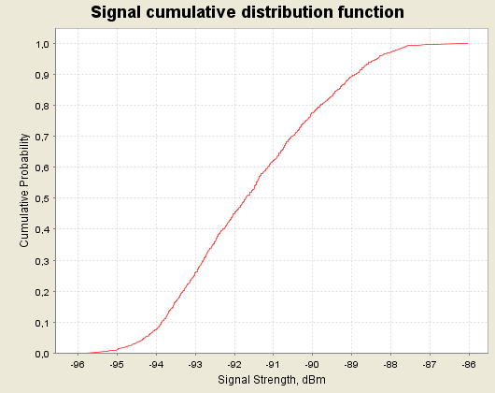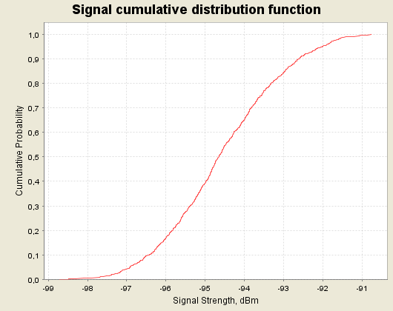

Figure 32: CDF graphs for the ac-MS for 900 MHz at 3000 m (left) and 5000 m (right) above ground

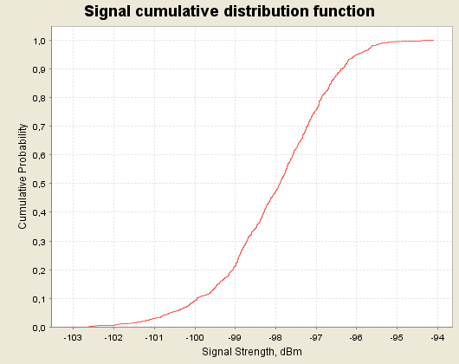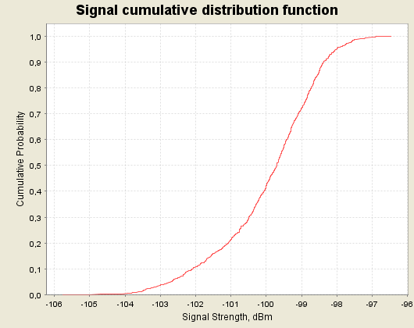

Figure 33: CDF graphs for the ac-MS for 900 MHz at 8000 m (left) and 10000 m (right) above ground

A.2.2.2 Impact of the ac-MS/UE on a g-BTS in 1800 MHz
The following table provides the output of the SEAMCAT simulations for the probability that interference from the ac-MS to the g-BTS in 1800 MHz exceeds the threshold criteria (C/(N+I) < 9 dB and I/N > -6 dB) for a range of heights between 3000 to 10000 m. The results of the interferer received signal strength (IRSS), the 95th percentile and the attenuation sensitivity analysis are also given.

Situation |  |  | Reference attenuation (case B) |  |  |  | Sensitivity analysis  (Attenuation A-C)
Description of the case |  |  | iRSS mean  (dBm) | iRSS 95th percentile  (dBm) | Criterion  I  P(C/(N+I) < 9dB)  (%) | Criterion II  P(I/N  > -6 dB)  (%) | Reduced attenuation |  | Increased attenuation
 |  |  |  |  |  |  | Crit I  (%) | Crit II  (%) | Crit I  (%) | Crit  II  (%)
ac-MS trans-  mitting  in the 1800 MHz band over terrestrial GSM networks | 3 km | Transmitter at worst case angle, (48⁰ ) | -106 | -104.4 | 39.3 | 100 | 53.4 | 100 | 24.3 | 100
 | 5 km | Transmitter at worst case angle, (48⁰ ) | -109.8 | -108 | 25 | 100 | 39.2 | 100 | 13.5 | 100
 | 8 km | Transmitter at worst case angle, (48⁰ ) | -112 | -110.3 | 18.2 | 100 | 30.3 | 100 | 9.3 | 100
 | 10 km | Transmitter at worst case angle, (48⁰ ) | -113 | -111.5 | 15.5 | 100 | 27 | 100 | 7.6 | 100
Table 79: Results of the case with the ac-MS transmitting in the 1800 MHz band over terrestrial GSM networks

The following figures provide the CDF graphs for the ac-MS/UE for 1800 MHz at 3000, 5000, 8000 and 10000 m above ground.

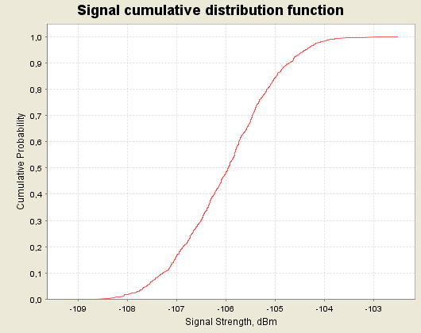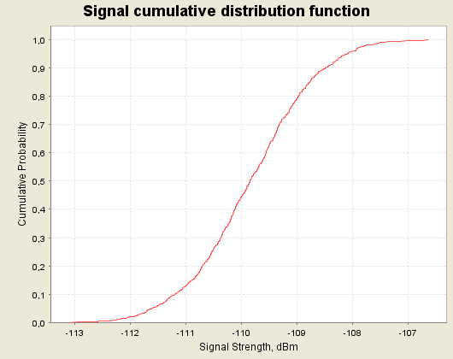

Figure 34: CDF graphs for the ac-MS for 1800 MHz at 3000 m (left) and 5000 m (right) above ground

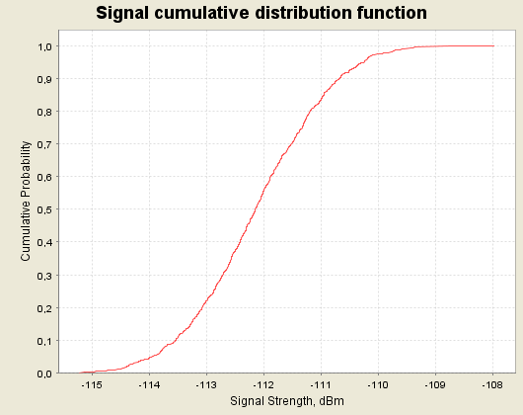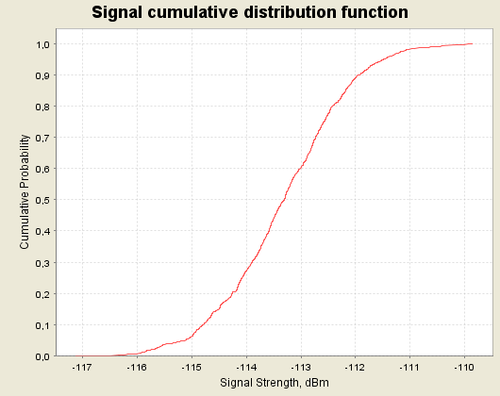

Figure 35: CDF graphs for the ac-MS for 1800 MHz at 8000 m (left) and 10000 m (right) above ground
A.3. SCENARIO 3
Scenario 3 uses both the MCL and SEAMCAT analysis.
A.3.1 MCL results of Scenario 3
The following provides the results of the MCL analysis for Scenario 3 and the comparison between the cylinder model and the Morgan based method (see annex B.1.)
A.3.1.1 900 MHz GSM analysis
A.3.1.1.1 GSM NCU over GSM 900 MHz analysis
Altitude (km) ⇒ | 3 | 4 | 5 | 6 | 7 | 8 | 9 | 10
Max received Signal Level (dBm) inside aircraft (5dB) | -73.5 | -75.9 | -77.7 | -79.2 | -80.5 | -81.6 | -82.5 | -83.3
Radiation Factor (Large Aircraft) (dB) | 64 | 64 | 64 | 64 | 64 | 64 | 64 | 64
Aircraft Attenuation for leaky feeder transmission (dB) | 10 | 10 | 10 | 10 | 10 | 10 | 10 | 10
Equivalent EIRP (as point of source) (dBm/200kHz) | -19.5 | -21.9 | -23.7 | -25.2 | -26.5 | -27.6 | -28.3 | -29.3
Free Space Propagation Losses (dB) | 101 | 103.5 | 105.5 | 107 | 108.4 | 109.5 | 110.6 | 111.5
Maximum Received Noise by g-MS (dBm) | -120.5 | -125.4 | -129.2 | -132.3 | -134.9 | -137.1 | -139.1 | -140.8
System Noise Level, reference values (dB/200kHz) | -109 | -109 | -109 | -109 | -109 | -109 | -109 | -109
Increase of the noise floor at g-MS with respect to reference values (dB) | 0.3 | 0.1 | 0.0 | 0.0 | 0.0 | 0.0 | 0.0 | 0.0
System Noise Level, typical operators (dB/200kHz) | -114 | -114 | -114 | -114 | -114 | -114 | -114 | -114
Increase of the noise floor at g-MS with respect to typical values (dB) | 0.9 | 0.3 | 0.1 | 0.1 | 0.0 | 0.0 | 0.0 | 0.0
Table 80: MCL calculation for NCU (GSM) 900 MHz to terrestrial GSM networks,
assuming large aircraft

A.3.1.1.2 GSM NCU over UMTS 900 MHz analysis
Altitude (km) ⇒ | 3 | 4 | 5 | 6 | 7 | 8 | 9 | 10
Max received Signal Level (dBm) inside aircraft (5dB) | -73.5 | -75.9 | -77.7 | -79.2 | -80.5 | -81.6 | -82.5 | -83.3
Radiation Factor (Large Aircraft) (dB) | 64 | 64 | 64 | 64 | 64 | 64 | 64 | 64
Aircraft Attenuation for leaky feeder transmission (dB) | 10 | 10 | 10 | 10 | 10 | 10 | 10 | 10
Equivalent EIRP (as point of source) (dBm/200kHz) | -19.5 | -21.9 | -23.7 | -25.2 | -26.5 | -27.6 | -28.5 | -29.3
Equivalent EIRP (as point of source) (dBm/3.84MHz) | -6.7 | -9.1 | -10.9 | -12.4 | -13.7 | -14.8 | -15.7 | -16.5
Free Space Propagation Losses (dB) | 101 | 103.5 | 105.5 | 107 | 108.4 | 109.5. | 110.6 | 111.5
Maximum Received Noise by g-MS (dBm) | -107.7 | -112.6 | -116.4 | -119.4 | -122.1 | -124.3 | -126.3 | -128
System Noise Level, reference values (dB/3.84MHz) | -96 | -96 | -96 | -96 | -96 | -96 | -96 | -96
Increase of the noise floor at g-MS with respect to reference values (dB) | 0.3 | 0.1 | 0 | 0 | 0 | 0 | 0 | 0
Table 81: MCL calculation for NCU (GSM) 900 MHz to terrestrial UMTS networks, assuming large aircraft

A.3.1.1.3 UMTS NCU over UMTS 900 MHz analysis
Altitude (km) ⇒ | 3 | 4 | 5 | 6 | 7 | 8 | 9 | 10
Max received Signal Level (dBm) inside aircraft (5dB) | -83.5 | -85.9 | -87.7 | -89.2 | -90.5 | -91.6 | -92.5 | -93.3
Radiation Factor (Large Aircraft) (dB) | 64 | 64 | 64 | 64 | 64 | 64 | 64 | 64
Aircraft Attenuation for leaky feeder transmission (dB) | 10 | 10 | 10 | 10 | 10 | 10 | 10 | 10
Equivalent EIRP (as point of source) (dBm/3.84MHz) | -8.5 | -10.9 | -12.7 | -14.2 | -15.5 | -16.6 | -17.5 | -18.3
Free Space Propagation Losses (dB) | 101 | 103.5 | 105.5 | 107 | 108.4 | 109.5. | 110.6 | 111.5
Maximum Received Noise by g-MS (dBm) | -109.5 | -114.4 | -118.2 | -121.2 | -123.9 | -126.1 | -128.1 | -129.8
System Noise Level, reference values (dB/3.84MHz) | -96 | -96 | -96 | -96 | -96 | -96 | -96 | -96
Increase of the noise floor at g-MS with respect to reference values (dB) | 0.2 | 0.1 | 0 | 0 | 0 | 0 | 0 | 0
Table 82: MCL calculation for NCU (UMTS) 900 MHz to terrestrial UMTS networks, assuming large aircraft
A.3.1.2 1800 MHz GSM analysis
A.3.1.2.1 GSM ac-BTS over GSM 1800 MHz analysis
Altitude (km) ⇒ | 3 | 4 | 5 | 6 | 7 | 8 | 9 | 10
Max received Signal Level (dBm) inside aircraft (5dB) | -81.7 | -83.9 | -85.5 | -86.8 | -87.9 | -88.8 | -89.6 | -90.3
Radiation Factor (Large Aircraft) (dB) | 70 | 70 | 70 | 70 | 70 | 70 | 70 | 70
Aircraft Attenuation for leaky feeder transmission (dB) | 10 | 10 | 10 | 10 | 10 | 10 | 10 | 10
Equivalent EIRP (as point of source) (dBm/200kHz) | -9.7 | -11.9 | -13.5 | -14.8 | -15.9 | -16.8 | -17.6 | -18.3
Free Space Propagation Losses (dB) | 107 | 109.5 | 111.5 | 113.1 | 114.4 | 115.6 | 116.6 | 117.5
Maximum Received Noise by g-MS (dBm) | -116.7 | -121.4 | -125 | -127.9 | -130.3 | -132.4 | -134.2 | -135.8
System Noise Level, reference values (dB/200kHz) | -109 | -109 | -109 | -109 | -109 | -109 | -109 | -109
Increase of the noise floor at g-MS with respect to reference values (dB) | 0.7 | 0.2 | 0.1 | 0.1 | 0 | 0 | 0 | 0
System Noise Level, typical operators (dB/200kHz) | -114 | -114 | -114 | -114 | -114 | -114 | -114 | -114
Increase of the noise floor at g-MS with respect to typical values (dB) | 1.9 | 0.7 | 0.3 | 0.2 | 0.1 | 0.1 | 0 | 0
Table 83: MCL calculation for ac-BTS 1800 MHz to terrestrial GSM networks, assuming large aircraft
A.3.1.2.2. GSM NCU over GSM 1800 MHz analysis
Altitude (km) ⇒ | 3 | 4 | 5 | 6 | 7 | 8 | 9 | 10
Max received Signal Level (dBm) inside aircraft (5dB) | -81.7 | -83.9 | -85.5 | -86.7 | -87.9 | -88.8 | -89.6 | -90.3
Radiation Factor (Large Aircraft) (dB) | 70 | 70 | 70 | 70 | 70 | 70 | 70 | 70
Aircraft Attenuation for leaky feeder transmission (dB) | 10 | 10 | 10 | 10 | 10 | 10 | 10 | 10
Equivalent EIRP (as point of source) (dBm/200kHz) | -21.7 | -23.9 | -25.5 | -26.8 | -27.9 | -28.8 | -29.6 | -30.3
Free Space Propagation Losses (dB) | 107 | 109.5 | 111.5 | 113.1 | 114.4 | 115.6 | 116.6 | 117.5
Maximum Received Noise by g-MS (dBm) | -128.7 | -133.4 | -137 | -139.9 | -142.3 | -144.4 | -146.2 | -147.8
System Noise Level, reference values (dB/200kHz) | -109 | -109 | -109 | -109 | -109 | -109 | -109 | -109
Increase of the noise floor at g-MS with respect to reference values (dB) | 0.0 | 0.0 | 0.0 | 0.0 | 0.0 | 0.0 | 0.0 | 0.0
System Noise Level, typical operators (dB/200kHz) | -114 | -114 | -114 | -114 | -114 | -114 | -114 | -114
Increase of the noise floor at g-MS with respect to typical values (dB) | 0.1 | 0.0 | 0.0 | 0.0 | 0.0 | 0.0 | 0.0 | 0.0
Table 84: MCL calculation for NCU (GSM) 1800 MHz to terrestrial GSM networks, assuming large aircraft

Modelling leaky feeders has several theoretical proposals and several models exist for this work. Besides the model adopted within this report, other approach uses a model based on diffuse radiation emitted by the cable, cited from a paper by S.P. Morgan, “Prediction if indoor wireless coverage by leaky coaxial cable using ray tracing”, IEEE Trans Veh. Tech., Vol. 48(6), pp. 2005-2014, Nov 1999.
The next tables show an example of the MCL calculations by using the Morgan model, which is described in detail in Annex B.1.
Altitude (km) ⇒ | 3 | 4 | 5 | 6 | 7 | 8 | 9 | 10
Aircraft Attenuation for leaky feeder transmission (dB) | 10 | 10 | 10 | 10 | 10 | 10 | 10 | 10
Frequency (MHz) | 1800 | 1800 | 1800 | 1800 | 1800 | 1800 | 1800 | 1800
Max Signal Level (dBm) | -81.7 | -83.9 | -85.5 | -86.7 | -87.9 | -88.8 | -89.6 | -90.3
C/N ratio for ac-mobile shielding (dB) | 0 | 0 | 0 | 0 | 0 | 0 | 0 | 0
Fading margin (dB) | 10 | 10 | 10 | 10 | 10 | 10 | 10 | 10
Required signal at ac-MS (dBm) | -71.7 | -73.9 | -75.5 | -76.8 | -77.9 | -78.8 | -79.6 | -80.3
Coupling-loss of the Radiating cable (dB) | 69 | 69 | 69 | 69 | 69 | 69 | 69 | 69
Attenuation between mobile and cabin (dB) | 3.9 | 3.9 | 3.9 | 3.9 | 3.9 | 3.9 | 3.9 | 3.9
Required Radiating Cable power injected (dBm) | -1.2 | -1 | -2.6 | -3.9 | -5 | -5.9 | -6.7 | -7.4
Power at the middle of the cable (dBm) | -0.75 | -2.95 | -4.55 | -5.85 | -6.95 | -7.85 | -8.65 | -9.35
Maximum Received Noise by g-MS (dBm) | -130.3 | -135 | -138.6 | -141.5 | -143.9 | -146 | -147.8 | -149.4
Total Noise = Internal Noise + External Noise (dBm) | -114 | -114 | -114 | -114 | -114 | -114 | -114 | -114
Increase of the noise floor at g-MS (dB) | 0.1 | 0.0 | 0.0 | 0.0 | 0.0 | 0.0 | 0.0 | 0.0
Table 85: MCL calculation for alternative analysis using Morgan approach
A.3.1.2.3 GSM NCU over UMTS 1800 MHz analysis
Altitude (km) ⇒ | 3 | 4 | 5 | 6 | 7 | 8 | 9 | 10
Max received Signal Level (dBm) inside aircraft (5dB) | -81.7 | -83.9 | -85.5 | -86.8 | -87.9 | -88.8 | -89.6 | -90.3
Radiation Factor (Large Aircraft) (dB) | 70 | 70 | 70 | 70 | 70 | 70 | 70 | 70
Aircraft Attenuation for leaky feeder transmission (dB) | 10 | 10 | 10 | 10 | 10 | 10 | 10 | 10
Equivalent EIRP (as point of source) (dBm/200kHz) | -21.7 | -23.9 | -25.5 | -26.8 | -27.9 | -28.8 | -29.6 | -30.3
Equivalent EIRP (as point of source) (dBm/3.84MHz) | -8.9 | -11.1 | -12.7 | -14 | -15.1 | -16 | -16.8 | -26.5
Free Space Propagation Losses (dB) | 107 | 109.5 | 111.5 | 113.1 | 114.4 | 115.6 | 116.6 | 117.5
Maximum Received Noise by g-MS (dBm) | -115.9 | -120.6 | -124.2 | -127.1 | -129.5 | -131.6 | -133.4 | -144
System Noise Level, reference values (dB/200kHz) | -96 | -96 | -96 | -96 | -96 | -96 | -96 | -96
Increase of the noise floor at g-MS with respect to reference values (dB) | 0 | 0 | 0 | 0 | 0 | 0 | 0 | 0
Table 86: MCL calculation for NCU (GSM) 1800 MHz to terrestrial UMTS networks, assuming large aircraft

A.3.1.2.4 UMTS NCU over UMTS 1800 MHz analysis
Altitude (km) ⇒ | 3 | 4 | 5 | 6 | 7 | 8 | 9 | 10
Max received Signal Level (dBm) inside aircraft (5dB) | -91.7 | -93.9 | -95.5 | -96.8 | -97.9 | -98.8 | -99.6 | -100.3
Radiation Factor (Large Aircraft) (dB) | 70 | 70 | 70 | 70 | 70 | 70 | 70 | 70
Aircraft Attenuation for leaky feeder transmission (dB) | 10 | 10 | 10 | 10 | 10 | 10 | 10 | 10
Equivalent EIRP (as point of source) (dBm/3.84MHz) | -10.7 | -12.9 | -14.5 | -15.8 | -16.9 | -17.8 | -18.6 | -19.3
Free Space Propagation Losses (dB) | 107 | 109.5 | 111.5 | 113.1 | 114.4 | 115.6 | 116.6 | 117.5
Maximum Received Noise by g-MS (dBm) | -117.7 | -122.4 | -126 | -128.9 | -131.3 | -133.4 | -135.2 | -136.8
System Noise Level, reference values (dB/200kHz) | -96 | -96 | -96 | -96 | -96 | -96 | -96 | -96
Increase of the noise floor at g-MS with respect to reference values (dB) | 0 | 0 | 0 | 0 | 0 | 0 | 0 | 0
Table 87: MCL calculation for NCU (UMTS) 1800 MHz to terrestrial UMTS networks, assuming large aircraft

A.3.1.3 UMTS 2GHz analysis
Altitude (km) ⇒ | 3 | 4 | 5 | 6 | 7 | 8 | 9 | 10
Max received Signal Level (dBm) inside aircraft (5dB) | -92.6 | -94.8 | -96.4 | -97.7 | -98.8 | -99.7 | -100.5 | -101.2
Radiation Factor (Large Aircraft) (dB) | 71 | 71 | 71 | 71 | 71 | 71 | 71 | 71
Aircraft Attenuation for leaky feeder transmission (dB) | 10 | 10 | 10 | 10 | 10 | 10 | 10 | 10
Equivalent EIRP (as point of source) (dBm/3.84MHz) | -10.6 | -12.8 | -14.4 | -15.7 | -16.8 | -17.7 | -18.5 | -19.2
Free Space Propagation Losses (dB) | 108 | 110.5 | 112.4 | 114 | 115.3 | 116.5 | 117.5 | 118.4
Maximum Received Noise by g-MS (dBm) | -118.6 | -123.3 | -126.8 | -129.7 | -132.1 | -134.2 | -136 | -137.6
System Noise Level, reference values (dB/3.84MHz) | -99 | -99 | -99 | -99 | -99 | -99 | -99 | -99
Increase of the noise floor at g-MS with respect to reference values (dB) | 0.0 | 0.0 | 0.0 | 0.0 | 0.0 | 0.0 | 0.0 | 0.0
System Noise Level, typical operators  (dB/3.84MHz) | -101 | -101 | -101 | -101 | -101 | -101 | -101 | -101
Increase of the noise floor at g-MS with respect to typical values (dB) | 0.0 | 0.0 | 0.0 | 0.0 | 0.0 | 0.0 | 0.0 | 0.0
Table 88: MCL calculation for NCU (UMTS) 2GHz to terrestrial UMTS networks, assuming large aircraft

A.3.2 SEAMCAT results of Scenario 3
The SEAMCAT simulations for Scenario 3 are based on the parameters defined in section 6 and the modelling approaches and cases described in section 7. The following two “cases” of simulations have been carried out:
- Case 1: For a set of heights (3000 – 10000 m) an interferer is placed at the worst case elevation angle seen from the victim receiver (90 degrees given that the victim receiver is a g-MS and that the aircraft is assumed to be an omni-directional radiator). This illustrates the probability that a receiver with this configuration experiences any interference according to the interference criteria threshold used,

- Case 2: The interferer is located at constant height with a random position within a radius corresponding to the minimum elevation angle to the victim receiver (10 degrees). This is described in SEAMCAT terminology as the “uniform polar distance”.

As in all scenarios, this scenario assumes 5 dB attenuation for signals entering the aircraft and 10 dB attenuation for signals leaving the leaky cable transmitter. For each scenario a sensitivity analysis was also carried out using the range +/- 9 dB.

For the analysis of GSM networks the results indicate the probability that the interference exceeds the threshold criteria of C/(N+I) = 9 dB and I/N > -6 dB.
A.3.2.1 Impact of the GSM NCU on a g-MS in 900 MHz
The following table provides the output of the SEAMCAT simulations for the probability that interference from the GSM NCU for g-MSs in GSM 900 MHz networks exceeds the threshold criteria (C/(N+I) < 9 dB and I/N > -6 dB). The results of the interferer received signal strength (IRSS), the 95th percentile and the attenuation sensitivity analysis are also provided.

Situation |  |  | Reference attenuation (case B) |  |  |  | Sensitivity analysis  (Attenuation A-C)
Description of the case |  |  | iRSS mean (dBm) | iRSS 95th percentile  (dBm) | Criterion  I  P(C/(N+I) < 9dB)  (%) | Criterion II  P(I/N  > -6 dB)  (%) | Reduced attenuation |  | Increased attenuation
 |  |  |  |  |  |  | Crit I  (%) | Crit II  (%) | Crit I  (%) | Crit  II  (%)
NCU trans-  mitting  in the 900 MHz band over terrestrial GSM networks | 3 km | Transmitter at worst case angle, (90⁰ ) | -120.6 | -118.8 | 0.4 | 28.3 | 2.9 | 100 | 0.03 | 0
 | 3 km | Transmitter randomly placed within a radius of 17 km at 3000 m above ground | -131.9 | -124.7 | 0.03 | 0.18 | 0.32 | 18.9 | 0.01 | 0.08
 | 5 km | Transmitter at worst case angle, (90⁰ ) | -129.2 | -127.5 | 0.05 | 0 | 0.45 | 41.6 | 0.015 | 0
 | 5 km | Transmitter randomly placed within a radius of 28 km at 5000 m above ground | -140.5 | -132.8 | 0.01 | 0 | 0.03 | 0.2 | 0 | 0
 | 8 km | Transmitter at worst case angle, (90⁰ ) | -137.2 | -135.5 | 0 | 0 | 0.03 | 0 | 0 | 0
 | 8 km | Transmitter randomly placed within a radius of 45 km at 8000 m above ground | -148.5 | -141.4 | 0 | 0 | 0.005 | 0. | 0 | 0
 | 10 km | Transmitter at worst case angle, (90⁰ ) | -140.9 | -139.3 | 0 | 0 | 0.02 | 0 | 0 | 0
 | 10 km | Transmitter randomly placed within a radius of 56 km at 10000 m above ground | -152.2 | -144.9 | 0 | 0 | 0 | 0 | 0 | 0
Table 89: Results of the case with the NCU (GSM) transmitting in the 900 MHz band over terrestrial GSM networks

The following figures provide the CDF graphs for the NCU (GSM) for 900 MHz at 3000, 5000, 8000 and 10000 m above ground.

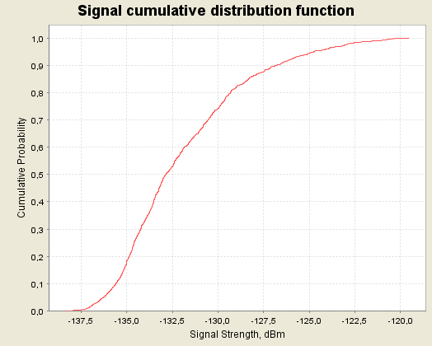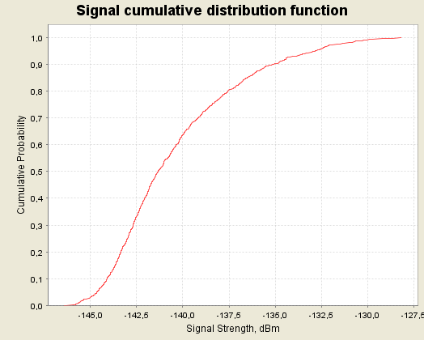

Figure 36: CDF graphs for the NCU (GSM) for 900 MHz at 3000 m (left) and 5000 m (right) above ground

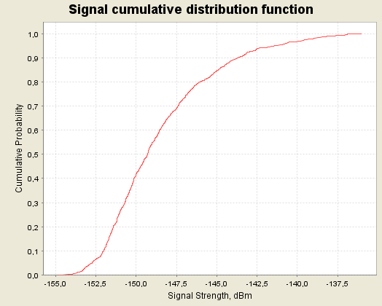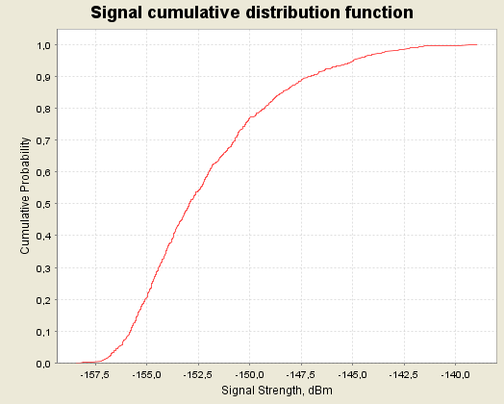

Figure 37: CDF graphs for the NCU (GSM) for 900 MHz at 8000 m (left) and 10000 m (right) above ground

A.3.2.2 Impact of the GSM NCU on a g-MS in 1800 MHz
The following table provides the output of the SEAMCAT simulations for the probability that interference from the NCU for g-MS in GSM 1800 MHz networks exceeds the threshold criteria (C/(N+I) < 9 dB and I/N > -6 dB). The results of the interferer received signal strength (IRSS), the 95th percentile and the attenuation sensitivity analysis are also provided.

Situation |  |  | Reference attenuation (case B) |  |  |  | Sensitivity analysis  (Attenuation A-C)
Description of the case |  |  | iRSS mean (dBm) | iRSS 95th percentile  (dBm) | Criterion I P(C/(N+I) < 9dB)  (%) | Criterion II  P(I/N  > -6 dB)  (%) | Reduced attenuation |  | Increased attenuation
 |  |  |  |  |  |  | Crit I  (%) | Crit II  (%) | Crit I (%) | Crit II  (%)
NCU trans-  mitting  in the 1800 MHz band over terrestrial GSM networks | 3 km | Transmitter at worst case angle (90⁰), placed at 3 km above ground | -128.8 | -127.1 | 0.04 | 0 | 0.45 | 82 | 0 | 0
 | 3 km | Transmitter randomly placed at within a radius of 17 km at 3000 m above ground | -140.1 | -132.7 | 0.01 | 0 | 0.06 | 0.45 | 0 | 0
 | 5 km | Transmitter at worst case angle (90⁰), placed at 5000 m above ground | -137 | -135.3 | 0.01 | 0 | 0.04 | 0 | 0 | 0
 | 5 km | Transmitter randomly placed within a radius of 28 km at 5000 m above ground | -148 | -141.7 | 0 | 0 | 0 | 0 | 0 | 0
 | 8 km | Transmitter at worst case angle (90⁰), placed at 8000 m above ground | -144.1 | -142.7 | 0 | 0 | 0.03 | 0 | 0 | 0
 | 8 km | Transmitter randomly placed within a radius of 45 km at 8000 m above ground | -155.4 | -147.7 | 0 | 0 | 0 | 0 | 0 | 0
 | 10 km | Transmitter at worst case angle(90⁰), placed at 10000 m above ground | -147.8 | -146.1 | 0 | 0 | 0 | 0 | 0 | 0
 | 10 km | Transmitter randomly placed within a radius of 56 km at 10000 m above ground | -159.1 | -151.8 | 0 | 0 | 0 | 0 | 0 | 0
Table 90: Results of the case with the NCU (GSM) transmitting in the 1800 MHz band
over terrestrial GSM networks

The following figures provide the CDF graphs for the NCU (GSM) for 1800 MHz at 3000, 5000, 8000 and 10000 m above ground.

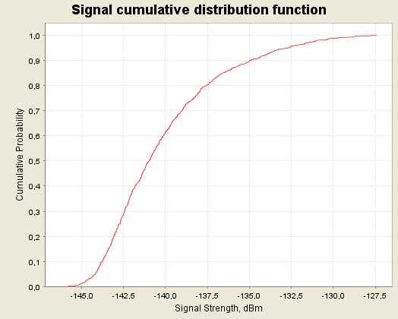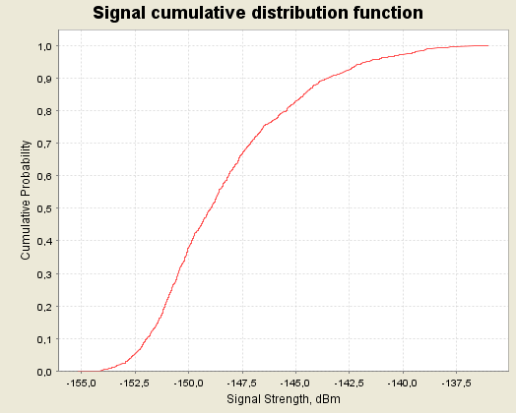

Figure 38: CDF graphs for the NCU (GSM) for 1800 MHz at 3000 m (left) and 5000 m (right) above ground

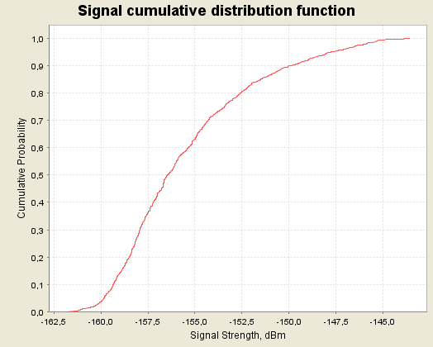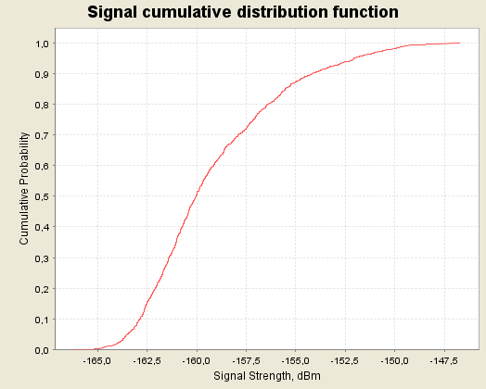

Figure 39: CDF graphs for the NCU (GSM) for 1800 MHz at 8000 m (left) and 10000 m (right) above ground

A.3.2.3 Impact of the NCU on g-UE in UMTS 2000 MHz
The following table provides the output of the SEAMCAT simulations. As it was impossible to use the C/(N+I) or the I/N as an interference criteria for networks using CDMA systems in SEAMCAT simulations, only the results of the interferer received signal strength (IRSS), for the 95 % percentile, and the attenuation sensitivity analysis are provided.

Situation |  |  | Reference attenuation (case B)
Description of the case |  |  | iRSS mean (dBm) | iRSS 95th percentile  (dBm) | Increase of noise for  iRSS mean value (dB) | Increase of noise for  iRSS 95th percentile value  (dB)
NCU trans-  mitting  in the 2 GHz band over terrestrial UMTS  networks | 3 km | Transmitter at worst case angle(90⁰), placed at 3000 m above ground | -118.6 | -116.9 | 0.074 | 0.11
 | 3 km | Transmitter randomly placed within a radius of 17 km at 3000 m above ground | -129.9 | -122.6 | 0.005 | 0.03
 | 5 km | Transmitter at worst case angle(90⁰), placed at 5000 m above ground | -126.8 | -125.2 | 0.011 | 0.016
 | 5 km | Transmitter randomly placed within a radius of 28 km at 5000 m above ground | -138 | -130.2 | 8.6E-04 | 0.005
 | 8 km | Transmitter at worst case angle(90⁰), placed at 8000 m above ground | -134.2 | -132.5 | 0.002 | 0.003
 | 8 km | Transmitter randomly placed within a radius of 45 km at 8000 m above ground | -145.5 | -138 | 1.5E-04 | 8.6E-04
 | 10 km | Transmitter at worst case angle(90⁰), placed at 10000 m above ground | -137.6 | -136 | 9.5E-04 | 0.0013
 | 10 km | Transmitter randomly placed within a radius of 56 km at 10000 m above ground | -148.9 | -141.7 | 7E-05 | 3.7E-04
Table 91: Results of the case with the NCU (UMTS) transmitting in the 2000 MHz band
over terrestrial UMTS networks

The following figures provide the CDF graphs for the NCU (UMTS) for 2000 MHz at 3000, 5000, 8000 and 10000 m above ground.

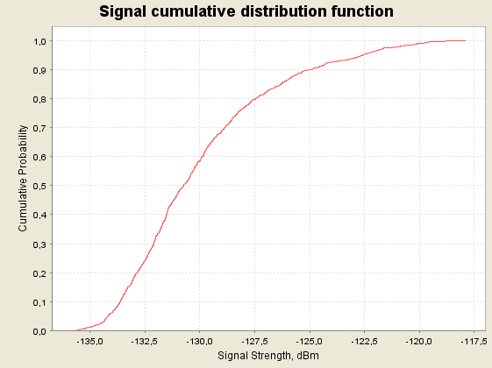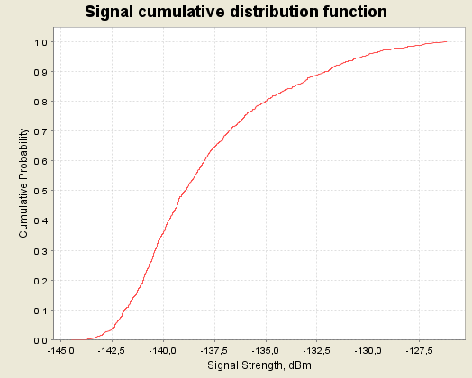

Figure 40: CDF graphs for the NCU (UMTS) for 2000 MHz at 3000 m (left) and 5000 m (right) above ground

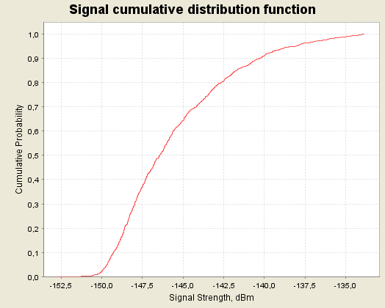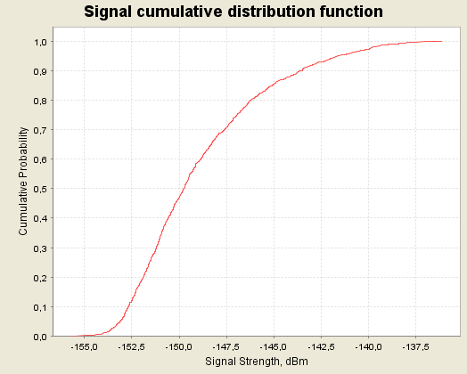

Figure 41: CDF graphs for the NCU (UMTS) for 2000 MHz at 8000 m (left) and 10000 m (right) above ground

A.3.2.4 Impact of the ac-BTS on a g-MS in 1800 MHz
The following table provides the output of the SEAMCAT simulations for the probability that interference from the ac-BTS for g-MS in GSM 1800 MHz networks exceeds the threshold criteria (C/(N+I) < 9 dB and I/N > -6 dB). The results of the interferer received signal strength (IRSS), the 95th percentile and the attenuation sensitivity analysis are also provided.

Situation |  |  | Reference attenuation (case B) |  |  |  | Sensitivity analysis  (Attenuation A-C)
Description of the case |  |  | iRSS mean (dBm) | iRSS 95th percentile  (dBm) | Criterion  I  P(C/(N+I) < 9dB)  (%) | Criterion II  P(I/N  > -6 dB)  (%) | Reduced attenuation |  | Increased attenuation
 |  |  |  |  |  |  | Crit I  (%) | Crit II  (%) | Crit I  (%) | Crit  II  (%)
Ac-BTS trans-  mitting  in the 1800 MHz band. | 3 km | Transmitter at worst case angle, (90⁰ ). | -116.8 | -115.1 | 0.93 | 100 | 5.8 | 100 | 0.1 | 0
Ac-BTS trans-  mitting  in the 1800 MHz band. | 3 km | Transmitter randomly placed within a radius of 17 km at 3000 m above ground | -128.1 | -121 | 0.1 | 3.6 | 0.7 | 50 | 0.025 | 0
Ac-BTS trans-  mitting  in the 1800 MHz band. | 5 km | Transmitter at worst case angle, (90⁰ ) | -125 | -125 | 0.11 | 0 | 0.96 | 100 | 0.015 | 0
Ac-BTS trans-  mitting  in the 1800 MHz band. | 5 km | Transmitter randomly placed within a radius of 28 km at 5000 m above ground | -136.4 | -129.6 | 0.02 | 0 | 0.18 | 5 | 0 | 0
Ac-BTS trans-  mitting  in the 1800 MHz band. | 8 km | Transmitter at worst case angle, (90⁰ ) | -132.4 | -132.4 | 0.03 | 0 | 0.23 | 0.015 | 0 | 0
Ac-BTS trans-  mitting  in the 1800 MHz band. | 8 km | Transmitter randomly placed within a radius of 45 km at 8000 m above ground | -143.7 | -136.3 | 0 | 0 | 0.01 | 0 | 0 | 0
Ac-BTS trans-  mitting  in the 1800 MHz band. | 10 km | Transmitter at worst case angle, (90⁰ ) | -135.8 | -135.8 | 0.005 | 0 | 0.06 | 0 | 0 | 0
Ac-BTS trans-  mitting  in the 1800 MHz band. | 10 km | Transmitter randomly placed within a radius of 56 km at 10000 m above ground | -147.1 | -139.5 | 0 | 0 | 0 | 0 | 0 | 0
Table 92: Results of the case with the ac-BTS transmitting in the 1800 MHz band over terrestrial GSM networks

The following figures provide the CDF graphs for the ac-BTS for 1800 MHz at 3000, 5000, 8000 and 10000 m above ground.

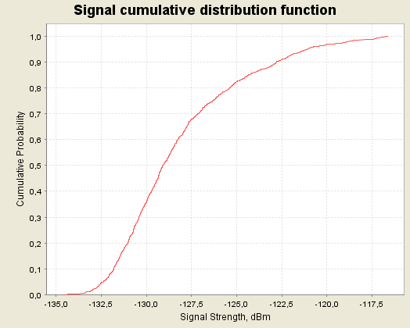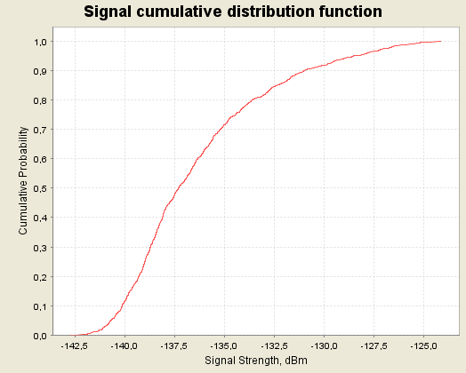

Figure 42: CDF graphs for the ac-BTS for 1800 MHz at 3000 m (left) and 5000 m (right) above ground

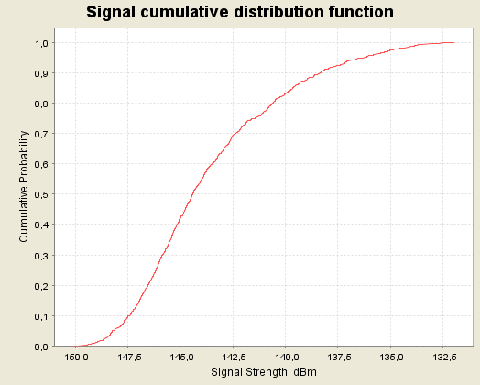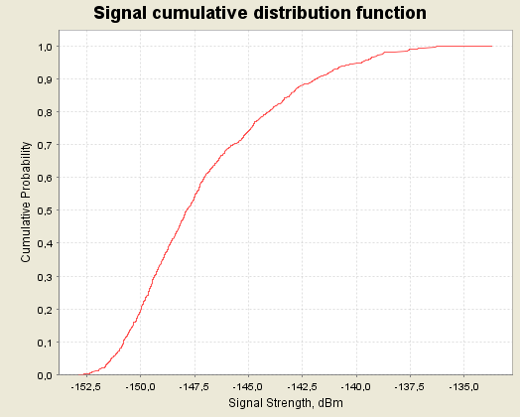

Figure 43: CDF graphs for the ac-BTS for 1800 MHz at 8000 m (left) and 10000 m (right) above ground

A.3.2.5 Impact of the NCU (GSM) on g-UE in UMTS 900 MHz
In the case of UMTS and GSM sharing the same 900 MHz band, the NCU power calculated for GSM shielding should be used, since the power/Hz needed to shield GSM is higher than the power/Hz needed to shield UMTS (measured in UMTS bandwidth, and taking note of the assumptions on shielding margins used in section 6 and 7 (see table 13) of the report, the difference is 1.8 dB).
The results of this analysis are given in the following table:
Situation |  |  | Reference attenuation (case B)
Description of the case |  |  | iRSS mean (dBm) | iRSS 95th percentile  (dBm) | Increase of noise for  iRSS mean value (dB) | Increase of noise for  iRSS 95th percentile value  (dB)
GSM NCU trans-  mitting in the 900 MHz band over terrestrial UMTS networks |  | Transmitter at worst case angle(90⁰), placed at 3000 m above ground | -107.8 | -106.1 | 0.277 | 0.4
 |  | Transmitter randomly placed within a radius of 17 km at 3000 m above ground | -119.1 | -111.9 | 0.021 | 0.11
 |  | Transmitter at worst case angle(90⁰), placed at 5000 m above ground | -116.4 | -114.7 | 0.039 | 0.06
 |  | Transmitter randomly placed within a radius of 28 km at 5000 m above ground | -127.6 | -120.2 | 0.003 | 0.016
 |  | Transmitter at worst case angle(90⁰), placed at 8000 m above ground | -124.4 | -122.7 | 6.2E-03 | 9E-03
 |  | Transmitter randomly placed within a radius of 45 km at 8000 m above ground | -135.6 | -127.8 | 4.8E-04 | 2.9E-03
 |  | Transmitter at worst case angle(90⁰), placed at 10000 m above ground | -128.1 | -126.5 | 2.7E-04 | 3.9E-04
 |  | Transmitter randomly placed within a radius of 56 km at 10000 m above ground | -137.7 | -131.6 | 3E-04 | 1.2E-03
Table 93: Results of the case with the NCU (GSM) transmitting in the 900 MHz band
over terrestrial UMTS networks

The following figures provide the CDF graphs for the NCU (GSM) for 900 MHz at 3000, 5000, 8000 and 10000 m above ground.

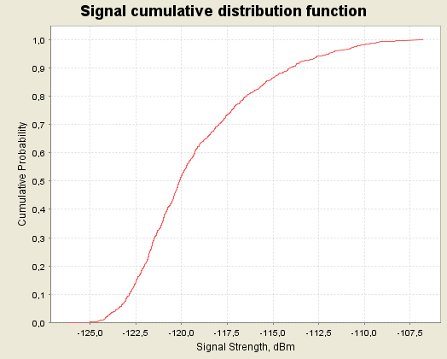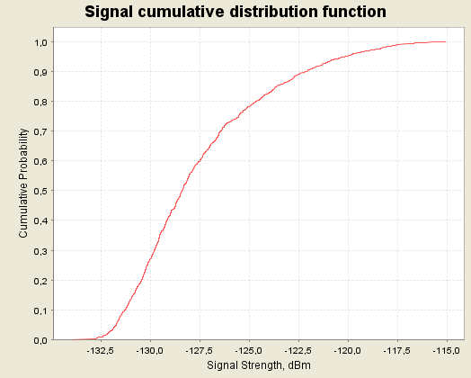

Figure 44: CDF graphs for the NCU (GSM) for 900 MHz at 3000 m (left) and 5000 m (right) above ground

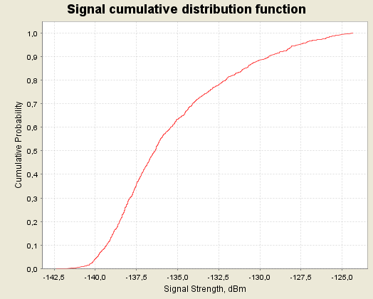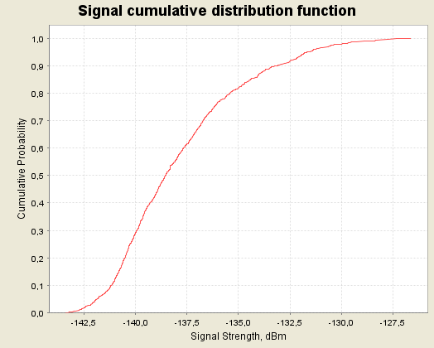

Figure 45: CDF graphs for the NCU (GSM) for 900 MHz at 8000 m (left) and 10000 m (right) above ground

A.3.2.6 Impact of the NCU (GSM) on g-UE in UMTS 1800 MHz
In the case of UMTS and GSM sharing the same 1800 band, the NCU power calculated for GSM shielding should be used, since the power/Hz needed to shield GSM is higher than the power/Hz needed to shield UMTS (measured in UMTS bandwidth, and taking note of the assumptions on shielding margins used in section 6 and 7 (see table 13) of the report, the difference is 1.8 dB).
The results of this analysis are given in the following table:

Situation |  |  | Reference attenuation (case B)
Description of the case |  |  | iRSS mean (dBm) | iRSS 95th percentile  (dBm) | Increase of noise for  iRSS mean value (dB) | Increase of noise for  iRSS 95th percentile value  (dB)
GSM NCU trans-  mitting  in the 1800 MHz band over terrestrial UMTS  networks | 3 km | Case1: Transmitter at worst case angle, 90⁰ to victim receiver | -116 | -114.2 | 0.043 | 0.065
 | 3 km | Case2: Transmitter placed randomly within a radius of 17 km at 3000 m above ground | -127.3 | -120.3 | 3.2E-03 | 0.016
 | 5 km | Case1: Transmitter at worst case angle, 90⁰ to victim receiver | -124.2 | -122.5 | 6.5E-03 | 9.7E-03
 | 5 km | Case2: Transmitter placed randomly within a radius of 28 km at 5000 m above ground | -135.5 | -128.1 | 4.8E-04 | 2.7E-03
 | 8 km | Case1: Transmitter at worst case angle, 90⁰ to victim receiver | -131.6 | -129.9 | 1.1E-03 | 1.7E-03
 | 8 km | Case2: Transmitter placed randomly within a radius of 45 km at 8000 m above ground | -142.9 | -135.4 | 8.9E-05 | 4.9E-04
 | 10 km | Case1: Transmitter at worst case angle, 90⁰ to victim receiver | -135 | -133.4 | 5.5E-04 | 8E-04
 | 10 km | Case2: Transmitter placed randomly within a radius of 56 km at 10000 m above ground | -146.2 | -138.5 | 4.1E-05 | 2.4E-04
Table 94: Results of the case with the NCU (GSM) transmitting in the 1800 MHz band
over terrestrial UMTS networks

The following figures provide the CDF graphs for the NCU (GSM) for 1800 MHz at 3000, 5000, 8000 and 10000 m above ground.

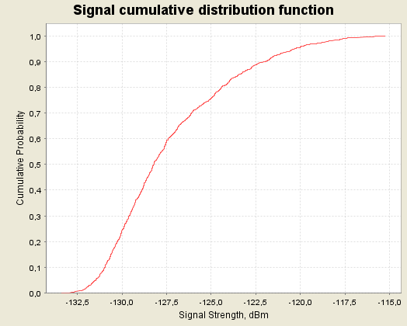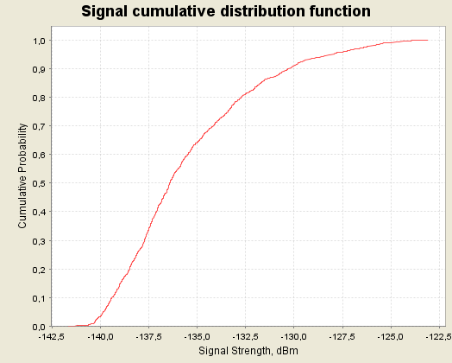

Figure 46: CDF graphs for the NCU (GSM) for 1800 MHz at 3000 m (left) and 5000 m (right) above ground

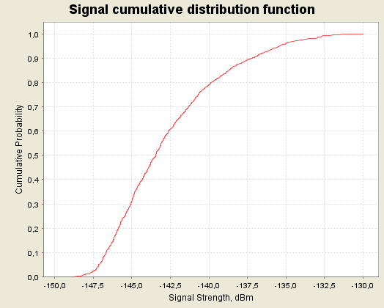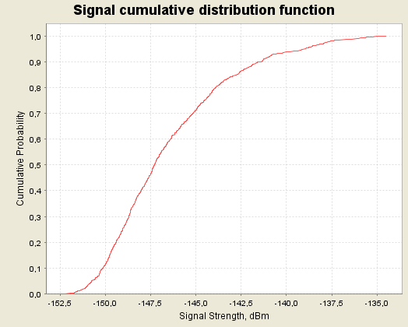

Figure 47: CDF graphs for the NCU (GSM) for 1800 MHz at 8000 m (left) and 10000 m (right) above ground

A.3.2.7 Impact of the NCU (UMTS) on g-MS in UMTS 900 MHz
The following table provides the output of the SEAMCAT simulations. As it was impossible with SEAMCAT to use the C/(N+I) or the I/N as an interference criteria for networks using CDMA systems, only the results of the interferer received signal strength (IRSS), for the 95 % percentile, are provided.
The sensitivity analysis is reflected by adding or reducing (i.e. case A or case C) by 9 dB the value of the iRSS.

Situation |  |  | Reference attenuation (case B)
Description of the case |  |  | iRSS mean (dBm) | iRSS 95th percentile  (dBm) | Increase of noise for  iRSS mean value (dB) | Increase of noise for  iRSS 95th percentile value  (dB)
UMTS NCU trans-  mitting  in the 900 MHz band over terrestrial UMTS  networks | 3 km | Case1: Transmitter at worst case angle, 90⁰ to victim receiver | -109.6 | -108 | 0.18 | 0.26
 | 3 km | Case2: Transmitter placed randomly within a radius of 17 km at 3000 m above ground | -120.9 | -113.4 | 0.014 | 0.078
 | 5 km | Case1: Transmitter at worst case angle, 90⁰ to victim receiver | -118.2 | -116.6 | 0.026 | 0.037
 | 5 km | Case2: Transmitter placed randomly within a radius of 28 km at 5000 m above ground | -129.4 | -122.5 | 1.9E-03 | 9.7E-03
 | 8 km | Case1: Transmitter at worst case angle, 90⁰ to victim receiver | -126.2 | -124.5 | 4.1E-03 | 6.1E-03
 | 8 km | Case2: Transmitter placed randomly within a radius of 45 km at 8000 m above ground | -137.4 | -130 | 3E-04 | 1.7E-04
 | 10 km | Case1: Transmitter at worst case angle, 90⁰ to victim receiver | -129.9 | -128.3 | 1.7E-03 | 2.5E-03
 | 10 km | Case2: Transmitter placed randomly within a radius of 56 km at 10000 m above ground | -139.5 | -133.2 | 1.94E-04 | 8.2E-04
Table 95: Results of the case with the NCU (UMTS) transmitting in the 900 MHz band over
terrestrial UMTS networks

The following figures provide the CDF graphs for the NCU (UMTS) for 900 MHz at 3000, 5000, 8000 and 10000 m above ground.
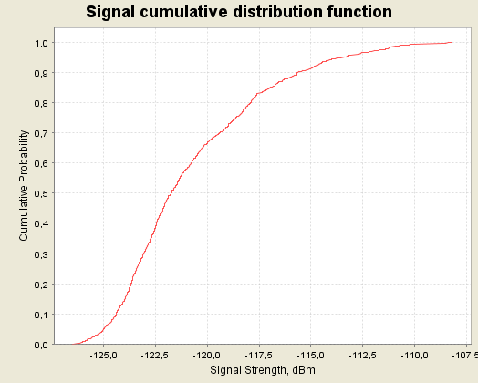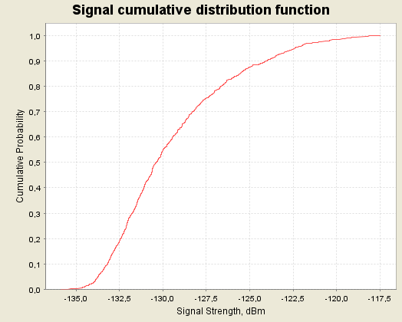

Figure 48: CDF graphs for the NCU (UMTS) for 900 MHz at 3000 m (left) and 5000 m (right) above ground

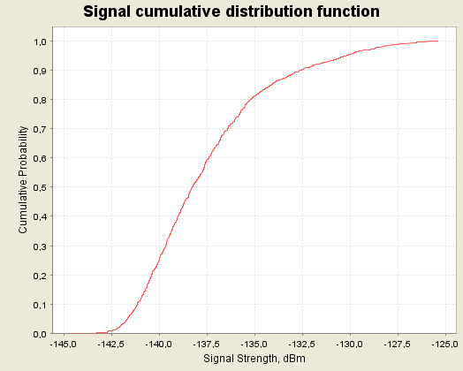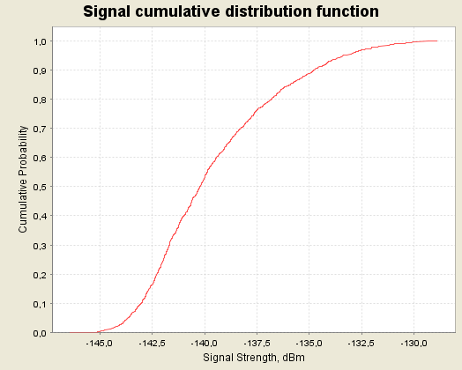

Figure 49: CDF graphs for the NCU (UMTS) for 900 MHz at 8000 m (left) and 10 000 m (right) above ground
A.3.2.8 Impact of the NCU (UMTS) on g-UE in UMTS 1800 MHz
The following table indicates the output of the SEAMCAT simulations. As it was impossible with SEAMCAT to use the C/(N+I) or the I/N as an interference criteria for networks using CDMA systems only the results of the interferer received signal strength (IRSS), for the 95 % percentile, are provided.
The sensitivity analysis is reflected by adding or reducing (i.e. case A or case C) by 9 dB the value of the iRSS.

Situation |  |  | Reference attenuation (case B)
Description of the case |  |  | iRSS mean (dBm) | iRSS 95th percentile  (dBm) | Increase of noise for  iRSS mean value (dB) | Increase of noise for  iRSS 95th percentile value  (dB)
UMTS NCU trans-  mitting in the 1800 MHz band over terrestrial UMTS  networks | 3 km | Case1: Transmitter at worst case angle, 90⁰ to victim receiver | -117.8 | -116.1 | 0.028 | 0.04
 | 3 km | Case2: Transmitter placed randomly within a radius of 17 km at 3000 m above ground | -129.1 | -122.2 | 2.1E-03 | 0.01
 | 5 km | Case1: Transmitter at worst case angle, 90⁰ to victim receiver | -126 | -124.3 | 4.3E-03 | 6.4E-03
 | 5 km | Case2: Transmitter placed randomly within a radius of 28 km at 5000 m above ground | -137.3 | -129.7 | 6.4E-04 | 1.85E-03
 | 8 km | Case1: Transmitter at worst case angle, 90⁰ to victim receiver | -133.4 | -131.8 | 7.9E-04 | 1.1E-03
 | 8 km | Case2: Transmitter placed randomly within a radius of 45 km at 8000 m above ground | -144.7 | -137.7 | 5.9E-05 | 1.1E-03
 | 10 km | Case1: Transmitter at worst case angle, 90⁰ to victim receiver | -136.8 | -135.2 | 3.6E-04 | 5.2E-04
 | 10 km | Case2: Transmitter placed randomly within a radius of 56 km at 10000 m above ground | -148 | -140.4 | 2.7E-05 | 1.6E-04
Table 96: Results of the case with the NCU transmitting in the 1800 MHz band over
terrestrial UMTS networks

The following figures provide the CDF graphs for the NCU (UMTS) for 1800 MHz at 3000, 5000, 8000 and 10000 m above ground.

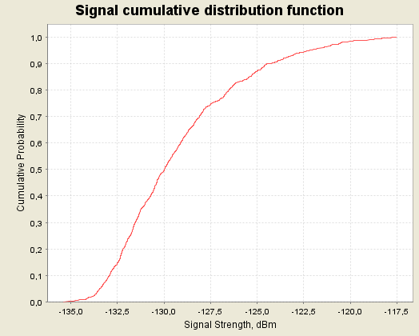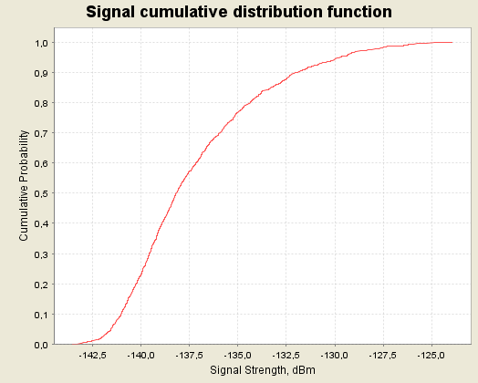

Figure 50: CDF graphs for the NCU (UMTS) for 1800 MHz at 3000 m (left) and 5000 m (right) above ground

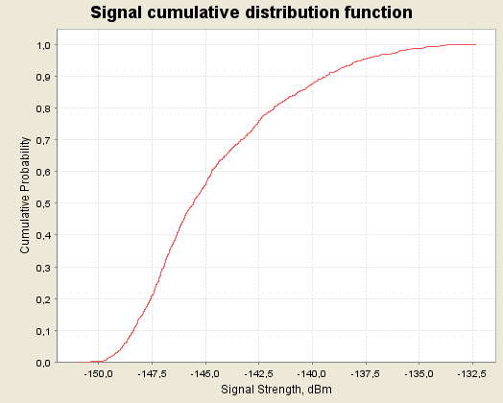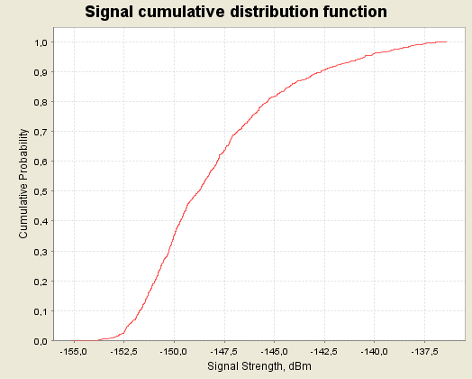

Figure 51: CDF graphs for the NCU (UMTS) for 1800 MHz at 8000 m (left) and 10000 m (right) above ground

A.3.2.9 Impact of the NCU (CDMA) on g-UE in CDMA 450
The following table indicates the output of the SEAMCAT simulations. As it was impossible with SEAMCAT to use the C/(N+I) or the I/N as an interference criteria for networks using CDMA systems only the results of the interferer received signal strength (IRSS), for the 95 % percentile, are provided.
The sensitivity analysis is reflected by adding or reducing (i.e. case A or case C) by 9 dB the value of the iRSS.

Situation |  |  | Reference attenuation (case B)
Description of the case |  |  | iRSS mean (dBm) | iRSS 95th percentile  (dBm) | Increase of thermal noise  iRSS mean value (dB) | Increase of noise for  iRSS 95th percentile value  (dB)
CDMA NCU trans-  mitting  in the 450 MHz band over terrestrial CDMA networks | 3 km | Case1: Transmitter at worst case angle, 90⁰ to victim receiver | -102.7 | -101.1 | 4.9 | 6.1
 | 3 km | Case2: Transmitter placed randomly within a radius of 17 km at 3000 m above ground | -114.1 | -107.2 | 0.6 | 2.5
 | 5 km | Case1: Transmitter at worst case angle, 90⁰ to victim receiver | -111.4 | -109.6 | 1.1 | 1.6
 | 5 km | Case2: Transmitter placed randomly within a radius of 28 km at 5000 m above ground | -122.6 | -115.5 | 0.1 | 0.5
 | 8 km | Case1: Transmitter at worst case angle, 90⁰ to victim receiver | -117 | -115.3 | 0.3 | 0.5
 | 8 km | Case2: Transmitter placed randomly within a radius of 45 km at 8000 m above ground | -128.2 | -120.4 | 0.02 | 0.2
 | 10 km | Case1: Transmitter at worst case angle, 90⁰ to victim receiver | 123.1 | -121.4 | 0.08 | 0.1
 | 10 km | Case2: Transmitter placed randomly within a radius of 56 km at 10000 m above ground | -134.3 | -126.6 | 0.006 | 0.04
Table 97: Results of the case with the NCU transmitting in the 450 MHz band for CDMA networks
The following figures provide the CDF graphs for the NCU (CDMA) for 450 MHz at 3000, 5000, 8000 and 10000 m above ground.

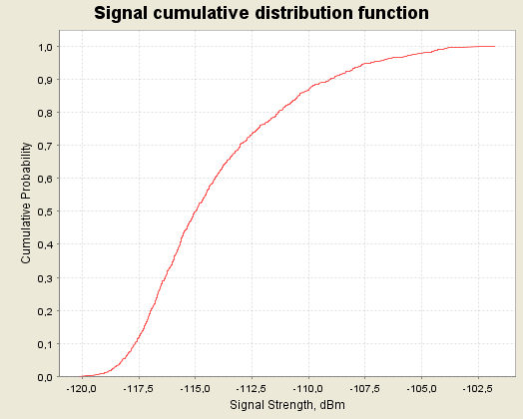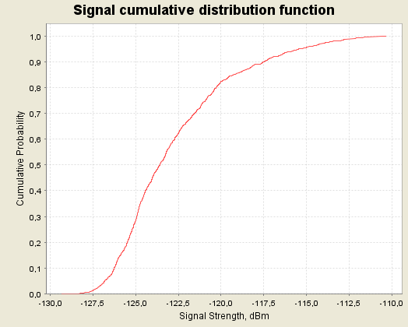

Figure 52: CDF graphs for the NCU (CDMA) for 450 MHz at 3000 m (left) and 5000 m (right) above ground

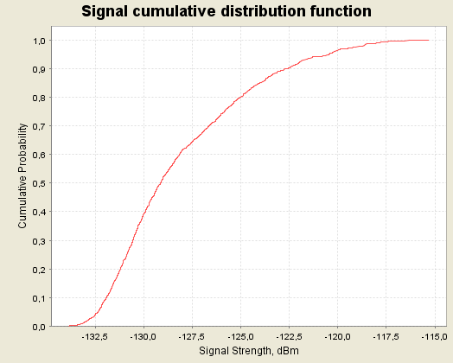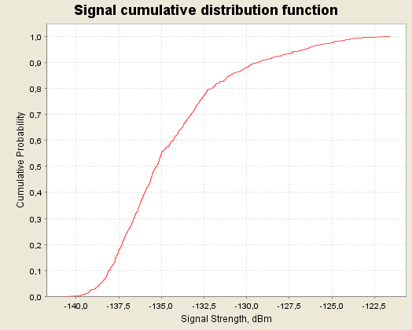

Figure 53: CDF graphs for the NCU (CDMA) for 450 MHz at 8000 m (left) and 10000 m (right) above ground

A.4 SCENARIO 4
A.4.1 SEAMCAT results of Scenario 4
The SEAMCAT simulations are based on the parameters defined in section 6 and the modelling approaches described in section 7. Consequently two “cases” of simulations are proposed for a busy hour in a normal day, and for a busy hour in a busy day (see Tables 18 and 19 of the report).
In SEAMCAT analysis, these 2 different distributions are applied to the height of the interfering transmitter (NCU or ac-BTS) antenna.

The maximum distance of the area around the victim receiver is given according to the 10000 m height.

As in other scenarios, this scenario assumes 5 dB attenuation for signals entering the aircraft and 10 dB attenuation for signals leaving the leaky cable transmitter, consequently for each scenario case a sensitivity analysis is carried out ranging +/- 9 dB.

All calculations used the “typical’ input parameters (see section 6 of the report).

A.4.1.1 Impact of multiple ac-BTS on a g-MS
The following table provides the output of the SEAMCAT simulations for the probability of interference to a g-MS from the ac-BTS in multiple aircraft distributed between 3000 and 10000 m above ground, in the two aircraft distributions. Additionally the amount of frequency re-use across the GSMOB is shown for the two cases: with 2 MHz or 10 MHz being shared between GSMOB in all aircraft in the area analysed.

Situation | Reference attenuation (case B) |  |  |  | Sensitivity analysis  (Attenuation A-C)
 | iRSS mean (dBm) | iRSS 95th percentile  (dBm) | Criterion I:  P(C/(N+I) < 9dB)  (%) | Criterion II  P(I/N > -6 dB)  (%) | Reduced attenuation |  |  | Increased attenuation
 |  |  |  |  | Crit I  (%) | Crit II  (%) |  | Crit I  (%) |  | Crit II  (%)
ac-BTS, normal busy,  50 GSM1800 channels  (1 interferer) | -140.5 | -132.2 | 0 | 0 | 0 |  | 1.8 |  | 0 |  | 0
ac-BTS, extreme busy  50 GSM1800 channels (2 interferer) | -136.8 | -129.7 | 0.01 | 0.01 | 0.1 |  | 3.2 |  | 0 |  | 0
ac-BTS, normal busy,  10 GSM1800 channels  (5 interferers) | -132 | -126.3 | 0.03 | 0.07 | 0.28 |  | 15.5 |  | 0 |  | 0
ac-BTS, extreme busy,  10 GSM1800 channels  (9 interferers) | -129.3 | -125 | 0.05 | 0.13 | 0.4 |  | 40 |  | 0.01 |  | 0
Table 98: SEAMCAT results of Scenario 4, ac-BTS transmissions

The following figures provide the CDF graphs for the multiple ac-BTS (GSM) for the normal busy and extreme busy cases and the distributions of 10 and 50 GSM 1800 channels in GSMOB.

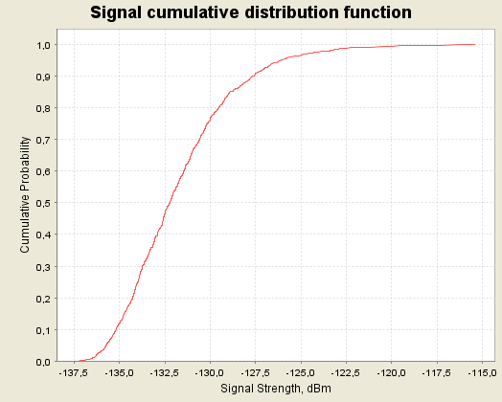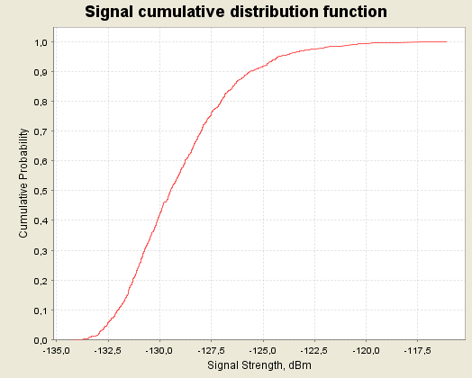

Figure 54: CDF graphs for the multiple ac-BTS for 1800 MHz for 10 GSM 1800 channels onboard for the normal busy (left) and the extreme busy (right) cases

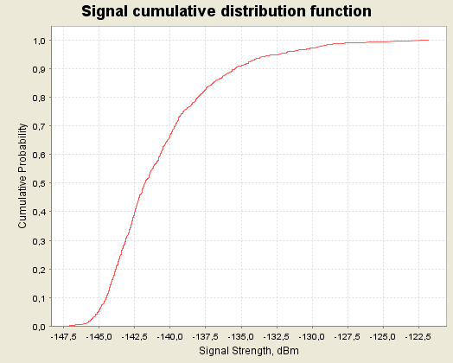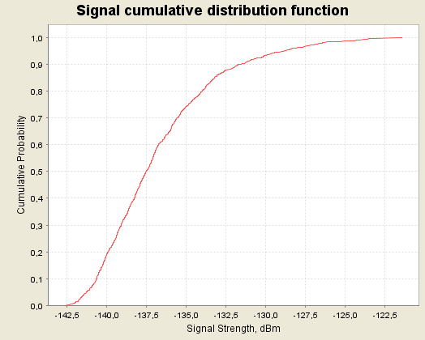

Figure 55: CDF graphs for the multiple ac-BTS for 1800 MHz for 50 GSM 1800 channels onboard
for the normal busy (left) and the extreme busy (right) cases

A.4.1.2 Impact of multiple NCU on a g-MS
The following table provides the output of the SEAMCAT simulations for the probability of interference to a g-MS from NCUs in multiple aircraft distributed between 3000 and 10000 m above the ground, in the two aircraft distributions.

Situation | Reference attenuation (case B) |  |  |  | Sensitivity analysis  (Attenuation A-C)
 | iRSS mean (dBm) | iRSS 95th percentile  (dBm) | Criterion I:  P(C/(N+I) < 9dB)  (%) | Criterion II  P(I/N > -6 dB)  (%) | Reduced attenuation |  |  | Increased attenuation
 |  |  |  |  | Crit I  (%) | Crit II  (%) |  | Crit I  (%) |  | Crit II  (%)
NCU-GSM-1800  normal busy day  (18 interferers) | -137.7 | -133.7 | 0.01 | 0.02 | 0.08 |  | 0.71 |  | 0 |  | 0
NCU-GSM-1800  extreme busy day  (33 interferers) | -135 | -132.5 | 0.01 | 0.03 | 0.12 |  | 0.03 |  | 0 |  | 0
NCU-GSM-900  normal busy day  (18 interferers) | -129.5 | -125.9 | 0.05 | 0.5 | 0.6 |  | 35.5 |  | 0 |  | 0.03
NCU-GSM-900  extreme busy day  (33 interferers) | -126.9 | -124.3 | 0.06 | 0.62 | 0.78 |  | 94. |  | 0.01 |  | 0.03
Table 99: SEAMCAT results of Scenario 4, NCU (GSM) 900&1800 MHz transmissions

The following figures provide the CDF graphs for the multiple NCU (GSM) for 900, 1800 MHz for the normal busy and extreme busy cases.

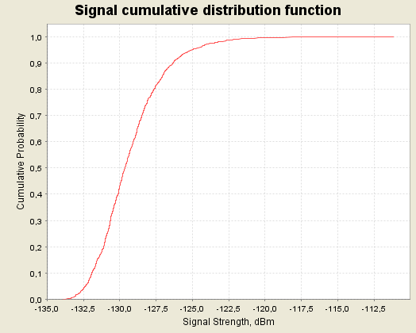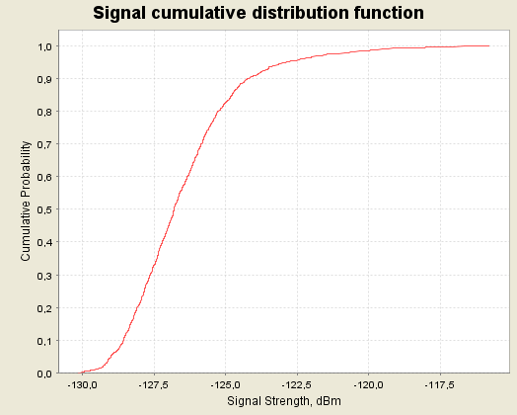

Figure 56: CDF graphs for the multiple NCU (GSM) for 900 MHz for normal busy (left)
and extreme busy (right) cases

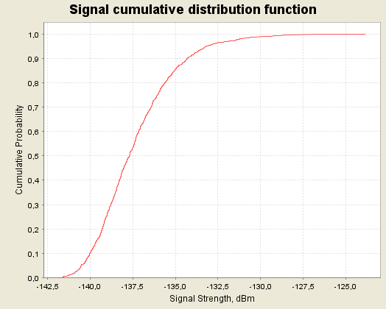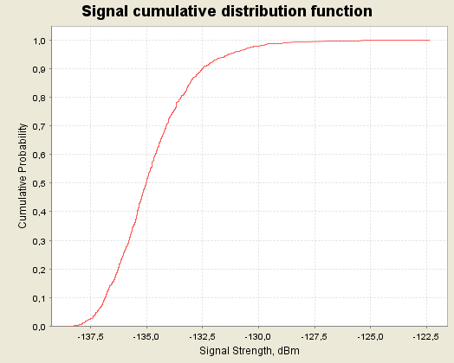

Figure 57: CDF graphs for the multiple NCU (GSM) for 1800 MHz for normal busy (left)
and extreme busy (right) cases

A.4.1.3 Impact of multiple GSM NCU on a g-UE
In the case of UMTS and GSM sharing the same 900 or 1800 MHz bands the NCU power calculated for GSM shielding should be used, since the power/Hz needed to shield GSM is higher than the power/Hz needed to shield UMTS (measured in UMTS bandwidth, and taking note of the assumptions on shielding margins, using the values in table 13 of the report, the difference is 1.8 dB).

Situation | iRSS mean (dBm) | iRSS 95th percentile  (dBm) | Increase of noise(dB)
Situation | iRSS mean (dBm) | iRSS 95th percentile  (dBm) | iRSS mean | iRSS 95 percentile
GSM NCU over UMTS900 normal busy day (18 interferers) | -116.7 | -112.6 | 0.03 | 0.1
GSM NCU over UMTS900 extreme busy day (33 interferers) | -114.1 | -111.2 | 0.06 | 0.12
GSM NCU over UMTS1800 normal busy day (18 interferers) | -124.9 | -121.3 | 0.005 | 0.012
GSM NCU over UMTS1800 extreme busy day (33 interferers) | -122.3 | -120 | 0.01 | 0.017
Table 100: SEAMCAT results of Scenario 4, NCU (UMTS) 900&1800 MHz transmissions

The following figures provide the CDF graphs for the multiple NCU (GSM) for 900, 1800 MHz for the normal busy and extreme busy cases.

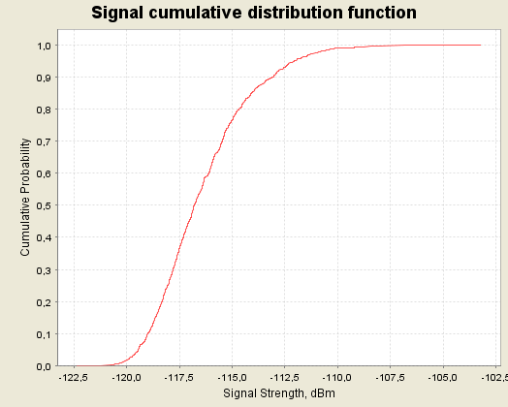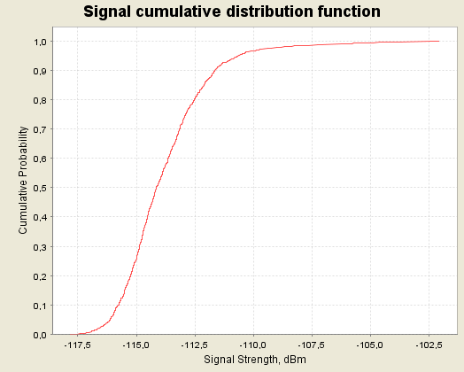

Figure 58: CDF graphs for the multiple NCU (GSM) for 900 MHz for normal busy (left)
and extreme busy (right) cases

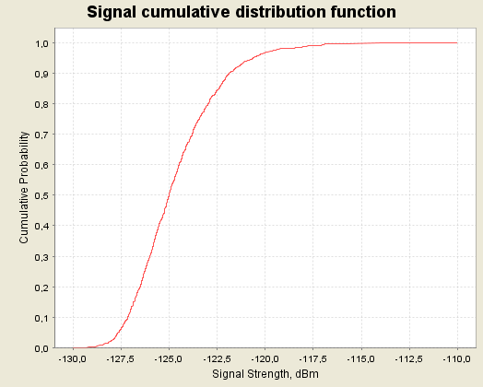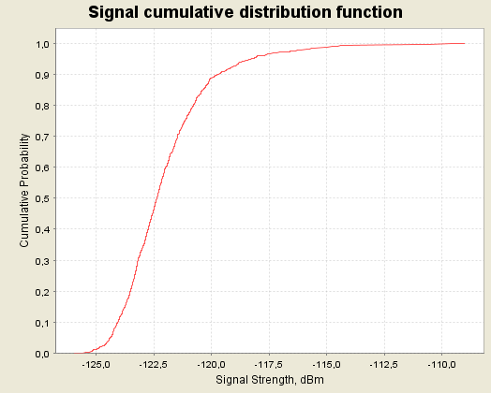

Figure 59: CDF graphs for the multiple NCU (GSM) for 1800 MHz for normal busy (left)
and extreme busy (right) cases

A.4.1.4 Impact of multiple NCU (UMTS) on a g-UE
The following table provides the output of the SEAMCAT simulations. As it was impossible with SEAMCAT to use the C/(N+I) or the I/N as an interference criteria for networks using CDMA systems only the results of the interferer received signal strength (IRSS), for the 95th percentile, are provided.
The sensitivity analysis is reflected by adding or reducing (i.e case A or case C) by 9 dB the value of the iRSS.

Situation | iRSS mean (dBm) | iRSS 95th percentile  (dBm) | Increase of noise(dB)
Situation | iRSS mean (dBm) | iRSS 95th percentile  (dBm) | iRSS mean | iRSS 95th percentile
NCU-UMTS-2000 normal busy day (18 interferers) | -127.5 | -123.6 | 0.01 | 0.023
NCU-UMTS-2000 extreme busy day (33 interferers) | -125 | -122.2 | 0.017 | 0.032
NCU-UMTS-1800 normal busy day (18 interferers) | -126.9 | -123 | 3E-03 | 0.01
NCU-UMTS-1800 extreme busy day (33 interferers) | -124.1 | -121.2 | 6E-03 | 0.013
NCU-UMTS-900 normal busy day (18 interferers) | -118.5 | -114.8 | 0.02 | 0.05
NCU-UMTS-900 extreme busy day (33 interferers) | -115.9 | -113.2 | 0.05 | 0.08
Table 101: SEAMCAT results of Scenario 4, NCU (UMTS) 900, 1800 MHz & 2 GHz transmissions

The following figures provide the CDF graphs for the multiple NCU (UMTS) for 900, 1800 MHz and 2 GHz for the normal busy and extreme busy cases.

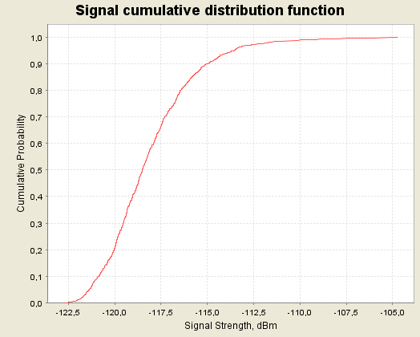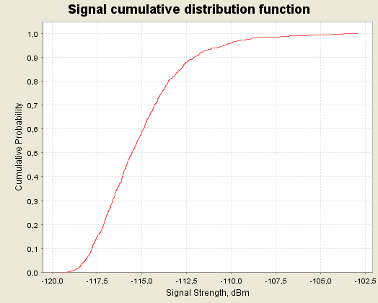

Figure 60: CDF graphs for the multiple NCU (UMTS) for 900 MHz for normal busy (left)
and extreme busy (right) cases

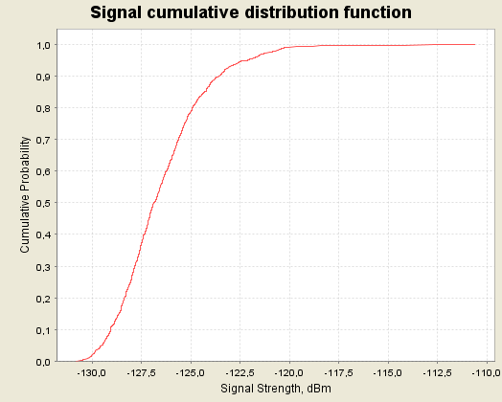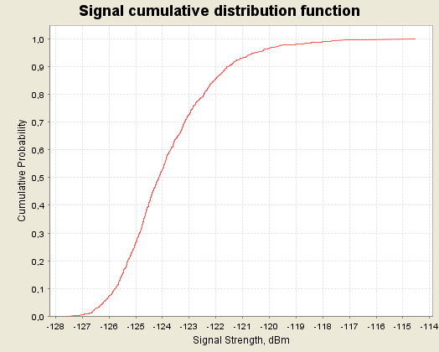

Figure 61: CDF graphs for the multiple NCU (UMTS) for 1800 MHz for normal busy (left)
and extreme busy (right) cases

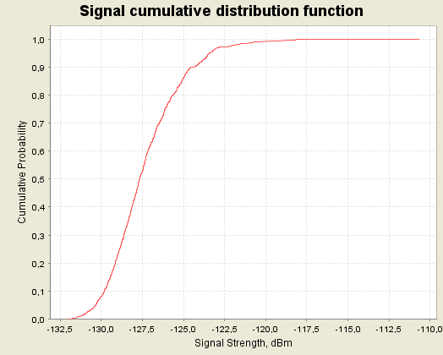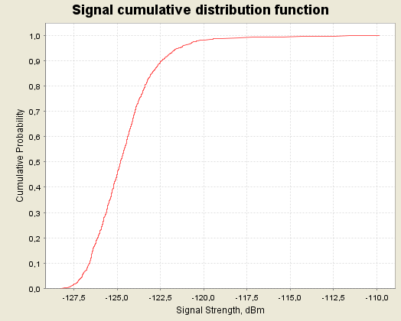

Figure 62: CDF graphs for the multiple NCU (UMTS) for 2000 MHz for normal busy (left)
and extreme busy (right) cases

A.4.1.5 Impact of multiple ac-BTS on a g-UE in 1800 MHz
The following table provides the output of the SEAMCAT simulations. As it was impossible with SEAMCAT to use the C/(N+I) or the I/N as an interference criteria for networks using CDMA systems only the results of the interferer received signal strength (IRSS), for the 95 % percentile, and the corresponding receiver increase of noise are provided.

Situation | iRSS mean (dBm) | iRSS 95th percentile  (dBm) | Increase of noise(dB)
Situation | iRSS mean (dBm) | iRSS 95th percentile  (dBm) | iRSS mean |  | iRSS 95th percentile
ac-BTS normal busy day and 50 GSM 1800 channels onboard | -141.3 | -137 | 1.2E-04 | 3.4E-04
ac-BTS extreme busy day and 50 GSM 1800 channels onboard | -138.7 | -135 | 2.3E-04 | 5.4E-04
ac-BTS normal busy day and 10 GSM 1800 channels onboard | -137 | -132.3 | 3.4E-04 | 7.3E-04
ac-BTS extreme busy day and 10 GSM 1800 channels onboard | -134.5 | -132.3 | 6E-04 | 1E-03
Table 102: SEAMCAT results of Scenario 4, ac-BTS transmissions

The sensitivity analysis is reflected by adding or reducing (i.e case A or case C) by 9 dB the value of the iRSS.

The following figures provide the CDF graphs for the multiple ac-BTS for 1800 MHz for the normal busy and extreme busy cases.
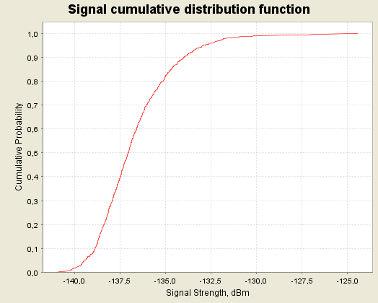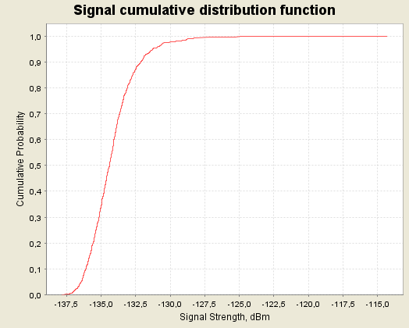
Figure 63: CDF graphs for the multiple ac-BTS for 1800 MHz for normal busy (left)
and extreme busy (right) cases for 10 GSM 1800 channels onboard

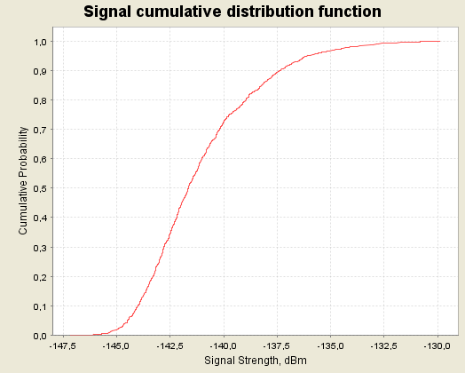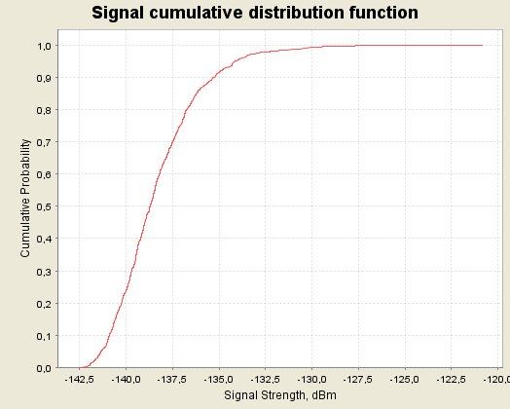
Figure 64: CDF graphs for the multiple ac-BTS for 1800 MHz for normal busy (left)
and extreme busy (right) cases for 50 GSM 1800 channels onboard

A.4.1.6 Impact of multiple NCU (CDMA) on a g-UE
The following table provides the output of the SEAMCAT simulations. As it was impossible with SEAMCAT to use the C/(N+I) or the I/N as an interference criteria for networks using CDMA systems only the results of the interferer received signal strength (IRSS), for the 95 % percentile, are provided.
The sensitivity analysis is reflected by adding or reducing (i.e case A or case C) by 9 dB the value of the iRSS.

Situation |  | iRSS mean (dBm) | iRSS 95th percentile  (dBm) |  |  | Increase of noise(dB)
 |  | iRSS mean (dBm) |  |  |  | iRSS mean | iRSS 95th percentile
NCU-CDMA450 normal busy day (18 interferers) | -111.8 |  |  | -108 | 1 |  | 2.1
NCU-CDMA450 extreme busy day (33 interferers) | -109.2 |  |  | -106.4 | 1.7 |  | 2.8
Table 103: SEAMCAT results of Scenario 4, NCU (CDMA) 450 MHz transmissions

The following figures provide the CDF graphs for the multiple NCU (CDMA) for 450 MHz for the normal busy and extreme busy cases.

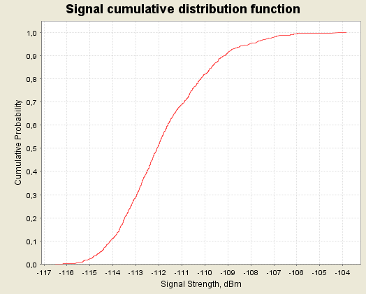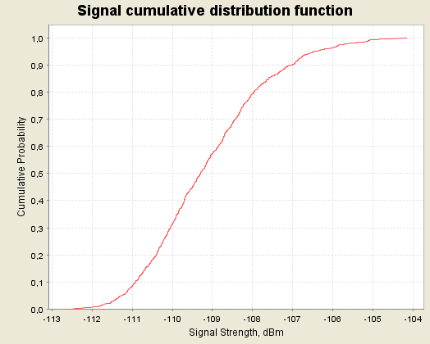

Figure 65: CDF graphs for the multiple NCU (CDMA) for 450 MHz for normal busy (left)
and extreme busy (right) cases

A.5 SCENARIO 5
A.5.1 MCL results of Scenario 5
The MCL results for Scenario 5 can be found in the following tables.

Altitude (km) ⇒ | 3 | 4 | 5 | 6 | 7 | 8 | 9 | 10
Distance g-BTS / ac-MS (km) | 4 | 94.6 | 114.1 | 132.5 | 150.1 | 167 | 183 | 198.4
Power MS onboard (dBm) | 0 | 0 | 0 | 0 | 0 | 0 | 0 | 0
MS Antenna Gain (dBi) | 0 | 0 | 0 | 0 | 0 | 0 | 0 | 0
Attenuation due to the aircraft (dB) | 5.00 | 5.00 | 5.00 | 5.00 | 5.00 | 5.00 | 5.00 | 5.00
Path Loss (dB) | 109.6 | 137 | 138.7 | 140 | 141 | 142 | 142.8 | 143.5
Terrestrial BTS Antenna Gain (dBi) | -10.04 | 15.14 | 15.14 | 15.14 | 15.14 | 15.14 | 15.14 | 15.14
Power Received at g-BTS (dBm) | -124.6 | -126.8 | -128.5 | -129.8 | -130.8 | -131.8 | -132.6 | -133.3
System Noise Level (reference values) | -113 | -113 | -113 | -113 | -113 | -113 | -113 | -113
Increase of the noise floor at g-BTS with respect to reference values (dB) | 0.3 | 0.2 | 0.1 | 0.1 | 0.1 | 0.1 | 0 | 0
System Noise Level (typical operators) | -117 | -117 | -117 | -117 | -117 | -117 | -117 | -117
Increase of the noise floor at g-BTS with respect to typical values (dB) | 0.7 | 0.4 | 0.3 | 0.2 | 0.2 | 0.1 | 0.1 | 0.1
Table 104: MCL calculation for ac-MS 1800 MHz to terrestrial GSM networks, assuming large aircraft

Note that the elevation angle considered here was 48 degrees at 3,000 m and 2 degrees above 3,000 m as it gives a worst-case value of the factor propagation losses + antenna gain.

Altitude (km) ⇒ | 3 | 4 | 5 | 6 | 7 | 8 | 9 | 10
Distance g-BTS / ac-MS (km) | 4 | 94.6 | 114.1 | 132.5 | 150.1 | 167 | 183 | 198.4
Power MS onboard (dBm/200kHz) | 0 | 0 | 0 | 0 | 0 | 0 | 0 | 0
Power MS onboard (dBm/3.84MHz) | -12.8 | -12.8 | -12.8 | -12.8 | -12.8 | -12.8 | -12.8 | -12.8
MS Antenna Gain (dBi) | 0 | 0 | 0 | 0 | 0 | 0 | 0 | 0
Attenuation due to the aircraft (dB) | 5.00 | 5.00 | 5.00 | 5.00 | 5.00 | 5.00 | 5.00 | 5.00
Path Loss (dB) | 109.6 | 137 | 138.7 | 140 | 141 | 142 | 142.8 | 143.5
Terrestrial BTS Antenna Gain (dBi) | -10.04 | 15.14 | 15.14 | 15.14 | 15.14 | 15.14 | 15.14 | 15.14
Power Received at g-BTS (dBm) | -137.4 | -139.6 | -141.3 | -142.6 | -143.6 | -144.6 | -145.4 | -146.1
System Noise Level (reference values) | -103 | -103 | -103 | -103 | -103 | -103 | -103 | -103
Increase of the noise floor at g-BTS with respect to reference values (dB) | 0 | 0 | 0 | 0 | 0 | 0 | 0 | 0
Table 105: MCL calculation for ac-MS 1800 MHz to terrestrial UMTS networks, assuming large aircraft

A.5.2 SEAMCAT results of Scenario 5
The SEAMCAT simulations are based on the parameters defined in section 6 and the modelling approaches described in section 7. Consequently two “cases” of simulations were carried out:

- Case 1: For a set of heights (3000 – 10000 m) an interferer is placed at the worst case elevation angle seen from the victim receiver (the angle 48 degrees has been calculated as the worst case angle for the BTS 1800 MHz antenna signal strength in Scenario 1 at 3000 m and a worst case angle of 2 degrees for all heights above 3000 m. This is applied given that the victim receiver is a g-BTS in 1800 MHz and that the aircraft is assumed to be an omni-directional radiator). This case illustrates the worst case probability that a receiver with this configuration experiences any interference according to the interference criteria threshold used

- Case 2: The interferer is located at constant height with a random position within a radius corresponding to the minimum elevation angle to the victim receiver (2 degrees). This is described in SEAMCAT terminology as the “uniform polar distance”.

This scenario also assumes 5 dB of attenuation for signals entering in the aircraft and 5 dB of attenuation for signals leaving the ac-MS transmitter. For each scenario case a sensitivity analysis was carried out using the range +/- 4 dB.

For the analysis of GSM networks the results indicate the probability that the interference exceeds the threshold criteria that C/(N+I) = 9 and I/N > -6 dB.

All calculations use the “typical’ input parameters (see section 6).
A.5.2.1 Impact of a GSM mobile on a g-BTS in 1800 MHz
The following table provides the output of the SEAMCAT simulations for the probability that interference from an ac-MS transmitting at minimum power exceeds the threshold criteria (C/(N+I) < 9 dB and I/N > -6 dB) in a g-BTS in 1800 MHz. The results of the interferer received signal strength (IRSS), the 95th percentile and the attenuation sensitivity analysis are also provided.

Situation |  |  | Reference attenuation (case B) |  |  |  | Sensitivity analysis  (Attenuation A-C)
Description of the case |  |  | iRSS mean (dBm) | iRSS 95th percentile  (dBm) | Criterion  I  P(C/(N+I) < 9dB)  (%) | Criterion II  P(I/N  > -6 dB)  (%) | Reduced attenuation |  | Increased attenuation
 |  |  |  |  |  |  | Crit I  (%) | Crit II  (%) | Crit I  (%) | Crit  II  (%)
ac-MS trans-  mitting  in the 1800 MHz band over terrestrial GSM  networks | 3 km | Transmitter at worst case angle, (48⁰) calculated from MCL analysis in Scenario 1, downtilt at 2⁰ | -129 | -127.3 | 0.53 | 0 | 1.3 | 2.4 | 0.2 | 0
 | 3 km | Transmitter randomly placed within a radius of 4 km at 3000 m above ground | -129 | -127.3 | 0.6 | 0 | 1.4 | 2.4 | 0.2 | 0
 | 5 km | Transmitter at worst case angle, (2⁰) calculated from MCL analysis in Scenario 1, downtilt at 2⁰ | -140.5 | -139 | 0.04 | 0 | 0.09 | 0 | 0.03 | 0
 | 5 km | Transmitter randomly placed within a radius of 114 km at 5000 m above ground | -139.7 | -137.2 | 0.05 | 0 | 0.14 | 0 | 0.01 | 0
 | 8 km | Transmitter at worst case angle, (2⁰) calculated from MCL analysis in Scenario 1, downtilt at 2⁰ | -144 | -142.3 | 0.02 | 0 | 0.07 | 0 | 0.01 | 0
 | 8 km | Transmitter randomly placed within a radius of 167 km at 8000 m above ground | -143.7 | -139.9 | 0.03 | 0 | 0.06 | 0 | 0 | 0
 | 10 km | Transmitter at worst case angle, (2⁰) calculated from MCL analysis in Scenario 1, downtilt at 2⁰ | -146 | -144.3 | 0.01 | 0 | 0.03 | 0 | 0 | 0
 | 10 km | Transmitter randomly placed within a radius of 200 km at 10000 m above ground | -145.5 | -141.6 | 0.02 | 0 | 0.04 | 0 | 0 | 0
Table 106: Results of the case with the ac-MS transmitting in the 1800 MHz band over
terrestrial GSM networks.

The following figures provide the CDF graphs for the ac-MS for 1800 MHz at 3000, 5000, 8000 and 10000 m above ground.

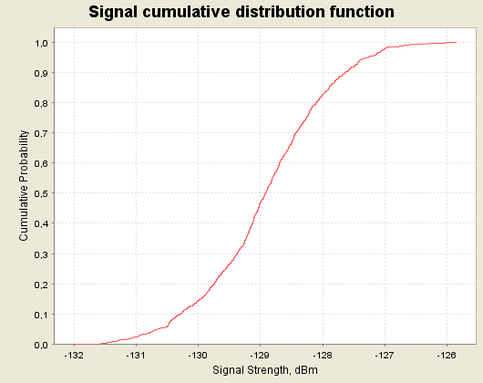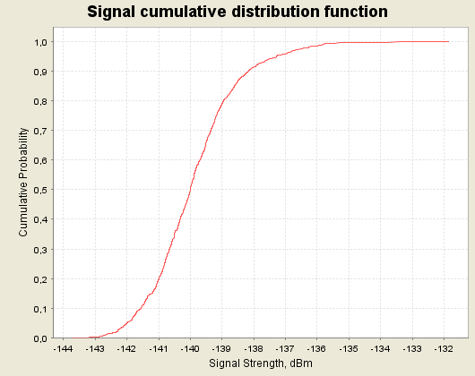

Figure 66: CDF graphs for the ac-MS for 1800 MHz at 3000 m (left) and 5000 m (right) above ground

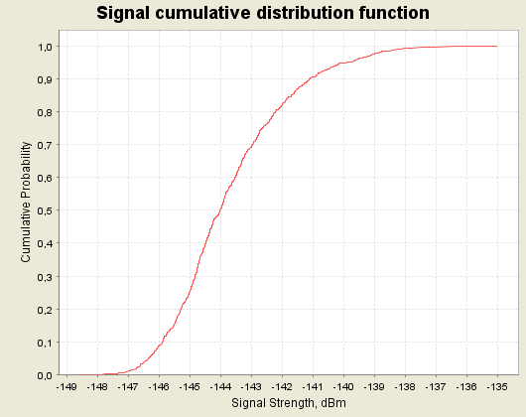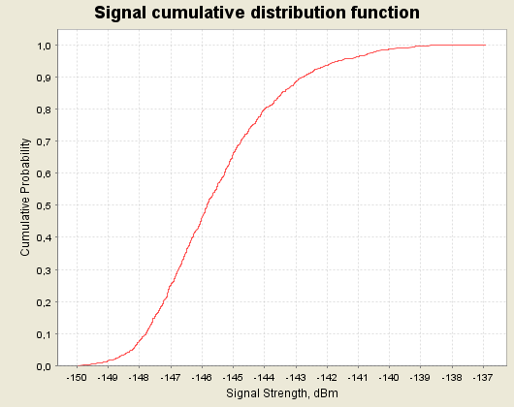

Figure 67: CDF graphs for the ac-MS for 1800 MHz at 8000 m (left) and 10000 m (right) above ground

A.5.5.2 Impact of a ac-MS on a g-Node B in UMTS 1800 MHz
The following table provides the output of the SEAMCAT simulations. As it was impossible with SEAMCAT to use the C/(N+I) or the I/N as an interference criteria for networks using CDMA systems only the results of the interferer received signal strength (IRSS), for the 95 % percentile, and the corresponding receiver increase of noise are provided.

Situation |  |  | Reference attenuation (case B)
Description of the case |  |  | iRSS mean (dBm) | iRSS 95th percentile  (dBm) | Increase of noise for  iRSS mean value (dB) | Increase of noise for  iRSS 95th percentile value  (dB)
ac-MS trans-  mitting  in the 1800 MHz band over terrestrial UMTS  networks | 3 km | Case1: Transmitter at worst case angle, 48⁰ to victim receiver | -141.8 | -140.1 | 5.7E-04 | 8.4E-04
 | 3 km | Case2: Transmitter placed randomly within a radius of 4 km at 3000 m above ground | -141.9 | -140.1 | 5.7E-04 | 8.4E-04
 | 5 km | Case1: Transmitter at worst case angle, 2⁰ to victim receiver | -153.2 | -151.6 | 4E-05 | 6E-05
 | 5 km | Case2: Transmitter placed randomly within a radius of 114 km at 5000 m above ground | -152.7 | -150 | 4.6E-05 | 8.6E-05
 | 8 km | Case1: Transmitter at worst case angle, 2⁰ to victim receiver | -156.9 | -155.3 | 1.7E-05 | 2.6E-05
 | 8 km | Case2: Transmitter placed randomly within a radius of 167 km at 8000 m above ground | -156.5 | -152.7 | 1.94E-05 | 4.6E-05
 | 10 km | Case1: Transmitter at worst case angle, 2⁰ to victim receiver | -158.8 | -157.2 | 1.1E-05 | 1.7E-05
 | 10 km | Case2: Transmitter placed randomly within a radius of 200 km at 10000 m above ground | -158.3 | -154.5 | 1.28E-05 | 3E-05
Table 107: Results of the case with the ac-MS transmitting in the 1800 MHz band over terrestrial UMTS networks

The following figures provide the CDF graphs for the ac-MS for 1800 MHz at 3000, 5000, 8000 and 10000 m above ground.

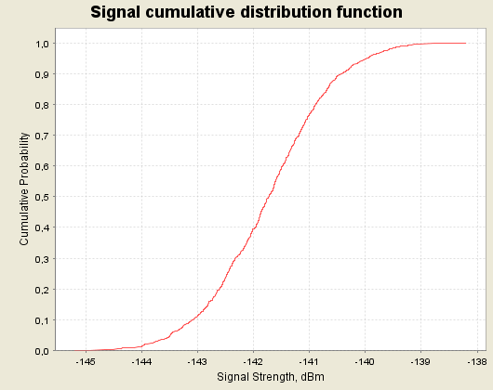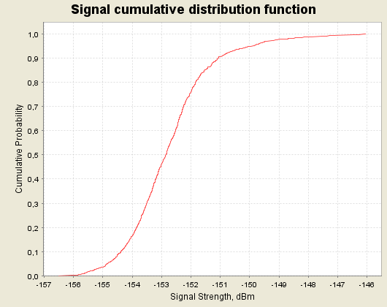

Figure 68: CDF graphs for the ac-MS for 1800 MHz at 3000 m (left) and 5000 m (right) above ground

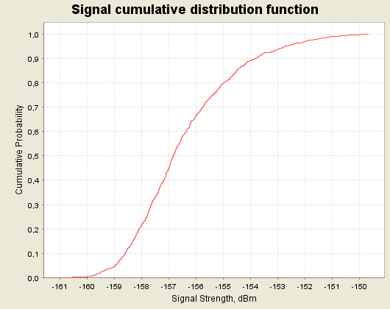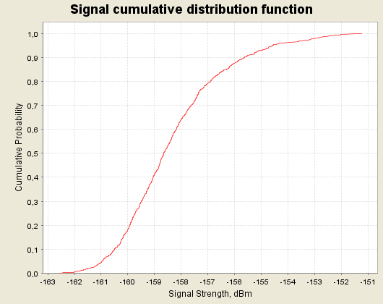

Figure 69: CDF graphs for the ac-MS for 1800 MHz at 8000 m (left) and 10000 m (right) above ground
A.6 SCENARIO 6
A.6.1 SEAMCAT results of Scenario 6
The SEAMCAT simulations are based on the parameters defined in section 6 and the modelling approaches described in section 7. Consequently two “cases” of simulations are proposed for a busy hour in a busy day, and for a busy hour in a normal day.

In SEAMCAT analysis, these 2 different distributions were applied to the height of the interfering transmitter (NCU or ac-BTS) antenna.

The maximum distance of the area around the victim receiver is given according to the 10000 m height.

This scenario also assumed 5 dB of attenuation for signals entering the aircraft and 5 dB of attenuation for ac-MS signals leaving the aircraft, consequently a sensitivity analysis is carried out ranging +/- 4 dB.

All calculations use the “typical’ input parameters (see section 6).
A.6.1.1 Impact of multiple ac-MSs on a g-BTS in 1800 MHz
The following table provides the output of the SEAMCAT simulations for the probability of interference to a g-BTS from multiple ac-MSs transmitting at 0 dBm/200 kHz at an aircraft window, and distributed between 3000 and 10000 m above the ground, in the two aircraft distributions. Additionally the amount of frequency re-use between the GSMOB systems is shown for the two cases: with 2 MHz or 10 MHz shared between GSMOB in all aircraft in the area analysed.

Situation |  | Reference attenuation (case B) |  |  | Sensitivity analysis  (Attenuation A-C)
 | iRSS mean (dBm) | iRSS 95th percentile  (dBm) | Criterion I:  P(C/(N+I) < 9dB)  (%) | Criterion II  P(I/N > -6 dB)  (%) | Reduced attenuation |  |  | Increased attenuation
 |  |  |  |  | Crit I  (%) | Crit II  (%) |  | Crit I  (%) |  | Crit II  (%)
ac-MS normal busy day  50 GSM1800 Channels  (2 interferers) | -136.9 | -133.7 | 0.1 | 0 | 0.3 |  | 0 |  | 0.03 |  | 0
ac-MS extreme busy day,  50 GSM1800 Channels  (3 interferers) | -135.9 | -132.5 | 0.12 | 0 | 0.35 |  | 0 |  | 0.07 |  | 0
ac-MS normal busy day  10 GSM1800 Channels  (8 interferers) | -130.5 | -128.6 | 0.44 | 0 | 1.1 |  | 0.1 |  | 0.18 |  | 0
ac-MS extreme busy day,  10 GSM1800 Channels  (15 interferers) | -128.4 | -126.7 | 0.6 | 0 | 1.8 |  | 6.8 |  | 0.2 |  | 0
Table 108: SEAMCAT results of Scenario 6, ac-MS transmissions

The following figures provide the CDF graphs for the multiple ac-MS for 1800 MHz for the normal busy and extreme busy cases.

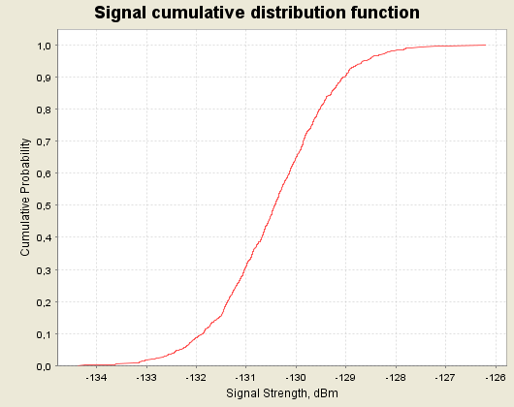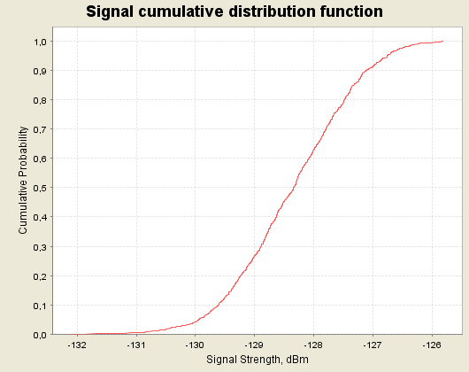

Figure 70: CDF graphs for the multiple ac-MS for 1800 MHz for 10 GSM 1800 channels onboard
for the normal busy day (left) and the extreme busy day (right) cases

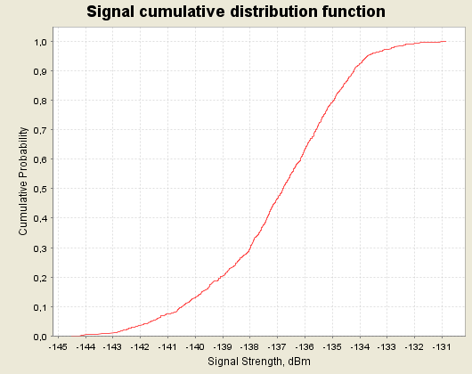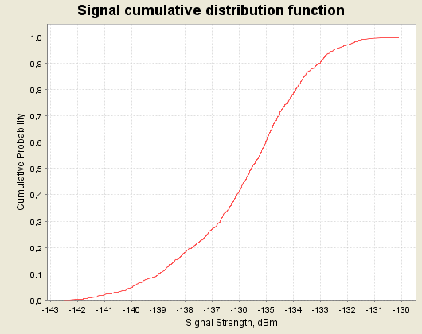

Figure 71: CDF graphs for the multiple ac-MS for 1800 MHz for 50 GSM 1800 channels onboard for the normal busy day (left) and the extreme busy day (right) cases

A.6.1.2 Impact of multiple ac-MS on a g-Node B in UMTS 1800 MHz
The following table indicates the output of the SEAMCAT simulations. As it was impossible with SEAMCAT to use the C/(N+I) or the I/N as an interference criteria for networks using CDMA systems only the results of the interferer received signal strength (IRSS), for the 95 % percentile, and the corresponding receiver increase of noise are provided.
The sensitivity analysis is reflected by adding or reducing (i.e case A or case C) by 9 dB the value of the iRSS.

Situation | iRSS mean (dBm) | iRSS 95th percentile  (dBm) | Increase of noise(dB)
Situation | iRSS mean (dBm) | iRSS 95th percentile  (dBm) | iRSS mean | iRSS 95th percentile
ac-MS normal busy day  50 GSM1800 channels onboard | -137.4 | -136.5 | 1.5E-03 | 1.9E-03
ac-MS extreme busy day  50 GSM1800 channels onboard | -135.5 | -134.6 | 2E-03 | 3E-03
ac-MS normal busy day  10 GSM1800 channels onboard | -133.2 | -132.1 | 4E-03 | 5E-03
ac-MS extreme busy day  10 GSM1800 channels onboard | -131.3 | -130.8 | 6E-03 | 7E-03
Table 109: SEAMCAT results of Scenario 6, ac-MS transmissions

The following figures provide the CDF graphs for the multiple ac-MS for the normal busy and extreme busy cases and the re-use of 2 MHz and 10 MHz frequency allocations.

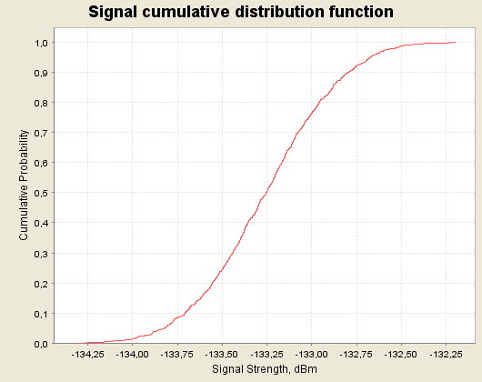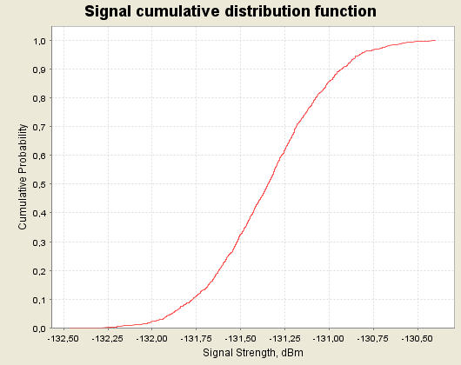

Figure 72: CDF graphs for the multiple ac-MS for 1800 MHz for normal busy (left)
and extreme busy (right) cases for 10 GSM 1800 channels onboard

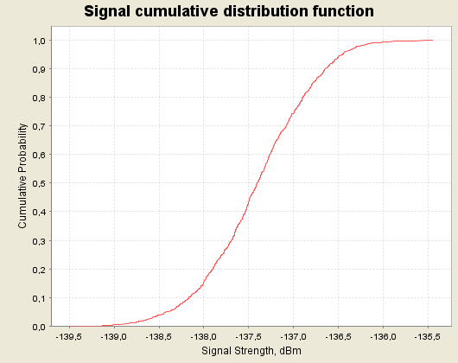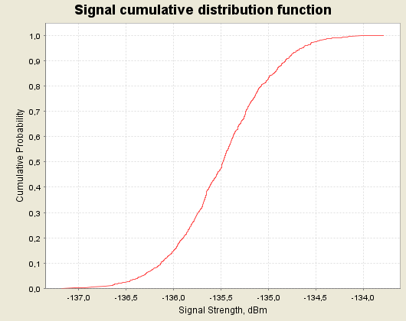

Figure 73: CDF graphs for the multiple ac-MS for 1800 MHz for normal busy (left)
and extreme busy (right) cases for 50 GSM 1800 channels onboard
A.7 SUMMARY OF THE RESULTS
This section provides the limiting cases of the complete results of analyses carried out in sections A.1 to A.6. Consequently, the results highlighted here showcase the impact of the GSMOB when it is in operation from a height of 3000 m and higher above the ground. Both MCL and SEAMCAT analyses are included in the summary of results presented below.
A.7.1 Analysis of received signal strengths when GSMOB is not in operation
A.7.1.1 Results of Scenario 1
For Scenario 1, only the MCL results are provided given that it is not possible to model them in SEAMCAT. The following Table provides the predicted field strength inside and outside an aircraft (assuming 5 dB aircraft attenuation) and subsequent required margins to prevent a mobile from resolving the pilot channel at 3000 m above ground at the worst case angle to the aircraft.

SCENARIO 1 | MCL analysis for the worst case angle at  3000 m
SCENARIO 1 | Received power outside aircraft  at 3,000 m  (dBm / channel) | Received power inside  aircraft  at 3,000 m  (dBm / channel) | Margins (dB)
SCENARIO 1 | Received power outside aircraft  at 3,000 m  (dBm / channel) | Received power inside  aircraft  at 3,000 m  (dBm / channel) | Reference values | Typical values
GSM 900 MHz | -68.5 | -73.5 | -28.5 | -31.5
UMTS 900 MHz | -78.5 | -83.5 | -30.5 | NA
GSM 1800 MHz | -76.1 | -81.7 | -20.3 | -23.3
UMTS 1800 MHz | -86.1 | -91.7 | -22.3 | NA
UMTS FDD 2GHz | -87.6 | -92.6 | -24.4 | -26.4
CDMA 450/FLASH-OFDM | -70.64 | -75.64 | -28.3 | NA
Table 110: Results of Scenario 1,
Required margins to prevent ac-MS/UE attempting to attach to terrestrial networks

A.7.1.2 Results of Scenario 2
Table 111 provides the predicted field strengths on the ground (assuming 5 dB aircraft attenuation) for an ac-MS/UE transmitting at full power and the subsequent margins over the g-BTS/NodeB sensitivity limit. The SEAMCAT analysis identifies the impact to a second g-BTS due to the communication between an ac-MS and a g-BTS. All calculations are made at 3000 m above ground at the worst case angle to the aircraft. The following table presents two values for the iRSS and the increase of thermal noise: the first one relates to the mean value and the second one, presented in brackets, relates to the 95th percentile value.

For networks using CDMA systems, only the MCL results are provided given that it was impossible to model those scenarios in SEAMCAT.

SCENARIO 2 | MCL analysis for the worst case angle at  3000 m |  |  | SEAMCAT analysis for the worst case angle at  3000 m
SCENARIO 2 |  |  |  | Reference attenuation (case B) |  |  |  | Sensitivity analysis  Worst case
SCENARIO 2 | Received power on ground  (dBm / channel) | Margins (dB) |  | iRSS  Mean value  (95th percentile value)  dBm | Increase of thermal noise  Mean value  (95th percentile value)  dB | Criterion  I  P(C/(I+N) < 9dB)  (%) | Criterion  II  P(I/N) >-6dB)  (%) | Reduced attenuation  (case A)
SCENARIO 2 | Received power on ground  (dBm / channel) | Reference Values | Typical Values |  |  |  |  | Crit I  (%) | Crit  II  (%)
GSM 900 MHz | -83.5 | -20.5 | -24.5 | -91.4  (-88.3) | 25.6  (28.7) | 79 | 100 | 87 | 100
UMTS 900 MHz | -92.5 | -28.5 | NA | NA | NA | NA | NA | NA | NA
GSM 1800 MHz | -94.7 | -9.3 | -13.3 | -106  (-104.4) | 11.3  (12.8) | 39.3 | 100 | 53.4 | 100
UMTS 1800 MHz | -101.7 | -20.3 | NA | NA | NA | NA | NA | NA | NA
UMTS FDD 2 GHz | -104.6 | -16.4 | -17.4 | NA | NA | NA | NA | NA | NA
CDMA 450/FLASH-OFDM | -83.5 | -38.6 | NA | NA | NA | NA | NA | NA | NA
Table 111: Results of Scenario 2,
Expected received signal strength from ac-MS/UEs transmitting at full power towards terrestrial networks
A.7.2 Single aircraft scenarios analysis
A.7.2.1 Results of Scenario 3
Tables 112 to 115 provide the predicted field strengths on the ground for an NCU/ac-BTS transmitting and the corresponding increase of noise in terrestrial receiver using both MCL and SEAMCAT analysis. The reference attenuation results assume 5 dB aircraft attenuation to signals arriving into the aircraft and 10 dB attenuation for the NCU/ac-BTS transmission leaving the aircraft towards the ground (the reduced attenuation uses 1 dB and 5 dB respectively).
- The MCL analysis identifies the IRSS when the aircraft is at the worst case angle to the receiver;
- The SEAMCAT analysis identifies the probability that the C/(I+N) is higher than 9 dB and the probability that I/N is less than -6 dB. A sensitivity analysis for the worst case attenuation of the aircraft (case A) is also provided.

For networks using CDMA systems, only the results of the interferer received signal strength (IRSS), for the 95 % percentile and the corresponding increase of noise of the receiver, are provided given that it is impossible with SEAMCAT to use the C/(I+N) or the I/N as an interference criteria for networks using CDMA systems.

All calculations are made with an aircraft flying at 3000 m above ground.
The following tables present two values for the iRSS and the increase of thermal noise: the first one relates to the mean value and the second one, presented in brackets, relates to the 95th percentile value.

Situation |  |  | Reference attenuation (case B) |  |  |  | Sensitivity analysis  Worst case
Description of the case |  |  | iRSS  Mean value  (95percentile value)  dBm | Increase of thermal noise  Mean value  (95th percentile value)  dB | Criterion  I  P(C/(I+N) < 9dB)  (%) | Criterion  II  P(I/N) >-6dB)  (%) | Reduced attenuation  (case A)
 |  |  |  |  |  |  | Crit I  (%) | Crit  II  (%)
SCENARIO  3 | NCU GSM over terrestrial GSM networks  900 MHz | Transmitter at worst case angle (90⁰), placed at 3 km above ground | -120.6  (-118.8) | 0.85  (1.24) | 0.4 | 28.3 | 2.9 |  | 100
SCENARIO  3 | NCU GSM over terrestrial GSM networks  900 MHz | Transmitter randomly placed within a radius of 17 km at 3 km above ground | -131.9  (-124.7) | 0.07  (0.35) | 0.03 | 0.18 | 0.32 |  | 18.9
SCENARIO  3 | NCU GSM over terrestrial GSM networks  900 MHz | MCL analysis for the worst case angle at 3 km above ground | -120,5  (NA) | 0.9  (NA) | NA | NA | NA |  | NA
SCENARIO  3 | NCU GSM over terrestrial UMTS networks  900 MHz | Transmitter at worst case angle (90⁰), placed at 3 km above ground | -107.8  (-106.1) | 0.277  (0.4) | NA | NA | NA |  | NA
SCENARIO  3 | NCU GSM over terrestrial UMTS networks  900 MHz | Transmitter randomly placed within a radius of 17 km at 3 km above ground | -119.1  (-111.9) | 0.021  (0.11) | NA | NA | NA |  | NA
SCENARIO  3 | NCU GSM over terrestrial UMTS networks  900 MHz | MCL analysis for the worst case angle at 3 km above ground | -107.7  (NA) | 0.9  (NA) | NA | NA | NA |  | NA
SCENARIO  3 | NCU UMTS over terrestrial UMTS networks  900 MHz | Transmitter at worst case angle(90⁰), placed at 3 km above ground | -109.6  (-108) | 0.18  (0.26) | NA | NA | NA |  | NA
SCENARIO  3 | NCU UMTS over terrestrial UMTS networks  900 MHz | Transmitter randomly placed within a radius of 17 km at 3 km above ground | -120.9  (-113.4) | 0.014  (0.078) | NA | NA | NA |  | NA
SCENARIO  3 | NCU UMTS over terrestrial UMTS networks  900 MHz | MCL analysis for the worst case angle at 3 km above ground | -109.5  (NA) | 0.6  (NA) | NA | NA | NA |  | NA
Table 112: Impact of a single GSM/UMTS NCU 900 over terrestrial GSM/UMTS 900 networks

Situation |  |  | Reference attenuation (case B) |  |  |  | Sensitivity analysis  Worst case
Description of the case |  |  | iRSS  Mean value  (95percentile value)  dBm | Increase of thermal noise  Mean value  (95th percentile value)  dB | Criterion  I  P(C/(I+N) < 9dB)  (%) | Criterion  II  P(I/N) >-6dB)  (%) | Reduced attenuation  (case A)
 |  |  |  |  |  |  | Crit I  (%) | Crit  II  (%)
SCENARIO 3 | AC-BTS over terrestrial GSM  Networks  1800 MHz | Transmitter at worst case angle (90⁰), placed at 3 km above ground | -116.8  (-115.1) | 1.8  (2.5) | 0.93 | 100 | 5.8 |  | 100
SCENARIO 3 | AC-BTS over terrestrial GSM  Networks  1800 MHz | Transmitter randomly placed at within a radius of 17 km at 3 km above ground | -128.1  (-121) | 0.16  (0.79) | 0.1 | 3.6 | 0.7 |  | 50
SCENARIO 3 | AC-BTS over terrestrial GSM  Networks  1800 MHz | MCL analysis for the worst case angle at 3 km above ground | -116.7  (NA) | 1.9  (NA) | NA | NA | NA |  | NA
SCENARIO 3 | NCU GSM over terrestrial GSM networks  1800 MHz | Transmitter at worst case angle (90⁰), placed at 3 km above ground | -128.8  (-127.1) | 0.14  (0.2) | 0.04 | 0 | 0.45 |  | 82
SCENARIO 3 | NCU GSM over terrestrial GSM networks  1800 MHz | Transmitter randomly placed within a radius of 17 km at 3 km above ground | -140.1  (-132.7) | 0.01  (0.06) | 0.01 | 0 | 0.06 |  | 0.45
SCENARIO 3 | NCU GSM over terrestrial GSM networks  1800 MHz | MCL analysis for the worst case angle at 3 km above ground | -128.7  (NA) | 0.14  (NA) | NA | NA | NA |  | NA
SCENARIO 3 | NCU GSM over terrestrial UMTS networks  1800 MHz | Transmitter at worst case angle (90⁰), placed at 3 km above ground | -116  (-114.2) | 0.043  (0.065) | NA | NA | NA |  | NA
SCENARIO 3 | NCU GSM over terrestrial UMTS networks  1800 MHz | Transmitter randomly placed within a radius of 17 km at 3 km above ground | -127.3  (-120.3) | 3.2E-03  (0.016) | NA | NA | NA |  | NA
SCENARIO 3 | NCU GSM over terrestrial UMTS networks  1800 MHz | MCL analysis for the worst case angle at 3 km above ground | -115.9  (NA) | 0.1  (NA) | NA | NA | NA |  | NA
SCENARIO 3 | NCU UMTS over terrestrial UMTS networks  1800 MHz | Transmitter at worst case angle(90⁰), placed at 3 km above ground | -117.8  (-116.1) | 0.028  (0.04) | NA | NA | NA |  | NA
SCENARIO 3 | NCU UMTS over terrestrial UMTS networks  1800 MHz | Transmitter randomly placed within a radius of 17 km at 3 km above ground | -129.1  (-122.2) | 2.1E-03  (0.01) | NA | NA | NA |  | NA
SCENARIO 3 | NCU UMTS over terrestrial UMTS networks  1800 MHz | MCL analysis for the worst case angle at 3 km above ground | -117.7  (NA) | 0.1  (NA) | NA | NA | NA |  | NA
Table 113: Impact of a single GSM/UMTS NCU 1800 over terrestrial GSM/UMTS 1800 networks

Situation |  |  | Reference attenuation (case B)
Description of the case |  |  | iRSS  Mean value  (95percentile value)  dBm | Increase of thermal noise  Mean value  (95th percentile value)  dB
SCENARIO 3 | NCU UMTS over terrestrial UMTS networks  2 GHz | Transmitter at worst case angle(90⁰), placed at 3 km above ground | -118.5  (-116.9) | 0.074  (0.11)
SCENARIO 3 | NCU UMTS over terrestrial UMTS networks  2 GHz | Transmitter randomly placed within a radius of 17 km at 3 km above ground | -129.9  (-122.6) | 0.005  (0.03)
SCENARIO 3 | NCU UMTS over terrestrial UMTS networks  2 GHz | MCL analysis for the worst case angle at 3 km above ground | -118.7  (NA) | 0.1  (NA)
Table 114: Impact of a single UMTS NCU 2 GHz over terrestrial UMTS 2GHz networks

Situation |  |  | Reference attenuation (case B)
Description of the case |  |  | iRSS  Mean value  (95percentile value)  dBm | Increase of thermal noise  Mean value  (95th percentile value)  dB
SCENARIO 3 | NCU CDMA over terrestrial CDMA 450 networks at  450 MHz | Transmitter at worst case angle(90⁰), placed at 3 km above ground | -99  (-97.2) | 7.8  (9.3)
SCENARIO 3 | NCU CDMA over terrestrial CDMA 450 networks at  450 MHz | Transmitter randomly placed within a radius of 17 km at 3 km above ground | -110.3  (-103.5) | 1.4  (4.4)
SCENARIO 3 | NCU CDMA over terrestrial CDMA 450 networks at  450 MHz | MCL analysis for the worst case angle at 3 km above ground | -98.9  (NA) | 7.9  (NA)
Table 115: Impact of a single CDMA NCU 450 MHz over terrestrial CDMA 450 MHz networks

A.7.2.2 Results of Scenario 5
Table 116 provides the predicted field strength on the ground (assuming 5 dB aircraft attenuation in the reference case) for an ac-MS transmitting and the corresponding increase of noise in terrestrial receiver using both MCL and SEAMCAT analyses:
- The MCL analysis identifies the IRSS when the aircraft is at the worst case angle to the receiver;
- The SEAMCAT analysis identifies the probability that the C/(I+N) is higher than 9 dB and the probability that I/N is less than -6 dB. A sensitivity analysis for the worst case attenuation of the aircraft (case A) is also provided.
For networks using CDMA systems, only the results of the interferer received signal strength (IRSS), for the 95 % percentile and the corresponding increase of noise of the receiver, are provided given that it is impossible with SEAMCAT to use the C/(I+N) or the I/N as an interference criteria for networks using CDMA systems.

All calculations are made with an aircraft flying at 3000 m above ground.

Situation |  |  | Reference attenuation (case B) |  |  |  | Sensitivity analysis  Worst case
Description of the case |  |  | iRSS  Mean value  (95percentile value)  dBm | Increase of thermal noise  Mean value  (95th percentile value)  dB | Criterion  I  P(C/(I+N) < 9dB)  (%) | Criterion  II  P(I/N) >-6dB)  (%) | Reduced attenuation  (case A)
 |  |  |  |  |  |  | Crit I  (%) | Crit  II  (%)
SCENARIO 5 | AC-MS over terrestrial GSM networks  1800 MHz | Transmitter at worst case angle(48⁰), placed at 3 km above ground | -129  (-127.3) | 0.26  (0.39) | 0.53 | 0 | 1.3 |  | 2.4
SCENARIO 5 | AC-MS over terrestrial GSM networks  1800 MHz | Transmitter randomly placed within a radius of 4 km at 3 km above ground | -129  (-127.3) | 0.26  (0.39) | 0.6 | 0 | 1.4 |  | 2.4
SCENARIO 5 | AC-MS over terrestrial GSM networks  1800 MHz | MCL analysis for the worst case angle at 3 km above ground | -124.7  (NA) | 0.7  (NA) | NA | NA | NA |  | NA
SCENARIO 5 | AC-MS over terrestrial UMTS networks  1800 MHz | Transmitter at worst case angle(48⁰), placed at 3 km above ground | -141.8  (-140.1) | 5.7E-04  (8.4E-04) | NA | NA | NA |  | NA
SCENARIO 5 | AC-MS over terrestrial UMTS networks  1800 MHz | Transmitter randomly placed within a radius of 4 km at 3 km above ground | -141.9  (-140.1) | 5.7E-04  (8.4E-04) | NA | NA | NA |  | NA
SCENARIO 5 | AC-MS over terrestrial UMTS networks  1800 MHz | MCL analysis for the worst case angle at 3 km above ground | -134.8  (NA) | 2E-03  (NA) | NA | NA | NA |  | NA
Table 116: Impact of a single ac-MS over ground GSM/UMTS networks
A.7.3 Multiple aircraft scenarios analysis
A.7.3.1 Results of Scenario 4
Tables 117 to 120 give the results of the SEAMCAT analysis for the worst case distribution of multiple aircraft (extreme busy day).

Situation |  |  | Reference attenuation (case B) |  |  |  | Sensitivity analysis  Worst case
Description of the case |  |  | iRSS  Mean value  (95percentile value)  dBm | Increase of thermal noise  Mean value  (95th percentile value)  dB | Criterion  I  P(C/(I+N) < 9dB)  (%) | Criterion  II  P(I/N) >-6dB)  (%) | Reduced attenuation  (case A)
 |  |  |  |  |  |  | Crit I  (%) | Crit II  (%)
SCENARIO  4  900 MHz | Multiple NCU GSM over terrestrial GSM networks | extreme busy day (33 interferers) | -126.9  (-124.3) | 0.21  (0.38) | 0.06 | 0 | 0.8 | 94.
SCENARIO  4  900 MHz | Multiple NCU GSM over terrestrial UMTS networks  900 MHz | extreme busy day (33 interferers) | -114.1  (-111.2) | 0.06  (0.12) | NA | NA | NA | NA
SCENARIO  4  900 MHz | Multiple NCU UMTS over terrestrial UMTS networks  900 MHz | extreme busy day (33 interferers) | -115.6  (-113.2) | 0.05  (0.08) | NA | NA | NA | NA
Table 117: Impact of multiple GSM/UMTS NCU 900 over terrestrial GSM/UMTS 900 networks

Situation |  |  | Reference attenuation (case B) |  |  |  | Sensitivity analysis  Worst case
Description of the case |  |  | iRSS  Mean value  (95percentile value)  dBm | Increase of thermal noise  Mean value  (95th percentile value)  dB | Criterion  I  P(C/(I+N) < 9dB)  (%) | Criterion  II  P(I/N) >-6dB)  (%) | Reduced attenuation  (case A)
 |  |  |  |  |  |  | Crit I  (%) | Crit II  (%)
SCENARIO  4  1800 MHz | Multiple AC-BTS  over terrestrial GSM networks  1800 MHz | extreme busy day,  10 GSM 1800 channels onboard | -129.3  (-125) | 0.12  (0.33) | 0.05 | 0.13 | 0.4 | 40
SCENARIO  4  1800 MHz | Multiple AC-BTS  over terrestrial GSM networks  1800 MHz | extreme busy day,  50 GSM 1800 channels onboard | -136.9  (-129.7) | 0.02  (0.11) | 0.01 | 0.01 | 0.1 | 3.2
SCENARIO  4  1800 MHz | Multiple AC-BTS  over terrestrial UMTS networks  1800 MHz | extreme busy day,  10 GSM 1800 channels onboard | -134.5  (-132.3) | 6.E-04  (1.E-03) | NA | NA | NA | NA
SCENARIO  4  1800 MHz | Multiple AC-BTS  over terrestrial UMTS networks  1800 MHz | extreme busy day,  50 GSM 1800 channels onboard | -138.7  (-135) | 2.3E-04  (5.4E-04) | NA | NA | NA | NA
SCENARIO  4  1800 MHz | Multiple NCU GSM over GSM networks  1800 MHz | extreme busy day  (33 interferers) | -135  (-132.5) | 0.03  (0.06) | 0.01 | 0 | 0.12 | 0.03
SCENARIO  4  1800 MHz | Multiple NCU GSM over UMTS networks  1800 MHz | extreme busy day  (33 interferers) | -122.3  (-120) | 0.01  (0.017) | NA | NA | NA | NA
SCENARIO  4  1800 MHz | Multiple NCU UMTS over UMTS networks  1800 MHz | extreme busy day  (33 interferers) | -124.1  (-121.2) | 6E-03  (0.013) | NA | NA | NA | NA
Table 118: Impact of multiple GSM/UMTS NCU/ac-BTS over terrestrial GSM/UMTS 1800 networks

Situation |  |  | Reference attenuation (case B)
Description of the case |  |  | iRSS  Mean value  (95percentile value)  dBm | Increase of thermal noise  Mean value  (95th percentile value)  dB
SCENARIO 4  2 GHz | Multiple NCU UMTS over terrestrial UMTS networks | extreme busy day (33 interferers) | -125  (-122.2) | 0.017  (0.032)
Table 119: Impact of multiple UMTS NCU 2 GHz over terrestrial UMTS 2GHz networks

Situation |  |  | Reference attenuation (case B)
Description of the case |  |  | iRSS  Mean value  (95percentile value)  dBm | Increase of thermal noise  Mean value  (95th percentile value)  dB
SCENARIO 4  450 MHz | Multiple NCU CDMA over terrestrial CDMA 450 networks | extreme busy day (33 interferers) | -105.4  (-102.6) | 3.3  (5)
Table 120: Impact of multiple CDMA NCU 450 MHz over terrestrial CDMA 450 MHz networks

A.7.3.2 Results of Scenario 6
Table 121 shows the impact of multiple ac-MS on terrestrial networks and only gives the results of the SEAMCAT analysis for the worst case distribution of aircraft (extreme busy day).

Situation |  |  | Reference attenuation (case B) |  |  |  | Sensitivity  analysis
Description of the case |  |  | iRSS  Mean value  (95percentile value)  dBm | Increase of thermal noise  Mean value  (95th percentile value)  dB | Criterion  I  P(C/(I+N) < 9dB)  (%) | Criterion  II  P(I/N) >-6dB)  (%) | Reduced attenuation
 |  |  |  |  |  |  | Crit I  (%) | Crit II  (%)
SCENARIO  6 | Multiple AC-MS over terrestrial GSM networks  1800 MHz | extreme busy day,  10 GSM 1800 channels onboard | -128.4  (-126.7) | 0.15  (0.22) | 0.6 | 0 | 1.8 | 6.8
SCENARIO  6 | Multiple AC-MS over terrestrial GSM networks  1800 MHz | extreme busy day,  50 GSM 1800 channels onboard | -135.9  (-132.5) | 0.02  (0.06) | 0.12 | 0 | 0.35 | 0
SCENARIO  6 | Multiple AC-MS over terrestrial UMTS networks  1800 MHz | extreme busy day,  10 GSM 1800 channels onboard | -131.3  (-130.8) | 0.006  (0.007) | NA | NA | NA | NA
SCENARIO  6 | Multiple AC-MS over terrestrial UMTS networks  1800 MHz | extreme busy day,  50 GSM 1800 channels onboard | -135.5  (-134.6) | 0.002  (0.003) | NA | NA | NA | NA
Table 121: Impact of multiple ac-MS over terrestrial GSM/UMTS networks
A.8 Estimation of limiting parameters for the GSMOB service operation
This section calculates what would be the minimum limiting parameters to operate the GSMOB service over a range of altitudes for permitting the minimum height for operation of the service. The approach is used to define the minimum aircraft attenuation for an ac-MS at a particular starting height. The system then calculates the maximum e.i.r.p allowed for GSMOB entities on the aircraft. It is assumed that the cylinder model provides a minimum attenuation due to the aircraft for signals from the GSMOB system.
A.8.1.1 Limitation criteria
In order to determine parameters for operation of the GSMOB system the limiting interference criteria has to be defined. The following two criteria are proposed to be used:
- for MCL calculations: the resulting increase of noise floor does shall not exceed 1 dB;
- for SEAMCAT simulations: the probability that I/N > -6 dB shall be below 1% (I/N = -6 dB corresponds to 1 dB increase in the noise floor).

All three categories of calculations are used in this section:
- single interferer MCL calculations for worst case position of aircraft at selected heights;
- single interferer SEAMCAT simulations with random position in the sky down to the 2 or 10 degree limit of elevation seen from the interfered receiver;
- multiple interferers SEAMCAT simulations with a height distribution from a selected minimum value and above, according to the extreme density pattern described in chapter 6.

The analysis is based on the results for Scenarios 3, 4, 5 and 6, with extensions in some cases and limitations in other:
- For MCL, different values of aircraft attenuation are tested and the value giving 1.0 dB increase in the receiver is noted and included in the tables;
- For SEAMCAT, the translation function of the interference calculation engine is used, the value giving P(I/N > -6 dB) = 1% is noted and included in the result tables.

A.8.1.2 Impacts of varying the minimum height for GSMOB service operation
For the analysis of single aircraft, a variation of the minimum height for GSMOB service activation affects the distance and angle between the aircraft and the ground to be used. This variation is already described in section 7 and 8.

For the multiple aircraft the effects of raising the height for service activation will change both the total number of interferers and the height distributions used. The following therefore provides the necessary conversion table of the distribution of aircraft as the minimum height of service activation is increased. The conversion is based on the busiest moment of a busy day distribution as this is seen as the limiting case:

Altitude (m) | Distribution of aircraft in the busiest moment of a busy day from a selected minimum altitude
3 000-4 000 | 25% | - | - | - | - | -
4 000-5 000 | 12% | 16% | - | - | - | -
5 000-6 000 | 11% | 15% | 17% | - | - | -
6 000-7 000 | 8% | 11% | 13% | 15% | - | -
7 000-8 000 | 6% | 8% | 10% | 12% | 14% | -
8 000-9 000 | 9% | 12% | 14% | 17% | 20% | 24%
9 000-10 000 | 11% | 15% | 17% | 21% | 25% | 29%
10 000-11 000 | 8% | 11% | 13% | 15% | 18% | 21%
11 000+ | 10% | 13% | 16% | 19% | 23% | 26%
Number of ac-MS  Using the same frequency | 15 | 11 | 9 | 8 | 7 | 6
Number of ac-BTS  Using the same frequency | 9 | 7 | 6 | 5 | 4 | 3
Number of NCU | 33 | 25 | 21 | 17 | 15 | 13
Table 122: Conversion table for distribution of multiple aircraft (busy moment during a busy day) as the minimum activation height is increased
A.8.1.3 Analysis of required attenuation for ac-MS signals (Scenario 5 and 6)
For Scenario 6, the aircraft height distribution is based on the “extreme busy” case described in chapter 6. The following table shows the results for required ac-MS signal attenuation due to the aircraft determined by MCL and SEAMCAT analysis (given that the ac-MS is transmitting at 0 dBm):

Altitude | Required Attenuation  (MCL),  For 1 dB increased Noise Floor | Single  aircraft  SEAMCAT  P(I/N>-6) <= 1% | Multiple aircraft  SEAMCAT  P(I/N>-6) <=1%  Busy day  2 MHz spectrum allocated
Altitude | Required Attenuation  (MCL),  For 1 dB increased Noise Floor | Single  aircraft  SEAMCAT  P(I/N>-6) <= 1% | Number of  interferers | Required  attenuation  for the  ac-MS (dBm)
3000 m | 3.3 | -1.7 | 15 | 1.7
4000 m | 1.1 | -4 | 11 | -1.3
5000 m | -0.5 | -6 | 9 | -3.3
6000 m | -1.8 | -7.5 | 8 | -4.6
7000 m | -2.9 | -8.8 | 7 | -5.7
8000 m | -3.8 | -10 | 6 | -6.5
Table 123: Required attenuation due to the aircraft for ac-MS signal

A.8.1.4 Analysis of required attenuation for ac-BTS signals (Scenario 3 and 4)
In the following table, the attenuation due to the aircraft for signals to and from the ac-MS calculated previously is used to determine (using MCL) the minimum power required for the ac-BTS at each height. The calculated ac-BTS value as function of height (based on the cylinder model) is then used to determine the required attenuation due to the aircraft for the ac-BTS signal (being transmitted from a radiating cable) as a result of both MCL and SEAMCAT analysis. The “max eqv e.i.r.p”. value is determined from SEAMCAT as the level which satisfies the interference criteria I/N = -6 stated in 8.4.1.

Altitude  (m) | MCL,  1 dB Increased Noise Floor |  |  | Single aircraft SEAMCAT  Pwr: 2.0 dBm |  |  | Multiple aircraft,  number of interferers reduced with increased height:
Altitude  (m) | MS-att  dB | ac-BTS power  dBm | Required  attenuation  (dB) | Max eqv  e.i.r.p  dBm | Ac-BTS pwr (dBm) | Required  attenuation  dB | Number  of inter-ferers | Max eqv  e.i.r.p  dBm | Ac-BTS pwr (dBm) | Required  attenuation  dB
3,000 m | 3.3 | 2.0 | 15.0 | -11.9 | 2.0 | 13.9 | 9 | -9.9 | -0.5 | 9.4
4,000 m | 1.1 | 2.0 | 12.5 | -9.2 | 2.0 | 11.2 | 7 | -8 | -0.5 | 7.5
5,000 m | -0.5 | 2.0 | 10.5 | -7.5 | 2.0 | 9.5 | 6 | -6.8 | -0.5 | 6.3
6,000 m | -1.8 | 2.0 | 8.9 | -5.8 | 2.0 | 7.8 | 5 | -5.7 | -0.5 | 5.2
7,000 m | -2.9 | 2.0 | 7.6 | -4.5 | 2.0 | 6.5 | 4 | -4.7 | -0.5 | 4.2
8,000 m | -3.8 | 2.0 | 6.4 | -3.2 | 2.0 | 5.2 | 3 | -3.7 | -0.5 | 3.2
Table 124: Required aircraft attenuation for ac-BTS

Given that the ac-BTS is transmitting the power independently from the height of the aircraft, the minimum power required for the ac-BTS inside the cabin equals 2 dBm.
A.8.1.5 Analysis of required attenuation for the NCU signal in 900 MHz (Scenario 3 and 4)
In the following table, the attenuation due to the aircraft for signals to and from the ac-MS calculated previously is used to determine (using MCL) the power required for the NCU at each height. Since the 900 MHz g-BTS antenna is different from the 1800 MHz antenna used in the calculations of the attenuation values for signals to and from the ac-BTS, the calculated NCU power values are not exactly the same for the different height. These values of the power are then used to determine the required attenuation due to the aircraft for the NCU 900 MHz signal (being transmitted from a radiating cable) as a result of both MCL and SEAMCAT analysis.

Altitude  (m) | MCL,  1 dB Increased Noise Floor |  |  | Single aircraft SEAMCAT |  |  | Multiple aircraft, number reduced with increased height:
Altitude  (m) | MS-att  dB | GSM NCU  pwr  dBm | Required  attenuation  dB | Max eqv  e.i.r.p  dBm | GSM NCU  pwr  dBm | Required  attenuation  dB | Number  of inter-ferers | Max eqv  e.i.r.p  dBm | NCU  pwr  (dBm) | Required  attenuation  dB
3000 | 3.3 | −7.8 | 11.2 | -17.9 | −7.8 | 10.1 | 33 | -19.2 | -10.3 | 8.9
4000 | 1.1 | −8.0 | 8.5 | -15.4 | −8.0 | 7.4 | 25 | -17.2 | -10.5 | 6.9
5000 | -0.5 | −8.2 | 6.3 | -13.5 | −8.2 | 5.3 | 21 | -16.1 | -10.7 | 5.8
6000 | -1.8 | −8.4 | 4.5 | -11.9 | −8.4 | 3.5 | 17 | -14.9 | -10.9 | 4.6
7000 | -2.9 | −8.6 | 3 | -10.6 | −8.6 | 2 | 15 | -14.1 | -11.1 | 3.8
8000 | -3.8 | −8.8 | 1.7 | -9.4 | −8.8 | 0.6 | 13 | -13.5 | -11.3 | 3.2
Table 125: Required attenuation due to the aircraft for NCU 900 MHz

A.8.1.6 Analysis of required attenuation for the NCU signal in 1800 MHz (Scenario 3 and 4)
In the following table, the same approach as described for the ac-BTS case is used to determine the power required for the NCU at each height. As for the ac-BTS case, the value is identical for all heights as a consequence of reciprocity. This value is then used to determine the required attenuation due to the aircraft of the NCU 1800 signal (being transmitted from a radiating cable) as the result of both MCL and SEAMCAT analysis.

Altitude  (m) | MCL,  1 dB Increased Noise Floor |  |  | Single aircraft SEAMCAT |  |  | Multiple aircraft, number reduced with increased height  NCU power = -12.5 dBm
Altitude  (m) | MS-att  dB | GSM NCU  pwr  dBm | Required  attenuation  dB | Max eqv  e.i.r.p  dBm | GSM NCU  pwr  dBm | Required  attenuation  dB | Number  of inter-ferers | Max eqv  e.i.r.p  dBm | Required  attenuation  dB
3,000 | 3.3 | -10 | 3 | -12 | -10 | 2 | 33 | -13.3 | 0.8
4,000 | 1.1 | -10 | 0.5 | -9.5 | -10 | -0.5 | 25 | -11.2 | -1.3
5,000 | -0.5 | -10 | -1.5 | -7.5 | -10 | -2.5 | 21 | -10.1 | -2.4
6,000 | -1.8 | -10 | -3.1 | -6 | -10 | -4 | 17 | -8.9 | -3.6
7,000 | -2.9 | -10 | -4.4 | -4.7 | -10 | -5.3 | 15 | -8.2 | -4.3
8,000 | -3.8 | -10 | -5.6 | -3.4 | -10 | -6.6 | 13 | -7.5 | -5
Table 126: Required attenuation due to the aircraft for NCU 1800 MHz
A.8.1.7 Analysis of required attenuation for the NCU signal in 2 GHz (Scenarios 3 and 4)
In the following table, the attenuation due to the aircraft for signals to and from the ac-MS calculated previously is used to determine from the MCL, the minimum power required for the NCU at each height. Again the result is identical values for all heights since the same base station antenna is used.

In the following table, the required attenuation due to the aircraft of the NCU-UMTS 2 GHz signal (being transmitted from a radiating cable) is shown. In this case only MCL calculations are provided given that it was impossible to use the I/N criteria within SEAMCAT for CDMA networks.

Altitude  (m) | MCL,  1 dB Increased Noise Floor
Altitude  (m) | MS-att  dB | UMTS NCU  pwr  dBm | Required  attenuation  dB
3,000 | 3.3 | 1 | 0.2
4,000 | 1.1 | 1 | -2.4
5,000 | -0.5 | 1 | -4.3
6,000 | -1.8 | 1 | -5.9
7,000 | -2.9 | 1 | -7.2
8,000 | -3.8 | 1 | -8.4
Table 127: Required attenuation attenuation for NCU 2000 MHz signal
A.8.1.8 Analysis of required attenuation for the NCU signal in 450 MHz (Scenario 3 and 4)
In the following table, the attenuation due to the aircraft for signals to and from the ac-MS calculated previously is used to determine from the MCL, the minimum power required for the NCU at each height.

In the following table, the required attenuation due to the aircraft of the NCU-CDMA 450 MHz signal (being transmitted from a radiating cable) is shown. In this case only MCL calculations are provided given that it is impossible to use the I/N criteria within SEAMCAT for CDMA networks.

Altitude  (m) | MCL,  1 dB Increased Noise Floor
Altitude  (m) | MS-att  dB | CDMA  NCU  pwr  dBm | Required  attenuation  dB
3,000 m | 3.3 | 4.1 | 20.9
4,000 m | 1.1 | 3.8 | 18.2
5,000 m | -0.5 | 3.6 | 16
6,000 m | -1.8 | 3.4 | 14.2
7,000 m | -2.9 | 3.2 | 12.7
8,000 m | -3.8 | 3.0 | 11.5
Table 128: Required attenuation due to the aircraft for NCU 450 MHz signal

A.8.1.9 Summary of the limiting parameters for the GSMOB service

Minimum operational  height above ground  (m) | Maximum permitted e.i.r.p. produced by ac-MS, outside the aircraft (dBm/200 kHz) | Maximum permitted e.i.r.p. produced by NCU/aircraft-BTS, defined outside the aircraft in dBm / channel, with victim receiver directly below aircraft
Minimum operational  height above ground  (m) |  | Ac-BTS | NCU
Minimum operational  height above ground  (m) |  | 1800 MHz  (dBm/  200 kHz) | 450 MHz  (dBm / 1250 kHz) | 900 MHz |  | 1800 MHz |  | 2000 MHz  (dBm /  3840 kHz)
 |  |  |  | (dBm / 200 kHz) | (dBm / 3840 kHz) | (dBm / 200 kHz) | (dBm / 3840 kHz) | 2000 MHz  (dBm /  3840 kHz)
3000 | -3.3 | -13.0 | -17.0 | -19.0 | -6.0 | -13.0 | 0.0 | 1.0
4000 | -1.1 | -10.5 | -14.5 | -16.5 | -3.5 | -10.5 | 2.5 | 3.5
5000 | 0.5 | -8.5 | -12.6 | -14.5 | -1.5 | -8.5 | 4.5 | 5.4
6000 | 1.8 | -6.9 | -11.0 | -12.9 | 0.0 | -6.9 | 6.1 | 7.0
7000 | 2.9 | -5.6 | -9.6 | -11.6 | 1.4 | -5.6 | 7.4 | 8.3
8000 | 3.8 | -4.4 | -8.5 | -10.5 | 2.5 | -4.4 | 8.6 | 9.5
Table 129: Summary of maximum e.i.r.p. values for GSMOB transmitting entities, defined outside aircraft, to comply with I/N < -6dB in a receiver (mobile or base station) on ground

The values in Table 129 have been derived using the following assumptions:
- The characteristics of the GSM 1800 base station and antenna and terminals are based on typical performance of state-of-the-art equipment (based on data supplied by mobile operators) for the stringent case of a noise-limited network;
- The e.i.r.p. of the GSMOB transmitting entities in the aircraft depends on the characteristics of the leaky cable, input power to the leaky cable, and the effective attenuation of this signal due to the aircraft .

If an equivalent effective attenuation due to the aircraft for the signals from the leaky cable complex has to be defined, then this will only be possible if we assume the cylinder model to define the e.i.r.p. for the leaky cable as if it were a single (dipole) point source as seen from an object distant from the aircraft.

Starting height above ground  (m) | Required effective attenuation of signals to and from the ac-MS | Required effective attenuations of the signals from sources transmitting from a radiating cable
Starting height above ground  (m) |  | Ac-BTS | NCU
Starting height above ground  (m) |  | 1800 MHz  (dB) | 450 MHz  (dB) | 900 MHz  (dB) | 1800 MHz (dB) | 2000 MHz (dB)
3000 | 3.3 | 15.0 | 20.9 | 11.2 | 3.0 | 0.2
4000 | 1.1 | 12.5 | 18.2 | 8.5 | 0.5 | -2.4
5000 | -0.5 | 10.5 | 16 | 6.3 | -1.5 | -4.3
6000 | -1.8 | 8.9 | 14.2 | 4.5 | -3.1 | -5.9
7000 | -2.9 | 7.6 | 12.7 | 3.0 | -4.4 | -7.2
8000 | -3.8 | 6.4 | 11.5 | 1.7 | -5.6 | -8.4
Table 130: Summary of required attenuation due to the aircraft for GSMOB signals to comply with I/N < -6dB in a receiver (mobile or base station) on ground, assuming the minimum attenuation supported to incoming terrestrial signals and the cylinder model for calculation of required e.i.r.p.

The following points are highlighted:
- The minimum attenuation that an aircraft has to exhibit to operate the GSMOB is defined by the required minimum attenuation for the ac-MS for a particular height;
- The minimum attenuation that an aircraft has to exhibit to operate the ac-BTS/NCU transmission however is governed by a number of aspects being described in this report;
- The required effective attenuation of the ac-BTS/NCU signals due to aircraft is a function of the attenuation of the incoming signal and the required power level needed. The attenuation to the incoming signal (in the table identified as the minimum attenuation for ac-MS operation) defines the transmit power required for the ac-BTS / NCU and consequently determines the minimum attenuation of the ac-BTS (or NCU) signal. The result of this relationship is that the required attenuation is limited by the sum of the two attenuations. E.g. for 3,000 m the attenuation required for ac-BTS operation is calculated as 3.3dB (attenuation of the incoming signal) + 15 dB (for the leaky cable to the ground), in this case the summing of the two attenuation values provides a constant (18.3). Therefore if an aircraft exhibits greater (or less) attenuation to ground signals before reaching the ac-MS then this will reduce (or increase) the required attenuation for the ac-BTS (NCU) signal. An example would be if 5 dB attenuation is exhibited by an aircraft for signals arriving from terrestrial networks then the effective attenuation of the ac-BTS case for initialisation of service at 3000 m would be 18.3 dB – 5 dB = 13.3 dB.

ANNEX B: OTHER APPROACHES FOR ANALYSING THE TERRESTRIAL RF EFFECTS OF THE ONBOARD LEAKY FEEDER
This annex describes the modelling of the leaky cable. First a leaky feeder model is described, then the array effect of the combination of the windows of the aircraft and the leaky feeder is considered.
B.1 CONSIDERATIONS ON LEAKY FEEDERS
Modelling leaky feeders is a difficult task, and several models exist for this work. One approach uses a model based on diffuse radiation emitted by the cable, cited from a paper by S.P. Morgan, “Prediction if indoor wireless coverage by leaky coaxial cable using ray tracing”, IEEE Trans Veh. Tech., Vol. 48(6), pp. 2005-2014, Nov 1999.

The approach here is to derive the results using Morgan’s approach and then use the same analysis to derive the e.i.r.p. seen from the ground, and finally compare the results with the assumptions made.

The first stage is to determine the power from the feeder cable when a receiver is located aboard the aircraft at distance D << L, where L is the length of the feeder cable within the fuselage, and then the second stage is to determine the e.i.r.p. from the feeder cable seen from the ground at a distance D >> L.
Turning to the first stage, the Morgan result assumes that each element of the cable radiates diffusely, that is, each segment is approximated by a point source that radiates incoherently according to the so-called Lambert’s law. Furthermore, it is supposed that the cable is “infinitely” long (that is D << L) and lossless. The power intensity radiated from a diffusely radiating element of length dl along the cable is thus assumed to be
(1) ,
where θ is the angle between the viewing direction and the cable axis, Π is the power radiated per unit length of the cable and r is the distance. (Integrating over a sphere, gives the total power Πdl.) The receiving antenna is assumed to be a half-wave dipole parallel to the cable, the directivity function of the former is (in the E-plane)
$f(θ)=1\text{.}\text{64}{\left[\frac{\text{cos}((π/2)\text{cos}θ)}{\text{sin}θ}\right]}^{2}$.
The total received power at a distance D from the axis of the (infinite) feeder is a sum of the power received from the incoherent point sources along the cable
$$P(D)=\int_{−∞}^{∞}{\left[f(θ)A_{e}\right]\text{dp}}$$
where $A_{e}={λ^{2}}/(4π)$ is the effective antenna area of an isotropic antenna. The factors within the square brackets thus represent the effective antenna area of the dipole in the direction θ. Making the variable substitution $l=−D\text{cot}θ$, whence $\text{dl}=−D{\text{/sin}}^{2}θ$, and set $r=D\text{/sin}θ$ (see equation (1) above which produces:
$$P(D)=\frac{Π}{πD}{\left(\frac{λ}{4π}\right)}^{2}4\int_{0}^{π}{f(θ)\text{sin}θ dθ}$$
The integral is of the same type as that used when determining the radiation resistance, and luckily a close form result exists:
$$4\int_{0}^{π}{f(θ)\text{sin}θ dθ}=2⋅1\text{.}\text{64}\left(γ+\text{ln}2π−\text{Ci}(2π)\right)≈8\text{.}\text{00}$$
where γ = 0.5772… is Euler’s constant and Ci a Cosine integral (see mathematical table). Hence obtaining the Morgan’s result
(2) .

The next stage is to determine the e.i.r.p. from the leaky feeder as seen from the ground by following the same analysis that resulted in equation (2) for the case in which D >> L. The key to this is thus equation (1), the power intensity of the incoherently radiating point sources along the cable. Integrating along the length of the feeder, to obtain the received power by an isotropic antenna as the sum
(3) ,

This result is consistent with the well known fact that any finite sized radiator looks like a point source at sufficient distance. The aircraft (feeder) is assumed to be parallel to the ground and θ is the viewing angle. The maximum occurs in a direction normal to the aircraft, with the result $4/π⋅ΠL$

Turning back briefly to the case in which D << L, there are alternative ways of deriving an expression for the received power from the feeder cable. Using the same notation, it is noted that the power intensity at a distance D from the feeder, assumed to be a cylindrical radiator, is
$S(D)=\frac{Π}{2πD}$.
The power received by an isotropic antenna of gain Ga is then
$P(D)=S(D)G_{a}\frac{λ^{2}}{4π}=\frac{(2{πG}_{a})Π}{πD}{\left(\frac{λ}{4π}\right)}^{2}$.
For a half-wave dipole$2{πG}_{a}=\text{10}\text{.}3$ with the maximum gain 1.64, this produces a result close to equation (2). Both of the models are in fact approximations and either of them could be used. Cable attenuation is more easily included if one assumes an ideal isotropic antenna at the receiver end similar to the previous approach. The integrals above for the received power can then be solved explicitly.

Generally, in order to obtain the radiated power intensity of the feeder cable, one should first have obtained the radiated electric and magnetic fields, which are coherent sums due to induced currents on the cable shield. However the approach used is based on incoherently radiating sources and a power sum, which does not indicate fast local variation of the radiated field: the fading pattern. However, in practice, it is impossible to determine the induced cable currents in the presence of surrounding objects, and the scattered local fields (within a few wavelengths) will vary randomly. Therefore it appears to be appropriate to use a model based on incoherent scattering to obtain an estimate of the mean value of the radiated cable power. A fading margin can then be added in order to account for the local variation of the received signal. Indeed, Morgan reports that the diffuse model quoted above more closely agrees with measured data than a certain (deterministic) coherent model.
B.1.1 MCL analysis
The comparison of the leaky cable (and cylinder model) and the Morgan approach can be found in Annex A, section A.3.1.
B.2 Characteristics of the attenuation due to the aircraft when considering an onboard leaky feeder antenna
B.2.1 Introduction
The assumptions on the attenuation due to the aircraft as defined in section 6.4 of the report have a significant impact on the compatibility study between GSMOB and terrestrial systems.

The GSM on board system described in section 4 proposes the use of a leaky feeder to distribute the on board BTS signal as well as the NCU signal. The use of this antenna type has the potential to transform the aircraft fuselage, with its multiple apertures, into an array antenna with potentially high peak gain patterns.

This annex analyses the principal behaviour of the radiated field from the fuselage when illuminated by a leaky cable. Note that it is not intended that the results of this study be used for obtaining absolute values.

Figure 74: Detail showing a typical leaky cable installation in a narrow body aircraft

The simplest treatment of external signal leakage from an RF source inside the aircraft cabin is to assume that the total e.i.r.p. of the source is subject to some fixed attenuation due to the aircraft, i.e. no directivity at all when the far-field is observed. The MCL and SEAMCAT compatibility studies contained in the main body of the compatibility report take this approach and use a range 5-15 dB for the ac-BTS and NCU signal attenuation due to the aircraft. This range is based on the worst case average attenuation values taken from a number of measurement campaigns.

In a more detailed analysis for the case for ac-BTS/NCU emissions from a leaky feeder antenna running the length of the aircraft cabin, the far-field signal leakage external to the aircraft is governed by the physical conditions inside the aircraft (placement of the leaky feeder antenna, the windows and the interior objects of the aircraft) and the traditional RF emission characteristics.

The following sections present the analysis and modelling on the possible behaviour of aircraft attenuation for a leaky cable transmitter.
B.2.2 Theoretical assessment of the combined effects of leaky cable and multiple windows in an aircraft
In order to assess the impact of the combination of leaky cable transmission and multiple windows, to the signal strength received on the ground, a number of steps need to be considered. Considering antenna theory analysis the RF emission characteristics are governed by four principal factors:
- The far field emission characteristics of the leaky feeder antenna, including coupling loss and longitudinal attenuation;
- The fraction of RF energy from a segment of the leaky feeder which escapes a single fuselage window, which is the primary aperture for external signal leakage (assumed equal to the fraction of total RF energy escaping from the total number of windows);
- The far-field antenna pattern of a single window aperture;
- The combined far-field pattern of all aircraft windows, including array effects.

These four factors are discussed in more detail below:
B.2.2.1 Coupling loss.
Given the impact that the fuselage has on the leaky feeder placed along the inside of the aircraft, then this value would have to be determined from cabin measurements. Figure 75 shows a typical cable attenuation and resulting received power as a function of position, based on data from a commercially available leaky feeder..

Figure 75 Leaky feeder parameters

B.2.2.2 Window aperture field.
The windows of the aircraft are considered to be the main source from which the inside electric field can escape. The estimated coupling loss is used to determine the electric field strength on the inside of the window aperture.

B.2.2.3 Element (window) far field.
From the estimated aperture field, the far field is generally calculated using a two-dimensional Fourier transform. In this case a simplified method has been applied by estimating the far field patterns in the two planes, horizontal and vertical, by discretizing the aperture in 100x140 small elements. Each element has a uniform aperture field, and the resulting far field is an array factor multiplied with the small element factor.

The window size is typically 25x35 cm which for 900 MHz is in the order of one wavelength. Assuming that there are no longitudinal waves on the window surface, it can therefore be assumed that the electric (E-) field is parallel to the aperture.
B.2.2.4 Array factor.
An aircraft usually has a row of identical windows along each side of the body with the number of windows varying from 40-80. Assuming that the windows are regularly spaced, the row of windows can be considered as a linear array. As each element of the array can have random amplitude and phase, the resulting far field cannot be calculated analytically. A numerical vector summation has to be performed for each angle Φ.
B.2.2.5 Path loss.
To determine the actual field strength, or e.i.r.p., on the ground, the actual path loss between the aircraft and the ground must be subtracted and in this case a free space loss model is assumed.
B.2.2.6 Consideration for modelling the impact of the array effect
The following conclusions are drawn from the theoretical discussions above:
- In order to analyse the effect of the combination of a leaky cable and multiple apertures from an aircraft on the received interfering power on the ground a number of considerations must be made. These include consideration of the signal properties (field strength, phase and polarisation) arriving on the window, far field effects of a single window and the combined effect of multiple windows.
- Uniform excitation along the row of windows should not be assumed.
- Each window is treated as an element of a linear array, but because each element can have random amplitude and phase, the resulting far field cannot be calculated analytically. A numerical vector summation has to be performed for each angle.
B.2.3 Modelling approach used to determine the impact of the array effect
A simplified model has been developed in order to understand the general far field characteristics of the effects of the combination of the leaky cable and multiple windows of a fuselage. The following approach was used to model this phenomenon:
- Step 1: Determine the amount of energy from the leaky coax line source passing through a single aircraft window
- Step 2: Obtain the far-field antenna pattern of a single window – the element factor of the final antenna pattern
- Step 3: Calculate the far-field antenna pattern of all the windows – the array factor of the final antenna pattern

The aircraft dimensions and configuration were based on a Boeing 737-300 single aisle/narrow body aircraft. However, in order to reduce the computational overhead the fuselage cross section was simplified. The following assumptions have been used in the simulation model:
- The cabin is modelled as 37 periodic cells of 20in long along the length of the aircraft. Each cell contains 2 windows (1 on each side) as shown in Figure 76;
- The window is modelled as a 10in x 12in aperture on an infinite XY ground plane at position z=0 (the ground plane is not shown in the figure) and the centre of the window is at position (x,y,z) = (0,0,0);
- The fuselage is assumed to be a perfect reflector;
- The section of leaky coax within the fuselage section is modelled as a single dipole source positioned at (x,y,z) = (0, 54.9in, -71.3in), with its length parallel to the x-axis.
- The total energy radiated from the dipole source is modelled as a cylindric wave;

10” x 12” window
Dipole source
Figure 76: Simplification of aircraft cross section for the computational model

- The calculations use the specified coupling loss to determine the total radiated power (TRP) of the cable. The total power is then divided among the 37 segments accounting for the cable insertion loss such that power is conserved;
- The internal cabin environment (the effect of seats, overhead bins and passengers) is not modelled in this analysis;
- The external aircraft environment outside the fuselage area (e.g. wings, tail, cockpit) is not modelled in the analysis;
- Assuming symmetry of the aircraft and the leaky coax line source, only one half of the aircraft structure is modelled;
- Whilst the effects of scattering are considered in the analysis (variation of random components and coherent components) there is no modelling for signal absorption inside the aircraft.
B.2.3.1 Single-Window RF Leakage (Step 1)
The model cross-section was simulated using EM simulation software to analyze how much energy goes into the upper hemisphere (z>0) compared to the total energy radiated by the dipole source.

Simulation at 1.92 GHz indicates that 0.7% (or -21.5 dB) of total radiated power of the dipole escapes through the 10in x 12in window.
B.2.3.2 Far-Field Pattern for a Single Window (Step 2)
The far-field antenna pattern of the energy leaking through a single window (not obstructed by the wing) according to the single elevation and azimuth gain cuts are shown in Figure 77. Each window was found to have a peak aperture gain of +13.5 dB at 1920 MHz relative to an isotropic source. The location of this beam peak is directly abeam of the aircraft at an elevation of 36.5° below horizontal.

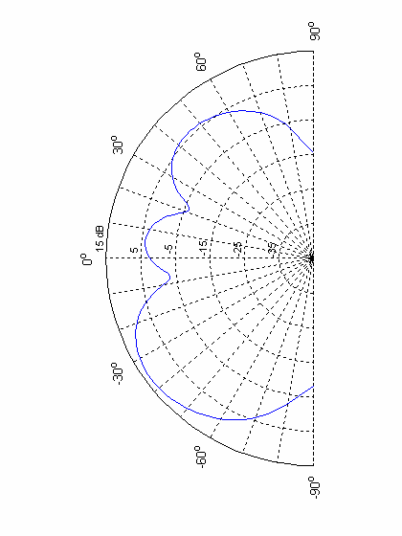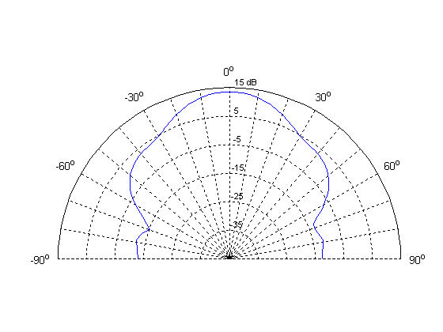

Figure 77: Elevation and azimuth patterns for a single aircraft window coherently illuminated by
an isotropic source

As aperture gain scales inversely with the square of the wavelength, the expected values for other bands are expected as:
- UMTS 2 GHz band (2.14 GHz) is 0.9 dB more, resulting peak gain would be +14.4 dBi
- GSM 1800 MHz band (1.85 GHz) is 0.3 dB less, resulting peak gain would be +13.2 dBi
- GSM 900 MHz band (0.94 GHz) is 6 dB less, resulting peak gain would be +7.5 dBi
B.2.3.3 100% Coherent Model between windows
The worst case condition assumes coherent emission along the window array, a situation which could occur if the leaky cable was perfectly aligned in an empty cylinder. Figure 78 shows the expected azimuth distribution of gain, incorporating the effects of both Factor 3 and Factor 4. In this case, the peak gain occurred at an elevation angle of 37.2° below horizontal, equivalent to the peak gain location of the single window element. The figure shows the gain profile at this elevation angle.
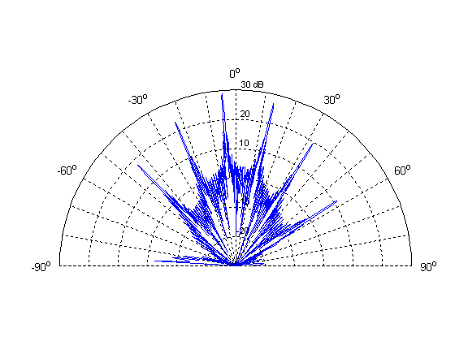
Figure 78: Aircraft azimuth aperture and array gain pattern for the 100% coherent array model. Azimuth slice is shown for peak gain elevation angle of 37.2° below horizontal

Peak gain in this case is 28.8 dBi (for 1.92 GHz), but does not include the single window leakage fraction (Factor 2 calculated above). If the window loss is included, this implies gain peaks of 7.3 dBi relative to the total radiated power of the leaky feeder antenna for 1.92 GHz spectrum band. (equivalent of 8.2 dBi for 2.14 GHz, 7 dBi for 1850 MHz and 1.3 dBi for 900 MHz).
B.2.4 Combined Effects of Coherent and Random Excitation
RF propagation studies have demonstrated significant signal reflection and scattering within the aircraft cabin, even without passengers, seat variations and baggage present. The effect of this internal environment contributes a random element to the illumination of each window and between windows.

The field incident on the window is therefore the vector sum of the individual multipath components. It is convenient for analysis to consider the multipath components that are coherent between windows and those that are random separately.
- Coherent Component: The direct uninterrupted ray from the leaky feeder to the window will have coherency between windows, for which the geometry is consistent along the length of the cabin. These rays may also include direct reflections from the opposite wall or the floor of the cabin.
- Random multipath components: Any multipath component that involves a reflection from an object in the cabin that is not consistent along the length of the cabin will not have coherency between windows. These will include reflections from internal partitions and seats (since these do not have the same pitch as windows). Multipath components involving two or more reflections will generally have enough variability along the length of the cabin that these will also not have coherency between windows

Two models have been proposed for combining the random and coherent radiated components. The first (Approach 1) defines the random array profile as the equivalent of a single aperture and then combines the coherent model and random model in various proportions. The second model (Approach 2) calculates the random profile based on the coherent model and then applies a two component Rician vector model approach to calculate the combined effect. The following describes the output of the two approaches used:
B.2.4.1 Approach 1: Random bounded phase error approach
Approach 1 assumes first that when there is zero phase coherence between windows along the window array (i.e. 100% random phase), all array effects due to Factor 4 are eliminated. In this case, it is assumed that the worst case effective far field pattern becomes equivalent to that of the single window emission profile as described in Factor 3. Figure 79 shows this emission azimuth pattern, which has a peak aperture gain of 13.5 dBi at an elevation angle of 37.2° below horizontal

Figure 79: Aircraft azimuth gain pattern for the 100% random array model. Azimuth slice is shown for peak gain elevation angle of 37.2° below horizontal

Accounting for the 21.5 dB single-window loss value (Factor 2), this suggests an overall peak aircraft gain of −8 dBi (for 1.92 GHz, -7 dBi for 2.14 GHz, -8.3 dBi for 1.85 GHz and -14 dBi for 900 MHz) relative to the total radiated power of the leaky feeder antenna.

The effect of fractional random excitation on the phased array can then be obtained by adding random bounded phase error to the array elements. For example, if the random phase component at each window is equal in amplitude to the coherent component, the resultant signal in the model will have a random phase uniformly distributed between ±90° relative to the coherent component.

Figure 80 shows the predicted azimuth radiation pattern from this model (at the peak elevation angle) for zero, ±30°, ±60°, and ±90° of random phase error across the elements of the phased window array for a 37-window aircraft. In all cases, the peak gain occurred at an elevation angle of 37.2° below horizontal, equivalent to the peak gain location of the single window element. These plots represent the combined effect of the single window aperture (Factor 3) and the window array (Factor 4), but do not include the single window leakage fraction (Factor 2), of -21.5 dB. As the phase error increases to ±30°, ±60°, and ±90°, the peak array gain decreases by 0.4, 1.7 and 3.7 dB relative to the purely coherent case.

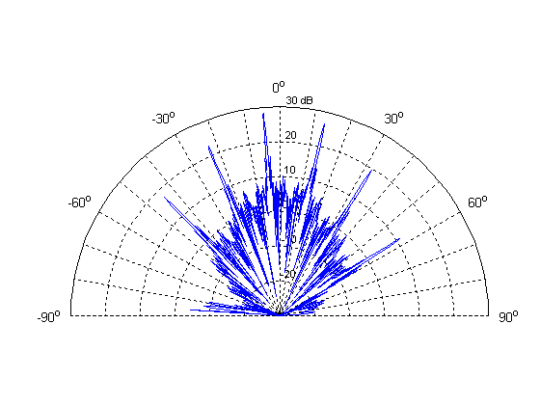
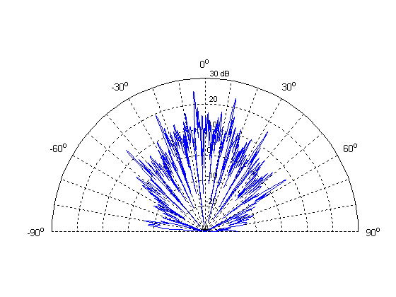
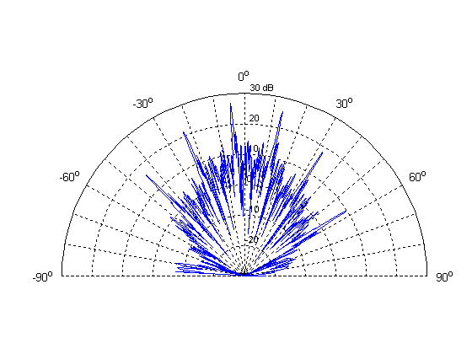
With ±30° Random Phase Errors
(Peak = 28.4dBi)
No Random Phase Errors
(Peak = 28.8dBi)
With ±60° Random Phase Errors
(Peak = 27.1dBi)
With ±90° Random Phase Errors
(Peak = 25.1dBi)

Figure 80: Azimuth plots of aircraft aperture and array gain for varying amounts of phase noise. Azimuth slices are at the elevation angle of maximum gain, 37.2° below horizontal

B.2.4.2 Approach 2: Two component vector model approach
The second approach for evaluating the combination of the random and coherent components applies the “Rician two-component” model. In this approach the random part is constructed as a Rayleigh process with the same average power as the coherent part. The phase of the random part is uniformly distributed [0,2π].

The two complex field components are added with varying weight as shown in Figure 81, producing a resulting complex field value. In order to assess how varying power ratio between the two components influences the radiation pattern and peak gain, the Rice-factor K is used.

Figure 81 Complex addition of the coherent and random field components. The dashed vectors indicate that the random component can take any direction and length

An observation from the two component model is that the calculated gain-value is sensitive to the power ratio between the coherent and random components (the Rician K-value). A difference in gain between 5 and 6 dB is estimated to occur when the power ratio changes from 75 / 25 to 25 / 75.

Figure 82 shows predicted azimuth radiation patterns (1800 MHz/37 windows) based on the two-component model, confirming the values obtained by the “random bounded phase error approach” for coherent dominance and adding the case of random dominance.

With 75 / 25 power ratio With 50 / 50 power ratio
(Peak = 26.9 dBi) (Peak = 24.7 dBi)

with 25 / 75 power ratio
(Peak = 21 dBi)
Figure 82 Azimuth plots of aircraft aperture and array gain determined by a Rician two-component model for different coherent/random power ratios

B.2.4.3 Comparison of the two combining approaches
The two approaches proposed provide very similar methods for analysing the effects of multiple apertures illuminated by a leaky cable. Both approaches analyse the combinations of the in phase and random components in a multiple window array. Both approaches also assume the same antenna pattern when all components are in phase. However neither case considers the affects of absorption of the signal within the aircraft. Where the two models differ is the assumptions behind the random case, and the combinations of the random case with the coherent model.
- The first case assumes that the random model simplifies to the equivalent of a single aperture. The combination is calculated using a random bounded phase error approach.
- In the second approach the random part is constructed as a Rayleigh process with the same average power as the coherent part, the phase of the random part is uniformly distributed. The combination is calculated using a two vector Rician model.

The results of the two approaches for combining varying random components would indicate that the random bounded phase approach +/- 90 degree case has similar peaks to the Rician two component model for 50/50 power ratio. Furthermore the two-component model results reveal that when random components dominate, shown in the 25 / 75 power ratio, the gain drops significantly. Both analyses show peaks and variations of attenuation with direction (spatial variations). The results of measurement campaigns of in cabin signal propagation using a leaky feeder indicate a close alignment to Raleigh fading.

Note that the compatibility report uses a non directional characteristic for the effective attenuation of the aircraft, i.e. the attenuation is constant at all polar angles. Consequently in the compatibility report the worse case position for interference from the leaky cable and aircraft transmission is to terrestrial mobiles directly below the aircraft. In the modelling approaches presented above the worse case elevation angle is predicted at 37.2 degrees below the horizontal, with an average antenna gain perpendicular to the aircraft of about 10 dB. Taking into consideration the -21.5 dB of radiated power that escapes out of the window this equates to an effective worse case average gain of -10.5 dB at 37.2 degrees. On calculating the difference in free space path loss of 37.2 degrees compared to 90 degrees (as used in the report for the worst case elevation) this equates to approximately 4.5 dB further attenuation (i.e. effective attenuation to mobiles directly below the aircraft of -15 dB).
B.2.5 Temporal Characteristics of Ground Interference
The spatial variations in the aircraft leakage pattern imply that there is a significant temporal characteristic to the ground interference. Although the terrestrial victim is subject to higher peak levels of interference due to the directionality of the leakage pattern, the duration of this exposure is limited by the beamwidth of the gain peaks. Consideration of spatially-varying aircraft emission due to aperture and array effects introduces a new category of interference, “higher gain/short duration” or “transient” interference. The peaks of increased field strength may sweep over the ground alongside the flight path of the aircraft as it passes overhead. Interference events lasting less than one second could cause disruption to GSM connections operating close to the link budget limit, although this would not be sufficient to drop the connection. To assess this effect, the time history was simulated for a single victim receiver on the ground using the random bounded phase error approach. Note that any consideration for this effect must also include the probability analysis of the combination of these conditions occurring to a mobile station at the same time that it is operating at its thermal limit.

An aircraft possessing the radiation patterns shown in Figure 80 (the random bounded phase error approach) was simulated on a straight line trajectory at an altitude of 3,000 m above ground level and an assumed speed of 400 km/hr over the ground. It should be noted that commercial aircraft operate at approximately 800km/h while at cruise altitudes and so in this case the duration of the ground illumination will be half the time shown in this analysis.

The aircraft was modelled with an interference source consisting of a leaky feeder antenna with an assumed total e.i.r.p. of −7 dBm. A leakage fraction of -21.5 dB was assumed, consistent with previous analysis.

A single victim receiver was positioned on the ground so that the peak of the radiation pattern passed exactly over it. Accounting for line-of-sight path loss between the aircraft and victim, the time history of power received on the ground was determined and compared to the 1 dB desensitisation point (I/N = -6 dB, I= -120 dBm for “typical” device) for a GSM receiver.

Figure 83 and Figure 84 show the simulated time history of received interference power for a period of 120 seconds at the worst case elevation angle surrounding the interception of the array pattern gain peak for the 100% and the ±90° random phase coherent model. The horizontal dotted line denotes the I/N = -6 dB threshold. In this case, the power level exceeds the interference threshold during four of the gain peaks. The right side of the figures show the close-up of the pass of the maximum gain peak. Assuming 100% coherency, the interference power exceeds the threshold for a period of 570 ms. Transit time for the other three peaks was in the range of 200-400 ms.

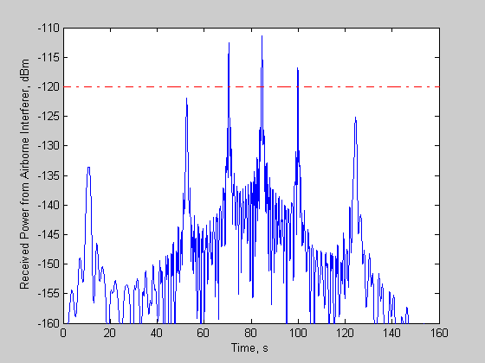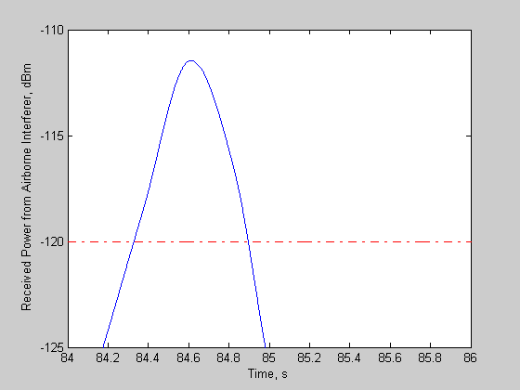

Figure 83: Time history of interference power received by g-MS. 100% coherent array model. Dotted line denotes the (I/N = -6 dB) interference threshold for a GSM mobile. Plot on right is close-up view of the main gain peak

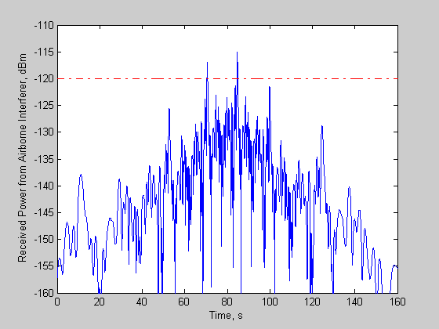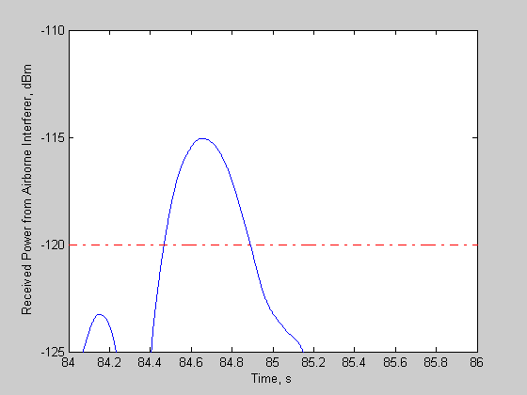

Figure 84: Time history of interference power received by g-MS. Phased array with ±90° random phase error

B.2.6 Field Measurement Challenges and Considerations
Making measurements related to the topic of window effects on fuselage leakage is very challenging; the radiation pattern of an antenna can only be measured properly in its far field. For a typical aircraft, the far field distance for the aperture of the length of an aircraft (30 / 50 m) would be over two kilometres. As the main lobes are narrow, it is also necessary to make measurement with a high angular resolution.
To date no array effect has been observed in measurement campaigns. However these measurements have been made at a distance of less than 100m, and generally with an angular resolution that is less than the expected beamwidth of a phased array of windows.

The following points should therefore be considered when establishing a test campaign to look at these effects
- The influence of any potential window array effects can only be observed in the far field of the array, at a distance of several kilometres for a typical commercial airliner. In order to measure both the elevation and azimuth components of the path loss from cabin to ground for the purpose of modelling, flight tests would therefore be required. Successful / accurate measurement of this phenomenon using in-cabin picocells is unlikely given the very low signals strengths received on the ground due to the high attenuation from free space path loss. Consequently, alternative signal sources allowing higher transmit powers would be necessary to test this. It is highlighted that perfect laboratory environment conditions will be impossible given the inability to replicate the same conditions reliably.
- Single-window emissions from a real aircraft probably cannot be measured in the far field, since at the requisite minimum distance of approximately 1 m (assuming frequencies in the 1800/1900 MHz band), it is not possible to isolate a single window. Consequently, near-field techniques are necessary.
- Given the dimensions of the typical aircraft window, an antenna used for near-field measurement must be sufficiently small so as not to cause distortions of the gain, phase, and polarization pattern of the window aperture field. Near-field measurements of a single window aperture require a specialized measurement probe (such as an open-ended waveguide) and very careful calibration.
- In order to assess array effects, the field associated with an aircraft window aperture being radiated from within the fuselage by a leaky feeder must be measured on the outside of the aircraft fuselage in order to determine the actual polarization and field distribution of the signal passing through the window.
B.3 SUMMARY OF THE ANALYSIS OF THE ATTENUATION DUE TO THE AIRCRAFT, WITH LEAKY CABLE TRANSMISSION
In this Annex two models for characterising aircraft fuselage attenuation due to leaky feeder radiation and possible array effects have been presented. Both of these employ a standard array factor but differ in the way the window aperture fields (the array elements) are calculated. The two models are in turn based on:
- a field-integral equation method for obtaining the window aperture field resulting from the feeder radiation, thus implying a coherent sum of array elements;
- an approximate aperture field augmented by a random phase factor, which implies an incoherent sum.

The coherent model (first bullet point) yields significant variability of the array antenna signal with a peak gain of 7.3 dB (1.92 GHz) relative to the total radiated power of the leaky feeder at an angle of 37.2 degrees below the horizontal (7 dB for 1850 MHz and 1.3 dB for 900 MHz).

Coherent and incoherent (random) component can be combined in both of the modelling approaches. To do this, a random phase variation was introduced in the first model above, and a two component Rician method was used for the second. The minimum attenuation of the fuselage increases as the proportion of random components increases, and the gain effect gradually disappears: for the completely random case the first method yields a minimum attenuation of 8 dB at 37.2 degrees below the horizontal. The second method indicates a 1.5 dB lower attenuation for a similar case. A direct comparison is not straightforward and the methods differ in the way the random component is defined.

It is difficult to draw conclusions on the proportion between coherent and random components and hence the significance of the array effect. It is noted that the models are very approximate but should work reasonably well for minimum aircraft attenuation. The leaky-feeder measurements made to date and summarized in Annex C were made with the aircraft under test on the ground. The array effects can only be measured in the far field (order of km distance) and hence, if they occurred, would not have been identified by these measurements.

ANNEX C: SYNTHESIS OF MEASUREMENT CAMPAIGNS PRESENTED DURING THIS STUDY
The following provides a summary of all test campaign measurement results received during writing of this report for the analysis of the effects of the GSMOB to terrestrial networks. The results are not intended to provide absolute values but merely give an indication of the actual results obtained from a number of measurement campaigns carried out by different companies and involving a range of aircraft types.
A summary of the overall results obtained per measurement campaign is provided which is followed by a description of the actual measurement campaigns carried out.
C.1 SUMMARY OF TEST MEASUREMENTS RESULTS PRESENTED
The results of the measurement campaigns presented are summarised into three areas:
- Measured in cabin received terrestrial signal strength
- In cabin fading
- Effective aircraft attenuation.
As well as the results measurements obtained, the tables below include a brief description of the tests carried out with a more detailed description provided in the later subsections.
C.1.1 Summary of Measured Received terrestrial networks signal strength
All values highlighted are made inside the cabin, i.e. the effect of aircraft attenuation to terrestrial signals is included here.

Source | Description | Value | Comments
Airbus | Flight test using Airbus A320 over France Metropolitan area covering the  900 MHz band | Maximum -78 dBm/200 kHz  Typical values between -80 and – 85 dBm at 3,000 m | Same maximum and typical range measured for both a single 200 kHz frequency and averaged over all 900 MHz band.
Telenor | Flight test using Boeing 737 700 over Norway Central Eastern part (north of Oslo region), covering the 1800 MHz band | Maximum  -84 dBm/200 kHz, typical measured value -95 dBm/200 kHz | Altitude: 4900 m, TEMS measurements (scanning mode).
Qualcomm | Flight test using Cessna Citation and Bombardier Global Express aircraft  Values quote both terrestrial BTS and terrestrial mobile signals entering the aircraft. | -88.9 dBm/200 kHz ;  g- BTS above 3,000 m  -97.9 dBm/200 kHz  g-MS above 3,000 m; both values are based on 90th percentile of in-flight measurements taken on multiple flights. | The values were first calculated for 1,25 MHz CDMA systems in the 1900 MHz Band and then they were adjusted for the GSM bandwidth. So its is 1900 MHz / 200 kHz channel
Ericsson | Flight test over Stockholm, Sweden area, covering the 900 MHz. | -75 to -80 dBm/200 kHz
Qualcomm | Flight test of a Boeing 737 over northern USA at 3000 m and 9000 m altitude. Two sets of measurements carried out:  Measurements of power received by CDMA2000 mobile from base stations in 800 and 1900 MHz band  Measurements of acquisition of CDMA2000 mobile of base stations in 800 and 1900 MHz band | Measurements of power:  At 800 MHz, 90th percentile power of -77dBm/1.25 MHz (≡ -85 dBm/200 kHz) for window and ~ -85 dBm/1.25 MHz (≡ -93 dBm/200 kHz) for seat positions.  At 1900 MHz, 90th percentile power of -96 dBm/1.25 MHz (≡ -104 dBm/200 kHz) for window and ~ -98 dBm/1.25 MHz (≡ -106 dBm/200 kHz) for seat positions.  Measurements of acquisitions  At 3000 m altitude and 800 MHz, acquisition rate of 94-98% for window and 70-98% for seat positions.  At 9000 m altitude and 800 MHz, acquisition rate of 75-95% for window and 52-54% for seat positions.  At 3000 m altitude and 1900 MHz, acquisition rate of 35-44% for window and 29-37% for seat positions.  At 9000 m altitude and 1900 MHz, acquisition rate of 45-49% for window and 33-44% for seat positions. | Performance of WCDMA network should be very similar.  Phones in seats receive ~5 dB less power than phones in window.  Aircraft altitude had no significant effect on received power.  At 9000 m, it is possible to acquire base stations up to 700 km away.  The two values relate to left and right seats/windows.
Table 131
C.1.2 Measured fading effects inside the cabin
Source | Description | Value | Comments
OnAir/Airbus | Static test on Airbus A340. Using the 1800 MHz band | For 95% availability  -12 dB to 5 dB for in cabin fading
Qualcomm | The results for a GSM 200 kHz channel are derived by reanalysing the raw data measurements in the US PCS band, between 1974.74 and 1987.25 MHz. | 90% confidence  -8.7 dB  99% confidence  -18.5 dB
OnAir | Static test on Boeing 737-800 BBJ for the 1800 MHz band | Total fading (99 % confidence) -17 dB to +5 dB
Ericsson | Test on MD81 for GSM/WCDMA/WLAN bands 900-2500 MHz | For 90% confidence 10 dB  For 95% confidence 13.5 dB
Telenor | In-cabin propagation from dual radiating cable | 99 % fading approximately 12 dB, coupling loss approximately 58 dB
Table 132
C.1.3 Measured affective attenuation caused by aircraft
C.1.3.1 Effective attenuation caused by the aircraft either to or from a mobile at the window

Effective attenuation caused by the aircraft either to or from a mobile at the window.
Source | Description | Value | Comments
Airbus | Flight test of Airbus A320 with internal and external antenna for the 900 MHz band | Minimum 15 dB to Maximum 18 dB for whole band.  Minimum of 10 dB to Maximum of 12 dB for single carrier observed. | Comparing internal and external antenna results of both single carrier and across the whole 900 MHz band. Measured in flight.
Airbus | Static test of Airbus A340 of mobile receiving on board base station signal for the 1800 MHz band | Minimum 11 dB to a Maximum of 17 dB | For signals received outside the aircraft at the worst case position.
Telenor | Flight test in the Central Eastern region of Norway measurement of 900 and 1800 MHz band | Ranges from 0 to 32 dB | In-cabin TEMS measurements (4900 m) compared to theoretical calculation based on ac-position and relevant data for terrestrial network (position, power, antennas)
Qualcomm | Based on RF campaign of CDMA technology on a Boeing 727. For the 850, 1900 and 2450 MHz bands | 2 dB at 850 MHz  6 dB at 1981 MHz  5 dB at 2450 MHz; these are all median values
Ericsson | Test on MD81 for GSM/WCDMA/WLAN bands 900-2500 MHz | Ranges from 5 to 35 dB avg (0 to 90º elevation),  1 to 30 dB min at 900-1900 MHz  11 to 42 avg (6 to 40 min) at 2440 MHz | Window seat
OnAir | Static test on Boeing 737-800 BBJ for the 1800 MHz band | Ranges from 8 dB to  15.7 dB  13.41 dB average
Airbus | Static test of Airbus A340 of mobile at the window transmitting to external base station for the 1800 band | Ranges at worse case position of from minimum calculated value of 9 dB to maximum 17 dB loss
Airbus | Static test on Airbus A321 for the 1800 MHz band | 13 dB loss in average. Airbus proposes the use of 10 dB as conservative value for Airbus aircraft | Tested with dipole transmitter at the window area.
Telenor | Ground measurements on a Boeing 737-800 at Gardermoen airport | 900 MHz: Ranges from 7-12 dB average  1800 MHz: Ranges from  8 -9 dB | Comparing TEMS-measured values of RXlev from surrounding BTSs inside cabin with reference measurements at same position and height without aircraft present
Boeing | Flight test of a Boeing 737 over northern USA at 3000 m and 9000 m altitude. Signal from a CW ground station at 1989 MHz | Facing window seats:  5 dB gain max, 12 dB average attenuation.  Aisle seats:  3 dB max, 16 dB av. attenuation | Highest gain tends to be broadside to, and horizontal with the long axis of the fuselage.
Table 133

C.1.3.2 Effective attenuation caused by the aircraft for the onboard BTS / NCU to terrestrial mobiles
Effective attenuation caused by the aircraft for the onboard BTS / NCU to terrestrial mobiles
Source | Description | Value | Comments
OnAir | Static test of Boeing 737, of a leaky cable for the 1800 MHz band | 13.9 dB (worse case window/wing)
Airbus | Static test on Airbus A321 using leaky cable for both 900 and 1800 MHz bands | Average values:  900 MHz  = 12 dB.  1800 MHz  = 17 dB. | Attenuation values quoted for a single leaky cable solution
Ericsson | Static test of MD81 GSM/WCDMA/WLAN bands 900-2500 MHz | 1800 MHz range 19 to 35 dB average (0 to 90º elevation), 12 to 26 dB min | Indoor measurement, severe reflections, near-field values
Table 134

C.2 DESCRIPTION OF MEASUREMENT CAMPAIGNS PRESENTED
The following describes the test campaigns carried out to obtain various values related to the GSM on board service. The descriptions are separated according to the author company and displayed in alphabetical order.
C.2.1 AeroMobile (Telenor /ARINC)
AeroMobile carried out a number of measurement campaigns and the three examples presented contain results from two static tests and one in flight test.

A flight was carried out over Norway (but avoiding densely populated areas around Oslo) using a Boeing 737 – 700. Total flight time was approximately 1 hour. A test (TEMS) mobile was positioned at the window and later data obtained from the equipment was correlated with GPS equipment (receiver located on other side of aircraft) and relevant known terrestrial cell parameters (position and antenna height, antenna type, output power). A number of errors in accuracy were highlighted including limitations due to the TEMS receiver and GPS “noise” (due to aircraft speed and direction). Calculations for the effective attenuation based on the measurements showed a large fluctuation in results. Reasons for this variation were attributed not only to the accuracy of the measurement equipment but also to the combination of measured results with theoretical calculations to determine the attenuation of an aircraft. Finally it was highlighted that the maximum measured received level throughout the whole test in the 1800 MHz band within or outside of the main lobes of the antenna was measured at – 84 dBm/200 KHz. The typical value inside the main lobe was measured around -95 dBm/200 KHz. Assuming 40 dBm or more BTS power at the antenna input then this suggest a path loss of over 125 dB (including the BTS antenna).
A static test campaign was carried out using a Boeing 737 – 800 at Gardermoen Airport outside Oslo. Measurements were taken by TEMS equipment monitoring the BCCH-channels of live GSM cells. The aircraft was placed in a remote position at the airport, and turned in order to get measurements from different angle of sight towards the cell sites. As a reference the received levels were measured at the same location (with the antenna placed on a high pole) without the aircraft present. In each position the antenna was moved around within some 15-20 cm in order to reduce the fading permutations. The intention was to position the aircraft with a pointing direction directly towards the BTS site, and turn it 180 degrees in 22,5 degree steps. Some practical problems linked to the pushing of the aircraft resulted in the measurements at slightly different positions, as shown in Table 135 below.

The signals from two cells at the same site were measured at both 1800 and 900 MHz. The distance from the cell to the place of measurements was approximately 1.5 km.

In Table 135 the measured difference in the measured values at window seat 3A compared to the reference is shown for each position, each cell and both frequencies. The A-seat is on the left-hand side of the fuselage, i.e. all measurement angles except the first one have more or less direct line of sight towards the BTS site. (In some cases a group of trees was in the path).

Signal angle of arrival (º) | 900 MHz |  | 1800 MHz
Signal angle of arrival (º) | Cell A (dB) | Cell B (dB) | Cell A (dB) | Cell B (dB)
-11 | 9,96 | 10,14 | 9,32 | 7,17
9 | 8,4 | 12,48 | 1,39 | 2,06
33 | 11,92 | 11,99 | 9,22 | 13,24
54 | 10,89 | 8,79 | 4,04 | 7,67
75 | 6,65 | 3,86 | 7,30 | 12,01
97 | 11,10 | 7,99 | 8,20 | 4,13
119 | 15,96 | 8,32 | 10,49 | 6,33
142 | 14,31 | 10,13 | 9,26 | 12,76
179 | 8,42 | 12,17 | 4,37 | 8,25
Average value  (linear) | 11,8 | 10,2 | 7,9 | 9,6
Table 135: MS measured aircraft attenuation

A second test campaign was carried out by ARINC using a Boeing 777. This analysed the in-cabin propagation characteristics of a two cable installation The two radiating cables of 8 m length were placed in the lighting duct over the parallel aisles, as shown in Figure 70. The BTS power into each segment was –9 dBm, and the received levels were measured also in this case by TEMS equipment.

Figure 85: System test setup

Figure 86 shows the PDF (Probability Density Function) of all measured levels. It suggests that the 1% fading value is around 12 dB. The manufacturer data for the coupling loss of the radiating cable is 68 dB at 1800 MHz (50% / mean value). Even if we correct for dual sources, the measured levels indicate that in the aircraft environment the coupling loss is less than the manufacturer data for free space.

Figure 86: PDF for measured RX levels

C.2.2 Airbus
Three different Airbus measurement campaigns have been submitted for consideration, one in flight test (using a single aisle A320) and two static tests (using a wide body A340 and a single aisle A321).

A flight test was undertaken using an external antenna (mounted on the lower fuselage) and an internal antenna located in the cabin with flight route around the French metropolitan area from Toulouse, Marseille, Paris and then back to Toulouse. Results of the flight test measuring the received terrestrial network broadcast signals in the 900 MHz range using a Rhode and Schwarz FSH spectrum analyser were: received internal power level range from -78 to -83 dBm at 10,000 feet (3,000 m). The external antenna showed RF values between -64 and -85 dBm. Assuming a BTS transmitting at 40 dBm this indicates a minimum path loss including the gain of the antenna as 118 dB for this test campaign. Comparisons between the internal and external received signal strengths indicate a difference between 10 to 12 dB for a single 200 kHz frequency and between 15 and 18 dB difference for the averaged power.

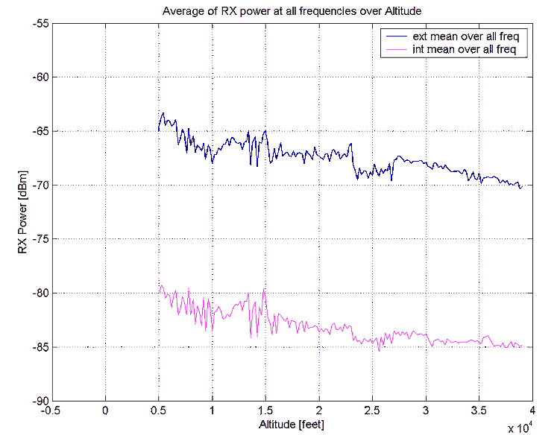
Figure 87

Airbus performed a static test using an Airbus A340 600 aircraft with a pico cell and leaky line installed. The objective of the tests was to determine the internal coverage characteristics of the leaky cable antenna solution and the external leakage of the signal. On measuring at set distances outside the aircraft with a mobile transmitting at full power at the window indicated a drop at the receiver compared to the free space path loss calculation between 9 and 17 dB. The distribution of signal inside the aircraft gave a fading between -12 and + 5 dB in 95 % range, see cdf plot below:

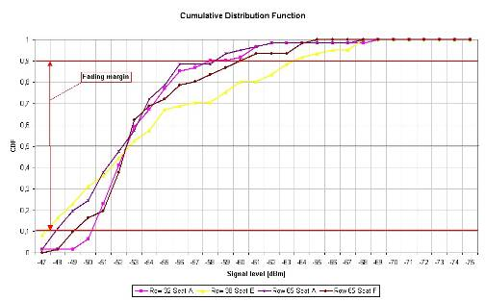
Figure 88

Airbus performed a second static test on a single aisle A321 aircraft using a pre commercial set up (both of equipment and location of installation of cable) of their proposed solution and tested connectivity for GSM 1800 and control for 900 and 1800 MHz for GSM networks. The leaky cable was installed above the overhead bins close to the centre line of the upper fuselage. A 200 kHz carrier with GMSK modulation was used as the signal transmitted. Four lines of measurements were taken corresponding to seats just in front of the wing and seats just behind the wing, see figure below:

Figure 89: Principle setup aircraft attenuation test

Measurements were made of the received signal at the various points, covering angles between

test spot | α°  (angle between AC window and test points) | Attenuation values based on measurements at C60 spots (leaky cable test) | Attenuation values based on measurements at C28 spots (dipole test)
1 | ~11 | 17 dB | 14 dB
2 | ~12 | 2dB | 14 dB
3 | ~13 | 16dB | 14 dB
4 | ~15 | 5dB | 13 dB
5 | ~17 | 12dB | 13 dB
6 | ~19 | 5dB | 13 dB
7 | ~23 | 6dB | 12 dB
8 | ~27 | 19dB | 11 dB
9 | ~34 | 9dB | 15 dB
Table 136

Note it is highlighted that the measurement signals from the leaky cable vary considerably. This is attributed to the additional contributions from other sections of the leaky cable and/or external reflections which have not been taken into consideration in the calculated reference values.

A final measurement test was carried out to determine the RF signal strength around the aircraft at discrete points 30 and 50 m radius around with an input power to the cable of 23 dBm / 200 kHz in the 1800 MHz range. The measured values for each point are shown below.

Figure 90

C.2.2 Ericsson
Ericsson carried out one flight test over the Stockholm area and a number of static tests at Stockholm’s airport. Measurements from the aircraft flight test over Stockholm area (urban and rural) show –75 to –80 dBm signal level from terrestrial 900 MHz networks.

Ericsson also carried out three separate static measurement tests using a McDonald Douglas MD-81 located inside a hangar (50 m X 50 m) at Arlanda Airport (Stockholm, Sweden).

- Part One: The first analysis measured the in cabin performance of three different leaky cable configurations inside the aircraft, measurement were obtained using a TEMS receiver
  - Set up a) two cables at the overhead bins close to the ceiling. Median value of -61.5 dBm measured with a fading margin of 15 dB for 5 to 95 % of all measured values.
  - Set up b) one cable at the ceiling covering the entire cabin. Median value of -64 dBm measured with a fading margin of 15 dB for 5 to 95 % of all measured values.
  - Set up c) two cables above the window. Median value of -61.5 dBm measured with a fading margin of 13 dB for 5 to 95 % of all measured values.
The measured coupling loss was calculated as 50 dB while the manufacturer coupling loss for free space was quoted as 67 dB (95 %) for 1800 MHz.
The same approach was taken but this time using a network analyser for the cable setup b). The results showed on average the variation is less than 12 dB for 1800 MHz band and less than 14 dB for any band. In addition the narrowband measurement (1 kHz) reveals a Rayleigh fading environment with 12 dB maximum spread with frequency and position in a narrow band system.

- Part Two A walk-around while recording the signal strength at specific positions was made at different distances and angles to the aircraft. Measurements were made using a TEMS receiver at a window height along the walls of the hangar, i.e. 3.6 m above ground.
Apart from the front part and behind the aircraft, the measuring distance was 20 m. The procedure was repeated on the ground, 1.2 m above ground and several times: 1) along the same route as at window height, 2) 3 m from aircraft body and 3) just below the windows. By adjusting the values to a reference distance and normalized to the measured values at window height, an elevation angle-dependence was estimated.

Angle to horizontal plane at window height | Relative attenuation factor (dB) | Leaky cable configuration
0º | 0 | a)
10 º | 4 | a)
40 º | 9 | a)
90 º | 17 | c)
Table 137

The average signal level at window level at a distance of 16 m was 23 dB below the average value inside the cabin. Applying Morgan’s formula for calculating the equivalent, radiated power of leaky cables, and assuming free space propagation outside the aircraft, the results indicates a 19 dB hull attenuation of the power radiated by the two 30 m leaky cables.

- Part Three: Attenuation of signals to and from a MS inside the aircraft to the outside. This set of measurements was performed around the same aircraft as in part 1 in a hangar.
The measurements were performed with a network analyzer, generating a weak swept CW signal on all GSM/WCDMA bands into a broadband antenna, and receiving the same signal via another broadband antenna inside the aircraft.

Although the scattering is fairly large due to uncompensated reflections, it is clear that the aircraft body attenuation increased significantly for angles from 45º to 90º, 90º being in the vertical plane at the windows. For all GSM bands there is an attenuation of at least 10 dB at 45º, approaching 20 dB immediately below the aircraft. It was noted in the analysis that there is an additional contribution from ground reflections by up to 6 dB for lower angles for some measurements. These could not be resolved completely with increased spread and reduced accuracy as a consequence.

Overall Ericsson Measurement test Conclusions
- Although some results available from these tests are preliminary, some conclusions may be drawn already:
- In cabin propagation variation is restricted to 12-15 dB for more than 95% of measured values on all positions as seen by a GSM MS. The variation of the average signal strength of all seats is 12-15 dB.
- Aircraft body attenuation for signals to and from the mobile inside the aircraft increases significantly for angles in the range 45º to 90º to the horizontal plane. At window level the attenuation is at least 4 dB at 1800 MHz, but at 45º an attenuation of at least 10 dB is expected, approaching 20-30 dB at 90º.
- The aircraft body attenuation for signals from leaky cables is measured to be at least 19 dB. Using 15 dB as a worst case value is fairly conservative. This value applies at low elevation angles and the attenuation is increasing with increasing elevation angle.
C.2.4 OnAir
OnAir presented the results of their static measurement campaign using a Boeing 737 – 800 BBJ executive fit set up aircraft carried out at Geneva Airport in Switzerland. The antenna system was first measured outside in close to free space conditions. The same antenna was then tested inside the aircraft. The aircraft system comprised of the leaky cable antenna set up suspended along the ceiling of the aircraft. A continuous wave un-modulated signal was used for the NCU signal and a Gaussian wave simulated up to 4 GSM carriers for the connectivity part. Tests were made both for external signals inside the aircraft and RF leakage around the aircraft up to a radius of 50 m.

Measurements of the strongest BCCH 50 metres from the aircraft were made and an average of -43.57 dBm was recorded at the strongest position (0.81 km away). The strongest received signal of a whip antenna at the window facing the base station was measured as -52.2 dBm (– 6.7/ +3.2 at the 99 % confidence level). This calculation assumes that the variation of 50 metres (between 810 m and 760 m) was due to free space path loss (i.e. 0.6 dB). This would suggest an effective attenuation of 8 dB for the window facing broadside to the BTS antenna. It is noted that the measurements around the aircraft indicated an increase compared to the value at 50 m, however this increase was not observed inside the aircraft.

The effective coupling loss of the leaky cable inside an aircraft was compared with both the manufacturer’s value and testing in the open air. The manufacturer stated value of 69 dB was verified by open air testing (variation of -69 to 75 dB). Measurements in the cabin gave an average coupling loss of -57.1 dB indicating up to 12 dB gain compared to the free space coupling loss, presumably due to scattering. Measurements of the in cabin signals were also made to ascertain the fading.
C.2.5 Qualcomm
There were two / three measurement campaigns presented by Qualcomm covering a range of areas from internal RF characteristics of a leaky cable to leakage of signals.

An investigation of in-cabin propagation was conducted using a Boeing 727. Although initially carried out to understand the in-cabin propagation for CDMA 1X it was later recalculated for a GSM 200 kHz carrier between 1974.75 and 1987.25 MHz. The actual tests covered both discone antenna and a leaky cable antenna. The results of the leaky cable analysis were recalculated for GSM carrier indicating fades of 8.7 dB for the 90th percentile and 18.5 dB for the 99th percentile. It was noticed that the distribution tracks a Rayleigh fading even more closely than the 1.25 MHz (CDMA 1X) case.

Figure 91: Cumulative distribution of power variation about the median.
Leaky feeder antenna, 200 kHz channel bandwidth

Qualcomm have undertaken a number of airborne and ground based tests using private and commercial aircraft. Quoted values of received levels of interference from ground CDMA 1X networks in the 1900 MHz spectrum provide -81 dBm and -89.94 dBm for the 90th percentile for CDMA 1X networks and terminals respectively. This equates to an equivalent GSM power of -88.9 dBm/200 kHz for terrestrial networks and -97.9 dBm/200 kHz for terrestrial mobile signals entering the aircraft.

The description of the tests covering the acquisition and measurement campaign highlighted in the summary table can be found in Annex F.
2.6 Boeing
The description of the tests aircraft attenuation campaign highlighted in the summary table can be found in Annex F.

ANNEX D: DETAILED DESCRIPTION ON THE NCU
D.1 GENERAL DESCRIPTION
The NCU controls the signal transmission of in-flight mobile phones by generating a suitable noise floor in the aircraft cabin. In order to allow connectivity on board the aircraft the NCU ensures that a) in-flight mobile phones do not transmit without control of the GSM on board system and b) that in-flight mobile phones do not roam onto terrestrial mobile phone networks.
The power level of the control signal is dependent on the aircraft altitude and geographical position. That means that the NCU will decrease the power level with increased flight altitude and vice versa. In order to ensure the correct level for the control signal the NCU will calculate the absolute height above ground, depending on the aircraft position and regulation for each country over flown. The NCU is only active above 10000 ft / 3000 m. Hence the NCU is not active below 10000 ft /3000 m, during take off, landing or on the ground.
The power level needed for each control band can be dynamically modified via a configuration database, which is implemented in the NCU itself and the GSM onboard server. In this annex only the control bands considered in the report (see section 1.2) have been taken into account.
D.2 LIMITS ON THE EMISSION OF RADIO FREQUENCY ENERGY ON BOARD CIVIL AIRCRAFT
For all airborne electronic equipment, the EUROCAE-14E (2005) and its US equivalent DO-160D defines a series of minimum standard environmental test conditions and applicable test procedures. The purpose of these tests is to determine that the equipment does not emit undesired RF noise in excess of the levels specified in the measurement instructions. The NCU must be tested, except in band of the wanted control bands, according to category M requirements. This category is defined for equipment and interconnected wiring located in areas where apertures are EM significant and not directly in view of radio receiver’s antenna. This category is suitable for equipment and associated interconnecting wiring located in the passenger cabin or in the cockpit of a transport aircraft. Figure 92 shows the limit lines for category M and H. Category H is defined for equipment located in areas, which are in direct view of radio receiver’s antenna. This category is typically applicable for equipment located outside the aircraft.

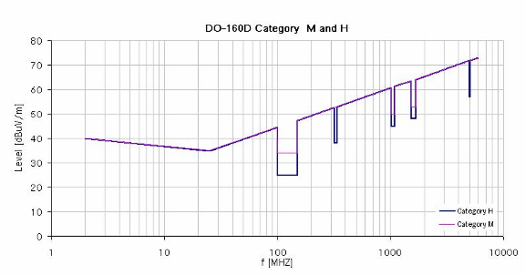
92: Limit line for emission of radio frequency energy according to category M and H

It is required that the wanted NCU emissions (in-band) follow a dedicated value according to transmit the suitable noise floor. For the out of band characteristic the DO-160 requirements described above will have to be complied with.

D.3 SIGNAL AND SPECTRUM CHARACTERISTICS
The signal generated constitutes band limited noise.
D.3.1 Measurement results for a NCU Prototype
Measurements were carried out for a NCU prototype operating in the GSM900, GSM1800 and UMTS2100 downlink frequency bands. The output spectrum was measured with narrow, middle and wideband span. The results are shown in the following figures.

Figure 93:GSM 900 output spectrum narrow band

Figure 94:GSM 900 output spectrum

Figure 95: GSM 900 output spectrum wideband

Figure 96: GSM 1800 output spectrum narrow band

Figure 97: GSM 1800 output spectrum

Figure 98: GSM 1800 output spectrum wideband

Figure 99: UMTS output spectrum narrow band

Figure 100:UMTS output spectrum

Figure 101: UMTS output spectrum wide band

D.3.2 Comments on measurement results
The emitted power of the NCU prototype in the control bands was set to 0 dBm per 200 kHz equal to the GSM channel bandwidth. Note that the “noise floor” of about -70 dBm as shown in the wideband measurements is NOT the physical noise floor. This limit is through the dynamic range limitation of the spectrum analyzer and can be reduced with appropriate Notch filters in the measurement setup.

Note the measurements made are quoted inside the aircraft; consideration must be taken into account that the aircraft will be operating above 3,000 m from the ground and an additional path loss will be encountered (101, 107 and 108 dB attenuation at 3,000 meters for 900, 1800 and 2000 MHz respectively).

ANNEX E: CHARACTERISTICS OF G-BTS/NodeB
E.1 REFERENCE POINTS ON BASE STATION RECEIVER
Given the various combinations by which the BTS cabinet and antenna complex can be configured the following highlights two main cases and provides values to derive parameters between the test ports highlighted.

Reference case 1: Basic case: only cable loss and connector loss

Figure 102: BTS Reference Case 1 (No LNA)

Reference case 1 reflects the configuration assumed for the values referred to in the 3GPP specifications. It consists of a BTS cabinet and antenna where only cable loss and connector loss are considered.
- Derived value (from specifications) for Noise Figure at point A: 8 dB.
- Noise Floor at point A (GSM BTS): -113 dBm/ 200 kHz
- Typical cable and connector loss: 3 dB.
- Resulting Noise Figure at point B: 11 dB.
- Resulting Noise Floor at point B (GSM BTS): -110 dBm/ 200 kHz

Reference case 2: Typical deployed case: LNA mounted close to the antenna, frequency diversity

Figure 103: BTS Reference Case 2 (LNA included)

Reference case 2 reflects the configuration assumed for typical operator configuration. It consists of a BTS cabinet and a low noise amplifier and associated antenna. Note that losses due to multiple carriers sharing the same antenna are not included.
- Typical Noise Figure for LNA: 2 dB.
- Typical cable and connector loss: 3 dB.
- Resulting Noise Figure at point B: 4 dB.
- Resulting Noise Floor at point B: -117 dBm / 200 kHz

E.2 g-BTS/NodeB Antenna patterns
The g-BTS antenna patterns represent generic antenna patterns covering the majority of real antenna patterns provided by manufacturers (an envelop including the side lobes patterns of the antennas). It is noted that for some antennas used in terrestrial networks, all side lobes of antenna pattern are not included in the envelop defined by the model described below.
E.2.1 Elevation patterns used for the MCL simulations
MCL calculations aim to study the worst cases. The patterns used are based on the following equations should be used for elevation angles that range from 0° to 90° and for azimuth angles that range from –180° to 180°:

G
where:
$G_{\text{ref}}(x)=G_{0}−\text{12}x^{2}$ for $0≤x<1$
$G_{\text{ref}}(x)=G_{0}−\text{12}−\text{15}\text{log}(x)$ for $1≤x$
$$α=\text{arctan}\left(\frac{\text{tan}θ}{\text{sin}ϕ}\right)$$
$$ψ_{α}=\frac{1}{\sqrt{{\left(\frac{\text{cos}α}{ϕ_{3}}\right)}^{2}+{\left(\frac{\text{sin}α}{θ_{3}}\right)}^{2}}}$$
$=ϕ_{3}⋅θ_{3}\sqrt{\frac{(\text{sin}θ)^{2}+(\text{sin}ϕ⋅\text{cos}θ)^{2}}{(ϕ_{3}⋅\text{sin}θ)^{2}+(θ_{3}⋅\text{sin}ϕ⋅\text{cos}θ)^{2}}}$ (degrees)
$ψ=\text{arccos}(\text{cos}ϕ⋅\text{cos}θ)$ (degrees)
$x=ψ/{ψ_{α}}$
where:
ϕ : azimuth angle relative to the angle of maximum gain (degrees)
$ϕ_{3}$: the 3 dB beamwidth in the azimuth plane (degrees) (generally equal to the sectoral beamwidth). Set to 120° (see chapter 6)

The following figure represents the elevation off-axis gain calculated on the basis of a maximum antenna gain of 15 dBi (450 and 900 MHz) and 18 dBi (1800 MHz and 2 GHz).

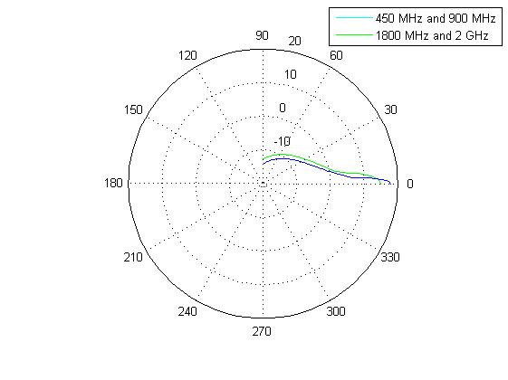

Figure 104: Elevation patterns used for the MCL simulations

Data: patterns used for MCL
Angle | 450 MHz | 900 MHz | 1800 MHz | 2 GHz |  | Angle | 450 MHz | 900 MHz | 1800 MHz | 2 GHz
0 | 15.00 | 15.00 | 18.00 | 18.00 |  | 46 | -8.26 | -8.26 | -9.76 | -9.76
1 | 14.82 | 14.82 | 17.28 | 17.28 |  | 47 | -8.40 | -8.40 | -9.90 | -9.90
2 | 14.28 | 14.28 | 15.14 | 15.14 |  | 48 | -8.54 | -8.54 | -10.04 | -10.04
3 | 13.38 | 13.38 | 11.56 | 11.56 |  | 49 | -8.67 | -8.67 | -10.17 | -10.17
4 | 12.12 | 12.12 | 6.55 | 6.55 |  | 50 | -8.80 | -8.80 | -10.30 | -10.30
5 | 10.50 | 10.50 | 4.70 | 4.70 |  | 51 | -8.93 | -8.93 | -10.43 | -10.43
6 | 8.53 | 8.53 | 3.51 | 3.51 |  | 52 | -9.06 | -9.06 | -10.56 | -10.56
7 | 6.19 | 6.19 | 2.51 | 2.51 |  | 53 | -9.18 | -9.18 | -10.68 | -10.68
8 | 3.49 | 3.49 | 1.64 | 1.64 |  | 54 | -9.30 | -9.30 | -10.80 | -10.80
9 | 2.37 | 2.37 | 0.87 | 0.87 |  | 55 | -9.42 | -9.42 | -10.92 | -10.92
10 | 1.68 | 1.68 | 0.18 | 0.18 |  | 56 | -9.54 | -9.54 | -11.04 | -11.04
11 | 1.06 | 1.06 | -0.44 | -0.44 |  | 57 | -9.66 | -9.66 | -11.16 | -11.16
12 | 0.49 | 0.49 | -1.01 | -1.01 |  | 58 | -9.77 | -9.77 | -11.27 | -11.27
13 | -0.03 | -0.03 | -1.53 | -1.53 |  | 59 | -9.88 | -9.88 | -11.38 | -11.38
14 | -0.51 | -0.51 | -2.01 | -2.01 |  | 60 | -9.99 | -9.99 | -11.49 | -11.49
15 | -0.96 | -0.96 | -2.46 | -2.46 |  | 61 | -10.10 | -10.10 | -11.60 | -11.60
16 | -1.38 | -1.38 | -2.88 | -2.88 |  | 62 | -10.20 | -10.20 | -11.70 | -11.70
17 | -1.77 | -1.77 | -3.27 | -3.27 |  | 63 | -10.31 | -10.31 | -11.81 | -11.81
18 | -2.15 | -2.15 | -3.65 | -3.65 |  | 64 | -10.41 | -10.41 | -11.91 | -11.91
19 | -2.50 | -2.50 | -4.00 | -4.00 |  | 65 | -10.51 | -10.51 | -12.01 | -12.01
20 | -2.83 | -2.83 | -4.33 | -4.33 |  | 66 | -10.61 | -10.61 | -12.11 | -12.11
21 | -3.15 | -3.15 | -4.65 | -4.65 |  | 67 | -10.71 | -10.71 | -12.21 | -12.21
22 | -3.45 | -3.45 | -4.95 | -4.95 |  | 68 | -10.80 | -10.80 | -12.30 | -12.30
23 | -3.74 | -3.74 | -5.24 | -5.24 |  | 69 | -10.90 | -10.90 | -12.40 | -12.40
24 | -4.02 | -4.02 | -5.52 | -5.52 |  | 70 | -10.99 | -10.99 | -12.49 | -12.49
25 | -4.29 | -4.29 | -5.79 | -5.79 |  | 71 | -11.09 | -11.09 | -12.59 | -12.59
26 | -4.54 | -4.54 | -6.04 | -6.04 |  | 72 | -11.18 | -11.18 | -12.68 | -12.68
27 | -4.79 | -4.79 | -6.29 | -6.29 |  | 73 | -11.27 | -11.27 | -12.77 | -12.77
28 | -5.02 | -5.02 | -6.52 | -6.52 |  | 74 | -11.36 | -11.36 | -12.86 | -12.86
29 | -5.25 | -5.25 | -6.75 | -6.75 |  | 75 | -11.44 | -11.44 | -12.94 | -12.94
30 | -5.47 | -5.47 | -6.97 | -6.97 |  | 76 | -11.53 | -11.53 | -13.03 | -13.03
31 | -5.69 | -5.69 | -7.19 | -7.19 |  | 77 | -11.61 | -11.61 | -13.11 | -13.11
32 | -5.89 | -5.89 | -7.39 | -7.39 |  | 78 | -11.70 | -11.70 | -13.20 | -13.20
33 | -6.10 | -6.10 | -7.60 | -7.60 |  | 79 | -11.78 | -11.78 | -13.28 | -13.28
34 | -6.29 | -6.29 | -7.79 | -7.79 |  | 80 | -11.86 | -11.86 | -13.36 | -13.36
35 | -6.48 | -6.48 | -7.98 | -7.98 |  | 81 | -11.94 | -11.94 | -13.44 | -13.44
36 | -6.66 | -6.66 | -8.16 | -8.16 |  | 82 | -12.02 | -12.02 | -13.52 | -13.52
37 | -6.84 | -6.84 | -8.34 | -8.34 |  | 83 | -12.10 | -12.10 | -13.60 | -13.60
38 | -7.01 | -7.01 | -8.51 | -8.51 |  | 84 | -12.18 | -12.18 | -13.68 | -13.68
39 | -7.18 | -7.18 | -8.68 | -8.68 |  | 85 | -12.26 | -12.26 | -13.76 | -13.76
40 | -7.35 | -7.35 | -8.85 | -8.85 |  | 86 | -12.33 | -12.33 | -13.83 | -13.83
41 | -7.51 | -7.51 | -9.01 | -9.01 |  | 87 | -12.41 | -12.41 | -13.91 | -13.91
42 | -7.67 | -7.67 | -9.17 | -9.17 |  | 88 | -12.48 | -12.48 | -13.98 | -13.98
43 | -7.82 | -7.82 | -9.32 | -9.32 |  | 89 | -12.56 | -12.56 | -14.06 | -14.06
44 | -7.97 | -7.97 | -9.47 | -9.47 |  | 90 | -12.63 | -12.63 | -14.12 | -14.13
45 | -8.12 | -8.12 | -9.62 | -9.62

E.2.2 Elevation patterns used for the SEAMCAT simulations
SEAMCAT calculations aim to study the average cases (statistical). The patterns used are based on the following equations, which should be used for elevation angles that range from 0° to 90° and for azimuth angles that range from –180° to 180°:
G(φ, θ) = G_{ref}(x)
where:
$G_{\text{ref}}(x)=G_{0}−\text{12}x^{2}$ for $0≤x<1\text{.}\text{152}$
$G_{\text{ref}}(x)=G_{0}−\text{15}−\text{15}\text{log}(x)$ for $1\text{.}\text{152}≤x$
x being defined in the previous section.

Note that these formulas differ from the ones used for the MCL calculations. MCL calculations are based on antenna patterns with peak side lobes whereas SEAMCAT simulations are based on antenna patterns with average side lobes.

The following figure represents the elevation off-axis gain calculated on the basis of a maximum antenna gain of 15 dBi (450 and 900 MHz) and 18 dBi (1800 MHz and 2 GHz).

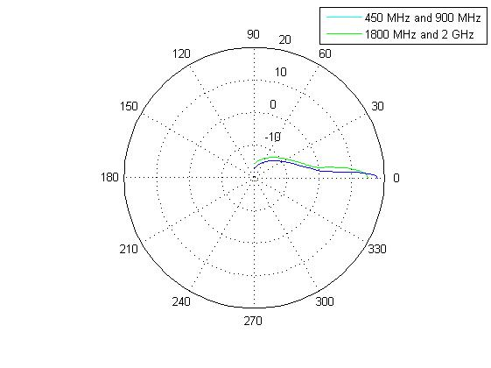
Figure 105: Elevation patterns used for the SEAMCAT simulations

Data: patterns used for SEAMCAT
Angle | 450 MHz | 900 MHz | 1800 MHz | 2 GHz |  | Angle | 450 MHz | 900 MHz | 1800 MHz | 2 GHz
0 | 15.00 | 15.00 | 18.00 | 18.00 |  | 46 | -11.26 | -11.26 | -12.76 | -12.76
1 | 14.82 | 14.82 | 17.28 | 17.28 |  | 47 | -11.40 | -11.40 | -12.90 | -12.90
2 | 14.28 | 14.28 | 15.14 | 15.14 |  | 48 | -11.54 | -11.54 | -13.04 | -13.04
3 | 13.38 | 13.38 | 11.56 | 11.56 |  | 49 | -11.67 | -11.67 | -13.17 | -13.17
4 | 12.12 | 12.12 | 6.55 | 6.55 |  | 50 | -11.80 | -11.80 | -13.30 | -13.30
5 | 10.50 | 10.50 | 1.70 | 1.70 |  | 51 | -11.93 | -11.93 | -13.43 | -13.43
6 | 8.53 | 8.53 | 0.51 | 0.51 |  | 52 | -12.06 | -12.06 | -13.56 | -13.56
7 | 6.19 | 6.19 | -0.49 | -0.49 |  | 53 | -12.18 | -12.18 | -13.68 | -13.68
8 | 3.49 | 3.49 | -1.36 | -1.36 |  | 54 | -12.30 | -12.30 | -13.80 | -13.80
9 | 0.44 | 0.44 | -2.13 | -2.13 |  | 55 | -12.42 | -12.42 | -13.92 | -13.92
10 | -1.32 | -1.32 | -2.82 | -2.82 |  | 56 | -12.54 | -12.54 | -14.04 | -14.04
11 | -1.94 | -1.94 | -3.44 | -3.44 |  | 57 | -12.66 | -12.66 | -14.16 | -14.16
12 | -2.51 | -2.51 | -4.01 | -4.01 |  | 58 | -12.77 | -12.77 | -14.27 | -14.27
13 | -3.03 | -3.03 | -4.53 | -4.53 |  | 59 | -12.88 | -12.88 | -14.38 | -14.38
14 | -3.51 | -3.51 | -5.01 | -5.01 |  | 60 | -12.99 | -12.99 | -14.49 | -14.49
15 | -3.96 | -3.96 | -5.46 | -5.46 |  | 61 | -13.10 | -13.10 | -14.60 | -14.60
16 | -4.38 | -4.38 | -5.88 | -5.88 |  | 62 | -13.20 | -13.20 | -14.70 | -14.70
17 | -4.77 | -4.77 | -6.27 | -6.27 |  | 63 | -13.31 | -13.31 | -14.81 | -14.81
18 | -5.15 | -5.15 | -6.65 | -6.65 |  | 64 | -13.41 | -13.41 | -14.91 | -14.91
19 | -5.50 | -5.50 | -7.00 | -7.00 |  | 65 | -13.51 | -13.51 | -15.01 | -15.01
20 | -5.83 | -5.83 | -7.33 | -7.33 |  | 66 | -13.61 | -13.61 | -15.11 | -15.11
21 | -6.15 | -6.15 | -7.65 | -7.65 |  | 67 | -13.71 | -13.71 | -15.21 | -15.21
22 | -6.45 | -6.45 | -7.95 | -7.95 |  | 68 | -13.80 | -13.80 | -15.30 | -15.30
23 | -6.74 | -6.74 | -8.24 | -8.24 |  | 69 | -13.90 | -13.90 | -15.40 | -15.40
24 | -7.02 | -7.02 | -8.52 | -8.52 |  | 70 | -13.99 | -13.99 | -15.49 | -15.49
25 | -7.29 | -7.29 | -8.79 | -8.79 |  | 71 | -14.09 | -14.09 | -15.59 | -15.59
26 | -7.54 | -7.54 | -9.04 | -9.04 |  | 72 | -14.18 | -14.18 | -15.68 | -15.68
27 | -7.79 | -7.79 | -9.29 | -9.29 |  | 73 | -14.27 | -14.27 | -15.77 | -15.77
28 | -8.02 | -8.02 | -9.52 | -9.52 |  | 74 | -14.36 | -14.36 | -15.86 | -15.86
29 | -8.25 | -8.25 | -9.75 | -9.75 |  | 75 | -14.44 | -14.44 | -15.94 | -15.94
30 | -8.47 | -8.47 | -9.97 | -9.97 |  | 76 | -14.53 | -14.53 | -16.03 | -16.03
31 | -8.69 | -8.69 | -10.19 | -10.19 |  | 77 | -14.61 | -14.61 | -16.11 | -16.11
32 | -8.89 | -8.89 | -10.39 | -10.39 |  | 78 | -14.70 | -14.70 | -16.20 | -16.20
33 | -9.10 | -9.10 | -10.60 | -10.60 |  | 79 | -14.78 | -14.78 | -16.28 | -16.28
34 | -9.29 | -9.29 | -10.79 | -10.79 |  | 80 | -14.86 | -14.86 | -16.36 | -16.36
35 | -9.48 | -9.48 | -10.98 | -10.98 |  | 81 | -14.94 | -14.94 | -16.44 | -16.44
36 | -9.66 | -9.66 | -11.16 | -11.16 |  | 82 | -15.02 | -15.02 | -16.52 | -16.52
37 | -9.84 | -9.84 | -11.34 | -11.34 |  | 83 | -15.10 | -15.10 | -16.60 | -16.60
38 | -10.01 | -10.01 | -11.51 | -11.51 |  | 84 | -15.18 | -15.18 | -16.68 | -16.68
39 | -10.18 | -10.18 | -11.68 | -11.68 |  | 85 | -15.26 | -15.26 | -16.76 | -16.76
40 | -10.35 | -10.35 | -11.85 | -11.85 |  | 86 | -15.33 | -15.33 | -16.83 | -16.83
41 | -10.51 | -10.51 | -12.01 | -12.01 |  | 87 | -15.41 | -15.41 | -16.91 | -16.91
42 | -10.67 | -10.67 | -12.17 | -12.17 |  | 88 | -15.48 | -15.48 | -16.98 | -16.98
43 | -10.82 | -10.82 | -12.32 | -12.32 |  | 89 | -15.56 | -15.56 | -17.06 | -17.06
44 | -10.97 | -10.97 | -12.47 | -12.47 |  | 90 | -15.63 | -15.63 | -17.13 | -17.13
45 | -11.12 | -11.12 | -12.62 | -12.62

ANNEX F: EFFECTIVENESS OF AIRCRAFT RF SHIELDING AND SUBSEQUENT IMPACT ON THE ABILITY FOR AN AIRBORNE MOBILE TO ACQUIRE TERRESTRIAL CDMA NETWORKS
F.1 INTRODUCTION
This Annex is a summary of an in-flight test campaign carried out jointly by Connexion By BoeingSM and QUALCOMM Incorporated, in August 2005. The goal of the test campaign was to measure the in-flight attenuation due to an aircraft fuselage and to evaluate the effectiveness of RF shielding of the fuselage using a Boeing developed technique including window shielding materials developed and provided by Mitsubishi Heavy Industries, Ltd and Fujiwara Co. Ltd. No active techniques for controlling airborne mobile phone acquisition of the ground networks were involved in this test campaign.

A Boeing 737-400 aircraft was tested in-flight over two phases:
- baseline tests with the aircraft in its original configuration;
- a repeat of the tests with the same aircraft modified to reduce RF signals.
For each phase of the test campaign the aircraft was instrumented to simultaneously gather data on the attenuation due to the aircraft and the success rates of airborne mobile phones acquiring CDMA terrestrial networks.

This test campaign was carried out over the United States with acquisition data obtained from commercially deployed CDMA2000 networks. Even though the results were obtained from 1.25 MHz-wide CDMA2000 systems, they are generally applicable to WCDMA/UMTS given the comparable link budgets and technology parameters. The measured attenuations with and without RF shielding can also be approximately applicable to cellular networks in adjacent frequency bands, for example GSM 1800.
F.1.1 Instrumentation for Evaluating Attenuation due to the aircraft
The 737-400 test aircraft was instrumented to detect a CW signal that was transmitting from a 30W station located on the ground and operating at a frequency of 1989 MHz. The antennas were distributed throughout the interior of the aircraft (including the cabin, flight deck and the cargo bays) and connected to a measurement system set up to record power levels every 100 ms.

Tests were conducted at altitudes of 10000 feet (3000 m) and 30000 feet (9000 m) above ground level and the aircraft flew in “star” patterns around the ground based transmitter designed to exercise as many elevation and azimuth angles with respect to the ground transmitter as feasible. Aircraft position data was collected by the aircraft flight recorder. See Figures 106 and 107.

-150
-100
-50
0
50
100
150
-150
-100
-50
0
50
100
150
-250
-200
-150
-100
-50
0
50
100
150
200
250
-250
-200
-150
-100
-50
0
50
100
150
200
250
Figure 106: Flight Pattern at 10,000ft (3,000 m) Altitude Figure 107: Flight Pattern at 30,000ft (9,000 m) Altitude

F.1.2 Instrumentation for Evaluating CDMA Airborne Phone Acquisition Success Rates
The aircraft was equipped for studying the in-flight acquisition performance of CDMA phones before and after applying the RF shielding to the aircraft. Four commercial-grade CDMA2000 handsets with custom test software were distributed within the cabin at Left/Right Windows and Left/Right Window Seats. The preferred roaming lists on the phones were modified to search all four primary 800 MHz cellular channels and forty-two 1900 MHz band channels with no priority systems or geographical areas defined.

On each frequency search each phone measured and logged received power and attempts system acquisition. The phone transmitter function was disabled, thus no registration attempts were possible. Following a successful system acquisition additional system parameters were logged as defined below:
- Pilot E_{c}/I_{o};
- CDMA2000 Sync Channel;
- CDMA2000 Paging Channel (system parameters, Channel List msgs only).

The system parameters message contains fields that are typically populated with Latitude and Longitude information for the base station (BTS) that has been successfully acquired. For all system acquisitions where Lat/Lon was obtained the validity of the positioning was checked by reviewing system identification information and confirming that Lat/Lon was consistent with the location information of the Network provider.

Together with the system parameter location information and the time synchronized record of the aircraft position, altitude and heading as provided by the aircraft flight recorder it was possible to compute the aircraft to BTS path and from this derive distance, elevation angle and bearing to BTS relative to aircraft.
F.2 DATA REVIEW
F.2.1 Attenuation due to the aircraft
The data plots shown in Figures 108 and 109 represents the normalized received signal strength at a number of locations within the aircraft measured in the unshielded and RF shielded aircraft configuration respectively. The data collected was corrected for test antenna gain, cable losses and equipment losses, and radiated to conducted conversions. The data was normalized to what a theoretical isotropic antenna would receive at the equivalent distance.

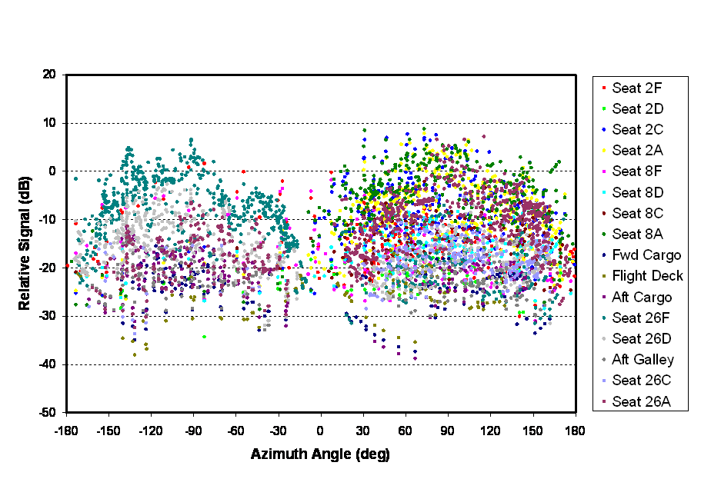
Figure 108: Unmodified aircraft received signals normalized to theoretical values

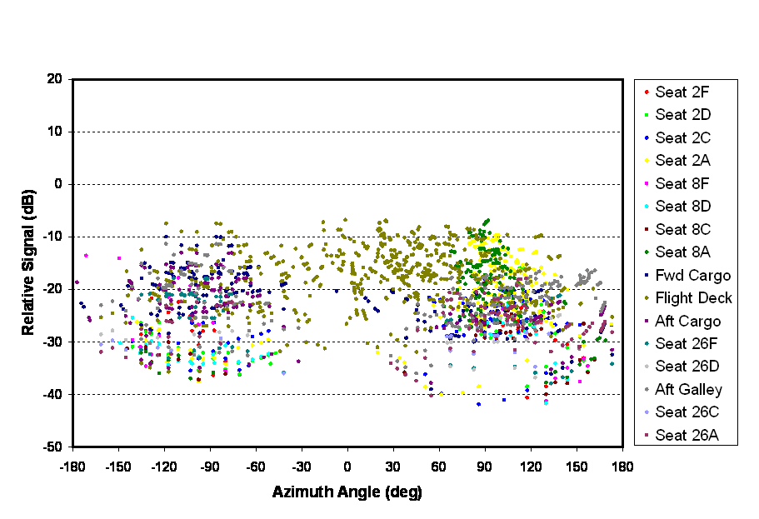
Figure 109: RF Shielded aircraft received signals normalized to theoretical values

A statistical and aggregated comparison of the data is presented in Figures 110 and 111 respectively.

Figure 110: Statistical comparison of received signals normalized to theoretical values

Figure 111: Summary of received signals normalized to theoretical values

F.2.2 CDMA Airborne Phone Acquisition Success Rates
For each verified acquisition that the CDMA phones logged, the range, relative bearing and elevation angle between the ground BTS and aircraft were calculated and the results plotted on a map indicating the paths between BTS and aircraft. The data for the two different test altitudes (3000 m and 9000 m) and multiple phone locations (right and left window and seat locations) were analyzed to produce statistics for the following:
- Received power;
- CDMA Pilot E_{c}/I_{o} ;
- Acquisition rates;
- Acquisition distance between aircraft and ground BTS;
- Acquisition elevation angles;
- Acquisition bearing histograms.

Figure 112 contains pictorial representations of the acquisition history for a phone located at the right side window of the aircraft at 30000 ft (9000 m) altitude. The triangular flight pattern is superimposed on the map along with connecting lines showing the trajectory to terrestrial base stations that were acquired by the airborne CDMA phone. The left-hand plot depicts the acquisition history for the unmodified aircraft. The right-hand plot represents the data taken for the RF shielded configuration and shows significant reduction in acquisition rate and distance as a result of the applied shielding.

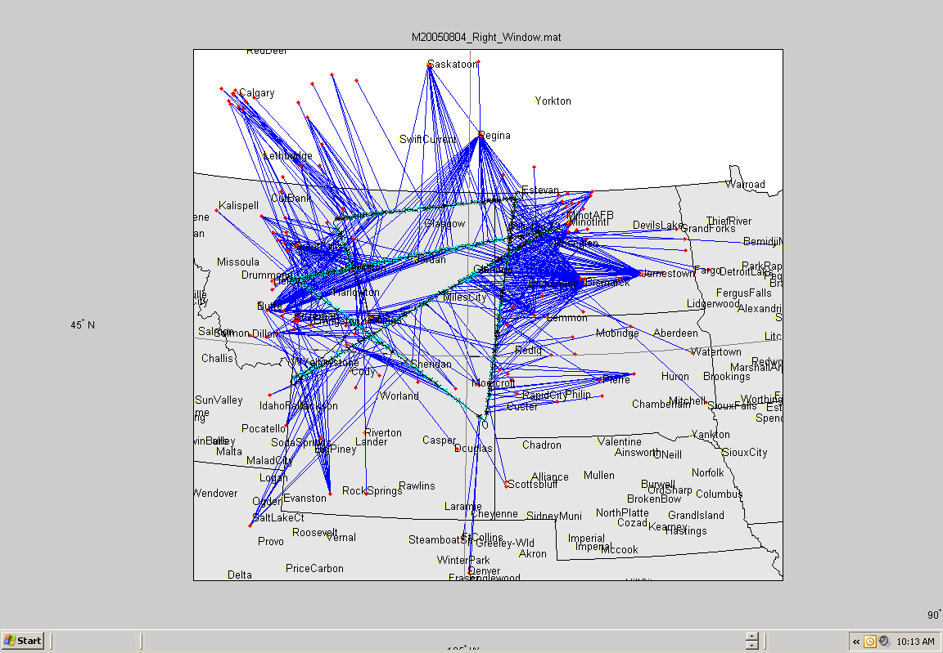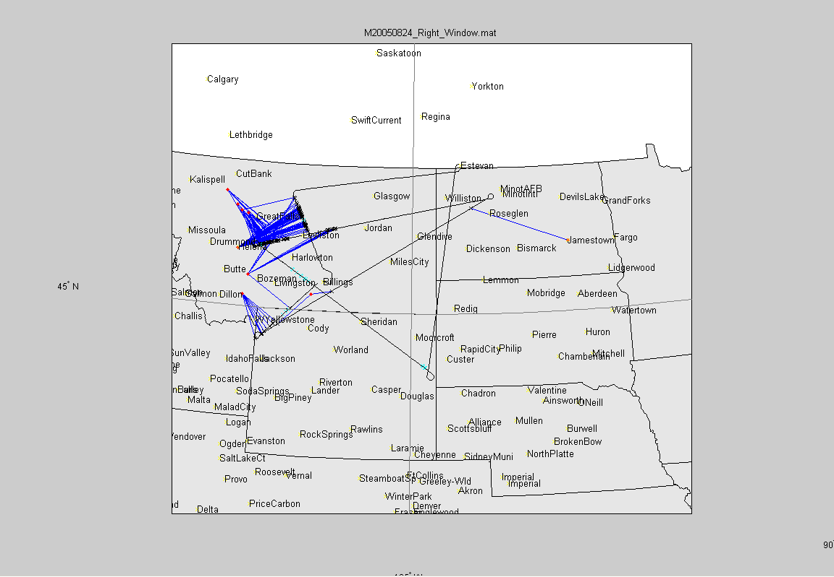

Figure 112: Maps of terrestrial system acquisition during flight. Left: Unmodified aircraft; Right:
RF shielded aircraft

The acquisition statistics for the 9000 m altitude are shown in Figure 113. On average the aircraft RF shielding had a significant effect on the acquisition success rate, however when reviewing the time history of acquisition success it can be seen that for selected periods of time the success rate was still as high as 50% even with RF shielding. Figure 114 represents the 800 MHz network acquisition success rate for the phone located at the left window.

Figure 113: Acquisition Statistics @ 9,000 m Altitude

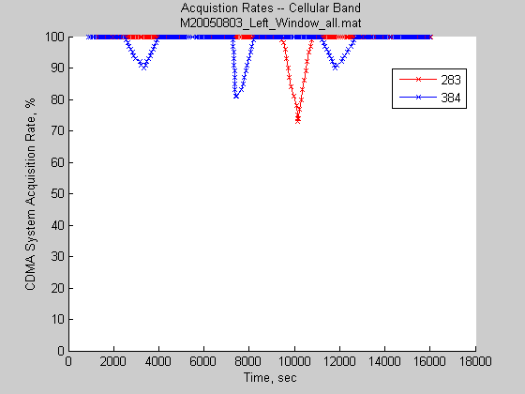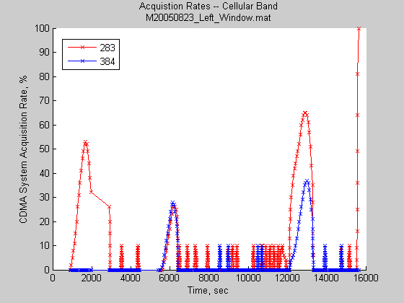
Unmodified
RF Shielded

Figure 114: Time History of Acquisition Success – Left Window Cellular Band

F.3 SUMMARY OF TEST RESULTS
F.3.1 Attenuation due to the aircraft
The results indicate that the aircraft fuselage can exhibit gain characteristics for certain antenna locations within the fuselage with the highest gain broadside to, and horizontal with the long axis of the fuselage. The nose and tail directions have substantial roll-off.

With the aircraft in an unmodified condition, i.e. no RF shielding, the following results for attenuation (-) or gain (+) due to aircraft fuselage were calculated (based on a theoretical expectation of the received signal):
- Facing window seats: +5 dB max, -12 dB av.;
- Aisle seats: -3 dB max, -16 dB av.

The RF shielding modification of the aircraft resulted in an overall increase in attenuation between 13 and 17 dB.
F.3.2 CDMA Airborne Phone Acquisition Success Rates
On reviewing the data the following observations were made:
- Under good conditions, terrestrial CDMA system acquisition success rate can be very high at 10000 ft (3000 m) and 30000 ft (9000 m) altitude:
  - At 3000 m altitude and 800 MHz, the acquisition rate is 94-98% for window and 70-98% for seat positions.
  - At 9000 m altitude and 800 MHz, the acquisition rate is 75-95% for window and 52-54% for seat positions.
  - At 3000 m altitude and 1900 MHz, the acquisition rate is 35-44% for window and 29-37% for seat positions.
  - At 9000 m altitude and 1900 MHz, the acquisition rate is 45-49% for window and 33-44% for seat positions.
- Phones in the seat locations see 5-10 dB less power than phones in the window locations;
- Altitude (3000 m vs. 9000 m) had no effect on received power;
- At 9000 m, it is possible to acquire systems up to 700 km away; i.e. beyond the aircraft horizon;
- Median acquisition angles were 2-5 degrees elevation;
- Systems were not acquired above an elevation angle of 40 deg;
- Most acquisitions for window mounted phones were abeam of the aircraft and acquisitions for seat mounted phones were more uniformly distributed;
- Received CDMA Pilot powers indicate negligible shielding at window.

Aircraft RF shielding had a significant effect on system acquisition:
- At 9000 m altitude and 800 MHz, the average acquisition rate is reduced to 1.4% although success rates of up to 50% were logged for selected periods of time;
- At 9000 m altitude and 1900 MHz, the average acquisition rate is reduced to 0.9% although success rates of up to 50% were logged for selected periods of time;
- Power reduction (as seen by the handsets) was up to 20 dB, but variable within the cabin.

ANNEX G: COMPATIBILITY BETWEEN GSM EQUIPMENT ON BOARD AIRCRAFT AND TERRESTRIAL NETWORKS USING THE 2.6 GHZ BAND
G.1 INTRODUCTION

This Annex provides an extension of the analysis of the compatibility of the GSM onboard system and terrestrial networks to cover the technologies envisaged for the 2.6 GHz band.

G.2 Reference technologies identified for 2.6 GHz study
The study for the 2.6 GHz band is carried out analysing the impact of the NCU into the following potential ground network technologies:
- UMTS WCDMA FDD
- UMTS WCDMA TDD
- WiMAX (IEEE 802.16e)
- MMDS

Note that 3GPP Long Term Evolution (LTE) / Enhanced UMTS Terrestrial Radio Access (E-UTRA) was not included in this analysis due to the fact that the parameters have not been finalised in the specifications.

G.3 Reference parameters used for 2.6 GHz study

The reference parameters defined for the 2.6 GHz study are based where possible on the latest versions of the technical standards in the industry. Given that at the time of writing no live networks exist and that most standards documentation has not been ratified then no definitive parameters can be quoted. However given the maturity of the specifications a very high confidence of the final parameters can be taken. Consequently the following provides the justifications for the parameters proposed for the four technologies identified in section G.2:
- UMTS WCDMA FDD
3GPP TSG RAN 4 has studied the parameters and impacts for 2.6 GHz use and definition in the Technical Report “3rd Generation Partnership Project; Technical Specification Group TSG RAN;UMTS 2.6 GHz (FDD) Work Item Technical Report; (Release 7) TR 25.810v7.0.0. In work involving simulations they have used the same parameters from UMTS FDD 2 GHz.
- UMTS WCDMA TDD
3GPP TSG RAN 4 has studied the parameters and impacts for 2.6 GHz use and definition in the Technical Report “3rd Generation Partnership Project; Technical Specification Group TSG RAN;UMTS 2.6 GHz (TDD) Work Item Technical Report; (Release 7) TR 25.811v7.0.0. In work involving simulations they have used the same parameters from UMTS TDD 2 GHz.

On analysing the UMTS TDD parameters defined for 2GHz networks in the specifications 3GPP TS 25.104 and 3GPP TS 25.105 and comparing them with the parameters defined for UMTS FDD networks in the 2GHz networks from the specifications 3GPP TS 25.101 and 3GPP TS 25.102 then only two differences can be obtained. First the power transmit level for the UE for TDD systems can be as high as 30 dBm/channel and second the TDD UE has a lower sensitivity value. In the analysis used in this study neither parameter is used and the assumption that controlling UMTS FDD networks will also control UMTS TDD networks onboard the aircraft is valid. Furthermore the analysis comparing the impact of TDD networks to FDD networks carried out in 3GPP TR 25.942 also uses the same parameters for both. Consequently the UMTS FDD parameters are used for the UMTS TDD analysis.
- WiMAX
WiMAX reference parameters are currently defined in three international communities the IEEE, ETSI BRAN and the ITU-R SG5 (former SG8). Furthermore the parameters defined sometimes differ between the definition per subcarrier and the definition per receiver bandwidth. The following takes the parameters as defined by the report ITU-R M.2116 where relevant parameters are not present (for example Signal to noise ratio) then these are taken directly from the WiMAX forum definitions. It is highlighted that WiMAX uses a OFDM structure with scalable bandwidth, using sub-carrier spacing of 10.94 kHz. Typical channel spacing will be 5 MHz.
- MMDS
Multichannel multipoint distribution service, also known as MMDS or Wireless Cable, is a wireless telecommunications technology, used for general-purpose broadband networking or, more commonly, as an alternative method of cable television programming reception. The MMDS band uses microwave frequencies from 2 GHz to 3 GHz. Reception of MMDS-delivered television signals is done with a special rooftop microwave antenna and a set-top box for the television receiving the signals. Consequently the issue is not to control the MMDS but to ensure that harmful interference is not caused. The relevant values are therefore noise floor of the receiver, and the bandwidth of the channel. The following values are taken from ECC Report 45 (Annex A.5, page 33).

Rx antenna gain. | 22 dBi
Noise Floor | -102 dBm
Bandwidth | 8000 kHz
Table G-1: Relevant MMDS parameters used in the 2.6 GHz studies

G.3.1 Reference transceiver parameters
The following table provides the parameters used in the studies:
Parameter |  | UMTS FDD |  | UMTS TDD |  | WiMAX
 |  | UE | Node B | UE | Node B | MS | BS
Antenna input Power | dBm / channel | 21/24*** | 33- 37.8* | 21/24*** | 33- 37.8* | 20 | 36
Receiver bandwidth | kHz | 3840 | 3840 | 3840 | 3840 | 4750 | 4750
Masking factor ** | dB | 21 | NA | 21 | NA | 6 | NA
Reference System noise figure (taken from values quoted in standards) | dB | 9 | 5 | 9 | 5 | 5 | 3
Typical System noise figure (operator quoted “typical” values) | dB | 7 | 4 | 7 | 4 | - | -
Reference Noise level (taken from values quoted in standards) | dBm / channel | -99 | -103 | -99 | -103 | -102 | -104
Typical Noise level (“typical” operator values) | dBm / channel | -101 | -104 | -101 | -104 | - | -
Reference Receiver Sensitivity (taken from values quoted in standards) | dBm / channel | -117 | -121 | -117 | -121 | -95.6 | -100.6
Typical; Receiver Sensitivity  (“typical” operator values) | dBm / channel | -119 | -122 | -119 | -122 | - | -
Interference criterion I (C/(N+I) ) | dB | NA | NA | NA | NA | NA | NA
Interference criterion II (I/N) | dB | -6 | NA | -6 | -6 | -6 | -6
Channel Spacing | kHz | 5000 | 5000 | 5000 | 5000 | 5000 | 5000
Maximum antenna gain | dBi | 0 | 18 | 0 | 18 | 0…6 | 18
Table G-2: Parameters used in the 2.6 GHz studies
Notes:
* Value quotes typical operator power levels for the UMTS pilot channel = max Input power (43 dBm) -10 dB = 33 dBm, however higher levels have been proposed for the UMTS pilot channel = max Input power (44.8 dBm) -7 dB = 37.8 dBm. 7 dB is equivalent to the 20 % power level of the pilot channel. Note that in order to effectively screen against terrestrial UMTS network recognition for the mobiles in the aircraft only the pilot channel needs to be screened in the onboard environment.

** Masking factor: the additional power by which the inserted noise has to exceed the received terrestrial signals in order to remove visibility of terrestrial networks in the cabin.

*** Maximum UE transmit powers values quoted to be used for the following simulations:
- Maximum UE transmission power for UE = 24 dBm;
- Maximum terrestrial UE transmission power value for simulations on the impacts for the support of voice service = 21 dBm (assumes UE power class 4);
- Maximum terrestrial UE transmission power value for simulations on impacts for the support of non voice service = 24 dBm.

The reference values taken from standards documentation are based on the 3GPP specifications and ITU-R Recommendation M.2039, as well as from the technical reports 3GPP TR 25.810, 3GPP TR 25.811, and 3GPP TR 25.942.

Definition of the interference criteria
The interference criteria that has been applied is I/N = -6 dB, which is equivalent of a 1 dB increase over the receiver noise floor.

Masking factor definition
The masking factor is defined as the ratio by which the inserted noise has to exceed the received terrestrial signals in order to remove visibility of terrestrial networks in the cabin:
- For UMTS /CDMA systems the masking factor has to take into consideration the processing gain inherent in those systems. Thus the masking factor results in a net Eb/No = 0 dB:
  - For WCDMA this equates to an additional 21 dB (for the common pilot channel).

- For OFDMA systems the masking factor has to take into consideration the interference cancelling properties inherent in those systems.
  - For WiMAX this equates to an additional 6 dB.
G.3.2 Reference antenna parameters
There are two terrestrial antenna types considered in the compatibility study:
- g-BS/NodeB antennas;
- g-MS/UE antennas.
G.3.2.1 g-BS/NodeB antennas
The study assumes a three-sector cell site with uniform gain in the horizontal plane:
- G-BS/NodeB antenna patterns used:
  - Vertical pattern derived from ITU-R F.1336-1 using agreed input parameters, see Annex E.
    - Note that the off-axis gain is calculated on the basis of a maximum antenna gain of 18 dBi.
  - Horizontal pattern: omni-directional in the horizontal plane within opening angle 120 degrees.
  - Downtilt angle: 0 degrees.
- Terrestrial antenna height: 30 m.

G.3.2.2 g-MS/UE antennas
It is expected that WiMAX will be introduced in many types of terminals. PC-like terminals being one of the terminal types that potentially can include implementations with an antenna gain of more than 0 dBi.

An implementation of an antenna with a maximum gain in the order of 6 dBi is regarded realistic. It is foreseen however that this would be appropriate for PC-like terminals, rather than hand held devices.
From a radio point of view the main lobe of a non uniform antenna used in a terrestrial network should be pointing at the horizon.
One simple antenna implementation that requires very little volume is a patch antenna. The effect of a generic 6 dBi patch antenna is therefore analyzed.
The methodology used for analyzing the effect of the antenna gain in the terminal is the same as when analyzing the effect of the Node-B antenna in this Report [the Report 93], this includes the vertical antenna diagram, and curved earth.
A vertical antenna diagram for a 6 dBi patch antenna is shown in Figure G-1.
Figure G-1 Typical vertical diagram for a 6 dBi patch antenna

By combining the elevation angle with the antenna profile and the associated free space path loss then the composite gain / loss of the path between transmitter and the aircraft receiver can be calculated.

Control of PC-like terminals onboard the aircraft

For control of the PC-like terminal located on the aircraft then the combination of free space path loss, antenna gain due to the ground BTS antenna and the antenna gain of the patch antenna is added. Assuming that the PC-like terminal is placed with the screen upwards inside the aircraft then the vertical antenna pattern of the patch antenna is inversed: The minimum attenuation at 2.6 GHz is then calculated as given in the table G-3.

Aircraft height above ground (m) | Minimum attenuation of signal combination of free space path loss and antenna pattern of g- BTS and omni-directional antenna (dB) | Minimum attenuation of signal combination of free space path loss and antenna pattern of g- BTS and patch antenna (dB)
3000 | 122.9 | 121.0
4000 | 125.1 | 123.5
5000 | 126.7 | 125.5
6000 | 128.0 | 127.1
7000 | 129.1 | 128.4
8000 | 130.0 | 129.6
9000 | 130.8 | 130.6
10000 | 131.5 | 131.5
Table G-3: Comparison of the minimum attenuation of transmitted signal from the ground to the ac-MS using either an omni-directional or a 6dBi patch antenna

As can be seen from the table G-3 the difference between minimum attenuation of the patch antenna and the minimum attenuation for an omni antenna is less than 2 dB in the worst case scenario. It is highlighted however that the PC-like terminal will be in a position more favourable to the onboard system ensuring that the device is controlled thus cancelling any difference identified here.

Potential power levels received by networks on the ground due to PC-like terminal transmissions onboard the aircraft

The minimum attenuation of the combined antenna gain and free space path loss, assuming a PC-like terminal, is shown below for the various heights above the ground:

Aircraft height above ground (m) | Minimum attenuation of signal combination of free space path loss and omni-directional antenna (dB) | Minimum attenuation of signal combination of free space path loss and patch antenna (dB)
3000 | 110.2 | 113.0
4000 | 112.7 | 115.5
5000 | 114.7 | 117.4
6000 | 116.3 | 119.0
7000 | 117.6 | 120.3
8000 | 118.8 | 121.5
9000 | 119.8 | 122.5
10000 | 120.7 | 123.4
Table G-4 Minimum attenuation comparison between aircraft and the victim receiver g-MS located on the ground (using either an omni-directional or a 6dBi patch antenna)

As can be seen in the table G-4 above the minimum attenuation for the PC-like terminal is actually greater than for the mobile phone.

Conclusions

Consequently the study assumes the following for mobile terminal transmitters onboard the aircraft:
- an antenna for g-UE / g-MS with a gain of 0 dBi and an antenna height of 1.5 m; this includes consideration for PC-like terminal with a potential gain of up to 6 dBi.

G.4 Methodology used for 2.6 GHz study

The methodology follows the same process as used in the ECC Report 93 but only using MCL analysis. The method is applied for the relevant technologies in the 2.6 GHz band. Given that the 2.6 GHz band may carry both FDD and TDD type traffic the possible victim receivers will be:
- UMTS TDD Node-B.
- UMTS UE.
- WiMAX BTS.
- WiMAX terminal.
- MMDS receivers (covered in section G.6).

Note: that the analyses use the typical system noise figure operator quoted “typical” values in preference to the reference system noise figure (taken from values quoted in standards) when available (see Table G-2).

Dimensioning of the NCU level in the 2.6 GHz band must be based on the maximum received signal level from ground networks in the aircraft from:
- WCDMA base stations (UMTS Node B).
- WiMAX base stations (BTS).
It is highlighted that due to possible TDD operation in the 2.6 GHz band then the following implications must be considered:
- The NCU must operate in the entire band. The exception will be the part of the band that is exclusively allocated to FDD uplink.
- Both g-MS (UMTS and WiMAX terminal), and g-BTS/Node B are potential interference victims.
Scenario 1 in this Report for the 450, 900, 1800 and 2100 MHz band, describes the maximum power received in the aircraft at the ac-MS, and can be found from:
$P_{{\text{rec}}_{\text{ac}}−\text{Ms}}={\text{EIRP}}_{g−\text{BTS}}−L_{\text{prop}}−L_{\text{Aircraft}}+G_{\text{ac}−\text{MS}}$ (G.4.1)

Where EIRP_{g-bts} follows from the combined effect of the BTS antenna and the Tx power, L_{prop} is the free space loss at the relevant elevation angle. L_{aircraft} is the loss in the aircraft fuselage, assumed to be 0 dB, which is worst case. G_{ac-MS} is the MS antenna gain.

Using the BTS antenna diagram definition described in the ECC Report 93, assuming no angle dependency on L_{aircraft} , the worst angle for each aircraft height and the corresponding values for e.i.r.p, maximum Tx power inside the aircraft and margin to the MS sensitivity limit can be found.

The margin is the difference (in dB) between the signal levels received from the base station on the ground and the MS sensitivity value. A negative value indicates that NCU operation is needed.

To find the maximum NCU e.i.r.p. permitted outside the aircraft to avoid harmful interference the following equation is valid:
${\text{EIRP}}_{\text{max}}=I_{\text{max}}+L_{\text{prop}}−G_{g−{\text{BTS}}/{\text{MS}}}$ (G.4.2)
Here I_{max} is the level that ensures no harmful interference as defined in the interference criteria II.

L_{prop} is the path loss for the worst case angle, and G_{g-BTS/MS} is the antenna gain for the corresponding angle. For g-MS being the victim the worst case is the g-MS being directly below the aircraft.

The next step is to determine the NCU power needed to shield the terrestrial networks.

The method allows the calculation of a radiation factor, which is interpreted as the maximum coupling factor between the power transmitted from the NCU inside the aircraft, and the power received on the cylinder surface. The power level inside the cabin requires a value for the potential attenuation of the aircraft. For the MCL analysis carried out the attenuation values were 5 dB for signals entering the cabin and 10 dB for the effective attenuation by the aircraft to the leaky line complex.

In order to calculate the necessary power needed to transmit to the leaky cable requires the mapping of the input power to the cable to the cylinder service. The approach used in this Report has been called the “cylinder model”, further information can be found in section 7 of ECC Report 93. The values for the associated radiation factor are dependent on the frequency of transmission. For 2.6 GHz they are calculated for large aircraft and small aircraft as:
- Radiation factor, large aircraft: 73 dB
- Radiation factor, small aircraft: 69 dB
Note that these values include a margin M = 15 dB, to account for fading and other propagation effects.

The NCU power/channel is calculated from the maximum received power from ground network inside the aircraft:

$P_{\text{NCU}}=P_{t\text{arg}\text{et}}+\text{RadiationFactor}$ (G.4.3)
where P_{target} is
P_{target} = P_{max_rec_ac-Ms} + Shielding Margin (G.4.4)
Where Shielding Margin is the value by which the P_{target} must exceed the P_{max_rec:ac-MS} to control the MS, due to the system ability for noise suppression. While the actual value P_{max_rec:ac-MS} is system dependant the cylinder model provides a technology agnostic approach to show the feasibility.

By using the cylinder model the equivalent emitted power of the aircraft as a point source can be calculated. By removing the effective attenuation of the aircraft to the leaky cable (i.e. 10 dB for the analysis carried out in this Report) provides the effective point source e.i.r.p. of the aircraft.

The permitted e.i.r.p emitted by the aircraft can be calculated via applying the interference criteria II. Comparisons between this value and the value obtained from the cylinder model will show if the solution is feasible.

Comparisons between these values for each of the technologies will identify the limiting value for 2.6 GHz.

G.5 Results of the analyses for UMTS and WiMAX
G.5.1 UMTS
It is assumed that the calculations for WCDMA / UMTS in this document will be valid for both TDD and FDD systems. Therefore the same performance parameters are used for both TDD and FDD although for TDD systems both downlink and uplink interference has to be taken into account.

For UMTS the calculations are performed for 3.84 MHz bandwidth. The received signal level received in the aircraft is calculated using the defined assumptions using equation G.4.1. The results are given in Table G-5.
Power level received at the aircraft
The combined effect of the node-B antenna gain and the free space loss gives the worst case elevation angle of 48 degrees for the aircraft height of 3000 m and 2 degrees for the aircraft heights 4000 - 10000 m (see for example Tables 55, 58, and 60 in the ECC Report 93 Section A.1).

Aircraft height above ground (m) | Worst case elevation angle (deg) | Path loss (dB) | Ant. Gain (dBi) at given angle | UMTS
 |  |  |  | EIRP (dBm) | Max. received power in aircraft, P_{max_rec:ac-MS} (dBm/ch) | Margin(dB)
3000 | 48 | 112.5 | -10.0 | 27.8 | -90.1 | -31.9
4000 | 2 | 139.9 | 15.1 | 52.9 | -92.3 | -30.7
5000 | 2 | 141.5 | 15.1 | 52.9 | -93.9 | -29.1
6000 | 2 | 142.8 | 15.1 | 52.9 | -95.2 | -27.8
7000 | 2 | 143.9 | 15.1 | 52.9 | -96.3 | -26.7
8000 | 2 | 144.8 | 15.1 | 52.9 | -97.2 | -25.8
9000 | 2 | 145.6 | 15.1 | 52.9 | -98.0 | -25.0
10000 | 2 | 146.3 | 15.1 | 52.9 | -98.7 | -24.3
Table G-5 Maximum power received in the aircraft by the ac-MS and the margin required to control the band using operator values
Note: A negative value for the margin indicates that NCU operation is needed.
Maximum permitted e.i.r.p. outside the aircraft
Using the interference criterion II for the receiver noise level the maximum values for different heights can be calculated. Note that the worst case angle for the omni directional antenna used for the g- MS is directly below the aircraft where as the worst case angle to the g-Node B combines the antenna pattern and the associated free space path loss:

 | Maximum permitted e.i.r.p produced by NCU, defined outside aircraft as dBm/channel
Aircraft height above ground (m) | Worst case elevation angle (deg) | NCU -> UMTS MS  (dBm) | Worst case elevation angle (deg) | NCU -> UMTS Node B (dBm)
3000 | 90 | 2.9 | 48 | 12.5
4000 | 90 | 5.4 | 2 | 14.8
5000 | 90 | 7.3 | 2 | 16.4
6000 | 90 | 8.9 | 2 | 17.7
7000 | 90 | 10.3 | 2 | 18.8
8000 | 90 | 11.4 | 2 | 19.7
9000 | 90 | 12.4 | 2 | 20.5
10000 | 90 | 13.4 | 2 | 21.2
Table G-6 Maximum e.i.r.p permitted from the NCU outside aircraft (EIRP_{max})

Note that for UMTS FDD analysis only the NCU -> UMTS MS results are relevant. For UMTS TDD analysis both the NCU -> UMTS Node B results and the NCU -> UMTS MS results are required.

It is highlighted that the power needed to control UMTS in the 2.6 GHz band is substantially lower than the permitted power level assuming the interference criteria II.

G.5. 2 WiMAX
The WiMAX analysis was carried out using the same approach as the one applied for UMTS. The signal level received in the aircraft is calculated using the defined assumptions and parameters using equation G.4.1 and table G-2.
Aircraft height above ground (m) | Worst case elevation angle (deg) | Path loss (dB) | Ant. Gain [dBi] at given angle | WiMAX
 |  |  |  | e.i.r.p. (dBm) | Max. received power in aircraft, P_{max_rec:ac-MS} [dBm/4.750 MHz] | Margin  (dB)
3000 | 48 | 112.5 | -10.0 | 26.0 | -86.5 | -19.8
4000 | 2 | 139.9 | 15.1 | 51.1 | -88.8 | -17.6
5000 | 2 | 141.5 | 15.1 | 51.1 | -90.4 | -16.0
6000 | 2 | 142.8 | 15.1 | 51.1 | -91.7 | -14.7
7000 | 2 | 143.9 | 15.1 | 51.1 | -92.8 | -13.6
8000 | 2 | 144.8 | 15.1 | 51.1 | -93.7 | -12.7
9000 | 2 | 145.6 | 15.1 | 51.1 | -94.5 | -11.9
10000 | 2 | 146.3 | 15.1 | 51.1 | -95.2 | -11.2
Table G-7 Maximum power received in the aircraft by the ac-MS
Note: A negative value for the margin indicates that NCU operation is needed.
Using the interference criterion II for the receiver noise level the maximum values for different heights can be calculated. Note that the worst case angle for the omni directional antenna used for the g- WiMAX MS is directly below the aircraft, where as the worst case angle to the g-WiMAX BS combines the antenna pattern and the associated free space path loss;
 | Maximum permitted e.i.r.p produced by NCU, defined outside aircraft as dBm/channel
Aircraft height above ground (m) | Worst case elevation angle (deg) | NCU -> WiMAX MS (dBm) | Worst case elevation angle (deg) | NCU -> WiMAX BTS (dBm)
3000 | 90 | 1.9 | 48 | 12.5
4000 | 90 | 4.4 | 2 | 14.8
5000 | 90 | 6.3 | 2 | 16.4
6000 | 90 | 7.9 | 2 | 17.7
7000 | 90 | 9.3 | 2 | 18.8
8000 | 90 | 10.4 | 2 | 19.7
9000 | 90 | 11.4 | 2 | 20.5
10000 | 90 | 12.4 | 2 | 21.2
Table G-8 Maximum e.i.r.p permitted from the NCU outside aircraft

It is highlighted that the power needed to control WiMAX is substantially lower than the permitted power level assuming the interference criteria II.
G.6 Results of analyses for MMDS
Assuming the same interference criterion (I /N=-6 dB) to the noise floor of the receiver as used for the cellular systems then this equates to the following power limits at various heights: Note that this analysis used the same base station antenna pattern but with an antenna gain of 22 dBi:

Aircraft height above ground (m) | Effective attenuation (dB) assuming Receive antenna of 22 dBi | Max power (dBm / channel bandwidth 8000 kHz) | Max power (dBm / channel bandwidth 4750 kHz)
3000 | 124.3 | 16.3 | 14.0
4000 | 126.2 | 18.2 | 15.9
5000 | 127.6 | 19.6 | 17.3
6000 | 128.7 | 20.7 | 18.4
7000 | 129.6 | 21.6 | 19.3
8000 | 130.3 | 22.3 | 20.0
9000 | 131.0 | 23 | 20.7
10000 | 131.6 | 23.6 | 21.3
Table G-9 Maximum e.i.r.p permitted from the NCU outside aircraft (EIRP_{max})

It is therefore concluded that MMDS will not be affected if the system transmits within the criterion for WiMAX and/or UMTS equipment.
G.7 Conclusion
This Annex provides an extension of the analysis of the compatibility of the GSM onboard system and terrestrial networks to cover the technologies envisaged for the 2.6 GHz band.

By following the same approach to that carried out in the ECC Report 93 the analysis has shown that a GSMOBA system can be created that will be able to control the network technologies operating in the 2.6 GHz band without causing harmful interference to terrestrial networks. This study does not include the analysis between GSMOBA and E-UTRA because the E-UTRA network parameters are currently not finalised.

The analysis highlights that the effective power level from UMTS networks on the ground entering the aircraft is greater than for terrestrial WiMAX systems. Therefore if the GSMOBA system is operated to ensure UMTS mobile terminals cannot synchronise to UMTS 2.6 GHz networks on the ground then WiMAX terminals will also be prevented from attempting to register to WiMAX networks operating in the 2.6 GHz band.

The analysis shows that mobile terminals using a typical patch antenna with a gain of 6 dBi will not suffer from more interference over a terminal with 0 dBi antenna.

The analysis also clarifies that MMDS systems will not be affected if the GSMOBA system transmits within the criterion for WiMAX and/or UMTS equipment.

It is highlighted that due to system performance characteristic parameters (defined in Table G-2) the WiMAX terminal is more susceptible to interference than the UMTS terminal. Consequently the 1 dB rise in the noise floor of the WiMAX terminal is used to define the harmful interference limit for the 2.6 GHz band.

In order for the GSMOBA system to not cause harmful interference to cellular networks on the ground using the 2.6 GHz frequency band then the total e.i.r.p. defined outside the aircraft, resulting from the NCU shall not exceed the values given in Table G-10.

Aircraft height above ground (m) | Max power (dBm / channel bandwidth 4.750 MHz)
3000 | 1.9
4000 | 4.4
5000 | 6.3
6000 | 7.9
7000 | 9.3
8000 | 10.4
9000 | 11.4
10000 | 12.4
Table G-10 Maximum permitted e.i.r.p. produced by NCU, outside the aircraft at 2.6 GHz.

Spectrum Engineering Advanced Monte-Carlo Analysis Tool developed for compatibility studies within CEPT, available free of charge from www.ero.dk/seamcat
Where the results of the calculation are negative, these have been replaced by zero, indicating that no effective attenuation is required to prevent interference for operation at that height above ground.
The values quoted in this column have been calculated assuming a nominal transmit power of 0 dBm for the onboard terminals (ac-MS).
All values presented in these columns assume the minimum required effective attenuation of signals to and from the onboard terminals.
The legal status of the NCU is outside the scope of this report.
Both sources are available from public web sites.
This is described in SEAMCAT terminology as the “uniform polar distance”.
All values presented in these columns assume the minimum required effective attenuation of signals to and from the onboard terminals.
Air Traffic forecasts for the United Kingdom, 2000
Where the results of the calculation are negative, these have been replaced by zero, indicating that no effective attenuation is required to prevent interference for operation at that height above ground.
The values quoted in this column have been calculated assuming a nominal transmit power of 0 dBm for the onboard terminals.
All values presented in these columns assume the minimum required effective attenuation of signals to and from the onboard terminals.
With base station and mobile terminal and antenna parameters defined in Chapter 6.
Taken from tables above (elevation angle at 5 degrees for 900 MHz and 48 degrees for 1800/2000 MHz)
Taken from tables above (elevation angle at 5 degrees for 900 MHz and 48 degrees for 1800/2000 MHz)
Taken from tables above (elevation angle at 5 degrees for 900 MHz and 48 degrees for 1800/2000 MHz)
Taken from tables above (elevation angle at 5 degrees for 900 MHz and 48 degrees for 1800/2000 MHz)
Taken from tables above (elevation angle at 5 degrees for 900 MHz and 48 degrees for 1800/2000 MHz)
Taken from tables above (elevation angle at 5 degrees for 900 MHz and 48 degrees for 1800/2000 MHz)
Taken from tables above (elevation angle at 5 degrees for 900 MHz and 48 degrees for 1800/2000 MHz)
Taken from tables above (elevation angle at 5 degrees for 900 MHz and 48 degrees for 1800/2000 MHz)
S.P. Morgan, “Prediction of indoor wireless coverage by leaky coaxial cable using ray tracing”, IEEE Trans Veh. Tech., Vol. 48(6), pp. 2005-2014, Nov 1999.
RTCA/DO-160D, “Environmental Conditions and Test Procedures for Airborne Equipment”, Chapter 21

