Technical studies on sharing between weather radars in part of 5365-5470 MHz and EESS (active)

approved 7 October 2022

ECC Report 346

# Executive summary

As a result of considerations related to the interference to meteorological radars in the 5600-5650 MHz band from 5 GHz WAS/RLAN, ECC adopted at its March 2021 meeting a list of “ECC options that may assist in the alleviation of interference to meteorological radar from WAS/RLAN at 5.6-5.65 GHz” [1].

Amongst others, one of these options is to “Highlight the band 5350-5470 MHz as an extension / additional opportunity to 5.6 GHz via guidance in an ECC output” to allow for operation of meteorological radars in a band that is not available to 5 GHz WAS/RLAN, i.e. the 5350-5470 MHz band.

The 5350– 5470 MHz band is allocated to radiolocation on a co-primary basis and is already used by meteorological and military radars. However, it was decided that possible compatibility issues with other radars, especially with military radars, were a national matter.

Recognising that some weather radars are already deployed in this portion of bands in Europe (i.e. in Switzerland), the present report has studied, on a more general way, the compatibility between weather radars in part of 5365-5470 MHz and EESS (active), including EESS (active) systems part of the EU Copernicus programme.

The technical studies performed in this report have been addressing the compatibility between these systems in both directions, i.e. the potential interference from a deployment of weather radars on EESS (active) as well as the potential interference from EESS (active) SAR and altimeters instruments on weather radars. Their conclusions can be summarised as follows:

* a quite large deployment of weather radars (e.g. up to 55 radars, which corresponds to one third of the existing 166 radars operated in the 5.6 GHz band) would be compatible with EESS (active) without the need for specific operational conditions for weather radars;
* possible interference from EESS (active) systems to weather radars would be kept within very limited percentage of occurrence that are unlikely to be harmful to meteorological operations. This finding has also been confirmed by relevant measurements.

Overall, it can be concluded that compatibility between weather radars and EESS (active) in the 5365-5470 MHz band can be ensured without the need for specific operational conditions for weather radars.

This conclusion remains valid for a quite large deployment of weather radars. It should be noted that such move to the 5365-5470 MHz band is not expected to be massive. Decision on re-farming some existing 5.6 GHz radars (with relevant RF modifications) or allowing for new radars to be specifically designed and deployed in the 5365-5470 MHz band will be made on a case-by-case basis.

TABLE OF CONTENTS

0 Executive summary 2

1 Introduction 5

2 Regulatory Framework in the 5365-5470 MHz band 6

3 Weather radars in the 5.4 GHz range 7

3.1 Current use of the 5.4 GHz band by weather radars 7

3.2 Technical and operational characteristics of 5.4 GHz weather radars for sharing studies 8

3.2.1 Weather radars currently operating at 5.4 GHz 8

3.2.2 Weather radars potentially moved from 5.6 GHz to 5.4 GHz 9

4 EESS (active) in the 5.4 GHz range 12

4.1 Typical parameters of Sensors in the EEESS (active) service 12

4.2 EESS (active) Performance and interference criteria 15

5 methodology for sharing studies 17

5.1 Methodology and key assumptions 17

5.2 distribution of Meteorological radars gain toward EESS (active) 19

5.2.1 Weather radars scanning strategies 19

5.2.2 Calculation of radar gain toward EESS (active) 21

6 Assessment of the potential interference from 5.4 GHz weather radars into EESS (active) 24

6.1 Main beam calculations 24

6.2 Dynamic simulation 25

6.2.1 Additional considerations on SAR characteristics for the purpose of dynamic simulation 25

6.2.2 Simulation results 27

6.3 Summary for the potential interference from 5.4 GHz weather radars into EESS (active) 33

7 Assessment of the potential interference from EESS (Active) into 5.4 GHz weather radars 34

7.1 Main beam calculations 34

7.2 Dynamic simulation 35

7.3 Results of measurements 35

7.3.1 Description of the measurements 35

7.3.2 Summary of the measurements 37

7.4 Summary for the potential interference from EESS (active) into 5.4 GHz weather radars 38

8 Conclusions 39

ANNEX 1: List of References 40

LIST OF ABBREVIATIONS

|  |  |
| --- | --- |
| Abbreviation | Explanation |
| CEPT | European Conference of Postal and Telecommunications Administrations |
| ECC | Electronic Communications Committee |
| EESS | Earth Exploration-Satellite Service |
| EU | European Union |
| IW mode | Interferometric wide swath mode |
| OTR | On-tune rejection |
| PRF | Pulse repetition frequency |
| RF | Radio Frequency |
| SAR | Synthetic Aperture Radar |
| SNR | Signal-to-Noise ratio |
| WAS/RLAN | Wireless Access Systems including Radio Local Area Network systems |
|  |  |

# Introduction

As a result of considerations related to the interference to meteorological radars in the 5600-5650 MHz band from 5 GHz WAS/RLAN, ECC adopted at its March 2021 meeting a list of “ECC options that may assist in the alleviation of interference to meteorological radar from WAS/RLAN at 5.6-5.65 GHz” [1].

Amongst others, one of these options is to “Highlight the band 5350-5470 MHz as an extension / additional opportunity to 5.6 GHz via guidance in an ECC output” to allow for operation of meteorological radars in a band that is not available to 5 GHz WAS/RLAN, i.e. the 5350-5470 MHz band. Such possibility is not expected to lead to a massive move of radars in the 5350-5470 MHz but, on a case-by-case basis, to decide on re-farming some existing 5.6 GHz radars (with relevant RF modifications) or to allow for new radars to be specifically designed and deployed in the 5.4 GHz band.

The 5350–5470 MHz band is allocated to radiolocation on a co-primary basis and is already used by meteorological and military radars. However, it was decided that possible compatibility issues with other radars, especially with military radars, were a national matter. Thus, it was proposed to further analyse only the possible move of additional meteorological radars, with a focus on the 5365-5470 MHz band by addressing the technical compatibility with EESS (active) and to provide relevant and consistent technical and operational guidance all over CEPT.

Consequently, the technical studies of this ECC Report are limited to sharing between weather radars in part of 5365-5470 MHz and EESS (active), including EESS (active) systems part of the EU Copernicus programme.

# Regulatory Framework in the 5365-5470 MHz band

In the 5350–5470 MHz frequency range, the Radio Regulations (2020 edition, [2]) allocate the Earth Exploration-Satellite (active), the Radiolocation, as well as some other services on a primary basis to all three ITU-R Regions (see Table 1).

Table 1: Frequency allocations in the 5350-5470 MHz band (ITU Radio Regulations, Edition 2020)

|  |  |  |
| --- | --- | --- |
| Allocation to services | | |
| **Region 1** | **Region 2** | **Region 3** |
| 5350-5460 EARTH EXPLORATION-SATELLITE (active) 5.448B  RADIOLOCATION 5.448D  AERONAUTICAL RADIONAVIGATION 5.449  SPACE RESEARCH (active) 5.448C | | |
| 5460-5470 EARTH EXPLORATION-SATELLITE (active)  RADIOLOCATION 5.448D  RADIONAVIGATION 5.449  SPACE RESEARCH (active)  5.448B | | |
| 5.448B The Earth exploration-satellite service (active) operating in the band 5 350-5 570 MHz and space research service (active) operating in the band 5 460-5 570 MHz shall not cause harmful interference to the aeronautical radionavigation service in the band 5 350-5 460 MHz, the radionavigation service in the band 5 460-5 470 MHz and the maritime radionavigation service in the band 5 470-5 570 MHz.     (WRC-03)  5.448D In the frequency band 5 350-5 470 MHz, stations in the radiolocation service shall not cause harmful interference to, nor claim protection from, radar systems in the aeronautical radionavigation service operating in accordance with No. 5.449.     (WRC-03) | | |

# Weather radars in the 5.4 GHz range

## Current use of the 5.4 GHz band by weather radars

As far as known, Switzerland is the only country that makes use of the band 5350–5470 MHz for meteorological radars in CEPT to date. In an area of 41285 km2 five ground-based meteorological radars are installed. The exact locations, heights, and frequencies are given in Table 2 and Figure 1 below.

Table 2: Locations and frequencies of ground-based meteorological radars in Switzerland

|  |  |  |  |  |  |
| --- | --- | --- | --- | --- | --- |
|  | Radar | Height of the center of the antenna [m asl] | Latitude | Longitude | Frequency [MHz] |
| 1. | Albis | 935 | 47.2853 | 8.5131 | 5450 |
| 2. | La Dôle | 1681 | 46.4262 | 6.0997 | 5430 |
| 3. | Monte Lema | 1627 | 46.0419 | 8.8344 | 5455 |
| 4. | Pointe de la Plaine Morte | 2937 | 46.3718 | 7.4873 | 5468 |
| 5. | Weissfluhgipfel | 2840 | 46.8380 | 9.7946 | 5433 |

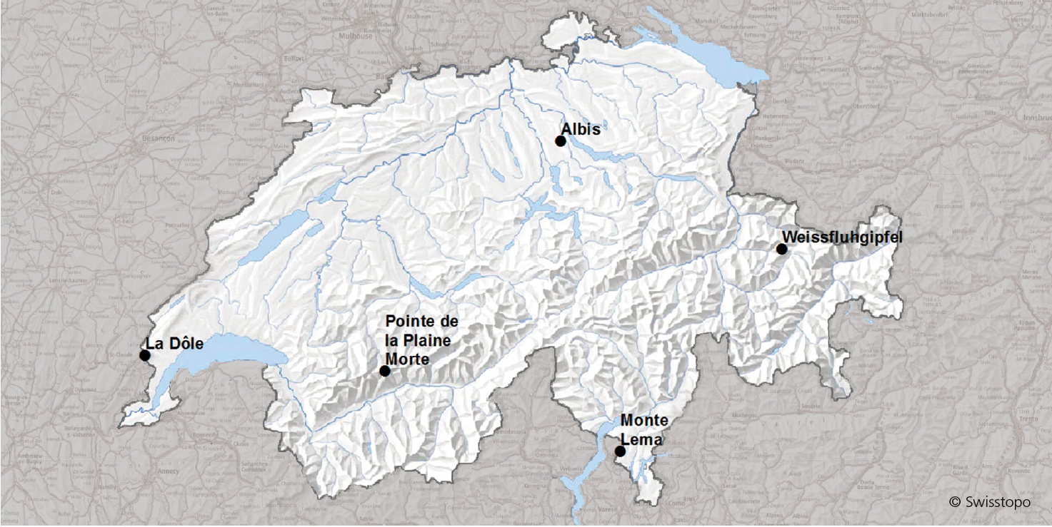

Figure 1: Map of ground-based meteorological radars in Switzerland

Most of the weather radars have been in operation for quite some time: Monte Lema since 1993, Albis since 1994, and La Dôle since 1995. Over the years, the existing stations have been modernised and additional ones have been added. This increased the spatial resolution from two to one kilometre and expanded the vertical scanning from previous 12 to 18 kilometres. The weather radars deliver around the clock measurement data for coloured real-time images, which are transmitted via television, Internet, or mobile phones. All images and products are now generated every 5 minutes, if required by the application even every 2.5 minutes.

In contrast to topographically very flat countries, Switzerland, with its many high mountains, poses a challenge for radar detection. The alpine valleys behind mountain ranges or peaks are in the radar shadow, which means that the radar rays cannot penetrate there and thus provide no information on precipitation.

The low air density in the high mountains also requires technical adjustments to the radar system. The difference in altitude within the weather radar network of around 2000 meters must also be taken into account.

## Technical and operational characteristics of 5.4 GHz weather radars for sharing studies

Recommendation ITU-R M.1849 [3] provides “Technical and operational aspects of ground-based meteorological radars“, including C-band radars operating in the 5250-5725 MHz band.

### Weather radars currently operating at 5.4 GHz

The technical parameters of the Swiss meteorological radars listed in section 3.1 above are covered by “Radar 14” in Recommendation ITU-R M.1849. A summary is given below.

Table 3: Characteristics of MeteoSwiss radars in the 5430-5470 MHz band

|  |  |
| --- | --- |
| Characteristics | MeteoSwiss |
| Tuning range (MHz) | 5430-5470 |
| Modulation | With Doppler capability |
| Tx power into antenna (kW peak) | 240 for each polarisation |
| Pulse width (µs) | 0.5 |
| Pulse rise/fall time (µs) | 0.25-0.30 |
| Pulse repetition rate (pps) | 600-1500 |
| Output device | Coaxial Magnetron |
| Antenna pattern type (pencil, fan, cosecant-squared, etc.) | Pencil |
| Antenna type (reflector, phased array, slotted array, etc.) | Parabolic |
| Antenna polarisation | Horizontal and vertical |
| Antenna main beam gain (dBi) | 45 |
| Antenna elevation beamwidth (degree) | 1 |
| Antenna azimuthal beamwidth (degree) | 1 |
| Antenna horizontal scan rate (degree/s) | 18-36 |
| Antenna horizontal scan type (degree) (continuous, random, 360°, sector, etc.) | 360 |
| Antenna vertical scan rate (degree) | 20 steps in 5 min |
| Antenna vertical scan type (continuous, random, 360°, sector, etc.) (degree) | –0.2 to +40 |
| Antenna side‑lobe (SL) levels (1st SLs and remote SLs) (dB) | –28 |
| Antenna height (m) | 5-45 |
| Receiver IF 3 dB bandwidth (MHz) | 2.5 |
| Receiver noise figure (dB) | 1.8 |
| Minimum discernable signal (dBm) | –113 |

In the operational Swiss scan strategy, the antenna rotates continuously in azimuth and changes elevation angle between -0.2° and 40° in an interleaved pattern. This results in measurements at 20 different elevations. For each elevation, the antenna rotates 360° in azimuth before moving to the next elevation. This procedure takes 5 minutes and results in a volume scan.

An operational calibration is performed at 35° and 40°elevation, which consists of injecting a reference signal into the receiver path and measuring the noise floor level of the system between 60 km and 70 km. At these elevations and ranges, the measurements are performed well beyond the tropopause (no weather echoes).

The MeteoSwiss weather radars are polarimetric radars, with transmission and reception on both polarisation (horizontally and vertically).

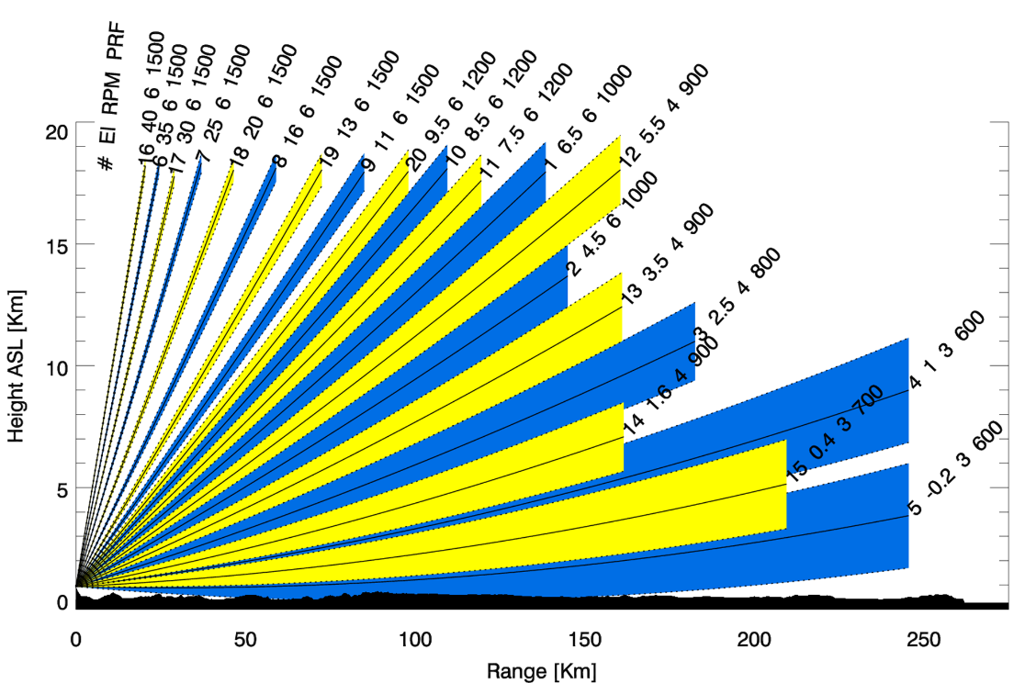

Figure 2: Swiss scan strategy

A volume scan takes five minutes and is divided into two half-volumes. The blues sweeps constitute the first half-volume, the yellow the second half-volume. Indicated are the order of the sweep (#), elevation (EL), the speed of the antenna in Rounds Per Minute (RPM) and the Pulse Repetition Frequency (PRF). The pulse width is 0.5 µs.

### Weather radars potentially moved from 5.6 GHz to 5.4 GHz

The details of C-band meteorological radars that are currently operated within the EUMETNET radar network can be found in the EUMETNET OPERA Database at:

<https://www.eumetnet.eu/wp-content/themes/aeron-child/observations-programme/current-activities/opera/database/OPERA_Database/index.html>

For the meteorological radars that may be moved from 5.6 GHz to 5.4 GHz, such a move will be more than likely accompanied by a limited modification of their technical parameters to only change the relevant RF part consistent with the new operating frequency. This means that the rest of the parameters will remain identical. To this respect, most European meteorological radars can be described by “Radar 10” in Recommendation ITU-R M.1849-2 (Table 7, section 2 of Annex 2), as given below:

Table 4: Characteristics of 5.6 GHz radars that may be moved to 5.4 GHz

|  |  |
| --- | --- |
| Characteristics | Radar 10 (Recommendation ITU-R M.1849-2) |
| Tuning range (MHz) | From 5600-5650  To 5365-5470 MHz |
| Modulation | With Doppler capability (including noise calibration w/o emission) |
| Tx power into antenna (kW peak) | 250 (note 1) |
| Pulse width (µs) | 0.5 to 3.3 |
| Pulse rise/fall time (µs) |  |
| Pulse repetition rate (pps) | 250-1200  Fixed, interleaved and staggered |
| Output device | Coaxial magnetron |
| Antenna pattern type (pencil, fan, cosecant-squared, etc.) | Pencil |
| Antenna type (reflector, phased array, slotted array, etc.) | Solid parabolic |
| Antenna polarisation | Horizontal and vertical |
| Antenna main beam gain (dBi) | 45 |
| Antenna elevation beamwidth (degree) | 0.9 |
| Antenna azimuthal beamwidth (degree) | 0.9 |
| Antenna horizontal scan rate (degree/s) | 6-36 1-6 |
| Antenna horizontal scan type (degree) (continuous, random, 360°, sector, etc.) | 360 |
| Antenna vertical scan rate (degree) |  |
| Antenna vertical scan type (continuous, random, 360°, sector, etc.) (degree) | –2 to +90 |
| Antenna side‑lobe (SL) levels (1st SLs and remote SLs) (dB) | –25 to –45 |
| Antenna height (m) | 7-30 |
| Receiver IF 3 dB bandwidth (MHz) | 0.3 to 2 |
| Receiver noise figure (dB) | 3 |
| Minimum discernable signal (dBm) | −107 to −115 |
| Note 1: Dual-polarisation for most radars | |

In addition to these parameters, it is important to consider that meteorological radars present a number of specificities in term of operational conditions, that could have both some impact on compatibility with other services, such as volumetric scanning strategy and use of different emission schemes mixing different pulse width and PRF, and in particular the use of fixed, staggered or interleaved PRF (i.e. different PRF during a single scheme).

These specificities are also well described in Recommendation ITU-R M.1849-2 and representative examples are provided in Recommendation ITU-R M.1849-2, section 4.1, as follows:

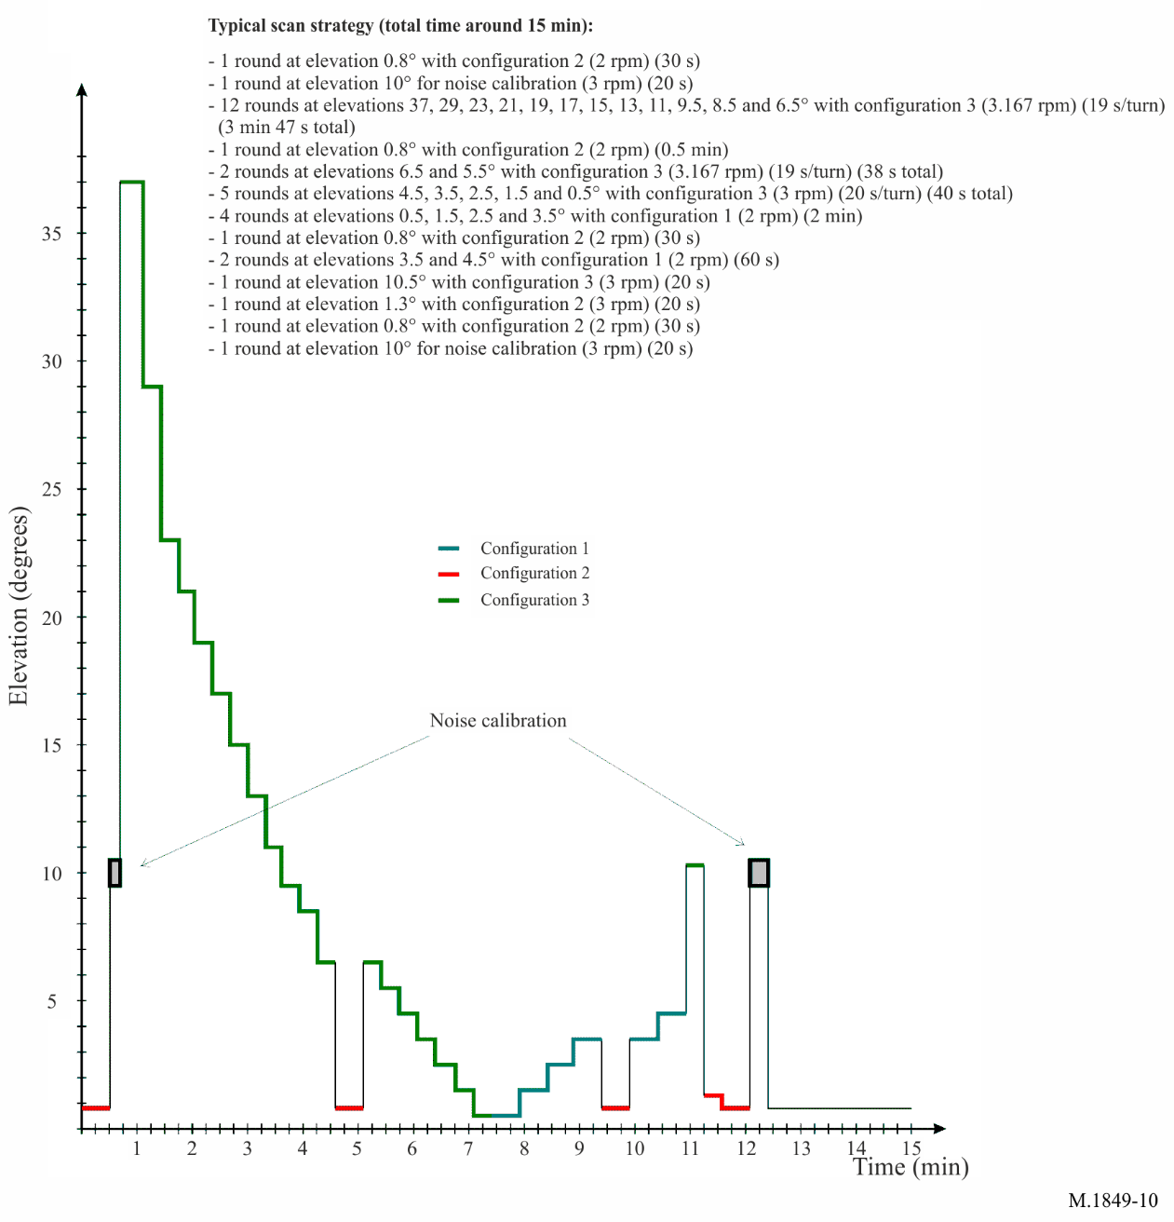

Figure 3: Typical meteorological radar scan strategy

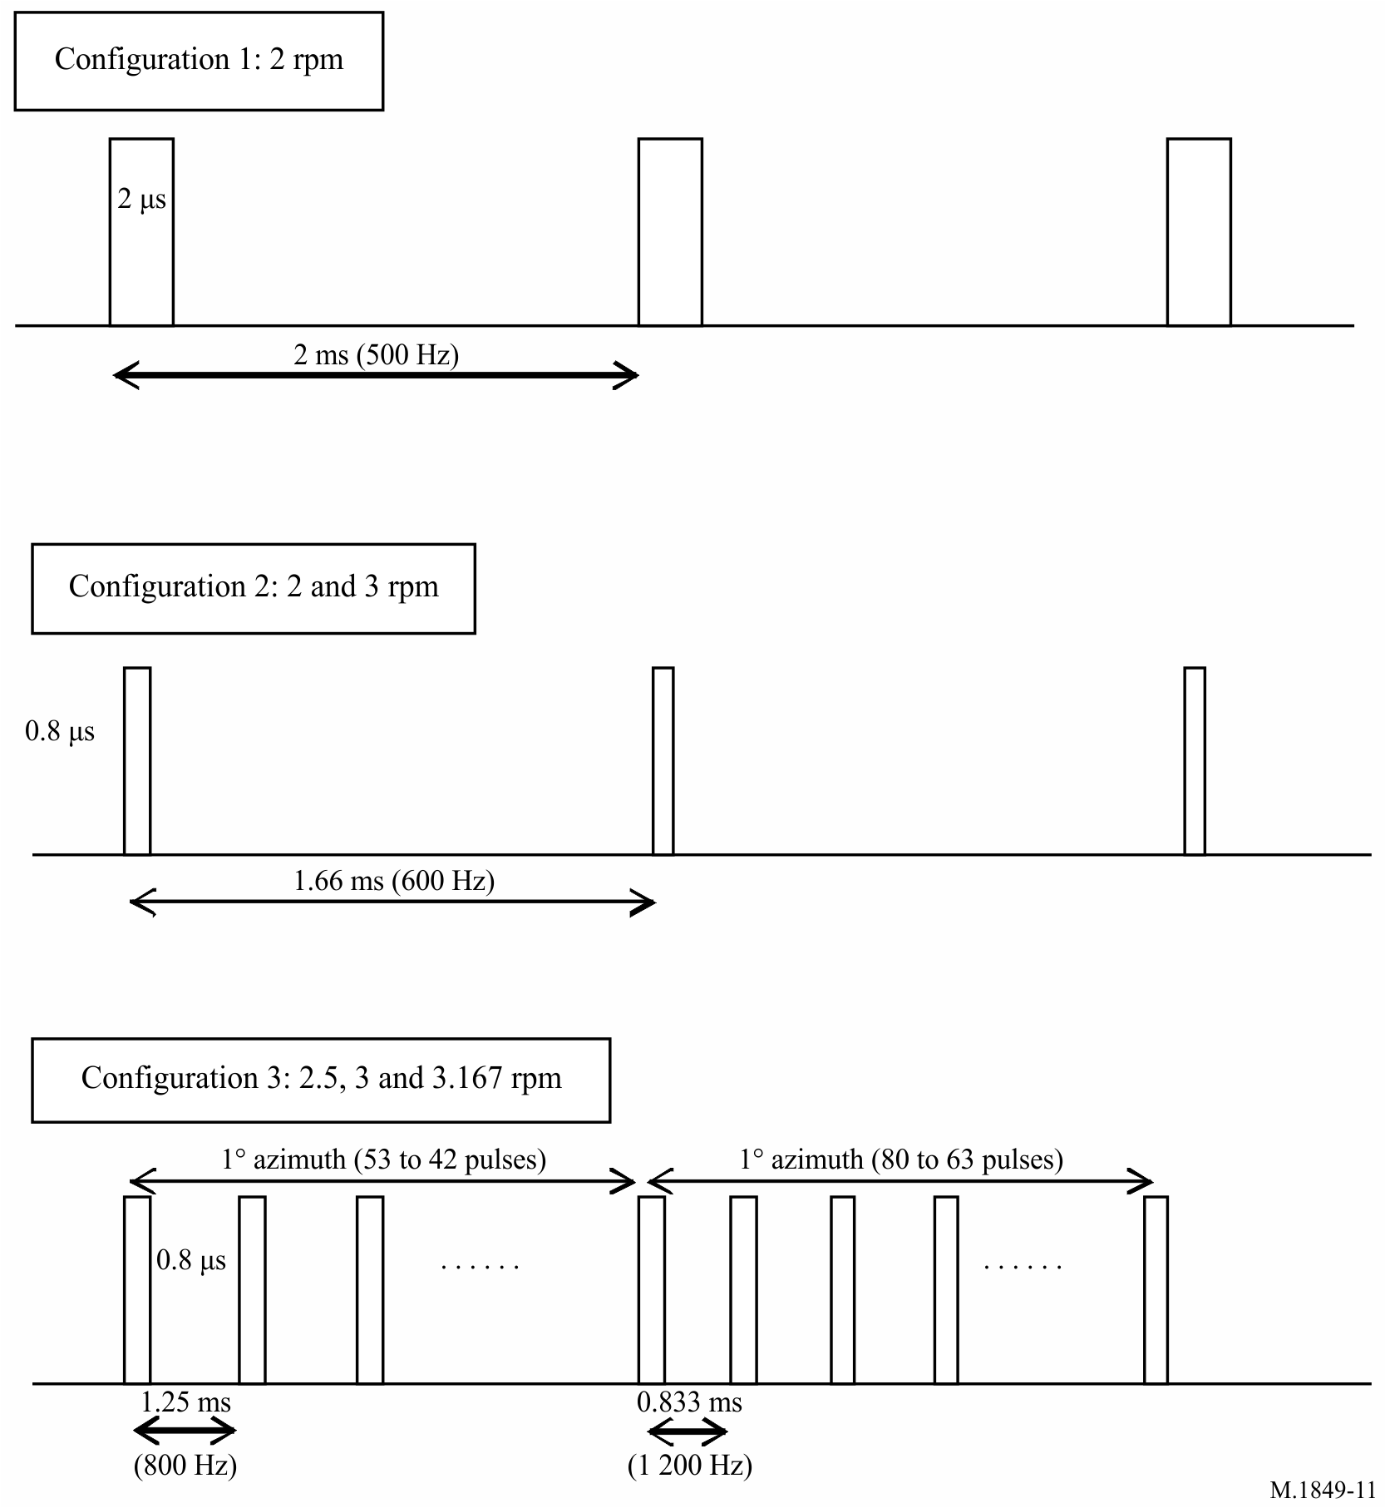

Figure 4: Typical meteorological radar scan strategy

Different emission schemes and scanning strategies exists over various meteorological radars in Europe, but one can assume that the above could be considered representative.

Finally, the parabolic antenna used by meteorological radars are usually well described by the antenna pattern given in Recommendation ITU-R F.1245 [4].

# EESS (active) in the 5.4 GHz range

## Typical parameters of Sensors in the EEESS (active) service

The typical technical and operational characteristics of EESS (active) systems are captured in Recommendation ITU-R RS. 2105-1 [5]. The table below includes characteristics that correspond to systems under the responsibility of CEPT observers or administrations. One additional row has been added with the names of the known missions corresponding to the parameters in the table.

Table 5: Characteristics of EESS (active) sensors

|  |  |  |  |  |
| --- | --- | --- | --- | --- |
| Mission names in Recommendation ITU-R RS.2105 | SAR-D1 | ALT-D1 | ALT-D2 (Note 1) | ALT-D4 (Note 1) |
| Actual mission names | Copernicus Sentinel-1 |  | Copernicus Sentinel-3 | Copernicus Sentinel-6 |
| Sensor type | SAR | Altimeter | Altimeter | Altimeter |
| Type of orbit | Circular SSO | NSS | Circular, SSO | NSS |
| Altitude (km) | 693 | 1336 | 814 | 1336 |
| Inclination (degrees) | 98.18 | 66 | 98.65 | 66 |
| Ascending Node LST | 18:00/6:00 (note 2) | NSS | 22:00 | NSS |
| Repeat period (days) | 12 | 10 | 27 | 10 |
| Antenna type | Phase array | Parabolic reflector | Parabolic reflector | Parabolic reflector |
| Number of beams | 1 | 1 | 1 | 1 |
| Antenna size/diameter | 12.3 m × 0.8 m | 1.2 m | 1.2 m | 1.2 m |
| Antenna Pk Xmt gain (dBi) | 43.5 to 45.3 | 32 | 32 | 33.5 |
| Pk Rcv gain (dBi) | 43.5 to 44.8 | 32 | 32 | 33.5 |
| Polarisation | V, H | linear | linear | linear |
| Azimuth scan rate (rpm) | 0 | 0 | 0 | 0 |
| Antenna beam look angle (degrees) | 20-47  (note 3) | 0 | 0 | 0 |
| Antenna beam azimuth angle (degrees) | 90 | 0 | 0 | 0 |
| Antenna elev. beamwidth (degrees) | 6 to 8 | 3.4 | 3.4 | 3.4 |
| Antenna az. beamwidth (degrees) | 0.3 | 3.4 | 3.4 | 3.4 |
| Swath width (km) | 20-410 | 79.4 | 48.4 | 97 |
| RF centre frequency (MHz) | 5 405 | 5 300 | 5 410 | 5 410 |
| RF bandwidth (MHz) | 100 | 100, 320 | 320 | 320 |
| Transmit Pk pwr (W) | 4 140 | 17 | 32 | 25 |
| Transmit Ave. pwr (W) | 370 | 0.51 | 0.4 (LRM),  0.25 (SAR) | < 2 |
| Pulsewidth (μs) | 5 to 53 | 106.0 | 49 | 32 |
| Pulse repetition frequency (PRF) Hz | 1450-2000 | 300 | 275 (LRM),  157 (SAR) | 2060-9280 |
| Chirp rate (MHz/μs) | 0.34-3.75 | 0.9, 3.0 | 6.5 | 9.69 |
| Transmit duty cycle (%) | 0.5-9.0 depending on ops mode | 3.1 | 1.5 (LRM),  0.7 (SAR) | 30 |
| e.i.r.p. ave (dBW) | 70 (for 9% duty cycle) | 29.5 | 30.8 (LRM), 28.4 (SAR) | 36.51 |
| e.i.r.p. peak (dBW) | 80 | 44.8 | 49.5 | 47.47 |
| System noise figure (dB) | 3.2 | 4.45 | 3.8 | 3.5 |
| Note 1: Dual frequency radar altimeter (C/Ku Band) which performs measurements either in low resolution mode (LRM) or synthetic aperture radar mode (Nadir-SAR). LRM mode is the conventional altimeter pulse limited mode with interleaved C/Ku Band pulses, while Nadir-SAR mode is the high along track resolution mode based on SAR processing. The system is a two‑satellite constellation.  Note 2: This system is a two-satellites constellation.  Note 3: Antenna beam “incident angles”. | | | | | |

Recommendation ITU-R RS.2105 [5] also provides definitions for these parameters, which are reported in the table below.

Table 6: Definition of parameters used in Recommendation ITU-R RS.2105

|  |  |
| --- | --- |
| Parameter | Definition |
| Sensor type | One of the five types described in the Introduction of this Recommendation |
| Orbit parameters | |
| Type of orbit | Such as: circular or elliptical, sun-synchronous (SSO) or non-sun-synchronous (NSS) |
| Altitude (km) | The height above the mean sea level |
| Inclination (degrees) | Angle between the equator and the plane of the orbit |
| Ascending Node LST | The local solar time (LST) of the ascending node is that local solar time for which the ascending orbit of the spacecraft crosses the equator |
| Repeat period (days) | The time for the footprint of the antenna beam to return to (approximately) the same geographic location. |
| Sensor antenna parameters  (Antenna characteristics vary among sensors) | |
| Antenna type | Such as: Parabolic offset fed to active phased array, Passive waveguide to active phased array, Planar slotted waveguide array |
| Number of beams | The number of beams is the number of locations on Earth from which data are acquired at one time. |
| Antenna diameter (or size) | Diameter of the antenna reflector (when applicable), or length and width of the planar array (when applicable). |
| Antenna Peak (Transmit & Receive) Gain (dBi) | The maximum (peak) antenna gain can be the measured value, or, if it is not known, it can be computed.  For the case of parabolic reflectors, the maximum antenna gain can be estimated by using the antenna efficiency η and D diameter of the reflector (when applicable):  For the case of planar array antennas, the maximum gain can be estimated by using the length l and width w of the planar array (when applicable) with the formula:  Maximum_antenna_gain = η 4π l w /λ2 |
| Polarisation | Specification of linear (H or V) or circular polarisation (RHCP or LHCP).  NOTE: where “HV” polarisation is listed, “H” polarisation is transmitted and “V” polarisation is received and vice versa for “VH” polarisation. |
| Azimuth scan rate (rpm) | The azimuth scan rate is the number of 360 degrees revolutions per minute that the antenna scans in azimuth. |
| Antenna beam look angle (degrees) | The antenna beam look angle, α, is the angle between the antenna boresight axis and nadir, sometimes called the off-nadir pointing angle. Some systems provide instead the information of the incident angle, i. They are the angle α and i, as shown in Recommendation ITU-R RS.2105, figure 1 [5]. |
| Antenna beam azimuth angle (degrees) | The antenna beam azimuth angle is the angle between the antenna boresight axis and velocity vector in the plane defined by the velocity vector and the negative orbit normal vector (see Recommendation ITU-R RS.2105, figure 2 [5]). |
| Antenna elevation beamwidth (degrees) | The antenna elevation beamwidth is the angle in the elevation or cross-track direction between the −3 dB points of the beam. |
| Antenna azimuth. beamwidth (degrees) | The antenna azimuth beamwidth is the angle in the azimuth or along-track direction between the −3 dB points of the beam. |
| Swath width (km) | The swath width is defined as the linear ground distance covered in the cross-track direction. |
| Transmitter characteristics | |
| RF centre frequency (MHz) | The RF centre frequency is that frequency about which the bandwidth of the transmitted signal is centred. |
| RF bandwidth (MHz) | The RF bandwidth is the −3 dB bandwidth of the transmitted signal. For compatibility analysis, this is also typically used as the receiver bandwidth. |
| Transmit Pk pwr (W) | The transmit peak power is the peak power of the envelope of the transmitted waveform. |
| Transmit Ave. pwr (W) | The transmit average power is the product of the peak power of the envelope of the transmitted waveform times the transmit duty cycle. |
| Pulsewidth (μs) | The pulsewidth is the half power duration of the transmitted pulse. |
| Pulse repetition frequency (PRF) (Hz) | The pulse repetition frequency is the frequency of the transmitted pulse waveforms. |
| Chirp rate (MHz/μs) | The chirp rate for a linear FM (LFM) pulse is the ratio of the RF bandwidth in MHz and the pulsewidth in μsec. |
| Transmit duty cycle (%) | The transmit duty cycle is the product of the transmitted pulsewidth and the pulse repetition frequency. |
| e.i.r.p. ave (dBW) | The average effective isotropically radiated power (e.i.r.p.) is the amount of power that a theoretical isotropic antenna would radiate to produce the average power density observed in the direction of maximum antenna gain; the e.i.r.p. is the product of the transmit average power and the antenna peak gain in dBW. |
| e.i.r.p. peak (dBW) | The peak effective isotropically radiated power (e.i.r.p.) is the amount of power that a theoretical isotropic antenna would radiate to produce the peak power density observed in the direction of maximum antenna gain; the peak e.i.r.p. is the product of the transmit peak power and the antenna peak gain in dBW. |
| Sensor receiver parameters | |
| System noise figure (dB)  or  System noise temperature (K) | The system noise figure is the ratio of the input signal-to-noise power ratio (S/N)i to the output signal-to-noise power ratio (S/N)o. The system noise temperature is effectively the antenna noise temperature plus the first stage receiver noise temperature; the other system noise temperature contributions can usually be neglected when the first stage receiver gain is greater than 16 dB. |

## EESS (active) Performance and interference criteria

Recommendation ITU-R RS.1166-4 [6] includes the performance and interference criteria for sensors in the EESS (active) service. Table 7 and Table 8 include, for the two types of sensors mentioned in Table 5, proposed amendments for a revision. Note that the values in Table 7 and Table 8 are the same as in the in-force version of this Recommendation.

Table 7: Performance criteria

|  |  |  |
| --- | --- | --- |
| Frequency band | Performance criteria for remote sensing instruments | |
| **Altimeter** | **SAR imager** |
| 5250-5570 MHz | Sea level precision ≤ 3 cm | Minimum reflectivity of –24 dB |

Table 8: Interference and data availability criteria

|  |  |  |  |
| --- | --- | --- | --- |
| Sensor type | Interference criteria | Data availability criteria (%) | |
| **I/N (dB)** | **Systematic** | **Random** |
| Synthetic aperture radar | –6 | 99 | 95 |
| Altimeter | –3 | 99 | 95 |

# methodology for sharing studies

## Methodology and key assumptions

The interference calculations are assumed to be represented through average cases.

The relevant interference formula is derived from Recommendation ITU-R RS.1280 [7], to assess the I/N in the case of interference from spaceborne sensor into terrestrial radar:

|  |  |
| --- | --- |
| $$I/N = 10*log(Pt) + 10*log (τ*PRF ) + Gt + Gr – (32.44 + 20*log ( f*R )) + OTR – N – PG$$ | (1) |

Where:

* Pt : peak spaceborne sensor transmitter power (W);
* τ : spaceborne sensor pulse width (s);
* PRF : spaceborne sensor pulse repetition frequency (Hz);
* Gt : spaceborne sensor antenna gain towards terrestrial radar (dBi);
* Gr : terrestrial radar antenna gain towards spaceborne sensor (dBi);
* F : frequency (MHz);
* R : slant range between sensor and radar (km);
* OTR : radar receiver on-tune rejection (dB);
* N: noise level (dBW);
* PG : processing gain (dB), rejection of unwanted signals due to radar receiver signal processing

(assumed to be zero if not known).

Although this formula is given for a specific case of the impact of spaceborne radar to terrestrial radar, the same formula can also apply in the reverse direction.

Formula (1) can be simplified as follows :

|  |  |
| --- | --- |
| $$I/N = P + Gt + Gr – FS + OTR – N – PG$$ | (2) |

Where:

* P : transmitting radar average power (dBW)
* Gt : transmitting radar antenna gain towards receiving radar (dBi)
* Gr : receiving radar antenna gain towards transmitting radar (dBi)
* FS : free space losses (dB)
* OTR : radar receiver on-tune rejection (dB)
* N: noise level (dBW)
* PG : processing gain (dB), rejection of unwanted signals due to radar receiver signal processing

(assumed to be zero if not known).

In the initial calculations, it is proposed to consider the case of the EESS (active) sensor pointing at the position of the meteorological radar, i.e. that the EESS (active) sensor maximum antenna gain is taken into account.

For the meteorological radar, the antenna gain distributions described in section 5.2 will be taken into account.

Considering the EESS (active) sensors and meteorological radars characteristics, the on-tune rejection is merely the bandwidth ratio.

Since the EESS (passive) sensor bandwidth is higher than the meteorological radar one, OTR = 0 in the “Met radar to EESS” direction.

In the other direction, (from EESS (active) to meteorological radars) the OTR is 10 log(100/2), hence OTR = 17 dB.

Table 9 summarises the assumptions used in the interference calculations:

Table 9: Assumptions used in the interference calculations

|  |  |  |  |  |
| --- | --- | --- | --- | --- |
| Scenarios |  | 1 | 2 | 3 |
| EESS Sensor |  | S6 | S1 | S1 |
| Frequency | MHz | 5400 | 5400 | 5400 |
| EESS |  |  |  |  |
| Satellite altitude | km | 814 | 693 | 693 |
| Incidence angle of main beam | ° | 0 | 20 | 47 |
| Elevation at ground | ° | 90 | 70 | 43 |
| Slant path length | km | 814 | 733 | 964 |
| Free Space losses | dB | 165.3 | 164.4 | 166.8 |
| Antenna gain | dBi | 34.5 | 44.5 | 44.5 |
| Bandwidth | MHz | 320 | 100 | 100 |
| average power | W | 0.4 | 370 | 370 |
|  | dBW | -4 | 25.7 | 25.7 |
| interference criteria | I/N | -3.0 | -6.0 | -6.0 |
|  | systematic | 99% | 99% | 99% |
|  | random | 95% | 95% | 95% |
| Noise figure | dB | 3.8 | 3.2 | 3.2 |
| interference level (without processing gain) | dBW | -118.1 | -126.8 | -126.8 |
|  |  |  |  |  |
| Meteorological radar |  |  |  |  |
| Maximum Antenna gain | dBi | 45 | | |
| Antenna gain in the direction of EESS sensor | dBi | -12.3 | see distributions | |
| Bandwidth | MHz | 2.0 | | |
| Noise figure | dB | 3.0 | | |
| Peak power (Recommendation ITU-R M.1849) | kW | 250 | | |
| Peak-to-average ratio |  | 31 | | |
| average power | dBW | 23.0 | | |
| OTR (EESS to radar) | dB | 22 | 17.0 | |
| OTR (radar to EESS) | dB | 0.0 | | |
| interference criteria | I/N (dB) | -10 | | |
| interference level | dBW | -148.0 | | |

## distribution of Meteorological radars gain toward EESS (active)

### Weather radars scanning strategies

The radar gain toward EESS (active) sensor is considered in a fixed direction (fixed in azimuth and at the Reference EESS elevation) and is calculated considering the radar scanning strategies described above and summarised in Table 10 and Table 11.

Table 10: Radar scanning strategy (derived from Recommendation ITU-R M.1849-1)

|  |  |  |
| --- | --- | --- |
| Elevations (°) | Rotation speed (°/s) | Round duration (s) |
| 0.8 | 12.00 | 30.00 |
| 10 | 18.00 | 20.00 |
| 37 | 18.95 | 19.00 |
| 29 | 18.95 | 19.00 |
| 23 | 18.95 | 19.00 |
| 21 | 18.95 | 19.00 |
| 19 | 18.95 | 19.00 |
| 17 | 18.95 | 19.00 |
| 15 | 18.95 | 19.00 |
| 13 | 18.95 | 19.00 |
| 11 | 18.95 | 19.00 |
| 9.5 | 18.95 | 19.00 |
| 8.5 | 18.95 | 19.00 |
| 6.5 | 18.95 | 19.00 |
| 0.8 | 12.00 | 30.00 |
| 6.5 | 18.95 | 19.00 |
| 5.5 | 18.95 | 19.00 |
| 4.5 | 18.00 | 20.00 |
| 3.5 | 18.00 | 20.00 |
| 2.5 | 18.00 | 20.00 |
| 1.5 | 18.00 | 20.00 |
| 0.5 | 18.00 | 20.00 |
| 0.5 | 12.00 | 30.00 |
| 1.5 | 12.00 | 30.00 |
| 2.5 | 12.00 | 30.00 |
| 3.5 | 12.00 | 30.00 |
| 0.8 | 12.00 | 30.00 |
| 3.5 | 12.00 | 30.00 |
| 4.5 | 12.00 | 30.00 |
| 10.5 | 18.00 | 20.00 |
| 1.3 | 18.00 | 20.00 |
| 0.8 | 12.00 | 30.00 |
| 10 | 18.00 | 20.00 |
|  | | |
| Total duration (s) | | 746 |
| Number of rotations | | 33 |

Table 11: Radar scanning strategy (MeteoSwiss)

|  |  |  |
| --- | --- | --- |
| Elevations (°) | Rotation speed (°/s) | Round duration (s) |
| 6.5 | 36.00 | 10.00 |
| 4.5 | 36.00 | 10.00 |
| 2.5 | 24.00 | 15.00 |
| 1 | 18.00 | 20.00 |
| -0.2 | 18.00 | 20.00 |
| 35 | 36.00 | 10.00 |
| 25 | 36.00 | 10.00 |
| 16 | 36.00 | 10.00 |
| 11 | 36.00 | 10.00 |
| 8.5 | 36.00 | 10.00 |
| 7.5 | 36.00 | 10.00 |
| 5.5 | 24.00 | 15.00 |
| 3.5 | 24.00 | 15.00 |
| 1.6 | 24.00 | 15.00 |
| 0.4 | 18.00 | 20.00 |
| 40 | 36.00 | 10.00 |
| 30 | 36.00 | 10.00 |
| 20 | 36.00 | 10.00 |
| 13 | 36.00 | 10.00 |
| 9.5 | 36.00 | 10.00 |
|  | | |
| Total duration (s) | | 250 |
| Number of rotations | | 20 |

### Calculation of radar gain toward EESS (active)

#### EESS (active) altimeters

EESS (active) altimeters (e.g. SENTINEL-6) operate at nadir, with hence their main beam seen at 90° elevation at ground.

For both types of radars described above, the radar gain toward EESS (active) sensor is constant at -12.3 dBi, corresponding to the back lobe gain from antenna pattern given in Recommendation ITU-R F.1245 [4].

#### EESS (active) SAR

Unlike altimeters, EESS (active) SARs operate at various incidence angles at ground (20° and 47° for SENTINEL-3)

For the radar scanning strategy from Recommendation ITU-R M.1849 [3], the following Figure 5 and Figure 6 provide the timing of the radar gain for the 20° and 47° reference incidence angles (corresponding respectively to 70° and 43° elevation at ground).

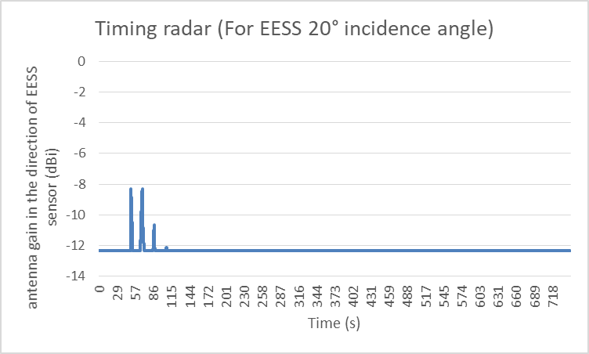

Figure 5: Radar gain timing at 20° incidence angle (M.1849-1)

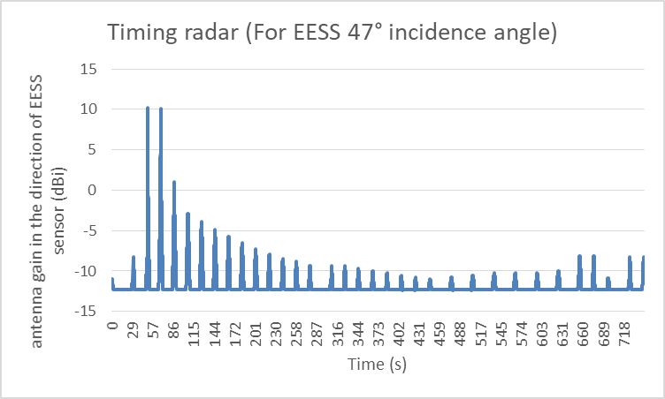

Figure 6: Radar gain timing at 47° incidence angle (M.1849-1)

Similarly, for the radar scanning strategy of MeteoSwiss radars, the following Figure 7 and Figure 8 provide the timing of the radar gain for the 20° and 47° reference incidence angles.

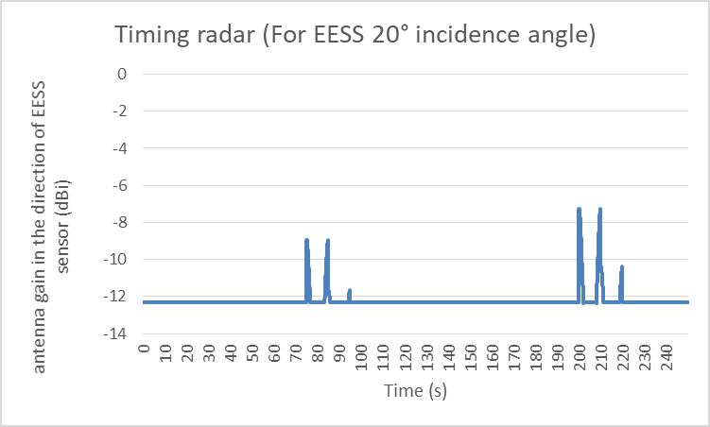

Figure 7: Radar gain timing at 20° incidence angle (MeteoSwiss)

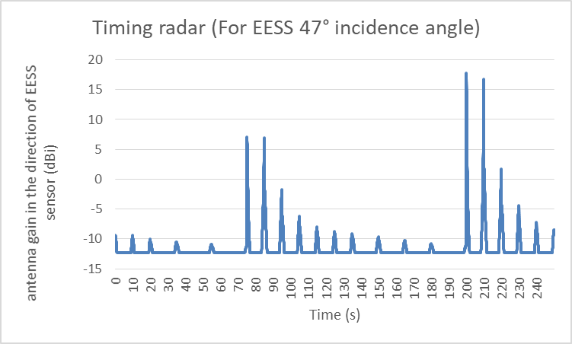

Figure 8: Radar gain timing at 47° incidence angle (MeteoSwiss)

As a summary, the radar gain above can also be described as distributions, as on Figure 9 below.

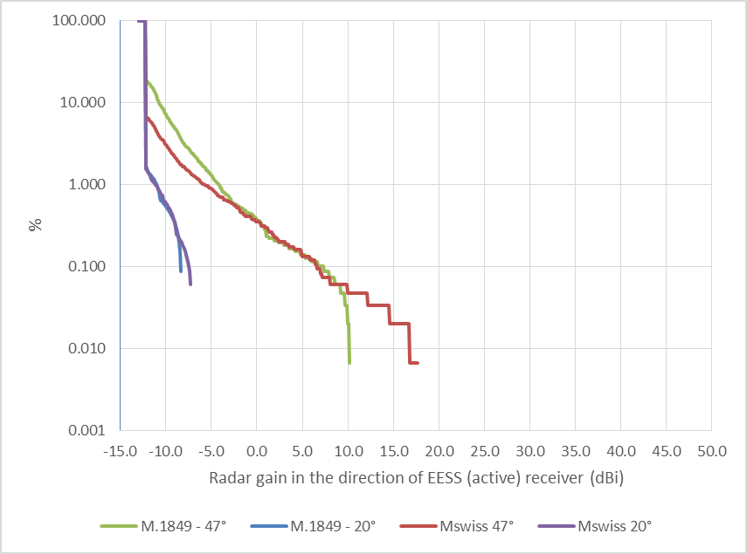

Figure 9: Distribution of radar gain toward EESS (active)

# Assessment of the potential interference from 5.4 GHz weather radars into EESS (active)

## Main beam calculations

Using the methodology described in section 5, the following Figure 10 depicts the distribution of interference level from meteorological radar to EESS (active) sensor (SAR case) main beam, compared with relevant protection criteria (accounting for Processing Gain).

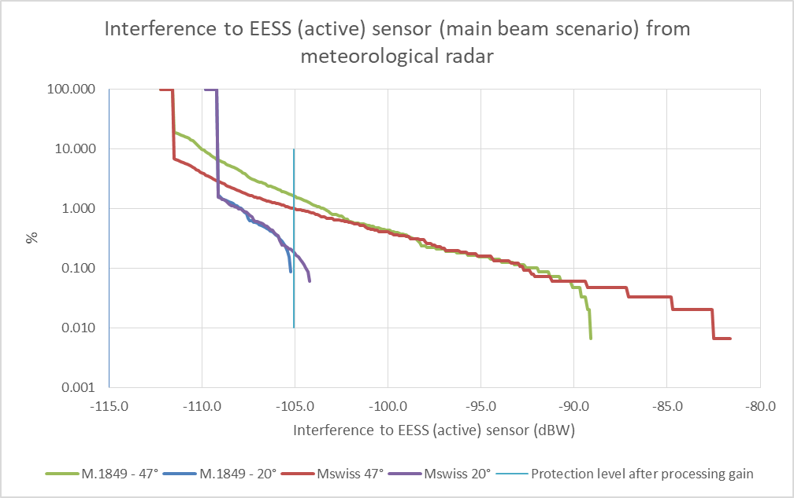

Figure 10: Interference to EESS (active) from meteorological radar (main beam scenario without processing gain)

Figure 10 shows that, only considering the specific case, where the EESS (active) sensor is pointing to the meteorological radar, the calculated interference is exceeding the protection level for a limited percentage of time.

As such, this would already satisfy the protection criteria from Recommendation ITU-R RS.1166-4 [6], considering both the systematic and random cases.

In addition, it should be highlighted that the conditions for which the EESS (active) sensor main beam is pointing over a meteorological radar are limited in theory to 2 daily periods of few seconds each.

Apart from these limited periods, the potential interference from weather radars would be produced within the EESS sensor side lobes, i.e. reducing the calculated interference by several tens of dB (more than 45 dB assuming negative gains in sidelobes).

This would hence in theory lead to possible interference that would be kept within very limited percentage that are unlikely to be harmful to EESS (active) SAR operations.

Finally, for EESS(active) altimeters (for which the radar gain toward EESS sensor is constant at -12.3 dBi), the potential interference would probably be constant at every pass over the meteorological radar but, here also corresponding to geometric situations with very low percentage of occurrence.

These scenarios may have to be further validated by dynamic analysis considering EESS (active) move on their orbit.

## Dynamic simulation

### Additional considerations on SAR characteristics for the purpose of dynamic simulation

#### SAR Modes

SENTINEL-1, as all SARs, can make use of several different modes of image acquisition, depending on the swath and resolution desired. This is illustrated in Figure 11.

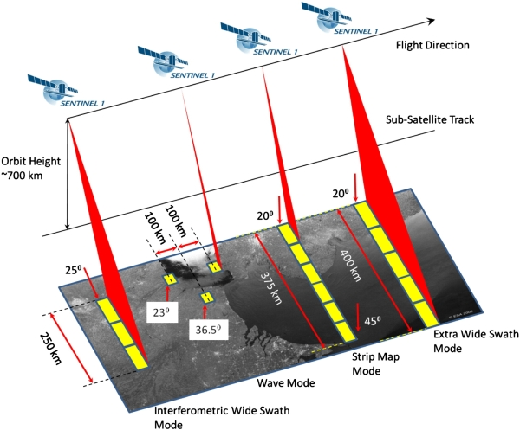

Figure 11: Illustration of SENTINEL-1 modes

The interferometric wide swath mode (IW) is the default mode used over land and it is the mode used in the simulations. The bandwidth in this mode is in the order of 50 MHz. The noise level assuming a noise figure of 3.2 dB is -124 dBW, and the processing gain for noise is in the order of 24 dB.

The stripmap and wave modes are making use of larger bandwidths than the IW mode. The stripmap mode for the two extreme antenna positions has also been studied, but it shows better results than the IW mode. The wave mode reduces the probability of having a meteorological radar within the image area and therefore SAR main beam area. The extra wide swath mode is making use of lower bandwidths (10 to 15 MHz) and frequency overlap would therefore be even less probable.

#### SAR Processing gain

The I/N of -6 dB in Recommendation ITU-R RS.1166-4 [6] is defined after the SAR processing operations; this processing in both range (across the satellite track) and azimuth (along satellite track) aim at extracting from the noisy raw data the details of the image.

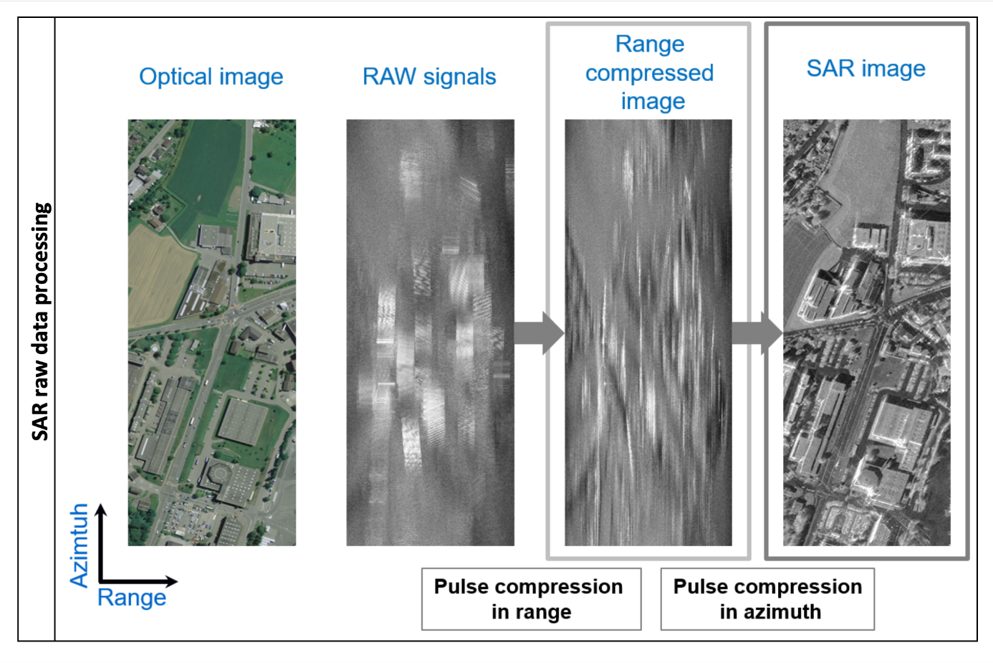

Figure 12: Example of SAR processing effect

This results in a so-called ‘SAR processing gain’ (Mainly due to compression in azimuth and range) of the wanted radar signal (overall in the order of 80 to 90 dB), of the noise (in the order of 2 to 30 dB), as well as the interfering signal (variable depending on its characteristics). Recommendation ITU-R RS.1166-4 provides some information on the processing gain values.

Since the criterion is an I/N, what we are interested in are the processing gains for noise and interference.

When dealing with relatively narrow band interfering signals such as a non-modulated pulsed signal from a meteorological radar, the SAR processing has a non-negligible and rather important impact. Recommendation ITU-R RS.1166-4 indeed gives an overall “interference” processing gain of 2.3 to 11.8 dB for a 2 µs unmodulated radar pulse train (a more precise value could be derived from the exact characteristics of the SAR and meteorological radar but at this stage these two extreme values have been retained in the assessment).

This “interference” processing gain has then to be compared with the processing gain obtained for noise that can be up to 30 dB.

For the SENTINEL-1 IW mode, the actual “noise” processing gain is 24 dB. This means that the overall processing gain of the I/N would therefore be between 12.2 dB (24 – 11.8) and 21.7 dB (24-2.3). These values have been accounted for in the following simulations.

It is interesting to note that for noise like interference (e.g. aggregate of large band interferers), the processing gain would be the same as the processing gain for noise, hence leading to an overall processing gain of 0 dB for the I/N.

### Simulation results

#### Impact of Switzerland meteorological radars into SAR (SENTINEL-1)

A simulation has been run over 11 days (SAR repeat period) with a 0.1 s time step, over a measurement area of 10 000 000 km² corresponding to Europe (although Recommendation ITU-R RS.1166-4 [6] does not specify such measurement area size).

The SENTINEL-1 satellite is assumed to operate in IW mode with the beam scanning in azimuth and distance.

The 5 Swiss meteorological radars have been deployed at their actual locations given in Table 2. Although 3 of the 5 Swiss radars are actually operating outside of the SENTINEL-1 band, the current exercise is of a generic nature and hence simulates the 5 radars as being in the SENTINEL-1 band (which is a worse case compared to reality).

The scanning of the radars over azimuth and elevation has been simulated, taking into account the scanning pattern provided in section 3.2.1.

Simulations results are given in Figure 13 and Figure 14, for both “I/N” processing gain of 12.2 dB (corresponding to the 2.3 dB SAR processing gain on the meteo radars signal) and 21.7 dB (corresponding to the 11.8 dB SAR processing gain on the meteo radars signal).

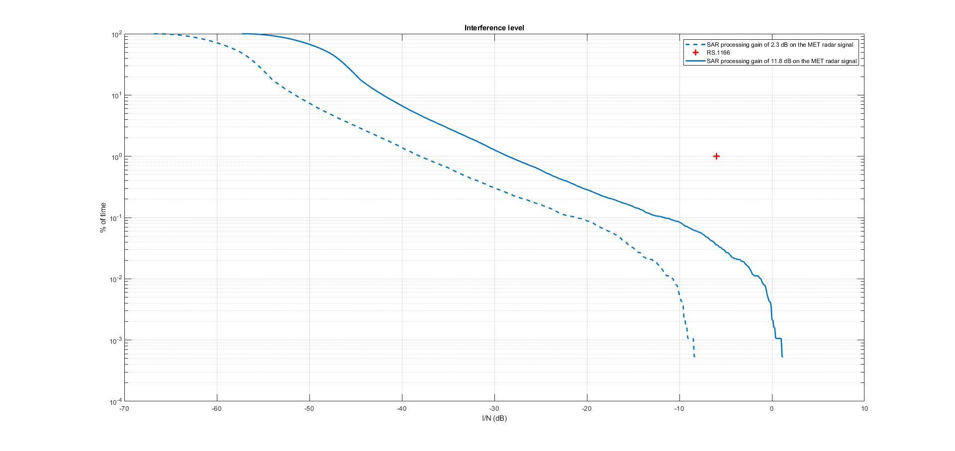

Figure 13: Cdf of I/N obtained in the simulation

In Figure 13, the thin blue lines represent the measurement area. Thick blue lines represent the position of the satellite when images are taken within this measurement area. The black circles represent the locations of meteorological radars, and the red dots the SAR footprint when the I/N of -6 dB has been exceeded.

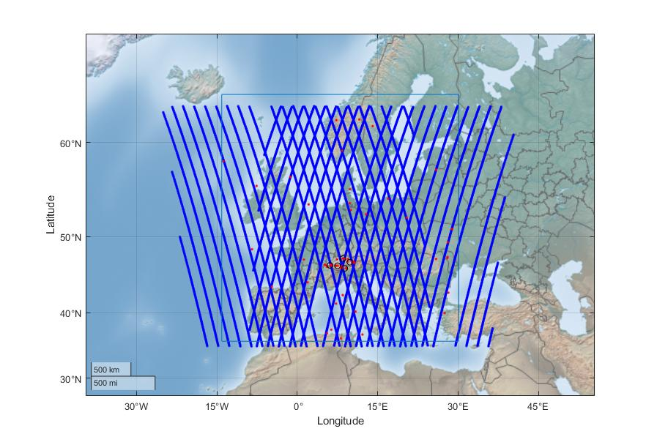

Figure 14: Map of interference (SAR processing gain on the meteo radars signal of 11.8 dB)

These results tend to show that a deployment of meteorological radars, similar to those currently operating in Switzerland, would be compatible with SENTINEL-1 operations. The following additional elements are to be noted:

It is worth noting that SENTINEL-1 consists in 2 satellites in orbit. Only one of the satellites has been considered here.

It should also be noted that over the 11 days of simulation, there was never any main beam to main beam coupling observed between the SENTINEL-1 radar and any of the meteorological radars. Hence the maximum levels of mutual coupling gains observed are much less than the levels calculated in the analysis in section 6.1. This could be explained by the fact that the 11 days simulations correspond to quite a limited number of satellite passes over the meteorological radars, corresponding to a very limited time period. In theory, the maximum coupling determined in section 6.1 is correct but would hence be associated with an extremely low probability.

#### Impact of a large number of meteorological radars deployed over Europe into SAR (SENTINEL-1)

In this analysis, 1/3 of the meteorological radars deployed over Europe (with the exception of Italy) are assumed to switch frequencies to operate into the same frequency band as SENTINEL-1. From the list of 166 radars provided by EUMETNET, see section 3.2.2, 55 were therefore assumed to be operating in the SENTINEL-1 band.

The antenna scanning pattern of meteorological radars, as provided in section 3.2.2, is considered in this analysis. All other assumptions are similar to the previous analysis.

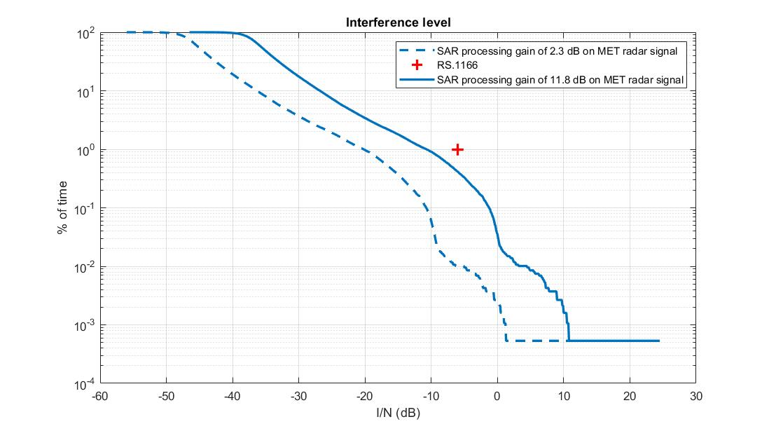

Figure 15: Cdf of I/N obtained in the simulation

It can be seen that the increase in the number of meteorological radars increases the probability of main beam to main beam coupling and hence the increase in the maximum levels of interference observed in the distribution tail. Both cdf are however below the Recommendation ITU-R RS.1166-4 protection criterion, for both SAR processing gain assumptions.

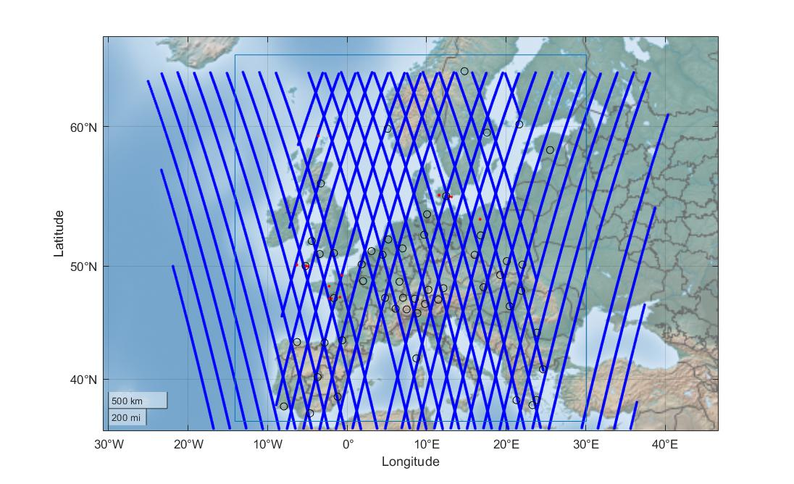

Figure 16: Map of interference (SAR processing gain on the meteo radars signal of 2.3 dB)

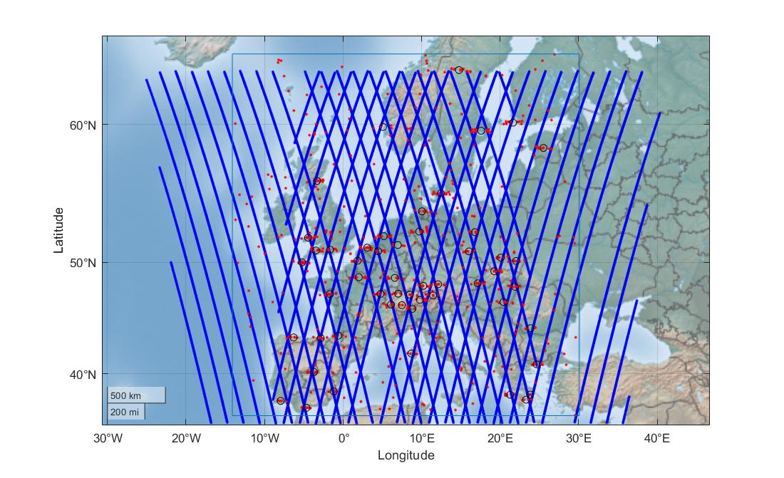

Figure 17: Map of interference (SAR processing gain on the meteo radars signal of 11.8 dB)

#### Impact of Switzerland meteorological radars into Altimeters (SENTINEL-6)

A simulation has been run over 11 days with a 0.1 s time step, over a measurement area of 10 000 000 km² corresponding to Europe (although Recommendation ITU-R RS.1166-4 does not specify such measurement area size).

The SENTINEL-6 satellite has been chosen for this analysis, with a sensor pointing towards Nadir as described in section 5.2.2 as well as in Table 5.

No processing gain has been accounted for in this section as Recommendation ITU-R RS.1166-4 does not consider any for altimeters.

All 5 Swiss meteorological radars are assumed to transmit in the SENTINEL-6 band, which in this case is fully justified given that this band is 320 MHz wide.

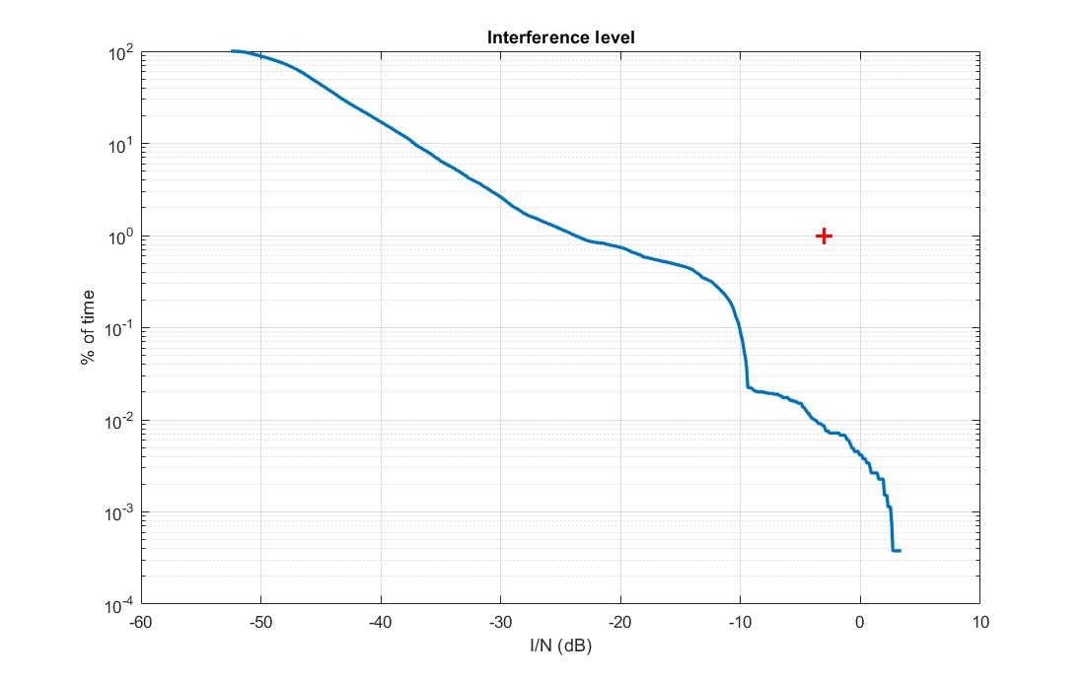

Figure 18: Cdf of I/N obtained in the simulation

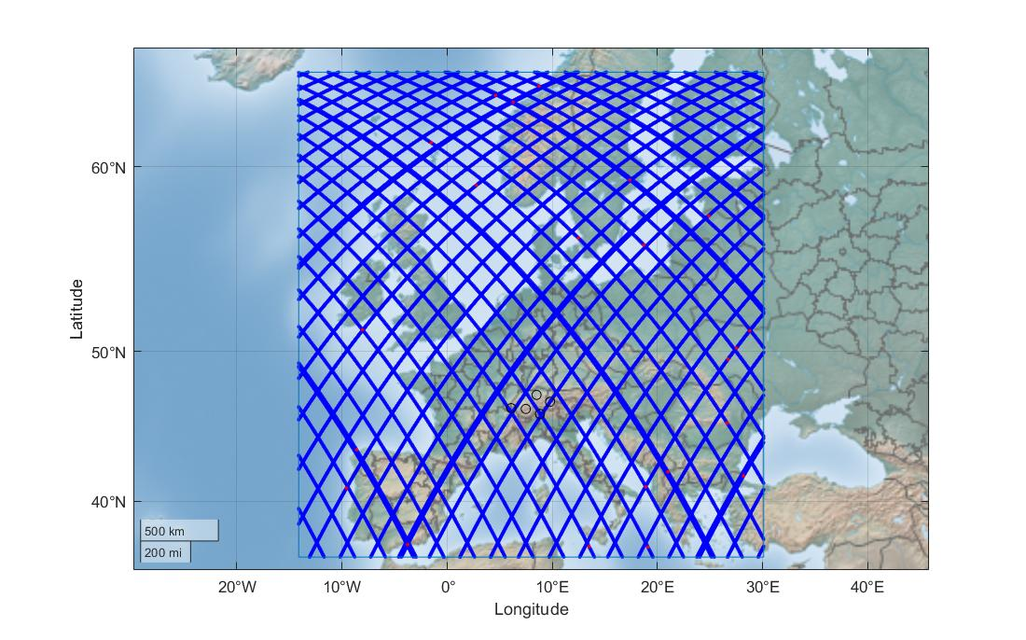

Figure 19: Map of interference

#### Impact of large number of meteorological radars deployed over Europe into Altimeters (SENTINEL-6)

The assumptions are similar to the section above, except that 55 radars are assumed to transmit within the SENTINEL-6 320 MHz bandwidth.

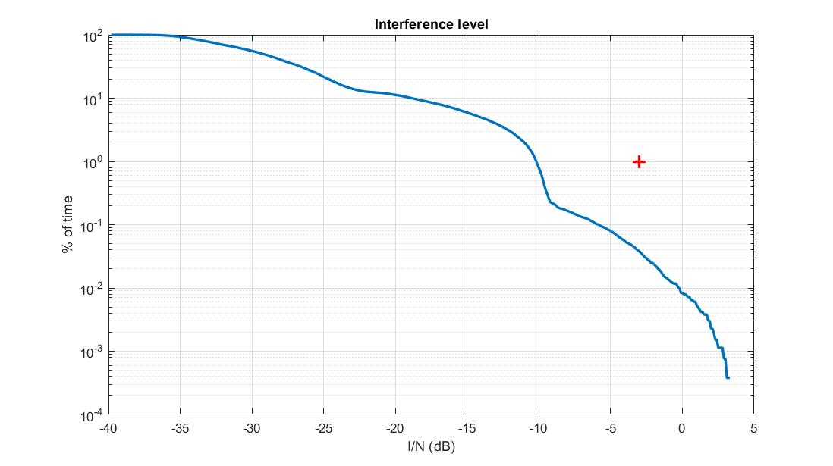

Figure 20: Cdf of I/N obtained in the simulation

One important thing to highlight is that all altimeters measurements are considered, including the ones over land; this is not realistic as the altimeter would perform measurements over sea, large portions of waters such as lakes or big rivers, and not over land where the meteorological radars are deployed. Limiting the measurements to such portions of water would largely improve the situation, and in particular, eliminate high I/N values found in the distribution tail.

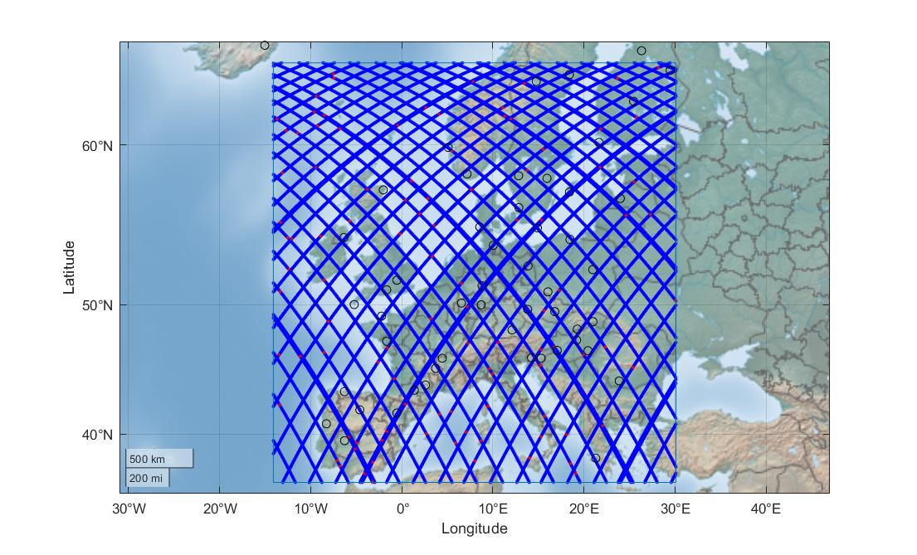

Figure 21: Map of interference

## Summary for the potential interference from 5.4 GHz weather radars into EESS (active)

This section has addressed the potential interference from a deployment of weather radars in portions of the 5365-5470 MHz band on EESS (active), both using main beam analysis and dynamic simulations for either SAR or Altimeters instruments.

The calculations show that a quite large deployment of weather radars (e.g. up to 55 radars, which corresponds to one third of the existing 166 radars operated in the 5.6 GHz band) would be compatible with EESS (active) without the need for specific operational conditions for weather radars.

# Assessment of the potential interference from EESS (Active) into 5.4 GHz weather radars

## Main beam calculations

Using the methodology described in section 5, the following figure depicts the distribution of interference level from EESS (active) main beam to meteorological radar.

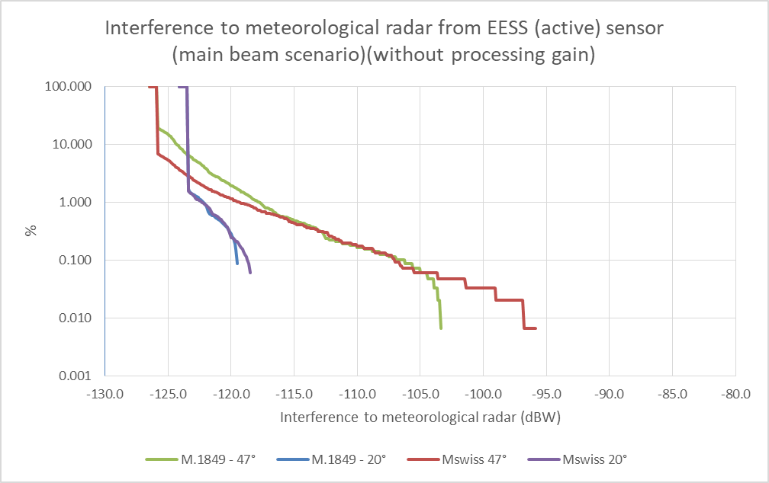

Figure 22: Interference to EESS (active) from meteorological radar (main beam scenario)

Figure 22 shows that when the EESS (active) SAR main beam is pointing is pointing over a meteorological radar, the interference is exceeding the radar protection criteria (-148 dBW), However, here also this scenario is limited in theory to 2 daily periods of few seconds each.

Apart from these limited periods, the potential interference from EESS (active) would be produced within the sensor side lobes, i.e. reducing the calculated interference by several tens of dB (more than 45 dB assuming negative gains in sidelobes). This will lead to drastically decrease the interference levels as well as the interference probability, leading in theory to possible interference that would be kept within very limited percentage (occurring twice a day) that are unlikely to be harmful to meteorological operations.

This scenario may have to be further validated by dynamic analysis considering EESS (active) move on their orbit.

Finally, it should be noted that for EESS(active) altimeters (for which the radar gain toward EESS sensor is constant at -12.3 dBi), the potential interference to meteorological radars is very low compared to the SAR case due to more favourable assumptions (lower average power, lower antenna gain, higher OTR), The potential interference is calculated at -169 dBW, i.e. about 20 dB below the meteorological radar protection level.

## Dynamic simulation

The impact of EESS (active), in that case the SENTINEL-1 SAR, which is more powerful than the SENTINEL-6 altimeter, has been assessed using the simulation described in section 6.2.2.1, into the first Swiss radar in the list, operating in the same band. This time the SAR is transmitting, and the meteorological radar is receiving.

There is no meteorological radar processing gain considered that would decrease the impact of the SAR signal. However, in accordance with Recommendation ITU-R RS.1280, an On-Tune Rejection (OTR) factor of 14 dB (10log(50 MHz/2 MHz)) has been considered against this particular SENTINEL-1 emission mode.

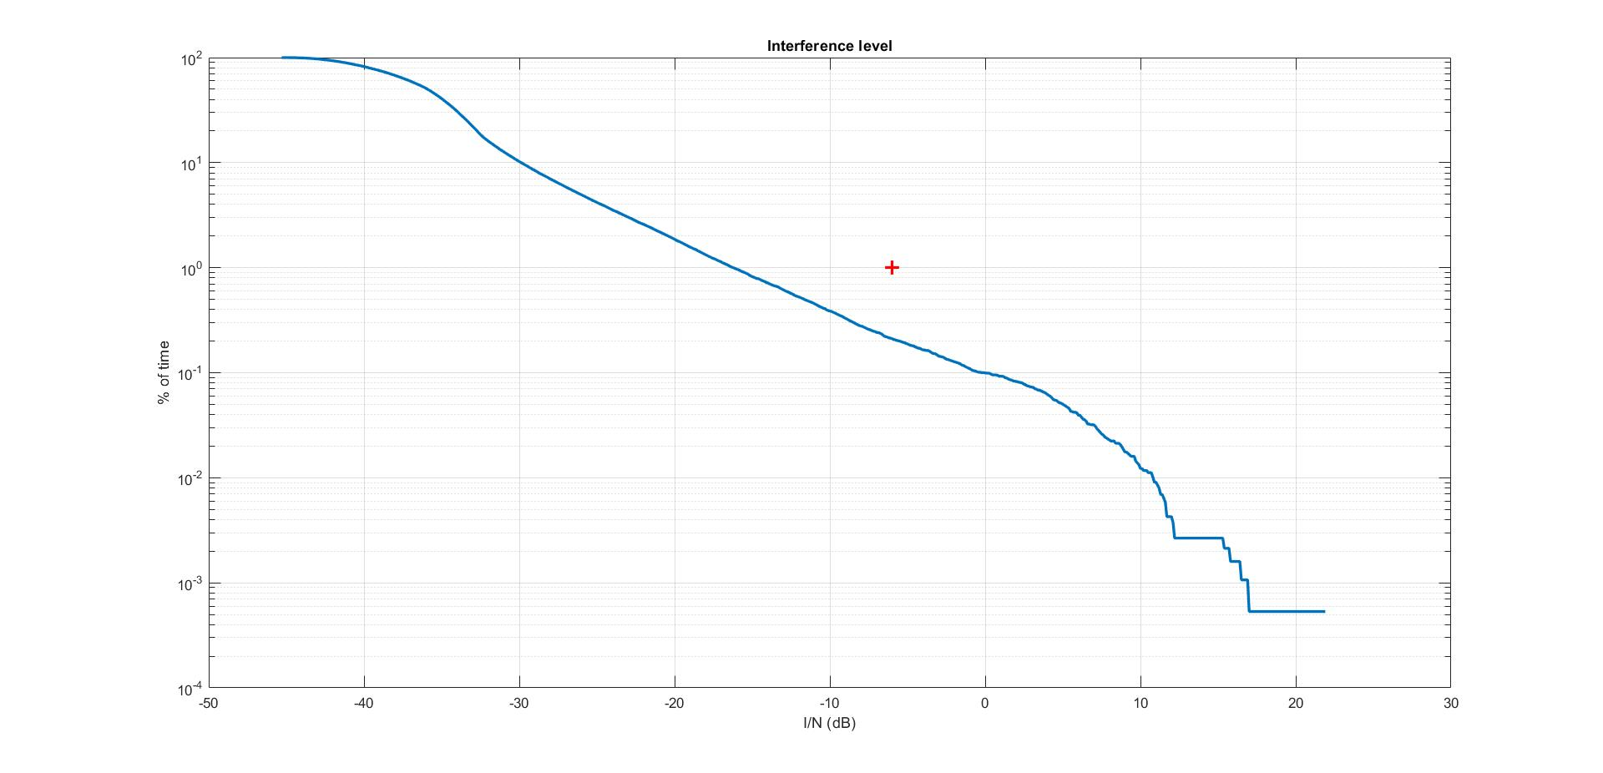

Figure 23: Cdf of I/N obtained in the simulation

The interference levels (here in I/N) are much lower than the ones determined in section 7.1 (the I/N of -10 dB corresponds to a level of -148 dBW) due to the accounting of the satellite move on its orbit. The maximum interference depicted is also lower due to the absence of main beam to main beam coupling observed in the simulation.

## Results of measurements

The aim of the measurements was to check whether transmissions from SENTINEL-1 had an impact on Swiss weather radars. A detailed description of the process can be found in [8].

### Description of the measurements

The SENTINEL-1 images generated in the region centered on the radar ‘La Dôle’ were used as a reference, but interferences were also present in the radar ‘Weissfluhgipfel’. In this context, it is worth to note that both radars use similar frequencies, while the other three Swiss radars deviate somewhat more from them (5430 MHz for ‘La Dôle’, 5433 MHz for ‘Weissfluhgipfel’, 5450 MHz for ‘Albis’, 5455 MHz for ’Monte Lema’ and 5468 MHz for ‘Pointe de la Plaine Morte’).

The analysis was based on dedicated operational noise measurements during the two highest sweeps at elevation angles of 35° and 40° in the Swiss scan strategy (see Figure 2). Between January and July 2021, there were 50 SENTINEL-1 images with a timestamp overlapping the time interval of a sweep at elevation 40°, and 33 SENTINEL-1 images with a timestamp overlapping the time interval of a sweep at elevation 35°. In case of an overlap, the noise values were sampled and plotted for an interval of +/- one hour - centered on the overlapping time stamp - for a total of 25 radar volumes.

An example of a single event on 7 May 2021 is given in Figure 24.

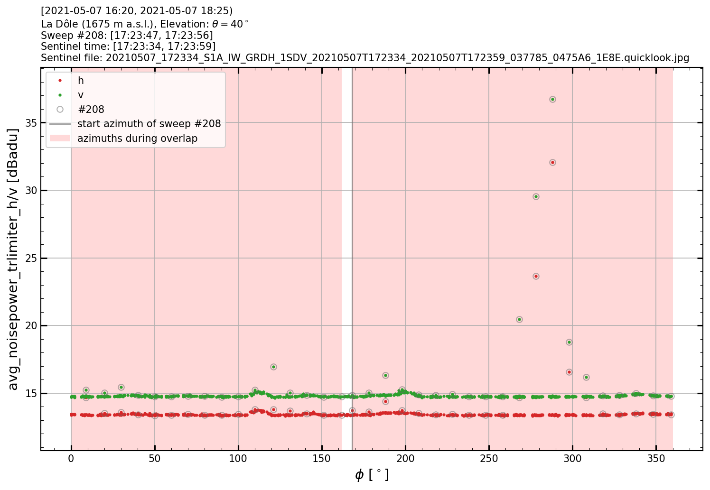

Figure 24: Measured noise power at elevation 40° as a function of azimuth at ‘La Dôle’ on 7 May, 2021

In Figure 24, a total of 25 sweeps are superimposed. Each sweep is 10 seconds long with 36 measurements (one average noise value every 10° for both polarisations h and v). All dots with a grey circle belong to the same sweep (#208), which overlaps the timestamp of the generated SENTINEL-1 ground image included above

The measured noise values, averaged over 10° in azimuth, can reach magnitudes of ca. 22 dB above background noise at elevation 40°, as shown in Figure 24.

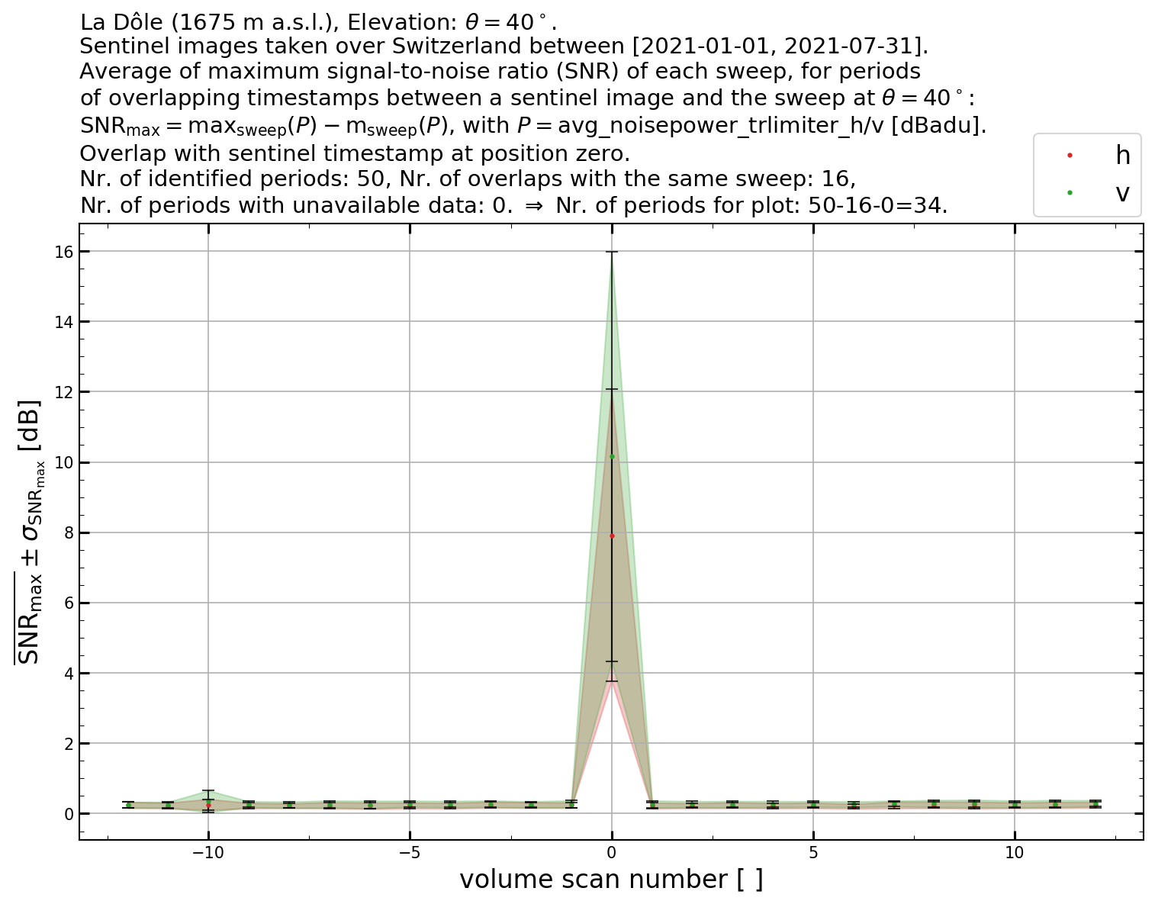

Figure 25: Summary of all events and their statistical characteristics in terms of power distribution

Figure 25 shows a significant increase in the measured noise power during the overlapping SENTINEL-1 sweeps (volume scan number 0), with an average SNRmax = 7.92 dB (horizontal) and 10.16 dB (vertical) for elevation 40°. At elevation 35°, these values are significantly lower. In the remaining sweeps for the adjacent 12 volumes only background noise is measured (before and after volume scan number 0).

### Summary of the measurements

In Table 12, a statistic with the minimum and maximum SNR for the detected overlapping sweeps are given for elevation 35° and 40°, including their standard deviation and average values.

Table 12: Statistical summary, La Dôle.

|  |  |  |  |  |
| --- | --- | --- | --- | --- |
|  | elevation 35° | | elevation 40° | |
|  | **SNRmax (32 samples)** | | **SNRmax**  **(34 samples)** | |
| Statistics [dB] | Horizontal | Vertical | Horizontal | Vertical |
| Minimum | 0.15 | 0.33 | 1.43 | 2.22 |
| Maximum | 3.11 | 4.02 | 18.61 | 21.87 |
| St. Dev. | 0.65 | 1.08 | 4.09 | 5.75 |
| Average | 0.76 | 1.61 | 7.92 | 10.16 |

The noise power measurements performed at 35° and 40° elevation show that the weather radar system ‘La Dôle’ detects the RF-signal transmitted by SENTINEL-1. Single events can be up to 21.87 dB above the background noise at elevation 40°, but the probability of occurrence is very low and confirm the simulations results in section 7.1 above.

## Summary for the potential interference from EESS (active) into 5.4 GHz weather radars

This section has addressed the potential interference from EESS (active) SAR and altimeters instruments on weather radars in portions of the 5365-5470 MHz band, using both main beam analysis and dynamic simulations.

The calculations, confirmed by measurement analysis on existing radars, show that possible interference would be kept within very limited percentage of occurrence that are unlikely to be harmful to meteorological operations.

# Conclusions

As a result of considerations related to the interference to meteorological radars in the 5600-5650 MHz band from 5 GHz WAS/RLAN, ECC adopted at its March 2021 meeting a list of “ECC options that may assist in the alleviation of interference to meteorological radar from WAS/RLAN at 5.6-5.65 GHz” [1].

Amongst others, one of these options is to “Highlight the band 5350-5470 MHz as an extension / additional opportunity to 5.6 GHz via guidance in an ECC output” to allow for operation of meteorological radars in a band that is not available to 5 GHz WAS/RLAN, i.e. the 5350-5470 MHz band.

The 5350–5470 MHz band is allocated to radiolocation on a co-primary basis and is already used by meteorological and military radars. However, it was decided that possible compatibility issues with other radars, especially with military radars, were a national matter.

Recognising that some weather radars are already deployed in this portion of bands in Europe (i.e. in Switzerland), the present report has studied, on a more general way, the compatibility between weather radars in part of 5365-5470 MHz and EESS (active), including EESS (active) systems part of the EU Copernicus programme.

The technical studies performed in this report have been addressing the compatibility between these systems in both directions, i.e. the potential interference from a deployment of weather radars on EESS (active) as well as the potential interference from EESS (active) SAR and altimeters instruments on weather radars. Their conclusions can be summarised as follows:

* a quite large deployment of weather radars (e.g. up to 55 radars, which corresponds to one third of the existing 166 radars operated in the 5.6 GHz band) would be compatible with EESS (active) without the need for specific operational conditions for weather radars;
* possible interference from EESS (active) systems to weather radars would be kept within very limited percentage of occurrence that are unlikely to be harmful to meteorological operations. This finding has also been confirmed by relevant measurements.

Overall, it can be concluded that compatibility between weather radars and EESS (active) in the 5365-5470 MHz band can be ensured without the need for specific operational conditions for weather radars.

This conclusion remains valid for a quite large deployment of weather radars. It should be noted that such move to the 5365-5470 MHz band is not expected to be massive. Decision on re-farming some existing 5.6 GHz radars (with relevant RF modifications) or allowing for new radars to be specifically designed and deployed in the 5365-5470 MHz band will be made on a case-by-case basis.

1. List of References
2. ECC options that may assist in the alleviation of interference to meteorological radar from WAS/RLAN at 5.6-5.65 GHz, [ECC(21)027 Annex 11](https://cept.org/Documents/ecc/63347/ecc-21-027-annex-11_options-for-weather-radars-at-56-ghz-clean), March 2021
3. ITU Radio Regulations, Edition 2020
4. Recommendation ITU-R M.1849: “Technical and operational aspects of ground-based meteorological radars”
5. Recommendation ITU-R F.1245-3: “Mathematical model of average and related radiation patterns for point-to-point fixed wireless system antennas for use in interference assessment in the frequency range from 1 GHz to 86 GHz”
6. Recommendation ITU-R RS.2105-1: “Typical technical and operational characteristics of Earth exploration-satellite service (active) systems using allocations between 432 MHz and 238 GHz”
7. Recommendation ITU-R RS.1166-4: “Performance and interference criteria for active spaceborne sensors”
8. Recommendation ITU-R RS.1280: “Selection of active spaceborne sensor emission characteristics to mitigate the potential for interference to terrestrial radars operating in frequency bands 1-10 GHz”
9. MeteoSwiss: “[SENTINEL-1 Satellite and Swiss Weather Radars - Measurement results](https://cept.org/ecc/groups/ecc/wg-se/fg-on-weather-radars-at-54-ghz/client/meeting-documents/file-history/?fid=67953)”