Compatibility studies between low power transmitters for animal tracking and other existing radiocommunication applications in the frequency band 401-403 MHz

Approved 27 January 2017

ECC Report 257

# Executive summary

In the European Common Allocation (ECA), the frequency band 401-403 MHz is allocated to the Earth exploration-satellite service (Earth-to-space), the meteorological satellite service (Earth-to space) and the meteorological AID service on primary basis. Following ERC/DEC/(01)17 [2], active medical implants can be operated on a secondary level in this frequency band.

Data collecting systems (DCS) operated in the Earth exploration-satellite service or meteorological satellite service utilize this frequency band due to its favourable propagation characteristics enabling low and medium power transmitters to operate properly over large distances. The purpose of these DCS is to collect information from a variety of sources. Animals equipped with transmitters are one source providing information about the state of environment and other natural phenomena.

This report provides a description of DCS used for animal tracking, in specific the ICARUS satellite network system in section 3. The scope of the report is limited to the analysis of the uplink transmissions from the animal tags to the ICARUS satellite in the 401-403 MHz band; it does not address any other type of transmission from the animal tags.

In section 4, sharing study analysis for a limited number of low power animal transmitters and other applications in the frequency band 401-403 MHz are presented:

In section 4.1, studies are provided to assess the potential of interference from animal tags to sonde receivers in the Meteorological Aids service. Based on this investigation, it can be stated that there is a potential for interference from animal tags towards sonde receivers. Therefore, a mitigation technique is proposed to ensure the protection of the Meteorological Aids; in particular by avoiding any animal tag transmission during radiosonde synoptic operations for 2 hours starting at 00:00 and 12:00 UTC. It should be noted that the mitigation technique proposed is based on typical scenarios and thus may not fully protect particular measurements scenarios taking place out of synoptical observations. Nevertheless, the probability of having these scenarios taking place at the same time, place and frequency than transmissions of ICARUS tags is significantly low.

The study results in section 4.2 indicate that the described ICARUS system used for animal tracking will not cause harmful interference to non-GSO and GSO receiving space stations. The study results also indicated that the described ICARUS system used for animal tracking will not cause harmful interference to non-GSO and GSO receiving space stations. Dynamic simulations show that the aggregated level of interference does not exceed the protection criteria since it is found to be below 1% of the time. However, it should be noted that this result is based only on the investigated scenario.

Based on the analyses described in section 4.3, it can be concluded that there would be no harmful interference from ICARUS system on Medical Implant Communication system (MICS) operated in the mobile service.

It should be noted that these conclusions are only valid for the ICARUS system presenting the following specific characteristics:

* a single space station (ISS);
* tags operated at very low power (-24 dBW e.i.r.p) and for limited time (3.5 s);
* 50 maximum simultaneously transmitting tags;
* Total number of animal tags limited by nature and principle.

TABLE OF CONTENTS

0 Executive summary 2

1 Introduction 5

2 Table of frequency allocations 6

3 Description of transmitters for animal tracking in the frequency band 401-403 MHz 7

4 COMPATIBILITY ANALYSES 9

4.1 Effect of animal transmitters operated in the Earth exploration-satellite service on radiosondes, dropsondes and rocketsondes operated in the Meteorological Aids service 9

4.1.1 Typical characteristics of radiosondes, dropsondes and rocketsondes in the 400.15-406 MHz band 9

4.1.2 Static analysis 11

4.1.3 Dynamic analyses 14

4.1.3.1 Radiosondes 15

4.1.3.2 Dropsondes 16

4.1.3.3 Rocketsondes 17

4.1.4 Consideration of the dynamic analysis and potential mitigation techniques 17

4.1.5 Conclusion on the compatibility analyses for sondes operated in the MetAids service 18

4.2 Effect of animal transmitters on other applications operated in the Earth exploration-satellite service (EESS) and the Meteorological-satellite service in the band 401-403 MHz 19

4.2.1 EESS and MetSat service protection requirements 19

4.2.2 Static analysis, single entry interference case 20

4.2.3 Static analysis, aggregate interference case 21

4.2.3.1 Aggregate interference case in regard to Recommendation ITU-R SA.2044 22

4.2.4 Dynamic analysis 22

4.2.5 Conclusion of the compatibility analyses with applications of the EESS and MetSat service 25

4.3 Effect of animal transmitters on MICS operated in the Mobile service in the band 401–403 MHz 25

4.3.1 MICS characteristics and protection requirements 25

4.3.2 Static analysis 26

4.3.3 Dynamic analyses 28

4.3.3.1 Dynamic simulation without indoor attenuation (3 days-time basis) 28

4.3.3.2 Dynamic simulation with indoor attenuation (3 days- time basis) 30

4.3.4 Conclusion on the compatibility analyses for MICS operated in the Mobile service 31

5 Conclusions 32

ANNEX 1: Description of the ICARUS satellite network system 33

ANNEX 2: List of Reference 35

LIST OF ABBREVIATIONS

|  |  |
| --- | --- |
| Abbreviation | Explanation |
| AFA | Adaptive Frequency Agility |
| AIMD | Active Implantable Medical Device |
| CDMA | Code Division Multiple Access |
| CEPT | European Conference of Postal and Telecommunications Administrations |
| DCP | Data Collection Platform |
| DCS | Data collecting systems |
| DSSS | Direct Sequence Spread Sectrum |
| ECA | European Common Allocation |
| ECC | Electronic Communications Committee |
| EESS | Earth exploration-satellite service |
| e.i.r.p. | Equivalent isotropically radiated power |
| ERC | European Radiocommunications Committee |
| GSO | Geostationary orbit |
| ICARUS | International Cooperation for Animal Research using Space |
| ISS | International Space Station |
| ITU-R | International Telecommunication Union - Radiocommunication Sector |
| LBT | Listen Before Talk |
| MetAids | Meteorological Aids service |
| MetSat | Meteorological-satellite |
| MICS | Medical Implant Communication system |
| NGSO | Non geostationary orbit |
| RF | Radio frequency |
| RR | Radio Regulations |
| ULP-AMI | Ultra-low power - active medical implants |
| **UTC** | Coordinated Universal Time |
| WMO | World Meteorological Organisation |

# Introduction

Around the globe, billions of animals migrate regularly; they connect the most remote places on Earth and in the oceans, and could be seen as our sensors to monitor changes around the planet. However, most wild animals are poorly understood because it is difficult to track their locations, internal and external conditions, their behaviour and sometimes, the reasons for their death. All this information is needed to preserve essential ecosystem and to safeguard human livelihoods.

The frequency band 401-403 MHz is allocated to the Earth exploration-satellite service on a primary basis in all three ITU regions, which makes it suitable for animal tracking since it supports worldwide recognition. In addition, this frequency band presents favourable propagation conditions, required for low-power devices. In ECA, the band is also allocated to the meteorological satellite service (Earth-to-space) and the meteorological aids service on a primary basis.

Current systems in this band include a variety of types of meteorological equipment that operate under primary allocation of Meteorological Aids service in all three ITU Regions. This equipment is used worldwide and the collected data (e.g. upper atmosphere data, ozone level data and other atmospheric parameters) is of extreme importance for the protection of life and property e.g. through the prediction of severe storms and providing vital data for commercial airlines operations.

More detailed descriptions of the systems operating under Meteorological Aids service and under EESS and MetSat service can be found in sections 4.1 and 4.2, respectively. Systems operating under mobile service (e.g. medical implants to promote people's health) are described in section 4.3.

The network to track migrating animals described in this report consists of spaceborne and mobile airborne and ground-deployed elements. The ICARUS Initiative (International Cooperation for Animal Research Using Space), a research endeavour that transcends disciplines and continents, will close this knowledge gap by monitoring the local, regional and global movement patterns of tagged animals. ICARUS is supported by international organisations and conventions such as the FAO (Food and Agricultural Organisation of the United Nations) and the CMS (Convention on Migratory Species as an environmental treaty under the aegis of the United Nations Environment Programme). The satellite network is described in ANNEX 1:

The animal transmitters that are studied in this Report use the spread spectrum technique to make their signals less susceptible to interference from other sources. The transmitters are described in more detail in section 3. The spaceborne elements are used as relay for the radio frequency communication link between animal transmitters and the operations centre. The miniaturized tag attached to the animal is determining its position using GPS, thus providing the capability of logging the track of the tag with high accuracy. During the communication with the space station, the tag transmits the recorded data. The communication concept is described in A1.2 in more detail. The operations centre is responsible for processing and disseminating the data to the science community.

This document provides relevant sharing study analyses related to co-channel operation of the Earth exploration-satellite service and Meteorological-satellite service application animal tracking with applications of the Meteorological Aid service (MetAids), the Earth exploration-satellite service, the Meteorological-satellite service and the mobile service in the frequency band 401-403 MHz. The mobile service has a secondary allocation in this frequency band while the Earth exploration-satellite service has a primary allocation; however, to evaluate the effect on national infrastructures, the studies also include applications of the mobile service.

# Table of frequency allocations

ERC Report 25 [1], which contains the European Table of Frequency Allocation, an extraction of this report focussing on the frequency band 401-403 MHz is given in Table 1.

Table 1: Abstract of ERC Report 25

|  |  |  |  |  |  |  |
| --- | --- | --- | --- | --- | --- | --- |
| 401 MHz – 402 MHz | | | | | | |
| RR Region 1 Allocation and RR footnotes applicable to CEPT | European Common Allocation | ECC/ERC harmonisation measure | Applications | European footnotes | Standard | Notes |
| EARTH EXPLORATION-SATELLTE (EARTH-TO-SPACE)  METEOROLOGICAL AIDS  METEOROLOGICAL-SATELLITE (EARTH-TO-SPACE)  SPACE OPERATIONS (SPACE-TO-EARTH)  Fixed  Mobile except aeronautical mobile | EARTH-EXPLORATION-SATELLITE (EARTH-TO-SPACE)  METEOROLOGICAL AIDS  METEOROLOGICAL-SATELLITE (EARTH-TO-SPACE)  EU2 | ERC/DEC/(01)17 | Active medical implants  Sondes  Weather satellites |  | EN 302 537  EN 302 054 | ULP-AMI within the band 401-406 MHz  Data collection platform telemetry |

|  |  |  |  |  |  |  |
| --- | --- | --- | --- | --- | --- | --- |
| 402 MHz – 403 MHz | | | | | | |
| EARTH EXPLORATION-SATELLTE (EARTH-TO-SPACE)  METEOROLOGICAL AIDS  METEOROLOGICAL-SATELLITE (EARTH-TO-SPACE)  Fixed  Mobile except aeronautical mobile | EARTH-EXPLORATION-SATELLITE (EARTH-TO-SPACE)  METEOROLOGICAL AIDS  METEOROLOGICAL-SATELLITE (EARTH-TO-SPACE)  EU2 | ERC/DEC/(01)17 | Active medical implants  Sondes  Weather satellites |  | EN 302 537  EN 302 054 | ULP-AMI within the band 401-406 MHz  Data collection platform telemetry |

EU2: Civil-military sharing;

ERC/DEC/(01)17 on harmonised frequencies, technical characteristics and exemption from individual licensing of Ultra Low Power Active Medical Implants (ULP-AMI) communication systems operating in the frequency band 401-406 MHz on a secondary basis;

EN 302 537 [3] Ultra Low Power Medical Data Service Systems operating in the frequency range 401-402 MHz and 405-406 MHz;

EN 302 054 [4] Radiosondes to be used in the 400.15 to 406 MHz frequency range with power levels ranging up to 200 mW

In ECA, the frequency band 401-403 MHz is allocated to the Earth exploration-satellite service (Earth-to-space), the meteorological satellite service (Earth-to space) and the meteorological AID service on primary basis. Following ERC/DEC/(01)17 [2] active medical implants can be operated on a secondary level in this frequency band.

# Description of transmitters for animal tracking in the frequency band 401-403 MHz

Since 1970 animals have been monitored from space by so-called data collecting systems operating in the frequency band 401-403 MHz. The first transmitters, called data collecting platforms (DCP), weighted some kilograms limiting the observed animals to bears, whales or great birds. Due to the technological progress, the transmitters became smaller and lighter. Deployed on animals, they can provide information as the absolute position using GPS or acquire local temperatures and values in relation with the behaviour of animals.

Several space systems have been used for animal monitoring. Firstly, this was done by the NIMBUS satellite system operated by United States; later on by the French ARGOS satellite system. ARGOS has been invaluable as a system for wildlife monitoring, allowing tag sizes down to 5 grams. Nevertheless, these transmitters are still too heavy to be carried by around 75% of all animal species as indicated by the black line in Figure 1. Typically, a bird can carry a load of 3% to 5% of its body mass. The ICARUS system will be specialised to track animals too small to be monitored by the current operating satellite systems; ICARUS is foreseen to use DCP, called "tags", weighting less than 5 grams. Based on this design criterion, the power and transmission time of such a transmitter would be limited.

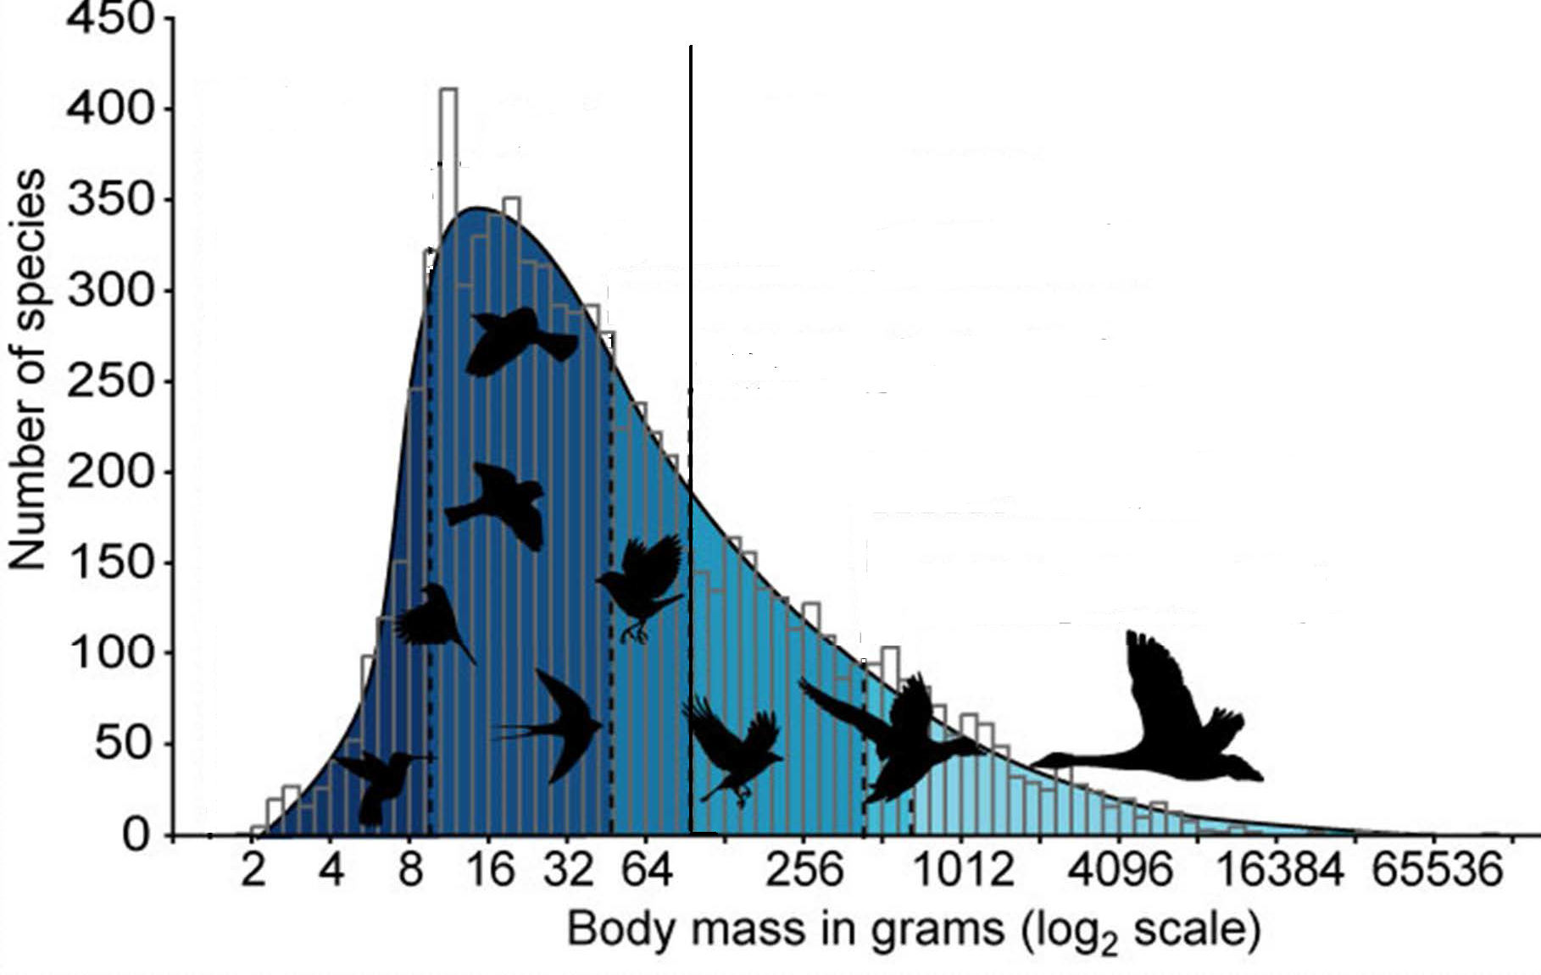

Figure 1: Number of bird species indicated by body mass

The ICARUS satellite network to track migrating animals consists out of spaceborne and mobile airborne and ground-deployed elements. The ICARUS Initiative (International Cooperation for Animal Research Using Space), a research endeavour that transcends disciplines and continents, will close this knowledge gap by monitoring the local, regional and global movement patterns of tagged animals. The satellite network is described in ANNEX 1:

Based on research proposals received by the scientific community, it is a requirement to communicate with up to 50 tags simultaneously during the communication time. Technically it would be possible to activate more than 50 tags simultaneously, but this would lead to interference of the animal tracking system itself. A maximum number of fifty tags may be activated at the same time via a downlink channel (frequency of the downlink is 468.1 MHz with a 45 kHz bandwidth) to transmit at defined times during the ISS receive window. To fulfil this technical constraint, operational measures will be taken like organising groups of tags allowed to operate at the same time or defining areas in which some tags may not operate. To accommodate the number of tags, a code diversity scheme is implemented. The multi user handling relies on a direct sequence spread spectrum code division multiple access (DSSS-CDMA) scheme. Each tag is assigned a unique spreading code used to modulate the signal.

The main challenge of ICARUS is the implementation of an operating low-volume data link between the tags on the animal and the receiver on the ISS. A miniaturized animal tag provides the capability of communicating at up to 800 km with the ICARUS equipment at the ISS, to measure its absolute position in regular intervals using GPS and to acquire local temperatures and acceleration values that give indications of the behaviour of the animal – all with a mass of the tag less than 5 gram and a volume of less than 1.5 cm³. To achieve this challenging objective, the essential functions of the tag are concentrated within an ASIC chip. The ASIC is optimised for low power consumption, the main power consumers being the radio frequency communication system and the GPS. The tag is most of the time in hibernation mode, i.e. in the mode with the lowest power consumption. The tag will be switched on once per day at a predefined time and transmits its data for around 3.5 sec, before returning in the hibernation mode again. The design life time of the tag is one year. Table 2 provides key parameters for the animal transmitters considered for this study.

Table 2: Animal transmitter technical specifications

|  |  |
| --- | --- |
| Parameter | Tag Uplink (animal transmitter to space station) |
| Frequency | 402.25 MHz |
| Bandwidth | 900 kHz |
| e.i.r.p. | -24 dBW (4 mW) |
| Duty cycle | 3.5 seconds per day |

# COMPATIBILITY ANALYSES

## Effect of animal transmitters operated in the Earth exploration-satellite service on radiosondes, dropsondes and rocketsondes operated in the Meteorological Aids service

### Typical characteristics of radiosondes, dropsondes and rocketsondes in the 400.15-406 MHz band

The term MetAids is used to describe a variety of types of meteorological equipment; radiosondes, dropsondes and rocketsondes. Most MetAids systems are operated by National meteorological services but other users are also identified (environmental agencies, universities and research bodies, defence services).

MetAids are flown worldwide for the collection of upper atmosphere meteorological data for weather forecasts and severe weather warning service, collection of ozone level data, and measurement of atmospheric parameters for various applications. The data collected from these flights, or soundings, is of extreme importance for weather forecasts and for the protection of life and property through the prediction of severe storms and providing vital data for commercial airlines operations.

The observations are performed by radiosondes carried by ascending balloons launched from land stations or ships, or by dropsondes deployed from aircraft and carried by a parachute. Radiosonde observations are carried out routinely at four synoptical times (0h00, 06h00, 12h00, 18h00 UTC) by almost all countries, but typically twice a day (at 0h00 and 12h00 UTC) for a typical duration of 2 hours. Nevertheless, additional measurements may be performed at any time of the day, e.g. for specific measurement campaigns or under specific requirements such as severe weather conditions or in case of chemical and nuclear events. The observations are then circulated immediately to all other countries within a few hours. The observing systems and data dissemination are all organized under the framework of the World Weather Watch Program of WMO (World Meteorological Organisation). Detailed information on technical characteristics and performance criteria for systems in the meteorological aids service in the 400.15-406 MHz is provided in Recommendation ITU-R RS.1165 [5].

Dropsondes are carried aloft on aircraft and dropped beneath a parachute to profile the atmosphere. They are typically used over ocean areas where operation of radiosonde sites is not possible. Dropsondes are used mostly for monitoring conditions within tropical storms, hurricanes and typhoons since the aircraft can drop them from altitudes ranging from 3000 m to 21400 m at key points as the aircraft traverses the storm. Therefore, it is not likely that animal tags will operate in the same area as most of the dropsondes.

In the frequency band 400.15-406 MHz, low altitude rocketsondes are used to deploy a measurement package to a height of approximately 1000 m. The sensor package is ejected from the rocket body at apogee.

Interference criteria for radiosondes, rocketsondes and dropsondes operating in the Meteorological Aids service are given in Table 3; for radiosondes and dropsondes they are extracted from Recommendation ITU-R RS.1263 [6], for low altitude rocketsondes they have been calculated following the methodology provided in Recommendation ITU-R RS.1263 [6].

Since MetAids are typically most vulnerable to interference at the maximum slant range of operation, the interference criteria are established based on the link margin at the maximum slant range. The interference criteria are established for three percentages: an interference level at 0.02% of the time for loss of receiver lock, an interference level at 0.2% (radiosondes) or 0.06% (dropsondes and rocketsondes) of time for loss of data, and a long term interference level at 20% of the time. The time basis is the flight time which is typically 120 min for radiosondes, 15 to 30 min for dropsondes and 6 min for rocketsondes.

Table 3: MetAIDS characteristics

|  |  |  |  |  |  |
| --- | --- | --- | --- | --- | --- |
| Parameter | Unit | NAVAID radiosonde with directional antenna | NAVAID radiosonde with omnidirectional antenna | Dropsonde | Rocketsonde |
| Frequency range | MHz | 400.15-406 | 400.15-406 | 400.15-406 | 400.15-406 |
| reference bandwidth | kHz | 300 | 300 | 20 | 6 |
| Receiver antenna gain | dBi | 8 | 2 | 0 | 2 |
| Receiver system loss | dB | 2 | 2 | 0 | 2 |
| Interference signal  (no more than 0.02% (2)) | dBW | -141.9 per 300 kHz | Not applicable (1) | Not applicable (1) | Not appicable(1) |
| Interference signal  (no more than p% (2)) | dBW | -149.6 per 300 kHz p = 0.2 | -154.4 per 300 kHz p = 0.2 | -161.6 per 20 kHz; p = 0.06 | -135.9 per  6 kHz; p = 0.06 |
| Interference signal  (no more than 20% (2)) | dBW | -156.1 per 300 kHz | -156.1 per 300 kHz | -168.9 per   20 kHz | -155. per 6 KHz |

(1) Systems with omnidirectional antennas are not vulnerable to losing antenna lock on the signal due to interference or signal fading.

(2) This percentage of time shall not be exceeded on a per-flight basis.

The very short percentage of times needed for these applications result from the meteorological needs. While data reception is important throughout the flight, data loss during an abrupt change (shown in the circles in Figure 2, taken from Recommendation ITU-R RS.1165 [5]) in temperature, humidity or wind can have a significant impact on forecast capabilities since that particular transition point cannot be accurately determined. The loss of data in such a critical change has major impact on the data. Therefore, the timing issue is very important in the assessment of interference.



Figure 2: Example plot of a radiosonde temperature and humidity profile

### Static analysis

The following analysis is based on the Minimum Coupling Loss (MCL) concept, co-frequency operation and simultaneous operation of animal tags and MetAIDS systems. To determine the distance needed to prevent harmful interference from a single animal tag to a sonde receiving station, the method of required propagation path loss is used. Worst case would obviously apply for co-channel operation.

The required path loss can be calculated using the following equation to determine the minimum required attenuation to prevent interference to the sonde receiving station:

Pl = e.i.r.p. – I + Gr – RL – PFO (1)

where

Pl: Propagation loss

e.i.r.p.: maximum e.i.r.p. from animal transmitters

I: Interference criterion

Gr: sonde receiver antenna gain

RL: Receiver system loss

PFO: Bandwidth correction factor (=10*log(Bandwidth_tag/Bandwidth_sonde).

To calculate the necessary separation distances, the free space propagation model is considered at 402.25 MHz. Line-of-sight is appropriate to apply since the sondes receiving stations are relatively low with respect to the ground. They utilize omnidirectional or directional antenna.

From the path loss requirement we can compute the separation distance and from this, determine the geographic area on the Earth where interference will occur.

Path loss (Pl) = 32.4 + 20 log(f) + 20 log(d) = 32.4 + 20 log(402.25) + 20 log(d) (2)

In addition, the timing aspect of the animal tag transmissions (3.5 s) together with the metaids flight time (120 min for radiosondes, 6 min for rocketsondes (low altitude) and 15 to 30 min for dropsondes) need to be considered when addressing the metaids protection criteria.

For example, when considering the long-term interference criterion (20% of the time), it represents a potential interference time of 24 minutes for radiosondes, 1,2 min for rocketsondes and 3 to 6 minutes for dropsondes. These periods of time are much longer than the 3.5 s animal tag transmission time. Therefore, one cannot expect a single tag producing interference exceeding the long-term protection criteria.

Similarly, timing calculations are also given for short-term interference criteria in the table below.

Table 4: Timing analysis for static analysis

|  |  |  |  |  |  |
| --- | --- | --- | --- | --- | --- |
| Protection criteria | Unit | NAVAID radiosonde with directional antenna | NAVAID radiosonde with omnidirectional antenna | Dropsonde | Rocketsonde |
| Flight time | Min | 120 | 120 | 15 to 30 | 6 |
| Interference signal (no more than 0.02%) | dBW | -141.9 per 300 kHz | N/A | N/A | N/A |
| Corresponding interference time | S | =120*60*0.02%  =1.44 s | N/A | N/A | N/A |
| Relevance for static analysis |  | Yes (< 3.5 s) | N/A | N/A | N/A |
| Interference signal (no more than p%) | dBW | -149.6 per 300 kHz; p = 0.2 | -154.4 per 300 kHz; p = 0.2 | -161.6 per 20 kHz; p = 0.06 | -135.9 per 6 kHz; p = 0.06 |
| Flight time | Min | 120 | 120 | 15 to 30 | 6 |
| Corresponding interference time | S | =120*60*0.2%  =14.4 s | =120*60*0.2%  =14.4 s | =(15 to 30) *60*0.0.6%  =0.54 to 1.08 s | =6*60*0.06%  = 0.022 s |
| Relevance for static analysis |  | No (> 3.5 s) | No (> 3.5 s) | Yes (< 3.5 s) | Yes (< 3.5 s) |

This table first shows, in the case of only one animal transmitter, that there is no need to consider a static calculation for radiosondes with omnidirectional antenna. The protection criteria for such systems will not be exceeded.

For other systems, static calculations only need to be considered for the following protection criteria:

* radiosonde with directional antenna: -141.9 per 300 kHz p =0.02%
* dropsonde: -161.6 per 20 kHz p =0.06%
* rocketsonde: -135.9 per 6 kHz p=0.06%.

On this basis, substituting parameters from Table 1and Table 3 into the above equations (1) and (2), gives the results presented in Table 5 - Table 7.

Table 5: Separation distances for radiosondes with directional antenna

|  |  |  |
| --- | --- | --- |
| Parameter | Unit | NAVAID radiosonde with  directional antenna |
| Interference signal (no more than p%) | % | 0.02 |
| I | dBW/300kHz | -141.9 |
| e.i.r.p. | dBW | -24 |
| Gr | dBi | 8 |
| RL | dB | 2 |
| PFO | dB | 4.8 |
| Pl | dB | 119.1 |
| Distance d | Km | 53.5 |

Table 6: Separation distances for dropsondes

|  |  |  |
| --- | --- | --- |
| Parameter | Unit | Dropsonde |
| Interference signal (no more than p%) | % | 0.06 |
| I | dBW/20kHz | -161.6 |
| Pt | dBW | -24 |
| Gr | dBi | 0 |
| RL | dB | 0 |
| PFO | dB | 16.5 |
| Pl | dB | 121.1 |
| Distance d | km | 67.4 |

Table 7: Separation distances for rocketsondes

|  |  |  |
| --- | --- | --- |
| Parameter | Unit | Rocketsonde |
| Interference signal (no more than p%) | % | 0.06 |
| I | dBW/6 kHz | -135.9 |
| Pt | dBW | -24 |
| Gr | dBi | 2 |
| RL | dB | 2 |
| PFO | dB | 21.8 |
| Pl | dB | 90.1 |
| Distance d | Km | 1.9 |

The results of this analysis show needed separation distances of up to 53.9 km (in the main beam) for radiosondes using directional antennas whereas radiosondes with omnidirectional antennas cannot experience interference from a single animal tag.

For dropsondes, the results of the static analysis show needed separation distance of up to 67.4 km (see Table 5).

For rocketsondes the needed separation distance is of up to 1.9 km corresponding to a single animal tag.

The present static analyses provide an overview of potential compatibility situations between a single animal tag and MetAids, calculating necessary separation distances between the tag and the MetAids receiver. However, in case of multiple animal tags operating around the sonde receiver within the calculated separation distance, the situation would be different, as the aggregated transmission time of all tags within the separation distance would increase remarkably.

Static analyses hence do not allow drawing definitive conclusions since it cannot relevantly depict a situation with multiple animal tags operating around the MetAids receiver while taking into account the ICARUS space station movement at 7.66 km/sec.

Dynamic analyses are therefore needed.

### Dynamic analyses

Dynamic studies were performed to assess the aggregated effect of animal tags on MetAids receivers over a period of time.

The dynamic simulations determine the incoming aggregate interference level at the victim receiver in time steps of 3.5 seconds. The general scenario of these analyses is described on Figure 3 below.

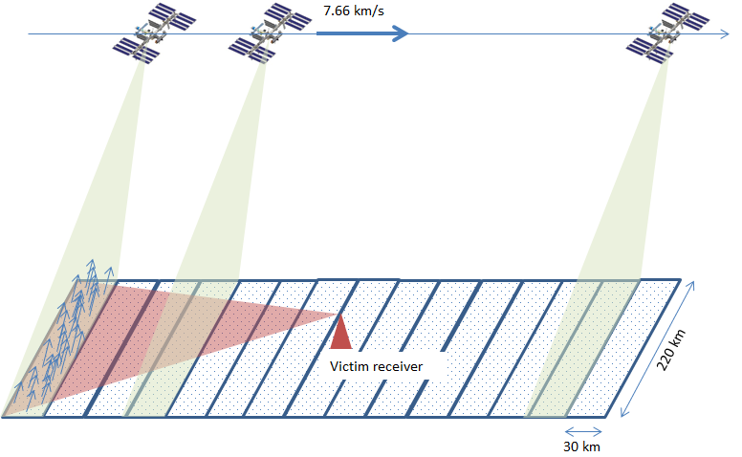

Figure 3: Scenario taken for the dynamic simulation

The detailed assumptions considered to perform the simulations are described below, expected to represent a worst-case situation:

* The simulation supposes that both systems are in operation at the same time and co-frequency;
* The International space station is travelling directly across the MetAids receiver, activating the tags;
* The overflown landscape is divided in 15 cells being rectangular areas (30 km x 220 km) as illustrated in Figure 4. The size of each cell is determined by the coverage of the ICARUS antenna (with a 220 km footprint) and by the distance it covers during a 3.5 s time (30 km at 7.66 km/s);
* The overall event considered for the simulations is therefore of around 53 seconds duration (15 x 3.5 s);
* Although the maximum number of ICARUS tags transmitting simultaneously is 50, the consideration of 50 tags in each cell would lead to 750 tags operated in the area around the victim receiver, which may be unrealistic. Therefore, in each cell, the number of tags transmitting simultaneously is randomly chosen between 1 and 50 (hence 25.5 tags per cell on average and a total of 382.5 tags on average);
* The tags are randomly deployed in each cell;
* The maximum height for tags is 1500 m which is the typical flight altitude for most of bird species. The tag height is hence randomly chosen between 0 and 1500 m;
* For MetAids systems using directional antenna, the antenna is pointing horizontally in the direction of the ISS trace on the ground (see figure 4);
* The directional antenna of the radiosonde receiver is modelled to have an opening angle of 60 degrees in which the maximum antenna gain of 8 dBi. For the other angles an antenna gain of 2 dBi is used;
* The tag e.i.r.p. is -24 dBW.

For each tag, the interference at the MetAids receiver and its visibility from the receiver are calculated separately, taking into account the distance between the tag and the MetAids receiver, their heights and the victim antenna gain towards the tag. Only free space losses are considered when the tag is in visibility of the victim receiver; no attenuation of vegetation, buildings or other obstacles is considered. Then the aggregate intererence coming from each cell is determined by adding up the interference of associated tags of this cell.

Finally, it should be noted that although the dynamic simulations includes a number of parameters selected on a random basis (location and height of tags, number of tags per cell), the final results are quite stable over multiple runs. Presentation of results for each sonde type are therefore well represented by a single distribution.

#### Radiosondes

Figure 4 shows the interference distribution in dBW/300kHz for radiosonde receiver with directional antenna (corresponding to a total of 402 tags) and Figure 5 illustrates the case for radiosonde receiver with omnidirectional antenna (corresponding to a total of 478 tags).



Figure 4: Interference distribution (dBW/300kHz) for radiosonde receiver with   
directional antenna



Figure 5: Interference distribution (dBW/300kHz) for radiosonde receiver with   
omnidirectional antenna

In both cases, the interference density is below the long-term interference criterion (20%) for loss of data whereas the 0.2% interference criterion for loss of data is not met for the scenario considered.

In addition, for radiosondes with directional antenna, the 0.02% protection criteria for loss of receiver lock is not met for the scenario considered.

#### Dropsondes

Figure 6 shows the Interference distribution in dBW/20 kHz for dropsondes (corresponding to a total of 418 tags).



Figure 6: Interference distribution (dBW/20kHz) for dropsondes receivers

The interference density is below the long-term interference criteria (20%) for loss of data whereas the 0.06% interference criteria for loss of data is not met for the scenario considered.

#### Rocketsondes

Figure 7 illustrates the Interference distribution in dBW/6kHz for rocketsondes (corresponding to a total of 465 tags).

Figure 7: Interference distribution (dBW/6kHz) for rocketsonde receiver

As seen from the figure, the interference density meets the 3 protection criteria for the scenario considered.

### Consideration of the dynamic analysis and potential mitigation techniques

The dynamic analysis presented in section 4.1.3 above allows concluding that there is no compatibility issue between the ICARUS system and rocketsondes.

On the contrary, this dynamic analysis shows that under the worst-case scenario considered, short-term interference from the ICARUS system could occur for radiosondes (with omnidirectional and directive antenna) and dropsondes.

However, these results should be put in the perspective of the conditions set for the dynamic analysis:

* the dynamic analysis assumes co-frequency operations of both systems. The ICARUS system operates in the 401.8-402.7 MHz band whereas Metaids can make use of the whole 400.15-406 MHz band. On a general basis, this represents a probability of co-frequency operation of 15.4 % (0.9/5.85). However, it should be noted that there are some countries where restrictions apply to Metaids limiting their use to portions of the frequency band 400.15- 406 MHz. On the other hand, it should also be noted that in some countries MetAids are not used within this frequency band.
* the dynamic analysis assumes a quite large deployment of tags within a limited area around the MetAids receiver. Taking into account the limited total number of tags expected for the ICARUS system, as well as the specific period and location of birds migrations and nesting, such a situation is not assumed to be typical to all MetAids stations.
* the dynamic analysis assumes simultaneous and co-located operations of both systems. As described in section 4.1.1 above, MetAids systems are not operated 24/7 but for given period of the time.

Dropsondes are typically used over ocean areas where operation of radiosonde sites is not possible and are used mostly for monitoring conditions within tropical storms, hurricanes and typhoons. Their operations is therefore limited in time and it is therefore not considered likely that ICARUS tags will operate in the same area as most of the dropsondes.

Radiosonde observations are carried out routinely at four synoptical times (0h00, 06h00, 12h00, 18h00 UTC) by almost all countries, but typically twice a day (at 0h00 and 12h00 UTC) for a typical duration of 2 hours. Nevertheless, additional measurements may be performed at any time of the day, e.g. for specific measurement campaigns or under specific requirements such as severe weather conditions or in case of chemical and nuclear events.

The ICARUS tags will only transmit their data while they are within the receive window of the International space station (ISS). Depending on the latitude, areas in Europe will be overflown between once every three days and two times per day for short period of times. A specific example for one day is shown in Figure 9 (Due to Earth´s rotation, different areas will be affected at other days with a repeat cycle of three days). In this example, the ISS will be above Europe eight UTC times during one day from: 00:35 - 00:46; 02:01 - 02:24; 15:36 - 15:50; 17:02 - 17:16; 20:24 - 20:38; 21:36 - 21:50 and 23:31 - 23:51. On this specific example, only the first period of 11 minutes (00:35 - 00:46) is concomitant with synoptic radiosondes operations.

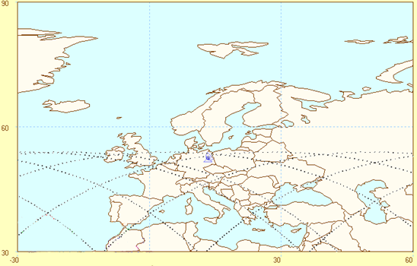

Figure 8: Example of an ISS flight path

Overall, taking into account the above elements, the potential risk of interference from ICARUS system to MetAids is either null (rocketsondes) or very limited. This is further confirmed by the interference free operations over the last decades of both MetAids and EESS/METSAT systems (e.g. Argos, meteorological DCPs), although operating at higher e.i.r.p.

Nevertheless, considering the importance and the daily and mandatory nature of radiosondes synoptic operations in all countries at 0h00 and 12h00 UTC and to further mitigate the risk of interference, it could be proposed that the ICARUS system stop its operation for the corresponding times, i.e. 2 hours starting at 00h00 and 12h00 UTC when passing over land masses. During this time, it can be considered that no tag will be activated, thus eliminating the potential for harmful interference during synoptic observations.

### Conclusion on the compatibility analyses for sondes operated in the MetAids service

Since the performed static analysis do not take into account the total transmission time of the animal transmitters and the aggregate effect on the MetAids receiver station, dynamic simulations have been performed.

The simulations are based under the hypotheses that the ISS is passing for a specific event of around 53 seconds duration over the MetAids receiver while in operation and that an average of 382.5 ICARUS tags are active around the sonde receiver within an area of 99 000 km². The number of such events depends on how often the ISS passes over the victim receiver and both systems are in operation simultaneously. Depending on the latitude of the victim receiver, areas in Europe will be overflown between once every three days and two times per day by the ISS for short period of times.

For such events and considering the dynamic analysis results, the following statements can be made (see details in section 4.1.4):

* there is no compatibility issue between the ICARUS system and rocketsondes;
* under the worst-case scenario considered, short-term interference from the ICARUS system could occur for radiosondes (with omnidirectional and directive antenna) and dropsondes;
* The dynamic analysis results should be in the perspective of the conditions set for the dynamic analysis:

Both systems co-frequency operation represent a relatively low probability;

the number of ICARUS tags around MetAids receiver will typically be lower;

simultaneous and co-located operations of both systems will be limited.

Overall, taking into account the above elements, the potential risk of interference from ICARUS system to MetAids is either null (rocketsondes) or very limited. This is further confirmed by the interference free operations over the last decades of both MetAids and EESS/METSAT systems (e.g. Argos, meteorological DCPs), although operating at higher e.i.r.p.

Nevertheless, considering the importance and the daily and mandatory nature of radiosondes synoptic operations in all countries at 0h00 and 12h00 UTC and to further mitigate the risk of interference, it could be proposed that the ICARUS system stop its operation for the corresponding times, i.e. 2 hours starting at 00h00 and 12h00 UTC when passing over land masses. During this time, it can be considered that no tag will be activated, thus eliminating the potential for harmful interference during synoptic observations.

It should further be noted that these conclusions are only valid for the ICARUS system presenting specific characteristics:

* a single space station (ISS);
* tags operated at very low power (-24 dBW e.i.r.p) and for limited time (3.5 s);
* 50 maximum simultaneously transmitting tags;
* Total number of animal tags limited by nature and principle.

## Effect of animal transmitters on other applications operated in the Earth exploration-satellite service (EESS) and the Meteorological-satellite service in the band 401-403 MHz

### EESS and MetSat service protection requirements

Although there are similarities between EESS and MetSat systems operated the frequency band 401-403 MHz, the MetSat focuses on meteorological purposes and preferably operate geostationary satellites to study the worldwide weather behaviour, while EESS systems are typically non-geostationary satellite networks. Both services use this frequency band especially for Data Collection and location purposes. The corresponding data collection systems (DCS) provide a worldwide in-situ environmental data collection and Doppler-derived location service. Those systems have been designed and optimised as based on the random access concept, i.e. short unidirectional messages (< 1 s) with a high time interval (> 60 s) and a low bit rate (400 bps). Therefore, the sharing analysis related to compatibility between animal transmitters and EESS and MetSat applications are included in the same section.

Some small satellites are also operated in this frequency band in the EESS. Typically, these satellite networks use ground station antennas with higher power and higher antenna gain compared to data collection systems. Therefore, it is assumed that small satellites can tolerate the effect of animal transmitters, if data collection platforms can. Recommendation ITU-R SA.1163 [7] specifies the interference criteria for service links of stations in the Earth exploration-satellite and meteorological-satellite service; the relevant extraction is provided in Table 8. A basic general partitioning for the frequency band 401-403 MHz is provided in Recommendation ITU-R SA. 2045 [8] for future long-term coordinated use of DCS. It should be noted that the required bandwidth of 900 kHz cannot be entirely accommodated in the proposed NGSO partition.

Table 8: Interference criteria for service links of stations in the EESS and MetSat services

|  |  |  |  |  |
| --- | --- | --- | --- | --- |
| Frequency band  (MHz) | Function and type of earth station | Station subject to interference | Interfering signal power (dBW) in the reference bandwidth to be exceeded no more than 20% of the time | Interfering signal power (dBW) in the reference bandwidth to be exceeded no more than p% of the time |
| 401-403  Earth-to-space | Non-GSO data collection, low-gain antenna | Space station | -178.8 dBW per 1600 Hz(1) | -174.7 dBW per 1600 Hz(1) p = 0.1 |
| 401-403  Earth-to-space | GSO data collection,  low-gain antenna | Space station | -187.4 dBW per 100 Hz(2) | -173.4 dBW per 100 Hz(3)  p = 0.1 |

(1) The interfering signal power (dBW) in the reference bandwidths are specified for reception at elevation angles > 5°

(2) The interfering signal power (dBW) in the reference bandwidths are specified for reception at elevation angles > 3°

(3) The interfering signal power (dBW) in the reference bandwidths are specified for reception at elevation angles > 0°

In addition, Recommendation ITU-R SA.2044 [9] states that the maximum aggregate acceptable spectral power flux-density (spdf) at the antenna of a non-GSO DCS instrument should not exceed -197.9 dB(W/(m²Hz)) for more than 1% of the time in the field of view of the satellite for broadband noise interference.

### Static analysis, single entry interference case

The method used to calculate the distance between the tag and the space station victim receiver at which there is a worst case potential for interference is based on the minimum propagation path loss. Worst case would obviously apply for co-channel operation.

The required path loss can be calculated using the following equation to determine the minimum required attenuation to prevent interference to the receiving space station:

Pl = e.i.r.p. – I + Gr (3)

where

Pl: Propagation loss

e.i.r.p.: maximum e.i.r.p. from animal transmitters

I: Interference criterion

Gr: receiver antenna gain (0 dBi antenna)

To calculate separation distances to preclude interference, the free space propagation model is considered.

From the path loss requirement we can compute the separation distance and from this later, it is possible to determine the geographic area on the earth where interference would occur.

Pl = 32.4 + 20 log(f) + 20 log(d) = 32.4 + 20 log(402.25) + 20 log(d) (4)

Substituting parameters from Table 2 and Table 8 into the above equations, gives the results presented in Table 9.

Table 9: Mimimum separation distance for EESS and MetSat space stations

|  |  |  |  |  |
| --- | --- | --- | --- | --- |
| Parameter | Unit | animal transmitter | | |
| Frequency | MHz | 401 - 403 | | |
| Bandwidth | kHz | 900 | | |
| Tag e.i.r.p | dBW | -24 | | |
| Tag e.i.r.p density | dBW/Hz | -83.5 (= -51.5 dBW/1600Hz) | | |
| Interference criterion |  | -178.8 dBW/1600Hz (NGSO) | -187.4 dBW/100Hz (GSO) | -197.9 dBW/m²Hz (NGSO) |
| Propagation loss Pl | dB | 127.3 | 123.9 | 10log(4πr²) = 114.4 dBm² |
| Minimum distance d | Km | 138.2 | 93.0 | 147.3 |

EESS and MetSat space stations typically operate at altitudes of more than 500 km. Even with a receiver antenna gain of 10 dBi, the interference criteria provided in Recommendations ITU-R SA.1163 [7] and ITU-R SA.2044 [9] are met. For GSO satellites the situation is even more relaxed, because they have an altitude of around 36 000 km. Therefore, in case of a single interfering animal transmitter, co-existence between animal transmitters and other EESS and MetSat applications is feasible.

### Static analysis, aggregate interference case

The interference criteria and the results provided in the section above can be used to estimate the effect of multiple animal transmitters within the footprint of a satellite.

As indicated in Section 3, the maximum number of tags operated simultaneously is 50, which increases the received interference e.i.r.p by 10 log(50) = 17 dB. This leads to an increase of the distances as shown in table 9.

Table 10: Minimum separation distance for EESS and MetSat space stations in the case of   
multiple interferers

|  |  |  |  |  |
| --- | --- | --- | --- | --- |
| Parameter | Unit | Small animal transmitter | | |
| Frequency | MHz | 401 - 403 | | |
| Bandwidth | kHz | 900 | | |
| Cumulative Tag e.i.r.p | dBW | -7 (50 tags) | | |
| Cumulative Tag e.i.r.p density | dBW/Hz | -66.5 (= -34.5 dBW/1600Hz) | | |
| Interference criterion |  | -178.8 dBW/1600Hz (NGSO) | -187.4 dBW/100Hz (GSO) | -197.9 dBW/m²Hz (NGSO) |
| Propagation loss Pl | dB | 144.3 | 140.9 | 10log(4πr²) = 131.4 dBm² |
| Minimum distance d | Km | 978.2 | 658.2 | 1043.0 |

The result for the geostationary space stations indicates that there should be no effect from animal transmitters.

In case of non-geostationary space stations, there might be the case that non-GSO satellites are affected if they are in view of multiple animal transmitters during transmission.

#### Aggregate interference case in regard to Recommendation ITU-R SA.2044

Recommendation ITU-R SA.2044 [9] provides information on the current and future usage of the non-GSO data collection systems (DCS) in the 401-403 MHz, especially the ARGOS satellite system described in ANNEX 1: in that report.

The analysis to determine the effect on non-GSO DCS systems in the 401-403 MHz should be based on the following protection criteria:

–197.9 dB(W/(m2 · Hz)) maximum aggregate acceptable spectral power flux-density (spfd) at the antenna of a non-GSO DCS instrument for broadband noise interference;

–165.4 dB(W/m2) maximum power flux-density (pfd) within a resolution bandwidth of 19 Hz at the antenna of a non-GSO DCS instrument for each narrow-band spectral line interference.

In addition, the protection criteria defined above should not be exceeded for more than a percentage of 1% of time in the field of view of the satellite.

Based on this protection criteria, a worst case analysis has been performed to assess the impact of animal transmitters on this satellite system. The analysis is presented in Table 11. Based on the result, it can be concluded that there is no harmful interference from animal transmitters to the ARGOS satellite system.

Table 11: Impact of animal transmitters on the ARGOS satellite network

|  |  |  |
| --- | --- | --- |
| Parameter | Unit | Value |
| Frequency | MHz | 401 |
| Altitude of the ARGOS satellite | Km | 850 |
| Animal tag power e.i.r.p. | dBW | -24 |
| Animal tag bandwidth | MHz | 0.9 |
| Number of animal tags transmitting simultaneously |  | 50 |
| Resulting animal tag e.i.r.p. | dBW | -7 |
| Free space loss | dB | 143.05 |
| Corresponding pfd at the ARGOS satellite level | dBW/m²/Hz | -196.1 |
| Interference criterion | dBW/m²/Hz | -197.9 |
| Margin | dB | -1.8 |

In the worst case in which 50 tags are transmitting at the same time, the interference criterion is exceeded by 1.8 dB. Nevertheless, it is met in cases when up to 33 animal tags are transmitting simultaneously (resulting aggregate animal tag e.i.r.p. of -8.8 dBW). Also, it should be taken into account that the maximum interference power level is linked to a time percentage, which implies that that the interference power level can be exceeded during 1% of the time. Therefore, dynamic studies are needed to provide the statistical analyses of the interference received by NGSO systems.

### Dynamic analysis

Dynamic studies were performed to assess the effect of animal tags on non-geostationary space stations operated in the EESS and MetSat service over a period of twenty-five days with time-increment of 4 seconds. To determine the aggregate interference level, a victim satellite is moving across Europe at an altitude of 850 km, receiving signals from a number of simultaneously transmitting tags distributed over an area specified by the footprint of the satellite used for animal tracking. An even deployment of one tag every 12 km is implemented within the deployment area defined from 0 degrees to 55 degrees northern latitude and from 30 degrees West to 58 degrees East longitude.

The main orbital parameters considered for the ISS are: inclination=51.6°, perigee=401 km, apogee=406 km. The flight track of the ISS is shown in Figure 9.



Figure 9: Flight track of the ISS

Whenever the tags are within the receive window of the ISS defined by an elevation between 29 degrees and 32 degrees and an azimuth from 153 degrees down to -153 degrees, these tags are activated, while the other tags are in hibernation mode. If the active tags are within the footprint of the ARGOS satellite, then, the ARGOS satellite network will be impacted by the aggregate transmit power of the tags. The simulation does not take into account the 3.5 seconds transmission time of the tag.

The antenna of a typical tag is a short dipole. The following Figure 10 shows the antenna pattern with the relative gain, and the max antenna gain equals 1.76 dBi.

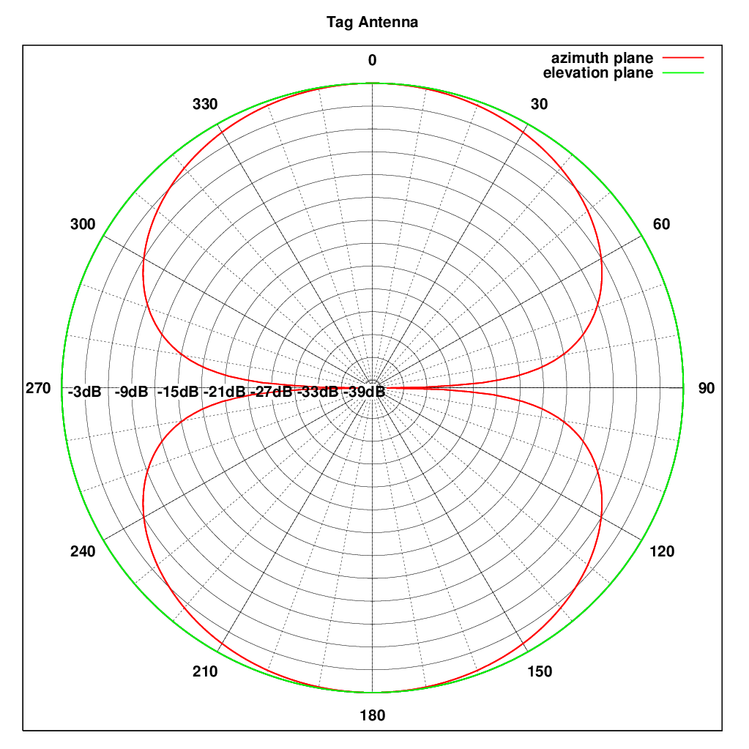

Figure 10: dipole antenna pattern of the animal tag

In addition, the maximum e.i.r.p. of a tag equals -24 dBW. Therefore, at low elevation angles, we have the following -25.76 dBW (input power) + 1.76 dBi antenna gain = -24 dBW. Therefore, -25 dBW is considered to be the typical input power of a tag.

In Figure 11, the result of the simulation is provided in pfd levels and compared with the protection criteria given in Recommendation ITU-R SA.2044 [9].

According to Recommendation ITU-R SA.2044, the protection criterion is -197.9 dBW/m²/Hz that should not be exceeded for more than a percentage of 1% in the field of view of the satellite. The pfd level equals -201 dB(W/(m².Hz)) for 1% and is therefore below the protection criteria. It can be noted the maximum pfd level received by the non-GSO system equals -197 dBW/m²/Hz, and this value is very similar to the worst case analysis derived from the static analysis in the previous section.

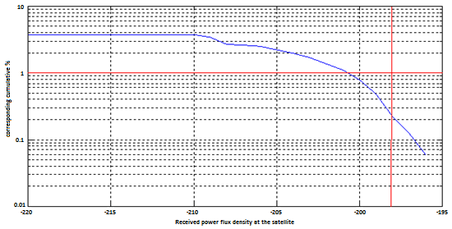

Figure 11: Interference density

### Conclusion of the compatibility analyses with applications of the EESS and MetSat service

The study results indicate that the transmission of one single animal transmitter will not interfere non-GSO and GSO receiving space stations.

In the static analysis considering simultaneous transmissions of 50 animal transmitters, the aggregate power may only have an effect on the receiving non-GSO space stations.

Dynamic simulations confirm the results of the static analysis and show that the aggregated level of interference does not exceed the protection criteria since it is found to be below 1% of the time. However, it should be noted that this result is based on the scenario described in the section 4.2.4.

For GSO space stations, there is no potential of interference from animal transmitters.

## Effect of animal transmitters on MICS operated in the Mobile service in the band 401–403 MHz

### MICS characteristics and protection requirements

MICS (Medical Implant Communication system) or Active Implantable Medical Device (AIMD) systems operating in the frequency band 401-403 MHz consist of devices implanted within the body (ULP-AMI), body worn sensors (ULP-AMI), or peripherals external to the body (ULP-AMI-P) that must be able to communicate with each other in order to allow the transfer of data between the system devices. The communications content can be either: stored data, telecommand or telemetry. Other than the unique technological requirements that are essential to radio systems, integrated in an AIMD (size limits, power consumption and impedance considerations), they can be considered as typical data telemetry and telecommand devices using conventional modulation formats with proprietary telemetry protocols.

MICS devices are placed in the body to deliver therapies and/or provide diagnostic data that is used by a physician to determine the condition of the implant-wearing patient and develop appropriate therapies. External devices support the operation of the implanted devices by providing a means for programming or altering the programming of the implanted device, retrieving medically related diagnostic data from the implant, transferring data to a mass storage system and to provide real time read-out of the monitored physiological parameters.

MICS must consume very little power and be extremely small in size. The implant or body worn sensor itself must contain a medical therapeutic section as well as an interface circuit to a radio system and the radio system itself. Based on the sharing analysis and the usage conditions envisioned for these devices (Recommendation ITU-R RS.1346 [10]), a power level of a maximum of 25 µW e.r.p. was determined as adequate for medical systems. This power level permits a highly reliable communications link at a distance of 2-3 m.

For this study, MICS characteristics are taken from Recommendation ITU-R RS.1346 and shown in Table 12.

Table 12: MICS Technical Specifications and link budget

|  |  |  |  |
| --- | --- | --- | --- |
| Parameter | Unit | Uplink  (Implant -> Programmer) | Downlink  (Programmer -> Implant) |
| Frequency | MHz | 401-403 | 401-403 |
| Modulation |  | FSK | FSK |
| Receiver noise bandwidth | kHz | 200 | 25 |
| Ambient noise at receiver input |  | 20 dB above kTB | kTB |
| Receiver noise figure | dB | 4 | 9 |
| Receiver noise floor | dBW | -131 | -151 |
| Receive antenna gain | dBi | 2 | -31.5 |
| Required SNR | dB | 14 | 14 |
| Free space loss @ 2m | dB | 30.5 | 30.5 |
| Fade margin1 (with diversity) | dB | 10 | 10 |
| Excess loss2 (polarisation, etc.) | dB | 15 | 15 |
| Transmit antenna gain | dBi | -31.5 | 2 |
| Power into antenna | dBW | -32 | -52 |
| ERP | dBW | -63.5 (at body surface) | -50 |

1 By using the same antenna as selected for uplink and keeping the downlink message time short relative to the 4 Hz fade rate, link reciprocity keeps the downlink fade depth of 10 dB in spite of the absence of spatial diversity in this direction.

2 Excess loss in the link is the result of patient orientation, antenna misalignment, obstructions (such as a physician) in the main line of sight path and polarisation losses. These statistically independent processes can be meaningfully modelled by adding 15 dB of margin. Note that polarisation loss occurs to varying degrees for all antenna configurations.

3 For this analysis, -20 dBm was used as the effective radiated power. Additional margin is desirable provided that it can be obtained without jeopardizing interference-free operation in the Metaids band and can be achieved within the design constraints imposed by the environment in which MICS stations will operate.

The primary purposes of the devices with MICS capabilities are diagnosis and therapy. Since the use of the communications system reduces the device lifetime for these operations it is used only when necessary. As an example, today’s low frequency RF inductive communication system is activated for only 0.005% of the implanted device’s lifetime (about 4 hours out of 9 years). In the case of the programming device used by the physician, the duty cycle will be much higher. In the case of a clinic with multiple programmers, overall use of the band could approach 50% during business hours.

### Static analysis

The method used to calculate the distance at which there is the highest potential for interference to the MICS receiver from a signal transmitted by an animal tag is based on the required propagation path loss needed to prevent an animal tag from interfering with the receiver of the MICS. Worst case would obviously apply for co-channel operation.

The following analysis considers free space attenuation for outdoor equipment and modified free space including additional 12 dB loss (12 dB is an average between commercial and residential construction) for wall attenuation for indoor equipment, in accordance with ECC Report 92 [11].

The required path loss can be calculated using the following equation to determine the minimum required attenuation to prevent interference to the MICS receiving station:

Pl = e.i.r.p. – RNF + Gr – PFO (5)

where

Pl: Propagation loss

e.i.r.p.: maximum e.i.r.p. from animal transmitters

RNF: Receiver noise floor

Gr: receiver antenna gain

PFO: Partial frequency overlap.

To calculate the separation distances to preclude interference, the free space propagation model is considered.

From the path loss requirement, the separation distance is computed.

Pl = 32.4 + 20 log(f) + 20 log(d) = 32.4 + 20 log(402.25) + 20 log(d) (6)

The results are presented in Table 13 for outdoor MICS and Table 14 for indoor MICS.

Table 13: Separation distance for MICS (outdoor)

|  |  |  |  |
| --- | --- | --- | --- |
| Parameter | Unit | MICS Uplink | MICS Downlink |
| Frequency | MHz | 401-403 | 401-403 |
| Receiver noise bandwidth | kHz | 200 | 25 |
| Receiver noise floor | dBW | -131 | -151 |
| Receive antenna gain | dBi | 2 | -31.5 |
| Tag bandwidth | kHz | 900 | 900 |
| Tag e.i.r.p | dBW | -24 | -24 |
| Partial frequency overlap | dB | 6.5 | 15.6 |
| Propagation loss Pl | dB | 102.5 | 79.9 |
| Distance | km | 7.9 | 0.6 |

Table 14: Separation distance for MICS (indoor)

|  |  |  |  |
| --- | --- | --- | --- |
| Parameter | Unit | MICS Uplink | MICS Downlink |
| Frequency | MHz | 401-403 | 401–403 |
| Receiver noise bandwidth | kHz | 200 | 25 |
| Receiver noise floor | dBW | -131 | -151 |
| Receive antenna gain | dBi | 2 | -31.5 |
| Tag bandwidth | kHz | 900 | 900 |
| Tag e.i.r.p | dBW | -24 | -24 |
| Partial frequency overlap | dB | 6.5 | 15.6 |
| Indoor loss | dB | 12 | 12 |
| Propagation loss Pl | dB | 90.5 | 67.9 |
| Distance | km | 2.0 | 0.2 |

It has to be noted that the animal transmitter operates for only 3.5 seconds per day. Even when considering the MICS 50% duty cycle during business hours, the probability of interference is low due to the short transmission duration and the short separation distances.

Further, if during medical implant communications session an animal transmitter operates in the band occupied by the medical system, it will interfere with the medical system communications causing the medical system to re-scan the band and select a new frequency on which to continue its communications.

For the fixed frequency MICS systems, one must rely on probabilities for interference reduction. Considering a duty cycle limit of 0.1% of the MICS, the probability of interference is estimated to be negligible.

It is vital that patients suffer no harmful effects from interference from any source including other medical systems. Obviously systems employing LBT coupled with AFA, error detection and correction schemes and data re-transmission of any corrupted packets provide a significant level of protection to the patients from interference.

### Dynamic analyses

Dynamic studies were performed to assess the effect of animal tags on MICS over a period of three days. The simulation calculates the incoming aggregate interference level of multiple animal tags at the victim receiver in time steps of 3.5 seconds. To determine the aggregate interference level, a satellite is supposed to move across Europe, passing over the victim receiver. Every tag transmits once per day for 3.5 seconds. The repeat cycle of the satellite is three days. This means that after three days the sub-satellite point of the satellite is again at the same location. The victim receives signals from a number of tags distributed within the footprint of the satellite during each time step. The footprint is defined as follows: 30 km along the flight track and 220 km vertical to the flight track resulting in an area of 6.600 km². For each tag, the power flux density at the victim receiver is calculated separately, taking into account the distance between tag and MICS and the MICS antenna gain. The duty cycle of the MICS is not considered in the analysis.

The following two scenarios are presented in this section:

The first scenario shows the worst case assuming that there are always 50 transmitting tags within the footprint of the satellite and that their e.i.r.p. is -24 dBW. The victim antenna gain is maximal. No attenuation of vegetation, buildings or other obstacles is considered, so only free space loss is taken into account. The total simulation time is based on the repeat cycle of the satellite, which is three days.

In the second scenario, indoor attenuation of 12 dB is considered in the simulation.

#### Dynamic simulation without indoor attenuation (3 days-time basis)

In Figure 12, the Interference density level in dBW/Hz is shown for the MICS uplink. The red line indicates the receiver noise floor in dBW/Hz. This value is not exceeded.

Figure 13 shows the interference power density level in dBW/Hz for the MICS downlink. The red line indicates the receiver noise floor in dBW/Hz. The result is comparable to the result above. The receiver noise floor value is not exceeded.

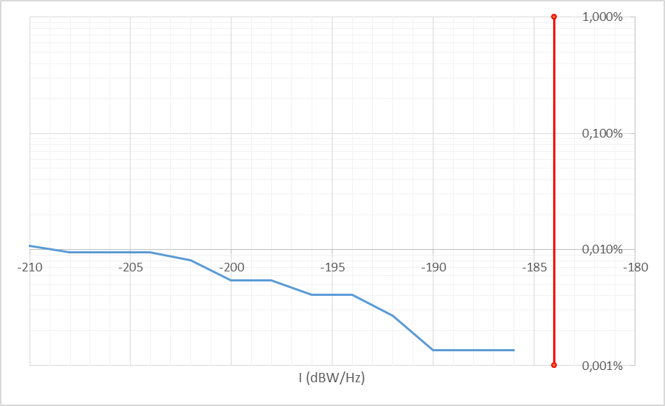

Figure 12: Interference power density (dBW/Hz) for MICS Uplink case

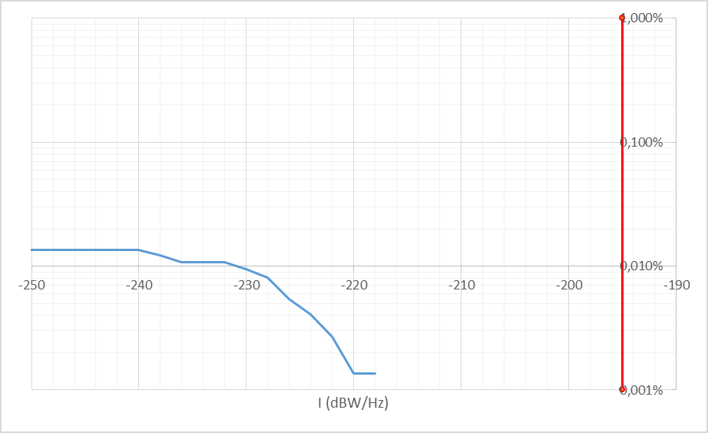

Figure 13: Interference power density (dBW/Hz) for MICS Downlink case

#### Dynamic simulation with indoor attenuation (3 days- time basis)

In Figure 14, the Interference density level in dBW/Hz is shown for the MICS uplink with wall attenuation of 12 dB. The red line indicates the receiver noise floor in dBW/Hz. This value is not exceeded. Figure 15 shows the interference density in dBW/Hz for the MICS downlink with the same indoor attenuation. The red line indicates the receiver noise floor in dBW/Hz. The result is comparable to the result above. The receiver noise floor value is not exceeded.

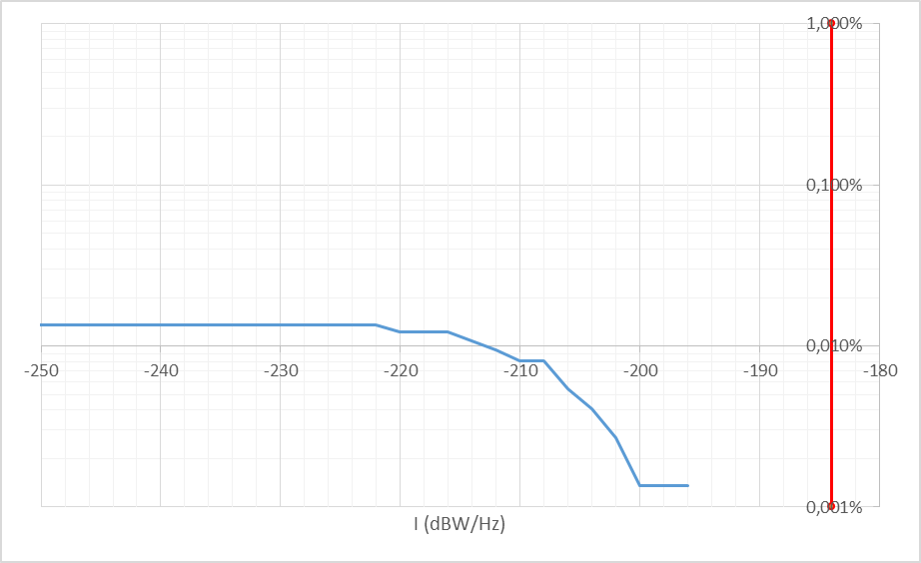

Figure 14: Interference density (dBW/Hz) for MICS Uplink case

Figure 15: Interference density (dBW/Hz) for MICS Downlink case

### Conclusion on the compatibility analyses for MICS operated in the Mobile service

The results of the static study show needed separation distances of up to 8.66 km for MICS operating outdoor and 2.18 km for indoor operation. Considering that the animals tracked are wild animals migrating, the distance should be achieved for most of the time. Also, the transmission time of the animal transmitters is only 3.5 seconds per day. Due to power limitation, the animal transmitter will operate only once per day and only in view of the associated space station. Dynamic simulations show that animal tags may have an effect on the MICs uplink but due to the short transmission time of the animal tags, the level of interference is below 0.01% of the time and, therefore, should be acceptable.

Further, if during medical implant’s communications session an animal transmitter operates in the band occupied by the medical system and interferes with the medical system communications, it will cause the medical system to re-scan the band and select a new frequency on which to continue its communications.

For the fixed frequency MICS systems, the duty cycle is 0.1%; then the probability of interference is estimated to be low. It should also be noted that the MICS are operating in the mobile service on a secondary status.

These studies conclude that the co-existence between the animal tracking and MICS operated in the Mobile service is feasible.

# Conclusions

Around the globe, billions of animals migrate regularly connecting remote places on Earth and in the oceans and they could be seen as sensors to monitor changes around the planet. However, most wild animals are poorly understood. The network to track migrating animals described in this report is the ICARUS system that aims to better understand animal behaviour by monitoring the local, regional and global movement patterns of tagged animals.

The report provides relevant sharing study analyses related to co-channel operation of the Earth exploration-satellite service application animal tracking with applications of the Meteorological Aid service (MetAids), the Earth exploration-satellite service, the Meteorological-satellite service and the mobile service in the frequency band 401-403 MHz. The mobile service has a secondary allocation in this frequency band while the Earth exploration-satellite service has a primary allocation; however, to evaluate the effect on national infrastructures, the studies also include applications of the mobile service.

Studies are provided to assess the potential of interference from animal tags to sonde receivers in the Meteorological Aids service. Based on this investigation, it can be stated that there is a potential for interference from animal tags towards sonde receivers. Therefore, a mitigation technique is proposed to ensure the protection of the Meteorological Aids; in particular by avoiding any animal tag transmission during radiosonde synoptic operations for 2 hours starting at 00:00 and 12:00 UTC. It should be noted that the mitigation technique proposed is based on typical scenarios and thus may not fully protect particular measurements scenarios taking place out of synoptical observations. Nevertheless, the probability of having these scenarios taking place at the same time, place and frequency than transmissions of ICARUS tags is significantly low.

The study results also indicated that the described ICARUS system used for animal tracking will not cause harmful interference to non-GSO and GSO receiving space stations. Dynamic simulations show that the aggregated level of interference does not exceed the protection criteria since it is found to be below 1% of the time. However, it should be noted that this result is based only on the investigated scenario.

Finally, it was also concluded that there would be no harmful interference from ICARUS system on MICS operated in the mobile service.

It should be noted that these conclusions are only valid for the ICARUS system presenting the following specific characteristics:

* a single space station (ISS);
* tags operated at very low power (-24 dBW e.i.r.p) and for limited time (3.5 s);
* 50 maximum simultaneously transmitting tags;
* Total number of bird tags limited by nature and principle.

1. Description of the ICARUS satellite network system

The ICARUS Initiative (International Cooperation for Animal Research Using Space), is a research endeavour that transcends disciplines and continents, to increase the knowledge of migration by monitoring the movement patterns of tagged animals.

ICARUS is supported by international organisations and conventions such as the FAO (Food and Agricultural Organisation of the United Nations) and the CMS (Convention on Migratory Species as an environmental treaty under the aegis of the United Nations Environment Programme). CMS refers to ICARUS as an instrument for further work to be done and asks for support of the members for ICARUS. The CMS COP11 stated:

* 1. ”Acknowledging that the ability to increasingly track animals globally will greatly enhance the knowledge base for informed conservation decision making, for example through global tracking initiatives such as ICARUS (International Cooperation for Animal Research Using Space), planned to be implemented on the International Space Station by the German and Russian Aerospace Centres (DLR and Roscosmos) by the end of 2015.”
  2. ”New technologies, such as those developed under the ICARUS project, and new methodologies will make tracking of smaller animals feasible. [….] Keeping up to date on these new technologies and promoting their use among CMS Parties is an issue that can help bring forward the CMS agenda in the coming years, particularly the Convention’s work on connectivity and ecological networks.”
  3. ”Calls upon Parties and invites other Range States and relevant organizations to use tools such as Movebank, ICARUS and other tools to better understand the movements of CMS-listed species, including the selection of those endangered species whose conservation status would most benefit from a better understanding of their movement ecology, while avoiding actions which may enable the unauthorised tracking of individual animals and facilitate poaching.”
  4. SYSTEM OVERVIEW

ICARUS consists of spaceborne and ground-deployed elements. The space borne elements are used as relay for the radio frequency communication link between animal tags and the Operations Center. The International Space Station (ISS) will be used as platform for the spaceborne elements for the initial ICARUS mission.

For the tags a two-way communication via RF link to the ISS is provided. The miniaturized tag attached to the animal is determining its position using GPS, thus providing the capability of logging the track of the tag with high accuracy. During contact with the ISS the tag transmits the recorded data and can receive reconfiguration commands. The Operations Center is monitoring and controlling the spaceborne elements at the ISS and the tags via the ISS. In addition, it is responsible for processing the science data and for disseminating them to the science community via the Movebank database. As amendment to the space link, the user can communicate with the tags at short range using hand-held base stations.ANIMAL TAG

Due to the small size of the tags, batteries can only store a small amount of energy. Therefore, the tag is most of the time in hibernation mode, i.e. in the mode with the lowest power consumption. The tag will be switched on once per day at a predefined time and transmits its data for around 3.5 sec, before returning in the hibernation mode again. The typical lifetime of an animal tag is around one year. The communication concept will be described in more detail in A1.2.

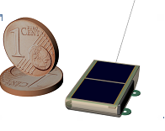

Figure 17: Animal tag size compared to one cent

* 1. Communication Concept

The communication sequence between tag and the ICARUS on board equipment at the ISS consists of the following steps:

Step 1: The tag is in the hibernation mode, i.e. in the mode with the lowest power con­sumption, waiting for the internal timer to awake the system at the time of the expected ISS appearance.

Step 2: After wake-up, the receiver starts listening intermittently in order to detect the presence of the ISS downlink radio frequency signal.

Step 3: This intermittent operation will be continued until the detection is suc­cessful. With the successful reception of the ISS downlink signal, the tag will extract the most recent information about the ISS orbit from the received signal.

Step 4: With the received ISS orbit data the tag will determine its relative position to the ISS using its own GPS based position on ground. Based on this information the tag calculates its presence within the field of view of the ISS receive antennas. Until then, the receiver will go back into stand-by mode.

Step 5: Upon reaching the predicted receive window, the tag will transmit the stored position and sensor data.

Step 6: After data transmission, the tag will remain for a predefined time in receive mode to listen for a configuration command that may be sent by the ICARUS on-board equipment.

Step 7: Before falling back into hibernation mode, the tag calculates the time gap until the next scheduled ISS contact. The hibernation mode is interrupted periodically for position determination and acquisition of sensor data.

1. List of Reference
2. ERC Report 25 on European Common Allocation Table;
3. ERC Decision (01)17 on harmonised frequencies, technical characteristics and exemption from individual licensing of Ultra Low Power Active Medical Implants (ULP-AMI) communication systems operating in the frequency band 401-406 MHz on a secondary basis;
4. ETSI European Standard EN 302 537: Ultra Low Power Medical Data Service Systems operating in the frequency range 401-402 MHz and 405-406 MHz;
5. ETSI European Standard EN 302 054: Radiosondes to be used in the 400.15 to 406 MHz frequency range with power levels ranging up to 200 mW
6. Recommendation ITU-R RS.1165: Technical characteristics and performance criteria for systems in the meteorological aids service in the 403 MHz and 1 680 MHz bands
7. Recommendation ITU-R RS.1263: Interference criteria for meteorological aids operated in the 400.15-406 MHz and 1 668.4-1 700 MHz bands
8. Recommendation ITU-R SA.1163: Interference criteria for service links in data collection systems in the Earth exploration-satellite and meteorological-satellite services
9. Recommendation ITU-R SA.2045: Basic general partitioning and sharing conditions for the band 401-403 MHz for future long-term coordinated use of data collection systems on geostationary and non-geostationary METSAT and EESS systems
10. Recommendation ITU-R SA.2044: Protection criteria for non-GSO data collection platforms in the band 401-403 MHz
11. Recommendation ITU-R RS.1346: Sharing between the meteorological aids service and medical implant communication systems (MICS) operating in the mobile service in the frequency band 401-406 MHz
12. ECC Report 92 on coexistence between ultra-low power active medical implants devices (ULP-AMI) and existing radiocommunication systems and services in the frequency bands 401-402 MHz and 405-406 MHz.