ERC Recommendation (01)02

Preferred channel arrangements for Fixed Service systems operating in the frequency band 31.8-33.4 GHz
Approved 2001
Amended 29 May 2019

introduction
This ERC Recommendation provides a channel arrangement on a purely technical basis for the development of fixed service equipment. Like the channel arrangements for the 26 GHz and 28 GHz bands this recommendation it is not aimed to give any preference with regard to what kind of technologies (e.g. FDD or TDD) or applications (e.g. fixed wireless access (FWA) or infrastructure) to be accommodated in this band.
Furthermore, this ERC Recommendation does not provide any guidance on frequency assignment issues (e.g. block assignment, measures to ensure inter-operator-compatibility, symmetrical and asymmetrical traffic etc.).

ERC recommendation (01)02 of 2001 on PREFERRED CHANNEL ARRANGEMENTS FOR FIXED SERVICE SYSTEMS OPERATING IN THE FREQUENCY BAND 31.8-33.4 GHz , revised 5 february 2010 and amended 29 MAY 2019
“The European Conference of Postal and Telecommunications Administrations,
considering
- that the WRC-2000 allocated on a world-wide primary basis the 31.8-33.4 GHz band to the Fixed Service, available for high density applications in the fixed service (HDFS) (RR No. 5.547);
- that sharing in the 31.8-33.4 GHz band with radionavigation (RNS), space research (SRS) (Deep Space-space-to-Earth) and inter-satellite services (ISS) is considered as feasible taking into account footnote 5.547A stating that administrations should take practical measures to minimise the potential interference between stations in the fixed service and airborne stations in the radionavigation service in the 31.8-33.4 GHz band, taking into account the operational needs of the RNS;
- that CEPT has a long term objective to harmonise the use of frequencies throughout Europe to benefit from technical and economic advantages;
- that CEPT administrations should apply preferred channel arrangement in order to make the most effective and efficient use of the spectrum for fixed service applications;
- that it may sometimes be desirable to interleave additional radio frequency channels between those of the main pattern;
- that technical and operational restrictions may be necessary to minimise potential interference between stations in the fixed service and airborne stations in the radionavigation service;
- that, when very high capacity links are required, it may be achieved by using wider channel bandwidth.

recommends
- that CEPT administrations should follow the recommended preferred channel arrangement for the frequency band 31.8-33.4 GHz given in ANNEX 1;
- that when an interleaved channel arrangement is used, the values of the centre frequencies of these radio frequency channels should be below those of the corresponding channel frequencies (as detailed in ANNEX 1) by a value of half the channel spacing;
- that in the case of deployment of point to multipoint systems with frequency duplex division (FDD) the upper sub-band should be used for the transmission from the terminals to the central station and the lower for the transmission from the central station to the terminals;
- that CEPT administrations may consider merging any two adjacent 112 MHz channels recommended in ANNEX 1 to create one 224 MHz channel with its centre frequency between the merged channels. To assist cross-border co-ordination, administrations may refer to the channel identifiers described in ANNEX 2.”
Note:
Please check the Office documentation database https://www.ecodocdb.dk for the up to date position on the implementation of this and other ECC Recommendations.
- PREFERRED CHANNEL ARRANGEMENT IN THE BAND 31.8-33.4 GHz
The centre frequencies for channel separations of 3.5 MHz, 7 MHz, 14 MHz, 28 MHz, 56 MHz and 112 MHz shall be derived as follows:
Let
F_{R} be the reference frequency of 32599 MHz;
F_{N} be the centre frequency (MHz) of the radio frequency channel in the lower half of the band;
F_{N}’ be the centre frequency (MHz) of the radio frequency channel in the upper half of the band;
Duplex spacing = 812 MHz;
Centre gap = 56 MHz for the 3.5, 7, 14 and 28 MHz channel separations,
140 MHz for the 56 and 112 MHz channel separations.

then the frequencies (MHz) of individual channels are expressed by the following relationships:
- For channel separation of 112 MHz:
lower half of the band: | F_{N} = F_{R} − 784 + 112n
upper half of the band: | F_{N}’ = F_{R} + 28 + 112n | where n = 1, 2, 3, … 6
- For channel separation of 56 MHz:
lower half of the band: | F_{N} = F_{R} − 756 + 56n
upper half of the band: | F_{N}’ = F_{R} + 56 + 56n | where n = 1, 2, 3, … 12
- For a channel separation of 28 MHz:
lower half of the band: | F_{N} = F_{R} − 798 + 28n
upper half of the band: | F_{N}’ = F_{R} + 14 + 28n | where n = 1, 2, 3, … 27
- For a channel separation of 14 MHz:
lower half of the band: | F_{N} = F_{R} − 791 + 14n
upper half of the band: | F_{N}’ = F_{R} + 21 + 14n | where n = 1, 2, 3, … 54
- For a channel separation of 7 MHz:
lower half of the band: | F_{N} = F_{R} − 787.5 + 7n
upper half of the band: | F_{N}’ = F_{R} + 24.5 + 7n | where n = 1, 2, 3, … 108
- For a channel separation of 3.5 MHz:
lower half of the band: | F_{N} = F_{R} − 785.75 + 3.5n
upper half of the band: | F_{N}’ = F_{R} + 26.25 + 3.5n | where n = 1, 2, 3, … 216

Table 1: Calculated parameters according to Recommendation ITU-R F.746
XS  MHz | n | f₁  MHz | f_{n}  MHz | f₁’  MHz | f_{n}’  MHz | ZS₁  MHz | ZS₂  MHz | YS  MHz | DS  MHz
112 | 1…6 | 31927 | 32487 | 32739 | 33299 | 127 | 101 | 252 | 812
56 | 1...12 | 31899 | 32515 | 32711 | 33327 | 99 | 73 | 196 | 812
28 | 1...27 | 31829 | 32557 | 32641 | 33369 | 29 | 31 | 84 | 812
14 | 1...54 | 31822 | 32564 | 32634 | 33376 | 22 | 24 | 70 | 812
7 | 1...108 | 31818.5 | 32567.5 | 32630.5 | 33379.5 | 18.5 | 20.5 | 63 | 812
3.5 | 1...216 | 31816.75 | 32569.25 | 32628.75 | 33381.25 | 16.75 | 18.75 | 59.5 | 812

XS Separation between centre frequencies of adjacent channels
YS Separation between centre frequencies of the closest go and return channels
ZS₁ Separation between the lower band edge and the centre frequency of the lowest channel in the lower half of the band
ZS₂ Separation between centre frequency of the highest channel in the upper half of the band and the upper band edge
DS Duplex spacing (F_{N}’ - F_{N})

- Occupied spectrum: 31.8-33.4 GHz band

(e) 3.5 MHz channels

- Channel arrangements and identifiers for 224 MHz channels by merging 112 MHz channels
The 224 MHz channels (ref. recommends 4) can be identified by using the following numbering:

Let
F_{R} be the reference frequency of 32599 MHz;
F_{N} be the centre frequency (MHz) of a radio frequency channel in the lower half of the band;
F_{N}’ be the centre frequency (MHz) of a radio frequency channel in the upper half of the band;
Duplex spacing = 812 MHz;
Centre gap = 140 MHz;
Lower guard band width = 71 MHz (see Figure 1 a) ):
Upper guard band width = 45 MHz (see Figure 1 a) ):.

then the frequencies of individual channels are expressed by the following relationships:

Lower half of band: F_{N} = (F_{R} - 728 + 112n) MHz
Upper half of band: F_{N}’ = (F_{R} + 84 + 112n) MHz where: n = 1, 2, 3, …. 5

It is to be noted that the numbering is just for identification of the channelling. It should also be noted that two consecutive channel numbers cannot be used on the same physical link due to channels overlap. See figures below for channel arrangement example with identifiers.

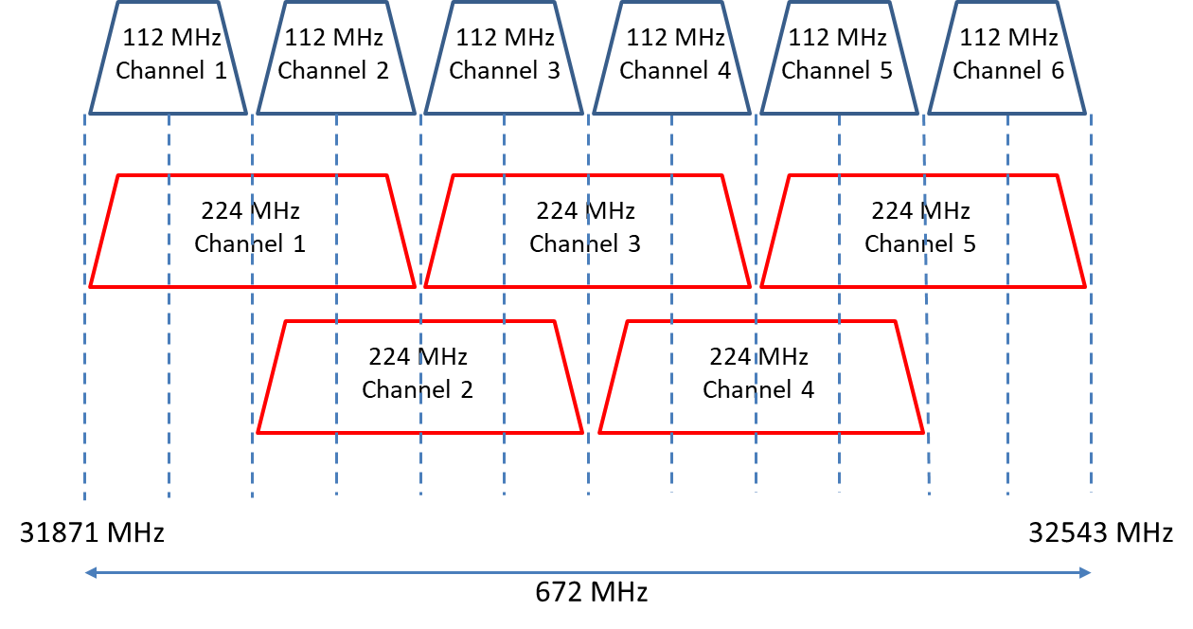
- Channel arrangement and identifiers with channel width of 224 MHz (lower half of band)

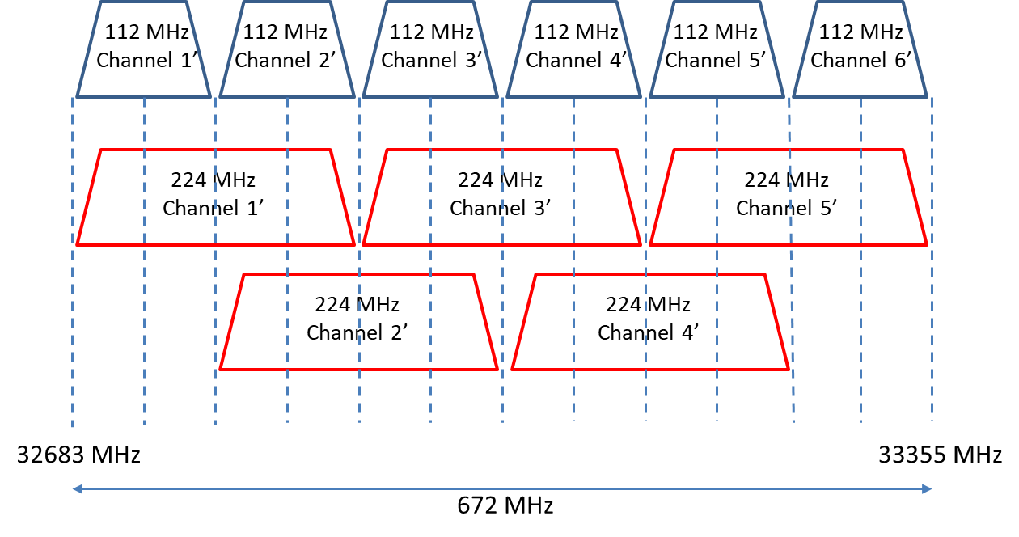
- Channel arrangement and identifiers with channel width of 224 MHz (upper half of band)

