Regulatory impact on Number Portability following migration to an all-IP environment

approved 24 November 2021

ECC Report 328

# Executive summary

This ECC Report analyses the regulatory impact of moving to new architecture and technological solutions for Number Portability (NP) in an all-IP environment. It describes the NP scenarios in an all-IP environment, including different routing solutions and Number Portability Database (NPDB) interaction with the Internet Protocol (IP) routing. Following this analysis, the regulatory impact is assessed regarding the migration process, legacy issues and whether or not new regulations are required.

The technical solutions to be adopted may be different and there may even be more than one solution at national level, but the aspects related to interconnection and call routing mechanisms should be standardised and agreed between all parties. Engagement by the NRA may be needed to make this work effectively.

TABLE OF CONTENTS

0 Executive summary 2

1 Introduction 5

2 Number portability databases in use 6

2.1 Centralised databases 6

2.2 Decentralised databases 7

2.3 Distributed Ledger Technology - Blockchain 8

3 Scenarios for databases in an all-IP environment 10

3.1 Interim solution 10

3.1.1 Option 1 10

3.1.2 Option 2 10

3.2 All-IP solution 11

3.2.1 Option 3 11

3.2.2 Option 4 11

3.3 Examples of solutions adopted in different countries 11

3.4 Call Routing Mechanisms adopted at National Level 12

4 Regulatory impacts 14

5 Conclusions 15

ANNEX 1: List of Reference 16

LIST OF ABBREVIATIONS

|  |  |
| --- | --- |
| Abbreviation | Explanation |
| 3GPP | 3rd Generation Partnership Project |
| CEPT | European Conference of Postal and Telecommunications Administrations |
| CRDB | Central Reference Data Base |
| DLT | Distributed Ledger Technology |
| DNS | Domain Name System |
| ECC | Electronic Communications Committee |
| ECNO | Electronic Communications Network Operator |
| ECSP | Electronic Communications Service Provider |
| ENUM | tElephone NUMber mapping |
| ETSI | European Telecommunications Standards Institute |
| IETF | Internet Engineering Task Force |
| INAP | Intelligent Network Application Protocol |
| IP | Internet Protocol |
| ITU-T | International Telecommunication Union - Telecommunication Standardisation Sector |
| MNO | Mobile Network Operator |
| MVNO | Mobile Virtual Network Operator |
| NGN | Next-generation network |
| NP | Number portability |
| NPDB | Number portability database |
| NRA | National Regulatory Authority |
| NRN | Network routing number |
| OP | Operator |
| OPDB | Real-time Operational Data Base |
| PSTN | Public switched telephone network |
| SIP | Session Initiation Protocol |
| SS7 | ITU-T Signalling System No. 7 |

# Introduction

Effective competition in electronic communications markets in Europe benefits and empowers end-users subscribed to electronic communications services in terms of choice, prices and quality. Over the last 15-20 years, Number Portability (NP) has been a key competition enabler since electronic communications markets were liberalised. NP solutions have enabled end-users to switch service providers within the national market while retaining their telephone number.

These solutions are based on standard technical solutions (usually NP mechanisms defined by ITU-T and ETSI on traditional telephony network technology), nationally adapted and implemented with country-specific characteristics.

The National Regulatory Authorities (NRAs) for Electronic Communications Networks and Services have responsibility for the effective implementation of NP and they adopt a technology neutral approach on how the industry implements NP obligations in the respective national markets.

As the evolution to all-IP networks continues apace, several mechanisms have emerged for identifying E.164 numbers and routing them to the correct recipient network serving these numbers. For example, tElephone NUMber mapping (ENUM)-like mechanisms could be used inside Domain Name System (DNS) systems for routing purposes.

The purpose of this ECC Report is to identify and describe the different options for implementing NP in an all‑IP environment and to assess the regulatory impact of these new approaches on national markets in Europe.

# Number portability databases

A database is needed in a number portability implementation in order to store the information about the ported numbers. This information includes at least the numbers that are ported and the identifier of the associated Electronic Communications Service Provider or Electronic Communications Network Operator (ECSP/ECNO) (e.g. Routing Number (RN)). In principle, data related to ported numbers is generated during administrative porting processes and it is used by ECNOs to route calls to those numbers. Depending on how the information is stored and shared, portability databases can be classified into several categories.

## Centralised databases

Most number portability implementations in Europe use centralised databases[1]. As illustrated in Figure 1, this solution involves a single non-real-time Central Reference Database (CRDB) that contains routing information (usually a routing number) for the ported numbers of all ECSPs/ECNOs in a country. Each ECNO's real-time operational databases (OpDB) are synchronised with the reference database. Usually the number portability centralised databases also have a role in the administrative processes that lead to the porting of numbers, acting as an intermediary and centraliser of messages exchanged by ECSPs/ECNOs during the porting processes.

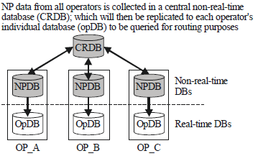

Figure 1: Example of a centralised database architecture

(Source: Recommendation ITU-T E.164/Suppl.2 (06/2020))

In addition to the core functions presented above, centralised databases are an important resource that can be used for various purposes related to number portability. The information stored in centralised databases can be used to aggregate complex statistics and insights on the porting processes carried out in a country, giving ECSPs/ECNOs the opportunity to use those to streamline their internal porting processes and procedures. The NRA or other competent authorities can use this data to evaluate the compliance of ECSPs/ECNOs with number portability regulations and for market monitoring purposes. Access to the centralised database can also be granted to entities other than those who have obligations to implement number portability at the national level [6] [7].

There are various arrangements about database administration, specific to each country. The centralised database is generally managed by a separate entity, for example by a consortium of ECSPs/ECNOs, which would assume the role of intermediary between ECSPs/ECNOs [2]. The development and the effective operation of the centralised database is usually entrusted to specialised companies.

## Decentralised databases

The other approach is a "decentralised database" which has advantages and disadvantages. Example of advantages are:

* There are no complicated questions of cost allocation to be clarified, because each ECSP/ECNO bears its own costs;
* No operational tasks need to be performed by a central administrator.

A possible disadvantage is the absence of a reference database, which may give rise to synchronisation and routing issues, as well as inefficiencies in replicating and verifying data.

There can be various implementation solutions. As an example:

* Each ECNO receives a porting ID that can be linked in databases with number blocks and ported numbers that are assigned to this ECNO;
* According to a specification agreed between all ECNOs, each ECNO maintains a file containing all number blocks which are assigned to him and all numbers that were ported to him;
* Every ECNO grants all other ECNOs access to these files;
* Each ECNO retrieves these files of the other ECNOs according to a regular schedule (e.g. same time every night) and inserts the content into its own database which is used for the routing.

Another example of an implemented solution works as follows:

* The ECSPs/ECNOs are divided in two types: those belonging to a core group (e.g. Mobile Network Operator (MNOs)) and those that are linked to one of the ECSPs/ECNOs of the core group (e.g. Mobile Virtual Network Operator (MVNO)s);
* Each ECSP/ECNO belonging to the core maintains a database with all the portability carried out by the ECSPs/ECNOs;
* In the first phase, the number portability process is realised exchanging data only among the involved parties (e.g. recipient, donor and, depending on the solution, number range holder);
* At the end of the first phase, one of these parties (e.g. the recipient) sends a message informing all the parties belonging to the core about the number portability to be realised;
* Each ECSP/ECNO of the core informs all the non-core ECSPs/ECNOs that they are linked to, of the numbers that will be ported;
* At the time of cut-over, each ECSP/ECNO updates its own database.



Figure 2: Example of a decentralised/distributed database architecture

(Source: Recommendation ITU-T E.164/Suppl.2 (06/2020) [3])

In this architecture, NP data is stored within each ECSP/ECNO's individual non-real-time database, referred to as the number portability data base (NPDB), as illustrated in Figure 2. The data is reciprocally exchanged between ECSPs/ECNOs. This reciprocal exchange of database information enables each ECSPs/ECNOs' NPDB and OpDB to hold NP data of all ECSPs/ECNOs.

## Distributed Ledger Technology - Blockchain

Distributed Ledger Technology (DLT) is a protocol that enables decentralised database management by multiple participants across multiple nodes. Three characteristics of DLT mean that its platforms are particularly well-suited to establishing the databases:

* delivers trust and assurance within the processes;
* creates secure immutable assets; and
* delivers regulatory compliance through ‘smart contracts’ (programmes that encode the rules for specific types of transactions in a way that can be validated and triggered by specific conditions).

Blockchain is a type of distributed ledger. It is composed of digitally recorded data arranged as a successively growing chain of blocks, with each block cryptographically linked and hardened against tampering and revision. When applied to number management, including number portability, blockchain provides a type of distributed ledger based on right of use and status of the telephone number as the digital asset, using a platform that is distributed through decentralised nodes among members. It would need to be a ‘Permissioned Blockchain’ platform (as opposed to private or public), so that it is functional for all parties involved in number portability but has the additional security measure of an access control layer that allows actions to be performed only by certain identifiable and permissioned participants. Data can be exchanged securely and transparently, while the porting process itself can be simplified. Significantly, it uses open-source software code and is completed without the need for an intermediary, e.g. a third-party porting solution provider, to carry out the functionality and provide assurance, and without a need to reconcile data afterwards.

The move from traditional analogue telephone lines to an all-IP infrastructure is an appropriate time to look at blockchain as a means for improving the number porting process. It has the potential to bring a number of benefits:

* improved customer experience when moving a number between providers;
* lower business costs;
* increased industry agility, with updates seen in real-time by all permissioned users;
* resilience, as the number database is replicated, with each user having their own copy; and
* other number management improvements, including more effective disruption of nuisance calls and fraud.

However, blockchain is in a highly emergent phase. Although there are a few case studies where DLT has been introduced in the telecommunications industry, there has been substantive speculation about their future application. The technical complexities and operational overheads involved in creating, configuring, and operating the system so that it integrates with existing number management systems, plus educating all relevant parties in its use, may be a barrier to implementation. At the moment, there is not conclusive evidence that DLT is the most efficient means of delivering a number portability system and may be too sophisticated a solution for the task. For example, the replication of the database in real-time by all users is inefficient and may be wasteful of resource.

DLT may be appropriate for use in establishing databases to enable number portability in the coming years when the technology is more mature and solutions are available to address inefficiencies. Also, there is growing interest in Blockchain-as-a-Service (BaaS), where a third-party provider can offer cloud-based infrastructure and management to support the building and operating of blockchain applications and platforms.

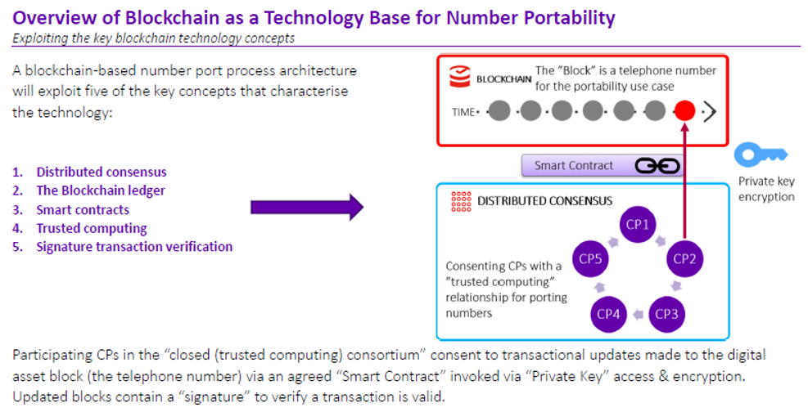

Figure 3: Example of a decentralised database architecture, based on Blockchain

(Source: British Telecom)

# Scenarios for databases in an all-IP environment

In this section, four scenarios are described. The first two scenarios involve an interim solution, where the networks that must interconnect involve both legacy networks and all-IP networks. The other two scenarios are related to an all-IP end solution which would be relevant after legacy networks have been phased out.

## Interim solution

A common scenario for most service providers would be to make simultaneous use of a legacy network and an all-IP network for a period of time. During this time, number portability databases will continue to be queried. Figure 4 shows two different options although other options are also possible.

Figure 4: Interim solutions

### Option 1

This solution is based on an architecture where the role for querying the number portability database (NPDB) is still made by the legacy network. All calls originated in an all-IP network shall first be routed to the legacy network, where the appropriate node queries the NPDB/OPDB. Depending on the type of number (e.g. fixed or mobile), different databases could be queried. Only after the querying process, the call is routed to the terminating all-IP network on the basis of the response received from the NPDB/OPDB.

### Option 2

The main difference of this option is that the all-IP network supports the functionality of querying a "traditional" NPDB. For this reason, for each call originated in the all-IP network, only the query to the NPDB is routed through the legacy network and not the call itself as for Option 1. This results in more efficient routing of the call.

## All-IP solution

Figure 5: All-IP solution

### Option 3

Option 3 is based on an implementation where a NPDB and an OPDB are implemented in the all-IP network. When a call is originated, a query shall be done using any internal signalling, and the routing address (based on an IP Session Initiation Protocol (SIP) address) would be returned in the response received from the database. Number portability is in this step already resolved.

### Option 4

Option 4 implements a standardised solution for routing which makes use of the ENUM protocol (a protocol based on the DNS querying). ENUM, which is defined by Internet Engineering Task Force (IETF), is a database hierarchical system and a query protocol for mapping an ITU-T E.164 number into a domain name that is understandable in IP networks [2].

## Examples of solutions adopted in different countries

The supplement 2 of Recommendation ITU-T E.164 was updated in June 2020 by Study Group 2 of ITU-T in order to show the different approaches done in several countries [3]. Figure 6 aggregates the known information:

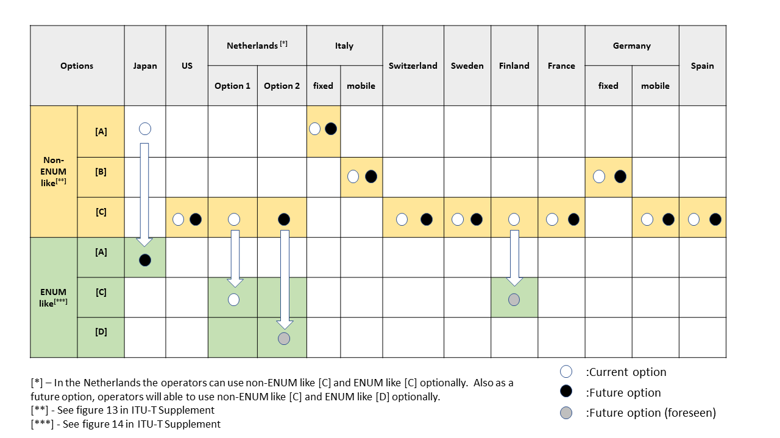

Figure 6: Options of evolution in an all-IP environment

(Source: based on Recommendation ITU-T E.164/Suppl.2 (06/2020))

As shown, there are countries where the evolution will be using different technologic solutions.

There are two options described in Figure 6:

* Non ENUM-like options utilising current technologies;
* ENUM-like.

Non ENUM-like options utilising current technologies could make use of a centralised or a decentralised database. When a network is establishing a communication, it should query a database to route the communication to the right network. The protocols involved are several and may not be harmonised for all partners in the country. This solution is used to rehabilitate investments made during the last years. It was already used during mixed scenarios where legacy and all-IP networks have interworked.

An ENUM-like option here means a technology providing capabilities similar to those provided by the standardised infrastructure ENUM. In addition, infrastructure ENUM is defined in IETF RFC 5067 [11] as an ENUM system that is technically based on IETF RFC 6116 [12] and is defined and used only inside a network and among networks for routing purposes. The use of User ENUM, where end-users control the provisioning, attributes, and accessibility for their assigned numbers, is not considered appropriate for the purpose of NP solutions since it could be insecure, incomplete, not private and/or offers no guaranteed quality of service or data integrity [8].

In any case, it is always possible to have several solutions implemented in the same country. The only relevant aspect to be considered is related to the interconnection between the different operators. The parties involved must agree a common protocol and options when the communication crosses the border of their networks.

## Call Routing Mechanisms adopted at National Level

The call routing mechanism in the respective number portability architecture adopted at a national level, namely All Call Query, Onward Routing, Query on Release or Call Drop Back [4], may also influence the interconnection aspects on which an agreement is required among the parties involved. In particular, when call routing is based on either the Query on Release or the Call Drop Back mechanism, the originating network routes each call to the network originally associated with the called number which then carries out the number portability query. If the number would be ported:

* In the Query on Release mechanism, the call would be released back to the originating network with a specific cause code indicating that the number had ported such that the originating network would then proceed to query its OPDB to obtain information identifying the correct terminating network;
* In the Call Drop Back mechanism, the call would be released back to the originating network together with routing information identifying the correct terminating network.

Due to the inter-network communication exchanged before the correct terminating network is identified, it becomes essential to define relevant parameters related to the release of the call for both Query on Release and Call Drop Back mechanisms. Furthermore, parameters related to the provision of routing information in the case of the Call Drop Back mechanism would also have to be defined.

ENUM-like options could also include solutions where the originating network sends the ENUM query to another network such as the local ENUM database of the number range holder or a national ENUM database [3]. Such solutions rely on the exchange of ENUM queries and responses between different networks and, in this respect, would also require an agreement among all parties on aspects related to the ENUM protocol used and relevant parameters.

# Regulatory impacts

There are several solutions associated with number portability and most of them can be made compatible in an all-IP environment.

The objective of number portability regulations stays the same independently of whether legacy networks or all-IP networks are in place, i.e., the solutions shall allow for new entrants to enter the market.

It is also acknowledged that there may be possible hybrid solutions, including solutions used in legacy networks such as centralised databases but where communication is done using queries in the IP environment. This is the scenario described in option 3 in section 3.2.1 of this report. This type of solution allows the protection of the investments already made by the service providers.

A fundamental aspect will be always that the interconnections between networks would be standardised and all relevant options (e.g. version of SIP protocol, format of the SIP address, etc.) shall be agreed between all parties.

The standardisation of the SIP protocol allows several options and for that reason it is fundamental that a minimum set of options are defined on an IP interconnection interface. Besides defining the supported SIP protocol(s) (e.g. IETF SIP, 3GPP SIP) and version(s), it is also important to define other options like how to combine the RN and the called party number, (e.g. a concatenated address ('To' header) or two separated headers ('To' and 'RN' headers). Furthermore, when a Query on Release or a Call Drop Back mechanism is implemented, relevant parameters related to the release of the call and also the provision of routing information in the case of the Call Drop Back mechanism would have to be defined and agreed between all parties.

In the case of ENUM-like options, the implementation of a solution which includes an exchange of ENUM queries and responses between different networks would require all parties to agree on which ENUM protocol to be used and all relevant parameters.

The use of DLT in regulation raises wider policy questions – some of which are outside NRAs’ remit – relating to data protection, rights and standards. For example, the ‘immutability’ of information contained within DLT has implications for existing end user protections such as the right to be forgotten. There are approaches to limiting access to and securing the data, but in the longer term there needs to be alternative ways to manage distributed ledgers and transaction storage over time.

For some aspects of the previous paragraphs the intervention of the NRA may be needed if market parties do not find a common solution.

# Conclusions

The solutions to be adopted in an all-IP environment shall be open to all ECSPs/ECNOs in order to allow free competition in the electronic communication market.

The technical solutions to be adopted may be different and there may even be more than one solution at national level, but the aspects related to interconnection should be standardised and agreed between all parties. Engagement by the NRA may be needed to make this work effectively.

The extent of the interconnection parameters to be defined would depend on the call routing mechanism adopted, whereby the Query on Release or the Call Drop Back mechanism would entail additional parameters due to the inter-network communication involved to identify the correct terminating network.

There may also be implementations of ENUM-like solutions which rely on the exchange of ENUM queries and responses between different networks. In such cases, aspects related to ENUM protocol should also be agreed between all parties. For some aspects the intervention of the NRA may be needed if market parties do not find a common solution.

DLTs are still highly novel, with few applied case studies in ‘real world’ scenarios and limited awareness of its implications (including amongst NRAs). Further research is likely to be required before functioning platforms are introduced. It is noted that substantive work on the implications and applications of DLT in the communications sector is being undertaken by a range of organisations, most notably the International Telecommunications Union (ITU) [9]. Therefore, the viability of using distributed ledgers such as blockchain in number portability should be kept under review, with NRAs having a ‘watching brief’.

1. List of References
2. ETSI TR 184 003: "Portability of telephone numbers between operators for Next Generation Networks (NGNs)"
3. ETSI TR 103 282: "ENUM/ENUM-like options for Number Portability and actual use cases"
4. Recommendation ITU-T E.164 Supplement 2: "The international public telecommunication numbering plan - Supplement 2: Number portability"

1. [ECC Report 031](https://docdb.cept.org/document/1003): “Implementation of Mobile Number Portability in CEPT Countries”, approved October 2005

1. [ECC Report 155](https://docdb.cept.org/document/263): “Number Portability efficiency: Impact and analysis of certain aspects in Article 30.4 of the Universal Service Directive and general remarks on NP efficiency”, approved October 2011

1. [ECC Report 238](https://docdb.cept.org/document/344): “3rd Party Access to Number Portability Data (NP Data)”, approved October 2015

1. [ECC Recommendation (16)01](https://docdb.cept.org/document/950): “3rd party access to Number Portability Data (NP Data)”, approved April 2016
2. GSMA ENUM: “Guidelines for Service Providers and IPX Providers, May 2018
3. ITU-T Technical Specification FG DLT D1.1: “Distributed ledger technology terms and definitions”, August 2019
4. ETSI TR 101 122: "Network Aspects (NA); Numbering and addressing for number portability"
5. IETF RFC 5067: "Infrastructure ENUM requirements"
6. IETF RFC 6116: "Dynamic Delegation Discovery System (DDDS) Application (ENUM)"

1. More information about the utilisation, role and architecture of centralised databases can be found in ECC Report 31 [4], ECC Report 238 [6], ECC Report 155 [5], Recommendation ITU-T E.164/Suppl.2 (06/2014) [3] and ETSI TR 184 003 [1].
2. Source: ECC Report 155, annex 2: National NP Procedures