Implementation of digital voice radio telephony in the VHF maritime mobile band
approved 08 October 2021
ECC Report 329

Executive summary
This is a first Report on the digitisation of the analogue maritime VHF channels and further developments will be closely monitored. This ECC Report could potentially be the base for future discussions in ITU and IMO.
Intention of the work item was to investigate the possible expansion of the number of VHF voice channels based on the implementation of digital technology. In addition, a plan for change over from analogue to digital was required. Any migration plan is currently merely indicative.
Analysis concluded: Current maritime VHF radio is inherently FDMA in nature, one radio channel carries one voice channel. TETRA and DMR are TDMA systems in which one radio carrier can carry multiple voice channels, however the timing of these is critical to its operation and so is limited to systems where there is a ”master” transmitter that can define the slot timing accurately for all units in the network. Whilst this may be feasible close to coast, clearly this is not possible in the high seas or areas not covered by a coast station.
Digital Private Mobile Radio (dPMR) and Next Generation Digital Narrowband (NXDN) suit well to replace analogue audio in maritime environment. Technically, the standards are comparable and offer similar functionality. However, the dPMR published as open ETSI standard is more preferred.
Two test trials were carried out by two CEPT administrations. Full reports of the trials can be found in ANNEX 2 and ANNEX 3.
For further observation on the issue:
- The Digital channelling arrangements need to fit within the analogue channel plan. (Compatible with Recommendation ITU-R M.1084 [21]);
- Practical trials undertaken in Estonia and the Netherlands demonstrate that digital systems operated successfully in coexistence with analogue systems in these locations;
- Similar technologies already exist and are used in other communities but need to have minor modifications for use in the maritime community;
- Analogue and digital channels may need to exist in parallel during a migration period and some analogue channels may need to be retained in perpetuity.

TABLE OF CONTENTS

0 Executive summary 2
1 Introduction 7
2 SCOPE 8
3 Current REGULATION 9
3.1 Table of allocation for the maritime mobile service and applicable standards 9
3.2 ITU 15
3.2.1 Regulations/recommendations/reports 15
3.3 IMO 15
3.3.1 Regulations as of March 2021 15
3.3.2 Performance standard 16
3.4 IALA 17
3.4.1 Correspondence 18
3.4.2 IALA Standards, Guidelines and Recommendations 18
3.5 other bodies/countries/Companies 18
3.5.1 Regional Arrangement on the Radiocommunication Service for Inland Waterways (RAINWAT) 18
3.5.2 Cybernetica 19
3.5.3 Estonia 19
3.5.4 The Netherlands 19
3.5.5 Committee International Radio-Maritime (CIRM) 20
4 overview of the current situation 21
4.1 Maritime radio usage cases 21
4.2 Terrestrial radio usage 22
5 DIGITAL voice VHF RR APPendix 18 24
5.1 Technical parameters 24
5.2 Requirements for Voice Communication and associated dsc in the VHF band 24
5.3 VOice CODEcs 25
5.3.1 CML Microcircuits (UK) 25
5.3.2 Digital Voice Systems (USA) 25
5.3.3 VoiceAge (Canada) 25
5.3.4 ITU-T Codecs 26
5.3.5 Opus (free open audio codec) 26
5.3.6 Comparison of Voice CODECS 26
5.4 Overview existing digital radio protocols 27
5.4.1 digital Private Mobile Radio (dPMR) 27
5.4.2 Next Generation Digital Narrowband (NXDN) 28
5.4.3 Digital mobile radio (DMR) 28
5.4.4 Trans-European Trunked Radio System (Tetra) 29
5.4.5 Comparison of Digital Radio Protocols 29
5.5 Other issues raised 29
5.6 Summary 30
5.7 Possible ADVICE for dPMR Marine 31
5.7.1 Proposed changes from ESI TS 102 658 31
6 Roadmap 32
7 Conclusions 34
ANNEX 1: Report from CYBERNETICA (Y-399-70) “Analyses of different digital radio protocols for use in maritime communication” 35
ANNEX 2: Report from Estonia 42
ANNEX 3: dPMR Trial Port of Rotterdam 60
ANNEX 4: ITU Codecs 70
ANNEX 5: List of References 74

LIST OF ABBREVIATIONS

Abbreviation | Explanation
ACELP | Algebraic code-excited linear prediction
ADPCM | Adaptive differential pulse-code modulation
AIS | Automatic Identification System
AMBE | Advanced Multi-Band Excitation
AMR-WB | Adaptive Multi-Rate Wideband
ATIS | Automatic Transmitter Identification System
CIRM | Comité International Radio-Maritime
CCNR | Central Commission on the Rhine
CEPT | European Conference of Postal and Telecommunications Administrations
CS-ACELP | Conjugate-Structure Algebraic-Code-Excited Linear-Prediction
CVSD | Continuously variable slope delta modulation
DSC | Digital Selective Call
DCME | Digital Circuit Multiplication Equipment
dMMR | Digital Maritime Mobile Radio
DMR | Digital Mobile Radio
dPMR | Digital Private Mobile Radio
ECA | European Common Allocation
ECC | Electronic Communications Committee
ETSI | European Telecommunications Standards Institute
EU | European Union
FDMA | Frequency Division Multiple Access
FEC | Forward error correction
FRAND | Fair, Reasonable and Non-Discriminatory
FSK | Frequency shift keying
GMDSS | Global Maritime Distress and Safety System
GOFREP | Gulf of Finland Reporting System
GSM | Global System for Mobile Communications
HF | High Frequency
IALA | International Association of Marine Aids to Navigation and Lighthouse Authorities
IMO | International Maritime Organization
ITU | International Telecommunication Union
LD-CELP | Low delay code excited linear prediction
LEO | Low Earth orbit
LED | Light emitting diode
LTE | Long-Term Evolution
MF | Medium Frequency
MH | Megahertz
MMSI | Maritime Mobile Service Identity
MoU | Memorandum of Understanding
MSC | Maritime Safety Committee
NCSR | IMO sub-committee on Navigation, Communications and Search and Rescue
NXDN | Next Generation Digital Narrowband
PAMR | Public Access Mobile Radio
PESQ | Perceptual Evaluation of Speech Quality
PMR | Private Mobile Radio
POTS | Plain Old Telephone Service
PSTN | Public Switched Telephone Network
RAINWAT | Regional Arrangement on the Radiocommunication Service for Inland Waterways
RALCWI | Robust Advanced Low Complexity Waveform Interpolation
RR | Radio Regulations
SB-ADPCM | Sub-band adaptive differential pulse code modulation
SMS | Short Message Service
SNR | Signal to noise ratio
SOLAS | Safety of Life at Sea
TETRA | Trans-European Trunked Radio System
TDMA | Time Division Multiple Access
TCP/IP | Transmission Control Protocol/Internet Protocol
TWELP | Tri-Wave Excited Linear Prediction
Tx | Transmission
VDES | VHF data exchange system
VHF | Very High Frequency
VTS | Vessel Traffic Service
WRC | World Radiocommunication Conference

Introduction
The voice radio telephony in the VHF maritime mobile band is the most important communication for shipping. At this moment the congestion in the VHF maritime mobile band has become a serious problem not only in CEPT countries and is continuing to grow. As a consequence of the implementation of DSC, AIS and VDES the number of voice channels in the VHF maritime mobile band has been reduced.
The first intent to cope with this problem was the reduction to 12.5 kHz/6.25 kHz bandwidths as indicated in Recommendation ITU-R M.1084 but has never been implemented. Also splitting duplex channels into simplex does not lead to the doubling of available voice channels due to the fact that AIS Rx sensitivity will be degraded in the “upper legs” unless the antennas are separated significantly. This is not always possible on ships.
The Recommendation ITU-R M.1084 provides ways to improve efficiency in the use of the band 156-174 MHz by stations in the maritime mobile service; specifically describes technical characteristics when using channels spaced by 12.5 kHz and 6.25 kHz, migration to narrow-band channels, an example method for implementing interleaved narrowband channels at 12.5 kHz or 6.25 kHz offset spacing and assignment of channels numbers to interleaved channels and simplex operation of duplex channels.
This ECC Report gives an analysis to investigate the feasibility of implementation of digital voice radio telephony in the VHF maritime mobile band. This ECC Report could be the base for future discussions.

SCOPE
The purpose of the analysis is to investigate in a new direction the possible expansion of the number of VHF maritime voice channels based on the implementation of digital technology. Analyses concerning reliability, GMDSS, mode of operation (simplex/duplex), bandwidth, range, etc. are the necessary milestones to decide on the feasibility of implementation of digital voice radio telephony in the VHF maritime mobile band.
The Report contains of seven chapters:
- First part of the Report, up to Chapter 5, gives an overview of current situation;
- Second part of the Report, from Chapter 6, describes possible ways for implementation coexistence with analogue and digital voice channels.
In addition to basic analysis of the digital technology in the VHF maritime mobile band, discussions on a plan for a crossover from analogue to digital are required. This includes time frame, possibility of parallel operation, possible technical requirements to the manufacturers, testing etc.
The Report does not take into account the lifespan of current VHF radios which could be as long as 20 years.

Current REGULATION
This ECC Report was produced in October 2021, and the following regulations were in order. This information was gathered by the members of CEPT FM58 and by a review of the documents detailed in section 3.2.1.

Table of allocation for the maritime mobile service and applicable standards
The below table provides an extract of the current European Common Allocation (ECA) Table (ERC Report 25 (approved November 2020)) [2] in the 156-174 MHz band. The latest version of this table could be found at https://efis.cept.org/sitecontent.jsp?sitecontent=ecatable.

Table 1: TABLE OF ALLOCATION FOR THE MARITIME MOBILE SERVICE AND APPLICABLE STANDARDS [2]
RR Region 1 Allocation and RR footnotes applicable to CEPT | European Common Allocation and ECA footnotes | ECC/ERC harmonisation measure | Applications | Standard | Notes
154 MHz - 156.4875 FIXED MOBILE EXCEPT AERONAUTICAL MOBILE (R) 5.225A 5.226 MHz | MOBILE EXCEPT AERONAUTICAL MOBILE (R)  5.226  ECA7  ECA8 | ECC/DEC (19)03 | Maritime communications | EN 300 162  EN 300 698  EN 301 025  EN 301 178  EN 301 929 | RR Appendix 18
 |  | ECC/DEC/ (19)02  T/R 25-08 | PMR/PAMR | EN 300 086  EN 300 113  EN 300 219  EN 300 296  EN 300 341  EN 300 390  EN 300 471  EN 301 166  EN 302 561  EN 303 039 | 154-154.5 MHz base station transmit paired with 149.4-149.9 MHz, 154.5-154.65  MHz single frequency appl. 154.65-156 MHz, base station transmits paired with 150.05-151.4 MHz
156.4875 MHz - 156.5125 MHz MARITIME MOBILE (DISTRESS AND CALLING VIA DSC)  5.226  5.22 | MARITIME MOBILE (DISTRESS AND CALLING VIA DSC)  5.226  5.227  ECA7  ECA8 | ECC/DEC (19)03 | Maritime communications | EN 300 162  EN 300 698  EN 301 025  EN 301 178  EN 301 929 | RR Appendix 18
156.5125 MHz - 156.5375 MHz MARITIME MOBILE (DISTRESS AND CALLING VIA DSC)  5.111  5.226 | MARITIME MOBILE (DISTRESS AND CALLING VIA DSC) 5.111  5.226 | ECC/DEC (19)03 | DSC | EN 301 025  EN 301 929  EN 302 885  EN 303 132 | RR Appendix 18. Distress, safety and calling 156.525 MHz
156.5375 MHz - 156.5625 MHz MARITIME MOBILE (DISTRESS AND CALLING VIA DSC)  5.226  5.227 | MARITIME MOBILE (DISTRESS AND CALLING VIA DSC) MOBILE EXCEPT AERONAUTICAL MOBILE (R)  5.226  5.227  ECA7  ECA8 | ECC/DEC (19)03 | Maritime communications | EN 300 162  EN 300 698  EN 301 025  EN 301 178  EN 301 929 | RR Appendix 18
156.5625 MHz - 156.7625 MHz FIXED MOBILE EXCEPT AERONAUTICAL MOBILE (R)  5.226 | MOBILE EXCEPT AERONAUTICAL MOBILE (R)  5.226  ECA7  ECA8 | ECC/DEC (19)03 | Maritime communications | EN 300 162  EN 300 698  EN 301 025  EN 301 178  EN 301 929
156.7625 MHz - 156.7875 MHz MARITIME MOBILE Mobile-Satellite (Earth-to-space)  5.111  5.226  5.228 | MARITIME MOBILE (DISTRESS AND CALLING)  5.111  5.226  5.228 | ECC/DEC (19)03 | Maritime communications | EN 301 929 | RR Appendix 18. Satellite AIS Earth-to-space
156.7875 MHz - 156.8125 MHz MARITIME MOBILE (DISTRESS AND CALLING)  5.111  5.226 | MARITIME MOBILE (DISTRESS AND CALLING)  5.111  5.226 | ECC/DEC (19)03 | Maritime communications | EN 300 162 | RR Appendix 18. Distress, safety and calling 156.8 MHz for the maritime mobile VHF radiotelephone service
156.8125 MHz - 156.8375 MHz MARITIME MOBILE Mobile-Satellite (Earth-to-space)  5.111  5.226  5.228 | MARITIME MOBILE 5.111  5.226  5.228 | ECC/DEC (19)03 | Maritime communications | EN 301 929 | RR Appendix 18. Satellite AIS Earth-to-space
156.8375 MHz – 157.1875 MHz FIXED MOBILE EXCEPT AERONAUTICAL MOBILE  5.226 | MOBILE EXCEPT AERONAUTICAL MOBILE  5.226  ECA7  ECA8 | ECC/DEC (19)03 | Maritime communications | EN 300 162  EN 300 698  EN 301 025  EN 301 178  EN 301 929 | RR Appendix 18
 |  | ECC/DEC/(19)02  T/R 25-08 | PMR/PAMR | EN 300 086  EN 300 113  EN 300 219  EN 300 296  EN 300 341  EN 300 390  EN 300 471  EN 301 166  EN 302 561  EN 303 039
157.1875 MHz – 157.3375 MHz FIXED MOBILE EXCEPT AERONAUTICAL MOBILE 5.226Maritime Mobile-Satellite  5.208A  5.208B  5.228AC  5.228AB | Maritime Mobile-Satellite 5.208A  5.208B  5.228AB  5.228AC  Mobile except aeronautical mobile 5.226  ECA7  ECA8 | ECC/DEC (19)03 | Maritime communications | EN 300 162  EN 300 698  EN 301 025  EN 301 178  EN 301 929 | RR Appendix 18
 |  | ECC/DEC (19)02  T/R 25-08 | PMR/PAMR | EN 300 086  EN 300 113  EN 300 219  EN 300 296  EN 300 341  EN 300 390  EN 300 471  EN 301 166  EN 302 561  EN 303 039
157.33775 MHz – 161.7875 MHz FIXED MOBILE EXCEPT AERONAUTICAL MOBILE 5.226 | MOBILE EXCEPT AERONAUTICAL MOBILE  5.226  ECA7  ECA8 | ECC/DEC (19)03 | Maritime communications | EN 300 162  EN 300 698  EN 301 025  EN 301 178  EN 301 929 | RR Appendix 18
 |  | ECC/DEC (19)02  T/R 25-08 | PMR/PAMR | EN 300 086  EN 300 113  EN 300 219  EN 300 296  EN 300 341  EN 300 390  EN 300 471  EN 301 166  EN 302 561  EN 303 039
161.7875 MHz – 161.9375 MHz FIXED MOBILE EXCEPT AERONAUTICAL MOBILE 5.226  Maritime Mobile-Satellite 5.208A 5.228AC 5.228AB 5.208B | MOBILE EXCEPT AERONAUTICAL MOBILE 5.226  Maritime Mobile-Satellite 5.208A 5.208B 5.228AB 5.228AC ECA7 ECA8 | ECC/DEC (19)03 | Maritime communications | EN 300 162  EN 300 698  EN 301 025  EN 301 178  EN 301 929 | RR Appendix 18
 |  | ECC/DEC (19)02  T/R 25-08 | PMR/PAMR | EN 300 086  EN 300 113  EN 300 219  EN 300 296  EN 300 341  EN 300 390  EN 300 471  EN 301 166  EN 302 561  EN 303 039
161.9375 MHz – 161.9625 MHz FIXED MARITIME MOBILE-SATELLITE (EARTH-TO-SPACE) 5.228AA  MOBILE ECXEPT AERONAUTICAL MOBILE 5.226 | MOBILE EXCEPT AERONAUTICAL MOBILE  Maritime Mobile-Satellite (Earth-to-space) 5.228AA 5.226 ECA7 ECA8 | ECC/DEC (19)03 | Maritime communications | EN 300 162  EN 300 698  EN 301 025  EN 301 178  EN 301 929 | RR Appendix 18
 |  | ECC/DEC (19)02 T/R 25-08 | PMR/PAMR | EN 300 086  EN 300 113  EN 300 219  EN 300 296  EN 300 341  EN 300 390  EN 300 471  EN 301 166  EN 302 561  EN 303 039
161.9625 MHz - 161.9875 MHz FIXED MOBILE EXCEPT AERONAUTICAL MOBILE  Mobile-Satellite (Earth-to-space) 5.228F 5.226 5.228A 5.228B | MOBILE EXCEPT AERONAUTICAL MOBILE Mobile-Satellite (Earth-to-space) 5.228F 5.226 ECA7 ECA |  | AIS | EN 303 098 | 161.975 MHz
 |  | ECC/DEC (19)03 | Maritime communications | EN 300 162  EN 300 698  EN 301 025  EN 301 178  EN 301 929 | RR Appendix 18
161.9875 MHz - 162.0125 MHz FIXED MARITIME MOBILE-SATELLITE (EARTH-TO SPACE) 5.228AA  MOBILE EXCEPT AERONAUTICAL MOBILE 5.226 5.229 | MARITIME MOBILE-SATELLITE (EARTH-TO SPACE) 5.228AA  MOBILE EXCEPT AERONAUTICAL MOBILE 5.226 ECA7 ECA8 | ECC/DEC (19)03 | Maritime communications | EN 300 162  EN 300 698  EN 301 025  EN 301 178  EN 301 929 | RR Appendix 18
162.0125 MHz - 162.0375 MHz FIXED MOBILE EXCEPT AERONAUTICAL MOBILE  Mobile-Satellite (Earth-to-space) 5.228F 5.226 5.228A 5.228B 5.22 | MOBILE EXCEPT AERONAUTICAL MOBILE  5.226  ECA7  ECA8 |  | AIS | EN 303 098 | 162.025 MHz
 |  | ECC/DEC (19)03 | Maritime communications | EN 300 162  EN 300 698  EN 301 025  EN 301 178  EN 301 929 | RR Appendix 18

ITU
A quick scan and information delivered by the members of CEPT FM58 produced the following list of possible ITU documents related to the subject.

Regulations/recommendations/reports
- Radio Regulations Appendix 18;
- Recommendation ITU-R M.493 (DSC);
- Recommendation ITU-R M.1084 [21] (Interim solutions for improved efficiency in the use of the band 156-174 MHz by stations in the maritime mobile service);
- RECOMMENDATION ITU-R M.1309 [22] (DIGITALLY CODED SPEECH IN THE LAND MOBILE SERVICE);
- Report ITU-R BT.2140 [17] Transition from analogue to digital terrestrial broadcasting;
- Report ITU-R M.2231 [16] Use of Appendix 18 to the Radio Regulations for the maritime mobile service;
- Report ITU-R M.2288 [24] Digital voice communication system on MF/HF radio channels of the maritime mobile service for shore-to-ship/ship-to-shore applications;
- Report ITU-R M.2474 [25] Conventional digital land mobile radio systems;
- Recommendation ITU-R M.1808 [23] Technical and operational characteristics of conventional and trunked land mobile systems operating in the mobile service allocations below 869 MHz to be used in sharing studies in bands below 960 MHz;
- REPORT ITU-R SM.2022 [27] The effect on digital communications systems of interference from other modulation schemes.
The Radio Regulations Appendix 18 describes which frequencies and bandwidth are designated to which channel and what should be the use of the channel. For instance analogue or digital. Together with the performance standards and resolutions of IMO is this the bases of the use and how (analogue or digital) of VHF radio channels.
Recommendation ITU-R M.1084 [21] recommends how to assign channel numbers when 25 kHz channels are divided into 12.5 or 6.25 kHz sub-channels. This recommendation could be used when assigning new channel numbers to the (digital) voice channels and depending on the chosen technique used to (automatically) switch to analogue if required.

IMO
As stated in the previous paragraph VHF radio communication performance standards for maritime are defined by IMO within SOLAS and IMO resolutions. This section will focus on these performance standards and resolutions.

Regulations as of March 2021
From a desktop scan on the possible IMO documents related to the use of VHF radio, the following documents were identified.
- SOLAS performance standards
resolution A.694(17) [13];
resolution A.803(19) [14] Performance standards for shipborne VHF radio installations capable of voice communication and digital selective calling;
resolution MSC.68(68), annex 1 [15];
resolution A.805(19) [43];
assembly resolution A.609(15) [44];
SOLAS Convention Chapter IV/4-1(b) [54];
- SOLAS IV 7.1.1 [38];
- SOLAS IV 7.1.2 [38];
- Resolution MSC.131(75) [45].

Performance standard
The main performance standard for VHF radio on ships is from IMO Resolution A.803(19) [14].. This performance standard defines the minimal requirements for the use, availability, installation, robustness, etc. for VHF radio’s on board of ships.
Below an overview of the most important requirements from the IMO Resolution A.803(19). This Resolution has been reviewed by NCSR meeting eight in April 2021.
- General:
The installation, which may consist of more than one piece of equipment, should be capable of operating on single-frequency channels or on single- and two-frequency channels.
The equipment should provide for the following categories of calls using both voice and digital selective calling (DSC):
distress, urgency and safety;
ship operational requirements;
public correspondence.
The equipment should provide for the following categories of communications using voice:
distress, urgency and safety;
ship operational requirements;
public correspondence.
The equipment should comprise at least:
a transmitter/receiver including antenna;
an integral control unit or one or more separate control units;
a microphone with a press-to-transmit switch, which may be combined with a telephone in a handset;
an internal or external loudspeaker;
an integral or separate digital selective calling facility; and
a dedicated DSC watch keeping facility to maintain a continuous watch on Channel 70.
The installation may also include additional receivers;
A distress alert should be activated only by means of a dedicated distress button. This button should not be any key of an ITU-T digital input panel or an ISO keyboard provided on the equipment;
The dedicated distress button should:
be clearly identified;
be protected against inadvertent operation.
The distress alert initiation should require at least two independent actions;
The equipment should indicate the status of the distress alert transmission;
It should be possible to interrupt and initiate distress alerts at any time.
- Class of emission, frequency bands and channels:
The equipment may be designated for operation on one or more channels selected from and in accordance with Appendix 18 of the Radio Regulations.
The radiotelephone facility should be capable of operating as follows:
in the band 156.3 MHz to 156.875 MHz on single-frequency channels as specified in Appendix 18 to the Radio Regulations;
in the band 156.025 MHz to 157.425 MHz for transmitting and the band 160.625 MHz to 162.025 MHz for receiving on two-frequency channels as specified in Appendix 18 to the Radio Regulations.
The digital selective calling facility should be capable of operating on Channel 70;
Class of emission should comply with Appendix 19 of the Radio Regulations;
- Controls and indicators:
General:
Change of channel should be capable of being made as rapidly as possible, but in any event within 5 s;
The time taken to switch from the transmit to the receive condition, and vice versa, should not exceed 0.3 s;
An on/off switch should be provided for the entire installation with a visual indication that the installation is switched on;
A visual indication that the carrier is being transmitted should be provided;
The equipment should indicate the channel number, as given in the Radio Regulations, to which it is tuned. It should allow the determination of the channel number under all conditions of external lighting. Where practicable, Channel 16 and Channel 70 should be distinctively marked;
Control of the equipment should be possible at the position from which the ship is normally navigated. Control from that position should have priority if additional control units are provided. When there is more than one control unit, indication should be given to the other units that the equipment is in operation;
The equipment should not be able to transmit during a channel switching operation;.
Operation of the transmit/receive control should not cause unwanted emissions;
Radiotelephone facility;
Provision should be made for changing from transmission to reception by use of a press-to-transmit switch. Additionally, facilities for operation on two-frequency channels without manual control may be provided;
The receiver should be provided with a manual volume control by which the audio output may be varied;
Squelch (mute) control should be provided on the exterior of the equipment;
- Permissible warming-up period:
The equipment should be operational within 1 min of switching on;
- Transmitter output power:
The transmitter output power should be between 6 and 25 W:
Provision should be made for reducing the transmitter output power to a value of between 0.1 and 1 W. However, this reduction of the power is optional on Channel 70.
- Receiver parameters:
Radiotelephone facility. The sensitivity of the receiver should be equal to or better than 2 μV e.m.f. for a signal-to-noise ratio of 20 dB;
Digital selective calling facility. With a DSC modulated input signal having a level of 1 μV e.m.f. to its associated VHF receiver, the DSC equipment should be capable of decoding the received message with a maximum permissible output character error rate of 10 -2;
Immunity to interference. The immunity to interference of the receiver should be such that the wanted signal is not seriously affected by unwanted signals.

IALA
On the shore side, IALA defines Standards, Guidelines and Recommendations on VHF radio to communicate with shipping on their waters/area of responsibility for safety. In the process of adaption and migration to digital VHF radio, all parties involved need to be addressed, to ensure proper and clear communications between ships and ships and shore.
Although there were initiatives before IALA started their discussion in February 2019 at a IALA ENAV WG3 intersessional meeting with a presentation on this subject. The discussion was followed up at ENAV23 in Singapore where there were several presentations about possible more efficient use of the spectrum currently used by VHF radio. The presentations focussed at that moment on one specific international standard, namely dPMR, as an example but there are other possible solutions.
From this IALA ENAV meeting, a liaison note was sent to CEPT FM58 and IEC stating their vision on digitisation of VHF radio.

Correspondence
IALA in their Liaison Note on 04. April 2019 stated the following (IALA ENAV Committee, 2019-04 [12]) text.
“IALA recognises and agrees that the maritime voice service on the maritime VHF band should be digitised. In this respect, IALA recommends that the following shall be included in the consideration:
- That any evaluated technologies should have a clear migration path both from the current analogue voice services to the new digital voice services by allowing both the digital and analogue services to co-exist in the same transceiver for the duration of the entire migration period. This could extend to using the same antenna and other existing physical installation hardware;
- The channel efficiency be a high priority by allowing four (4) or more digital voice channels for each 25 kHz maritime VHF voice channel;
- The digital service includes the capability of transmitting the location of the radio for the entire duration of the digital voice conversation;
- The digital service allows a Short Message Service (SMS) without the need to set up a digital or other voice call;
- The digital voice quality be similar to or better than the analogue voice service especially using weaker radio signals at the extents of the radio coverage.
IALA is currently evaluating digital Private Mobile Radio (dPMR) as one of the candidate technologies and is able to share high-level evaluation reports when this process is completed”

IALA Standards, Guidelines and Recommendations
From a review of the possible IALA documents related to the use of VHF radio, the following documents were identified:
- Maritime Radio Communications Plan (MRCP) (Edition 15 December 2017);
- R1012 VTS communications [46] (Edition 1.0 December 2017);
- G1089 Provision of VTS services[47] (INS, TOS & NAS) (Edition 1.0 December 2012);
- G1111 Preparation of operational and technical performance requirements for VTS systems [48] (Edition 1.0 May 2015);
- G1132 VTS VHF voice communications [49] (Edition 1.0 December 2017).

other bodies/countries/Companies

Regional Arrangement on the Radiocommunication Service for Inland Waterways (RAINWAT)
The RAINWAT regulates radiocommunication on some European inland waterways. It is based on Art. 6 of the RR and concluded between the administrations of the following countries:
Austria, Belgium, Bulgaria, Croatia, the Czech Republic, France, Germany, Hungary, Luxembourg, Moldova, Montenegro, the Netherlands, Poland, Romania, Serbia, the Slovak Republic and Switzerland.
The current revision of the RAINWAT agreement is from 11 October 2016.
There are differences between the performance requirements of IMO as stated in paragraph 3.3 and the operational and technical requirements of the equipment as stated in Annex 3 of the RAINWAT agreement. The most important differences are:
- Dual watch is not allowed;
- DSC usage is not allowed in radiocommunication on Inland Waterways;
- Identification of the radio by ATIS code is required and the reception of the ATIS signals on the loudspeaker or handset can be suppressed by suitable technical measures ;
- The output power for mobile VHF radiotelephone equipment shall be set to a value between 0.5 and 25 W, however:
the output power for frequencies designated for service categories ship-to-ship, ship-to port and on-board communications shall be limited automatically to a value between 0.5 and 1 W;
for nautical information the Administrations may demand the reduction of the output power to a value between 0.5 and 1 W for vessels within their territory;
- Output power for handheld equipment used on Inland waterways shall be set to a value between 0.5 and 6 W. The following exceptions apply:
the output power for frequencies designated for service categories ship-to-ship, ship-to port and on board communications shall be limited automatically to a value between 0.5 and 1 W;
for nautical information the Administrations may demand the reduction of the output power to a value between 0.5 and 1 W for vessels within their territory.

Cybernetica
Cybernetica made a report on ”Analyses of different digital radio protocols for use in maritime communication (Y-399-70)” where they compared different digital radio protocols. This analysis resulted in the following advice:
”Technically, the standards are comparable and offer similar functionality. However, the dPMR published as open ETSI standard is more preferred.”
The full report can be found in ANNEX 1.

Estonia
The test in Estonia the participants in the test were generally positive about the introduction of digital communication. The range of digital communications was the same (or better) than the range of analogue communication. At maximum distances that the digital [dPMR] communication was understandable (d = 19.6 NM) — analogue communications experienced very high noise and was not understandable. During the digital switchover period, when the digital station and the analogue station are very close together, the digital station signal will overlap the analogue channel, but this did not cause any interference during testing.
The full report can be found in ANNEX 2.

The Netherlands
The Netherlands did a trial in The Port of Rotterdam to test digitisation of VHF radio to include users in the process. Before and during the trial several issues were raised to consider:
- An appropriate used voice codec and digital VHF system seems to be a possible solution for a future replacement or co-existence of the present analogue VHF;
- In principle: one analogue voice Channel can be converted into 4 digital voice Channels;
- Technologies should have in principle a clear migration path both from current analogue voice services to new digital voice services by allowing both digital and analogue services to co-exist in the same transceiver for the duration of the entire migration period. This could be extended to using the same antenna and other existing physical installation hardware;
- The technology should confirm during the migration period to the standards set by international bodies like IMO and ITU. Next to this additional regional functionality could be applicable;
- Digital services should include the capability to embed additional information such as short messages (SMS) and position information of the radio for the entire duration of the digital voice conversation;
- Digital voice quality should be similar or better than the analogue voice quality, especially at the extent of the radio coverage where the radio signals are weaker;
- From a financial point of view (digital) radios should have the same price as analogue radios;
- The present dPMR technique/digital equipment should detect an analogue or digital signal and switch over automatically to the right frequency;
- In relation to maritime there should be clear functional requirements, such as: must have, need to have, nice to have, undesirable and compare this to possible different technical standards and solutions.
The full report can be found in ANNEX 3.

Committee International Radio-Maritime (CIRM)
The CIRM’s view is that the following issues need to be considered in the ongoing work on this subject:
- A cost benefit analysis covering the entire maritime community, i.e. VHF coast stations, commercial shipping, recreational boating, ports, harbours and marinas etc.;
- The relative merits of TDMA vs. FDMA (e.g. in terms of frequency spectrum efficiency);
- Management of co-existence of digital and analogue channels;
- Should there be an allocation of a separate channel for digital distress, safety and calling (or should Channel 16 or Channel 70 take on this role);
- What will be the future relationship between Digital Voice and DSC (e.g. could the same technology be used for DSC);
- Could digitisation create an opportunity for SMS on VHF channels and position information with low overhead;
- What ITU alignment issues are involved;
- An implementation plan that clearly sets out how digitisation would be introduced and the impact of each stage on the maritime community.

overview of the current situation
This section gives an overview of how the maritime VHF service is built up in general at the moment and the impact of VDES from 1 January 2024 as stated in IMO MSC.1/Circ.1460/Rev.2 [50]
The current use of the VHF band after the WRC-2019 is shown in the below figure.
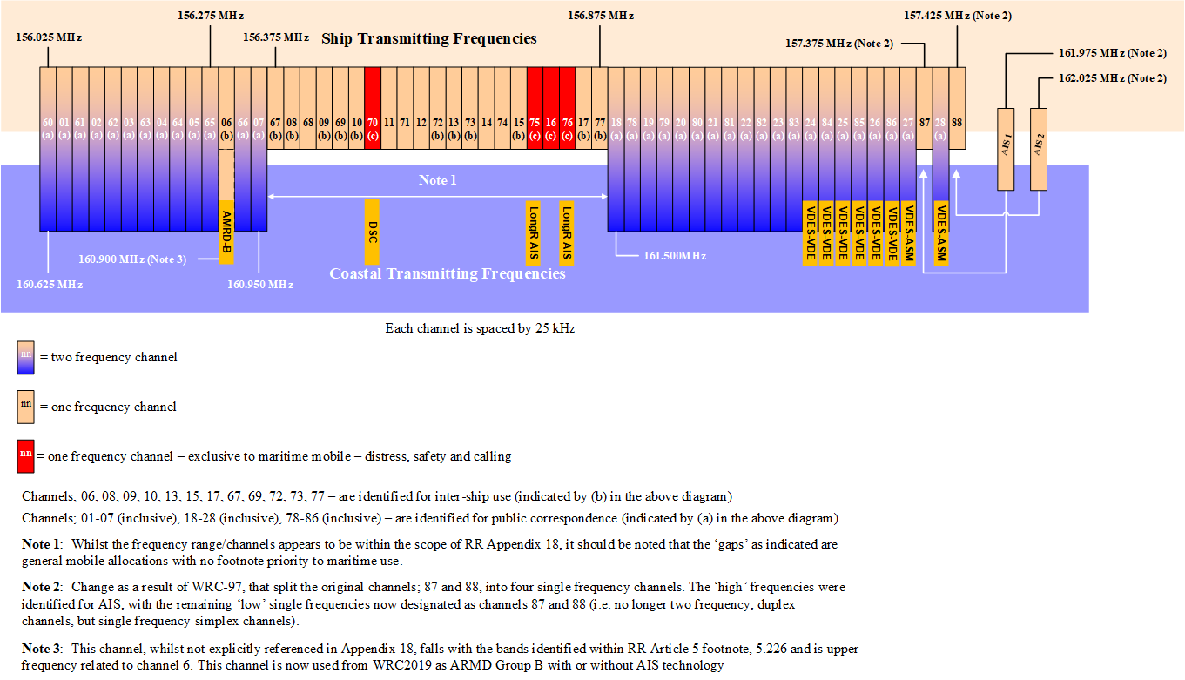
Figure 1: The current VHF frequency plan after WRC-2019
In the past, several analogue VHF voice channels were given over to other maritime purposes than voice. Examples of these are DSC and AIS. Most recently from 2012 VHF channels are given to the development of IMO’s e-Navigation where channels were assigned to VDES and AMRD group B.

Maritime radio usage cases
The maritime environment can be divided into two different zones, the open sea and the coastal/inland areas, such as harbours and rivers.
In marine environment, voice communication over VHF band are widely used. There are two main usage cases.
- Ship-to-Ship communication. Normally vessels are listening to Channel 16 (distress and alerting frequency). Therefore, Channel 16 is used as call channel, to negotiate working channel (normally channel 6). If the vessels MMSI address is known, a preferable method is to use Digital Selective Calling (DSC) call to negotiate working channel.
- Ship-to-Shore communication. Protocols are similar. Coastal stations are using fixed traffic channels, Channel 16/DSC can be used to advise vessels to switch to working channel.
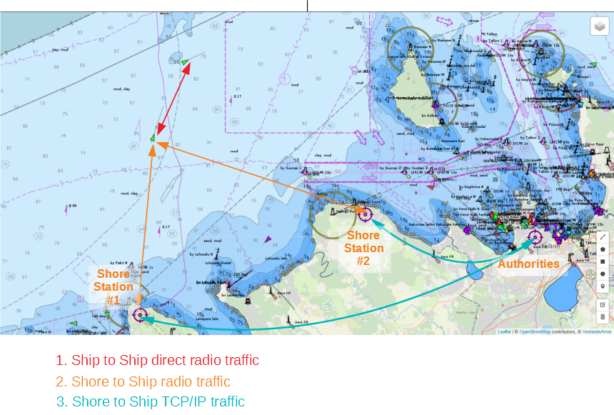
Figure 2: Maritime communication
Ship-to-Ship communication is implemented using simplex channels (vessels cannot contact each other over duplex channel). Ship-to-Shore communication can be over duplex channel but, in this case, other vessels can hear only the coast part of communication. In some situations (security related communication), it is preferred that all vessels can listen to both parties. When free simplex channels are not available coastal station broadcast vessel TX back to sea on coastal TX frequency (The Gulf of Finland Reporting GOFREP working channels are used like this).
With satellite and mobile communication development duplex channels are rarely used to VHF-PSTN connections (commercial service) therefore it will not be taken into account in this Report.

Terrestrial radio usage
In terrestrial communication, mainly two type of communication is in use: Peer-to-Peer Direct Network and Centralised Repeater Network [39].
In Direct Network mode, all radios in network work in the same frequency. There are no Master-Slave relationship and each radio in responsible for channel access rules. This is how maritime communication works today in analogue VHF band.
In a digital network, communication can be individual (like analogue VHF Ship-to-Ship call in traffic channel), group calls (used in DSC group call) and Broadcast Call.
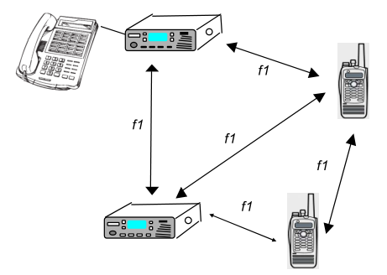
Figure 3: Peer-to-Peer Direct Network
In a Centralised Repeater Network, communication follows a star topology. All communication is between Base station and radio. Two frequencies could be in use - TX and RX are separate frequencies as in the maritime duplex channels. In the repeater network it is possible to extend the network via additional inter-connected base stations (as communication between radios in different base stations coverage).
AIS VDE communication uses similar approx. - direct communication between vessels are allowed when no base station in view.
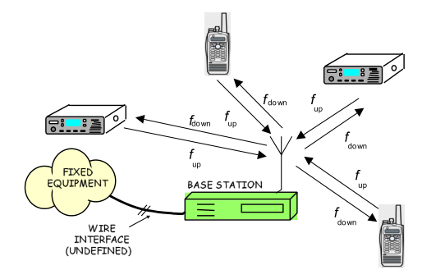
Figure 4: Centralised Repeater Network

DIGITAL voice VHF RR APPendix 18

Technical parameters
The technical parameters of transmitting apparatus must comply with the ITU regulations.

Requirements for Voice Communication and associated dsc in the VHF band
Gathered from the previous chapters, the following requirements could be composed (the source of regulation is given in brackets):
- Should be capable of operating on single-frequency channels or on single- and two-frequency channels (IMO);
- Operating in the bands 156.025 MHz to 157.325 MHz and 160.625 MHz to 161.925 MHz on single-frequency and two-frequency channels (ITU/IMO);
- Should provide at least three priorities of communications using voice (IMO);
- A dedicated DSC watchkeeping facility to maintain a continuous watch on channel 70 (IMO);
- Digital selective calling facility should be capable of operating on Channel 70 (IMO);
- Should provide at least three categories of calls using both voice and digital selective calling (DSC) (IMO);
- Should be capable of disabling DSC capabilities (RAINWAT);
- Switch time between transmit and receive condition, and vice versa, should not exceed 0.3 seconds (IMO);
- Transmitter output power should be between 6 and 25 Watt for a fixed installation (IMO);
- Reducing the transmitter output power to a value of between 0.1 and 1 Watt (IMO);
- Reduction of the power is optional on Channel 70 (IMO);
- The sensitivity of the receiver should be equal to or better than 2 μV e.m.f. for a signal-to-noise ratio of 20 dB (IMO);
- DSC modulated input signal having a level of 1 μV e.m.f. to its associated VHF receiver, the DSC equipment should be capable of decoding the received message with a maximum permissible output character error rate of 10 ⁻² (IMO);
- Should allow both the digital and analogue services to co-exist during the migration to future digital services (IALA/NL);
- Channel efficiency be a high priority by allowing four (4) or more digital voice channels for each 25 kHz maritime VHF voice channel. (IALA/NL);
- The ability to regularly transmit the location of the radio for the entire duration of the digital voice communication (IALA/NL);
- Short Message Service (SMS) without the need to set up a digital or other voice call (IALA/NL);
- Digital voice quality be similar to or better than the analogue voice service especially using weaker radio signals at the extents of the radio coverage (IALA);
- The capability of transmitting the identification (MMSI) of the radio for the entire duration of the digital voice conversation (ITU);
- The capability of transmitting the identification (ATIS) of the radio for the entire duration of the analogue voice conversation (RAINWAT);
- Could/should detect an analogue or digital signal and switch over automatically to the appropriate frequencies (NL);
- Should be possible for Coastal stations to relay transmissions (with the same voice quality in digital mode) (NL);
- Should be able to work in a network (trunked system) (NL);
- Should be able to auto connect to a trunked system (NL);
- Mobiles should automatically be activated (transmit SAR position and identification);
- Be able of “graceful degradation”.

VOice CODEcs
It is the view that licensing and patents are important considerations when selecting an appropriate vocoder. Use of technology should not involve patents unless a patent owner was prepared to donate or sell the patent. Although this is the “best” for the maritime community, sometimes a small fee for the patent could be acceptable if a formal declaration of the patent holder is in place not to increase the fee.
The VHF band today offers channels with a spectrum bandwidth of 25 kHz for analogue speech communications. Using technologies available today this can be split up to improve the spectral efficiency by applying digital encoding techniques to the speech signals. For instance, the TETRA system allows for four TDMA speech channels to be carried over its 25 kHz radio channel by encoding each speech channel into a 7200 bps data stream, which, after removing the error correction, results in a 4800 bps voice channel. Adding control and overhead signalling, this results in a total over-air data rate of 36 kbps using pi/4 QPSK modulation.
Alternatively, following an FDMA approach and splitting the 25 kHz radio channel into four separate radio channels yields a channel bandwidth of 6.25 kHz. Again, by using conventional technology, this allows for an over air data rate of 4800 bps, using 4 FSK modulation and still remaining within the adjacent channel power limits. Removing the signalling overhead, this results in a speech channel of 3600 bps, of which approx. 1/3 is used for error correction, so that the data channel available for encoding the speech waveform is approx. 2400 bps.
Two of the most used vocoders for mobile radio at present are AMBE+2 and ACELP. AMBE+2 is used by DMR and dPMR, and ACELP is used by TETRA. Both AMBE+2 and ACELP are covered by patents.

CML Microcircuits (UK)
CML Microcircuits offers various solutions for vocoders for use in low data rate radio channels, among them the CMX7262 and CMX618/638.
Detailed information on these vocoders could be found here: https://www.cmlmicro.com/digital-voice-2/.
These are available as hardware devices on the open market with no additional license fees.

Digital Voice Systems (USA)
Digital Voice Systems offers various solutions for vocoders, among them the AMBE+2 series which could be found on https://www.dvsinc.com/products/compare.shtml.
AMBE+2 is covered by patents, but is made available under licences by their developers under the ETSI FRAND policy (Fair, Reasonable And Non-Discriminatory). Whilst this does impose a cost on each radio produced, it is consistent for all manufacturers; however, this may make smaller manufacturers hesitate to enter the market.

VoiceAge (Canada)
VoiceAge Corporation has developed the Algebraic code-excited linear prediction (ACELP) which is a patented speech coding algorithm.
The ACELP method is widely employed in current speech coding standards such as: AMR, EFR, AMR-WB (G.722.2 [32]), VMR-WB, EVRC, EVRC-B, SMV, TETRA, PCS 1900, MPEG-4 CELP and ITU-T G-series standards G.729 [36], G.729.1 [37] (first coding stage) and G.723.1 [33]. The ACELP algorithm is also used in the proprietary ACELP.net codec. More information could be found on: http://www.voiceage.com/Overview.html.
ACELP is covered by patents, but is made available under licences by their developers under the ETSI FRAND policy (Fair, Reasonable And Non-Discriminatory). Whilst this does impose a cost on each radio produced, it is consistent for all manufacturers; however this may make smaller manufacturers hesitate to enter the market. The licence for ACELP is significantly lower than that charged for the AMBE+2 and is a single one-off charge which makes it much simpler to manage and cost.

ITU-T Codecs
ITU-T has described a number of Codecs as listed below. Details are contained in ANNEX 4::
- ITU-T Codecs - G.711 [28];
- ITU-T Codecs - G.722 and G.722.1 [31];
- ITU-T Codecs - G.723.1 [33];
- Recommendation ITU-T G.726: (ADPCM) [34];
- Recommendation ITU-T G.728: Coding of speech at 16 kbit/s using LD-CELP [35];
- Recommendation ITU-T G.729: Coding of speech at 8 kbit/s using CS-ACELP [36];
- Recommendation ITU-T G.729.1: ITU-T G.729 based embedded variable bit-rate coder: An 8-32 kbit/s, scalable wideband, coder-bitstream interoperable with ITU-T G.729 codecs [37].

Opus (free open audio codec)
Opus is a totally open, royalty-free, highly versatile audio codec. More details can be found on http://opus-codec.org. It supports bit rates from 6 to 510 kbps.

Comparison of Voice CODECS
Table 2:Comparison of Voice CODECS
Codec (note 5) | Audio Band-width (note 1) | Samples | Speed | FEC | Use policy | Quality
CMX 7262 (TWELP) (note 2) | 300-3400 |  | 2400 bps | add | Patent | POTS (note 4)
CMX 618/638 (RALCWI) (note 2) | 300-3400 |  | 2400 bps | add | Patent | POTS (note 4)
AMBE+2 (note 3) | 300-3400 |  | 2450 bps | add | Patent (FRAND) | POTS (note 4)
ACELP | 300-3400 |  | 7200 bps | Incl. | Patent (FRAND) | POTS (note 4)
G.711.0 [28]- G.711.1 [29] | 50-4000 | 40-320 | 6400 bps | add | Free
G.722 [30] – G.722.1 [31] – G.722.2 [32] | 50-7000 | 320 | 6400 bps | add | Free
G.723.1 [33] |  |  | 5400 bps | add | Free
G.726 [34] |  |  | 16000 bps | add | Free
G.728 [35] |  |  | 16000 bps | add | Free
G.729 [36] | 50-4000 |  | 8000 bps | add | Free
G.729.1 [37] | 50-4000 |  | 8000 bps | add | Free
Opus | Below 3000 |  | 6000 bps | add | Free | Poor
Note 1: The audio bandwidth for analogue FM is 300-3000 Hz.
Note 2: CMX7262 and CMX618/638 are commercially available as chip devices in volume. In this case there is no additional licence fee.
Note 3: AMBE+2 is available as both low-volume commercial chip devices or as a software package for popular micro controllers under a licensing agreement.
Note 4: POTS = “Plain Old Telephone System”
Note 5: Noise Reduction: Voice codecs that use a model of the human vocal tract as the basis for their algorithm have an inherent facility to reject background noise and other non-voice signals (this includes AMEBE+2, ACELP, RALCWI, TWEWLP and OPUS). Audio codecs that convert an analogue signal (which could be voice, music, tones etc) do not have this facility and so could require additional noise reduction (this includes most of the ITU G.7xx codecs).
The ability of a radio channel to transfer a significant number of bits whilst still remaining within the spectrum mask defined for its channel is limited. In the case of AIS, one 25 kHz marine channel can only transfer 9600 bps.
By using a multi-level modulation scheme, such as 4-FSK, this can be doubled to approximately 19200 in a 25 kHz channel and by extrapolation, 9600 bps in a 12.5 kHz channel and 4800 bps in a 6.25 kHz channel. This is the over-air bit rate, and to get to the bit rate available to the vocoder, both the signalling overhead and forward error correction must be deducted – generally these would account for about half the over-air rate to ensure a robust and usable system, so the maximum bit rates available to the vocoder is effectively 2400 bps per voice channel. This basic engineering fact then rules out a significant number of the vocoders detailed here. 4-FSK can be received and transmitted by existing VHF FM radio modulators, PA’s and demodulators with only minor adjustments to filtering.
Using even higher level modulation schemes, such as 8-PSK or 16-QAM, would allow higher bit rate vocoders to be used, however the hardware to implement these schemes requires linear transmitters and receivers with much more complex decoders and so are significantly more expensive, power hungry and with reduced receiver sensitivity.

Overview existing digital radio protocols
There are multiple digital radio protocols in use worldwide, for different purpose and goals, most of them proprietary.

digital Private Mobile Radio (dPMR)
The dPMR MoU was established in February 2007 to develop open, non-proprietary EU standard for 6.25 kHz channel audio protocol (dPMR Association, 2012 [1]). It is published by ETSI under the reference License-free version (ETSI TS 102 490 [9], 2013-02) and Licensed version (ETSI TS 102 658 [10]).
Table 3: Technical specifications of dPMR
Technical specifications of dPMR
Access Method | FDMA
Channel Spacing | 6.25 kHz
Transmission Rate | 4800 bps
Modulation | 4-level FSK
Vocoder | AMBE+2
Codec Rate | 3600 (Voice 2450 + Error Correction 1150 bps)
Protocol defines four modes. Tier1 - License Exempt dPMR or dPMR446. Tier 2: Licensed dPMR Mode 1 for operations without repeater, Licensed dPMR Mode 2 for operations with repeater and Licensed dPMR Mode 3 for multi-site, multi-channel trunked repeaters.
dPMR classifies itself as "specifically target highly functional, spectrum efficient solutions employing proven, low cost and low complexity".
NXDN and dPMR is similar protocols but not compatible. dMPR is not known in US market.

Next Generation Digital Narrowband (NXDN)
Icom and JVC KENWOOD began the collaboration in 2003 to develop protocol to provide voice and/or data at 6.25 kHz or an “equivalent” bandwidth. Following the announcement of the NXDN protocol in 2005, the NXDN forum was established in July 2008, (Next Generation Digital Narrowband (NXDN) ™ Forum, 2014).
Table 4:Technical Specifications of NXDN
Technical Specifications of NXDN
Access Method | FDMA
Channel Spacing | 6.25 kHz or 12.5 kHz
Transmission Rate | 4800 bps (at 6.25 kHz channel)
Modulation | 4 l FSK
Vocoder | AMBE+2, 3600 bps (at 6.25 kHz channel)
Codec Rate | 3600 bps (Voice 2450 bps + Error Correction 1150 bps)
Protocol defines three levels: Conventional (with and without repeater); Type-C trunking (with control channel) and Type-D trunking (without control channel).
NXDN protocol documentation is downloadable from NXDN forum.

Digital mobile radio (DMR)
Digital communication standard to allow easy migration from existing 12.5 kHz narrowband FM analogue channel. 12.5 kHz channel size allows re-use of existing frequency licenses and site infrastructure and doubles network capacity (6.25 kHz channel efficiency) (ETSI TR 102 398 [5]).
DMR is non-proprietary EU standard. It is first published 2005 by ETSI under the reference TS 102 361-1 ETSI TS 102 361-1 [8].
Table 5: Technical Specifications of DMR
Technical Specifications of Next Generation Digital Narrowband (NXDN)
Access Method | 2 slot TDMA
Channel Spacing | 12.5 kHz
Transmission Rate | 9600 bps (symbol rate of 4800 symbols/sec)
Modulation | 4 l FSK
Vocoder | AMBE+2
Codec Rate | 3600 bps (Voice 2450 bps + Error Correction 1150 bps)
DMR defines three tiers: Tier-I - license free 446 MHz operation, power limited to 0.5 W; Tier-II - direct replacement for analogue conventional radio, can be used with repeaters; Tier-III - trunking mode and data services.

Trans-European Trunked Radio System (Tetra)
TETRA is European standard for trunked radio system, designed for government agencies, emergency services and public safety networks. TETRA is European version of trunked radio similar to Project 25.
Tetra is EU open standard, published by ETSI under the reference ETS 300.392 [7], ETSI TS 300 396-1 [11], ETSI TS 100 392-2 [7].
Table 6:Technical specifications of Trans-European Trunked Radio System
Technical specifications of Trans-European Trunked Radio System
Access Method | 4 slot TDMA
Channel Spacing | 25 kHz
Transmission Rate | 7.2 kbit/s per timeslot
Modulation | π/4 DQPSK
Vocoder | ACELP 4.567 kbit/s
Codec Rate | 7200 bps (Voice 4567 bps + Error Correction, 2633 bps)
TETRA system works mainly as a trunking mobile radio network, but it is possible to use TETRA radio as conventional radio (DMO mode).

Comparison of Digital Radio Protocols
Table 7: Comparison of Digital Radio Protocols
Protocols | Over-air rate | Access Method | Bit rate for vocoder | Modulation | Vocoder | Channel  spacing
dPMR | 4800 bps | FDMA | 3600 | 4 FSK | AMBE+2 | 6.25 kHz
NXDN | 4800 bps | FDMA | 3600 | 4 FSK | AMBE+2 | 6.25 kHz
DMR | 9600 bps | TDMA 2 slot | 3600 | 4 FSK | AMBE+2 | 12.5 kHz
Tetra | 7200 bps | TDMA 4 slot | 7200 | π/4 DQPSK | ACELP | 25 kHz
Note: Tetra π/4 DQPSK requires a linear transmitter and receiver what results in a significant hardware cost increase compared with conventional constant envelope schemes.

Other issues raised
The Ministry of Infrastructure and Water Management (Rijkswaterstaat) in the Netherlands have asked about the ability of dPMR to support ATIS operation on Inland Waterways – the significant difference between dPMR and marine operations is the use of the MMSI in marine operations which demands the use of a 30-bit addressing field, whereas dPMR today can only support 24-bits. ETSI ERM TG MARINE have recognised that there are significant differences between the investigated technologies and marine operations and have already been working on the modifications to the dPMR addressing protocol to support 30-bit modes, which should make it suitable for both MMSI and ATIS addressing modes.
It was recognised that support of legacy functionality is needed during the full migration period. The ability to support ATIS functionality on Europe’s Inland waterways and disabling some maritime functionality (such as DSC) is mandatory by RAINWAT.

Summary
Current maritime VHF radio is inherently FDMA in nature, one radio channel carries one voice channel. TETRA and DMR are TDMA systems in which one radio carrier can carry multiple voice channels, however the timing of these is critical to its operation and so is limited to systems where there is a ”master” transmitter that can define the slot timing accurately for all units in the network. Whilst this may be feasible close to coast, clearly this is not possible in the high seas or areas not covered by a coast station.
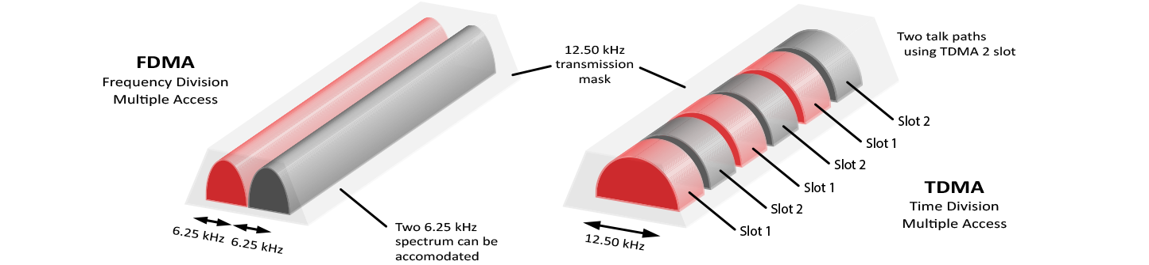
Figure 5: FDMA vs. TDMA
TETRA is designed for large public safety networks and requires expensive infrastructure and although its spectrum efficiency meets the ”6.25 kHz per voice channel” requirement, its deployment requires 25 kHz channelization and its TDMA nature make it unsuitable for the maritime environment.
DMR is designed to replace 12.5 kHz analogue commercial channels and does meet the ”6.25 kHz per voice channel” requirement, but, like TETRA, its TDMA nature makes it unsuitable for maritime use.
dPMR and Next Generation Digital Narrowband (NXDN) suits well to replace analogue audio in maritime environment. They both provide:
- standardised minimal cost digital radio solution, working on 6.25 kHz channels;
- group call and individual call;
- short data transmission;
- security Services (location and status transmission);
- coexistence with analogue audio.
They both claim: improved audio quality in weak signal conditions; better range performance (this is taken to mean a good quality of service out to the range boundary rather than much greater absolute range).
NXDN uses 16 bit user and 16 bit group address space. dPMR uses 24 bit address, both need modification to support 32 bit MMSI address as radio ID. Both are using AMBE+2 codec. This codec is proprietary, usage needs license from Digital Voice Systems, Inc.
dPMR is ETSI open standard, NXDN is standard published by NXDN forum.
Technically, the standards are comparable and offer similar functionality. However, the dPMR published as open ETSI standard is more preferred.

Possible ADVICE for dPMR Marine
ETSI is working on a draft document (ETSI TR 103 784 [6]) for using digital voice calls in the marine VHF band. It is based on the modified dPMR protocol to use 32 bit address space instead 24 bit. (ETSI TS 102 658, 2019-01; ETSI, 2019)
The following sections are a short summary about changes from TS 102 658 and comments about technical details.

Proposed changes from ESI TS 102 658

Address field related changes
For 32 bit address support frame encoding is changed (chapter "5 Frame coding"). Total frame length is same, but field are changed:
- "Frame Number" - unchanged;
- "Called ID (lower 16 bits)" - changed from 12 bit to 16;
- "Communications mode" - unchanged;
- "Category" - new field, 2 bit long;
- "Version", "Comms format", "Reserved" - fields removed, total 6 bits.
Similar changes are in Header frame and ACK frame content. Address fields are changed, added "category" and "Version", "Comms format", "Reserved" fields are removed. Total frame size is unchanged.

"Communication mode" field related changes
"Communication mode" field defines following:
- Voice communication + slow data (slow data contains position lat and lon.);
- Data Communication Type 2 (user data with FEC);
- Data Communication Type 2 (user data with FEC) + Appended data;
- Reserved for future use.

"Category" field related changes
New "Category" field defines the order of priority of communications according to article 53 of the RR [26]:
- Distress;
- Urgency;
- Safety;
- Routine.

Roadmap
To migrate from the current analogue VHF voice to digital a concept roadmap has yet to be confirmed by IMO and ITU. An indicative roadmap was proposed by JRC (Japan Radio Company) in January 2019. This is a second version of this roadmap.
This roadmap below can only indicate the meetings and possible actions. This roadmap is not in any way a prescription of what should be done but only what could be a possible way forward. The roadmap is an indication of the organisations possible involved and the possible moments the organisations could discuss the digitisation of VHF radio.
This roadmap is an indication of the organisations possible involved and the possible moments in time the organisations could discuss the digitisation of VHF radio. The roadmap does not take in account the lifespan of current VHF radio’s.
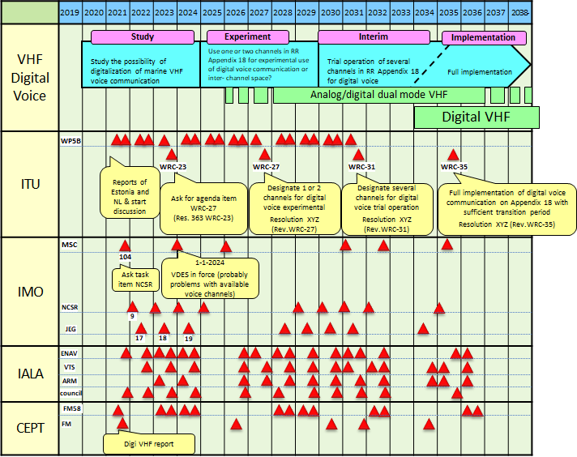
Figure 6: Roadmap
In the process of digitisation of VHF radio, there might be some questions that need to be discussed by the different organisations and between these organisations. Those could be:
- Should there be a cost benefit analysis be performed covering the entire maritime community, i.e. VHF coast stations, commercial shipping, recreational boating, ports, harbours and marinas etc.?
- Should all VHF analogue channels move over to digital or should for instance GMDSS channels to be kept analogue like Channel 16 and Channel 70 (DSC)?
- Should there be an allocation of a separate channel for digital distress, safety and calling (or should Channel 16 or Channel 70 take on this role)?
- How is the co-existence of digital and analogue channels managed?
- Is it appropriate to use the techniques covered in this document or do more investigation about the relative merits of TDMA vs. FDMA (e.g. in terms of frequency spectrum efficiency)?
- What will be the future relationship between digital voice and DSC (e.g. could the same technology be used for DSC)?
- Could digitisation create an opportunity for extra services on VHF channels like SMS, position information with low overhead and EMC detection?
- What are the implications of the current channel raster? (ITU-R RR Appendix 18)?
- What will the eventually implementation plan will be? Should this plan clearly sets out how digitisation would be introduced and the impact of each stage on the maritime community?
- Will the existence of Patents and IPR present an impediment to migration from Analogue to Digital?
The above questions became apparent during the preparation of this report and are just an indication. Because of the importance of VHF radio for the maritime community more questions are due to arise by the different organisations involved. It would be beneficial that all questions, information, results and reports of tests/pilots are shared among all organisations.

Conclusions
This is a first Report on the digitisation of the analogue maritime VHF channels and further developments will be closely monitored. This ECC Report could potentially be the base for future discussions in ITU and IMO.
Intention of the work item was to investigate the possible expansion of the number of VHF voice channels based on the implementation of digital technology. In addition, a plan for change over from analogue to digital was required. Any migration plan is currently merely indicative.
Analysis concluded: Current maritime VHF radio is inherently FDMA in nature, one radio channel carries one voice channel. TETRA and DMR are TDMA systems in which one radio carrier can carry multiple voice channels, however the timing of these is critical to its operation and so is limited to systems where there is a ”master” transmitter that can define the slot timing accurately for all units in the network. Whilst this may be feasible close to coast, clearly this is not possible in the high seas or areas not covered by a coast station.
Digital Private Mobile Radio (dPMR) and Next Generation Digital Narrowband (NXDN) suit well to replace analogue audio in maritime environment. Technically, the standards are comparable and offer similar functionality. However, the dPMR published as open ETSI standard is more preferred.
Two test trials were carried out by two CEPT administrations. Full reports of the trials can be found in ANNEX 2 and ANNEX 3.
For further observation on the issue:
- The Digital channelling arrangements need to fit within the existing analogue channel plan. (Compatible with Recommendation ITU-R M.1084 [21]);
- Practical trials undertaken in Estonia and the Netherlands demonstrate that digital systems operated successfully in coexistence with analogue systems in these locations;
- Similar technologies already exist and are used in other communities but need to have minor modifications for use in the maritime community;
- Analogue and digital channels may need to exist in parallel during a migration period and some analogue channels may need to be retained in perpetuity.
- Report from CYBERNETICA (Y-399-70) “Analyses of different digital radio protocols for use in maritime communication”
  - Background
    - Maritime radio usage cases
In marine environment, voice communication over VHF band is widely used. There are two main usage cases:
- Ship-to-Ship communication. Normally vessels are listening Channel 16 (distress frequency). Therefore, Channel 16 is used as call Channel, to negotiate working channel (normally channel 6). If vessels MMSI address is known, preferable method is to use Digital Selective Calling (DSC) call to negotiate working channel;
- Ship-to-Shore communication. Protocols are similar. Coastal stations are using fixed traffic channels, Channel 16/DSC can be used to advice vessels to switch to working channel.

Figure 7: Maritime communication
Ship-to-Ship communication is done using simplex channels (vessels cannot contact each other over duplex channel). Ship-to-Shore communication can be over duplex channel but, in this case, other vessels can hear only the coast part of communication. In some situations (security related communication), it is preferred that all vessels can listen to both parties. When free simplex channels are not available coastal station broadcast vessel TX back to sea on coastal TX frequency. (The Gulf of Finland Reporting GOFREP working channels are used like this).
With satellite and mobile communication development duplex channels are rarely used to connect make VHF-PSTN connections (commercial service).
  - Terrestrial radio usage
In terrestrial communication, mainly two type of communication is in use: Peer-to-Peer Direct Network and Centralised Repeater Network [39].
In Direct Network mode, all radios in network work in the same frequency. There are no Master-Slave relationship and each radio in responsible for channel access rules. This is how maritime communication woks in analogue VHF band.
In digital network, communication can be individual (like analogue VHF Ship-to-Ship call in traffic channel), group calls (used in DSC group call) and Broadcast Call.
Figure 8: Peer-to-Peer Direct Network
In Centralised Repeater Network communication follows star topology. All communication is between Base station and radio. In dMPR licensed mode 2 two frequencies are in use - TX and RX are separate frequencies as the maritime duplex channels. In the repeater network is possibility to extend network via base station (as communication between radios in different base stations coverage).
AIS VDE communication uses similar approx. - direct communication between vessels are allowed when no base station in view.
Figure 9: AIS VDE Direct Network
    - IALA recommendations
IALA in their Liaison Note on 04 April 2019 stated following recommendations (IALA ENAV Committee, 2019-04) [12]:
- 6.25 kHz should be used (one 25 kHz channel divided into for channels);
- new networks should support Short Messages (SMS);
- new network should support transmitting radios location duration voice call;
- digital voice quality should be similar to or better than analogue voice.
    - Transceivers addressing
In digital networks radio stations normally have Identity. In maritime digital communication (DSC) there is already ID in use - MMSI number. Same number is used by AIS network. It is preferable when same ID can be used in new digital network.
  - Overview existing digital radio protocols
There are multiple digital radio protocols in use worldwide, for different purpose and goals, most of them proprietary.
    - digital Private Mobile Radio (dPMR)
The dPMR MoU was establish in February, 2007 to develop open, non-proprietary EU standard for 6.25 kHz channel audio protocol (dPMR Association , 2012) [1]. It is published by ETSI under the reference License-free version (ETSI TS 102 490, 2013-02) and Licensed version ETSI TS 102 658 [10].
Technical specifications of dPMR (dPMR Association , 2012):
- Access Method: FDMA;
- Transmission Rate: 4800 bps;
- Modulation: 4-level FSK;
- Vocoder: AMBE+2;
- Codec Rate: 3600 bps (Voice 2450 bps + Error Correction 1150 bps).
Protocol defines four modes. Tier1 - License Exempt dPMR or dPMR446. Tier 2: Licensed dPMR Mode 1 for operations without repeater, Licensed dPMR Mode 2 for operations with repeater and Licensed dPMR Mode 3 for multi-site, multi-channel trunked repeaters.
dPMR classifies itself as "specifically target highly functional, spectrum efficient solutions employing proven, low cost and low complexity".
NXDN and dPMR is similar protocols but not compatible. dMPR is not known in US market.
    - Next Generation Digital Narrowband (NXDN)
Icom and JVC KENWOOD began the collaboration in 2003 to develop protocol to provide voice and/or data at 6.25 kHz or an “equivalent” bandwidth. The announcement of the NXDN protocol in 2005, the NXDN forum was established in July, 2008 (dPMR Association , 2012), (NXDN ™ Forum, 2014).
Table 8:Technical Specifications of NXDN
Technical Specifications of NXDN
Access Method | FDMA
Access Method | FDMA
Vocoder | AMBE+2, 3600 bps (at 6.25 kHz channel)
Channel Spacing | 6.25 kHz or 12.5 kHz
Transmission Rate | 4800 bps (at 6.25 kHz channel)
Codec Rate | 3600 bps (Voice 2450 bps + Error Correction 1150 bps)
Protocol defines three levels: Conventional (with and without repeater); Type-C trunking (with control channel) and Type-D trunking (without control channel)
NXDN protocol documentation is downloadable from NXDN forum.
    - Digital mobile radio (DMR)
Digital communication standard to allow easy migration from existing 12.5 kHz narrowband FM analogue channel. 12.5 kHz channel size allows re-use of existing frequency licenses and site infrastructure and doubles network capacity (6.25 kHz channel efficiency) ETSI TR 102 398 [5].
DMR is non-proprietary EU standard. It is first published 2005 by ETSI under the reference TS 102 361-1 - TS 102 361-4 (ETSI TS 102 361-1, 2006-01)
Table 9: Technical Specifications of DMR
Technical Specifications of DMR
Transmission Rate | 9600 bps (symbol rate of 4800 symbols/sec)
Modulation | 4-level FSK
Access Method | 2slot TDMA
Modulation | 4-level FSK Modulation
Vocoder | AMBE+2
Channel Spacing | 12.5 kHz
DMR defines three tiers: Tier-I - license free 446MHz operation, power limited to 0.5W; Tier-II - direct replacement for analogue conventional radio, can be used with repeaters; Tier-III - trunking mode and data services.
    - Trans-European Trunked Radio System (Tetra)
TETRA is European standard for trunked radio system, designed for government agencies, emergency services and public safety networks. TETRA is European version of trunked radio similar to Project 25.
Tetra is EU open standard, published by ETSI under the reference ETS 300.392 - ETS 300.396 (ETSI TS 300 396-1 [11], ETSI TS 100 392-2 [7]).
Table 10: Technical specifications of Trans-European Trunked Radio System
Technical specifications of Trans-European Trunked Radio System
Transmission Rate | 7.2 kbit/s per timeslot
Modulation | π/4 DQPSK
Access Method | 4 slot TDMA
Vocoder | ACELP 4.567 kbit/s
Channel Spacing | 25 kHz
TETRA system works mainly as a trunking mobile radio network, but it is possible to use TETRA radio as conventional radio (PTT mode).
  - Summary
TETRA is designed for large networks and requires expensive infrastructure and does not provide the 6.25 kHz channel requirement.
DMR is meant to replace 12.5 kHz analogue channel and so does not allow to make separate 6.25 kHz channels. Lot of maritime audio traffic is broadcast (or all vessel), so TDMA does not offer advantages here.
dPMR and NXDN are well suited to replace analogue audio in maritime environment. They both provide:
- standardised minimal cost digital radio solution, working on 6.25 kHz channels;
- group call and individual call;
- short data transmission;
- security Services (location and status transmission);
- coexistence with analogue audio.
They both claim: improved audio quality in weak signal conditions; better range performance (this is taken to mean a good quality of service out to the range boundary rather than much greater absolute range).
NXDN uses 16 bit user and 16 bit group address space. dPMR uses 24 bit address, both needs modification to support 32 bit MMSI address as radio ID. Both are using AMBE+2 codec. This codec is proprietary, usage needs license from Digital Voice Systems, Inc.
dPMR is ETSI open standard, NXDN is standard published by NXDN forum.
Technically, the standards are comparable and offer similar functionality. However, the dPMR published as open ETSI standard is more preferred.
  - dPMR Marine
ETSI has proposed draft document for using digital voice for Routine category calls in the marine VHF band. It is based modified dPMR protocol to use 32 bit address space instead 24 bit.
Last documents version is V 1.2.0 created 09.04.2019. Document is based license free dPMR ETSI TS 102 490 [9]
Next chapters are short summary about changes from TS 102 490 and comments about technical details.
    - Proposed changes from ESI TS 102 490
For 32 bit address support frame encoding is changed (Chapter 5 "Frame coding"). Total frame length is same, but field are changed:

Table 11: Address field related changes
Address field related changes
Frame Number | Unchanged
Called ID (lower 16 bits) | changed from 12 bit to 16
Communications mode | Unchanged
Category | new filed, 2 bit long
Version | Comms format", "Reserved" - fields removed, total 6 bits
Similar changes are in Header frame and ACK frame content. Address fields are changed, added "category" and "Version", "Comms format", "Reserved" fields are removed. Total frame size is unchanged.
Comment: It remains unclear whether this protocol sufficiently "future proof" when there are no "Version" field.
    - "Communication mode" field related changes

The ”Communication mode” field defines the settings as set out in Table 12.

Table 12: Communications mode field related changes
Communications mode field related changes
Voice communication | no user data in SLD field
Voice + slow data | position data in SLD field
Voice and appended data | Type 2
Data communication type 2 | Payload is user data with FEC
    - "Category" field related changes
Table 13: Category field related changes
Communications mode field related changes
New "Category" field defines:
- Routine
- Safety
- Urgency
- Distress
    - Channel Code
ETSI TS 102 658 Chapter "6.1.5 Channel Code describes algorithm to calculate 24 bit value of "channel code" from channels centre frequency.
Algorithm gives integer value from 0-63.
Comment: ITU Recommendation ITU-R M.1084 [21] recommends how to assign channel number when 25 kHz channels are divided 12.5 or 6.25 kHz sub-channels. There is example for channel 01 and surrounding 60 and 61 channels:
Table 14:Channel Frequency
Channel number | Ship Frequency | Coast Frequency
60 | 156.025 | 160.625
160 | 156.03125 | 160.63125
260 | 156.0375 | 160.6375
360 | 156.04375 | 160.64375
01 | 156.050 | 160.650
101 | 156.05625 | 160.65625
201 | 156.0625 | 160.6625
301 | 156.06875 | 160.66875
61 | 156.075 | 160.675
An open question remains whether Channel Code be generated from ITU-R M.1084 [22] channel number.
    - Call types
Chapter explains how DSC (ITU-R M.493-15, 2019) [19] calls should be used to make call dPMR channel. There are defined " Individual, Routine, Data" for individual call and no information about group calls (Recommendation does not specify Data telecommand for group call).
Frequency field should be proposed 6.25 kHz Channel
Comment: It remains unclear whether audio call be "All mode RT" (technically, yes it is digital data), or whether future version of ITU-R M.493 [19] should add "digital RT" option. Channel should be ITU-R M.1084 [21] channel number. It is open whether this channel number related "Channel Code".
    - Subscriber mapping
Chapter explains how to use MMSI address as radio protocols address field. There are defined that address can be individual or group MMSI address.
Comment: This chapter refers to ITU Recommendation ITU-R M.585-7 [20]
In maritime communication, most calls are "All Call" (s.t broadcasted to all listeners in current channel).
ITU-R M.585-7 does not define "All Call" MMSI. There is MMSI address 009990000 to address all coastal stations. For DSC "All ships" calls in the ITU-R M.493-15 [19] are defined special messages, without destination MMSI address.
One option to consider is whether some legal MMSI address (for example 000000000) should be selected and documented in the future versions of ITU-R M.585-7.

- Report from Estonia
  - Summary of the maritime communication test
    - Previous measurements:
Sensitivity of transceivers:
- AT 20 dB SINAD 4 dBµV
- AT 5% BER 8 dBµV
The Figure 10 describes a signal for which the perceived quality of the communication is 2, i.e. interrupted and poorly understood. The data of the manufacturer and the measured signal are consistent. V_{v} = -7,5... 14 dB µV (at speed V = 20 Knots)
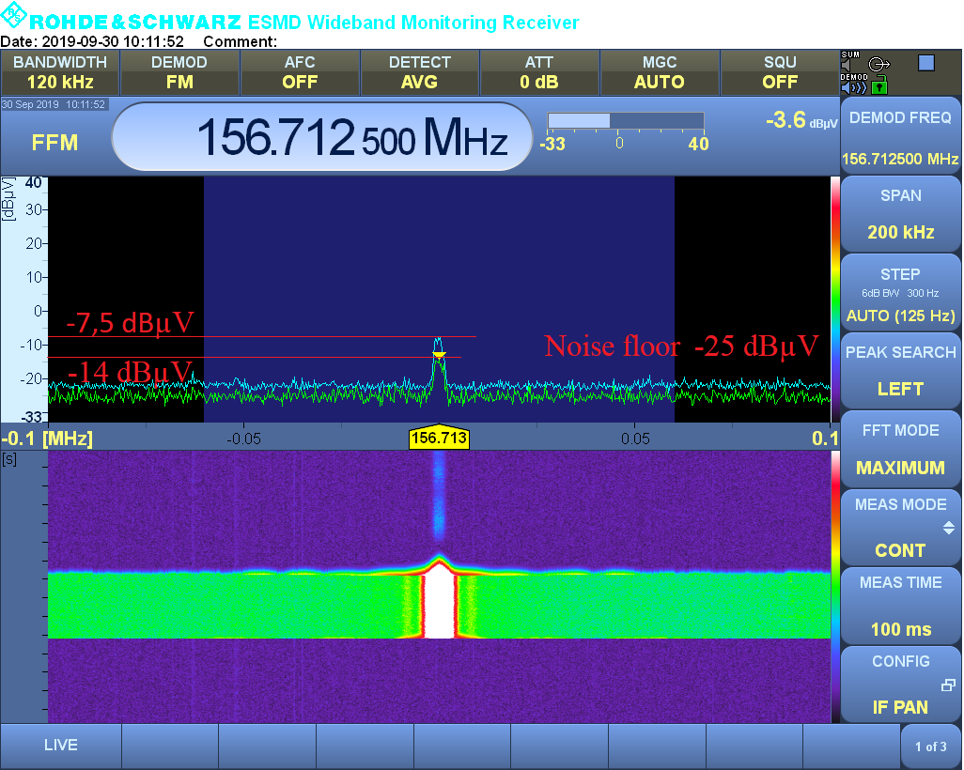
Figure 10: Signal voltage at the receiver inlet as the perceived quality of the communication is 2
The instrument’s noise is -25 dBµV. It is not possible to estimate how much the received radio transmitter signal must be more powerful than the noise signal. The actual noise signal strength is unknown.
An additional measurement was performed. The receiver was introduced into a noisy environment and an approximate signal of noise in relation to the interruption of the communication was checked. Measurement location are shown in Figure 11 (the source of noise is a LED screen mounted on the Shopping Centre).
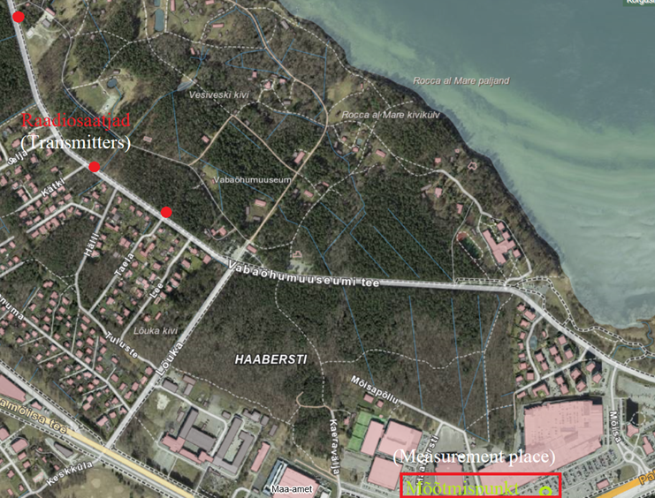
Figure 11: Measurement location for assessing environment with high radio interference
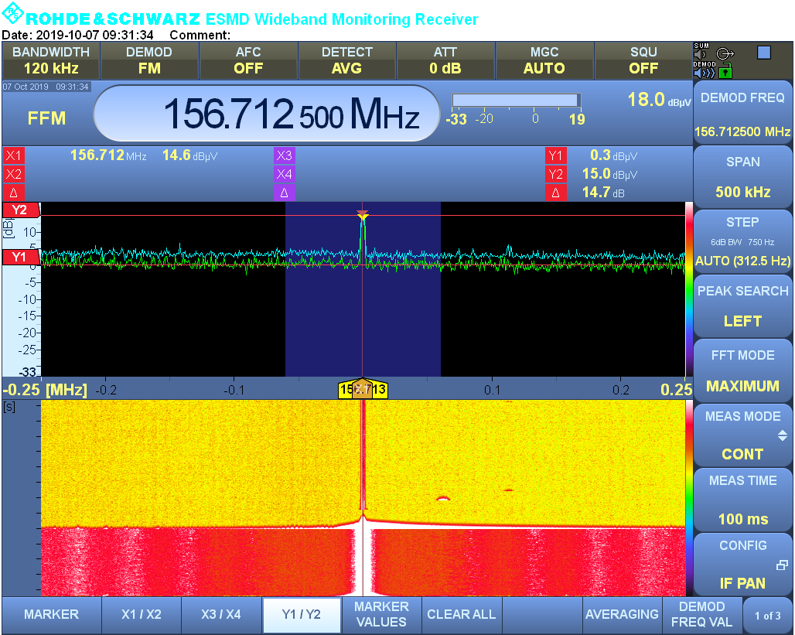
Figure 12: Signal vs interference level during signal interruption situation
As a result of the measurement, the communication was interrupted when the signal to-noise ratio was less than SNR <14.7 dB. The power of the signal must exceed noise by more than 30 times.
The measurement was carried out on 214th channels (156.7125 MHz).
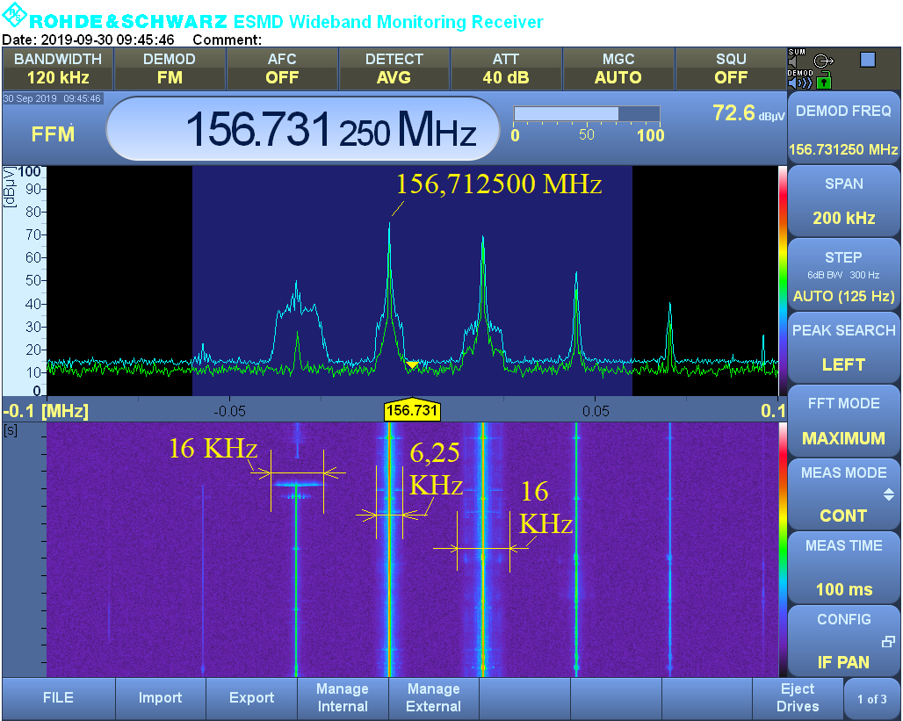
Figure 13: 6.25 kHz channel spacing between two 25 kHz step channels as used
during the transition period
74th analogue channel (Ks = 25 kHz) and the 214th digital channel, the bands may overlap.
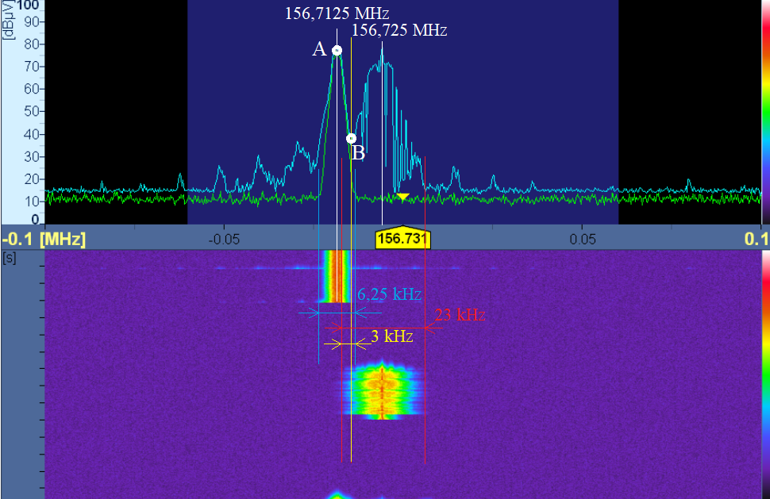
Figure 14: Example of frequency overlap (f_{overlap} = 3 kHz)
between 74th digital and 214th analogue channel
In the case described in Figure 14, the digital signal at point A must be at least $∆E$ = 14.7 dBµV/m above the yellow line point B (explanation on Figure 14 above).
The communication was carried out using the vessel on-board analogue station and temporarily installed a digital station with an additional antenna:
- The digital station installed on board the vessel: Icom IC-F5400D;
- Antenna: Celwave CX4 146-162.5 MHz.
For taking measurements vertically polarised dipole antenna was fitted to the ship:
- Measuring antenna Rohde & Schwarz HZ-12;
- 'The length of the dipole element: L = 0.913 m (f = 156 MHz), gain G = 2.15 dBi.
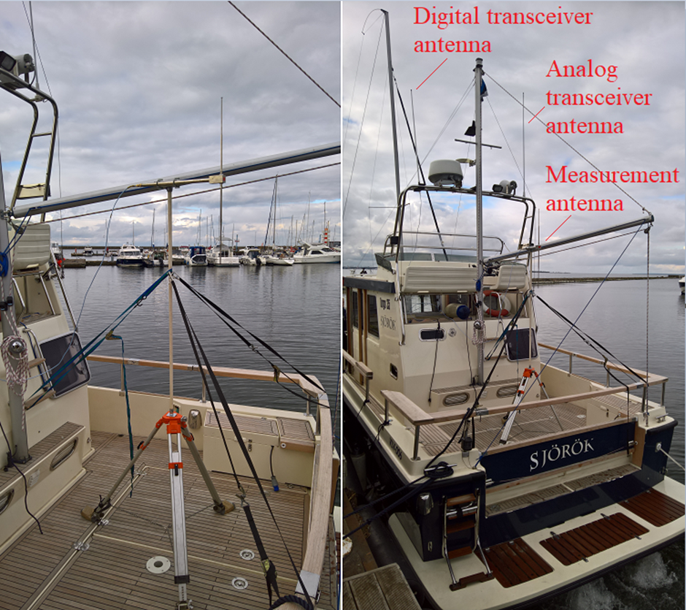
Figure 15: Antennas installed on a vessel

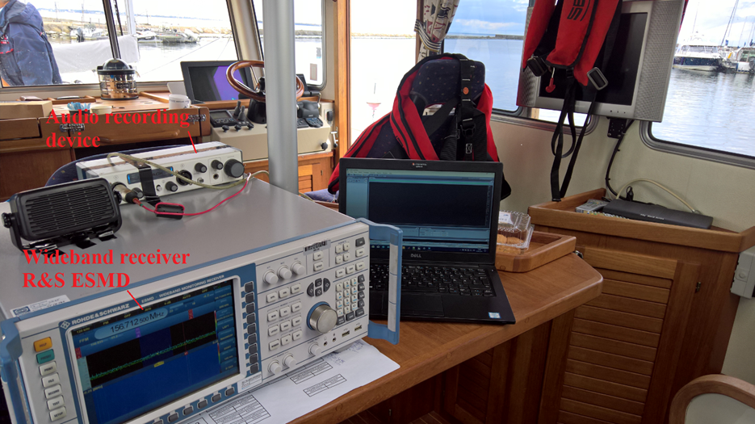
Figure 16: On-board measurement instrumentation Rohde & Schwarz
The distance between Pirita and Hundipea ports d = 3.2 NM (5.9 km) and the estimated quality of communication between them on a scale of 5 is 2 for analogue and 5 for digital stations.
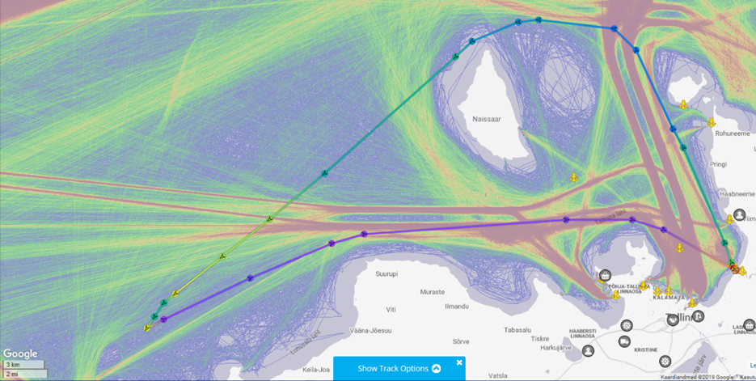
Figure 17: Path of the vessel
The vessel (callsign — Jaam1) set out from Pirita along the edge of the Viimsi peninsula around Naissaar island to the direction of the Pakri peninsula. When leaving Pirita, the quality of the digital communication with Hudipea port (callsign — Jaam2) was assessed until the connection was lost. Estimates are shown on a map (Figure 18) with green symbols. After navigating around Naissaar direct visibility (line of sight LOS) with the tip of the Pakri peninsula was achieved from a distance of 21 NM (39 km), since the tip of the peninsula is elevated 23 m above sea level. At the Pakri peninsula, in the viewpoint parking lot, there was a vehicle with a digital and analogue station (call sign — Jaam3 stationary) and two handheld stations (switchable between analogue and digital) one in the Pakri lighthouse (Jaam3 handheld-tower) and another on observation platform (plateau) (Jaam3 handheld-plateau).
Table 15: on the evaluation of the quality of digital communications
Digital
Quality of communications [0... 5] Vessel - Pakri |  |  |  |  | Coordinates
Distance [NM] | Stationary | Handheld-tower | Handheld plateau | Handheld on vessel | Latitude | Longitude
19.6 | 2 |  | 0 |  | 59°37,031 ′ | 24°30,303 ′
18.9 | 4 |  | 0 |  | 59°36,64 ′ | 24°29,5 ′
16.8 | 5 | 5 | 0 |  | 59°35,18 ′ | 24°26,3 ′
8.5 | 5 | 5 | 5 | 3 | 59°29,72 ′ | 24°13,85 ′
6.3 | 5 | 5 | 5 | 4 | 59°28,46 ′ | 24°10,67 ′
2.7 | 5 | 5 | 5 | 5 | 59°26,06 ′ | 24°05,64 ′
Communication between Hundipea and Pirita
 | Distance [NM] |  | Handheld on vessel |  | 59°45,891 ′ | 24°71,8338 ′
 | 3.2 |  | 5
Communication between Hundipea and the vessel
 | 7.7 | Intermittent | 3 |  | 59°34,661 ′ | 24°42,529 ′
 | 9.8 | No signal | 0 |  | 59°37,009 ′ | 24°40,24 ′
Quality of communications [0... 5] Vessel — Pakri |  |  |  |  | Coordinates
Distance [NM] | Stationary | Handheld-tower | Handheld plateau | Handheld on vessel | Latitude | Longitude
19.6 | 2 |  | 0 |  | 59°37,031 ′ | 24°30,303 ′
18.9 | 4 |  | 0 |  | 59°36,64 ′ | 24°29,5 ′
16.8 | 5 | 5 | 0 |  | 59°35,18 ′ | 24°26,3 ′
8.5 | 5 | 5 | 5 | 3 | 59°29,72 ′ | 24°13,85 ′
6.3 | 5 | 5 | 5 | 4 | 59°28,46 ′ | 24°10,67 ′
2.7 | 5 | 5 | 5 | 5 | 59°26,06 ′ | 24°05,64 ′
Communication between Hundipea and Pirita
 | Distance [NM] |  | Handheld on vessel |  | 59°45,891 ′ | 24°71,8338 ′
 | 3.2 |  | 5
Communication between Hundipea and the vessel
 | 7.7 | Intermittent | 3 |  | 59°34,661 ′ | 24°42,529 ′
 | 9.8 | No signal | 0 |  | 59°37,009 ′ | 24°40,24 ′

Table 16: Quality of analogue communication
Analogue
Quality of communication [Graded 0 to 5] |  |  | Coordinates
Distance [NM] | Onboard station on vessel | Handheld on vessel | Latitude | Longitude
18.2 | 2 |  | 59°36,14 ′ | 24°28,4 ′
11.6 | 3 |  | 59°31,7 ′ | 24°18,59 ′
8.5 | 4 | 1 | 59°29,72 ′ | 24°13,85 ′
6.3 |  | 2 | 59°28,46 ′ | 24°10,67 ′
2.7 |  | 5 | 59°26,06 ′ | 24°05,64 ′
Communication between Hundipea and Pirita
Distance | Handheld on board |  | 59°45,891′ | 24°71,8338 ′
3.2 | 2
Measurement results in the above tables were recorded on the map (Figure 18). Map in Google:
https://www.google.com/maps/d/viewer?mid=1kaQC1VE_env6Mac5T9k2pGHsrseyaCME&ll=59.50154582929907%2C24.322173566386027&z=11
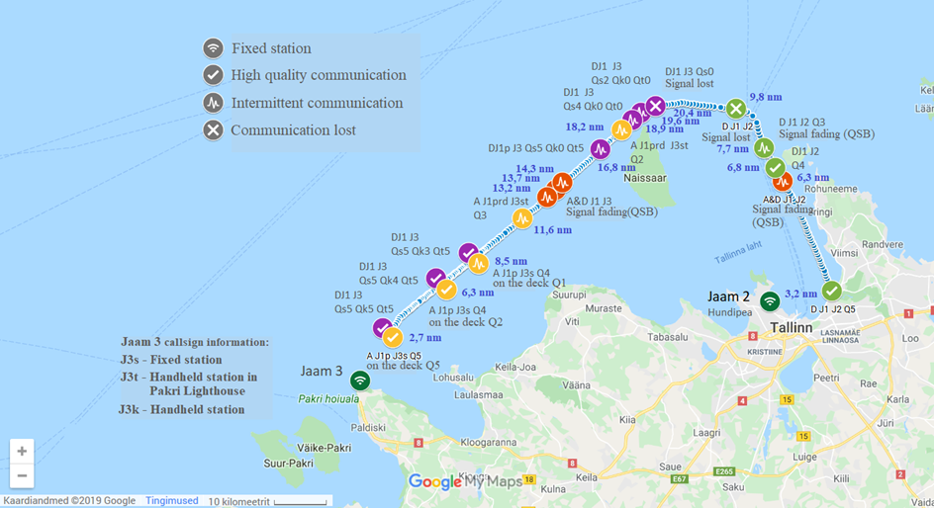
Figure 18: Measuring points and results on a map
Colour codes:
- Green — measuring point for digital communication;
- Violet — measuring point for digital communication;
- Yellow — measuring point for analogue communication;
- Dark green — shore station.
After leaving Pirita harbour there were interruptions in communications between Jaam1 and Jaam2, at the distance d = 6.3 NM (Vessel – Hundipea port), and between Jaam1 and Jaam3, at a distance d = 13.4—14.3 NM (Vessel – Pakri fixed station). Such weakening of the signal may be caused due to the multipath propagation, as described in the measurement methodology (ANNEX 2), influencing the quality of both analogue and digital communications. The waterfall diagram on measurement screenshots (Figure 19, 20) shows the variation of signal strength (measured electric field strength) within 10 seconds. On the map variations are marked with a zigzag symbol. At the place where the communication appears — there is no change in the colour of the symbols. Orange symbols mark places where communication was lost due to radio propagation attributes.
In the case of analogue voice, it is possible to distinguish and understand the speech even in case of a very weak signal, for example by storing and processing (using ear-muffs). The Digital signal is completely interrupted, thus the operator does not know that someone is trying to start communicating (Figure 21). As a consequence, in one case there is the risk of integrity loss, but in the second case, the loss of availability is not guaranteed and it is also the biggest weakness of digital communication. As soon as it is possible to decode the signal, digital communication ensures significantly better understanding than analogue signals. Analogue and digital communications quality became comparable only at the last measurement point d = 2.7 NM.
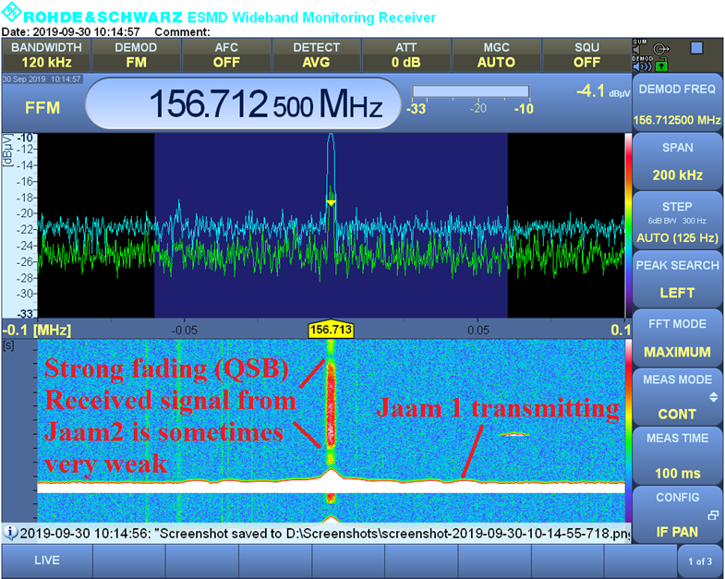
Figure 19: Variation of the signal strength due to propagation attributes between Jaam1 and Jaam2
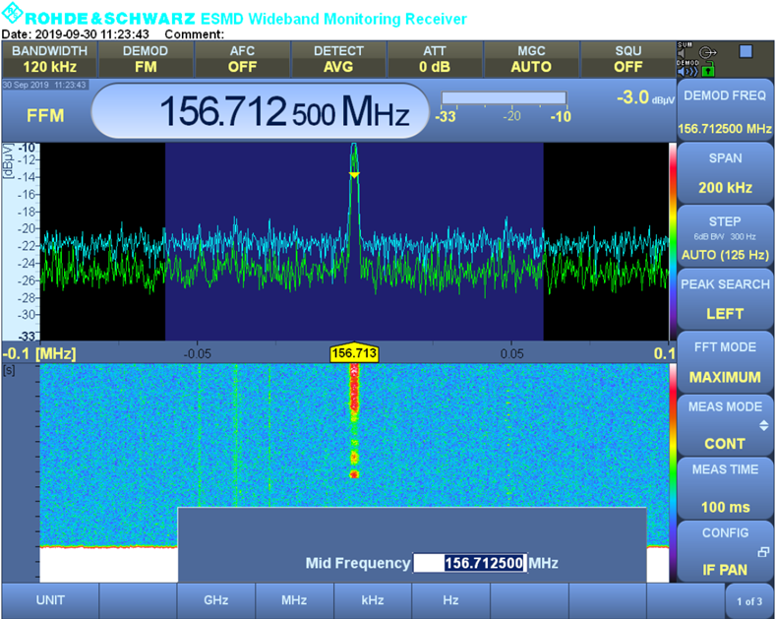
Figure 20: Variation of the signal strength due to propagation attributes between Jaam1 and Jaam3
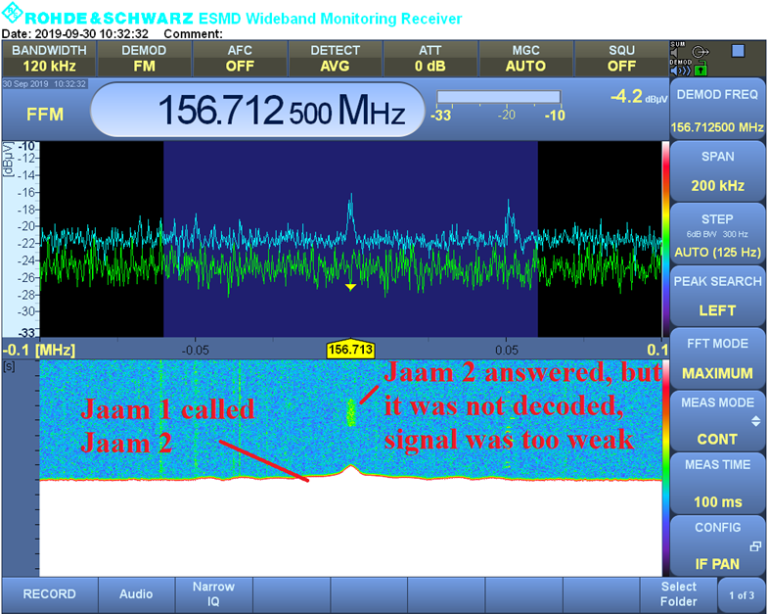
Figure 21: Jaam1 calling Jaam2, Jaam2 not decoded
  - Brief summary
Participants in the test were generally positive about the introduction of digital communication. The range of digital communications was the same (or better) than the range of analogue communication. At the maximum distances that the digital communication was understandable (d = 19.6 NM) — analogue communications experienced very high noise and were not understandable. During the digital switchover period, when the digital station and the analogue station are very close together, the digital station signal will overlap the analogue channel, but this did not cause any interference during testing.
    - Description of transceivers
Icom IC-F3162T
Switching between analogue and digital mode:
- P ₀ (for analogue – digital switch)
- Analog – Digital choice 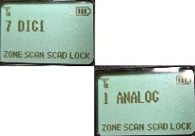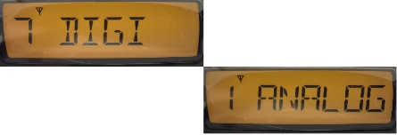
- P ₀ (for analogue – digital switch)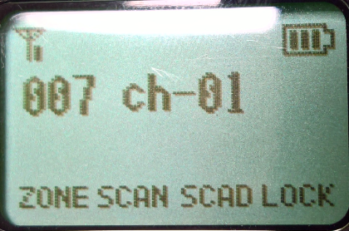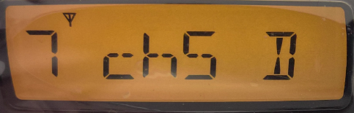
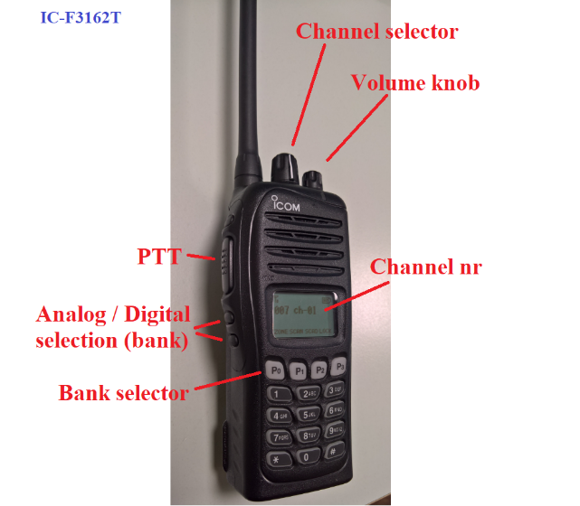
Figure 22: Icom IC-F3162T
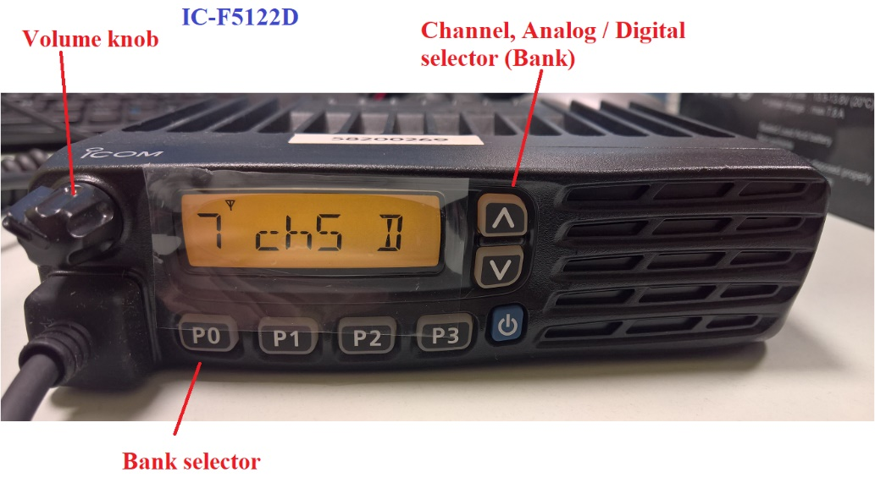
Figure 23: Icom IC-F5122D
Icom IC-F1000D that works only in digital mode
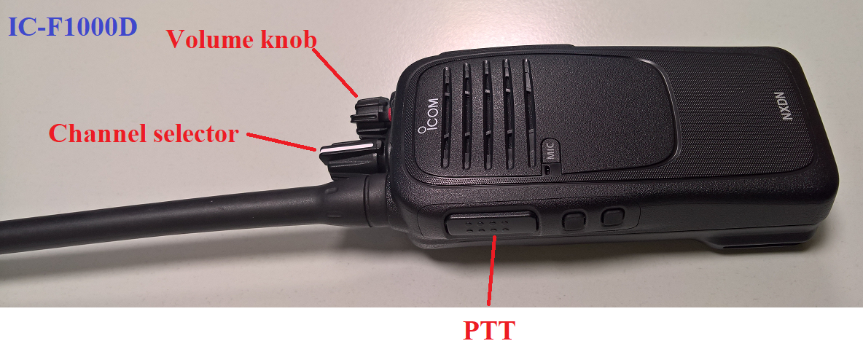
Figure 24: Icom IC-F1000D
Icom IC-F5400D that works only in digital mode
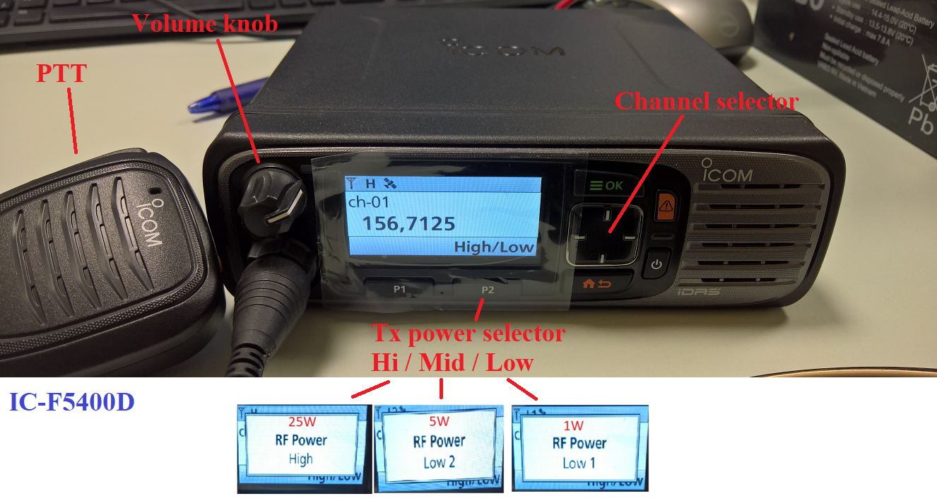
Figure 25: Icom IC-F5400D
  - Description of marine VHF communication digitalisation testing methodology
    - Introduction
This measurement methodology is designed to test possibilities to increase the number of VHF voice channels by switching from analogue to digital channels and reducing channel bandwidth (channel step) Ks = 25 kHz to Ks = 6.25 kHz. This method of measurement is intended to evaluate the effects of the digitalisation of marine radio communications.
Evaluation measurement shall be carried out in the frequency range f = 156.7-156.8 MHz (or more precisely f = 156.709375–156.7625 MHz; ITU Radio Regulations Appendix 18 channel designator K = 15;74).
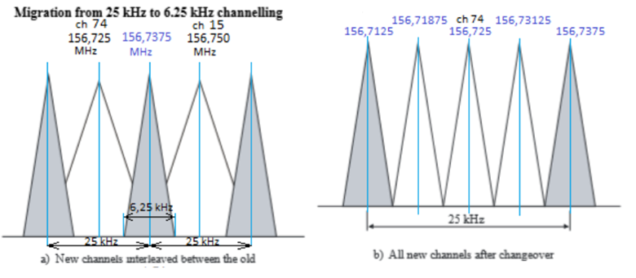
Figure 26: Distribution of ducts in the frequency range
A speech contains certain redundant information that is not reasonable to be sent over the channel. The dPMR standard uses the source to codec AMBE+2 (Advanced Multiband Excitation) or more advanced.
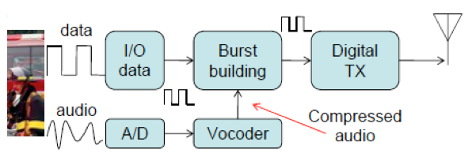
Figure 27: Channel block-diagram
The dPMR standard uses Hamming code (Hamming code can correct single errors) in combination with interleaving. However, these are effective up to a certain point. In case of fading, long link or noise, bit errors can reduce the channel’s capacity and make it incomprehensible. To assess the quality of the communication calls are made from various distances (d). In break points (d):
- Quality of the speech is assessed in the 5-point scale (good without interruption; good with disruptions; distorted without interruption; distorted with interruption; impossible to understand);
- Measure the signal to-noise ratio SNR (Signal power or averaged level during transmission/ noise level without transmission). The electric field strength E is measured and signal power is calculated;
- Signal to-noise ratio SNR provided that adjacent analogue channels (K _{s} = 25 kHz) are working, and digital communication is interrupted. Pictures of spectrum and measurement results are recorded in the event of a disruption.
The measurement shall be carried out between shore station, vessel, and handheld stations.
The distance d shall be determined using the multi- ray propagation model for over-the-sea communication.
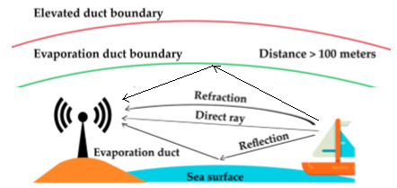
Figure 28: Three ways the VHF radio waves are propagated at sea
The reflection of radio waves on the surface of the sea will have a significant effect on the loss of the link. Therefore, only the marine propagation model can be used for this calculation.
Theoretical dual-beam distribution model at sea for line-of-sight:
$$L_{2-ray}=-10\log_{10}\left\{{\left(\frac{λ}{4πd}\right)}^{2}{\left[2sin\left(\frac{2π{h_{t}h}_{r}}{λd}\right)\right]}^{2}\right\}$$ | (1)
Where:
- L_{2-ray} is the net loss of the link for two-ray propagation [dB];
- λ is the wavelength [m];
- d is the distance between the sender and the receiver [m];
- h_{t} and h_{r} are the height of the transmitter and receiver antenna [m].
Antenna heights:
- h_{b} = 100 m and h_{mk =} 1.5 m (handheld station, boat) where h_{b} – base station antenna height and h_{m} –mobile transceiver antenna height.
Antenna gain:
- G_{b} = 7 dBi (base station on shore); G_{m} = 2,15 dBi (craft); G_{k} = 0 dBi (handheld transceiver).
Transceiver gain:
- P_{WK} = 5 W = 36,9 dBm (handheld transceiver);
- P_{wb} = 25 W = 43,9 dBm (base station);
- P_{WM} = 25 W = 43,9 dBm;
- Radio receiver sensitivity P_{Rmin} = -115 dBm.
Transmission power including antenna:
- Base station P_{b} = 43,9 + 7 = 50,9 dBm and P_{r} = -115-7 = -122 dBm;
- Vessel (G = 2,15 dBi and G = 3 dBi) P_{m} = 43,9 + 2,2 = 46,1 dBm;
- Handheld transceiver: P_{k} = 36,9 dBm.
    - Information about evaporation duct
In case of sunny weather or changes in temperature a layer of steam may appear over the water. The layer may start from h_{e} = 7 m but normally it starts between 25 and 40 m], in this case radio wave is transmitted in the channel between stream and surface of sea and model of three-ray propagation must be used.
The below figure shows that FSL (Free Space Loss) and the two-ray propagation model are not usable at a –distances longer than d_{break} (break point d_{break}$≈2$ – 3 km).
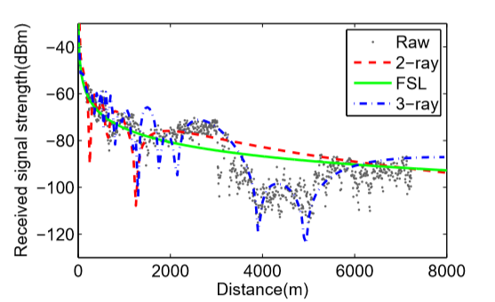
Figure 29: Comparison between two- and three-ray propagation models (f = 5 GHz, h r = 10 m)
In this link budget calculations, the two-ray propagation model is used.
    - Link loss
The calculation allows selecting a lower measurement distance for the test, analyse the measured and theoretical results.
Link loss in the case of two-ray propagation, where the antenna height h_{t} = 100 m and h_{r =} 1.5 m and d = 37 km ($≈20$ nautical miles)
$$L_{2-ray}= -10\log_{10}\left\{{\left(\frac{\left(\frac{300}{156}\right)}{4π37000}\right)}^{2}{\left[2\sin\left(\frac{2π1,5∙100}{\left(\frac{300}{156}\right)37000}\right)\right]}^{2}\right\}=139.2 dB$$ | (2)
Table 17: Antenna elevation and distance
Link loss depending on antenna heights d = 30 NM [dB]
H _{/h s} [m] | 1.50 | 4 | 10 | 100
1.50 | 182.57086 | 174.05148 | 166.09268 | 146.0928
4 | 174.05148 | 165.53211 | 157.57332 | 137.57413
10 | 166.09268 | 157.57332 | 149.61456 | 129.61963
Link loss depending on antenna heights d = 20 NM [dB]
H _{/h s} [m] | 1.50 | 4 | 10 | 100
1.50 | 175.68442 | 167.16504 | 159.20625 | 139.2065
4 | 167.16504 | 158.64567 | 150.68689 | 130.68868
10 | 159.20625 | 150.68689 | 142.72818 | 122.7394
Link loss depending on antenna heights d = 13.5 NM [dB]
H _{/h s} [m] | 1.50 | 4 | 10 | 100
1.50 | 168.87395 | 160.35458 | 152.39578 | 132.39633
4 | 160.35458 | 151.83521 | 143.87644 | 123.88037
10 | 152.39578 | 143.87644 | 135.91785 | 115.94242
Link loss depending on antenna heights d = 8 NM [dB]
H _{/h s} [m] | 1.50 | 4 | 10 | 100
1.50 | 160 | 151.48063 | 143.52184 | 123.52338
4 | 151.48063 | 142.96127 | 135.00256 | 115.01348
10 | 143.52184 | 135.00256 | 127.04434 | 107.11266
Link loss depending on antenna heights d = 5.4 NM [dB]
H _{/h s} [m] | 1.50 | 4 | 10 | 100
1.50 | 152.95635 | 144.43698 | 136.47821 | 116.48166
4 | 144.43698 | 135.91764 | 127.95905 | 107.98362
10 | 136.47821 | 127.95905 | 120.00155 | 100.15559
Link loss depending on antenna heights d = 2,7 NM [dB]
H _{/h s} [m] | 1.50 | 4 | 10 | 100
1.50 | 140.91515 | 132.3958 | 124.43711 | 104.45093
4 | 132.3958 | 123.87656 | 115.91859 | 96.017048
10 | 124.43711 | 115.91859 | 107.965 | 88.58803
    - Finding measurement distances
Sea area-1 (IMO Resolution A.801 (19) [55]).
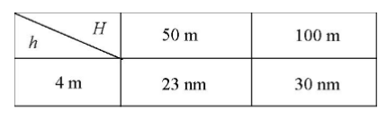
Where:
- h is the height of the mobile station antenna;
- H is the height of the base station antenna;
- d = 30 NM = 55.56 km (NM — nautical mile);
- d = 20 NM = 37.04 km
From Table 17, it can be found that:
  - link loss between mobile and base station at 30 NM from
PL = 137.6 dB.
P_{r} = 46.7-137.6 = -90.9 dBm. This condition P_{r} > P_{rmin} ensures connection
(P_{rmin} = -122 dBm that is receiver sensitivity limit).
  - link between two mobile stations (antenna heights h_{m} = 4 m) is limited by direct visibility, but the transmission power of 25w allows the connection to be achieved from d = 20 NM (37 km):
PL = 158.6 dB
P_{r} = 46.7-158.6 = -111.9 dBm. This condition P _{r} > P_{rmin} provides connection
(P_{r} = 117.2 dBm).
Line-of-site D_{los} = 4.12$∙(\sqrt{h_{1}}+ \sqrt{h_{2}} )$ = 4,12$∙(\sqrt{4}+ \sqrt{4} )$ = 16.48 km = 8.9 NM
  - link between two handheld transceivers (height of antenna 1.5 m)
d = 10 km
PL = 153 dB;P _{Rmin} = -115 dBm (antenna gain G = 0 dB)
P_{r} = 36.9-153 = -116.1 dBm This condition P_{r} $≈$ P_{rmin} may ensure communication.
  - link between the handheld transceiver and the mobile station
(antenna heights 1.5 m and 4 m) d = 18 km = 9.7 NM
PL = 153 dB; P_{rmin} = -117.2 dBm (antenna gain G _{k} = 0 dB and Gm = 2.15 dB)
P_{r} = 36.9-154.6 = -117.7 dBm This condition P _{r}$≈$ P_{rmin} may ensure connectivity from distance d = 18 km = 9.7 NM.
  - link between the handheld transceiver and base station (height of 1.5 m and 100 m for aerials) d = 55 km = 30 NM.
Line-of-site distance:
d_{los} = 4,12 = $∙(\sqrt{h_{1}}+ \sqrt{h_{2}} )$ 4,12$∙(\sqrt{1,5}+ \sqrt{100} )$ = 46,24 km = 25 NM;
PL = 146 dB; P_{rmin} = -122 dBm (antenna gain G_{k} = 0 dB and G_{m} = 7 dB);
P_{r =}36,9-146 = -109,1 dBm, thus P_{r} > P_{rmin} and link could be assured to distance
d = 55 km, but actually there is no link out of line-of-site d_{los} = 46.24 km = 25 NM.
    - Testing distance between mobile and base stations
Distance needed is derived to ensure the same condition (P _{s} = 25 W, d = 30 NM = 55.56 km) for the mobile transceiver with transmit power P_{s =} 5 W. Sender + antenna gain: P_{m} = 36.9 + 2.2 = 39.1 dBm
The necessary power at the receiver input P_{r} = -90.9 dBm
Therefore, link loss PL =| -90.9 – 39.1| = 130 dB.
For verifying maximum distance, transmitter output power is reduced P_{s} = 1 W = 30 dBm: d = 30 NM = 55.56 km) P_{m} = 30 + 2.2 = 32.2 dBm.
The minimum power at the receiving antenna should be P_{rmin} = -122 dBm
(antenna gain G_{k} = 0 dB and G_{m} = 7 dB).
Thus, the maximum link loss can be PL_{max} = |-122 – 32.2| = 154.2 dB.
Line-of-site d_{los} = 4.12$∙(\sqrt{h_{1}}+ \sqrt{h_{2}} )$ = 4,12$∙(\sqrt{100}+ \sqrt{4} )$ = 49.44 km = 23.5 NM.
Power spectral density for the digital transceiver.
According to Recommendation ITU-R M.489-2 [18], the radio channel with step K_{s} = 25 kHz used to transmit 3 kHz voice signal needs bandwidth B = 16 kHz
(max deviation dev_{max} = $± 5 kHz$)
  - Measurement plan
The electric field measurement must be performed from a tripod using a measurement antenna with linear vertical polarisation and circular direction diagram.
Icom dPMR (dMMR) protocol shall be used to assess the quality of communications. Two analogue radio transceivers with channel step K _{s} = 25 kHz and transmit power up to P_{s =} 25 W.
Transceivers output power is programmed to be switchable between values P_{s} = 1 W, 5 W, 25 W (for hand-held transceivers P_{s} = 1 W, 5 W).
Each antenna used in the test shall be vertical with linear vertical polarization and circular direction diagram.
Antennas mounted on vessel or with magnetic mount having amplification G = 2.15 dBi are used. Antenna height h_{m} = 4 m. Onshore station antenna height h_{m} = 100 m with amplification G = 7 dBi.
Handheld transceiver antennas have amplification G = 0 dBi.
One vessel and one boat or vessel with a lower deck (where handheld transceiver with antenna height of h_{s} = 1.5 m above sea level can be used) are required for testing. On shore there should be a handheld transceiver and base station. The test between the two boats (height h_{s} = 1,5 m) shall be carried out between the boat and the onshore handheld transceiver. As described in 2-c connection is expected to break at d = 10 km. In case there is not a boat, one handheld transceiver shall remain ashore, and communication should be tested between the ship and the shore-based handheld transceiver (according to point 2-d — communication is expected to break at d = 18 km) should be tested. Between vessel and handheld transceiver maximum length of the link d (tested until the link is broken) will be measured. In other cases, the electrical field strength (noise floor vs radio signal) shall be measured.
The calculation of the measurement points does not take into account any rain loss. In the case rain, loss adds to link loss and distances will change (probably marginally).
Important measurement points in clear weather are:
- Communications test with handheld transceiver until the link is lost, including speech quality evaluation. When the link is broken, electric field strength E can be measured from tripod height. The testing also includes the situation when adjacent analogue channels (in steps K _{s} = 25 kHz) are occupied. It is expected that the communication will be lost at d = 18 km = 9.7 NM. In this section, the measurement will certainly be carried out.
- In addition, the quality of the speech at the shoreline base station is assessed with reduced power P_{smobile =} 5 W, 1 W. Communication test between boat and handheld transceiver will be done from distance d = 10 km = 5.4 NM. The electric field strength shall be measured on board. If the link is not lost, the adjacent analogue channels (in steps K_{s} = 25 kHz) shall be occupied, and the test will be repeated;
Also, the quality of the speech with the shoreline base station will be assessed.
- After the vessel is moved to distance d = 20 NM = 37 km from the base station while continuous monitoring quality of the speech using reduced power P_{S} ₌ 5 W. In case of change the electric field strength E shall be measured and adjacent analogue channels (with steps K_{S =} 25 kHz) will be occupied and quality of the speech evaluated;
- If possible, proceed further until the link is lost or d = 30 NM = 55 km;
(Line-of-site d_{los} = 49 km = 26,5 NM for antenna heights h = 4 m and 100 m);
The quality of the communication is monitored continuously with reduced output power P_{s} = 5 W and, in case of changes, the electric field strength E will be measured adjacent analogue channels (with steps K_{S =} 25 kHz) will be occupied and quality of the speech evaluated;
If the link is lost transmitting power shall be increased to P_{s} = 25 W.

Mobile communications engineering, William C. Y. Lee, Chapter “Path loss over flat terrain[40].
  - Annex to measurement methodology:
Three-ray propagation model:
(3)
- dPMR Trial Port of Rotterdam
  - Foreword
Communication between ships and shore has taken place traditionally through the use of VHF radio. VHF radio equipment is used for shipping both at sea and inland. Over the years, the use of VHF radio, and the wish to communicate and be sure that your message is received and understood, has grown. Digitisation in other areas of communication has improved the way to communicate (GSM, LTE, etc.). But, in the marine bands the introduction of new digital communication channels for data has put pressure on the availability of VHF voice channels.
With the introduction of VDES (VHF Data Exchange System) a problem arises that this would not be an easy task for the Netherlands to contend with. The ITU (International Telecommunication Union) has taken the decision that the frequencies for VDES are available from 1 January 2017 in the World Radio Conference of 2015. Because the Netherlands has foreseen the same problems as they encountered they sent in a paper to MSC97 to raise awareness of this problem. Due to this, IMO (International Maritime Organisation) agreed that from 1 January 2024 these frequencies should be freed by Contracting States and VDES could then use these frequencies. In the World Radio Conference of 2019, ITU also decided on the use of frequencies for VDES satellite communication.
During the IALA eNAV Communication (International Association of Lighthouse Authorities) communications workgroup intersessional meeting in Sydney a possible technical way of a more efficient use of VHF frequencies was presented. This should at least have the same performance standards (functionality) as the current VHF radio.
There are multiple ways to achieve this but the technical candidate solution presented is called dPMR (digital Private Mobile Radio), currently used in land mobile communications as a replacement for analogue FM voice communication in both VHF and UHF bands. There was, as far as it is known, no specific test done for maritime use of dPMR as a candidate technology to replace analogue VHF radio. Replacing analogue VHF radio needs to be done in such a way that both the “old” and new technology could be used next to each other and therefore an important task is the possible migration plan.
This new candidate technology could also have a place within Maritime Safety Information and/or Smart Shipping because it is possible to embed small data/text with the voice transmission. This information could contain the intentions of ships or information about hazards.
For situational awareness it is commonly known that eye-sight, VHF radio and radar are the main tools to accomplish this. Next to this, the use of AIS and by transmitting the position of the VHF (digital) radio could complete the picture by showing identification, size, location and which ship is transmitting.
  - Goals
The purpose of the trial was to identify if dPMR could be a possible candidate technology to replace and possibly improve the current voice communication by VHF radio by digitising the voice.
    - Inquiry goal 1 current functionality
The first inquiry goal was to identify if:
- The quality of the speech was equal or better than with current VHF radio under various ranges;
- Migration strategy from current situation to a mixed and maybe a full digital situation;
- Possible (harmful) interference of current communication;
- Possible (harmful) interference of new digital communication;
- Are multiple systems from different vendors capable of working together.
    - Inquiry goal 2 new functionality
Because dPMR is a ETSI standard, there are already extra functionality embedded in this standard that could be used:
- Could position information embedded with the signal be used;
- Is it possible to identify the transmitting station;
- Could short messages for Maritime Safety Information and/or broadcasting your intention (Smart Shipping) be sent;
- Are there possibilities to check the validity of transmissions;
- Is there more functionality needed (must have, need to have and nice to have).
    - Tracks
To ensure that these goals would be reached there were identified two tracks during the trials.
- Work together with the users of VHF radio (mariners, operators, skippers, etc.) if the quality of the speech and range is enough and if possible new features are a possible asset.
- Check with national ITU organisation (Agentschap Telecom), waterway users and authorities if dPMR will interfere with the current communication, discuss a possible migration strategy and possible adjustments to the standard to make it more appropriate for maritime.
  - Setup
    - Groups
Before the trial started two main groups were identified. One group of users that actively participated to the trial and one group observers that would be informed about the technology and developments.
The group that actively participated to the trial were technicians, VTS operator, skipper and law enforcement agency for frequency (national ITU organisation).
At first, the idea was to have a small group of observers for the trial. After defining this group, and sending out the invitation, there was a lot of additional interest . This group consists of policy makers, managers, advisors and technicians from different governmental and non-governmental organisations. In total, during the day, 40 people visited the trial.
    - Area
During the planning of the trial a suitable area needed to be chosen. The Netherlands is very flat with almost no mountains, as a result radio signals carry far and will possibly interfere with other signals. Next to this, the complete area of the Netherlands has about 7500 ships sailing on a daily base where most are concentrated around the big ports like Port of Rotterdam. The Netherlands also have a lot of infrastructure such as locks and bridges where communication is needed.
So an ideal place to test interference would be around the Port of Rotterdam.
    - Locations
For the test, the Port of Rotterdam was contacted for their assistance and to use some of their assets and personnel. The Port of Rotterdam was willing to help us with this trial and offered a de-commissioned VTS centre in the middle of the city and one of their assistance vessels. Also they provided us with an experienced VTS operator and crew for the vessel. These employees of the Port of Rotterdam had been working for at least 30 years at the Port on the vessel or VTS centres.
The below figure shows the trial area, VTS centre, vessel and monitoring setup.
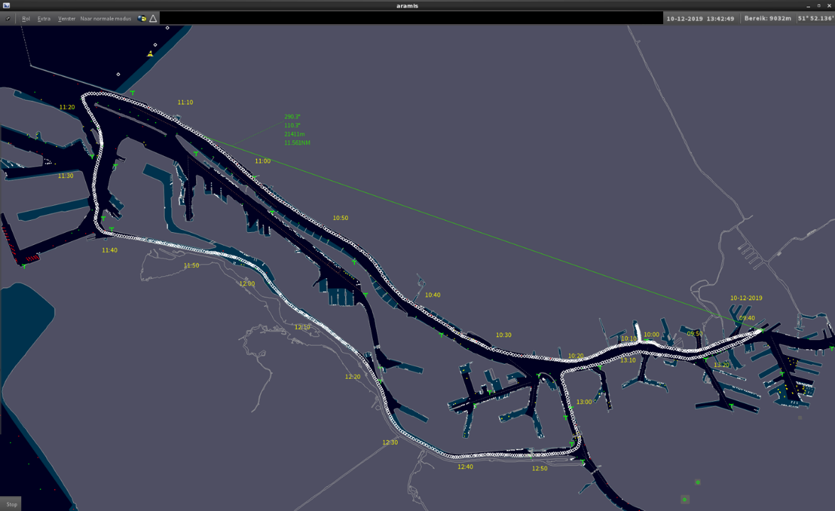
Figure 30: Trial Area
On the right side is the VTS centre where one of the antennas was placed on a height of 16 meter. The dots show how the vessel sailed and the time the vessel was on a specific location.
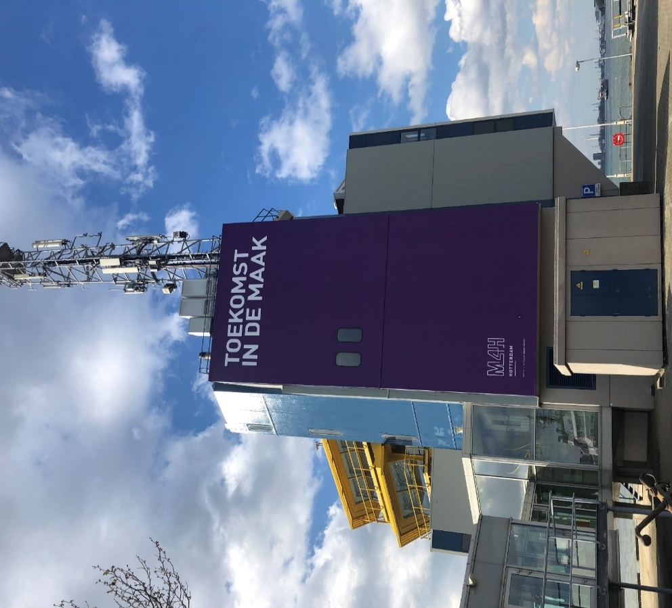
Figure 31: VTS centre in Port of Rotterdam
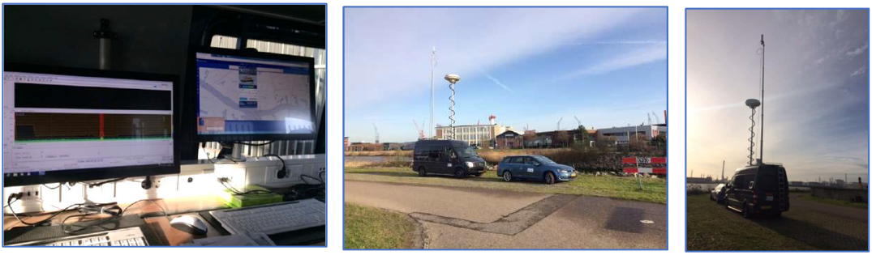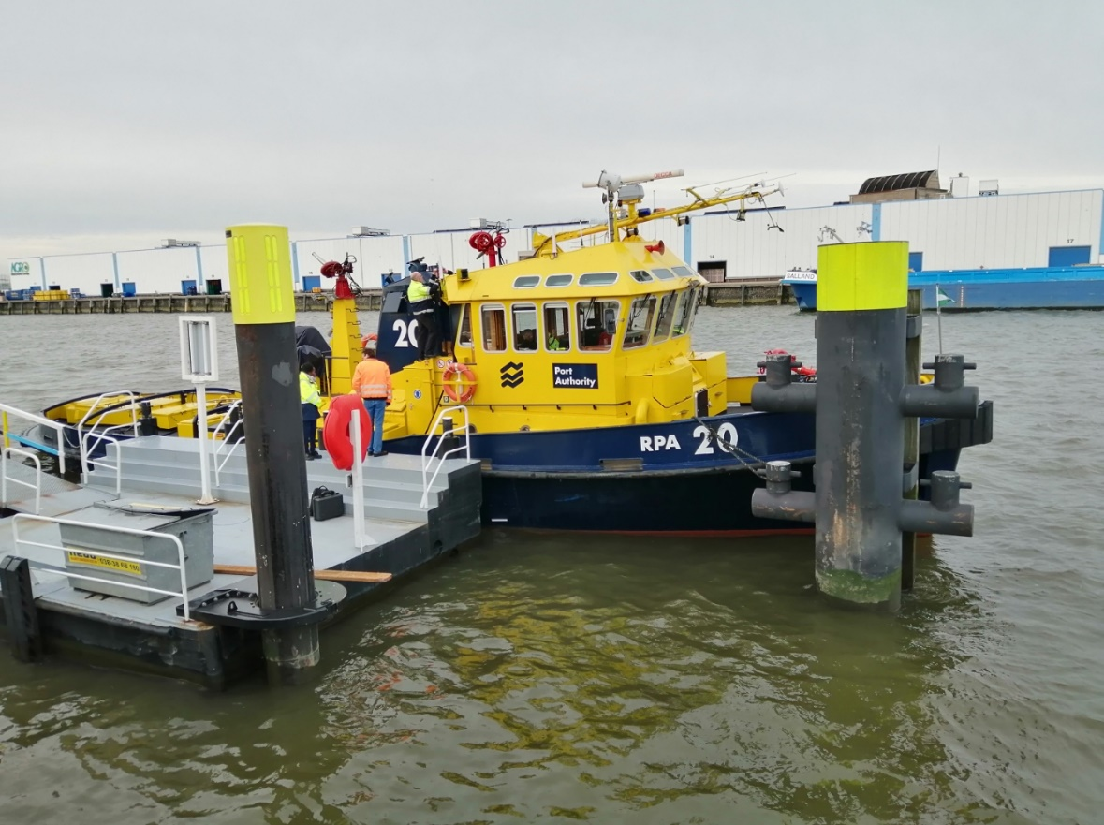
Figure 32:Vessel used belonging to the Port of Rotterdam
The monitoring setup/site of the ITU organisation (Agentschap Telecom).
  - Used hardware
The antenna installation on the ship was 0 dB omni-directional antenna (Procom CXL2) with 6 meter RG214 coax cable.
The antenna installation on the VTS centre was a 0 dB omni-directional antenna (Procom CXL2) with a 15 meter RG213 and 5 meter Ecoflex coax cable between the two cables was a lightning security.
During the test the following equipment was used:
- Mobile station Kenwood NEXEDGE NX720 (VTS centre);
- Mobile station Icom IC-F5400DP (ship);
- Portable Kenwood NX220;
- Portable Icom IC-F3400DPT.
The transmit power measurements at the connector of the station were:
- 43 dBm and 30 dBm (Kenwood NEXEDGE NX720);
- 43 dBm, 39 dBm and 36 dBm. (Icom IC-F5400D ).

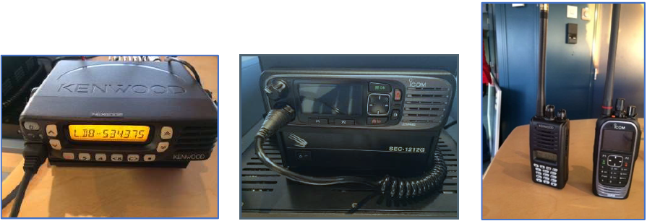
Figure 33: Pictures of the equipment
  - Used frequencies
A trial license for the period from the 1 December 2019 till the end of 1 July 2020 was obtained. This was done so more trials could take place. Next to this it would provide the opportunity to give different users and interested people to hear and experience the quality of voice and use of the equipment. Plans were made to give participants of the VTS-ENAV Symposium (25-29 May 2020) a chance to experience the digitisation of VHF radio (dPMR).
Although a license has been received to use all maritime frequencies, the test was made on frequencies used by Rijkswaterstaat only, so as not to affect the normal port operations.
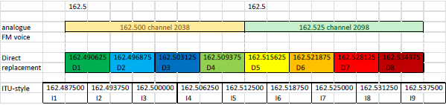
Figure 34: Rijkswaterstaat frequencies used in the trial
  - Considerations
    - IALA
- That any evaluated technologies have a clear migration path from the current analogue voice services to the new digital voice services by allowing both the digital and analogue services to co-exist in the same transceiver for the duration of the entire migration period. This could extend to using the same antenna and other existing physical installation hardware;
- The channel efficiency should be a high priority, by allowing four (4) or more digital voice channels for each 25 kHz maritime VHF voice channel;
- The digital service includes the capability of transmitting the location of the radio for the entire duration of the digital voice conversation;
- The digital service allows a Short Message Service (SMS) without the need to set up a digital or other voice call;
- The digital voice quality be similar to, or better than, the analogue voice service, especially using weaker radio signals at the extent of the radio coverage.
    - Before trial
- That the candidate technologies are easy to use by the users and limit the possibility of the users to make mistakes;
- That the candidate technology is independent of other (supporting) technology (like GPS) and manufacturer (no vendor lock);
- Support the current functionality of VHF radio (DSC / ATIS);
- Costs of the equipment is around the same as current;
- Impact on current regulations is minimal (RR appendix 18) [43];
- The candidate technology, with most of the requested functionality, should already be available;
- The candidate technology should be future-proof;
- Could support (Cyber) security for instance to check your own transmissions;
- Support of Smart Shipping, for instance sending small data packets with the intentions of the ship;
- Harmonised;
- Should be implemented using open standards.
    - Results
      - Start trial
Before the trial was started, the equipment and installation (antenna and cabling) was tested. The first results were that the antennas initially used were not good enough and needed to be replaced.
The next test was to test the installation. On the ship, this was all good after replacing the antenna but on the VTS centre a problem with the cabling was encountered. This problem with the cabling needed us to replace the cabling in the VTS centre. This was done very quickly by the technical staff of the Port of Rotterdam.
After the installation was tested again, there were no problems with cabling or antennas.
During the testing of the installation both technicians of CML and Koning and Hartman checked the configuration of the stations and tested them. These tests passed ok but not all of the envisioned features could not be tested at that moment because of some missing parts. These parts were delivered after the test but did not jeopardise the main purpose of the test.
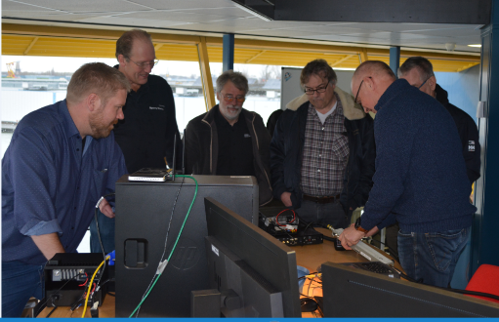
Figure 35: Checking the configuration of settings
After everything was tested the scenarios were checked again. The red line in the scenario’s was to go sailing and test on different distances with different power levels, digital and analogue communication and two languages English and Dutch. During the test, the time, distance, power, language and possible (harmful) interference were recorded. For the last test, the equipment of our ITU organisation was used and of course informed the VTS operators of the Port of Rotterdam to inform us if something unusual within communication happened.
    - Test day
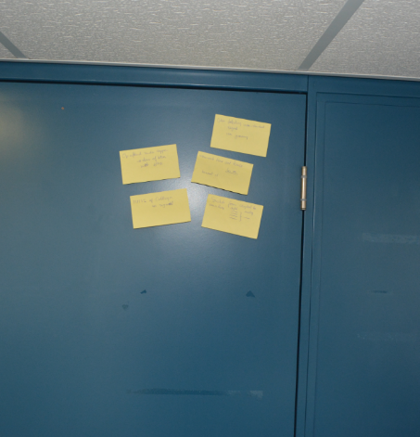
Figure 36: Questions and Observations
On the test day (10 December 2019) there was a short instruction and roles. The main group of the attendees would be busy with the trial while two other staff would accompany the observers. There was a presentation about the trial to the observers after which the observers were asked to post up their questions and observations.
    - Use of equipment
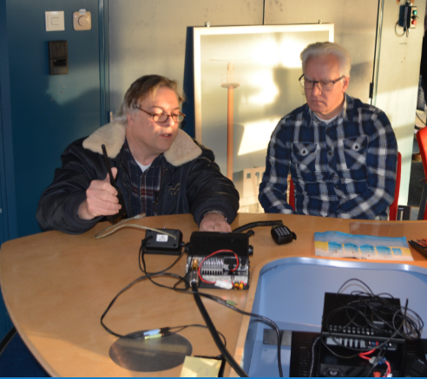
Figure 37: Monitoring of equipment during the trial
After a short introduction and demonstration, the use of the equipment was easy to use. They are similar as VHF radio equipment. For the trial, there were buttons programmed to switch between high and low power and change between all channels analogue and digital. Also, the display showed which channel you were using, transmitting level, reception level and the station on the ship recorded the voice communications.
Next to the default installation, an emergency button function on the Kenwood equipment was also programmed. This as a possible feature to show to the observers.
  - Voice quality
During the test all voice was recorded on the ship side only. This was because the equipment at the VTS centre did not have this functionality. Therefore, only recordings coming from the VTS centre and recorded on the ship are accountable for the test.
Both users on the ship and the VTS centre were enthusiastic about the quality of the digital voice and said that especially on the edges of the transmitting range the sound was clear and less tiring to listen to. Also the interference was much less.
During the test, the reception quality of the digital transmissions was higher than on the same range when compared with analogue ones.
A question arose that if the operator could distinguish if the mariner would still be able to operate a ship by the sound of his/her voice was answered: that to determine this would not only be done by the voice quality but also by the sentence structure, response time and ability to response.
  - Interference
During the test the ITU organisation (Agentschap Telecom) monitored if the equipment stayed in the standard (ETSI TS 102.658 [10] and Appendix 18) [42] and if it caused (harmful) interference. They measured that frequency 162,500 MHz was used for analogue communication and frequency 162.534375 MHz for digital communication (dPMR).
The two positions where the monitoring took place from was about 4 km from the VTS centre (because monitoring next to the transmitter has no use). Locations were Wilhelminahaven/Nieuwe Waterwegstraat and the Karel Doormanweg, both near the waterway.
The monitoring equipment consists of a broadband-omni-directional antenna at a height of 10 meter connected to a Tektronix RSA real-time spectrum analyser. At the same time this was monitored with a Rohde & Schwarz direction-tracker. This antenna height was 6 meter. During the test, no irregularities were discovered. A small note was that some of the communication could not be received due to the lower height of the antennas what could be explained.
On the ship, signals were also monitored with a Rohde & Schwarz FSH-6 spectrum-analyser if they noticed any interference in the spectrum when they were unable to connect to the VTS centre and ship. Also, no irregularities were found. A note was that they only sailed on the main fairways and not all the inlets / basins at the Port of Rotterdam.
During the test there were some findings these were:
- On lager distances, quality deteriorated when sailing. This was probably caused by the horizon / line of sight that current VHF radio also encounters;
- On a specific area of the fairway the quality deteriorated because of large storage tanks standing between the VTS and vessel. The large storage tanks probably blocked or reflected the signal. (multipath);
- When the quality deteriorated it presented itself by losing the connectivity or a “metallic/robotised” sound. When it happened with analogue VHF communication it caused noise).
During the trial, it was not possible to test the Adjacent and Nearby Channel Rejections and this was tested later for both the current 25 kHz analogue FM (voice) and 6.25 kHz dPMR (digital voice) channels. This test is to quantify the interference potential of an adjacent / near dPMR channel on an existing analogue voice channel.
Also additional qualitative testing was also done to establish the closest distance an interfering dPMR radio would need to be before affecting the analogue reliever. This is particularly important when it comes to channel planning and migration strategies.
These tests were done by using the ETSI specification procedure, measurements were made using two different instruments to perform the SINAD measurement, the 2955R having a flat filter response, whereas the 8903 measurement uses the psophometric filter as defined in ETSI EN 300 086 [41]. A third set of measurements were made using the TIA procedure.
Two channel plans have been proposed for implementing the replacement of analogue voice with digital voice:
- Direct replacement – where a 25 kHz analogue channel is split exactly into 4 dPMR channels;
- ITU-style, where the channel centre of digital channels is aligned with the channel of the analogue channel, so that the extreme digital channels overlap into the adjacent analogue channels.
These two channel plans are indicated in the channel selections as D5 to D8 and I5 to I9 respectively.
  - After trial considerations/questions
During and after the trial the following additional observations/considerations came out:
- Be able of shutting down a transmitter remotely;
- Be able to limit the maximum time of one conversation;
- Be able of integration GMDSS (DSC, MSI);
- Capable of dual watch functionality;
- Identification integration embedded in signal like MMSI, Callsign or ATIS for the entire duration of the digital voice conversation;
- Be able to switch automatically between analogue and digital voice transmissions;
- Capable of detection of poor signal;
- Capable of detecting of interference;
- To be able to cope with multicast / diversity;
- Support (half) duplex;
- Possible of to dedicate one digital channel for data only;
- Support multi languages by voice and user interface;
- Tests were in perfect weather/communication conditions, so how does it operate when not;
- Must have an interface to connect to other bridge equipment for instance obtaining ships position from its centralised positioning system;
- How can you detect destruction of the signal, like with analogue;
- Would the repeater and trunking possibilities enhance communication and safety in a Port or traffic dense area.
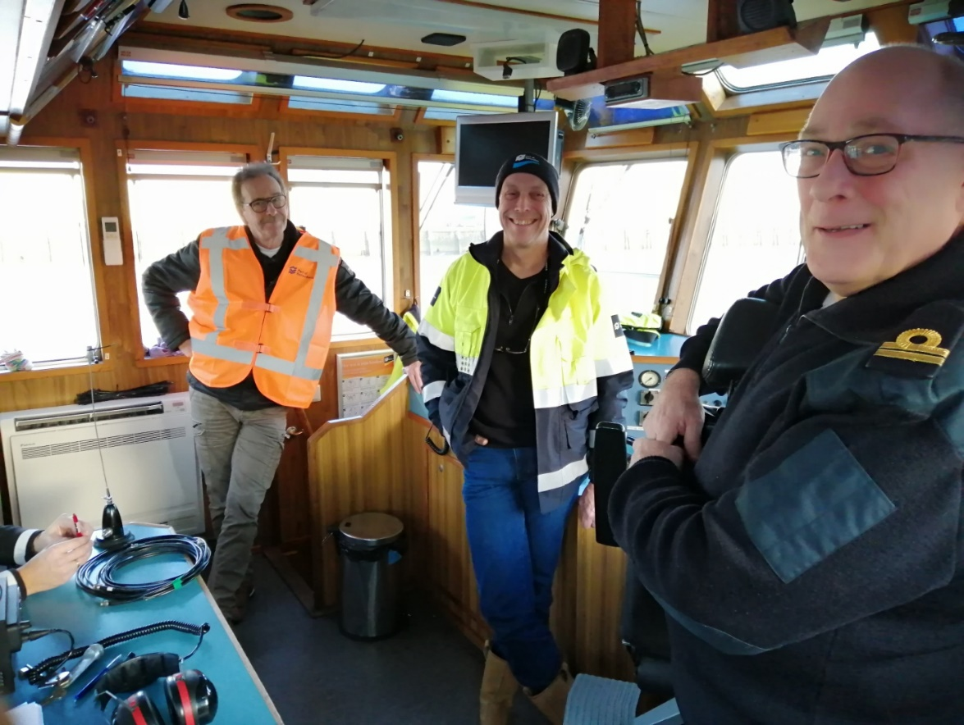
Figure 38: Users appeared content with the operation of the digital radio system
  - Conclusions
    - Use equipment
During the test the users had no problem with operating the equipment. There might be some slight adjustments to the user interface when integrating DSC/dual watch functionality.
    - Voice quality
Both the users and the observers found the voice quality the same or better than analogue. The users reported back that listening to digital voice with the noise reduction made it easier and less intensive to listen. Concluding that with digital transmission of voice, if a mariner is still capable of operating his ship is equal as analogue.
The bad reception or failure of digital VHF that caused a “metallic/robotised” sound of losing the connection is similar of analogue VHF where it causes noise. The impact and acceptance of this against the gains has to be analysed and decided.
    - Frequencies
In the lab tests, the equipment exceeds the requirements of both ETSI and TIA standards by some margin and the rejection of the dPMR channels in excess of 70 dB in the direct frequency replacement format indicates that that the same adjacent channel practices can be applied to both analogue and digital implementations.
In the case of the ITU channel plan, the 61 dB result on Channel I5 indicates that this arrangement could be marginal and would need very careful consideration before implementing.
The Walk Test was provided to illustrate the difference in range of the interferers that could be expected in a typical deployment. It shows that the use of Channel I5 in close proximity to the wanted analogue channel will produce more interference than the existing analogue channel and so calls into question its usefulness in a real-world scenario. Although Channel D5 does interfere slightly more than the analogue, it is not significantly so (only 11 m compared to 10 m). All the other channels showed that they would introduce less interference than the existing analogue channel and so could be deployed using the same (or possibly stricter) channel planning criteria as currently used for analogue channels.
The field test did not show any (harmful) interference.
    - Additions
The use of the candidate technology dPMR for maritime use could be a good option. Some possible functionalities need to be defined by IMO in their performance standards.
- ITU Codecs
  - ITU-T Codecs - G.711
Recommendation ITU-T G.711.0 [28] describes a lossless compression scheme of G.711 bitstream, mainly aimed for transmission over IP (e.g. VoIP).
The coder operates on frame lengths of 40, 80, 160, 240 and 320 samples, has a maximum algorithmic delay equals to the frame length, and has a worst-case computational complexity of less than 1.7 weighted million operations per second (WMOPS) for encoder plus decoder.
This Recommendation includes an electronic attachment containing the ANSI C code (fixed-point arithmetic implementation of the specification), as well as a non-exhaustive set of test signals for use with it.
Recommendation ITU-T G.711.1 [29] describes embedded wideband speech and audio coding algorithm operating at 64, 80 and 96 kbit/s.
The encoder input and decoder outputs are sampled at 16 kHz by default, but 8-kHz sampling is also supported. When sampled at 16 kHz, the output of the ITU-T G.711.1 coder can encode signal with a bandwidth of 50-7000 Hz at 80 and 96 kbit/s, and for 8-kHz sampling, the output may produce signal with a bandwidth ranging from 50 up to 4000 Hz, operating at 64 and 80 kbit/s (the bandwidth of the narrowband signal output from the decoder is characterised by the built-in split-band filterbank which has cut-off frequency of 4000 Hz). At 64 kbit/s, ITU-T G.711.1 is compatible with Recommendation ITU-T G.711. The coder operates on 5 ms frames, has a maximum algorithmic delay of 11.875 ms, and has a worst-case computational complexity of 8.70 WMOPS.
The encoder produces an embedded bitstream structured in three layers corresponding to three available bit rates: 64, 80 and 96 kbit/s. The bitstream can be truncated at the decoder side or by any component of the communication system to adjust the bit rate to the desired value, but since it does not contain any information on which layers are contained, an implementation would require outband signalling on which layers are available.
The underlying algorithm has a three layer coding structure: log companded pulse code modulation (PCM) of the lower band including noise feedback, embedded PCM extension with adaptive bit allocation for enhancing the quality of the base layer in the lower band, and weighted vector quantisation coding of the higher band based on modified discrete cosine transformation (MDCT).
  - ITU-T Codecs - G.722 and G.722.1
Recommendation ITU-T G.722 describes the characteristics of an audio (50 to 7000 Hz) coding system which may be used for a variety of higher quality speech applications. The coding system uses sub-band adaptive differential pulse code modulation (SB-ADPCM) within a bit rate of 64 kbit/s. The system is henceforth referred to as 64 kbit/s (7 kHz) audio coding. In the SB-ADPCM technique used, the frequency band is split into two sub-bands (higher and lower) and the signals in each sub-band are encoded using ADPCM. The system has three basic modes of operation corresponding to the bit rates used for 7 kHz audio coding: 64, 56 and 48 kbit/s. The latter two modes allow an auxiliary data channel of 8 and 16 kbit/s respectively to be provided within the 64 kbit/s by making use of bits from the lower sub-band.
Recommendation ITU-T G.722, Appendix II [30] describes digital test sequences for the verification of the ITU-T G.722 64 kbit/s SB-ADPCM 7 kHz codec. This guide gives information concerning the digital test sequences which should be used to aid verification of implementation of the ADPCM codec part of the wideband coding algorithm.
Recommendation ITU-T G.722.1 [31] describes a low complexity encoder and decoder that may be used for 7 kHz bandwidth audio signals working at 24 kbit/s or 32 kbit/s. Furthermore, this algorithm is recommended for use in hands-free applications such as conferencing where there is a low probability of frame loss. It may be used with speech or music inputs.
The digital input to the coder may be in a 14-, 15- or 16-bit 2's complement format, at a sampling rate of 16 kHz (handled in the same way as in Recommendation ITU-T G.722). The analogue and digital interface circuitry at the encoder input and decoder output should conform to the same specifications described in Recommendation ITU-T G.722. The algorithm is based on transform technology, using a Modulated Lapped Transform (MLT). It operates on 20 ms frames (320 samples) of audio. Because the transform window (basis function length) is 640 samples and a 50 percent (320 samples) overlap is used between frames, the effective look-ahead buffer size is 20 ms. Hence the total algorithmic delay of 40 ms is the sum of the frame size plus look-ahead. All other delays are due to computational and network transmission delays.
Recommendation ITU-T G.722.1 [31] includes a software package which contains the encoder and decoder source code and a set of test vectors for developers. These vectors are a tool that can provide an indication of success in implementing this codec.
Recommendation ITU-T G.722.2 [32] describes the high quality Adaptive Multi-Rate Wideband (AMR-WB) encoder and decoder that is primarily intended for 7 kHz bandwidth speech signals. AMR-WB operates at a multitude of bit rates ranging from 6.6 kbit/s to 23.85 kbit/s. The bit rate may be changed at any 20-ms frame boundary.
Annex C includes an integrated C source code software package which contains the implementation of the ITU-T G.722.2 encoder and decoder and its Annexes A and B and Appendix I.
A set of digital test vectors for developers is provided in Annex D. These test vectors are a verification tool that can provide an indication of success in implementing this codec. Digital test sequences are necessary to test for a bit-exact implementation of the adaptive, multi-rate wideband (AMR-WB) speech-transcoder; voice-activity detection; comfort noise generation; and source controlled rate operation.
  - ITU-T Codecs - G.723.1:
ITU-T G.723.1 [33] specifies a coded representation that can be used for compressing the speech or other audio signal component of multimedia services at a very low bit rate. In the design of this coder, the principal application considered was very low bit-rate, visual telephony as part of the overall ITU-T H.324 [51] family of Recommendations. This coder has two bit rates associated with it (5.3 and 6.3 kbit/s).
  - Recommendation ITU-T G.726: (ADPCM)
The characteristics below are recommended for the conversion of a 64 kbit/s A-law or Mu-law pulse code modulation (PCM) channel to and from a 40, 32, 24 or 16 kbit/s channel. The conversion is applied to the PCM bit stream using an ADPCM transcoding technique. The relationship between the voice frequency signals and the PCM encoding/decoding laws is fully specified in Recommendation ITU-T G.711.
The principal application of 24 and 16 kbit/s channels is for overload channels carrying voice in Digital Circuit Multiplication Equipment (DCME).
The principal application of 40 kbit/s channels is to carry data modem signals in DCME, especially for modems operating at greater than 4800 kbit/s.
The Appendix II describes the test sequences (vectors) for the ADPCM algorithms of Recommendation ITU-T G.726 at the four fixed bit rates (16 kbit/s, 24 kbit/s, 32 kbit/s, 40 kbit/s) for both A-law and Mu-law.
NOTE: Recommendation ITU-T G.726 [34] is the consolidation of Recommendation ITU-T G.721 [52] (1988) and Recommendation ITU-T G.723 [33] (1988), which are now superseded as individual Recommendations.
  - Recommendation ITU-T G.728: Coding of speech at 16 kbit/s using LD-CELP
Recommendation ITU-T G.728 contains the description of an algorithm for the coding of speech signals at 16 kbit/s using low-delay, code-excited, linear prediction.
The LD-CELP algorithm consists of an encoder and a decoder. The essence of CELP techniques, which is an analysis-by-synthesis approach to codebook search, is retained in LD-CELP. The LD-CELP however, uses backward adaptation of predictors and gain to achieve an algorithmic delay of 0.625 ms. Only the index to the excitation codebook is transmitted. The predictor coefficients are updated through LPC analysis of previously quantised speech. The excitation gain is updated by using the gain information embedded in the previously quantised excitation. The block size for the excitation vector and gain adaptation is five samples only. A perceptual weighting filter is updated using LPC analysis of the unquantised speech.
  - Recommendation ITU-T G.729: Coding of speech at 8 kbit/s using CS-ACELP
Recommendation ITU-T G.729 [36] contains the description of an algorithm for the coding of speech signals at 8 kbit/s using Conjugate-Structure Algebraic-Code-Excited Linear-Prediction (CS-ACELP). This coder is designed to operate with a digital signal obtained by first performing telephone bandwidth filtering (Recommendation ITU-T G.712 [53]) of the analogue input signal, then sampling it at 8000 Hz, followed by conversion to 16-bit linear PCM for the input to the encoder. The output of the decoder should be converted back to an analogue signal by similar means. Other input/output characteristics, such as those specified by Recommendation ITU-T G.711 [28] for 64 kbit/s PCM data, should be converted to 16-bit linear PCM before encoding, or from 16-bit linear PCM to the appropriate format after decoding. The bitstream from the encoder to the decoder is defined within this Recommendation.
Recommendation ITU-T G.729 and its Annexes and Appendices offer different functionalities in terms of various bit rates and/or DTX operations using either fixed point or floating point arithmetic. Table 18 summarises these functionalities.
Table 18: Recommendation ITU-T G.729 functionalities
 | Annex
Functionality | - | A | B | C | D | E | F | G | H | I | C+
Low Complexity |  | X | X
Fixed-point | X | X | X |  | X | X | X | X | X | X
Floating-point |  |  |  | X |  |  |  |  |  |  | X
8 kbit/s | X | X | X | X | X | X | X | X | X | X | X
6.4 kbit/s |  |  |  |  | X |  | X |  | X | X | X
11.8 kbit/s |  |  |  |  |  | X |  | X | X | X | X
DTX |  |  | X |  |  |  | X | X |  | X | X
  - Recommendation ITU-T G.729.1: ITU-T G.729 based embedded variable bit-rate coder: An 8-32 kbit/s, scalable wideband, coder-bitstream interoperable with ITU-T G.729 codecs
Recommendation ITU-T G.729.1 [37] describes an 8-32 kbit/s, scalable, wideband speech and audio coding algorithm interoperable with ITU-T G.729 [36], ITU-T G.729A and ITU-T G.729B codecs. The output of the ITU-T G.729.1 coder has a bandwidth of 50-4000 Hz when operated at 8 and 12 kbit/s and 50-7000 Hz when operated from 14 to 32 kbit/s. At 8 kbit/s, ITU-T G.729.1 codecs are fully interoperable with codecs conforming to Recommendation ITU-T G.729, Recommendation ITU-T G.729 Annex A and Recommendation ITU-T G.729 Annex B. The coder operates on 20 ms frames and has an algorithmic delay of 48.9375 ms. By default, the encoder input and decoder output are sampled at 16 kHz. The encoder produces an embedded bitstream structured in 12 layers corresponding to 12 available bit rates from 8 to 32 kbit/s. The bitstream can be truncated at the decoder side or by any component of the communication system to adjust "on the fly" the bit rate to the desired value with no need for outband signalling. The underlying algorithm is based on a three-stage coding structure: embedded Code-Excited Linear Predictive (CELP) coding of the lower band (50-4000 Hz), parametric coding of the higher band (4000-7000 Hz) by Time-Domain Bandwidth Extension (TD-BWE), and enhancement of the full band (50-7000 Hz) by a predictive transform coding technique referred to as Time-Domain Aliasing Cancellation (TDAC).

- List of References

- dPMR Association (2012): “dPMR Whitepaper Issue 1.3”
- ERC Report 25: “European Common Allocation Table”, approved November 2020
- ETSI EN 300 396-2 (2011-12): “Terrestrial Trunked Radio (TETRA); Part 2: Radio aspects”
- ETSI EN 300 698: “Electromagnetic compatibility and Radio spectrum Matters (ERM); Radio telephone transmitters and receivers for the maritime mobile service operating in the VHF bands used on inland waterways - Harmonised Standard covering the essential requirements of articles 3.2 and 3.3(g) of Directive 2014/53/EU”
- ETSI TR 102 398 (2008-05): “Digital Mobile Radio (DMR) General System Design”
- Draft ETSI TR 103 784: “Digital Maritime Mobile Radio using FDMA in 6.25 kHz bandwidth”
- ETSI TS 100 392-2 (2013-05): “Terrestrial Trunked Radio (TETRA); Voice plus Data (V+D); Part 2: Air Interface (AI)”
- ETSI TS 102 361-1 (2006-01): “Digital Mobile Radio (DMR) Systems; Part 1: DMR Air Interface (AI) protocol”
- ETSI TS 102 490 (2013-02): “Peer-to-Peer Digital Private Mobile Radio using FDMA with a channel spacing of 6,25 kHz with e.r.p. of up to 500 mW”
- ETSI TS 102 658 (2019-01: “Digital Private Mobile Radio (dPMR) using FDMA with a channel spacing of 6,25 kHz”
- ETSI TS 300 396-1 (1997): “Terrestrial Trunked Radio (TETRA); Part 1: General network design”
- IALA ENAV Committee (2019-04): “Digitisation of Maritime Services - digital VHF voice”
- IMO Resolution A.694(17): “General Requirements for Shipborne Radio Equipment Forming Part of the Global Maritime Distress and Safety System (GMDSS) and for Electronic Navigational Aids”
- IMO Resolution A.803(19): “Performance standards for shipborne VHF radio installations capable of voice communication and digital selective calling”
- IMO Resolution MSC.68(68): “Adopting of amendments to performance standards for shipborne radiocommunication equipment”, Annex 1 „Amendments to Resolution A.803(19) – Performance standards for VHF radio installations capable of voice communication and digital selective calling“
- ITU-R 2231 Use of Appendix 18 to the Radio Regulations for the maritime mobile service;
- ITU-R BT.2140 Transition from analogue to digital terrestrial broadcasting;
- Recommendation ITU-R M.489-2: “Technical characteristics of VHF radiotelephone equipment operating in the maritime mobile service in channels spaced by 25 kHz”
- Recommendation ITU-R M.493-15 (2019): “Digital selective-calling system for use in the maritime mobile service”
- Recommendation ITU-R M.585-7 (2015): “Assignment and use of identities in the maritime mobile service”
- Recommendation ITU-R M.1084: “Interim solutions for improved efficiency in the use of the band 156-174 MHz by stations in the maritime mobile service”
- Recommendation ITU-R M.1309: “Digital coded speech in the land mobile service”
- Recommendation ITU-R M.1808: “Technical and operational characteristics of conventional and trunked land mobile systems operating in the mobile service allocations below 869 MHz to be used in sharing studies in bands below 960 MHz”
- Report ITU-R M.2288: “Digital voice communication system on MF/HF radio channels of the maritime mobile service for shore to-ship/ship-to -shore applications”
- Report ITU-R M.2474: “Conventional digital and land mobile radio systems”
- ITU RR Article 53: “Order of priority of communications” (5.7.1.3)
- Report ITU-R SM.2022: “The effect on digital communications systems of interference from other modulation schemes”
- Recommendation ITU-T G.711.0: “Lossless compression of G.711 pulse code modulation”
- Recommendation ITU-T G.711.1: “Wideband embedded extension for ITU-T G.711 pulse code modulation”
- Recommendation ITU-T G.722: “7 kHz audio-coding within 64 kbit/s”
- Recommendation ITU-T G.722.1: “Low-complexity coding at 24 and 32 kbit/s for hands-free operation in systems with low frame loss”
- Recommendation ITU-T G.722.2: “Wideband coding of speech at around 16 kbit/s using Adaptive Multi-Rate Wideband (AMR-WB)”
- Recommendation ITU-T G.723.1: “Dual rate speech coder for multimeedia communications transmitting at 5.3 and 6.3 kbit/s”
- Recommendation ITU-T G.726: “40, 32,24, 16 kbit/s Adaptive Differential Pulse Code Modulation (ADPCM)”
- Recommendation ITU-T G.728: “Coding of speech at 16 kbit/s using low-delay code excited linear prediction”
- Recommendation ITU-T G.729: “Coding of speech at 8 kbit/s using conjugate-structure algebraic-code-excited linear prediction (CS-ACELP)”
- Recommendation ITU-T G.729.1: “G.729-based embedded variable bit-rate coder: An 8-32 kbit/s scalable wideband coder bitstream interoperable with G.729”
- SOLAS Convention: “International Convention for the Safety of Life at Sea (SOLAS)” 1974
- Tait Radio Communications. (2010). White Paper: “Technologies and Standards for Mobile Radio Communications”
https://www.taitradio.com/our-resources/white-papers
- William C. Y. Lee: “Mobile communications engineering, Chapter „Path loss over flat terrain” ”, ISBN: 9780070371033
- ETSI EN 300 086 (2010-06): “Land Mobile Service; Radio equipment with an internal or external RF connector intended primarily for analogue speech”
- ITU-R Radio Regulations (Volume 2 - Appendices, RR Appendix 18)
- IMO Resolution A.805(19): “Performance Standards for Float-Free VHF Emergency Position-Indicating radio Beacons”
- IMO Resolution A.609(15): “Performance Standards for Shipborne VHF Radio Installations Capable of Voice Communication and Digital Selective Calling”
- IMO Resolution MSC.131(75): “Maintenance of a Continuous Listening Watch on VHF Channel 16 By SOLAS Ships whilst at sea after 1 February 1999 and Installation of VHF DSC Facilities on Non-SOLAS Ships”
- IALA: “R1012 VTS COMMUNICATIONS”
https://www.iala-aism.org/product/r1012-vts-communications/
- IALA: “PROVISION OF VTS TYPES OF SERVICE 1089”
https://www.iala-aism.org/product/provision-of-vts-types-of-service-1089/
- IALA: “ PREPARATION OF OPERATIONAL AND TECHNICAL PERFORMANCE REQUIREMENTS FOR VTS SYSTEMS 1111”
https://www.iala-aism.org/product/preparation-of-operational-and-technical-performance-for-vts-equipment/
- IALA: “G1132 – VTS VOICE COMMUNICATIONS AND PHRASEOLOGY”
https://www.iala-aism.org/product/g1132-vts-vhf-voice-communication/
- Guidance on the Validity of Radiocommunications Equipment Installed and Used on Ships, June 2017
- Recommendation ITU-T H.324: “Terminal for low bit-rate multimedia communication”
- Recommendation ITU-T G.721: “32 kbit/s adaptive differential pulse code modulation (ADPCM)”
- Recommendation ITU-T G.712: “Transmission performance characteristics of pulse code modulation channels”
- SOLAS Convention 1974, as amended, Regulation IV/4-1(b)
- IMO Resolution A.801(19): "Provision of Radio Services for the Global Maritime Distress and Safety System (GMDSS)“

The final document and publication is expected in November 2022
The final document and publication is expected in November 2022

