Electronic Communications Committee (ECC)
within the European Conference of Postal and Telecommunications Administrations (CEPT)

Protection of aircraft from Satellite Earth stations operAting on the ground in the vicinity of airfields

Riga, June 2005

EXECUTIVE SUMMARY
In order to facilitate the development of broadband facilities in Europe, new types of terminals and allocations will be introduced using different radio characteristics such as EIRP values higher or lower than 50 dBW, higher input power (greater than 2W), or wishing to operate within an airport perimeter (e.g. Aircraft Earth Station equipment). The purpose of this report is to study the impact of such terminals on, specifically, aircraft avionics, in order to determine the necessary conditions that would permit operations of such terminals.

Historically, there are different ECC Decisions in place that limit the exemption from individual licensing (and thus promote harmonised use) of satellite equipment. Specifically, ERC Decisions (00)3, (00) 04 and (00)05 facilitate the licence exemption of satellite equipment (SITs, SUTs and VSATs) in the Ku and Ka frequency bands. But the license exemption of such equipment is conditional on terminals complying with three requirements specified in noting (c) of the decisions, namely:

“noting
…
- that this Decision applies only to VSATs:
- using a transmitter power of no more than 2 watts;
- using an equivalent isotropically radiated power (e.i.r.p.) of no more than 50 dBW;
- used beyond 500 metres from the boundary fence of an airport.”
…
DECIDES
- to exempt VSATs that fulfil noting a), b) and c) from individual licensing. Where justified, administrations may require a simple form of registration;
…”

It seems to be clear from the above that, for any VSAT equipment that does not comply with the noting (c) above, then the ECC decision does not apply. This does not mean (as has been interpreted by some Administrations) that the VSAT equipment is prohibited to operate under different conditions than that given in noting (c) above, instead what it means is that such equipment would require an individual equipment license.

The studies under this report have shown that:
- Emissions from Earth Stations (ES) within or near airfields could exceed the certification levels of aircraft (i.e. the electric field strength of 20V/m);
- A coordination area around an airfield may be required as a consequence of the previous conclusion;
- There is a limited set of locations where ES emissions could exceed the aircraft certification limits;
- For types of ES with EIRP covered by the ECC Decisions referenced above, the 500 m coordination area may not be ideal, being conservative in some directions, and insufficient in others;
- For the new types of ES with EIRP greater or lower than 50 dBW, the coordination area would scale with EIRP;

However the studies of this report have not explicitly addressed other flight paths (e.g. helicopters, non-standard flight patterns) and ground-based operations. Nevertheless, we note that the methodology of this report could be easily applied to the above cases.

This report concludes that there is no necessity to impose an absolute EIRP or power limit on ES terminals, provided that the coordination area is a function of the EIRP. It is considered that the coordination area that has been applied to protect the aircraft in the current ECC decisions can be changed by applying a rectangular shape, size of which is derived in section 6.

INDEX TABLE

EXECUTIVE SUMMARY 2
1 INTRODUCTION 4
2 ASSUMPTIONS 4
2.1 Immunity level of aircraft equipments 4
2.2 Distance from the runway to the fence of the airfield 5
2.3 Airfield considerations 6
3 calculation of the ELECTRICAL field value radiated by an earth station 6
3.1 Near-Field zone 7
3.2 Transition zone 7
3.3 Far-Field zone 8
3.4 Example calculation results 8
3.5 Relation between distance, EIRP and the electric field limit 11
4 scenario involving a single Earth station 12
5 Definition of a coordination area 13
6 OTHER ConsiderationS 16
7 Comparison with aeronautical radionavigation radars 16
8 CONCLUSION and proposals 17

PROTECTION OF AIRCRAFT FROM SATELLITE EARTH STATIONS OPERATING
ON THE GROUND IN THE VICINITY OF AIRFIELDS

INTRODUCTION
Historically, there are different ECC decision in place that limit the exemption from individual licensing (and harmonised use) of satellite equipment. Specifically, ERC Decisions (00)3, (00) 04 and (00)05 facilitates the licence exemption of satellite equipment (SITs, SUTs and VSATs) in the Ku and Ka frequency bands. The license exemption of such equipment is conditional on complying with three requirements specified in noting (c) of the decision, namely:

“noting
…
(c) that this Decision applies only to VSATs:
- using a transmitter power of no more than 2 watts;
- using an equivalent isotropically radiated power (e.i.r.p.) of no more than 50 dBW;
- used beyond 500 metres from the boundary fence of an airport.”
…
DECIDES
…
1. to exempt VSATs that fulfil noting a), b) and c) from individual licensing. Where justified, administrations may require a simple form of registration;
...”
The requirements in noting (c) have been imposed to ensure that there is no possibility of disruption to aircraft flight during final approach at airports, by ensuring that the electric field requirement under which the aircraft are certified is not exceeded. It is known that the operations of the above satellite equipment will not cause co-frequency interference to AM(R)S and AMS(R)S since they do not operate in the same bands as FSS/MSS, thus the potential disruption from FSS/MSS satellite equipment may come from different considerations, e.g. out-of-band emissions, or aircraft electric field susceptibility.

It is clear from the above “noting” and the “decides” in each decision that their intent is to allow exemption from individual equipment licensing if the equipment complies with noting (c). Equipment not complying with noting (c) would require additional considerations by the concerned Administration. It is noted that 500 m distance around the airport perimeter fence stated in the noting section of ERC Dec(00)05 should be interpreted as defining an area within which a VSAT must not be brought into operation without the specific authorisation of national administrations and/or local airfield authorities, rather than an absolute prohibition on permission being granted for such operation. The same principle can be extended to the local coordination of other types of satellite terminal – AES, SIT, SUT, ESV, SNG/TES.

In order to facilitate the development of broadband facilities in Europe, new types of terminals and allocations (i.e. AMSS) will be introduced using different radio characteristics such as EIRP values higher or lower than 50 dBW, higher input power (greater than 2W), or wishing to operate within an airport perimeter (e.g. Aircraft Earth Station equipment). The purpose of this report is to study the impact of such terminals on, specifically, aircraft avionics, in order to determine the necessary conditions that would permit operations of such terminals.

In the following sections, the term coordination area is defined by the area within which assessment on a case-by-case basis may be necessary.

ASSUMPTIONS

Immunity level of aircraft equipments
The High Intensity Radiated Fields (HIRF) limits apply to all equipment onboard an aircraft and not only to the radio systems such as the instrument landing systems and the microwave landing system, but also to the flight management, engine control, fuel management, and electronic display and instrumentation systems as well as the auto-pilot and other systems used to operate control surfaces.

Aircraft systems that could be affected by a HIRF are critical in all phases of flight especially when on final approach where the margin for error and time to correct are limited. For instance a category III instrument landing system is used to guide an aircraft all the way to touchdown with no pilot input and the safety of the aircraft is totally dependant on the systems working.

The certification requirement for aircraft before 1986 has been in the order of 20 V/m and after 1986 the requirement has been raised to 190 V/m and 150 V/m for the Ku and Ka bands respectively.Considering that today (i.e. 2004) approximately 40% of the aircraft flying over the area with the highest population density in Europe has been certified before 1986, the 20 V/m criterion should apply (For more information, see section 20 of the standard EUROCAE ED614 / RTCA DO-160 "Environmental conditions and test procedures for airborne equipment"). CISPR 022 requirements on the electrical field limits for immunity are defined as root mean square values of test signal amplitude modulated up to 80%.

What happens should the HIRF limit for the aircraft be exceeded is not defined, nor is the recovery time of the system. Statistically the interference may only exist for a short percentage of time but the effects of that interference may continue beyond the period within which safe recovery of the situation can be achieved. Unless an assessment has been carried out for each type of aircraft likely to be affected by a signal that exceeds the HIRF limit, it is impossible to determine whether it is safe or not.

Additionaly, a military aircraft, in addition to its electronic flight critical systems, which are susceptible to electromagnetic fields, sometimes carries weapons and other devices (such as detonators for canopies and ejection seats) that contain Electro-Explosive Devices (EEDs), which are also susceptible. If the field strength in the vicinity of the EED was sufficient, it could detonate. For example, the worst case power flux density (pfd) for all UK military aircraft and EED’s in the VSAT band (14 – 14.25 GHz) is 10 W/m² (61.4 V/m) and 100 W/m² (194 V/m) in the SUT/SIT band (29.5 – 30 GHz). On the assumption that, whilst unlikely, it is possible for two Earth Stations (ES) to illuminate the same point in space, UK MOD have set the pfd limit for calculating safe distances to 5 W/m².

Therefore, the figure of 20 V/m (1 W/m²) required by civil aviation also covers the military aviation requirements.

Distance from the runway to the fence of the airfield
The distances from the runway to the airfield fence vary from one airfield to the other. For instance, some military airfields have runways that start very close (often less than 100 metres) from the perimeter fence.

All runways of civilian airfield have to comply with Annex 14 “Aerodromes” of the ICAO “Convention on International Civil Aviation”. Within this annex 14 some aspects of a runway’s design are specified including the minimum distances associated with the design of the end of a runway.
ICAO Annex 14 Para 3.3.2 defines the length of a runway strip as follows:
“A strip shall extend before the threshold and beyond the end of the runway or stopway for a distance of at least:-
- 60 m where the code number is 2, 3 or 4;
- 60 m where the code number is 1 and the runway is an instrument one; and
- 30 m where the code number is 1 and the runway is a non-instrument one”

(Note: the code number refers to the length and width of a runway.)

Given that a code 1 runway refers to a general aviation airfield with no precision approach facilities and hence is flown under visual rules, the referred distance can be taken as a minimum of 60 metres.

Moreover, ICAO Annex 14, Paragraph 3.4.2 defines the minimum length of a Runway End Safety Area as 90 metres. Annex 14 does recommend that this distance should be increased for larger airfields, however these lengths are not mandatory and hence were not considered.

Given the definitions above the minimum distance between the runway threshold and the airfield boundary equates to 150 metres.

Airfield considerations
Fixed-wing aircraft typically make automated approaches prior to landing along a straight, 3° glide slope which is aligned with the runway. It is expected that in real scenarios, there will be some variation around the ideal approach trajectory, potentially both between different aircraft types and, more randomly, between individual flights, and other possibilities exist (e.g. steeper or curved descents). The take-off trajectory is normally steeper, and often involves turns to minimise noise for residents below and to increase aircraft separation. In addition, aircraft may need to abort landing attempts and fly-through above the runway, and, especially at military airfields, may make low-level circuits of the airfield. Helicopters do not typically follow the same flight-paths as other aircraft, but may be managed along other flight paths to ensure separation from other aircraft. While studies generally assume that the land surrounding the airfield is level, it must be recognised that some airfields are close to higher ground or navigable water.

An airport or military airfield is a complex radio environment, potentially with several primary and secondary radars, automated landing systems and voice communication systems related to air traffic control, in addition to normal public and business communications systems. Authorities may wish to ensure that transmissions from satellite terminals do not interfere with safety services.

calculation of the ELECTRICAL field value radiated by an earth station
The relation between the power flux density (pfd) and the electric field (E) is given by:

$\text{pfd}=\frac{E^{2}}{\text{120}π}$ (1)

where,
pfd : power flux density (W/m²)
E : electric field strength (V/m)

Theoretical studies of RF fields produced by circular dish antennas are often used to evaluate potential exposure levels, particularly in the near field. The electromagnetic field, plane wave equivalent power density in front of a dish can be estimated from the input power to the dish, its aperture dimension and distance from the aperture plane. The figure below illustrates how the power density, designated as pfd, can be estimated in the near-field, transition zone and far-field regions. Note that the classical engineering definition of the start of the far field at 2 D²/ is entirely too conservative; in reality, the power density is found to begin decreasing as inverse square law after only 0.6 D²/. It is also noted that in the true near-field region, the peak power density can be simply estimated from power and aperture cross-sectional area alone, somewhat analogous to estimating the field adjacent to vertical collinear antennas used in the wireless industry where gain really plays no role.

It is appropriate to note that the analysis presented in this report, based on aircraft certification limits specified in field-strength, uses the total EIRP of the satellite terminal rather than its power spectral density.

FIGURE 1
Near-field / far-field zones

Near-Field zone
The maximum power flux density in front of an antenna (e.g., at the antenna surface) can be approximately by the following equation:
${\text{pfd}}_{\text{nf}}=\frac{4P}{A}$ (2)
where,
pfd_{nf} : Maximum power flux density at the antenna surface (W/m²)
P : Power fed to the antenna (W)
A : Physical area of the aperture antenna (m²)

In the near-field, or Fresnel region, of the main beam, the power density can reach a maximum before it begins to decrease with distance. The extent of the near-field can be described by the following equation (D and λ in same units):
$d_{\text{nf}}=\frac{D²}{4λ}$ (3)
where,
d_{nf} : Extent of near field (m)
D : Maximum dimension of antenna (diameter if circular) (m)
λ : Wavelength (m)

Transition zone
Power density in the transition region decreases inversely with distance from the antenna, while power density in the far-field, Fraunhofer region of the antenna decreases inversely with the square of the distance. For purposes of evaluating RF exposure, the distance to the beginning of the far-field region (farthest extent of the transition region) can be approximated by the following equation:
$d_{\text{ff}}=\frac{0\text{.}6D²}{λ}$ (4)
where,
d_{ff} : Distance to beginning of far-field (m)
D : Maximum dimension of antenna (diameter if circular) (m)
λ : Wavelength (m)

The transition region will then be the region extending from d_{nf} to d_{ff}. If the location of interest falls within this transition region, the on-axis power density can be determined from the following equation:
${\text{pfd}}_{t}=\frac{{\text{pfd}}_{\text{nf}}d_{\text{nf}}}{d}$ (5)
where,
pfd_{t} : Power flux density in the transition region (W/m²)
pfd_{nf} : Maximum power density for near-field calculation (W/m²)
d_{nf} : Extent of near field (m)
d : Distance to the point of interest (m)

Far-Field zone
The power density in the far-field, Fraunhofer region of the antenna pattern decreases inversely with the square of the distance. The power density in the far-field region of the antenna can be estimated by the general equation discussed earlier:
${\text{pfd}}_{\text{ff}}=\frac{\text{PG}}{4πd²}$ (6)
where,
pfd_{ff} : Power flux density (W/m²)
P : Power fed to the antenna (W)
G : Antenna gain in the direction of interest relative to an isotropic radiator
d : Distance to the point of interest (m)

In the far-field region, the power flux density is distributed in a series of maxima and minima as a function of the off-axis angle (defined by the antenna axis, the center of the antenna and the specific point of interest.) For constant phase, or uniform illumination over the aperture, the main beam will be the location of the greatest of these maxima. The on-axis power densities calculated from the above formulas represent the maximum exposure levels that the system can produce. Off-axis power densities will be considerably less.

For off-axis calculations in the near-field and in the transition region it can be assumed that, if the point of interest is at least a distance D (antenna diameter) away from the center of the main beam, the power flux density at the point would be at least a factor of 100 (20 dB) less than the value calculated for the equivalent distance in the main beam.

Example calculation results
The following table gives the results of the electrical field calculation for a Ka-band Interactive TV terminal and for a Ka-band SUT with an EIRP of 60 dBW. Similar calculations can be done as well for other frequency bands and EIRPs.

 |  | Interactive TV ES | SUT 60 dBW EIRP
Frequency | [GHz] | 29.75 | 29.75
Wavelength | [m] | 0.010 | 0.010
Diameter | [m] | 0.6 | 1.8
Power to feed | [W] | 0.1 | 5
Feed and other losses | [dB] | 0.5 | 0.5
Antenna efficiency |  | 0.65 | 0.65
Power at the antenna flange | [W] | 0.09 | 4.46
Antenna gain | [dBi] | 43.56 | 53.10
EIRP | [dBW] | 33.06 | 59.59
Near-field, Fresnel region
Upper boundary | [m] | 8.93 | 80.33
pfd max (on axis) | [W/m²] | 1.26 | 7.00
Emax (on axis) | [V/m] | 21.80 | 51.39
NOTE: Modify those values with the physical area
Transition region
Lower boundary | [m] | 8.93 | 80.33
Upper boundary | [m] | 21.42 | 192.78
pfd max (on axis) at the upper boundary | [W/m²] | 0.53 | 2.92
Emax (on axis) at the upper boundary | [V/m] | 14.07 | 33.17
Far-field, Fraunhoffer region
Lower boundary | [m] | 21.42 | 192.78
pfd at the lower boundary (on axis) | [W/m²] | 0.35 | 1.95
E at the lower boundary | [V/m] | 11.50 | 27.12

TABLE 1
Example Ka-band Near-field and Far-Field values

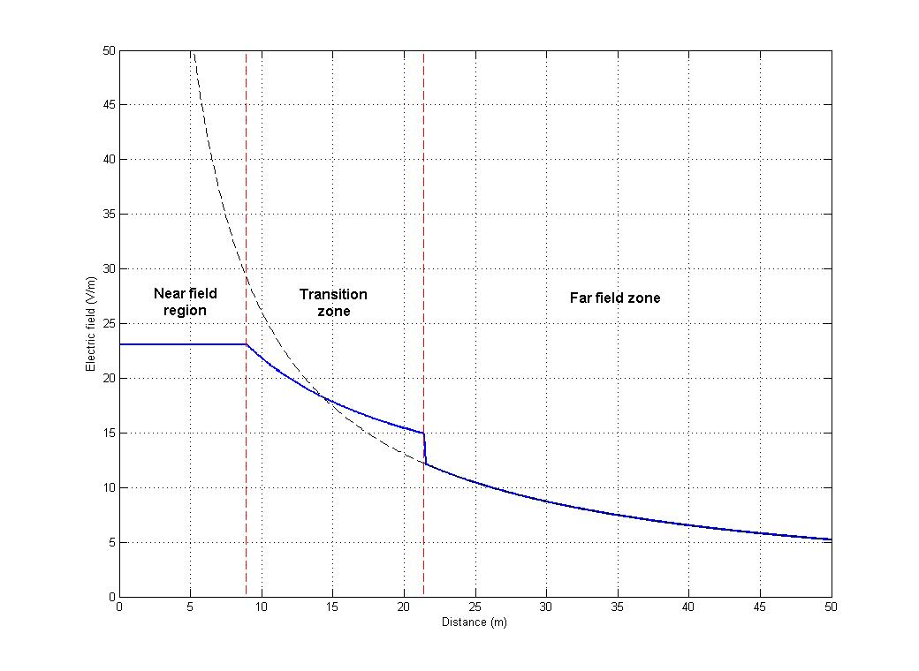
FIGURE 2
Example of radiated field from Interactive TV ES terminal

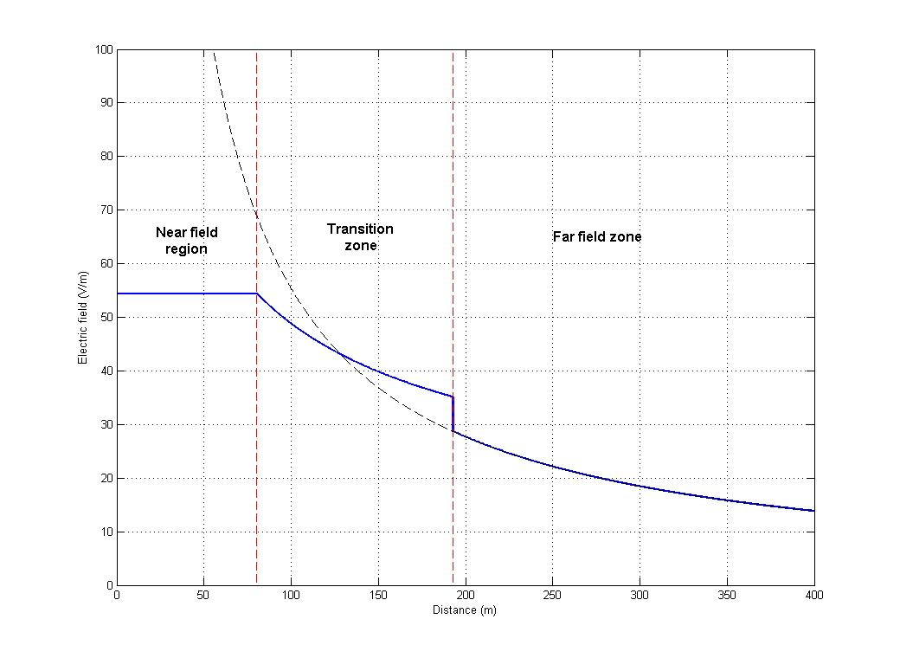

FIGURE 3
Example of radiated field from 60 dBW EIRP terminal
As it can be seen in above figures, the far-field formula is not applicable in the near-field area.

The electric field generated by terminals such as Interactive TV terminals (note the EIRP of 30 dBW) does not exceed the limit of 20 V/m after 12 meters, which means that no further coordination distance is needed apart from the already existing distance between the runway and the fence.

For the SUT terminal with an EIRP of 60 dBW, the value of 20 V/m is reached when the aircraft is located at a distance lower than 277 m from the satellite terminal in this case. This distance is in the far-field region (the lower boundary of the far-field, in this case, is at 193 m). All further calculation was made considering only the far-field region for high-EIRP terminals, which is a conservative assumption.

Relation between distance, EIRP and the electric field limit
Because the protection requirements described in section 3 are expressed in terms of the maximum electric field, in the far-field region, the distance from the satellite terminal to the aircraft is given by the following formula:
$\text{pfd}=\frac{\text{EIRP}}{4{πd}^{2}}=\frac{E^{2}}{\text{120}π}$ (7)

where
$E=\frac{\sqrt{\text{30}\text{.}\text{EIRP}}}{d}$ (8)
and therefore

(9)
where,

EIRP Equivalent Isotropic Relative Power (W),
E Field strength (V/m),
d Distance from station to aircraft (m)

FIGURE 4
Relation of the distance (between ES and aircraft) vs EIRP for various electric field values

scenario involving a single Earth station
This scenario considers a landing aircraft which follows a glide path with an inclination α.

Consider that the aircraft may cross the main beam of the ES during the descent, see Fig. 5. The scenario only deals with one single ES. The case where several ES terminals are pointing at the same time to an aircraft was considered very unlikely to occur in normal circumstances, although this could occur when a number of TES/SNG vehicles have congregated in a small area, making simultaneous transmissions to the same satellite. The main beams of two adjacent earth stations pointing to the same satellite can be assumed to be parallel as the satellite is a comparatively large distance away (approximately 36,000 km). It is therefore possible for an aircraft 40 metres in length to be illuminated by the main beams of two earth stations positioned <=40 metres apart.

FIGURE 5
Illustration of the single ES scenario

The coordination area in this case is given by a rectangular surface (see figure 6 below) whose dimensions are based on the two parameters ‘D’ and ‘a’. The equations to determine the values of ‘D’ and ‘a’ are given below.

$h=\text{tg}(α)×L$ (10)
where,
h : minimum aircraft altitude above which no interference is experienced (m)
α : glide path elevation (°)
L : distance measured on the ground between the runway threshold and the aircraft (m)

$h=d_{\text{min}}×\text{sin}(ε)+H$ (11)
where,
h : minimum aircraft altitude above which no interference is experienced (m)
d_{min} : minimum distance required between ES and aircraft (m)
ε : ES pointing elevation angle (°)
H : Difference of altitude between the runway and the ES (m)

H is assumed to be 0 m in the analysis.

The following table provides the value of h for an ES elevation pointing angle of 50°.

EIRP (dBW) | 30 | 40 | 50 | 60 | 70 | 80
d_{min} (m) | 8.7 | 27.4 | 86.6 | 273.9 | 866.0 | 2738.6
h (m) | 6.6 | 21.0 | 66.3 | 209.8 | 663.4 | 2097.9
TABLE 2
Required h for determination of a coordination area for E=20 V/m

Therefore,
$L=\frac{d_{\text{min}}×\text{sin}(ε)+H}{\text{tg}(α)}$ (12)

$D=L+\frac{a}{\text{tg}(ϕ)}$ (13)
where,
D : distance between the runway threshold and the ES (m)
L : distance measured on the ground between the runway threshold and the aircraft (m)
a : distance between the ES and the axe of the runway (m)
ϕ : difference of azimuth between the runway axe and the ES position (°)

$a=d_{\text{min}}×\text{sin}(ϕ)×\text{cos}(ε)$ (14)
where,
a : distance between the ES and the axe of the runway (m)
d_{min} : minimum distance required between ES and aircraft (m)
ϕ : difference of azimuth between the runway axe and the ES position (°)
ε : ES pointing elevation angle (°)

$D=\frac{d_{\text{min}}×\text{sin}(ε)+H}{\text{tg}(α)}+d_{\text{min}}×\text{cos}(ϕ)×\text{cos}(ε)$ (15)
where,
D : distance between the runway threshold and the ES (m)
d_{min} : minimum distance required between ES and aircraft (m)
ϕ : difference of azimuth between the runway axe and the ES position (°)
ε : ES pointing elevation angle (°)
H : Difference of altitude between the runway and the ES (m)
α : glide path elevation (°)

The value of ‘d_{min}’ is a function of the ES EIRP and the electric field limit (see equation in §4.4).

It can be seen, from equations 14 and 15, that a[m] relates linearly to D[m].

Definition of a coordination area
As a conservative approach and for simplicity, the proposed coordination area is a rectangular surface (see figure 6), whose dimensions are expressed with ‘D_{max}’ (along the runway main axis, from the touchdown point of the aircraft (the runway threshold as mentioned in section 3.2)), and ‘a_{max}’ (perpendicular to the runway main axis, from the centre of the runway), as defined in Figure 6.

‘D_{max}’ is the maximum value of ‘D’ (which is obtained for a value of ‘ϕ' of 0° and the maximum value of ‘ε’) and ‘a_{max}’ the maximum value of ‘a’ (which is obtained for a value of ‘ϕ' of 90° and the minimum value of ‘ε').

The minimum value of ‘ε’, 'ε_{min}’, is taken to be 7°. This value may be different depending on the equipment and other considerations adopted by the administration or authority (for example, ITU RR No 21.14 considers a value of 3°). Although the calculations show that the results do not vary significantly between 0 and 7°, the actual value of elevation angle can be applied in the calculation of a_{max} and D_{max} to obtain accurate results.

The maximum value of ‘ε’, 'ε_{max}’ is obtained when the difference of longitude between the ES and the satellite is equal to 0, and depends on the latitude of the ES according to the following formula:

$ε_{\text{max}}=\text{arctan}(\frac{\text{cos}({\text{lat}}_{\text{ES}})−K}{\text{sin}({\text{lat}}_{\text{ES}})})$ (16)
where,
ε_{max} : Maximum ES pointing elevation angle (°)
lat_{ES} : ES latitude (°)

and K = 6378/42166 = 0.15

‘D_{max}’ will be smaller as latitudes move towards higher values.

a_{max}
D_{max}
D_{max}
Runway
FIGURE 6
Definition of the coordination area

This coordination area assumes a terminal height (H) of 0 m and a glide path angle (α) of 3°. This value is assumed to be the typical inclination of the approach path, but there may be cases when an aircraft may be below because of particular flight conditions. In applying these results, allowance must be made for aircraft which do not exactly follow this 3° straight trajectory. For a terminal height (H) greater than 0 m the coordination area length (‘D_{max}’) has to be increased with ‘H/tan(3°)’.
- $a_{\text{max}}=d_{\text{min}}×\text{cos}(ε_{\text{min}})$ (17)
- $D_{\text{max}}=d_{\text{min}}×\left(\frac{\text{sin}(ε_{\text{max}})}{\text{tan}(3°)}+\text{cos}(ε_{\text{max}})\right)$ (18)

With $d_{\text{min}}=\frac{\sqrt{\text{30}\text{.}\text{EIRP}}}{E}$ (19)
where,
a_{max} : Maximum distance between the axe of the runway and the ES (m)
D_{max} : Maximum distance between the runway threshold and the ES (m)
d_{min} : minimum distance required between ES and aircraft (m)
ε_{min} : Minimum ES pointing elevation angle (°)
ε_{max} : Maximum ES pointing elevation angle (°), depending on the ES latitude
EIRP : ES on-axis EIRP (W)
E : required electric field at the aircraft (V/m)

Depending on the assumptions (eg EIRP, latitude,…) and the airport fence dimensions, the coordination area may fall within or outside of the airport fence.

EIRP (dBW) |  | 30 |  | 40 |  | 50 |  | 60 |  | 70 |  | 80
Latitude (°) | Elevation max (°) | D_{max} (m) | a_{max} (m) | D_{max} (m) | a_{max} (m) | D_{max} (m) | a_{max} (m) | D_{max} (m) | a_{max} (m) | D_{max} (m) | a_{max} (m) | D_{max} (m) | a_{max} (m)
40 | 44 | 121 | 9 | 383 | 27 | 1210 | 86 | 3827 | 272 | 12101 | 860 | 38268 | 2718
50 | 33 | 97 | 9 | 308 | 27 | 973 | 86 | 3076 | 272 | 9726 | 860 | 30756
60 | 22 | 70 | 9 | 221 | 27 | 699 | 86 | 2211 | 272 | 6993 | 860 | 22113
70 | 11 | 40 | 9 | 127 | 27 | 400 | 86 | 1266 | 272 | 4003 | 860 | 12659
TABLE 3
Dimensions of a coordination area for E=20 V/m

EIRP (dBW) |  | 30 |  | 40 |  | 50 |  | 60 |  | 70 |  | 80
Latitude (°) | Elevation max (°) | D_{max} (m) | a_{max} (m) | D_{max} (m) | a_{max} (m) | D_{max} (m) | a_{max} (m) | D_{max} (m) | a_{max} (m) | D_{max} (m) | a_{max} (m) | D_{max} (m) | a_{max} (m)
40 | 44 | 13 | 1 | 40 | 3 | 127 | 9 | 403 | 29 | 1274 | 90 | 4028 | 286
50 | 33 | 10 | 1 | 32 | 3 | 102 | 9 | 324 | 29 | 1024 | 90 | 3237 | 286
60 | 22 | 7 | 1 | 23 | 3 | 74 | 9 | 233 | 29 | 736 | 90 | 2328 | 286
70 | 11 | 4 | 1 | 13 | 3 | 42 | 9 | 133 | 29 | 421 | 90 | 1332 | 286
TABLE 4
Dimensions of a coordination area for E=190 V/m

FIGURE 7
Variation of co-ordination distance a_{max} vs EIRP

FIGURE 8
Variation of co-ordination distance D_{max} vs EIRP

OTHER ConsiderationS
During this study the take-off, touch-and-go, abort landing were also considered, as well as the impact of the ES sidelobes.

The results for the take-off scenario show that, because of the steeper rate of climbing of an aircraft, the potential coordination area is smaller and within the already determined area (see section 6) for the landing case provided this is applied to both directions of the runway. This coordination area is also valid for the case of touch-and-go, i.e. when an aircraft that has landed does not stop and takes off again. Additionally, it was also considered what happens when an aircraft may abort its landing and would then require to climb back over the run-way. Again here the coordination area would still be within the one already determined above. All of this is due to the fact that, whatever is the flight path, what determines the parameters of the coordination area is in effect the height (h) of the aircraft as given in Table 2 above. For aircraft being above such height it will never have the electric field exceeded, and for aircraft below such height, only the ES within the coordination area may exceed the electric field. However any refinement of the coordination areas, or assessment of individual terminals, should consider these cases in addition to the normal landing case.

The coordination area derived in section 6, because it is based on the boresight EIRP, also encompasses off-axis EIRP cases. This is because the resulting minimum distance from the off-axis EIRP is smaller than the distance associated with the boresight. However any refinement of these areas, or assessment of individual terminals, may need to consider off-axis EIRP for higher power ES.

Comparison with aeronautical radionavigation radars
This section considers the exceeding of electric field requirements of aircraft when considering aviation radionavigation radars in the frequency band 2700-2900 MHz on the ground near airfields. Table 5 gives the dimensions of the equivalent coordination area for typical radionavigation systems whose characteristics are taken from recommendation ITU-R M.1464.

 | Radar A | Radar B | Radar C | Radar D
Peak power (MW) | 1.4 | 1.32 | 0.025 | 0.45
Duty cycle (%) | 0.07 | 0.14 | 9.34 | 0.1
Mean power (W) | 980 | 1848 | 2335 | 450
Mean power (dBW) | 30 | 33 | 34 | 27
Maximum antenna gain (dBi) | 33.5 | 33.5 | 34 | 34
Mean EIRP (dBW) | 63 | 66 | 68 | 61
Electrical field limit for the aircraft (V/m) | 20 | 20 | 20 | 20
Distance plane - radar (m) | 406 | 557 | 663 | 291
Elevation for maximum gain (°) | 5 | 5 | 5 | 5
D_{max} (m) | 1076 | 1477 | 1759 | 772
a_{max} (m) | 404 | 555 | 661 | 290
TABLE 5
Methodology applied to radionavigation systems

The mean power was taken into account. Since the elevation angle is lower for those radionavigation systems, the distances found are lower than for ES.

CONCLUSION and proposals
It is considered that there is no necessity to impose an absolute EIRP or power limit on ES, provided that the necessary coordination area made a function of the EIRP. It is considered that the co-ordination area that has been applied to protect the aircrafts in the current ECC decisions can be changed to a rectangular shape, with dimensions as presented in section 6.

This co-ordination area should not been considered as an area where any ES deployment is forbidden, but as an area within which co-ordination should be effected with the relevant aeronautical authority. The analysis presented in the Annex gives an example of such procedure.

The conclusions of this report apply directly only to the protection of aircraft, which follows exactly a conventional 3° glide slope in alignment with the runway. Administrations, in consultation with civil aviation and military authorities, may need to consider other situations, such as protection of on-airfield radio systems, as well as different flight patterns (e.g. expected deviations, helicopters, or circuits), when setting co-ordination areas or assessing individual satellite terminals. It is recognised that authorities responsible for airports or military airfields may wish to co-ordinate all satellite terminals seeking to operate within their perimeter fences.

Moreover, from the obtained results, it can be concluded that exceeding the electric field requirement can only happen from satellite terminals operating in a few very specific locations (see Annex for an example). At each latitude, for each value of GSO longitude, one may find fixed values for the Azimuth and Elevation of the ES; therefore the locations where the electric field requirement is exceeded can be easily calculated and avoided.

When refining the recommended coordination areas, additional cases not covered by this report should be considered. For example flights of helicopters as well as radars or other aeronautical ground equipment. The detailed analysis of these cases is left to the responsibility of each individual Administration or Aeronautical organizations and these bodies could require a larger coordination area that would at the least encompass the whole airfield area.
ANNEX

Example of a detailed analysis for satellite equipment that may affect aircraft landing

A.1 Introduction
The report has determined a coordination area within which satellite equipment (we will also use the words Earth station (ES) for any satellite type equipment using the FSS and MSS bands) may affect aircraft (airborne or on ground) and other airport equipment. This annex tries to show, as an example, a more detailed analysis of which locations on the ground may affect aircraft during a landing approach. A similar analysis may be done for take-off and other flight conditions.

In order to make a preliminary detailed analysis of the area affected by satellite equipment operating around and inside an airport it also must be considered in detail the GSO arc seen by a satellite station on the Earth surface. This will show that in reality the coordination area derived in the report is conservative. A specific analysis of the problem is not the intent of this document and can always be done for the specific ES and specific GSO satellite orbital position.

This Annex shows that the coordination areas determined in the section 5 and 6 of the report are larger than what they should be. This is because not all of the ES position points within the coordination area with d ≤ d_{min} will illuminate the aircraft’s trajectory.

This annex is not trying to propose a new procedure or even to define a smaller coordination area, but to illustrate which points within the co-ordination area are in effect the ones that affect the landing trajectory.

A.2 Determining the potential circular area affecting aircraft landing
In section 5 of the report, Fig. 5 shows the position of the satellite stations affecting the landing trajectory of an aircraft. This figure is reproduced below in Fig. A1, and shows that for a generic elevation angle (ε) of the satellite station, the points of interception to the trajectory will be potentially located on a circumference of radius r. Let such circumference be denoted as γ(ε).

The meaning of γ(ε) is the following (see Fig. A2):
  - all locations on the circumference, are pointing to the same point of the aircraft trajectory, will be at a distance d_{min} from that point and will have the same elevation (ε) angle;

  - all locations outside of the circle γ(ε) and pointing to the same point of the aircraft trajectory will be at a distance d > d_{min} and their elevation will be smaller than ε. Those locations will not affect the aircraft at that point since d > d_{min};

  - all locations inside the circle γ(ε) and pointing to the same point of the aircraft trajectory will be at a distance d < d_{min} and their elevation will be greater than ε . Only some of those locations with ε ≤ ε_{max}, may affect the satellite trajectory at that point.

Fig. A1: Interference scenario with one ES

Fig. A2: Different positioning of ES with regards to reference circumference
A.3 The GSO arc
In the Figure A3 below it can be seen that different latitudes of ES correspond to a different GSO arc. As the ES location moves to higher latitudes both maximum of the elevation angle and the range of azimuth decreases. For example, at latitude of 35ºN the maximum elevation angle is 49.5º, while at 65ºN the maximum elevation angle is 16.7º.

The points on the GSO arc (Fig. A3) can be depicted by the polar coordinates (azimuth, elevation), or simply (α, ε), and these are a function of the latitude θ. Note that, in the following sections, α will be considered as the azimuth angle.

Also, in Fig. A4 one could see how to calculate the maximum elevation angle ε_{max} and Table A1 shows the ε_{max} for different European cities.

Fig. A3: The GSO arc

Fig. A4: Calculation of Maximum Elevation

Table A1: Maximum Elevation at Different European Cities

The Fig. A5a and Fig. A5b, show how to calculate the GSO arc (α,ε). Fig. A5c provides the formulas to determine the azimuth (α) of the point in the GSO arc when given an elevation angle (ε). This latter formula will be used later.

Fig. A5a: Geometry for the calculation of GSO arc (α, ε)

Fig. A5b: Calculation of GSO arc (α, ε)

Fig. A5c: Calculation of GSO azimuths ( α₁ , α₂) for a given elevation angle ε

A.4 Satellite station points on the ground for a given elevation
This section will try to determine which locations of the coordination area will illuminate the aircraft trajectory.

Two prior observations can be made:
- Firstly, it can be seen from Fig. A3 that, at given latitude (θ), there will be only 1 point in the GSO arc with the maximum elevation ε_{max}. This happens when the azimuth of the satellite station is pointing straight South. This means that for all the points on the circumference γ_{max}=γ(ε_{max}), only 1 point on the circumference will illuminate the aircraft trajectory, i.e. p_{max}=(α=180º, ε=ε_{max}).

- Secondly, similar to the above observation, at given latitude (θ) and at given elevation angle (ε) ε < ε_{max} , it can be seen that of all the points in the circumference γ(ε) only 2 points may illuminate the aircraft trajectory (see Fig. A7a and A7b), i.e. p₁=(α₁, ε) and p₂=(α₂, ε).

In the main body of the report, it was concluded that the size of the coordination area is dependent on ε_{max} and ε_{min}. The longest side of the coordination area is determined by ε_{max} and the shorter side of the coordination area is determined by ε_{min}.

A.4.1 Points, at elevation ε_{max}, that may illuminate the landing trajectory
Given latitude (θ), it can be seen, from Fig. A6a and A6b, that assuming an elevation angle of ε_{max} and also that d < d_{min}, there is a continuous line of points below the flight trajectory which also could illuminate the flight trajectory (since d < d_{min}). These points lie on a single straight line between the touch-down point and the 1 point that was determined above on the γ_{max}.

A.4.2 Points, at a generic elevation ε, that may illuminate the landing trajectory
Given latitude (θ), it can be seen from Fig. A7a and A7b, that for each elevation angle from ε_{max} to ε_{min} for the corresponding circles γ(ε) only 2 points on their circumferences will illuminate directly the flight trajectory.

Thus, when considering all other locations below the flight trajectory (see Fig. A7a and Fig. A7b), at the elevation angle ε and at distances d < d_{min} ,the locus of points that illuminate the flight trajectory will lie on 2 straight lines whose extremes being the touch-down point on the run-way and the two points derived in the above paragraph.

Fig. A6a: Earth station points with elevation ε_{max} and d ≤ d_{min} which may illuminate the flight path

Fig. A6b: Locus of points (on ground plane) with elevation ε_{max} and d≤d_{min}
illuminating the flight path

Fig. A7a: Earth station points with elevation ε < ε_{max} and d ≤ d_{min} which illuminate the flight path

Fig. A7b: Locus of points (on ground plane) with elevation ε_{min}≤ε ≤ε_{max}
and d≤d_{min} illuminating the flight path

A.5 Off-Axis Impact to the Coordination Area
From Fig. A2 it can be seen that when an ES points to the GSO arc, even if it is not illuminating the flight trajectory with the boresight, the off-axis emissions with off-axis angle φ may however illuminate the flight trajectory. But since the off-axis emissions are smaller than the emission at the boresight (i.e. where EIRP has maximum value) the conclusion is that those emissions will require a smaller distance d_{min} between the Earth station and the flight trajectory.

For example, taking an ES with an EIRP of 50dBW and an antenna mask, given by ITU-R S.580, at the off-axis angle of 1º, the distance d_{min} drops from 86.7 m (boresight) to 68m, and at 2º off-axis it drops further to about 32m. This means that the smaller distance d’_{min} also corresponds to a smaller radius r’. Thus concluding that the coordination area determined in the report (section 5 and 6) also covers adequately the cases of the off-axis emissions.

A.6 The real coordination area
The conclusions reached above in sections A.4 and A.5 are demonstrated below in Fig. A8, which shows for a runway with azimuth North-South, the locus lines l(ε) (as determined in sections A.4.1 and A.4.2 above) for each elevation with 1º step.

In addition to this, it can be concluded that the determination of those locus lines l(ε) is dependent on the same factors as the coordination area, i.e.:
- Electric field E (20 V/m or 190 V/m);
- EIRP of the ES;
- Latitude θ of the airport or the satellite station location;
- Satellite station minimum elevation angle, here assumed ε_{min}= 7º, and maximum elevation ε_{max} which depends on the latitude.

In addition to this set of parameters, it can also be concluded from Fig. A8, A9 and A10, that the real area of points affecting the landing trajectory is also dependent on the azimuth of the runway.

An excel spreadsheet was developed in order to calculate all the points that may affect the landing trajectory, for constant elevation angles. The results are show in Fig. A8 to A10, noting that a specific latitude was chosen (i.e. Paris CDG). For this latitude, the range of elevation angles varies from the maximum of 33.8º to the minimum of 7º, in steps of 1º. Here it was assumed an ES with an EIRP of 50 dBW. Note that the locus points l(ε) would change for other values of ES parameters, e.g. EIRP.

Thus:

- Fig. A8 shows the resulting area of points that affect the trajectory of the landing aircraft. This area is for a runway that is North-South, i.e. Azimuth of 0º from North. Also it can be seen the coordination area determined in the report;

- Fig. A9 shows the same scenario, but for a runway that is East-West, i.e. Azimuth of 90º from North. Here the area is only half of the coordination area.

- Fig. A10 shows the same scenario, but for a run-way that is with Azimuth of 150º from North.

From this analysis and figures it is seen that the set of real location points affecting the aircraft landing trajectory is smaller than the coordination area derived in Sections 5 and 6 of the report.

A.7 Conclusion
From the analysis in this Annex it can be concluded that when a detailed analysis is performed, the ES locations within the coordination area that potentially affect airborne aircraft (i.e. exceed the electric field requirement) is smaller than the coordination area itself.

Nevertheless, the detailed analysis for the coordination of a specific ES with specific radio characteristics shall be left to the individual concerned Administrations or aviation authorities.

Fig. A8: ES locations affecting the flight trajectory (run-way North-South; Az. 0º North)
(assumptions given in the figure)

Fig. A9: ES locations affecting the flight trajectory (run-way East-West; Az. 90º North)

Fig. A10: ES locations affecting flight trajectory (run-way Az. 150º from North)

