
Electronic Communications Committee (ECC)
within the European Conference of Postal and Telecommunications Administrations (CEPT)

MEASUREMENTS USING FAST FOURIER TRANSFORM (FFT)

Utrecht, January 2005

EXECUTIVE SUMMARY

This report describes the benefits of Fast Fourier Transform (FFT) measuring methods for radio monitoring services. Some practical measurement systems are introduced as example applications. Looking at these applications it becomes evident that there could not be one single FFT measurement system that fulfils all different measurement needs of a monitoring service because this would require recording of a very large part of the spectrum for as long as several days with very high frequency and time resolution for off-line analysis. Neither the necessary bandwidths of the digitisers nor the mass storage devices required are available today or in the near future. It seems, however, that, apart from some special applications (eg measurements below the noise floor), the most common FFT measurements could be broken down into two different kinds of applications:
- long-term spectrum observation and occupancy measurements
- signal detection and analysis
Due to different measurement aims, both applications need different prerequisites for the FFT system.
I. Long-term spectrum observation and occupancy measurements
For this application a long recording time of several days or even weeks is most important. The time resolution only needs to be in the range of the standard duration of a transmission (seconds or even minutes) since we do not want to do a modulation analysis. However, frequency resolution should be high enough to allow exact frequency measurements, especially with regard to HF observations. To reduce the amount of data, the frequency domain information could be stored with a resolution of 2048 or 4096 lines. This means that the FFT is done on-line and only its result is saved. Actual frequency and time resolution would then depend on parameters defined at the beginning of the observation such as frequency range and observation time.
II. Signal detection and analysis
For this application, only short-time recording in the range of seconds to several minutes is necessary. For the off-line signal analysis, a high time and frequency resolution is needed. Whereas the detection of short signals always requires a high time resolution for the whole spectrum, the modulation analysis is only done on one specific signal at a certain frequency so that the necessary bandwidth for this task could be rather small. To cover these different FFT needs it is essential that the time data are recorded and that all FFT calculations are performed off-line.
Although the theory of FFT is not new, it is getting more and more important for radio monitoring applications as faster ADCs and DSPs become available. The examples in this report show that some measurement tasks can be performed much faster when using FFT. Others, e.g. off-line modulation analyses, are not even possible without it.
INDEX TABLE
1 Basics 4
1.1 Analogue to Digital Conversion 4
1.1.1 Principle 4
1.1.2 Problems and limitations of the ADC process 5
1.2 Fast Fourier Transform 5
2 Important parameters that can be measured with FFT 6
2.1 Level 6
2.2 Frequency 6
2.3 Occupied Bandwidth 7
2.3.1 The“x-dB” method 7
2.3.2 The “β/2” method 7
2.4 Modulation parameters 8
3 Examples of monitoring tasks that can be performed using FFT 9
3.1 Spectrum Occupancy Measurements 9
3.1.1 Band registrations 9
3.1.2 Frequency Channel Occupancy Measurements 9
3.2 Detection of short time emissions 10
3.3 Detection of signals below the noise floor 12
4 Examples of existing applications 13
4.1 Frequency Occupancy Measurements 13
4.1.1 System description 13
4.1.2 Advantages due to FFT 13
4.1.3 Technical specifications 13
4.1.4 Sample measurement result 14
4.2 Spectrum Analysis 15
4.2.1 System description 15
4.2.2 Advantages due to FFT 15
4.2.3 Technical Specifications: 15
4.2.4 Sample measurement result 15
4.3 Modulation Analysis 16
4.3.1 System description 16
4.3.2 Advantages due to FFT 16
4.3.3 Technical specification 16
4.3.4 Sample measurement results 17
4.4 Detection and analysis of frequency agile, short emissions 18
4.4.1 System description 18
4.4.2 Advantages due to FFT 18
4.4.3 Technical specifications 18
4.4.4 Sample measurement results 19
4.5 Signal Detection below the Noise Floor 21
4.5.1 System description 21
4.5.2 Advantages due to FFT 21
4.5.3 Technical Specifications 21
4.5.4 Sample measurement results 21

- Basics
Whenever a signal is to be transformed from time domain into frequency domain, a mathematical method called Fast Fourier Transformation (FFT) can be used. This method is based on the fact that any real signal, irrespective of its waveform, can be constructed by adding up a number of sine wave signals of different amplitudes, frequencies and phases. Consequently, any received time signal can be broken up into a number of different sine waves in the frequency domain.
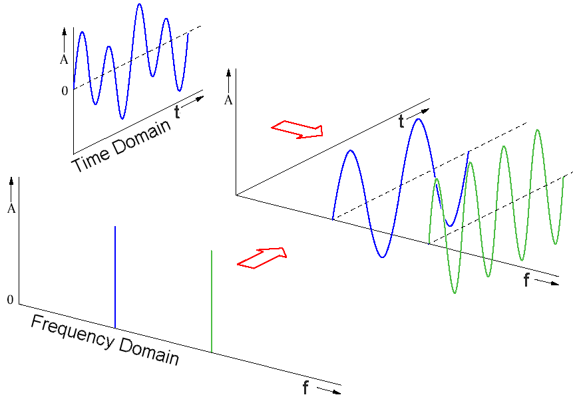
Being a mathematical process, FFT is best performed by a digital signal processor (DSP), which basically is a special computer. For this purpose, the time signal has to be present in digital form. This is done by analogue-to-digital converters (ADC).
Whereas the FFT method at first sight seems to be the best way to solve all signal analysing problems, there are certain restrictions as well as measurement uncertainties which originate from both the ADC process and the FFT itself. To understand these restrictions, a short look into the principles of ADC and FFT is necessary.

Analogue to Digital Conversion

Principle
An analogue signal is converted into a digital signal by taking samples of its current amplitude during a certain period of time. The time between two samples has to be less than half the period of the highest frequency to be digitised. The output of the ADC is a bit stream in which a number represents the amplitude of the original signal at the time of each sample.
ADC output:
0.5
0.9
0.7
0.0
-0.7
-0.9
-0.5
0.3
...

Problems and limitations of the ADC process
The accuracy of this digital representation depends on the number of bits reserved for each amplitude value. A typical ADC resolution is 18 bits, resulting in 262,144 different amplitude steps. Although the discrete amplitude values cannot accurately represent the original signal, the error due to this effect can be minimised by proper selection of the spacing between two steps (narrow spacing at low, wide spacing at high amplitude values). This way, the dynamic range of the digitised signal can be better than 100 dB (for single carrier analysis).
Frequencies higher than twice the sample rate would be “undersampled”, resulting in additional frequency components in the digitised signals that are not part of the original signal. To avoid this error, it is essential that the analogue signal is fed through a low pass filter placed before the ADC.
In principle, the accuracy of the digitising process is therefore only limited by the speed of the ADC unit. Today, ADC chips allowing for signal frequencies of up to 20 MHz and a digitisation depth of 18 bits are available. To analyse higher frequencies, the RF signal first has to be down-converted to a range that can be digitised. The maximum frequency of the ADC represents the maximum bandwidth of the following FFT process.

Fast Fourier Transform
Before the mathematical FFT process can be applied, a certain amount of data representing the waveform has to be stored in memory as a so-called “time record”. The minimum duration of this time record is the period of the lowest frequency to be processed. The time this takes is called collection time. Then the whole waveform is analysed in one go and mathematically converted into a series of sine waves of different amplitudes, frequencies and phases. The result is an analysis of the whole spectrum part at a certain point in time.
The FFT procedure implies that the collected signal is continuously present for an infinite time. This means that the result is based on the assumption that the collected waveform in the time record repeats itself over and over. If the amplitude of the original signal is not zero at the beginning and the end of the time record, the FFT will compute a result for a waveform having sharp edges at every collection interval. This effect can be shown by the example of a simple sine wave signal:

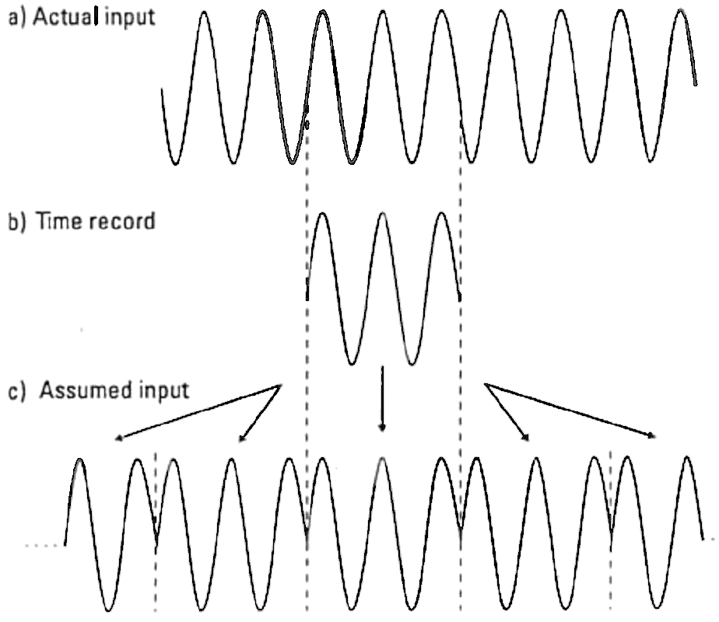
The FFT result of this assumed input would have a number of spectral lines and give unacceptable errors. To prevent such errors, the signal has to be fed through a filter that forces the amplitude to be zero at the beginning and at the end of each time record. This “time filter” has to be applied to the digitised signal and is therefore also a mathematical process. It is called windowing.
In case of signals that fall completely within one time record, the amplitudes at the beginning and at the end are already zero. These signals are called self windowing. To analyse them accurately with FFT, no extra windowing has to be applied (sometimes this is called applying a rectangular window): examples of this kind of signal are spikes occurring only once and bursted digital signals, as long as the burst lies completely within the time record.

For continuous signals, however, it is quite obvious that we alter the original waveform due to the need for windowing, and always introduce a certain error. This error lies in the principle of the FFT and cannot be completely avoided. However, depending on the parameter to be measured (amplitudes, frequencies, phases), this error can be minimised by choosing a proper shape of this filter, called window function. Two main types of window functions are common here:
- Hanning
- Flattop
The Hanning window function looks as follows:

Although it offers good frequency resolution, the Hanning window suppresses considerable parts of the total amplitude of a continuous signal. It is therefore the best choice for transient signals and for cases in which frequency resolution is important, but not for accurate level measurements.
The Flattop window equally weighs a good part in the centre of the time record and suppresses the amplitude only towards the edges:

Because of its shape, this window offers less frequency resolution but better amplitude reproduction. It is therefore the best choice for amplitude measurements on continuous signals.
With this information it is obvious that there cannot be one single window type that is a good choice in all cases. One always has to consider the kind of signal to be analysed (transient or continuous) and the aim of the measurement (frequency resolution or amplitude) in order to find a window that offers the best compromise.
Another limitation due to a principle of FFT is the time it takes to collect the signal and compute the FFT which is not infinitely short. This means that we cannot achieve a real time representation of the spectrum (there will always be a certain delay between receiving the signal and seeing the results of the FFT), but for most monitoring tasks this delay can be neglected.
- Important parameters that can be measured with FFT
- Level
One of the most important monitoring parameters of a signal is its level. Since its value can always be measured with conventional methods from the voltage after the detector, it can also be derived from the results of an FFT with acceptable accuracy. When measuring digital signals, it is often necessary to measure the peak and the RMS value of the signal. Whereas true RMS detectors are very expensive, this value can also be calculated by analysing the digitised signal components.

Frequency
Another important monitoring parameter of an unknown signal is the centre frequency. For analogue modulations, this is the frequency of the unmodulated RF carrier. While this frequency can also be measured conventionally in such cases (for example with a frequency counter), the FFT method usually offers accurate results in a shorter time.
For modulated signals, the frequency counter method only works correctly if the spectrum is assumed to be symmetrical, whereas the FFT method can provide the centre frequency of a spectrum regardless of the modulation.
For digital modulations, the centre frequency can only be determined by examining the resulting spectrum, which can easily be done after an FFT. Frequency counter methods will not work here.
In multi-carrier systems such as DAB, FSK or systems using sub-carriers, the FFT also delivers the frequency of each of these components very accurately. This also applies to systems that are modulated with discrete frequencies such as aeronautical beacons (A2A) where the exact modulation frequencies can be measured.
Considering that an increasing number of signals to be measured by monitoring services use digital modulation, the only method left for determining the centre or carrier frequency will be the analysis of the RF spectrum, which will make FFT more and more important.

Occupied Bandwidth
In theory, any real signal has an infinite bandwidth. This fact is exemplified by modulated signals with Gauss-shaped spectrum or even pulsed signals such as radar or amplitude shift keying:
RF spectrum of an (unfiltered) ASK system

For the monitoring service, the so-called 99% bandwidth is most important. This is the bandwidth in which 99% of the total emitted RF power lies. Although this definition serves well for frequency planning (the remaining 1% is neglected and the signals are handled as band-limited), it is virtually impossible to measure this bandwidth exactly. Two different methods are commonly used instead:

The“x-dB” method
Using a spectrum analyser, this method measures during a first run the total power with a wide resolution bandwidth (RBW) which is then set to be the reference power. Then, the spectrum is again recorded with a smaller bandwidth and markers are placed in such a way that the level at the marker points is a certain amount (namely x dB) below the previously determined reference level. The bandwidth is then the frequency difference between the two markers. In order to give a result as close as possible to the true 99% bandwidth, the value of x is different for every type of analogue modulation. In many cases, especially in the case of unknown signals, the x-db method does not seem to be usable for the monitoring service because it requires detailed knowledge of the signal before the 99% bandwidth can be measured.
The situation becomes even worse for digitally modulated signals. If the reference level is determined with a wide RBW as described above, the suppression in level due to the smaller RBW in the second run will depend on the bandwidth of the signal. Therefore, the value of x to set the markers is no longer constant but depending on the parameter itself that we want to measure (namely the bandwidth of the signal). To overcome this problem, we can measure the reference level and the spectrum for setting the markers with the same RBW. But then, again, the value of x depends on often unknown parameters of the signal such as modulation type and base band filtering.

The “β/2” method
This method scans the spectrum only once with a narrow RBW. Then, the spectral power (or level) of each line of the analyser’s display is added throughout the whole recorded frequency range to give the 100% reference power. In a second calculation, starting from the lowest frequency recorded, the spectral power of each display line is again added up until the sum reaches 0.5% of the previously determined total power. At this point, a marker is set. The same calculation is then performed starting from the highest frequency recorded (the right end of the display) until again 0.5% of the total power is reached and a second marker is set. The 99% bandwidth is the frequency difference between the two markers.
Although this method is in principle able to determine the exact 99% bandwidth of any signal, a few considerations have to me made:
- The RR 1.153 definition relates to the momentary bandwidth of a signal. If a sweeping analyser was used, changes of the signal during the sweep time would result in a corruption of the displayed spectrum. An FFT, however, will record the spectral power density (PSD) for all frequencies in the spectrum at the same time and thus give a more accurate result.
- For the integration of the PSD, the whole recording range is divided up into many spectrum parts, the number of which is equal to the resolution of the graphical display of the analyser or its internal trace memory. To give an accurate PSD result, the level of each spectrum part has to be recorded with a filter that ideally needs to have rectangular shape. The width of this filter (RBW) has to be wide enough to capture the entire spectrum part but narrow enough not to overlap with the next part. It is obvious that these assumptions can not be exactly met by analogue filters but realized when using FFT.
- To achieve good accuracy, the spectrum recording has to consist of as many lines as possible (several hundreds). Using sweeping analysers, the necessary narrow RBW filters force a very long sweep time which make the measurement rather slow. For example, if a spectrum of 1 kHz is to be recorded with 10 Hz resolution, the necessary RBW filter of 10 Hz requires 0.1 s on every line of the spectrum which results in a sweep time of over one minute. An FFT with 0.1 Hz resolution, however, will only require the signal to be recorded for 0.1 s. Assuming fast calculation speeds of modern computers, the result can be seen shortly after 0.1 s.
Taking these considerations into account, the FFT approach of the β% method should be preferred when measuring the bandwidth of unknown modulated signals.

Modulation parameters
As mentioned above, spectral parts of the signal that are due to the modulation can be measured exactly using FFT. In many cases it is therefore possible to determine the type of modulation of an unknown signal which greatly helps monitoring services to identify a station. Real-time measurement of modulation parameters on a known frequency is typically done with vector analysers using FFT. These analysers enable different displays such as polar diagrams and visualise the phase of the RF carrier at certain points in time (constellation diagrams). Example: With the display of a sweeping analyser, one can not distinguish between a fast MSK and a PSK or QAM as all of them basically have the same spectrum. Using a vector analyser, the constellation diagram easily shows the type of modulation. A display of the carrier phase vs. time also allows to measure the symbol rate of a PSK.
Modulation analysis of signals on unknown frequencies in a certain bandwidth can be performed by recording and storing the time signals of the whole band and performing the FFT analysis at a later time (off-line). Using this method, it is also possible to apply certain mathematical functions on the time signals before the FFT process in order to reveal characteristics of certain modulations. For example, an MSK signal usually has a spectrum similar to a PSK. However, when squaring the signal in the time domain, the following FFT shows two characteristic peaks with a frequency difference that even allows to determine the symbol rate:
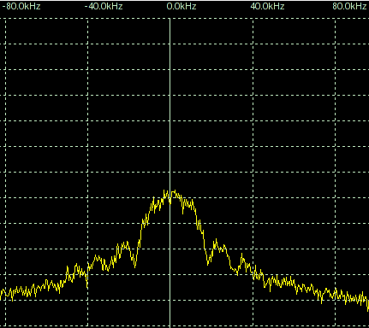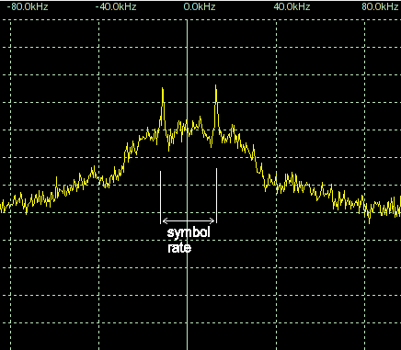
Left: normal spectrum of a GMSK signal. Right: spectrum of the square values of the same
time signal with peaks revealing the symbol rate.
- Examples of monitoring tasks that can be performed using FFT

Spectrum Occupancy Measurements

Band registrations
A common task of monitoring services is to determine the occupancy of certain frequency bands. This is mainly done for HF bands where the database of national assignments does not reflect the actual usage because international stations can be received well. The expected presentation of the results is a spectrogram with frequency vs. time where occupied frequencies will appear as dots or lines in different colours depending on the received field strength:
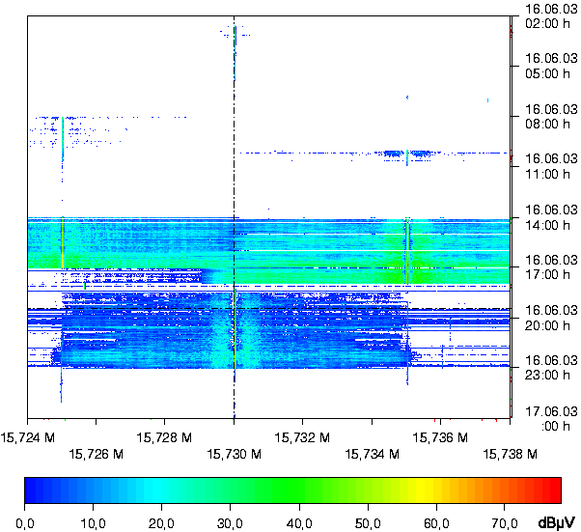
If this display has sufficient resolution, it can not only be used to determine the on and off- times of a transmitter, but also for frequency measurements.

Frequency Channel Occupancy Measurements
To determine the traffic load especially of shared frequencies, the pure information of the number of stations assigned is not sufficient if the question arises whether that frequency is “full” or can take more stations. This information can only be the result of measurements. Ideally, a measurement receiver will be tuned to that frequency and continuously register the level in order not to miss any transmission. To make better use of the measurement equipment, it is feasible that this measurement is done automatically and covers many channels at the same time. Using conventional scanning methods, the receiver only looks into each channel for a short time and scans the others in between. The accuracy of the result valid for short transmissions on each channel is then dependent on
- the re-visit time (depends on scanning speed and number of channels measured)
- the number of measurement samples (depends on re-visit and total observation time).
If FFT could be used, the whole frequency range would be captured as a whole (at the same time), resulting in a parallel measurement of all channels. The re-visit time is now only dependent on the computation speed and generally much faster. This method leads to more accurate results in a much shorter observation time. Very short transmissions (like data telegrams) may only be measurable using FFT.

When larger mobile networks are converted from analogue systems with discrete frequencies to digital trunked systems and therefore the number of traffic channels in the new system has to be determined, or when the maximum actual occupancy of a trunked system with dynamic channel allocation has to be measured, it is important to know how many frequencies are used simultaneously. FFT techniques are capable of determining the number of simultaneously occupied traffic channels. The result is a diagram that shows this number vs. time as in the following example.

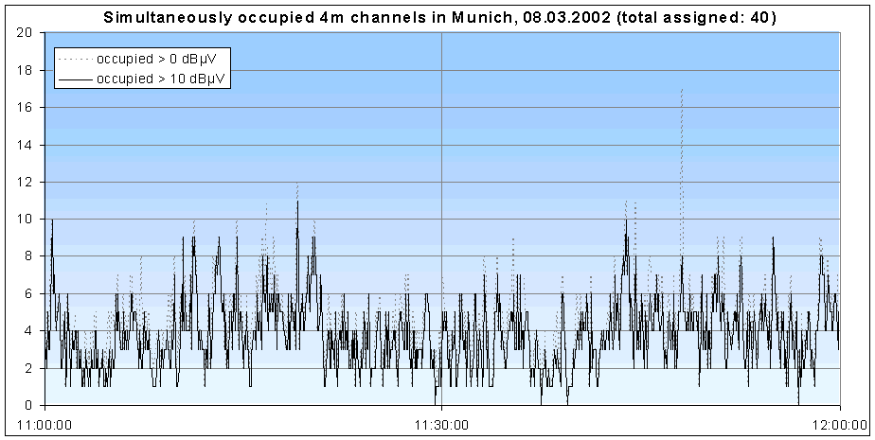

If the number of scanned channels is not too high and very fast scan speed of the receiver is available, the measurement can be done using conventional scan methods with a limited accuracy in case of short transmissions: It has to be assumed that once the first channel was measured as occupied, it is still occupied when the measurement receiver reaches the last channel in the list. For accurate results, however, all frequencies in question would have to be measured at exactly the same time which is only possible using FFT.

Detection of short time emissions
One of the main simple measurement tasks of monitoring services is the detection of a transmission in a certain frequency band. This could be both wanted and interfering signals. With an increasing number of digital systems using frequency hopping, TDMA and collision avoidance by dynamic frequency selection, it is more often the case that a transmitter will come up for a very short burst time only and on an unknown channel. If conventional methods are used (sweeping spectrum analyser or receiver scan), the relation between burst time, frame length and sweep time of the receiver/analyser could lead to the situation that the transmission is never detected. At best, it will take a relatively long time until the spectrum is filled. Using FFT analysis, however, the spectrum can be measured very fast. If parallel processing of digitising and FFT calculation is used, the transmission is even detected at every burst. For best recognition, the result would have to be displayed in a spectrogram that displays frequency over time and shows detected emissions in different colours depending on their level:
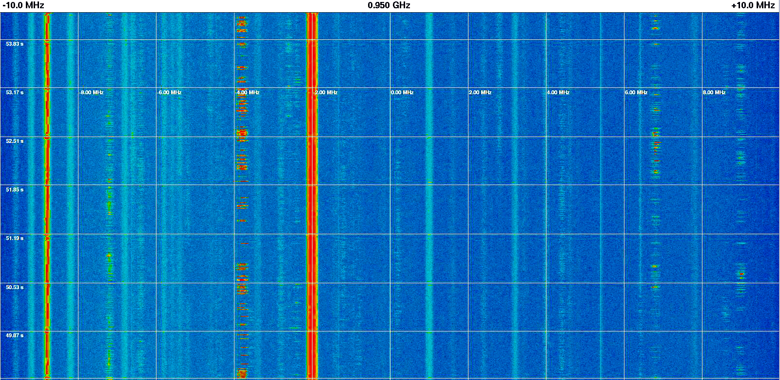

In case very short emissions like single bursts of digital TDMA systems have to be detected, two problems arise:
- The spectrogram scrolls too fast for an operator to follow and notice emissions
- The time resolution of the analysis or display may be too low to show a single burst
To achieve a fast reaction of the system to short emissions, the display has to scroll very fast so that the result of real-time measurements of the detected emissions will disappear before an operator notices them. The only way to prevent this effect is to record all sampled data on a mass storage device and analyse it at a convenient speed later (off-line). If the digitised time signals are stored instead of the spectrum data, the actual FFT can also be performed off-line. This way various further measurements on the detected signals can be performed because it allows FFTs with different parameters optimised for the respective analysis task.
The second problem is mainly due to a principle of the FFT, namely a dependency between frequency and time resolution: For good frequency resolution, the time record has to be long, resulting in a poor time resolution. If the time signal data is stored and the FFT is done offline, one way to overcome this problem is to apply the FFT on relatively long samples that overlap each other:
Burst duration
A

t

1
2
3
Time records for the FFT
4
5
6
t

To reproduce the true amplitude of all components of the signal, the minimum time record length is equal to the burst length. By placing the time records with a 50% overlap, the final time resolution of the result is doubled.
Both problems mentioned above are best resolved by recording and storing the time data and perform all analysis tasks at a later time.

Detection of signals below the noise floor
Especially in the GHz range, transmitters often use directional antennas with very close aperture so that the signals can practically be detected only if the receiver is inside the main beam. Sensitive receiving antennas have a high directional characteristic too so that the situation for the monitoring service gets even worse. Satellite communications using GHz frequency ranges also produce very weak signals due to low transmit powers and very large distances to the receiver. In any case, sensitivity is the main issue when monitoring signals above 1 GHz. But also when seeking signals at lower frequencies, for example in interference situations, it would be feasible to have very sensitive measurement equipment. Apart from background and atmospheric noise, the noise figure of any receiver limits the sensitivity. However, applying a special FFT measurement procedure allows us to detect signals even below the noise floor:
The spectrum including the hidden signal is sampled some thousand times and the FFT results of each record are averaged. This way, the signal peaks of all noise components that have a Gaussian distribution shape cancel each other. In a second measurement cycle, the same spectrum part is again sampled and averaged in the same way, but without the hidden signal. Both averaged curves are then subtracted which cancels all noise components that have been present during both measurements. What is left is the hidden signal with an s/n ratio that is improved by as much as 10 to 20 dB:
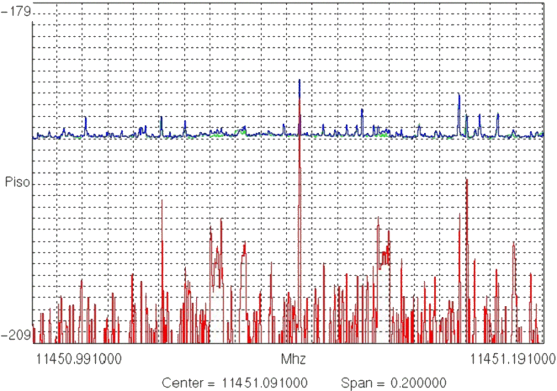
- Examples of existing applications

Frequency Occupancy Measurements

System description
The system consists of a VXI based computer running Linux and containing a specially designed digitiser and FFT board. Signals below 2 MHz are fed directly from the antenna into the digitiser, signals above 2 MHz are down converted by a receiver. Control of the receiver is done by the computer. The user interacts with the system using a terminal that is connected to the central computer via LAN (TCP/IP). Data is recorded on hard disk. Multiple frequency ranges can be registered quasi-parallel and evaluated online or offline.

Advantages due to FFT
Faster sweep times, needed here because a wide band has to be registered with high frequency resolution.

Technical specifications
Frequency range: 1 kHz to 2.6 GHz, up to 3.7 MHz direct processing with DSP (no Rx)
Dynamic range: 70 dB
Digitiser bandwidth: 4 MHz
Digitiser resolution: 18 bit
FFT resolution: 1024 lines, equivalent frequency resolution 0.5 Hz to 40 kHz
FFT processing time: 2 ms
FFT level accuracy: 0.5 dB, 241 steps between 0 and 120 dBµV
Maximum bandwidth of a single observation range: 3.7 MHz
Re-visit time: 12 s

Sample measurement result

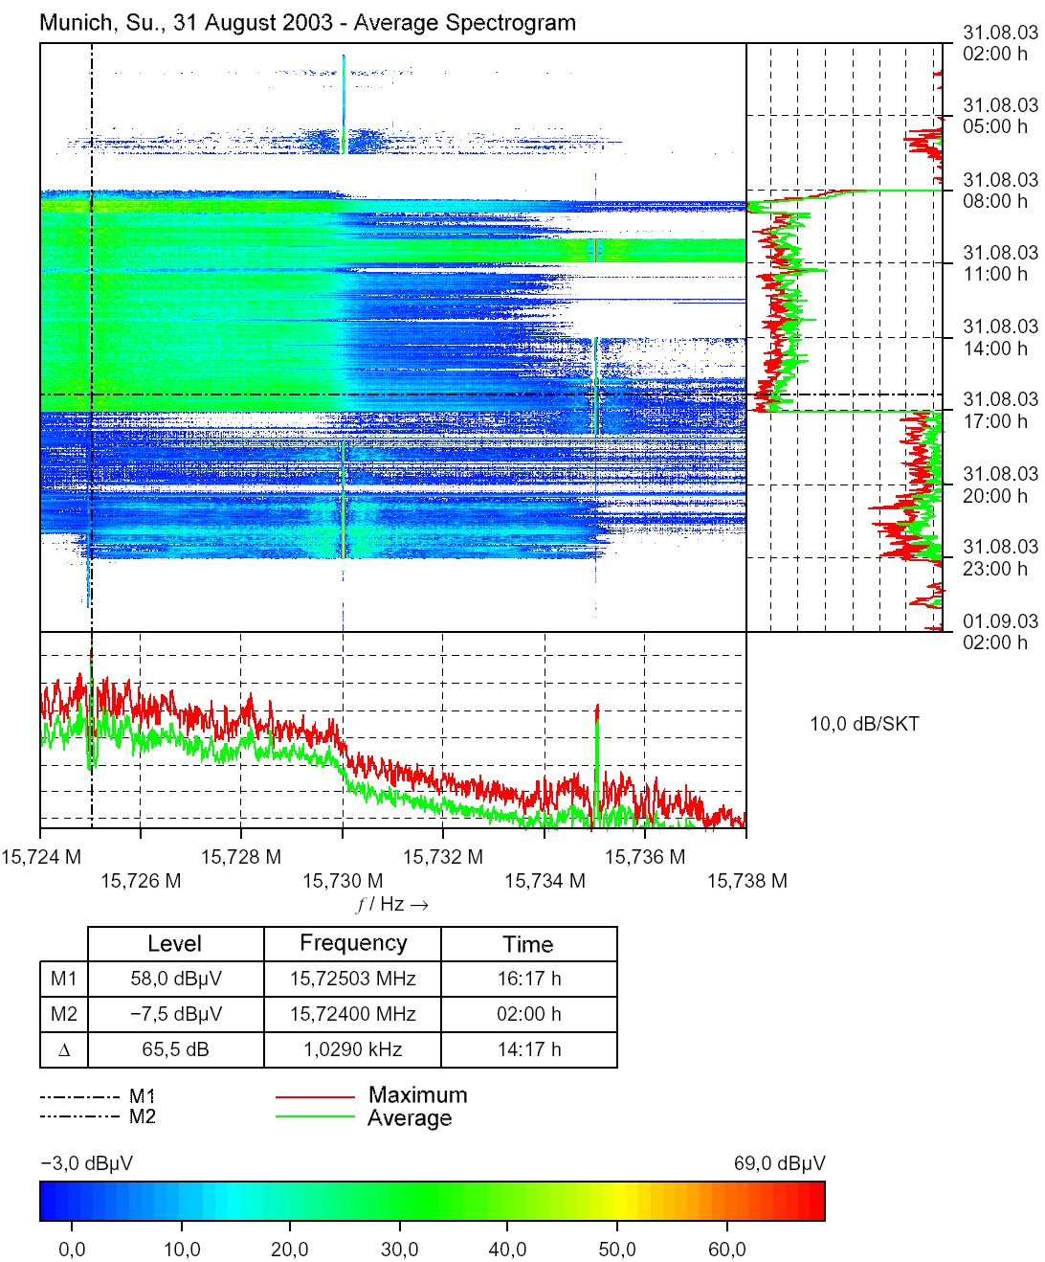
M1

FFT spectrogram of a 14 kHz wide part of the 15 MHz frequency range. The diagrams right and bottom show the level and spectrum at the current marker position (M1).

Spectrum Analysis

System description
This is a readily available spectrum analyser that can use FFT and digital filters at resolution bandwidths up to 1 kHz. In addition to the features of a sweeping spectrum analyser, it can be switched into vector analysing mode where it allows various measurements of modulation parameters including I/Q demodulation and display of the bit stream. The parameters needed for many digital standards are preset in memory and can easily be recalled.

Advantages due to FFT
- Vector analysis only possible with FFT because phase information is required
- Faster sweep times especially with high resolutions (equal to narrow RBW)

Technical Specifications:
Frequency range: 1 kHz to 40 GHz
Digitiser bandwidth: 6.4 MHz
Digitiser resolution: 12 bit
FFT resolution: 500 lines, equivalent frequency resolution 1 Hz to 4 kHz
FFT level accuracy: 2-3 dB
Maximum bandwidth of a single FFT range: 4 kHz
Wider frequency ranges are realized by calculating and combining multiple FFTs in sequence.

Sample measurement result

A

U
n
i
t
d
B
m
R
e
f

L
v
l
-
4
0

d
B
m
R
e
f

L
v
l
-
4
0

d
B
m
R
F

A
t
t

1
0

d
B
C
e
n
t
e
r
8
.
1
1
2
9
6
8
7
5

M
H
z
S
p
a
n
5

k
H
z
5
0
0

H
z
/
R
B
W

3
0

H
z
S
W
T

2
7
0

m
s
1
V
I
E
W
1
S
A

-
1
3
0

-
1
2
0

-
1
1
0

-
1
0
0

-
9
0

-
8
0

-
7
0

-
6
0

-
5
0

-
1
4
0

-
4
0
D
a
t
e
:

2
7
.
A
U
G
.
2
0
0
3

0
9
:
3
3
:
4
5
Average spectrum of a digital HF system with 30 Hz resolution. Using an FFT filter, only 270 ms sweep time is needed. An analogue filter with the same resolution requires 28 s sweep time, increasing the analysis time by a factor of 100.

Plot of the demodulated I/Q signals of a GSM signal (amplitude vs. time). The dots mark the decision times used to decode the symbols. This diagram is provided by vector analysers using amplitude and phase information available after the FFT.

Modulation Analysis

System description
The system consists of a standalone, portable rack that contains a two channel digitisers, computer with hard and floppy disk drives, keyboard and built-in monitor. For more convenience, an external monitor and keyboard can be connected. Data can be documented on a colour printer. The inputs are connected with the IF output of a receiver. The signals can be recorded on disk and replayed for off-line analysis. The system also allows output of the recorded time signal after editing at any time. The software allows virtually all kinds of analysis of the signal in various display formats.

Advantages due to FFT
Analysis of digital modulation is only possible using FFT.

Technical specification
Frequency range: 0 to 70 kHz
Dynamic range: 80 dB
Digitiser bandwidth: 70 kHz
Digitiser resolution: 16 bit
FFT resolution: 1024 lines
FFT level accuracy: 2 dB

Sample measurement results

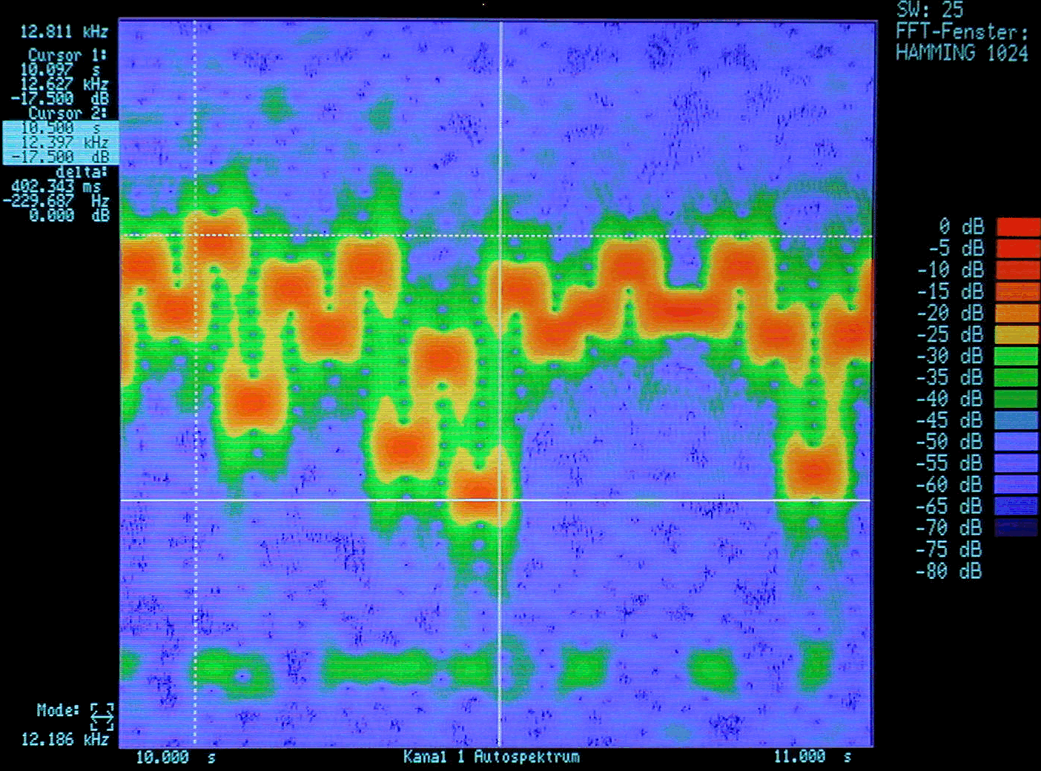
Top: Analysis of an F9 system in the HF range. Instantaneous frequency vs. time is displayed. The horizontal cursor lines mark the highest and lowest frequency.

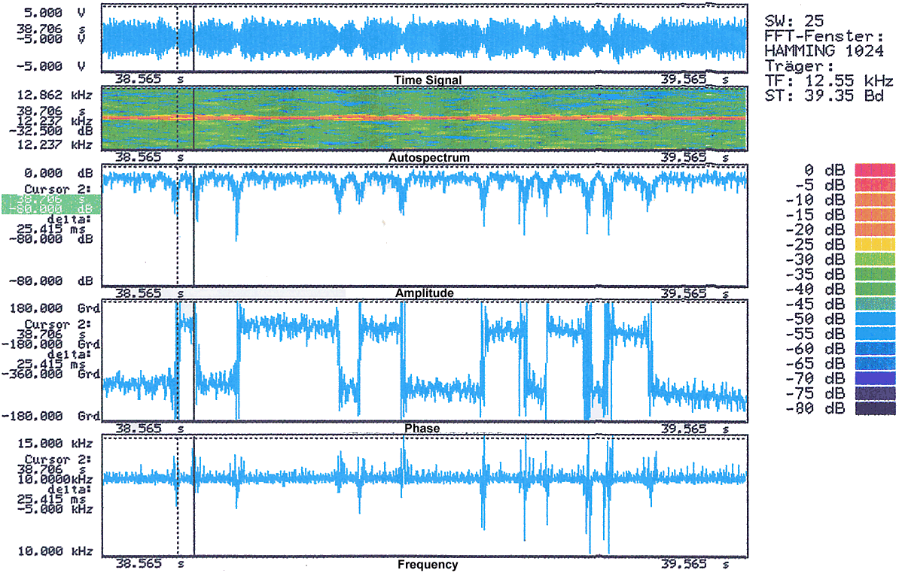
Left: Analysis of one second of a
2-PSK modulated HF signal

Detection and analysis of frequency agile, short emissions

System description
The system consists of a VXI based mainframe incorporating the receiver, high-speed wideband ADC and DSP. Memory and hard disk space for recording and user interface for off-line analysis are provided by a PC based workstation.
A time signal sample from the receiver’s IF in a frequency band of 20 MHz width is recorded and stored. While on-line overview of the activity in the band is possible through a live spectrogram, the main process of FFT, signal detection and analysis is done off-line. The first step consists of transforming the time-signal into frequency domain. Within the resulting spectrogram (also sometimes called a sonogram), burst parameters such as time length, bandwidth or gap periods between bursts can be determined. Burst(s) of interest can be selected within the sonogram for a numerical analysis. Using a Software-DDC (digital down converter), a narrowband FFT (bandwidth range: 25 kHz – 500 kHz) can be calculated, allowing accurate modulation analysis with a high time/frequency resolution.

Advantages due to FFT
This measurement principle can only be realised using FFT

Technical specifications
Frequency range: Receiver: 20 MHz – 3.6 GHz
Dynamic range: 80 dB
Digitiser bandwidth: 20 MHz
Digitiser resolution: 14 bit
FFT resolution: 512 - 16,384 lines
FFT level accuracy: 3 dB (typical)

Sample measurement results

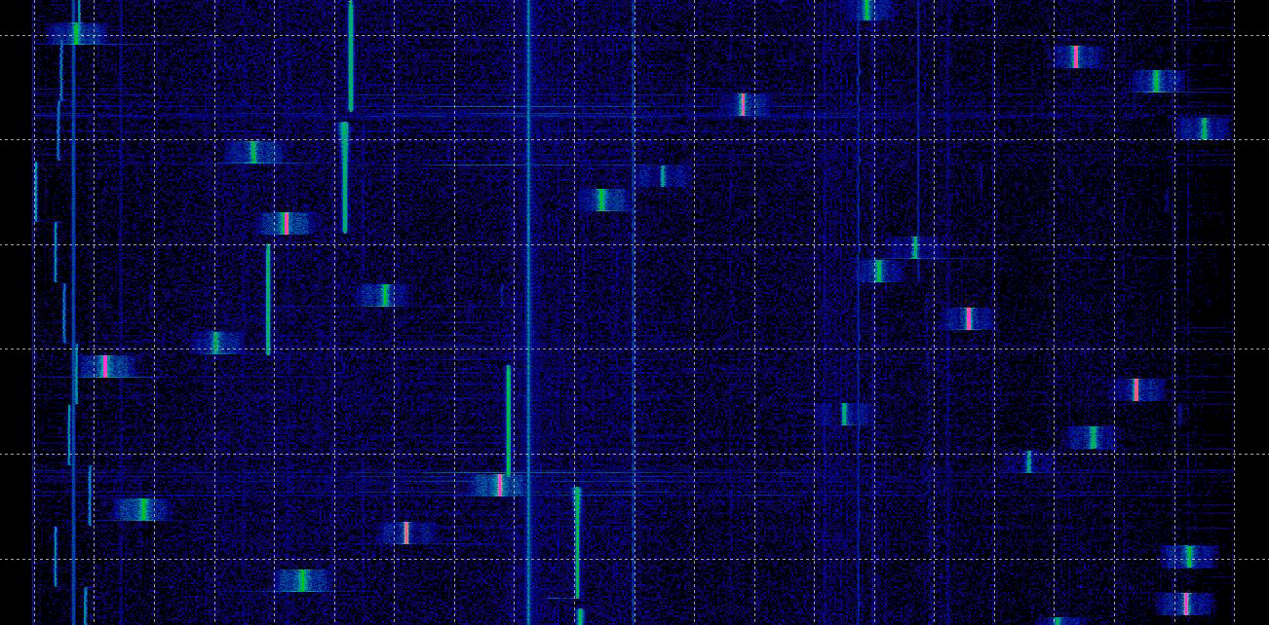
1
2
3
Sonogram of stored data (frequency over time, bandwidth 20 MHz) with three different frequency agile systems working in the same band. (Only a few portions of the emissions 1, 2 and 3 are labelled.)

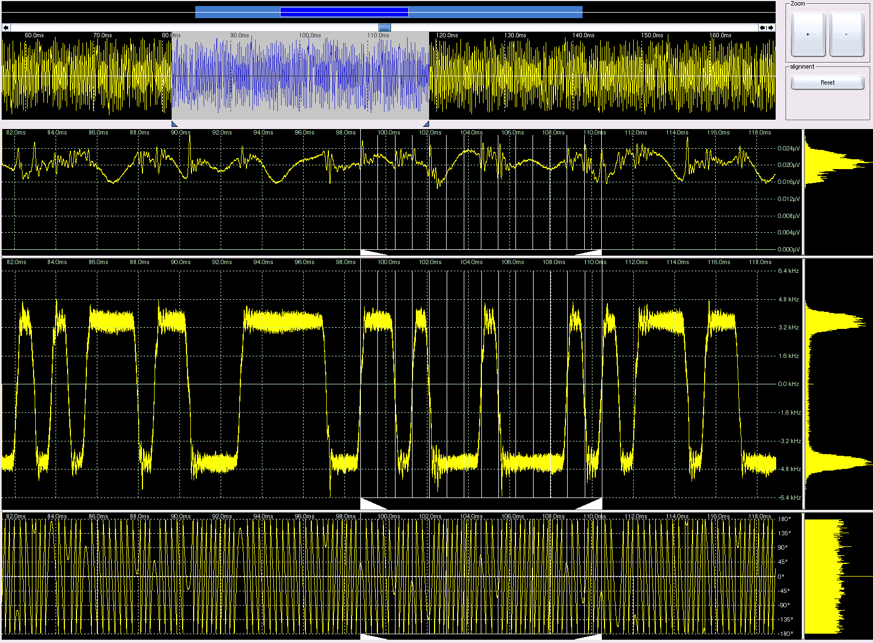
Modulation analysis of a single burst selected from the screen above. Display of the following parameters versus time (from top to bottom): Time signal/amplitude, envelope power, carrier frequency, carrier phase. From the third window we can identify this as an FSK system where the frequency changes between two distinct values. A harmonic cursor is placed to determine the symbol rate. Several emissions can be re-combined to build a continuous narrowband signal that can be investigated in numerical analysis like a single emission.

Signal Detection below the Noise Floor

System description
The system consists of a VXI based mainframe incorporating the ADC, a DSP, hard disk for storage and a computer running self-written software to perform the necessary calculations and provide the user interface.
Although in principle it could be used for any frequency range, the sample system is currently used in the space monitoring station Leeheim/Germany and is still in a developing phase. The satellite signals are down-converted and feed a wideband receiver. The IF from this receiver is the input for the ADC.

Advantages due to FFT
- Thousands of wideband scans require very high frequency and level consistency. Whereas analogue analysers have considerable drift during observation time, FFT is independent from most of these effects.
- The observation time is much shorter when using FFT. Analogue filters require much slower scan speeds resulting in longer measurement times during which the reception conditions and the signal itself may change.

Technical Specifications
Frequency range: Receiver: 20 MHz – 3 GHz (after down-conversion from up to 12.5 GHz)
Dynamic range: 100 dB
Digitiser bandwidth: 6 MHz
Digitiser resolution: 18 bit
FFT resolution: 4096 lines
FFT level accuracy: 1 dB

Sample measurement results

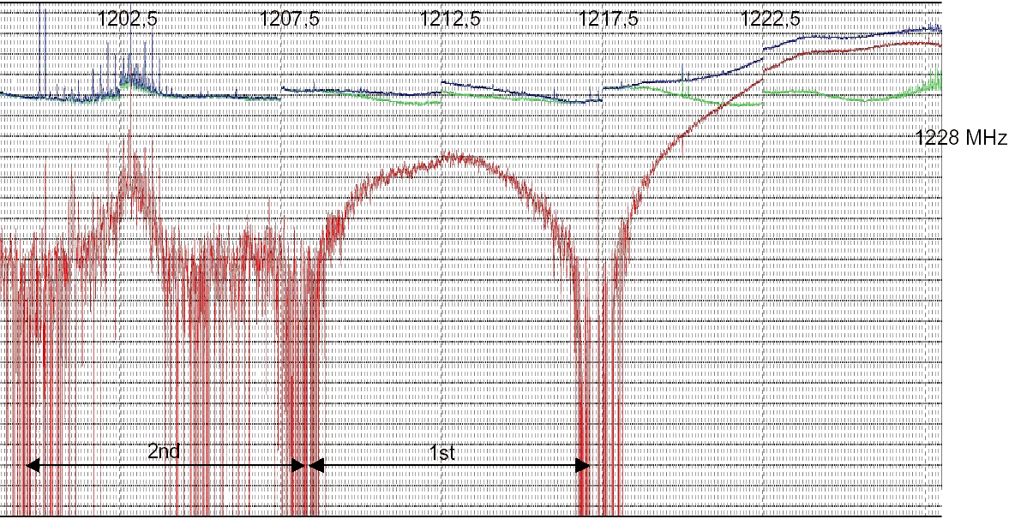
Recording of the lower side lobes of a NavStar satellite. The top (blue) line represents the averaged spectrum with the wanted signal, the line close below (green) is the spectrum without the wanted signal. The bottom line (red) is the difference where at least the first side lobe can easily be seen.

