ECC Decision (21)02

The harmonised frequency band 76-77 GHz, technical characteristics, exemption from individual licensing and free circulation and use of High Definition Ground Based Synthetic Aperture Radar (HD-GBSAR)
approved 5 November 2021

explanatory memorandum

INTRODUCTION
The free circulation of radio communication products and the provision of equipment in Europe for radio communications are only achievable if there are common regulations throughout Europe regarding the availability of frequency bands, harmonised technical conditions and border crossing procedures. The main requirements for fulfilling these objectives for HD-GBSAR are the Europe-wide availability of a suitable frequency band, harmonised technical conditions and the implementation of national regulations.
The mature and readily available radar technology in the band 76 GHz to 77 GHz provides appropriate sensor performance for real-time monitoring of deformation and displacement.
Radar characteristics are derived from the required detection capability to illuminate a surface over wide area with submillimetre accuracy. the measurement is performed by a high frequency interferometry radar working as a rotating Synthetic Aperture Radar (SAR). The system can perform an acquisition in less than a minute and provide as output a displacement heat-map of the monitored scenario.
The intended function of the HD-GBSAR is to provide up to 5 times improvement of resolution performance compared with existing GBSAR application, while allowing to achieve 4 times reduction of physical size of measurement equipment. Moreover, the HD-GBSAR technology enables a higher interferometric accuracy on displacement measurements. It is possible to reach 0.1 mm accuracy on natural targets allowing the early detection of displacement trends such as those occurring before a rock fall event.
This decision covers the radio regulatory aspects of operation of such system.

BACKGROUND
ECC received the ETSI TR 103 594 V1.1.1 (2018-08) on ”High-Definition Ground Based Synthetic Aperture Radars (HD-GBSAR) operating in 1 GHz band within 74 GHz to 81 GHz tuning range” [1].
In the ETSI Report, 1 GHz bandwidth is required for operation of HD-GBSAR, which could be accommodated in the frequency range between 74 GHz and 81 GHz.
The technical studies in ECC Report 315 [5] concluded that there is the possibility to use HD-GBSAR in 1 GHz of spectrum between 76 to 81 GHz. It also concluded that 74-76 GHz should be excluded due to interference issues with the fixed service. Among the possible options 76 to 77 GHz was chosen, because it is already used by other radar applications under the SRD regulation (in line with the SRD strategy of CEPT Report 14 [2]).
An agreed regulatory approach is required to ensure that the spectrum used by HD-GBSAR can be accessed in any national territory, provided that the system conforms to agreed radio specification limits in order to prevent harmful interference.
The designation of a harmonised band forms the basis for the free circulation and use of HD-GBSAR within Europe. ECC currently envisages to include this application also within the next update process under the permanent mandate for revision of the technical annex of the EC Decision for short range devices (Commission Decision 2006/771/EC and its amendments [3]).

REQUIREMENT FOR AN ECC DECISION
The allocation or designation of frequency bands for use by a service or system under specified conditions in CEPT administrations is laid down by law, regulation or administrative action. ECC Decisions are required to deal with the radio spectrum related matters and for free circulation and use of equipment throughout Europe. The free circulation and use of radio equipment will be greatly assisted when all CEPT administrations exempt the same categories of radio equipment from licensing and accordingly apply the same criteria.
The harmonisation on a European basis supports the Directive 2014/53/EU of the European Parliament and of the Council of 16 April 2014 [4] on the harmonisation of the laws of the Member States relating to the making available on the market of radio equipment and repealing Directive 1999/5/EC. A commitment by CEPT administrations to implement this ECC Decision will provide a clear indication that the required frequency bands are available on a European-wide basis, for HD-GBSAR application use.

ECC Decision of 5 November 2021 on the harmonised frequency band 76-77 GHz, technical characteristics, exemption from individual licensing and free carriage and use of HD-GBSAR APPLCATION Use (ECC/DEC/(21)02)
“The European Conference of Postal and Telecommunications Administrations,
considering
- that every state has sovereignty on its territory and on the radio spectrum;
- that use of HD-GBSAR application requires authorisation by the relevant national administration of the country where the HD-GBSAR is registered;
- that harmonised conditions across CEPT/EU help to establish an effective single market for these applications, with consequent economies of scale and benefits to the UWB industry in Europe, and avoid difficulties in enforcing divergent national regulations;
- that devices using HD-GBSAR application for deformation and displacement monitoring must operate on a non-interference, non-protected basis;
- that the issue of compatibility of HD-GBSAR application use with other radio equipment is the responsibility of the relevant national authorities;
- that a coexistence study considering HD-GBSAR use in the frequency band from 74 GHz to 81 GHz, and existing radio services and applications (Radio Astronomy Service (RAS), fixed service, automotive radar applications, rotorcraft obstacle detection radar, obstruction detection radar and fixed transport infrastructure radar applications (as in Commission Decision 2006/771/EC and its amendments [3])) operating in the frequency band from 74 GHz to 81 GHz and in the adjacent bands has been conducted by the ECC and that the results of these studies are contained in ECC Report 315 [5];
- that administrations can define exclusion zones to protect the Radio Astronomy Service (RAS) on a national level;
- that ECC Report 315 recommends to implement a generic free line of sight exclusion zone of 157 km around radio astronomy stations operating or potentially operating in the 76-77 GHz band for the protection of RAS from the HD-GBSAR. For RAS site specific exclusion zones see Annex 1;
- that HD-GBSAR systems are operated in relative small numbers by trained professionals;
- that administrations and manufacturers should take steps to indicate the limitations on use of HD-GBSAR in the vicinity (i.e. within 50 m line of sight) of fixed transport infrastructure radar and or railway level crossing obstacle detection radar operating in the 76-77 GHz band;
- that ECC Report 315 indicated that HD-GBSAR shall implement Detect and Avoid (DAA) to protect automotive radars;
- that there is an industry and user requirement for harmonised usage conditions for the use of radio equipment throughout Europe for HD-GBSAR application use;
- that it would be desirable for administrations to have common regulations at their disposal in order to control free carriage and use of obstacle detection radars for HD-GBSAR application use throughout Europe;
- that ETSI is developing the European Standard EN 303 661 for Ground Based Synthetic Aperture Radar, which includes HD-GBSAR;
- that changes of the protection of radio astronomy sites (RAS) in Annex 1 will be visible by means of this Decision as well as the ETSI EN 303 661 and subsequently be implemented under the responsibility of the HD-GBSAR manufacturers;
- that in EU/EFTA countries the radio equipment that is under the scope of this Decision shall comply with the RE Directive. Conformity with the essential requirements of the RE Directive may be demonstrated by compliance with the applicable harmonised European standard(s), cited in the Official Journal (OJ) of the European Union, or by using the other conformity assessment procedures set out in the RE Directive;

DECIDES
- that the purpose of this ECC Decision is to harmonise the usage conditions for HD-GBSAR radars operating in 76 GHz to 77 GHz for displacement and deformation monitoring applications;
- that CEPT administrations shall designate the band 76 GHz to 77 GHz for HD-GBSAR application use;
- that subject to decides 6 (RAS exclusion zone implementation) and 8 to 11 (technical requirements) below, CEPT administrations shall permit free circulation and use of HD-GBSAR application;
- that CEPT administrations shall exempt from individual licensing the HD-GBSAR devices permitted under this ECC Decision;
- that HD-GBSAR devices permitted under this ECC Decision operate on a non-interference and non-protected basis;
- that HD-GBSAR devices permitted under this ECC Decision shall inhibit sensor emission inside a RAS exclusion zone included in ANNEX 1, in case of outdoor use;
- that any request for update of the information on radio astronomy sites (RAS) in ANNEX 1 (new RAS sites or withdrawal of RAS sites, exclusion zones) shall be notified by administrations to the Office;
- that changes of protection of radio astronomy sites (RAS) in ANNEX 1 shall be effective to HD-GBSAR devices within a timeframe of not more than 12 months after the publication of the specified exclusion zones;
- that HD-GBSAR shall implement Detect and Avoid (DAA) with technical requirements as described in ANNEX 2;
- that HD-GBSAR shall not be operated in the vicinity (i.e. within 50 m line of sight) of fixed transport infrastructure radar and/or railway level crossing obstacle detection radar operating in the 76-77 GHz band;
- that HD-GBSAR shall limit its emissions level in the bands 71-76 GHz and 81-86 GHz to -22 dBm/10MHz e.i.r.p. to protect fixed service;
- that HD-GBSAR shall limit the maximum mean e.i.r.p. to 48 dBm and the maximum mean e.i.r.p. spectral density to 18 dBm/MHz;
- that this Decision enters into force on 5 November 2021;
- that the preferred date for implementation of this Decision shall be 5 May 2022;
- that CEPT administrations should inform the Office about the national implementation of this Decision by updating their national implementation information in relation to the entry for HD-GBSAR use in ERC Recommendation 70-03 Annex 6 [6].”
Note:
Please check the Office documentation database https://docdb.cept.org/ for the up to date position on the implementation of this and other ECC Decisions.

- Protection of Radio Astronomy service (RAS) Sites
The following table lists the RAS stations in the CEPT operating in the range 76 to 77 GHz and the related exclusion zones to be implemented by HD-GBSAR. The Table 1 reports in the last column the exclusion zones to be implemented for each RAS station defined as geographic polygons enclosing the areas with potential free line of sight with RAS station and a distance lower than 157 km. For each RAS station, the exclusion zone polygons are graphically represented and provided in shapefile format according to WGS84 (World Geodetic System 1984) [7] coordinate system.
Table 1: Use or potentially use of RAS in the 76 to 77 GHz frequency band within CEPT
Observatory Name | Administration | Latitude  (N)  Longitude  (E) | Altitude (Above Mean Sea Level)  (in metres) | Line of Sight Exclusion Zone Implementation
Plateau de Bure,  12 x 15 m Array, IRAM | France | 44º38’02”  05º54’28.5” | 2250 | 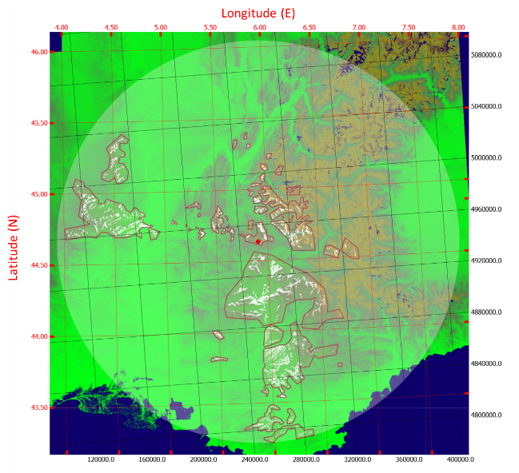
Maido (la Réunion)  Horns 0.25 x 0.36 m, 0.70 x 0.48 m | France | -21°04’46”  55°23’01” | 2200 | 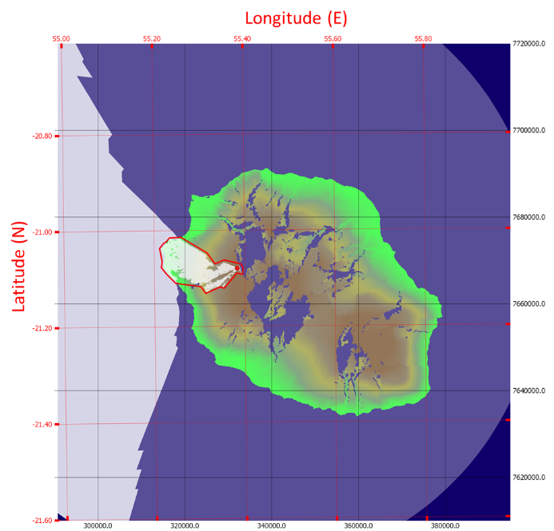
Effelsberg, 100 m | Germany | 50º31’32”  06º53’00” | 369 | 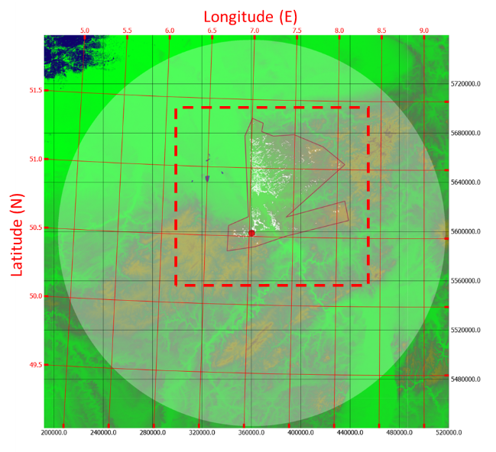
Sardinia Radio Telescope, 64 m | Italy | 39º29’34”  09º14’42” | 600 | 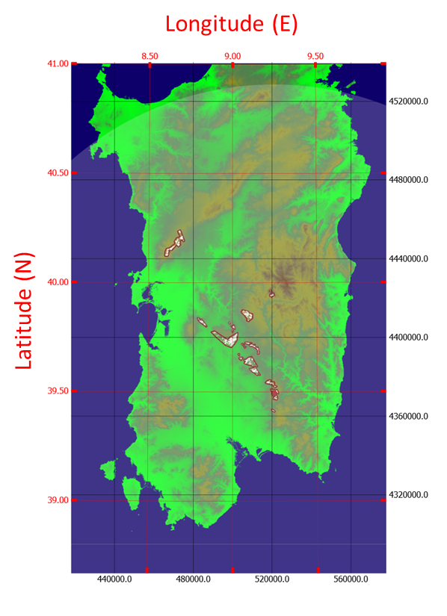
Noto, 32 m | Italy | 36°52′33″  14°59′20″ | 90 | 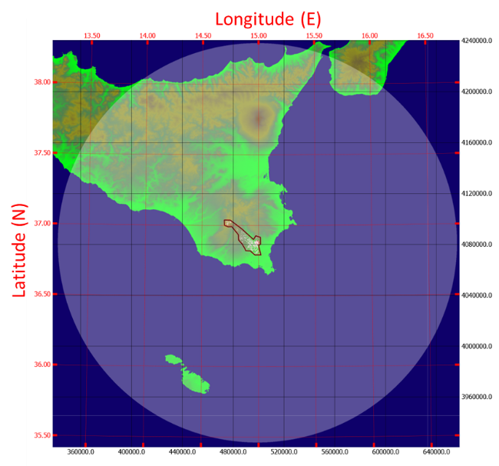
Zelenchukskaya, 32 m  IAA RAS  Zelenchukskaya, 600 m  SAO RAS | Russian Federation | 43°47′16.2′′  41°33′52.6′′  43°49′34.2′′  41°35′12.06′′ | 1175  970 | 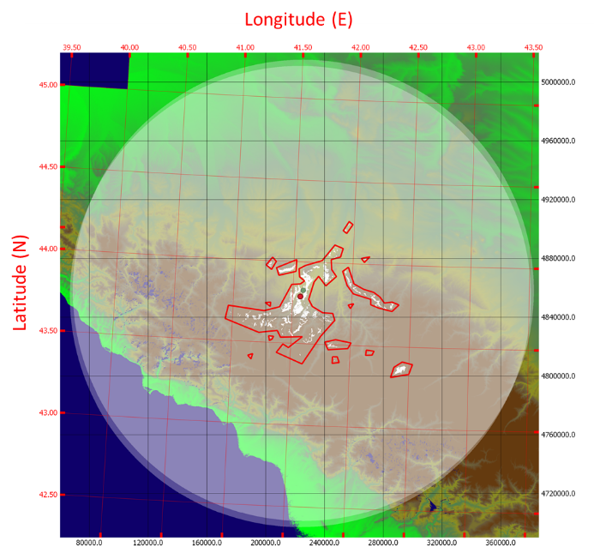
Badary, 32 m  IAA RAS | Russian Federation | 51°46′11.6′′  102°14′04.95′′ | 813 | 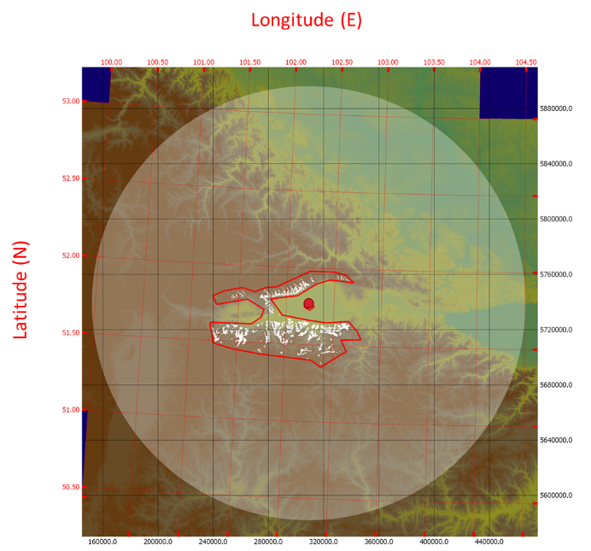
Svetloe, 32 m  IAA RAS | Russian Federation | 60°31′56′′  29°46′54′′ | 86 | 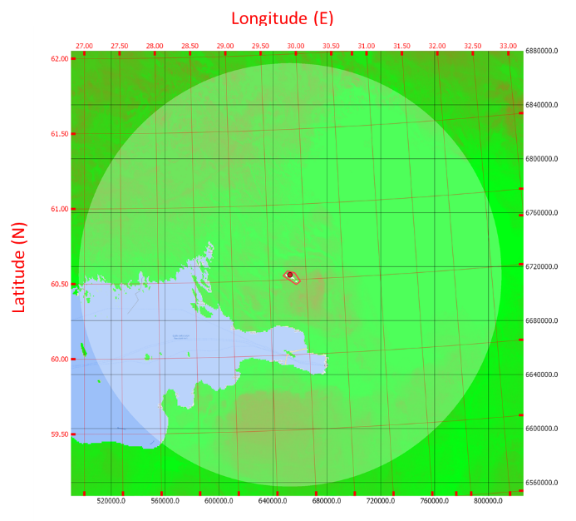
Pushchino, 22 m  PRAO ASC LPI, RAS | Russian Federation | 54°49′22″  37°37′57′′ | 190 | 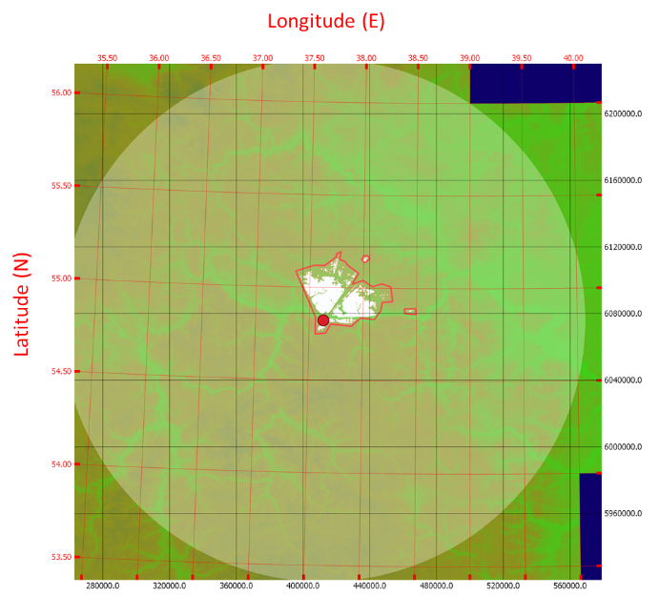
Kalyazin, 64 m | Russian Federation | 57°13′23′′  37°54′01′′ | 195 | 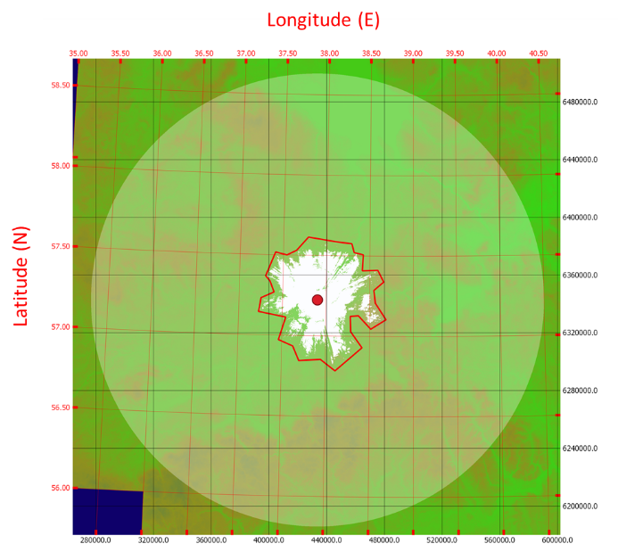
Ussurijsk, 70 m | Russian Federation | 44°0′57′′  131°45′25′′ | 20 | 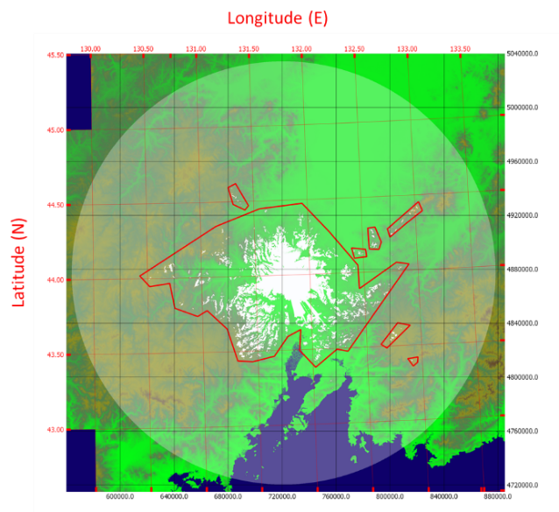
Pico de Veleta, 30 m  IRAM | Spain | 37º03’58”  -03º23’34” | 2850 | 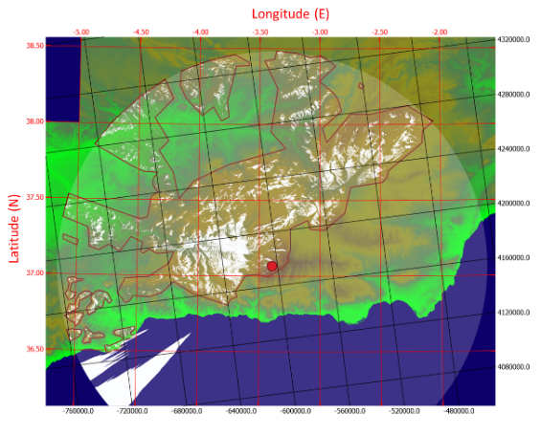
Yebes, 40 m  Yebes, 14 m | Spain | 40º31’27”  -03º05’22” | 981 | 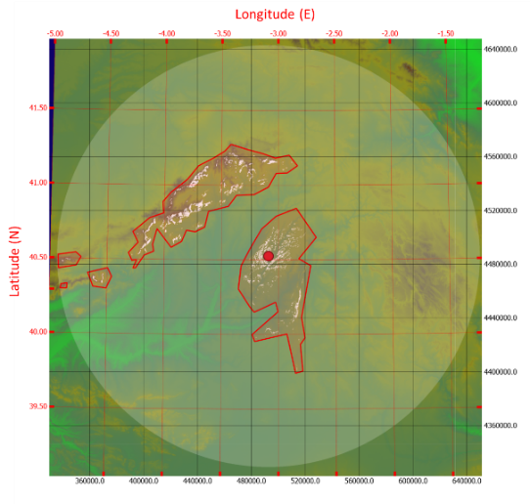
Onsala, 20 m | Sweden | 57º23’45”  11º55’35” | 23 | 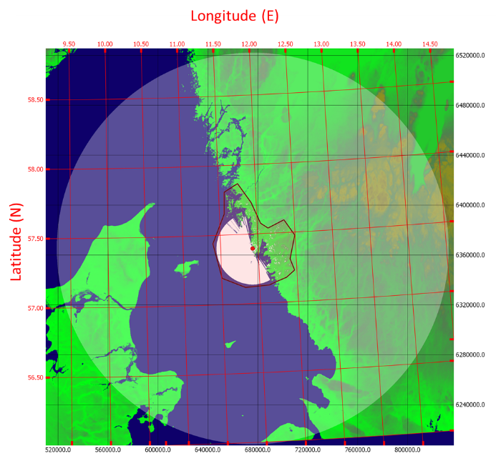

- Detect and Avoid (DAA) Technical requirements
HD-GBSAR devices shall implement a Detect and Avoid (DAA) system capable to detect automotive radar signals operating in the band 76–77 GHz and to stop HD-GBSAR transmission, in case of automotive radar detection.
The characteristics of the automotive radar to be considered for DAA are defined in the table below (ECC Report 315, table 9 [5]).
Table 2: Automotive radar operating in the 76 to 77 GHz frequency band signal characteristics
Parameter | Values
Modulation Type | FMCW
Occupied RF bandwidth | 100-1000 MHz
TX frequency sweep time | Slow FMCW: 1-20 ms;  Fast FMCW: 20-80 µs
TX antenna feed power | 10 dBm
TX duty cycle  (Ratio of transmit on/off ratio) | 20–50%
Radar measurement cycle | 50 ms

The DAA shall detect the presence of an automotive radar, when the peak power of the automotive radar signal with at the input of the HD-GBSAR receiver exceeds the threshold defined by the following equation:
 | $$Peak Power DAA threshold (dBm)=-70.8-P_{I}$$ | (1)
Where:
- $P_{I}$ is the HD-GBSAR conducted peak power at the transmitter antenna input in dBm. The equivalent average power DAA threshold corresponds to:

 | $$Average Power DAA threshold (dBm)=-70.8-P_{I}+10⋅\log_{10}{DC}$$ | (2)
Where:
- DC is the automotive radar signal duty cycle (TX duty cycle of Table 2).

HD-GBSAR DAA shall detect the presence of a victim automotive radar and stop the transmission within the time of a single radar measurement cycle.
ANNEX 3: list of references

- ETSI Report ETSI TR 103 594 V1.1.1 (2018-08) on ”High-Definition Ground Based Synthetic Aperture Radars (HD-GBSAR) operating in 1 GHz band within 74 GHz to 81 GHz tuning range”
- CEPT Report 14: “Report from CEPT to the European Commission in response to the Mandate to: Develop a strategy to improve the effectiveness and flexibility of spectrum availability for Short Range Devices (SRDs)”, approved July 2006
- Commission Decision 2006/771/EC and its amendments
- Directive 2014/53/EU OF THE EUROPEAN PARLIAMENT AND OF THE COUNCIL of 16 April 2014 on the harmonisation of the laws of the Member States relating to the making available on the market of radio equipment and repealing Directive 1999/5/EC
- ECC Report 315: “Feasibility of spectrum sharing between High-Definition Ground Based Synthetic Aperture Radar (HD-GBSAR) application using 1 GHz bandwidth within 74-81 GHz and existing services and applications”, approved May 2020
- ERC Recommendation 70-03: “ERC Recommendation of 1997 (as amended) on relating to the use of Short Range Devices (SRD)”
- WGS84 (World Geodetic System 1984) of the National Geospatial-Intelligence Agency

