Spectrum use and future spectrum requirements for PMSE

approved 12 February 2021

ECC Report 323

# Executive summary

PMSE is the term used to describe the wireless communication links that allow the creative industries to transport the captured audio and video content from performers and presenters on location to audiences, either at the venue, at home, or increasingly, on the move. PMSE is primarily divided into audio and video, and each has unique characteristics that need to be catered for. The amount of spectrum needed for PMSE varies between different countries and at different locations within each country.

This Report examines some of the principal changes and trends affecting PMSE's use of radio spectrum since the publication of ECC Report 204 [1] in February 2014. It is intended to provide a resource to administrations to ensure that spectrum decisions are made with appropriate considerations of the needs of the creative industries.

PMSE content capture sits at the start of the supply and value chains for a wide range of products, and consequently, it is expected to provide the highest quality possible. The commercial pressures on users are significant as events cannot be repeated, and so the tolerance for disturbance to the quality of service is extremely low.

PMSE applications typically share spectrum with other services based on sharing criteria, primarily defined to protect primary radio services from interference from PMSE.

Audio PMSE has specific requirements in terms of latency, that is, the time delay imposed by the wireless link. In the case of live performance, the round-trip-delay is important as the artist will normally be listening to a mix of their own performance (captured with a wireless microphone) with that of other performers delivered back directly via an In-Ear Monitor (IEM).

Video PMSE has specific requirements in terms of link capacity, especially with the increasing move towards higher image resolution (including Ultra High Definition/4K).

Demand for access to spectrum for PMSE is rising due to new streaming content producers, new forms of content (for example more immersive views), safety considerations over cables as potential trip hazards, etc.

Spectrum readily available to audio PMSE in the UHF band has been significantly reduced since 2010, whilst that for video PMSE has also been reduced.

Changes to operating practices and the development of new technology have helped to mitigate against the reduction in available spectrum, and there are emerging technologies that might provide additional options in the future. However, the unique requirements of low latency and very high quality of service are challenges for these developments.

The appetite amongst audiences for more is set to continue. To meet this demand, there is a continuing need for access to high quality spectrum for PMSE users.

TABLE OF CONTENTS

0 Executive summary 2

1 Introduction 7

2 Definitions 9

3 Technical and operational considerations for PMSE applications 10

3.1 Requirements applicable to PMSE applications 10

3.1.1 General requirements of manoeuvrability and safety 10

3.1.2 Requirements applicable to audio PMSE 10

3.1.2.1 High quality of service (QoS) 10

3.1.2.2 Low latency 11

3.1.2.3 Battery performance 11

3.1.2.4 Spectrum requirements 12

3.2 The tuning range concept 13

4 Changes and trends in PMSE demand for radio spectrum 14

4.1 Defining PMSE spectrum demand 14

4.2 Audio PMSE 14

4.2.1 Sustained growth in the number of microphones and IEMs in use at the largest events 14

4.2.1.1 Live music events 14

4.2.1.2 New television show formats 14

4.2.1.3 Theatre 15

4.3 Video PMSE 15

4.3.1 Increasing use of wireless cameras 15

4.3.2 Increasing demand for higher resolution 15

4.3.3 Audience and broadcaster appetite for new formats and viewing experiences 15

4.3.4 Increasing film production 15

4.3.5 Video links used with IP 16

4.4 Service links 16

5 Changes and trends in supply of radio spectrum for PMSE 19

5.1 Regulatory changes in spectrum allocations for PMSE 19

5.1.1 EC Implementing Decision 2016/687 and its impact on spectrum availability for audio PMSE 19

5.1.2 Reduction in availability of spectrum for video PMSE 19

5.2 New regulatory approaches 19

5.2.1 Video PMSE booking system in the Netherlands in the frequency range 2.3-2.4 GHz 19

6 Mitigating factors in response to changing demand and supply of spectrum 21

6.1 Changing working practices in PMSE 21

6.1.1 Frequency management and site planning 21

6.1.2 Reduction in the mixing of analogue and digital PMSE equipment 21

6.1.3 Temporal sharing 21

6.1.4 Spatial re-use 22

6.1.5 Greater use of DECT technology for talkback and intercom 22

6.2 Technological development in PMSE equipment and its limitations 22

6.2.1 Audio PMSE equipment 22

6.2.2 Video PMSE equipment 23

6.3 Developing and potential technologies for PMSE use 23

6.3.1 Wireless Multichannel Audio System (WMAS) 23

6.3.2 C-PMSE 23

6.3.3 4G and 5G public mobile networks 24

6.3.4 4G and 5G private mobile networks 24

6.3.5 DECT 25

ANNEX 1: CEPT and ECC Reports 26

ANNEX 2: Tables of PMSE assignment data (UK) 27

ANNEX 3: Tables of PMSE assignment data (France) 32

ANNEX 4: Tables of PMSE assignment data (Netherlands) 36

ANNEX 5: PMSE spectrum requirements use for large events in Slovenia. 37

ANNEX 6: Video PMSE case studies 38

ANNEX 7: Events requiring the support of various types of PMSE equipment 47

ANNEX 8: Research projects for 5G 51

ANNEX 9: DECT 52

ANNEX 10: List of references 54

LIST OF ABBREVIATIONS

| Abbreviation | Explanation |
| --- | --- |
| BAS | Broadcast Auxiliary Systems |
| CCI | Creative and Culture Industry |
| CD | Compact Disc |
| CE | Connection Endpoint |
| CEPT | European Conference of Postal and Telecommunications Administrations |
| COTS | Commercial Off the Shelf |
| C PMSE | Cognitive PMSE |
| DCA/S | DECT Channel Allocation/Selection |
| DECT | Digital Enhanced Cordless Telecommunications |
| DMX | Digital Multiplex (lightning control standard) |
| DVB-T | Digital Video Broadcast – Terrestrial |
| DVD | Digital Versatile Disc |
| ECC | Electronic Communications Committee |
| EFIS | ECO Frequency Information System |
| eLSA | evolved LSA |
| EMF | Electro Magnetic Field Limits (Human Exposure) |
| ENG | Electronic News Gathering |
| ERC | European Radio Communications committee |
| ETSI | European Telecommunications Standardisation Institute |
| EU | European Union |
| FIA | Federation Internationale de l’Automobile |
| GPS | Global Positioning System |
| GSM | Global System for Mobile Communications |
| HD | High Definition |
| HDR | High Dynamic range |
| HEVC | High Efficiency Video Codec |
| IEM | In-Ear Monitor |
| ICT | Information and Communications Technology |
| IMT | International Mobile Telecommunications |
| IoT | Internet of Things |
| ITU | International Telecommunications Union |
| IP | Internet Protocol |
| LIPS | Live Interactive PMSE Services (project) |
| LSA | Licensed Shared Access |
| LTE | Long Term Evolution |
| mMTC | Massive Machine Type Communication |
| MEC | Mobile Edge Cloud |
| MFCN | Mobile and Fixed Communication Networks |
| MNO | Mobile Network Operator |
| NR | New Radio (5G) |
| OB | Outside Broadcasting |
| PA | Public Address (system) |
| PMSE | Programme Making and Special Events |
| QoS | Quality of Service |
| RAN | Radio Access Network |
| RF | Radio Frequency |
| SAB | Services Ancillary to Broadcasting |
| SAP | Services Ancillary to Programme making |
| SD | Standard Definition |
| SDN | Software-Defined Networking |
| SNG | Satellite News Gathering |
| SRD | Short Range Device |
| SRIT | Set of Radio Interface Technologies |
| STF | Special Task Force |
| TDD | Time Division Duplex |
| UCI | Union Cycliste Internationale |
| UE | User Equipment |
| UHF | Ultra High Frequency |
| UHD | Ultra High Definition |
| ULE | Ultra Low Energy |
| UMTS | Universal Mobile Telecommunication System |
| URLLC | Ultra Reliable and Low Latency |
| WMAS | Wireless Multichannel Audio System |

# Introduction

Programme Making and Special Events (PMSE[1]) describes the service and applications that use radio spectrum to support the capture, production and broadcast of audio and video content consumed all over the world on a multitude of platforms. It relates typically to televised sport, outdoor music events, theatre productions, television light entertainment, feature film production and live television news gathering. However, it also encompasses many other applications, for example PMSE is used at exhibitions, conferences and educational institutions.

PMSE content capture sits at the start of the supply and value chains for a wide range of products, such as recordings of live performances or the archiving of culturally significant material. Consequently, content capture is expected to provide the highest quality possible, with producers and programme makers taking steps to ensure the quality and robustness of content capture and delivery.

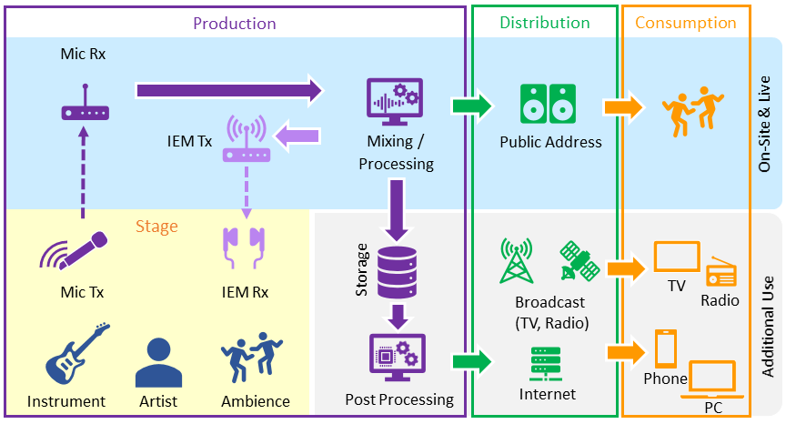

Figure 1: From capture to consumption

For these reasons, quality and reliability of the radio link are fundamental to PMSE users. For high-end (live) PMSE productions especially, the commercial pressures on users are significant as there is no opportunity for recovery, and so the tolerance for disturbance to the quality of service is extremely low.

PMSE applications typically share spectrum with other services based on sharing criteria, primarily defined to protect these other services from interference from PMSE. Another important aspect of these sharing arrangements is that the spectrum is able to provide the high quality of service required for live events and programme making i.e. there should be a predictable sharing environment.

Access to radio spectrum that provides high quality and reliability of wireless audio and video radio links is therefore a fundamental requirement for PMSE production. This Report provides information about some of the technical and operational requirements specific to PMSE.

This Report also examines some of the principal changes and trends affecting PMSE's use of radio spectrum since the publication of ECC Report 204 [1] in February 2014. It is addressed in three broad categories:

* changes and trends affecting PMSE demand for radio spectrum;
* changes and trends affecting the supply of radio spectrum for PMSE;
* mitigating factors that affect the demand and supply of radio spectrum for PMSE.

PMSE applications have been categorised into audio PMSE and video PMSE. Though audio and video PMSE applications complement each other, and some trends identified may apply to both, in current practice there are important differences between audio and video applications that merit analysis of each separately:

* audio PMSE - the most commonly used audio PMSE applications are wireless microphones (hand-held and body-worn) and in-ear monitors (IEMs);
* video PMSE - the most commonly used video PMSE applications are portable or mobile wireless video links and cordless cameras.

A brief analysis of PMSE service links is included, covering PMSE equipment used for data transmission for production, such as effect and remote control and team connection.

This categorisation is also reflected in the EFIS[2] system: the list of applications for PMSE is divided into three layers of detail as shown in Table 1.

Table 1: List of EFIS searchable applications relating to PMSE

| Layer 1 | Layer 2 | Layer 3 |
| --- | --- | --- |
| PMSE | Audio PMSE | In-ear monitor systems  Radio microphones  Audio links |
| Video PMSE | Airborne Video Links  Cordless cameras  Video links |
| Service links | Talkback |

# Definitions

| Term | Definition |
| --- | --- |
| Wireless microphone | Hand-held or body-worn microphone with integrated or body-worn transmitter. |
| In-ear monitor | Body-worn miniature receiver with earpieces for personal monitoring of single or dual channel soundtrack. |
| Cordless camera | Hand-held or otherwise mounted camera with integrated transmitter, power pack and antenna for carrying broadcast-quality video together with sound signals over short-ranges. |
| Portable video link | Hand-held camera with separate body-worn transmitter, power pack and antenna. |
| Mobile airborne video link | Video transmission system employing radio transmitter mounted on helicopters or other flight vehicles. |
| Mobile vehicular video link | Video transmission system employing radio transmitter mounted in/on motorcycles, pedal cycles, cars, racing cars or boats. One or both link terminals may be used while moving. |
| Temporary point-to-point video links | Temporary link between two points (e.g. part of a link between an OB site and a studio), used for carrying broadcast quality video/audio signals. Link terminals are mounted on tripods, temporary platforms, purpose-built vehicles or hydraulic hoists. Two-way links are often required. |
| Talkback | For communicating the instructions of the director instantly to all those concerned in making the program; these include presenters, interviewers, cameramen, sound operators, lighting operators and engineers. Several talkback channels may be in simultaneous use to cover those different activities. Talkback usually employs constant transmission. |
| Talkback System | A radio or wired system or a mixture of both used for non-broadcast communication when programme making, for example, communications between producer and cameraman, or communication and instructions from producer and actor or presenter. |
| Conference system | A multiple microphone and sound reinforcement system for discussion groups and face-to-face meetings as well as far end-to-far end (including video) conference events. A conference system comprises of one control unit and a number of delegate units. |

# Technical and operational considerations for PMSE applications

## Requirements applicable to PMSE applications

As described previously, high-end and live PMSE production and content capture sit at the start of the value chain. In order to achieve the highest quality possible, its requirements are uncompromising. Each of the requirements listed below are important to PMSE applications, as are the potential constraints that may arise if mitigating action is required by the PMSE industry in response to external changes that further reduce spectrum availability.

The requirements are often interdependent, conditional on the application, desired outcome and circumstances unique to each deployment or location. For example, technology advances in audio PMSE equipment now allows users to achieve greater density of deployments per MHz of spectrum. However, achieving denser deployments involves trade-offs such as range, latency, audio quality and the flexibility in equipment deployed.

### General requirements of manoeuvrability and safety

The migration from wired to wireless in PMSE applications has been a sustained trend over the last decades. Wireless performance confers several advantages over wired equipment.

Wireless microphone and IEM use enables artists at live music events to move freely around a large stage unencumbered by trailing wires. In theatre, they have made possible certain large-scale productions that would previously have been challenging, such as those in which many cast members on stage simultaneously are each using a wireless microphone and IEM.

Developments in wireless camera technology have also greatly improved portability, affording directors greater artistic freedom in the type of camera shots available to them. "Wiring up" a site is no longer necessary, meaning coverage of breaking news stories can be performed quickly and at short notice, both indoors and outdoors. The lack of trailing wires also means that in locations where crews might come into contact with the general public, camera and microphone users do not create a trip hazard for themselves, other performers, or members of the public.

Reductions in weight and size of camera units allows several cameras to be spread around a stage or studio, providing the producer with multiple views to switch between or from which to edit and compile footage. In live televised sport, which sees some of the most intensive use of video PMSE, small cameras are now placed right in the middle of the action to offer audiences and production teams immersive point-of view camera angles, for example on racing cars in F1 and World Rally Championship Rally, and bicycle seat posts in the Tour de France.

In these examples, where cameras are mounted directly on equipment used by competitors, the governing bodies of many sports have incorporated wireless cameras directly into their rules and regulations (see Annex A6.1). In some cases, ensuring good reception using multiple moving wireless cameras (such as the Tour de France) can only be achieved with the use of aerial platforms such as helicopters and fixed-wing aircraft, but advances in drone technology may yet make them an efficient and cost effective solution in some cases.

### Requirements applicable to audio PMSE

Technology advances in audio PMSE equipment can permit more assignments in the same amount of spectrum than were previously possible but important requirements remain that can affect deployment flexibility which needs to be considered, particularly for high-end PMSE applications. The major factors described below are not exhaustive but illustrate their impact in relation to total spectrum demand.

#### High quality of service (QoS)

There is an established expectation from both performers and the audience for the highest quality audio signal from wireless systems, matching what can be achieved from wired systems. Wireless microphones and IEM systems are expected to fulfil these highest demands for quality audio achieving a 100% duty cycle with no interruptions in audio output. Manufacturers design their equipment to meet these high standards and the PMSE industry goes to great lengths with their installations to achieve the same ends.

#### Low latency

Latency refers to the round-trip delay between the time audio is transmitted and the time the audio is received. When latency is excessive it can manifest itself in a mismatch between images and sound known as ‘lip-sync’ issues which can be distracting to the audience. More fundamentally for performers using wireless microphones and IEMs, excessive delay is also unacceptable. It can be very off-putting and make it impossible for an artist to perform, hearing themselves back over their IEM out of sync with the vibration of their own voice heard directly, conducted via the ear.

An acceptable end-to-end latency for live events is between 2 and 4 milliseconds (ms) [2]. However, in some other applications, such as conferences, the lowest latency may not be such a critical factor for a live audience listening to a single speaker. Virtually all IEM equipment currently available continue to employ analogue FM for low latency. In the past, combining these with digital consoles and digitally modulated microphones would have introduced unacceptable levels in end-to-end latency. However, due to the improvements in digital microphones and consoles, combining these with analogue IEMs it is now possible to achieve sufficiently acceptable end-to-end latency.



Figure 2: Example of audio production with distribution over different media channels

#### Battery performance

The battery life of portable PMSE equipment and its physical battery size is a major compromise. Battery life must be sufficiently long for productions and rehearsals without needing frequent changes and the size of the batteries must not be too large to make the equipment impractical for the performer to wear or carry. Wireless microphone transmitters and IEM receivers are often incorporated into costumes for musical theatre shows or period drama productions. Replacing batteries in these cases can be a major task to be avoided. Battery life ranges from 4 to 12 hours, with between 5 to 7 hours operation seen as the acceptable minimum.

Greater current consumption and lower battery life was one factor holding back wireless microphones moving from analogue to digital technologies. Recently, modern rechargeable batteries and precise battery management have become available to enable the development of digital equipment with highly linear power amplifiers and signal processing as well as remote telemetry to report precisely the battery status from the portable equipment.

#### Spectrum requirements

Wireless microphones, IEMs and low-power talkback systems typically occupy 200 kHz channels and have traditionally used analogue FM modulation. In recent years more modern equipment, particularly wireless microphones, now use proprietary forms of digital modulation, though still occupy 200 kHz channels.

Where there are a large number of simultaneously transmitting audio PMSE devices, the dominant factor that drives total spectrum demand is the requirement for the use of frequencies resulting from a phenomenon known as ‘reverse intermodulation’. It is also known as ‘transmitter-to-transmitter intermodulation’ and occurs when transmitters operate close to one another, which is often the case for PMSE. The output from the first transmitter (f1) couples into the antenna of the second transmitter (f2). The two signals from each transmitter mix in the non-linear output stages of the second transmitter producing and radiating sum and difference signals (2f1-f2, 2f 2-f1), as shown.

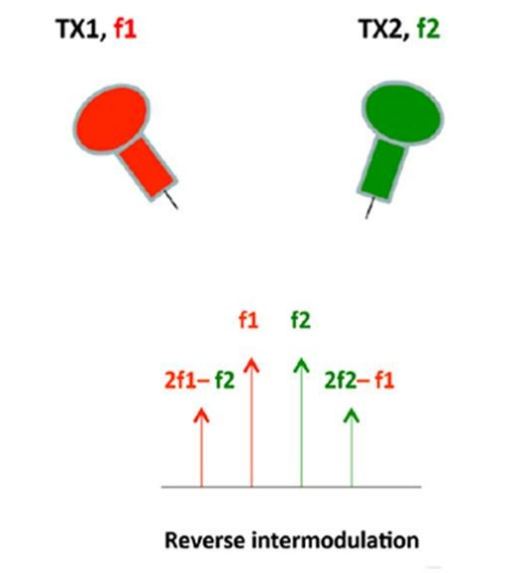

Figure 3: Reverse intermodulation

Consequently, spectrum that would otherwise be available for further transmitters is sterilised by these intermodulation components and spectral efficiency is reduced. Robust intermodulation planning software tools are therefore employed which identifies further assignments, thus avoiding these potential interferers. The result, however, is that as spectrum demand increases, the spectral efficiency decreases, as exemplified in Table 2 (data is extracted from CEPT Report 32 [5]).

Table 2: Spectral efficiency of conventional FM wireless microphones with increased demand and robust intermodulation-free planning

| Total number of wireless microphones | Number of 8 MHz TV channels | Total amount of spectrum (MHz) | Number of wireless microphones per 1 MHz |
| --- | --- | --- | --- |
| 12 | 1 | 8 | 1.5 |
| 98 | 18 | 144 | 0.7 |

Digitally modulated wireless microphone transmitters and some recent analogue modulated products generally have much improved reverse intermodulation performance. As a result, their spectral efficiency is much better without the need to employ intermodulation-free plans, and it is scalable as demand increases. Advanced systems can deploy over 20 wireless microphones per 8 MHz channel, and can occupy every available 8 MHz channel.

The number of microphones per 8 MHz depends on several external factors. These include interference from other services or systems, i.e. high noise floor and the type of production. In some cases, a robust spectrum plan is required where artists (equipment) are physically close or there is a high value artist whose output is fundamental to the production.

IEMs overwhelmingly continue to use analogue FM modulation, requiring robust intermodulation-free planning and remaining relatively spectrally inefficient. Consequently, when IEMs and more spectrally efficient wireless microphones are used together it is necessary to employ robust intermodulation planning and the overall spectral efficiency can fall. Additionally, the use of IEMs has increased dramatically in recent years and in some productions the ratio of wireless microphones to IEMs is 1 to 1.

## The tuning range concept

Aside from some relatively limited harmonising measures across EU Member States, the availability of spectrum for PMSE audio and video applications is determined by national administrations, according to differing national PMSE requirements, authorisation mechanisms and divergent national frequency plans.

This fragmentation of spectrum access contrasts with the preference of PMSE stakeholders that operate internationally for equipment that may be operated across multiple countries, and of PMSE equipment manufacturers for economies of scale to encourage innovation and investment in new equipment.

Reconciling the requirements of PMSE users with the divergence in PMSE demand for spectrum and fragmentation of supply across administrations lies behind the recommended “tuning ranges” concept for PMSE developed by CEPT. A “tuning range” is a range of frequencies over which radio equipment is envisaged to be capable of operating. Within this tuning range, the use in any one administration of radio equipment will be limited to the range of frequencies identified for PMSE nationally (if any) within that country and will be operated in accordance with the related national regulatory conditions and requirements.

There are practical limits, however, to the concept of tuning range. Too large a frequency range increases the cost of the equipment due to higher complexity in design, increased power consumption and challenges the performance of antenna systems. Where the whole tuning range of the equipment comprises frequency ranges available for PMSE interspersed with other frequency ranges not available, operations need to be limited to appropriate frequencies:

* The tuning range concept is used in the following Recommendations: ERC Recommendation 25-10 Frequency Ranges for the Use of Terrestrial Audio and Video Programme Making and Special Events (PMSE) applications, <https://docdb.cept.org/document/838> [3];
* ERC Recommendation 70-03 Annex 10 for PMSE Relating to the use of Short Range Devices (SRD), <https://docdb.cept.org/document/845> [4].

# Changes and trends in PMSE demand for radio spectrum

## Defining PMSE spectrum demand

Demand for radio spectrum from PMSE applications is time and location specific. It is often incorrectly assumed that PMSE deployments are temporary in nature, when in fact a large proportion of deployments are for long-term use at fixed locations, such as broadcast centres, large studio complexes, or where dense clusters of PMSE venues are found, such as London's West End theatre district. These locations experience very high daily demand for spectrum.

At other locations, spikes in demand for spectrum occur only for a limited time, such as outdoor music festivals and sporting events like the Tour de France and Formula One Grands Prix. Spectrum demand in these locations experiences a very high peak over perhaps a few days each year.

The overall trend is one of increasing PMSE demand at the largest events, and for an increasing number of those large events. This trend does not itself create a difficulty because meeting spectrum demand for PMSE applications becomes acute only if the required spectrum is difficult to supply at both the time and location it is needed. However, problems can occur if the temporary events themselves generate extremely high demand for spectrum, or if a temporary event occurs at a location where PMSE use is already high (for example, in proximity to a broadcast studio complex).

In assessing the spectrum requirement for PMSE, it is therefore important to consider that the normal regular demand for spectrum should be distinguished from the peak demand, which may be temporary or geographically limited (see CEPT Report 32 [5]). Overviews of PMSE spectrum usage in some countries are provided in Annex 2, Annex 3 and Annex 4.

In these cases, detailed intervention or planning by a band manager or administration may be necessary. Later in this ECC Report, the factors that planners need to consider (such as intermodulation effects) and the impact this has on the amount of spectrum available are outlined. The factors behind the demand trends in both audio and video PMSE are discussed below.

## Audio PMSE

### Sustained growth in the number of microphones and IEMs in use at the largest events

#### Live music events

The trend in industry working practices at the largest events has been towards providing a microphone and radio in-ear monitor (IEM) to each performer. In the last decade, the largest PMSE events have grown year-on-year. This is coupled with considerable growth in the number of these live music events overall due to changes in the music industry that mean musicians now derive most of their income from live performances, rather than from recorded content.

Allocating wireless IEM and microphone to each performer avoids creating a trip hazard and affords free movement around stage or set. Performers have got used to using IEMs and now demand them for live or TV performances. Major live music bands now typically insist on IEMs for backing singers, instrumentalists and their technicians.

#### New television show formats

Audience appetite for new formats of television light entertainment has also driven up demand for microphones and IEMs. For example, contest or casting shows will often have each performer wearing a microphone and body-worn transmitter.

#### Theatre

In theatre productions, the audience expectation of quality and reliability sees many lead performers wear double microphones to ensure continuity in the performance through equipment failure or interference. In one leading production 8 leading performers each wore dual transmitters, while in other productions requiring quick costume changes, microphones are built into the costumes. All these resilience measures and working practices have developed to ensure continuity and quality, but they have all added to the demand for spectrum.

## Video PMSE

### Increasing use of wireless cameras

Wireless camera technology has improved steadily over the last decade so that camera link equipment is now very reliable (see Annex 6 for further information). This improved performance has been accompanied by a reduction in the costs of equipment, making it far more accessible to broadcasters and production teams who want to take advantage of the improved mobility wireless cameras afford. As it is noted in more detail below, audience appetite for richer, more immersive viewing experiences in live sport, and new formats in television light entertainment, such as spin-off shows, are behind the increased use of wireless cameras.

### Increasing demand for higher resolution

Broadcasters are moving rapidly from HD towards 4K with HDR and higher frame-rates. All this additional information needs to be transmitted and uses extra bandwidth. And although High Efficiency Video Coding (HEVC) helps with additional compression, it is still required to transport between 20 and 60 Mbps in low latency. For the lower bitrates, this can still be done in a 10 MHz channel using DVB-T2 and HEVC. For higher bitrates, however, 4K uses the so-called dual pedestal, meaning twice the bandwidth of a standard DVB-T2 HD camera. So, each wireless 4K camera ideally requires 20 MHz for operation.

### Audience and broadcaster appetite for new formats and viewing experiences

Technological advances have combined with audience appetite for richer, more immersive viewing experiences in live sport. Point-of-view footage captured by onboard cameras (such as those on Tour de France bikes, or on Formula One cars) allows fans to experience the action from the “best seat in the house”. Dedicated “player cams” now track individual footballers in close-up around the pitch, in addition to the main live video feed of the match. Advances in drone technology means that the capture of aerial footage is no longer the preserve of broadcasters with access to aircraft and is therefore an increasingly common addition to programme-making.

Traditional television viewing is now complemented, or in some cases superseded, by internet or mobile-centric platforms which either purchase existing content or increasingly make their own. Much of this content is produced specifically for consumption on official social media channels, as a means of deepening fans’ engagement with their favourite sports and sportspeople.

In television light entertainment, new formats such as spin-off shows and reality shows, are also behind the increased use of wireless cameras, as broadcasters attempt to capture “fly on the wall” footage from every conceivable angle.

The cumulative effect of the demand for ever-more personalised and varied content is a growth in demand for video PMSE spectrum.

### Increasing film production

Film production boomed in Europe over the past 10 years. More than 18000 films were produced in Europe between 2007 and 2016, with overall production on the continent growing by 47%, from 1444 feature films in 2007 to 2124 in 2016. An upward trend for most of the period was recorded for both purely national productions and co-productions. Majority co-productions accounted for 20.4% of the overall production volume on the continent over the said period. The volume of documentaries boomed, almost doubling, to 698 films in 2016, while production of feature fiction also rose significantly, by 33% [16].

### Video links used with IP

Over time, changes in presentation standards have led to changes in production standards. Standard Definition (SD) has been largely replaced by High Definition (HD) and this is progressively being replaced by Ultra High Definition (UHD, 4K and 8K), especially for prestigious sports events, drama and natural world productions. As noted previously, such an increase in picture quality leads to an increase in the bit rate and thus necessary capacity of the video link, and in some cases a "standard" 10 MHz channel is insufficient for the required video link. Reduction in the number of video PMSE channels available has also led to a move towards a more flexible use of the available channels and the need to exploit all available links. The result is an increasing use of IP based data links rather than dedicated video links, and these links tend to be bidirectional in order to allow dynamic allocation of the uplink capacity. A bidirectional link also lends itself to providing return video from the studio centre to allow remote presenters to see the complete shape of the production, autocue to bring statistics and other data live to the remote site, and provide remote control of equipment. In terms of spectrum usage, it is likely that more capacity is needed from the remote site to the studio centre and therefore several "transmit" channels to the studio centre may be serviced by each "receive" channel from the studio centre.

## Service links

A PMSE service link is a communication channel that connects two or more devices for the purpose of data transmission. The link may be a dedicated physical or a virtual circuit that uses one or more physical links or shares a physical link with other telecommunication links such as wireless fixed links, communication satellites, terrestrial radio communications infrastructure and computer networks.

Audio PMSE uses service links primarily between the transmitter and receiver to allow battery information and in some cases changes in parameters such as power. The 2.4 GHz band is preferred for these links being common throughout the world.

Video PMSE requires many control service links, which may be carried either in-band of the video channel or in other spectrum. Examples are:

* data communication between a stand-alone camera and a base station;
* intercom station connected with another single internal intercom station;
* video communication between a stand-alone camera and a base station;
* a radio path between two points (Porto-Porto);
* two [nodes](https://en.wikipedia.org/wiki/Node_(networking)) of a network.

Broadcast links (as in one to many transmission) connect two or more nodes and support broadcast transmission, where one node can transmit so that all other nodes can receive the same transmission.

A broadcast link for PMSE use is for example:

* Wireless timecode for ENG;
* Wireless DMX for lightning;
* Ethernet;
* Director's intercom (broadcast) with several listen systems for the crew.

A multipoint link is a link that connects two or more nodes. Also known as general topology networks, these include [ATM](https://en.wikipedia.org/wiki/Asynchronous_Transfer_Mode) and [Frame Relay](https://en.wikipedia.org/wiki/Frame_Relay) links, as well as [X.25](https://en.wikipedia.org/wiki/X.25) networks when used as links for a network layer protocol like [IP](https://en.wikipedia.org/wiki/Internet_Protocol).

Unlike broadcast links, there is no mechanism to efficiently send a single message to all other nodes without copying and retransmitting the message.

A multipoint link for PMSE use is, for example, a mesh network in which any radio station can be used as an intermediary to establish a connection to a point that cannot be reached directly.

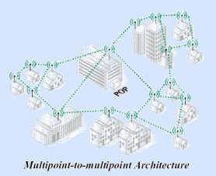

Figure 4: Multipoint to multipoint network architecture

Point-to-multipoint link (or simply a multipoint) is a specific type of multipoint link which consists of a central connection endpoint (CE) that is connected to multiple peripheral connection endpoints. Any transmission of data that originates from the central CE is received by all of the peripheral CEs while any transmission of data that originates from any of the peripheral CEs is only received by the central CE.

Forward link is the link from a fixed location (e.g., a [base station](https://en.wikipedia.org/wiki/Base_station)) to a mobile user. If the link includes a [communications relay satellite](https://en.wikipedia.org/wiki/Communications_satellite), the forward link will consist of both an [uplink](https://en.wikipedia.org/wiki/Uplink) (base station to satellite) and a downlink (satellite to mobile user).

Reverse link (sometimes called a [return channel](https://en.wikipedia.org/wiki/Return_channel)) is the link from a mobile user to a fixed base station. If the link includes a [communications relay satellite](https://en.wikipedia.org/wiki/Communication_satellite), the reverse link will consist of both an [uplink](https://en.wikipedia.org/wiki/Uplink) (mobile station to satellite) and a [downlink](https://en.wikipedia.org/wiki/Downlink) (satellite to base station) which together constitute a half [hop](https://en.wikipedia.org/wiki/Hop_(telecommunications)).

A reverse link for PMSE use is for example:

* Data between motorcycle-helicopter-and ground station;
* wireless MIDI;
* Bluetooth;
* SNG.

Links are often referred to by terms that refer to the ownership or accessibility of the link:

* A private link is a link that is either owned by a specific entity or a link that is only accessible by a specific entity;
* A public link is a link that uses the public switched telephone network or other public utility or entity to provide the link and which may also be accessible by anyone.

In some cases, the same data is transmitted over several frequencies in order that the systems keep working and can work safely even when a data channel is interrupted.

More complex PMSE systems, for example a wireless camera robot, needs many service links:

* Geolocation;
* Multipoint Frequency for driving;
* Point to point Frequency for safety;
* Reverse link Frequency for moving head/data;
* Point to point Frequency for video;
* Broadcast link Frequency for shading.

# Changes and trends in supply of radio spectrum for PMSE

## Regulatory changes in spectrum allocations for PMSE

### EC Implementing Decision 2016/687 and its impact on spectrum availability for audio PMSE

PMSE applications typically share spectrum with other services on an interleaved basis. The criteria for sharing and the method of authorising spectrum access for PMSE is determined by national administrations. When alterations are made to the spectrum allocations for services with which PMSE shares, there is invariably an impact on PMSE services.

A good illustration of this is in the successive changes in spectrum allocations in the UHF band, first between 790 to 862 MHz [6], and more recently between 694 to 790 MHz [7]. These two bands were intensively used by audio PMSE applications. Until recently, the bands' primary allocation to television broadcast services on an ITU Region-wide basis offered audio PMSE a contiguous block of interleaved spectrum to use and economies of scale for PMSE equipment manufacturers owing to the increased size of the potential market.

It also conferred other benefits, such as the ability for PMSE users to use the same equipment across national borders (subject to obtaining the relevant authorisation) and a predictable and stable sharing environment presented by broadcast television transmitter networks that offered the high QoS conditions demanded by PMSE.

The re-purposing of those bands from broadcast services to IMT has resulted in a significant reduction in spectrum available for audio PMSE applications. Of the spectrum in 470 to 694 MHz that remains allocated to broadcast and thus available for interleaved PMSE use in line with Decision (EU) 2017/899 in EU member states [18], the reduction in spectrum is already acutely felt by PMSE users in some locations.

On the other hand, new bands for audio PMSE have been identified by CEPT and are now included in ERC Recommendation 25-10 [3] and ERC Recommendation 70-03, Annex 10 [4] (e.g. 1350-1400 MHz and 1518-1525 MHz).

### Reduction in availability of spectrum for video PMSE

For large events, spectrum in the 2-4 GHz range allocated to other services (typically government services) was often made available for specific events for video PMSE use to help alleviate short-term peaks in demand for video PMSE spectrum, such as those seen for major sporting events. However, changes in use of this frequency range have reduced the availability of this so called "loan spectrum" as a tool to mitigate these peaks in video PMSE spectrum demand.

## New regulatory approaches

### Video PMSE booking system in the Netherlands in the frequency range 2.3-2.4 GHz

In 2015, the Netherlands started a pilot for an online booking system for PMSE in the 2.3-2.4 GHz band, which is normally used for video PMSE applications and licensed on a per event basis for outdoor use. The web-application for the pilot was ready in May 2016 and has been tested extensively. Practical user and development experience was gained from the pilot.

The pilot required that temporary spectrum use for PMSE in the 2.3-2.4 GHz must be booked by users via a booking system. This booking system applies at this moment in time only for PMSE but will be extended to other users in the future. The use of the Licensed Shared Access (LSA) video PMSE booking system has been made obligatory for licensees for PMSE and this obligation is incorporated in the licences of PMSE users in this band.

LSA is now incorporated in the regular process of the Radiocommunications Agency. The LSA booking facility will be further embedded in the ICT landscape of the Dutch Radiocommunications Agency (Agentschap Telecom), and introduced in the first quarter of 2021. This embedded system will easily enable to widen the LSA scope to other bands and users.

The PMSE sector originally requested that the lead time for receiving spectrum assignments for temporary use would be shortened and that interference problems would be reduced. This booking system has been proven to fulfil this request.

Further development of the system will involve other existing users in the band, namely, government use and radio amateurs. A roadmap was drawn up to describe future possibilities and expected timelines of LSA in the Netherlands. This roadmap looks beyond the 2.3-2.4 GHz band and its users and will also consider other means of sharing the spectrum than via a manual booking in a web-application. Other potentially promising bands for future LSA usage are under investigation.

# Mitigating factors in response to changing demand and supply of spectrum

## Changing working practices in PMSE

### Frequency management and site planning

Accommodating peak demand often involves detailed intervention and planning by PMSE users or the national administration. ECC Report 44 [8] offers detailed guidance on the considerations in planning radio use at major PMSE events.

In the UK, the Digital Television Group in co-ordination with Ofcom UK published a report [9] on PMSE 700 MHz Clearance Coordination in 2019. It contains detailed information for PMSE users on best practice in PMSE site planning in response to the reduction in available spectrum for audio PMSE in the 700 MHz band.

Frequency management for a site includes the selection of appropriate equipment, technology and frequency bands for the different PMSE applications. PMSE use is a mixture of fixed sites and temporary use. Thus, at large venues, frequency management is a key factor in interference-free productions. Some of the ways these working practices might mitigate the combined effect of reduced spectrum supply and increasing demand are discussed below.

### Reduction in the mixing of analogue and digital PMSE equipment

The increasing number of items of audio PMSE equipment in use at the busiest locations and events, combined with the reduction in availability of UHF spectrum described above, is likely to result in denser audio PMSE deployments. This is likely to be made possible by improvements in the efficiency of both analogue and digital PMSE equipment. However, due to differences in the way analogue and digital PMSE equipment operates, achieving greater density in deployment may prohibit the use of analogue and digital equipment in the same studio location.

In principle, so long as the frequency ranges used are the same, there should be no need for different cabling and distribution used for analogue wireless microphones, and the cabling and distribution used for digital wireless microphones.

However, some digital equipment uses filtering and gain control on studio receive antennas which is sent from the receiver via the coaxial cable. This could have an adverse effect on analogue systems as the frequencies they use could be blocked by the filtering of the PMSE antenna or could cause issues with levels due to the gain control.

In general, if systems have existing filtering, RF boosters, or other equipment tuned to a range of frequencies or band-limited, then regardless of whether replacement equipment is analogue or digital, the compatibility of the new equipment to existing equipment will need to be considered.

There may not necessarily be a difference in audio quality between analogue and digital systems. However, there may be tonal variations that mean that mixing the two systems is not feasible within a production.

Additionally, digital audio may produce a cleaner and more consistent sound, whereas analogue equipment may not be as clean and consistent due to companding, which can produce artefacts [10].

### Temporal sharing

Several artists at an event may use the same PMSE channel as long as they are not performing at the same time, i.e. temporal sharing. To use an example, in an ideal set-up of a large multi-stage outdoor music concert like Glastonbury Festival, temporal sharing would require, per stage, the largest sum of audio channel requirements of two adjacent acts (so that one act can be performing whilst the next is kitted up with their microphones, IEMs, etc). Another example of this practice in operation was at the London 2012 Olympics opening and closing ceremonies. All performers, including bands, shared a total of approximately 40 frequency assignments for wireless microphones and 24 for IEMs, with a high level of management of individual devices.

It should be noted, however, that temporal sharing has its limitations and may depend on the authorisation regimes of individual administrations and the full cooperation of participants [11] .

### Spatial re-use

Spatial re-use of the same frequency at the same time is possible over a large site, because interference is unlikely to occur at distances in excess of a few hundred metres and intermodulation effects between transmitters is most likely to occur when transmitters are in proximity.

### Greater use of DECT technology for talkback and intercom

If available spectrum at a location is in short supply, PMSE users might manage the available UHF spectrum by adopting systems that use DECT technology for talkback and intercom, thereby taking the place of systems that would traditionally share spectrum with wireless microphone and IEMs. It has the advantage of maximising availability of spectrum for wireless microphones and IEMs in the range 470-694 MHz. The robust nature of DECT and the ability to deploy complex private networks is particularly attractive, and it serves a valuable purpose, though it does not achieve the low latency required for other PMSE applications.

## Technological development in PMSE equipment and its limitations

### Audio PMSE equipment

The term “spectrum efficiency” has different meanings in different contexts. It is used in this Report to describe how many audio signals or links can be accommodated within a given amount of spectrum and which meets QoS requirements of the application and user.

The audio PMSE industry is an innovative sector and many new technology developments have been incorporated within PMSE products in the last decade. The stringent requirements users place on audio PMSE products impact all the technology blocks used in an audio PMSE system. These systems sit at the front end of the audio chain and must deliver flawless high-quality real-time audio for a wide variety of downstream uses including live performances, breaking news, sports events, and audio and video productions among others.

The PMSE industry has invested heavily in the development of new spectrally efficient transmission technologies and techniques. These have been supported by the development of other technologies such as smaller and higher capacity batteries. Nevertheless, it is not possible to maximize product performance for every requested feature. For example, a longer transmitter runtime requirement influences the maximum allowed current consumption, which will impact the performance of the RF output power stage, with the potential consequence of lower spectrum efficiency and/or higher latency.

The spectrum efficiency of different equipment varies because audio PMSE products are often designed for a specific application, which requires the manufacturer to focus on certain performance attributes, and not only on spectrum efficiency.

Spectrum efficiency is often characterised as the number of audio channels that can operate within a frequency bandwidth of 8 MHz, which relates to a typical UHF-TV channel bandwidth. The availability of spectrum with low enough noise levels is a requirement in order to achieve high spectral efficiency.

Spectrum efficiency numbers for wireless microphones vary between 12 and >25 audio channels for an equivalent audio quality in an 8 MHz channel, depending on the application. Where there is a mixture of wireless microphones and IEMs the numbers will vary.

The calculation of a frequency list for a multichannel audio PMSE system needs to consider the different types of audio PMSE products used in that specific setup, as well as the RF environment in that location and the regulatory and licensing requirements.

Frequency management software can calculate the best frequency list for a given audio PMSE setup for a specific location. The spectrum efficiency value obtainable in each scenario might differ from the maximum number of theoretically achievable channels, due to local conditions.

While new PMSE technologies have delivered significant spectrum efficiency gains, PMSE faces a fast-growing demand by wireless microphone and IEM users for more audio channels and clean, interference-free spectrum as well as for higher audio quality.

### Video PMSE equipment

Video PMSE is making greater use of higher frequencies such as the allocations around 7 GHz and above. This is relieving demand pressure on the core sub-3 GHz video PMSE bands. In exceptional cases, such as that of Formula 1 (which sees the largest simultaneous use of video PMSE at a single event), a migration to much higher frequencies has been accomplished (see Annex A6.2 Formula 1 (F1)). However, it is important to note that this solution is an exceptional case and not applicable to other use cases of video PMSE.

Use of higher frequencies (above 3 GHz) may be suitable for some short-range terrestrial PMSE use cases. But cycling, marathons, triathlons, and cross-country skiing rely on high-altitude microwave mid-points which need frequencies below 3 GHz for non-line-of-sight coverage. Similar considerations apply, for example, to the World Rally Championship racing where helicopters and fixed wing aircraft are an integral part of the content delivery system.

Where motorcycles are used, an important consideration is the safety of the cameraman seated at the rear of the bike and often facing backwards. At frequencies below 3 GHz, the EMF safety limits can be achieved; however, as frequencies become higher more power is required to maintain the same coverage and thus the EMF safety limit might be exceeded.

## Developing and potential technologies for PMSE use

### Wireless Multichannel Audio System (WMAS)

Currently the audio PMSE industry make use of analogue and digital technologies employing narrowband modulation techniques in typically 200 kHz RF channels. These narrow-band audio PMSE systems follow a typical link-based approach and are separated in frequency.

A WMAS[3] is a digital solution employing a wideband RF channel and establishes a system-based approach targeting on multi-channel audio applications, e.g. wireless microphones and IEMs in live audio production such as concerts, musicals, theatres or TV shows. In these targeted applications, WMAS may offer improved spectral efficiency in terms of audio channels per MHz and operational flexibility while maintaining, and in many instances even improving, interference protection to other services operating in adjacent bands compared to narrowband equipment. In WMAS all portable devices share the same physical RF channel but depending on the access scheme are separated in different audio channels.

### C-PMSE

The technical report ETSI TR 102 801 ‘Methods, parameters and test procedures for cognitive interference mitigation techniques for use by PMSE devices’ [12] developed by ETSI STF 386 describes cognitive PMSE systems (C-PMSE system) in detail, including block diagrams and interface descriptions of the different modules.

Currently available PMSE systems offer various cognitive capabilities as a standalone hardware product. Additional cognitive features can be achieved if the PMSE system is used in conjunction with specially designed software to create a frequency management network.

The main goal of a C-PMSE system is to enhance the reliability, stability and quality of the audio channels.

### 4G and 5G public mobile networks

Although the configuration and business model of public mobile networks typically focusses on the downlink capacity, whereas PMSE applications tend to use wireless systems for maximum uplink, the IMT technology could provide interesting solutions for some PMSE use cases. For many years, broadcasters have made use of so-called "IP bonding units" for delivering video content, especially for ENG, by doing nothing more than creating an IP pipe between the camera on location and the studio centre. These bonding units use multiple SIM-cards from multiple mobile network operators. This solution of getting live footage back to the studio centre is cheaper and quicker than the cost of providing an SNG truck with crew, but the quality of the link fully depends on the available mobile network capacity at the specific location. Using public mobile networks, the first news crews to arrive at a breaking-news event can provide early content, as long as the connection provides enough capacity. However, for scheduled events this technique may not provide acceptable quality and reliability.

Employing cellular communication technology, such as 3GPP 5G NR, for PMSE is still a topic of early research. The interest in 5G is motivated by the potential to generate new business models, enabled mainly by the possible technology convergence of production and distribution in media and entertainment. In addition, 5G is seen as the first mobile communications technology, which offers the possibility to integrate vertical industries. This, of course, has to be evaluated to identify the possible potential for PMSE.

The first aspects of the feasibility of this technology approach was investigated by the PMSE-xG research project and further research and developments are continuing in the LIPS project. Results indicate that especially non-public, self-deployed local area 5G networks combined with an evolved Licensed Shared Access (eLSA) enabled access to radio spectrum are a promising way forward.

Nevertheless, the combination of important key performance indicators like power consumption, mouth-to-ear streaming latency and spectral efficiency of demonstrated research by various stakeholders are currently far off the limits compared to what is currently possible with legacy digital PMSE systems. This might change in future due to continued efforts in research, standardisation and development of 5G.

In conclusion, PMSE in 5G, and here especially for live audio productions, has currently an unknown target date for implementation in technical specification of 3GPP, in the technology support itself and in the deployment. PMSE applications with less demanding requirements like audio distribution to the audience of an event or ENG benefiting from a national deployed 5G network with full coverage might be early adopters of 5G technology.

Further information on the research projects is provided in Annex 8.

### 4G and 5G private mobile networks

The technologies used for public mobile networks but operated as a private network provide the advantage of access to commercial off-the-shelf (COTS) products (e.g. dongles, UE, RANs) and a core network that can either be placed at the event location or via a link in a centralised core production environment which could be hundreds of kilometres away from the event. The core can be configured to manage multiple wireless cameras at the same time at different locations, and there is no contention with other users' data requirements as there would be over a public mobile network. Another advantage is that the QoS can be defined by the producer on a per camera basis and small cells (picocells or nanocells) can be placed wherever they are required. If equipment fails or needs adjustment, it can be swapped out or reconfigured instantly from the control room, whether locally or remotely.

Private networks of small cells could meet the requirements for several PMSE use- cases such as talkback and data in the initial stages and if various features proposed for 5G release 17 (2023), such as low latency and seamless handover (service continuity) at high speed, become available, then the potential for wider use for video PMSE would be enhanced.

For TV production and other video PMSE use-cases, promising solutions based on 5G private networks are currently being investigated, as e.g. in an innovation project 5G PROLIVE. Further information on this project can be found in Annex 8.

In any case, private 4G/5G networks for PMSE purposes would require sufficient spectrum to be available locally and often on an ad-hoc basis. In principle, private networks for PMSE could be deployed in different ways, including by the content producers themselves, by third-party providers on a neutral host basis or by an MNO, provided that a business case is seen by the operator.

Various solutions are currently being proposed by European regulators for making spectrum locally available for private 5G networks[4]. However, the currently considered approaches tend to be focused generally on longer time frames, i.e. a minimum of a year. While this may work in a fixed location such as a studio, a venue, or a frequently visited news location, in many cases PMSE usage happens on a short-term (from a few hours to some days or weeks) so that on-demand local access to spectrum would be more appropriate. Thus, short term ad-hoc site licensing as already used for PMSE should continue.

A possible solution for PMSE could be to let 4G/5G private networks for PMSE use frequency bands already within the PMSE tuning ranges recommended in ERC Recommendation 25-10 (in particular, the E-UTRA band 40 in the 2.3-2.4 GHz band) [3], under the same technical conditions as conventional PMSE, based on a technology neutral authorisation.

In conclusion, the access of spectrum by PMSE using 4G/5G private networks would depend on the underlying network deployment model and on the applicable national spectrum regulation. In order to maximise the economic benefits of 4G/5G private networks for PMSE in Europe, PMSE users would welcome a close coordination on an international level regarding spectrum access rules and available bands. Technical suitability for different PMSE applications also depends on the spectrum band, noting that different frequency bands have different propagation characteristics which may or may not support mobility, indoor penetration etc. Furthermore, technology neutral local spectrum licenses for PMSE would allow for the integration of supplementary systems with 5G or a mixed operation of conventional and 5G-based PMSE systems.

### DECT

With the reduction of spectrum available in the 470-862 MHz band, many PMSE users have changed from FM or digital talkback to DECT in order to preserve the 470-694 MHz for wireless microphones/IEM. It is a solution only where latency is not a top priority.

The Digital Enhanced Cordless Telecommunications (DECT) system has started its operation in Europe in the band 1880-1900 MHz (EC Decision 1993/310/EC [13]). It has spread around the globe and has become the most successful digital cordless telephone system in the world. This global capability is attractive to PMSE users

DECT is in the process of development with the 'Ultra Low Energy' (ULE) technical specification, DECT evolution and DECT-2020. Further information in is provided in Annex 9.

1. CEPT and ECC Reports

List of CEPT and ECC Reports relevant for PMSE:

* ECC Report 219: "Characteristics of PMSE digital video links to be used in compatibility and sharing studies 2014,

download at: <https://docdb.cept.org/document/326>;

* ECC Report 220: "Compatibility/sharing studies related to PMSE, DECT and SRD with DA2GC in the 2 GHz unpaired bands and MFCN in the adjacent 2 GHz paired band 2014",

download at: <https://docdb.cept.org/document/327>;

* ECC Report 221: “Adjacent band compatibility between MFCN and PMSE audio applications in the 700 MHz frequency band”,

download at: <https://docdb.cept.org/document/328>;

* ECC Report 243: “Wireless video links in the frequency bands 2700-2900 MHz and 2900-3400 MHz”,

download at: <https://docdb.cept.org/document/349>;

* ECC Report 245: “Compatibility studies between a PMSE and other systems / services in the band 1350-1400 MHz”,

download at: <https://docdb.cept.org/document/351>;

* ECC Report 253: “Compatibility studies for audio PMSE at 1492-1518 MHz and 1518-1525 MHz”,

download at: <https://docdb.cept.org/document/957>;

* ECC Report 285: “Best practices for Video Programme Making and Special Event (PMSE) in the 2700-2900 MHz band”,

download at: <https://docdb.cept.org/document/6038>;

* ECC Report 286: “Body effect of hand-held and body-worn audio PMSE equipment”,

download at: <https://docdb.cept.org/document/6160>;

* CEPT Report 50: “Report A from CEPT to the European Commission in response to the Mandate “On technical conditions regarding spectrum harmonisation options for wireless radio microphones and cordless video-cameras (PMSE equipment)”, Technical conditions for the use of the bands 821-832 MHz and 1785-1805 MHz for wireless radio microphones in the EU,

download at: <https://docdb.cept.org/document/50>;

* CEPT Report 51: “Report B from CEPT to the European Commission in response to the Mandate “On technical conditions regarding spectrum harmonisation options for wireless radio microphones and cordless video-cameras”, Technical conditions for ensuring the sustainable operation of cordless video-cameras”,

download at: <https://docdb.cept.org/document/51>;

* CEPT Report 61: “Harmonised compatibility and sharing conditions for video PMSE in the 2.7-2.9 GHz frequency band, taking into account radar use”,

download at <https://docdb.cept.org/document/978>.

1. Tables of PMSE assignment data (UK)

Table 3: Total number of frequency assignments in five major cities

|  |  |  |  |  |  |
| --- | --- | --- | --- | --- | --- |
|  | Year 2014 | Year 2015 | Year 2016 | Year 2017 | Year 2018 |
| London (26 km of centre) | 69781 | 81395 | 88874 | 97044 | 105499 |
| Birmingham (5 km of centre) | 4249 | 4437 | 4941 | 5652 | 5941 |
| Liverpool (5 km of centre) | 3821 | 3796 | 4801 | 4619 | 5305 |
| Manchester (7 km of centre) | 8591 | 9424 | 11713 | 12284 | 13414 |
| Edinburgh (7 km of centre) | 3070 | 3239 | 3434 | 4089 | 4148 |

Table 4: Number of frequency assignments by band - London

|  | Year 2014 | Year 2015 | Year 2016 | Year 2017 | Year 2018 |
| --- | --- | --- | --- | --- | --- |
| 25-65 MHz (Audio Links and ADS) | 42 | 66 | 41 | 75 | 59 |
| 65-470 MHz (Talkback, mics, audio links, camera data) | 12479 | 13824 | 13581 | 16062 | 15130 |
| 470-790 MHz (Mics, IEMs, talkback, camera data) | 55003 | 64556 | 72522 | 77791 | 87128 |
| 1-2 GHz (STLs, telemetry, vision links, mics) | 28 | 58 | 8  (Note 1) | 4 | 2 |
| 2 GHz (video links) | 1551 | 2018 | 2238 | 2413 | 2246 |
| 3 GHz (video links) | 376 | 429 | 130  (Note 2) | 88 | 87 |
| 4-7 GHz (video links) | 198 | 314 | 239 | 526 (Note 3) | 505 |
| 8-12 GHz (video links) | 104 | 130 | 115 | 85 | 92 |
| >20 GHz (video links) | 0 | 0 | 0 | 0 | 0 |
| Note 1: The reduction in frequency assignments (in 2016 compared with 2014 and 2015) is due to the 1.8 GHz band (1785-1805 MHz) being added to the UHF Shared licence rather than individual frequency assignments in the band. This was in response to the EC Implementing Decision 2014/641/EU [19].  Note 2: PMSE ceased to have access to the 3.4 GHz band in 2016 leading to a reduction in the number of frequency assignments.  Note 3: The increase in frequency assignments in the 4-7 GHz band is primarily a result of increased use of 7 GHz for wireless cameras. | | | | | | |

Table 5: Number of frequency assignments by band - Birmingham

|  | Year 2014 | Year 2015 | Year 2016 | Year 2017 | Year 2018 |
| --- | --- | --- | --- | --- | --- |
| 25-65 MHz (Audio Links and ADS) | 8 | 12 | 8 | 6 | 10 |
| 65-470 MHz (Talkback, mics, audio links, camera data) | 1147 | 1008 | 952 | 1287 | 1286 |
| 470-790 MHz (Mics, IEMs, talkback, camera data) | 2903 | 3242 | 3808 | 4163 | 4473 |
| 1-2 GHz (STLs, telemetry, vision links, mics) | 2 | 2 | 2 | 2 | 2 |
| 2 GHz (video links) | 154 | 149 | 152 | 152 | 129 |
| 3 GHz (video links) | 27 | 12  (Note 1) | 2 | 1 | 1 |
| 4-7 GHz (video links) | 8 | 12 | 17 | 41  (Note 2) | 40 |
| 8-12 GHz (video links) | 0 | 0 | 0 | 0 | 0 |
| >20 GHz (video links) | 0 | 0 | 0 | 0 | 0 |
| Note 1: PMSE ceased to have access to the 3.4 GHz band in 2016 leading to a reduction in the number of frequency assignments.  Note 2: The increase in frequency assignments in the 4-7 GHz band is primarily a result of increased use of 7 GHz for wireless cameras. | | | | | | |

Table 6: Number of frequency assignments by band - Liverpool

|  | Year 2014 | Year 2015 | Year 2016 | Year 2017 | Year 2018 |
| --- | --- | --- | --- | --- | --- |
| 25-65 MHz (Audio Links and ADS) | 3 | 9 | 2 | 1 | 1 |
| 65-470 MHz (Talkback, mics, audio links, camera data) | 1216 | 980 | 1185 | 1192 | 1292 |
| 470-790 MHz (Mics, IEMs, talkback, camera data) | 2452 | 2645 | 3410 | 3196 | 3775 |
| 1-2 GHz (STLs, telemetry, vision links, mics) | 0 | 0 | 0 | 0 | 0 |
| 2 GHz (video links) | 120 | 134 | 158 | 177 | 185 |
| 3 GHz (video links) | 23 | 23  (Note 1) | 5 | 0 | 0 |
| 4-7 GHz (video links) | 7 | 5 | 41 | 53  (Note 2) | 52 |
| 8-12 GHz (video links) | 0 | 0 | 0 | 0 | 0 |
| >20 GHz (video links) | 0 | 0 | 0 | 0 | 0 |
| Note 1: PMSE ceased to have access to the 3.4 GHz band in 2016 leading to a reduction in the number of frequency assignments.  Note 2: The increase in frequency assignments in the 4-7 GHz band is primarily a result of increased use of 7 GHz for wireless cameras. | | | | | |

Table 7: Number of frequency assignments by band - Manchester

|  | Year 2014 | Year 2015 | Year 2016 | Year 2017 | Year 2018 |
| --- | --- | --- | --- | --- | --- |
| 25-65 MHz (Audio Links and ADS) | 6 | 10 | 9 | 8 | 5 |
| 65-470 MHz (Talkback, mics, audio links, camera data) | 1902 | 2102 | 2382 | 2268 | 2475 |
| 470-790 MHz (Mics, IEMs, talkback, camera data) | 6302 | 6935 | 8882 | 9527 | 10466 |
| 1-2 GHz (STLs, telemetry, vision links, mics) | 4 | 4 | 4 | 4 | 3 |
| 2 GHz (video links) | 329 | 331 | 376 | 409 | 403 |
| 3 GHz (video links) | 37 | 26  (Note 1) | 11 | 6 | 0 |
| 4-7 GHz (video links) | 11 | 16 | 49 | 62  (Note 2) | 62 |
| 8-12 GHz (video links) | 0 | 0 | 0 | 0 | 0 |
| >20 GHz (video links) | 0 | 0 | 0 | 0 | 0 |
| Note 1: PMSE ceased to have access to the 3.4 GHz band in 2016 leading to a reduction in the number of frequency assignments.  Note 2: The increase in frequency assignments in the 4-7 GHz band is primarily a result of increased use of 7 GHz for wireless cameras. | | | | | |

Table 8: Number of frequency assignments by band - Edinburgh

|  | Year 2014 | Year 2015 | Year 2016 | Year 2017 | Year 2018 |
| --- | --- | --- | --- | --- | --- |
| 25-65 MHz (Audio Links and ADS) | 7 | 6 | 6 | 9 | 6 |
| 65-470 MHz (Talkback, mics, audio links, camera data) | 630 | 571 | 628 | 829 | 856 |
| 470-790 MHz (Mics, IEMs, talkback, camera data) | 2309 | 2507 | 2642 | 3068 | 3108 |
| 1-2 GHz (STLs, telemetry, vision links, mics) | 10 | 6 | 3  (Note 1) | 0 | 0 |
| 2 GHz (video links) | 107 | 130 | 127 | 142 | 152 |
| 3 GHz (video links) | 2 | 12  (Note 2) | 16 | 22  (Note 3) | 15 |
| 4-7 GHz (video links) | 2 | 7 | 12 | 19  (Note 4) | 11 |
| 8-12 GHz (video links) | 0 | 0 | 0 | 0 | 0 |
| >20 GHz (video links) | 0 | 0 | 0 | 0 | 0 |
| Note 1: The reduction in frequency assignments (in 2016 compared with 2014 and 2015) is due to the 1.8 GHz band (1785-1805 MHz) being added to the UHF Shared licence rather than individual frequency assignments in the band. This was in response to the EC Implementing Decision 2014/641/EU [19].  Note 2: PMSE ceased to have access to the 3.4 GHz band in 2016 leading to a reduction in the number of frequency assignments.  Note 3: The number of assignments in the 3 GHz band is a result of coordinated access to this spectrum to cover a series of rugby matches. This licensee has now moved to alternative bands.  Note 4: The increase in frequency assignments in the 4-7 GHz band is primarily a result of increased use of 7 GHz for wireless cameras. | | | | | |

Table 9: Number of frequency assignments at major events - Wimbledon

|  | Year 2014 | Year 2015 | Year 2016 | Year 2017 | Year 2018 |
| --- | --- | --- | --- | --- | --- |
| Microphone / IEM | 94 | 142 | 124 | 149 | 159 |
| Talkback VHF | 0 | 0 | 0 | 2 | 0 |
| Talkback UHF | 94 | 132 | 103 | 128 | 121 |
| 1-2 GHz | 0 | 0 | 0 | 1 (camera) | 0 |
| 2 GHz | 9 | 10 | 12 | 12 | 13 |
| 3 GHz | 1 | 0 | 0 | 2 | 2 |
| 4-7 GHz | 0 | 0 | 0 | 0 | 0 |
| 8-12 GHz | 0 | 0 | 0 | 0 | 0 |
| >20 GHz | 0 | 0 | 0 | 0 | 0 |

Table 10: Number of frequency assignments at major events – British Grand Prix

|  |  |  |  |  |  |
| --- | --- | --- | --- | --- | --- |
|  | Year 2014 | Year 2015 | Year 2016 | Year 2017 | Year 2018 |
| Microphone / IEM | 218 | 229 | 190 | 265 | 200 |
| Talkback VHF | 121 | 124 | 82 | 63 | 72 |
| Talkback UHF | 188 | 178 | 156 | 158 | 148 |
| 1-2 GHz | 16 (telemetry) | 9 (telemetry) | 4 (telemetry) | 6 (telemetry) | 7 (telemetry) |
| 2 GHz | 16 | 18 | 5  (Note 1) | 4 | 3 |
| 3 GHz | 23 | 25 | 15 | 18 | 16 |
| 4-7 GHz | 25 | 23 | 25 | 29 | 24 |
| 8-12 GHz | 2 | 2 | 29  (Note 1) | 30 | 30 |
| >20 GHz | 0 | 0 | 0 | 0 | 0 |
| Note 1: New technology has come about in the form of 8 to 10 GHz where complete circuits carrying onboard video, audio, telemetry and communications is carried on a 8 MHz channel. This has reduced the load significantly on 2 GHz. | | | | | | |

Table 11: Number of frequency assignments at major events – Open Golf Championship

|  | Year 2014 | Year 2015 | Year 2016 | Year 2017 | Year 2018 |
| --- | --- | --- | --- | --- | --- |
| Microphone / IEM | 148 | 122 | 149 | 178 | 148 |
| Talkback VHF | 11 | 0 | 0 | 0 | 2 |
| Talkback UHF | 149 | 166 | 182 | 192 | 185 |
| 1-2 GHz | 4 (camera) | 4 (camera) | 0 | 0 | 0 |
| 2 GHz | 18 | 19 | 22 | 26 | 24 |
| 3 GHz | 0 | 0 | 1 | 1 | 1 |
| 4-7 GHz | 1 | 4 | 0 | 1 | 0 |
| 8-12 GHz | 0 | 0 | 0 | 0 | 0 |
| >20 GHz | 0 | 0 | 0 | 0 | 0 |

Table 12: Number of frequency assignments at major events – Reading Festival

|  |  |  |  |  |  |
| --- | --- | --- | --- | --- | --- |
|  | Year 2014 | Year 2015 | Year 2016 | Year 2017 | Year 2018 |
| Microphone / IEM | 469 | 422 | 634 | 681 | 606 |
| Talkback VHF | 0 | 4 | 4 | 0 | 5 |
| Talkback UHF | 69 | 65 | 100 | 91 | 50 |
| 1-2 GHz | 0 | 0 | 0 | 0 | 0 |
| 2 GHz | 0 | 0 | 0 | 0 | 0 |
| 3 GHz | 0 | 0 | 0 | 0 | 0 |
| 4-7 GHz | 0 | 0 | 0 | 0 | 0 |
| 8-12 GHz | 0 | 0 | 0 | 0 | 0 |
| >20 GHz | 0 | 0 | 0 | 0 | 0 |

1. Tables of PMSE assignment data (France)
2. PMSE assignment data during major events in Paris and Le Mans

Every year, three major events occur in Paris and Le Mans:

* Roland-Garros : major tennis tournament over two weeks in Paris which begins in late May;
* 24 HEURES DU MANS (24 Hours of Le Mans): 24-hour car race which takes place in June in the town of Le Mans;
* DÉFILÉ 14/07: The 14 July parade along the Champs-Elysées in Paris during the French national holiday celebration.

|  |  |
| --- | --- |
| Roland Garros (Auteuil, Paris) RÃ©sultat de recherche d'images pour "roland garros" | 24 HEURES DU MANS (Le Mans) |
| DÉFILÉ 14/07 (Les Champs-Elysées, Paris) | |

Figure 5: Major events in Paris and Le Mans

Table 13: Total number of frequency assignments during major events in Paris and in Mans

|  |  |  |  |  |  |  |
| --- | --- | --- | --- | --- | --- | --- |
|  | Year 2014 | Year 2015 | Year 2016 | Year 2017 | Year 2018 | Year 2019 |
| Roland Garros (Auteil, Paris) | 508 | 525 | 746 | 653 | 638 | 654 |
| DÉFILÉ 14/07 (Les Champs-Elysées, Paris) | 364 | 366 | 421 | 388 | 363 | 427 |
| 24 HEURES DU MANS (Le Mans) | 690 | 851 | 1327 | 1462 | 1291 | 1183 |

Table 14: Number of assignments by frequency band – Roland Garros

|  | Year 2014 | Year 2015 | Year 2016 | Year 2017 | Year 2018 | Year 2019 |
| --- | --- | --- | --- | --- | --- | --- |
| 25-65 MHz (Audio Links and ADS) | 0 | 0 | 0 | 0 | 0 | 0 |
| 65-470 MHz (Talkback, mics, audio links, camera data) | 238 | 198 | 306 | 290 | 310 | 349 |
| 470-790 MHz (Mics, IEMs, talkback, camera data) | 252 | 309 | 416 | 339 | 292 | 278 |
| 1-2 GHz (STLs, telemetry, vision links, mics) | 4 | 4 | 0 | 0 | 0 | 0 |
| 2 GHz (video links) | 10 | 9 | 12 | 9 | 15 | 14 |
| 3 GHz (video links) | 4 | 4 | 4 | 4 | 6 | 0 |
| 4-7 GHz (video links) | 0 | 1 | 8 | 11 | 15 | 15 |
| 8-12 GHz (video links) | 0 | 0 | 0 | 0 | 0 | 0 |
| >20 GHz (video links) | 0 | 0 | 0 | 0 | 0 | 0 |

Table 15: Number of assignments by frequency band – 24 HEURES DU MANS

|  |  |  |  |  |  |  |
| --- | --- | --- | --- | --- | --- | --- |
|  | Year 2014 | Year 2015 | Year 2016 | Year 2017 | Year 2018 | Year 2019 |
| 25-65 MHz (Audio Links and ADS) | 0 | 0 | 0 | 0 | 0 | 0 |
| 65-470 MHz (Talkback, mics, audio links, camera data) | 494 | 586 | 1045 | 1187 | 1056 | 914 |
| 470-790 MHz (Mics, IEMs, talkback, camera data) | 147 | 192 | 223 | 214 | 185 | 227 |
| 1-2 GHz (STLs, telemetry, vision links, mics) | 4 | 10 | 6 | 6 | 2 | 0 |
| 2 GHz (video links) | 19 | 27 | 27 | 28 | 27 | 26 |
| 3 GHz (video links) | 14 | 20 | 8 | 8 | 4 | 4 |
| 4-7 GHz (video links) | 4 | 8 | 8 | 12 | 10 | 12 |
| 8-12 GHz (video links) | 2 | 2 | 1 | 1 | 1 | 0 |
| >20 GHz (video links) | 6 | 6 | 9 | 6 | 6 | 0 |

Table 16: Number of assignments by frequency band – DÉFILÉ 14/07

|  |  |  |  |  |  |  |
| --- | --- | --- | --- | --- | --- | --- |
|  | Year 2014 | Year 2015 | Year 2016 | Year 2017 | Year 2018 | Year 2019 |
| 25-65 MHz (Audio Links and ADS) | 0 | 0 | 0 | 0 | 0 | 0 |
| 65-470 MHz (Talkback, mics, audio links, camera data) | 73 | 54 | 47 | 86 | 51 | 56 |
| 470-790 MHz (Mics, IEMs, talkback, camera data) | 241 | 254 | 327 | 250 | 262 | 323 |
| 1-2 GHz (STLs, telemetry, vision links, mics) | 5 | 2 | 2 | 3 | 1 | 2 |
| 2 GHz (video links) | 22 | 31 | 26 | 26 | 24 | 28 |
| 3 GHz (video links) | 16 | 7 | 8 | 8 | 9 | 5 |
| 4-7 GHz (video links) | 7 | 18 | 11 | 15 | 16 | 13 |
| 8-12 GHz (video links) | 0 | 0 | 0 | 0 | 0 | 0 |
| >20 GHz (video links) | 0 | 0 | 0 | 0 | 0 | 0 |

A3.2 PMSE assignment data during Tour De France 2017, 2018 and 2019

The Tour de France is an annual multiple-stage race held primarily in France every summer, occasionally venturing into surrounding countries. Table 17 below provides only an overview of the PMSE assignment data in French territory during the Tour de France in 2017, 2018 and 2019.

|  |  |  |
| --- | --- | --- |
| Image associÃ©e | RÃ©sultat de recherche d'images pour "tour de france 2018" | Image |

Figure 6: Map of the Tour de France 2017, 2018 and 2019

Table 17: Number of assignments by frequency band during the Tour de France

|  | Year 2017 | Year 2018 | Year 2019 |
| --- | --- | --- | --- |
| 25-65 MHz (Audio Links and ADS) | 0 | 0 | 0 |
| 65-470 MHz (Talkback, mics, audio links, camera data) | 338 | 339 | 316 |
| 470-790 MHz (Mics, IEMs, talkback, camera data) | 752 | 712 | 878 |
| 1-2 GHz (STLs, telemetry, vision links, mics) | 10 | 10 | 10 |
| 2 GHz (video links) | 25 | 26 | 30 |
| 3 GHz (video links) | 14 | 12 | 12 |
| 4-7 GHz (video links) | 12 | 14 | 16 |
| 8-12 GHz (video links) | 0 | 0 | 0 |
| >20 GHz (video links) | 0 | 0 | 0 |

In France, PMSE equipment was allowed to operate in the 700 MHz band until 1 July 2019. Consequently, the number of frequencies assigned to wireless microphone equipment during the Tour de France in UHF-TV channels 50 to 60 has decreased since 2017.

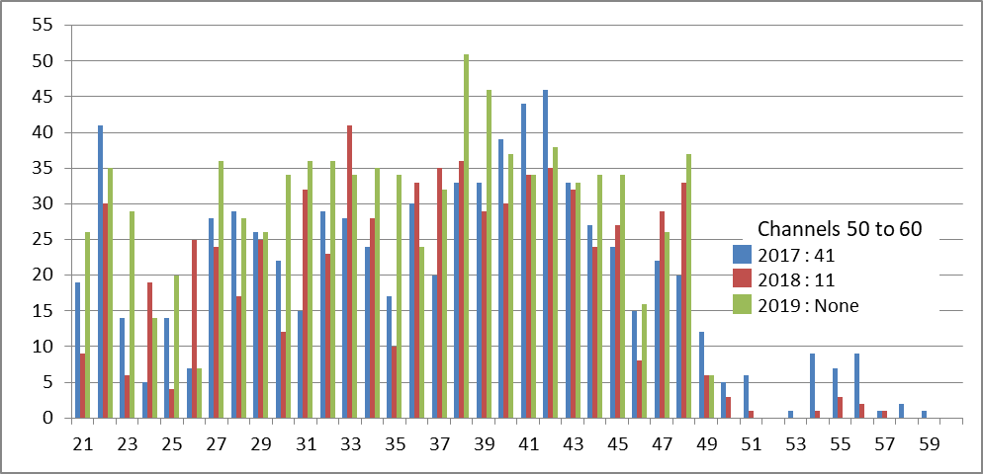

Figure 7: Frequencies assigned to wireless microphone equipment per UHF-TV channel during the Tour de France

1. Tables of PMSE assignment data (the Netherlands)

The below table presents the total number of frequency assignments for video PMSE by band from 2015 to 2018 in the Netherlands.

Table 18: Total number of PMSE video frequency assignments by band

|  | Year 2015 | Year 2016 | Year 2017 | Year 2018 |
| --- | --- | --- | --- | --- |
| 25-65 MHz (Audio Links and ADS) | n/a (Note 1) | n/a (Note 1) | n/a (Note 1) | n/a (Note 1) |
| 65-470 MHz (Talkback, mics, audio links, camera data) | n/a (Note 1) | n/a (Note 1) | n/a (Note 1) | n/a (Note 1) |
| 470-790 MHz (Mics, IEMs, talkback, camera data) | n/a (Note 1) | n/a (Note 1) | n/a (Note 1) | n/a (Note 1) |
| 1-2 GHz (STLs, telemetry, vision links, mics) | 102 | 116 | 42 | 75 |
| 2 GHz (video links) | 2519 | 2581 | 2482 | 3025 |
| 3 GHz (video links) | 183 | 117 | 138 | 222 |
| 4-7 GHz (video links) | 227 | 286 | 141 | 211 |
| 8-12 GHz (video links) | 22 | 36 | 32 | 23 |
| >20 GHz (video links) | 0 | 0 | 0 | 0 |
| Note 1 : Wireless microphones do not require a user license in the Netherlands (license exempt). Most other audio applications, like audio links and talkback, are licensed with a general license. The frequencies that are part of these licenses are not coordinated separately for each event. Therefore, accurate numbers are not available regarding audio PMSE usage. | | | | |

1. PMSE spectrum requirements use for large events in Slovenia

The biggest yearly events in PMSE usage are:

* Cycle event "Tour of Slovenia";
* Ski Jumping World Cup in Planica;
* Biathlon World Cup in Pokljuka;
* Alpine Ski World Cup in Kranjska Gora;
* Alpine Ski World Cup in Maribor.

A5.1 Mobile cameras

Two large media-broadcast companies hold permanent licences for mobile cameras:

* National Broadcast Company (RTV Slo)

2085 MHz bandwidth 30 MHz;

2325 MHz bandwidth 50 MHz (in future this frequency band likely to become unavailable).

* Pop TV

2017.5 MHz bandwidth 15 MHz.

As the licences are permanent, no information is available on times and locations of use.

Additional frequencies may be provided on a temporary basis, in some cases, from military frequency bands.

A5.2 Wireless microphones

Wireless microphones usage follow ERC Recommendation 70-03 [4]. Exceptions and limitations exist for specific frequency bands, but in general, use is licence exempt free and as such is not coordinated by the regulator. On-site coordination is performed in some cases by the National Broadcast Company (RTV Slo) or the Ministry of Defence.

1. video pmse case studies
2. video pmse spectrum demand in live sport

Televised sport currently uses the highest simultaneous number of wireless video devices (mainly radio cameras) and is forecast to do so for the foreseeable future, with F1 representing the highest instances. Flagship events with a global audience, for example the Tour de France and Formula One Grands Prix, have for years been broadcast using a variety of equipment that includes planes, helicopters and motorbikes.

Wireless cameras have proliferated and are now commonplace, but these sports have also pioneered the use of multiple participant ‘on-board’ cameras, a trend increasingly adopted by other sports such as horse racing. This trend has further contributed to increases in spectrum demand for video PMSE.

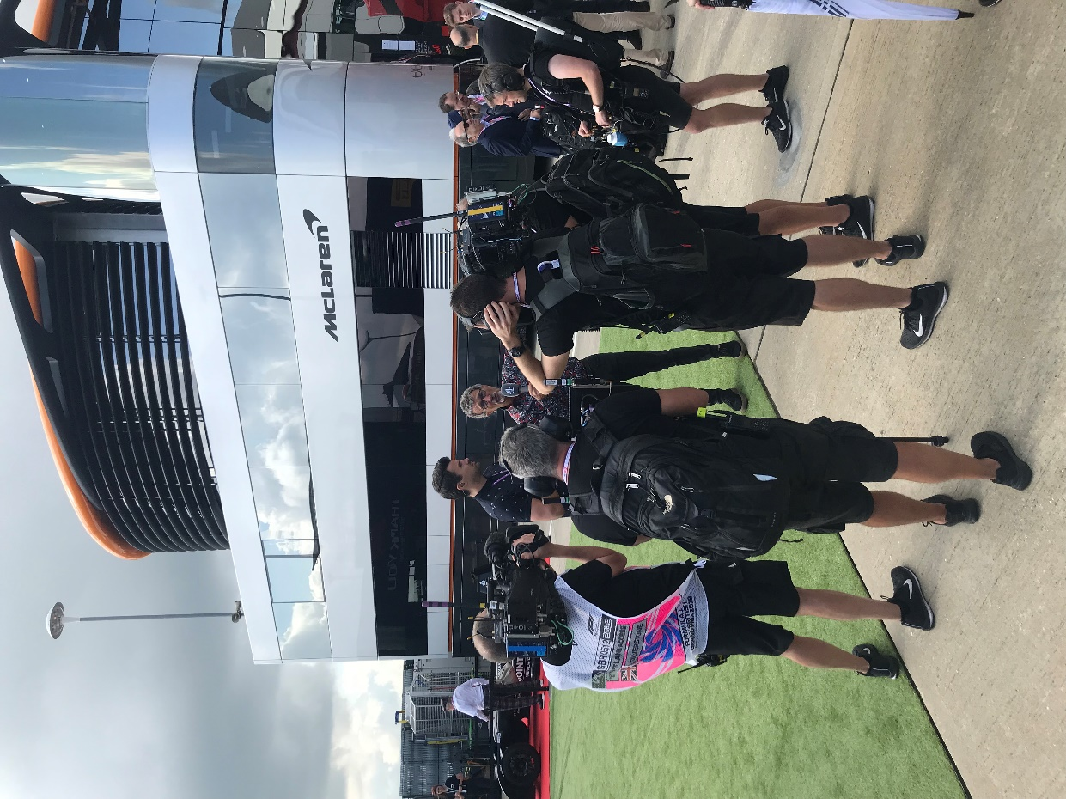

Figure 8: Wireless camera crew and presenters in "The Paddock", British F1 GP, Silverstone, July 2019. Wireless cameras allow "roving" footage, free from the constraints of cables

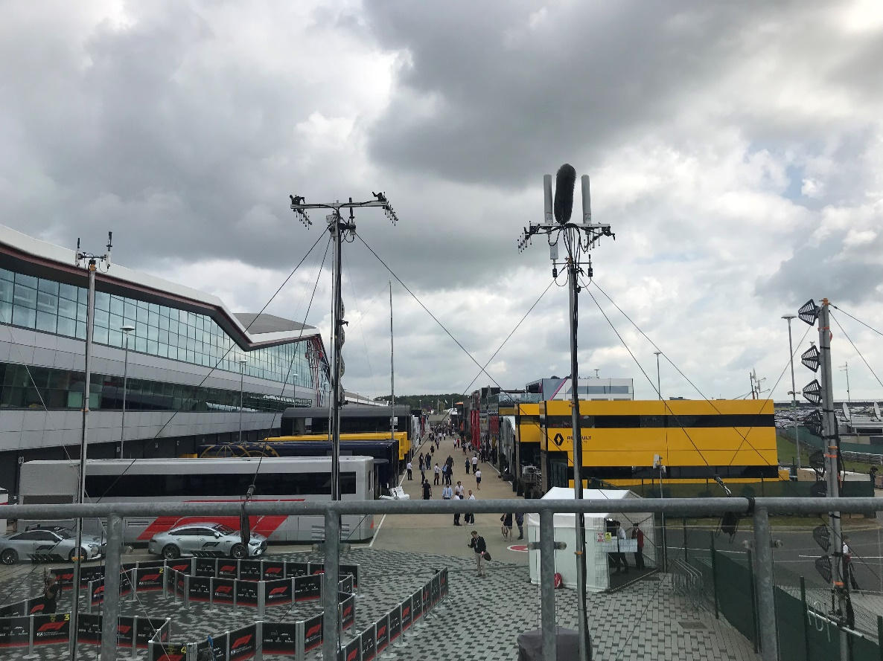

Figure 9: View down "The Paddock" of mobile team HQs at Silverstone, 2019. The satellite dishes of the large broadcast compound are just visible to the far right-hand-side of picture

The growth in "point-of-view" footage

Advances in camera technology (higher resolution, vastly improved battery performance and reliability, reduced form factor and cost) and the demand from broadcasters, sponsors and fans for a more immersive viewing experience has led to growth in “point of view” footage that captures an intensity, sense of speed and proximity not previously possible.

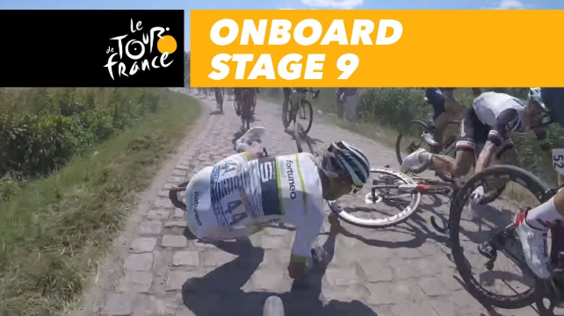

Figure 10: On-board HD bike camera capturing a crash on a cobbled section of the Tour de France

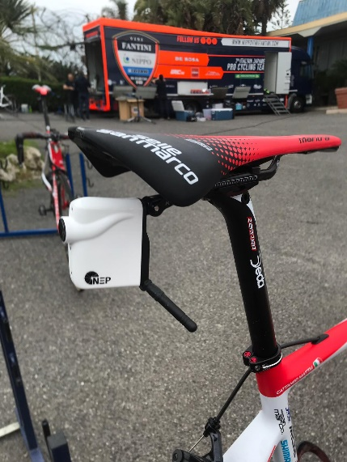

Figure 11: Rear-pointing HD camera mounted on the seat post of a Tour de France bike

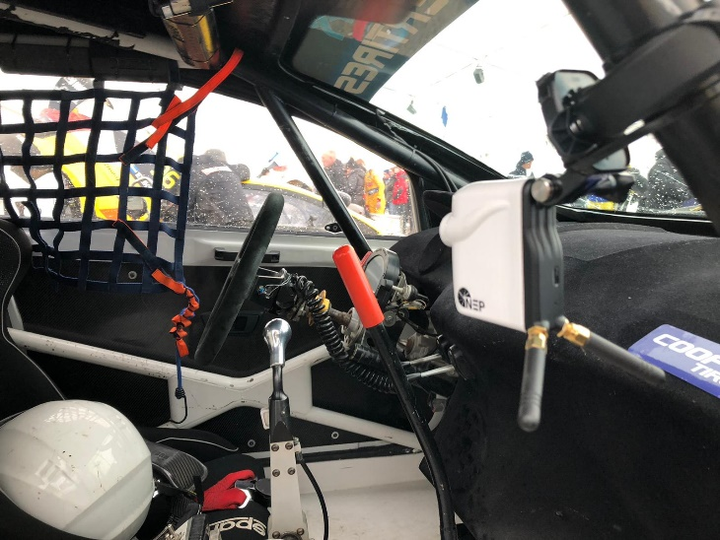

Figure 12: On-board camera mounted inside a car, Porsche Cup

A6.2 Formula 1 (F1)

Following continual development, on-board cameras have been mandatory in F1 since 1998. The incorporation by governing bodies (such as the Union Cycliste Internationale (UCI) for professional cycling, and the Federation Internationale de l’Automobile (FIA) for Formula 1) of on-board cameras into their respective regulations means broadcast producers now have dozens of options at their disposal. In F1, on-board footage can be edited with footage from approximately 25 cameras positioned around a track, 5 roving pit-lane wireless camera operators, the helicopter camera and CAMCAT[5] providing aerial shots, and other special angles, such as cameras embedded in the track and crash barriers of street circuits like Monaco and Singapore.

F1 is a truly global sport with a racing season that spans nine months per year and visits twenty-one countries. Each season produces approximately 430 hours of live TV, with on-board footage now an integral and indispensable part of race coverage that reflects broader changes in the way, video and audio content in live sport is consumed.

In 2017, the new owners of the controlling rights to F1 relaxed previously stringent restrictions on the use of footage by teams on their social media platforms, at once generating fresh interest and engagement from fans. In addition to augmenting live coverage, selected on-board clips are carefully curated and published on F1’s Facebook page, such as their ‘Top 10’ series of on-board clips from each race. This generates further engagement among its fan-base and has attracted new ‘cord-cutter’ viewers who might consume the content solely on mobile devices or via on-demand/subscription streaming platforms. Greater choice of video content also offers the flexibility and potential to offer tiered subscription models. For example, paying subscribers might consume a hybrid product, watching the main race feed on their TV while simultaneously streaming more bespoke ‘behind the scenes’ or on-board video and audio footage on their mobile device.

A6.2.1 Technological development and sports’ governing regulations

Consideration of weight, aerodynamics and car performance is critical and so the technology and devices used to capture video footage are subject to meticulous and rigorously enforced technical regulations.

An example of this is evident from the below figure, and the example is from the 2020 F1 Technical Regulations [14], published by F1’s governing body, the Federation Internationale de l’Automobile (FIA).The drawing and regulations prescribe precisely where cameras may be positioned on an F1 car, and how they are to be fitted[15].

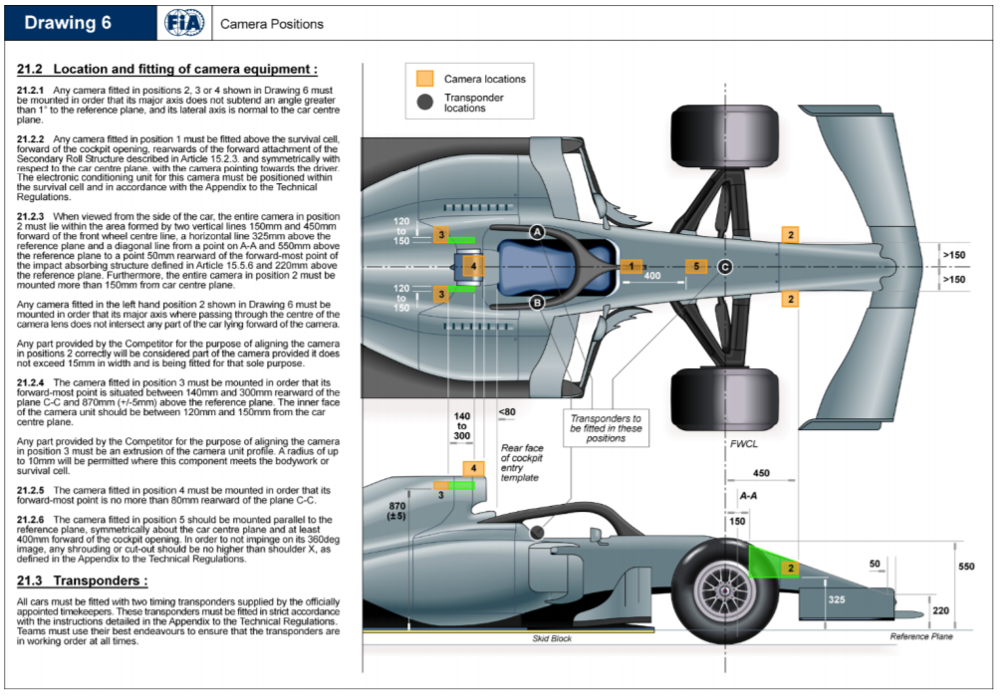

Figure 13: Drawing 6 (on-board camera positions) from FIA 2020 F1 Technical Regulations

All F1 cars must be fitted with at least six cameras or camera housings. The fastest teams often carry the full set of cameras on their cars, but all cars must carry dummies to make sure they gain no aerodynamic advantage. Two cameras, one front-facing and one rear-facing, are mounted in the main onboard camera unit, a T-shaped box on top of the car’s roll hoop, behind the driver’s head (figure below). Other cameras are placed on the nose and chassis of the car.

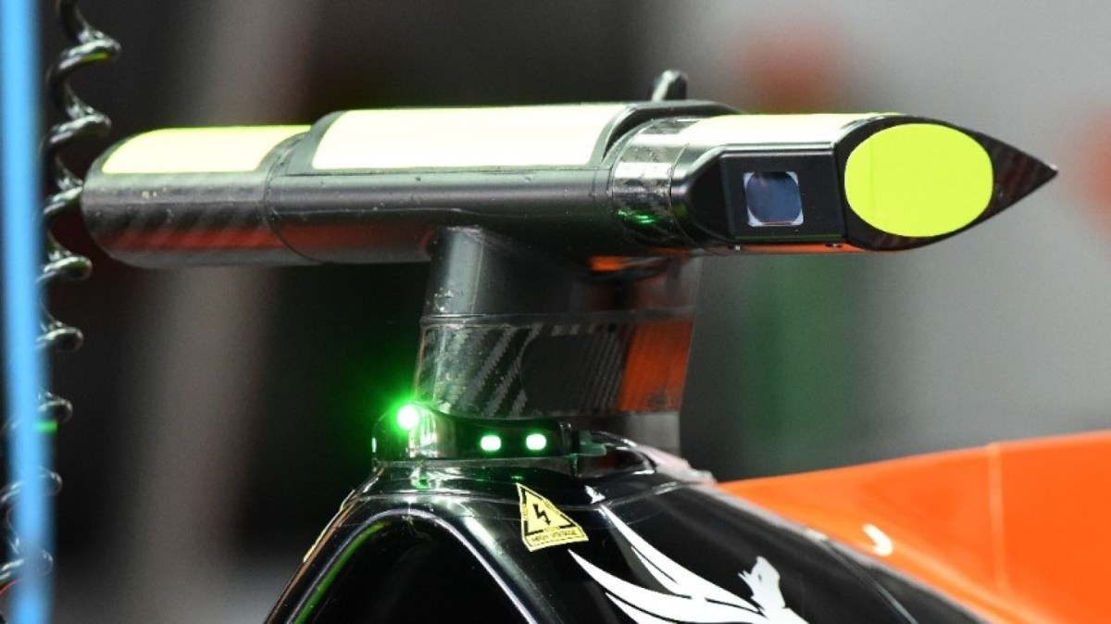

Figure 14: On-board camera, mounted above F1 car’s cockpit

The on-board camera team constantly experiments with the location of the cameras. The introduction of the halo – a protective barrier that goes around the car’s cockpit to protect the driver – resulted in the chassis camera’s image getting obscured, which generated complaints from viewers. According to regulations, F1 must inform the teams of any new camera positions for a season by the end of the previous June, so that teams can design the cars around the new requirements.

A6.2.2 Mitigating demand in video PMSE

F1 is the biggest user of video PMSE spectrum at a single event, and further growth in demand was projected. In response, F1 introduced its own technological solution in the form of radio link equipment it had developed for car-to-trackside communications. The new system replaced up to six existing on-car radio systems used for telemetry, voice communications etc., and supports one video link from each car. The equipment typically operates in an 8 MHz wide channel in the 8 to 10 GHz frequency range.

F1’s migration to higher frequencies for video PMSE is reflected in Ofcom’s PMSE licensing data for the British Grand Prix, shown in Table 19. The data shows that from 2016 there was a significant reduction in the number of assignments for 2 and 3 GHz camera and video links, with a correspondingly large increase in the number of assignments in the 8-12 GHz band. It is assumed that this was due to a technology change in the cars, where on-board video is multiplexed onto channels in the 8-12 GHz band, rather than the 2 GHz band.

However, it is worth noting that F1’s solution should be viewed as the exception, not the rule. The key video PMSE spectrum at 2 GHz, together with steadily increasing use around 7 GHz, are still vital to the broadcast of live sport, and video PMSE content production generally. Gross video spectrum demand at F1 was projected to reach a peak instance of 670 MHz by 2024 (assuming one camera/device per 10 MHz) [11].

Notwithstanding the development of their own solution, F1 still serves as a good representation of the growth in demand for video PMSE spectrum in sports broadcasting. To take one example, in golf’s Ryder Cup, between 9-11 wireless cameras are in use by host broadcasters, in addition to guest broadcasters, who each have 1 or 2 cameras. Due to the nature of the coverage, all cameras will be in use simultaneously with little chance of mitigating spectrum supply shortages by sharing spectrum between those cameras.

Table 19: Number of frequency assignments at the British F1 Grand Prix

|  | Year 2014 | Year 2015 | Year 2016 | Year 2017 | Year 2018 |
| --- | --- | --- | --- | --- | --- |
| Microphone / IEM | 218 | 229 | 190 | 265 | 200 |
| Talkback VHF | 121 | 124 | 82 | 63 | 72 |
| Talkback UHF | 188 | 178 | 156 | 158 | 148 |
| 1-2 GHz | 16 (telemetry) | 9 (telemetry) | 4  (telemetry) | 6 (telemetry) | 7 (telemetry) |
| 2 GHz | 16 | 18 | 5  (Note 1) | 4 | 3 |
| 3 GHz | 23 | 25 | 15 | 18 | 16 |
| 4-7 GHz | 25 | 23 | 25 | 29 | 24 |
| 8-12 GHz | 2 | 2 | 29  (Note 1) | 30 | 30 |
| >20 GHz | 0 | 0 | 0 | 0 | 0 |
| Note 1: New technology has come about in the form of 8 to 10 GHz where complete circuits carrying onboard video, audio, telemetry and comms is carried in an 8 MHz channel. This has reduced the load significantly on 2 GHz. | | | | | | |

Table 20: Number of frequency assignments at the Grand Prix of Austria

|  | Year 2017 | Year 2018 | Year 2019 | Year 2020 |
| --- | --- | --- | --- | --- |
| 470-790 MHz (Mics, IEMs, talkback, camera data) | 226 | 251 | 246 | 192 |
| 1-2 GHz (STLs, telemetry, vision links, mics) | 5 | 7 | 18 | 6 |
| 2 GHz (video links) | 13 | 11 | 14 | 9 |
| 3 GHz (video links) | 17 | 15 | 12 | 9 |
| 4-7 GHz (video links) | 35 | 26 | 24 | 20 |
| 8-12 GHz (video links) | 33 | 29 | 29 | 29 |
| >20 GHz (video links) | 0 | 0 | 0 | 0 |

**A6.3 Outside Broadcast**

For any large event, a temporary control room is required to coordinate the content inputs from cameras and microphones, etc. The size and complexity of the control is a reflection of the size of the event. Figure 15 shows a typical situation (note the spectrum analyser on the desk).

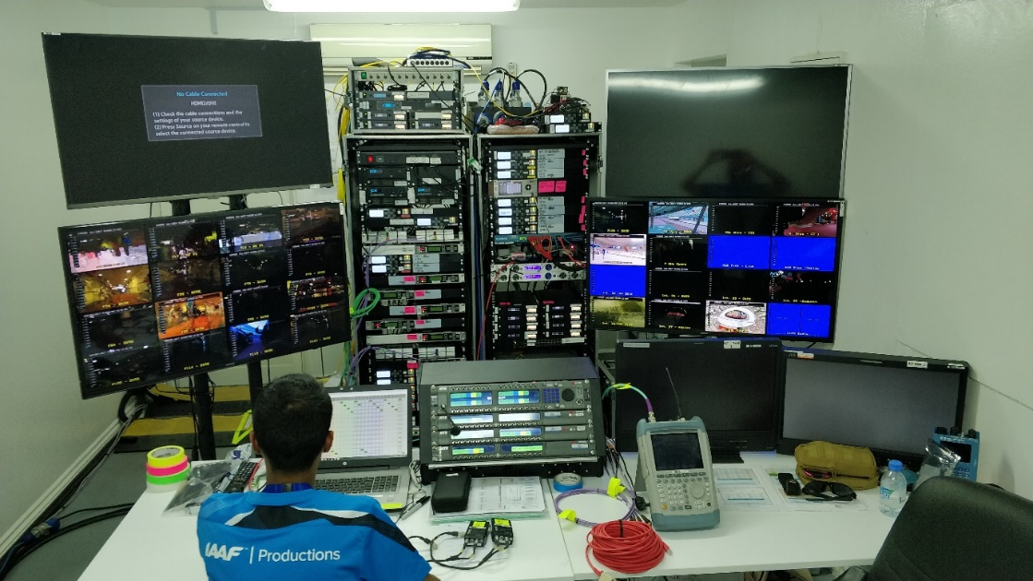

Figure 15: Temporary control room

This control room was handling simultaneous inputs from multiple wireless cameras, as shown in Figure 15.

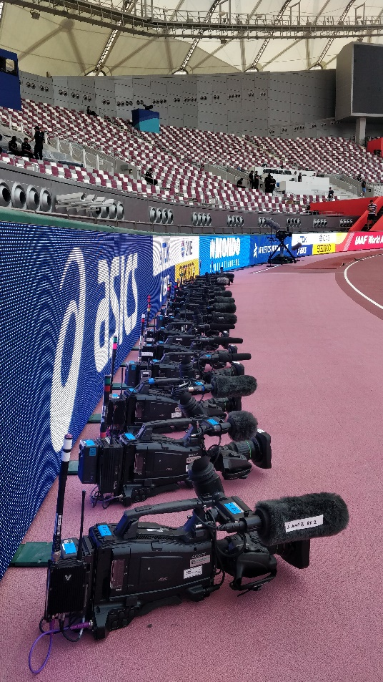

Figure 16: Wireless cameras ready for action at athletics event

**A6.4 live cycle race coverage**

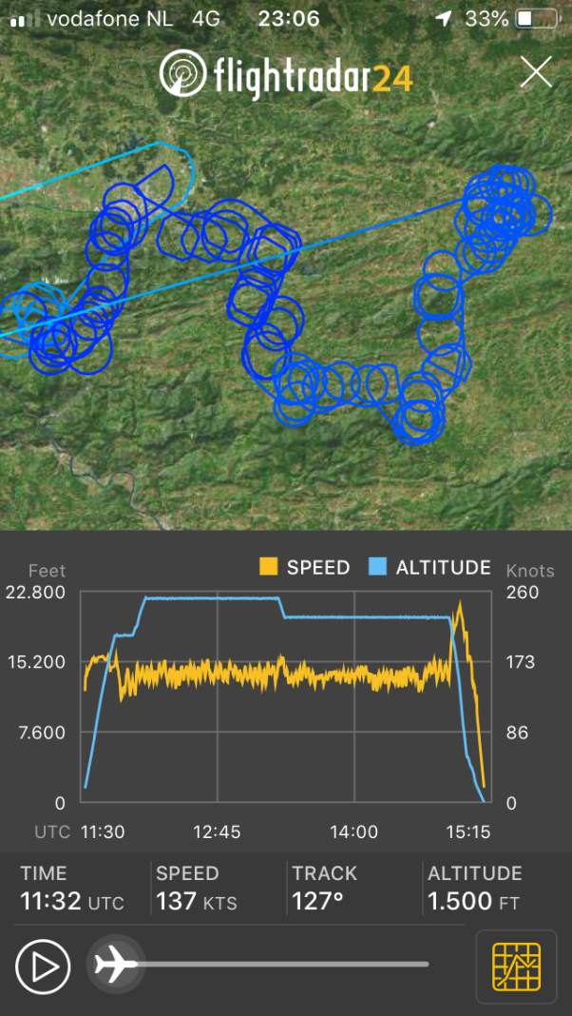

Figure 17: Flight path of high altitude relay aircraft for a live cycling race

Auto-tracking antennas on the ground vehicles follow the relay aircraft by using the GPS data sent via a service link from the aircraft.

A6.5 Video Equipment

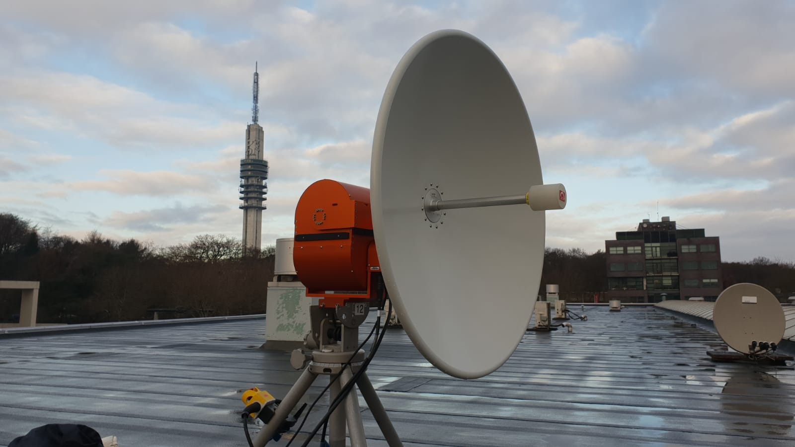

Figure 18: Antenna

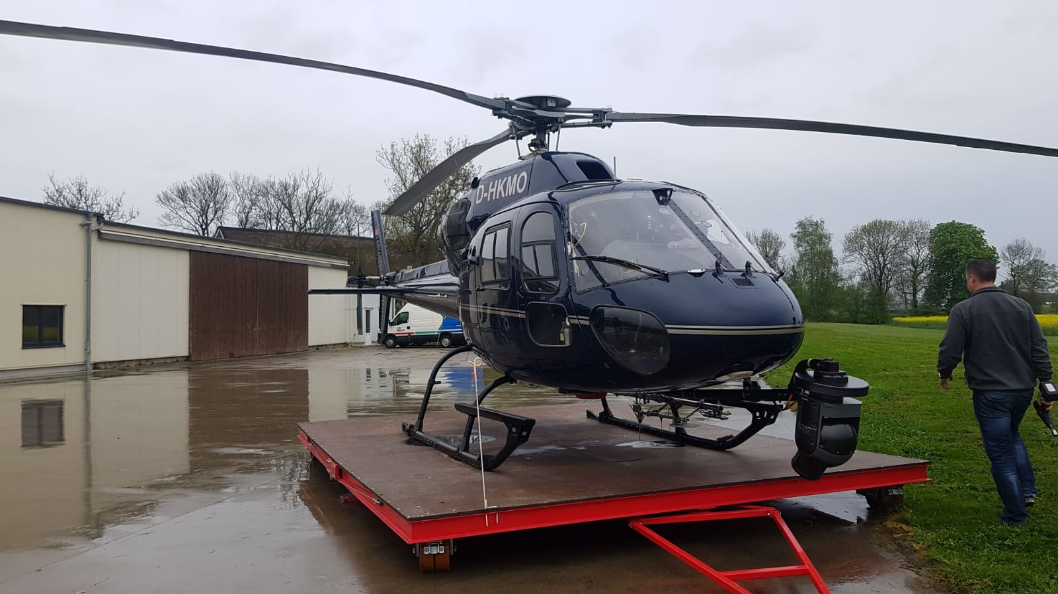

Figure 19: Camera Helicopter

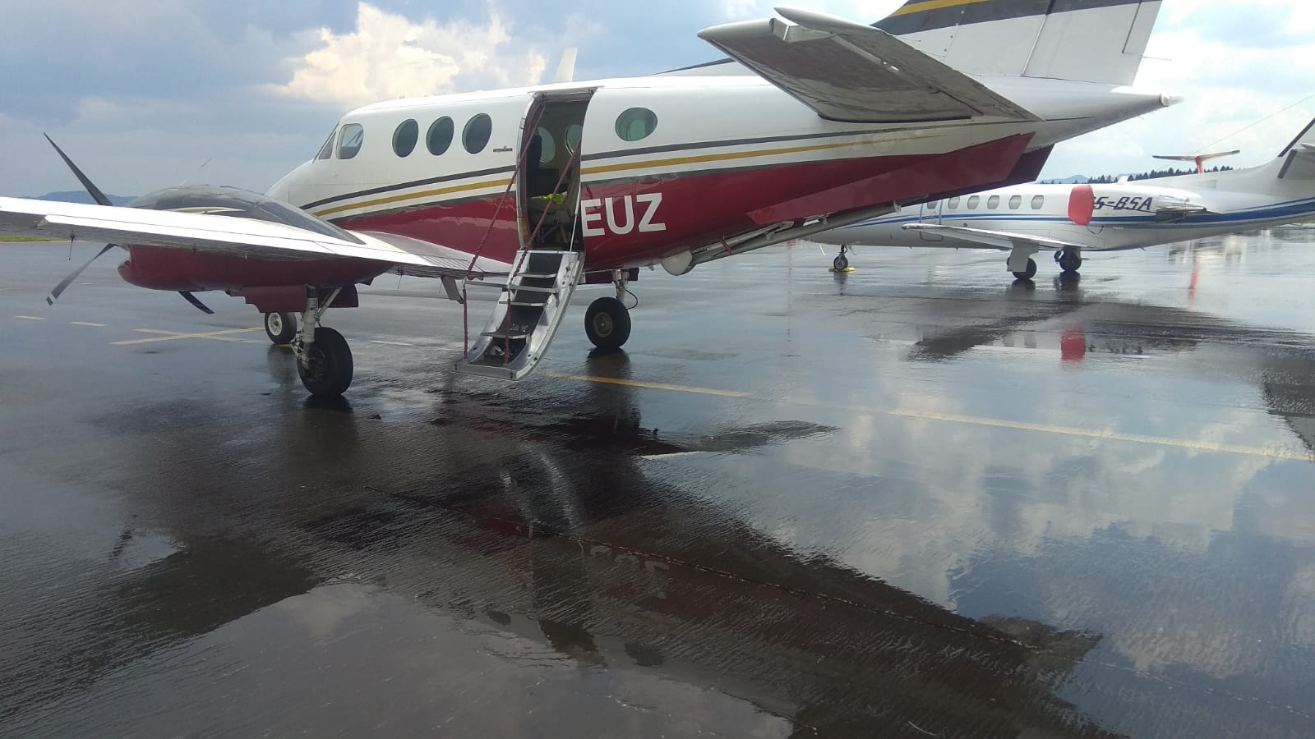

Figure 20: Relay Plane with the down-link antenna actuator mounted under the fuselage

1. EVENTS REQUIRING THE SUPPORT OF VARIOUS types of PMSE EQUIPMENT

In assessing regular spectrum requirements for PMSE, it must be borne in mind that PMSE demand either is at permanent sites or is time and location specific.

Peak demand for PMSE is usually temporarily and locally limited, such as big music festivals or sporting events or where several events are co-located at the same time. However, peak demand may also appear in various permeant locations where there is a high density of longer-term PMSE in use, such as theatre districts, broadcasting facilities and studio complexes.

Meeting peak demand becomes acute only if spectrum at both the time and at the location it is required is difficult to supply. The biggest challenge regarding access to spectrum is the peak demand at large events or multiple concentrated events, where spectrum is required simultaneously by many users both at the same time and location. In the context of large events, there may also be variations between spectrum needs for each type of application in use.

A7.1 audio PMSE can be separated into the following major use case areas:

* A) Live Event;
* B) Presentation;
* C) Conferencing;
* D) ENG;
* E) Audio for Video.

A) Live Event

A.1) Music Event

* Latency requirement:

Latency from audio input (microphone used by artist) to audio output (IEM with fold back mix used by same artist) needs to be below 4 ms.

* Typical Venue or Locations:

Outdoor site often on farms or at large stadium's.

* Typical audio channel count:

Small event, e.g. local coverage: 16 to 24;

Medium event, e.g. regional coverage: 24 to 48;

Large event, e.g. national coverage: 49 to 192;

Mega event with international coverage: 193 and more.

* Other PMSE use:

Light and effect control;

Multiple fixed, mobile, line or flying video cameras to capture stage, back stage, audience;

Large Intercom setup for event direction and security.

A.2) Sports Event

Often common video, but individual audio content by multiple reporters from various countries.

B) Presentation

Person(s) giving a presentation, speech, lecture, sermon, employing hand-held or body-worn wireless microphones. Free movement of equipped person(s) during use.

Additional hand-held wireless microphones might be in use to pick-up questions from the auditorium and for podium discussions involving multiple persons.

Additional IEM-like devices might be in use for hearing assist, especially in schools and universities.

Audio is immediately distributed via the public address (PA) system, but also available for recording or live streaming to the internet.

Person(s) might be equipped with earphones (IEM) to receive instructions from event direction or security.

* Latency requirement:

Latency of play back via PA needs to be low enough, so that the presenter(s) and audience are not distracted.

* Typical Venue or Locations:

Dimension: Larger Rooms, Lecture hall, Theatre;

Deployments include schools, universities, conference centres, hotels, trade fairs, shopping centres, restaurants, churches, multi-purpose halls, press conference, political event areas and public places including streets and parks;

* Typical wireless audio channel count:

Small event, e.g. local coverage: 4 to 12;

Medium event, e.g. regional coverage: 13 to 24;

Large event, e.g. national coverage: 25 to 48;

Mega event with international coverage: 49 and more, plus multiple interpretation channels.

* Other PMSE use:

Light control;

Multiple video cameras;

Intercom for event direction and security;

Wireless voting;

Interpretation, multi-language.

C) Conferencing

* Ad-hoc In-Room, business use
* Installed larger conference rooms and conference centres

D) Electronic News Gathering

Dependant on type of "news" either a single team or multiple teams will be present, a team will consist as a minimum of presenter & cameraman.

Wireless microphone receiver(s) usually mounted on camera wireless microphone hand-held or body-worn with a second hand-held for interviews.

Video camera might provide a fold back link to remote screen.

Audio and video output (remote or OB van) are typically linked to the remote production facilities. Such links can be satellite or telecoms based.

D.1 Local News

* Each market area generally has several independent news crews that provide information to local residents.

D.2 National / International News

* ENG team follow the news event so that cross border use is routine;
* Huddle of multiple ENG teams in one news event location, if event is of major importance. Wireless audio channel count can reach well over 100 (national) and more than 300 if international.

E) Audio for Video

Focus is on entertainment and may be produced by professional or non-professional organisations:

* Wireless audio link between video camera and wireless microphone hand-held or body-worn;
* Video camera might provide a fold back link.

E.1) Video blogger

* Video bloggers have discovered that wireless audio provides significant improvements in audio quality and flexibility in deployment, while producing content in their daily routine.

E.2) Film recording

Significantly more organisations in addition to traditional broadcasters and movie studios are now producing content, e.g. video streaming platform providers, independent film makers and project studios.

All forms of PMSE equipment may be in use:

* Light control;
* Multiple video cameras;
* Intercom for event direction and security;
* Dependant on the type of production and staff numbers, the amount of equipment in use will be similar to live events (see A.1 Music Event).

Action scenes require high mobility and reliability in audio transmission as number of film shoots are limited due to cost and safety reasons.

A7.2 EXCEPTIONAL EVENTS AND REGULAR LARGE EVENTS

Examples:

* F1;
* Eurovision Song Contest;
* Cycle racing: Tour de France, Tour of It UK etc.;
* Golf;
* Football;
* Music festivals;
* National and State events;
* Olympic Games;
* Other sporting events.

A7.3 Studio/Live production

Studios and live production units now produce programmes for a wide range of clients, many of which will not be broadcast or streaming based. Complex programmes are used by many areas of industry for training, education and PR. The rise of streaming services has revitalised many of the film studios and the additional flexibility of tools such as drones carrying high definition cameras plus microphones have enabled directors to expand their creativity.

A7.2 Daily use

Normal Base use consists of:

* Long-term assignments;
* Long-term demands, production plants, media cities;
* Universities, educational, disability schools;
* Bars, pubs etc.;
* Corporate;
* Religious use;
* Annual assignments for theatre studio etc.

1. Research Projects for 5G

A8.1 PMSE-xG

PMSE-xG was a pre-competitive research project running from 01.10.2016 until 31.03.2018. The project was co-funded by the German Federal Ministry of Transportation and Digital Infrastructure (BMVI).

PMSE-xG was an interdisciplinary and cooperative bridge between the mobile communications industry and the PMSE industry, which brings stakeholders together to build and reinforce cooperation. For the first time, PMSE-xG considered the future-oriented use of mobile broadband radio technology and network infrastructure for PMSE applications.

PMSE-xG focused on technological and economic feasibility of PMSE in 4G+/5G. It tried to anchor PMSE applications in the standardisation of mobile broadband radio. Main research topics were, in particular, ultra-reliable, low latency streaming technologies for mobile and nomadic applications.

A8.2 Research: Live Interactive PMSE Services (LIPS)

The LIPS project started 01.04.2018 and will run until 30.09.2020. The project is a pre-competitive research project co-funded by the German Federal Ministry of Economics and Technology (BMWi)

The ongoing technological convergence of production and distribution networks and the availability of new mobile communications and network technology (4G+ / 5G, Mobile Edge Cloud (MEC), Software Defined Networks (SDN)) provide new platforms and possibilities for the Creative and Culture Industry(CCI) and for PMSE as an application.

The LIPS project aims at an interactive, immersive linking of live events at different locations using these new platforms and technical possibilities. With PMSE, LIPS thus serves an attractive and technically demanding area of application for digital services and platforms with a lighthouse character.

Aims and planned results of the project are:

* Solutions to improve access and participation of rural areas in the creative, cultural and political operation of metropolitan areas (basic cultural services) and vice versa.
* Development and demonstration of novel, smart services for the interactive and immersive linking of and to events of the CCI.
* Introduction of smart, innovative services based on new technologies of event and production technology, taking advantage of technological convergence of production and distribution networks for live production and live distribution (e.g. participation in events via AV immersion).
* LIPS also studies solutions to enable people with disabilities who are unable to travel to a political or cultural event due to disability or illness to participate holistically and immersively.

A8.3 5G PROLIVE: 5G PROfessional audio-visual LIVE broadcast

5G PROLIVE project started 01.01.2020 and will run until 31.12.2022. The project is a science-based innovation project co-funded by Innosuisse, the Swiss Innovation Agency.

The main innovation of the project is the introduction of new 5G emerging telecom technologies for the live production of TV content covering different use cases ranging from indoor studio up to mobile outdoor large sport events.

Goals and planned results of the project are:

* The development and integration of 5G connection capabilities including Ultra low latency HEVC codec for TV production terminals;
* The development of demonstrators and the Proof of concept of production use cases;
* The organisation of field tests and validations.

1. DECT

A9.1 Introduction

The Digital Enhanced Cordless Telecommunications (DECT) system started its operation in Europe in the band 1880 MHz-1900 MHz (EC decision 1999/310/EC [13]). It has spread around the globe and has become the most successful digital cordless telephone system in the world.

DECT is well known for digital cordless telephony and voice focused solutions (e.g. cordless phones, cordless headsets), in both domestic home market where low-cost single cell devices are used and in the business market, which requires multi-cell systems with more complex functionality. Wide band and super wide band speech codecs have been introduced in DECT and ETSI TC DECT is working on integrating the newest technology advancements available. DECT has managed to address new markets by improvement and evolution of features and technology.

With the 'Ultra Low Energy' (ULE) technical specification, DECT supports applications in machine-to-machine communication, Internet of Things (IoT) and Smart Home Automation. Further, the ability of DECT to enable highly effective application specific protocols attracted audio conferencing and wireless microphones.

DECT enables application-specific communication protocols as well as IP-based communication including support of the IPv6 standard. DECT is thereby already now well-positioned to serve as technology for several vertical industries (Industry 4.0, PMSE, e-Health, …).

DECT is part of the IMT-2000 family of standards called IMT-2000 FDMA/TDMA and is so far the only IMT standard available for general authorised (license-exempt) operation in IMT bands. The frequency band 1880-1900 MHz is in Europe designated by ERC/DEC(94)03 to DECT, allowing cross European deployment at any location and at any time.

A9.2 Recent Activities for Technology Evolution within ETSI

ETSI TC DECT is currently following two parallel development paths: DECT evolution and DECT-2020:

* DECT evolution is an update of the DECT standard to improve support of applications regarding latency, data-rate, and reliability based on the latest existing chipsets. The required changes to the DECT standard have been incorporated to the relevant DECT standard parts;
* DECT-2020 updates the air interface to OFDM FDMA/TDMA and will support URLLC and mMTC (including mesh networking) use cases in end-user deployed and operated networks. DECT-2020 as part of a Set of Radio Interface Technologies (SRIT) is currently candidate for being included to the IMT-2020 family of standards;
* DECT has interworking profiles available for interworking with GSM and UMTS networks. ETSI TC DECT will define additional interworking profiles for LTE and 3GPP 5G-NR to provide complementary solution that can operate on license-exempt or licensed shared, local license or licensed IMT bands, with and without cellular operator involvement.

A9.3 Relevance of the DECT standards for the PMSE sector

DECT's easy configuration makes it ideal for ad-hoc deployment, which is enabled by the automatic frequency and interference management functionalities inherent to the technology, the so-called DECT Channel Allocation/Selection (DCA/S) algorithm. Further, the European-wide designation of 1880-1900 MHz to DECT by ERC/DEC(94)03 allows DECT-based audio PMSE use at any location, at any time and cross border. Nevertheless, PMSE use cases based on DECT technology experience local congestion as a 20 MHz band is quite limited resource.

In the production and contribution of media content, legacy DECT is primarily used for conferencing, audio for video, intercoms, talkback and wireless microphones for presentations and lectures, but not for musicians.

This is mainly due to its transmission latency of 10.5 ms, while professional Audio PMSE (live music event) requires mouth-to-ear latencies being below 4 ms, so that musicians are undisturbed in their performance while using wireless microphones in conjunction with in-ear monitor (IEM) systems.

DECT evolution is delivering link latencies (mouth or ear to audio-plug) of below 4 ms and has immediate availability by current chipsets. DECT evolution enables music entry market applications (e.g. audio for video, music hobbyist, garage bands) and provides significant improvements for conferencing, intercoms, and wireless microphones for presentations and lectures.

DECT-5G based on DECT-2020 will enable further PMSE use cases by delivering a quality of service already required by audio professionals and audio hobbyists with professional demands.

1. **List of references**
2. ECC Report 204: “Spectrum use and future requirements for PMSE”, approved 2014
3. Report ITU-R BS.2161: ”Low delay audio coding for broadcasting applications”
4. ERC Recommendation 25-10 Frequency Ranges for the Use of Terrestrial Audio and Video Programme Making and Special Events (PMSE) applications
5. ERC Recommendation 70-03: “ERC Recommendation of 1997 on relating to the use of Short Range Devices (SRD)”, latest amended on 12 June 2020
6. CEPT Report 32: “Report from CEPT to the European Commission in response to the Mandate on “Technical considerations regarding harmonisation options for the digital dividend in the European Union” “Recommendation on the best approach to ensure the continuation of existing Program Making and Special Events (PMSE) services operating in the UHF (470-862 MHz), including the assessment of the advantage of an EU-level approach”, approved October 2009

1. [EC Decision 2010/267/EU](https://eur-lex.europa.eu/legal-content/EN/ALL/?uri=CELEX%3A32010D0267): “Commission Decision of 6 May 2010 on harmonised technical conditions of use in the 790-862 MHz frequency band for terrestrial systems capable of providing electronic communications services in the European Union”

1. [EC Decision 2016/687/EU](https://eur-lex.europa.eu/legal-content/EN/TXT/?qid=1601638112367&uri=CELEX:32016D0687): “Commission Implementing Decision (EU) 2016/687 of 28 April 2016 on the harmonisation of the 694-790 MHz frequency band for terrestrial systems capable of providing wireless broadband electronic communications services and for flexible national use in the Union"
2. ECC Report 44: “Guidance for radio usage at special events”, approved February 2004 and revised October 2014

1. [DTG: “PMSE 700 MHz Clearance Coordination”](https://dtg.org.uk/publication/pmse-700-mhz-clearance-coordination/)
2. Digitisation of wireless microphones: [Management summary](https://www.stratix.nl/wp-content/uploads/2020/11/Report-on-Digital-Microphones-Final_web.pdf)
3. Cambridge Consultants’ Report for Ofcom (2014): “[Technology Evolution in the PMSE Sector](https://www.ofcom.org.uk/__data/assets/pdf_file/0024/59163/cambridge-main-report.pdf)”
4. ETSI TR 102 801: “Methods, parameters and test procedures for cognitive interference mitigation techniques for use by PMSE devices”

1. [EC Decision 1999/310/EC](https://eur-lex.europa.eu/legal-content/EN/TXT/?uri=CELEX%3A31999D0310): “Commission Decision of 23 April 1999 on a common technical regulation for digital enhanced cordless telecommunications (DECT) equipment accessing the integrated services digital network (ISDN)”
2. Technical Regulations, published by F1’s governing body
3. Article 21 of the Technical Regulations 2020

1. [Film production in Europe Production volume, co-production and worldwide circulation](https://rm.coe.int/filmproductionineurope-2017-j-talavera-pdf/1680788952)
2. Cambridge Consultants’ Report for Ofcom (2014): “[Technology Evolution in the PMSE Sector](https://www.ofcom.org.uk/__data/assets/pdf_file/0024/59163/cambridge-main-report.pdf)”, P.57

1. [Decision (EU) 2017/899](https://eur-lex.europa.eu/legal-content/fr/ALL/?uri=CELEX:32017D0899) of the European parliament and of the council of 17 May 2017 on the use of the 470-790 MHz frequency band in the Union
2. [EC Decision 2014/641/EU](https://eur-lex.europa.eu/legal-content/EN/TXT/?uri=CELEX%3A32014D0641): “Commission implementing Decision of 1 September 2014 on harmonised technical conditions of radio spectrum use by wireless audio programme making and special events equipment in the Union”

1. Programme Making and Special Events (PMSE) equipment is meant for use in applications identified in various publications as Services Ancillary to Programme making (SAP), Services Ancillary to Broadcasting (SAB), Electronic News Gathering (ENG) / Outside Broadcasting (OB), Broadcast Auxiliary Systems (BAS) and applications used in meetings, conferences, cultural and education activities, trade fairs, local entertainment, sport, religious and other public or private events.
2. For further information see <https://www.efis.dk/>
3. For further information, see ETSI TR 103 450 System Reference document (SRdoc); Technical characteristics and parameters for Wireless Multichannel Audio Systems (WMAS).
4. Examples:

   Dedicated spectrum band (3.7-3.8 GHz) for local campus networks in Germany.

   Licensed Shared Access in the Netherlands.

   The use of unlicensed bands for 5G.
5. An overhead camera on a wire that can zoom from one end of the starting grid / finishing straight to the other.