Analysis of the suitability of the regulatory technical conditions for 5G MFCN operation in the 3400-3800 MHz band
approved 6 July 2018
ECC Report 281
ECC Report 281
ECC Report 281

Executive summary
Due to its favourable properties, such as radio wave propagation and available bandwidth, the frequency band 3400-3800 MHz will be the primary frequency band, within the 1 to 6 GHz range, for the introduction of 5G mobile/fixed communications networks (MFCN) systems based on TDD mode in Europe.
The development of this Report was triggered in June 2016 when the ECC added the action "A.1 Review as a matter of urgency the suitability of 3.4-3.8 GHz ECC decision for 5G" to its "CEPT roadmap for 5G" [1]. Consequently the ECC started the work to assess the suitability for 5G of the harmonised technical conditions defined for the 3400-3800 MHz range in ECC Report 203 [2] and adopted in the ECC Decision (11)06 amended in March 2014 ("ECC/DEC/(11)06 (rev. 2014)" hereafter) [3].
Three main areas were investigated during the development of this Report:
- Development of the most suitable frequency arrangement for 5G in the 3400-3800 MHz band;
- Coexistence with other services below 3400 MHz (radiolocation services in particular) and above 3800 MHz (FSS and FS services);
- Management of interference between MFCN networks with particular emphasis on the "synchronisation framework" to support the operation of MFCN networks based on the TDD access scheme in outdoor deployment scenarios.
The development of this Report followed the following steps:
- Assessment of the existing frequency arrangements and definition of the most appropriate frequency arrangement for 5G in the 3400-3800 MHz band - Chapter 4 "Frequency arrangement". CEPT concluded that there is no need to consider separate frequency arrangements for 3400-3600 MHz and 3600-3800 MHz from a regulatory perspective. The unpaired arrangement is therefore selected as the only option for the 3400-3800 MHz band;
- Assessment of the existing block edge mask (BEM) requirements - Chapter 5 "Existing BEM Requirements";
- Analysis of the existing BEM and required amendments - Chapter 6 "Analysis of the suitability of the current BEM requirements for 5G";
- Identification of required amendments to the existing BEM for AAS MFCNs - Chapter 7 "Updated BEM requirements for AAS MFCN Base Stations and UE";
- The various annexes contain the technical studies that were submitted to support the definition of the amended regulatory framework, together with the assumptions and parameters that were agreed as basis for the coexistence studies;
- The report concludes with the proposed new regulatory framework to support the introduction of 5G in the 3400-3800 MHz range. This analysis confirms that the current BEM remains applicable for non-AAS systems and the need additional BEM for AAS systems - Chapter 8 "Conclusions".

TABLE OF CONTENTS

0 Executive summary 2
1 Introduction 7
2 Scope of this report 9
3 Background and Context 10
4 Frequency arrangement 11
4.1 Frequency arrangement in current framework 11
4.1.1 Alternative frequency arrangements for the 3400-3600 MHz band 11
4.1.2 Harmonised frequency arrangement for the 3600-3800 MHz band 11
4.2 Proposed frequency arrangement 12
5 Existing BEM Requirements 13
5.1 Out-of-block power limits: Interference between synchronised MFCNs 14
5.2 Out-of-block power limits: Interference between unsynchronised MFCNs 15
5.3 Out-of-band power limits: Interference towards radars below 3400 MHz 16
5.4 In- block power limits 17
6 Analysis of the suitability of the current BEM requirements for 5G 18
6.1 Definitions 18
6.1.1 Non-AAS MFCN base stations 18
6.1.2 AAS MFCN base stations 18
6.1.3 Total Radiated Power (TRP) 19
6.1.4 Synchronisation in TDD MFCNs 19
6.2 Suitability for non-AAS MFCN 20
6.3 Suitability for AAS MFCN 20
6.3.1 Implications from the AAS architecture 20
6.3.2 Out-of-block power limits: Interference between synchronised MFCNs 21
6.3.2.1 TRP metric vs. e.i.r.p. 21
6.3.2.2 Synchronisation in 5G NR 24
6.3.3 Out-of-block power limits: Interference between unsynchronised MFCNs 25
6.3.4 Out-of-block power limits: Interference between LTE and 5G NR MFCNs 25
6.3.4.1 Common synchronisation between LTE and 5G NR 26
6.3.4.2 No common synchronisation between LTE and 5G NR 27
6.3.5 Out-of-band power limits: Interference towards radars below 3400 MHz 27
6.3.6 Out-of-band power limits: coexistence with FSS / FS services above 3800 MHz 28
6.3.7 Out-of-band power limits: coexistence with radio astronomy 29
6.3.8 In- block power limits 29
7 Updated BEM requirements for AAS MFCN Base Stations and UE 30
7.1.1 Out-of-block power limits: Interference between synchronised MFCNs 30
7.1.2 Out-of-block power limits: Interference between unsynchronised or semi-synchronised MFCNs 31
7.2 Out-of-band power limits: Interference towards radars below 3400 MHz 31
7.3 Out-of-band power limits: Coexistence with FSS/FS 32
7.4 In-block power limit 33
7.5 UE In-block requirement 33
8 Conclusions 34
ANNEX 1: MFCN parameter values and assumptions for simulations 39
ANNEX 2: Studies on the interference between synchronised MFCNs 46
ANNEX 3: Studies on the interference between unsynchronised MFCNs 47
ANNEX 4: Studies on the coexistence between AAS MFCN and Radiolocation systems 52
ANNEX 5: Studies on the coexistence between AAS and Radio Astronomy systems 77
ANNEX 6: List of References 98

LIST OF ABBREVIATIONS

Abbreviation | Explanation
3GPP | 3rd Generation Partnership Project
AAS | Active Antenna System
ACIR | Adjacent Channel Interference Ratio
ACLR | Adjacent Channel Leakage Ratio
ACS | Adjacent Channel Selectivity
BEM | Block Edge Mask
BS | Base Station
CEPT | European Conference of Postal and Telecommunications Administrations
DL | Downlink
EC | European Commission
ECA | European Common Allocation
ECC | Electronic Communications Committee
e.i.r.p. | Equivalent Isotropically Radiated Power
E-UTRA | Evolved Universal Terrestrial Radio Access
FDD | Frequency Division Duplex
FSS | Fixed Satellite Service
FS | Fixed Service
IMT | International Mobile Telecommunications
ISD | Inter-Site Distance
LRTC | Least Restrictive Technical Conditions
LTE | Long Term Evolution
MIMO | Multiple Input Multiple Output
MCL | Minimum Coupling Loss
MFCN | Mobile/Fixed Communications Network
MSR | Multi-Standard Radio
NR | New Radio
OOB | Out of Band
OTA | Over The Air
RAN | Radio Access Network
RR | Radio Regulations
SDO | Standards Developing Organisation
SEM | Spectrum Emission Mask
TDD | Time Division Duplex
TRP | Total Radiated Power
TSG | Technical Specification Group
UE | User Equipment
UEM | Unwanted Emission Mask
UL | Uplink
WRC | World Radiocommunication Conference

Introduction
The assessment and revision of existing least restrictive technical conditions (LRTC) for the operation of MFCNs in the 3400-3800 MHz band addresses two main areas:
- Assessment and revision of the frequency arrangement;
- Assessment and revision of the BEM.
The development of this Report accounted for the development of new radio interfaces (5G NR) that support the new capabilities of IMT-2020 along with the enhancement of IMT-2000 and IMT-Advanced systems. The work also accounted for the fact that the 3400-3800 MHz band is the primary spectrum band in the 1 to 6 GHz range for the introduction of 5G MFCN systems in Europe due to its favourable properties, such as radio wave propagation and available bandwidth.
To facilitate the readers' understanding, here follows a description of the BEM elements which is the basis of the technology neutral harmonisation of this band.
The BEM consists of several elements:
- The in-block power limit is applied to a block owned by an operator;
- The out-of-block elements consist of a baseline level, designed to protect the spectrum of other MFCN operators, and transitional levels enabling filter roll-off from in-block to baseline levels. Such limits may be relaxed whenever there are bilateral agreements between operators. For the spectrum 3400­3800 MHz, the BEM has not been developed to protect other services or applications, and only applies in blocks that have been licensed to MFCN according to the new harmonised frequency arrangement. In the figures below it is assumed for simplicity that all blocks have been licensed to MFCN;
The BEM also incorporates out-of-band requirements for the protection of other services.
Figure 1 shows the combination of the different BEM elements.
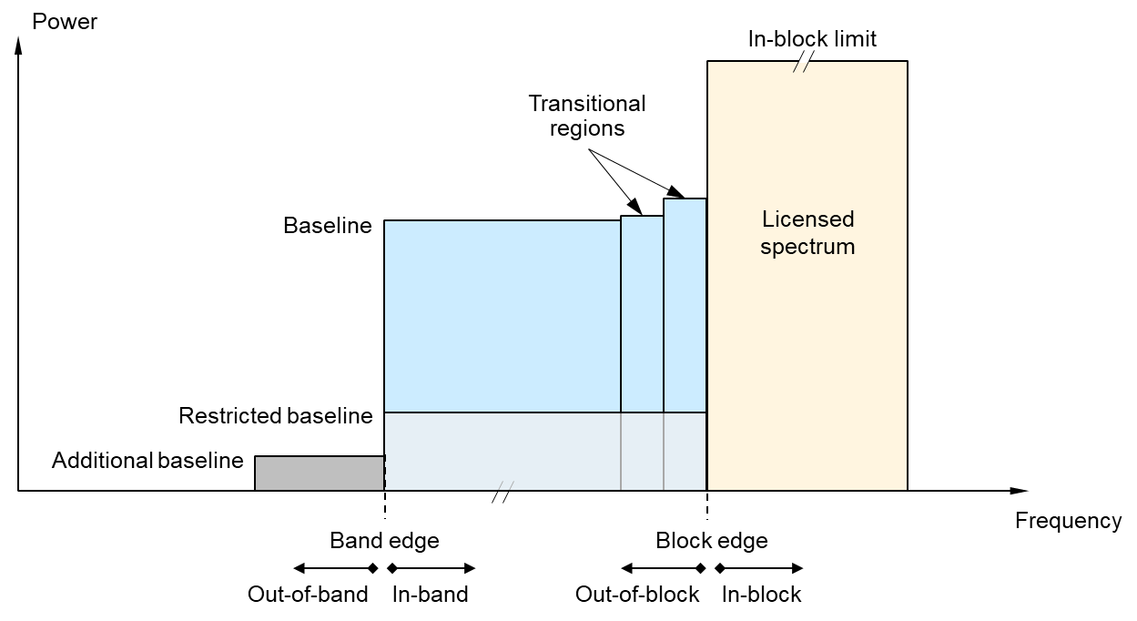
Figure 1: Illustration of a general block edge mask
Table 1 below contains a brief description for the different elements of the BEM for the 3400-3800 MHz band.
Table 1: BEM elements
BEM element | Definition
In-block | Block for which the BEM is derived.
Baseline | Spectrum used for MFCN, except from the operator block in question and corresponding transitional regions.
Transitional regions | The transitional region applies 0 to 10 MHz below and above the block assigned to the operator.  Transitional regions do not apply to TDD blocks allocated to other operators, unless networks are synchronised.  The transitional regions do not apply below 3400 MHz or above 3800 MHz.
Additional baseline | Below 3400 MHz and above 3800 MHz
Restricted baseline | Spectrum used for WBB ECS by networks unsynchronised or semi-synchronised with the operator block in question
To obtain a BEM for a specific block, the BEM elements that are defined in Table 1 are used as follows:
- In-block power limit is used for the block assigned to the operator;
- Transitional regions are determined, and corresponding power limits are used;
- For remaining spectrum assigned to MFCN, baseline power limits are used;
- For spectrum below 3400 MHz and above 3800 MHz, “additional baseline” power limits are used.
Co-existence with other services and applications, co-channel or adjacent channel, is not necessarily guaranteed by the BEM for MFCN, as other methods may be more efficient, depending on the co-existence scenario, such as frequency or distance separation, or specific site engineering.
The BEM is a ‘regulatory mask’ and should not be confused with Spectrum Emission Masks (SEM) for base stations and user equipment employed by Standards Developing Organisations (SDOs). The BEM concept does not in itself define the means by which the equipment in an operator’s network meets the BEM.
For user equipment, the BEM proposed by this ECC Report is restricted to in-block power, which is in line with previous decisions of the European Commission on UE BEMs. UE aspects are taken into consideration however when deriving the BS BEM and in the analysis of interference to and from other services.

Scope of this report
The purpose of this Report is to assess the suitability for 5G of the existing harmonised technical conditions as defined in ECC Report 203 [2] for the operation of MFCN in the 3400-3800 MHz band. The assessment accounts for the following:
- The need for technology neutral regulations addressing, among others, 4G and 5G systems with non-AAS or AAS base stations;
- 5G will adopt AAS base stations, larger channel bandwidths and new frame structures. Noting that AAS could also apply to non-5G MFCNs;
- System parameters of AAS MFCNs are different from non-AAS MFCNs, the non-AAS MFCN deployment scenarios and parameters in this Report are based on those in ECC Report 203;
- Continued operation of existing MFCN equipment compliant to the current framework is to be ensured, without impacts;
- Coexistence issues with other incumbent services in the band and in adjacent bands.
Based on the assessment, the report identifies amendments to the existing least restrictive technical conditions in terms of frequency arrangement and BEM.

Background and Context
The development of this Report accounted for the development of new radio interfaces (5G NR) that support the new capabilities of IMT-2020 along with the enhancement of IMT-2000 and IMT-Advanced systems. The work also accounted for the fact that the 3400-3800 MHz band is the primary frequency band in the 1 to 6 GHz range for the introduction of 5G MFCN systems in Europe due to its favourable properties, such as radio wave propagation and available bandwidth.
A BEM for the bands 3400-3600 MHz and 3600-3800 MHz was introduced for the first time during 2006-2008 period through ECC Recommendation ECC/REC/(04)05 [7], ECC Decision ECC/DEC/(07)02 [8] and EC Decision 2008/411/EC [9]. Such BEM was derived primarily to ensure co-existence between systems intended for fixed services (e.g. Fixed Wireless Systems) and did not establish a harmonised frequency arrangement. ECC Decision (07)02 was withdrawn in July 2018.
In 2011 the ECC Decision (11)06 [3] supplemented the existing FWA/BWA framework by introducing new least restrictive technical conditions (LRTC) for MFCNs, including BEM and harmonised frequency arrangements; such harmonised frequency arrangements for the 3400-3800 MHz facilitated high data rate MFCN including International Mobile Telecommunications (IMT) services supported by larger channel bandwidths as an evolution to the existing framework without the consequential requirement for a replacement of systems based on the existing regulatory framework.
In 2014 ECC Report 203 [2] concluded on the need to develop new BEM to support the high data rate MFCN services, including IMT, supported by larger channel bandwidths. This ECC Report served as the basis for drafting the relevant parts of CEPT Report 049 [10]. CEPT took into account existing CEPT studies on coexistence with other services and the potential impact on these services, such as FSS usage, in these bands. Consequently the previously mentioned ECC/DEC/(11)06 (rev. 2014) was introduced.
For the purposes of this Report the term MFCN includes IMT and other communications networks in the mobile and fixed services and refers to radio communication systems which should comply with the BEM defined in this Report. IMT covers IMT-2000, IMT-Advanced and IMT-2020, as defined in Resolution ITU-R 56 (naming for International Mobile Telecommunications) [11]; the development of new radio interfaces (5G) that support the new capabilities of IMT-2020 is expected along with the enhancement of IMT-2000 and IMT-Advanced systems. The IMT-2020 process is on-going in ITU-R, in cooperation with standardisation organisations. IMT-2020 will interwork with and complement existing IMT and its enhancements. Recommendation ITU-R M.2083 [12] addresses the objectives of the future development of IMT for 2020 and beyond, which includes further enhancement of existing IMT and the development of IMT-2020.
In the context IMT-2020, the 5G new radio interface (5G NR) will optimally support wide channel bandwidth operation, allowing mobile operators to take full advantage of larger allocations of contiguous spectrum to increase peak rates and user experience, with optimised terminal complexity and power consumption. Current 5G NR specifications support contiguous channel bandwidths up to 100 MHz. Carrier aggregation may be used for utilising wider bandwidths.
The detailed specifications of IMT radio interfaces are described in Recommendation ITU-R M.1457 [13] for IMT­2000 and Recommendation ITU-R M. 2012 [14] for IMT-Advanced. IMT-2020 systems, system components, and related aspects that support to provide far more enhanced capabilities than those described in Recommendation ITU-R M.1645 [15].

Frequency arrangement
This chapter analyses the existing frequency arrangements against the latest 5G technology and market developments and derives the suitable frequency arrangement to support the introduction of 5G across CEPT countries.

Frequency arrangement in current framework
ECC/DEC/(11)06 (rev. 2014) [3] includes two frequency arrangements for the 3400-3600 MHz block, one preferred and a second alternative. It also includes one harmonised frequency arrangement for 3600-3800 MHz.

Alternative frequency arrangements for the 3400-3600 MHz band
The preferred frequency arrangement is based on TDD, with 5MHz block size starting at the lower edge of 3400 MHz.
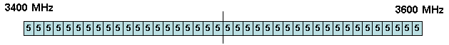
Figure 2: ECC/DEC/(11)06 preferred frequency arrangement for 3400-3600 MHz based on TDD
Multiple adjacent blocks of 5 MHz can be combined to obtain wider channels.
The alternative frequency arrangement is based on FDD, with 5MHz block size starting at the lower edge of 3410 MHz. The sub-band 3410-3490 MHz is used for the uplink, the sub-band 3510-3590 MHz is used for the downlink. The resulting duplex gap is 20 MHz (3490-3510 MHz).
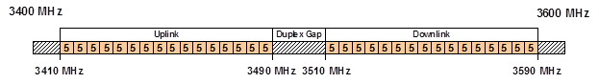
Figure 3: ECC/DEC/(11)06 alternative frequency arrangement for 3400-3600 MHz based on FDD
Multiple adjacent blocks of 5 MHz can be combined to obtain wider channels.

Harmonised frequency arrangement for the 3600-3800 MHz band
The frequency arrangement is a TDD arrangement, based on a block size of 5 MHz starting at the lower edge of 3600 MHz.
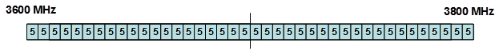
Figure 4: ECC/DEC/(11)06 harmonised frequency arrangement for 3600-3800 MHz based on TDD
Multiple adjacent blocks of 5 MHz can be combined to obtain wider channel.

Proposed frequency arrangement
The unpaired arrangement is selected as the only option for the 3400-3800 MHz range for the following reasons:
- The TDD mode exploits downlink/uplink flexibility to support traffic asymmetry: today, with the rapid development of smartphones and their increasing usage, mobile applications are increasingly download-centric;
- The TDD mode exploits channel reciprocity for effective AAS implementation: relying on uplink and downlink channel reciprocity (when the same portion of spectrum is used in both link directions this is frequently the case), the base stations can in some cases quickly and accurately obtain the downlink Channel State Information based on the uplink channel estimation. This can be advantageous for AAS implementation to enhance the downlink transmission capacity while minimising interference;
- The TDD mode adapts better to possible incumbent users: given the current fragmented utilisation of the 3400-3800 MHz portions of 3400-3800 MHz may be used by incumbent systems. Unpaired spectrum arrangement clearly has the advantage over a process that would include re-farming and pairing of new spectrum;
- Furthermore, it is noted that 3GPP has agreed on a TDD-only band plan in this band for its NR specification, 3GPP has defined the following channel bandwidths for 5G NR applicable to the 3400-3800 MHz range: 10, 15, 20, 40, 50, 60, 80 and 100 MHz.
ECC/DEC/(11)06 (rev. 2014) [3] considers 3400-3600 MHz and 3600-3800 MHz as separate bands and defines its preferred frequency arrangements accordingly. However, in case of 5G NR, 3GPP has defined the whole 3400-3800 MHz as part of one single band (in both its specifications for the NR bands n77 and n78). This suggests that, in case of 5G, there is no need to consider separate frequency arrangements for 3400-3600 MHz and 3600-3800 MHz from a regulatory perspective.
Furthermore, if the 3400-3600 MHz and the 3600-3800 MHz are defined as separate bands, there could be complications at the time of licensing if assignments straddle over the 3600 MHz boundary. This is likely given that it is expected that assignments in the band will be large.
The 5 MHz block size is chosen, despite expected 5G larger channel bandwidths. The 5 MHz granularity will facilitate dealing with the existing assignments and will make it easier for the market to decide on the required bandwidth per operator during the assignment procedures.
The considerations above lead to the following frequency arrangement:
Figure 5: Proposed harmonised frequency arrangement 3400-3800 MHz band
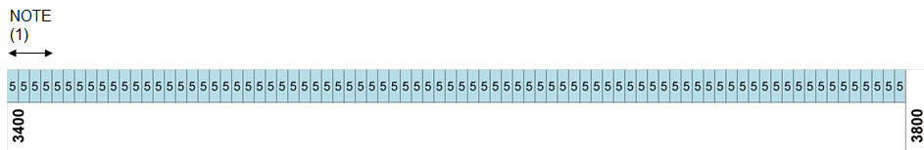
NOTE (1): The feasibility of implementation of wide area outdoor AAS base stations in the lowest 5 MHz blocks taking into account the out-of-band unwanted emission limits to protect radars will require evolution of filtering capabilities for AAS. However, these lowest blocks would remain usable in some circumstances. See also section 7.2.
The proposed frequency arrangement will facilitate availability of larger contiguous frequency blocks to 5G operators.

Existing BEM Requirements
The harmonised technical conditions for MFCN base stations (BSs) in 3400-3800 MHz as described in ECC/DEC/(11)06 (rev. 2014) [3] consist of BEM requirements with both in-block power limits, out-of-block emission limits which apply outside an operator’s block as well as out-of-band emission limits (below 3400 MHz).
For the purposes of this document, focus is kept on the technical conditions for MFCNs which use time division duplex (TDD).
Figure 6 below illustrates the combined BEM elements described earlier as TDD base stations as specified in ECC/DEC/(11)06 (rev. 2014). The values of these limits are described in the tables in the following sections.
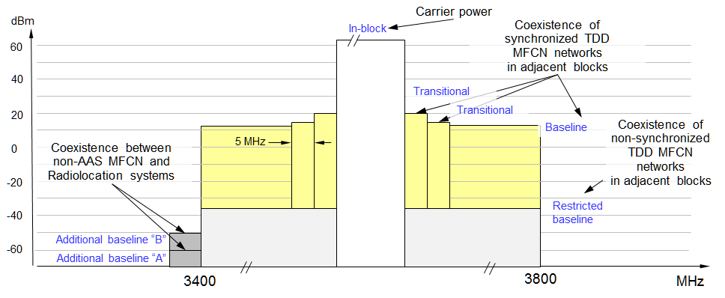
Figure 6: TDD base station power limits (e.i.r.p.) in ECC/DEC/(11)06 (rev. 2014)
NOTE: the ECC/DEC/(11)06 (rev. 2014) only refers to "baseline" power limits and to "additional baseline" power limits. In the context of this Report two limits are defined: baseline limits for synchronised network coexistence and "restricted baseline" power limits for unsynchronised.
The above emission limits are all specified as e.i.r.p. and consist of two so-called ”transitional region" limits, a baseline limit, a restricted baseline limit and two additional baseline limits:
- The two transitional limits, and the baseline power limit are specified to address the matter of base station to terminal station interference between synchronised TDD MFCNs, and are derived from 3GPP unwanted emission masks for LTE;
- The restricted baseline limit addresses the matter of base station-to-base station interference between unsynchronised TDD MFCNs (i.e. implying that UL/DL transmissions are not time aligned). This limit is more stringent than the 3GPP unwanted emission masks for LTE;
- The two additional baseline limits address the matter of interference from MFCN base stations to military radar systems below 3400 MHz. This limit is considerably more stringent than the 3GPP unwanted emission masks for LTE.
The following sections describe the key aspects associated with the in-block and out-of-block (OOB) power limits as currently defined by ECC/DEC/(11)06 (rev. 2014), based on e.i.r.p. metric.

Out-of-block power limits: Interference between synchronised MFCNs
ECC/DEC/(11)06 (rev. 2014) [3] proposes two different BEMs for coexistence of MFCN networks in adjacent blocks. One BEM applies for synchronised network coexistence (two transitional limits and one baseline limit), while the restricted baseline limit is defined for unsynchronised network coexistence.
Table 2: Baseline power limits for non-AAS BSs in case of synchronised MFCNs
BEM element | Frequency range | non-AAS e.i.r.p. limit  dBm/(5 MHz) per antenna
Baseline | FDD DL (3510-3590 MHz). Synchronised TDD blocks (3400-3600 or 3600-3800 MHz depending on the chosen frequency arrangement, TDD only or FDD and TDD) | Min(PMax−43, 13)
PMax is the maximum mean carrier power for the base station measured as e.i.r.p. per carrier.
The transitional region power limits are defined to enable the reduction of power from the in-block level to the baseline level. The requirements are defined for 0–5 MHz and 5–10 MHz offset from the upper and lower edges of an operator’s block (see below).
Table 3: Transitional region power limits for non-AAS BSs in case of synchronised MFCNs
BEM element | Frequency range | non-AAS e.i.r.p. limit  dBm/(5 MHz) per antenna
Transitional region | -5 to 0 MHz offset from lower block edge  0 to 5 MHz offset from upper block edge | Min(PMax−40, 21)
Transitional region | -10 to -5 MHz offset from lower block edge  5 to 10 MHz offset from upper block edge | Min(PMax−43, 15)
PMax is the maximum mean carrier power for the base station measured as e.i.r.p. per carrier

Note: for TDD blocks the transitional region applies in case of synchronised adjacent blocks, and in-between adjacent TDD blocks that are separated by 5 or 10 MHz. The transition region does not extend below 3400 MHz or above 3800 MHz.
The two transitional limits are based on the unwanted emission mask specified in 3GPP TS 37.104 [16] for multi-standard radio (MSR) E-UTRA wide area base stations. More specifically:
- The limits are specified relative to the maximum carrier power of the base station, measured as e.i.r.p.;
- The limits are capped at values that are consistent with the absolute levels of the 3GPP MSR E-UTRA wide area base station unwanted emission mask (assuming a 21 dBi antenna gain).
ECC/DEC/(11)06 (rev. 2014) assumes, in line with 3GPP, the compliance with the BEM is sufficient to ensure coexistence of synchronised MFCN BSs, irrespective of the number of antennas or the power of the base station.
Table 4 describes the relationship between the baseline and transitional power limits defined in ECC/DEC/(11)06 (rev. 2014) and the 3GPP unwanted emission mask.
Table 4: ECC limits and the 3GPP unwanted emission mask
From TS 37.104 Table 6.6.2.1-1 [16]:  Wide Area operating band unwanted emission mask (UEM) for BC1 and BC3 |  |  |  | Comparison between 3GPP  and ECC limits
Frequency offset (MHz) | 3GPP unwanted emission mask | Average Tx power | Units | 3GPP:  Tx Power  (dBm/(5 MHz)) |  | 3GPP:  e.i.r.p. (1)  (dBm/(5 MHz)) | ECC  e.i.r.p. (2) limits  (dBm/(5 MHz))
0 to 0.2 | -14 | -14.0 | dBm/30kHz | 8.2 | 0.1 | 21.1 | 21
0.2 to 1 | -14 to -26 | -16.7 | dBm/30kHz | 5.5
1 to 5 | -13 | -13.0 | dBm/1MHz | -6.0
5 to 10 | -13 | -13.0 | dBm/1MHz | -6.0 | -6.0 | 15.0 | 15
10 to 15 | -15 | -15.0 | dBm/1MHz | -8.0 | -8.0 | 13.0 | 13
(1) Assuming a nominal antenna gain of 21 dBi.
(2) Assuming a carrier e.i.r.p. of 61 dBm/(5 MHz) or more.
Figure 7 depicts the application of the power limits to two adjacent and synchronised TDD MFCNs. The transitional limits and the baseline limits relate to inter-MFCN BS-to-UE interference. Inter-MFCN interference is addressed by 3GPP specifications of unwanted emission masks.
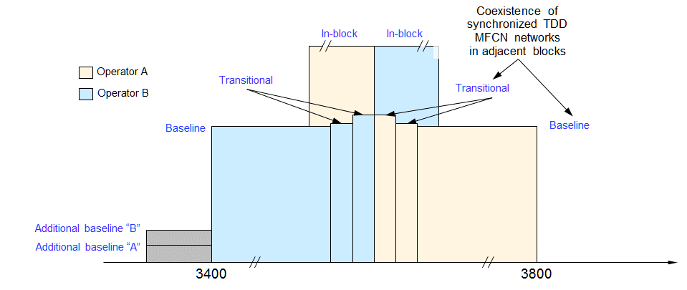
Figure 7: Out-of-block base station power limits for adjacent synchronised MFCNs

Out-of-block power limits: Interference between unsynchronised MFCNs
One restricted baseline limit is defined to address the interference between two unsynchronised MFCNs.
Table 5: ECC/DEC/(11)06 (rev. 2014) [3] restricted baseline power limits for unsynchronised non-AAS BSs
BEM element | Frequency range | Non-AAS e.i.r.p. limit  dBm/(5 MHz) per cell
Restricted baseline | FDD UL (3410-3490 MHz). Unsynchronised TDD blocks (3400-3800 or 3600-3800 MHz depending on the chosen frequency arrangement, TDD only or FDD and TDD). | -34
An exception for this type of baseline can be negotiated between adjacent operators for femto base stations in the case when there is no risk for interference to macro base stations. In that case -25 dBm/(5 MHz) e.i.r.p. per cell may be used.

Out-of-band power limits: Interference towards radars below 3400 MHz
Two additional baseline limits have been introduced to reflect the need for protection for military radiolocation in some countries.
ECC/DEC/(11)06 (rev. 2014) [3] specifies maximum permitted out-of-band e.i.r.p. levels of –59 and ­50 dBm/MHz below 3400 MHz for FDD and TDD MFCN base stations. Administrations may select one or the other (or no limit) depending on the required level of protection of radar in the region in question. These limits had originally been derived via minimum coupling loss analysis, although the derivation was not formally documented in any CEPT or ECC reports.
Table 6: ECC/DEC/(11)06 (rev. 2014) [3] base station additional baseline power limits
below 3400 MHz for country-specific cases
Case |  | BEM element | Frequency range | Non-AAS e.i.r.p. limit dBm/MHz
A | CEPT countries with military radiolocation systems below 3400 MHz | Additional baseline | Below 3400 MHz for both TDD and FDD allocation (1) | -59 (2)
B | CEPT countries with military radiolocation systems below 3400 MHz | Additional baseline | Below 3400 MHz for both TDD and FDD allocation (1) | -50 (2)
C | CEPT countries without adjacent band usage or with usage that does not need extra protection | Additional baseline | Below 3400 MHz for both TDD and FDD allocation | Not applicable
(1) Administrations may choose to have a guard band below 3400 MHz. In that case the power limit may apply below the guard band only.
(2) Administrations may select the limit from case A or B depending on the level of protection required for the radar in the region in question.
Cases A, B and C can be applied per region or country so that the adjacent band may have different levels of protection in different geographical areas or countries, depending on the deployment of the adjacent band systems.
In addition, the levels given in Table 6 are applicable only to outdoor cells. In case of indoor deployments, the levels can be relaxed on a case by case basis. Other mitigation measures like geographical separation, coordination on a case by case basis or an additional guard band may be necessary.
For UEs other mitigation measures will be necessary such as e.g. geographical separation or an additional guard band for both FDD and TDD allocation.
Figure 8 illustrates the regulatory e.i.r.p. limits defined in ECC/DEC/(11)06 (rev. 2014) as a function of the number of antennas.
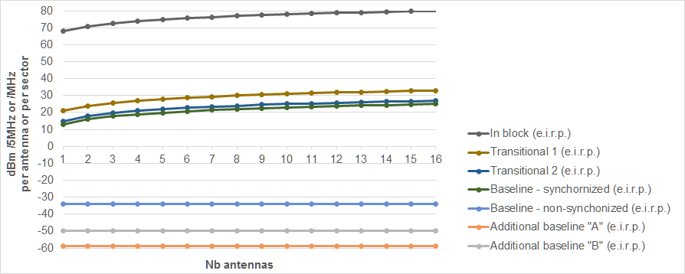
Figure 8: TDD base station power in block and out of block limits (e.i.r.p.) in ECC Decision (11)06 as a function of the number of the base station antennas

In-block power limits
ECC/DEC/(11)06 (rev. 2014) [3] does not mandate a regulatory in-block limit for base stations. However, it does recommend that if such a limit “is desired by an administration, a value which does not exceed 68 dBm/5 MHz per antenna may be applied”.
Table 7: ECC/DEC/(11)06 (rev. 2014) [3] in-block power limit
BEM element | Frequency range | non-AAS e.i.r.p. limit  dBm/(5 MHz) per antenna
In-block | Block assigned to the operator | 68  Not obligatory (1)
(1) For femto base stations, the use of power control is mandatory in order to minimise interference to adjacent channels.
Different licensing methodologies might be chosen by administrations to license TDD spectrum. One example for a regulation methodology could be the definition of restricted blocks, where the in-block limit could be restricted and would be different than the one as defined in Table 7.
UE In-block requirement
The only technical condition for user equipment (UEs) in ECC/DEC/(11)06 (rev. 2014) is a recommendation that their in-block radiated power (e.i.r.p. for fixed UEs, and TRP for nomadic/mobile UEs) does not exceed 25 dBm.

Analysis of the suitability of the current BEM requirements for 5G
The significant growth in the number of mobile devices and exponential increase in consumption of wireless data is the basis for the adoption of AAS for MFCNs operating in the 3400-3800 MHz frequency range. AAS can be applied to any IMT system providing significant increase in the peak and average cell throughput.
In the context of the evolution of MFCN networks (5G NR and LTE evolution), by design, the 5G NR will optimally support wideband operation, allowing operators to take full advantage of assignments of wide contiguous spectrum to increase peak rates and user experience, with manageable terminal complexity and minimal power consumption. Current 5G NR specifications support contiguous channel bandwidths up to 100 MHz. Carrier aggregation may be used for utilising wider bandwidths.
This section, provides the analysis on the suitability of existing BEM requirements of ECC Decision (11)06 [3] for 5G, and provides proposals for amendments where necessary. MFCNs which use time division duplex (TDD) are considered.

Definitions

Non-AAS MFCN base stations
For the purposes of this document, the term non-AAS (short for non-active antenna systems) refers to MFCN base station transmitters which are manufactured or supplied separately to antenna systems. Non-AAS base stations will provide one or more antenna connectors, which are connected to one or more separately supplied passive antenna elements or arrays to radiate radio waves.
The existing ECC regulatory power limits (described in Chapter 5) apply to non-AAS MFCN base stations, in the sense that they are derived from the analysis of the sum of the radiated powers across multiple antenna connectors, and in some cases accounting for the anticipated antenna directional pattern, and the contribution of these to harmful interference at a victim receiver.

AAS MFCN base stations
AAS (short for active antenna systems) is one of the key features for 5G NR and LTE evolution products.
According to Recommendation ITU-R M.2101 [16] an IMT system using an AAS will actively control all individual signals being fed to individual antenna elements in the antenna array in order to shape and direct the antenna emission diagram to a wanted shape, e.g. a narrow beam towards a user.
For the purposes of this document, the term AAS refers to a base station and antenna system where the amplitude and / or phase between antenna elements is continually adjusted resulting in an antenna pattern that varies in response to short term changes in the radio environment. This is intended to exclude long term beam shaping such as fixed electrical down tilt.
In AAS base stations the antenna system is integrated as part of the base station system/product. Due to the higher frequencies of the 3400-3800 MHz band compared to those of existing bands harmonised for MFCN, and therefore smaller wavelengths and antenna dimensions/spacing, it is feasible to perform beam forming with large numbers (tens) of antenna elements and to benefit from the resulting narrow beamwidths. Performing beam forming with a large number of elements in general requires the antenna array to be supplied and integrated with the base station.
For instance, this can be realised by mapping a set of antenna ports into a physical antenna, where each antenna port consists of a certain number of antenna elements. Consequently, signals from the different antenna ports are added coherently at the receiver side to form a beam pointing in the direction of the receiver. The antenna diagram and beam characteristics will be dependent on the chosen antenna implementation, number of antenna ports, antenna elements, etc. The transmitter will in turn be able to direct the energy to different directions (i.e. following the positions of the served receivers).

Total Radiated Power (TRP)
TRP is defined as the integral of the power transmitted in different directions over the entire radiation sphere as shown in the expression below.
$TRP≝\frac{1}{4π}\int_{0}^{2π}{\int_{0}^{π}{P\left(θ,φ\right)sin⁡(θ)dθdφ}}$ (1)
where
- $TRP$ is equal to the total conducted power input into the antenna array system less any losses in the antenna array system;
- $P\left(θ,φ\right)$: power radiated by an antenna array system in direction$\left(θ,φ\right).$
$P\left(θ,φ\right)=P_{Tx}g(θ,φ)$ (2)
where
- $P_{Tx}$: conducted power (Watts) input to the array system;
- $g(θ,φ)$: array systems directional gain along $\left(θ,φ\right)$ direction.
The maximum e.i.r.p. for an AAS base station can be written in log domain as follows:
${e.i.r.p.}_{max}=TRP+G_{E}+{10log}_{10}{N}$ (3)
where $G_{E}$ is the antenna element gain in dBi, and $N$ is the number of beam forming elements.

Synchronisation in TDD MFCNs
The definitions below may not necessarily apply to an entire network. In particular, there are use cases where different base stations within a network may be unsynchronised or semi-synchronised.
Synchronised operation:
The synchronised operation in the context of this Report means operation of TDD in several different networks, where no simultaneous UL and DL transmissions occur, i.e. at any given moment in time either all networks transmit in DL or all networks transmit in UL. This requires the alignment of all DL and UL transmissions for all TDD networks involved as well as synchronising the beginning of the frame across all networks.
Unsynchronised operation:
The unsynchronised operation in the context of this Report means operation of TDD in several different networks, where at any given moment in time at least one network transmits in DL while at least one network transmits in UL. This might happen if the TDD networks either do not align all DL and UL transmissions or do not synchronise at the beginning of the frame.
Semi-synchronised operation:
The semi-synchronised operation corresponds to the case where part of the frame is consistent with synchronised operation as described above, while the remaining portion of the frame is consistent with unsynchronised operation as described above. This requires the adoption of a frame structure for all TDD networks involved, including slots where the UL/DL direction is not specified, as well as synchronising the beginning of the frame across all networks.
The semi-synchronised operation can be beneficial for small-cells. The interference mitigation techniques necessary for semi-synchronisation would be studied at the earliest in 3GPP Release 16. It is expected that not all User Equipment will be able to support this type of operation.

Suitability for non-AAS MFCN
As described in section 5.1, existing emission limits are derived from 3GPP specification TS 37.104 [16], where unwanted emission requirements are applied per antenna connector. The antenna connector would most likely be connected to a passive antenna array, meaning that the resulting antenna gain is fairly invariant (between different implementations and between wanted and unwanted signals). Hence, using e.i.r.p. as a metric for setting requirements was considered to be suitable, given the passive nature of the antenna array.
Based on the need to avoid disrupting the usage rights that have been already assigned for non-AAS MFCN in the 3400-3800 MHz range, it is proposed to maintain the existing in-block, out-of-block and out-of-band e.i.r.p. limits as specified in ECC/DEC/(11)06 [3] and reported in Chapter 5.

Suitability for AAS MFCN

Implications from the AAS architecture
As described in section 5.1, ECC/DEC/(11)06 [3] defines the BEM requirements for MFCN including IMT-2000 and IMT-advanced technologies in terms of e.i.r.p. limits at the spectrum block edge. Some of these requirements (i.e. the restricted baseline power limit applying to the unsynchronised MFCNs and the additional baseline power limits defined to protect radar systems below 3400 MHz) are not specified in the equipment standard and are used by national regulators as part of MFCN license condition therefore representing a regulatory obligation for mobile operators. To respect such regulatory limits in non-AAS MFCN base stations, if needed, mobile operators have the possibility of installing additional external filters between the base station antenna connector and the antenna.
$e.i.r.p. BEM = SEM - Feeder_Loss + Antenna_Gain - Filter_Rejection$ (4)
In case of AAS base stations, as illustrated in Figure 9, the antenna arrays are included in the base station without an accessible interface between the AAS system and the base station. Differently from non-AAS base stations, it is not possible to meet the BEM regulatory limits through the installation of external filters anymore: the BEM regulatory requirements must therefore be met by product design.
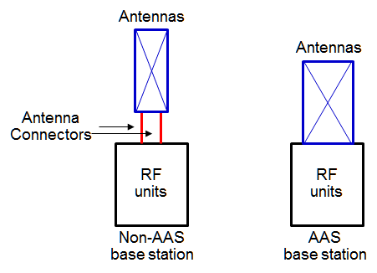
Figure 9: AAS and non-AAS base stations architecture
Given the need to implement any additional filtering inside the AAS base station itself the additional baseline regulatory limits need to be harmonised across CEPT countries as much as possible in order to avoid country-specific or even operator-specific implementations which would not be able to rely on significant economies of scale and would therefore not be commercially viable.

Out-of-block power limits: Interference between synchronised MFCNs
The baseline power limit applies to the coexistence of networks in synchronised operation, while the restricted baseline power limit is defined for unsynchronised networks coexistence (see definition in section 6.1.4).
In this section, the suitability of the two transitional region power limits and the baseline power limit, which apply to synchronised TDD base stations, is addressed.
Section 5.1 described the relationship between the 3GPP MSR E-UTRA wide area base station unwanted emission mask and the baseline and transitional regulatory limits in ECC/DEC/(11)06 (rev. 2014) [3]. 3GPP TS 37.104 [16] specified the relevant unwanted emission mask in the form of conducted power limits measured at the antenna connector.

TRP metric vs. e.i.r.p.
A second item to be addressed is related to the most appropriate metric to characterise the unwanted emissions from AAS.
The use of TRP for specification of emission limits is illustrated in Figure 10 below. Each of the depicted examples of radiation patterns correspond to the same TRP (i.e. each example is associated with the same area in the two-dimensional diagram).
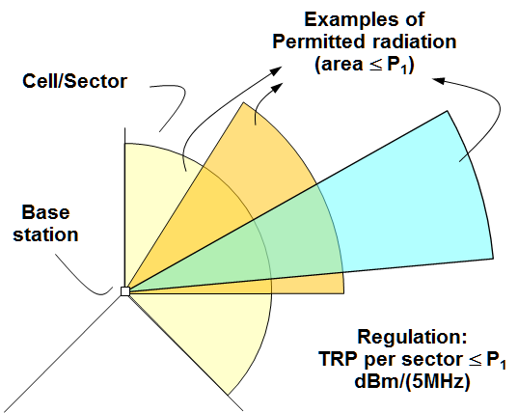
Figure 10: An illustration of the use of TRP for specification of emission limits
As illustrated above, in terms of impact to adjacent systems (base station downlink direction), for the same total maximum conducted power, adopting a larger number of base station antennas may lead to high values of peak e.i.r.p., although the total radiated power (TRP) will remain unchanged. Least restrictive regulatory technical conditions for AAS MFCN base stations should account for this behaviour.
The following text explains why, in the context of AAS base stations, it would be appropriate to specify any amended regulatory limits as TRP.
Consistency with the 3GPP approach
Considerable effort has been made by 3GPP to assess the effects of the AAS unwanted emissions on other mobile networks and to identify the appropriate metric for their characterisation. The different characteristics of the AAS systems in comparison with traditional sector or omni-directional antennas were analysed in detail. 3GPP RAN4 technical group has therefore been considering the following approaches for AAS:
- In case of AAS in the context of 5G-New Radio and LTE evolution, the unwanted emission masks will be specified as over-the-air (OTA) rather than conducted power limits. Furthermore, the OTA emission limits will be specified as TRP, rather than e.i.r.p. This is because 3GPP studies have indicated that harmful interference to adjacent mobile systems is primarily dictated by the TRP (rather than the e.i.r.p.) of a base station in any given cell or sector.
3GPP studies [19] have shown that the impact in terms of throughput degradation of the unwanted emissions on the adjacent mobile systems (i.e. inter-MFCN interference) depends on the total amount of interference which is injected into the network. Such total amount of interference is well represented by TRP. Setting the requirements in terms of TRP would limit the level of throughput degradation in the victim network to a desired level. The total emissions power and not the spatial pattern impacts the victim network.
Even for the same antenna implementation, the wanted signal and the unwanted signal may have different beam shapes. The correlation properties of the unwanted emissions coming from the different AAS antenna elements will be implementation dependent and may differ between different BS implementations. If the unwanted emissions at each antenna element are fully correlated, then the unwanted emissions would form the same spatial pattern as the wanted signal (i.e. a narrow, moving beam). If on the other hand the unwanted emissions from each antenna element are uncorrelated, then there would be no beam forming and the unwanted emissions can be expected to form the same spatial pattern as that of the individual radiating antenna elements (i.e. a wide beam).
The relationship between the TRP and e.i.r.p. is therefore not known, being directly related to the number of radiating antennas and on specific base station implementation (e.g. geometry of the antenna array: elements spacing, linear array of elements) and correlation between unwanted emission signals from different antenna ports. In other words, specifying an e.i.r.p. limit could result in different levels of TRP depending on implementations. This would in turn cause different implementations that would meet an e.i.r.p. requirement to cause different levels of degradation in a victim network. Thus e.i.r.p. would be an inappropriate metric.
The definition of an e.i.r.p. limit can lead to the situation in which the system with lower antenna gain could meet the emission requirements by injecting higher level of interference into the network (the exaggerated example depicted on the right hand side of in Figure 11). Therefore, specifying an e.i.r.p. requirement will not allow guaranteed control of the total amount of interference in the network and would lead to misleading results and potentially reduced protection [20] or overprotection for co-existing systems.
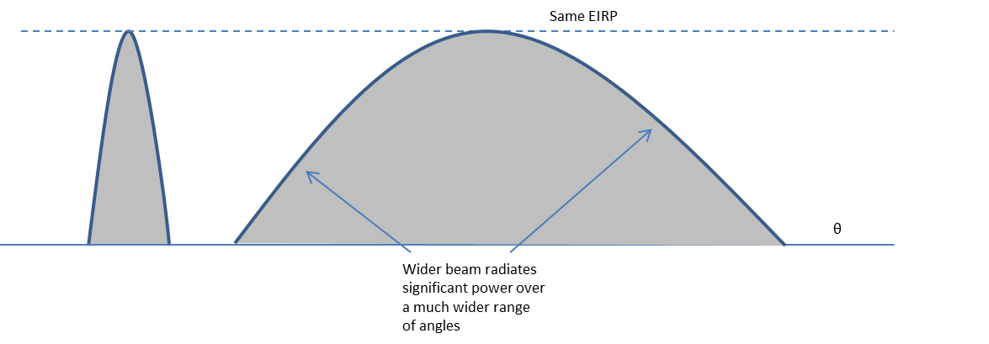
Figure 11: Example spatial patterns of unwanted emissions from two AAS base stations, both meeting the same e.i.r.p. limit but radiating different TRPs corresponding to different conducted unwanted emissions power levels
On the other hand, a TRP requirement will limit the total amount of interference injected in the network regardless the specific BS implementation. For the same level of TRP, BS with higher antenna gains will have higher directivity, thus higher spatial control of the radiating interference, while the total amount of injected interference will be the same compared to a BS deploying lower number of antenna elements.
In other words, different BS implementations may lead to the same impact on a given victim system, meaning that limiting the BS implementation would not bring any benefit to the victim system and would only lead to less flexible and less efficient antenna solutions. Hence, the requirements should be independent of the correlation level of the unwanted emissions.
The throughput impact of emissions from an AAS network to a legacy (non-AAS) victim network was analysed using simulations for the specific class of antenna arrays with specific elements spacing (that is described in section 5.4 of 3GPP TR 37.840 [21], [22]). Different correlation properties between transmitters were simulated and the level of the AAS unwanted emissions were varied in order to observe the effect of correlation and emissions level of an AAS on a legacy (non-AAS) victim network. With the simulation assumptions used for the studies, 100% correlation implies that the unwanted emissions are beam-formed in the same manner as the wanted signal. 0% correlation implies that the unwanted emissions are not beam-formed but are radiated with the individual antenna element pattern. It was found that the aggressor (AAS BS) total radiated unwanted emissions power was directly proportional to the victim network throughput degradation, independently of the correlation and hence the spatial pattern of the unwanted emissions. The results of these studies showed that, the level of correlation (and hence the spatial pattern of the emissions) does not impact the co-existence performance. Simulation have shown, for the specific antenna configuration used, that the TRP would be an appropriate metric in assessing harmful interference since it would be independent of the effect of correlation level.
Finally, another relevant element behind 3GPP choice of defining unwanted emission with a TRP metric is the different behaviour between passive and active antenna systems. In case of passive systems, the antenna gain does not vary much between the wanted signal and unwanted emissions. Thus e.i.r.p. is directly proportional to TRP and can be used as a substitute. For active systems, the e.i.r.p. could vary wildly between wanted signal and emissions and between implementations, so e.i.r.p. is not proportional to TRP and using e.i.r.p. to substitute TRP would be incorrect.
As a minor note, it is worth noticing that a TRP requirement would also correspond to the conducted requirement in case of an ideal system with perfect matching and no antenna losses.
Based on the above observations, 3GPP has concluded that TRP is the appropriate metric for specifying the ACLR and out-of-block emission limits, in the context of interference between adjacent channel mobile networks.
Implications from the AAS architecture
As described in section 6.3, in case of AAS base stations, the antenna arrays are included in the base station without an accessible interface between the AAS system and the base station.
In addition, the AAS antenna main beam moves while following the UE positions, the base station BEM compliance measurement procedure proposed in the ECC/DEC/(11)06 (rev. 2014) [3] may not be applicable anymore. The AAS base station unwanted emission mask including out-of-band emissions and spurious emissions needs to be specified and tested in lab as TRP levels, the conducted power test does not apply to AAS base stations.
Therefore:
- The current regulatory technical conditions (e.i.r.p. BEM) studied in the ECC Report 203 [2] and defined in the ECC/DEC/(11)06 (rev. 2014) are applicable for 3G/4G MFCN and fixed wireless access networks which do not use AAS antennas, but they are not suitable and cannot be applied to 4G and 5G MFCN AAS base stations with integrated antenna arrays;
- The unwanted emissions are to be specified as over-the-air (OTA), rather than as conducted requirement, since the conducted power cannot be measured due to the fact that the amplifier is an integral part of the antenna element. In particular, the OTA emission limits will be expressed in terms of TRP rather than e.i.r.p.;
- TRP-based additional baseline limits for AAS base stations may need to be included in the BS standard, e.g. European Harmonised Standard as operators will not be able to improve the product performance over what is specified in the standard as external filters cannot by applied to AAS base stations and due to the fact that TRP limits can be measured in laboratories but not in the field.

Synchronisation in 5G NR
Several LTE-TDD networks are currently providing services to millions of end users with hundreds of thousands of base stations deployed in the field adopting synchronisation and alignment of uplink and downlink transmissions between operators using adjacent frequency blocks. Such networks provide proven experience in the field that should be considered as the starting point for the definition of the regulatory framework for 5G NR.
With particular reference to the aspect of interference between MFCN networks, the updated CEPT regulatory framework should account for the following principles:
- Accounting for proven technologies and best practices in the field in the framework;
- The framework should remain open towards technology evolutions such as those that are being discussed in 3GPP defining new schemes that will ensure more flexibility in UL and DL transmissions between 5G NR networks operating in adjacent frequency blocks. The specifications for such schemes are currently being discussed and will be finalised within Release 16 of the 5G NR specifications;
- The framework should be applicable to all UEs.
One of the most important features of NR is the ability to choose the transmission direction of any portion of the slot and the ability to use any portion of the slot for control or data. This ability allows flexibility in adapting to the traffic pattern as well as latency reduction, improved capacity, robust mobility. Interference management would be simplified in case of alignment of the transmission directions at least for some portions of the slot (e.g. portions used for control plane).
NR is also defining the framework for the network to evaluate the interference conditions and dynamically adjust the transmission direction based on traffic demand, especially in small cell deployment topologies. This possibility of dynamically adjusting the transmission direction based on traffic demand is not defined today for Macro cells deployment topology, and therefore this capability cannot be assumed for all possible deployment scenarios.
Different examples of slot configuration are discussed in 3GPP and presented below.
Figure 12 below shows an example of NR-NR coexistence with UL and DL control transmission in every slot. In this case, each slot has both DL and UL control regions at the edges, whereas the middle is occupied with UL or DL data. The position of the DL and UL control blocks in this special case are fixed regardless of whether this is an UL-centric or DL-centric slot. The critical control regions are therefore protected from cross-link interference even when adjacent channel deployment chooses to utilise the same slot for data in the opposite direction (as seen in the middle slot in Figure 12).
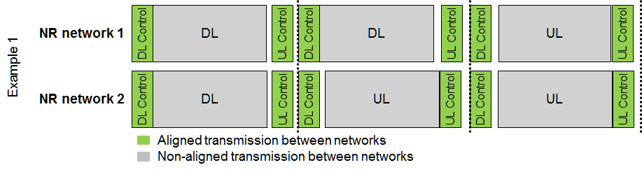
Figure 12: Example of NR-NR coexistence with UL and DL control transmissions in every slot
This configuration is defined in 3GPP as a UE capability that only capable UEs support. Not all UEs from the market are mandated to support it. Therefore, it cannot be considered as the baseline assumption for 5G MFCN synchronisation.
Other possible scenarios exist as shown in Figure 13 below where the DL and UL control regions are not present in all slots, some portions of the slots are reserved for aligned UL or DL transmissions (either for data or control plane) between adjacent networks.
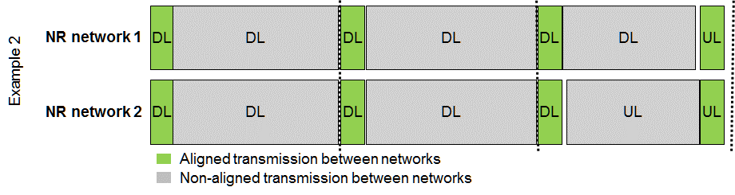
Figure 13: Example of NR-NR coexistence with portions of the slot dedicated to UL or DL transmissions (either for control or data plane)
Interference caused by non-aligned UL-DL data transmissions between adjacent networks are expected to be managed through:
- Introducing a guard band (not using certain radio resource at the edge of the channel);
- Reducing the DL data transmit power in the DL/UL misaligned subframes, together with some advanced scheduling and receiving solutions such as cross-link interference mitigation mechanisms.

Out-of-block power limits: Interference between unsynchronised MFCNs
Simulations were carried out (ANNEX 3:) for the coexistence between unsynchronised MFCNs at 3400-3800 MHz, leading to the definition of restricted baseline power limits which would apply to AAS base stations. Specifically, the following two scenarios have been considered:
- Interference from AAS base stations to non-AAS base stations;
- Interference from AAS base stations to AAS base stations.
The impact of interference was assessed by evaluating the degradation in the mean uplink throughput of the victim MFCN.

Out-of-block power limits: Interference between LTE and 5G NR MFCNs
Coexistence between LTE and 5G NR in adjacent frequencies is ensured when:
- Each system respects the relevant applicable baseline level in case of synchronised operation for AAS or non-AAS systems; or
- Each system respects the relevant applicable restricted baseline level in case of unsynchronised LTE and 5G NR networks for AAS or non-AAS systems.
The two approaches are assessed in more details in the following sections leading to the following conclusions:
Synchronised operation between 5G NR and LTE is technically feasible but may lead to higher latency and reduced flexibility in the UL/DL transmission ratio, although networks could be designed to overcome some of these drawbacks.
In case of unsynchronised operation of 5G NR and LTE networks, respecting the restricted baseline level for unsynchronised MFCN networks coexistence would be challenging to implement as AAS systems cannot be fitted with additional external filters.
Assuming it would be economically feasible to implement the required additional filters, in addition, a frequency separation is likely to be required and studies should be conducted to confirm the need for such separation and to determine the width of such a frequency separation (simulations that were carried out in Annex 3 for the coexistence between unsynchronised MFCNs at 3400-3800 MHz may provide valuable reference about the ACIR/ACLR requirements). Relaxed restricted baseline limits can be defined at national level.

Common synchronisation between LTE and 5G NR
This section provides an analysis on the possibility to synchronise and align LTE and 5G NR transmissions from a technical perspective and the associated implications.
As first step, the following section provides the necessary technical background related to 5G NR subcarrier spacing and symbol alignment. This background is based on 3GPP agreements.
5G NR subcarrier spacing
3GPP RAN1 has agreed on an LTE-based 5G NR subcarrier spacing (and cyclic prefix length) for 5G NR [24] based on 2^n×15 kHz subcarrier spacing as illustrated in the example table below.
The value of the parameter n depends on the intended frequency band. For instance, n = 0, 1 and 2, corresponding to 15, 30 and 60 kHz subcarrier spacing, are considered by 3GPP RAN4 for frequencies below 6 GHz. On the other hand, larger subcarrier spacing is considered for frequencies above 6 GHz, e.g. 120 kHz, in addition to 15, 30 and 60 kHz.
Table 8: Subcarrier spacing for 5G NR for frequencies below 6 GHz
Subcarrier spacing | Slot duration (assuming 7 OFDM symbols per slot) | Slot duration (assuming 14 OFDM symbols per slot)
15 kHz | 500 µs | 1000 µs
30 kHz (2 x 15 kHz) | 250 µs | 500 µs
60 kHz (4 x 15 kHz) | 125 µs | 250 µs
The corresponding 3GPP agreement is captured in [24].
Symbol alignment
The Symbol alignment is a 5G NR property, allowing a long OFDM symbol (i.e. with narrow subcarrier spacing) to exactly cover an integer number of shorter OFDM symbols (i.e. with wider subcarrier spacing). Figure 14 is an illustration of the symbol alignment property of 5G NR.
The darker symbols in Figure 14 are symbols with longer Cycle Prefix (CP), as the cyclic prefix of the first OFDM symbol in every 0.5 ms interval is 16 x $T_{s}$ longer than the cyclic prefix of the remaining symbols in the time interval ($T_{s}$ is the 30.72 MHz chip duration).
As Figure 14 shows, a 15 kHz NR symbol exactly covers four 60 kHz NR symbols. Similarly, considering an LTE sub-frame of 1 ms, the latter would exactly overlap with four 14-symbols 60 kHz NR slots.
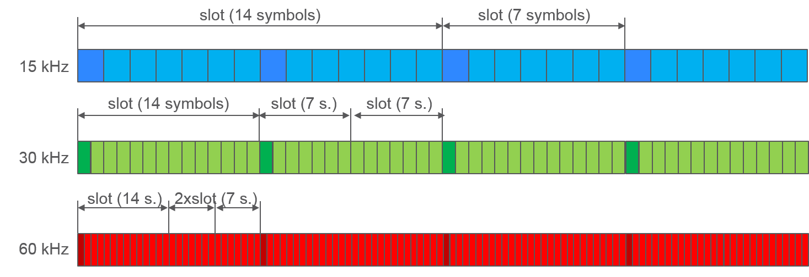Figure 14: Symbol alignment in 5G NR
5G NR slot structure can therefore be utilised in a manner such that the direction of transmission is fully aligned with the LTE TDD Configuration.
Considering that symbol alignment is a fundamental property of 5G NR, and that it ensures alignment between LTE and 5G NR as described in the previous sections, it can be concluded that synchronisation and alignment of UL/DL transmissions between LTE and 5G NR base stations is technically feasible.
Implications
Although complete alignment of UL/DL transmissions between LTE and NR can be achieved as described above, this would have implications on the minimum latency achievable by 5G NR. Full synchronisation of the NR slot structure and LTE TDD Configuration brings significant drawback to the NR implementation. Many of the benefits of NR are linked precisely to the frame structure. Reverting to the LTE structure would imply higher latency, higher UE memory cost, TCP performance loss, mobility performance loss and spectral efficiency loss, although networks could be designed to overcome some of these drawbacks. This does not impact the technical conditions but degrades 5G QoS.

No common synchronisation between LTE and 5G NR
A possible alternative to the synchronised approach implies respecting the restricted baseline level for unsynchronised MFCN coexistence.
Respecting the restricted baseline limit would imply the introduction of an additional internal filter within the AAS base station. Since the implementation of such filter would depend on the operator's specific spectrum assignment, the filter (and the AAS base stations) would become operator-specific which would not be economically sustainable.
CEPT is developing a toolbox for coexistence of MFCN in 3400-3800 MHz in synchronised, unsynchronised and semi-synchronised mode to help either network operators or administrations to address relevant coexistence issues

Out-of-band power limits: Interference towards radars below 3400 MHz
The existing regulatory requirements described in section 5.1 for the protection of radiolocation systems below 3400 MHz from MFCN non-AAS base stations (-50 dBm/MHz or -59 dBm/MHz e.i.r.p. applied below 3400 MHz) introduce implementation challenges in MFCN base stations. Compliance with these regulatory requirements can be achieved through the use of additional filters and would results in a required frequency separation of approximately 20 MHz in order to meet the limit.
The adjacent band protection requirements for radiolocation systems below 3400 MHz were therefore carefully studied for AAS base stations.
Unlike the derivation of current additional baseline e.i.r.p. limits which relied on MCL some of the studies supporting this Report also took into account the time varying directional antenna patterns at the mobile network base station transmitter.
Annex 4 describes five studies that were submitted to support the preparation of this Report.
Considering the outcomes of the studies described below that were submitted for the preparation of this Report, a value of −52 dBm/MHz is considered as an appropriate TRP value for AAS BS to be adopted to ensure protection of radiolocation systems below 3400 MHz.
In "Study #1" and "Study #4" the probability of the interference at a terrestrial radar receiver exceeding a target level of -118 dBm/MHz (corresponding to I/N of -6dB) has been calculated via Monte Carlo simulations and as a function of MFCN base station out-of-block emissions for a number of scenarios.
Several observations can be made based on the results of these two studies described in Annex 4:
- The probability of exceeding any given interference threshold (exceedance probability) increases monotonically with the MFCN base station out-of-block e.i.r.p. and TRP;
- The out-of-block TRP required for a given exceedance probability is more stringent for MFCN macro base station deployments than for MFCN micro base station deployments;
- The statistics of interference at the radar receiver as a function of TRP are far less sensitive to the correlation level between the antenna elements (extent of beam forming) than is the case for e.i.r.p. In the case of AAS base stations, the use of the e.i.r.p. metric would imply widely different levels of interference to radar systems below 3400 MHz, depending on the extent of signal correlation across the base station’s antennas;
- The impact of the correlation of out-of-block signals across the antenna elements of an AAS MFCN base station on the exceedance probability varies according to the value of out-of-block TRP considered;
- The regulatory out-of-block power limits below 3400 MHz should be specified as TRP;
- For the protection of a terrestrial radar receiver, a study was performed for an out-of-block TRP limits below 3400 MHz, corresponding to a 0.1% probability that the I/N at the terrestrial radar receiver would exceed -6 dB.
"Study #2" deals with the blocking effect on the radar caused by AAS base stations assuming a radar blocking threshold limit of -30dBm for the frequency range up to 3420 MHz. The results presented for AAS BSs with in block TRP=48dBm shows an exceedance of the overload threshold level (-30dBm) for almost 3% probability while the in block TRP=47dBm ensures the blocking limit for more than 99.99% (i.e. exceeds the limit for less than 0.01%).
"Study #5" deals with protection of airborne radar, which – through a qualitative analysis of the geometries involved – concludes on a value of −53dBm/MHz for the regulatory out-of-block TRP limits but below 3390 MHz only.
"Study #3" also deals with the protection of airborne radars, which – through a quantitative analysis of the geometries involved – concludes that a value of -49 dBm/MHz can be specified for the regulatory out-of-block TRP limits below 3400 MHz, corresponding to a 0.00001% probability that the I/N at the radar receiver would exceed -6 dB.

Out-of-band power limits: coexistence with FSS / FS services above 3800 MHz
ECC/DEC/(11)06 (rev. 2014) [3] states that coordination between MFCN and FSS or FS should be carried out on a case-by-case basis, since no single separation distance, guard band or signal strength limit can be provided. The Decision (in its Annex 5) provides the key principles the Administrations should implement in relation to the coexistence with other services than MFCN in the 3400-3800 MHz range.
More recently, the ECC published ECC Report 254 [6] containing operational guidelines to support the implementation of the current ECC framework for MFCNs in the 3600-3800 MHz range. The Report outlines optional procedures to enable administrations to allow sharing between MFCN and Fixed Satellite Service and Fixed Service in this band. Based on national circumstances an administration might apply the most suitable procedures to set up its national sharing framework. ECC Report 254 does not address AAS systems.
For protection of FSS and FS above 3800 MHz, a set of additional baselines is proposed for AAS and non­AAS base stations to support the coordination process to be carried out at national level on a case by case basis with support from the operations guidelines from ECC Report 254 [6].
Out-of-band power limits: coexistence with FSS/FS Service is defined above the 3800 MHz edge of the 3400-3800 MHz band for non-AAS and AAS base stations.

Out-of-band power limits: coexistence with radio astronomy
For the protection of RAS observations from possible detrimental interference by IMT AAS MFCNs, exclusion zones around RAS stations are required, whose radii are to be determined based on coordination at national level on a case-by-case basis.
The study reported in A4.5.1 provides a useful information for the aggregate scenario: the study provides the necessary separation distances from RAS stations for IMT AAS base stations plus their linked user equipment, the validity of the reported results is limited to the specific assumptions that were at the basis of the simulations: the study does not account for detailed terrain information which would apply for RAS stations in mountainous areas.

In-block power limits
As described in Section 5, no mandatory limit was defined in the existing regulatory framework. The same approach will be used also in the updated regulatory framework.
Similarly it is recommended that if such a limit “is desired by an administration, a value which does not exceed 47 dBm/5 MHz for AAS base stations may be applied.

Updated BEM requirements for AAS MFCN Base Stations and UE
Based on the analysis carried out in Section 6, the following sections propose updates to some of the BEM elements.

Out-of-block power limits: Interference between synchronised MFCNs
For AAS base stations, TRP is selected as the metric for specifying regulatory power limits. This corresponds to out-of-block power limits in the context of MFCN-to-MFCN interference in the case of synchronised networks and time aligned UL/DL transmissions. The limits have been derived based on outdoor deployment scenarios.
For the case of synchronised MFCNs with time aligned UL/DL transmissions, the following Table 9 shows the proposed out-of-block TRP limits for the update of ECC/DEC/(11)06 (rev. 2014) [3].
Table 9: Proposed updated baseline and transitional power limits for AAS base stations
BEM element | Frequency range | AAS BS TRP limit  dBm/(5 MHz) per cell (1)
Transitional region | -5 to 0 MHz offset from lower block edge  0 to 5 MHz offset from upper block edge | Min(PMax'-40, 16) (2) (3)
Transitional region | -10 to -5 MHz offset from lower block edge  5 to 10 MHz offset from upper block edge | Min(PMax'-43, 12) (2) (3)
Baseline | Below -10 MHz offset from lower block edge.  Above 10 MHz offset from upper block edge.  Within 3400 - 3800 MHz. | Min(PMax'-43, 1) (2) (3)
(1) In a multi-sector base station, the radiated power limit applies to each one of the individual sectors.
(2) The transitional regions and the baseline power limit apply to the synchronised operation of MFCN networks as defined in section 6.1.4.
(3) PMax' is the maximum mean carrier power in dBm for the base station measured as TRP per carrier in a given cell.

Note: for TDD blocks the transitional region applies in case of synchronised adjacent blocks, and in-between adjacent TDD blocks that are separated by 5 or 10 MHz. The transition region does not extend below 3400 MHz or above 3800 MHz.
Table 10 describes the relationship between the proposed baseline and transitional power limits and the 3GPP unwanted emission mask.
Table 10: ECC limits and the 3GPP unwanted emission mask
From TS 38.104 [25], Table 6.6.4.2.2-2 |  |  |  | Comparison between 3GPP and ECC limits
Frequency  offset  (MHz) | 3GPP unwanted emission mask  (TS 38.104, Table 6.6.4.2.2-2) (1) | Mean power  over 5 MHz block | Units | 3GPP:  Tx Power (dBm/(5 MHz)) | AAS TRP limit:  dBm/(5 MHz)  per cell (2)
0–5 MHz | -7 to -14 | -10 | dBm/(100 kHz) | 6.99 | 16
5–10 MHz | -14 | -14 | dBm/(100 kHz) | 2.99 | 12
≥ 10 MHz | -15 | -15 | dBm/MHz | -8.01 | 1
(1) Wide Area BS operating band unwanted emission limits (NR bands above 1 GHz) for Category B
(2) In a multi-sector base station, the radiated power limit applies to each one of the individual sectors.

Out-of-block power limits: Interference between unsynchronised or semi-synchronised MFCNs
As described in section 5.2, ECC/DEC/(11)06 (rev. 2014) provides power limits for coexistence between unsynchronised and semi synchronised MFCN networks through the definition of a single restricted baseline level.
It is proposed to update the existing restricted baseline limit in line with the simulations results provided in ANNEX 3:, and to express this in terms of TRP as indicated below.
Table 11: Updated restricted baseline power limits for unsynchronised and semi-
synchronised MFCN networks, for AAS base stations in the same geographical area
BEM element | Frequency range | AAS TRP limit  dBm/(5 MHz) per cell (1)
Restricted baseline | Unsynchronised and semi-synchronised blocks.  Below the lower block edge.  Above the upper block edge.  Within 3400-3800 MHz | -43
(1) In a multi-sector base station, the radiated power limit applies to each one of the individual sectors.

NOTE: CEPT is developing a toolbox for coexistence of MFCN in 3400-3800 MHz in synchronised, unsynchronised and semi-synchronised mode to help address relevant coexistence issues, including cases other than outdoor AAS macrocells.

Out-of-band power limits: Interference towards radars below 3400 MHz
Based on the co-existence analysis reported in ANNEX 4:
- The cumulative effect of interference (due to a set of BSs in the vicinity of the radar) case onto radiolocation system involves different situations of interfering and receiving antennas pointing (because of the moving nature of radar antenna and IMT-2020 AAS) which requires to use a metric accounting the interference in all directions like TRP;
- it shows that the single entry worst case scenario would more rely on an e.i.r.p. metric to set the unwanted emission limits but at the same time may be not applicable in practice since statistical and aggregated study of interference is needed to address any future deployment of 5G in 3400-3800 MHz;.
- it raises a question about the correlation level (between elements of the antenna arrays) issue by observing that the distribution of I_{agg}/N is not necessarily similar for both full correlation and uncorrelated elements of the antenna panel and that the gap between the results may be high. It shows that this dependence may be linked with the statistical pointing of the IMT-2020 BS beam which differ for small cell & macro BSs. Further investigation on that issue is needed.
In line with the simulation results from ANNEX 4: the following power limits are proposed for countries wishing to protect radar below 3400 MHz. It is noted that, for AAS base stations, manufacturers have indicated that the power limit of -52 dBm/MHz would imply, under current technology, about 20 MHz frequency separation between the block edge and the additional baseline limit below 3400 MHz.
Table 12: Updated base station additional baseline power limits below 3400 MHz
for country specific cases, for AAS base stations (1)
Case |  | BEM element | Frequency range | AAS TRP limit  dBm/MHz per cell (2)
A | CEPT countries with military radiolocation systems below 3400 MHz | Additional baseline | Below 3400 MHz (3) | -52
B | CEPT countries with military radiolocation systems below 3400 MHz
C | CEPT countries without adjacent band usage or with usage that does not need extra protection |  | Below 3400 MHz | Not applicable
(1) Alternative measures may be required on a case by case basis for indoor AAS BSs on a national basis.
(2) In a multi-sector base station, the radiated power limit applies to each one of the individual sectors
(3) In cases where CEPT administrations have already implemented a guard band when issuing licences for MFCN before the adoption of this ECC Decision and in accordance with ECC Decision (11)06 (rev. 2014) [3], these CEPT administrations may apply the additional baseline only below such guard band, provided it complies with the protection of radars in the adjacent band and with cross-border obligations.
The additional baseline limit reflects the need for protection for military radiolocation in some countries. EU Member States may select the limits from case A or B for non AAS depending on the level of protection required for the radar in the region in question.
A coordination zone of up to 12 km around fixed terrestrial radars, based on a AAS TRP limit of -52 dBm/MHz per cell, may be required. Such coordination is the responsibility of the relevant administration. Other mitigation measures like geographical separation, in-block power limit, or an additional guard band may be necessary.
In case of indoor deployments, Member States may define a relaxed limit applying to specific implementation cases.

Out-of-band power limits: Coexistence with FSS/FS
Accounting for the analysis in section 6.3.6, the baseline and transitional power limits defined in Table 9 are applied at the 3800 MHz band edge to support the coordination process to be carried out at national level on case by case basis with support from the operations guidelines from ECC Report 254 [6].
Table 13: Additional baseline and transitional power limits
To be applied above 3800 MHz for non-AAS and AAS base stations
BEM element | Frequency range | AAS TRP limit  dBm/(5 MHz) per cell (1)
Additional baseline | 3800-3805 MHz | Min(PMax'-40, 16) (2)
 | 3805-3810 MHz | Min(PMax'-43, 12) (2)
 | 3810-3840 MHz | Min(PMax'-43, 1) (2) (3)
 | Above 3840 MHz | -14 (4)
(1) In a multi-sector base station, the radiated power limit applies to each one of the individual sectors
(2) PMax' is the maximum mean carrier power in dBm for the base station measured as TRP per carrier irrespective of the number of antennas
(3) Additional limits may apply on a case by case basis at national level
(4) derived from 3GPP TS 38.104 [25]

In-block power limit
As described in Section 5, no mandatory limit was defined in the existing regulatory framework. The same approach will be used also in the updated regulatory framework.
Administrations wishing to include a limit in their authorisation or to use a limit for national and cross-border coordination purposes may define such limits on a national basis.
Table 14: Updated in-block power limit for AAS base stations
BEM element | Frequency range | AAS TRP limit  dBm/(5 MHz) per cell (1)
In-block | Block assigned to the operator | Not obligatory.  In case an upper bound is desired by an administration, a value of 47 dBm/5 MHz per cell (1) may be applied. For femto base stations, the use of power control is mandatory in order to minimise interference to adjacent channels.
(1) In a multi-sector base station, the radiated power limit applies to each one of the individual sectors

UE In-block requirement
As for the technical conditions for user equipment (UEs), it is recommended that the in-block TRP for mobile UEs does not exceed 28 dBm. The in-block radiated power limit for fixed/nomadic UEs may be agreed on a national basis provided that cross-border obligations are fulfilled.

Conclusions
Updated frequency arrangement
The following diagram shows the updated frequency arrangement which is based on TDD arrangement, it addresses the whole 3400-3800 MHz band and is based on 5MHz frequency blocks.
Figure 15: Proposed harmonised frequency arrangement for the 3400-3800 MHz band
NOTE (1): The feasibility of implementation of wide area outdoor AAS base stations in the lowest 5 MHz blocks taking into account the out-of-band unwanted emission limits to protect radars will require evolution of filtering capabilities for AAS. However these lowest blocks would remain usable in some circumstances. See also section 7.2.
The proposed frequency arrangement will facilitate availability of wide contiguous frequency blocks for 5G operators. Accounting for the need for largest possible contiguous portions of spectrum to be made available for 5G, there is a need to reorganise and defragment the band. The ECC is now developing guidelines/best practices for administrations suggesting ways to facilitate availability of largest possible contiguous portions of spectrum.
Updated regulatory BEM for AAS base stations
It is concluded that the current BEM remains applicable for non-AAS systems and shall be retained. There is a need for additional BEM for AAS systems. For convenience, BEM for both non-AAS (with reference to the TDD only frequency arrangement) and the BEM for AAS MFCN are reported in the table below.
Out-of-block power limits: Interference between synchronised MFCNs
The following out-of-block power limits are proposed for coexistence of synchronised MFCN BSs. Less stringent technical parameters, if agreed among the operators of such networks, may also be used.
Table 15: Updated baseline and transitional power limits,
for non-AAS and AAS base stations
BEM element | Frequency range | Non-AAS e.i.r.p. limit  dBm/(5 MHz) per antenna | AAS TRP limit  dBm/(5 MHz) per cell (1)
Transitional region | -5 to 0 MHz offset from lower block edge  0 to 5 MHz offset from upper block edge | Min(PMax−40, 21) (2) (3) | Min(PMax'-40, 16) (2) (4)
Transitional region | -10 to -5 MHz offset from lower block edge  5 to 10 MHz offset from upper block edge | Min(PMax−43, 15) (2) (3) | Min(PMax'-43, 12) (2) (4)
Baseline | Below -10 MHz offset from lower block edge.  Above 10 MHz offset from upper block edge.  Within 3400 - 3800 MHz. | Min(PMax−43, 13) (2) (3) | Min(PMax'-43, 1) (2) (4)
(1) In a multi-sector base station, the radiated power limit applies to each one of the individual sectors.
(2) The transitional regions and the baseline power limits apply to the synchronised operation of MFCN networks as defined in section 6.1.4.
(3) PMax is the maximum mean carrier power in dBm for the base station measured as e.i.r.p. per carrier interpreted as per antenna
(4) PMax' is the maximum mean carrier power in dBm for the base station measured as TRP per carrier in a given cell.

Note: for TDD blocks the transitional region applies in case of synchronised adjacent blocks, and in-between adjacent TDD blocks that are separated by 5 or 10 MHz. The transition region does not extend below 3400 MHz or above 3800 MHz.
Out-of-block power limits: Interference between unsynchronised or semi-synchronised MFCNs
The following out-of-block power limit is proposed for coexistence of unsynchronised and semi-synchronised MFCN BSs. Less stringent technical parameters, if agreed among the operators of such networks, may also be used. In addition, depending on national circumstances, administrations may define relaxed baseline limit applying to specific implementation cases to ensure a more efficient usage of spectrum. The ongoing ECC work towards a toolbox for the most appropriate synchronisation regulatory framework will provide useful guidance for Administrations on this issue.
Table 16: Updated restricted baseline power limits for unsynchronised and
semi-synchronised MFCN networks, for non-AAS and AAS base stations
BEM element | Frequency range | Non-AAS e.i.r.p. limit  dBm/(5 MHz) per cell (2) | AAS TRP limit  dBm/(5 MHz) per cell (1)
Restricted baseline | Unsynchronised and semi-synchronised blocks.  Below the lower block edge.  Above the upper block edge.  Within 3400-3800 MHz | -34 | -43
(1) In a multi-sector base station, the radiated power limit applies to each one of the individual sectors
(2) It is assumed that note (1) also applies in this case.
Specific measures to facilitate unsynchronised operation include:
- Guard bands and/or restricted blocks;
- Additional filter to be applied at the MFCN base station transmitters and receivers;
- Site coordination between operators: inter-site distance separation (for non co-located sites) and antenna separation distances and site engineering (for co-located sites);
- Reduction of the base station output power.
Coexistence between LTE and 5G NR in adjacent frequencies
Coexistence between LTE network and 5G NR in adjacent frequencies is ensured when either:
- Each system respects the relevant applicable baseline level in case of synchronised operation for AAS or non-AAS systems; or
- Each system respects the relevant applicable restricted baseline level in case of unsynchronised operation for AAS or non-AAS systems.
Synchronised operation between 5G NR and LTE is technically feasible but may lead to higher latency and reduced flexibility in the UL / DL transmission ratio.
Overall synchronisation framework
The baseline limit applies to MFCN synchronised operation as defined in section 6.1.4.
For unsynchronised and semi-synchronised operations, if no geographic or indoor/outdoor separation is available, the restricted baseline limit must be respected. However, agreements at national level (including bilateral agreements among any pair of adjacent MNOs) may be concluded to allow the definition of a different BEM.
The ongoing ECC work towards a toolbox for the most appropriate synchronisation regulatory framework will support national administrations in setting up TDD synchronisation frameworks.
Out-of-band power limits: Interference towards radars below 3400 MHz
The following out-of-block power limits are proposed for the protection of radiolocation systems. It is noted that, for AAS base stations, manufacturers have indicated that the power limit of -52dBm/MHz would imply, under current technology, about 20 MHz frequency separation between the block edge and the additional baseline limits.
Table 17 Updated base station additional baseline power limits below 3400 MHz
for country specific cases, for non-AAS and AAS base stations (1)
Case |  | BEM element | Frequency range | Non AAS e.i.r.p. limit  dBm/MHz per antenna | AAS TRP limit  dBm/MHz per cell (2)
A | CEPT countries with military radiolocation systems below 3400 MHz | Additional baseline | Below 3400 MHz (3) | -59 | -52
B | CEPT countries with military radiolocation systems below 3400 MHz |  |  | -50
C | CEPT countries without adjacent band usage or with usage that does not need extra protection |  | Below 3400 MHz | Not applicable | Not applicable
(1) Alternative measures may be required on a case by case basis for indoor AAS BSs on a national basis.
(2) In a multi-sector base station, the radiated power limit applies to each one of the individual sectors
(3) In cases where CEPT administrations have already implemented a guard band when issuing licences for MFCN before the adoption of this ECC Decision and in accordance with ECC Decision(11)06 (rev. 2014) [3], these CEPT administrations may apply the additional baseline only below such guard band, provided it complies with the protection of radars in the adjacent band and with cross-border obligations.
Explanatory note to Table 17: The additional baseline power limits given in Table 17 are applicable only to outdoor cells. In the case of an indoor cell, the power limits can be relaxed on a case by case basis.
The additional baseline limit reflects the need for protection for military radiolocation in some countries. EU Member States may select the limits from case A or B for non AAS depending on the level of protection required for the radar in the region in question.
A coordination zone of up to 12 km around fixed terrestrial radars, based on a AAS TRP limit of -52 dBm/MHz per cell, may be required. Such coordination is the responsibility of the relevant administration. Other mitigation measures like geographical separation, in-block power limit, or an additional guard band may be necessary.
Out-of-band power limits: coexistence with FSS/FS to be applied above the 3800 MHz edge of the 3400-3800 MHz band for non-AAS and AAS base stations
Accounting for the analysis in section 6.3.6, the baseline defined in Table 18 for AAS and non-AAS base stations are applied above the 3800 MHz band edge to support the coordination process to be carried out at national level on case by case basis with support from the operational guidelines from ECC Report 254 [6].
For protection of FSS and FS above 3800 MHz in the context of non-AAS system, for consistency, the inclusion of emission limits above 3800 MHz for non-AAS, based on the baseline BEM, similarly to what has been done for AAS is recommended. It is noted that, even for existing WBB ECS authorisations, this does not bring any additional constraint since base stations are already complying with the baseline BEM. Coexistence above 3800 MHz could be managed on case by case basis as it is the case today (for example, by adding relevant filters to BS).
Table 18: Additional baseline power limits to be applied above 3800 MHz
for non-AAS and AAS base stations
BEM element | Frequency range | Non -AAS e.i.r.p. limit  dBm/(5 MHz) per antenna | AAS TRP limit  dBm/(5 MHz) per cell (1)
Additional baseline | 3800-3805 MHz | Min(PMax−40, 21) (2) | Min(PMax'−40, 16) (3)
 | 3805-3810 MHz | Min(PMax−43, 15) (2) | Min(PMax'−43, 12) (3)
 | 3810-3840 MHz | Min(PMax−43, 13) (2) | Min(PMax'−43, 1) (3) (4)
 | Above 3840 MHz | -2 (2)(5) |  | -14 (5)
(1) In a multi-sector base station, the radiated power limit apples to each one of the individual sectors.
(2) PMax is the maximum mean carrier power in dBm for the base station measured as e.i.r.p. per carrier, interpreted as per antenna
(3) PMax' is the maximum mean carrier power in dBm for the base station measured as TRP per carrier in a given cell
(4) Additional limits may apply on a case by case basis at national level
(5) derived from 3GPP TS 38.104 [25]
In-block power limit
It is concluded that BS in-block EIRP is not mandatory, therefore, there is no need to include a reference limit in the regulatory framework for either non-AAS or AAS systems. Administration wishing to include a limit in their authorisation or to use a limit for coordination purpose may define such limits on a national basis.
Table 19: Updated in-block power limits, for non-AAS and AAS base stations
BEM element | Frequency range | Non-AAS e.i.r.p. limit dBm/(5 MHz) per antenna | AAS TRP limit dBm/(5 MHz) per cell (1)
In-block | Block assigned to the operator | Not obligatory.  In case an upper bound is desired by an administration, a value of 68 dBm/5 MHz per antenna may be applied.  For femto base stations, the use of power control is mandatory in order to minimise interference to adjacent channels. | Not obligatory.  In case an upper bound is desired by an administration, a value of 47 dBm/5 MHz may be applied.  For femto base stations, the use of power control is mandatory in order to minimise interference to adjacent channels.
(1) In a multi-sector base station, the radiated power limit applies to each one of the individual sectors.
UE In-block requirement
As for the technical condition for user equipment (UEs), it is recommended that the in-block TRP for mobile UEs does not exceed 28 dBm. The in-block radiated power limit for fixed/nomadic UEs may be agreed on a national basis provided that cross-border obligations are fulfilled.
- MFCN parameter values and assumptions for simulations
  - Aas MFCN
    - System Parameters
      - 5G NR Base Station and User Equipment Characteristics
3GPP TSG RAN is presently developing the Next Generation New Radio (NR) Access Technology in the context of 5G, and TSG RAN WG4 is developing the related RF parameters. The work includes bands above 24 GHz as well as existing IMT bands below 6 GHz, which includes the 3GPP bands defined for 3400­3800 MHz. While a new set of RF parameters is being developed for bands above 24 GHz, it has been agreed that for bands below 6 GHz, the existing 3GPP requirements for E-UTRA should be re-used for NR as much as possible.
In the context of 5G/New Radio and LTE evolution, 3GPP is implementing changes to the way in which unwanted emission masks are specified in order to properly set requirements for the potentially large number of antennas which are used in AAS supporting beam forming and massive MIMO.
The unwanted emission masks will be specified as over-the-air (OTA) rather than conducted power limits. OTA emission limits will be specified as total radiated power (TRP), rather than equivalent isotropic radiated power (e.i.r.p.). This is because 3GPP studies have indicated that harmful interference to adjacent mobile systems is primarily correlated to the TRP (rather than the e.i.r.p.) of a base station.
The detailed work on the RF parameters related to 3400-3800 MHz is ongoing in 3GPP, and TSG RAN can give a preliminary response based on the present status of discussions. Some parameters such as bandwidth and power levels are based on the present status of NR work, while the unwanted emission and receiver ACS/blocking parameters are largely based on present LTE parameters in the summary below, with the assumptions that NR will re-use as much as possible of those parameters. 3GPP will inform ECC of any further developments of the parameter values.
In absence of specific 5G NR values from 3GPP, the parameters from ECC Report 203 [2] will be used as baseline for the transmitter, for example:
- The maximum base station in-block transmitted power;
- BS ohmic loss is assumed as 0 dB (ohmic loss would be needed to derive the conducted power from TRP), the AAS antenna pattern is applied to the conducted power (derived from TRP).

Table 20: 5G NR Base Station and User Equipment parameters
5G NR parameters | BS characteristics | UE characteristics
Maximum channel bandwidth | Up to 100 MHz per carrier
Minimum channel bandwidth | 5 or 10 MHz
BS and UE maximum transmitter power | May not be specified by 3GPP | 23 dBm
BS and UE receiver ACS and blocking requirements | ACS: 45 dB  Blocking: -43 dBm (in-band) | ACS: 27 dB (20 MHz)  Blocking: -56 dBm (in-band)
BS and UE transmitter ACLR and 3GPP emission masks for non-AAS products | ACLR: 45 dB  Emission mask: see TS 136 104, Table 6.6.3.2.1-6 [26], applicable to all transmission bandwidths (NOTE 1) | ACLR: 30 dB  Emission mask: see TS 136 101, clause 6.6.2.1 and 6.6.2.1A [27]
BS transmitter 3GPP emission masks for AAS products  (Specified as TRP) | ACLR: 45 dB (TRP)  Emission mask: see TS 136 104, Table 6.6.3.2.1-6 [26], with 9 dB added to emission values (TRP) (NOTE 1) | N/A
AAS characteristics | Many solutions are possible in terms of antenna techniques, number of antenna elements, radiation pattern etc. The transmitter characteristics listed above, as expressed in TRP, apply for all solutions. See further details below. | N/A
NOTE 1: Due to the larger transmission bandwidths, the emission mask (defined as in in TS 136 104, clause 6.6.3.2.1) [26] can for operation in 3.4-3.8 GHz extend more than 10 MHz outside the operating band (under discussion). Spurious emission limits will apply outside of this range (-30 dBm/MHz).
      - LTE Evolution Base Station and User Equipment Characteristics
In the same framework TSG RAN is continuously evolving LTE and will in 3GPP Rel-15 provide support for IMT-2020 technical performance requirements. The fundamental RF characteristics will substantially remain the same as in previous LTE releases.
Table 21: LTE Evolution Base Station and User Equipment parameters [28]
LTE evolution parameters | BS characteristics | UE characteristics
Maximum channel bandwidth | 20 MHz per component carrier, Carrier Aggregations provides larger transmission bandwidths up to 100 MHz.
Minimum channel bandwidth | 5 or 10 MHz
BS and UE maximum transmitter power | Not specified by 3GPP | 23 dBm
BS and UE receiver ACS and blocking requirements | ACS: 45 dB  Blocking: -43 dBm (in-band) | ACS: 27 dB (20 MHz)  Blocking: -56 dBm (in-band)
BS and UE transmitter ACLR and 3GPP emission masks | ACLR: 45 dB  Emission mask: See TS 136 104, Table 6.6.3.2.1-6 [26] (NOTE 1) | ACLR: 30 dB  Emission mask: See TS 136 101, clause 6.6.2.1 and 6.6.2.1A [27]
BS transmitter 3GPP emission masks for AAS products  (Specified as TRP) | ACLR: 45 dB (TRP)  Emission mask: see TS 136 104, Table 6.6.3.2.1-6 [26], with 9 dB added to emission values (TRP) (NOTE 1) | N/A
AAS characteristics | Many solutions are possible in terms of antenna techniques, number of antenna elements, radiation pattern etc. The transmitter characteristics listed above, as expressed in TRP, apply for all solutions. See further details below. | N/A
NOTE 1: Due to the larger transmission bandwidths, the emission mask defined by the “Operating Band Unwanted Emissions” in TS 136 104, clause 6.6.3.2.1 [26] can for operation in 3.4-3.8 GHz extend more than 10 MHz outside the operating band (under discussion). Spurious emission limits will apply outside of this range (-30 dBm/MHz).

Table 22: 5G MFCN Antenna element and array parameters
Parameter | Value
Antenna element  directional pattern  aE(θ,ϕ) | According to 3GPP TR 37.840 (section 5.4.4.2) [21]:  $a_{E dB} \left(θ,φ\right)=-min\left\{-\left[A_{E,V dB}\left(θ\right)+A_{E,H dB}\left(φ\right)\right],{ A}_{m dB}\right\},$ (5)  $A_{E,H dB}\left(φ\right)=-min\left\{12{\left(\frac{φ}{φ_{3dB}}\right)}^{2},A_{m dB}\right\},$ (6)  $A_{E,V dB}\left(θ\right)=-min\left\{12{\left(\frac{θ-90°}{θ_{3dB}}\right)}^{2},{SLA}_{V dB}\right\},$ (7)  where  3 dB elevation beamwidth θ3dB = 65°,  3 dB azimuth beamwidth ϕ3dB = 80°,  Front-to-back ratio Am = 30 dB,  Side-lobe ratio SLAV = 30 dB.  NOTE: $a_{E}\left(θ,φ\right)≤1$.  NOTE: Each antenna element is larger in size in the vertical direction, and so θ3dB < ϕ3dB . See 3GPP TR 37.840.
Number of base station beam forming elements  (N_{V}, N_{H}) | (8,8) and (16,16)
Element spacing | 0.9λ vertical separation.  0.6λ horizontal separation.  NOTE: Larger vertical spacing provides narrower array beamwidth in elevation. See 3GPP TR 37.840 (Table 5.4.4.2.1-1) [21].
Mechanical downtilt | Macro-cell: 10°  Micro-cell: 10°  NOTE: For macro-cell, see ITU-R M.2292 [29] for 20 metres height and 300 m sector radius.  NOTE: For micro-cell, the downtilt is not obvious.
Array beam forming  directional pattern  aA(θ,ϕ) | According to 3GPP TR 37.840 (section 5.4.4.2) [21]:  $a_{A}\left(θ,φ\right)=1+ρ\left[{\left|\sum_{m=1}^{N_{H}}{\sum_{n=1}^{N_{V}}{w_{m,n}^{}v_{m,n}^{}}}\right|}^{2}-1\right]$ (8)  where  ${ v}_{m,n}=exp\left[ j\frac{2π}{}\{\left(m-1\right)d_{H}\sin\left(φ\right)\sin\left(θ\right)+\left(n-1\right)d_{V}cos\left(θ\right)\}\right] ,$ (9)  ${ w}_{m,n}=\frac{1}{\sqrt{N_{H}N_{V}}}exp\left[-j\frac{2π}{}\{\left(m-1\right)d_{H}\sin\left(φ_{SCAN}\right)\cos\left(θ_{TILT}\right)-\left(n-1\right)d_{V}sin\left(θ_{TILT}\right)\}\right] ,$ (10)  and  $ρ$ is the signal correlation across the antenna elements, $N_{V}{,N}_{H}$are the number of vertical and horizontal antenna elements, $d_{V}{,d}_{H}$are the vertical and horizontal antenna element spacings, ${-π/2≤θ}_{TILT}≤π/2$ is the downward beam steering tilt angle relative to boresight, and $-π≤φ_{SCAN} ≤π$ is the anti-clockwise horizontal beam steering scan angle relative to boresight.  NOTE: $0≤a_{A}\left(θ,φ\right)≤N$.
Correlation | ρ = 0 and 1.
Array beam forming  directional (power) gain  g(θ,ϕ) | Power $P\left(θ,φ\right)$radiated by antenna array system in direction $\left(θ,φ\right)$is $P\left(θ,φ\right)=P_{TX} g\left(θ,φ\right)$ (11)  where $P_{TX}$ is the conducted power, and  $g\left(θ,φ\right)= G a\left(θ,φ\right)=G a_{E}\left(θ,φ\right) a_{A}\left(θ,φ\right)$ (12)  where  $G=\frac{1}{L}{\left(\frac{1}{4π}\int_{0}^{2π}{\int_{0}^{π}{a\left(θ,φ\right)\sin\left(θ\right)dθdφ}}\right)}^{-1}$ (13)  is the normalization factor and L is the antenna loss.
Antenna loss, L | L = 0 dB.  NOTE: Loss is not relevant, since the objective is to derive radiated power.
Beam forming | At each Monte Carlo trial, in each sector a single beam is steered in azimuth and elevation toward a UE which is dropped randomly within the sector.  In the macro-cell urban scenario, 7% of UEs will be considered indoor (see ITU-R M.2292 [29]), with a height above ground that is uniformly distributed with values of 1.5 + {0, 3, 6, 9, 12, 15} metres.  In the micro-cell urban scenario, 70% of UEs will be considered indoor (see ITU-R M.2292), with a height above ground that is uniformly distributed with values of 1.5 + {0, 3, 6} metres.  In rural areas, 50% of UEs will be considered indor, with a height of 1.5 m above ground.  Outdoor UEs in all cases are assumed to be at a height of 1.5 m above the ground.
TDD factor | TDD factor can be accounted for in the Monte Carlo trials by multiplying all radiated powers by the same single binary random variable x (0 or 1), where Pr{x = 1} = ratio of DL transmissions to total frame duration. A DL ratio of 0.8 will be assumed. Use of a single value is based on the assumption of synchronised UL/DL phases in a network.  This value is based on the proposed value in TG5/1 document 36 [31].  NOTE: Is the assumption of synchronisation valid for NR?
Network loading | Network loading can be accounted for in the Monte Carlo trials by multiplying each sector’s radiated power by an independent binary random variable x (0 or 1), where Pr{x = 1} = network loading factor. A network loading factor of 0.5 will be assumed. This value is based on the maximum network loading as proposed in WP 5D contribution no. 475 (attachment 2, section 2) [30] from Japan and TG5/1 document 36 [31].
    - 5G MFCN Base Station deployment
Table 23: 5G MFCN Base Station deployment parameters
Parameters | Value
Base station coordinates  (xBS, yBS) | Approach-1: Random deployment of small cells  At each Monte Carlo trial, NBS base stations are distributed randomly over a ring of width D, centred at the radar receiver coordinate (0,0), where xBS and yBS have uniform distributions, and each base station is located a distance d from the radar receiver where d_{min} ≤ d ≤ d_{max}, d_{min} = 1000 or 3000 metres, and  d_{max} = 5000 metres.  NOTE: D = d_{max} − d_{min}.  NOTE: d_{min} of 3000 & 1000 metres respectively correspond to the protection & exclusion distance for “category 1” (high level of protection) sites in France.  NOTE: The appropriate value of d_{max} should be evaluated through sensitivity analysis to quantify the impact on aggregated interference.  The number of base stations NBS is given by  $N_{BS}=\text{BS density} × R_{a}×R_{b}×\text{Area}$ (14)  BS density = n × macro site density (km−2) where n is between  1 and 3, and the macro site density is based on an ISD of  1.5 × 300 = 450 metres. See ITU-R M.2292.  R_{a} (ratio of hotspot areas to built-up areas)  = 0.4 (urban), 0.01 (rural)  R_{b} (ratio of built-up areas to total area)  = 0.9 (urban) or 0.1 (rural).  Area (area of ring) = π (d_{max}2 − d_{min}2)  NOTE: The chosen values of R_{a} are between the values approved by WP 5D (ITU-R TG5/1 document 36 [31]) for 26 GHz (suburban vs. urban: 0.03 vs. 0.07) and a nominal value of 1 for lower frequencies such as sub-1GHz.  NOTE: The chosen values of R_{b} are a compromise between urban areas (near 1) and rural areas (near 0), and also the size of the area analysed.  Approach-2: Hexagonal deployment of macro-cells  NBS base stations are distributed on a hexagonal grid with a given ISD, and where each base station is located a distance d from the radar receiver where d_{min} ≤ d ≤ d_{max} ,  d_{min} = 3000 metres, d_{max} = 5000 metres.  Macro-cell ISD: 1.5 × 300 = 450 metres. See ITU-R M.2292 [29].
Base station antenna height  (above ground) z_{BS} | Macro-cells: 20 metres. See ITU-R M.2292 [29].  Micro-cells: 6 metres. See ITU-R M.2292.
Channel bandwidth | 100 MHz.  NOTE: For information only. Not relevant to calculations.
Sectorisation | Each macro base station would have three independent sectors (120° each). See 3GPP TR 37.840 [21]. The orientation of the sectors need not change from one Monte Carlo trial to the next.  Micro base stations will not be sectorised.

  - propagation model
Table 24: Propagation model parameters
Parameter | Value
Frequency | 3400 MHz.
Median path loss  and clutter | Macro-cell:  a) Free space and Fresnel diffraction, or  b) P.452 [32]  Micro-cell:  a) Free space and statistical clutter loss, or  b) P.452  NOTE: The random clutter loss for micro-cells has a CDF that is specified by ITU-R P.2108 [33]  NOTE: Building (clutter) height of 18 metres in urban and  5 metres in rural
Polarisation loss | 3 dB for a compatibility between aeronautical radar and Base Stations  0 dB for a compatibility between terrestrial radar and Base Station  NOTE: Based on ITU-R TG5/1 contribution no. 104 [34].
- Studies on the interference between synchronised MFCNs
3GPP studies [19] have shown that the impact in terms of throughput degradation of the unwanted emissions on the adjacent mobile systems (i.e. inter-MFCN interference) depends on the total amount of interference which is injected into the network.
The throughput impact of emissions from an AAS network to a legacy (non-AAS) victim network was analysed using simulations for the specific class of antenna arrays with specific elements spacing (that is described in section 5.4 of 3GPP TR 37.840 [21]).
- Studies on the interference between unsynchronised MFCNs
Analysis results on coexistence between unsynchronised MFCN networks at 3400-3800 MHz.
  - Simulation scenarios and deployments
This study considers the impact of base station to base station interference between MFCNs with non-time-aligned UL and DL transmission in terms of the resulting degradation in UL throughput of the victim MFCN. The MFCNs are considered to consist of macro base stations.
The following two scenarios are addressed according to whether the interferer and victim base stations use AAS technology or not, namely:
- Interference from “AAS to non-AAS” base stations;
- Interference from “AAS to AAS” base stations.
Note that an AAS base station is considered to form a beam towards a UE (assumed to be uniformly distributed within a cell), whereas a non-AAS base station is assumed to have a fixed antenna directional pattern.
This study considers two specific cases for the deployments of the interfering and victim base stations. These two cases are illustrated in Figures 1 and 2. In either case, the MFCNs consist of base stations in a hexagonal grid with an inter-site distance (ISD) of 500 metres.
In Case-1, the victim MFCN consists of base stations in a hexagonal grid that is shifted by 70 metres with respect to the interfering MFCN. The separation of 70 metres between a victim base station and the nearest interferer base station is consistent with the 70 metres used in the minimum coupling analysis of ECC Report 203 [2] used to define the existing baseline BEM of -34 dBm/(5 MHz) for so-called non-synchronous MFCNs.
In Case-2, the victim MFCN consists of base stations in a hexagonal grid, where the nearest interfering MFCN is at a distance of 288 metres from each victim base station. This arrangement is consistent with the analysis presented in ECC Report 203 (Annex 3) which considered the impact of base station to base station interference on UL throughput.
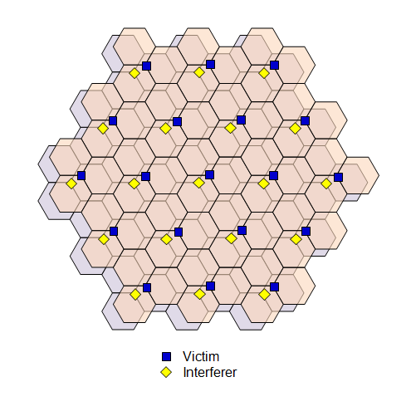
Figure 16: Interferer-victim separation of 70 metres (Case 1)

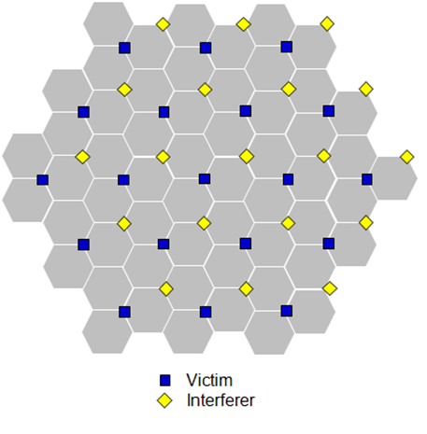
Figure 17: Interferer-victim separation of 288 metres (Case 2)
  - Simulation parameters
Table 25 and Table 26 show parameters used in simulating the various scenarios.
Note that free space path loss is considered for the modelling of signal propagation from an interfering base station to a victim base station.
The antenna directional pattern for non-AAS base stations is modelled as per described in ECC Report 203 [2]. Table 27 shows the antenna array characteristics modelled for AAS base stations.
Table 25: Parameters for “AAS to non-AAS” scenario
Interferer |  | Victim
Beam forming towards UEs with (8×8) array.  UEs uniformly distributed in each hexagonal cell. |  | Fixed directional pattern  (effectively single antenna)
Network deployment | Hexagonal cells  ISD = 500m. | Network deployment | See Case-1 and Case-2.
Element gain | 8 dBi | Maximum antenna gain | 18 dBi
Channel bandwidth | 60 MHz | Channel bandwidth | 20 MHz
Effective channel bandwidth | 90% | Effective channel bandwidth | 90%
Tx (conducted) power | 51 dBm/(60 MHz) | Noise figure | 5 dB
Table 26: Parameters for “AAS to AAS” scenario
Interferer |  | Victim
Beam forming towards UEs with (8×8) array.  UEs uniformly distributed in each hexagonal cell. |  | Beam forming towards UEs with (8×8) array.  UEs uniformly distributed in each hexagonal cell.
Network deployment | Hexagonal cells  ISD = 500m. | Network deployment | See Case-1 and Case-2.
Element gain | 8 dBi | Element gain | 8 dBi
Channel bandwidth | 60 MHz | Channel bandwidth | 60 MHz
Effective channel bandwidth | 90% | Effective channel bandwidth | 90%
Tx (conducted) power | 51 dBm/(60 MHz) | Noise figure | 5 dB
Table 27: Parameters for “non-AAS to AAS” scenario
Parameter | Value
Antenna element  directional pattern $a_{E dB}\left(θ,φ\right)$ | According to 3GPP TR 37.840 (section 5.4.4.2) [21]:  $a_{E dB}\left(θ,φ\right)=-min\left\{-\left[A_{E,V dB}\left(θ\right)+A_{E,H dB}\left(φ\right)\right],{ A}_{m dB}\right\},$ (15)  $A_{E,H dB}\left(φ\right)=-min\left\{12{\left(\frac{φ}{φ_{3dB}}\right)}^{2},A_{m dB}\right\},$ (16)  $A_{E,V dB}\left(θ\right)=-min\left\{12{\left(\frac{θ-90°}{θ_{3dB}}\right)}^{2},{SLA}_{V dB}\right\},$ (17)  where  3 dB elevation beamwidth θ3dB = 65°,  3 dB azimuth beamwidth ϕ3dB = 80°,  Front-to-back ratio Am = 30 dB,  Side-lobe ratio SLAV = 30 dB.  NOTE: $a_{E}\left(θ,φ\right)≤1$.  NOTE: Each antenna element is larger in size in the vertical direction, and so θ3dB < ϕ3dB . See 3GPP TR 37.840.
Antenna element gain $G_{E dB}$ | 8 dBi
Number of base station beam forming elements  (NV, NH) | (8,8)
Element spacing | 0.9λ vertical separation.  0.6λ horizontal separation.  NOTE: Larger vertical spacing provides narrower array beamwidth in elevation. See 3GPP TR 37.840 (Table 5.4.4.2.1-1) [21].
  - Simulation results
Figure 18 and Figure 19 show the estimated degradation of the mean uplink throughput of the victim MFCN due to base station to base station interference from the interfering MFCN, presented as a function of ACIR.
Case 1: Interferer victim separation = 70 metres.
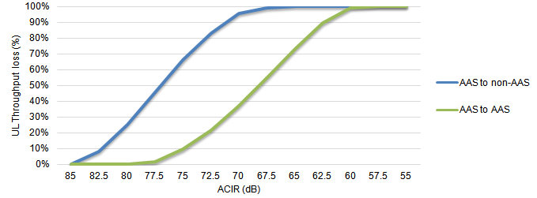
Figure 18: Impact of base station to base station interference on mean uplink throughput in Case 1
Case 2: Interferer-victim separation = 288 metres.
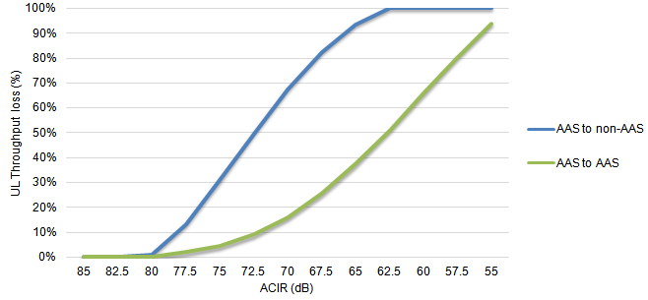
Figure 19: Impact of base station to base station interference on mean uplink throughput in Case 2
As expected, the impact of interference on network performance diminishes with increasing values of ACIR. Also as might be expected, one can see that the degradation in throughput is less for “AAS to AAS” interference than for “AAS to non-AAS” interference. It can also be seen that the impact on throughput is less for Case 2 (288 metres) than it is for Case 1 (70 metres). This is due to the smaller interferer-victim separation in Case 1.
Table 28 and Table 29 present the implied restrictions on the out-of-block radiations based a target 5% degradation in the mean UL throughput of the victim MFCN. Note that the required ACLR is assumed to be nominally equal to the required ACIR, with the understanding that interference is not dominated by the adjacent channel selectivity (ACS) of the victim base station.
Table 28: Out-of-block emission limits which would result in a 5% degradation in mean uplink throughput of victim MFCN (Case-1: 70 metres)
Scenarios | Interferer BS  bandwidth | Victim BS bandwidth | In-block  radiated  power | ACIR  required  (~ACLR) | Out-of-block  radiated power
(1)  AAS to non-AAS | 60 MHz | 20 MHz | TRP: 51  dBm/(60 MHz) | 83 dB | TRP:  -32 dBm/(60 MHz)  -43 dBm/(5 MHz)
(2)  AAS to AAS | 60 MHz | 60 MHz | TRP: 51  dBm/(60 MHz) | 77 dB | TRP:  -26 dBm/(60 MHz)  -37 dBm/(5 MHz)

Table 29: Out-of-block emission limits which would result in a 5% degradation in mean uplink throughput of victim MFCN (Case-2: 288 metres)
Scenarios | Interferer BS  bandwidth | Victim BS bandwidth | In-block  radiated  power | ACIR  required  (~ACLR) | Out-of-block  radiated power
(1)  AAS to non-AAS | 60 MHz | 20 MHz | TRP: 51  dBm/(60 MHz) | 79 dB | TRP:  -28 dBm/(60 MHz)  -39 dBm/(5 MHz)
(2)  AAS to AAS | 60 MHz | 60 MHz | TRP: 51  dBm/(60 MHz) | 74 dB | TRP:  -23 dBm/(60 MHz)  -34 dBm/(5 MHz)
  - Conclusions
The impact of base station to base station interference between MFCNs with non-time-aligned UL and DL transmission has been characterised in terms of the resulting degradation in UL throughput of the victim MFCN. Specifically, “AAS to non-AAS” and “AAS to AAS” interferer to victim scenarios have been considered.
For each scenario, two deployment geometries are considered, where the separation between a victim base station and the nearest interfering base station is 70 and 288 metres, respectively. The former case is aligned with the assumption of 70 metre interferer-victim separation used in ECC Report 203 [2] to derive the existing baseline BEM of -34 dBm/(5 MHz).
As might be expected, the results indicate that the restrictions on out-of-block radiations are more stringent in the case of 70 metre separations. For this reason, the results for this case are used to propose out-of-block radiation limits.
Based on the results, and assuming a target 5% degradation in UL throughput in the victim MFCN, one may conclude that for AAS base stations, the results indicate that a baseline TRP limit of -43 dBm/(5 MHz) would be appropriate.
- Studies on the coexistence between AAS MFCN and Radiolocation systems
  - STUDY #1: Coexistence study between 5G (Advanced Antenna Systems AAS) Macro & micro BSs & TERRESTRIAL radiolocation systems in adjacent band (3400MHz) as well as the compatibility between MFCN with non-AAS and Radiolocation
Table 30: Radiolocation parameter values and assumptions for simulations
Parameter | Value
Radar receiver coordinates  (xRAD, yRAD) | (0, 0)  NOTE: Radar receiver is positioned at the origin and is surrounded by mobile network base stations.
Radar receiver antenna height above ground zRAD | 30 metres  NOTE: The height for terrestrial radar can vary from 4 to 30 metres.
Radar receiver  directional gain | Approach-1  ITU-R M.1464 [35]  3 dB elevation beamwidth: 4.8°,  3 dB azimuth beamwidth: 1.5°,  First azimuth side-lobe level: 26 dB,  Remote azimuth side-lobe level: 35 dB.  Maximum gain: 33.5 dB.  NOTE: the directional pattern of the radar is unknown.  Approach-2  3GPP TR 37.840 [21]  Template aE(θ,ϕ) for base stations.  where  3 dB elevation beamwidth: 4.8°,  3 dB azimuth beamwidth: 1.5°,  Front-to-back ratio: 35 dB,  Side-lobe ratio: 35 dB,  Maximum gain G = X dBi (to be calculated).  NOTE: Directional pattern and maximum gain values should be consistent with law of conservation of energy.
Mechanical up-tilt | 0°  NOTE: No up-tilt is used in the absence of other information.
Mechanical  azimuth scan | At every Monte Carlo trial, the radar antenna points to a random azimuth direction that is uniformly distributed between 0 and 360°.
Noise figure | 2dB.  NOTE: See ITU-R M.1464-2 [35].
Adjacent channel  selectivity  ACS | NOTE: In the absence of any information on the radar receiver selectivity, only interference from the mobile base station leakage is studied (i.e. the impact of the radar receiver is not studied). This is consistent with the assumptions used to derive the existing regulatory limits.
Target experienced  interference  I/N | -6 dB.  NOTE: Radionavigation (safety B/D/E) radar I/N = -10 dB (ITU-R M.1464­2 [35]), radiolocation (I/J/K/L/M) radar I/N = -6 dB (ITU-R M.1464-2).
Probability of interference exceeding the target level | 1%
Experienced  interference  PI | $PI \left(\frac{mW}{MHz}\right)=P_{OOB,Rx} \left(\frac{mW}{MHz}\right)+P_{IB,Rx} \left(\frac{mW}{40 MHz}\right)/ ACS$ (18)  NOTE: Received powers PRX are radiate powers scaled by coupling loss.  NOTE: The ACS is in principle derived based on measurements of radar receiver and implicitly performs the translation from interferer bandwidth (e.g. 100 MHz) to 1 MHz.
    - Characteristics of the systems
      - Radiolocation system
Radars operating below 3400MHz are described, among others, in Recommendations ITU-R M.1464-2 [35] & M.1465-2 [36]. Radar I (see Rec. M.1464-2) is considered for this preliminary analysis, noting that its range goes up to 3400MHz as highlighted by the same reference:
The characteristics of the radar used in this document are provided in the table below:
Table 31: Radar characteristics
Parameters | Unit | Radar I
Antenna pattern type (pencil, fan, cosecant-squared, etc.) |  | Cosecant-squared
Antenna type (reflector, phased array, slotted array, etc.) |  | Shaped reflector
3dB azimuth beamwidth | degree | 1.5
Antenna polarisation |  | linear or circular  or switched
Typical peak antenna gain | dBi | 33.5
3dB elevation beamwidth | degree | 4.8
Antenna side lobe (SL) levels  (1st SLs and remote SLs) | dB  dB | 26  35
Antenna height (above the ground) | m | 4 to 30 (10 assumed in this document)
One could notice that the antenna side lobe levels apply for the antenna diagram in azimuth. Moreover, as the discrimination antenna gain may be higher in azimuth due to lower azimuth 3dB beamwidth compared to the 3dB beamwidth in elevation, the resulting radar antenna pattern in azimuth is given below:
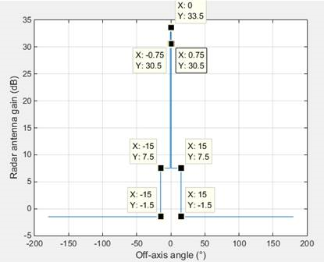
Figure 20: Radar Radiation pattern
Finally, the protection of the radiolocation service is based on a I/N=-6dB protection criterion.
      - AAS Base Station characteristics
Table 32: AAS BS antenna parameters
Antenna array 8x8 | Unit | Value
Maximum composite antenna Gain | dBi | 23
BS Ohmic Loss | dB | 0
Maximum element gain | dBi | 5
Antenna height (above ground level) | m | 20 (Macro-BS urban), 6 (micro-BS urban)
Mechanical downtilt | ° | 10 (Macro-BS urban), 10 (micro-BS urban)
H/V 3dB beamwidth | ° | 80/65
Am & SLA | dB | 30 for both
Horizontal & Vertical element spacing | N/A | 0.6λ for horizontal 0.9λ for vertical
Note that since a sensitivity analysis based on extending the simulation area (up to 12 km) involves BSs deployed in suburban environment, it is proposed to consider additional parameters related to the suburban deployment for:
- Macro-BS suburban: 25 m antenna height, 10° mechanical tilt
This analysis focuses on the impact from Macro-BSs onto the radar as the most critical ones, compared to the other scenario with small cells.
Correspondence with 3GPP has noted “the need to introduce a normalization factor to the calculation of the antenna directivity in each direction (using the formula in 3GPP TR 37.840 Table 5.4.4.2-3 [21] and ITU-R Rec. M.2101 Table 4 [17]) in order to ensure that the total array directivity is equal to 0dB”
Recalling the 3GPP expression for the composite array radiation pattern (TR 37.840):
${\check{G}}_{dB}\left(θ,φ\right)=A_{E dB}\left(θ,φ\right)+10\log_{10} \left\{1+ρ\left[{\left|\sum_{m=1}^{N_{H}}{\sum_{n=1}^{N_{V}}{w_{m,n}^{}v_{m,n}^{}}}\right|}^{2}-1\right]\right\}$ (19)
The actual array gain to be used in any sharing studies should be normalised as follows
$D\left(θ,φ\right)={\frac{\check{G}\left(θ,φ\right)}{\frac{1}{4π}\int_{0}^{2π}{\int_{0}^{π}{\check{G}\left(θ,φ\right)\sin\left(θ\right)dθdφ}}}}_{} ,$ (20)
to ensure that $TRP=P_{Tx}$ where $P_{Tx}$ is the conducted power input to the array system.
Moreover, as indicated in the above equation, the correlation factor ρ between the elements of the antenna panel is required to compute the composite array radiation pattern. It has been previously noted that the correlation of out-of-block emissions across the antenna elements is uncertain. Although 3GPP (R4-125474) [37] has indicated that the impact (in terms of interference level) of unwanted out-of-block signal across antenna elements on the BSs from another mobile network is insensitive to the correlation factor of the elements of the interferer antenna panel, this observation hasn’t yet be generalised to other systems/services. Consequently, this study accounts for this normalisation factor in the computation of the IMT2020 BS antenna gain. Among two assumed correlation sub-cases (because of a lack of knowledge of the correlation of elements within an array for the unwanted emissions range): fully correlated and uncorrelated ones, the one that handles the highest interference level situation corresponds to the uncorrelated case. For that reason, the current analysis only deals with the uncorrelated case which does not require any consideration of the BS beam steering statistics.
      - Non-AAS BS characteristics
Since the document addresses the sharing between MFCN with Non-AAS and Radiolocation, the parameters that have to be considered to carry out this use case are extracted from ECC Report 203 [2] & ITU-R Report M.2292 [29] on the least restrictive technical conditions for MFCN in 3400-3800MHz, noting that ITU-R Rec. F.1336-4 [38] is selected to model the BS sectoral antenna.
Table 33: Non-AAS Macro BS antenna parameters (ECC Report 203 [2])
Sectoral antenna | Unit | Value
Maximum antenna Gain | dBi | 21 (Note 1)
BS Ohmic Loss | dB | 0 (Note 2)
Antenna height (above ground level) | m | 20 (urban), 25 (suburban)
Mechanical downtilt | ° | 10 (urban), 6 (suburban)
Horizontal 3dB beamwidth | ° | 65
k parameters | N/A | ka=0.7, kp=0.7, kh=0.7, kv=0.3
Sectorisation | sectors | 3
Note 1: See pages 37, 39 and 60 of ECC Report 203 [2].
Note 2: See Table 7 of ECC Report 203 [2].
    - PROPOSED METHODOLOGY FOR THE SHARING STUDIES
      - Coexistence study with AAS and non-AAS Base Stations
The scenario involves as interferers part or entire IMT-2020 or IMT-Advanced mobile network, composed by a set of Macro or micro BSs. These stations are deployed in a structure way, e.g. within a grid or following hexagonal shaped cells, or in a non-uniform way like ad-hoc heterogeneous networks (see section 3.1.4 of Rec ITU-R M.2101 [17]). For AAS, Total Radiated Power (TRP) metric is relevant to describe the unwanted emission limits coming from BSs. For non-AAS, Equivalent Isotropic Radiated Power (e.i.r.p.) is the current metric for specifying the BEM out-of-blocks below 3400 MHz (2 values are considered in the EC Decision 2014/276/EU [39]: -50 dBm/MHz e.i.r.p.& -59dBm/MHz e.i.r.p.). However, it could be possible to specify such a constraint in term of TRP when the characteristic of the non-AAS pattern enables, reminding that these patterns are generally expressed in terms of envelopes (e.g. for ITU-R Rec F-1336 [38]).

      - Propagation assumptions
Considered phenomena involved in the losses of the Link Budget between the radar and the Macro BSs are:
- the free space loss (using ITU-R P.525 [40])
- loss due to polarisation: Since there is a domination of interfering power level for a limited number of the BSs with the same sense of rotation or the same tilt angle of polarisation ellipse with respect to the terrestrial radar, 3dB cannot be assumed. Therefore, 0dB (as another value) is proposed for study.
Since the distance between BSs and the radar are significantly lower than the horizon distance and that there is no assumption on the terrain profile, there is no need to consider any other propagation mechanisms such as ducting, spherical diffraction or tropospheric scatterings.
It has been considered that free space loss and Fresnel diffraction or P.452 [32] propagation could be used between Macro BS and the radar. When considering P.452-16 propagation model, one could notice that the Fresnel ellipsoid of the radio wave is subject to partial/total diffraction (see section 4.2 of the Rec. P.452-16) when the obstacle is a part of the terrain profile between the transmitter Tx and the receiver Rx. The building as an obstacle cannot be considered as a part of the terrain profile but as a part of the clutter (see section 4.5 of P.452-16) because the building cannot be seen as an infinite (in size) obstacle unlike relief like mountains or hills. In addition, as there is no assumption on the relief, one could consider that the terrain profile is flat surrounded by buildings. In such a case and because distance (BS, radar)<<horizon distance, diffraction loss=0dB and only clutter has to be accounted for. For that reason, Free Space Loss+Clutter Loss is a relevant model for the calculation of the loss between a Macro BS and a radar and is used in the following study.
When implementing the clutter loss formula (see extract below) from Rec P.452-16, referred to as height-gain model (see section 4.5.3 of the Rec ITU-R P.452-16), where the clutter is located at 100m from the receiver/transmitter:
The additional loss due to protection from local clutter is given by the expression:
dB (21)
where:
(22)
and:
- d_{k} : distance (km) from nominal clutter point to the antenna;
- h : antenna height (m) above local ground level;
- h_{a} : nominal clutter height (m) above local ground level.
One could notice through Figure 21 that the formula is valid for nominal clutter height above the BS antenna height or radar receiver.
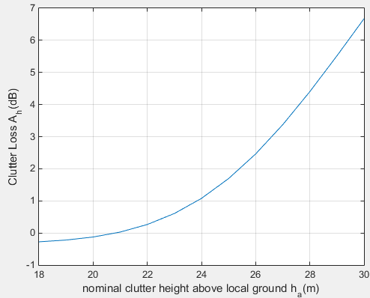
Figure 21: Clutter loss in Rec. P.452-16 in 100 m from Rx/Tx at height=20 m
This leads to conclude that because the clutter height is lower than Rx/Tx height (18m<20m), there is no clutter loss to account for in the case of calculation of path loss (Macro BS to radar).
On the contrary, the scenario involving micro-BSs considers additional losses due to clutter because these BSs are located below the roof (at 6 m) and their emissions may likely face obstacles in the direction of the radar. Recommendation ITU-R P.2108 [33] is used to derive the clutter losses.
    - Discussion on the BSs deployment
The area of interest defines the zone where BSs (as interferers) are deployed in the vicinity of the terrestrial radar. The following figure depicts the geometry of the simulation surface by considering a ring centred at the victim (radar) receiver location on which BSs are positioned on a hexagonal grid with a given Inter-Site Distance and where distance(radar,BS)$∈$ [d_{min} ; dmax] (in km), ( with d_{min} =1km). During previous analysis the assessment of the appropriate value of d_{max} was performed through a sensitivity analysis to quantify the impact on aggregated interference. However, this sensitivity analysis did not consider the fact that the environment could change when extending the simulation area, e.g. from urban to suburban. For that reason, the current analysis apportions the simulation area over urban and suburban regions as follows: the range 1-5km (Figure 22 left) is urban while 5-12 km is suburban (Figure 22 right). The parameters related to the suburban environment (Inter-site distance, BS antenna height, BS mechanical downtilt) are extracted from ITU-R Report M.2292 [29].
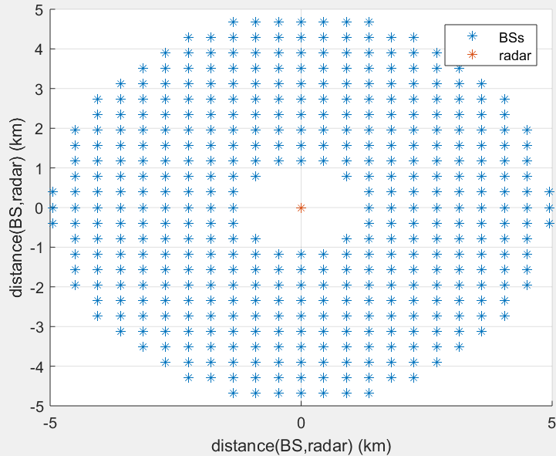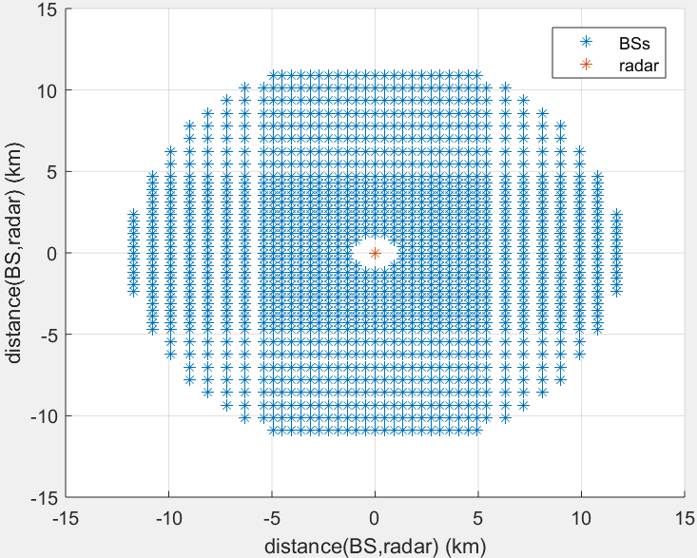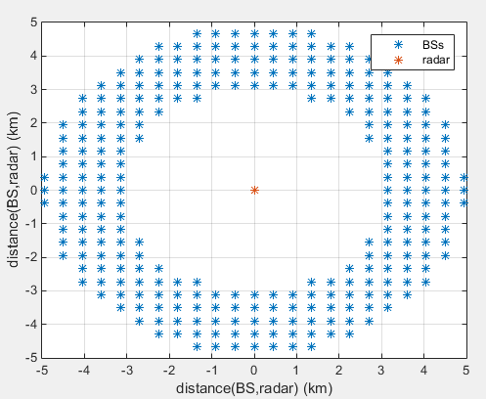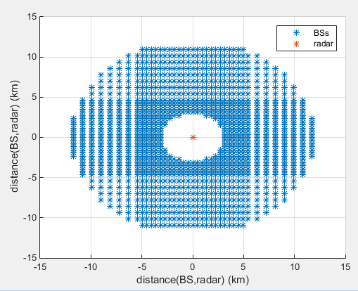
Figure 22: Deployment of Macro BS (left: 1-5km, right: 3-12km)
For AAS and non-AAS scenarios, each Macro site is composed by three 120° sectors whose capacity and coverage are independent each other. The orientation of the antenna sectors with respect of the vertical line is respectively: -30°, -150° and +90°. As described in Rec ITU-R M.2101 [17] (see Figure 10), the 0° azimuth reference direction is taken as the vertical line.
The amount of Macro BSs spread within the ring is derived following the mathematical formula:
$NbBSs=BS density × TDD Factor×Network load$ (23)
Where
- BS TDD Factor (%) corresponds to the DL activity factor;
- Network load (%) refers to the percentage of BSs transmitting at full power;
- BS density provides the number of BSs per km2.
The amount of micro BSs spread within the ring is derived following the mathematical formula:
$NbBSs=BS density × R_{a}×R_{b}×TDD Factor×Network load$ (24)
Where
- $R_{a}$(%) refers to the ratio of hotspot areas to areas of cities/built areas/districts;
- $R_{b}$(%) relates to the ratio of built areas to total area of region in study.
Noting that
- R_{a} & R_{b} values are only provided for urban and rural scenarios case;
- No number of micro-BSs per macro cell is given for the suburban area (<1 per sector) in Report ITU-R M.2292,
it is then proposed to extend the simulation area (from 1..5km to 5..12km) with only (random) micro-BSs urban deployment, reminding that such a scenario can be considered as a rather conservative one for micro-BSs (when assuming 3 micro-BSs operating within each sector) as from a certain area size, there is an apportionment between urban & suburban environment. Figure 23 illustrates the topology of the mobile micro-cells network in urban environment.
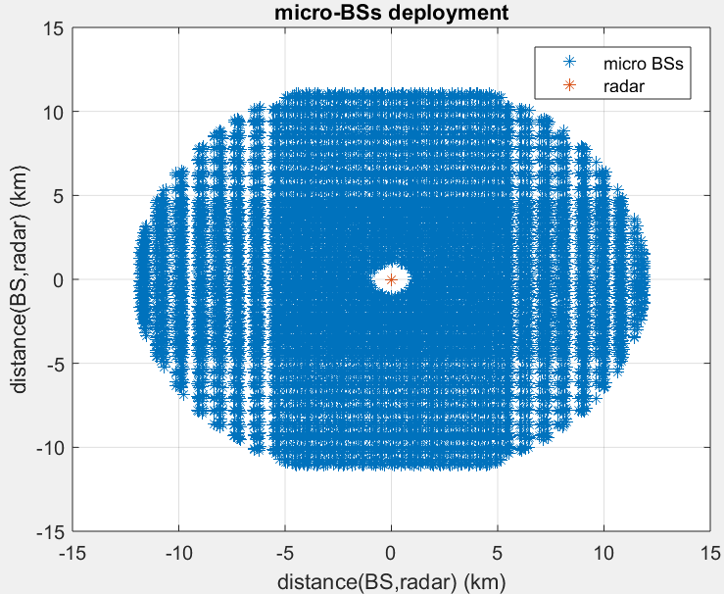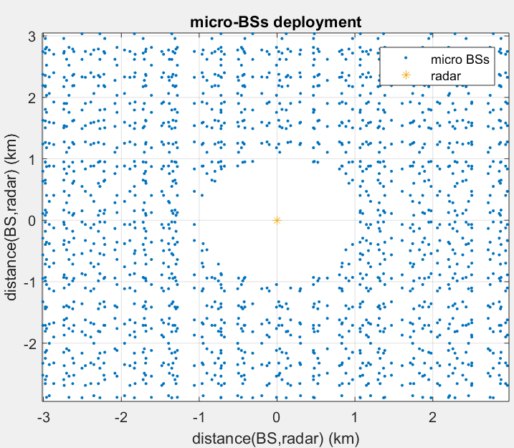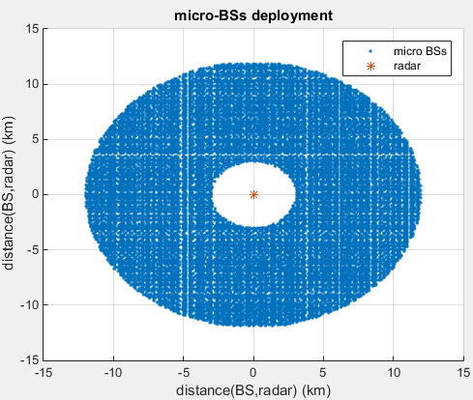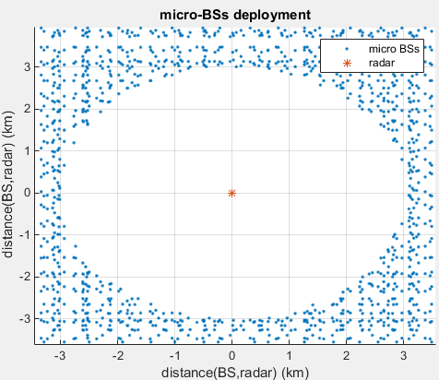
Figure 23: Random deployment of micro-BSs with 1km<distance (BS,radar)<12km
The BS density was calculated with BS Inter-Site Distance parameter available in Report ITU-R M.2292 [29] and also by considering, for the micro-BS deployment case, a number of BSs per sector.
Table 34: BS Deployment parameters
Parameter | Unit | Value
BSs Inter-site distance | km | 0.45 (urban), 0.9 (suburban)
Number of (small cell) micro BSs per macro cell | N/A | 1-3 per sector (urban) (3 is assumed in this document)
TDD Activity Factor | % | 20 for UL, 80 for DL can be accounted for in the Monte Carlo trials by multiplying all radiated powers by the same single binary random variable x (0 or 1), where Pr{x = 1} = ratio of DL transmissions to total frame duration. A DL ratio of 0.8 will be assumed. Use of a single value is based on the assumption of synchronised UL/DL phases in a network.
Distance(BS,Radar) | km | 1-5 km Urban and 5-12 km Suburban
Network Load | % | 50 can be accounted for in the Monte Carlo trials by multiplying each sector’s radiated power by an independent binary random variable x (0 or 1), where Pr{x = 1} = network loading factor.
Ra | % | 40 (urban)
Rb | % | 90 (urban)
One could notice that for the TDD activity factor, for the case when no BSs is transmitting, this means that the UL is on and then there is a need to account the impact of the UEs (in UL) since they are transmitting during that period. For that reason, aggregate effect of interference has to be calculated during this 20% activity period. In this study, the impact of UEs has not been considered.
    - Radar operation
The antenna height of the radar system (above the ground) is assumed to be 10m based on national operational information on this system. The rotating nature of the radar antenna is also accounted in the current study, that’s why a random (e.g. uniform) distribution of radar main beam orientation in the azimuthal plane is performed. Finally a radar mechanical antenna tilt of -10 to 10° is considered in the Monte-Carlo simulation.
    - BS Aggregated interference calculation
The cumulative effect of interference signal coming from BSs requires performing the calculation of the single radio link budget between one interfering BSi (i=1..BS) and the victim (radar) receiver:
$P_{R,i}(dBm/MHz)=P_{BS}(dBm)+G_{BS}(dBi)-PL(dB)-ClutterLoss(dB)-PolarisationLoss(dB)+G_{radar}(dBi)$ (25)
Where
- $P_{R,i}$ is the power at the radar receiver, coming from BSi;
- $P_{BS}$ refers to the conducted power;
- $G_{BS}$ is the BS transmitting antenna gain towards the radar;
- $G_{radar}$ is the radar receiving antenna gain in the direction of BSi.
For that reason, Monte-Carlo simulations are performed over the IMT-2020 mobile network and the radar to calculate the aggregated interference caused by the BSs through ${10}^{6}$ samples in order to derive a reliable statistic, e.g. cdf of the experienced Iagg/N.
With j denoted as the index of the random sampling, the aggregated interference is then achieved in the following way:
$Iagg\left(\frac{dBm}{MHz}\right)=10\log_{10}\left(\sum_{\begin{aligned}1≤i≤NbBSs, \\ 1≤j≤NbEvents\end{aligned}}{{10}^{\frac{P_{R,ij}}{10}}}\right)$ (26)
    - AGGREGATE EFFECT ANALYSIS
As described in previous sections, the aggregated interference coming from BSs was assessed only with absence of correlation (0%) between elements of the BS antenna panel for Macro BSs using AAS and Non­AAS. A sensitivity analysis was also performed on the aggregated effect with varying dmax value (5km up to 12km with urban-suburban environment apportionment for Macro BS and urban only for micro-BSs); the cdf (i.e. P(X≤x0)) for these scenarios is depicted on the y-axis while the x-axis provides associated I/N values for different conducted power values.
      - Scenario 1: Hexagonal deployment of macro-cells with conducted power =-52dBm/MHz (AAS)
&-56dBm/MHz (non-AAS only)
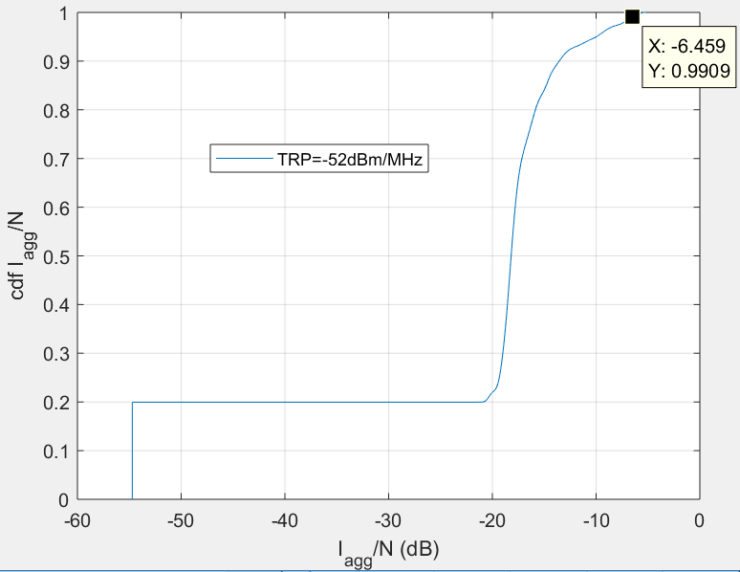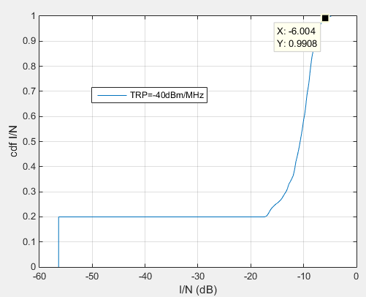
Figure 24: Aggregated I/N performance for dmax=12km with AAS BSs
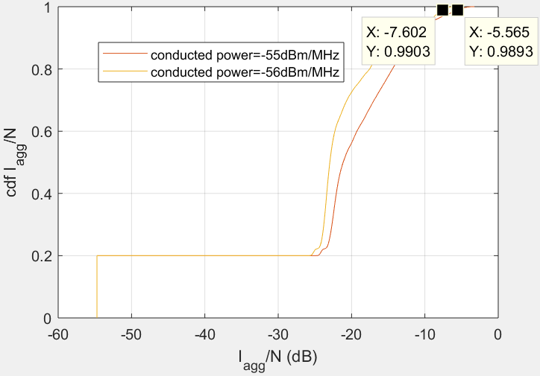
Figure 25: Aggregated I/N performance for dmax=12km with non-AAS BSs
These results suggest several comments:
- The results obtained for very low I/N<-60dB with probability=20% came from the effect of the UL mode (20%) where no BS is transmitting. In practise, the effect of UEs unwanted emissions should increase this low value and needs to be accounted in further studies;
- The results obtained for non-AAS are more constraining (conducted power=-56dBm/MHz) than for AAS (conducted power=-52dBm/MHz), noting that the TRP is not necessarily equal to conducted power for non-AAS since the BS antenna models are envelopes.
      - Scenario 2: random deployment of small (micro) cells with TRP=-33dBm/MHz & -34dBm/MHz (AAS only).
Results of the simulations carried out for this scenario were performed over more than 1 million samples are displayed through two graphs aiming at comparing the probability of exceeding the protection criterion of the radar:
- for two different sizes of simulation area (1-5km & 1-12km) in order to quantify the aggregation bound (see Figure 27),
- for two different values of TRP (-33dBm/MHz & -34dBm/MHz) in order to derive the TRP maximum requirement for the micro-BSs AAS (see Figure 26)
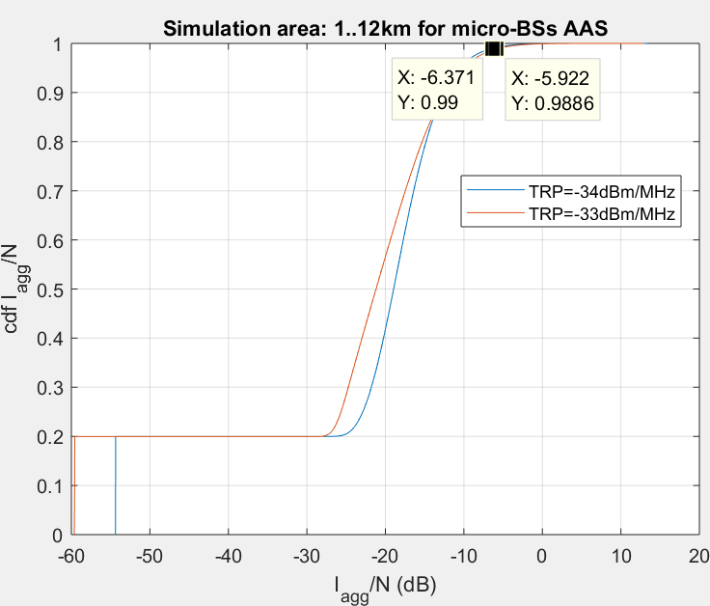
Figure 26: Aggregated I/N performance for different TRPs (micro-BSs AAS)

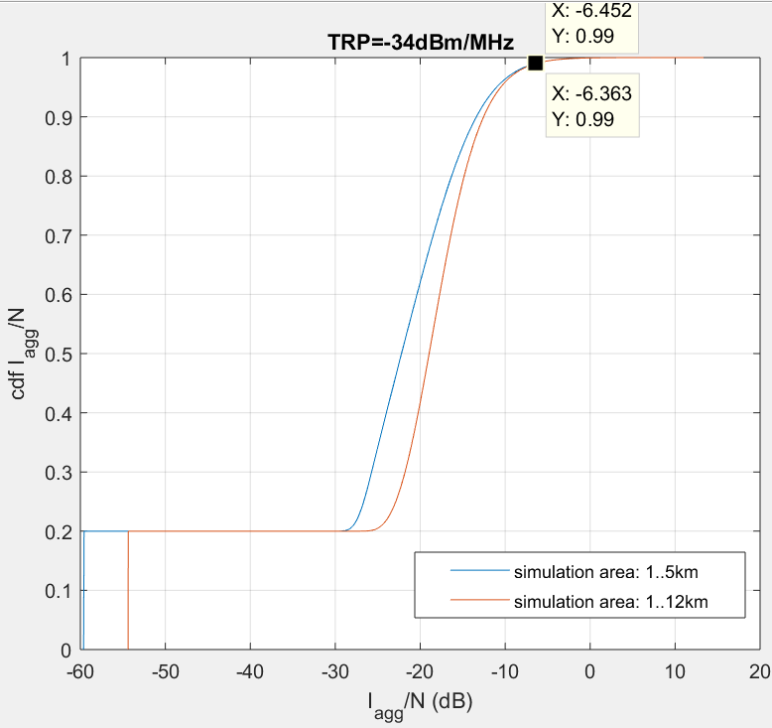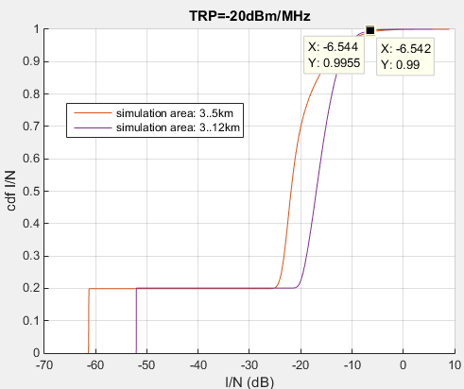
Figure 27: Aggregated I/N performance for different simulation areas (AAS BSs)
These results suggest several comments:
- The required TRP to ensure the protection of the radar operating below 3400MHz obtained for a deployment of micro-BSs (AAS) is by far less constraining (-34dBm/MHz) (Figure 26 & Figure 27) than one for the Macro-BSs (-52dBm/MHz) (Figure 24) and result from various factors: the clutter losses affecting the unwanted emissions for small cells BSs installed below the roof, the impact of Ra & Rb parameters reducing the number of simultaneously transmitting micro-BSs although there are more micro-BSs sites than for Macro (the number of micro-BSs per sector being 1 to 3);
- The very low I/N<-60dB achieved with probability≤20% came from the effect of the UL mode (20%) where no BS is transmitting. In practise, the effect of UEs unwanted emissions should increase this low value and needs to be accounted in further studies;
- Although the cdf curve for two different cases of simulation area differ in Figure 26 & Figure 27, the achieved probability of exceeding I/N (for micro-BSs AAS deployment) is almost the same independently of the considered sizes of the simulation area. This observation means that the initial simulation area size (1-5 km) is sufficient to derive the conditions to protect the terrestrial radar from BSs unwanted emissions.
  - STUDY #2
This study provides an analysis of the blocking effect on the radar caused by Advanced Antenna Systems (AAS) and non-AAS BSs, using the same system characteristics and methodology as outlined in Study #1 above (see section A4.1.1 to A4.1.4).
    - Aggregate effect analysis
As described in previous sections, the aggregated interference coming from BSs was assessed only with for Macro BSs using AAS and non-AAS. The cdf (i.e. P(X≤x0)) for these scenarios is depicted in ordinate while x-axis provides associated blocking level values at the radar receiver for different values of TRP (or conducted power): 31-32dBm.
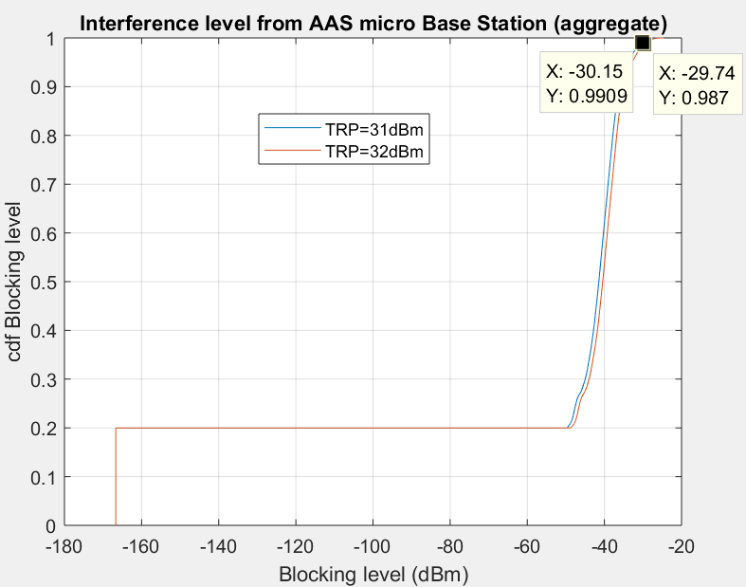
Figure 28: d_{max}=12km with AAS BSs for different TRP values
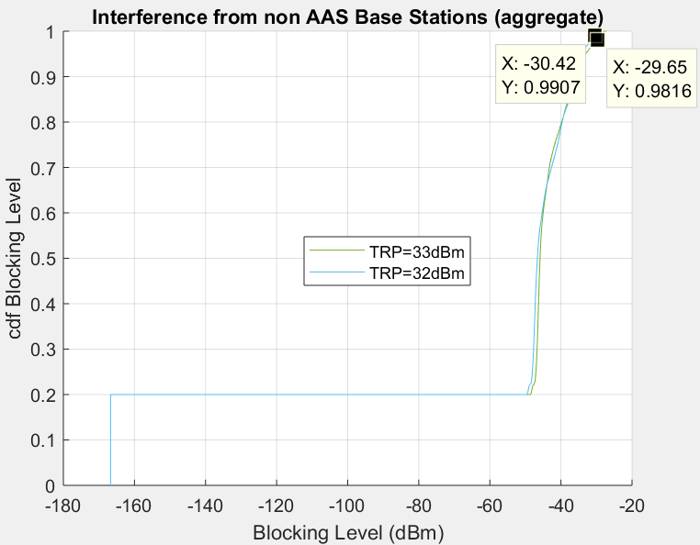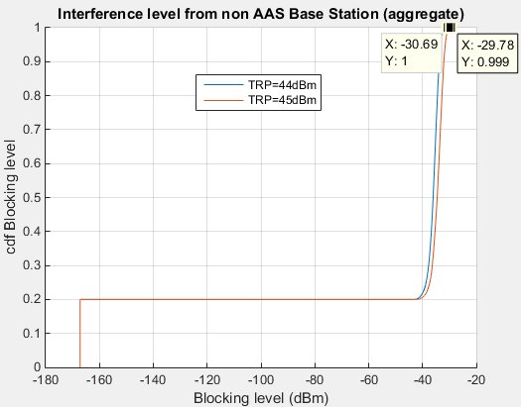
Figure 29: dmax=12 km with non-AAS BSs
These results suggest several comments:
- The results obtained for very low Blocking level<-160 dBm with probability=20% came from the effect of the UL mode (20%) where no BS is transmitting. In practise, the effect of UEs unwanted emissions should increase this low value and needs to be accounted in further studies.
- The results presented for non-AAS BSs with TRP=33 dBm shows an exceedance of the overload threshold level (-30dBm) >0.1% while the TRP=44dBm ensures the blocking limit for more than 99.99% (i.e. exceeds the limit for less than 0.01%). Moreover, it has to be noted that for any given probability of exceedance of the overload threshold, the resulting TRP that meets this limit is defined per BS sector, i.e. that this TRP should be apportioned with the number of BS antennas (e.g. if the resulting retained TRP = 44 dBm, for BS using 2 antennas, e.i.r.p.max=TRP + BS peak gain - 10log₁₀(nb_antennas) = 44+21-10log₁₀(3) = 62 dBm).
- The results presented for AAS BSs with TRP = 32 dBm shows a slight exceedance of the overload threshold level (-30 dBm) (less than 1%) while the TRP = 31 dBm ensures the blocking limit for more than 99% (i.e. exceeds the limit for less than 1%).
  - STUDY #3
This study provides an analysis on the issue of compatibility between airborne radar & AAS Macro BSs
    - Assumptions on the compatibility between airborne radar & AAS Macro BSs
Table 35: Radar parameters
Parameters | Unit | Value
Radar type | N/A | Radar A Airborne  (Rec ITU-R M.1465-2)
3dB azimuth beamwidth | degree | 1.2
Protection criterion | dB | I/N=-6
Antenna polarization |  | linear or circular or switched
Typical peak antenna gain | dBi | 40
3dB elevation beamwidth | degree | 6
Antenna height (above the ground) | m | 9000 (embedded on aircraft)
Noise Factor | dB | 3
Maximum antenna vertical scan | degree | -60..+60  (-60..0 assumed in the study)
Table 36: Macro BS AAS Deployment parameters
Parameter | Unit | Value
BSs Inter-site distance | km | 0.45 (urban), 0.9 (suburban)
Network Load | % | 50
TDD Activity Factor | % | 20 for UL, 80 for DL can be accounted for in the Monte Carlo trials by multiplying all radiated powers by the same single binary random variable x (0 or 1), where Pr{x = 1} = ratio of DL transmissions to total frame duration. A DL ratio of 0.8 will be assumed. Use of a single value is based on the assumption of synchronised UL/DL phases in a network.
Horizontal distance(BS,Radar) | 3-160km | Apportionment of the simulation area between urban & suburban environments  3-91 km Urban and 91-160km Suburban
Network Load | % | 50 can be accounted for in the Monte Carlo trials by multiplying each sector’s radiated power by an independent binary random variable x (0 or 1), where Pr{x = 1} = network loading factor.
AAS Antenna model | N/A | No correlation of radiating elements+Usage of normalization factor
    - Results
In order to consider reliable figures, a simulation has been run with 1247200 samples to evaluate the required unwanted emission levels for a significantly lower probability of I/N exceedance (i.e. <10⁻⁶) as indicated in another study #5.
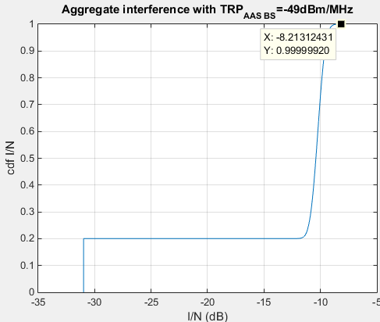
Figure 30: Airborne radar & AAS Macro BS compatibility results
  - STUDY #4
    - Introduction
This study addresses the issue of regulatory out-of-block emission limits for MFCN base stations in the 3400-3800 MHz band in the context of harmful interference to military radars operating below 3400 MHz.
ECC Decision (11)06 (rev. 2014) [3] specifies maximum permitted out-of-block e.i.r.p. levels of –59 and –50 dBm/MHz below 3400 MHz for FDD and TDD MFCN base stations. Administrations may select one or the other (or no limit) depending on the required level of protection of radar in the region in question. These limits had originally been derived via minimum coupling loss analysis, although the derivation was not formally documented in any CEPT or ECC reports.
The present study addresses the introduction of 5G systems in the 3400-3800 MHz band, with a view to establish
  - Whether these limits represent LRTC on MFCN base stations for the protection of radar, and
  - Whether the use of beam forming techniques in 4G and 5G base stations will have any implications on how regulatory out-of-block emission limits should be specified.
With regards to (a), the analysis indicates that there is indeed room for relaxation of the existing e.i.r.p. limits while maintaining a low probability of harmful interference to radar.
With regards to (b), it is demonstrated that the use of total radiate power (TRP) is the preferred approach for specifying out-of-block emission limits for MFCN base stations which use beam forming techniques.
    - Modelling approach (macro cells)
The modelling approach and a set of parameter values are described in A4.4.5.
Figure 31 illustrates the approach for the modelling of MFCN macro base stations. Here, a radar receiver is surrounded by multiple rings of tri-sector MFCN base stations in a hexagonal arrangement. The minimum and maximum separations between the radar and MFCN base stations are 3000 and 5000 metres, respectively. This implies a total of 5 rings and 272 macro-sites, with an inter-site distance of 450 metres.

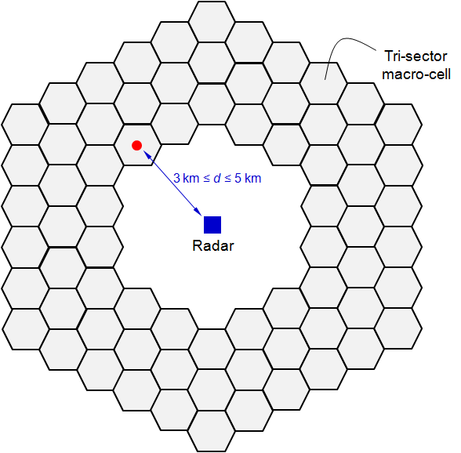
Figure 31: A radar receiver is surrounded by 5 rings of 272 tri-sectored MFCN macro base stations (only three rings are shown)
The MFCN base stations are assumed to operate with a TDD DL: UL ratio of 8:2, a network loading of 50%, and with antennas located 20 metres above the ground with a mechanical downtilt of 10°. The antenna element radiation pattern is based on ITU-R M.2101, with vertical and horizontal 3 dB beamwidths of 65° and 80°, respectively, a front-to-back ratio of 30 dB, and a gain of 8.9 dBi.
The radar receiver antenna is modelled as located 30 metres above the ground with a mechanical downtilt of 0°. The antenna pattern is again based on ITU-R M.2101, but with vertical and horizontal 3 dB beamwidths of 4.8° and 1.5°, respectively, a front-to-back ratio of 35 dB, a maximum gain of 33 dBi, and a loss of 3 dB.
Interference to the radar receiver is calculated as the aggregate of the out-of-block emissions of all MFCN base stations, using the ITU-R P.452 propagation model. No clutter loss is assumed for the geometry considered. The target interference level at the input to the radar receiver is considered to be -118 dBm/MHz (I/N of –6 dB, for a noise figure of 2 dB).
Figure 32 illustrates the way in which angular discrimination is modelled at the MFCN base stations and radar receiver:
- At each Monte Carlo trial, the radar receiver is assumed to point its beam towards a random direction in azimuth (uniformly distributed between 0° and 360°).
- At each Monte Carlo trial, each MFCN base station sector is assumed to radiate towards a user equipment (UE) which is located within the area of the sector. UEs are assumed to be indoors with a probability of 7% (equally likely to be 1.5, 4.5, 7.5, 10.5, 13.5 or 16.5 metres above ground). Outdoors UEs are assumed to be 1.5 metres above ground.
The intention in the above modelling approach is to adequately capture the benefits of angular discrimination at the transmitters and receiver. It should be noted that the extent to which the out-block transmissions of a MFCN base station undergo beam forming depends on the level of the correlation of the said signals across the transmitting antenna elements.
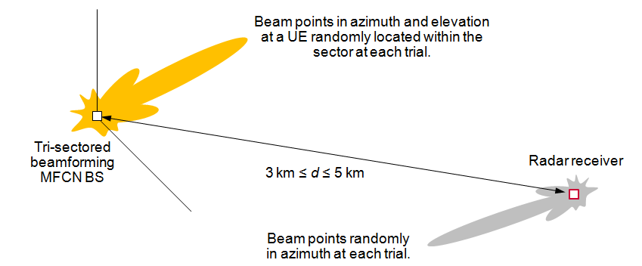
Figure 32: Modelling of angular discrimination
This is illustrated in Figure 33 below for an antenna array of 16×16 elements spaced at 0.9 of a wavelength horizontally and vertically. The figure shows the array system gain as a function of azimuth and for zero elevation. As can be seen, the out-of-block radiation pattern can vary considerably depending on the correlation $ρ$ of the out-of-block signal across the antenna elements. Specifically, for $ρ$ = 0, the radiation pattern is identical to that of an individual antenna element. Whereas, for $ρ$ = 1, the out-of-block signal is fully beamformed, with a maximum e.i.r.p. towards boresight which considerably exceeds that for the case of $ρ$ = 0.
In practice, it is difficult to know the precise value of the correlation $ρ$ for the out-of-block signal. This is because unwanted emissions are generated by a mix of noise sources and non-linearities which can be common or distinct among the multiple transmitter chains. This poses an important concern regarding how the use of e.i.r.p. to specify power limits might unnecessarily constrain the operation of MFCN base stations which use beam forming. We address this in the next section.
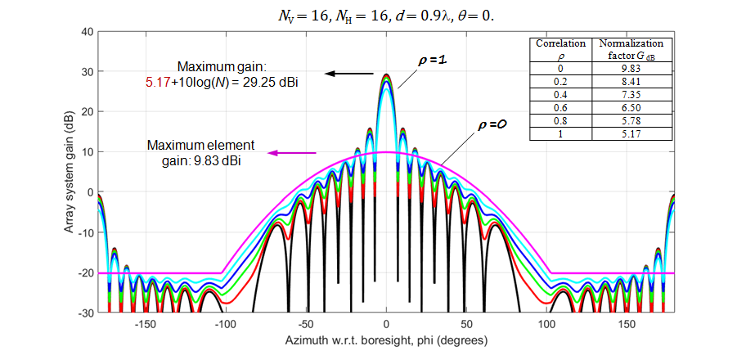
Figure 33: The variation of out-of-block radiation pattern with correlation $ρ$ across antenna elements
    - Simulation results
In this section, the results of simulations regarding the relationship between the out-of-block e.i.r.p. of MFCN base stations, and the statistics of harmful interference at the radar receiver are presented, and these are contrasted with the existing regulatory limits.
We then present similar results in the context of the out-of-block TRP of MFCN base stations, and assess the suitability of TRP for the specification of regulatory emission limits for beam forming base stations.
      - Maximum permitted out-of-block e.i.r.p.
Figure 34 and Figure 35illustrate the variation of exceedance probability as a function of out-of-block e.i.r.p. for two antenna array configurations, and correlations of 0 and 1. Exceedance probability is the probability that interference at the radar receiver exceeds a target value of -118 dBm/MHz.
As expected, the exceedance probability is a monotonic function of the out-of-block e.i.r.p.. Specifically, exceedance probability approaches 0 and 1 as the out-of-block e.i.r.p. takes increasingly small and larger values, respectively.
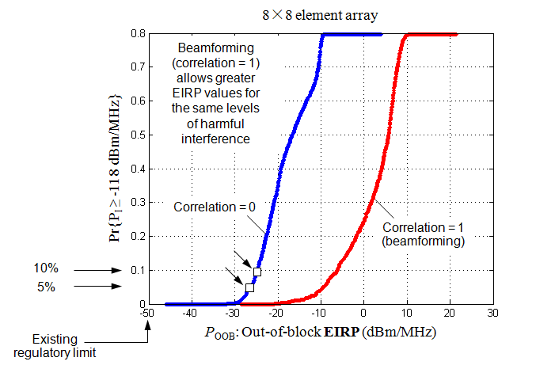
Figure 34: Exceedance probability as a function of out-of-block e.i.r.p. for a 8×8 array
The existing regulations specify a maximum permitted out-of-block e.i.r.p. of -59/-50 dBm/MHz.
As can be seen, when correlation is 1 rather than 0, the same exceedance probability can be achieved at larger values of out-of-block e.i.r.p. This is because when correlation is 1, beam forming at the MFCN base stations mitigates the impact of interference to the radar receiver. Whereas, when correlation is zero, the radiation from the MFCN base stations simply follows the radiation pattern of each antenna element, with no benefits from beam forming (i.e., the exceedance probability is not a function of the array configuration). The benefits of beam forming with the larger number of antenna elements is also readily evident.
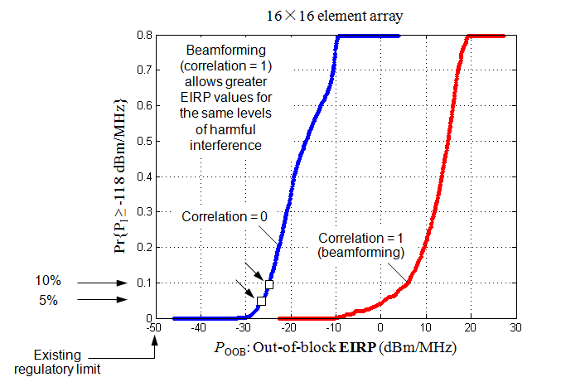
Figure 35: Exceedance probability as a function of out-of-block e.i.r.p. for a 16×16 array. The existing regulations specify a maximum permitted out-of-block e.i.r.p. of -59/-50 dBm/MHz
Note that for correlation of 0, exceedance probabilities of 5% to 10% can be achieved with a maximum permitted e.i.r.p. in the range of -25 to -27 dBm/MHz. This must be contrasted with the existing regulatory limits of -59/-50 dBm/MHz.
For correlation of 1, the maximum permitted e.i.r.p. values could be considerably greater.
      - Maximum permitted total radiated power (TRP)
As noted above, considerably greater out-of-block e.i.r.p. values can be permitted when the emissions are subject to beam forming at the transmitting MFCN base stations (correlation of 1). This implies that regulatory limits that are specified based on e.i.r.p. for non-beam forming base stations can be over-restrictive in the context of beam forming base stations and would severely constrain the operation of the latter with little or no added protection of the radar receiver.
A similar issue has been observed at 3GPP in the context of interference between MFCNs, where studies have shown that TRP is a more suitable metric for the specification of out-of-block emissions and reduces unnecessary restrictions on beam forming base stations.
This is also confirmed here in the context of interference to radar receivers as illustrated in Figure 36 and Figure 37 which show the variation of exceedance probability as a function of out-of-block TRP for the two antenna array configurations, and correlations of 0 and 1.
As can be seen, the statistics of interference at the radar receiver as a function of TPR are far less sensitive to the correlation level (extent of beam forming) than is the case for e.i.r.p. This implies that the use of TRP for the specification of MCN base station out-of-block emissions can provide the same levels of protection to radar receivers, while imposing far less restrictions on the beam forming operation.
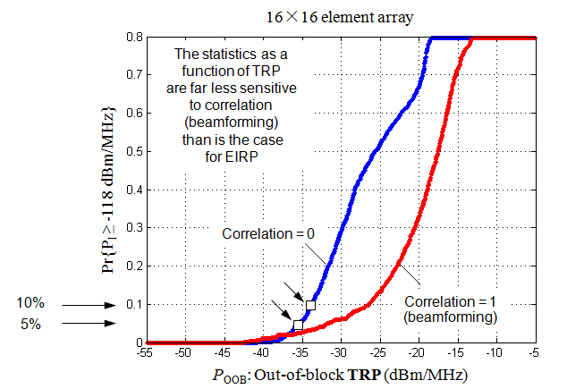
Figure 36: Exceedance probability as a function of out-of-block TRP for a 8×8 array
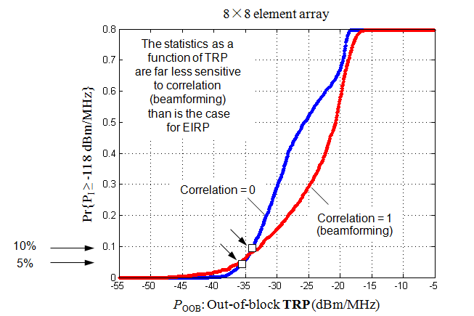
Figure 37: Exceedance probability as a function of out-of-block TRP for a 16×16 array
Note that in order to achieve exceedance probabilities of 5% to 10%, the maximum permitted TRP is in the range of approximately -36 to -26 dBm/MHz.
    - Conclusions
The regulatory out-of-block emission limits for MFCN base stations in the 3400-3800 MHz band have been examined in the context of harmful interference to military radar systems operating below 3400 MHz.
This has been with the specific objectives of assessing a) whether the existing maximum permitted out-of-block e.i.r.p. levels of –59 and –50 dBm/MHz represent LRTC, and b) whether the use of e.i.r.p. has any implications on 4G and 5G base stations which use beam forming techniques.
The analysis has indicated that:
- There is indeed room for relaxation of the existing out-of-block e.i.r.p. limits for MFCN base stations while maintaining a low probability of harmful interference to radar. For example, for a 5% to 10% probability of interference at a radar receiver exceeding the target value, the maximum permitted e.i.r.p. can be specified to be in the range of -25 to -27 dBm/MHz;
- TRP is more suitable than e.i.r.p. for the specification of out-of-block power limits for MFCN base stations which use beam forming techniques. This is because the use of TRP reduces unnecessary constraints on the operation of the MFCN base stations, without increasing the likelihood of harmful interference to radar. For a 5% to 10% exceedance probability, the maximum permitted TRP can be specified to be in the range –36 to –26 dBm/MHz.
    - Parameter values
The MFCN base station deployment parameters used were as specified for macro-cells in Table 23, with Approach 2 used for the base station co-ordinates.
The MFCN base station antenna element and array parameters were as specified in Table 22 for macro­cells, with antenna element gain $G_{E dB}$of 8.9 dB
The propagation model was as specified in Table 24 for macro-cells.
The radar receiver parameters were as specified in Table 30 for study#1, with maximum gain G = 33 dBi. An additional radar antenna loss of 3 dB has been assumed.
The following modelling approaches and parameter values were agreed.
  - STUDY #5: coexistence with aeronautical radar operating below 3400 MHz
    - Summary
In addition to ground based radars that are considered in other studies in this annex, some administrations operate an airborne radar system below 3.4 GHz. Its parameters are similar to airborne system A in Recommendation ITU-R M.1465-2 [36].
This airborne radar will have a much greater aggregation of interference from multiple base stations than the ground based radar system modelling in other studies in this annex. This study shows that the aggregation factor could be as high as 22 dB.
ECC Decision 11(06) [3] currently specifies three options for an additional baseline to the BEM as discussed in section 5. Although AAS can have a peak gain higher than a standard passive sector antenna, the effect of aggregation of signals from multiple base stations means that a conversion between e.i.r.p. limits and total radiated power limits (TRP) by subtracting the base station antenna gain is appropriate without a risk of increased interference.
    - Minimum Coupling Loss Analysis
Some analysis was undertaken based on minimum coupling loss from representative base station parameters in the UK.
Table 37: Radar parameters
Parameters | Parameter | Unit | Value
Radar type |  | N/A | Radar A Airborne  (Rec ITU-R M.1465-2)
3dB azimuth beamwidth |  | degree | 1.2
3dB elevation beamwidth |  | degree | 6
Protection criterion | I/N | dB | I/N = - 6 (considered insufficient protection)  I/N = -10  I/N = -16
Antenna polarization |  |  | Linear or circular or switched
Typical peak antenna gain | $$G_{radar}$$ | dBi | 40
Antenna height (above the ground) |  | m | 9150 (embedded on aircraft)
Noise Factor | NF | dB | 3
Antenna downtilt |  | degree | 2 and 5.5
Table 38: Base station parameters
Parameters | Unit | Value
BS locations | N/A | Based on a UK 2.1 GHz macro-cell network of June 2017 which uses multiple channels
BS powers | dBm/(5 MHz) | Based on actual 2.1 GHz powers  (increased by 5 dB to account for the change in frequency)
BS height | m | Actual site heights
Antenna downtilt | Degrees | Actual site downtilts
Network loading |  | 50%
This analysis looks at several locations around the UK where airborne radars operate. The received interference power from each base station at each radar location was modelled based on ITU-R P.528 [41] propagation models with 50% time. Base stations were modelled based on the location, height and antenna directions of a 2.1 GHz Macro-cell network declared by one of the UK mobile network operators. This included antenna parameters, heights and powers. All base stations were modelled with their true antenna parameters, including downtilt.
The contributions from all base stations were assessed at the radar location based on co-channel interference and the difference between the strongest signal from an individual sector (max) and the sum of power from all base station sectors (cumulative) was considered. The ratio between the two is the aggregation factor which was also calculated. An example from one radar location which has the highest aggregate interference is shown in Figure 38 below. When the radar was orientated at around 90 degrees, the cumulative power was just under 22 dB more than the max power from a single base station (aggregation factor). Power levels in Figure 38 were modelled based on the modified MFCN in-band power. The radar antenna pattern downtilt was 5.5 degrees in this worst case radar location example.
The peak cumulative co-channel power at 89° azimuth is -28.2 dBm and the maximum single base station power is -50 dBm at the radar receiver. This was based on base station e.i.r.p. of 52.5 dBm at a distance of 78.7 km from the radar. The resulting modelled path loss (including vertical antenna discrimination) is 141.7 dB.
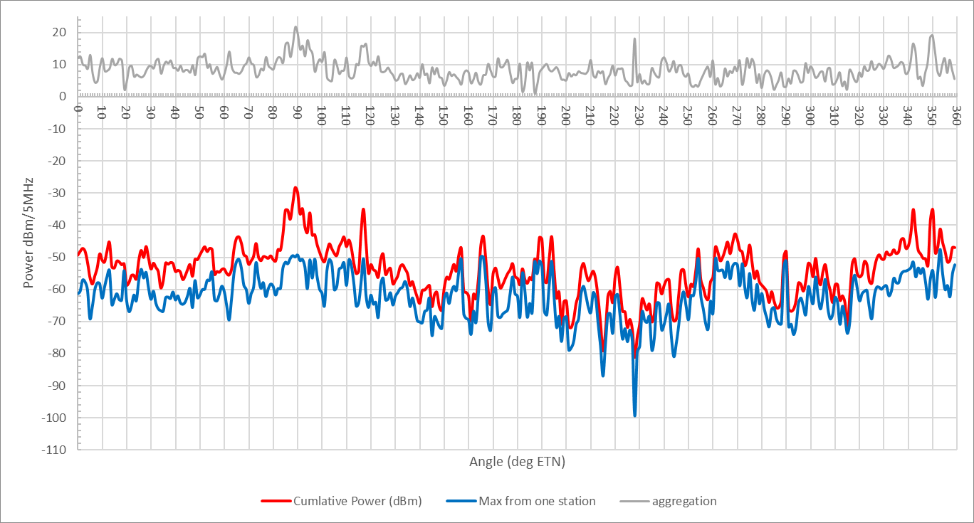
Figure 38: Ratio of total co-channel power (cumulative) to maximum individual component (max) against azimuth of the radar beam for one example location. Results were based on a UK 2100 MHz network
As there are many hundreds of base stations contributing to the total aggregated power and an aggregation factor of over 20dB, then it is considered reasonable that effects such as network loading and AAS antennas can be considered in a more simplistic way than using Monte Carlo analysis.
A 50% network loading can be considered as a 3dB reduction in power on all sites due to the reduced average traffic level or when considering the probability that a base station is "on" being 50%.
The dynamic nature of AAS means that the antenna patterns will be variable in the direction of the airborne radar location. This may result in a few single interferer levels that are greater than the non-AAS case. However, in comparison, contributions from other base stations will be reduced.
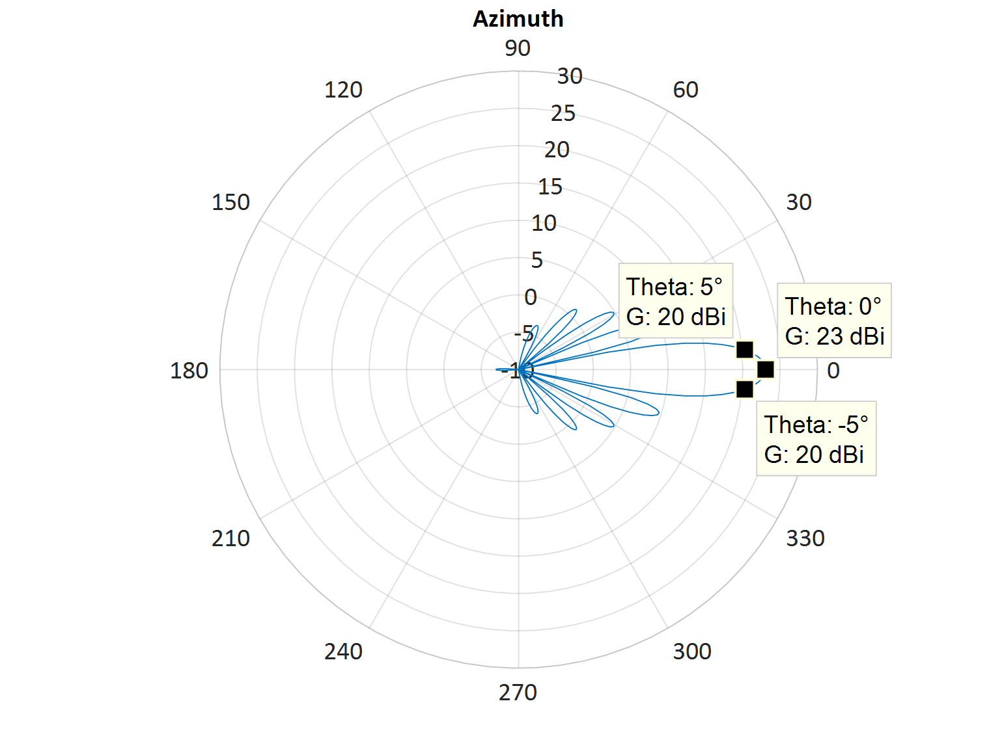
Figure 39: Example beamformed pattern in azimuth with 64 elements and 5dBi element gain
For example, in the case of a 64-element AAS array with a 5dBi element gain, this can lead to a peak gain of 23dBi with an azimuth 3dB beamwidth of 10° (see Figure 39). However, at beam pointing angles that are significantly off perpendicular, the array will generate a peak gain of only 19dBi with a larger 13° 3dB-beamwidth.
Considering approximately 10 non-overlapping beams within a 120° sector can therefore be representative. With a uniform distribution of users in azimuth there will be approximately 10% of base stations pointing towards the radar location with the other 90% pointing elsewhere. With a perfect antenna, this would lead to a 10dB reduction in the aggregation factor, however side and grating lobes may be only 13dB down on the peak gain (see Figure 39) and therefore make a contribution to the aggregate and the reduction in aggregation factor becomes 8.4 dB. Taking these assumptions of the side lobes within the sector leads to a reduction in average power at the radar location. The median antenna gain in the UK network analysed was 18 dBi and so whilst an AAS may deliver 5 dB higher e.i.r.p. in the main beam, compared to the antennas used in the UK network, the fact that only 10% of base stations will have the main beam pointing at the radar leads to a modest overall reduction in the aggregation factor of 8.4 dB and a net reduction in cumulative power of 3.4 dB.
Using the determined path loss and assuming that the single base station with the maximum contribution is radiating -50dBm / MHz e.i.r.p when considering out-of-band emissions, the total power at the radar can be determined as:
$P_{radar}= P_{tx}-PL+G_{radar}+Agg+NetworkLoad+AASimpact$ (27)
Where Agg is the aggregation factor or difference between cumulative and max power (21.8dB in our example) and
NetworkLoad is the adjustment in power from the base stations to account for the network loading. For 50% loading this is -3dB; and
AASimpact is the adjustment in aggregation factor as a result of 10 non-overlapping AAS beams in the sector. In this example this is -3.4dB
$$P_{radar}= -50 dBm-141.7 dB+40 dBi+21.8-3 dB-3.4dB$$
$$P_{radar}= -136.3 dBm/MHz$$
The radar noise floor (per MHz) is 3 dB above the thermal noise of -174 dBm / Hz which is -111 dBm / MHz
The interference threshold is therefore:
Table 39: Radar interference thresholds
I/N | Interference threshold
- 6 dB | -117 dBm/MHz
- 10 dB | -121 dBm/MHz
- 16 dB | -127 dBm/MHz
Comparing $P_{radar}$ with the I/N threshold levels shows that an out-of-band emission limit of -50dBm / MHz e.i.r.p. allows a margin of 19.3 dB (for I/N of -6 dB), 15.3 dB (for I/N of -10 dB) or 9.3 dB (for I/N of -16 dB).
Running a similar analysis but assuming that all base stations in the network are radiating at an out-of-band emissions level of -50 dBm/MHz e.i.r.p. level irrespective of their in-block e.i.r.p. increases the aggregation factor by approximately 2.6dB (see Figure 40) with an equivalent reduction in margin.
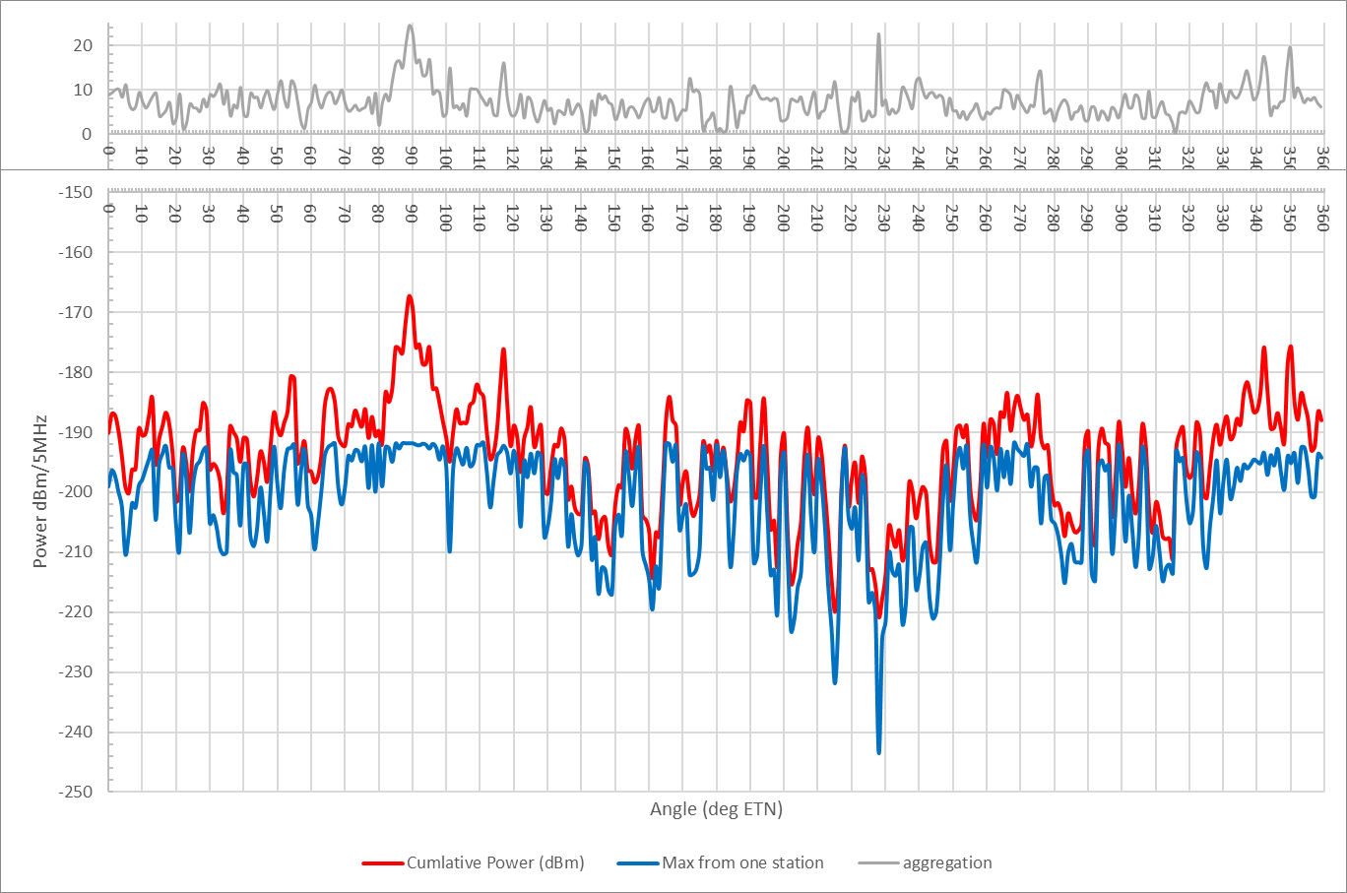
Figure 40: Ratio of total power (cumulative) to maximum individual component (max) against azimuth of the radar beam for one example location when assuming all base stations had an e.i.r.p below 3400 MHz of -50 dBm/MHz. Results were based on a UK 2100 MHz network
Based on the in-block analysis in this study with an aggregation factor of 21.8 dB, the current -50 dBm/MHz e.i.r.p. limit provides a 15 dB margin in the protection criteria for airborne radars operating below 3390 MHz.
To define a baseline level as a total radiated power for non-AAS antennas rather than e.i.r.p., then antenna gain should be subtracted. In the case of this analysis the median antenna gains were determined to be 18 dBi which is considered suitable. Taking 18dBi antenna gain and the margin into account, an equivalent TRP would be -53 dBm/MHz.
- Studies on the coexistence between AAS and Radio Astronomy systems
Compatibility study between the RAS in the frequency range 3.33-3.35 GHz and IMT 5G systems in the frequency range 3.4-3.6 GHz.
    - Introduction
This compatibility study concerns the protection of the radio astronomy service (RAS) in the frequency range 3.33-3.35 GHz from unwanted emissions of IMT base stations (BS) and user equipment (UE) operating in the frequency band 3.4-3.6 GHz. It is assumed that the RAS will be affected in the spurious domain of the emission mask of the IMT devices.
    - Summary of studies
Table 38 contains a summary of the compatibility study presented here between the RAS in the frequency range 3.33-3.35 GHz and IMT 5G systems in the frequency range 3.4-3.6 GHz.

Table 40: Overview of the compatibility study between the RAS in the range 3.33-3.35 GHz and IMT in the band 3.4-3.6 GHz
Parameter | Parameters from expert WPs and TG 5/1 Ad-Hoc Group |  | This study
Methodology
Number of IMT stations considered | Single-entry or Multiple-entry (aggregated) |  | Single-entry and Multiple-entry (aggregated)
Type of interference evaluation method | Deterministic study or Statistical study |  | Statistical study
 | If statistical,  based on Rec. ITU-R M.2101 [17] |  | In general, yes - as appropriate
Technical and operational characteristics of IMT-2020 systems
Deployment scenario | Outdoor urban hotspot,  Outdoor suburban hotspot,  Outdoor suburban open space hotspot (optional),  Indoor |  | Outdoor urban hotspot,  Outdoor suburban hotspot,  Outdoor suburban open space hotspot
IMT stations | BS and UE |  | BS and UE
Method to deploy multiple IMT stations for the aggregated interference analysis | R_{a} & R_{b} method:  Ra: Urban (Outdoor): 7%, Suburban (Outdoor): 3%, Urban (Indoor) 2%, Suburban (Indoor) 1%  R_{b}: 5% |  | R_{a} & R_{b} method:  Ra: Urban (Outdoor): 40%, Rural (Outdoor): 1%  R_{b}: 5%
Network loading factor for BS and UE (% | 20 |  | 20
TDD activity factor (%) | BS: 80, UE: 20 |  | BS: 80, UE: 20
Number of simultaneously transmitting stations in the aggregated interference analysis | – |  | Within a box of 400 km × 400 km a total of 10000/250 (urban/rural) BSs and 561000/7550 (urban/rural) UEs are sampled during each Monte Carlo iteration. These numbers represent the situation before TDD activity is accounted for. To calculate necessary separation distances, si, the power of all devices was aggregated (considering path propagation losses and effective antenna gains), neglecting all devices within spheres of radius si.
Antenna pattern | Rec ITU-R M.2101 [17] |  | Composite antenna patterns in Rec ITU-R M.2101 , with efficiency, ρ
Normalization of antenna gain |  |  | Total integrated gain correction
Technical and operational characteristics of RAS stations
Protection criterion I/N (dB) | Recommendation ITU-R RA.769-2 [44]  Power entering receiver Spectral PFD  Interference (continuum measurements); from RA.769 -191 dB(W / 1000 MH)z -227 dB(W/m2 Hz)  Interference (spectral line measurements) -207 dB(W/500 kHz) -210 dB(W/m2 Hz)  Antenna noise temp. (K) 25 25  Receiver noise temp. (K) 65 65 |  | Power entering receiver Spectral PFD  Interference (spectral-line measurements); from RA.769 (interpolated) -219 dB(W/40 kHz) -232 dB(W/m2 Hz)  Antenna noise temp. (K) 12 12  Receiver noise temp. (K) 10 10
Other characteristics of RAS stations | Recommendation ITU-R RA.769-2 [44] assumed that the interference enters the antenna through the 0 dBi sidelobe and hence the gain is assumed to be isotropic. If the antenna pattern for RAS is needed it can be obtained via Recommendation ITU-R SA.509 [45]. Locations and characteristics of RAS antennas exist in various Recommendations and Reports in the ITU-R literature e.g. Recommendation ITU-R RS.2066 [46] and Report ITU-R M.2322 [47]. |  | An isotropic antenna with a gain of 0 dBi with a height of 50 m above the ground is assumed.
Apportionment of interference between services
Apportionment value (dB) | Case-by-case | 0
Propagation model
Baseline | Rec. ITU-R P.452 [32] | Rec. ITU-R P.452 (with a flat profile) with p = 2%
Clutter loss | Rec. ITU-R P.2108 [33] | Distribution of clutter loss values based on Rec. ITU-R P.2108 [33] (median: 24.4 dB)
Results of studies
Single-entry interference from an IMT station | – | Separation distances around RAS stations, ρ=0.8  Zone Pspurious (dBm/MHz) Separation distance for BS (km) Separation distance for UE (km) Separation distance for BS + UE (km)  Spurious emission case  Urban -50 22 1 n/a  Rural -50 22 1 n/a  Urban -30 62 9 n/a  Rural -30 62 9 n/a
Aggregated interference from multiple IMT stations | – | Separation distances around RAS stations, ρ=0.8  Uniform deployment density  Zone Pspurious (dBm/MHz) Separation distance for BS (km) Separation distance for UE (km) Separation distance for BS + UE (km)  Spurious emission case (2%)  -50 11 3 14  -30 60 31 61  Clustered deployment density  Zone Pspurious (dBm/MHz) Separation distance for BS (km) Separation distance for UE (km) Separation distance for BS + UE (km)  Spurious emission case (2%)  -50 22 9 23  -30 62 38 64

    - Study parameters
      - RAS station parameters
The frequency range 3.33-3.35 GHz is extremely important to the RAS for observations of spectral lines of the CH molecule, which is among the radio-frequency lines of greatest importance to radio astronomy listed in Recommendation ITU-R RA.314 [48]. This spectral line is observed in the interstellar medium in the Milky Way and in other galaxies. The chemical processes related to the CH molecule are complex and difficult to interpret, in which observations of these radio spectral lines play an important role.
The list of CEPT countries with radio astronomy stations operating in the frequency range 3.33-3.35 GHz is as follows: Czech Republic (Ondřejov), France (Nançay), Germany (Effelsberg), Russia (Pushchino, Zelenschukskaya), Sweden (Onsala), Switzerland (Bleien).
The IMT frequency band 3.4-3.6 GHz is almost adjacent the frequency bands 3.332-3.339 GHz and 3.3458-3.3525 GHz which are used by the radio astronomy service (RAS) and to which Footnote RR No. 5.149 [4] applies, which urges administrations to take all practicable steps to protect the radio astronomy service from harmful interference. The RAS does not have an allocation in these two bands. In this study it is assumed that a sufficiently wide guard band between the IMT allocation and the RAS band will be implemented, such that the RAS will be affected in the spurious domain of the emission mask of the 5G devices.
Threshold levels for interference detrimental to RAS observations are listed in Table 39; they are based on Recommendation ITU-R RA.769 [44](see also Document 5-1/27 [49]). In this study only the case of spectral-line RAS observations is considered. For the RAS station an isotropic antenna with a gain of 0 dBi with a height of 50 m above the ground is assumed.
No modification has been applied to the interference threshold levels based on apportionment of interference between services, following the opinion expressed by the RAS expert group, WP 7D (see Document 5-1/176 [50]).
Table 41: Protection criteria for radio astronomy observations in the frequency range 3.33-3.35 GHz
RAS allocation status  RR Footnotes 1  RAS use 2  IMT/RAS band situation | RAS protection criteria interpolated from Recommendation ITU-R RA.769-2 [44]
no allocation  RR No. 5.149 [4]  narrowband  Nearby band | Power entering receiver Spectral PFD  Interference (spectral line measurements); from RA.769 -219 dB(W/40 kHz) -232 dB(W/m2 Hz)  Antenna noise temp. (K) 12  Receiver noise temp. (K) 10
1) RR No. 5.149 states “In making assignments to stations of other services to which the bands (band list omitted) are allocated, administrations are urged to take all practicable steps to protect the radio astronomy service from harmful interference. Emissions from space borne or airborne stations can be particularly serious sources of interference to the radio astronomy service (see RR Nos. 4.5 and 4.6 and Article 29)”.
2) The term “Broadband” corresponds to “continuum” observations (see Table 1 of Recommendation ITU-R RA.769-2) and “narrowband” to “spectral line” observations (see Table 2 of Recommendation ITU-R RA.769-2) respectively. Both in-band emissions in these RAS bands and emissions from outside these RAS bands falling into them should remain below the thresholds for detrimental interference given in Recommendation ITU-R RA.769-2, subject to Recommendation ITU-R RA.1513 [51] which provides with 2% data loss to the RAS due to interference by all stations of one service, and with an aggregate data loss of 5% in any band from all services.
      - IMT parameters
The IMT technical parameters used for this study (see Table 40) were mainly adopted from the main body of this Report and otherwise from Attachment 2 to Document 5-1/36 [31] pertaining to compatibility studies with IMT systems under WRC-19 agenda item 1.13 (if not covered in the main body). The typical deployment densities are defined as a function of the environment of the IMT BS and UE, urban or rural hotspots. For larger-area compatibility studies, Document 5-1/36 also distinguishes which fraction of the land is to be assigned. The base stations are usually not operating at 100% of their maximum capacity. In the calculations a network loading factor of 20% is assumed, following Annex 1 to Document 5-1/92 [52]. The time division duplex (TDD) activity factors are 80% for base stations and 20% for user equipment. Antenna patterns are also taken from Attachment 2 to Document 5-1/36.
The total integrated gain correction factors listed in Table 40 are based on the guidelines provided in Annex 1 to Document 5-1/173 [53], where it is noted that they will be developed at the January 2018 TG 5/1 meeting. For the composite antenna patterns the factors were calculated for the beam formed in forward direction only.
Table 42: IMT technical parameters for base stations and user equipment
Parameters | IMT base station | IMT user equipment
Frequency | 3.4 GHz | 3.4 GHz
Antenna | 8×8 array elements,  80°/65° 3-dB width, Gelem=5 dBi,  30 dB f/b ratio,  spacing: dH=0.6λ, dV=0.9λ | single element,  90° 3-dB width, Gelem=5 dBi,  25 dB f/b ratio
Total integrated gain correction | +3.81 dB (composite beam) | +2.44 dB (single element)
Tilt | -10° (urban/rural) | 0°
Antenna height | 20 m (urban/rural) | 1.5 m
Ohmic losses | -3 dB | -3 dB
Other losses | n/a | 4 dB (body loss)
Spectral power density in RAS band | -50 dBm/MHz (spurious) | -50 dBm/MHz (spurious)
Total tx power into RAS band | -67 dBm (spurious) | -71 dBm (spurious)
Network loading factor | 20% | n/a
TDD activity factor | 80% | 20%
Rb (housing ratio) | 5% | 5%
Ra (ratio of hotspot area to housing area) | 40% (urban), 1% (rural) | 40% (urban), 1% (rural)
Ri (indoor ratio) | n/a | 7% (urban), 50% (rural)
Deployment density in hotspot area | 3.1 km-2 (nominal)  0.063 km-2 (urban)  0.002 km-2 (rural) | 63 km-2 (nominal)  1.17 km-2 (urban)  0.016 km-2 (rural)
 | Distribution of user equipment (relative to base station)
Distance distribution | Rayleigh(0, 200) (urban)  Rayleigh(0, 300) (rural)
Angular distribution | Uniform(-60, 60)
        - AAS Base Station parameters
The base stations utilise 8×8 antenna elements. The considered RAS band is assumed to be in the spurious domain of unwanted emissions with respect to the 3.4-3.6 GHz MS band, and additional ohmic losses of -3 dB. The spurious emission level into the RAS band is -50 dBm/MHz.
Although Rec M.2101 proposes the use of the single-element antenna pattern for compatibility studies with the RAS in the spurious domain, based on recent experiences with similar compatibility studies involving the FS and IMT equipment at 26 GHz, where the composite antenna pattern was used, we also decided to use the composite antenna pattern for the present study. Calculations are provided for two values of the efficiency coefficient, ρ: with ρ=0.2 and ρ=0.8. We show only one antenna pattern in Figure 41, for ρ=0.8.
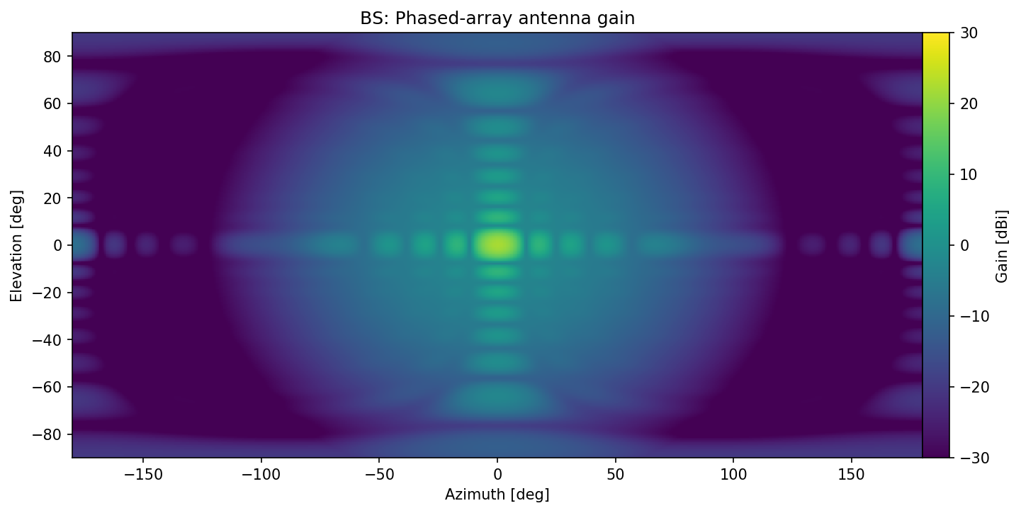
Figure 41: Composite antenna gain of an IMT base station, ρ=0.8
For BS, the antenna heights have to be considered. To improve the gain after beam-forming, the arrays are furthermore slightly tilted with respect to the horizon.
        - UE parameters
Compared to the base stations, the UE have phased array antenna, so the single-element pattern has to be applied. Their emitted power in the spurious domain is also -50 dBm/MHz. Additionally, 4 dB body absorption loss is applied.
The UE single-element antenna gain is visualised in Figure 42. The user equipment will have antenna arrays on the front and the back, and it is assumed that all UE antenna frame normal vectors will be pointing at most 60° away from the direct sight lines to their associated BSs.
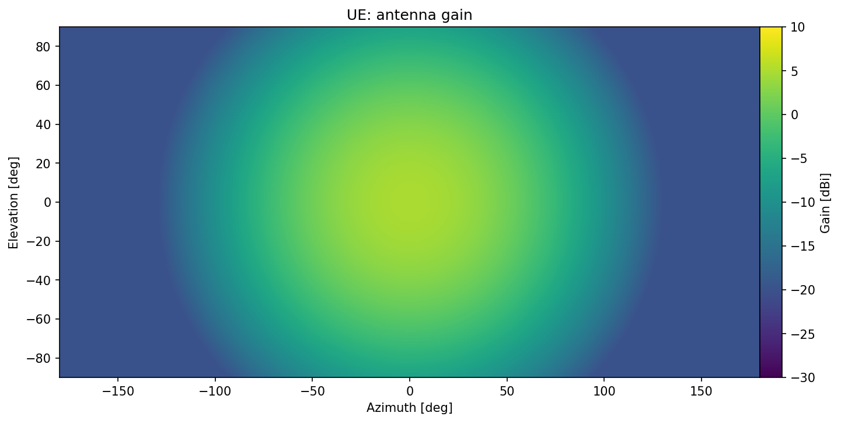
Figure 42: Antenna gain of a single element of IMT user equipment
      - Propagation and clutter models
For this generic compatibility study, a flat (smooth-earth) propagation model according to Recommendation ITU-R P.452-16 [32] is used, accounting for the relative angle between the propagating path and the boresight of the IMT antenna elements (including BS tilt and UE rotations) that influences the effective antenna gain. Furthermore, in case the composite antenna pattern has to be used, the position of the formed beam changes the effective gain towards the RAS station. Further details on this are discussed in Section 1.1.3.2. Parameter p, as defined in Recommendation ITU-R P.452-16, was assumed not to be exceeded for 2% of the time, following recommends 2 of Recommendation ITU-R RA.1513 [51].
Study Group 3 advised ITU-R TG 5/1 in Document 5-1/38 [54] that calculating diffraction using only a flat (smooth earth) profile is not necessarily the lowest loss case and should therefore not be used as a simplified model”. Nevertheless, this study considered a flat (smooth earth) profile in order to allow for the results to be general rather than site specific. As a result, when interpreting the results of this study it will be important to keep in mind the limitations of this method and that interference could occur at greater distances in some instances. It should be noted however that the results concerning the single-interferer scenario presented in this study are compatible with those from Document 5-1/73 [53] where detailed terrain profiles were used.
For the deployment of IMT equipment around RAS stations, case studies for individual RAS stations may be required, which can only be performed using detailed and specific information about deployment scenarios for IMT equipment.
For the prediction of clutter loss Recommendation ITU-R P.2108 [33] was used, following the guidance provided in Document 5-1/38. This new algorithm depends only on frequency, distance and the location percentage, pL. The latter quantity is to be understood as the percentage of emitters (spread across an urban or suburban zone) producing the lowest clutter loss. For example, if pL is 2%, (i.e., adopting a worst case scenario) the value returned by the method indicates that for 2% of all cases the clutter loss will be lower than the value.
At 3.4 GHz and for distances larger than 5 km, clutter loss values for pL=2% are about 16.3 dB. In the case of aggregate emissions, an integration of received powers over a sufficiently large area will be performed. Therefore random pL values, ranging from 0% to 100% are assigned to each BS and UE device. The expectation value of the clutter loss distribution for distances larger than 5 km is 24.4 dB at 3.4 GHz.
Typical atmospheric conditions (temperature: 20°C, pressure: 1013 mbar) were assumed. For IMT equipment, the path attenuation is not dependent on the associated zone (urban/rural), as the clutter type is the same for both zones, and the BS antenna heights are the same. The resulting path attenuation values are displayed in Figure 43 for BS and UE, respectively. For UE an additional 4 dB of body absorption loss needs to be taken into account.
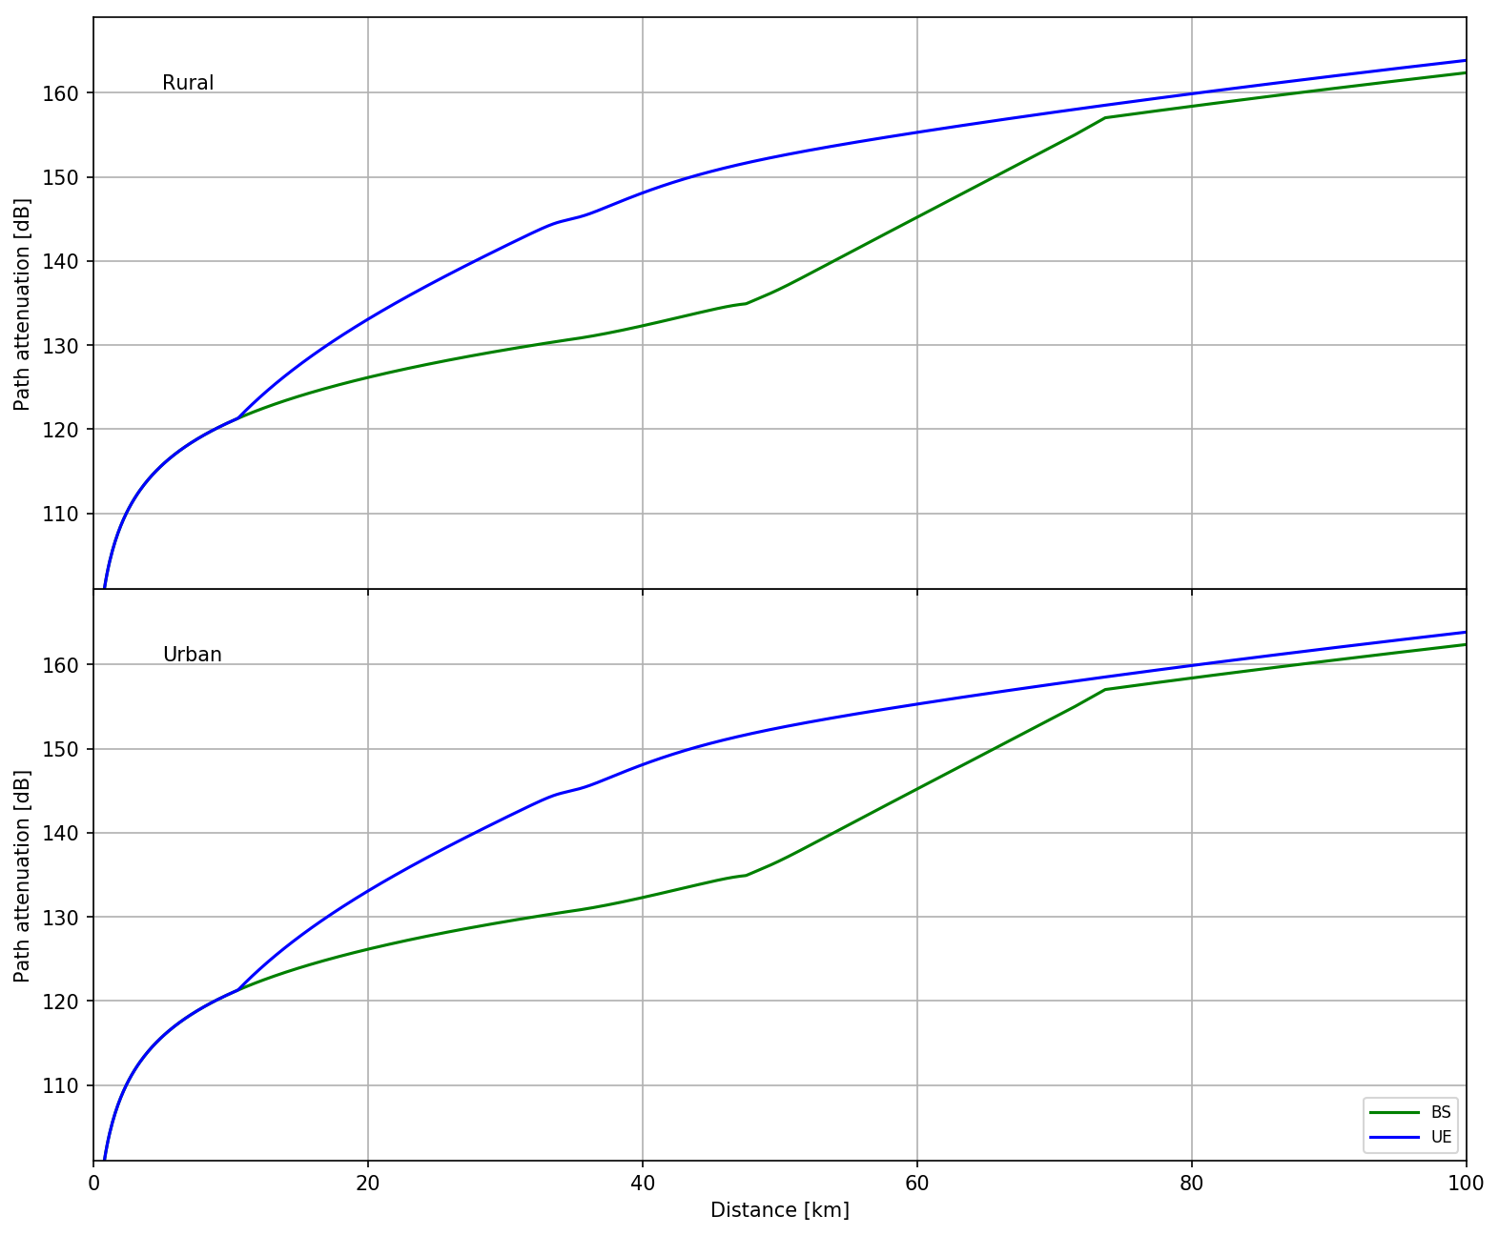
Figure 43: Path attenuation of BS and UE as a function of distance to the RAS station obtained using
Recommendations ITU-R P.452-16 [32] and P.2108 [33]
    - Single-interferer scenario
For the single-interferer case the worst-case situation of a BS or UE device pointing directly towards the RAS station is of main concern.
      - Base stations
In the case of base stations, the tilt of the transmitting antenna arrays has to be accounted for (-10°). Using the given antenna patterns (see Figure 41 and Figure 42), the effective gain towards the RAS station was calculated. In combination with the total power transmitted into the RAS band and the total path attenuation, the power received at the RAS station is determined and visualised in Figure 44.
Furthermore, additional curves for a transmitter power of -30 dBm/MHz are provided, which is 20 dB above the nominal transmitter power of -50 dBm/MHz as given in the main body of this Report. This spurious spectral power value of -30 dBm/MHz has previously been determined as the maximum permitted level of spurious domain emissions of any unwanted component supplied by a transmitter to the antenna transmission line for Category B equipment, i.e., the category of limits defined and adopted in Europe and used by some other countries (see Table 3 in Recommendation ITU-R SM.329 [55]) and has been routinely used for other IMT compatibility studies.
The horizontal dashed red line indicates the Recommendation ITU-R RA.769 [44] power threshold level for detrimental interference. The interception of the received power plots with the dashed red line therefore defines the radius of the exclusion zone that would be necessary to protect the RAS station.
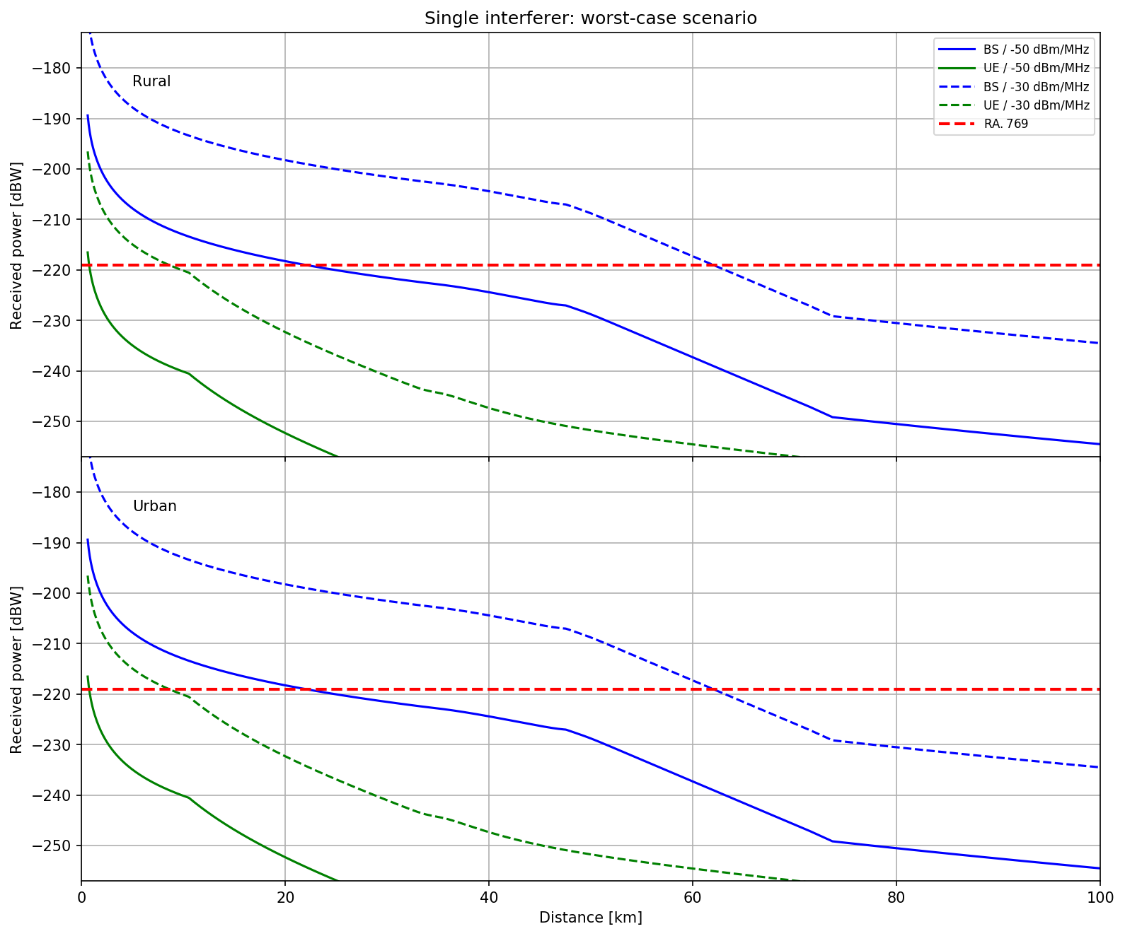
Figure 44: Single-interferer scenario for BS and UE. The total received power is shown as a function of distance to the RAS station for two different transmitter power levels. The composite antenna pattern with ρ=0.8 was used for the case of BS
      - User equipment
As for the BS (Section A5.1.4.1), the single-interferer case was also studied for UE.
4 also shows the single-interferer received powers (green curves) obtained for a transmitting antenna tilt of 0°.
    - Aggregated power scenario
Not only the single-interferer scenario has to be considered for a compatibility study but also the aggregated power scenario, which considers the impact of the accumulated emitted power of all IMT devices around an RAS station. Here a Monte Carlo simulation is used to infer the total aggregated power of an ensemble of BS and UE devices, which are located randomly in a box of sufficient size, adhering to the given distribution functions.
      - IMT equipment deployment
In Recommendation ITU-R M.2101 [17] several possible deployment topologies are discussed, such as hexagonal or Manhattan-style grid layouts. Typical deployment number densities and other technical parameters are provided in the main body of this Report and Document 5-1/36 [31].
In the particular case that is analysed here, the network topology can be neglected because one needs to average over a very large region such that the aggregated power at the RAS station will be completely defined by the constant deployment densities defined in the main body of this Report and Document 5-1/36 (per zone type: urban and rural).
Following main body of this Report, it is assumed that parameter R_{b} = 5% (percentage of the considered area which has housing), and that R_{a} = 40% Urban and 1% Rural. Not all UEs are considered to be located outdoor. The fraction, R_{i}, is the indoor percentage and is 7% (urban) and 50% (rural), respectively. However, as the building entry loss is rather large, only the outdoor UE devices are considered for this study. Accounting for the R_{a}, R_{b} and R_{i} fractions, for urban zones, up to 0.063 BSs (or 1.17 UEs) per square kilometre could be present. In rural zones, the numbers are lower (0.002 BSs and 0.016 UEs).
In practice, urban areas in a region are often clustered. Since no distribution functions for the BS and UE device locations to be used in generic studies were specified so far, a uniform distribution is used here as a reference. Nevertheless, to analyse the impact of clustering effects, the following simple algorithm was developed to produce a typical distribution of urban and rural zones.
First, a rectangular grid of 400 km × 400 km with cells of size 500 m × 500 m is produced. For each cell a random number is drawn from a Normal distribution. The uniform-density generation of urban and suburban cells is possible by computing appropriate percentiles: all cells with a random value above $(100\%-{(R}_{a}^{urban}+ R_{a}^{rural})R_{b})$ are classified as rural, while cells with random values above $(100\%-R_{a}^{urban}R_{b})$ are classified as urban. The result of this is visualised in Figure 45. To achieve a clustering effect, a correlation length between adjacent pixels has to be introduced. This is possible by smoothing the original grid of random numbers with a blurring filter such as a Gaussian filter. To achieve a realistic effect, three different kernel scales, σk, and relative amplitudes were used simultaneously: σk =2 km, 5 km, and 15 km with relative amplitudes of 30%, 30% and 40%. Again, calculating distribution percentiles of the smoothed random number field leads to the classification of zone types, displayed in Figure 46.
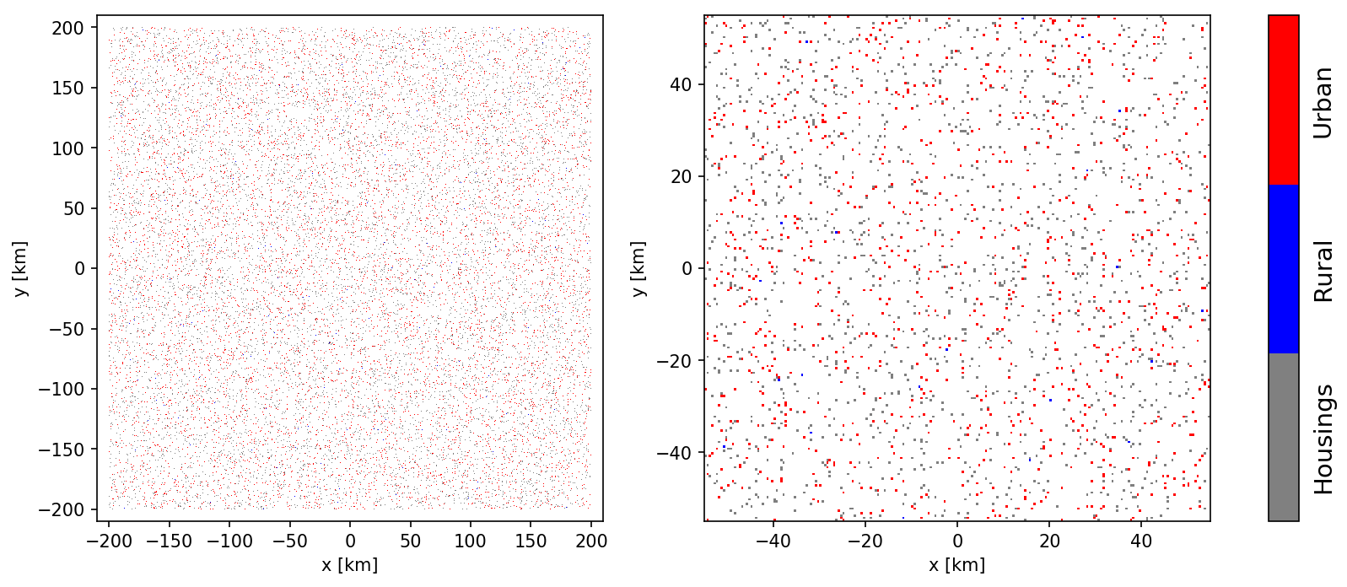
Figure 45: Sampling of urban and rural zones with uniform density; the right panel shows a zoom-in
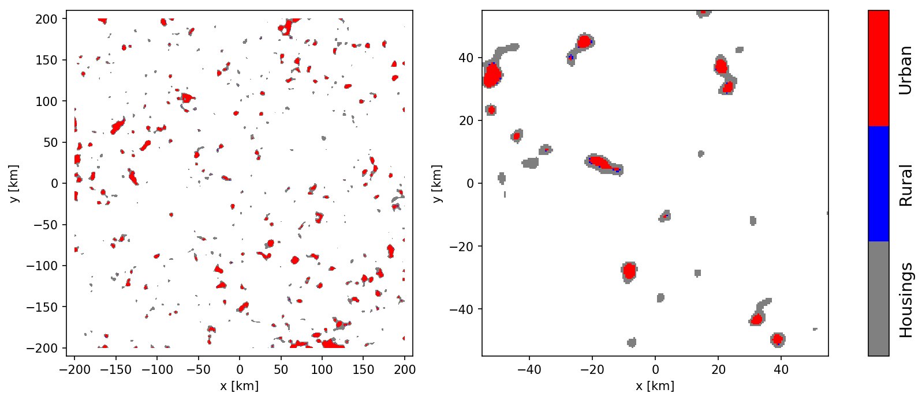
Figure 46: Sampling of urban and rural zones with clustering; the right panel shows a zoom-in
The Monte Carlo methodology used here to calculate the aggregated power is straightforward: BSs are randomly sampled into urban and rural zones until the total number of devices leads to the specified BS number density. For a box of 400 km × 400 km this leads to 250 BS in rural and 10060 BS in urban zones. To each BS a random azimuthal orientation (bearing) is assigned, and it is assumed that three sectors (of 120°) are active per BS.
From the perspective of a base station, the UE devices are distributed in a forward cone, following a radial and angular distribution function as defined in Annex 1 to Document 5-1/92 [52]. The distance between BS and UE is given by a Rayleigh distribution (urban/rural; see Table 40 for the defining parameters). The angular distribution is given by a Uniform distribution per sector, with angles restricted within ± 60°. The combination of both distributions defines the desired forward cone. The total number of UE devices that are sampled into the box is higher than for BS: 7550 (rural) and 56000 (urban).
In addition, a UE device can be rotated almost randomly, with the only restriction that the UE-BS direction be located within 60 degrees from the antenna normal vector (Annex 1 to Document 5-1/92).
      - Effective antenna gains and propagation losses
To infer the effective antenna gains of the BS toward the RAS station it is necessary to calculate the directions to the associated UE devices (yielding the Azi and Eli steering direction of the beam) as well as to the RAS receiver, both in the antenna reference frame. Likewise, for UE gains the direction to the BS and RAS receiver need to be inferred in the UE antenna frame. As the BS and UE antenna frames are rotated and tilted this calculation is best performed using 3D vector algebra and appropriate rotation matrices. For the direction to the RAS station it is furthermore necessary to account for the path propagation horizon angle derived from the propagation loss calculation. In Figure 47 an example configuration is visualised. Stars and filled circles show positions of BS and UE respectively, whose colours indicate the resulting antenna gain (in dBi) as indicated by the colour bar in the figure. For visualisation purposes the three sectors of a BS were slightly displaced from their true position in the figure, as each BS sector antenna has different effective gain towards the RAS receiver.
Red lines show the vectors between UEs and their BSs. Black arrows indicate the antenna frame normal vectors while grey arrows show the direction to the RAS receiver. It is noted that only a projection onto the x-y plane is visualised, although 3D vectors are used throughout the simulation. As the length of all arrows is equal in 3D, the apparent length of the arrows in Figure 47 is an indicator of their z-component.
The larger the resulting effective antenna gain towards the RAS station, the closer the vector between UE and BS aligns (red lines) with the vector to the receiver (grey arrows). But also the orientation of the transmitting antenna arrays (black arrows) plays a role, because it changes the side-lobes of the formed beam. For example, a rotation about the forward direction (defined by the antenna normal vector) will only mildly change the forward gain, but can have significant impact on the gain into any other direction.
One detail, which needs to be considered in the calculation of the BS gain for the composite-array scenario, is that one BS often serves multiple UEs. In such cases, the effective BS gain was determined by averaging over the individual gains resulting from the beam pointing to the various UE devices.
The propagation losses can simply be derived from the ITU-R P.452-16 [32] prediction over the distance given by the respective grid cell to the map centre (where the RAS station is situated). As discussed in Section A5.1.3.3, the clutter losses are calculated by assigning a random pL (uniformly distributed over the range 0% to 100%).
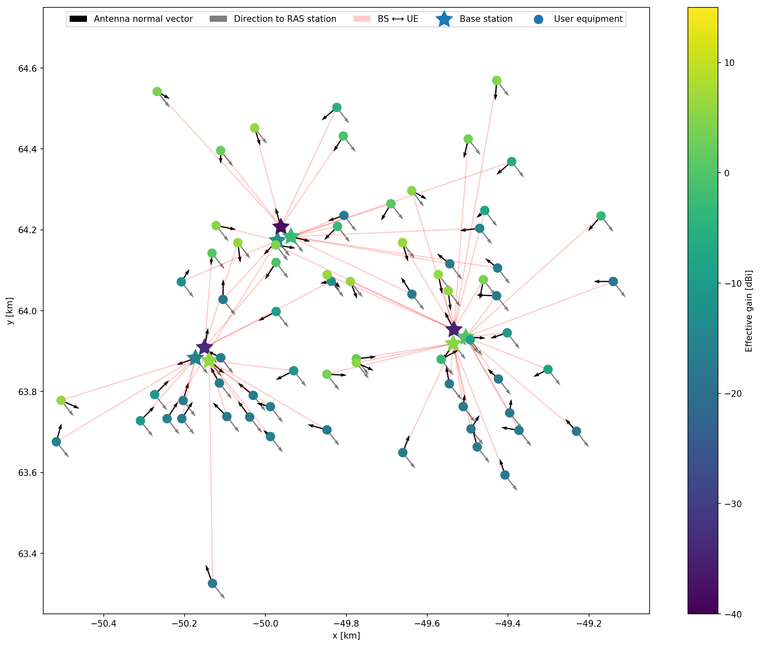
Figure 47: Example of a BS-UE configuration
      - Integrated power at RAS receiver
Each Monte Carlo iteration (i.e., one realisation of a BS+UE configuration within the box) yields a total power level received at the RAS station, which is calculated by simply aggregating all individually emitted power levels and accounting for antenna gains and propagation loss. In practice, in effectively all cases the RAS interference threshold levels are exceeded.
A minimal separation distance can be calculated by determining the received power as a function of a separation distance (exclusion radius) si. For each si the total contribution of devices outside a circular zone of radius si is inferred. As this is performed for each iteration, an ensemble of curves (received power as a function of separation distance) is generated. By studying the distribution percentiles, the 50% (median) or highest 2% curve can be extracted. The latter matches the highest acceptable data loss for RAS, following Recommendation ITU-R RA.1513 [51]. The minimal separation distances are defined by the crossing points of the received-power curves with the threshold power level for detrimental interference given in Recommendation ITU-R RA.769 [44].
For each of the two deployment scenarios (uniform density and clustered), as well as for the two composite antenna efficiencies (ρ=0.2 and 0.8), a Monte Carlo simulation was run. In Figure 48 to Figure 51 the ensemble curves and distribution percentiles are displayed for the various scenarios. Again, curves (2% only) were added for a spurious power level value of -30 dBm/MHz for comparison.
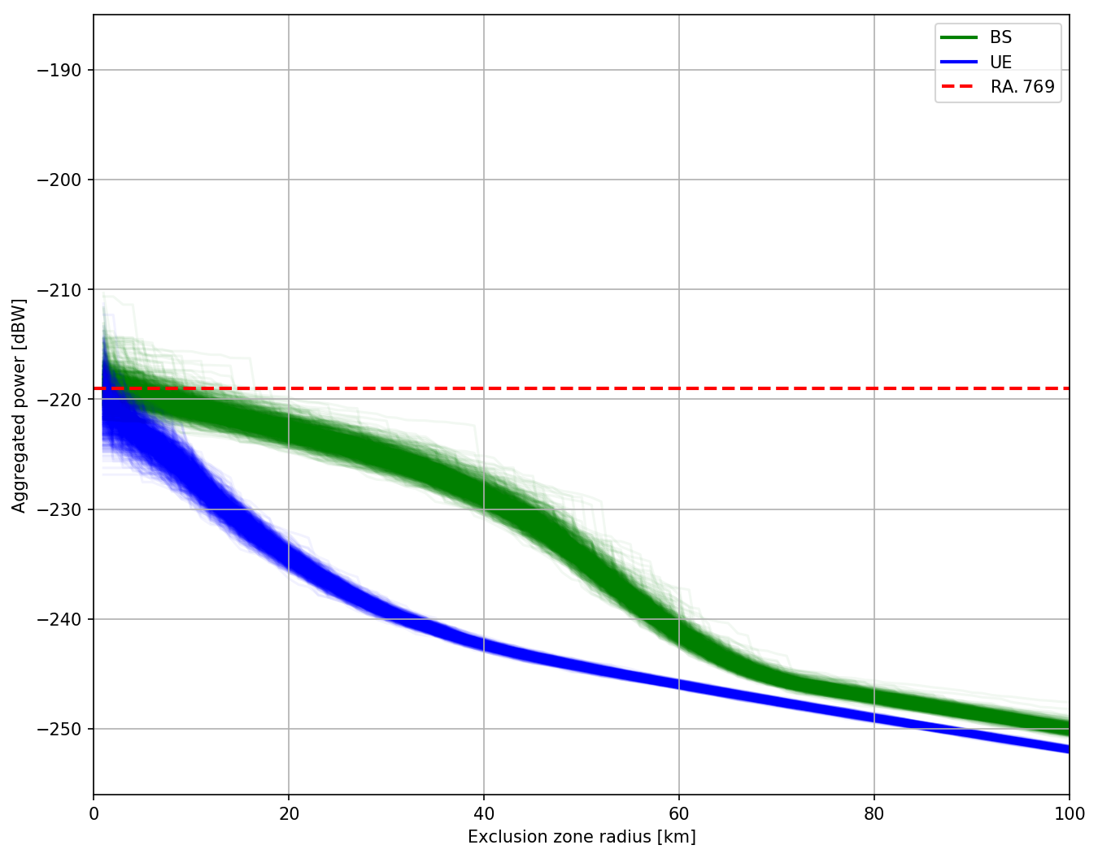
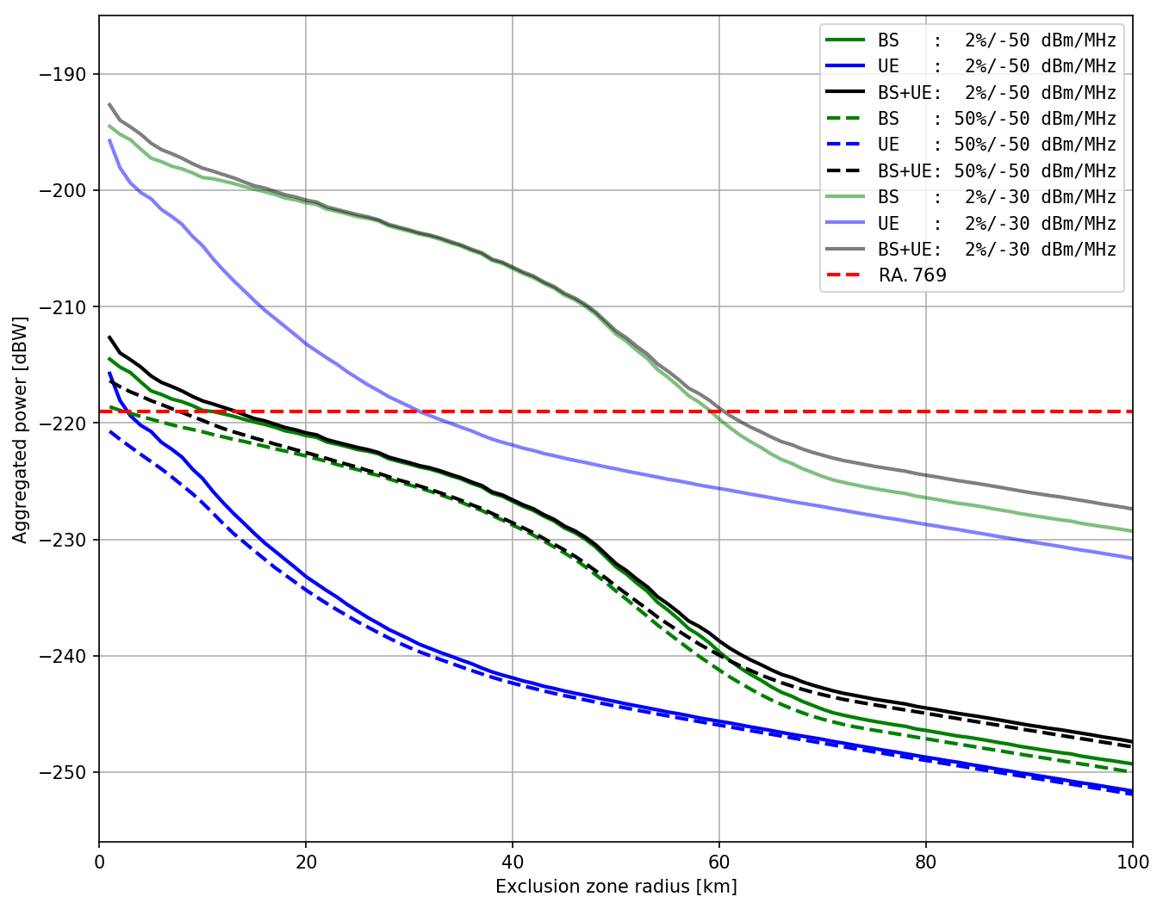
Figure 48: Aggregated power (uniform density, ρ=0.8) as a function of separation distance.
Top panel: Monte Carlo simulation results for the -50 dBm/MHz spurious emission level
Bottom panel: curves for the -50 and -30 dBm/MHz spurious emission levels
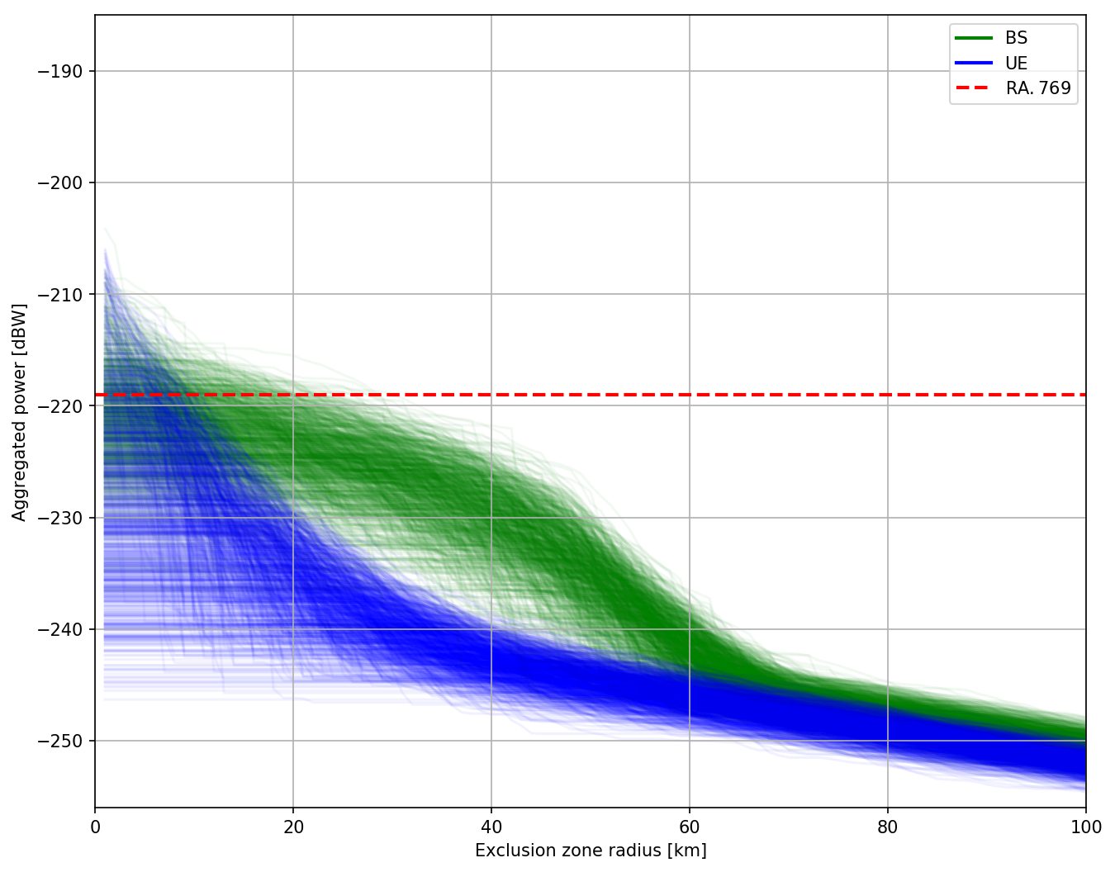
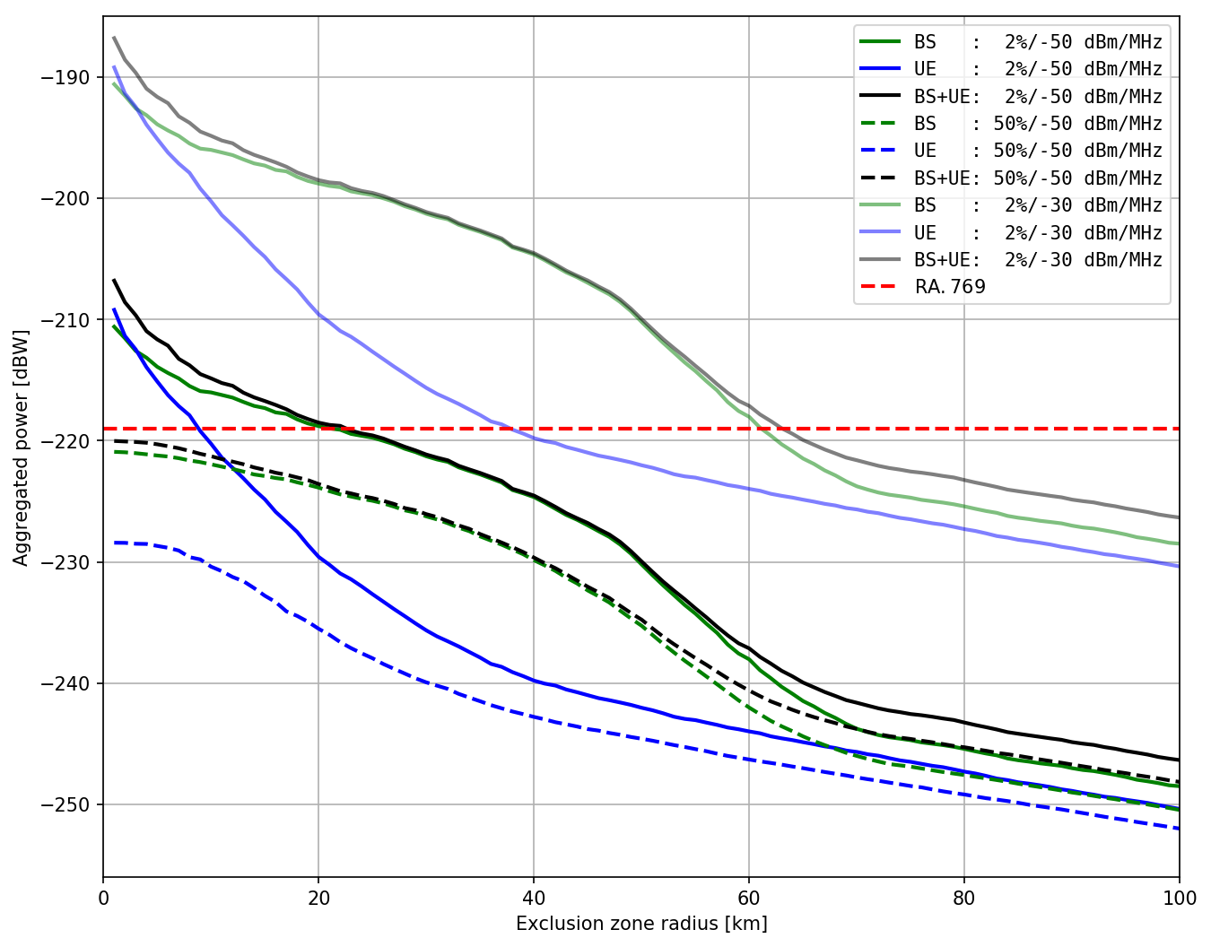
Figure 49: Aggregated power (clustered, ρ=0.8) as a function of separation distance.
Top panel: Monte Carlo simulation results for the -50 dBm/MHz spurious emission level
Bottom panel: curves for the -50 and -30 dBm/MHz spurious emission levels

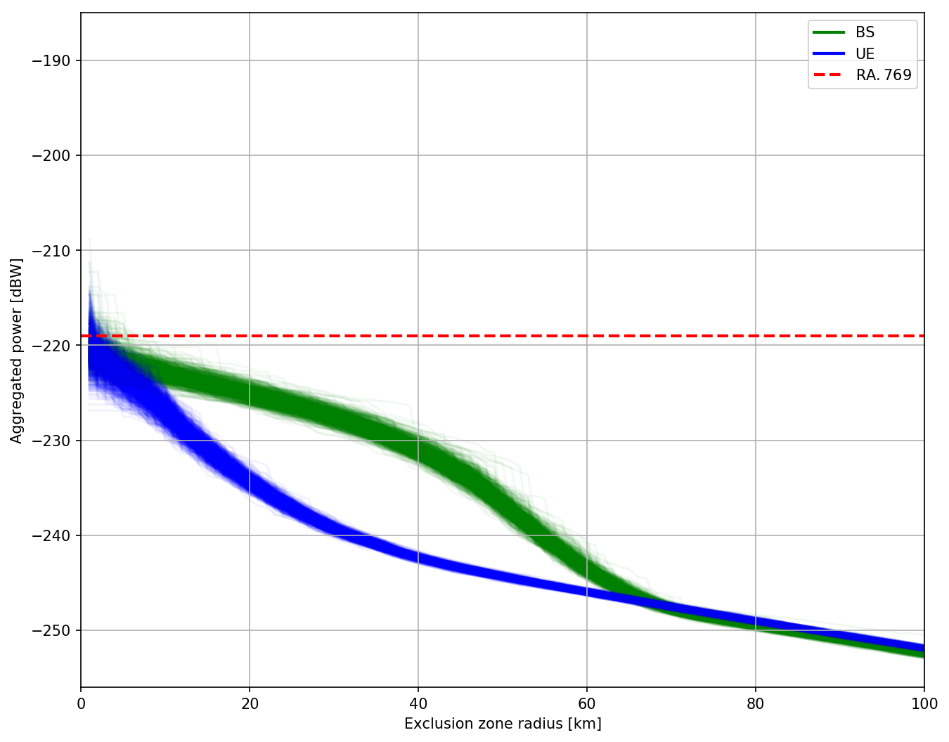
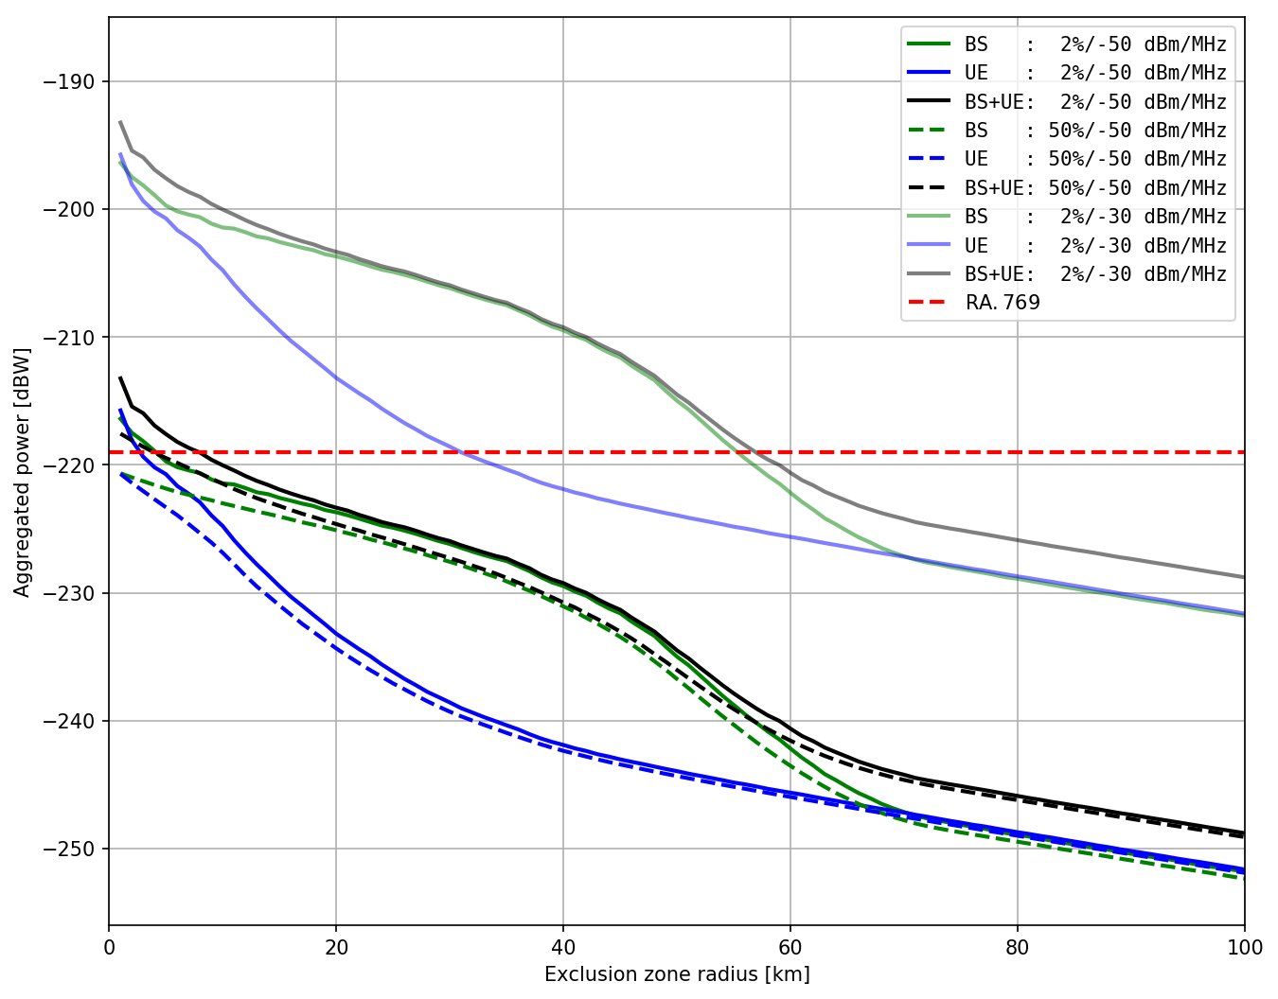
Figure 50: Aggregated power (uniform density, ρ=0.2) as a function of separation distance
Top panel: Monte Carlo simulation results for the -50 dBm/MHz spurious emission level
Bottom panel: curves for the -50 and -30 dBm/MHz spurious emission levels

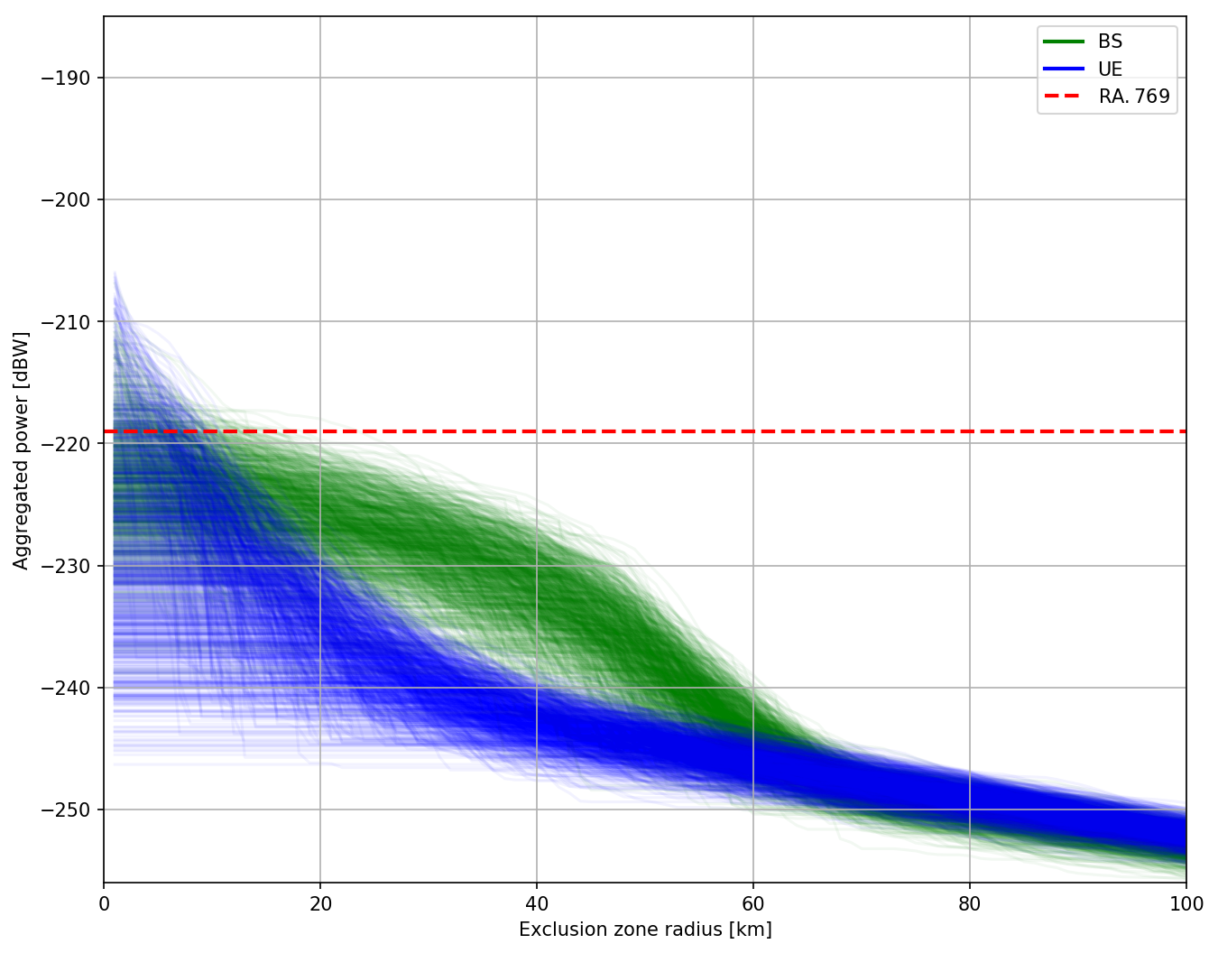
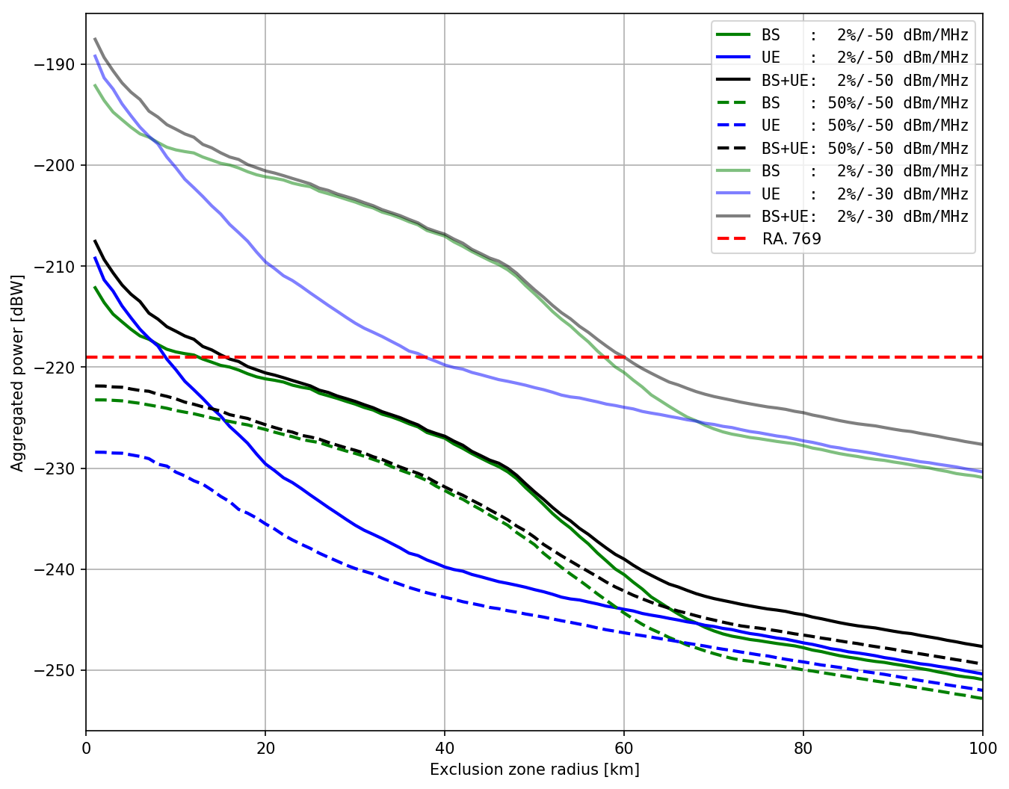
Figure 51: Aggregated power (clustered, ρ=0.2) as a function of separation distance
Top panel: Monte Carlo simulation results for the -50 dBm/MHz spurious emission level
Bottom panel: curves for the -50 and -30 dBm/MHz spurious emission levels

    - Summary and analysis of the results
For the generic compatibility study between the RAS in the frequency range 3.33-3.35 GHz and IMT systems in the frequency band 3.4-3.6 GHz it was assumed that the RAS will be affected in the spurious domain of the emission mask of the IMT devices. Both single-interferer and aggregate emission scenarios were studied.
Results are listed in Table 41 as separation distances, or exclusion zone radii, around RAS stations for two levels of spurious emission from IMT equipment. The assumed nominal level (power spectral density) of spurious emission into the RAS band is -50 dBm/MHz. The entries for the -30 dBm/MHz level are provided for comparison. For the single-interferer case radii were calculated for two different kinds of environmental zones (urban and rural). However, as clutter types and antenna heights are equal currently, the results are identical.
For spurious emissions of IMT systems at the -50 dBm/MHz level, in a typical deployment scenario assuming a constant density of BSs and UEs around an RAS station, for user equipment separation distances of 1 km will be required for a single interferer and 3 km for aggregate emissions, whereas for base stations separation distances are 22 km for a single interferer and 11 km for the aggregate scenario. If the combined aggregated emissions of both BSs and UEs are considered, a separation distance of 14 km is necessary. Here, only the uniform-density results (ρ=0.8) for the aggregation have been considered, because the final clustering properties to be used are not known yet. If the spurious emission limits were significantly relaxed to -30 dBm/MHz, much larger separation distances were necessary, of about 60 km for UE and BS combined (aggregate scenario).
A flat-earth terrain profile was used in all cases; separation distances will decrease in case of mountainous terrain. Concerning the use of detailed terrain profiles, it is noted that for a similar generic study regarding the RAS in the passive band 23.6-24 GHz (Document 5-1/162 [56]) the results for the single-interferer scenario are consistent with those of Document 5-1/73 [53] where detailed terrain profiles were used.
Table 43: Separation distances around RAS stations for various scenarios, ρ=0.8
Zone | Pspurious (dBm/MHz) | Separation distance for BS (km) | Separation distance for UE (km) | Separation distance for BS+UE (km)
Single interferer
Urban | -50 | 22 | 1 | n/a
Rural | -50 | 22 | 1 | n/a
Urban | -30 | 62 | 9 | n/a
Rural | -30 | 62 | 9 | n/a
Aggregate scenario, uniform density (2%)
 | -50 | 11 | 3 | 14
 | -30 | 60 | 31 | 61
Aggregate scenario, clustered (2%)
 | -50 | 22 | 9 | 23
 | -30 | 62 | 38 | 64

Table 44: Separation distances around RAS stations for various scenarios, ρ=0.2
Zone | Pspurious (dBm/MHz) | Separation distance for BS (km) | Separation distance for UE (km) | Separation distance for BS+UE (km)
Single interferer
Urban | -50 | 10 | 1 | n/a
Rural | -50 | 10 | 1 | n/a
Urban | -30 | 55 | 9 | n/a
Rural | -30 | 55 | 9 | n/a
Aggregate scenario, uniform density (2%)
 | -50 | 5 | 3 | 8
 | -30 | 56 | 31 | 57
Aggregate scenario, clustered (2%)
 | -50 | 13 | 9 | 16
 | -30 | 58 | 38 | 60
- List of References

- ECC(17)117 Annex 22: CEPT Roadmap for 5G, updated November 2017
- ECC Report 203: "Least Restrictive Technical Conditions suitable for Mobile/Fixed Communication Networks (MFCN), including IMT, in the frequency bands 3400-3600 MHz and 3600-3800 MHz", Corrected March 2014
- ECC Decision (11)06: "Harmonised frequency arrangements for mobile/fixed communications networks (MFCN) operating in the bands 3400-3600 MHz and 3600-3800 MHz" - Approved 09 December 2011, Amended 14 March 2014
- ITU Radio Regulations Edition of 2016
- ERC Report 25: “The European table of frequency allocations and applications in the frequency range 8.3 kHz to 3000 GHz”, updated October 2017
- ECC Report 254: "Operational guidelines for spectrum sharing to support the implementation of the current ECC framework in the 3600-3800 MHz range", November 2016
- ECC Recommendation (04)05: “Guidelines for accommodation and assignment of Multipoint Fixed Wireless systems in frequency bands 3.4 - 3.6 GHz and 3.6 - 3.8 GHz”, amended February 2006
- ECC Decision (07)02: “Availability of frequency bands between 3400-3800 MHz for the harmonised implementation of Broadband Wireless Access systems (BWA)”, withdrawn in July 2018
- EC Decision 2008/411/EC: “Commission Decision of 21 May 2008 on the harmonisation of the 3400 - 3800 MHz frequency band for terrestrial systems capable of providing electronic communications services in the Community”
- CEPT Report 049: “Technical conditions regarding spectrum harmonisation for terrestrial wireless systems in the 3400-3800 MHz frequency band”, Corrected March 2014
- Resolution ITU-R 56: “Naming for International Mobile Telecommunications”
- Recommendation ITU-R M.2083-0: “IMT Vision - "Framework and overall objectives of the future development of IMT for 2020 and beyond"”
- Recommendation ITU-R M.1457-13: “Detailed specifications of the terrestrial radio interfaces of International Mobile Telecommunications-2000 (IMT-2000)”
- Recommendation ITU-R M.2012-2: “Detailed specifications of the terrestrial radio interfaces of International Mobile Telecommunications Advanced (IMT-Advanced) ”’
- Recommendation ITU-R M.1645-0: “Framework and overall objectives of the future development of IMT-2000 and systems beyond IMT-2000”
- 3GPP TS 37.104 Technical Specification Group Radio Access Network: "E-UTRA, UTRA and GSM/EDGE; Multi-Standard Radio (MSR) Base Station (BS) radio transmission and reception (Release 15)"
- Recommendation ITU-R M.2101-0 (02/2017): "Modelling and simulation of IMT networks and systems for use in sharing and compatibility studies"
- 3GPP TS 37.105 Technical Specification Group Radio Access Network: "Active Antenna System (AAS) Base Station (BS) transmission and reception (Release 14)"
- 3GPP R4-168430: “On NRb BS ACLR requirement”, Huawei, 3GPP TSG-RAN WG4 #80bis, October 2016.
- 3GPP R4-165896: “Metric for unwanted emissions and ACLR”, Ericsson, 3GPP TSG-RAN WG4 #80, August 2016
- 3GPP TR 37.840 Technical Specification Group Radio Access Network: "Study of Radio Frequency (RF) and Electromagnetic Compatibility (EMC) requirements for Active Antenna Array System (AAS) base station (Release 12)
- 3GPP R4-165899: “On modelling the spatial shape of ACLR”, Ericsson, 3GPP TSG-RAN WG4 #80, August 2016
- ECC Report 216: "Practical guidance for TDD networks synchronisation", August 2014
- 3GPP R1-1611081: Final Report of 3GPP TSG RAN WG1 #86bis, November 2016
- 3GPP TS 38.104 V15.0.0 (2017-12), "NR; Base Station (BS) radio transmission and reception (Release 15)”
- ETSI TS 136 104 V14.6.0, “LTE; Evolved Universal Terrestrial Radio Access (E-UTRA); Base Station (BS) radio transmission and reception (3GPP TS 36.104 version 14.6.0 Release 14)”
- ETSI TS 136 101, “LTE; Evolved Universal Terrestrial Radio Access (E-UTRA); User Equipment (UE) radio transmission and reception (3GPP TS 36.101 version 14.6.0 Release 14)”
- ECC PT1(17)070, “LS on Suitability of technical conditions of ECC/DEC/(11)06 for 5G”, 3GPP TSG-RAN WG4, April 2017
- Report ITU-R M.2292-0: “Characteristics of terrestrial IMT-Advanced systems for frequency sharing/interference analyses”
- ITU-R WP 5D Document 475: “Proposal on operational characteristics of IMT-2020 systems for sharing and compatibility studies under WRC-19 agenda item 1.13”, Japan, February 2017
- ITU-R TG5/1 Document 36: “Liaison statement to Task Group 5/1 - Spectrum needs and characteristics for the terrestrial component of IMT in the frequency range between 24.25 GHz and 86 GHz”, ITU-R WP 5D, February 2017
- Recommendation ITU-R P.452-16: “Prediction procedure for the evaluation of interference between stations on the surface of the Earth at frequencies above about 0.1 GHz ”
- Recommendation ITU-R P.2108-0: “Prediction of Clutter Loss”
- ITU-R TG5/1 Document 104: “Polarization loss for aggregate studies”, France, July 2017
- Recommendation ITU-R M.1464-2: “Characteristics of radiolocation radars, and characteristics and protection criteria for sharing studies for aeronautical radionavigation and meteorological radars in the radiodetermination service operating in the frequency band 2 700-2 900 MHz”
- Recommendation ITU-R M.1465-2: “Characteristics of and protection criteria for radars operating in the radiodetermination service in the frequency range 3 100-3 700 MHz”
- 3GPP R4-125474: “Updated simulation results for AAS ACLR”, Huawei, 3GPP TSG-RAN WG4 #64Bis, October 2012
- Recommendation ITU-R F.1336-4: “Reference radiation patterns of omnidirectional, sectoral and other antennas for the fixed and mobile service for use in sharing studies in the frequency range from 400 MHz to about 70 GHz ”
- EC Decision 2014/276/EU: “Commission Implementing Decision of 2 May 2014 on amending Decision 2008/411/EC on the harmonisation of the 3400 - 3800 MHz frequency band for terrestrial systems capable of providing electronic communications services in the Community”
- Recommendation ITU-R P.525-3: “Calculation of free-space attenuation ”
- Recommendation ITU-R P.528-3: “Propagation curves for aeronautical mobile and radionavigation services using the VHF, UHF and SHF bands”
- “Radar system analysis and design using Matlab”, B R Mahafza, Chapman and Hall/CRC, 2000. ISBN 1-58488-182-8
- “Advanced Engineering Mathematics”, E. Kreyszig, John Wiley, 1983
- Recommendation ITU-R RA.769-2: “Protection criteria used for radio astronomical measurements ”
- Recommendation ITU-R SA.509-3: “Space research earth station and radio astronomy reference antenna radiation pattern for use in interference calculations, including coordination procedures, for frequencies less than 30 GHz”
- Recommendation ITU-R RS.2066-0: “Protection of the radio astronomy service in the frequency band 10.6-10.7 GHz from unwanted emissions of synthetic aperture radars operating in the Earth exploration-satellite service (active) around 9 600 MHz”
- Report ITU-R M.2322-0: “Systems characteristics and compatibility of automotive radars operating in the frequency band 77.5-78 GHz for sharing studies ”
- Recommendation ITU-R RA.314-10: “Preferred frequency bands for radio astronomical measurements ”
- ITU-R TG 5/1 Document 27: “Liaison statement to Task Group 5/1 on parameters concerning the radio astronomy service for WRC-19 agenda item 1.13”, ITU-R WP 7D, November 2016
- ITU-R TG 5/1 Document 176: “Liaison statement to Task Group 5/1 on apportionment of interference between services in studies concerning the radio astronomy service (WRC-19 agenda item 1.13)” , ITU-R WP 7D, October 2017
- Recommendation ITU-R RA.1513-2: “Levels of data loss to radio astronomy observations and percentage-of-time criteria resulting from degradation by interference for frequency bands allocated to the radio astronomy service on a primary basis”
- ITU-R TG5/1 Document 92: “Report on the meeting of Task Group 5/1 (15-23 May 2017)”
- ITU-R TG 5/1 Document 173: “Report on the third meeting of Task Group 5/1 (Abu Dhabi, United Arab Emirates, 19-28 September 2017)”
- ITU-R TG 5/1 Document 38: “Liaison statement to Task Group 5/1 - Guidance on the use of ITU-R P-Series Recommendations for interference prediction and sharing studies under WRC-19 agenda item 1.13”, ITU-R WPs 3K, 3J &3M, March 2017
- Recommendation ITU-R SM.329-12: “Unwanted emissions in the spurious domain ”
- ITU-R TG 5/1 Document 162: “Compatibility study between the radio astronomy service in the passive band 23.6-24 GHz and IMT systems in the frequency band 24.25-27.5 GHz”, Committee on Radio Astronomy Frequencies, September 2017

The term IMT covered IMT-2000 and IMT-Advanced systems.
In the context of the ECC Decision (11)06, synchronised networks refer to networks which are synchronised and all uplink and downlink transmissions are aligned.
In case of passive systems, the antenna gain does not vary much between the wanted signal and unwanted emissions. Thus, e.i.r.p. is directly proportional to TRP and can be used as a substitute.
ECC Report 216 "Practical guidance for TDD networks synchronisation" [23] contains some of the considerations that might be relevant for the definition of the regulatory framework"
TRP is a measure of how much power the antenna actually radiates. The TRP is defined as the integral of the power transmitted in different directions over the entire radiation sphere. e.i.r.p. and TRP are equivalent for isotropic antennas.
The detailed work on the RF parameters related to 3400 to 3800 MHz is ongoing in 3GPP, and TSG RAN can give a preliminary response based on the present status of discussions.
The detailed work on the RF parameters related to 3400 to 3800 MHz is ongoing in 3GPP, and TSG RAN can give a preliminary response based on the present status of discussions.
As indicated by the document TG5/1/104: the 3dB derived value is only valid when "there is a large number of IMT stations seen by the antenna in a direction where the antenna has a given polarization ellipse and that these IMT stations have uncorrelated polarization ellipses, so that the polarization discrimination will be the average discrimination polarization M", i.e. when the dominant effect of the interference is not due to few Base Stations, unlike the scenario with terrestrial Base Stations.
Noting that main military radars operating in France have similar characteristics to Radar I.
Several sectors may be active, i.e. transmit, while other sectors of the same site do not.
And for a larger area, rural deployment should be also considered.
The graphic displays “1” as a probability but this value is a rounded one of a 4 decimal precisions number (0.9999).
Here we consider macro base station deployments because they (rather can micro cell deployments) represent the more critical case in terms of the likelihood of harmful interference to radar.
The power radiated by the array is then equal to the total conducted power input to the array system, multiplied by the array system gain.
See for example, R4-125474 (Huawei) [37] and R4-165896 (Ericsson) [20].
Note that the value of the antenna element gain has to be calculated according to the specific vertical and horizontal 3 dB beamwidths and front-to-back ratios in order to ensure conservation of energy.
Note that the value of the antenna maximum gain has to be calculated according to the specific vertical and horizontal 3 dB beamwidths and front-to-back ratios in order to ensure conservation of energy
As noted in section 3 of Annex 1 in ITU-R M.1465-2 [36], an I/N ratio of -6dB may not be adequate for systems such as this that use pulse compression techniques, however results have been included for comparison
50% time probability is appropriate as the radar operates in an airborne area and is therefore mobile
Powers were based on the powers of a 2.1 GHz network with the addition of 5dB so that an equivalent C-band network would have similar cell coverage to the 2.1 GHz network. If necessary, base station powers were capped at 68 dBm / 5 MHz.
These figures are reduced slightly to take account of vertical antenna discrimination between the radar and the base station.
Although for beams with a large steering angle, there may be a secondary beam that is less than 13dB down
The following is based on a similar IMT-RAS compatibility study, which concerns the RAS frequency band 42.5-43.5 GHz and IMT systems in the frequency range 37-43.5 GHz

