
Electronic Communications Committee (ECC)
within the European Conference of Postal and Telecommunications Administrations (CEPT)

PROTECTION OF THE RADIO ASTRONOMY SERVICE
FROM UNWANTED EMISSIONS OF HEO BSS SYSTEMS OPERATING
IN THE BAND 620-790 MHz

Galati, May 2004

EXECUTIVE SUMMARY

This report considered the compatibility between Highly Elliptical Orbit (HEO) Broadcasting Satellite Service (BSS) systems operating in the band 620-790 MHz and Radio Astronomy Service (RAS) stations operating in the 608-614 MHz. Other bands which may be concerned since they are used by some RAS stations are also examined in the present document (namely 1330-1400 MHz – see ITU RR No. 5.149, and 1400-1427 MHz).

This study showed that the compatibility between unwanted emissions from HEO BSS systems operating in the band 620-790 MHz and the RAS in the bands 608-614 MHz, 1330-1400 MHz and 1400-1427 MHz can be ensured if the pfd radiated by a HEO BSS satellite at any RAS station is lower than the values given in the table below.

RAS band (MHz) | pfd limit per satellite (dBW/m²) | Reference bandwidth (MHz)
608-614 (reference) | -188.0 | 6
1330-1400 (spectral line) | -198.7 | 0.02
1400-1427 (continuum) | -183.7 | 27
1400-1427 (spectral line) | -198.7 | 0.02
Maximum pfd levels per HEO BSS satellite to protect RAS

These levels ensure that the loss of data to the RAS over the part of the sky within which the RAS station performs observations, taking into account the minimum elevation angle θ_{min} at which the RAS station conducts observations in the frequency band (as defined in the Table A of Annex 2 to the RR Appendix 4 (WRC-03)), will be less than 2%.

It should be noted that this Report does not give guidance on the combined effect to the RAS of several BSS systems and on the feasibility of the required attenuation for BSS systems. When necessary, further work may be initiated on this matter.

INDEX TABLE

1 INTRODUCTION 3
2 METHODOLOGY 3
3 HEO BSS SYSTEM CHARACTERISTICS 3
3.1 Constellation parameters 3
3.2 Times of satellite activity 3
3.3 Satellite antenna and power management 3
4 RAS STATIONS CHARACTERISTICS 3
4.1 Locations 3
4.2 Antenna characteristics: 3
5 INTERFERENCE THRESHOLD FOR THE RAS 3
6 DETERMINATION OF THE REQUIRED REJECTION LEVEL 3
6.1 Procedure 3
6.2 Results for the band 608-614 MHz 3
7 EXTRAPOLATION TO OTHER RAS BANDS 3
8 CONCLUSIONS 3

Protection of the Radio Astronomy Service from unwanted emissions of HEO BSS systems
operating in the band 620-790 MHz
- INTRODUCTION
The study presented in this report aimed at determining the maximum pfd value that can be radiated by one satellite from a non-GSO HEO BSS system into the band 608-614 MHz and still adequately protect the RAS service in this band.

In addition to the RAS band 608-614 MHz, other RAS bands which may be concerned are examined in the present report (namely 1330-1400 MHz – see ITU RR No. 5.149, and 1400-1427 MHz).

It should be noted that this report does not give guidance on the combined effect to the RAS of several BSS systems and on the feasibility of the required attenuation for BSS systems. When necessary, further work may be initiated on this matter.
- METHODOLOGY
Recommendation ITU-R S.1586 provides a methodology for evaluating the levels of unwanted emissions produced by a non-geostationary satellite system at RAS sites. It is based on a division of the sky into cells of nearly equal size and a statistical analysis, where the pointing direction of the RAS antenna and the starting time of the satellite constellation are the random variables. For each trial, the unwanted emission level (expressed in terms of epfd) is averaged over a 2000 s period.

In the case of a HEO system the calculation is greatly simplified because there is only one satellite transmitting towards the Earth at any time and the orbital period of the constellation is short.

Moreover, Annex 1 to Recommendation ITU-R RA.769 provides the threshold levels for interference detrimental to the RAS and Recommendation ITU-R RA.1513 provides a criterion of 2% for maximum allowable data loss to the RAS due to interference from any one network, which is determined as the percentage of integration periods of 2000 s in which the average spectral power flux-density (pfd) at the radio telescope exceeds the levels defined in Recommendation ITU-R RA.769.

The purpose of the present study was to determine the maximum pfd level required from non-GSO HEO BSS systems emissions to comply with the criteria of Recommendations ITU-R RA.1513 and ITU-R RA.769, using the methodology of Recommendation ITU-R S.1586, which is designed to take into account the non-geostationary nature of these systems when assessing their unwanted emission levels at radio telescope sites.

The analysis has been carried out for 14 RAS stations operating in the bands 608-614 MHz and 1330-1427 MHz and located inside or near the service area of a HEO BSS system operating in conformance to RR No. 5.311 in the band 620-790 MHz.
- HEO BSS SYSTEM CHARACTERISTICS
HEO BSS systems may be operated in accordance with ITU RR No. 5.311 in the band 620-790 MHz. For the purpose on this analysis the following characteristics were considered.

Constellation parameters
The constellation parameters are optimized to offer satisfactory visibility conditions to any users within the service area. The example below illustrates the case of a Tundra constellation covering Western European countries with 3 satellites orbiting in a 24 hour period:
- Semi-major axis: 42 164 km
- Eccentricity: 0.2684
- Inclination: 63.4°
- Argument of perigee: 270°
- Right ascension of ascending node: 110°, 230° and 350°
- Mean anomaly: 340°, 220° and 100°

Figure 1 illustrates the satellite’s ground track on the Earth’s surface.
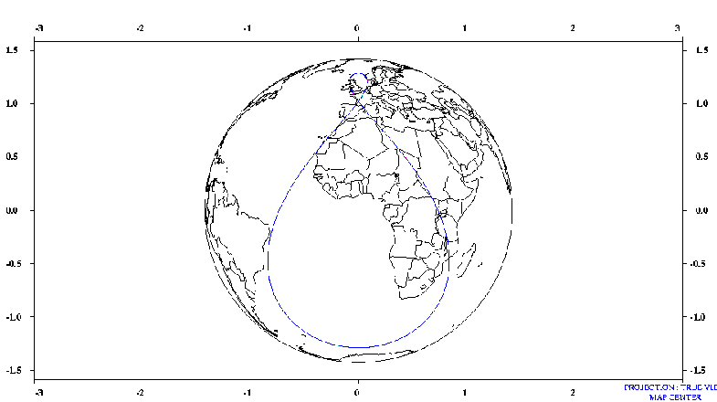
Service area
Figure 1: HEO constellation ground track

Times of satellite activity
With the orbital parameters of an HEO constellation, a given satellite is in visibility of the service area with an elevation angle better than 60° only 1/3 of the time:
- Over its 24-hour orbit period, the satellite will be in visibility of the service area with an elevation angle better than 60° during a continuous period of 8 hours, after which 16 hours will be spent in “non-visibility”.
- Satellites will be programmed to be inactive during their 16-hour long periods of “non-visibility”. This means that only one satellite will be transmitting towards the service area at any given time.

Satellite antenna and power management
The satellite antenna will be designed to meet a number of requirements during the active transmissions periods:
- Iso-flux transmission over the service area
The satellite will use an iso-flux antenna to optimize its power requirements and to cope with the power-flux density limits in the service area. It means that the satellite antenna gain within the service area will be such that the power-flux density at the Earth’s surface will be kept constant, irrespective of the position of a terminal within the service area.
- Beam zooming
The solid angle with which a satellite sees the service area will vary with time, as function of its altitude. In order to cope with this “zooming effect” and to reduce the overall power requirements, the satellite will also adjust the power and the shape of its beam as function of its altitude.

Consequently, the pfd on the ground will be kept constant, irrespective of time and location of the terminal within the service area.

RAS STATIONS CHARACTERISTICS

Locations
Information about the European RAS stations operating in the band 608-614 MHz are available on the COMMITTEE RADIO ASTRONOMY FREQUENCIES of the European Science Foundation (CRAF) website (www.astron.nl/craf) and are reproduced in Table 1.

Country | Station | Longitude (East) | Latitude (North)
Austria  Belgium  France  Germany  Italy  The Netherlands  Poland  Portugal  Russian Federation  Switzerland  United Kingdom | Lustbühel  Humain  Nançay  Effelsberg  Tremsdorf  Medicina  Westerbork  Toruń  Espiunca  Kalyazin  Zimenki  Bleien  Cambridge  Jodrell Bank | 15° 29'34"  05° 15'19"  02° 12'00"  06° 53'00"  13º 08'12"  11° 38'43"  06° 36'15"  18° 33'30"  -08° 13'52"  37° 54'01"  43° 57'00"  08° 06'44"  00° 02'20"  -02° 18'26" | +47° 04'03"  +50° 11'31"  +47° 23'00"  +50° 31'32"  +52º 17'06"  +44° 31'14"  +52° 55'01"  +52° 54'48"  +40° 59'57"  +57° 13'22"  +56° 18'00"  +47° 20'26"  +52° 09'59"  +53° 14'10"
Table 1: European RAS stations requiring protection in the band 608-614 MHz
Note: After completion of the studies, it became known that one more RAS station in Russian Federation (Pushchino, 37°E40'00"; 54°N49'00") performs VLBI observations in the band 608 - 614 MHz. However, it was assumed that the conclusions of this report should be valid for this station as well.

Antenna characteristics:
Assumed RAS station antenna diameter: 100m (note that this parameter has hardly any influence on the results);
Antenna pattern and peak gain at boresight: ITU-R RA.1631
Minimum elevation angle: 0°.

INTERFERENCE THRESHOLD FOR THE RAS
The affected RAS bands with their corresponding detrimental threshold levels are given in table 2 hereafter:

Frequency band (MHz) | Interference level (dBW/m²) | Reference bandwidth (MHz) | Type of observation
608-614  1330-1400  1400-1427  1400-1427 | -185  -196  -180  -196 | 6  0.02  27  0.02 | Continuum  Spectral line  Continuum  Spectral line
Table 2: RAS frequency bands and detrimental interference threshold levels

A detrimental threshold level corresponds to a protection criterion in terms of epfd of:
epfd_{lim} = pfd_{lim} – G_{max}
Frequency band (MHz) | epfd interference level (dBW/m²) | Reference bandwidth (MHz)
608-614  1330-1400  1400-1427  1400-1427 | -241  -259  -243  -259 | 6  0.02  27  0.02
Table 3: RAS detrimental interference epfd threshold levels
Note: there is no protection criterion defined in Recommendation ITU-R RA.769 for the band 1330-1400 MHz (see No. 5.149). The protection criterion listed above for this band was derived from the one used in the band 1400-1427 MHz in case of spectral line observations.

DETERMINATION OF THE REQUIRED REJECTION LEVEL

Procedure
The following approach is used to determine the pfd limit per satellite required to meet the epfd associated with the 2% maximum allowable data loss criterion (see Recommendation ITU-R S.1586):
Step 1: Selection of a pfd value per satellite.
Step 2: Selection of a RAS station.
Step 3: Division of the sky into 2334 cells of about 9 square degrees solid angle each (see Table 1 Annex 3 of Rec. ITU-R S.1586).
Step 4: For each cell, within which the RAS station performs operation (taking into account the minimum elevation angle θ_{min} at which the RAS station conducts observations in the frequency band as defined in Appendix 4 of the RR and any other restriction at the considered RAS station), point the radio telescope towards a randomly chosen direction within the cell, and start the satellite transmissions at a randomly chosen point in time. The epfd is then evaluated for each time sample over a 2000 s integration time, with a time step of 1 second. The average epfd corresponding to this trial is then calculated.
Step 5: If the epfd level averaged over the 2000 s integration interval of the trial exceeds the interference threshold level, that particular 2000 seconds observation is considered to be affected.
Step 6: Repeat steps 4 and 5 to get a representative number of trials (30 trials were found to be statistically sufficient).
Step 7: Determine the percentage of affected integration periods of 2000 s over the whole sky.
Step 8: Change the pfd level from the non-GSO HEO BSS system until this percentage is below 2%.

Results for the band 608-614 MHz
Table 4 hereafter gives the percentages of data loss obtained with a pfd value of –188 dBW/m² radiated at the listed RAS stations in the band 608-614 MHz. This pfd value corresponds to an attenuation of 74 dB of the pfd radiated by the HEO BSS satellite at the Earth’s surface in a 6 MHz bandwidth under the assumption that the maximum pfd radiated by the HEO BSS system in the 620-790 MHz band is –113 dBW/(m².8MHz), which is the maximum level indicated in ITU-R Rec. 705.

Country | Station | Percentage of data loss
Austria  Belgium  France  Germany  Italy  The Netherlands  Poland  Portugal  Russian Federation  Switzerland  United Kingdom | Lustbühel  Humain  Nançay  Effelsberg  Tremsdorf  Medicina  Westerbork  Toruń  Espiunca  Kalyazin  Zimenki  Bleien  Cambridge  Jodrell Bank* | 1.80 %  1.73 %  1.74 %  1.70 %  1.70 %  1.74 %  1.72 %  1.78 %  1.76 %  1.79 %  1.70 %  1.72 %  1.68 %  1.67 %
Table 4: Percentage of data loss
* Minimum RAS antenna elevations of 0° were used; note that, when considering a minimum elevation angle of 5°, the percentage of data loss is 1.86%, still below 2%.
Figure 2 gives for the RAS site of Jodrell Bank, for each cell, over the whole sky, the number of 2000 s long trials where the epfd criterion has been exceeded. The total number of trials per cell is 30, the vertical scale on the right represents the number of trials per cell for which the epfd criterion has been exceeded. For example, Figure 2 shows that if the radio telescope points towards an azimuth of 350° and an elevation of 84° to 87° (see the corresponding cell in Figure 2), all the observations performed will be affected by interference exceeding the detrimental level given in Recommendation ITU-R RA.769.

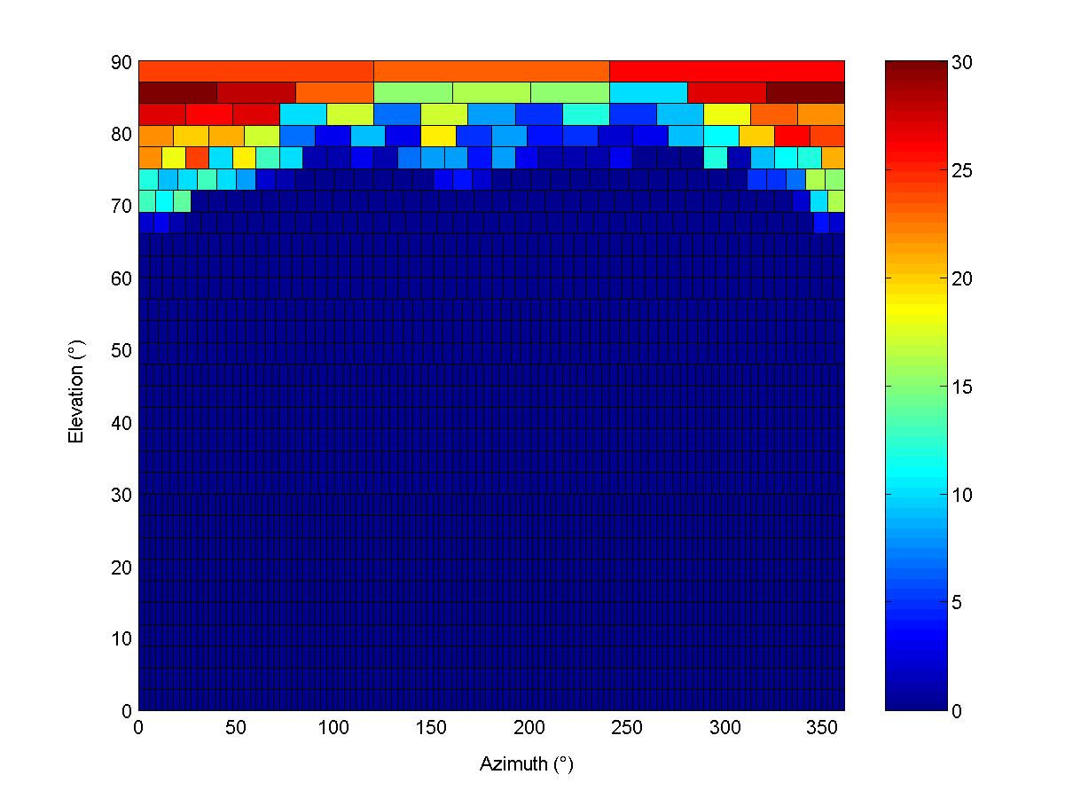
Figure 2: Simulation results for Jodrell Bank

EXTRAPOLATION TO OTHER RAS BANDS
The power received by the RAS station receiver to be compared with the detrimental threshold level is:
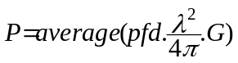 (1)
where,

P Received power in the RAS bandwidth (W),
pfd pfd radiated by one satellite at the RAS station in the RAS bandwidth (assumed constant) (W/m²),
λ Wavelength (m),
G RAS antenna gain in the direction of the satellite.

The average is calculated over the assumed 2000 seconds duration of a RAS observation.

From this equation, it is seen that the difference from one frequency to another is determined by: the value of λ, the radio telescope antenna gain, the detrimental threshold level, and the propagation conditions. Document 7D/99 in ITU-R WP 7D has already shown that the antenna gain has hardly any influence on the results: that is why an antenna diameter of 100 m is chosen for all frequencies in all studies. Moreover, for the frequencies considered here, the propagation conditions do not change a lot. It is therefore possible to consider that the difference in pfd per satellite from one frequency to another will be mainly due to the wavelength and the detrimental threshold level.
Therefore:

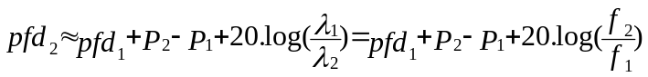 (2)

where,
pfd₁ required pfd per satellite at frequency 1 (dBW/m²),
pfd₂ required pfd per satellite at frequency 2 (dBW/m²),
P₁ detrimental threshold level at frequency 1 (dBW),
P₂ detrimental threshold level at frequency 2 (dBW),
f1 frequency 1 (MHz),
f2 frequency 2 (MHz)

Applying this method for all the considered RAS bands, the following pfd levels may be produced, as shown in Table 5:

RAS band (MHz) | pfd limit per satellite (dBW/m²) | Reference bandwidth (MHz)
608-614 (reference) | -188.0 | 6
1330-1400 (spectral line) | -198.7 | 0.02
1400-1427 (continuum) | -183.7 | 27
1400-1427 (spectral line) | -198.7 | 0.02
Table 5: Maximum pfd levels per HEO BSS satellite to protect RAS

In order to check the validity of this extrapolation method, the epfd simulation was performed over Nançay RAS station in the band 1400-1427 (spectral line). The percentage of data loss obtained was 1.76 %, to be compared with 1.74 % obtained in the band 608-614 MHz.

CONCLUSIONS
This study showed that the compatibility between unwanted emissions from HEO BSS systems operating in the band 620-790 MHz and the RAS in the bands 608-614 MHz, 1330-1400 MHz and 1400-1427 MHz can be ensured if the pfd radiated by a HEO BSS satellite at any RAS station is lower than the values given in Table 5, in the sense that the loss of data to the RAS over the part of the sky within which the RAS station perform observations (taking into account the minimum elevation angle θ_{min} at which the RAS station conducts observations in the frequency band, as defined in the Table A of Annex 2 to the RR Appendix 4 (WRC-03)), will be less than 2%.

