

CEPT Report 26

Report from CEPT to the European Commission
in response to the Permanent Mandate to CEPT regarding the
“annual update of the technical annex of the Commission Decision on the technical harmonisation of radio spectrum for use by short range devices”

Final Report on 13 March 2009 by the

Electronic Communications Committee (ECC)
within the European Conference of Postal and Telecommunications Administrations (CEPT)

- Executive summary
This Report describes the update of the technical annex of the EC Decision on Short Range Devices (SRD) and has been developed in 2008 by the European Conference of Postal and Telecommunications Administrations (CEPT) in response to the Permanent Mandate to CEPT regarding the annual update of the technical annex of the Commission Decision on the technical harmonisation of radio spectrum for use by short range devices.

The update proposes the following changes to the annex:

- Conditional inclusion of the band 2400 - 2483.5 MHz for Wideband Data Transmission systems.
- Conditional inclusion of the band 2400 - 2483.5 MHz for radiodetermination applications
- Conditional inclusion of the band 57 - 66 GHz for Wideband Data Transmission systems
- Conditional inclusion of the band 17.1 - 17-3 GHz for Ground Based Synthetic Aperture Radar (GBSAR)
- Inclusion of the frequency bands for Tank Level Probing Radar (TLPR)
- Inclusion of frequencies 26.995, 27.045, 27.095, 27.145 and 27.195 MHz for Model control
- An additional regulatory text for Active medical implants in the frequency band 402 - 405 MHz.

The following items for further work were indentified:

- Identify the need for compatibility studies and possible inclusion in the technical annex of the frequency bands 9200 - 9500 MHz, 9500 - 9975 MHz, 10.5 - 10.6 GHz and 13.4 - 14.0 GHz for radiodetermination applications.
- Complete the ongoing compatibility studies for the frequency band 24.05 - 24.25 GHz for radiodetermination applications and possibly include this band in the technical annex.
- Investigate 500mW and 4W permissible power levels for the frequency band 2446 - 2454 MHz for RFID.
- Develop generic limits for Ultra Low Power SRDs
- Consider the development of and contribute to the harmonised standard for indoor Multiple Gigabit Wireless Systems (MGWS) in the band 57 - 66 GHz to finalise the inclusion in the technical annex.
- Investigate the possible creation of additional generic spectrum for SRDs in the UHF frequency range.

Table of contents

0 Executive summary 2
1 Introduction 4
2 Background 4
3 Discussion 4
3.1 General principles 5
3.2 Review of ERC Recommendation 70-03 7
3.2.1 Non-specific Short Range Devices 7
3.2.2 Tracking, Tracing and Data Acquisition 8
3.2.3 Wideband Data Transmission systems 8
3.2.4 Railway applications 10
3.2.5 Road Transport and Traffic Telematics (RTTT) 10
3.2.6 Radiodetermination applications 11
3.2.7 Alarms 13
3.2.8 Model Control 13
3.2.9 Inductive applications 14
3.2.10 Radio microphones and Assistive Listening Devices 15
3.2.11 Radio frequency identification applications 15
3.2.12 Wireless applications in Healthcare 16
3.2.13 Wireless Audio Applications 16
3.3 Generic limits 17
3.3.1 Existing generic limits for SRDs 17
3.3.2 What further needs to be done. 17
3.3.3 Summary of actions required / Timescales 18
3.4 Indoor Multiple Gigabit Wireless Systems (MGWS) in the 57-66 GHz band 18
3.5 Active Medical Implants in the 402 - 405 MHz band 19
3.6 Additional generic spectrum for SRDs 20
3.7 Review of usage conditions for inductive applications 20
4 Overview of CEPT proposal 20
5 Work items for further investigations 21
Annex 1 : Guidance to CEPT regarding the annual update of the technical annex of the SRD Decision 2008/432/EC 22
Annex 2 : Proposed amendments to the technical annex of the EC Decision on SRDs 28
ANNEX Harmonised frequency bands and technical parameters for short-range devices 29
Annex 3: Plan for the implementation of SRD strategy given in the CEPT Report 014 (Summary) 38
Annex 4 : List of Abbreviations 40

- Introduction
This Report has been developed in 2008 by the European Conference of Postal and Telecommunications Administrations (CEPT) in response to the Permanent Mandate to CEPT regarding the annual update of the technical annex of the Commission Decision on the technical harmonisation of radio spectrum for use by short range devices.

Pursuant to Article 4 of the Radio Spectrum Decision, the Commission may issue mandates to the CEPT for the development of technical implementing measures with a view to ensuring harmonised conditions for the availability and efficient use of radio spectrum; such mandates shall set the task to be performed and the timetable thereof.

This report for the second update of the technical annex of the SRD Decision 2006/771/EC has been developed within SRD/MG and approved by WG FM and the ECC with contributions from administrations, ETSI and industry.

It was submitted to the European Commission in accordance with the timescales of the Guidance to CEPT regarding the annual update of the technical annex of the SRD Decision 2006/771/EC issued 3 April 2008 (Doc. RSCOM08-11 final) which is given in Annex 1 to this report.
- Background
The EC Decision on Short Range Devices (SRD) refers to Commission Decision of 9 November 2006 on harmonisation of the radio spectrum for use by short-range devices (2006/771/EC). This Decision was first amended by Commission Decision of 23 May 2008 (2008/432/EC).

The purpose of the EC Decision on Short Range Devices (SRD) is to harmonise the frequency bands and the related technical parameters for the availability and efficient use of radio spectrum for short-range devices so that such devices may benefit from ‘Class 1’ classification under Commission Decision 2000/299/EC.

Given their pervasive use in the European Community and in the world, short-range devices are playing an increasing role in the economy and in the daily life of citizens, with different types of applications such as alarms, local communications equipment, door openers or medical implants. The development of applications based on short-range devices in the European Community could also contribute to achieving specific Community policy goals, such as completion of the internal market, promotion of innovation and research, and development of the information society.

Due to the rapid changes in technology and societal demands, new applications for short-range devices will emerge, which will require constant scrutiny of spectrum harmonisation conditions, taking into account the economic benefits of new applications and the requirements of industry and users. Member States will have to monitor these evolutions. Regular updates of this Decision will therefore be necessary to respond to new developments in the market and technology.
- Discussion
In July 2006, ECC adopted CEPT Report 014 in response to a European Commission (EC) Mandate to develop a strategy to improve the effectiveness and flexibility of spectrum availability for Short Range Devices (SRDs). In order to take full benefits from this work, CEPT/WGFM tasked the SRD/MG to review the Recommendations contained in Report 014 and to identify practical steps to implement them.

The report developed in response to this task was approved by WG FM at its meeting in Brussels in May 2008 as the “Plan for the implementation of SRD strategy given in the CEPT Report 014”. As shown in the summary of this Plan which is provided in Annex 3 to this report, the annual review of the technical annex of the EC Decision on SRDs plays an important role for improving the European regulatory framework for SRDs.

The Guidance from the Commission to CEPT on the second update of the SRD Decision requests CEPT when preparing its response to the permanent mandate to take into account a number of principles which are generally consistent with the approach developed by CEPT for the implementation of the “SRD strategy”. It emphasizes in particular that “technical parameters in the technical annex of the SRD Decision set the requirements which all short range devices to be used in these bands must at least comply with while additional requirements defined via Harmonised Standards may apply in order to meet the essential requirements defined pursuant article 3 of the R&TTE Directive”. The Guidance document requests in addition CEPT to pay attention to a number of specific issues.

The outcome of CEPT investigations in view of improving existing regulatory framework for SRDs and identifying additional categories to be harmonised through the SRD Decision is presented in the following sections.

These investigations have resulted in a CEPT proposal for amendment of the technical annex of the EC Decision on SRD (see section 4 and Annex 3) and clarification of current CEPT work items for further investigations (see section 5).
  - General principles
The report on the implementation of the “SRD strategy” concludes the following concerning the annual review of the technical annex of the EC Decision on SRDs:
  - Priorities to be addressed on an annual basis need to be identified well in advance of the review;
  - The process shall aim to identify the “minimum regulation” (as per Recommendation i of CEPT Report 014) to ensure the efficient use of the radio spectrum and to avoid harmful interference;
  - Review of existing “national restrictions” (as per Recommendation ii of CEPT Report 014) could take place within this process;
  - The process should take due account of practical guidance given in support of pursuing the principles of application and technology neutrality wherever possible (see Recommendation iii of CEPT Report 014).

It shows among others that various levels of flexibility can be achieved by the specification of regulatory parameters, without omitting sharing obligations or constraints that have been identified through compatibility studies. Careful consideration is however required on a case by case basis.

The following guidelines have been proposed in support of ensuring that only minimum regulations are specified and are particularly relevant to the review process of the technical annex of the EC Decision on SRDs:
- When there is an obligation to use spectrum access/mitigation technique whose purpose is to protect a given radiocommunication service, then that purpose should be explicitly stated in the regulation and the detailed technical requirements should be described in the relevant harmonised standards only.
- In the case of sharing obligations between SRDs, greater flexibility is certainly desirable. The regulations should not preclude mitigation techniques that achieve the same effect with respect to sharing between the respective SRDs.
- Consideration of regulations for specific license-exempt applications with safety-critical implications, or more generally for applications with higher QoS (quality of service) requirements, suggest that more specific regulatory parameters could better preserve the usefulness of a frequency band.

With respect to the first bullet above, it should be noted that the ECC deliverables should provide the detailed technical requirements for spectrum access/mitigation technique that result of the compatibility studies performed by CEPT with the participation of relevant stakeholders including industry and ETSI. Such detailed technical requirements, which may e.g. be summarized in an Annex to an ECC Decision (see e.g. amended ECC/DEC/(06)12 on UWB DAA and LDC mitigation techniques), shall set the reference for the development of relevant ETSI Harmonised Standards in accordance with the principles of the ECC/ETSI MoU, but do not need to be replicated in national Radio Interface Specifications.

In ensuring that only the minimum regulations are specified, greater consistency of ERC/REC 70-03 with the common format of template agreed for the EFIS and national Interfaces should also be sought. The report on the implementation of the “SRD strategy” indicates also that consideration should be given to the terminology being used in the EC Decision on SRDs and whether it fits with the EFIS format. Consistency with the terminology used by ETSI Harmonised Standards and the ITU-R regulation has to be ensured too.

Greater consistency between the EC Decision on SRDs (Decision 2006/771/EC), ERC Recommendation 70-03 (ERC/REC 70-03) and associated ETSI harmonised standards is also required.

In the past, generic ETSI standard for SRDs (EN 300 220, EN 300 330 and EN 300 440) were not including regulatory parameters applying to SRD bands. Only classes of power were for instance defined and, concerning the permitted carrier power in a SRD frequency band, a reference to ERC/REC 70-03 was given.

ETSI EN 300 440-1 & -2 (V1.2.1) in their final version published in 2008 includes the detailed set of technical parameters for relevant SRD bands within frequency range 1 – 40 GHz. ETSI EN 300 220, currently under review, will follow the same trend thus rendering those HS self-standing and not relying on ERC/REC 70-03. In particular, the detailed channel arrangements for frequency band 863 – 870 MHz would be found in both ERC/REC 70-03 and ETSI EN 300 220.

This evolution goes actually along with the desired increased flexibility with respect to Radio Interface Specifications. The absence of the detailed set of technical requirements for band 863 – 870 MHz in the EC Decision on SRDs needs obviously to be compensated by its incorporation in the relevant “harmonised standards adopted under Directive 1999/5/EC”.

ERC/REC 70-03 keeps on its side the merit of offering a consolidated view of SRD regulations available in Europe and, unlike Harmonised Standards, can be amended quite rapidly.

This suggests simply that ERC/REC 70-03 should continue to provide the detailed set of technical parameters that are necessary to ensure an efficient use of the spectrum and avoid harmful interferences. Regulatory parameters should primarily reflect obligations to implement appropriate channel access/mitigation techniques to protect a given radiocommunication service while technical parameters needed to ensure intra-SRD sharing should appear as “informative parameters”, also referred to in the harmonised standard.

This guidance can be simply summarized with the table below:

Technical / operational parameters | ERC/REC 70-03 | ETSI harmonised standards | EC Decision on SRDs (Decision 2006/771/EC)
Protection of radio services | Included  (regulatory parameters) | Included | Included
Intra-SRD sharing criteria | Included  (informative part) | Included | Not included

  - Review of ERC Recommendation 70-03
    - Non-specific Short Range Devices
The table below presents the frequency bands included in Annex 1 of ERC/REC 70-03 (version of 30 May 2008) and their status with respect to the EC Decision on SRDs.

Annex 1 | Non-specific Short Range Devices | Comments / Status
1a | 6.765 - 6.795 MHz | Already covered by the EC Decision on SRDs.
1b | 13.553 - 13.567 MHz | Already covered by the EC Decision on SRDs.
1c | 26.957 - 27.283 MHz | Already covered by the EC Decision on SRDs.  Exclusion of video applications for consideration (see below)
1d | 40.660 - 40.700 MHz | Already covered by the EC Decision on SRDs.  Exclusion of video applications for consideration (see below)
1e | 138.200 - 138.450 MHz | Not planned for inclusion in the EC Decision on SRDs.  Not implemented by several administrations in Europe due to the operation of defence systems.
1f | 433.050 - 434.790 MHz | Already covered by the EC Decision on SRDs.  Exclusion of audio/voice signals and video applications for consideration (see below)
1g | 863 - 870 MHz | Already covered by the EC Decision on SRDs.  Exclusion of audio/voice signals and video applications for consideration (see below)
1h | 2400 - 2483.5 MHz | Already covered by the EC Decision on SRDs.
1i | 5725 - 5875 MHz | Already covered by the EC Decision on SRDs.
1j | 24.00 - 24.25 GHz | Band 24.15 – 24.25 GHz covered by the EC Decision on SRDs.  Ongoing compatibility studies and field tests performed within CEPT on the impact of 24 GHz SRDs on Radar Speed Meters (RSM) operated by police forces.
1k | 61.0 - 61.5 MHz | Already covered by the EC Decision on SRDs.
1l | 122 - 123 GHz | Not identified as a priority for inclusion in the EC Decision on SRD. Lack of demand expressed for EU harmonisation.
1m | 244 - 246 GHz | Not identified as a priority for inclusion in the EC Decision on SRD. Lack of demand expressed for EU harmonisation.

- Exclusion of audio/voice signals and video applications
CEPT further considered the issue of audio/voice signals and video applications and concluded that these exclusions should be retained for the moment until the necessary studies by the ETSI and by the ECC/WG SE/SE24 have been completed.

The possibility to keep the exclusion of audio/video only for analogue devices operating 100% duty cycle should be investigated.

As explained in section 3.1, ETSI Harmonised Standards EN 300 220 and EN 300 440 will include in their next version for publication in 2008/2009 the detailed set of technical specifications and essential requirements for relevant SRD bands (consistently with the values given in ERC/REC 70-03). Those HS are thus becoming “self-standing” in terms of technical parameters and no longer rely on a reference to ERC/REC 70-03.

National restrictions are though still possible provided they are justified “for reasons related to the effective and appropriate use of the radio spectrum, avoidance of harmful interference or matters relating to public health” (R&TTE Directive Article 7.2). Such restrictions are usually expected when there is a need to ensure the protection of a specific national usage.

The issue of restrictions on voice/audio signals and video applications in the non-specific SRD bands is actually a matter of “intra-SRD sharing”. Proper means to ensure coexistence between SRDs should be reflected in the ETSI standard.

The approach followed by ETSI when submitting draft amended ETSI EN 300 220 for public enquiry in April 2008 is basically “generic”. It does not include such restrictions on audio/voice/video which might suggest that coexistence is feasible as long as specified technical specifications and essential requirements (max power, duty cycle limit or LBT…) are met. Further deliberation within ETSI is however necessary.

There is no longer any justification for a fragmented European situation with respect to the issue of restrictions on audio/voice signals and video applications in the non-specific SRD bands. Conformity to the essential requirements in ETSI EN 300 220-2 shall provide confidence that various types of compliant SRDs can coexist together.

CEPT proposes to retain the restrictions on voice/audio signals and video applications in the technical annex of the EC Decision on SRDs for the moment taking into account ongoing deliberation within ETSI.

However, it should be noted that the removal of these restriction should allow substantial simplification of the alternative sets of usage conditions currently given for frequency bands 433.050 - 434.790 MHz and 863 – 870 MHz in the technical annex of the EC Decision on SRDs.
    - Tracking, Tracing and Data Acquisition
The table below presents the frequency bands included in Annex 2 of ERC/REC 70-03 (version of 30 May 2008) and their status with respect to the EC Decision on SRDs.

Annex 2 | Tracking, Tracing and Data Acquisition | Comments / Status
2a | 457 kHz | For Detection of avalanche victims.  Not identified as a priority for inclusion in the EC Decision on SRD. Already “class 1” (see sub-class 49).
2b | 169.4 - 169.475 MHz | For Meter Reading.  Already covered by the EC Decision on the harmonisation of the 169.4-169.8125 MHz frequency band (2005/928/EC).
2c | 169.4 - 169.475 MHz | For Asset Tracking and Tracing.  Already covered by the EC Decision on the harmonisation of the 169.4-169.8125 MHz frequency band (2005/928/EC).
    - Wideband Data Transmission systems
The table below presents the frequency bands included in Annex 3 of ERC/REC 70-03 (version of 30 May 2008) and their status with respect to the EC Decision on SRDs.

Annex 3 | Wide Band Data Transmission Systems | Comments / Status
3a | 2400 - 2483.5 MHz | For consideration
3b | 5150 - 5250 MHz | For wireless access systems including radio local area networks (WAS/RLANs).  Already covered by the EC Decision on 5 GHz WAS/RLANs (2005/513/EC).
3c | 5250 - 5250 MHz
3d | 5470 - 5725 MHz
3e | 17.1 - 17.3 GHz | Not identified as a priority for inclusion in the EC Decision on SRD. Lack of demand expressed for EU harmonisation.

- Frequency band 2400 - 2483.5 MHz
The use of frequency band 2400 – 2483.5 MHz by Wideband Data Transmission systems is nearly harmonised. Only France has a restriction: within the band 2454 - 2483.5 MHz, the operation of Wideband Data Transmission systems (WDTS) at max. 100 mW e.i.r.p. is restricted in France to indoor. It can be noted that operation in the band 2400 - 2483.5 MHz up to 10 mW e.i.r.p. is already harmonised in Europe under the provisions for non-specific SRDs.

France has indicated that its national restriction is necessary to avoid interference on radar defence systems which can be operated for the protection of public areas, notably during special events. Taking into account national refarming plans and the lifetime of existing radar equipments, France announced that this restriction shall remain until 1st July 2012.

The Guidance to CEPT from the Commission calls for consideration of this frequency band.

The consideration of this issue requires as a prerequisite an assessment of the potential benefits that could result from the inclusion of the 2.4 GHz band for WDTS/RLANs in the EC Decision on SRDs.

Some industry representatives underlined that the EC Decision on SRDs is of increasing importance for the industry although it is addressed to the EU Member States only. The inclusion of the 2.4 GHz band for WDTS/RLANs – which is used on a global basis – would give greater visibility to this frequency band.

The French administration has argued that its current national regulation, by allowing indoor operation at 100 mW e.i.r.p. within the whole of frequency band 2400 – 2483.5 MHz respond to the core market demand for RLANs. It is not likely to create any significant burden for administrations, manufacturers and users in other European countries.

Under the R&TTE Directive, the manufacturer or person responsible for the placing on the EU market of the device is obliged to inform users of national restrictions applicable in France through the user manual. ERC/REC 70-03 provides this information. Sub-class 22 is consistent with this restriction. Furthermore, as this restriction is basically « operational », TCAM agreed that equipment capable of operating at 100 mW across the whole of the 2.4 GHz band do not need to be notified to Member States under Article 6.4 of the R&TTE Directive:
*) “Equipment within the scope of subclass 22, but capable also of operating at 100 mW across the whole of the frequency band is not to be considered a class 1 device. They can be operated in the EU without restrictions indoor, but cannot be operated outdoors in France in the whole of the band until further notice. They have to be marked with the alert sign accordingly. Member States have however agreed, that they do not need to be notified to Member States under Article 6.4 of Directive 1999/5/EC, provided that users are informed about the restrictions of use.”

A preliminary conclusion can be drawn here: the 2.4 GHz band for WDTS/RLANs is already heavily used Europe wide and Worldwide and its inclusion would barely improve the “display” of this band in European regulatory tools. It would not improve however the “class 1” status since 2.4 GHz WDTS/RLANs operating at 100 mW are already not subject to R&TTE Article 6.4 notification.

French restriction shall remain until 1st July 2012 in order to protect primary radiolocation service. The possibility of a derogation given to France until this date is not a satisfactory solution as the French “indoor” restriction that is in force would be hidden in the EC Decision on SRDs which is likely to become a prime reference for the industry. This would cause confusion about the conditions of use allowed in Europe and could reduce the possibility to inform properly the end users of national restrictions in France.

In conclusion, inclusion of the band 2400 - 2483.5 MHz for Wideband Data Transmission systems can be envisaged under the condition of a clear and transparent display of the operational restriction that is in force in France. This can be achieved simply by incorporating the following text under the column ‘Other usage restrictions’:
“In France, the use of the band 2454 - 2483.5 MHz by Wideband Data Transmission systems with e.i.r.p. > 10 mW is restricted to indoor”

- Frequency band 57 - 66 GHz
See detailed consideration and proposal under section 3.4.
    - Railway applications
The table below presents the frequency bands included in Annex 4 of ERC/REC 70-03 (version of 30 May 2008) and their status with respect to the EC Decision on SRDs.

Annex 4 | Railway applications | Comments / Status
4a | 2446 - 2454 MHz | Not identified as a priority for inclusion in the EC Decision on SRD. Lack of demand expressed for EU harmonisation.
4b | 27.095 MHz | Not identified as a priority for inclusion in the EC Decision on SRD. Lack of demand expressed for EU harmonisation.
4c | 4234 kHz | Not identified as a priority for inclusion in the EC Decision on SRD. Lack of demand expressed for EU harmonisation.
4d1 | 4516 kHz | Not identified as a priority for inclusion in the EC Decision on SRD. Lack of demand expressed for EU harmonisation.
4d2 | 11.1 - 16.0 MHz | Not identified as a priority for inclusion in the EC Decision on SRD. Lack of demand expressed for EU harmonisation.

    - Road Transport and Traffic Telematics (RTTT)
The table below presents the frequency bands included in Annex 5 of ERC/REC 70-03 (version of 30 May 2008) and their status with respect to the EC Decision on SRDs.

Annex 5 | Road Transport & Traffic Telematics (RTTT) | Comments / Status
5a | 5795 - 5805 MHz | Not identified as a priority for inclusion in the EC Decision on SRD. Lack of demand expressed for EU harmonisation.
5b | 5805 - 5815 MHz | Not identified as a priority for inclusion in the EC Decision on SRD. Lack of demand expressed for EU harmonisation.
5c | 63 - 64 GHz | To be considered separately following adoption of the ECC Decision on 63 GHz ITS systems.
5d | 76-77 GHz | For Vehicle and infrastructure radar systems  Not identified as a priority for inclusion in the EC Decision on SRD. Already “class 1” (see sub-class 50).

    - Radiodetermination applications
The table below presents the frequency bands included in Annex 6 of ERC/REC 70-03 (version of 30 May 2008) and their status with respect to the EC Decision on SRDs.

Annex 6 | Equipment for Detecting Movement and Alert | Comments / Status
6a | 2400 - 2483.5 MHz | For consideration (see below)
6b | 9200 - 9500 MHz | Further consideration needed within CEPT.  CEPT shall review first compatibility studies performed in the past for these bands and identify additional studies that may be needed.
6c | 9500 - 9975 MHz
6d | 10.5 - 10.6 GHz
6e | 13.4 - 14.0 GHz
6f | 24.05 - 24.25 GHz | Ongoing compatibility studies and field tests performed within CEPT on the impact of 24 GHz SRDs on Radar Speed Meters (RSM) operated by police forces.
6g | 4.5 - 7 GHz | For Tank Level Probing Radar (TLPR)  For consideration (see below)
6h | 8.5 - 10.6 GHz
6i | 24.05 - 27 GHz
6j | 57 - 64 GHz
6k | 75 - 85 GHz
6l | 17.1 - 17.3 GHz | For Ground Based Synthetic Aperture Radar (GBSAR)  For consideration (see below)

- Frequency band 2400 - 2483.5 MHz
The use of frequency band 2400 – 2483.5 MHz by short range radiodetermination applications is nearly harmonised. France has a restriction: within the band 2454 - 2483.5 MHz, the operation of radiodetermination applications at max. 25 mW e.i.r.p. is restricted in France to indoor. In Spain, the band is not implemented due to lack of demand according to Appendix 3 of ERC/REC 70-03.

French restriction shall remain until 1st July 2012 in order to protect primary radiolocation service.

Based on the same argumentation given under section 3.2.3 for Wideband Data Transmission systems (WDTS), inclusion of the band 2400 - 2483.5 MHz for radiodetermination applications can be envisaged under the condition of a clear and transparent display of the operational restriction that is in force in France. This can be achieved simply by incorporating the following text under the column ‘Other usage restrictions’:
“In France, the use of the band 2454 - 2483.5 MHz by radiodetermination applications with max. 25 mW e.i.r.p. > 10 mW is restricted to indoor”

- Tank Level Probing Radar (TLPR)
Tank Level Probing Radar (TLPR) are installed in closed metallic tanks or reinforced concrete tanks, or similar enclosure structures made of comparable attenuating material, holding a substance, liquid or powder. TLPR utilizes bandwidths that extend over multiple frequency bands allocated to numerous radio services. The emission limits for TLPR are specified outside the tank.

Given the specificities of TLPRs, in particular of typical deployment scenarios (low numbers, at fixed location, in industrial plant areas…), CEPT administrations had considered in the past that compatibility studies for TLPR are not necessary.

These frequency bands are used for tank level probing radar TLPR and are already in use for many years. The power levels for these bands are -41.3 dBm/MHz e.i.r.p. but in reality the power levels outside the actual tank are much lower than this maximum value. The value of -41.3 dBm/MHz e.i.r.p. is based on a standard test tank of 500 litre. The reason for doing so is as follows. Levels outside an installed tank are in many cases difficult if not impossible to measure because average is ranging from 8 to 100,000 cubic meters. In practice therefore a test tank of 500 litre is used that fits for example in an anechoic chamber. The practical outside levels of an installed tank however are lower (varying from 20dB to 30dB thanks the cavity attenuation) than the -41.3 dBm/MHz limit the test tank emits.

To clarify the condition of using the test tank the power limit in the column Power limit / field strength limit / power density limit should be described as follows for all these bands.

-41.3 dBm/MHz e.i.r.p measured.
The measured power level reflects only a level measured outside a 500 litre test tank. Power levels measured outside a real tank should be lower than his values to ensure protection of the respective primary services in the operative bands.

CEPT proposes to include the frequency bands for TLPR in the technical annex of the EC Decision on SRDs.

It should be noted that CEPT proposal includes a definition for TLPR which is based on the language used in the scope of ETSI standard EN 302 372-1.

During the discussion, concern was expressed that the PSD limit as presented could be interpreted as radiated power into free space by installed tank instead of the radiated power by a 500 litre test tank.

A proper reference to the provisions defined in harmonised standards adopted under Directive 1999/5/EC enabling to minimise the effective power radiated outside a real installed tank could help resolving this difficulty.

- Ground Based Synthetic Aperture Radars (GBSAR)
The compatibility between Ground Based Synthetic Aperture Radar (GBSAR) applications operating in the frequency range 17.1 – 17.3 GHz and the Radiolocation Service and Earth Exploration Satellite Service (EESS) operating in this frequency range has been studied by CEPT and is presented in ECC Report 111.

ECC Report 111 concludes that compatibility between GBSAR and the Radiolocation Service is almost achieved. The GBSAR antenna pattern (as given in Figure 1 of ECC Report 111) ensures such compatibility for high elevation angles. Nevertheless, the calculations show also that some interference may occur in unlikely situations where the main beam of GBSAR device crosses the Radiolocation Service main beam. In that case, it is proposed to implement a spectrum access technique such as DAA. Also, compatibility is achieved between GBSAR and EESS with GBSAR using the GBSAR antenna pattern.

This band was included in ERC/REC 70-03 with +26 dBm e.i.r.p. limit and Detect And Avoid feature in accordance with the results of ECC Report 111, and with a reference to the specific requirements for the radar antenna pattern and for the implementation of Detect And Avoid (DAA) technique as described in Annex E of ETSI Harmonised Standard EN 300 440-1 for Ground Based Synthetic Aperture Radar (GBSAR) systems.

The intended use is for SRD Ground Based Synthetic Aperture Radars (GBSAR). These are systems to be used for the precise monitoring of terrain conditions and changes in these conditions.

Examples of applications are the monitoring of terrain such as: volcanoes, earthquakes, land slides, urban area subsidence detection and the monitoring of structures such as: bridges and buildings where movement and resonance can be analysed.

Due to the nature of the monitored objects and the specialised companies monitoring them, systems like this need to be deployed in an urgent way in most cases. Social importance and rapid unrestricted deployment are the main reasons for inclusion in the annex.

It appears however that ETSI EN 300 440-1 V1.4.1 (2008-05) does not include the GBSAR antenna pattern which has been emphasized as critical parameter for the avoidance of harmful interference on both the Radiolocation Service and EESS.

Under these conditions, the inclusion of GBSAR in the technical Annex of the EC Decision would necessitate that the proposed “set of usage conditions” specifies the GBSAR antenna pattern. Simplification of the regulation is possible only if associated ETSI harmonised standards contain corresponding detailed technical requirements.

CEPT agrees to the inclusion of frequency band 17.1 – 17.3 GHz for GBSAR in the technical annex of the EC Decision on SRDs under the condition that the GBSAR antenna pattern is incorporated in associated ETSI harmonised standard EN 300 440.

A one-step accelerated ETSI approval procedure of an amended HS (inclusive of GBSAR antenna pattern) has been instigated, therefore it can be expected that the revised standard is published in due time.
    - Alarms
The table below presents the frequency bands included in Annex 7 of ERC/REC 70-03 (version of 30 May 2008) and their status with respect to the EC Decision on SRDs.

Annex 7 | Alarms | Comments / Status
7a | 868.6 - 868.7 MHz | Already covered by the EC Decision on SRDs
7b | 869.25 - 869.3 MHz | Already covered by the EC Decision on SRDs
7c | 869.65 - 869.7 MHz | Already covered by the EC Decision on SRDs
7d | 869.2 - 869.25 MHz | For Social alarms  Already covered by the EC Decision on SRDs
7e | 869.300 - 869.400 MHz | Already covered by the EC Decision on SRDs
7f | 169.4750 - 169.4875 MHz | For Social alarms  Already covered by the EC Decision on the harmonisation of the 169.4-169.8125 MHz frequency band (2005/928/EC)
7g | 169.5875 - 169.600 MHz | For Social alarms  Already covered by the EC Decision on the harmonisation of the 169.4-169.8125 MHz frequency band (2005/928/EC)

    - Model Control
The table below presents the frequency bands included in Annex 8 of ERC/REC 70-03 (version of 30 May 2008) and their status with respect to the EC Decision on SRDs.

Annex 8 | Model Control | Comments / Status
8a | 26.995, 27.045, 27.095, 27.145, 27.195 MHz | For consideration (see below)
8b | 34.995 - 35.225 MHz | Not identified as a priority for inclusion in the EC Decision on SRD. Lack of demand expressed for EU harmonisation.
8c | 40.665, 40.675, 40.685, 40.695 MHz | Not identified as a priority for inclusion in the EC Decision on SRD. Lack of demand expressed for EU harmonisation.

- Frequencies 26.995, 27.045, 27.095, 27.145, 27.195 MHz
This band was included in ERC Recommendation 70-03 after extensive compatibility studies.
These frequencies are already harmonised for a long time and can therefore be included as requested in the Commission’s guidance document.

CEPT proposes to include the frequencies 26.995, 27.045, 27.095, 27.145 and 27.195 MHz for Model control in the technical annex of the EC Decision on SRDs.
    - Inductive applications
The table below presents the frequency bands included in Annex 9 of ERC/REC 70-03 (version of 30 May 2008) and their status with respect to the EC Decision on SRDs.

Annex 9 | Inductive Applications | Comments / Status
9aa | 9 - 59.750 kHz | Frequency band 20.050 - 59.750 kHz covered by the EC Decision on SRDs
9ab | 59.750 - 60.250 kHz | Already covered by the EC Decision on SRDs
9ac | 60.250 - 70 kHz | Already covered by the EC Decision on SRDs
9b | 70 - 119 kHz | Already covered by the EC Decision on SRDs
9c | 119 - 135 kHz | Already covered by the EC Decision on SRDs, with more restrictive field strength limit within frequency band 127 - 135 kHz (42 dBµA/m instead of 66 dBµA/m under ERC/REC 70-03)
9c1 | 135 - 140 kHz | Already covered by the EC Decision on SRDs
9c2 | 140 - 148.5 kHz | Already covered by the EC Decision on SRDs
9d | 6765 - 6795 kHz | Already covered by the EC Decision on SRDs
9e | 7400 - 8800 kHz | Already covered by the EC Decision on SRDs
9f | 13.553 - 13.567 MHz | Already covered by the EC Decision on SRDs
9f1 | 13.553 - 13.567 MHz | For RFID and EAS  Already covered by the EC Decision on SRDs
9g | 26.957 - 27.283 MHz | Already covered by the EC Decision on SRDs
9h | 10.2 - 11 MHz | Already covered by the EC Decision on SRDs
9k | 3155 - 3400 kHz | Already covered by the EC Decision on SRDs
9l1 | 148.5 kHz - 5 MHz | Already covered by the EC Decision on SRDs
9l2 | 5 - 30 MHz | Already covered by the EC Decision on SRDs
9l3 | 400 - 600 kHz | For RFID  Already covered by the EC Decision on SRDs

    - Radio microphones and Assistive Listening Devices
The table below presents the frequency bands included in Annex 10 of ERC/REC 70-03 (version of 30 May 2008) and their status with respect to the EC Decision on SRDs.

Annex 10 | Radio Microphones | Comments / Status
10a | 29.7 - 47 MHz | Frequency band identified on a tuning range basis.  Not planned for inclusion in the EC Decision on SRDs.
10b | 173.965 - 174.015 MHz | For Aids for the hearing impaired.  Low harmonisation in Europe.  Not planned for inclusion in the EC Decision on SRDs due to harmonised frequencies available at 169 MHz.
10c | 863 - 865 MHz | Not identified as a priority for inclusion in the EC Decision on SRD. Nearly harmonised. No difficulties expected as the band 863 – 865 MHz for wireless audio applications is already included in the EC Decision on SRDs.
10d | 174 - 216 MHz | Frequency band identified on a tuning range basis.  Individual license required.  Not planned for inclusion in the EC Decision on SRDs.
10e | 470 - 862 MHz | Frequency band identified on a tuning range basis.  Individual license required.  Not planned for inclusion in the EC Decision on SRDs.
10f | 1785 - 1795 MHz | Not identified as a priority for inclusion in the EC Decision on SRD.
10g | 1795 - 1800 MHz | Not identified as a priority for inclusion in the EC Decision on SRD.
10h1 | 169.4000 - 169.4750 MHz | For Aids for the hearing impaired.  Already covered by the EC Decision on the harmonisation of the 169.4-169.8125 MHz frequency band (2005/928/EC).
10h2 | 169.4875 - 169.5875 MHz | For Aids for the hearing impaired.  Already covered by the EC Decision on the harmonisation of the 169.4-169.8125 MHz frequency band (2005/928/EC).
10i | 169.4 - 174.0 MHz | For Aids for the hearing impaired.  Frequency band identified on a tuning range basis.  Not planned for inclusion in the EC Decision on SRDs due also to harmonised frequencies available at 169 MHz.

    - Radio frequency identification applications
The table below presents the frequency bands included in Annex 11 of ERC/REC 70-03 (version of 30 May 2008) and their status with respect to the EC Decision on SRDs.

Annex 11 | RFID | Comments / Status
11a | 2446 - 2454 MHz | Not harmonised in Europe for 500mW/4W power levels.  The benefit from using this band by RFID 500 mW/4W should be reassessed at the light of market developments and taking into account the priority development of UHF RFID.
11b1 | 865.0 - 865.6 MHz | Already covered by the EC Decision on UHF RFIDs (2006/804/EC)
11b2 | 865.6 - 867.6 MHz
11b3 | 867.6 - 868.0 MHz

- Frequency band 2446 -2454 MHz
This frequency band is not harmonised because some member states have power restrictions. A 100mW power restriction seems to be an acceptable compromise to include this band in the technical annex of the Decision.

It has to be underlined that past technical studies on RFID operation in the frequency band 2446 -2454 MHz considered three categories of power i.e. 100 mW, 500 mW (without restrictions) and 4W (with some restrictions). Although concern was expressed on the discrepancy with ERC/REC 70-03, the discussion showed an opportunity for global harmonisation, at least for some type of RFID applications.

CEPT proposes to include the frequency band 2446-2454 MHz for RFID in the technical annex of the EC Decision on SRDs with a power restriction of 100mW e.i.r.p.
    - Wireless applications in Healthcare
The table below presents the frequency bands included in Annex 12 of ERC/REC 70-03 (version of 30 May 2008) and their status with respect to the EC Decision on SRDs.

Annex 12 | Wireless applications in healthcare | Comments / Status
12a | 402 - 405 MHz | Already covered by the EC Decision on SRDs  See addition consideration under section 3.5 of this report
12a1 | 401 - 402 MHz | Not identified as a priority for inclusion in the EC Decision on SRD.
12a2 | 405 - 406 MHz | Not identified as a priority for inclusion in the EC Decision on SRD.
12b | 9 - 315 kHz | Already covered by the EC Decision on SRDs
12c | 315 - 600 kHz | Not identified as a priority for inclusion in the EC Decision on SRD.
12d | 30 - 37.5 MHz | Not identified as a priority for inclusion in the EC Decision on SRD.
12e | 12.5 - 20 MHz | Not identified as a priority for inclusion in the EC Decision on SRD.
    - Wireless Audio Applications
The table below presents the frequency bands included in Annex 13 of ERC/REC 70-03 (version of 30 May 2008) and their status with respect to the EC Decision on SRDs.

Annex 13 | Wireless Audio Applications | Comments / Status
13a | 863 - 865 MHz | Already covered by the EC Decision on SRDs
13b | 864.8 - 865 MHz | Already covered by the EC Decision on SRDs
13c | 1795 - 1800 MHz | Not identified as a priority for inclusion in the EC Decision on SRD.
13d | 87.5 - 108 MHz | Already covered by the EC Decision on SRDs

  - Generic limits
    - Existing generic limits for SRDs
Annex 9 of ERC/REC 70-03 includes the regulatory provisions for generic inductive applications below 30 MHz.

To date, spectrum designated for SRDs has been subject to certain limits on transmission parameters, defined in such a way so as to minimize the probability of interference to other occupiers of the frequency band. CEPT should question whether it is appropriate or possible to define a transmission power limit below which the resulting interference can be considered as harmless, and consequently the transmitting devices can be automatically exempted from licensing.

This question is closely related to the emergence of ultra-wideband (UWB) technologies. A UWB device transmits signals over wide bandwidths at low power spectral densities, thereby reducing the probability of harmful interference toward other co-channel, comparatively narrowband, occupiers of spectrum. The wide bandwidth of the transmissions is also exploited at a UWB receiver in order to mitigate the impact of co-channel interference from other occupiers of spectrum.
    - What further needs to be done.
Investigations on a possible generic limit for ultra low power SRDs should take into account the outcome of the work on UWB (see ECC Report 64 and Decision ECC/DEC/(06)04 amended July 2007). This work should also take into account EC Decision 2007/131/EC which defines equipment using UWB technology as:

“… equipment incorporating, as an integral part or as an accessory, technology for short-range radiocommunication, involving the intentional generation and transmission of radio-frequency energy that spreads over a frequency range wider than 50 MHz, which may overlap several frequency bands allocated to radiocommunication services;”

Devices permitted under this Decision are exempt from individual licensing and operate on a non-interference, non-protected basis, with technical requirements as specified in Table 1 below. Decision ECC/DEC/(06)04, the baseline ECC Decision on generic UWB which is completed by Decision ECC/DEC/(06)12, aim to provide a stable picture of the European spectrum mask for generic UWB devices without the requirement for additional mitigation.

In a first analysis, it seems logical to conclude that any device that transmits at a power spectral density which is does not exceed the UWB limits would, at worst, cause as much interference as a UWB device, and certainly far less interference than the non-UWB licence-exempt short-range devices available today. Consequently, any such device, irrespective of its transmission bandwidth, would most likely be a candidate for licence-exemption.

Further consideration is however needed before the spectrum mask for generic UWB can be endorsed as the basis for this ULP generic limit for SRDs.

By comparison with the results of initial compatibility studies given in ECC Report 64, Decision ECC/DEC/(06)04 shows various degrees of compromise made on assumptions, e.g., for deployment scenarios. This results from detailed discussions on future market and usage patterns for UWB applications with the objective of facilitating the introduction of UWB in Europe. The high sensitivity of the assumptions used in deployment scenarios is actually well captured in considering s) to w) of Decision ECC/DEC/(06)04. Some categories of UWB devices characterized by predominantly outdoor usage are besides subject to specific restrictions or excluded from the scope of this regulation as they could present a significant risk of interference to radio services deployed outdoor.

Under section 9.7.1 (Generic limits for all spectrum) of CEPT Report 14, it is explained that the ULP-SRD would be achieved by the definition of generic masks. The maximum level of those masks should, by definition, be very low and should afford protection to other radiocommunication applications/services. The Report also invites consideration of the potential impact of ULP-SRDs on conventional SRDs:
However, there is reason to be cautious since conventional SRDs may experience a reduction in range in the presence of ULP devices due to an increase in the noise floor. Before taking any decisions in this respect, CEPT should commission appropriate feasibility studies.

Finally, it should be underlined that currently there is no market requirement for such generic limits. This concept is based on the protection requirements of radio services. Taking into account also the quite stringent limits resulting from ITU-R TG1/8 work in the past on UWB, a more conservative approach with simple flat limits for the following frequency ranges may be easier to achieve and promote at ITU level:
- 30 MHz – 300 MHz
- 300 MHz – 3 GHz
- 3 GHz – 30 GHz
- 30 GHz – 300 GHz…

CEPT should also consider if WRC-11 agenda item 1.22 “to examine the effect of emission from short-range devices on radiocommunication services in accordance with Resolution 953 (WRC 07)” could offer the right framework for developing a generic limit. The prime benefit of this approach is that an ITU-R Recommendation or similar regulation could offer a basis for global harmonisation.
    - Summary of actions required / Timescales
As a new Work Item, CEPT should investigate the possibility of a generic limit for Ultra Low Power SRDs.

Noting that a number of administration outside of Europe have already implemented ULP regulations, CEPT should also consider the possibility of promoting a common approach to this issue when submitting changes to ITU-R SM.1538-1. The timescale for this would be fairly long and the first steps would need to be taken once CEPT has developed some initial views on the regulatory environment, including power levels, that that might be suitable.
  - Indoor Multiple Gigabit Wireless Systems (MGWS) in the 57-66 GHz band
The Commissions guidance document requests to consider the inclusion of this band for indoor MGWS. With the principle of being flexible and not to assign frequency bands for specific applications in mind the initial idea was not to limit this band to MGWS but to designate it as a non specific SRD band. Having however no suitable harmonised standard available and possible compatibility issues with the military radio service in mind it was decided to limit the designation to wideband data transmission systems only. ECC Report 114 states that for indoor applications a typical power level is 20dBm e.i.r.p and for other applications the maximum power level is 40dBm. Assuming the typical wall attenuation of 15dB as stated in ECC Report 114 and the maximum power of 40 dBm a maximum power level of 25dBm was defined for all applications except fixed outdoor installations. For all, except any outdoor application, a maximum power level of 40 dBm was defined.

The compatibility study also assumes the MGWS bandwidth to be 500 MHz worst case for compatibility studies. This leads to a maximum power density of -2dBm/MHz for the 25dBm case and 13 dBm/MHz for the 40dBm case.

The reason for having two separate power levels needs some explanation. The power level of 25 dBm allows portable outdoor and indoor devices to be operated in such a way that emf safety and compatibility with other SRD applications and radio services is ensured. The 40dBm allocation is specially meant for indoor non portable devices. This flexible approach allows a range of interesting applications to emerge in this band.

Especially with this last remark in mind CEPT therefore also advises to further investigate the possibilities for the intended flexible, not MGWS limited, approach for the 25dBm power designation at a later stage.

It needs to be noted that the 57-66 GHz band is not included in ERC/REC 70-03 yet, it was decided to develop an entry in parallel to the revision of the technical annex to the SRD EC decision.

CEPT proposes to conditionally¹ include the frequency band 57 - 66GHz in the technical annex of the EC Decision on SRDs under the category Wideband data transmission systems with two different power levels for two different usage scenarios.

In parallel to the inclusion in the annex an entry in ERC/REC 70-03 needs to be developed.

CEPT also advises to investigate the possibility to include the frequency band 57 - 66GHz with 25dBm power as a non specific short range device band in the technical annex of the EC Decision on SRDs at a later stage.

¹Based on the development of the harmonised standard, and compatibility with the military service.
  - Active Medical Implants in the 402 - 405 MHz band
Both industry and the Meteorological community stressed the need for a bandwidth restriction of 300 kHz to be included as restrictive parameter to guarantee the protection of the primary service and inter SRD compatibility. The Commission (as indicated in the guidance document) and some administrations thought this limitation was insufficiently justified. To their opinion the right place for this restriction should be a harmonised standard.

An acceptable compromise for the commission, the administrations, the Meteorological community and industry was found using the following text for the section “Additional parameters / spectrum access and mitigation requirements”
- Channel spacing: 25 kHz.
- Individual transmitters may combine adjacent channels for increased bandwidth up to 300 kHz.
- Other techniques to access spectrum or mitigate interference, including bandwidths greater than 300 kHz, can be used providing they result at least in an equivalent performance to the techniques described in harmonised standards adopted under Directive 1999/5/EC in particular to ensure compatible operation with meteorological radiosondes.

The proposed amendment presents the merits of not imposing more restrictive conditions since operation with higher bandwidth than 300 kHz will still be feasible under this set of usage conditions. The medical implant industry strongly objected to this higher bandwidth provision and continued to request the maximum emission bandwidth should be 300 kHz and deemed the compromise unacceptable

Subsequent to the 43rd SRD/MG, CEPT liaised specifically with ETSI at the request of RSCOM on this matter and received a response emphasizing strongly that the 300 kHz bandwidth was determined by the ITU-R in cooperation with the World Meteorological Organisation as the appropriate maximum bandwidth to permit only active medical implant communications sharing the 402-405 MHz band with the MetAids Service (radiosondes), hence confirming the elements already presented by WMO at RSCOM#20. Multiple studies prior to the allocation of this band at ITU-R concluded that a 300 kHz bandwidth limit permits multiple users to have high quality spectrum available as well as limiting the potential of co-channel interference between MetAids systems and Medical Implant Communication Systems.

ETSI expressed that with the proposed amended text, it could be misunderstood that individual transmitters may combine adjacent channels for increased bandwidth up to 300 kHz without the need for implementing appropriate mitigation techniques; which is not the case under to the applicable Harmonized Standard EN 301 839-2. ETSI presented the alternative text for discussion:

- Channel spacing: 25 kHz.
- Individual transmitters may combine adjacent channels for increased bandwidth up to 300 kHz.
- Spectrum access is subject to the implementation of appropriate mitigation techniques that provide at least equivalent performance to the results that would be obtained using the techniques described in the appropriate Harmonized Standard adopted under Directive 1999/5/EC to ensure compatible operation with the MetAids Service.

However, it was generally felt that this alternative language would cause more confusion, and could be interpreted either as a more restrictive provision (i.e. not allowing higher bandwidth than 300 kHz).
  - Additional generic spectrum for SRDs
The commission requests in its guidance document to investigate the current and projected density of usage of the ‘non-specific SRD’ allocations in the 863 - 870 MHz. range.

Based on this investigation possible follow-up discussions can take place on the need for additional spectrum.

At this moment in FM-22 a monitoring campaign is initiated to investigate the actual use, and the notifications for class 2 devices in these bands.

ETSI produced a System Reference Document (TR 102 649-2) on additional spectrum requirements for UHF RFIDs and SRDs. This is currently being considered within ECC.
  - Review of usage conditions for inductive applications
The commission requests in its guidance document to review the usage conditions for inductive applications.

- Some frequency bands contain gaps to protect radiodetermination services that are probably not in use anymore. A review involving administrations will be performed.

- For inductive applications the dimension of the antenna has a direct relation with the ratio of e.r.p. and fieldstrength in the near field. Extremely small magnetic antennas could generate much higher fieldstrength ensuring the same fieldstrength in the far field than conventional small antennas generating a lower fieldstrength in the near field. This issue should be treated in SE24.

Such investigation needs to be initiated in ETSI and supported by relevant proponents. Technical studies in cooperation with CEPT would then follow.
- Overview of CEPT proposal
In summary, CEPT proposes the following substantial amendments to the technical Annex of the EC Decision on SRDs:
- Inclusion of the band 2400 - 2483.5 MHz for Wideband Data Transmission systems can be envisaged under the condition of a clear and transparent display of the operational restriction that is in force in France. This can be achieved simply by incorporating the following text under the column ‘Other usage restrictions’:
“In France, the use of the band 2454 - 2483.5 MHz by Wideband Data Transmission systems with e.i.r.p. > 10 mW is restricted to indoor”
- Inclusion of the band 2400 - 2483.5 MHz for radiodetermination applications can be envisaged under the condition of a clear and transparent display of the operational restriction that is in force in France. This can be achieved simply by incorporating the following text under the column ‘Other usage restrictions’:
“In France, the use of the band 2454 - 2483.5 MHz by radiodetermination applications with e.i.r.p. > 10 mW is restricted to indoor”
- Inclusion of the band 57 - 66 GHz for Wideband Data Transmission systems
- Inclusion of the band 17.1 - 17-3 GHz for Ground Based Synthetic Aperture Radar (GBSAR) can be envisaged under the condition that the GBSAR antenna pattern is incorporated in associated ETSI harmonised standard EN 300 440
- Inclusion of the frequency bands for Tank Level Probing Radar (TLPR)
- Inclusion of frequencies 26.995, 27.045, 27.095, 27.145 and 27.195 MHz for Model control
- For Active medical implants in the frequency band 402 – 405 MHz, amendment of the text in the column ‘Additional parameters / spectrum access and mitigation requirements’ as follows:
- Channel spacing: 25 kHz.
- Individual transmitters may combine adjacent channels for increased bandwidth up to 300 kHz.
- Other techniques to access spectrum or mitigate interference, including bandwidths greater than 300 kHz, can be used providing they result at least in an equivalent performance to the techniques described in harmonised standards adopted under Directive 1999/5/EC in particular to ensure compatible operation with meteorological radiosondes.

Additionally, it is suggested that the various regulatory provisions contained in the technical annex of the EC Decision could be generally described as “sets of usage conditions”, consistently with footnote (⁵) of the technical Annex (“For this frequency band Member States must make all the alternative sets of usage conditions possible”). Conversely, the national implementation of a given “set of usage conditions” can be commonly described as the national “regulation” or “Radio Interface Specification”.

Such clarification of language can be useful in view of improving overall consistency between the EC Decision on SRDs (Decision 2006/771/EC), ERC Recommendation 70-03 (ERC/REC 70-03) and relevant ETSI harmonised standards, in particular with respect e.g. to the ‘Type of short-range device’ identified in the first column of the technical Annex. In cases where a given “set of usage conditions” applies only to a subset of the ‘Type of short-range device’ (e.g. social alarms, TLPR, GBSAR…), it should be specified in the column “other usage restriction” as was done already e.g. for inductive RFID applications operating within the band 400 – 600 kHz.

The proposed amendments to the technical annex of the EC Decision on SRDs are provided in Annex 2 of this report.
- Work items for further investigations
CEPT has identified the following work items for further investigation within the frame of the permanent EC Mandate on SRDs.
- Frequency bands 9200 - 9500 MHz, 9500 - 9975 MHz, 10.5 - 10.6 GHz and 13.4 - 14.0 GHz for radiodetermination applications
  - CEPT should review first compatibility studies performed in the past for these bands and identify additional studies that may be needed.
- Frequency band 24.05 - 24.25 GHz for radiodetermination applications
  - Ongoing compatibility studies and field tests performed within CEPT on the impact of 24 GHz SRDs on Radar Speed Meters (RSM) operated by police forces.
- Frequency band 2446 - 2454 MHz for RFID
  - The benefit from using this band by RFID 500 mW/4W should be reassessed at the light of market developments and taking into account the priority development of UHF RFID.
- Generic limit for Ultra Low Power SRDs
- Indoor Multiple Gigabit Wireless Systems (MGWS) in the 57 - 66 GHz band. Inclusion in the annex is conditional based on the development of the harmonised standard and compatibility with the military service. Some work needs to be done.
- Additional generic spectrum for SRDs in the UHF frequency range

Annex 1 : Guidance to CEPT regarding the annual update of the technical annex of the SRD Decision 2008/432/EC 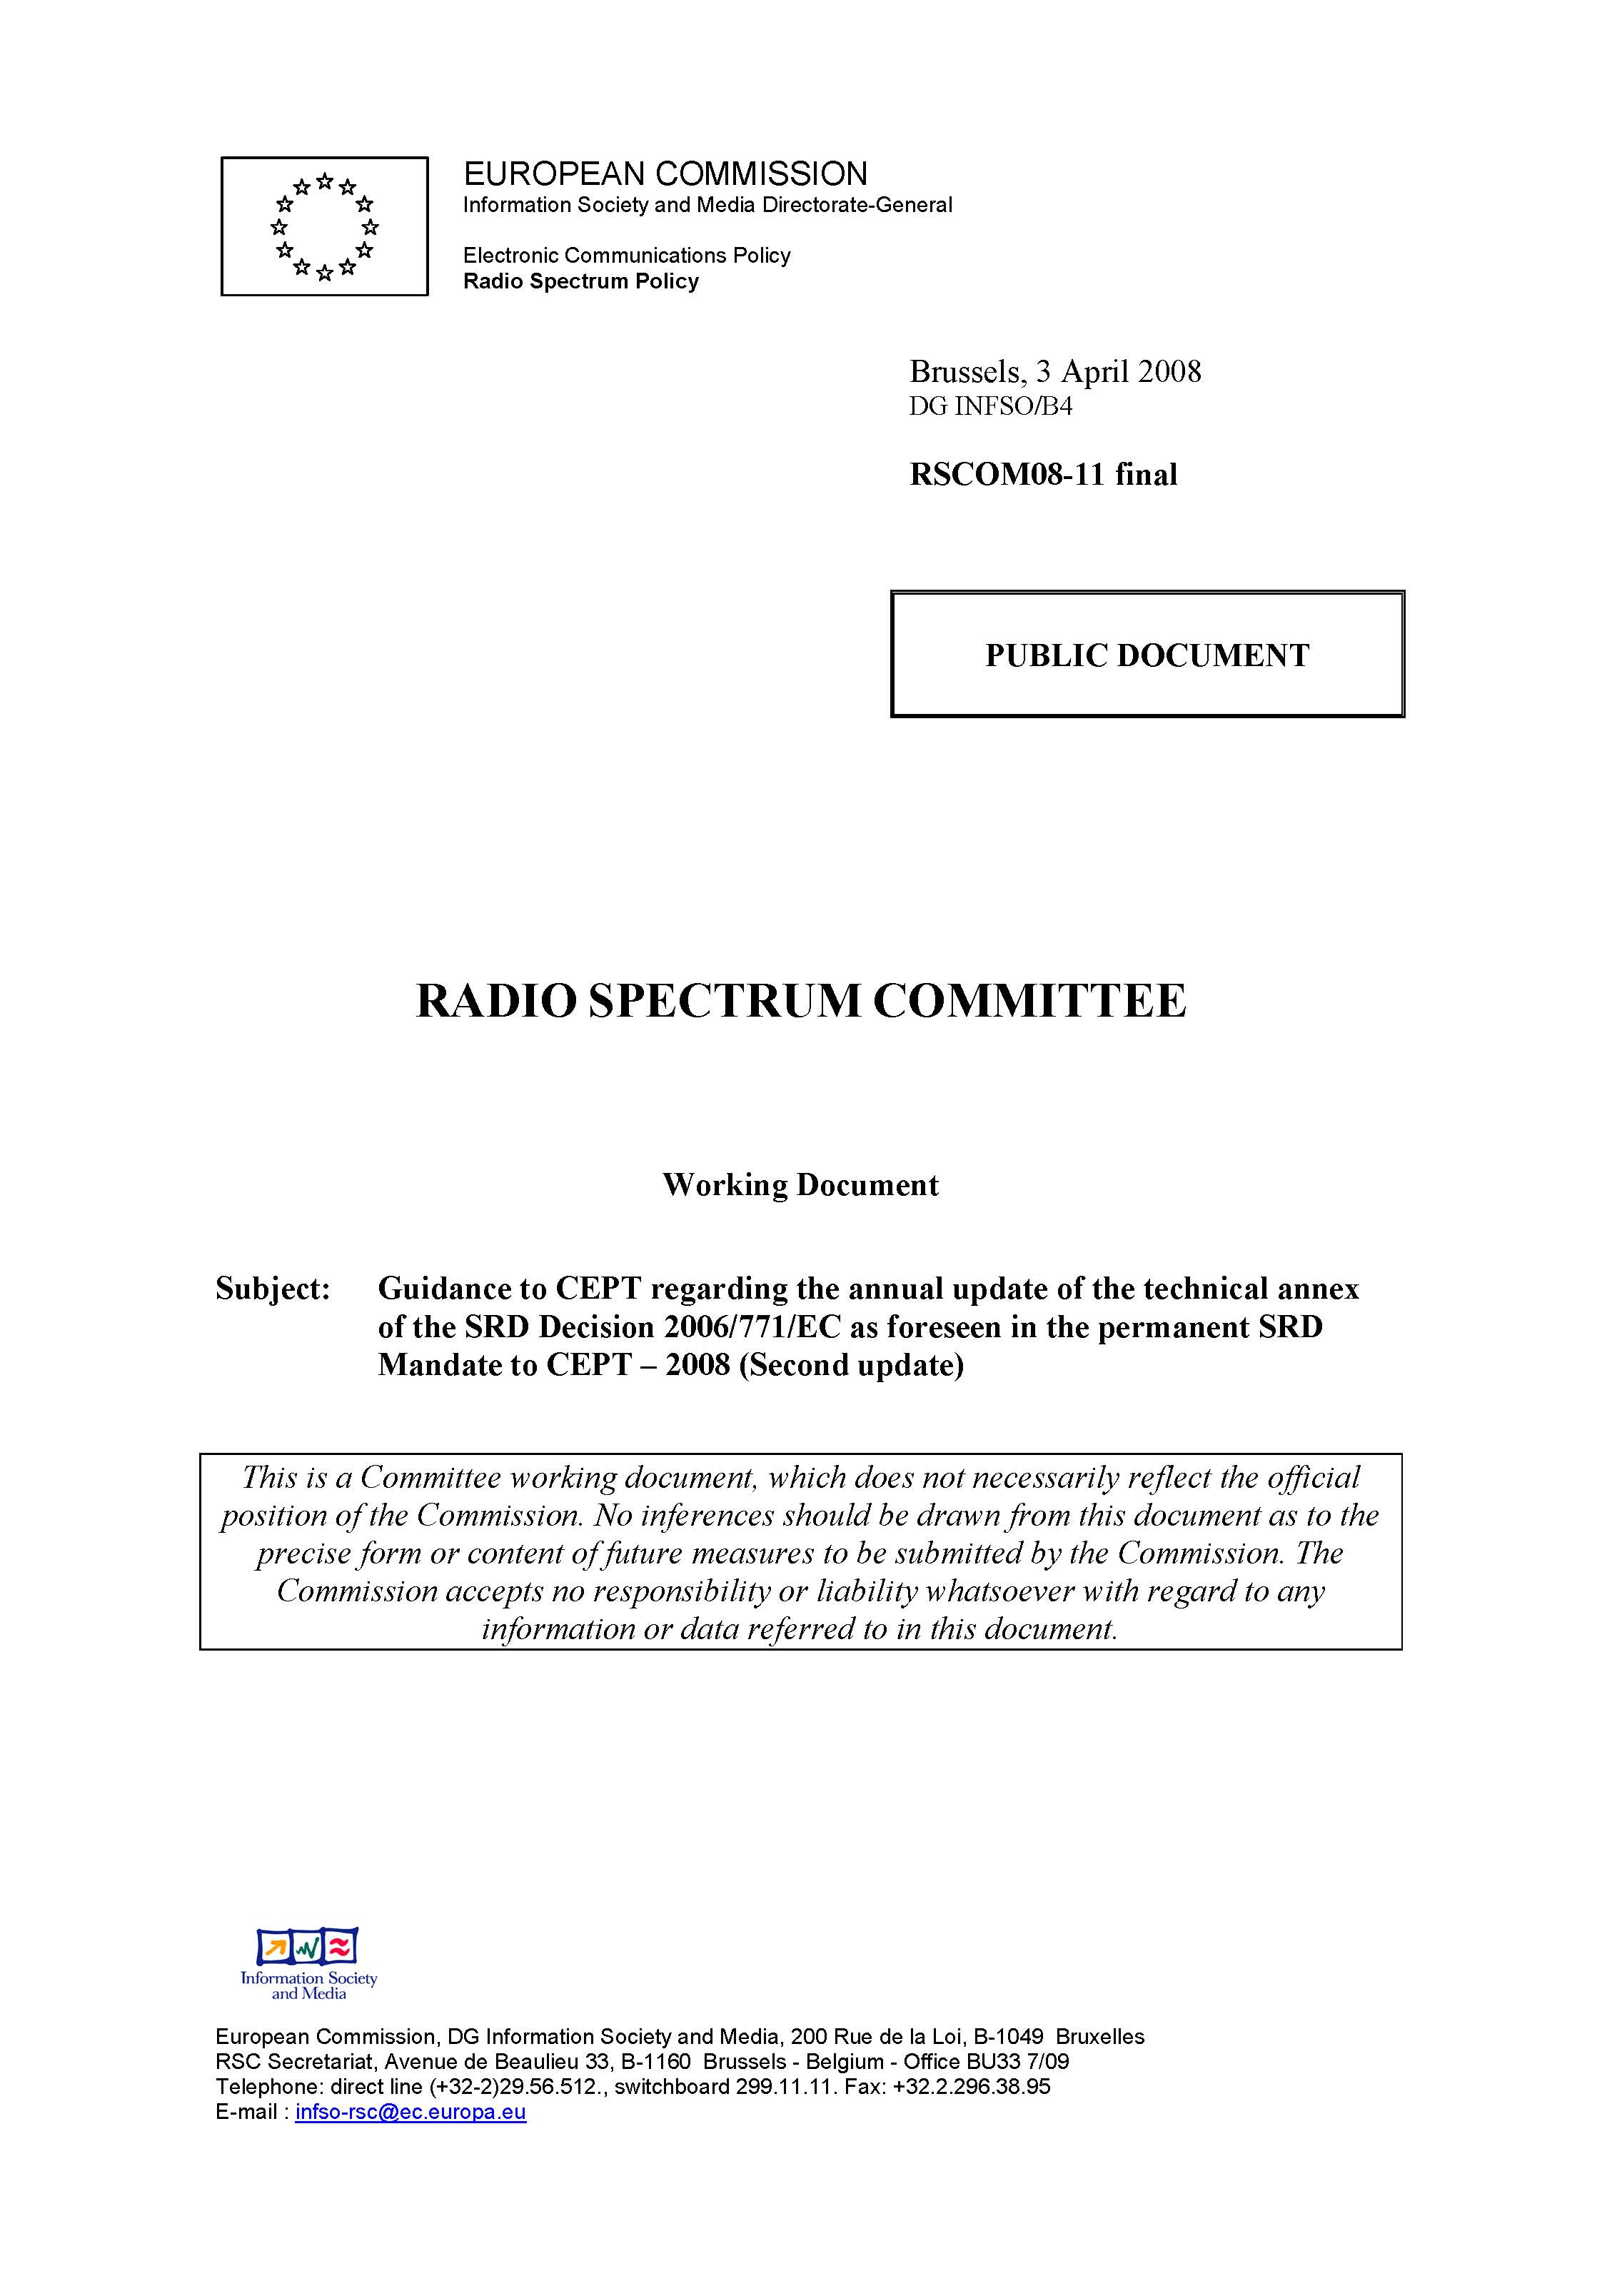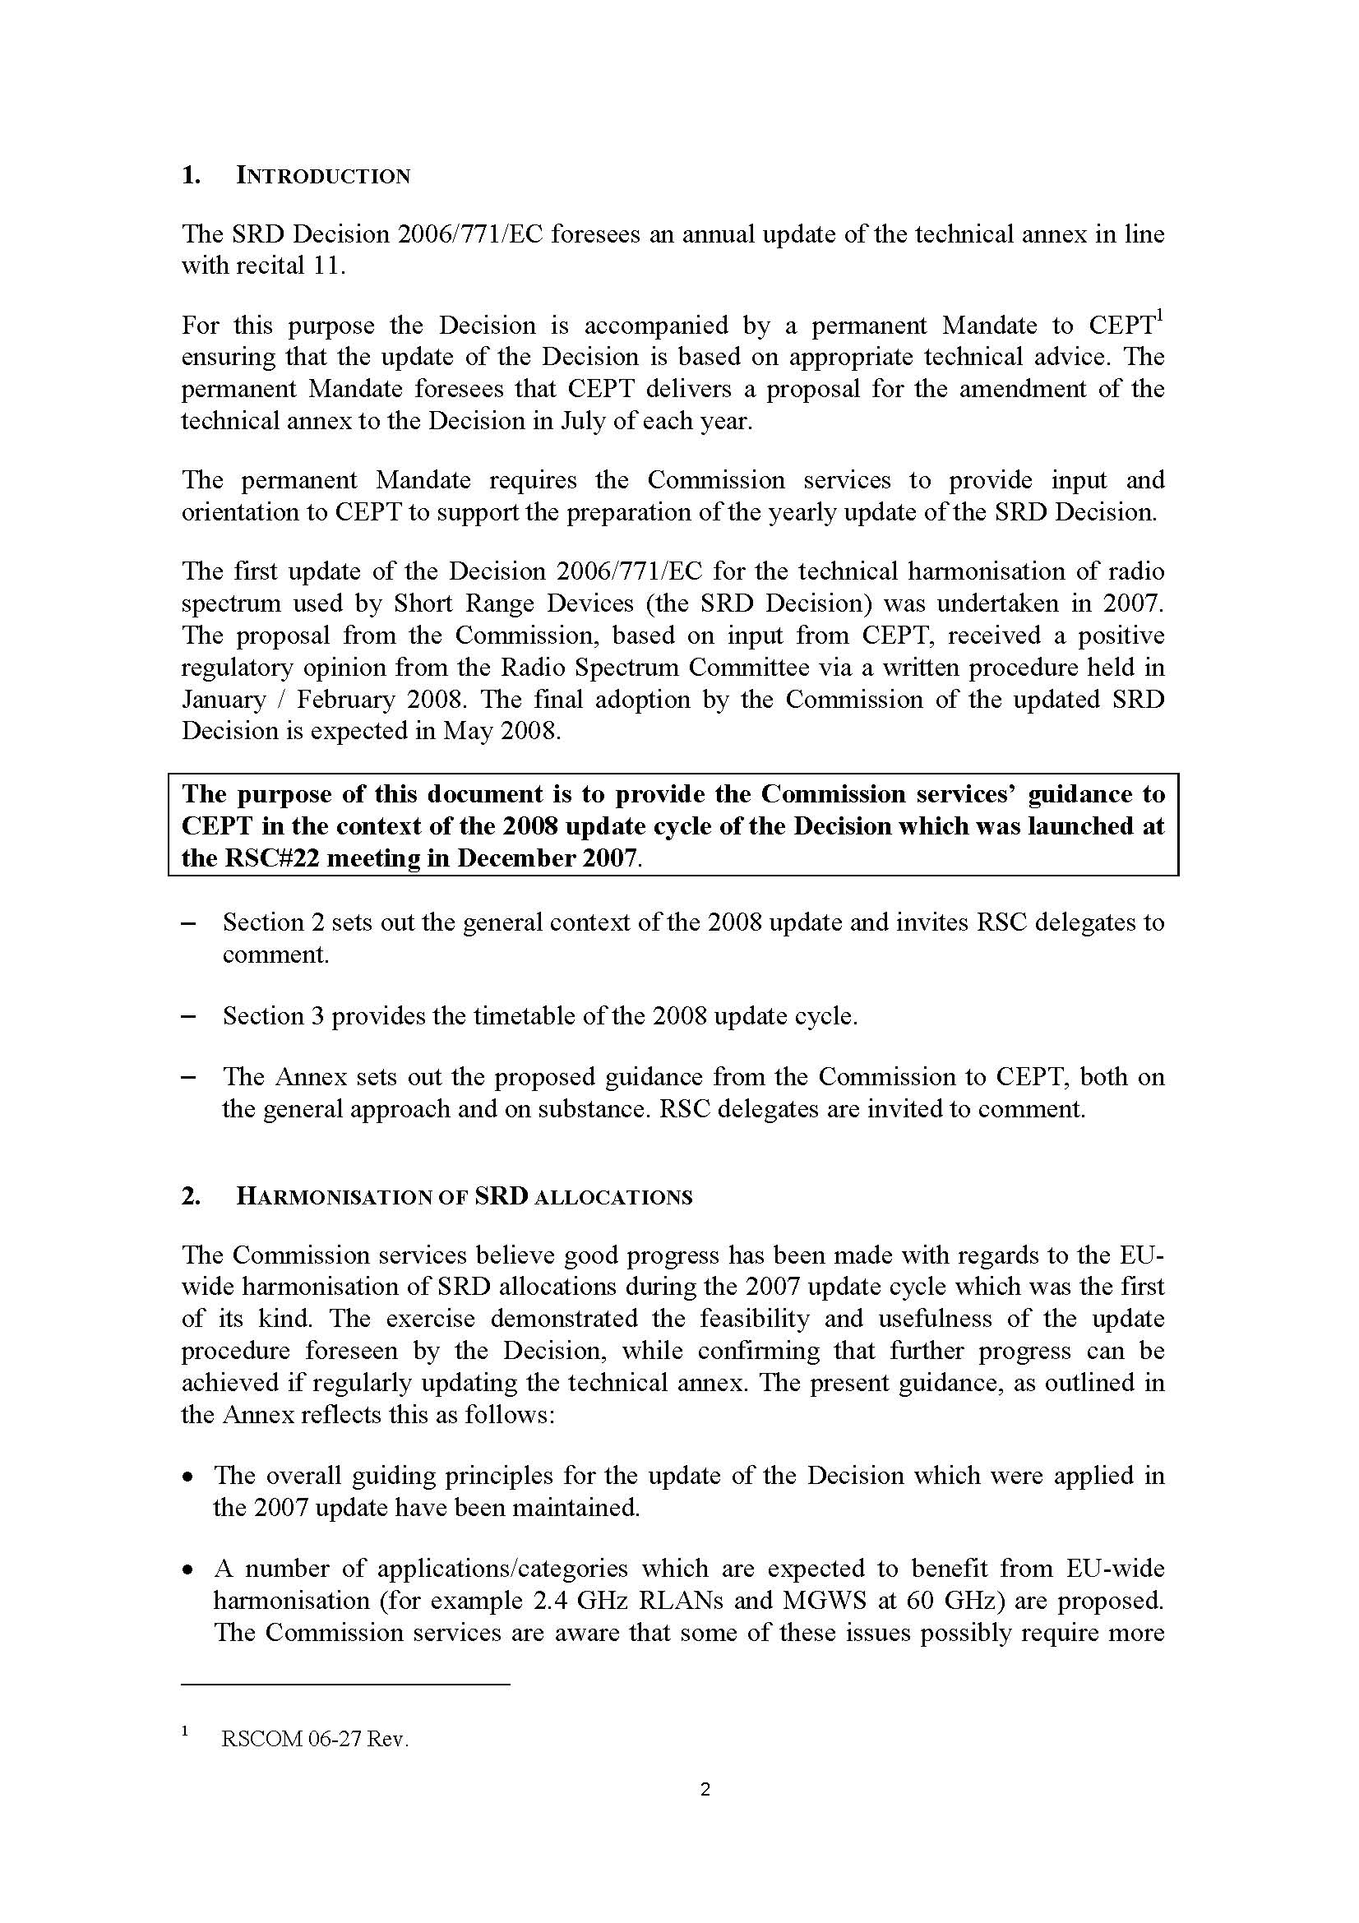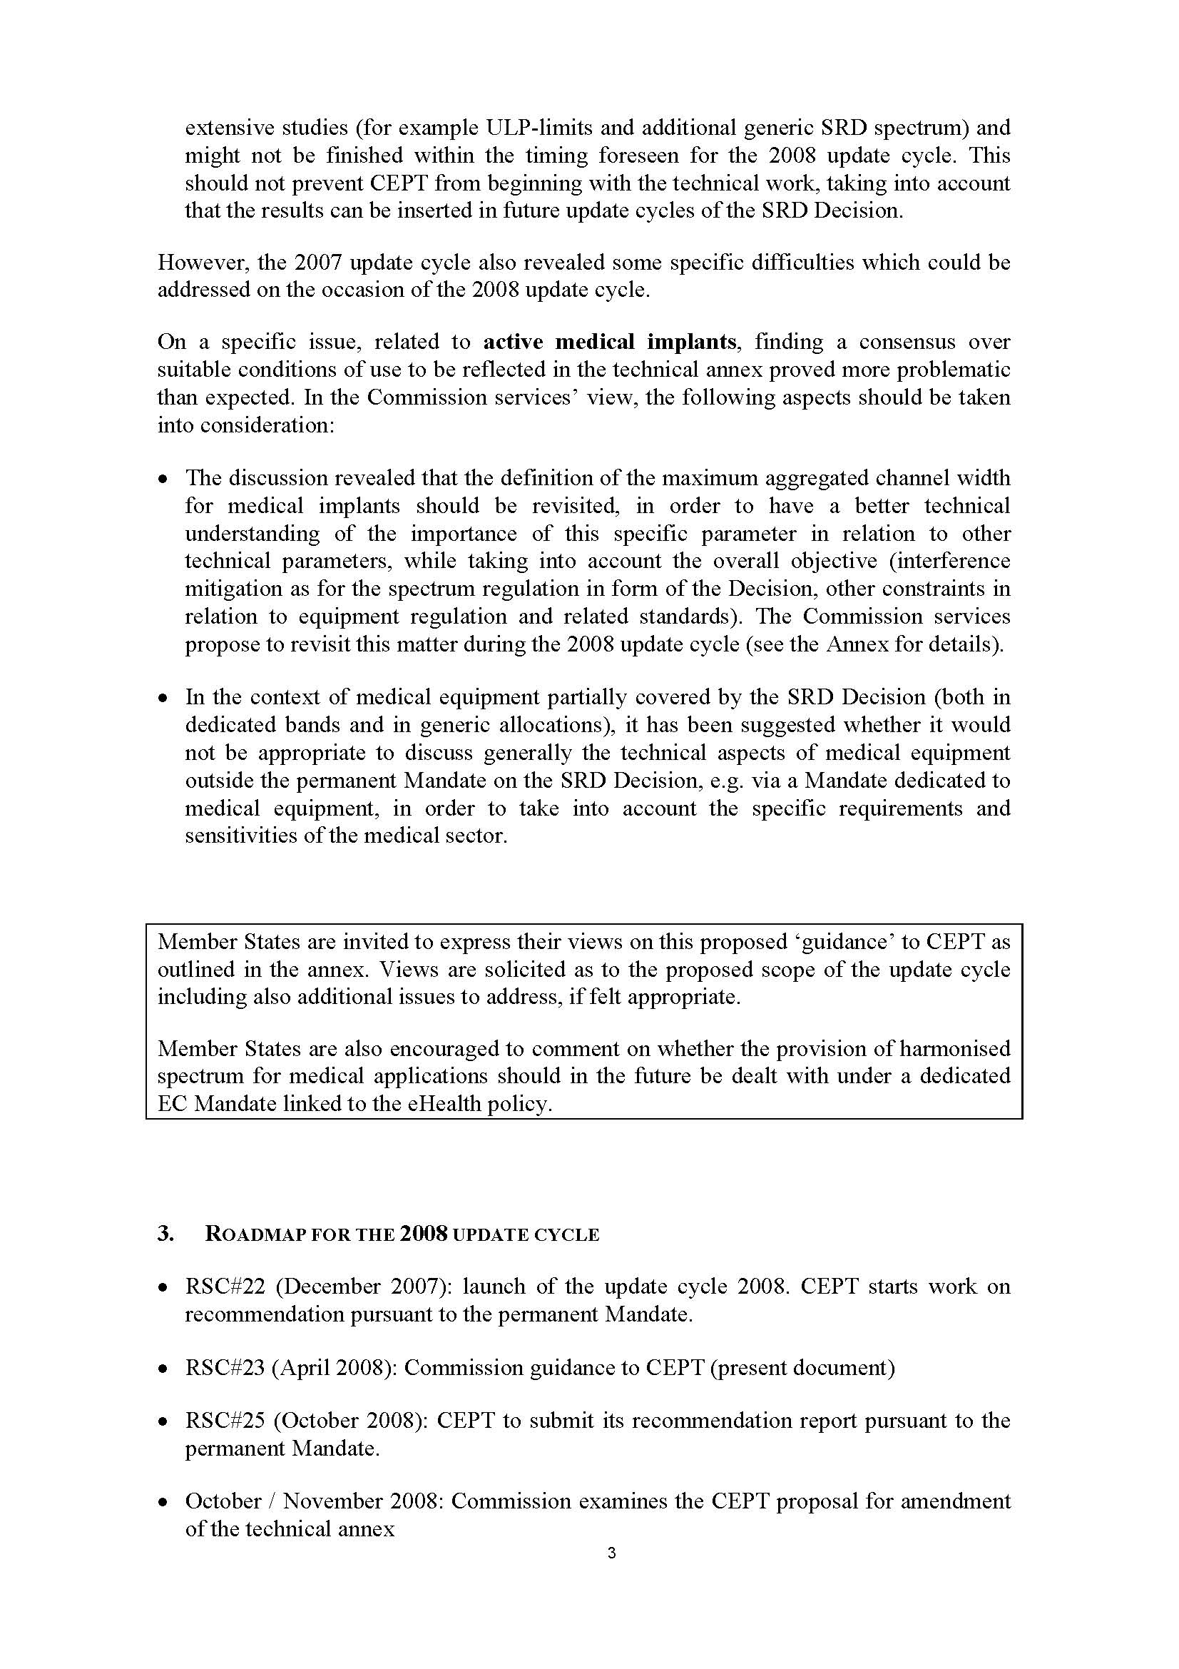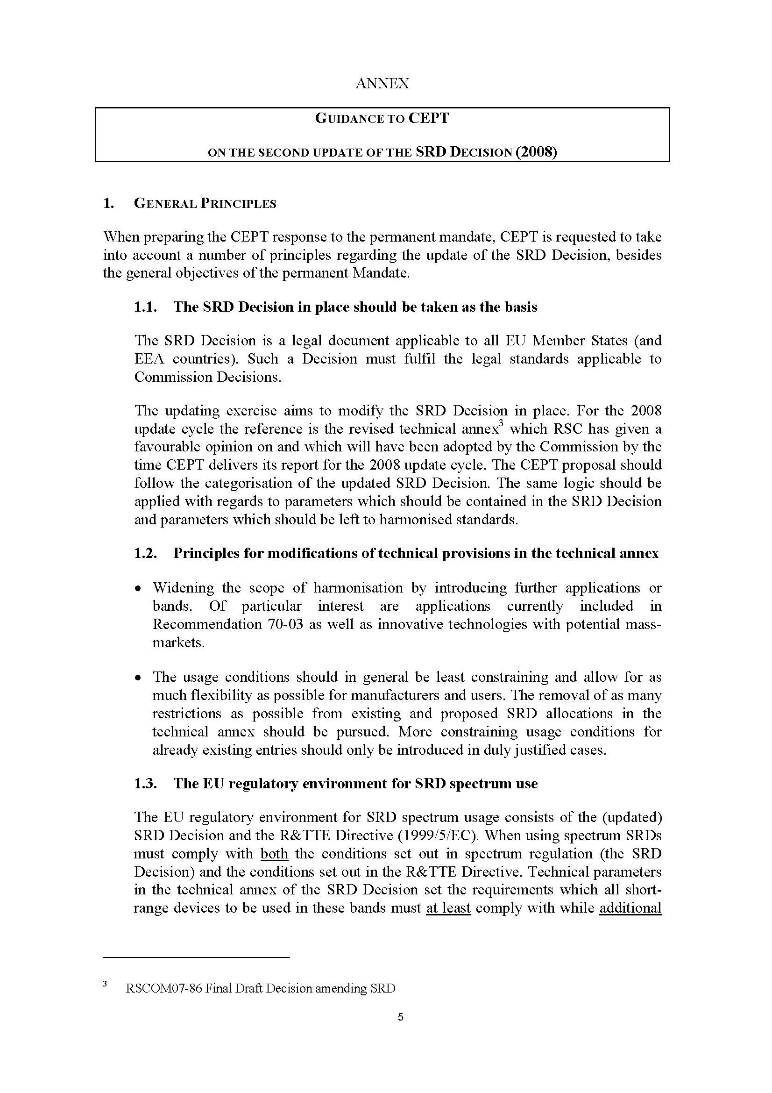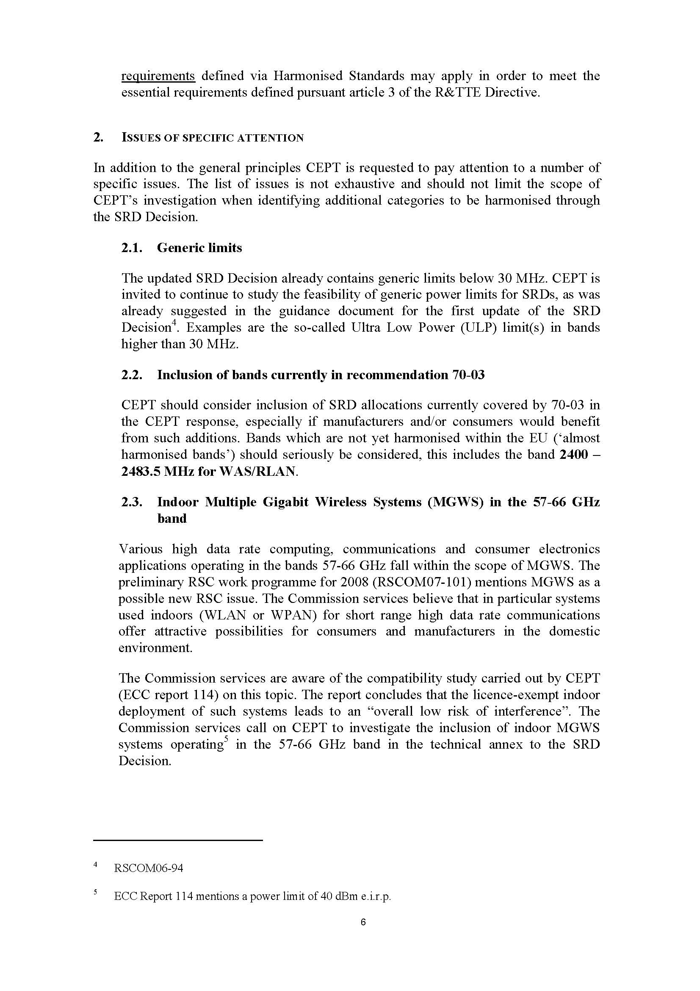

Annex 2 : Proposed amendments to the technical annex of the EC Decision on SRDs

ANNEX
Harmonised frequency bands and technical parameters for short-range devices
Type of short-range device | Frequency band | Power limit / field strength limit / power density limit | Additional parameters / spectrum access and mitigation requirements | Other usage restrictions | Implementation deadline
Non-specific short-range devices | 6765 - 6795 kHz | 42 dBµA/m at 10 metres |  |  | 1 October 2008
Non-specific short-range devices | 13.553 - 13.567 MHz | 42 dBµA/m at 10 metres |  |  | 1 October 2008
Non-specific short-range devices | 26.957 - 27.283 MHz | 10 mW effective radiated power (e.r.p.), which corresponds to 42 dBµA/m at 10 metres |  | Video applications are excluded | 1 June 2007
Non-specific short-range devices | 40.660 - 40.700 MHz | 10 mW e.r.p. |  | Video applications are excluded | 1 June 2007

Non-specific short-range devices (cont.) | 433.050 - 434.040 MHz | 1 mW e.r.p.  -13dBm/10 kHz power density for bandwidth modulation larger than 250 kHz |  | Audio and voice signals, and video applications, are excluded | 1 October 2008
Non-specific short-range devices (cont.) | 433.050 - 434.040 MHz | 10 mW e.r.p. | Duty cycle: 10% | Audio and voice signals, and video applications, are excluded | 1 June 2007
Non-specific short-range devices (cont.) | 434.040 - 434.790¹⁰ MHz | 1 mW e.r.p.  -13dBm/10 kHz power density for bandwidth modulation larger than 250 kHz |  | Audio and voice signals, and video applications, are excluded | 1 October 2008
Non-specific short-range devices (cont.) | 434.040 - 434.790¹⁰ MHz | 10 mW e.r.p. | Duty cycle⁶: 10% | Audio and voice signals, and video applications, are excluded | 1 June 2007
Non-specific short-range devices (cont.) | 434.040 - 434.790¹⁰ MHz | 10 mW e.r.p. | Duty cycle⁶: 100% subject to channel spacing up to 25 kHz | Audio and voice signals, and video applications, are excluded | 1 October 2008
Non-specific short-range devices (cont.) | 863.000 - 868.000 MHz | 25 mW e.r.p. | Techniques to access spectrum and mitigate interference that provide at least equivalent performance to the techniques described in harmonised standards adopted under Directive 1999/5/EC must be used. Alternatively a duty cycle⁶ of 0.1% may also be used | Audio and voice signals, and video applications, are excluded | 1 October 2008

Non-specific short-range devices (cont.) | 868.000 - 868.600¹⁰ MHz | 25 mW e.r.p. | Techniques to access spectrum and mitigate interference that provide at least equivalent performance to the techniques described in harmonised standards adopted under Directive 1999/5/EC must be used. Alternatively a duty cycle⁶ of 1% may also be used | Video applications are excluded | 1 October 2008
Non-specific short-range devices (cont.) | 868.000 - 868.600¹⁰ MHz | 25 mW e.r.p. | Techniques to access spectrum and mitigate interference that provide at least equivalent performance to the techniques described in harmonised standards adopted under Directive 1999/5/EC must be used. Alternatively a duty cycle⁶ of 0.1% may also be used | Audio and voice signals, and video applications, are excluded | 1 October 2008
Non-specific short-range devices (cont.) | 868.700 - 869.200¹⁰ MHz | 25 mW e.r.p. | Techniques to access spectrum and mitigate interference that provide at least equivalent performance to the techniques described in harmonised standards adopted under Directive 1999/5/EC must be used. Alternatively a duty cycle⁶ of 0.1% may also be used | Video applications are excluded | 1 October 2008
Non-specific short-range devices (cont.) | 868.700 - 869.200¹⁰ MHz | 25 mW e.r.p. | Techniques to access spectrum and mitigate interference that provide at least equivalent performance to the techniques described in harmonised standards adopted under Directive 1999/5/EC shall be used. Alternatively a duty cycle⁶ of 0.1% may also be used | Audio and voice signals, and video applications, are excluded | 1 October 2008

Non-specific short-range devices (cont.) | 869.400 - 869.650¹⁰ MHz | 500 mW e.r.p. | Techniques to access spectrum and mitigate interference that provide at least equivalent performance to the techniques described in harmonised standards adopted under Directive 1999/5/EC must be used. Alternatively a duty cycle⁶ of 10 % may also be used  Channel spacing must be 25 kHz, except that the whole band may also be used as a single channel for high-speed data transmission | Video applications are excluded | 1 October 2008
Non-specific short-range devices (cont.) | 869.400 - 869.650¹⁰ MHz | 25 mW e.r.p. | Techniques to access spectrum and mitigate interference that provide at least equivalent performance to the techniques described in harmonised standards adopted under Directive 1999/5/EC must be used. Alternatively a duty cycle⁶ of 0.1% may also be used | Audio and voice signals, and video applications, are excluded | 1 October 2008
Non-specific short-range devices (cont.) | 869.700 - 870.000¹⁰ MHz | 5 mW e.r.p. | Voice applications allowed with advanced mitigation techniques | Audio and video applications are excluded | 1 June 2007
Non-specific short-range devices (cont.) | 869.700 - 870.000¹⁰ MHz | 25 mW e.r.p. | Techniques to access spectrum and mitigate interference that provide at least equivalent performance to the techniques described in harmonised standards adopted under Directive 1999/5/EC must be used. Alternatively a duty cycle⁶ of 0.1% may also be used | Audio and voice signals, and video applications, are excluded | 1 October 2008

Non-specific short-range devices (cont.) | 2400 - 2483.5 MHz | 10 mW e.i.r.p. |  |  | 1 June 2007
Non-specific short-range devices (cont.) | 5725 - 5875 MHz | 25 mW e.i.r.p. |  |  | 1 June 2007
Non-specific short-range devices (cont.) | 24.150 - 24.250 GHz | 100 mW e.i.r.p. |  |  | 1 October 2008
Non-specific short-range devices (cont.) | 61.0 - 61.5 GHz | 100 mW e.i.r.p. |  |  | 1 October 2008
Wideband Data Transmission systems | 2400.0 - 2483.5 MHz | 100 mW e.i.r.p.  For wide band modulations other than FHSS, the  maximum e.i.r.p. density is limited to 10 mW/1 MHz | Techniques to access spectrum and mitigate interference that provide at least equivalent performance to the techniques described in harmonised standards adopted under Directive 1999/5/EC must be used. | In France, the use of the band 2454 - 2483.5 MHz by Wideband Data Transmission systems with e.i.r.p. >10 mW is restricted to indoor | 1 October 2009
Wideband Data Transmission systems | 57.0 - 66 GHz | 40 dBm e.i.r.p. with a maximum spectral power density of 13 dBm/MHz e.i.r.p |  | Outdoor applications are excluded | 1 October 2009
Wideband Data Transmission systems | 57.0 - 66 GHz | 25 dBm e.i.r.p. with a maximum spectral power density of -2 dBm/MHz e.i.r.p. |  | Fixed outdoor installations are excluded | 1 October 2009
Alarm systems | 868.600 - 868.700 MHz | 10 mW e.r.p. | Channel spacing: 25 kHz  The whole frequency band may also be used as a single channel for high-speed data transmission  Duty cycle⁶: 1.0% |  | 1 October 2008
Alarm systems | 869.250 - 869.300 MHz | 10 mW e.r.p. | Channel spacing: 25 kHz  Duty cycle⁶: 0.1% |  | 1 June 2007
Alarm systems | 869.300 - 869.400 MHz | 10 mW e.r.p. | Channel spacing: 25 kHz  Duty cycle⁶: 1.0% |  | 1 October 2008
Alarm systems | 869.650 - 869.700 MHz | 25 mW e.r.p. | Channel spacing: 25 kHz  Duty cycle⁶ : 10% |  | 1 June 2007
Alarms | 869.200 - 869.250 MHz | 10 mW e.r.p. | Channel spacing: 25 kHz  Duty cycle⁶: 0.1% | This set of usage conditions applies to social alarms⁷ only | 1 June 2007

Inductive applications | 20.050 - 59.750 kHz | 72 dBµA/m at 10 metres |  |  | 1 June 2007
Inductive applications | 59.750 - 60.250 kHz | 42 dBµA/m at 10 metres |  |  | 1 June 2007
Inductive applications | 60.250 - 70.000 kHz | 69 dBµA/m at 10 metres |  |  | 1 June 2007
Inductive applications | 70 - 119 kHz | 42 dBµA/m at 10 metres |  |  | 1 June 2007
Inductive applications | 119 - 127 kHz | 66 dBµA/m at 10 metres |  |  | 1 June 2007
Inductive applications | 127 - 140 kHz | 42 dBµA/m at 10 metres |  |  | 1 October 2008
Inductive applications | 140 - 148,5 kHz | 37.7 dBµA/m at 10 metres |  |  | 1 October 2008
Inductive applications | 148.5 - 5000 kHz  In the specific bands mentioned below, higher field strengths and additional usage restrictions apply: | -15 dBµA/m at 10 metres in any bandwidth of 10 kHz  Furthermore the total field strength is -5 dBμA/m at 10 m for systems operating at bandwidths larger than 10 kHz |  |  | 1 October 2008
Inductive applications | - 400 - 600 kHz | - -8 dBµA/m at 10 metres |  | This set of usage conditions applies to RFID only | 1 October 2008
Inductive applications | - 3155 - 3400 kHz | - 13.5 dBµA/m at 10 metres |  |  | 1 October 2008

Inductive applications (cont.) | 5000 - 30000 kHz  In the specific bands mentioned below, higher field strengths and additional usage restrictions apply: | -20 dBµA/m at 10 metres in any bandwidth of 10 kHz  Furthermore the total field strength is -5 dBμA/m at 10 m for systems operating at bandwidths larger than 10 kHz |  |  | 1 October 2008
Inductive applications (cont.) | - 6765 - 6795 kHz | 42 dBµA/m at 10 metres |  |  | 1 June 2007
Inductive applications (cont.) | - 7400 - 8800 kHz | - 9 dBµA/m at 10 metres |  |  | 1 October 2008
Inductive applications (cont.) | - 10200 - 11000 kHz | - 9 dBµA/m at 10 metres |  |  | 1 October 2008
Inductive applications (cont.) | - 13553 - 13567 kHz | - 42 dBµA/m at 10 metres |  |  | 1 June 2007
Inductive applications (cont.) | - 13553 - 13567 kHz | - 60 dBµA/m at 10 metres |  | This set of usage conditions applies to RFID⁹ and EAS only | 1 October 2008
Inductive applications (cont.) | - 26957 - 27283 kHz | - 42 dBµA/m at 10 metres |  |  | 1 October 2008

Active medical implants | 9 - 315 kHz | 30 dBµA/m at 10m | Duty cycle⁶: 10% |  | 1 October 2008
Active medical implants | 402 - 405 MHz | 25 µW e.r.p. | Channel spacing: 25 kHz  Individual transmitters may combine adjacent channels for increased bandwidth up to 300 kHz. Other techniques to access spectrum or mitigate interference, including bandwidths greater than 300 kHz, can be used providing they result at least in an equivalent performance to the techniques described in harmonised standards adopted under Directive 1999/5/EC in particular to ensure compatible operation with meteorological radiosondes. |  | 1 October 2008
Wireless audio applications | 87.5 - 108.0 MHz | 50 nW e.r.p. | Channel spacing up to 200 kHz |  | 1 October 2008
Wireless audio applications | 863 - 865 MHz | 10 mW e.r.p. |  |  | 1 June 2007

Radiodetermination applications | 2400.0 - 2483.5 MHz | 25 mW e.i.r.p. |  | In France, the use of the band 2454 - 2483.5 MHz by radiodetermination applications >25 mW e.i.r.p. is restricted to indoor | 1 October 2009
Radiodetermination applications | 4.5 - 7.0 GHz | -41.3 dBm/MHz e.i.r.p. spectral density outside the 500 litre test tank | The measured power level reflects only a level measured outside a 500litre test tank. Power levels measured outside a real tank should be lower than these values to ensure protection of the respective primary services in the operative bands. | This set of usage conditions applies to Tank Level Probing Radar (TLPR) only | 1 October 2009
Radiodetermination applications | 8.5 - 10.6 GHz
Radiodetermination applications | 24.05 - 27.0 GHz
Radiodetermination applications | 57 - 64 GHz
Radiodetermination applications | 75 - 85 GHz
Radiodetermination applications | 17.1 - 17.3 GHz | +26 dBm e.i.r.p. | Techniques to access spectrum and mitigate interference that provide at least equivalent performance to the techniques described in harmonised standards adopted under Directive 1999/5/EC must be used. | This set of usage conditions applies to ground based radar only. | 1 October 2009
Model control | 26.995 MHz  27.045 MHz  27.095 MHz  27.145 MHz  27.195 MHz | 100 mW e.r.p. | Channel spacing: 10 kHz |  | 1 October 2009
RFID | 2446 - 2454 MHz | 100 mW e.i.r.p | Up to 100% |  | 1 October 2009

Annex 3: Plan for the implementation of SRD strategy given in the CEPT Report 014 (Summary)
Summary

In July 2006, ECC adopted CEPT Report 014 in response to a European Commission (EC) Mandate to develop a strategy to improve the effectiveness and flexibility of spectrum availability for Short Range Devices (SRDs). As requested by CEPT/WGFM the SRD/MG reviewed the Recommendations contained in Report 014. Practical steps to implement these recommendations were endorsed by WGFM in Brussels in May 2008 and can be summarised as follows:

- The principle of “minimum regulation” (see Recommendation i of Report 014) is reemphasized. Various levels of flexibility can be achieved by the specification of appropriate regulatory parameters without omitting sharing obligations or constraints that have been identified through compatibility studies.
  - Some simple guidelines are proposed in the following cases:
- obligation to use spectrum access and mitigation technique in order to protect a given radiocommunication service;
- sharing obligations between non-specific SRDs;
- specific licence-exempt applications which have safety-critical implications, or more generally for applications with higher Quality of Service (QoS) requirements.
  - SRD/MG should furthermore develop proposals for ensuring greater consistency between ERC/REC 70-03 and the EFIS format. As a first step, alignment of the terminology being used and development of a new appendix to ERC/REC 70-03 presenting the editing rules of the Recommendation would be needed. Consistency with the terminology used by ETSI Harmonised Standards and the ITU-R regulation has to be ensured.

  - Practical guidance is also given in order to improve overall consistency between the EC Decision on SRDs (Decision 2006/771/EC), ERC Recommendation 70-03 (ERC/REC 70-03) and the relevant ETSI harmonised standards, taking into account the final outcome of TCAM/RSC RIG2 activities on the development of a harmonised format for Radio Interface Specifications (RIS).

- Practical guidance is given in support of pursuing the principles of application and technology neutrality wherever possible, applicable when reviewing existing line entry of ERC/REC 70-03, as well as when addressing a specific request for new spectrum (see Recommendation iii of the Report).

- Concerning the annual review of the technical annex of the EC Decision on SRDs:
  - Priorities to be addressed on an annual basis need to be identified well in advance of the review;
  - The process shall aim to identify the “minimum regulation” (as per Recommendation i of the Report) to ensure the efficient use of the radio spectrum and to avoid harmful interference;
  - Review of existing “national restrictions” (as per Recommendation ii of the Report) could take place within this process.
  - The process should take due account of practical guidance given in support of pursuing the principles of application and technology neutrality wherever possible (see Recommendation iii of the Report).

- When assessing requests for new spectrum for SRDs based on ETSI System Reference Documents (SRDocs), the Short Range Device Maintenance Group (SRD/MG) should take due account of:
  - The principle that additional spectrum should only be made available to SRDs on the basis of a clear and demonstrable need (as per Recommendation v of the Report);
  - The principles of “Minimum regulation” (as per Recommendation i of the Report) and application- and technology-neutrality (Recommendation iii of the Report);
  - The objective of maximising the efficiency of spectrum use, recognising that the implementation of techniques to facilitate greater spectrum sharing shall be encouraged (Recommendation viii of the Report);
  - The results of compatibility studies developed by Working Group Spectrum Engineering (WG SE) of CEPT/ECC.

- A new Work Item is proposed on the assessment of future spectrum needs for SRDs (see Recommendations vi, vii and viii of the Report). Such an assessment should also consider an investigation of the use of frequency bands above 40 GHz. However industry representatives felt that some technical issues need to be answered first, before conducting that investigation (see “Recommendation vii” for detail).
While this could presumably be handled by SRD/MG, WGFM, as the supervising group, should also take into account future developments following RSPG discussions on “Collective Use of Spectrum”. This analysis could also address benefits in terms of capacity associated with the implementation of enhanced spectrum access and mitigation techniques.

- As a new Work Item, SRD/MG should investigate the possibility of a generic limit for Ultra Low Power SRDs (see Recommendation iv of the Report). The required compatibility studies will have to address both the impact on radiocommunication services and conventional SRDs.

- The following items have been identified in relation to global harmonisation of the SRD market (see Recommendation ix of the Report):
  - WRC-11 agenda items 1.19 (cognitive radios) and 1.22 (SRD);
  - ITU-R Resolution 54 (AR-07) on studies to achieve harmonization for short-range radiocommunication devices (SRDs).

Annex 4 : List of Abbreviations

Abbreviation | Explanation
CEPT | European Conference of Postal and Telecommunications Administrations
DAA | Detect And Avoid
e.i.r.p. | Equivalent isotropically radiated power
ECC | Electronic Communications Committee of CEPT
EESS | Earth Exploration Satellite Service
ETSI | European Telecommunications Standards Institute
GBSAR | Ground Based Synthetic Aperture Radar
ITU | International Telecommunication Union
LBT | Listen Before Talk
MGWS | Multiple Gigabit Wireless System
RFID | Radio Frequency Identification
SAR | Synthetic Aperture Radar
SRD | Short Range Device
TLPR | Tank Level Probing Radar

Member States must allow the usage of spectrum up to the power, field strength or power density given in this table. In conformity with Article 3(3) of Decision 2006/771/EC, they may impose less restrictive conditions, i.e. allow the use of spectrum with higher power, field strength or power density.
Member States may only impose these ‘additional parameters / spectrum access and mitigation requirements’, and may not add other parameters or spectrum access and mitigation requirements. Less restrictive conditions within the meaning of Article 3(3) of Decision 2006/771/EC mean that Member States may completely omit the parameters / spectrum access and mitigation requirements in a given cell or allow higher values.
Member States may only impose these ‘other usage restrictions’, and may not add additional usage restrictions. As less restrictive conditions may be introduced within the meaning of Article 3(3) of Decision 2006/771/EC, Member States may omit one or all of these restrictions.
This category is available for any type of application which fulfils the technical conditions (typical uses are telemetry, telecommand, alarms, data in general and other similar applications).
For this frequency band Member States must make all the alternative sets of usage conditions possible.
Duty cycle’ means the ratio of time during any one-hour period when equipment is actively transmitting. Less restrictive conditions within the meaning of Article 3(3) of Decision 2006/771/EC mean that Member States may allow a higher value for ‘Duty cycle’.
Social alarm devices are used to assist elderly or disabled people when they are in distress.
This category covers, for example, devices for car immobilisation, animal identification, alarm systems, cable detection, waste management, personal identification, wireless voice links, access control, proximity sensors, anti-theft systems, including RF anti-theft induction systems, data transfer to handheld devices, automatic article identification, wireless control systems and automatic road tolling.
This category covers inductive applications used for Radio Frequency Identification (RFID).
This category covers inductive applications used for Electronic Article Surveillance (EAS).
This category covers the radio part of active implantable medical devices, as defined in Council Directive 90/385/EEC of 20 June 1990 on the approximation of the laws of the Member States relating to active implantable medical devices and their peripherals (OJ L 189, 20.7.1990, p. 17).
Applications for wireless audio systems, including: cordless loudspeakers; cordless headphones; cordless headphones for portable use, e.g. portable CD, cassette or radio devices carried on a person; cordless headphones for use in a vehicle, for example for use with a radio or mobile telephone, etc.; in-ear monitoring, for use at concerts or other stage productions.
Tank Level Probing Radars are used for tank level measurement applications and are installed in closed metallic tanks or reinforced concrete tanks, or similar enclosure structures made of comparable attenuating material, holding a substance, liquid or powder.

