Recommandation T/R 13-02 (Montreux 1993, amended Tromsø, May 2010)

PREFERRED CHANNEL ARRANGEMENTS FOR FIXED SERVICE SYSTEMS
IN THE FREQUENCY RANGE 22.0 - 29.5 GHz

Recommendation adopted by the Working Group "Spectrum Engineering" (WG SE)

“The European Conference of Postal and Telecommunications Administrations,

considering:

- that CEPT has a long term objective to harmonise the use of frequencies throughout Europe to benefit from technical and economic advantages;
- that CEPT administrations should apply preferred channel arrangements in order to make the most effective and efficient use of the spectrum for fixed service applications;
- that in the frequency range 22.0 - 29.5 GHz three bands are commonly identified for the accommodation of fixed service systems; notably 22.0 - 23.6 GHz (23 GHz band), 24.5 - 26.5 GHz (26 GHz band) and 27.5 - 29.5 GHz (28 GHz band);
- that the frequency range 24.25 - 24.50 GHz may be used by the CEPT administrations at national level for unidirectional links as ENG/OB SAP/SAB applications;
- that, in order to maximise the spectrum resources for Fixed Service (FS) applications, CEPT Aministrations may consider to use also the band 22.6 - 23.0 GHz (23 GHz band center-gap), for optimizing the deployment of unidirectional links such as those for ENG/OB- SAP/SAB applications as well as of bidirectional conventional point-to-point links;
- that ECC/DEC/(05)01 introduce a band segmentation between Fixed Satellite Service (FSS) and FS in the frequency band 27.5 - 29.5 GHz,

recommends:

1. that the fixed service systems in the frequency range 22.0 - 23.6 GHz should refer to Annex A and be operated as follows:

1.1. the band 22.0 - 22.6 GHz paired with 23.0 - 23.6 GHz should be operated in accordance with the channel plan given in Annex A.1;

1.2. when CEPT administrations wish to use, within the centre-gap of the arrangement in recommend 1.1, the band 22.6 - 22.75 GHz paired with 22.84 - 23.0 GHz should select a channel plan in accordance with Annex A.2;

1.3. when CEPT administrations wish to use the unpaired band 22.75 - 22.84 GHz in the centre-gap of the arrangement in recommend 1.2, a channel plan for unidirectional links should be selected in accordance with Annex A.3;

2. that the fixed service in the band 24.5 - 26.5 GHz should be operated in accordance with the channel plan given in Annex B;

3. that the fixed service in the band 27.5 - 29.5 GHz should be operated in accordance with the channel plan given in Annex C, taking into account ECC/DEC/(05)01.”

Note:
Please check the Office web site (http//:www.ero.dk) for the up to date position on the implementation of this and other ECC Recommendations
ANNEX A

Channel arrangements in the frequency range 22.0 - 23.6 GHz

A.1 Frequency bands 22.0 - 22.6 GHz paired with 23.0 - 23.6 GHz

Let
fo be the reference frequency of 21196 MHz
fn be the centre frequency of the radio-frequency channel in the lower half of the band
fn' be the centre frequency of the radio-frequency channel in the upper half of the band
TX/RX separation = 1008 MHz
Centre gap = 400 MHz

then the frequencies of individual channels are expressed by the following relationships :

a) for systems with a carrier spacing of 112 MHz:

lower half of the band : fn = (fo + 770 + 112n) MHz
upper half of the band : fn' = (fo + 1778+ 112n) MHz where n = 1, ... 5

b1) for systems with a carrier spacing of 56 MHz providing 9 channels:

lower half of the band : fn = (fo + 826 + 56n) MHz
upper half of the band : fn' = (fo + 1834+ 56n) MHz where n = 1, ... 9

b2) alternative plan for systems with a carrier spacing of 56 MHz providing 10 channels:

lower half of the band : fn = (fo + 784 + 56n) MHz
upper half of the band : fn' = (fo + 1792+ 56n) MHz where n = 1, ... 10

c) for systems with a carrier spacing of 28 MHz:

lower half of the band : fn = (fo + 798 + 28n) MHz
upper half of the band : fn' = (fo + 1806+ 28n) MHz where n = 1 , ... 20

d) for systems with a carrier spacing of 14 MHz:

lower half of the band : fn = (fo + 805 + 14n) MHz
upper half of the band : fn' = (fo + 1813 + 14n) MHz where n = 1 , ... 41

e) for systems with a carrier spacing of 7 MHz:

lower half of the band : fn = (fo + 808.5 + 7n) MHz
upper half of the band : fn' = (fo + 1816.5 + 7n) MHz where n = 1 , ... 83

f) for systems with a carrier spacing of 3.5 MHz:

lower half of the band : fn = (fo + 805 + 3.5n) MHz
upper half of the band : fn' = (fo + 1813 + 3.5n) MHz where n = 1 , ...168

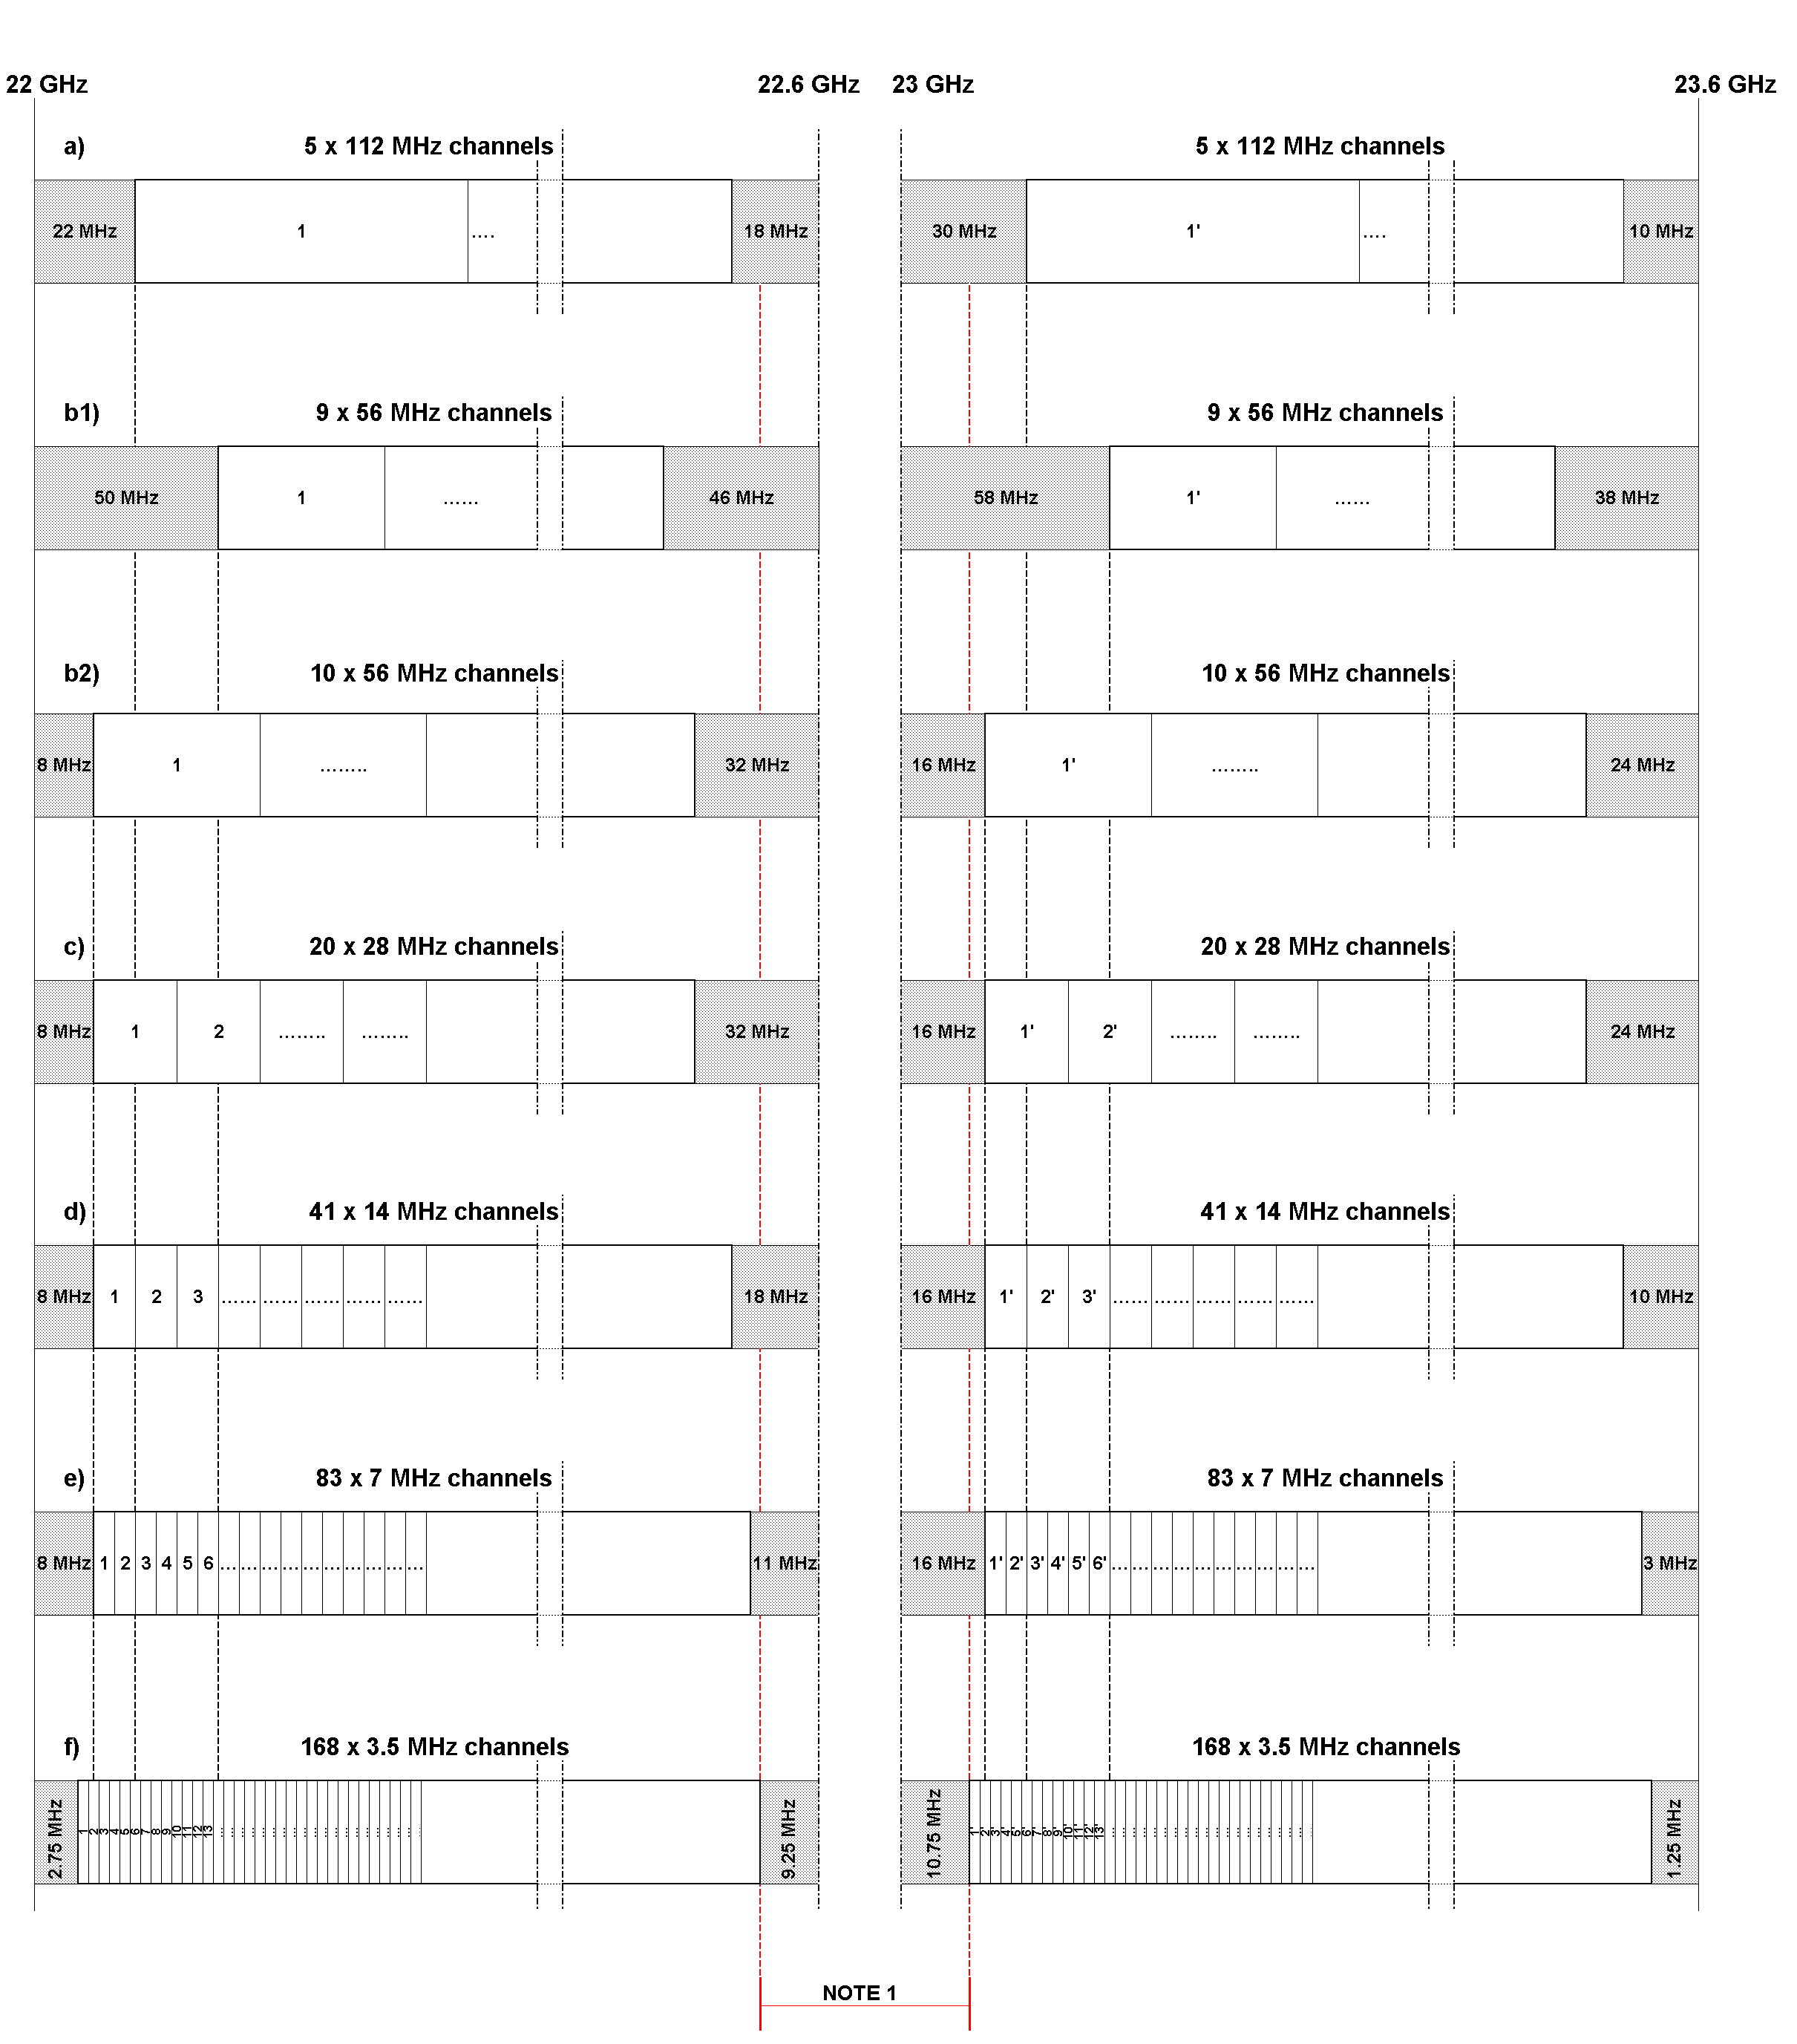
Note 1: For the centre-gap channel arrangements see sections A.2 and A.3

Figure A1: Occupied spectrum: 22.0 - 22.6 GHz / 23 - 23.6 GHz

A.2 Frequency bands 22.59075 - 22.75875 paired with 22.84275 - 23.01075 GHz

These bands are portions of centre-gap of the channel arrangement shown in A.1, combined with the innermost guard bands of the 3.5 MHz arrangement (see Figure A.1).

The preferred radio frequency channel arrangement for digital point-to-point fixed wireless systems for carrier spacings of 28 MHz, 14 MHz, 7 MHz and 3.5 MHz should be derived as follows:

Let
fo be the reference frequency of 21196 MHz
fn be the centre frequency of the radio-frequency channel in the lower half of the band
fn' be the centre frequency of the radio-frequency channel in the upper half of the band
TX/RX separation = 252 MHz
Centre gap = 84 MHz

then the frequencies of individual channels (Note 1) are expressed by the following relationships:

- For systems with a carrier spacing of 28 MHz:

Lower half of band: fn = (fo + 1380.75 + 28 n) MHz
Upper half of band: f´n = (fo + 1632.75 + 28 n) MHz where: n = 1, …. 6

- For systems with a carrier spacing of 14 MHz:

Lower half of band: fn = (fo + 1387.75 + 14 n) MHz
Upper half of band: f´n = (fo + 1639.75 + 14 n) MHz where: n = 1, …. 12

- For systems with a carrier spacing of 7 MHz:

Lower half of band: fn = (fo + 1391.25 + 7 n) MHz
Upper half of band: f´n = (fo + 1643.25 + 7 n) MHz where: n = 1, …. 24

- For systems with a carrier spacing of 3.5 MHz:

Lower half of band: fn = (fo + 1393 + 3.5 n) MHz
Upper half of band: f´n = (fo + 1645 + 3.5 n) MHz where: n = 1, …. 48

Note 1: The channels are shown as paired; however, administrations may envisage unpaired use of those channels according the national need (e.g. for ENG/OB-SAP/SAB applications). Some administrations may also wish to pair some of the lower channels within the 22.6 - 23.0 GHz band with the 21.2 - 21.4 GHz band which is outside the scope of this recommendation.

Note 1: This is the 3.5 MHz channel arrangement according section A.1.
Note 2: For the centre-gap channel arrangement see section A.3.

Figure A.2: Occupied spectrum: 22.59075 - 22.75875 / 22.84275 - 23.01075 GHz

A.3 Frequency band 22.75875 - 22.84275 GHz

This band is the centre-gap of the channel arrangement in section A.2 (see figure A.2), which may be used for unpaired channels.

The preferred radio frequency channel arrangement for digital and analogue point-to-point fixed wireless systems for carrier spacings of 28 MHz, 14 MHz, 7 MHz and 3.5 MHz should be derived as follows:

Let fo be the reference frequency of 22757 MHz;
fn be the centre frequency (MHz) of a radio-frequency channel;

then the frequencies of individual channels are expressed by the following relationships:

- For systems with a carrier spacing of 28 MHz:
fn = (fo – 12.25 + 28 n) MHz where: n = 1, 2, 3

- For systems with a carrier spacing of 14 MHz:
fn = (fo – 5.25 + 14 n) MHz where: n = 1, 2, …. 6

- For systems with a carrier spacing of 7 MHz:
fn = (fo – 1.75 + 7 n) MHz where: n = 1, 2, …. 12

- For systems with a carrier spacing of 3.5 MHz:
fn = (fo + 3.5 n) MHz where: n = 1, 2, …. 24

Note 1: This is the centre-gap of the channel arrangement in section A.2 (see figure A.2)
Figure A.3: Occupied spectrum: 22.75875 - 22.84275 GHz
ANNEX B

Frequency band 24.5 - 26.5 GHz

Let
fo be the reference frequency of 25501.0 MHz
fn be the centre frequency of the radio-frequency channel in the lower half of the band
fn' be the centre frequency of the radio-frequency channel in the upper half of the band
TX/RX separation = 1008 MHz
Centre gap = 112 MHz

then the frequencies of individual channels are expressed by the following relationships:

a) for systems with a carrier spacing of 112 MHz:

lower half of the band: fn = (fo - 1008 + 112n) MHz
upper half of the band: fn' = (fo - + 112n) MHz where n = 1, ... 8

b) for systems with a carrier spacing of 56 MHz:

lower half of the band: fn = (fo - 980 + 56n) MHz
upper half of the band: fn' = (fo + 28 + 56n) MHz where n = 1, ... 16

c) for systems with a carrier spacing of 28 MHz:

lower half of the band: fn = (fo - 966 + 28n) MHz
upper half of the band: fn' = (fo + 42 + 28n) MHz where n = 1, ... 32

d) for systems with a carrier spacing of 14 MHz:

lower half of the band: fn = (fo - 959 + 14n) MHz
upper half of the band: fn' = (fo + 49 + 14n) MHz where n = 1 , ... 64

e) for systems with a carrier spacing of 7 MHz:

lower half of the band: fn = (fo - 955.5 + 7n) MHz
upper half of the band: fn' = (fo + 52.5 + 7n) MHz where n = 1 , ... 128

f) for systems with a carrier spacing of 3.5 MHz:

lower half of the band: fn = (fo - 953.75 + 3.5n) MHz
upper half of the band: fn' = (fo + 54.25 + 3.5n) MHz where n = 1 , ... 256

Figure B1: Occupied spectrum: 24.5 - 26.5 GHz
ANNEX C

Frequency band 27.5 - 29.5 GHz

Let
fo be the reference frequency of 28500.5 MHz
fn be the centre frequency of the radio-frequency channel in the lower half of the band
fn' be the centre frequency of the radio-frequency channel in the upper half of the band
TX/RX separation = 1008 MHz
Centre gap = 112 MHz

then the frequencies of individual channels are expressed by the following relationships :

a) for systems with a carrier spacing of 112 MHz:

lower half of the band: fn = (fo - 1008 + 112n) MHz
upper half of the band: fn' = (fo + 112n) MHz where n = 1, ... 8

b) for systems with a carrier spacing of 56 MHz:

lower half of the band: fn = (fo - 980 + 56n) MHz
upper half of the band: fn' = (fo + 28 + 56n) MHz where n = 1 , ... 16

c) for systems with a carrier spacing of 28 MHz:

lower half of the band: fn = (fo - 966 + 28n) MHz
upper half of the band: fn' = (fo + 42 + 28n) MHz where n = 1 , ... 32

d) for systems with a carrier spacing of 14 MHz:

lower half of the band: fn = (fo - 959 + 14n) MHz
upper half of the band: fn' = (fo + 49 + 14n) MHz where n = 1 , ... 64

e) for systems with a carrier spacing of 7 MHz:

lower half of the band: fn = (fo - 955.5 + 7n) MHz
upper half of the band: fn' = (fo + 52.5 + 7n) MHz where n = 1 , ... 128

f) for systems with a carrier spacing of 3.5 MHz:

lower half of the band: fn = (fo - 953.75 + 3.5n) MHz
upper half of the band: fn' = (fo + 54.25 + 3.5n) MHz where n = 1 , ... 256

Figure C1: Occupied spectrum: 27.5 - 29.5 GHz

In addition, ECC /DEC/(05)01 has defined a band segmentation as sharing condition between FS and FSS in this band; consequently, in CEPT countries implementing that Decision, part of the channels described above may no longer be available as shown in figure C2 for the 28 MHz case.

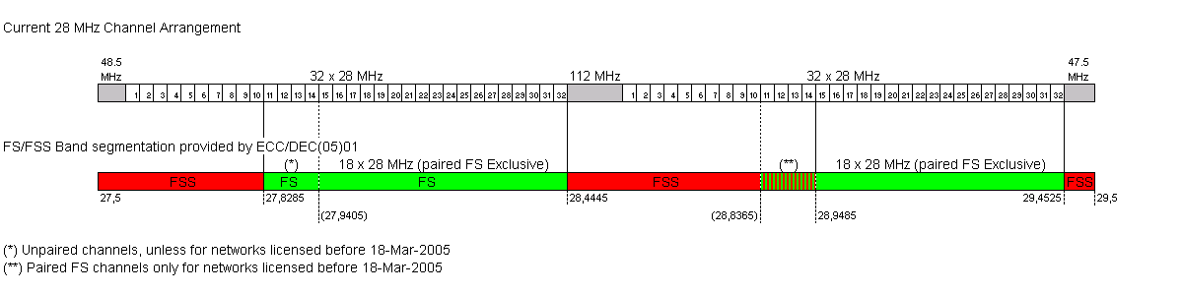

Figure C2: Band segmentation according ECC/DEC/(05)01; 28 MHz channel case

Accordingly the following paired channels might be unavailable:

- 112 MHz arrangement: channels 1 through 4 paired with 1’ through 4’
- 56 MHz arrangement: channels 1 through 7 paired with 1’ through 7’
- 28 MHz arrangement: channels 1 through 14 paired with 1’ through 14’
- 14 MHz arrangement: channels 1 through 28 paired with 1’ through 28’
- 7 MHz arrangement: channels 1 through 56 paired with 1’ through 56’
- 3.5 MHz arrangement: channels 1 through 112 paired with 1’ through 112’

and the following channels may remain available only unpaired (for unidirectional links):

- 112 MHz arrangement: channel 4
- 56 MHz arrangement: channels 6 and 7
- 28 MHz arrangement: channels 11 through 14
- 14 MHz arrangement: channels 22 through 28
- 7 MHz arrangement: channels 44 through 56
- 3.5 MHz arrangement: channels 88 through 112

