Electronic Communication Committee (ECC)
within the European Conference of Postal and Telecommunications Administrations (CEPT)
THE ANALYSIS OF THE COEXISTENCE OF POINT-TO-MULTIPOINT FWS CELLS
IN THE 3.4 - 3.8 GHz BAND

Revised in Vilamoura, February 2006

EXECUTIVE SUMMARY AND CONCLUSIONS

Summary

The scope of this ECC Report is to provide up-to-date guidelines for efficient, technology independent deployment of 3.5 GHz (or 3.7 GHz) Point-to-Multipoint (PMP) Fixed Wireless Systems (FWS), traditionally referred to as Fixed Wireless Access (FWA) systems.
The Report recognises that the current technology for FWA in bands around 3.5 GHz is in continuous extensive evolution since first ERC Recommendations 14-03 and 12-08 were developed. A detailed study on the coexistence of various technologies was needed in order to provide guidance to Administrations that wish to adopt an efficient and technology neutral approach to the deployment rules in these bands.
It is also noted that ETSI ENs in these bands are not presently designed for a technology neutral deployment (this is done only in the 40 GHz Multimedia Wireless Systems in EN 301 997) therefore do not contain system controlling parameters, in terms of EIRP, useful for the desired “technology neutral” and “uncoordinated” deployment. Not having any ECC harmonised guidance for such deployment, the ENs are still bound to a cell-by-cell “co-ordinated deployment” concept actually not used in most of the licensing regimes. This report might generate future feedback actions in revising also ETSI ENs accordingly.
Aspects that relate to sharing issues with Point-to-Point FS, FSS, radiolocation (in adjacent band) and ENG/OB are not considered in this Report. However they should be taken into account when applying any method of deployment suggested in this document.
The applicability limits of the current Report are as follows:
- Application is mostly devoted to “block assignment” licensing methods, rather than “channel assignment” method.
- The guidelines presented have been maintained, as far as possible, independent from the access methods described in the ETSI ENs (e.g. EN 302 326).
- MP-MP (MESH) architectures are not yet considered. In order to include MESH architectures, a number of assumptions on “typical” application (e.g. on the omni-directional/directional antenna use) need to be defined in order to devise the typical intra-operators, mixed MP-MP/PMP interference scenarios for which simulations would have to be carried.
- Channel sizes and modulation schemes are also not specifically considered unless for defining “typical” system parameters. It should be noted that high state modulations (e.g. 64/128 QAM) have not been specifically addressed in the typical system parameters; nevertheless they would not change the general framework of this report. This may be considered during future update.
- FDD/TDD, symmetric/asymmetric deployments are considered.
- Additionally, system independent, EIRP density limits and/or guard-bands at the edge of deployed region (pfd boundary conditions) as well as at the edge of assigned spectrum (block edge boundary conditions) are considered as licensing conditions for neighbouring operators’ coexistence (similarly to the latest principles in ERC Recommendation 01-04 in the 40 GHz band).

Presently, the spectrum blocks assigned to an operator vary widely from country to country - from 10 MHz up to 28MHz (single or duplex) blocks have been typically assigned. The block allocation size and the frequency re-use plan employed by the operator to achieve a multi-cell and multi-sector deployment drives the channel bandwidth of the systems presently on the market to be typically no greater than 7MHz. Conversely, the requirement for higher data throughputs is driving the need for wider channel widths (e.g. up to ~28 MHz) and therefore correspondingly wider spectrum blocks assignment in the future.

Therefore, system channel bandwidths and block sizes are not fixed, even if typical data for current technologies are used for feasibility analysis of the “block-edge” constraints.
The report considers two different aspects of deployment scenarios for two operators:
- Operating in the same or partly overlapping area with adjacent bands assignment
- Operating in adjacent or nearby areas and re-using the same band assignment.

A number of different methods have been used to assess the severity of interference. These are:
- Worst Case (WC) (generally used for Central Station (CS) to CS interference) and for PFD limits at geographical boundary for frequency (block) reuse
- Interference Scenario Occurrence Probability (ISOP) (for CS to Terminal Stations (TS) interference between adjacent blocks in rural LoS situations)
- Monte Carlo simulations for CDF (cumulative distribution function) vs. C/I (for CS to TS interference between adjacent blocks in urban mostly NLoS situations and for TS to CS interference between adjacent blocks).

For the above methods it has been possible to estimate the probability of interference between FWA systems. From these results, estimates have been made of the frequency and/or geographical spacing needed between these systems in order to reduce the level of interference to an acceptably low level. Absolute recommendations cannot be made because some system parameters are not defined by the available standards and because the effects of buildings and terrain are very difficult to model. The report therefore gives guidelines that will lead to acceptably low levels or low probability of interference in most cases.

For the above methods that might be described as:
- The Worst Case (WC) method derives system deployment parameters to ensure that interference is always below a set threshold for all cases.
- The Interference Scenario Occurrence Probability (ISOP) is defined as the probability that an operator places at least one terminal in the IA. ISOP is related to the number of terminals deployed by the operator, and possibly to the cell planning methodology. The ISOP method evaluates the NFD or the out-of-block rejection required in order to meet an interference probability lower than a certain value.
- The Cumulative Distribution Function (CDF), derived from Monte Carlo simulation of large number of “trial” TSs with a certain equipment/antenna/propagation model, is defined as the probability that a certain percentage of those trials would result in a C/I of the victim CS exceeding a predefined target limit.

The Report derives the following alternative parameters, useful for defining an “uncoordinated technology independent” deployment:
- The Interference protection factor (IPF) and associated guard-band method used to define the amount of isolation required from the interfering station to victim receivers in adjacent frequency block in terms of Net Filter Discrimination (NFD), obtained also by frequency separation (guard bands) and EIRP limitation.
- The Block Edge EIRP Density Mask (BEM) method is used for directly limiting the EIRP density in the adjacent block, and for assessing the CS to CS worst case interference, the CS to TS interference through acceptable ISOP value and the TS to CS through acceptable probability of exceeding a limit C/I to the victim CS.

An important finding of this Report is that stringent protection requirement (e.g. in terms of BEM or NFD) is required only for CS emissions; the protection factor for TS is far less stringent and reduces as the antenna directivity is improved.
Another important conclusion is a significant impact of CS antenna height on co-ordination distance for the frequency block reuse; due to the low LoS attenuation with distance, sensible size of co-ordination distance and associated PFD value are obtained only considering spherical diffraction attenuation. If the CS antenna height is not limited (or a down-tilt angle is required) as a licensing parameter, it is nearly impossible to tell how far away the block may be reused.
The example presented, made with typical system values, led to examples of BEM coherent with a “technology neutral” deployment of different systems in adjacent blocks. Receiver filters are assumed to be stringent enough to maintain the potential NFD implicit in the BEM (i.e. have sufficient out-of-block selectivity for avoiding non linear distortion in the RX front-end chain).
In annexes to the report, some further technical background and studies for related issues are also reported. They include urban obstructed propagation (near-NLoS) models and examples of practical application of RF filtering for easing the CS absolute EIRP BEM fulfilment when using equipment-generic relative spectrum masks defined by ETSI.
Conclusions
This Report has considered a number of facts as initial considerations for deriving the coexistence study:
- Presently ERC Recommendations 14-03 and 12-08 for the bands 3.6 GHz and 3.8 GHz do not give harmonised and detailed suggestion to administration for implementing FWA (such as those produced for 26, 28 and 40 GHz). Those ERC Recommendations offer only channel arrangements.
- The band is limited and wasted guard-bands might drastically reduce the number of licensed operators, limiting the potential competition for new services.
- Legacy FWA (WLL) systems have been already licensed in these bands in some countries, and their co-existence with new FWA systems, assigned in accordance with provisions recommended in this study, may need additional check on a case-by-case basis, using the same methodology as described in this report, but with the parameters corresponding to those of legacy systems.
- Sharing issues with PP FS systems, FSS, radiolocation (in adjacent band), ENG/OB were not considered in this report, but are subject of a different CEPT study.
- At least for CSs, ETSI ENs in these bands are not presently designed for a technology neutral deployment (this is done only in the 40 GHz MWS EN 301 997) therefore do not contain system controlling parameters, in terms of EIRP, which would be useful for the desired “technology neutral” and “uncoordinated” deployment
- The study suggested that the block edge mask together with the contiguous assignment of frequency blocks should be the main means for avoiding interference between neighbouring frequency blocks. Since block edge mask parameters are linked to the size of the block, it is also recommended that the neighbouring blocks should be of a similar size.
- It is also shown that, for PMP TSs, the antenna RPE plays a fundamental role in the coexistence; the more directive is the antenna of TSs, the less demanding might be their NFD (or the EIRP density BEM) required (offering a flexible trade-off to the market). That is why the resulting BEM limits outside the block are described in terms of transmitter output power, allowing operators to make practical use of this phenomenon.
- In addition, basic rules has been set for the co-ordination distance and PFD boundary levels between operators re-using the same block in adjacent geographical areas. In this field, the importance of limiting CS antenna height (or down-tilt angle) as possible licensing parameter is highlighted in order of having sensible co-ordination distances (i.e. limited by spherical diffraction attenuation).
- MP-MP (MESH) architectures have not been considered in this Report. It is recognised that whilst some of the results in this report might also be applicable to mixed PMP and MESH deployment, others may clearly need additional work. These studies might be carried on out in due time if needed and when manufacturers will be in a position to offer the necessary information.

INDEX TABLE
1 Introduction 7
1.1 Scope 7
1.2 The frequency licensing policy and the possible approaches 8
1.2.1 The Worst Case deployment scenario (derived from ERC Report 99) 8
1.2.2 The “predefined guard band deployment” 8
1.2.3 The "guided unplanned deployment" (Block edge emission density mask) 9
2 “SAME AREA - ADJACENT FREQUENCY BLOCKS” INTERFERENCE SCENARIO 9
2.1 Analysis of the coexistence of two FWA cells in the 3.4 - 3.8 GHz band 9
2.1.1 Typical System Parameters 9
2.1.2 Cell coverage. 11
2.1.2.1 Rural LOS scenario 12
2.1.2.2 Urban NLOS scenario 14
2.1.3 Interference protection factor (IPF) 15
2.1.3.1 Channel arrangements 16
2.2 CS-to-CS interference 17
2.3 CS-to-TS interference 19
2.3.1 Rural LOS scenario 19
2.3.2 Urban NLOS scenario 22
2.3.2.1 Methodology 26
2.3.2.2 Results: 27
2.3.2.2.1 C/I statistics 27
2.3.2.2.2 Inter-block protection evaluation 29
2.3.3 Conclusions for CS→TS protection in urban NLOS environment 30
2.4 TS to CS interference 31
2.4.1 Interference evaluation 31
2.4.2 Conclusions for the TS to CS interference study 32
2.5 Terminal Station to Terminal Station 32
3 ”Adjacent area - same frequency block” interference scenario 32
3.1 Power Flux Density Limits for adjacent FWS service areas 32
3.1.1 Assumptions 33
3.1.2 Methodology 35
3.1.3 Central Station to Central Station 35
3.1.3.1 Worst case single interferer scenario: 3.5 GHz calculations 35
3.1.3.2 Antenna height 39
3.1.3.3 Transmit EIRP 39
3.1.3.4 Conclusions and possible self-regulation method for CSs co-ordination distance 40
3.1.4 Terminal Station to Central Station 40
3.1.4.1 ATPC impact 40
3.1.4.2 Worst case single interferer scenario, 3.5 GHz calculations 40
3.1.4.3 Examples: 41
3.1.4.4 TS to CS Conclusions 42
3.1.5 Terminal Station to Terminal Station 43
3.2 Conclusions on adjacent service areas boundary block reuse co-ordination 43
4 Conclusions of the report 44
Annex 1: AVERAGE CELL SIZE EVALUATION 45
A1.a) Simulation Model 45
A1.b) Mean Excess Loss (MEL) only 45
A1.c) Mean Excess Loss and Log-Normal Shadowing 46
A1.d) Mean Excess, Log-Normal Shadowing and Rician Fading 47
A1.e) Simulation Caveat 48
A1.f) Urban scenarios, directional outdoor versus omni-directional indoor TS 49
A1.f.1 Coverage and availability objectives: 49
A1.f.2 Methodology 49
A1.f.3 Cell radius evaluation 50
A1.g) Conclusions of the annex 53
ANNEX 2: TS to CS interference evaluation 54
A2.1 Directional outdoor TS 54
A2.1.1 Rural scenario 54
A2.1.1.1 System Model and Simulation Methodology 54
A2.1.1.2 Unfaded Simulation Results 56
A2.1.1.3 Rayleigh Faded Simulation Results 59
A2.11..4 Conclusions 61
A2.1.2 Urban Scenario 62
A21..2.1 Simulation Methodology 62
A2.1.2.2 Simulation Results 62
A2.1.2.2.1 Unfaded 62
A2.1.2.2.2 Rician Faded 69
A2.1.2.3 Conclusions, directional outdoor antennas 69
A.2.2 Omni-directional indoor TS 69
A.2.2.1 Input parameters and models 69
A.2.2.1.1. Objectives 69
A.2.2.1.2 CS data (same used for CS→TS evaluation): 70
A.2.2.1.3 TS omni-directional indoor out of block eirp: 70
A.2.2.1.4 TS activity factor and density: 71
A.3.2.1 Shared traffic, VDSL like 72
A.2.2.2 Summary of TS density and OOB eirp reference values: 72
A.2.2.3 Scenarios 73
A.2.2.4 Propagation models: 73
A.2.2.5 Simulation results 73
A.2.2.5.1 h_{CS} = 30 m 74
A.2.2.5.2 h_{CS} = 40 m 74
A.2.2.6 Conclusions 76
Appendix 1 to Annex 2: Model basic description 77
Appendix 2 to Annex 2: Acceptance-Rejection method 83
ANNEX 3: examples for managing a CS block-edge mask 84
Annex 4: Evaluation of the C/I ratio exceeded for more than 99% (and 97% for omni-directional case) of probability. 88
References: 96

THE ANALYSIS OF THE COEXISTENCE OF POINT-TO-MULTIPOINT FWS CELLS
IN THE 3.4 - 3.8 GHz BAND

1 Introduction

1.1 Scope
The scope of this report is to investigate the co-existence of Point-to-Multipoint (PMP) Fixed Wireless Systems (FWS), traditionally referred to as Fixed Wireless Access (FWA). These systems are developed in accordance with the ETSI EN 301 021, EN 301 080, EN 301 124, EN 301 253 and EN 301 744. In conjunction with the CEPT channel plan defined by the ERC Recommendations 14-03 (sections A1 and B1) and 12-08 (sections B2.1.1 and B2.2.1).
During the development of this report, the account was taken of the latest developments of FWA technologies, in particular developments with ETSI BRAN (HIPERMAN) and IEEE 802.16 standardisation activities, and new market realities calling for wide spread use of flexibly deployed user terminals with non-directional antennas.
Systems, owned by different operators, should be able to be deployed without mutual interference when operating in:
- adjacent frequency blocks in the same area or,
- the same frequency block(s) in adjacent areas.
This report aims to assist the administrations in the assignment of frequency blocks to the operators who operate FWA systems in the available bands between 3.4 GHz to 3.8 GHz.
These bands were subject to the previous ERC Recommendation 14-03, on harmonised radio frequency arrangements for Multipoint systems. Nowadays more experience has been gained from recent studies for the 26 and 28 GHz bands, finalised by ERC Report 99 and Recommendations 00-05 and 01-03, and most of all for the 42 GHz MWS band, finalised by ECC Recommendation 01-04.
ERC Report 97 qualitatively summarised requirements for modern licensing process and has also been taken into account in developing this report.
This report incorporates and enriches the information in earlier reports and recommendations.
In order to cater for the mix of technologies and services to be delivered it is most appropriate that a block (or blocks) of spectrum is made available to a potential operator in a manner consistent with the technology and market that the operator may wish to address.
It should be noted that the current ETSI masks for P-MP equipment in this band were not designed with the block assignment coordination in mind; therefore they were not specifically considered as a starting point in this study. Taking into account the final conclusions of this study, CEPT may wish to liaise with ETSI in order to align CEPT and ETSI deliverables on this issue.
A key principle of the assignment guidelines is that even though a technology specific channelisation scheme is expected to operate within an assigned block this channelisation is not the basis for the assignment process. Operators are free to subdivide the assigned frequency block in the most efficient way for deploying or re-deploying the selected technology.
Due to the flexibility required in newly deployed services, it is important that the block assignment process supports systems for both symmetric and asymmetric traffic as well as systems that employ FDD and TDD techniques.
In principle no assumption has been made regarding the architecture of any FWA network; however MP-MP (MESH) architectures have not been considered in detail in this Report. Other ECC work has reported and concluded on MESH systems in higher frequency millimetric bands. It is recognised that whilst some of the results in this report might also be applicable to mixed PMP and MESH architectures, others may clearly need additional work. These studies might be carried out in due time if needed and when manufacturers will be in a position to offer the necessary information.
Measures are suggested in this report for dealing with the issue of inter-operator coexistence both between adjacent frequency blocks and between neighbouring geographic areas. The basis for these measures is to allow deployment with the minimum of co-ordination although more detailed co-ordination is encouraged as an inter-operator issue.
In order to cope with the often-conflicting requirements of a number of technologies in terms of efficient and appropriate block assignments, some compromise is suggested in order to develop reasonable assignment guidelines, which balance constraints as far as possible on any specific technology.

1.2 The frequency licensing policy and the possible approaches
When considering the adjacent frequency blocks, same area scenario, the possible process of frequency licensing should guarantee, as far as possible, a “controlled interference” deployment. Emissions from one operator’s frequency block into a neighbour block will need to be controlled. This can be done by different methodologies.
A first one, already recommended in other frequency bands, imposes, between the assignments, fixed guard bands evaluated around the most likely equipment to be deployed.
Alternatively, as recommended in the 42 GHz MWS band, a frequency block edge EIRP density emission mask is used. The block edge mask limits the emissions into a neighbouring operator's frequency block and it enables operators to place the outermost radio channels with suitable guard-bands, inside their assigned block, in order to avoid co-ordination with the neighbour's frequency blocks.
Having considered the pros and cons of these two approaches, in particular taking into account a general shortage of frequencies in this band, the current study agreed to follow the second approach, i.e. the contiguous assignment of frequency blocks with the associated Block Edge Mask (BEM) requirement. For further enhancing the spectrum efficiency, administrations might wish, after the block assignment procedure has been done, to decide later not to enforce the block-edge mask for neighbouring operators who will apply mutual co-ordination at the blocks edge in view to optimise the utilisation of outermost parts of the assigned blocks. In that case, the enforcing rules will apply only in a “mutually agreed” way or it would be flexibly changed according the actual interference scenario shared by both operators with theirs planning tools.

1.2.1 The Worst Case deployment scenario (derived from ERC Report 99)
In principle, the most efficient way of evaluating the guard bands would be through a “case by case” evaluation. This would imply that the administrations should, in the application phase, analyse the actual behaviour, the planned coverage range, the hubs location, the cellular structure and the cell planning aspects of the system operated by the operators in any particular area.
However, when Terminal Stations (TS) are taken into account, the number of variables become so huge that the method is practical only for deterministic evaluation of Central Station (CS) to CS interference, based on I/N objective (then independent from system characteristics apart the noise figure).
For the above reasons, a more realistic approach is necessary, and hereby only the two examples described in next sections 1.2.2 and 1.2.3 are mentioned; however, only the last one in section 1.2.3 would be extensively used in this report because looks more attractive from the point of view of spectrum usage and certain results in technology neutral environment.

1.2.2 The “predefined guard band deployment”
In the first approach, here called “predefined guard band deployment”, the administration would aim to provide, to both operators and end users, a reasonably interference free environment.
In addition, for maintaining good spectrum efficiency, this method asks for a quite good knowledge of the typical FWA system technologies used. The guard-bands are likely to be determined by the wider band systems therefore the method is most suited in case the differences among deployed technologies (e.g. channel spacing, NFD and modulation formats) are expected to be small or in bands already deployed where fixed channel arrangements are recommended. This approach tends to prevent spectrum efficiency improvement with the technology evolution and thus is not recommended as a preferred method.

1.2.3 The "guided unplanned deployment" (Block edge emission density mask)
The second approach, here called ”guided unplanned deployment”, implies that additional EIRP density limits are set in order to allow an “average” interference free scenario to the operators. In this case, the guard band is to be included in the blocks assigned to the operators; the blocks are to be made consequentially larger. In this case the “interference free environment” is ensured by the EIRP density limits set by the administration, evaluated for “average worst-case” interference scenarios.
With this approach, the operator is permitted to use the assigned block as much as the equipment filtering and actual EIRP allow operation close to the block-edge, leaving to him and the manufacturers the possibility to improve the spectral efficiency as far as possible.
This method is most suited when very different technologies are used. The EIRP density mask is designed on the basis of acceptable noise floor increase due to interference from adjacent block; therefore only the knowledge of typical victim receiver noise figure and antenna gain are necessary. The method is therefore quite independent from ETSI standards, and is effective for bands that do not have fixed channel arrangements as a deployment constraint.
For a sensible and cost-effective regulation, a block edge mask is generally designed on the basis of a small degradation in an assumed scenario with a low occurrence probability of a worst case (e.g. two directional antennas pointing exactly each other at close distance).
As for the guard-band method described in section 1.2.2 above it is not therefore excluded that in a limited number of cases specific mitigation techniques might be necessary; operators would still be asked to solve, with conventional site engineering methods, the "worst cases" that may happen in few cases. In particular when CSs are co-located on the same building or very close to each other, the statistical approach is not applicable and it is assumed that common practice of site engineering (e.g. vertical decoupling) is implemented for improving antenna decoupling as much as possible.
Moreover, for further enhancing the efficiency, administrations are not expected, after the block assignment procedure, to enforce the block-edge requirements to neighbour operators who will apply mutual co-ordination at the block edge in view to optimise the guard bands. In that case, only the maximum "in-block" EIRP/power density applies while the "out-of-block" noise floor will apply only from a "mutually agreed" starting point within the adjacent block.
It is up to operators to possibly further co-ordinate with other operators using adjacent blocks.
Also adjacent block receiver rejection concurs to a reduced interference scenario, however this is not in the scope of this Report to set limits for it; nevertheless it is expected that ETSI standards will adequately cover the issue.

2 “SAME AREA - ADJACENT FREQUENCY BLOCKS” INTERFERENCE SCENARIO

2.1 Analysis of the coexistence of two FWA cells in the 3.4 - 3.8 GHz band

2.1.1 Typical System Parameters
Considering the scenario of a wide sub-urban area with relatively high traffic demand and a small amount of obstructing buildings, medium bandwidth systems (3.5/7 MHz) are analysed in LoS conditions as well as similar system in more restricted and dense urban areas analysed in mostly NLoS conditions.
The examples shown refer to the ETSI EN 301 021 and BRAN HIPERMAN system (including foreseen applications for indoor terminals with omnidirectional antennas for easy user defined deployment, only for defining a typical receiver BER thresholds, power output and C/I sensitivity. However, the considerations made are not too sensitive to the multiple access method, provided that all have similar spectral and link-budget characteristics. These data are then “technology independent”, nevertheless for defining typical cell coverage sizes also real modulation formats should be used; in Table 1 data for two systems types only are referred. Different modulation are obviously possible (e.g. 64 states) but, they would not, in principle, lead to different conclusions on the regulatory framework objective of this report.
 | System Type (according typical ETSI definitions)
 | Type A (typical 4 state) | Type B (typical 16 state)
System Channel bandwidth MHz | 3.5/7 | 3.5/7 Error: Reference source not found
Transmitted Power at section D’ (dBm) (CS) | 30 (rural LOS cases)  35 (NLOS cases) | 30 (rural LOS cases)  35 (NLOS cases)
Transmitted Power at section D’ (dBm) (conventional outdoor TS) | 30 | 30
Transmitted Power at section D’ (dBm) (indoor TS) | 23 | 23
Receiver Noise Figure at section D (dB) | 8 | 8 Error: Reference source not found
Receiver Threshold for BER= 10⁻⁶ (dBm) | -84 | -76
Critical C/I for BER= 10⁻⁶ (dB) | ~14 | ~22
Hub (CS) antenna - 90° sector bore-sight gain (dB) | 16 | 16
CS antenna azimuth and elevation radiation patterns | ETSI EN 302 085 [5]  ITU-R F.1336 | ETSI EN 302 085 [5]  ITU-R F.1336
Terminal (TS) outdoor directional antenna bore-sight gain (dBi) and RPE | 16  ETSI EN 302 085 [5]  ITU-R F.1336 | 16  ETSI EN 302 085 [5]  ITU-R F.1336
Terminal (TS) indoor omni-directional antenna gain (dBi) | 4 | 4
Table 1: Typical system data for typical cell size evaluation

The same system parameters will be initially used for both victim and interferer. The 3.5 GHz will be used as radio frequency throughout the calculations.
Due to the importance of Terminal Station (TS) directional antennas RPEs (and in particular of their main lobe) on the results shown in this Report, suggest that the use of ETSI RPE for TS antennas might give worst-case results that are not experienced in practice. ETSI RPEs are generally defined only for “type approval” purpose (i.e. 100% of RPE values shall be within the mask). Annex2 of ITU-R F.1336 gives typical “average” RPE that are more representative of the field situation; F.1336 recommends RPE for the bands below 3 GHz that here are considered appropriate also in the 3.5 and 3.7 GHz bands; Figure 1 show the difference between those RPE.
The antenna gain is the parameter used in the formulas of Annex 2 of ITU-R F.1336 for identifying different RPEs, therefore it has been used in Figure 1 to reference the different antenna RPEs; the gain range 16 to 20 dB is considered representative, from the ITU-R recommendation F.1336 point of view, of classes of antennas similar to ETSI TS 2 and TS 3. However the objective of this report would be mainly to consider the impact of different ETSI antenna RPEs for coexistence studies, not necessarily for studying the increase of cell size. Therefore, while the typical ITU-R F.1336 RPEs with gain 16 and 20 dBi will be generally used in all numerical evaluations, the Report will maintain a fixed gain of 16 dBi, reported in Table 1 as representative of the average value on the market.
In addition, the report also considered omni-directional TS antennas, assuming the uniform figure of antenna gain in all directions, i.e. no azimuth or elevation specifics were considered due to assumption of uncontrolled deployment by users, without any specific alignment towards the CS antenna.

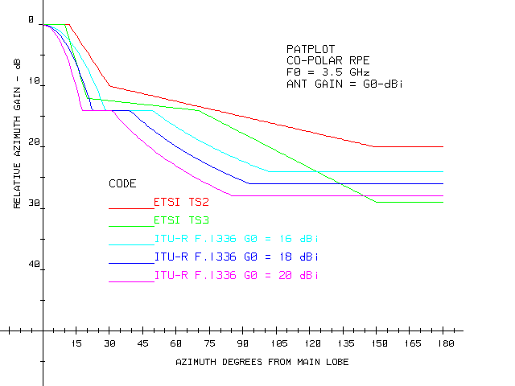
Figure 1: Antenna RPE Comparison

2.1.2 Cell coverage.
For evaluating the interference potential, it is initially needed a rough evaluation of the cells radius in the various environments using appropriate propagation models.
We will examine two typical scenarios based on LOS and NLOS propagation, they will be conventionally identified as “rural” or “urban”; however, the results should not be considered strictly applicable for those areas only, but might be applied whenever the propagation specific LOS or NLOS conditions are applicable (at least for the fraction of the user terminals concerned). The two scenarios are specific for:
- LOS “Rural” situations, when for wider cells coverage (or high quality of service) it is necessary to rely on conventional P-MP deployment with directional antennas and mostly LOS situation (certainly applicable for the users at cell border). The cell dimension is noise-limited free-space attenuation and Rayleigh fading, with correction derived by spherical diffraction phenomenon.
- NLOS “urban” situation, when presence of high building or foreseen service to indoor terminals is likely to shade most of the links to users terminals, considerably reducing the available coverage. Propagation phenomena is modelled with SUI model, assuming fast varying multiple reflections.

2.1.2.1 Rural LOS scenario
The scenario examined is a LoS, relatively flat environment without significant obstructions, located in central Europe.

The main propagation modes are assumed to be free space and, possibly, spherical diffraction. The link availability will be affected by clear-air multi-path.

The maximum cell radius R will be calculated from the link budget:
SG + G_{CS} + G_{TS} = FSPL + A_{sph} + FM ()

where:
SG is the “system gain” (i.e. difference in dB of TX output power and RX threshold at given BER 10⁻⁶)

G_{CS} and G_{TS} are CS and TS antenna gains in dB. For this evaluation we will consider G_{TS}=16 dB as worst case (resulting in smaller cell size).

FSPL is the free space attenuation loss for f=3.5 GHz given by:
FSPL = 92.4+ 20 log(f D) = 103.28 + 20 log(D) ()

A_{sph} is the spherical diffraction attenuation described in ITU-R Recommendation P.562 that depends on the height of CS and TS antennas, relative to the ground.

FM is the fade margin (excess attenuation) required to meet the yearly availability objective.

FM can be evaluated according to ITU-R P.530, which covers both the deep fade and shallow fade regions. For the purpose of the present analysis, it seems adequate to use the deep fade approximation or 10 dB, whichever is greater.
The 10 dB has been chosen as a safe value to ensure proper operation in "normal" clear air propagation.

From ITU-R P.530-8:
FM=-10 log[P_{wm} /P₀], ()

P_{wm} is the probability of exceeding the critical BER during the worst month. Scaling it to a yearly average, for the assumed geographical area and for 3.5 GHz radio frequency, with the conservative approach that the yearly unavailability (un_{year}%) is spread over four “worst” months only, FM can be written as:
P_{wm} %= 3 * un_{year} % ()

P₀%=5*10⁻⁷ * 10^{[-0.1*(Co-Clat-Clon)]} * pl^{(1.5)} * (1+ε)^{(-1.4)} * f^{(0.89)} * D^{3.6} ()

Assuming C₀=3.5 (hilly terrain), C_{lon}=3 dB (Europe), C_{lat}=0 dB (medium latitude); pl=10%; ε=0;

P₀% = 5*10⁻⁷ * 10^{[-0.1*(3.5-3)]} * 10^{(1.5)} * (1+0)^{(-1.4)} * 3.5^{(0.89)} * D^{(3.6)}

P₀% = 4.2972*10⁻⁵ * D^{(3.6)}

P₀/P_{wm} = [4.2972*10⁻⁵* D^{(3.6)}] / (3 * un_{year}%)

Substituting (4) and (5) into (3) we obtain:
FM= - 48.44+36*log(D) - 10*log(un_{year}%) ()

Spherical diffraction attenuation A_{sph} can be calculated by subtracting the free space attenuation from the output of the program GRWAVE (available from ITU). A sample output for two significant cases is shown in Figure 2. Neglecting the ripple at short distances, which comes from reflections in the plane earth model, A_{sph} is approximated as:
A_{sph}= 0 (for D < D₀) (a)
A_{sph} = K₂ (D-D₀) (for D ≥ D₀) (b)

D₀ is taken as the point where the total attenuation equals the free space value (i.e. A_{sph} = 0 in Figure 2) where spherical diffraction attenuation starts to be significant. D₀ depends on the heights of hub and terminal antennas above ground (hc, ht). Values for a few significant cases are shown in the following Figure 2 that shows that K₂ ≅ 1.3 dB/km is nearly invariant and that when different CS and TS antenna heights are considered, the mean height value could be used.
Figure 2: Additional attenuation due to spherical diffraction
Substituting (2), (6) and (7) into (1), the link budget at the cell edge (D=R) can be rewritten as:
SG+ G_{CS} + G_{TS} = 54.84 -10 log(un_{year}%) +56 log(R) + K₂ (R-D₀) ()

With the assumed equipment parameters, antenna heights, and yearly availability objectives 99.99 %, and 99.999%, the maximum cell radius values are shown in Table 2.
 |  | Availability
System | Antenna heights | 99.99% |  |  |  | 99.999%
type |  | G_{TS}=16 dB |  | G_{TS}=20 dB |  | G_{TS}=16 dB |  | G_{TS}=20 dB
 |  | R [km] | FM [dB] | R [km] | FM [dB] | R [km] | FM [dB] | R [km] | FM [dB]
 | hc =40m  ht = 20m | 18.7 | 17.3 | 22 | 19.9 | 12.4 | 20.9 | 14.6 | 23.4
 | hc =30m  ht = 30m | 18.7 | 17.3 | 22 | 19.9 | 12.4 | 20.9 | 14.6 | 23.4
A | hc = 30m  ht = 10m | 18.7 | 17.3 | (21.2) | (19.3) | 12.4 | 20.9 | 14.6 | 23.4
 | hc =20m  ht = 20m | 18.7 | 17.3 | 22 | 19.9 | 12.4 | 20.9 | 14.6 | 23.4
 | (hc =10m  ht =10m) | (14.7) | (13.6) | (16.2) | (15.1) | (11.4) | (19.6) | (12.9) | (21.5)
 | hc =40m  ht = 20m | 13.4 | 12.2 | 15.8 | 14.7 | 8.9 | 15.7 | 10.5 | 18.3
 | hc =30m  ht = 30m | 13.4 | 12.2 | 15.8 | 14.7 | 8.9 | 15.7 | 10.5 | 18.3
B | hc = 30m  ht = 10m | 13.4 | 12.2 | 15.8 | 14.7 | 8.9 | 15.7 | 10.5 | 18.3
 | hc =20m  ht = 20m | 13.4 | 12.2 | 15.8 | 14.7 | 8.9 | 15.7 | 10.5 | 18.3
 | (hc =10m  ht =10m) | (12) | (10.4) | (13.5) | (12.2) | (8.7) | (15.4) | (10.5) | (18.3)
Note: Values in parenthesis denote the impact of spherical diffraction attenuation
Table 2: Cell radius and FM vs. Availability (BER 10⁻⁶)

The conclusions of Table 2 show that, for most cases of practical antenna height, the cell radius is limited by the system gains considered and by the free space loss only. Hence spherical diffraction is not yet affecting the propagation; moreover, antenna heights are not affecting the area coverage. The cases with CS and TS antenna heights = 10 m (see Figure 2) are the only ones where spherical diffraction attenuation has some impact by reducing the cell size. The latter cases are shown only as explanatory example of the phenomenon, however, hc = 10m is not considered realistic and therefore will no longer be taken into account in further evaluations.

2.1.2.2 Urban NLOS scenario
For urban propagation models there are not consolidated ITU models. However, the one recently adopted by IEEE 802.16 for similar coexistence studies [4] might be profitably used; it describes he associated path attenuation, in dB, with a Gaussian probability distribution function (p.d.f.), with mean value (here called A₅₀) and a shadowing variance with standard deviation “σ” (between ~8 to 10 dB). Over-imposed to this attenuation probabilistic spread, another “fast-fading” occurrence probability described with SUI propagation model, derived from multiple facets attenuation due to quick variable situations (e.g. windows openings, leaves, cars etc.)
In IEEE 802.16 an “excess attenuation” for all TSs is introduced (mostly based on tests made over wooden/hilly areas among low rise buildings, typical for most US cities outside their relatively small downtown) increasing with distance from CS and subdivided into three different categories (Erceg categories A, B and C) according the terrain characteristics and 6 SUI models. However, subsequent tests made in European urban environment has shown that some of the variants (notably Erceg B with intermediate SUI 2-4) are suitably applicable as well as Erceg C for rural NLoS (or wide spread suburban areas).
The following basic principles describe the IEEE model:
- The path loss (PL) can be seen as the summation of basic free space loss (FSL) and the excess loss (Lex) due to the local blockage conditions or reduction of antenna gains: PL(dB) = FSL (dB) + Lex (dB)
- The path loss can be modelled as follows: PL(dB) = A0(dB) + 10 n log(d/d0) + S(dB) , where the exponent n represents the decay of path loss and depends on the operating frequency, antenna heights and propagation environments. The reference path loss A0 (also sometimes referred as A₅₀ in the document) at a distance d0 (generally d0 is assumed =100m considering that propagation closer to 100 m might be dominated by other unpredictable factors such as reflections) from the transmitter is typically found through field measurements. The shadowing loss S denotes a zero mean Gaussian random variable (Log-normal variable) with a standard deviation (also in decibels).

The detailed evaluation of cell size as a function of desired availability is reported in Annex 1.
Results might be summarised in cell sizes of 2/3 km radius (depending on the predominant modulation format) in suburban areas for conventional Outdoor TS coverage ~95% and availability objective of 99.99% (QoS) services.

In urban scenarios cell sizes drop down to 1/2 km (depending on the predominant modulation format) for conventional Outdoor TS coverage ~95% and availability objective of 99.99% (QoS) services and is maintained around the same size for indoor applications provided that the objectives would be relaxed to ~70% coverage and 99% availability (best effort service). Alternatively the cell size should be further reduced to 0.5/1 km.

2.1.3 Interference protection factor (IPF)
The potential coexistence of different cells in adjacent frequency blocks is guaranteed when there is sufficient isolation between interfering transmitters of one cell and victim receivers of the other cell.

This required isolation, generally referred as Interference protection factor (IPF), might be obtained enforcing a block-edge spectrum density mask (in form of either out-of-block EIRP density or out-of-block absolute power density emission at antenna port as discussed later in the document.

As a consequence a “technology neutral” approach is hereby used in the form of the above IPF, out of which a specific example is the transmitter output power density Block-edge mask (BEM) concept, described in Figure 3.

The BEM concept, strictly related to the Net Filter Discrimination (NFD) concept, actually summarised all the equipment/antenna related IPF contributions and might be best fit in environment where equipment characteristics are not known beforehand.

This does not imply that the BEM is always the best method, when system characteristics are known (e.g. when one or few specific technologies are privileged) so that fixed co-ordination rules might be uniquely set a more detailed approach might be more appropriate.

Also polarisation decoupling is a factor that might not be prejudged (unless different polarisations are imposed in licensing two adjacent blocks operators, limiting their free usage of the block) and in the following evaluation is not taken into account.

The relationship between NFD (in the central portion of adjacent block) and BEM, expressed in terms of EIRP, is equipment/antenna dependent only and is described as:
P_{out-density} (dBW/MHz) + G_{TX} − NFD = X₃ (dBW/MHz) ()

where X₃ represents, in EIRP density terms, the CS BEM out-of block lowest requirement within the central portion of the adjacent block as described in Figure 3.

Figure 3: Scheme of the BEM concept

In Figure 3 the “0” frequency reference is intended as the central frequency between contiguous blocks, either having a fixed external guard-band assigned in between or, in case of immediately adjacent blocks, having a corresponding wider block bandwidth assigned for operators to manage the best an internal guard band between them.
The transition zone, shown between X₁ and X₃ power density levels, is not considered in this report, neither in terms of IPF or NFD, but should be determined through a trade-off between the need of a limited amount of guard-band, the possible slight decrement of NFD available for the block-outermost system channels and the practical feasibility of equipment filtering for reaching the required X₃ level from in-block P_{max} density, which is generally defined for suitable service and sharing conditions in the licensing process. Annex 3 give some more consideration on the definition of the transition zone.

It should also be noted that equation assumes that the receiver filters of equipment are matched to the transmit requirements (i.e. are able to reduce the adjacent block interfering carriers power down to a level not impacting the receiver linearity or the total amount of in-band interfering power). On the other hand, ETSI ENs do not give any specific requirement or guidance for receive filtering but only minimal C/I rejection capability, leaving to manufacturer freedom for its best practice, also considering that in the R&TTE Directive spirit receiver performances should be dominated by market forces.

For convenience, in the following sections, where specific numerical examples are made on the base of representative system characteristics defined in Table 1 the parameter X₃ only is used with the understanding that NFD is easily derived from equation .

2.1.3.1 Channel arrangements
Prior to evaluating BEM requirements, possible channel arrangement should be analysed, as offered by CEPT/ERC Recommendations 14-03 (3.4-3.6 GHz) and 12-08 (3.6-3.8 GHz).

Both recommend assignments based on "number of slots" 0.25 MHz wide; apparently only symmetric assignments are foreseen and no specific mention is made of internal (go-return) guard band except for the fact that in 3.41-3.6 GHz the "odd" 10 MHz automatically create a ~ 10 MHz guard band. However such guard band disappears for the 3.5-3.6 MHz (50 MHz duplex) and for all 3.6 - 3.8 GHz.

That means that unless specific number of slots are reserved in both go and return sub-bands (wasting at least half of them), adjacent TX/RX interference is expected also for FDD systems.

Moreover, the recommendations mention that:
"where a duplex frequency allocation is required, the spacing between the lower edges of each paired sub-band shall be 100 MHz"
and also:
"P-MP equipment may be used having a duplex spacing other than exactly 50(100) MHz. However, such equipment must conform to the limits of the block allocation as defined above."

These sentences and the fact that no recommendation on sub-band for CS and TS operation is made, clearly show the intention to admit (on a non discriminatory way) TDD and FDD, symmetric and asymmetric systems.

It has been recently demonstrated by CEPT studies for 40 GHz band the best compromise method for allowing flexibility and efficient use of the spectrum with the recommended symmetrical assignment, the deployment of asymmetrical systems being made with mixed uplink/downlink sub-bands within the symmetrical assignment.

The above considerations and the small duplex spacing, lead to the conclusion that, unless the band should be assigned for predefined technology (e.g. FDD only) and spectrum waste is envisaged for creating go-return guard band, a mixed TX/RX in nearly adjacent assignments should be in any case considered.

2.2 CS-to-CS interference
A "same area, adjacent frequency blocks" scenario will be assumed (Figure 4). CS-to-CS interference is particularly dangerous, since it can cause unavailability of a whole sector. Therefore a worst case analysis will be presented for it. Both CSs are supposed to face each other in line of sight (worst case situation). The fading events (mainly due to clear air multipath) are considered as completely uncorrelated. Rain attenuation is negligible at this frequency band.

Figure 4: CS-to-CS interference scenario

As far as propagation model is concerned, the allowed interfering IPF (or EIRP) is calculated for free-space propagation only, since:
- The distance between CSs is in practice short enough to exclude spherical diffraction.
- Both antennas are in relatively high locations (30m in the example) even in the urban environment. In this case the mean path loss predicted by the IEEE propagation model (see Annex 1) is near or lower than the free-space attenuation.

It is further assumed that the allowed degradation of the victim receiver threshold due to interference is

Δ_{Threshold} = 1 dB, hence the allowed interference spectral density is:
I_{S} = N₀ − 6 = −144 +NF −6 (dBW/MHz).

As in the 40 GHz case, it may be assumed that the victim receiver has selectivity that matches the IPF or the block edge mask. Hence the main carriers of the adjacent block EIRP are always reduced below the interfering out-of-block noise floor so that their residual contribution is negligible; therefore, the required eirp level in the central portion of the adjacent block is:
X₃− 92.4 − 20 log(RF) − 20 log(d) + G_{RX} = −144 +NF −6

where: X₃ = P_{out-density} + G_{TX} −NFD represents, in EIRP density terms, the CS BEM out-of block lowest requirement in dBW/MHz within the central portion of the adjacent block (see Figure 3 and paragraph 2.1.3), RF is the frequency in GHz, “d” the CS distance in km,

with the assumed system reference values shown in Table 1, a plot of the required X₃ value vs. “d” is shown in Figure 5, giving obviously the same result for both A and B systems, having the same CS antenna gains (16 dBi).
0
0.5
1
1.5
2
-75
-70
-65
-60
-55
-50
-45
d (km)
km
Figure 5: Required CS-to-CS spacing for un co-ordinated deployment

If, as initial assumption, one would consider an out-of-block emission limit of -50 dBm/MHz at the antenna connector, one would get for X₃:

X₃ = − 50 − 30 + G_{antCS} = − 50 − 30 +16 = − 64 dBW/MHz

This would allow a minimum uncoordinated distance of about 350m, which seems quite reasonable in a rural environment, given the typical cell radius values shown in Table 2.

On the other hand a value of X₃ = −73 dBW/MHz would lead, for system types B in LOS CS to CS scenarios, to a minimum uncoordinated distance of less than 100m, which seems more appropriate in a urban scenario where more dense network and higher number of user terminals in NLOS, lead to smaller cells size.
It is assumed that when lower distances are concerned, there is a likely mutual shading between two elevated buildings so close by; therefore the two CSs would be likely co-located on the same building. It is then assumed that common practice of site engineering (e.g. vertical decoupling of few meters, for avoiding near field propagation effects) is implemented, recovering with side-to-side antenna decoupling the reduction in free space loss.

Therefore, these values will be carried over for being validated through further analysis related to CS to TS interference, in the next section 2.3 for having a suitably low ISOP or unacceptable C/I occurrence probability.

It should be noted that for urban scenarios, the above LoS evaluation is an absolute worst-case. The additional shading attenuation probability is not a negligible factor and using specific propagation models helps prove this
(e.g. the IEEE 802.16 adopted one depicted in Annex 1.2 and in IEEE document available at http://grouper.ieee.org/groups/802/16/tg3/contrib/802163c-01_29r4.pdf ).

2.3 CS-to-TS interference
As for the cells coverage area, the CS to TS interference scenario should be analysed for the two cases of LOS and NLOS propagation, see description of “rural” and “urban” scenarios in section 2.2.1.

2.3.1 Rural LOS scenario
The ISOP approach will be used, due to the random nature of this kind of interference. Also in this case complete uncorrelation will be assumed between fading events affecting the "wanted" and the interference path.

There will be an area in the victim sector where the receiver threshold degradation will exceed the assumed 1 dB limit. Its size and shape depends on the distance between CS's and the additional protection from the terminal antenna RPE.
Referring to Figure 5, we will label V the victim TS, W the "wanted" CS and I the interfering CS.
CS (W)
CS (I)
TS (V)
d_{W-I}
Interf. Area (IA)
Antenna: TS 2
Interf. Area (IA)
Antenna: TS 3

Figure 6: CS to TS interfering scenario
The area where the threshold degradation exceeds the 1 dB objective will be defined by:
X₃ -FSPL_{(I-V)} + G_{antTS(V)} - A_{ΦTS(I-W)} ≥ -144 + NF – 6

This formula is commonly used for rural scenario (where availability is dominated by Rayleigh deep-fade phenomena) considering the un-correlation of deep fading events in the different paths..

A_{ΦTS(I-W)} is the additional attenuation given by the TS victim antenna RPE at an angle equal to the difference in azimuth between the victim-to-wanted-CS and the victim-to-interferer-CS path (assuming that the victim antenna is aligned at boresight with the wanted CS).

Using the TS 2 and TS 3 antenna classes (represented by typical ITU-R F.1336 antenna RPE derived with G=16 and 20 dB, still maintaining fixed boresight gain of 16 dB), the "forbidden" interference area IA can be derived and are represented in Figure 7.
-0,3
-0,2
-0,1
0
0,1
0,2
0,3
0
0,1
0,2
0,3
0,4
0,5
km
km
X3=-64 dBW/MHz - TS 2 antenna class
X3=-73 dBW/MHz -TS 2 antenna class
X3=-64 dBW/MHz - TS 3 antenna class
X3=-73 dBW/MHz - TS 3 antenna class
Figure 7: Interference Areas (IA) for victim TS as function of out-of-block EIRP density X3
and ITU-R TS antenna RPE

Figure 7 is representative of the worst case AI experienced when the two W and I CSs are boresight aligned and at their minimum distance (derived in section 2.1.3.2 CS to CS scenario).

ISOP is calculated following the approach in ECC Report 99, as ISOP = (1-(1-P₁)^{Nt})*P₂*P₃
where:
- P1 is the probability that one TS falls within the interference area where the margin degradation exceed a predefined value (here assumed 1 dB) evaluated as P₁ = IA/A_{sector}.
- N_{t} is the total number of terminals deployed in a sector.
- P₂ is the probability that the attenuation from wanted TX to victim RX and from interfering TX to victim RX are uncorrelated. In a propagation environment dominated by multipath we assume P₂=1. This is valid for “rural” scenario where the cell size is limited only by LoS propagation following Rayleigh statistics and described in ITU-R Recommendation P.530. For urban near-NLoS scenario this is not generally true; however, due to its shortness, one of the two paths (the interference one) is still here considered LoS for actually affecting the victim TS region. In addition the assumption P₂ = 1 is conservative.
- P₃ is the probability that operators use adjacent frequency blocks and equal coverage on the same area. It depends on the number of available blocks, the number of operators, the relative area coverage and the number of sectors per cell. Assuming 2 or 3 blocks (one per operator) and 4 sectors per cell, P3=1/6 for 2 operators, P3=~1/2 for 3 operators.

Assuming N_{t} = 64 or N_{t} = 32 (considered representative of relatively wide-band systems adopted in this frequency bands). An average P₃ = 1/4, a few values of ISOP have been calculated as examples in Table 3a) and Table 3b) with G_{CS}=16dBi, G_{TS} = 16 dBi and TS2 and TS3 antenna typical RPE (using typical ITU-R F.1336 RPE derived with gain of 16 and 20 dBi, respectively).

Scenario | X₃  (dBW/MHz) | TS  Antenna | d_{U-I} min  (m) | A_{Sector}  (km²) | IA  (km²) | P1 | ISOP %  N_{T}=64 | ISOP %  N_{T}=32
Rural | -64 | TS2 | 350 | 274.65 | 0.0445 | 0.0162 | 0.258 | 0.129
Rural | -64 | TS3 | 350 | 274.65 | 0.02924 | 0.01065 | 0.1698 | 0.085
Rural | -73 | TS2 | 100 | 274.65 | 0.006 | 0.0022 | 0.0352 | 0.0176
Rural | -73 | TS3 | 100 | 274.65 | 0.00397 | 0.00145 | 0.0231 | 0.0156
Table 3a): ISOP % as function of out-of block EIRP density in some rural scenarios
−System type A (4 states)−

Scenario | X₃  (dBW/MHz) | TS  Antenna | d_{U-I} min  [m] | A_{Sector}  (km²) | IA  (km²) | P1 | ISOP %  N_{T}=64 | ISOP %  N_{T}=32
Rural | -64 | TS2 | 350 | 141.03 | 0.0445 | 0.0315 | 0.499 | 0.251
Rural | -64 | TS3 | 350 | 141.03 | 0.02924 | 0.02073 | 0.3296 | 0.1653
Rural | -73 | TS2 | 100 | 141.03 | 0.00605 | 0.00429 | 0.0686 | 0.0343
Rural | -73 | TS3 | 100 | 141.03 | 0.00397 | 0.00282 | 0.045 | 0.0225
Table 3b): ISOP % as function of out-of block EIRP density in some rural scenarios
−System type B (16 states)−

The above data are obtained for the worst case of W and I CS placement (boresight aligned and in closest position); however the ISOP drops rapidly as the distance increases. Figure 8 shows two examples taken from those in Table 3.
dU-I [km]
ISOP %
0,00
0,25
0,50
0,75
1,00
1,25
0
1
2
3
4
5
6
7
8
9
10
11
12
13
14
15
16
64 QAM (N_{T}=64)
X3=-64 dBW/MHz
Rmax=13.4 km
4 QAM (N_{T}=64)
X3=-64 dBW/MHz
Rmax=18.7 km
Figure 8: ISOP as function of W and I CS distance

From the above it appears that:
- The use of Class 3 TS antenna reduce the ISOP by ~25% to 35% in comparison to Class 2 one.
- In rural LOS scenario an ISOP < 1% is already obtained with the less demanding NFD (or X₃) limit of −64 dBW/MHz. Therefore the more critical parameter might still be the CS to CS interference.

2.3.2 Urban NLOS scenario
For the urban scenario, on quite lower cell size, availability will not be dominated by deep Raleigh fading but by NLoS statistics (i.e. SUI channel models of the IEEE 802.16 adopted model) which are fully uncorrelated between wanted (victim) and unwanted (interferer) paths.
Therefore, the system performance degradation from interference is not considered “noise limited”, but “interference limited” whenever the C/I falls down a critical value for the assumed modulation format.
In the following evaluations we will conservatively consider CS with the following data:
- TX output power = 35 dBm
- Signal bandwidth = 3.5 MHz
- TX output power density = 29.5 dBm/MHz
- Antenna TX Gain (sectorial 90°) = 16 dB
- Antenna height = 30 / 40 m
- Modulation formats = QPSK / 16QAM
and TS relevant data as:
- NF = 8 dB (including cable connection to antennas)
- Modulation formats = QPSK / 16QAM
- Typical S/N @ BER=10⁻⁶ for coded modulation:
- QPSK = 11.2 dB
- 16QAM = 18.2 dB
- Typical C/I for 1dB threshold degradation at BER=10⁻⁶:
- QPSK = 18 dB
- 16QAM = 25 dB
- Typical C/I for BER=10⁻⁶ in unfaded conditions:
- QPSK = 12 dB
- 16QAM = 19 dB
- Antenna Gain = G_{TS}=18 dB (ETSI TS3 typical RPE, directional roof-top/high balcony outdoor deployment, typical for high coverage of business high quality connections). For the calculations the typical ITU.R F.1336 radiation pattern will be used.
- Antenna Gain = G_{TS}=4 dB (omni-directional desk indoor deployment, typical for generic purpose residential IP connections with less coverage/quality requirements). For simulating the actual random building/indoor propagation losses, which are also different for the C and I path due to different average arrival directions, a 90° sector RP with random orientation will be used, dropping the antenna gain by the 5 dB minimum losses (i.e. G=−1 dB).
- Antenna Gain = G_{TS}=10 dB (ETSI TS2 typical RPE, directional indoor window deployment, intermediate situation deployment). For the calculations the typical ITU.R F.1336 radiation pattern will be used.
- Antenna height = h_{TS}=4 / 15 m (see also considerations in the Propagation model section)
Propagation models:
As in the objective for the revision we will use the IEEE 802.16 NLOS model described in Annex 1 section A1.2.
Having to manage roof-top outdoor and indoor (ranging from ground floors to higher floors) situations, we need to differentiate also the propagation model parameters to be used.
It should also be noted that, even if antennas heights are a free parameters in IEEE formulas, formally the models are valid for TS heights from 2 to 10 m; therefore, conservatively we will not use TS locations higher than 15m.
We would rather use two different Erceg Categories and SUI models, for representing more or less favourable propagation conditions.
With the above assumptions we have selected two specific models with two variant each:
Business case (directional TS outdoor):
Erceg-Category B+SUI-4 as worst case (lower floors or more obstructed situations)
Erceg- Category C+SUI-2 as best case (higher floors or less obstructed situations)
Shadowing variance: σ = 8 dB
Additional Attenuation = 0 dB (no building entrance loss)
Residential case (omni/low directivity TS indoor):
Erceg-Category B+SUI-4 as worst case (lower floors or more obstructed situations)
Erceg- Category C+SUI-2 as best case (higher floors or less obstructed situations)
Shadowing variance: σ = 10 dB
Additional Attenuation = 5 dB (building entrance loss with window or desk antenna, in any case likely close to a window) or 15 dB (less favourable indoor location conditions)
TS antenna height:
Three cases are only considered for the C/I evaluation, 4m, 10m and 15m
For higher floors situations, that would in any case fall outside the Erceg model applicability (limited to TS height ~ 10m), they are considered conservative; moreover, being the terminal location, and then the propagation model, common to wanted and unwanted signals, it will be shown that C/I statistic is practically independent from TS height and propagation models applied.
The following and Figure 10 show examples (for Erceg Category C at two different h_{TS} height) of the attenuation distribution of the received power due to shadowing at various occurrence probability versus distance, while Figure 11show the additional distribution of “fast-faded Rice attenuation” for the two selected typical in SUI-2 and SUI-4 channels, respectively.
The latter curves are obtained as average of about 10⁶ channels trials; in figure the average curve of the two models is also reported.
In NLOS scenarios there are many possible combinations of parameters to obtain such channel descriptions; in particular a SUI-2 result into a model suitable for a light multipath scenario instead a SUI-4 results into a model suitable for a scenario characterized by strong multipath. Practical experience in the mobile services shows that SUI-4 model is quite severe.

Figure 9: Example of shadowing attenuation variance (h_{TS}=2m).
Figure 10:Example of shadowing attenuation variance (h_{TS}=15m)

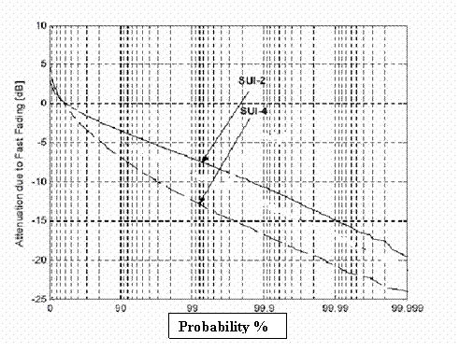
Figure 11: Examples of Rice fading statistics

Additional antennas and path loss simulation methodology for the indoor TS evaluation
- The antenna radiation patterns are taken into account only in azimuth; this might be marginal for the evaluation of the “wanted” C, while for the Interfering signal it might be too conservative, even in NLOS propagation, provided that the most critical cases are TS far from the wanted CS (lower average elevation of C arrival angles) and close to the I CS (higher average elevation of I arrival angles).
- In case of omni-directional TS antennas, here used only for indoor applications, there was sensible contribution to the results from TS that appears to be within the side lobes of the Interfering CS.
At first glance it might look correct; however, it certainly would have been if the antenna would be outdoor, while for indoor use additional considerations should be made:
The IEEE 802.16 does not cover indoor applications; other available models treat only indoor-to-indoor propagation.
The widows themselves would act as lateral shielding for the omni antenna so that it might be better described as low-gain “sectorial”;
Nevertheless, the orientation of such antenna should be rendered random on a 360° azimuth (due to the random position of the window closest to the TS, with respect to the principal direction of the main signal. With this modelling, some of the cases considered in the C/I statistic would have been discarded for lack of wanted signal (i.e. the area coverage would become lower for lack of signal and not for excess of C/I);
In this section the same propagation models and system parameters will be used for evaluating the occurrence probability of C/I ratio between a wanted and an unwanted CS stations.
The interference scenario is described by the following Figure 12.
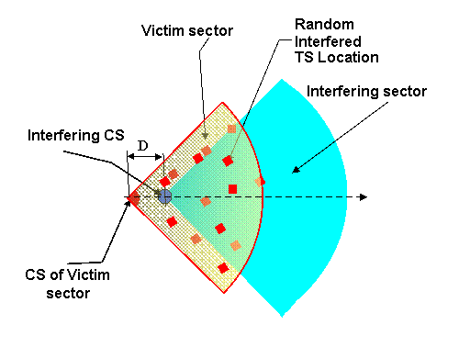
Figure 12A: Generic model for CS→TS interference (Case A)
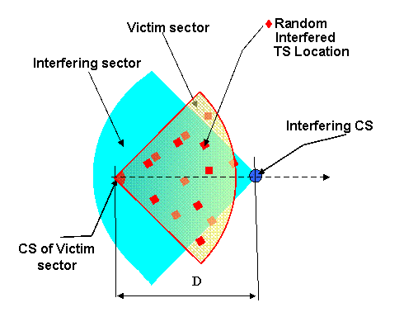
Figure 12B: Generic model for CS→TS interference (Case B)
In principle, wanted and unwanted sectors CS will be also randomly located and the sectors boresight also randomly oriented.
For simplification, we will study only the case with sectors aligned (when sectors are differently aligned, the interfered sector will be in any case wholly interfered by one or another sector of the interfering cell).
Case in Figure 12A has proven to be worst case when directional TS antennas are concerned, while case of Figure 12B would be more severe for applications with TS omni-directional antennas.
The interfering CS is moved along the axis.
In NLOS propagation; even with CS collocated, their distance, in elevation or in roof-space, will be at least of several wavelengths so that the statistic components of Shielding and Rician attenuation of wanted RSL and unwanted interference (I) could be considered uncorrelated.

2.3.2.1 Methodology
The objective is to define the EIRP discrimination between adjacent blocks (e.g. in term of block mask or NFD) in order to offer a suitable protection between blocks.
The RSL of the possible active Terminal Stations of the wanted cell would be randomly distributed according the selected propagation model, therefore only few will have RSL close to the threshold, while most will have higher RSL; the C/I by acceptable those stations would then range from the C/I producing a small degradation of the threshold (e.g. 1 dB was assumed in present Report 33) up to the critical C/I producing BER >10⁻⁶ in unfaded condition.
When indoor omni-directional antennas are concerned, the simulation of the random building entry and indoor losses will be made artificially assuming the antenna RP as a 90° sectorial with a randomly assigned orientation; this will result in privileging the C or the I paths according their different average arrival angle (i.e. resulting in more trials discarded when the C path is unfavourable, according the procedure described in step 1 below). For introducing the minimal building entry effect (i.e. 5 dB), the gain of the antenna will also be artificially reduced by 5 dB (i.e. G = −1 dB).
Conservatively we would consider, as target for all cases, only the C/I for 1dB degradation of 10⁻⁶ BER threshold.
The two CS are placed at distance D=0 m (CS co-located), R/4, R/2, ¾R and 0.99*R (cell border) and 1.5*R (only for validate omni-directional worst case).
As in the previous cell coverage evaluation, the wanted signals sector is populated by a pattern of TS location.
Using the same Monte Carlo method and propagation models the probability distribution of the RSL is derived.
However, unlike the previous case, here each trial resulting in RSL lower that the BER 10⁻⁶ threshold is excluded from the final probability distribution because, if affected by an interference, it will be irrelevant.
Also in this case, the evaluation of the inter-block NFD/EIRP protection requires a number of steps:
Step 1:
Evaluation of the statistic distribution of the wanted RSL (C) related to the shadowing:
For each TS the mean wanted path attenuation (Aw₅₀) is evaluated.
Other ~300 independent Monte Carlo trials for the shadowing attenuation are generated.
Trials with RSL < BER 10⁻⁶ threshold are discarded.
The overall sum constitutes the distribution function of the wanted “shadowed” component of RSL (C_{SH}).
Step 2:
Evaluation of the statistic distribution of the unwanted interference (I) related to the shadowing:
For each TS the mean interference path attenuation (Au₅₀) is evaluated.
Other ~300 independent Monte Carlo trials for the shadowing attenuation are generated.
The overall sum constitutes the distribution function of the unwanted “shadowed” component of interference (I_{SH}).
Step 3:
Inclusion of the Rician fading component in the overall statistic distribution of the wanted RSL (C):
For each TS the distribution function of wanted path attenuation, derived from the step 1, is convoluted with the relevant SUI channel attenuation distribution.
The result constitutes the spatial and time distribution function of the wanted RSL (C).
Step 4:
Inclusion of the Rician fading component in the overall statistic distribution of the unwanted interference (I):
For each TS the distribution function of unwanted interference path attenuation, derived from the step 2, is convoluted with the relevant SUI channel attenuation distribution.
The result constitutes the spatial and time distribution function of the unwanted interference (I).
Step 5:
Evaluation of the overall probability of the C/I:
The overall C and I distribution for each TS are convoluted for defining the probability distribution of C/I.
The mean value of the probability distributions for all TSs is calculated.
The cumulative probability function of C/I is calculated
The result constitutes the mean spatial and time cumulative probability function of C/I < x dB.
Step 6:
Evaluation of the required inter-block EIRP/NFD protection:
The two CS are placed at distance D=0 m (CS co-located), R/4, R/2, ¾R and 0.99*R (cell border) and 1.5*R (for omni-directional case only in order to validate the worst case situation).

2.3.2.2 Results:

2.3.2.2.1 C/I statistics
The following simplifications have been used for the simulations.
- The antenna radiation patterns are taken into account only in azimuth; this might be marginal for the evaluation of the “wanted” C, while for the Interfering signal it might be too conservative, even in NLOS propagation, provided that the most critical cases are TS far from the wanted CS (lower average elevation of C arrival angles) and close to the I CS (higher average elevation of I arrival angles).
- In case of omni-directional TS antennas, here used only for indoor applications, the random building/indoor attenuation, likely different for the C and I paths, are taken into account with the methodology described above.
The following Figure 13 shows examples of the cumulative distributions of the C/I derived with the above methodology.
(GTS=18 dB) (GTS=4dB + random building loss 5÷40 dB)
Figure 13: C/I distribution (Erceg Cat B, SUI-4, h_{CS}=30m, h_{TS}=4m) versus D on a 2 km cell (Case A)
In Annex 4 of this document the value of C/I exceeded for more than 99% and, for omni-directional indoor case, also for 96 to 99% of the trials are reported.
In addition, provided that the calculations depend on a significant number of input data, and actual situations might contains various mixture of those data, analysis of the variations produced by each data are reported in next Figures; (Note that basic data, whenever not subject of the variation are those of Figure 13, Erceg Cat B, SUI-4, h_{CS}=30, h_{TS}=4, G_{TS}=18, R=2km cell, CS distance R/4).
Of particular importance are the last two Figure 19and Figure 20that show the impact of having different W and I CS height, which variation is not elsewhere considered.
Figure 14: Variations with overall propagation model Figure 15: Variations with h_{TS}
Figure 16: Variations with G_{TS} ( G= −1dB represent the omni-directional indoor case)
Figure 17: Variations with cell radius Figure 18: Variations with h_{CS} (W=I)

Figure 19: Variations of Wanted h_{CS}
Figure 20: Variations of Interfering h_{CS}

2.3.2.2.2 Inter-block protection evaluation

2.3.2.2.2.1 Directional TS antennas
Provided that the average number of TS is constant over the sector (being physically limited by the handling capability of the system and not by the sector area), from Annex 4 it might be seen that the result depends in practice from the W and I CS positioning relative to the cell radius (D/R ratio) and only marginally from G_{TS}; the propagation model and TS height have nearly no impact.
The worst C/I cases reported in Annex 2 are concentrated, with interfering CS situation of Figure 4A, where the interfering CS is at 3/4 of the wanted cell; here a worst C/I ≅ −49 dB with 99% probability is evaluated (for antenna gain 10 dB, Erceg Cat. B/SUI4) and are practically independent from any parameter a part the antenna gain; 18 dB gain antennas resulted in better results with worst C/I≅ −44 dB. With interfering CS situation of Figure 4B, the results are sensibly better by several dB.
For defining the Required inter-block protection, we should compare it with the minimum C/I for 1 dB degradation (16QAM): ≅+25 dB
We should now consider that the 99% occurrence probability is evaluated on the basis that ALL TS locations and antennas are in the same conditions; in reality, for a given cell size the distribution of antenna types and TS location would be random among the various cases considered (~30 for each antenna types for a total of ~60 cases with directional antennas).
From Table 35to Table 38of Annex 4 it may be seen that for a given cell size only 6 cases have actually a C/I ≅ −49 dB, next 9 cases have C/I ≅ −46 dB other ~45 cases have −44 < C/I < −10 dB.
It seems therefore correct to say that real 99% of the cases would happen with an average C/I among those cases. We would conservatively assume a factor of 60/15= 4 reduction, corresponding to 6 dB of C/I improvement.
In addition we should consider safeguard margins for some differences in CS EIRP and heights between wanted and interfering systems:
- Max ΔEIRP W/I = −5 dB
- Additional allowance for Δh_{CS} W/I: −5 dB (from Figure 19 and Figure 20)
With these assumptions the required protection could be evaluated as:
Inter-block protection = 25 − (−49 + 6) + 5 + 5 = 78 dB
Considering that the CS EIRP density considered in the study (see CS data) is +45.5 dBm/MHz, the Out of block eirp for protection of adjacent block TSs is:
Out of block eirp = +45.5 − 78 = −33.5 dBm/MHz
It should be considered that this value is still conservative for a number of factors:
- The comparison is made using the C/I for 1dB threshold degradation, while a number of the cases with higher average RSL might be affected only if C/I exceed the “critical C/I” that for any modulation format is assumed to be ~ 7 dB lower.
- Being the worst cases concentrated around an area at ¾R of the cell it is likely that a number of those cases already use a 4QAM format that would require less protection.
- We have not specifically considered the 64 QAM modulation format that would require ~7 dB more stringent requirements; however, it is understood that systems offering 64QAM will be of “mixed-mode” nature with dynamic change of formats on a per TS basis. Therefore, only the TSs closer to the CS_{W} or those with very favourable propagation will be addressed with this format. In these cases the expected C/I distribution would not be the worst one (e.g. related to lower W to I distances or better propagation situation in Annex 2).
- It contains 10 dB margin for W/I ΔEIRP and Δh_{CS} that, in average, might not be present.

2.3.2.2.2.2 Omni-directional indoor TS antennas
From the results in Table 39Annex 4, the use of omni-directional antennas results in interference situation, at the 99% of occurrence probability of worse C/I cases, is more severe of ~23dB .
This is physically expected consequent to the lesser gain/directivity; however, standing that we wish to consider only indoor applications, a number of additional considerations, with respect to those made above for terminals with directional antennas should be taken into account:
- Systems offering indoor applications are assumed to be necessarily of “mixed mode” type, with dynamic modulation formats management (actually any new generation BWA system will have this characteristic).
The worst case appears to be when interfering CS is at the wanted cell border; the affected TS are likely the ones close by, which, being also at cell border will already in average require QPSK format (most applications foreseen even BPSK modulations offering additional safeguard margin).
Therefore, the ~7dB more robustness to interference (kept as additional safeguard in directional antennas applications) may be taken into account.
- The indoor applications, for their own nature, are considered “best effort” service; therefore lower performance objectives (from the point of view of coverage and availability) are justified. If we look at a less demanding objective of 96% of worse C/I cases occurrence probability, from Figure 66in annex 4, ~ 17dB (from a C/I ≅ −72 at 1% to C/I ≅ −55 at 4%) are immediately recovered.
This should not be seen as an absolute degradation of the performance of the interfered system, the 4% degradation is only relative to actual percentage of coverage of indoor terminals, which is already assumed to be significantly lower than that of outdoor applications with directional antennas (e.g. if the expected cell coverage, at 99% availability, for indoor/omni-directional terminals is 80% in no interference, the coverage will further drop for adjacent block interference of 4*0.8= 3.2 % resulting in a total 76.8% expected cell coverage with 99% availability). In addition, being any system generally deployed with a mixture of indoor and outdoor TS, the overall coverage degradation should be further mediated over all cases.
The above two points justified that it is reasonable to assume that the 23 dB worse C/I situation for indoor omni-directional antennas with respect to conventional outdoor directional cases, may be duly compensated by the ~7 + 17 ≅ 21dB, as shown.
Therefore, an overall discussion of the differentiate applications and objectives and of cost/benefits is reported in next section.

2.3.3 Conclusions for CS→TS protection in urban NLOS environment
This new, more complex evaluation, based on real C/I occurrence probability following a certified NLOS propagation model, gives results that, for directional antennas, are ~ 10 dB less demanding than the value of EIRP previously evaluated with a more empirical propagation model and based on deterministic areas where RSL thresholds might be exceeded due to interference levels only.
This result was expected since the actual fade margin due to dynamic propagation (i.e. the Rician fade) is sensibly lower than Raleigh multi-path expected in free-space. Most of the overall system fade margin is dedicated to provide for the “shadowing” attenuation that is somehow static, once the CS and TS locations are fixed.
Therefore, comparing the interference level with the BER thresholds in NLOS propagation environment will result in very conservative scenario; actually most of the TS “in deep shadow from their CS” will have RSL significantly higher than the threshold, without need of very high additional FM.
During preparation of the first published version of this report, the expected scenario for the deployment of FWA in 3.4-3.8 GHz has changed and a wide interest on this kind of applications are now re-shaping the market expectations:
- The market, for rural as well as for sub-urban still highly populated areas, is addressing broadband services only. This would, in practice, greatly reduce the system characteristics spread (in term of significant power density and bandwidth options) among various implementations. The recent draft revision of draft ECC/REC 04-05 after public consultation have highlighted the wide preference for typical applications with channel bandwidth of 3.5 MHz or higher.
- “Conventional” PMP fully outdoor systems, originally designed for mostly LOS (or moderately obstructed paths requiring professional intervention also for TS deployment), are migrating towards more sophisticated performance in strong NLOS environment (allowing simpler TS deployment, ideally by the user alone)
- Standards organisations (ETSI/BRAN, IEEE 802.16, WiMAX) have published standards and conformance tests including multi-vendor interoperability options based on the above market expectation.
- From administrations point of view, a wide number of consultations on the use/regulations of bands around 3.5 GHz have been made or are in progress in CEPT and worldwide. Most of them are considering the redefinition of rules assuming only ad-hoc provisions for “grandfathering” of existing old licensee.
- previous responses from industries show great difficulty in matching the proposed “urban” block-edge mask; the new focus on potential wide consumer market suggests the adoption of less demanding as possible regulations for stimulating development and deployment of initial networks.
- Originally the two separate out-of-block eirp levels have been considered, according a rural or urban environment, respectively; however, previous responses from administrations have highlighted the difficulty in managing two values from regulatory and manufacturers point of view. Therefore it would be advisable to have just one definition of limits for all application scenarios.
The introduction in the study of indoor TS with omni-directional applications have shown that their higher sensitivity, with respect to more conventional applications with directional antennas, might be somehow balanced by their lower quality objectives on an overall mixture of cases, containing indoor and outdoor applications, with more or less severe NLOS.
Therefore this report used an assumption that a single mask, without distinction between urban and rural scenarios, should be suitable, and the out-of-band EIRP limit of -73 dBW/MHz would be appropriate to ensure co-existence of both CS->TS and CS->CS, the latter being the defining critical case.
Then, if the BEM were expressed in terms of transmitter output power, the out-of-band limit would become -73-G_{a}=-73-16=-89 dBW/MHz.

2.4 TS to CS interference

2.4.1 Interference evaluation
This evaluation would lead to setting the required NFD (or the X₃ value of the block-edge mask) for TS.

However, the evaluation might be based only on a statistical IPF, common to the evaluation made in the section devoted to the IPF and guard-band methodology (see Annex 2) and its details are there reported.

From the detailed evaluation made in Annex 2, the required NFD or “out-of-block” EIRP density for suitably low (<1%) probability of TS interfering a victim CS, may be summarised, for the worst cases presented, in Table 4 depending on the assumed TS antenna ITU-R RPE:
TS antennas class | Typical gain (dBi) | Required TS “X₃” value  (out-of-block EIRP density)
TS 3 | 18 | − 35 dBW/MHz
TS 2 | 16 | − 37 dBW/MHz
TS indoor Omni-directional (no ETSI standard available) | 4 | −49 dBW/MHz
Table 4: Out-of-block EIRP density requirement
for ~ 1% of TS to CS interference probability in urban scenarios

2.4.2 Conclusions for the TS to CS interference study
The expected more stringent requirements for less directivity antennas suggests that the possible BEM limit would be more suitably defined in term of absolute out-of-block power density rather than out-of-block EIRP.
In such way a single power density requirement will automatically adapt to the necessary EIRP according the used antenna, which gain is universally intended to be inversely proportional to antenna directivity.
This would lead to a single value of out-of-block power density, derived from the more stringent EIRP requirement detailed in Annex 2 (A2.2.6) (reduced by the assumed omni-directional gain of 4 dBi), of −53 dBW/MHz at the antenna connector.
However, the results in the above Table 4are only incidentally linear with down to omni antenna gain; actually in this case also the additional indoor to outdoor propagation attenuation has been included (evaluated to be at ~ 15 dB in average).
Therefore the limit of −53 dBW/MHz should be assumed valid for omni-directional use in prevalent indoor situations; whenever the prevalence would be expected for outdoor situations then some 15 dB more stringent value should be required.

2.5 Terminal Station to Terminal Station
This kind of interference, unlike the cases where a CS is involved, would only impair the operation of one terminal; therefore a worst case approach is considered as too stringent. Due to the random nature of this kind of interference, a statistical Monte Carlo approach seems more adequate. A possible scenario could be two CSs located at both sides of the boundary, each pointing into its own service area. Each TS will have its EIRP level set to deliver a signal to the CS 6 dB above the receiver threshold, except one (different in each trial) which would have maximum EIRP, to simulate the occurrence of a fading event.

However this effect, at least for PMP architectures with directive TS antennas, is not generally considered a limiting factor for coexistence (when compared to the other interference cases). This evaluation may require further work in case of mixed PMP and MESH architectures or TS with mobile (outdoor) characteristics are possibly considered.

3 ”Adjacent area - same frequency block” interference scenario

3.1 Power Flux Density Limits for adjacent FWS service areas
This section focuses on initial inter-operator co-ordination guidelines that would support assignments to FWA operators in the same frequency block adjacent geographic areas. These guidelines consist of service boundary PFD limits to assist frequency reuse between neighbouring service areas. The PFD limits are linked with a co-ordination distance, which is the distance from the service area boundary within which transmitter stations should be co-ordinated with adjacent area operators.

The methodology used in this report follows the same approach as for the 40 GHz band, which was base for the relevant Annex 4 of draft ERC Recommendation (01)04.
The specific propagation behaviour in 3.5 GHz band was taken into account; in particular the spherical diffraction attenuation has been introduced as function of the antenna height. Due to the relatively large radius of first Fresnel zone (≈ 50 m) and the typical horizontal pointing of FWA antennas, the spherical diffraction attenuation will play significant role in defining the respective area and the PFD level for triggering co-ordination.

The study here presented assume PMP FWS services deployed over flat land, mostly LoS conditions, so that only well known free space and spherical diffraction propagation models apply. Therefore, the results represent only an example for this territory and propagation assumption.
However, it might be considered an upper bound for most situation, whenever over the service borderline are not present quite different geographical situations such as:
- high mountain chains acting as physical barriers, then increasing the path blockage situation and the NLOS attenuation.
- broad depressions (more than ~10 km wide), e.g. river valley, somehow counteracting the spherical diffraction effects, then reducing the path attenuations
In these cases, the methodology here offered might still be applied provided that suitable modification of propagation model are adopted.

The findings of this section may be as follows:
FWA Central Stations (CS) transmitters should be co-ordinated when the PFD generated at the network’s service area boundary exceeds the value of PFD (dBW/MHz/m²) shown in Figure 24.

Due to the determinant contribution of spherical diffraction, the co-ordination distance and PFD at the boundary strongly depend on the antenna (interfering TX and victim RX) heights.

The values derived from Figure 24 can be used to determine co-ordination distances over flat land. For typical values of EIRP expected in the 3.5 GHz band, co-ordination distances are evaluated as ≈ 60 to 80 km for PMP CS (see Figure 23).

For terminal stations’ (TS) EIRP, being similar to that of CS, there is no practical difference apart from the typically lower height of their antenna.

A reference EIRP = 20 dBW/MHz and antenna heights 20 to 50 m for CS and 10 to 40 for TS are used for this evaluation.

The range of distance and relevant PFD may be reduced or fixed in case administrations may wish to limit, as close as the radio site is to the service border, upper-bounds for both EIRP and antenna heights above the ground or to define CS down-tilt angles in case that height is exceeded.

This section reviews the methodology behind these figures and proposes the principle of boundary PFD limits as an appropriate means of controlling the interference environment between operators assigned same frequency block(s) in neighbouring geographical areas.

The proposed methodology might be also suitable for FSS co-ordination.

3.1.1 Assumptions
In order to cater for the variety of technologies possible for FWA no assumptions were made regarding duplex method or multiple access method. To generate the broadest of guidelines the assumption was merely that an interfering transmitter is deployed in one service area and a victim receiver is operating on the same frequency, but located in an adjacent service area.

In Table 5, equipment characteristics are reported for interference analysis and for a consequent tentative technology independent regulatory framework. Those values are not regarded as “typical” for most current system available on the market, but cater for due allowance for some special cases and possible further technology developments.

Nominal channel bandwidth: | 7 MHz
Central station EIRP: | 20 dBW/MHz
Central station antenna gain: | 18 dBi
Central station antenna radiation pattern (90º): | EN 302 085 class C2
Central station antenna height | 20 to 50 m
Terminal station EIRP_{TX}: | 20 dBW / MHz
Terminal station antenna gain | 18 dBi
Terminal station antenna 3dB beam width | ~ ±10°
Terminal station antenna radiation pattern: | EN 302 085 class TS2
Terminal station antenna height | 10 to 40 m
Typical Central Station and Terminal station receiver threshold (10⁻⁶ BER) | -84 dBm (4QAM)  -76 dBm (16qam)
Nominal ATPC regulated up-link receiver level | 6 dB above 10⁻⁶ BER threshold
Receiver noise figure | 8 dB
Interference limit (kTBF – 10 dB) | -146 dBW / MHz
Table 5: Summary of system characteristics assumed for defining the proposed regulatory framework
In addition the following propagation characteristics have been assumed:
- Line of sight path unless otherwise stated.
- No atmospheric attenuation at 3.5 GHz.
- Spherical diffraction attenuation (1st Fresnel zone partially obstructed due to limited antenna height) calculated following ITU-R Rec. P.562.
- ATPC effect at 3.5 GHz should also be taken into account; however, it is assumed that ATPC, in these lower bands, will be operated by multipath and not by rain, therefore correlation between interfering and victim paths attenuation is negligible.

3.1.2 Methodology
The PFD threshold has been determined assuming a single interferer and unobstructed LOS, directly aligned path between interferer and victim essentially a “minimum coupling loss” approach. The PFD limit is then used to derive an appropriate maximum co-ordination distance.

The threshold can then be tested using Monte Carlo statistical analysis to check its validity in a typical multiple interferer environment.

3.1.3 Central Station to Central Station
The generic scenario for the definition of PFD limits at service boundary between two operators re-using the same frequency block is shown in Figure 21. Operator “B” is assumed to be deploying service, while operator “A” represents the potential “victim” receivers.
D
D/2
Boundary between
licensed areas
Operator “B” Interferer radiating towards the victim in neighboring area. Representative EIRP assumed.
PFD “A”
Boundary PFD “B”
Operator “A” Victim receiver looking towards the interferer.
Max acceptable interference = x dB below thermal noise floor.
Figure 21: Defining PFD limit at geographical block assignment boundary

3.1.3.1 Worst case single interferer scenario: 3.5 GHz calculations
Assuming a 18 dBi victim antenna gain, the minimum separation between the two CSs (R_{min}) vs. the interfering station EIRP_{int}, can be derived from the link budget equation, i.e.,
P_{RX} = EIRP_{int} – FSPL – A_{sph} + G_{RX}
where P_{RX} is the interference power at the receiver input
FSPL is the free space path loss =20 log(4πR_{min}/λ)
A_{sph} is the spherical diffraction attenuation depending on the heights (ha and hb) of the two
CS antennas relative to the ground. This has been calculated following ITU-R Rec. P.562 and
approximated as:
A_{sph} = 0 dB D < D₀ (km)
A_{sph} = 1.3 (D-D₀) db D ≥ D₀ (km)
D₀ is the maximum distance where the total calculated attenuation equals the free space attenuation
G_{RX} is the receiver antenna gain in the direction of the interferer
P_{RX} Max (dBW/MHz) = - 146 = EIRP_{int} – 92.5 –20log(3.5) –20log(D) – A_{sph} + 18

Figure 22 shows the received interference power as a function of the separation distance from the interfering transmitter for EIRP_{int}= 20dBW/MHz and some different cases of antenna heights (ranging from 20m to 50 m). The curves for different EIRP values can be obtained by simple shift of the same amount.

In Figure 22 flat terrain has been assumed and it shows that in case of different interferer/interfered antenna height, the mean value of the two can be taken into account (e.g. ha=20m and hb=40m correspond to the case ha=hb=30m).

Flat terrain is assumed to be close to the worst case; it is not likely that operator boundaries lie along a relatively narrow valley and, even in that case, antennas would be “ground-grazing” aligned.
(1) P_{REC}MAX proposed for CSs and TSs at nominal operating EIRP (6 dB above threshold)
(2) P_{REC}MAX proposed for TSs (with ATPC enabled) at maximum EIRP
(3) Each curve is valid also for any mixed antenna heights with the same sum value (e.g. 30-30 is valid also for 20-40, 20-30 is valid for 25-25 and so on)
Figure 22: Received interference power vs. separation distance for the CS to CS interference scenario
(3.5 GHz, line of sight)

In Figure 22 two limits are shown. The first (-146 dBW/MHz) is valid for little or no degradation of the victim CS receiver.

The second (-136 dBW/MHz) is proposed for TSs at the maximum EIRP (during the small percentage of time when ATPC is required to operate to counteract multipath attenuation) as discussed later.

The minimum separation, required to meet the –146 dBW / MHz interference criterion defined above, between directly aligned CSs under clear LOS air conditions is shown in Figure 23 as a function of EIRP, with the antennas height as parameter.

Within practical antenna heights range (20 to 50 m) the minimum separation distance ranges from 58 to 80 km.
Figure 23: Minimum separation between CSs vs. EIRP
for the CS to CS interference scenario (3.5 GHz, line of sight)

If the required separation distance is apportioned equally between the two regions, this will require each operator to ensure any CS directly aligned with an adjacent operator’s service area boundary is located at least (D_{min}/2) km away from the adjacent service area boundary.

The interference power produced by a CS D_{min}/2 km away is calculated again as:
P_{rec}(D_{min}/2) = EIRP_{tx} - FSPL(D_{min}/2) -A_{sph} (D_{min}/2) + G_{rec}
The PFD at this distance can be determined using the formula:
PFD = P_{rec} - A_{e},
where:
A_{e} = G_{rec} + 10 log(λ²/4π) is the receiving antenna effective aperture
A_{e} = - 14.3 dB m² evaluated at 3.5 GHz with G_{rec}=18 dB
The PFD at D_{min}/2 is shown in Figure 24 as a function of EIRP_{tx} for different antenna heights.

Therefore the PFD at the service area boundary should not exceed the values derived from the above relationships, and summarised in Figure 24.

Data in Figure 24 are obtained with P_{rec}(D_{min}/2) evaluated assuming a virtual receive antenna height at D_{min}/2 to be the same than that at D_{min} (not taking into account any earth surface curving as shown in Figure 25).
The graphs in Figure 24 show crossovers that are due to the different slopes of line-of-sight (linear with the distance) and spherical attenuation (non-linear with the distance). This impacts only the formal PFD evaluation (and its possible measurement) at D_{min}/2, while at D_{min} distance the maximum received interference is still satisfied.
The impact of antenna height and EIRP for defining the boundary PFD co-ordination triggers is evaluated separately in following section 3.1.3.2 and 3.1.3.3.
(*) The first value refers to transmit antenna
Figure 24: PFD (Ф) at D_{min}/2 (half the minimum distance
derived from Figure 23 between CSs vs. EIRP_{tx}

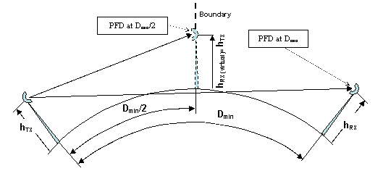
Figure 25: Principle for evaluating PFD at D_{min}/2 in Figure 24

3.1.3.2 Antenna height
Provided that the separation distance is dominated by spherical diffraction attenuation, Figure 24 shows that different mix of antenna heights produce little difference when the sum of the TX and victim RX antenna heights is the same (e.g. 30-30 is close to 20-40, 20-30 is close to 25-25 and so on). Therefore values not shown could be extrapolated with small potential error.
For this reason, the distance from the boundary (D_{min}/2) may be managed with the assumption that neighbour operator have equal antenna height, the suitable value for the boundary PFD (dBW/MHz/m²) could be derived from Figure 24 without knowing the actual CS antenna height of neighbour operator.
Rationale of this approach is shown in Figure 26, where the PFD at the boundary (D_{min}/2) is plotted in function of the TX antenna height, assuming equal height on potential RX victim side.
Operator “B”, once knowing its own tower height and EIRP, would keep its own minimum distance (D_{min}/2)_{B} evaluated assuming the same antenna height for neighbour victim of Operator “A”. In fact, if the victim Operator “A” has higher or lower antenna height, the difference in D_{min} length will be balanced by its own (D_{min}/2)_{A} portion; the example in Figure 26 shows that the distances adopted by operators “B” and “A” with antenna heights = 20 and 40 m, respectively, are D_{min}= 30m (“B”) and 38m (“A”) will result in a separation distance of 30+38 = 68 m ≅ D_{min} for 20/40 m in Figure 23, therefore respecting the required separation distance.
Nevertheless the lower is the antenna height, the higher are the diffraction attenuation and all other attenuation due to obstacles such as building, trees etc. generally reducing the probability of worst case occurrence; therefore, as recommended by ECC Report 97, the use of low antenna heights should be encouraged at the boundary.
Figure 26: Example of balanced D_{min} obtained by different D_{min}/2 for different antenna heights
(EIRP = +20 dBW/MHz)

3.1.3.3 Transmit EIRP
While the antenna height impact on D_{min} is self balancing without knowing the victim receiver side (see example of Figure 4.5), transmit EIRP, which also has impact on D_{min} does not have any intrinsic balancing mechanism.
In principle, as far as Operator “B” reduces EIRP, Dmin becomes lower (see Figure 23) and the station, respecting the PFD at (D_{min})_{B}, could be placed closer to the boundary without coordination not risking interference to Operator “A” as far as the latter uses an equal or higher EIRP for evaluating (D_{min})_{A}; however the opposite is no longer true and Operator “B” receiver would be interfered because being too close to the boundary.
Therefore, a “minimum” EIRP, for evaluating PFD trigger should be defined, actual lower EIRP should be disregarded in this evaluation and replaced by the agreed value.

3.1.3.4 Conclusions and possible self-regulation method for CSs co-ordination distance
Unlike what commonly happens in HDFS frequency bands, where line of sight applications give enough clearance from 1st Fresnel zone for not considering spherical diffraction attenuation, the above discussion has shown that, in the 3.5 GHz band, the co-ordination distance, besides EIRP_{tx,}, depends on antenna heights of both interfering and victim CS.

In such a way an operator, according to its own actual deployed maximum EIRP_{tx} and antenna height, and assuming victim receiver antenna height at the maximum foreseen (e.g. 50 m), should:
- evaluate the minimum co-ordination distance (D_{min} from Figure 23)
- verify that the PFD at D_{min}/2 (service boundary) does not exceed the limits given in Figure 24.

This does not mean that CSs cannot be located closer than D_{min}/2 to the boundary. However, the PFD at the boundary should be no greater than that produced via an unobstructed path by a directly aligned transmitter radiating the same EIRP. With an antenna height at a distance D_{min}/2 from the adjacent service area boundary, in order to allow a similar transmitter (with the same EIRP and with the tallest antenna mast) at the same D_{min}/2 from service boundary.

In this case administrations may wish to limit CSs transmitters in both EIRP_{tx} and maximum antenna height (automatically limiting the maximum co-ordination distance) or to define down-tilt angles in cases when height is exceeded.

At closer distances to the boundary, additional protection in the form of reduced EIRP in the direction of the boundary or shielding from terrain or other obstacles will be required. The extent of additional protection required would be subject of further studies.

3.1.4 Terminal Station to Central Station

3.1.4.1 ATPC impact
The TS is assumed to have ATPC. Under normal conditions each TS is assumed to have its EIRP level set to deliver a signal to the CS 6 dB above the receiver threshold.

Fadings from clear-air multipath on interfering and victim paths are assumed to be uncorrelated. Actually, slight correlation may be expected for directly aligned line of sight interference scenario but a very rough estimate of the percentage of time, where both the useful and the interference path might be contemporarily faded, gives negligible values (based on ITU-R P.530-8 paragraph 2.3.6).

3.1.4.2 Worst case single interferer scenario, 3.5 GHz calculations
For the worst-case interference scenario, it is assumed that the interfering TS is directed towards a CS located at the network service area boundary, pointing into its own service area. The worst-case interference arises when the TS is at the maximum distance from its CS.

This maximum cell size can be determined by considering the downlink power budget, assuming a CS EIRP of
20 dBW / MHz.

This evaluation, assuming multipath environment in rural (flat terrain) scenario, may be found in the previous section “Same area – Adjacent Block scenario” of this report and is summarised, with the fade margin (FM) in Table 6 as function of required availability.

Rural Scenario
 | Availability
System Type | 99.99% |  | 99.999%
 | R_{max} (km) | FM₀ (dB) | R_{max} (km) | FM₀ (dB)
A | 18.7 km | 17.3 | 12.4 km | 20.9
B | 13.4 km | 12.2 | 8.9 km | 15.7
Table 6: Typical cell size in rural scenarios

Therefore, the worst-case interference scenario occurs when the interfering TS is at a distance D_{int} = D_{min}/2 + R_{max} from the directly aligned victim CS, where D_{min} is derived from Figure 23 and R_{max} can be taken from Table 6.

With the assumption made of fading uncorrelation, two requirements need to be considered:
a) Interfering TS operating at the "normal" EIRP set by ATPC (unfaded percentage of time ~99.X %)
EIRP_{ATPC} = EIRP_{max} - FM₀ + FM_{ATPC}
FM₀ is the fade margin corresponding to maximum transmitted power (from Table 6). In this case (most of the time) the received interference power, into the victim CS, should not exceed the required limit (kTBF - 10dB) for not impairing the victim performance and availability.
b) Interfering TS operating at maximum EIRP (faded percentage of time ~ (100-99.X) %)
Due to uncorrelation, the victim CS would receive normal level, depending on the availability objective and the ATPC range, from the useful link (for a percentage of time usually less than 1%) In this case a higher interference level can be tolerated without impairments.
Assuming that also victim system will work at 6 dB above threshold, we may tolerate up to 3 dB of noise floor degradation (i.e. up to kTBF= -136 dBW/MHz).
Assuming the TS delivering the assumed maximum EIRP of 20 dBW / MHz, the received signal level at the victim CS at this distance is derived from Figure 22, for the rural scenario.

3.1.4.3 Examples:
Example 1
Type B interfering system, height of interfering TS h_{t} = 10 m, height of victim CS h_{c} = 30 m, availability 99.99%.
R_{max} = 13.4 km FM₀ = 12.2 dB D_{min} = 68 km (for CS to CS interference assuming hc = 30 m on both sides)
D_{int} = 13.4 + 68/2 = 47.4 km
EIRP_{ATPC}= 20 – 12.2 + 6 = 13.8 dBW/MHz
From Figure 22 (at D_{int} and scaled to the actual EIRP level) it is possible to derive:
For case a) an interfering power I =~ -132 – (20 - EIRP_{ATPC}) = - 138.2 dBW/MHz
For case b) an interfering power I =~ -132 dBW/MHz.

Both these levels are higher than requirement.

In case a) in order to receive an interfering power of -146 dBW/MHz, the CS of the interfering system should be placed at a distance Dx from the border, so that:
D(a) + R_{max} + D_{min}/2 =~ 54 km (from Figure 23, at EIRP = 13.8 dBW/MHz)
D(a) = 54 – 13.4 - 34 = ~ 6.6 km

for case b), in order to receive an interfering power of -136 dBW/MHz (=kTBF), the CS of the interfering system should be placed at a distance Dy from the border, so that:
D(b) + R_{max} + D_{min}/2 =~ 52 km (from Figure 22 with P_{rec} Max set to –136 dBW/MHz)
D(b) = 52 – 13.4 - 34 = ~ 4.6 km

Therefore the minimum distance where a CS (supporting far system type B TSs with height lower than 10 m and victim CS height lower than 30 m) could be placed is 6.6 km.

Example 2
Type B interfering system, height of interfering TS h_{t} = 20 m, height of victim CS h_{c} = 40 m, availability 99.99%.

R_{max} = 13.4 km FM₀ = 12.2 dB D_{min} = 75 km (for CS to CS interference assuming hc = 40 m on both sides)

D_{int} = 13.4 + 75/2 = 50.9 km

EIRP_{ATPC}= 20 – 12.2 + 6 = 13.8 dBW/MHz

From Figure 22 (at D_{int} and scaled to the actual EIRP level) we would derive:
For case a) an interfering power I =~ -121 – (20 - EIRP_{ATPC}) = - 127.2 dBW/MHz
For case b) an interfering power I =~ -121 dBW/MHz.

Also in this example, both these levels are higher than requirement.

In case a) in order to receive an interfering power of -146 dBW/MHz, the CS of the interfering system should be placed at a distance Dx from the border, so that:
D(a) + R_{max} + D_{min}/2 =~ 64 km (from Figure 23, at EIRP = 13.8 dBW/MHz)
D(a) = 64 – 13.4 - 37.5 = ~ 14.8 km

for case b), in order to receive an interfering power of -136 dBW/MHz (=kTBF), the CS of the interfering system should be placed at a distance Dy from the border, so that:
D(b) + R_{max} + D_{min}/2 =~ 62 km (from Figure 22 with P_{rec} Max set to –136 dBW/MHz)
D(b) = 62 – 13.4 - 37.5 = ~ 11.1 km.

Therefore the minimum distance where a CS (supporting system type B TSs with height lower than 20 m and victim CS height lower than 40 m) could be placed is 14.8 km.

Example 3
Type A interfering system, height of interfering TS h_{t} = 20 m, height of victim CS h_{c} = 40 m, availability 99.99%.

R_{max} = 18.7 km FM₀ = 17.3 dB D_{min} = 75 km (for CS to CS interference assuming hc = 40 m on both sides)

D_{int} = 18.7 + 37.5 = 56.2 km

EIRP_{ATPC}= 20 – 17.3 + 6 = 8.7 dBW/MHz.

From Figure 22 (at D_{int} and scaled to the actual EIRP level) derive:
For case a) an interfering power I =~ -129 – (20 - EIRP_{ATPC}) = - 140.3 dBW/MHz
For case b) an interfering power I =~ -129 dBW/MHz

Also in this example, both these levels are higher than requirement.

In case a) in order to receive an interfering power of -146 dBW/MHz, the CS of the interfering system should be placed at a distance Dx from the border, so that:
D(a) + R_{max} + D_{min}/2 =~ 61 km (from Figure 23, at EIRP = 8.7 dBW/MHz)
D(a) = 61 - 18.7 - 37.5 = ~ 4.8 km.

For case b), in order to receive an interfering power of -136 dBW/MHz (=kTBF), the CS of the interfering system should be placed at a distance Dy from the border, so that:
D(b) + R_{max} + D_{min}/2 =~ 62 km (from Figure 22 with P_{rec} Max set to –136 dBW/MHz)
D(b) = 62 - 18.7 - 37.5 = ~ 5.8 km.

Therefore the minimum distance where a CS (supporting system type A TSs with height lower than 20 m and victim CS height lower than 40 m) could be placed is 5.8 km.

3.1.4.4 TS to CS Conclusions
From the above examples, a CS, even if pointing away from the border, could not be indifferently placed nearer than the co-ordination distance evaluated in Figure 22 and Figure 23. The terminals PFD will become determinant and engineering of the cell (reduced EIRP and sector beams pointing) should be used to ensure that also TSs PFD (in the direction of the boundary) does not exceed the values derived from Figure 24.

shows an example of such methodology based on previous examples 2 and 3.
X
Rmax
(
TypeB)
Rmax
(
TypeA)
X
X
D
min
/2
X
Closest sector-blanked
cells (Type A and B)
Boundary
Standard uncoordinated cells
Blanked sectors of boundary engineered cells (example)
D
min
/2
D(a)
D(b)
Active sectors of boundary engineered cells (example)

Figure 27: Example of cell sector engineering at service boundary
(assuming h_{c} = 40 m on both service areas; for D_{min}/2 see Figure 23)

3.1.5 Terminal Station to Terminal Station
This kind of interference, unlike the cases where a CS is involved, would only impair the operation of one terminal; therefore a worst case approach is considered as too stringent. Due to the random nature of this kind of interference, a statistical Monte Carlo approach seems more adequate. A possible scenario could be two CSs located at both sides of the boundary, each pointing into its own service area. Each TS will have its EIRP level set to deliver a signal to the CS 6 dB above the receiver threshold, except one (different in each trial) which would have maximum EIRP, to simulate the occurrence of a fading event.

However this effect, at least for PMP architectures with directive TS antennas, is not generally considered a limiting factor for coexistence (when compared to the other interference cases). This evaluation may require further work in case of mixed PMP and MESH architectures.
As far as TS with omni-directional antennas are concerned, it is further assumed that:
- the vast majority is deployed indoor; large building/walls blocking attenuation will be always present.

3.2 Conclusions on adjacent service areas boundary block reuse co-ordination
It is therefore recommended that co-ordination between operators using same frequency block(s) in the 3.5 GHz band in adjacent geographic areas should take place for any transmitter (CS and TS assumed to supply very similar EIRP) that produces a PFD derived from Figure 24 or greater at the service area boundary. The distance from the service area boundary that will be subject to co-ordination, as a function of transmitter EIRP, is indicated in .

The proposed PFD guidelines can be tested in Monte Carlo simulations to assess their validity in multiple interferer scenarios.

4 Conclusions of the report
This Report has considered a number of facts as initial considerations for deriving the coexistence study:
- Presently ERC Recommendations 14-03 and 12-08 for the bands 3.6 GHz and 3.8 GHz do not give harmonised and detailed suggestion to administration for implementing FWA (such as those produced for 26, 28 and 40 GHz). Those ERC Recommendations offer only channel arrangements.
- The band is limited and wasted guard-bands might drastically reduce the number of licensed operators, limiting the potential competition for new services.
- Legacy FWA (WLL) systems have been already licensed in these bands in some countries, and their co-existence with new FWA systems, assigned in accordance with provisions recommended in this study, may need additional check on a case-by-case basis, using the same methodology as described in this report, but with the parameters corresponding to those of legacy systems.
- Sharing issues with PP FS systems, FSS, radiolocation (in adjacent band), ENG/OB were not considered in this report, but are subject of a different CEPT study.
- At least for CSs, ETSI ENs in these bands are not presently designed for a technology neutral deployment (this is done only in the 40 GHz MWS EN 301 997) therefore do not contain system controlling parameters, in terms of EIRP, which would be useful for the desired “technology neutral” and “uncoordinated” deployment
- The study suggested that the block edge mask together with the contiguous assignment of frequency blocks should be the main means for avoiding interference between neighbouring frequency blocks. Since block edge mask parameters are linked to the size of the block, it is also recommended that the neighbouring blocks should be of a similar size.
- It is also shown that, for PMP TSs, the antenna RPE plays a fundamental role in the coexistence; the more directive is the antenna of TSs, the less demanding might be their NFD (or the EIRP density BEM) required (offering a flexible trade-off to the market). That is why the resulting BEM limits outside the block are described in terms of transmitter output power, allowing operators to make practical use of this phenomena.
- In addition, basic rules has been set for the co-ordination distance and PFD boundary levels between operators re-using the same block in adjacent geographical areas. In this field, the importance of limiting CS antenna height (or down-tilt angle) as possible licensing parameter is highlighted in order of having sensible co-ordination distances (i.e. limited by spherical diffraction attenuation).
- MP-MP (MESH) architectures have not been considered in this Report. It is recognised that whilst some of the results in this report might also be applicable to mixed PMP and MESH deployment, others may clearly need additional work. These studies might be carried on out in due time if needed and when manufacturers will be in a position to offer the necessary information.

Annex 1: AVERAGE CELL SIZE EVALUATION

A1.a) Simulation Model
The simulation model is illustrated on Figure 28. The cell is subdivided into segments whose angular width is. Within each segment, angular arcs are positioned at R_{j} multiples of 0.1 R_{max} where R_{max} is the radius of the cell. There are thus 10 arcs within each segment. Hence, there are 10 bounded sub-area limits within each segment. The area limits of each may be readily computed.

TS are assumed to be centrally positioned within each sub-area. For each TS, the transmission distance is computed. The impairments relative to LOS are then added. These include Mean Excess Loss (MEL), the random variations to MEL due to log-normal shadowing and the impact of Rician fading.

For a given simulation, MEL and Rician K are set to the values specified for the SUI channel models. A standard deviation of = 9 dB is set for log-normal shadowing. This is a mid-range value of the range set for the SUI models. A random deviate procedure is employed to create shadow loss and Rician K signal variations. For MEL estimates, the CS antenna elevation was set to 30 m and the TS antenna elevation and gain set to the indicated values.

Setting = 1 degree results in 360 estimates of signal level. When the signal level of an estimate is found to be less than the specified performance threshold, the sub-area associated with the estimate is accumulated in an "excluded area" running total. At the completion of a simulation, the ratio of the running total to the cell area defines the % of the cell that cannot meet coverage requirements for 99.999% availability.

The TS antenna RPEs are those derived from ITU-R F.1336 (see Figure 1), while antenna gain is kept fixed at 16 dBi as for general system assumptions in Table 1.
Figure 28: Simulation Model

A1.b) Mean Excess Loss (MEL) only
When only MEL was considered, there were no exposures found that exceeded the performance threshold of Type A Systems. Table 7 and Table 8 illustrate the simulation results for covered areas of Type B systems. Log-normal shadowing and Rician fading are excluded.
SUI Terrain Category | Excluded Area (%)
SUI Terrain Category | TS antenna class TS 2  (ITU-R RPE G=+16 dBi) | TS2/TS3 intermediate RPE  (ITU-R RPE G= +18 dBi) | TS antenna class TS 3  (ITU-R RPE with G= +20 dBi)
A | 18.8 | 0 | 0
B | 0 | 0 | 0
C | 0 | 0 | 0
Table 7: Type B System MEL Excluded Area for R_{max}= 2.0 km, TS Antenna Elevation = 10 m

TS Antenna Elevation  (m) | SUI Terrain Category | Excluded Area (%)
TS Antenna Elevation  (m) | SUI Terrain Category | TS antenna class TS 2  (ITU-R RPE G=16 dBi) | TS2/TS3 intermediate  (ITU-R RPE G= +18 dBi) | TS antenna class TS 3  (ITU-R RPE with G=20 dBi)
10 | A | 51 | 37.3 | 35.5
10 | B | 19 | 0 | 0
10 | C | 0 | 0 | 0
15 | A | 39.6 | 36 | 19
15 | B | 0 | 0 | 0
15 | C | 0 | 0 | 0
20 | A | 36 | 19 | 0
20 | B | 0 | 0 | 0
20 | C | 0 | 0 | 0
Table 8: Type B System MEL Excluded Area for R_{max} = 2.7 km

A1.c) Mean Excess Loss and Log-Normal Shadowing
Table 9 through Table 12 show the results of the simulations when both MEL and log-normal shadowing are considered. As previously noted, the standard deviation for the log-normal fading was set to = 9 dB.

With the inclusion of log-normal shadowing, it is apparent that even a Type A system will begin to experience coverage problems. This is constrained to Terrain Category A and R_{max} = 2.7 km.

Due to reduced threshold, coverage issues for Type B systems are significantly increased. Referenced to Table 11 and Table 12, both 2.0 km and 2.7 km cell radius designs exceed coverage objectives in Terrain Categories A and B.

TS Antenna Elevation  (m) | SUI Terrain Category | Excluded Area (%)
TS Antenna Elevation  (m) | SUI Terrain Category | TS antenna class TS 2  (ITU-R RPE G=16 dBi) | TS2/TS3 intermediate  (ITU-R RPE G= +18 dBi) | TS antenna class TS 3  (ITU-R RPE with G=20 dBi)
10 | A | 8.9 | 5.7 | 2.8
10 | B | 2.8 | 1.9 | 1.2
10 | C | 0.2 | 0 | 0
15 | A | 5.9 | 3.9 | 1.5
15 | B | 1.9 | 1.1 | 0.45
15 | C | 0 | 0 | 0
20 | A | 4.1 | 2.6 | 1.5
20 | B | 1.6 | 0.6 | 0
20 | C | 0 | 0 | 0
Table 9: Type A System Excluded Area Due to MEL and Log-Normal Shadowing (R_{max} = 2.0 km)

TS Antenna Elevation  (m) | SUI Terrain Category | Excluded Area (%)
TS Antenna Elevation  (m) | SUI Terrain Category | TS antenna class TS 2  (ITU-R RPE G=16 dBi) | TS2/TS3 intermediate  (ITU-R RPE G= +18 dBi) | TS antenna class TS 3  (ITU-R RPE with G=20 dBi)
10 | A | 22.0 | 16.8 | 13.4
10 | B | 8.7 | 6.3 | 4.3
10 | C | 0.7 | 0.5 | 0
15 | A | 17.2 | 11.85 | 9.4
15 | B | 6.9 | 4.0 | 3.5
15 | C | 0 | 0.36 | 0
20 | A | 12.8 | 8.1 | 6.2
20 | B | 5.5 | 2.9 | 2.3
20 | C | 0 | 0 | 0
Table 10: Type A System Excluded Area Due to MEL and Log-Normal Shadowing
(R_{max} = 2.7 km)

TS Antenna Elevation – m | SUI Terrain Category | Excluded Area (%)
TS Antenna Elevation – m | SUI Terrain Category | TS antenna class TS 2  (ITU-R RPE G=16 dBi) | TS2/TS3 intermediate  (ITU-R RPE G= +18 dBi) | TS antenna class TS 3  (ITU-R RPE with G=20 dBi)
10 | A | 26.8 | 20.1 | 16.8
10 | B | 12.8 | 9.7 | 6.2
10 | C | 1.9 | 1.4 | 1.0
15 | A | 20.3 | 16.0 | 11.9
15 | B | 9.0 | 6.9 | 4.2
15 | C | 0.8 | 0.46 | 0
20 | A | 17.3 | 13.1 | 9.3
20 | B | 7.6 | 5.0 | 4.2
20 | C | 0.5 | 0 | 0
Table 11: Type B System Excluded Area Due to MEL and Log-Normal Shadowing
(R_{max} = 2.0 km)

TS Antenna Elevation  (m) | SUI Terrain Category | Excluded Area (%)
TS Antenna Elevation  (m) | SUI Terrain Category | TS antenna class TS 2  (ITU-R RPE G=16 dBi) | TS2/TS3  intermediate RPE  (ITU-R RPE G= +18 dBi) | TS antenna class TS 3  (ITU-R RPE with G=20 dBi)
10 | A | 44.6 | 39.9 | 33.4
10 | B | 29 | 23.0 | 19.0
10 | C | 5.9 | 4.0 | 3.2
15 | A | 39.2 | 33.6 | 26.4
15 | B | 21.7 | 17.5 | 13.3
15 | C | 3.1 | 1.8 | 1.2
20 | A | 35.4 | 29.2 | 23.3
20 | B | 18.8 | 13.0 | 9.4
20 | C | 1.8 | 0.6 | 0.6
Table 12: Type B System Excluded Area Due to MEL and Log-Normal Shadowing
(R_{max} = 2.7 km)

A1.d) Mean Excess, Log-Normal Shadowing and Rician Fading
Generally speaking, it is not appropriate to inter-relate space and time availability. However, in the NLOS transmission environment, Rician fading is constantly present. In the event that there is no motion associated with the reflective facets, it simply means that we are in a fixed up or down fade, subject to the vector addition of all of the signal components.
In order to examine the significance of Rician fading, its impact was examined for each of the SUI channel models by running 10 simulations for each channel model. The range of variation in the excluded area was noted and these are presented in Table 13 and Table 14 for R_{max} = 2 km. Table 15 and Table 16 examine the same scenarios for R_{max} = 2.7 km.
SUI Channel Model | Terrain Category | Rice K (dB) | Excluded Area Spread (%)
SUI-1 | C | 12 | 0.0 - 0.15
SUI-2 | C | 8 | 0.0 - 0.1
SUI-3 | B | 5 | 1.7 - 2.8
SUI-4 | B | 0 | 3.1 -4.2
SUI-5/6 | A | 0 | 6.9 - 8.5
Table 13: Impact of Rician Fading on Type A Systems (R_{max} = 2 km)

SUI Channel Model | Terrain Category | Rice K (dB) | Excluded Area Spread (%)
SUI-1 | C | 12 | 0.32 - 0.78
SUI-2 | C | 8 | 0.39 - 0.79
SUI-3 | B | 5 | 8.5 -9.8
SUI-4 | B | 0 | 11.0 - 12.4
SUI-5/6 | A | 0 | 20.6 - 22.9
Table 14: Impact of Rician Fading on Type B Systems (R_{max} = 2 km)

SUI Channel Model | Terrain Category | Rice K – (dB) | Excluded Area Spread (%)
SUI-1 | C | 12 | 0.04 - 0.36
SUI-2 | C | 8 | 0.16 - 0.46
SUI-3 | B | 5 | 5.4 - 6.7
SUI-4 | B | 0 | 7.2 - 9.2
SUI-5/6 | A | 0 | 16.6 - 20.1
Table 15: Impact of Rician Fading on Type A Systems (R_{max} = 2.7 km)

SUI Channel Model | Terrain Category | Rice K - dB | Excluded Area Spread (%)
SUI-1 | C | 12 | 1.9 - 2.8
SUI-2 | C | 8 | 2.0 - 3.2
SUI-3 | B | 5 | 20 -22.1
SUI-4 | B | 0 | 22.8 -25.2
SUI-5/6 | A | 0 | 38.0 -40.9
Table 16: Impact of Rician Fading on Type B Systems (R_{max} = 2.7 km)

A1.e) Simulation Caveat
Section A1.d) does not cover all of the combinations as Sections A1.b) and A1.c): they are just “mid-range” values illustrative sensitivity analysis examples, with TS antenna height = 15 m and TS antenna gain = +18 dBi).

A close examination of the Tables might imply that there are some inconsistencies in the Table entries. However, this is not the case. For example, examine Table 8 and Table 12 for Terrain Type A and R_{max} =2.7 km. It may be noted that the Excluded Area is less when the MEL plus log-normal shadowing loss is considered compared to that just resulting from MEL. However, this is a quite possible result of simulation. The shadowing loss exhibits a random +/- variation about the mean value that can enhance the signal level of some links. The same may be said about Rician fading for which both up and down fades can occur.

A1.f) Urban scenarios, directional outdoor versus omni-directional indoor TS

A1.f.1 Coverage and availability objectives:
Being focused on urban scenarios, addressing different kinds of customer need and deployments, ranging from business to residential internet connections we should also distinguish the objectives for the evaluation of the covered area and availability objectives.
Defining different objectives for business (mostly outdoor roof-top) and residential (mostly indoor), besides being commercially applicable, might equalise the coverage area for the two cases that would exhibit different Fade Margin.
For this study we have considered the following cases:
Business deployment:
Coverage = 95% / 80% / 65%
Availability = 99.99%

Residential deployment:
Coverage = 95% / 80% / 65%
Availability = 99.0%

A1.f.2 Methodology
As initial task we could evaluate the impact of the model on the cell radius with the system assumptions made above.
The evaluation is done establishing a pattern (~3000/sector) of possible TS location; then running Monte-Carlo simulation for each location (~300 trials) for finding the RSL distribution and the percentile of “good” trials (RSL exceeding the equipment threshold).
The calculation is made in four steps covering the separate objectives of geographical coverage and link availability:
Step 1:
Evaluation of the System Gain (SG) defined as:
SG = P_{TX}+G_{TX}+G_{RX}-AATT-P_{TH}
where:
P_{TX} = TX power [dBm]
G_{TX}, G_{RX} = Antenna gains [dB]
AATT = Additional Attenuation [dB] (e.g. indoor penetration losses)
P_{TH} = RSL threshold @ BER=10⁻⁶ [dBm] (function of modulation format, noise figure (NF) e Rx bandwidth)
Step 2:
Evaluation of Shadowing Margin (SHM):
SHM = SHM(Cov%, σ, γ)
where:
Cov% = coverage objective [%]
σ = Shadowing variance [dB]
γ = Erceg’s category (A, B and C) parameter
The SHM is a statistical function, therefore it is not appropriate and exceedingly conservative to impose the coverage objective at the cell border only (closer areas would have higher coverage); therefore the coverage is evaluate as the integral of the probability over the whole cell normalised area.
It could be demonstrated that the SHM (additional to A₅₀) does not depend on the cell radius itself; the dependence of required SG, for a certain coverage, on the cell radius is then limited to the A₅₀(R) only.
Step 3:
Evaluation of Rician Fast Fading Margin (FFM) derived from cumulative probability of the selected SUI model (see Figure 3) at the required availability.
FFM = FFM(SUI-Prob, Avail)
where:
SUI-Prob is the cumulative attenuation probability curve
Avail = required availability
Step 4:
Evaluation of R_{MAX} with the relationship:
SG = A_{50,0} +γ*10log(R_{MAX} /R₀)+SHM+FFM
where:
R₀ = a reference distance (0.1 km)
A_{50,0} = mean attenuation (dB) at reference distance R₀, evaluated for the selected Erceg category model.
R_{MAX} is therefore finally given by:
R_{MAX} =R₀*10^((SG - A_{50,0} –SHM-FFM)/(10*γ))

A1.f.3 Cell radius evaluation
With the above methodology, in the following tables different evaluations are made using different CS and TS location heights, antenna typology and relevant Erceg Categories and SUI models
Business case (availability 99.99%, TS outdoor directional antennas G_{TS}=18 dB)
Lower elevation/more obstructed antennas (Erceg-Category B+SUI-4; σ = 8 dB)
CS = 30 [m] |  |  |  |  |  | CS = 40 [m]
TS = 4 [m] |  |  | TS = 10 [m] |  |  | TS = 4 [m] |  |  | TS = 10 [m]
Cov.  95% | Cov.  80% | Cov.  65% | Cov.  95% | Cov.  80% | Cov.  65% | Cov.  95% | Cov.  80% | Cov.  65% | Cov.  95% | Cov.  80% | Cov.  65%
1.26 | 1.87 | 2.38 | 1.58 | 2.35 | 2.98 | 1.42 | 2.14 | 2.75 | 1.80 | 2.72 | 3.48
Table 17: R_{MAX} [km] for QPSK formats
CS = 30 [m] |  |  |  |  |  | CS = 40 [m]
TS = 4 [m] |  |  | TS = 10 [m] |  |  | TS = 4 [m] |  |  | TS = 10 [m]
Cov.  95% | Cov.  80% | Cov.  65% | Cov.  95% | Cov.  80% | Cov.  65% | Cov.  95% | Cov.  80% | Cov.  65% | Cov.  95% | Cov.  80% | Cov.  65%
0.87 | 1.30 | 1.65 | 1.09 | 1.62 | 2.06 | 0.96 | 1.46 | 1.86 | 1.22 | 1.84 | 2.36
Table 18: R_{MAX} [km] for 16QAM formats
Higher elevation/less obstructed antennas (Erceg-Category C+SUI-2; σ = 8 dB)
CS = 30 [m] |  |  |  |  |  | CS = 40 [m]
TS = 4 [m] |  |  | TS = 10 [m] |  |  | TS = 4 [m] |  |  | TS = 10 [m]
Cov.  95% | Cov.  80% | Cov.  65% | Cov.  95% | Cov.  80% | Cov.  65% | Cov.  95% | Cov.  80% | Cov.  65% | Cov.  95% | Cov.  80% | Cov.  65%
2.35 | 3.57 | 4.59 | 3.67 | 5.57 | 7.16 | 2.78 | 4.30 | 5.58 | 4.45 | 6.88 | 8.93
Table 19: R_{MAX} [km] for QPSK formats

CS = 30 [m] |  |  |  |  |  | CS = 40 [m]
TS = 4 [m] |  |  | TS = 10 [m] |  |  | TS = 4 [m] |  |  | TS = 10 [m]
Cov.  95% | Cov.  80% | Cov.  65% | Cov.  95% | Cov.  80% | Cov.  65% | Cov.  95% | Cov.  80% | Cov.  65% | Cov.  95% | Cov.  80% | Cov.  65%
1.59 | 2.41 | 3.10 | 2.48 | 3.77 | 4.84 | 1.84 | 2.84 | 3.69 | 2.94 | 4.55 | 5.90
Table 20: R_{MAX} [km] for 16QAM formats

Residential case (availability 99 %, TS indoor window antennas G_{TS}=10 dB)
Lower elevation/more obstructed antennas (Erceg-Category B+SUI-4; σ = 10 dB)

Alt.CS = 30 [m] |  |  |  |  |  | Alt.CS = 40 [m]
Alt.TS = 4 [m] |  |  | Alt.TS = 10 [m] |  |  | Alt.TS = 4 [m] |  |  | Alt.TS = 10 [m]
Cov.  95% | Cov.  80% | Cov.  65% | Cov.  95% | Cov.  80% | Cov.  65% | Cov.  95% | Cov.  80% | Cov.  65% | Cov.  95% | Cov.  80% | Cov.  65%
0.84 | 1.36 | 1.81 | 1.06 | 1.71 | 2.27 | 0.93 | 1.53 | 2.06 | 1.18 | 1.94 | 2.61
Table 21: R_{MAX} [km] QPSK

Alt.CS = 30 [m] |  |  |  |  |  | Alt.CS = 40 [m]
Alt.TS = 4 [m] |  |  | Alt.TS = 10 [m] |  |  | Alt.TS = 4 [m] |  |  | Alt.TS = 10 [m]
Cov.  95% | Cov.  80% | Cov.  65% | Cov.  95% | Cov.  80% | Cov.  65% | Cov.  95% | Cov.  80% | Cov.  65% | Cov.  95% | Cov.  80% | Cov.  65%
0.58 | 0.94 | 1.25 | 0.73 | 1.18 | 1.57 | 0.63 | 1.04 | 1.40 | 0.8 | 1.32 | 1.77
Table 22: R_{MAX} [km] 16QAM
Higher elevation/less obstructed antennas (Erceg-Category C+SUI-2; σ = 10 dB)

Alt.CS = 30 [m] |  |  |  |  |  | Alt.CS = 40 [m]
Alt.TS = 4 [m] |  |  | Alt.TS = 10 [m] |  |  | Alt.TS = 4 [m] |  |  | Alt.TS = 10 [m]
Cov.  95% | Cov.  80% | Cov.  65% | Cov.  95% | Cov.  80% | Cov.  65% | Cov.  95% | Cov.  80% | Cov.  65% | Cov.  95% | Cov.  80% | Cov.  65%
1.51 | 2.49 | 3.36 | 2.35 | 3.89 | 5.25 | 1.73 | 2.94 | 4.01 | 2.77 | 4.70 | 6.42
Table 23: R_{MAX} [km] QPSK

Alt.CS = 30 [m] |  |  |  |  |  | Alt.CS = 40 [m]
Alt.TS = 4 [m] |  |  | Alt.TS = 10 [m] |  |  | Alt.TS = 4 [m] |  |  | Alt.TS = 10 [m]
Cov.  95% | Cov.  80% | Cov.  65% | Cov.  95% | Cov.  80% | Cov.  65% | Cov.  95% | Cov.  80% | Cov.  65% | Cov.  95% | Cov.  80% | Cov.  65%
1.02 | 1.69 | 2.27 | 1.59 | 2.63 | 3.55 | 1.15 | 1.94 | 2.65 | 1.83 | 3.11 | 4.25
Table 24: R_{MAX} [km] 16QAM
Residential case (availability 99 %, TS indoor omnidirectional antennas G_{TS}=4 dB)
Lower elevation/more obstructed antennas (Erceg-Category B+SUI-4; σ = 10 dB)
Alt.CS = 30 [m] |  |  |  |  |  | Alt.CS = 40 [m]
Alt.TS = 4 [m] |  |  | Alt.TS = 10 [m] |  |  | Alt.TS = 4 [m] |  |  | Alt.TS = 10 [m]
Cov.  95% | Cov.  80% | Cov.  65% | Cov.  95% | Cov.  80% | Cov.  65% | Cov.  95% | Cov.  80% | Cov.  65% | Cov.  95% | Cov.  80% | Cov.  65%
0.71 | 1.15 | 1.53 | 0.90 | 1.44 | 1.92 | 0.78 | 1.28 | 1.73 | 0.99 | 1.63 | 2.19
Table 25: R_{MAX} [km] QPSK; Building/indoor losses = 5 dB

Alt.CS = 30 [m] |  |  |  |  |  | Alt.CS = 40 [m]
Alt.TS = 4 [m] |  |  | Alt.TS = 10 [m] |  |  | Alt.TS = 4 [m] |  |  | Alt.TS = 10 [m]
Cov.  95% | Cov.  80% | Cov.  65% | Cov.  95% | Cov.  80% | Cov.  65% | Cov.  95% | Cov.  80% | Cov.  65% | Cov.  95% | Cov.  80% | Cov.  65%
0.42 | 0.68 | 0.90 | 0.53 | 0.85 | 1.13 | 0.45 | 0.74 | 0.99 | 0.57 | 0.94 | 1.26
Table 26: R_{MAX} [km] QPSK; Building/indoor losses = 15 dB

Alt.CS = 30 [m] |  |  |  |  |  | Alt.CS = 40 [m]
Alt.TS = 4 [m] |  |  | Alt.TS = 10 [m] |  |  | Alt.TS = 4 [m] |  |  | Alt.TS = 10 [m]
Cov.  95% | Cov.  80% | Cov.  65% | Cov.  95% | Cov.  80% | Cov.  65% | Cov.  95% | Cov.  80% | Cov.  65% | Cov.  95% | Cov.  80% | Cov.  65%
0.49 | 0.80 | 1.06 | 0.62 | 1.00 | 1.33 | 0.53 | 0.87 | 1.17 | 0.67 | 1.11 | 1.49
Table 27: R_{MAX} [km] 16QAM; Building/indoor losses = 5 dB

Alt.CS = 30 [m] |  |  |  |  |  | Alt.CS = 40 [m]
Alt.TS = 4 [m] |  |  | Alt.TS = 10 [m] |  |  | Alt.TS = 4 [m] |  |  | Alt.TS = 10 [m]
Cov.  95% | Cov.  80% | Cov.  65% | Cov.  95% | Cov.  80% | Cov.  65% | Cov.  95% | Cov.  80% | Cov.  65% | Cov.  95% | Cov.  80% | Cov.  65%
0.29 | 0.47 | 0.63 | 0.37 | 0.59 | 0.78 | 0.30 | 0.50 | 0.67 | 0.39 | 0.64 | 0.86
Table 28: R_{MAX} [km] 16QAM; Building/indoor losses = 15 dB
Higher elevation/less obstructed antennas (Erceg-Category C+SUI-2; σ = 10 dB)
Alt.CS = 30 [m] |  |  |  |  |  | Alt.CS = 40 [m]
Alt.TS = 4 [m] |  |  | Alt.TS = 10 [m] |  |  | Alt.TS = 4 [m] |  |  | Alt.TS = 10 [m]
Cov.  95% | Cov.  80% | Cov.  65% | Cov.  95% | Cov.  80% | Cov.  65% | Cov.  95% | Cov.  80% | Cov.  65% | Cov.  95% | Cov.  80% | Cov.  65%
0.86 | 1.42 | 1.92 | 1.34 | 2.22 | 2.99 | 0.96 | 1.62 | 2.22 | 1.53 | 2.60 | 3.55
Table 29: R_{MAX} [km] QPSK; Building/indoor losses = 5 dB

Alt.CS = 30 [m] |  |  |  |  |  | Alt.CS = 40 [m]
Alt.TS = 4 [m] |  |  | Alt.TS = 10 [m] |  |  | Alt.TS = 4 [m] |  |  | Alt.TS = 10 [m]
Cov.  95% | Cov.  80% | Cov.  65% | Cov.  95% | Cov.  80% | Cov.  65% | Cov.  95% | Cov.  80% | Cov.  65% | Cov.  95% | Cov.  80% | Cov.  65%
0.49 | 0.81 | 1.10 | 0.77 | 1.27 | 1.71 | 0.53 | 0.90 | 1.23 | 0.85 | 1.44 | 1.97
Table 30: R_{MAX} [km] QPSK; Building/indoor losses = 15 dB

Alt.CS = 30 [m] |  |  |  |  |  | Alt.CS = 40 [m]
Alt.TS = 4 [m] |  |  | Alt.TS = 10 [m] |  |  | Alt.TS = 4 [m] |  |  | Alt.TS = 10 [m]
Cov.  95% | Cov.  80% | Cov.  65% | Cov.  95% | Cov.  80% | Cov.  65% | Cov.  95% | Cov.  80% | Cov.  65% | Cov.  95% | Cov.  80% | Cov.  65%
0.58 | 0.96 | 1.30 | 0.91 | 1.50 | 2.02 | 0.63 | 1.07 | 1.47 | 1.01 | 1.72 | 2.35
Table 31: R_{MAX} [km] 16QAM; Building/indoor losses = 5 dB

Alt.CS = 30 [m] |  |  |  |  |  | Alt.CS = 40 [m]
Alt.TS = 4 [m] |  |  | Alt.TS = 10 [m] |  |  | Alt.TS = 4 [m] |  |  | Alt.TS = 10 [m]
Cov.  95% | Cov.  80% | Cov.  65% | Cov.  95% | Cov.  80% | Cov.  65% | Cov.  95% | Cov.  80% | Cov.  65% | Cov.  95% | Cov.  80% | Cov.  65%
0.33 | 0.55 | 0.74 | 0.52 | 0.86 | 1.16 | 0.35 | 0.60 | 0.81 | 0.56 | 0.95 | 1.30
Table 32: R_{MAX} [km] 16QAM; Building/indoor losses = 15 dB

A1.g) Conclusions of the annex
The Tables in this annex summarise all cases generated from the input parameters for the business and residential applications.
The results for the more and the less favourable conditions might also be averaged for having the actual overall coverage %.
We should consider that those evaluations do not take into account a number of features that last generation systems, specifically designed for these NLOS applications, offer for improving the situation. They could be for example:
- Adaptive modulation/coding formats (when RSL of a TS is marginal, the lower modulation format and the strongest error coding is automatically selected)
- Adaptive antenna arrays
- Diversity
- sub-channelling
All these techniques enhance the coverage with respect to the conventional PMP characteristics used in this study.
In conclusion, we could qualitatively say that the coverage and availability objectives could be fulfilled with cell radius ranging from ~0.5 km to ~ 3 km depending on the decision to privilege or not residential traffic with respect to business only. It should also be taken into account that, addressing in real offered service a mixture of different situations (residential or business, with more or less favourable expected propagation), the actual expected coverage/cell-size would be trade-off considering which market is addressed and the local environment situations.
Therefore, in following study for evaluating the CS to TS interference based on statistical occurrence of C/I, we would consider four radii cases: 0.5 km, 1 km, 2 km, 2.7 km.

ANNEX 2: TS to CS interference evaluation

A2.1 Directional outdoor TS

A2.1.1 Rural scenario

A2.1.1.1 System Model and Simulation Methodology
In subsequent sections, estimates of interference susceptibility are based on Monte-Carlo simulations that identify the spatial probability of a victim link experiencing an excessive level of interference. Graphically, the simulation results are presented as an interference grade of service (GOS) probability shown as a Cumulative Distribution Function (CDF) vs. C/I.

The TS to CS system model is illustrated on Figure 29. It is computationally convenient to consider the overlaid sector/cell as being the victim. This is parameterised at some separation distance S between the two CS sites. Within the victim sector, all TS locations are assumed to employ distance proportional ATPC. Thus, all received signal levels from victim TS links are assumed to arrive at the victim CS at the same level of signal strength. Thus, it is only necessary to set a victim TS to CS signal level based on that of a single cell-edge victim link located at distance R_{max}.

Even for the rural environment, the link margin is modest; thus no cell edge ATPC is assumed. It is important to note that there is no valid technical reason to apply cell edge ATPC except for interference exposures associated with TS to TS couplings. These are considered to be quite rare. Maximising cell edge signal level reduces the sensitivity of CS to CS couplings (not examined in this report).

The number of randomly located interference TS locations within a sector is set to N_{t}. = 64. There is no statistical measurement data available to identify how these TS locations should be located. Two extreme possibilities can be considered. The first assumption might be to assume that the TS locations are randomly distance-proportionally located referenced to the maximum cell radius R_{max}. The second assumption is to assume that the TS locations are randomly area-proportionally located. In this latter case, approximately 50 % of TS locations would be expected to be located at greater than 0.75R_{max}. Only the area proportional assumption will be subsequently examined.

To account for the assumption that there is no operator co-ordination, the relative boresight alignment of the two CS antennas is considered to be unknown. A simulation run is configured to spin the relative sector alignment in 5 degree increments. A complete simulation run thus consists of 360/5*N_{t} interference estimates (N_{t} = 64, resulting in 4608 interference estimates).

In the rural environment, only LOS transmission is considered. Thus, the only fading mechanism considered to be applicable is that of atmospheric Rayleigh multi-path. Generally speaking, it is not statistically appropriate to mix spatial link availability with time varying availability. However, we will examine this situation, with the caveat that it only applies during the time intervals when Rayleigh fading occurs.

Due to the distance differentials associated with the victim and interference paths, uncorrelated Rayleigh fading is ensured. To account for Rayleigh fading, it is necessary to generate random Rayleigh deviates that are created from the uniform random deviates available with computational machine programs. The procedure is based on the Acceptance-Rejection method as detailed in [3] and is summarised in Appendix 2 to Annex 2.
Figure 29: Simulation Model
The inclusion of Rayleigh fading adds considerable complexity to the simulation model. It is best described by reference to Figure 30. It is no longer valid to assign the victim TS to be at distance R_{max}. Only one victim TS is active during a given TDMA time block. As the magnitude of Rayleigh fading is distance related, we should now place the victim TS at some random distance R_{v} from it's serving CS. To establish link loss, we must now do the following:
- Compute FSL based on the distance R_{v.}
- Adjust the FSL signal level PT_{v} so that it is reduced to be ATPC distance proportional, i.e., by 20log(R_{v}/R_{max}).
- Determine the Rayleigh fading adjustment as discussed above. Modify the value of PT_{v} accordingly.
- Adjust the victim TX signal level via ATPC so that it adjusts to the FSL margin level set at R_{max}. If the Rayleigh fade impairment exceeds this adjustment, then set the victim TX power to be at its maximum level.

This sets the TX power level of the victim link transmitter. However, we now have to examine the TX power of the interference link. Given that we have a local meteorological environment that induces Rayleigh fading on the victim link, it is quite valid to assume that the same conditions apply to the interference link. But we now have two transmission paths to consider. Referenced to Figure 30, the first of these is the link between the interference TS and it's serving CS. For any one of the N_{t} interference TS's, located at some random distance R0, the uncorrelated Rayleigh fading signal level adjustment is described as above. This fixes the TX power level PT_{i} of any single interference link.

However, the interference coupling path is a different uncorrelated Rayleigh path at a distance R_{i}. Employing the same methodology as previously described, a new Rayleigh fading adjustment is determined for this path. Given that both the uncorrelated Rayleigh faded victim signal level (C) and the interference signal (I) can now be computed, the C/I of each interference estimate can be determined.
Figure 30: Rayleigh Faded Interference Model

A2.1.1.2 Unfaded Simulation Results
For a cell size of Rmax = 8.9 km, Figure 31 trough Figure 34 illustrate the Monte Carlo simulation results (unfaded) with antenna classes TS2 to TS3 (i.e. with typical RPE derived from ITU-R F.1336 TS antenna using Gain = 16, 18 and 20 dBi).

In each figure a value of NFD has been selected, identifying the minimum NFD requirement to “hit” the ~ 1% CDF at the C/I critical threshold for the system types reported in Table 1.

Figure 31 applies to S being between 3 to 6 km while Figure 32 applies to a CS separation distance S from 0.1 to 2 km. A comparative examination of Figure 31 and Figure 32 indicates that the poorest CDF results occur when S is large. These differences can be explained as follows:
- When S is small, and both the interference and victim CS antennas are partially aligned, a high percentage of the interference TS links are illuminated by the victim CS antenna. Also, when S is small, FSL is comparable on both links and TS Antenna RPE is modest. With ATPC, both interference and victim link signals would be expected to arrive at the victim CS at comparable levels. Hence, the major difference in signal level is that of NFD and, as shown on Figure 32, there is a resultant sharp "knee" in the C/I in the vicinity of the NFD value.
- As S increases, conflicting geometrical results occur. Some interference TS locations are essentially eliminated as they are behind the victim CS antenna. As well, as interference TS distance from victim CS decreases, angles increase, and the RPE rejection of the interference TS increases, thus further reducing the number of serious interference exposures. Countering this, is relative distance proportional ATPC. It now becomes modest on the interference links, thus setting up an increase in signal level differentials. The C/I "knee" is thus diminished while the percentage of C/I exposures above the knee is reduced. However the level, and percentage of worst case C/I exposures, will increase, as shown on Figure 31.

Hence in the subsequent simulations (Figure 33 and Figure 34), we will only present the S > 3 km case, which controls the NFD requirement.
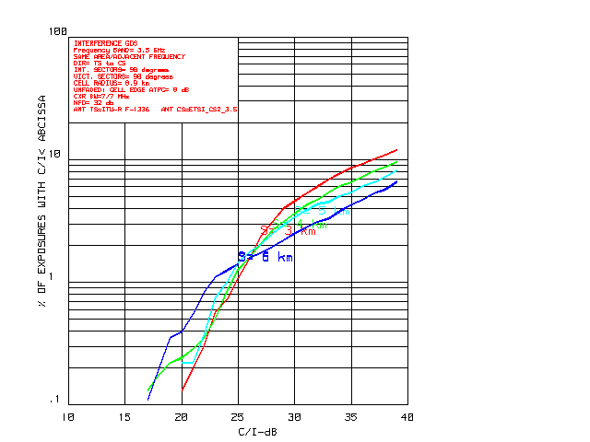
Figure 31 . Unfaded CDF (S > 3 km, NFD = 32 dB)
(TS 2 antenna class (ITU-R RPE G=16 dBi))

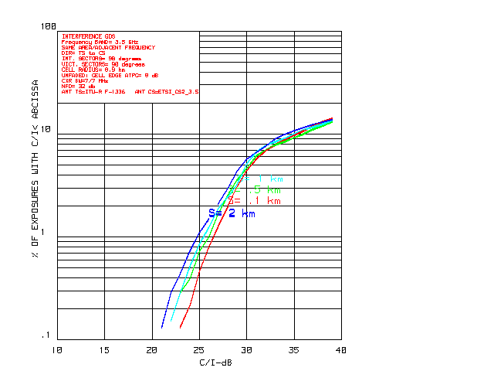
Figure 32: Unfaded CDF S < 2 km, NFD = 32 dB)
(TS 2 antenna class (ITU-R RPE G=16 dBi))

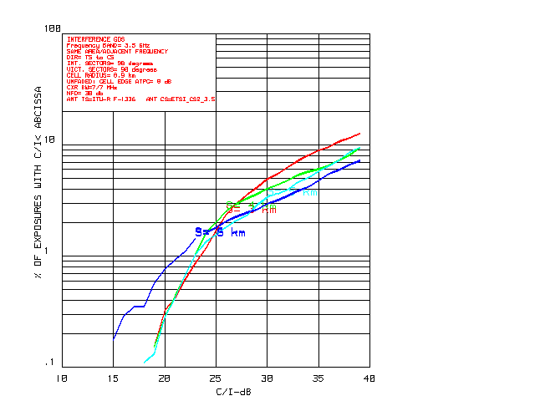
Figure 33: Unfaded CDF (S > 3 km, NFD = 30 dB)
(TS2/TS3 intermediate RPE (ITU-R RPE G= +18 dBi))

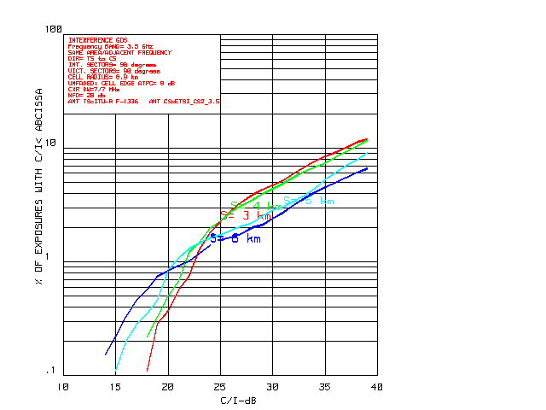
Figure 34: Unfaded CDF (S > 3 km, NFD = 28 dB)
(TS 3 antenna class (ITU-R RPE G=20 dBi))

A2.1.1.3 Rayleigh Faded Simulation Results
Figure 35through Figure 38 illustrate the results for the case where the Rayleigh fading distance probability coefficient d_{coeff} is set to 3.. As compared to the unfaded case, the CDF impairments resulting from uncorrelated Rayleigh fading are quite modest.

To explain this somewhat surprising result, we first note that the median level p.d.f. crossover for Rayleigh occurs at 63%. But this also means that 37% of the links will be in excess of the median level. For the interference links, these TS transmitters are ATPC adjusted to be lower in power. They thus transmit at a lower power than in the unfaded coexistence scenario.

For the victim links, a statistical examination of the ATPC adjusted signal level was performed. Here, it was found that 24% of the victim links were required to operate at maximum power. For the remainder, the distance proportional ATPC range was sufficient to restore the signal level to its unfaded margin level. However, 50% of these maximum power links were within 3 dB of the unfaded signal margin. Thus, a high percentage of victim links arrive at close to the same signal level as that for the unfaded scenario.

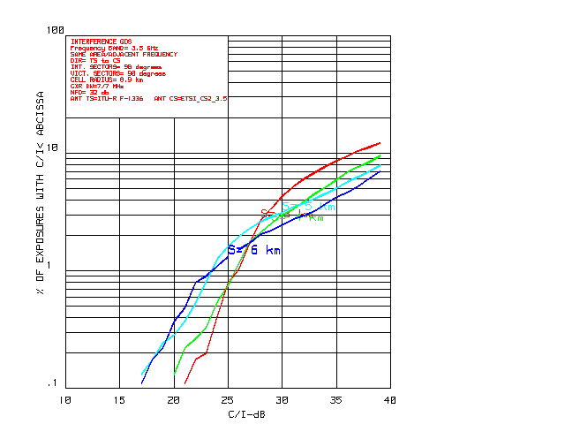
Figure 35: Rayleigh Faded CDF (S > 3 km, NFD = 32 dB)
(TS 2 antenna class (ITU-R RPE G=16 dBi))
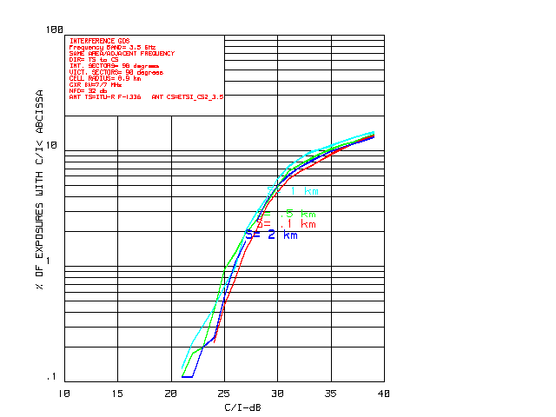
Figure 36: Rayleigh Faded CDF (S < 2 km, NFD = 32 dB)
(TS 2 antenna class (ITU-R RPE G=16 dBi))

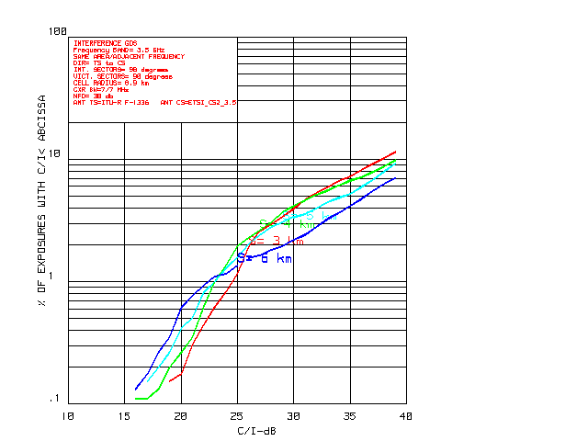
Figure 37: Rayleigh Faded CDF (S > 3 km, NFD = 30 dB)
(TS2/TS3 intermediate RPE (ITU-R RPE G= +18 dBi))
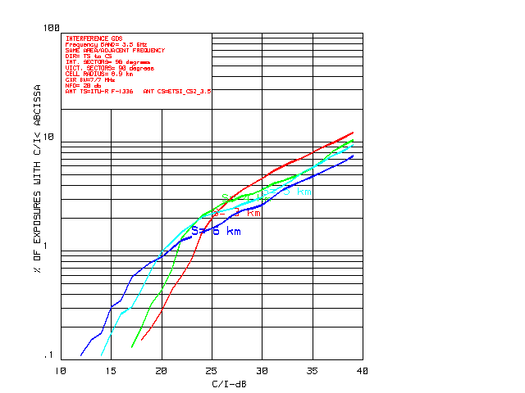
Figure 38: Rayleigh Faded CDF (S > 3 km, NFD = 28 dB)
(TS 3 antenna class (ITU-R RPE G=20 dBi))

A2.11..4 Conclusions
It is concluded that the NFD values summarised in the following Table 33 are acceptable values for the TS emissions associated with TS to CS interference couplings in the rural scenario.
TS antenna class | TS antenna class TS 2  (ITU-R RPE G=16 dBi) | TS2/TS3  intermediate RPE  (ITU-R RPE G= +18 dBi) | TS antenna class TS 3  (ITU-R RPE with G=20 dBi)
Minimum NFD required for Type B System (dB) | 32 | 30 | 28
Table 33: Minimum NFD required for Type B Systems Rural scenario

A2.1.2 Urban Scenario

A21..2.1 Simulation Methodology
The simulation model is comparable to that described in section A2.1 and Figure 30 for the rural scenario. Again, there are three transmission paths to consider. These are the victim link at distance R_{v}, the interference link at distance R₀ and the interference-coupling path at distance R_{i}. For each interference computation it is necessary to set the TX power of the TS for the first two links. The procedure is as follows:
- Compute FSL based on the distance R_{x} equal to R_{v} or R₀.
- Adjust the FSL signal level so that it is reduced to be distance proportional, i.e., 20log(R_{x}/R_{max}).
- Compute the mean excess path loss based on the distance R_{x}.
- Compute the mean value of Rician K based on distance R_{x} and relative to the SUI value for K, as specified for the cell edge at R_{max}.
- Determine the Rician fading adjustment by the random deviate method.
- Adjust the RX signal level to account for both mean excess loss and Rician fading.
- Readjust the TX signal levels via ATPC so that some signal margin above the threshold level is restored. This would typically be somewhere between 6 dB and 15 dB. As subsequently discussed, the simulations found some degree of C/I performance sensitivity referenced to the margin value selected.
- Set the TS - TX Power level accordingly. If the ATPC range is insufficient to achieve the specified margin, then set the TX power to P_{max}.

The TX power of both the interference and victim links is now set. The signal level of the interference-coupling path at distance R_{i} is now determined based on the procedure for computation of excess loss and Rician fading described. The C/I for each interference estimate can now be determined.

A2.1.2.2 Simulation Results

A2.1.2.2.1 Unfaded
Figure 39 through Figure 50 in this section illustrate the CDF vs. C/I results for:
- Rice factor K = 30 dB. For this K value, the probability of a deep fade is extremely low. Hence, this is essentially the case without fading.
- R_{max} = 2.7 km. and R_{max} = 2.0 km
- Different TS antenna heights (15 and 20 m)
- Different TS antenna classes TS2 to TS3 (i.e. with typical RPE derived from ITU-R F.1336 TS antenna using Gain = 16, 18 and 20 dBi, still with fixed 16 dBi boresight gain).

Each time, in the presented simulations the NFD used correspond to the minimum required to “hit” the ~ 1% of cases with C/I over the critical C/I threshold for the system type as reported in Table 1.

Performance degrades noticeably as CS separation distance S increases. This is a result of the excess loss differential and can be explained as follows:
- When S is small, a large number of interference and victim links are at a comparable distance from their serving CS sites. Consequently, excess loss is comparable on both interference and victim links.
- When S is large, there are fewer interference links that can illuminate the victim CS. But for those that do so, the interference distance is small; thus setting up an excess loss differential that strongly favours the interference link.
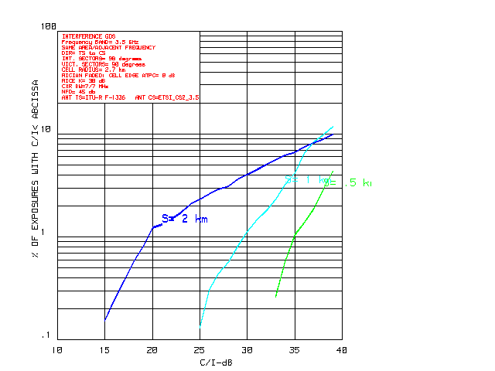
Figure 39: Mean Excess Loss-based CDF R_{max} = 2.7 km, TS Ant Elev = 15 m, NFD = 45
(TS 2 antenna class (ITU-R RPE G=16 dBi))

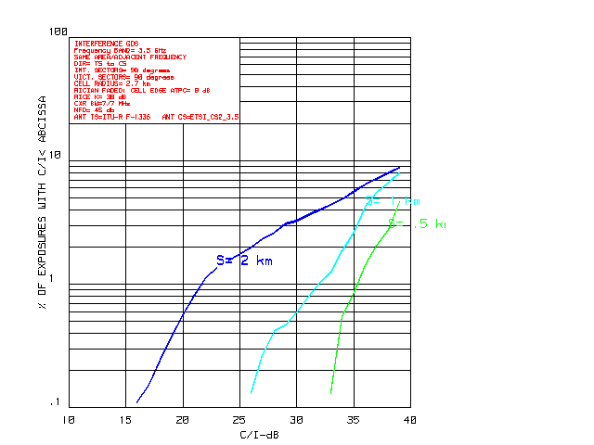
Figure 40: Mean Excess Loss-based CDF R_{max} = 2.7 km, TS Ant Elev = 15 m, NFD = 45 dB
(TS2/TS3 intermediate RPE (ITU-R RPE G= +18 dBi))
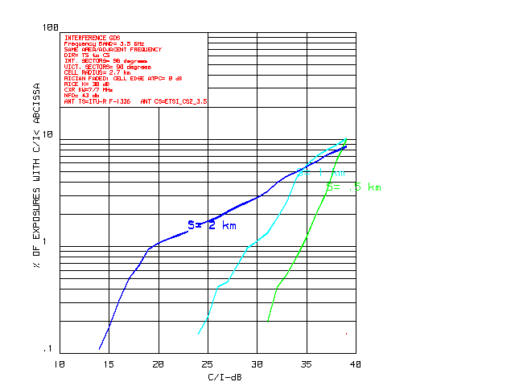
Figure 41: Mean Excess Loss-based CDF R_{max} = 2.7 km, TS Ant Elev = 15 m, NFD = 43 dB
(TS 3 antenna class (ITU-R RPE G=20 dBi))

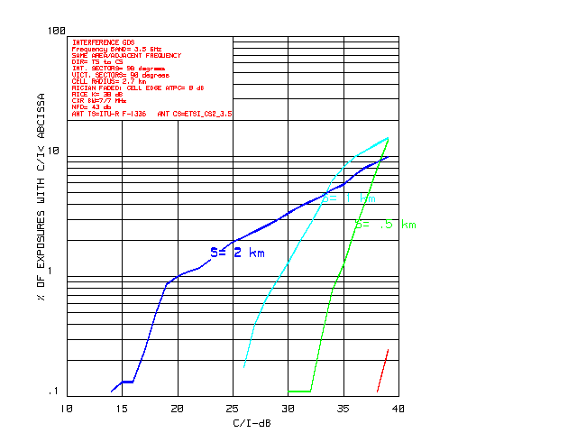
Figure 42: Mean Excess Loss based CDF R_{max} = 2.7 km, TS Ant Elev = 20 m, NFD = 43 dB
(TS 2 antenna class (ITU-R RPE G=16 dBi))
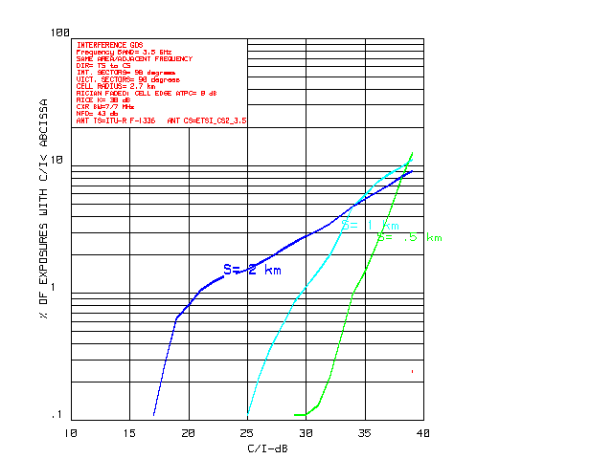
Figure 43: Mean Excess Loss based CDF R_{max} = 2.7 km, TS Ant Elev = 20 m, NFD = 43 dB
(TS2/TS3 intermediate RPE (ITU-R RPE G= +18 dBi))

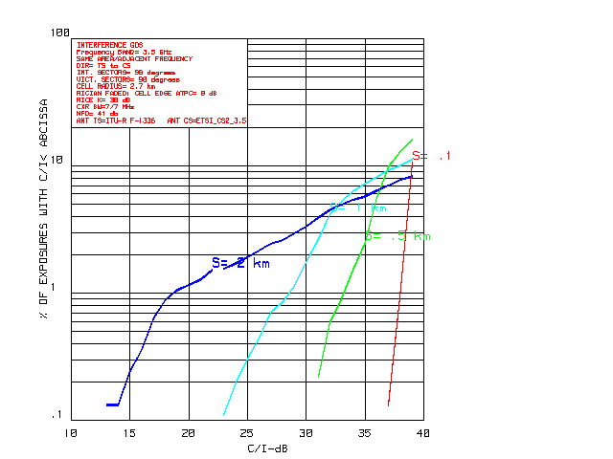
Figure 44: Mean Excess Loss based CDF R_{max} = 2.7 km, TS Ant Elev = 20 m, NFD = 41 dB
(TS 3 antenna class (ITU-R RPE G=20 dBi))
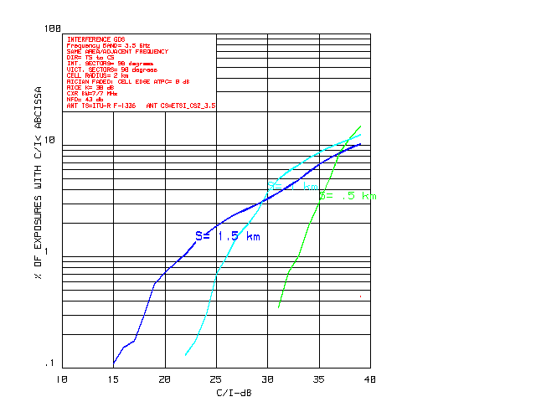
Figure 45: Mean Excess Loss based CDF R_{max} = 2.0 km, TS Ant Elev = 15 m, NFD = 43 dB
(TS 2 antenna class (ITU-R RPE G=16 dBi))

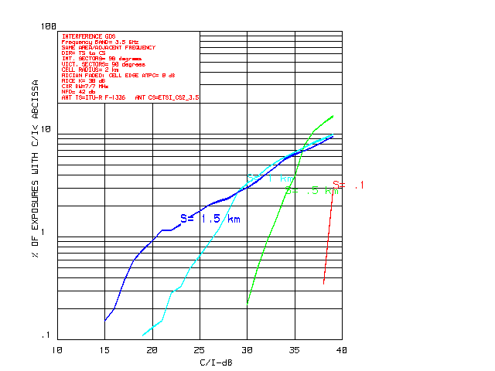
Figure 46: Mean Excess Loss based CDF R_{max} = 2.0 km, TS Ant Elev = 15 m, NFD = 42 dB
(TS2/TS3 intermediate RPE (ITU-R RPE G= +18 dBi))
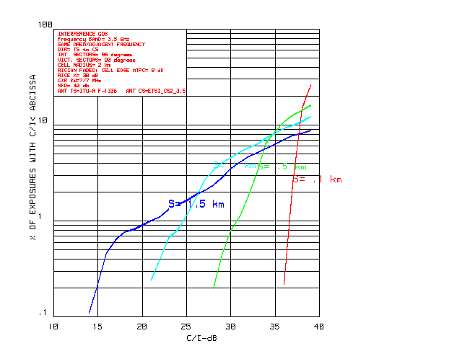
Figure 47: Mean Excess Loss based CDF R_{max} = 2.0 km, TS Ant Elev = 15 m, NFD = 40 dB
(TS 3 antenna class (ITU-R RPE G=20 dBi))

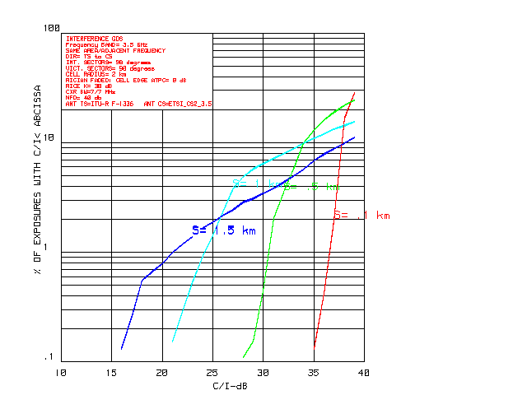
Figure 48: Mean Excess Loss based CDF R_{max} = 2.0 km, TS Ant Elev = 20 m, NFD = 40 dB
(TS 2 antenna class (ITU-R RPE G=16 dBi))
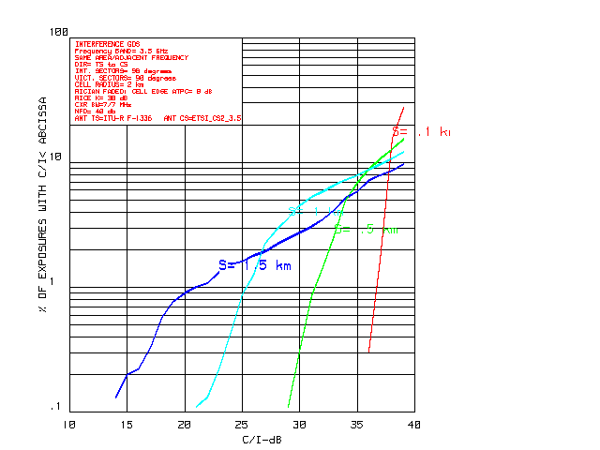
Figure 49: Mean Excess Loss based CDF R_{max} = 2.0 km, TS Ant Elev = 20 m, NFD = 40 dB
(TS2/TS3 intermediate RPE (ITU-R RPE G= +18 dBi))

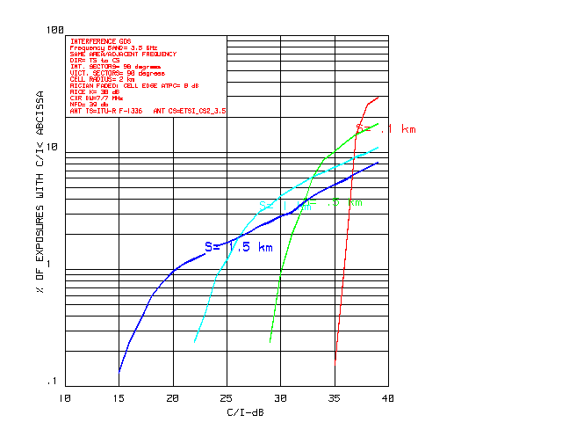
Figure 50: Mean Excess Loss based CDF R_{max} = 2.0 km, TS Ant Elev = 20 m, NFD = 39 dB
(TS 3 antenna class (ITU-R RPE G=20 dBi))

The following Table 34 summarizes, for the most critical system type B, the main findings, in terms of minimum required NFD value, for the various configurations in the urban scenario:
 |  | TS Antenna class
 | TS Antenna Height (m) | TS antenna class TS 2  (ITU-R RPE G=16 dBi) | TS2/TS3  intermediate RPE  (ITU-R RPE G= +18 dBi) | TS antenna class TS 3  (ITU-R RPE with G=20 dBi)
 | ⇩ | Minimum NFD value required (dB) 
System Type B  (Cell size 2.7 km) | 15 | 45 | 45 | 43
 | 20 | 43 | 43 | 41
System Type B  (Cell size 2.0 km) | 15 | 43 | 42 | 40
 | 20 | 40 | 40 | 39
Table 34: Minimum NFD required for Type B Systems Urban scenario

In case of 4-QAM system (system type A), there is an 8 dB increase in system gain. Thus, the critical receiver levels drop to 14.2 dB and 20.2 dB and the CDFs values improve.

A2.1.2.2.2 Rician Faded
If we run simulations for the SUI-1 channel model with cell edge Rice K = 12 dB, with cell radius R_{max} = 2.7 km, except for differences in detail, there will be very little difference between the previous unfaded results and the Rician faded case. This result is expected, Rician fading is modest for K = 12 dB. As well, the uncorrelated fading relationship results in an "averaging out" of fading differentials between the interference and victim paths. Coexistence performance criteria are thus dominated by the excess loss differential associated with near-NLoS transmission.

For simulation for a cell radius of R_{max} = 2 km, a SUI-2 channel is assumed with a mean value of Rice K equal to 9 dB at cell edge. Note that the maximum value for S has to be reduced to 1.5 km, reflecting the smaller value of R_{max}.

In spite of the reduced value of K, the results will be little changed from those of the previous SUI-1 case. Due to the smaller cell size, excess path loss at cell edge is reduced, resulting in a larger fade margin. As the excess loss differential was previously concluded to control CDF vs. C/I performance, this loss differential reduction is sufficient to offset the increased probability of deep fades.

A2.1.2.3 Conclusions, directional outdoor antennas
From the preceding analysis and simulations, the following may be concluded:
- The system gain set for the assumed transmission model constrains near-NLoS operation to be within the SUI-1 and SUI-2 transmission environment. To operate in more severe near-NLoS environments, additional system gain is required. While means exist to provide some increase in system gain, they are outside the scope of this Report.
- With the use of ITU-R F.1336 TS antenna RPE, representative of reasonably designed ETSI antennas, a NFD between 40 dB and 45 dB looks adequate for acceptable percentages of interference impairment, depending both on antenna gain and TS antenna heights.

A.2.2 Omni-directional indoor TS

A.2.2.1 Input parameters and models

A.2.2.1.1. Objectives
In present version of Report 33 only directional outdoor TS antennas are considered. The study for rural and urban scenarios, based on the fact that TS antenna directivity will eliminate most of the possible source of interference, show that urban worst case could be studied in unfaded conditions looking for a suitably low probability of a NLOS interfering TS to reach a victim CS with a C/I exceeding a fixed threshold level for the most stringent modulation format.
For the omni-directional case a different approach should be used; in this case each TS will contribute to an aggregate interference on the victim CS.
Therefore, the statistical study will be based on:
- Evaluation of a maximum terminal density
- Evaluation of an activity factor averaged over that population
- Distribution of the TS population among various households and offices
- Evaluation of a typical propagation model according the selected location of each TS
- Evaluation of the probability and cumulative distribution functions of the aggregate interference through an high number of Monte Carlo trials (snapshots).
- Comparison with the noise floor of the CS receiver.

A.2.2.1.2 CS data (same used for CS→TS evaluation):
TX output power = not relevant
Signal bandwidth = 3.5 MHz
TX output power density = not relevant
Antenna Gain (sectorial 90°) = 16 dB
Antenna pattern ITU-R F.1336
Antenna height = 30 / 40 m
NF = 8 dB (including cable connection to antennas) or 5 dB (ETSI BRAN working assumptions)
Noise floor = −109 to −106 dBm/MHz
Modulation formats = not relevant

A.2.2.1.3 TS omni-directional indoor out of block eirp:
The characteristics used for the CS→TS evaluation should be integrated with TX characteristics not specified for that purpose; however, for this TS→CS evaluation, only the expected out-of-block emissions would be necessary.
Reference eirp limit
As reference value we will use the present eirp limit (≤−37 dBW/MHz) reported in draft REC04-05, defined for directional TS with antenna gain of ≅ 16dB, reduced by the expected gain difference.
This is reasonable considering that TSs are generally designed for being coupled with a number of different antennas; therefore it should not concern the manufacturers.
Therefore, with TS omni-directional antenna gain ≅ 4dB, the out of block emissions would become:
Omni OOB eirp ≤ − 37 − (16−4) ≅ − 49 dBW/MHz
Besides the lesser antenna gain, this value is also justified by lesser expected output power for these TS applications.
Note: ETSI BRAN assumptions for this kind of applications is limited to +20 dBm typical; however, unless specific limitations might be necessary for sharing purposes, in practice certain percentage of higher power terminals might also be expected.
ATPC range
Even if ETSI ENs assumed ATPC as an option and do not specify any range, modern PMP systems implement quite large range of ATPC on TSs in order to balance all TS arrival powers to the CS at minimum operating level improving linearity of CS operation and keeping inter-cell interference as low as possible. ATPC of ~ 40/50 dB are quite common.
Out of block eirp emission will possibly be further reduced, even if not of the same amount due to noise limitation.
This would add sensible additional margin that we would evaluate in at least 10 dB in average.

A.2.2.1.4 TS activity factor and density:
The aggregate interference of a number of terminals on the territory will be proportional to their density (D_{TS}) and to their average activity factor (A_{f}).
Modern PMP systems might manage quite large number of Terminal stations per BS sector; however, all TSs should share the overall BS capacity/sector. Therefore, this results in an maximum average activity factor.
PMP systems may manage a number (N_{T}) of TS per BS sector; these TS are sharing a constant capacity per sector. Whichever the capacity the average maximum activity factor (A_{f}) is defined as:
A_{f} = 1/N_{T}
Modern PMP systems may manage a quite large number (N_{T}) of TS per BS sector; typically 256 or even more (e.g. up to 1024 addresses are foreseen in BRAN HM and IEEE 802.16 standards protocols).
However, we should consider some physical and market limitations, derived from the actual number of households over a certain area.
The following considerations are taken from the draft ETSI BRAN System Reference Document (SRD) for fixed/nomadic convergence presented to the 2nd JPTBWA meeting:
Reprinted from Doc. JPTBWA(05)17 Annex 1 (may be found at ERO document server at www.ero.dk/download )
Considering that the maximum penetration rate is 30% for the target broadband services, in sub-urban and rural areas, results the maximum subscriber number. The urban penetration was considered also 30% due to the special attractiveness of the nomadic usage.

Households | L = 2km | L=1km | L = 500 m | L = 250m
Area (sq km) | 4 | 1 | 0.25 | 0.0625
Urban | 12000 | 3000 | 750 | 187.5
Sub-urban | 4000 | 1000 | 250 | 62.5
Rural | 1000 | 250 | 62.5 | 15.625
Table 7:Total number of households / cell

 | L = 2km | L=1km | L = 500 m | L = 250m
Urban | 3600 | 900 | 225 | 56
Sub-urban | 1200 | 300 | 75 | 19
Rural | 300 | 75 | 19 | 5
Table 8: Total number of subscribers / cell

The above considerations, over a simplified square cells scenario, tell that, in average, the households’ physical constraints maintain the maximum terminal density (urban scenario) constant at:
D_{TSi} ≅ 900 / km²
They would be subdivided on sectors containing a number of terminals that, in case of reuse 4 deployment, ranges from:
Urban: ~14 < N_{T} < ~ 256 or more, depending on maximum terminal handling and data rate offered
Suburban ~5 < N_{T} < ~ 256 or more, depending on maximum terminal handling and data rate offered
The lower N_{T} value is, in principle, the most unfavourable for our aggregate interference evaluation because it will result in the possibly higher activity factor (e.g. A_{f} ≅ 1/14). However, also in this case, some practical considerations on the actual up-link data rate should be taken into account.
The same ETSI BRAN draft SRD contains evaluation of the maximum data traffic/cell; its aim to evaluating the spectrum need, therefore it made an average up-link + down-link traffic estimation.
Reprinted from Doc. JPTBWA(05)17 Annex 1 (may be found at ERO document server at www.ero.dk/download )
The traffic estimation will be done for the assumption of VDSL-like services, allowing broadband data and VoD, using the shared traffic assumption.
Supplementary, will be calculated the data traffic generated by broadcast services, needed for triple-play service concept.
The 5 subscribers/cell, in rural like deployment, cannot provide any positive business case; due to this, the variant of 250m cell in Rural deployment has been omitted in the following calculations.

A.3.2.1 Shared traffic, VDSL like
The data rate calculation is done for the following assumptions:
- Peak data rate: 7Mb/s, UL+DL, shared between 20 users
- VoD using MPEG2, regular video, at 2Mb/s: 20% of users
- VoD using MPEG4, for HDTV, at 6Mb/s: 10% of users
- 2 frequencies / cell
 | L = 2km | L=1km | L = 500 m | L = 250m
Urban (Mb/s) | 4860 | 1222 | 320 | 88
Sub-urban (Mb/s) | 1620 | 412 | 108 | 34
Rural (Mb/s) | 412 | 108 | 34
Table 9: Shared traffic / cell for VDSL-like services, Mb/s

The above data show that, with the same assumption of reuse 4 deployment, the capacity per sector (DL + UL) ranges from 22 Mbit/s to maximum handled by the system.
Assuming a 1/3 UL/DL ratio as reasonable average, we could estimate:
Urban ~7 Mbit/s < ULdata/sector < maximum handled by the system
subUrban ~2.3 Mbit/s < ULdata/sector < maximum handled by the system.
In modern PMP systems designed for fixed/nomadic purpose the UL maximum data capacity is in the range of few tens of Mbit/s (e.g. the BRAN HM objectives are for minimum 25 Mbit/s per sector, which is a reasonable value standing the limited spectrum availability in 3.5 GHz bands).
Assuming this value as typical we could estimate that the full UL capacity in urban scenario might not be reached in the lower cell size deployment of radius L=250 m, where a minimum N_{T} ≅ 14 has been estimated. The activity factor, in this worst assumed case, will be further limited by a factor 1/4 due to physical deployment reasons.
With same reasoning in suburban case, while the maximum D_{TS} would be ~ 1/3 the A_{f} will have the same upper bound of ~1/56.

A.2.2.2 Summary of TS density and OOB eirp reference values:
Following the above evaluation of possible worst cases an average mitigations we would derive the parameters to be used for the overall aggregation of interfering TSs.
The device densities evaluated above are the overall expected TS population; however, we should consider that:
- A fraction of population belongs to the victim operator and then are not to be counted; assuming the market shared by 3 operators only 2/3 of the TSs will add as interference.
- A fraction only of the interfering TS will be of indoor/omni-directional nature here evaluated
- The interfering TS population will be spread over various adjacent channels; those operating on channels closer to the wanted CS channels would predominate over those on farter channels.
Therefore it is reasonable to assume that only 1/3 of the potential interferers would actually concur to the aggregation.
Regarding the OOBlock eirp the reference value it would be derived as:
OOBlock (RECOMMENDATION) − ATPC − (Delta antenna gain) − 10 log(A_{f})
− 37 − 10 − (16-4) 10log56 ≅ −76.5 dBW/MHz or − 46.5 dBm/MHz
Sector radius 0.25 km:
TS density urban: D_{TS} = 900/3 = 300/km²
TS density suburban: D_{TS} = 300/3 = 100/km²
Activity factor urban A_{f} = (1/14)*1/4 = 1/56
Activity factor suburban A_{f} = (1/5)*1/12 = 1/56
Reference OOBlock eirp −46.6 dBm/MHz
Sector radius 0.5 km:
TS density urban: D_{TS} = 900/3 = 300/km²
TS density suburban: D_{TS} = 300/3 = 100/km²
Activity factor urban A_{f} = 1/56
Activity factor suburban A_{f} ≅ (1/19)*1/3 ≅ 1/56
Reference OOBlock eirp −46.6 dBm/MHz
These are the worst considered cases; in all other cell radius it can be seen that the factor (D_{TS} * A_{f}), which affects the aggregate interference, have equal or lower value due to the constant density and a possible lower activity factor.

A.2.2.3 Scenarios
The analysis is made using a simulation program developed, within ECCTG3, for evaluating the aggregate interference from a population density of indoor TS communication applications to a Fixed Service station (i.e. a FWA CS, for our purpose). Therefore it is well suited for any other randomly distributed source of interference (i.e. a population of TSs belonging to other FWA systems).
Annex 1 shows the basics of the model used.

A.2.2.4 Propagation models:
As for the CS→TS interference study, the IEEE 802.16 adopted Erceg propagation model is used for NLOS paths, added to an indoor-to-outdoor attenuation statistic as explained in Annex 1.
Erceg B variant has shown to be quite tailored for typical NLOS paths in Milan urban areas.
Cases of TS distributed on higher buildings will use free-space for the outdoor portion of the path, while maintaining the indoor statistical distribution of attenuations.
Annex 1 gives all details.

A.2.2.5 Simulation results
In the following Pmed is the mean value of the aggregate interference evaluated as sum in power of each the aggregate result snapshot divided by the number of total snapshot and is used as quick reference of the result, corresponding to ~ 90% probability of not exceeding the value.

A.2.2.5.1 h_{CS} = 30 m
Pmed Sector1 = -116.73 dB
Pmed Sector2 = -133.79 dB
Pmed Totale = -116.64 dB
Details per sector and propagation models split:
Sector 1:
Erceg B situations (73.13 %): Pmed = -119.23 dB
FSpace situations (26.87 %): Pmed = -120.32 dB

Sector 2:
Erceg B situations (72.95 %): Pmed = -168.01 dB
FSpace situations (27.05 %): Pmed = -133.80 dB

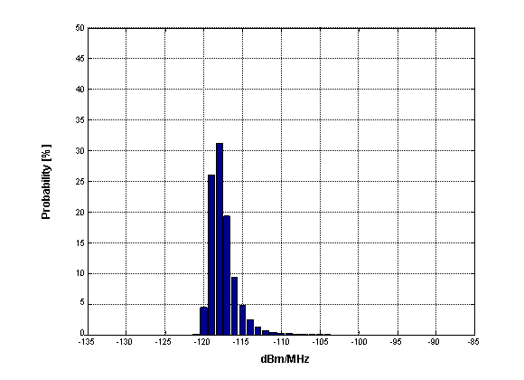
Figure 51: Total PdF for h_{CS} = 30 m

A.2.2.5.2 h_{CS} = 40 m
Pmed Sector1 = -118.27 dB
Pmed Sector2 = -133.79 dB
Pmed Totale = -118.16 dB

Details per sector and propagation models split:
Sector 1:
Erceg B situations (73.13 %): Pmed = -121.28 dB
FSpace situations (26.87 %): Pmed = -121.29 dB

Sector 2:
Erceg B situations (72.95 %): Pmed = -163.84 dB
FSpace situations (27.05 %): Pmed = -133.80 dB

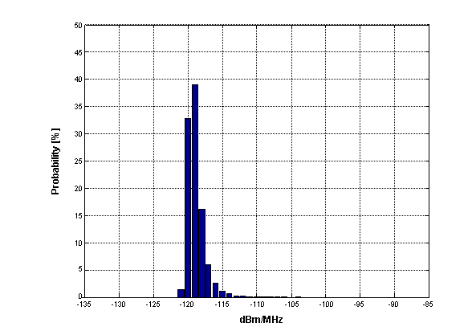
Figure 52: Total PdF for h_{CS} = 40 m

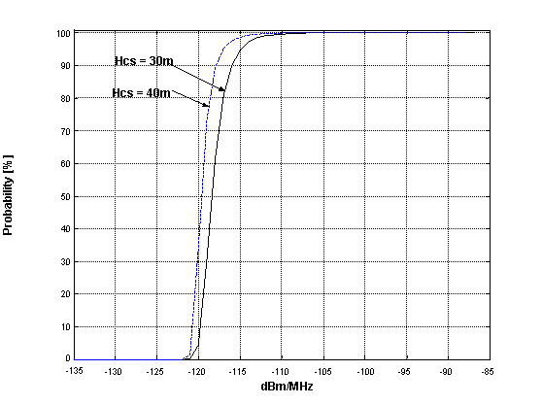
Figure 53: CDF comparison

A.2.2.6 Conclusions
The above Monte-Carlo simulations show that:
- The contribution of the surrounding sub-urban area (sector 2) is negligible.
- With high cumulative probability (e.g. 95%) of the 40000 snapshots the aggregate interference to a CS antenna 30m height is lower than −115 dBm/MHz. This mean that, assuming the actual floors average height of ~3.4m, on top of a 6 storey + ground floor building with 6m mast, which could be considered a quite worse situation in urban areas
- This worst case is already 6 to °9 dB lower than the CS noise floor therefore contributing by less than 0.5 to °1 dB to threshold degradation.
- Higher CS antennas are already ~ 5dB more protected or alternatively the cumulative probability of similar protection will become ~99%.
Therefore we could conclude that the proposed EIRP limit of -49 dBW/MHz is considered suitable also for omni-directional indoor TS, provided that it is reduced linearly with the antenna gain difference.
The study reported here shows that an out-of-block EIRP value of -49 dBW/MHz, further linearly reduced by the difference in antenna gain, coupled to the indoor use and its additional average attenuation might be considered safe enough for the deployment of a considerable number of omni-directional indoor terminals.
The linear scaling with antenna gain, for omni-directional antennas, is however incidental; actually, omni-directional case here studied benefits also of the indoor-to-outdoor attenuation, which, in average, contributes by ~15 dB. Therefore, omni-directional antennas should be restricted, with the eirp estimated herein, to indoor use. Otherwise an additional reduction of the limit is required.

Appendix 1 to Annex 2: Model basic description
The model is based on data taken from aerial pictures of the city of Milan in northern Italy; it may represent a typical European city.
Data on buildings height on a great 21 x 21 km area and on a more restricted 8 x 8 km urban area (see Figure 54) encompassing more or less urban and sub-urban areas) were evaluated over ~ 184000 building entries, ~80000 of which in the narrower urban area; by difference, the distribution on the sub-urban frame area is derived.
Building density is ~ 1200/km² in the urban area and ~ 280/km² in the sub-urban frame area.
The cumulative probability distribution of building height is shown in .
The probability distribution of floor # and its cumulative probability (assuming them ~ 3m height each) has been derived from the total number of buildings and the related ~ 790000 floors (see Figure 56).
In such a way we could define through simple Monte Carlo trials an elevation for each interfering TS entry, assigning to it the appropriate propagation model.

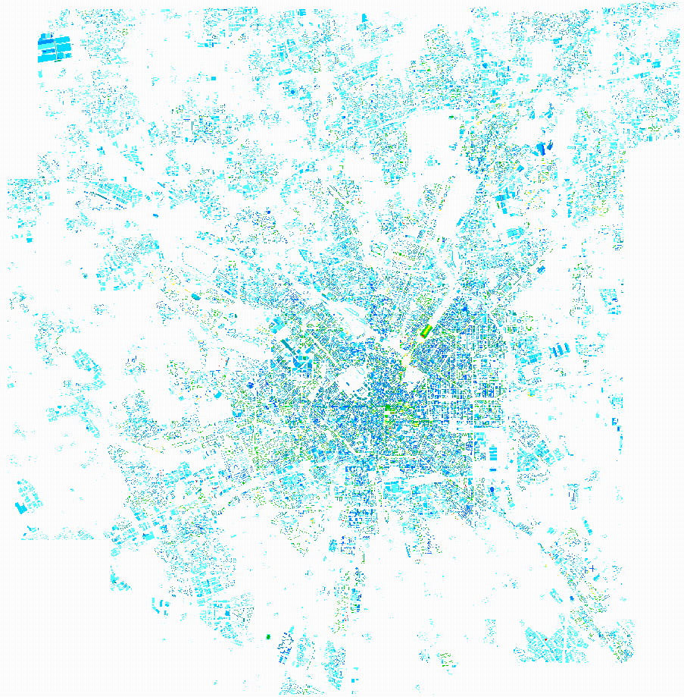
21 x 21 km
8 x 8 km
Figure 54: Milan example areas:
urban (square 8x8 km) and suburban (external cornice 21x21 km)

Figure 55: Probability distribution of building heights within Milan,
urban and suburban cornice areas

Note: Floor #1 means ground floor
Figure 56: Probability distribution of floor # within the areas of Figure 54
Geometrical description of the model
The scenario has been described as semicircles areas around FWA base station shown in Figure 57.
It simulate the worst case of a CS sector at urban area border facing the urban area, it is also quite conservative because the same 8 km radius of urban density is maintained up to ± 180°, while it should have been reduced to ±4 km.
-12
-10
-8
-6
-4
-2
0
2
4
6
8
10
12
0
2
4
6
8
10
12
14
16
18
20
km
1
2
Figure 57: Description of different TS distribution areas in the model
Each scenario is represented by a 180° semi-circular area; each one is subdivided in sectors where TS deployment is different i.e.:
Sector 1 portion with urban terminal density
Sector 2 portion with Sub-urban terminal density

In each sector a pattern of TS devices is established with the required density over the horizontal plane.
Description of Monte-Carlo snapshots
Step 1: Assigning a TS height
Each TS device is given with an elevation randomly derived from the relevant building/floor distribution.
Figure 58 pictorially show the random height assignment.
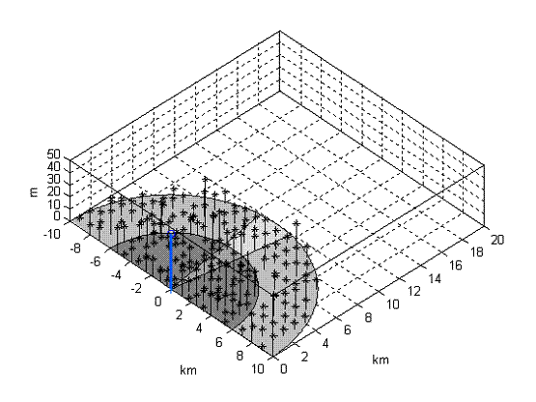
Figure 58: Visual example of TS height distribution over model areas

Step 2: Defining the suitable outdoor propagation model
Each TS now allocated in the space, will be given a propagation model depending its height (i.e. Erceg B or free-space); arrival angle and distance is calculated and path loss, including relevant antenna RPE contribution is calculated.
- TS distributed below the mean building height (i.e. ~15m in urban building distribution and ~10m for sub-urban):
Outdoor Propagation Erceg B; Gaussian shadowing variance σ = 9 dB (truncated at ± 2 σ)
- TS distributed on height above: will be considered LOS free-space.
Step 3: Defining the additional indoor to outdoor attenuation
For each TS, an indoor + building exit additional attenuation is picked up from the random distribution described below.
For defining a suitable distribution we consider areas of a “typical floor” and assume that each building will face the FS station with one side only (if the building orientation is tilted, only portions of two sides will count, maintaining the same average exposition).
On the side facing the victim antenna the lower attenuation is expected and on the opposite side higher attenuation would be added.
Assuming typical building area to be ~400 m² will give an average 20 x 20m square building footprint. A continuous distribution derived through the convolution (representing the joint probability) of building through wall attenuation Gaussian distribution given in ITU-R P.1411 and the indoor attenuation, additional to free space, given by the two slope Siwiak model (d_{t}=3m) extended over the floors area. An additional step of 10db, representing the additional attenuation of internal elevators and stairs areas, is introduced in the middle of the building as shown in Figure 59 and Figure 60.
This seems also conservative when considering that no floor trespassing attenuation is considered; this would add high contribution to TSs closer to the victim CS, which might significantly contribute standing the limited elevation RPE discrimination of CS antennas.
Figure 59: Probability density and cumulative probability of
the P.1411 penetration distribution
Figure 60: Attenuation of the indoor path additional to free-space
(each value assumed to have equal probability)
The joint probability obtained from convolution of the two distributions is shown in Figure 61 as probability density and cumulative probability
Figure 61: Probability density and cumulative probability of
the joint attenuation functions.
Step 4
Using the attenuation of each TS device, evaluated in previous steps 1 to 3, the received power density generated by each TS is evaluated and cumulated for all TS population within the same snapshot subdivided into the different sectors and into the overall aggregation.
Step 5
After concluding the first snap-shot, described in the previous steps, other ~39.999 similar snapshots are conducted and a probability density and cumulative probability function of the aggregate PSD is calculated.
Separate evaluations are made for the mean power density value (Note) in each sector and in the whole area.
Note: the mean power density values are obtained as the power sum of aggregation results of all snapshots divided by 40000 (number of snapshots). It roughly corresponds to the value not exceeded for 90% of the snapshots.

Appendix 2 to Annex 2: Acceptance-Rejection method

- Generate three uniform random deviates U1, U2, U3. U3 is a spare deviate to be subsequently described.
- Let F_{max} be the maximum value of a normalized Rayleigh distribution.
- Compute a probability point P_{r}(3U2) based on the Rayleigh probability equation and within a finite truncated range for U2. Setting the range for U2 to be within (0, 3) allows Rayleigh fades to span the range from to +10 dB.
- Examine the ratio u = P_{r}(3U2)/ F_{max}. If the ratio u is less than U1, then accept U2 as the random deviate. If not, then reject the triplet and start again.
- Once accepted as a valid Rayleigh deviate, the adjustment to the FSL signal level is 20log(U2).

Random deviate U3 was not required in the preceding. However, once U1 and U2 are accepted, the associated U3 value is employed to identify the probability of Rayleigh fading at some transmission distance R_{x}. For Rayleigh fading, the probability of it's occurrence is known to vary as the 3rd power of the distance [4]. The simulation assumptions are as follows:
- Under Rayleigh fading conditions, set the probability of a Rayleigh fade at maximum distance R_{max} to be = 1. For some lesser distance, say R_{x}, set the probability to be , where 3.
b) Compare the value of with that of U3. If U3 > , then conclude that there is no Rayleigh fading on the link. If U3 < , then set the Rayleigh fading adjustment to be that given by step v. above.

ANNEX 3: examples for managing a CS block-edge mask
When it is considered appropriate a complete “technology independent/uncoordinated use of the bands, the BEM methodology seems the easiest way to contain mutual interference while minimising the need for detailed coordination.

Using a block-edge mask concept implies that operators should meet the requirements having freedom on three elements only:
- The EIRP level
- The minimum frequency separation from edge of outermost channels
- The transmit spectrum mask attenuation enhancement.

The first parameter is intended for maximising coverage, while the other two are strictly related to the actual equipment implementation. Manufacturers might improve the transmitter spectrum mask (and then the possibility of going closer to the block edge) by actually offering guaranteed masks that, at least for the CSs, are tighter than the minimum ETSI requirement.

Managing these three elements, equipment manufacturer and an operator can define systems parameters that better fit the network requirements addressed (e.g. for rural or for urban applications).

The provisions in this section have been based on coexistence studies described in this report; it should here be noted that those studies are mostly made with statistical tools and typical radio systems, deployment and service performance objectives assumptions.
Consequently, a block edge mask is generally designed on the basis of a small level of degradation in an assumed interference scenario with a low occurrence probability of a worst case (e.g. low probability of two directional antennas pointing exactly at each other). It is not therefore excluded that in a limited number of cases specific mitigation techniques might be necessary.
In particular when CSs are co-located on the same building, the statistical approach is not applicable and it is assumed that common practice of site engineering (e.g. vertical decoupling) is implemented for improving antenna decoupling as much as possible.
Also adjacent block receiver rejection concurs to a reduced interference scenario, however this is not in the scope of this recommendation to set limits for it; nevertheless it is expected that ETSI standards will adequately cover the issue.
It should be also noted that when TDD or mixed FDD/TDD systems are placed in immediately adjacent bands, the probability of occurrence of worse cases of interference between CSs is quite higher than in situations where only FDD are deployed. Therefore, even if the mask here proposed offer a suitably low occurrence probability of interference for such cases, when TDD systems are concerned additional mitigation techniques (geographic separation of stations, natural/physical shielding, etc) or additional co-ordination (including networks synchronisation) between operators should be implemented as far as possible.
The current studies has shown that less directional antennas (either CS or TS) generally produce more probability of interference; therefore out-of-block emissions in terms of EIRP should be more stringent for lower directivity (and consequently with lower gain) antennas. That is why the recommended block edge mask limits outside the block are here described in terms of transmitter output power, allowing operators to make practical use of this phenomenon by obtaining higher EIRP when using highly directional hence less interfering antennas, while EIRP would be automatically lowered when low gain (e.g. omni-directional antennas) are employed.
The transition zone, shown between X₁ and X₃ power density levels (see Figure 3), is not here considered in terms of IPF or NFD, but should be determined through a trade-off between the need of a limited amount of guard-band, the possible slight decrement of NFD available for the block-outermost system channels and the practical feasibility of equipment filtering for reaching the required X₃ level from in-block P_{max} density, which is generally defined for suitable service and sharing conditions in the licensing process.
Implementing a smooth transition zone implies that the amount of protection within a block is not constant but increases as far as the operating channel is removed from the edge.
Therefore, the example mask here considered assumes adjacent blocks to be sized from 4 typical system channels plus an internal guard band as recommended in Annex 1 of ECC/REC(04)05, with increasingly protected frequency areas:
- Internal guard bands areas where protection is not offered unless the interested operators would practice active coordination
- Outermost system channels areas where protection is given with high probability, but in few worse cases coordination between CS might be needed. However, in most cases, administrations require CS notification of emissions parameters (i.e. transmitter EIRP and antenna data with geographical locations) and make the data-base available; therefore, the operator, with the knowledge of other CS already deployed, may operate self-coordination avoiding worse cases and eventually use innermost systems channels in the block that are more protected.
- Innermost system channels areas where protection is given with very high probability.
The increasing drop-down attenuation at the block edge has the scope of easing TX filtering. Its size has been chosen taking into account the block size typically needed for broadband applications that will likely dominate current and future FWA licenses in these bands. The drop-down portion, with higher permitted out-of-block emission, mostly fall within a guard-band (internal or external to the block), thus not affecting expected mutual interference.
In the following examples the transition zone of block-edge mask is analyses against the 16 QAM TDMA type B and OFDMA/TDMA type F from ETSI 302 326-2 equipment masks for 3.5 MHz channels.

In particular the following considerations are made:
- Analysis of typical block size: 4*3.5 + 1*3.5(guard) = 17.5 MHz block.
- outermost system channel placed at the reference distance of 3.5 MHz from edge (i.e. not wasting spectrum but also not gaining any)
- Analysis over 16 QAM (considered a sensible reference). In modern adaptive equipment QPSK is considered to fit the higher order masks; 64 QAM is considered an option that not all systems might offer.
- 5/6 resonators filter as medium high complexity realization or 7 resonators filters as feasible limit for stable and effective hardware design.
- wide-band filters (i.e. 14 MHz bandwidth) for maintaining frequency agility within the block.
- System CS output power +35 dBm (i.e. ~+30.5 dBm/MHz of power density), considered a typical target for indoor TS coverage.
The result in terms of the maximum power density allowed by the mask is shown in Figure 62. Without extra filtering the system could not meet the mask unless with very low power, with 5 cavity filter the power should be reduced by ~10 dB, while using 6 and 7 cavity the target is feasible with the desired power.

As a second example, in Figure 63 systems at proposed power density are allowed to be placed nearer to block-edge as far as the filter complexity increases. Also in this case unfiltered equipment can not meet the edge mask unless with very large power reduction.

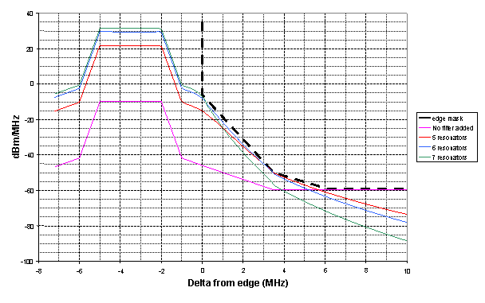
TDMA
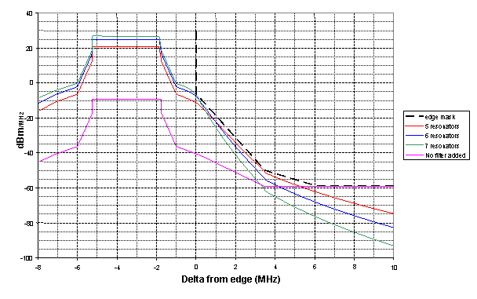
OFDMA/TDMA
Figure 62: Examples of increasing power density with RF filtering at same edge distance

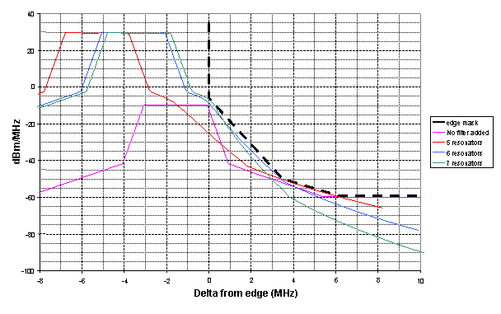
TDMA
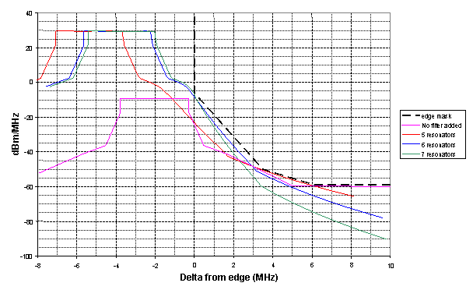
OFDMA/TDMA
Figure 63: Example of decreasing edge distance with RF filtering at same max EIRP

Annex 4: Evaluation of the C/I ratio exceeded for more than 99% (and 97% for omni-directional case) of probability.
The following Figures summarise the worst cases of the large number of different conditions evaluated in Table 35to Table 39. In addition, for evaluating the possible degradation gradient, Figure 65compares similar evaluation of directional antennas with 1% and 3% occurrence probability.
Figure 66summarise the worst omni-directional situation at various occurrence probabilities.
Figure 64: Summary results for worse C/I cases (1% occurrence probability) with directional antennas
(Derived from Table 35through Table 38)

0
0.25
0.5
0.75
1
1.25
1.5
-50
-40
-30
-20
-10
0
10
D / R
C/I (dB)
Fig 11A
1% prob.
Fig 11B
1% prob.
Fig 11B
3% prob.
Fig 11A
3% prob.
Figure 65: Comparisons of worse C/I cases (Erceg B-SUI4)
(1% and 3% occurrence probability) with 10 dB directional antennas
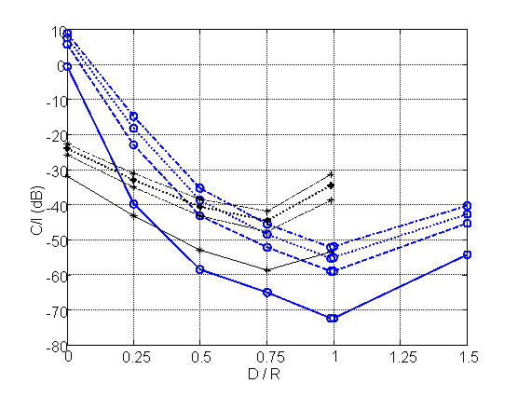
Fig 11A
5% prob.
Fig 11A
1% prob.
Fig 11B
5% prob.
Fig 11B
1% prob.
Fig 11B
4% prob.
Fig 11B
3% prob.
Fig 11A
4% prob.
Fig 11A
3% prob.
Figure 66: Summary results for worse C/I cases (Erceg B-SUI4)
(1% to 5% occurrence probability) with omni-directional antennas

Table 35: C/I exceeded for more than 99%
Directional antennas Cell radius 0.5 and 1 km
R [km] | Erceg Category | SUI | h TS [m] | Ant.Gain [dB] | D_{CS}/R | C/I [dB]  at 99%
0,5 | Erceg-B | SUI-4 | 4 | 10 | 0 | -32,82
0,5 | Erceg-B | SUI-4 | 10 | 10 | 0 | -32,82
0,5 | Erceg-B | SUI-4 | 15 | 10 | 0 | -32,82
0,5 | Erceg-C | SUI-2 | 4 | 10 | 0 | -31
0,5 | Erceg-C | SUI-2 | 10 | 10 | 0 | -31
0,5 | Erceg-C | SUI-2 | 15 | 10 | 0 | -31
0,5 | Erceg-B | SUI-4 | 10 | 18 | 0 | -32,82
0,5 | Erceg-B | SUI-4 | 15 | 18 | 0 | -32,82
0,5 | Erceg-B | SUI-4 | 4 | 18 | 0 | -32,81
0,5 | Erceg-C | SUI-2 | 4 | 18 | 0 | -31
0,5 | Erceg-C | SUI-2 | 10 | 18 | 0 | -31
0,5 | Erceg-C | SUI-2 | 15 | 18 | 0 | -31
0,5 | Erceg-B | SUI-4 | 4 | 10 | 1/4 | -40,44
0,5 | Erceg-B | SUI-4 | 10 | 10 | 1/4 | -40,44
0,5 | Erceg-B | SUI-4 | 15 | 10 | 1/4 | -40,44
0,5 | Erceg-C | SUI-2 | 15 | 10 | 1/4 | -38,03
0,5 | Erceg-C | SUI-2 | 4 | 10 | 1/4 | -38,02
0,5 | Erceg-C | SUI-2 | 10 | 10 | 1/4 | -38,02
0,5 | Erceg-B | SUI-4 | 10 | 18 | 1/4 | -37,63
0,5 | Erceg-B | SUI-4 | 15 | 18 | 1/4 | -37,63
0,5 | Erceg-B | SUI-4 | 4 | 18 | 1/4 | -37,62
0,5 | Erceg-C | SUI-2 | 4 | 18 | 1/4 | -35,33
0,5 | Erceg-C | SUI-2 | 10 | 18 | 1/4 | -35,33
0,5 | Erceg-C | SUI-2 | 15 | 18 | 1/4 | -35,33
0,5 | Erceg-B | SUI-4 | 4 | 10 | 1/2 | -46,24
0,5 | Erceg-B | SUI-4 | 10 | 10 | 1/2 | -46,24
0,5 | Erceg-B | SUI-4 | 15 | 10 | 1/2 | -46,24
0,5 | Erceg-C | SUI-2 | 15 | 10 | 1/2 | -43,39
0,5 | Erceg-C | SUI-2 | 4 | 10 | 1/2 | -43,38
0,5 | Erceg-C | SUI-2 | 10 | 10 | 1/2 | -43,38
0,5 | Erceg-B | SUI-4 | 4 | 18 | 1/2 | -41,74
0,5 | Erceg-B | SUI-4 | 10 | 18 | 1/2 | -41,74
0,5 | Erceg-B | SUI-4 | 15 | 18 | 1/2 | -41,74
0,5 | Erceg-C | SUI-2 | 4 | 18 | 1/2 | -39,01
0,5 | Erceg-C | SUI-2 | 10 | 18 | 1/2 | -39,01
0,5 | Erceg-C | SUI-2 | 15 | 18 | 1/2 | -39,01
0,5 | Erceg-B | SUI-4 | 4 | 10 | 3/4 | -49,77
0,5 | Erceg-B | SUI-4 | 10 | 10 | 3/4 | -49,77
0,5 | Erceg-B | SUI-4 | 15 | 10 | 3/4 | -49,77
0,5 | Erceg-C | SUI-2 | 4 | 10 | 3/4 | -46,57
0,5 | Erceg-C | SUI-2 | 10 | 10 | 3/4 | -46,57
0,5 | Erceg-C | SUI-2 | 15 | 10 | 3/4 | -46,57
0,5 | Erceg-B | SUI-4 | 4 | 18 | 3/4 | -44,11
0,5 | Erceg-B | SUI-4 | 10 | 18 | 3/4 | -44,11
0,5 | Erceg-B | SUI-4 | 15 | 18 | 3/4 | -44,11
0,5 | Erceg-C | SUI-2 | 4 | 18 | 3/4 | -41
0,5 | Erceg-C | SUI-2 | 10 | 18 | 3/4 | -41
0,5 | Erceg-C | SUI-2 | 15 | 18 | 3/4 | -41
0,5 | Erceg-B | SUI-4 | 10 | 10 | 0.99 | -23,52
0,5 | Erceg-B | SUI-4 | 15 | 10 | 0.99 | -23,52
0,5 | Erceg-B | SUI-4 | 4 | 10 | 0.99 | -23,51
0,5 | Erceg-C | SUI-2 | 4 | 10 | 0.99 | -20,22
0,5 | Erceg-C | SUI-2 | 10 | 10 | 0.99 | -20,22
0,5 | Erceg-C | SUI-2 | 15 | 10 | 0.99 | -20,22
0,5 | Erceg-B | SUI-4 | 4 | 18 | 0.99 | -13,14
0,5 | Erceg-B | SUI-4 | 10 | 18 | 0.99 | -13,14
0,5 | Erceg-B | SUI-4 | 15 | 18 | 0.99 | -13,14
0,5 | Erceg-C | SUI-2 | 4 | 18 | 0.99 | -9,81
0,5 | Erceg-C | SUI-2 | 10 | 18 | 0.99 | -9,81
0,5 | Erceg-C | SUI-2 | 15 | 18 | 0.99 | -9,81

Table 36: C/I exceeded for more than 99%
Directional antennas Cell radius 1 km
R [km] | Erceg Category | SUI | h TS [m] | Ant.Gain [dB] | D_{CS}/R | C/I [dB]  at 99%
1 | Erceg-B | SUI-4 | 4 | 10 | 0 | -32,82
1 | Erceg-B | SUI-4 | 10 | 10 | 0 | -32,82
1 | Erceg-B | SUI-4 | 15 | 10 | 0 | -32,82
1 | Erceg-C | SUI-2 | 15 | 10 | 0 | -31,01
1 | Erceg-C | SUI-2 | 4 | 10 | 0 | -31,00
1 | Erceg-C | SUI-2 | 10 | 10 | 0 | -31,00
1 | Erceg-B | SUI-4 | 4 | 18 | 0 | -32,82
1 | Erceg-B | SUI-4 | 10 | 18 | 0 | -32,82
1 | Erceg-B | SUI-4 | 15 | 18 | 0 | -32,82
1 | Erceg-C | SUI-2 | 4 | 18 | 0 | -31,00
1 | Erceg-C | SUI-2 | 10 | 18 | 0 | -31,00
1 | Erceg-C | SUI-2 | 15 | 18 | 0 | -31,00
1 | Erceg-B | SUI-4 | 4 | 10 | 1/4 | -40,44
1 | Erceg-B | SUI-4 | 10 | 10 | 1/4 | -40,44
1 | Erceg-B | SUI-4 | 15 | 10 | 1/4 | -40,44
1 | Erceg-C | SUI-2 | 4 | 10 | 1/4 | -38,03
1 | Erceg-C | SUI-2 | 10 | 10 | 1/4 | -38,03
1 | Erceg-C | SUI-2 | 15 | 10 | 1/4 | -38,02
1 | Erceg-B | SUI-4 | 4 | 18 | 1/4 | -37,63
1 | Erceg-B | SUI-4 | 10 | 18 | 1/4 | -37,63
1 | Erceg-B | SUI-4 | 15 | 18 | 1/4 | -37,62
1 | Erceg-C | SUI-2 | 4 | 18 | 1/4 | -35,33
1 | Erceg-C | SUI-2 | 10 | 18 | 1/4 | -35,33
1 | Erceg-C | SUI-2 | 15 | 18 | 1/4 | -35,33
1 | Erceg-B | SUI-4 | 4 | 10 | 1/2 | -46,24
1 | Erceg-B | SUI-4 | 10 | 10 | 1/2 | -46,24
1 | Erceg-B | SUI-4 | 15 | 10 | 1/2 | -46,24
1 | Erceg-C | SUI-2 | 4 | 10 | 1/2 | -43,38
1 | Erceg-C | SUI-2 | 10 | 10 | 1/2 | -43,38
1 | Erceg-C | SUI-2 | 15 | 10 | 1/2 | -43,38
1 | Erceg-B | SUI-4 | 4 | 18 | 1/2 | -41,74
1 | Erceg-B | SUI-4 | 10 | 18 | 1/2 | -41,74
1 | Erceg-B | SUI-4 | 15 | 18 | 1/2 | -41,74
1 | Erceg-C | SUI-2 | 4 | 18 | 1/2 | -39,01
1 | Erceg-C | SUI-2 | 10 | 18 | 1/2 | -39,01
1 | Erceg-C | SUI-2 | 15 | 18 | 1/2 | -39,01
1 | Erceg-B | SUI-4 | 10 | 10 | 3/4 | -49,77
1 | Erceg-B | SUI-4 | 15 | 10 | 3/4 | -49,77
1 | Erceg-B | SUI-4 | 4 | 10 | 3/4 | -49,76
1 | Erceg-C | SUI-2 | 4 | 10 | 3/4 | -46,57
1 | Erceg-C | SUI-2 | 10 | 10 | 3/4 | -46,57
1 | Erceg-C | SUI-2 | 15 | 10 | 3/4 | -46,57
1 | Erceg-B | SUI-4 | 4 | 18 | 3/4 | -44,11
1 | Erceg-B | SUI-4 | 10 | 18 | 3/4 | -44,11
1 | Erceg-B | SUI-4 | 15 | 18 | 3/4 | -44,11
1 | Erceg-C | SUI-2 | 4 | 18 | 3/4 | -41,00
1 | Erceg-C | SUI-2 | 10 | 18 | 3/4 | -41,00
1 | Erceg-C | SUI-2 | 15 | 18 | 3/4 | -41,00
1 | Erceg-B | SUI-4 | 10 | 10 | 0.99 | -23,52
1 | Erceg-B | SUI-4 | 4 | 10 | 0.99 | -23,51
1 | Erceg-B | SUI-4 | 15 | 10 | 0.99 | -23,51
1 | Erceg-C | SUI-2 | 4 | 10 | 0.99 | -20,22
1 | Erceg-C | SUI-2 | 10 | 10 | 0.99 | -20,22
1 | Erceg-C | SUI-2 | 15 | 10 | 0.99 | -20,22
1 | Erceg-B | SUI-4 | 4 | 18 | 0.99 | -13,14
1 | Erceg-B | SUI-4 | 10 | 18 | 0.99 | -13,14
1 | Erceg-B | SUI-4 | 15 | 18 | 0.99 | -13,14
1 | Erceg-C | SUI-2 | 15 | 18 | 0.99 | -9,82
1 | Erceg-C | SUI-2 | 4 | 18 | 0.99 | -9,81
1 | Erceg-C | SUI-2 | 10 | 18 | 0.99 | -9,81

Table 37: C/I exceeded for more than 99%
Directional antennas Cell radius 2 km
R [km] | Erceg Category | SUI | h TS [m] | Ant.Gain [dB] | D_{CS}/R | C/I [dB]  at 99%
2 | Erceg-B | SUI-4 | 4 | 10 | 0 | -32,82
2 | Erceg-B | SUI-4 | 10 | 10 | 0 | -32,82
2 | Erceg-B | SUI-4 | 15 | 10 | 0 | -32,82
2 | Erceg-C | SUI-2 | 4 | 10 | 0 | -31,00
2 | Erceg-C | SUI-2 | 10 | 10 | 0 | -31,00
2 | Erceg-C | SUI-2 | 15 | 10 | 0 | -31,00
2 | Erceg-B | SUI-4 | 4 | 18 | 0 | -32,82
2 | Erceg-B | SUI-4 | 15 | 18 | 0 | -32,82
2 | Erceg-B | SUI-4 | 10 | 18 | 0 | -32,81
2 | Erceg-C | SUI-2 | 4 | 18 | 0 | -31,00
2 | Erceg-C | SUI-2 | 10 | 18 | 0 | -31,00
2 | Erceg-C | SUI-2 | 15 | 18 | 0 | -31,00
2 | Erceg-B | SUI-4 | 4 | 10 | 1/4 | -40,44
2 | Erceg-B | SUI-4 | 15 | 10 | 1/4 | -40,44
2 | Erceg-B | SUI-4 | 10 | 10 | 1/4 | -40,43
2 | Erceg-C | SUI-2 | 10 | 10 | 1/4 | -38,03
2 | Erceg-C | SUI-2 | 15 | 10 | 1/4 | -38,03
2 | Erceg-C | SUI-2 | 4 | 10 | 1/4 | -38,02
2 | Erceg-B | SUI-4 | 4 | 18 | 1/4 | -37,62
2 | Erceg-B | SUI-4 | 10 | 18 | 1/4 | -37,62
2 | Erceg-B | SUI-4 | 15 | 18 | 1/4 | -37,62
2 | Erceg-C | SUI-2 | 4 | 18 | 1/4 | -35,33
2 | Erceg-C | SUI-2 | 10 | 18 | 1/4 | -35,33
2 | Erceg-C | SUI-2 | 15 | 18 | 1/4 | -35,33
2 | Erceg-B | SUI-4 | 10 | 10 | 1/2 | -46,24
2 | Erceg-B | SUI-4 | 15 | 10 | 1/2 | -46,24
2 | Erceg-B | SUI-4 | 4 | 10 | 1/2 | -46,23
2 | Erceg-C | SUI-2 | 4 | 10 | 1/2 | -43,38
2 | Erceg-C | SUI-2 | 10 | 10 | 1/2 | -43,38
2 | Erceg-C | SUI-2 | 15 | 10 | 1/2 | -43,38
2 | Erceg-B | SUI-4 | 4 | 18 | 1/2 | -41,74
2 | Erceg-B | SUI-4 | 10 | 18 | 1/2 | -41,74
2 | Erceg-B | SUI-4 | 15 | 18 | 1/2 | -41,74
2 | Erceg-C | SUI-2 | 4 | 18 | 1/2 | -39,01
2 | Erceg-C | SUI-2 | 10 | 18 | 1/2 | -39,01
2 | Erceg-C | SUI-2 | 15 | 18 | 1/2 | -39,01
2 | Erceg-B | SUI-4 | 4 | 10 | 3/4 | -49,77
2 | Erceg-B | SUI-4 | 10 | 10 | 3/4 | -49,77
2 | Erceg-B | SUI-4 | 15 | 10 | 3/4 | -49,76
2 | Erceg-C | SUI-2 | 4 | 10 | 3/4 | -46,57
2 | Erceg-C | SUI-2 | 10 | 10 | 3/4 | -46,57
2 | Erceg-C | SUI-2 | 15 | 10 | 3/4 | -46,57
2 | Erceg-B | SUI-4 | 4 | 18 | 3/4 | -44,11
2 | Erceg-B | SUI-4 | 10 | 18 | 3/4 | -44,11
2 | Erceg-B | SUI-4 | 15 | 18 | 3/4 | -44,11
2 | Erceg-C | SUI-2 | 4 | 18 | 3/4 | -41,00
2 | Erceg-C | SUI-2 | 10 | 18 | 3/4 | -41,00
2 | Erceg-C | SUI-2 | 15 | 18 | 3/4 | -41,00
2 | Erceg-B | SUI-4 | 4 | 10 | 0.99 | -23,52
2 | Erceg-B | SUI-4 | 10 | 10 | 0.99 | -23,51
2 | Erceg-B | SUI-4 | 15 | 10 | 0.99 | -23,51
2 | Erceg-C | SUI-2 | 4 | 10 | 0.99 | -20,22
2 | Erceg-C | SUI-2 | 10 | 10 | 0.99 | -20,22
2 | Erceg-C | SUI-2 | 15 | 10 | 0.99 | -20,22
2 | Erceg-B | SUI-4 | 4 | 18 | 0.99 | -13,15
2 | Erceg-B | SUI-4 | 10 | 18 | 0.99 | -13,14
2 | Erceg-B | SUI-4 | 15 | 18 | 0.99 | -13,14
2 | Erceg-C | SUI-2 | 10 | 18 | 0.99 | -9,82
2 | Erceg-C | SUI-2 | 4 | 18 | 0.99 | -9,81
2 | Erceg-C | SUI-2 | 15 | 18 | 0.99 | -9,81

Table 38: C/I exceeded for more than 99%
Directional antennas Cell radius 2.7 km
R [km] | Erceg Category | SUI | h TS [m] | Ant.Gain [dB] | D_{CS}/R | C/I [dB]  at 99%
2,7 | Erceg-B | SUI-4 | 4 | 10 | 0 | -32,82
2,7 | Erceg-B | SUI-4 | 10 | 10 | 0 | -32,82
2,7 | Erceg-B | SUI-4 | 15 | 10 | 0 | -32,82
2,7 | Erceg-C | SUI-2 | 4 | 10 | 0 | -31,00
2,7 | Erceg-C | SUI-2 | 10 | 10 | 0 | -31,00
2,7 | Erceg-C | SUI-2 | 15 | 10 | 0 | -31,00
2,7 | Erceg-B | SUI-4 | 10 | 18 | 0 | -32,82
2,7 | Erceg-B | SUI-4 | 15 | 18 | 0 | -32,82
2,7 | Erceg-B | SUI-4 | 4 | 18 | 0 | -32,81
2,7 | Erceg-C | SUI-2 | 4 | 18 | 0 | -31,00
2,7 | Erceg-C | SUI-2 | 10 | 18 | 0 | -31,00
2,7 | Erceg-C | SUI-2 | 15 | 18 | 0 | -31,00
2,7 | Erceg-B | SUI-4 | 10 | 10 | 1/4 | -40,44
2,7 | Erceg-B | SUI-4 | 15 | 10 | 1/4 | -40,44
2,7 | Erceg-B | SUI-4 | 4 | 10 | 1/4 | -40,43
2,7 | Erceg-C | SUI-2 | 4 | 10 | 1/4 | -38,03
2,7 | Erceg-C | SUI-2 | 15 | 10 | 1/4 | -38,03
2,7 | Erceg-C | SUI-2 | 10 | 10 | 1/4 | -38,02
2,7 | Erceg-B | SUI-4 | 10 | 18 | 1/4 | -37,63
2,7 | Erceg-B | SUI-4 | 15 | 18 | 1/4 | -37,63
2,7 | Erceg-B | SUI-4 | 4 | 18 | 1/4 | -37,62
2,7 | Erceg-C | SUI-2 | 4 | 18 | 1/4 | -35,33
2,7 | Erceg-C | SUI-2 | 10 | 18 | 1/4 | -35,33
2,7 | Erceg-C | SUI-2 | 15 | 18 | 1/4 | -35,33
2,7 | Erceg-B | SUI-4 | 4 | 10 | 1/2 | -46,24
2,7 | Erceg-B | SUI-4 | 10 | 10 | 1/2 | -46,24
2,7 | Erceg-B | SUI-4 | 15 | 10 | 1/2 | -46,24
2,7 | Erceg-C | SUI-2 | 15 | 10 | 1/2 | -43,39
2,7 | Erceg-C | SUI-2 | 4 | 10 | 1/2 | -43,38
2,7 | Erceg-C | SUI-2 | 10 | 10 | 1/2 | -43,38
2,7 | Erceg-B | SUI-4 | 4 | 18 | 1/2 | -41,74
2,7 | Erceg-B | SUI-4 | 10 | 18 | 1/2 | -41,74
2,7 | Erceg-B | SUI-4 | 15 | 18 | 1/2 | -41,74
2,7 | Erceg-C | SUI-2 | 4 | 18 | 1/2 | -39,01
2,7 | Erceg-C | SUI-2 | 10 | 18 | 1/2 | -39,01
2,7 | Erceg-C | SUI-2 | 15 | 18 | 1/2 | -39,01
2,7 | Erceg-B | SUI-4 | 4 | 10 | 3/4 | -49,77
2,7 | Erceg-B | SUI-4 | 10 | 10 | 3/4 | -49,77
2,7 | Erceg-B | SUI-4 | 15 | 10 | 3/4 | -49,77
2,7 | Erceg-C | SUI-2 | 4 | 10 | 3/4 | -46,57
2,7 | Erceg-C | SUI-2 | 10 | 10 | 3/4 | -46,57
2,7 | Erceg-C | SUI-2 | 15 | 10 | 3/4 | -46,57
2,7 | Erceg-B | SUI-4 | 4 | 18 | 3/4 | -44,11
2,7 | Erceg-B | SUI-4 | 10 | 18 | 3/4 | -44,11
2,7 | Erceg-B | SUI-4 | 15 | 18 | 3/4 | -44,11
2,7 | Erceg-C | SUI-2 | 4 | 18 | 3/4 | -41,00
2,7 | Erceg-C | SUI-2 | 10 | 18 | 3/4 | -41,00
2,7 | Erceg-C | SUI-2 | 15 | 18 | 3/4 | -41,00
2,7 | Erceg-B | SUI-4 | 10 | 10 | 0.99 | -23,52
2,7 | Erceg-B | SUI-4 | 4 | 10 | 0.99 | -23,51
2,7 | Erceg-B | SUI-4 | 15 | 10 | 0.99 | -23,51
2,7 | Erceg-C | SUI-2 | 4 | 10 | 0.99 | -20,22
2,7 | Erceg-C | SUI-2 | 10 | 10 | 0.99 | -20,22
2,7 | Erceg-C | SUI-2 | 15 | 10 | 0.99 | -20,22
2,7 | Erceg-B | SUI-4 | 4 | 18 | 0.99 | -13,14
2,7 | Erceg-B | SUI-4 | 10 | 18 | 0.99 | -13,14
2,7 | Erceg-B | SUI-4 | 15 | 18 | 0.99 | -13,14
2,7 | Erceg-C | SUI-2 | 4 | 18 | 0.99 | -9,82
2,7 | Erceg-C | SUI-2 | 10 | 18 | 0.99 | -9,81
2,7 | Erceg-C | SUI-2 | 15 | 18 | 0.99 | -9,81

Table 39: C/I exceeded for more than 99% or 97%
Omni-Directional antennas - Cell radius 0.5, 1 and 2 km
R [km] | Erceg Category | SUI | h TS [m] | D CS [m] | C/I [dB]  at 99% | C/I [dB]  at 97%
0,5 | Erceg-C | SUI-2 | 4 | 0 | -32,25 | -26,16
0,5 | Erceg-C | SUI-2 | 10 | 0 | -32,25 | -26,16
0,5 | Erceg-C | SUI-2 | 15 | 0 | -32,25 | -26,16
0,5 | Erceg-B | SUI-4 | 4 | 0 | -31,91 | -25,9
0,5 | Erceg-B | SUI-4 | 10 | 0 | -31,91 | -25,9
0,5 | Erceg-B | SUI-4 | 15 | 0 | -31,91 | -25,9
0,5 | Erceg-B | SUI-4 | 10 | 1/4 | -43,82 | -35,52
0,5 | Erceg-B | SUI-4 | 15 | 1/4 | -43,62 | -35,48
0,5 | Erceg-B | SUI-4 | 4 | 1/4 | -43,47 | -35,4
0,5 | Erceg-C | SUI-2 | 10 | 1/4 | -42,76 | -34,85
0,5 | Erceg-C | SUI-2 | 15 | 1/4 | -42,75 | -34,89
0,5 | Erceg-C | SUI-2 | 4 | 1/4 | -42,67 | -34,94
0,5 | Erceg-B | SUI-4 | 10 | 1/2 | -52,98 | -43,19
0,5 | Erceg-B | SUI-4 | 4 | 1/2 | -52,73 | -43,16
0,5 | Erceg-B | SUI-4 | 15 | 1/2 | -51,94 | -42,76
0,5 | Erceg-C | SUI-2 | 10 | 1/2 | -51,59 | -42,03
0,5 | Erceg-C | SUI-2 | 15 | 1/2 | -51,57 | -42,09
0,5 | Erceg-C | SUI-2 | 4 | 1/2 | -51,33 | -41,93
0,5 | Erceg-B | SUI-4 | 15 | 3/4 | -60,32 | -48,51
0,5 | Erceg-B | SUI-4 | 4 | 3/4 | -60,12 | -48,67
0,5 | Erceg-B | SUI-4 | 10 | 3/4 | -59,38 | -48,07
0,5 | Erceg-C | SUI-2 | 15 | 3/4 | -58,17 | -46,77
0,5 | Erceg-C | SUI-2 | 4 | 3/4 | -57,8 | -46,71
0,5 | Erceg-C | SUI-2 | 10 | 3/4 | -57,07 | -46,11
0,5 | Erceg-B | SUI-4 | 4 | 0.99 | -52,52 | -37,67
0,5 | Erceg-B | SUI-4 | 15 | 0.99 | -51,57 | -37,75
0,5 | Erceg-B | SUI-4 | 10 | 0.99 | -51,14 | -37,47
0,5 | Erceg-C | SUI-2 | 15 | 0.99 | -50,98 | -37,65
0,5 | Erceg-C | SUI-2 | 10 | 0.99 | -50,51 | -36,44
0,5 | Erceg-C | SUI-2 | 4 | 0.99 | -49,63 | -36,36
1 | Erceg-C | SUI-2 | 4 | 0 | -32,25 | -26,16
1 | Erceg-C | SUI-2 | 10 | 0 | -32,25 | -26,16
1 | Erceg-C | SUI-2 | 15 | 0 | -32,25 | -26,16
1 | Erceg-B | SUI-4 | 4 | 0 | -31,91 | -25,9
1 | Erceg-B | SUI-4 | 10 | 0 | -31,91 | -25,9
1 | Erceg-B | SUI-4 | 15 | 0 | -31,91 | -25,9
1 | Erceg-B | SUI-4 | 4 | 1/4 | -43,84 | -35,48
1 | Erceg-B | SUI-4 | 10 | 1/4 | -43,63 | -35,33
1 | Erceg-B | SUI-4 | 15 | 1/4 | -43,17 | -35,17
1 | Erceg-C | SUI-2 | 10 | 1/4 | -42,88 | -34,94
1 | Erceg-C | SUI-2 | 4 | 1/4 | -42,83 | -34,9
1 | Erceg-C | SUI-2 | 15 | 1/4 | -42,69 | -34,89
1 | Erceg-B | SUI-4 | 10 | 1/2 | -53,55 | -43,46
1 | Erceg-B | SUI-4 | 15 | 1/2 | -52,93 | -43,25
1 | Erceg-C | SUI-2 | 4 | 1/2 | -52,68 | -42,8
1 | Erceg-B | SUI-4 | 4 | 1/2 | -52,62 | -42,99
1 | Erceg-C | SUI-2 | 10 | 1/2 | -52,06 | -42,47
1 | Erceg-C | SUI-2 | 15 | 1/2 | -51,78 | -42,18
1 | Erceg-B | SUI-4 | 4 | 3/4 | -59,02 | -47,83
1 | Erceg-B | SUI-4 | 15 | 3/4 | -58,87 | -47,82
1 | Erceg-B | SUI-4 | 10 | 3/4 | -58,67 | -47,52
1 | Erceg-C | SUI-2 | 15 | 3/4 | -57,19 | -46,33
1 | Erceg-C | SUI-2 | 4 | 3/4 | -57,11 | -46,04
1 | Erceg-C | SUI-2 | 10 | 3/4 | -56,13 | -45,51
1 | Erceg-B | SUI-4 | 15 | 0.99 | -53,53 | -38,79
1 | Erceg-B | SUI-4 | 10 | 0.99 | -52,44 | -37,62
1 | Erceg-B | SUI-4 | 4 | 0.99 | -52,39 | -38,6
1 | Erceg-C | SUI-2 | 4 | 0.99 | -50,91 | -36,02
1 | Erceg-C | SUI-2 | 10 | 0.99 | -50,70 | -36,83
1 | Erceg-C | SUI-2 | 15 | 0.99 | -49,86 | -35,86
2 | Erceg-C | SUI-2 | 4 | 0 | -32,25 | -26,16
2 | Erceg-C | SUI-2 | 10 | 0 | -32,25 | -26,16
2 | Erceg-C | SUI-2 | 15 | 0 | -32,25 | -26,16
2 | Erceg-B | SUI-4 | 4 | 0 | -31,91 | -25,9
2 | Erceg-B | SUI-4 | 10 | 0 | -31,91 | -25,9
2 | Erceg-B | SUI-4 | 15 | 0 | -31,91 | -25,9
2 | Erceg-B | SUI-4 | 10 | 1/4 | -43,61 | -35,48
2 | Erceg-B | SUI-4 | 4 | 1/4 | -43,30 | -35,3
2 | Erceg-C | SUI-2 | 15 | 1/4 | -43,10 | -35,04
2 | Erceg-B | SUI-4 | 15 | 1/4 | -43,05 | -35,22
2 | Erceg-C | SUI-2 | 10 | 1/4 | -42,81 | -34,84
2 | Erceg-C | SUI-2 | 4 | 1/4 | -42,67 | -34,72
2 | Erceg-B | SUI-4 | 15 | 1/2 | -54,24 | -43,81
2 | Erceg-B | SUI-4 | 4 | 1/2 | -53,94 | -43,92
2 | Erceg-B | SUI-4 | 10 | 1/2 | -53,50 | -43,34
2 | Erceg-C | SUI-2 | 10 | 1/2 | -51,95 | -42,02
2 | Erceg-C | SUI-2 | 15 | 1/2 | -51,52 | -41,99
2 | Erceg-C | SUI-2 | 4 | 1/2 | -51,05 | -41,85
2 | Erceg-B | SUI-4 | 10 | 3/4 | -60,22 | -48,81
2 | Erceg-B | SUI-4 | 4 | 3/4 | -59,94 | -48,62
2 | Erceg-B | SUI-4 | 15 | 3/4 | -59,24 | -47,98
2 | Erceg-C | SUI-2 | 10 | 3/4 | -58,12 | -46,84
2 | Erceg-C | SUI-2 | 4 | 3/4 | -57,31 | -45,85
2 | Erceg-C | SUI-2 | 15 | 3/4 | -57,31 | -46,36
2 | Erceg-B | SUI-4 | 4 | 0.99 | -53,23 | -38,66
2 | Erceg-B | SUI-4 | 15 | 0.99 | -50,51 | -36,18
2 | Erceg-B | SUI-4 | 10 | 0.99 | -50,32 | -36,6
2 | Erceg-C | SUI-2 | 10 | 0.99 | -50,25 | -36,01
2 | Erceg-C | SUI-2 | 4 | 0.99 | -49,79 | -36,45
2 | Erceg-C | SUI-2 | 15 | 0.99 | -49,20 | -35,33

References:
[1] Y. Okumura, E. Ohmori, T. Kawano, K. Fukuda "Field Strength and its Variability in VHF and UHF land-Mobile Radio Service" (in "Communication Channels: Characterization and Behaviour", Editor B. Goldberg, IEEE Press 1976).
[2] J.D. Parsons "The Mobile Radio Propagation Channel" Pentech Press, London.
[3] S. R. Saunders "Antennas and Propagation for Wireless Communication Systems" J. Wiley & Sons.
[4] IEEE 802.16.3c-01/29r4, Channel Models for Fixed Wireless Applications, 2001-07-17.
[5] ETSI EN 302 085 v1.1.2,(2001-02) Fixed Radio Systems; Point-to-Multipoint Antennas; Antennas for point-to-multipoint fixed radio systems in the 3 GHz to 11 GHz band.
[6] Coexistence Same Area Simulations at 3.5 GHz (Inbound), C802.16.2a-02/08,02/03/16.
_____________________________

The approved ETSI EN 302 326 will supersede equipment EN 301 021, EN 301 124, EN 301 744, EN 301 080, EN 301 253, antenna EN 302 085 and related HEN 301 753; technical characteristics in EN 302 326 are identical, or very similar, to those present in the ENs listed.
This channel spacing is considered the most representative for being carried over in the calculation. It is considered that the larger channel systems would lead the coexistence rules. Nevertheless lover spacing channels (e.g. from 1.5 MHz up), also widely popular, should more easily fit in that possible framework
The lower power level is considered typical for “conventional” PMP systems, while the higher level might be justified for applications including NLOS propagation and TS indoor with low-gain omnidirectional antennas. This value includes feeder losses for full indoor applications.
This outdoor TS power is assumed as typical for symmetric traffic in conventional PMP systems, mostly with LOS operation. This value includes feeder losses for full indoor applications. The 35 dBm Maximum Power presently allowed in ETSI ENs (e.g. EN 301 021 and 301 080) is considered not realistic for conventional outdoor TS.
Power for indoor, user operated, TS is kept typically lower, according ETSI BRAN contributions, due to the need of containing size and power consumption. The corresponding up-link margin loss is recovered by other methods (e.g. modulation formats and/or sub-channelling..
The Noise Figure estimated from EN 301 021 BER values and typical modulation formats would result in ~12 dB; however this is justified considering the significant margins used in ETSI EN that have had regulatory valence for old “national type approval” as well as for R&TTED regimes; therefore for network planning purpose it seems too pessimistic and a value of 8 dB has been assumed, it should already give enough margin for the possible necessity of a selective RF channel filter of reduced size for TS.
This value includes feeder losses for full indoor applications. These values are used only for evaluating reference order of magnitude of cell sizes in various environments. The actual interference study is based either on I/N in a noise limited scenario or on C/I between blocks (without specific carriers positioning) in an interference limited scenario; therefore, the results are parametric on “interference power density”, then independent from the system channel bandwidth. Modulation order is taken care by two different critical C/I values provided in this table, sophisticated coding is conservatively neglected.
These are typical conservative values, independent from the system channel bandwidth. Modulation order is taken care by two different critical C/I, sophisticated coding is conservatively neglected.
An antenna with relatively low gain is frequently used for transmitting and receiving signals at the out-stations or in sectors of central stations of P-MP radio-relay systems. These antennas may exhibit a gain of the order of 20 dBi or less. It has been found that using the reference radiation pattern given in Recommendation ITU-R F.699 for these relatively low-gain antennas will result in an overestimate of the gain for relatively large off-axis angles. As a consequence, the amount of interference caused to other systems and the amount of interference received from other systems at relatively large off-axis angles will likely be substantially overestimated if the pattern of Recommendation ITU-R F.699 is used. On the other hand ITU-R F.1336 gives low gain TS antenna patterns only for bands below 3 GHz, nevertheless it is considered more appropriate and will be used in this study.”
Standing that in these indoor, user-defined deployment the antenna would be of very simple technology without any attempt to define and/or align the antenna according conventional azimuth and elevation planes, these omnidirectional antennas, unlike the ETSI standardised ones for CS, would be considered to have constant gain over the whole spherical 360° angle.
In principle, it happens for the part of the time when the two CS are in opposite Tx /Rx modes. This will be 100% of the time in the case of two FDD systems, at least for the innermost assigned blocks where the mitigation of predefined up-link/down-link duplex blocks becomes ineffective. When at least one system operates in TDD mode it will be less than 100%. The actual interference intervals will vary because the two CS T/R periods will not be synchronised. In any case the contribution to availability of unsynchronised T/R period tends to be negligible when the multipath activity is large and propagation events last far longer than T/R periods. Therefore this aspect of T/R period impact will not be taken into account.
At 3.5 GHz, for a dish antenna of ~same gain (i.e. diameter D ~ 30 cm), the near-field area is ~ 2m (i.e. ~ 2D²/λ); sectorial antennas should not be far from this figure. It is assumed that, even if co-located, the antennas may have at least 3-5 m distance (in height on the same pole). Other arrangement topologist are also possible with similar results.
This channel spacing is considered the most representative for being used in the calculation. It is considered that the larger channel systems would determine the coexistence rules. Nevertheless lover spacing channels (e.g. from 1.5 MHz up), also widely popular, should more easily fit in that possible framework.
This value includes allowance for feeder losses for full indoor applications. The assumed EIRP is intended to make room for the highest values allowed by present technology, used in particular applications (e.g. very large coverage in remote areas or when NLoS area should be covered at best), nevertheless network considerations would generally lead to lower EIRP. In this case it is also intended that the latter systems would more easily meet any regulatory limit.
Even if antenna gain might be slightly lower in typical applications, antenna technology is in fast evolution; therefore 18 dB has been used for taking into account a not infrequent worst case, while 16 dB has been assumed as typical value in previous section of this report dealing with “same area – adjacent block”.
Antenna height would impact the cell coverage but also the pfd at area boundaries. It is current practice for limiting the latter, when high antenna location is used, to down-tilt the antenna itself for remaining in the boundary pfd limits set by the Administration.
This is the worst case, assuming symmetrical up-link/down-link capacity.
In principle there should be no limitation to TS antenna height, it being dependent on the customer location. However, the same consideration made for CS antenna regarding the higher value still applies. For the lower limit, we should consider that second generation FWA systems might employ techniques which enable them to operate without a clear LoS path. The desire for low cost, simple (self) installs has resulted in system performance being improved to allow the TS to be deployed within buildings. Hence, TS heights may be less than 7 meters, and are rarely higher than 2 meters above the subscribers’ building height.
Typical front ends noise figure in this band are lower (e.g. ~5 dB). The 8 dB value included allowance for feeder losses and possible narrow-band filters for enhanced selectivity required by dense environment as assumed in this report.
For the “adjacent area- same frequency block” scenario a more stringent requirement is used (i.e. frequency reuse by another operator should be more protected than when operators use adjacent blocks of frequency).
The path loss PL(d) derived from the Siwiak study, where f_{m} is the geometrical mean of the signal frequency, and c is the velocity of propagation and d_{t} is the break point where the 20dB free-space attenuation slope, gives way to a 30dB attenuation slope:

