Electronic Communications Committee (ECC)
within the European Conference of Postal and Telecommunications Administrations (CEPT)

MECHANISMS TO IMPROVE CO-EXISTENCE OF Multipoint (MP) SYSTEMS

Jalta, October 2003

EXECUTIVE SUMMARY

This ECC Report addresses the issue of improving inter-operator co-existence of multipoint (MP), that is both point-to-multipoint and multipoint-to-multipoint (otherwise known as Mesh) Fixed Wireless Access (FWA) systems, notably in the 26 GHz, 28 GHz and 32 GHz frequency bands.

Prior to current work, the CEPT have had early investigations into this subject, which resulted in earlier adoption of ERC Report 99 “The analysis of the co-existence of two FWA cells in the 24.5-26.5 GHz and 27.5-29.5 GHz bands” and two resulting ERC recommendations: ERC/REC 00-05 (October 2000) “Use of the band 24.5-26.5 GHz for Fixed Wireless Access” and ERC/REC 01-03 (June 2001) “Use of parts of the band 27.5-29.5 GHz for Fixed Wireless Access”.

This report draws on the experience of applying findings and guidance of those earlier CEPT deliverables and proposes some further measures, which might be helpful to improve co-existence of FWA systems while preserving the principle of most efficient utilisation of assigned frequency bands.

Section 1 of the report describes the scope and section 2 gives the background and history for the development of this report. Section 3 provides a detailed analysis of various mechanisms available for improving co-existence of MP systems and this analysis is summarised in section 4.

In particular the report concludes that:
- The identification of guard channels remains the principal means of providing the first level of isolation between two FWA systems. However, the identification of a single guard channel as currently recommended may cause some difficulties if this channel is not explicitly identified as being outside the frequency block(-s) assigned to operators.
- An alternative to a guard channel is the identification of a compulsory block edge mask, as e.g. applied in the 40 GHz band. However, although attractive from technology neutrality point of view, this approach may result in less efficient spectrum use when the frequency blocks assigned to operators are not large enough.
- A combination of the two above methods could provide a flexible and transparent regulatory solution, especially when the edge of the assigned block is at the centre of a certain channel, thus producing “half channel width” guard bands at the edges of two adjacent blocks.
- It would be beneficial if regulations allow more flexibility to utilise the mitigation techniques presented in this report, such as Autonomous Frequency Assignment, network topology and architecture related aspects (directional antennas, deployment below roof tops, etc).

INDEX TABLE

1 Scope of the report 4
2 Introduction 4
2.1 Background/history 4
2.2 Trends and developments in (B)FWA 4
2.3 Rationale justifying need for further considerations 5
3 Techniques / Mechanisms addressing /improving MP co-existence 5
3.1 Block Edge Mask approach 5
3.1.1 Summary 5
3.1.2 Co-ordination distance and EIRP limits 6
3.1.2.1 CS to CS interference 6
3.1.2.2 TS related interference and EIRP limits 8
3.1.3 Example of Block mask 9
3.1.3.1 EIRP within the block and equipment receiver selectivity 9
3.1.3.2 Examples 10
3.2 Autonomous Frequency Assignment (AFA) mechanism 11
3.2.1 Autonomous Frequency Assignment (AFA) description 11
3.2.2 C/I Before & After AFA, with one Guard Band 11
3.2.3 Conclusion on AFA 13
3.3 Mesh Networks 13
3.3.1 Coexistence between Mesh Systems and PMP Systems including consideration of building effects. 13
3.3.2 Same Area / Adjacent Frequency 14
3.3.3 Flexible and Dynamic Frequency Assignment 15
4 ConclusionS of the REPORT 16
4.1 Introduction 16
4.2 Adjacent Frequency Block / Same Area Coexistence 16
4.2.1 Guard Channels 16
4.2.2 Block Edge Mask 16
4.2.3 “Block Edge Guard Channel” 17
4.3 Conclusion S focused on new techniques and mechanisms 17
4.4 Further items which improve the situation: 18
5 Annexes 18
5.1 Annex 1: An example of separation distance guidelines 18
5.2 Annex 2: Typical system cells coverage 19
5.3 Annex 3: Impact of radio characteristics 20
5.3.1 NFD further analysis 20
5.3.1.1 System and Equipment Parameters 20
5.3.1.2 CS to TS Simulation Results 21
5.3.1.3 CS to CS Simulation Results 23
5.3.1.4 Summary and Conclusion 25
5.3.2 Effect on Minimum Distances 25
5.4 Annex 4: Meshed Networks 26
5.4.1 Adjacent Area / co-frequency scenario 26
5.4.2 Safety Zone 27
5.4.2.1 Blocking zone 28
5.4.2.2 Multiple Interferers 28
5.4.2.3 Mesh node inside “safety zone”. 28
5.4.2.4 Numbers of links within the “safety zone”. 28
5.5 Annex 5: Discussion on Impact of Antenna Patterns 29
5.5.1 FWA TS Directional Antennas for the Frequency range 26 to 28 GHz 29
5.5.2 Examples of Antennas 29
5.5.3 Summary 36
6 References 37

MECHANISMS TO IMPROVE CO-EXISTENCE OF Multipoint (MP) SYSTEMS
- Scope of the report
The scope of the analysis in this report on mechanisms for Multipoint (MP) co-existence improvement is:
- focused on 26/ 28 / 32 GHz frequency bands
- focused on the «same area / adjacent frequencies» scenario
- restricted to inter-operator interference scenarios

This Report proposes new mitigation techniques/deployment technologies that can improve MP coexistence and justify more flexibility in the block assignment process (e.g. in terms of ECC REC).

Introduction

Background/history
CEPT/ERC Report 99 [1] tackles the issue of inter-operator FWA co-existence. Based upon the conclusions of this report, ERC Recommendations ERC/REC(00)05, edition of 20 October 2000 [2] and ERC/REC(01)03, edition of 11 June 2001 [3], concerning FWA licensing in the 26 GHz and 28 GHz bands have been published. These recommend assignment of appropriate frequency blocks to FWA operators and recommend measures that facilitate inter-operator co-existence.

Focusing on the “same area / adjacent frequency” co-existence scenario, Report 99 draws conclusions regarding suitable guard bands which are dependant upon the FWA system duplexing method. A 28MHz guard band is recommended between licensed blocks if the system is employing FDD techniques and either a greater guard band (two 28MHz channels) or a single 28 MHz guard channel combined with a minimum CS separation distance of 500 m if the system is employing TDD techniques.
ERC Recommendations [2] and [3] have been developed on the bases of assumed NFD and C/I sensitivity of a “typical” system.

Trends and developments in (B)FWA
Since the time of that report some trends and developments have emerged in FWA system characteristics, particularly those that are targeted towards broadband service.

Some of those typical characteristics include:
- Wider channel operation for capacity – typically 28MHz.
- Adaptive modulation schemes that range from QPSK through to 64-QAM on a frame by frame basis.
- FDD or TDD systems may offer higher advantages depending on the service offered.
- Symmetric asymmetric and mixed system capacity.
- Autonomous Frequency Assignment (AFA) techniques.
- New Multipoint network topologies – known as “mesh” networks.
- Provision for higher utilisation of the frequency bands (i.e. guard bands usage).
- Provision for future change of technology without need, for both Administration and Operator, of re-addressing the assignment.
- New 32 GHz candidate frequency band

Many of these features bring increased flexibility to the FWA system to maximise the data throughput and provide adaptable capacity when and where it is requested. Systems are available today that exhibit these features.

Hence, some of the Report 99 assumptions and limitations of its applicability are no longer totally representative of the market demand, that is looking for more flexibility and in particular for less restriction in technology use.

Rationale justifying need for further considerations
Moreover, as not all of the Report 99 assumptions have been carried over in the FWA REC, the application of these REC into national licensing frameworks may generate difficulties for administrations when assessed along with other matters, or lead to a less efficient system deployment when faced to different system assumptions.

At present, restrictive interpretation of the ERC Recommendations [2] and [3] may put barriers in the way of the deployment of some new technologies displaying certain of the characteristics mentioned above and the subsequent development of new and differentiating FWA services.

When, alternatively, the RECs are not applied, the issue is passed on to the operators by not making any provision for guard bands within the licensing plans. However the problem remains and uncertainty on how to efficiently resolve the guard band issue remains without detailed site-by-site coordination.

Therefore the goal of this report is to suggest improvements in licensing regimes to be, as far as possible, truly “technologically neutral ” as desired by a number of administrations. It can help remove some constraints that may hinder the development of FWA services and provide greater autonomy to the FWA operators to make technology decisions that best meet their needs.

Techniques / Mechanisms addressing /improving MP co-existence
This section contains information regarding a number of ways in which the inter-operator coexistence can be improved with regard to TDD system FWA deployment. The mechanisms detailed either directly improve the general interference environment or take steps to avoid and mitigate against interference. The rationale behind highlighting these issues is to investigate ways of improving the regulatory framework so as to address TDD FWA systems in a more flexible way.

Block Edge Mask approach

Summary
This section extends the “eirp block edge mask” methodology, derived from the recently developed ECC/REC 01-04 [4] for 40 GHz MWS applications and adapts these considerations made for the 40 GHz band to lower frequency bands (e.g. 26 and 28 GHz) but maintaining compatibility with the already established method of “guard-band channel”, introduced by ECC/RECs [2] and [3], and used for initial deployment in technology-dependent licensing.

This section shows that, with still acceptable degree of interference risk, similar to the one introduced in 40 GHz MWS, a technology independent deployment is possible.

Two different “eirp block edge mask” examples are shown in Figures 4 and 5 and the most stringent one would also allow neighbouring blocks operators to use the “guard-band” channel(s) eventually set in the initial licensing.

The examples are not intended as definite proposals but only as discussion elements for further more detailed studies.

Co-ordination distance and EIRP limits
Due to the limitations described in the Introduction section it is important to consider the block-to-block co-existence issue in order to re-assess the values for the best trade-off between performance and coexistence rules.

CS to CS interference

Generic evaluation
Assuming that in case of CSs of different operators co-located on the same mast their required decoupling would be achieved by means of site engineering, this Report evaluates the case of different locations (without up-link/down-link direction of transmission defined, as foreseen with mixed cases FDD/TDD and for asymmetric FDD).
The generic scenario is shown in Figure 1.

Figure 1: Co-existence scenario, CS-to-CS co-ordination distance

Assuming for example a maximum allowed fade margin reduction of 0.4 dB (i.e. interference 10 dB below RX noise floor and less than 25 meters of cell radius reduction in the example of Figure 3) it should fulfil the requirement:

Σ Interference power density (dB) ≤ RX noise power density - 10
K_{N} + {X (dBW/MHz) + 30} - (92.5 + 20logF + 20logD) + G - K_{D} ≤ -114 + N_{F} -10
where:
X is the “out-of-block eirp emission defined by the block mask
D is the CS to CS distance in Figure 1
K_{N} is the number of CS of different operators at the same distance D (see Figure 2)
K_{D} is a correction factor that take into account other favorable factors:
-rain attenuation also on the CS to CS interference path
-elevation decoupling of the two CS sectorial antennas, both generally aiming towards the ground
F is the frequency in GHz.

Assumed Noise Figure is 7.5 dB (including all RF filtering at 26/28 GHz, generally required for rejection of far frequencies (e.g. images, harmonics…); lower values are not considered practical at this frequency.

CS antenna gain of 18 dB is still considered appropriate; higher gain antennas do not show suitable elevation pattern for efficient coverage in so high frequency band.
Figure 2: Multiple operators CSs mutual positioning

From Figure 2, and assuming sectors ≤ 90°,it may be evaluated K_{N} ≤ 4 dB.

K_{D} is at least a fraction (D/cell-radius) of the rain attenuation (e.g. ~ 0.35 to 0.55 dB per 100m for ITU-R defined rain zones F/K); moreover we may assume additional (> 1) dB for antennas decoupling due to different elevations and their general downward pointing (less decoupling would also mean lesser gain in the formula).

Therefore it may be generally considered:
K_{N} - K_{D} ≤ 2.5 dB
The above formula translates into:
X (dBW/MHz) ≤ + 20logD(km) - 30 -114 + 7.5 - 10 + (92.5 + 20log24.5) - 18 - 2.5
X (dBW/MHz) ≤ + 20logD(km) - 46.7
Assuming D ≥ 200m
X (dBW/MHz) ≤ -60.7.

The assumption of D ≥ 200m, as in the 40 GHz studies for ERC Rec 01-04 [4], is still justified, even if the cell radius is ~2.5 times larger (covering ~6 times larger area), by same practical considerations. On flat or nearly flat territory (e.g. in suburban/residential areas) this distance is not considered problematic; different CS locations are generally more easily found.

On the other hand in urban areas (e.g. with a number of higher building and with more environmental restrictions), when co-location is not possible, the higher CS building at closer distance will shade a large amount of the territory beyond and the positioning of a CS sector in that direction and at a closer range will not be economically justified.

Further comments on block mask methodology

Mask floor and Spurious emissions limits
The mask floor derived above is ~ 9 dB more stringent than the present value of spurious emissions set by EN 301 390 (i.e. -40 dBm/MHz at antenna port) that would be converted, in the same examples, into -52 dBW/MHz.

It seems impractical to propose hard limits in an EIRP mask that formally conflict with present ETSI spurious emissions limits; the formal inconsistency of those limits has already been neglected in ERC Recommendation 01-04 while assuming NFD values higher than those formally derived from ETSI masks. That seems still consistent when practical considerations are made such as:
- Actual equipment would have margins against ETSI “minimum requirements” standards.
- The probability of having “marginally emitting” TDD CS very close to another CS (both operating at block borders) might be considered very low.

The Report should thus consider which impact would give the unlikely event of a worst case when the regulatory framework would allow EIRP mask floor equal to the spurious emissions.
In the following Table 1 an evaluation of the impairments expected by the out-of-block EIRP density floor are reported.

Out-of-block EIRP density floor | Interference below the CS RX noise floor (dB) | Fade margin reduction  (dB) | Equivalent Cell radius/area coverage reduction (rain zone K)
-60.7 dBW/MHz | 10 | 0.41 | ~40 meters (~1.5%)
-52 dBW/MHz  (EN 301 390) | 1.3 | 2.4 | ~230 meters (~8%)
Table 1: System impairments versus Out-of-block EIRP density floor

Interference impairment actual impact
The worst case event would lead to a reduction in the cell radius of ~ 8%, however when conventional cells are deployed a considerable amount of the cell-edge area might be covered also by the adjacent cell (assumed statistically less interfered), so that the actual impairment of cell coverage will be reduced to small portion of territory in the cell “corners” (see Figure 3 where the simple “square” cells case is shown).
Figure 3: Cells deployment and impairments management

In Figure 3, it may be seen that the possible reduced coverage of sectors A or B can be easily recovered by sectors D or C.

TS related interference and EIRP limits
During previous studies, it has already been shown that the TS to TS and TS to CS interference, is generally far less limiting than the CS to CS; this is also due to the fact that the TS antenna higher directivity greatly reduces interference probability.

However, it should be noted that the draft ETSI EN 301 997-1 (MWS systems in 42 GHz band) on which the first example of block mask has been derived in ERC Recommendation 01-04, requires that TSs with power density more than 0.5 dBm/MHz have ATPC as mandatory function.

This is not actually required by EN 301 213-1 and ATPC is considered a purely optional feature.

However it is considered that all TS actually have ATPC for proper operation; therefore the possible requirement for mandatory ATPC also in this band might be negotiated with ETSI TM4.
In symmetric systems, requiring equal downlink and uplink system gains, CS and TS power output should be considered equal.

It is therefore assumed that the TS block mask should be defined only from the CS one by adding the antenna gain ratio:

$$\text{TS EIRP BlockMaskFloor }=\text{ CS EIRP BlockMaskFloor }\frac{\text{TSAntenna gain}}{\text{CSAntenna gain}}$$

TS typical antenna gain might be considered to be ~ 38 dB therefore a 20 dB difference between CS and TS masks might be justified (similar to the 40 GHz approach).

Example of Block mask

EIRP within the block and equipment receiver selectivity
In order to ensure that carrier emissions in an adjacent block would not cause additional interference problems due to poor receiver selectivity, a maximum EIRP density within the block should be also defined for guidance to manufacturer on the design of receiver selectivity.

This aspect has been thoroughly debated in the joint development of ERC Recommendation 01-04 [4] and ETSI EN 301 997 for the 42 GHz MWS case. It resulted in “matched” EIRP density mask (in the ERC recommendation) and receiver selectivity (in ETSI EN) requirements.

The same approach should be taken in case a “block mask” approach would be used as licensing rule. A decaying EIRP density when approaching the block border would ease this requirement.

Based on the above considerations, Figure 4 and 5 show examples of block edge masks.

Table 2 is very similar to the one introduced in ERC Recommendation 01-04 [4] with slightly changed parameters for the different frequency band.

Station Type | Max EIRP spectral density (dBW/MHz) | Typical informative assumptions for deriving the EIRP limits (Note 2)
(Note 1) | (Including tolerances and ATPC range) | Maximum Power Spectral Density at antenna port | Maximum Antenna Gain
CS (and RS down-links) | + 10 | +20 dBm/MHz | 20 dB
TS (and RS up-links) | + 30 | +17 dBm/MHz | 43 dB
Note 1: From the point of view of applying the appropriate EIRP density and block edge mask, when MP-MP systems are considered, the mean value of the EIRP density, shown above for CS and TS, will apply. In addition any MP-MP station providing co-frequency coverage to a defined area, without addressing any specific TS (in terms of antenna radiation pattern), should be considered as CS.
Note 2: In actual applications trade off in these values is possible provided that EIRP limits are met.
Table 2: Maximum Allowed Transmitter EIRP Spectral Density

Examples
Figure 4 shows a possible less “stringent” approach endorsing also the present minimum guard-band of 28 MHz between blocks. Figure 5 shows a possible more “efficient” approach removing the necessity of guard-bands.
-50
0
50
100
-60
-50
-40
-30
-20
-10
0
10
20
30
Block-edge Masks with guard-band
Frequency Off-set from the block-edge (MHz)
EIRP (dBW/MHz)
Uplink (TS)
Downlink (CS)
5
-52
-32
14
-14
Guard-band
Note 1: Notwithstanding the above EIRP limits, the equipment shall meet, if resulting in more stringent requirement, the spurious emission limits set by EN 301 390, referenced to the antenna port section.
Figure 4: Block Spectral Density Mask. Example with guard-band included

-50
0
50
100
-60
-50
-40
-30
-20
-10
0
10
20
30
Proposed block-edge Masks
Frequency Off-set from the block-edge (MHz)
EIRP (dBW/MHz)
Uplink (TS)
Downlink (CS)
5
-52
-32
-9
+11
14
-39
-19
-14
Note 1: Notwithstanding the above EIRP limits, the equipment shall meet, if resulting in more stringent requirement, the spurious emission limits set by EN 301 390, referenced to the antenna port section.
Figure 5: Block Spectral Density Mask. Example where guard-band is utilised

Autonomous Frequency Assignment (AFA) mechanism
The Autonomous Frequency Assignment (AFA) mechanism, as an alternative to frequency coordination and guard bands in difficult interference environments, offers potential advantages over the sole use of an a priori worst-case predictive plan.

AFA responds to the actual interference within a real system at a given point in time, rather than predictions based on worst-case line-of-sight (LoS) conditions, hence results in a flexible, self-coordinating approach that can reduce reliance on more conservative co-existence measures such as number of guard bands, which may waste otherwise usable spectrum.

The study reported in ETSI Technical Report TR 102 073-1 [5] determined that the AFA concept, applied to a TDD frequency plan, could reduce the number of dedicated a priori guard bands (from two to one) between TDD and FDD spectral blocks. In principle, AFA can measure the actual interference environment and respond by creating its own localized, ad hoc “guard bands” by avoiding use of TDD channels adjacent to other operators’ spectrum only where needed (at selected TDD CS’s).

Autonomous Frequency Assignment (AFA) description
The AFA approach utilizes the TDD’s inherent capability to transmit and receive on the same channel to optimize re-use assignments in the field thereby optimizing both intra-system and inter-system interference between operators in the same frequency band and minimizing the amount of spectrum needed for “guard bands”.

The Quasi-Static Autonomous Frequency Assignment (QSAFA) algorithm used in the simulations converges to a local minimum of interference as measured by the TDD system:
- Each TDD sector, in turn, goes silent (turns off). The interference in that sector is measured versus frequency across the spectrum.
- After a TDD sector finishes measuring the spectrum of interference (with some additional required post-processing to integrate all measurements), the QSAFA algorithm selects a channel for this TDD sector that has the minimum interference power. Then the radios in that TDD sector return to normal operation (turn on) using the newly-selected channel assignment, and the process moves on to the next sector.
- The above process is repeated through all TDD sectors until a final iteration (or two) through all TDD sectors results in no further TDD frequency re-assignments (algorithm has converged).

The FDD outbound/inbound channel pairing must be known in advance so that TDD CS measurements of FDD CS outbound transmissions can be used to determine the likely reciprocal interference from a TDD radio into FDD CS inbound channels.

The algorithm does not guarantee any minimum C/I performance, but generally improves the overall interference environment.

Note that QSAFA is applied only to the TDD system and therefore affects only the TDD channel assignments in response to interference. The fixed polarization assignments are not affected by QSAFA.

C/I Before & After AFA, with one Guard Band
Simulations were run with and without QSAFA application (“Before” and “After”), and with and without building blockage (“LoS” and “Building Blockage”), see [8] for more details.

Before AFA (one Guard Band): The TDD and FDD cells produce significant interference into each other:
FDD CS C/I > 19 dB, TDD CS C/I > 16 dB

After AFA (one Guard Band): The revised TDD frequency plan improves interference:
FDD CS C/I > 25 dB, TDD CS C/I > 22 dB
The following Figures 6 show the C/I distributions. All TDD TS C/I values (not shown) have C/I values > 35 dB.

Before AFA
After AFA

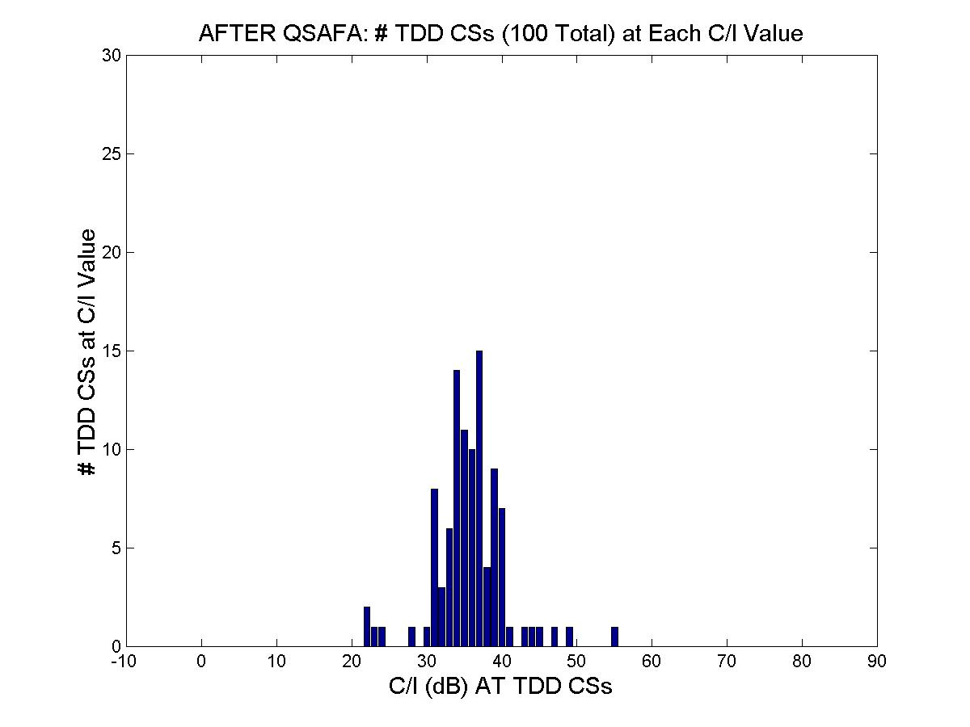
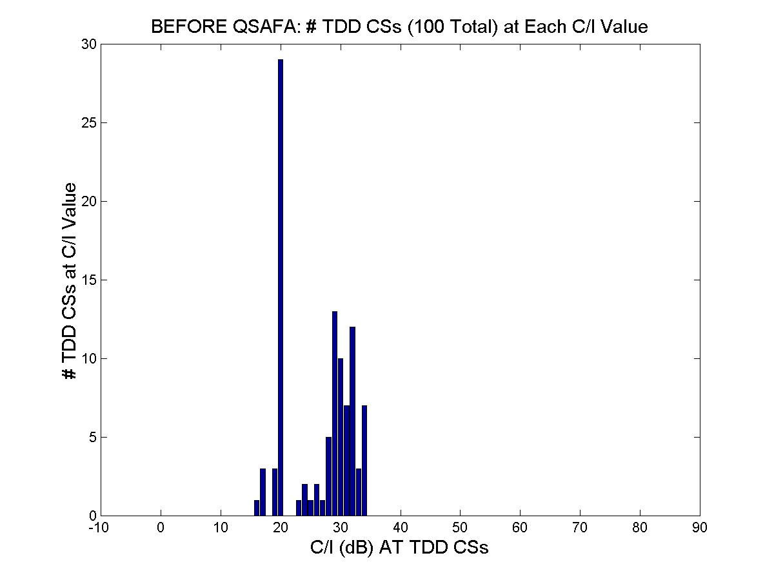
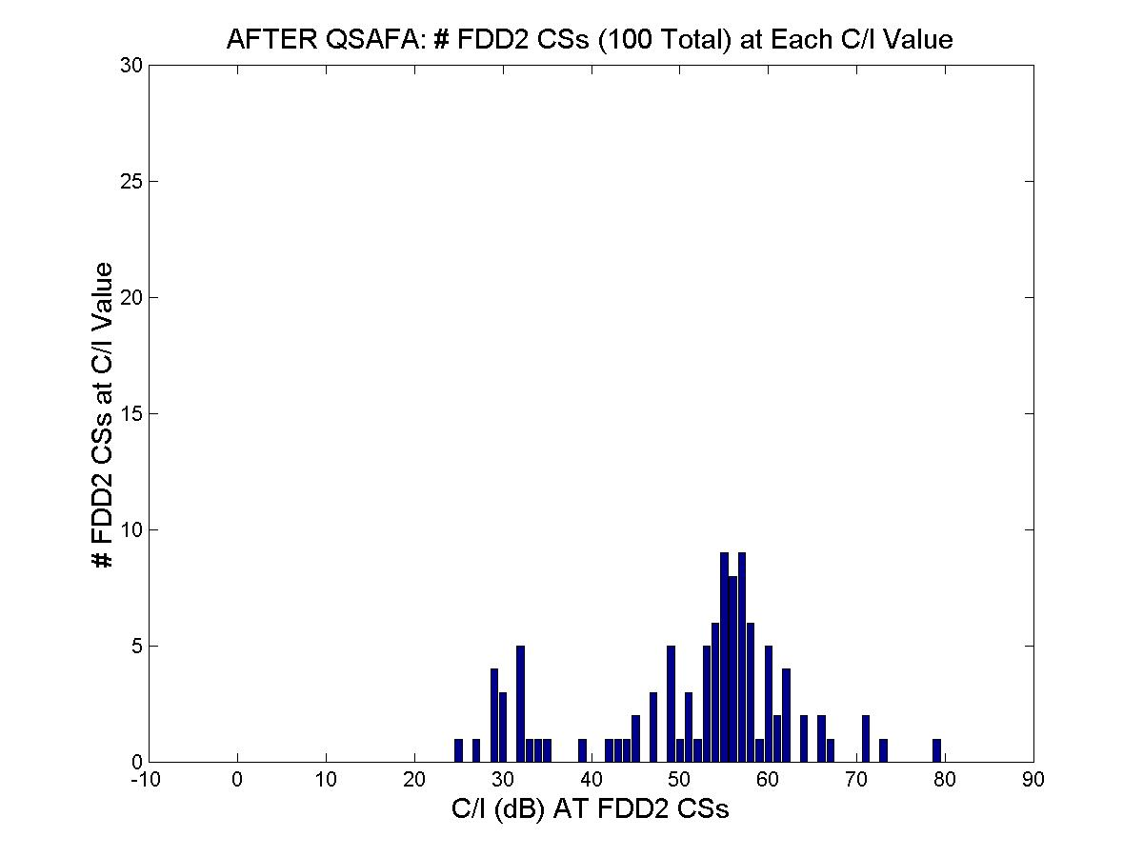
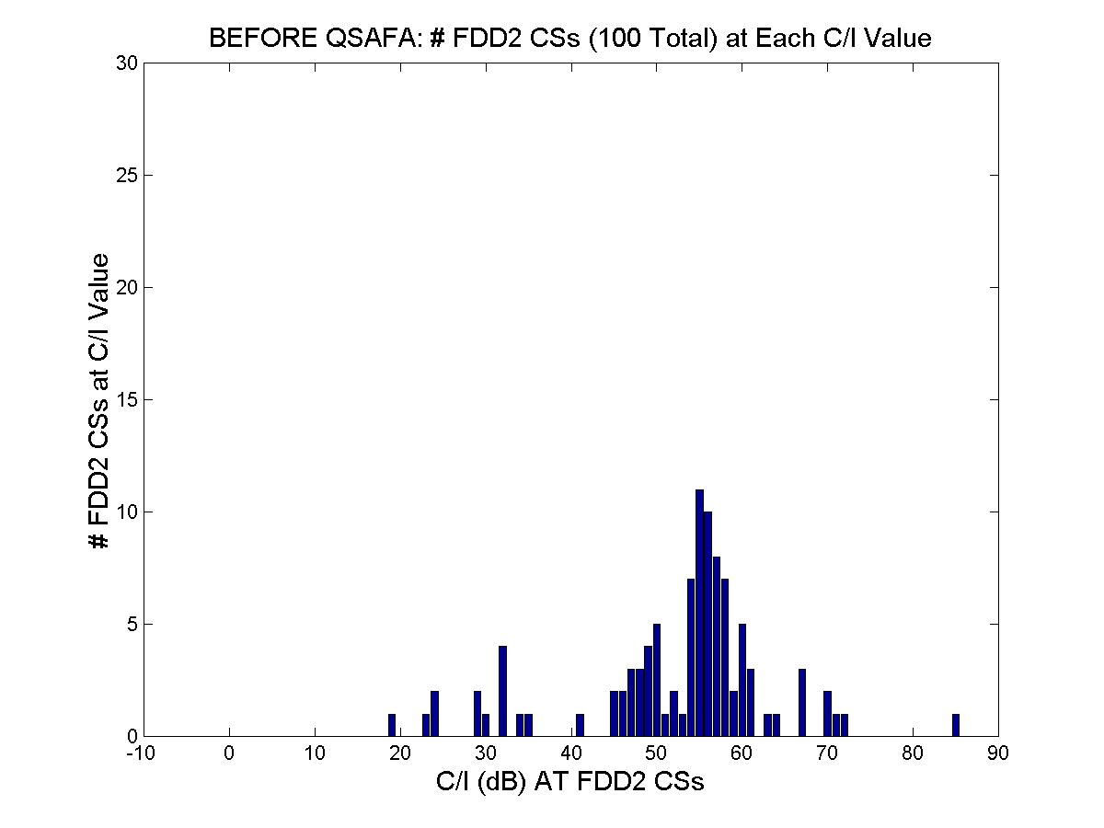
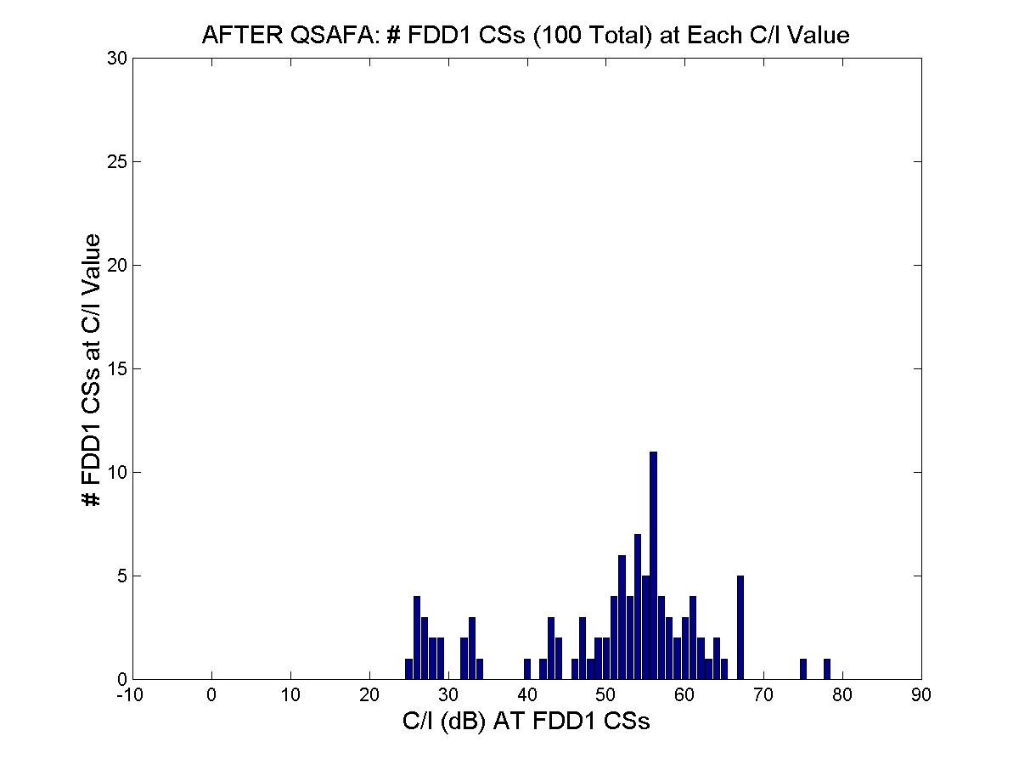
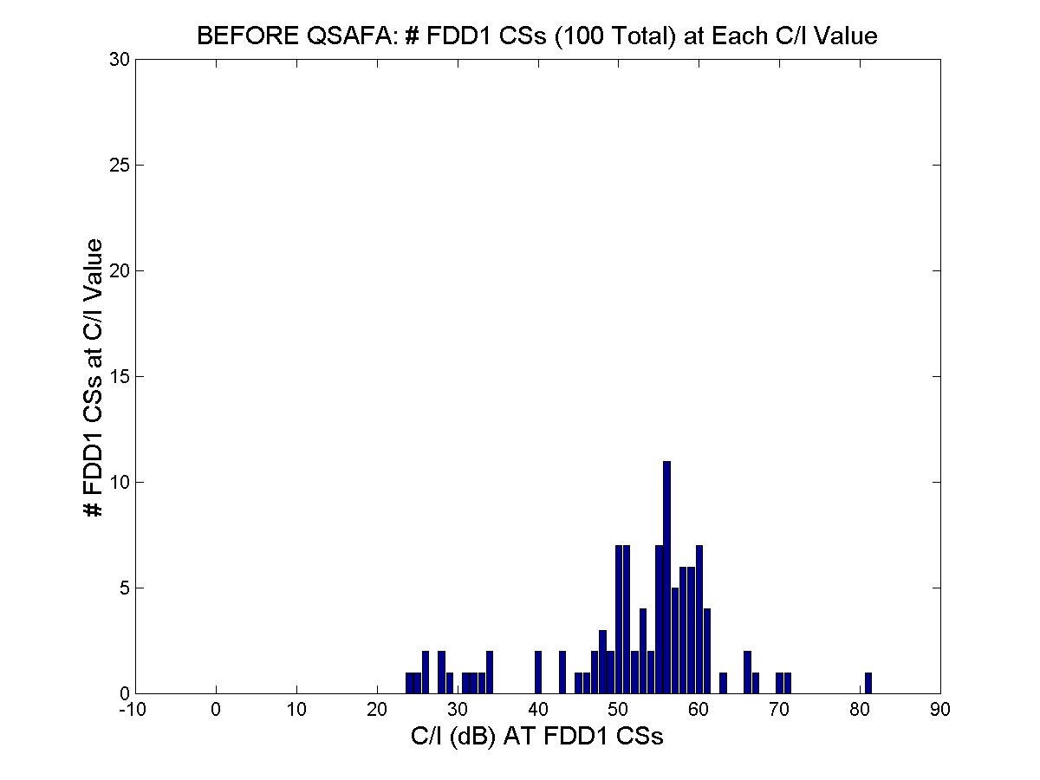
FDD#1 CS
FDD#2 CS
TDD CS
FDD#1 CS
FDD#2 CS
TDD CS

Conclusion on AFA
The various comprehensive simulation scenarios depicted both in [5] and [8] produced very difficult TDD/FDD intersystem interference environment (multi-cell grids for multiple operators, >3000 TDD links, 100’s CS Sectors, 100 m CS-CS spacings with no CS-CS blockage), but at the same time, injected some realism, e.g. random placement of TDD TS’s and inclusion of statistical occurrences of building blockage between a TDD CS in one sector and TDD TS’s in other sectors.

The results show that the TDD/FDD operator coexistence is possible without excessive use of expensive guard bands: simulations showed that QSAFA can improve intersystem interference significantly while simultaneously conserving valuable spectrum (reducing guard bands) by intelligently reacting to the actual interference environment.

Work on AFA to date confirms it is a promising mechanism to aid millimetre wave FWA coexistence and these results should invite to continue efforts on the implementation strategies for AFA.

Mesh Networks
Developments have now made feasible alternative FWA system architectures, in particular systems described as MP-MP, otherwise known as "Mesh" systems. MP-MP systems do not have base stations. Instead, all stations (often referred to as nodes) act as repeaters, with local access for traffic. Most (possibly all) nodes can be located on customer premises. The remainder (if any) are associated with connecting the mesh to convenient core network access points.

The key characteristic is that traffic is routed via one or more nodes to the required destination. Each node itself may also support a user and the requirement for connectivity and routing diversity is that any node needs only to have line of sight to a small number of neighbouring nodes. The MP-MP system differs from a P-P system in that it behaves as a complete network, rather than a series of individual links.

General architecture and system reference diagrams are given in TR 101 939 [6].

The systems considered in this report deploy narrow-beam antennas on installations sited at roof top height. Report TR 101 939 [6] also describes how these networks evolve from initial stages to more dense deployment.

A suitable choice of antenna radiation pattern and gain combined with relatively short link lengths allows the interference to be localized. Apart from the reduction in normal transmitter power, less margin (or less ATPC range) is required to overcome rain fading. Frequencies can then be re-used many times within a network. Since there are usually several choices for the structure of a mesh joining a given set of user stations, the actual link directions can be chosen to maximize re-use and improving spectrum efficiency.

Coexistence between Mesh Systems and PMP Systems including consideration of building effects.
The results of a detailed study [6] into co-existence between MP-MP systems and P-MP systems show that geographical and frequency spacing can often be lower than those between P-MP systems. Automated frequency assignment methods can be deployed, which significantly reduce co-ordination requirements between operators.

The analysis is based on reducing the interfering signal to -144 dBW/MHz at the victim station. This is a more severe (and arguably unnecessarily strict) requirement than that used in a number of other studies of the interference problem. The detailed interference scenarios and simulation methodology are also detailed in TR 101 939 [6] but some key mesh specific characteristics are repeated here (see also SE19(02)12):

MP-MP systems operate with short link paths, typically in the range 100m to 1km in length. Figure 7 shows the results of an analysis of model meshes providing the following distribution of link lengths:

Figure 7

The significance of this is that the MP-MP system operates with normalised received power levels, i.e. for each link the transmitter power is set to give just enough received signal level. A short link means a low transmit power. The same mechanism serves to reduce the levels of interference outside the mesh.

The current modelling for the 24-28 GHz band is based on an antenna with half power beam-width of 9° in both azimuth and elevation. Slightly different values are likely to be optimum but the simulation results have not been found to be critical to moderate changes to the RPE.

A simplified model of the antenna pattern has been used. Although a real antenna will perform better than this model, it turns out not to be necessary from a coexistence point of view or from an intra system interference point of view. For the 24- 28GHz band, the simplified model is based on a formula (exponential function) to represent the main beam and a side lobe pattern conforming to ETSI EN 301 215 part 2 (TS1 antenna).

Other parameters in the simulation tool were set as follows:
- Frequency = 28 GHz
- victim receiver = base station with 90 degree sector antenna and 19dBi gain
- mesh link lengths from 50m to 1000m (uniform probability distribution)
- mesh nodes placed 1m above roof height in all cases
- mesh antenna gain = 25dBi
- Rayleigh parameter (building/ground height distribution) varying from zero to 20m
- For adjacent frequency block scenarios a single guard channel is assumed.

Same Area / Adjacent Frequency
The results of the simulation with a single (28 MHz) guard channel between the mesh and P-MP cell are detailed in report TR101 939 and summarized for the P-MP BS victim scenario in Figure 8 below. The worst scenario of those computed is shown, with uniform wet weather conditions applied, although other weather conditions have negligible effect on the results. This corresponds to a 0,02 % (and therefore negligible) probability that the - 100 dBm interference threshold is exceeded.

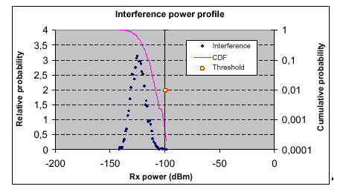
Figure 8
The full table of probabilities is shown in table 3:

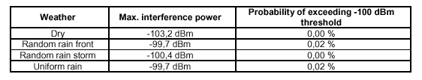
Table 3

For the P-MP TS case (also addressed in TR 101 939), if a single channel guard band is provided between the systems, then the maximum interference power still exceeds the threshold by around 15 dB, but the probability of interference has now reduced to a very low value of around 0.35 % (i.e. only 0.35 % of randomly chosen mesh layouts leads to a figure above the required noise threshold).

Flexible and Dynamic Frequency Assignment
The simple mitigation technique described here uses the possibility for flexible and dynamic frequency assignment (FDFA) to eliminate virtually all occurrences of interference from a mesh system into a PMP base station, without the need for specific coordination by operators. The process can be entirely automated and under the control of the mesh operator. It does not require a complex algorithm to be developed. A suitable routine could easily be defined, without the need for description in standards.

In general, a mesh system will have available a set of frequencies (channels), each of which can be used anywhere in the system. When operating in accordance with the CEPT T/R 13-02 channel plan, frequencies will be available in two widely spaced sub - blocks. From the point of view of the mesh, however, the channels in the paired sub - blocks need not be related and can be used independently. A particular link can use one frequency uplink and the same or a different frequency downlink.

The assignment of channels from the upper and lower sub - blocks is made on a link-by- link basis, as part of the mesh set-up process. This set-up process is dynamic and responds to changes in system configuration and traffic demands. In all but the simplest mesh configurations, it is necessary to automate this process in order to achieve the spectrum efficiency gains possible in mesh systems and to minimise interference.

This requires that the planning system collects data on the system layout, node positions and directions, as well as the required traffic data.

An algorithm (not standardized and not described here) is then used to compute a satisfactory mesh set-up scheme. This algorithm can be extended to deal with certain cases of external interference, especially where the victim or interfering stations are few in number and are at known locations. This would apply particularly to Base Stations of a PMP system. Thus, the statistically few cases (detailed above) of interference that occur when a mesh operates in the same area as a PMP system, with a single guard channel, can potentially be eliminated by an automatic process, instead of requiring the system operators to coordinate.

The proposed mitigation technique would operate as detailed in the Annex 4 dedicated to Meshed Networks (within Section 5.4.2 “Safety Zone“, while Section 5.4.1 addresses the Adjacent area / Co-frequency scenario).

ConclusionS of the REPORT

Introduction
This section seeks to address aspects of the regulation which can be combined with results from the technical arguments put forward in the Report, which might have impact on regulation (in the form of the ERC Recommendations) that:
- Maintains the inter-operator safeguards in a manner that addresses both FDD and TDD FWA systems.
- Provides a basis for assignment that reduces the guard band apportionment conflict.
- Facilitates either specifically identified guard channels or “included” guard channels without detracting from the capacity of the useable spectrum.
- Balances the requirements for coexistence with considerations for spectrally efficient assignment.

Adjacent Frequency Block / Same Area Coexistence

Guard Channels
Generally it has become accepted that guard frequency is needed between operators in adjacent blocks when working in the same or overlapping geographic area. In the majority of cases it is also accepted that one guard channel equal in width to the channelisation of the system in use provides an adequate level of inter-operator protection (accepting however that it does not remove all the potential cases of interference for any type of system whether using FDD or TDD techniques).

Therefore being well understood, it is proposed that identification of guard frequency remains the principal means of introducing at least the first level of isolation required between the operators from the point of view of the FWA Recommendations for the 26/28GHz bands.

However across the CEPT area there are differing views about whether guard channels represent an effective use of spectrum or not, resulting in a number of different assignment plans.

The identification of a single guard channel as currently recommended can cause some difficulties if it is not explicitly identified outside an operator’s assigned blocks. Where no specific guard channels are identified, assignments tend to start and end at “28MHz channel edges”. This means that if a 28MHz system is deployed in each adjacent block, then the operators have either to co-ordinate extremely closely to make limited use of their edge channels or they both avoid the edge 28MHz channels. In effect, two 28MHz guard channels could result.

Block Edge Mask
An alternative to guard channels is the identification of a regulatory Block Edge EIRP mask as seen in the 40GHz MWS band. However, the objectives for that band were different, assuming an expectation of accommodating a wider range of technologies for MWS and block assignments expected to be several hundred MHz wide. Although very attractive from the “technology neutrality” point of view, with the narrower blocks generally assigned in these 26-28GHz bands there may be an unacceptable assignment inefficiency when adopting the same approach.

“Block Edge Guard Channel”
However, perhaps a combination of both these techniques could provide a flexible solution to the identification of a guard channel that:
- Does not modify the conclusions drawn from Report 99.
- Helps with guard channel apportionment when there is a preference not to explicitly identify guard channels in an assignment plan.
- Continues to facilitate identification of specific guard channels if preferred.
- Effectively assignments could be constructed in a manner consistent with the existing channel plans but with a single “half channel width” guard band at each end of the block. In effect the assignment boundary would fall on a channel centre frequency. The diagram below based on the common practice that all 26/28GHz FWA assignments in Europe are based upon the 28MHz channel plan, illustrates a 4 channel assignment:

Of course to retain the inter-operator protection the “half channels” at the edge of the blocks must still be considered as guard frequency. This can be compared against assignments based on the existing recommendation which tend either to identify the “half channels” as an explicit guard channel outside the assigned blocks (this would still be possible) or identify no guard channels which can limit the number of full channels for deployment.

Conclusion S focused on new techniques and mechanisms
Looking for technology independence from the single guard band approach, more flexibility in the interpretation of the Rec, e.g. enlarging to usage of mitigation technologies (without impacting on the neighbouring assignment) could be recommended.

For 26 and 28 GHz bands, additional to the current approach, and the 32 GHz band : the following mitigation techniques or deployment technologies are considered to provide an acceptable level of protection to the neighbouring operators comparable with the current situation between FDD P-MP systems (a single guard channel):

i)- Autonomous Frequency Assignment(AFA) mechanism, particular valid for TDD systems, provided that the operator can guarantee a regular checking of updated status of operation

ii)-For networks deploying a mesh architecture, the network characteristics (rooftop/eaves station deployment, normalised Rx power, directional antennas, dynamic frequency assignment) and the consequential effects of terrain and buildings combine to statistically mitigate interference (caused or received) to the extent that the same coexistence guidelines used for FDD P-MP systems can be followed.

Further items which improve the situation:
- Block Edge Mask (BEM),
Alternatively to the mitigation measures described in Section 4.3, it is recognized in section 4.2.2. that the use of BEM can also be proposed as a regulatory measure to limit the level of interference to an acceptable level of protection to the neighbouring operators comparable with the current situation between FDD P-MP systems (a single guard channel) and allow to reduce the guard band for TDD systems.
The use of BEM could also be proposed for further improvement, allowing to not specify explicitly a guard band, but to incorporate the guard band into the blocks assigned to the operators for a flexible use of it.
With the use of BEM as a mitigation technique (operators’s self declaration), the guard band could also be reduced, however to what extent it remains neutral to the neighbouring operator (issue of Rx selectivity) needs to be addressed.

Note: A relation of the BEM, declaration of max EIRP, the impact on NFD constraints at the edge of the block and the relation to EN 301 390 unwanted emissions levels needs further investigation.

Lastly, as reminders, the following elements :
- Additional level of information on CS:
    - TX power / EIRP levels limitations
    - Greater flexibility for tackling the CS-CS coordination (see Annex 3, Section 5.3.2)
- Max EIRP level
- ATPC, as an add-on technique (but not sufficient in itself to enable the usage of guard band )
- Cooperation between operators, combined with mitigation techniques (already a considering of the existing Rec), l making sense in case of use of the single (remaining) guard band
also contribute to improve the co-existence of multipoint systems and have to be considered on an ad-hoc basis, where praticable.

Annexes

Annex 1: An example of separation distance guidelines
Based on the elements of this Report, a possible example for co-ordination guidelines between operators is given below:
Operator to Operator Guidance for Site Sharing Situations:
- Between FDD system assignments, operating in a harmonised sub-band plan and employing channelisation schemes up to 28MHz, one guard band equal to 28MHz is recommended, see [1], [3].
- Systems that are not operating in accordance with any harmonised sub-band plan should ensure adequate spatial separation between central stations when deploying P-MP systems. ECC/REC(01)03 recommends a minimum of 500m in conjunction with one guard band. In the circumstances where spatial separation is not possible (e.g. site sharing), additional co-ordination aspects may be required. These are further discussed in CEPT (REC(01)03 and Report 99) and these discuss additional spectral considerations.
- In an FDD/TDD scenario, if operators of FDD systems decide to plan networks by drawing spectrum from, for example, the centre of their allocation, guard band adequacy is accommodated. However, when spectral usage increases, consideration of additional co-ordination aspects (as discussed in (ECC/REC(01)03 and Report 99) should be considered. An increased level of spectrum use could also result in systems being planned where the siting of central stations is outside the spatial separation distance (for reasons of spectrum re-use) and therefore at this point extra spectral guard space may not be required. As always, operator co-operation to fairly apportion the any guard band requirement is a function of proficient network planning.
- For network architectures that do not employ central stations, guidance again suggests that a single channel guard band is adequate for acceptable performance.

It is recognized that further study of these issues is required for the consideration of mixed system type deployments.

Annex 2: Typical system cells coverage
This information is necessary for quantifying impairments due to possible interference from adjacent blocks. From Figure 9 the coverage of the typical ETSI system may be seen as meeting the out-of-block EIRP requirement.

Assumed parameters:
symmetric 28 MHz systems
Pout =+25 dBm (4QAM), +20 dBm (16QAM) ; Antennas gain= 18 dB (CS), 35 dB (TS)
N_{F}=7.5 dB; S/N=13dB(4QAM), 19dB(16QAM); Unavailability p%=0.005%
Figure 9: Example of cell coverage evaluation

Annex 3: Impact of radio characteristics
Regarding equipment characteristics the most important is the ability of a victim receiver to be unaffected by extraneous emissions as well as its ability to reject extraneous emissions in adjacent operating frequencies. This characteristic is quantified as Net Filter Discrimination (NFD). This is defined as the discrimination with respect to frequency offset between an interfering transmitter and victim receiver having considered the spectral spread of transmitted emissions and the selectivity of the receiver filtering. This can be estimated by performing a numerical integration procedure between the receiver bandwidth and the transmitter emission. ETSI Technical Report TR101-854 refers to this process for P-P system planning purposes that evaluate the same NFD characteristic.

NFD further analysis
As reminded in the introduction of this report, the CEPT/ERC Report 99 [1] mostly focused on 4 level modulation schemes, leaving systems with high order modulation schemes for further study. As nowadays, FDD and TDD systems with up to 16 and 64 level and adaptive modulation schemes are becoming available on the market, the following section re-examines the NFD requirements, based on a Monte Carlo simulation technique (see [9]).

Note: The considered interference scenarios refer to typical situations but do not take into account worst case conditions.

System and Equipment Parameters
Table 4 below summarizes the system and equipment parameters.

Parameter | 4-QAM | 16-QAM | 64-QAM
Frequency (GHz) | 26 | 26 | 26
TX Power (dBm) | 24 | 21 | 18
CS Antenna Gain (dBi) | 19 | 19 | 19
CS Antenna Type | ETSI CS2 | ETSI CS2 | ETSI CS2
TS Antenna Gain (dBi) | 34 | 34 | 34
TS Antenna Type | ETSI TS1 | ETSI TS1 | ETSI TS1
RX Noise Figure (dB) | 6 | 6 | 6
Channel BW (MHz) | 28 | 28 | 28
Excess BW (%) | 25 | 25 | 25
C/N @ BER=10⁻⁶ (dB) | 13 | 19 | 25
C/I for 1 dB threshold impairment (dB) | 19 | 25 | 31
Link Availability (%) | 99.995 | 99.995 | 99.995
ITU Rain Region | K | K | K
Fade Margin (dB) | 25 | 20 | 15
Rain Cell Radius (km) | 1.2 | 1.2 | 1.2
Max. Cell Radius (km) | 3.6 | 2.5 | 1.7
Table 4: System and Equipment Parameters

CS to TS Simulation Results
4-QAM
Figure 10 illustrates the rain faded results for 4-QAM when the CS sites are in close proximity. In this case almost all victim TS sites fall within the beam width of the interference CS. While both interference and victim links share comparable rain loss, the close proximity minimizes the angular RPE discrimination of the victim TS antenna. For 4-QAM, an NFD of 45 dB is adequate. This value is less than the NFD assumption of 54 dB for 1 guard band employed in [1].

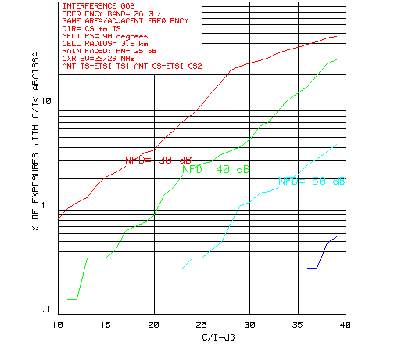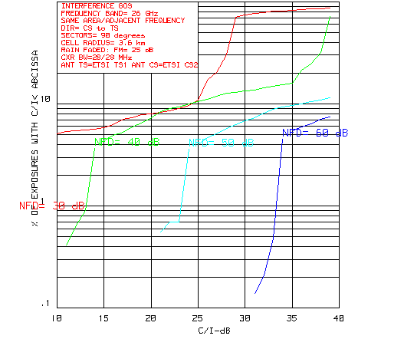
Figure 10: CDF Estimates for 4-QAM Figure 11: CDF Estimates for 4-QAM
(R=3.6km and S=0.1km) (R=3.6km and S= 0.5 km)

Figure 11 illustrates the CDF as separation distance S is increased to 0.5 km. The imbalance in relative rain loss now moves in favor of the interference CS. However, there are now an increased number of TS locations are at a distance less than S and do not experience significant interference. As well, for those victim TS sites still within the beam width of the interference CS, their RPE angular discrimination increases. Consequently, CDF improves and an NFD of 40 dB is adequate for 4-QAM.
As separation distance increases further, rain loss differential favors the interference link. But, there are fewer victim links impacted and RPE discrimination continues to increase. CDF results subsequently improve.

16-QAM

With 16-QAM modulation, cell radius R reduces from 3.6 km to 2.5 km. The rain cell of radius now occupies a significantly larger area of a victim sector. Thus, any imbalance between rain loss on the victim and interference links would be expected to reduce. As well, the rain loss limit to performance threshold is reduced from 25 dB to 20 dB. Countering this, is the increased threshold C/N requirement which has now moved from 13 dB to 19 dB and the 1 dB threshold impairment from 19 dB to 25 dB.
As separation distance S being small was previously noted to be the most severe, this is the only case we report on. Figure 12 illustrates the CDF results for S = 0.1 km. Referenced to the adjusted impairment limits, it would appear that an NFD of 45 dB is again adequate.
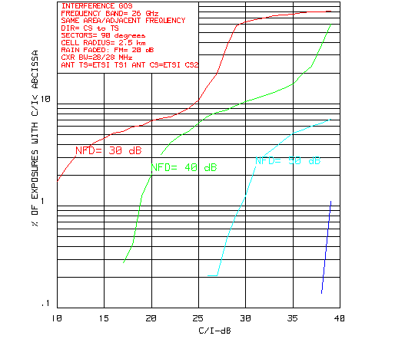
Figure 12: CDF Estimates for 16-QAM (R=2.5 km and S=0.1 km)

64-QAM

With 64-QAM modulation index, cell radius R is reduced to 1.7 km. As the rain cell radius is R_{c} = 1.2 km, the rain cell essentially covers the entire victim sector. Consequently, we would expect any rain loss differentials between victim and interference links to be substantially reduced. All other criteria previously specified would be expected to remain the same. In spite of the increased threshold requirements, NFD requirements are reduced, now being of the order of 40 dB as illustrated on Fig.13.
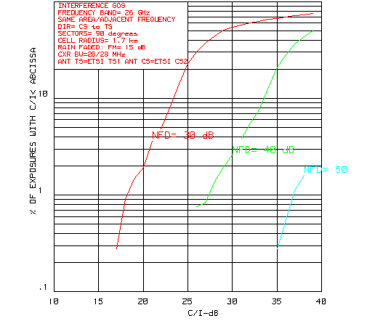
Figure 13: CDF Estimates for 64-QAM (R=1.7 km and S=0.1 km)

The preceding has assumed that the modulation index of both interference and victim sectors is the same. Based solely on 4-QAM, the Report 99 did the same. However, we should also consider multi-mode transmission. This could be both favourable and disfavourable.

In the worst case, 4-QAM on the interference link and 64-QAM on the victim link, the different TX power levels would introduce a worst case 6 dB increase in the NFD requirements. However, this has to be played off against who is transmitting what at the same time. Actual NFD requirements would likely be less, but this simulation scenario has not been examined.

CS to CS Simulation Results
4-QAM
Figure 14 illustrates the rain faded CDF for S = 0.1 km. An NFD of 50 dB is not adequate with 1 guard band, but an NFD of 55 dB would probably suffice.
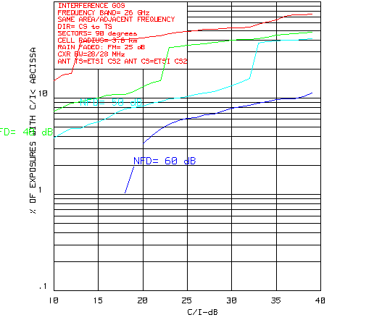
Figure 14: Rain Faded CDF Estimates for 4-QAM (R=3.6 km, S=0.1 km and FM=25 dB)

Figures 15 through 17 illustrate the CDF results when the separation distance is increased. For Figure 7 (S=0.2 km), an NFD of 50 dB is marginal but likely acceptable. There are no exposures that exceed the 4-QAM performance threshold of 13 dB, but 5% of the exposures exceed the 1 dB threshold impairment level of 19 dB.

With S = 0.3 km (Figure 8), and an NFD of 50 dB the likelihood of a 1 dB threshold impairment is bordering on zero. For S = 0.5 km (Figure 9), it is apparent that the NFD requirements are less than one would expect from 1 guard band. The current restriction for S > 0.5 km is thus too restrictive.

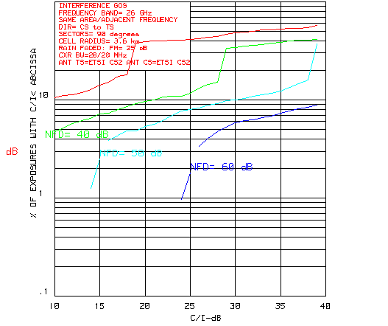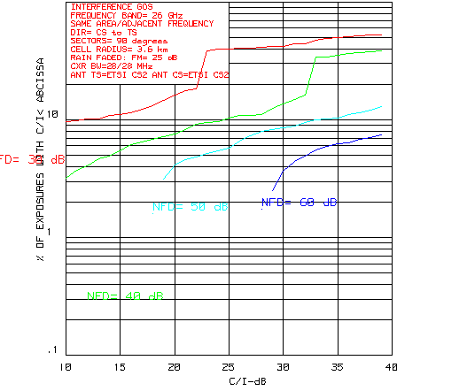
Figure 15:. Rain Faded CDF Estimates for 4-QAM Figure 16: Rain Faded CDF Estimates for 4-QAM
(R=3.6 km, S=0.2 km and FM=25 dB) (R=3.6 km, S=0.3 km and FM=25 dB)

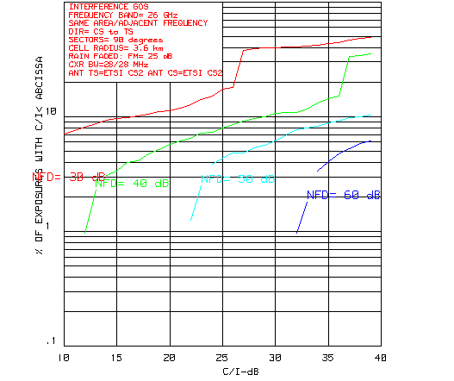
Figure 17: Rain Faded CDF Estimates for 4-QAM
(R=3.6 km, S=0.5 km and FM=25 dB)

16-QAM

Figure 18 illustrates the CDF results for S = 0.1 km. An NFD of 50 dB is quite marginal as we have a 3% threshold failure probability at C/I = 19 dB. We either need to improve NFD to 55 dB or set S to 0.2 km. Figure 19 illustrates this latter scenario.

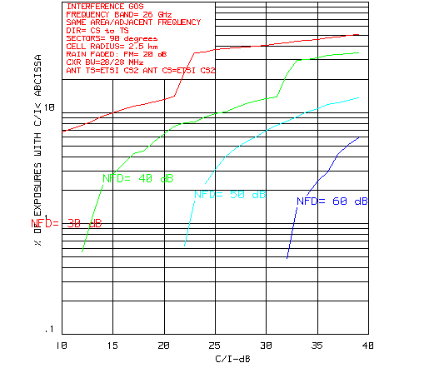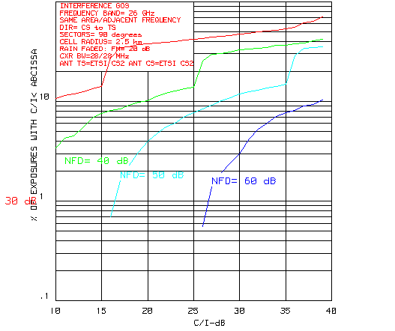
Figure 18: Rain Faded CDF Estimates for 16-QAM Figure 19: Rain Faded CDF Estimates for 16-QAM
(R=2.5 km, S=0.1 km and FM=20 dB) (R=2.5 km, S=0.2 km and FM=20 dB)

64-QAM
Figure 20 illustrates the rain faded results for 64-QAM at S = 0.1 km. Here, an NFD of 50 dB would probably be sufficient. At the threshold failure C/I of 25 dB, the CDF probability is a small fraction of 1 %.

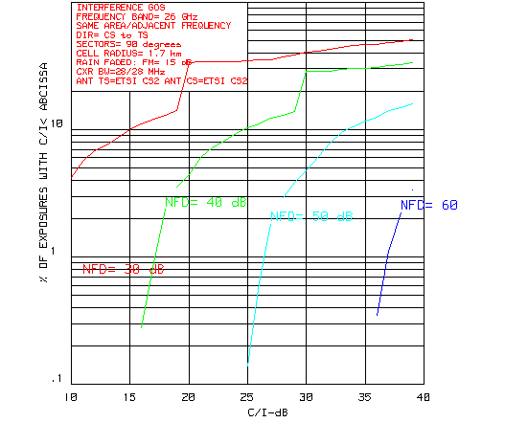
Figure 20: Rain Faded CDF Estimates for 64-QAM
(R=1.7 km, S=0.1 km and FM=15 dB)

Summary and Conclusion
An overall rule of thumb is that an NFD of 55 dB is probably adequate to cover all the cases.

A single guard band would probably still be required as CS to TS NFD requirements are about 45 dB.

The current restriction for separation distance S > 0.5 km is too restrictive.

Effect on Minimum Distances
Based on the evaluation procedure detailed in section 3.3.1 of ERC Report 99 but utilising an I/N interference criteria as Recommended in [4], the minimum safe distance between hubs operating in adjacent frequency blocks can be evaluated.

Table 5 below illustrates a number of results from the evaluation of minimum separation distance. It shows how with one guard channel between licensed blocks, the CS-CS distance (D(min)) reduces against a range of improving second adjacent channel NFD values. The equivalent “Interfered Area” based on D(min) around a CS site is shown as a percentage of a typical overall deployment area and the “Total Isolation” column confirms the constant coexistence requirement.
Table 5: Hub-hub separation distances

The range of NFD values chosen encompasses figures used in the simulation referred to in Annex A and figures derived from other sources. The constant isolation figure is equivalent to the difference between the transmitting hub EIRP and the receiver threshold equivalent in front of the receiving antenna (161dB shown above is of course specific to the assumptions used in Annex A).

One key point is that to satisfy the “worst case” CS-CS scenario considered here, extra isolation is required between the systems in addition to that provided by a single guard channel. As NFD improves, it can account for a larger proportion of this isolation, hence requiring less additional separation distance and reducing the coexistence deployment constraints.

The total isolation is the important constant parameter regarding co-existence as opposed to the means to achieve it. As the table shows frequency separation and separation distance as well as other mitigation factors that can introduce more “dB’s” between the systems are all variables that can be used to achieve the required isolation.

Therefore the performance characteristics considered here can improve the coexistence environment for TDD systems (and FDD systems) and support a regulatory framework that encompasses the various FWA technologies which is based upon the actual coexistence requirement (isolation) rather than the means to achieve it (increased frequency separation).

Annex 4: Meshed Networks

Adjacent Area / co-frequency scenario
The results shown in report ETSI TR 101 939 [6] indicate that mesh systems do not generate high levels of external interference. The analysis, based on a large number of simulations of relatively high- density random mesh configurations, show that system spacings can generally be less than those required for P-MP systems. The analysis is valid for TDD and FDD systems.

If the Rayleigh parameter (R) is varied so the effect of differing building height distributions can be investigated. The Rayleigh parameter characterises the building height distribution curve, so that a value of zero would mean that there are no buildings, whilst a value of 20m would be a reasonable figure for a small to medium sized city. An example taken from real data, for the large city of Leeds in the UK (pop. circa 1million), indicates a best –fit value of R=40.

The result based on 10,000 trials, in which each trial represented a separate random mesh with 100 nodes per sq km. A cumulative distribution curve (Figure 21) was produced for each run, showing the probability that the total interference received at the victim station was less than a particular value (x axis of the graph). The threshold = -100dBm (equivalent to –144dBW/MHz in a 28MHz channel).
Figure 21: CDF of probability of interference

Safety Zone
A “safety zone” of radius x around a known base station (which could be FDD or TDD) is defined as having an interference potential higher than some limit. This could be set at the point where an interfering mesh station with worst pointing direction produces a value of interference of –114.5dBW/MHz in the victim receiver. A mesh node inside the “safety zone” does not necessarily cause high interference but by considering every such occurrence and assigning an appropriate frequency, any potential interference can be reduced or eliminated. Assuming a single guard channel, this gives a “safety zone” radius of x = 60-200m (see appendix 1 for calculation of x), see Figure 22 below.
Figure 22: Safety zone concept

Blocking zone
Very close to the victim base station and, dependent on the receiver design and front end filtering arrangements, any terminal (FDD or TDD) can potentially cause blocking of the receiver due to front - end overload. This “blocking zone” is generally very small, but within it an interferer can make the base station completely unworkable. A mesh system can mitigate virtually all occurrences of this kind by choosing a pointing direction away from the victim base station. A PMP system does not have this flexibility and operator coordination is then required.

Multiple Interferers
In theory, multiple interferers could increase the size of the required “safety zone”. However, the probability of multiple interferers over such a small area is extremely low and can be ignored for practical purposes. For mesh stations placed outside the “safety zone” and, provided the single guard band is applied between operators, there will be no cases where interference exceeds the required interference threshold.

Mesh node inside “safety zone”.

There are two possible cases:
- where one end of the mesh link is inside the “safety zone”
- where both end of the mesh link are within the “safety zone” .

In the first case, and assuming an FDD Base Station, the mesh station is assigned a transmit frequency from the same sub – block as that of the PMP system uplink direction. The corresponding far end of the mesh link is assigned a transmit frequency that is either from the downlink sub – block, or any other available frequency meeting the guard band requirement.

In the second case, each mesh “half - link” requires a specific calculation to determine a suitable operating channel, which may be chosen from either the upper or lower sub - block. More than one guard channel will sometimes be required but the number of cases when this happens will be so small that there is negligible impact on spectrum efficiency (see 4.5 for an estimate of the numbers of links affected).

Numbers of links within the “safety zone”.
The numbers of mesh links, for which either or both ends of the link are potentially within the “safety zone” is small. For example, for a zone of 60m radius, a mesh with 100 nodes/ sq km would on average have 1 node within the “safety zone”.

For a 200m radius there are on average 12 nodes within the “safety zone”.

If link lengths are within the range 100m to 1000m and all link lengths occur with equal probability , the average number of links where both ends are within the coordination zone is zero in the first case and about 2 links in the second case.

Thus, without any additional coordination, the number of mesh links that might (but do not necessarily) cause higher levels of interference is already very low. With additional coordination (which can be fully automated) virtually all of these cases can be eliminated.

The only remaining cases of potential interference are due to blocking. These occur potentially for all types of system (PMP or mesh, FDD or TDD). They have very low probability and, with a mesh, would only occur when stations of different operators are effectively co-sited and have the worst pointing directions.

The use of the described mitigation technique has no significant impact on spectrum efficiency.

Annex 5: Discussion on Impact of Antenna Patterns

FWA TS Directional Antennas for the Frequency range 26 to 28 GHz
Antenna patterns are an essential factor for the determination of necessary guard distances between the radio stations of various PMP- or/and Mesh networks and with it for a spectrum efficient use. For networks with high density of radio stations it is important to calculate with nearly realistic antenna patterns. On the one hand the distance between stations of various radio networks shall give a sufficient protection to interference, on the other hand the guard distance shall not be larger than necessary to guarantee spectrum efficiency and a dense deployment of radio stations. It is therefore proposed to find well usable guidelines which describe realistically the antenna properties.

In this Annex a comparison is given between the current ETSI and ITU guidelines, a theoretical description by Bessel function⁾ and antenna envelope patterns of real antennas. This Annex does not provide any judgement of the quality of antennas. It should be noted that the listed real antennas are products of various manufacturers.

At present there are following guidelines for fixed service antennas in the 26/28-GHz-range:
- ETSI TR 101 939 V1.1.1 (2002-01)
- ETSI EN 301 215-2 V1.3.1 (2002-01), Part 2, § 4.1
- ITU-R F.699-4
- ITU-R F.1245-1.

Exemplary the envelope patterns of following real antennas were taken:
- Elliptical Cassegrain Antenna with the mayor diameter of 0.14 m and the minor diameter of 0.10 m
- Lens Antenna with a diameter of 0.15 m for 26 GHz
- Parabolic Antenna with a diameter of 0.3 m for 26 GHz
- Parabolic Antenna with a diameter of 0.6 m for 26 GHz
- Parabolic Antenna with a diameter of 1.2 m for 26 GHz
- Antenna with a diameter of 0.26 m for 28 GHz
- Parabolic Antenna with a diameter of 0.3 m for 28 GHz
- Parabolic Antenna with a diameter of 0.6 m for 28 GHz.

Envelope patterns of the exemplary real antennas show considerable deviations from the corresponding ETSI and ITU antenna patterns. Also there are (large) differences between the antenna patterns of the above mentioned ETSI and ITU guidelines.

The current ETSI antenna standards are aligned to a boresight antenna gain of only 28 dBi for the frequency range of 24 to 30 GHz. The boresight antenna gain of the most antennas in this frequency range is higher than 28 dBi. The given ETSI antenna masks describe a very high (unwanted) antenna gain at the side lobes.
The antenna pattern of ITU-R F.1245-1 corresponds well with a mathematical description by the Bessel function envelope, but this seems to be idealized and optimistic. So the real antenna envelope patterns can be wider than the ITU-R F.1245-1 pattern for an azimuth <5 degree. Between an azimuth of 8 to 30 degree and an azimuth of 40 to 70 degree real envelope antenna patterns have a very low roll off. This phenomenon originates from the theoretical description of a circular aperture antenna and is not considered in the ITU-R F.699-4 and F.1245-1 recommendations.
The real antenna patterns corresponds hardly with ITU-R F.699-4.

Examples of Antennas
Figures 23 and 24 show the envelope elevation pattern and the envelope azimuth pattern of an Elliptical Cassegrain Antenna with a mayor diameter of 0.14 m and a minor diameter of 0.10 m.

According to the current ETSI masks there is only correspondence between the real antenna envelope elevation pattern and ETSI TR 101 939 up to an angle of 20 degree and between the real antenna azimuth pattern and ETSI EN 301 215 up to an angle of 10 degree. From these angles the given ETSI patterns are pessimistic, the given ETSI side lobe gains are very high.
The real antenna envelope patterns nearly correspond with ITU-R F.699-4 and F.1245-1 up to an angle of 10 degree. From the angle of 10 degree the real antenna patterns are between the ITU-R F.699-4 curve and the ITU-R F.1245-1 curve.

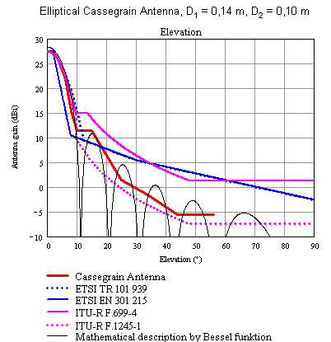
Figure 23: Envelope elevation pattern for Cassegrain antenna
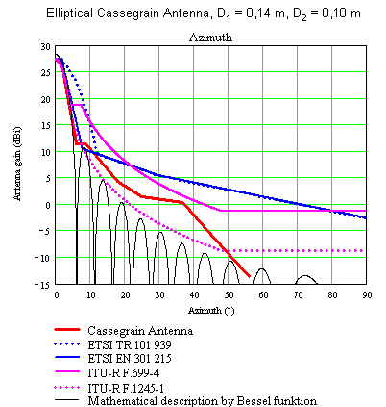

Figure 24: Envelope azimuth pattern for Cassegrain antenna

Figure 2 shows the envelope pattern of a Lens antenna with a diameter of 0.15 m for 26 GHz.
The real antenna envelope pattern nearly corresponds to ITU-R F.1245-1.
There is correspondence to ETSI EN 301 215 only up to an angle of 8 degree.
Between the azimuths of 20 and 40 degree the real antenna pattern is flat and fall off again from the azimuth of 40 degree.

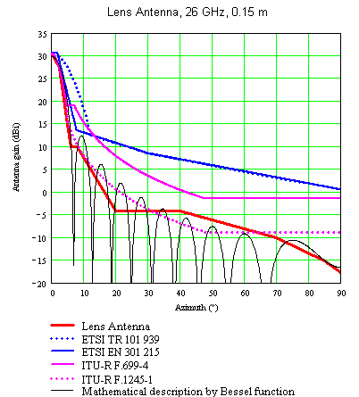
Figure 25: Envelope pattern for a lens antenna

Figure 26 to Figure 28 show envelope patterns of parabolic antennas with the diameters of 0.3 m, 0.6 m and 1.2 m for
26 GHz.

The real antenna envelope patterns correspond partly to ITU-R F.1245-1 up to an azimuth of 12 to 20 degree. It is notable that the real envelope patterns are wider than the envelope patterns according to ITU-R F.699-4 and F.1245-1 up to an azimuth of 5 degree.

From an azimuth of 12 to 20 degree up to an azimuth of 50 to 55 degree the real antenna patterns are flat and fall off again from the azimuth of 50 to 55 degree.

No correspondence is to any current ETSI mask.
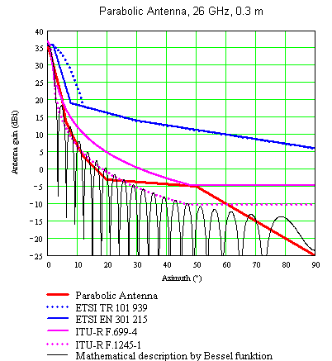

Figure 26

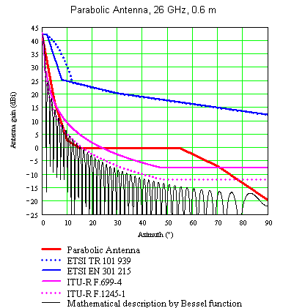
Figure 27

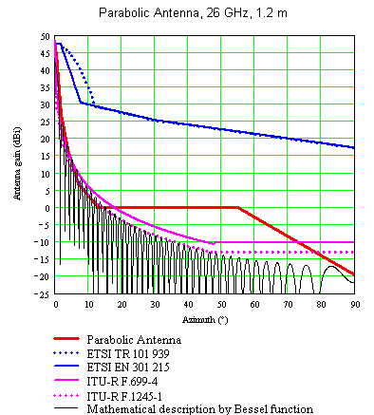
Figure 28

Figure 29 shows the envelope pattern of an antenna with a diameter of 0.26 m for 28 GHz.
The real antenna envelope pattern is between the ITU-R F.699-4 curve and the ITU-R F.1245-1 curve. Between the azimuth of 10 and 75 degree the real antenna envelope pattern has a slight roll off.
There is correspondence to ETSI EN 301 215 only up to an angle of 8 degree.
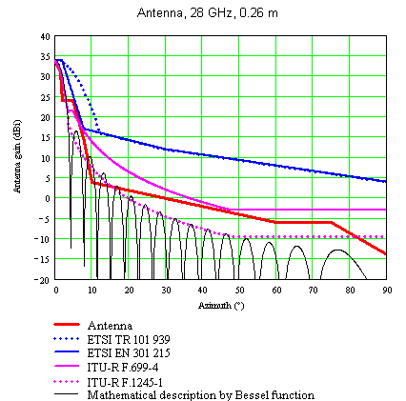
Figure 29
Figure 30 shows the envelope pattern of an parabolic antenna with a diameter of 0.3 for 28 GHz.
The real antenna envelope pattern nearly corresponds with ITU-R F.699-4. Between the azimuth of 20 and 50 degree the real antenna envelope pattern has a slight roll off.
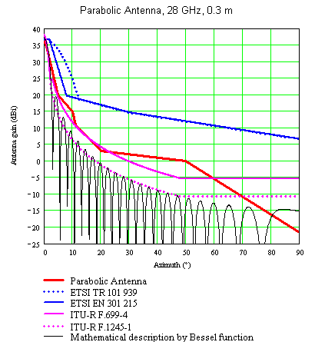
No correspondence is to any current ETSI mask.

Figure 30
Figure 31 shows the antenna envelope pattern of a parabolic antenna with a diameter of 0.6 for 28 GHz.
The real antenna envelope pattern is wider than the envelope pattern according to ITU-R F.699-4 up to an azimuth of 7 degree. From an azimuth of 7 degree up to an azimuth of 23 degree the real antenna pattern is between the ITU-R F.699-4 curve and the ITU-R F.1245-1 curve.
Between the azimuths of 18 and 57 degree the real antenna envelope pattern is flat and fall off again from the azimuth of 57 degree.
No correspondence is to any current ETSI mask.
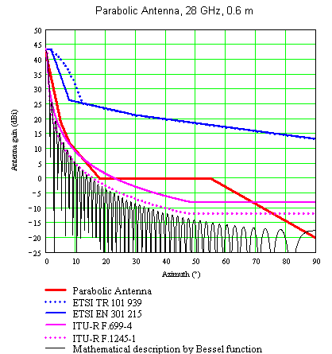
Figure 31

Summary
The antenna mask of the current ETSI Standards ETSI TR 101 939 V1.1.1 (2002-01) and ETSI EN 301 215-2 V1.3.1 (2002-01), Part 2, § 4.1 seems to be aligned to antennas with a boresight antenna gain of ≤28 dBi. Also for antennas with low boresight gain the mask above the side lobes is very high in relation to the real antenna envelope pattern.

ITU-R F.1245-1 is suitable well for antennas with very good side lobe attenuations and with a nearly ideal antenna pattern, but this recommendation is critical for usual antennas. The “step” in the real antenna envelope curves is not considered in this recommendation.

Correspondence between the exemplary real antenna envelope patterns and ITU-R F.699-4 could not be realized.

References
[1] ERC Report 99; THE ANALYSIS OF THE COEXISTENCE OF TWO FWA CELLS IN THE 24.5 - 26.5 GHZ AND 27.5 - 29.5 GHZ BANDS

[2] ERC/REC(00)05; USE OF THE BAND 24.5 - 26.5 GHz FOR FIXED WIRELESS ACCESS (edition of 20 October 2000)

[3] ERC/REC(01)03; USE OF PARTS OF THE BAND 27.5-29.5 GHz FOR FIXED WIRELESS ACCESS (FWA) (edition of 11 June 2001)

[4] ECC/REC/(01)04 RECOMMENDED GUIDELINES FOR THE ACCOMMODATION AND ASSIGNMENT OF MULTIMEDIA WIRELESS SYSTEMS (MWS) IN THE FREQUENCY BAND 40.5 – 43.5 GHz

[5] ETSI Technical Report TR 102 073-1 (2002-08) “Fixed Radio Systems; Deployment considerations for TDD Fixed Wireless Access (FWA) systems; Autonomous Frequency Assignment (AFA);Part 1: Proof of concept simulation”

[6] ETSI Technical Report TR 101 939: “Requirements for broadband multipoint-to-multipoint radio systems operating in the 24,25 GHz to 29,5 GHz band and in the available bands within the 31,0 GHz to 33,4 GHz frequency range.”

[7] Doc. SE19int3(00)10: "Co-existence Simulations for P-MP and MP-MP Networks".

[8] Doc SE19(02)34:”TDD/FDD millimetre wave MP coexistence improvement with Autonomous Frequency Assignment (AFA) mechanism” , May 2002

[9] Doc SE19(02)95: “Coexistence NFD Requirements @26GHz with high order modulation schemes”, September 2002

See introduction to [2]: “It should be noted that the measures in this Recommendation which are aimed to ensure coexistence, namely the size of the necessary guard band and the guard distance between neighbouring assignments were derived from studies ERC Report 99, considering only systems using 4 level modulation schemes and channel sizes up to 28 MHz which are considered so far to be the most common.”. See Annex 3 for the impact of higher order modulation schemes.
“The applicability limits of the current version of the report are as follows: - TDMA and FDMA access methods as described in the ETSI EN 301 213-1,-2,-3 standard - 3.5, 7, 14 and 28 MHz channel sizes with 4 level modulation schemes 56 and 112 MHz systems with any modulation schemes are not analysed because of lack of suitable parametric data. Systems with high order modulation schemes are for further study. It is worth noting that 3.5, 7 and 14 MHz systems with any modulation schemes are expected to be compatible with the current conclusions if the interfering system has channels narrower than 28 MHz. It is intended to update the report in order to cover CDMA, Multi-Carrier TDMA and other technologies.”
See Rec 4 in [2] and 3 in [3]: “that in the case of systems operating in adjacent frequency blocks in the same area, adequate inter-assignment protection should be ensured through the introduction of guard bands between neighbouring block assignments; such guard band may be explicit outside the blocks allocated to the operators or included within such blocks;”
this trend is already present in Note 3 of [3]: “This situation could be improved for the introduction of FWA TDD systems through the application of mitigation techniques. At least one, semi-autonomous or autonomous cell planning, is under study”.
Could be extended to 32 GHz band, when appropriate
“that the size of the guard bands to ensure adequate inter-assignment protection of FDD systems should be at least equal to 28 MHz (NOTE 1, NOTE 2); the guard band may consist of one unused slot of frequency, or of slots used only with one polarisation, adjacent to slots used on the opposite polarisation (see the figures in annex 1); that, for deployment of TDD systems alongside TDD or FDD systems, the guard band should be 2x28 MHz (NOTE 1, NOTE 2);”
Noting k) of [2] : « that through appropriate regulations and co-operation between neighbouring operators the size of the guard bands could be reduced;”
A cell radius of R = 3.6 km was implicit to the analysis in [1], a radius that 16/64 QAM are not likely to support for high levels of link availability.
I/N = -6dB.
These references include contributions to the ETSI BRAN project (BRAN24.5d008, BRAN26d053), ETSI Draft Technical Report W1 DTR/TM04136.
As described in ERC Report 99.
Extensive modelling of mesh systems, using terrain and building data from real cities shows that the link length distribution is close to uniform.
The pattern of circular aperture antennas can be described approximately by Bessel function.

