Compatibility and sharing studies related to NGSO satellite systems operating in the FSS bands 10.7-12.75 GHz (space-to-Earth) and 14-14.5 GHz (Earth-to-space)
approved 26 January 2018
ECC Report 271

Executive summary
This Report contains compatibility and sharing studies between the operations of non-Geostationary Satellite Orbit (NGSO) Fixed Satellite Service (FSS) systems in both space-to-Earth and Earth-to-space directions and the incumbent services. The Report also looks at the protection of aircraft from Earth stations deployed near airports.
The studies cover the compatibility of the operations in the FSS downlink allocation in the band
10.7-12.75 GHz with the radio astronomy service (RAS) and the EESS (earth exploration satellite service) (passive), and the compatibility of the earth stations using the FSS uplink allocation in the band 14-14.5 GHz with the fixed service (FS) and the RAS. Two kinds of earth stations were considered in these studies, namely the fixed stations, and earth stations in motion (ESIM). The ESIM include mobile stations on land, ships and aircraft.
With regard to the FSS downlink allocation in the band 10.7-12.75 GHz, the studies have only addressed one NGSO FSS system (ONEWEB) for which specific characteristics have been made available at the time this Report was written. The studies have been conducted to determine unwanted emissions e.i.r.p. levels that have to be met in each beam of any satellite of this NGSO FSS constellation in order to meet the 2% data loss limit at radio astronomy stations performing observations in the band 10.6-10.7 GHz. These unwanted emission e.i.r.p. levels can be met by the NGSO FSS constellation through a careful design of the satellite payload using appropriate modulation shaping, Intermediate Frequency (IF) and Radio Frequency (RF) filtering, constraints on the SSPA design. However, these techniques would not be sufficient for the ONEWEB frequency channel immediately adjacent to the passive band (10.7-10.95 GHz) and this channel would therefore have to be deactivated when in visibility of a RAS station performing observations in this band. In general, any NGSO FSS satellite emissions shall not exceed an epfd value of -241 dBW/m² in the band 10.6-10.7 GHz for more than 2% of the time. It should be noted that, if another NGSO FSS constellation is to be considered, specific assessment should be made taking into account the unwanted emissions e.i.r.p. limits of such constellation and also the overall data loss values due to the additional system. The unwanted emission e.i.r.p. limits determined for this NGSO FSS system (ONEWEB) also ensure protection of EESS (passive) sensors operating in the band 10.6-10.7 GHz.
The studies related to NGSO FSS earth stations operating in the band 14-14.5 GHz at fixed locations concluded the following:
- The results of a survey conducted by CEPT show that so far only five administrations out of the 25 respondents have deployments of fixed service in the 14.25-14.5 GHz band. Compatibility with fixed service stations in the band 14.25-14.5 GHz used in a few CEPT countries will be achieved through the establishment of relevant areas around the fixed service station. In these areas, the FSS earth stations would have to avoid transmitting on frequency channels overlapping with the channel used by the FS station. The actual size of the area has to be determined on a case by case basis, taking into account the FS and FSS ES characteristics as well as the surrounding terrain. The typical size of these areas has been determined to be in the order of 58 to 77 km in a 37 dBi FS main beam direction assuming smooth Earth and FSS terminals with an e.i.r.p. towards the horizon of -20 dBW/(40 kHz), but decreases rapidly down to 11 km outside the pointing direction of the FS station, under the same assumptions;
- There are a limited number of RAS stations within the CEPT that perform observations in the secondary RAS allocation in the frequency band 14.47-14.5 GHz. The protection of these RAS stations can be achieved through areas around such stations where any NGSO FSS earth station will have to cease transmissions on channels overlapping with the band 14.47-14.5 GHz. The size of the areas has to be determined on a case-by-case basis taking into account the FSS and terrain characteristics. For FSS terminals with an e.i.r.p. towards the horizon of -20 dBW/(40 kHz) the size of the area can be up to 340 km (single entry analysis), thus not limiting it to a national issue for some of these RAS stations.
The compatibility studies related to land NGSO FSS ESIM operating in the band 14-14.5 GHz concluded the following:
- The compatibility with fixed service stations in the band 14.25-14.5 GHz used in few CEPT countries can be achieved through relevant protection zones. Once the earth station enters into a protection zone, it should cease transmitting on frequency channels overlapping with the channel used by the FS station. This cessation of transmission should be automatically performed by the network control unit of the NGSO FSS satellite system and this action will be assisted by the GPS receiver incorporated in the earth station. The actual size of the exclusion area has to be determined on a case by case basis, taking into account the FS and NGSO FSS ES characteristics, as well as the surrounding terrain. The typical size of these protection zones for the FSS terminals with an e.i.r.p. of -33 dBW/(40 kHz) towards the horizon has been determined to be in the order of 33 km in the 37 dBi FS antenna main beam direction (assuming smooth Earth), but decreases rapidly down to 2 km outside the pointing direction of the FS station;
- The protection of the RAS stations performing observations in the band 14.47-14.5 GHz can be achieved through areas around such stations where any NGSO FSS earth station will have to cease transmissions on channels overlapping with the band 14.47-14.5 GHz. The size of the areas has to be determined on a case-by-case basis taking into account the FSS and terrain characteristics. For FSS terminals with an e.i.r.p. towards the horizon of -33 dBW/(40 kHz) the size of the area can be up to 200 km (single-entry analysis). The GPS capability of the Earth station and the network control unit of the NGSO satellite system mentioned above should be able to automatically perform the cessation of transmissions.
The compatibility studies related to airborne NGSO FSS ESIM operating in the band 14-14.5 GHz concluded the following:
- Assuming that the airborne ESIM operate under the primary FSS allocation, the protection of fixed service stations in the band 14.25-14.5 GHz used in some CEPT countries can be achieved through a pfd mask. The proposed mask is the following:
–122 dB(W/(m² · MHz)) for θ ≤ 5°;
–127 + θ dB(W/(m² · MHz)) for 5° < θ ≤40°;
–87 dB(W/(m² · MHz)) for 40° < θ ≤90°.
where θ is the angle of arrival of the radio-frequency wave (degrees above the horizontal);
- The protection of the RAS stations observing in the secondary RAS allocation in the band
14.47-14.5 GHz can be achieved through a pfd mask. The proposed mask is the following:
–185 + 0.5 · θ dB(W/(m2 · 150 kHz)) for θ ≤ 10°;
–180 dB(W/(m2 · 150 kHz)) for 10° < θ ≤ 90°.
where θ is the angle of arrival of the radio-frequency wave (degrees above the horizontal);
Compliance with this mask can only be achieved by avoiding transmissions within the 14.47-14.5 GHz band when the aircraft enters in visibility of RAS stations performing observations in this band.
The compatibility studies related to shipborne NGSO FSS ESIM operating in the band 14-14.5 GHz show the following:
- There would be no need for any separation distance from the shore to protect FS stations close to the coast assuming FSS terminals with a total e.i.r.p. of -13 dBW towards the horizon. In order to cover all kinds of NGSO FSS systems, a pfd limit at the shore could be defined, similarly to the one developed for ESOMPs in the Ka-band. The proposed level is -116 dBW/m²/MHz at 80 m above sea level with an associated percentage of time of 0.06% or 4.5%, depending on the retained short-term protection criterion. This would apply to shipborne earth stations located in national waters of CEPT countries;
- The protection of RAS stations observing in the secondary RAS allocation in the band 14.47-14.5 GHz and located close to the sea would require protection zones up to 200 km for NGSO FSS terminals with e.i.r.p. of -33 dBW/(40 kHz) towards the horizon. The NGSO FSS operator would have to cease transmissions in the band 14.47-14.5 GHz when the ship enters within these protection zones, the size of which has to be determined on a case-by-case basis taking into account FSS characteristics as well as surrounding terrain. This would apply to shipborne earth stations located in national waters of CEPT countries.
The NGSO FSS satellite system will be able to maintain compatibility with fixed links and RAS stations deployed within an administration by establishing the protection zones (as stipulated above) for all fixed link receiving stations or RAS observatories and suppressing use of those frequencies, utilised with the fixed service, by fixed earth stations or land and shipborne ESIM. If an administration has deployed fixed links in the band 14.25-14.5 GHz and the specific locations of these fixed links cannot be established, then the protection zones could be established as the whole territory of the administration. The protection zone may include territories of neighbouring administrations. The satellite system, by suppressing the use by fixed earth stations of frequencies 14.25-14.5 GHz (or specific frequencies deployed by the fixed service or RAS) within the identified protection zone(s), will provide necessary compatibility with the fixed service and RAS. The FSS satellite system will be able to deploy the "control of emission" function stipulated in the ETSI standard EN 303 980 ‎[1] to ensure the suppression of relevant frequencies by fixed earth stations within the protection zone.
According to the findings in ECC Report 272, NGSO earth stations with e.i.r.p. levels lower than 54.5 dBW would not be subject to restrictions on operations in the proximity of aircraft.

TABLE OF CONTENTS

0 Executive summary 2
1 Introduction 9
2 NGSO FSS systems in the 14-14.5 GHz band 10
3 Allocations within the 14-14.5 GHz band 11
3.1 allocations Given in EFIS 11
3.2 Deployment of other services by CEPT administrations 11
3.2.1 Fixed service (FS) 12
3.2.2 Space research service (SRS) 12
3.2.3 Radio astronomy service 12
3.2.4 Radionavigation service 13
3.2.5 Summary of deployments in the 14-14.5 GHz band within CEPT 13
4 Characteristics of NGSO FSS systems 14
4.1 ONEWEB Satellite and payload characteristics in the 10.7-12.75 GHz band 14
4.2 NGSO earth stations in the 14-14.5 GHz band 17
4.2.1 Deployment of NGSO earth stations 17
4.2.2 General characteristics common to both types of earth stations 18
4.2.3 Control of the emissions from earth stations 19
4.2.4 Earth stations at fixed locations 19
4.2.5 Earth stations in motion (ESIM) 21
5 Characteristics and protection criteria of other services 24
5.1 Fixed service in the 14.25-14.5 GHz band 24
5.1.1 Long-term criterion 25
5.1.2 Short-term criterion 25
5.2 Radio astronomy 27
5.2.1 Characteristics for the band 10.6-10.7 GHz 27
5.2.2 Protection criteria for the band 10.6-10.7 GHz 29
5.2.3 Characteristics and protection criteria for the band 14.47-14.5 GHz 29
5.3 EESS (PASSIVE) 29
5.3.1 Characteristics 29
5.3.2 Meteor-3M satellite system description 30
5.3.3 Protection criteria 31
6 Compatibility between NGSO FSS (space-to-earth) in the band 10.7-12.75 GHz and RAS in the band 10.6-10.7 Ghz 32
6.1 Methodology 32
6.2 Results 32
6.3 Conclusions and discussions 34
7 Compatibility between NGSO FSS (space-to-earth) in the band 10.7-12.75 GHz and EESS (passive) in the band 10.6-10.7 Ghz 36
7.1 STUDY 1: Assessment of Impact on passive sensors, provided in Recommendation ITU-R RS.1861 36
7.1.1 Methodology 36
7.1.2 Results 36
7.2 STUDY 2 (Assessment of Impact on METEOR-M passive sensor) 37
7.2.1 Interference scenarios 37
7.2.2 Initial data and assumptions of the study 37
7.3 Simulation results 38
7.4 Conclusion 38
8 Sharing between NGSO FSS ES at fixed location and incumbent services in the band 14-14.5 GHz 40
8.1 Sharing with Fixed Service in the band 14.25-14.5 GHz 40
8.1.1 Methodology 40
8.1.2 Results 40
8.1.3 Conclusions 42
8.2 Sharing with the Radio Astronomy Service in the 14.47-14.5 GHz band 42
8.2.1 Methodology 43
8.2.2 Results 43
8.2.3 Conclusions 51
9 Sharing between NGSO FSS ESIM and incumbent services in the band 14-14.5 GHz 53
9.1 Sharing with FS in the band 14.25-14.5 GHz 53
9.1.1 Land FSS ESIM 53
9.1.1.1 Methodology 53
9.1.1.2 Results 53
9.1.2 Sharing with airborne FSS ESIM 55
9.1.2.1 Methodology 55
9.1.2.2 Short-term protection criterion 57
9.1.2.3 Results of simulation 57
9.1.3 Conclusions 60
9.1.4 Sharing with shipborne FSS ESIM 61
9.1.4.1 Methodology 61
9.1.4.2 Results 61
9.1.4.3 Conclusions 61
9.2 Sharing with RAS in the 14.47-14.5 GHZ BAND 62
9.2.1 Sharing with land FSS ESIM 62
9.2.1.1 Methodology 62
9.2.1.2 Results 62
9.2.1.3 Conclusions 70
9.2.2 Compatibility with airborne FSS ESIM 71
9.2.2.1 Methodology 71
9.2.2.2 Results 72
9.2.2.3 Conclusions 76
9.2.3 Compatibility with shipborne FSS ESIM 76
9.2.3.1 Methodology 76
9.2.3.2 Results 77
9.2.3.3 Conclusion 77
10 Protection of aircraft from ES deployed in vicinity of aircraft 78
11 Conclusions 79
ANNEX 1: LIST OF REFERENCES 82

LIST OF ABBREVIATIONS

Abbreviation | Explanation
ABW | Allocated Bandwidth
AES | Aircraft Earth Station
AMSS | Aeronautical Mobile Satellite Service
API | Advance Publication Information
ATPC | Adaptive Transmission Power Control
BER | Bit Error Rate
CEPT | European Conference of Postal and Telecommunications Administrations
CRAF | Committee on Radio Astronomy Frequencies
dB | Decibel
dBi | Decibel relative to an Isotropic antenna
dBW | Decibel relative to 1 W
DP | Degradation of Performance
ECC | Electronic Communications Committee
EESS | Earth Exploration-Satellite Service
EFIS | ECO Frequency Information System
e.i.r.p. | equivalent isotropically radiated power
epfd | equivalent power flux density
EMC | Electromagnetic Compatibility
EPO | Error Performance Objective
ES | Errored Second
ESA | European Space Agency
ESIM | Earth Stations in Motion
ESOMPs | Earth Stations On Mobile Platforms
ESV | Earth Stations on Vessels
ETSI | European Telecommunications Standards Institute
FDMA | Frequency Division Multiple Access
FDP | Fractional Degradation of Performance
FM | Frequency Modulation
FS | Fixed Service
FSS | Fixed Satellite Service
GLONASS | Global Navigation Satellite System
GPS | Global Positioning System
HEO | High Earth Orbit
IF | Intermediate Frequency
IMT | International Mobile Telecommunications
I/N | Interference to Noise
ITU-R | International Telecommunication Union – Radiocommunication Sector
LEO | Low Earth Orbit
LTAN | Local Time of Ascending Node
MEO | Medium Earth Orbit
NCF | Network Control Facility
NEST | NGSO Earth Station
NGSO | Non-Geostationary Satellite Orbit
OBW | Occupied Bandwidth
pfd | power flux density
RAS | Radio Astronomy Service
RF | Radio Frequency
RR | ITU Radio Regulations
SES | Severely Errored Second
SRS | Space Research Service
SSPA | Solid State Power Amplifier
VSAT | Very Small Aperture Terminal
WRC | World Radiocommunication Conference
WST | Water Surface Temperature

Introduction
The frequency bands 14-14.5 GHz (Earth-to-space) and 10.7-12.75 GHz (space-to-Earth) allocated to the fixed satellite service (FSS) are available for deployment with Non-Geostationary Satellite Orbit (NGSO) satellite systems. The consideration in this Report is primarily focused on the earth stations in the 14-14.5 GHz (Earth-to-space) band deployed as user terminals. This Report provides study results on compatibility between these user terminals of NGSO satellite systems operating in the 14-14.5 GHz band and systems of other services with allocations in the same band and with deployments in Europe. These other services are the fixed service and the radio astronomy service (RAS). The space research, radio navigation and radio navigation-satellite services also have allocations within the band but there are no deployments within Europe, therefore were not subject to these compatibility studies. In addition, the Report also provides study results of adjacent band interference resulting from NGSO satellites operating in the band 10.7-12.75 GHz into the radio astronomy service (RAS) and Earth exploration satellite service (EESS) in the band 10.6-10.7 GHz.
The Report also provides the conditions for the protection of aircraft from earth stations deployed near airports.
The assessment of compatibility between NGSO earth stations or a NGSO satellite system and systems of other incumbent services (i.e. fixed service and RAS) requires a detailed knowledge of relevant technical characteristics of systems considered. There were no ITU Recommendations that provided the technical characteristics of NGSO satellite systems required for compatibility assessments. Such characteristics could not be established on a generic basis due to disparate system characteristics of NGSO satellite systems. At the time of preparation of this Report, detailed technical characteristics of only one NGSO system, identified as ONEWEB, were available. Therefore, the compatibility assessments in this Report were carried out for the ONEWEB system; nevertheless, where possible, the results from those assessments are offered on a generic basis.
When other NGSO satellite systems are considered for establishing sharing conditions in the frequency bands dealt with in this Report, particular attention should be given to the relevant sections of this Report that have drawn conclusions based on the specific system characteristics of the ONEWEB NGSO satellite system. Whenever possible, the studies on the NGSO FSS earth stations operating in the band 14-14.5 GHz have been identified as being also applicable to other NGSO systems.

NGSO FSS systems in the 14-14.5 GHz band
There are several proposed NGSO satellite systems identifying the 14-14.5 GHz band for earth stations for Earth-to-space links. The corresponding space-to-Earth links would operate in the 10.7-12.75 GHz band.
At the time of the preparation of the Report the technical characteristics of ONEWEB were the only information available for this study. ONEWEB plans to deploy a constellation of 720 Low Earth Orbit (“LEO”) satellites in 18 orbital planes in near-polar circular orbits at an altitude of 1200 km. This NGSO satellite system will consist of ground control facilities, gateway earth stations and user terminals. This system aims to provide high-quality broadband Internet access to small low-cost earth stations located anywhere on the Earth.
The earth stations will be developed for fixed and nomadic or transportable applications, the latter falling within the category of earth stations in motion (ESIM). Such ESIM terminals are expected to be deployed on vehicles on land, on vessels and on aircraft.

Allocations within the 14-14.5 GHz band
EFIS offers information regarding harmonised spectrum allocations in Europe. These allocations will provide the basis for the consideration of compatibility between earth stations and systems of other services.

allocations Given in EFIS
The existing services are identified in the EFIS as:
Table 1: Allocations given in the EFIS for the band 14-14.5 GHz
Frequency band | Allocations
14-14.25 GHz (5.504) | Space Research  Mobile-Satellite (Earth-to-space) (5.504B) (5.504C) (5.506A)  FIXED-SATELLITE (EARTH-TO-SPACE) (5.457A) (5.457B) (5.484A) (5.506) (5.506B)
14.25-14.3 GHz (5.504) | FIXED-SATELLITE (EARTH-TO-SPACE) (5.457A) (5.457B) (5.484A) (5.506) (5.506B)  Space Research  Mobile-Satellite (Earth-to-space) (5.504B) (5.506A) (5.508A)
14.3-14.4 GHz | Mobile-Satellite (Earth-to-space) (5.504B) (5.506A) (5.509A)  FIXED-SATELLITE (EARTH-TO-SPACE) (5.457A) (5.457B) (5.484A) (5.506) (5.506B)
14.4-14.47 GHz (5.504A) | FIXED-SATELLITE (EARTH-TO-SPACE) (5.457A) (5.484A) (5.506) (5.457B) (5.506B)  Mobile-Satellite (Earth-to-space) (5.504B) (5.506A) (5.509A)
14.47-14.5 GHz (5.149) (5.504A) | FIXED-SATELLITE (EARTH-TO-SPACE) (5.457A) (5.484A) (5.506) (5.457B) (5.506B)  Mobile-Satellite (Earth-to-space) (5.504B) (5.506A) (5.509A)  Radio Astronomy
In addition, the deployment of fixed links within the band 14.25-14.5 GHz by a number of administrations is also identified in EFIS. The administrations with fixed links deployed in this band are identified in Section 3.2.1 of this Report.

Deployment of other services by CEPT administrations
The services deployed, other than satellite services, within the band 14-14.5 GHz are described below.

Fixed service (FS)
The band 14.3-14.5 GHz is allocated on a primary basis to the FS in the ITU Radio Regulations ‎[2]. RR No 5.508 makes an additional allocation to the FS in the band 14.25-14.3 GHz to few countries, and they include the CEPT countries: France, Germany, Italy, and the former Yugoslav Republic of Macedonia and the United Kingdom.
A recent survey conducted by the CEPT ‎[3] indicates that out of the 25 CEPT administrations who responded to the questionnaire only four administrations deploy fixed links in the band 14.25-14.5 GHz. These administrations are:
- United Kingdom 164 FS links;
- France 141 FS links;
- Germany < 50 FS links;
- Russia 30 FS links, existing links are planned to be taken out of service;
- Italy 1089 FS links.
In addition, Romania identified the heavy use of 15 GHz band with channel arrangement that starts with 14.4 GHz. Romania also mentioned the expected continued use by fixed links. However, information on the number of links was not provided to CEPT.
All other respondents stated that they had no use of FS in the band 14.25-14.5 GHz.

Space research service (SRS)
The allocation to SRS is on a secondary basis in the band 14-14.5 GHz.
No usage of this allocation has been identified in CEPT countries. In particular, ESA does not use this band for space research, and the Russian Federation uses the band above 14.5 GHz for Data Relay Satellites.
Recommendation ITU-R SA.1414 ‎[5] (Characteristics of data relay satellite) indicates that the band is only used by the USA (NASA) for return links from the GSO data relay satellite down to Earth, and limited to the band 14-14.05 GHz. This being said, even if such a SRS earth station were to be deployed in Europe, it would operate under a secondary status and therefore cannot claim protection from FSS at fixed locations.
If an SRS earth station is to be based in a CEPT country and offered protection from FSS earth stations, it could be done by establishing the protection distance based on the technical characteristics of the systems concerned.

Radio astronomy service
Radio astronomy observations in the 14.47-14.5 GHz band are carried out in several countries within the CEPT. The CRAF webpage lists the radio astronomy stations operating within this band at the time this Report is being written. These are located in Germany (Effelsberg), Italy (Medicina), Sweden (Onsala), Russian Federation, Portugal and the United Kingdom (Cambridge and Jodrell Bank).
The 14.47-14.5 GHz band is mainly used for spectral line observations. At 14.4885 GHz, an important formaldehyde (H2CO) spectral line exists, which has been observed in the direction of many galactic sources. Observation of this spectral line gives valuable information on the physical conditions of the interstellar medium, because the excitation energies required to produce the line are different from the energies required to produce the H2CO line observed at the lower frequency of 4829.66 MHz.

Radionavigation service
The radionavigation service is allocated on a primary basis in the band 14-14.3 GHz. There is no ITU-R Recommendation or other documentation providing technical characteristics for such systems.
There is also secondary allocation to the radionavigation-satellite service in the band 14.3-14.4 GHz, but it appears not to be used. An API has been published for the Global Navigation Satellite System (GLONASS system) in this band, however this band does not appear in the notification issued for the GLONASS system.

Summary of deployments in the 14-14.5 GHz band within CEPT
The deployments in the 14-14.5 GHz within the CEPT could be summarised as:
- 14.0-14.25 GHz: fixed satellite service;
- 14.25-14.5 GHz: fixed satellite service and fixed service;
- 14.47-14.5 GHz: radio astronomy service.

Characteristics of NGSO FSS systems
The frequency bands allocated to the fixed satellite service (FSS) considered in this Report, namely 14-14.5 GHz (Earth-to-space) and 10.7-12.75 GHz (space-to-Earth), are available for the deployment of NGSO satellite systems. The NGSO satellite systems to be deployed using these bands invariably be proprietary systems with their own unique system characteristics. For instance, these NGSO satellite systems are unlikely to have in common those technical parameters needed for compatibility assessments. These technical parameters include (but not limited to these):
- type of orbit, LEO, MEO, HEO etc.;
- orbit altitude;
- orbit inclination (to the equatorial plane);
- number of planes;
- number of satellites per plane;
- satellite e.i.r.p. and antenna pattern;
- earth station e.i.r.p. and antenna pattern;
- minimum elevation of the earth station.
Since the compatibility assessments are linked to these technical characteristics, which are not common amongst NGSO systems, it is not possible to offer a "generic" case to describe compatibility between NGSO satellite systems and other services. For this reason technical compatibility assessments offered in this Report (see Sections ‎6 to ‎9) are carried out for the ONEWEB NGSO satellite system, whose technical characteristics were made available for this study. In some cases the results on such assessments are highly dependent on the NGSO characteristics and therefore are not be directly transposable to other NGSO systems. In some other cases, the results are applicable to other NGSO systems. For each of the cases studied, details are provided in the relevant sections to identify the applicability of the results.
The sections below refer to technical characteristics of ONEWEB satellite system and its earth stations unless stated otherwise.

ONEWEB Satellite and payload characteristics in the 10.7-12.75 GHz band
The satellite payload characteristics are established in order to facilitate the assessment of adjacent band interference resulting from NGSO satellites operating in the band 10.7-12.75 GHz into the radio astronomy and EESS (passive) services allocated in the band 10.6-10.7 GHz.
The following studies have been performed for the ONEWEB constellation, whose satellites are planned to be deployed in polar orbits as depicted in Figure 1.

Table 2 lists the basic characteristics of this NGSO satellite system.
Table 2: Orbital characteristics of the ONEWEB NGSO system
Parameter | Value
Number of satellites | 720
Orbits | Polar orbits
Number of planes | 18
Number of satellites per plane | 40
Altitude (km) | 1200
Inclination (°) | 87.9
Note: Additional satellites will be launched as spare satellites but will not be active.
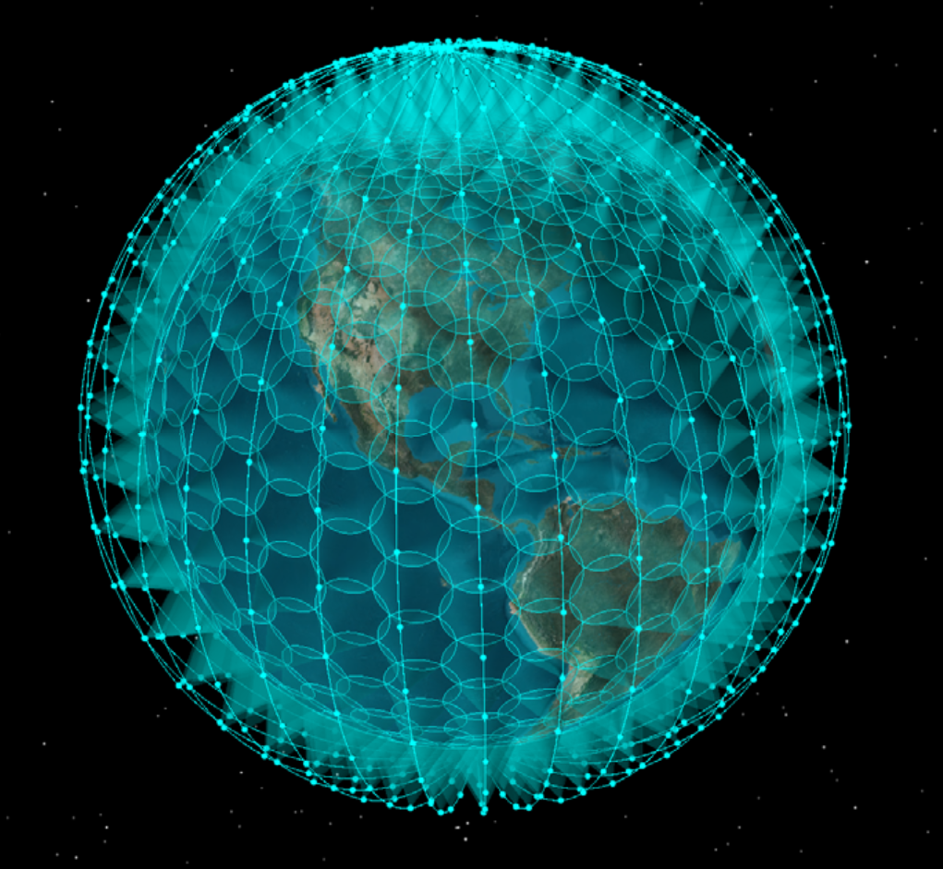
Figure 1: Configuration of the ONEWEB NGSO satellite constellation
The number of satellites visible from a point of the earth varies in time and with the latitude of the observing point considered. As an example, for the latitude of Effelsberg (50°N), the number of satellites above 0° elevation varies between 58 and 77. At the equator, this number is between 35 and 43.
The satellite antenna in Ku-band consists of 16 beams. Figure 2 provides the -3 dB aperture of each of the beams both along and across the satellite path.
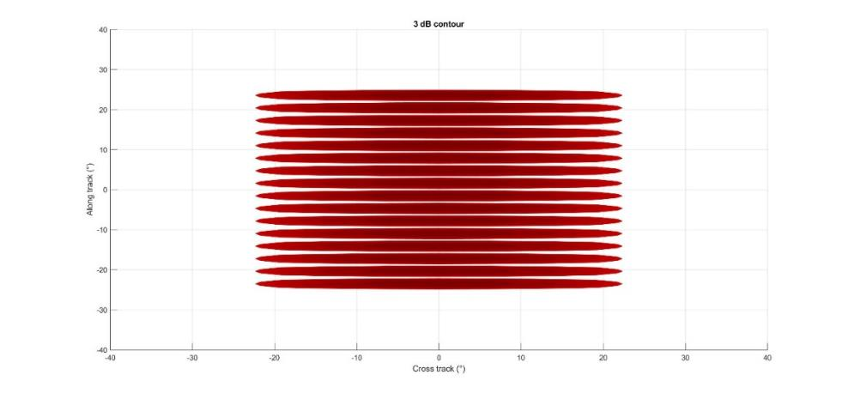
Figure 2: - 3 dB composite antenna aperture
The orientation of these beams from the satellite nadir is provided in Table 3.
Table 3: Orientation of each beam from Nadir
Beam | Orientation from Nadir (°)
1 | -23.5
2 | -20.4
3 | -17.3
4 | -14.1
5 | -11.0
6 | -7.8
7 | -4.7
8 | -1.6
9 | 1.6
10 | 4.7
11 | 7.8
12 | 11.0
13 | 14.1
14 | 17.3
15 | 20.4
16 | 23.5

The antenna pattern for each of these beams is provided in Table 4. It is a 3D pattern defined in two orthogonal directions, one along the satellite track (along track), and one perpendicular to the satellite track (cross-track). The offset angles corresponding to 10 different antenna gain roll off values are provided for both directions. The corresponding 3D antenna pattern is shown in Figure 3.
Table 4: Antenna pattern for all beams

Roll off (dB) | 0 | -0.2 | -1 | -4 | -6 | -8 | -10 | -15 | -20 | -20
Offset along track (°) | 0 | 0.5 | 1 | 1.2 | 1.6 | 1.95 | 2.3 | 2.9 | 3.3 | 180
Offset cross track (°) | 0 | 6 | 14 | 19 | 27.8 | 35.9 | 44.2 | 52.7 | 73.7 | 180
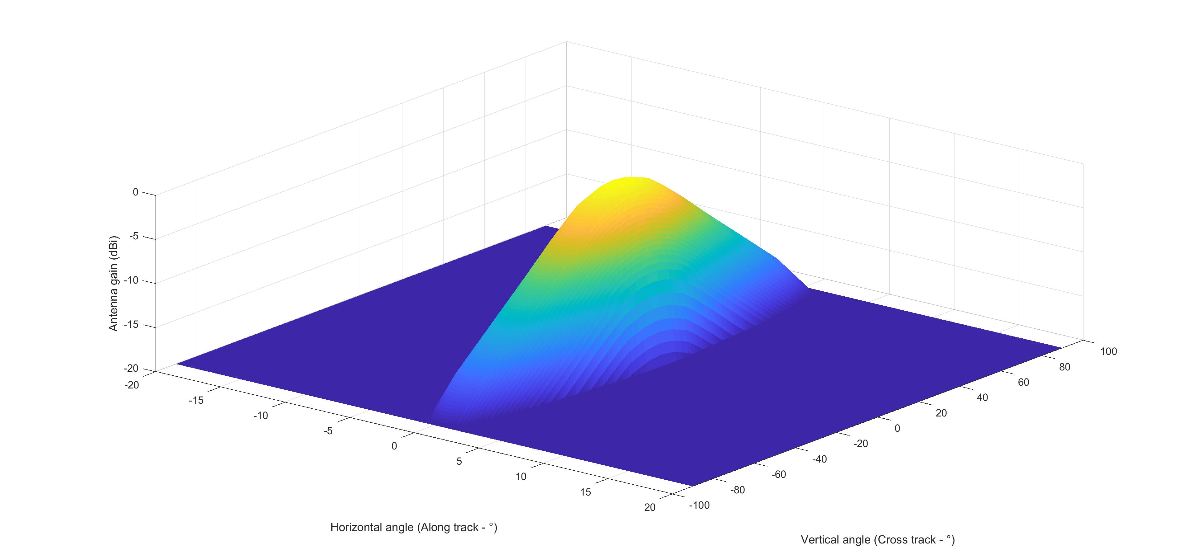
Figure 3: - 3 dB composite antenna aperture
Each satellite beam will use a different frequency channel. The level of unwanted emission falling into the RAS band below 10.7 GHz would depend on the separation between the channel frequency and the edge of the FSS allocation, leading to different unwanted emission e.i.r.p. in the RAS band per beam.

NGSO earth stations in the 14-14.5 GHz band

Deployment of NGSO earth stations
Specific deployments of fixed and ESIM earth stations for NGSO satellite systems will be contingent upon the position on their compatibility with other services in the 14-14.5 GHz band. The discussion in Section ‎4 identified that the use of the band 14-14.25 GHz is limited to the fixed satellite service. Therefore, the band 14-14.25 GHz is available for ubiquitous deployment of earth stations within CEPT. The upper part of the band 14.25-14.5 GHz is used by other services, namely the fixed service and radio astronomy service, therefore the use of the upper part of the band by earth stations is subject to relevant compatibility considerations.
With the above consideration, the deployment of NGSO earth stations in the 14-14.5 GHz band could be as follows:
- In the 14-14.25 GHz band: ubiquitous deployment of fixed earth stations and ESIM;
- In the 14.25-14.5 GHz band: deployment of fixed and ESIM earth stations subject to specific technical conditions in order to maintain compatibility with incumbent services using the band.
There are two types of earth stations considered for deployment:
- Fixed earth stations using parabolic antennas;
- ESIM on land vehicles, aircraft or ships using phased array antennas.

General characteristics common to both types of earth stations
As shown in Figure 4, the ONEWEB satellite antenna covers an area of about 1100 km x 1100 km on the earth. Given the orbit altitude of 1200 km it can be calculated that the NGSO FSS earth stations will point at a minimum elevation of 57°, which is much higher than the minimum elevation that could be used by a GSO VSAT for instance.
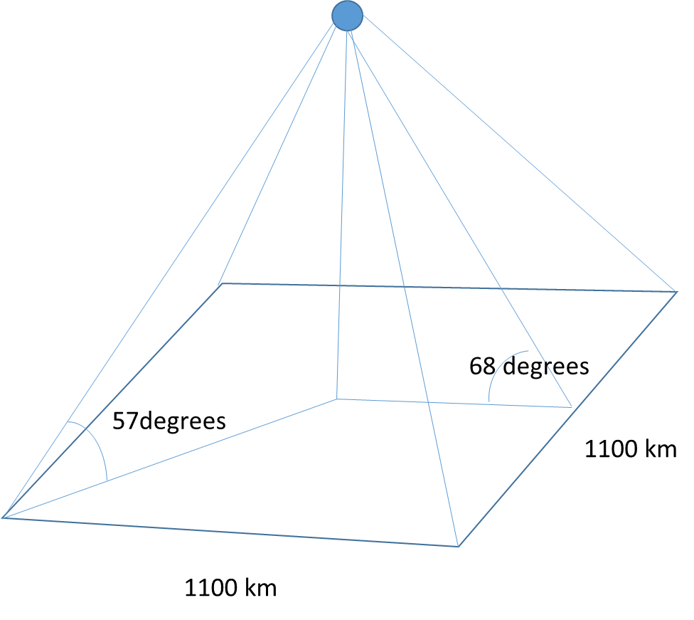
Figure 4: Determination of the minimum elevation angle
Due to this elevation angle, the e.i.r.p. radiated towards the horizon, i.e. towards the victim, will be in the side lobes. Hence, no polarisation loss can be considered.
It should be noted that ONEWEB NGSO satellite system plans to deploy two types of terminals, identified as consumer and enterprise, whose characteristics are described in Table 5. For both types of terminals in Table 5 the maximum on-axis e.i.r.p. is 34 dBW/(20 MHz) or 37 dBW/(40 MHz) when two 20 MHz channels are simultaneously transmitted.
Table 5: Transmitter parameters
Parameter | Units | Consumer  earth station | Enterprise  earth station | Notes
Carrier Allocated Bandwidth (ABW) | MHz | 20 |  | 6 carriers per transponder
Carrier Occupied Bandwidth (OBW) | MHz | 18.2
Symbol rate | MBds | 18.2
Data rate | Mbps | 36.4
Error Correction Coding |  | 3GPP Turbo Convolutional Code
Equivalent Parabolic Antenna Diameter | m | 0.45 | 0.90
Transmit Antenna Beamwidth | degrees | 3.27 | 1.64 | @ 14.25 GHz
Minimum Operational Elevation Angle | degrees | 50 to 60
Tx Antenna Gain (Gtx) | dBi | 35 | 41 | 70% Efficiency @ 14.25 GHz
Feeder Loss (Lf) | dB | 1.0 | 1.0
Power input into antenna | dBW | 0 | -6 | The input power scales with the carrier bandwidth (10 MHz carriers would have an input power of -1 dBW for the Consumer UT)
e.i.r.p. | dBW | 34 | 34
Note: For uplink carrier bandwidths less than 20 MHz the parameters in this table will scale accordingly, including a corresponding reduction in transmit power and e.i.r.p. for lower bandwidth carriers.

Control of the emissions from earth stations
The ETSI Standard EN 303 980 (Harmonised EN for fixed and in-motion Earth Stations communicating with Non-Geostationary Satellite Orbit (NEST) in the 11 GHz to 14 GHz frequency bands covering essential requirements of article 3.2 of the Radio Equipment Directive 2014/53/EU) [1] identifies in its section 4.2.6.2.2 that the conditions for cessation of emissions, which include, amongst others, the location of the earth station working to a NGSO satellite system and the boundaries of the authorised operating area so that cessation of emissions occurs prior to entering any protection zone including any inaccuracy in determination of the geographic location of the NEST.
ONEWEB earth stations, both fixed and ESIM, are expected to comply with EN 303 980. Consequently, ONEWEB earth stations will be equipped with GPS receivers allowing them (or their Network Control facility (NCF)) to determine the position of each earth station with a high level of accuracy. The fixed earth stations will have the possibility to cease emissions over a given frequency band, either autonomously or through the Network Control Facility (NCF), when located within protection zones such as those determined around individual FS stations in the band 14.25-14.5 GHz, or RAS stations in the band 14.47-14.5 GHz. This aspect is further discussed in Section 8 below. Similarly, ESIM will be able to cease emissions prior to entering protection zones, determined for FS stations or RAS stations, which not only include the territory of a country but also the neighbouring territories. This may include territorial waters. These aspects are also further discussed in Section 9.

Earth stations at fixed locations
The earth stations at fixed locations are expected to use a parabolic antenna. Such antennas are expected to be mounted on top of houses and buildings as shown in the example of Figure 5. For the subsequent studies, an antenna height of 20 m has been assumed.
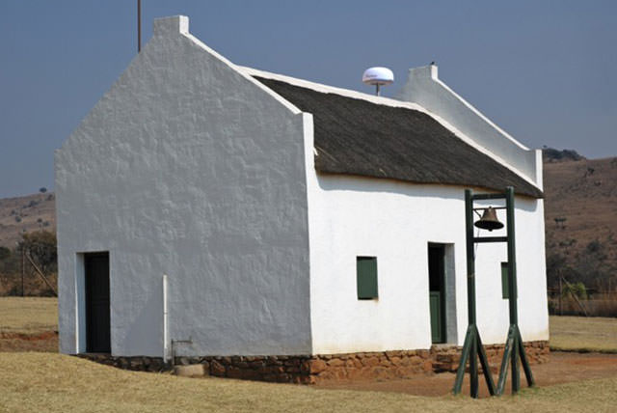
Figure 5: Example of parabolic antenna
An e.i.r.p. mask for ONEWEB fixed earth stations indicate that the off-axis e.i.r.p. within this domain varies between -20 dBW/(40 kHz) and -17 dBW/(40 kHz) depending on the offset angle, as shown in Figure 6.
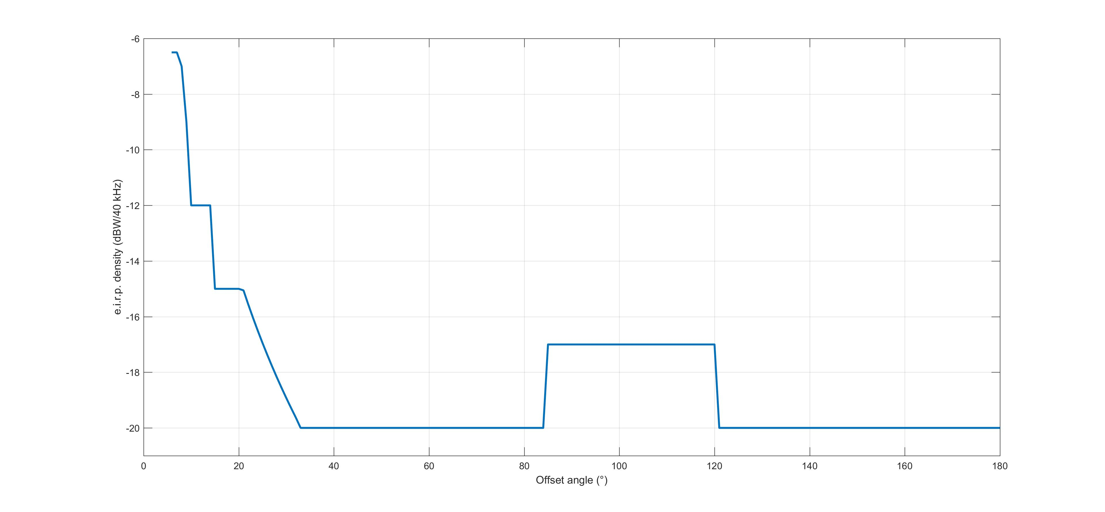
Figure 6: e.i.r.p. mask for parabolic antennas
This mask is a peak one, i.e. the output power plus the peak antenna gain have to meet this mask. However, in sharing studies involving NGSO satellites, the side lobes in the antenna patterns are averaged (3 dB below the peak sidelobes) because the antenna is moving while tracking the satellites and hence the antenna gain shifts between the peaks and holes in the pattern. Considering this, an e.i.r.p. of
-17 dBW/(40 kHz) – 3 dB has to be used for the studies.

Earth stations in motion (ESIM)
In the case of ESIM, apart from the fact that the earth station is moving, the antenna and emission power used differ from fixed earth stations. As shown in Figure 7 the antenna for terminals in motion is a phased array; therefore, the level of side lobes varies with the pointing angle of the antenna as shown in Figure 10.

Figure 7: Aircraft earth station

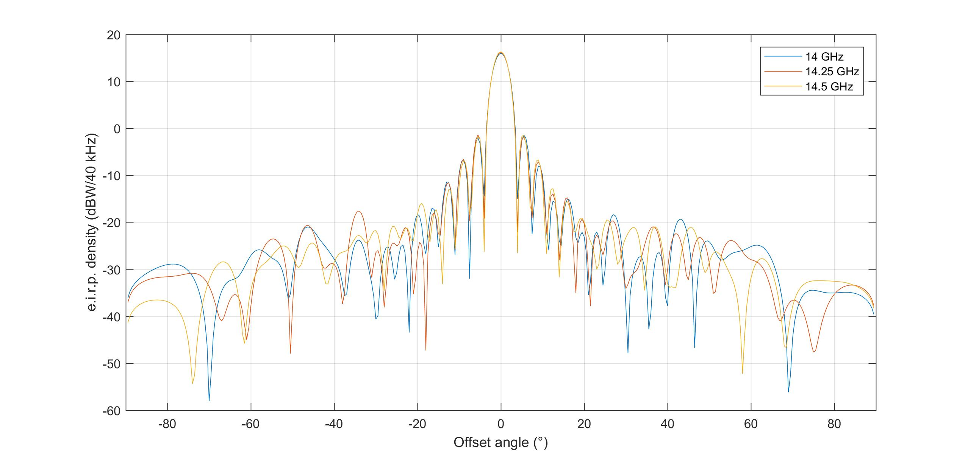
Figure 8: e.i.r.p. mask for the phased array antenna (dBW/(40 kHz)) for 90° pointing for three frequencies (14, 14.25 and 14.5 GHz)
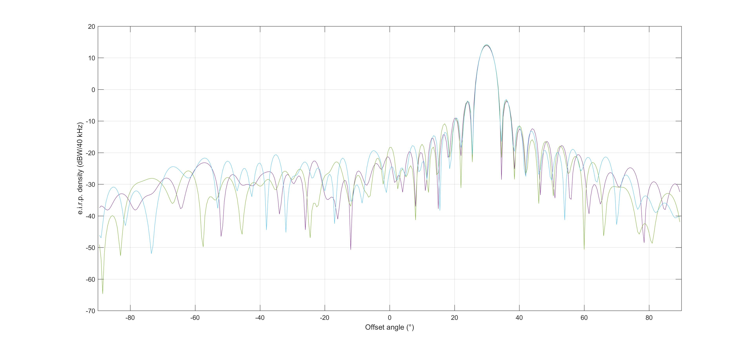
Figure 9: e.i.r.p. mask for the phased array antenna (dBW/(40 kHz)) for 120° pointing for three frequencies (14, 14.25 and 14.5 GHz)
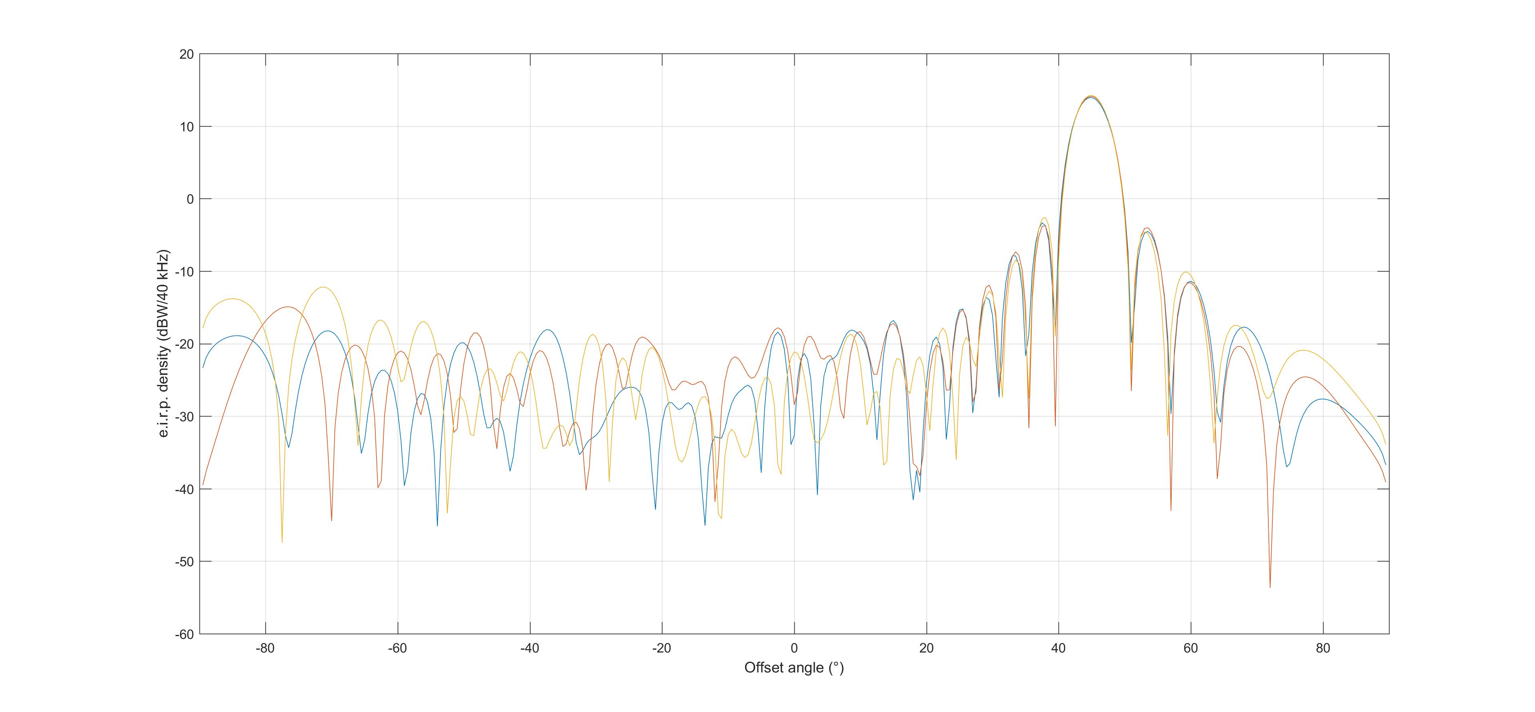
Figure 10: e.i.r.p. mask for the phased array antenna (dBW/(40 kHz)) for 45° pointing for three frequencies (14, 14.25 and 14.5 GHz)
E.i.r.p. masks in Figure 8, Figure 9 and Figure 10 are plots produced from measurements when the ONEWEB ESIM is set to transmit with a bandwidth of 2 MHz. The e.i.r.p. spectral density would be reduced when the bandwidth is increased to 20 MHz so that the total e.i.r.p. does not exceed 34 dBW.
For the ONEWEB ESIM, the peak e.i.r.p. radiated towards the horizon stays below the -30 dBW/(40 kHz) peak (-33 dBW/(40 kHz) average) for antenna elevation angles with an offset above 60° with respect to the maximum antenna gain; this value increases up to -15 dBW/(40 kHz) for elevation angles lower than 60°, due to appearance of grating lobes. This is 5 dB higher than the -20 dBW/(40 kHz) considered for earth stations at fixed location. However, the earth station will operate in such a way to track the satellite to obtain the best signal-to-noise ratio amongst all visible satellites. The modelling of such tracking leads to the distribution of elevation angles as shown in Figure 11 for land and shipborne ESIM; it is noted that, most of the time (99.5%), the elevation angle stays above 60° and never goes below 57°. This is consistent with Figure 4, which demonstrated the minimum elevation angles of the earth station at the edges of the coverage area of an ONEWEB satellite.
This assumption is not true for airborne ESIM since the aircraft can be inclined. However, the compatibility studies for this type of ESIM, a pfd mask on the ground is considered, which avoids the discussion on e.i.r.p. towards the horizon.

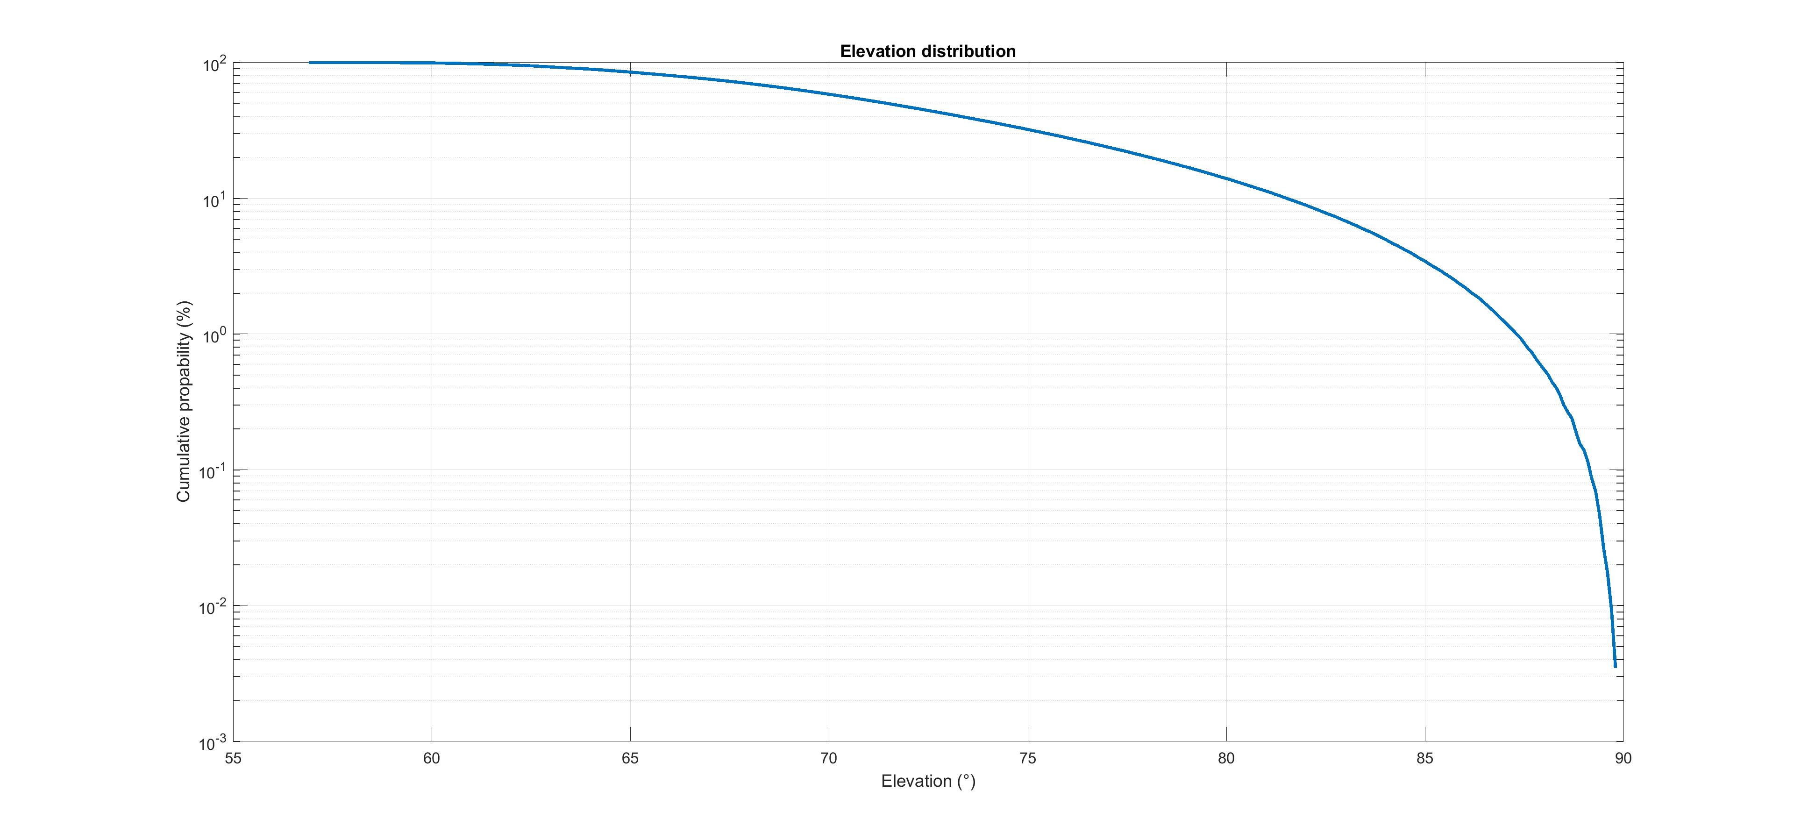
Figure 11: Distribution of FSS Earth station antenna pointing elevations
A peak e.i.r.p. of -30 dBW/(40 kHz) and an averaged e.i.r.p. of -33 dBW/(40 kHz) were considered for the land and shipborne ESIM studies.
Additionally, when the earth station is installed on trains or vehicles, the antenna height is lower than the 20 m considered for fixed Earth stations, e.g. 5m. For small ships, this would also be the case. A higher antenna height should be considered for bigger ships (e.g. an antenna on top of the mast). An antenna height of 40 m has been assumed as in previous ESV studies (see Recommendation ITU-R SF.1650 ‎[17]).

Characteristics and protection criteria of other services

Other services in the 14.25-14.5 GHz band operating within the CEPT that were identified in Section 3 are as follows:
- Fixed service in the 14.25-14.5 GHz;
- Radio astronomy service in the 14.47-14.5 GHz.

The criteria for the protection of systems operating within these services are identified below.
Characteristics and protection criteria of radio astronomy and EESS (passive) in the 10.6-10.7 GHz band are also provided in this section.

Fixed service in the 14.25-14.5 GHz band
Recommendation ITU-R F.758-6 ‎[6] provides characteristics for two fixed service systems in the band
14.4-15.35 GHz which are reproduced in Table 6.
Table 6: FS characteristics in the band 14.25-14.5 GHz contained in Recommendation ITU-R F.758-6
Frequency range (GHz) | 14.4-15.35
Reference ITU-R Recommendation | F.636 ‎[7]
Modulation | FSK | 128-QAM
Channel spacing and receiver noise bandwidth (MHz) | 2.5, 3.5, 7, 14, 28 | 2.5, 3.5, 7, 14, 28
Tx output power range (dBW) | 0 | 15
Tx output power density range (dBW/MHz) | −5.44 | 0.528
Feeder/multiplexer loss range (dB) | 0… 6.0 | 0…5.0
Antenna gain range (dBi) | 37 | 31.9
e.i.r.p. range (dBW) | 31…37 | 41.9…46.9
e.i.r.p. density range (dBW/MHz) | 25.6…31.6 | 27.4…32.4
Receiver noise figure typical |  | 8
Receiver noise power density typical (=NRX) (dBW/MHz) |  | −136
Normalized Rx input level for  1 × 10−6 BER (dBW/MHz) |  | −106.5
Nominal long-term interference power density (dBW/MHz) | NRX + I/N | −136 + I/N
In CEPT, antenna gains up to 49 dBi are also reported. ECC Report 026 ‎[18] related to studies between the AMSS and FS at 14 GHz considered an antenna gain of 43 dBi for the FDP analysis, and an antenna gain of 49 dBi for the short-term analysis. In addition, it should be noted that Recommendation ITU-R SF.1650 ‎[17] (ESV) also considers an average antenna gain of 40.5 dBi. Both 37 and 49 dBi antenna gains have been considered for the aeronautical ESIM studies as well as for the shipborne ESIM studies. For the fixed or land ESIM terminals, the protection zone has in any case to be determined on a case-by-case basis taking into account the actual FS parameters used by the administrations.
The parameters generally used in the studies, extracted from Table 6 and from deployments in CEPT, are the following.
Table 7: FS parameters used in the studies
Parameter | Value
Bandwidth (MHz) | 1
Antenna gain (dBi) | 37, 49
Antenna pattern | ITU-R F.699 ‎[8]
Feeder/Multiplexer loss (dB) | 0
Receiver noise figure (dB) | 8
Antenna height above ground (m) | 30
Elevation angle (°) | 0 - 5
When the FS station is on the coast, an additional ground height above sea level of 50 m was considered.

Long-term criterion
The long-term protection criterion is based on an I/N of -10 dB not to be exceeded more than 20% of the time as described in ITU-R F.758-6 ‎[6]. In addition, the same recommendation states that sharing studies in the frequency bands where multipath fading is the dominant propagation impairment for FS receivers (mostly in frequency bands below about 15 GHz), the fading on the desired and interfering paths are uncorrelated. Under these conditions, Recommendation ITU-R F.1108 ‎[19] introduced the Fractional Degradation in Performance (FDP) method, which shows that it is appropriate to use the average value of the interference power as the critical value for long-term interference power. By analogy with Recommendation ITU-R F.1494 ‎[20] dealing with the protection of FS from time varying aggregate interference from other co-primary services in the 10.7-12.75 GHz band, it can be established that the FDP should not exceed 10%.

Short-term criterion
The determination of a short-term criterion shall be based upon the allowed degradation of performance of links as set forth in Recommendation F.1565 ‎[10] which replaces a number of other recommendations such as F.1241 ‎[22] which were used back in 2000-2003.
The degradation due to a given interference short-term criterion is the probability of the simultaneous effect of this criterion and a fading higher than the net fade margin (F), defined as follows:
$F = FM – ATPCrange –\frac{ I}{N}$ (1)
The degradation of performance is linked to the percentage of time p associated with the protection criterion by:
$DP\left(\%\right)=\frac{p(\%).A(\%)}{100}$ (2)
therefore
$p(\%)=\frac{DP(\%)}{A(\%)}100$ (3)
where
- DP: allowed degradation of performance (%);
- EPO: error performance objective (%) p: percentage of time where the short-term I/N may be exceeded (%);
- A: percentage of time a given fade margin may be exceeded (%),
(see Recommendation ITU-R P.530 ‎[9]).
Recommendation ITU-R F.1565 ‎[10] provides the values of degradation of performance allowed due to interference for international, national long-haul, short-haul, and access connections, respectively. The degradation values are also given in this Recommendation for the errored second (ES) and severely errored second (SES) objectives.
As indicated in other recommendations such as F.1494 ‎[20] or F.1495 ‎[21], the fade margin for SES is 1 dB below the fade margin for a 10–3 BER. The fade margin for ES is 5 dB below the fade margin for a 10–3 BER. A fade margin for a 10–3 BER of 24 dB without ATPC has been retained, based on previous calculations.
It is understood that FS links in this band are mainly used for national short-haul or access networks (e.g. backhauling to mobile IMT networks).
Table 8: Percentage of time based on the SES for a FS part of a national short haul or access network
Parameter | Value | Origin
Fade margin for BER 10-3 (dB) | 24 | From 2002 studies
Fade margin for SES (dB) | 23
I/N short-term (dB) | 23 | Maximum
Net fade margin for SES (dB) | 0
Allowed degradation of performance SESR (%) | 0.0002 x 0.075 x 100 = 0.0015% | Rec. ITU-R F.1565 Tables 4a, 4b, 5a and 5b
Probability that the fade margin is exceeded (%) | 63% | Rec. ITU-R P.530 with the net fade margin
Probability associated with the short-term criterion (%) | 0.0024
Table 9: Percentage of time based on the ES for a FS part of a national short haul or access network
Parameter | Value | Origin
Fade margin for BER 10-3 (dB) | 24 | From 2002 studies
Fade margin for ES (dB) | 19
I/N short-term (dB) | 19 | Maximum
Net fade margin for ES (dB) | 0
Allowed degradation of performance ESR  (%) | 0.001 x 7.5%= 0.0075% | Rec. ITU-R F.1565 Tables 4a, 4b, 5a and 5b (worst case)
Probability that the fade margin is exceeded  (%) | 63 | Rec. ITU-R P.530 with the net fade margin
Probability associated with the short-term criterion (%) | 0.0119
For NGSO FSS studies, it is proposed to retain a I/N of +19 dB (lower value from Table 8 and Table 9), not to be exceeded more than 0.0119% of the time as determined in Table 9.
Alternatively, another short-term protection criterion was proposed, which is I/N of +19 dB not to be exceeded more than 2.7 x 10-4% of the time. It should be noted that the percentage of time associated with this protection criterion, used in Recommendation ITU-R SF.1650 ‎[17] as well as in the studies related to AMSS, was derived using Recommendation ITU-R F.1241 ‎[22] that has since been suppressed, although both criteria have been addressed by the study.

Radio astronomy

Characteristics for the band 10.6-10.7 GHz
The RAS station is basically described by its antenna, for which the average patterns and maximum gain is provided in Recommendation ITU-R RA.1631 ‎[11]. The recommended patterns represent average side-lobe levels to predict interference to a radio astronomy station from one or more fast moving stations seen under continuously variable angles such as NGSO systems. This Recommendation also provides a maximum antenna gain of 81 dBi for a 100 m diameter antenna at 10.6-10.7 GHz, which is considered in the epfd simulation in this Report.
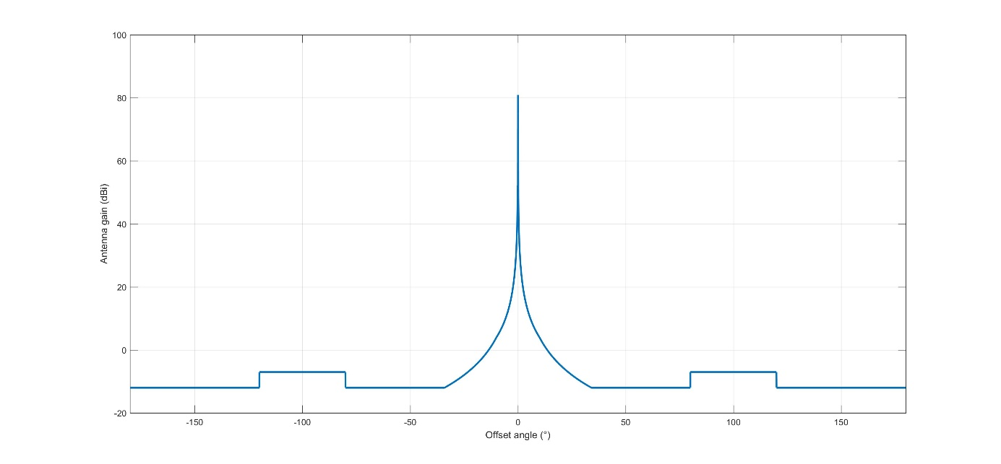
Figure 12: RAS antenna pattern (basic version)
The analysis in this Report uses the antenna pattern provided in the second Recommendation of ITU-R RA.1631 ‎[11], which provides a more accurate representation of the main beam radiation pattern for frequencies above 150 MHz. The results of calculations provided in this paper are for the location of the Effelsberg radio telescope in Germany.
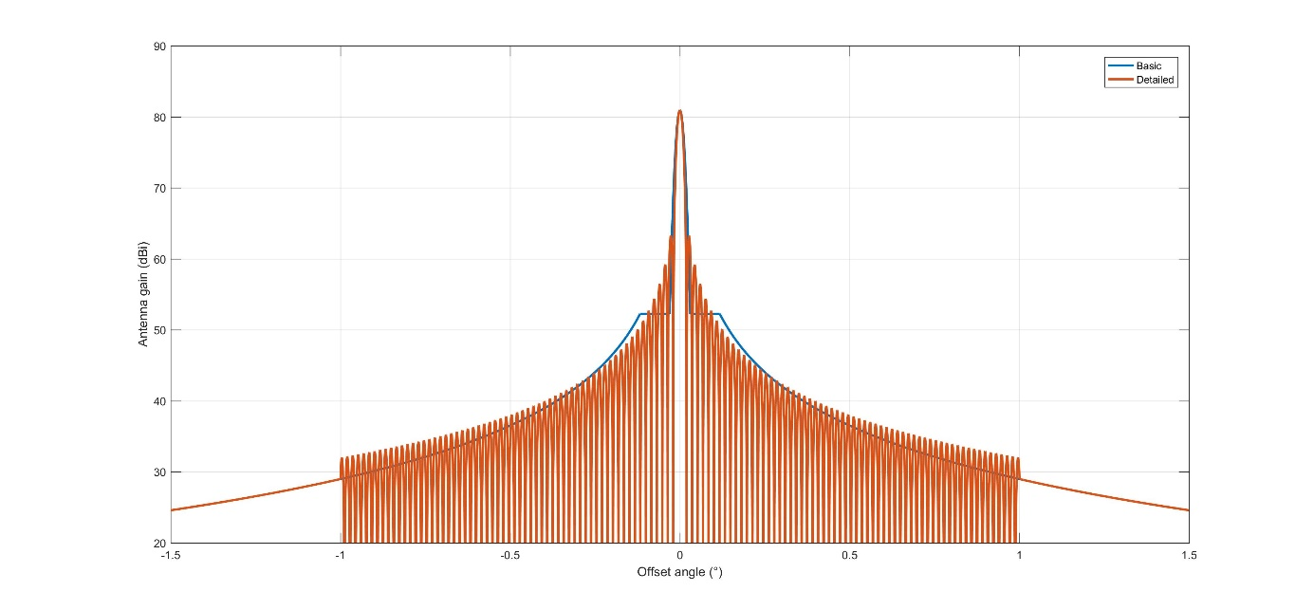
Figure 13: RAS antenna pattern (detailed version - zoomed around the main beam)
Table 10 lists the RAS stations in the CEPT countries that operate in the 10.6-10.7 GHz band.
Table 10: CEPT radio astronomy observatories using the band 10.6-10.7 GHz
Administration | Name | Longitude | Latitude | Diameter | Minimum elevation
Belgium | Humain | 05° 15′ 12″ | 50° 11′ 31″ | 6 m
Germany | Effelsberg | 06° 53′ 01″ | 50° 31′ 29″ | 100 m | 8°
 | Stockert | 06° 43′ 19″ | 50° 34′ 10″ | 25 m | -2°
 | Wettzell | 12° 52′ 38″ | 49° 08′ 42″ | 20 m | 0°
Italy | Medicina | 11° 38′ 49″ | 44° 31′ 15″ | 32 m | 5°
 | Noto | 14° 59′ 20″ | 36° 52′ 33″ | 32 m | 5°
Russia | Kalyazin | 37° 54′ 01″ | 57° 13′ 22″ | 64 m | 0°
 | Puschino | 37° 37′ 53″ | 54° 49′ 20″ | 22 m | 6°
 | Badari | 102° 13' 16" | 51° 45' 27" | 32
 | Svetloe | 29° 46' 54" | 61° 05' 00" | 32
 | Zelenchukskaya | 41° 35' 12" | 43° 49' 34" | 32
Portugal | Santa Maria | – 25° 07′ 33″ | 36° 59′ 07″ | 13.2 m | 5°
Spain | Yebes | – 03° 05′ 18.7″ | 40° 31′ 24.5″ | 13.2 m | 5°
Sweden | Onsala (OTT) | 11° 55′ 11″ | 57° 23′ 37″ | 13.2 m | 0°
Turkey | Kayseri | 35° 32′ 43″ | 38° 42′ 37″ | 12.8 m | 10°
United Kingdom | Jodrell Bank | -2° 18' 26" | 53° 14′ 10"- | 76 m | -1°
 | Cambridge | 52° 10’ 00” | 00° 02’ 15”
 | Darnhall | 53° 09’ 22” | –02° 32’ 07”
 | Defford | 52° 06’ 01” | –02° 08’ 39”
 | Knockin | 52° 47’ 24” | –02° 59’ 49”
 | Pickmere | 53° 17’ 18” | –02° 26’ 38”

Protection criteria for the band 10.6-10.7 GHz
The 10.6-10.7 GHz band involves two allocations. The lower end contains a primary allocation to RAS in 10.60-10.68 GHz, while the 10.68-10.7 GHz band is a passive band (No. 5.340). The calculation of data loss levels to radio astronomy observations and percentage-of-time criteria resulting from degradation by interference is described in Recommendation ITU-R RA.1513 ‎[12].
Radio astronomy measurements can tolerate interference from any one network, which exceeds the thresholds given in Recommendation ITU-R RA.769 ‎[13] for 2% data loss and the aggregate interference from all networks must not exceed 5% data loss. The latter is usually very difficult to determine since it would mean taking the contribution of all GSO, NGSO satellite systems, as well as terrestrial systems operating in the band or in nearby bands.
Radio astronomy observations are categorised to two types: continuum and spectral lines. The 10.6-10.7 GHz band is used for continuum observations and the threshold interference level is given as a pfd of -160 dBW/m², assuming an integration time of 2000 seconds. To get the epfd threshold level, we need to subtract the maximum antenna gain, i.e., 81 dB, from the pfd level. The epfd threshold is therefore -241 dBW/m².

Characteristics and protection criteria for the band 14.47-14.5 GHz
The 14.47-14.5 GHz band is used for spectral line observations with a typical resolution of 150 kHz.
The interference threshold level is a received power of -214 dBW/150 kHz, leading to a pfd of
-169 dBW/m²/(150 kHz). When considering a 100 m diameter antenna such as Effelsberg, a maximum gain of 84 dBi should be considered, leading to an epfd criterion of -253 dBW/(150 kHz). This value will vary with the antenna diameter. The same data loss threshold value of 2% from ITU-R RA.1513 ‎[12] applies to this band.
A list of the RAS stations in the CEPT countries that operate in the 14.47-14.5 GHz band is provided in Table 11.
Table 11: CEPT RAS observatories using the band 14.47-14.5 GHz
Administration | Name | Longitude | Latitude | Diameter | Minimum elevation
Germany | Effelsberg | 06° 53′ 01″ | 50° 31′ 29″ | 100 m | 8°
Italy | Medicina | 11° 38′ 49″ | 44° 31′ 15″ | 32 m | 5°
Russia | Kalyazin | 37° 54′ 01″ | 57° 13′ 22″ | 64 m | 0°
 | Puschino | 37° 37′ 53″ | 54°49′ 20″ | 22 m | 6°
Portugal | Santa Maria | –25° 07′ 33″ | 36° 59′ 07″ | 13.2 m | 5°
Sweden | Onsala (OTT) | 11° 55′ 11″ | 57° 23′ 37″ | 13.2 m | 0°
United Kingdom | Cambridge | 00° 02′ 20″ | 52° 09′ 59″ | 32 m | 2°
 | Jodrell Bank | -02° 18' 26" | 53° 14′ 10" | 76 m | -1°

EESS (PASSIVE)

Characteristics
The characteristics of passive sensors operating in the band 10.6-10.7 GHz have been taken from Recommendation ITU-R RS.1861 ‎[24]. They are given in Table 12.
Table 12: EESS (passive) sensor characteristics in the 10.6-10.7 GHz band
 | Sensor C1 | Sensor C2 | Sensor C3 | Sensor C4 | Sensor C5
Sensor type | Conical scan
Orbit parameters
Altitude | 817 km | 705 km | 833 km | 835 km | 699.6 km
Inclination | 98° | 98.2° | 98.7° | 98.85° | 98.186°
Eccentricity | 0 | 0.0015 | 0 | 0 | 0.002
Repeat period | N/A | 16 days | 17 days | N/A | 16 days
Sensor antenna parameters
Number of beams | 1 |  | 2 | 1
Reflector diameter | 0.9 m | 1.6 m | 2.2 m | 0.6 m | 2.0 m
Maximum beam gain | 36 dBi | 42.3 dBi | 45 dBi | 36 dBi | 44.1 dBi
Polarisation | H, V |  | H, V, R, L | H, V
–3 dB beamwidth | 2.66° | 1.4° | 1.02° | 3.28° | 1.2°
Instantaneous field of view | 56 km ×  30 km | 51 km ×  29 km | 48 km ×  28 km | 76 km × 177 km | 41 km ×  21 km
Main beam efficiency |  | 94.8% | 95% |  | 93%
Off-nadir pointing angle | 44.3° | 47.5° | 47° | 55.4° | 47.5°
Beam dynamics | 20 rpm | 40 rpm | 31.6 rpm | 2.88 s scan period | 40 rpm
Incidence angle at Earth | 52° | 55° | 58.16° | 65° | 55°
–3 dB beam dimensions | 56.7 km  (cross-track) | 27.5 km  (cross-track) | 42.9 km (cross-track) | N/A | 23 km  (cross-track)
Swath width | 1 594 km | 1 450 km | 1 600 km | 2 000 km | 1 450 km
Sensor antenna pattern | See Rec.  ITU-R RS.1813 | Fig. 8a | Fig. 8b | See Rec. ITU-R RS.1813
Cold calibration ant. gain | N/A | 29.1 dBi | N/A |  | 29.6 dBi
Cold calibration angle (degrees re. satellite track) | N/A | 115.5º | N/A |  | 115.5º
Cold calibration angle (degrees re. nadir direction) | N/A | 97.0º | N/A |  | 97.0º
Sensor receiver parameters
Sensor integration time | 1 ms | 2.5 ms | 2.47 ms | N/A | 2.5 ms
Channel bandwidth | 100 MHz | 100 MHz centred at 10.65 GHz
Measurement spatial resolution
Horizontal resolution | 38 km | 27 km | 15 km | 38 km | 23 km
Vertical resolution | 38 km | 47 km | 15 km | 38 km | 41 km

Meteor-3M satellite system description
Meteor-3M satellite system comprises of two satellites, Meteor-M №1 (launched in 2009) and Meteor-M №2 (launched in 2014), deployed in sun-synchronous circular orbit (LTAN 9:30) with orbit height of 835 km and inclination around 98.8°. Each satellite carries passive instrument, representing a multi-channel conical scan radiometer, using 0.65 m (-3 dB beamwidth is 2.9°) reflector receiving antenna (H, V polarizations are used) with maximum gain of 34.3 dBi and off-nadir pointing angle of 53.3°.
10.65 GHz channel is used to make measurements of Water Surface Temperatures (WST) and has a sensitivity (radiometric resolution) of 0.06 K, separate cold calibration channel is applied to increase accuracy. Cold calibration channel receiving antenna (0.24*0.2 m, -3 dB beamwidth is 10 degrees, maximum gain is 25.4 dBi) is oriented in the upper hemisphere and measures the brightness temperature of sky.
A next generation meteorological satellite, Meteor-MP, is planned for launch after 2021, which would carry an advanced conical scan radiometer with a 0.9 m reflector receiving antenna with improved side-lobe performance, reaching a sensitivity of 0.03 K in the 10.65 GHz channel.

Protection criteria
Recommendation ITU-R RS.2017-0 ‎[25] specifies permissible interference level at the input of passive instrument receiver as 20% of the radiometer threshold power, which is based on radiometer sensitivity. For a typical value of 0.1 K, provided in Recommendation ITU-R RS.2017-0, the permissible interference level is -166 dBW/(100 MHz). For Meteor-M, for which the sensitivity is 0.06 K, the permissible interference level is
-168 dBW/(100 MHz). The above values should not to be exceeded more than 0.1% of the time. The reference measurement area is a square on the earth of 10 000 000 km².

Compatibility between NGSO FSS (space-to-earth) in the band 10.7-12.75 GHz and RAS in the band 10.6-10.7 Ghz

Methodology
Recommendations ITU-R M.1583 ‎[14] and S.1586 ‎[15] provide methodologies to evaluate the percentage of data loss induced in a radio astronomy service (RAS) station by the emissions of a constellation of satellites operating respectively in the mobile satellite and radio navigation services, and in the fixed satellite service. The two Recommendations essentially apply the same methodology.
The methodology is based on a Monte Carlo simulation where the pointing of the RAS antenna and the initial time for integration is randomly changed from one trial to another. The position of all satellites of the constellation is determined from the integration time frame of 2000 seconds, which is a representative integration time for RAS. The equivalent power flux density (epfd) produced at the RAS station by all satellites in visibility during the integration time is then calculated, and averaged over the 2000 seconds. The value obtained is then compared to a specified interference threshold to determine if the data is considered lost or not. This process is then repeated for a sufficient number of trials in order to get an overall percentage of data loss over the sky.
The specificity of the methodology lies in the fact that the pointing of the RAS station is not randomly chosen with a uniform distribution in azimuth and elevation, but in solid angles. In addition, radio astronomers require a map of the sky where they can expect the worst-case data losses. This is done by dividing the sky in 2334 cells of nearly equal solid angles. The RAS antenna is pointed randomly in each of these cells, and the process described above is repeated for each cell. Assuming 100 trials per cell, this would give a total of 233400 trials sufficient to determine the overall percentage of data loss. A number of 10 trials per cell would also be sufficient but would not provide a detailed map of the sky.

Results
The unwanted emission levels derived from simulations, as a function of different combination of the satellite beams and the filter capabilities complying with the 2% data loss are provided below:
Table 13: Maximum unwanted emission e.i.r.p. levels per beam
Satellite beams | e.i.r.p. in the RAS band (dBW/100 MHz)
Beams 1,5,9,13 | -34.9
Beams 2,6,10,14 | -61.9
Beams 3,7,11,15 | -49.9
Beams 4,8,12,16 | -61.9
For these e.i.r.p. levels in the RAS band, the overall data loss at Effelsberg is 1.93% distributed over the sky as shown in Figure 14.

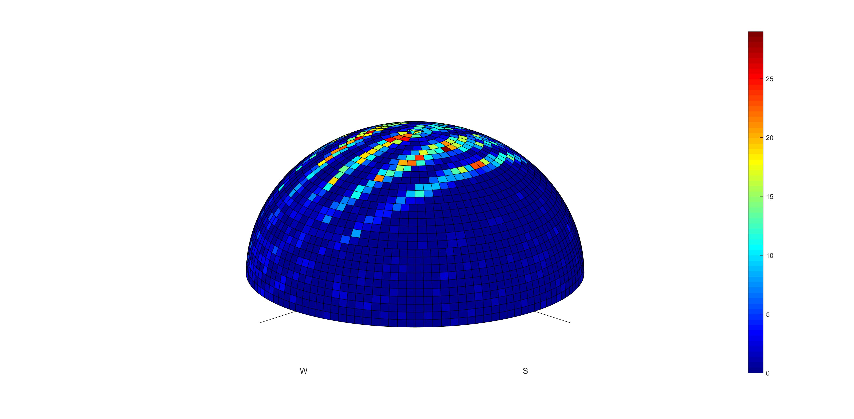
Figure 14: Plot of the data loss over sky
The maximum level of exceedance of the epfd threshold in dB over the sky over all trials is given in Figure 15.

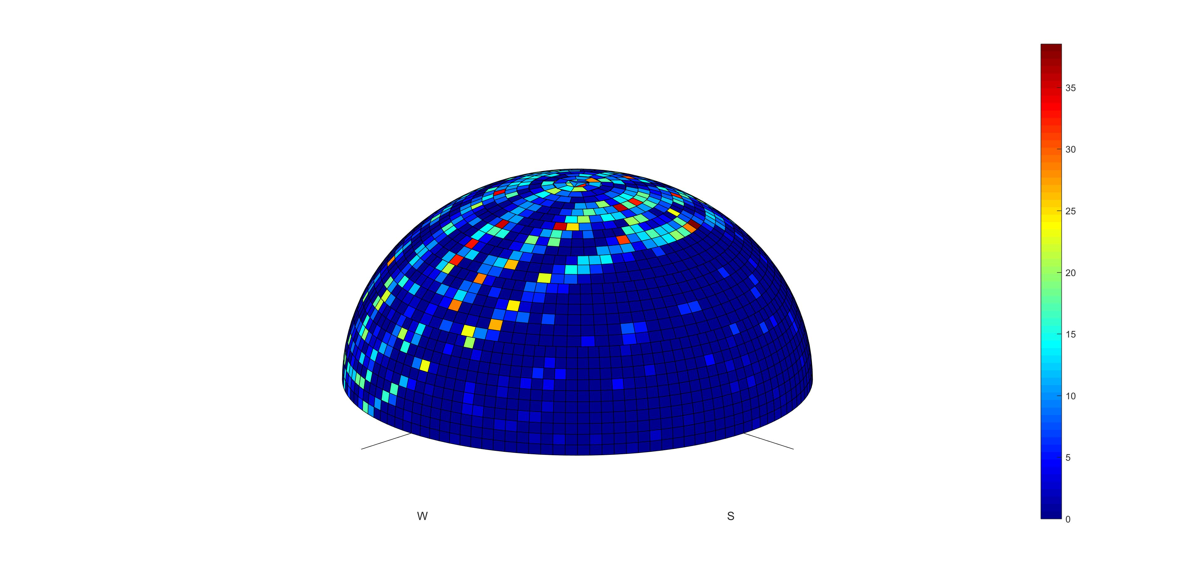
Figure 15: Maximum exceedance of epfd threshold
The maximum values of data loss in the 2000 seconds-long periods will appear where there is coupling between the RAS main beam or first side lobes with the satellite beams producing higher e.i.r.p., i.e. beams 1, 5, 9 and 13. Otherwise, the RAS antenna will only see the beam where the e.i.r.p. is much lower (15 to 30 dB below). Beams 1, 5, 9 and 13 have respectively an offset angle of -23.5°, -11°, 1.5° and 14.1° with respect to nadir. This corresponds, when the satellite is going South to North, to elevation angles of respectively 62° (at about 180° azimuth), 77° (180° azimuth), 88° (0° azimuth) and 73° (0° azimuth). One also has to consider the descending orbits and in this case the azimuth will be reversed, with worst cases at respectively 62° (at about 0° azimuth), 77° (0° azimuth), 88° (180° azimuth) and 73° (180° azimuth). This shows why there will be 5 different stripes of highest data loss on the sky instead of 4, spreading as follows:
- One at 62° elevation and 180° azimuth;
- The largest one at 75° (from 73 to 77°) elevation and 180° azimuth;
- One at 90° (from 88 to 92°) elevation and 0 or 180° azimuth;
- Another large one at 75° elevation and 0° azimuth;
- One at 62° elevation and 0° azimuth.
Figure 16 provides the evolution of the percentage of data loss when the unwanted emission power levels are increased or decreased over all beams by a given value.
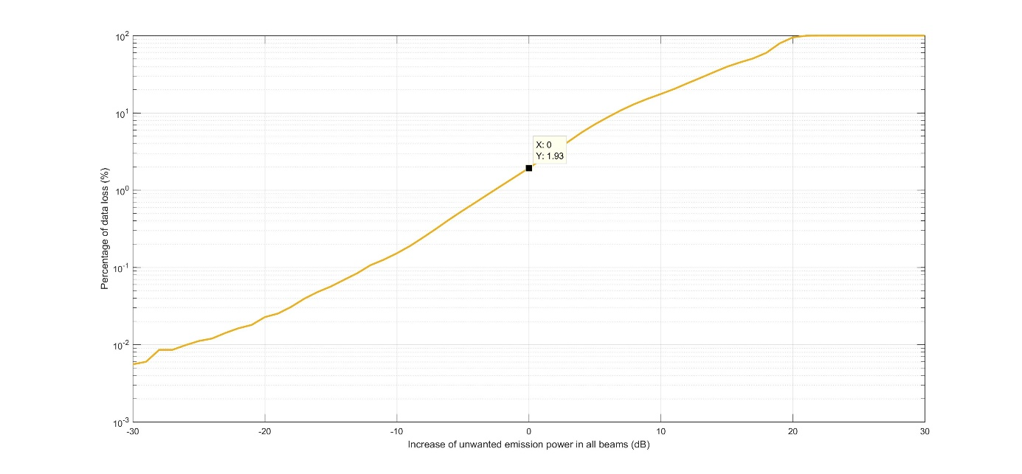
Figure 16: Evolution of the data loss when the unwanted emission level is
decreased or increased over all beams

Conclusions and discussions
The unwanted emission e.i.r.p. levels provided in Table 13 meet the 2% data loss criterion of RAS for the worst case considered in terms of maximum antenna gain (Effelsberg site with a 100 m antenna diameter) and constitute an additional requirement for the NGSO FSS payload for the ONEWEB system. Indeed, those limits were obtained by taking into account the satellite antenna characteristics of the space stations in the ONEWEB system, including the 16 beams with the corresponding antenna pattern presented in section ‎4.1.
Those e.i.r.p. levels may be achieved through a combination of modulation shaping, IF and RF filtering. The current design of the ONEWEB constellation payload incorporates a combination of those techniques which permits to meet the levels indicated in Table 13 with additional margin. However, these techniques would not be sufficient for the frequency channel immediately adjacent to the passive band
(10.7-10.95 GHz), for which an unwanted emission e.i.r.p. of -5 dBW in the 100 MHz of the passive band is expected, and this channel would therefore have to be deactivated when in visibility of a RAS station performing observations in this band. As shown in Figure 17 this would leave limited possibilities for the usage of this channel.
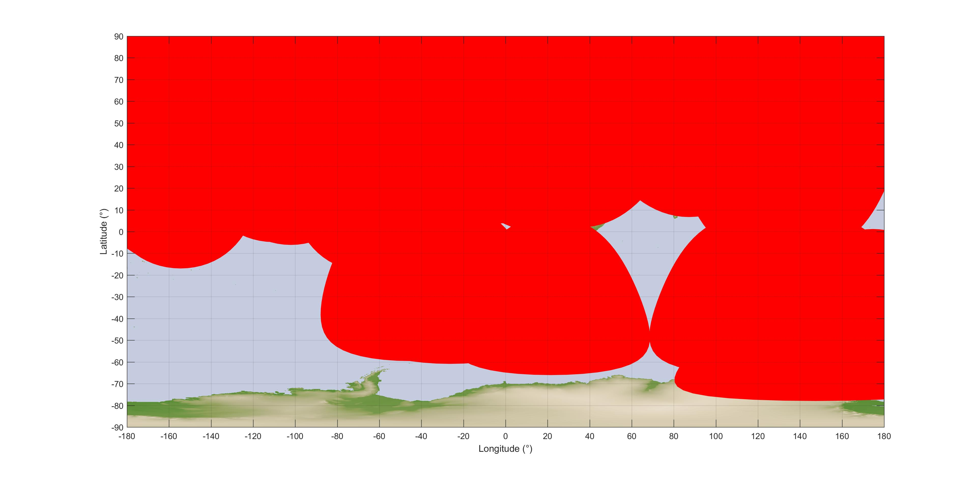
Figure 17: Visibility areas of RAS stations performing observations in the 10.6-10.7 GHz band
For a different NGSO FSS system, the particular satellite antenna characteristics should be considered in order to deduce the e.i.r.p. limitations allowing the protection RAS in the adjacent band; therefore, the results in this section are not transposable to other NGSO FSS systems. If another FSS NGSO system is considered to operate in this band, new analysis should be carried out.

Compatibility between NGSO FSS (space-to-earth) in the band 10.7-12.75 GHz and EESS (passive) in the band 10.6-10.7 Ghz

STUDY 1: Assessment of Impact on passive sensors, provided in Recommendation ITU-R RS.1861

Methodology
The unwanted emission e.i.r.p. levels required for the protection of radio astronomy as derived in Table 13 are expected to also protect the EESS (passive) sensors. In order to verify this, the worst case unwanted emission e.i.r.p. in beams 1, 5, 9 and 13 has been considered and the interference from those beams into the side-lobes of the EESS (passive) sensor, as well as within the main beam of the EESS (passive) sensor after reflection over the sea.

Results
With regard to the interference received in the EESS sensor side-lobes, the worst case EESS satellite was considered that leads to the shortest distance between the EESS satellite and one NGSO satellite located right above. This corresponds to a worst case EESS satellite altitude of 835 km. A 0 dBi EESS back-lobe antenna gain has been assumed, which again is a worst case as the antenna pattern in recommendation RS.1813 gives a back-lobe gain value in the order of -10 dBi.
Table 14: Calculation of interference in EESS (passive) sensor backlobes
Parameter | Value | Unit
e.i.r.p. | -34.9 | dBW/(100 MHz)
EESS gain | 0.0 | dBi
Altitude | 835.0 | km
Distance | 365.0 | km
Loss | 164.2 | dB
I | -199.1 | dBW/(100 MHz)
Criterion | -166.0 | dBW/(100 MHz)
Margin | 33.1 | dB
Even with these worst-case assumptions there would be more than 30 dB margin with regard to the EESS (passive) protection criterion.
With regard to the interference received in the EESS sensor main beam after reflection over the sea, a worst-case scattering coefficient of 120% has been assumed, which in theory would only occur at the NGSO satellite nadir during short period of time.

Table 15: Calculation of interference in EESS (passive) sensor main beam after reflection over sea
Parameter | Sensor C1 | Sensor C2 | Sensor C3 | Sensor C4 | Sensor C5
e.i.r.p. (dBW/(100 MHz)) | -34.9 | -34.9 | -34.9 | -34.9 | -34.9
NGSO FSS satellite altitude (km) | 1200.0 | 1200.0 | 1200.0 | 1200.0 | 1200.0
pfd (dBW/m²/(100 MHz)) | -167.5 | -167.5 | -167.5 | -167.5 | -167.5
Area covered by the FSS satellite beam (km²) | 75625.0 | 75625.0 | 75625.0 | 75625.0 | 75625.0
Backscatter coefficient (%) | 120.0 | 120.0 | 120.0 | 120.0 | 120.0
Reflected power (dBW/(100 MHz)) | -57.9 | -57.9 | -57.9 | -57.9 | -57.9
Distance ground − Satellite EESS passive (km) | 1221.7 | 1123.50 | 2033.70 | 1766.10 | 1114.90
Propagation loss (dB) | 174.7 | 174.0 | 179.2 | 177.9 | 173.9
EESS antenna gain (dBi) | 36.0 | 42.3 | 45 | 36 | 44.1
Received power at the passive sensor (dBW/(100 MHz)) | -196.6 | -189.6 | -192.1 | -199.8 | -187.7
Protection criterion (dBW/(100 MHz)) | -166.0 | -166.0 | -166.0 | -166.0 | -166.0
Margin (dB) | 30.6 | 23.6 | 26.1 | 33.8 | 21.7
Even with these worst-case assumptions there would be more than 20 dB margin with regard to the EESS (passive) protection criterion.

STUDY 2 (Assessment of Impact on METEOR-M passive sensor)

Interference scenarios
The following interference scenarios were considered in assessment of impact from FSS satellites:
- Aggregated interference from FSS satellites (both NGSO and GSO), resulting from unwanted emissions in 10.6-10.7 GHz, is received through far side-lobes and back-lobes of the main antenna of the passive instrument;
- Aggregated interference from FSS satellites (both NGSO and GSO), resulting from unwanted emissions in 10.6-10.7 GHz, is received through main beam of the cold calibration channel antenna of the passive instrument.
Due to significant complexity of the studies, scenario of aggregated interference from FSS satellites (both NGSO and GSO), resulting from unwanted emissions in 10.6-10.7 GHz received through main beam of passive instrument main antenna after back-scattering from water surface, was not studied.

Initial data and assumptions of the study
The ONEWEB NGSO satellite constellation is to be modelled based on orbit parameters, provided in section ‎4.1. All four beams per satellite, employing 10.7-10.95 GHz band, are assumed to be active. A maximum unwanted emission e.i.r.p. of -5 dBW in the 100 MHz is assumed for ONEWEB NGSO satellites. For all ONEWEB satellites, the relative gain pattern from section 4.1 was used (Table 4). The Meteor-M satellite antennas (primary antenna and secondary antenna for cold calibration channel) are calculated according to ITU Recommendation RS.1813.
The main beam of Meteor-M satellites has a scanning sector 105 degrees wide (angle alpha changing from 165 to 270 degrees, off-nadir pointing angle beta is 53.3 degrees), scan period is 2.5 seconds. Secondary antenna for cold calibration channel has a fixed pointing, with orientation angle alpha of 315 degrees and orientation angle beta of 90 degrees. Protection criterion of -168 dBW/(100 MHz) not to be exceeded for more than 0.1% of time was used for Meteor-M satellite passive sensors. It should be noted that this protection criterion is related only to data accuracy and reliability and is not considering possible hardware damage.
The frequency band 10.7-10.95 GHz is already used by FSS GSO satellites and it’s use will only grow in future due to congestion in unplanned Ku-bands; therefore, the existing interference environment needs to be taken into account in assessment of aggregate impact to EESS passive sensors. Emission parameters for FSS GSO systems, to be used in the study, are provided in Table 16. Peak e.i.r.p. values were used so as to meet pfd limits, established in Article 21 of the RR ‎[2].
Table 16: Emission parameters of the typical GSO FSS systems
Parameter | Value
Peak e.i.r.p. (dBW) | 54.5
Transponder bandwidth (MHz) | 54
Peak e.i.r.p. density (dBW/Hz) | -22.8
Assessment of interference is to be made only with respect single transponder of each satellite, adjacent to the 10.6-10.7 GHz band. Taking into account possible loading options of the transponder (single-carrier/multi-carrier), it is assumed that at least 0.5% of transponder power falls into the adjacent band.

Simulation results
Considering information provided in sections 4.1 and 7.2.2, dynamic studies were carried out by simulating ONEWEB constellation with one Meteor-M satellite. Taking into account 2.5 second scan period of Meteor-3M primary sensor antenna, time step of 0.1 second was used for the first interference scenario (interference into main beam through side-lobes). For the second interference scenario (interference into cold calibration channel), a time step of one second was used. Due to the relation between the orbital periods of ONEWEB and Meteor M satellites, it is preferable to run the simulation during at least ten times more than Meteor-3M orbital period (36 Hours).
For the first interference scenario, a peak interference of -177.9 dBW/100 MHz was recorded, which is about 10 dB lower than protection criterion and therefore should only be considered when interference from GSO systems is close to the threshold level. Maximum aggregate interference from GSO FSS constellation reached -173.8 dBW/100 MHz, which in total is around – 172.4 dBW/100 MHz.
On the other hand, interference into cold calibration channel is exceeding -166 dBW/100 MHz for 6.7% of time and interference level of -168 dBW/100 MHz is exceeded in 13.5% of time. Peak interference in this case will be -160.8 dBW/100 MHz, which may lead to significant degradation of measurements. It should be noted that by changing maximum unwanted emission e.i.r.p. from -5 dBW to -34.9 dBW (thus disabling channel one) in the 100 MHz will change peak interference to -190.7 dBW/100 MHz, which will be enough to comply with protection criteria on standalone basis.

Conclusion
Meeting the epfd protection criterion for the protection of radio astronomy in the band 10.6-10.7 GHz leads to unwanted emission e.i.r.p. limits applied for the ONEWEB satellites. Meeting these unwanted emission e.i.r.p. limits in vicinity of EESS satellites is also sufficient for the protection of passive sensors and no additional constraint for this system would be needed to ensure compatibility with EESS (passive) in the band 10.6-10.7 GHz. As the level of filtering for the channel adjacent to the passive band (channel 1) is currently not sufficient for the ONEWEB constellation, this requires either to improve filtering, or the deactivation of this channel when in visibility of the EESS (passive) satellite. If other means, different from disabling channel one, are used to ensure protection of RAS, additional studies should be carried out to check compatibility between ONEWEB and EESS (passive) systems.
For a different NGSO FSS system, the particular satellite antenna characteristics should be considered in order to deduce the e.i.r.p. limitations allowing the EESS protection in the 10.6-10.7 GHz band; therefore, the results in this section are not transposable to other NGSO FSS systems. If another FSS NGSO system is considered to operate in this band, new analyses should be carried out, including the aggregate effect of the NGSO and GSO systems.

Sharing between NGSO FSS ES at fixed location and incumbent services in the band 14-14.5 GHz

Sharing with Fixed Service in the band 14.25-14.5 GHz

Methodology
The methodology used in the study consists in determining an area around the FS station where any deployed FSS earth station will not be able to use one or several frequency channels overlapping with the channels used by the FS station.
The propagation loss needed in order to meet the FS protection criterion (long-term and short-term) is given by:
$Lp=e.i.r.p.+G_{R}-N-\frac{I}{N}+10log⁡\left(\frac{B}{0.040}\right)$ (4)
where
- Lp : Propagation loss required (dB);
- e.i.r.p.: FSS ES e.i.r.p. towards the horizon (dBW/(40 kHz));
- GR: FS antenna gain towards the FSS earth station (dBi);
- N: FS Noise level (dBW);
- I/N: FS protection criterion (dB);
- B: FS reference bandwidth considered (e.g. 1 MHz).
Once the required propagation loss is known, the corresponding distance can be determined using a propagation model. Recommendation ITU-R P.452-14 ‎[4] was used to this effect. The size of protection areas around FS stations needs to be determined on a case-by-case basis to take into account actual FSS, FS parameters and surrounding terrain. An example is given in section ‎8.1.2 for the FS station in Table 7. Considering a higher antenna gain would lead to a larger distance in-axis, but with a narrower area, whereas the consideration of a lower antenna gain would lead to a smaller distance in-axis, but widening the overall area.

Results
For the FS system in Table 7, the propagation loss required is 148 dB, with a percentage of time of either 0.0119% or 0.00027% depending on the considered short-term protection criterion (see section ‎5.1.2).
The minimum propagation loss becomes 177 dB with a percentage of time of 20% with regard to the long-term protection criterion.
Figure 18 shows the propagation loss calculated using the Recommendation ITU-R P.452-14 as a function of the separation distance. The receiver location is in United Kingdom (-1° longitude and 52° latitude).
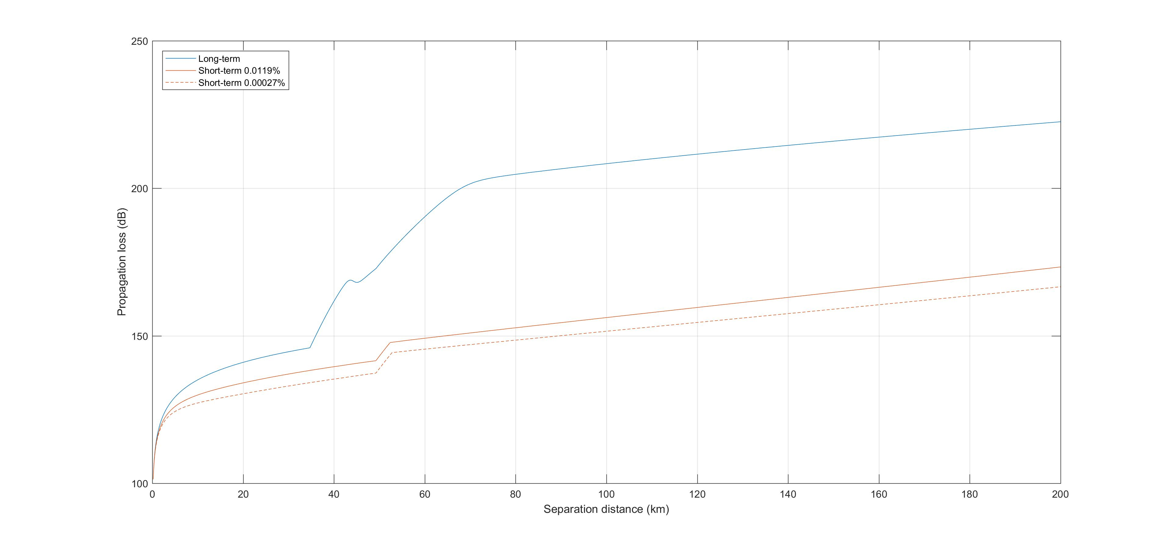
Figure 18: Recommendation ITU-R P.452 Propagation loss over flat terrain
The distance corresponding to a 148 dB loss for short-term is in the order of 58 km and 77 km for the percentages of time 0.0119% or 0.00027%, respectively. The distance corresponding to a 177 dB loss for long-term is in the order of 58 km. This would be in the axis of the FS receiver. However, off-axis, the antenna gain decreases rapidly, and so is the required propagation loss, and the separation distance, as shown in Figure 20 for a FS station pointing North.
Figure 20 also shows the separation distance for the same FS station located in United Kingdom, taking into account actual terrain elevation. The maximum distance is reduced to 11 km instead of 77 km but at the same time the angle of interference is widened due to terrain clutter and reflections.
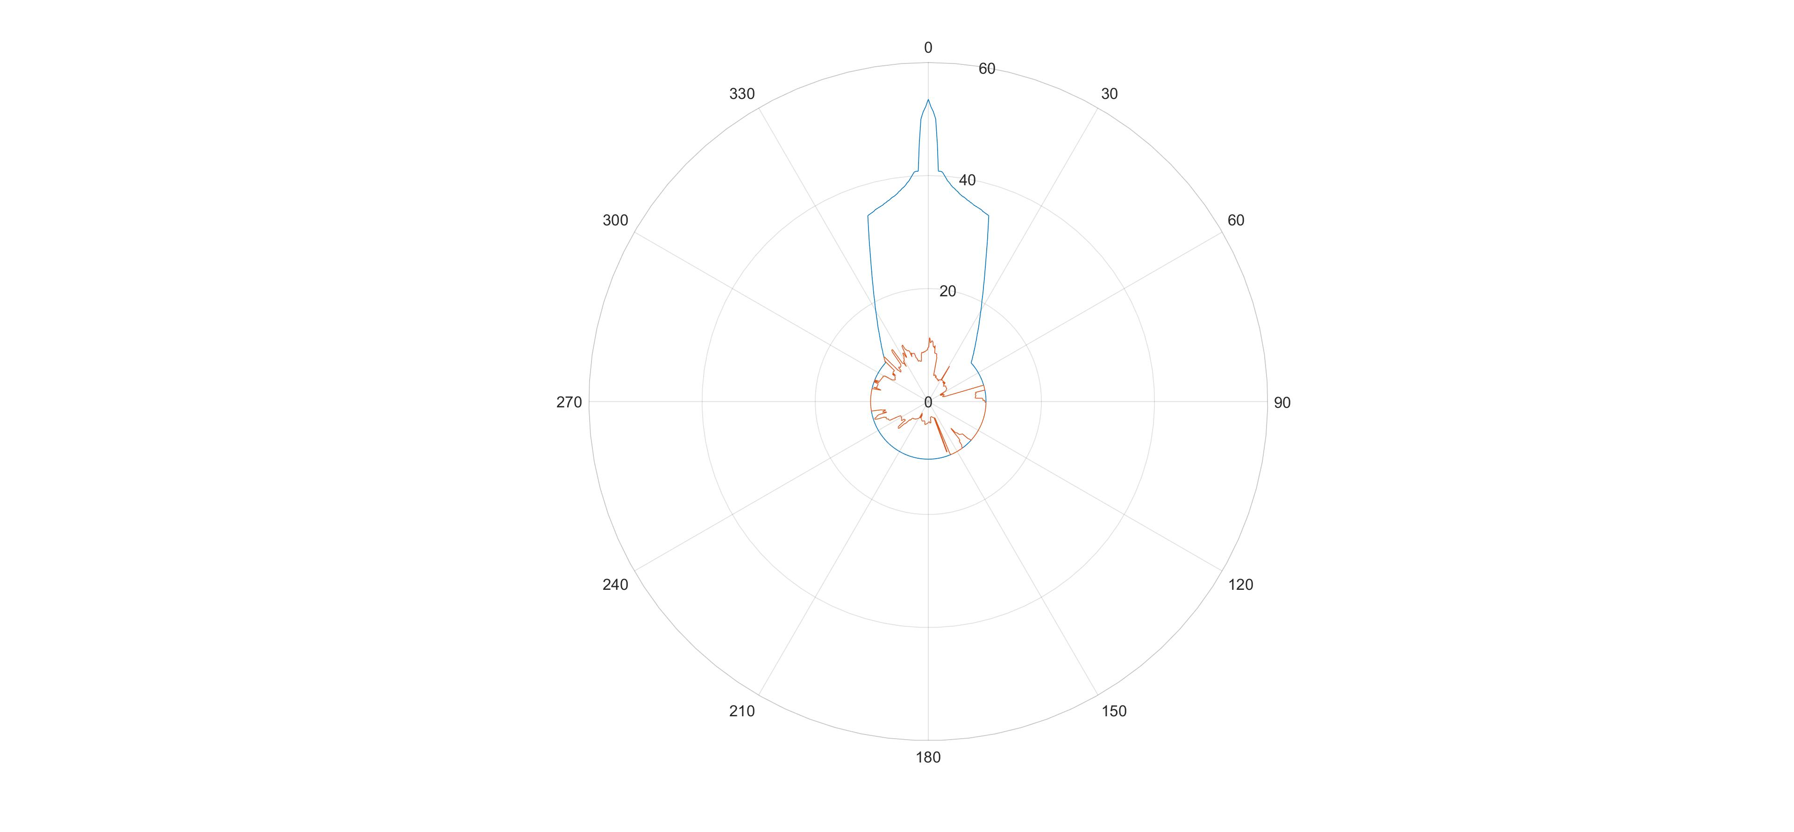
Figure 19: Protection contour for a percentage of time of 0.0119%

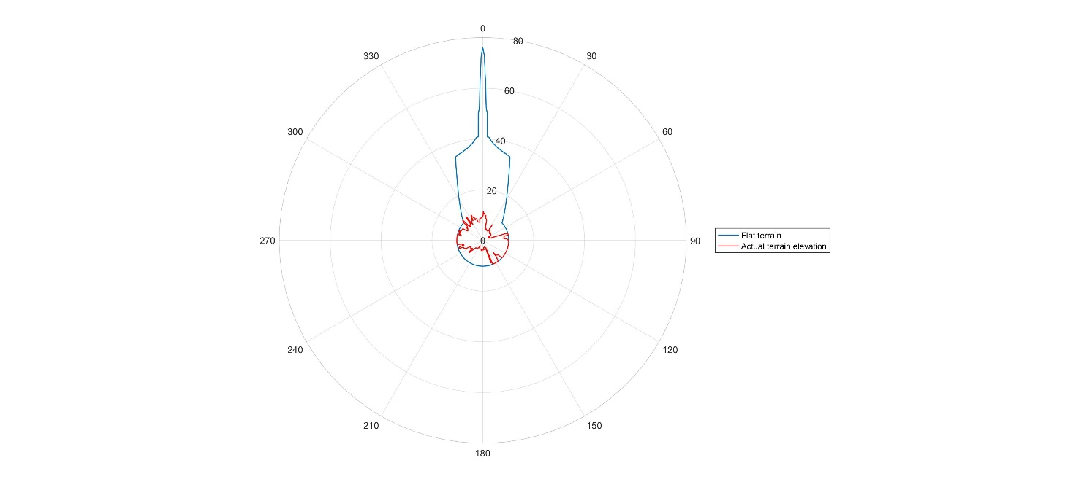
Figure 20: Protection contour for a percentage of time of 0.00027%

Conclusions
The studies have shown that the protection of FS stations in the band 14.25-14.5 GHz from NGSO FSS Earth stations transmitting in the same band requires the establishment of protection zones around the FS stations. In order to avoid large protection zones determined from typical FS parameters, more accurate calculations can be performed by taking into account the real characteristics of both FS and FSS stations, including the frequency channel, as well as its geographical locations; this implies however a case by case analysis. If such approach is considered, then sharing can be achieved between the FS and any NGSO satellite system because the protection zones would be computed by utilising the real FS stations characteristics. The typical size of these protection zones has been determined to be for the ONEWEB system in the order of 58 to 77 km in a 37 dBi gain of the FS station in the main beam direction (assuming smooth Earth and an FSS terminals with an e.i.r.p. towards the horizon of -20 dBW/(40 kHz)), but decreases rapidly down to 11 km outside the main beam direction of the FS station, under the same assumptions.
When establishing compatibility with fixed links with known locations deployed within an administration, the NGSO satellite system will initially identify the protection zones for all fixed link receiving stations using the methodology given above. If an administration has deployed fixed links in the band 14.25-14.5 GHz and the specific locations of fixed links cannot be provided, then the protection zones could be established as the whole territory of the administration. In both cases, the protection zone may extend beyond the national territory into the territories of neighbouring administrations.
The NGSO satellite system will then be able to deploy the "control of emission" function, stipulated in the ETSI standard EN 303 980 ‎[1] (see Section ‎4.2.3 above) to ensure the suppression of relevant frequencies by fixed earth stations located within the protection zone. In this way, compatibility with the fixed service can be achieved.

Sharing with the Radio Astronomy Service in the 14.47-14.5 GHz band
From a technical point of view, the study contained in this section uses the same approach as one that would be conducted between co-primary services; nevertheless, it is reminded that the RAS allocation in this band has a secondary status.

Methodology
The methodology used in the study consists of determining an area around the RAS station where any single deployed FSS earth station will not be able to use the frequency channels overlapping with the frequencies observed by the RAS station in the 14.47-14.5 GHz band. This methodology does not take into account the effect of aggregate interference resulting from simultaneous operation of several FSS earth stations.
The propagation loss needed in order to meet the RAS interference threshold is given by:
$Lp=e.i.r.p. +G_{R}-I+10log⁡\left(\frac{B}{40}\right)$ (5)
where
- Lp: Propagation loss required (dB);
- e.i.r.p.: FSS ES e.i.r.p. towards the horizon (dBW/(40 kHz));
- GR: RAS antenna gain towards the FSS earth station (0 dBi);
- I: RAS interference threshold (dB);
- B: RAS reference bandwidth considered (150 kHz).
This simplifies to
$Lp=e.i.r.p.+219.7$ (6)
With a -20 dBW/(40 kHz) e.i.r.p., this roughly leads to a required propagation loss of 200 dB, with an associated percentage of 2% of time.
Once the required propagation loss is known, the corresponding separation distance can be determined using a propagation model, in which case Recommendation ITU-R P.452-14 ‎[4] was used to this effect.
The size of protection areas around RAS stations varies significantly and needs to be determined on a case-by-case basis to take into account actual FSS and RAS parameters and surrounding terrain by the administration where the RAS station operates.

Results
Figure 21 shows the propagation loss calculated using Recommendation ITU-R P.452-14 function of the separation distance, for the RAS location at Effelsberg (Germany).
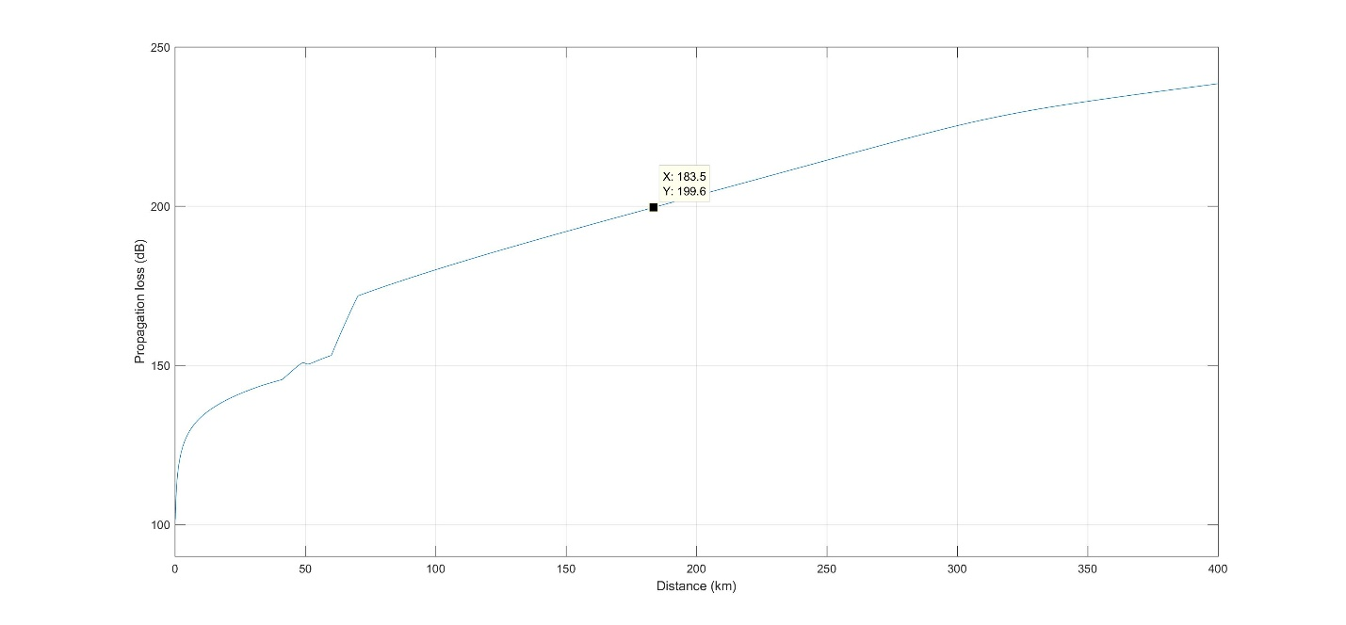
Figure 21: Recommendation ITU-R P.452 Propagation loss over flat terrain
The distance corresponding to a 200 dB loss is in the order of 184 km.
Using a similar approach, the next figures show the separation distances for the RAS stations in Table 11, taking into account the actual terrain profile.
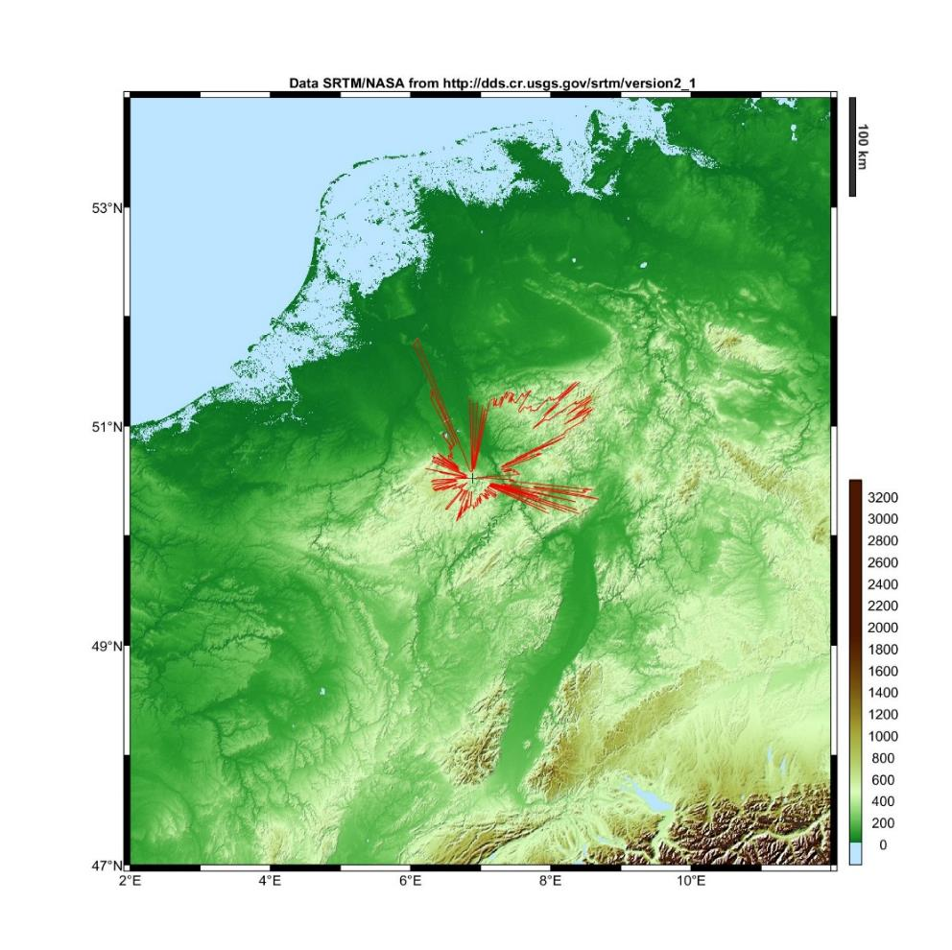
Figure 22: Effelsberg, Germany - max 152 km

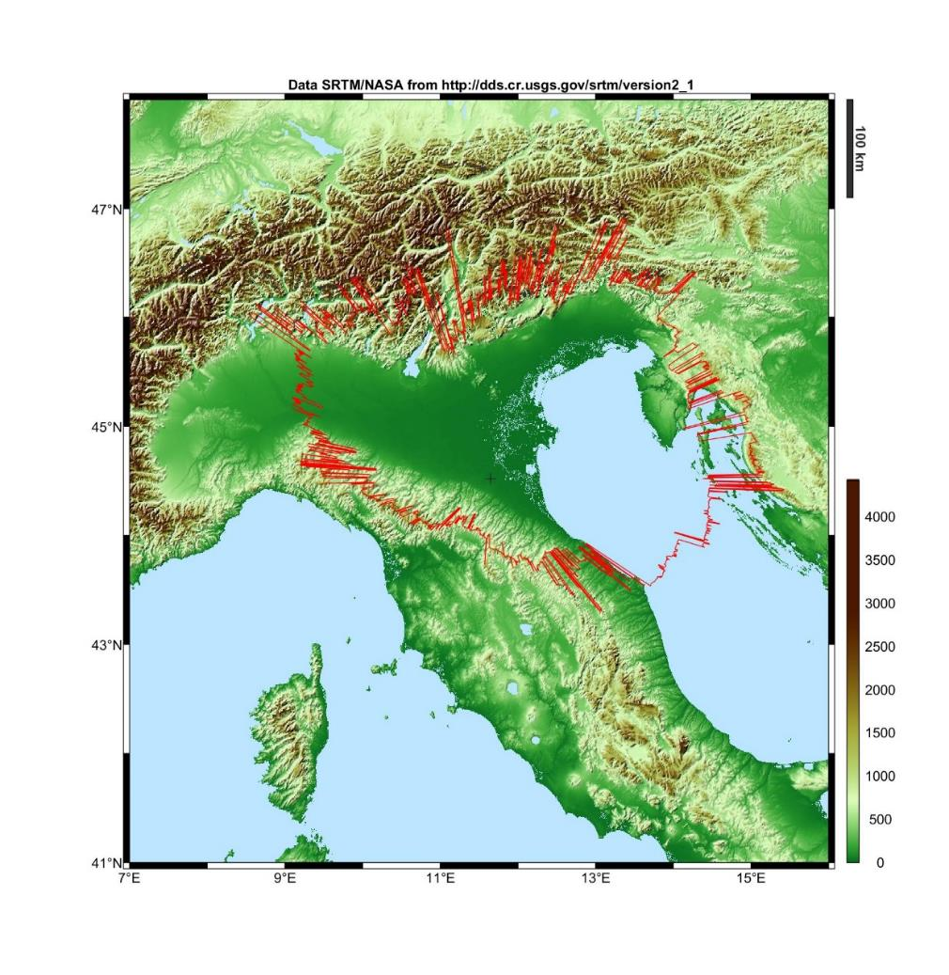
Figure 23: Medicina, Italy - max 300 km

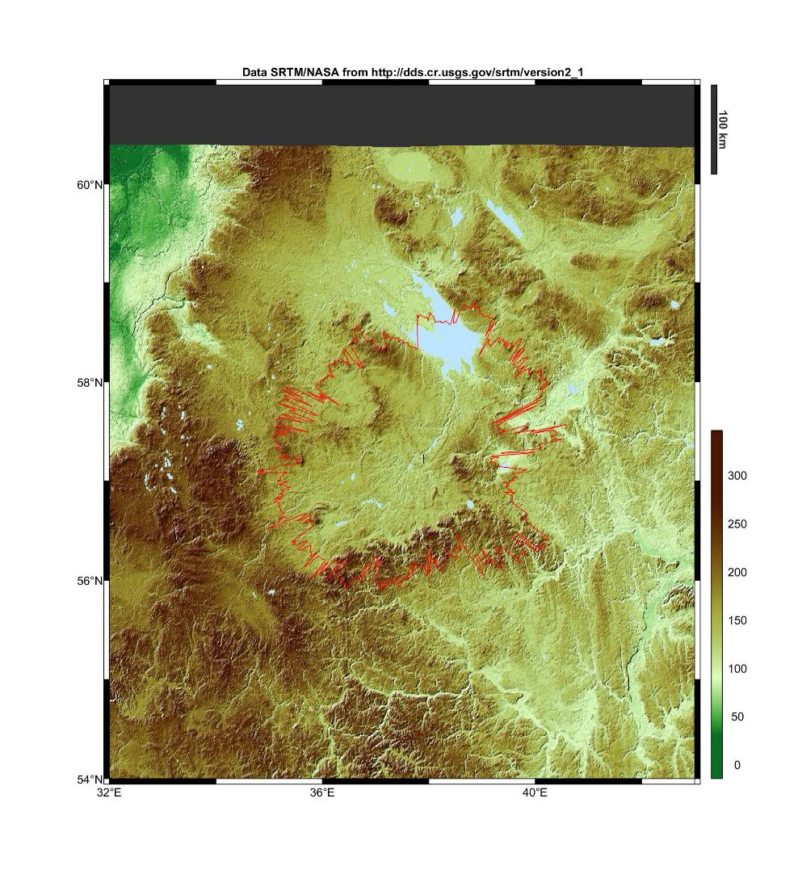
Figure 24: Kalyazin, Russia - max 200 km

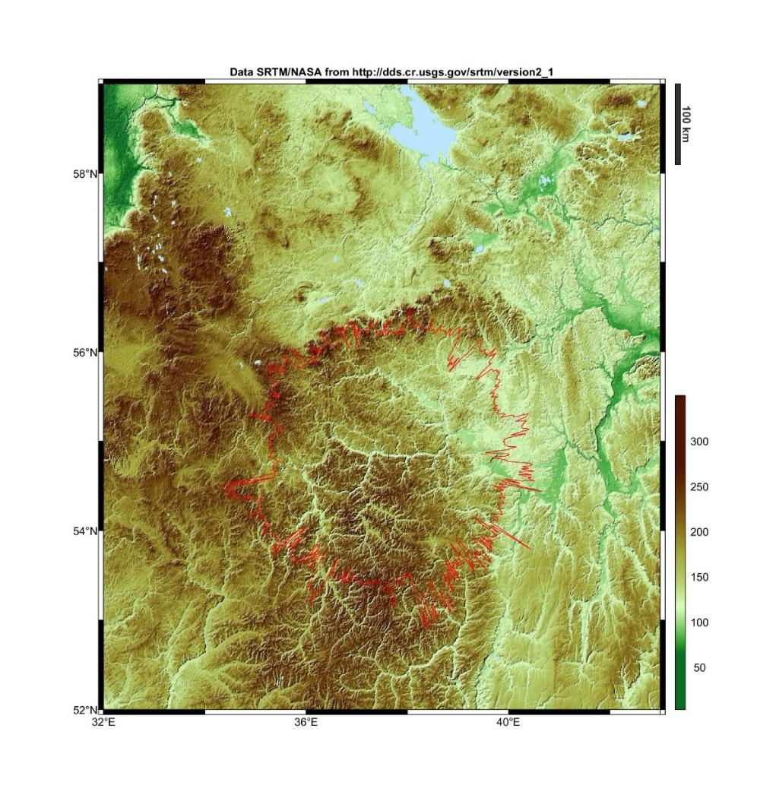
Figure 25: Puschino, Russia - max 220 km

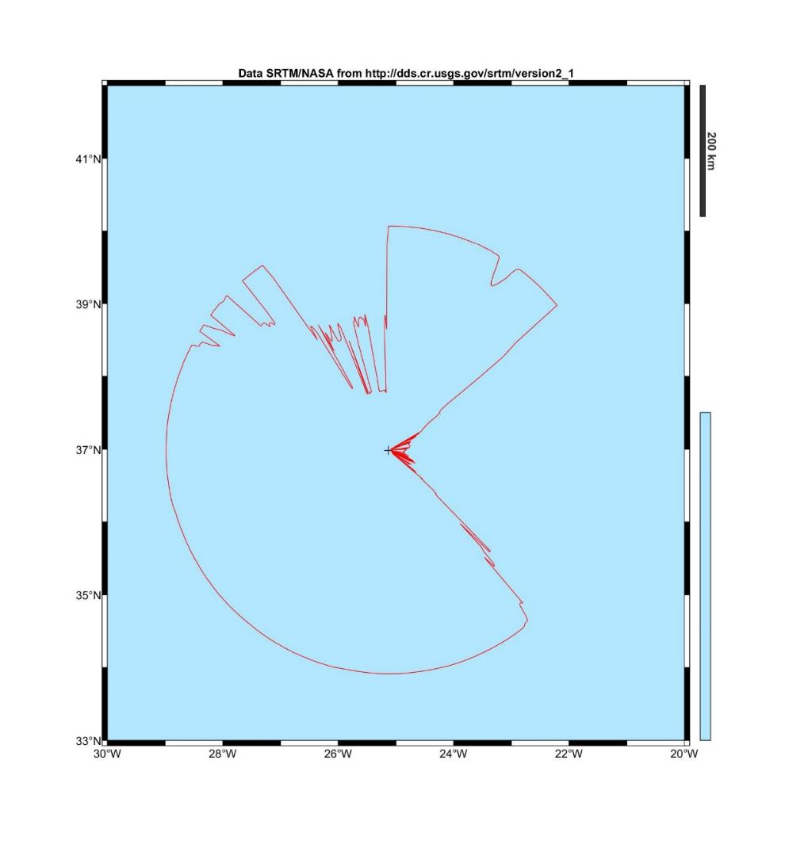
Figure 26: Santa Maria, Portugal – max 345 km, but over sea

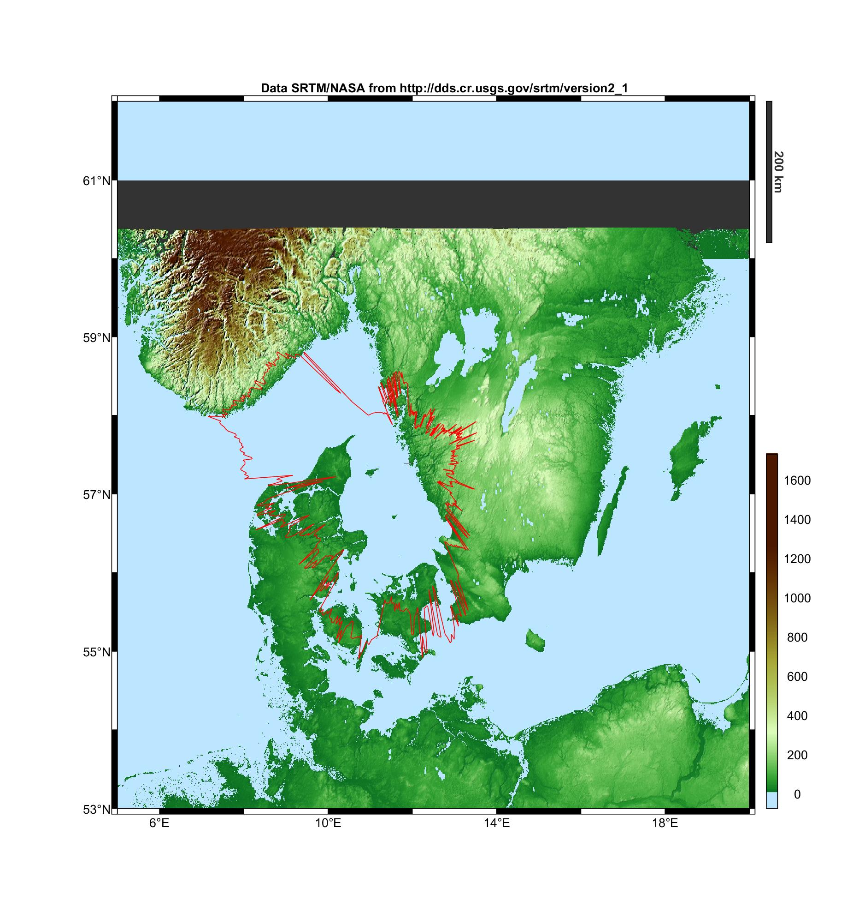
Figure 27: Onsala, Sweden – max 293 km

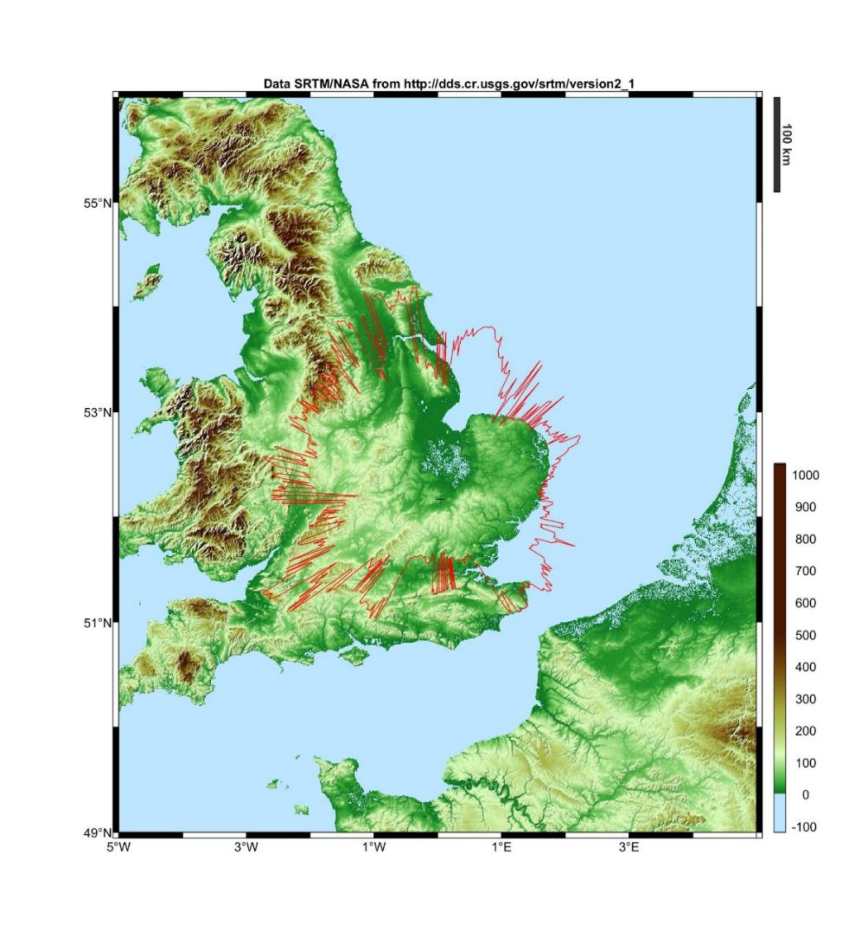
Figure 28: Cambridge, United Kingdom – max 235 km
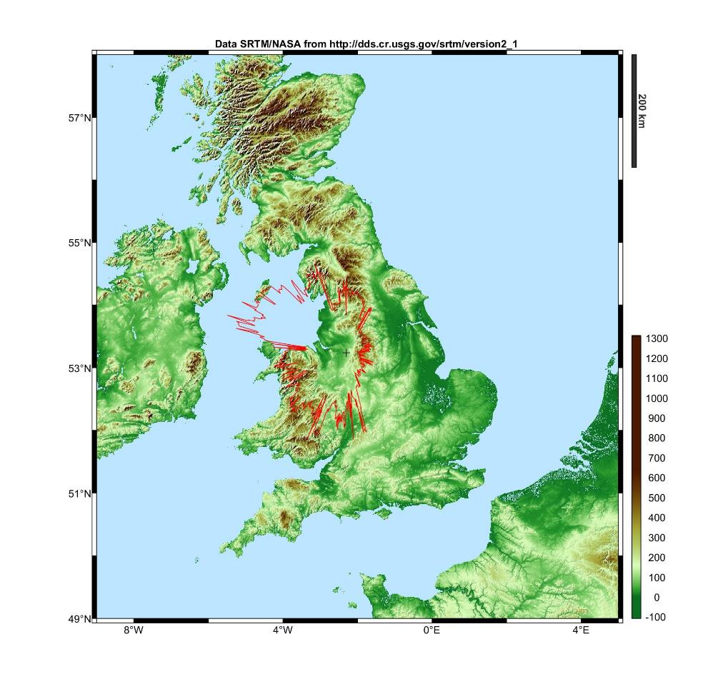
Figure 29: Jodrell Bank, United Kingdom – max 223 km

Conclusions
The protection of the RAS stations observing in the secondary RAS allocation in the band 14.47-14.5 GHz can be achieved through areas around such stations where any single NGSO FSS earth station will not be able to transmit on frequency channels overlapping with this frequency band (the aggregate effect of several earth stations was not assessed).
The size of the areas has to be determined on a case-by-case basis taking into account the FSS and terrain characteristics. For ONEWEB earth stations (with an e.i.r.p. towards the horizon of -20 dBW/(40 kHz)), the maximum distance can be up to 340 km thus not limiting it to a national issue for some of these RAS stations. For other kind of NGSO Earth stations, the distances would be computed with the relevant e.i.r.p. levels towards the horizon. Notwithstanding the conclusions in this subsection, calculations could be performed on a case by case basis and taking into account the actual FSS characteristics in order to determine the required protection zone.
When establishing compatibility with RAS observatories within an administration, the NGSO satellite system, could initially identify the protection zone for each of the RAS observatories using the methodology described in this section. It should be noted that the protection zone may extend beyond the national territory into the territories of neighbouring administrations. The NGSO satellite system would be able to deploy the "control of emission" function stipulated in the ETSI standard EN 303 980 ‎[1] (see Section ‎4.2.3above) to ensure the suppression of relevant frequencies used by RAS observatories located within the protection zone.

Sharing between NGSO FSS ESIM and incumbent services in the band 14-14.5 GHz

Sharing with FS in the band 14.25-14.5 GHz

Land FSS ESIM

Methodology
The methodology would not differ much from the one used for fixed FSS earth stations. The earth station is moving, but since its location is known by the Network Control Facility (NCF) thanks to the use of a GPS receiver within the earth station, this latter should be able to switch off emissions on the frequencies used by the FS stations as soon as the ES enters in their vicinity.
In order to ensure the most effective use of the available spectrum, the size of protection areas around FS stations is to be determined on a case-by-case basis, taking into account actual FS and FSS ES parameters as well as surrounding terrain. Section ‎9.1.1.2 provides an example of determination of such area surrounding the FS station in Table 7.

Results
For the FS system in Table 7, the propagation loss required is 135 dB with percentage of time of 0.0119% and 0.00027%, depending on which short-term protection criterion is considered. The required propagation loss becomes 164 dB with a percentage of time of 20% with regard to the long-term protection criterion.
Figure 30 shows the propagation loss calculated using ITU-R Recommendation P.452-14 ‎[4] function of the separation distance.
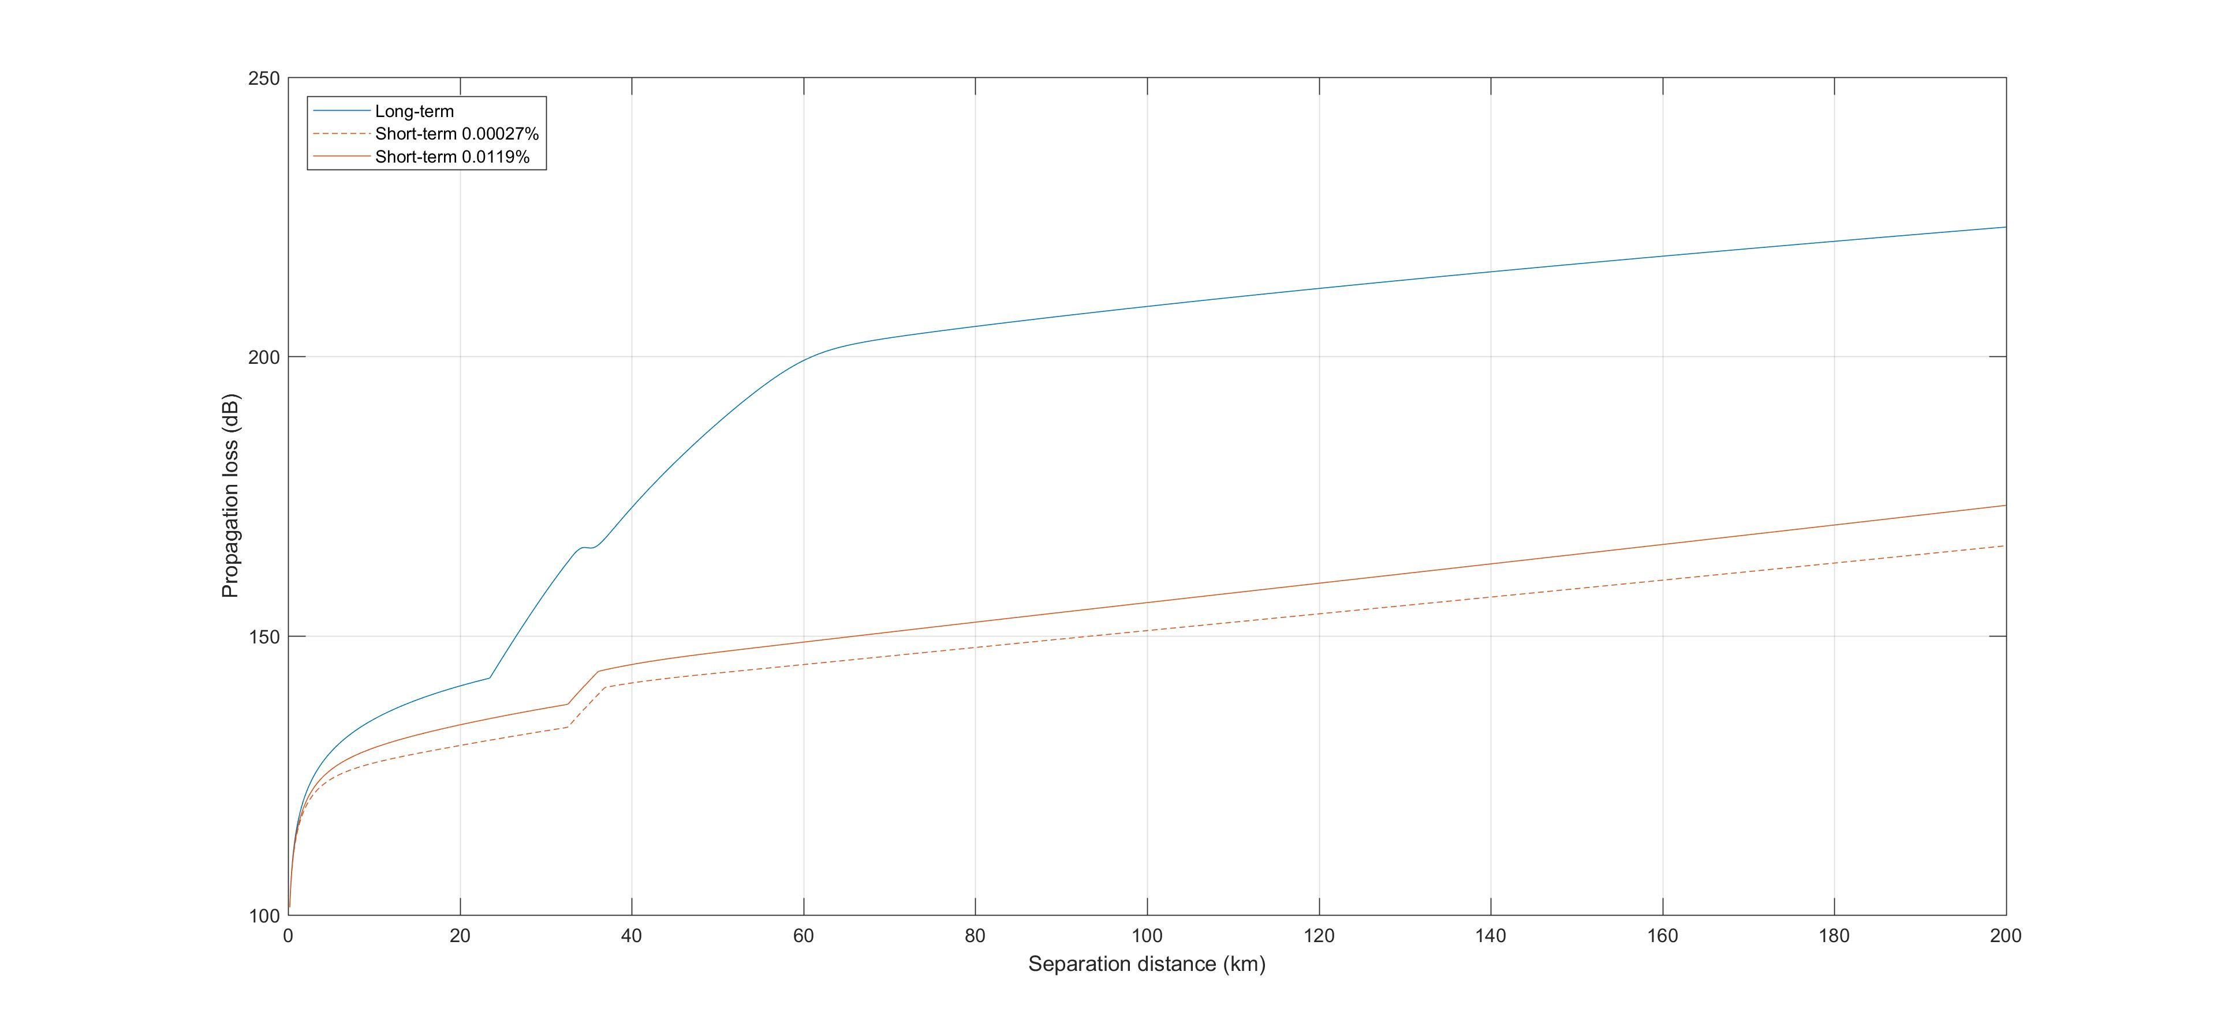
Figure 30: Recommendation ITU-R P.452 Propagation loss over flat terrain
The distance corresponding to a 135 dB loss for short-term is in the order of 33 km and 23 km, for the percentages of time of 0.00027% and 0.0119%, respectively. The distance corresponding to a 164 dB loss for long-term is around 33 km. This would be in the axis of the FS receiver. However, off-axis, the antenna gain decreases rapidly, and so is the required propagation loss, and the separation distance, as shown in Figure 31 for a FS station pointing North (blue curve). Figure 31 also shows the exclusion area for the same FS station located in United Kingdom (-1° longitude and 52° latitude), taking into account actual terrain elevation (red curve). The maximum distance is reduced to 10 km but at the same time the angle of interference is widened due to terrain clutter and reflections.
It should be noted that in this case the contour is driven by the long-term criterion and therefore does not vary with the percentage of time associated to the short-term.
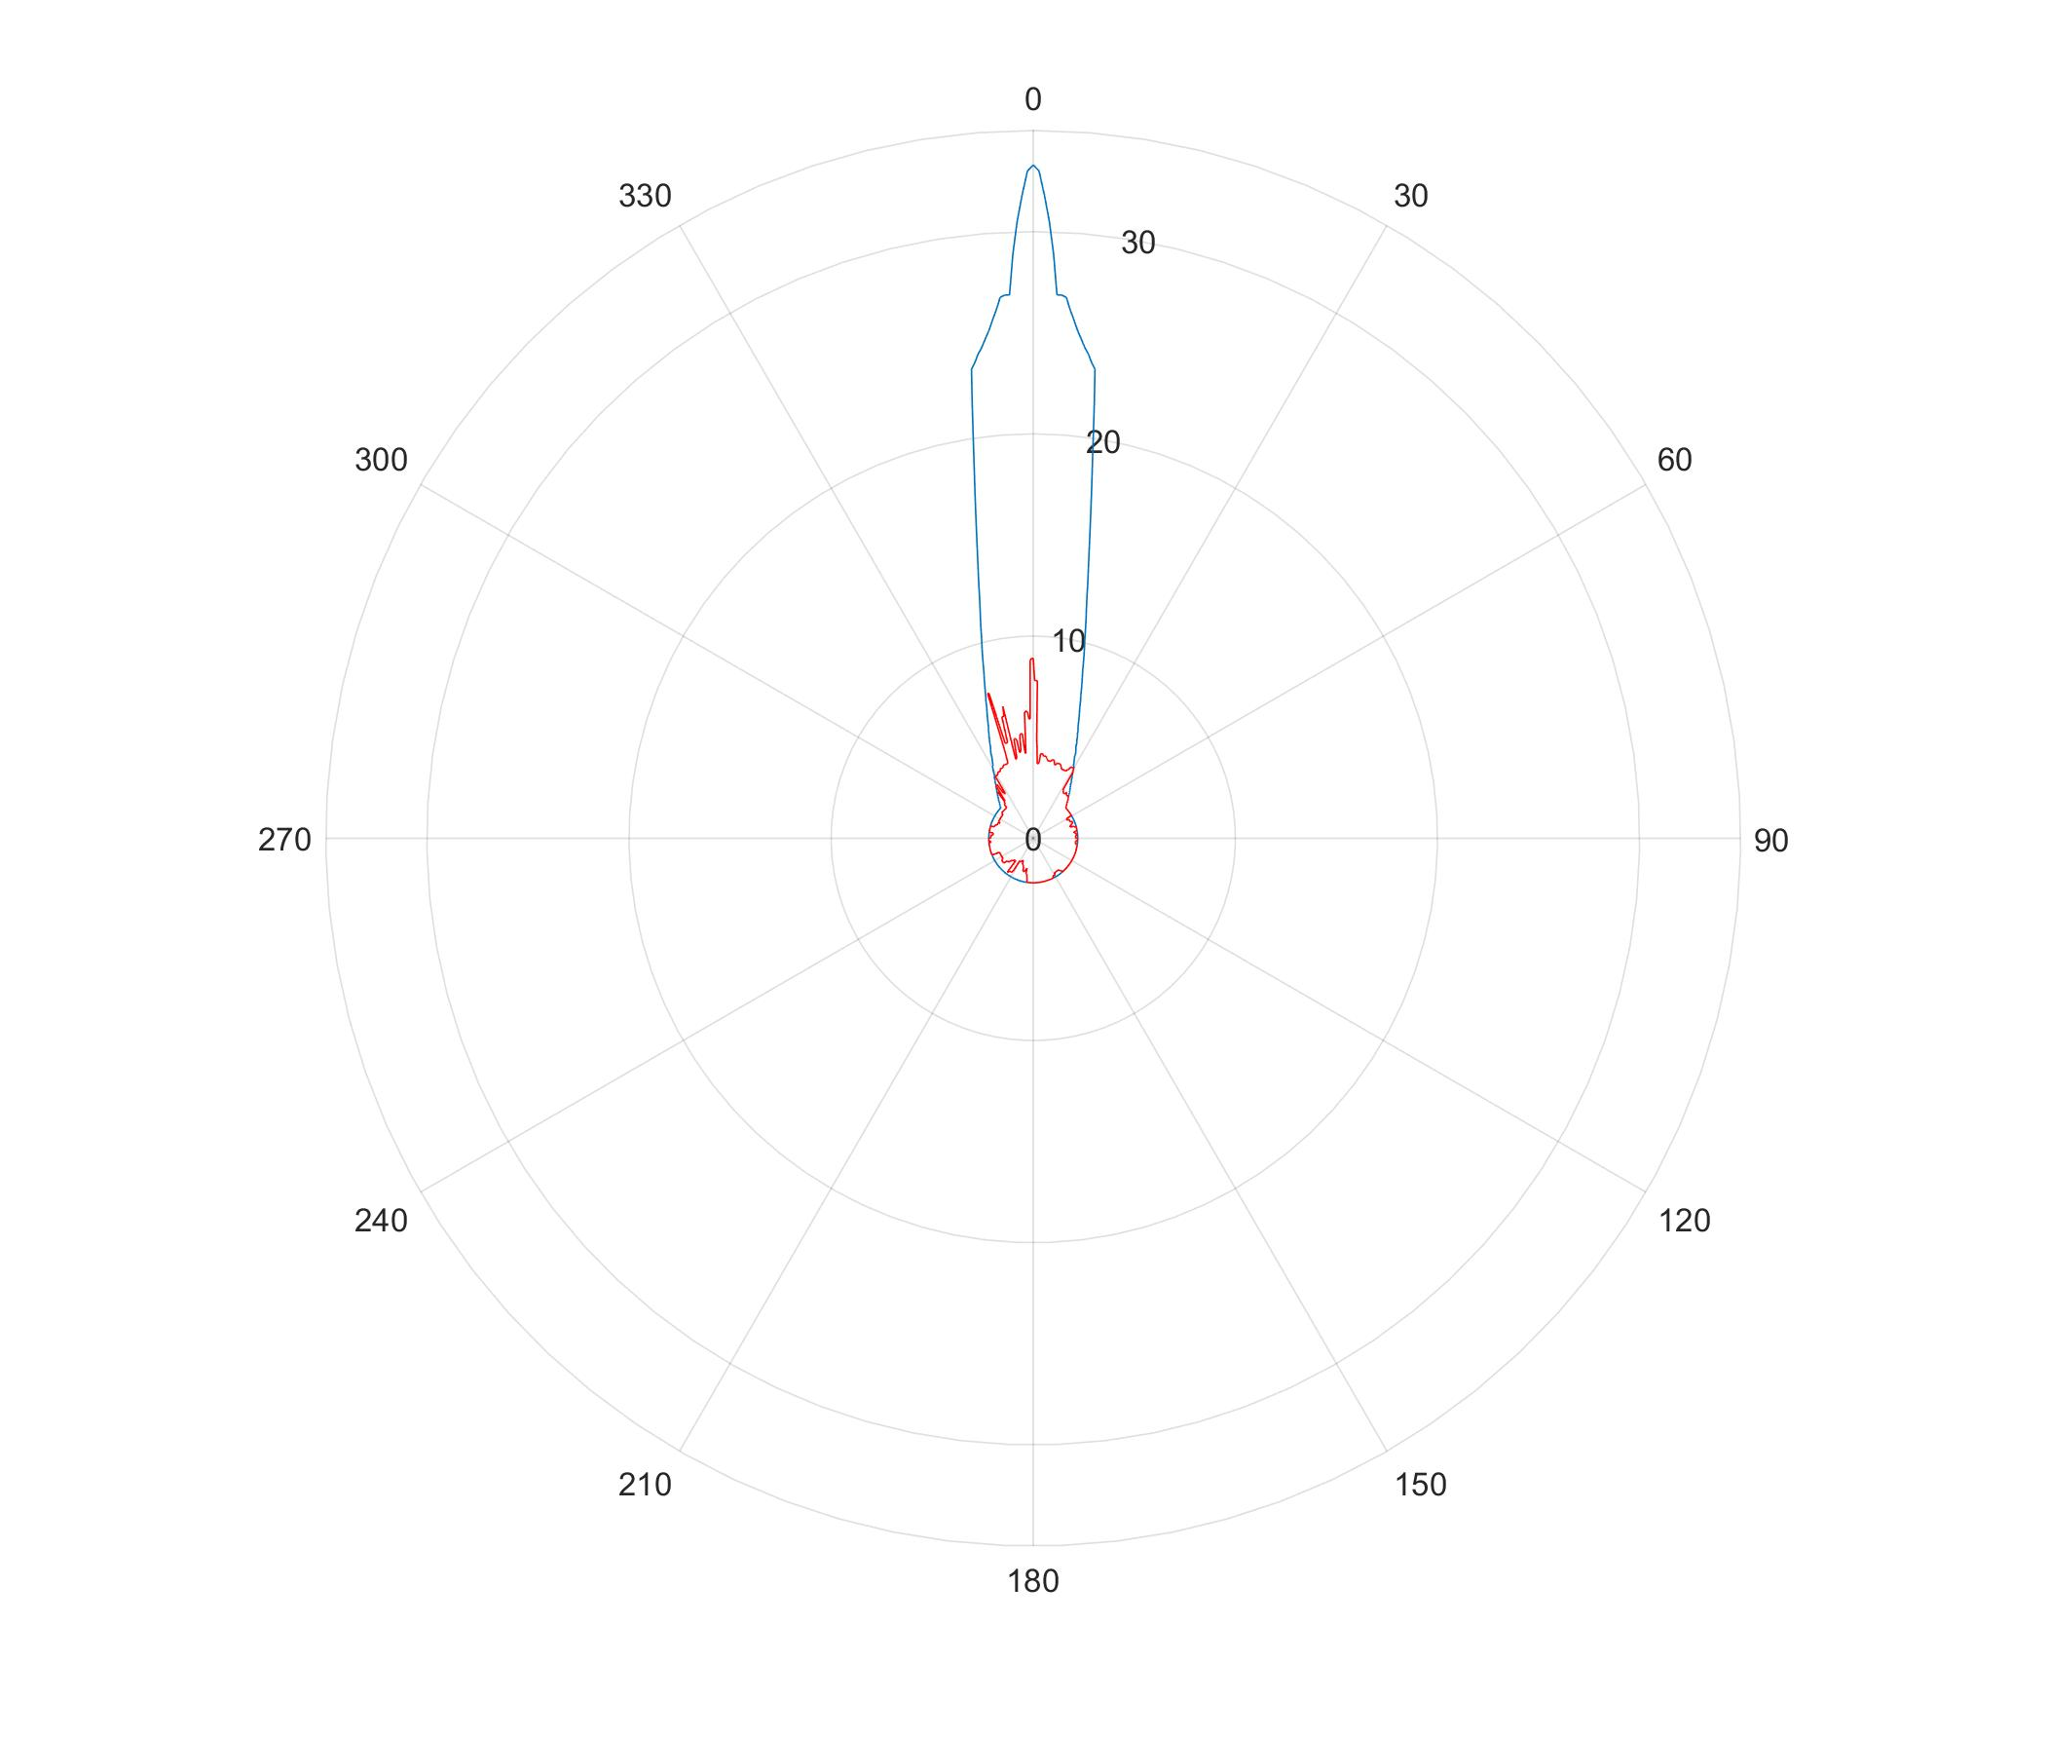
Figure 31: Protection contours
Compatibility with fixed service stations in the band 14.25-14.5 GHz used in few CEPT countries can be achieved through the establishment of protection zones around the fixed service station in which the FSS earth stations would have to cease transmitting on frequency channels overlapping with the channel used by the FS station. This cessation of transmission should be automatically performed by the network control facility of the NGSO FSS satellite system, and this action can be assisted by the GPS receiver incorporated in the earth station.
For the ONEWEB earth stations with e.i.r.p. towards the horizon of -33 dBW/(40 kHz), the typical size of these areas has been determined to be in the order of 57 to 77 km in a 37 dBi FS main beam direction assuming smooth Earth. ONEWEB This size decreases rapidly, down to 11 km outside the pointing direction of the FS station, under the same assumptions.
The actual size of the area has to be determined on a case by case basis, taking into account the FS and NGSO FSS ES characteristics, as well as the surrounding terrain.
When establishing compatibility with specific fixed links deployed within an administration, the NGSO satellite system should identify the protection zones for all fixed link receiving stations using the methodology described in this section. If an administration has deployed fixed links in the band 14.25-14.5 GHz, and the specific locations of fixed links cannot be established, then the protection zones could be established as the whole territory of the administration. In both cases, the protection zone may extend beyond the national territory into the territories of neighbouring administrations.
To ensure the suppression of relevant frequencies by land ESIM when entering the protection zone of FS stations, the NGSO satellite system should be able to deploy the "control of emission" function, stipulated in the ETSI standard EN 303 980 ‎[1] (see Section ‎4.2.3 above). In this way, the NGSO satellite system can avoid the use of the band 14.25-14.5 GHz or specific frequencies deployed by the fixed service within the FS protection zone and ensure compatibility with the fixed service.

Sharing with airborne FSS ESIM

Methodology
The methodology chosen is similar to the one used for studies between AMSS and FS in the band
14-14.5 GHz described in ECC Report 026 [18]. A number of aircraft are deployed on air routes, some of them using NGSO FSS ESIM.
In 2002 the number of aircraft simultaneously transmitting over the same channel was determined as being 50 to 60 in average over France and United Kingdom. However, this was supposing that the access scheme was CDMA with all these aircraft transmitting over the same frequency channel and that all the traffic over this frequency channel was for aeronautical earth stations.
This would not be the case with ONEWEB constellation since the access scheme is based on FDMA/TDMA and most of the traffic would be related to earth stations at fixed locations. Each aircraft within a satellite spot-beam would use a different frequency channel (of typically 20 MHz). The number of aircraft in visibility of the FS station to be considered at one moment in time in a 1 MHz bandwidth would therefore be directly given by the number of satellites that can be visible from the altitude where the aircraft are located (i.e. one channel per aircraft and satellite), multiplied by the number of beams using the same frequency channel (4 out of 16), multiplied by the ratio of aeronautical earth stations and the total number of earth stations.
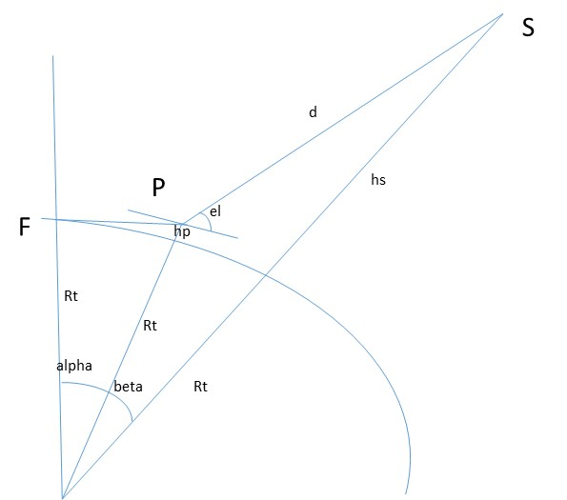

Figure 32: Geometry to determine the number of satellites in visibility above a given elevation angle
In Figure 32,
- F is the location of the Fixed Service station;
- P is the location of one aircraft seen from the FS station at the horizon (0° elevation);
- S is the location of one satellite seen at a given elevation el from the aircraft.
In order to determine the number of satellites that can be visible from a given altitude above 57° elevation it is necessary to first determine the angle alpha+beta, and then the number of satellites that would be contained within the cone of semi angle alpha+beta.
For an elevation of 57° and an aircraft altitude of 11 000m, the distance d (aircraft to satellite) is 1374 km, angles alpha and beta are 3.36° and 5.67° respectively. Therefore, 2.(alpha+beta)=18.06°.
At 0° latitude, since the satellite planes are separated by 20°, one single plane is contained within this 18.06° cone. The satellites are separated by 9° on a plane and therefore up to 3 satellites may be visible at one moment in time. At 45° latitude, the planes are separated by 14° and 2 planes are contained within the 18.06°. In this case the number of visible satellites becomes 6. At higher latitudes, some of the satellites are shut down since a number of them are covering the same area.
Assuming a 57° minimum elevation angle and an aircraft altitude of 11000 m would lead to a number of 6 visible satellites. Assuming that only 10% of the total traffic in the system is for aircraft stations, the total number of aircraft is 2 to 3, which is 30 times less than in previous studies for AES in the AMSS. As a conservative approach, a number of 5 to 6 aircraft in visibility at each moment in time has been considered in the studies.
The simulation tool used for the AMSS previous studies has been developed again by taking into account even more air routes than for the initial studies. One hundred trials have been performed, whereby the azimuth and elevation pointing angle of the FS station varies, as well as the location of aircraft. The simulation is run for a one day period and the aggregate I/N as well as the FDP are calculated at each second. The altitude of aircraft depends on the air route length. An altitude of 7000 m was assumed for air routes less than 800 km, 9000 m for air routes less than 2000 km and 11000 m otherwise. A sensitivity analysis has also been conducted for the worst-case FS pointing elevation angle of 5°, with altitudes ranging from 1000 to 11000 m.
The simulation tool was validated with the assumptions taken in 2001/2002 for fixed service and the pfd mask in Recommendation ITU-R M.1643 ‎[16]. As shown in Figure 34, this pfd mask meets the I/N of -20 dB for 20% of the time for all 100 trials. The average FDP is 0.7%, below the 1% criterion.
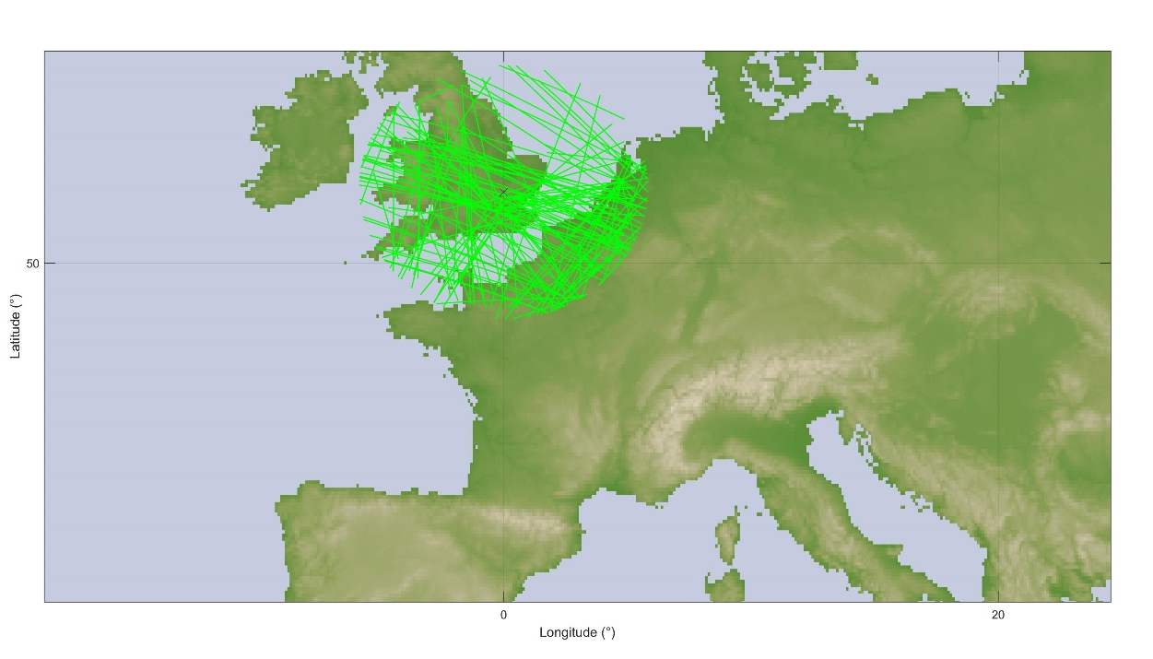
Figure 33: Air routes in visibility of the FS station

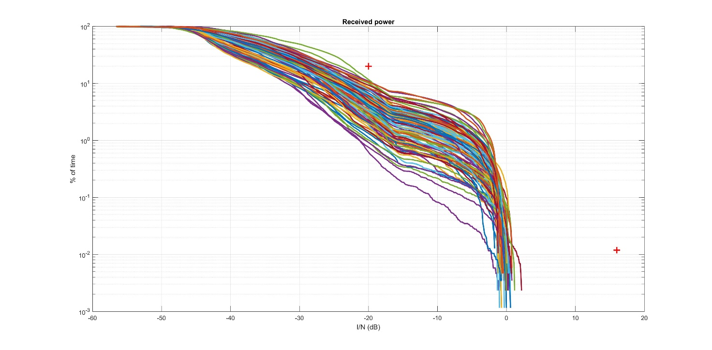
Figure 34: Validation tests with AMSS and previous assumptions

Short-term protection criterion
In order to evaluate the pfd corresponding to the short-term criterion, the following equation is used:
$pfd=\frac{I}{N}+N-G-10\log\left(\frac{λ^{2}}{4π}\right)+LF$ (7)
where
- pfd: Power flux density (dBW/m²/MHz);
- I/N: Short-term protection criterion (19 dB);
- N: Noise level (dBW/m²/MHz);
- G: Antenna gain (dBi);
- LF: Feeder loss (dB).
The application of this equation to the parameters contained in Table 7 gives a pfd level of
-109 dBW/m²/MHz. The pfd value has been also calculated for the FS system with a 49 dBi, 4 dB feeder loss and 6 dB noise figure as in ECC Report 026 [18]. The result is a short-term pfd of
-119 dBW/m²/MHz. There will therefore be a need to ensure that at least 10 dB margin is available with regard to the short-term criterion in order to encompass the 49 dBi FS system included in ECC Report 026.
This pfd value has to be met for angles of arrival of the radio-frequency wave from 0° to 5°.

Results of simulation
The pfd mask in part B of Recommendation ITU-R M.1643 ‎[16], relaxed by 10 dB, has been first tested:
- –122 + 0.5 · θ dB(W/(m² · MHz)) for θ ≤ 40°;
- –102 dB(W/(m² · MHz)) for 40° < θ ≤ 90°.
where θ is the angle of arrival of the radio-frequency wave (degrees above the horizontal).
Figure 35 provides the results of simulations for a FS station located in the United Kingdom with the characteristics in Table 7 for different pointing angles.
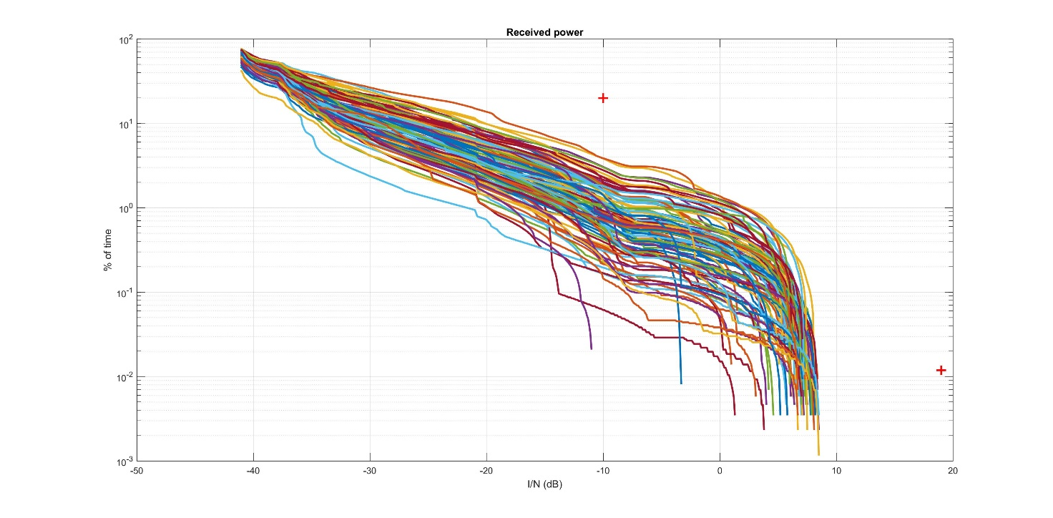
Figure 35: Recommendation ITU-R M.1643 mask relaxed by 10 dB
The pfd mask in Recommendation ITU-R M.1643 part A relaxed by 10 dB for all elevation angles meets both the FS short-term and long-term protection criteria with an additional margin due to the reduction of the number of aircraft operating with the same carrier. The average FDP over all trials is 1.4%, well below the 10% criterion. It should be noted that with this pfd level of -122 dBW at 0° elevation up to -119.5 dBW at 5° elevation, the short-term criterion is met with 11 dB margin, which is sufficient to also encompass the 49 dBi FS system in ECC Report 026 ‎[18].
The following mask has also been tested and appears to afford protection to the FS system in Table 7, as shown in Figure 36.
- –122 + θ dB(W/(m² · MHz)) for θ ≤ 40°;
- –82 dB(W/(m² · MHz)) for 40° < θ ≤ 90°.
where θ is the angle of arrival of the radio-frequency wave (degrees above the horizontal).
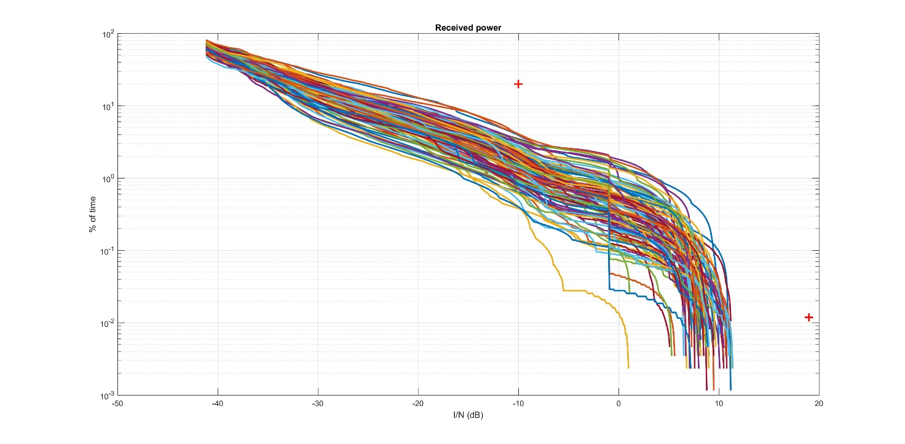
Figure 36: Pfd mask further relaxed by 20 dB for high elevations
There is still sufficient margin with regard to the long-term protection criteria. The average FDP is in this case 2%, well below the 10% criterion. There is however only 6.5 dB margin with regard to the short-term protection criterion, and 3.5 dB missing in order to encompass the 49 dBi FS system contained in ECC Report 026 [18].
To solve this issue, it is proposed to retain the following pfd mask:
- –122 dB(W/(m² · MHz)) for θ ≤ 5°;
- –127 + θ dB(W/(m² · MHz)) for 5° < θ ≤ 40°;
- –87 dB(W/(m² · MHz)) for 40° < θ ≤ 90°.
where θ is the angle of arrival of the radio-frequency wave (degrees above the horizontal).
Figure 37 gives the simulations results for the 37 dBi FS system contained in Table 7.
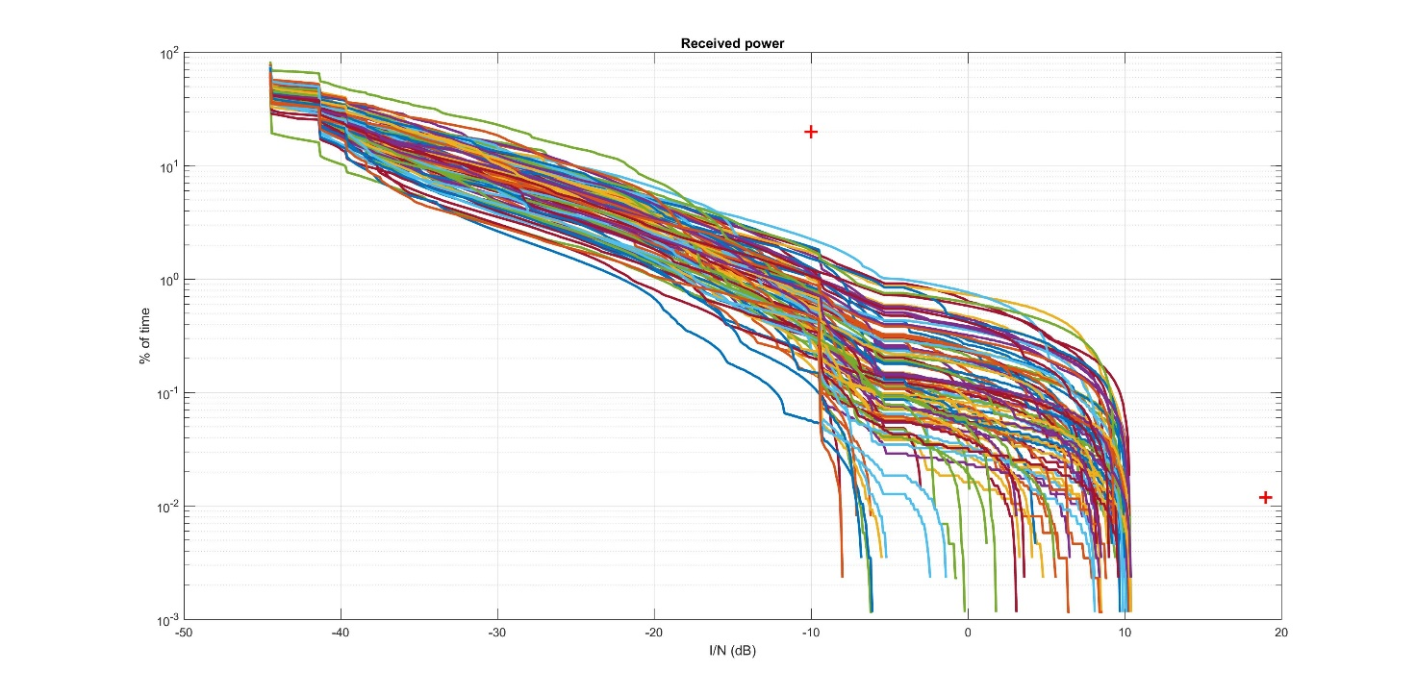
Figure 37: Pfd mask with a constant value below 5° elevation and a 37 dBi FS
Figure 38 gives the simulations results for the 49 dBi FS system contained in ECC Report 026.
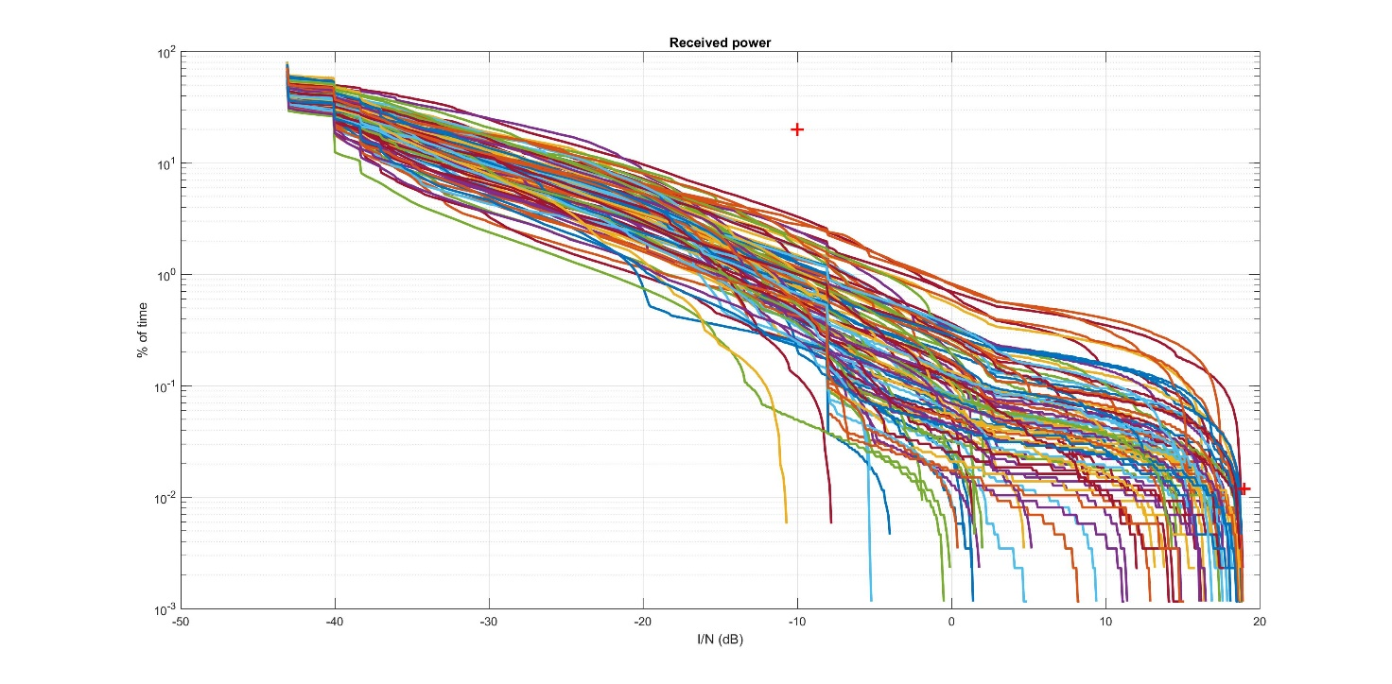
Figure 38: Pfd mask with a constant value below 5° elevation and a 49 dBi FS
It can be seen that both criteria are met. The average FDP is in this case respectively 2.48% and 2.24%, well below the 10% criterion, and there is still about 17 dB margin with regard to the long-term protection criterion.
Figure 39 provides a sensitivity analysis where the altitude of the aircraft is changed from 1000 m to 11000 m for a pointing elevation angle of 0° and a pointing azimuth of 90°, corresponding to a worst case in terms of long-term interference. It shows that the worst case actually appears for high altitudes, where the visibility time of aircraft as seen from the FS is longer. It should be noted however that meeting the pfd mask at low altitudes would be a constraint that could push the NGSO operator to limit the altitude above which an ESIM terminal can be activated in the band 14.25-14.5 GHz. The figure has been generated for the case in which the maximum gain of the FS station is 37 dBi.
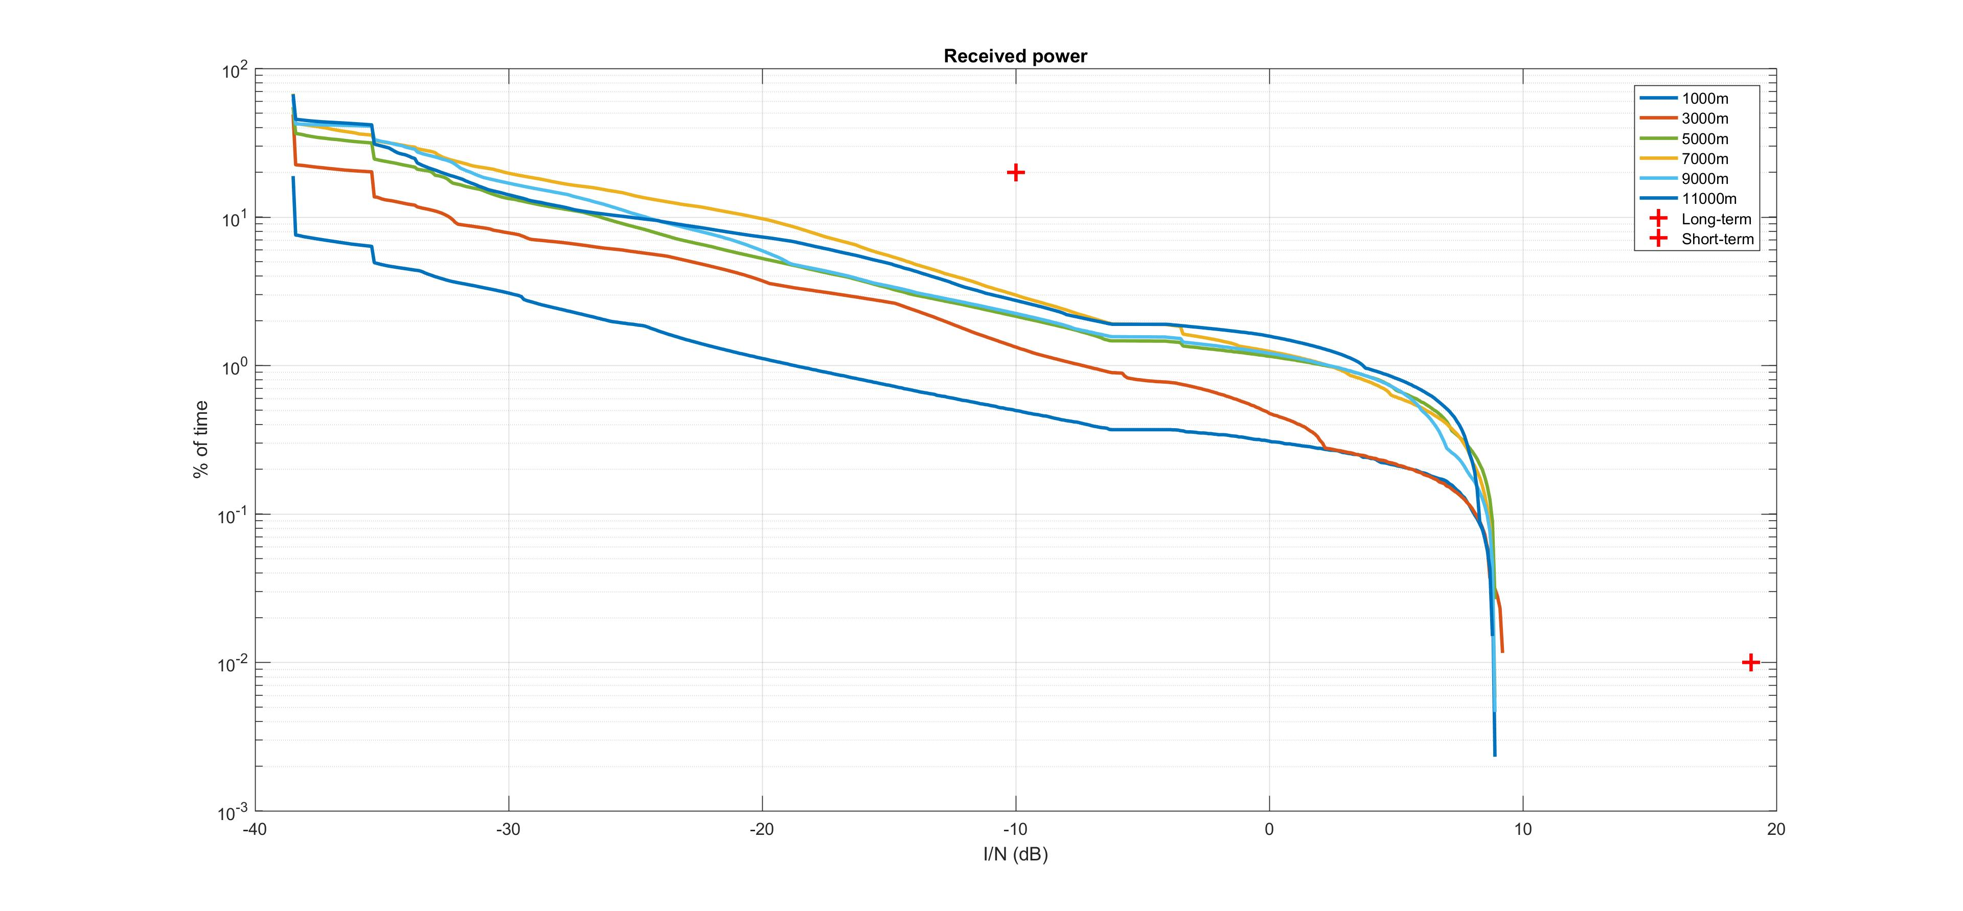
Figure 39: Sensitivity analysis vs altitude

Conclusions
The protection of fixed service stations in the band 14.25-14.5 GHz used in some CEPT countries can be achieved by imposing pfd limits on the Earth's surface to airborne ESIM.
The assessments have shown that for airborne ESIM operating in the ONEWEB system under the FSS allocation, the following mask would protect FS station:
- –119.5 dB(W/(m² · MHz)) for θ ≤ 5°;
- –124.5 + θ dB(W/(m² · MHz)) for 5° < θ ≤ 20°;
- –84.5 dB(W/(m² · MHz)) for 20° < θ ≤ 90°.
where θ is the angle of arrival of the radio-frequency wave (degrees above the horizontal).
The method(s) to comply with the mask depend on the NGSO FSS operator. This can be achieved through control of the e.i.r.p. radiated in the back lobes of the airborne earth station, taking into account, as appropriate for the specific deployments, the available fuselage attenuation.
The simulations that resulted in the proposed mask have taken into account particular characteristics of the ONEWEB NGSO system. If a different NGSO system has to be considered, the number of ESIM visible by the FS station and simultaneously transmitting over the same channel as the FS station has to be clearly specified. Such number may depend on the number of satellites visible by aircraft at a given altitude, the type of access scheme of the NGSO FSS system, the percentage of traffic carried by ESIM on board aircraft.
Once such number of earth stations is clearly identified, a new analysis should be performed to verify if the limits above can still protect the FS or if new limits should be established for ESIM aircraft in the relevant NGSO system.

Sharing with shipborne FSS ESIM

Methodology
There is already a regulation for ESV with a maximum distance from the coast set at 125 km. The calculation of this distance has been done assuming a given FSS e.i.r.p., with the FSS ES pointing towards a GSO satellite. CEPT proposed at WRC-15 to modify this distance and set up a distance as a function of the FSS ES e.i.r.p. This was however not accepted by the conference.
In order to assess the separation distance from the coast that would be required to ensure the protection of FS from shipborne NGSO ESIM, the methodology contained in Recommendation ITU-R SF.1650 ‎[17] has been applied. Similarly to the airborne ESIM, a MATLAB program has been developed and validated using the exact parameters contained in Recommendation ITU-R SF.1650. The separation distances and percentage of time obtained were similar to the ones obtained in this recommendation although the separation distances were slightly higher (in the order of 2 km).
Recommendation ITU-R P.452 ‎[4] was used for the propagation model. The latitude has been arbitrarily set to 45° and the longitude to 0°, noting that no terrain elevation was considered. The FS receiver is located 15 km from the coast and pointing towards the sea. The FS station considered was the same as in Recommendation ITU-R SF.1650. Two different percentages of time associated to the short-term protection criterion have been considered; namely 0.0119% and 2.7 10-4%.
The parameters for the FSS ES were then replaced by the e.i.r.p. of the NGSO earth station towards the horizon. It should be noted that the power spectral density of -33 dBW/(40 kHz) is valid assuming a transmission bandwidth of 2 MHz for the FSS earth station, which leads to a maximum e.i.r.p of -13 dBW towards the horizon when two channels are transmitted simultaneously, to be compared with the 2.2 to 16.2 dBW of the GSO FSS earth station in Recommendation ITU-R SF.1650 [17].

Results
Applying the methodology described above results in a separation distance of 14.6 km from an FS station with a 49 dBi antenna. The separation distance from the FS is 4.9 km when considering the 37 dBi FS station in Table 7. Both distances result in a 0 km distance from the shore when subtracting the 15 km distance between the FS and the shore. The different results obtained are summarised in Table 17.
Table 17: Separation distance from the FS/from the shore obtained using SF.1650 recommendation
 | 49 dBi FS with ps=0.00027% | 49 dBi FS with ps=0.0119% | 37 dBi FS with ps=0.00027% | 37 dBi FS with ps=0.0119%
3 vessels per day | 13.4 km/0 km | 8.7 km/0 km | 4.6 km/0 km | 3.7 km/0 km
6 vessels per day | 14.6 km/0 km | 9.2 km/0 km | 4.9 km/0 km | 3.9 km/0 km

Conclusions
The results showed, for the assumptions made, that ONEWEB earth stations radiating with a total e.i.r.p of -13 dBW towards the horizon, do not need to maintain any separation distance from the shore..
If required, a pfd limit at the low water mark could be defined similarly to the one developed in Ka-band. Assuming the FS characteristics and methodology specified in Recommendation ITU-R. SF.1650; such a pfd limit would be of -116 dBW/m²/MHz at 80m above sea level, with an associated percentage of time of 0.06% for the 0.00027% short-term protection criterion. For the protection criterion with associated percentage of time of 0.0119%, the same pfd is applicable (-116 dBW/m²/MHz) but it is associated to a percentage of time of 4.5%.
A pfd limit would apply to all NGSO FSS system, since it only depends on the FS characteristics, whereas a separation distance would require also the knowledge of the e.i.r.p. radiated towards the horizon by the NGSO FSS system.

Sharing with RAS in the 14.47-14.5 GHZ BAND
From a technical point of view, the study contained in this section uses the same approach as one that would be conducted between co-primary services; nevertheless, it is reminded that the RAS allocation in this band has a secondary status.

Sharing with land FSS ESIM

Methodology
The methodology does not differ much from the one used for fixed FSS earth stations. The earth station may be moving, but its location should be known by the Network Control Unit (NCU) and this latter should be able to cease emissions over the frequencies observed by RAS stations as soon as the ES enters in the protection zone identified for the RAS station.
The size of protection zones around RAS stations needs to be determined on a case-by-case basis to take into account actual FSS earth stations parameters and surrounding terrain by the administration where the RAS station operates.

Results
Figure 40 shows the propagation loss calculated using P.452-14 [4] function of the separation distance, for a RAS location at Effelsberg (Germany).
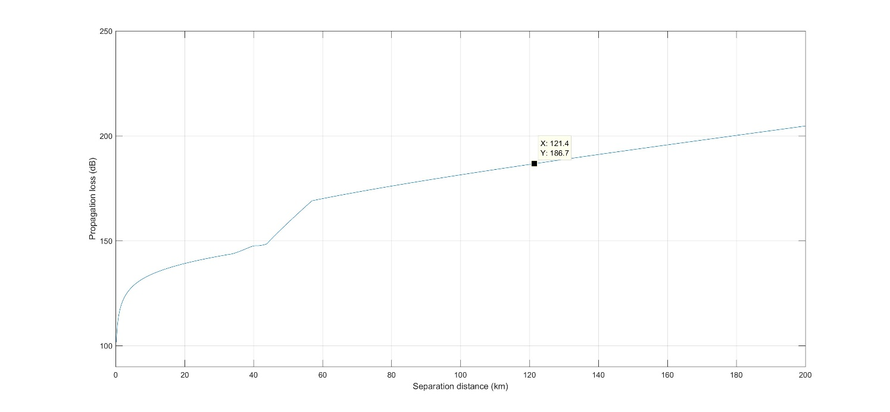
Figure 40: Recommendation ITU-R P.452 Propagation loss over flat terrain
The distance corresponding to a 183 dB loss is in the order of 121 km.
Figure 41 shows the separation distances around the same RAS station, taking into account actual terrain elevation. The maximum distance is reduced in most directions, with the exception of a few azimuths where it reaches up to 150 km. This is due to the fact that Effelsberg is at a 369m altitude which adds to its antenna height above ground. In those directions where the separation distance reaches high values, the terrain elevation decreases down to 0m, and the results are similar to a flat terrain case with a 420m antenna height above ground instead of 50m.
The following figures show the same attenuation contour for the other RAS stations listed in Table 11.
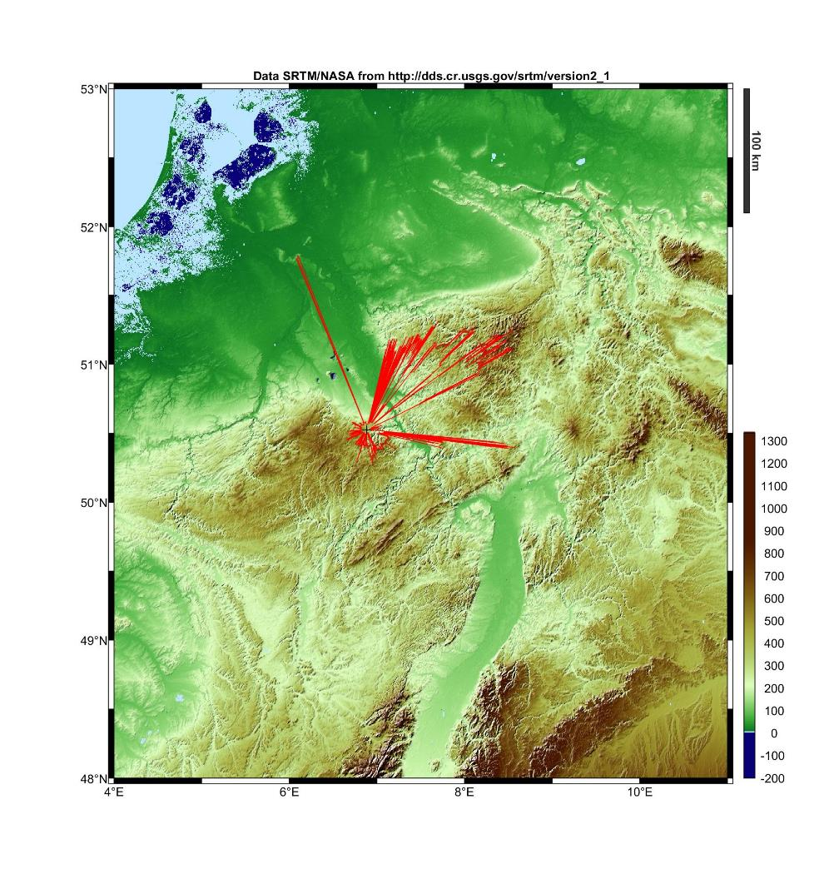
Figure 41: Effelsberg, Germany – max 150 km
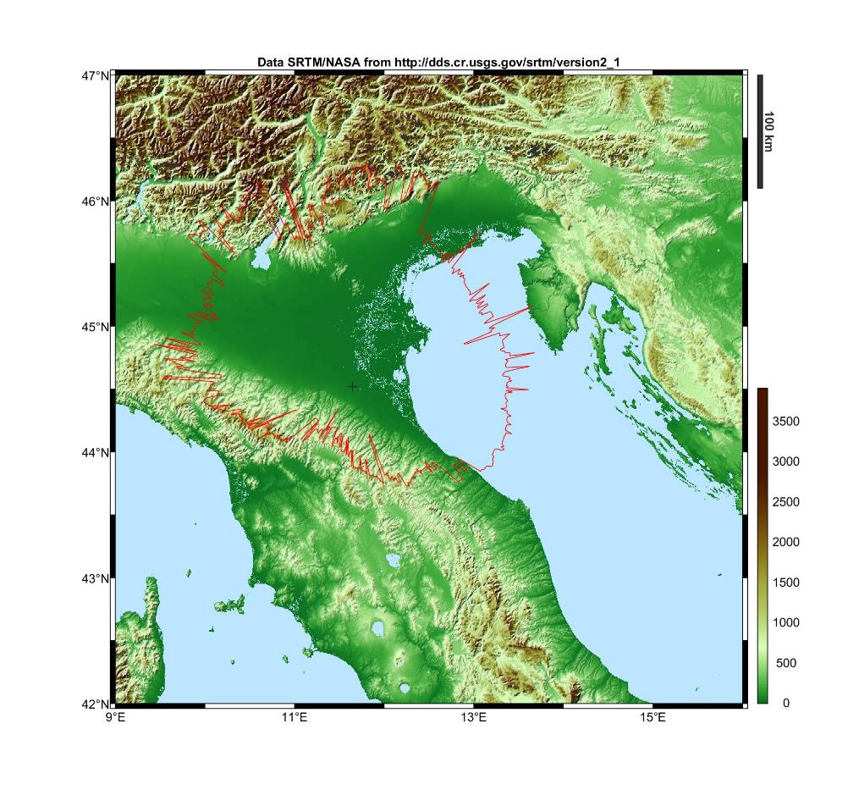
Figure 42: Medicina, Italy – max 200 km

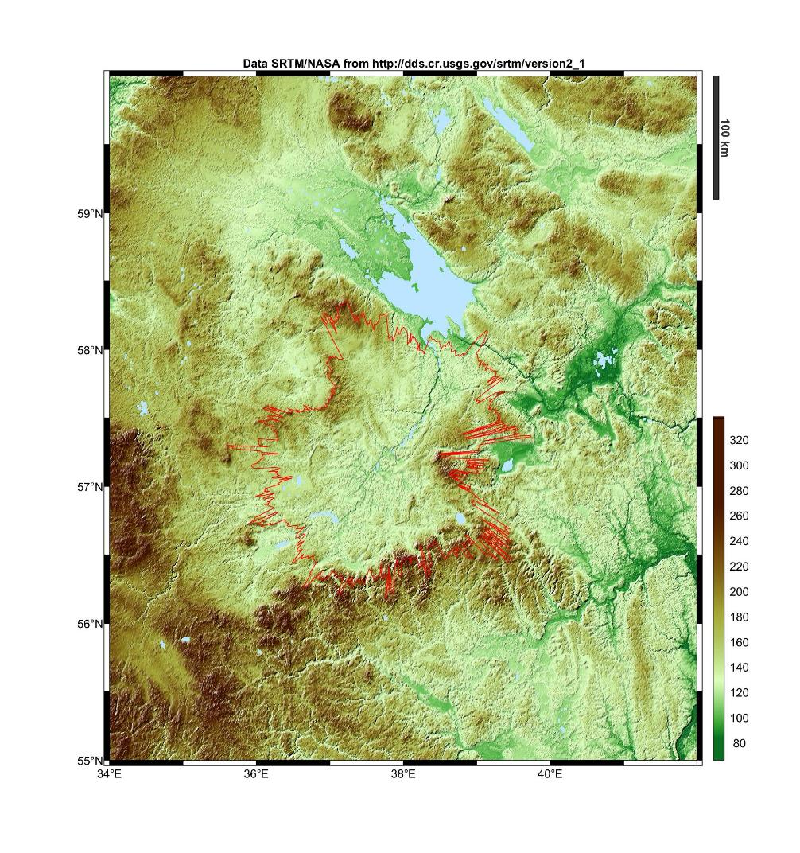
Figure 43: Kalyazin, Russia – max 140 km

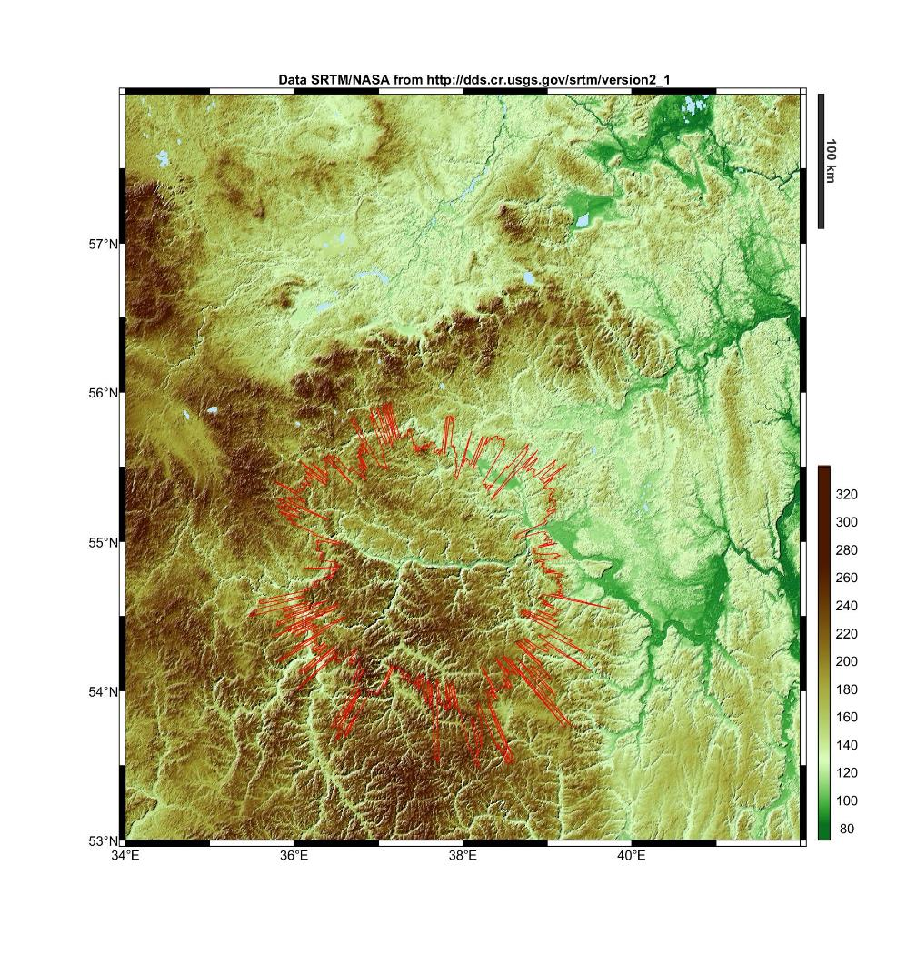
Figure 44: Puschino, Russia – max 160 km

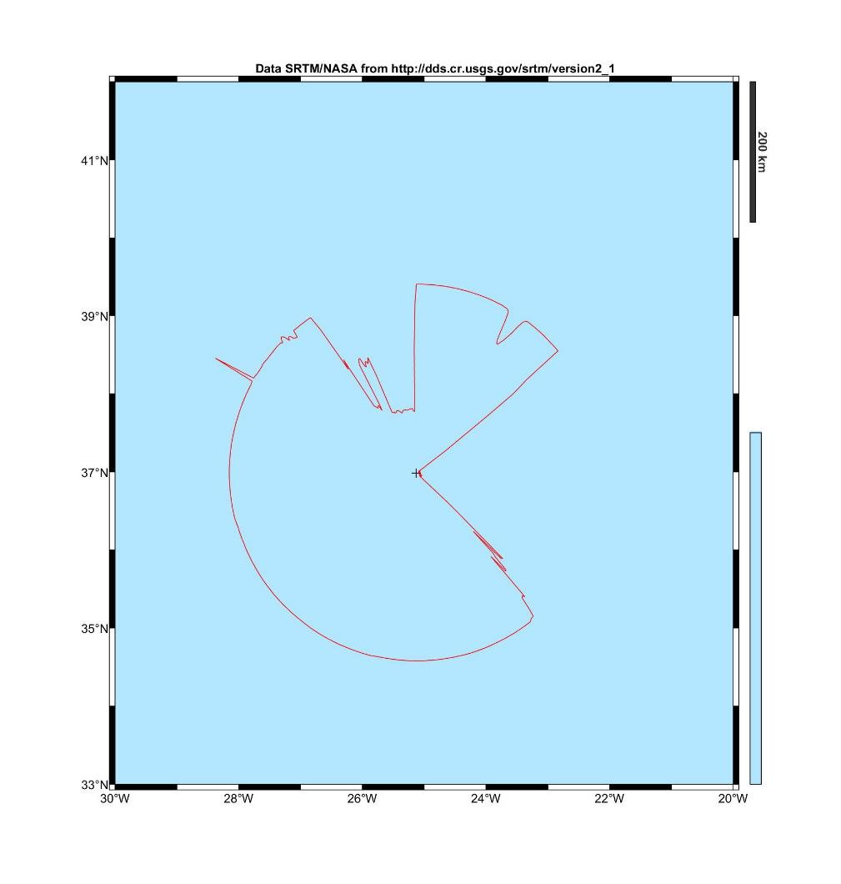
Figure 45: Santa Maria, Portugal – max 332 km

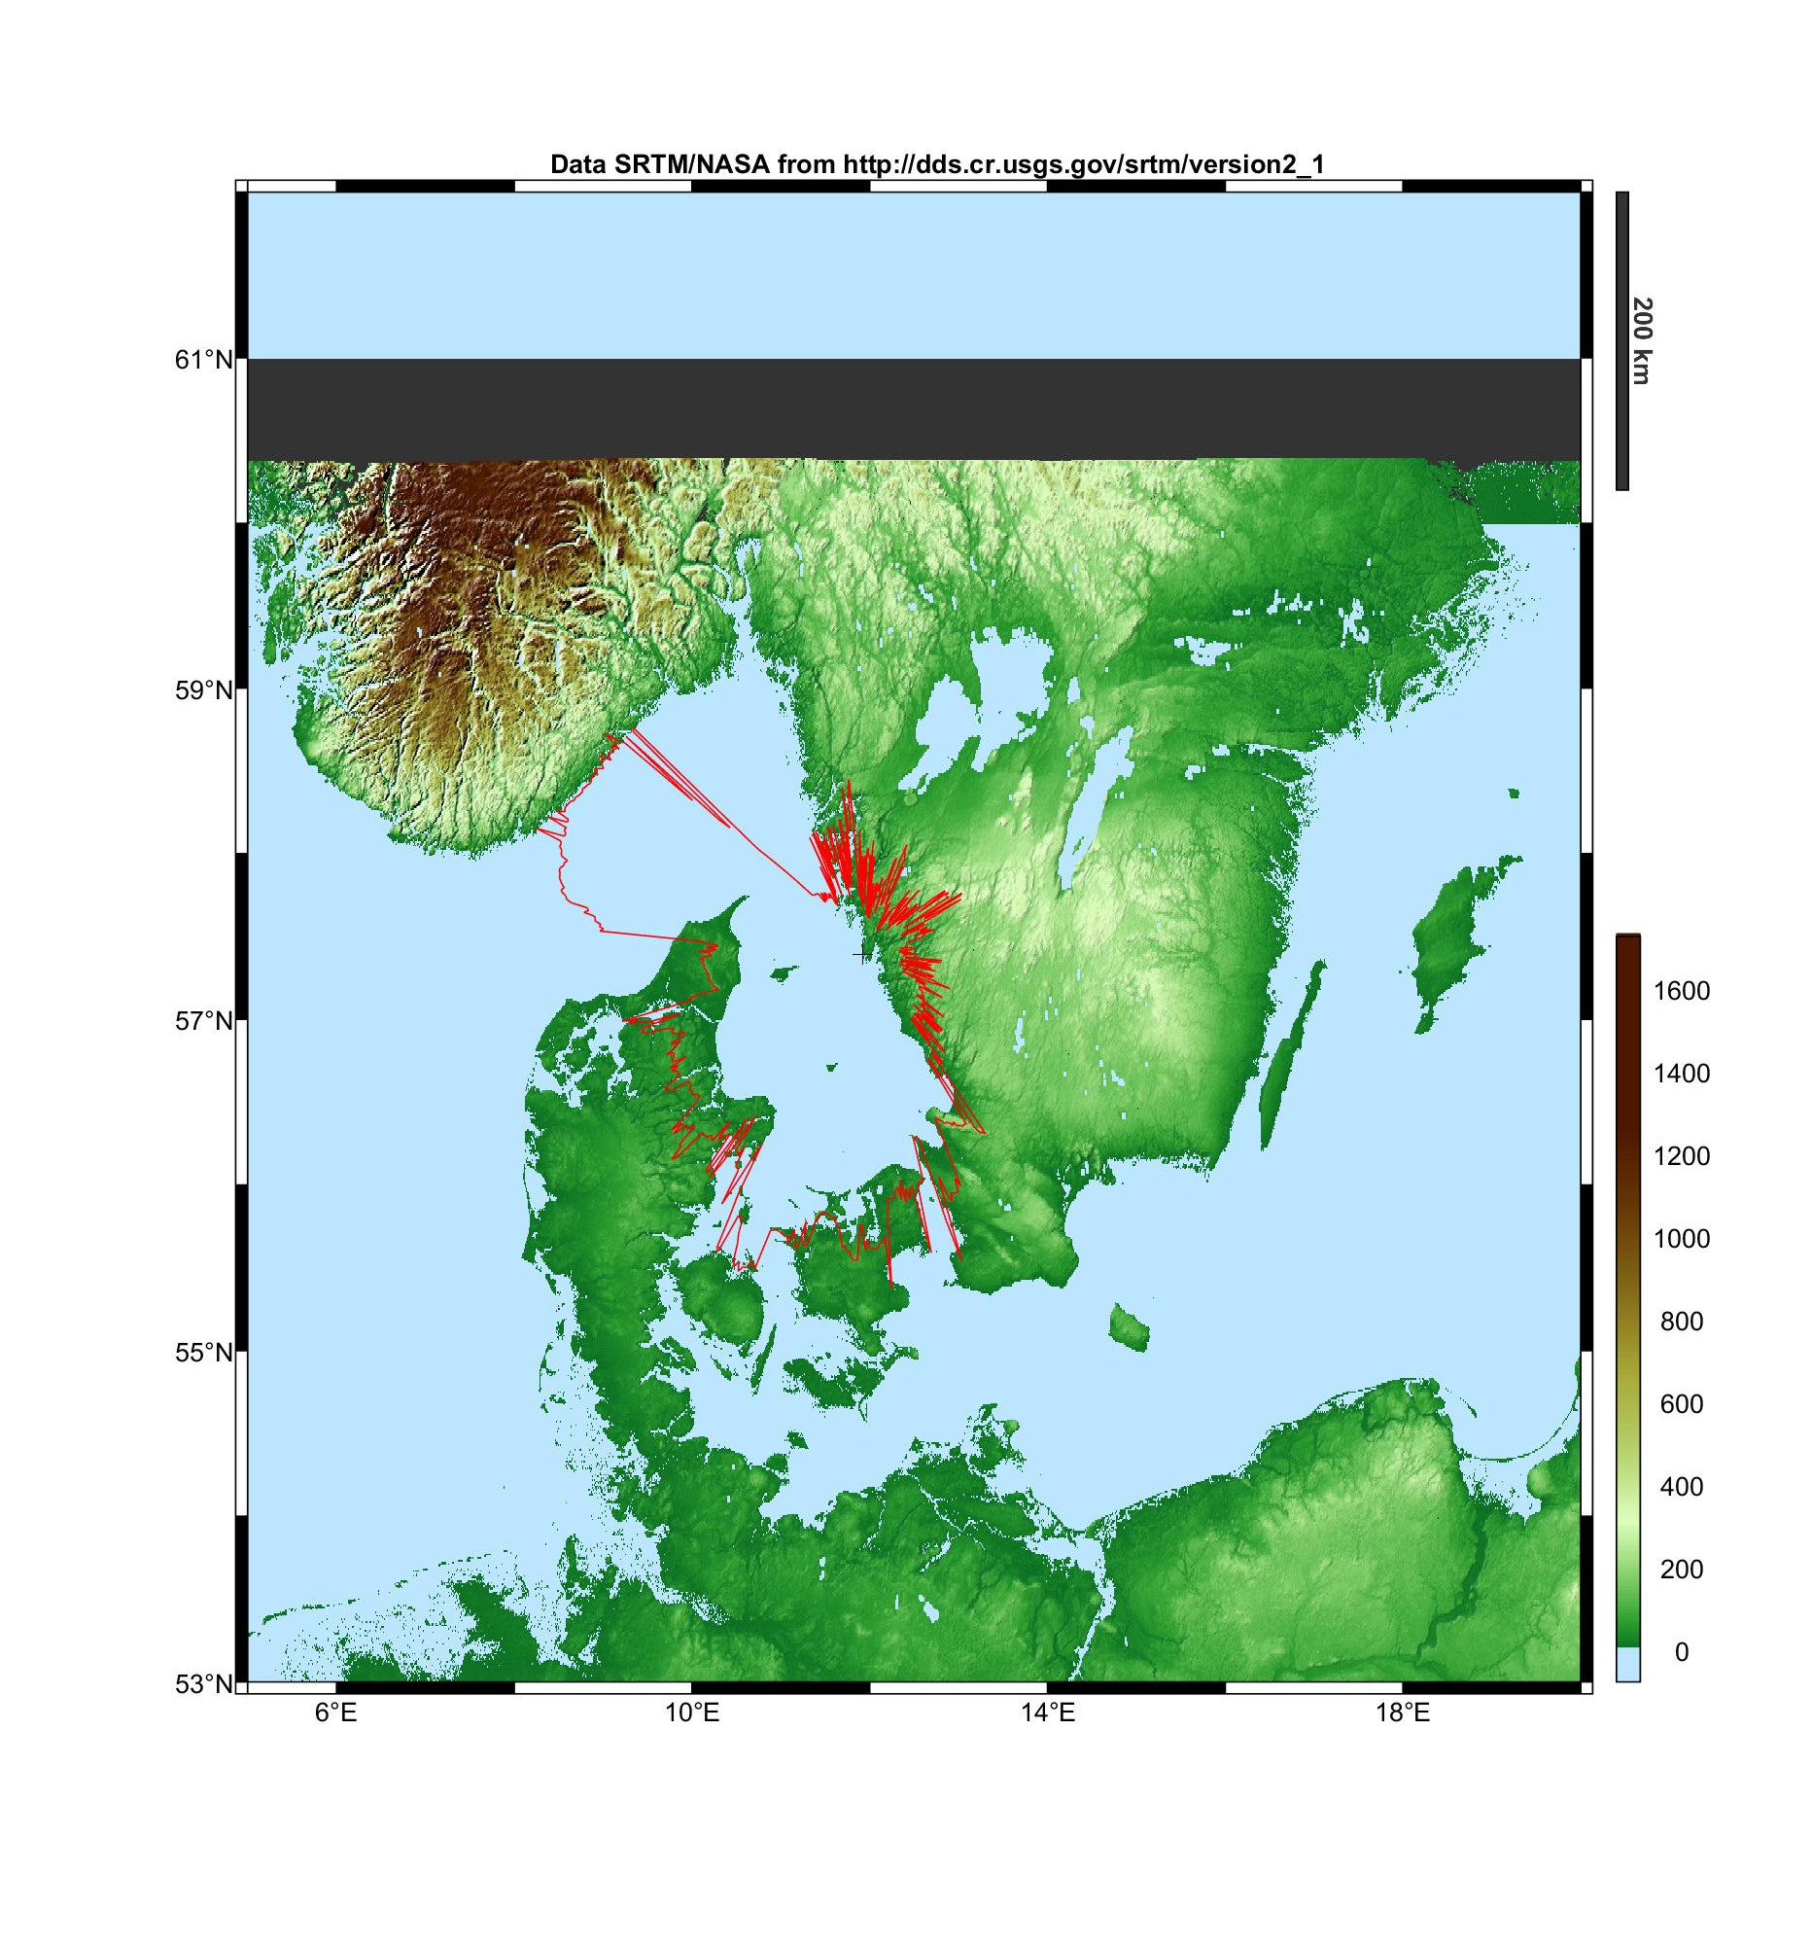
Figure 46: Onsala, Sweden – max 170 km

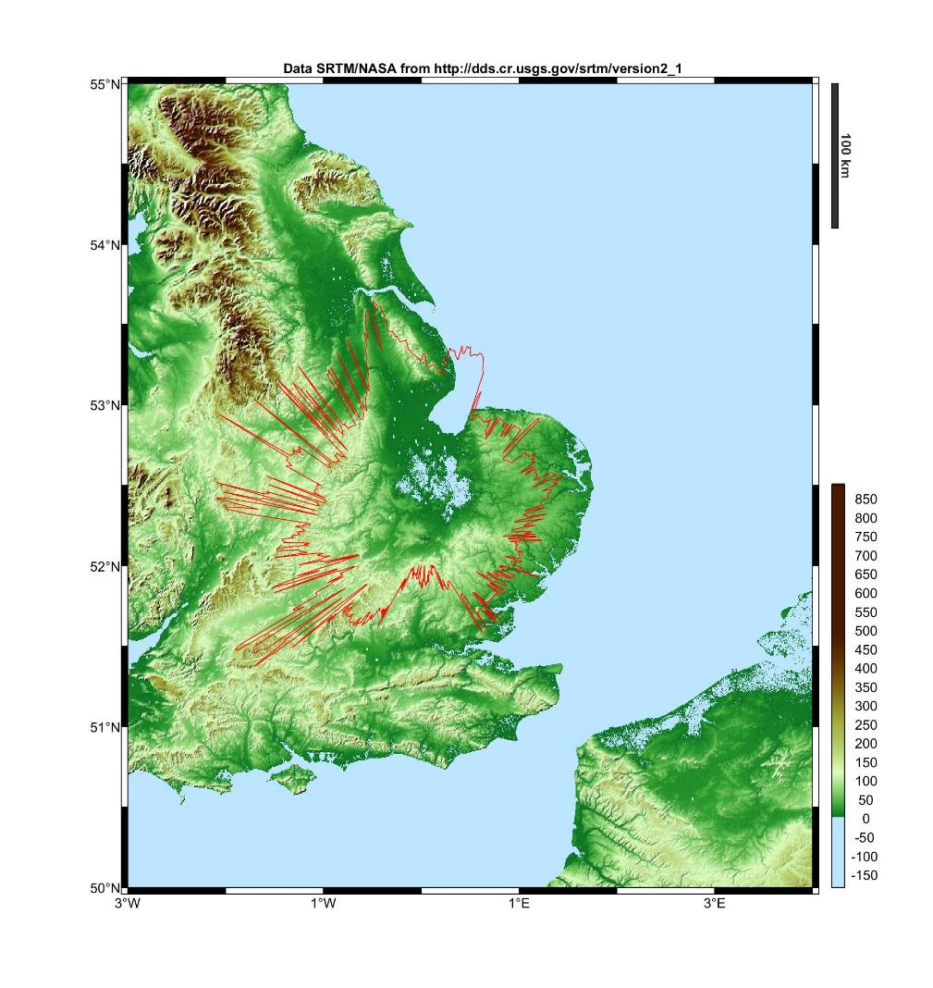
Figure 47: Cambridge, United Kingdom – max 170 km

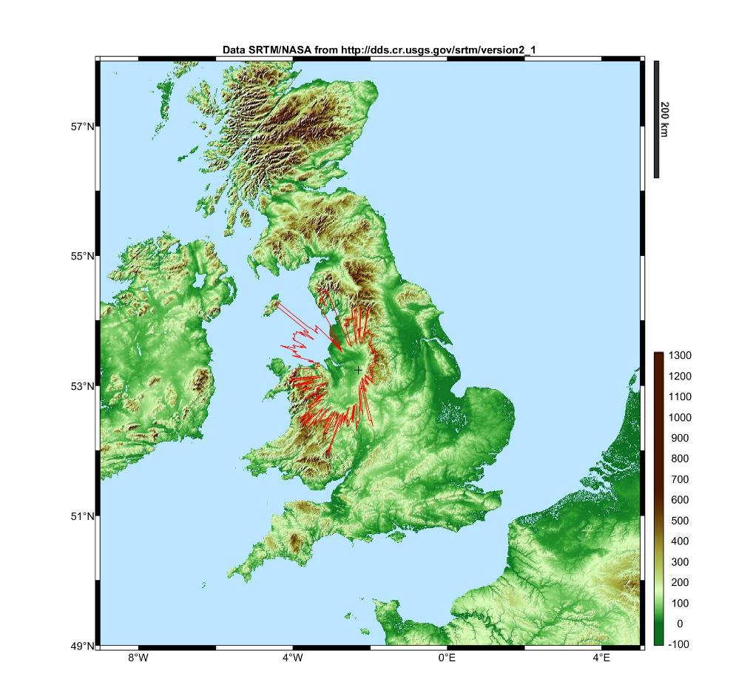
Figure 48: Jodrell Bank, United Kingdom – max 180 km

Conclusions
There are a limited number of RAS stations within the CEPT that perform observations in the secondary RAS allocation in the frequency band 14.47-14.5 GHz. The protection of these RAS stations can be achieved through protection zones around such stations where any single NGSO FSS earth station will have to cease transmissions on channels overlapping with the band 14.47-14.5 GHz (the aggregate effect of several FSS earth stations has not been assessed).
The size of the protection zone has to be determined on a case-by-case basis taking into account the FSS and terrain characteristics. For ONEWEB terminals (with an e.i.r.p. towards the horizon of -33 dBW/(40 kHz)) the size of the zone can be up to 200 km. For other type of earth stations with different e.i.r.p. levels towards the horizon, the protection zones would not be the same as presented in this section. Notwithstanding this assessment, specific calculations on the protection zones for RAS should be computed on a case by case basis, taking into account the real FSS characteristics.

The NGSO satellite system, when establishing compatibility with RAS observatories within an administration, will initially identify the protection zones for each of the RAS observatories using the methodology described in this section. It should be noted that this protection zone may extend beyond the national territory into the territories of neighbouring administrations. The NGSO satellite system should be able to deploy the "control of emission" function stipulated in the ETSI standard EN 303 980 ‎[1] (see Section ‎4.2.3 above) to ensure the suppression of relevant frequencies by land ESIM when entering the protection zone or when located within the protection zone. The NGSO satellite system, by suppressing the use by land ESIM (located within the protection zone) of frequencies 14.47-14.5 GHz (or specific frequencies deployed by the RAS observatory), will provide necessary compatibility with the RAS.

Compatibility with airborne FSS ESIM

Methodology
The methodology chosen is similar to the one used for studies between AMSS and RAS in the band
14-14.5 GHz as documented in ECC Report 026 [18]. A number of aircraft are deployed on air routes, some of them using NGSO FSS ESIM.
Consistently with the studies related to the protection of FS in section 8.1 of this document, a number of 5 to 6 aircraft in visibility of the RAS station and operating on the same 150 kHz channel at each moment in time was considered.

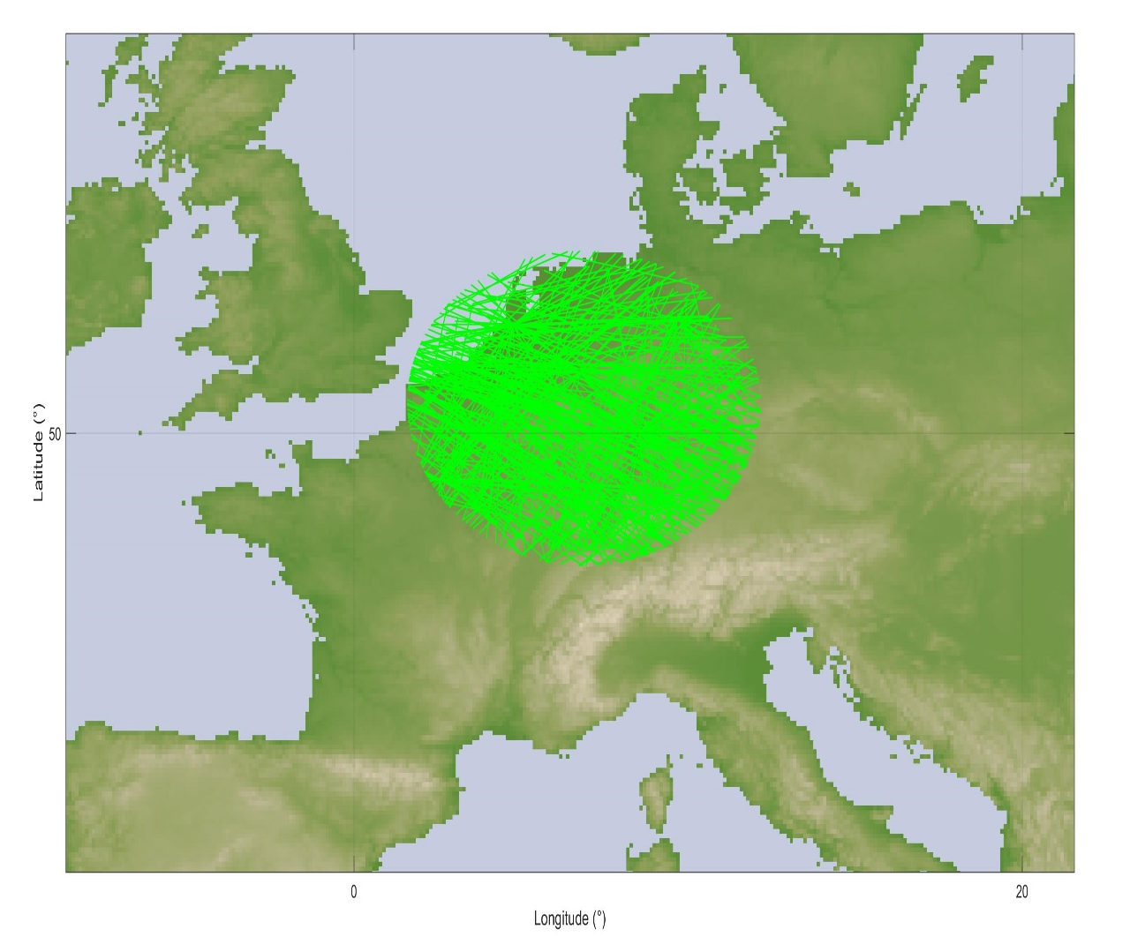
Figure 49: Air routes in visibility of the Effelsberg RAS station

Results
The pfd mask contained in part C of recommendation ITU-R M.1643 ‎[16], relaxed by 5 dB, was considered in epfd simulations:
- –185 + 0.5 · θ dB(W/(m2 · 150 kHz)) for θ ≤ 10°;
- –180 dB(W/(m2 · 150 kHz)) for 10° < θ ≤ 90°.
where θ is the angle of arrival of the radio-frequency wave (degrees above the horizontal).
The following figures have been derived using this mask.
Figure 50 provides the results of simulations for the Effelsberg RAS station. The percentage of data loss is 0.4% above 8° elevation.
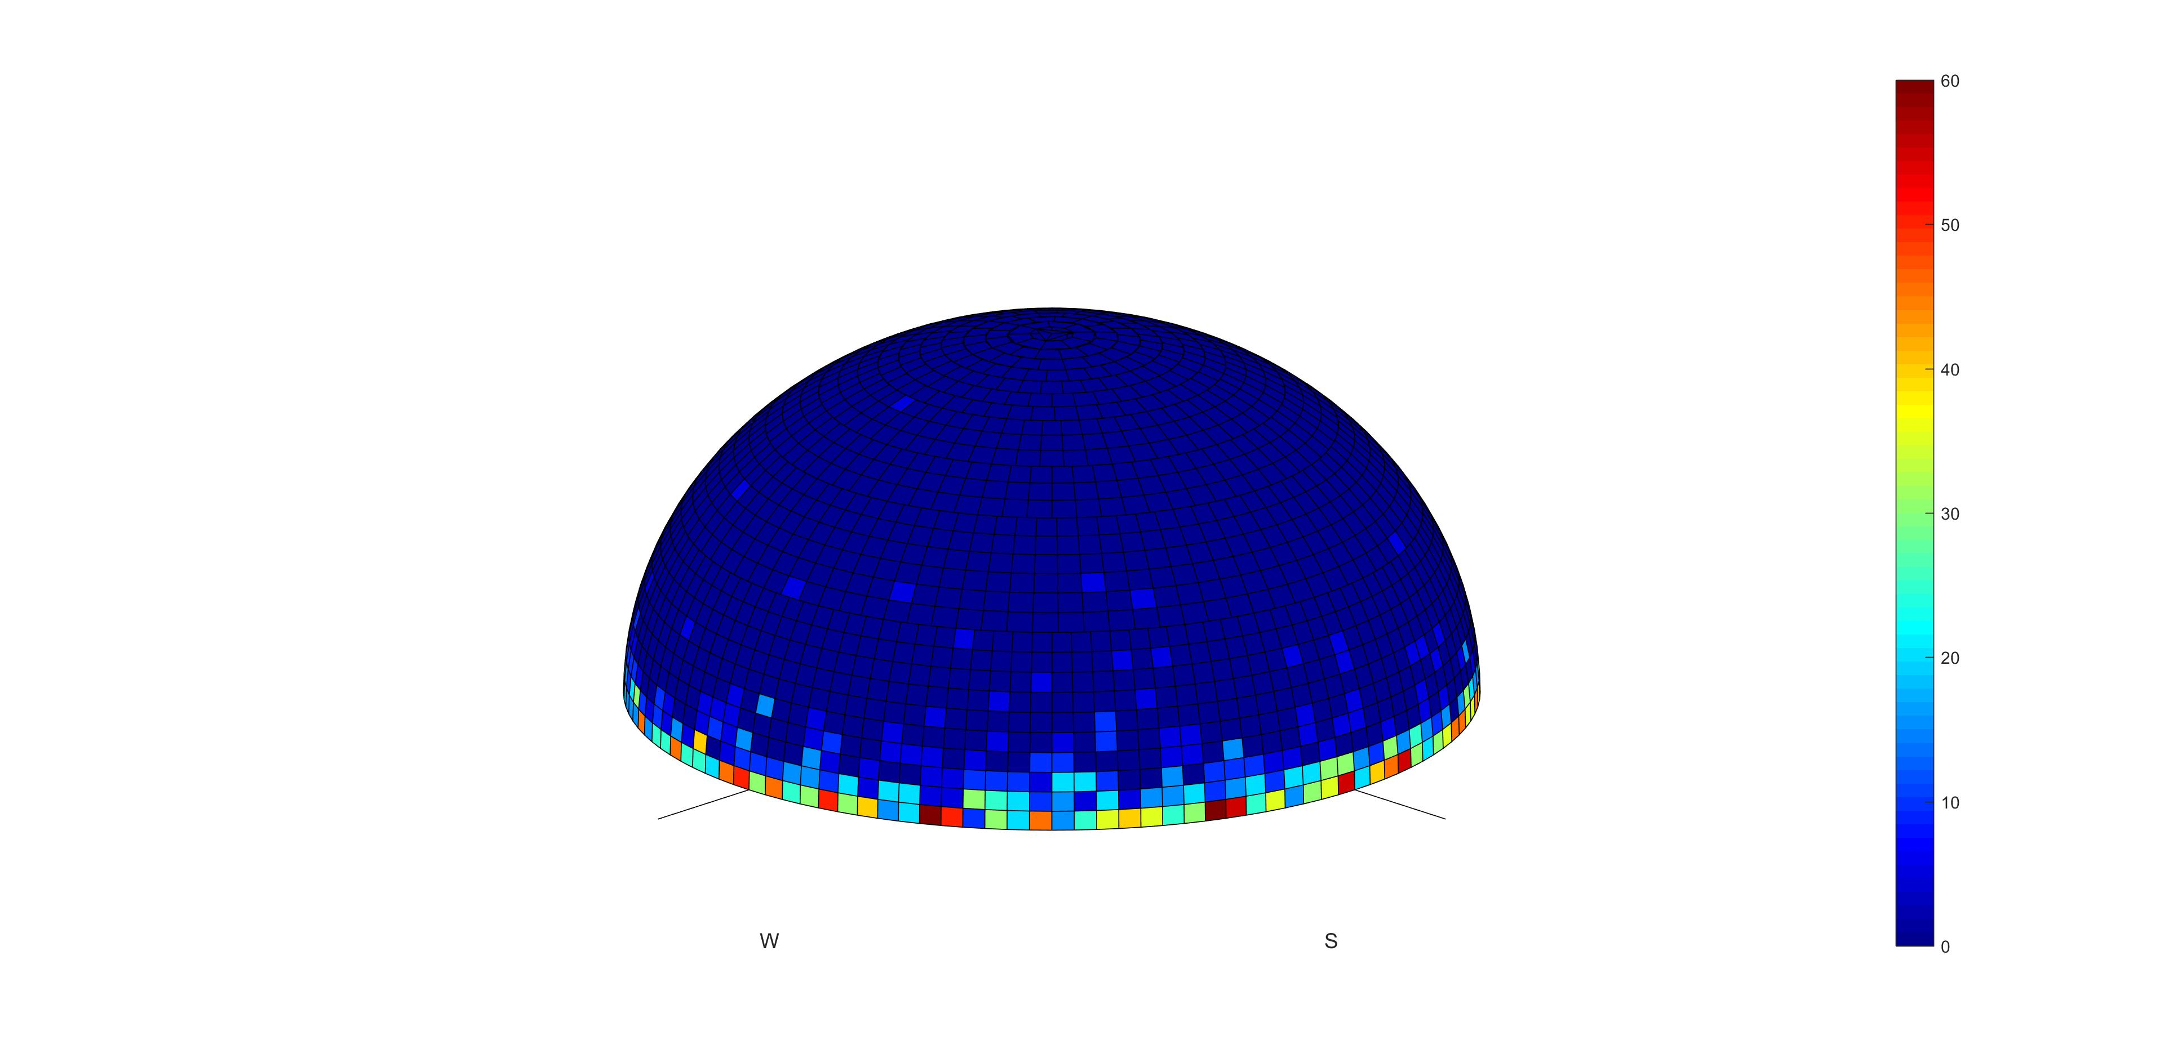
Figure 50: Data loss due to airborne ESIM over Effelsberg
Figure 51 provides the results of simulations for the Medicina RAS station. The percentage of data loss is 0.35% above 5° elevation.

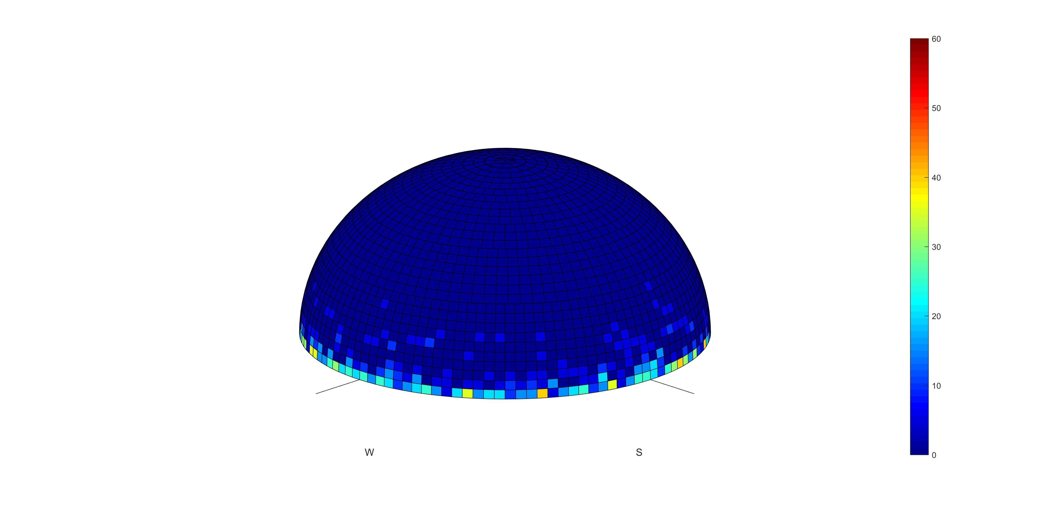
Figure 51: Data loss due to airborne ESIM over Medicina
Figure 52 provides the results of simulations for the Kalyazin RAS station. The percentage of data loss is 1.64% above 0° elevation.
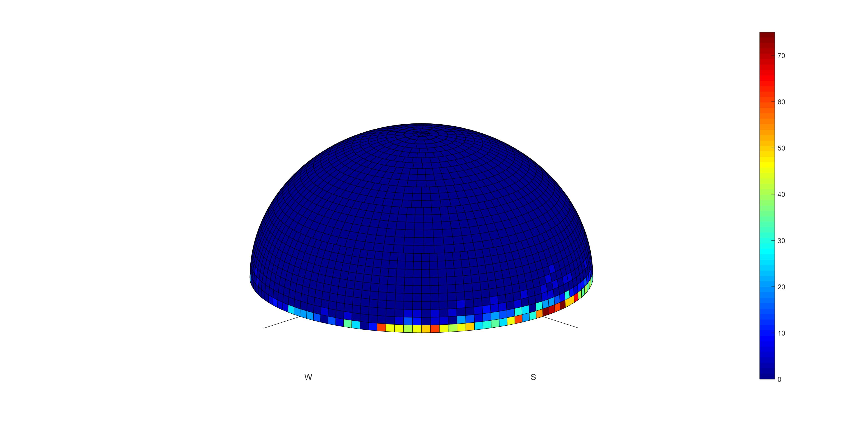
Figure 52: Data loss due to airborne ESIM over Kalyazin
Figure 53 provides the results of simulations for the Puschino RAS station. The percentage of data loss is 1.08% above 6° elevation.
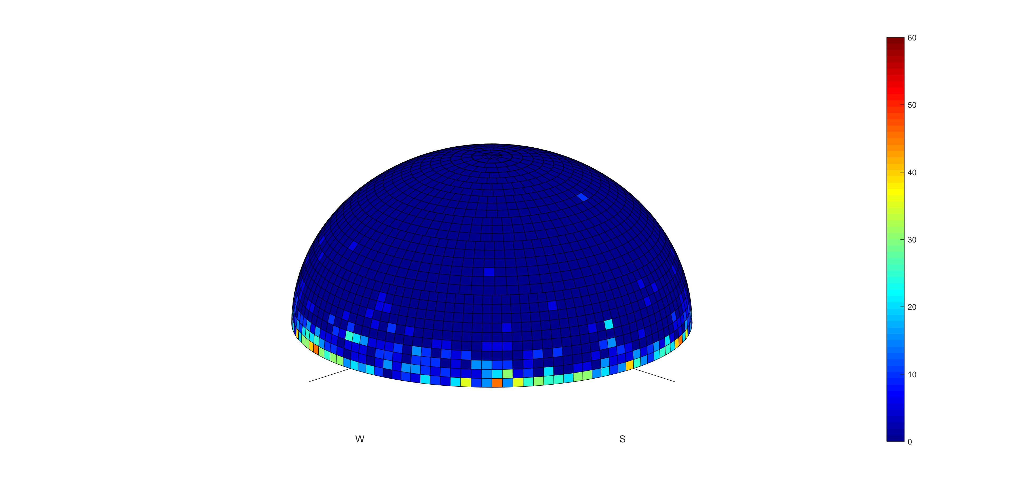
Figure 53: Data loss due to airborne ESIM over Puschino
Figure 54 provides the results of simulations for the Santa Maria RAS station. The percentage of data loss is 0.19% above 5° elevation.
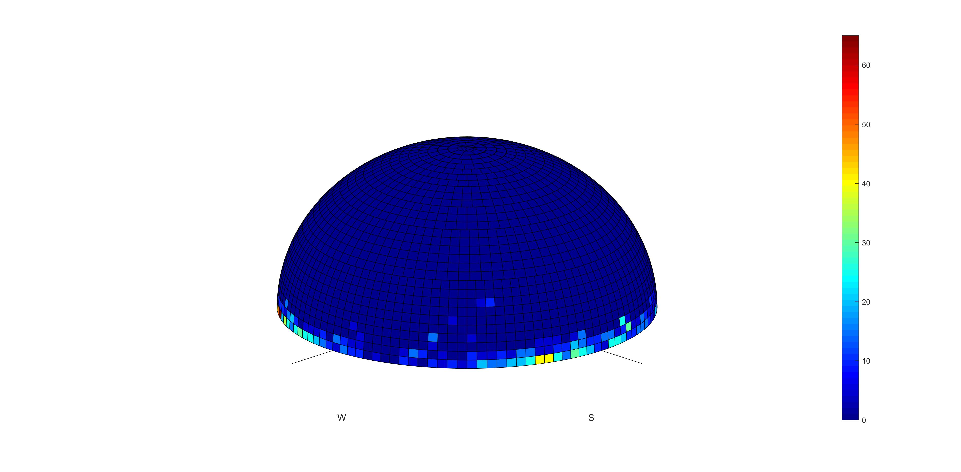
Figure 54: Data loss due to airborne ESIM over Santa Maria

Figure 55 provides the results of simulations for the Onsala RAS station. The percentage of data loss is 0.89% above 0° elevation.
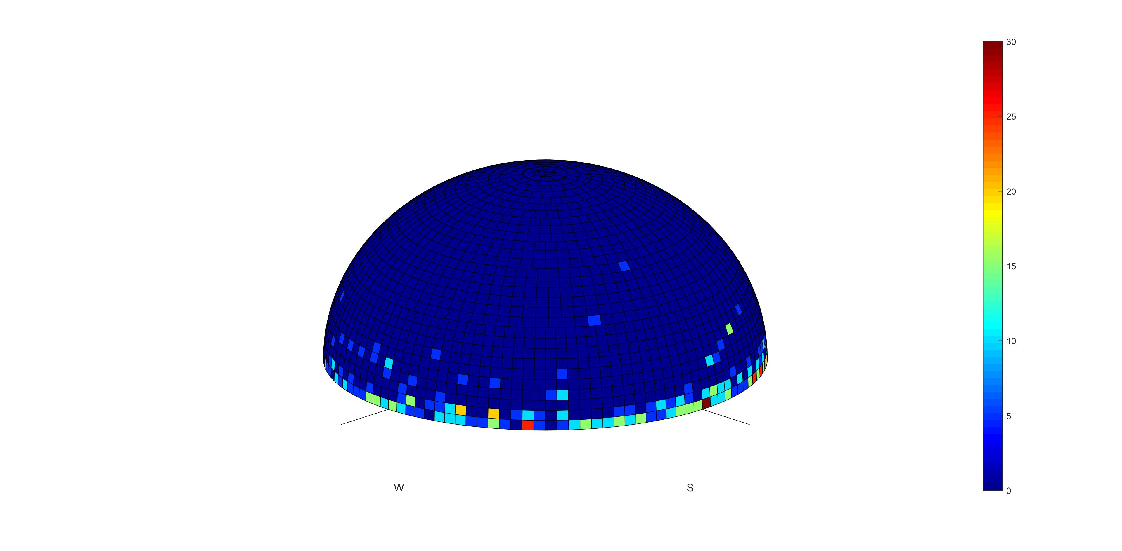
Figure 55: Data loss due to airborne ESIM over Onsala
Figure 56 provides the results of simulations for the Cambridge RAS station. The percentage of data loss is 0.89% above 2° elevation.
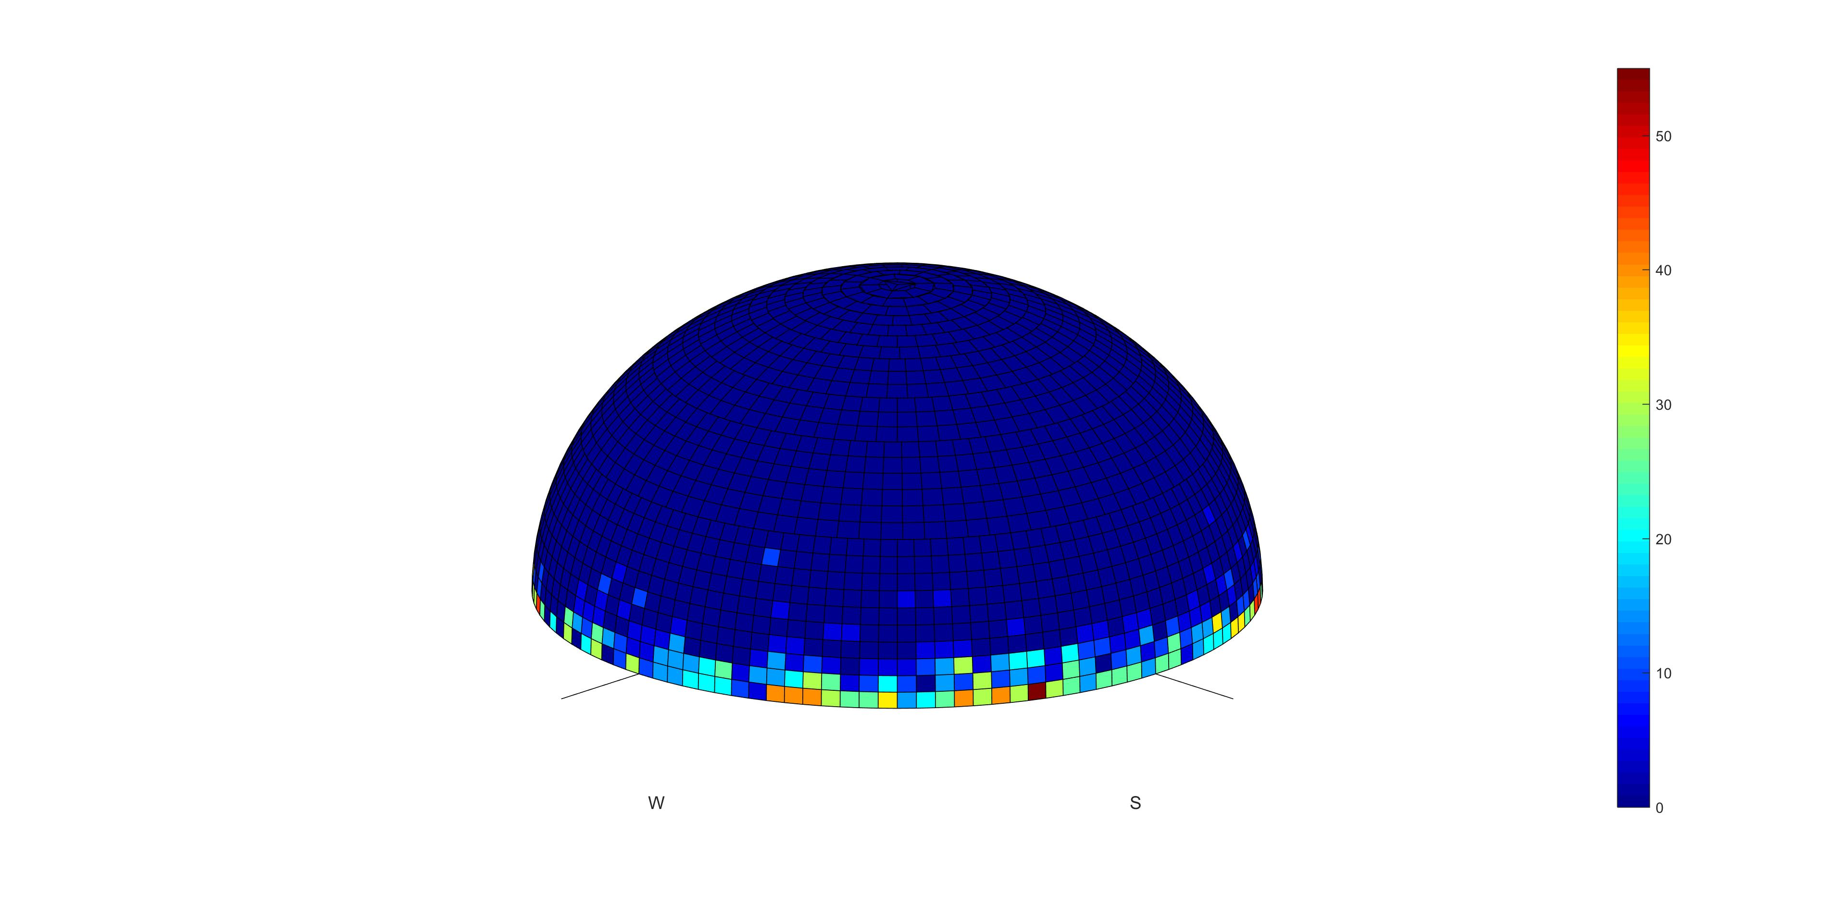
Figure 56: Data loss over Cambridge
Figure 56 provides the results of simulations for the Jodrell Bank RAS station. The percentage of data loss is 1.53% above 0° elevation.
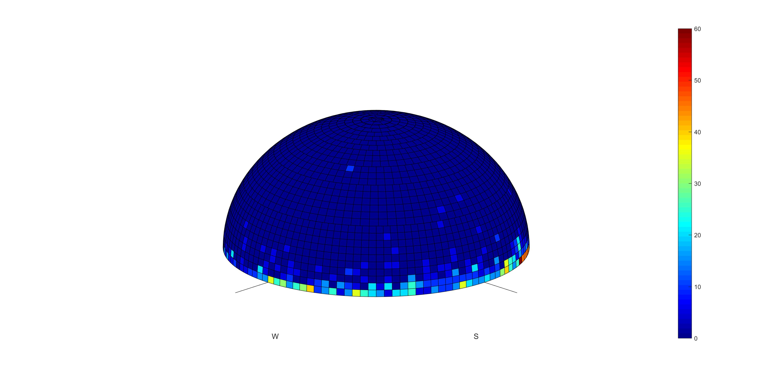
Figure 57: Data loss over Jodrell Bank

Conclusions
The protection of the RAS stations observing in the secondary RAS allocation in the band 14.47-14.5 GHz can be achieved through a pfd mask.
Taking into account the characteristics of the ONEWEB system, the following pfd mask on the Earth's surface is proposed:
- –185 + 0.5 · θ dB(W/(m2 · 150 kHz)) for θ ≤ 10°;
- –180 dB(W/(m2 · 150 kHz)) for 10° < θ ≤ 90°.
where θ is the angle of arrival of the radio-frequency wave (degrees above the horizontal);
It should be noted that the previous pfd masks have been derived assuming 5 to 6 aircraft in visibility of an FS or RAS station and transmitting on the same 150 kHz channel. The number of aircraft depends on the number of visible satellites at the aircraft height, the number of beams of each satellite, the access scheme and the traffic estimated to be carried out by aircraft within the NGSO system. If a different NGSO FSS system is considered, a new analysis has to be performed by using the relevant parameters proper to that system that may lead to different number of aircraft and to different pfd values.
In view of the low pfd levels, the NGSO airborne stations may be required to cease emissions in the band 14.47-14.5 GHz when in visibility of a RAS station performing observations in this band and ensuring that unwanted emissions falling into the RAS band meet the pfd mask.

Compatibility with shipborne FSS ESIM

Methodology
The methodology is similar to the one used for fixed ES and land ESIM, but would be limited to the following RAS stations close to the sea.
Table 18: CEPT RAS observatories located close to the sea and using the band 14.47-14.5 GHz
Administration | Name
Italy | Medicina
Portugal | Santa Maria
United Kingdom | Cambridge
 | Jodrell Bank
Sweden | Onsala

Results
As the FSS terminal is similar to the one used for land ESIM, the results for small ships will be similar to the ones obtained in Figure 23, Figure 26, Figure 27, Figure 28 and Figure 29. The results for big ships will be a bit larger due to a higher antenna height.
Once again, since the distances largely depend on the FSS and RAS characteristics, as well as propagation conditions (Terrain, temperature, and other parameters), the protection zones can be more accurately determined on a case-by-case basis.

Conclusion
The protection of RAS stations observing in the secondary RAS allocation in the band 14.47-14.5 GHz and located close to the sea would require protection zones. The NGSO FSS operator would have to cease transmissions in the band 14.47-14.5 GHz when the ship enters within these protection zones, the size of which has to be determined on a case-by-case basis taking into account FSS characteristics as well as surrounding terrain. This would also apply to shipborne earth stations located in CEPT countries national waters.
The size of the protection zones can be up to 200 km for ONEWEB earth stations. Nevertheless, the sharing conditions for this sharing scenario can be extended to any NGSO FSS system since the real characteristics of the earth stations would be taken into account for calculating the protection zones.
When establishing compatibility with RAS observatories within an administration, the NGSO FSS system would initially identify the protection zones for each of the RAS observatories using the methodology described in this section. This cans be done by deploying the "control of emission" function stipulated in the ETSI standard EN 303 980 ‎[1] (see Section ‎4.2.3 above) to ensure the suppression of relevant frequencies by shipborne ESIM when entering the protection zone or when located within the protection zone. By suppressing the use by shipborne ESIM (located within the protection zone) of frequencies 14.47-14.5 GHz (or specific frequencies deployed by the RAS observatory), the NGSO will be able to achieve compatibility with the RAS.

Protection of aircraft from ES deployed in vicinity of aircraft
ECC Report 272 specifies that there would be no additional constraint imposed on land mobile or airborne FSS earth stations operating with e.i.r.p. lower than 54.4 dBW in Ku-band. The e.i.r.p. of NGSO earth stations documented in this Report is 34 dBW, 20 below the e.i.r.p. limit. There would therefore be no restriction on the operation of NGSO earth station within or in the vicinity of aircraft.

Conclusions
This Report contains compatibility and sharing studies between the operations of non-Geostationary Satellite Orbit (NGSO) Fixed Satellite Service (FSS) systems in both space-to-Earth and Earth-to-space directions and the incumbent services. The Report also looks at the protection of aircraft from Earth stations deployed near airports.
The studies cover the compatibility of the operations in the FSS downlink allocation in the band
10.7-12.75 GHz with the radio astronomy service (RAS) and the EESS (earth exploration satellite service) (passive), and the compatibility of the earth stations using the FSS uplink allocation in the band 14-14.5 GHz with the fixed service (FS) and the RAS. Two kinds of earth stations were considered in these studies, namely the fixed stations and earth stations in motion (ESIM). The ESIM include mobile stations on land, ships and aircraft.
With regard to the FSS downlink allocation in the band 10.7-12.75 GHz, the studies have only addressed one NGSO FSS system (ONEWEB) for which specific characteristics have been made available at the time this Report was written. The studies have been conducted to determine unwanted emissions e.i.r.p. levels that have to be met in each beam of any satellite of this NGSO FSS constellation in order to meet the 2% data loss limit at radio astronomy stations performing observations in the band 10.6-10.7 GHz. These unwanted emission e.i.r.p. levels can be met by the NGSO FSS constellation through a careful design of the satellite payload using appropriate modulation shaping, IF and RF filtering, constraints on the SSPA design. However, these techniques would not be sufficient for the ONEWEB frequency channel immediately adjacent to the passive band (10.7-10.95 GHz), and this channel would therefore have to be deactivated when in visibility of a RAS station performing observations in this band. In general, any NGSO FSS satellite emissions shall not exceed an epfd value of -241 dBW/m² in the band 10.6-10.7 GHz for more than 2% of the time. It should be noted that, if another NGSO FSS constellation is to be considered, specific assessment should be made taking into account the unwanted emissions e.i.r.p. levels of such constellation and also the overall data loss values due to the additional system. The unwanted emission e.i.r.p. levels determined for this NGSO FSS system (ONEWEB) also ensure protection of EESS (passive) sensors operating in the band 10.6-10.7 GHz.
The studies related to NGSO FSS earth stations operating in the band 14-14.5 GHz at fixed locations concluded the following:
- The results of a survey conducted by CEPT show that so far only five administrations out of the 25 respondents have deployed fixed service in the 14.25-14.5 GHz band. Compatibility with fixed service stations in the band 14.25-14.5 GHz used in a few CEPT countries will be achieved through the establishment of relevant areas around the fixed service station. In these areas, the FSS earth stations would have to avoid transmitting on frequency channels overlapping with the channel used by the FS station. The actual size of the area has to be determined on a case by case basis, taking into account the FS and FSS ES characteristics, as well as the surrounding terrain. The typical size of these areas has been determined to be in the order of 58 to 77 km in a 37 dBi FS main beam direction assuming smooth Earth and FSS terminals with an e.i.r.p. towards the horizon of -20 dBW/(40 kHz), but decreases rapidly down to 11 km outside the pointing direction of the FS station, under the same assumptions;
- There are a limited number of RAS stations within the CEPT that perform observations in the secondary RAS allocation in the frequency band 14.47-14.5 GHz. The protection of these RAS stations can be achieved through areas around such stations where any NGSO FSS earth station will have to cease transmissions on channels overlapping with the band 14.47-14.5 GHz. The size of the areas has to be determined on a case-by-case basis taking into account the FSS and terrain characteristics. For FSS terminals with an e.i.r.p. towards the horizon of -20 dBW/(40 kHz) the size of the area can be up to 340 km (single entry analysis), thus not limiting it to a national issue for some of these RAS stations.
The compatibility studies related to land NGSO FSS ESIM operating in the band 14-14.5 GHz concluded the following:
- The compatibility with fixed service stations in the band 14.25-14.5 GHz used in few CEPT countries can be achieved through relevant protection zones. Once the earth station enters into a protection zone, it should cease transmitting on frequency channels overlapping with the channel used by the FS station. This cessation of transmission should be automatically performed by the network control unit of the NGSO FSS satellite system and this action will be assisted by the GPS receiver incorporated in the earth station. The actual size of the exclusion area has to be determined on a case by case basis, taking into account the FS and NGSO FSS ES characteristics, as well as the surrounding terrain. The typical size of these protection zones for the FSS terminals with an e.i.r.p. of -33 dBW/(40 kHz) towards the horizon has been determined to be in the order of 33 km in the 37 dBi FS antenna main beam direction (assuming smooth Earth), but decreases rapidly down to 2 km outside the pointing direction of the FS station;
- The protection of the RAS stations performing observations in the band 14.47-14.5 GHz can be achieved through areas around such stations where any NGSO FSS earth station will have to cease transmissions on channels overlapping with the band 14.47-14.5 GHz. The size of the areas has to be determined on a case-by-case basis taking into account the FSS and terrain characteristics. For FSS terminals with an e.i.r.p. towards the horizon of -33 dBW/(40 kHz) the size of the area can be up to 200 km (single-entry analysis). The GPS capability of the Earth station and the network control unit of the NGSO satellite system mentioned above should be able to automatically perform the cessation of transmissions.
The compatibility studies related to airborne NGSO FSS ESIM operating in the band 14-14.5 GHz concluded the following:
- Assuming that the airborne ESIM operate under the primary FSS allocation, the protection of fixed service stations in the band 14.25-14.5 GHz used in some CEPT countries can be achieved through a pfd mask. The proposed mask is the following:
–122 dB(W/(m² · MHz)) for θ ≤ 5°;
–127 + θ dB(W/(m² · MHz)) for 5° < θ ≤ 40°;
–87 dB(W/(m² · MHz)) for 40° < θ ≤ 90°
where θ is the angle of arrival of the radio-frequency wave (degrees above the horizontal);
- The protection of the RAS stations observing in the secondary RAS allocation in the band
14.47-14.5 GHz can be achieved through a pfd mask. The proposed mask is the following:
–185 + 0.5 · θ dB(W/(m2 · 150 kHz)) for θ ≤ 10°;
–180 dB(W/(m2 · 150 kHz)) for 10° < θ ≤ 90°.
where θ is the angle of arrival of the radio-frequency wave (degrees above the horizontal).
Compliance with this mask can only be achieved by avoiding transmissions within the 14.47-14.5 GHz band when the aircraft enters in visibility of RAS stations performing observations in this band.
The compatibility studies related to shipborne NGSO FSS ESIM operating in the band 14-14.5 GHz show the following:
- There would be no need for any separation distance from the shore to protect FS stations close to the coast assuming FSS terminals with a total e.i.r.p. of -13 dBW towards the horizon. In order to cover all kinds of NGSO FSS systems, a pfd limit at the shore could be defined, similarly to the one developed for ESOMPs in the Ka-band. The proposed level is -116 dBW/m²/MHz at 80 m above sea level with an associated percentage of time of 0.06% or 4.5%, depending on the retained short-term protection criterion. This would apply to shipborne earth stations located in national waters of CEPT countries;
- The protection of RAS stations observing in the secondary RAS allocation in the band 14.47-14.5 GHz and located close to the sea would require protection zones up to 200 km for NGSO FSS terminals with e.i.r.p. of -33 dBW/(40 kHz) towards the horizon. The NGSO FSS operator would have to cease transmissions in the band 14.47-14.5 GHz when the ship enters within these protection zones, size of which has to be determined on a case-by-case basis taking into account FSS characteristics as well as surrounding terrain. This would apply to shipborne earth stations located in national waters of CEPT countries.
The NGSO FSS satellite system will be able to maintain compatibility with fixed links and RAS stations deployed within an administration by establishing the protection zones (as stipulated above) for all fixed link receiving stations or RAS observatories and suppressing use of those frequencies, utilised with the fixed service, by fixed earth stations or land and shipborne ESIM. If an administration has deployed fixed links in the band 14.25-14.5 GHz and the specific locations of these fixed links cannot be established, then the protection zones could be established as the whole territory of the administration. The protection zone may include territories of neighbouring administrations. The satellite system, by suppressing the use by fixed earth stations of frequencies 14.25-14.5 GHz (or specific frequencies deployed by the fixed service or RAS) within the identified protection zone(s), will provide necessary compatibility with the fixed service and RAS. The FSS satellite system will be able to deploy the "control of emission" function stipulated in the ETSI standard EN 303 980 ‎[1] to ensure the suppression of relevant frequencies by fixed earth stations within the protection zone.
According to the findings in ECC Report 272, NGSO earth stations with e.i.r.p. levels lower than 54.5 dBW would not be subject to restrictions on operations in the proximity of aircraft.
- LIST OF REFERENCES
- ETSI EN 303 980, “Harmonised EN for fixed and in-motion Earth Stations communicating with non-geostationary satellite systems (NEST) in the 11 GHz to 14 GHz frequency bands covering essential requirements of article 3.2 of the Radio Equipment Directive 2014/53/EU”
- ITU Radio Regulations Edition of 2016
- SE19(16)58rev6, “ Summary of results of questionnaire on revision of ECC Report 173”, ECO, updated March 2017
- Recommendation ITU-R P.452, “Prediction procedure for the evaluation of interference between stations on the surface of the Earth at frequencies above about 0.1 GHz”
- Recommendation ITU-R SA.1414, “Characteristics of data relay satellite systems”
- Recommendation ITU-R F.758, “System parameters and considerations in the development of criteria for sharing or compatibility between digital fixed wireless systems in the fixed service and systems in other services and other sources of interference”
- Recommendation ITU-R F.636, “Radio-frequency channel arrangements for fixed wireless systems operating in the 14.4-15.35 GHz band”
- Recommendation ITU-R F.699, “Reference radiation patterns for fixed wireless system antennas for use in coordination studies and interference assessment in the frequency range from 100 MHz to about 70 GHz”
- Recommendation ITU-R P.530, “Propagation data and prediction methods required for the design of terrestrial line-of-sight systems”
- Recommendation ITU-R F.1565, “Performance degradation due to interference from other services sharing the same frequency bands on a co-primary basis with real digital fixed wireless systems used in the international and national portions of a 27 500 km hypothetical reference path at or above the primary rate”
- Recommendation ITU-R RA.1631, “Reference radio astronomy antenna pattern to be used for compatibility analyses between non-GSO systems and radio astronomy service stations based on the epfd concept”
- Recommendation ITU-R RA.1513, “Levels of data loss to radio astronomy observations and percentage-of-time criteria resulting from degradation by interference for frequency bands allocated to the radio astronomy service on a primary basis”
- Recommendation ITU-R RA.769, “Protection criteria used for radio astronomical measurements”
- Recommendation ITU-R M.1583, “Interference calculations between non-geostationary mobile-satellite service or radionavigation-satellite service systems and radio astronomy telescope sites”
- Recommendation ITU-R S.1586-1, “Calculation of unwanted emission levels produced by a non-geostationary fixed-satellite service system at radio astronomy sites”
- Recommendation ITU-R M.1643, “Technical and operational requirements for aircraft earth stations of aeronautical mobile-satellite service including those using fixed-satellite service network transponders in the band 14-14.5 GHz (Earth-to-space)”
- Recommendation ITU-R SF.1650, “The minimum distance from the baseline beyond which in-motion earth stations located on board vessels would not cause unacceptable interference to the terrestrial service in the bands 5 925-6 425 MHz and 14-14.5 GHz”
- ECC Report 026, “The compatibility and sharing of the aeronautical mobile satellite service with existing services in the band 14.0-14.5 GHz”, May 2003
- Recommendation ITU-R F.1108, “Determination of the criteria to protect fixed service receivers from the emissions of space stations operating in non-geostationary orbits in shared frequency bands”
- Recommendation ITU-R F.1494, “Interference criteria to protect the fixed service from time varying aggregate interference from other services sharing the 10.7-12.75 GHz band on a co-primary basis”
- Recommendation ITU-R F.1495, “Interference criteria to protect the fixed service from time varying aggregate interference from other radiocommunication services sharing the 17.7-19.3 GHz band on a co-primary basis”
- Recommendation ITU-R F.1241, “Performance degradation due to interference from other services sharing the same frequency bands on a primary basis with digital radio-relay systems operating at or above the primary rate and which may form part of the international portion of a 27 500 km hypothetical reference path”
- Recommendation ITU-R RS.1813, “Reference antenna pattern for passive sensors operating in the Earth exploration-satellite service (passive) to be used in compatibility analyses in the frequency range 1.4-100 GHz”
- Recommendation ITU-R RS.1861, “Typical technical and operational characteristics of Earth exploration-satellite service (passive) systems using allocations between 1.4 and 275 GHz”
- Recommendation ITU-R RS.2017, “Performance and interference criteria for satellite passive remote sensing”
- ECC Report 066, “Protection of aircraft from satellite earth stations operating on the ground in the vicinity of airfields”, June 2005

ECO Frequency Information System: www.efis.dk
www.craf.eu
The air routes have been taken from the website http://openflights.org/data.html#route
Long-term protection criterion for Fixed-service used in ECC Report 026 [18] (secondary status allocation)
FDP criterion also assumed in ECC Report 026 for AMSS (secondary status allocation)

