ELECTRONIC COMMUNICATIONS COMMITTEE
ECC Decision (11)06

Harmonised frequency arrangements for mobile/fixed communications networks (MFCN) operating in the bands 3400-3600 MHz and 3600-3800 MHz
Approved 09 December 2011
Amended 14 March 2014

EXPLANATORY MEMORANDUM

INTRODUCTION
The harmonised frequency arrangements for the 3400-3800 MHz band in this ECC Decision are intended to facilitate high data rate mobile/fixed communications networks (MFCN) including International Mobile Telecommunications (IMT) services supported by larger channel bandwidths as an evolution to the existing framework without the consequential requirement for a replacement of systems based on the existing regulatory framework. It aims at providing the basis to the mobile industry and administrations to respond to the growth of mobile broadband and technological developments for wider channel bandwidths and increased data rates.
Since WRC-07, the 3400-3600 MHz band has been allocated on a primary basis to the mobile, except aeronautical mobile, service and identified for IMT in almost all CEPT member countries.
The term IMT covers IMT-2000 and IMT-Advanced systems. A wide range of systems are defined: 6 IMT-2000 radio interfaces and 2 IMT-Advanced radio interfaces ensuring a competitive environment.
Recommendation ITU-R M.1036 (on frequency arrangements for implementation of the terrestrial component of IMT) has been revised to include, among others, the arrangement(s) for the 3400-3600 MHz band.
In parallel, the IMT-Advanced process is on-going in ITU-R, in cooperation with standardisation organisations.
The former ERO carried out a survey in 2008 which found diverse implementation of BWA/FWA within 3400-3800 MHz in CEPT countries, including some IMT systems. This is reflected in various licensing coverages (national, regional), various frequency blocks choices (different portions of the 3400-3800 MHz). Moreover, the paired blocks are used in TDD mode.
In so far as practicable, these frequency arrangements are intended to be technology neutral and capable of facilitating competitive provision of services using a range of technologies and modes (fixed, nomadic and mobile) with sufficient flexibility to accommodate current wireless broadband services deployed in the band.

BACKGROUND
In addition to this ECC Decision, the following CEPT regulatory framework is in force for broadband and fixed wireless access systems (BWA/FWA) in the 3400-3800 MHz band:
- The ECC/REC/(04)05, that offers guidelines for accommodation and assignment of multipoint fixed wireless systems in the frequency bands 3400-3600 MHz and 3600-3800 MHz;
- The ECC/DEC/(07)02, on availability of frequency bands between 3400-3800 MHz for the harmonised implementation of Broadband Wireless Access systems (BWA). This Decision refers to ECC Recommendation (04)05 for frequency arrangements..

ECC developed the following CEPT reports in response to EC Mandates:
- CEPT Report 015 in response to the first EC Mandate on 3400-3800 MHz (issued in 2006)
- CEPT Report 049 in response to the second EC Mandate on 3400-3800 MHz (issued in 2012).

CEPT conducted additional analysis to determine whether the existing least restrictive technical conditions (BEM – Block Edge Masks) are suitable also for the high data rate IMT services supported by larger channel bandwidths as foreseen in the context of this ECC Decision and concluded on the need to develop new BEM. ECC studied the least restrictive technical conditions (BEM) suitable for MFCN, including IMT, in the 3400-3800 MHz band (ECC Report 203). This ECC Report served as the basis for drafting the relevant parts of CEPT Report 049 in response to Task 1 of the second EC Mandate.
Consistency is ensured with the ITU-R band plan in the bands 3400-3600 MHz.
CEPT considered the band 3400-3800 MHz as two separate bands:
- a lower band 3400-3600 MHz and
- an upper band 3600-3800 MHz.

In this ECC Decision, CEPT took into account the two possible duplex modes, Frequency Division Duplex (FDD) and Time Division Duplex (TDD). In the case of a TDD operation, it is beneficial to synchronise the TDD networks of different operators to avoid restricted blocks / guard bands between operators and therefore to facilitate an efficient use of spectrum. CEPT noted the lack of interest from industry for an FDD arrangement in the 3600-3800 MHz frequency band.
CEPT took into account existing CEPT results on coexistence with other services and the potential impact on these services, such as FSS usage, in these bands.
The implementation of this ECC Decision will encompass different stages at the national level (e.g. national consultation processes and update of existing authorisations as required) with a varying complexity depending on the legal and regulatory framework of each country.

REQUIREMENT FOR AN ECC DECISION
The ECC recognises that implementation of MFCN including IMT systems providing high data rate applications in the band 3400-3800 MHz based on a harmonised frequency arrangement will maximise the opportunities and benefits for end users and society, will benefit capital expenditure for operators, reduce development and implementation costs of manufacturing equipment and will secure future long terms investments by providing economies of scale. A harmonised frequency arrangement will reduce complexity in cross border coordination. The opportunity to utilize larger channel bandwidths will assist the provision of high data rates for IMT (especially with IMT-Advanced).
The ECC recognises that for the continuation of the successful development of MFCN including IMT, the regulatory framework needs to provide the confidence and certainty for industry to make the necessary investment. ECC recognises that administrations need flexibility to adapt their use of the bands 3400-3600 / 3600-3800 MHz to national circumstances. Any transition from legacy systems to future systems would be managed at national level. Such national measures may need to be studied (e.g. refarming of the band, planning of renewal or extension of authorisations etc.). Moreover, the framework defined by this ECC Decision does not supersede the BWA/FWA framework. Instead, it aims at supplementing this framework to facilitate high data rate services supported by larger channel bandwidths as an evolution to the existing framework without the consequential requirement to replace systems that are based on the existing regulatory framework.

ECC Decision of 9 December 2011 on harmonised frequency arrangements for mobile/fixed communications networks (MFCN) operating in the bands 3400-3600 MHz and 3600-3800 MHz (ECC/DEC/(11)06) amended 14 March 2014
“The European Conference of Postal and Telecommunications Administrations,
considering
- that WRC-07 allocated the band 3400-3600 MHz to the Mobile, except Aeronautical Mobile, Service on a primary basis in a large number of countries in Region 1 subject to provisions of RR 5.430A;
- that RR 5.430A also identifies the 3400-3600 MHz band for IMT;
- that the 3400-3500 MHz and 3500-3600 MHz bands have been allocated to the Mobile Service and identified for IMT in some countries of Region 3 (RR 5.432A, 5.432B and 5.433A);
- that the 3500-3600 MHz band is allocated to the Mobile, except Aeronautical Mobile, Service on a primary basis in Region 2, and that the 3400-3500 MHz band is allocated on a primary basis to the Mobile, except Aeronautical Mobile, Service in some countries of Region 2 and to the Mobile Service on a secondary basis in the rest of Region 2;
- that the 3600-3800 MHz band is allocated to the Mobile Service in Region 1 on a secondary basis in the Radio Regulations and not identified for IMT;
- that in the European Table of Frequency Allocations (ERC Report 25) the major use or major interest in CEPT member countries in the 3400-3800 MHz band is the Mobile Service on a primary basis;
- that “mobile/fixed communications networks” (MFCN) for the purpose of this Decision includes IMT and other mobile and fixed communications networks;
- that IMT covers both IMT-2000 and IMT-Advanced, as defined in Resolution ITU-R 56 (Naming for International Mobile Telecommunications);
- that detailed specifications of IMT radio interfaces are described in Recommendation ITU-R M.1457 for IMT-2000 and Recommendation ITU-R M. 2012 for IMT-Advanced;
- that a harmonised frequency arrangement facilitates economies of scale resulting in the availability of affordable equipment;
- that the designation of a frequency band for a specific application does not prevent the designation of the same frequency band for other applications;
- that the bands 3400-3600 MHz and 3600-3800 MHz are allocated to the Fixed-Satellite Service (space-to-Earth) on a primary basis in the Radio Regulations and are used in some CEPT countries for that service;
- that the band 3400 MHz to 3410 MHz is identified in ERC Report 25 for airborne radars;
- that in some CEPT countries the band 3400 MHz to 3410 MHz is not available for MFCN due to use by land, airborne and naval military radars;
- that the use of the band 3400-3600 MHz and the band 3600-3800 MHz for Fixed-Satellite Service (FSS) varies between these frequency bands. The band 3600-3800 MHz is used for FSS more heavily than the band 3400-3600 MHz;
- that there could be differences in the market demand for spectrum for MFCN, in different CEPT countries, which could lead to different timescales for the introduction of MFCN within the bands 3400-3600 MHz and 3600-3800 MHz;
- that ECC Decision (07)02 designates spectrum “for BWA deployment within the band 3400-3600 MHz and/or 3600-3800 MHz, subject to market demand and with due consideration of other services deployed in these bands”;
- that ECC Recommendation (04)05 provides “guidelines for accommodation and assignment of multipoint fixed wireless systems in frequency bands 3400-3600 MHz and 3600-3800 MHz”;
- that in some CEPT countries parts of the bands 3400-3600 MHz and/or 3600-3800 MHz are already used for BWA, FWA and IMT systems;
- that global roaming is facilitated by common frequency arrangements and measures for free circulation for IMT terminals;
- that wider channel bandwidths such as 10, 20 and 40 MHz or more could be accommodated in the bands 3400-3600 MHz and 3600-3800 MHz thereby enabling higher data rates;
- that spectrum licensed for MFCN is generally assigned in multiples of 5 MHz, except where this is not possible, e.g. due to the presence of existing users;
- that measures might be needed to ensure coexistence between unsynchronized TDD networks in adjacent blocks (e.g. additional filtering, site coordination, restricted blocks/guardbands) and different licensing approaches may be applied by administrations to avoid interference between adjacent operators (e.g., guard band between the block edges of two adjacent operators, to enable sufficient roll-off of filters to meet the baseline or by power limitation used in the upper or lower part of the assigned blocks);
- that in case of TDD networks in the same geographical area, it may be beneficial to synchronise them ( avoiding simultaneous uplink and downlink transmissions) or add filtering to base stations, to improve the efficient usage of spectrum by avoiding restricted blocks/guardbands between their networks
- that the synchronisation of TDD networks of different operators can be managed at national level (e.g. voluntary agreement between operators or national regulatory measures);
- that studies on sharing between IMT and the Fixed Satellite Service have been carried out by ITU-R, (see Report ITU-R M.2109);
- that in some CEPT countries, the deployment of networks will need a bilateral agreement concerning the use of stations in the mobile service in one country and stations of other primary services in a neighbouring country (e.g. Earth stations of the fixed satellite service) (see RR 5.430A for the band 3400-3600 MHz);
- that in EU/EFTA countries the radio equipment that is under the scope of this Decision shall comply with the R&TTE Directive; Conformity with the essential requirements of the R&TTE Directive may be demonstrated by compliance with the applicable harmonised European standard(s) or by using the other conformity assessment procedures set out in the R&TTE Directive;
- that a separate ECC Report will cover measures to facilitate coexistence between TDD networks in adjacent blocks by synchronisation;
- that although there are licensed paired frequency arrangements in many CEPT countries, TDD systems are currently used in a number of those countries in the band 3400 - 3600 MHz for various reasons (e.g. equipment availability at time of deployment);
- that TDD may allow more flexible accommodation of current use of the frequency bands by other services;
- that least restrictive technical conditions suitable for mobile/fixed communications networks (MFCN), including IMT, in the frequency bands 3400-3600 MHz and 3600-3800 MHz are developed in the ECC Report 203;
- that the coordination between mobile/fixed communications network stations and Fixed-Satellite Service (FSS) Earth stations could be required at national level or between neighbouring administrations;
- that CEPT Report 049 and ECC Report 203 conclude that coordination (including, if needed, power limitation and separation distance) between MFCN and other systems and services should be carried out on a case-by-case basis due to the diversity of interference scenarios;

- that maximum unwanted emission levels from MFCN base stations have been determined for protection of radiolocation systems deployed below 3400 MHz, while noting that other mitigation measures (e.g., geographical separation, coordination or additional guard band) may be needed on a case-by-case basis;

- that a transitional period may be necessary during which previous networks (BWA) and new networks (MFCN) with different technical characteristics coexist;

- that CEPT Report 049 and ECC Report 203 conclude that BWA and MFCN systems can coexist under the new BEM licensing regime, but that care should be taken to avoid interference to BWA systems, e.g. by applying the appropriate frequency separation or MFCN BEM elements;

DECIDES
- that CEPT administrations shall designate the frequency bands 3400-3600 MHz and 3600-3800 MHz on a non-exclusive basis to mobile/fixed communications networks (MFCN), without prejudice to the protection and continued operation of other existing users in these bands;
- that administrations wishing to implement MFCN in the 3400-3600 MHz band should follow the preferred frequency arrangement given in Annex 1 (TDD) or the alternative frequency arrangement given in Annex 2 (FDD);
- that administrations wishing to implement MFCN in the 3600-3800 MHz band should adhere to the harmonised frequency arrangement given in Annex 3 (TDD);
- that administrations wishing to implement MFCN in the 3400-3600 MHz band and in the 3600-3800 MHz band should follow the least restrictive technical conditions suitable for mobile/fixed communications networks (MFCN), given in Annex 4;
- that administrations should consider facilitating the migration of existing terrestrial networks and authorisations to the frequency arrangements described in the Annexes;
- that administrations should implement key principles related to the coexistence with other services than MFCN as described in Annex 5;
- that this Decision enters into force on 14 March 2014;
- that the preferred date for implementation of the Decision shall be 14 September 2014;
- that CEPT administrations shall communicate the national measures implementing this Decision to the ECC Chairman and the Office when the Decision is nationally implemented.”

Note:
Please check the Office documentation database http://www.ecodocdb.dk for the up to date position on the implementation of this and other ECC Decisions.

ANNEX 1: Preferred Frequency arrangement for the 3400-3600 MHz band based on TDD
The frequency arrangement is a TDD arrangement, based on a block size of 5 MHz starting at the lower edge of 3400 MHz.
If blocks need to be offset to accommodate other users, the raster should be 100 kHz. Narrower blocks can be defined adjacent to other users, to allow full use of spectrum. It has to be noted that TDD in one extreme case also covers downlink only operation.
3400 MHz
3600 MHz
5
5
5
5
5
5
5
5
5
5
5
5
5
5
5
5
5
5
5
5
5
5
5
5
5
5
5
5
5
5
5
5
5
5
5
5
5
5
5
5
5
5
5
5
5
5
5
5
5
5
5
5
5
5
5
5
5
5
5
5
5
5
5
5
5
5
5
5
5
5
5
5
5
5
5
5
5
5
5
5
5
5
5
5
5
5
5
5
5
5
5
5
5
5
5
5
5
5
5
5
5
5
5
5
5
5
5
5
5
5
5
5
5
5
5
5
5
5
5
5
5
5
5
5
5
5
5
5
5
5
5
5
5
5
5
5
5
5
5
5
5
5
5
5
5
5
5
5
5
5
5
5
5
5
5
5
5
5
5
5
5
5
5
5
5
5
5
5
5
5
5
5

Multiple adjacent blocks of 5 MHz can be combined to obtain wider channel.
ANNEX 2: alternative Frequency arrangement for the 3400-3600 MHz band based on FDD

The frequency arrangement is an FDD arrangement, based on a block size of 5 MHz starting at the lower edge of 3410 MHz. The sub-band 3410-3490 MHz is used for the uplink, the sub-band 3510-3590 MHz is used for the downlink. The resulting duplex gap is 20 MHz (3490-3510 MHz).
If blocks need to be offset to accommodate other uses, the raster should be 100 kHz. Narrower blocks can be defined adjacent to other users, to allow full use of spectrum.
Multiple adjacent blocks of 5 MHz can be combined to obtain wider channel.
ANNEX 3: Harmonised frequency arrangement for the 3600-3800 MHz band based on TDD

The frequency arrangement is a TDD arrangement, based on a block size of 5 MHz starting at the lower edge of 3600 MHz.
If blocks need to be offset to accommodate other uses, the raster should be 100 kHz. Narrower blocks can be defined adjacent to other users, to allow full use of spectrum. It has to be noted that TDD in one extreme case also covers downlink only operation.

Multiple adjacent blocks of 5 MHz can be combined to obtain wider channel.
ANNEX 4: LEAST RESTRICTIVE TECHNICAL CONDITIONS SUITABLE FOR MOBILE/FIXED COMMUNICATIONS NETWORKS (MFCN) IN THE FREQUENCY BANDS 3400-3600 MHZ AND 3600-3800 MHZ
The least restrictive technical conditions defined in this annex are in the form of a block-edge mask (BEM) applicable to MFCN base stations with different power levels (macro, micro, pico and femto base stations). The BEM has been derived to allow coexistence between MFCN applications in the 3400-3800MHz band. In addition, this annex includes an “additional base line” power limit for protection of military radiolocation systems below 3400MHz.
To obtain a BEM for a specific block, the BEM elements that are defined in Table 1 are used as follows:
- In-block power limit is used for the block assigned to the operator.
- Transitional regions are determined, and corresponding power limits are used. The transitional regions may overlap with guard bands, in which case transitional power limits are used.
- For remaining spectrum assigned to MFCN FDD or TDD, baseline power limits are used.
- For remaining guard band spectrum, guard band power limits are used.
- For spectrum below 3400 MHz, one of the “additional baseline” power limits is used.
In the tables below, P_{Max} is the maximum carrier power for the base station in question, measured as e.i.r.p..The base station BEM as described below may be relaxed whenever there are bilateral agreements between operators.
Synchronised operation means operation of TDD in two different systems, where no simultaneous uplink and downlink occur, between any pairs of cells in the same band and which may interfere with each other. More precisely, this means:
- synchronizing the beginning of the frame;
- configuring compatible frame structures.
- BEM elements
BEM elements
In-block | Block for which the BEM is derived.
Baseline | Spectrum used for TDD and FDD UL and DL, except from the operator block in question and corresponding transitional regions.
Transitional region | For FDD DL blocks, the transitional region applies 0 to 10 MHz below and above the block assigned to the operator.  For TDD blocks, transitional regions apply for unwanted emissions into adjacent blocks allocated to other operators if networks are synchronised.  They also apply in-between adjacent TDD blocks with a frequency separation of 5 or 10 MHz.  For immediately adjacent unsynchronised TDD networks, there is no transitional region and the baseline levels apply outside the allocated block.  The transitional regions do not apply below 3400 MHz or above 3800 MHz.
Guard bands | The following guard bands apply in case of an FDD allocation:  3400-3410, 3490-3510 (duplex gap) and 3590-3600 MHz  In case of overlap between transitional regions and guard bands, transitional power limits are used.
Additional baseline | Additional baseline limits apply below 3400 MHz
- In-block power limit
BEM element | Frequency range | Power limit
In-block | Block assigned to the operator | Not obligatory.  In case an upper bound is desired by an administration, a value which does not exceed 68 dBm/5 MHz per antenna may be applied.  For femto base stations, the use of power control is mandatory in order to minimize interference to adjacent channels.

Note: The requirement on power control for femto base stations results from the need to reduce interference from equipment that may be deployed by consumers and may thus not be coordinated with surrounding networks.

In the case of unsynchronized TDD networks, the compliance of two adjacent operators with the BEM requirements could be achieved by introducing frequency separation (e.g. through the authorisation process at national level) between the block edges of both operators.
Another option is for administrations to introduce so called restricted channels. Operators would then be required to limit the power used in the upper or lower part of their assigned spectrum, to limit the interference due to the selectivity of the adjacent operator’s receiver. Assuming standard performance of the interfered receiver, an in-block level of 4 dBm/5MHz e.i.r.p. per cell may be used. This limit would be applied to the upper- or lowermost 5 MHz part of an operator’s block to protect the adjacent operator, and may be relaxed in case of bilateral agreements between operators.
If the restricted channel solution is selected, the requirements of another operator’s out-of-block emissions into this restricted channel may also be relaxed, e.g. so that the transitional level applies. If the requirements on emissions from other operators are not relaxed, the baseline requirement must be met already at the edge of the restricted channel. In this case an adjacent operator may need to apply an internal guard band for the filter roll-off.
- Baseline power limits
BEM element | Frequency range | Power limit
Baseline | FDD DL (3510-3590 MHz). Synchronized TDD blocks (3400-3800 or 3600-3800 MHz depending on the chosen frequency arrangement, TDD only or FDD and TDD). | Min(P_{Max} – 43, 13) dBm/5 MHz  e.i.r.p. per antenna
Baseline | FDD UL (3410-3490 MHz). Unsynchronised TDD blocks (3400-3800 or 3600-3800 MHz depending on the chosen frequency arrangement, TDD only or FDD and TDD). | -34 dBm/5 MHz e.i.r.p. per cell

- Transitional region power limits
BEM element | Frequency range | Power limit
Transitional region | -5 to 0 MHz offset from lower block edge  0 to 5 MHz offset from upper block edge | Min(P_{Max} – 40, 21) dBm/5 MHz  e.i.r.p. per antenna
Transitional region | -10 to -5 MHz offset from lower block edge  5 to 10 MHz offset from upper block edge | Min(P_{Max} – 43, 15) dBm/5 MHz  e.i.r.p. per antenna

Note: For TDD blocks the transitional region applies either in the case of synchronized adjacent blocks, or in-between unsynchronised adjacent TDD blocks that are separated by at least 5 MHz. The transition region does not extend below 3400 MHz or above 3800 MHz.
- Guard band power limits for the FDD frequency arrangement
BEM element | Frequency range | Power limit
Guard band | 3400-3410 MHz | -34 dBm/5 MHz e.i.r.p. per cell
Guard band | 3490-3500 MHz | -23 dBm/5 MHz per antenna port
Guard band | 3500-3510 MHz | Min(P_{Max} – 43, 13) dBm/5 MHz  e.i.r.p. per antenna
Guard band | 3590-3600 MHz | Min(P_{Max} – 43, 13) dBm/5 MHz  e.i.r.p. per antenna

Note: The power limit for the frequency range 3490-3500 MHz is based on the spurious emission requirement of -30 dBm/MHz at the antenna port, converted to 5 MHz bandwidth.
- Additional base station baseline power limits below 3400 MHz for country specific cases
Case |  | BEM element | Frequency range | Power limit
A | CEPT countries with radiolocation systems below 3400 MHz | Additional Baseline | Below 3400 MHz for both TDD and FDD allocation⁽¹⁾ | -59 dBm/MHz e.i.r.p.⁽²⁾
B | CEPT countries with radiolocation systems below 3400 MHz | Additional Baseline | Below 3400 MHz for both TDD and FDD allocation⁽¹⁾ | -50 dBm/MHz e.i.r.p.⁽²⁾
C | CEPT countries without adjacent band usage or with usage that does not need extra protection | Additional Baseline | Below 3400 MHz for both TDD and FDD allocation | Not applicable

(1) Administrations may choose to have a guard band below 3400 MHz. In that case the power limit may apply below the guard band only.
(2) Administrations may select the limit from case A or B depending on the level of protection required for the radar in the region in question.

Cases A, B and C can be applied per region or country so that the adjacent band may have different levels of protection in different geographical areas or countries, depending on the deployment of the adjacent band systems. In addition, the levels given in Table 6 are applicable only to outdoor deployment. In case of indoor deployment, the levels can be relaxed on a case-by-case basis. Other mitigation measures like geographical separation, coordination on a case-by-case basis or an additional guard band may be necessary for a TDD allocation. For UEs other mitigation measures will be necessary such as e.g. geographical separation or an additional guard band for both FDD and TDD allocation.
Combination of BEM elements
The BEM elements as described above are combined to provide a BEM for a particular block following the five steps listed above. Figures 1 to 3 provide examples of such combinations of BEM elements for TDD and FDD.

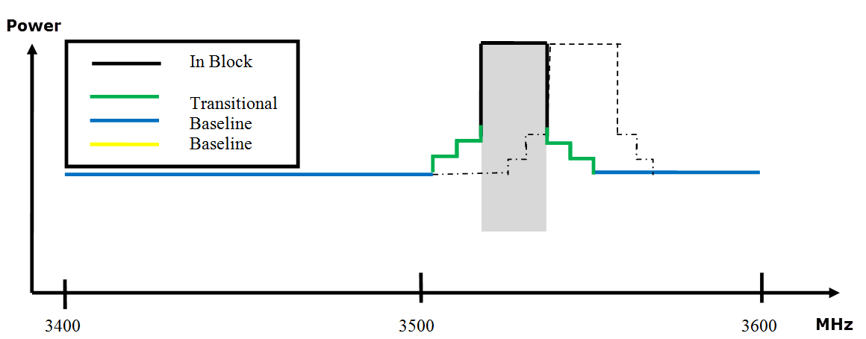

- Combined BEM elements for adjacent blocks with synchronised TDD networks

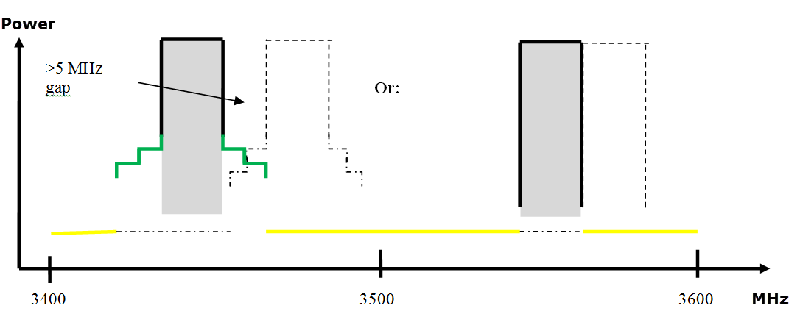

- Combined BEM elements for adjacent blocks with non-synchronized TDD networks
Figure 3 provides an example of such a combination of BEM elements for a FDD block in the lower part of the FDD DL spectrum.
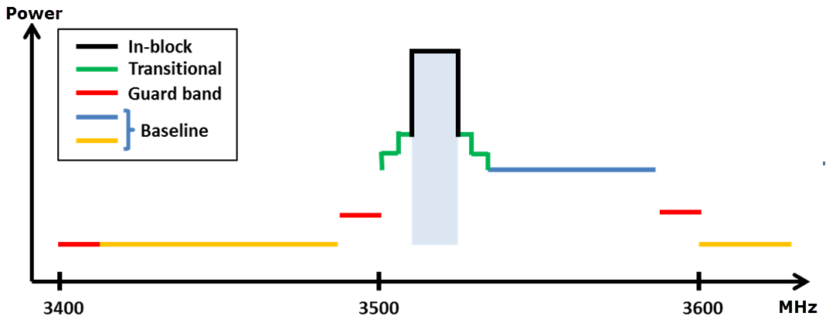
- Combined BEM elements for an FDD block starting at 3510 MHz
UE In-block requirement
This decision provides a recommended upper limit of 25 dBm for the in-block power of the UEs.
This power limit is specified as e.i.r.p. for UEs designed to be fixed or installed and as TRP for UEs designed to be mobile or nomadic.
A tolerance of up to +2 dB has been included in this limit, to reflect operation under extreme environmental conditions and production spread.
If administrations decide to establish that maximum value in the national regulation, they could still relax this limit under certain circumstances, for example for fixed UEs, providing that protection of other services, networks and applications is not compromised and cross-border obligations are fulfilled.
ANNEX 5: CO-EXISTENCE WITH OTHER SERVICES THAN MFCN
Coordination between MFCN and FSS or FS should be carried out on a case-by-case basis, since no single separation distance, guard band or signal strength limit can be provided. The services can be coordinated based on the same methodology as that which has been used for coordination between BWA and FSS or FS.
The following key principles related to the coordination between MFCN stations and (FSS). Earth stations should be considered at national level or between neighbouring countries in order to ensure coordination between these systems:
- Frequency coordination is primarily concerned with local implementation, local propagation conditions and local licensed use of the shared band. This is best dealt with by national administrations;
- Some administrations have effective co-ordination arrangements in place. The implementation of these guidelines is at the discretion of the national administrations to the extent this may help them;
- The key objectives of co-ordination processes are maximising efficient use of the available spectrum for the benefit of the CEPT whilst protecting existing licensed uses of the band;
- Coordination processes and associated protection should only apply to registered/licensed spectrum users;
- Data exchange and coordination processes are mutual and reciprocal to all band users;
- Data on registered use of the band should be available to all users under relevant legal protections and confidentiality obligations;
- The coordination process must be both accurate and fast to enable all operators to efficiently plan spectrum utilisation and network deployments;
- Operators should have access to registered band usage to maximise the successful coordination of spectrum through propagation modelling without physical measurement at the planning stage;
- All parties are responsible for the efficient use of spectrum. In deploying new MFCN stations and new FSS Earth stations, operators should be cognisant of the need to minimise constraints on the other service;
- These guidelines primarily relate to co-ordination within national boundaries. For the situation where MFCN and FSS stations are within the territories of different administrations, the use of these guidelines within bilateral agreements may help to expedite cross border co-ordination;
- All parties should undertake reasonable efforts to successfully complete the coordination exercise as quickly as possible;
- Either party has the inherent right to refer the co-ordination to the relevant NRA(s) if agreement cannot be reached.
For coexistence with BWA, it is assumed that BWA systems are similar to MFCN systems and that BWA can co-exist under the new BEM licensing regime. It should however be noted that BWA systems compliant to the former technical characteristics (as defined in ECC/REC/(04)05) may suffer interference from MFCN systems compliant with the BEM described above. The BWA UL needs to be protected from MFCN DL interference in the same way as a MFCN UL is protected. This can be achieved by frequency separation, or by applying the appropriate BEM elements as described above.
As a consequence of the above, a transitional phase could be considered during which previous and new technical characteristics should coexist. During this transitional phase, new authorisations shall be based on the new technical characteristics. This transitional phase may only apply in countries (and possibly neighbouring countries) where a BWA network has been effectively deployed and has not been updated with the new technical characteristics.
In some CEPT countries military radiolocation systems that are deployed below 3400 MHz need a fixed limit for protection from base station interference (cases A and B in Table 6 – Annex 4). Other mitigation measures like geographical separation, coordination on a case-by-case basis or an additional guard band may be necessary for a TDD allocation. For UEs other mitigation measures may be necessary such as e.g. geographical separation or an additional guard band for both FDD and TDD allocation.

Comparable technical specifications to those given in this ECC Decision are given in Commission Decisions 2008/411/EC and 2014/276/EU. EU Member States and, if so approved by the EEA Joint Committee, Iceland, Liechtenstein and Norway are obliged to implement the Commission Decisions.
TRP is a measure of how much power the antenna actually radiates. The TRP is defined as the integral of the power transmitted in different directions over the entire radiation sphere. E.i.r.p. and TRP are equivalent for isotropic antennas.
For cross-border coordination with non-EU administrations not listed in the 5.430A footnote of RR the provisions of this footnote should be taken into account.

