
Electronic Communications Committee (ECC)
within the European Conference of Postal and Telecommunications Administrations (CEPT)

ECC RECOMMENDATION (05) 01

HARMONISATION OF AUTOMATIC MEASURING METHODS AND DATA TRANSFER FOR FREQUENCY BAND REGISTRATIONS

Recommendation approved by the “Working Group Frequency Management" (WGFM)

In order to support the WGFM and its Project Teams as well as the preparatory work for WRCs by CPG and its Project Teams, monitoring campaigns are conducted by the radio monitoring services of the various CEPT Administrations.

With regard to such campaigns and other exchanges of monitoring information between Administrations, the measuring method and format in which data is stored should be harmonised. It is also helpful to harmonise the presentation of the processed data.

“The European Conference of Postal and Telecommunications Administrations,

considering

- that different measuring methods applied to the same frequency bands at the same time can produce different results;
- that various Administrations may use different measuring equipment and controlling software;
- that there are various data formats in which captured data can be stored;
- that there are several possibilities to process the data and produce presentations of the measurement data;
- that there are also similar needs within the framework of RR Article 16, International Monitoring.

recommends

- that data gathered and exchanged during common monitoring campaigns should be in accordance with the method described in Annex 1.

- that results from such co-ordinated measurements should be processed and presented as described in Annex 2.”

Annex 1

Harmonisation of automatic measuring methods and data transfer for frequency band registrations

1. Introduction

Automatic frequency band registrations collect a large amount of data from a certain Start frequency to a certain Stop frequency.

From the monitoring point of view, there is always a wish to measure as large a frequency band as possible in as short a time as possible with very good resolution whilst keeping the amount of data collected down to an acceptable size.

In practice, this is very difficult to achieve and the final solution will be a compromise between all the above-mentioned parameters.

2. Relationship between the different parameters

There is a strong relationship between:
- Size of the band
- Resolution of measurements
- Scan time
- Step size
- Filter bandwidth
- Duration of monitoring
- Occupied bandwidth of the expected spectra in the band to be measured
- Transmission length of the expected emissions.

If one of these variables changes, many other parameters will change or this will have an influence on the accuracy of the results.

3. Harmonised measurements

A measurement co-ordinator should be nominated for each monitoring campaign who will liaise with the requesting body to ensure that there is a common understanding on the required data, processing method and manner of final presentation.

The initial discussions with the requesting body should cover the following items:
 | Parameter | Considerations | Example
1. | Dates/times of measurements | Availability of monitoring stations
2. | Wanted geographic location | Availability of monitoring stations | Europe
3. | Frequency range  (FreqStart, FreqStop) | As desired, noting the relationship between the frequency span and the resolution of measurements | 6200-6400 kHz
4. | Duration of monitoring | This will vary depending on the task | 24 hours
5. | Re-visit time | Should be short enough to detect brief duration transmissions | 10 seconds
6. | Antenna  (AntennaType) | Directivity, gain, etc depending on task | Omnidirectional
7. | Detector  (Detector) | Intermittent signals may be best presented using maximum hold | Average
 | Others | As appropriate

The co-ordinator should also recognise that there are some parameters which are controlled by the measuring equipment. These include:
 | Parameter | Settings | Comments
1. | Number of measuring points / step size  (DataPoints) | = > 400 points | To guarantee sufficient resolution
2. | Filter Bandwidth  (FilterBandwidth) | Around 120% of step size | To ensure that all frequencies are monitored with minimal overlap
3. | Scan Time  (ScanTime) | < re-visit time | The actual time taken for the equipment to scan from FreqStart to FreqStop
4. | Attenuation  (Attenuation) | As required | As low as possible, depending on local conditions
5. | RF level | As required | To ensure that sufficient dynamic range is available to cope with the strongest signals expected to be received
 | Others |  | As appropriate

The co-ordinator should advise all participating Administrations of the required parameters prior to the start of the task. They should establish if their equipment is capable of measuring with these parameters and advise the co-ordinator if they are unable to fulfil the requirements.

All participating Administrations must ensure that their measuring equipment is operating in a calibrated manner. This is necessary as it is often possible to manually uncouple some spectrum analyser parameters which can result in un-calibrated measurement results.

4. Exchange of data

Once the agreed measurements have been made, it is necessary to send the results obtained from all the participating Administrations to the co-ordinator in order to process the data on a common basis.

Although the type of information stored by the various Administrations is broadly common, the internal format in which the monitoring data is stored varies greatly between the different types of equipment used. The often incompatible data format makes this transfer (data processing) very difficult.

5. Standard data format

To allow easy processing of the data, it should be submitted to the co-ordinator as an ASCII text file conforming to the following format.

The data file should comprise two sections:
- A ‘Header’ section containing the static information relating to the monitoring task such as the location used for monitoring, date and key monitoring parameters (see later).
- A ‘Data’ section containing all the measured results during the period of observation.

5.1 Header section

The following fields and fieldnames should be used. All appropriate data fields should be included in the header area before the measured results are added.

The header section can contain two types of information – Essential or Optional (marked E or O in the following table.)

Header fields
Type | Fieldname | Data format | Description
E | FileType | Text | ‘Bandscan’
E | LocationName | Text | Name of location making the measurements
E | Latitude | Text | DD.MM.SSx where ‘x’ is ‘N’ or ‘S’
E | Longitude | Text | DDD.MM.SSx where ‘x’ is ‘E’ or ‘W’
E | FreqStart | Numeric (real) | Frequency in kHz
E | FreqStop | Numeric (real) | Frequency in kHz
E | AntennaType | Text
E | FilterBandwidth | Numeric (real) | In kHz
E | LevelUnits | Text | dBuV, dBuV/m or dBm (note that ’u’ is used instead of ’μ’)
E | Date | Text | Date of measurements in the format YYYY-MM-DD (start date if measurements span midnight)
E | DataPoints | Numeric (integer) | Number of data elements in the data row (analyser data points or receiver steps)
E | ScanTime | Numeric (real) | The actual time taken (in seconds) for the equipment to scan from FreqStart to FreqStop
E | Detector | Text
O | Note | Text | General comments
O | AntennaAzimuth | Text | DDD.DD
O | AntennaElevation | Text | DD.DD
O | Attenuation | Numeric (integer) | Equipment attenuator setting in dB
O | FilterType | Text | e.g. ‘Gaussian 3dB’
O | DisplayedNote | Text | A small remark of less than 40 characters containing essential information which could be displayed next to the data on any final report

Additional fields may be added to the header in order to provide further information, however, these will not be automatically processed or recognised by the transfer software.

The header and data sections should be separated by ONE blank line.

5.2 Data section

The data area should consist of a separate line of data for each scan.

Each line should contain the start time of the measurement in HH:MM:SS format converted to UTC (or local time if requested by the co-ordinator) followed by a reading for each analyser data point or receiver step, all separated by commas.

Each signal level value should be rounded to the nearest integer value. If necessary, the co-ordinator will ask for an accuracy of one decimal place however this will increase the size of the resultant data file.

5.3 Example files

FileType Bandscan
LocationName Baldock
Latitude 52.00.00N
Longitude 000.08.00W
FreqStart 7000
FreqStop 7200
AntennaType Inverted V
FilterBandwidth 0.5
LevelUnits dBuV/m
Date 2004-04-18
DataPoints 501
ScanTime 7.5
Detector Average
Note This is a sample file of the data format.

00:00:00,65,56,64,54,23,29,32,43,54,25,29,25,36…etc…,43,59
00:00:10,64,53,65,59,42,37,35,34,64,25,26,36,63…etc…,54,61
00:00:20,62,57,64,59,41,36,26,42,53,62,16,52,24…etc…,52,66
etc
23:59:30,53,33,61,44,25,44,36,26,46,24,26,24,63…etc…,29,56
23:59:40,54,32,62,48,24,42,35,26,24,64,24,34,35…etc…,29,56
23:59:50,64,52,63,57,33,23,32,53,25,26,63,35,26…etc…,32,59

6. Transfer software

As various Administrations use different data formats, they should therefore develop their own specific transfer software in order to translate their internal data layout to and from the common interchange format. Depending on the complexity of the internal design, this transfer software may be a simple macro file and could be shared between Administrations using the same type of data gathering equipment.

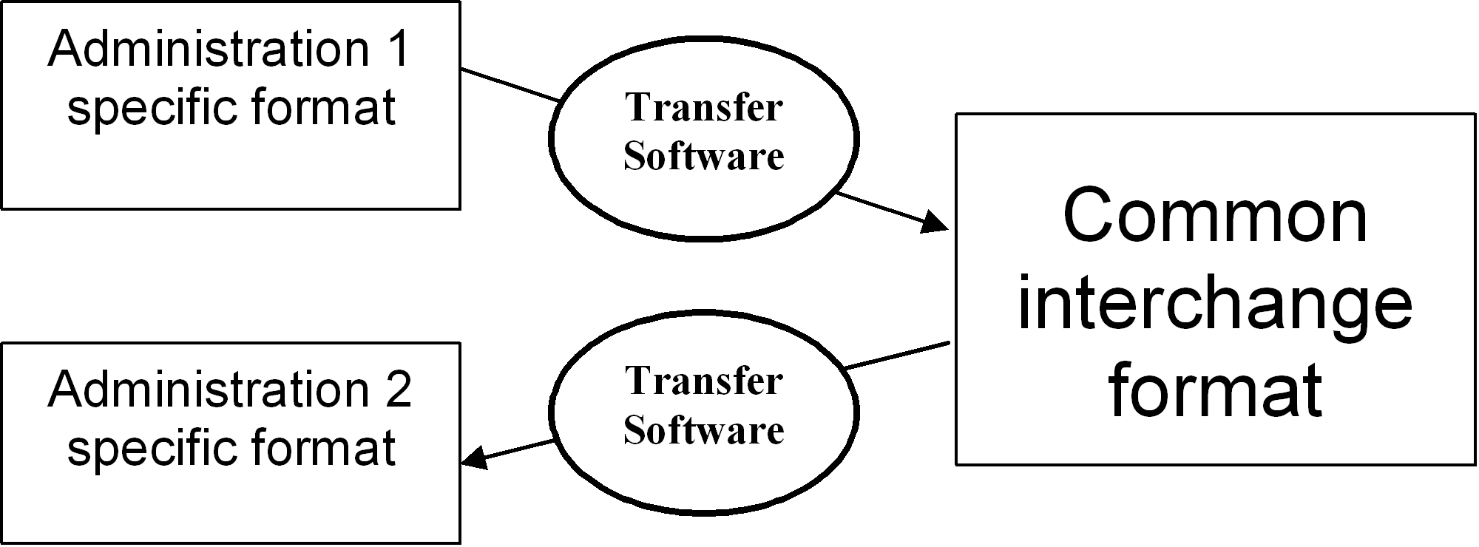

Annex 2

Examples of frequency band registration presentations

1. Introduction
The measured field strength values, stored in the format described in chapter 5 of Annex 1, enables different processing methods which can produce several presentations. A number of them are described below.

When comparing harmonized results from different locations, it is beneficial to use common scaling values for displaying time and signal level.

2. Spectrogram
A spectrogram is a two-dimensional plot representing the received transmissions in the measured frequency band with the frequency on the horizontal axis and time on the vertical axis.

The colour indicates the field strength of the captured data in accordance with the colour bar on the right side of the plot.

3. Minimum/median/maximum values
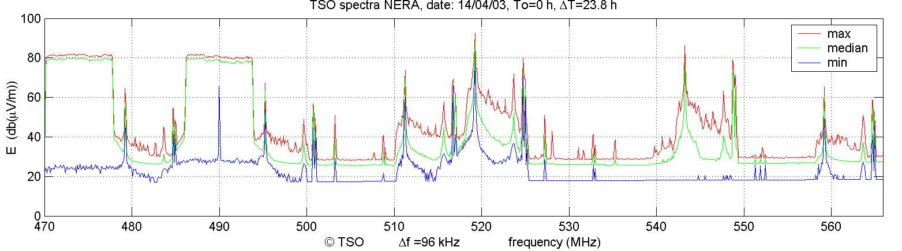
A minimum (blue), median (green) and a maximum value (red) can be calculated for all the measured data points during the monitoring period.

In the case of a monitoring duration of 24 hours and a re-visit time of 10 seconds there are 8,600 field strength values available for each data point to determine the minimum, median and maximum value.

4. Occupancy
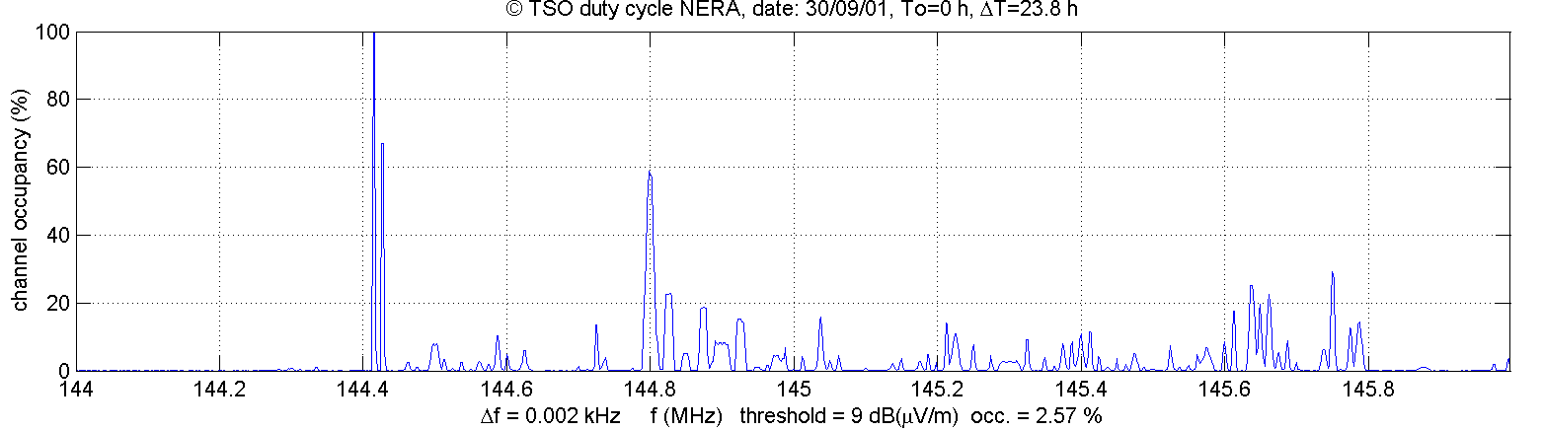
The occupancy plot shows the occupancy above a certain threshold level for all measured data points during the monitoring period.
In the case of a re-visit time of 10 seconds and a measurement period of 24 hours, 4,300 of the measured 8,600 values of a certain data point exceed the adjusted threshold level, the occupancy for that data point is 50%. The occupancy is calculated and presented for each data point.

5. Waterfall
This is a three-dimensional plot presenting the frequency, time and fieldstrength in a number of scans.  The number of scans must be adjusted, but optically a number of about 60 scans is often sufficient to give a reliable picture of the measured frequency band. | 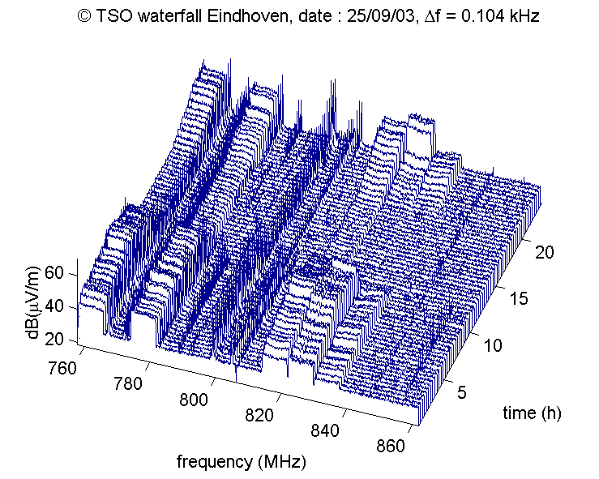
Each individual scan could also be a maximum, median, average or maximum value for each data point.

6. Fieldstrength over time per channel (e.g. in case of broadcasting)
A plot presenting the field strength over time can be compiled for each of the measured data points, normally > 400.
This is often useful in case the measured bands are broadcasting bands. The time of on and off switching transmitters can be determined.

In the case of a frequency span of 200 kHz, 40 of these channels can be displayed (channel separation is 5 kHz).

