ANNEXES to ECC REPORT 24
PLT, DSL, CABLE COMMUNICATIONS (INCLUDING CABLE TV),
LANS AND THEIR EFFECT ON RADIO SERVICES

INDEX TABLE

Annex 1: Text of the European Commission mandate M313 2
Annex 2: Overview of the present national regulations on cable TV in Europe 4
Annex 3: Extracts from the FCC Part 15 & Part 76 regulations concerning cable communication systems and from the FCC report and order 02-157 9
Annex 4: Field strength in the far field area and effective radiated power from an infinitesimal electric or magnetic dipole 16
ANNEX 5: Typical results from a cable TV measurement campaign in France 29
ANNEX 6: radiation from equipment below 30 MHz 33
Annex 7: cumulative effect of broadband PLT below 30 MHz 49
Annex 8: Effects on amateur radio of the use of power lines for broadband data communications (PLT) 58
Annex 9: Compatibility between cable TV and aeronautical radio systems 84

Annex 1: Text of the European Commission mandate M313
STANDARDISATION MANDATE
ADDRESSED TO CEN, CENELEC AND ETSI
CONCERNING ELECTROMAGNETIC COMPATIBILITY (EMC)

TELECOMMUNICATIONS NETWORKS
1 Title

EMC harmonised standards for telecommunication networks.

2 Content

This mandate concerns the preparation of harmonised standards covering EMC aspects of wire-line telecommunication networks including their in-house extensions. These standards should cover the types of networks, which are currently operational or which are under development, including, but not limited to those using power lines, coaxial cables and classical telephone wires. This mandate does not concern the preparation of harmonised standards relating to the electromagnetic compatibility of equipment to be connected to the networks.

3 Legal basis

This is a standardisation mandate within the framework of Directive 89/336/EEC on the approximation of the laws relating to EMC.

4 Previous mandates

The following mandates have been issued to CEN, CENELEC and ETSI requesting the production of harmonised standards under Directive 89/336/EEC:

BC-T-353 | Development of harmonised standards for telecommunication terminal equipment, satellite earth station equipment and radiocommunication equipment
BC/CLC-03/88 | Development of EMC product standards
BC/CLC-02/92 | Supplementing BC/CLC-03/88
BC/CLC/03/0000/98-3 | Supplementing BC/CLC-02/92
BC-IT-82 | EMC aspects of IT and Telecommunications equipment
M/038 | Supplementing BC-IT-82 by introducing the concept of harmonised standard in the context of the New Approach
M/282 | Aircraft and aeronautical equipment

5 Description of the mandate

Since the entry into force of the EMC Directive, a number of harmonised standards have been produced covering the electromagnetic compatibility of electrical and electronic appliances. No harmonised standards, however, have been developed covering the electromagnetic compatibility of fixed installations, such as, for instance, telecommunication networks. While this situation so far may have been satisfactory, such installations increasingly cause interference to radio services, and are in some case experiencing interference. Several workshops, organised by the European Commission during the years 2000 and 2001, with wide participation of users of the radio spectrum, industry and regulators, have highlighted this situation.

Harmonised standards for telecommunication networks would simplify the application of the EMC Directive to all parties involved and provide a level playing field, as far as EMC is concerned, for the development of new telecommunication technologies. In this context, the already achieved electromagnetic compatibility of wired broadband networks is to be maintained.

Therefore, the European Commission requests CEN, CENELEC and ETSI:
- to prepare and adopt harmonised standards covering the electromagnetic compatibility requirements (emission and immunity) for telecommunication networks using:
- power lines
- coaxial cables
- telephone wires (e.g. using xDSL technology)
- to consider the feasibility of harmonised standards covering the electromagnetic compatibility requirements (emission and immunity) for other types of telecommunication and data networks, and, when pertinent, to prepare and adopt such harmonised standards.

These harmonised standards shall lay down the limits and the test methods needed to allow presumption of conformity with the essential requirements of Directive 89/336/EEC. They should take into account, whenever possible, existing European and international technical specifications already developed in this area (for instance, the values defined in EN 50083-8, Germany's NB 30 or the United Kingdom's enforcement standard MPT 1570). They shall especially take into account the need to protect frequencies used by safety and emergency services.

These standards should, be coherent with generic standards. They should take into account any other harmonised standards (produced under either Directive 89/336/EEC or Directive 99/5/EC) relating to the electromagnetic compatibility of equipment to be connected to the networks.

The standards produced under this mandate should form a comprehensive, technology-neutral set. A coherent approach, in particular in terms of electromagnetic emission, must be sought. In this respect, it should be considered to initiate the work by identifying generic limits applicable to all wire-line telecommunication networks.

6 Execution of the mandate

The Commission hereby entrusts CEN, CENELEC and ETSI this mandate.

CEN, CENELEC and ETSI will provide by [date of sending of mandate to the ESOs + 6 months] a programme with the standards that will cover the mandate and the target date for their availability.

CEN, CENELEC and ETSI are, at regular intervals, to inform the European Commission, which in turn will inform the Committee established under Directive 98/34/EC, of any new draft standard covered by this mandate.

Within six months of their adoption, the European standards produced under this mandate are to be transposed into national standards, and the conflicting national standards are to be withdrawn from the catalogues of the EU national standards organisations. CEN, CENELEC and ETSI will provide the Commission with the titles of the standards in the Community languages.

CEN, CENELEC and ETSI are advised to coordinate their activities with the relevant European or international bodies.

The standstill period referred to in Article 7 of Directive 98/34/EC of 22 June 1998 shall start when the relevant European standards body accepts this standardisation mandate.

Annex 2: Overview of the present national regulations on cable TV in Europe
In response to a questionnaire send out primo 2000 the ERO had received 17 responses. Information about frequency bands allowed within cable TV networks, restricted bands and power limits are indicated below.

Responses were received from the following Administrations:

In addition, Ireland presented in WG SE a paper explaining the present leakage radiation limits applicable to cable TV networks.
France also indicated that there exists no specific cable TV regulation in terms of limits or forbidden frequency bands in France.
The following table is a summary of the information received at the ERO, together with the information provided by Ireland and France.
Administration | Regulatory provisions
Andorra | No regulation regarding Cable TV.
Austria | Standard EN 50083 applies in Austria.
Croatia | General regulation on Cable TV. No regulation available on frequency bands excluded from use and the limits for radiation from the Cable and associated equipment.
Cyprus | No relevant legislation exists.
Czech Republic | Standard EN 50083 implemented, no additional restrictions.
Denmark | Only requirements from EMC Directive  New executive order limit emission from cable-TV networks in the aeronautical bands to max 27 dBuV/m at 3 metres. (April 2000).
Estonia | Frequency usage within cable networks:  - forward frequency range 47–862 MHz  - frequency range for FM broadcasting only 87.5–108 MHz  - frequency ranges permitted for overhead lines 47–68 MHz,  87.5–108 MHz  174–862 MHz  Unwanted modulation of vision carrier at the frequency of the supply mains and harmonics thereof shall be such that the reference modulation to hum modulation is not less than 46 dB.
Finland | TAC evaluation of the usefulness of the planned frequencies in a particular region if other frequencies that 47-68, 87.5-108, 174-230, 319-328.6, 470-862 MHz or 950-1750 MHz are planned in the network.
France | No specific legislation exists.
Germany | Free use of frequency bands in cable-TV if the following field strength limits are applied:  and the following frequency bands for safety related services are excluded:  - 74.2-74.8 MHz (public safety authorities and organisations);  - 74.8-75.2 MHz (aeronautical radionavigation service);  - 75.2-77.5 MHz (public safety authorities and organisations);  - 84-87.3 MHz (public safety authorities and organisations);  - 108-117.975 MHz (aeronautical radionavigation service);  - 117.975-137 MHz (aeronautical mobile service);  - 167-174 MHz (public safety authorities and organisations);  - 328.6-335.4 MHz (aeronautical radionavigation service).  The following frequency bands are available in Germany for cable TV distribution networks nationwide:
  Frequency f (MHz) in the Range | Interfering Field Strength Limit  at 3 m (dB(µV/m))
  9 kHz – 1 MHz | 40 - 20·log10(f/MHz)
  1 – 30 MHz | 40 - 8.8·log10(f/MHz)
  30 – 1000 MHz | 27 dBuV/m (20 dBpW)
  1000 – 3000 MHz | 40 dBuV/m (33 dBpW)
  47-68 MHz | 7 MHz | TV broadcast distribution
  87.5-108 MHz | 100 kHz  channel bandwidth 300 kHz | FM sound broadcast distribution
  111-174 MHz | 7 MHz | TV broadcast distribution
  174-230 MHz | 7 MHz | TV broadcast distribution
  230-300 MHz | 7 MHz | TV broadcast distribution
  302-446 MHz | 8 MHz | TV broadcast distribution
Hungary | Currently no comprehensive regulation for cable TV networks.  However, Cable TV operates on a non interference and non protected basis. Current standard implies a limit of interfering radiation from a Cable TV network 100 pW referred to any point of the network.  Hungary have implemented EN 50083 Parts 1 to 7.  The Authority refuses licensing of the band 104-134 MHz to protect Aeronautical Radionavigation Service.

Ireland | The policy regarding leakage currently in force in Ireland is based on the limits that are given below. These limits are a mandatory condition of the licence and can be enforced under regulation 18 of the Wireless Telegraphy (Programme Services Distribution) Regulations, 1999.  Signal Leakage Limits for Cable Distribution Networks  Note 1: This value assumes 100 kHz separation from off-air FM broadcasting.  Note 2: Except for the leakage reference signal, provided it is specifically authorised in the licence by the Director for Telecommunications Regulations.  Note 3: The limit specified is based on the assumption that the digital cable system is not using a frequency channel that is co-channel with the frequency channels used for off-air reception of digital or analogue television signals within the cable area.  Correction factors that can be applied for various measurement distances are given in the following table:  Note: intermediate values of reduction factor should be obtained by interpolation.  It should be noted that the limit for 5-30 MHz was obtained by averaging the sensitivity of 5 amateur radio transceivers for a 10 dB SNR. This gave a figure of 5.8 dBμV, which was converted into a field strength assuming a 50 ohms antenna impedance and then scaled for 10 meters.
  Frequency Range  MHz | Maximum Field Strength (dBμV/m) at  10m distance from the cable system
  5-30 | 2
  30 – 68 | 10
  68 – 74.8 | -2
  74.8 | Use prohibited
  75.2 | -2
  87.5 – 108 | 8 (note 1)
  108 – 138 | Use prohibited (note 2)
  138 – 144 | 4
  144 – 146 | Use prohibited
  146 – 156.6 | 5
  156.6 – 157.0 | Use prohibited
  157.0 – 174 | 5
  174 – 230 | 13 (note 3)
  230 – 242.8 | 9
  242.8 – 243.2 | Use prohibited
  243.2 – 281 | 10
  281 – 282 | Use prohibited
  282 – 318.5 | 10
  318.5 – 319.5 | Use prohibited
  319.5 – 328.6 | 11
  328.6 – 335.4 | Use prohibited
  335.4 – 380 | 11
  380 – 405.85 | 11
  405.85 – 406.25 | Use prohibited
  406.25 – 430 | 12
  430 – 440 | Use prohibited
  440 – 450 | 12
  450 – 470 | 12
  470 – 790 | 13 (note 3)
  790 – 862 | 13 (note 3)
  Distance (m) | Correction factor dB
  3 | + 10
  5 | +6
  10 | 0
  15 | -3.5
  20 | -6
  25 | -8
  30 | -9.5
Latvia  TV channels | Standard EN 50083 applies in Latvia  Distribution channels for TV in cable networks:  - 48.5-56.5 MHz  - 58 – 66 MHz  - 76 – 100 MHz  - 174 230 MHz  - 470 – 582 MHz  - 582 – 862 MHz  - 110 – 470 MHz SK channels 1 – 40  - 2500 – 2692 MHz MVDS channels 1-24.  Electromagnetic radiation from cable networks shall not exceed 20 dB pW within 30 – 1000 MHz.  The value of the radiated volume referred to shall conform to the intensity of the electromagnetic field measured at 10 metres from the radiating cable network.  At distances other than 10 metres the following adjustment shall be applied:  3 metres -10.5 dB  10 metres 0 dB  20 metres +6 dB  30 metres +9.5 dB  100 metres +20 dB.
Lithuania | Standard EN 50083 applies in Lithuania as indicated in technical regulation RR 15-97.  Frequency bands allowed:  48.5 – 862 MHz with the exception of 66-76, 84-87.5, 150-174 in those cases when radiation from other telecommunications systems interfere with the cable networks and the band 462-470 MHz.  Radiated power limit 20 dB pW in accordance with EN 50083-8.
Netherlands | EN 50083-2-1995 and EN 50117 are applied in the Netherlands.  No further details on frequency bands.
Norway | Frequency range 5 – 2150 MHz is allowed in cable TV except the bands: 108-137 MHz, 242-244 MHz and 328-336 MHz (risk of interference). Cable TV networks which transfer signal in the frequency range 960-1215 MHz must be established at least 1000 meters from any navigation of Air traffic.
Romania | EN 50083 is applied.  Frequency bands used within cable TV networks are:  Maximum radiated power from cable networks not exceed 10⁻¹⁰W.  Not permitted to use frequencies of terrestrial and local TV and Radio stations on the Cable network.  Mutual isolation 46 dB.  New technical specification for CATV of introducing supplementary services such as data transmission systems in progress.
   | OIRT-D |  | CCIR-B
  1.  2  3.  4.  5. | 48.5-56.5 MHz  58-66 MHz  76-84 MHz  84-92 MHz  92-100 MHz | 2.  3.  4. | 47-54 MHz  54-61 MHz  61-68 MHz
  S1-S9  6-12  S11-S19 | 102-174 MHz  174-230 MHz  230-302 MHz | S1-S10  5-12  S11-S20 | 104-174 MHz  174-230 MHz  230-300 MHz
  S21-S38  21-60 | 302-446 MHz  470-790 MHz
Russia | Frequencies used within Cable networks:  Information about radiation limits subject to detailed translation from Russian of regulations.
  Secam B |  | Secam D
  104-174 MHz | SE2-10 | 110-174 MHz | SR1-R8
  230-300 MHz | SE11-20 | 230-294 MHz | SR11-18
  5-30 MHz |  | 5-20 MHz
Slovak Republic | Slovak Telecommunications Standard STN 36 7211.  Frequency bands for cable distribution:  148.5-283.5 kHz  526.5-1606.5 kHz  66 – 73 MHz  87.5 – 108 MHz  - standard TV channels within TV bands I, III, IV, VI  - telecommunications satellite 10950 – 11700 MHz.  Special TV bands:  - 110-174 MHz  - 111-174 MHz  - 230-294 MHz  - 230-300 MHz  - 300-446 MHz  back channels from 5 to 21 MHz  Measurement and controlling of radiation in accordance with national standards. Not informed in response to questionnaire.

Annex 3: Extracts from the FCC Part 15 & Part 76 regulations concerning cable communication systems and from the FCC report and order 02-157
1 Part 15
Relevant extracts of Part 15 are reproduced below. Text in italics represents some comments and explanatory information that are not part of the original US regulations.

A: Section §15.3 Definitions
§15.3 (f) Carrier current system.
A system, or part of a system, that transmits radio frequency energy by conduction over the electric power lines. A carrier current system can be designed such that the signals are received by conduction directly from connection to the electric power lines (unintentional radiator) or the signals are received over-the-air due to radiation of the radio frequency signals from the electric power lines (intentional radiator)
PLT (but not DSL etc.) falls under the definition of ‘carrier current system’. PLT is clearly to be interpreted here as an unintentional radiator:
§15.3 (m) Harmful interference.
Any emission, radiation or induction that endangers the functioning of a radio navigation service or of other safety services or seriously degrades, obstructs or repeatedly interrupts radiocommunications service operating in accord with this chapter.
§15.3 (n) Incidental radiator.
A device that generates radio frequency energy during the course of its operation although the device is not intentionally designed to generate or emit radio frequency energy. Examples of incidental radiators are dc motors, mechanical light switches, etc.
§15.3 (o) intentional radiator.
A device that intentionally generates and emits radio frequency energy by radiation or induction
DSL/PLT etc. falls into neither incidental nor intentional radiator categories. It is an unintentional radiator as defined:
§15.3 (z) Unintentional radiator.
A device that intentionally generates radio frequency energy for use within the device, or that sends radio frequency signals by conduction to associated equipment via connecting wire, but which is not intended to emit RF energy by radiation or induction.

B: Section §15.5 General conditions of operation
Intentional or unintentional radiators can be prohibited from continued operation:
§15.5(b) Operation of intentional or unintentional radiators shall not be deemed to have any vested or recognized right to continued use of any given frequency by virtue of prior registration or certification of equipment, or, for power line carrier systems, on the basis of prior notification of use pursuant to §90.63(g) of this chapter.
Although quantified limits are spelled out in Sections § 15.109 and 15.209, more restrictive limits are enforced in the case of the occurrence of harmful interference:
§15.5 (c) The operator of a radio frequency device shall be required to cease operating the device upon notification by a Commission representative that the device is causing harmful interference. Operation shall not resume until the condition causing the harmful interference has been corrected.

C: Section §15.15 General technical requirements
Regardless of the quantitative limits, emissions must be minimized:
§15.15 (a) An intentional or unintentional radiator shall be constructed in accordance with good engineering design and manufacturing practice. Emanations from the device shall be suppressed as much as practicable but in no case shall the emanations exceed the levels specified in these rules.
The explicit quantitative limits given in Sections §15.109 and 15.209 are recognized not to prevent harmful interference under all circumstances. However, in such cases operators are required to ‘cease operation should harmful interference occur’ (similar ‘Information to the user’ is given in Section § 15.105 with respect to use of a Class A and/or Class B digital device or peripheral):
§ 15.15 (c) Parties responsible for equipment compliance should note that the limits specified in this part will not prevent harmful interference under all circumstances. Since the operators of part 15 devices are required to cease operation should harmful interference occur to authorized users of the radio frequency spectrum, the parties responsible for equipment compliance are encouraged to employ the minimum field strength necessary for communications, to provide greater attenuation of unwanted emissions than required by these regulations, and to…
Furthermore, the parties responsible for equipment compliance should:
… advise the user as to how to resolve harmful interference problems (for example, see § 15.105(b)).

D: Section §15.19 Labelling requirements.
The equipment must be marked to indicate that
- it could cause harmful interference
- it is not permitted to do so
- it must accept any interference received:
§ 15.19(a) (3) All other devices shall bear the following statement in a conspicuous location on the device:
“This device complies with part 15 of the FCC Rules. Operation is subject to the following two conditions: (1) This device may not cause harmful interference, and (2) this device must accept any interference received, including interference that may cause undesired operation.”

Subpart B – Unintentional Radiators
In principle, xDSL/PLTetc. fall under this sub-part.

F: Section § 15.107 Conducted limits.
(a) …
(b) …
Limits given in § 15.107 (a) and (b) do not apply to PLT; § 15.107 (c) do apply:
(c) The limits shown in paragraphs (a) and (b) of this section shall not apply to carrier current systems operating as unintentional radiators on frequencies below 30 MHz. In lieu thereof, these carrier current systems shall be subject to the following standards:
- for emissions intended to be received using a standard AM broadcast receiver
(2) For all other carrier systems: 1000 μV within the frequency band 535-1705 kHz.
(3) Carrier current systems operating below 30 MHz are also subject to the radiated emissions in § 15.109(e) which in turn refers to Section § 15.209.

G: Section § 15.109 Radiated emission limits.
The applicable radiated emission limits applicable to xDSL/PLT, for frequencies > 30 MHz are reproduced below together with some of the relevant text.:

(a) Except for Class A digital devices, the field strength of radiated emissions from unintentional radiators at a distance of 3 meters shall not exceed the following values:
Frequency of Emission (MHz) | Field Strength (microvolts/meter)
30 - 88 | 100
88 - 216 | 150
216 - 960 | 200
Above 960 | 500

(b) The field strength of radiated emissions from a Class A digital device, as determined at a distance of 10 meters, shall not exceed the following:
Frequency of Emission (MHz) | Field Strength (microvolts/meter)
30 - 88 | 90
88 - 216 | 150
216 - 960 | 210
Above 960 | 300

(c) In the emission tables above, the tighter limit applies at the band edges. Sections § 15.33 and 15.35 which specify the frequency range over which radiated emissions are to be measured and the detector functions and other measurement standards apply.
For xDSL/PLT etc., at frequencies below 30 MHz, the limits of Section § 15.209 (which are otherwise intended for intentional radiators) apply.
(e) Carrier current systems used as unintentional radiators or other unintentional radiators that are designed to conduct their radio frequency emissions via connecting wires or cables and that operate in the frequency range of 9 kHz to 30 MHz, including devices that deliver the radio frequency energy to transducers, such as ultrasonic devices not covered under Part 18 of this Chapter, shall comply with the radiated emission limits for intentional radiators provided in Section 15.209 for the frequency range of 9 kHz to 30 MHz ...
For PLT only, § 15.221 (a) (also intended for intentional radiators) may be applied instead of § 15.209:
As an alternative, carrier current systems used as unintentional radiators and operating in the frequency range of 525 kHz to 1705 kHz may comply with the radiated emission limits provided in Section 15.221(a)…
For frequencies above 30 MHz:
At frequencies above 30 MHz, the limits in paragraph (a), (b) or (g) of this Section, as appropriate, apply.

H: Section § 15.113 Power-line carrier systems.
This Section is for utilities only, not communications to the home:
(f) The provisions of this section apply only to systems operated by a power utility for general supervision of the power system and do not permit operation on electric lines which connect the distribution substation to the customer or house wiring. Such operation can be conducted under the other provisions of this part.
Subpart C – Intentional Radiators
Although DSL/PLTetc. are unintentional radiators, the emission limits in Section § 15.209 or § 15.221 (a) apply to them according to Section § 15.109 (e):

I: Section § 15.205 Restricted bands of operation.
In many frequency intervals in the LF/MF/HF/VHF/UHF bands only spurious emissions are permitted:
(a) a table of the restricted frequencies is contained in this indent
J: Section § 15.207 Conducted limits.
This Section applies to intentional radiators connected to a power line (i.e., not xDSL/PLT):
(a) For an intentional radiator…
and intentional radiators that deliberately inject signals into the power line (also excludes xDSL/PLT):
(c) The limit shown in paragraph (a) …shall not apply to current systems operating as intentional radiators on frequencies below 30 MHz. In lieu thereof, these carrier current systems shall be subject to the following standards:
(1) For carrier current system containing their fundamental emission within the frequency band 535-1705 kHz and intended to be received using a standard AM broadcast receiver: no limit on conducted emissions.
This seems to refer to a special case where AM MW signals are deliberately injected onto cable for reception by a standard AM receiver (i.e., not applicable to xDSL/PLT etc.)
(2) For all other carrier current systems: 1000 μV within the frequency band 535-1705 kHz.
This gives a 1 mV conducted emission limit in (extended) MF broadcast band, but note that it is not applicable to DSL/PLT, etc.
(3) Carrier current systems operating below 30 MHz are also subject to the radiated emission limits in § 15.205, § 15.209, § 15.221, § 15.223, or § 15.227, as appropriate.
By virtue of § 15.109 (e), radiated emission limits below 30 MHz for xDSL/PLT/etc. are the same as given in § 15.209, or optionally § 15.221 (a) for PLT only.
K: Section § 15.209 Radiated emission limits; general requirements.
This Section applies to intentional radiators and also, via § 15.109 (e), to xDSL/PLT/etc. below 30 MHz:
(a) Except as provided elsewhere in this subpart, the emissions from an intentional radiator shall not exceed the field strength levels specified in the following table:
Frequency Field Strength Measurement Distance
(MHz) (microvolts/meter) (meters)
_______________________________________________________________

0.009 - 0.490 2400/F(kHz) 300
0.490 - 1.705 24000/F(kHz) 30
1.705 - 30.0 30 30
30 - 88 100 ** 3
88 - 216 150 ** 3
216 - 960 200 ** 3
Above 960 500 3
_______________________________________________________________
** Except as provided in paragraph (g), fundamental emissions from intentional radiators operating under this Section shall not be located in the frequency bands 54-72 MHz, 76-88 MHz, 174-216 MHz or 470-806 MHz. However, operation within these frequency bands is permitted under other sections of this Part, e.g., Sections 15.231 and 15.241.
From the table:
LF translates to the formula : 7.6-20 log(fMHz) dBμV/m at 300m;
MF translates to 27.6-20 log(fMHz) dBμV/m at 30m;
HF translates to 29.5 dBμV/m at 30m.
(b) In the emission table above, the tighter limit applies at the band edges.
(d) The emission limits shown in the above table are based on measurements employing a CISPR quasi-peak detector except for the frequency bands 9-90 kHz, 110-490 kHz and above 1000 MHz. Radiated emission limits in these three bands are based on measurements employing an average detector.
The emission limits are to be made using a CISPR quasi-peak detector in most but not all relevant frequency ranges. Note that an average detector is used at LF, which includes the range in which LW broadcasting occurs in Europe/Africa, but not in the USA.

L: Section § 15.219 Operation in the band 525-1705 kHz.
The Sections § 15.219, § 15.221, § 15.223 seem to confirm that the main motivation of sub-part C is for intentional radiators, including applications like on-campus student radio stations. This explains why the limits of § 15.209 are measured as such long distances – the emissions in this case are actually WANTED at shorter distances. The large measurement distances are thus inherited when applied to Unintentional radiators. The requirement NOT to cause harmful interference, independent of emission levels is clearly expressed in e.g., § 15.5.
(a) Carrier current systems and transmitters employing a leaky co-axial cable as the radiating antenna may operate in the band 525-1705 kHz provided the field strength levels of the radiated emissions do not exceed 15 μV/m, as measured at a distance of 47.715/(frequency in kHz) meters (equivalent to Lambda/2Pi) from the electric power line or the coaxial cable, respectively. The field strength levels shall not exceed the general radiated emission limits in § 15.209.
This Section can be applied to PLT systems (but not to xDSL, etc.) as an alternative to the limits of § 15.209 (a), for the US MW band only. The limits appear to be loosely comparable in stringency, but use different measurement distances.
(d) For the band 535-1705 kHz, the frequency of operation shall be chosen such that operation is not within the protected field strength contours of licensed AM stations.
Licensed AM MW broadcast stations are in any case to be protected in their service area. In addition this indent explicitly excludes intentional or unintentional radiators form radiating emissions in broadcast frequencies anywhere WITHIN the coverage area of licensed broadcast transmitters using those same frequencies.

2 Part 76
Relevant extracts from Part 76 are reproduced below:

Sec. 76.605 Technical Standards

(12) As an exception to the general provision requiring measurements to be made at subscriber terminals, and without regard to the type of signals carried by the cable television system, signal leakage from a cable television system shall be measured in accordance with the procedures outlined in Sec. 76.609(h) and shall be limited as follows:

Frequencies | Signal leakage limit (micro-volt/meter) | Distance in meters (m)
Less than and including 54 MHz, and over 216 MHz | 15 | 30
Over 54 up to and including 216 MHz | 20 | 3

Sec. 76.609 Measurements.

(h) Measurements to determine the field strength of the signal leakage emanated by the cable television system shall be made in accordance with standard engineering procedures. Measurements made on frequencies above 25 MHz shall include the following:
(1) A field strength meter of adequate accuracy using a horizontal dipole antenna shall be employed.
(2) Field strength shall be expressed in terms of the rms value of synchronizing peak for each cable television channel for which signal leakage can be measured.
(3) The resonant half wave dipole antenna shall be placed 3 meters from and positioned directly below the system components and at 3 meters above ground. Where such placement results in a separation of less than 3 meters between the center of the dipole antenna and the system components, or less than 3 meters between the dipole and ground level, the dipole shall be repositioned to provide a separation of 3 meters from the system components at a height of 3 meters or more above ground.
(4) The horizontal dipole antenna shall be rotated about a vertical axis and the maximum meter reading shall be used.
(5) Measurements shall be made where other conductors are 3 or more meters (10 or more feet) away from the measuring antenna.

Sec. 76.610 Operation in the frequency bands 108-137 and 225-400 MHz--scope of application.

The provisions of Secs. 76.611 (effective July 1, 1990), 76.612, 76.613, 76.614 and 76.1803 and 76.1804 are applicable to all cable television systems transmitting carriers or other signal components carried at an average power level equal to or greater than
10 to the power -4 watts across a 25 kHz bandwidth in any 160 microsecond period, at any point in the cable distribution system in the frequency bands 108-137 and 225-400 MHz for any purpose. For grandfathered systems, refer to Secs. 76.618 and 76.619.

Note 1: See the provisions of Sec. 76.616 for cable operation near certain aeronautical and marine emergency radio frequencies.

Sec. 76.611 Cable television basic signal leakage performance criteria.

(a) No cable television system shall commence or provide service in the frequency bands 108-137 and 225-400 MHz unless such systems is in compliance with one of the following cable television basic signal leakage performance criteria:
(1) prior to carriage of signals in the aeronautical radio bands and at least once each calendar year, with no more than 12 months between successive tests thereafter, based on a sampling of at least 75% of the cable strand, and including any portion of the cable system which are known to have or can reasonably be expected to have less leakage integrity than the average of the system, the cable operator demonstrates compliance with a cumulative signal leakage index…………………………..

Sec. 76.613 Interference from a multi-channel video programming distributor (MVPD).

(a) Harmful interference is any emission, radiation or induction, which endangers the functioning of a radionavigation service or of other safety services or seriously degrades, obstructs or repeatedly interrupts a radiocommunication service operating in accordance with this chapter.
(b) An MVPD that causes harmful interference shall promptly take appropriate measures to eliminate the harmful interference.
(c) If harmful interference to radio communications involving the safety of life and protection of property cannot be promptly eliminated by the application of suitable techniques, operation of the offending MVPD or appropriate elements thereof shall immediately be suspended upon notification by the……….[FCC]
(d) The MVPD may be required by the District Director and/or Resident Agent to prepare and submit a report regarding the cause(s) of the interference, corrective measures planned or taken, and the efficacy of the remedial measures.

Aeronautical Operational Requirements (Sections 76.610 – 76.616)

A) FREQUENCY OFFSETS
All carrier signals or signal components carried at an average power level equal to or greater than 10-4 watts in a 25 kHz bandwidth in any 160 microseconds period must operate at frequencies offset from certain frequencies which may be used by aeronautical radio services operated by Commission licensees or by the United States Government or its Agencies. The following table summarizes the frequency-offset requirements:
FREQUENCY OFFSETS

Frequency Band (Standard and IRC) | Offset | Tolerance
118-137, 225-328.6 and 335.4 - 400 MHz | 12.5 kHz | + - 5 kHz
108-118 and 328.6-335.4 MHz | 25.0 kHz | + - 5 kHz
For Harmonically Related Carrier (HRC) systems, the fundamental frequency from which the visual carrier frequencies are derived should be a multiple of 6.0003
MHz with a tolerance of + - 1 Hz.

B) INTERFERENCE
- Harmful interference is any emission, radiation or induction, which endangers the functioning of a radio-navigation service or of other safety services or seriously degrades, obstructs or repeatedly interrupts a radiocommunication service.
- The operator of a cable television system that causes harmful interference shall promptly take appropriate measures to eliminate the harmful interference.
- If harmful interference to radiocommunications involving the safety of life and protection of property cannot be promptly eliminated by the application of suitable techniques operation of the offending cable television system or appropriate elements thereof shall immediately be suspended upon notification by the Engineer in Charge (EIC) of the Commission's local field office, and shall not be resumed until the interference has been eliminated to the satisfaction of the EIC. When authorized by the EIC, short test operations may be made during the period of suspended operation to check the efficacy of remedial measures.
- The cable television system operator may be required by the EIC to prepare and submit a report regarding the cause(s) of the interference, corrective measures planned or taken, and the efficacy of the remedial measures.
3 FCC 02-157 Report and order
Adopted: May 23, 2002 Released: May 30, 2002

By the Commission:

I. INTRODUCTION
1. By this action, we are amending Parts 15 and 18 of the Commission’s rules for radio frequency (RF) devices to modify the limits on the amount of RF energy that is permitted to be conducted onto alternating current (AC) power lines. These limits protect against interference to licensed radio services operating below 30 MHz. The rule changes adopted herein harmonize our domestic requirements with the international standards developed by the International Electrotechnical Commission (IEC), International Special Committee on Radio Interference (CISPR). We believe that such harmonization will benefit consumers and manufacturers by providing better interference protection to licensed radio services as well as promoting a global marketplace for RF devices.

2. We defer the alternative limits and measurement procedures proposed in the Notice of Proposed Rulemaking in this proceeding for carrier current systems (CCS) to a future proceeding. We observe that there is substantial development under way of new broadband delivery systems that use power line communication (PLC) technologies. Pending the development of worldwide standards for these new technologies in home communication systems, and until we adopt new rules, our existing requirements for carrier current systems will continue to apply to these devices.

Annex 4: Field strength in the far field area and effective radiated power from an infinitesimal electric or magnetic dipole

INTRODUCTION
The purpose of this study is to make estimations of effective radiated power, 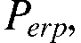 radiated from mains wiring in a building in case the radiation is limited by the proposal n°1 limit (NB30). Two measurement distances are applied for this limit: 3 m in combination with the official limit values, and 10 m with limit values that are 10.5 dB lowered. Also estimations of interference ranges are made by comparing the field strength of the interfering signal level with the level of manmade noise in quiet rural areas.

As source of radiation two point sources are studied, the elementary electric dipole, and the magnetic dipole. For comparison the simple model of inverse linear roll-off throughout the whole of near and far field regions is included. The effect of extra loss by groundwave propagation at larger distances has not been taken into account, nor the effect of coaxial magnetic near field from magnetic dipoles.

ELECTRIC DIPOLE
The generic formula for the magnetic field strength from an electric dipole is given by:
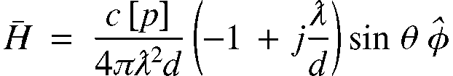
The absolute value:
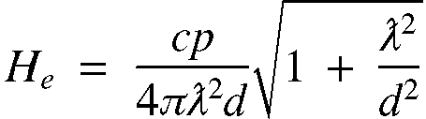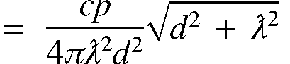

where 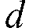 is the measuring distance and 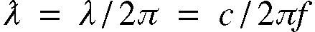.

In the far field where 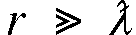:
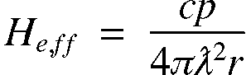 where is a distance in the far field.

The ratio of the field strength in the far field, and that on the measuring position, is given by:
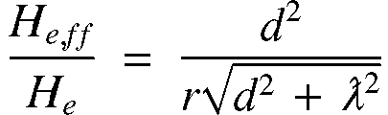
For the far field is true:
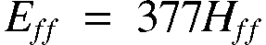
The proposal N°1 limit is defined as an electric field strength  which is measured with a magnetic loop antenna. The conversion factor in the measuring receiver is by definition:

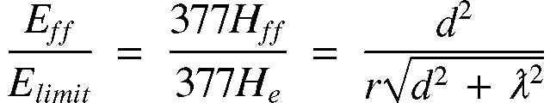
Now the electric field strength of an electric dipole on some point at a distance in the far field is given by:
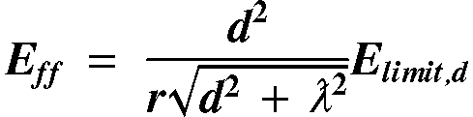 wherein 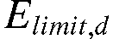 is depending on .
The effective radiated power, radiated in the optimal direction of an electric dipole, is given by:
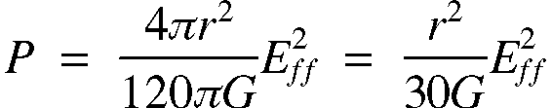

Herein the antenna gain for a half wave dipole and nearly the same for a small dipole. So
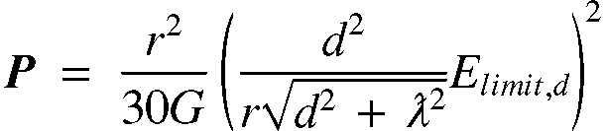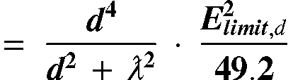

The interference can be calculated by comparing 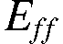 with an existing noise level, for example the manmade noise in a quiet rural environment. The level is given by:
Wherein for quiet rural manmade noise:
For B = 9 kHz:
When we allow an increase of the total noise level by  dB we can calculate the maximum acceptable noise level of the interferer as:

So let 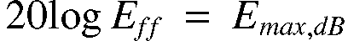, and 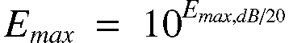.
The interference range for an electric dipole as a source is now:
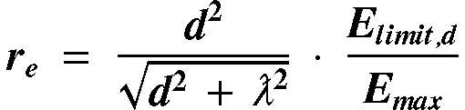

THE MAGNETIC DIPOLE
The generic formula for the magnetic field strength from a magnetic dipole is given by:
We consider the component that causes far field radiation, and in the optimal direction, so :
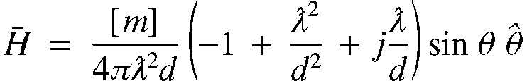
The absolute value:
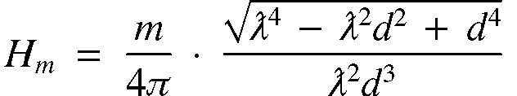

In the far field where :
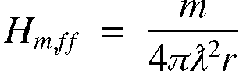 where is a distance in the far field.

The ratio of the field strength in the far field, and that on the measuring position, is given by:
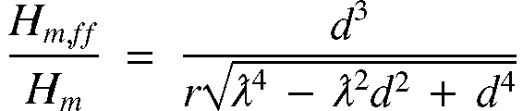
For the far field is true:
The NB30 limit is given as an electric field strength which is measured with a magnetic loop antenna. The conversion factor in the measuring receiver is by definition:
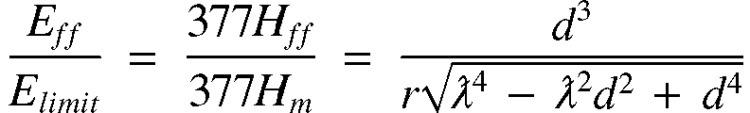
Now the electric field strength of a magnetic dipole on a point at a distance in the far field is given by:
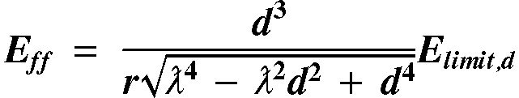
The effective radiated power, radiated in the optimal direction of an electric dipole, is given by:

Herein the antenna gain for a half wave dipole and nearly the same for a small dipole. So
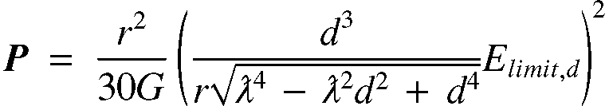
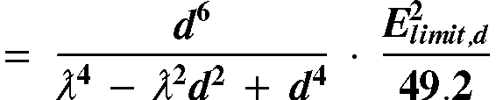

The interference range for a magnetic dipole as a source is now:
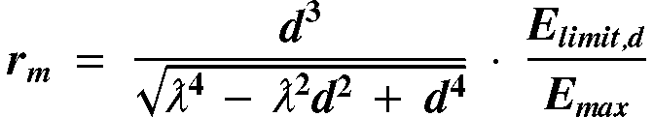

Inverse linear roll-off
In the past SE35 meetings several sources have indicated that the roll-off of the measured field strength from the (main) cables is inverse linear with distance. This means for the field strength in the far field:
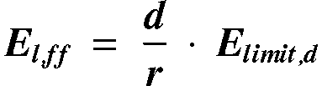
The effective radiated power:
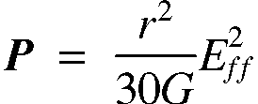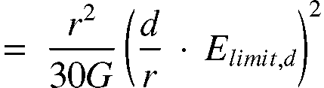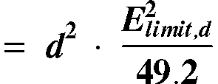

The interference range in the case of inverse linear roll-off is now:
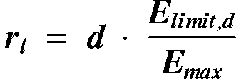
RESULTS
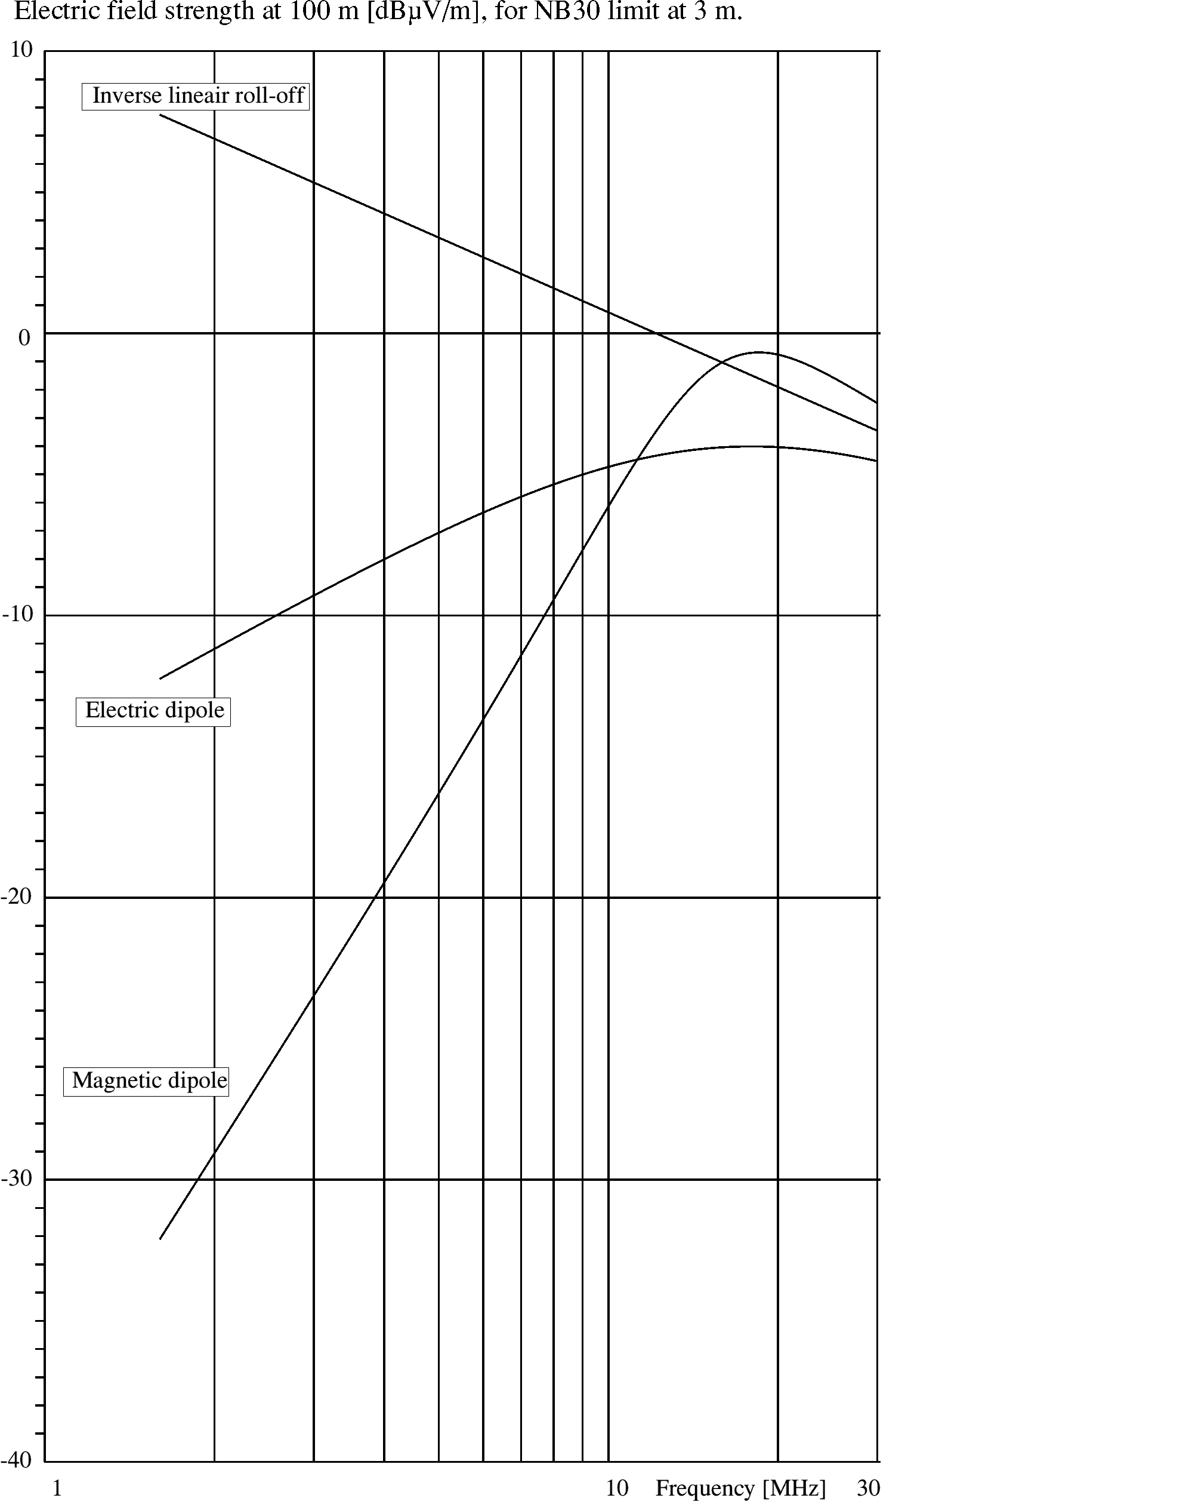
Figure 1
The calculations are performed for the measuring distance of 3 m which is defined in the proposal n°1 limit, see the figures 1, 3, 5, 7, and 9, and for the distance of 10 m, see the figures 2, 4, 6, 8, and 10. The field strength limit at 3 m is:

The limit at10 m is derived from the limit at 3 m by assuming an inverse linear roll-off:
The bandwidth of the measuring receiver is defined to be 9 kHz. A broadband interference signal is assumed, so the radiated power, , will be proportional with bandwidth and is calculated here for the bandwidth of 9 kHz.

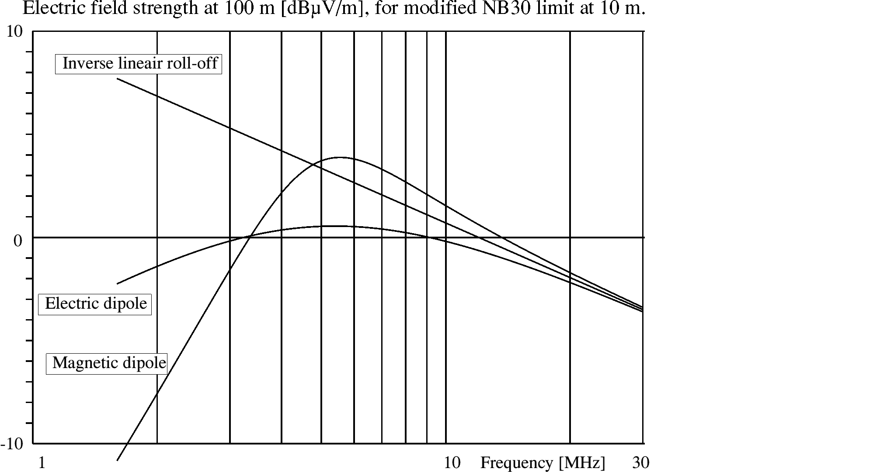
Figure 2
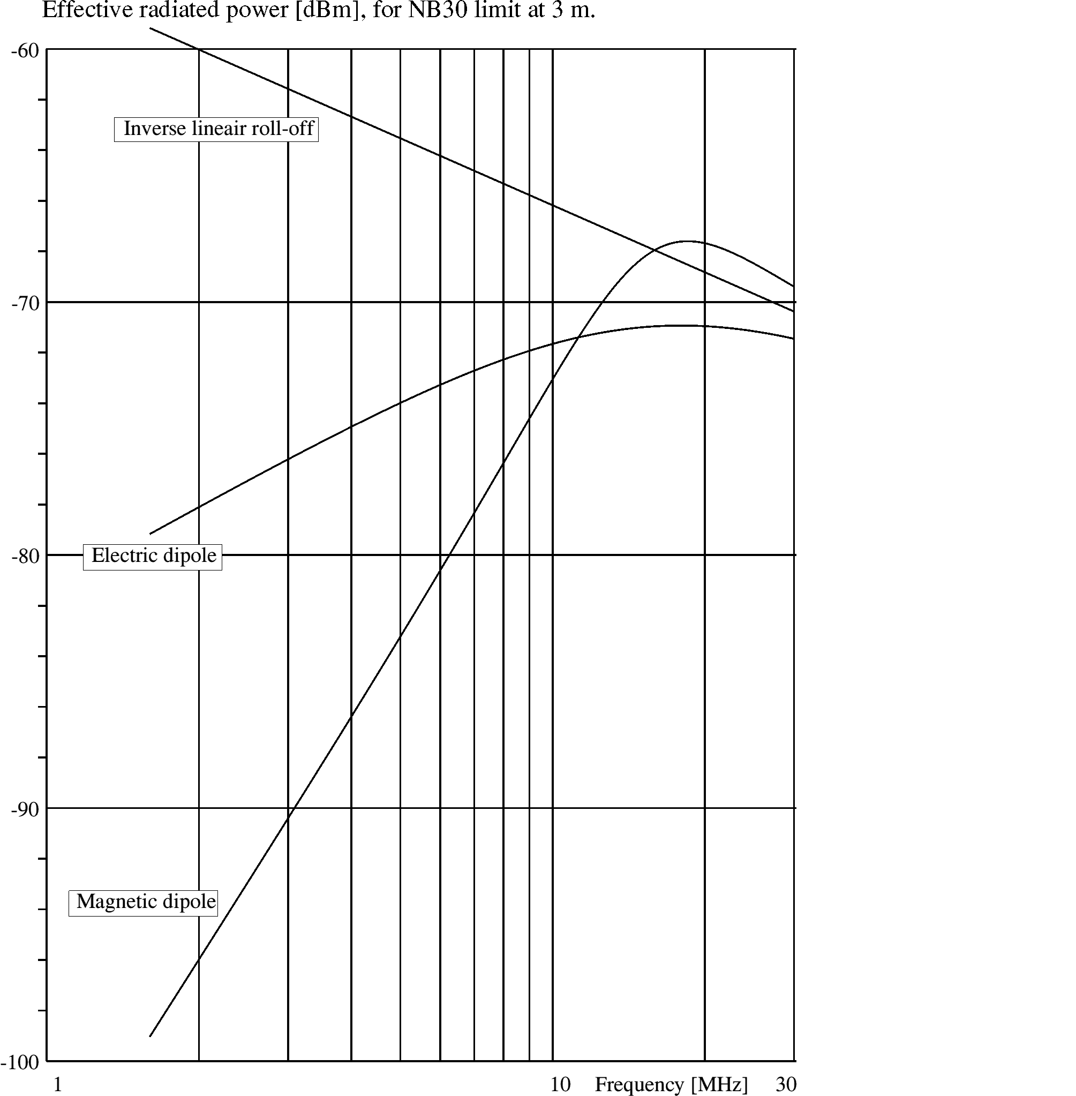
Figure 3
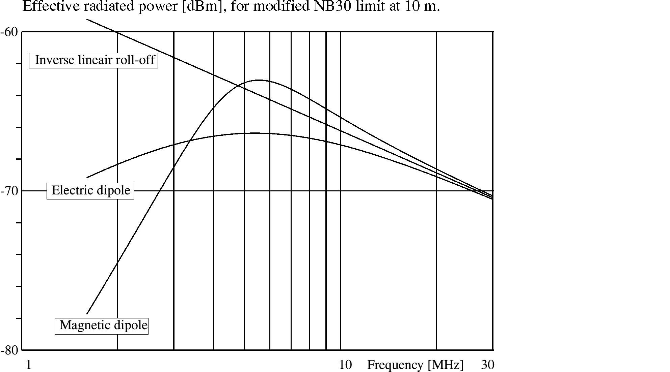
Figure 4
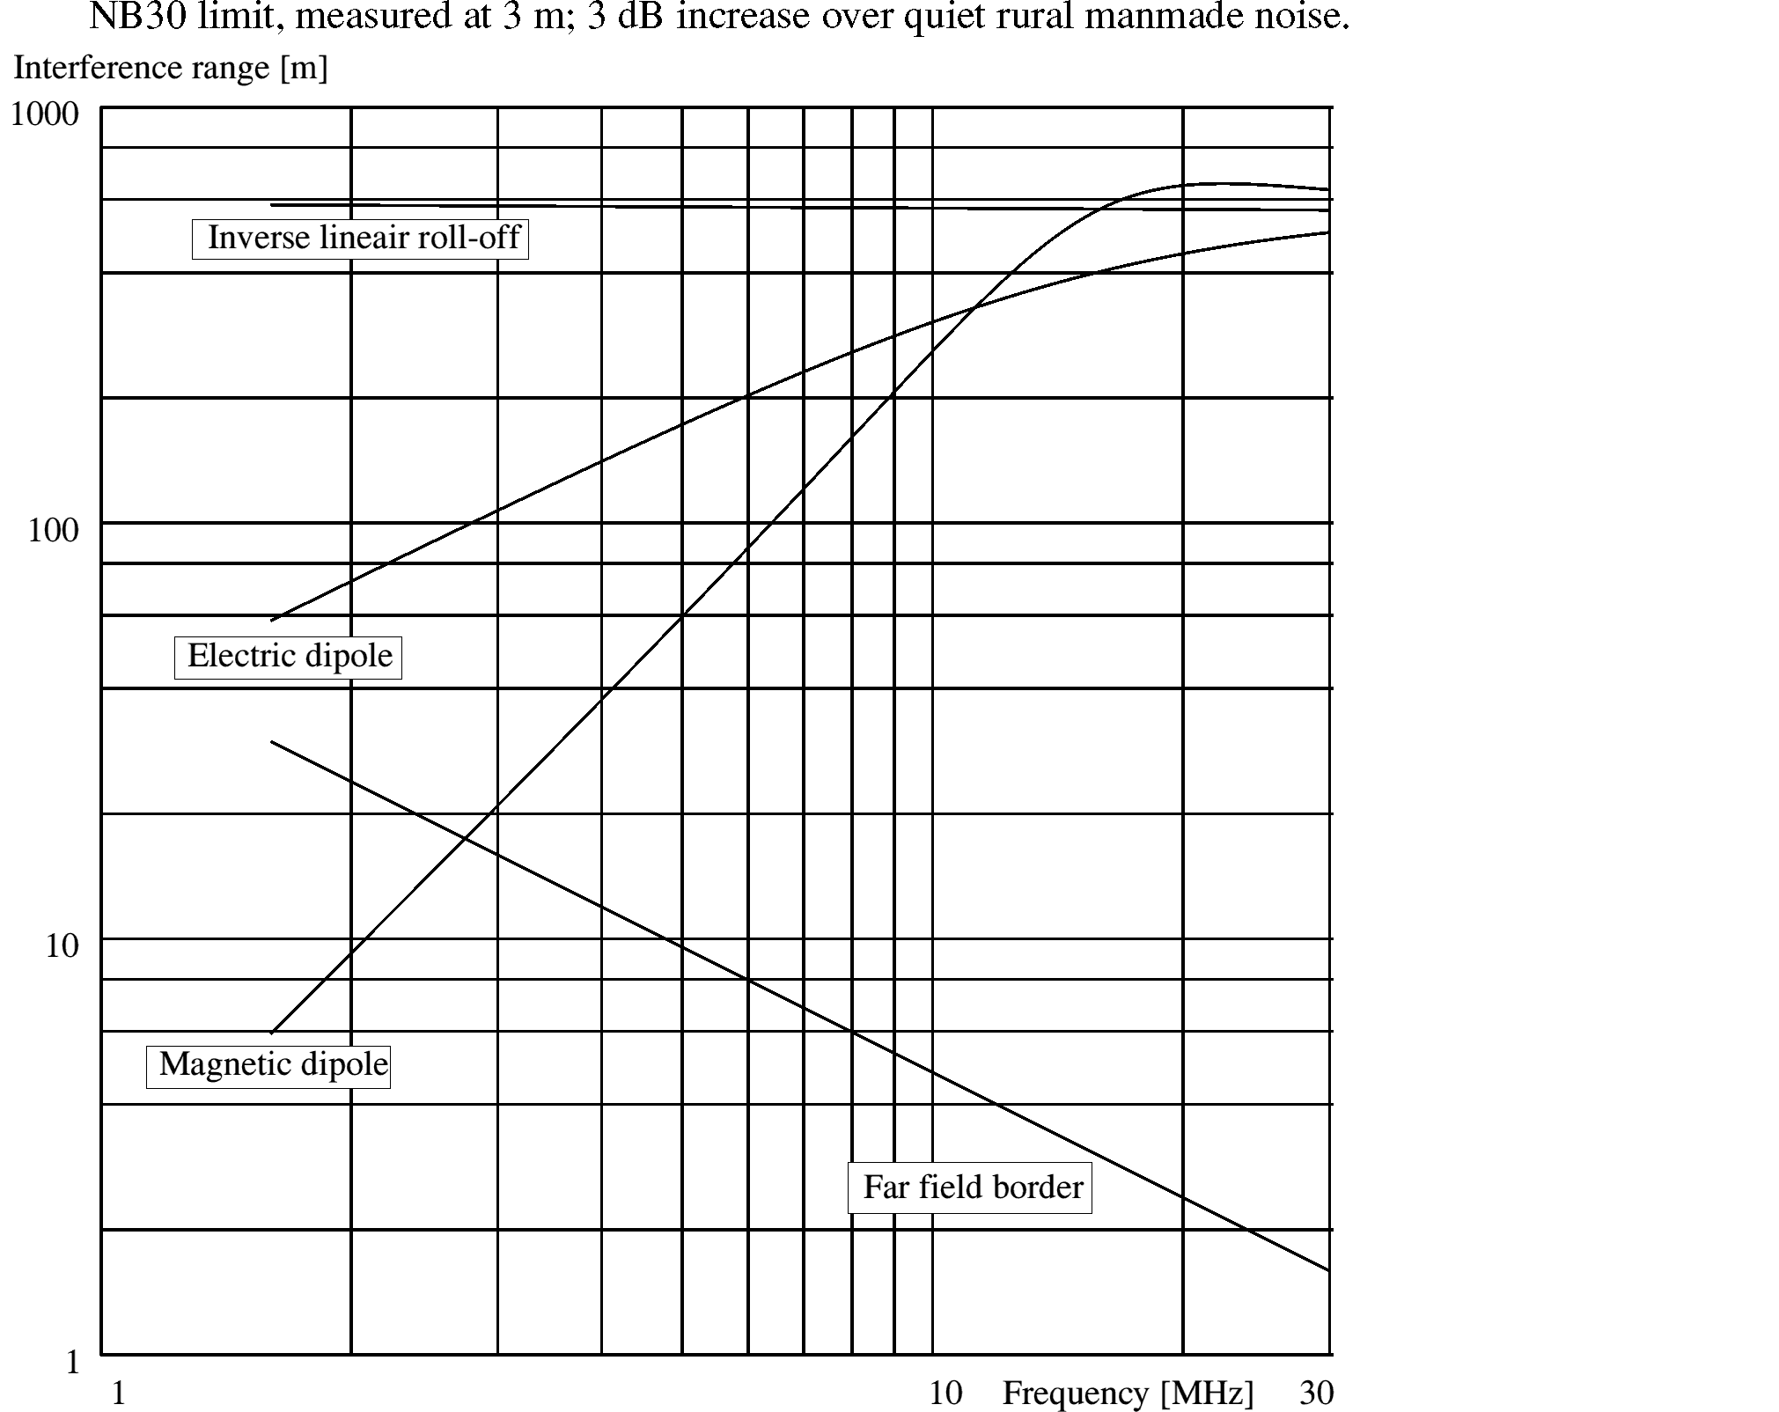
Figure 5

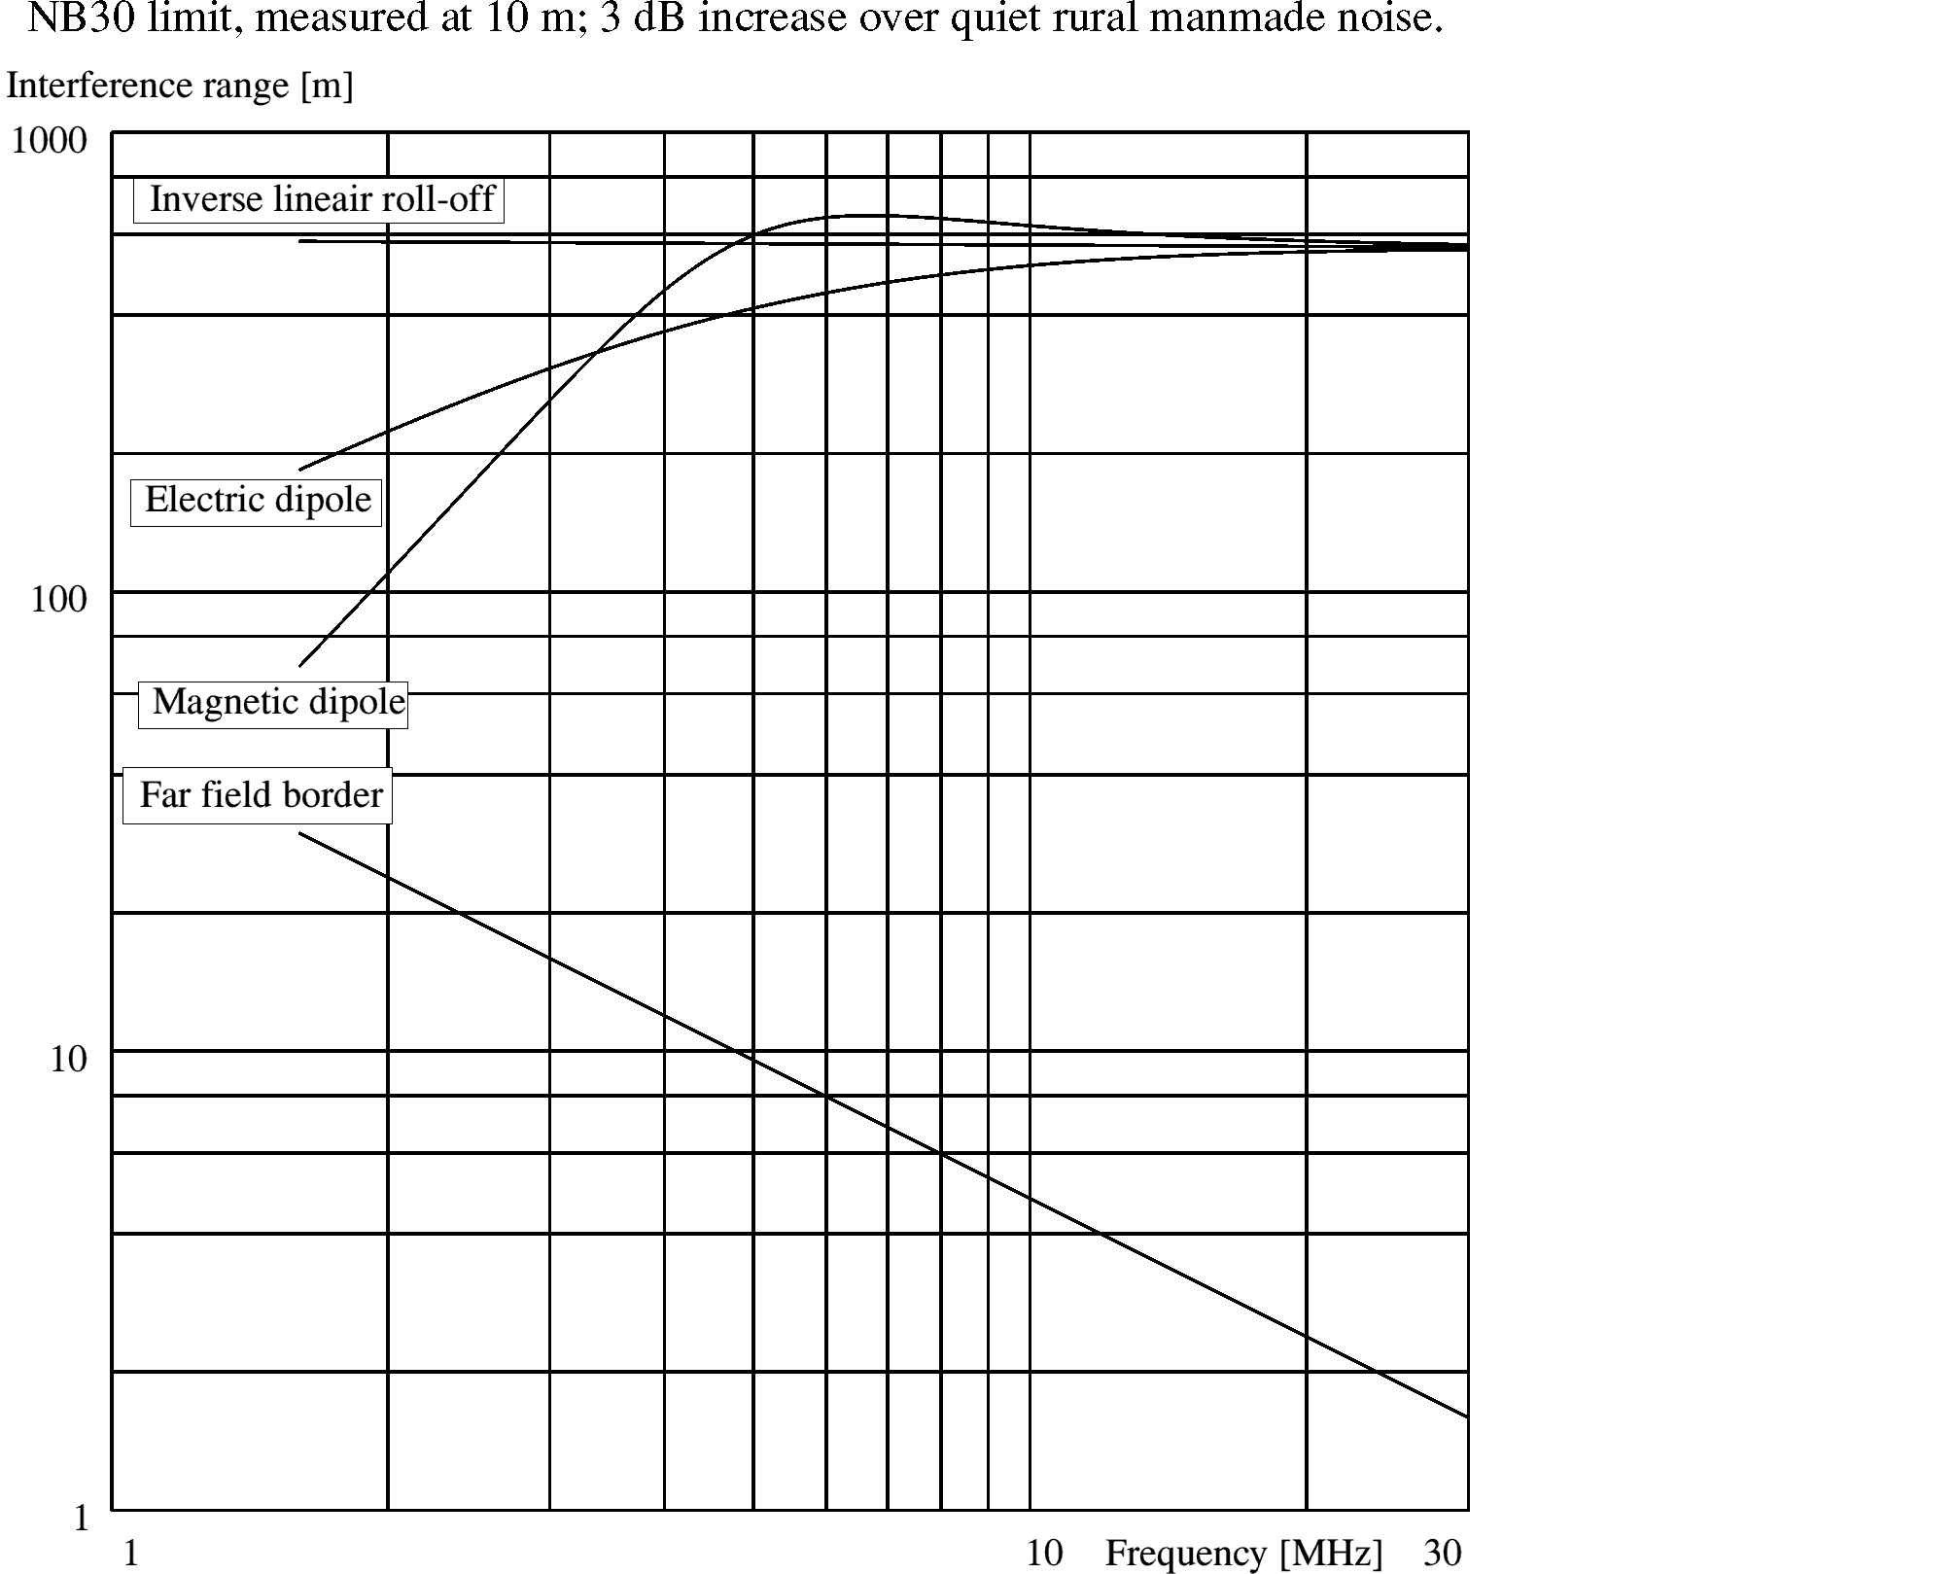
Figure 6

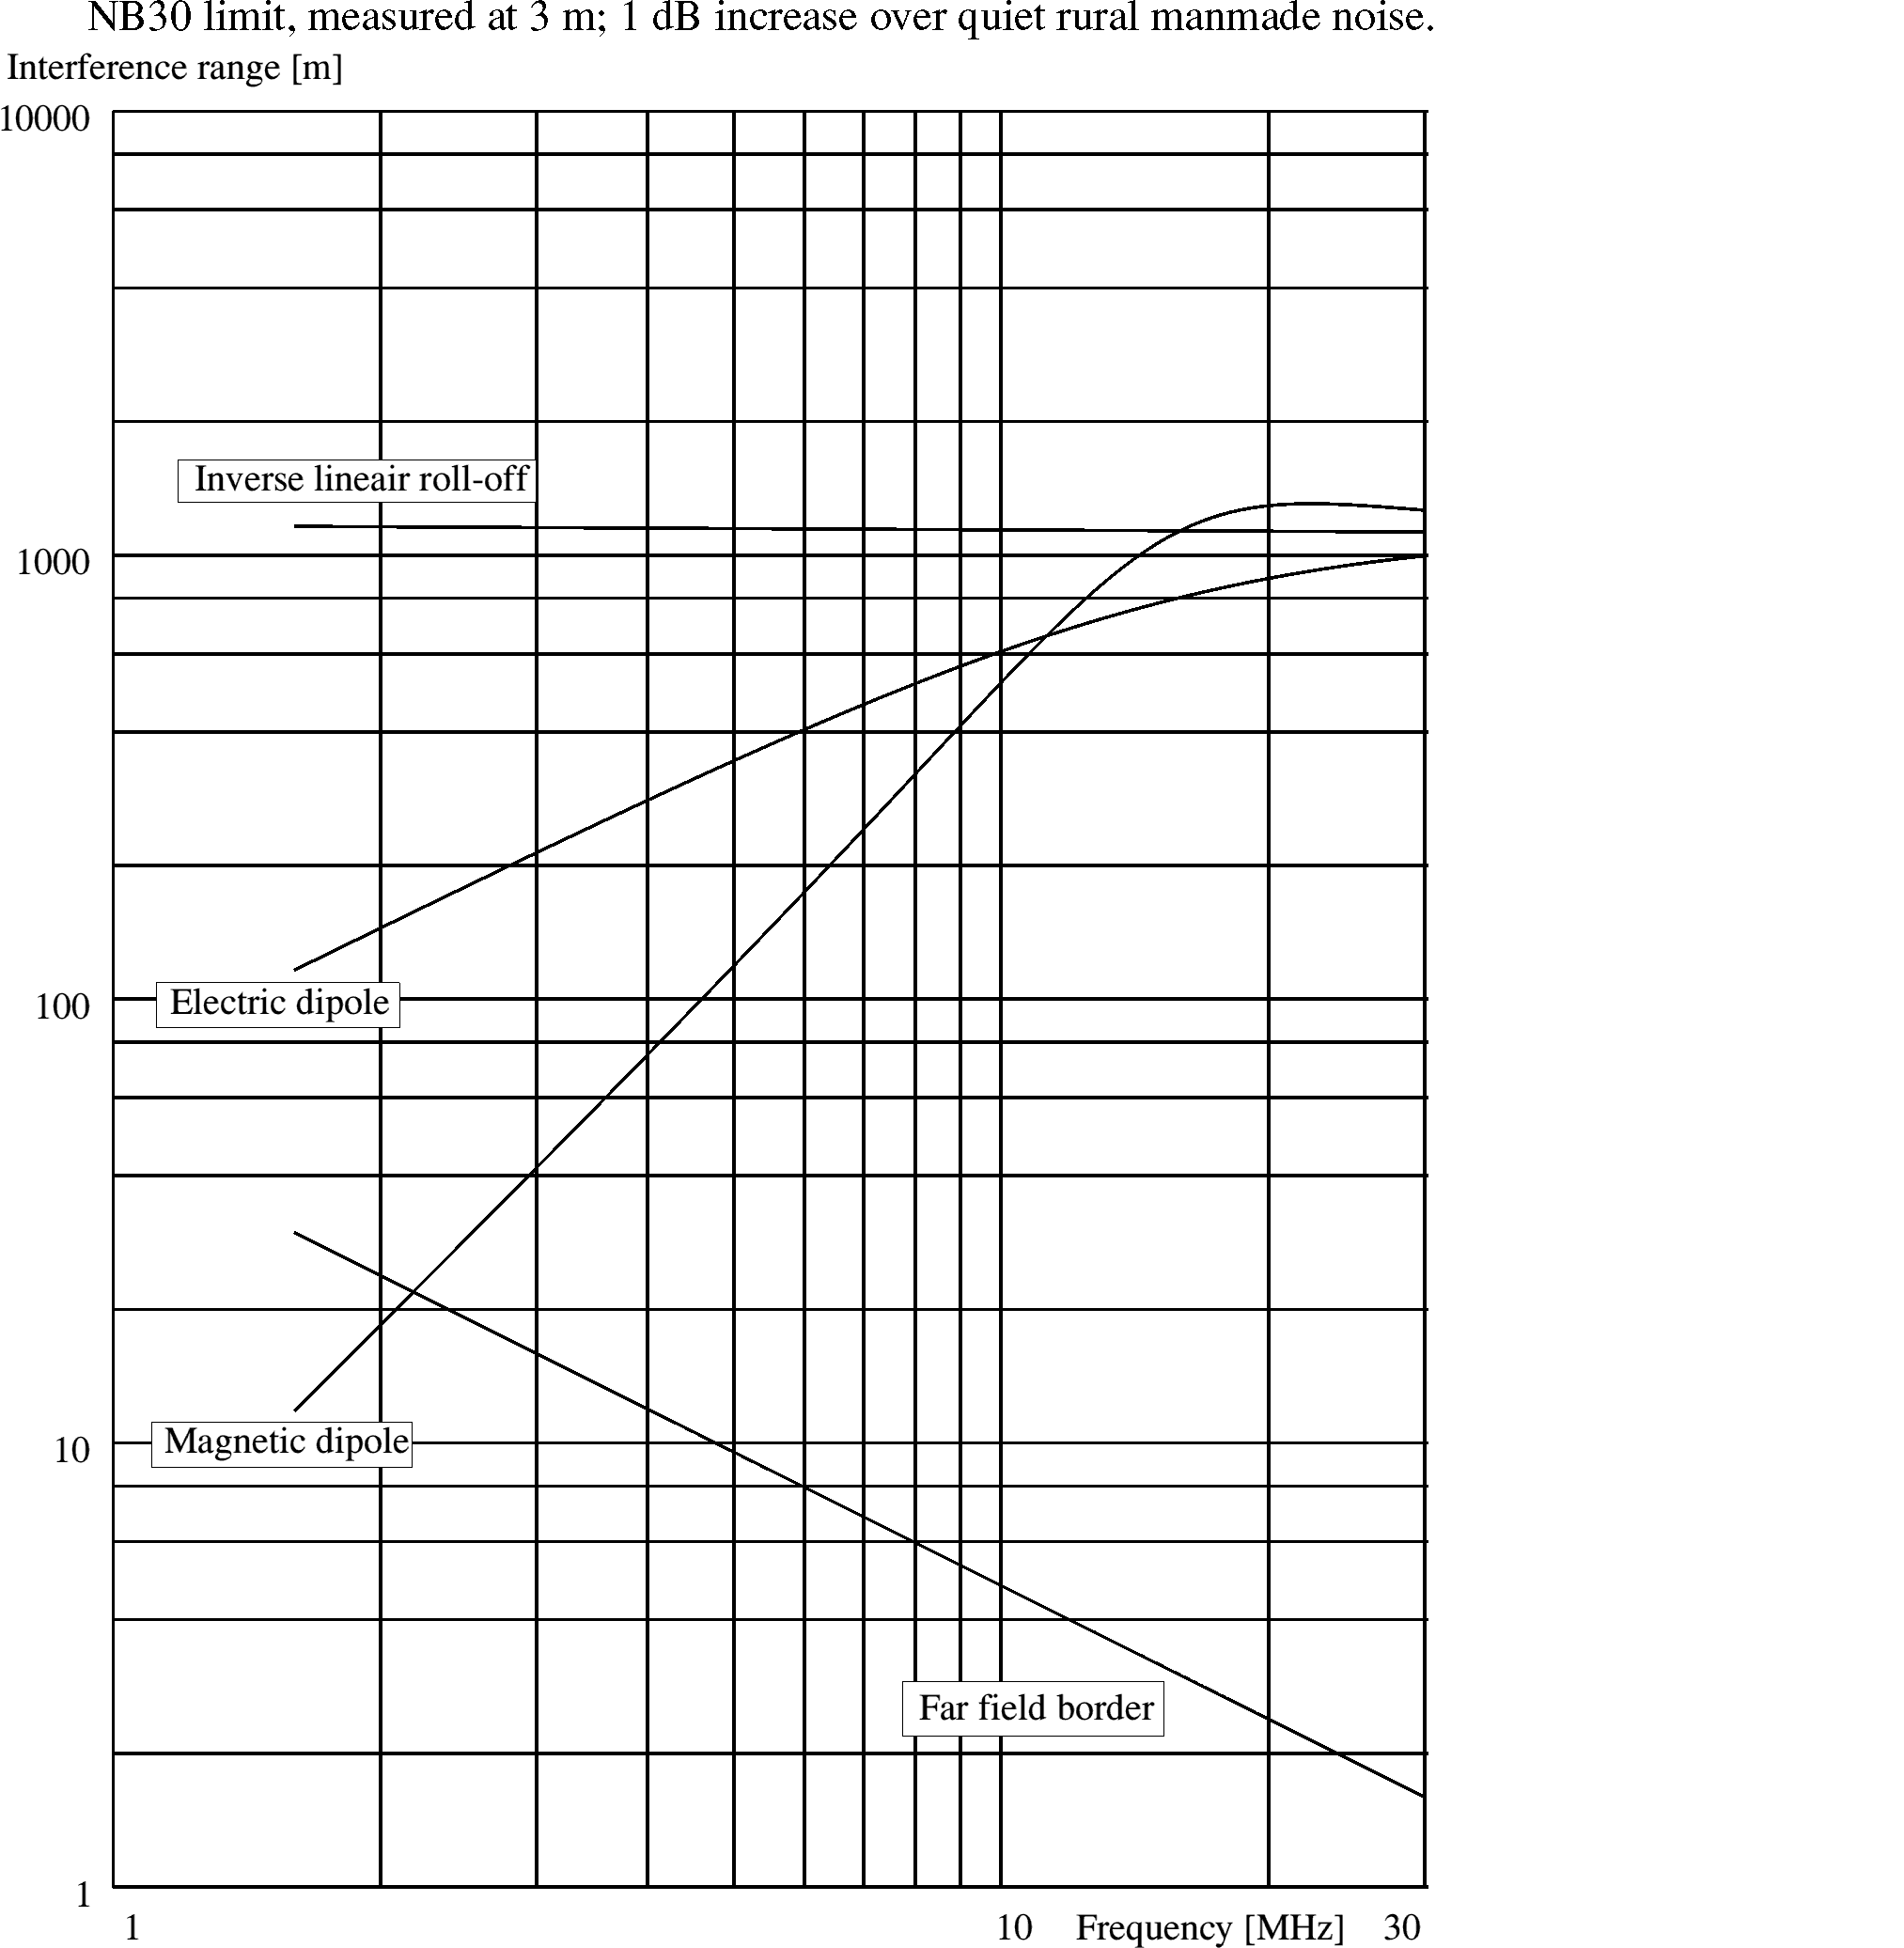
Figure 7

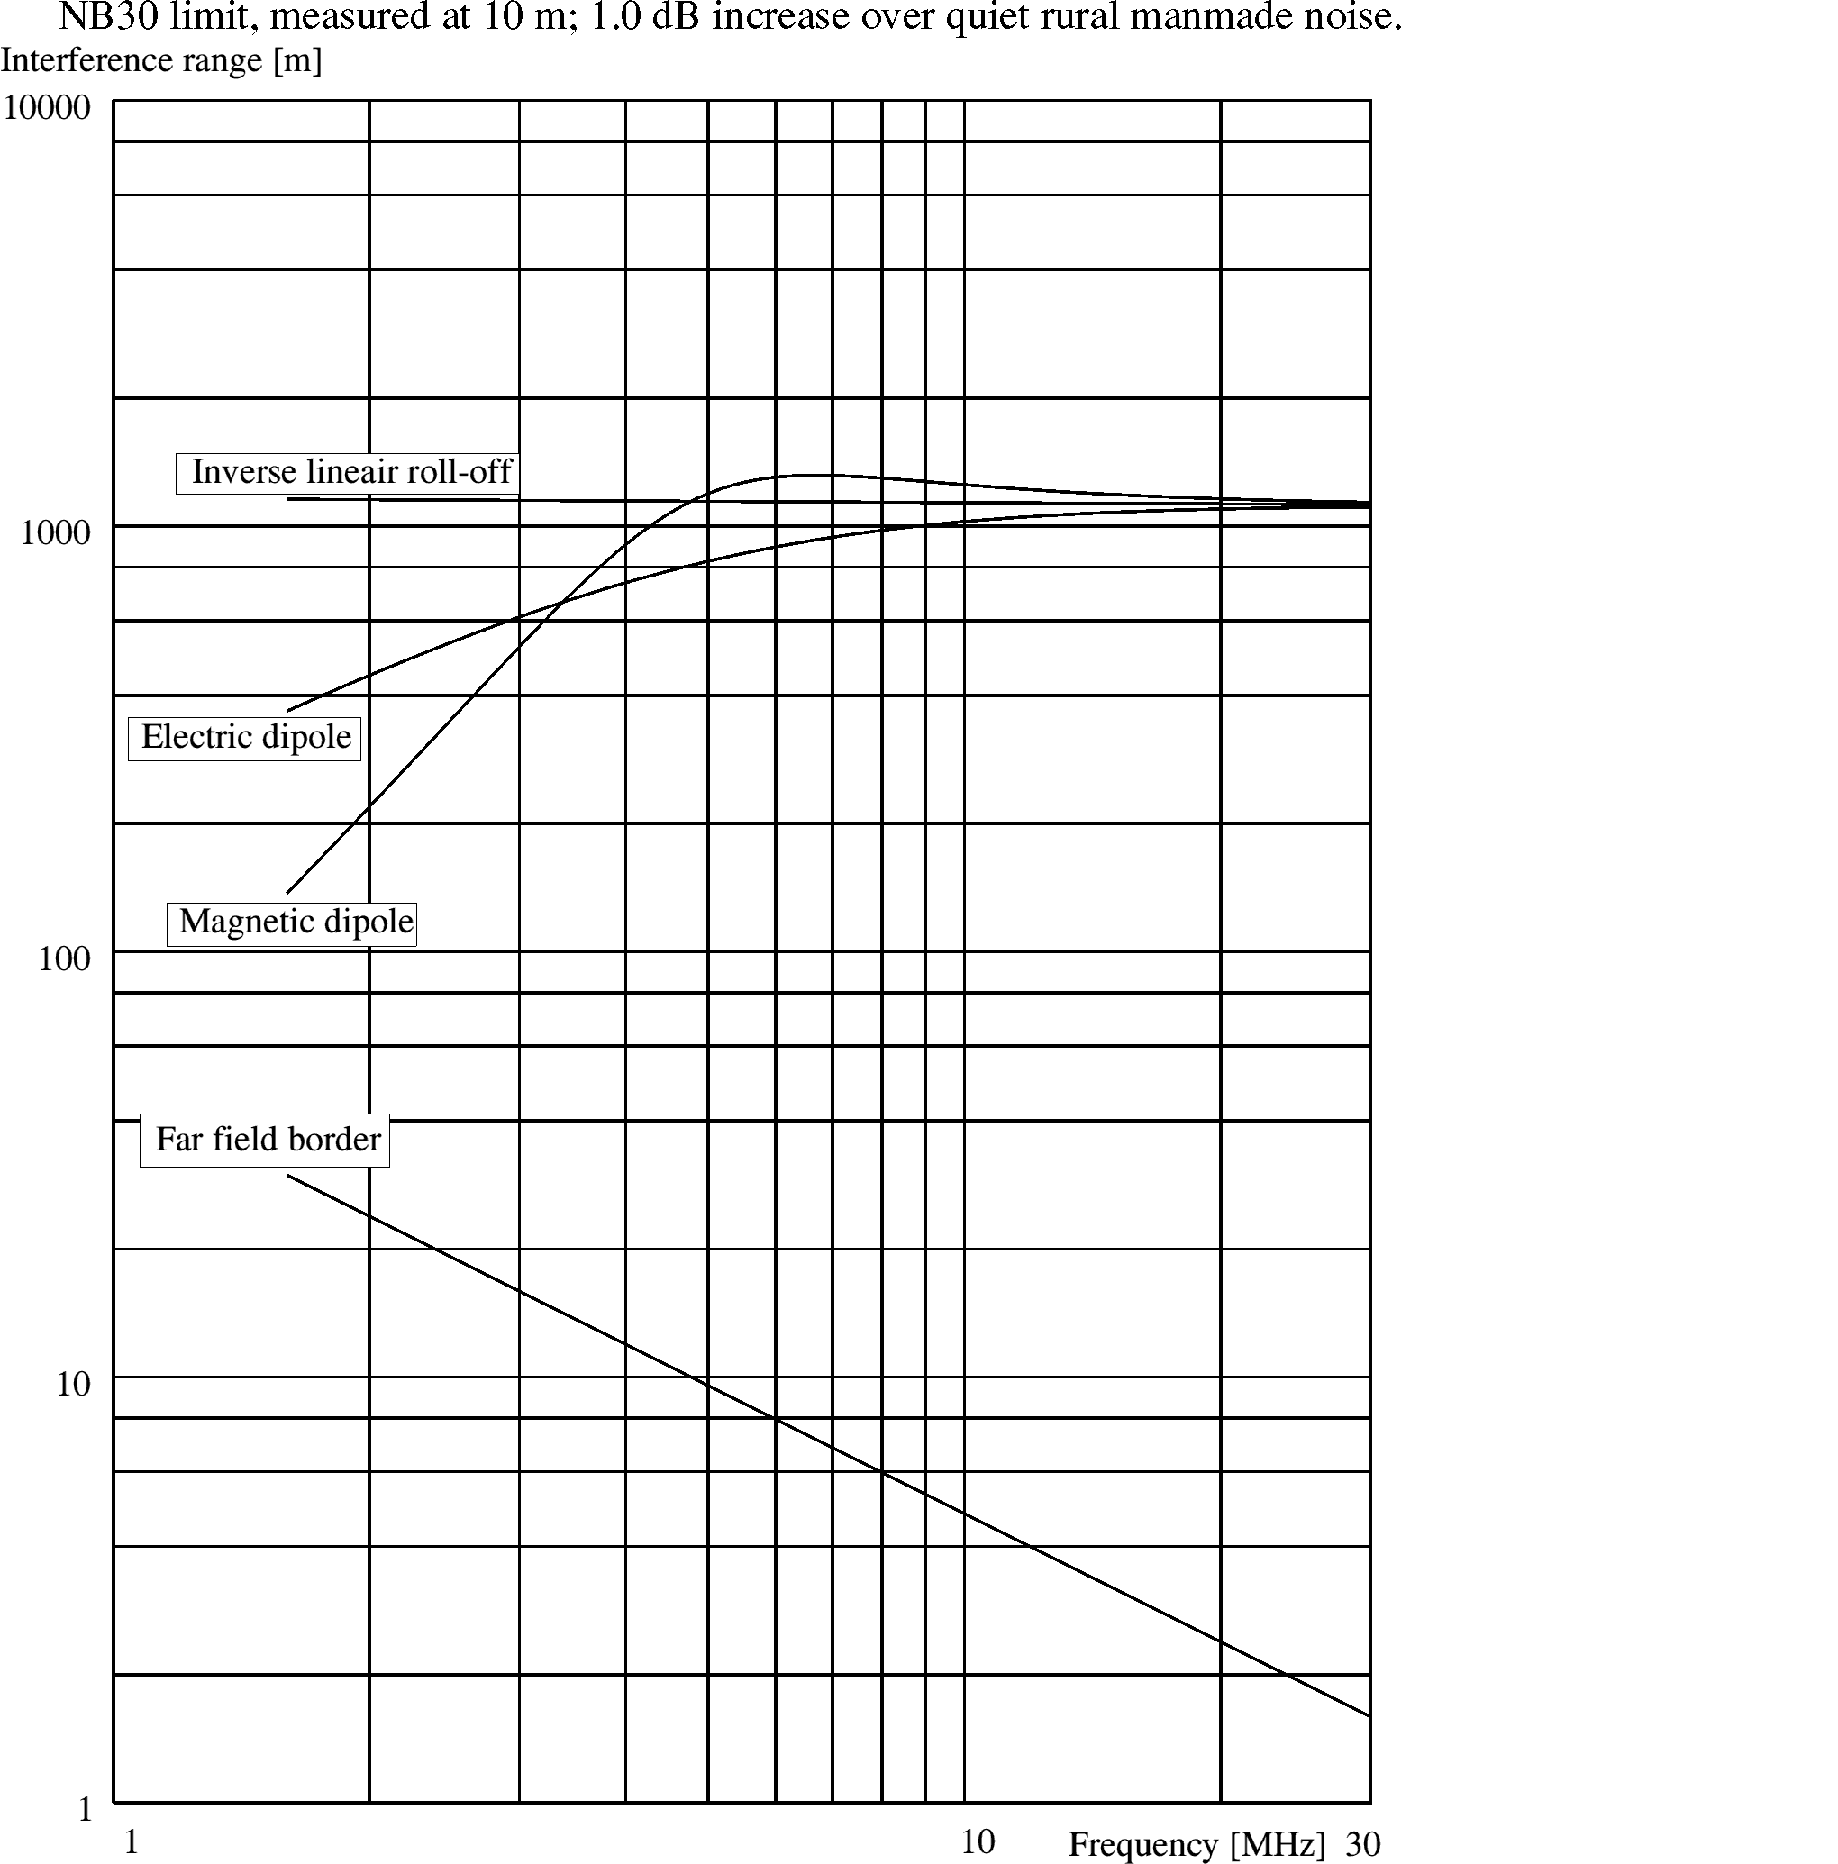
Figure 8

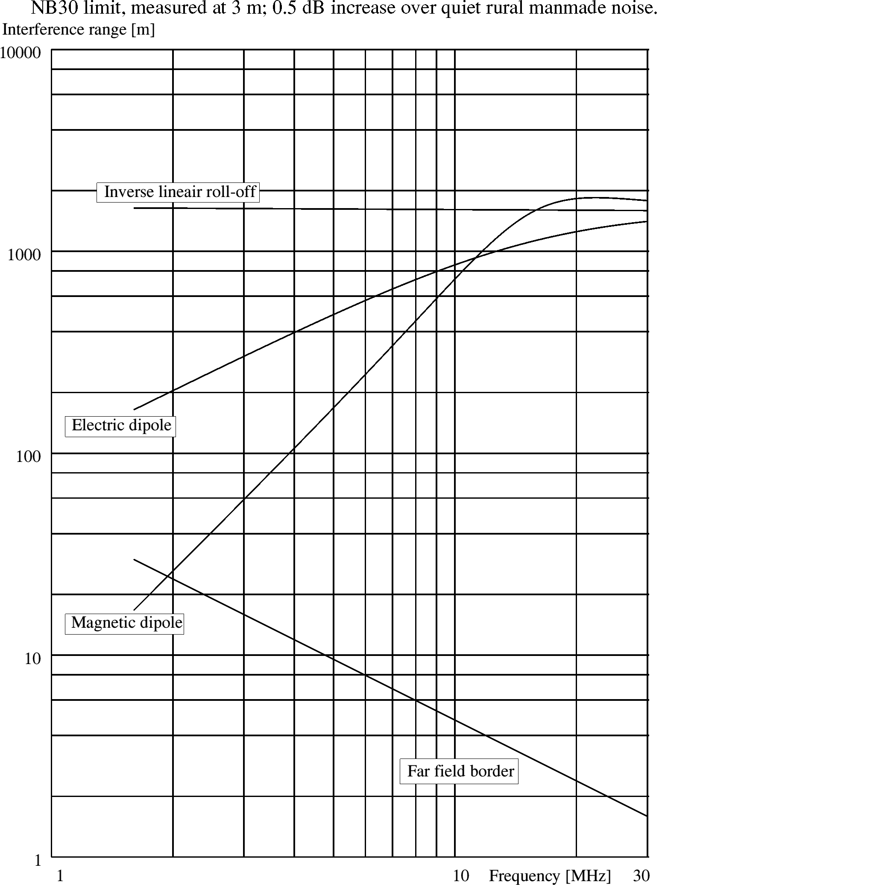
Figure 9

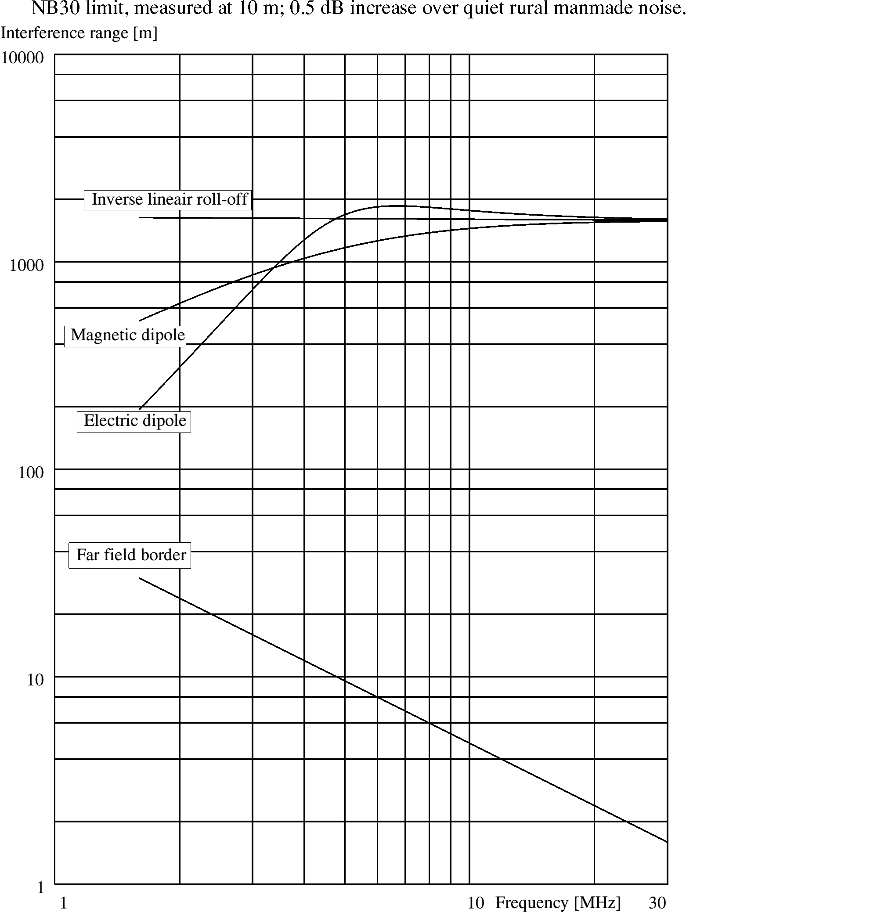
Figure 10

Discussion
These calculations of effective radiated powers and interference ranges of an electric or magnetic dipole do not represent the radiation from a mains net in a building directly, because such a cable network has dimensions which are large compared with 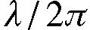 for most frequencies and does not form a point source.

A better estimation would be to consider a cross-section of the building, normal to the direction of the measurement position, and to project a square with dimensions twice the measurement distance on that cross-section. Because of the fact that the phase relationship between the rf current on the cable are not known, the ratio of the two areas should be used to multiply the radiated power in the direction of the measuring position.

In this light the use of a measurement distance of 10 m instead of 3 m would give a more complete estimation of the radiation from a building. A practical problem however is the relative low level of field strength from the interference compared with background signals from radio services, especially when measured with a receiver bandwidth of 9 kHz.

As there seem to be a consensus about measuring the noise from cable transmission systems using a peak detector instead of using the CISPR Quasi Peak method, there is an ability to use a smaller bandwidth for the measurement and correct the measurement results to the normalized 9 kHz bandwidth. This will enhance the possibilities to measure noise levels in between the radio signals.

The results from the calculations in figures 1 - 10 show that the results on the higher frequencies for the electric and magnetic dipole are nearly equal to the results of the inverse linear roll-off approach. In combination with the above mentioned consideration, that in the real world the mains wiring in a building will not behave as a single point source, and with the knowledge that the roll-off of a magnetic field of a wire, long in relationship to the measuring distance, also shows an inverse linear roll-off with distance, the approach of the overall inverse linear roll-off seem to be reasonable.

These figures show that radiation from cable transmissions systems at frequencies above 10 MHz can be very strong and that these systems should not be overlooked.

ANNEX 5: Typical results from a cable TV measurement campaign in France
INTRODUCTION
Several measurement campaigns have been undertaken in France to assess the radiated leakage level produced by existing cable networks. Some typical measurement results that are believed to be widely representative of the situation are shown in the next pages.

As far as possible, the measurements were done according to the method and limit defined in the CENELEC standard EN 50083-8.

Concurrently to the measurements, a tracking of radiation sources from the cable network was carried out using a commercially available combination of RF source/RF detector. In this system, a modulated 118 MHz RF carrier is injected into the coaxial cable at the headend and RF leakage points can then be located precisely using a portable receiver and a directional antenna. When a leakage point was found, the fault was tentatively repaired.

Measurements were recorded before and after intervention on the network.

MEASUREMENT RESULTS
Three different kinds of measurements were performed using a specially equipped EMC measuring van :
- H field (10 – 30 MHz);
- E field , horizontal polarization (30 – 1000 MHz)
- E field, vertical polarization (30 – 1000 MHz)

The main measuring devices that were used are listed as follows:
- Spectrum analyser (100 Hz – 40 GHz);
- Low noise preamplifier (G = 25 dB);
- CISPR compliant H-field antenna (10 kHz – 30 MHz);
- Bi-Log E-field antenna (30 MHz – 2 GHz)

The main measurement parameters are as follows:
- Peak detection;
- 10 kHz resolution bandwidth between 10 MHz and 30 MHz;
- 100 kHz resolution bandwidth between 30 MHz and 1000 MHz;
- Measurement distance between 3 and 10 m (depending on the practical possibilities);
- Mean antenna height 1.5 m above ground.

The E/H fields strength levels and the antenna distance to the network were recorded for each measurement point. The data were then post-processed to compute the E/H field levels at a 3 m distance using the following formula:

Field at 3 m distance = Field at D m distance + 20.log₁₀(D m/3 m)

The measurement results are presented as a set of curves where the E/H field levels at a 3 m distance are given versus frequency for each of the three different measurement kinds:
- H-field (dBµA/m) = radiated magnetic field, below 30 MHz;
- EH-field (dBµV/m) = radiated electric field, horizontal polarization, between 30 and 1000 MHz;
- EV-field (dBµV/m) = radiated electric field, vertical polarization, between 30 and 1000 MHz.

-40
-30
-20
-10
0
10
20
30
10
15
20
25
30
Frequency (MHz)
H (dBµA/m)

Figure 1: H-field measurement before intervention

-40
-30
-20
-10
0
10
20
30
10
15
20
25
30
Frequency (MHz)
H-field (dBµA/m)

Figure 2: H-field measurement after intervention

H-field measurements have been performed before and after intervention on the cable network, based on signal leakage detection and location. Based on this result and other similarly obtained, it is almost impossible to differentiate levels produced by the network from ambient noise and it is not possible to determine whether the intervention brought significant improvement or not.

The frequency range below 30 MHz is used for the cable TV return channel and the signal produced by the network can differ between two measurements depending on the traffic on the network.
0
10
20
30
40
50
60
70
80
90
0
100
200
300
400
500
600
700
800
900
1000
Frequency (MHz)
EV-field (dBµV/m)

Figure 3: E-field measurement, vertical polarization, before intervention
0
10
20
30
40
50
60
70
80
90
0
100
200
300
400
500
600
700
800
900
1000
Frequency (MHz)
EV-field (dBµV/m)

Figure 4: E-field measurement, vertical polarization, after intervention

By comparing these two curves, it can be shown that there is a slight decrease of radiation between 200 and 900 MHz brought by the intervention. This decrease is particularly visible between 500 and 600 MHz. However, it is not possible to conclude whether the network comply or not with the limit after intervention.

0
10
20
30
40
50
60
70
80
90
100
0
100
200
300
400
500
600
700
800
900
1000
Frequency (MHz)
EH-Field (dBµV/m)

Figure 5: E-field measurement, horizontal polarization, before intervention

Figure 6: E-field measurement, horizontal polarization, after intervention

The intervention seems to have had an impact on radiation levels at frequencies between 200 and 800 MHz. A sharp decrease near 700 MHz can be seen. It is however not possible to conclude whether the network comply or not with the limit after intervention.

ANNEX 6: radiation from equipment below 30 MHz
1 LIMITS

The following diagrams show the five proposals for limits that are described in section 7 of the Report.

Figure 1: Comparison of the different proposals for limits at 1 meter

The different proposals are the following (bold fonts indicate that this limit is defined at 1 meter and not extrapolated from another distance):
- BBC: proposal n°4. The measurement distance is 1 meter in the CISPR 9 kHz resolution bandwidth (the proposed limit starts at 150 kHz) ;
- "Norway proposal": proposal n°2. The field is measured at 3 meters in a 9 kHz resolution bandwidth. The basic limit is extrapolated here to a 1 meter distance assuming free space (20dB/decade) propagation conditions;
- MPT 1570: proposal n°3. The measurement distance is 1 meter in the CISPR resolution bandwidth;
- NB30: proposal n°1. The field is measured at 3 meters (CISPR resolution bandwidth). The basic limit is extrapolated here to a 1 meter distance assuming free space (20dB/decade) propagation conditions;

Note: the proposal n°5 (FCC Part 15) limit is not represented on this diagram because FCC doesn't allow extrapolating at less than 3 meters.

Figure 2: Comparison of the different standard limits at 3 meters

The different proposals are the following (bold fonts indicate that this limit is defined at 3 meters and not extrapolated from another distance):

- BBC: proposal n°4. The measurement distance is 1 meter in the CISPR 9 kHz resolution bandwidth (the proposed limit starts at 150 kHz). The basic limit is extrapolated here to a 3 meters distance assuming free space (20dB/decade) propagation conditions;
- "Norway proposal": proposal n°2. The field is measured at 3 meters in a 9 kHz resolution bandwidth;
- MPT 1570: proposal n°3. The measurement distance is 1 meter in the CISPR resolution bandwidth. The basic limit is extrapolated here to a 3 meters distance assuming free space (20dB/decade) propagation conditions;
- NB30: proposal n°1. The field is measured at 3 meters (CISPR resolution bandwidth);
- FCC: proposal n°5 limit defined at 30 meters in the CISPR resolution bandwidths. An extrapolation down to 3 meters assuming 40dB/decade fall off as defined by FCC is made here. Only values between 1.705 and 30 MHz are represented on the diagram, but higher limits (70 dBµV/m at 1.7 MHz at 3 meters; 94 dBµV/m at 3 meters; 130 dBµV/m at 9 kHz at 3 meters…) are defined by the FCC for lower frequencies that are not shown here for readability of the diagram.

2 MEASUREMENTS in an anechoic chamber – sensitivity

For a correct measurement, the noise level should be typically 6 dB lower than the limit to check. Instrumentation (active magnetic loop and spectrum analyser) used here is compliant with the CISPR 16 rules. The measurement method is as defined in the Draft CEPT Recommendation. The noise level for the instrumentation is shown in the following diagrams against the 1 meter limits and the three meters limits.

Figure 3: Noise level of the measuring equipment compared to the limits at 1 meter

It can be seen that measurements at a 1 meter distance are possible only against proposal n°1 and n°3 limits : the sensitivity of the measuring set largely exceeds proposal n°2 and n°4 limits.

At 3 meters, the sensitivity largely exceeds proposal n°2 and n°4 limits and is at the level of the proposal n°1 and n°3 limits, therefore making compliance measurements against these two limits difficult.

It's only for the proposal n°5 limit that a good sensitivity margin exists at 3 meters.

A passive loop associated with a low noise amplifier could improve the sensitivity in the order of 10 dB, but it will not solve the problem of measuring against the BBC and Norway limits using measuring equipment compliant with CISPR requirements.

Figure 4: Noise level of the measuring equipment compared to the limits at 3 meters

3 ANECHOIC CHAMBER MEASUREMENTS

These measurements in a low background noise aim at identifying precisely the emissions produced by the devices under test before proceeding to field test measurements.

Some of the tested devices are part of or could be connected to a telecommunication network (Minitel, computer, television receiver…). Other tested devices don't belong to that category, but are present in a typical environment where radio receivers operate.

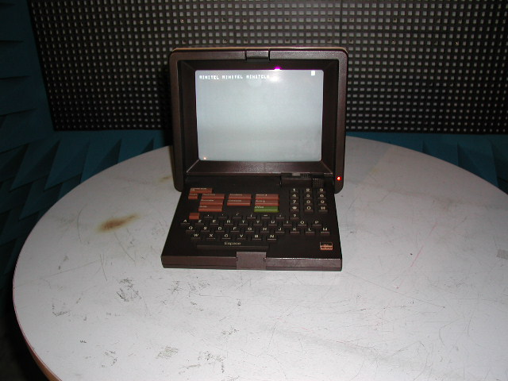
Figure 5 : Picture of a Minitel
Figure 6: Magnetic field from a Minitel in an anechoic chamber at 1 meter

Figure 7: Magnetic field from a Minitel in an anechoic chamber at 3 meters

Figure 8: Magnetic field from a TV set in an anechoic chamber at 1 meter

Figure 9: Magnetic field from a TV set in an anechoic chamber at 3 meters

Figure 10: Magnetic field from a computer display at 1 meter in an anechoic chamber

Figure 11: Magnetic field from a computer display at 3 meters in an anechoic chamber

Figure 12: Measured field from a grinding machine at 1 meter in an anechoic chamber

Figure 13: Measured field from a grinding machine at 3 meters in an anechoic chamber

Note : in the case of a grinding machine or a microwave oven, the peak level is very high but the disturbance is impulsive and have less effect on a radio receiver than a permanent source, for the same peak level.
Figure 14: Microwave oven radiated field in an anechoic chamber at 1 m - Max. hold time: 3mn

Figure 15: Microwave oven radiated field in an anechoic chamber at 3 m - Max.hold time: 3mn

These measurements show that domestic mass-deployed devices (millions of Minitel in France, billions of computers, television sets in Europe…) radiate electromagnetic fields at or above the proposal n°1 and n°3 limits. The results of these measurements should be taken into account to evaluate the cumulative effect of these already present sources, compared with emerging new sources such as DSL or PLT.

- Electromagnetic environment

Outside an anechoic room, the main difficulty is to identify unwanted emissions from non radio equipment and networks from the radio services wanted signals. The two following diagrams show the typical radio environment measured in Paris in a yard in between buildings measured under the conditions defined in the draft CEPT Recommendation. They illustrate the practical difficulty to measure against the lowest proposed limits.
Figure 16: Radio environment compared with the proposed limits at 1 m

Figure 17: Rradio environment compared with the proposed limits at 3 m

Measurements in domestic flats
In order to characterise in-house extensions of telecommunication networks, magnetic field measurements were carried out below 30 MHz in domestic flats in the Paris area.

It's not easy to analyse these diagrams as they show the superposition of levels produced by equipment as shown in the anechoic chamber measurements (part 4 diagrams) with the radio environment (part 5 diagrams).

As far as possible, measurements were first done with all identified sources switched off and then done when switching on the devices one by one and finally altogether.

Flat number 1
In this two room flat in Paris, the only identified source of emission is a TV receiver.

Figure 18: Flat number 1 – measurement at 1 m from the TV switched on (violet curve) and off (blue curve)

Emissions from the TV set are clearly noticeable above the radio environment.

Figure 19: Flat number 1 – measurement at 3 m from the TV switched on (violet curve)
and off (blue curve)
Emissions from the TV set are also noticeable above the radio environment.

Flat number 2
This three rooms flat located in the vicinity of Paris contains a TV set, a computer and a microwave oven.
Figure 20: Flat number 2 – measurement in the center of the living room approximately 3 m
from the TV, computer and microwave oven all off (violet curve) and all on (red curve).
Emissions from the three devices are clearly noticeable above the radio environment.

Figure 21: Flat number 2 – measurement at 1 m from the TV switched on (violet curve) and off (blue curve)
Figure 22: Flat number 2 – measurement at 3 m from the TV switched on (violet curve) and off (blue curve)
At one and three meters, emissions from the TV set are clearly noticeable above the radio environment.

Flat number 3
This small flat located in downtown Paris is equipped with a portable PC with an ADSL connexion and with a microwave oven. The radio environment is quite high and it was not possible to identify any emission from ADSL at 1 or 3 m above this radio environment.
Figure 23: Flat number 3 – noise floor (all domestic equipments off)
Figure 24: Flat number 3 – microwave oven (on) at 1 meter
Emissions from the oven are noticeable above the radio environment.
Figure 25: Flat number 3 – microwave oven (on) at 3m

Emissions from the oven are noticeable above the radio environment, in particular in between 1 MHz and 2 MHz.

Measurements in a telephone exchange
Some measurements has been done inside a switching centre, using the measurement method defined in the draft ECC Recommendation.
The two following measurement curves show that proposal n°1, n°2, n°3 and n°4 limits are exceeded by several tens of dBs (up to 50 dB above proposal n°1 at some frequencies).
This situation is due to the fact that many collocated equipment radiate simultaneously. This does not represent a typical radio receiving environment.
Figure 26: Telecom exchange – measurement made between two “main frame distributors”
separated by 2 meters (1 m measurement), against the 1 m proposed limits
Figure 27: Telecom exchange – measurement made between one “main frame distributor” and
DSLAM equipments separated by more than 2 meters, against the 1 m proposed limits

Annex 7: cumulative effect of broadband PLT below 30 MHz
1 INTRODUCTION
This paper tries to summarise the various studies that have been presented to SE35 on potential cumulative effect of Power Line Telecommunications (PLT) below 30 MHz. The methodology presented here is also valid for the other cable technologies addressed in this ECC Report (DSL, cable TV, LANs…). However, to obtain cumulative effect results for these systems, it would be necessary to determine first the necessary input parameters: injected power or leakage level, equivalent gain of the cable network, typical density of sources.

2 PROPAGATION MODEL
In this frequency range, ITU-R has defined a model for ground-wave and a model for sky-wave propagation. These are used as bases for calculation but some simplifications are made in order that the influence of the various parameters can be clearly brought out rather than hidden in the inner workings of computer models.

2.1 Ground wave propagation
The basic model is defined in ITU-R Rec 368. But this document gives curves and not the corresponding equations, so that it is necessary to approximate the model by some equations.
This has been done the following way:
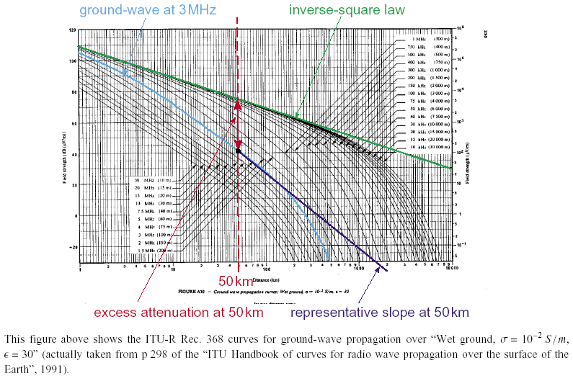
It has been assumed that, starting from an assumed hypothetical exclusion distance $x_{1}$ (e.g. 50 km), the attenuation follows a simple power law (dark blue straight line in the Figure)
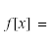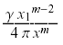
$m$ = downward slope at the point $x_{1}$
Another possibility is to use software freely available on the Internet GRWAVE (ref ERC Report 69).
2.2 Skywave propagation
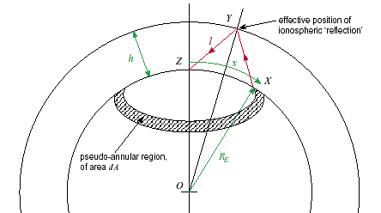

If '$α$' is the attenuation factor corresponding to the power lost to ionospheric absorption in each hop, the factor '$β$' being to account for the loss in each ground reflection, we obtain for $f[x]$:
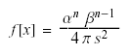
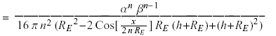
$s=2\text{nl}$ is the whole distance travelled up and down by the wave, while $l$ (the half-distance for 1 hop) can be obtained from the geometry as
$$l=\sqrt{R_{E}^{2}−2\text{Cos}[x/R_{E}]R_{E}(h+R_{E})+(h+R_{E})^{2}}$$
$f[x]$ is the attenuation factor (i.e. a value less than unity) as a function of curved-earth distance $x=\text{XZ}$ for $n$ hops
the attenuation is least (i.e. $f[x]$ is greatest) for one hop, in which case a representative near-minimum value for $α$ is 0.25, corresponding to –6 dB.

3 CHARACTERISTICS of the cable transmission system
Assumptions have to be made on the power, number of units simultaneously transmitting.

Values for the injected power of one modem range from –40 dBm/Hz to –70 dBm/Hz..

The equivalent gain of the electricity cable has been determined by measurements made, in particular in Switzerland.

Typical gains are reported to range from –20dBi to –50 dBi.

In the "ground-wave" case, the measured equivalent antenna gain was as follows:

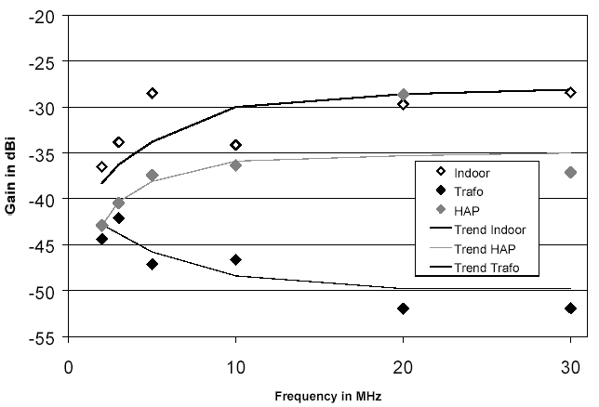
Resulting average pseudo antenna gain of LVDN vs frequency with trend lines
Indoor: indoor mains socket
Trafo: transformer sub-station
HAP: House Access Points

In the skywave case, the measured equivalent antenna gain was as follows:
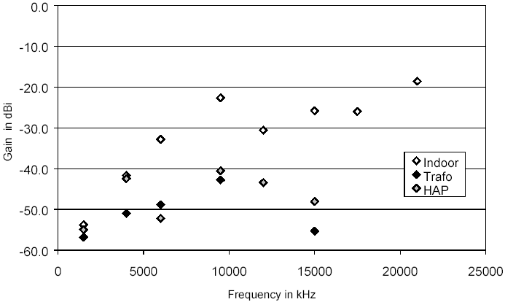Average skywave antenna gains (RMS of values in linear units over all measured samples) vs frequency
Indoor: indoor mains socket
Trafo: transformer sub-station
HAP: House Access Points
It should be noted that in Switzerland all electric cables are buried. Equivalent gains with overhead cables, or with different styles of power connection, may be different.

4 CALCULATION PRINCIPLE

4.1 Key steps
We have to determine the interference caused by a single interfering source at some distance ($x$ in the figures and equations).
This means how much interfering signal is radiated and how it propagates i.e. how it is attenuated with distance.
We have to sum all the interference from many sources present when systems of one type (PLT for instance) are fully deployed.
This means knowing the distribution of interference sources, and the manner and the geometry of the propagation path to reach the victim receiver.
The sources are supposed to be uncorrelated, so we can estimate their total effect by power addition.
We can go on to estimate the density of sources, treating the sources as being uniformly spread over an area, and replace the summation by an integral (valid if distance travelled by the interference is large compared with distances between the sources).

4.2 General assumptions
The peaks and nulls in the individual radiation patterns of the sources will tend to be cancelled when a large number of them is summed, so that they can be treated as isotropic on average.
Each system is thus equivalent to a transmitter (of power as injected to the cable) coupled to a lossy isotropic antenna (gain < 0 dBi).
Each source will have an EIRP = and if the density is $D$ (systems/m²) within an area $\text{dA}$ containing sources we have watts.
Over a distance of $x$ (m), if $f[x]$ is the representative attenuation function of the path travelled, the received power flux density is =
For example, for one PLT system in the UK, all the premises connected to one electricity substation form a ‘cell’. Only one modem transmits at a time, so that the maximum density of instantaneously operating systems is thus the same as the density of substations. The area covered by a substation has a diameter of 600 m (approximately) so that $D=\frac{1}{\text{90000}p}$ systems/m², i.e. $D»3\text{.}5´{\text{10}}^{−6}$ systems/m², $p_{\text{TX}}g_{\text{TX}}=5´{\text{10}}^{−6}$ W/10 kHz (PLT case) and the EIRP density is thus –107.5 dBW/m² in 10 kHz
For a mix of potentially interfering systems, we could apply a combined EIRP density $p_{\text{TX}1}g_{\text{TX}1}+p_{\text{TX}2}g_{\text{TX}2}+K$

4.3 Victim radio receiver in the sky
The receiver of the aircraft sees an increase in the apparent noise floor. The geometry of the problem is derived from figure
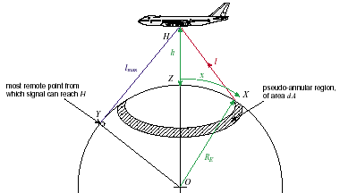

4.3.1 For an interference which hits the receiver directly (free space propagation)
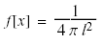
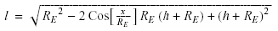
where the values of $x$ and $l$ are physically constrained not to exceed $x_{\text{max}}=R_{E}\text{ArcCos}[R_{E}/(R_{E}+h)]$ and $l_{\text{max}}=\sqrt{h(h+2R_{E})}$ respectively
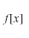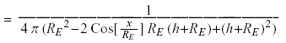
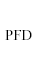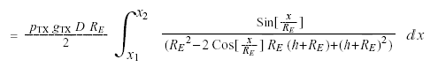
And , for the normalized form
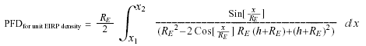
This integral can be evaluated for the completely general case, with the result
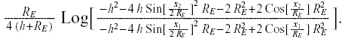
The Log[] function in the above result is a natural logarithm (base e). The appropriate values of the limits $x_{1},x_{2}$ have to be substituted for particular practical cases. Commonly we could consider the ‘interfering area’ to be a spherical cap, with $x_{1}→0$, while $x_{2}$ must not exceed $x_{\text{max}}$.
4.3.2 Case where interference reaches the airborne receiver by sky-wave propagation via the ionosphere
While the aircraft is flying over an area containing interferers, then the interference from these (as calculated in §4.3.1) may be expected to dominate. However, if the aircraft is over an unpopulated area, then interference received via sky-wave propagation may become significant. This case is not considered in detail here; it is very similar to the case where the victim receiver is on the ground, as considered in §4.4.2, provided the aircraft height is small compared with the effective ‘reflection’ height in the ionosphere. This will normally be the case.

  - Victim radio receiver on the ground

4.4.1 Ground-wave propagation
In the case of ground-wave propagation, we have:
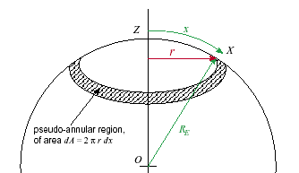

If earth were flat, or if we consider very nearby interference (x<50 km)
$$\text{dA}=2px\text{dx}$$
Or in general $r=R_{E}\text{Sin}[x/R_{E}]$
and 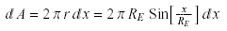
and the resulting interfering PFD is obtained by integration:
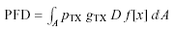
$f[x]$ quantifies the attenuation caused by ground-wave propagation over the distance $x$ (curved earth), see §2.1.

4.4.2 Sky-wave propagation
See the figure and equations in §2.2 which define $f[x]$ for this case. The relevant values of $x_{1}$ and $x_{2}$ should be chosen to define a pseudo-annular region on the curved earth which contains interferers that should be included in the integration. Note that $x_{1}$ can never be less than the skip distance (a function of frequency and the state of the ionosphere), while $x_{2}$ cannot exceed $x_{\text{max,}n}=2{nR}_{E}\text{ArcCos}[R_{E}/(R_{E}+h)]$.
The result for 1 hop (assuming loss-less propagation, $α=1$) can be shown to be:

$\begin{aligned}{\text{PDF}}_{\text{for} \text{unit} \text{EIRP} \text{density}, \text{lossless} 1−\text{hop} \text{propagation} }= \\ \frac{1}{8 {\left(h+R_{E}\right)}^{2}}\left\{2R_{E}\left(h+R_{E}\right)\left(\text{Cos} \left[\frac{x_{2}}{2R_{E}}\right]−\text{Cos} \left[\frac{x_{1}}{2R_{E}}\right]\right)+\left(h^{2}+2{\text{hR}}_{E}+2R_{E}^{2}\right) \text{Log} \left[\frac{2R_{E}(h+R_{E}) \text{Cos} \left[\frac{x_{2}}{2R_{E}}\right]−h^{2}−2{\text{hR}}_{E}−2R_{E}^{2}}{2R_{E}(h+R_{E}) \text{Cos} \left[\frac{x_{1}}{2R_{E}}\right]−h^{2}−2{\text{hR}}_{E}−2R_{E}^{2}}\right]\right\}\end{aligned}$

- RESULTS
5.1 Victim receiver in the sky
For convenience, the figure below plots the result of using the formula in §4.3[.1], showing the received interfering equivalent field strength at an aircraft as a function of its height, assuming the visible earth is uniformly populated with interferers having a unit EIRP density, i.e. 1 W/m². There is relatively little variation in the interfering field strength with aircraft height. The corresponding interfering field strength for any particular system is easily obtained by adding the appropriate correction factor in dB(W/m²), e.g. for PLT systems in the UK. For PLT systems (UK) described in§4.2 the interfering field strength lies between 42.5 and 40.5 µV/m for a height of an aircraft between 200 m and 14000 m.
The effect of flying over a more restricted area containing interferers (rather than the entire visible earth) and effects of variation of interferer EIRP as a function of elevation angle have been investigated, but neither makes a very profound difference.
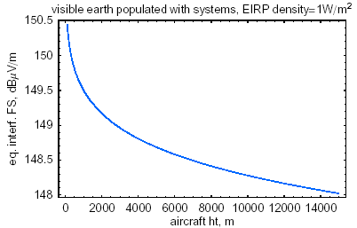

5.2 Victim receiver on the ground

5.2.1 Interference path without ionospheric reflections (ground-wave propagation)
Due to the propagation of ground waves the problem is relevant for distances $x_{2}$<30km (frequencies between 2 and
30 MHz).
With an exclusion zone of r=0.1km, and a radius $x_{2}$ of 10km (<30 km) over a medium soil.
$εr$=4, $σ$=(10⁻³) S/m. For PLT systems with –50 dBm/Hz of radiated power, an antenna gain of –50 dBi and density of 100 equipments/km² at F=5 MHz we have a total interfering field strength E($x_{1}$,$x_{2}$)=13 dBµV/m.
If the soil is dry the level of E($x_{1}$, $x_{2}$) decreases. If the frequency increases, the result decreases.

5.2.2. Interference path via sky wave propagation (one hop)
One hop is the most unfavourable case. The interfering field strength varies, when $x_{2}$ parameter is between 0 and 500km,from 90 to 140 dBµV/m (for a spherical cap, standard PLT EIRP density of 1 W/m², no ionospheric loss, reflection height 300 km)

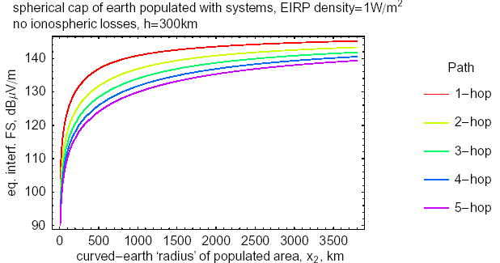

If $x_{2}$ varies between 500 and 3500 km, the interfering field does not vary very much (140 to 142 dBµV/m)
If for example, we consider PLT systems with parameters of §4.2 and one hop with 10 dB ionospheric loss, then the curve reaches 28.5 dBµV/m at 3500 km. If $x_{1}$ is a parameter, the result does not change very much until 3500 km (decreases with r2).
All these developments are valid for broadband incoherent sources.

6 CONCLUSION
PLT and other cable technologies may affect radio reception in the immediate vicinity, e.g. in the same or nearby houses. Where this is the case, this interference can be expected to dominate over interferers at a greater distance. However, if there are no immediately-local interferers, then the cumulative effect of many interferers at a greater distance may become significant.

Whether cumulative interference is a significant issue is essentially determined by the EIRP density of the potentially-interfering systems, together with the area within which they are deployed and its location with respect to the receiver.
Considering interference to aircraft, the critical scenario is where they are flying over a populated area while using LF/MF NDBs or HF communications. There is some debate about the acceptable interfering field strength. We can probably assume that there would be little or no impact if the interfering field strength at the aircraft is no more than 0 dBµV/m (10kHz), which would be assured if the EIRP density did not exceed –150 dBW/m²(10kHz). At the other extreme, levels say 40 dB greater (corresponding to an EIRP density of –110 dBW/m²) appear certain to cause problems.

The EIRP density is made up from three factors: the power injected into the cable being used, the effective transmitter gain of that cable, and the density of systems.

Injection powers in the range –70 to –40dBm/Hz are mentioned; these correspond to –60 to –30 dBW(10kHz).

Effective transmitter gains in the range –50 to –20 dBi are claimed.
The system density quoted for an access PLT system in the UK was –54.5 dB/m². This corresponds to the density of power sub-stations. The density could be slightly less in rural areas (but constrained by the maximum length of LV cable from transformer to customer); conversely, in-house or xDSL systems could have a greater density, namely one per household. So the range of density can perhaps be estimated to lie from say –60 to –30 dB/m².

The possible range of EIRP density thus appears to be from –170 dBW/m²/10 kHz (no cumulative problem) to –80 dBW/m²/10 kHz (definite cumulative problem).

The true spread is probably not quite as great as this, as the parameters do not take the extremes independently. E.g. access PLT may have the highest EIRP, but does not have the highest density, so its maximum EIRP density is perhaps –105 dBW/m²/10 kHz — thus still having the potential to cause difficulty.

Sensitive HF receiving sites on the ground affected by sky-wave interference could tolerate an EIRP density of approximately –140 dBW/m²/10 kHz.

Calculations of ground-wave interference to such sites show a spread of results which imply that the necessary exclusion zone around them should extend from 100 m radius to as much as 100 km.

Annex 8: Effects on amateur radio of the use of power lines for broadband data communications (PLT)

1 INTRODUCTION
This Annex describes a series of measurements that were conducted in the house of a radio amateur in a rural area of the Netherlands to try to answer the following questions:
- What is the relation between the injected HF voltage on the 230 Volt mains and the resulting noise field strength in and outside the house?
- How are these generated noise field strengths related to the proposed field strength limits for PLT, if the interference voltage on the mains equals the limits as set forth in the EMC Standards (CISPR 22)?
- How high are the already present noise voltages on the 230 V mains circuit.

All these points have been the subject of numerous discussions and studies. In particular the first point has been extensively studied by theoretical analysis, simulations and measurements. A general applicable formula is still desirable. The relationship in the second point is even more difficult to establish.

Measurements in the house were made with a CISPR compliant measuring receiver, a loop antenna, a signal generator and a mains coupling device, necessary to inject a signal into the 230 Volt mains, which was specially constructed to perform these measurements.
2 THE ENVIRONMENT
The house is located just outside a village. There are no busy main roads, nor there are in the neighbourhood any overhead high voltage lines. The local low voltage transformer is shared with 16 families including 2 farms.

3 THE MEASUREMENT POINTS
Figure 1 provides relevant data on the layout of our house. Because of the location directly behind the electricity meter and house access point, a mains grounded wall outlet in the kitchen was used to couple the generator or the measurement receiver to the mains. The distance to the outlet is approximately 2 meters.

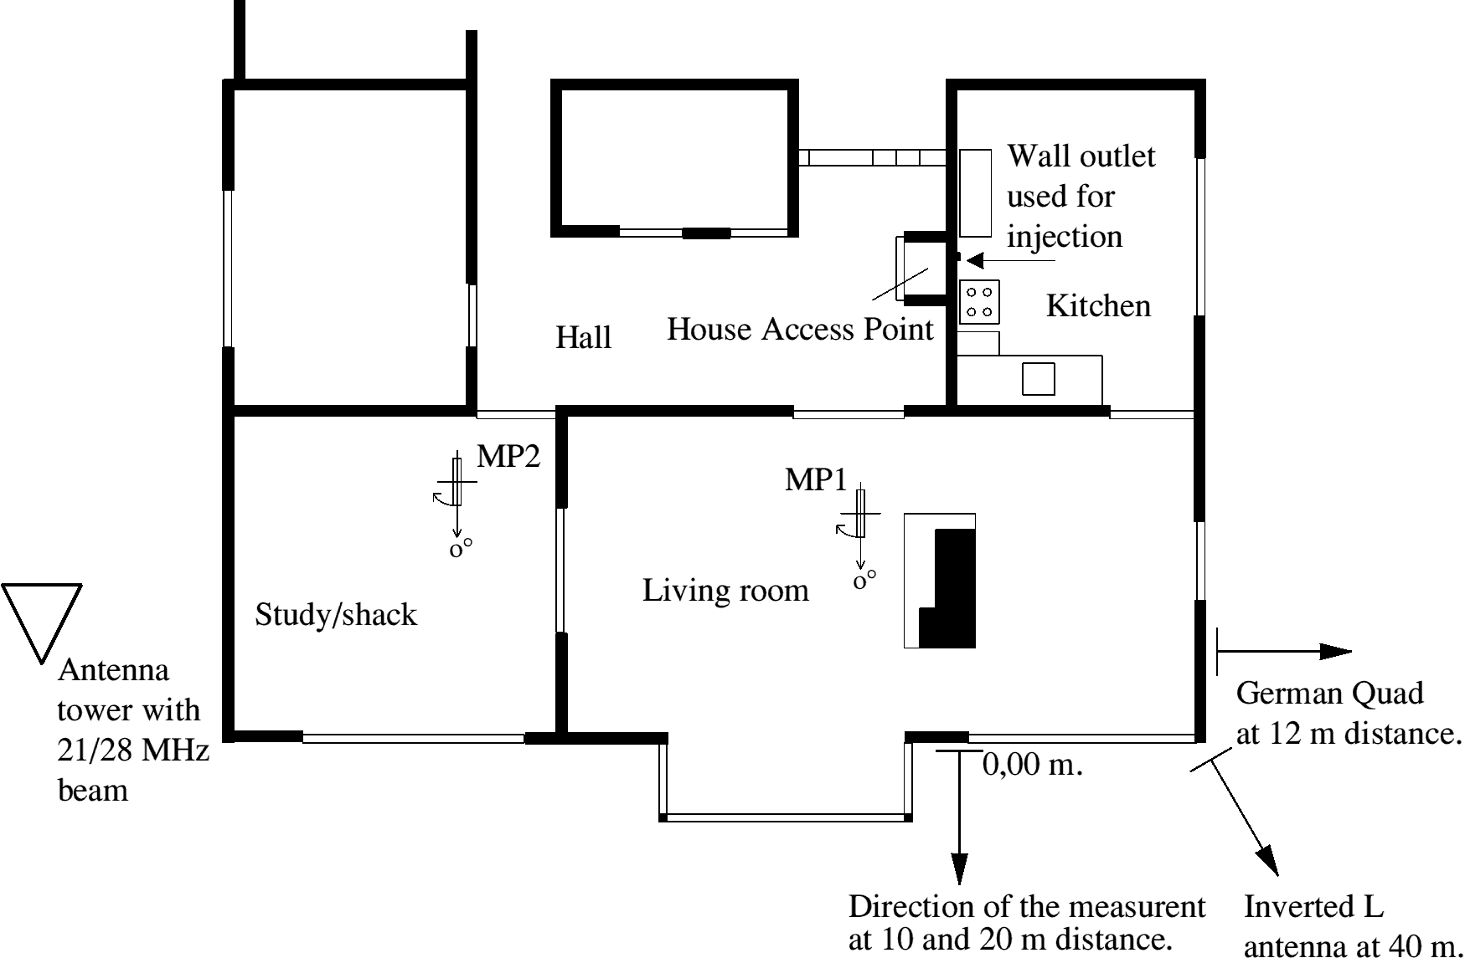
Figure 1: Measurement layout

In-house field strength measurements were performed at two positions. Measurement point 1 is in the living (MP1) en measurement point 2 in the study annex shack (MP2).

The position of MP1 was selected for a local maximum in the field strength at 3.5 MHz, and is located approximately 0,5 m in front of the open fireplace on the prolonged side. Apparently there is a mains wiring located overhead, running from the window in the direction of the electricity meter. The distance to the centre of the measurement antenna is approx. 1.25 m. The loop antenna was turned around its vertical axis until a maximum signal was detected. The angle of rotation was noted where 0 degrees was in the direction of the mains wiring. The 0 degree reference is depicted in figure 1.

MP2 was also chosen at a location with a local field strength maximum under a mains wiring. Distance to rear wall: 0.7 m, middle wall: 1.3 m, distance to the centre of the measurement antenna is also approx. 1.25 m. Orientation is the same as for MP1.

In the garden are the two positions for field strength measurements, 10 m, respectively 20 m, from the outside wall, as indicated.

On the right side of the house is a German Quad antenna. This is a horizontal loop antenna with a height of 10 meters and sides of 20 m each. The nearest side of the loop is at a distance of 12 m from the wall of the house. This antenna covers the 160 - 20 m bands.

In figure 1, (right-hand corner), at a distance of 40 metres from the house, is an inverted L- antenna. The length of the vertical part is 10 m, the horizontal part is 30 m. Coupling is achieved via a home-made broadband transformer and a coaxial cable. The frequency range of the antenna is 9 kHz – 15 MHz.

On the left side of the house at a distance of 2 m is a variable length tower (max. 21 m) with a 2 x 4 element dual beam for 21/28 MHz.

4 THE MEASUREMENTS
The following measurements has been performed:
- Measurement of the impedances of the mains wiring at the injection point. As well as between Neutral – Earth port, as between Phase - Earth port, and as between Neutral – Phase.
- Measurement of the injected HF power at a constant available power setting of the generator.
- Field strength measurements inside the house.
- Field strength measurements outside the house.
- Measurements of the interference signal levels on the HF receiving antennas, determining of the antenna coupling factors and evaluation of the reception with an amateur receiver.
- Measurement of the effects of the height and direction of the HF beam.
- Measurement of the HF voltage at the 230 Volt injection point as a result of the radiation by the outside amateur antennas.
- Measurement of the actual mains interference voltages at the injection point in comparison with the CISPR 22 Class B limit values.

5 IMPEDANCE AND injected power measurement
Figure 2 shows the measurement set-up for all measurements where a HF signal is injected in the 230 Volt mains. Signal source is a signal generator, adjusted to an available output power of 0 dBm. The injection into the 230 Volt mains is through a Mains Connector Device (MCD). For a description see Appendix 1.

To get an impression of the impedance of the 230 Volts mains a measurement has been made at the injection point. For reasons of simplification it was assumed that the impedance of the mains is real. Also the impedance of the separation capacitor C is assumed to be zero Ohm. For the frequency range under consideration 1,6 – 30 MHz (21 Ohm at 1,6 MHz), this is acceptable.

The advantages for this approach are that simple measurement devices like an oscilloscope can be used and that computations also remain relatively simple.

Figure 3 gives the equivalent schematic for the measurement set-up
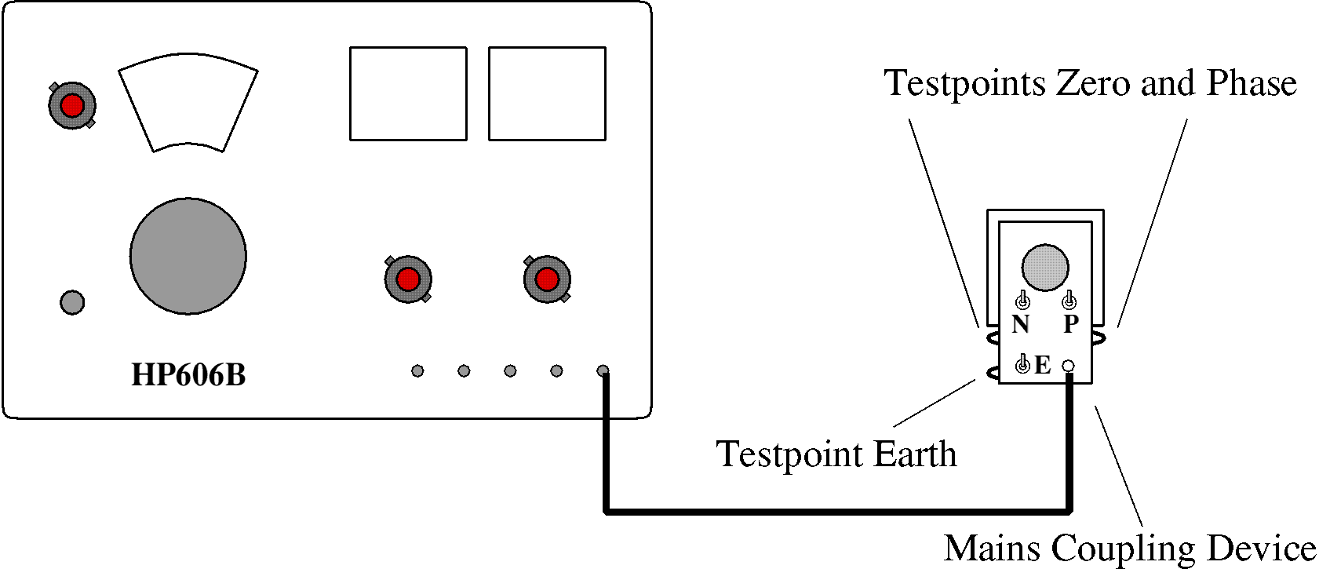
Figure 2: Set-up for injection measurements.

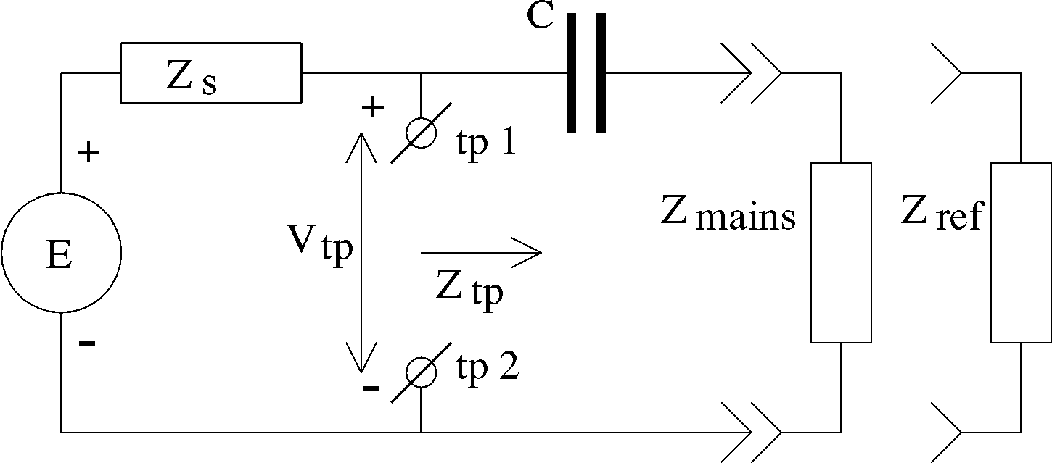
Figure 3: Equivalent schematic.

A comparative measurement has been performed, wherein the MCD first is plugged into a reference wall outlet containing two reference resistors of 50 Ohm each, see Appendix 1. In figure 3 these reference resistors are marked as 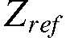. The voltage across the test points, 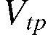, is measured and represented by 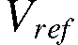.

Next the MCD is plugged into the 230 Volt wall outlet and the voltage across the test points is measured as now representing .

There are three possible combinations:
Measurement modes and measurement points, switch positions and
impedance references.
Measurement mode: | Neutral (N) | Phase (P) | Symmetric (S)
tp1 | TP Neutral | TP Phase | TP Neutral
tp2 | TP Ground | TP Ground | TP Phase
S1 | open | closed | closed
S2 | closed | open | closed
Sw E | closed | closed | open
Z_{ref} [Ω] | 50 | 50 | 100
Table 1

Floating voltage measurements were made possible by using a battery powered oscilloscope.

The signal generator was powered from an wall outlet in the opposite wall via a 10 m long extension cable, thereby minimising the influence on the impedance to be measured. In addition the earth connection of the signal generator is connected to the earth connection of the wall outlet to be measured separately. The voltages are read as top-top values and recorded as such.

The conversion to the impedance values is as follows. For the reference measurement is true:
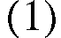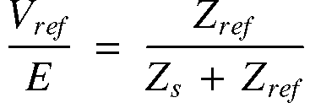
For the measurement connected to the mains:
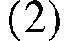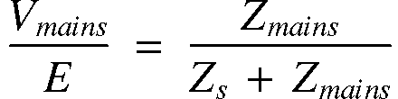
Dividing (2) by (1) gives:
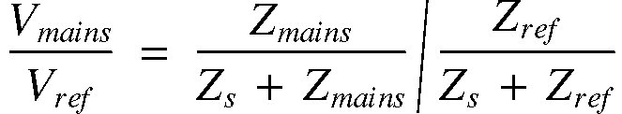
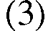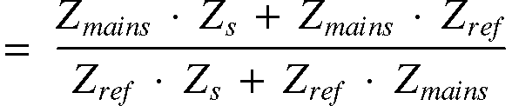
After some ciphering follows:
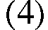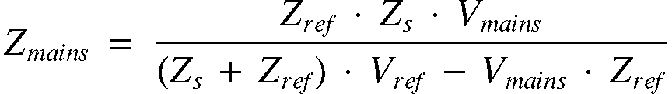
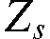 is the source impedance resulting from the combination of the MCD and the signal generator, and can be frequency dependant. Therefore the values used for are those computed with the use from data from Annex 1.
Although not indicated in the formulas all values for the impedance are absolute values without phase information. As the complex values for the impedance are not taken into account for the derivation, the calculated values for 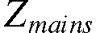 are not to be taken as exact values but approximations. The values found are also in agreement with the measurements found in practice and recorded in [1].

Table 2 gives the results:
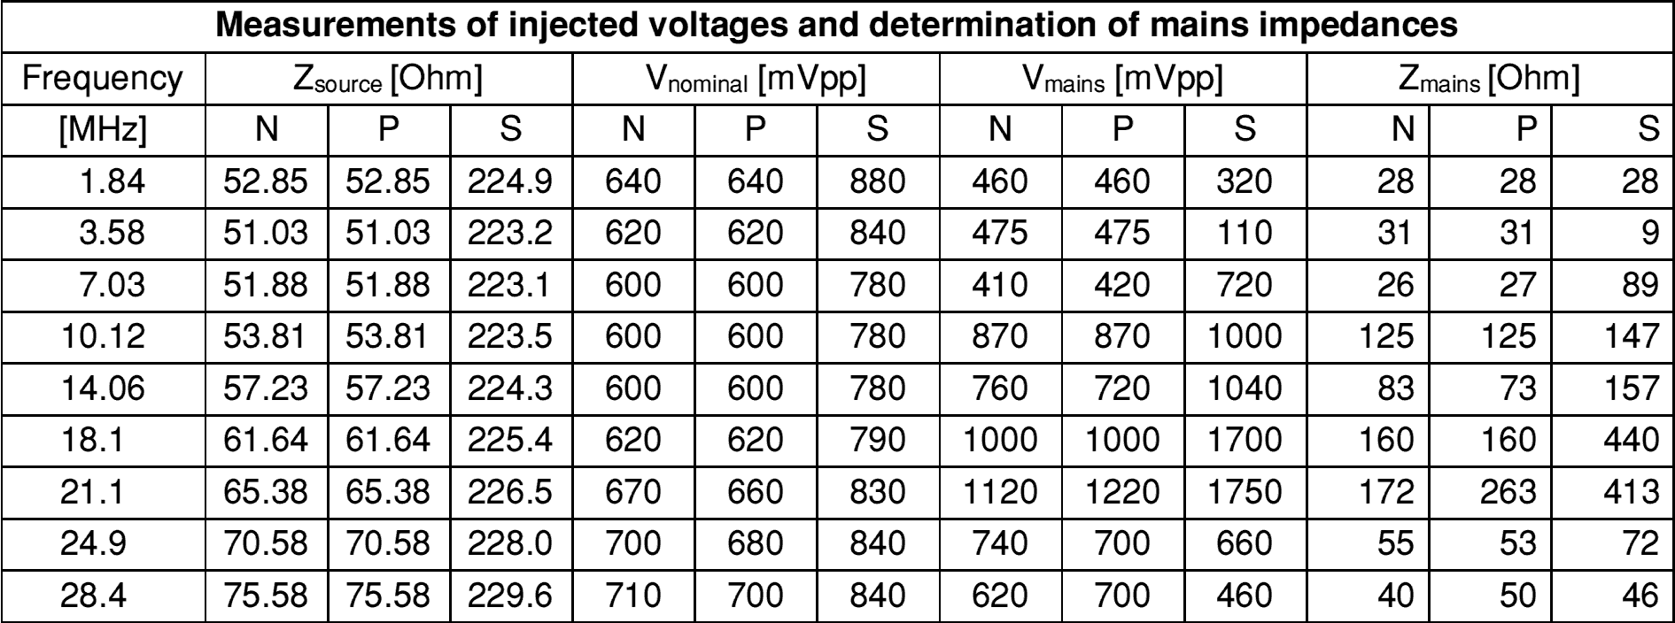
Table 2: Measurement of the injected voltage and determining of the mains impedances.
In [1], para 3.2, a diagram represents the minimal, average and maximum expected values for the HF impedance’s of the mains circuit. Figure 4 is a copy of this diagram but now with the values for the amateur bands from table 2 inserted. We can conclude that the measured values are in agreement with the values found in other sources.
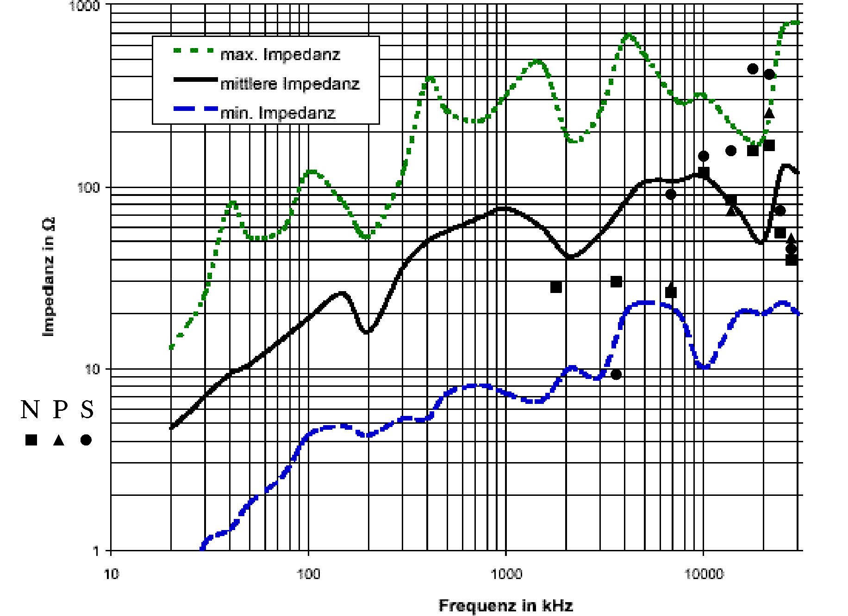
Figure 4: Figure 5 from [1] with the measured values here inserted.
From the results in table 2 estimations can be made of the injected HF power. First we have to convert the measured voltages Vmains into rms values by:
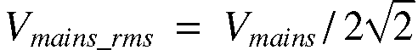
The injected power is then:

In dBm:
Table 3 gives the results:
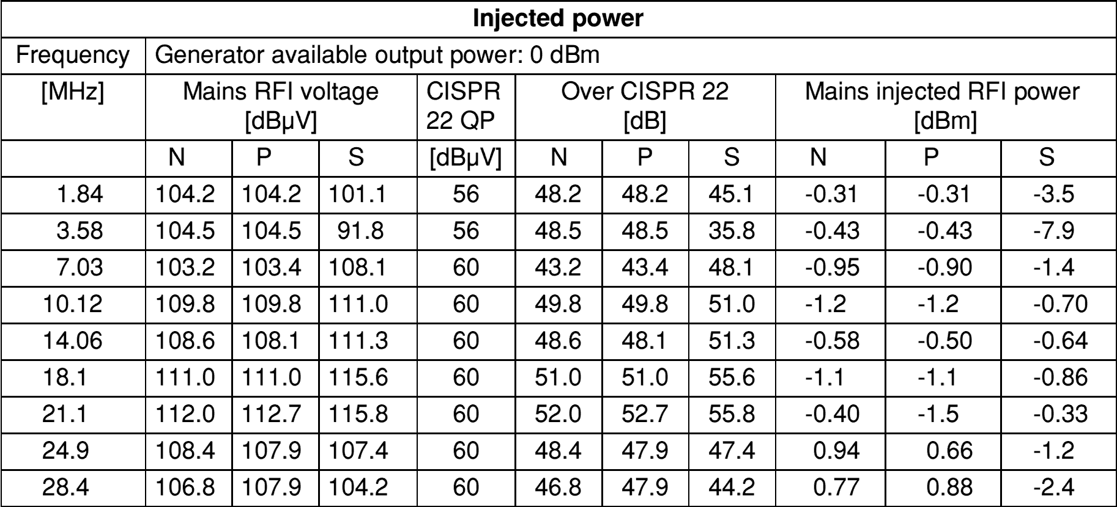
Table 3: Results of the calculation of the injected power.
In the table the measured voltages are in dBµV to facilitate a quick comparison with the CISPR 22 Class B noise limit. The difference with these limit values is also shown.

There is no great difference between the calculated values for the injected power and the available generator power (0 dBm). Some values are even somewhat higher. This is mainly explained by the limited accuracy of the measurements and the simplifications in the calculations. Also has to be taken in consideration that a part of this power could be reactive power as the impedance is not pure resistive.

6 IN HOUSE FIELD STRENGTH MEASUREMENTS
At two in-house positions field strength measurements were executed with a measurement receiver in combination with a magnetic loop antenna. These positions were already defined in section 3. Table 4 shows the results for MP1 in the living room.

As customary for this kind of measurements, the electric field strength E converted via the far-field impedance of 377 Ohms, is displayed. Also is shown the rotation angle of the loop antenna in respect to the reference direction for the maximum signal strength. Then these measured values were normalized for the standard distance of 3 meter, assuming a linear decay of the field strength with distance. This procedure is in accordance with the guidelines of NB30. Finally, for comparison, the limit values of NB 30 are mentioned.

Now with the HF voltages at the injection point are known, together with the measured field strengths, the relation can be defined in a coupling factor K [dB/m]. Table 5 shows these for MP1. Note: The resulting values for the coupling factor are only valid for this specific location.
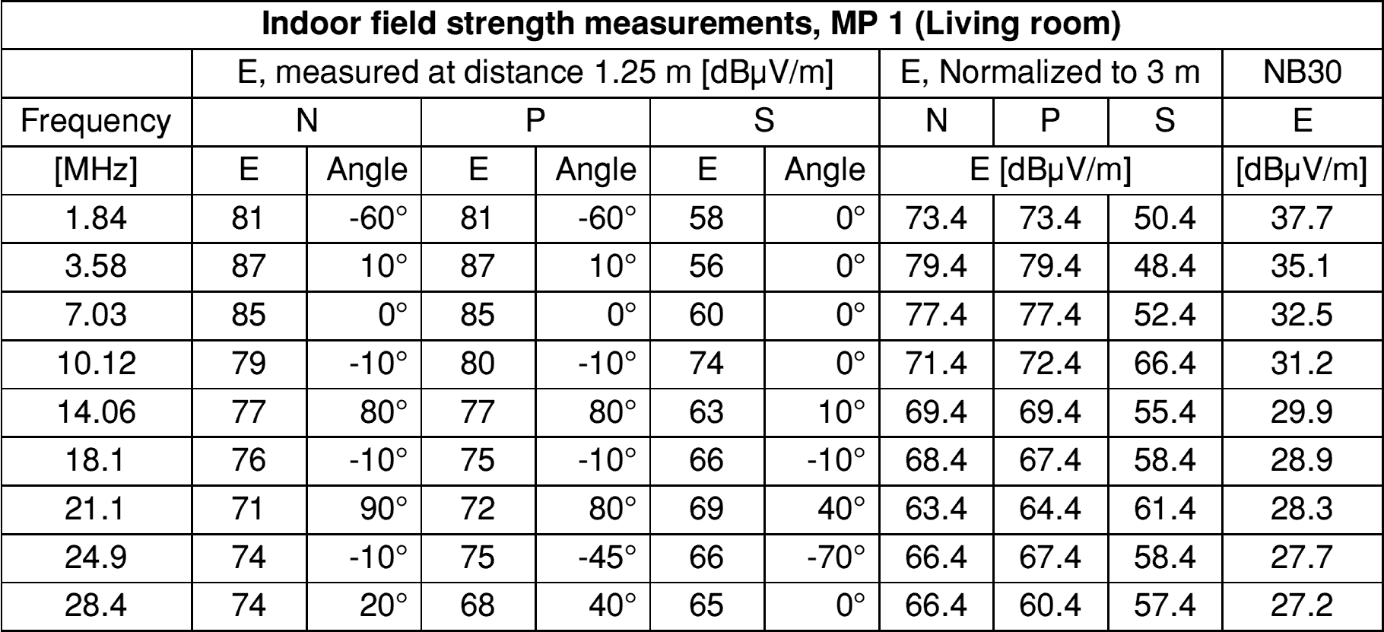
Table 4
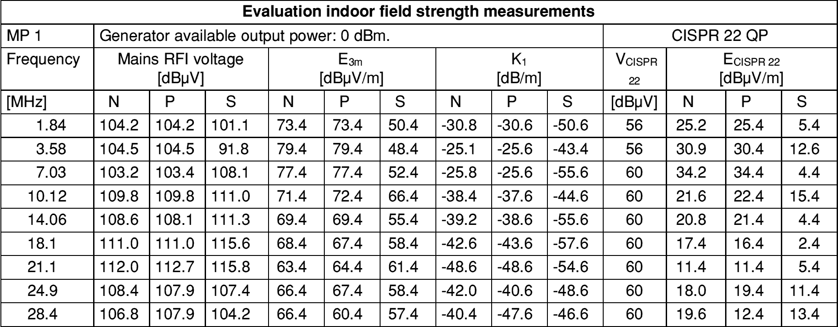
Table 5
The resulting coupling factor K is then applied on the power line noise limit of CISPR 22 QP, also reflected in table 5, resulting in an equivalent noise field strength  for this measurement point. Tables 6 and 7 show the results for MP2 in the study.

The six measured values for the coupling factors are together shown in figure 5, this in relation with the average K-factors for asymmetric and symmetric injection.

The results for K are comparable with the K-values found in literature. In [2], para. 5.11.1 a general value of –60 dB/m at a distance of 15 m is stated. Measurements lead to values for the coupling factor K from –53dB/m to –75 dB/m for a distance of 3 meter. Only symmetrical injection was used.
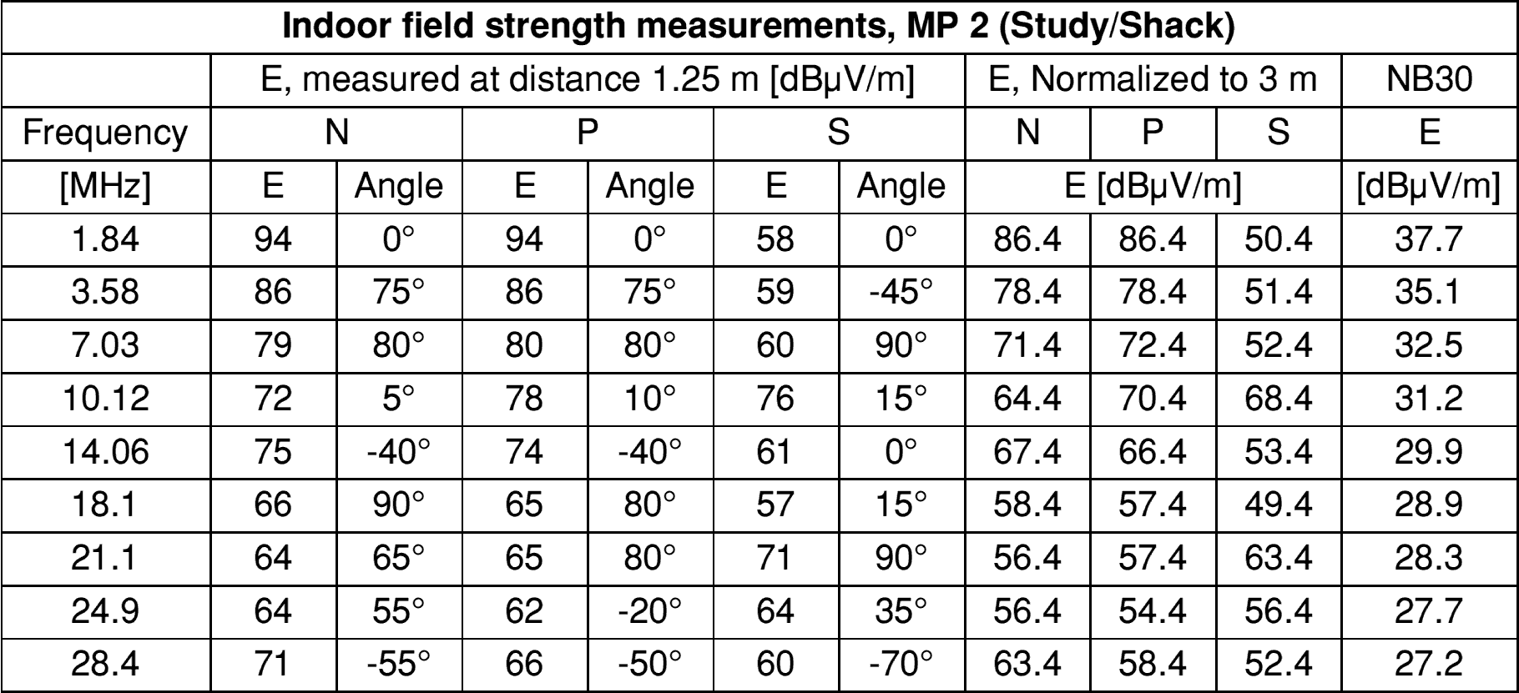
Table 6
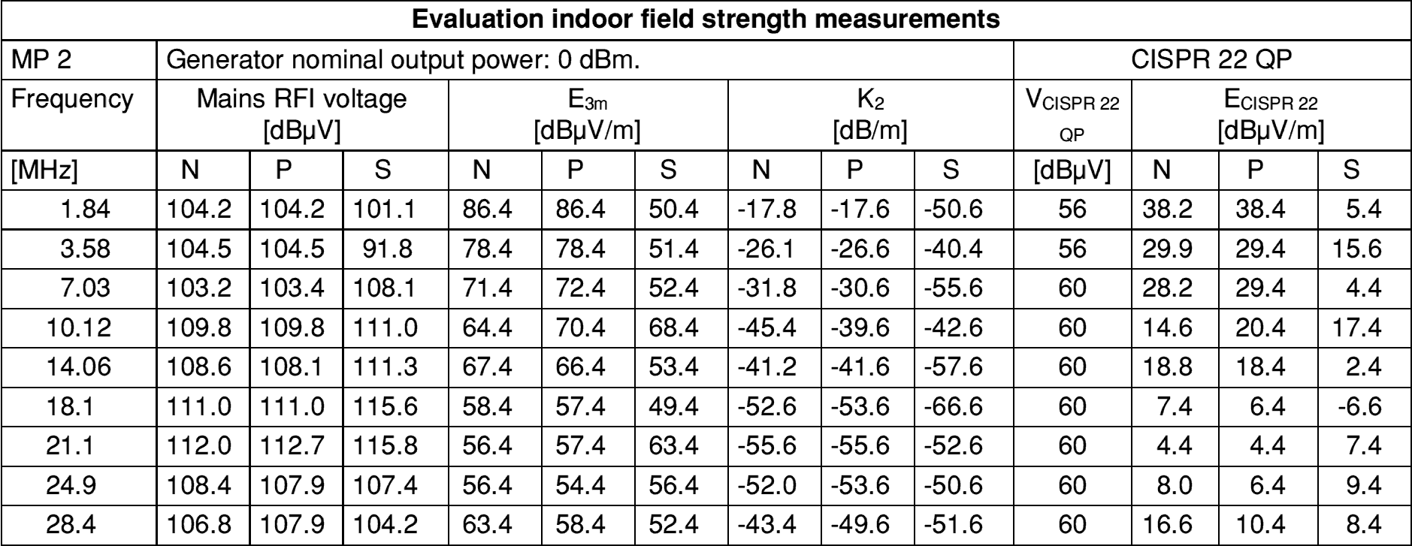
Table 7
The coupling factor K is dependant on the measurement set-up and will be different for each house and location caused by the difference in power line wiring. Given the fact that K is also frequency dependant means: a well defined definition of the measurement procedures in a limit is of decisive importance to determine if an interference level is too high in case of complaints.
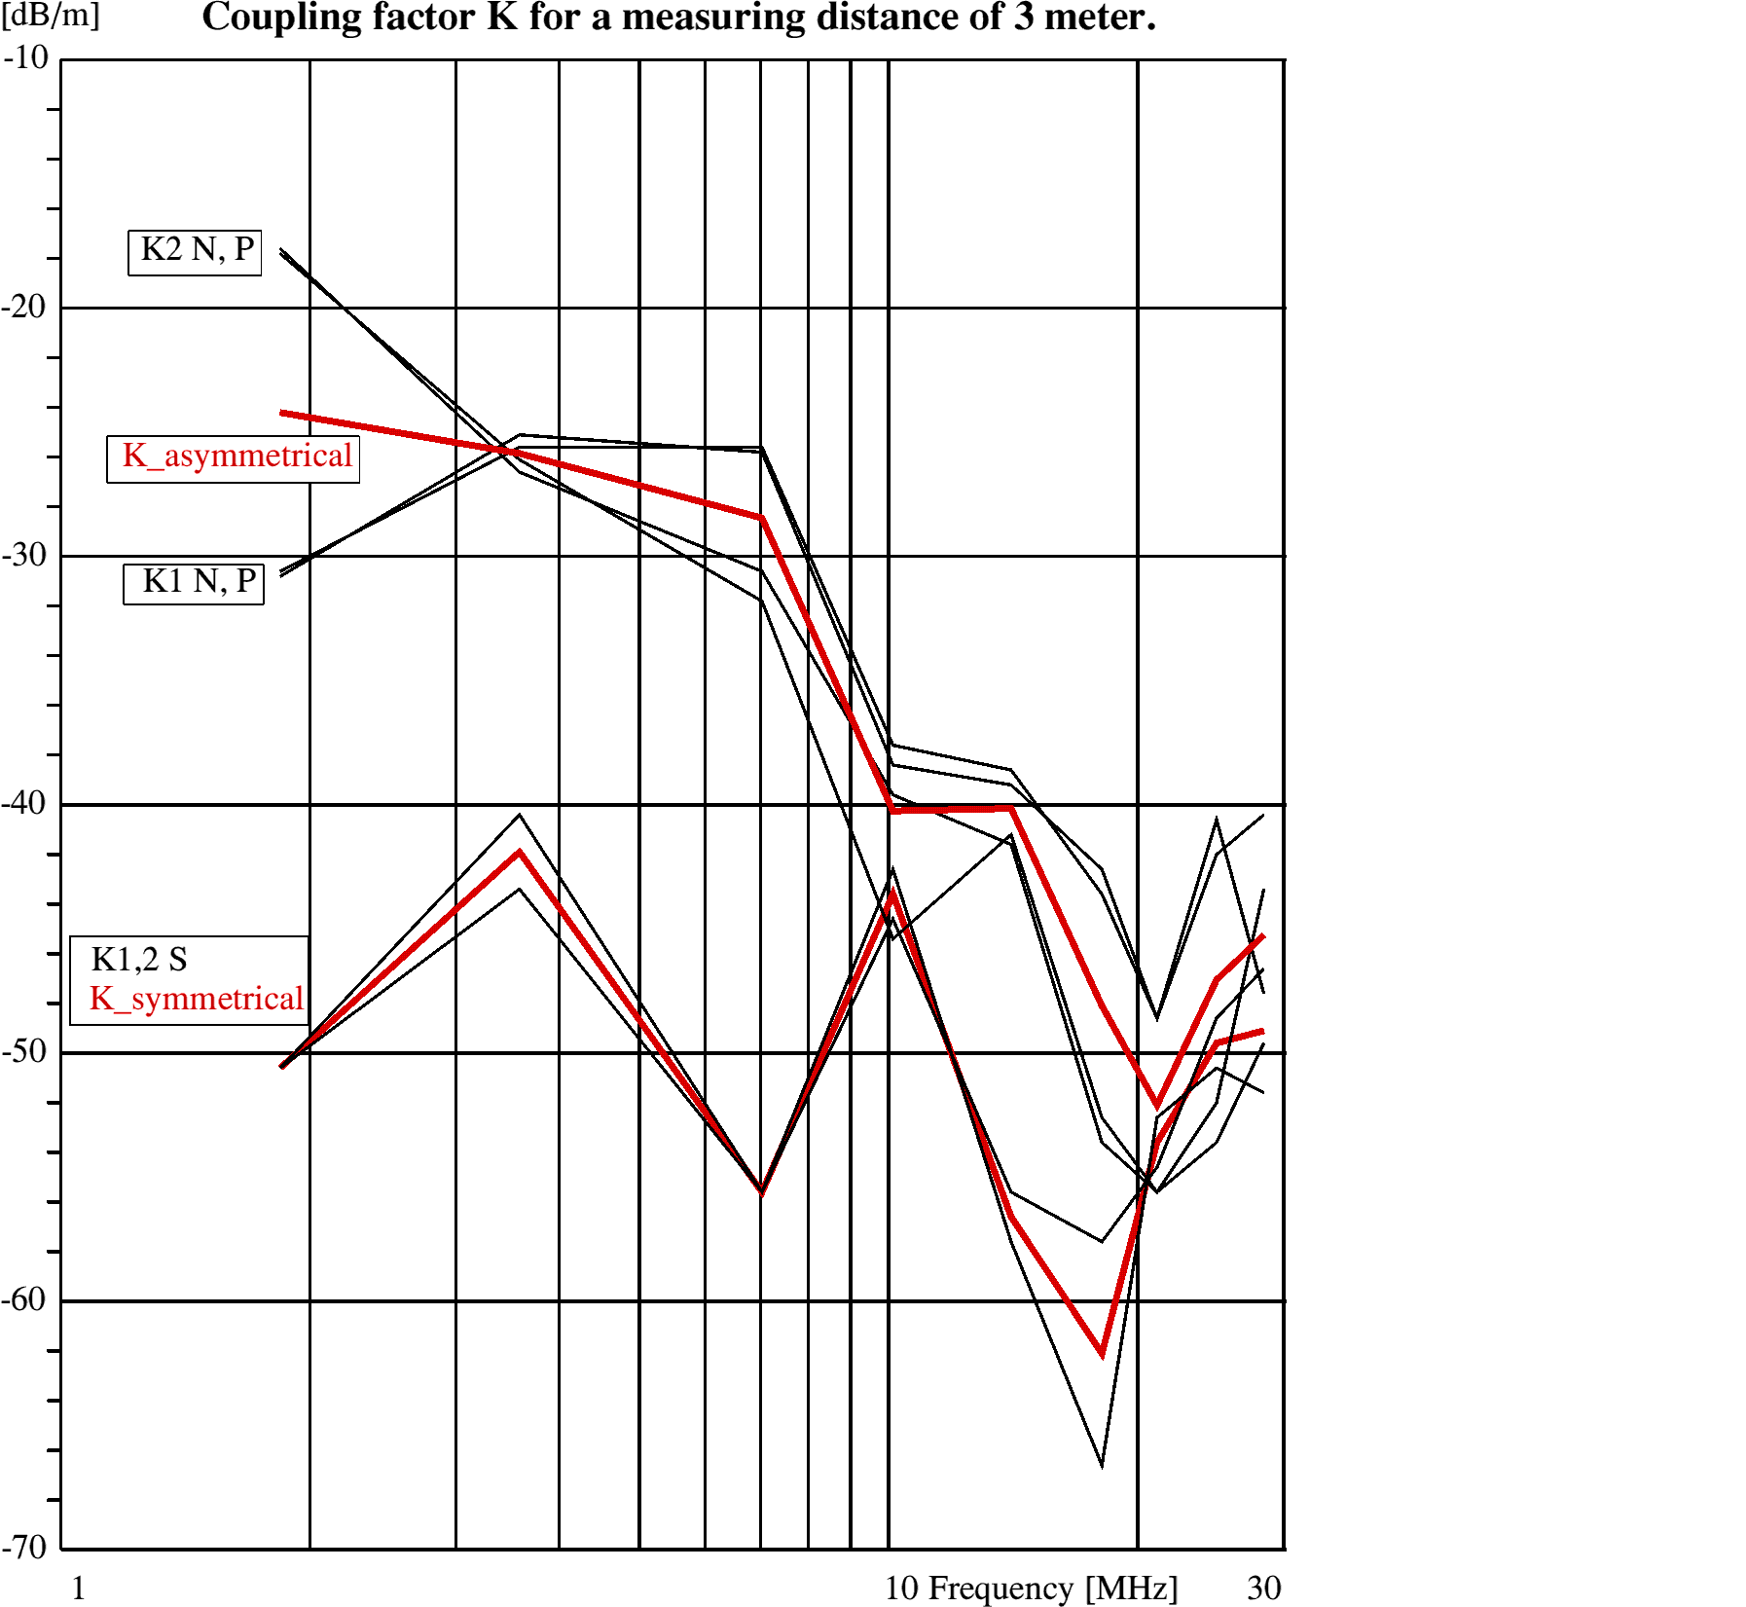
Figure 5: Coupling factor

7 RELATION OF CISPR field strength limits against proposal n°1 limit
The data from the tables 5 and 7 for the field strength are further modified by levelling out the values of both measurement points that are then plotted in figure 6. For comparison, the proposal n°1 (NB 30) limit was also plotted in. Now we have the resulting electrical field strength generated in a home by a test signal, injected at a CISPR 22 Class B (Quasi Peak) limit level.

The conclusions are easy to draw:
- All field strength values are below the NB 30 limit.
- Despite the spread as result of the unpredictable standing wave behaviour on the 230Volts in-home network, and even the fact that the CISPR 22 limits in the frequency range above 5 MHz are higher, clearly is shown that the generated field strength decays with frequency, this as a result of the decreasing K- factor.
- Symmetrical coupling results generally in substantial lower field strength levels. However, in the higher frequency region where the symmetrical behaviour of the wiring decreases, the field strength increase as a result of the symmetrical injection.
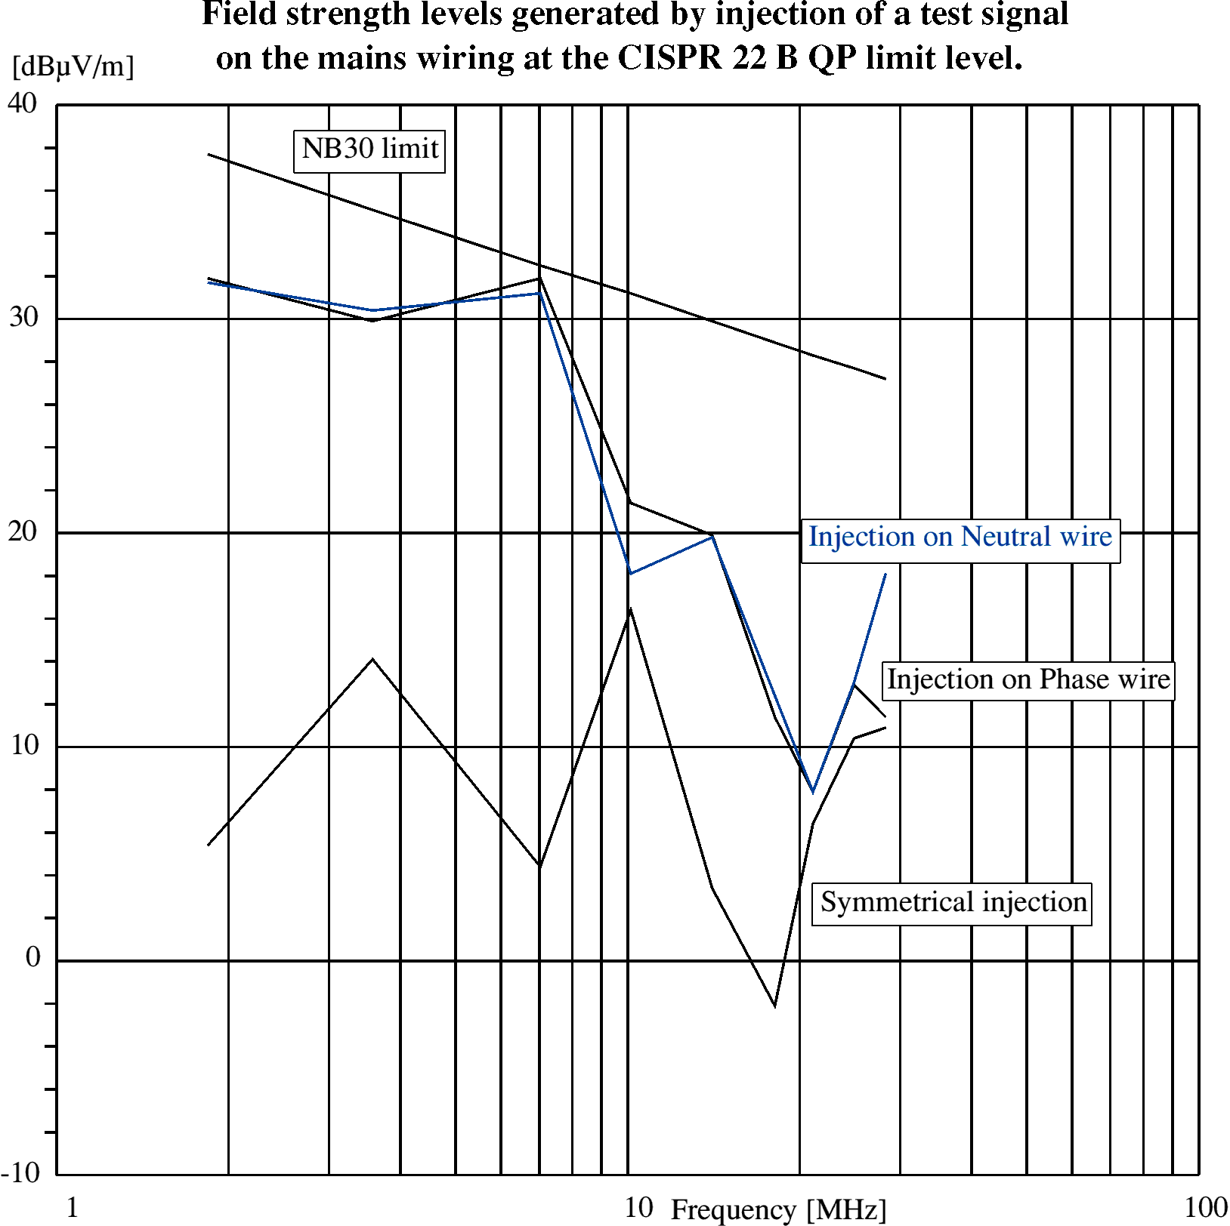
Figure 6. Field strength levels related to the CISPR 22 B QP limit

8 OUTSIDE field strength measurements
To acquire an impression of the decay of the radiating field with distance, two spots in the garden were measured, one at 10 m and another at 20 m from the house wall (not from the extension). Signal injection was made only in the Neutral and field strength measurements were done again with the receiver and magnetic loop antenna.
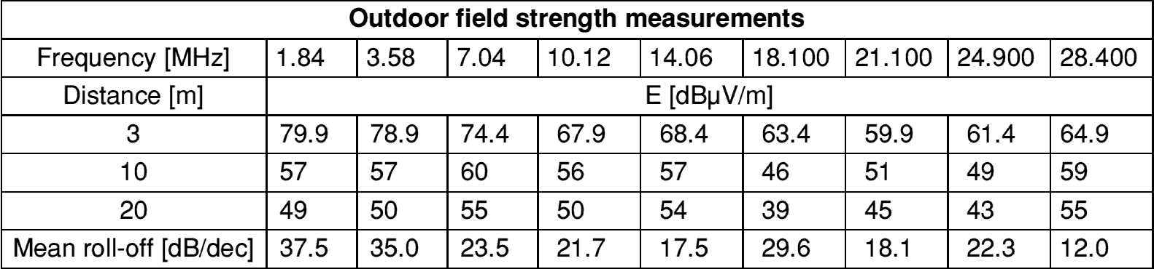
Table 8
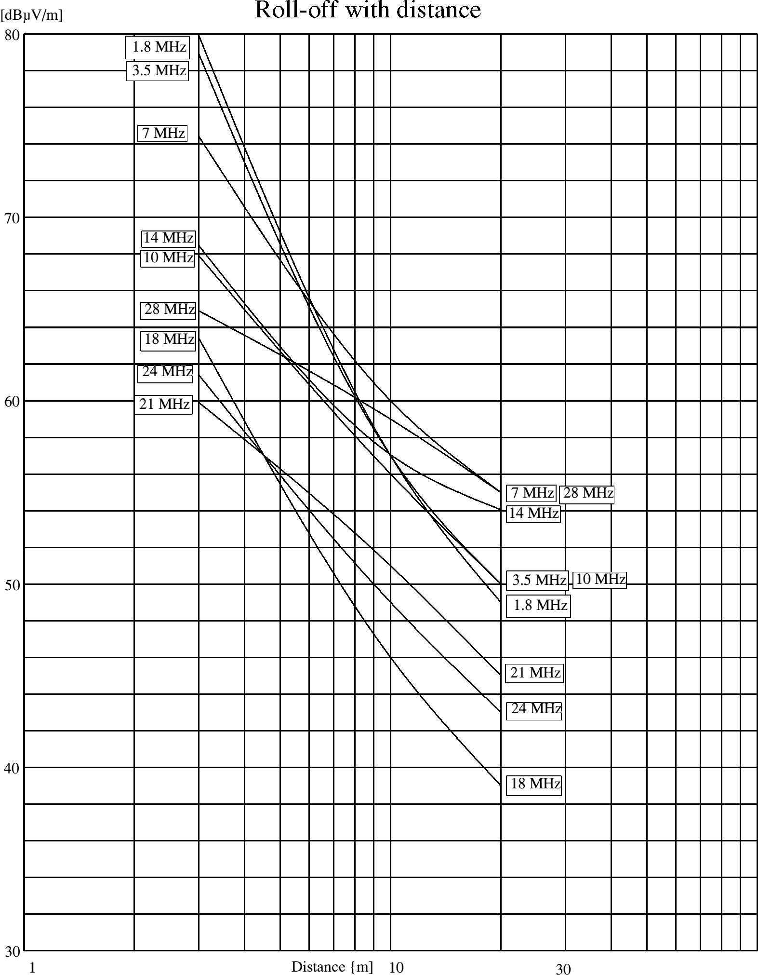
Figure 7
Table 8 shows the results, where for a distance of 3m the averages of the in-house measured field strengths are used.

Much indistinctness exists about the course of the field strength in the nea- and in the changeover to the far-field region. The results of the measurements were therefore plotted in figure 7, and the average decay in dB's per decade in table 8.

Field strength values normalized for NB 30 field strength at 3m are depicted in figure 8.
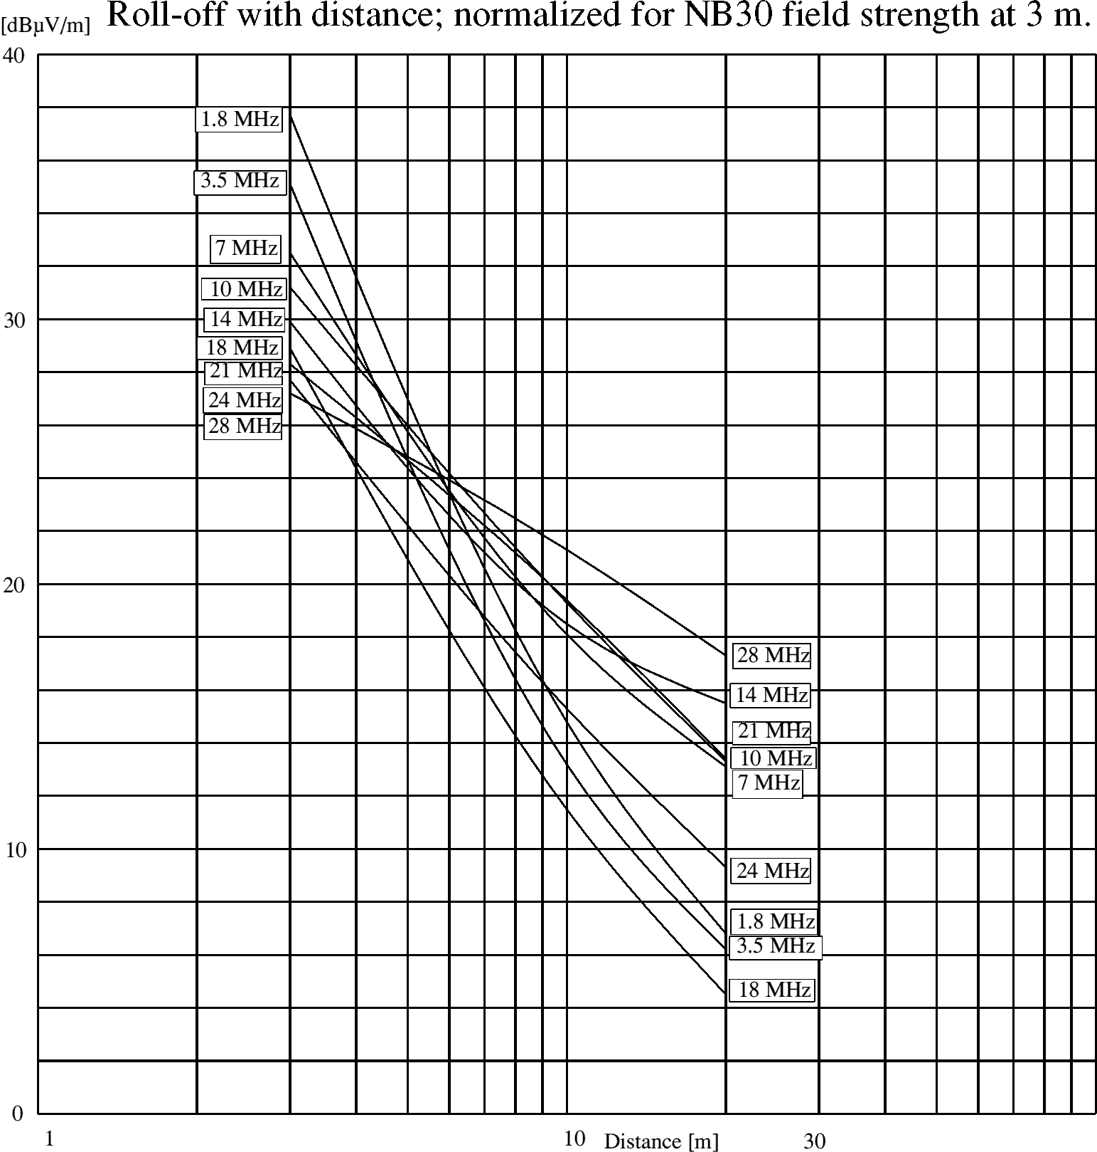
Figure 8

From figures 7 and 8 we can conclude that the general assumption, that for all frequencies in this situation there is a linear decay, is only true for the statistical average over the 7 higher bands. At 1.8 and 3.5 MHz there is a faster decay.

Note: The assumption, that the field strength roll-off with distance linearly in the near as well as in the far field, is only true in one theoretical situation: for a half wave dipole and only if measured magnetically. Moreover one has to consider these results with great care because of many accidental factors like the flow of the currents in the wiring system of the house or ground reflections, all have impact on the results.

9 EFFECTS OF height and direction of the antenna
A very interesting question is if we can escape from the interference by PLT systems by the use of higher antennas. In the evaluated house's situation, we could check this by varying the height of the 21/28 MHz beam. During these measurements the directive sensitivity could also be checked for the interference. Measurements were conducted in all three injection modes. For the results see table 9.
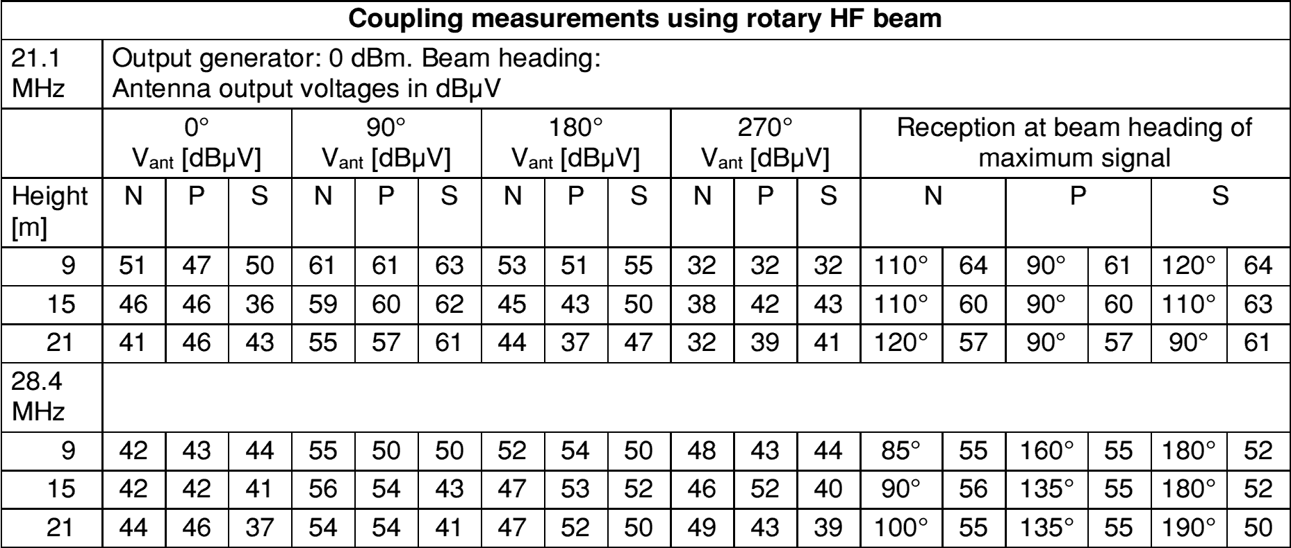
Table 9
The results of table 9 are next normalized to the proposal n°1 (NB 30) limit. This was done by averaging of the on MP1 and MP2 measured field strengths (tables 4 and 6) for each injection method (N,P,S) and frequency f:

and subtracting from those averages the field strength values for those frequencies NB 30 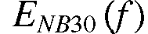, and subsequently to subtract the remaining values from  in table 9:

The results are plotted in figure 9.
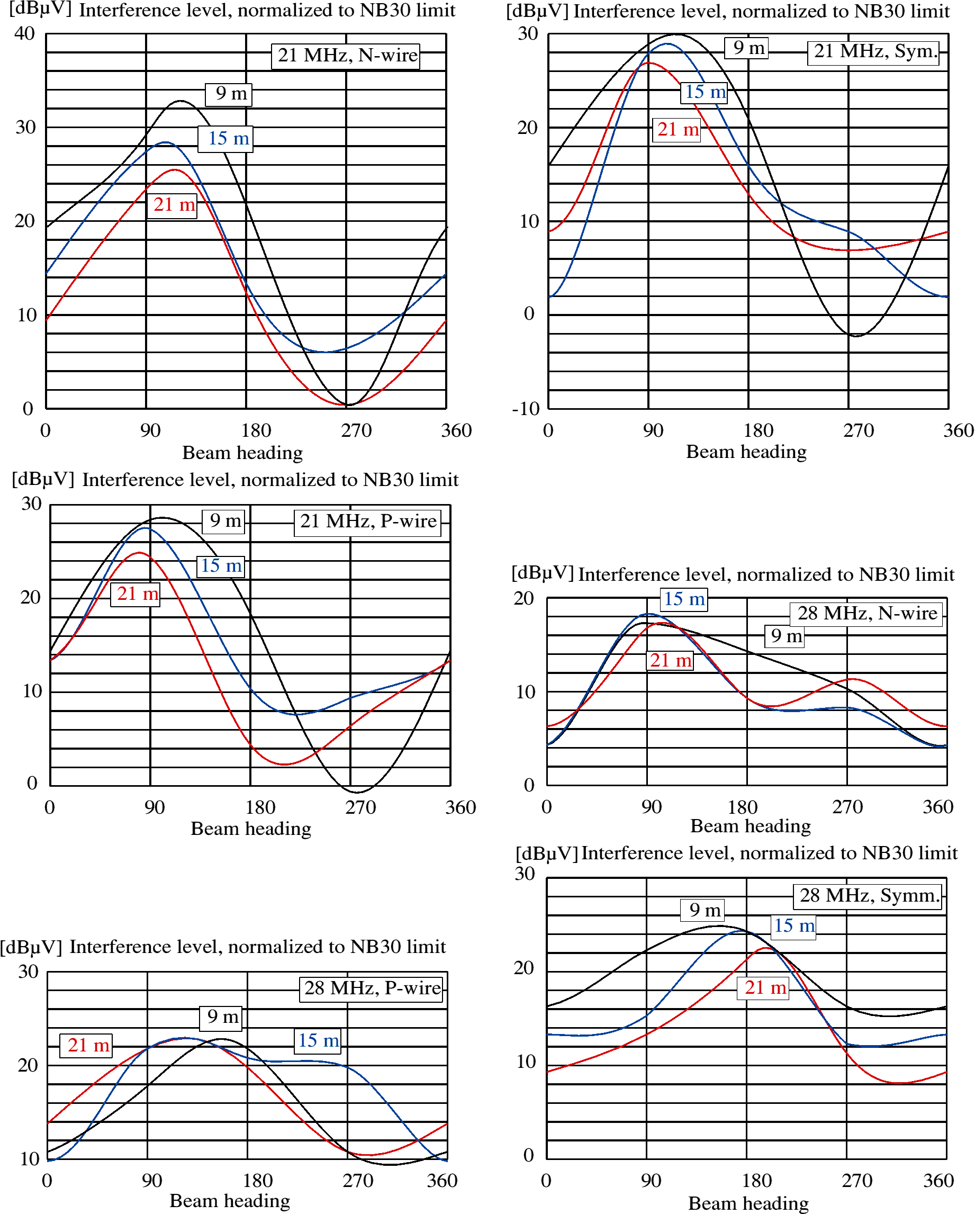
Figure 9: Antenna voltages 
We can see, that from the results of the measurements, the height of the beam has in average only a very limited effect on the amplitude of the interference signal. In the most favourable position only 7 dB for a difference in height between 9 and 21 meters. Considering that the interference signals approach the beam from underneath and not in the main direction, then reflections and accompanying standing wave effects have to be the reason for this irregular and unpredictable behaviour.

The maximum interference is approximately received when the beam is pointing in parallel with the longitudinal axis of the house.

10 INTERFERENCE VOLTAGE ON THE MAINS WIRING
The purpose of this measurement is to establish the actual level of the background noise level on the 230V in-house grid and to study if the CISPR 22 limits already represent the normal background noise level.

The measurement receiver is for this measurement connected through the MCD to the grounded wall outlet, approximately at a 2m distance from the electricity meter. All noted measurements were taken from the neutral. The voltages on the phase are nearly equal to those on the neutral and the symmetrical voltages between neutral and phase are much lower, except for the highest frequency range from 20 – 30 MHz, where grid shows a less symmetrical behaviour. All measured values have been corrected for the transfer function of the MCD.

In order to achieve a representative situation, a number of common and potential internal sources of interference were switched on. The TV set in the living room, the PC in the study and also two electronic energy saving lamps.

10.1 Results
Figure 10 (Average mode) and 11 (Quasi-Peak mode) show the mains interference voltages on the MF and HF bands. The measuring bandwidth is here 9 kHz, although in the case of the broadband interference for the average measurement often an actual bandwidth of 200 Hz has been used with a correction of + 16.5 dB towards a normalized bandwidth of 9 kHz.
In the figures 7 and 8 a differentiation is made between more or less broadband, rattle-like, hum modulated (background) signals, and well outstanding small-band signals. The first ones are shown as a curve, the latter as single points. Not all the detectable signals are shown, only a selection, giving a good representation of frequencies and levels.

In the figures 10 and 11 also the CISPR 22 limits (class B equipment = equipment for use in domestic environment) have been drawn, as well as the equipment measurement sensitivity limits.

10.2 Discussion
Outside the (used) broadcast frequencies on long and medium wave and below 2 MHz it was well possible to measure the broadband noise on the mains wiring. Above the 2 MHz the real broadband noise vanishes rapidly, although hum modulated noise lumps reappear there and here. Remarkable are the harmonics of the line deflection from the TV set, which become audible above 1.6 MHz, and show their maximum in the neighbourhood of the 80 m band. In the higher frequency band, above 20 MHz, a number of carriers show off, probably clock signals, some hum modulated. These carriers were positively identified as generated in-house and not coming from outside.

In the frequency range from 5-15 MHz the measurements were hampered by the strong reception of radio signals. In fact the mains wiring appears to be a real effective receiving antenna!

The TV line deflection harmonics, which are a very common source of interference as experienced by radio amateurs on the 1.8 and 3.6 MHz bands, disappear when the TV outside antenna was disconnected. Probably the mains wiring together with the lightning ground of the TV antenna form a closed loop.

10.3 Conclusion on the interference voltage measurements :
- Although on LF and MF up to 1 MHz the measured interference voltages more or less approach the CISPR 22 limits, above 1.6 MHz they stay far below these limits. For frequencies above 5 MHz the broadband interference is more than 40 dB below the CISPR limits. Only some narrow band interference signals were up to 30 dB below CISPR 22.
- TV line oscillator harmonics approach the CISPR limits up to 20 dB for frequencies 1.6 – 5 MHz. In practice these harmonics are very often experienced as harmful interference.
- Although the outcome of these measurements does not need to be representative for all residences, they do indicate that the CISPR 22 limits cannot be regarded as the general level of existing background interference/noise on the 230 V mains grid. This is not unexpected as the CISPR 22 limits only apply to the mains connector of an apparatus, and not to a (mains) network.
- When such a piece of equipment actually is connected to the mains network, the available interference power is spread out over the two or three dimensional network. Partly this power is also dissipated in the high frequency losses (PVC isolated wires!), and even radiated increasingly with frequency, which is inherent to such a network which is not intended to be used as a conductor for RF energy. This makes clear that from the point of energy balance it is very unlikely to measure a level of interference voltage equal to the CISPR 22 limits at a random point of a mains network.

However, the most important conclusion of this measurement is that the conducted measured noise level at a random chosen point on the mains grid is much lower than what is expected in accordance with the CISPR 22 Standard.

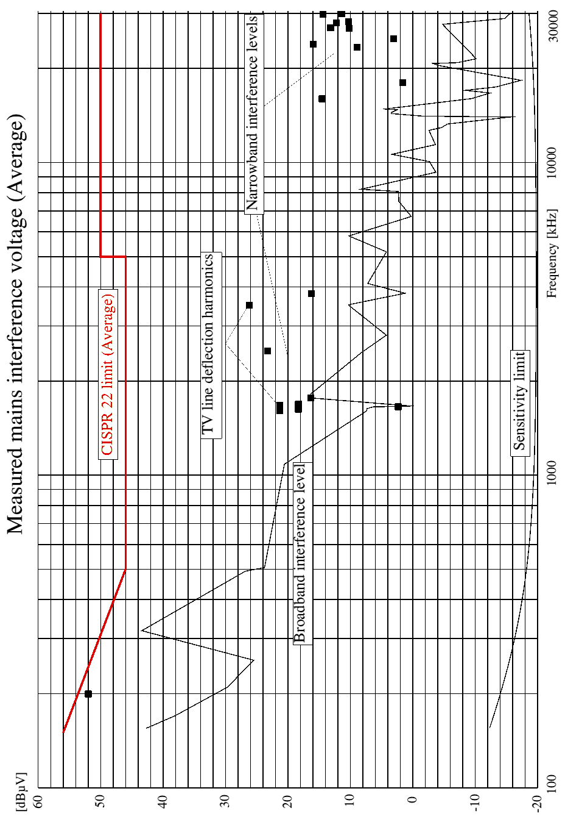
Figure 10: MF and HF, 150 kHz - 30 MHz, Average
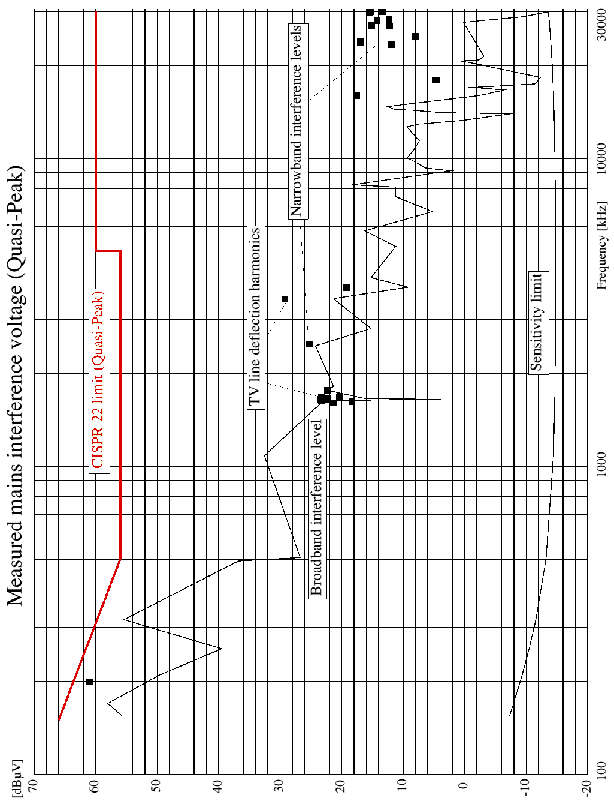
Figure 11: MF and HF, 150 kHz - 30 MHz, Quasi-Peak
11 DISTURBANCE by the emission of an interference voltage on the mains
The question is, after we have found the noise level on the mains via conducted measurement, what are the resulting EM fields in home?
With the aid of the measured K-factor, see tables 5 and 7, and the averages of K₁ en K₂ in figure 5, we can compute the interference field strength on the amateur bands. For that reason an estimation of the broadband noise on the HF bands was made with the quasi-peak measured values from figure 8, and imported in table 10.

The relevant small band noise signals are also incorporated in the second column of this table. Using 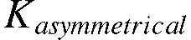 these values were converted into field strength values, and consequently plotted in figure 12, together with the three previous mentioned limits. These field strength values are valid for a measurement distance of 3 meter.
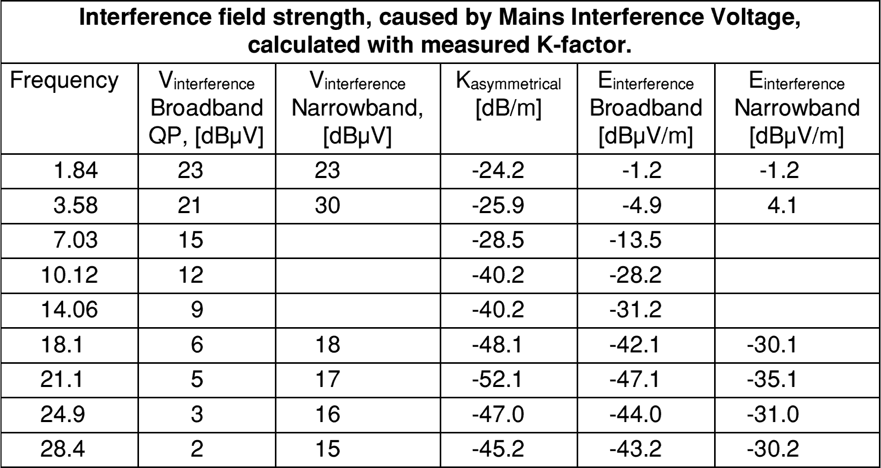
Table 10

From figure 12 we can remark several points:
- All measured interference signals have a field strength value below all limits including the proposal n°4 (BBC) values.
- A number of small band noise signals in the range from 20 -30 MHz were positively observed with the station receiver and HF beam, although weak. This supposes though a much higher field strength that computed. A good explanation for this effect could be that the source for these signals, the PC with peripheral equipment which are fed via an extra mains RFI filter, is located in the shack. For this reason the coupling with the antenna for the PC-noise is stronger than what would be expected from the conducted measured PC-noise signal level at the wall outlet in the kitchen. Also the signal attenuation of the signal between the study/shack and the kitchen wall outlet plays a role here.
- The coax cable to the TV antenna is probably the cause for the contribution of the radiation of the line deflection harmonics from the TV.
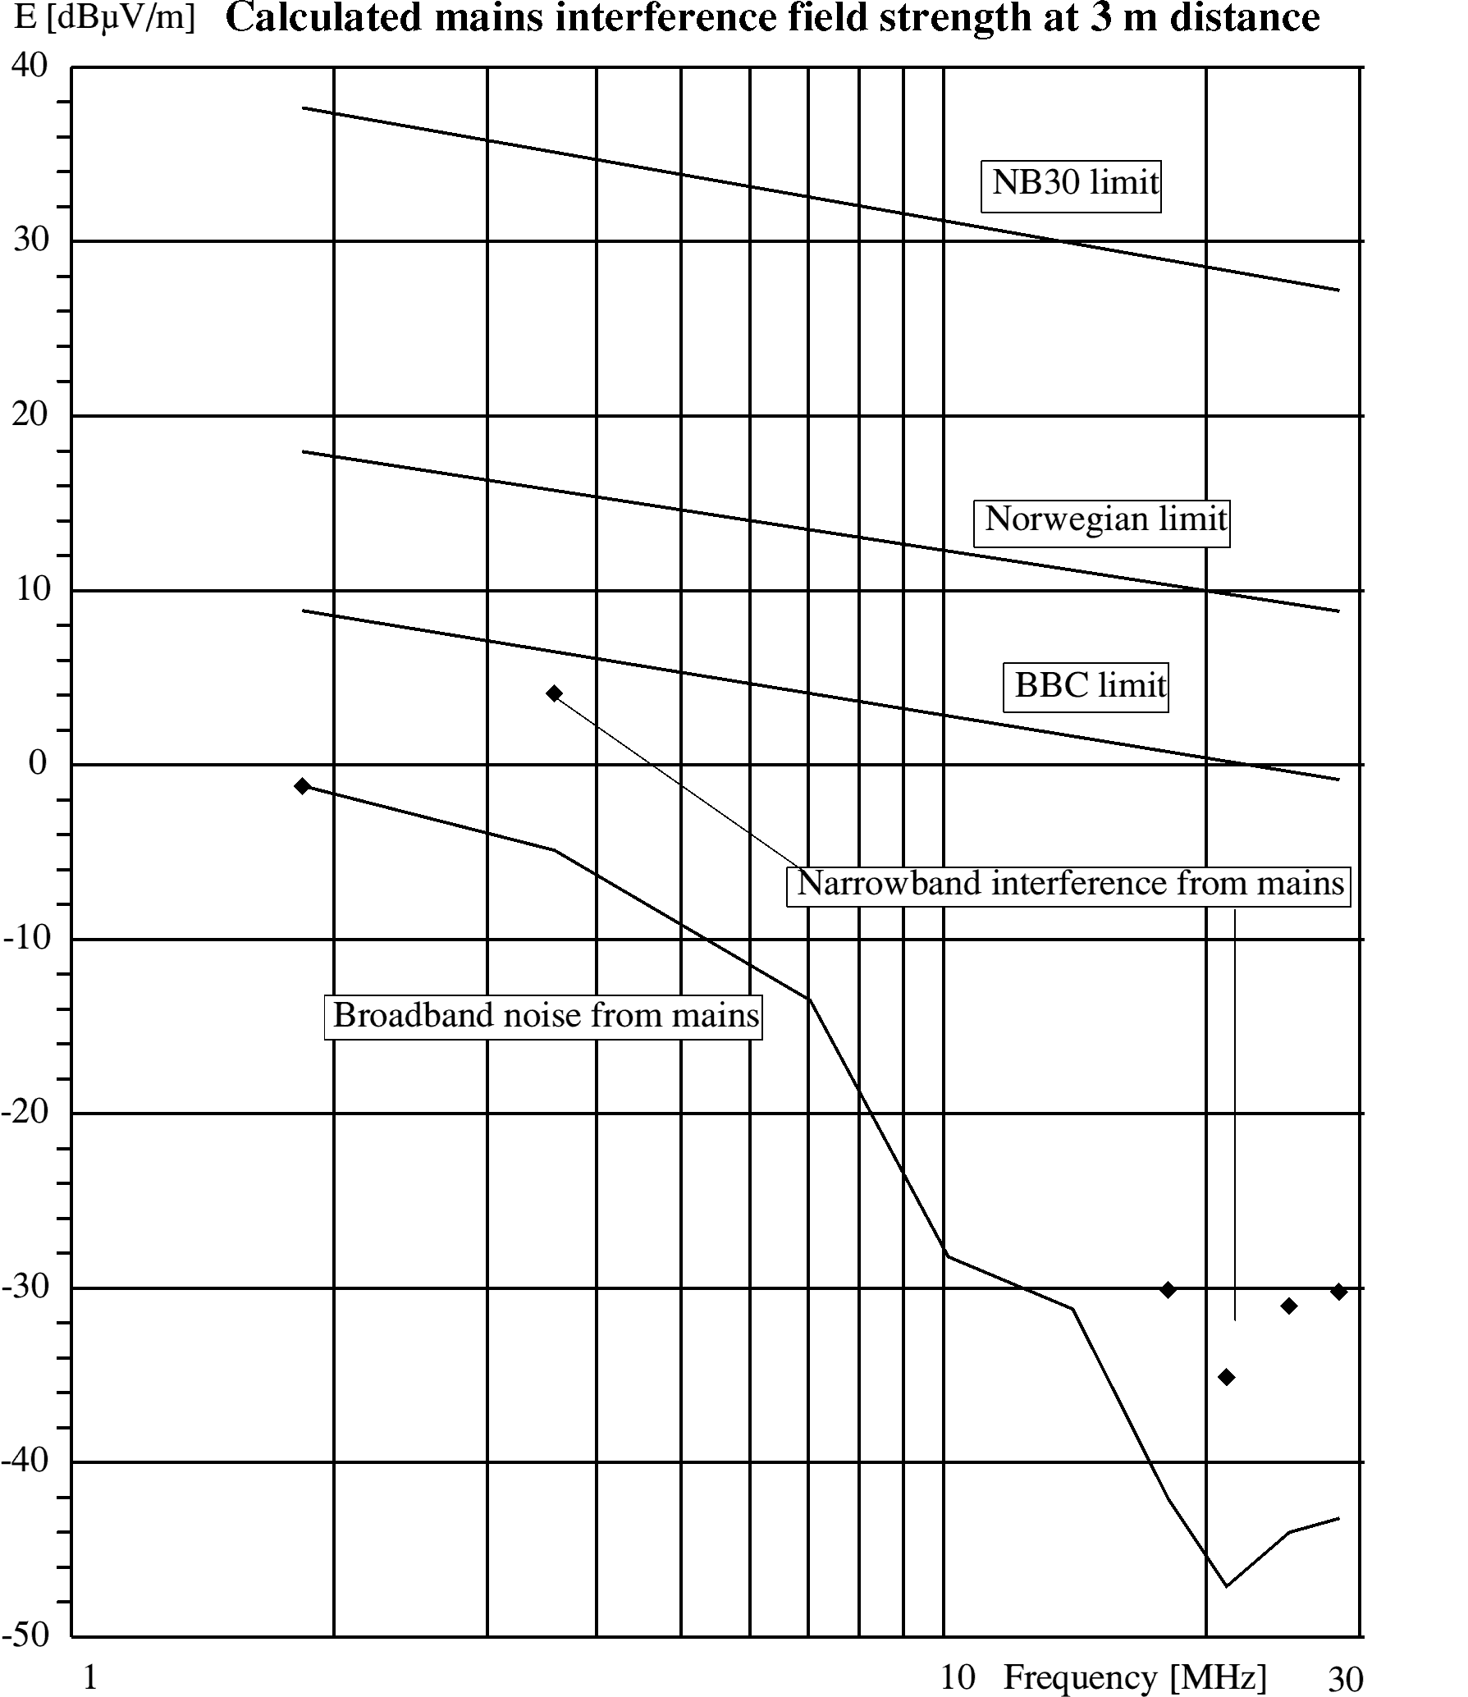
Figure 12
12 RELATIONSHIP between received interference in a amateur receiver and the various limits
The conclusions on this aspect are given in section 9.5 from the main body of this ECC Report.

13 RF voltages induced in the mains because of the fields from an amateur radio transmitter
PLT modems not only may be able to interfere the reception on the amateur bands, but inversely a PLT modem may be interfered by RF voltages that are induced in the mains wiring by an amateur transmitter via its antenna. In fact this is the reciprocal effect of the coupling, discussed in the foregoing paragraph.

The measurement was performed by transmitting an unmodulated carrier with transmitting power of 10 W via the for that frequency relevant antenna. At the wall outlet, earlier used as injection point, the RF-voltage of the carrier was measured using the MCD and the measuring receiver. The results are given in table 13. Also the received signal levels are converted in dBm according:
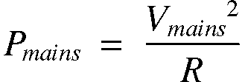

The difference with the transmitting level (40 dBm), indicates the coupling between transmitting antenna and the mains at the position of the injection point:
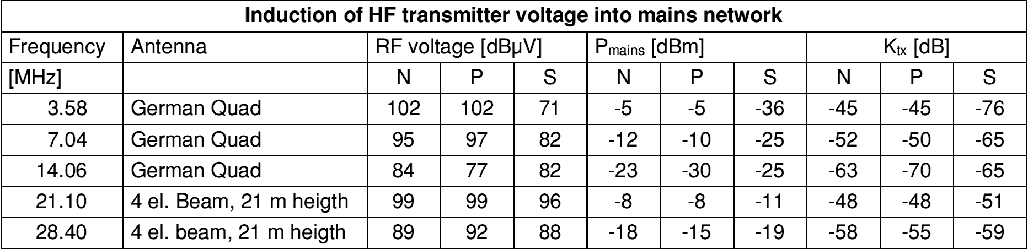
Table 13: RF voltage induced in the 230 V network by the amateur radio transmitter
14 GENERAL CONCLUSIONS
By injecting a test signal into the 230 V grid of the house a series of preliminary measurements were carried out for the EM radiation as result of the injected RF interference signal on the 230 V mains. For this specific situation the following conclusions can be drawn:
- If the RF voltage on the injection point has a level which is equal to the CISPR 22 Quasi Peak limit, then the resulting field strength has in average a level 2 – 10 dB below the NB 30 limit.
- The level of the actual present mains interference voltage on the grid for frequencies above 1.6 MHz is several tens of dBs below the CISPR 22 Class B limits. One can distinguish here between the relative sporadic appearing small band signals, the “clock signals” and the signals of a broadband type. These wide spectrum signals have a roll-off of 20 dB/decade and reach at 30 MHz a value of 55 to 60 dB below the CISPR 22 Class B limits.
More general conclusions are:
- In residential situations one cannot say that the NB30 limit forms a more stringent limitation on interference carried by the mains grid than the CISPR 22-B limit. The opposite seems to be true.
- For an antenna location as is common for most amateurs, close to or above the house, the reception of interference radiating from the mains is very serious for field strength levels equal to the NB 30 limit or equivalent field strength level of the CISPR 22 limit.
- Even the BBC limit is inadequate to avoid interference in the above-mentioned situation, in particular on the higher amateur bands.
- For the residential situations and for frequencies above 1.6 MHz the CISPR 22 limits do not form a useful indication for the existing background noise levels on the mains wiring.
15 REFERENCES
[1] PLC Studie RegTp, door EMV- Beratungs-und Planungsbüro, Prof. Dr.-Ing. K.H. Gonschorek, Dr.-Ing. R. Vick. www.emc.experts.de.
[2] Powerline Communications, door Klaus Dostert. Prentice Hall, ISBN 0-13-029342-3.
[3] CEPT/ERC Report 69.
APPENDIX 1

Mains Connector Device (MCD)
Purpose
A dedicated device was made for injecting RF power into a mains network and measure RF voltages on that network. This document describes this device and gives calibration information.

Objective
The objective of the device is to inject RF power into a mains network in a asymmetrical way, using the Neutral - Earth port or the Phase - Earth port, or in a symmetrical way using Neutral - Phase connection. In the latter case a choice can be made between a forced symmetry by connecting the Earth as a reference, or a floating symmetry. In practice it appeared that the effect of this is small. The registered symmetrical measurements are all performed with S3 open.

The original intended frequency range was 1.6 to 30 MHz, but using the transfer function, described below, measurements can be performed from 10 kHz to 50 MHz.

Description
Figure A1-1 gives the principal circuit and Figure A1-2 the circuit diagram itself.

For injecting in the Phase line (P) switches S1 and S3 are closed, for Neutral line (N) S2 and S3, and for symmetrical injection S1 and S2, while S3 left open. By closing S3 in the last case the symmetry of the voltages on the Neutral and Phase wire can be forced. However in practice it appeared that the effect is little. For the symmetrical measurements only those measuring values for S3 is open are registered.

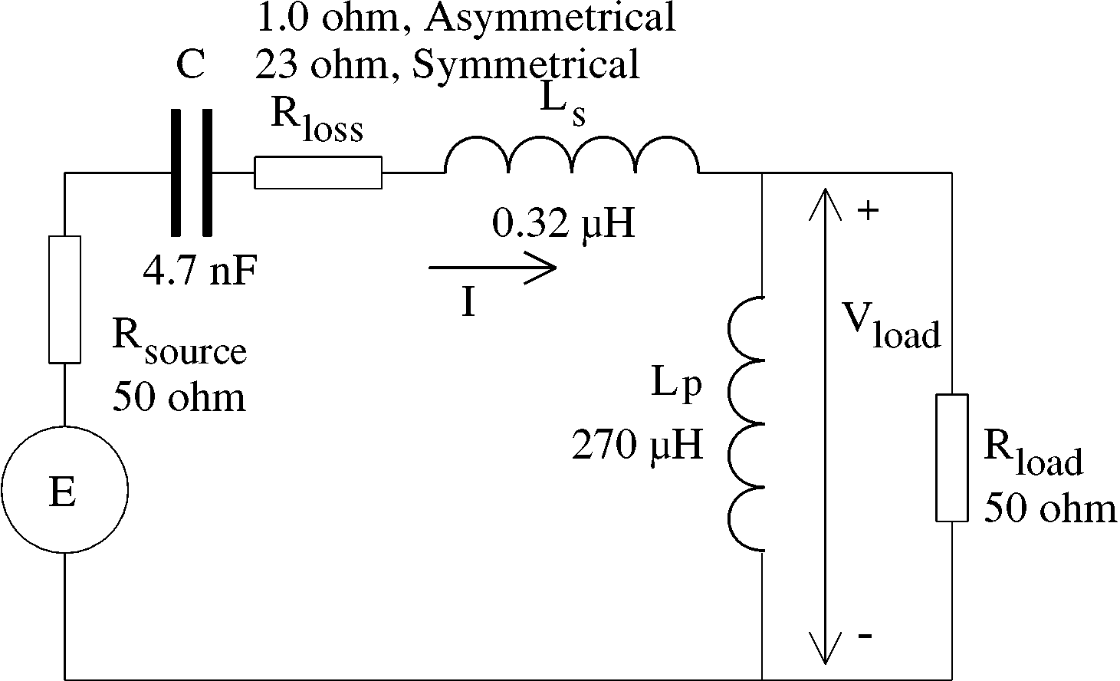
Figure A1-1: Principal schematic

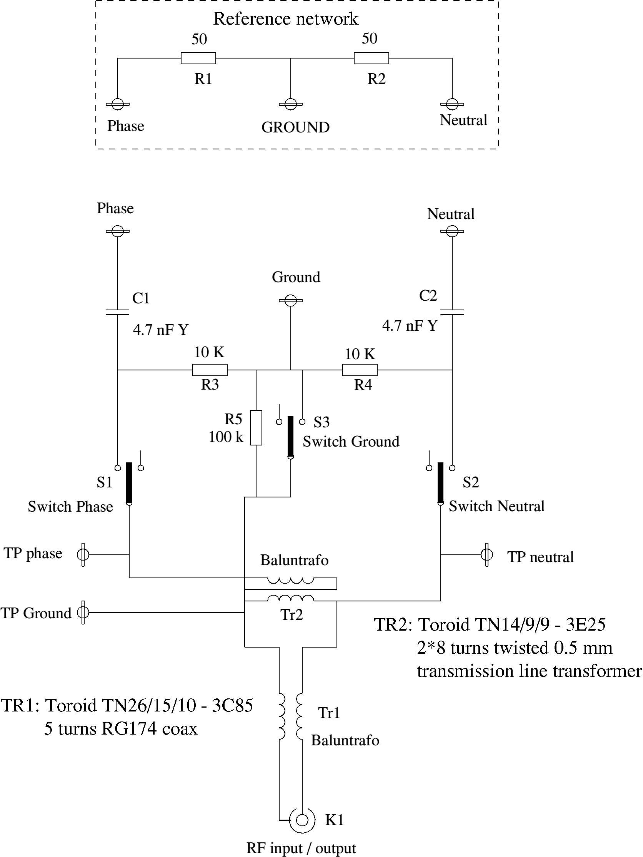
Figure A1-2: Circuit of the Mains Connector Device (MCD)

The transfer ratio is defined as:

with 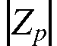 the absolute value of the impedance of the parallel connection of 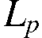, the parallel self inductance of balun transformer Tr2, and the (resistive) load on the output (= input impedance of the measuring receiver, 50 ohm).

 is the absolute value of the total loop impedance, in which the current runs.
The values of  and 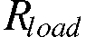 are set by design, the values of  and 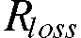 are determined from a transmission measurement using a spectrum analyser with a tracking generator as network analyser.

The calculation of the loop impedance :
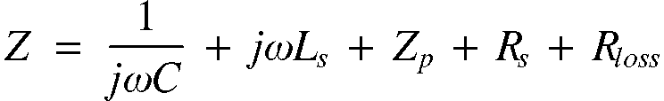
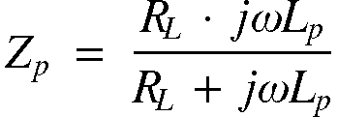
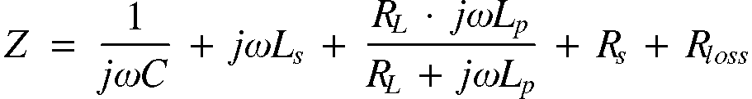

To determine the absolute value of we divide in a real part  and in a complex part :
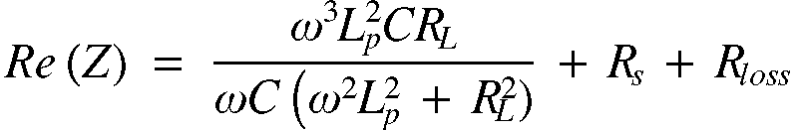
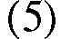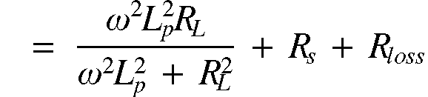
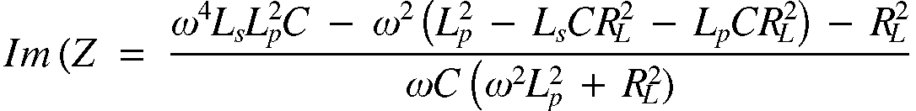
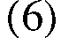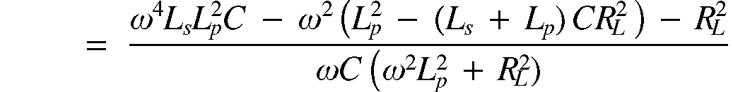
Combining we get:
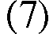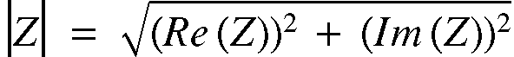

In the same way we derive for 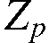:
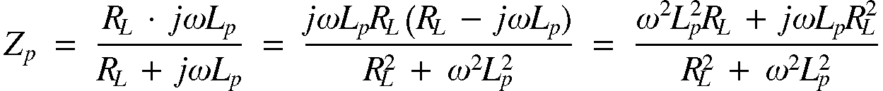
and
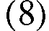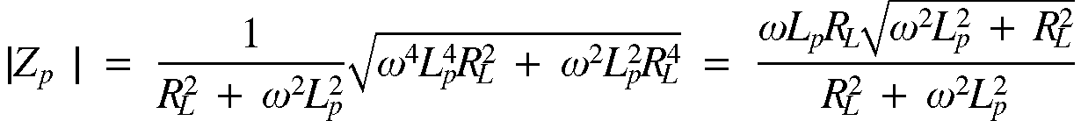

The formulas (1), (5), (6), (7), and (8) are being inputted in a math program together with a list of frequencies and the component values. The result is displayed in figure A1-3 for asymmetrical coupling, and in figure A1-4 for symmetrical coupling.

The outcome has been compared with the measured transfer function, and in this way the values of 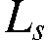, , en has been iterated to the indicated values. The resulting calculated curve is deviating less than 0,5 dB from the measured curve.

Now the transfer function is available in the form of a formula, the by the measuring receiver measured interference voltages at the connector of the MCD can be calculated back into mains disturbance voltages at the wall outlet where the MCD was inserted by software means.

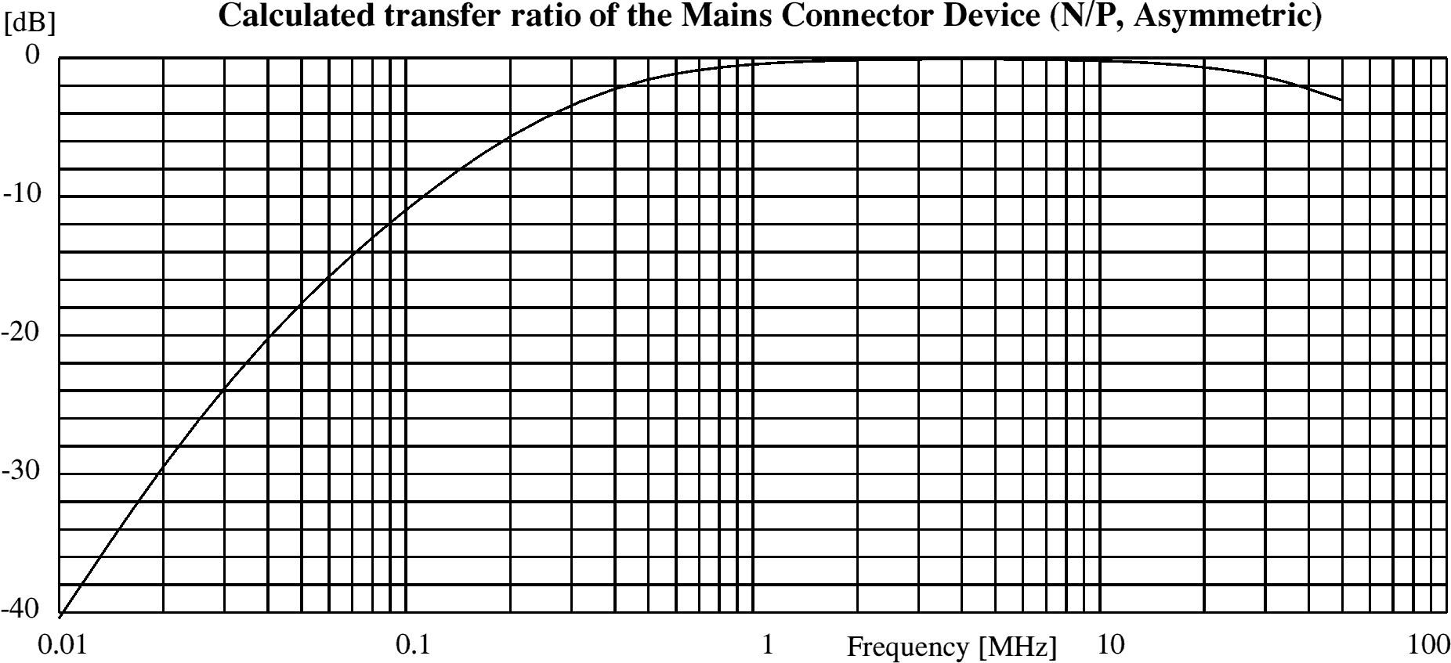
Figure A1-3: Transfer function for the case of asymmetric coupling

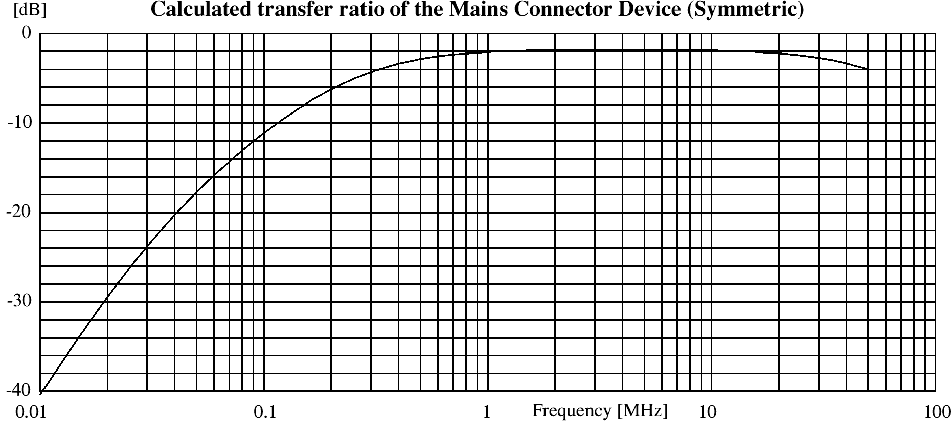
Figure A1-4: Transfer function for the case of symmetric coupling

Source impedance
For the benefit of measurement of the impedance that the 230 V grid forms at the place where a signal is to be injected, and also for an assessment of the injected power, we need the magnitude of the source impedance of the combination of generator and MCD. Therefore we reverse the principal schematic of figure A1-1, see figure A1-5. The component values are based on the measurements of the transfer function in figure A1-1. For the symmetrical injection the effect of the balun transformer is taken care of by quadruple the impedance of the generator. Also the other component values are modified for the symmetrical injection, and mentioned between square brackets.
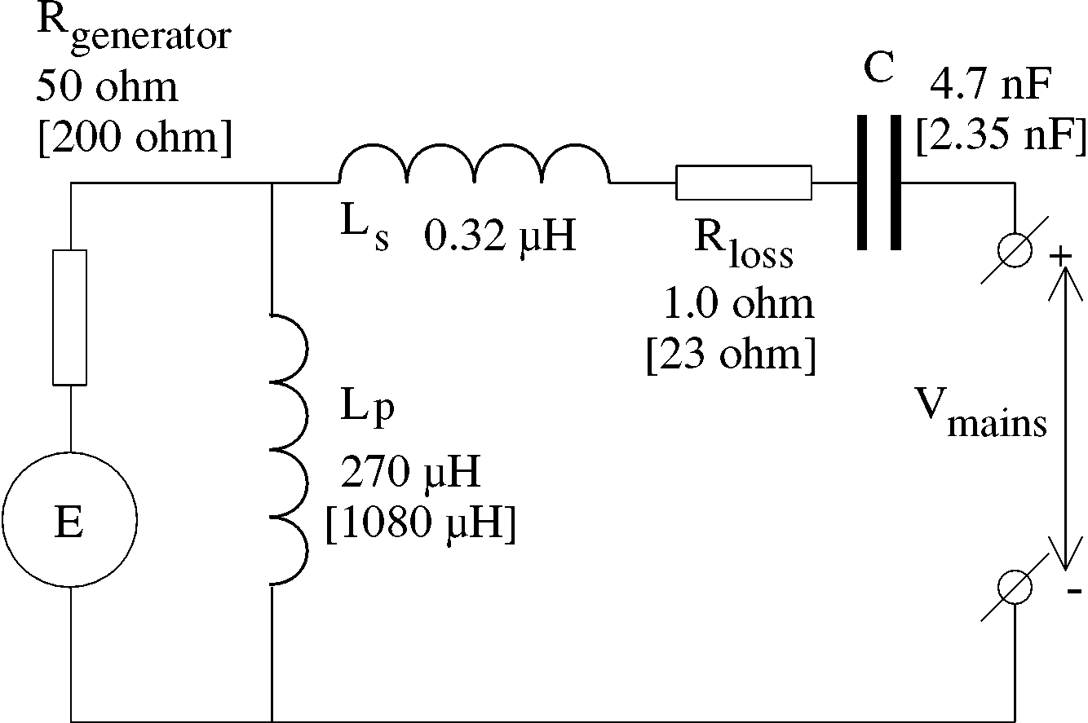
Figure A1-5. Principal schematic mains impedance measurement

The source impedance follows from the modified formulas (2) en (3):
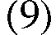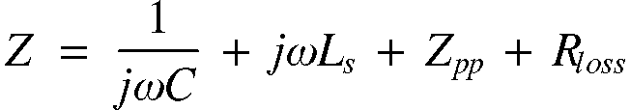
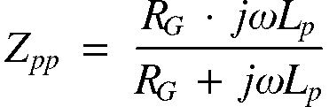
According the same derivation we arrive at the magnitude of the source impedance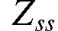:
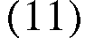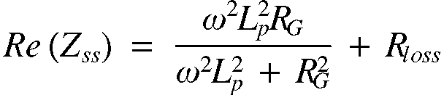
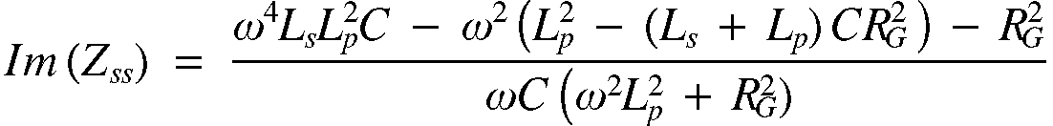
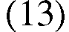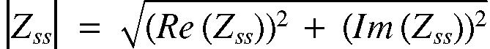

Figure A1-6 gives the result of the calculation for the asymmetric injection, as well as in the neutral, as in the phase wire, and figure A1-7 shows the results for the symmetric injection.
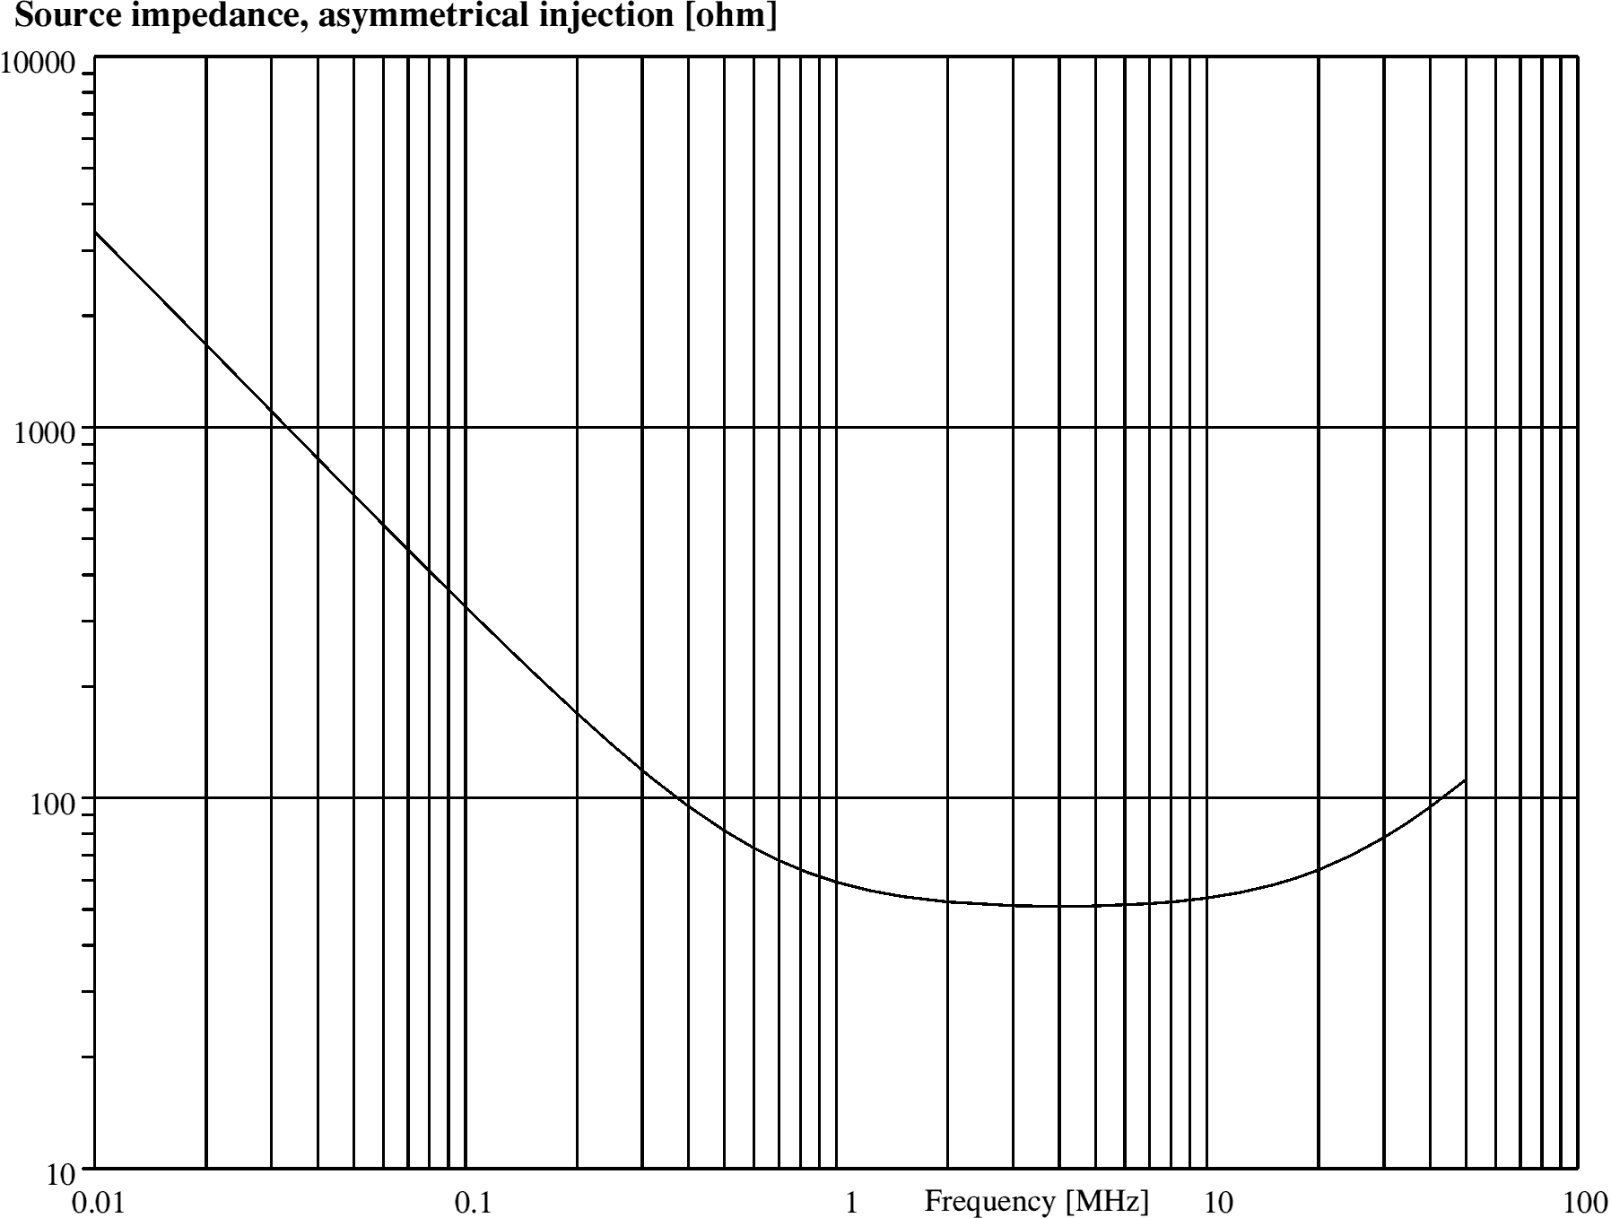
Figure A1-6: Source impedance in the case of asymmetric injection
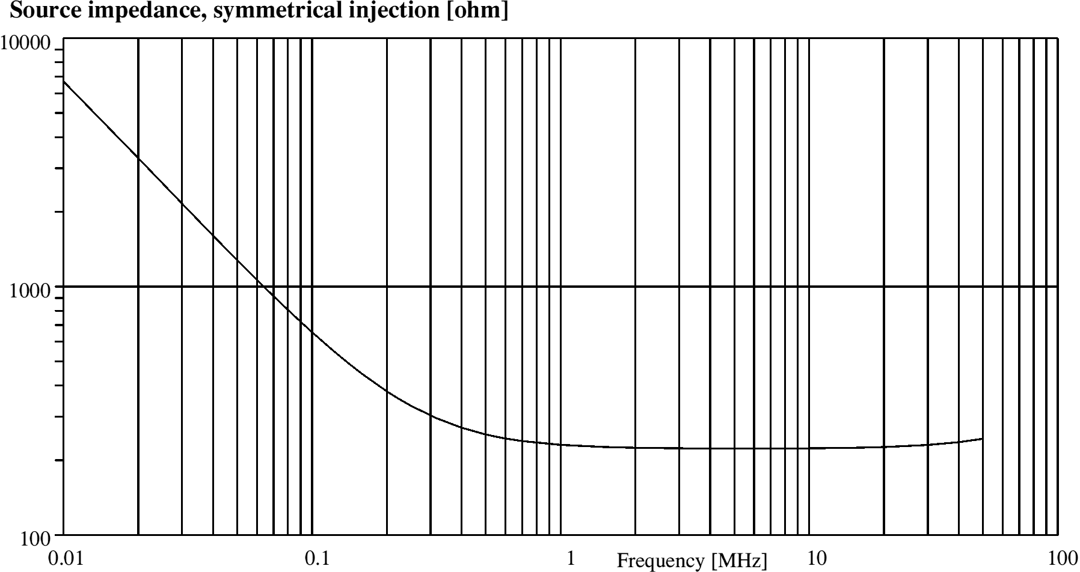
Figure A1-7: Source impedance in the case of symmetric injection

APPENDIX 2

Calculation of the antenna factor of a receiving antenna
Introduction
When the field strength, , or the power density, 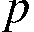, of a radio signal is known we are able to calculate the voltage, that is induced in a conductor with a length small in relation to the wavelength directly from the field strength pro meter.
For a receiving antenna with dimensions that are not small compared with the wavelength, like a half wave dipole, we have to integrate the field strength over the length of the antenna.
We can avoid this calculation if we know the effective surface, aperture, of the antenna. For an electrical dipole is that (every dimension, but loss free!):
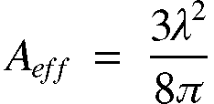
For a receiving antenna in general:
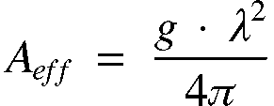
with 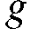 as the antenna gain.
The power density is:
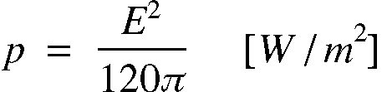
Then the received power is:
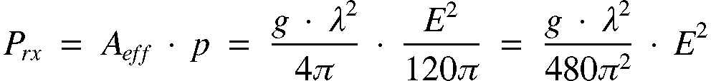
But at the receiver input with input resistance, 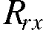, is valid:
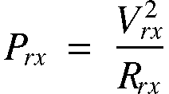
with 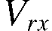 the voltage over the receiver input terminal, thus:
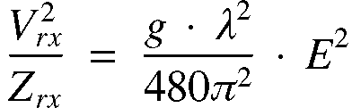
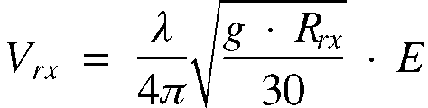
This means for the antenna factor, 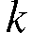:
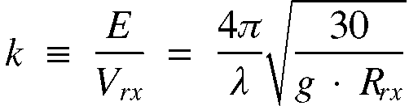
The antenna gain, , is mostly given as, , in dB's, so:

or
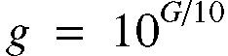
For a half wave dipole with a gain of 1.64 (2.14 dB) relative to an isotropic radiator and a receiver input impedance of 50 ohm (real) we get:
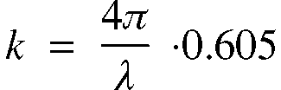
Or in dB:
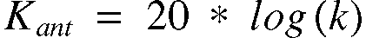
For half wave dipoles on several amateur bands that results in:
Antenna factor
Band | 1,8 | 3.6 | 7.0 | 10.1 | 14 | 18 | 21 | 24 | 28 [MHz]
k | 0.046 | 0.091 | 0.177 | 0.256 | 0.360 | 0.459 | 0.537 | 0.631 | 0.732 [1/m]
K_{ant} | -26.8 | -20.8 | -15.0 | -11.8 | -8.9 | -6.8 | -5.4 | -4.0 | -2.7 [dB/m]

Annex 9: Compatibility between cable TV and aeronautical radio systems
1 INTRODUCTION
Frequencies used for aeronautical navigation and emergency systems are protected by worldwide frequency allocation agreements. The need for more bandwidth in Cable TV systems led to the use of frequencies in the aeronautical bands for such systems. The signals are propagated in coaxial cables; therefore there will always be a limited screening effect, causing some radiation.

Local area networks are increasing the data rates with higher clock frequencies and the side bands extend into the aeronautical frequencies. Local area networks are usually made with twisted pair cables where the balance to earth is limited or undefined at frequencies above the nominal operation frequency.

Interference problems have been encountered in several places throughout Europe that could not be related to high single leakage levels and could therefore only be explained by the existence of a cumulative effect between many low level emissions.

For Cable TV systems an EMC standard exists, EN 50 083-8. It states a maximum emission level of 20 dBpW (quasi-peak value in a 120 kHz bandwidth). The German regulation NB30 has the same limit. This annex discusses the aeronautical systems in the VHF band, their field strengths as a function of geographic location and the maximum allowed interfering field strength. The interfering field strength is related to interfering sources, which are assumed to be distributed randomly and having random frequency/phase.
2 PROTECTION requirements of Aeronautical Radio Systems
There are a number of navigation/communication systems, which are safety related. However, aeronautical systems for which there are no available protection criteria have not been considered.
a. Relevant Characteristics of the Aeronautical Radio Services
For compatibility assessments it is essential to have available at least the following characteristics of the victim radio services:
- The type of service;
- Used frequency range;
- The minimum wanted field strength;
- The horizontal and vertical extension of the Designated Operational Coverage (DOC).
Section 3.5 of the main body of this ECC Report provides full information on the characteristics and protection requirements of all aeronautical radio services, which could potentially be interfered by cable radiation in the frequency range 9 kHz to 3000 MHz
The following table 1 provides an extract from Section 3.5 containing only the radio systems of interest in the case of cable TV for which measurement data were available and for which it was therefore possible to make calculations in the present Annex 9.
Frequency Band  (MHz) | Application Abbreviation | Receiving Bandwidth (kHz) | Minimum wanted field strength at the airborne platform (dBµV/m)
108 – 111.975 | ILS/LOC | 50 | 32
108 – 117.975 | VOR | 50 | 39
118 – 136.975  138-143.975 | VHF COM  VHF COM Off Route (OR) | 8.3  or  25 | DSB-AM: 14
230-399.9  (except  328.6-335.4; 380-385  and 390-395) | UHF Air-Ground-Air COM | 25 | 32
328.6 – 335.4 | ILS/GP | 150 | 52

Table 1: Characteristics of the aeronautical radio applications for which calculations have been made

Notes to Table 1:
- The mentioned aeronautical radio services are safety of life services, that need special protection against harmful interference.

- Only the airborne receivers of the respective radio services are considered to be a potential victim of cable TV network interference. It is assumed that the ground facilities (the RX) are normally located in remote areas, where cable TV network interference is less probable. But if such interference occurs, it is a local problem, where the source of interference may be more easily identified.

- The stipulated minimum field strengths of the respective radio application are taken as the wanted field strengths to be protected. It is recognized that the wanted field strengths exceeds the minimum wanted field strengths remarkably in areas close to the ground transmitter, but the calculation of the wanted field strengths cannot take into account the influence of all properties of the surface, e.g. buildings, hills, woods etc. Therefore, as experience shows, gaps of low field strengths may occur even in shorter distances to the transmitter. Hence the worst-case scenario has to be used. The excess of the wanted field strengths over the minimum wanted field strengths might be taken into account when assessing safety margins.

- ICAO Annex 10, which contains Standards and Recommended Practices (SARPs), stipulates minimum desired field strengths e.g. for VOR and ILS as a Standard, and recommends a desired signal level of 37 dBµV/m for a high percentage of time for VHF COM. The Guidance Material of Annex 10, which provides instruction on how to realize the recommendations and how to avoid interference generated by other VHF COM services, applies the squelch lift field strength of 14 dBµV/m. It must be stressed that Annex 10 deals only with interferences caused by other VHF COM services (intra-system interference), and that Annex 10 provides guidance material how to avoid squelch lift interference and interference caused by exceeding a certain protection ratio. The operating field strength is recommended to be 37 dBµV/m in a high percentage of time and location, but it may be less in a lower percentage of time and location, e.g. down to 14 dBµV/m, due to unpredictable propagation, shadowing and antenna lobe effects.
So with the recommendation to provide 37 dBµV/m for a high percentage of time and location, the requirement of a safety of life radio communication service to offer communication to (nearly) all times and location within the service volume may be fulfilled, if the receiving capability of the receivers for field strength down to 14 dBµV/m is taken into account.

The Frequency Management Group (FMG), a subgroup of the ICAO European Air Navigation Planning Group (EANPG), considering the above discussed technical and operational items, decided at its 5th Meeting in September 2001 that the desired signal level, to be protected from interference, be the squelch lift level. Since there is no otherwise a standard value for the squelch lift level stipulated, the Annex 10 figure of 14 dBµV/m should be applied.

Taking into account that the squelch lift level of 14 dBµV/m seems to represent a worst case situation, and that the applied protection ratio of 27 dB also are worst case values, and that the use of these values leads to undesired signal levels not far from the receiver noise floor, it is proposed not to apply the safety margins of (6+3) dB.

- The minimum wanted field strength of the UHF Air-Ground-Air COM is defined as follows:
Antenna Isotropic
Frequency used for calculation (MHz) 300 (wavelength = 1m)
Rx Bandwidth (kHz) 25
Rx Noise Figure (dB) 10
Losses (multipath, antenna cable…) (dB) 5
Total Noise at Rx (dBm) kTo(dB) + 10*log(BW (Hz)) + Rx NF (dB) + Losses (dB)
= -115
Total Noise at Rx (dBW) -145
Protection Ratio (dB) 20
Minimum Wanted Signal MWS (dBW) -125
Minimum Wanted Signal MWS (Watts) (E(V/m)^2)/(120*Pi())] * [(λ (m) ^2)/(4*Pi())
E(V/m) SQRT(MWS(W)* (120*Pi()) * ((4*Pi())/λ (m)²))
E(V/m) 4*Pi()*SQRT(Wanted Signal (Watts) * 30/λ(m) ^2)
Minimum Field Strength Wanted Signal (V/m) 3.9E-05 (V/m)
Minimum Field Strength Wanted Signal (μV/m) 39 (μV/m)

b. Desired/undersired Values of Signal Ratio measured in Germany
The main results are presented in the following table, which contains the measured D/U values, where the wanted signal power is RMS over the whole bandwidth, and where the unwanted signal power is RMS over the whole Bandwidth.

Victim airborne  Receivers | D/U values in dB for the following interfering signals
Victim airborne  Receivers | 16QAM, 64QAM  256 QAM  Signal Bandwidth =  7 MHz | QPSK  Signal Bandwidth =  27 MHz | COFDM/DAB  Signal Bandwidth =  1.54 MHz | Analogue PAL-TV  Signal Bandwidth =  7 MHz
ILS/LOC | -7 | -12 | 0 | 20
VOR | -4 | -9 | +3 | 10
VHF COM 8,33 | -11 (-6) | -16 (-11) | -5 (0) | 22 (27)
VHF COM 25 | -10 (-7) | -15 (-12) | -3 (0) | 24 (27)
UHF COM 25 | -11 (-9) | -17 (-15) | -5 (-3) | 20 (22)
ILS/GP | -8 | -14 | -1 | 10
Table 2: Measured D/U values, wanted signal power and unwanted signal power is RMS
over the whole bandwidth
Notes to Table 2:
- The D/U values in brackets are valid for wanted signal levels near the sensitivity threshold of the receiver (near the squelch lift level). The D/U values are constant for wanted signal levels of COM-receivers down to (–90 ...-95) dBm. Then the D/U values get worse to the figures in brackets around the sensitivity level of the COM-receiver near –104 dBm. The respective values are 5 dB for VHF receivers with 8.33 kHz channel spacing, 3 dB for VHF receivers with 25 kHz channel spacing, and 2 dB for UHF receivers with 25 kHz channel For ILS- and VOR-receivers the D/U values are constant for wanted input levels well lower than the minimum wanted signal levels.

- In the case of analogue PAL over 90% of the power is concentrated within the video carrier (bandwidth < 120 kHz) and therefore nearly the whole power of this signal is represented. The D/U values assume the case where the video carrier falls within the receiver’s band. Frequency offsets can improve this situation.
c. Correction Factors for other Detector types
Table 3 contains correction factors, which allow calculating the RMS power over the whole bandwidth of a digital signal, when the power measurement of the digital signal is made with certain other measurement detectors X, like Quasipeak/120 kHz or Peak/1MHz. The RMS power P_{RMS} of the digital signal is calculated by P_{RMS} = P_{X} + C, where P_{X} is the power measured by detector X, and C is the correction factor in dB.

For instance, a power of 20 dBpW of a 16QAM signal measured with the detector Quasipeak/120 kHz represents a RMS power of that 16QAM signal over the whole bandwidth of 33 dBpW.

 | 16-, 64-, 256-QAM  Signal Bandwidth =  7 MHz |  |  | QPSK  Signal Bandwidth =  27 MHz |  |  | COFDM  Signal Bandwidth =  1.536 MHz |  |  | PAL  Signal Bandwidth  7 MHz
 | 9 kHz | 120 kHz | 1 MHz | 9 kHz | 120 kHz | 1 MHz | 9 kHz | 120 kHz | 1 MHz | 9 kHz | 120 kHz | 1 MHz
PK | 19.3 | 8.1 | 0.2 | 25.3 | 13.6 | 4.4 | 15.7 | 2.1 | -9.3 | -3.1 | -3.8 | -3.5
QP |  | 12.9 |  |  | 18.8 |  |  | 5.8 |  |  | -3.1
AV | 33.6 | 20.5 | 11.4 | 37.5 | 26.3 | 17.5 | 24.8 | 13.5 | 5.3 | 1.5 | 1.4 | 1.4
RMS | 30.5 | 19.4 | 10.2 | 36.4 | 25.3 | 16.3 | 23.6 | 12.4 | 3.2 | 1.4 | 0.9 | 0.8
Table 3: Correction factors for transforming a measured power into RMS power over the whole bandwidth
Notes to Table 3:
- the accuracy of measurement of the signal levels in dB is assumed to be ± 1 dB
- the correction factors, given with decimals of db, should be rounded to full dB for further application. They are presented here with decimals in order to facilitate their comparison with tables in other papers related to this issue.

- for further application of the correction factors it is assumed that they are valid universally, although they are determined by one type of receiving equipment.
- as far as PAL-TV – signal is involved, the video carrier was always included in the measurements (this is also true for Table 1).
- the measured correction factors for the RMS detector comply satisfactorily with the formula Correction Factor = 10 log (BW_{overall}/BW_{measured})
d. Calculated protection ratios
The information needed to assess a safety margin can hardly be quantified, and this results in a subjective influence on the determination of the safety margin. According to the excerpts of the ICAO Frequency Management Handbook quoted below, two types of safety margins should be applied: first, a margin in order to take into account the effect of multiple interference sources (at least 3 dB recommended), and second, an aeronautical safety margin of at least 6 dB only for the reason that the victim aeronautical radio application is a safety of life service. Consequently, a safety margin of 9 dB is considered appropriate and is taken into account in Table 4 for approach and landing aeronautical applications.

Excerpts from the ICAO Frequency Management Handbook:

Multiple interference inputs
9.2.21 Assessment of interference effects and of acceptable levels tend to be conducted in isolation one from another. In any given practical situation, the net effect of many potentially interfering sources must be considered and due allowance made. An extra margin of between 3 dB is recommended in general, with higher values in particular cases where a number of interference sources are known to exist (for example, see ITU-R Recommendation M.1343).

Aviation safety factor
9.2.22 Some aeronautical applications (for example, precision approach and landing) are regarded as having high criticality in safety terms thereby meriting an additional safety factor. In this application, the analysis would consider the probabilities applying in the total operational situation, which would then be narrowed down to the element involving unacceptable interference. From there, an additional protection factor of not less than 6 dB would be applied to increase the operational assurances to the required level.

Table 4 below contains the protection ratios used in the calculations contained in Sections 5. The maximum aggregate interference field strength is expressed as a quasi-peak value in a 120 kHz bandwidth. Equivalent values for other detectors or other reference bandwidth can be derived using the conversion factors given in table 3.

Aviation  applications  Used band  (MHz) | Minimum field strength to be protected (dBµV/m) | Quasi peak D/U Ratio (dB)  Measured with 120 kHz bandwidth  (correction factors shall be applied for other detector type and BW) |  |  |  | Maximum aggregate interference field strength (dBµV/m)  Quasi-peak values in a 120 kHz bandwidth  Multiple entry factor (3dB) and safety margin (6dB) are included, except for VHF/UHF COM)
Aviation  applications  Used band  (MHz) | Minimum field strength to be protected (dBµV/m) | PAL | 16, 64, 256 QAM | QPSK | COFDM | PAL | 16-, 64-, 256-QAM | QPSK | COFDM
ILS LOC  108.1-111.95 MHz | 32 | 17 | 6 | 7 | 6 | 15 (6) | 26 (17) | 25 (16) | 26 (17)
VOR  108-117.975 MHz | 39 | 7 | 9 | 10 | 9 | 32 (23) | 30 (21) | 29 (20) | 30 (21)
VHF COM  8.3 kHz  117.975-137 MHz | 14 | 24 | 7 | 8 | 6 | -10 | 7 | 6 | 8
VHF COM  25 kHz  117.975-137 MHz | 14 | 24 | 6 | 7 | 6 | -10 | 8 | 7 | 8
UHF COM  25 kHz  230 - 380 MHz | 32 | 19 | 4 | 4 | 3 | 13 | 28 | 28 | 29
ILS GP  328.6-335.4 MHz | 52 | 7 | 5 | 5 | 5 | 45 (36) | 47 (38) | 47 (38) | 47 (38)
Table 4: Maximum aggregate interference field strength to VHF-COM, VOR and ILS

Notes to Table 4:
- QP D/U Ratio (dB) values in Table 4 are taken from the values of Table 2 and the correction values for QP in Table 3.
- The wanted signal was measured with the RMS detector (120 kHz) and the unwanted signal with the QP detector (120 kHz).
- The values for COM taking into account that D/U ratios for low wanted field strength levels are not linear, hence the additional correction factors need to be taken into account: 5 dB for VHF receivers with 8.33 kHz channel spacing, 3 dB for VHF receivers with 25 kHz channel spacing, and 2 dB for UHF receivers with 25 kHz channel.(Table 2 values in brackets)
- In the Column “maximum aggregate interference field strength”, the values in brackets are calculated by including a safety margin of 9 dB.
Calculations presented in Section 5 are based on the PAL Table 4 protection requirements for analogue TV calculations.

For digital TV calculations, a 64 QAM is considered the most used type of signal. Consequently, digital networks calculations in Section 5 are based on the Table 4 "16-, 64-, 256-QAM" column.

3 MODELS for the calculation of the cumulative effect of a complete network
Two models have been considered for the treatment of cumulated effects, which are further referred to in this report as model 1 and model 2:
- Model 1 is based on computer simulations and has been proposed by the Danish administration;
- Model 2 uses an analytical approach and has been proposed by the German Air Traffic Control Authority DFS (Deutsche Flugsicherung GmbH).
a. Prerequisites and Procedures for Compatibility Assessments
Under normal conditions, the distribution of signals via the cable TV network should only be allowed, if an appropriate compatibility assessment has been performed successfully. All information needed for such an assessment should be evaluated and validated without time constrain, models could be refined to the highest possible extent.

In reality however, cable TV signals have been fed into the network without performing any compatibility assessment, or strong electronic industrial or multimedia groups are pushing the implementation of new cable TV modulation schemes in short time scales, without taking care in a sufficient manner of possibly interfering with radio applications. Therefore, aviation may be forced to accomplish the compatibility assessment on short notice, and has to gather the needed information having just the present level of accuracy and confidence, and some „educated guesses“ may have to be made. Since the interference with safety of life radio applications are considered, the assumptions normally will be of worst-case type. The assessment result may become „overprotective“, which is unavoidable and necessary due to safety of life reasons. The possible „overprotection“ of the aeronautical radio applications could be reduced, if the information/models/assumptions could be refined to more realistic levels.

When a compatibility assessment is to be accomplished for a combination of wanted signal type and unwanted cable TV signal type, the following information has to be available.

- the desired field strengths to be protected;
- the relevant D/U ratio;
- a method to assess the undesired field strengths level;
- relevant information for assessing a safety margin, in order to take into account cumulative effects of other sources of interference, and the uncertainties of the assessment of the unwanted field strengths level;
- a criterion, scale or indication, which allow to justify whether the compatibility is given or not.

While the information regarding the first and second dash can be determined pretty well by Standards and measurements, the known method(s) to assess the undesired field strength level is(are) for the time being theoretical. In general, the theoretical models incorporate two types of uncertainties. Firstly, whether the calculation model with the mechanisms of radio wave propagation and radiated power summation to a resulting field strength reflects the reality in a sufficient way. Secondly, whether the used parameters such as leak density and single leak power, are realistic. Therefore the need to verify the theoretical model by series of flight tests exists.

A compatibility assessment cannot be finalized without using a criterion, scale or indication, which is necessary to make a decision whether compatibility exists or not. The possibility of defining a quantified criterion depends on the possible degree of quantification of the parts of the compatibility assessment mentioned at the beginning of this paragraph. Due to the uncertainties inherent in the used model for assessing the sum field strengths, the impossibility to quantify the effect of cumulative interference of other sources than cable TV, and due to the subjective influence when assessing an aviation safety margin, a quantified criterion cannot be established. Instead of that, different levels of „risk of interference“ may be used. The scale of those levels may reach from „very high risk of interference“, „high risk of interference“, „risk of interference“, „low risk of interference“ to „very low risk of interference“.

According to statements of legal experts, all safety of life procedures/applications (like Air Traffic Control, Air Navigation) have to undertake measures to prevent in advance the emerge of any predicted events, which incorporate risk levels higher than „very low risk“ of malfunction of those safety of life procedures/applications.

Since the interference with aeronautical radio applications can result in a malfunction of these applications with fatal consequences, all risk of interference levels assumed to be higher than „very low risk of interference“ is not acceptable to aviation.
b. Model n°1
A model for calculation of the cumulative affect shall give the relation between the density of interfering sources with a certain distribution in radiated power and an interfering field strength at certain heights. This may be calculated for one characteristic power and density. The interfering field strength in other cases will be proportional to the square root of the power and the density of interferers. The geographical area visible to the aircraft would be assumed to have a density of cable subscribers typical for a European city (i.e. Rotterdam). The distribution of leaking power is assumed to have a log normal distribution with a certain mean value and a certain standard deviation (see section 3). The model shall be used to determine the limit for the mean value.

It may be assumed that the basis for such a model would change over time on the assumption that regulatory authorities would develop procedures to ensure compliance with the specified levels. The model and the limits should therefore be reviewed on a regular basis.

Using such a model based on a realistic scenario an appropriate safety margin should be included in the protection criteria. Furthermore consideration will have to be made for non-cable TV interferers in affected frequency bands.

It is possible to use mathematical simulation to obtain data from such a model. The physical layout is a square area where a number of interfering sources are distributed randomly. The power of the sources has a normal distribution, and the sources are modelled as small dipoles with a random orientation in space and equal frequency and phase. Free-space propagation is assumed. The resulting interfering field strength with a certain polarisation is calculated taking into account the phase shift resulting from different distances. The field strength is calculated at a number of points along a line in a specified height. The mean value, the 95% fractile and the highest field strength is recorded.

The geographic scenario is an urban area with an aeroplane flying over it at a certain height. In the urban area there are sources (leaks) emitting electromagnetic energy. This emission will produce an interfering field strength at the place of an antenna on the aeroplane.

The interfering field will be a result of one or two statistical distributions. The power sources (leaks) are themselves assumed to have a power distribution which is log-normal. If the leaks are coherent, and essentially single-frequency, i.e. the vision carrier frequency of an analogue TV signal, then the combined field from the leaks (sources) will show a Rayleigh distribution — this is because the signal from each leak will reach the receiver with random phase. The combined field will therefore vary as the aircraft moves, even by a small distance. If the interfering signal is digital and relatively broadband but is received in a narrow bandwidth, the autocorrelation function will also lead to Rayleigh fading. The result is that the interfering field has neither a defined maximum nor a homogeneous spatial distribution. The interfering field for a plane in flight has a time varying value, and the effective value to cause interference must either be measured in experiments or stated as some percentage of occurrences.

One possible estimate of the effective interfering field may be the mean value of the varying field. The simulations give the peak to mean ratio as 10 dB so this approach is not good enough. Another approach is to take the effective interfering field to be the 95% fractile of the distribution. In only 5% of the time, the field will exceed this value. The ratio between the 95% fractile and the normally occurring peak value is approximately 5 dB. This approach has been chosen.
i. Relation between fields
The field at flight height and the field at ground level are computed in a simulated scenario. One set of simulations will give the relation between the sources and the interfering field in the flight height.

E_{p} = F_{i}(n, P, v, h, A)

where E_{p} is the interfering field, n is the density of sources, P is the mean value of the source power, v is the variance of the power distribution and A is the size of the area underneath the plane.

Another set of simulations will give the relation between a density of sources and the field in a height of 1,5 m.

E_{g} = G_{i}(n, P, v)

The dependence on A is removed because there are no fringe effects deep inside the area under consideration when the measurements are taken in a height of 1,5 m.

When the functions F and G are found, you have a relation between the interfering field and the field E_{g} measured on the ground.

This relation may be used to assess interfering field strengths by measurements on the ground and to transform the protection level for the aeroplane to a protection level on the ground.

The figures from the simulations are combined to obtain the relation between interfering field and measured field on the ground:

E_{95%} = E_{flight} + k + g

in dBµV/m and dB, where k is the ratio for a fixed geometry and g is the correction for the variable geometry.

The simulations shall be performed with the same geometry, i.e. the same ratio between height and side-length. The ratio 1 to 4 has been chosen as can be seen in Table 5

\Height/sidelength k/Fieldstrength | 12 km/50 km | 2,5 km/10 km | 500 m/ 2 km | 1,5 m
k @ (E_{95%}) | 6,0 | 7,3 | 7,3 | -
Fieldstrength 95% [dBμV/m] | 27,2 | 25,9 | 25,9 | 33,2
Fieldstrength max [dBμV/m] | 32,7 | 29,9 | 29,9 | 39,5
Table 5:
Simulation result, value k in dB. k is calculated by the simulated fieldstrength at fligth height divided by the simulated fieldstrength (95%) at 1,5 m. The simulated max values of the fieldstrength are for information only, using a density of 4000 sources with a log normal power distribution with µ = 23 dBpW, σ = 10 dB.

Analytic calculations using power summing can yield the relative field strength as a function of height/side-length with a fixed density of sources. This value shall be added to the value of k in Table 5.

h/a | 1 | 0,5 | 0,25 | 0,1 | 0,05
g | 7 dB | 3 dB | 0 dB | -2 dB | -2,6 dB
Table 6: Calculated geometrical corrections, relative to the ratio 1:4

When h/a approaches zero g will approach –3 dB relative to k.

For a density (1000 sources /km2) of sources with fixed power (20 dBpW) in a large area the fieldstrength will be:

Fractile | 95% | max
Fieldstrength [dBμV/m] | 10,4 | 15,2

The area for the simulation was chosen so large (a large fraction of the radio horizon) that the value h/a was less than or equal to 0,05. Then the fieldstrength is independent of height. At least in comparison with the spread of the simulation results.

The interfering field on a plane is not constant. It has a statistic distribution of field strengths along the flight path, which will result in a time-varying interfering signal. The immunity of the aeronautical systems to fading interfering signals is not known, and should be investigated.
ii. Suggested measuring method according to the model
The sources which have been considered are large networks or similar systems where you get the accumulation effect. The simulation has been made using a random approach. The measuring method must reflect this. To investigate the emission from an installation, it is necessary to take a number of measurements where you can estimate the 95% fractile. The minimum is 20. The measuring points are chosen in random around the installation and not in any specified distance. Do not perform activities to maximize the readings. Apply ordinary statistical methods. This means that if 2 out of 20 readings are above the limit, either the installation exceeds the limit or a larger number of measurements must be performed. Using 100 measurements should be sufficient.

Note: At 120 MHz a measuring receiver with a noise figure of 9 dB and a standard measuring antenna will have a noise floor with average detector of 1.6 dBµV/m. At 330 MHz this value is increased to approximately 11 dBµV/m. Quasi-peak detection will raise these values further by approximately 10 dB. As PAL signals are narrow band, the measuring bandwidth may be reduced to lower the noise floor. To reach –10 dBµV/m you shall use a bandwidth less than 4 kHz with an average detector or less than 400 Hz with a quasi peak detector.
iii. Parameters applied for model n°1
The scenario for model 1 is an aeroplane flying over an area with a cable system for communication purposes. The signal in the cable may have different modulation schemes, but the signal has the same content throughout the cable. This means that the leaking signals from the cable system are correlated. Another way to say this is to say that the cross correlation function between any two signals is the same as the autocorrelation function of each signal.

The correlation between the received signals f_{i}(t) and f_{j}(t) is defined by the cross correlation function:

$$L(τ)=\int{fi(t)fj(t−τ)\text{dt}}$$

When f_{i}(t) is equal to f_{j}(t) the cross correlation function reduces to the autocorrelation function. When there is a time delay due to a propagation time, the resulting cross correlation function may be written:

$$L(τ,ΔR)=\int{fi(t)fj(t−τ+{ΔR}/c)\text{dt}}$$

where c is the velocity of light. The normalized autocorrelation function has the value 1 for τ = 0. The envelope of the autocorrelation function drops off symmetrically around zero as a function of τ. The physical meaning of this is that the signal has correlation with itself for time differences below a certain value, the autocorrelation time. Usually the autocorrelation time is chosen as the value for τ where the envelope of |L(τ)|drops below approximately 0.3. For signals which arrive at a receiver with a time difference below the autocorrelation time will produce fading. This puts a limit on the physical extension of the radiating system, which will produce fading.

The simulations have been made assuming a fading system. This will be discussed in general in section 5.2.1. The result of the simulations has been to establish a constant which may be used to calculate the value of the interfering field which will only be exceeded in 5% of the time. The constant is the value necessary to multiply the protection requirement at flight height to obtain the protection requirements on the ground.
c. Model n°2
Since the airplane in flight is exposed to the radiation of a big number of leaks from the area below the airplane, a model for calculation of the cumulative field strength, generated by that big number of leaks is needed. This model should have the capability to predict the field strength effective to the airborne antenna at different flight altitudes, when knowing the leak powers and leak densities on the ground.

The model takes an analytical approach which allows you to vary the parameters freely. It integrates the power flux density from an assumed density of sources on the ground.

Since the airplane in flight is exposed to the radiation of a big number of leaks from the area below the airplane, a model for calculation of the cumulative field strength, generated by that big number of leaks is needed. This model should have the capability to predict the field strength effective to the airborne antenna at different flight altitudes, when knowing the leak powers and leak densities on the ground.

The following formula is used to calculate the equivalent cumulative field strength:
$E_{{{\text{eq}}/{\text{uV}}}/m}=\text{9708}⋅\sqrt{n_{1/{\text{sqkm}}}⋅P_{{\text{si}}/W}}⋅\sqrt{\text{ln}(R_{2/{\text{km}}}^{2}+h_{\text{km}}^{2})−\text{ln}(R_{1/{\text{km}}}^{2}+h_{\text{km}}^{2})}$
(1)
where
- E_{eq} - equivalent cumulative field strength in µV/m
- n - number of leaks per km², leak density
- P_{si} - power of the single leak in Watt
- R₂, - radius of the outer circle of the annulus under consideration. Maximum is the Radio Horizon R_{H}, R₂ ≤ R_{H}
- R₁ - radius of the inner circle of the annulus under consideration, R₁<R₂

The following assumptions were used for developing the above formula:
- the single leak power P_{si} is radiated omni directional, as if it is radiated by an isotropic antenna, under free space conditions;
- all the single leaks are statistically independent;
- the power flux densities of all leaks, generated by the numerous single leak powers P_{si}, are added up arithmetically to the cumulative PFD;
- the area under consideration, limited by R₂ and R₁, is a plain area. Calculations with a curved surface determined by the earth radius require a more complicated formula and deliver results which have a negligible difference to the results obtained by the formula used here. Within the plain area under consideration there is a leak density n, each of the leaks having the same single leak power P_{si}.

aircraft

single leaks
h
d

dr
r
r

Figure 1: Geometry used for developing the formula for calculation of the equivalent cumulative field strength

Based on the geometry of Figure 1, the formula was developed the following way:

Starting with the term for the PFD of an isotropic radiator with the power P
S = P/(4πd²) (2)

with d being the distance between the source and the point where S, the PFD, is measured, replacing P by (n⋅P_{si}⋅dF), with dF = 2⋅π⋅r⋅dr, and using the units of measurement for S(W/m²), P_{si}(W), r(km), h(km), and using according to Figure 1 d² = r² + h², the term dS = (0,5⋅n⋅Psi⋅10⁻⁶)⋅(r⋅dr/r²+h²) results.

Performing the integration of dS over the range of r from r = R₁ to r = R₂, and transforming S into E by using the relation S = E²/377Ω, the above formula for the equivalent field strength is obtained.

Figure 2 presents some examples for calculated equivalent field strength with various n and P_{si} versus flight altitude.
Figure 2: Equivalent field strength E_{eq} versus airplane altitude

Notes to Figure 2:
- The equivalent field strength decreases by less than 2 dB, if the altitude changes from 0.5 to 13 km
- Doubling the leak density n results in increasing of the equivalent field strength by 3 dB
- Increasing the single leak power P_{si} by X dB results in increasing of the equivalent field strength by X dB.

The radio horizon R_{H} is defined by the following formula:
R_{H} (km) = 4.12 √h (m)

Figure 3: Sum Field Strength, Single Leak Field Strengths, and Overall Field Strengths

Notes to Figure 3:
- The overall sum field strengths - being the geometrically summation of the cumulative field strengths generated by leak density of 1000/km² with a single leak power of 20 dBpW, and of the field strengths of a single leak with 80 dBpW (the highest experienced value) – is predominated in lower altitudes by the single leak generated field strengths, and predominated in higher altitudes by the leak density generated field strengths.
- it is unlikely that interferences in high altitudes (which VHF COM has suffered from) are caused by a single leak radiation.
Transformation of the equivalent field strength into the effective field strength
Since the figure of the calculated equivalent field strength does not take into account the polarizations and the propagation directions of the added field strength generated by the various single sources, a correction of the equivalent field strength is necessary in order to achieve the field strength, which actually affects the receiving antenna. This field strength may be called effective field strength. Due to polarization theoretically -3 dB should be added, but due to the construction of real airborne antenna, which have no exact zero-gain lobes due to polarization, this figure may be slightly lower. The correction due to zero-gain lobes from the characteristic of the receiving antenna as λ/4- or λ/2 – type has been assessed to be less than 1 dB, although the actual airborne antennas are not genuine λ/4- or λ/2 antennas. As result the following formula for calculation of the effective field strength may be appropriate:
E_{eff/dB} = E_{eq/dB} – 3,5 dB (3)

d. Comparison of the two models
When judging the advantages and disadvantages of the models, it is helpful to have a look at the intended application of the models. Two cases seem to be most likely:
- From stipulated maximum field strength in the air to conclude on a figure for the maximum radiated single leak power, which is to be stipulated in Standards. It may be noted that usually in Standards only a single value and not a statistical variation of that value is given.
- To calculate the expected interfering field strength in the air for a given single leak power (distribution).
Further, the model used in this study should be such that everyone can apply the model, and it should be as flexible as possible.

It is kept in mind that for both models the calculated field strength in the air need to be „adjusted“ by flight measurements, so in the following overview this item is left out.

Model n°1:

Advantages
- the statistical approach
This is seen here as an advantage, because the results achieved by another theoretical approach as those of Model n°2 allow a well appreciated comparison of the methods. This approach, however, requires to stipulate a value for the percent fractile of the calculated field strength, which is finally the field strength, used for further applications. The application of the statistical approach however may run into difficulties, if according to a) above the task is to conclude on a maximum single leak power without a given statistical power distribution.

Disadvantages
- The lack of flexibility
The results presented in Table 5 are only valid for the special simulation conditions, which are not in every case chosen to be appropriate. There is no indication how it might be possible „to play“ with the parameters. For the proper operation of the model the value of the factor k is very important. Leaving aside for the moment that k is the difference of the field strength in the air, which has to be verified by flight measurements, and the field strength on the ground, which has to be gained by measurements on the ground, whose results also may be much more different than expected in theory, k in Table 2 is also only valid for the special simulation conditions chosen (at least nothing else is proved in the paper). The conclusion is that with this model, predictions for the field strength are impossible, if other parameters (other area sizes, other heights, other leak power distributions) have to be applied.

- The impossibility to conclude on a single leak power (distribution)
The principle of this method is to conclude from a measured field strength on the ground (to be assumed constant over the whole area) on the field strength in the air by means of the factor k, or vice versa. Therefore, if the field strength in the air and k is given, the field strength on ground can be calculated (again, which is assumed to be constant over the whole area). But the model does not provide a means to conclude from the field strength on the ground to an unambiguous leak power (distribution). The leak power distribution is given as a prerequisite in the model, but it seems to be possible that different leak power distributions may generate the same field strength on the ground.
- Valid only for 2 limited radiating areas
although this item is already covered by the first dash, it is mentioned here explicitly due to its importance, since the whole area extended to the radio horizon should be taken into account.

- Extensive measurements on ground necessary
The theoretical calculation of the field strength in the air and on the ground by computer simulation, and hence the determination of k, have as a prerequisite a given leak power distribution. Therefore, when applying the method, two measurement actions on the ground are necessary, first to check if the actual leak power distribution complies with that of the model, and second to determine the 95% field strength on the ground. The model, as presented in the paper, can only be applied, if the leak power distribution measured on ground is the same as used in the simulations.

Model n°2:

Advantages
- Easy insight and application
The model is presented by an easy to apply formula, the influence of the parameters, used as prerequisites of the model, on the results can be traced back in a simple way.

- high flexibility
The model allows to play with all the parameters, which are used in the formula. The cumulative field strength, generated of parts of the circular area, can be calculated, as well as the cumulative field strength, generated by not only a constant single leak power but a leak power distribution, can be approximated. As an example, for a given area the cumulative field strength E_{a} for a leak density A and a single leak power P_{A} can be calculated, and then for the same given area the cumulative field strength E_{b} can be calculated, using a leak density B and a single leak power P_{B}. The resulting cumulative field strength E_{ab} is gained by geometrical addition of E_{a} and E_{b}
(E_{ab} = $\sqrt{E_{a}^{2}+E_{b}^{2}}$). This can be done as often as deemed necessary. The question how many sub-calculations are necessary to approximate a leak power normal distribution with a practical acceptable accuracy might be the objective of a separate future paper.

The same principle will be applied if the cumulative field strength, generated by a part (or a number of parts) of the circular area, is to calculate. Also a mix of parts of the area with different leak powers can be handled.

- no ground measurements necessary
As soon as the equivalent leak densities for different population areas have been determined, no ground measurements are necessary for the application of the model.

Disadvantages
- No information on the statistical variation of the calculated results
As already discussed, according to the prerequisites of the model no statistical variation of the results can occur. The prerequisites may be nearly but not completely fulfilled, therefore the result surely will have a statistical variation. This variation may be different depending on flight altitude. As long as no information from flight tests are available, it is assumed that the calculated field strength is effective with a 50% ITU probability in time (see discussion in Para 4, c)).

4 CABLE TV network parameters
In order to calculate the cumulative radiation produced by a given cable TV network, one needs to know the leak distribution of the sources, the number of leaks per square kilometres and the shape and size of the radiating area. These aspects are discussed in this section where we have used the available measurement data detailed in section 8.3 of the main body of this ECC Report.

The ground measurement values and distribution obtained in Hannover, together with the flight measurement values obtained over several cities of Germany are used to determine values for each of these parameters that fit with these measurement results.
a. Calculation of Eeq for Any Arbitrary Single Leak Power Distribution
Ground measurements of single leak powers may provide an arbitrary distribution of the single leak powers D_{A}, which cannot be approximated by a mathematical function. An example of such a single power distribution is given in Figure 4.

Psi /dBpW
n/km²
Interval i with ni and Psii
Figure 4: An example of an arbitrary Distribution DA of single leak powers
Section 4.3 provides the basic formula (1) used in Model n°2. When R₂, h and R₁ are fixed, (1) will become

$E_{{{\text{eq}}/{\text{uV}}}/m}=\text{9708}⋅\sqrt{n_{{\text{km}}^{2}}⋅{\text{Psi}}_{W}}k$ (4)

where k = f(R₂, h, R₁) = constant

Since in general the measurement results are provided in dBpW, the single leak powers have to be converted in pW for application in the formulas (1) or (4).

Then for each interval i with the respective n_{i} and Psi, the equivalent field strength E_{eqi} is calculated, for example by formula (5):

$E_{\text{eqi}}=\text{9708}⋅{\text{10}}^{−6}⋅\sqrt{n_{i/{\text{sqkm}}}⋅{\text{Psi}}_{\text{pW}}}⋅k$ (5)

The overall equivalent field strength Eeqov of the whole distribution D_{A} is got by geometrical summation of all E_{eqi}:

$$E_{\text{eqov}}=\sqrt{\sum_{i}{E_{\text{eqi}}^{2}}}$$

It may be recalled that the field strengths of the intervals i have to be summed up geometrically, because when developing the basic formula (1) the power flux densities of the single leaks were added up arithmetically, and not the field strengths.

This method is also applied for the calculation of Eeq for the lognormal distribution of paragraph 3, in order to give some examples of the accuracy of this method.
b. Calculation of Eeq for Log-Normal Distributions D_{LN}
Ground measurements indicated (for example the measurement campaign of the German RegTP in the Hannover area in 1999) that the distribution of the single leak powers is in a good approximation lognormal. Therefore for practical reasons it is tried to find an easy way to calculate the Eeq of lognormal Psi –distributions.

The Psi (measured in a linear scale) are log-normal distributed, if the logarithms of these Psi are normal distributed. This means that the Psi, measured in dBpW, have a normal distribution.

Figures 5 to 8 show four different normal distributions of Psi/dBpW, each normal distribution is characterized by µ and σ.

Figure 5: Normal distribution µ = 23 dBpW, σ = 5 dB
Figure 6: Normal distribution µ = 23 dBpW, σ = 10 dB

Figure 7: Normal distribution µ = 30 dBpW, σ = 5 dB

Figure 8: Normal distribution µ = 30 dBpW, σ = 10 dB

In the Figures 5 to 8 the values for the n_{i} are based of a total of 4000/km², where the numerical values of the Integral of the density function of the µ =0, σ² =1 normal distribution are given. When this was done, differences between small numbers had to be taken, which causes a certain inaccuracy of the n_{i}. These small irregularities of the n_{i} in the above Figures are visible but have no perceptible influence on the results.

Another way for determining the n_{i} would be to apply the density function of the normal distribution, as it is similarly done lower this paper for the log-normal distribution. But the resulting n_{i} do not differ remarkably from those used in the Figures 5 to 8, and this differences do not have a perceptible influence on the results.

Eeq of the normal distributions of Figure 5 to 8 can be calculated by two different methods.

The first method is, as described in paragraph 3.1, to sum up the Eeqi of each interval of a given normal distribution geometrically.

The second method is to use the density function of the lognormal distribution. This function depicts the Psi in linear scale, is a non-symmetric function, but has as parameters µ_{L} and σ_{L}. µ_{L} and σ_{L} can be taken as µ/10 and σ/10 from the above normal distributions. Since in the lognormal density function the Psi are in linear scale (in pW), the integration of this density function can directly be made in combination with formula (4) or (5) for calculation of Eeq.

Here the calculation of Eeq has been done with both methods. The reason is to demonstrate the accuracy of the results by method 1, when summing up the Eeqi, which is the way to handle any arbitrary Psi-distribution in paragraph 3.1. Method 2 is expected to provide the most accurate results, which serve for comparison with the results of method 1, even as the calculation of the integral has been performed by Mathcad software, which internally also performs numerical integration.

Method 1: The Eeq for the four normal distributions of Figure 5 to 8 were calculated as described in Paragraph 4.1, and the results for a height of 6 km, R2 = RH = 310 km, R1 = 0 (which gives k = 2,81) are presented in Table 7.

Method 2: The density function of a lognormal distribution is

$f(x)=\frac{\text{log}e}{x⋅σ_{L}⋅\sqrt{2π}}\text{exp}\left(−\frac{(\text{log}x−μ_{L})^{2}}{2σ_{L}^{2}}\right)$ for x > 0 and 0 for x ≤ 0

The meaning of this function is that it provides the probability P for the occurrence of x within an interval Δx at the place x, if f(x) is multiplied with Δx.

Applying this to our problem, x has to be replaced by Psi, f(x) becomes f(Psi), and the probability P that Psi is in the interval ΔPsi is P = f(Psi) · ΔPsi. If P would be 1 or 100%, all leaks per km², in our example 4000, would be within the single leak power interval ΔPsi. In order to get the number of leaks per km², Δn, within the interval ΔPsi, the probability P has to be multiplied by the total number n of leaks per km²:

Δn = P·n = f(Psi) · ΔPsi · n

The following Figure 9 shows this.

Psi/pW
f(Psi)
0
Psi
delta Psi
Figure 9: Example of a log-normal distribution of Psi

Since we have the number Δn for Psi within an interval around Psi, ΔEeq can be calculated, for example by formula (2):

$${ΔE}_{\text{eq}}=\text{9708}⋅{\text{10}}^{−6}⋅\sqrt{Δn⋅\text{Psi}}⋅k=\text{9708}⋅{\text{10}}^{−6}⋅\sqrt{f(\text{Psi})⋅Δ\text{Psi}⋅\text{Psi}⋅n}⋅k$$

Reducing the interval of ΔPsi to almost zero, then ΔPsi becomes the differential dPsi, and ΔEeq becomes dEeq:

${\text{dE}}_{\text{eq}}=\text{9708}⋅{\text{10}}^{−6}⋅\sqrt{\text{dn}⋅\text{Psi}}⋅k=\text{9708}⋅{\text{10}}^{−6}⋅\sqrt{f(\text{Psi})⋅\text{dPsi}⋅\text{Psi}⋅n}⋅k$ (6)
Integration of (6) over Psi leads to

$$\text{Eeq}=\text{9708}⋅{\text{10}}^{−6}⋅\sqrt{n⋅\int_{\text{Psi}1}^{\text{Psi}2}{f(\text{Psi})⋅\text{Psi}⋅\text{dPsi}}}⋅k$$

and

$\text{Eeq}=\text{9708}⋅{\text{10}}^{−6}⋅\sqrt{n⋅\frac{\text{log}e}{σ_{L}⋅\sqrt{2π}}\int_{\text{Psi}1}^{\text{Psi}2}{e^{−\frac{(\text{log}\text{Psi}−μ_{L})^{2}}{2σ_{L}^{2}}}⋅\text{dPsi}}}k$ (7)

By means of formula (7) the equivalent field strengths for the normal distributions of Figure 5 to 8 have been calculated, and the results are shown in Table 7. k = 2,81 was used, which is for R₂ = R_{H} = 310 km, h = 6 km, R₁ = 0.
It must be noted that for µ_{L} and σ_{L} in (7), µ and σ of the normal distributions of Figure 5 to 8 divided by 10 have to be taken. For better comparison of the results with those of method 1, the upper integration limit Psi2 in (7) was set to the highest value which was used for the calculation by method 1.

Example: For the log-normal distribution, which is converted the normal distribution of Figure 6, µ_{L} = 2,3 σ_{L} = 1,0 Psi1 = 0 and Psi2 = 177824 pW (corresponds to 52,5 dBpW) have been taken.

Results of the calculations:

The results of the calculations can be found in Table 7.

Normal distribution of Psi/dBpW | Eeq with method 1  dBµV/m | Eeq with method 2  dBµV/m | approx. Eeq  with  PsiN=µ+σ²/10  dBµV/m | Eeq of only the “right side” of the normal distributions  dBµV/m
µ=23 dBpW/σ=5 dB | 30,47 | 30,456 | 30,24 | 29,88
µ=23 dBpW/σ=10 dB | 38,09 | 37,950 | 37,74 | 38,03
µ=30 dBpW/σ=5 dB | 37,47 | 37,456 | 37,24 | 36,88
µ=30 dBpW/σ=10 dB | 45,10 | 44,950 | 44,74 | 45,04
Table 7: Calculation results for the equivalent field strength Eeq of normal distributions of single leak powers (measured in dBpW) with n = 4000/km², R₂=310 km, R₁=0, h = 6 km

Notes to Table 7:

- With the method of trial and error the formula
PsiN = µ+σ²/10
has been found to alleviate the calculation of Eeq for normal distributions of Psi (measured in log scale, e.g dBpW). This PsiN has to be converted in linear scale, e.g. pW, and applied together with the total number of leaks n per km² in the basic formula of the DFS model, formula (1) or (5). In this Table the difference between Eeq and the approximated Eeq is 0,36 dB or less, and it can be expected that the difference is less than 0,5 dB for all µ in a practical reasonable range. Therefore for practical applications this formula provides an easy means for the calculation of normal distributed Psi (measured in log scale), with a sufficient accuracy.

- The figures of the column “Eeq with method 2” have been calculated with formula (7) by Mathcad 2001i software.

- In order to give a certain indication about the variation of the calculated Eeq, if the exact normal distribution is violated, Eeq for only “the right side” of the normal distributions (this is for Psi larger than µ) of Figure 5 to 8 are calculated and shown in Table 7. It can be seen that the contributions of Psi lower than µ are very small, and almost neglectible. The main contribution for Eeq is provided by the Psi in vicinity of +σ, and this the more the higher σ is.

Equivalent leak densities deduced from flight measurements
Flight measurements performed over the cities of Berlin, Hannover, Neustrelitz and Neubrandenburg are described in section 8.3.2 of the main body of the draft ECC Report.

In this sub-section, we calculate the equivalent leak density corresponding to the measurement field strength in the air, assuming that the leakage distribution follows the distribution measured on the ground in Hannover in 1999: a lognormal distribution characterized by µ = 23 dBpW, σ= 10 dB.
i. Berlin
With the assumption that the single leak power distribution on the ground is a lognormal distribution (Psi measured in dBpW) with µ = 23 dBpW, σ = 10 dB, as it approximately was found during the ground measurements of RegTP in Hannover 1999, and with the flight measurement results, the effective leak density n_{eff} will be calculated by means of the model n°2.

As explained previously, the above single leak power distribution is represented by the uniform single leak power of PsiN = µ + σ²/10, which is here 33 dBpW, which is converted to linear scale to 2000 pW.

The region of Berlin is divided into 2 areas, area A with the radius R1, and area B with the Radius R2 (see Figure 10). Area A is the core area of Berlin, with the highest density of population and therefore with flats consisting of many stories. Area B consists of the outer part of Berlin, where mostly houses with one or 2 stories occur, and of suburbs of Berlin, also with mostly houses of one or 2 stories. Both areas are supposed to have different equivalent leak densities.

For each flight altitude, 4 individual measurement results are averaged, and the mean value is taken for the calculation of the effective leak density n_{eff} (see Table 8).

n_{eff} is evaluated by trial and error, by calculating the equivalent field strength EeqA for area A with a tentative n_{eff1}, with PsiN = 2000 pW, R2 = 10 km, R1 = 0, h = 0,55 km or 6 km, then calculating EeqB for area B with another tentative n_{eff2}, PsiN = 2000 pW, R2 = 20 km, R1 = 10 km, h = 0,55 or 6 km. EeqA and EeqB are added geometrically to Eeq, and n_{effA} and n_{effB} are varied with the aim to get as result an Eeq, which is as close as possible to the measured value of Eeq.

The formulas below are used

$E_{{{\text{eqi}}/{\text{uV}}}/m}=\text{9708}⋅\sqrt{n_{{\text{effi}}/{{\text{km}}^{2}}}⋅{\text{PsiN}}_{W}}\sqrt{\text{ln}(R_{2/{\text{km}}}^{2}+h_{\text{km}}^{2})−\text{ln}(R_{1/{\text{km}}}^{2}+h_{\text{km}}^{2})}$ ;

with PsiN = µ + σ²/10

$E_{\text{eq}}=\sqrt{\sum_{i}{E_{\text{eqi}}^{2}}}$ ; with i = 2

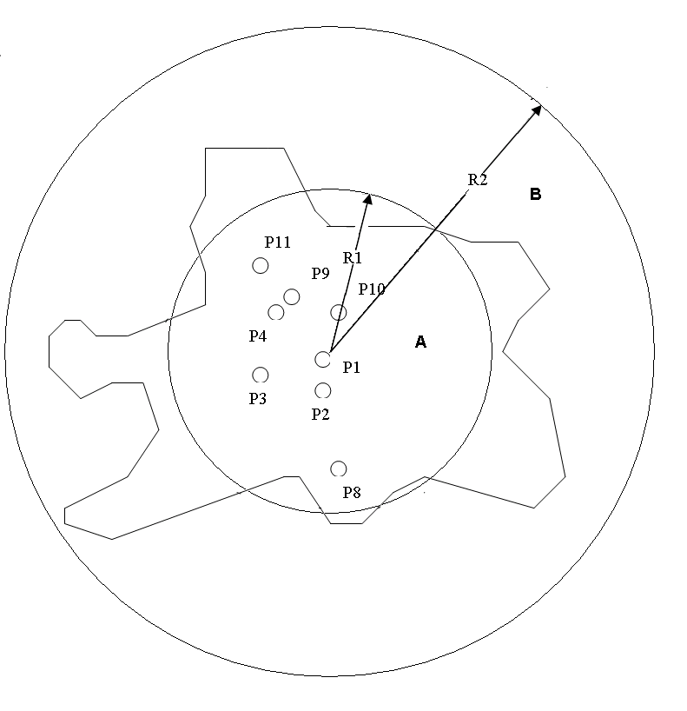
Figure 10: Location of the measurement points of Table 8 (not to scale)

The result is shown in Table 8 for n_{effA} = 2000/km² and n_{effB} = 500/km². These values for the n_{eff} of the two areas can be taken as realistic ones, and it does not make much sense to try to calculate more accurate ones, since these values depend strongly on the assumed single leak power distribution (if µ would be 3 dB lower, then the n_{eff} would be about twofold as high as now).

h = 0,55 km
n_{effA}/km² | EeqA/µV/m | n_{effB}/km² | EeqB/µV/m | Eeq/µV/m | measured Eeq/µV/m
2000 | 46,7 | 500 | 11,40 | 48,1 (33,64 dBµV/m) | 45,22 (33,10 dBµV/m)
h = 6 km
2000 | 22,4 | 500 | 10,5 | 24,7 (27,85 dBµV/m) | 23,5 (27,4 dBµV/m)
Table 8: Calculated field strength for Berlin area
ii. Neustrelitz
For the calculation of the field strength of point P1, a half circle area with R2 = 2,5 km, R1 = 0 and β = 180° is taken (see Figure 11).

For the calculation of the field strength of Point 2, the area of Neustrelitz is divided into three sub-areas, area A, B and C, each area being a sector of an annulus (see Figure 11).

Area A is defined with R2 = 1,6 km, R1 = 0,8 km, β = 50°, area B is defined with R2 = 3 km, R1 = 1,5 km, β = 45°, and area C is defined with R2 = 4 km, R1 = 3 km, β = 30°.

The single leak power distribution on the ground is assumed again as a normal distribution with µ = 23 dBpW, σ = 10 dB, which is represented by a uniform single leak power of 2000 pW.

The formula used for calculation of the Eeqi for the different areas is

$E_{{{\text{eqi}}/{\text{uV}}}/m}=\text{9708}⋅\sqrt{\frac{β_{i}}{\text{360}}}⋅\sqrt{n_{{\text{effi}}/{{\text{km}}^{2}}}⋅{\text{PsiN}}_{W}}\sqrt{\text{ln}(R_{2i/{\text{km}}}^{2}+h_{\text{km}}^{2})−\text{ln}(R_{1i/{\text{km}}}^{2}+h_{\text{km}}^{2})}$ ,

with i =1 for P1 (only one area) and i=3 (3 areas A, B, C) for P2,

and Eeq for P2 is

$E_{\text{eq}}=\sqrt{\sum_{i}{E_{\text{eqi}}^{2}}}$ ; with i = 3

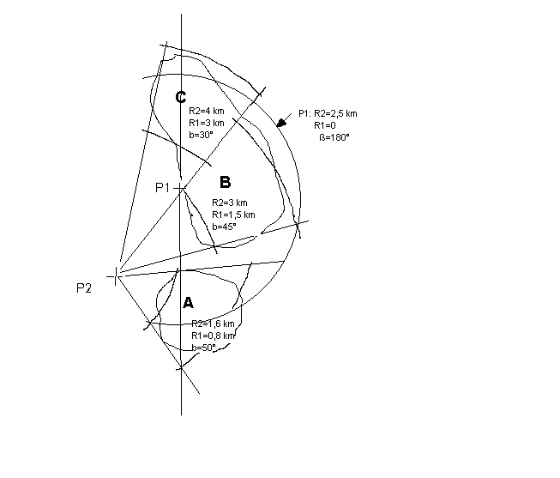
Figure 11: Location of the measurement points and the sub-areas of Neustrelitz (not to scale)

By the method of trial and error it has been found that with the n_{eff} of Table 9 and 10 the calculated field strength for the points P1 and P2 are very close to the measured field strength.

Result for P1:
The results for P1 are shown in Table 9.

n_{eff}/km² | Eeq/µV/m | Meas. Eeq/µV/m
1000 | 17,01 | 17,18
Table 9: Calculated field strength for P1 Neustrelitz, height 550 m

The measured field strength at P1 is approximated sufficiently by calculation, if an effective leak density of 1000/km² is taken.

Result for P2:

The results for P2 are shown in Table 10.

n_{eff} A  1/km² | EeqA  µV/m | n_{eff} B  1/km² | EeqB  µV/m | n_{eff} C  1/km² | Eeq C  µV/m | EeqP2  µV/m | meas. EeqP2  µV/m
2000 | 8,0 | 2000 | 7,8 | 2000 | 4,2 | 11,94  (21,5 dBµV/m) | 12,45  (21,9 dBµV/m)
Table 10: Calculated field strength for P2 Neustrelitz, height 550 m

The measured field strength at P2 is approximated sufficiently by calculation, if for each area A, B and C an effective leak density of 2000/km² is taken.

Summary on the calculated equivalent leak density of Neustrelitz:
Since the evaluated n_{eff} = 1000/km² by means of P1 are based on a calculation with a relative large area, which contains some parts without population, this figure is a more average value. The n_{eff} = 2000/km² found by means of P2 are based on a more detailed partition of the city area, and therefore it is concluded that for the populated parts of the city area of Neustrelitz a n_{eff} = 2000/km² can be applied.
III. Neubrandenburg
The town area of Neubrandenburg is divided into 4 sections A, B, C and D (see Figure 12). For each sector the equivalent field strength was calculated in the same way as above for Neustrelitz, and all the equivalent field strength of the sectors were summed up geometrically.

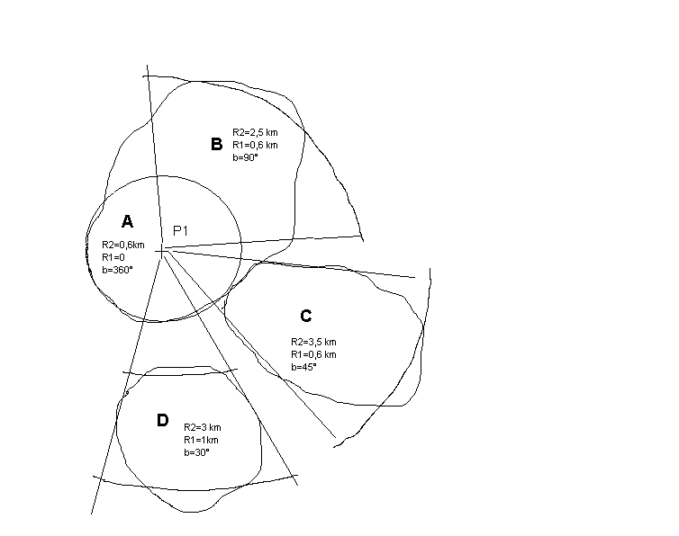
Figure 12: Location of the measurement point and the sub-areas of Neubrandenburg (not to scale)

The result is shown in Table 11.

n_{eff} A  1/km² | Eeq A  µV/m | n_{eff} B  1/km² | Eeq B  µV/m | n_{eff} C  1/km² | Eeq C  µV/m | n_{eff} D  1/km² | Eeq D  µV/m | Eeq P1 | Eeqmeas P1
400 | 7,68 | 400 | 6,56 | 400 | 5,26 | 400 | 3,52 | 11,92 | 12,02
Table 11: Calculated field strength for P1 Neubrandenburg, height 550 m

Summary on the calculated equivalent leak density of Neubrandenburg:
An effective leak density of 400/km² can be taken for Neubrandenburg. This value is significant lower than that for Neustrelitz and Berlin. A reason for this could be that the actual single leak power distribution has a higher µ and/or σ than that of the Hannover distribution, which was assumed here.
iv. Hannover
The location of the measurement points and the distribution of the parts of the radiating areas are shown in Figures 13 and 14. For the measurement point P1 there are 5 contributing sub-areas, and for measurement point P2 there are 3 contributing sub-areas. The equivalent field strength is calculated for each sub-area, and these sub-field strength are added geometrically. The leak densities are chosen by trial in such a way that the measured field strength is met as close as possible.

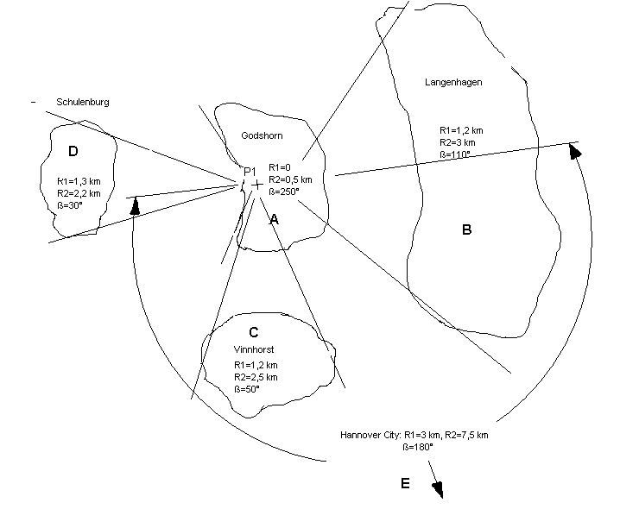

Figure 13: Measurement point P1 of Hannover with the sub-areas (not to scale)

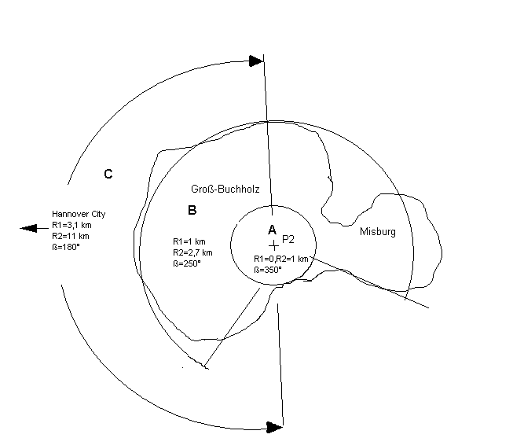
Figure 14: Measurement point P2 with the sub-areas (not to scale)

The results of the calculation is shown in Table 12 and Table 13.

n_{eff} A  1/km² | Eeq A  µV/m | n_{eff} B  1/km² | Eeq B  µV/m | n_{eff} C  1/km² | Eeq C  µV/m | n_{eff} D  1/km² | Eeq D  µV/m | n_{eff} E  1/km² | Eeq E  µV/m | Eeq P1 | Eeqmeas  P1
5000 | 24,71 | 5000 | 22,27 | 5000 | 13,40 | 5000 | 8,84 | 5000 | 29,27 | 47,13 | 47,32
Table 12: Calculated equivalent field strength for P1 Hannover

n_{eff} A  1/km² | Eeq A  µV/m | n_{eff} B  1/km² | Eeq B  µV/m | n_{eff} C  1/km² | Eeq C  µV/m | Eeq P2 | Eeqmeas P2
4200 | 39,53 | 4200 | 31,75 | 4200 | 31,75 | 59,83 | 59,57
Table 13: Calculated equivalent field strength for P2 Hannover

Summary on the calculated equivalent leak density of Hannover:
From the measured field strength at P1 an effective leak density of 5000/km² has been derived, and from the measured field strength of P2 an effective leak density of 4200/km² has been found. There is no obvious reason to prefer one of these values, therefore a mean value of 4600/km² may be assumed for the housing areas of Hannover. If this mean value would be used in Table 12 and 13, then the calculated field strength Eeq P1 and Eeq P2 would change by 0,4 dB.

Influence of the area outside of Hannover City up to the Radio Horizon:
The areas outside Neustrelitz and Neubrandenburg were not taken into account, because those areas are very low populated and there are no bigger towns in the vicinity.

In the vicinity of Hannover however, up to a distance of 80 km (Radio Horizon), there are a lot of larger towns like Braunschweig, Wolfsburg, Goslar, Minden, Celle, Hildesheim, Salzgitter, Hameln.
Therefore, the influence of the area outside Hannover has been checked.
If an average effective leak density of 50/km² would be applied, this area alone would generate 6,1 µV/m (15,7 dBµV/m) and would enhance the calculated Eeq in Table 11 and 12 by only 0,38 µV/m (0,07 dB) for P1 and 0,3 µV/m (0,04 dB) for P2.

A leak density of 100/km² would generate 8,6 µV/m.

Therefore, it is concluded that the influence of the outside area of Hannover up to the Radio Horizon on the calculated field strength for P1 and P2 can be neglected, although the outside area alone generates a field strength, which exceeds the squelch lift level of VHF COM receivers.
v. Accuracy considerations
From the calculated field strength of the sub-areas in the above Tables it can be found that the accuracy, which is spent in the definition of the sub-areas has not a significant influence on the result. For instance, if for the Hannover point P1 the area A would be completely left out (Figure 13, Table 12), then the calculated field strength would be reduced by 1,4 dB.

Also, the accuracy of the effective leak density has not a significant influence on the calculated field strength. For each sub-area, the reduction (enhancement) of the effective leak density to half (twice) of the previous value would reduce (enhance) the result by 3 dB. If all sub-areas have the same effective leak density, like for Hannover P1 or P2, then the result of P1 or P2 would be reduced/enhanced by 3 dB. For instance, if for P1 Hannover (Table 12) the effective leak density would be reduced from 5000/km² to 2500/km², the result would be lowered from 33,47 dBµV/m to 30,47 dBµV/m.

The accuracy of the single leak power distribution has a more significant influence on the calculated field strength. If µ varies by 3 dB, the result also varies by 3 dB. If σ=10 dB, as applied here, varies by 1 dB, then the result varies by around 2 dB. If we had σ=5 dB, a variation of σ by 1 dB would cause a variation of the result by around 1 dB.
In practice, it is a lot of effort needed to determine the single leak power distribution by ground measurements with a sufficient accuracy, and measurement uncertainties of 1 or 2 dB for µ and σ would be rather good.

Example:
For the calculation of the equivalent field strength for Berlin (see Table 8) a normal distribution of the single leak powers with µ=23 dBpW, σ= 10 dB was applied, and effective leak densities of 2000/km² for the city area and 500/km² for the suburb area were found. If the real single leak power distribution for Berlin would be µ=22 dBpW, σ=9 dB, then the effective leak density of Berlin city area would be 4000/km² and for Berlin suburb area 1000/km², in order to produce the measured field strength.

This example shows how important the knowledge of the accurate existing single leak power distribution is for the prediction of the cumulative field strength in the air. Ground measurement tolerances for µ and σ of 1 or 2 dB can result in multiplying the calculated leak density by 2 or 0,5.
vi. summary on the calculated equivalent leak densities
The leak densities for the different cities were calculated with the prerequisite that the single leak power distribution µ=23 dBpW, σ=10 dB measured in RMS/120 kHz would exist, corresponding to the distribution measured by RegTP during its measurement campaign in Hannover 1999.

The following table 14 summarises the calculated leak densities.

 | Leak density/km²
Berlin, city centre | 2000
Berlin, suburbs | 500
Neustrelitz | 2000
Neubrandenburg | 400
Hannover | 4600
Table 14: calculated equivalent leak densities

However, as the Hannover 1999 ground measurement were made using a QP/120 kHz detector, the single leak power distribution in Hannover 1999 was actually µ=23 dBpW QP/120 kHz, σ=10 dB. The correction of the figures of Table 14 due to this new leak distribution can easily be done as described in the following, and leads to (nearly) doubling the figures for the leak densities.

The measured field strength in the air was RMS/12 kHz, which is nearly the same as RMS/120 kHz. The measured RMS-field strength in the air was compared with the calculated RMS-field strength in the air, and both field strength were brought to an equal level by adjusting the equivalent leak density (see Table 8). Now, since the calculated field strength in the air, based on the QP-single leak distribution on the ground, is no longer RMS, but QP, this calculated QP-field strength in the air has to be compared with the measured QP-field strength in the air, which is (nearly) 3 dB higher than the measured RMS-field strength in the air. The calculated QP-field strength now must be brought at the equal level as the measured QP-field strength, and this is be done by (nearly) doubling the equivalent leak density, which results in an increase of 3 dB of the calculated field strength.

As explained above, the evaluated leak densities depend strongly on the parameters µ and σ of the normal distribution. Since due to comparable population densities of the cities the leak densities also should have comparable levels. Therefore, the differences in the calculated equivalent leak densities are probably due to different single power distributions.
vii. Comparison with population data
In order to verify if the calculated equivalent leak densities are realistic, the following table provides calculated values of leak densities assuming a 60% cable penetration.

City | Population density in inhabitants per sq km | Leak density in leaks per sq km (assumption: 60 % cable penetration)
Berlin | 3730 | 2238
Hannover | 2543 | 1526
Hamburg | 2110 | 1266
Frankfurt | 2490 | 1494
Munich | 4100 | 2460
Table 15:Leak densities of German towns (city area)
Source: Umweltatlas Berlin (http://www.stadtentwicklung.berlin.de/umwelt/umweltatlas/)

For the two cities for which we can compare with the calculated equivalent leak densities, in the case of Berlin, it can be seen that there is a good correlation between the two ways of evaluating the leak densities (2000 versus 2200), but that in the case of Hannover, there is approximately a 1/3 ratio between the two values (4600 versus 1500).

In the case of Hannover, the number of households is 270 000 (approximately half the population that is equal to 518 722 inhabitants), leading to a density of households (the surface of the city is 204 km²) of 1324. If the number of leaks is proportional to the number of houses rather than inhabitants, this would lead to a even greater discrepancy of 1/6 between the two ways of calculating the leak density. However, assuming one leak per household does not take into account the leak arising in the cable TV network itself, but equally, assuming that every household leaks is also a worst case.

In any case, values summarised in section 4.3.6 are only equivalent leak densities calculated so that the aggregate signal produced by all these leaks over the surface of cities under study is equal to the measured field strength values obtained by flyover measurements, assuming that the distribution of leaks on the ground follows the statistical distribution measured in Hannover. It should be pointed out that the Hannover ground measurements were made on a different area of the city than the areas over flew in the aerial measurements detailed previously. Therefore, the most probable explanation for the difference between the calculated equivalent leak density and population data is a difference between the assumed and the actual ground leak distribution.
d Leakage levels assumed in the calculations
Based on the analysis of the flight measurements detailed above, Section 5 calculations are made in the case of Berlin as representative of a typical worst case of a cable TV network spread over a big city. The Berlin area under consideration is divided in two sub-areas as explained in section 4.3.1: the core area is a circle with a radius of 10 km and the suburb area is an annulus around the core area with an inner radius of 10 km and an outer radius of 20 km. The leak density of the core area is 2000/km², and the leak density of the suburb area is 500/km².

As explained in section 4.3.6, the flyover measurement values were obtained with an rms detector, whereas the Hannover ground measurements were made using a quasi-peak detector. As there is approximately a 3 dB difference between measurements with the two detectors, a 3 dB correction factor is accounted for in the calculations. This adjustment can also be made without adding 3 dB in the calculations and, instead, by assuming in the Berlin case a leak density of the core area of 4000/km² and a leak density of the suburb area of 1000/km².
In Section 5, we make calculations under two hypotheses:
- One calculation assumes that the statistical distribution of the leakage levels follows the distribution shown on figure 3: a normal distribution with an average value µ = 23 dBpW and a standard deviation value σ = 10 dB;
- Another calculation that all leakage values are equal to the EN 50083-8 limit of 20 dB(pW).
Both the statistical distribution and the fixed value are quasi-peak values in a 120 kHz bandwidth.
For the digital Cable TV network calculations, for simplicity, it has been assumed in the calculations that the leakage levels are the same as for an analogue Cable TV network. However, the normal practise on actual cable TV networks is that the digital power over 7 MHz is equal to:
- the analogue power over 7 MHz minus 16 dB for 16QAM.
- the analogue power over 7 MHz minus 10 dB for 64QAM.
- the analogue power over 7 MHz minus 4 dB for 256QAM.
When converted into QP values over 120 kHz, due to the different nature of the two signals, an additional factor of 16 dB (12.9 - -3.1 = 16 dB, see Table 2) needs to be taken into account. This means that for QP values over 120 kHz, digital 16QAM is 32 dB below analogue TV, digital 64QAM is 26 dB below analogue TV, digital 256QAM is 20 dB below analogue TV. Conclusions are therefore based on these differences. An example of such a reduction can be seen on Figure 2.3.1 in section 2.3.1 of the main body of this ECC Report (example of the frequency spectrum measured at a German cable network, date: 1998): it shows on a measurement in a 1 MHz bandwidth that the digital DVB-C carriers are approximately 15 dB below the analogue PAL carriers.
For example in the case of the commonly used 64QAM modulation scheme, this 26 dB reduction means that for digital TV the assumed probability distribution has an average value µ = -3 dBpW (and the same standard deviation value σ = 10 dB) and for the constant distribution corresponding to EN 50083-8, the assumed maximum leakage level is equal to -6 dBpW.
- RESULTS of the compatibility studies
a. Results with model n°1
The influence of the autocorrelation time on the fading properties will be discussed in two different cases:
- bandwidth of the signal smaller than the bandwidth of the receiver
- bandwidth of the signal larger than or equal to the bandwidth of the receiver.

Small signal bandwidth
The autocorrelation time is determined by the signal. In the present case of different TV signals, the only signal width small bandwidth is the PAL signal. This signal has two main carriers, picture and sound. If you only take the carriers into account, the autocorrelation function is a pure sinusoidal. If you take the modulation into account, you get a periodic autocorrelation function with short periods of 16 kHz (line sync) and 50 Hz (frame sync). There is no well-defined autocorrelation time as the signal will have almost full correlation at least every 20 ms. So there is no physical limit of the area where fading may occur.

Large signal bandwidth
The autocorrelation time is defined by the receiver. When a wide band signal is passed through a band pass filter, the filtered signal will show an autocorrelation time which at least is equal to the inverse of the noise bandwidth:

τ= 1/BW

Emitters with a path difference less than the value

$$ΔR<τc$$

will exhibit fading.

Scenario
The discrete carrier systems (PAL) will always be fading.

In the case of a broad band signal received by a narrow band receiver, you may experience fading. In a COM receiver to be used with an 8.33 kHz channel spacing and a bandwidth of 8.25 kHz, the correlation time is 0.12 msec. This is equal to a maximum path difference of 36 km in order to produce fading. The path difference is the electrical length of the cabling system, and with typical coax cables, the physical length is about 70% of the electrical length. If the bandwidth is increased to 35 kHz as is the case in ILS receivers, the correlation time is only 0.0285 msec and the maximum path difference to produce fading will be 8.5 km.

Conclusion
When the main contributions to the interference of the aeronautical systems on an aeroplane come from an area less than 6 km in diameter, you can under all circumstances assume that you have Rayleigh fading.

If the area contributing to the interference is larger than 5 km, the fading properties depend on the TV signal and the receiver. A PAL signal will always show fading. So will an 8.33 kHz COM receiver.

A digital TV signal together with an ILS receiver will show a mixture between fading interference and constant interference. The contribution from the constant interference may be calculated from the radio powers emitted from a density of interferers.

In most cases you get valid simulation results using model N°1. This model is able to produce a correspondence factor between fading interfering field strengths at flight height and field strengths which may be measured at ground level. As all values have a distribution, the measurements shall be treated on a statistical basis, i.e. you shall take enough measurements and derive the mean value or the 95% fractile. When the protection criteria have been defined for the systems on the plane, you can calculate the maximum fields you are allowed to measure on the ground.

In section 3.2.1 simulations using a fading interfering signal have yielded a connection between the interference field strength in the flight height and the measured interference field at ground level. As the signals have a statistical distribution, the measurements shall also be made and treated in a statistical way.

The obtained results are shown in section 3.2.1, tables 5 and 6.

The model has been used on the assumed data from Berlin. The density of interferers is set to 2000 /km² in the centre area and 500 /km² in the suburb area. The circular areas have been approximated by squares with the same area. The calculated field strengths for a specific polarisation are:

 | Eeff (dBµV/m)  core area |  | Eeff (dBµV/m)  suburb area |  | Eeff (dBµV/m)  city centre (whole area)
h (km) | 95% | max | 95% | max | 95% | max
0,3 | 29,2 | 33,9 | 17,3 | 21,0 | 29,5 | 34,1
0,55 | 27,9 | 32,0 | 20,1 | 23,4 | 28,6 | 32,6
1,0 | 27,3 | 32,8 | 17,1 | 18,5 | 27,7 | 33,0
2,0 | 26,2 | 30,1 | 17,3 | 19,1 | 26,7 | 30,4
6,0 | 22,1 | 26,9 | 14,0 | 19,6 | 22,7 | 27,6
12,0 | 19,3 | 23,9 | 12,4 | 19,5 | 20,1 | 25,3
Table 16: Effective field strength over city centre of Berlin, normal distributed sources, µ=23 dBpW, σ= 10 dB

The fieldstrengths shown are the 95% fractile (i.e. 95% of the results are below this value) and the maximum calculated value.

You may assume a fixed relation between fieldstrengths from sources with a normal power distribution and sources with fixed power. This can be seen in the results from model 2, where you have 13 dB difference between a normal power distribution with µ=23 dBpW, σ= 10 dB and a fixed power of 20 dBpW.
b Results with model n°2
Using the formulas (1), (3), the equation PsiN = µ + σ²/10 for representing a µ, σ normal distribution (see Para 3.2), and the parameters of 5.1.2, the effective field strength for Berlin city centre, depending on the altitude, was calculated.

The results are presented in the following tables. In order to show the influence of the suburb area on the effective field strength over the city centre, the effective field strength of both the core area and the suburb area are given separated. The effective field strength of the city centre is the geometric addition of the effective field strengths of the core area and the suburb area.

It should be noted that when applying the formula (1), a single leak power, measured with any detector, can be inserted. The result is the aggregate field strength, measured with the same detector, as which was taken for the single leak power. This is for instance, if the leak power 20 dBpW QP/120 kHz was taken for formula (1), the result will be a field strength, also as measured as with a QP/120 kHz detector.

h (km) | Eeff (dBµV/m)  core area | Eeff (dBµV/m)  suburb area | Eeff (dBµV/m)  city centre (whole area)
0,3 | 33,7 | 20,7 | 34,0
0,6 | 32,8 | 20,7 | 33,0
1,0 | 31,9 | 20,6 | 32,2
2,0 | 30,4 | 20,5 | 30,8
4,0 | 28,3 | 20,3 | 28,9
6,0 | 26,5 | 19,9 | 27,4
8,0 | 25,0 | 19,4 | 26,1
10,0 | 23,7 | 18,9 | 24,9
12,0 | 22,5 | 18,3 | 23,9
Table 17: Effective field strength over city centre of Berlin, normal distributed sources,
µ=23 dBpW, σ= 10 dB, QP/120 kHz, for PAL image carrier and 64QAM

h (km) | Eeff (dBµV/m)  core area | Eeff (dBµV/m)  suburb area | Eeff (dBµV/m)  city centre (whole area)
0,3 | 20,7 | 7,7 | 20,9
0,6 | 19,8 | 7,7 | 20,0
1,0 | 18,9 | 7,6 | 19,2
2,0 | 17,4 | 7,5 | 17,8
4,0 | 15,3 | 7,3 | 15,9
6,0 | 13,5 | 6,9 | 14,4
8,0 | 12,0 | 6,4 | 13,1
10,0 | 10,6 | 5,9 | 11,9
12,0 | 9,5 | 5,3 | 10,9
Table 18: Effective field strength over city centre of Berlin, uniform leak power 20 dBpW,
QP/120 kHz, for PAL image carrier and 64 QAM

The results of Tables 17 and 18 together with the minimum interfering field strength for the different aeronautical radio applications from Table 4 (including the safety margin of 9 dB for ILS LOC, VOR, ILS GP, and measured with QP/120 detector) are presented in Figure 18 below.
Figure 18: Effective field strength over Berlin City for two single leak power distributions, minimum interfering field strength levels for two interfering signal types, measured with QP/120 kHz detector

If different input parameters are assumed, different resulting field strength will be found. We provide below two examples of such alternative calculations also obtained with model n°2:

- Scenario 1 (flight over a city)
altitude = high, radius = big, leak density = low
h = 10 km, R₁ = 0, R₂ = 10 km, P_{si} = 20 dBpW, n = 500
E_{eq} = 5.14 dBµV/m

- Scenario 2 (approach to airport):
altitude = low, radius = small, leak density = high
h = 0.5 km, R₁ = 0, R₂ = 0.5 km, P_{si} = 20 dBpW, n = 2460
E_{eq} = 12.06 dBµV/m

The transformation of E_{eq} into E_{eff}: E_{eff} = E_{eq} – 3.5 dB
c. Comparison of the two models
The aggregate interference calculated with model n°1 ranges from (depending on the airplane altitude):
- 25 to 34 dBµV/m for 100% of the results;
- 20 to 29 dBµV/m for 95% of the results.
These two ranges have been obtained assuming that leakage on the ground follow a lognormal distribution with an average value µ = 23 dBpW and a standard deviation value σ = 10 dB.

The aggregate interference calculated with model n°2 ranges from (depending on the airplane altitude):
- 24 to 34 dBµV/m for a lognormal distribution µ = 23 dBpW, σ = 10 dB;
- 11 to 21 dBµV/m when all leakage values are equal to the EN 50083-8 limit of 20 dB(pW).

For the result that can be directly compared (first result for each model), it can be seen that the correlation between the two models is extremely good (25 to 34 dBµV/m compared to 24 to 34 dBµV/m), i.e. within 1 dB.

In the next sub-sections numerical results with model n°2 are given in details as they correspond to the two leak distribution assumed in section 4.4, but the comparison we have just made enable to conclude that these conclusions are valid also for model n°1.
d. Analysis for ILS LOC
Model n°1 results:
The protection requirements in the air are given in section 2.5, table 4. With a receive bandwidth of 35 kHz all interfering signals inside a radius of 3 km will show Rayleigh fading.

For an interfering PAL system, the interference will be fading regardless of extension. The interfering signal from a broad band digital system will show some fading, depending on the extension of the radiating area.

As a first approximation one can estimate with model n°1 the protection requirements on the ground by assuming a fading interference and use the correction value obtained from section 3.2.1, tables 5 and 6.

Model n°2 results for analogue TV:

In the case of the lognormal distribution, there is interference by 28 dB (at a 300 m altitude) to 18 dB (at a 12 km altitude).

In the case of the constant 20 dBpW distribution, there is interference by 15 dB (300 m) to 5 dB (12 km).

To become compatible, assuming all leakage values can be reduced below a given value, the limit for all leakage values should be 5 dBpW.

Model n°2 results for digital TV:
In the case of the lognormal distribution, there is interference by 17 dB (300 m) to 7 dB (12 km).

In the case of 64QAM, taking the 26 dB reduction for digital TV compared to analogue TV into account, there is compatibility by 9 dB at 300 m to 19 dB at 12 km.

In the case of the constant 20 dBpW distribution, there is interference by 4 dB at 300 m to 0 dB at 3 km and there is compatibility by 0 dB at 3 km to 6 dB at 12 km.

In the case of 64QAM, taking the 26 dB reduction for digital TV compared to analogue TV into account (i.e. assuming all leakages are equal to -6 dBpW), there is compatibility by 22 dB (300 m) to 28 dB (12 km).

Assuming all leakage values can be reduced below a given value, to ensure compatibility, all leakage values can be up to 16 dBpW.
e. Analysis for VOR
Model n°1 results:
The protection requirements in the air are given in section 2.4, table 4. With a receive bandwidth of 35 kHz all interfering signals inside a radius of 3 km will show Rayleigh fading.

For an interfering PAL system, the interference will be fading regardless of extension. The interfering signal from a broad band digital system will show some fading, depending on the extension of the radiating area.

As a first approximation you can estimate the protection requirements on the ground by assuming a fading interference and use the correction value obtained from section 3.2.1, tables 5 and 6.

Model n°2 results for analogue TV:

In the case of the lognormal distribution, there is interference by 11 dB (at a 300 m altitude) to 1 dB (at a 12 km altitude).

In the case of the constant 20 dBpW distribution, there is compatibility by 2 dB (300 m) to 12 dB (12 km).

Assuming all leakage values can be reduced below a given value, to ensure compatibility, all leakage values can be up to 22 dBpW.

Model n°2 results for digital TV:
In the case of the lognormal distribution, there is interference by 13 dB (300 m) to 3 dB (12 km).

In the case of 64QAM, taking the 26 dB reduction for digital TV compared to analogue TV into account, there is compatibility by 13 dB at 300 m to 23 dB at 12 km.

In the case of the constant 20 dBpW distribution, there is compatibility by 0 dB (300 m) to 10 dB (12 km).

In the case of 64QAM, taking the 26 dB reduction for digital TV compared to analogue TV into account (i.e. assuming all leakages are equal to -6 dBpW), there is compatibility by 26 dB (300 m) to 36 dB (12 km).

Assuming all leakage values can be reduced below a given value, to ensure compatibility, all leakage values can be up to 20 dBpW.
f. Analysis for VHF COM
Model n°1 results:
The protection requirements in the air are given in section 2.4, table 4. VHF COM systems are narrowband (IF bandwidths of 6 and 15 kHz are assumed for 8,33 kHz and 25 kHz channel spacing respectively). As a consequence the interfering signals will exibit fading when they arrive from an area smaller than 20 km in diameter (25 kHz channel spacing) or 50 km (8,33 kHz channel spacing). This shows that the fading model is appropriate in all cases.

It shall be noted that the protection requirements are so low that it is important to use a measuring receiver with a very low noise figure. It may be necessary to use a low noise preamplifier. In this case it is important to investigate the total signal present in the bandwidth of the preamplifier to ensure that the preamplifier does not compress the interfering signals.

Model n°2 results for analogue TV:

In the case of the lognormal distribution, there is interference by 44 dB (at a 300 m altitude) to 34 dB (at a 12 km altitude).

In the case of the constant 20 dBpW distribution, there is interference by 31 dB (300 m) to 21 dB (12 km).

To become compatible, assuming all leakage values can be reduced below a given value, the limit for all leakage values should be -11 dBpW.

Model n°2 results for digital TV:
In the case of the lognormal distribution, there is interference by 27 dB (300 m) to 17 dB (12 km) for the 8.3 kHz VHF COM and there is interference by 26 dB (300 m) to 16 dB (12 km) for the 25 kHz VHF COM.

In the case of 64QAM, taking the 26 dB reduction for digital TV compared to analogue TV into account, there is interference by 1 dB (300 m) to 0 dB (300 m) and there is compatibility by 0 dB at 600 m to 9 dB at 12 km for the 8.3 kHz VHF COM ; there is compatibility by 0 dB (300 m) to 10 dB (12 km) for the 25 kHz VHF COM.

In the case of the constant 20 dBpW distribution, there is interference by 14 dB (300 m) to 4 dB (12 km) for the 8.3 kHz VHF COM and there is interference by 13 dB (300 m) to 3 dB (12 km) for the 25 kHz VHF COM.

In the case of 64QAM, taking the 26 dB reduction for digital TV compared to analogue TV into account (i.e. assuming all leakages are equal to -6 dBpW), there is compatibility by 12 dB at 300 m to 22 dB at 12 km for the 8.3 kHz VHF COM and there is compatibility by 13 dB at 300 m to 23 dB at 12 km for the 25 kHz VHF COM.

Assuming all leakage values can be reduced below a given value, to ensure compatibility, all leakage values can be up to 6 dBpW for 8.3 kHz VHF COM and 7 dBpW for 25 kHz VHF COM.
g. Analysis for UHF COM

Model n°1 results:
The protection requirements in the air are given in section 2.4, table 4. UHF COM systems are relatively narrowband: IF bandwidth of 35 kHz is assumed with 50 kHz channel spacing.

For an interfering PAL system, the interference will be fading regardless of extension. The interfering signal from a broad band digital system will show some fading, depending on the extension of the radiating area.

The interfering signals will exhibit fading when they arrive from an area smaller than 6 km in diameter. This shows that the fading model is appropriate as a first approximation.

It shall be noted that the protection requirements are so low that it is important to use a measuring receiver with a very low noise figure. It may be necessary to use a low noise preamplifier. In this case it is important to investigate the total signal present in the bandwidth of the preamplifier to ensure that the preamplifier does not compress the interfering signals.

Model n°2 results for analogue TV:

In the case of the lognormal distribution, there is interference by 21 dB (at a 300 m altitude) to 11 dB (at a 12 km altitude).

In the case of the constant 20 dBpW distribution, there is interference by 8 dB at 300 m to 0 dB at 8 km and there is compatibility by 0 dB at 8 km to 2 dB at 12 km.

To become compatible, assuming all leakage values can be reduced below a given value, the limit for all leakage values should be 12 dBpW.

Model n°2 results for digital TV:
In the case of the lognormal distribution, there is interference by 6 dB at 300 m to 0 dB at 5 km and there is compatibility by 0 dB at 5 km to 4 dB at 12 km.
In the case of 64QAM, taking the 26 dB reduction for digital TV compared to analogue TV into account, there is compatibility by 20 dB (300 m) to 30 dB (12 km).
In the case of the constant 20 dBpW distribution, there is compatibility by 7 dB (300 m) to 17 dB (12 km).
In the case of 64QAM, taking the 26 dB reduction for digital TV compared to analogue TV into account (i.e. assuming all leakages are equal to -6 dBpW), there is compatibility by 33 dB (300 m) to 43 dB (12 km).
Assuming all leakage values can be reduced below a given value, to ensure compatibility, all leakage values can be up to 27 dBpW.
h. analysis for ILS GP
Model n°1 results:
The protection requirements in the air are given in section 2.5, table 4. With a receive bandwidth of 25 kHz all interfering signals inside a radius of 5 km will show Rayleigh fading.

For an interfering PAL system, the interference will be fading regardless of extension. The interfering signal from a broad band digital system will show some fading, depending on the extension of the radiating area.

As a first approximation you can estimate the protection requirements on the ground by assuming a fading interference and use the correction value obtained from section 3.2.1, tables 5 and 6.

Model n°2 results for analogue TV:

In the case of the lognormal distribution, there is compatibility by 2 dB (300 m) to 12 dB (12 km).

In the case of the constant 20 dBpW distribution, there is compatibility by 15 dB (300 m) to 25 dB (12 km).

Assuming all leakage values can be reduced below a given value, to ensure compatibility, all leakage values can be up to 35 dBpW.

Model n°2 results for digital TV:
In the case of the lognormal distribution, there is compatibility by 4 dB (300 m) to 14 dB (12 km).

In the case of 64QAM, taking the 26 dB reduction for digital TV compared to analogue TV into account, there is compatibility by 30 dB (300 m) to 40 dB (12 km).

In the case of the constant 20 dBpW distribution, there is compatibility by 17 dB (300 m) to 27 dB (12 km).
In the case of 64QAM, taking the 26 dB reduction for digital TV compared to analogue TV into account (i.e. assuming all leakages are equal to -6 dBpW), there is compatibility by 43 dB (300 m) to 53 dB (12 km).

Assuming all leakage values can be reduced below a given value, to ensure compatibility, all leakage values can be up to 37 dBpW.

6. Conclusions
a. Results of the compatibility calculations
Calculations have been made of the cumulative interference created in the sky by a cable TV network over a large city (Berlin) assuming either that the statistical distribution of the leakage levels on the ground follows a lognormal distribution or that all leakage values are equal to a given number.

In the case of analogue TV signals, a first calculation has been made assuming that leakage on the ground follow a lognormal distribution with an average value µ = 23 dBpW and a standard deviation value σ = 10 dB (these values come from a ground measurement campaign performed in 1999 in Hannover), or that all leakage values are equal to the EN 50083-8 limit of 20 dB(pW).

It should be reminded that EN 50083-8 is a voluntary standard and that measurements performed in various European countries showed that the 20 dB(pW) is exceeded by several individual leaks.

For the digital Cable TV network calculations, in the case of a 64QAM, a 26 dB reduction is assumed as in practise, the digital power over 7 MHz is equal to the analogue power over 7 MHz minus 10 dB and, converted into QP values over 120 kHz, due to the different nature of the two signals, this relationship over the whole bandwidth corresponds to an overall 26 dB difference. This 26 dB reduction means that for digital TV the assumed probability distribution has an average value µ = -3 dBpW (and the same standard deviation value σ = 10 dB) and for the constant distribution corresponding to EN 50083-8, the assumed maximum leakage level is equal to -6 dBpW. In the case of 16QAM, the difference with regard to analogue is 32 dB and in the case of 256QAM, the corresponding difference is 20 dB.

The conclusions summarised below are valid only as long as the 10 dB back-off for 64QAM is used in practise.

Two models to calculate the cumulative effect are described and have been used in the calculations and, for the results that can be directly compared, there is an extremely good correlation between the two models, i.e. within 1 dB.

Based on these scenarios and using these two models, the following conclusions can be reached with regard to the compatibility between such cable TV networks and the following radio services:
- ILS LOC:
ILS LOC is not compatible with analogue TV, but is compatible with digital TV with the power distributions and the scenarios assumed here.
Assuming all leakage values can be reduced below a given value, to ensure compatibility, all leakage values should be below 5 dBpW for analogue TV and 16 dBpW for digital TV.
- VOR:
In the case of the lognormal distributions assumed here, VOR is not compatible with analogue TV, but is compatible with digital TV.
In the case of the constant 20 dBpW/QP120 kHz leakage level assumed here, VOR is compatible with both analogue and digital TV.
Assuming all leakage values can be reduced below a given value, to ensure compatibility, all leakage values should be below 22 dBpW for analogue TV and 20 dBpW for digital TV.
- VHF COM:
VHF COM is not compatible with analogue TV, in the case of both the lognormal and the constant distributions assumed here. VHF COM is however compatible with digital TV in the case of the constant distributions assumed here. In the case of the lognormal distribution assumed here, VHF COM is compatible with a 16QAM digital TV and is partly compatible (depending on the airplane height) with 64QAM (incompatibility by 1 dB) and 256 QAM (incompatibility by 7 dB) digital TV.
Assuming all leakage values can be reduced below a given value, to ensure compatibility, all leakage values should be below -11 dBpW for analogue TV, 6 dBpW for digital TV in the case of 8.3 kHz VHF COM and 7 dBpW for digital TV in the case of 25 kHz VHF COM.
As a comparison, in the United States, a compliance figure of 20 dBµV/m at 450 m is used in cumulative level flight tests. However, if interference is experienced below this level, it is understood that it has to be resolved. The apparent discrepancy with our calculated values needs further investigation.
- UHF COM:
In the case of the lognormal distributions assumed here, UHF COM is not compatible with analogue TV, but is compatible with digital TV.
In the case of the constant 20 dBpW/QP120 kHz leakage level assumed here, UHF COM is partly compatible (depending on the interfered airplane height) with analogue TV, and is compatible with digital TV.
Assuming all leakage values can be reduced below a given value, to ensure compatibility, all leakage values should be below 12 dBpW for analogue TV and 27 dBpW for digital TV.
- ILS GP:
ILS GP is compatible with both analogue and digital TV with the power distributions assumed here.
Assuming all leakage values can be reduced below a given value, to ensure compatibility, all leakage values can be up to 35 dBpW for analogue TV and 37 dBpW for digital TV.

b. Risk assessment
Since the service provider of an aeronautical safety of life radio application (in general the national Air Traffic Control Authority) has to guarantee the proper function of its offered service, all real life circumstances and conditions of a case of potential interference between CATV and the offered service have to be taken into account, when the service provider is deciding on the compatibility case.

As a first step, a calculation of the interfering field strength, which could be expected, will be done by using an appropriate calculation model and network parameters (e.g. single leak power distribution, leak density, network area) as good as they are known in this special case for the time being.

As a second step, a risk level assessment (see paragraph 3.1) will be done, using the result of the calculations of the first step and additional information, which cannot be implemented in the calculations, but can occur under real life conditions and have influence on the risk of interference. Only if the risk level assessment leads to the result that the level “very low risk of interference” is reached, the compatibility between CATV service and the aeronautical radio application is given.

If the result of the first step, the calculation, shows clear incompatibility, and therefore the level “very low risk of interference” clearly cannot be concluded, the compatibility case is already solved and the decision “not compatible” has to be drawn. A risk assessment using additional information may be conducted, in order to support the taken decision.

If the result of the calculation shows compatibility, a risk assessment should be done, in order to include all additional relevant information in the decision-making process. In this case the decision whether or not compatibility is given, depends on this risk assessment analysis. Examples of factors that should be studied in this analysis are listed below.

Risk enhancing factors:
- Intra system interference due to heavy congested frequency band up to the tolerable level.
- Intermodulation caused by terrestrial TV stations and other Glide Path frequencies.
- Low possibility of occurrence of a very strong single CATV leak radiation.
- Emissions from other sources such as ISM equipment….
- Timely unlimited duration of the CATV interference.
- Absence of indication to the pilot that interference, occurring as a deviation of the glide path pointer, happens.
- Long time to identify and switch off the interfering CATV source.

Risk mitigating factors:
- Higher desired field strength than the sensitivity level in some parts of DOC.
- Internal noise on board the aircraft (due to electrostatic discharges…) that might degrade the sensitivity.
- The calculations include a 3 dB multiple interference factor and a 6 dB aviation safety factor, so only the risk enhancing factors inducing more than a 9 dB overall degradation should be taken into account additionally.

c. Discussion
The methodology contained in this Annex and associated sections of the body of the Report will provide administrations, users and industry with valuable tools to help Standardisation Bodies to determine field strength limits appropriate for cable communications networks. Such limits will be developed to inter alia permit radiocommunications services to operate as intended in the presence of the cumulative effect of disturbances arising from the same unwanted emission radiated from a number of different locations. However the models developed, in general rely heavily on theoretical and mathematical analyses, which have not been sufficiently tested in practice. In addition a number of radiocommunications services have not supplied the necessary criteria for the protection of their services above 30 MHz. As a consequence of the above it is believed necessary to continue work on the refinement of the model and the collection of protection criteria.

The additional factors that require study include a need to study the data from trials to confirm the mathematical distribution of data. It will also be necessary to consider phase cancellation and summation effects at the arrival point. Furthermore, a realistic shielding factor to allow for the effects of slant path propagation through adjacent buildings and geographical obstructions needs to be addressed.

In summary future work items are:
- Continuance of the collection and analysis of protection criteria for European radiocommunications systems and services operating in the frequency band 30 – 3000 MHz,
- From field airborne surveys of coaxial cable communications networks, confirm the mathematical distribution of measured results,
- Consider the effects of phase cancellation and summation at the measuring point,
- Address the statistical probability of additional propagation factors occurring as a result of slant path propagation through buildings and obstructions,
- If additional factors are found to be significant amend the mathematical models in this Annex as appropriate,
- If appropriate develop a revision to the Report taking account of subsequent studies.

Where (sub-)networks are terminal equipment in the sense of Directive 1999/5/EC, the standards will also be recognised as harmonised standards under that Directive.
See 47 C.F.R. §§ 15.107, 15.207 and 18.307 for the conducted emission limits. The regulations also specify radiated emission limits to protect against interference to radio services operating above 30 MHz. In certain cases, the rules specify limits on radiated emissions below 30 MHz. See 47 C.F.R. §§ 15.109(e), 15.209(a) and 18.305.
See 1998 Biennial Regulatory Review - Conducted Emission Limits Below 30 MHz for Equipment Regulated under Parts 15 and 18 of the Commission's Rules, ET Docket No. 98-80, Notice of Proposed Rule Making, 14 FCC Rcd 18180 (1999).
A carrier current system is defined as a system, or part of a system, that transmits radio frequency energy by conduction over the electric power lines to a receiver also connected to the same power lines. See 47 C.F.R. § 15.3(f).
The IEC CISPR I committee has a task group developing limits and measurement methods for new broadband Power Line Communications technologies.
Consider a signal whose power follows a lognormal distribution. Its power expressed in dB units then follows a normal distribution, with mean µdB and variance σdB2 .
The 10 dB power back-off for 64QAM is mainly implemented to mitigate potential interference problems between the analogue and the digital channels on the same cable. In the case where no analogue channel would be used, the digital TV power should not be increased above the level assumed here.

