ERC Recommendation 54-01

Method of measuring the maximum frequency deviation of FM broadcast emissions in the band 87.5 to 108 MHz at monitoring stations

**Approved May 1998**

**Amended 13 February 2015**

# introduction

The purpose of this Recommendation is to provide a common measurement method which will enable CEPT administrations to recognise measurement results relating to the frequency deviation of FM broadcast emissions on a mutual basis.

The latest revision of this ERC Recommendation was necessary to align it with Recommendation ITU-R SM.1268-3 (08/2014) on ‘Method of measuring the maximum frequency deviation of FM broadcast emissions at monitoring stations’ [3].

# ERC recommendation of 13 february 2015 on METHOD OF MEASURING THE MAXIMUM FREQUENCY DEVIATION OF FM BROADCAST EMISSIONS IN THE BAND 87.5 - 108 MHz AT MONITORING STATIONS

“The European Conference of Postal and Telecommunications Administrations,

*considering*

1. that the frequencies in the VHF band 87.5-108 MHz are assigned to an increasing number of FM broadcasting stations;
2. that protection ratios for the planning of broadcasting transmitter frequencies are based on a maximum frequency deviation of ±75 kHz and a maximum power of the modulation signal which does not exceed the power of a sinusoidal tone which causes a ±19 kHz frequency deviation;
3. that various broadcast transmissions exceed the maximum frequency deviation and/or modulation power owing to different types of programmes, additional components of the composite signal (e.g. Radio Data System (RDS)) and audio compression;
4. that the limitation of the peak frequency deviation is required to guarantee mutual protection of broadcast services (on adjacent channels) and the aeronautical radionavigation service in the frequency band above 108 MHz;
5. that the monitoring of broadcast emissions is necessary to prevent transmissions from exceeding the maximum frequency deviation;
6. that common measurement procedures are necessary in order to achieve mutual acceptance of measurement results by the parties concerned, e.g. frequency managers, monitoring services and broadcasters;
7. that the number of broadcasting stations using additional signals as RDS and high speed data signals is increasing and these systems are highly sensitive to interference from adjacent channels;
8. that the method described in Annex 1 is a simple "go - no go" test based on a spectrum mask which cannot replace precise measurements of the frequency deviation;

*recommends*

1. that the method described in Annex 1 may be used as a verification to indicate whether the frequency deviation of an FM broadcasting station exceeds the limits;
2. that the method described in Annex 2 is used when the values of the deviation and modulation power are required.”

*Note:*

Please check the Office documentation database <http://www.ecodocdb.dk> for the up to date position on the implementation of this and other ECC/ERC Recommendations.

1. SIMPLE SPECTRUM MASK BASED METHOD TO INDICATE THE EXCEEDING OF FREQUENCY DEVIATION LIMITS
   1. requirements

For this measurement any suitable spectrum analyser or test receiver with analyser capabilities can be used.

* 1. CONNECTION BETWEEN TRANSMITTER AND SPECTRUM ANALYSER

With the aid of a measurement antenna.

* 1. measurement conditions

1. During three measurements of five minutes each, the transmitter to be judged should be modulated with a representative programme material for that particular transmitter. Additional measurements may be carried out to ensure that the programme material is truly representative;
2. Impulse interferences should not occur (for example interference from an ignition source);
3. Signal / interference + noise should be ≥50 dB.
   1. ADJUSTMENTS OF THE SPECTRUM ANALYSER

The spectrum analyser should be adjusted as follows:

* Centre frequency = fo (Carrier frequency of the transmitter)
* Resolution BandWidth (RBW) 10 kHz (IF filter)
* Video BandWidth (VBW) 10 kHz (Video filter)
* Span 340 kHz
* Sweeptime 340 ms (1ms/kHz)
* max hold mode
* Input attenuation is dependent on input level.

Settings for digital signal processor analysers will be different but should provide equivalent results.

* 1. MEASUREMENT INSTRUCTIONS

1. Record the transmitter signal over a five minutes period;
2. Observation of the analyser and acoustic controls at the receiver should be used as a means to ensure that no measurement results are evaluated which have been distorted by impulse interference. For the same reason the measurement is repeated twice;
3. Overlay the graphical measurement with the mask as described in section A1.7;
4. The centre of the x-axis of the mask shall correspond with the centre frequency (f0);
5. Adjust the reference level so that the maximum amplitude of the measurement corresponds to 0 dB;
6. Determine whether the measurement is within the limits of the mask.
   1. limits

If any of the measured spectra exceeds the mask the deviation of the transmitter is assumed not to meet the requirements.

* 1. MASK CONSTRUCTION

1. The calibration of the mask should be consistent with the analyser settings;
2. The centre of the X-axis is aligned to f0;
3. The top of the Y-axis corresponds with the 0 dB reference level;
4. Straight lines connect the co-ordinates:

Table 1: Mask construction

| **X-axis (kHz)** | **Y-axis (dB)** |  | **X-axis (kHz)** | **Y-axis (dB)** |
| --- | --- | --- | --- | --- |
| f0 - 74 | 0 |  | f0 + 74 | 0 |
| f0 - 107.5 | -15 | f0 + 107.5 | -15 |
| f0 - 124 | -30 | f0 + 124 | -30 |
| f0 - 152.5 | -40 | f0 + 152.5 | -40 |

The graphic display of the Table 1 is shown in Figure 1.



Figure 1: Shape of the Mask

1. METHOD OF MEASURING THE MAXIMUM FREQUENCY DEVIATION OF FM BROADCAST EMISSIONS AT MONITORING STATIONS
   1. general
      1. Definition

Table 2: Definitions

| **Term** | **Definition** |
| --- | --- |
| Frequency deviation | In the case of frequency modulation, the deviation of the frequency from the frequency of the unmodulated carrier f0 |
| Instantaneous deviation | In the case of frequency modulation, the instantaneous deviation ∆f(t) is the difference between the unmodulated carrier frequency (f0) and the instantaneous frequency at any given time (t). The instantaneous frequency is: f(t) = f0 +∆f(t) |
| Peak deviation: | In the case of frequency modulation, the peak deviation F is the absolute maximum of the difference between the instantaneous frequency f(t) and the unmodulated carrier frequency (f0). In the case of frequency modulation with sinusoidal signals, the instantaneous frequency is: f(t) = f0+ F*sin(t) |
| Composite signal: | This signal includes all stereo information (including the pilot tone) and may also include the traffic radio signal, the RDS signal and other additional signals |
| Modulation power (also called multiplex power): | The relative power averaged over 60 s of the modulation signal according to the formula:  modulation power = 10 log {(2/60)  (f(t)/19)2 dt} [dBr]  where:  f(t): instantaneous deviation (kHz)  t: time (s)  t0: any start time. |
| 0 dBr: | is the average power of a signal equivalent to the power of a sinusoidal tone which causes a peak deviation of ±19 kHz |

* + 1. Introduction

There are various reasons, such as a reduction in the time required for the measurements, which make it seem sensible to carry out frequency deviation measurements in the field and not directly at the transmitter output. Compliance by the signal to be measured with the conditions in section A2.2 is required in addition to compliance by the measuring equipment with the requirements described in A2.1.3 in order to avoid measurement uncertainties.

* + 1. Limits

The protection ratios specified in Recommendation ITU-R BS.412 for the planning of FM sound broadcasting transmitters apply on the condition that a peak deviation of ±75 kHz is not exceeded and that the average modulation power over any interval of 60 s does not exceed that of a single sinusoidal tone which causes a peak deviation of ±19 kHz.

* + 1. Observation time

The observation time should be at least 15 minutes. In some cases one hour or even longer may be required to be sure to measure programme material that leads to maximum values for frequency deviation and modulation power.

* 1. required conditions for measurementes
     1. Required wanted-to-unwanted RF signal level ratio En/Es at the measurement equipment

This ratio depends on the characteristics of the equipment used for the measurements. For the required accuracy defined in sections A2.3.1 and A2.3.2, unwanted emissions have to be suppressed at least by the values given below.

1. Measurement receivers with Gaussian IF filters:

Table 3: Measurement receivers with Gaussian IF filters

| **Frequency difference ± ∆f**  **(kHz)** | **Required protection ratio**  **(dB)** |
| --- | --- |
| 0 | 40 |
| X |  |

In Table 3, “B” is the nominal 3 dB bandwidth of the measurement filter. The following diagram in figure 2 illustrates the required protection ratios with three example measurement bandwidths.

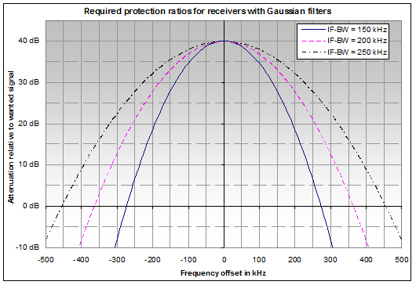

Figure 2: Required protection ratios with three example measurement bandwidths

1. Measurement receivers with channel filters:

Table 4: Measurement receivers with channel filters

| **Frequency difference ± ∆f**  **(kHz)** | **Required protection ratio**  **(dB)** |
| --- | --- |
| 0 | 40 |
| B/2 | 35 |
| X (for X > B/2) | 35 – 0.2*(X - B/2) |

In Table 4, “B” is the nominal 3 dB bandwidth of the measurement filter. A linear interpolation is used between discrete values. The following diagram in Figure 3 illustrates the required protection ratios with three example measurement bandwidths.

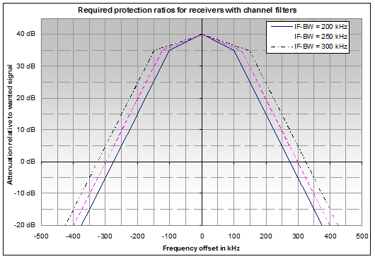

Figure 3: Required protection ratios with three example measurement bandwidths

It is essential that the applicable protection ratios given above are observed because even a minor increase in unwanted signal levels will result in considerable measurement errors.

* + 1. Multipath propagation and distortion

Delayed signals from the wanted transmitter as well as signals from other co-channel or adjacent channel transmitters shall be small enough to ensure that measurement results are not influenced by the effects of multipath propagation. In case of multipath reception only, it is considered to be sufficient if the product of delay time and amplitude ratio is:

(Ur/Ud)*  < 64% * µs (1)

where

Ur is the amplitude of the reflected signal;

Ud is the amplitude of the direct signal;

 is the time delay.

A more general way of specifying the distortion created by both multipath reception and signals from other transmitters is based on the fact that all of these components result in a certain amplitude modulation of the received signal. This resulting amplitude modulation is best defined by the maximum gradient of the dependence of RF amplitude on RF frequency and is called distortion degree. Its value is easily measurable with reflection meters. The corresponding maximum permissible gradient for stereophonic reception is:

d(U/Ud)/df < 0.4%/kHz (2)

It is essential that the distortion degree does not exceed the limits above, because even minor increases will result in considerable measurement errors.

* + 1. Wanted signal level at the receiver input

To ensure a sufficient AF signal-to-noise ratio, the wanted signal input level for the receiver should be at least -47 dBm.[1]

* 1. CHARACTERISTICS OF SUITABLE MEASURING EQUIPMENT

To ensure that all the peaks of the frequency deviations are captured, the equipment must be able to detect the deviation caused by the highest component of the base band signal or composite signal. For this reason, if digital measuring equipment is used, it must have a sampling rate of 200 kHz or higher depending on the maximum composite signal frequency.

* + 1. Reflection measurements

Due to a lack of directivity of the measurement antenna, it will in most cases not be possible to measure the field strengths of wanted and unwanted emissions separately and use formula (1) to calculate the degree of distortion and multipath propagation. A more practical way to measure this parameter is the use of reflection meters that actually measure the amount of amplitude modulation in the received signal and compute the degree of multipath propagation using formula (2).

Ideally the reflection meter shall have a measurement bandwidth of 150 kHz. However, most reflection meters available have a bandwidth that is considerably smaller. In this case, the maximum permissible degree of multipath propagation is less than the 0.4% / kHz stated in section A2.2.2. Figure 4 shows the corrected values for maximum degree of distortion depending on the measurement bandwidth of the reflection meter.

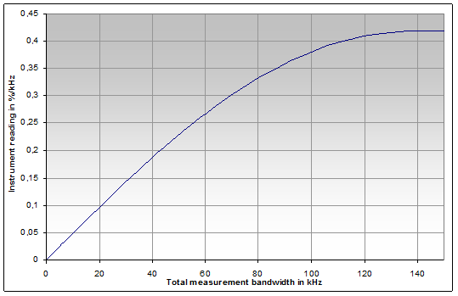

Figure 4: Corrected values for maximum degree of distortion depending on the measurement bandwidth

* + 1. Frequency deviation measurements

The measuring equipment used should be able to measure deviations of 100 kHz or higher. In addition the measuring equipment must possess such characteristics that take into account the required measurement bandwidth, filter shape factor, etc. to ensure that nonlinearity and distortion do not lead to an inaccuracy greater than specified in Table 5.

Table 5: Instrument accuracy for deviation measurements

| **Instantaneous deviation** | **Required accuracy** |
| --- | --- |
| ≤80 kHz | ±2 kHz |
| >80 kHz | ±5 % |

* + 1. Modulation power measurements

The modulation power is specified in dBr according to section 1.1. The measuring equipment shall be able to measure modulation power in the range from -6 dBr to +6 dBr. The instrument accuracy shall at least meet the values specified in Table 6.

Table 6: Instrument accuracy for modulation power measurements

| **Modulation power** | **Required accuracy** |
| --- | --- |
| <‑2 dBr | ±0.4 dB |
| ‑2 dBr to + 2 dBr | ±0.2 dB |
| >2 dBr | ±0.4 dB |

* 1. RESULT EVALUATION

It is considered inappropriate to regard the occurrence of single measurement samples above 75 kHz as a violation of the deviation limit, because

1. the dynamic modulation of an FM broadcast transmitter by normal programme content may include modulation peaks that occur extremely seldom, and may not be reproducible in a second measurement;
2. even when the measurement conditions stated in section A2.2 are met, external interference cannot completely be avoided at all times.

For these reasons, and considering the measurement uncertainty with an aimed confidence level of 95%, an FM broadcast transmitter can be regarded as violating the deviation limit if a certain number of measurement samples exceed ± (75 kHz plus measurement uncertainty). 10-4 % of the measurement samples exceeding 77 kHz deviation may be considered as a practical value.

Since the modulation power is averaged over a period of 60 s, short peaks included in the programme content or caused by external interference are already cancelled out to a great extent. Therefore, an FM broadcast transmitter can be regarded as violating the modulation power limit if the highest measured modulation power value exceeds 0.2 dBr.

* 1. PRESENTATION OF MEASUREMENT RESULTS
     1. Modulation power

The modulation power shall be presented as a function of time during the measurement interval. The maximum value recorded must be indicated.

* + 1. Frequency deviation

The percentage of samples exceeding 77 kHz (see section A2.4) has to be indicated.

To provide more information the deviation is better represented by histograms and as a function of time rather than only displaying the highest value in a "Max Hold" mode over a certain period of time. Histograms of frequency deviation are processed as follows:

1. Divide the range of frequency deviation of interest (i.e. 150 kHz) into the desired resolution (for example 1 kHz) to give the number of bins (in this case 150 bins);
2. For each bin, count the number of samples which have a value within the bin. The result is a distribution plot of the deviation (histogram) as shown in Figure 5;
3. For each bin x, add counts from bin 0 to bin x and normalise by N. The result is a plot of the accumulated distribution as shown in Figure 6; additionally, obtain N peak hold values during the observation time of the deviation each taken during an integration time of at least 50 ms. The 50 ms ensures that the peak values of the deviation are captured even at modulating frequencies as low as 20 Hz. A practical value for the integration time may be 1 s;
4. Additionally the N peak hold values of the frequency deviation shall be presented as a function of time during the measurement interval as in Figure 7.

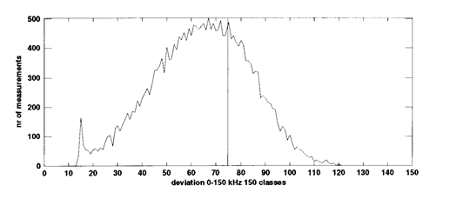

Figure 5: Distribution plot of deviation (histogram)

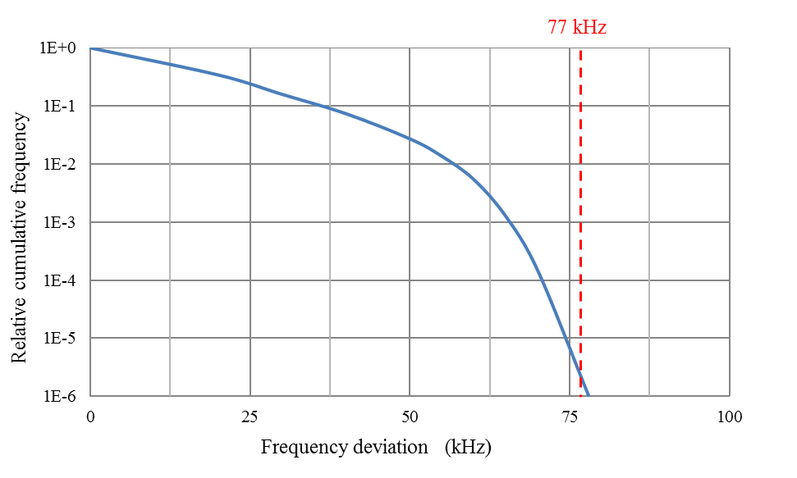

Figure 6: Accumulated distribution plot of deviation

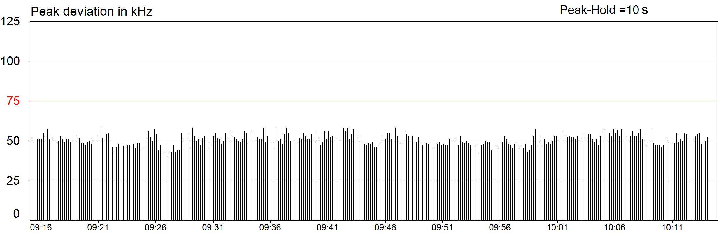

Time of the day

Figure 7: Plot of deviation as a function of time

1. List of reference

This annex contains the list of relevant reference documents.

1. Recommendation ITU-R BS.412: Planning standards for terrestrial FM sound broadcasting at VHF
2. Recommendation ITU-R BS.599: Directivity of antennas for the reception of sound broadcasting   
   in band 8 (VHF)
3. Recommendation ITU-R SM.1268-3: Method of measuring the maximum frequency deviation of FM broadcast emissions at monitoring stations

1. This corresponds to a field strength of about 68 dBµ/m using an antenna as recommended in Recommendation ITU‑R BS.599, Figure 2, Curve B (12 dB front-to-back ratio).