
Electronic Communications Committee (ECC)
within the Conference of Postal and Telecommunications Administrations (CEPT)

ECC Recommendation (05)08
(replacing recommendations T/R 20-08 and 22-07)

FREQUENCY PLANNING AND FREQUENCY COORDINATION FOR
THE GSM 900, GSM 1800, E-GSM and GSM-R LAND MOBILE SYSTEMS
(Except direct mode operation (DMO) channels)

Recommendation adopted by the "Working Group Frequency Management" (WGFM)

"The European Conference of Postal and Telecommunications Administrations,

considering

- that the GSM system will use the frequency bands 890-915 MHz / 935-960 MHz and 1710-1785 MHz / 1805-1880 MHz in accordance with relevant agreements, directives and CEPT recommendations,

- that the E-GSM⁾ system will use the frequency bands 880-890 MHz / 925-935 MHz in accordance with relevant agreements, directives and CEPT recommendations,

- that the GSM-R system will use frequency bands 876-880 MHz / 921-925 MHz in accordance with relevant agreements, directives and CEPT recommendations,

- that in the implementation of the GSM, E-GSM and GSM-R systems it is necessary to take account of national policies for the use of the frequency bands in question,

- that national frequency planning for the GSM, E-GSM and GSM-R systems is carried out by the operators and approved by the national administrations or carried out by such administrations in cooperation with the operators,

- that frequency planning in border areas will be based on coordination between national administrations,

- that the difficulties encountered with this coordination depend on a great number of parameters (technical, operational or topographical),

- that agreements have successfully been concluded between some administrations concerning coordination of frequencies for the land mobile service, notably the “HCM Agreement” ²⁾ which also contains details of propagation issues and co-ordination procedures,

- that in order to facilitate coordination and to avoid inefficient frequency usage in border areas, a large number of parameters (technical and operational) need to be presented,

- that in the case of operator arrangements approved by national administrations it is possible to deviate from this Recommendation,

- that in many CEPT member countries there are multiple operators for the GSM system,

- that frequency coordination procedure and interservice sharing is necessary both between countries operating the GSM system and between those countries and countries operating other services ³⁾ in accordance with the Radio Regulations,

recommends

- that frequency co-ordination between GSM systems, except direct mode operation (DMO) channels, in border areas shall be based on the concept of preferential frequencies,

- that frequency co-ordination between GSM systems and other systems in neighbouring countries shall be based on bi/multi-lateral agreements,

- that frequency coordination in border areas is based on the following concept:

3.1 In the case of a preferential frequency agreement
3.1.1 Preferential frequencies, except adjacent block-end preferential frequencies, may be used without coordination if the field strength of each carrier produced by the base station does not exceed a value of 19 dBμV/m in the 900 MHz band and 25 dBµV/m in the 1800 MHz band for digital systems at a height of 3 m above ground at a distance of 15 km inside the neighbouring country.
When blocks of preferential frequencies are allocated to different countries in border areas all adjacent block-end channels shall be treated in such a way that adjacent channel interference be avoided by either forwarding the characteristics of base stations using block-end channels or regulating the use of the block-end channels in bi/multi-lateral agreements.

3.1.2 Non-preferential frequencies may be used without coordination if the field strength of each carrier produced by the base station does not exceed a value of 19 dBμV/m in the 900 MHz band and 25 dBµV/m in the 1800 MHz band for digital and analogue systems at a height of 3 m above ground at the borderline.
3.1.3 Frequencies on which the field strength exceeds the limits laid down in 3.1.1 and 3.1.2 shall be co-ordinated.

3.2 In the case where a preferential frequency agreement is not available:
All frequencies shall be treated as non-preferential ones.

  - Frequency planning in coastal areas is based on the concept of preferential frequencies and coordinated frequencies assuming a middle line between the countries involved. Other principles for frequency planning and frequency coordination in coastal areas may be agreed between the administrations concerned.

3.4 Propagation criteria for calculating the interfering field strength are described in Annex 1.

3.5 For adding multiple interferers the simplified algorithm described in Annex 2 can be used.

3.6 that the technical parameters described in Annex 3 are used in the frequency coordination for the GSM system.

3.7 that the technical parameters described in Annex 4 are used for frequency coordination between the GSM system and existing fixed services in the frequency bands 890-915 MHz / 935-960 MHz,

4 that the following frequency coordination procedure is used:
4.1 When requesting coordination, at least the following characteristics of base stations shall be forwarded to the Administration(s) affected unless otherwise laid down in bi/multi-lateral agreements:
- carrier frequency (MHz)
- name of transmitter station
- country of location of transmitter station
- geographical coordinates (W/E, N)
- effective antenna height (m)
- antenna polarisation
- antenna azimuth (deg)
- directivity in antenna systems or antenna gain (dBi)
- effective radiated power (dBW)
- expected coverage zone or radius (km)
- date of entry into service (month, year).

4,2 The Administration affected shall evaluate the request for coordination and shall within 30 days notify the result of the evaluation to the Administration requesting coordination.

4.3 The Administration affected may request additional information on stations to be co-ordinated.

4.4 If no reply is received by the Administration requesting coordination within 30 days it may send a reminder to the Administration affected. An Administration not having responded within 30 days following communication of the reminder shall be deemed to have given its consent and the frequency may be put into use with the characteristics given in the request for coordination.

4.5 The periods mentioned above may be extended by common consent.

5 That in general, Administrations may diverge from the technical parameters, calculation method and procedures described in this Recommendation subject to bi/multi-lateral agreements, for example HCM Agreement ⁾.

6. that a new Recommendation will be developed to deal with the situation of evolution of GSM to UMTS in the 900 and 1800 MHz bands.

²⁾ Agreement between the administrations of Austria, Belgium, the Czech Republic, Germany, France, Hungary, the Netherlands, Croatia, Italy, Liechtenstein, Lithuania, Luxembourg, Poland, Romania, the Slovak Republic, Slovenia and Switzerland on the Coordination of frequencies between 29.7 MHz and 39.5 GHz for Fixed Service and Land Mobile Service (Vilnius, 12 October 2005). The latest version of this agreement can be found from www.ero.dk/Deliverables/Agreements
³⁾ e.g. CT1+

Note:
Please check the Office web site (http//:www.ero.dk) for the up to date position on the implementation of this and other ECC Recommendations

Annex 1

Propagation curves
The curves attached to this Annex should be used to determine the interfering field strength. Administrations may agree on other curves.

Correction factors for GSM 900, EGSM and GSM-R
A general correction factor of -2 dB is used in the 900 MHz band.
Correction factor to convert receiving antenna heights from 10 m to 3 m:
Distance < 50 km: - 10 dB
Distance > 100 km: - 3 dB
Linear interpolation is used for intermediate distances from 50 to 100 km.
For sea path propagation the correction factor to convert receiving antenna heights from 10 m to 3 m is - 10 dB.

Correction factors applicable for GSM 1800
A general correction factor of - 9 dB is used in the 1800 MHz band.
Correction factor to convert receiving antenna heights from 10 m to 3 m:
Distance < 50 km: -10 dB
Distance > 100 km: -3 dB
Linear interpolation is used for intermediate distances.
For sea path propagation the correction factor for receiving antenna from 10 m to 3 m is - 10 dB.

Effective antenna height
The effective antenna height used to determine interfering field strength is defined as its height in metres over the average level of the ground between distances of 3 and 15 km from the base station/transmitting antenna in the direction of the mobile/receiving antenna. The evaluation of the average height of the terrain may be subject to agreement between administrations.

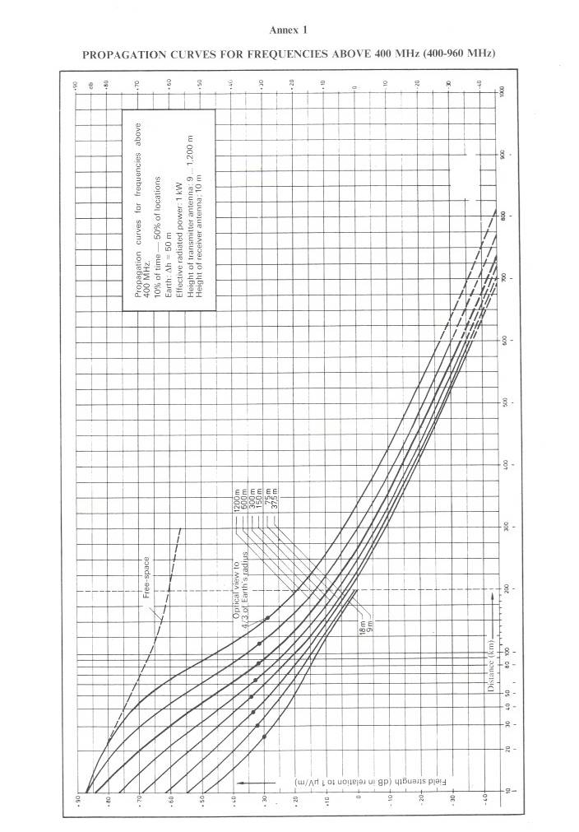

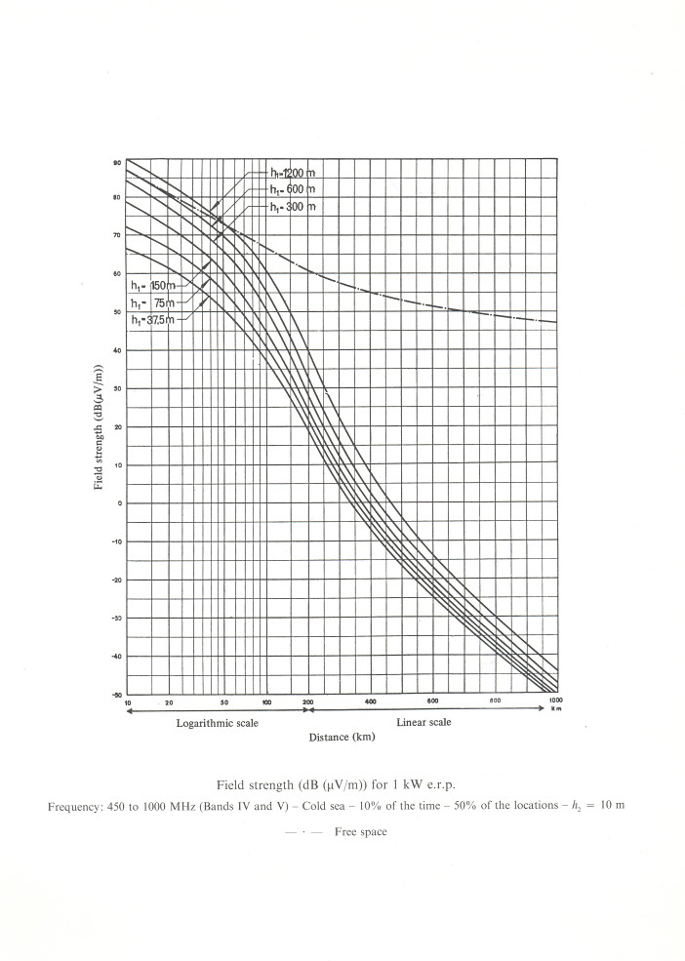

Annex 2

- SIMPLIFIED ALGORITHM FOR CALCULATION OF TOTAL INTERFERRING FIELD STRENGHT IN THE CASE OF MULTIPLE-ENTRY INTERFERENCE

1. 1 Notation
P = e.i.r.p. of wanted transmitter in the direction of receiver (dBm).
L = Isotropic path loss from wanted transmitter to receiver (dB).
P_{i} = e.i.r.p. of interfering transmitter into the direction of receiver (dBm).
L_{i} = Isotropic path loss from interfering transmitter i to receiver (dB).
a = Receiver antenna gain towards wanted transmitter (dBi).
a_{i} = Receiver antenna gain towards interfering transmitter i (dBi).
β_{i} = Gain due to receiver filter selectivity on interference from transmitter i (dB).
γ = Estimated shadowing margin to be allowed on C/I value (dB).
C = Total wanted carrier power at receiver input (dBm).
I_{i} = Effective interfering power due to transmitter i at receiver input (allowing for the effect of receiver
filtering) (dBm).
I = Total effective interfering power at receiver input (allowing for shadowing margin) (dBm).
χ =C/I threshold value.

1.2 Base-mobile Path Algorithm
- For each cell in question, take one or more "worst case" mobile station MS locations. These are locations at which the C/I is known, or believed to be, lowest.
- Calculate the wanted carrier power at the receiver input:
C = P - L + a
- Calculate the effective interfering power due to each potentially interfering transmitter (whether co-channel or adjacent channel) at the receiver input (allowing for the effect of receiver filtering): I_{i} = P_{i} - L_{i} + a_{i} + β_{i}
- Sum the interfering powers at the receiver and allow for the shadowing margin:
I = 10 log₁₀ Σ 10^{(Ii/10)} + γ
- Check the effective C/I ratio (C -I) against the threshold value λ.

1.3 Mobile-base Path Algorithm
- Take each cell that has a potentially interfering mobile station (MS). If N is the number of carrier frequencies allocated to that cell that can cause potential interference to the base station (BS), assume there are N MS's, one radiating each carrier, in that cell.
A proportion of the total number of MS's so identified (e.g. 20%) should be assumed to be the worst case locations of their cells and the rest at the mid-point of their cells.
Alternatively a "Monte Carlo" simulation can be undertaken in which a number of "snapshots" of the interference scenario are taken. In each snapshot, the interfering MS's are placed at random locations (uniformly distributed) within their cells. To find for example the 90% C/I value. 100 snapshots could be taken, and the C/I which is exceeded by 90 of the snapshots used.
- Perform steps (b) to (e) of the base-mobile path algorithm.

1.4 Notes on Calculation of Parameters
- P, P_{i}—These should be supplied by the land mobile network operators. For GSM transmitters each P, P_{i} is the power in the active part of the timeslot.
- L, L_{i} —These can either be calculated using appropriate terrain modelling, or some simplified power distance law, e.g. d^{-3.3}.
- a, a_{i—}These should be supplied by the land mobile network operators.
- β_{i}—These can be read off Figure A2-1

(e) If shadowing effects have been allowed for in the calculation of L and L_{i},ϒ can be set to 0. Otherwise a value of 7 dB could be used (this assumes the wanted and unwanted signals each have a 5 dB shadowing margin (log normal distribution) and the composite shadowing margin is √2 x 5 dB, i.e. 7 d B).

- χ can be taken as follows:
GSM receiver = 9 dB
Note. The calculation must take into account all interfering transmitters from the wanted Land Mobile Network as well as those from the neighbouring Land Mobile Networks.”

Annex 3

TECHNICAL PARAMETERS NECESSARY FOR COORDINATION
OF THE GSM SERVICE

C/I ratios applicable to GSM 900, E-GSM, GSM-R and GSM 1800 systems

The C/I ratio is the ratio between wanted signal power to interfering signal power at the receiver input during the active part of the GSM timeslot including multiple interferes.

The following C/I ratios apply:

Wanted  signal | Interferer  signal | Co-channel interference | Adjacent channel interference  200 kHz | Adjacent channel interference  400 kHz | Adjacent channel interference  600 kHz
GSM | GSM | 9 dB | - 9 dB | - 41 dB | - 49 dB

Curves indicating C/I values for intermediate values of frequency offset are attached to this Annex.

Notes.
(1) Values from GSM Recommendation 05-05.

For GSM 900, E-GSM, GSM-R system:
Minimum field strength to be protected (Emin) for mobile stations: 32 dBμ/ m
(50% of location and 50% of time in the mobile receive band)

For GSM 1800 system
Minimum field strength to be protected (Emin):
(50 % of location and 50 % of time)

GSM-1800 MS 42 dB µV/m1),
GSM-1800 BS 38 dB µV/ml).

1 Values from GSM Recommendation 05-05 ( Version 4.3.0)

Annex 4

TECHNICAL PARAMETERS FOR FREQUENCY COORDINATION
BETWEEN THE GSM SYSTEM
AND EXISTING FIXED SERVICES IN THE FREQUENCY BANDS
890-915 MHz/935-960 MHz

The following C/I ratios apply:

Wanted  signal | Interferer  signal | Co-channel interference | Adjacent channel interference  200 kHz | Adjacent channel interference  400 kHz
GSM | Fixed | 9 dB | - 33 dB | - 51 dB
Fixed | GSM | subject to bilateral agreement

⁾ The E-GSM system will not be used in all European countries. The actual status can be found on the ERO Internet Homepage (www.ero.dk).

