Electronic Communications Committee (ECC)
within the European Conference of Postal and Telecommunications Administrations (CEPT)

METHODOLOGY to determine the Density of fixed service LINKS

Sesimbra, October 2002

METHODOLOGY to determine the Density of fixed service LINKS

EXECUTIVE SUMMARY

This report provides methodologies to estimate the density of Fixed Service (FS) links per km² that may be reached when deploying FS PP systems in a given area. Such a methodology could be used in sharing analyses when the density of Fixed Service links may impact on the sharing conditions.

INDEX TABLE

1 INTRODUCTION 1
2 TECHNICAL CHARACTERISTICS 1
2.1 Reference antenna pattern 1
2.2 Maximum hop length 1
2.3 Architecture of the network 3
2.3.1 Point-to-Point Daisy Chain Configuration 3
2.3.2 Point-to-Point Star Configuration 4
2.4 Interference criteria 4
2.5 Other parameters that may impact on the link density 5
3 METHODOLOGY TO EVALUATE THE DENSITY OF ACTIVE POINT-TO-POINT LINKS PER CHANNEL 6
3.1 Algorithm of the Methodology 6
3.2 Possible improvements of the Simulation 7
3.3 Example of simulation at 38 GHz 7
3.3.1 Parameters used in the simulations 7
3.3.2 Interference threshold 8
3.3.3 Calculation 8
3.3.4 Results 9
4 TECHNICAL LIMITS OF THE METHODOLOGY 11
5 OTHER ASPECTS THAT MAY LIMIT THE DENSITY OF FS LINKS 11
6 CONCLUSION 11

METHODOLOGY TO DETERMINE THE DENSITY OF FIXED SERVICE LINKS

INTRODUCTION
The knowledge or an estimation of the density of point-to-point (PP) FS links is extremely helpful for sharing studies in frequency bands were an indication of the maximum density of FS deployment would provide an outlook on the maximum interference potential caused by the FS. The usefulness of such an estimation became evident prior to WRC-97 when the density of FS links and with this, the impact on EESS (passive) was calculated in the 50 to 60 GHz band. The aim of this document is to present calculation method for the estimation of the maximum density of Fixed Service links based on technical characteristics of Fixed Service systems.

TECHNICAL CHARACTERISTICS
A range of characteristics (e.i.r.p, antenna type, channel spacing…) in the band available for High Density Fixed Service (HDFS) PP systems are provided in Recommendation ITU-R F.758, “Considerations in the development of criteria for sharing between the terrestrial fixed service and other services” and in the ERC Report 40, “Fixed Service System Parameters for Frequency Sharing”, October 1996.

Reference antenna pattern
Recommendations ITU-R F.699 and ITU-R F.1245 provide PP reference radiation pattern for sharing studies in the frequency range from 1 to about 70GHz. The ETSI standard ETS 300 833 “Transmission and Multiplexing (TM); Digital Radio Relay Systems (DRRS); Antennas used in PP DRRS operating in the frequency band 3 to 60 GHz” provides radiation pattern envelope for several classes of antennas depending on the potential of interference (from low interference potential to extremely high interference potential).

Maximum hop length
The maximum hop length is evaluated by considering the following formula:
$$P_{r}=G_{r}∗\text{EIRP}∗\text{Att}$$
where:
- P_{r}(W) is the required minimum signal level
- G_{r} is the gain of the receiver antenna.
- EIRP(W) power radiated by the transmitter in the receiver direction
- Att is the attenuation between the transmitter and the receiver.
The e.i.r.p. and the required received signal level are linked with the desired Bit Error Rate. A BER of 10⁻⁶ is a typical value used in the evaluation of permissible performance degradation. The ITU-R F.758 provides carrier level corresponding to the 10⁻³ BER and stipulates that typically, the carrier level corresponding to 10⁻⁶ BER is around 4 dB higher than that for the 10⁻³ BER (this ratio depends on the type of modulation which is used).
The attenuation (Att) during the propagation is the sum of three phenomena: free space loss (ITU-R PN-525), gaseous absorption at the considered frequency (ITU-R P.676) and the rain fade (ITU-R P.530 and 838), as described in Figure 1.

Figure 1: Budget of a PP link

Attenuation by precipitation is in all considered PP HDFS bands above 30 GHz the restricting factor for the hop length, depending on the rain zone. Furthermore the propagation conditions around 60 GHz are dominated by the O2 absorption losses. Since the O2 absorption losses are varying between 5 dB/km at 55.78 GHz and 15 dB/km at 59 GHz, a partitioning of this band in two ranges seems to be favourable. The same approach is possible for the 64 GHz to 66 GHz band. Since the variation between 64 and 66 GHz is in the range of "only" 5 dB also the complete 64.00 - 66.00 GHz band with a duplex spacing in the order of 1 GHz would cause a difference for the absorption losses in the lower and upper half band of 3.5 dB/km.
Several examples are provided in the table below for FS systems in the bands available for PP HDFS. These maximum hop lengths were calculated for an availability of 99.99%, a rain rate of 42mm/h and an elevation angle of 0°.

Frequency Band (GHz) | 31.8 – 33.4 | 37 – 40 | 51.4 – 52.6 | 55.78 – 57 | 58 – 59 | 64 – 65 | 65 - 66
Frequency used in calculations (GHz) | 32.6 | 38 | 52 | 57 | 59 | 64 | 65
Modulation | 4 FSK | 4 FSK | 4 FSK | 2 FSK | 2 FSK | 4 FSK | 4 FSK
Capacity | 2x2 Mbit/s | 2x2 Mbit/s | 2x8 Mbit/s | 2x2 Mbit/s | >2x2 Mbit/s | 2x2 Mbit/s | 2x2 Mbit/s
Channel spacing (MHz) | 3.5 | 3.5 | 14 | 14 | 50 | 3.5 | 3.5
Antenna Gain Maximum (dBi) | 46 | 47 | 47 | 47 | 32 | 46 | 46
Feeder loss (dB) | 0 | 0 | 0 | 0 | 0 | 0 | 0
Maximum Tx output power (dBW) | -3 | 0 | -6 | 0 | -20 | -20 | -20
Receiver level for 10-3 BER (dBW) | -116 | -115 | -108 | -111 | -100 | -112 | -112
Receiver level for 10-6 BER (dBW) | -112 | -111 | -104 | -107 | -96 | -108 | -108
Gaseous absorption (dB/km) | 0.09 | 0.11 | 0.73 | 10.0 | 14.2 | 6.7 | 3.8
Maximum hop length (km) (Availability 99.99%) | 9.6 | 8 | 4.3 | 2.8 | 0.58 | 2.1 | 2.4
Table 1: Example of PP maximum hop length (based on characteristics provided in Recommendation ITU-R F.758)

Architecture of the network
Two architectures of PP system may be considered:
- P-P Daisy-Chain
- P-P Star

Point-to-Point Daisy Chain Configuration

The figure below shows nodes connected using a daisy-chain architecture.
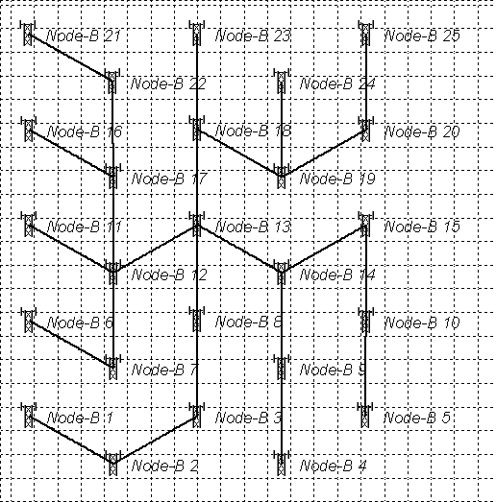
Figure 2: P-P daisy-chain network

Point-to-Point Star Configuration
The figure below shows nodes connected using a star architecture.
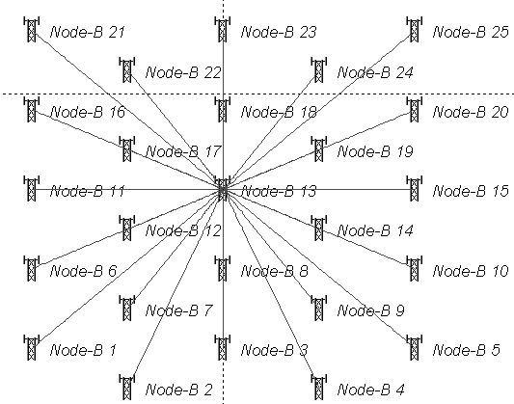
Figure 3: P-P Star Architecture

Interference criteria
Three options may be considered to define the interference threshold.
a) The first one is based on a C/I criteria (evaluated without taking into account the internal interference), which is
defined as followed:
Figure 4: Option A

This C/I includes the fade margin, the C/I defines by the manufacturer to achieve a given level of protection; the degradation of the threshold (3dB) and long term interference (10dB below the receiver noise level).

b) The second option is based on consideration given in the ECC Recommendation (01)05 on “List of Parameters of Digital PP Fixed Radio Links Used For National Planning”, which recommends that the level of threshold degradation of a victim receiver be evaluated as the increase of the noise power in the receiver bandwidth resulting from the aggregation of all interference coming from the relevant sources of the FS; this increase of the noise power should not exceed 3dB for the aggregate and 1dB for a single link.
Figure 5: Option B

- The third option is based on the same ECC Recommendation (01)05 but taking into account the Note 5 of this recommendation, which says that. “After consultation of the concerned operators by the administration, higher threshold degradation could be accepted (e.g. for dense network deployment), if performance and availability objectives can still be met and increased degradation can be compensated in the link budget.”

Figure 6: Option C

Interference + Internal Noise (1) – corresponds to overall level of interference which is allowed under worst case assumption in term of fade margin. C1 is the received power under worst case condition.

By considering the equipment characteristics in term of C/(I+N), output power (provided by the manufacturer), to the power received under clear sky condition, the operator obtains the maximum “allowed” level of interference under clear sky condition (Interference + Internal Noise (2)). C2 is the received power under clear sky condition.

Other parameters that may impact on the link density
Other parameters may be taken into account to obtain density of terminal close to the reality such as:

- Polarisation of the link: In most countries both polarisation are used simultaneously and equally in the frequency assignment procedure by the Regulators in each frequency band in a given deployment area (may not be the case for higher millimetric bands). Thus the cross-polar discrimination is important for the deployment density of PP as it may provide “isolation” to a link from other links operating at the same frequency but using other polarisation. Taking into account this effect allows to reduce the interference created by transmitters using the cross-polarisation and then to increase the density of terminals. It should be noted that the ETSI standard ETS 300 833 provides radiation pattern corresponding to the cross-polarisation.
- High-Low frequency conflict: High-Low conflict means that TX and RX are very closely located but working in the same frequency sub-band. This will result in total blocking of the RXs by TX co-channel. To avoid such blocking effects, a protection distance between TX and Rxs using the same sub-band is defined.
- Transmitters operating at adjacent or nearby frequencies may also contribute to the received interference level. This may be taken into account by considering the emissions characteristics of the transmitters operating at adjacent of nearby frequency and the characteristics of the receiver (Net Filter Discrimination).

METHODOLOGY TO EVALUATE THE DENSITY OF ACTIVE POINT-TO-POINT LINKS PER CHANNEL

Algorithm of the Methodology
The methodology described in this report allows estimating density of FS links per km² by using simulations, which provide the maximum number of active FS links that may be deployed over a given area.
To determine the maximum number of FS links in a test area, it was decided to let the positions, length and direction of the links to be chosen at random but bound by certain limits. If no information is available on the maximum length of a link used in the network, it may be calculated according to the guidance provided in the paragraph 2.2. A practical minimum link length may also be included to obtain more realistic results. The Receiver and Transmitter antennas of a link are supposed to be main beam to main beam.
The simulation will then begin to place links in the test area, each time checking the interference to each receiver and from each transmitter, assigning the new link when the interference levels are below the threshold, and failing the link when the co-channel interference levels are above the threshold. This continues until a predetermined number of consecutive assignment failures occurs. It is decided that the practical maximum link density for the test area is reached, as far as link-to-link interference is concerned, when this number of consecutive failures is reached. For example, the number of consecutive failures may be taken equal to 20.
The effect of co-channel FS terminals based outside the test area may be taken into account by distributing the links in an “expanded test area” characterised by a radius:
Radius tot = Radius area + dmax
where:
- Radius area is the radius of the test area where we want to know the density of terminals:
- dmax is the maximum hop length radius;
- Radius tot is the radius of the expanded test area.

Figure 7: Test Area and Expanded Test Area
The links are distributed in the whole “expanded test area” according to the previous methodology, this allows to take into account the interference caused by terminals outside the test area.

Possible improvements of the Simulation
The Algorithm described above does not take into account several parameters described in 2.3 and 2.5. These parameters will impact on the calculated maximum number of co-channel FS links that may be deployed in the area and will lead to a more realistic number.

The architecture of the network may be taken into account by adopting one of the options described below:
- Pre-define a grid where the network nodes may be based, then the simulation start by choosing randomly nodes of the grid where transmitters are located. Then the corresponding receivers (other end of the PP link) may be placed by choosing other nodes or nodes already allocated (daisy chain network) or randomly (star network); taking into account the characteristics of the link (in particular hop length).

- Pre-define randomly the location of the transmitters in the area and then choose randomly one of these transmitters and place randomly corresponding receivers (star network). Then repeat the same procedure.

- The simulation may start by placing a first link. Then when assigning a new link, the following procedure may be considered: the receiver is placed, then the simulation check if there is already a transmitter placed in the area which may be used to set up a link taking into account the characteristics of the system. If no transmitter is available, then a new transmitter is placed on the area (star network).

Example of simulation at 38 GHz

Parameters used in the simulations
Simulations were conducted at 38 GHz for FS links using the following parameters:
- antenna gain is supposed to be equal to 46 dB;
- the maximum power of the transmitter of –14 dBW;
- minimum hop length is taken as 50 m;
- maximum hop length is about 5 km (availability of 99.99%, zone K);
- the receiver noise level is supposed to be equal to –121 dBW;
- the received power for a BER of 10⁻⁶ is supposed to be equal to –99dBW;
- The receiver nominal input level is equal to –70dBW.
It was decided to stop the simulation after 20 consecutive assignment failures.

Interference threshold
The three options described in section 2.4 were tested.

In case of the first option, three C/I were tested to assess the impact of this parameter (C/I of 55dB, 45dB and 35dB).

Calculation
In the simulation, dmax is equal to 5km and the radius of the tested area is 5 km (78.5 km²).

Antenna pattern
The first set of results was obtained by using antenna patterns based on Recommendation ITU-R F.699. This reference radiation pattern for line-of-sight PP FS system antennas gives the peak envelope of side-lobe patterns. Therefore in the assessment of the aggregate interference consisting of many interference sources, the predicted interference will result in values that are greater than values that would be experienced in practice. To refine the results in case of multiple sources of interference, it is necessary to use the antenna radiation pattern representing average side-lobe levels, therefore it is more appropriate to use the antenna pattern given in Recommendation ITU-R F.1245. The two patterns were used to allow a comparison in the results.

Deployment of the network

High_Low frequency conflict
A distance of 150 m was used as a criteria for avoiding the High – Low conflict, it was understood being theradius of a circle around each TX if f(TX) = f(RX) for channels operating in the same block.

Location of the FS link terminals
To obtain more realistic result it was decided that each time a new FS link terminal (terminal node in FS link) is set up in the area to test the first three closest existing transmitters, to see if it is feasible to set up a link using existing location. If not then new location for the link terminal is tested.

Polarisation
The following assumptions were used in term of polarisation:
- polarisation H for all links with hop lengths of less than 3 km, and
- polarisation V for all links with hop lengths of more than 3 km.
The polarisation may be taken into account as a first step approach, by adopting the same antenna pattern than in the previous section if the polarisations of the receiver and the transmitter are the same; and by adopting the following pattern for cross-polarisation:
- G=Gain F.1245-30dB for angle below 0.025°
- G=min(5dB,Gain F.1245) for angle between 0.025° and 15°
- G=Gain F.1245 for angle between 15° and 48°
- G=-13dB for angle above 48°.
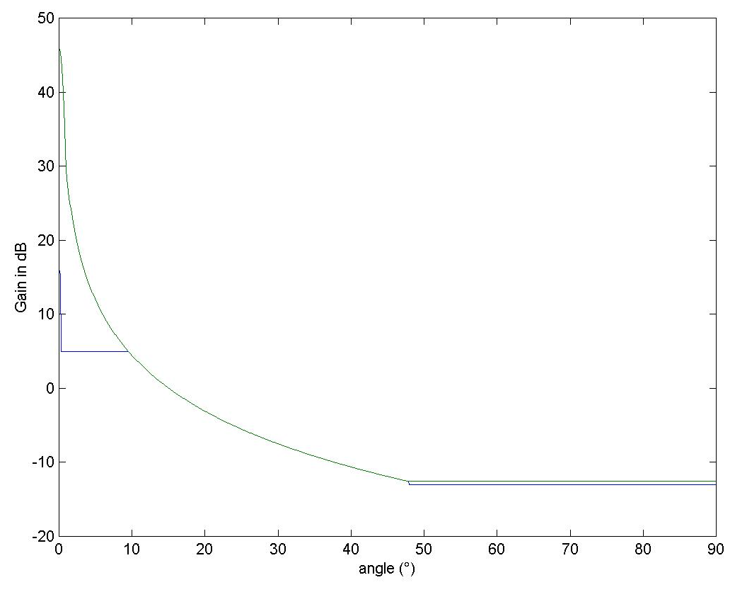
Figure 8: Antenna pattern for cross-polarisation

Results
The following tables describe the maximum density of FS links in terms of density of link terminals (receivers, see algorithm description) over both the “test” and the “expanded test” areas that were reached using the parameters described in section 3.3.2 by running 50 simulations.

Antenna pattern based on Recommendation ITU-R F.699
The following table provides results of simulations using Recommendation ITU-R F.699.

Option | Threshold | mean density of receivers in the whole area (314 km2) | maximum density of receivers in the whole area (314 km2) | minimum density of receivers in the whole area (314 km2) | mean density of receivers in the tested area (78.5 km2) | maximum density of receivers in the tested area (78.5 km2) | minimum density of receivers in the tested area (78.5 km2)
a) | 55 | 0.031 | 0.045 | 0.01 | 0.031 | 0.051 | 0
a) | 45 | 0.065 | 0.089 | 0.041 | 0.067 | 0.025 | 0.115
a) | 35 | 0.138 | 0.175 | 0.095 | 0.135 | 0.216 | 0.076
b) | 1dB/3dB | 0.056 | 0.102 | 0.0159 | 0.056 | 0.127 | 0
c) | 3dB/22dB | 0.392 | 0.544 | 0.172 | 0.368 | 0.586 | 0.127
Table 2: Results of simulation using Recommendation ITU-R F.699
As expected the density of FS link terminals per frequency is decreasing as the C/I is increasing (option a)).

Antenna pattern based on Recommendation ITU-R F.1245
The following table provides results of simulations using Recommendation ITU-R F.1245.

Option | Threshold | mean density of receivers in the whole area (314 km2) | maximum density of receivers in the whole area (314 km2) | minimum density of receivers in the whole area (314 km2) | mean density of receivers in the tested area (78.5 km2) | maximum density of receivers in the tested area (78.5 km2) | minimum density of receivers in the tested area (78.5 km2)
a) | 55 | 0.052 | 0.067 | 0.038 | 0.052 | 0.089 | 0
a) | 45 | 0.105 | 0.137 | 0.057 | 0.102 | 0.166 | 0.038
a) | 35 | 0.236 | 0.309 | 0.133 | 0.245 | 0.343 | 0.140
b) | 1dB/3dB | 0.076 | 0.188 | 0.025 | 0.066 | 0.166 | 0.013
c) | 3dB/22dB | 0.605 | 0.818 | 0.013 | 0.573 | 0.853 | 0.013
Table 3: Results of simulation using Recommendation ITU-R F.1245
The density of FS link terminals per frequency is increased by using antenna pattern based on F.1245 instead of the antenna pattern given in Recommendation ITU-R F.699.

Deployment of the network
The following tables provide results of simulations taking into account the consideration described in section 3.3.2.2.

High-Low frequency conflict
Option | Threshold | mean density of receivers in the whole area (314 km2) | maximum density of receivers in the whole area (314 km2) | minimum density of receivers in the whole area (314 km2) | mean density of receivers in the tested area (78.5 km2) | Maximum density of receivers in the tested area (78.5 km2) | minimum density of receivers in the tested area (78.5 km2)
a) | 55 | 0.051 | 0.064 | 0.01 | 0.051 | 0.102 | 0
a) | 45 | 0.109 | 0.140 | 0.080 | 0.108 | 0.204 | 0.064
a) | 35 | 0.235 | 0.277 | 0.146 | 0.245 | 0.344 | 0.127
b) | 1dB/3dB | 0.076 | 0.140 | 0.0127 | 0.071 | 0.166 | 0
c) | 3dB/22dB | 0.658 | 0.891 | 0.191 | 0.592 | 0.891 | 0.191
Table 4: Results of simulations by introducing the High-Low conflict

Location of the FS link terminals
Option | Threshold | mean density of receivers in the whole area (314 km2) | maximum density of receivers in the whole area (314 km2) | minimum density of receivers in the whole area (314 km2) | mean density of receivers in the tested area (78.5 km2) | Maximum density of receivers in the tested area (78.5 km2) | minimum density of receivers in the tested area (78.5 km2)
a) | 55 | 0.053 | 0.073 | 0.035 | 0.057 | 0.115 | 0.035
a) | 45 | 0.106 | 0.134 | 0.01 | 0.107 | 0.255 | 0.166
a) | 35 | 0.223 | 0.306 | 0.01 | 0.227 | 0.420 | 0.01
b) | 1dB/3dB | 0.079 | 0.169 | 0.016 | 0.076 | 0.216 | 0
c) | 3dB/22dB | 0.664 | 0.856 | 0.283 | 0.639 | 0.891 | 0.229
Table 5: Results of simulations by introducing the location of terminals (see section 3.3.3.2.2)
These two parameters do not affect significantly the density of FS links.

Polarisation
Option | Threshold | mean density of receivers in the whole area (314 km2) | maximum density of receivers in the whole area (314 km2) | minimum density of receivers in the whole area (314 km2) | mean density of receivers in the tested area (78.5 km2) | maximum density of receivers in the tested area (78.5 km2) | minimum density of receivers in the tested area (78.5 km2)
a) | 55 | 0.060 | 0.083 | 0.001 | 0.055 | 0.089 | 0.013
a) | 45 | 0.150 | 0.197 | 0.111 | 0.144 | 0.280 | 0.076
a) | 35 | 0.390 | 0.497 | 0.286 | 0.386 | 0.535 | 0.386
b) | 1dB/3dB | 0.085 | 0.197 | 0.01 | 0.0843 | 0.267 | 0
c) | 3dB/22dB | 1.28 | 1.55 | 0.78 | 1.17 | 1.46 | 0.83
Table 6: Results of simulations by introducing the polarisation
The polarisation allows to increase significantly the density of FS link terminals.

TECHNICAL LIMITS OF THE METHODOLOGY
In practice, the figures of maximum FS link density resulting from the simulation are very difficult to achieve in a real world assignment situation. Links tend to cluster around the town centres, hence congestion limits would be reached at the centre of the considered area while other areas of the considered cell will remain relatively empty.

OTHER ASPECTS THAT MAY LIMIT THE DENSITY OF FS LINKS
The above method is based only on technical parameters and does not take into account other parameters, which may limit the deployment of FS links such as economical aspects. If we want to introduce in the achieved result of the simulation such a consideration we may consider the dense urban area as the reference case and for the other areas, we have to multiply the calculated maximum number of terminals by the penetration rates depending on the clutter class, see Table 7.

 | Penetration ratio
Hydro | 0.00
Forest | 0.00
Rural/Open | 0.01
Suburban | 0.2
Urban | 0.5
Dense Urban | 1

Table 7: Penetration ratio depending on the area

The same penetration rate may be applied to point-to-multipoint system and PP system.

CONCLUSION
The methodology described in the previous sections allows estimating density of FS links that may be used in compatibility studies between the FS and other services. A refinement of the results may be obtained by introducing in the simulation other parameters such as topology or other technical characteristics (i.e. ATPC).

