
European Radiocommunications Committee (ERC)
within the European Conference of Postal and Telecommunications Administrations (CEPT)

HANDLING AND USAGE OF
EMERGENCY POSITION INDICATING RADIO BEACON
(EPIRB)
TO PREVENT FALSE ALERTs

Bergen, June 2001

INDEX TABLE

1 INTRODUCTION 1
2 PURPOSE OF REPORT 1
3 HISTORY 1
4 WHAT IS AN EPIRB ? 2
5 APPLICATIONS 2
6 OPERATING FREQUENCIES 2
7 INTERNATIONAL AND NATIONAL INFORMATION SOURCES 3
8 EXAMPLES OF TYPICAL FALSE ALERT INTERFERENCE REPORTS : 4
9 STATISTICS 5
10 CONCLUSIONS 5
11 RECOMMENDATIONS 5
ANNEX A 7
COSPAS-SARSAT STATISTICAL INFORMATION 7
Table 2: Beacon false alert rate by type of beacon 9
ANNEX B 10
RESOLUTION 349 (WRC-97) 10
Operational procedures for cancelling false distress alerts in the Global Maritime Distress and Safety System 10

References:

- http://www.cospas-sarsat.org;
- http://www.inmarsat.com;
- http://www.icao.org
- Handbook of Regulations on 406 MHz and 121,5 MHz Beacons.

INTRODUCTION
Many vessels, aircraft and in some circumstances individuals, are equipped with battery powered emergency radio beacons, so that, in case of an emergency, the beacon can be activated and located. The transmissions from the beacons are received by satellite systems operated by Cospas-Sarsat and Inmarsat to be forwarded to the appropriate control centre for search and rescue operations.

However, search and rescue organisations have, on many occasions, identified sources which are unlikely to be genuine emergencies, in particular, those indicating a land based location. In these circumstances, the search and rescue organisations, in some countries, seek the assistance Enforcement authorities to locate and deactivate the source. These alerts are often found to be due to poor handling, inefficient maintenance, careless disposal etc. of the device.

One of the objectives of administrations is to keep the radio spectrum clear of interference. In achieving this objective it is necessary to prioritise the investigation of categories of interference. Emergency beacons attract the highest priority of investigation, requiring urgent attention, resulting in a high resource implication for the administrations. In many cases such investigations could be avoided by greater attention being given to the correct usage and handling of the devices by the user or owner.

PURPOSE OF REPORT
The purpose of this report is to draw the attention of CEPT administrations to the problem of false alerts of beacons and to suggest measures as to how these alerts can be reduced. This should lead to a reduction in time and costs of administrations and Enforcement Authorities in the work of tracing, locating and deactivating devices. The report includes:
- Background information of the types of systems in use;
- Brief history of the origin of the EPIRB systems;
- Specific examples of false alerts resulting in interference;
- Methods of safe transportation, storage and prevention of misuse;
- Statistical information of false alerts to indicate the dimensions of the problem.

HISTORY
In the seventies an aeroplane with two US congressmen crashed in a remote region of Alaska. A massive search and rescue effort was mounted, but no trace of the aircraft has ever been found. In reaction to this tragedy, the US Congress mandated that all aircraft in the United States carry an Emergency Locator Transmitter.

This device was designed to automatically activate after a crash and transmit a homing signal. Satellite technology was still in its infancy and the frequency selected for transmissions at that time was 121,5 MHz, the international aeronautical emergency frequency. This system worked, but had many limitations.

The frequency was cluttered, there was no way to verify from where the signal was originating and most importantly, another aircraft had to be within range to receive the signal. Thus began development of the present EPIRB satellite systems, by Cospas-Sarsat and Inmarsat satellite systems.

WHAT IS AN EPIRB ?
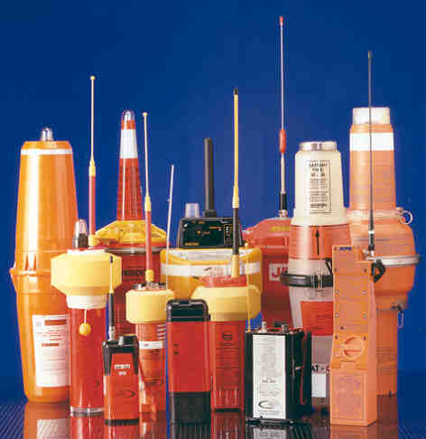

When activated, an EPIRB transmits an emergency signal, which is picked up by satellites, stored and forwarded to rescue co-ordination centres. There are basically three different applications used and (see chapter 5).

EPIRBs are solely intended to be used in the case of emergency situations.

Other use is prohibited.

APPLICATIONS
There are basically three different applications:

- Emergency Position Indicating Radio Beacons (EPIRBs) are used in maritime applications. There a two categories of EPIRBs:
Category I is activated either manually or automatically;.

Category II is activated manually only.

- Emergency Locator Transmitters (ELTs) are used on aircraft and are activated either automatically or manually.

- Personal Locator Beacons (PLBs) are used by individuals in distress.

OPERATING FREQUENCIES
Beacons transmit on four dedicated emergency frequencies:

- 121.5 MHz: This frequency is used by older beacons which do not transmit any encoded information.

- 243.0 MHz: This frequency is used in some older beacons deployed by the U.S. military and NATO forces. Some new 406 MHz ELTs operate on 243,0 MHz;

- 406.0 to 406.1 MHz: beacons which transmit, within the alert, digitally encoded information containing at least the identity of the ship, aircraft or person. In addition to the 406 MHz signal, a 121,5 MHz transmission may be included for homing purposes;

- 1.6 GHz similar to the 406 MHz models. In addition they carry coded geographical position information.

In 1999, the Council of the International Civil Aviation Organisation (ICAO) adopted amendments to the annexes of the Convention on International Civil Aviation requiring all new aircraft from 2002, and all aircraft from 2005, under the jurisdiction of the ICAO Convention, to carry an Emergency Locator Transmitter (ELT) operating on 406 MHz, and on 121,5 MHz for homing purpose. The ICAO Council also agreed that Cospas-Sarsat processing of 121,5 MHz ELTs could be discontinued from 2008.

INTERNATIONAL AND NATIONAL INFORMATION SOURCES
The following organisations can provide additional general information on the subject:

- IMO (International Maritime Organisation), responsible subcommittee is COMSAR (Radiocommunication and Search and Rescue);
- ICAO (International Civil Aviation Organisation);
- ITU, especially ITU-R WP8B (maritime and aeronautical matters);
- Cospas-Sarsat;
- Inmarsat;
- CEPT (mainly WGRR-RR2);
- NRC (North Sea Regional GMDSS Conference);
- BBRC (Baltic and Barents Sea regional GMDSS Conference).

International Regulations

The following international organisations have published recommendations, resolutions etc. for international use:

- International Civil Aviation Organisation (ICAO);
- International Maritime Organisation (IMO);
- International Telecommunication Union (ITU).

Copies of the relevant publications can be obtained through these organisations..

EXAMPLES OF TYPICAL FALSE ALERT INTERFERENCE REPORTS :
Operating frequency (MHz) | Source | Reason for Activation
121.5 | Life Raft EPIRB | Activated due to sea water damage
121.5  243  406 | Hawk Jet Aircraft  Epirb | Nothing determined  Unit reset
121.5  243 | Lufthansa Aircraft  RJ 850 | Mis-operation during maintenance work
121.5 | Aircraft  BA RJ 100 | Mis-operation during maintenance work
121.5 | Fishing Boat | Vandalism of moored boat resulting in EPIRB being thrown into water and being activated
121.5  243 | Life Jacket | Careless handling after use
121.5  243 | EPIRB traced to private house (Marine type) | Activation caused by pin becoming dislodged during storage
121.5  243 | Yacht | Faulty switch
121.5 | Aircraft | Possibly caused by vibration
121.5 | Stand alone EPIRB (Marine) | Located to rubbish dump where it had been disposed of without battery being removed.
121.5 | Marine Yacht Race | Faulty equipment activation
121.5 | Vessel | Mishandling of EPIRB
243 | Aircraft | Faulty equipment activation
121.5 | BT Global Challenge Round the World Yacht Race PLB's | 172 Items stored. One of which activated due to sea water damage. All items voluntarily surrendered
243 | Aircraft (Fitted into Pilots waistcoat) | False activation
121.5 | Marine | Traced to business premises - activated when device fell off desk
406 | French vessel | Traced to landfill site. Disposed of carelessly
406 | Aircraft | Located to scrapyard - disposed of without removing battery

Note:
The frequency of operation in the majority of cases reported above indicates 121,5 MHz as the main problem. However, it should be noted that in approximately 30% of these cases, the beacon operated on 406 MHz but due to the final tracing on 121,5 MHz, the case was reported and recorded as this frequency source.

STATISTICS
Information provided by some ERC member administrations on the number of false alerts their enforcement authorities have dealt with are as follows:

COUNTRY | 1997 | 1998 | 1999 | 2000 | 2001
Austria | - | - | - | 9 | -
Norway | - | - | - | - | 40
Switzerland | 9 | 13 | 12 | 17 | -
The Netherlands | 65 | 94 | 93 | - | -
United Kingdom | 115 | 147 | 116 | - | -
Sweden | 186 | 179 | 233 | 202 | -
Portugal | - | - | - | 1 | 1

Statistical information on false alerts in general, as provided by Cospas-Sarsat, is shown in Annex A.

CONCLUSIONS
Possible courses of action to reduce the number of false alerts

It is the conclusion that the main cause of false alerts are associated with:
- poor handling;
- poor maintenance;
- a lack of awareness by both maintenance personnel and users of the consequences of not taking due regard to 1) and 2).

RECOMMENDATIONS
a. Custody and Control
An emergency radio beacon should at all times be safely stowed.
In all cases where emergency radio beacons are mandatory, see the appropriate regulations for installation and handling.
In cases where emergency radio beacons are carried on a voluntary basis, the owner is advised to follow the recommendations below:
b. Removal for safekeeping or servicing
Any servicing should be carefully handled. Any EPIRB taken out of service should be deactivated wherever possible following the manufacturers procedures and in all cases the device should be completely wrapped in two layers of aluminium foil which provides suitable radio frequency screening. The same procedures should apply if the devices are sent for repair or servicing.

If units are being sent for service or repair the responsible person shall disconnect the battery before shipping. If the manufacturer ships units they shall take every step to prevent false alert. However it is advised that unskilled persons should not disconnect the battery and connect it again because there is a great risk that the EPIRB will loose being waterproof .
c. General Recommendations
Administrations should endeavour to:

- establish close links with ship operators, aircraft operators and the associated maintenance personnel who use or service EPIRBS in order to improve their understanding of potential problems;
- make users fully aware of the potential problems, during beacon maintenance and testing, of poor operation/handling and the possible resultant enforcement action that may follow;
- provide guidance and information to educate owners, salvage companies, scrap yards and brokers on the proper disposal of beacons;
- encourage ship and aircraft crews to be aware of methods to cancel a false distress alert and that they adhere to the Resolution 349 (WRC-97) as detailed in Annex B;
- inform other Administrations and the specific manufacturer when a model fails to operate correctly. If a particular EPIRB type repeatedly gives rise to false alerts due to malfunction, then the procedures concerning non compliance with the essential requirements contained in the RTTE Directive and Marine Equipment Directive shall be followed;
- liaise with local coast-guards to obtain information from existing databases of registered beacons in order to aid detection and location of false alerts;

Manufacturers are recommended to:

- consider two-step beacon activation procedures where practical and appropriate (mandatory under IMO);
- design test features and fix the type-specific testing instructions in an easily readable and indelible form on the EPIRB itself. Testing should be completed in accordance with RR S31.3 and ITU-R Recommendations 633-1;
- improve the design so that it is not possible to transmit an alert unintentionally;
- improve the design of beacons so that the arrangement of operation panels and procedures are standardised;

Manufacturers and standards organisations:

- should ensure that any activation is visually and/or audibly indicated;

Suppliers should encourage:

- users to only allow authorised agents to carry out repair and maintenance;
- the transition to the 406 MHz/1,6GHz bands.

ANNEX A

COSPAS-SARSAT STATISTICAL INFORMATION

1.1 Distress Beacons World wide

- 121.5 MHz estimated number: 640.000
- 406 MHz estimated number: 220.000
- 1.6 GHz no figures available

1.2 System Operations

In 1999, the Cospas-Sarsat System provided assistance in rescuing 1.227 persons in 340 SAR events:

- Aviation distress: 85 persons in 60 SAR events
- Maritime distress: 1008 persons in 216 SAR events
- Land distress: 134 persons in 64 SAR events

The 406 MHz system was used in 180 of these incidents (882 persons rescued) and the 121.5 MHz system was used in the other 160 SAR events.
From September 1982 to the end of December 1999, the Cospas-Sarsat System provided assistance in rescuing 11.227 persons in 3.361 SAR events.
1.3 COSPAS - SARSAT SYSTEM USAGE

1.4 COSPAS-SARSAT FALSE ALERT STATISTICS FOR YEAR 1999
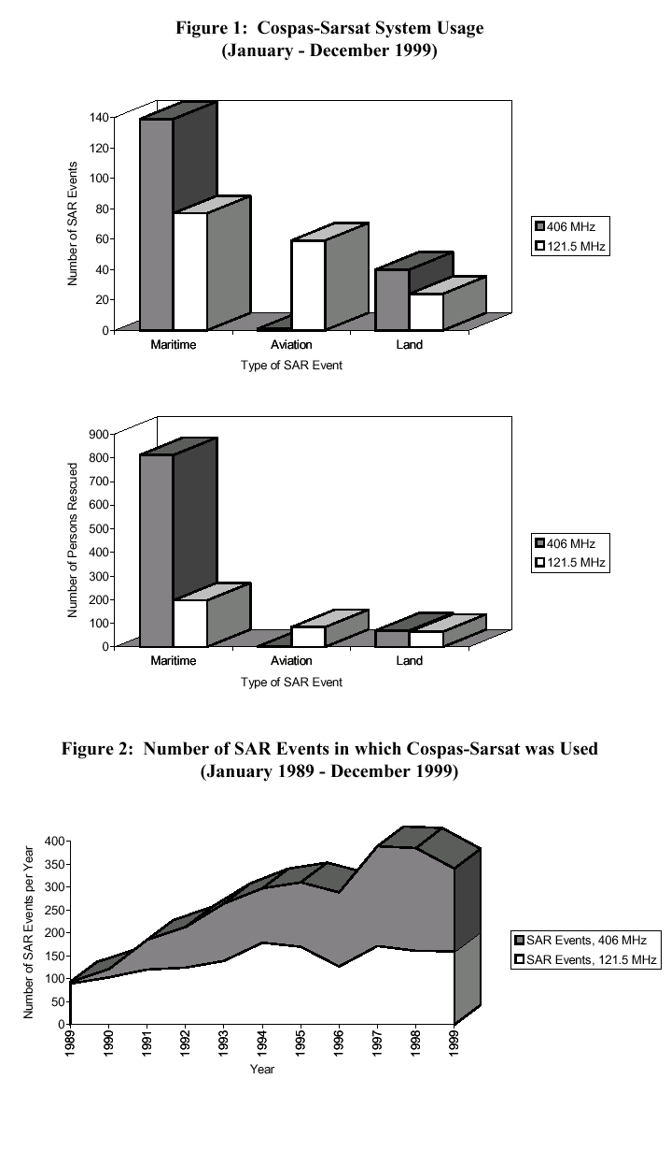

For year 1999, 21 COSPAS-SARSAT Participants provided information on 406 MHz false distress alerts. Because not all Participants provided the data broken down by type of beacon (EPIRB, ELT or PLB), the following data is an aggregate of all 406 MHz false alerts, unless indicated otherwise. There were reported 5.258 confirmed 406 MHz alerts passed to SAR forces in 1999, of which 425 were real distress activation’s and 4.833 false alerts. In addition, there were an additional 1.957 alerts transmitted to SAR forces for which no feedback information was received and, therefore, the nature of the alert was undetermined.

The number of false alerts reported by category (as collected from 17 Participants who provided the complete breakdown) was as shown in Table 1 below.

Category of False Alert | Number Reported by  Category (17 Participants) | % by Category
Beacon Mishandling | 1.660 | 40 %
Beacon Malfunction | 412 | 10 %
Mounting Failure | 246 | 6 %
Environmental Conditions | 158 | 4 %
Unknown | 1.652 | 40 %
Total Reported by  17 Participants | 4.128 | 100

Table 1 : Statistics on false alerts by category

Based on the data provided by Participants, COSPAS-SARSAT calculates two different false alert rates, identified for convenience as the “SAR false alert rate” and the “beacon false alert rate”. The SAR false alert rate which characterises the impact of false alerts on SAR services is calculated according to the traditional manner by determining the percentage of false alerts as a function of the total number of alerts transmitted to SAR authorities. In 1999, based on the number of confirmed real distresses and the number of false and other unconfirmed alerts, the SAR false alert rate (ratio of false alerts to the total number of alerts provided to SAR forces) was 94.1% (6.773 / 7.198).

The beacon false alert rate is calculated by dividing the number of false and undetermined alerts observed over one year by the number of beacons in the system. This provides a “rate of false activation’s per beacon per year” which characterises the performance of beacons and, when calculated for different populations (i.e. in a particular country or for a particular beacon model) provides a better means of tracking any evolution over the years, discrepancies amongst countries, or the performance of particular beacon models. In 1999, for a beacon population of 119.964 for those Participants providing data, there were 4.863 false and unconfirmed alerts, corresponding to a beacon false alert rate of 4.05% (i.e. 4.05% of the beacons in the population were activated and generated a false alert during that year).

The 406 MHz beacon false alert statistics for year 1999 provided one interesting result which will require further monitoring. It was noted from the reports of 13 Participants that provided information by type of beacon (EPIRB, ELT, PLB), that there was a significantly higher false alert rate for ELTs, as a function of the population, than for EPIRBs. Specifically, for those reports with data for each type of beacon, the average rate for EPIRBs was 2.68% and 15.08% for ELTs. The cause for this difference is unknown, but might be attributed to the early stage of introduction on a large scale of 406 MHz ELTs to aircraft, and the resultant lack of experience in the operation, maintenance and testing of the beacons. COSPAS-SARSAT plans to monitor the reported 406 MHz ELT false alert rate during the next several years and provide information to the appropriate bodies as required. It is also interesting to note that the reported beacon false alert rate for PLBs, which are usually manually operated, was 0%.

 | EPIRBs | ELTs | PLBs
Beacon Population  (13 C/S Participants) | 47.147 | 1.797 | 2.009
Number of False Alerts from Beacons in the Population | 1.263 | 271 | 0
Beacon False Alert Rate  (as % of population per year) | 2.7 % | 15.1 % | 0 %

Table 2: Beacon false alert rate by type of beacon

ANNEX B

RESOLUTION 349 (WRC-97)

Operational procedures for cancelling false distress alerts in the Global Maritime Distress and Safety System
The World Radiocommunication Conference (Geneva, 1997),
considering
a) that the 1974 International Convention for the Safety of Life at Sea (SOLAS), as amended, prescribes that ships subject to that Convention shall be fitted with Global Maritime Distress and Safety System (GMDSS) equipment as appropriate;
b) that non-SOLAS vessels are also being equipped with GMDSS equipment;
c) that the transmission and relay of false distress alerts is a significant problem within the GMDSS,
noting
that the International Maritime Organisation (IMO) has developed similar operational procedures to cancel false distress alerts,
resolves
1 to urge administrations to take all necessary measures to avoid false distress alerts and to minimise the unnecessary burden on rescue organisations which occurs;
2 to urge administrations to encourage the correct use of GMDSS equipment, with particular attention to appropriate training;
3 to urge administrations to implement the operational procedures contained in the Annex to this Resolution;
4 that administrations should take any consequential appropriate action in this respect,
instructs the Secretary-General
to bring this Resolution to the attention of IMO.

ANNEX TO RESOLUTION 349 (WRC-97)
Cancelling of false distress alerts
If a distress alert is inadvertently transmitted, the following steps shall be taken to cancel the distress alert.

1 VHF digital selective calling
1) Reset the equipment immediately;
2) Set to channel 16; and
3) Transmit a broadcast message to “All Stations” giving the ship’s name, call sign and maritime mobile service identity (MMSI), and cancel the false distress alert.

2 MF digital selective calling
1) Reset the equipment immediately;
2) Tune for radiotelephony transmission on 2 182 kHz; and
3) Transmit a broadcast message to “All Stations” giving the ship’s name, call sign and MMSI, and cancel the false alert.

3 HF digital selective calling
1) Reset the equipment immediately;
2) Tune for radiotelephony on the distress and safety frequency in each band in which a false distress alert was transmitted (see Appendix S15); and
3) Transmit a broadcast message to “All Stations” giving the ship’s name, call sign and MMSI, and cancel the false alert on the distress and safety frequency in each band in which the false distress alert was transmitted.

4 Inmarsat ship earth station

Notify the appropriate rescue co-ordination centre that the alert is cancelled by sending a distress priority message by way of the same coast earth station through which the false distress alert was sent. Provide ship name, call sign and Inmarsat identity with the cancelled alert message.

5 Emergency position indicating radio-beacon (EPIRB)

If for any reason an EPIRB is activated inadvertently, contact the appropriate rescue co-ordination centre through a coast station or land earth station and cancel the distress alert.

6 General

Notwithstanding the above, ships may use additional appropriate means available to them to inform the appropriate authorities that a false distress alert has been transmitted and should be cancelled.

Published in Cospas-Sarsat Information Bulletin No. 13 (January 2000), page 3.
Global Maritime Distress and Safety System.

