
European Radiocommunications Committee (ERC)
within the European Conference of Postal and Telecommunications Administrations (CEPT)

METEOR SCATTER APPLICATIONS

Vilnius, June 2000

INDEX TABLE

1 INTRODUCTION 1
2 TECHNICAL CHARACTERISTICS 1
2.1 Channel identification 3

ANNEX 1: THE METEOR BURST COMMUNICATION SYSTEM 4

ANNEX 2: EXAMPLES OF METEOR BURST COMMUNICATION SYSTEMS IN EUROPE, AND OTHER COUNTRIES WORLDWIDE 8

METEOR SCATTER APPLICATIONS

INTRODUCTION
It is fairly dusty in space. Many large and many more tiny fragments of stars which exploded in the past float, or rather shoot, through space. Countless billions of these dust particles are "swept up" by the gravitational force of the Sun and remain in an orbit around it. On their wary, some of them meet up with the planet Earth. Every day, Earth attracts innumerable (>10¹²) particles the size of a grain of sand. During the impact, these grains of sand burn up in the upper layers of the atmosphere and end their existence as a stream of hot gases.

In the burning phase that lasts less than a second, these small meteor trails are capable of reflecting radio waves. Ingeniously, Meteor Scatter communication systems make use of this property. Powerful transmitters send short signals (probes) into space. If by chance a meteor appears in the right place at the right time, the signal is reflected towards the Earth surface and a remote station is able to receive this signal at a distance up to 1500 kilometres. During the quarter of a second available, a brief exchange of messages can take place. This special radio technology can thus be used to build a communication network for a number of specific applications.

For a general description of the Meteor Scatter phenomenon and the technique behind Meteor Scatter applications ITU Recommendation Rec. ITU-R P.843-1 is referred to. In ITU Recommendation Rec. ITU-R F.1113 two examples of communication systems using the Meteor Scatter phenomenon are given.

Within the framework of CEPT Working Group Spectrum Engineering (WG SE) the compatibility of a mobile Meteor Scatter application at 39 MHz and TV reception has been investigated. The results of this studies were laid down in the final report SE(99)T19.rev2 at the WG SE meeting in Marbella, in February 1999. The general conclusion was that possible interference can either be avoided by careful site planning (base stations) or will be negligible in practice (mobile stations). Based on the results of the compatibility studies, 39.0-39.2 MHz has been identified as a harmonized frequency band for Meteor Scatter applications.

TECHNICAL CHARACTERISTICS
Meteor Scatter communication systems have a number of characteristic properties which need to be taken into account in the technical structure:

- The Meteor Scatter transmission channel has a limited availability and is unpredictable in the sense that it is impossible to say in advance when a meteor entry will take place. As a result, a delay is introduced before the actual communication takes place. This certainly does not implicate that the system is unreliable. Based on statistical figures it can be stated that the channel is extremely dependable and reliable estimates can be given with respect to the capacity and the delay experienced in the data link.

- On average, the duration of a usable meteor is 200-250 milliseconds. Using a data transmission rate of 10 kilobits per second, data packages of approximately 100 characters can be exchanged. In spite of the limited capacity for message transfer, Meteor Scatter communication systems are able to offer an inexpensive solution to the information requirement in a number of specific applications. A prime example is the transport sector, where control of the logistic facilities produces significant savings, while the related communication requirement is, in terms of technology, modest.

- An important precondition for the Meteor Scatter technology is the choice of frequency. Only in the low VHF band (38 - 52 MHz) can the right combination of receiver sensitivity and reflecting capacity of the meteor trails be found to develop a viable system.

- Meteor Scatter communication systems are highly efficient in its use of the radio spectrum. Radio frequencies are a scarce commodity and the increasing appetite for information demands economical use of the radio spectrum. Because in a large service area different users are "served" by different meteors, interference between the users is virtually ruled out, even if the same frequency is used over a very large area. In this way, the whole of Europe can be served by using only one or two channels, dependent upon the configuration of the communication network.

- In case the communication system is configured as a star network wit a central base station and a number of remote station, the link balance is disturbed by the limited terminal power at the remote station. In case a mobile application is running on the network, the use of an omni-directional antenna will also affect the link balance. To restore the balance in the communication link, the transmitter power and the receiver antenna gain at the base stations must be increased. To obtain an acceptable link budget, a terminal power of 100 W is required.

- Larger systems might be built using multiple base stations that are connected via a direct link. Dependent upon the network planning, it is possible that base station A is located within the coverage area of base station B and vice versa. When using a single frequency channel for the entire network communication, it is very likely that the base stations will interfere and disturb the communication with the remote stations. Due to the high power of the transmitter and the high gain of the receive antenna array at the base stations, a link between two base stations will experience substantially smaller waiting times which further increases the level of interference. By identifying a single transmitter frequency channel and a single receiver frequency channel for the base stations the interference between two base stations can be omitted and the Meteor Scatter communication link can be used more efficiently. The two channels will be used by the remote stations in reversed order.

- There is only one way to operate on a Meteor Scatter communication channel: one of the nodes will have to illuminate the meteor trail. This is accomplished by a call/listen cycle of 60-80 milliseconds which is called probing. In a star network configuration, the base stations will perform the probing. The receiving node will respond as soon as there is a pathway for communication. To achieve maximum profit of the bandwidth available, a hand-shake protocol should be used. As soon as one end finishes sending, it informs the other end that it's ready to receive. All data received is acknowledged so no information will get lost.

- To minimise the interference on adjacent channels the Gaussian Minimum Shift Keying (GMSK) modulation technique should be used. To accomplish a data transmission rate of 10 kilobits per second, the effective bandwidth is determined at 16 kHz when the GMSK modulation technique is used. With a channel spacing of 25 kHz, the system is completely compliant with the limits for spurious emission defined within the ETS 300-113 standard and recent ERC Recommendation 74-01.

General characteristic
Frequency usage: | Two channels of 25 kHz
Data package size: | 100 characters
Data rate: | 10 kbits/sec
Modulation: | GMSK
Transmission: | Half duplex
Applicable ETSI standard: | ETS 300-113 (Land Mobile Radio)

Base station characteristics
Transmit frequency: | Channel 1
Transmitting power: | 3000-5000 W
Transmit antenna gain: | 5-10 dBi
Receive frequency: | Channel 2
Receive antenna gain: | 15-20 dBi
Antenna height: | 6 -9 m

Remote station characteristics
Transmit frequency: | Channel 2
Transmitting power: | 100 W
Receive frequency: | Channel 1
Antenna gain: | 0 dBi (mobile); 5 dBi (fixed)
Antenna height: | 0-3 m
Overview (Example characteristics)

Channel identification
Based on the characteristics defined above, a maximum of 8 channels of 25 kHz bandwidth can be identified within the harmonized frequency band for Meteor Scatter applications.

200 kHz
39.0 Mhz
39.2 Mhz
-12.5
+12.5
Center frequency

CH 1
CH 2
CH 3
CH 4
CH 5
CH 6
CH 7
CH 8

Annex 1

ANNEX 1: THE METEOR BURST COMMUNICATION SYSTEM
The Meteor Burst Communication (MBC) Network

The MBC network can be divided into the radio frequency (RF) part and the data transfer and processing part, as shown in the figure below.


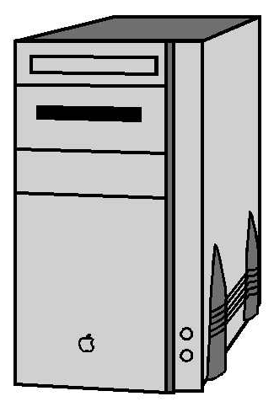
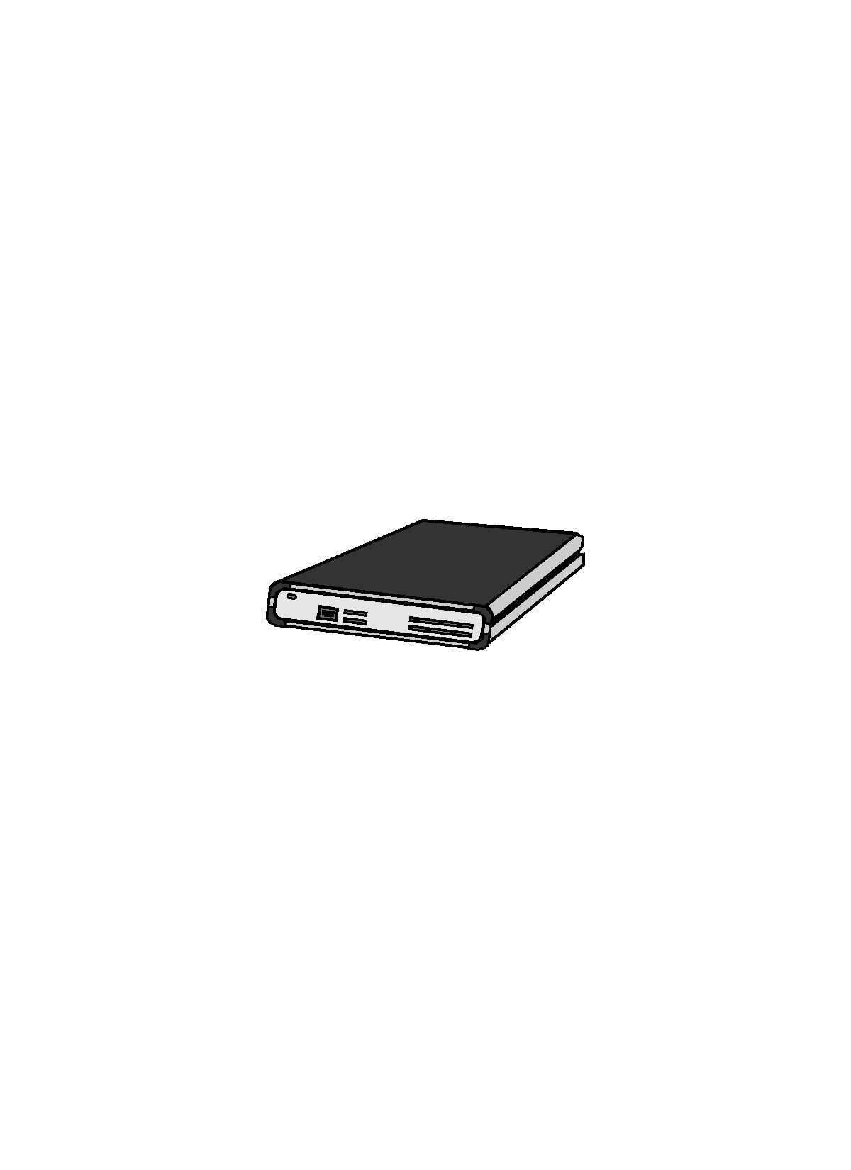
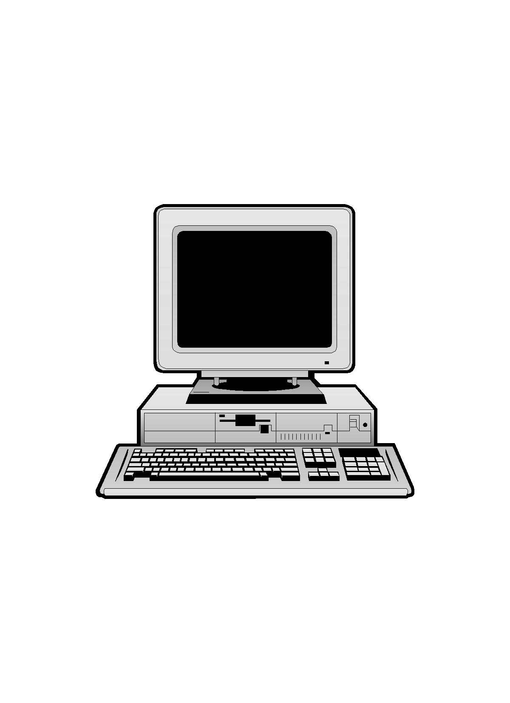
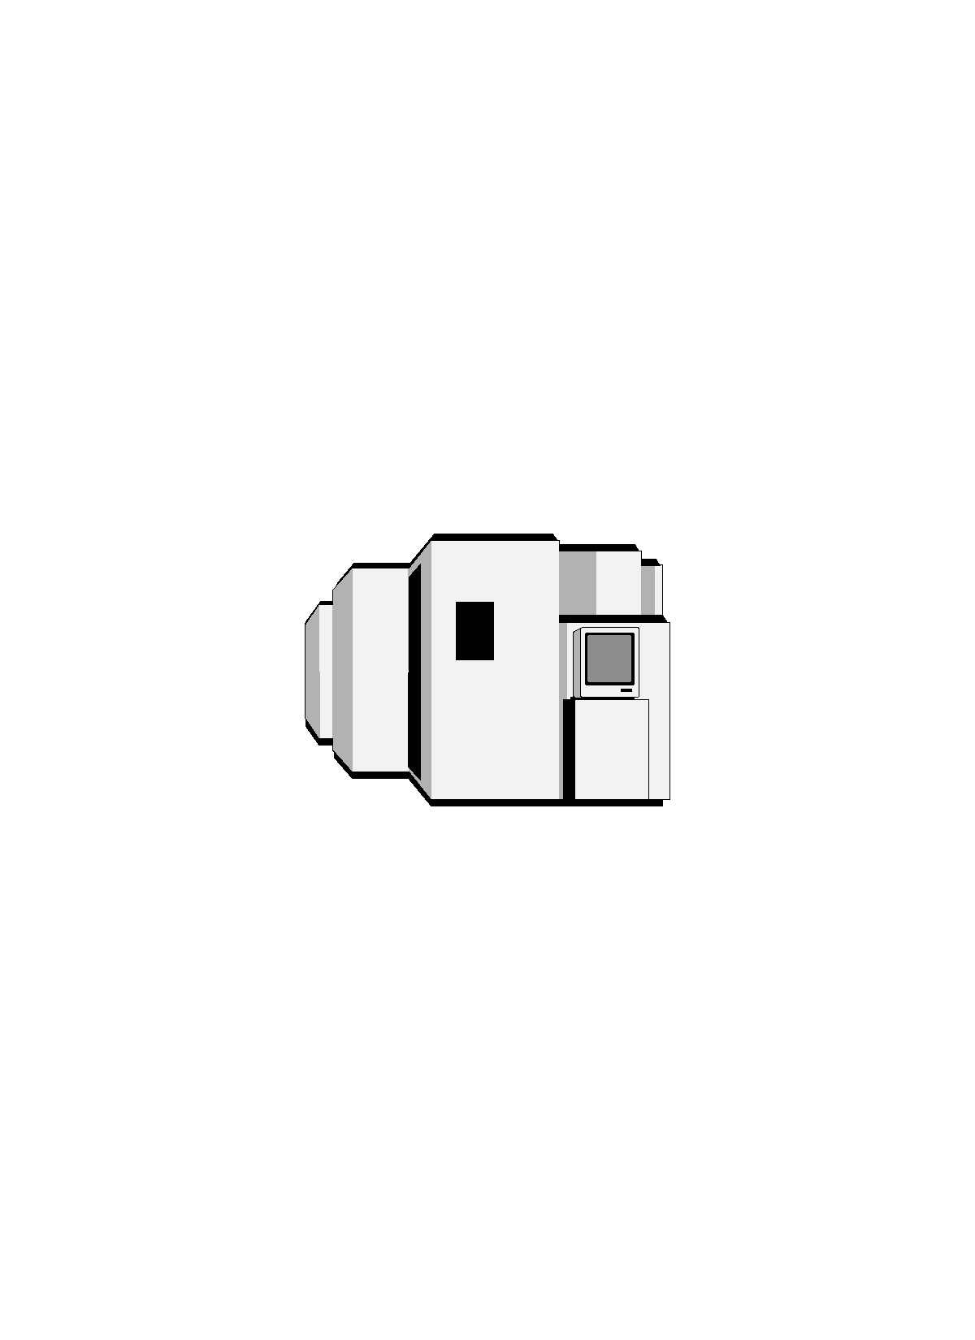
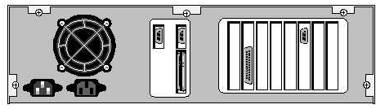
WAN
Remote Stations (mobile or fixed)

Meteor Burst Base Station A (MBBS)
Meteor Burst Base Station B (MBBS)
Auxiliary Station
Data Center
Data transfer & processing
RF network
Customer Data Terminal
WAN

Figure 2: MBC Network system overview

The number of Meteor Burst Base Stations (MBBS) depends on the size of the area which has to be covered. All network subsystems are described in the next sections.

Meteor Burst Base Station

Using meteor trails, a meteor burst base station (MBBS) can communicate with remote stations, either mobile or fixed, over distances between 500 and 1500 km. Using meteor burst technology, a few tens of base stations provide the infrastructure for the pan-European data communication network. The data exchange between a base station and a remote station is initiated by a test signal (probe) transmitted into space by the base station. If and when a meteor trail is in the right position and reflects the signal back to Earth, the remote station answers the call by the base station and data is exchanged. The base stations are connected directly to the Data Center of the network.

Auxiliary Station

For communication in a densely populated, industrial area, auxiliary stations might be installed to supplement the coverage by the base stations. The auxiliary stations do not use the meteor burst phenomenon, but work in a Line-of-Sight (LOS) mode. The data received can be transferred to one of the base stations using a meteor burst connection after which it will be delivered at the Data Center. A direct link between the auxiliary station and the Data Center is possible as well. In the current network planning, no auxiliary stations have been adopted.

Remote Station

A remote station can either be mobile or fixed. Mobile stations are for example trucks that communicate with the dispatch center through the MBC network. The mobile stations use a radio modem and an omni-directional antenna that is mounted on the roof of the vehicle. Fixed stations, for example meteorological sites located in remote areas use the same radio modem. For the fixed stations, however, a directive antenna can be used to communicate with the meteor burst base stations. The use of a directive antenna will improve the communication link and reduce the waiting times. The power necessary to operate the radio equipment can be generated via solar cells.

Data Center

The heart of the network is the Data Center, where the information from the remote station and the customer data terminals is gathered and passed on. Until the data is passed to either base station or customer data terminal, it is stored in so-called Call Detail Records (CDRs). The CDRs contain a flag indicating whether the message is delivered or not. After a message is delivered, the CDR is used for Billing and Accounting purposes and deleted from the database.

The customer is able to contact the Data Center by means of a modem. In the future, the Data Center will be accessible via the Internet. As a standard SMS protocol is used to transfer the data across the MBC network, the customer is free to use any SMS interface at the remote station or at the customer end of the network.

Customer Data Terminal

As stated above, the customer is free to use any SMS compliant device at the end of the MBC network. Within the MBC network, this device is called the Customer Data Terminal (CDT). In case a mobile application is running on the network, MBC is able to offer a CDT software package enabling fleet management.

Technical Specifications MBC network

Remote Station (Mobile)

Receiver/Transmitter
Transmitting frequency: 39.000-39.025 MHz
Receiving frequency: 39.000-39.025 MHz (LOS mode)
39.025-39.050 MHz (MB mode)
Output power: 100 Watt
Type approval: compliant with ETS 300-113
EMC standard: compliant with ETS 300-279
Receiver Noise Figure: 4 dB
Receiver Sensitivity: -119 dBm

Antenna
Antenna type: typically omni-directional antenna*
Antenna height: 3 meter, 10-30 cm above rooftop
Antenna gain: 0 dBi
Beam elevation: 20-30 deg.

* Antenna size and weight are limited as antenna is to be mounted on the roof of a truck. Furthermore, the antenna should be resistant to vibrations and contact with branches. The maximum tuneable frequency range of the Remote Radio is from 38.9875 MHz up to 39.2125 MHz.

Remote Station (Fixed)

Receiver/Transmitter
Transmitting frequency: 39.000-39.025 MHz
Receiving frequency: 39.000-39.025 MHz (LOS mode)
39.025-39.050 MHz (MB mode)
Output power: 100 Watt
Type approval: compliant with ETS 300-113
EMC standard: compliant with ETS 300-339
Receiver Noise Figure: 4 dB
Receiver Sensitivity: -110 dBm (min. reference)

Antenna
Antenna type: typically directive antenna
Antenna height: 0-8 meter
Antenna gain: 5 dBi
Beam elevation: 20-30 deg.

Meteor Burst Base Station (MBBS)

Location
Base station location: quiet rural site
MB Base Station
500
0
1500
Coverage
Range: 500-1100 km

Transmitter
Operating frequency: 39.025-39.50 MHz
Transmitting power: 3500 Watt
Type approval: compliant with ETS 300-113/ETS 300-384
EMC standard: compliant with ETS 300-339
Modulation: GMSK, BT=0.5
Data rate: 10 kbits/sec
Channel bandwidth: 25 kHz
Transmissions: Half duplex

Transmit antenna
Antenna type: 8-element Yagi
Antenna height: 9 meter
Antenna gain: 10 dBi
Beam elevation: 15 deg.
Coverage sector width: 60 deg. (single antenna)
120 deg. (two antennas)
Receiver
Operating frequency: 39.000-39.025 MHz
Receiver noise figure: 5 dB
Receiver sensitivity: -118 dBm (min. reference)
Man-made noise assumption: quiet rural

Receive antenna
Antenna type: 11-element Yagi antenna
Antenna gain: 15 dBi
Phased array gain: 5 dBi (4 antennas per array)
Antenna height: 6-9 meter
Beam elevation: 15 deg.
Coverage sector width: 40 deg per array
3 arrays for 120 deg coverage
Receiver method: Coherent receiver

Auxiliary Station (AIS)

Location
Auxiliary station location: rural

Coverage
Coverage area: typically 70 km radius

Receiver/Transmitter
Operating frequency: 39.000-39.025 MHz
Transmitting power: 100 Watt
Type approval: compliant with ETS 300-113
EMC standard: compliant with ETS 300-339
Receiver Noise Figure: 4 dB
Receiver Sensitivity: -110 dBm (min. reference)

Antenna
Antenna type: crossed dipole
Antenna height: 65 meter
Antenna gain: 2 dBi

Frequency usage Meteor Burst Communication system

Channel | Frequency  range (MHz) | Center frequency  (MHz) | Remote Station (mobile/fixed) |  | Meteor Burst Base Station |  | Auxiliary Station
 |  |  | Tx | Rx | Tx | Rx | Tx | Rx
1 | 39.000 –39.025 | 39.0125 | x | x |  | x | x | x
2 | 39.025 –39.050 | 39.0375 |  | x | x

Annex 2

ANNEX 2: EXAMPLES OF METEOR BURST COMMUNICATION SYSTEMS IN EUROPE, AND OTHER COUNTRIES WORLDWIDE
Meteor Burst Communication relies on the phenomenon of reflecting radio waves off the ionised trails left by micrometeors as they enter the atmosphere and disintegrate. Billions of dust-size meteors large enough to give usable trails enter the atmosphere each day.

The operational principle is as follows: the Master Station transmits a continuous, coded signal. When a meteor appears in the proper location, it reflects that signal to a receiving Remote Station. The Remote Station decodes the signal, turns on its transmitter and reflects a signal back along the same path to the Master Station. Information can be sent in either direction until diffusion reduces the electron density in the trail to a value too low to sustain reflection.

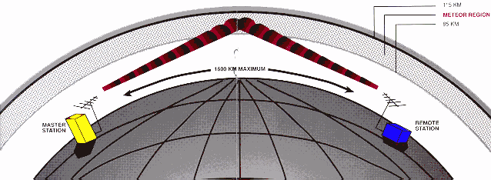
The maximum length of a single-hop link is about 1600 kilometres, a distance determined by the height of the meteor trail layer and the curvature of the earth. A typical meteor trail has an average duration of a few hundred milliseconds, while wait-times between suitably located trails can range from a few seconds to a few minutes depending on the time of day, time of year and system design factors. Hence the data transfer consists of “bursts” of compressed data transmitted at high data rates and data flow can be either or both directions. One important by-product of the burst characteristic is the ability of many links to share a single transmission frequency – an increasingly important feature in radio systems today.

Data can consist of short messages such as sensor data readout, coded messages of up to several hundred characters, text messages of a few words or longer messages achieved by splicing together the transmission of successive bursts. In these applications, average throughput of up to several hundred words per minute are achieved with relatively simple equipment.

The performance of a meteor burst link is defined, as the “wait time” required to transfer a message between two stations at a specified reliability. The primary system parameters that will influence this “wait time” are operating frequency, data rate, transmit power, antenna gain and receiver threshold level. Since there are different costs related to each of these parameters, it is important that flexibility is maintained in these areas so that the most cost effective system can be designed for each application.

Meteors occur randomly. Therefore, a natural time-division-multiplex access (TDMA) feature is inherent in all meteor burst networks. This TDMA feature allows thousands of stations to operate within a network on a single 25 kHz frequency channel providing highly efficient use of radio spectrum.

MBC systems can be employed effectively for both point-to-point services and multiple station networks for ranges up to 1600 kilometres. For extended ranges, relay stations are employed using data store-and-forward techniques. A meteor burst system can be fully automated so that it is simple and economical to operate. Its rapid deployment capability also makes it ideal for disaster and emergency communications.

For over 25 years, meteor burst systems have been deployed around the world on all seven continents, with many different applications. The largest of the systems covers the Western half of the USA and comprises two base stations and over 700 remote stations. It mainly monitors weather parameters and has been in full operation since 1978.

A meteor burst network has been successfully operating in the United Kingdom since 1985. Applications for this system include environmental monitoring, performance monitoring and offshore platform SCADA as well as lone worker protection and vehicle location. Other, similar systems with an even wider range of applications have been deployed throughout the world since 1975.

The meteor burst networks around the world operate in either full-duplex or half-duplex mode depending on application and level of performance required. BPSK and GMSK modulation techniques are used at data rates up to 19.200 baud. Full-duplex systems require two frequency channels, each of 25 kHz bandwidth and separated by a minimum of 1 MHz. Half-duplex networks are operated on either one or two frequencies. Mostly, half-duplex networks are operated on one frequency both to conserve spectrum and to increase the versatility of the network. Communication protocols have been developed to provide single channel utilisation of over 90%.

