
European Radiocommunications Committee (ERC)
within the European Conference of Postal and Telecommunications Administrations (CEPT)

ASSESSMENT OF INTERFERENCE FROM UNWANTED EMISSIONS
OF NGSO MSS SATELLITE TRANSMITTERS OPERATING
IN THE SPACE-TO-EARTH DIRECTION
IN THE BAND 1621.35 - 1626.5 MHZ TO GSO MSS SATELLITE RECEIVERS
OPERATING IN THE EARTH-TO-SPACE DIRECTION
IN THE BAND 1626.5 - 1660.5 MHZ

Vilnius, June 2000

INDEX TABLE

1 INTRODUCTION 1
2 NATURE OF PROBLEM 1
3 SE28 STUDIES 1
4 MOTOROLA DETAILED SIMULATIONS 2
4.1 Simulation Results 3
4.2 Methodology for simplified analysis 5
4.3 Panel discrimination factor 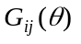 5
4.4 Other mitigation factors: Pij 7
4.5 Comparison of detailed simulation and simplified methodology 8
5 INMARSAT VERIFICATION STUDY 9
5.1 Static link budget analysis 9
5.2 Inmarsat dynamic simulation 10
5.3 Results of Inmarsat dynamic simulation 13
6 CONCLUSION 14
6.1 From Motorola studies 14
6.2 Conclusions from Inmarsat verification studies 15

ASSESSMENT OF INTERFERENCE FROM UNWANTED EMISSIONS OF NGSO MSS SATELLITE TRANSMITTERS OPERATING IN THE SPACE-TO-EARTH DIRECTION
IN THE BAND 1621.35 - 1626.5 MHZ TO GSO MSS SATELLITE RECEIVERS OPERATING
IN THE EARTH-TO-SPACE DIRECTION IN THE BAND 1626.5 - 1660.5 MHZ

INTRODUCTION
WARC-92 allocated the band 1610 - 1626.5 MHz on a primary basis to the Mobile Satellite Service (MSS) in the Earth-to-space direction (uplink) and the band 1613.8 - 1626.5 MHz on a secondary basis to the MSS in the space-to-Earth direction (downlink).

Band sharing arrangements adopted by the US for the ‘Big LEO’ NGSO MSS systems assigned the band 1621.35 - 1626.5 MHz to Motorola Satellite Communications Incorporated for the Iridium system. Iridium will use this band on a bi-directional basis (Earth-to-space and space-to-Earth) for its service links in communicating with its mobile terminals.

The band 1626.5 - 1660.5 MHz is allocated on a primary basis to the MSS in the Earth-to-space direction. Inmarsat, along with other GSO MSS network operators, use this band for its service-uplinks.

The proposed space-to-Earth use by Iridium is at frequencies directly adjacent to the band being used by Inmarsat. Therefore, there is potential for unwanted emissions from Iridium satellite transmitters interfering into Inmarsat satellites receivers.

This report summarises the technical analysis made by CEPT Project Team SE28 on the potential of out-of-band interference from the Iridium system downlinks into Inmarsat GSO satellite receivers operating above 1626.5 MHz.

NATURE OF PROBLEM
Unwanted emissions are produced by nonlinearities in the amplification of signals, and also by the process of modulating a carrier by a signal.

The generation of out-of-band emissions for Iridium satellites occurs in the transmitting amplifiers that drive the elements of the phased-array antennas.

SE28 STUDIES
SE28 had been studying this issue of interference for some time, having received many input contributions from both Inmarsat and Motorola over the period 1996 - 1998. There is, however, a large divergence in the results presented by the two parties making it difficult for SE28 to positively conclude on the studies.

The conclusion of the studies depends, for the most part, on the value assumed for the out-of-band emissions characteristics of Iridium satellites. As these characteristics are commonly measured during the space qualification of satellites, Inmarsat has previously called on such measurements to be presented within SE28 in order to accurately conclude on the studies.

However, in the absence of such measurements, Inmarsat accept the declaration made by Motorola on the out-of-band emissions levels from Iridium satellites to the geostationary orbit. However, Inmarsat notes these levels towards the geostationary orbit are significantly (of the order of 38dB) below the FCC regulatory requirements. Therefore, if the Motorola estimates are deemed to be widely optimistic (for example from the on-going measurement programme by radio-astronomers of the Iridium spurious emissions levels at the surface of the earth, or receipt of interference by Inmarsat satellites), it is requested CEPT re-examine this issue.

MOTOROLA DETAILED SIMULATIONS
A dynamic simulation model of the entire Iridium constellation was used to assess the potential interference from the Iridium downlinks in to the uplinks of Inmarsat GEO systems operating above 1626.5 MHz. These simulations modeled the complete transmission system of the Iridium system. In particular, in order to estimate the total unwanted emissions, the simulation includes:

· all visible satellites of the constellation
· all 3 phased array panels on a satellite
· world-wide traffic model with 125% of expected traffic
· distribution of traffic across satellites, panels and beams
· beam management techniques
· combined input signal at each phased array element (sum over beams, frequencies)
· the individual radiating elements in the phased array antennas (PA characteristics, individual driving functions and antenna patterns),
· Inmarsat antenna patterns

The simulation calculates the total interference from all visible satellites at the Inmarsat victim satellite.

The Inmarsat antenna patterns are assumed to satisfy the following gain contours:

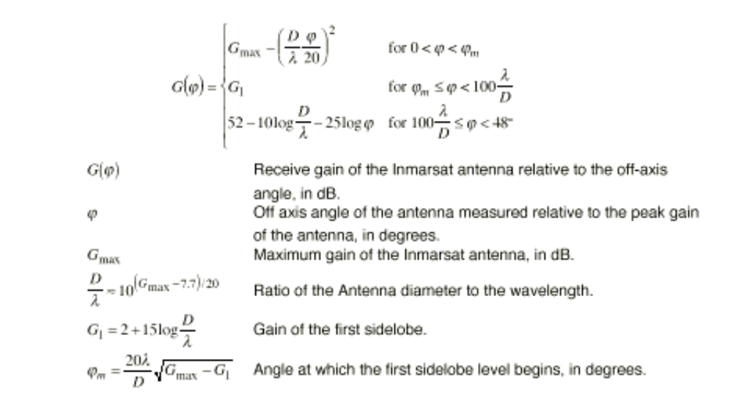
The input parameters for the Inmarsat constellation are shown in Table 1. In addition to the parameters in Table 1, it is assumed that the boresite of the Global Beam is in the nadir direction and the boresite of the Spot beam is in the direction of the equator and pointed such that the gain towards the edge of the earth is 25 dBi.

Location of Inmarsat satellite | 0 | degrees
Maximum Gain of Global Beam | 18.5 | dBi
System noise floor (Global beam) | -201 | dB(W/Hz)
Maximum gain of Spot Beam | 27.0 | dBi
System noise floor (Spot beam) | -200 | dB(W/Hz)
Requested Protection level Io/No | -22 | dB
Table 1: Input parameters for the Inmarsat constellation

Simulation Results
Shown in Figure 1 is the sample of the results in which the highest level of interference is found for the simulation of an Inmarsat global beam. The simulation was performed over a 24 hour period, sampled at 1 second increments. Over the 24 hour period the interference level, Io/No, had a mean value of -29.0 dB and a standard deviation of 0.58 dB, the range of interference levels is from -31.1 dB to -27.1 dB with 95% of the samples below -28.0 dB and 99% of the samples below -27.6 dB.
Figure 1: Io/No for an Inmarsat global beam at the highest interference levels.
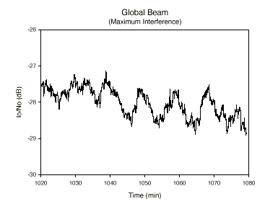

Shown in Figure 2 is a portion of the results in which the highest level of interference is found for the simulation of a Inmarsat spot beam. The simulation was performed over a 24 hour period, sampled at 1 second increments. The interference level, Io/No, had a mean value of -23.7 dB and a standard deviation of 0.56 dB, the range of interference levels is from-26.0 dB to -22.3 dB with 95% of the samples below -22.9 dB and 99% of the samples below -22.5 dB.

Figure 2: Io/No for an Inmarsat spot beam at the highest interference levels.
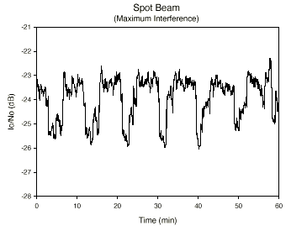

The averaged simulated spectrum of the Iridium system emissions at the ground is given in Figure 3 (for North European busy hour traffic). The results are shown at the ground since the intent here is to compare unwanted and wanted emission levels. It can be seen that the levels at 1626.5 MHz are below –185 dBW/m²/Hz, i.e. about 25 dB less than the intended in-band emission levels of about –160 dBW/m²/Hz. This is a realistic attenuation factor for unwanted emissions from a radio transmitter, which confirms that the simulation does not estimate unrealistically low unwanted emission levels.

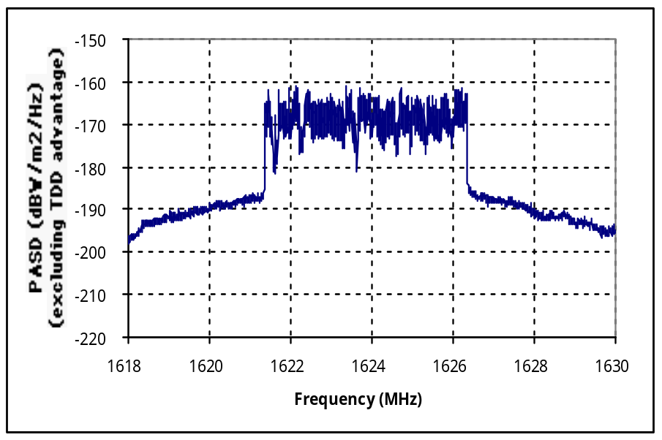 Y axis: Spectral power flux density / dB(W/m²/Hz).
Figure 3: Total Iridium system simulated emissions at the ground (2000s average)

Methodology for simplified analysis
It has been recognised that third parties would not be able to conduct such detailed simulations as conducted by Motorola and described above. Therefore a simplified methodology has also been proposed and verified which allows third parties to approximate these simulations. This is different from the initial model assumed in SE28, since it was found that this initial model did not reflect to a sufficient extent the physical mechanisms underlying the generation of the unwanted emissions.

In particular, it is critical to understand that for the phased array technology used by the Iridium system, unwanted emissions do not follow the beam shapes and layouts of the intended transmissions. Furthermore the level of unwanted emissions depends on the total loading of the Power Amplifiers (PA’s) which in turn depends on the total panel loading, not on the individual beam loading. This is the case because the intermodulation products giving rise to the unwanted emissions are generated in the amplifiers of each radiating element, which amplify the signals for all beams simultaneously.

The simplified methodology needs to take account of the total interference from each panel (not per beam like before). The following improved methodology is proposed. For time t:

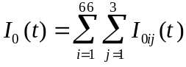
where

I₀(t) is the total interference psd (W/Hz) from the Iridium constellation

I_{0ij}(t) is the interference psd (W/Hz) from j’th panel of the i’th Iridium satellite

P_{ij} is the spurious psd (dBW/Hz) from j’th panel of the i’th Iridium satellite. This is a function of the load of the panel (see Section 4.4).

G_{ij}(θ) is the modelled antenna gain discrimination of the j’th panel of the i’th Iridium satellite towards the Inmarsat satellite. This is a function of the offset angle of the Inmarsat satellite from the panel boresight (see Section 4.3).

L_{i} is the loss (in dB) from the i’th Iridium satellite to the Inmarsat satellite. If the satellite is in view, this equals the free space loss. Else it equals plus infinity.

G_{Ri} is the receive gain of the Inmarsat satellite in the direction of the i’th Iridium satellite.

Panel discrimination factor
The detailed simulator described in Section 4.1 has been used to generate simulation results analysing the unwanted emission levels per panel as seen in the direction of the ground (figure 4). These simulation results were taken during the system busy hour and give the estimated interference level PER PANEL versus offset angle from panel boresight, which include voice activation and power control advantage. The power spectral density was calculated at a range of 780 km from the panel. The frequency is 1626.5 MHz.

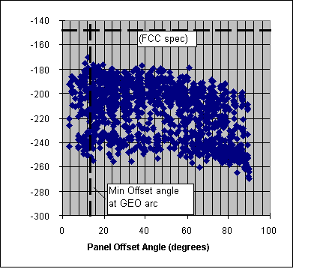
Y axis: Spectral power flux density / dB(W/m²/Hz).
Figure 4: Simulated interference PER PANEL versus offset angle from panel boresight,
calculated at a range 780 km from the panel. Freq. = 1626.5 MHz

Note that the results of Figure 4 are consistent in magnitude with the results presented in Figure 3. Each point represents the level from one panel during one timeslot. It is assumed here that the vertical scatter in the plot is entirely due to loading differences. An equivalent power spectral density reference level to the FCC specifications is also shown in figure 4. Note also that although shown, a SPFD equivalent of the FCC specification is NOT used in the simulation or modelling of the Iridium unwanted emissions described in this paper. It is simply used as a reference level to help describe the unwanted emission levels.

The envelope of these results can be used to derive a simple relationship to relate the panel discrimination factor to the panel boresight offset angles. Angles greater than 90 degrees mean the panel is not in view.

This gives the following suggested relationship for G_{ij}(θ):

G_{ij}(θ) = 0 dBi (θ less than 40 degrees)
0 to -2 dBi (θ between 40 and 60 degrees, linearly interpolated in dBi versus angle)
-2 to -22 dBi (θ between 60 and 90 degrees, linearly vinterpolated in dBi versus angle)
-64.3 dBi otherwise

where θ is the offset angle in degrees between panel boresight and direction of Inmarsat satellite. The –64.3 dBi value is taken when the panel face and hence array of radiating elements is not in view to the victim satellite.

The three phased array panels themselves are arranged with a 40° downtilt from the satellites vertical axis, and are spaced in azimuth at 0°, 120° and 240° relative to the direction of travel of the satellite. Note that there is a minimum offset angle of about 12 degrees between the panel boresite of an orbiting Iridium satellite and the GEO arc. This minimum angle is also shown in figure 4.

Other mitigation factors: Pij
The Pij depend on many factors such as power control, voice activity etc. The FCC spectral power flux density reference level in figure 4 is arrived at assuming 780 km separation, and 24.3 dBi Iridium antenna gain (see note above). These simulation results suggest that, per panel, and in the worst case, the actual unwanted emission levels observed TOWARDS THE GROUND at 1626.5 MHz are 27.9 dB below this equivalent FCC specification (excluding time division effect). Note that this does NOT mean that the simulation is predicting unreasonably low levels of unwanted emission (see Figure 3), rather the FCC specification is rather loose.

Further simulation results, presented in Figure 5, again obtained with the detailed simulator, suggest that in the worst-case the difference between the simulated values and the reference FCC level IN THE DIRECTION OF THE GEO ARC is even higher. The position taken on the GEO arc is 53.5 degrees West, as in SE28(97)100 from Inmarsat. This further improvement (of 10 dB) can be explained by the fact the satellite intended coverage area is not in the direction of the GEO arc.

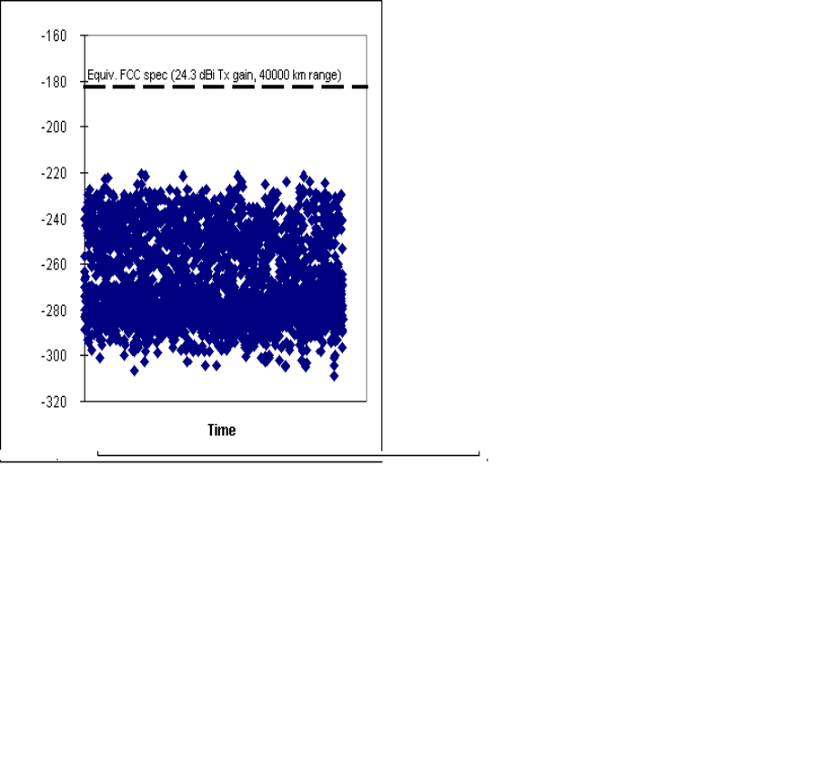
Y axis: Spectral power flux density / dB(W/m²/Hz).
Figure 5: Simulated interference PER PANEL versus time,
calculated at the GEO arc (53.5 degrees West). Freq. = 1626.5 MHz

In the worst case, the simulated spectral power flux density is 38 dB less than the FCC reference SPFD. Note that during this simulation time, many instances occurred where panels of the Iridium satellites were fully loaded and in worst-case alignment with the Inmarsat satellites (offset angles less than 40 degrees).
These results were used to derive the following suggested relationship for P_{ij}:

P_{ij} =14.5*n^{0.319}-152.4 (dBW/Hz) (1)

where n is the number of carriers on the panel (maximum approximately 400, assuming traffic loading to 125% of expected traffic). Note that this includes all mitigation factors (power control, voice activity) except the TDD advantage.

Third parties can model the number of carriers on panel by considering diurnal traffic distributions within each beam, which are summed to generate a total panel loading.

Comparison of detailed simulation and simplified methodology
During the same traffic hour as above (busy hour over Europe), and with the GEO position at 53.5 degrees West (as assumed in a previous Inmarsat study), the results of the full detailed simulation as described in Section 4.1 (modelling individual radiating elements) and the above suggested methodology were compared. This assumed the above relationships for Gij(θ) and Pij (for the simplified methodology), and the same traffic was present for both approaches. Note that the effects of the Inmarsat antenna pattern have not been included - hence the results are given in dBW/m²/Hz.

Comparing the results of figures 5 and 6 shows that, due to the statistical effects of traffic, satellite alignments etc, the net effect from the whole Iridium system is not significantly above that of a single fully loaded panel in worst-case alignment.

They also show that the simplified methodology still tends to over-estimate the worst-case interference levels (by about 2 dB).

For information purposes, the requested protection level of 0.6% is shown on the plot, assuming an Inmarsat global beam having a gain of 16.5 dBi in the direction of the Earth. Note that this is not exactly a fair way to represent the protection criteria, since it assumes all visible Iridium satellites are in the direction of maximum gain of the Inmarsat satellite antenna. See Section 4.1 for a more accurate analysis.

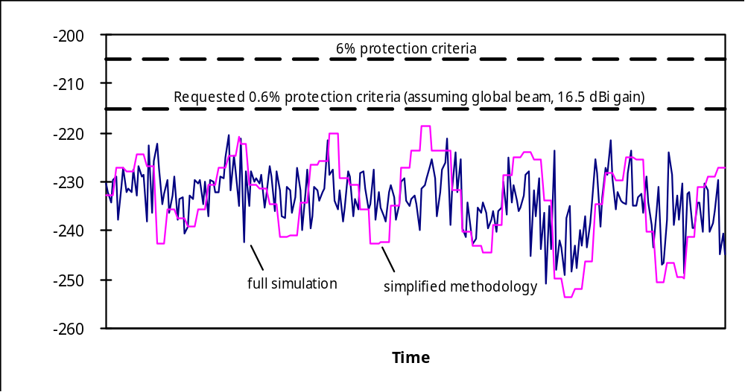 Y axis: Spectral power flux density / dB(W/m²/Hz).
Figure 6: Comparison of detailed simulation and simplified methodology.
Interference at 1626.5 MHz from total Iridium system, excluding time-division advantage.

INMARSAT VERIFICATION STUDY

Static link budget analysis
As a first step towards verifying Motorola’s analysis, a simple ‘static’ link budget calculation using a single full loaded Iridium panel interfering into an Inmarsat spot beam at the edge of its coverage was performed (Figure 7):

Iridium beam at 50 deg elevation from Nadir.

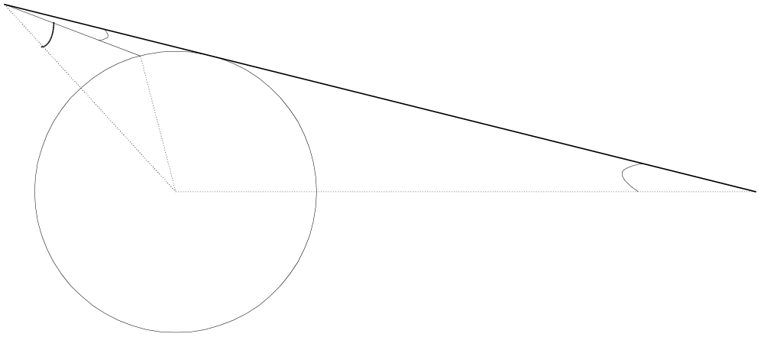
ϕ
Antenna discrimination towards GSO
Iridium Satellite
Inmarsat Satellite
Antenna discrimination towards NGSO
Re
Radius_Earth
h_ngso
height_gso
φ

Figure 7: Antipodal interference from a NGSO satellite
to a GSO satellite occurring over the rim of Earth

The received interference can be estimated by

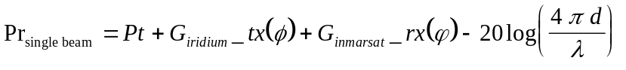  Pr_{single panel} | dB(W/Hz) | (1)

Where

Pr_{single panel} = the out-of-band Iridium emission level for a fully loaded panel having 400 carriers on the panel. Using equation 1 proposed by Motorola, Pt is assigned a value of :

= 14.5 * 400^{0.319} - 152.4 = -54.3 dBW/Hz.

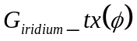 = gain of beam in the direction on Inmarsat satellite. As the visibility to the edge of coverage is 63 degrees, if the elevation of the panel boresight is 50 degrees, the minimum off-axis discrimination is 13 degrees. Therefore, the off-axis panel gain using the Motorola suggested relationship is 0 dBi.

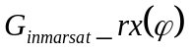 = Inmarsat satellite EOC gain, which is 24dBi (-3dBi contour).

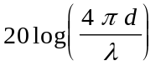= the path loss = 189.7 dBi.

The received interference from a single fully loaded Iridium panel is therefore:
= -54.3 + 0 - 189.7 + 24.0
= -220.0 dB(W/Hz).

Which, is 2 dB above the protection criteria for the Inmarsat spot beam.

Inmarsat dynamic simulation
In order to determine whether the net effect from the whole Iridium system is not significantly above that of a single fully loaded panel in a worst case alignment (as claimed by Motorola), a complete dynamic simulation of the Iridium constellation was modelled in software. The assessment followed the simplified panel based methodology proposed by Motorola (detailed in section 4.3). The modelling process is shown in the following graphs:

Figure 8 shows the modelling of Iridium beams visible to a GSO satellite located at 0 degrees longitude. Here, beam switch-off diversity is simulated so as to avoid the overlap between Iridium beams overlap at high latitudes.

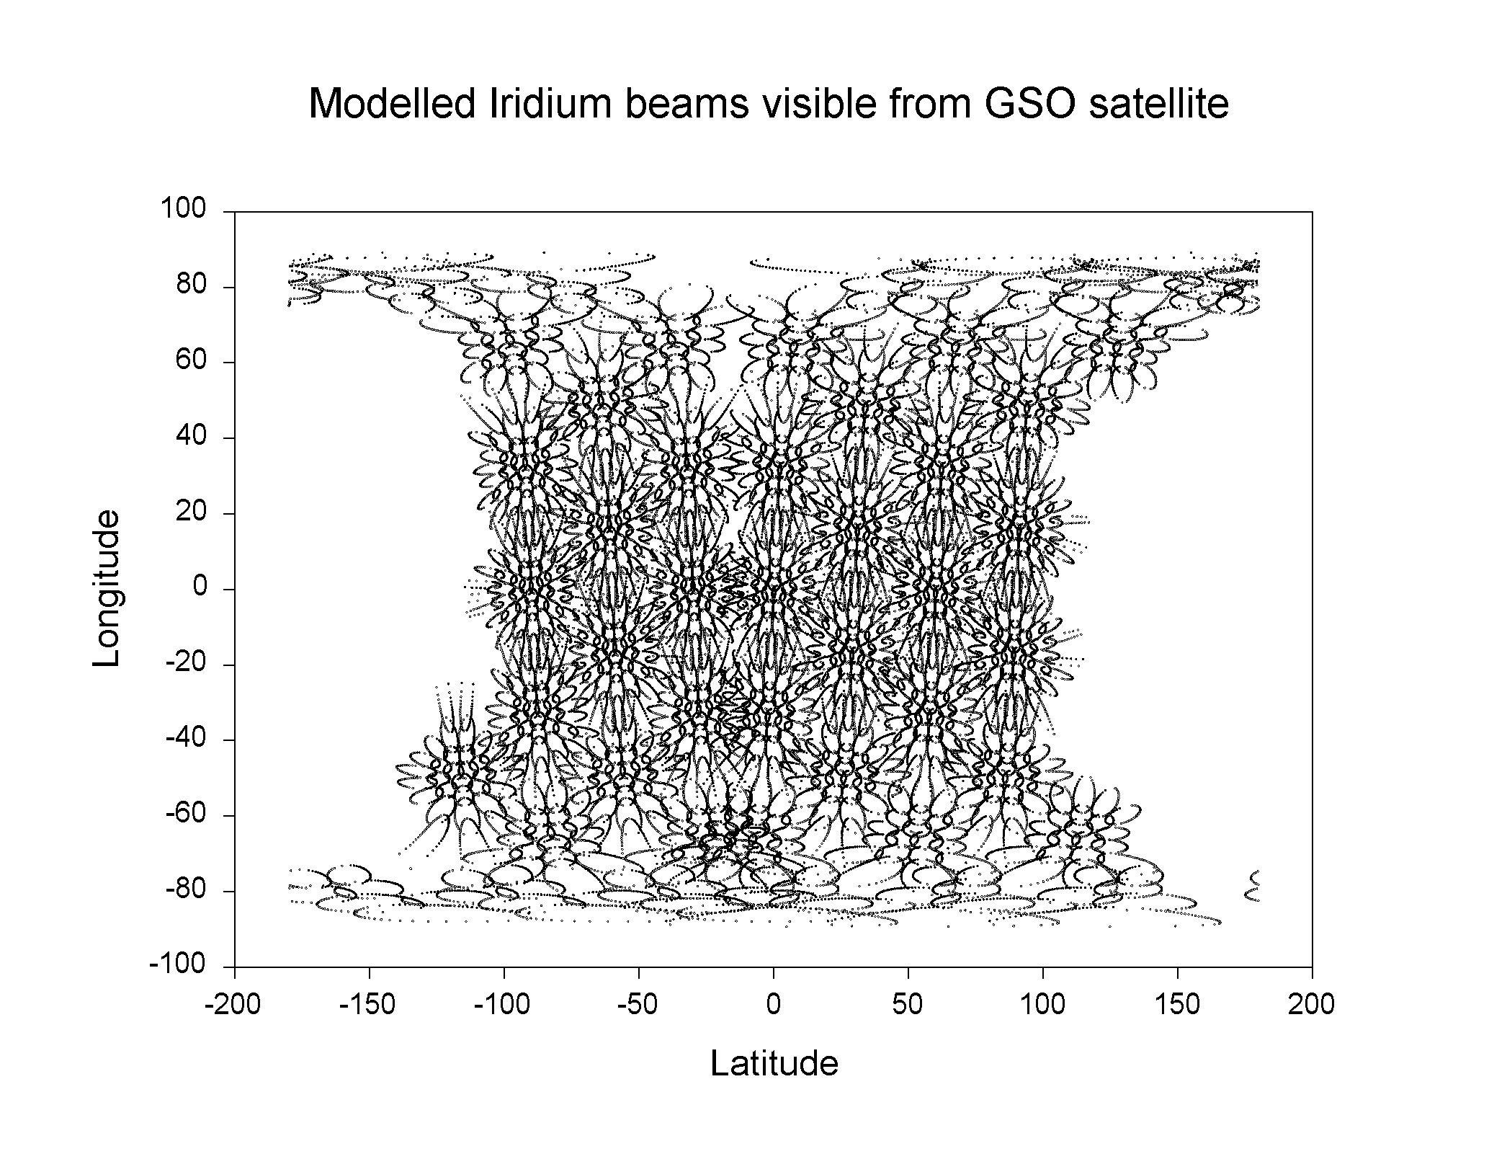
Figure 8: Modelled iridium constellation seen from GSO satellite

Figure 9 shows the modelling of Iridium panels. This conforms to the simplified panel model proposed by Motorola. The figure shows an illustrative coverage of the panels. It is noted that the panel coverage areas would overlap at high latitudes and therefore a distribution of traffic loading would need to be incorporated in the interference assessment - so as not to ‘double count’ out-of-band spurious emission generation by panels serving high latitudes. Also, please note, only the boresight locations are required for the interference assessment.
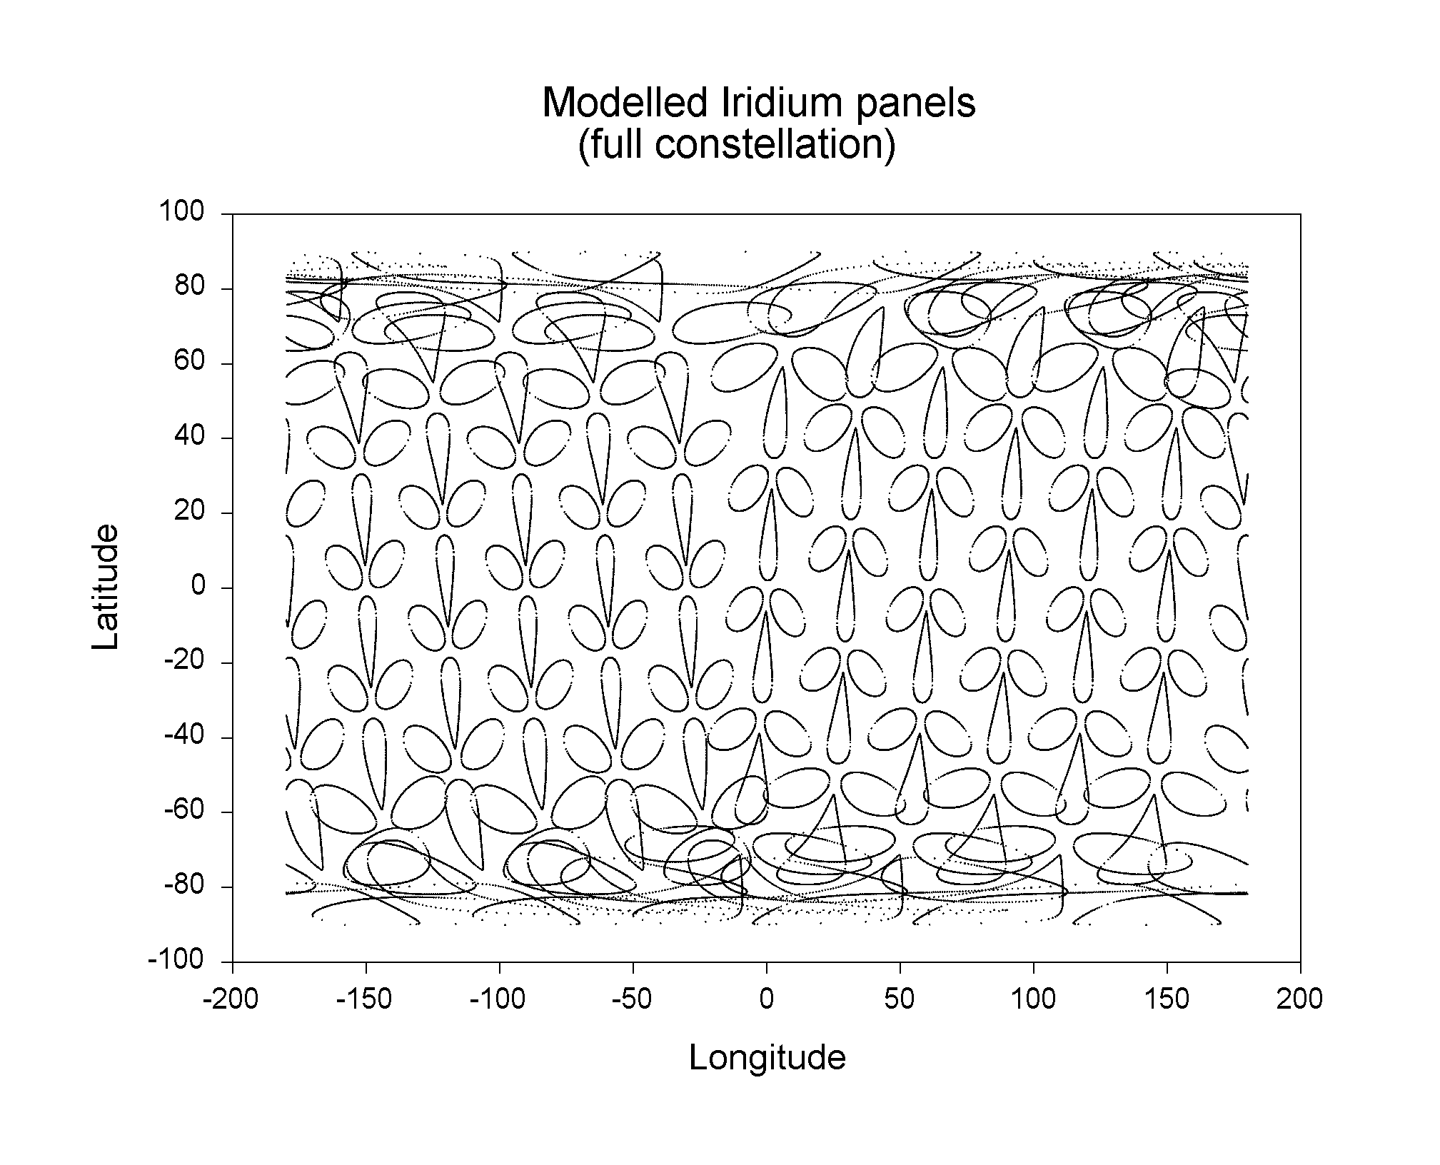
Figure 9: Modelling of Iridium panel (illustrative coverage plot only)

Figure 10 shows the assumed geographical distribution of traffic. The model assumes panels whose boresight location on the earth’s surface coincides with areas marked with a cross could have the potential of full loading, whereas panels serving other locations could have at the most 20% of maximum loading. For boresight latitudes above +75 degrees and below -75 degrees (and at all boresight longitudes), the loading is assumed to be 5% so as to allow for the co-coverage of panels.

Figure 10: Assumed distribution of panel traffic loading
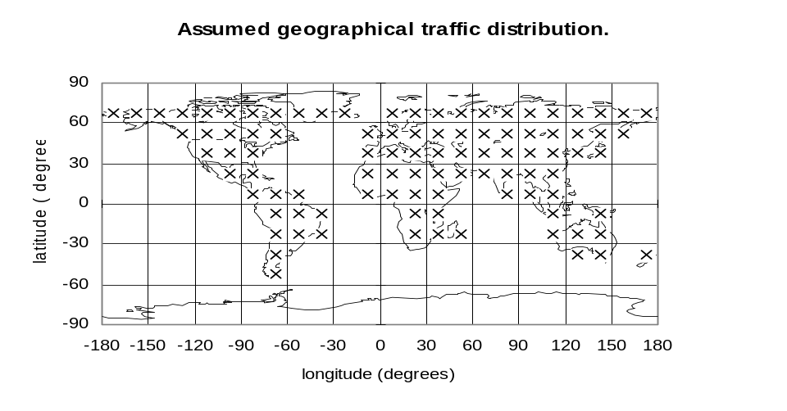
Figure 11 shows the assumed diurnal traffic distribution for a panel. This was modelled so as not to over-estimate interference, particularly into the Inmarsat global beam which would see many Iridium panels spanning different local time zones.

The total loading assumed for a given Iridium panel would depend on both its geographical location and local time traffic profile.

Figure 11. Example diurnal panel traffic distribution
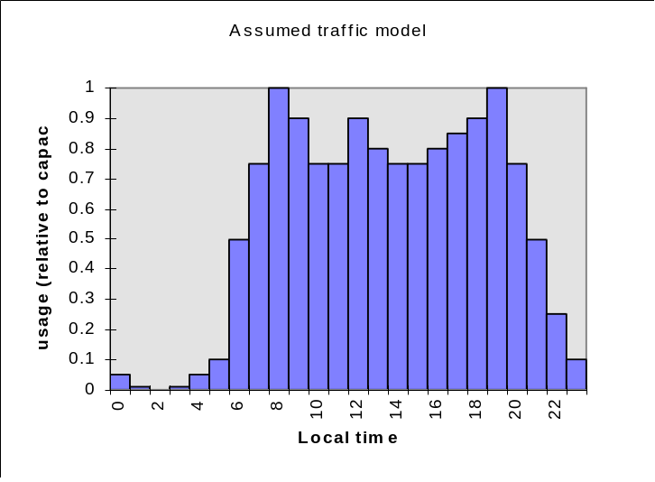

Results of Inmarsat dynamic simulation
Results from the Inmarsat simulation for the interference into the global and spot beam are given in Figures 12 and 13 respectfully. The simulation was conducted at run time step of 1 second over a 10 day period. The graph shows values of Io/No and where each point represents the maximum interference over a 60 second period.
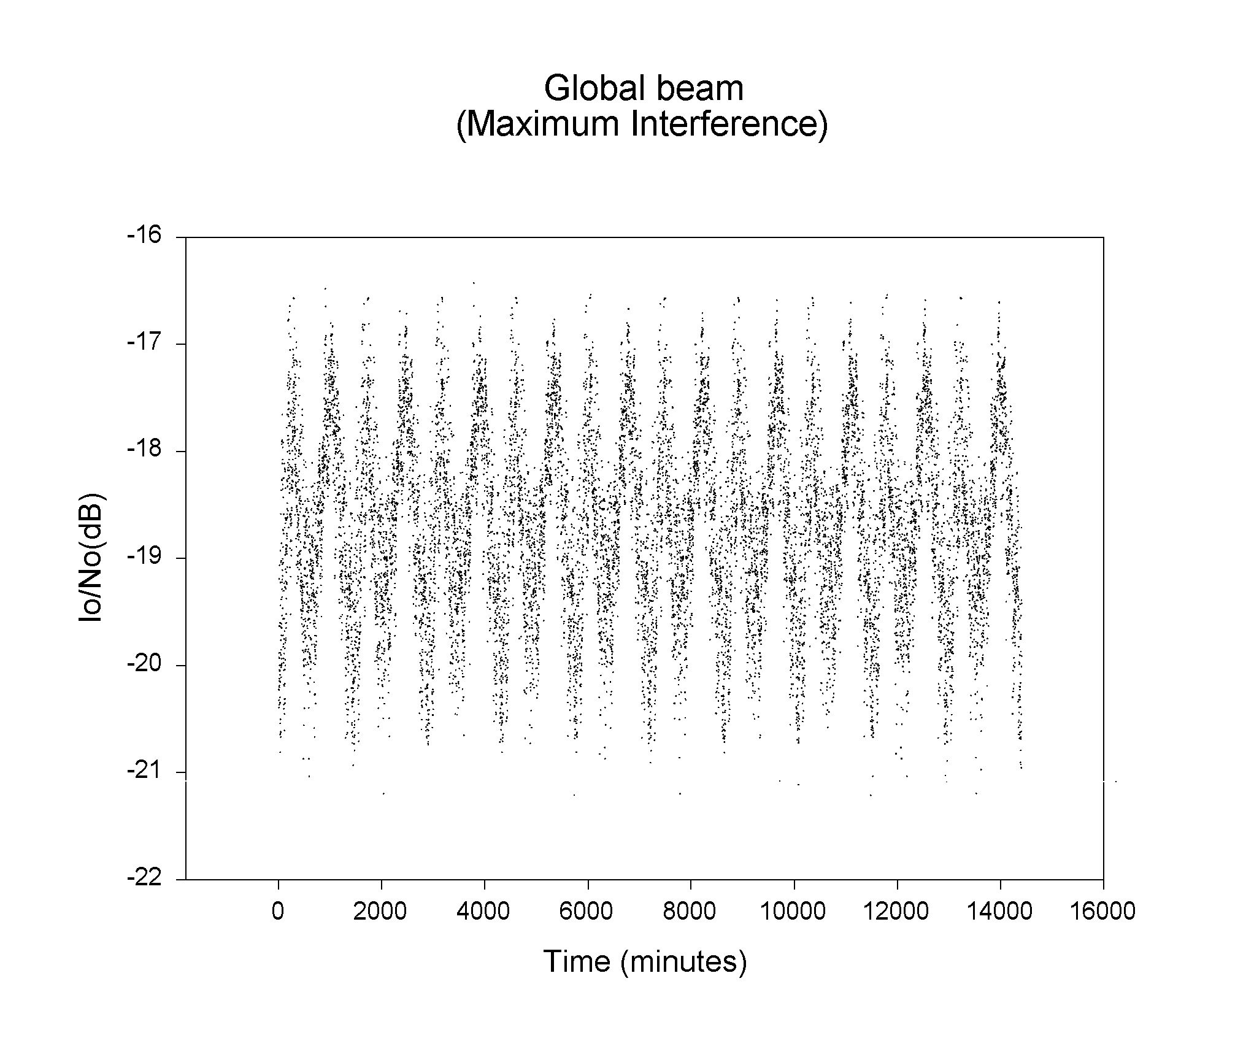
Figure 12: Estimated interference to Inmarsat Global beam
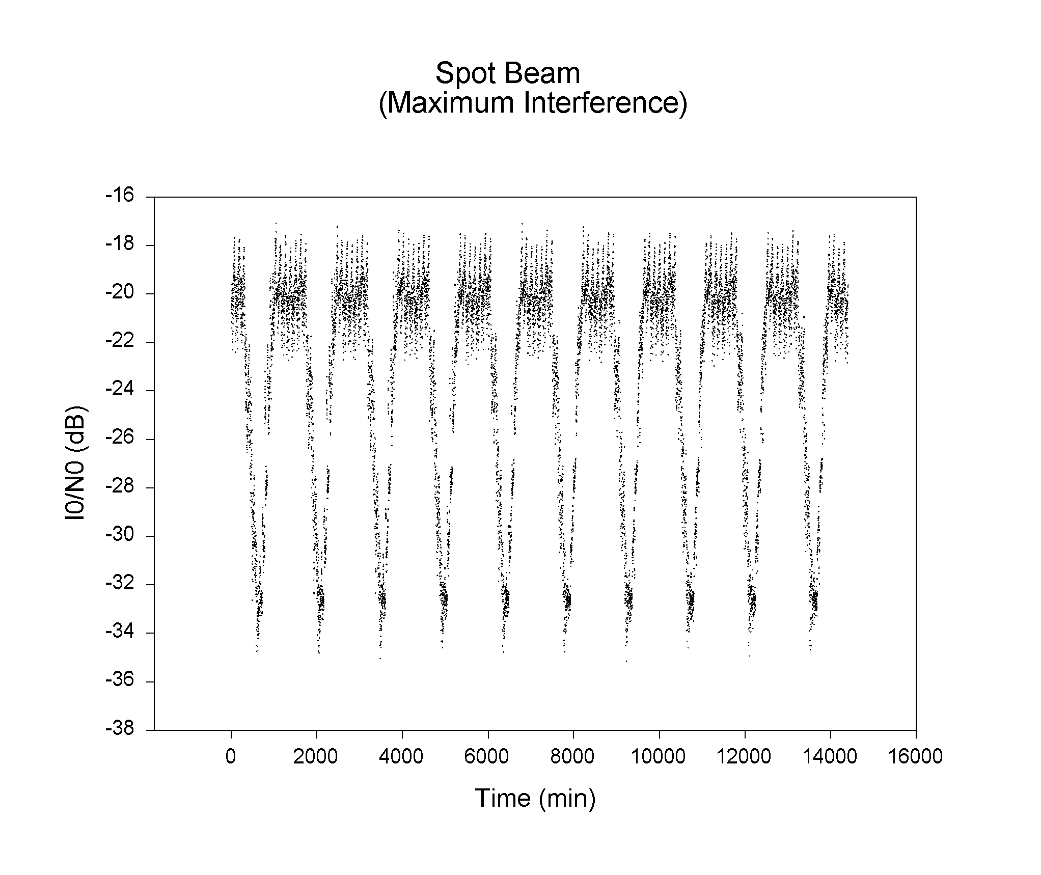
Figure 13: Estimated interference to Inmarsat Spot beam

The cumulative distribution of received interference (of 1 minute maxima) is shown in Figure 14. The graph shows interference at all percentages of time would be above -223.3 dB(W/Hz), which is the protection criterion for the global beam. And approximately 55% of the time above -222.3 dB(W/Hz), which is the protection criterion for the spot beam.

Furthermore, for 5 % of the time interference would be above -218.7 dB(W/Hz) for the global beam and -219.1 dB(W/Hz) for the spot beam. Note, the maximum figures are -217.5 and -217.2 dB(W/Hz) into the global and spot beams but which occur at very small percentages of time.

Taking the interference into the spot beam, for 1% of time the interference is above -218.2 dB(W/Hz). This corresponds to Io/No figure -18.1 dB, or 4.1 dB more interference than the protection criterion. Moreover, the figure is 4.4 dB above the figure from the Motorola full simulation and suggest the combined effect of the simulation over the interference received from a fully loaded panel into the Inmarsat spot beam (c.f. §5.1) is nearly twice.

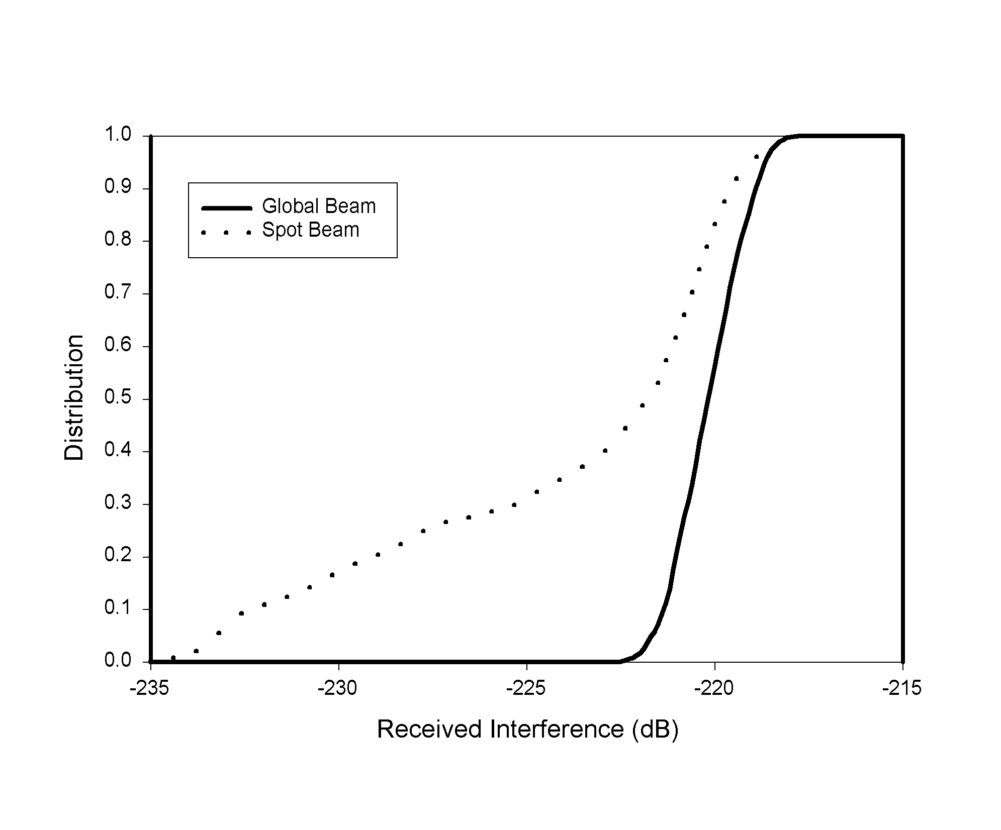
Figure 14: Cumulative distribution of received interference into
Inmarsat Spot and Global beams.

CONCLUSION

From Motorola studies
Detailed simulations conducted by Motorola show no problems of interference from Iridium system downlinks in to Inmarsat GEO uplinks at and above 1626.5 MHz. These simulations modelled the complete transmission system, including the individual radiating elements in the phased array antennas, and the expected traffic models. It should be noted that these conclusions hold even with the worst-case traffic conditions used (125% expected traffic) and the rather tight requested protection levels.

It has been recognised that third parties would not be able to conduct such detailed simulations. Therefore a simplified methodology has also been proposed and verified which allows third parties to approximate these simulations. This is different from the initial model assumed in SE28, since it was found that this initial model did not reflect to a sufficient extent the physical mechanisms underlying the generation of the unwanted emissions. It was found that the simplified methodology tended to slightly over estimate the interference (by 2dB) when compared to the full detailed simulation.

Conclusions from Inmarsat verification studies
Inmarsat has used the proposed Motorola ‘panel’ based simplified methodology to assess interference into its existing Global and Spot beam operations and found that although interference is above that presented by Motorola (and above the proposed protection requirements for these beams) it is not grossly above the requirements and interference could be deemed acceptable given the nature of the problem. Also, please note, further information on the Iridium panel boresight locations has been presented by Motorola which would make the results of interference into Inmarsat receivers worse, but this is not thought to alter this conclusion. Furthermore, Motorola have indicated that in their opinion the differences between the Motorola and Inmarsat results are mainly due to differences in assumed traffic.

The concern Inmarsat has is that if the actual Motorola out-of-band emission levels are at, or near those levels permitted by US regulatory requirements (currently the only defined applicable emission limits), then harmful interference will certainly occur into Inmarsat operations.

In the proposed methodology for assessing interference into Inmarsat satellite receivers, the value assumed for the Iridium out-of-band emission power is -54.3 dBW/Hz towards the GSO from a fully loaded Iridium panel. This is derived from Motorola best estimates of spurious emissions from their simulations. However, the figure is 38 dB below the equivalent FCC limit. This is a key concern of Inmarsat who has some reservations with the figure as no measured results have been presented to support this value.

Inmarsat have requested Motorola make available measurements of out-of-band emission levels from fully loaded Iridium panels but Motorola have indicated that they can not do so. In the absence of any measured results of Iridium out-of-band emissions levels, Inmarsat accept with reservation the declaration made by Motorola on the out-of-band emissions levels from Iridium satellites towards the geostationary orbit at frequencies of 1626.5 MHz and above. This is modelled as a maximum out-of-band emission eirp of between -54.3 dB(W/Hz) to -118.6 dB(W/Hz) depending on the off-axis angle between the Iridium panel and Inmarsat satellite. However, if the Motorola estimates are deemed to be widely optimistic (for example by inference from the on-going measurement programme by radio-astronomers of the Iridium spurious emissions levels at the surface of the earth, or receipt of interference by Inmarsat satellites), it is requested CEPT re-examine this issue.

It is noted the patterns assumed by Motorola for Inmarsat space craft antennas are specified patterns for earth-station antennas. However, since these patterns are close to space station antennas for gains of 18dBi and 27dBi (as used by Inmarsat), and for off-axis angles less than 10 degrees, this is thought to make no significant difference to the results.
The Inmarsat verification model assumes an Iridium panel elevation angle from the satellite nadir of 40 degrees. It was subsequently revealed that the Iridium panel elevation from nadir is 50 degrees. The effect of this will make the results of interference into Inmarsat satellite receivers presented in Section 5.3 worse; However, as this is not thought to alter the substance of the Inmarsat conclusions, no change is made to this document.

