
European Radiocommunications Committee (ERC)
within the European Conference of Postal and Telecommunications Administrations (CEPT)

COMPATIBILITY AND SHARING ANALYSIS BETWEEN DVB–T
AND TALKBACK LINKS IN BANDS IV AND V

Edinburgh, October 2000

Executive Summary

This study assesses the compatibility between talkbacks and DVB–T in bands IV and V and determines the necessary separation distances between talkbacks and DVB–T as a function of frequency. The study takes account of three spectrum masks: the spectrum mask for sensitive cases according to the Chester Agreement, 1997 and the spectrum masks recommended by SE PT 212. The results are only valid for the DVB–T and talkback system parameters given in this study.

The main results of the study are as follows:

- In most cases, Co-channel operation (frequency difference from 0 to 4 MHz between the centre frequencies) of DVB–T and talkbacks within a DVB–T coverage area will cause unacceptable interference to talkbacks and vice-versa. However, indoor operation of talkbacks may be feasible even in the co-channel case depending on building shielding loss and the location of the nearest DVB-T receiver. These cases may be evaluated on a site by site basis.

- Operation of talkbacks in the 1st adjacent channel of DVB–T (frequency difference from 4 to 12 MHz between the centre frequencies), except for the first 500 kHz of this channel, may be possible, depending on local conditions.

- In practice, use of the 2nd adjacent channel (frequency difference from 12 to 20 MHz between the centre frequencies) by talkbacks will be feasible in most cases. This applies to both indoor and outdoor operation of talkbacks.

These conclusions are based on the use of the sensitive spectrum mask specified in the Chester Agreement. The use of less stringent masks such as the SE PT 21 mask will significantly increase the required separation distances in the adjacent channels.

All protection ratio measurements were limited to professional DVB–T receivers. The immunity of domestic receivers, particularly for adjacent channel rejection, is not yet known. Therefore the frequency separation needed between the future wanted DVB–T channel and talkback operation may change for domestic receivers.

INDEX TABLE

1 INTRODUCTION 1
2 INTERFERENCE SCENARIO: DVB–T INTERFERES WITH TALKBACKS 1
2.1 Calculations with the system parameters according to the Chester Agreement 1
2.1.1 DVB–T system parameters 1
2.1.2 Talkback system parameters 2
2.1.3 Considered interference scenarios 2
2.1.4 Results for an 8 MHz DVB–T signal 3
2.2 Calculations with the DVB-T spectrum masks adopted by CEPT SE PT 21 for out-of-band emissions 8
2.2.1 DVB–T system parameters 8
2.2.2 Talkback system parameters 8
2.2.3 Considered interference scenarios 9
2.2.4 Results for an 8 MHz DVB–T signal 9
3 INTERFERENCE SCENARIO: TALKBACKS INTERFERE WITH DVB–T 14
3.1 Talkback system parameters 14
3.2 DVB–T system parameters 14
3.3 Calculations and considered interference scenarios 14
3.3.1 Measurement results for the protection ratio values 14
3.3.2 Description of the interference scenarios 15
3.3.3 Maximum permissible interfering field strength at the DVB-T receiving location for fixed reception 16
3.3.4 Calculation of the equivalent radiated power of the talkbacks 17
3.3.5 Determination of the propagation model 18
3.3.6 Description and results of the calculations 18
3.4 Interpretation of the results 20
4 CONCLUSION 21

COMPATIBILITY AND SHARING ANALYSIS BETWEEN DVB–T
AND TALKBACK LINKS IN BANDS IV AND V

INTRODUCTION
Talkback links are typically used to supplement radio-microphones and OB links by providing a ‘return-path’ for, e.g. stage direction. These links are not intended to provide contribution quality audio and are typically simple 12.5 kHz narrow-band FM. For further information see ERC report 42.

The aim of this compatibility analysis is to determine the interference potential of DVB–T transmissions with regard to talkback reception (see Section 2) and talkback transmissions with regard to DVB-T reception (see Section 3). For this purpose, the necessary separation distances between talkbacks and DVB–T as a function of the frequency separation between the two applications are determined. Section 4 of this document uses the results from Sections 2 and 3 to produce overall conclusions with regard to compatibility between DVB-T and talkbacks.

INTERFERENCE SCENARIO: DVB–T INTERFERES WITH TALKBACKS
All compatibility results and conclusions are valid only for the system parameters given below. In case of changes, new calculations are necessary.

Calculations with the system parameters according to the Chester Agreement

DVB–T system parameters
DVB–T e.r.p.: 100 W, 200 W, 1 kW, 2 kW, 10 kW, 20 kW, 100 kW;
DVB–T effective antenna heights: 150 m, 300 m.
Modulation: 16 QAM, 64 QAM and QPSK (no influence on results)
Number of carriers: 2k, 8k (no influence on results)
Bandwidth: 8 MHz
Shoulder attenuation: 50 dB

Spectrum mask:

Breakpoints
Relative frequency (MHz) | Relative level dB
- 12 | -87.2
-6 | -62.2
-4.2 | -50.2
-3.8 | 0
+3.8 | 0
+4.2 | -50.2
+6 | -62.2
+12 | -87.2
Table 1: Spectrum mask

Note: The out of channel values in this spectrum mask correspond to the breakpoints in Figure A1.2 in the Chester Agreement (8 MHz channel in the sensitive case). The value of 3.8 MHz was used because it is more accurate than the value given in the Chester Agreement (In Chester, the true value of 3.81 MHz was rounded up to 3.9 MHz).

Talkback system parameters
The parameters in the table below are given in Annex 5 of the Chester Agreement.

Wanted: | Talkback  (non companded) |  |  | Default field strength to  be protected (dBµV/m) |  |  | 31 | Default receiving  antenna height (m) |  |  | 1.5
Service Identifier |  |  | NT8 | at frequency (MHz) |  |  | 650
Unwanted |  | DVB–T/8 MHz
Δf (MHz) |  | -12.0 | -10.0 | -8.0 | -6.0 | -4.2 | -3.8 | -3.6 | 0.0 | 3.6 | 3.8
PR (dB) |  | -97.0 | -92.0 | -85.0 | -80.0 | -70.0 | -20.0 | -14.0 | -14.0 | -14.0 | -20.0
Δf (MHz) |  | 4.2 | 6.0 | 8.0 | 10.0 | 12.0
PR (dB) |  | -70.0 | -80.0 | -85.0 | -92.0 | -97.0
Table 2: Protection ratios for talkbacks

Protection ratios were obtained from a series of measurements made in the UK and in Germany. For the measurements, DVB-T transmissions complying closely with the above spectrum mask were simulated.
The protection ratios in respect of talkbacks are based on the measurement results for the second most sensitive receivers.

The values in the table above are valid for talkbacks operating at 650 MHz. For talkbacks operating at other frequencies, the default field strength to be protected is obtained, using the following extrapolation equation :

E(f) = E(650) + 20log₁₀(f/650),

where f is the frequency in MHz, E(650) the field strength at 650 MHz and E(f) the field strength at the wanted frequency.

Considered interference scenarios
In order to make as realistic an analysis as possible, the two interference scenarios (outdoor operation and indoor operation) are considered separately.

Scenario 1: Outdoor operation.

No building attenuation was taken into account and a talkback receiving antenna height of 1.5 m was assumed.

The analysis was based on the propagation curve in Rec. ITU-R P.370, Figure 11 (1% of time, 50% of location). A correction factor of 12 dB was applied for a receiving antenna height of 1.5 m, according to Annex 1 of the Chester Agreement.

The Rec. ITU-R P.370 curve does not apply to distances of less than 10 km. The curves for the effective antenna heights of 150 m and 300 m were therefore extrapolated to the free-space propagation curve for distances of less than 10 km (to explain the interpolation procedure, the curves for a DVB-T transmitter of ERP of 1kW are displayed in Annex 1).

Scenario 2: Indoor operation.

A correction factor of 7 dB for building penetration loss, the median value given in Annex 1 of the Chester Agreement, was applied in addition to the factor of 12 dB as agreed for a receiving antenna height of 1.5 m. The value of 7 dB is appropriate for the case of 50% of locations inside a building.

Results for an 8 MHz DVB–T signal
Scenario 1: Outdoor operation.

Diagrams 1 and 2 and Tables 3a/3b show the required separation distance as a function of the frequency separation, the DVB-T e.r.p. and the DVB-T effective transmitting antenna height.

The results show that the required separation distances from a DVB-T transmitter in the range 0 to 3.8 MHz from the centre of a DVB-T channel are large and that there is a rapid transition to much shorter separation distances in the range of frequency separations from 3.8 to about 4.2 MHz i.e., from co - channel to adjacent channel operation. The separation distances given in Section 3, however, must also be respected.

Scenario 2: Indoor operation.

Diagrams 3 and 4 and Tables 4a/4b show the required separation distance as a function of the frequency separation, the DVB-T e. r. p. and the DVB-T effective transmitting antenna height.

The results show, as is to be expected, that the required separation distances from a DVB-T transmitter are less if a talkback is operated indoor. Indeed, there may be certain situations with high building penetration losses where operation with a frequency separation of less than
3.8 MHz from the centre frequency of a DVB-T transmission may be possible even though inside a DVB-T coverage area, provided that the protection requirements for the closest DVB-T receiver are also respected.

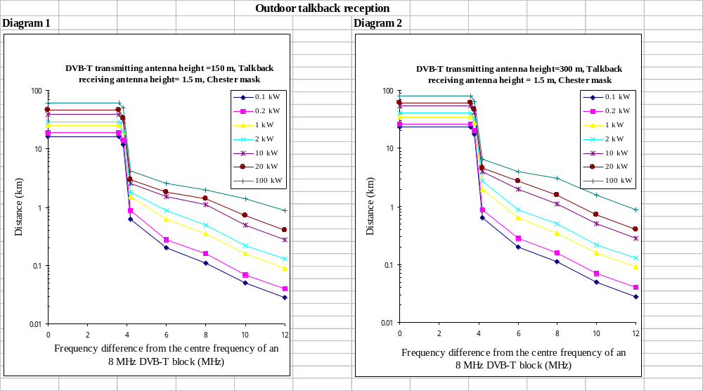

Necessary separation distances in km between DVB–T and talkbacks in bands IV and V
Talkback outdoor reception

 | DVB–T e.r.p.
Frequency  (MHz) | 0.1 kW | 0.2 kW | 1 kW | 2 kW | 10 kW | 20 kW | 100 kW
3.6 | 16.4 | 18.6 | 25.3 | 29 | 38.9 | 45.6 | 62.1
3.8 | 11.8 | 14.2 | 19.4 | 19.4 | 30 | 33.8 | 49.75
4.2 | 0.63 | 0.89 | 1.54 | 1.8 | 2.55 | 2.96 | 4.21
6.0 | 0.2 | 0.28 | 0.63 | 0.89 | 1.54 | 1.8 | 2.55
8.0 | 0.11 | 0.16 | 0.35 | 0.5 | 1.12 | 1.4 | 1.98
10.0 | 0.05 | 0.07 | 0.16 | 0.22 | 0.5 | 0.71 | 1.4
12.0 | 0.028 | 0.04 | 0.09 | 0.13 | 0.28 | 0.4 | 0.89
Table 3a heff = 150m

 | DVB–T e.r.p.
Frequency  (MHz) | 0.1 kW | 0.2 kW | 1 kW | 2 kW | 10 kW | 20 kW | 100 kW
3.6 | 23.3 | 26 | 35.6 | 40.4 | 53.6 | 61.8 | 80.2
3.8 | 17.3 | 20.2 | 28 | 31.6 | 42 | 46.7 | 63.9
4.2 | 0.63 | 0.89 | 1.99 | 2.76 | 3.92 | 4.56 | 6.47
6.0 | 0.2 | 0.28 | 0.63 | 0.89 | 1.99 | 2.76 | 3.92
8.0 | 0.11 | 0.16 | 0.35 | 0.5 | 1.12 | 1.58 | 3.05
10.0 | 0.05 | 0.07 | 0.16 | 0.22 | 0.5 | 0.71 | 1.58
12.0 | 0.028 | 0.04 | 0.09 | 0.13 | 0.28 | 0.4 | 0.89
Table 3b heff = 300m

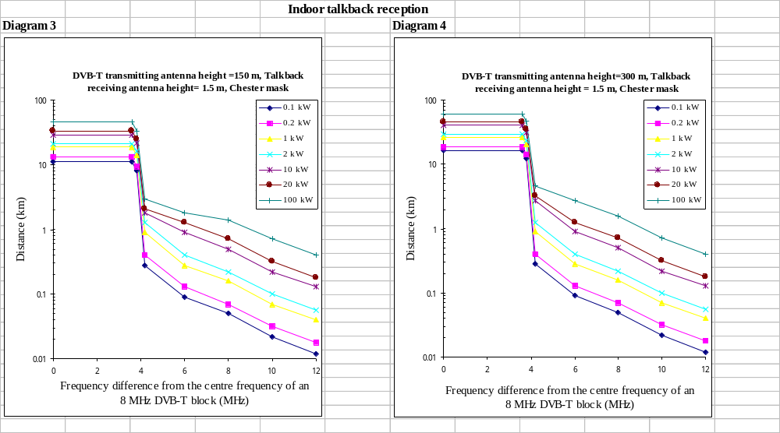

Necessary separation distances in km between DVB–T and talkbacks in bands IV and V
Talkback indoor reception

 | DVB–T e.r.p.
Frequency  (MHz) | 0.1 kW | 0.2 kW | 1 kW | 2 kW | 10 kW | 20 kW | 100 kW
3.6 | 11.3 | 13.3 | 18.6 | 21.2 | 29 | 33.3 | 45.6
3.8 | 8.06 | 9.37 | 14.2 | 16.4 | 21.9 | 25.3 | 33.8
4.2 | 0.28 | 0.4 | 0.9 | 1.26 | 1.8 | 2.09 | 2.96
6.0 | 0.09 | 0.13 | 0.28 | 0.4 | 0.9 | 1.26 | 1.79
8.0 | 0.05 | 0.07 | 0.16 | 0.22 | 0.5 | 0.71 | 1.4
10.0 | 0.022 | 0.032 | 0.07 | 0.1 | 0.22 | 0.32 | 0.71
12.0 | 0.012 | 0.018 | 0.04 | 0.056 | 0.13 | 0.18 | 0.4
Table 4a heff = 150m

 | DVB–T e.r.p.
Frequency  (MHz) | 0.1 kW | 0.2 kW | 1 kW | 2 kW | 10 kW | 20 kW | 100 kW
3.6 | 16.4 | 18.8 | 26 | 29.8 | 40.5 | 45.3 | 61.8
3.8 | 12.3 | 14.3 | 20.2 | 23.3 | 31.6 | 35.6 | 46.7
4.2 | 0.28 | 0.4 | 0.9 | 1.26 | 2.76 | 3.21 | 4.56
6.0 | 0.09 | 0.13 | 0.28 | 0.4 | 0.9 | 1.26 | 2.76
8.0 | 0.05 | 0.07 | 0.16 | 0.22 | 0.5 | 0.71 | 1.59
10.0 | 0.022 | 0.032 | 0.07 | 0.1 | 0.22 | 0.32 | 0.71
12.0 | 0.012 | 0.018 | 0.04 | 0.056 | 0.13 | 0.18 | 0.4
Table 4b heff = 300m

Calculations with the DVB-T spectrum masks adopted by CEPT SE PT 21 for out-of-band emissions

DVB–T system parameters
DVB–T e.r.p.: 100 W, 200 W, 1 kW, 2 kW, 8 kW, 10 kW, 20 kW, 100 kW
DVB–T effective antenna heights: 150 m, 300 m
Assumed antenna gain: 0-10 dBd
Modulation: 16 QAM, 64 QAM and QPSK (no influence on results)
Number of carriers: 2k, 8k (no influence on results)
Bandwidth: 8 MHz
Shoulder attenuation: 35 dB

Spectrum mask:
Breakpoints | Pout = 9-29 dBW | Pout = 39-50 dBW
Relative frequency (MHz) | Relative level dB
- 20 | -56.2 | -66.2
-12 | -48.2 | -58.2
-4.2 | -35 | -35
-3.9 | 0 | 0
+3.9 | 0 | 0
+4.2 | -35 | -35
+12 | -48.2 | -58.2
+20 | -56.2 | -66.2
Table 5: Spectrum masks

Note: The values of the DVB-T transmitter output power (Pout) in this spectrum mask correspond to the breakpoints adopted by SE PT 21 for out-of-band emissions.

It was necessary to assume a DVB-T antenna gain in order to calculate the DVB-T e.r.p for the analysis of compatibility. The antenna gain relative to a half-wave dipole was assumed to be 0-10 dB. Some of the DVB-T e.r.p. values are therefore higher than Pout.

Talkback system parameters
The following parameters were calculated using the protection ratio values in Section 2.1.2. In this connection it is important to note that it was assumed for the calculations that the DVB-T out-of-band emissions were the dominant interference mechanism. This assumption seems valid since it has been shown that, for talkbacks, the curves of the measured protection ratios given in 2.1.2. are in good agreement with the corresponding interfering spectrum mask (i.e. the Chester ‘sensitive case’ mask).

Default field strength to be protected: 31 dB(µV/m)
Default receiving antenna height: 1.5 m
Transmitter frequency: 650 MHz

Frequency difference (MHz) | Protection ratio (dB)
 | Pout = 9-29 dBW | Pout = 39-50 dBW
0 | -14 | -14
± 3.9 | -14 | -14
± 4.3 | -49 | -49
± 12 | -62.2 | -72.2
Table 6: Protection ratios

Considered interference scenarios
The same indoor and outdoor operation scenarios as described in Section 2.1.3 were considered. However, there are two SE PT 21 spectrum masks for out-of-band emissions: the first mask applies to a DVB-T transmission output power of 9-29 dBW and the second to a DVB-T transmission output power of 39-50 dBW. For power levels between 29 and39 dBW, a variable mask is used to provide a smooth transition. Statements about compatibility therefore need to distinguish between these two cases.

Results for an 8 MHz DVB–T signal
Results are presented for each of the two SE21 masks. In the case of DVB-T with 8kW ERP, two results are presented :
- One for Pout = 29 dBW with 10 dB antenna gain
- One for Pout = 39 dBW with no antenna gain.
The results are different due to the differences in the transmitter masks.

Scenario 1: Outdoor operation.

Diagrams 5a/5b and 6a/6b and Table 7a/7b show the required separation distance as a function of the frequency separation, the DVB-T e.r.p. and the DVB-T effective transmitting antenna height.

The results show that the required separation distances from a DVB-T transmitter in the range 0 to 3.8 MHz from the centre of a DVB-T channel are similar to those in Section 2.1.4. showing a transition to shorter separation distances in the range of frequency separations from 3.8 to about 4.2 MHz i.e., from co - channel to adjacent channel operation. However in this case the separation distances are rather larger than in the previous section. The separation distances given in Section 3, however, must also be respected.

Scenario 2: Indoor operation.

Diagrams 7a/7b and 8a/8b and Table 8a/8b show the required separation distance as a function of the frequency separation, the DVB-T e.r.p. and the DVB-T effective transmitting antenna height.

The results show, as is to be expected, that the required separation distances from a DVB-T transmitter are less if a talkback is operated indoor. Indeed, there may be certain situations with high building penetration losses where operation with a frequency separation of less than 3.8 MHz from the centre frequency of a DVB-T transmission may be possible even though inside a DVB-T coverage area, provided that the protection requirements for the closest DVB-T receiver are also respected.

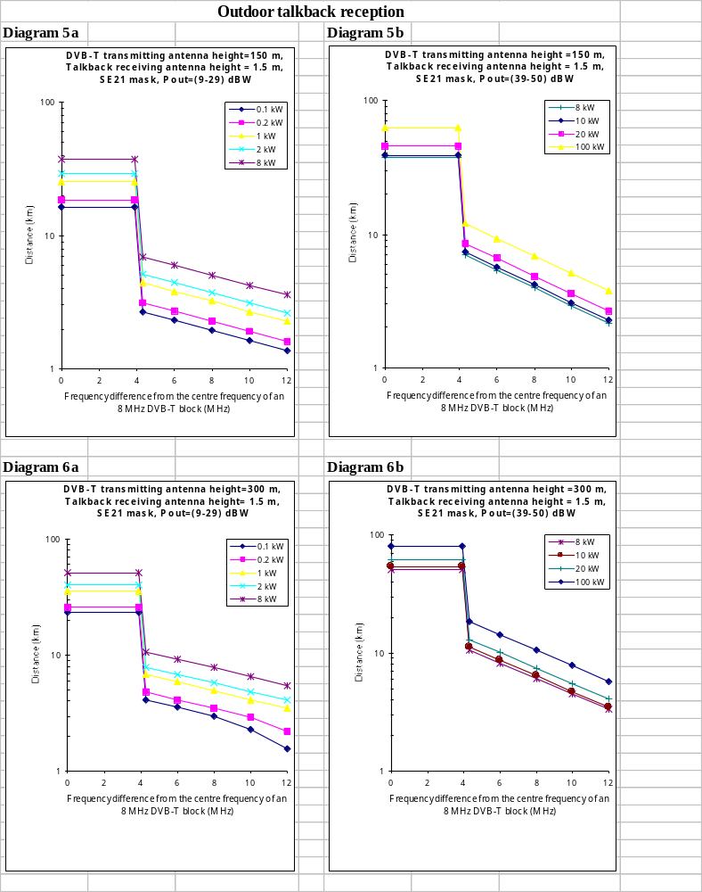

Necessary separation distances in km between DVB–T and Talkbacks in bands IV and V
Outdoor operation

 | DVB-T e.r.p
SE PT 21 mask | (Pout_max = 9-29 dBW) |  |  |  |  | (Pout_max = 39-50 dBW)
Frequency difference (MHz) | 0.1 kW | 0.2 kW | 1 kW | 2 kW | 8 kW | 8 kW | 10 kW | 20 kW | 100 kW
0.0 | 16.4 | 18.6 | 25.3 | 29 | 37.4 | 37.4 | 38.9 | 45.6 | 62.1
3.9 | 16.4 | 18.6 | 25.3 | 29 | 37.4 | 37.4 | 38.9 | 45.6 | 62.1
4.3 | 2.68 | 3.12 | 4.42 | 5.14 | 6.94 | 6.94 | 7.3 | 8.48 | 12
6.0 | 2.31 | 2.7 | 3.82 | 4.44 | 6 | 5.38 | 5.65 | 6.57 | 9.32
8.0 | 1.96 | 2.27 | 3.23 | 3.75 | 5.06 | 3.98 | 4.19 | 4.86 | 6.9
10.0 | 1.64 | 1.91 | 2.69 | 3.15 | 4.25 | 2.93 | 3.08 | 3.58 | 5.09
12.0 | 1.38 | 1.6 | 2.28 | 2.65 | 3.58 | 2.17 | 2.28 | 2.65 | 3.77
Table 7a heff = 150m

 | DVB-T e.r.p
SE PT 21 mask | (Pout_max = 9-29 dBW) |  |  |  |  | (Pout_max = 39-50 dBW)
Frequency difference (MHz) | 0.1 kW | 0.2 kW | 1 kW | 2 kW | 8 kW | 8 kW | 10 kW | 20 kW | 100 kW
0.00 | 23.3 | 26 | 35.6 | 40.5 | 51.4 | 51.4 | 53.6 | 61.8 | 80.3
3.9 | 23.3 | 26 | 35.6 | 40.5 | 51.4 | 51.4 | 53.6 | 61.8 | 80.3
4.3 | 4.12 | 4.79 | 6.8 | 7.9 | 10.7 | 10.7 | 11.22 | 13.04 | 18.51
6.0 | 3.55 | 4.1 | 5.88 | 6.84 | 9.23 | 8.27 | 8.69 | 10.1 | 14.34
8.0 | 3 | 3.49 | 4.96 | 5.77 | 7.79 | 6.12 | 6.44 | 7.48 | 10.62
10.0 | 2.29 | 2.93 | 4.14 | 4.84 | 6.53 | 4.51 | 4.74 | 5.51 | 7.82
12.0 | 1.55 | 2.18 | 3.51 | 4.08 | 5.51 | 3.34 | 3.51 | 4.08 | 5.79
Table 7b heff = 300m

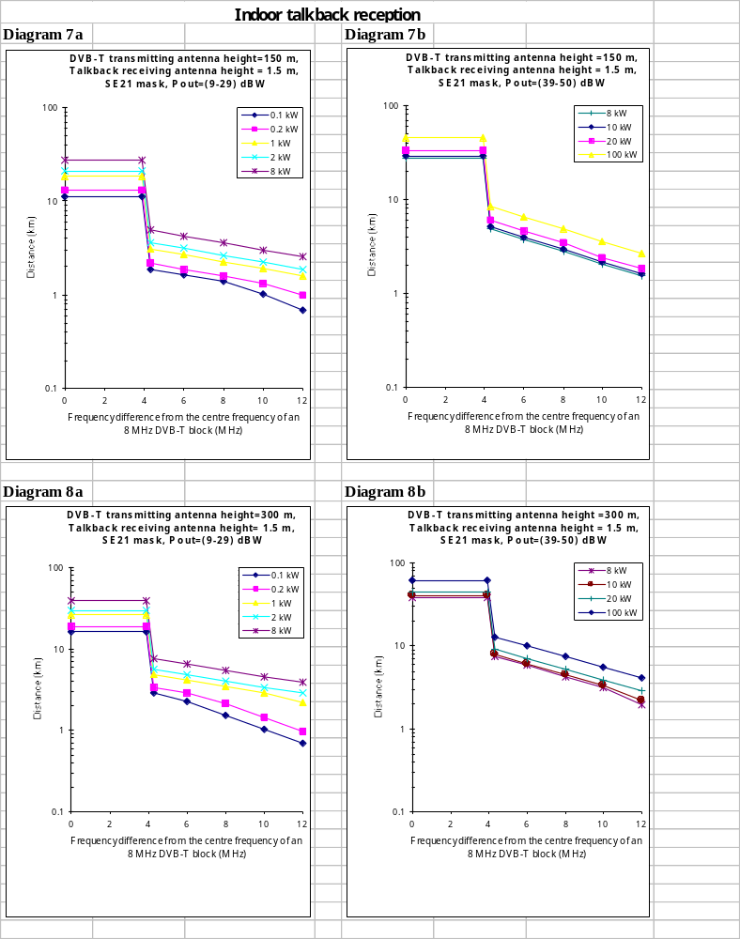

Necessary separation distances in km between DVB–T and talkbacks in bands IV and V
Indoor operation

 | DVB-T e.r.p
SE PT 21 mask | (Pout_max = 9-29 dBW) |  |  |  |  | (Pout_max = 39-50 dBW)
Frequency difference (MHz) | 0.1 kW | 0.2 kW | 1 kW | 2 kW | 8 kW | 8 kW | 10 kW | 20 kW | 100 kW
0.0 | 11.3 | 13.3 | 18.6 | 21.2 | 27.8 | 27.8 | 28.9 | 33.3 | 45.6
3.9 | 11.3 | 13.3 | 18.6 | 21.2 | 27.8 | 27.8 | 28.9 | 33.3 | 45.6
4.3 | 1.89 | 2.19 | 3.11 | 3.62 | 4.9 | 4.89 | 5.14 | 5.97 | 8.48
6.0 | 1.63 | 1.89 | 2.69 | 3.13 | 4.23 | 3.79 | 3.98 | 4.63 | 6.57
8.0 | 1.38 | 1.6 | 2.27 | 2.64 | 3.57 | 2.81 | 2.95 | 3.43 | 4.86
10.0 | 1.02 | 1.34 | 1.91 | 2.22 | 3 | 2.07 | 2.17 | 2.43 | 3.58
12.0 | 0.69 | 0.98 | 1.61 | 1.87 | 2.53 | 1.53 | 1.61 | 1.87 | 2.65
Table 8a heff = 150m

 | DVB-T e.r.p
SE PT 21 mask | (Pout_max = 9-29 dBW) |  |  |  |  | (Pout_max = 39-50 dBW)
Frequency difference (MHz) | 0.1 kW | 0.2 kW | 1 kW | 2 kW | 8 kW | 8 kW | 10 kW | 20 kW | 100 kW
0.0 | 16.4 | 18.8 | 26 | 29.8 | 38.9 | 38.9 | 40.4 | 45.3 | 61.8
3.9 | 16.4 | 18.8 | 26 | 29.8 | 38.9 | 38.9 | 40.4 | 45.3 | 61.8
4.3 | 2.9 | 3.38 | 4.79 | 5.57 | 7.53 | 7.53 | 7.9 | 9.19 | 13
6.0 | 2.26 | 2.92 | 4.14 | 4.82 | 6.51 | 5.83 | 6.12 | 7.12 | 10.1
8.0 | 1.53 | 2.16 | 3.49 | 4.06 | 5.49 | 4.32 | 4.53 | 5.27 | 7.48
10.0 | 1.02 | 1.45 | 2.93 | 3.41 | 4.61 | 3.18 | 3.34 | 3.88 | 5.51
12.0 | 0.69 | 0.98 | 2.19 | 2.88 | 3.89 | 1.96 | 2.19 | 2.88 | 4.08
Table 8b heff = 300m

INTERFERENCE SCENARIO: TALKBACKS INTERFERE WITH DVB–T

Talkback system parameters
A signal generator producing the following modulation characteristics was used as an interferer instead of a talkback transmitter.
Baseband input: 1 kHz sinusoidal
Modulation: FM, deviation 2.5 kHz; UK measurements
CW signal; GER measurements

DVB–T system parameters
DVB–T receiver: Professional type (NDS system 3000) UK measurements:
RF wanted DVB–T levels: DVB–T Modes
-52.0 dBm: 2k, QPSK, FEC 3/4
2k, 16 QAM, FEC 3/4
2k, 64 QAM, FEC 3/4
GER measurements:
RF wanted DVB–T levels: DVB–T Modes
-66.0 dBm: 2k, QPSK, FEC 2/3
2k, 16 QAM, FEC 1/2
2k, 16 QAM, FEC 2/3
2k, 64 QAM, FEC 1/2
2k, 64 QAM, FEC 2/3
Baseband I/P: MPEG-2 transport stream
Interference criterion: BER 2E-4 after Viterbi decoder

Note that these are a small sub-set of all the variants shown in the DVB specification. They were chosen purely for convenience of measuring and may not represent currently preferred systems.

Calculations and considered interference scenarios

Measurement results for the protection ratio values
The necessary protection ratio values for DVB–T professional receivers were measured by the United Kingdom and Germany. The results are shown in the table below.
 | Protection ratios (dB)
 | UK measurement results |  |  | GER measurement results
Frequency difference (MHz) | wanted DVB–T RF level  -52 dBm  Modulation  2k, 4 QAM, FEC 3/4 | wanted DVB–T RF level  -52 dBm  Modulation  2k, 16 QAM, FEC 3/4 | wanted DVB–T RF level  -52 dBm  Modulation  2k, 64 QAM, FEC 3/4 | wanted DVB–T RF level  -66 dBm  Modulation  2k, QPSK, FEC 2/3  2k, 16 QAM, FEC ½ or 2/3  2k, 64 QAM, FEC ½or 2/3
0 | -10.0 | -3.0 | 1.0 | -7 to -9 (*)
± 2 | -9.0 | -3.0 | 1.0 | --
± 3.8 | -15.0 | -13.0 | -8.0 | --
± 4.5 | -41.0 | -39.0 | -33.0 | --
± 6.0 | < -56.0 | -47.0 | -40.0 | --
± 7.0 | < -56.0 | -50.0 | -43.0 | --
± 8.0 | < -56.0 | -53.0 | -46.0 | --
Table 9: protection ratio measurement results for DVB–T receivers
(*): This depends on the DVB mode (2k QPSK 2/3; 2k 16 QAM ½ or 2/3; 2k 64 QAM ½ or 2/3).
--: Only the co-channel protection ratios were measured.

In this context it is important to mention that the wanted DVB–T level in the measurements differed from those given in the Chester Agreement. In what way this fact affects the protection ratio values, especially for the adjacent channel, is not yet known.
Furthermore it must be mentioned that the values were measured for professional and not for domestic DVB–T receivers. As the immunity of future domestic receivers is not yet known, the results for such receivers may change.

All further calculations were based on the protection ratio values in column 3 of table 9 for 16 QAM modulation with a code rate of 3/4 for a 2k-system. In practice, this modulation will be often used in the case of fixed DVB-T reception.

While other system variants like 64QAM have higher protection ratios, they also need a higher wanted signal level resulting in similar permissible interference levels due to a certain cancellation of the two effects. Conclusions from this study are therefore also valid for other DVB-T systems.

Description of the interference scenarios
In practice there are many different interference scenarios. In this report only the critical case was considered, namely the fixed DVB-T reception condition.

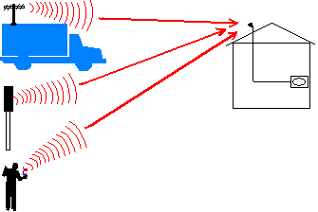Fixed DVB-T reception
TV-van, with
Stage direction
12dBd
TV
fixed station
PMR hand held
which used as
talkback
Figure 1

Note:
In practice, Private Mobile Radio (PMR) equipment is also used as talkback for the stage direction, i.e. from persons who arrange the scenery.

Some other possible scenarios are:

- portable DVB-T reception and outdoor talkback (fixed, TV-van, PMR hand held) operation: Preliminary studies showed that this condition gives shorter separation distances than the fixed case, i. e. if the fixed reception conditions are satisfied then portable is also possible.
- portable indoor DVB-T reception and indoor talkback (PMR hand held) operation (in the same room): In the case of interference it should be possible to switch off one of the devices.
- portable indoor DVB-T reception and indoor talkback (PMR hand held) operation (in different rooms): This situation is equivalent to indoor operation of the DVB-T receiver with outdoor operation of the talkback (PMR hand held).
- Fixed DVB-T reception and indoor operation of talkback (PMR hand held): This situation is less critical that the one in Fig. 1 because of building attenuation.

Maximum permissible interfering field strength at the DVB-T receiving location for fixed reception
The minimum equivalent field strength at the receiving place depends on the modulation and code rate of the DVB–T signal. As mentioned above in the paragraph 3.3.1 on further calculations 2k, 16 QAM and the code rate ¾ were chosen. This system variant corresponds to "B3" in table A1.1 of the Chester Agreement. The required C/N for a BER = 2*10⁻⁴ after the Viterbi decoder is 13 dB for fixed reception (Ricean channels). With this C/N value plus the implementation margin of 3 dB (16 dB) the corresponding minimum median equivalent field strength for bands IV and V can be determined. The tables A1.6 and A1.7 in the Chester Agreement are important in this context:

Minimum median equivalent field strength (E_{med}) for DVB-T at 10 m a.g.l. 50% of time and 50% of locations | Band IV  (f = 500 MHz) | Band V  (f = 800 MHz)
fixed reception | 49 dB(µV/m) | 53 dB(µV/m)
Table 10: Minimum median equivalent field strength for DVB-T (location probability of 95 %)

The maximum permissible interfering field strength at the DVB-T receiving location, E_{max_int} ,can be calculated as;

E_{max_int} = E_{med} - C/I - Lc

where

Emed is the minimum median equivalent field strength in table 10
C/I is the measured protection ratio value in table 9
Lc is the location correction factor in table 11

- Location correction factor (the corresponding values are given in table 11 below).
Different location correction factors for short and long distances between DVB–T and the talkbacks have to be taken. This is necessary because the standard deviation “τ” especially of the interfering signal depends on the separation distance between the two services. The calculation of the location correction factor is described below:
Long distance (> 100m):

Short distance (≤ 100m):

μ: distribution factor
τ_{DVB-T} and τ_{talkback}: standard deviations of the distribution

- For longer distances, a standard deviation of the distribution applies to both the wanted and unwanted signal, whereas for short distances the standard deviation of the distribution for the talkback signal is 0 dB.

Location correction factors to be applied are:
Victim DVB-T Reception Condition from Talkback | Location correction factor in dB
 | Short Separation Distance | Long Separation Distance
Fixed Reception | 9 | 13
Table 11: Location correction factors
DVB-T Reception Condition: Fixed, E_{med} = 49 dB(µV/m)
Frequency difference (MHz) | Maximum permissible interfering field strength at the receiving location, dB(µV/m)
 | Short Separation Distance (≤ 100 m ) | Long Separation Distance  (> 100 m)
0 | 43 | 39
± 2.0 | 43 | 39
± 3.8 | 53 | 49
± 4.5 | 79 | 75
± 6.0 | 87 | 83
± 7.0 | 90 | 86
± 8.0 | 93 | 89
Table 12 a: Band IV (A1.6 from Chester)

DVB-T Reception Condition: Fixed, E_{med} = 53 dB(µV/m)
Frequency difference (MHz) | Maximum permissible interfering field strength at the receiving location, dB(µV/m)
 | Short Separation Distance (≤ 100 m ) | Long Separation Distance  (> 100 m)
0 | 47 | 43
± 2.0 | 47 | 43
± 3.8 | 57 | 53
± 4.5 | 83 | 79
± 6.0 | 91 | 87
± 7.0 | 94 | 90
± 8.0 | 97 | 93
Table 12b: Band V (A1.7 from Chester)

Note:
The values are valid for 500 MHz (Band IV) and 800 MHz (Band V). Values at other frequencies may be obtained from a conversion factor of,

20 log Fr/Fx dB,
where Fr is the required frequency, Fx is the reference frequency for the considered band.

Calculation of the equivalent radiated power of the talkbacks
The reference conditions for the e.r.p. of the talkbacks were used to calculate the compatibility between talkbacks and DVB–T receivers. PMR hand held devices can also be used as Talkbacks. In this case the radiated power of the transmitter was influenced by body loss. The calculation of the corresponding value is given in the table below. Furthermore the radiated power of a fixed transmitter and a transmitter with transmitting antenna on the top of a van (which includes stage direction) are given in table 13.

 | TV-van transmitter | fixed transmitter | hand held transmitter
Output power of the talkbacks | 42 dBm (15W) | 37 dBm (5W) | 30 dBm (1W)
Antenna gain | 0 dBd | 0 dBd | -6 dBd*
Antenna height | 5 m | 5 m | 1.5 m
Radiated power for compatibility consideration | 42 dBm | 37 dBm | 24 dBm
Table 13: Radiated power for compatibility consideration
* The –6 dBd value corresponds to a combination of body losses and antenna efficiency

Determination of the propagation model
The propagation model for the calculation of the interference from talkbacks to DVB–T receivers was based on free-space propagation for distances < 100 m between the two services.
For distances between 100 m and 1 km, the propagation loss is generally higher than for free space attenuation. The higher propagation loss is due to clutter and topography. Therefore in this calculation a propagation loss of 30 dB per decade was assumed. In the case of separation distances greater than 1 km a propagation loss of 40 dB per decade was chosen from the two-ray model.

The diagram below illustrates the propagation model.

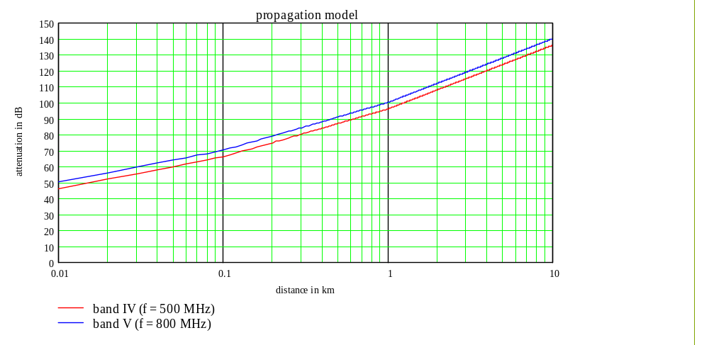Diagram 9

Description and results of the calculations
The necessary separation distances between a talkback transmitter and a DVB–T receiver are presented in diagram 10. The diagram shows the results for band IV and V. The values for Diagram 10 were derived from the parameters given in tables 12a and 12b.

Diagram 10 should be interpreted as follows:
The x-axis shows two parameters, namely the necessary frequency separation in MHz and the separation distances between the two services in km.
The y-axis shows the values both for the maximum permissible interfering field strength for a DVB–T receiver as a function of the frequency separation and for the interfering field strength of the talkback as a function of the corresponding separation distance.

An example based on 6 MHz is given to facilitate understanding of the diagram.
In a first step the x-axis is used to determine the maximum permissible interfering field strength for a frequency difference of 6 MHz between the two services. The corresponding value for band V is 87 dB(µV/m).

In a second step the x-axis shows the necessary separation distance in km. An interfering field strength of 87 dB(µV/m) is produced by a talkback (PMR hand held) at approximately 120 m. So the necessary separation distance between the two services is approximately 120 m. For a talkback which used from a TV-van (15W ERP) the corresponding separation distance is 400 m.

It is also possible to determine the necessary frequency difference for a specific separation distance.

The maximum permissible interfering field strength of 87 dB(µV/m) shown in the curve is calculated as follows:

53 dB(µV/m) minimum median equivalent DVB–T field strength at 10 m a.g.l.
table 12b for fixed reception (Band V)
- (13 dB) location correction factor (long distance)
- (-47 dB) protection ratio value, table 9, column 3, for a frequency difference of 6.0 MHz
87 dB(µV/m) maximum permissible interfering field strength for DVB–T receiver
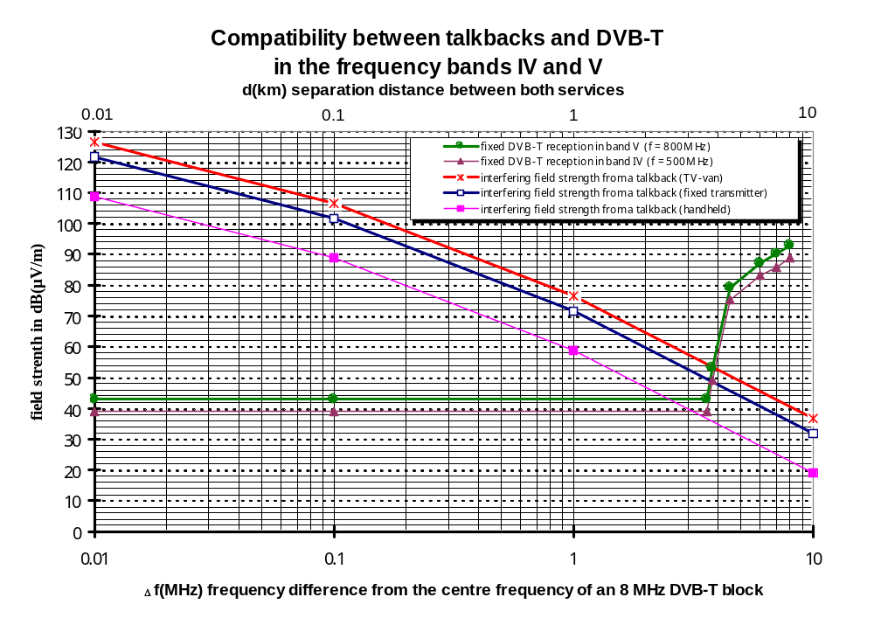Diagram 10: Compatibility between talkbacks and DVB-T in band V

The necessary separation distances for the fixed reception scenario are shown below in tabular form.

Frequency difference (MHz) | Necessary separation distance in km between talkbacks  and DVB-T in band IV
 | TV-van transmitter  (with stage direction) | Fixed transmitter | Hand held transmitter  (PMR device used as talkback)
0 | 8.5 | 6.5 | 3.1
± 2 | 8.5 | 6.5 | 3.1
± 3.8 | 5.0 | 3.7 | 1.7
± 4.5 | 1.10 | 0.78 | 0.28
± 6.0 | 0.60 | 0.42 | 0.14
± 7.0 | 0.48 | 0.32 | 0.12
± 8.0 | 0.38 | 0.25 | 0.10
Table 14a: Separation distances in km for DVB –T fixed reception
and outdoor operation of talkbacks in band IV

Frequency difference (MHz) | Necessary separation distance in km between talkbacks  and DVB-T in band V
 | TV-van transmitter  (with stage direction) | Fixed transmitter | Hand held transmitter  (PMR device used as talkback)
0 | 7.0 | 5.0 | 2.3
± 2 | 7.0 | 5.0 | 2.3
± 3.8 | 3.7 | 2.9 | 1.3
± 4.5 | 0.82 | 0.58 | 0.21
± 6.0 | 0.43 | 0.31 | 0.12
± 7.0 | 0.35 | 0.23 | 0.06
± 8.0 | 0.26 | 0.18 | 0.04
Table 14b: Separation distances in km for DVB –T fixed reception
and outdoor operation of talkbacks in band V

Interpretation of the results
The fixed reception scenario with outdoor operation of the talkback constitutes the worst case. For co-channel operation separation distances in the region of 2.3 to 8.5 km are necessary. The distance depends on the frequency band and type of talkback operation. In practice, distances above 1 km will not be acceptable in most cases. Therefore, in the most cases co-channel operation in the same area is not possible. In some cases 1st adjacent channel operation, apart from the first 500 kHz of this channel, is possible for this scenario because the separation distances range from approximately 60 m to approx. 1.1 km.

In the case of indoor operation of talkbacks (PMR hand held) the feasibility of sharing with DVB-T will be dependant on the building shielding loss and location of the closest DVB-T receiver. This is particularly relevant to locations with heavy talkback usage where co-ordination with the broadcaster should be practical.

CONCLUSION
In order to establish if in a given set of circumstances:
- the DVB-T service and
- talkback usage at a given location

are compatible, the relevant separation distances derived in Sections 2 and 3, must be examined. If both separation distances are respected, then usage is compatible.

- In most cases, Co-channel operation of DVB–T and talkbacks within a DVB–T coverage area will cause unacceptable interference to talkbacks and vice-versa. However, indoor operation of talkbacks may be feasible even in the co-channel case depending on building shielding loss and the location of the nearest DVB-T receiver. These cases may be evaluated on a site by site basis.

- Operation of talkbacks in the 1st adjacent channel of DVB–T, apart from the first 500 kHz of this channel, will be possible in a lot of cases. The necessary separation distances for SE PT 21 spectrum masks are longer than for the Chester spectrum mask, in particular if the DVB-T e.r.p. is produced using a low transmitter output power and a high antenna gain.

- In practice, use of the 2nd adjacent channel by talkbacks will be feasible in most cases. This applies to both indoor and outdoor operation of talkbacks. The necessary separation distances for SE PT 21 spectrum masks are longer than for the Chester mask.

All protection ratio measurements were limited to professional DVB–T receivers. The immunity of domestic receivers, particularly for adjacent channel rejection, is not yet known. Therefore the frequency separation needed between the future wanted DVB–T channel and talkback operation may change for domestic receivers.

Annex 1
Extrapolation between the free space propagation model and
the Rec ITU-R P.370-7 propagation model (Figure 11, 1% of the time, 50% of location)
for a reception antenna height of 1.5 m
(DVB-T transmitter power ERP = 1kW).

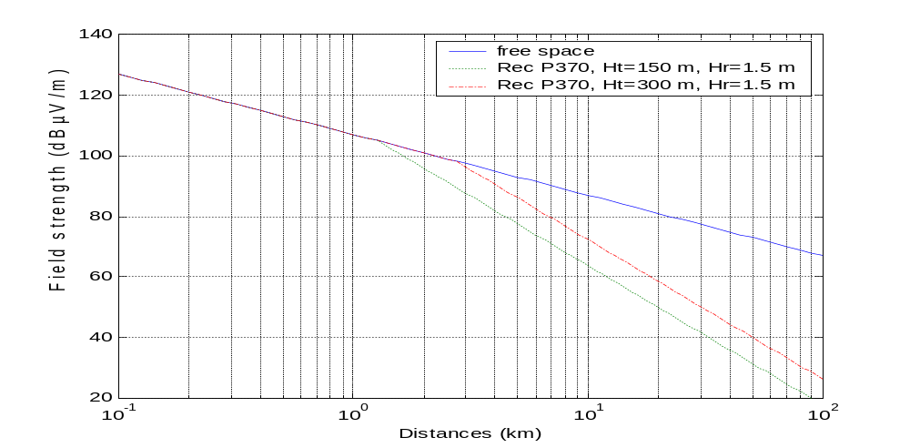

NB: Ht = DVB-T effective transmitter antenna height; Hr = talkback receiving antenna height

The Chester 1997 Multilateral Coordination Agreement relating to Technical Criteria, Coordination Principles and Procedures for the introduction of Terrestrial Digital Video Broadcasting (DVB-T), Chester, 25 July 1997
2 Limits for out-of-band emissions adopted by CEPT SE PT 21.

