
European Radiocommunications Committee (ERC) within the
European Conference of Postal and Telecommunications Administrations (CEPT)

PROPAGATION MODEL AND INTERFERENCE RANGE CALCULATION
FOR INDUCTIVE SYSTEMS 10 KHZ - 30 MHZ

Marbella, February 1999

PROPAGATION MODEL AND INTERFERENCE RANGE CALCULATION
FOR INDUCTIVE SYSTEMS 10 KHZ - 30 MHZ

EXECUTIVE SUMMARY 1
1 INTRODUCTION 2
2 THE NEAR FIELD MODEL 3
3 THE FAR FIELD MODEL 5
4 THE ITU-R GROUNDWAVE PROPAGATION MODEL 12
5 FREE SPACE PROPAGATION 14
6 INTERFERENCE RANGE 15
7 THE BANDWIDTH RATIO 16
8 THE INTERFERENCE RANGE CALCULATION 16
9 EXAMPLE OF A ROLL-OFF CURVE FOR AN INDUCTIVE LOOP SYSTEM 20
ANNEX A Data according to ITU-R P.368-7 22
ANNEX B Expected noise field strength levels 26

EXECUTIVE SUMMARY
Inductive short range radio systems are increasingly being introduced into the frequency bands below 30MHz. These systems are normally allowed to operate on a non-interference basis to existing services, after appropriate compatibility studies have been made. The ERC could not identify a suitable propagation model for inductive systems which is necessary for the compatibility studies. There is no suitable model available in ITU-R, although there is some relevant information. With the assistance of manufacturers of inductive systems, the ERC has produced the following report on a propagation model and interference range calculation for use in compatibility studies concerning inductive systems in the frequency range 10 kHz - 30 MHz.

To assess the interference potential of an inductive system the field strength at a given distance is calculated, this may be compared to the protection requirements of a specific service, or to predicted noise levels, to determine the interference range.

The Biot-Savart law can be used to calculate the magnetic dipole moment, however this is only valid when calculating the field strength very close to the antenna within the near field range. For this study longer distances are considered and so Maxwells equations are used to determine the magnetic dipole moment from the expected field strength at 10m. The magnetic dipole moment is the product of the total current in the inductive loop, multiplied by the surface area; from this figure an effective radiated power level can be calculated; once this is known ITU-R Recommendation P.368-7 can be used to determine the function of field strength with distance.

The interfering range is the distance at which field strength decays to either the specified protection level or, where this is not available, to the noise level. Figure B1 contains a summary of ITU-R Recommendation P.372 for both atmospheric and manmade noise. The methodology to determine the interference range can be found in Section 9.

Section 9 contains a complete algorithm for the interference range calculation which can be implemented as a computer program. A sample program has been made to complement this report, a copy is available from the ERO.

PROPAGATION MODEL AND INTERFERENCE RANGE CALCULATION
FOR INDUCTIVE SYSTEMS 10 KHZ - 30 MHZ

INTRODUCTION
The propagation model for inductive systems is split into four parts:
1. The near field model.
2. The far field model.
3. The ITU-R groundwave propagation model.
4. The free space model.

The near field model starts from the real antenna structure. The magnetic field strength is calculated using the Biot-Savart law. It is used to calculate the (effective) magnetic dipole moment from the measured magnetic field strength at the specified measuring distance.
There is a need to use this model when the dimensions of the inductive loop are of the same order as that of the measuring range. When the dimensions of the loop are smaller (most often the case), a simplified formula can be used to calculate the magnetic dipole moment, or the far field model can be used.
As the near field model is in principle a magneto static model it cannot be used for cases wherein the measuring distance is equal or larger than the radian wavelength (λ/2π).

Only magnetic dipoles are considered, not the far field cancelling antennas as quadropole (e.g. figure of 8) antennas. For the purpose of estimating the far field radiation far field cancelling antennas can be considered as a magnetic dipole wherein the magnetic dipole moment is the nett result of the cancelling of separate magnetic dipoles in counterphase.

In the compatibility studies the radiation and field strength is of interest at large distances only, and its relation to the field strength measurements at the specified measurement ranges.
Studies have shown that for antenna dimensions up to 2 m, the specific quadropole effects can be ignored at measuring distances of 10 m or more. For larger antenna dimensions the measuring distance of 30 m may be useful.

The dipole moment is considered as the source of a radiated power P_{rad} from where, according to the data from the recommendation ITU-R P.368-7, the field strength at 1 km or larger distances can be calculated. This data is accurate within 1 dB.
For distances smaller than 1 km an estimated 40 dB/decade or 20 dB/decade roll-off relative to the 1 km field strength value is applied, depending on frequency and type of ground.

For cases where victim receivers maybe elevated or airborne a free space propagation model has to be used. Here the asymptotic field strength decay of ITU-R P.368-7 is used starting from the same radiated power P_{rad.}

THE NEAR FIELD MODEL
The near field model uses the actual antenna structure. It calculates the magnetic field-strength using the Biot-Savart law. This model is valid in the near field region, r << λ/2π. Figure 1 defines a rectangular loop antenna and Figure 2 defines a circular type.

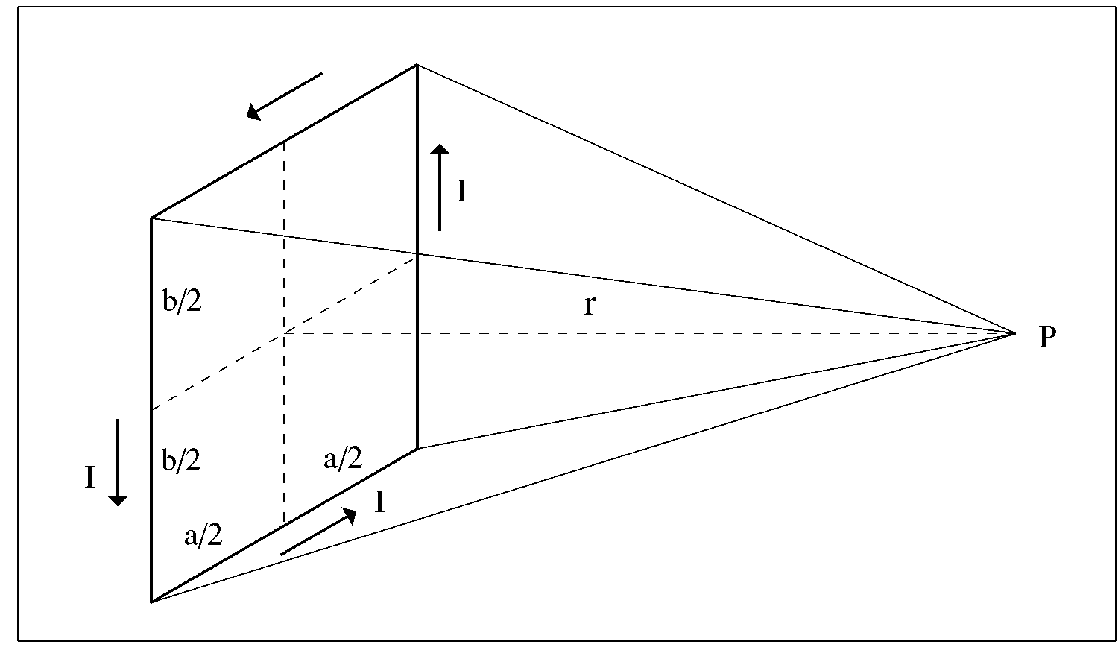
Figure 1. Field strength calculation at point P for a rectangular loop using the Biot-Savart law.

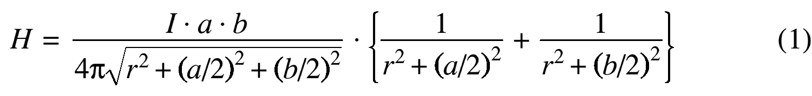
The magnetic field strength at a measuring point P on the axis of the loop is given by formula (1):

In the case where P is far away from the loop this formula simplifies to formula (2):
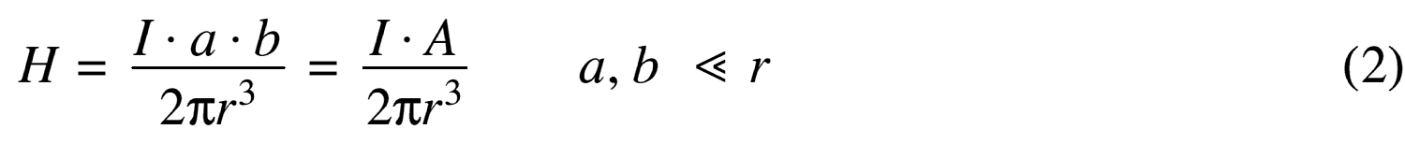

Wherein A = the surface of the loop.

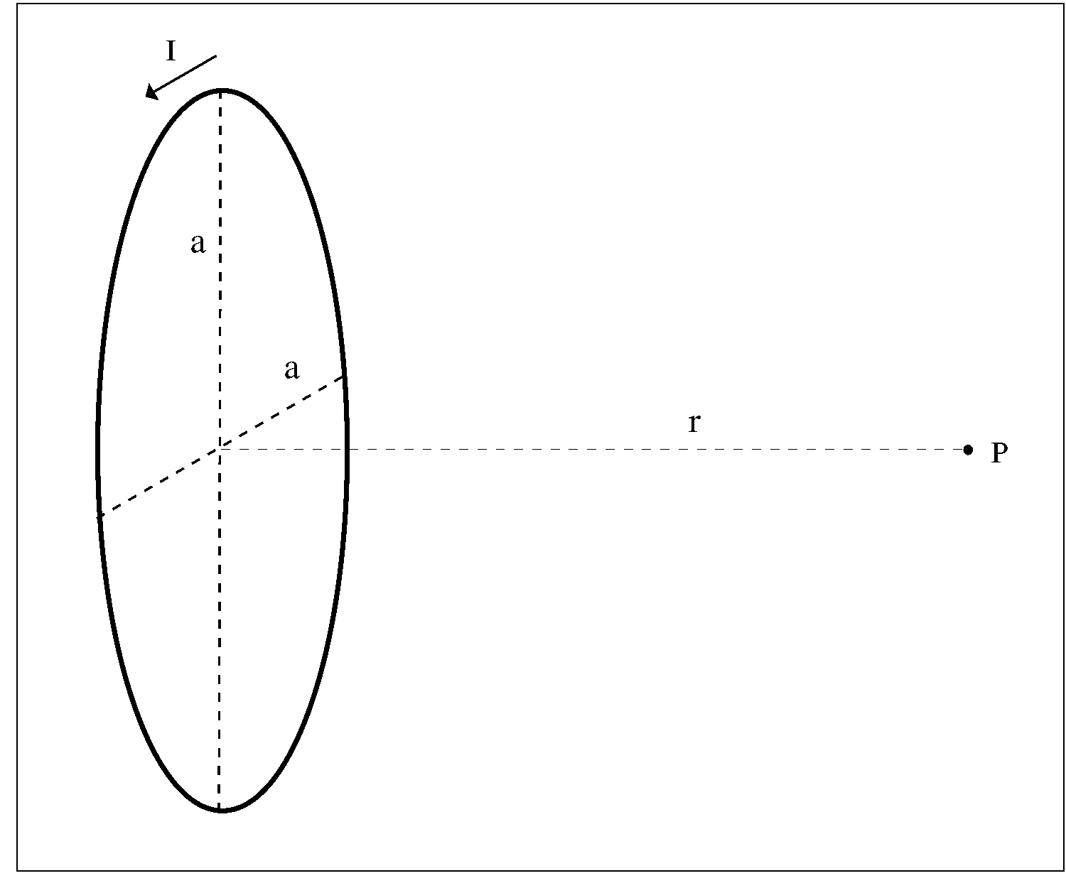
Figure 2. Field strength calculation at point P for a circular loop using the Biot-Savart law.

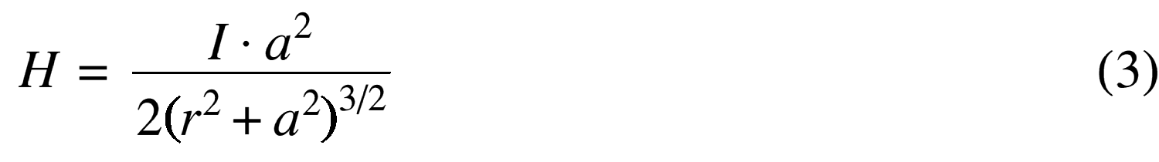
For the circular loop the field strength is given by formula (3):

and this simplifies to (4) for longer distances:
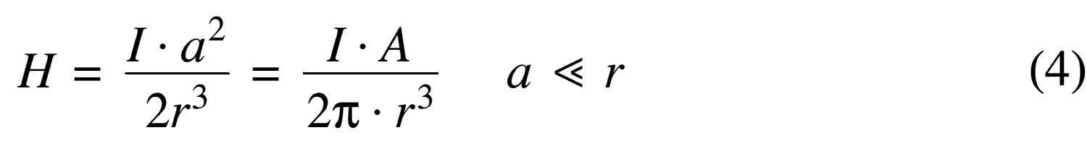

THE FAR FIELD MODEL

The far field model of radiation of loop antennas is based upon that of a magnetic dipole radiator. Figure 3 defines the magnetic dipole.

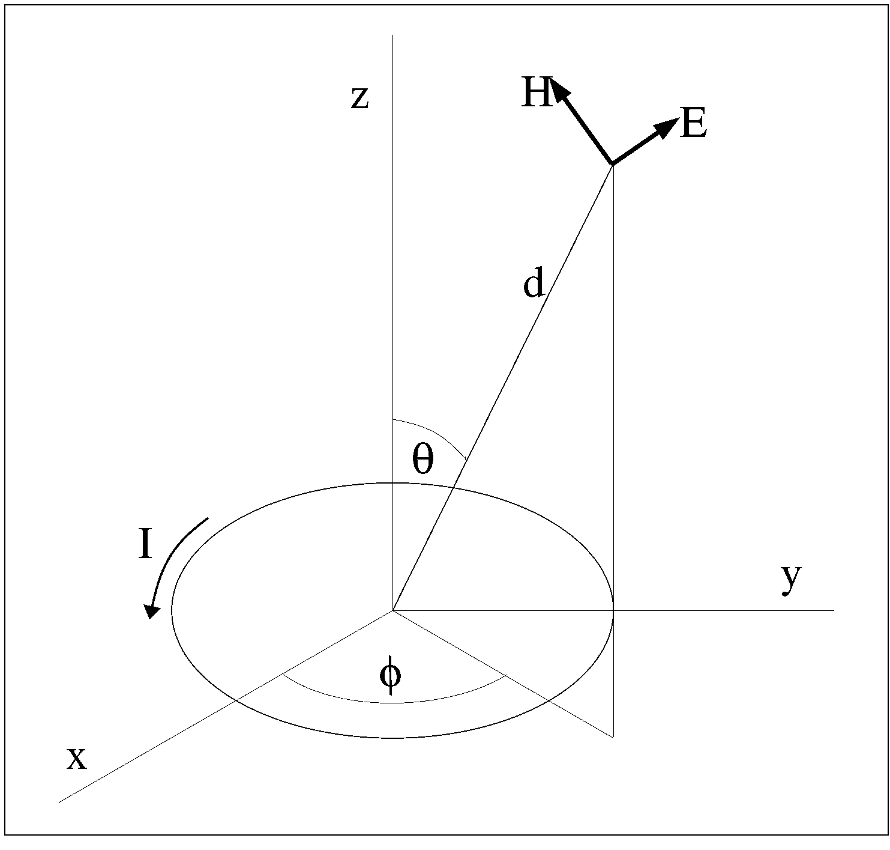
Figure 3. Definition of a magnetic dipole.
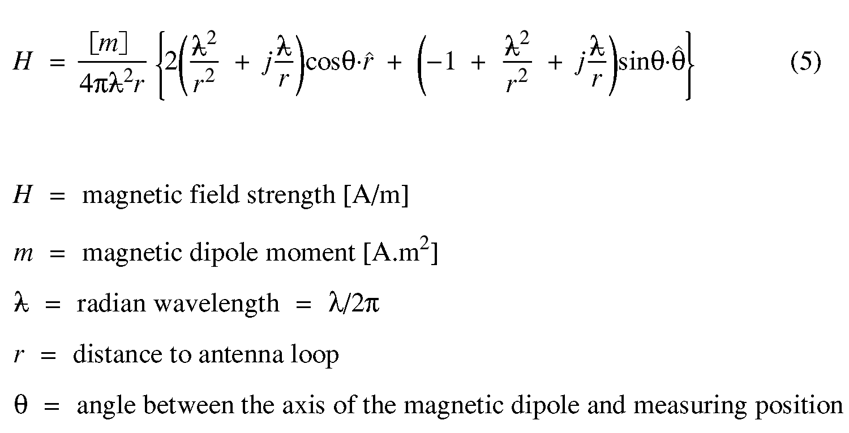

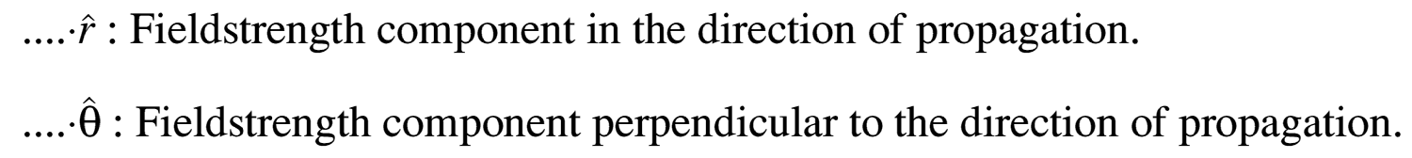

Two main directions are defined, see Figure 4:
1. Coaxial: on the axis of the loop. θ = 0°.
2. Coplanar: in the plane of the loop. θ = 90°.
Figure 4. Definition of radiation directions.
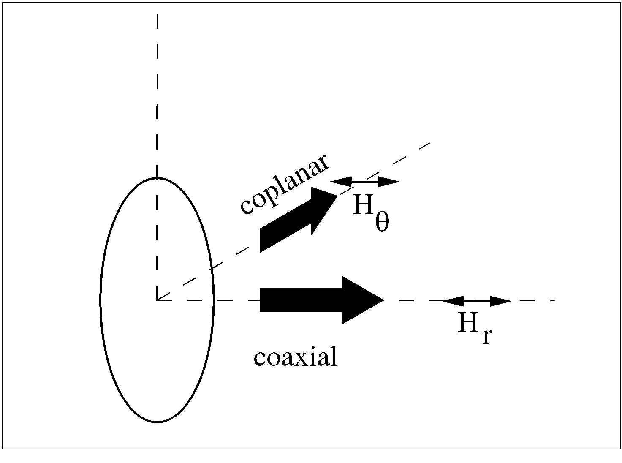
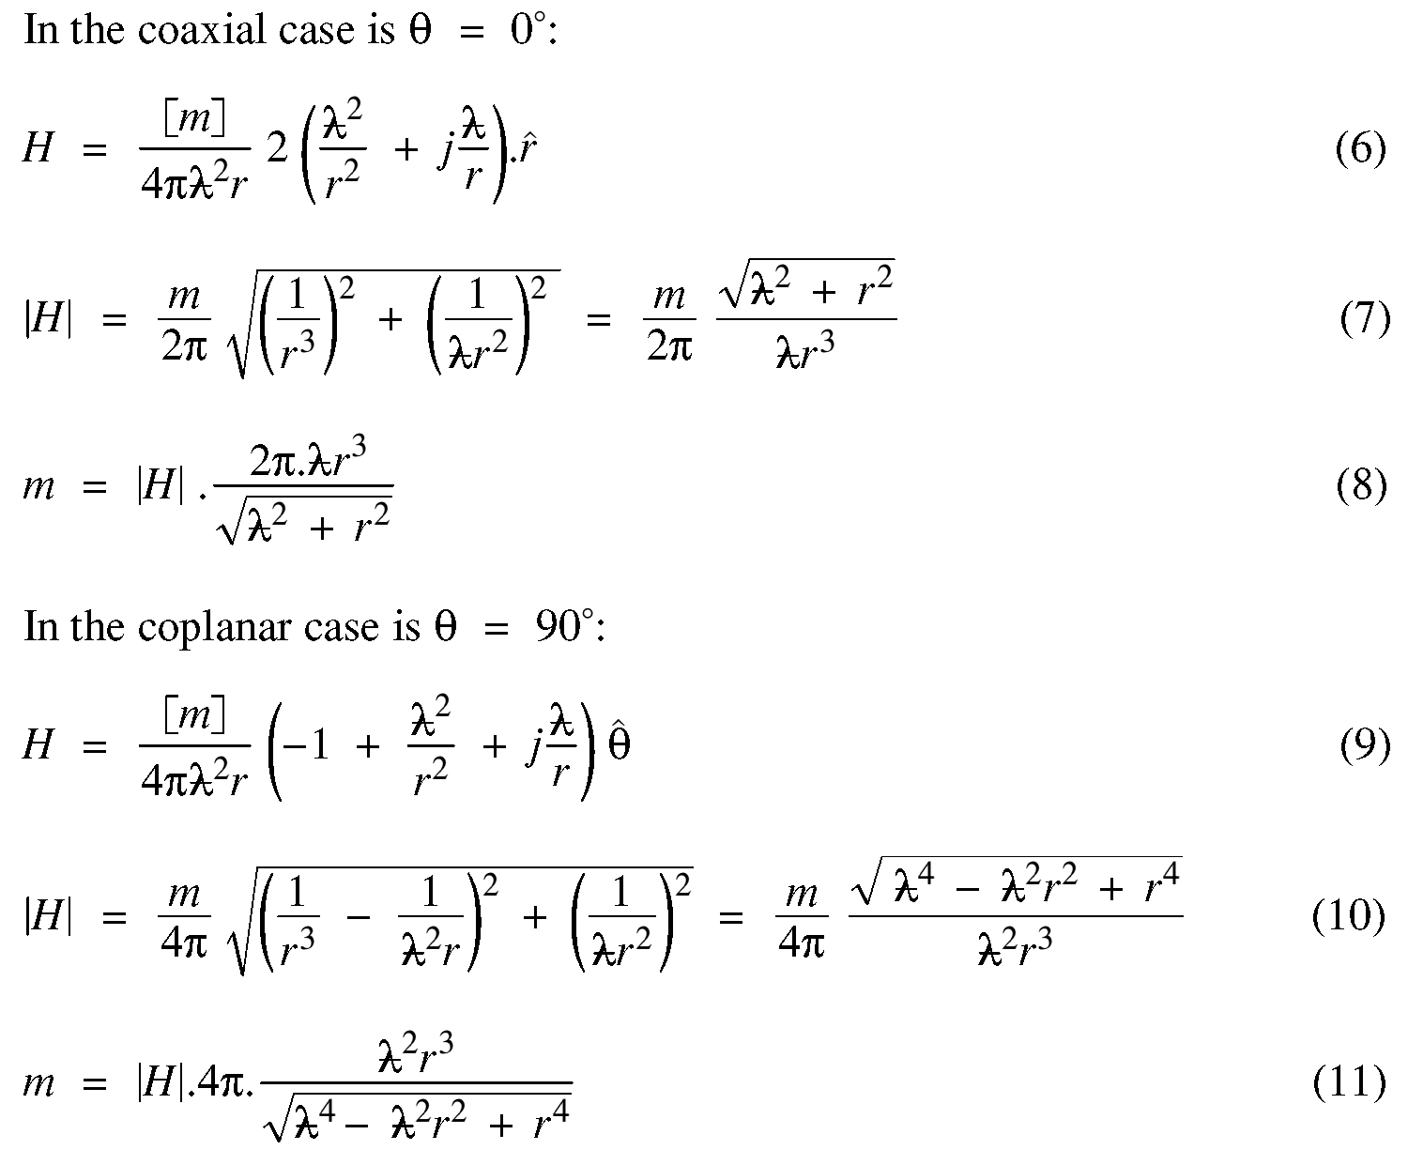

The formulas (8) and (11) give the ability to calculate the magnetic dipole moment from the field strength limit at the defined measuring distance.

Knowing the effective magnetic dipole the field strength at every position in space can be calculated according to formula (5). However for purpose of the compatibility study the field strength in the worse case direction needs to be calculated only. Thereby a different approach is needed for both the interfering source and victim receiver at ground level, and the interfering source and/or victim receiver elevated or airborne.

In the first case the propagation between interference source, the inductive loop, and the victim receiver is dominated by the ground propagation effects. The data in the recommendation ITU-R P.368-7, considering groundwave propagation, will be used for calculating interference distances.

In the second case the propagation between the inductive loop and the victim receiver is given by free space roll-off of the field strength, i.e., 20 dB/decade.

Determing the worse case direction of radiation a closer look is needed concerning the roll-off of the magnetic field strength in the immediate vincinity of a magnetic loop. Therefore the roll-off is plotted for the coaxial direction according to formula (7) and for the coplanar direction according to formula (10). The distance range is chosen in such a way that the distance according to the radian wavelength (λ/2π). is in the middle of the (logarithmic) plot.

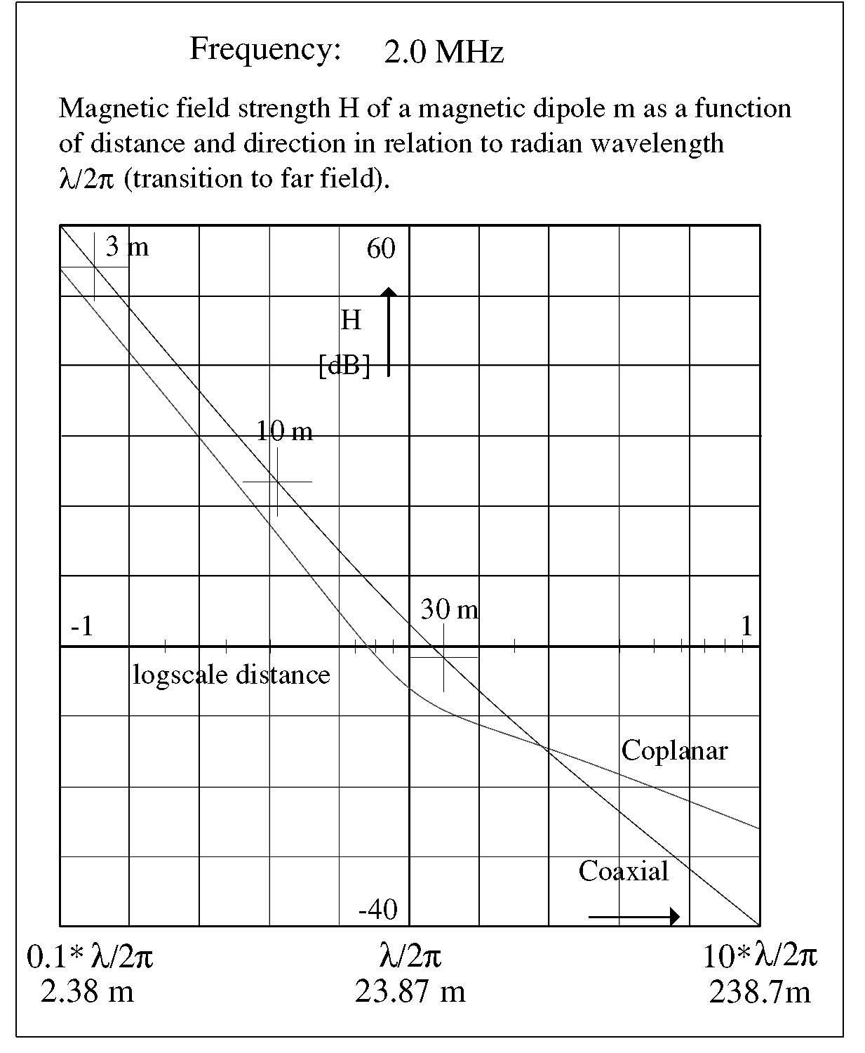
For some example frequencies the usual measuring distances (3, 10 and 30 m) are shown on this plot, which results in the Figures 5, 6 and 7 respectively for frequencies of 2.0, 6.78 and 13.56 MHz.

Figure 5. Magnetic field strength H of a magnetic dipole m as a function of distance and direction
in relation to radian wavelength λ/2π (transition to far field) for the frequency of 2.0 MHz.

Of practical importance is the cross-over point of the coaxial curve and the coplanar curve. This cross-over point is positioned at 2.354*λ/2π m from the magnetic dipole. At shorter distances the strongest magnetic field strength will be found on the coaxial direction, so that to calculate the magnetic dipole moment from the field strength limit, formula (8) has to be used.

At longer distances than the cross-over point the strongest magnetic field strength will be found in the coplanar direction, so that to calculate the magnetic dipole moment from the field strength limit, formula (11) has to be used.
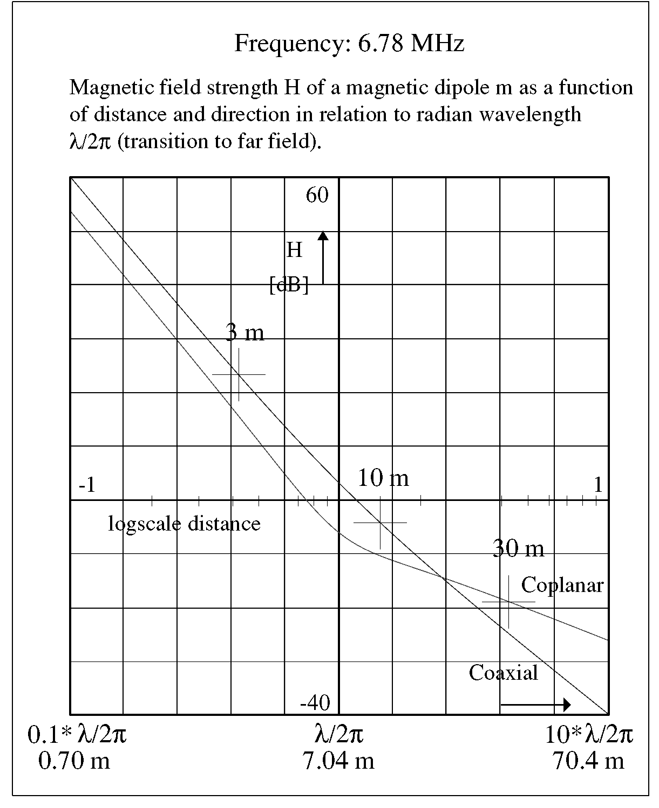

Figure 6. Magnetic field strength H of a magnetic dipole m as a function of distance and direction
in relation to radian wavelength λ/2π (transition to far field) for the frequency of 6.78 MHz.

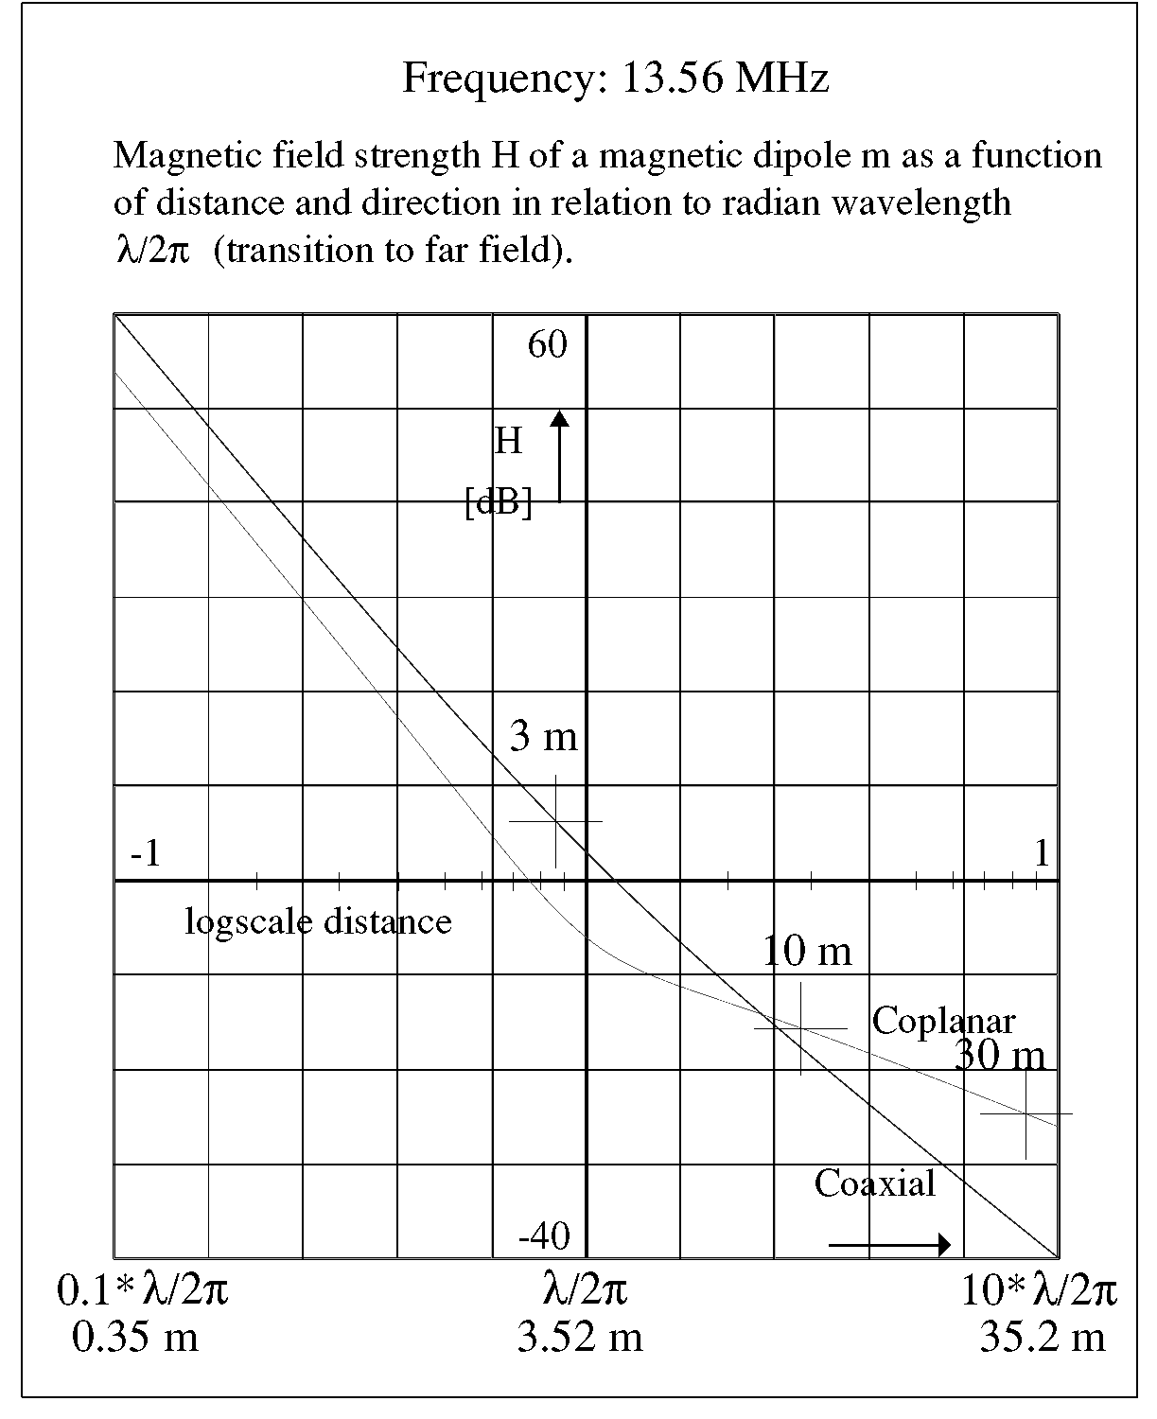
Figure 7. Magnetic field strength H of a magnetic dipole m as a function of distance and direction
in relation to radian wavelength λ/2π (transition to far field) for the frequency of 13.56 MHz.

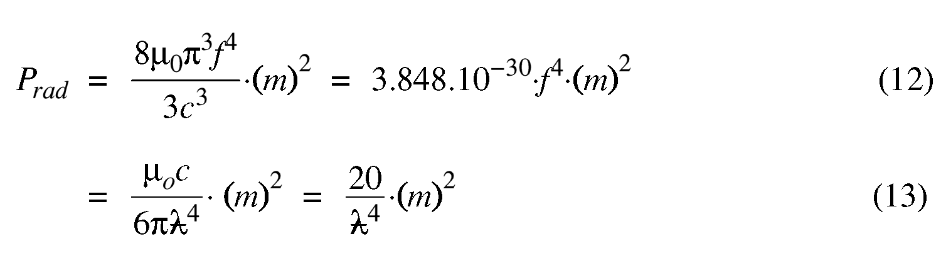
Now the magnetic dipole is calculated, the radiated power can calculated by the formulas (12) and (13).

The radiation pattern is in the shape of a figure of eight.
This level of radiated power links the far field model to the ITU-R groundwave propagation model.

THE ITU-R GROUNDWAVE PROPAGATION MODEL
In the far field model the loop antenna is assumed to be positioned in free space. In reality the antenna is mounted on a floor not far above ground level. This means that for propagation over larger distances the wave travels over ground. The recommendation ITU-R P.368-7 and the associated ITU-R computer program, GRWAVE, offers a model for vertically polarized groundwave propagation. The data is given in the format of sets of curves. A set of curves is related to a type of ground, each curve representing a frequency in the range 10 kHz to 30 MHz. The curves show the field strength as a function of the distance in the range 1 km to 10 000 km, assuming a radiated power of 1 kW from a short vertical monopole. ITU-R P. 368-7 indicates an accuracy of 1 dB, but the data is only given for distances of 1 km or more. For distances less than 1 km an estimate can be made by extrapolating the curves downwards from 1 km.

The propagation of a groundwave can be divided into three regions: the nearby region, the middle region, and the far region.

The nearby region.
The roll-off is 20 dB/decade. ITU-R P. 368-7 shows an asymptote here, which curve represents the roll-off for ideal conducting ground, and to which the curves approach for short distances. This asymptote has a roll-off of 20 dB/decade. The asymptotic value of the field strength at 1 km distance, E_{asymptote,20}, is 109.5 dBµV/m.
Note that this asymptote is 3 dB greater than the corresponding free space value, since radiation is confined to the halfspace above the conducting ground.

The curve of the asymptote is described by formula (14) (see the recommendations ITU-R P.341-3 and P.525-2):

The middle region.
The roll-off is 40 dB/decade. The middle region is determined for the field strength at 1 km distance for frequencies of 2 MHz and higher for most types of ground. For each type of ground a second asymptote can be drawn along the curve, with a roll-off of 40 dB/decade. This second asymptote will intersect the first one. At the point of intersection the transition distance, d_{transition}, is defined, as can be seen in Figure 8. The lower part of Figure 8 shows the situation where the transition distance is below 1 km. This means that the value of the second asymptote at 1 km distance, E_{asymptote,40}, is below the value of the first asymptote at 1 km, so E_{asymptote,40} < 109.5 dBµV/m.

The upper part of Figure 8 shows the situation for d_{transition} > 1 km, so E_{asymptote,40} > 109.5 dBµV/m. This value of E_{asymptote,40} only has a meaning for the extrapolation of the asymptote.

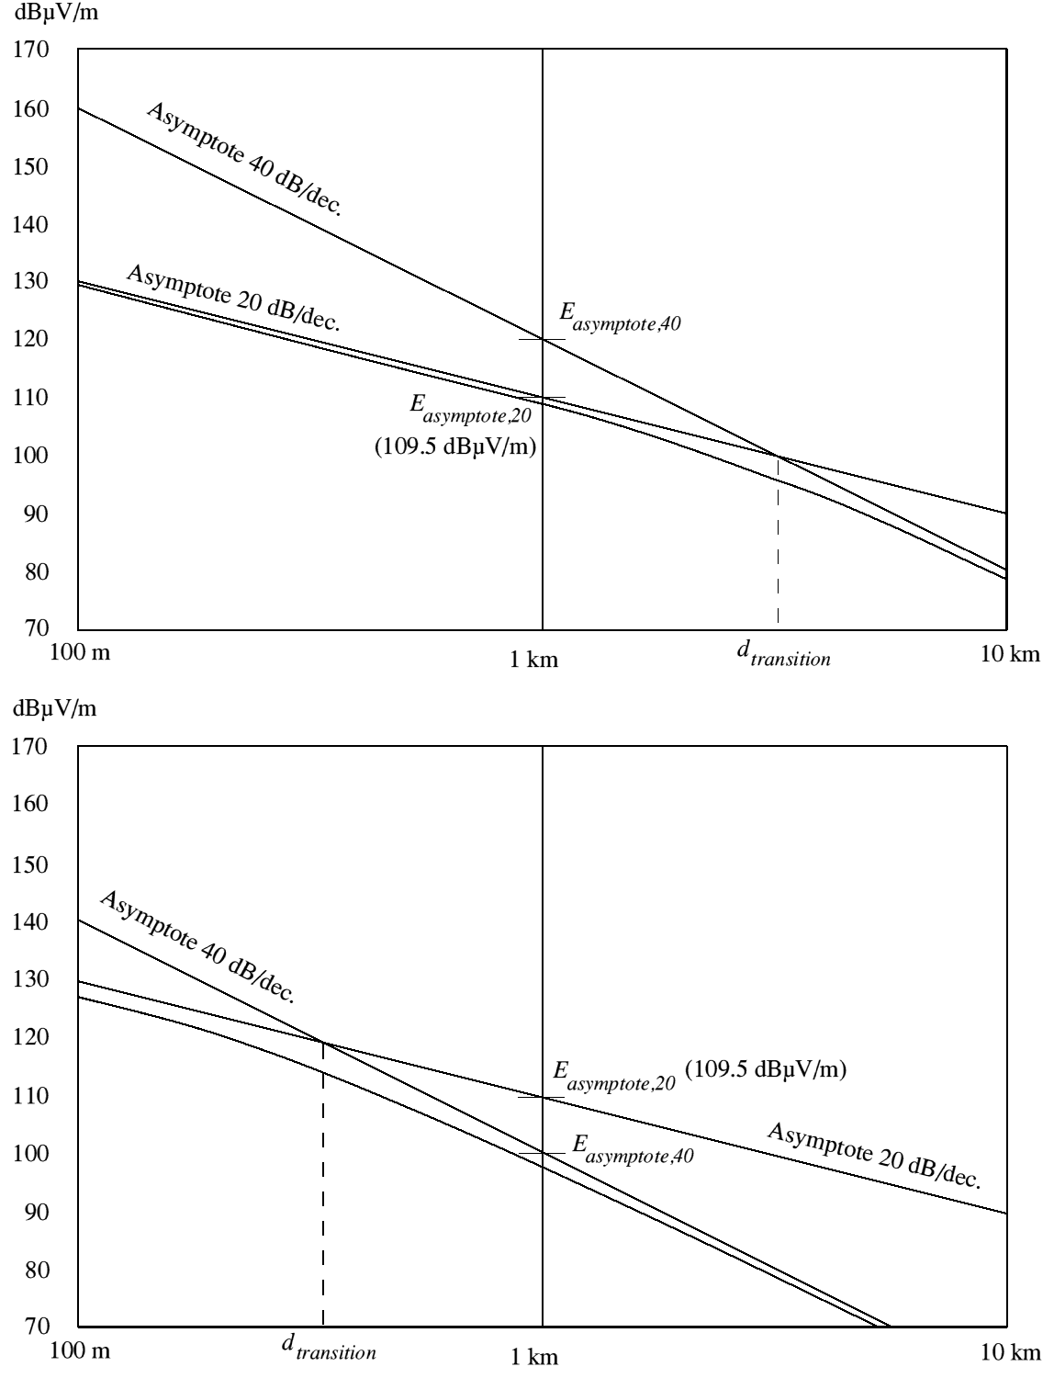
Figure 8. The upper diagram shows an example of the asymptotic curves when the transition distance
lies beyond 1km; the lower diagram shows the situation when the transition distance lies within 1km.

The value of the second asymptote at 1 km distance, E_{asymptote,40}, is shown in Table A1 and in Figure A1 of Annex A for frequencies between 10 kHz and 30 MHz, for the given types of ground.

The transition point between the three regions depends completely on the frequency and on the conductivity and permittivity of the ground.

The transition range, d_{transition}, can be calculated now from both asymptotic field strength values at 1 km distance, namely the field strength for the frequency under consideration at 1 km distance, according to the 40 dB/decade asymptote, E_{asymptote,40}, and the value of the field strength according to the 20 dB/decade asymptote at 1 km distance, E_{asymptote,20} (= 109.5 dBµV/m), both for a radiated power of 1 kW.

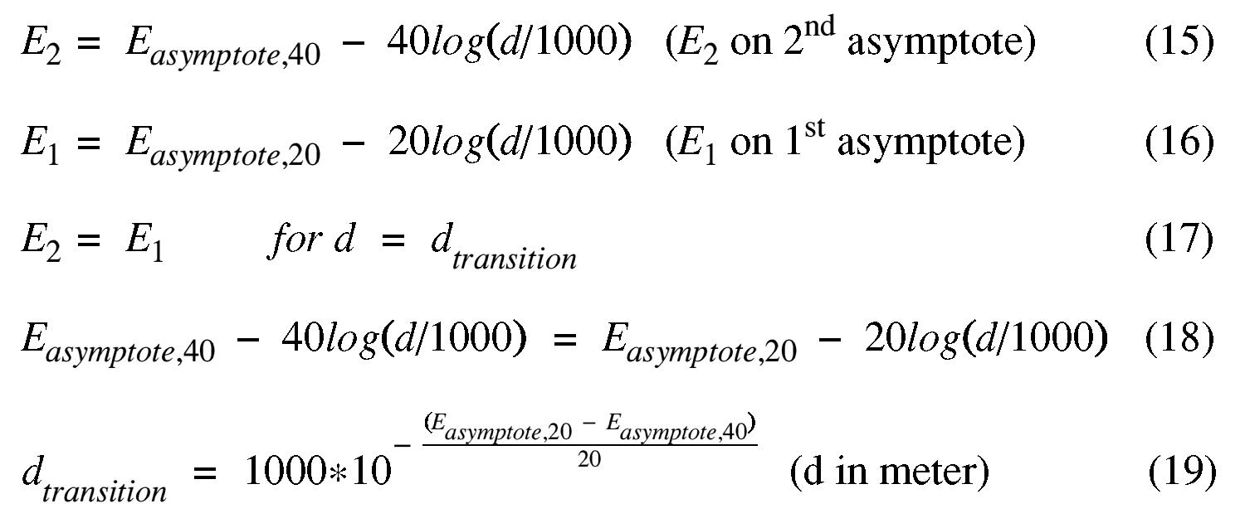
The far region.
The roll-off increases to 150 dB/decade at distances greater than 100 - 3000 km.
With the low radiated powers of the short range device (SRD) inductive systems the distances of concern are much less than100 km. This means that the far region in not of interest when considering SRD/inductive systems.

Note.
Carefully inspecting the curves for frequencies < 4 MHz reveals that the transition from the 40 dB/decade roll-off to the asymptotic 20 dB/decade roll-off is very gradual. This means that the actual value for the field strength at the transition point is a few dBs lower than indicated by the asymptotic roll-off curves. Measurements have shown that at a few hundred meters distance multi-path interference can occur between the groundwave and the free space wave, which can enhance the field strength by several dBs locally. The nett result is that these asymptotic curves can be taken as a worse case scenario.

FREE SPACE PROPAGATION
In case the victim receiver is not at groundlevel the free space propagation model has to be used. Still the source is assumed to be placed on the ground or only slightly elevated, so that the fraction of free space radiation that radiates downwards will be reflected and will add to the power radiated upwards in the worse case situation. This results in an antenna gain of 3 dB over the magnetic dipole free space radiation. As a consequence the free space radiation over ground can be described by formula (14), which gives the same outcome as the asymptote in ITU-R P.368-7.

INTERFERENCE RANGE
To determine the interference distance, the range outside which no harmful interference will occur, a maximum field strength level has to be determined. This level depends on the minimum signal level that an affected radio service expects.

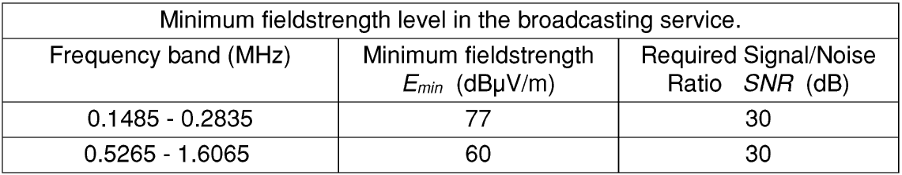
This minimum signal level depends on the kind of radio service. For example the broadcasting services guarantee minimum field strength levels at their target areas. Table 1 gives an overview of these field strength levels:

Table 1. Example of minimum field strength levels as required for the broadcasting service.

For other radio services the receiver characteristics and the noise level at the receiving site determine the minimum signal level. The source of the noise can be of atmospheric, galactic or manmade nature.

Annex B presents a study into noise field strength levels, based on the ITU-R Recommendation P.372. Figure B1 of Annex B shows the results of this study as noise field strength levels, depending on the frequency. The noise field strength levels are dependent on the receiver bandwidth. The shown curves correspond with a bandwidth of 2.7 kHz.

This bandwidth is the usual value for SSB telephony. For most telegraphy and data communication modes smaller bandwidths are used, while for shortwave broadcasting a a maximum bandwidth of 9 kHz is appropiate.

The manmade noise field strength levels are given for four different environments: business, residental, rural and quiet rural, and, like the galactic noise level, are time and season independent.

Atmospheric noise is the result of natural electrical activity (thunderstorms) in the earth’s atmosphere. Propagated over long distances, thousands of lightning discharges per minute result in a low level EM field with a nature of noise.
As well as the location of the electrical activity the propagation over the path from the location of the electrical activity to the receiver location is strongly dependent on the season of the year and on the time of the day.
The atmospheric noise field strength levels given in Figure B1 are derived as mean values for the European area. As there are large differences in the noise field strength levels between seasons and between time of day a statistical distribution is made. This results in three curves:
- the 20% curve: a chance of 20% that the actual noise level is below the given field strength level;
- the 50% curve: a chance of 50% that the actual noise level is below the given field strength level;
- the 80% curve: a chance of 80% that the actual noise level is below the given field strength level.

The nature of the radio service and the environment at the receiving site determines which curve should be used. The curve determines the reference noise field strength level which is used in the interference range calculation.

For example many radio services are well engineered. That means that the transmitting power, antenna characteristics, and coverage, are aligned with propagation characteristics, noise levels and operational conditions, so that a predictable and reliable service is obtained.
It is reasonable to assume that for these calculations the highest occurring noise field strength level is used, i.e., the relevant manmade level or the 80% atmospheric level.

Alternatively some services make use of the lowest noise field strength levels such as the Radio Astronomy Service, the Space Research service and the Amateur (-Satellite) Service. In this case the relevant noise field strength levels are those for quiet rural environment manmade noise, the galactic noise and the 20% curve of the atmospheric noise.

THE BANDWIDTH RATIO
The characteristics of the interfering inductive loop signal, especially the bandwidth, can be an important factor. The field strength level at the measuring distance is determined using a measuring receiver with quasi-peak weighting and a bandwidth of 9 kHz (200 Hz in the range 9 - 150 kHz).

In a victim receiver, with a smaller bandwidth than that of the measuring receiver, less interfering signal power is received when the interfering signal has a bandwidth wider then the actual receiver bandwidth. Also the detector in the victim receiver can have a response which is dependent on the characteristics of the interfering signal. These effects can be compensated for by adding the bandwidth ratio, BWR, to the reference noise field strength level.

In the generic case, or when the bandwidth of the interfering signal is not wider than the victim receiver bandwidth, or in case of an unmodulated carrier, BWR = 0 dB should be assumed.

In the case where the interfering signal frequency is swept over a bandwidth at least as large as the bandwidth of the measuring receiver, or otherwise the signal power is homogeneous spread over the bandwidth of the measuring receiver, such as the sidebands of the datalink in an ID system, the ratio of the bandwidth of the measuring receiver to the bandwidth of the victim receiver should be used as the bandwidth ratio:

BWR = 10 log (b_{measuring-rx}/b_{victim-rx}). (20)

THE INTERFERENCE RANGE CALCULATION
The interference range can now be calculated. First the reference noise field strength, E_{noise2.7}, is determined from Annex B. This noise level is corrected for the bandwidth of the victim receiver in kHz:
E_{noise} = E_{noise2.7} + 10 log(b_{victim-rx}/2.7) (21)

Secondly, for broadband interference the bandwidth ratio, BWR, is determined.
Adding these values give the maximum interference level, E_{interference}:

E_{interference} = E_{noise} + BWR (22)

E_{interference} is compared with the roll-off of the interfering signal.

In the case where for a service the minimum field strength, E_{min}, and required Signal/Noise Ratio, SNR, are known the maximum interference level is calculated as:

E_{interference} = E_{min} - SNR (23)

A complete algorithm for calculating the interference distance is shown below in quasi programming language:

INTERFERENCE RANGE CALCULATION

INPUT The frequency, f, in MHz.
The magnetic field strength limit, H_{limit}, in dBµA/m.
The measuring distance, d, in metres
The victim receiver at ground level (groundwave propagation) or airborne (free space propagation)?

IF groundwave is true:
INPUT E_{asymptote,40} according Annex A in dBµV/m.

CALCULATE

INPUT The noise field strength in 2.7 kHz,E_{noise2.7}, according to Annex B,in dBµV/m.
The bandwidth of the victim receiver, BW, in kHz.
The bandwidth ratio, BWR, in dB.
OR:
E_{interference}, directly from data of the radio service.

CALCULATE The radian wavelength λ/2π. = c/2πf.

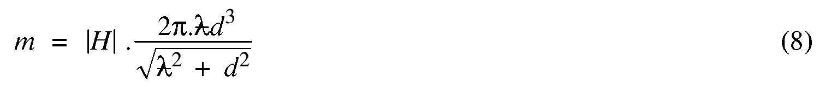
IF d < λ/2π *2.354

The field strength at the measuring position is maximal in the coaxial direction.

IF d >= λ/2π *2.354
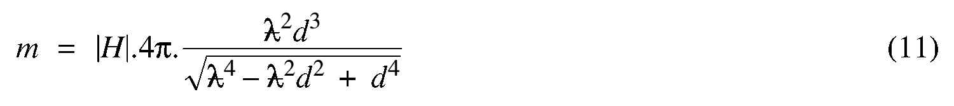
The field strength at the measuring position is maximal in the coplanar direction.

OUTPUT Magnetic dipole moment, m, in Am².

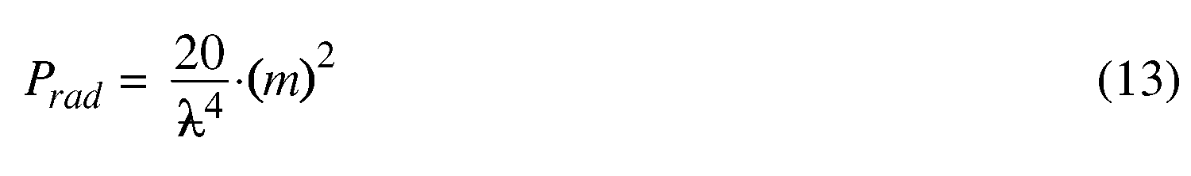
CALCULATE

P_{rad_dB} = 10*log10(P_{erp}) - 30
P_{rad_nW} = P_{rad}*1e9

OUTPUT Effective radiated power,P_{rad_dB}, in dBkW
P_{rad_nW},in nW.

CALCULATE The interference level at a distance of 1 km is:
E_{int_1km} = E_{asymptote,40} + P_{rad_dB}

The noise level is:
E_{noise} = E_{noise2.7} + 10*log10(BW/2.7)

The acceptable interference level is:
E_{interference} = E_{noise} + BWR

IF groundwave is TRUE
CALCULATE

IF r_{interference} > d_{transition} AND r_{interference} > λ/2π *2.354
OUTPUT The interference range extends into the 40 dB/decade range.
The groundwave interference range is r_{interference} m.
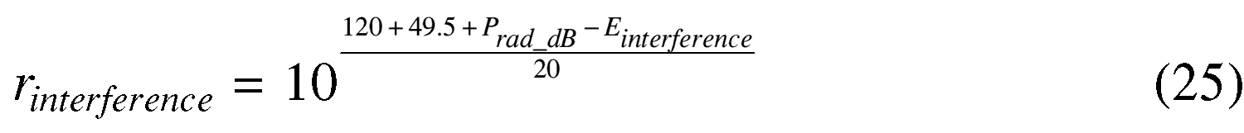
ELSE

(from formula (14))

IF r_{interference} > λ/2π *2.354
OUTPUT The interference range is limited to the 20 dB/dec. roll-off range.
The groundwave interference range is r_{interference} m.
ELSE
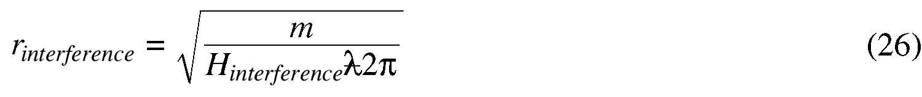
(from formula (7))

IF r_{interference} > λ/2π
OUTPUT The interference range is close to the near field range.
The groundwave interference range is r_{interference} m.

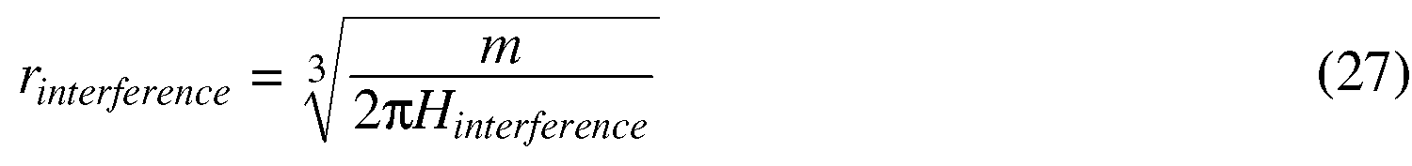
ELSE

(from formula (7))

OUTPUT The interference range is inside the near field range.
The groundwave interference range is r_{interference} m.

IF free space is TRUE
(from formula (14))

IF r_{interference} > λ/2π *2.354
OUTPUT The interference range is limited to the 20 dB/dec. roll-off range.
The free space interference range is r_{interference} m.
ELSE

(from formula (7))

IF r_{interference} > λ/2π
OUTPUT The interference range is close to the near field range.
The free space interference range is r_{interference} m.
ELSE

(from formula (7))

OUTPUT The interference range is inside the near field range.
The free space interference range is r_{interference} m.

EXAMPLE OF A ROLL-OFF CURVE FOR AN INDUCTIVE LOOP SYSTEM
Figure 9 gives an example of the roll-off of an inductive loop system. In this example the radian wavelength λ/2π equals 10 m, and the field strength at the measuring distance of 10 m is 9 dBµA/m.
For the type of ground "Land" is assumed with σ = 3 mS/m and ∈ = 22. Figure A1 in Annex A gives for E_{asymptote,40} 97 dBµV/m. Combined with an calculated radiated power P_{rad}= -95 dBkW the field strength at 1 km distance will be 2 dBµV/m in the case of groundwave propagation. In the free space situation the field strength at 1 km is obtained by adding P_{rad}= -95 dBkW to E_{asymptote,20} = 109.5 dBµV/m: 14.5 dBµV/m.
From both field strength values at 1 km the 20 dB/dec. and the 40 dB/dec. curves are drawn.

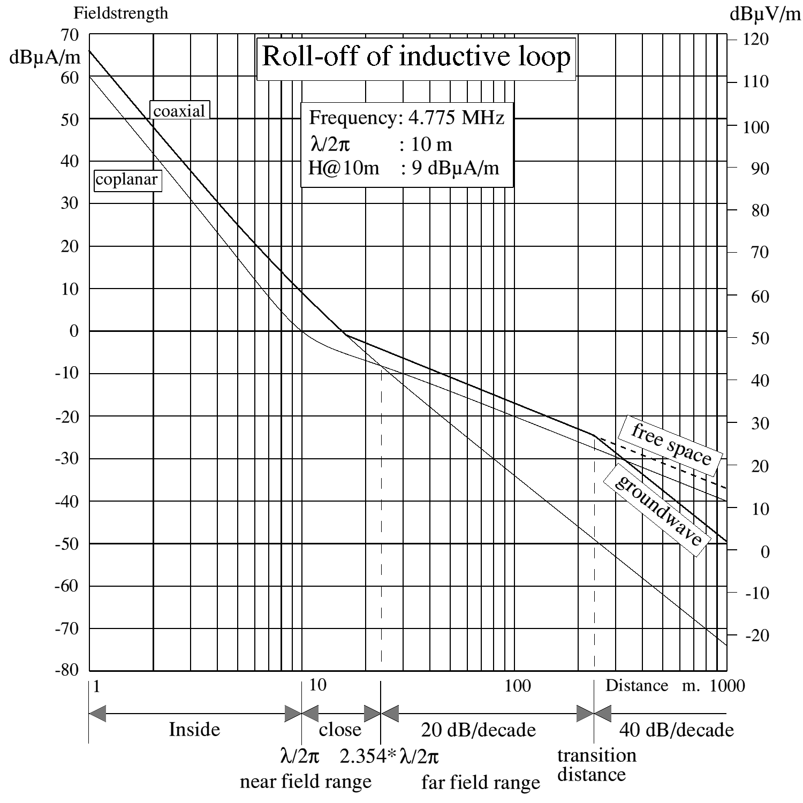
Figure 9. Roll-off of an inductive loop.

ANNEX A Data according to ITU-R P.368-7
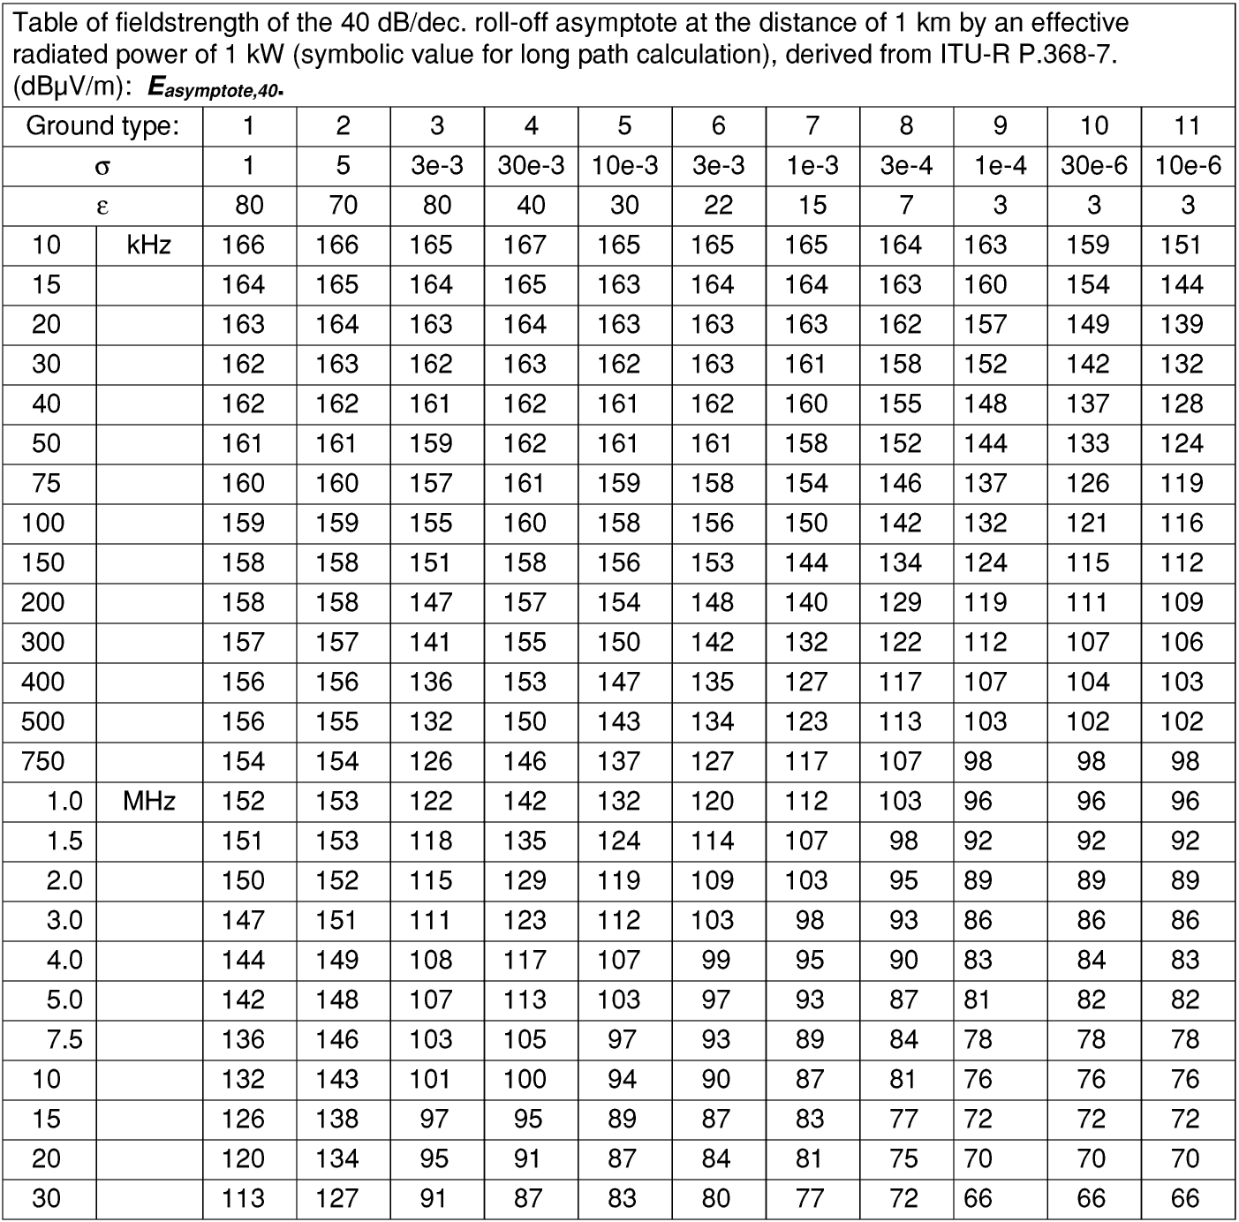
Table A1. Table of the asymptotic value of field strength of 1 kW transmitter at 1 km distance E_{asymptote,40}.

List of ground types according ITU-R PN.368-7:
1. Sea water, low salinity. σ = 1 S/m, ∈ =80.
2. Sea water, average salinity. σ = 5 S/m, ∈ =70.
3. Fresh water. σ = 3 mS/m, ∈ =80.
4. Land (very wet). σ = 30 mS/m, ∈ =40.
5. Wet ground. σ = 10 mS/m, ∈ =30.
6. Land. σ = 3 mS/m, ∈ =22.
7. Medium dry ground. σ = 1 mS/m, ∈ =15.
8. Dry ground. σ = 0.3 mS/m, ∈ = 7.
9. Very dry ground. σ = 0.1 mS/m, ∈ = 3.
10. Fresh water ice, -1 °C. σ = 30 µS/m, ∈ = 3.
11. Fresh water ice, -10 °C. σ = 10 µS/m, ∈ = 3.

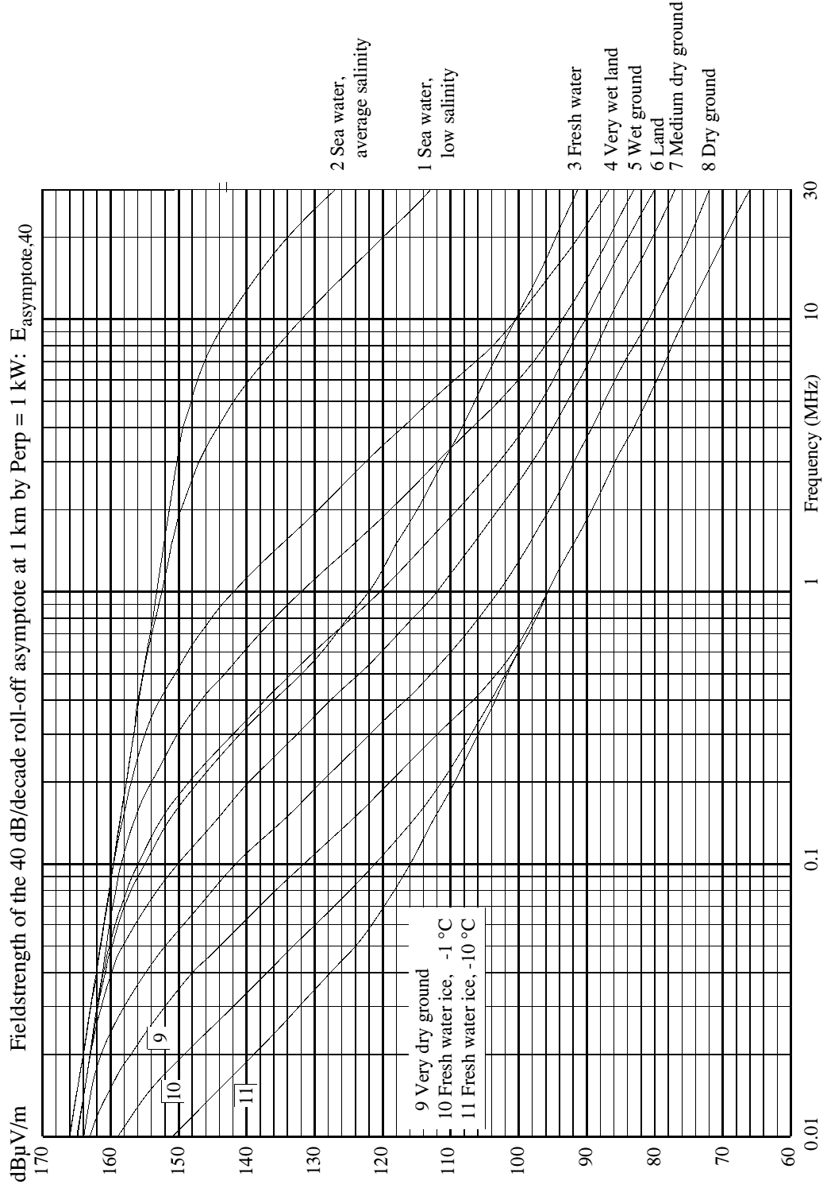
Figure A1. Field strength of the 40 dB/decade roll-off asymptote at 1 km distance form a 1 kW transmitter.

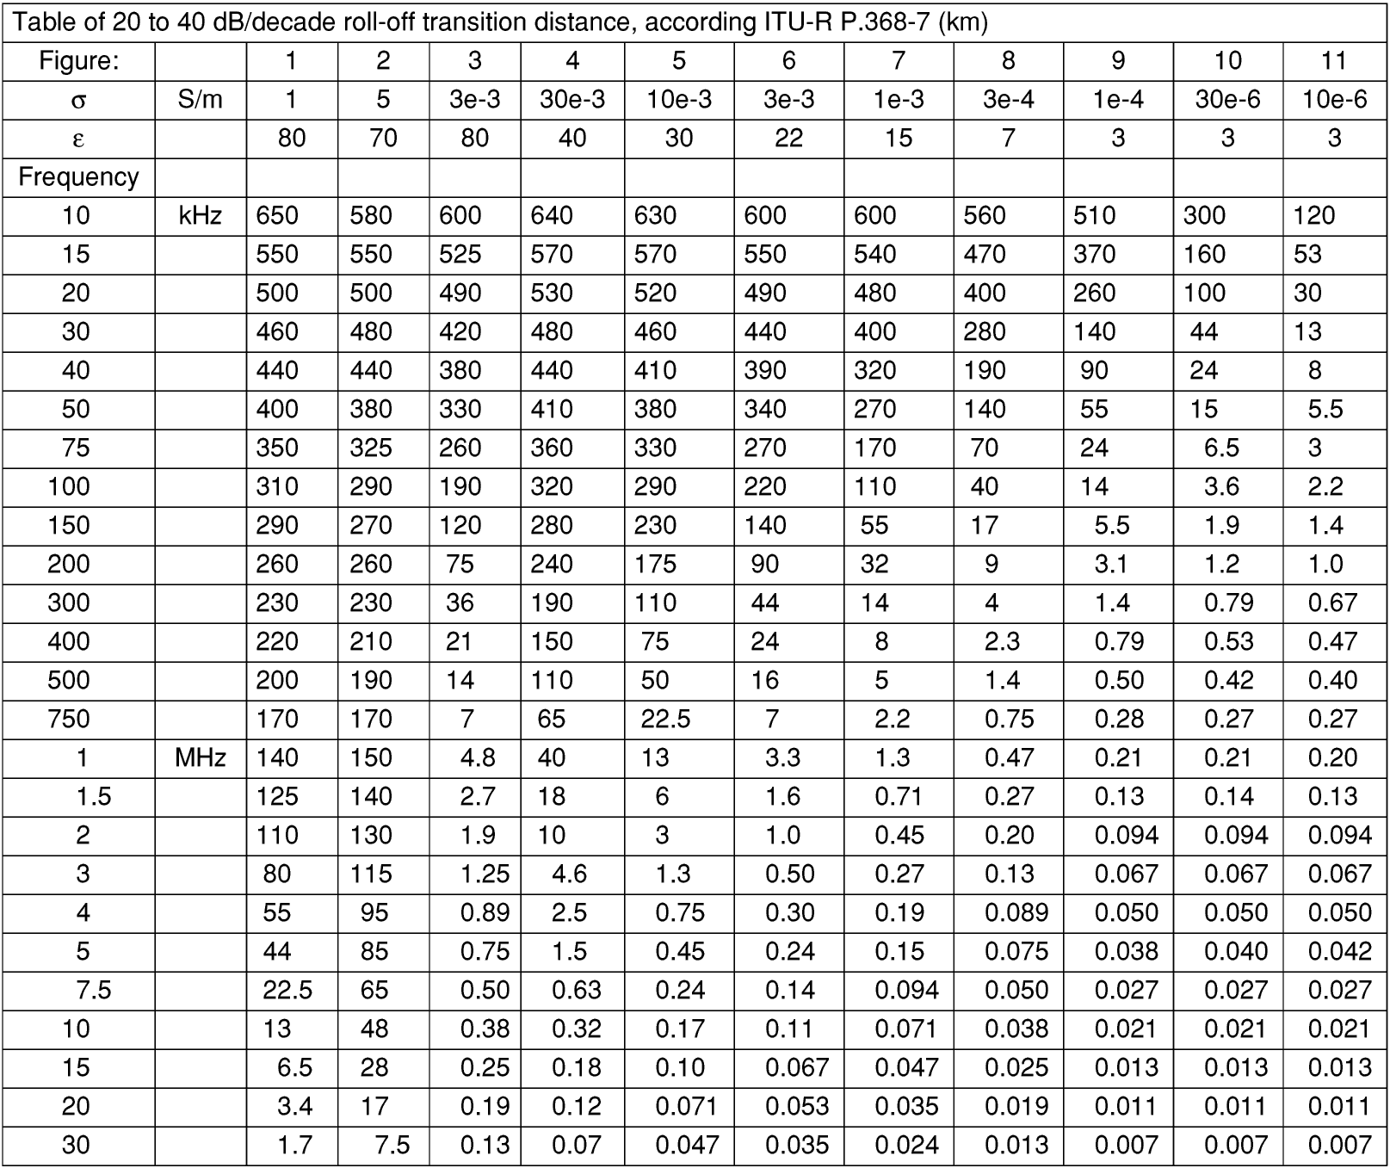
Table A2. Table of 20 to 40 dB/decade roll-off transition distance.

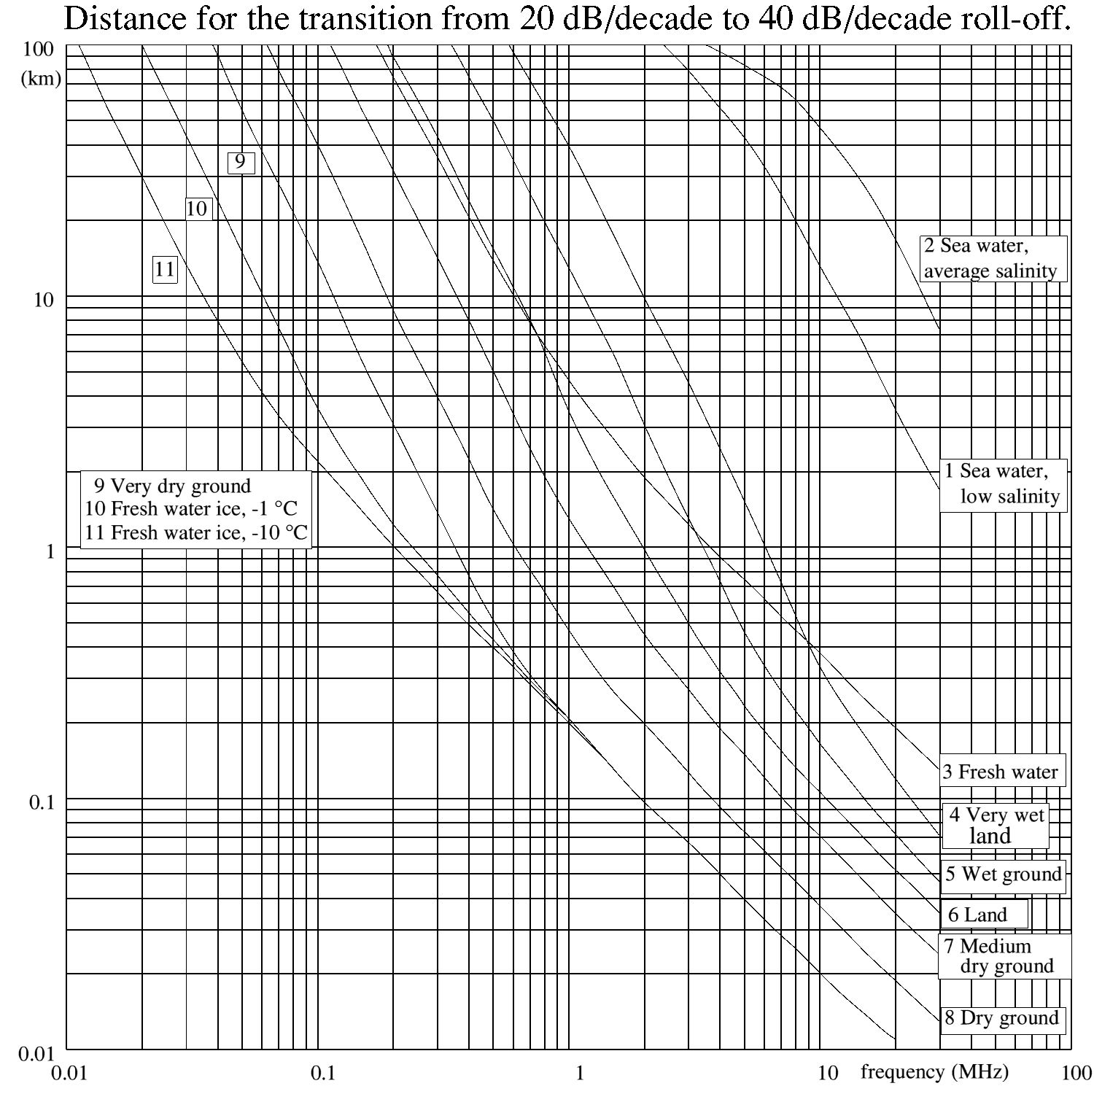
Figure A2. Transition distance as a function of frequency and type of ground.

ANNEX B Expected noise field strength levels

Introduction

In this Annex a study is made into the noise levels that primary radio users will encounter. Three sources of noise will be taken into account: the atmospheric noise, the galactic noise and manmade noise. Together they form the absolute lower sensitivity limit which a receiving station has to cope with.

This goal can be achieved by using the information of the ITU-R Recommendation P.372 and converting noise powers to noise field strength levels, depending on frequency and statistical distribution.

The Recommendation gives atmospheric noise data due to lightning as a function of:
the geographical position,
the four seasons of the year,
six blocks of 4 hours a day,
and the frequency.
Three curves are derived, which give probabilities of 20 %, 50 %, and 80 % that the actual noise level will be lower than the indicated field strength (distribution function of the field strength).
A receiver bandwidth of 2.7 kHz is assumed, field strength values for various bandwidths can be calculated from this curves.

The Recommendation also gives the relationships between the levels of manmade noise in four environments, such as:
quiet rural,
rural,
residental,
business,
and the frequencies are given. A relationship for the galactic noise level is also given.

Estimation of the atmospheric noiselevels.
Atmospheric noise is the result of natural electrical activity (thunderstorms) in the earth’s atmosphere, propagated over long distances. Thousands of lightning discharges per minute result in a EM field with a nature of noise.
As well as the location of the electrical activity the propagation to the receiver location is strongly dependendent on the season of the year as well as on the time of the day. Also the geographical location of the receiver is relevant.

ITU-R P.372 gives the noise figure (F_{a}) lines mapped on the earth’s surface for every season and for every 4 hour block of the day. These noise figures are valid for the frequency of 1 MHz. Additional graphs show the noise figures for other frequencies, 10 kHz to 100 MHz, using the 1 MHz value as a parameter.
The noise figures are estimated for the European area and collected in Table B1 of this Report for frequencies between 10 and 1000 kHz, and in Table B2 for frequencies between 1 and 20 MHz.

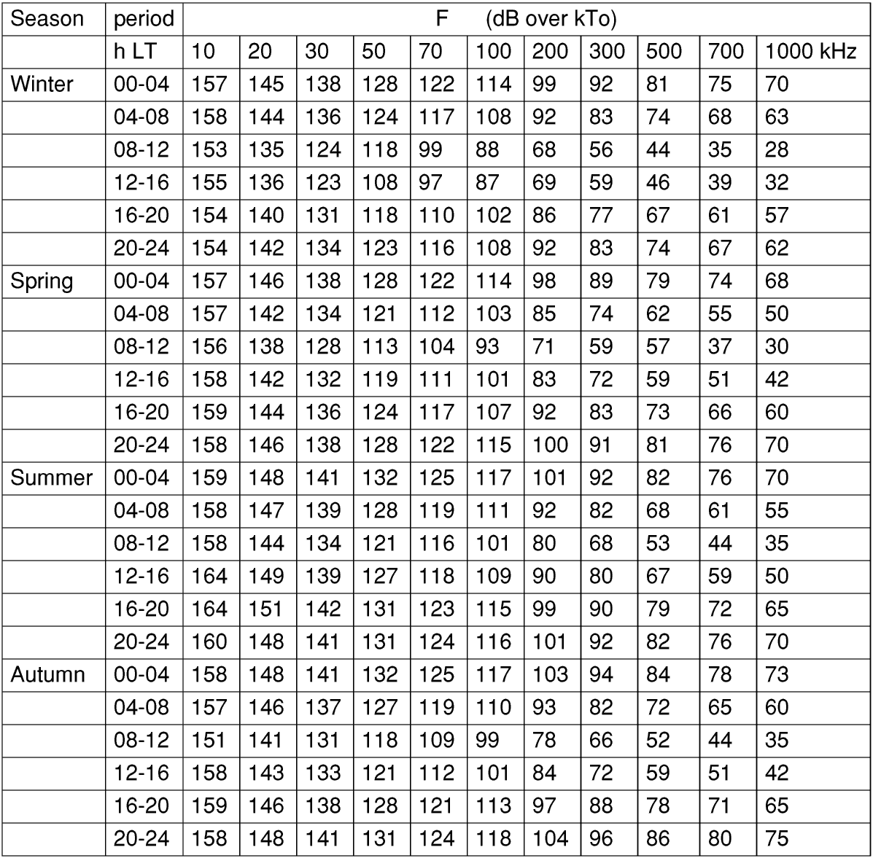
Table B1. Atmospheric noise figures for the frequency range 10 - 1000 kHz.

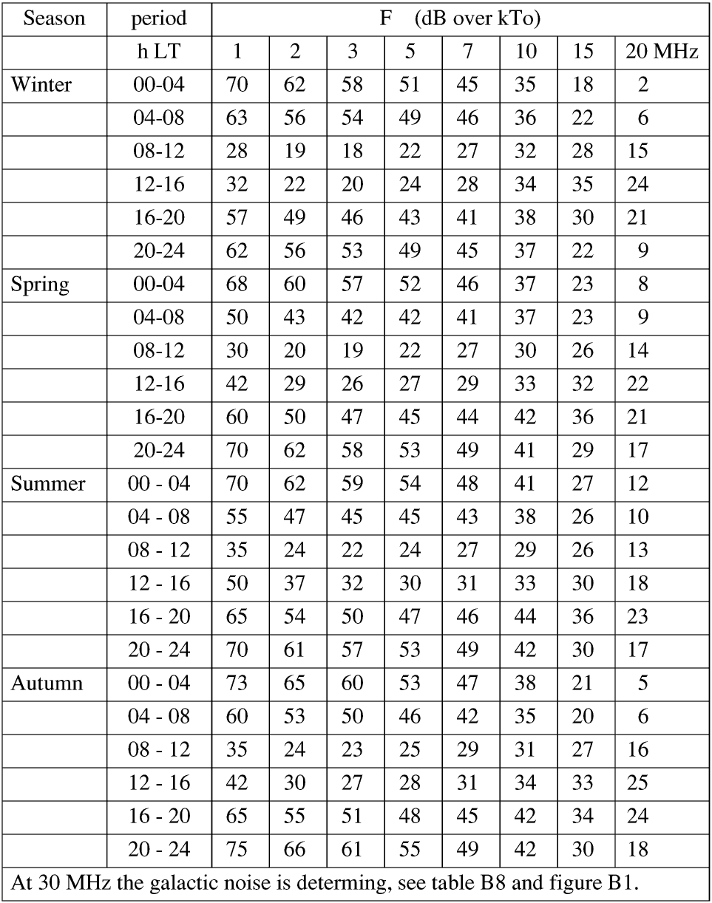 Table B2. Atmospheric noise figures for the frequency range 1 - 20 MHz.

The electric field strength can now be calculated:

Where:
E_{n} : r.m.s. noise field strength (dBµV/m) in bandwidth b (Hz).
F_{a} : noise figure for the centre frequency f _{MHz} (MHz).

For the receiver bandwidth b the value of 2.7 kHz is choosen, commonly the widest bandwidth in use in communication systems on the MF and HF bands, except for AM broadcasting, where 9 kHz is the standard bandwidth.
The tables B3 and B4 give the noise field strengths.

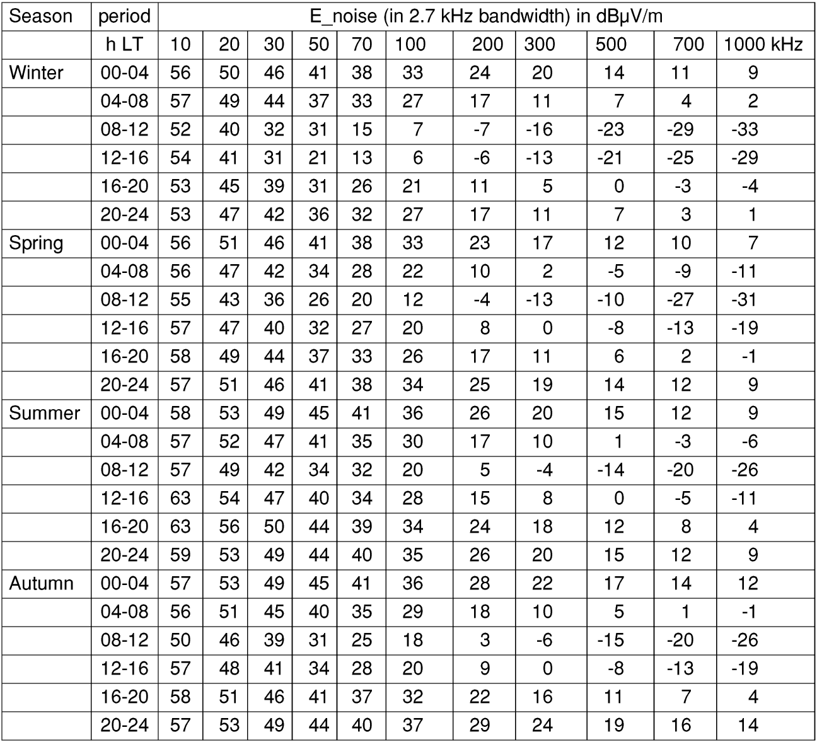
Table B3. Atmospheric noise field strength for the frequency range 10 - 1000 kHz.

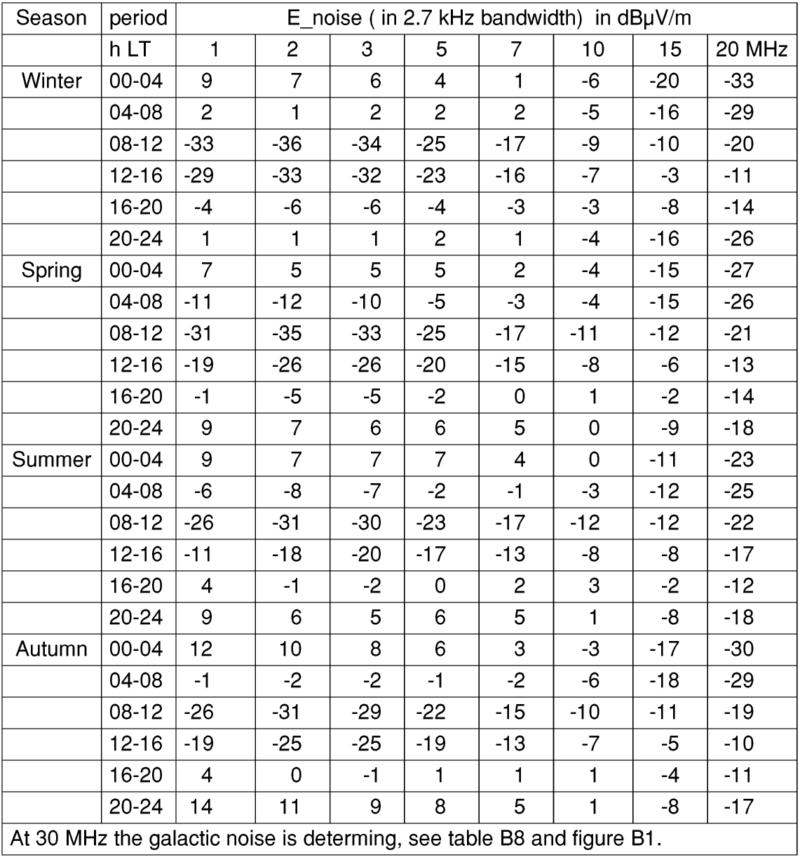
Table B4. Atmospheric noise field strength for the frequency range 1 - 20 MHz

For every frequency a value for the field strength is given for 24 equally distributed periods over the year and the day. Next the occurence of each value for E_{n} is counted and for every frequency a value of E_{n} is determined for which value the number of occurences, n , is below 20 %, about 50 %, and below 80 %. These results are collected in the tables B5 and B6.
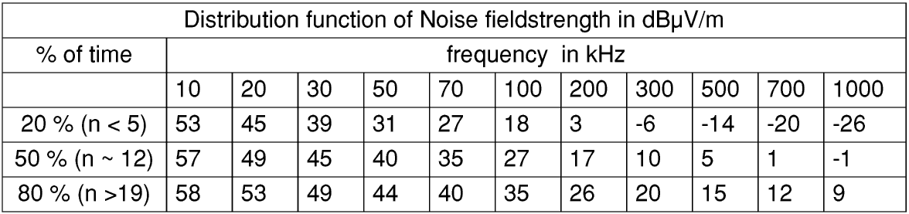
Table B5. Distribution function of atmospheric noise field strength levels for 10 - 1000 kHz.

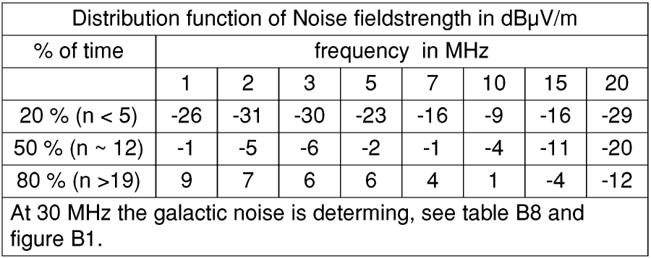
Table B6. Distribution function of atmospheric noise field strength levels for 1 - 20 MHz.

The values of E_{n} are plotted in Figure B1, resulting in three curves 20 %, 50 % and 80 %.

Manmade and galactic noise.

Manmade noise and galactic noise are not season and time dependent. The ITU-R Recommendation gives the relationship between the noise factor and the frequency in the form of formula (B2):

Wherein F_{am} = the median value of the noise figure, c and d are constants according Table B7, and f is the frequency.
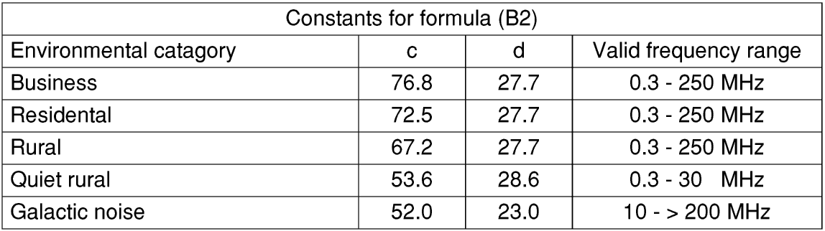
Table B7. Table of constants for formula B2.

Using formula (B2), and thereafter (B1), the noise figures and noise field strength levels are calculated for some key frequencies and shown in Table B8. As the relations are linear the values for two frequencies are needed to plot these curves in Figure B1.

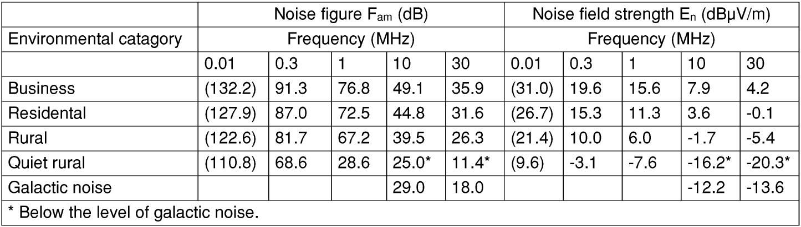
Table B8. Man made noise figures and field strength levels.

Conclusion

The curves in Figure B1 show the relevant noise levels that primary radio users will generally encounter in Europe.

The values of the noise levels which are shown correspond:
1. to the atmospheric noise with a distribution likelihood of respectively 20 %, 50 % and 80 %;
2. to manmade noise levels;
3. to the galactic noise level.

The quiet rural environment manmade noise level at the lower frequencies, and the galactic noise level at the higher frequencies, should be used as a floor level to the atmospheric noise.

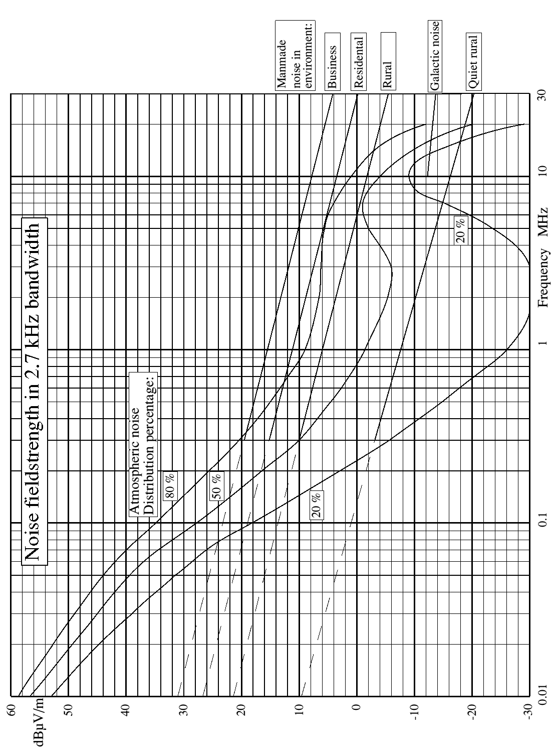
Figure B1. Noise field strength levels.

