European Radiocommunications Committee (ERC)
within the European Conference of Postal and Telecommunications Administrations (CEPT)
HANDBOOK ON RADIO EQUIPMENT AND SYSTEMS
VIDEO LINKS FOR ENG/OB USE

Stockholm, May 1995
HANDBOOK ON RADIO EQUIPMENT AND SYSTEMS
VIDEO LINKS FOR ENG/OB USE

CONTENTS

- INTRODUCTION

- ENG/OB TERMINALS THE ‘BUILDING BLOCKS’

- ENG/OB LINKS USED REGULARLY

- LINK MARGINS

- PROPAGATION

- DISCUSSION

APPENDIX 1: ANTENNAS FOR ENG/OB LINKS

APPENDIX 2: LINK BUDGET FOR ENG/OB VIDEO LINKS

APPENDIX 3: KNIFE-EDGE DIFFRACTION

APPENDIX 4: ENG/OB TRANSMITTER SPECTRUM MASK
HANDBOOK ON RADIO EQUIPMENT AND SYSTEMS
VIDEO LINKS FOR ENG/OB USE

- INTRODUCTION

Over the past few years, there have been various definitions of ENG (electronic news gathering) and OB (outside broadcast), and the various operations have been ascribed to either ENG or OB. Within the CEPT, definitions for ENG and OB have been agreed and are as follows.

ENG : Electronic News Gathering (ENG) is the collection of television news stories without the use of film, using small hand held, electronic, colour cameras with microwave links to the news room and/or portable video tape recorders. (CCIR report 803-2, annex to Volumes X and XI, parts 3).

OB : Outside broadcasts is the temporary provision of programme making facilities at the location of on-going news, sport or other events, lasting from a few hours to several weeks. Outside Broadcasts are generally planned in advance, but it is often necessary to accommodate short notice changes of venue or unforeseen requirements. Video links are required for mobile links, portable links and cordless cameras at the OB location. Additionally, video links may be required as part of a temporary point to point connection between the OB van and the studio. (CEPT Project Teams SE 19 and FM 20).

It can be seen that the definitions are not mutually exclusive. Certain operations could equally well reside in either or both categories. Added to this potential confusion, is the fact that equipment manufacturers, in line with the terminology used in the USA, refer to everything as ENG. Clearly, it is not possible to discriminate between ENG and OB, without becoming ambiguous. Therefore, for the purposes of this document, to avoid confusion, all types of operation will be considered under the general term ENG/OB.

Having decided to treat ENG/OB collectively, which type of operation best describes an ENG/OB video link ? The simple answer is none. It is impossible to describe ENG/OB in terms of specific video links.

A more accurate view is probably to consider ENG/OB as a set of ‘building blocks’ or modules. These modules consist of transmit terminals, receive terminals, and combined receive/transmit terminals (for mid-point applications). To service any particular requirement and provide the necessary connection between the location of an event and a destination, planners and operators will use the modules at their disposal as they consider most appropriate.

This modular approach also simplifies the task of explaining the technical characteristics of ENG/OB links. When the role of each module is understood, the required technical parameters become self evident.

- ENG/OB TERMINALS THE ‘BUILDING BLOCKS’

This section depicts graphically a selection of ‘building block’ modules currently utilised in ENG/OB links. Accompanying each drawing is a brief explanation where necessary and the antenna types that might be used.

Antenna types are grouped into five basic categories,

Low Gain; A1 to A3.

Omni-directional; B1 to B4.

Low to medium gain end-fire; C1 to C4.

Medium to high gain reflector; D1.

Special Antennas; E1.

Full details and representative radiation patterns from each antenna category are shown in Appendix 1.

Where the use of a module is unique to a specific type of link (i.e. cordless, portable, mobile or temporary point-to-point) this is shown, otherwise the module is defined as multi-purpose.

Figure 1: Cordless Camera Transmitter
Description: One Man Radio Camera

Antenna Types: Omni-directional, B4
Special Antennas, E1

Figure 2: Portable Camera Transmitter
Description: Two Man Radio Camera

Antenna Types: Low to Medium Gain End-fire, C1

Figure 3: Mobile Camera Transmitter

Description: Motor Bike Camera

Antenna Types: Low Gain, A1, A2, A3

Figure 4: Mobile Camera Transmitter

Description: Racing Car Camera

Antenna Types: Low Gain, A1, A2, A3

Figure 5a: Airborne Mobile Camera Transmitter

Description: Remotely Controlled, Gyro Stabilised Camera in Helicopter

Antenna Types: Omni-directional, B1, B2, B3

Figure 5b: Airborne Mobile Camera Transmitter

Description: Cameraman in Helicopter

Antenna Types: Omni-directional, B1, B2, B3

Figure 6: Multi-purpose receiver

Description: Manually tracked receiving antenna located
at any convenient point at ENG/OB site

Antenna Types: Low to Medium Gain Endfire, C1, C2, C3, C4
Medium to High Gain Reflector, D1

Figure 7: Multi-purpose Receiver, Transmitter or Mid-point
Description: Golf buggy, commonly used on a golf course as a mid-point

Antenna Types: Low to Medium Gain End-fire, C1, C2, C3, C4

Figure 8: Temporary Link Transmitter

Description: Heavy duty vehicle with telescopic mast

Antenna Types: Low to Medium Gain End-fire, C3, C4
Medium to High Gain Reflector, D1

Figure 9: Multi-purpose Receiver, Transmitter or Mid-point

Description: Hydraulically elevated antenna platform

Antenna Types: Low to Medium Gain End-fire, C2, C3
Medium to High Gain Reflector, D1

Figure 10: Multi-purpose Receiver, Transmitter or Mid-point

Description: Roof of communications vehicle, a environmentally safe platform with convenient access, so manually tracked antennas are often located here.
Becomes the home of a wide range of antennas at an ENG/OB event.

Antenna Types: Low Gain, A1
Low to Medium Gain End-fire, C1, C2, C3, C4
Medium to high Gain Reflector, D1

Figure 11: Multi-purpose, Airborne Mid-point

Antenna types: Low Gain, A1, A2, A3
Omni-directional, B1, B2, B3
Low to Medium Gain End-fire, C1

Figure 12: Temporary Point-to-point Receiver

Description: Existing Radio Tower. Normally fitted with remotely panned antennas

Antenna Types: Medium to High Gain Reflector, D1

- ENG/OB LINKS USED REGULARLY

Table 1 is reproduced from the ERC Draft Recommendation on ENG/OB. It shows typical technical characteristics for ENG/OB links. The column headed ‘type of link’ is grouped into four categories; cordless, portable, mobile and temporary point-to-point. This sub-division simplifies matters when frequency and power requirements are under consideration.

Table 1

Typical Technical Characteristics for ENG/OB Links

Type of Link | Range | Max E.I.R.P. | Min Tx ant. gain | Min  Rx ant. gain | Radio Link Path | Suitable Frequency Range | Description
Cordless Camera | <500m | 6dBW  13dBW  (22 GHz or 47GHz) | 0dBi | 6dBi | Usually clear line of sight. | Currently < 12GHz  but future systems at 22GHz and 47GHz may be achievable. | Handheld camera with integrated transmitter, power pack and antenna.
Portable Link | <2km | 16dBW | 6dBi | 17dBi | Not always clear line of sight. | <5GHz | Handheld camera but with separate bodyworn transmitter, power pack and antenna.
Mobile Link | <10km | 26dBW | 3dBi | 13dBi | Often obstructed and susceptible  to multipath impairment. | <5GHz | Mounted in helicopters, motorcycles, pedal cycles, cars, racing cars and boats. One or both link terminals may be used when moving.
Temporary Point-to-point  Link | <80km  each hop  for links at  <10GHz | 40dBW | 13dBi | 17dBi | Usually clear line of sight for OB, but often obstructed for ENG use. | <10GHz for long hops.  Hop length at >10GHz limited by precipitation fading. | Link terminals are mounted on tripods, temporary platforms, purpose built vehicles or hydraulic hoists.  Two-way links are often required.

As a series of examples, typical ENG/OB links in each of the preceding categories are constructed using the modules outlined in the previous section.

Figure 13: A cordless camera link

Description: One man radio camera to on site receiver
Suitable Frequencies: Less than 12 GHz,
(future systems at 22 GHz and 47 GHz may be achievable)

Figure 14: A portable link

Description: Two man radio camera to roof of communications vehicle
Suitable Frequencies: Less than 5 GHz
Figure 15: A mobile link

Description: Motor bike to helicopter
Suitable Frequencies: Less than 5 GHz

Figure 16: A temporary point-to-point link

Description: Hydraulic platform to radio tower
Suitable Frequencies: Less than 10 GHz for long hops

Figure 17: A temporary point-to-point link

Description: Fast response vehicle to radio tower
Suitable Frequencies: Less than 10 GHz

If transmit and receive terminals are not line of sight a mid-point may be necessary.

Figure 18: A cordless link feeding a mobile mid point link

Suitable Frequencies: First hop less than 12 GHz, second hop less than 5 GHz

Figure 19: A mobile link feeding a mobile (aeronautical) mid-point link

Suitable Frequencies: First hop less than 5 GHz, second hop less than 5 GHz

Figure 20: A temporary point-to-point link feeding a temporary point-to-point link
Suitable frequencies: First hop less than 10 GHz, second hop less than 10 GHz
Of course things will become even more complicated when the whole operation is considered!

Figure 21: Radio Links that may be used simultaneously for coverage of motor racing

- LINK MARGINS

Appendix 2 derives the link margins for the four categories of operation; cordless, portable, mobile and temporary point-to-point. The transmit E.I.R.P. and typical range values are obtained from Table 1. For all situations, the receiving antenna is considered to be a 1.2m parabolic dish, so the margins are not frequency dependant. In the case of cordless and portable links, especially at frequencies above 10 GHz, it will be difficult to manually track an antenna of this size due to its narrow beamwidth. If it is considered more appropriate to use a 0.6m parabola instead, the margins will be decreased by 6 dB.

It has already been explained that a wide selection of antennas are available, so in practice a high margin may be traded off against a more convenient antenna.

The margins are calculated assuming that the terminals are in ‘free space’ or line-of-sight (with first Fresnel Zone clearance). In general, any radio link used in ENG/OB will be planned to be clear line-of-sight; however in reality this may not always be the case. Someone always walks between a cordless link and its receiving terminal, a racing car always goes under a bridge when the helicopter is receiving best pictures, a news event always occurs in the centre of a cluster of high rise office blocks and so on! There will always be a time when a reliable radio link is required but the path between the terminals is obstructed. During these times the margin will decrease dramatically sometimes, unfortunately to levels where pictures are unusable.

- PROPAGATION

Experience gained using ENG/OB links in a wide range of frequency bands shows clearly that the higher the frequency, the greater the attenuation produced by an obstruction. This is may be attributed to a combination of increased absorption and diffraction losses.

Absorption losses are rather difficult to calculate and could well be the subject of further study. Diffraction calculations for well defined geometric structures produce exact solutions and are widely used in propagation models. A simple model considering a single obstruction in a short radio link is shown in Appendix 3. Such obstructions may be approximated to a knife-edge, and the results of the classical calculation of knife-edge diffraction loss at typical ENG/OB frequencies are show in Table A3-1. In general, once the radio path becomes severely obstructed, the diffraction loss increases monotonically with frequency.

Another characteristic of cordless, portable and mobile links which may significantly decrease their coverage is multipath propagation. Consider an example where a cordless link with an omni-directional transmitting antenna, is operating in a stadium. The radiation from the antenna is not only illuminating the area of the receiving antenna, it is also illuminating the rest of the stadium, much of which will be metallic. Reflections will occur, re-radiating the signal in many directions. The level of received signal is the vector sum of the direct signal and all the reflected signals arriving at the receiving antenna. It is not uncommon for complete cancellation to occur either at spot frequencies within the bandwidth of the signal, or over the entire bandwidth. The consequence of this, ranges from picture impairments to complete loss of signal.

Multipath effects may be alleviated by one of the two different methods described below.

(i) Circularly polarised transmitting and receiving antennas may be used.

As the direction of polarisation of a circularly polarised radio-wave changes on reflection, the receiving antenna can discriminate between direct and reflected signals. This is not a complete solution as the signal resulting from multiple reflections may be either direction of circular or elliptical polarisation. Also the design and construction of a compact, lightweight antenna producing good circular polarisation over 360° of azimuth is by no means trivial.

(ii) The use of directional transmitting and receiving antennas.

These may be either manually, mechanically or electronically tracked. The narrower the transmit beamwidth the less energy is directed towards reflecting surfaces, the narrower the receive beamwidth the fewer reflecting surfaces are visible. In principle this sounds simple, but antenna pointing requires extra personnel or expensive equipment. For cordless cameras, having only one operator, the tracking of the transmitting antenna must be automatic. This requires an additional radio link carrying antenna control data from the receiving point, back to the camera man. Suitable equipment is complicated and expensive, however Broadcasters and Programme Makers consider these operations of such importance, that substantial investments are made both in design and procurement of this equipment.

- DISCUSSION

Some representative ENG/OB links have been shown in section 3, constructed using the modules described. Obviously many other permutations are possible. Also, as technology provides smaller and smaller video cameras and transmitters, and as television viewers demand a ‘seat’ closer and closer to the action, so the art of engineering ENG/OB cordless, portable and mobile links will become more imaginative and ingenious. Inevitably this will place increasing demands on spectrum allocations.

There will always be a need to connect the location of an event to a studio. For this application, temporary point-to-point links are reliable and cost effective. Within the timescales of the current Detailed Spectrum Investigation, it is likely that the demands on spectrum allocated to temporary point-to-point links will increase.
Left blank
APPENDIX 1

ANTENNAS FOR ENG/OB LINKS

This section gives a brief introduction to some of the antennas used in ENG/OB. Antennas are grouped according to general usage. Typical characteristics and radiation patterns are included for examples in each category.

The examples given may relate to frequencies which do not align with the recommended or preferred bands. This is because, at present, antennas are not manufactured for all these bands and consequently the relevant information is not available. In principle, there is no reason why any of the antennas shown could not be designed to operate in any of the bands identified.

Radiation patterns in both polar and Cartesian format are shown where these have been measured or published, but in many other cases these are either not available or are of dubious origin.

This is by no means a complete list, nor could it ever be. Antenna manufacturers are continually reviewing and updating their product range and operators are continually requesting different characteristics.

Antenna names are as used by the operators or manufacturers.

A: Low Gain Antennas, (approx. 90° to 200° beamwidth)

A1: Wilted Dipole

Wide beamwidth giving circular polarisation with greater than hemispherical coverage. Used as mobile uplink to and downlink from helicopter. Versions available for 2.5 GHz and 3.5 GHz. Figs. 1 and 2.

A2: Low Profile Antenna

Less than hemi-spherical coverage. Versions available offering gains of 5 dBi and 9 dBi over a frequency range 1.3 - 8.5 GHz. Representative patterns shown in Figs. 3 and 4.

A3: Patch Antenna

Mounted on racing cars, hence very low profile. Used at 2.5 GHz, other availability unknown.

B: Omni-directional Antennas, (in azimuth with varying vertical beamwidths)

This range of antennas provides omni-directional or nominally omni-directional patterns in the horizontal plane. Gains of between 2 dBi to 10 dBi can be realised by reducing the vertical beamwidth.

B1: Franklin

Often used on helicopter to transmit vertical polarisation to remote receiving point. Only produced at 2.5 GHz. Gain 5 dBi. Figs. 5 and 6.

B2: Bi-cone

Vertically polarised, lowest gain available so widest vertical beamwidth. Only produced at 2.5 GHz. Gain 2 dBi. Figs. 7 and 8.

B3: Co-linear

Various implementations of designs similar to B1 and B2. Manufacturers quote gains of between 4 dBi to 10 dBi, available over a frequency range 1.3 GHz to 6 GHz.

B4: Lindenblad (FOSDA, Four offset dipole array)

Originally used by the Italian Broadcaster, RAI for cordless and portable radio cameras, it is generally referred to by the name of its inventor, Lindenblad. It radiates omni-directional circular polarisation. As explained in earlier, circular polarisation is an advantage in venues where multipath propagation causes RF signal dropouts. Used at 2.5 GHz and 3.5 GHz.

C: End-Fire Antennas, (Low to Medium Gain)

This category contains a wide selection of yagis, helices and dielectric rod antennas. It is not unusual to combine two or even four antennas to form a high gain array. Polarisations may be linear or circular. Overall gains vary from about 5 dBi up to 22 dBi for large arrays.

C1: Hand-held helix

Axial-mode helical antenna, producing left hand or right hand circular polarisation depending on direction of helix. Generally low gain to avoid high pointing accuracy. Often used with two man (portable) radio cameras as both transmit and receive antennas. Gain around 12 dBi. Manufacturers offer versions over the frequency ranges 1.3 to 8.5 GHz. Figs. 9 and 10.

C2: Disc Yagi

Yagi-Uda antenna but with metallic discs for reflector and director elements. This allows the use of linear or circular polarisation and also increases the bandwidth. Produced at 2.5 GHz. Switchable polarisation. Gain 16 dBi. Figs. 11 and 12.

C3: Golden Rod

Originally manufacturers trade name for a dielectric rod antenna, although nowadays the name is used generically for almost any end-fire antenna. Original Golden Rod's provided circular polarisation and gains between 13 dBi to 22 dBi in the 2 GHz and 2.5 GHz bands.

C4: Helical Antenna

Many versions of the axial-mode helical antenna are seen in ENG/OB applications. These antennas are reasonably easy to design and construct and can be engineered to be very rugged. Their size and gain limit is one of practicality, at some point a parabolic dish can more conveniently provide the same gain.

D: Medium to High Gain Reflector Antennas

D1: Parabolic Dishes

Parabolic dishes are frequently used in ENG/OB, as the receive antenna from any of the sources of transmission shown and for both transmit and receive ends of temporary point-to-point links. Assuming an aperture efficiency of 50 %, (typical for a simple feed system) the gain of a dish may be determined with reasonable accuracy by the equation.

Gain (dB) = 10 log (6A/λ2)

where A = area of mouth of dish
λ = wavelength

In general the main lobes of these antennas are narrow and the sidelobes low, so a conventional radiation pattern conveys little useful information. Consequently radiation characteristics are shown in the form of tables rather than a pattern. See Table 1 and Table 2. Approximate gains, 3 dB beamwidths, maximum sidelobe level 0° to ±45°, maximum sidelobe level in the range ±45° to ±100° and maximum level in the range ±100° to 180° are shown.

Table A1-1: Radiation characteristics of 0.6m Parabolic Dish

Frequency | 2.5 GHz | 3.5 GHz | 5 GHz | 7 GHz | 12 GHz
Maximum Gain,dBi | 21dBi | 24dBi | 27dBi | 30dBi | 34dBi
3 dB Beamwidth ±° | 7 | 5 | 3.5 | 2.5 | 1.5
Maximum sidelobe  level 0° to ±45°* | -16dB |  | -24dB | -20dB
Maximum sidelobe  level ±45° to ±100°* | -21dB |  | -30dB | -34dB
Maximum level  ±100° to 180°* | -30dB |  | -34dB | -40dB

* levels relative to main lobe.

Table A1-2: Radiation characteristics of 1.2m Parabolic Dish

Frequency | 2.5 GHz | 3.5 GHz | 5 GHz | 7 GHz | 12 GHz
Maximum Gain,dBi | 27dBi | 30dBi | 33dBi | 36dBi | 40dBi
3 dB Beamwidth ±° | 3.5 | 2.5 | 2 | 1.5 | 1
Maximum sidelobe  level 0° to ±45°* | -20dB |  | -11dB | -16dB
Maximum sidelobe  level ±45° to ±100°* | -30dB |  | -32dB | -40dB
Maximum level  ±100° to 180°* | -35dB |  | -40dB | -40dB

* levels relative to main lobe.

Values shown in tables have been obtained from measured patterns and so are representative of equipment currently in use.

Where values are not shown, no information has been found.

E: Special Antennas

E1: Switched Horn Cluster

This consists of an array of six waveguide horns, each with a beamwidth of 60° and each oriented at 60° relative to adjacent horns. In this configuration, by using one of the six horns, 360° of coverage can be realised. Horns are selected by RF switches, the specific choice dependant on received signal conditions. This antenna forms the basis of a new switched antenna radio-camera system. At present this concept has been applied only to 12 GHz, although the principles could be adopted at higher frequencies.
APPENDIX 2

LINK BUDGET FOR ENG/OB VIDEO LINKS

For example consider ENG/OB links using conventional frequency modulation in a 20 MHz channel bandwidth. (See Appendix 4).

The noise power in the receiver bandwidth of 20 MHz is kTB where
k is Boltzmann's constant = -228.6 dB Watts/Hz/K

T is effective noise temperature = 32 dBK
(antenna + 7 dB noise figure receiver)

B is Bandwidth = 20 MHz = 73 dB Hz

So noise power = -124 dB Watts

The performance requirement of a long term video link is an unweighted video signal to noise of 44 dB. (Depending on programme material, somewhat lower standards may be acceptable for short, news and current affairs, inserts).

For conventional frequency modulation with 8 MHz peak to peak deviation using CCIR Rec. 405 pre-emphasis for 625 line PAL, the FM advantage (C/N to S/N) is approximately 15 dB.

So to provide 44 dB signal to noise, a minimum C/N of 29 dB is necessary.

Therefore the required carrier power is -95 dB Watts

To convert this figure to a power flux density (PFD), the characteristics of the receiving antenna must be known. The highest gain antenna commonly in use is a 1.2m parabolic dish, which has an effective aperture of -3 dB m2.

So the required PFD is -92 dB Watts/m2.

Table A2-1 shows the link margins achieved with the E.I.R.P.’s used by the various types of ENG/OB link.

Table A2-1: Link margins for various types of ENG/OB link

Type of Link | Transmit  E.I.R.P. (dBW) | Typical  Range (km) | PFD at max. Range (dBW/m2) | Margin (dB)
Cordless Link | 6 | 0.5 | -59 | 33
Portable Link | 16 | 2 | -61 | 31
Mobile Link | 26 | 10 | -65 | 27
Temporary  Pt. to Pt. Link | 40 | 80 | -69 | 23

Left blank
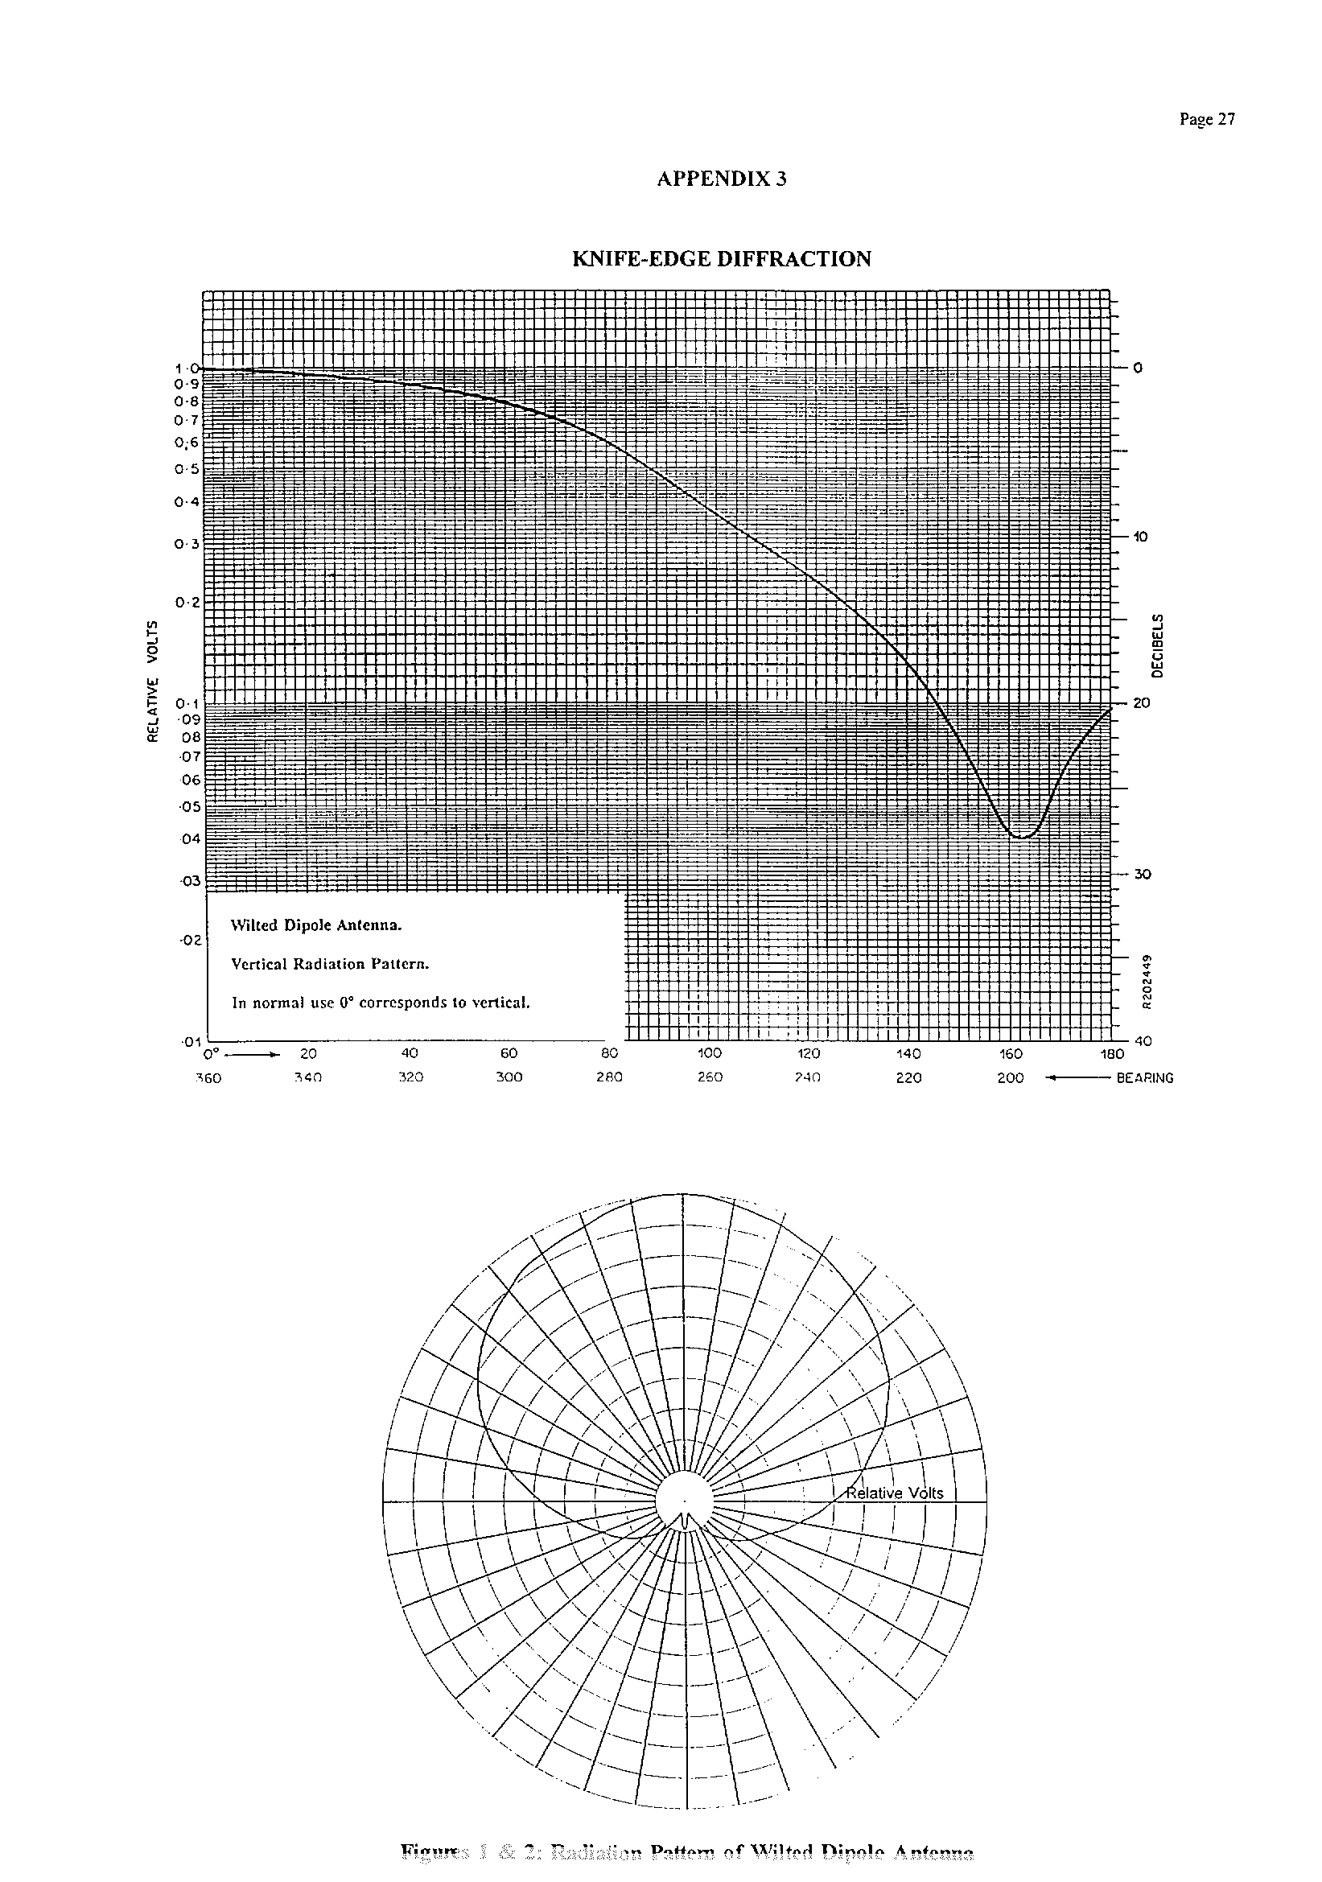NIFE-EDGE DIFFRACTION
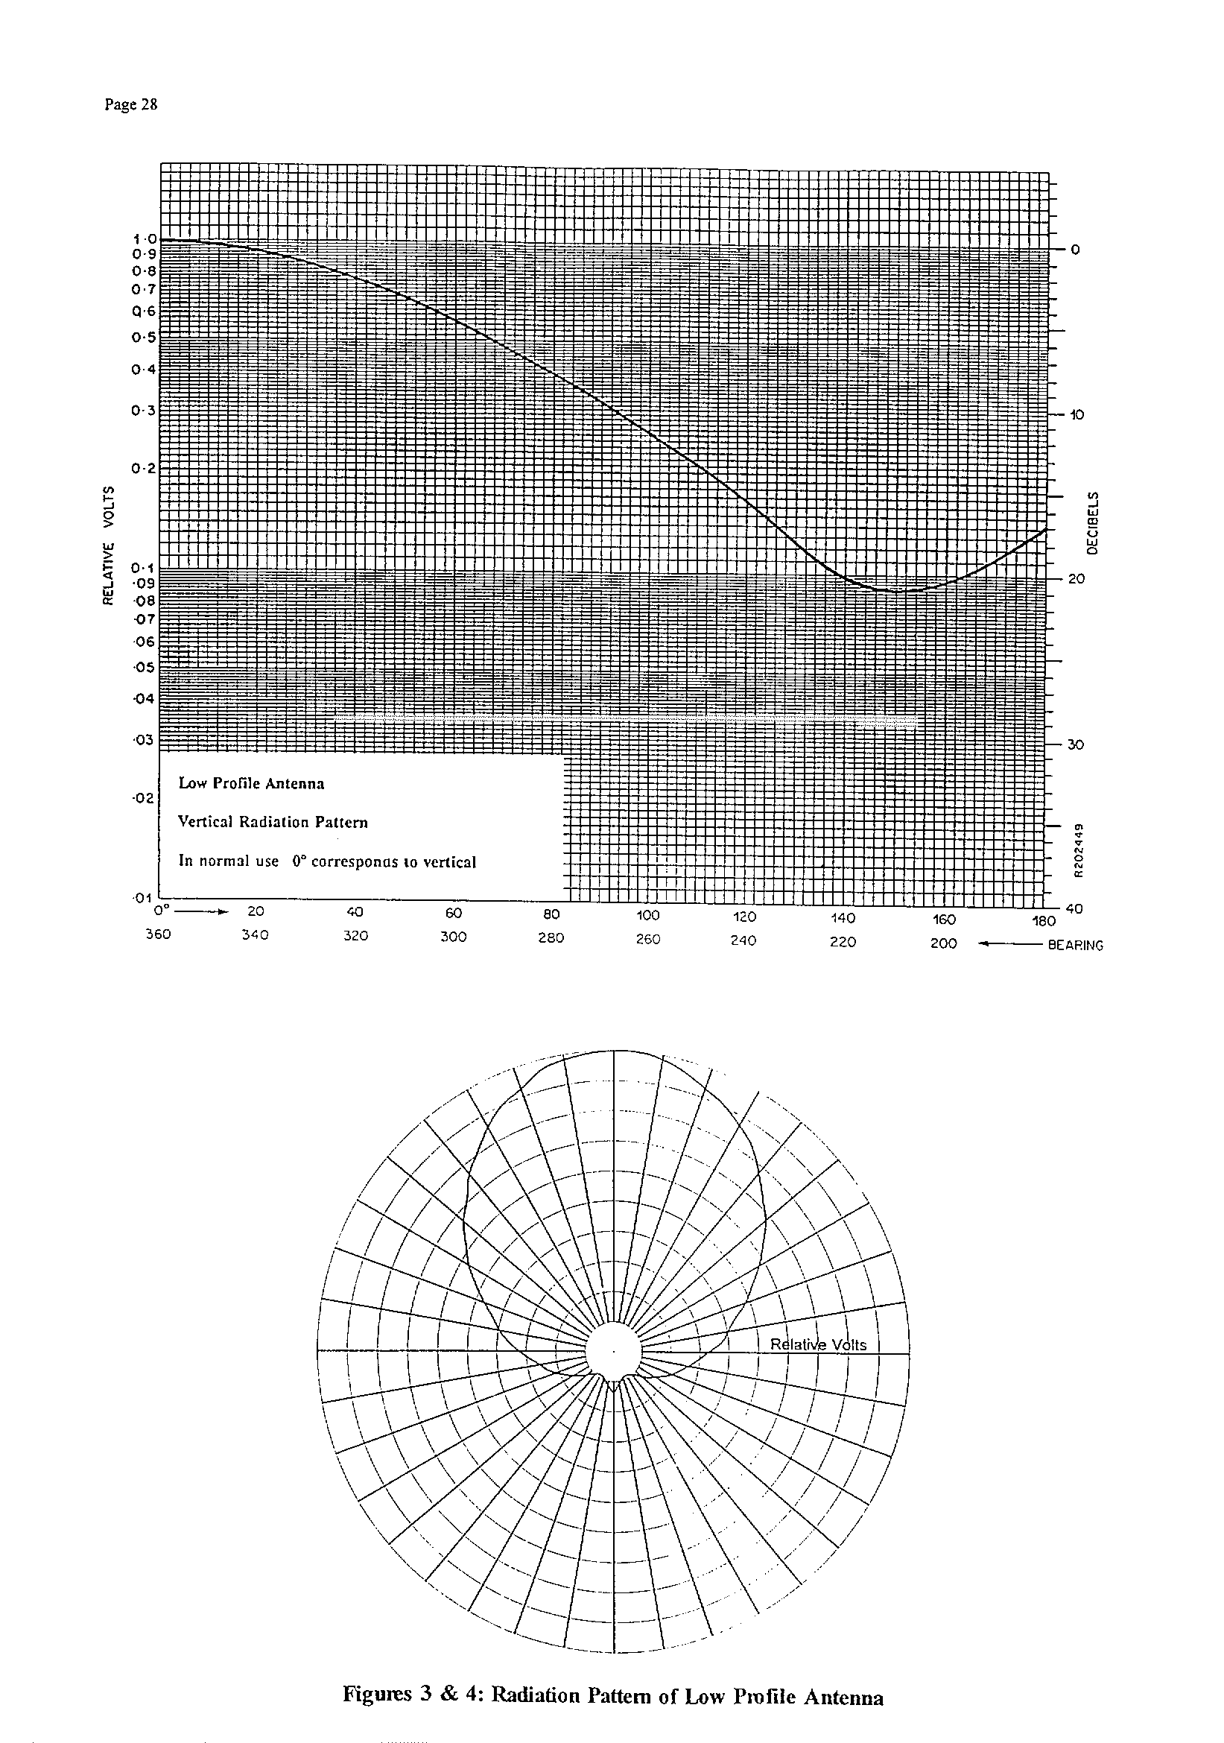
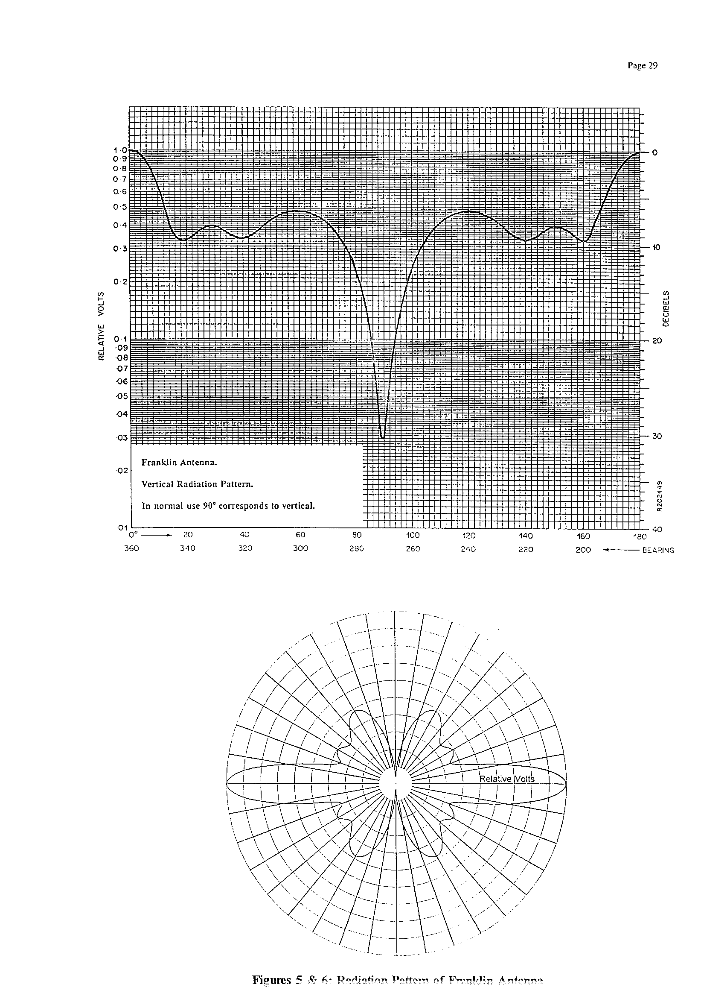
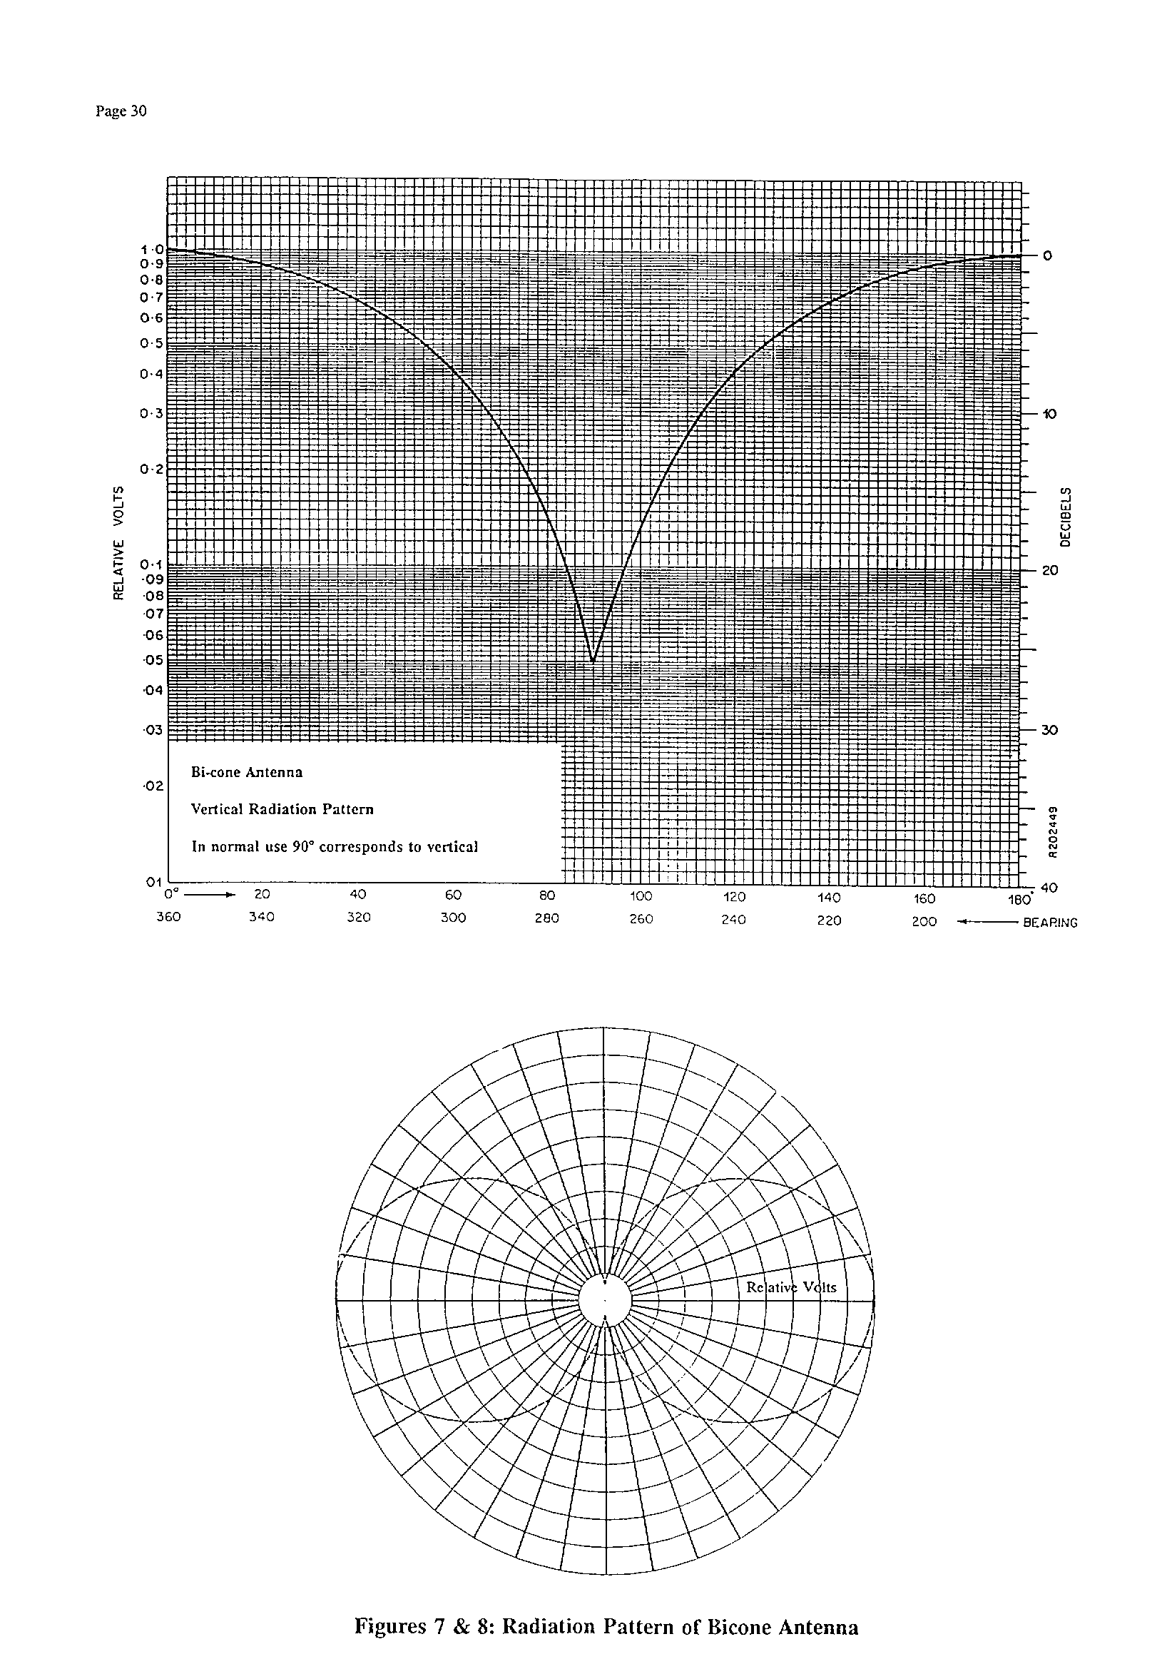
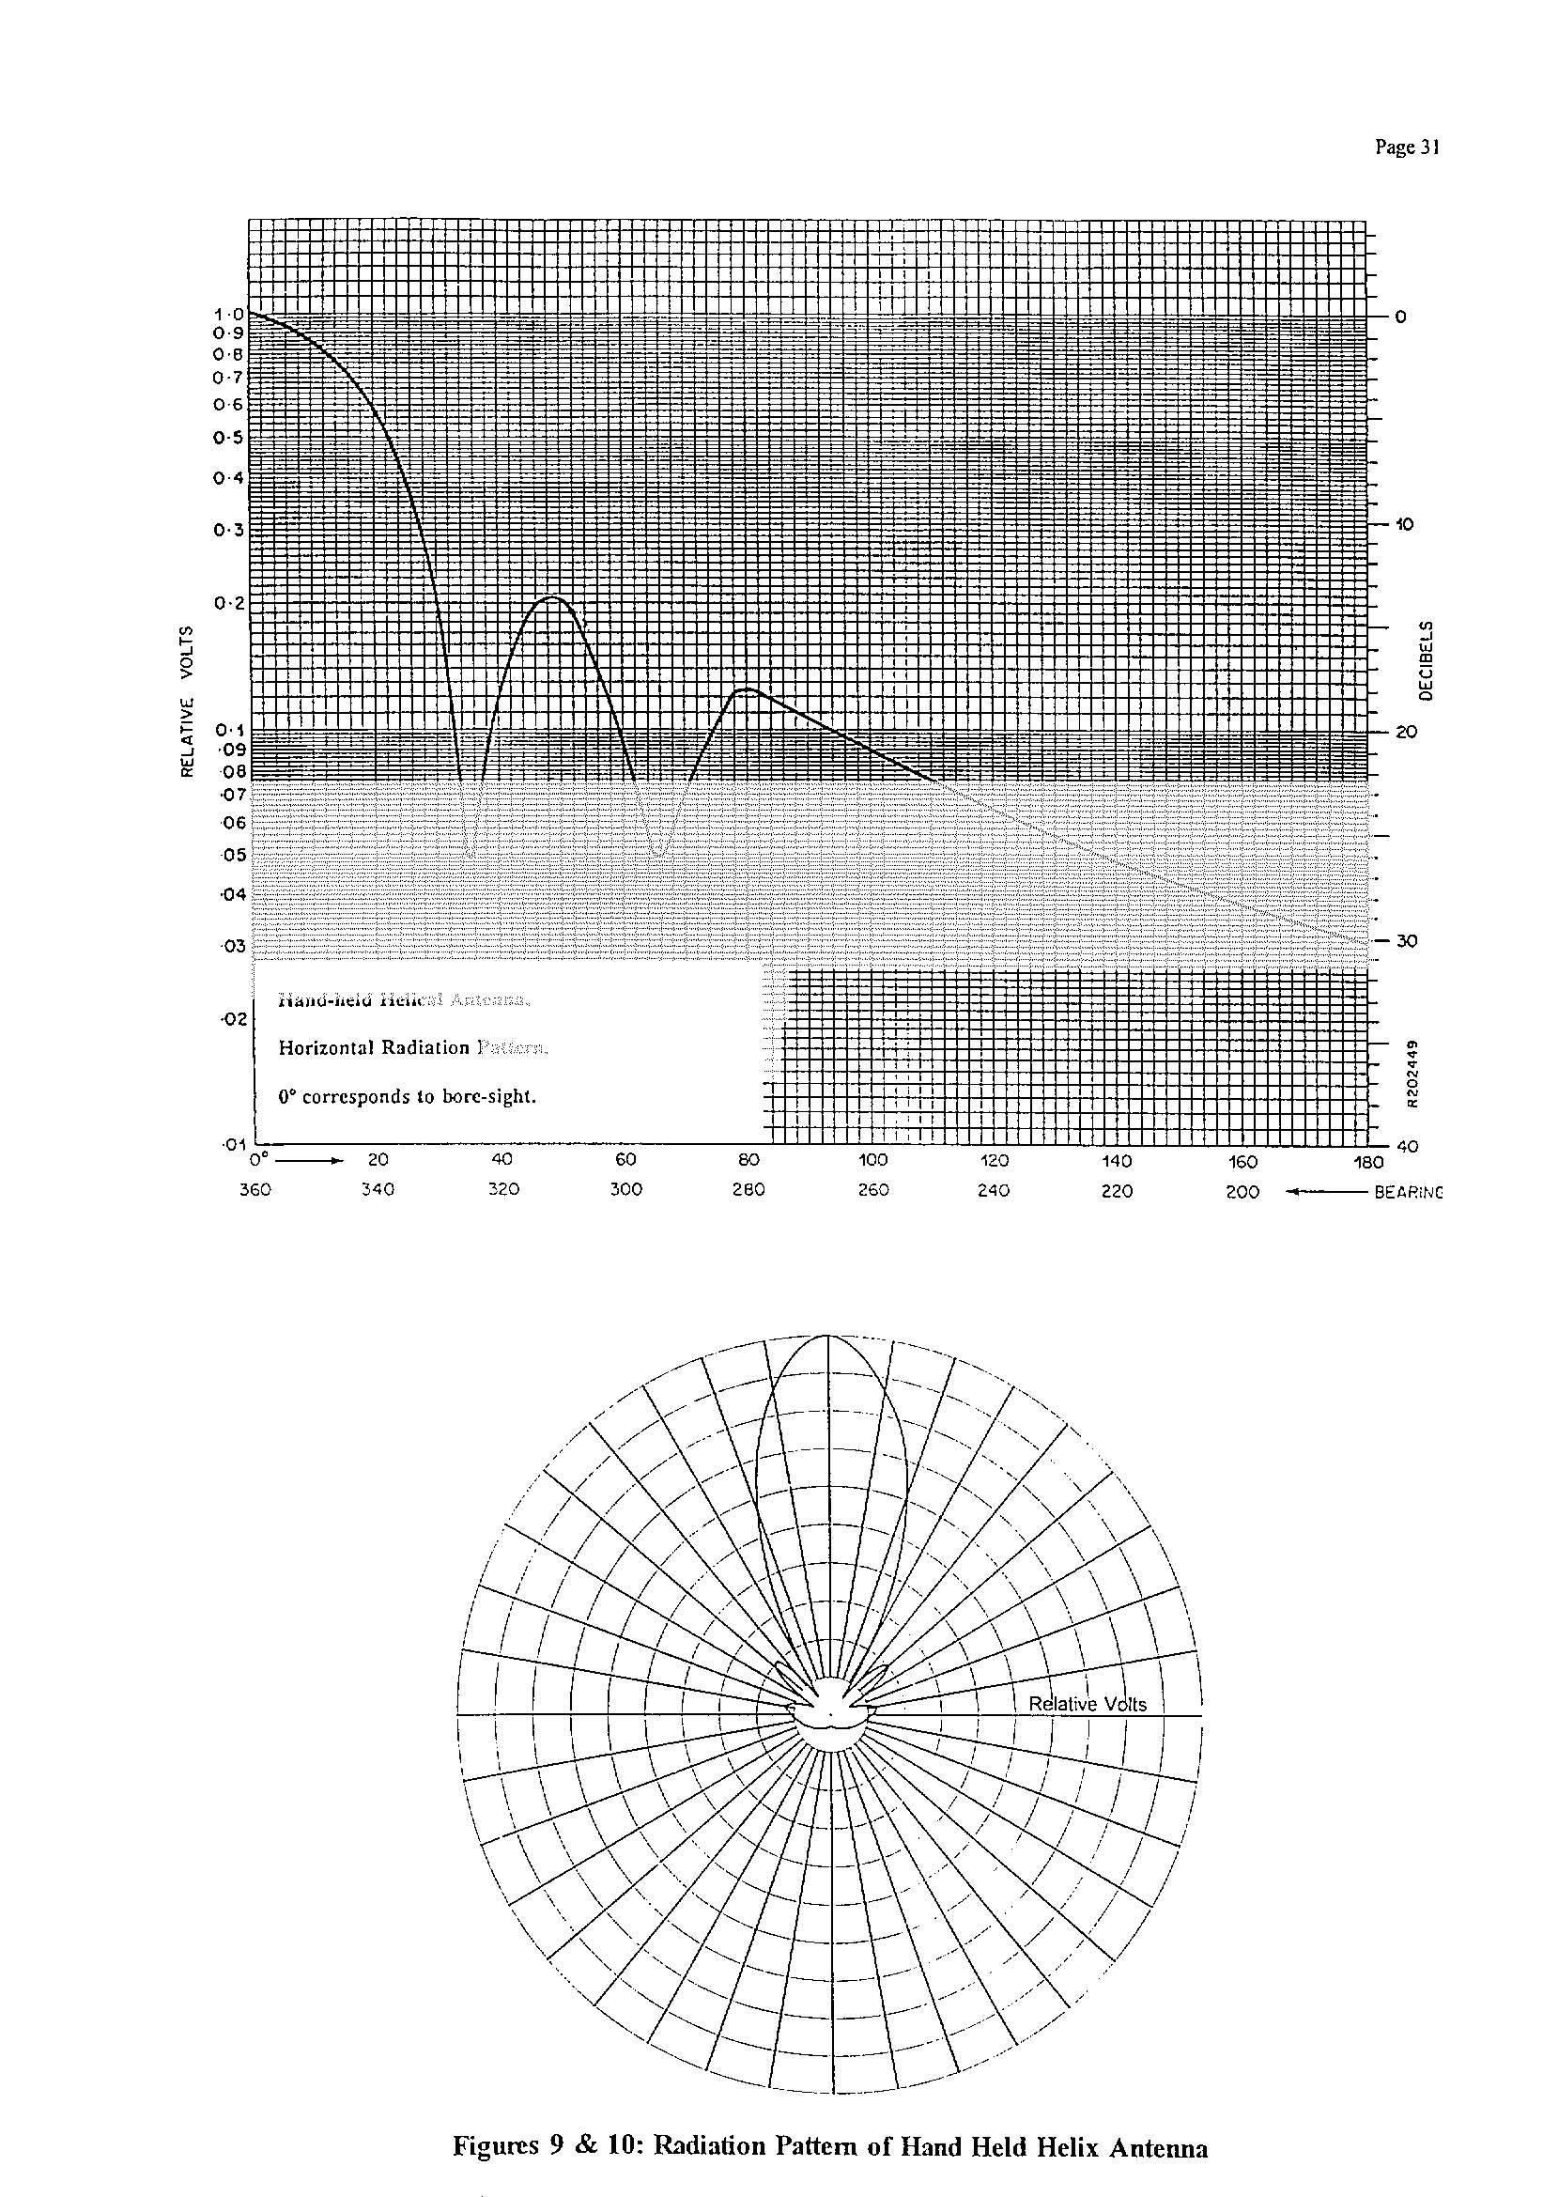
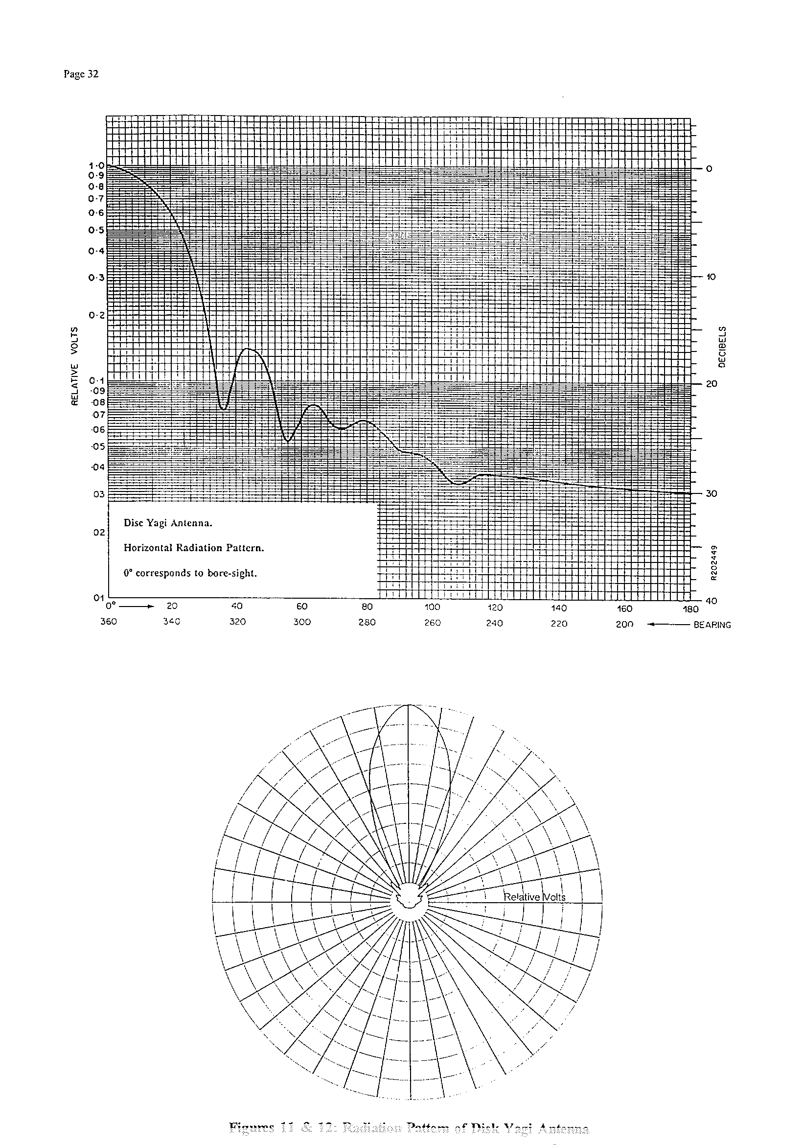

For the path geometry shown above, where :-

T, transmitting terminal height = 1 m
R, receiving terminal height = 5 m
D1, distance from transmitting terminal to obstruction = 0.3 km
D2, distance from obstruction to receiving terminal = 0.7 km
H, height of obstruction = 5 m, 10 m & 20 m

The knife edge diffraction loss, calculated at various frequencies, is shown in Table A3-1

Table A3-1: Diffraction Loss

Frequency | Diffraction loss for Obstruction  Height = 5m | Diffraction loss for Obstruction  Height = 10m | Diffraction loss for Obstruction  Height = 20m
2500 MHz | 12.4 dB | 19.9 dB | 27.0 dB
3500 MHz | 13.4 dB | 21.3 dB | 28.4 dB
4700 MHz | 14.4 dB | 22.6 dB | 29.7 dB
10000 MHz | 17.2 dB | 25.8 dB | 33.0 dB
22000 MHz | 20.4 dB | 29.2 dB | 36.4 dB
48000 MHz | 23.7 dB | 32.6 dB | 39.8 dB

Knife edge diffraction theory was originally formulated by Fresnel and exact solutions for diffraction loss require the solution of a Fresnel Integral. The values shown above have been produced by numerical evaluation of this integral. Should the reader require verification of these figures, an approximate method can be found in Section 4.1 of ITU-R, Rec. 526-2.
Left blank
APPENDIX 4

ENG/OB TRANSMITTER SPECTRUM MASK

In order to facilitate compatibility studies between ENG/OB systems and other services, a measure of the spectral characteristics of the ENG/OB transmitted signal is required. Of course the spectrum of such a signal varies with picture content, but this is not the only variable.

Unfortunately, currently there is no agreed standard for this equipment, so different manufacturers produce equipment with different characteristics. Sometimes the video bearer also carries analogue or digital sound signals, either time multiplexed or on separate sub-carriers. The spectral occupancy of the transmitted signal may be quite different from one system to another.

Nevertheless, to achieve efficient use of spectrum, it is considered important to include some details of transmitted signal.

The spectrum mask shown below has been used in previous sharing studies and may be considered representative of the majority of systems occupying a 20 MHz bandwidth. As a simple approximation, the frequency axis may be linearly compressed or extended to accommodate bandwidths between 14 and 25 MHz.

Figure A4-1: Representative spectrum mask for existing analogue ENG/OB video links.

Although the true sense of the spectrum mask is to show relative spectral density (for which a measurement bandwidth of one Hz. is implicit) versus frequency spacing; for all practical purposes a measurement bandwidth of up to 30 kHz is satisfactory.

In the context of ENG/OB, the destination is normally an established receiving installation although finally the signal will end up at a studio centre. The link from receiving installation to studio (either cable, fibre or permanent fixed links) is beyond the limits of ENG/OB involvement.

