
 European Communications Office (ECO)
ECO REPORT 01

Dynamic Evolution of RFID Market

31 August, 2010

Table of contents

0 summary 3
1 RFID in general 4
1.1 Introduction 4
1.2 History 5
1.3 The RFID evolution 5
1.4 The evolution of RFID Technology 5
2 Technical and regulatory background 5
2.1 RFID Technology 5
2.1.1 RFID tag/Transponder: 6
2.1.2 RFID reader (or interrogator) and systems: 6
2.1.3 Read-Only and Read-Write tags and systems 7
2.1.4 Supporting infrastructure: 7
2.2 Frequency bands used for RFID and related regulations in force: 7
3 Overview of RFID applications 8
4 ECO Study on “Dynamic Evolution of RFID Market” 9
4.1 119 - 148.5 kHz band (LF) 9
4.2 400-600 kHz band (MF) 11
4.3 13.553 - 13.567 MHz band (HF) 12
4.4 433 MHz band 13
4.5 865 - 868 MHz band (UHF) 14
4.6 2446 - 2454 MHz band 19
5 Overall market predictions and Economic impacts 20
5.1 Introduction 20
5.2 General tendency 21
5.3 Rapid growth 22
5.4 RFID market estimates 22
5.5 Forecasts by Application Category 23
5.6 Selected studies on the aggregate economic impact of RFID 26
6 Conclusions 27

summary
At its meeting in May 2009, WG FM decided to request ECO to carry out the following study under the guidance of the SRD/MG to, at least:

- draw up a detailed inventory of the actual RFID market and applications;
- retrace the dynamic evolution of the RFID market from the date of adoption of the current CEPT regulation (ERC/REC 70-03);
- compare it/them with the planned evolution of this market that was provided to CEPT to prepare the current regulation (as existing in ERC/REC 70-03).

The study should consider all of the RFID bands with an emphasis on the relevant part of the 863 - 870 MHz band.

Beyond the detailed inventory of the actual RFID market and applications, it has been endeavoured when developing this report to collect data in order to allow comparisons between past expectations and actual sales over the years for RFID equipment.

The following frequency bands were considered in this report:
- 119 - 148.5 kHz
- 400 - 600 kHz
- 13.553 - 13.567 MHz
- 433.05 - 434.79 MHz
- 865 - 868 MHz
- 2446 - 2454 MHz

As a result of these investigations, it was found that available data, which permitted a meaningful comparison to be made between past predictions and actual tag sales, was mainly limited to UHF RFID in the frequency band 865 - 868 MHz.

This comparison is presented in the table below:

Reference studies |  | Million of tags per year - UHF RFID in band 865 - 868 MHz  (forecasted figures are shown in italics)
Source | Issued | 2006 | 2007 | 2008 | 2009 | 2010 | 2011 | 2012 | 2017 | 2022
ETSI TR 102 649-1 | April 2007 | 190 | 220 | 320 | 450 | 680 | 960 | 1 200
BRIDGE project | February 2007 |  | 144 |  |  |  |  | 3 220 | 2 2400 | 86 700
IDTechEx | 2009 |  |  |  | 680
Table 5 of ECO study | Nov 2009 |  | 475 |  | 665 |  |  |  |  | 354 000

The exercise of collecting both early forecasts and actual data on RFID sales and of delivering consistent comparisons thus proved significantly more difficult than expected.

It should furthermore be noted that the various figures collected in this report cover multiple types of applications that may be used in very diverse industry segments - a fact that should urge for cautiousness when handling these figures.

In order to assess the growth of the RFID market in future, administrations should be better informed on the deployment of existing and new applications.

RFID in general

Introduction
Radio Frequency Identification (RFID) means the use of electromagnetic radiating waves or reactive field coupling in the radio frequency portion of the spectrum to communicate to or from a tag through a variety of modulation and encoding schemes to uniquely read the identity of a radio frequency tag or other data stored on it.

RFID technology is currently one of the most promising and discussed automatic identification and data capture (AIDC) technologies. Although it is not a new technology (it was originated during the early 40s) the range of applications is broadening rapidly and new applications which integrate other technologies such as sensors are developing. Nine major fields of application can be identified, comprising:
i) Logistics and materials handling, where mobile assets are tagged for their use along the supply chain. It also includes libraries and waste management;
ii) Asset monitoring and maintenance, where mostly fixed and high value assets are tagged to store information, e.g. for maintenance purposes;
iii) Item flow control in processes, where RFID tags are attached to items which are moving along a production line;
iv) Inventory audit, for example in warehouses where pallets are tagged to improve the speed, accuracy and efficiency of stock taking;
v) Item level tagging combined with Electronic Article Surveillance (EAS);
vi) Authentication to provide secure identification mechanisms for persons and objects; vii) Payment systems to secure transactions (ie mass transportation);
viii) Automatic display of information where items are tagged to provide additional information on products and services when read;
ix) Animal identification for farming, control of pets, livestock, herds, diseases, protection of endangered species, food etc.

It is difficult to quantify the impact of the technology, in part because most RFID applications are recent. Market analysis shows rapidly growing markets for RFID systems and, apart from very detailed mainly qualitative evaluations of particular applications, there are few aggregate impact studies. Available aggregate studies show large impacts in terms of benefit/cost ratios and productivity gains; however calculations are based largely on current good practice case studies, leading to a potential overestimation of aggregate benefits. Further, most studies begin with a presumption of manual data entry and do not begin with the assumption of forward looking companies having already implemented systems based on optically readable media, i.e. bar codes and two-dimensional symbols. Consequently, benefits have a tendency to be greater than what one might see in a real world situation.

A number of national initiatives have recently been launched. They can be divided into three main categories:
i) The use of RFID by the public sector;
ii) Information, awareness and education programmes; and
iii) Incentives for business R&D and public funding of projects.

Government support for RFID technologies is focused on government applications for own use, often with a large demonstration component, and supporting multi-stakeholder projects to meet technological and industry needs, often to develop new technologies or applications. There are potentially large gains in innovation and efficiency from more widespread applications. Due to technological and business uncertainties, education and awareness activities could be further emphasised, particularly for small businesses and more advanced applications where potential impacts are high, for example, those involving sensors.

History
The development of RFID started with the Low Frequency (LF) systems which were the first in volume production. This was because of available technologies, technology limitations at higher frequencies and the ease of use of the transformer principle for inductively powered tags which are simple and efficient.

Although some sources say that the first RFID systems date back to the Second World War, the first real tags and RFID systems, which were comparable to the present ones appeared around 1975 in Europe. They were used in animal identification systems and basically have used the same simple structure. The early systems used frequencies around 120 kHz in Europe. In the US, 400 kHz was chosen firstly because of the lower inductances needed to resonate, and secondly because it was a better fit with FCC frequency regulations.

The first major application funded by the US government was the application of RFID in
counting fish populations (to prove that the “whites” did not over-fish the salmon population as claimed by Indians in their territories). So millions of tags and thousands of reader systems were deployed starting in the late 70s and mid 80s in North America.
After LF, the next milestone in the RFID history was the development of the HF 13.56 MHz systems in the ISM band for ISO card applications followed by the UHF development starting in ITU region 2 because of the ISM band allocation from 902 to 928 MHz.

The RFID evolution
Whenever new technologies appear on the market, there is a danger of overestimation of the potential and especially concerning the implementation time frames. Implementation is influenced by a number of factors such as maturity of technology, infrastructure readiness, cost, early innovators, the technical standards as well as the applicability to a variety of markets.

For RFID the evolution begun before 1995 and peaked around 2000 to 2003 with a number of large field trials. Many of them did not perform as expected. This message spread around and caused some disappointment, which has multiplied in some of the industries.

Secondly, the initial cost calculations and comparisons were (incorrectly) made on a one-to-one basis with the barcode technology. Cost calculations were not made on a complete
system savings and cost structure basis.

Recently (2007/2008) a more realistic assessment of the possibilities took place, coinciding with the availability of standards and improved solving of field installation problems.

The evolution of RFID Technology
It can be argued that, on the basis of current RFID technology, the demand for additional spectrum is not that great. Because of their low-power and short read distance, their ability to re-use spectrum is high. Even increasing the number of readers to interrogate these tags will not require a similar increase in spectrum due to a number of factors including spectrum re-use and other techniques such as on-site screening. However, this is not the whole story. The RFID industry is seeking to increase tag functionality while, at the same time, addressing some of the limitations of existing tag design. These factors are dealt with in greater depth in section 4.5.

Technical and regulatory background

RFID Technology
An RFID system consists of three components:

1. A tag (or multiple tags), also called as transponder
2. A reader or interrogator together with antenna
3. Supporting infrastructure (hardware and software).

A schematic presentation of basic RFID system is shown in the picture below:

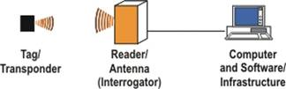

Figure 1: Basic RFID system

2.1.1 RFID tag/Transponder:
An RFID tag (also known transponder) means either a RFID device having the ability to produce a radio signal or a RFID device which couples, back-scatters or reflects (depending on the type of device), and modulates a carrier signal received from a reader or writer.

RFID tags are usually small and typically comprise three components:
1. an antenna,
2. a microchip unit containing memory storage,
3. an encapsulating material.

Tags can be either read-only or read-write tags. These terms refer to whether or not the information stored on the tag can be changed or erased.

RFID tags can be classified as follows:

Passive Tags: Passive tags are inherently low cost, have relatively low range and are often for single use only. The energy for the tags is derived from the received carrier signal; therefore the achievable operating range for a RFID system is predominantly set by the power transfer mechanism and the frequency of operation. The chip power consumption and antenna efficiency are also key factors for optimal reading range of passive tags.

Active tags: Active tags are divided in “Semi passive tags” and “fully active tags”.

i) “Semi passive” tags are categorised as active tags since these tags use batteries only to support the chip supply voltage. The tag is basically a passive tag, modified by a sensitive receiver detecting the interrogation signal from the reader over a longer distance because no power transfer is needed to activate the tag. Semi passive tags are also called “battery assisted” tags.

ii) Fully active tags can be considered as data telemetry transceivers or as data communication systems, because active tags frequently have an on-board oscillator to create the data return signal when activated by the reader. Active tags can therefore more effectively re-radiate the data signal to the reader and the range is (amongst others) limited by the antenna efficiency and the emitted power.

2.1.2 RFID reader (or interrogator) and systems:
An RFID reader, or interrogator, is a device to communicate with the RFID tag. It broadcasts a radio signal, which is received by the tag. The tag then transmits its information back to the reader. Readers can either be portable handheld terminals or fixed devices that can be positioned in strategic places such as loading bays in shipping and receiving facilities, or the doors in transport trucks.

RFID systems are also classified as "reader talks first" (RTF) or "tag talks first" (TTF). TTF systems emit an un-modulated powering signal and all TTF tags in the environment respond randomly with their tag information. In RTF systems the reader emits a coded powering system to call up a specific tag or category of tags and only these "addressed" RTF tags will respond.

2.1.3 Read-Only and Read-Write tags and systems
Read-only (or WORM) tags have a fixed memory and data content frequently written at the time of manufacturing, while Read-write tags can be programmed or the memory content changed/updated during an interrogation session by the reader. Some tags have an area of their memory with fixed data while another part of the memory is re-programmable.

2.1.4 Supporting infrastructure:
In addition to the tags and readers, an RFID system also includes other software and hardware. The most important component is the RFID-specific software translating the raw data from the tag into information about the goods and orders that are represented by the tags. This information can then be fed into other databases and applications (e.g., inventory management) for further processing. In the case of read-write tags, software is also required to control whether data can be written to the tag, which tag should contain the data and to initiate the process of adding data to, or changing data in the tag.

Frequency bands used for RFID and related regulations in force:
1. Bands below 135 kHz (LF): The LF frequency range is globally harmonised with regard to the frequency range up to 135 kHz (in some countries the upper range is extended beyond 135 kHz). The ISO standard ISO 18000-2 has limited the upper range to 135 kHz.

This frequency range is not covered in Annex 11 of ERC/REC 70-03 dealing with RFID. It is covered by Annex 9 dealing with inductive applications.

ETSI EN 300 330-1 V1.6.2 (2009-03) on “Technical characteristics and test methods for radio equipment in the frequency range 9 kHz to 25 MHz and inductive loop systems in the frequency range 9 kHz to 30 MHz” covers RFID in this frequency range.

The band 119 - 135 kHz is available for RFID in Europe, Americas, and most Far Eastern countries. In addition, for animal identification ISO standards exist which are widely accepted internationally (ISO 14223, ISO 11784, ISO 11785). Thus, the LF RFID frequencies benefit from global harmonisation and can be deployed in all three ITU regions.

The relevant standard for the air-interface for LF RFID in logistics is ISO 18000-2.

2. 400 - 600 kHz band (MF): In CEPT, the frequency range from 400 to 600 kHz has been allowed for RFID only at a fieldstrength of -8 dBµA/m, particularly to protect the Broadcasting and other primary services. This band was included in Annex 9 of ERC/REC 70-03 in 2006.

ETSI System Reference document (TR 102 378) provides insight into the applications, functionality, and basic requirement for a regulation for industrial RFID systems in the frequency range 400 - 600 kHz, especially in view of the large market impact. The regulation given in the SRDoc would provide an indispensable solution for all areas of the industry.

The generic ETSI standard EN 300 330 applies to LF, MF and HF RFID. These bands are available in Europe, US, China, Japan and most other countries.

3. 13.56 MHz (HF): The 13.56 MHz frequency range is an ITU regulated global ISM band for all 3 ITU-R regions and thus harmonised. ISM applications fall under EMC standards. ISM applications are not subject to frequency regulations, whereas the SRDs are communication systems and have to observe radio regulations regardless of the operation in ISM bands or not. All ISM bands are internationally allowed to be used for Short Range Devices (SRD) such as RFID.

The relevant standard for the air-interface for HF RFID is ISO 18000-3 predominantly used for logistic applications. ISO 14443 applies for smart card applications with a low reading range of approx. 10 cm. For larger ranges (e.g. access control) the ISO 15693 is applicable. The generic ETSI standard EN 300 330 applies to the HF RFID family operating at 13.56 MHz.

Another large and fast growing market is covered by 13.56 MHz is NFC (Near Field Communication) as standardized by EN 302 291.

4. 433 MHz (UHF): 433 MHz is only allocated as an ISM band in ITU Region 1 (including Europe). The 433 MHz RFID systems are subject to certification under ETSI EN 300 220. ISO 18000-7 is the standard for the air-interface for the 433 MHz RFID and ISO 24730-3 is the related 433 MHz RTLS (Real Time Location System) standard.

5. 865 - 868 MHz (UHF) band: The ETSI standard EN 302 208 is applicable for RFID reader certifications in the band 865 to 868 MHz. From the first industry request for an RFID band allocation, it took about 8 years in the ECC to define and release the present UHF band. The CEPT (European) RFID frequency carriers are allocated within the range of 865 - 868 MHz on 4 channels at power levels of up to 2 watts.

The relevant standard for the air-interface for UHF RFID is ISO 18000-6 A, B and C.

6. 2.45 GHz band (2446 - 2454 MHz): 2.45 GHz band has been promoted for RFID for some time but until now no large installations were realised in Europe. One of the reasons is that the performance/cost ratio is not commercially viable for most applications. The advantage for using 2.45 GHz is that these systems can provide higher data rates and the fact that this frequency range is almost globally harmonised.

The relevant ETSI standard for 2.45 GHz RFID is EN 300 440 and the standard for the air-interface is ISO 18000-4.

2.45 GHz is also used for RTLS (Real Time Location Systems) and ISO 24730-3 is the corresponding standard.

Overview of RFID applications
There are a large number of different RFID applications and the number is growing at a fast pace. To structure this range of applications, nine fields of application are described below.
- Logistics and materials handling: Mobile assets are tagged for their use along the supply chain. Typical examples are RFID–tagged cartons, containers and pallets which are used at different production stages. Companies rely on RFID technology in order to locate these assets and to monitor their progress along the supply chain. The aim is to optimise movement of goods and attain a more efficient use of capacity. Other materials handling applications include libraries, book stores, waste management and many other applications in daily life.
- Asset monitoring and maintenance: Mostly fixed and high–value assets are tagged to store information, e.g. for maintenance purposes. Examples include tagged machines where the maintenance history and information on replaced parts are stored on the tag. When data is stored directly on the tag and not on the companies’ network, tags with high data capacity are needed.
- Item flow control in processes: For item flow control, RFID tags are attached to items, which move through a manufacturing process. Often information going beyond a simple ID number is stored on the tag to control production processes. This is, for example, the case in the automotive industry where production information is stored on the tag, which can be attached to car bodies or smaller parts. This mainly aims to avoid costly errors during the production process.
- Inventory audit: A prominent application is the use of RFID for inventory audit. Examples include retailers’ warehouses where pallets and sometimes cases are tagged to improve the speed, accuracy and efficiency of stock control. In most cases, only an ID number and EPC code is stored on the tag, which is used subsequently by the host computer to control or monitor the handling of tagged objects.
- Theft control: Item level RFID tags are used to prevent theft along the supply chain or at the point of sale. A simple form is electronic article surveillance (EAS) which can be RFID-based. In this case, low-end RFID systems (e.g. 1-bit tags) are used which communicate when consumers leave the shop if they have not been deactivated at the point of sale. Recently the RFID and EAS functions have been combined within a single tag. This has a significant impact on the cost/benefit analysis. Applications for theft control for high-value products such as mobile phones will have the tag function integrated in their circuitry.
- Authentication: For authentication purposes, RFID is used to provide secure identification mechanisms for persons and objects. Prominent examples of personal authentication are company entry badges, transportation system cards, electronic passports and identity cards. Current fields of application for object authentication include the tagging of drugs in the pharmaceutical sector and high-value goods in the luxury sector to prevent counterfeiting.
- Payment systems: RFID technology is used for payment systems to secure transactions. Security requirements for tags are very high. The systems are further characterised by very low read ranges to avoid mixing different payment cards. Mass transportation is a major application for such systems
- Automatic display of information: In the emerging field of automatic display of information, items are tagged to provide additional information on products and services when read. Early applications can be found at the point of sale or in the public sector, for example, in museums.
- Medical Applications: RFID has some very specific uses in healthcare - some of which are today handled through bar coding, such as medical equipment tracking, others are hitherto untracked functions, such as patient location tracking. Generally the upside of healthcare RFID is automating formerly manual processes as well as cutting down on time needed to track/locate vital supplies, equipment and people, resulting in productivity gains. Most common uses of RFID in healthcare are medication administration, authentication and restocking, hospital equipment tracking, medical supplies tracking, asset and substance tracking, medical waste tracking, patient tracking, blood banking, lab and pathology sample tracking, medical alert implants, self-medication for seniors.
- Animal identification: The control of pets, livestock, the food chain, farming, diseases, protection of endangered species using either implanted or external tags (e.g. ear tags). The EU has mandated the tagging of animals such as pets and certain livestock categories.

ECO Study on “Dynamic Evolution of RFID Market”
At its meeting in May, WG FM decided to request ECO to carry out the following study under the guidance of the SRD/MG to, at least:
- draw up a detailed inventory of the actual RFID market and applications;
- retrace the dynamic evolution of the RFID market from the date of adoption of the current CEPT regulation (ERC/REC 70-03);
- compare it/them to the planned evolution of this market that was provided to CEPT to prepare the current regulation (as existing in ERC/REC 70-03).

The study should consider all the RFID bands with an emphasis on the relevant part of the 863 - 870 MHz band.

As requested by WG FM; the following 6 bands, which are already listed in section 2.2 above, are considered in this study:

1. 119 - 148.5 kHz
2. 400 - 600 kHz
3. 13.553 - 13.567 MHz
4. 433.05 - 434.79 MHz
5. 865 - 868 MHz
6. 2446 - 2454 MHz

The details of the use of these bands are summarised below:

119 - 148.5 kHz band (LF)
Introduction

The band 119 - 135 kHz was first included in Annex 9 of ERC/REC 70-03 in 1998. After completion of the studies related to the band 135 - 148.5 kHz this band was also included in 2002. It should to be noted that the whole frequency range 9 - 148.5 kHz is also included in the EC SRD decision under the section “inductive applications”.

This band is mostly used for identification of implants or external tags (especially for animals), access control and car ignition keys. Major applications using this range are;
· Production control
· Manufacturing Automation
· Access control, parking lots, garages
· Automotive: car access, antitheft
· Industrial machinery and tooling
· Animal ID
· Transport, chemicals handling, dangerous goods processing
· Waste management
· Semiconductor chip processing, packaging, manufacturing flow

Among all RFID technologies, the LF type presents the very first RFID technology. Commercial LF RFID was developed in the mid 70s. From 1990 onwards RFID technologies were already deployed in high volume in various markets as car immobilizers, livestock, access control, laundry, security and personal identification, ski pass, environmental and waste management, door locks, manufacturing control, parking control and many other applications.

Today, for cost reasons and low data rates, some of the original LF applications have migrated to HF. However LF remains the dominant frequency for animal applications and general industrial applications especially in environments where penetration in lossy materials is important, and robust reading performance is needed. It also continues to be used for car ignition keys and other car applications like Keyless-Go, Seat Occupancy etc. The actual number of new cars built each year is approx 30-35 millions worldwide which approximately multiplies by 3 for the number of LF tags used in the car applications.

Technical background

LF systems employ either amplitude modulation or frequency-shift keying to transmit signals to the tag. LF operates in the near field propagation domain with fast field strength roll-off rate of 60 dB/decade; which means that the maximum range is controlled by the emitted field-strength and by the antenna size of the tag and the interrogator, and by the system configuration. Secondly the LF waves can penetrate lossy materials. Therefore LF RFID devices are especially well performing if the operating environment contains metals, goods with high water content and liquids, dirt, snow, or mud (a very important characteristic of LF systems).

LF systems operate either in "full duplex (FDX). Or in "half duplex" (HDX) mode.
In FDX mode the powering signal is used by the tag to load modulate the received signal.
In HDX mode the powering signal to the tag is pulsed for a short time (typ. 20-50 msec). The energy for the tag is stored in a small capacitor and used to retransmit the code.

Active LF tags are also available. Because of the maturity of this type of tag, LF tag systems probably have one of the largest installed bases.

Evolution of LF RFID market

The present running rates of LF RFID systems are difficult to summarise but are in the order of 400 to 500 million tags per year.

The following table provides a forecast by quantities from 2000 to 2010.

 | 2000 | 2005 | 2010 | Units
Total Market of LF Tags (WW) | ~200 | ~ 300 | ~ 500 | Mio Tags/Y
Average number of tags per reader | 2000 | 3000 | 4000
ISO 18000-2, 14223 and other industry 134.2 kHz type systems of total RFID | - | 20 | 30 | %
Deployed Reader Systems (WW) | - | 20 | 38 | k Units
Deployed Reader Systems in CEPT countries | - | 8 | 15 | k Units
Table 1 Calculation of market penetration of LF RFID Readers
(Source: DATAQUEST)

The total market volume of tags shipped in 1999 (per the year 2000, DATAQUEST Market study) is 200 Million units. This study covers all LF tags operating worldwide below 135 kHz.

Many LF applications have now moved to HF because of the price per tag and the low data rates.

400-600 kHz band (MF)
Introduction

The whole band of 148.5 - 5000 kHz was included in Annex 9 for inductive applications in 2004. The range 400 - 600 kHz was identified for RFID in 2005.

This MF band is restricted to RFID and primarily used for industrial and manufacturing processes, which require only very short reading ranges. For many such applications 2 - 3 cm is fully adequate. Major applications using this band are;
· Industrial machinery and tooling
· Factory logistics
· Semiconductor chip processing, packaging flow
· Printing industry, paper making
· Proximity sensors
· Automotive manufacturing
· Processing and packaging
· Chemicals handling, dangerous goods processing, waste management
· Construction, steel-making
· Paper making, printing industry
· Medical supply handling
· Processing and control of food items
· Loading control

Technical background

Nearly all applications in this field use passive tags. In some applications, tags use a battery for power supply back-up in case the powering field strength is too low for excitation by the interrogator field strength. Because of cost reasons, such battery tag applications are often limited to reusable tags, which also have to be more robust. This means that the tag size is considerably larger.

Evolution of the RFID market for 400 - 600 kHz band

The following figure shows the typical structure of the industrial MF RFID market segments and the total market. It is to be noted that the figures for the year 2004 include the systems installed up to that date as well as installations planned for the rest of the year 2004 and which have been certified under present national regulations.

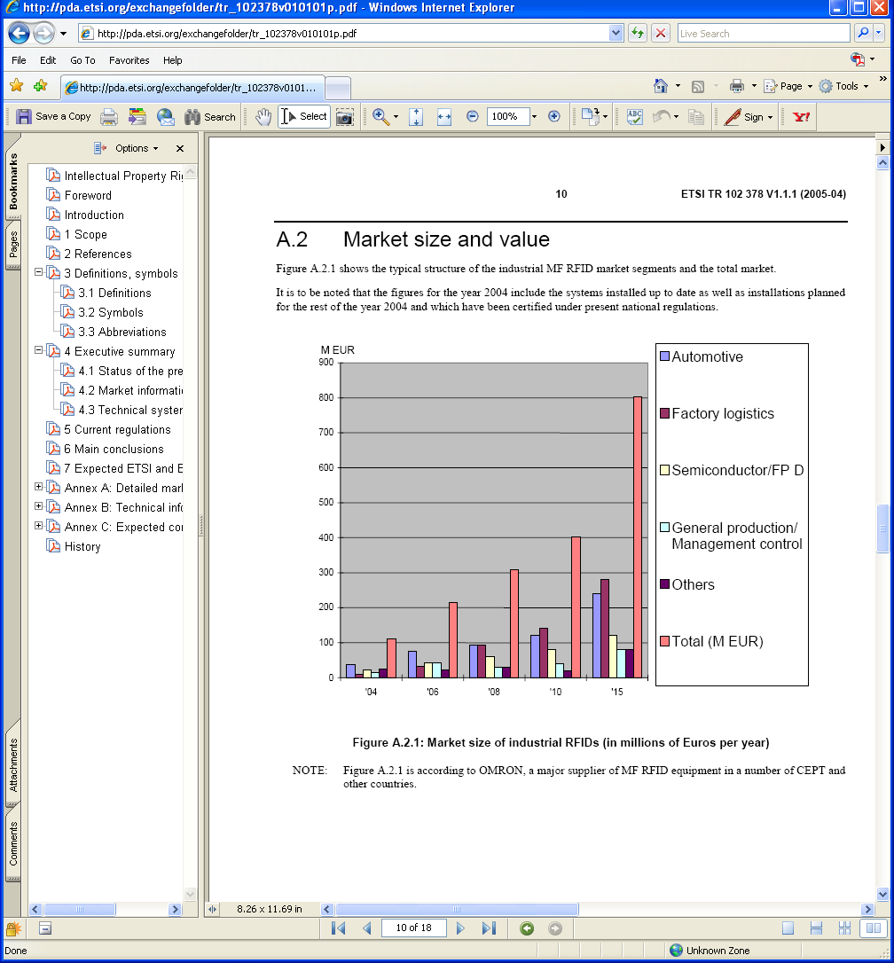
Figure 2 Market size of industrial RFID (in millions of Euros per year)
(Source: IDTechEx)

13.553 - 13.567 MHz band (HF)
Introduction

The band 13.553 - 13.567 MHz is designated by the ERC/REC 70-03 for non specific Short Range Devices (Annex 1) and Inductive Applications (Annex 9).

Inductive applications referred to in Annex 9 of ERC/REC 70-03 are used for RFID and EAS only. This band has been in Annex 9 since 2000.

Industry has developed RFID for a number of new applications such as ticketing systems, access control, logistics applications, car entry, container identification, contactless credit cards, passports, mobile phones, library systems, etc. Major applications using this frequency are;
· Library management
· Ticketing, (mass transportation, traffic and event management)
· Access control (including passports)
· Security
· Logistics - Item tagging
· Near field communication (NFC)

Technical background

HF RFID systems use coded amplitude modulation of the carrier with subcarrier modulation. The modulated signal from the reader has a fieldstrength level of 42 dBµA/m or 60 dBµA/m at 10 m according to respectively Annex 1 and Annex 9 of ERC/REC 70-03.

This band is allocated to the Fixed, BC, Standard Frequency, Aeronautical Mobile, Radio Astronomy and Amateur Radio Services.

The RFID applications in this band are inductive with the range of 50 – 75 cm (mid range).

Evolution of the HF RFID market

HF is presently the most important frequency band for RFID in terms of value. Many exciting new markets for passive RFID, from RFID enabled phones to financial cards, national ID cards, passports and tickets are at HF and in addition a significant number of the new smart active labels will be at HF. Many applications, typically met with LF RFID such as secure access and tagging metallic items, are moving to HF.

As a result, the global market for HF RFID will triple from $2.9 billion in 2008 to $8.6 billion in 2018 (Source: IDTechEx) remaining a larger and more lucrative business than UHF passive RFID, the number two.

For over a decade, most RFID in Europe has been practiced at High Frequency (13.56 MHz). In 2007, 50% of the global RFID market value was HF, expenditure on tags and systems at that frequency being ten times the amount spent on RFID at any other frequency. Its dominance has been retained as RFID entered a phase of rapid growth in the last two years mainly because of the e-passport, now issued by over 70 countries, and financial cards such as the MasterCard Paypass. Gas cylinders and marathon runners previously tagged at LF are now tagged at HF and UHF (For example ChronoTrack Systems Inc).

Finally, no data could be found for tag sales at HF that allowed comparison between past predictions for the period 2000 – 2009 and actual data. The table below on projected sales of contactless cards at HF is from a report by IDTechEx.

Table 2: Contactless cards market by sector
(Source: IDTechEx)

Assuming about half of tag sales at HF are in the form of cards, this gives an indication of projected total volumes. It should be noted that this forecast does not take into account the potential impact of printed electronics.

433 MHz band
Introduction

ISO 18000-7 has specified the use of 433 MHz for RFID applications in 2004.
Major applications using this frequency are;
· Cargo handling
· Container locations
· Real Time Location Systems
· Asset tracking

Technical background

The 433 MHz systems use active tags because of the low power allowance of 10 mW. Selecting an optimal radio frequency for operation of an active RFID system requires consideration of several factors, including technical performance, regulatory issues, and co-existence with other technologies. 433 MHz has been selected as the optimal frequency for global use of active RFID from a broad range of radio frequencies against these parameters and also a frequency used for ISM appliances. Two key technical performance parameters of an active RFID system are directly related to the frequency of operation: maximum communication range and propagation within crowded environments. Frequencies between 100 MHz and 1 GHz offer the best technical performance in terms of range for Active RFID. The use of active tags provides ranges of hundreds of meters outdoors, making this technology useful in the very large outdoor facilities used for storage and trans-shipment.

Implementation of active RFID in this band for some years has also shown that 433 MHz active RFID can be used without interfering with other systems in the same band.

Evolution of the RFID market for 433 MHz band

Initial use of 433 MHz RFID systems at seaports has received wide acceptance in economies during 2004-2005 timeframe including the Mainland China, the United States, European countries, Korea, Singapore and Taiwan.

The 433 MHz RFID system is out of the mainstream of high volume industrial RFID systems and can be considered as a niche market.

865 - 868 MHz band (UHF)
Introduction
UHF RFID systems also often employ coded amplitude modulation for the reader-to-tag link, along with various sub-carrier schemes for tag-to-reader communications.
This band was included in the Annex 11 of ERC/REC 70-03 in October 2004. In 2006 the band was also included in the EC RFID decision with the same regulatory parameters as in the ERC/REC 70-03. There are three segments with different power limitations:

b1 865.0 - 865.6 MHz with power of 100 mW e.r.p. and channel spacing of 200 kHz
b2 865.6 - 867.6 MHz with power of 2 W e.r.p. and channel spacing of 200 kHz
b3 867.6 - 868.0 MHz with power of 500 mW e.r.p. and channel spacing of 200 kHz

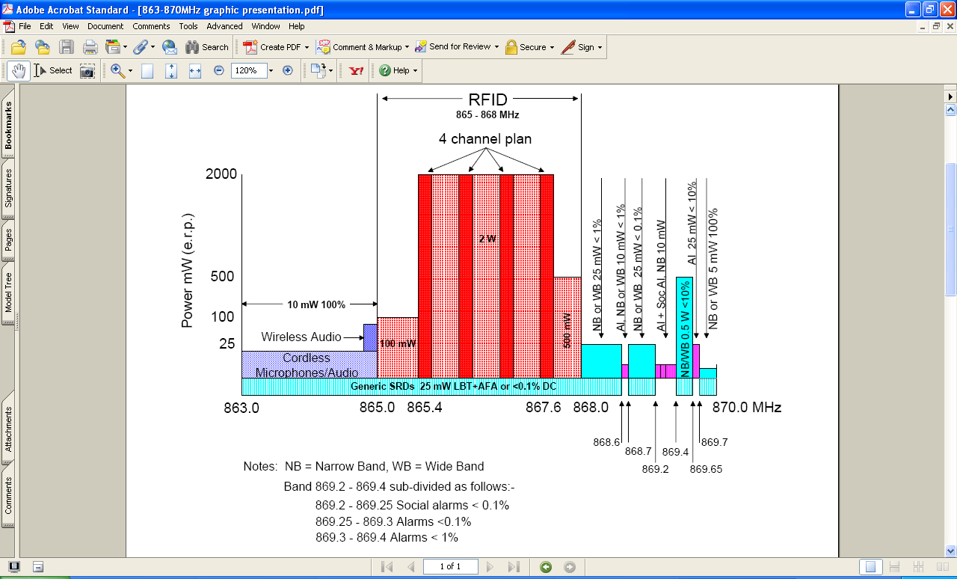
Figure 3: Existing RFID channel plan
Major applications using this band are;
· Logistics chain, Palettes ID etc
· Item tagging
· Integrated RFID and EAS applications
· Manufacturing process control & product tracking
· Cargo handling
· Airline baggage
· Location systems
· Asset tracking
Technical background
A compatibility study on SRDs in the band 863 - 870 MHz was done in 2003. The study covered consideration of the introduction of new techniques in the band including the operation of RFID. One of the conclusions in the new ECC report (ECC Report 037 adopted in 2004) was that the level of interference from RFID at power levels up to 2W e.r.p. was acceptable. At the same time ETSI produced a harmonised standard EN 302 208 for the operation of 2W RFID at UHF.

A revised Annex 11 of ERC/REC 70-03 to include RFID applications within the frequency band 865 - 868 MHz was adopted in 2004. The frequency band 865 - 868 MHz has been divided into 3 sub bands allowing increased power levels and making the use of LBT mandatory within these bands.

In April 2008 a new version of EN 302 208 was harmonised. The method of operation of RFID under this new system is much more spectrum efficient than the original arrangement. It removes the mandatory requirement for LBT but restricts the transmission of RFID interrogators to channel numbers 4, 7, 10 and 13. The remaining channels are reserved for the low power responses from the tags. The publication of this latest version of the standard made possible the installation of large-scale RFID installations in Europe. The whole band is also available for use by other SRDs, although in practice they will probably restrict their operation to the low power channels.

Evolution of the UHF RFID market

The following information about existing and future market volumes was provided by ETSI in TR 102 649-1. The first figure below shows market predictions from the year 2006 till year 2012 for logistic applications of passive tags operating at UHF. Second figure shows the market predictions for the same period for the growth of sites to be installed with RFID tag/interrogator systems.

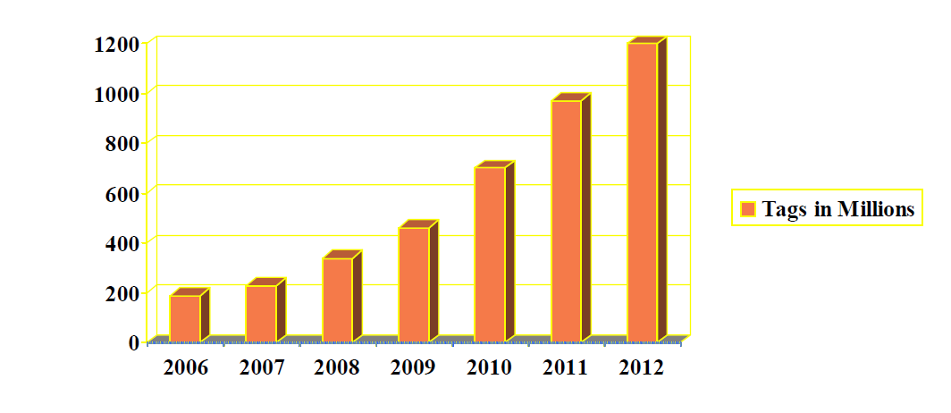
Figure 4: Predicted growth of passive tags at UHF for logistic applications
(Source: EPCGlobal)

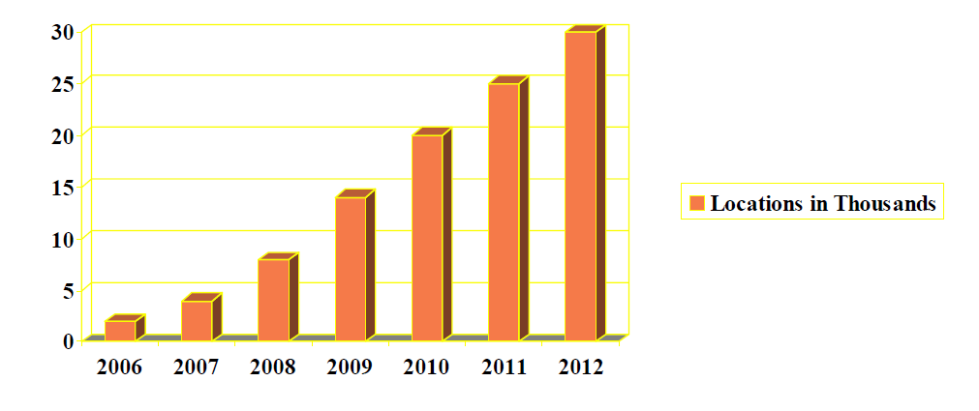
Figure 5: Predicted growth of sites with RFID systems
(Source: EPCGlobal)

The European Commission is funding the BRIDGE project (Building Radio frequency Identification solutions for the Global Environment). The project will develop easy-to-use technological solutions for the European business community including SMEs. This will ensure a basis for collaborative systems for efficient, effective and secure supply chains.

Between November 2006 and February 2007, LogicaCMG conducted a study on behalf of GS1 to forecast the market for passive RFID in Europe for the next fifteen years. This study was conducted as part of the BRIDGE research project and focused on the use of passive RFID to track physical objects. This study forecasts the number of tags that will be purchased annually, the number of locations that will deploy RFID readers, and the total number of readers at these locations. The forecast until 2022 is given in the table below:

Table 3: UHF RFID forecast for the period 2007 - 2022
(Source: BRIDGE project, February 2007)

Based on the market analysis carried out under the BRIDGE project, it is predicted that, in five years, more than 170 000 RFID readers will be deployed in Europe at 30 000 locations. During this period these readers will process a total of about 3 billion tags. These numbers will grow significantly, and by 2022, it is expected that more than 6 billion readers will be operating at 450 000 locations, with about 86 billion tags purchased annually.

It is believed that these numbers are conservative, as they only represent a small percentage of the total potential number of objects that can be tagged. For example, the forecast is based on the estimate that in 2012 approximately 2 % of all items in retail will be tagged. In 2022 the forecast is that roughly 25 % of all non-food items and 5 % of all food items in retail will be tagged. If we experience a technology breakthrough in the next fifteen years that reduces the cost of an RFID tag to less than one cent, these numbers could increase dramatically. In particular the number of tags on food items could grow to hundreds of billions.

The European Commission has published the results of a consultation "The RFID Revolution" stating that the present designation of spectrum for RFID at UHF is considered sufficient for the initial deployment of RFID but will be inadequate once the technology becomes ubiquitous.

Since publication of the new version of the ETSI standard, the use in Europe of RFID at UHF has expanded to meet a very broad range of applications. Although the rate of expansion has been adversely affected by the financial climate, nevertheless the installed base continues to grow steadily. Brief details of just some of the recent markets developments for RFID at UHF are described below

Currently the principal market for RFID at UHF is materials handling. Uses mainly include the tracking of tagged pallets, cartons and miscellaneous containers. Sales volumes of RFID tags at UHF during 2009 were 680 million. This is equivalent to the total volume in all preceding years (Source: IDTechEx). Depending on the specific application, benefits include improved traceability and reduced costs.

There is growing interest in using RFID tags for item level tagging of clothing. Published studies state that this can increase sales by up to 15% due to better inventory control and reduced out-of-stock items. This application was successfully pioneered in Europe by M&S. It is estimated that during 2009 they will consume 130M tags and their consumption will approach 200M in 2010. (Source: IDTechEx) The benefits of item level tagging are fully documented in a study by American Apparel and may be viewed at: http://www.rfid-monthly.com/?page_id=1156. C&A, Gerry Weber and Metro have all announced that they are introducing item level tagging. It is probable that other retail chains will follow.

In October 2009 EPCglobal issued an important press release, which describes the successful development of a system that combines both RFID and EAS functions within a single tag. Not only does this new system provide considerable functional benefits to the retailer, but also it dramatically improves the cost benefit analysis in favor of RFID. The development was undertaken by interested partners of GS1 under the umbrella of EPCglobal. As a consequence of this announcement, the RFID industry anticipates a substantial increase in tag volumes purchased by the retail sector. In addition there will be an increase in the number of interrogators required to meet the need for inventory control, point of sale and EAS protection.
The press release can be viewed at: http://www.epcglobalinc.org/about/media_centre/news/Press_Release_GS1_EPCglobal_RFID_based_EAS_Final.pdf

In a quite separate market, the aerospace industry is working towards the integration of RFID at UHF into their business model. Already Airbus is using RFID as part of their assembly process in Marseille. In the longer term it is planned to use the technology throughout the airline industry. This includes the handling of freight and baggage, where to date a total of 160 million tags have been used on baggage and other conveyances. (Source: IDTechEx) In addition RFID will provide improvements to operating efficiency and simplification of aircraft maintenance. All of these applications will lead to reduced costs. In some cases they will also provide greater passenger convenience and increased levels of safety.

Another emerging market for RFID at UHF is e-health. The principal application areas that are likely to be of interest include the tracking of assets, control of access to secure areas and improved patient care. Although a number of promising trials have taken place, RFID has not yet been deployed in hospitals on a national basis. At this stage it is not possible to provide any quantitative market data. However the potential social benefits of using RFID in healthcare are clearly very significant.

ETSI has requested an additional 6 MHz of spectrum for use by RFID within the band 915 - 921 MHz which is double the amount currently designated at UHF to RFID. If made available the additional spectrum would permit significant improvements to the performance of RFID systems in Europe. Under the proposed channel plan it would be possible to double the present data rate on the downlink from an interrogator to the tags and under certain conditions quadruple the data rate of the up-link. The improved transaction rate will provide the following operational benefits.

As organisations move towards the widespread adoption of item level tagging, we can expect to see growing numbers of tags in bulk shipments. Business will require that such shipments must pass through monitoring points at existing operational speeds. It will only be possible to read the increased volumes of tags satisfactorily by the use of higher data rates.

Similarly higher data rates will permit reading of faster moving tags as they pass monitoring points. Applications already exist where this is an operational requirement, such as high speed conveyors and high volume production lines. In other types of application it is very possible that users will wish to increase the quantity of data held by tags such as requested by the aircraft industry. Again where these tags are moving at speed it will only be possible to read their data by the use of higher data rates.

Frequently there are situations where tags are partially shielded or mis-tuned due to their immediate surroundings. Repeatedly interrogating these same tags increases the probability of reading them correctly. The use of higher data rates will make it possible to increase the number of attempts to interrogate problematical tags leading to an overall improvement in reading performance.

ETSI has also requested an increase in the permitted output power from 2W erp to 4 W erp. Such an increase will typically improve the reading range of RFID systems by 40 percent. More importantly for a given range, doubling of the output power can lead to an improvement in reading percentage (ie percentage of tags successfully identified) of up to 30 percent. This level of improvement has been verified by tests carried out with tagged cartons on palletised loads where reading percentage improved from 70 percent to 100 percent. When viewed in the context of a large distribution organisation such an improvement is very significant. For example assume that an organisation handles 10 million tagged cartons a year and the average value of each carton is EUR 50. A reading error of just 1% equates to goods to a value of EUR 5M that are potentially either lost or mislaid annually. At a reading error of 30% this would equate to a potential loss of EUR 150 M annually.

Based on the market projections, the industry expects to see a considerable increase in the deployment of interrogators. Some applications, such as for example production lines, may wish to site readers very close to each other. Although the four channel plan works well in situations where interrogators are spaced more that 2m apart, spacing them less than 2m can lead to the generation of unacceptable inter-modulation products within the tags. The use of a second frequency band with greater frequency separations will considerably alleviate this problem.

Recently developed techniques for antennas offer the possibility to scan large areas containing many tagged items. A typical example is the clothing section of a department store. In such an application, where the items being scanned are mostly static, some tags may be missed due to the presence of standing wave nulls. It is possible to overcome this situation by the use of frequency diversity. In the US this is achieved by selecting suitable frequencies at different ends of the band 902 – 928 MHz. In the ETSI proposed band 915 - 921 MHz the benefit is less but is still superior to that which is possible in the band 865 - 868 MHz. This same technique may be used to determine the range of an item. By knowing both the direction and distance of the item from an interrogator, it is possible to pin-point its exact location. This technique is also very relevant for example in eliminating stray or unwanted tags that may be close to an interrogation zone. In a broad range of applications these unwanted tag reads represent the principal limitation on system performance. Furthermore this situation will only deteriorate with increased tag density.

Most tags are optimised for operation in the band 902 - 928 MHz. This is of particular relevance with the growing use of physically small tags. For example such tags have been widely adopted by retail and also form an important deterrent in the grey goods market. In this later application size is particularly important as it is often necessary to conceal the existence of the tag. Unfortunately one consequence of reducing the size of a tag is that its bandwidth is reduced. A similar effect also applies to tags intended for use in proximity to metal objects. This reduction in bandwidth means that it is not possible for these tags to perform satisfactorily in both the bands 865 - 868 MHz and 902 - 928 MHz. As a consequence for installations where small tags are in use, performance in European will be inferior to elsewhere.

The deployment of RFID at UHF continues to grow globally both in volume and range of applications. One consequence of this increasing adoption is that, end-users will expect a uniform level of performance from their RFID equipment irrespective of the country in which they are operating. Under the present spectrum designations at UHF, in many circumstances the performance of RFID in Europe will be inferior to other parts of the world.

An additional complication is the expectation that RFID interrogators operating at UHF will increasingly cross Regional boundaries. Not only will this occur in logistics and materials handling applications but also with the growing use of small portable consumer devices. The trouble-free movement between Regions of RFID devices operating at UHF is a further reason to consider the adoption of a common globally agreed frequency band.

Finally it is important to remember that one of the stated objectives of the ITU is to encourage where possible the global adoption of common frequency bands for equipment that is deployed on an international scale. RFID at UHF undoubtedly falls into this category.

In summary, therefore, the RFID industry sees a need for faster, more accurate tag reading in greater numbers and over greater distances than the current technology permits and it is these elements that are driving the case for additional spectrum.

2446 - 2454 MHz band
Introduction
The frequency band 2400 - 2483.5 MHz has for some time been designated and used for Short Range Devices (SRD). In accordance with ERC/REC 70-03 the band 2400 - 2483.5 MHz or part of the band is designated for the following different applications:
- Non-specific Short Range Devices with 10 mW e.i.r.p. (Annex 1)
- Local Area Networks (RLANs) with 100 mW e.i.r.p. (Annex 3)
- Automatic Vehicle Identification for Railways with 500 mW e.i.r.p. (Annex 4)
- Movement detection and alert with 25 mW e.i.r.p. (Annex 6)
- RFID applications with up to 500 mW e.i.r.p, unrestricted use (Annex 11)
- RFID applications with up to 4 W e.i.r.p., restricted use (Annex 11)

In accordance with ERC/REC 70-03, the 2446 - 2454 MHz portion of the whole band is designated for RFID use. The relevant ETSI standard is EN 300 440.

In addition to this, the EC SRD Decision (in version 2008) also designated the band for RFID with a power level of < 100mW e.i.r.p. It should be noted that these power levels are in most cases only practically suitable for battery operated tags to achieve desired operating ranges.

Applications for RFID in the microwave band are believed to be predominantly in the industrial sector and limited in volumes. Major applications using this band are;
· Chip processing,
· Automotive manufacturing
· Proximity sensors
· Tote identification
· Location tracking
· Asset tracking

Technical background

Since today's supply chains are global, it is desirable that the devices used to identify and collect transaction data operate on a global scale to facilitate the international flow of goods. The 2.45 GHz band is a practical place in the frequency spectrum where adequate bandwidth is available to accommodate multiple, licence exempt and unsynchronised systems.

Evolution of the 2.45 GHz RFID Market

2.45 GHz RFID uses both active and passive tags. Across all of the RFID bands active RFID (including Real Time Locating Systems (RTLS)) alone is creating a market which will be worth $6.74 billion in 2019 within IDTechEx’s overall figures. Active RFID accounted for about 10% of all RFID expenditure in 2008 but this figure was boosted by the huge Chinese national ID card scheme (described as the SIM RFID card), which involves passive RFID. The Chinese ID card scheme has now peaked in deliveries of both cards and infrastructure.

Active RFID will now be powered by three generations, as shown below.

Generation 1: Conventional active RFID: 78% market share in 2008. 433 MHz, 2.45 GHz. ISO standards exist, e.g. car clicker $2 billion so far, non-stop road toll $0.5 billion and military supplies $0.5 billion order recently.

Generation 2: Real Time Locating Systems: 22% market share in 2008. 433 MHz, 2.45 GHz, UHF, WiFi, UWB, Ultrasound. No orders above a few million dollars as yet. The RTLS trend is moving to UWB systems.

Generation 3: Wireless Sensor Networks that are mesh networks: Tags also behave as readers. Form self-healing and self-organising ad-hoc networks.

Overall market predictions and Economic impacts

Introduction
The evolution of the RFID market is covered above on a band-by-band basis. The prediction of the overall RFID market for the coming decade is given in this section.

Most RFID applications are still recent and it is very difficult to quantify the impact of the technology. Recently market analysts have published projections on the growing RFID market, and studies are becoming available evaluating the economic impact for specific applications.

Data provided in the table below is an extract from the RFID knowledge database maintained by IDTechEx. It shows the number of case studies conducted in Europe on RFID. Analysis of the database shows that the case studies done within the European market of RFID represents nearly 20% of the studies conducted throughout the World RFID market.

Application | Number of case studies by frequency band
Application | HF | UHF | Other bands | Total
Airlines and airports | 4 | 14 | 3 | 21
Animals and farming | 0 | 9 | 11 (mainly in LF band) | 20
Books, Libraries, Archiving | 20 | 4 | 6 | 30
Financial, security, safety | 235 (mainly passports) | 15 | 50 (mainly at 433 MHz) | 300
Healthcare | 30 | 10 | 30 (mainly at 433 MHz) | 70
Land and Sea Logistics, Postal | 24 | 42 | 96 (50% at 433 MHz) | 162
Leisure, Sports | 100 | 5 | 100 (mainly in LF band) | 205
Manufacturing | 19 | 21 | 19 | 59
Military | 3 | 1 | 16 | 20
Passenger transport | 46 | 10 | 44 | 100
Retail, Consumer Goods | 42 | 51 | 14 | 107
Table 4: Number of case studies conducted in Europe on RFID
(Source: IDTechEx)

It can be concluded from the data given above, and from the information derived from other sources, that clear interest has been expressed in these bands although it does not show whether the case studies were successful. The evaluation of the RFID market for the coming years, therefore, is presented on this basis. The third category of frequency bands is indicated as “others” to cover the market predictions for the other frequency bands used for RFID.

General tendency
Some passive RFID applications are migrating to HF and UHF from the other bands. The exception is LF (which is stable with moderate growth because of the distinct propagation/penetration properties). Presently HF is in the lead with over 50% of RFID expenditure because of cards, tickets, library, rented apparel/laundry, mobile phones etc. The following advantages can be mentioned for this frequency range: Standards are available, simple radio regulations, controllable range, compatible with Near Field Communication (NFC) phones and ticket systems, tolerant of water, not a noisy environment.
UHF is growing rapidly because of air baggage, retail pallets, cases, distribution centres, retail apparel etc. The following advantages can be mentioned for this frequency range: Standards are available, longer range, higher data rates, cheapest tag for now.

Development in the RFID market from the point of view of frequency domain is foreseen in three main directions: HF, UHF and other frequency bands.
The following Table retraced the dynamic evolution of the RFID market (HF, UHF and other frequency bands) from the date of adoption of the current regulations. It illustrates the history and forecast of global sales of RFID tags in billions, split by frequency bands. It covers both active and passive tags.

Frequency band | Number of tags by year (billions)
Frequency band | 2001 | 2007 | 2009 | 2019 | Comments
HF | 0.450  (60%) | 1.000  (52%) | 1.215  (53%) | 354.500  (49.9%) | 1) Growth due to ID cards, tickets, library financial cards etc.  2) Gas cylinders, marathon runners, postal beer kegs and smart cards go from LF to HF
UHF | 0.010  (1%) | 0.475  (25%) | 0.665  (29%) | 354.500  (49.9%) | 1) Growth in pallet and case tagging and air baggage etc.  2) Growth due to retail drugs/consumer goods, postal, manufacturing, archiving, military items
Other bands | 0.290  (39%) | 0.431  (23%) | 0.417  (18%) | 0.555  (0.02%) | Growth caused by increased tagging of animals with LF by law
Total | 750 | 1906 | 2297 | 709.555
Table 5: Dynamic evolution of RFID market since the adoption of current regulations
(Source: IDTechEx)

The tagging of apparel at UHF by big retail companies is now in the roll-out phase with 200 million RFID labels being used for apparel globally in 2009. The tagging of animals (such as cows, pigs and sheep) with LF is growing strongly as it becomes a legal requirement in many more territories, with 105 million tags being used for this sector in 2009. This is happening in regions such as China, Australasia (cows and dogs) and now Europe. In total, 2.35 billion tags will be sold in 2009 versus 1.97 billion in 2008; 1.74 billion in 2006 and 1.02 billion in 2005.

Rapid growth
By 2019, the market value worldwide will be over five times the size of the market in 2009, but the number of tags supplied will be over 300 times that of 2009, driven by the development of lower cost tags and installed infrastructures which will enable high volumes of articles to be tagged and better, more affordable forms of sophisticated RFID such as RTLS (Real Time Location System) and WSN (Wireless Sensor Network). Table below shows the market projections of RFID for the 2009-2019 timeframe.
Total market $ bn | 2009 | 2010 | 2011 | 2012 | 2013 | 2014 | 2015 | 2016 | 2017 | 2018 | 2019
Tags - passive | 2.18 | 2.49 | 2.88 | 3.31 | 3.90 | 4.81 | 5.98 | 6.72 | 7.83 | 9.27 | 10.81
Tags - active/BAP | 0.21 | 0.22 | 0.28 | 0.37 | 0.57 | 0.75 | 0.99 | 1.16 | 1.26 | 1.43 | 1.57
Interrogators (incl. cellphones) | 1.20 | 1.22 | 1.69 | 2.25 | 3.20 | 4.08 | 5.09 | 5.12 | 5.35 | 5.47 | 5.71
Networking, Software, Services | 1.97 | 2.28 | 2.68 | 3.38 | 5.17 | 6.85 | 8.38 | 8.97 | 9.03 | 9.33 | 9.50
Total value $ bn | 5.56 | 6.21 | 7.53 | 9.32 | 12.84 | 16.49 | 20.44 | 21.97 | 23.47 | 25.49 | 27.59

Table 6: Total RFID Market Projections in US dollar billions 2009-2019 (Source: IDTechEx)

RFID market estimates
In terms of technology application, RFID implementation is still at an early stage. For this reason, it is difficult to obtain market projections and a challenging task to evaluate the RFID market. The table, given below, provides an overview of global market projections by different market analysts. When dealing with the notion “RFID market”, projections usually cover whole RFID systems (i.e. readers, tags, RFID middleware). Only the study by IDTechEx analysts includes services.

Market analyst | Date of release | 2005 | 2006 | 2007 | 2010/ 2011 | 2015 | 2017
Gartner | 2005 | 504 million | 2.7 billion |  | 3 billion (2010)
RNCOS | 2005 | 1.9 billion |  |  |  | 26.9 billion
BCC Research | 2006 | 649 million | 713.4 million |  | 1.05 billion (2011)
IDTechEx | 2007 |  |  | 4.96 billion |  |  | 27.88 billion
Table 7: Estimates of the RFID global market (USD)

Regions/Years | 2009 | 2014 | 2019
North America | 1.02 | 6.98 | 183.1
East Asia | 0.51 | 11.54 | 377.16
Europe | 0.72 | 5.22 | 124.2
ROW | 0.1 | 1 | 25.87
Total (billions) | 2.35 | 24.74 | 710.33
Table 8: Number of tags (billions) 2009-2019
(Source: IDTechEx)

Overall, large differences between market estimates are observed. For example, whereas the market for RFID systems for 2006 was estimated at USD 2.7 billion by Gartner analysts, BCC estimated an RFID market of only USD 713.4 million in the same year.

There are various reasons for these large differences. Two important reasons are the early stage of RFID implementation in both public and private sectors and, as a result, divergent evaluations of the technology in terms of both coverage and evolution. According to the European e-Business Watch large-scale survey of RFID adoption strategies and impacts in four broad economic sectors, 14% of the European companies interviewed were piloting, using or implementing RFID technology in 2007.

Companies that were using RFID or planning to use RFID expected major effects on: i) inventory management (49% of companies using or planning to use RFID), ii) control and efficiency of inbound logistics (46%), and iii) merchandise management and reduced out-of-stocks (44%). These results correspond to those found in the WPIE qualitative country study for Germany. The major costs for those using or planning to use the technology were seen to be the costs of project implementation and system integration (39% of all companies using or planning to use RFID). Interestingly, for those companies not using or planning to use RFID technology, 64% stated that a relevant reason for not using it was the insufficient evidence of a strong return on investment (ROI).

Forecasts by Application Category
In 2008 the value of the entire RFID market was $5.29 billion, up from $4.93 billion in 2007. This includes tags, readers and software/services for RFID cards, labels, fobs and all other form factors. The majority of this value is due to large national RFID schemes for transportation and national ID, incorporating contactless (RFID) cards. For example, China has almost completed issuing each citizen with a national ID RFID card. The tagging of pallets and cases as demanded by retailers (mostly in the US) will use approximately 325 million RFID labels in 2008, but we see strong take off in retail outside mandates. The tagging of animals (such as pigs and sheep) is quickly taking off as it becomes a legal requirement in many more territories, with 90 million tags being used for this sector in 2008. This is happening in regions such as China and Australasia. In total, 2.16 billion tags were sold in 2008 versus 1.74 billion in 2007 and 1.02 billion in 2006.
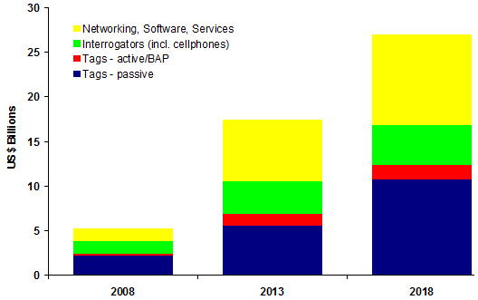
BAP: Battery Assisted Passive tags
Source: IDTechEx RFID Forecasts, Players & Opportunities 2008-2018
Figure 6: Total RFID Market Projections in US dollar billions by 2008, 2013 and 2018

Contactless smart cards dominate until 2009 by value
In 2008, 57.3% of the total market value for RFID was spent on cards and associated infrastructure, with $2.26 billion of the total $5.29 billion being spent on all other forms of RFID - from RFID labels to active tags. By volume, the tag part of the RFID market is dominated by labels or label like tags (such as tickets) which is 62.4% of the tag type shipped in 2008 rising to 99.1% in 2018.
What really happened in 2007?
At the start of 2008, the cumulative number of RFID tags sold over the last 33 years was 6.022 billion. The following table shows the number of tags sold by application in 2007.
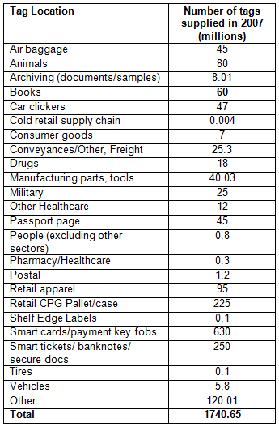
Source: IDTechEx RFID Forecasts, Players & Opportunities 2008-2018
Table 9: Number of tags sold by application in 2007

RFID Forecasts by market
Forecasts by vertical markets for tags only are shown below. These include active and passive tags.
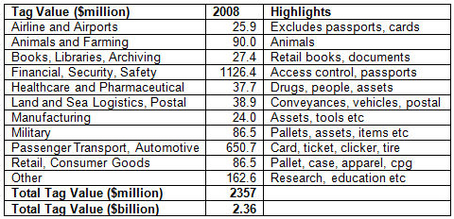
Source: IDTechEx RFID Forecasts, Players & Opportunities 2008-2018
Table 10: RFID Tag Revenues by market 2008

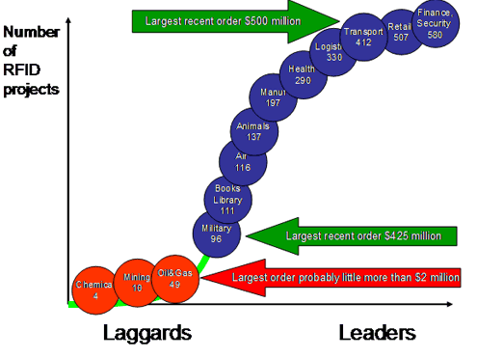
Source: IDTechEx RFID Forecasts, Players & Opportunities 2008-2018
Figure 7: Number of RFID projects

Selected studies on the aggregate economic impact of RFID
This section aims at assessing the impact of RFID at a more detailed aggregate level from a user perspective. Apart from studies of toll applications and access control, to date there are very few studies assessing the economic impact of RFID technology in business applications. Of these studies, the majority assess RFID benefits at a qualitative rather than a quantitative level resulting in an even lower number.

Overall, according to Barua, Mani and Whinston, benefits have already amounted to a global cumulated USD 40 billion in the retail and healthcare sectors. Out of these estimated USD 40 billion, the retail sector has cumulated benefits of USD 12.05 billion from RFID applications. Total cumulated spending on RFID systems from 2003 to 2006 amounted to USD 2.37 billion according to the authors, resulting in a ROI of about 500%.

This results from both the reduction of costs and increased revenues. On the cost reduction side, economies result from the reduction of labor costs, reduced losses during production and shipment (“shrinkage”) as well as from reduced inventory write-offs and non-working inventory. On the revenue side, benefits result from increased product availability at the point of sale, a faster time to market and “providing ubiquitous access to customers across multiple channels” (Barua, Mani and Whinston, 2006). Based on expected adoption rates of pallet tagging (45%) and item-level tagging (25%) in 2011, the authors estimate that benefits will reach USD 68.55 billion in 2011.

Total cumulated benefits in the healthcare sectors have been estimated at USD 27.95 billion. Investments in RFID systems have been USD 2.03 billion, leading to a significantly higher ROI (over 1 300%) compared to the retail sector. According to the authors, this is due to higher RFID adoption rates for the health sectors than for the retail sector.

Pharmaceutical companies have realised these benefits due to “i) a reduction in counterfeit, shrinkage and parallel trade, ii) efficient product recall, iii) efficient sample management, iv) enhanced inventory turns, and also shorter clinical trial cycles and faster time-to-market” (Barua, Mani and Whinston, 2006). For healthcare distributors, the authors attribute the benefits to enhanced inventory turns on the one hand and a reduction in labor costs at distribution centres on the other hand. Finally, by relying on RFID technology, hospitals have benefited from i) better asset utilisation, ii) higher inventory turns, iii) increased healthcare access and iv) higher patient safety because of fewer errors.

Overall, the report by Barua, Mani and Whinston is one of the first to discuss in detail how RFID benefits can be quantified. This is not an easy task as RFID implementation in these sectors has only taken place recently and the authors admit that “it is not easy to quantify the challenges for a successful implementation”. Furthermore, benefits are quantified in a rather optimistic way. Calculations are based on current case studies which are in general best practice examples and success stories of leading companies in these sectors. As a consequence, the results of successful projects have been taken to estimate economies and increased sales in a whole sector, which may over-state total benefits across firms which are less efficient in implementation. Very often, end users discover additional benefits not originally considered when a project was first implemented.

The study “RFID: Prospects for Germany” in 2007, focuses on a cross-sectional analysis of RFID in Germany. Within this analysis, one part is dedicated to sales and productivity effects of RFID technology. Sectors assessed in the study include the consumer goods, retail, logistics and the automotive sectors. Macroeconomic effects in Germany in 2010 are derived from sales and productivity effects for each of these sectors. Calculations for all sectors are based on sources such as preliminary case studies of RFID pilots and implementation projects. Overall, according to the study, sales and productivity gains amounted to EUR 3.24 billion in 2004 and are expected to rise to EUR 62.2 billion in 2010. In German retailing, productivity effects are estimated at EUR 8.6 billion in 2010. Estimates are based on total retail sales and the estimation is that companies having implemented RFID technology by 2010 will account for 40% of total retail sales. Moreover, the percentage of sales influenced by RFID is estimated at 30% and operational productivity effects (productivity gains from avoiding out-of-stock situations, less shrinkage, etc.) are estimated at 20%.

The model calculations for the German logistics sector differentiate between logistics and transport services only and auxiliary services in logistics (e.g. inventory management, order processing, logistics planning). In the logistics and transport services productivity effects will reach EUR 1.7 billion in 2010 according to the study. In the field of auxiliary services in logistics, RFID use will yield about EUR 4.3 billion in 2010.

Productivity gains in the German automotive sector are estimated at EUR 2.4 billion in 2010. Interestingly, these estimates are significantly lower than the estimated gains in the retail sector. This is explained by the estimates of the operational productivity effects directly attributable to adoption of RFID. In the automotive sector, the authors estimate these effects very conservatively at 2% by 2010. In the retail sector, however, these gains are estimated at 20%.

Conclusions
- This report has demonstrated that, right from their very early use, RFID devices have progressively evolved.
- As demonstrated in Table 9 the range of RFID applications in which RFID is used is already substantial. This development has been particularly evident over the last 2-3 years. The forecast given in Table 8 indicates that this growth will continue - particularly in the second half of the next decade.
- The data provided in Table 5 shows that the most promising frequency ranges are the HF and UHF bands. The other bands will also continue to be used for specific applications, such as LF for animal identification.
- The frequency band at 13.56 MHz, which is already used by RFID, is considered sufficient to handle future HF RFID applications.
- The existing UHF band at 865 - 868 MHz will also continue to be used for existing and future applications and should be sufficient for the short term.
- Additional frequency band(s) in the UHF range should be considered in order to improve the functionality of future applications as foreseen in section 4.5 of this report. Operation within globally accepted frequency bands for RFID at UHF is preferred.

EC Recommendation of 12.5.2009 on the implementation of privacy and data protection principles in applications supported by RFID
http://www.nationmaster.com/graph/ind_car_pro-industry-car-production

