ECC Recommendation (02)05

UNWANTED EMISSIONS
Approved 11 October 2002
Amended 30 March 2012

INTRODUCTION
Between 1996 and 2003, ITU-R Study Group 1 has developed and adopted a number of new or revised Recommendations dealing with unwanted emissions. These Recommendations cover spurious and out-of-band (OOB) emissions, the boundary between the spurious and out-of-band domains, intermodulation, OOB falling into adjacent bands, a description of spectra and bandwidth of emissions for modern modulation schemes. Special attention was also paid to the protection of passive and safety services from unwanted emissions.
The aim of this Recommendation is to give guidance about the use of the whole package of ITU-R Recommendations and their relation to the ERC Recommendation 74-01 on spurious emissions. This Recommendation on Unwanted Emissions does not contain special limits for spurious or OOB domain emissions except those in Annex 2. Figure 2 illustrates the frame or “roof” concept of this Recommendation.
Unwanted emissions are composed of OOB and spurious emissions. Definition relating to unwanted emission, out-of-band domain and spurious domain are given in Article 1, No. 1.144, 1.146bis, and 1.146ter of the RR. OOB and spurious emissions as defined there are outside the necessary bandwidth. Appendix 3 of the RR (WRC-2012) provides limits for unwanted emissions falling into the spurious domain and describes the variation of the boundary between the out-of-band and the spurious domains. Terminology and relevant definitions are given in Recommendation ITU-R SM.329.
They are reproduced in Annex 1 for information and are illustrated in Figure 1 below.
OOB Emissions
Spurious Emissions
OOB Domain
(OOB predominate)

Spurious Domain
(Spurious predominate)
250 %
of the necessary bandwidth
50 %
of the necessary bandwidth
Frequency
Unwanted Emissions

Figure 1: Illustration of the OOB and Spurious Domains
(not part of Recommendation ITU-R SM.329)
Note: The crossover point between OOB and Spurious emissions is not defined and Figure 1 shows only an example.

Resolution 739 (rev. WRC-07) provides threshold levels for the unwanted emissions of space services to ensure compatibility between the Radio Astronomy Service and the active space services in certain adjacent and nearby frequency bands based on results given in Recommendation ITU-R SM.1633 and Report ITU-R SM.2091.
Resolution 750 (Rev. WRC-12) provides limits for the unwanted emissions of active services to ensure compatibility between the Earth Exploration Satellite Service (passive) and the active services in certain adjacent and nearby frequency bands based on results given in Report ITU-R SM.2092.
This also resulted in the development of:
- ECC/DEC/(10)02 on compatibility between the Fixed Satellite Service in the 30-31 GHz band and the Earth Exploration Satellite Service (passive) in the 31.3-31.5 GHz band;
- ECC/DEC/(11)01 on the protection of the Earth Exploration Satellite Service (passive) in the 1400-1427 MHz band.

The definitions of OOB and Spurious emissions reflect more exactly the scope of the Recommendation ITU-R SM.329 and Recommendation ITU-R SM.1541, which address "unwanted emissions in the spurious domain" and "unwanted emissions in the out-of-band domain" respectively.
The Figure 2 below contains the frame or "roof" structure of this ECC Recommendation.

Figure 2: Frame or "roof" structure of this ECC Recommendation

“The European Conference on Postal and Telecommunications Administrations,

considering

- that the radio frequency spectrum is a common resource and it is necessary to keep it as unpolluted as possible, making the best use of the most modern and cost-effective techniques;

- that a number of ITU-R Recommendations are available for protection of other radio systems and services from unwanted emissions;

- that Recommendation ITU-R SM.329 (Unwanted Emission in the Spurious Domain) relates to effects, measurements, generic and specific regional limits to be applied to unwanted emissions in the spurious domain;

- that Recommendation ITU-R SM.1541 (Unwanted Emissions in the Out-of-band Domain) relates to effects, measurements and broadly generic limits to be applied to unwanted emissions in the out-of-band domain;

- that Recommendation ITU-R SM.329 and Recommendation ITU-R SM.1541 provide guidance for determining the boundary between the out-of-band and spurious domains in a transmitted radio frequency spectrum;

- that Recommendation ITU-R SM.1539 deals with variation of the boundary between the out-of-band and spurious domains required for the application of the Recommendation ITU-R SM.329 and Recommendation ITU-R SM.1541;

- that Recommendation ITU-R SM.1540 covers unwanted emissions in the out-of-band domain falling into adjacent allocated bands;

- that the protection of Passive Services is covered by Recommendation ITU-R SM.1542;

- that the protection of Safety Services is covered by Recommendation ITU-R SM.1535;

- that Recommendation ITU-R SM.1633 addresses a number of compatibility analyses between active and passive services;

- that Resolution 739 (Rev.WRC-07) provides threshold levels for the unwanted emissions of space services to ensure compatibility between the Radio Astronomy Service and the active space services in certain adjacent and nearby frequency bands based on results given in Recommendation ITU-R SM.1633 and Report ITU-R SM.2091;

- that Resolution 750 (Rev WRC-12) and relevant ECC/DEC/(10)02 and ECC/DEC/(11)01 provide limits for the unwanted emissions of active services to ensure compatibility between the Earth Exploration Satellite Service (passive) and the active services in certain adjacent and nearby frequency bands based on results given in Report ITU-R SM.2092;

- that Recommendation ITU-R SM.326 deals with intermodulation products generated in amplitude-modulated radio transmitters;

- that Recommendation ITU-R SM.1446 deals with definition and measurement of intermodulation products in transmitters using frequency, phase or complex modulation techniques and related background information and mitigation techniques are provided in the Report ITU-R SM.2021;

- that Recommendation ITU-R SM.328 gives definitions and explanatory notes which should be used when dealing with spectra and bandwidth of emissions;

noting

that the limits for unwanted emissions in the out-of-band domain (out-of-band domain emission limits) as given in Recommendation ITU-R SM.1541, are only generic “safety net limits”, since they generally constitute the least restrictive out-of-band domain emission limits that have been successfully implemented in national or regional regulations.

recommends

- that the ITU-R Recommendations on unwanted emissions should be used as general guidance;

- that the limits for unwanted emissions in the spurious domain (spurious domain emission limits) should be according to the ERC Recommendation 74-01 that corresponds to the Category B limits in Recommendation ITU-R SM.329 and has been derived taking into account ETSI standards;

- that the variation of the boundary between out-of-band and spurious domains should be established according to Recommendation ITU-R SM.1539, with the exception of radar systems designed for Category B spurious domain emission limits, for which guidance is provided in Annex 2 of this Recommendation;

- that Recommendation ITU-R SM.1535 and Recommendation ITU-R SM.1542 should be used for guidance on generic mitigation techniques for reduction of unwanted emissions;

- that Resolution 739 (rev. WRC-07) should be used to provide threshold levels for the unwanted emissions of space services to ensure compatibility between the Radio Astronomy Service and the active space services in certain adjacent and nearby frequency bands, and to provide a consultation procedure between concerned administrations in case these levels were not met;

- that Recommendation ITU-R SM.1633 should be used for compatibility analyses between passive services and active space services in certain adjacent and nearby frequency bands and for mitigation techniques to ensure compatibility between these services.”

Note:
Please check the Office documentation database (http//:www.ecodocdb.dk) for the up to date position on the implementation of this and other ECC Recommendations.

Annex 1 (informative)

TERMINOLOGY AND DEFINITIONS USED IN RECOMMENDATION ITU-R SM.329
The following terms and definitions complement those already defined in the Radio Regulations (RR). Definitions shown in italics are a direct quotation from the RR.

1 Spurious emission (Article 1, No. 1.145 of the RR)
Emission on a frequency, or frequencies, which are outside the necessary bandwidth and the level of which may be reduced without affecting the corresponding transmission of information. Spurious emissions include harmonic emissions, parasitic emissions, intermodulation products and frequency conversion products but exclude out-of-band emissions.

1.1 Harmonic emissions
Spurious emissions at frequencies which are whole multiples of the centre frequency emissions.

1.2 Parasitic emissions
Spurious emissions, accidentally generated at frequencies which are independent both of the carrier or characteristic frequency of an emission and of frequencies of oscillations resulting from the generation of the carrier or characteristic frequency.

1.3 Intermodulation products
Spurious intermodulation products result from intermodulation between:
- the oscillations at the carrier, characteristic, or harmonic frequencies of an emission, or the oscillations resulting from the generation of the carrier or characteristic frequency; and
- oscillations of the same nature, of one or several other emissions, originating from the same transmitting system or from other transmitters or transmitting systems.

1.4 Frequency conversion products
Spurious emissions, not including harmonic emissions, at the frequencies, or whole multiples thereof, or sums and differences of multiples thereof, of any oscillations generated to produce the carrier or characteristic frequency of an emission.

2 Out-of-band emission (Article 1, No. 1.144 of the RR)
Emission on a frequency or frequencies immediately outside the necessary bandwidth which results from the modulation process, but excluding spurious emissions.

3 Unwanted emissions (Article 1, No. 1.146 of the RR)
Consist of spurious emissions and out-of-band emissions.

4 Out-of-band and Spurious domains
Out-of-band and spurious domain emission limits apply, respectively, to all unwanted emissions in the out-of-band and spurious domains.

4.1 Out-of-band domain (Article 1, No. 1.146A of the RR)
(of an emission): The frequency range, immediately outside the necessary bandwidth but excluding the spurious domain, in which out-of-band emissions generally predominate.

4.2 Spurious domain (Article 1, No. 1.146B of the RR)
(of an emission): The frequency range beyond the out-of-band domain in which spurious emissions generally predominate.
NOTE – Out-of-band emissions, defined based on their source, occur in the out-of-band domain and, to a lesser extent, in the spurious domain. Spurious emissions likewise may occur in the out-of-band domain as well as in the spurious domain.
- Necessary bandwidth (Article 1, No. 1.152 of the RR)
For a given class of emission, the width of the frequency band which is just sufficient to ensure the transmission of information at the rate and with the quality required under specified conditions.
For application to multi-channel or multi-carrier transmitters/transponders, where several carriers may be transmitted simultaneously from a final output amplifier or an active antenna, the necessary bandwidth is taken to be the transmitter's or transponder's 3 dB bandwidth. For multi-carrier base stations and mobile stations in the Mobile Service, further guidance is given in Annex 2 of ERC/REC 74-01.
For Fixed Service, Recommendation ITU-R F.1191 is to be used to calculate the necessary bandwidth in the case of fixed digital radio multi-carrier systems.
For the Radiodetermination Service, the necessary bandwidth of frequency-agile radars is taken to be the part of the allocated band over which the carrier frequencies of those radars tune.

Annex 2

BOUNDARY AND LIMITS FOR PRIMARY RADAR EMISSIONS
This Annex defines limits for unwanted emissions in the out-of-band domain for fixed radar stations for which ERC/REC 74-01 that corresponds to the Category B Limits of Recommendation ITU-R SM.329. By providing these limits the boundary between the out-of-band domain and the spurious domain is also hereby defined for this type of systems.

The limits of unwanted emissions in the out-of-band domain for any other radar systems are given in Annex 8 of Recommendation ITU-R SM.1541. The roll-off for all waveforms is 30 dB/decade, except for continuous waveforms (CW), frequency-modulated continuous waveforms (FMCW) and phase coded waveforms for which the roll off is 20 dB/decade. This exclusion is to be reviewed before the 2016.

The different spectrum masks are given in Figure A2.1 a)-c). They are based on the roll-off of 30 and 20 dB/decade, and on the design objective of 40 dB/decade. New radar designs should aim to meet this design objective as soon as possible. In the future it is intended to apply a more stringent mask based upon the design objective limits.

A2.1 a) limit for unwanted emission in the spurious domain: 60 dB_{pp}
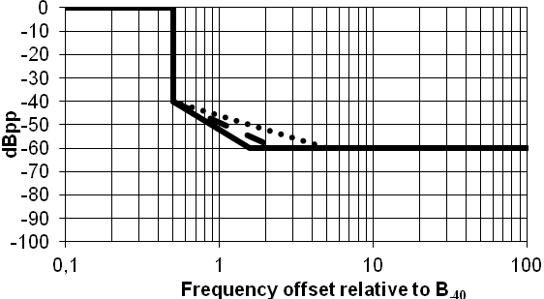

A2.1 b) limit for unwanted emission in the spurious domain: 90 dB_{pp}
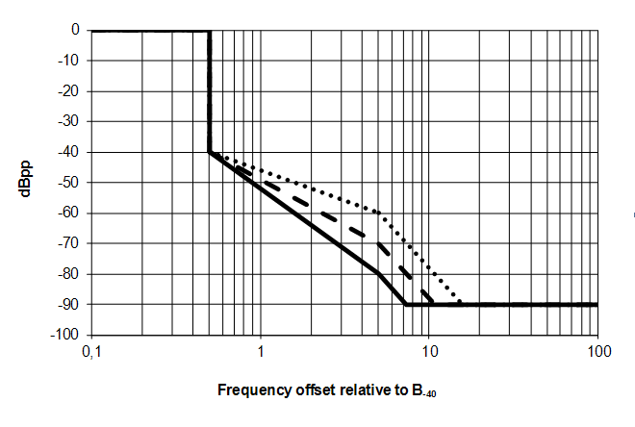

A2.1 c) limit for unwanted emission in the spurious domain: 100 dB_{pp}
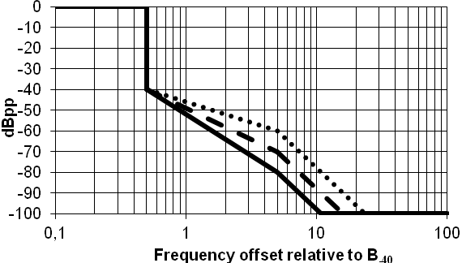

Figure A2.1: Emission masks for radars
(The dashed line shows the limit for unwanted emissions in the out-of-band domain corresponding
to 30 dB/decade, the dotted line corresponds to the excluded radars (20 dB/decade) and
the solid line represents the proposed design objective (40 dB/decade))
For the Recommendation ITU-R SM.329 Category B limit the mask has a roll-off at 30 dB/decade from the calculated 40 dB bandwidth (B₋₄₀) to a level of –60 dB_{pp}. For the limits -90 or -100 dB/dec, the mask continues until -70 dB_{pp} with 30 dB/decade and then continues with 60 dB/decade to the -90 or -100 dB level, respectively. For the design objective the mask has a roll-off at 40 dB/decade from the calculated B₋₄₀ to a level of –80 dB_{pp}. The mask then continues to roll-off at 60 dB/decade to the -100 dB level. The equations for determining the B₋₄₀bandwidth are given in Annex 8 of Recommendation ITU-R SM.1541.
For -100 dB_{pp}, the mask limit will result in the out-of-band emission domain width of 31.6 times B₋₄₀ and for the excluded radars in 46.4 times B₋₄₀.The design objective mask limits will reduce the out-of-band emission domain to the width of 21.5 times B₋₄₀.
The three masks have the characteristics listed in the following Tables 1 to 3. The limits are specified for the offset frequencies being multiple of the B₋₄₀ bandwidth.
Table 1: Limits for unwanted emissions of all radars except CW, FMCW, and phase coded
Offset  Frequency x B₋₄₀ | Limit  dB | Slope  dB/decade
0 to 0.5 | 0 | 0
0.5 | 40 | ∞
ERC/REC 74-01 : -60 dB_{pp}
0.5 to 2.3 | 40 to 60 | 30
2.3 to ∞ | 60 | 0
ERC/REC 74-01 : -90 dB_{pp}
0.5 to 5 | 40 to 70 | 30
5 to 10.8 | 70 to 90 | 60
10.8 to ∞ | 90 | 0
ERC/REC 74-01 : -100 dB_{pp}
0.5 to 5 | 40 to 70 | 30
5 to 15.8 | 70 to 100 | 60
15.8 to ∞ | 100 | 0

Table 2: Limits for excluded radars (CW, FMCW, and phase coded)
Offset  Frequency x B₋₄₀ | Limit  dB | Slope  dB/decade
0 to 0.5 | 0 | 0
0.5 | 40 | ∞
ERC/REC 74-01 : -60 dB_{pp}
0.5 to 5 | 40 to 60 | 20
5 to ∞ | 60 | 0
ERC/REC 74-01 : -90 dB_{pp}
0.5 to 5 | 40 to 60 | 20
5 to 15.8 | 60 to 90 | 60
15.8 to ∞ | 90 | 0
ERC/REC 74-01 : 100 -dB_{pp}
0.5 to 5 | 40 to 60 | 20
5 to 23.2 | 60 to 100 | 60
23.2 to ∞ | 100 | 0

Table 3: Design objective limits for unwanted emissions
Offset  Frequency x B₋₄₀ | Limit  dB | Slope  dB/decade
0 to 0.5 | 0 | 0
0.5 | 40 | ∞
ERC/REC 74-01 : -60 dB_{pp}
0.5 to 1.6 | 40 to 60 | 40
1.6 to ∞ | 60 | 0
ERC/REC 74-01 : -90 dB_{pp}
0.5 to 5 | 40 to 80 | 40
5 to 7.3 | 80 to 90 | 60
7.3 to ∞ | 90 | 0
ERC/REC 74-01 : -100 dB_{pp}
0.5 to 5 | 40 to 80 | 40
5 to 10.8 | 80 to 100 | 60
10.8 to ∞ | 100 | 0

Signals coupled through the antenna radiation system.

