CEPT Report 56

Report B1 from CEPT to the European Commission in response to the Mandate on ‘Harmonised technical conditions for the 2300-2400 MHz (‘2.3 GHz’) frequency band in the EU for the provision of wireless broadband electronic communications services’

Technological and regulatory options facilitating sharing between Wireless broadband applications (WBB) and the relevant incumbent services/applications in the 2.3 GHz band

**Report approved on 6 March 2015 by the ECC**

# Executive summary

This CEPT Report is the second part of the response to the Mandate issued by the European Commission on harmonised technical conditions for the 2300-2400 MHz ('2.3 GHz') frequency band in the EU for the provision of wireless broadband (WBB) electronic communications services.

This EC Mandate (see ANNEX 3: for the full text of the EC Mandate) tasks CEPT to undertake work to develop technical harmonisation conditions for the use of the 2300-2400 MHz frequency band for the provision of WBB electronic communications services with a view to also ensuring the long term incumbent use of the band in the territory of those Member States that wish to maintain such use.

Specifically, this CEPT Report addresses the tasks 2.1 and 2.2 of the EC Mandate:

*2.1 For each of the relevant incumbent services/applications in the Member States including military use, PMSE, fixed links, and radio amateur services: (i) assess the deployment assumptions and the operational footprint and (ii) take stock of the situation and future plans in the Member States regarding the application of the LSA concept to enable the deployment of WBB;*

*2.2 For each incumbent service/application considered under 2.1: (i) identify technological and regulatory options facilitating sharing between WBB and the relevant incumbent service/application including mutual dynamic coordination mechanisms between WBB operators and incumbents; (ii) assess the scope for harmonisation of technical sharing parameters and solutions through standardisation and/or an implementing decision.*

CEPT countries currently use all or parts of the band for a variety of applications including:

* PMSE (Commercial SAP/SAB video links);
* Telemetry, both terrestrial and aeronautical telemetry;
* Fixed links
* Other governmental use, e.g. Unmanned Aircraft Systems (UAS);
* Amateur, as a secondary service.

Licensed Shared Access (LSA), as defined by RSPG in [1] and further described in ECC Report 205 [2], is the recognised approach on the CEPT level for administrations wishing to introduce WBB while maintaining the current incumbent use. LSA excludes concepts such as “opportunistic spectrum access”, “secondary use” or “secondary service” where the applicant has no protection from primary user(s). Guidance for the implementation of LSA is contained in the following sections.

Possible sharing options are described in this Report for the shared use of the band between WBB and the incumbent use. Measures like the utilisation of exclusion, protection and restriction zones can apply on a general basis and can be used as part of a LSA sharing framework.

Technical conditions and details of implementation of the LSA sharing framework should be defined at the national level to reflect the national sharing scenarios, which depend strictly upon the types of incumbent use. This would contribute to the efficient use of the band.

The implementation of the LSA sharing framework on national level, which can lead to additional restrictions in concerned areas for WBB, will not have an impact on the common and minimal technical conditions for wireless broadband usage of the 2300-2400 MHz frequency band as described in CEPT Report 55 [3]. Those additional restrictions will be related to timely and/or geographical restrictions and will therefore not be in contradiction with the aim of getting European wide common technical conditions.

The introduction of WBB under LSA will require a dialogue involving Administration / NRA, Incumbent(s) and prospective LSA Licensees, in order to define the sharing framework. The detailed procedure will have to be defined at national level, taking into account the different national authorisation schemes.

Standardisation activities on LSA will facilitate the availability and interoperability of technical solutions for implementation of LSA, allowing the national implementations to be specific depending on the national conditions and incumbent usage of the band.

On the basis of the options for sharing identified in this Report and their assessment, further work is expected, in response to task 2.3 of the EC Mandate, on the development, where appropriate, of common technical sharing solutions for the shared use of the 2300-2400 MHz band for WBB and incumbent services/applications, in particular PMSE. This will be addressed in a subsequent CEPT Report.

The development of common and minimal (least restrictive) technical conditions for WBB usage of the 2300-2400 MHz frequency band is addressed in CEPT Report 55 [3].

**TABLE OF CONTENTS**

0 Executive summary 2

1 Introduction 7

2 Background 8

3 General considerations 9

3.1 Shared use of the 2.3 GHz band 9

3.2 Licensed Shared Access 9

3.3 Options for sharing 10

3.3.1 Basis for implementation 10

3.3.2 LSA functional blocks and interaction 11

3.4 Management of cross-border coordination 12

4 Sharing scenarios for the coexistence between PMSE and WBB 13

4.1 Scenarios for PMSE 13

4.1.1 Deployment assumptions for PMSE 13

4.1.2 Operational footprint for PMSE 15

4.2 Options for sharing 16

4.2.1 Possible scenarios 17

4.2.2 Considerations for implementation 18

4.3 Example of implementation 19

5 Sharing scenarios for the coexistence between telemetry systems and WBB 20

5.1 Scenarios for telemetry 20

5.1.1 Deployment assumptions for Telemetry 20

5.1.2 Operational footprint for Telemetry 21

5.2 Options for sharing 21

5.2.1 Interference from WBB to Telemetry 22

5.2.2 Interference from Telemetry to WBB 23

5.2.3 Example of implementation 23

6 Sharing scenarios for the coexistence between Fixed Service and WBB 24

6.1 Scenarios for the fixed service 24

6.1.1 Deployment assumptions for the Fixed Service 24

6.1.2 Operational footprint for the Fixed Service 25

6.2 Options for sharing 25

6.3 Example of implementation 25

7 Sharing scenarios for the coexistence between OTHER GOVERNMENTAL use and WBB 26

7.1 Unmanned Aircraft Systems (UAS) 26

7.2 Video links for governmental use 26

7.3 Other considerations 26

8 Sharing scenarios for the coexistence between WBB and Amateur service 27

8.1 Scenarios for the amateur service 27

8.1.1 Deployment assumptions for the amateur service 27

8.2 Options for sharing 27

9 Conclusions 29

ANNEX 1: Summary of the usage of the 2.3-2.4 GHz band 30

ANNEX 2: Finnish LSA trial 31

ANNEX 3: cept mandate 36

ANNEX 4: List of reference 41

**LIST OF ABBREVIATIONS**

|  |  |
| --- | --- |
| **Abbreviation** | **Explanation** |
| **3GPP** | 3rd Generation Partnership Project |
| **ACLR** | Adjacent Channel Leakage Ratio |
| **ACS** | Adjacent Channel Selectivity |
| **BS** | Base Station |
| **BWA** | Broadband Wireless Access |
| **BWS** | Broadband Wireless Systems |
| **CEPT** | European Conference of Postal and Telecommunications Administrations |
| **CW** | Continuous Wave |
| **ECC** | Electronic Communications Committee |
| **EME** | Earth-Moon-Earth |
| **eNB** | Evolved Node B |
| **ETSI** | European Telecommunications Standards Institute |
| **FDD-LTE** | Frequency Division Duplexing LTE |
| **FS** | Fixed Service |
| **GPS** | Global Positioning System |
| **GS** | Ground Station |
| **IARU** | International Amateur Radio Union |
| **ITU** | International Telecommunications Union |
| **LSA** | Licensed Shared Access |
| **LTE** | Long-Term Evolution |
| **MCL** | Minimum Coupling Loss |
| **MFCN** | Mobile/Fixed Communications Networks |
| **MNO** | Mobile Network Operator |
| **NRA** | National Regulatory Authority |
| **OAM** | Operations, Administration and Management system |
| **OB** | Outside Broadcast |
| **PMP** | Point-to-multipoint |
| **PMSE** | Programme Making Special Events |
| **PPDR** | Public Protection and Disaster Relief |
| **RSPG** | Radio Spectrum Policy Group |
| **SAB** | Services Ancillary to Broadcasting |
| **SAP** | Services Ancillary to Programme making |
| **SSB** | Single Sideband |
| **TC RRS** | Technical Committee Reconfigurable Radio Systems |
| **TDD-LTE** | Time-Division Duplex LTE |
| **UAS** | Unmanned Aircraft Systems |
| **UAV** | Unmanned Aircraft Vehicle |
| **UE** | User Equipment |
| **WBB** | Wireless Broadband |
| **WGS84** | World Geodetic System 1984 |

# Introduction

This CEPT Report is the second part of the response to the Mandate issued by the European Commission on harmonised technical conditions for the 2300-2400 MHz ('2.3 GHz') frequency band in the EU for the provision of wireless broadband (WBB) electronic communications services. This EC Mandate (see ANNEX 3: for the full text of the EC Mandate) tasks CEPT to undertake work to develop technical harmonisation conditions for the use of the 2300-2400 MHz frequency band for the provision of WBB electronic communications services with a view to also ensuring the long term incumbent use of the band in the territory of those Member States that wish to maintain such use.

Specifically, this CEPT Report addresses the tasks 2.1 and 2.2 of the EC Mandate:

*2.1 For each of the relevant incumbent services/applications in the Member States including military use, PMSE, fixed links, and radio amateur services: (i) assess the deployment assumptions and the operational footprint and (ii) take stock of the situation and future plans in the Member States regarding the application of the LSA concept to enable the deployment of WBB;*

*2.2 For each incumbent service/application considered under 2.1: (i) identify technological and regulatory options facilitating sharing between WBB and the relevant incumbent service/application including mutual dynamic coordination mechanisms between WBB operators and incumbents; (ii) assess the scope for harmonisation of technical sharing parameters and solutions through standardisation and/or an implementing decision.*

On the basis of the options for sharing identified in this Report and their assessment, further work is expected, in response to task 2.3 of the EC Mandate, on the development, where appropriate, of common technical sharing solutions for the shared use of the 2300-2400 MHz band for WBB and incumbent services/applications, in particular PMSE. This will be addressed in a subsequent CEPT Report.

The development of common and minimal (least restrictive) technical conditions for WBB usage of the 2300-2400 MHz frequency band is addressed in CEPT Report 55 [3].

# Background

Information on the ECC activities and deliverables relevant for the introduction of WBB in the 2.3-2.4 GHz band (such as ECC/DEC/(14)02 [4], ECC Report 172 [5] and ECC Report 205 [2]) are available in CEPT Report 55 [3], section 2.

CEPT countries currently use all or parts of the band for a variety of applications including:

* PMSE (Commercial SAP/SAB video links);
* Telemetry, both terrestrial and aeronautical telemetry;
* Fixed links;
* Other governmental use, e.g. Unmanned Aircraft Systems (UAS);
* Amateur, as a secondary service.

In 2012, a questionnaire to CEPT administrations was issued on the current and future usage of frequency band 2300-2400 MHz. The responses are provided in [6]. A summary of the responses, taking also into account updated information provided in 2014 by some CEPT administrations, is available as ANNEX 1:.

Administrations wishing to introduce WBB in the 2.3-2.4 GHz band while maintaining the current incumbent use should identify which existing applications need to be considered as incumbent and maintained in the long term.

Once the incumbent applications have been identified, sharing opportunities have to be assessed through studies to be performed.

Licensed Shared Access (LSA), as defined by RSPG in [1] and further described in ECC Report 205 [2], is the recognised approach on the CEPT level for administrations wishing to introduce WBB while maintaining the current incumbent use. Guidance for the implementation of LSA is contained in the following sections.

Administrations may also accommodate WBB in part of the band by consolidating incumbent use in other spectrum. This may be done to facilitate the availability of spectrum for certain part of the band to be used under LSA, or to make part of the spectrum band exclusively available for WBB.

# General considerations

## Shared use of the 2.3 GHz band

Sharing scenarios are summarised in the following sections based upon the sharing studies reported in ECC Report 172 [5]. LSA provides additional sharing opportunities, which can be in time domain, frequency domain or by geographical separation. It is a principle of LSA that for any single location or geographic area, an incumbent and an LSA licensee will not make use of the spectrum at the same time.

Administrations wishing to implement WBB under LSA are strongly advised to conduct national studies in order to get a more efficient sharing and to consider in their studies the impact of WBB topologies as coexistence between BWS and current users of the band has been studied in ECC Report 172 [5] in a worst-case analysis.

## Licensed Shared Access

LSA is a licensing scheme aiming to allow sharing between the incumbent services and WBB. The decision to introduce that concept is voluntary and lies by the national administrations.

An introduction of the LSA concept might be promoted from a technical point of view, if sharing is proved feasible. Respective technical studies have to be performed at national level regarding a concrete frequency band under consideration for introduction of LSA. This may require considering, as appropriate, the co-channel and adjacent channel compatibility scenarios.

The sharing framework is the principal element for the implementation of LSA at national level. It will define, for a given frequency band, the spectrum, with corresponding technical and operational conditions, that can be made available for LSA. National administrations should decide which existing applications need to be considered as incumbents within the sharing framework and maintained in the long term according to national policy objectives, and taking into account international obligations and community law in the case of EU Member States.

Several stakeholders must cooperate closely together at national level in order to introduce WBB in a band under LSA:

* The Administration / NRA;
* The incumbent(s) (i.e. non MNOs);
* The prospective LSA licensee(s) (i.e. MNOs).

The exact nature and implementation of LSA is likely to differ from country to country, in order to adapt to national circumstances.

The incumbent(s) are using the spectrum based on licences which had been granted in the past, hence before the LSA concept was introduced. It has to be assumed that the licence conditions for those incumbents do not provide a legal basis for introducing restrictions, e.g. operational restrictions, or additional conditions for enabling the introduction of WBB. Therefore, in those cases, an agreement involving the incumbent licensee(s) and the prospective WBB (LSA) licensee is an inevitable prerequisite for making available the band or parts of it for WBB. In some countries, because of lack of legal measures, the Administration / NRA can only support this process by acting as a moderator or mediator and also by looking for and proposing possible technical solutions. By granting new licences for the applications as indicated in section 2 above or by prolonging licences already in force, administrations should consider putting into force appropriate licence conditions which facilitate the introduction of a LSA usage (WBB).

In any case, the introduction of WBB under LSA will always require:

* a dialogue involving Administration / NRA, Incumbent(s) and prospective LSA Licensees, in order to define the sharing framework;
* the Administration / NRA issuing an individual right of use to the LSA Licensee, following a procedure that is compliant with the Authorisation Directive.

Further details are available in ECC Report 205 [2].

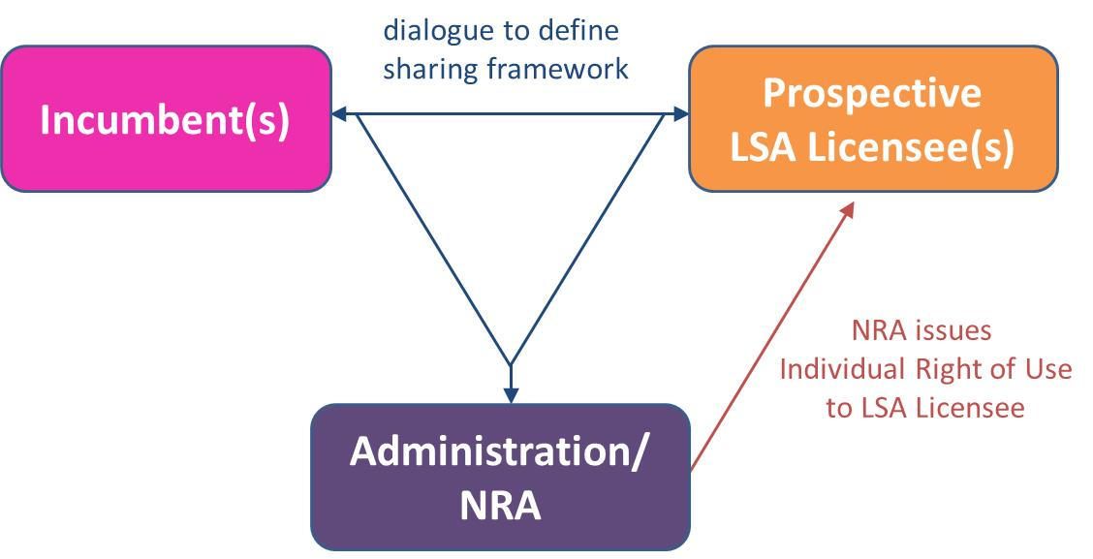

Figure : Regulatory process required before the introduction of WBB in a band under LSA

It should be noted that this process would require that the three parties are well identified. However, in some countries, it may be difficult to identify a single focal point representing the incumbent user(s). For example, some CEPT administrations reported the fact that video applications can be used by different entities for different purposes, i.e. for broadcasting production (SAB/SAP), in the industrial area (e.g. in nuclear power plants) and for PPDR (police, other PPDR organisations). In certain cases, the NRA may also have to act on behalf of the incumbent(s).

It is important to note that the level of the service that can be delivered by a LSA licensee is dependent on the situation in the band; it will be determined by the usage scenarios of the incumbent(s) and the corresponding sharing framework and LSA licensee need to have the knowledge of the level of interference they may face.

## Options for sharing

### Basis for implementation

The approach described below applies to assess the protection of the incumbent from potential interference from LSA licensee(s)

In order to protect victims (e.g. the incumbent) from harmful interferences, an exclusion zone and a protection zone are defined for each victim’s site. An exclusion zone (or protection zone) is typically defined as a circle of few kilometres and where the victim sits at the centre. When necessary e.g. for victims located nearby a potential high density interfering deployment area (e.g. the LSA licensee' network), an additional and larger restriction zone can be defined.

A definition for each type of zone is given below:

**Exclusion Zone**: a geographical area within which interferer are not allowed to have active radio transmitters. An exclusion zone is normally applicable for a defined frequency range and time period.

**Protection Zone**: a geographical area within which victim receivers will not be subject to harmful interference caused by interferer transmissions. A protection zone is normally applicable for a defined frequency range and time period.

NRA imposes that the electromagnetic field (E) emitted by all interferer transmitters operating in co-channel and/or adjacent channels of the victim receivers does not exceed a level dBµV/m/MHz within the defined protection zones i.e. a mean field strength that does not exceed a defined value in dBµV/m/MHz at a defined receiver antenna height above ground level.

The victim receiver sensitivity is converted from receiver’s received power level in dBm to field strength E (in dBµV/m) using the following equation:

E (dBµV/m) = (IC – Gr + Pfr) + 20 log10 (freq(MHz)) + 77,21

with:

* IC is the Interference Criteria at the receiver (dBm);
* Gr is receiver antenna gain in the direction of the interfering site;
* Pfr is cable and feeder loss at receiver (dB).

E (dBµV/m) above is given for co-channel situation. For 1st adjacent channel situation, a computed correction factor should be added.

**Restriction Zone:** a geographical area within which LSA Licensees are allowed to operate radio transmitters, under certain restrictive conditions (e.g. maximum EIRP limits and/or constraints on antenna parameters). A restriction zone is normally applicable for a defined frequency range and time period.

This may also be applicable on a national level to provide protection to the LSA licensee(s).

### LSA functional blocks and interaction

The following functional blocks may be required when implementing LSA on a national basis.

A LSA repository is required to deliver the information on spectrum availability and associated conditions when this information is subject to changes over time. The LSA repository may be managed by the Administration, the NRA or the incumbent, or be delegated to a trusted third party.

The LSA controller manages the access to the spectrum made available to the LSA licensee based on sharing rules and information on the incumbent’s use provided by the LSA repository. It retrieves information about spectrum from the LSA repository through a secure and reliable communication path.

The LSA controller can interface with one or multiple LSA repositories as well as with one or multiple LSA licensee’s networks. The LSA controller may be managed by the Administration, the NRA, the incumbent, the LSA licensee(s) or be delegated to a trusted third party.

There could be one or more repositories and/or controllers per country, depending e.g. on the LSA band and the incumbents’ nature. The following figure depicts an example of implementation of LSA with repository and controller.

Steps should be taken such that confidentiality and information sensitivity/security requirements are met.

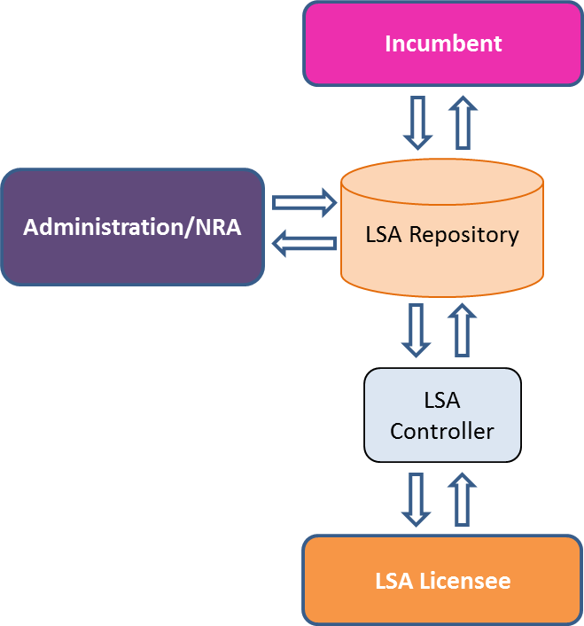

Figure : An example of LSA functional blocks and interactions

The LSA repository contains in particular the relevant information on LSA spectrum that must be protected together with the level of protection provided by the incumbent(s).

It should be noted that ETSI TC RRS has presented possible architecture that enables the LSA concept in document TR 103 113 (“System Reference Document on Mobile broadband services in the 2300 – 2400 MHz frequency band under Licensed Shared Access regime”) [7].

Further consideration for the standardisation of the LSA system requirements, architecture and interfaces is currently ongoing within ETSI. In particular, ETSI has approved TS 103 154 v 1.1.1 on the System requirements for operation of Mobile Broadband Systems in the 2 300 MHz-2 400 MHz band under Licensed Shared Access (LSA) [8].

## Management of cross-border coordination

Cross-border coordination is usually conducted through bilateral agreements between administrations / NRAs. Individual right of use delivered at national level request MNOs to respect the terms and conditions of such agreements. In traditional WBB bands, the CEPT may conduct studies and produce guidelines in order to support administrations / NRAs in their bilateral/multilateral negotiations.

Cross border coordination for WBB services introduced in a band under LSA follows the exact same framework. Bilateral/multilateral agreements must be contracted between relevant administrations / NRAs and the LSA licensee will be requested to comply with such agreement under its individual right of use.

# Sharing scenarios for the coexistence between PMSE and WBB

## Scenarios for PMSE

The application of PMSE and the wireless broadband systems (WBB) are usually deployed in the same geographical area, most likely in areas with a higher population density. It has to be taken into account that the various types of PMSE video links may be allowed to use the full frequency range identified.

### Deployment assumptions for PMSE

The main type of PMSE applications used in the 2300-2400 MHz band is related to temporary video links (portable, mobile with some allowance for airborne use) and cordless cameras as referred to in ERC/REC 25-10 [9], ECC Report 204 [10] and CEPT Report 51 [11]. Digital video links are now the industry standard for video PMSE use. ECC Report 219 [12] provides technical characteristics, which should be used in any future compatibility studies.

This is further described in the table and figures below.

Table 1: Categories of PMSE video links for spectrum study purposes

|  |  |
| --- | --- |
| **Type of link** | **Definition** |
| Cordless camera link | Handheld or otherwise mounted camera with integrated or Clip-on transmitter, power pack and antenna for carrying broadcast-quality video together with sound signals over short-ranges (line-of-sight and non-line of sight). |
| Portable video link | Small transmitter, for deployment over greater ranges, typically up to 2 km |
| Mobile video link | Video transmission system employing radio transmitter and receivers mounted in/on motorcycles, racing motorbikes, pedal cycles, cars, racing cars, boats, helicopters, airships or other aircraft (includes repeaters and relays). One or both link terminals may be used while moving. |

**Cordless camera link**

These are handheld cameras with integrated transmitter, power pack and antenna. Normally they are used by a cameraman to send a video link to an OB vehicle at short distance. The emitted power is therefore lower than in other cases.

Figure 3 below depicts the situation.

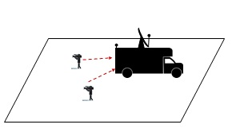

Figure 3: Cordless camera link

**Portable video link**

Portable links are mostly handheld cameras with a separate body worn transmitter, power pack and antenna. The emitted power is normally greater than in the case of cordless camera but lower than in the case of mobile links.

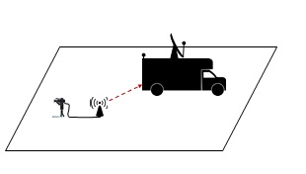

Figure 4: Portable video link

**Mobile video link**

These are camera links where, for the uplink, the transmitter is on a vehicle, typically on a motorcycle, and the receiver is on a helicopter.

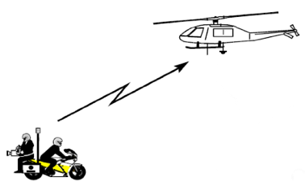

Figure 5: Mobile video up-link

These are camera links where, for the downlink, the transmitter is on a helicopter and the receiver is on a platform or on the ground.

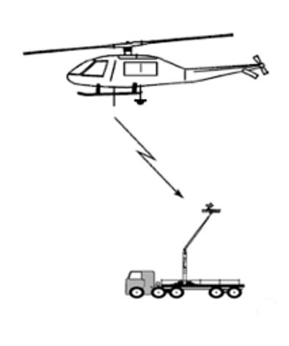

Figure 6: Mobile video down-link

### Operational footprint for PMSE

PMSE use in this band may be characterised as having in many cases a high degree of locality and temporality, as it is in such cases confined to the limits of a defined area for an event limited in time. For some PMSE video applications such as airborne links and temporary video links the defined area may be large e.g. tens of kilometres. The operational footprint for PMSE, therefore, is mainly driven by the types of PMSE deployment described in the previous section and by the types of authorisation schemes.

Administrations in Europe have different licensing/ authorisation schemes:

1. Regular long term license to use assigned frequencies anywhere and anytime on an exclusive basis or shared with existing authorised users.

The PMSE license holder can use the frequencies any time at any location. He must share the frequencies with existing authorised users, including other PMSE users, and coordinate with them on the use of the frequencies at the event location. The license is technology neutral and there may be no limit to the number of transmitter/receiver links used.

1. Regular long term license to use assigned frequencies on a specific location on an exclusive basis or shared with existing authorised users.

The PMSE license holder can use the frequencies any time but limited to a defined location or area/region. For shared use the licensee must coordinate use with existing authorised users, including other PMSE users, at the event location. The license is technology neutral there may be no limit to the number of transmitter/receiver links used.

1. Temporary license to use assigned frequencies on a specific location during an event, or group of events, on an exclusive basis.

For specific events, it is possible to request frequencies which can be used on a exclusively during an event.

1. Regular license with short duration which can be used at any time in any location.

As Video PMSE is normally a licensed service the parameters, such as power for an individual event or activity can be adjusted via the licence conditions for future bands.

Detailed information on the regulatory procedures used by administrations in granting access to spectrum for the use of the 2.3-2.4 GHz bands for PMSE was provided in response to the CEPT questionnaire on PMSE. Administrations’ responses to the questionnaire and summary can be found at <http://www.cept.org/ecc/topics/programme-making-and-special-events-applications-(pmse)>.

## Options for sharing

Incumbent PMSE applications (SAP/SAB video links) can coexist with WBB applications at the same time through the use of either geographic separation if co-frequency operation is expected or a combination of separation distance and frequency separation if co-located operation is anticipated.

Therefore two general options of sharing can be depicted as follows:

* Option A: The operation of a PMSE video-link at a given position or on the move is to be protected by devices and infrastructure of the WBB network. The network is required to reduce the transmit power or to shut down completely at the needed position(s) in the frequency block possibly affecting the operation of the incumbent and those adjacent to it. This needs to be done automatically and without any external control. The network should operate related interfaces accepting information by the incumbent(s) on the position of the cordless camera(s). Considered appropriate are databases (in accordance with section 3.3.2) or ad-hoc information on the incumbents’ device positions.
* Option B: The other option is to preserve a number of blocks for the operation of the PMSE video-link by limiting the use of these ranges for the additional use by the WBB network. The relevant blocks (and possible the adjacent as well) won’t be available for the additional user.

Both options could be combined as appropriate.

The details of such sharing situations may depend on the particular national circumstances, namely the spectrum usage and the type of the authorisation granted by the corresponding administration for the existing applications. Special care may be given to the case of airborne use of PMSE (e.g. mobile video down-link), which may require large separation distances.

### Possible scenarios

For the sharing between PMSE video links and WBB, possible scenarios of sharing can be depicted as in the pictures below:

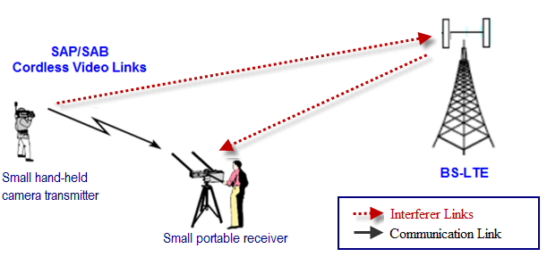

Figure 7: Cordless camera link

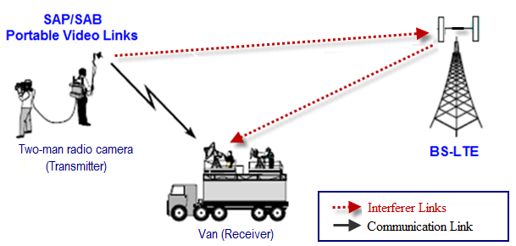

Figure 8: Portable video link

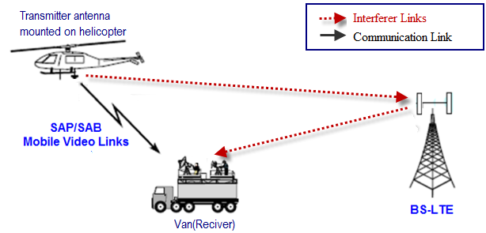

Figure 9: Mobile airborne video down-link

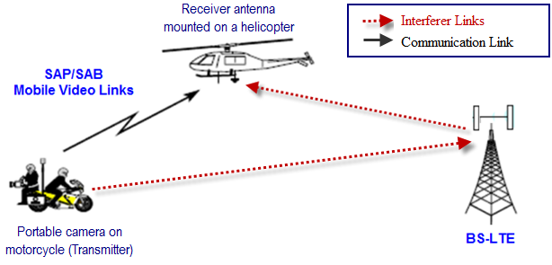

Figure 10: Mobile airborne video up-link

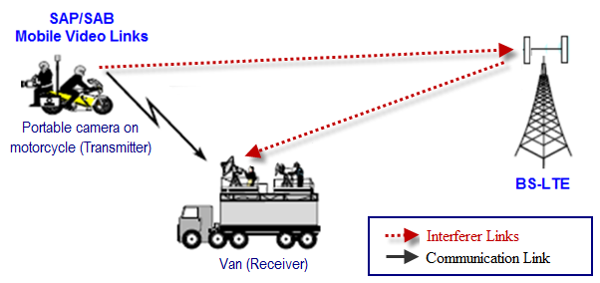

Figure 11: Mobile ground video link

On the figures above, both directions of interference are shown. However, in the case of PMSE possibly interfering with WBB, additional constraints are not expected on PMSE deployment. Appropriate measures for handling those parts of the WBB networks which might be affected by the incumbents’ operation can be defined in the sharing framework or can be taken as a decision of the LSA licensee.

Technical parameters and protection criteria for PMSE video links associated to cordless, portable, and mobile PMSE scenarios are provided in ECC Report 219 [12].

### Considerations for implementation

In order to protect the incumbent(s) from interferences, an exclusion zone, a protection and a restriction zone can be defined for appropriate protection of the incumbent (see section 3.3.1).

Taking into account the option A as described in section 4.2 above and considering the various PMSE deployments described in section 4.1.2, the following options for sharing are proposed:

Table 2: Options for sharing between PMSE and WBB

|  |  |  |  |
| --- | --- | --- | --- |
| **PMSE scenarios** | **Typical applications** | **Type of PMSE link** | **Options for sharing** |
| Regular long term license, specific location | TV studio, theatre, stadium | Cordless / Portable | Coexistence with exclusion, protection and/or restriction zones (may be static).  Spectrum vacation using e.g. pre-defined cell re-planning scenarios. |
| Temporary license, specific location | Special events (e.g. Cycling races, Marathons, Formula One) | Cordless / Portable / Mobile / Airborne | Coexistence with exclusion and protection zones.  Spectrum vacation using e.g. pre-defined cell re-planning scenarios. |
| Regular long term license, anywhere, anytime | TV news | Cordless / Portable | Coexistence with exclusion and protection zones.  Instant spectrum vacation. |
| Regular license with short duration, anytime, anywhere |

## Example of implementation

An example of the technical implementation of the LSA concept is the Finnish LSA trial system [13]. In this trial system, the LSA licensee is a mobile operator deploying fully commercial LTE equipment comprising of TDD-LTE and FDD-LTE eNBs, core network and OAM while the incumbent user is a PMSE video link. The LSA System comprises of LSA Repository and LSA Controller which are used in accordance to the ECC Report 205 [2], Section 5.6.1. The trial system has been implemented using commercially available building blocks as much as possible. The mobile operator has an LSA license to operate on the 2.36-2.40 GHz band and it uses this band to deploy an LSA network. When the incumbent needs to access a portion of this LSA band it can send an evacuation request to the WBB via Internet or mobile application in a secure manner using a simple interface. As the evacuation request arrives to the mobile operator, it closes the affected TDD-LTE eNBs either by locking the cell or using graceful shutdown. As a consequence, the commercially available UEs on the LSA band are able to make an automatic cell re-selection or seamless handover FDD eNBs.

With the Finnish LSA trial environment it has been shown that after the evacuation request is made by the incumbent it takes a bit over 30 seconds for the WBB to evacuate a spectrum band by locking the affected eNBs and the same amount of time to send a confirmation of the successful evacuation back to the incumbent. Further details on the technical implementation of the Finnish LSA trials as well as more deliberation on the obtained results can be found in the ANNEX 2:.

# Sharing scenarios for the coexistence between telemetry systems and WBB

## Scenarios for telemetry

### Deployment assumptions for Telemetry

The scenarios involving terrestrial telemetry ground stations are assumed to be covered by the scenarios involving aeronautical telemetry ground stations. Therefore, there is no scenario per se in this study involving terrestrial telemetry.

Aeronautical telemetry and telecommand operations are used for flight testing of manned and unmanned aerospace vehicles. These systems contribute to the security tests and support also the certification process. Vehicles are tested to their design limits, thus making safety of flight dependent on the reliability of information received on a real-time basis.

It is expected that the transmitted data would require a high integrity level; taking into account national circumstances, an example of required protection is 99.5 % of the test period.

The relevant scenarios involving WBB as the interferer (both base stations and user equipment’s) with telemetry ground station as the victim are shown in Figure 12.

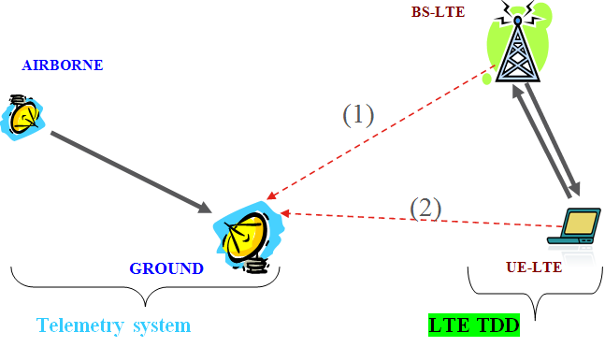

Figure : Interference paths from WBB systems to telemetry ground stations

The relevant scenarios involving aeronautical telemetry transmitter as the interferer with WBB systems (LTE, both base stations and user equipment) as the victim are shown in Figure 13.

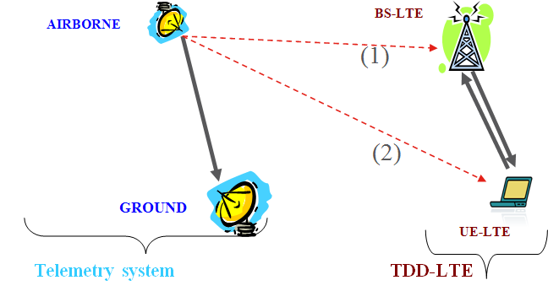

Figure : Interference paths from aeronautical telemetry transmitter to WBB BS

### Operational footprint for Telemetry

Both airborne and terrestrial telemetry applications are used in the band as described in ECC Report 172 [5]. These are expected to be scheduled activities often planned well in advance. The use of additional mobile stations for a network support is dependant of the type of the test mission. In some cases, part of the flight path of a test mission is done at a low elevation angle of 2° and lower, with the height of the ground station as reference.

In order to estimate the operational footprint for telemetry, several parameters need to be known:

* The location of the telemetry sites: The telemetry ground station is normally fixed at a given location.
* The zone of usage: The flight path of the airborne is usually known in advance.
* The frequency bands which need protection, usually known in advance. Several test missions can be run simultaneously, each on individual frequencies.
* Time period when the restriction on LSA licensee is applicable. Estimate also the overall time usage over a long period.

With all these information, it is possible to evaluate the operational footprint for telemetry, but also, combined with the sharing possibilities, the opportunities in the band for the possible LSA licensees. It has to be considered that some telemetric uses, in particular positioning of military mobile telemetry receiver stations, might be classified and maintained secrecy in general, e.g. from the LSA licensees and possibly the NRA (see section 3.2).

## Options for sharing

It is important to develop some studies in order to assess the impacts in co-channel and adjacent channel sharing at national level.

According to ECC Report 172 [5], incumbent Telemetry applications can coexist with WBB applications at the same time through the use of either geographic separation if co-frequency operation is expected or a combination of separation distance and frequency separation if co-located operation is anticipated.

### Interference from WBB to Telemetry

Relevant interference protection considerations involve WBB as the interferer (both base stations and user equipments) with telemetry ground station (covering both the terrestrial and aeronautical telemetry) as the victim. Since UE are assumed to operate under the control of a network, the protection of telemetry is addressed by considering interference from WBB BS.

In order to protect victims from harmful interferences, an exclusion zone, a protection zone and, when necessary, a restriction zone are defined for each victim’s site as described under section 3.3.1.

The exclusion or protection zones may be defined as fixed restrictions, for example without any time based allowances, in advance of any license issued for new wireless broadband systems.

**Exclusion Zone:** A practical implementation would be to list all exclusion zones in a reference table with the following information:

Table 3: example of reference table to identify exclusion zones

|  |  |  |  |  |  |
| --- | --- | --- | --- | --- | --- |
|  |  |  |  |  |  |
| reference or site name | Center point or perimeter of the site | Site coordinate latitude (WGS84) | Site coordinate longitude (WGS84) | Applicable Frequency range | Time period when the restriction is applicable |

**Protection Zone:** For each site, incumbent receiver sensitivity is converted from receiver’s received power level in dBm to field strength E (in dBµV/m. For co-channel situation, the equation given in section 3.3.1 applies. For 1st adjacent channel situation, a computed margin (e.g. based on 3GPP standard LTE BS ACS & ACLR) should be added.

A practical implementation would be to list all protection zones in a reference table with the following information:

Table 4: example of reference table to identify protection zones

|  |  |  |  |  |  |  |  |
| --- | --- | --- | --- | --- | --- | --- | --- |
|  |  |  |  |  |  |  |  |
| reference or site name | Center point or perimeter of the site | Site coordinate latitude (WGS84) | Site coordinate longitude (WGS84) | Receiver antenna height above ground level | Maximum allowable E (dBµV/m) | Applicable Frequency range | Time period when the restriction is applicable |

**Restriction Zone:** as described in section 3.3.1.

For the provision of the information needed for these different zones, appropriate databases (in accordance with section 3.3.2) may be used.

### Interference from Telemetry to WBB

Relevant interference protection considerations involve telemetry transmitter as the interferer with WBB system (both base stations and user equipment) as the victim.

In order to improve the protection of victims from harmful interferences and in particular airborne telemetry transmitters, exclusion zones (normally large urban areas where WBB is deployed) can be defined as a geographical area within which terrestrial or airborne telemetry transmitters are not allowed to operate or fly over. Exclusion zones are normally large urban areas.

### Example of implementation

None are available for the time being.

# Sharing scenarios for the coexistence between Fixed Service and WBB

## Scenarios for the fixed service

### Deployment assumptions for the Fixed Service

Fixed Service frequently used for various purposes within telecommunications and broadcast networks, on either a permanent or temporary basis. Usually the justification for using a fixed radio link instead of a wired or optical fibre link relates to geography or economics.  They can often be used to provide fixed communication links between stations in a network supporting a different service (such as mobile telephony): an application known as 'infrastructure' or 'backhaul'. Fixed Service applications used in the 2300-2400 MHz band are point-to-point radio links and point-to-multipoint radio links as depicted below.

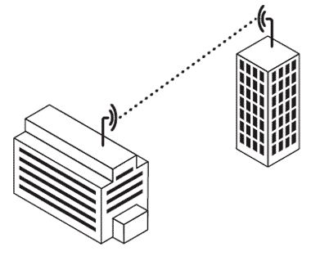  
Figure 14: point-to-point link

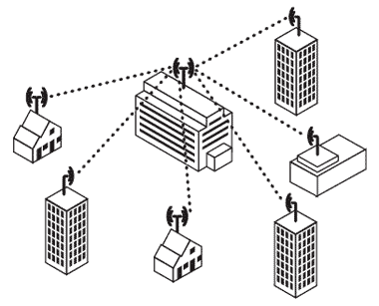  
Figure 15: point-to-multipoint link

### Operational footprint for the Fixed Service

Point-to-point links are typically used within telecommunications core networks. They may also be used within local access networks (connecting users to the core network) and as broadcast contribution and distribution links. Point-to-point links can be unidirectional or bidirectional with highly directional antennas and probable deployment in rural areas.

Point-to-multipoint (PMP) links are normally used within access networks, enabling network operators to provide services without the need to install conventional cables. A point to multipoint network topology provides a communication route (on a single radio channel for each sector) from one central point to a number of terminals where users are located. Each user location may be served directly from the central location or via one or more radio repeaters.

## Options for sharing

Due to the varying characteristics of different types of Fixed Service systems and their deployment, no single separation distance, guard band or signal strength limit can be provided to guarantee co-existence with WBB. Co-existence can be achieved through coordination on a case-by-case basis.

WBB and point-to-point links can coexist with a certain frequency separation, depending on the WBB and point-to-point links characteristics and with the required co-ordination between WBB base stations and the point-to-point systems (see ECC Report 100, [13]). Co-channel sharing between WBB and point-to-point links is not feasible in the same geographic area. A combination of exclusion and protection zones (as defined in section 3.3.1) should ensure that there is no WBB system in the main lobe of the point to point system and that the separation distance between the point to point system and the WBB base station is such that the interference between WBB UEs and the point to point link is limited.

The similarities between WBB and point-to-multipoint link indicate that the results for WBB - WBB adjacent channel co-existence largely apply to the WBB – point-to-multipoint link scenario as well. In case of BS – BS interference additional measures may thus be necessary, such as frequency separation and/or additional filters, whereas otherwise co-existence is expected to be possible without such measures. While coordinating WBB BS and FS it is sufficient to ensure that WBB BS do not interfere with FS, since that will also guarantee the protection of the FS from WBB UEs.

## Example of implementation

None available for the time being.

# Sharing scenarios for the coexistence between OTHER GOVERNMENTAL use and WBB

In addition to the telemetry, other defence or governmental applications are used on a national basis within CEPT administrations (see ANNEX 1:).

## Unmanned Aircraft Systems (UAS)

UAS is composed with one or several UAV (Unmanned Aircraft Vehicle) and a ground station (GS). UAS uses telecommand (uplink) and telecontrol and video links (downlink). Some UAS uses symmetrical link between UAV and ground station (same bandwidth for the uplink and for the downlink, same modulation, etc.) as described in ECC Report 172 [5]. These are expected to be scheduled activities often planned well in advance.

Incumbent UAS applications can coexist with WBB applications at the same time through the use of either geographic separation if co-frequency operation is expected or a combination of separation distance and frequency separation if co-located operation is anticipated.

The approach developed for telemetry (Section 5) can also apply for the shared use of the band by UAS and WBB, in particular for UAS down-links.

## Video links for governmental use

The band 2.3-2.4 GHz is used in some countries by video applications others than the PMSE applications described in section 4.1. This includes industrial, governmental and medical uses, for example bomb disposal, PPDR, safety systems, medical diagnosis which may have different deployment assumptions to PMSE.

Although the applicability of the LSA approach for the sharing between video applications for governmental use and WBB has not been studied, the approach developed for PMSE (Section 4) might also apply for these scenarios.

## Other considerations

Identified so far, are some aspects, which need to be recognised when considering the implementation of LSA for the sharing with governmental users:

* In some countries various governmental entities are involved and responsible on local, regional and governmental level. These entities might not be authorised (or it may not be desirable for them) to get into negotiations with third parties interested in the commercial use of spectrum that are not aligned with their set of responsibilities. In these cases, as already mentioned in other section of the Report, the NRA, if accordingly instructed by the responsible entities, might act on behalf of the governmental entities, replacing the incumbent’s part in the negotiations with the additional user;
* Furthermore, some information about the governmental use may be difficult to be shared and therefore may limit the applicability of the LSA approach;
* Moreover, governmental users are aimed to serve public purposes. This may make the sharing with commercial users challenging because of their different nature.

These listed aspects are not exhaustive.

# Sharing scenarios for the coexistence between WBB and Amateur service

## Scenarios for the amateur service

As defined in ECC Report 205 [2], LSA excludes concepts such as “opportunistic spectrum access”, “secondary use” or “secondary service” where the applicant has no protection from primary user(s). Therefore LSA cannot be applied to the Amateur Service in the band 2300-2400 MHz. However, it is recommended to take into account the sharing options as described in section 8.2 below.

### Deployment assumptions for the amateur service

The frequency band 2300-2400 MHz is allocated to the Amateur Service on a secondary basis by ITU Radio Regulations [14] in all three ITU regions.

The operational characteristics of amateur stations operating in the 2300-2400 MHz range vary significantly. However based on the IARU Region-1 VHF Managers Handbook [15] and studies for ECC Report 172 [5], they can be categorised as:

* Long range weak-signal reception of Narrowband Terrestrial (e.g. CW, SSB, digimodes) and EME (Earth-Moon-Earth - Moonbounce) operation - notably in the harmonised sub-band 2320-2322 MHz, including propagation beacons;
* Some additional narrowband activity in the 2300-2305 MHz range, including long range EME (Earth-Moon-Earth - Moonbounce) contacts with North America;
* Data, multimedia, and TV repeaters (point-to-point links and area systems) in other parts of the band.

Activity levels vary with propagation conditions and peak when national or international contests, or other activity events, are scheduled.

## Options for sharing

ECC Report 172 [5] found that regarding Radio Amateur systems in the 2300-2400 MHz band, operating as a secondary service, it was shown that the required MCL (Minimum Coupling Loss) can be achieved by various mitigation techniques.

Where authorised, licence conditions for amateurs already require secondary non-interference operation in the 2.3GHz band. In practice, the options are typically based on directional antennas, time, frequency and geographic sharing, as well as coordinated assignments by administrations of unattended systems such as propagation beacons or repeaters. The duty cycle of individual amateur transmissions can also be assumed to be quite low and is typically on a listen-before-transmit basis.

Current examples of shared access are based on where amateurs share with other incumbent services such as wireless cameras (PMSE) or airborne telemetry. For example:

* In the Netherlands where there is significant PMSE usage in the band, there is a regularly used notification system by the administration that restricts amateur transmissions at defined times and radii when PMSE usage needs priority.
* In the United Kingdom where amateurs are required to share on a non-interference basis, Ofcom have recently defined geographic, zones, field strength limits and times of day around certain sites to protect airborne telemetry use, as well as migrating amateurs out of the core 2350-2390 MHz sub band which will be made available to WBB (and making a new provision for amateur usage in the 2300-2302 MHz band edge). Amateur users of the 2.3GHz band have are also been requested to register their details with Ofcom to facilitate email notifications.

Further consideration required to assess whether these approaches are applicable for a shared use of the band with WBB, taking into account the expected dense usage of the band by WBB.

When WBB is deployed, it is also feasible that compatibility could be achieved with low density narrowband amateur activity choosing to near the band edges where administrations implement WBB power or frequency restrictions or guard bands - for adjacent Wi-Fi compatibility for example.

In accordance with Radio Regulations Article 1.56 - amateur service is a radiocommunication service for the purpose of self-training, intercommunication and technical investigations carried out by amateurs, that is, by duly authorised persons interested in radio technique solely with a personal aim and without pecuniary interest - in some countries it is forbidden by law that radio amateurs act on a commercial basis.

# Conclusions

Possible sharing options are described in this Report for the shared use of the band between WBB and the incumbent use. Measures like the utilisation of exclusion, protection and restriction zones can apply on a general basis and can be used as part of a LSA sharing framework.

Technical conditions and details of implementation of the LSA sharing framework should be defined at the national level to reflect the national sharing scenarios, which depend strictly upon the types of incumbent use. This would contribute to the efficient use of the band.

The implementation of the LSA sharing framework on national level, which can lead to additional restrictions in concerned areas for WBB, will not have an impact on the common and minimal technical conditions for wireless broadband usage of the 2300-2400 MHz frequency band as described in CEPT Report 55 [3]. Those additional restrictions will be related to timely and/or geographical restrictions and will therefore not be in contradiction with the aim of getting European wide common technical conditions.

The introduction of WBB under LSA will require a dialogue involving Administration / NRA, Incumbent(s) and prospective LSA Licensees, in order to define the sharing framework. The detailed procedure will have to be defined at national level, taking into account the different national authorisation schemes.

Standardisation activities on LSA will facilitate the availability and interoperability of technical solutions for implementation of LSA, allowing the national implementations to be specific depending on the national conditions and incumbent usage of the band.

Further work is expected, in response to task 2.3 of the EC Mandate, on the development, where appropriate, of common technical sharing solutions for the shared use of the 2300-2400 MHz band for WBB and incumbent services/applications, in particular PMSE. This will be addressed in a subsequent CEPT Report.

1. Summary of the usage of the 2.3-2.4 GHz band

This document contains a summary of the use of the band 2.3-2.4 GHz across CEPT derived from the responses to the questionnaire issued by WG FM in 2012 (see [6] for details ) and updated in 2014 for some administrations.

* 1. military and governmental use
     1. aeronautical telemetry

Eight countries are using the band or part of it for aeronautical telemetry.

* + 1. generic governmental or defence use

Three countries reported a use of the band for generic governmental or defence use.

* + 1. other defence or governmental use

Six countries have mentioned other defence or governmental applications, which includes Unmanned Aircraft System (UAS), public safety networks, military fixed applications and governmental BWA applications.

* 1. PMSE

In twenty-eight CEPT countries, the band 2.3-2.4 GHz or part of it is used for PMSE. When specified, the type of PMSE includes cordless cameras, portable and mobile video links with some airborne use in some countries.

* 1. fixed links

Six countries mentioned some use of the band for fixed links, with a limited number of links in some of these countries.

* 1. radio amateur services

Fourteen countries informed that part of the band is available for the amateur service, generally on a secondary basis.

* 1. Other uses

Three countries reported about the use of part of the band for other, very specific use.

* 1. Broadband mobile

Six CEPT countries reported that part of the band is currently available for WBB use.

Eleven countries plan to make the band or part of it available for WBB.

1. Finnish LSA trial
   1. Overall set-up

Finnish Trial program is developing trial environments to study spectrum sharing concepts [16]. The Finnish LSA trial environment developed in the Trial program is a combination of elements that are commercially available equipment or specifically designed for the purpose of the LSA concept as shown in Figure 16. On the commercial side, the LSA trial environment includes a cellular Long-Term Evolution (LTE) network that consists of commercial 3GPP Release 8 compliant radio accesses and a real core network [17]. The LTE network contains three Time-Division LTE (TD-LTE) LSA eNBs with five sectors that are located in Ylivieska, Finland, and operate in the 2.36-2.40 GHz frequency band under the permission from Finnish Communication Authority (FICORA). It also contains two Frequency Division Duplexing LTE (FDD-LTE) evolved Node Bs (eNBs) with four sectors that provide coverage to the same area using the 2.1 GHz band.

The eNBs provide support for TD-FDD handover and load balancing. All eNBs are connected to LTE core network and are managed from a single point by a commercially available Operations, Administration and Management (OAM) system. Commercially available LTE multi-band (band 1 and 40) user equipment (UEs) that support dual-mode LTE and provide TD-FDD seamless handover are used. The incumbent spectrum users are PMSE video links as introduced above in Section 4.1. The protection distances reported in ECC Report 172 [5] are used in the co-channel and adjacent channel scenarios between LTE eNBs and video links.

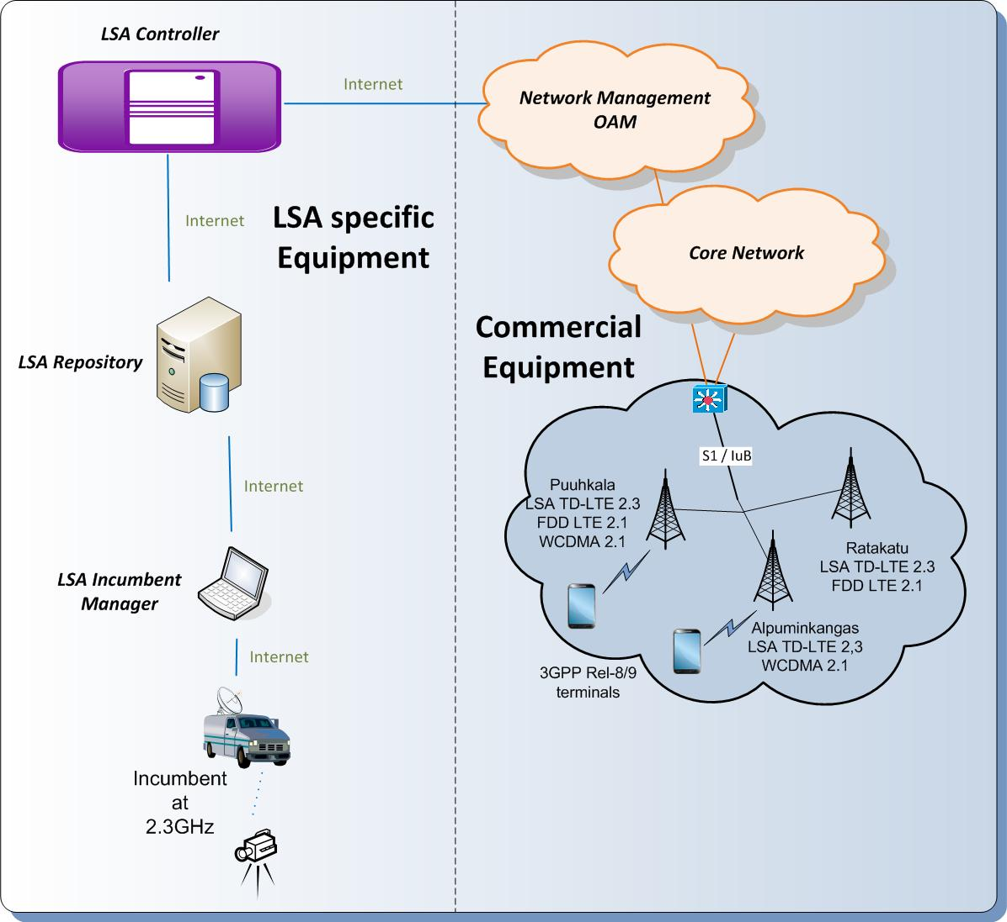

Figure 16: Finnish LSA trial set-up including commercial LTE equipment on the right and LSA specific research implementation on the left

* + 1. Specific tools developed for the support of LSA

In addition to the commercial equipment described above, the Finnish LSA trial environment includes LSA specific equipment that has been developed for the trials including LSA Incumbent Manager, LSA Repository, and LSA Controller.

* + 1. LSA Incumbent Manager

The LSA concept is based on the assumption that the incumbent is allowed to dynamically reclaim its spectrum band or part of it also during the LSA license duration by requesting the LSA licensee to evacuate the band. In the Finnish LSA trial, an LSA specific tool has been developed to help the PMSE service provider to reserve frequencies by placing evacuation requests in a simple and secure manner via mobile phone or a web browser, as shown in Figure 17. The tool is called the LSA Incumbent Manager and the incumbent user may set and remove evacuation requests with web and mobile applications.

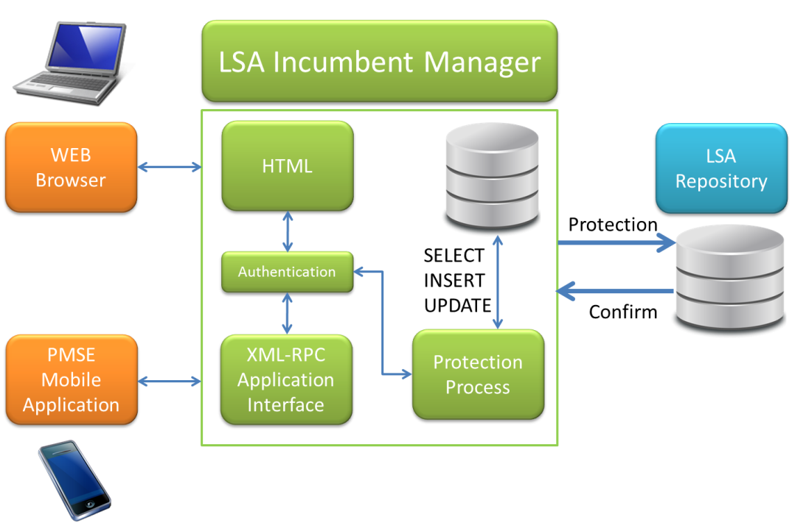

Figure 17: LSA Incumbent Manager

Using the web application of the LSA Incumbent Manager, the incumbent user can reserve the band by placing an evacuation request by setting the following information via web browser: the location in a map interface, the PMSE link type (see Section 4.1.1), the transmit frequency range and the time period for the reservation. The web application allows the incumbent user to request multiple protections ahead of time according to its planned usage in the future. Using the mobile application, the incumbent may make an evacuation request according to its current position. The mobile application uses GPS to locate the incumbent user on demand. The protection process may include algorithms to mask the actual usage of the incumbent user if necessary. The LSA Incumbent Manager transmits the incumbent user information to the LSA Repository.

* + 1. LSA Repository

The LSA Repository is a database containing up-to-date information about LSA spectrum bands together with the conditions for the use of each band. It collects, maintains and manages data on the spectrum use on the LSA band for different times and geographical locations. Additionally, the LSA Repository contains information e.g. on the LSA Controllers, licenses and the incumbent link and equipment types. Upon a change on the incumbent user activity, LSA Repository communicates it to the LSA Controller.

* + 1. LSA Controller

The LSA Controller provides the LSA licensee with the means to access the spectrum and to react to the changes in incumbent user activity. In case the incumbent appears in the operational area of the LTE network, the LSA Controller uses the incumbent user information received from the LSA Repository and the protection distances reported in ECC Report 172 [5] to calculate the affected eNBs/sectors on the LSA band and sends deactivation/activation commands to the OAM accordingly. Following options are identified for the LSA Controller to react to incumbent activity:

1. Evacuation with detailed incumbent information

All the information provided by the incumbent user via LSA Incumbent Manager is used by the LSA Controller to calculate which eNBs or sectors on the LSA band need to be evacuated.

1. Evacuation with a location update

In the case that only the location of the incumbent user has changed, the LSA Controller calculates changes needed to the network based on the new location of the incumbent user.

1. Emergency evacuation with minimal incumbent information

The LSA Controller will send an evacuate request to OAM to evacuate the whole LSA licensed area.

1. End of the evacuation need

When the incumbent user has removed its evacuation request from the incumbent manager or the predetermined evacuation period has ended, the LSA Controller will send an activation request to the OAM.

* 1. LSA functionality/LSA band evacuation

The functions of the different LSA components described above can be presented as the different phases of the LSA band evacuation process as follows:

1. The incumbent makes an evacuation request via LSA Incumbent Manager.

The LSA process starts as the incumbent spectrum user makes an evacuation request to the LSA Incumbent Manager. The LSA Incumbent Manager submits the information to the LSA Repository which forwards the information to the LSA Controller.

1. LSA Controller receives incumbent information from LSA Repository.

Based on the incumbent user information received from the LSA Repository, the LSA Controller calculates which eNBs or sectors on the LSA band are affected. LSA Controller submits de-activation command to the OAM accordingly.

1. OAM receives the de-activation command from LSA Controller

As the de-activation command arrives, OAM executes de-activation radio plan for the affected eNBs/sectors on the LSA band. There are two potential de-activation radio plans depending on the urgency of the evacuation request. When the evacuation needs to be done rapidly, the MFCN locks the affected LSA eNBs/sectors thereby turning off their air interfaces. As a result UEs will automatically start a cell re-selection procedure. Alternatively, graceful shutdown can be used when the need for evacuation is known well beforehand. In this case, the power of the LSA eNBs/sectors is decreased gradually and UEs will do the handover when the signal level at the serving LSA eNB/sector drops below the signal level of the available FDD eNB/sector.

1. eNB/sector on the LSA band is deactivated

At this point, the signal disappears from the LSA band. After this, the OAM finishes the radio plan execution and begins the LSA eNB/sector status check. As a result of successful radio plan execution LSA eNB/sector off-air status is sent to the LSA Controller.

1. The LSA Controller receives confirmation on the LSA eNB/sector off-air status from OAM.

As soon as all needed LSA eNBs/sectors have reached off-air status LSA Controller ends evacuation and submits evacuation completed information to LSA Repository.

1. Incumbent user receives a confirmation on the evacuation to the LSA Incumbent Manager.

The Finnish LSA trial environment implements the above described LSA band evacuation process and initial performance measurement studies have been conducted to evaluate the involved time scales. Corresponding time stamps are reported in Table 5. In these results eNB/sector locking is considered. In the case of graceful shutdown, the time for the graceful shutdown as well as the step size for the eNB power decrease can be specified. This time will be added to the band evacuation time.

Table 5: Time measured for different phases of the LSA band evacuation

|  |  |  |  |  |  |
| --- | --- | --- | --- | --- | --- |
|  | Measurement point | Evacuation using eNB/sector locking  (1 sector) | | Emergency evacuation using single radio plan  (3 eNBs/5 sectors) | |
| Time [s] | St. Dev. [s] | Time [s] | St. Dev. [s] |
| 1.    The incumbent makes an evacuation request via LSA Incumbent Manager. | The LSA Incumbent Manager | 0 |  | 0 |  |
| 2.    LSA Controller receives incumbent information from LSA Repository. | The LSA Controller | 1,135 | 0,532 | 1,044 | 0,267 |
| 3.    OAM receives the de-activation command from LSA Controller | OAM | 9,807 | 2,664 | 9,029 | 1,881 |
| 4.    eNB/sector on the LSA band is deactivated | LSA band | 31,778 | 2,572 | 33,800 | 1,833 |
| 5.   The LSA Controller receives confirmation on the LSA eNB off-air status from OAM. | The LSA Controller | 59,360 | 3,457 | 73,059 | 1,493 |
| 6.    Incumbent user receives a confirmation on the evacuation to the LSA Incumbent Manager. | The LSA Incumbent Manager | 61,000 | 3,464 | 76,400 | 4,128 |

The results in Table 5 indicate that, in the case of the evacuation of one sector, it takes a bit over half a minute from making the evacuation request until the LSA band has been cleared and approximately the same time until the confirmation of the evacuation is visible to the incumbent in the LSA Incumbent Manager. When the evacuation of all the sectors in the LSA trial environment is considered, the clearance of the band takes almost the same time, however, it takes over 10 seconds more for the confirmation to arrive to the incumbent user.

As mentioned before and shown in Figure 16, the Finnish trial environment consists of both commercial and specific research components developed for the LSA trials. Correspondingly, the measurement results can be divided into a LSA research platform and commercial LTE OAM delays as shown in Table 6. In step 3, the LTE OAM begins radio plan provisioning. In Step 4, the LSA channel was monitored using an air interface monitoring tool to capture time the LTE transmit power disappeared from the channel. The radio plan provisioning still continued 9-10 seconds. These delays together constitute of the commercial LTE OAM delay reported in Table 6. The LTE OAM provisioning time can be minimised by using pre-validated radio plans in which case the execution time of provision operation is shorter. It can also be noted that provisioning a multi-site de-activation radio plan takes only about 3 more seconds to complete than a single site command. This is indicating promising results for larger LSA network management.

On the LSA research platform delay side in step 5, the LSA Controller uses a separate LTE OAM command to retrieve status of the eNBs. In the emergency evacuation case, a larger delay is a result of executing an additional status query before the evacuation can be confirmed to the incumbent. The research platform is currently distributed in six different locations. The LSA research platform delay consists of system architecture related delays (complex event processing in intelligent logic platform, waiting an ongoing LTE status check before de-activation commands to LTE OAM, executing an extra LTE eNBs status check) and network delays (polling events behind firewalls, publish/subscribe event delivery). In a commercial system, four of six distributed locations could be integrated as a part of the LTE OAM leaving LSA Repository and LSA Incumbent Manager tools as external systems. In this way, approximately ~80% of the research platform delay could be removed.

Table 6: Total delay of research and commercial part of LSA trial

|  |  |  |
| --- | --- | --- |
|  | Evacuation using eNB/sector locking (1 sector) Average delay [s] | Emergency evacuation using single radio plan (5 sectors/ 3 eNBs) Average delay [s] |
| LSA research platform delay | 20,620 | 33,279 |
| Commercial LTE OAM provision time de-activation radio plan. | 40,380 | 43,121 |

1. cept mandate

**Mandate to CEPT   
to develop harmonised technical conditions for the 2300-2400 MHz ('2.3 GHz') frequency band in the EU for the provision of wireless broadband electronic communications services**

**1 PURPOSE**

This mandate aims at developing technical conditions for the introduction of wireless broadband (WBB) in the 2300-2400 MHz ('2.3 GHz') band which share with incumbent users. The technical conditions should enable the deployment of wireless broadband services while also ensuring the long term incumbent use of the band in the territory of those Member States that wish to maintain such use.

The results of this mandate should constitute a technical input to the EU-level political process of identifying 1200 MHz for WBB in accordance with the Radio Spectrum Policy Programme (RSPP)[1]. The spectrum inventory established by the RSPP involves assessment of spectrum supply and demand and will examine the efficiency of spectrum use in the range 400 MHz to 6 GHz. The inventory may earmark the 2.3 GHz band for Wireless Broadband use at an early stage in view of the suitability of the band and the scope for sharing with incumbent use.

The results of this mandate should serve as a basis for any Member State that may decide to proceed with WBB and related national sharing frameworks in the 2.3 GHz band at an early stage, so as to avoid fragmentation in the internal market and contribute to consistent national sharing frameworks.

Moreover, the mandate and its technical results should also complement the policy considerations of the European Commission with regard to shared use of spectrum[2] and of the Radio Spectrum Policy Group (RSPG) in the context of the RSPG Opinions on Wireless Broadband[3] and Licensed Shared Access[4].

**2 EU POLICY OBJECTIVES**

The Digital Agenda for Europe (DAE) has set ambitious broadband targets by 2020, namely ubiquitous fast broadband coverage in the EU of at least 30 Mbps as well as subscriptions to super-fast broadband of at least 100 Mbps for 50% of the EU households. WBB is expected to play an important role in achieving these objectives.

Corresponding to the Union policy objective of allocating sufficient and appropriate spectrum in a timely manner and to best meet the increasing demand for wireless broadband, the RSPP requires the Commission and Member States to make every effort to identify at least 1200 MHz of suitable spectrum by 2015. Furthermore, the RSPP establishes a spectrum inventory inter alia to help identify frequency bands that could be suitable for reallocation and spectrum-sharing opportunities. One of its objectives is to explore new ways for sharing spectrum, to the benefit of both private and public users, while taking into account the potential positive and negative impact of allocation or reallocation of such bands and of adjacent bands on existing users.

The Commission services take the view that spectrum sharing should become a mainstream mode of spectrum use in the internal market given the increasing scarcity of spectrum resources (at least at frequencies below 6 GHz) and in order to ensure efficient spectrum use. In its Communication on promoting shared use of spectrum[5] the Commission has stated that, to foster the development of wireless innovations in the EU, it is necessary to continuously improve the opportunities for harmonised spectrum access in both licence-exempt bands and licensed spectrum and to establish new tools for more shared use of radio spectrum resources in the internal market. In particular the Commission stated that it sees the need in a common path in the EU towards enabling more sharing possibilities, based on contractual agreements between users.

In this context the RSPG stated in its Opinion on LSA that the continued promotion of the shared use of radio spectrum is a valuable means to leverage the unique capability to re-used spectrum resources. In this regard it stated that access to previously assigned spectrum could be facilitated through licensed usage, under a Licensed Shared Access (LSA) approach.

Therefore, within the tasks of this mandate as specified in the Section "

4 TASK **ORDER AND SCHEDULE**", the Commission requests CEPT to take into account that use of the 2.3 GHz band should contribute to several important EU policy objectives, namely:

* strengthen the Internal Market for potential mass market WBB services and equipment which will operate in the band both for legacy uses and potential new uses;
* contribute to the DAE broadband targets, which rely on a mix of technologies, including wireless broadband;
* meet spectrum demand in support of the RSPP spectrum target of 1200 MHz for wireless broadband;
* promote innovation and investment through enhanced flexibility in spectrum use;
* foster shared use of spectrum.

**3 JUSTIFICATION**

Pursuant to Article 4(2) of the Radio Spectrum Decision[6] the Commission may issue mandates to the CEPT for the development of technical implementing measures with a view to ensuring harmonised conditions for the availability and efficient use of radio spectrum necessary for the functioning of the internal market. Such mandates shall set the tasks to be performed and their timetable.

In light of the EU policy objectives mentioned in the previous section the 2.3 GHz band has been identified by and by the Radio Spectrum Policy Group (RSPG) as a possible candidate band for the use by wireless broadband (WBB) services in the EU. In this regard the RSPG recommended[7] this frequency band to support WBB needs in the short term before 2015. Furthermore, the RSPG recommended the Commission to consider adopting complementary measures to further promote shared and flexible use of the 2.3 GHz band between wireless broadband applications and other services, based on LSA regulatory provisions, facilitating the long-term incumbent use of the band in the territory of those Member States that wish to maintain such use. Activities are already on-going in the framework of CEPT[8] to develop harmonisation measures for Mobile/Fixed Communications Networks (MFCN) under LSA in this band.

The band appears attractive for the use by WBB services, because it provides for a rather large bandwidth of 100 MHz, is suitable for providing WBB capacity with relatively low propagation and penetration loss, and has potential for global harmonisation having been identified globally for International Mobile Telecommunications (IMT) in the World Radiocommunications Conference in 2007 (WRC-07). Consequently, it is already planned to be used for WBB in several countries, e.g. in Asia. User equipment and base station equipment based on the TD-LTE standard are already commercially available and the equipment market for this band is expected to significantly grow in the coming years driven by large deployments in some countries, especially in Asia.

Currently in EU Member States this band is used for strategic governmental applications such as aeronautical telemetry and closed-circuit television (CCTV, a security application) as well as Programme Making and Special Events (PMSE), specifically Services Ancillary to Broadcasting and Programme Making SAB/SAP (ERC/REC 25-10), e.g., as a core band for wireless cameras, and also at national level for various other applications.

In light of these current allocations that are expected to be maintained in some Member States, considerations have been given by Member States and stakeholders to the possibility to provide access to this band for WBB through an appropriate sharing approach such as Licensed Shared Access (LSA). Such an approach should ensure the long term incumbent use of the band in the territory of those Member States that wish to maintain such use, while providing legal certainty for the LSA licensees.

Therefore, the Commission considers that on-going international and national developments set in the context of consistent implementation of the RSPP objectives through the inventory process justify the need for technical studies to identify technical and regulatory conditions for the usage of WBB in the 2.3 GHz band.

**4 TASK ORDER AND SCHEDULE**

CEPT is herewith mandated to undertake work to develop technical harmonisation conditions for the use of the 2300-2400 MHz frequency band for the provision of WBB electronic communications services with a view to also ensuring the long term incumbent use of the band in the territory of those Member States that wish to maintain such use.

In the work carried out under the Mandate, the general and specific policy objectives of the RSPP, such as effective and efficient spectrum use and the support for specific Union policies shall be given utmost consideration. In implementing this mandate, CEPT shall, where relevant, take utmost account of EU law applicable and support the principles of service and technological neutrality, non-discrimination and proportionality insofar as technically possible. CEPT is also requested to collaborate actively with the European Telecommunications Standardisation Institute (ETSI) which develops harmonised standards for conformity under Directive 1999/5/EC.

In particular, CEPT is mandated to carry out technical studies intended to support the policy objectives presented above, in fulfilment of the following tasks:

**Task 1:** Develop common and minimal (least restrictive) technical conditions for wireless broadband usage of the 2300-2400 MHz frequency band.

This task includes:

1.1 Identify *common and minimal (least restrictive) technical conditions*[9] for the introduction of wireless broadband use in the 2300-2400 MHz band for the provision of electronic communications services. These conditions should be sufficient to ensure coexistence between WBB services within the same band and with services in adjacent bands including use by Radio Local Area Networks (RLAN).

1.2 Develop *channelling arrangements* that are sufficiently precise for the development of EU-wide equipment and take into consideration the possibility of international harmonisation.

**Task 2**: Where appropriate develop common technical sharing solutions for the shared use of the 2300-2400 MHz band for WBB and incumbent services/applications.

This task includes:

2.1 For each of the *relevant incumbent services/applications* in the Member States including military use, PMSE, fixed links, and radio amateur services:(i) assess the *deployment assumptions and the operational footprint* and (ii) *take stock of the situation and future plans* in the Member States regarding the application of the LSA concept to enable the deployment of WBB.

2.2 For each incumbent service/application considered under 2.1: (i) identify *technological and regulatory options facilitating sharing* between WBB and the relevant incumbent service/application including mutual dynamic coordination mechanisms between WBB operators and incumbents; (ii) assess *the scope for harmonisation of technical sharing parameters and solutions* through standardisation and/or an implementing decision;

2.3 Depending on results for each relevant incumbent service/application under 2.2(ii) and without prejudice to national rules on data confidentiality define *technical and regulatory solutions* relevant for the technological and regulatory options identified under 2.2(i) that support consistent sharing frameworks defined at national level allowing for the development and efficient operation of EU-wide equipment.

The Commission may provide CEPT with further guidance on this mandate depending on future agreements at EU level (which may involve the European Parliament and the Council) concerning spectrum resources to be made available in the context of specific EU policies, as well as relevant impact assessments the Commission may undertake in this context. Also, the impact of spectrum demand assessments for different uses at national level may require to be taken into account during the work on the Mandate.

CEPT should provide deliverables under this Mandate according to the following schedule:

|  |  |  |
| --- | --- | --- |
| **Delivery date** | **Deliverable** | **Subject** |
| June 2014[10] | Final Draft Report A from CEPT to the Commission | Description of work undertaken for Task 1 and final results |
| November 2014 | **Final** Report A from CEPT to the Commission, taking into account the outcome of the public consultation | Description of work undertaken for Task 1 and final results taking into account the results of the public consultation |
| November 2014[11] | Final Draft Report B.1 from CEPT to the Commission | Description of work undertaken for Task 2, final results for task 2.2(ii)[12] |
| March 2015 | **Final** Report B.1 from CEPT to the Commission, taking into account the outcome of the public consultation | Final results for task 2.2(ii) taking into account the results of the public consultation |
| March 2015[13] | Final Draft Report B.2 from CEPT to the Commission | Description of work undertaken for Task 2 and final results |
| July 2015 | **Final** Report B.2 from CEPT to the Commission, taking into account the outcome of the public consultation | Description of work undertaken for Task 2 and final results taking into account the results of the public consultation |

CEPT is requested to report on the progress of its work pursuant to this Mandate to all meetings of the Radio Spectrum Committee taking place during the course of the Mandate.

The Commission, with the assistance of the Radio Spectrum Committee and pursuant to the Radio Spectrum Decision, may consider applying the results of this mandate in the EU, pursuant to Article 4 of the Radio Spectrum Decision and subject to the results of the inventory process.

1. List of reference
2. RSPG Opinion on Licensed Shared Access, November 2013, [Link](https://circabc.europa.eu/sd/d/3958ecef-c25e-4e4f-8e3b-469d1db6bc07/RSPG13-538_RSPG-Opinion-on-LSA%20.pdf)
3. ECC Report 205: Licensed Shared Access (LSA)
4. CEPT Report 55: Technical conditions for wireless broadband usage of the 2300-2400 MHz frequency band.
5. ECC Decision(14)02: Harmonised technical and regulatory conditions for the use of the band 2300-2400 MHz for Mobile/Fixed Communications Networks (MFCN)
6. ECC Report 172: Broadband Wireless Systems Usage in 2300-2400 MHz
7. Results of the WG FM QUESTIONNAIRE to CEPT ADMINISTRATIONS on the current and future usage of frequency band 2300-2400 MHz, [responses from 2012](http://www.cept.org/Documents/wg-fm/5035/FM(12)017-Rev1_Summary-Questionnaire-2300-2400-MHz), [update in 2014](http://www.cept.org/Documents/fm-52/19713/FM52(14)36_Update-of-the-responses-to-the-questionnaire-on-current-and-future-usage-of-the-band-23-24-GHz)
8. ETSI TR 103 113 (“System Reference Document on Mobile broadband services in the 2300 – 2400 MHz frequency band under Licensed Shared Access regime”)
9. ETSI TS 103 154 v 1.1.1: System requirements for operation of Mobile Broadband Systems in the 2 300 MHz-2 400 MHz band under Licensed Shared Access (LSA), October 2014.
10. ERC Recommendation 25-10: Frequency ranges for the use of temporary terrestrial audio and video SAP/SAB links (incl. ENG/OB)
11. ECC Report 204: Spectrum use and future requirements for PMSE
12. CEPT Report 51: Report B from CEPT to the European Commission in response to the Mandate   
    “On technical conditions regarding spectrum harmonisation options for wireless radio microphones and cordless video-cameras” - Technical conditions for ensuring the sustainable operation of cordless video-cameras
13. ECC Report 219: Characteristics of PMSE digital video links to be used in compatibility and sharing studies
14. ECC Report 100: Compatibility studies in the band 3400- 3800 MHz between Broadband Wireless Access (BWA) systems and other services
15. ITU Radio Regulations
16. IARU Region-1 VHF Managers Handbook
17. <http://www.tekes.fi/en/programmes-and-services/tekes-programmes/trial/>
18. Palola M. et al. “Licensed Shared Access (LSA) trial demonstration using real LTE network”, 9th International Conference on Cognitive Radio Oriented Wireless Networks and Communications (CROWNCOM), 2-4 June 2014, Oulu, Finland, pp. 498–502.

1. Decision 243/2012/EU of the European Parliament and of the Council of 14 March 2012
2. Commission Communication, "Promoting the shared use of radio spectrum resources in the internal market", COM(2012) 478 final, September 2012
3. RSPG12-521(rev1) "RSPG Opinion on Strategic Challenges facing Europe in addressing the Growing Spectrum Demand for Wireless Broadband"
4. RSPG13-538 "RSPG Opinion on Licensed Shared Access"
5. Commission Communication, "Promoting the shared use of radio spectrum resources in the internal market", COM(2012) 478 final, September 2012
6. Decision 676/2002/EC of the European Parliament and of the Council of 7 March 2002 on a regulatory framework for radio spectrum policy in the European Community, OJL 108 of 24.4.2002
7. RSPG13-521(rev1) "RSPG Opinion on Strategic Challenges facing Europe in addressing the Growing Spectrum Demand for Wireless Broadband"
8. CEPT has set up activities in September 2012, which are aimed at developing harmonised technical conditions for WBB in the 2.3 GHz band by the first half of 2014 (CEPT ECC WGs FM 52 on the 2300-2400 MHz band and FM 53 on RRS and LSA)
9. Such as the definition of appropriate BEMs (Block Edge Masks)
10. Subject to subsequent public consultation
11. Subject to subsequent public consultation
12. The final results under task 2.2(ii) will clarify the scope for technical and regulatory conditions that are relevant for a harmonisation decision. If such conditions are identified, the relevant results at this stage will serve as basis for a harmonisation decision. If not, and more work is required to identify relevant conditions within 2.2(ii), these will then be set out in an addendum to Report A submitted to the RSC no later than March 2015.
13. Subject to subsequent public consultation