ECC Decision (05)05

Harmonised utilization of spectrum for Mobile/Fixed Communications Networks (MFCN) operating within the band 2500-2690 MHz
Approved 18 March 2005
Latest amended 5 July 2019

explanatory memorandum

INTRODUCTION
On 9 March 2001, the European Commission issued Mandate 4 calling upon CEPT to undertake preliminary investigations and to adopt the measures necessary to ensure the availability in the community of harmonised frequency bands, within the additional spectrum bands identified by WRC-2000 for the provision of terrestrial and satellite IMT-2000 services. In response to this mandate the ECC adopted ECC Decision (02)06 [7], which decided:
- to designate the 2500 to 2690 MHz band to IMT-2000/UMTS systems;
- that the 2500 to 2690 MHz band should be made available for use by IMT-2000/UMTS systems by 1 January 2008, subject to market demand and national licensing schemes;
- to designate the 2520 to 2670 MHz band for use by terrestrial IMT-2000/UMTS systems; and
- that the detailed spectrum arrangements for the 2500 to 2690 MHz band, as well as the utilisation of the bands 2500 to 2520 MHz / 2670 to 2690 MHz, should be decided in an additional ECC Decision by the end of 2004.
This resulted in the development of ECC Decision (05)05. With the 2015 revision of ECC Decision (05)05, CEPT has decided to withdraw ECC Decision (02)06 since all relevant aspects of an MFCN usage of the 2500-2690 MHz band have now been included into the revised ECC Decision (05)05 so that ECC Decision (02)06 was no longer needed as a separate ECC Decision.
Following CEPT’s response to Mandate 4, the European Commission issued Mandate 5 in August 2003. This mandate requires CEPT to develop and adopt the measures necessary to ensure a harmonised and efficient use of the frequency band 2500-2690 MHz for IMT-2000/UMTS. Specifically CEPT is mandated to develop channelling arrangements for the band 2500-2690 MHz taking into account and commenting on at least the following issues;
- Availability of the bands 2500-2520 / 2670-2690 MHz for the use by the IMT-2000 satellite component and/or terrestrial component;
- The impact of BSS sound at 2605-2655 MHz (and possibly other services in the band 2500-2690 MHz) on IMT-2000/UMTS services;
- The impact of technological advances such as variable duplex spacing or other developments that may facilitate flexible channelling arrangements as well as technology neutrality, noting that these technologies must be commercially available by 2008;
- The desirability to take utmost account of making regulation technologically neutral, and
- Efficient and harmonised use of spectrum.
On 5 July 2006, the European Commission issued a Mandate to CEPT to develop least restrictive technical conditions for frequency bands addressed in the context of WAPECS (Wireless Access Policy for Electronic Communications Services). In response to this mandate the ECC adopted CEPT Report 19 [2] which contains the least restrictive technical conditions (e.g. a Block-Edge Mask (BEM)) for the 2500-2690 MHz band amongst other bands. In 2015, the ECC Decision (02)06 [7] of 15 November 2002 related to the designation of frequency band 2500-2690 MHz for UMTS/IMT-2000 was reviewed and it was concluded that this Decision was suitable for withdrawal as the content of this decision has been incorporated into the revision of ECC Decision (05)05 which now contains both the designation of and channelling arrangements for the band 2500-2690 MHz and covers mobile/fixed communications networks (MFCN) in a technology neutral way. The bands 2500-2690 MHz have been used widely in Europe for IMT networks deploying LTE technology and its evolutions, either on FDD mode or, more recently on TDD mode according to the band plan.
ECC conducted in 2018 a review of this ECC Decision and, based on this assessment, developed harmonised least restrictive technical conditions (LRTC) suitable for LTE AAS and 5G New Radio (NR) including Active Antenna Systems (AAS).

BACKGROUND
CEPT has recognised the importance of the European-wide harmonised availability of MFCN services to the citizens of Europe.
Initially two separate ECC Decisions addressed the band 2500-2690 MHz for UMTS/IMT-2000. ECC Decision (02)06 [7] designated the band for UMTS/IMT-2000 whilst ECC Decision (05)05 provided the channelling arrangements for UMTS/IMT-2000.
During the revision process of ECC Decision (05)05 carried out in 2015 care was taken to make it technology neutral by designating it for MFCN instead of UMTS/IMT-2000. As a consequence, this Decision, revising ECC Decision (05)05, also covers the designation of the 2500-2690 MHz band for MFCN.
The current revision of this ECC Decision aims to reflect the development of MFCN technologies, in particular the introduction of Active Antenna Systems (AAS).
The ECC analysis confirmed the current band plan (Annex 1). The BEM (Annex 2) as contained in the previous revision remains applicable for non-AAS systems and a new BEM was developed for AAS base stations for which Total Radiated Power (TRP) is the metric.
When considering the introduction of 5G AAS systems in the 2.6 GHz frequency band, there was a need to ensure coexistence with non–AAS MFCN systems already in operation in the band. The timing migration towards 5G AAS systems in this band is not subject of this regulatory framework.

REQUIREMENT FOR AN ECC DECISION
The ECC recognises that a harmonised implementation of MFCN in the band 2500-2690 MHz will be of greatest benefit to operators, manufacturers and end users and will promote the continued development of MFCN services across Europe.
The development of this decision accounted for the development of new radio interfaces that support new capabilities of IMT-2020 and enhancement of IMT-2000 and IMT-advanced systems. The ECC recognises that for MFCN services to continue to be developed successfully and in accordance with the global IMT definitions, manufacturers and operators must be given the confidence to make the necessary investment. The ECC believes that the continued development of MFCN services will be facilitated by harmonised use of IMT spectrum across the CEPT, and a commitment by CEPT member countries to implement this Decision will provide a clear indication that additional paired and unpaired frequency bands, necessary for the future successful development of MFCN services will be made available in a timely manner, subject to market demand, and on a Europe-wide basis.
The ECC recognises that harmonised use of the frequency band 2500-2690 MHz must ensure that spectrum is available for AAS and non-AAS MFCN systems while allowing administrations to respond to market demand. The least restrictive technical condition for AAS MFCN systems will complement the band plan to be used by MFCN systems in that band. This ECC Decision provides a harmonised band plan including 2x70 MHz for FDD and 50 MHz for TDD and SDL modes.
AAS base stations cannot easily be fitted with external additional filters (see CEPT report 67), therefore, an additional baseline for AAS base stations has been introduced in order to reduce the size of the coordination zone with Radio Astronomy Service (RAS) in 2690–2700 MHz where considered necessary by the concerned administrations. The feasibility of implementation of wide area outdoor AAS base stations in the highest two 5 MHz blocks taking into account the additional baseline limit may require evolution of filtering capabilities for AAS. However, these two upper blocks would remain usable for BS with lower power.

ECC Decision of 18 march 2005 on the harmonised utilisation of spectrum for Mobile/Fixed Communications Networks (MFCN) operating within the band 2500-2690 MHz (ECC/DEC/(05)05), amended 3 July 2015 and AMENDED on 5 July 2019
“The European Conference of Postal and Telecommunications Administrations,
considering
- that MFCN for the purpose of this Decision includes IMT and other communications networks in the mobile and fixed services;
- that IMT covers IMT-2000, IMT-Advanced and IMT-2020, as defined in Resolution ITU-R 56 [11] (Naming for International Mobile Telecommunications);
- that detailed specifications of IMT radio interfaces are described in Recommendation ITU-R M.1457 [10] for IMT-2000 and Recommendation ITU-R M.2012 [9] for IMT-Advanced;
- that there is on-going work in ITU-R to define specifications for IMT-2020;
- that WRC-2000 identified additional frequency bands for IMT-2000 in RR 5.384A of the Radio Regulations applying to the Mobile Service together with Resolutions 223 [12] and 225 [14] and in RR 5.317A together with Resolution 224 [13];
- that WRC-07 revised these identifications to cover IMT as described in considering b) above;
- that there is a need to facilitate the interoperability of MFCN throughout Europe and to ensure a coexistence between AAS and non-AAS MFCN systems in 2.6 GHz band;
- that MFCN spectrum may be used for Supplemental DownLink (SDL), i.e. downlink without paired uplink spectrum;
- that the band 2500-2690 MHz is currently used for MFCN in most CEPT member countries;
- that there will be differences in the demand for MFCN spectrum and there are different licensing schemes across Europe which could lead to an offset in timescales concerning the use of the band 2500-2690 MHz for MFCN;
- that ETSI has specified New Radio (NR) including Active Antenna Systems (AAS) and also specified AAS support for LTE;
- that the deployment of AAS MFCN will enhance the capacity and bit rates;
- that AAS MFCN systems should not claim more protection than provided to non-AAS MFCN systems;
- that AAS in the 2600 MHz frequency band only applies to base stations;
- that CEPT supports the development of globally harmonised frequency arrangements by ITU-R for the bands identified for IMT;
- that ECC Report 45 [15] addresses sharing and adjacent band compatibility studies between IMT-2000/UMTS in the band 2500-2690 MHz and other services;
- that CEPT Report 19 [2] contains least restrictive technical conditions in the context of WAPECS (Wireless Access Policy for Electronic Communications Services) for the frequency band 2500-2690 MHz amongst other bands;
- that co-ordination may be required on a national and/or bilateral basis to protect the radio astronomy service (see RR 4.6, RR 5.30, RR 5.149, RR 5.340 [16])
- that an additional baseline has been developed to reduce the size of the coordination zone with radio astronomy sites where considered necessary by the concerned administration. However, additional measures may also be needed on a national basis in order to protect the RAS. Depending on the size of the necessary coordination zone to protect RAS cross border co-ordination may be necessary
- that it is up to the concerned administration to decide when and where to use the additional baseline. The additional baseline referred to in considering s) is not applicable in areas outside coordination zone with RAS or in other situations where additional baseline is not seen necessary by the concerned administration.
- that national mitigation measures in order to protect RAS may include geographical separation distances, coordination on a case by case basis, or compliance with the maximum pfd level at the radio astronomy sites;
- that to facilitate global roaming it is important to have harmonised spectrum, licensing and circulation arrangements for the use of IMT terminals;
- that measures are necessary to ensure a harmonised and efficient use of the frequency band 2500-2690 MHz for MFCN;
- that flexibility should be afforded to administrations to determine, at a national level, the availability of the 2500-2690 MHz band for MFCN in order to meet their specific deployment of existing systems, based on market demand and other national considerations;
- that data traffic over public mobile broadband networks is predicted to increase over the coming years with an evolution towards asymmetrical traffic due to mobile multimedia usage which may lead to an increasing demand for downlink capacity which could be addressed by MFCN Supplemental downlink (SDL);
- that this ECC Decision, updating the previous version of ECC Decision (05)05 which entered into force at 18 March 2005, caters for the latest developments at a technical and regulatory level in order provide relevant conditions for the development of 5G and AAS systems in 2500 – 2690 MHz;
- that in case of non-AAS and AAS TDD networks in the same geographical area, it is beneficial to synchronise them (avoiding simultaneous uplink and downlink transmissions) to improve the efficient usage of spectrum by avoiding restricted blocks/guard bands between their networks and custom operator-specific filters on their non-AAS equipment (this approach is not feasible for AAS equipment) as described in ECC Report 216 and ECC Report 296;
- that in case of AAS and non-AAS TDD networks, in some situations, special measures from the administration may be needed to ensure whole-band inter-operator synchronisation, such as defining a default time reference, default UL/DL ratio, and scope of those measures (e.g. small cells may be excluded from those constraints);
- that in the case of unsynchronised AAS and non-AAS TDD networks and adjacent TDD and FDD UL blocks, the compliance of two adjacent operators with the BEM requirements may be achieved by introducing frequency separation (e.g. through the authorisation process at national level) between the block edges of both operators. Another option may be for CEPT administrations to introduce restricted spectrum blocks. Operators would then be required to limit the power used in the upper or lower part of their assigned spectrum, to limit the interference due to the selectivity of the adjacent operator’s receiver.
- that wider channel bandwidths such as 10, 20, 40 MHz and higher could be accommodated thereby enabling higher data rates;
- that mobile network operators could enter into bilateral or multilateral agreements to develop less stringent technical parameters
- that base stations operating in this band may also make use of equivalent isotropically radiated power (e.i.r.p.) limits and Total Radiated Power (TRP) limits other than those set out in Annex 2 provided that appropriate mitigation techniques are applied which comply with the Radio Equipment Directive 2014/53/EU (RED) [20] and which offer at least an equivalent level of protection to that provided by these technical parameters.
- that in the LRTC for this band as described in Annex 2 below, the spurious domain for the base station starts 10 MHz from the band edge and the spurious emissions limits are defined in ERC Recommendation 74-01 [19] (for the coexistence studies in ECC Report 308 the value of -30 dBm/MHz was used [21]);
- that in EU/EFTA countries the radio equipment that is under the scope of this Decision shall comply with the RED [20]. Conformity with the essential requirements of this RE Directive may be demonstrated by compliance with the applicable harmonised European standard(s) or by using the other conformity assessment procedures set out in the RED;
- that non-AAS (Non-Active Antenna Systems) refers to MFCN base stations that provide one or more antenna connectors, which are connected to one or more separately designed passive antenna elements to radiate radio waves.
- that AAS (Active Antenna Systems) refers to MFCN base stations and antenna systems where the amplitude and/or phase of the signals from the various antenna elements is continually adjusted resulting in an antenna pattern that varies in response to short term changes in the radio environment. This is intended to exclude long term beam shaping such as fixed electrical down tilt.

DECIDES
- that CEPT administrations shall designate the frequency band 2500-2690 MHz to mobile/fixed communications networks (MFCN);
- that administrations shall make provisions to allow for the harmonised utilisation of spectrum in the frequency band 2500-2690 MHz for MFCN, as identified in ANNEX 1: to this Decision;
- that the LRTC to be applied to the MFCN frequency arrangement are specified in Annex 2;
- that the frequency band in decides 1 is available for MFCN systems, subject to market demand and national licensing schemes;
- that this Decision shall enter into force at 5 July 2019;
- that the preferred date for implementation of this Decision shall be 5 January 2020;
- that CEPT administrations shall communicate the national measures implementing this Decision to the ECC Chairman and the Office when the Decision is nationally implemented.”

Note:
Please check the Office documentation database https://www.ecodocdb.dk for the up to date position on the implementation of this and other ECC Decisions.
- HARMONISED SPECTRUM SCHEME FOR MFCN IN THE BAND 2500-2690 MHz
- The frequency band 2500-2570 MHz is paired with 2620-2690 MHz for FDD operation with the mobile transmit within the lower band and base station transmit within the upper band;
- Administrations may assign the unpaired frequency band 2570-2620 MHz either for TDD or for Supplemental Downlink. Any guard bands required to ensure adjacent band compatibility at 2570 MHz and 2620 MHz boundaries will be decided on a national basis and taken within the band 2570-2620 MHz;
- Assigned blocks shall be in multiple of 5 MHz;
- The MFCN channelling arrangements blocks in the band 2500-2690 MHz are depicted in Figure 1.

2500 MHz | 2505 MHz | 2510 MHz | 2515 MHz | 2520 MHz | 2525 MHz | 2530 MHz | 2535 MHz | 2540 MHz | 2545 MHz | 2550 MHz | 2555 MHz | 2560 MHz | 2565 MHz | 2570 MHz | 2575 MHz | 2580 MHz | 2585 MHz | 2590 MHz | 2595 MHz | 2600 MHz | 2605 MHz | 2610 MHz | 2615 MHz | 2620 MHz | 2625 MHz | 2630 MHz | 2635 MHz | 2640 MHz | 2645 MHz | 2650 MHz | 2655 MHz | 2660 MHz | 2665 MHz | 2670 MHz | 2675 MHz | 2680 MHz | 2685 MHz | 2690 MHz

UL01 | UL02 | UL03 | UL04 | UL05 | UL06 | UL07 | UL08 | UL  09 | UL  10 | UL  11 | UL 12 | UL  13 | UL  14 | Unpaired frequency band (either for TDD or for Supplemental Downlink) with 5 MHz blocks* | DL  01 | DL  02 | DL03 | DL04 | DL05 | DL06 | DL07 | DL08 | DL09 | DL  10 | DL11 | DL12 | DL13 | DL14
FDD Uplink Blocks |  |  |  |  |  |  |  |  |  |  |  |  |  |  | FDD Downlink Blocks

*Any guard bands required to ensure adjacent band compatibility at 2570 MHz and 2620 MHz boundaries will be decided on a national basis and taken within the band 2570-2620 MHz.

- MFCN channelling arrangements blocks in the band 2500-2690 MHz

- Least restrictive technical conditions for mfcn in the frequency band 2500-2690 mhz
The following technical parameters called Block Edge Mask (BEM) shall be applied as an essential component of conditions necessary to ensure coexistence in the absence of bilateral or multilateral agreements between neighbouring networks, without precluding less stringent technical parameters if agreed among the operators of such networks.
The technical conditions presented in this Annex are in the form of Block Edge Masks (BEMs) based on CEPT Report 19 [2] for non-AAS systems, complemented by a BEM for AAS systems. BEMs are related to authorisation of spectrum rights of use and the avoidance of interference between users .which benefit from such authorisation
For AAS MFCN base stations, the BEM is expressed in terms of Total Radiated Power (TRP). TRP is defined as the integral of the power radiated by an antenna array system in different directions over the entire radiation sphere. TRP is equal to the total conducted power input into the antenna array system less any losses in the antenna array system.
The BEM ensures coexistence between MFCN.
- MFCN BS BEM elements
BEM Element | Definition
In-block | Block for which the BEM is derived.
Baseline | Spectrum used for TDD as well as FDD UL, DL and SDL, except from the operator block in question and corresponding transitional regions
Transitional region | For FDD DL blocks, the transitional region applies 0 to 5 MHz below and above the block assigned to the operator. For TDD blocks, the transitional region applies 0 to 5 MHz below and above the block assigned to the operator. Transitional regions do not apply to TDD blocks allocated to other operators, unless networks are synchronised. The transitional regions do not apply below 2570 MHz or above 2690 MHz.
Guard bands | Any guard bands required to ensure adjacent band compatibility at 2570 MHz  and 2620 MHz boundaries will be decided on a national basis and taken within  the band 2570-2620 MHz.
Additional baseline | From 2690 MHz to 2700 MHz to reduce the size of the coordination zone with radio astronomy service (RAS), where considered necessary by the concerned administrations.

CEPT administrations should ensure that network operators are free to enter into bilateral or multilateral agreements to develop less stringent technical parameters and, if agreed among all affected parties, these less stringent technical parameters may be used.
Equipment operating in this band may also make use of equivalent isotropically radiated power (e.i.r.p.) limits for non-AAS or TRP for AAS other than those set out below provided that appropriate mitigation techniques are applied which comply with the Radio Equipment Directive 2014/53/EU (RED) [20] and which offer at least an equivalent level of protection to that provided by these technical parameters.
In general, and unless stated otherwise, the BEM levels correspond to the power radiated by the relevant device irrespective of the number of transmit antennas, except for the case of non-AAS MFCN base station transition requirements which are specified per antenna.
In the case of unsynchronized TDD networks and adjacent TDD and FDD UL blocks, the compliance of two adjacent operators with the BEM requirements may be achieved by introducing frequency separation (e.g. through the authorisation process at national level) between the block edges of both operators.
Another option may be for CEPT administrations to introduce restricted spectrum blocks. Operators would then be required to limit the power used in the upper or lower part of their assigned spectrum, to limit the interference due to the selectivity of the adjacent operator’s receiver.
It should also be noted that a 5 MHz TDD block (2615-2620 MHz) immediately adjacent to a FDD DL block may suffer an increased risk of interference due to the emissions from the FDD DL. This may however for instance be mitigated by a TDD BS receiver antenna with lower gain or by placing the TDD BS receiver antenna at lower height. Administrations should also be aware of the above and therefore treat it appropriately when they award spectrum.
In the case of downlink only operation in the 2615-2620 MHz that is adjacent to FDD downlink there is no reason to treat it differently from the remaining blocks in 2570-2615 MHz. Where small cells have specifically been considered within this annex, these include various cell types including in-building cells (that may typically operate at up to 20 dBm e.i.r.p. in residential scenarios and up to 24 dBm e.i.r.p. in enterprises) and outdoor cells that may typically operate at up to 40 dBm e.i.r.p.
  - UNRESTRICTED BEM FOR BASE STATIONS
The BEM for an unrestricted spectrum block is built up by combining Tables 2, 3 and 4 for non-AAS and Tables 2, 5 and 6 for AAS in such a way that the limit for each frequency is given by the higher value out of the baseline requirements and the block specific requirements.
- BS In-block non-AAS and AAS power limit
BEM element | Frequency range | Non-AAS e.i.r.p. | AAS TRP power limit
In-block | Block assigned to the operator | Not obligatory.  In case an upper bound is desired by an administration, a value between 61 and 68 dBm/5 MHz per antenna may be applied. | Not obligatory.  In case an upper bound is desired by an administration, a value between 53 and 60 dBm/(5 MHz) per cell ⁽¹⁾ may be applied.
Note: For locations where coordination procedure with adjacent services applies an upper bound on output power can be set by administrations.
(1) In a multi-sector base station, the radiated power limit applies to each one of the individual sectors.
- BS Baseline requirement for non-AAS
BEM element | Frequency range | Maximum mean e.i.r.p
Baseline | FDD DL blocks (including SDL blocks), TDD blocks synchronised with the interfering TDD block ⁽²⁾, or used for downlink only operation. It further applies to 2615-2620 MHz. | +4 dBm/MHz ⁽¹⁾
Baseline | Frequencies in the band 2500-2690 MHz not covered by the definition in the row above. | -45 dBm/MHz
(1) the BS baseline BEM elements calculated for protection of spectrum used for downlink transmissions is based on the assumption that the emissions come from a Macro BS. It should be noted that small cells may be deployed at lower heights and thus closer to UEs which can result in higher levels of interference if the above power limits are used.
(2) Synchronised operation in the context of this Decision means operation of TDD in two different systems, where no simultaneous UL reception and DL transmissions occurs.

- BS Transitional region power limits for non-AAS
BEM element | Frequency range | Maximum mean e.i.r.p
Transitional region | -5 to 0 MHz offset from lower block edge | +16 dBm/ 5 MHz ⁽¹⁾
Transitional region | 0 to 5 MHz offset from upper block edge | +16 dBm/ 5 MHz ⁽¹⁾
(1) The BS transitional region BEM elements are based on the assumption that the emissions come from a Macro BS. It should be noted that small cells may be deployed at lower heights and thus closer to UEs which can result in higher levels of interference if the above power limits are used. For such cases, administrations could establish lower maximum mean e.i.r.p. on a national level.

- BS Baseline requirement for AAS
BEM element | Frequency range | AAS TRP power limit  per cell⁽¹⁾
Baseline | FDD DL blocks (including SDL blocks), TDD blocks synchronised with the interfering TDD block⁽²⁾, or used for downlink only operation⁽³⁾. It further applies to 2615-2620 MHz | +5 dBm/MHz ⁽⁴⁾
Baseline | Frequencies in the band 2500-2690 MHz not covered by the definition in the row above. | -52 dBm/MHz
(1) In a multi-sector base station, the radiated power limit applies to each one of the individual sectors.
(2) Synchronised operation in the context of this Decision means operation of TDD in two different systems, where no simultaneous UL reception and DL transmissions occurs.
(3) Introduction of FDD AAS does not impact the SDL usage condition for non-AAS/AAS.
(4) the BS baseline BEM elements calculated for protection of spectrum used for downlink transmissions is based on the assumption that the emissions come from a Macro BS. It should be noted that small cells may be deployed at lower heights and thus closer to UEs which can result in higher levels of interference if the above power limits are used.

- BS Transitional region power limits for AAS
BEM element | Frequency range | AAS TRP power limit  per cell ⁽²⁾
Transitional region | -5 to 0 MHz offset from lower block edge ⁽¹⁾ | +16 dBm/ 5 MHz
Transitional region | 0 to 5 MHz offset from upper block edge ⁽¹⁾ | +16 dBm/ 5 MHz
(1) The BS transitional region BEM elements are based on the assumption that the emissions come from a Macro BS. It should be noted that small cells may be deployed at lower heights and thus closer to UEs which can result in higher levels of interference if the above power limits are used. For such cases, administrations could establish lower maximum mean TRP on a national level.
(2) In a multi-sector base station, the radiated power limit applies to each one of the individual sectors.

  - RESTRICTED BEM FOR BASE STATIONS
The BEM for a restricted spectrum block is built up by combining Tables 3 and 7 (non-AAS/e.i.r.p.) and Table 5 and 7 (AAS/TRP) in such a way that the limit for each frequency is given by the higher value out of the baseline requirements and the block specific requirements.
The restricted blocks are 2570-2575 MHz (except in UL mode operation in that block) and any 5 MHz block between unsynchronised TDD networks. This is applicable for all configurations of FDD adjacent to TDD, both AAS and non-AAS.
- BS In-block power limit for restricted spectrum blocks for non-AAS and AAS
BEM element | Frequency range | Non-AAS e.i.r.p. limit | AAS TRP power limit  per cell(2)
In-block | Restricted Block spectrum | + 25 dBm/5 MHz ⁽¹⁾ | + 22 dBm/5 MHz⁽¹⁾
(1) It is noted that in some deployment scenarios this in-block power limit may not guarantee interference free UL operation in adjacent channels, although this would typically be mitigated by building penetration loss and/or difference in antenna height. Other mitigation methods may also be applied.
(2) In a multi-sector base station, the radiated power limit applies to each one of the individual sectors.

  - RESTRICTED BEM FOR BASE STATIONS WITH RESTRICTIONS ON ANTENNA PLACEMENT
In cases where antennas are placed indoors or where the antenna height is below a certain height, a CEPT administration may use alternative parameters in line with Table 8 for non-AAS, provided that at geographical borders to other countries Table 3 applies and that Table 7 remains valid nationwide.
For Indoor AAS BSs or AAS BS with restrictions on antenna placement, alternative measures compared to Table 5 or Table 7 may be required on a case by case basis and on a national basis.
It should be noted that restricted power use along with additional restrictions on the placement of antennas (such as being indoor or under a certain height) is applicable even if the channel bandwidth of the restricted power use is more than .5 MHz.
- BS BEM for restricted spectrum blocks with restrictions on antenna placement for non-AAS
BEM element | Frequency range | Maximum mean e.i.r.p
Baseline | Start of the band (2500 MHz) to -5 MHz (lower edge) | -22 dBm/MHz
Transitional region | -5 to 0 MHz offset from lower block edge | -6 dBm/5 MHz
Transitional region | 0 to 5 MHz offset from upper block edge | -6 dBm/5 MHz
Baseline | +5 MHz (upper edge) to end of band (2690 MHz) | -22 dBm/MHz
  - LIMITS AT 2690-2700 MHZ for FDD AAS base STATIONs
Cases for an additional baseline which may be applied between 2690-2700 MHz for AAS BS in specific geographical areas with regard to RAS usage are provided in Table 9. There are two cases described in Table 9: Case A where the additional baseline limit is applied in order to reduce the necessary coordination zone with RAS station(s) and Case B where the additional baseline limit is not considered necessary by the concerned administration (e.g. where there is no nearby RAS station or situation where no coordination zone is required).
- Cases for additional baseline to be applied between 2690-2700 MHz for AAS BS in areas where necessary to reduce the size of the coordination zone with RAS
Case | BEM element | Frequency range | AAS TRP power limit  per cell
A | Additional Baseline | 2690-2700 MHz | 3 dBm/10 MHz
B | Additional Baseline | 2690-2700 MHz | Not applicable
Case A: This additional baseline limit yields a reduced coordination zone with respect to RAS stations (see figure 12)
Case B: In situations where additional baseline is not considered necessary by the concerned administration (e.g. where there is no nearby RAS station or situation where no coordination zone is required).
Note: Additional measures may be needed on a national basis in order to protect the RAS station(s). Depending on the size of the necessary coordination zone to protect RAS station(s) cross border co-ordination may also be necessary.

Measures applicable at national level, such as pfd limits in order to protect the various types of radars would remain applicable, noting that it may be more complex for operators to comply with the pfd limit since AAS systems cannot be fitted with additional external filters.

  - LIMITS FOR TERMINAL STATIONS
- In-block power limits for terminal stations
BEM element | Maximum mean power  (including Automatic Transmitter Power Control (ATPC) range)
In-block | 31 dBm/5 MHz (TRP)
In-block | 35 dBm/5 MHz (e.i.r.p.)

  - Examples of Combining BEM elements
The BEM elements as described above are combined to provide a BEM for a particular block. Figures 2 to 11 provide examples of such combinations of BEM elements for TDD, SDL and FDD.

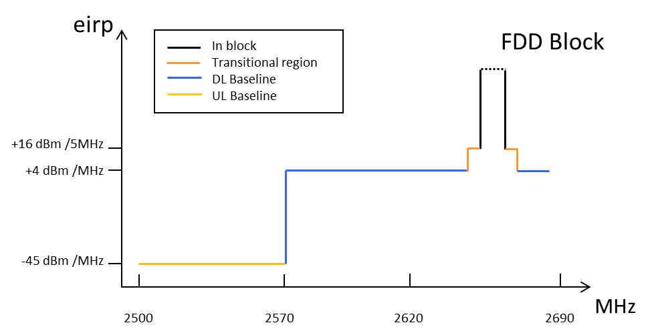

- Combined BEM elements for an FDD block above 2620 MHz
with downlink only operation within 2570-2620 MHz for non-AAS

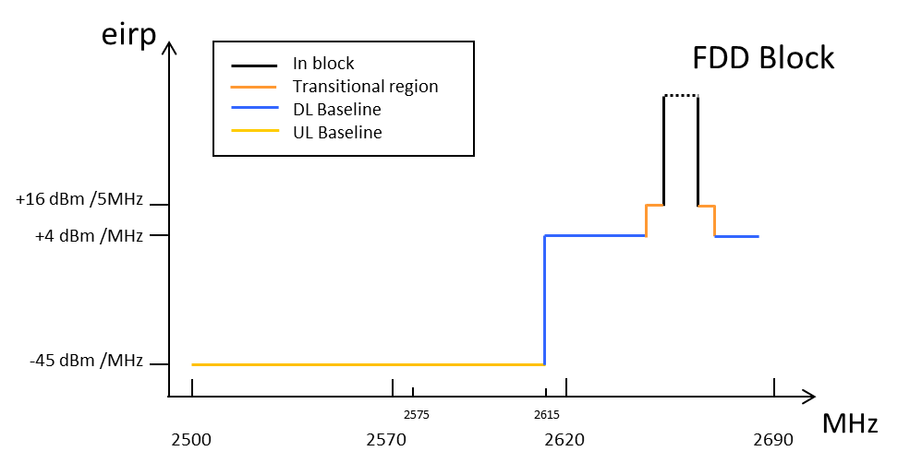
- Combined BEM elements for an FDD block with TDD (synchronised/unsynchronised) networks within 2570-2620 MHz

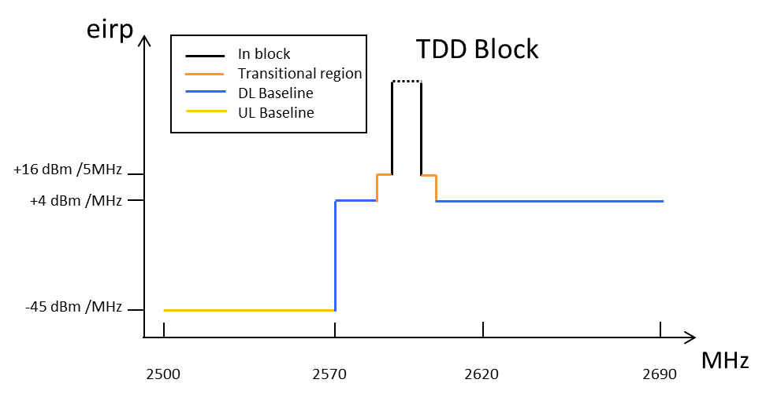
- Combined BEM elements for synchronised TDD blocks/downlink only blocks for non-AAS

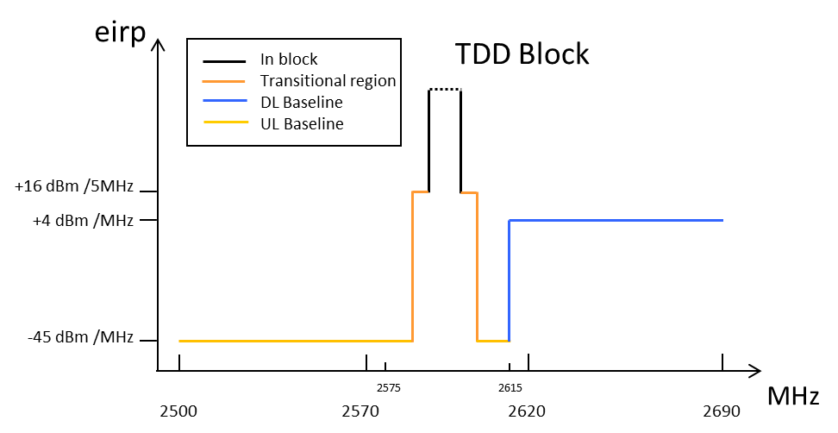
- Combined BEM elements for unsynchronised TDD blocks for non-AAS

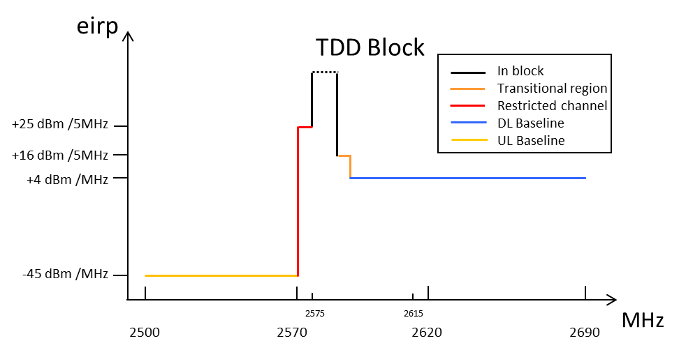
- Combined BEM elements for synchronised TDD blocks/downlink only blocks and
a restricted spectrum block in 2570-2575 MHz for non-AAS
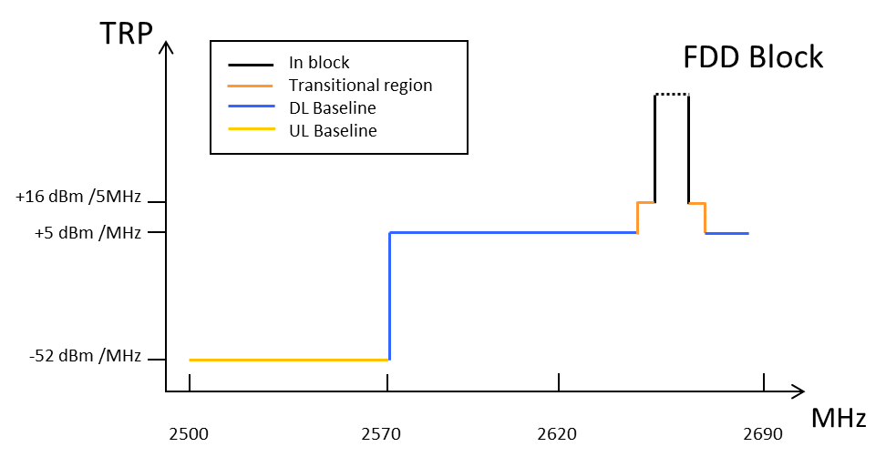
- Combined BEM elements for an FDD block above 2620 MHz
with downlink only operation within 2570-2620 MHz for AAS

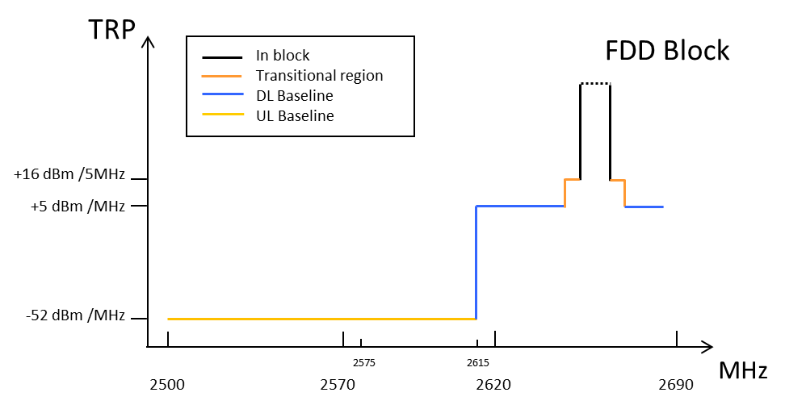
- Combined BEM elements for an FDD block with TDD
(synchronised/unsynchronised) networks within 2570-2620 MHz for AAS
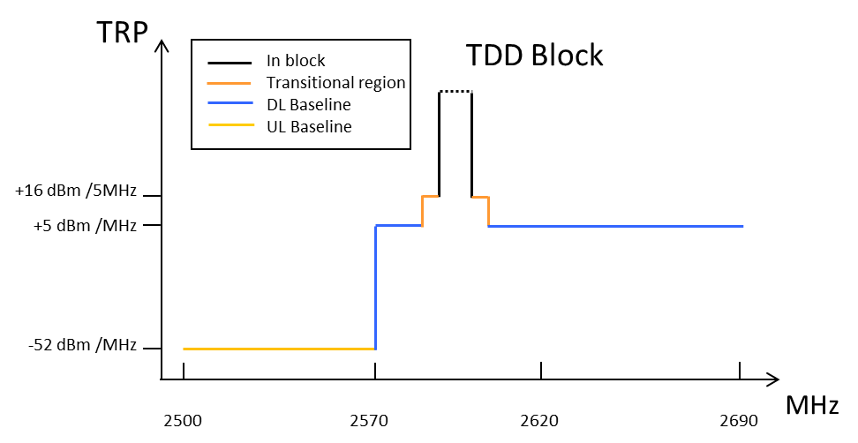
- Combined BEM elements for synchronised TDD blocks/downlink only blocks for AAS

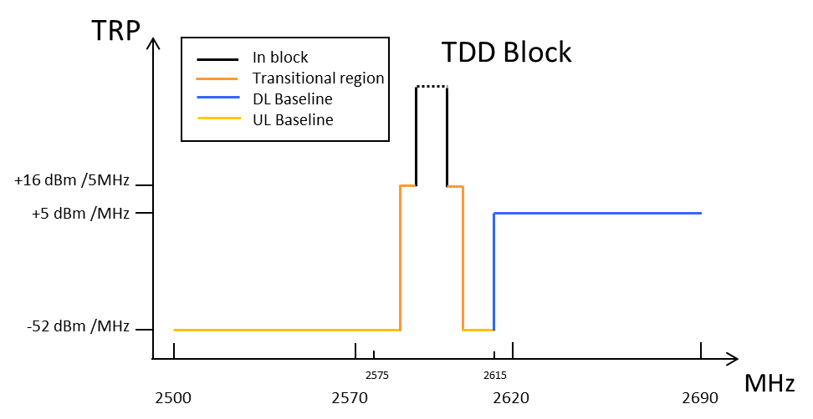
- Combined BEM elements for unsynchronised TDD blocks for AAS
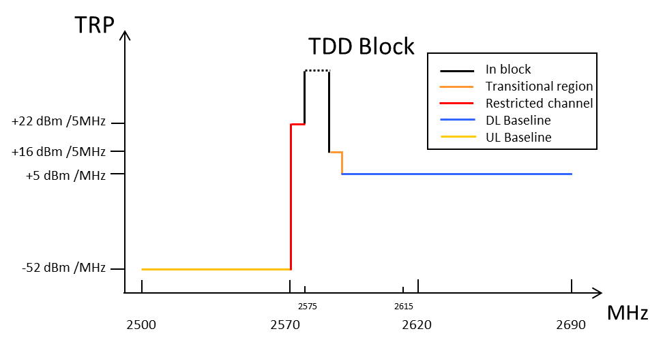
- Combined BEM elements for synchronised TDD blocks/downlink only blocks and a restricted spectrum block in 2570-2575 MHz for AAS
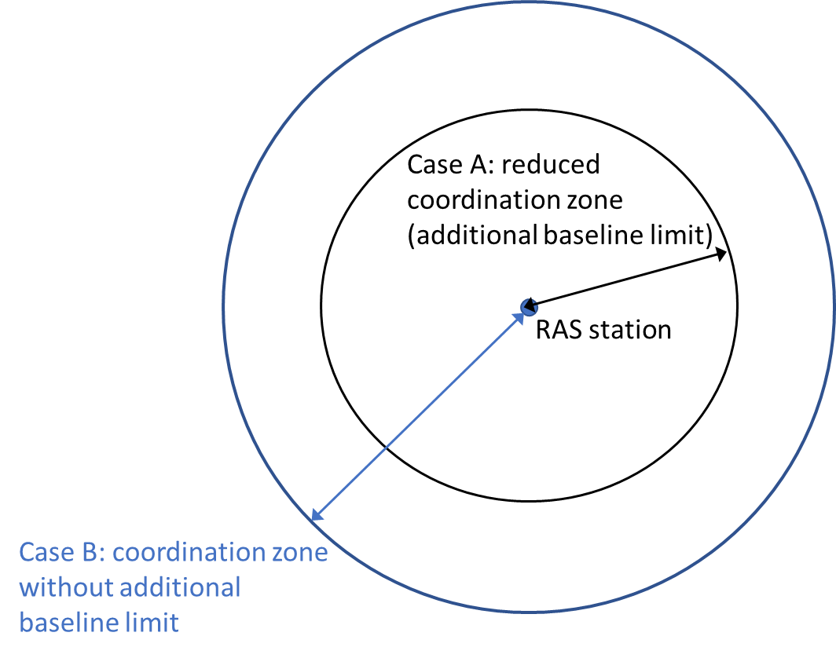
- Simplified example of coordination zones around RAS station for AAS base stations
  - Other conditions
The spurious emission domain for the base station in this frequency band starts 10 MHz from the band edge and the corresponding limits are defined in current ERC Recommendation 74-01 [19].
In addition, that MFCN networks making use of AAS systems shall not be granted more protection from systems in adjacent and neighbouring bands than experienced with non-AAS systems.
- List of referenceS
This annex contains the list of relevant reference documents.
- Commission Decision 2008/477/EC on the harmonisation of the 2500-2690 MHz frequency band for terrestrial systems capable of providing electronic communications services in the Community
- CEPT Report 19: Report from CEPT to the European Commission in response to
EC Mandate to develop least restrictive technical conditions for frequency bands addressed in the context of WAPECS
- ERC Decision (97)07: “The frequency bands for the introduction of the Universal Mobile Telecommunications System (UMTS)”
- ERC Decision (99)25:”The harmonised utilisation of spectrum for terrestrial Universal Mobile Telecommunications System (UMTS) operating within the bands 1900 - 1980 MHz, 2010 - 2025 MHz and 2110 - 2170 MHz”
- ERC Decision (00)01:The frequency bands for the introduction of terrestrial Universal Mobile Telecommunications System (UMTS)”
- ERC Recommendation (02)10: “Harmonised utilisation of spectrum for 1.28Mcps UTRA TDD option in connection with ERC/DEC/(99)25”
- ECC/DEC/(02)06: “The designation of frequency band 2500-2690 MHz for UMTS/IMT-2000”
- Commission Decision 128/1999/EC on the coordinated introduction of a third-generation mobile and wireless communications system (UMTS) in the Community
- Recommendation ITU-R M.2012: “Detailed specifications of the terrestrial radio interfaces of International Mobile Telecommunications Advanced (IMT-Advanced)”
- Recommendation ITU-R M.1457: “Detailed specifications of the terrestrial radio interfaces of International Mobile Telecommunications-2000 (IMT-2000)”
- Resolution ITU-R 56: “Naming for International Mobile Telecommunications”
- Resolution ITU-R 223: “Additional bands identified for IMT-2000”
- Resolution ITU-R 224: “Compatibility studies in relation to Resolution 224 in the bands 698-806 MHz and 790-862 MHz”
- Resolution ITU-R 225: “Use of additional frequency bands for the satellite component of IMT”
- ECC Report 45: “Sharing and adjacent band compatibility between UMTS/IMT-2000 in the band 2500-2690 MHz and other services”
- ITU Radio Regulations Edition of 2016
- ECC Report 216: “Practical guidance for TDD networks synchronisation”
- ECC Report 296: “National synchronisation regulatory framework options in 3400-3800 MHz: a toolbox for coexistence of MFCNs in synchronised, unsynchronised and semi-synchronised operation in 3400-3800 MHz”
- ERC Recommendation 74-01: “Unwanted emissions in the spurious domain”
- Directive 2014/53/EU of the European Parliament and of the Council of 16 April 2014 on the harmonisation of the laws of the Member States relating to the making available on the market of radio equipment and repealing Directive 1999/5/EC
- Draft ECC Report 308: “Analysis of the suitability and update of the regulatory technical conditions for 5G MFCN and AAS operation in the 2500-2690 MHz band”

Comparable technical specifications to those given in this ECC Decision are given in Commission Decision 2008/477/EC of 13 June 2008 [1]. EU/EFTA Member States and, if so approved by the EEA Joint Committee, Iceland, Liechtenstein and Norway are obliged to implement the EC Decision.
Mandate to CEPT to harmonise frequency usage in order to facilitate a co-ordinated implementation in the Community of third generation mobile and wireless communication systems operating in additional frequency bands as identified by WRC-2000 for IMT-2000 systems, 9 March 2001.
Mandate to CEPT to harmonise the frequency usage within the additional frequency band of 2500-2690 MHz to be made available for IMT-2000/UMTS systems in Europe (Mandate 5), August 2003.
This Report will be in public consultation from 8 July to 30 August 2019

