M2M/IoT Operation via Satellite
approved 14 February 2020
ECC Report 305

Executive summary
The development of the Internet of things (IoT) offers a wide range of opportunities for innovation and improvement of performance for all socio-economic sectors. In this context, this Report focuses on how satellite based solutions contribute to the M2M/IoT ecosystem as well as the spectrum requirements and resources available for the development of future M2M communication services via satellite networks.
Existing market studies show that the bulk of satellite M2M/IoT services are based on mobile solutions with relatively low throughputs and are predominantly deployed in MSS frequency bands below 3 GHz. Both GSO and NGSO solutions in these frequency ranges are parts of M2M communications infrastructure. Both solutions offer different advantages and they are able to address different requirements based on the technical and economical objective of the considered M2M/IoT application and its domain of activities.
Satellite networks already address a large number of M2M applications. Taking into account the increased demand for IoT solutions, it is expected that satellite solutions will play an even prominent role providing M2M/IoT services in the future. Satellite networks will help to accommodate increasing capacity needs in isolated or inaccessible areas and supplement or optimise services delivered by terrestrial networks, both in terms of geographical coverage and additional or fall-back communication services.
In this regard, hybrid systems combining the advantages of NGSO and/or GSO satellite networks with terrestrial networks could provide economies of scale, suitable coverage as well as the appropriate level of interoperability among M2M/IoT solutions, which are increasingly integrated at the level of Internet platforms and services. Such systems could be further enabled by the possibility of using close frequency bands, or even the same frequency bands, to deploy hybrid terminals that merge terrestrial and satellite networks to offer communication services for M2M/IoT applications, which support a higher level of integration and quality of radio communication systems.
This Report analyses both stand-alone and hybrid terrestrial-satellite terminal operation and concludes on the following:
- A vibrant ecosystem of M2M services are provided via stand-alone satellite terminals of various types and in multiple network configurations in almost all main satellite frequency bands. It is identified that a further review of ECC Decisions and harmonised implementation of such decisions by CEPT administration may benefit the provision of such services. For the emerging systems suitable frequency bands should be found in order to facilitate the deployment of IoT services via satellite. Due to the rapid increase in demand, the availability of spectrum below 5 GHz needs to be reviewed within the CEPT in order to facilitate novel use for M2M/IoT via satellite;
- Various solutions also exist for dual mode hybrid terminals where terrestrial and satellite communications are achieved. Such solutions generally operate in MSS bands below 3 GHz and are subject to the same regulatory and spectrum conclusions as indicated above for stand-alone terminals. It is also noted that such terminals could benefit from further standardisation work to ease the interoperability between new M2M/IoT technologies;
- There are currently no commercial satellite M2M IoT systems in operation that deliver a fully integrated service via satellite-terrestrial terminals that operate in the same or adjacent frequency bands.
In addition, when considering more specifically spectrum requirements for the development of fully integrated services, the Report determines that:
- Some bands below 3 GHz exist where satellite-terrestrial allocations are adjacent which could allow such services to be developed;
- There are also MSS allocations that overlap with MS allocations below 3 GHz, but these bands are globally harmonised and intensively used for MSS services by a number of satellite operators. Similarly to the band 1980-2010 MHz / 2170-2200 MHz, terrestrial components coordinated among satellite operators and operated as part of their networks in a limited amount of spectrum could still be envisioned although it would be difficult to ensure that such satellite networks could coexist and not interfere with the other satellite operators in the band;
- Finally, new allocations could be created for joint satellite-terrestrial M2M-IoT operation. However, this would also necessitate a need for certain regulatory and licensing frameworks to ensure that various operators could coexist in the same band. One example of such a framework would be ECC Decision (06)09 on the designation of the bands 1980-2010 MHz and 2170-2200 MHz [1];
- For each of the above scenarios, extensive studies to assess feasibility and coexistence between incumbent systems and any new narrow-band and low power IoT device operation would be required.
This Report also studies a specific example of integrated satellite-terrestrial operation in the SRD bands in more detail and reminds the conditions and risks of operating such systems under the provision No. 4.4 of the Radio Regulations [2].
Because of their native characteristics, the satellite networks will play an important role in completing a global infrastructure of M2M/IoT communications that is useful for developing ever more connected and intelligent services. Depending on the domain of activity as well as technical and economic requirements specific to each use case, different frequency resources may already be implemented or may be the subject of further regulatory studies when necessary.
As CEPT administrations consider how M2M/IoT networks will be implemented in the future, the information provided in this Report gives information on spectrum resources which might be the best suited to address the requirements of satellite-based and hybrid systems in the context of an emerging and flourishing M2M/IoT ecosystem. In particular, in order to facilitate novel use for M2M/IoT via satellite, it has been proposed that:
- ECC reviews the Decisions related to S-PCS below 1 GHz;
- ECC continues to review the availability of spectrum below 5 GHz within the CEPT, in order to identify suitable frequency bands for emerging M2M/IoT satellite systems;
- ECC investigates the measures to facilitate coexistence and sharing among non-GSO systems, and between non-GSO and GSO systems in existing MSS allocations below 5 GHz while protecting incumbent systems.

TABLE OF CONTENTS

0 Executive summary 2
1 Introduction 7
2 Definitions 8
3 Role of satellites in the M2M/IoT Ecosystem 9
3.1 Existing M2M satellite systems 9
3.2 Market considerations and future demand for satellite M2M 14
3.3 New satellite systems dedicated to M2M/IoT 15
4 Satellite M2M/IoT – Operational scenarios and regulatory aspects 17
4.1 M2M via satellite in standalone mode 17
4.1.1 IoT backhauling 17
4.1.2 Direct Access 18
4.1.3 Regulatory considerations 18
4.2 M2M via hybrid terrestrial/satellite systems 19
4.2.1 Integrated solution with two different frequency ranges 20
4.2.2 Fully-integrated solution operating on the same band 21
4.2.3 Different levels of integration 21
4.2.4 Regulatory considerations for hybrid operations 22
5 New hybrid IoT systems based on SRD framework 24
5.1 Operational considerations and background information 24
5.2 Frequency bands identified for use by terrestrial IoT SRD terminals 24
5.3 Regulatory Aspects 25
6 Conclusions 28
ANNEX 1: Frequency bands allocated to MSS below 1 GHz in CEPT 30
ANNEX 2: Frequency bands allocated to MSS above 1 GHz and below 3 GHz in CEPT 33
ANNEX 3: Main terrestrial IoT Frequency bands and Satellite component of ioT 37
ANNEX 4: List of references 39

LIST OF ABBREVIATIONS

Abbreviation | Explanation
3G, 4G, 5G | Third, Fourth, Fifth generation of mobile technology
3GPP | Third Generation Partnership Project
ADCS | Argos Data Collection System
BR | Radiocommunications Bureau
CEPT | European Conference of Postal and Telecommunications Administrations
CGC | Complementary Ground Component
DCAAS | Dynamic Channel Activity Assignment System
EC | European Commission
ECC | Electronic Communications Committee
EC-GSM-IoT | Extended Coverage GSM IoT
EESS | Earth Exploration Satellite Service
e.i.r.p. | Equivalent Isotropically Radiated Power
ES | Earth Station
ETSI | European Telecommunications Standards Institute
EU | European Union
FSS | Fixed Satellite Service
GMPCS | Global Mobile Personal Communications by Satellite
GSM | Global System for Mobile Communications
GSO | Geostationary Satellite Orbit
IMT | International Mobile Technologies
IoE | Internet of Everything
IoT | Internet of Things
IP | Internet Protocol
ITU | International Telecommunication Union
LBRDC | Low Bit Rate Data Communications
LEO | Low Earth Orbit
LPWAN | Low Power Wide Area Network
LTE | Long Term Evolution
LTE-eMTC | LTE evolved Machine Type Communications
LTE-MTC | LTE Machine Type Communications
M2M | Machine to Machine
MEO | Medium Earth Orbit
MES | Mobile Earth Station
MFCN | Mobile/Fixed Communications Networks
mMTC | Massive Machine Type Communications
MNO | Mobile Network Operator
MSS | Mobile-Satellite Service
MTC | Machine Type Communications
NB-IoT | Narrowband IoT
NCF | Network Control Facility
NGSO | Non-Geostationary Satellite Orbit
OSS | Operations Support Systems
PAN | Personal Area network
PMR | Private Mobile Radio
RLAN | Radio Local Area Network
RR | Radio Regulations
RSPG | Radio Spectrum Policy Group
SCADA | Supervisory Control And Data Acquisition
S-PCS | Satellite Personal Communication Systems
SRD | Short Range Devices
UMTS | Universal Mobile Telecommunications System
VHF | Very High Frequency
VSAT | Very Small Aperture Terminal
WAN | Wide Area Network
Wi-Fi | Wireless Fidelity
WG FM | Working Group Frequency Management
WRC | World Radiocommunications Conferences

Introduction
It is expected that by year 2020 the Internet of Things (IoT) ecosystem will consist of billions of connections between various M2M terminals. This is expected to provide significant socio-economic benefits and revolutionise a wide range of industries. Many solutions are already deployed or investigated to address this market, including satellite IoT solutions.
The main purpose of this Report is to analyse the role satellites are currently playing in the M2M/IoT ecosystem and to identify additional scenarios where satellites could play a central role in the future by:
- Investigating how satellite-based solution contribute to the M2M/IoT ecosystem;
- Identifying which range(s) of frequencies are currently used for satellite M2M/IoT ecosystem and could be used in the future;
- Identifying regulatory and spectrum challenges and potential enablers that impact satellite M2M/IoT operation.

Definitions
Various publications have focused on the terms IoT and/or “Internet of Everything” (IoE) when referring to the devices and application services. These publications describe IoT as the interconnection of large numbers of everyday devices to provide a range of new and innovative services. Machine-to-machine (M2M) is an older term used to refer to connected devices; sometimes, the terms M2M and IoT are used to describe the same services and types of connections. In parallel the concept of Machine Type Communications (MTC) has also emerged in the International Telecommunications Union. Fixing a definition of M2M communications or MTC as distinct from IoT only makes a crucial difference when market requirements or regulatory obligations explicitly depend on that distinction. In this Report, the terms MTC, M2M and IoT are used as equivalents.

Role of satellites in the M2M/IoT Ecosystem
Many industries rely on M2M services in order to ensure employee and equipment safety, to manage and optimise operations or to track and monitor their assets. When these industries have assets and personnel that constantly move from one location to another or operations that take place in areas with limited or no terrestrial connectivity, satellites with their large, reliable and ubiquitous coverage areas become a key enabler and often the only option to achieve M2M connectivity. The following table provides examples of M2M applications provided by satellite networks to various industries. Satellites have delivered some of these applications for more than a decade, while others are expected to become more widespread in the future as the markets develop.
Table 1: Examples of satellite M2M applications
Market Sector | Application
Transportation  (land, maritime and aeronautical) | Asset tracking, telematics and analytics, logistics optimisation, fuel management, safety applications, weather data, transportation network (road, railroad, shipping, airborne) monitoring and signalling
Governmental services | Military and civil governmental asset and personnel monitoring and tracking, fuel management, safety applications, logistics, telematics
Oil and gas | Monitoring of distribution, exploration and production of oil and gas, safety applications, telematics
Energy | Monitoring of electricity distribution and production (including renewables), smart-meters
Agriculture | Logistics optimisation, asset monitoring and tracking, production, yield monitoring and management (watering, fertilizing), precision farming
Environmental | Meteorological data monitoring and reporting, natural, industrial, pollution, emergency, and risk management, fishing monitoring , oceanography, animal tracking
Mining | Safety applications, asset and sensor monitoring, telematics
Construction | Monitoring of various meters and sensors (pressure, water flow), safety applications, employee and asset tracking
Telecommunications | Access to data networks (intranet, extranet, internet) and solutions via satellite, especially in terrestrial areas without adequate terrestrial communication means or with terrestrial coverage gaps, or where satellite coverage can be used for data acquisition or data distribution in an efficient way, especially in cases where national or multinational enterprises operate a greater number of points of presence or where point-to-multiple-point or broadcasting data applications can benefit from a greater satellite coverage (contribution and/or distribution of data).

Existing M2M satellite systems
M2M services have been mainly offered by MSS operators (e.g. Inmarsat, Orbcomm, EchoStar Mobile, Iridium, Globalstar, Thuraya and Omnispace) using frequencies below 3 GHz (L-Band, S-Band and VHF) over both NGSO and GSO constellations. A wide range of terminals with a wide range of prices, dimensions and capabilities are available to accommodate the industry-specific requirements of the end-users, including terminals that offer dual satellite-terrestrial operation to leverage the benefits of both technologies as well as satellite modules for easy integration into new products or bespoke solutions. The following table provides examples of M2M terminals operated with traditional MSS/FSS networks.
Table 2: Examples of existing M2M terminals
Terminal | Description
Inmarsat Explorer 540  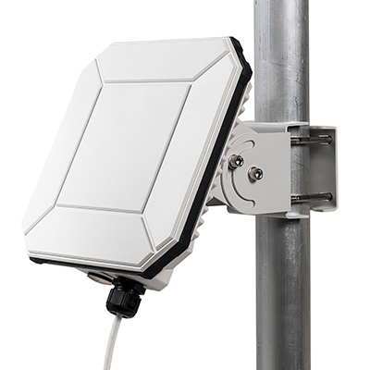 | M2M terminal at 20 x 20 cm and 1.6 kg that operates both Inmarsat BGAN and 2G/3G/LTE networks. It is used for following applications: IP SCADA for data backhaul, remote surveillance, remote telemetry, remote tracking of fixed and mobile assets, oil well head telemetry and monitoring, railway track and crossings, remote personnel tracking, traffic management, secure and encrypted ATM/PoS solution, smart grid, smart metering, telemetry, weather, environmental monitoring
Orbcomm IDP-782  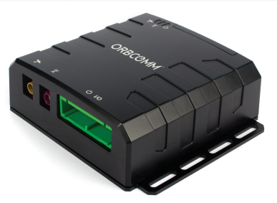 | Terminal for fleet-management that provides terrestrial based data transmission in areas with cellular coverage, and reliable, always-on satellite communications over the two-way Inmarsat IsatData Pro satellite network in remote locations that can be used in security applications to track vehicle location, driver behaviour, text messaging, e-forms, alarms and more. This device can also be used in SCADA applications to monitor and control fixed oil and gas equipment
EchoStar Mobile 4200 Portable Data Terminal  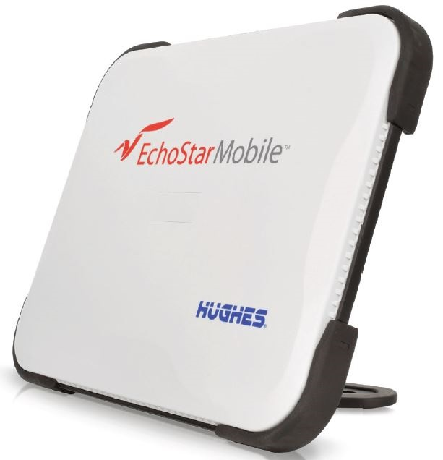 | The EML 4200 meets the SCADA requirements of governments, public protection and security, remote healthcare and emergency facilities, utility companies, forestry services, and applications in the oil & gas industry
IDP-800  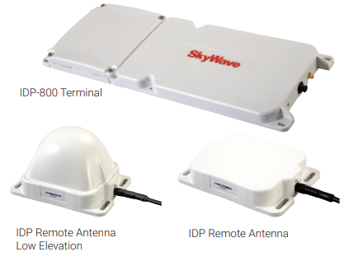 | Low-profile (43.2 cm x 14.7 cm x 2.5 cm), fully programmable satellite communications device with an integrated battery compartment that uses the two-way Inmarsat IsatData Pro satellite data service network for remotely tracking and monitoring trailers, containers, vessels and other fixed and mobile assets
Honeywell SAT-401  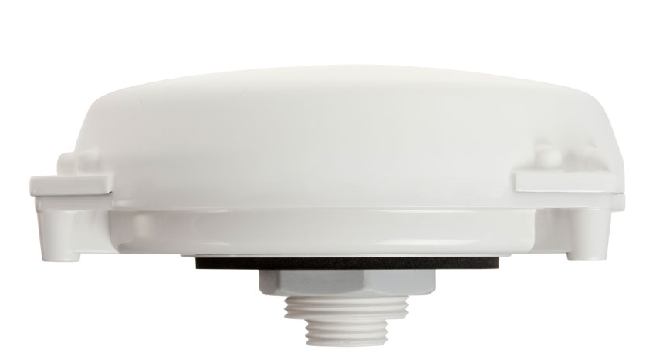 | Multi-purpose satellite terminal (11.2 cm x 3.7 cm) for tracking and monitoring high-value assets like vehicles, vessels, and cargo containers. Allows connected external sensors to report additional data such as speed, tyre pressure, fuel consumption and allows drivers to immediately warn others of danger. Uses the Inmarsat constellation of satellites and the IsatM2M standard
Iridium Edge  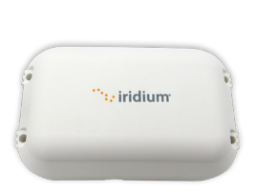 | Satellite IoT communications device (13 cm x 8 cm x 3 cm) that can be rapidly deployed and complements terrestrial-based solutions for fleet management, telematics, safety and other remote monitoring applications
Globalstar SmartOne C  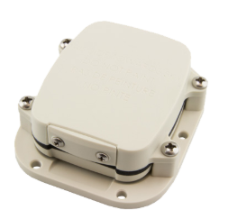 | Device (6.86 x 8.26 x 2.54 cm) for intelligent management of both fixed and mobile assets (including intermediate bulk containers, vehicles and boats). Utilises motion sensors, comparative GPS positions and custom configured sensors to gather and transmit asset status information. Configured to track its asset's specific needs and provide intermediate and emergency alerts by email or text
Globalstar SmartOne Solar  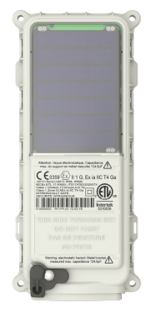 | Solar powered terminal (8.26 X 17.78 X 2.86 cm) with up to 10 years of usable service. Potential applications: monitor & track assets and fleet movements even in remote locations. Oil & Gas: aids in mobilizing & deploying high value assets in the field. Construction: equipment usage tracking. Security: track valuable mobile assets such as rail cars, propane tanks. Marine: Monitor & track high value assets, such as boats, barges and containers, at the dock and off-shore. Other industry uses: Mining, forestry, government, fisheries
Thuraya T2M-DUAL  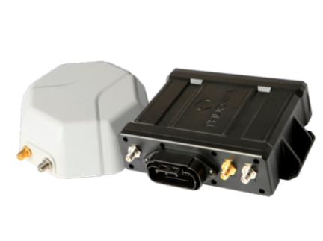 | M2M terminal 13 x 10 x 3.9 cm with dual-mode capabilities between Thuraya’s satellite M2M network and GSM networks. Provides simultaneous data collection from external sensors, peripherals, and vehicle or heavy equipment. Example applications: fleet management, rail tracking, oil and gas and pipeline monitoring, smart grid and smart metering, security surveillance and tracking
hiSky Smartellite™ Static  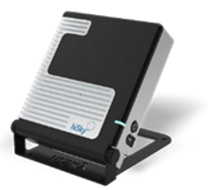 | hiSky is collaborating with Hispasat to commercialise its satellite terminal of 16 x 18.5 x 4.85 cm. The terminal includes antennas, RF modules, modem and battery, which are integrated in a small form factor, portable and lightweight terminal for IoT and MSS services. The terminals are easily connected with all M2M/IoT devices via WIFI/Bluetooth/LAN or any Smartphone. Applications include agriculture, oil and gas, electricity (smart grid/metering), mines, ATM/PoS solution, weather stations and more
hiSky Smartellite™ Dynamic  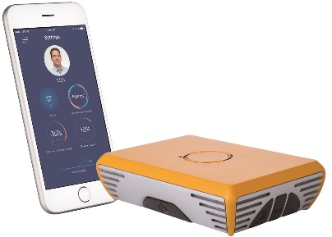 | hiSky is collaborating with Hispasat to commercialise its satellite terminal of 16 x 11 x 4.5 cm. The terminal includes Electronic Steerable Antennas (ESA), RF modules, modem and battery, which are integrated in a small form factor, low-profile and lightweight on the move terminal for IoT and MSS services. The terminals are easily connected with all M2M/IoT devices via Wi-Fi/Bluetooth/LAN or any Smartphone. Applications include fleet management, rail tracking, agriculture (tractors), fishery, connected cars, containers and more
Example of Argos connected devices  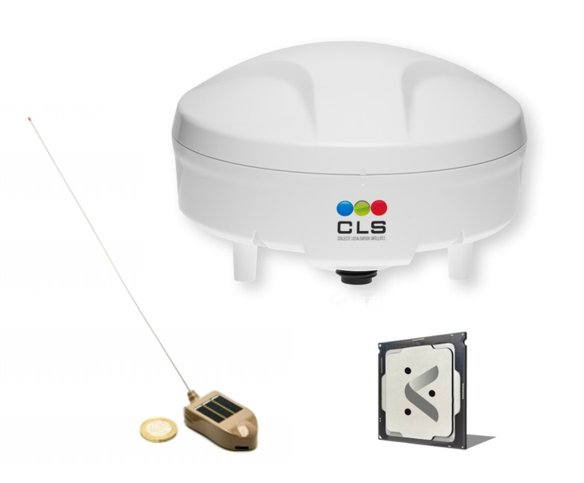 | Devices integrating Argos Transmitter are used for various applications, from animal tracking to fishing vessels monitoring and meteorological buoy data collection. Argos communication modules can be integrated in various objects to provide global tracking and data collection capabilities
Omnispace Terminal Model 1003  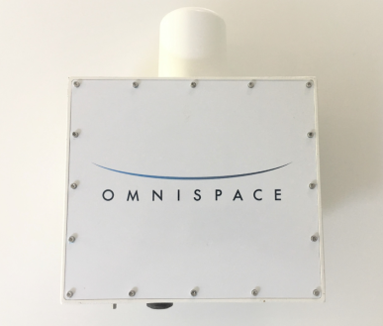  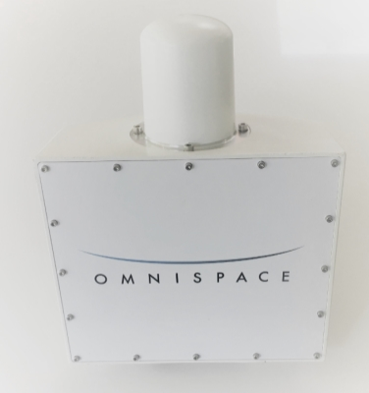 | Omnispace Model 1003 has been deployed in several areas for trials and provides user connectivity in remote areas with applications such as data gathering, remote site IoT backhaul, Shipboard and UAV data links, Emergency services and Maritime deployment. Terminal has capability for Full duplex data at 340 kbps per basic 150 kHz channel.
Examples of modules:  Iridium 9603  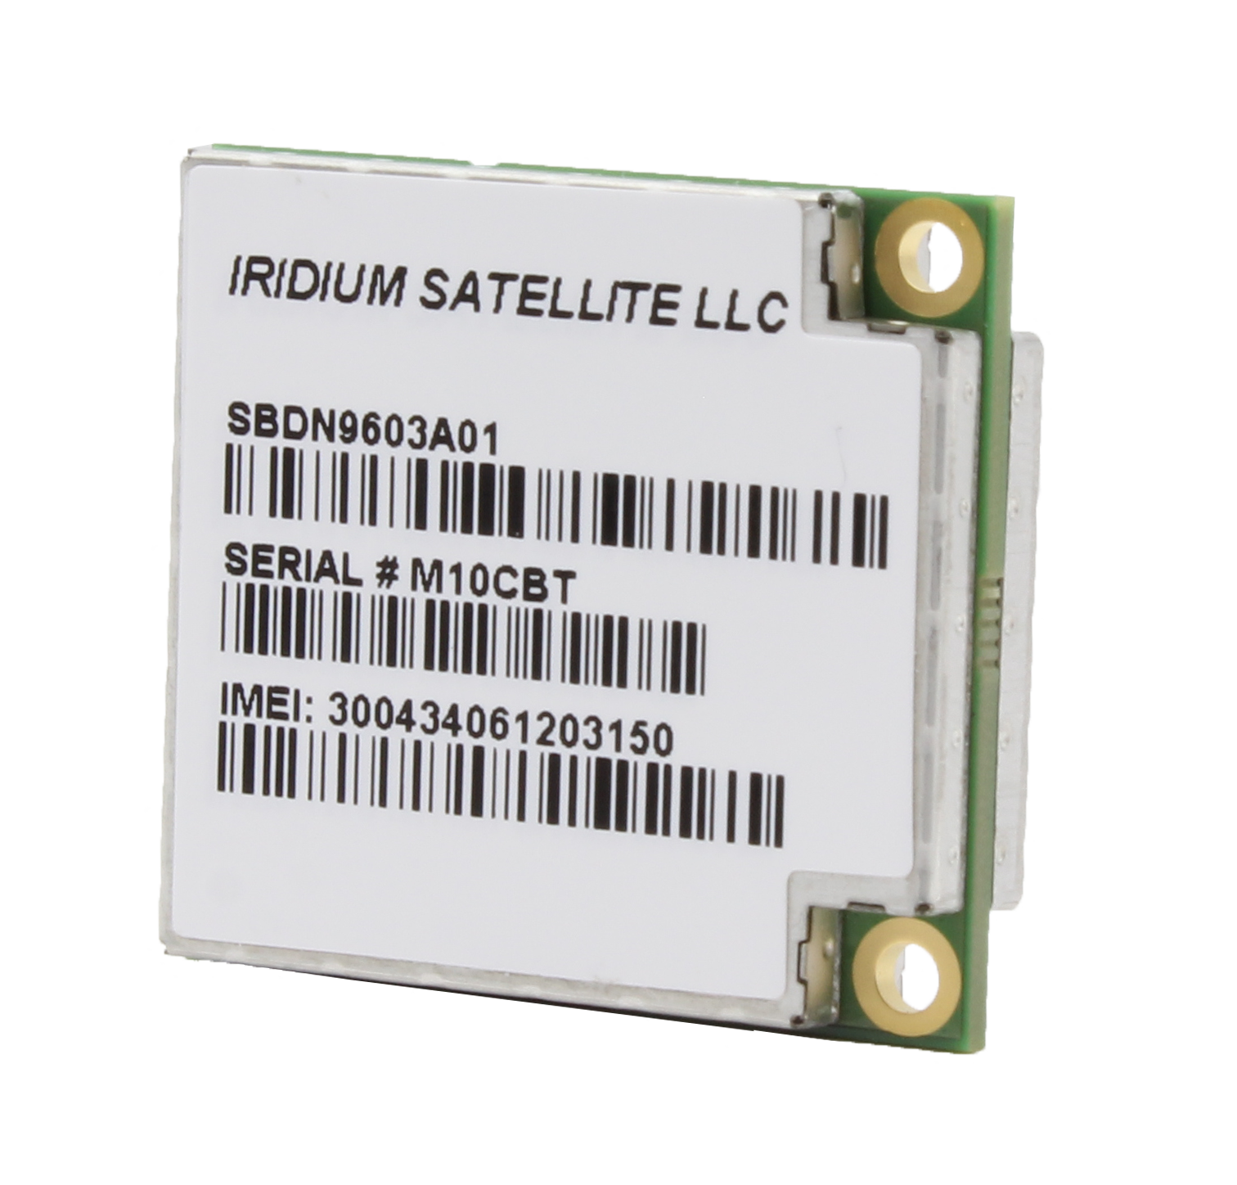  Globalstar Stinger  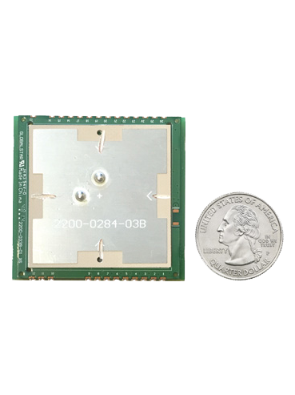  Orbcomm OGi  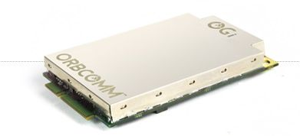  Inmarsat BGAN Radio Module (BRM)  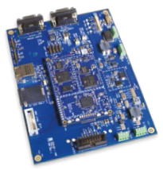  Airbus DS - UNIT Communication Module (UCM)  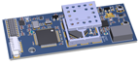  Hiber Communication Node  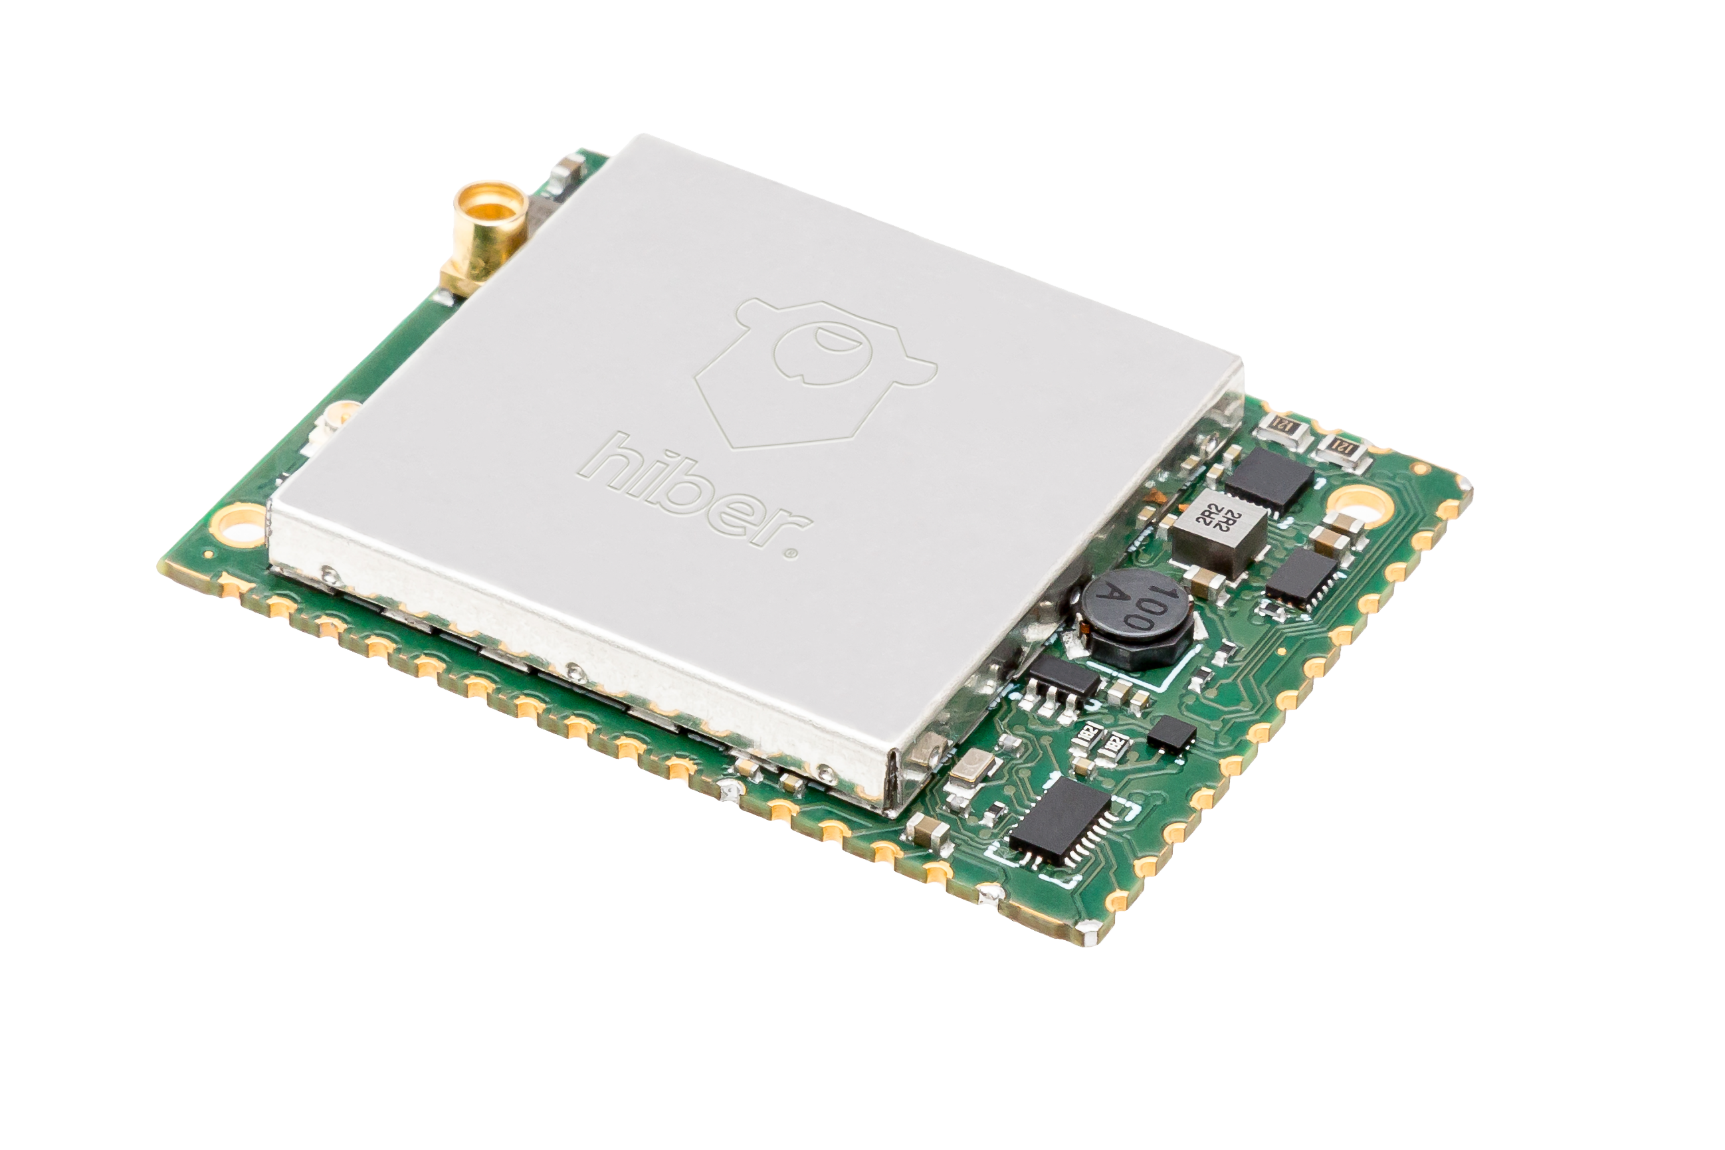 | Small satellite transceiver modules that that can be easily integrated into different M2M and IoT devices to provide satellite connectivity and enable remote sensing, tracking and monitoring applications
General connectivity requirements of various industries (including for M2M services) have increased significantly over the years, which has resulted in M2M/IoT connectivity being delivered through standard MSS or FSS satellite broadband connectivity terminals in addition to M2M terminals specifically designed for that purpose. For example, aircraft and vessel connectivity is generally delivered today through a single satellite terminal such as L-band and S-band MSS terminals or Ku or Ka-band terminals. Such terminals would provide at the time broadband connectivity as well as enable aircraft M2M services (sensor analytics, weather updates, flight route analytics, flight maps, safety applications). Similarly, mining operations are often in remote locations with satellites being the only option for connectivity. The use of VSAT type terminals for M2M services (as either standalone terminal or backhaul for other M2M devices) is expected to increase in the future as the evolution of satellite technology continues to drive down the cost of throughput as well as satellite terminals. This trend coincides with the general increase in demand for M2M connectivity as more and more industries are automated which is studied closer in the following section.

Market considerations and future demand for satellite M2M
Market size estimations vary widely depending on the definition and the analysis. A market study [3] funded by the UK Space Agency’s National Space Technology Programme (NSTP), anticipates that satellites served 3.16 million devices in 2015 and that they accounted for 5% of all M2M/IoT applications. Considering the unique capability of satellite networks to offer global coverage and reliable connectivity in remote areas, the same market study estimates that the total amount of devices connected by satellite networks could grow up to 5.97 million by 2025.
From a frequency perspective, the market study provides that a large majority (i.e. 93%) of the devices are used in frequency bands allocated to Mobile Satellite Service (MSS) below 3 GHz due to the narrowband nature of most satellite M2M applications.
Other analysts estimate that global retail revenue of M2M/IoT over satellites in 2017 were about USD1.5 billion and is expected to increase to USD2.6 billion in the next 10 years [4].
This growth is driven by the expansion of existing industries that rely heavily on satellite M2M services as well as demand from new applications arising from terrestrial 5G systems, which a number of different satellite systems can be envisaged to support. The introduction of 5G systems is expected to usher in a new era of mobile communications with one key area being massive Machine Type Communications (mMTC).
As described in a recent paper from the European Space Agency (ESA) [5], satellite systems can meet key mMTC system requirements with different levels of optimisation and efficiency depending on the use cases. In fact, IoT and mMTC domains cover almost all vertical sectors, the extremely large variety of resulting applications makes it inevitable that satellite technologies are required to support the different capabilities and achieve the level of expected coverage and reliability. Examples of expected mMTC applications are indicated in the figure below. Satellites networks are already providing services to these markets and will be required to do so in the future to support mMTC requirements.
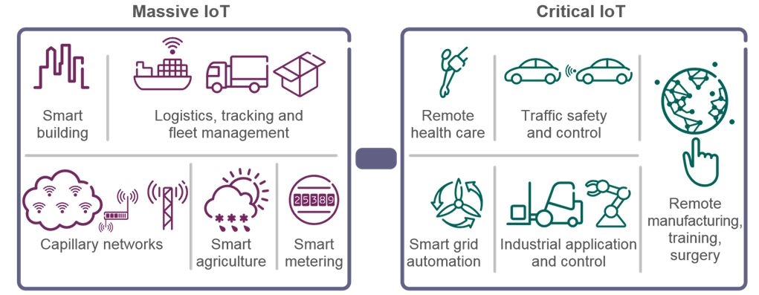
Figure 1: Categories of IoT applications
The Radio Spectrum Policy Group (RSPG) in its spectrum roadmap for IoT [6], also predicted growth of IoT applications and translated its wide range of use cases into a range of operational requirements for IoT networks as shown in the table below. It is evident that just one access technology will not be sufficient to achieve these operational requirements.
Table 3: IoT categories and operational requirements
Massive communications | Critical communications
Operational requirements
Low device cost  Simple devices  Low energy consumption  Small data volumes  Intermittent uses  Can tolerate signal latency  Massive number of devices  Extended coverage | Ultra-reliability  High availability  Potentially uninterrupted communications  Real-time communications  Very low signal latency  Guaranteed in-time delivery
Satellite networks can provide M2M services in many different configurations in order to meet the specific needs of the M2M application. A general distinction can be made between configurations that use satellite terminals, which offer stand-alone satellite connectivity and hybrid terminals, which combine both terrestrial and satellite connectivity into one terminal. These modes of operation are further studied in the sections below.

New satellite systems dedicated to M2M/IoT
As satellite launch cost has decreased and nanosatellite technologies have made possible faster and cheaper access to space technologies, new systems dedicated to Satellite IoT system have emerged in the last years.
For example, Kineis is launching a 20 nanosatellites constellation to provide low cost and global IoT connectivity. Relying on Argos System technology, the new system will enable to connect millions of objects and collect messages once per day or many times per hours. Such systems are particularly well suited to offer communication back up when terrestrial connection of Massive IoT objects is missing, to ensure coverage over oceans and seas where no terrestrial network is deployed, or to facilitate communication with internationally mobile objects.
There is a growing number of operators seeking to bring online their novel satellite IoT networks in the short to medium timeframe. Toronto’s Kepler Communications is launching 140 nanosatellites in LEO to provide a hybrid FSS/MSS network with global coverage, and is already providing FSS service to the Americas, Europe, and Australia. Amsterdam-based Hiber is deploying its constellation of 70 satellites to bring affordable connectivity to the world. SwarmTechnologies intends to operate a constellation of 150 small LEO satellites in the VHF band. Others include the UK’s Sky and Space Global, Switzerland’s Astrocast, Germany’s KLEO Connect and SAT4M2M, Australia’s Fleet Space and Myriota, and Canada’s HeliosWire.
One of the greatest barriers they face is a lack of access to, and availability of spectrum allocated to the MSS.
When considering constellations of small satellites, not all bands are equal. MSS spectrum particularly below 5 GHz is technically advantageous for mobile applications for reasons including the following:
- Low rain fade allows small, power-limited devices to achieve adequate link qualities;
- Antenna sizes are appropriate for small, portable equipment form factors;
- Frequencies are low enough to not necessitate highly directional antennas. A directionality requirement would severely complicate or jeopardise the utility of certain mobile devices;
Extensive popularity of the band begets greater commercial-off-the-shelf component availability. Manufacturers can leverage existing economies of scale for their ground equipment. By their nature, MSS devices need to be small, cheap, and numerous for successful market adoption.
Ultimately, spectrum within 1.5-5 GHz is ideal for MSS satellites with small form factors both in space and on the ground. Taking into account the desired throughputs; lower spectrum requires larger antennas while higher spectrum requires more power and directivity.

Satellite M2M/IoT – Operational scenarios and regulatory aspects
IoT applications provide various opportunities for established and emerging satellite operators, especially in connecting remote areas that lack terrestrial infrastructure. Over the past few years a number of initiatives and decisions were undertaken and adopted either at global level or at regional level to foster IoT development and to study the related wireless systems and applications. In particular, Resolution ITU-R 66 invites ITU-R to conduct studies on the technical and operational aspects of radio networks and systems for IoT. In Europe, RSPG identified among others, satellite frequency bands for the provision of IoT services and ECC Report 280 [7] lists a number of scenarios where satellite can play a key role for IoT deployment.
Satellite connectivity to IoT devices can be provided in various configurations utilising both GSO and NGSO satellite constellations. These services can be delivered either by terminals that provide stand-alone satellite connectivity or hybrid satellite-terrestrial terminals, which combine the advantages of both technologies. The sections below analyse the operation of both stand-alone and hybrid satellite terminal operation and the regulatory/spectrum challenges and enablers associated with each service.

M2M via satellite in standalone mode
As introduced in Section 3 above, satellite M2M services in standalone mode are already widespread throughout traditional satellite bands (VHF/UHF, L, S, C, Ku, Ka) and are delivered by both NGSO and GSO constellations. Standalone services can be divided into two applications: backhaul solutions and services that offer direct access to the M2M terminal.

IoT backhauling
Satellites terminals already provide connectivity to many industries, particularly in areas where terrestrial connectivity is inadequate or non-existent. As such, these terminals can be used to provide connectivity to a wide range of sensors that are required for the operation of specific industries (e.g. at mining camps, oil and gas platforms etc.). Another typical scenario where M2M/IoT applications can benefit from space system capabilities is the satellite backhaul of terrestrial networks such as Low Power Wide Area Networks (LPWAN) or mMTC networks. Although the majority of the base stations will be co-located in areas with existing infrastructure such as microwave links or fibre connectivity, fixed satellite connectivity will further expand the possibility of terrestrial operators to deploy base stations in remote areas as well as individuals or private companies to develop local area networks in specific points of interest. A diagram illustrating the scenario of IoT backhaul over satellite is shown on the figure below.
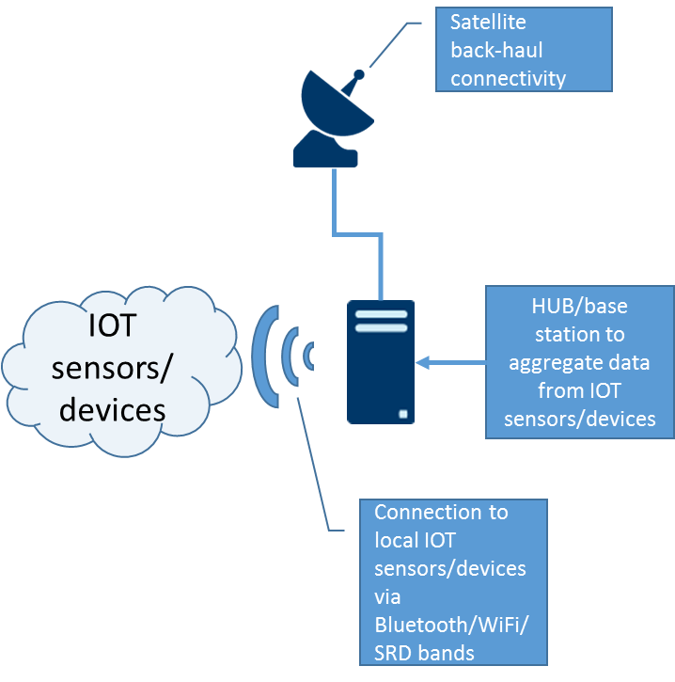
Figure 2: IoT backhauling

Direct Access
The majority of IoT applications operated by satellite systems rely on MSS bands below 3 GHz and as provided in Section 3, a wide range of terminals already exist that provide connectivity to a number of use cases by leveraging NGSO and GSO orbits, various architectures and coverage. When the power consumption and the form factor of the terminal take precedence over other aspects, NGSO constellations can bring significant advantages, including reduction of cost of service. On the other hand, when global coverage and real-time connectivity is a must-have with few or low constraints applicable in terms of energy efficiency, GSO systems can ensure a reliable and continuous connectivity over extended areas with only a few satellites.
Latency, uninterrupted communication and reliability requirements are also key criteria for network design and satellite on-board processing definition. Different strategies based on different topologies and routing protocols can result in very different categories of Quality of Services (QoS) from hard real-time, soft real-time to non-real-time communications with several hours of delays in some cases.
Ultimately, for the less stringent applications when the number of devices and cost considerations outweigh other aspects, simplified architecture can support very efficient Data Collection System (DCS) where low volume of data and information, such as position coordinates or temperature values are collected from simple and cost-effective sensors for both GSO and NGSO constellations. In fact, a wide range of small satellite LEO constellations are currently being launched, which intend to cater to such M2M/IoT applications. These constellations range from 10s to 100s of small LEO satellites and have been proposed to operate in various frequency bands (L, S, Ku, VHF/UHF) to deliver services for a few to tens of USD per device per year.
Modern satellites have the ability to reconfigure their mission and allocate part of their available frequency bands to new applications using software defined radio technology. Such a capability can enable the evolution of existing satellite solutions along with new radio protocols to meet new requirements for IoT applications. One example of such innovation is the development of new waveforms for satellite communication that would require significantly less energy to operate and extend the operational time of sensors and M2M equipment, therefore making the service even more attractive to M2M applications with stringent power consumption requirements.

Regulatory considerations
There is already a vibrant ecosystem of M2M services that are provided via stand-alone satellite terminals. These services are delivered through a wide range of terminals (as indicated in Section 3) and both GSO and NGSO constellations. Almost all MSS or FSS spectrum allocations can be used to deliver these services (depending on the nature of the application) and there has been a surge of new small satellite service providers attempting to enter the market.
Due to the nature of MSS and how systems have historically been developed, sharing spectrum is difficult. For example, co-located operations of omnidirectional terminals by different satellite operators on the same frequency may be among the causes of band segmentation in the MSS bands below 2.5 GHz. This is especially true where such systems operate Complementary Ground Components (CGC) to complement the satellite service, due to the interference environment.
Harmonisation and availability of MSS spectrum is an essential condition to facilitate a standardised and ubiquitous rollout of satellite IoT networks. WRC-23 will consider possible new allocations for mobile-satellite service for future satellite-based M2M/IoT applications. It will consider them for several frequency bands, between 1685 MHz and 3400 MHz on a regional basis, including in 2010-2025 MHz within ITU Region 1.
Some regulatory/spectrum challenges and enablers to facilitate satellite operation for stand-alone satellite operation are identified:
- There may be a need to review the ECC Decisions for free circulation of S-PCS devices below 1 GHz. These have not been amended since 1999 and could be updated to include the requirements of new satellite operators who are entering or have entered the market. This could improve the free-circulation of the terminals provided by new satellite operators by helping administrations to harmonise the licensing requirements. As part of the review, the application term S-PCS should also be reconsidered;
- Lack of national implementation of ECC Decisions can be problematic. In order to deliver satellite M2M services to the European customers, the devices would need to be able to freely operate throughout CEPT. However, it has been identified that not all member states have made such frequencies available for satellite M2M operation based on ECC Decisions (particularly below 1 GHz) without there being particular concerns for interference. Furthermore, even if the frequency ranges are available, there may still be a need for a licence for each terminal or requirement for operators to register/notify in a country before services can be provided. Therefore, the free circulation has not been successfully harmonised throughout CEPT and this can be particularly challenging for satellite operators targeting markets requiring very low cost of service, as additional fees and unnecessarily burdensome licensing procedures severely impact such operations;
- For the emerging systems suitable frequency bands should be found in order to facilitate the development of IoT services via satellite. Due to the rapid increase in demand, ECC should continue to review the availability of spectrum below 5GHz within the CEPT in order to facilitate novel use for M2M/IoT via satellite;
- Novel operators have the opportunity to participate in ECC groups and demonstrate how their technologies can avoid potential interference to existing, planned and future radio applications, and are encouraged to seek such opportunities in ECC groups;
- ECC investigates the measures to facilitate coexistence and sharing among non-GSO systems, and non-GSO and GSO systems in existing MSS allocations below 5GHz while protecting incumbent systems.

M2M via hybrid terrestrial/satellite systems
In this section, M2M via Hybrid satellite solution is defined as an alternative where the M2M service is offered by both terrestrial and satellite networks within a single terminal. Different scenarios could be envisaged and for each of them the regulatory enablers and challenges are further investigated.
The hybrid solution is identified as the scenario which may offer the most optimised approach to meet application service cost, performance and coverage targets. In this context, terrestrial networks can offer urban coverage whereas the satellite segment is more appropriate to cover other less populated areas (noting that the satellite solution may not be the most appropriate to offer a reliable solution to grant service within urban area due to shadowing by buildings, multiple path and other constraints).
As a matter of fact, solutions combining satellite networks with terrestrial networks generate great interest among the community of industrial users and IoT service providers, who want to expand their coverage areas, portfolio of services to various markets and improve or scale the quality of service to meet application needs.
In this perspective, the more integrated is the system, the better will be the user experience and system efficiency. However, such benefits may come with a greater system complexity as seamless integration between satellite and terrestrial networks may affect all the components of communication infrastructures: end-user devices, core networks, services, communication protocol, air-interface and spectrum access.
Hybrid satellite terminals may be designed in a number of ways. Multiple frequency bands (or modes) can be built into a single terminal, as is commonly seen today in cellular handsets or dual satellite-terrestrial M2M terminals. Alternatively, system integrators may utilise multiple separate modules, to access different available networks, automatically selecting either a satellite or terrestrial network based on availability. Standardisation of the interfaces has made the integration of such modules straightforward, and permits the substitution of alternative modules where the market demands.
Another option is to use a single front-end and antenna for both satellite and terrestrial communication on the same or adjacent frequency band. With this respect, the use of adjacent or shared frequency bands between terrestrial and satellite systems could result in market expansion of IoT services as such arrangements create opportunity of economy of scale for hybrid devices. Areas with high density of devices can be served by MFCN infrastructure, while satellite networks will support for the same pool of devices seamless communication in isolated areas as well as critical or last-mile connectivity. Combined with the standardisation of communication protocols and network architectures, the resulting level of interoperability could further enhance innovative applications and create new value added services for end-users.
The expansion of such hybrid/integrated systems comes with numerous advantages for network and service operators, manufacturers, administrations and ultimately European citizens and consumers:
- It increases the flexibility of systems to suite a wider range of applications;
- It expands coverage areas and supports truly ubiquitous solutions;
- It enables an higher level of interoperability between different technologies;
- It improves spectrum efficiency by adjusting resource occupancy along with traffic requirements;
- It reduces the cost of radio components and improves the form factor of the devices;
- It facilitates the adoption of IoT applications and creates new opportunities of innovations.

Integrated solution with two different frequency ranges
An example of integrated or hybrid solution with two different frequency ranges to communicate either toward the terrestrial network or the satellite network is illustrated on the figure below.
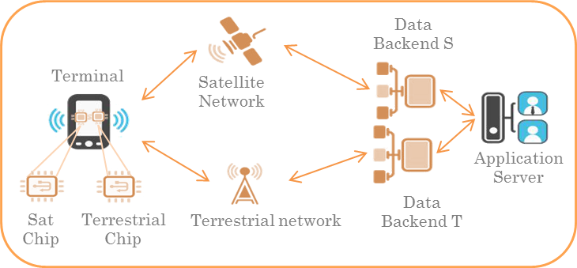
Figure 3: Example of hybrid network architecture
In this scenario two chipsets are included in the terminal, which bring the advantage of being able to provide the service with only one terminal.
The entire network would be able to operate on two parallel communication paths based on one side on the satellite segment and on the other side on the terrestrial segment each of which ends by a separate OSS.
Taking into account the situation, it has to be noted that the size and the complexity of the terminal is impacted on one hand by the fact that it includes two RF circuitry and on the other hand, by the fact that the terminal should also include a specific protocol which shall manage the two different networks.
As no convergence between the two networks are supposed, this implies that two frequency bands would be used one for the satellite communication and another one for the communication via the terrestrial installations. This approach may not be as spectrum efficient as a fully integrated approach.

Fully-integrated solution operating on the same band
An example of a fully integrated solution architecture operating on one single paired band to offer downlink and uplink communication is illustrated on the figure below.
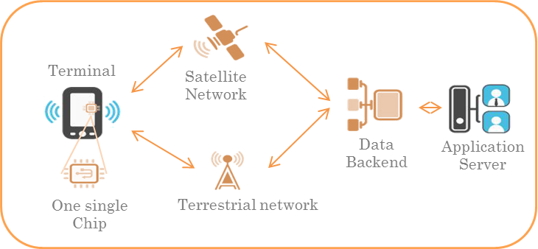
Figure 4 : Example of fully-integrated network architecture
This scenario represents a fully integrated scenario to establish a M2M network. The advantage of this scenario is that only a single front end for an antenna is required to communicate with both satellite and terrestrial networks. This simplifies the terminal design and reduces cost. It would also allow satellite to benefit from the economies of scale produced by terrestrial operations. However, it can add general network complexity, as such form of integration may require all the components of the infrastructure to be adjusted for this operation (e.g. end-user devices, core networks, communication protocols, air-interfaces etc.).

Different levels of integration
Different levels of integration could lead to different considerations on the use of frequency bands as summarise in the table below:
Table 4: Network integration levels
Level of integration | Identification of the integration scenario | Description
Less integrated  More integrated | Integrated solution implemented within a frequency range with frequency separation. | Both satellite and terrestrial networks operate within a designated frequency range which is split in two dedicated sub frequency bands respectively for satellite and terrestrial communications. This can also be accomplished in adjacent satellite/terrestrial frequency bands.
 | Integrated solution in a shared spectrum based on a static planning of the usage of the frequency band | Satellite and terrestrial networks operate in the same frequency band. Interferences within the frequency band are statically managed thanks to a coordinated planning of the usage of the band.
 | Integrated solution in a shared spectrum based on a dynamic planning of the usage of the frequency band | Satellite and terrestrial networks operate in the same frequency band. Interferences within the frequency band are dynamically managed thanks to appropriate mitigation techniques which manage the spectrum resource between systems.

Regulatory considerations for hybrid operations
Regulatory considerations for hybrid operations with two different frequency ranges
Dual-mode IoT terminals enabling radio communications through different technologies, either terrestrial or satellites, exist already in the bands below 3 GHz. The development of the different systems and their adaptation to specific IoT requirements are on-going. A wide range of satellite modules is available for system integrators to combine satellite with terrestrial connectivity in IoT terminals.
In the case of dual-mode systems, greater level of integration and interoperability between M2M/IoT networks could primarily come from the standardisation and the enhancement of communication protocol such as those based on GSO Mobile Interface specifications [7] or Broadband Global Area Networks (BGAN) and innovation in core network capabilities.
In the context of hybrid operation using two different frequency bands, the same satellite bands are used as for stand-alone satellite IoT terminals. Therefore, the same regulatory conclusions as indicated in 4.1.3 would generally be applicable.
With regards to the frequency bands in which most terrestrial IoT systems are deployed, it can be noted that CEPT delivered several reports (e.g ECC Report 266 [9]) on this matter over the past few years. A list of frequency bands identified for the deployment of new terrestrial IoT systems is given in ANNEX 3.
Regulatory considerations for fully-integrated hybrid operations
There are currently no commercial satellite IoT systems in operation that deliver a fully integrated satellite-terrestrial terminal operating in the same or adjacent frequency bands. In terms of spectrum allocations, this would require one of the following options to be used:
- Satellite and terrestrial operation using existing adjacent frequency bands:
For example, some frequency allocations below 3 GHz for mobile service, not identified for MFCN, are adjacent to MSS frequency bands in UHF or L-band, such as the frequency bands 395.0-399.9 MHz or 1675-1690 MHz. However, the former bands have priority requirements for defence applications and fall under the context of the NATO Joint Civil/Military Agreement (NJFA). In UHF ranges, based on recent studies from the ECC Report 283 [10] in the frequency range 410-430 MHz and 450-470 MHz, new opportunities for dual-band devices combining terrestrial air-interface with a satellite interface operated in the 399.9-401 MHz range could be considered. Finally, it is worth noting, that the frequencies 138.625, 138.675 MHz and 138.650 MHz are used for existing tracking and asset tracking systems in some CEPT countries. These bands are adjacent to the 137-138 MHz band allocated to MSS (s-E) bands. In Europe, the frequency range 169.4-169.8125 MHz is used for metering applications and data acquisition services and harmonised in many CEPT countries for this purpose (see ERC Recommendation 70-03 [11] and CEPT Report 43 [12] ).
- Satellite and terrestrial operation using the same existing frequency band:
According to the ITU Radio Regulations, there are spectrum allocations for MS in existing MSS frequency bands (e.g. 137-138 MHz / 148-149.9 MHz; 1518-1535 MHz / 1668.4-1675 MHz; 1980-2010 MHz / 2170-2200 MHz and 2483.5-2500 MHz). As it is already possible in the frequency ranges 1980-2010 MHz / 2170-2200 MHz (3GPP enables devices to be manufactured and deployed with dual or triple band for operations in the MSS and terrestrial frequencies), terrestrial components coordinated among operators and operated as part of their satellite networks in a limited amount of spectrum (e.g. few hundreds of kHz) could provide complementary capabilities for the deployment of truly ubiquitous IoT systems. However, in practise the bands are globally harmonised for MSS operations (also as per ECC decisions reflected in annexes 1 and 2) and used by a number of MSS operators. Most of these frequencies ranges are shared between multiple MSS operators and it could be difficult to ensure that none of the networks are impacted by unwanted interference if any terrestrial applications would be introduced in the band. Due to the above, these bands could be considered as a practical option for fully integrated hybrid operation only after the completion of compatibility studies to assess the feasibility of such operations and the development of suitable regulatory measures to ensure the protection of incumbent systems.
- Satellite and terrestrial operation using new allocations
It is possible to identify new frequency ranges for fully integrated hybrid satellite-terrestrial operation. For example, satellite allocations could be added to frequency ranges where terrestrial M2M ecosystems already exist. New technologies dedicated to massive IoT applications require limited bandwidth (a few hundred of kHz to a few MHz) and can serve a significant number of low duty cycle devices. This allows the interferences environment to be statically managed based on a pre-coordinated planning and enable co-existence of the satellite and terrestrial operation in the same band.
However, if a band is opened for combined satellite-terrestrial operation it will be difficult for many competing satellite systems to operate in the same frequency range. Different system architectures would require different deployment densities and duty cycles in order to manage the interference environment. This implies that such service providers would need to coordinate with each other in order to make sure their operations would not produce harmful interference to other systems. Alternatively, a specific regulatory framework can be created based on which a small number of service providers that could co-exist is selected through auctions or beauty contests. An example of such a framework would be the fully integrated system combining satellite and terrestrial components, which exist already in S-Band. In 2006, the ECC Decision (06)09 [1] on the designation of the bands 1980-2010 MHz and 2170-2200 MHz for use by systems in the Mobile-Satellite Service including those supplemented by a Complementary Ground Component (CGC) defined several conditions for the deployment of CGC. Although these bands and regulatory framework are not dedicated to M2M/IoT, such applications are also possible and developed as part of the data communication services.
All of the above scenarios would require extensive CEPT studies to assess feasibility and coexistence between incumbent systems and any new narrow-band and low power IoT device operation.

New hybrid IoT systems based on SRD framework
The development of terrestrial Low Power Wide Area Networks (LPWAN) operating in SRD bands has triggered market interest for complementary services by satellite systems dedicated to low power and low data rate devices. Indeed, the global coverage and the guarantee of a continuous service independently of the country or terrestrial infrastructure is a key asset of the satellite connectivity enabling critical LPWAN applications such as worldwide tracking or sensor monitoring in remote areas.
In addition it is worth noting that to date a large majority of the deployed M2M/IoT applications use low power technologies such as Bluetooth or Wi-Fi operated under SRD regulation. Nevertheless when considering the opportunity of hybrid satellite-SRD systems for IoT applications, it appears that there is no satellite allocation overlapping with existing frequency bands Identified for SRD applications.

Operational considerations and background information
Considering this initial information, WG FM initiated in 2016 a Correspondence Group to carry out an initial study on the need and opportunities to develop specific measures to foster or enable the development of hybrid systems combining connectivity solutions from terrestrial networks operated in SRD bands and satellite networks.
Information related to the technical requirements and scenarios to operate an hybrid terrestrial/satellite networks in SRD bands are described in detail in the Correspondence Group report on M2M via satellite provided to WG FM in 2017 [13]. No new information was submitted to this Report on these aspects, so the material of the CG report has not been duplicated in this Report.
In summary, the purpose and operational requirements of such networks are similar to those introduced in section 3.2 of this Report, where the satellite component should complement terrestrial infrastructure in the case of massive MTC scenario. Ubiquitous and affordable coverage could be ensured by enabling interoperability between terrestrial component and satellite component by using similar networking and interconnection considerations as those described in sections 4.2.2 and 4.2.3.
More specifically in the case of hybrid operation with SRD terminals, the operation of satellite component over areas already covered by terrestrial means may be not technically feasible since the satellite will not be in a position to retrieve the corresponding data due to the very high density of M2M/IoT devices. Therefore, the usage of M2M via satellite would be only meaningful over areas having low or moderate densities of devices operating with low duty cycles where terrestrial networks may be uneconomical or unpractical and satellites can enhance the coverage of the terrestrial networks
Preliminary analysis indicates that various NGSO constellations could be designed and operated that would allow for such hybrid satellite and terrestrial coverage.

Frequency bands identified for use by terrestrial IoT SRD terminals
As shown in the table below a number of new terrestrial networks and systems dedicated to M2M/IoT, such as LPWAN, are deployed in frequency bands identified in ERC Recommendation 70-03 [11].
Below 1 GHz, existing MSS allocation are outside the tuning range of standard and low cost transceivers deployed in the networks operated in these SRD bands. Therefore the development of new terminals to support the deployment of dual mode M2M applications via satellite and SRD is required except in the case where the systems would operate only SRD bands.
Table 5: Examples of SRD applications used for M2M/IoT communications
Frequency range (MHz) | Applications and/or standards | Authorisation model | CEPT/ECC References
169.4-169.8125 MHz | SRD,  meter Reading, data acquisition | General authorisation / Exempt from individual authorisation | CEPT Report 043 [12]  ERC Recommendation 70-03 [11]
433.05-434.79 MHz | SRD | General authorisation / Exempt from individual authorisation | CEPT Report 044 [14]  ERC Recommendation 70-03 [11]
862-870 MHz | SRD,  SRD wider area data networks,  data acquisition,  RFID | General authorisation / Exempt from individual authorisation | CEPT Report 059 [15] and Addendum [16]  ERC Recommendation 70-03 [11]
2.4 GHz | SRD  Wide Band Data Transmission Systems | General authorisation / Exempt from individual authorisation | CEPT Report 59 [15]  ERC Recommendation 70-03 [11]
Above 1 GHz, it is worth noting too that the frequency band 2400-2483.5 MHz is identified in Europe for Wideband Data Transmission Systems (e.g. Wi-Fi equipment) as per ERC Recommendation 70-03 [11]. This frequency band which is used intensively by a huge number of Personal Area network (PAN) and Wireless Local Area networks (WLAN) is immediately adjacent to the frequency band 2483.5-2500 MHz allocated to Mobile Satellite Service (space-to-Earth) in all ITU Regions. The 2400-2483.5 MHz frequency band is also globally available.
In addition, it should also be noted for the other frequency bands shown in above Table 5 that a global harmonisation may be more difficult to achieve taking into account that SRD regulation is not subject to any provision in the Radio Regulations [2] and the ITU SRD publications are limited to ITU-R Recommendations and Reports.

Regulatory Aspects
Earth-to-space transmissions:
From a national legal perspective, the emissions from a radio device within a territory have to be authorised by the corresponding national administration. The European regulatory framework provides a number of harmonised frequency bands that can be used by SRD applications, in particular frequency band 862-870 MHz. The emissions from an SRD application on the ground that comply with the technical conditions specified in the relevant general authorisation in the country where the system operate can obviously equally be received by a terrestrial receiver (e.g. acting as a relay or a base station in a data network) or by a space station in low earth orbit without the need for additional regulatory measures.
Taking into account Articles 44 and 45 of the Constitution of the ITU [17] and in accordance with provision No. 4.4 of the Radio Regulations [2], assignments of radio frequencies in derogation of the Table of Frequency Allocations or other provisions of the Radio Regulations shall be avoided and may only be possible on certain expressed conditions. Such assignments shall not claim protection, which renders such satellite use opportunistic as it can benefit only from the protection which could be provided by the robustness of the technology. This may not provide sufficient guarantees to operate a commercial service as there are no guarantees that the terrestrial operation would not become unacceptable for satellite operation, resulting in more potential problems for interference management.
In CEPT, ERC Recommendation 70-03 [11] contains a number of regulatory options that may be usable for uplink transmissions with various combination of power limits (25 mW or 500 mW) and maximum duty cycles (e.g. 0.1/2.5/10%). It should however be noted that compliance with specified regulatory conditions may imply that some options are not available for satellite links as illustrated by some proposals contained in the Addendum to CEPT Report 59 [16] i.e. the requirement in some bands that all devices within the radio network shall be under the control of network access points.
Technical studies included in ECC Report 261 [18] consider the possible use of frequency band 862-862.4 MHz by SRD with 500 mW-0.1% DC within specific networks (e.g. smart metering in rural or remote area and low density deployments). Within 862-863 MHz, this band is proposed for harmonisation for non-specific SRD with 25 mW and 0.1% in CEPT Report 70 [20]. There is no SRD regulation with 500 mW in 862-862.4 MHz at this stage.
Overall, frequencies in the 860 MHz frequency range may be particularly suitable for delivering services in Europe for uplink transmission in the sub-GHz range. However, it may be of interest for CEPT to also identify future opportunities to promote harmonisation of a certain frequency range for both satellite and terrestrial M2M/IoT operation on a global level.
Other harmonised frequency bands used by SRD below 1 GHz, e.g. in the 169 MHz or 433 MHz frequency ranges may provide additional opportunities. Above 1 GHz, the frequency range 2400-2483.5 MHz is globally available under license-exempt conditions and may be considered for satellite uplinks to receivers at the low earth orbit.
The situation is different at frequency ranges which were not harmonised or even studied for SRD use. When notifying the use of frequency assignments to be operated under No. 4.4, the notifying administration shall provide a confirmation that it has determined that these frequency assignments meet the conditions and that it has identified measures to avoid harmful interference and to immediately eliminate such in case of a complaint. To make this determination is difficult in absence of study results or suitable evidence and other administrations may deny the authorisation of such usage.
Space-to-Earth transmissions:
Taking into account Article 44 and 45 of the Constitution of the ITU and in accordance with provision No. 4.4 of the Radio Regulations assignments of radio frequencies in derogation of the Table of Frequency Allocations or other provisions of the Radio Regulations shall be avoided and may only be possible on certain expressed conditions. Such assignments shall neither cause harmful interference nor claim protection, which renders such satellite use opportunistic as it can benefit only from the protection which could be provided by the robustness of the technology. This may not provide sufficient certainties to operate a commercial service as there is no reliability that terrestrial operation would not become unacceptable for satellite operation. Any future systems operating within the Radio Regulations may prevent such commercial service.
When notifying the use of frequency assignments to be operated under provision No. 4.4, the notifying administration shall provide a confirmation to the ITU BR that it has determined that these frequency assignments meet the conditions and that it has identified measures to avoid harmful interference and to immediately eliminate such in case of a complaint. To make this determination is difficult in absence of study results or suitable evidence and other administrations may deny the authorisation of such usage when their territory is visible from the satellite on the downlink.
In this context, it is recommended to assign space-to-Earth frequencies under provision No. 4.4 only for the purpose of experimentation, technical demonstrators, scientific research and short terms missions. In complement, the operation of commercial and long terms systems under provision No. 4.4 should be discouraged and avoided not to increase the noise level in these bands (see also the separate paragraph on provision No. 4.4 further below).
Assignments under Provision No. 4.4 of the Radio Regulations
Provision No. 4.4 of the Radio Regulations states that “Administrations of the Member States shall not assign to a station any frequency in derogation of either the Table of Frequency Allocations in this Chapter or the other provisions of these Regulations, except on the express condition that such a station, when using such a frequency assignment, shall not cause harmful interference to, and shall not claim protection from harmful interference caused by, a station operating in accordance with the provisions of the Constitution, the Convention and these Regulations.” This provision clarifies that administrations of Member States shall not assign frequencies to station in derogation to the provisions of the international treaty and therefore should not be considered as an opportunity for a permanent usage.
To further clarify the context of assigning frequencies under provision No. 4.4, it should be noted that,
- “...shall not cause harmful interference” implies that the operator of the system must be able to cease immediately any interference if any and this could mean that the system could be switched off definitively;
- “…shall not claim protection” implies that no protection is granted to the system which operates under provision No. 4.4. In particular, in receiving mode in a band where no allocation is existing for satellite operation, if a satellite system tries to receive terrestrial emission but cannot due to interferences from a recognised system which operates under an existing allocation, then the satellite system cannot benefit from protection or specific regulatory arrangements to improve the situation.
In both situations it is important to underline that a satellite system which operates under provision No. 4.4 could be in a situation where the targeted mission may be unachievable and cannot be used for its purpose.
In July 2017, a contribution alerted the RRB on a usage more and more frequent of the provision No. 4.4.
Since 2014, the Radiocommunication Bureau has received an increased number of Advanced Publication Information (API) for non-geostationary satellite networks in frequency bands which are not allocated by Article 5 of the Radio Regulations for the type of foreseen service. Because there is no technical or regulatory examination by the Bureau on the acceptability of such above API filings, the Bureau had no option other than to publish these APIs including frequency assignments not in conformity with Article 5 of the Radio Regulations. Nos. 11.2 and 11.3 of the Radio Regulations specify that any frequency assignment to a transmitting station shall be notified to the Bureau if the use of that assignment is capable of causing harmful interference to any service of another administration, but for most of the API filings with non-conforming frequency assignments so far the Bureau has not received the required notification under No. 11.15, although some of the networks have been in operation.
As a follow up of the above mentioned contribution the Rules of Procedure related to provision No. 4.4 of the Radio Regulations were amended at RRB#78 meeting [18], in particular “the Board also concluded that administrations, prior to bringing into use any frequency assignment to a transmitting station operating under No. 4.4, shall determine:
  - That the intended use of the frequency assignment to the station under No. 4.4 will not cause harmful interference into the stations of other administrations operating in conformity with the Radio Regulations;
  - What measures it would need to take in order to comply with the requirement to immediately eliminate harmful interference pursuant to No. 8.5.
When notifying the use of frequency assignments to be operated under No. 4.4, the notifying Administration shall provide a confirmation that it has determined that these frequency assignments meet the conditions referred to above in item a) and that it has identified measures to avoid harmful interference and to immediately eliminate such in case of a complaint.”
To make such a determination is difficult in absence of study results or suitable evidence and other administrations may deny the authorisation of such usage when their territory is visible from the satellite on the downlink. Another argument to deny the provision of such satellite based services is the possible rise of the noise floor caused by low earth orbit transmissions at the surface of the earth.

Conclusions
Because of their native characteristics, satellite networks will play an important role in completing a global infrastructure for M2M/IoT ecosystems that is useful for developing ever more connected and intelligent services. Depending on the sector of activity and the technical and economical requirements, specific to each project and use cases, different frequency resources may be and are already utilised. In addition other opportunities, identified in this report, may be the subject of further regulatory studies when necessary.
Among the existing systems and spectrum resources, MSS frequency bands below 3 GHz for both NGSO and GSO satellite networks appear as the more common solutions implemented to address the majority of M2M/IoT services requiring at the same time low throughput, global or regional mobility capabilities and the connection of a large number of objects. Fixed-satellite service systems have also a role to play to address the needs of broadband applications or simply supplementing terrestrial networks with backhauling services in remote areas.
As various access technologies will be necessary in such a global infrastructure, which might include different fixed, terrestrial and satellite networks, the integration and interoperability between the systems will be a crucial element to achieve coverage and capacity goals.
This Report analyses both stand-alone and hybrid terrestrial-satellite terminal operation and concludes on the following:
- A vibrant ecosystem of M2M services are provided via stand-alone satellite terminals of various types and in multiple network configurations in almost all main satellite frequency bands as per the requirements of the M2M/IoT application. It is identified that a further review of ECC Decisions and harmonised implementation of such decisions by CEPT administration may benefit the provision of such services. For the emerging systems suitable frequency bands should be found in order to facilitate the deployment of IoT services via satellite.
- Due to the rapid increase in demand, the availability of spectrum below 5 GHz needs to be reviewed within the CEPT in order to facilitate novel use for M2M/IoT via satellite.
- Various solutions also exist for dual mode hybrid terminals where terrestrial and satellite communications are achieved. Such solutions generally operate in MSS bands below 3 GHz and are subject to the same regulatory and spectrum conclusions as indicated above for stand-alone terminals. It is also noted that such terminals could benefit from further standardisation work to ease the interoperability between new M2M/IoT technologies.
- There are currently no commercial satellite M2M/IoT systems in operation that deliver a fully integrated service via satellite-terrestrial terminals that operate in the same or adjacent frequency bands. In terms of spectrum requirements, some bands below 3 GHz exist where satellite-terrestrial allocations are adjacent which could allow such services to be developed. There are also MSS allocations that overlap with MS allocations, but these bands are globally harmonised and intensively used for MSS services by a number of satellite operators. Similarly to the band 1980-2010 MHz / 2170-2200 MHz, terrestrial components coordinated among satellite operators and operated as part of their networks in a limited amount of spectrum could be possible. However, it is underlined that it might be difficult to ensure that these satellite networks could coexist and not interfere with the other satellite operators in the band. Finally, new allocations could be created for joint satellite-terrestrial M2M/IoT operation. However, this would also necessitate a need for certain regulatory and licensing frameworks to ensure that various operators could coexist in the same band. One example of such a framework would be ECC Decision (06)09 [1] on the designation of the bands 1980-2010 MHz and 2170-2200 MHz. It was also determined that for each of the above scenarios, extensive studies to assess feasibility and coexistence between incumbent systems and any new narrow-band and low power IoT device operation would be required.
This Report also studies a specific example of integrated satellite-terrestrial operation in the SRD bands in more detail and reminds of the conditions and risks of operating such systems under the provision No. 4.4 of the Radio Regulations [2].
As CEPT administrations consider how M2M/IoT networks could be implemented in the future, the information provided in this Report gives information on spectrum resources which might be the best suited to address the requirements of satellite-based and hybrid systems in the context of an emerging and flourishing M2M/IoT ecosystem. In particular, in order to facilitate novel use for M2M/IoT via satellite, it has been proposed that:
- ECC reviews the Decisions related to S-PCS below 1 GHz;
- ECC continues to review the availability of spectrum below 5 GHz within the CEPT, in order to identify suitable frequency bands for emerging M2M/IoT satellite systems;
- ECC investigates the measures to facilitate coexistence and sharing among non-GSO systems, and non-GSO and GSO systems in existing MSS allocations below 5 GHz, while protecting incumbent systems.

- Frequency bands allocated to MSS below 1 GHz in CEPT
Some allocations to the mobile satellite service exist in all regions in the following frequency bands:
- 148-150.05 MHz and 399.9-400.05 MHz for MSS (Earth-to-space transmissions);
- 137-138 MHz and 400.15-401 MHz for MSS (space-to-Earth transmissions);
- The use of those bands is limited to non-geostationary satellite as per Footnote 5.209 of the RR.
In CEPT countries, these bands below 1 GHz are subject to a harmonisation decision for the introduction of satellite personal communication systems (S-PCS < 1 GHz) since 1999 through ERC Decision (99)06 [21].However, many CEPT administrations have not implemented them yet or have done so just partly because of lack of demand or because they have been allocated nationally for different purposes.
Therefore, three decisions were adopted in 1999 on the harmonisation of authorisation conditions and free circulation of MES in the field of S-PCS<1 GHz systems:
- ERC Decision (99)06 [21] on the harmonised introduction of satellite personal communication systems operating in the bands below 1 GHz (S-PCS<1 GHz);
- ERC Decision (99)05 [22] on Free Circulation, Use and Exemption from Individual Licensing of Mobile Earth Stations.(S-PCS < 1GHz);
- ECTRA Decision (99)02 [23] on Harmonisation of authorisation conditions in the field of Satellite Personal Communications Services (S-PCS) in Europe, operating in the bands below 1 GHz (S-PCS<1 GHz).
Typically, at present, most of the administrations still require that each S-PCS or MES is licensed individually. However, new trends and technology surrounding the IoT industry entail that terminals are ubiquitous and can easily move from place to place. Licence fees may apply which is impractical and unrealistic for global services meant to be affordable. Since S-PCS systems are satellite constellations, the lack of harmonisation of the above decisions makes the provision of affordable services near impossible. A review could also update the list of systems which are planned or put into operation. As an example, for 399.9-400.05 MHz / 400.15-401 MHz, there are currently 27 satellite network filings registered at the ITU (December 2018). This is a manifold increase from even one year ago, which proves the dramatic increase of existing and planned operations below 1GHz as a key component in the IoT industry. A new approach for regulating S-PCS<1 GHz, based upon technical criteria that mitigates the risk of interference is urgently required, and could be achieved by means of blanket licensing or a general authorisation. In addition, as part of this review, the usage of the application term S-PCS as used in those Decisions, should be reviewed to reflect the M2M/IoT via satellite usage aspect.
Sharing and Compatibility issues between MES and terrestrial services in such frequency bands were further studied in 2000 and the results captured in ERC Report 087 [24]. It is worth noting that unlike other MSS systems above 1 GHz, free circulation of MES is not linked to network control per se in the decisions related to S-PCS below 1 GHz. However sharing studies performed in 2000 showed that the implementation of Dynamic Channel Activity Assignment System (DCAAS) as per Recommendation ITU-R M.1039 [25] was required for FDMA MSS systems in bands shared with terrestrial services to ensure coexistence and such technical requirement which result in MES transmission being controlled by the satellite network has been made mandatory through the ETSI EN 301 721 [26].
Such requirements may not be justified in the case of bands that are not shared with terrestrial services, e.g. 399.9-400.05MHz, and may be reviewed in this case.
The existing ITU Region 1 allocations for commercial MSS below 1 GHz, which are not limited to very specific safety-related, rescue or emergency use, are summarised in the table below.
Table 6: MSS Allocations below 1 GHz
Frequency allocation (MHz) | Applicable footnotes | Allocation status
137-137.025 (space-to-Earth) | 5.209, 5.208, 5.208A, 5.208B | Primary
137.025-137.175 (space-to-Earth) | 5.209, 5.208, 5.208A, 5.208B | Secondary
137.175-137.825 (space-to-Earth) | 5.209, 5.208, 5.208A, 5.208B | Primary
137.825-138 (space-to-Earth) | 5.209, 5.208, 5.208A, 5.208B | Secondary
148-149.9 (Earth-to-space) | 5.209, 5.218, 5.219, 5.221 | Primary
149.9-150.05 (Earth-to-space) | 5.209, 5.220 | Primary
399.9-400.05 (Earth-to-space) | 5.209, 5.220 | Primary
400.15-401 (space-to-Earth) | 5.209, 5.208A, 5.208B | Primary
At the time of writing, the last version of ETSI standards developed for Mobile Earth Stations (MESs) operating in MSS bands below 1 GHz are shown in the table below.
Table 7: Current ETSI standards for MSS MES below 1 GHz
ETSI standard | Title | Version and date
EN 301 721 [26] | MES providing Low Bit Rate Data Communications (LBRDC) using LEO satellites operating below 1 GHz under Article 3.2 of the Directive 2014/53/EU | V2.1.1  (2016-05)
EN 300 721 [27] | MES providing Low Bit Rate Data Communications (LBRDC) using LEO satellites operating below 1 GHz | V1.2.2  (1999-7)
ETS 300 722 [28] | Network Control Facility (NCF) for MES providing Low Bit Rate Data Communications (LBRDC) using LEO satellites operating below 1 GHz | Ed.1  (1997-06)
In addition to these frequency ranges other frequency bands around 455 MHz are partly allocated to MSS at national or regional level:
- As per footnotes 5.286A 5.286B 5.286C 5.286D 5.286E of the RR [2], the use of the bands 455-456 MHz and 459-460 MHz by the mobile-satellite service is possible in ITU Region 2 and subject to coordination under No. 9.11A. The use of those bands is limited to non-geostationary satellite as per Footnote 5.209 of the RR, and is subject to neither causing interference nor claiming protection from other allocated services (Fixed and Mobile);
- In ITU Regions 1 and 3 additional allocations exist in Cape Verde, Nepal and Nigeria, where the bands 454-456 MHz and 459-460 MHz are allocated to the mobile-satellite (Earth-to-space) service on a primary basis as per footnote 5.286E of the RR. The band 454-455 MHz is also allocated in some ITU Region 2 countries (Canada, USA and Panama).
In addition to these 454-456 MHz and 459-460 MHz bands, it can be noted that although the band 460-470MHz is allocated on a primary basis to the fixed and mobile services, systems for data collection and platform location as described in Recommendation ITU-R SA.1627 [29], e.g. the Argos Data Collection System (ADCS), are also deployed for scientific applications under the meteorological-satellite service, currently has a secondary allocation in this band. However Resolution 766 (WRC-15) [30] invites ITU-R and administrations to consider the possible upgrading of the secondary allocation to the meteorological-satellite service (space-to-Earth) to primary status and a primary allocation to the Earth exploration-satellite service (space-to-Earth) in the frequency band 460-470 MHz.
To date this frequency 460-470 MHz band is used for data collection systems in complement to the frequency band 401-403 MHz band allocated to the Earth exploration-satellite service and the meteorological-satellite service.
ADCS is used to monitor over 21,000 individual platforms around the globe for 1,900 operators in 118 countries. Most scientific applications served by ADCS such as atmospheric & ocean monitoring/research, disaster forecasting, fishery management, fishing vessel tracking, search & rescue modelling (at sea), anti-piracy alerting, import/export and hazardous materials tracking, wildlife tracking and management are very close to a number of M2M and IoT typical use cases developed for security and safety activities and environment sustainable development. The compatibility between low power transmitters for animal tracking and other existing radio communication applications in the frequency band 401-403 MHz has been recently studied in 2017 and results were summarised in the ECC Report 257 [31].
At last, it can be noted that additional allocations to MSS between 800 MHz and 960 MHz exist in some countries, as per footnotes 5.138, 5.319 and 5.320 of the RR, including in Belarus, the Russian Federation and Ukraine in ITU Region 1.

- Frequency bands allocated to MSS above 1 GHz and below 3 GHz in CEPT
Most of the 174 MHz of spectrum allocated to MSS in L-Band and S-Band is already assigned and extensively used by mobile satellite operators to serve a number of applications, including safety and data communications, in land, maritime and aeronautical sectors.
Apart the bands limited to distress and safety communications, Resolution 225 (Rev. WRC-12) [32] resolves that, in addition to the frequency bands 1980-2010 MHz and 2170-2-200 MHz which have been identified for use by the satellite component of International Mobile Telecommunications (IMT) through No. 5.388 and Resolution 212 (Rev. WRC-15) [33], the frequency bands 1518-1544 MHz, 1545-1559 MHz, 1-610-1626.5 MHz, 1-626.5-1-645.5 MHz, 1-646.5-1-660.5 MHz, 1-668-1-675 MHz and 2-483.5-2-500 MHz may be used by administrations wishing to implement the satellite component of IMT, subject to the regulatory provisions related to the mobile-satellite service in these frequency bands.
Frequency allocations for mobile-satellite service are listed in the tables below. It is worth mentioning that distress, urgency and safety communications of the Global Maritime Distress and Safety System and the aeronautical mobile-satellite (R) service have priority over all other mobile-satellite service communications in accordance with Nos. 5.353A and 5.357A.
In CEPT countries, these bands were successively harmonised for MSS operations under S-PCS and satellite component of IMT umbrellas:
- ECTRA Decision (99)01 [34]: “Harmonisation of authorisation conditions in the field of Satellite personal Communications Services (S-PCS) in Europe, operating within the bands 1525-1544/1545-1559 MHz, 1626.5-1645.5/1646.5-1660.5 MHz”;
- ECC Decision (04)09 [35]: “ECC Decision of 12 November 2004 on the designation of the bands 1518-1525 MHz and 1670-1675 MHz for the Mobile-Satellite Service”;
- ECC Decision (06)09 [1]: “ECC Decision of 1 December 2006 on the designation of the bands 1980-2010 MHz and 2170-2200 MHz for use by systems in the Mobile-Satellite Service including those supplemented by a Complementary Ground Component (CGC)”;
- ECC Decision (09)02[36]: “ECC Decision of 26 June 2009 amended 02 November 2012 on the harmonisation of the bands 1610-1626.5 MHz and 2483.5-2500 MHz for use by systems in the Mobile-Satellite Service”.
In addition to the decisions related to spectrum harmonisation and authorisation arrangements, the ECC has also developed several regulatory measures and companion decisions to facilitate license exemption and free circulation and use of satellite mobile terminals. A common feature for these decisions was that each one of them relates to a specific category of radio equipment. However in order to achieve a more technology neutral approach, ECC Decision (12)01 [37], was endorsed in 2012 and later on amended in 2016, to replace and withdraw the multiple decisions pre-existing, and any reference to a special category or technology in the body of the ECC Decision was avoided as far as practicable.
Although Transmit-only MES are equipment designed to operate in the absence of any real time control from the satellite network control function, ECC Decision (09)04 [38] provides a basis for administrations to facilitate exemption from individual licensing and free circulation and use within the band 1613.8-1626.5 MHz for such transmit-only MES, as fits the national regime. The control of such transmit-only MES by the satellite network operator, must in any event ensure at least the same level of protection against interference to other services as for ECC Decision (12)01 through appropriate mechanisms. A set of mandatory Control and Monitoring Functions (CMF) is specified within the harmonised standard ETSI EN 301 426 V2.1.2. [39].
ECC carried-out several compatibility studies in L-band between satellite services and terrestrial services over the past years. Some of the reports are listed below:
- ECC Report 263 [40]: “Adjacent band compatibility studies between IMT operating in band 1492-1518 MHz and the MSS operating in1518-1525 MHz”;
- ECC Report 165 [41]: “Compatibility study between MSS complementary ground component operating in the bands 1610.0-1626.5 MHz and 2483.5-2500.0 MHz and other systems in the same bands or in adjacent bands”;
- ECC Report 095 [42]: “Sharing between MSS systems using TDMA and MSS systems using CDMA in the band 1610–1626.5 MHz”;
- ERC Report 091 [43]: “Assessment of interference from unwanted emissions of NGSO MSS satellite transmitters operating in the space-to-Earth direction in the band 1621.35-1626.5 MHz to GSO MSS satellite receivers operating in the Earth-to-space direction in the band 1626.5-1660.5 MHz”;
- ERC Report 071 [44]: “Sharing studies between the unwanted emissions of MSS mobile earth stations, operating in the band 1610-1626.5 MHz and the Radio Navigation-Satellite Service receiver operating in the band 1559-1610 MHz”;
- ERC Report 070 [45]: “Compatibility between MSS (Space-to-Earth) in the band 1559-1567 MHz and ARNS/RNSS including GNSS in the band 1559-1610 MHz”.
Existing MSS Allocations in L-Band in Region 1 are indicated in the table below.
Table 8: MSS Allocations in L-Band
Frequency allocation (MHz) | Applicable footnotes | Allocation status | ERC/ECC Decision and /or  ITU RR reference
1518.000-1525.000  (space-to-Earth) | 5.341, 5.342 | Primary | Res.225 (Rev. WRC-12) [32]  ECC Decision (04)09 [35]  ECC Decision (12)01 [37]
1525.000-1530.000  (space-to-Earth) | 5.341, 5.342, 5.350, 5.351, 5.352A, 5.354 | Primary | Res.225 (Rev. WRC-12) [32]  ECTRA Decision (99)01 [34]  ECC Decision (12)01 [37]
1530.000-1535.000 (space-to-Earth) | 5.341, 5.342, 5.351, 5.354 | Primary | Res.225 (Rev. WRC-12) [32]  ECTRA Decision (99)01 [34]  ECC Decision (12)01 [37]
1535.000-1544.000 (space-to-Earth) | 5.341, 5.351, 5.353A, 5.354, 5.355, 5.356, 5.357, 5.357A, 5.359 | Primary | Res.225 (Rev. WRC-12) [32]  ECTRA Decision (99)01 [34]  ECC Decision (12)01 [37]
1544.000-1545.000 (space-to-Earth) | 5.341, 5.351, 5.353A, 5.354, 5.355, 5.356, 5.357, 5.357A, 5.359 | Primary | RR Art. 31 [2]  limited to distress  and safety communications
1545.000-1559.000  (space-to-Earth) | 5.341, 5.351, 5.353A, 5.354, 5.355, 5.356, 5.357, 5.357A, 5.359 | Primary | Res.225 (Rev. WRC-12) [32]  ECTRA Decision (99)01 [34]  ECC Decision (12)01 [37]
1610.000-1610.600  (Earth-to-space) | 5.341, 5.355, 5.359, 5.364, 5.366, 5.367, 5.368, 5.369, 5.371, 5.372 | Primary | Res.225(Rev. WRC-12) [32]  ECC Decision (09)02  ECC Decision (12)01 [37]
1610.600-1613.800  (Earth-to-space) | 5.149, 5.341, 5.355, 5.359, 5.364, 5.366, 5.367, 5.368, 5.369, 5.371, 5.372 | Primary | Res.225(Rev. WRC-12) [32]  ECC Decision (09)02 [36]  ECC Decision (12)01 [37]
1613.800-1626.500  (Earth-to-space) | 5.341, 5.369, 5.355, 5.359, 5.364, 5.365, 5.366, 5.367, 5.368, 5.371, 5.372 | Primary | Res.225(Rev. WRC-12) [32]  ECC Decision (09)02 [36]  ECC Decision (12)01 [37]
1613.800-1626.500 (space-to-Earth) | 5.341, 5.369, 5.355, 5.359, 5.364, 5.365, 5.366, 5.367, 5.368, 5.371, 5.372 | Secondary | Res.225 (Rev. WRC-12) [32]  ECC Decision (09)02 [36]  ECC Decision (12)01 [37]
1626.500-1645.500 (Earth-to-space) | 5.341, 5.351, 5.353A, 5.354, 5.355, 5.357A, 5.359, 5.374, 5.375, 5.376 | Primary | Res.225 (Rev. WRC-12) [32]  ECC Decision (12)01 [37]
1645.500-1646.500 (Earth-to-space) | 5.341, 5.351, 5.353A, 5.354, 5.355, 5.357A, 5.359, 5.374, 5.375, 5.376 | Primary | RR Art.31 [2]  limited to distress and safety communications
1646.500-1660.000  (Earth-to-space) | 5.341, 5.351, 5.353A, 5.354, 5.355, 5.357A, 5.359, 5.374, 5.375, 5.376 | Primary | Res.225 (Rev. WRC-12) [32]  ECC Decision (12)01 [37]
1660.000-1660.500 (Earth-to-space) | 5.149, 5.341, 5.351, 5.354, 5.376A | Primary | Res.225 (Rev. WRC-12)  ECC Decision (12)01 [37]
1668.000-1668.400  (Earth-to-space) | 5.149, 5.341, 5.379, 5.379A | Primary | Assigned to meteorological and radio astronomy services in some CEPT countries
1668.400-1670.000 (Earth-to-space) | 5.149, 5.341, 5.379D, 5.379E | Primary
1670.000-1675.000 (Earth-to-space) | 5.341, 5.379D, 5.379E, 5.380A | Primary | Res.225 (Rev. WRC-12) [32]  ECC Decision (12)01 [37]
In S-Band, ECC carried out several compatibility studies between satellite services and terrestrial services over the past years. Some of the reports are listed below.
- ECC Report 197 [46]: “Compatibility studies – MSS terminals transmitting to a satellite in the band 1980-2010 MHz and adjacent channel UMTS services”
- ERC Report 065 [47]: “Adjacent band compatibility between UMTS and other services in the 2 GHz band”
- ECC Report 150 [48]: “Compatibility studies between RDSS and other services in the band 2483.5-2500 MHz”
Existing MSS Allocations in S-Band in ITU Region 1 are indicated in the table below.
Table 9: MSS Allocations in S-Band
Frequency allocation (MHz) | Applicable footnotes | Allocation status | ERC/ECC Decision and/or  ITU RR reference
1980.000-2010.000 (Earth-to-space) | 5.389A, 5.389B, 5.388, 5.389F | Primary | Res.212 (Rev. WRC-15) [33]  ECC Decision(06)09 [1]  ECC Decision (12)01 [37]
2170.000-2200.000 (space-to-Earth) | 5.388, 5.389A, 5.389F | Primary | Res.212 (Rev. WRC-15) [33]  ECC Decision (06)09 [1]  ECC Decision (12)01 [37]
2483.500-2500.000  (space-to-Earth) | 5.150, 5.399, 5.402, 5.401 | Primary | Res.225 (Rev. WRC-12) [33]  ECC Decision (09)02 [36]  ECC Decision (12)01 [37]

As per ECC Decision (09)02 [36], the frequency band 2483.5-2500 MHz is paired with the band 1610-1626.5 MHz while 1980-2010 MHz and 2170 MHz-2200 MHz fall together under the scope of the ECC Decision (06)09 [1]. Subject to coordination procedures between GSO and non-GSO satellites, these bands are all identified for use by the satellite component of International Mobile Telecommunications (IMT).
A large range of M2M applications requiring either narrow band or broad band communications are already providing using these frequency ranges.
At the time of writing, the last version of some ETSI standards developed for Mobile Earth Stations (MESs) operating in S-band and relevant for M2M/IoT devices are shown in the table below.
Table 10: Current ETSI standards for MSS MES
ETSI standard | Title | Version and date
EN 301 441 [49] | MES for S-PCN operating in the 1.6 GHz/2.4 GHz frequency band under MSS covering the essential requirements of article 3.2 of the Directive 2014/53/EU | V2.1.1  (2016-06)  (An update is in preparation)
EN 301 442 [50] | NGSO MES for S-PCN operating in the 1980 MHz to 2010 MHz (Earth-to-space) and 2170 MHz to 2200 MHz (space-to-Earth) frequency bands under MSS covering the essential requirements of article 3.2 of the Directive 2014/53/EU | V2.1.1  (2016-06)  (An update is in preparation)
EN 302 574-3 [51] | MES operating in the 1980 MHz to 2010 MHz (Earth-to-space) and 2170 MHz to 2200 MHz (space-to-Earth) frequency bands covering the essential requirements of article 3.2 of the Directive 2014/53/EU; Part 3: User Equipment (UE) for narrowband systems | V2.1.1  (2016-06)  (An update is in preparation)
EN 301 489-20 [52] | Electromagnetic compatibility and Radio spectrum Matters (ERM); Electromagnetic Compatibility (EMC) standard for radio equipment and services;  Part 20: Specific conditions for Mobile Earth Stations (MES) used in the Mobile-Satellite Services (MSS) | V2.1.1  (2019-04)  (On approval)
- Main terrestrial IoT Frequency bands and Satellite component of ioT
Historically M2M application, such as Supervisory Control and Data Acquisition (SCADA) systems, were deployed through digital land mobile technologies (e.g. International Mobile Technologies 2000 (IMT-2000)) or satellite networks depending on application requirements. While these incumbent systems have accessed spectrum resource through individual authorisation regime, the increase in demand for less critical applications and the development of new technologies encouraged the use of shared spectrum. Such use of shared spectrum under general authorisation regime combined with the development of communication over Internet Protocol (IP) has led to an exponential increase of IoT applications based on Short Range Devices (SRD) regulation. Low Power Wide Area Networks (LPWAN) is an example of such system. In parallel new mobile technologies emerged in the recent years with the development of 3GPP standards dedicated to IoT applications, such as LTE-M or NB-IoT standards.
When considering the opportunity for IoT hybrid terrestrial satellite terminals, it is worth mentioning existing trends and developments in the field of terrestrial IoT. In 2015, WG FM was tasked by ECC#39 to study M2M spectrum aspects. The report from WG FM on that issue was provided in Annex 13 to ECC(15)039 [48] and ECC endorsed the conclusions on M2M showing that most M2M applications existing today or foreseen can be carried over SRD, RLAN, PMR or MFCN (commercial mobile broadband networks). More specifically this Report and subsequent deliverables from ECC, point out various terrestrial technological developments deployed in different frequency bands. Frequency ranges below 3 GHz are shown in the table below.
Table 11: Examples of Terrestrial M2M and IoT technologies and associated frequency ranges
Frequency  range | Applications and/or standards | Authorisation model | CEPT/ECC References
169.4-169.8125 MHz | Meter reading, data acquisition | General authorisation/Exempt from individual authorisation | CEPT Report 43 [12]  ERC Recommendation 70-03 [11]
433.05-434.79 MHz | SRD | General authorisation/Exempt from individual authorisation | CEPT Report 44 [14]  ERC Recommendation 70-03 [11]
410 MHz  450 MHz | MTC/eMTC  NB-IoT  LPWAN | Individual authorisation | ECC Report 283 [10]
700 MHz | EC-GSM-IoT  LTE MTC  NB-IoT | Individual authorisation | CEPT Report 53 [54]  CEPT Report 60 [55]  ECC Decision (15)01 [56]  ECC Report 266 [9]
800 MHz | EC-GSM-IoT  LTE MTC  NB-IoT | Individual authorisation | CEPT Report 66 [57]  ECC Report 266 [9]
900 MHz | EC-GSM-IoT  LTE MTC  NB-IoT | Individual authorisation | CEPT Report 66 [57]  ECC Report 266 [9]
862-870 MHz | Wideband SRD - TR 103 245  LTN UNB  M3N - TR 103 055  Smart Grids - TR 102 886  RFID | General authorisation/Exempt from individual authorisation | CEPT Report 059 [15] and its Addendum [16]  ERC Recommendation70-03 [11]
1800 MHz | EC-GSM-IoT  LTE MTC  NB-IoT | Individual authorisation | CEPT Report 66 [57]  ECC Report 266 [9]
2.1 GHz | EC-GSM-IoT  LTE MTC  NB-IoT | Individual authorisation | CEPT Report 66 [57]  ECC Report 266 [9]
2.4 GHz | SRD  Wide Band Data Transmission Systems | General authorisation/ Exempt from individual authorisation | CEPT Report 44 [14]  CEPT Report 59 [15]  ERC Recommendation 70-03 [11]
2.6 GHz | EC-GSM-IoT  LTE MTC  NB-IoT | Individual authorisation | CEPT Report 66 [57]  ECC Report 266 [9]
With regards to Satellite solutions, the complementarity and the advantages of mobile satellite services with respect to terrestrial mobile services are identified and reflected in a number of ITU and CEPT deliverables for years now. Most MSS bands below 3 GHz are identified for satellite component of IMT or S-PCS networks which support M2M and IoT applications. Several reports provide already guidance on integration principles and technical characteristics of satellite components for IMT. The table below lists some relevant ITU-R recommendations.
Table 12 : ITU-R Recommendations
ITU-R Recommendations
M.1182 [58] | Integration of terrestrial and satellite mobile communication systems
M.1850 [59] | Detailed specifications of the radio interfaces for the satellite component of International Mobile Telecommunications-2000 (IMT-2000)
M.2047 [60] | Detailed specifications of the satellite radio interfaces of International Mobile Telecommunications-Advanced (IMT-Advanced)
M.1476 [61] | Performance objectives for narrow-band digital channels using geostationary satellites to serve transportable and mobile earth stations in the 1-3 GHz range forming part of the integrated services digital network
In Europe, in addition to the existing framework described in sections 4.2.4 and 5.3, CEPT Report 013 [62] and subsequent compatibility studies and ETSI standards laid the foundation to regulate and authorise the deployment of MSS networks including Complementary Ground Component (CGC), which can be seen as the most advanced level of integration between terrestrial and satellite systems from a radio spectrum management perspective.

- List of references
- ECC Decision (06)09: “The designation of the bands 1980-2010 MHz and 2170-2200 MHz for use by systems in the Mobile-Satellite Service including those supplemented by a Complementary Ground Component (CGC)”,amended September 2007
- ITU Radio Regulations Edition of 2016
- Nanosatellite Telecommunications: “A Market Study for IoT/M2M applications, London Economics”, August 2017
- Northern Sky Research: “M2M and IoT via satellite”, 9th Edition, September, 2018
- ESA: “On the Satellite Role in the Era of 5G Massive Machine Type of Communications”, July 2017
- RSPG17-006 FINAL: “A Spectrum Roadmap for IoT” November 2016
- ECC Report 280: “Satellite Solutions for 5G”, May 2018
- ETSI TS 101 376 series: “GSO-Mobile Radio Interface Specifications”
- ECC Report 266: “The suitability of the current ECC regulatory framework for the usage of Wideband and Narrowband M2M in the frequency bands 700 MHz, 800 MHz, 900 MHz, 1800 MHz, 2.1 GHz and 2.6 GHz”, June 2017
- ECC Report 283: “Compatibility and sharing studies related to the introduction of broadband and narrowband systems in the bands 410-430 MHz and 450-470 MHz”, September 2018
- ERC Recommendation 70-03: “Relating to the use of Short Range Devices (SRD)”, amended June 2019
- CEPT Report 43: “Technical studies on the efficient use of the harmonised 169.4-169.8125 MHz frequency band (169 MHz – Review Mandate)”, June 2012
- Doc FM(17)035 – Chairman Report CG M2M via satellite
- CEPT Report 44: “In response to the EC Permanent Mandate on the Annual update of the technical annex of the Commission Decision on the technical harmonisation of radio spectrum for use by short range devices”, March 2013
- CEPT Report 59: “Annual update of the technical annex of the Commission Decision on the technical harmonisation of radio spectrum for use by short range device”, June 2016
- Addendum to CEPT Report 59: “Possibilities for a harmonisation approach for the bands 870-876 MHz and 915-921 MHz also taking into account new opportunities in the band 862-868 MHz”, March 2017
- Constitution of the International Telecommunication Union
- ECC Report 261: “Short Range Devices in the frequency range 862-870 MHz”, January 2017
- ITU-R Rules of Procedure approved by the Radio Regulations Board – Edition 2017 rev2
- CEPT Report 70: “In response to the EC Permanent Mandate on the ”Annual update of the technical annex of the Commission Decision on the technical harmonisation of radio spectrum for use by short range devices”, March 2019
- ERC Decision (99)06: “The harmonised introduction of satellite personal communication systems operating in the bands below 1 GHz (S-PCS<1 GHz)”, revised July 2000
- ERC Decision (99)05: “Free Circulation, Use and Exemption from Individual Licensing of Mobile Earth Stations.(S-PCS < 1 GHz)”, approved March 1999
- ECTRA Decision (99)02: “Harmonisation of authorisation conditions in the field of Satellite Personal Communications Services (S-PCS) in Europe, operating in the bands below 1 GHz (S-PCS<1 GHz)”, approved March 1999
- ERC Report 087: “Sharing studies between MES and existing terrestrial services in the bands already allocated to the MSS below 1 GHz”, June 2000
- Recommendation ITU-R M.1039-3 (03/06): “Co-frequency sharing between stations in the mobile service below 1 GHz and mobile earth stations of non-geostationary mobile-satellite systems (Earth-space) using frequency division multiple access (FDMA)”
- ETSI EN 301 721 V2.1.1 (2016-05): “Harmonised Standard for Mobile Earth Stations (MES) providing Low Bit Rate Data Communications (LBRDC) using Low Earth Orbiting (LEO) satellites operating below 1 GHz frequency band”
- ETSI EN 300 721 V1.2.2 (1999-07): “Satellite Earth Stations and Systems (SES); Mobile Earth Stations (MES) providing Low Bit Rate Data Communications (LBRDC) using Low Earth Orbiting (LEO) satellites operating below 1 GHz”
- ETSI ETS 300 722 ed.1 (1997-06): “Satellite Earth Stations and Systems (SES); Network Control Facilities (NCF) for Mobile Earth Stations (MES) providing Low Bit Rate Data Communications (LBRDC) using LEO satellites operating below 1 GHz”
- Recommendation ITU-R SA.1627-0 (05/2003): “Telecommunication requirements and characteristics of EESS and MetSat service systems for data collection and platform location”
- Resolution 766 (WRC-15): “Consideration of possible upgrading of the secondary allocation to the meteorological-satellite service (space-to-Earth) to primary status and a primary allocation to the Earth exploration-satellite service (space-to-Earth) in the frequency band 460-470MHz”
- ECC Report 257: “Compatibility studies between low power transmitters for animal tracking and other existing radiocommunication applications in the frequency band 401-403 MHz”, January 2017
- Resolution 225 (Rev. WRC-12): “Use of additional frequency bands for the satellite component of IMT”
- Resolution 212 (Rev. WRC-15): “Implementation of International Mobile Telecommunications in the frequency bands 1 885-2 025 MHz and 2 110-2 200 MHz”
- ECTRA Decision (99)01: “Harmonisation of authorisation conditions in the field of Satellite personal Communications Services (S-PCS) in Europe, operating within the bands 1525-1544/1545-1559 MHz, 1626.5-1645.5/1646.5-1660.5 MHz”, approved March 1999
- ECC Decision (04)09: "Designation of the bands 1518-1525 MHz and 1670-1675 MHz for the Mobile-Satellite Service", amended June 2009
- ECC Decision (09)02: “Harmonisation of the bands 1610-1626.5 MHz and 2483.5-2500 MHz for use by systems in the Mobile-Satellite Service”, amended November 2012
- ECC Decision (12)01: “Exemption from individual licensing and free circulation and use of terrestrial and satellite mobile terminals operating under the control of networks”, amended November 2016
- ECC Decision (09)04: “Exemption from individual licensing and the free circulation and use of transmit-only mobile satellite terminals operating in the Mobile-Satellite Service allocations in the 1613.8-1626.5 MHz band”, October 2009
- ETSI EN 301 426 V1.2.1 (2001-10): “Satellite Earth Stations and Systems (SES); Harmonized EN for Low data rate Land Mobile satellite Earth Stations (LMES) and Maritime Mobile satellite Earth Stations (MMES) not intended for distress and safety communications operating in the 1,5 GHz/1,6 GHz frequency bands covering essential requirements under article 3.2 of the R&TTE Directive”
- ECC Report 263: “Adjacent band compatibility studies between IMT operating in band 1492-1518 MHz and the MSS operating in1518-1525 MHz”, March 2017
- ECC Report 165: “Compatibility study between MSS complementary ground component operating in the bands 1610.0-1626.5 MHz and 2483.5-2500.0 MHz and other systems in the same bands or in adjacent bands”, May 2011
- ECC Report 095: “Sharing between MSS systems using TDMA and MSS systems using CDMA in the band 1610 – 1626.5 MHz”, February 2007
- ERC Report 091: “Assessment of interference from unwanted emissions of NGSO MSS satellite transmitters operating in the space-to-Earth direction in the band 1621.35-1626.5 MHz to GSO MSS satellite receivers operating in the Earth-to-space direction in the band 1626.5-1660.5 MHz”, June 2000
- ERC Report 071: “Sharing studies between the unwanted emissions of MSS mobile earth stations, operating in the band 1610-1626.5 MHz and the Radio Navigation-Satellite Service receiver operating in the band 1559-1610 MHz”, September 1999
- ERC Report 070: “Compatibility between MSS (Space-to-Earth) in the band 1559-1567 MHz and ARNS/RNSS including GNSS in the band 1559-1610 MHz”, February 1999
- ECC Report 197: “Compatibility studies – MSS terminals transmitting to a satellite in the band 1980-2010 MHz and adjacent channel UMTS services”, May 2013
- ERC Report 065: “Compatibility studies – MSS terminals transmitting to a satellite in the band 1980-2010 MHz and adjacent channel UMTS services”, November 1999
- ECC Report 150: “Compatibility studies between RDSS and other services in the band 2483.5-2500 MHz”, September 2010
- ETSI EN 301 441 V2.1.1 (2016-06): “Satellite Earth Stations and Systems (SES); Harmonised Standard for Mobile Earth Stations (MES), including handheld earth stations, for Satellite Personal Communications Networks (S-PCN) operating in the 1,6 GHz/2,4 GHz frequency band under the Mobile Satellite Service (MSS) covering the essential requirements of article 3.2 of the Directive 2014/53/EU”
- ETSI EN EN 301 442 V2.1.1 (2016-06): “Satellite Earth Stations and Systems (SES); Harmonised Standard for NGSO Mobile Earth Stations (MES) including handheld earth stations, for Satellite Personal Communications Networks (S-PCN) operating in the 1 980 MHz to 2 010 MHz (earth-to-space) and 2 170 MHz to 2 200 MHz (space-to-earth) frequency bands under the Mobile Satellite Service (MSS) covering the essential requirements of article 3.2 of the Directive 2014/53/EU”
- ETSI EN 302 574-3 V2.1.1 (2016-06): “Satellite Earth Stations and Systems (SES); Harmonised Standard for Mobile Earth Stations (MES) operating in the 1 980 MHz to 2 010 MHz (earth-to-space) and 2 170 MHz to 2 200 MHz (space-to-earth) frequency bands covering the essential requirements of article 3.2 of the Directive 2014/53/EU; Part 3: User Equipment (UE) for narrowband systems”
- ETSI EN 301 489-20 V2.1.1 (2019-04): “ElectroMagnetic Compatibility (EMC) standard for radio equipment and services; Part 20: Specific conditions for Mobile Earth Stations (MES) used in the Mobile Satellite Services (MSS);; Harmonised Standard covering the essential requirements of article 3.1(b) of Directive 2014/53/EU”
- Doc. ECC(15)039 – Annex 13 M2M Report to ECC#40
- CEPT Report 53: “Report A from CEPT to the European Commission in response to the Mandate “To develop harmonised technical conditions for the 694 -790 MHz ('700 MHz') frequency band in the EU for the provision of wireless broadband and other uses in support of EU spectrum policy objectives”, November 2014
- CEPT Report 60: “Report B from CEPT to the European Commission in response to the Mandate “to develop harmonised technical conditions for the 694 -790 MHz ('700 MHz') frequency band in the EU for the provision of wireless broadband and other uses in support of EU spectrum policy objectives”, March 2016
- ECC Decision (15)01: “Harmonised technical conditions for mobile/fixed communications networks (MFCN) in the band 694-790 MHz including a paired frequency arrangement (Frequency Division Duplex 2x30 MHz) and an optional unpaired frequency arrangement (Supplemental Downlink)”, approved March 2015
- CEPT Report 66: “Report from CEPT to the European Commission in response to the Mandate to review the harmonised technical conditions for use of the 900 MHz and 1800 MHz frequency bands for terrestrial wireless broadband electronic communications services in support of the Internet of Things in the Union”, March 2018
- Recommendation ITU-R M.1182 (06/03): “Integration of terrestrial and satellite mobile communication systems”
- Recommendation ITU-R M.1850 (10/2014): “Detailed specifications of the radio interfaces for the satellite component of International Mobile Telecommunications-2000 (IMT-2000)”
- Recommendation ITU-R M. 2047 (12/2013): “Detailed specifications of the satellite radio interfaces of International Mobile Telecommunications-Advanced (IMT Advanced)”
- Recommendation ITU-R M. 1476 (05/2000): “Performance objectives for narrow-band digital channels using geostationary satellites to serve transportable and mobile earth stations in the 1-3 GHz range forming part of the integrated services digital network”
- CEPT Report 013: “Report from CEPT to the European Commission in response to the Mandate on: Harmonised technical conditions for the use of the 2 GHz bands for Mobile Satellite Services in the European Union”, July 2006

It is noted that WRC-23 will consider possible new allocations for mobile-satellite service for future satellite-based M2M/IoT applications. It will consider them for several frequency bands, between 1685 MHz and 3400 MHz on a regional basis, including in 2010-2025 MHz within ITU Region 1.
It is noted that WRC-23 will consider possible new allocations for mobile-satellite service for future satellite-based M2M/IoT applications. It will consider them for several frequency bands, between 1685 MHz and 3400 MHz on a regional basis, including in 2010-2025 MHz within ITU Region 1.
ITU Resolution. 225 covers the satellite component of IMT and not all MSS systems.
ITU Resolution. 225 covers the satellite component of IMT and not all MSS systems.

