Compatibility studies between smart tachograph, weight&dimension applications and systems operating in the band 5795-5815 MHz and in the adjacent bands

approved 25 January 2019

ECC Report 291

# Executive summary

This Report addresses the compatibility between smart tachograph, weight&dimension applications (TTT/DSRC) and other radio systems within the frequency band 5795-5815 MHz and in the adjacent bands.

The following radio systems were studied:

* Road tolling CEN DSRC in the band 5795-5815 MHz;
* Intelligent transport systems (ITS) in the band 5850-5925 MHz;
* Radiolocation systems below 5850 MHz.

This Report does not consider compatibility between smart tachograph, weight&dimension and the following systems / services:

* Amateur Service;
* BFWA;
* C-V2X;
* CBTC systems (Urban Rail);
* Non-specific SRDs (simple MCL considerations were performed);
* Radiodetermination applications (Tank level probing radar TLPR);
* WIA;
* Weather radar.

Starting from 2019, all new trucks must be equipped with a smart tachograph vehicle unit. The vehicle unit is read by a fixed or portable interrogator (REDCR) device located at the roadside which is directed towards the centre of the windscreen of the passing by vehicles to be inspected. The REDCR enforcement equipment, which is the equipment communicating with the vehicle units, is expected in a low volume, maybe some hundreds units in whole Europe. Taking into account the limited communication zone area, it is only a very small fraction of the European area that will be used for smart tachograph radio communication.

## Road Tolling in the band 5795-5815 MHz

* The following minimum coupling loss (MCL) calculations between smart tachograph and road tolling were performed:

The smart tachograph REDCR interfere the road tolling on-board unit (OBU) receiver;

The smart tachograph vehicle unit (VU) interferes the road tolling RSU receiver;

The road tolling RSU interfere the VU receiver;

The road tolling OBU interfere the REDCR receiver.

* The worst-case interference was from smart tachograph REDCR into road tolling OBU with a needed separation distance of 200 m which is equal to minimum required distance between smart tachograph and road tolling according to Commission Implementing Regulation 2016/799 [4].

## **ITS in the band 5850-5925 MHz**

* Compatibility regarding unwanted emissions can be achieved for ITS parameters as those used in ECC Report 228 [22] with an unwanted emissions limit of -30 dBm/MHz e.i.r.p. for vehicles transmitting cooperative awareness messages (CAM) according to ETSI European Standard EN 302 637-2 [15];
* The VU receiver blocking from ITS wanted emissions with a maximum output power of 33 dBm e.i.r.p. for vehicles transmitting CAM according to ETSI European Standard ETSI EN 302 637-2 [15] is not considered as an issue;
* Compatibility regarding truck platooning is achieved with unwanted emissions limit of -37 dBm/MHz e.i.r.p. and maximum output power of 30 dBm e.i.r.p. under worst-case conditions when each truck transmits 10 messages per second of length 1 ms independent of speed;
* Decentralised Environmental Notification Messages (DENM) were not included in the study. DENMs are transmitted sporadically by vehicles upon traffic incidents and regularly by roadside infrastructure including variable message signs (VMS) trailers to broadcast road works warnings etc.;
* It is only close to the remote early detection communication reader (REDCR) where reduction of duty cycles or/and unwanted emission levels are needed to avoid harmful interference;
* The interference probability from smart tachograph, weight&dimension applications into ITS receivers is considered low because of the high selectivity of the ITS receiver and has not been studied.

## Radiolocation Systems **below 5850 MHz**

Smart tachograph, weight&dimension applications impact on radars:

* Worst-case calculations lead to the following results:

Main beam coupling between smart tachograph, weight&dimension applications and radars would require separation distances up to the radio horizon. But the probability for this scenario is low because of the small beam width of both radar and REDCR antennas and the fact that radars are continuously changing direction;

The practical relevant scenario for smart tachograph is the side lobe coupling to the radar main beam; this requires theoretically separation distances between 7 km in urban environment and the radio horizon (rural environment); however, the impact here is comparable to the impact of available short range devices (SRD) with up to 25 mW e.i.r.p.;

The impact with side lobe to side lobe case was found to be smaller than for the main lobe and is comparable to the impact of available SRD with up to 25 mW e.i.r.p.

* Radar impact on smart tachograph, weight&dimension applications:

Worst-case calculations show huge separation distances to protect smart tachograph from radar transmissions. The impact from radar into smart tachograph seems to be much more severe as the other way around presented above, due to the huge TX power of radars. Although smart tachograph protocol contains some acknowledgement features, the timing parameters of radars from Recommendation ITU-R M.1638-1 [27] could be easily able to interfere onto the smart tachograph.

* Mitigation measures:

A mitigation measure would be to implement a sensing procedure (dynamic frequency selection (DFS) / listen before talk (LBT)) on the mobile road tolling road side unit (RSU). However, it should be noted that above sensing approach could only be feasible for traditional monostatic radars if the efficiency of DFS installed on mobile platform is demonstrated;

Finally, it should be noted that there may be some possibilities on national level to ensure the coexistence between both systems since both applications (radar and smart tachograph, weight&dimension applications) are often operated by an administration.

TABLE OF CONTENTS

0 Executive summary 2

0.1 Road Tolling in the band 5795-5815 MHz 2

0.2 ITS in the band 5850-5925 MHz 2

0.3 Radiolocation Systems below 5850 MHz 3

1 Introduction 8

2 Overview of Regulations in the Band 5795-5815 MHz 9

3 Description of Smart Tachograph and Weight&dimeNsion 11

3.1 Market regulatory background 11

3.1.1 Rationale for a market regulation 11

3.1.2 Market introduction 11

3.1.3 Technical prerequisites regulated by the European Union 11

3.1.3.1 Interrogation use cases 11

3.1.3.2 Radio technology 12

3.1.3.3 Antenna characteristics and mounting 12

3.1.3.4 Interference to other DSRC equipment 13

3.2 Technical characteristics 13

3.3 Technical ASsumptions 15

3.3.1 Interrogation use cases 15

3.3.1.1 Testing the installation in a garage or interrogation on a parking lot 15

3.3.1.2 REDCR mounted on a gantry 15

3.3.2 Mounting of vehicle unit antenna 15

3.3.3 Typical vehicle unit antenna characteristics 16

3.3.3.1 Vehicle unit antenna overview 16

3.3.3.2 Vehicle unit RX antenna 16

3.3.3.3 Vehicle unit TX antenna 16

3.3.4 REDCR antennas for different use cases 17

3.3.4.1 REDCR antenna type overview 17

3.3.4.2 Antenna for fixed REDCR mounted on a tripod at the roadside 17

3.3.4.3 Antenna for mobile REDCR mounted on a vehicle 19

3.3.4.4 Antenna for a fixed REDCR mounted on a gantry 20

3.3.4.5 Antenna for hand-held REDCR 22

3.4 Propagation model 22

4 Compatibility with road toll 24

4.1 Introduction 24

4.1.1 Road tolling technical parameters 24

4.2 MCL calculations 25

4.2.1 Results of MCL calculations for interference from smart tachograph REDCR into road tolling OBU 25

4.2.2 Results of MCL calculations for interference from smart tachograph VU into road tolling RSUs 25

4.2.3 Results of MCL calculations for interference from road tolling RSU into smart tachograph VU 26

4.2.4 Results of MCL calculations for interference from road tolling OBU into smart tachograph REDCRs 27

4.3 Summary compatibility with road toll 27

5 Compatibility with ITS operating in the band 5855-5925 MHZ 28

5.1 Introduction 28

5.2 Method for interference calculations 28

5.3 Studied use cases 28

5.4 Duty cycle considerations 30

5.4.1 The smart tachograph, weight&dimension protocol (CEN DSRC) 30

5.4.2 Consideration of the Duty Cycle limitations for ITS 31

5.5 Compatibility ITS unwanted emissions 34

5.6 Compatibility ITS wanted emissions 37

5.7 Summary compatibility with ITS 40

6 Compatibility with radiolocation service 41

6.1 Results from other ECC reports 41

6.2 Technical characteristics of Radiolocation systems 41

6.3 smart tachograph Impact on Radiolocation systems 41

6.3.1 Worst-case MCL calculations 41

6.3.2 Summary of Worst-case MCL calculations 42

6.3.3 Mitigation measures 43

6.4 Radiolocation systems Impact on smart tachograph 43

6.4.1 Worst-case MCL calculations 43

6.5 Radiolocation systems' impact on smart tachograph timing calculations 45

6.6 Summary Radiolocation systems 45

6.6.1 Smart tachograph, weight&dimension applications impact on radars 45

6.6.2 Radar impact on smart tachograph, weight&dimension applications 45

6.6.3 Mitigation measures 46

7 Conclusions 47

7.1 Road tolling in the band 5795-5815 MHz 47

7.2 ITS in the band 5850-5925 MHz 47

7.3 Radiolocation systems below 5850 MHz 47

ANNEX 1: Compatibility with RLAN under national UK regulation 49

ANNEX 2: List of References 52

LIST OF ABBREVIATIONS

|  |  |  |  |
| --- | --- | --- | --- |
| Abbreviation | | Explanation | |
| ASECAP | | European Association of Operators of toll road infrastructures | |
| AP | | Access point | |
| BFWA | | Broadband Fixed Wireless Access | |
| BPSK | | Binary Phase Shift Keying | |
| BW1 | | Transmitting Interferer bandwidth | |
| BW2 | | Victim receiver bandwidth | |
| CBTC | | Communications based train control | |
| CEN | | Comité Européen de Normalisation | |
| CEPT | | European Conference of Postal and Telecommunications Administrations | |
| COD | | Ordinary legislative procedure | |
| C-V2X | | Cellular V2X | |
| DA2GC | | Direct Air-to-Ground Communications | |
| DENM | | Decentralised Environmental Notification Messages | |
| DFS | | Dynamic frequency selection | |
| DSRC | | Dedicated Short-Range Communications | |
| DSRC-VU | | DSRC-Vehicle Unit | |
| ECA | | European common allocations | |
| ECC | | Electronic Communications Committee | |
| EETS | | European Electronic Toll Service | |
| e.i.r.p. | | Equivalent isotropically radiated power | |
| ETSI | | European Telecommunications Standards Institute | |
| EU | | European Union | |
| FWA | | Fixed Wireless Access | |
| GALILEO | | European Global Navigation Satellite System | |
| GSM | | Global System for Mobile Communications | |
| HGVs | | Heavy Goods Vehicles | |
| ISM | | Industrial, scientific and medical | |
| ITU | | International Telecommunication Union | |
| LBT | | Listen before talk | |
| LHCP | | Left hand circular polarised | |
| MCL | | Minimum Coupling Loss | |
| OBE | | On-Board Equipment | |
| OBU | | On-Board Unit | |
| OOB | | Out Of Band emissions | |
| PSD | | Power Spectral Density | |
| REDCR | | Remote Early Detection Communication Reader | |
| RF | | Radiofrequency | |
| RL | | Radiolocation Service | |
| RLAN | | Radio local area network | |
| RSU | | Road Side Unit | |
| RTI | | Road Traffic Information | |
| RTTT | | Road Transport and Traffic Telematics | |
| RX | | Receiver | |
| SRD | | Short Range Devices | |
| TLPR | | Tank level probing radar | |
| TPC | | Transmitter Power Control | |
| TTT | | Transport and Traffic Telematics | |
| TTT/DSRC | | TTT applications used for road tolling, road access and parking payment | |
| TX | | Transmitter | |
| V2X | | Vehicle to everything | |
| VU | | DSRC Vehicle Unit | |
| WAS | Wireless access systems | |
| WIA | Wireless industrial applications | |

# Introduction

This Report was triggered when a new regulation for smart tachograph [1] and a new directive for weight&dimension [2] were introduced by EU in the band 5795‑5815 MHz. This new type of applications use the same physical layer as Transport and Traffic Telematics (TTT) defined in [8], [9], [10], [11] and [12]. For frequency spectrum regulation, there is already an existing ECC Recommendation also applicable for this use [16], however in the EU spectrum Decision for short range devices (SRD) [3] the usage is restricted only for road tolling in the band 5795-5815 MHz. The goal with this study is to investigate whether it is possible also to include smart tachograph, weight&dimension into this EU SRD spectrum Decision.

In the scope of this Report, the compatibility of smart tachograph, weight&dimension systems with the following systems/applications will be investigated:

* Intelligent transport systems (ITS) systems 5855-5925 MHz (see section 5);
* Radiolocation service below 5850 MHz (see section 6);
* Road tolling applications 5795-5815 MHz (see section 0);

Although RLAN is not included in the ECA table [28], neither is identified in the RR, the United Kingdom (UK) has an RLAN identification in the band 5725-5850 MHz operating under national provisions. Since the UK is also affected by the new regulation for smart tachograph [1] and a new directive for weight&dimension [2] introduced by EU in the band 5795-5815 MHz, ANNEX 1: provides coexistence studies between RLAN under UK national regulation and the smart tachograph, weight&dimension applications.

The studies carried out in this Report are based on smart tachograph, weight&dimension technical characteristics defined in the ETSI Technical Report TR 103 441 [7]. The influence of various antenna configurations and user scenarios are investigated in this Report.

The aim of this Report is first to assess the impact of introducing smart tachograph, weight&dimension systems on incumbents within 5795-5815 MHz and adjacent bands, and then to define clear operating conditions for smart tachograph, weight&dimension applications to ensure coexistence between smart tachograph, weight&dimension and radio services and applications operating in this piece of spectrum.

# Overview of Regulations in the Band 5795-5815 MHz

Figure 1 below is an overview of the systems/services within and outside the band 5795-5815 MHz.

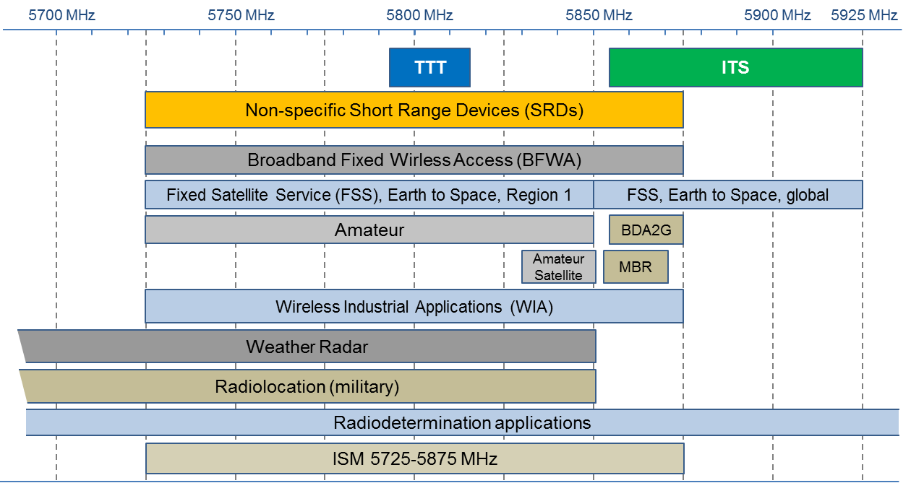

Figure 1: Overview of systems/services within and outside band 5795-5815 MHz

Table 1: Overview of applications within and outside band 5795-5815 MHz

|  |  |  |  |  |
| --- | --- | --- | --- | --- |
| Application | Frequency range | ECC/ERC  harmonisation  measure | ETSI Harmonised European Standard | Notes |
| Amateur | 5650-5850 MHz |  | EN 301 783 |  |
| Amateur Satellite | 5830-5850 MHz |  |  |  |
| BFWA | 5725-5875 MHz | ECC/REC/(06)04 | EN 302 502 |  |
| Direct Air-to-Ground Communications (DA2GC) | 5855-5875 MHz | ECC/DEC/(15)03 |  |  |
| FSS Earth Stations | 5850-5925 MHz |  | EN 301 443 | Priority for civil networks |
| ITS | 5855-5875 MHz,  5875-5925 MHz | ECC/DEC/(08)01  ECC/REC/(08)01  ERC/REC 70-03 | EN 302 571 |  |
| Industrial, scientific and medical (ISM) | 5725-5875 MHz |  |  |  |
| Maritime Broadband Radio (MBR) | 5852-5872 MHz,  5880-5900 MHz | ECC/REC/(17)03 | EN 303 276 |  |
| Non-specific SRD | 5725-5875 MHz | ERC/REC 70-03 | EN 300 440 |  |
| Radiodetermination applications | 4500-7000 MHz | ERC/REC 70-03  (Annex 6) | EN 302 372 | Within the band 4500-7000 MHz for TLPR application |
| Radiolocation (military) | 5250-5850 MHz |  |  |  |
| TTT | 5795-5815 MHz | ERC/REC 70-03  (Annex 5) | EN 300 674 |  |
| Weather Radar | 5250-5850 MHz |  |  | Ground based and airborne |
| WIA | 5725-5875 MHz | ERC/REC 70-03  (Annex 2) |  | Not considered to be used outside factories |
| Note: see the ECA table [28] for a complete list. | | | | |

# Description of Smart Tachograph and Weight&dimeNsion

## Market regulatory background

### Rationale for a market regulation

The digital tachograph introduction and the enforcement of weights&dimension both impact traffic safety and fair competition on the road transport market. Additionally, the digital tachograph is used to guarantee correct working conditions for truck drivers as prerequisite for safe driving. Since road transport is done on an international basis, the EU regulated the radio technology to be used for the remote enforcement of the tachograph in Appendix 14 of the Commission Implementing Regulation 2016/799 [4] and for the weights&dimension enforcement in Article 10d of the Directive 2015/719 [2].

### Market introduction

Given the last update of the EU regulation, the smart tachograph must be implemented in new heavy vehicles by early 2019.

National authorities are asked to start enforcement of smart tachographs by 2034, milestone by which each EU country must have at minimum one road side unit called Remote Early Detection Communication Reader (REDCR). A very rough estimation could be that each country buys one REDCR for each millions of inhabitants that means for Germany 82, Portugal 11 and Estonia 1 REDCR units, for example.

Compared with existing road tolling stations which use similar technology, the expected amount of REDCR enforcement equipment expected to be very low. Brought to the amount of European territories,, taking into account the limited communication zone area, it is only a very small fraction of the European area that will be used for smart tachograph radio communication. It has to be noted that the vehicle unit (VU) is a passive device only communicating when interrogated by a REDCR.

### Technical prerequisites regulated by the European Union

#### Interrogation use cases

The Commission Implementing Regulation 2016/799 [4] foresees two interrogation use cases.

The vehicle unit is read out by a fixed or portable interrogator (REDCR) device located at the roadside which is directed towards the centre of the windscreen of the passing by vehicles to be inspected (see Figure 2). Use case 1 is defined in Figure 2 with fixed REDCR installed on tripod.

The vehicle unit is read out from a mobile interrogator device situated within a moving vehicle and directed towards the centre of the windscreen of the vehicle to be inspected (see Figure 3). The vehicle unit can only be read out by one REDCR at the same time. Figure 2 and Figure 3 show the principle where these interrogator devices can be located, and in which direction they are pointing. Use case 2 is defined in Figure 3 with REDCR mounted on a moving car.



Figure 2: REDCR location in the roadside interrogation use case 1 (basic principle)



Figure 3: REDCR location in the vehicle based interrogation use case 2 (basic principle)

#### Radio technology

The Commission Implementing Regulation 2016/799 [4] foresees that the radio communication between the vehicle unit and the interrogator device operates according to ERC Recommendation 70-03[16], uses 5.8 GHz Dedicated Short-Range Communications (DSRC), respecting the technical characteristics defined in ETSI EN 300 674-1 [10]. Further, to ensure the compatibility to operational parameters of other standardised 5.8 GHz DSRC systems, the equipment used for remote tachograph monitoring should conform to parameters from EN 12253 [8] and EN 13372 [9].

Because of the Radio Equipment Directive 2014/53/EU [5] (RED), ETSI EN 300 674-2-1 [11] and ETSI EN 300 674-2-2 [12] apply for the interrogator and for the vehicle unit respectively.

#### Antenna characteristics and mounting

The Commission Implementing Regulation 2016/799 [4] foresees that the boresight of the vehicle unit antenna is approximately parallel with the road surface. All other antenna characteristics should be chosen in such a way that they efficiently support the use cases described in clause 3.1.3.1 (2016/799 [4]) and that they conform the parameters D5, D5a, U5, and U5a in [4].

The Commission Implementing Regulation 2018/502 [6] further foresees that the position of the DSRC-VU antenna should be optimised for a use case where the REDCR is installed in 15 m distance in front of the vehicle at 2 m height, targeting the horizontal and vertical centre of the windscreen. For light vehicles, an installation corresponding to the upper part of the windscreen is suitable. For all the other vehicles, the DSRC antenna should be installed either near the lower or near the upper part of the windscreen.

The REDCR antenna should be optimised for the specific purpose and read circumstances (use case) in which the REDCR has been designed to operate.

#### Interference to other DSRC equipment

The Commission Implementing Regulation 2016/799 [4] foresees that the remote interrogation of vehicles should not be done when closer than 200 m to a 5.8 GHz DSRC gantry (e.g. road tolling).

## Technical characteristics

The key radio parameters of the REDCR and the DSRC-VU are summarised in Table 2 to Table 4.

Table 2: Key radio parameters of the DSRC vehicle unit (DSRC VU) [7]

|  |  |  |
| --- | --- | --- |
|  | Value | Units |
| DSRC VU receiver parameters | | |
| Sensitivity (including antenna gain) | -60 to -43 | dBm |
| Blocking (Class 2) | ≥ -30 | dBm |
| Modulation of received signal | 2-ASK | |
| Protection Criteria (I/N) | -3 | dB |
| DSRC VU transmitter parameters | | |
| Maximum output power level, e.i.r.p. | -14 | dBm |
| TX frequency band | 5.795 – 5.815 | GHz |
| Conversion Gain (lower limit) | 1 | dB |
| Conversion Gain (upper limit) | 10 | dB |
| DSRC VU antenna | | |
| Antenna polarisation | LHCP | |
| Cross-polar discrimination, ellipticity of polarisation | ≥ 6 | dB |
| DSRC VU antenna mounting | | |
| Car windscreen loss (when applicable) | 3 | dB |
| Mounting height above ground | 1 to 2.2 | m |
| Elevation of boresight | 0° horizontal | |

Table 3: Key radio parameters of a roadside or vehicular REDCR [7]

|  |  |  |
| --- | --- | --- |
|  | Value | Units |
| Roadside or vehicular REDCR receiver parameters | | |
| Receiver bandwidth | 500 | kHz |
| Blocking limit | ‑30 | dBm |
| Receiver sensitivity (including antenna gain)  minimum typical  maximum | -104  -110 -115 | dBm dBm dBm |
| Modulation of received signal | 2-PSK |  |
| Protection criterion (I/N) | ≤ -3 | dB |
| Roadside or vehicular REDCR transmitter parameters | | |
| TX output power level, e.i.r.p. | ≤ 33 | dBm |
| TX frequency band | 5.795 – 5.815 | GHz |
| Roadside or vehicular REDCR antenna | | |
| Antenna polarisation | LHCP | |
| Antenna gain outside REDCR active angle relative to boresight gain | ≤ -15 | dB |
| Cross-polar discrimination, ellipticity of polarisation | ≥ 10 | dB |
| Roadside or vehicular REDCR antenna mounting | | |
| REDC mounting height above ground per use case | | |
| Vehicle  Tripod  Gantry | 1.5 m to 2 m 2 m 6 m to 7 m | |
| Elevation of boresight per use case | | |
| Gantry  All others | 45° downwards 0° horizontal | |

Table 4: Key radio parameters of a hand-held REDCR [7]

|  |  |  |
| --- | --- | --- |
|  | Value | Units |
| Hand-held REDCR receiver parameters | | |
| Receiver bandwidth | 500 | kHz |
| Reading range | ≤ 3 | m |
| Blocking limit | ‑30 | dBm |
| Modulation of received signal | 2-PSK |  |
| Protection criterion (I/N) | -3 | dB |
| Hand-held REDCR transmitter parameters | | |
| TX output power level, e.i.r.p. | < 33 | dBm |
| TX frequency band | 5.795 – 5.815 | GHz |
| Hand-held REDCR antenna | | |
| Antenna polarisation | LHCP | |
| Cross-polar discrimination, ellipticity of polarisation | ≥ 6 | dB |
| Hand-held REDCR antenna mounting | | |
| REDC mounting height above ground | 1 m to 1.5 m | |
| Elevation of boresight | 0° horizontal | |

## Technical ASsumptions

### Interrogation use cases

Despite the use cases defined by the Commission Implementing Regulation 2016/799 [4], other DSRC-VU readout scenarios are necessary or possible to enforce or install a tachograph in a vehicle. The following use cases can be assumed and are studied in this Report.

#### Testing the installation in a garage or interrogation on a parking lot

After installation of a new tachograph in a vehicle, the correct operation of the DSRC-VU is tested with a hand-held device. This device will be pointed in direction of the DSRC-VU from a distance typically not exceeding 3 m. A trigger button is used to initiate the DSRC-VU readout.

A similar device could be used to readout a DSRC-VU of a parked truck by the police.

Since these hand-held devices will be battery powered and the reading distance is short, the transmit power level can be low. The receiver sensitivity should be limited to avoid unintentionally reading out the DSRC-VU of other trucks parked nearby. The exact values of the radio characteristics are up for further investigations, but the transmit power level should be limited to values reasonable for hand-held devices to protect humans from harmful RF exposure.

Also because of the short reading distance, the opening angle of the REDCR antenna can be wide, what makes it possible to use a small low gain single patch antenna integrated in the hand-held device.

#### REDCR mounted on a gantry

For automatic enforcement of the digital tachograph, fixed enforcement stations are possible, where the DSRC-VU can be localised by radio detection and matched to a certain vehicle passing the enforcement station in free flow traffic. These digital tachograph enforcement stations can have a REDCR for each lane mounted on a gantry above the street like in a multilane free flow tolling enforcement station.

In these installations, the boresight of the REDCR antenna will be typically tilted by 45° downwards against the driving direction of the traffic. To achieve the necessary interrogation performance in such free flow scenarios, typically a transmit power level of 33 dBm e.i.r.p. is needed.

### Mounting of vehicle unit antenna

The Commission Implementing Regulation 2016/799 [4] does not foresee at which height the DSRC-VU is mounted, and whether it is mounted inside or outside the vehicle.

Therefore, it can be considered that the DSRC-VU can be mounted either inside the vehicle behind the windscreen, or outside on the front in the centre of the vehicle. In case of a fully metallized windscreen without a not metallized area in front of the VU antenna, the only possibility is to mount the DSRC-VU outside the vehicle.

For light vehicles, the mounting in the upper part of the windscreen is described in the Commission Implementing Regulation 2018/502 [6] to be suitable. This corresponds to a mounting height of about 1.5 m above ground.

As typical mounting position for a heavy good vehicle (HGV) the centre at the bottom of the windscreen is shown in the regulation [4]. This corresponds to a mounting height of about 2 m above ground.

In addition, the Commission Implementing Regulation 2018/502 [6] mandates that the DSRC-VU antenna is installed in all other than light vehicles either near the lower or near the upper part of the windscreen.

In summary, in most cases the DSRC-VU antenna will be mounted in an HGV inside a non-metallized windscreen in the centre of the vehicle at a height of 2 m above ground. All other mounting options together are expected to be used in less than 2% of all installations.

### Typical vehicle unit antenna characteristics

#### Vehicle unit antenna overview

The vehicle unit antennas have a relative wide opening angle as defined in the Commission Implementing Regulation 2016/799 [4], to make readout from an adjacent lane possible, as needed for the interrogation use cases described in section 3.1.3.1.

Typically, either the same antenna or similar antennas are used for the DSRC-VU transmitter and for the receiver. Usually, the antenna diagram is symmetric around boresight and given by the angle deviation θ from boresight. Since its boresight is directed in parallel with the road surface (see clause 3.1.3.3) and it is pointed in driving direction, azimuth and elevation characteristics are usually identical to the characteristic over θ. For more than 90° angle deviation θ from boresight (to the back) the VU is shielded by the vehicle compartment and it can be expected that the sensitivity to signals from outside the vehicle in this direction is very low. Therefore, also any emission into this direction to the outside of the vehicle can be neglected.

#### Vehicle unit RX antenna

A typical VU antenna diagram is shown in Figure 4. The boresight receiver sensitivity range (PVUsens) including antenna gain is specified by the parameters D11b and D12 in EN 12253 [8] and ETSI Harmonised European Standard EN 300 674-2-2 [12]:

* -60 dBm ≤ PVUsens ≤ ‑43 dBm.

Typically, the boresight receiver sensitivity PVUsens is -47 dBm including antenna gain.



Figure 4: Example for a vehicle unit antenna diagram relative to boresight [7]

#### Vehicle unit TX antenna

Because the DSRC-VU uses backscatter technology without an internal oscillator for the generation of the uplink signal, the REDCR sends an unmodulated continuous wave downlink signal while the VU is transmitting. The VU receives this signal, amplifies it by the conversion gain, modulates it with the uplink data, and transmits it back to the REDCR. Because of this, the TX power level of the DSRC-VU is not constant, it depends on the REDCR transmit power level in direction of the DSRC-VU, the distance from the REDCR, and when mounted within the vehicle on the attenuation of the windscreen. The maximum allowed boresight TX power level of the DSRC-VU is ‑14 dBm.

The antenna diagram of the VU TX antenna is usually identical to the RX antenna, as already described. Therefore, Figure 4 shows also the conversion gain of the DSRC-VU relative to boresight for a typical TX antenna. As described above, the TX power level of the VU does not depend on the conversion gain alone, but also, among other parameters, on the relative position of the REDCR and the direction of its boresight.

The maximum conversion gain in boresight is specified by the parameters U12b in EN 12253 [8] and ETSI EN 300 67422 [12]. The angular mask for the minimum conversion gain, defined by the parameter U12a in EN 12253, is specified in the Commission Implementing Regulation 2016/799 [4] and is slightly different from the values specified in EN 300 674-2-2.

In summary, the conversion gain (Gc) of a DSRC- should be in following range:

* Gc ≥1 dB for θ ≤ ±35° and additionally Gc ≥1 dB in the horizontal plane for Azimuth ≤ ±45°;
* and for all directions Gc ≤ 10 dB applies.

### REDCR antennas for different use cases

#### REDCR antenna type overview

The antennas are typically an integral part of the REDCR and cannot be changed by the user since they are optimised for a certain use case.

For interrogation devices mounted on a gantry as described in clause 3.3.1.2, or mounted on a tripod as described in clause 3.1.3.1 and shown in Figure 2, high gain RX antennas to increase the reception range are typically used.

For mobile interrogation from a vehicle the antenna size is limited by the size of the vehicle (e.g. a motorcycle) and by the air drag when the antennas are mounted on the rooftop of a car. So, either small high gain antennas like for fixed or nomadic installations, or even smaller antennas with reduced gain can be used.

For hand-held interrogation devices antenna size and weight are essential. In practice, only small antennas are suitable for this use case.

The examples given in the following clauses are expectations based on tolling implementations since no REDCR and DSRC-VU implementations existed at the time of preparation of the present Report. Therefore, other antenna types and characteristics meeting the proposed limits are not excluded from future implementations.

#### Antenna for fixed REDCR mounted on a tripod at the roadside

For an REDCR on a tripod at the roadside (see Figure 2) the antenna is mounted in approximately 2 m height with the antenna boresight pointing parallel to the road surface against the driving direction of the vehicles.

A high gain antenna with a typical transmit power level of 33 dBm e.i.r.p. in boresight as shown in Figure 5 and Figure 6 can be used. 33 dBm e.i.r.p. is the maximum power level allowed for REDCR devices. There was no spatial TX power masks defined for this use case when the present Report has been prepared. A proposal for such masks is based on the gantry use case as described in clause 3.3.4.4, but this proposal needs further investigation concerning radio interference.

A typical receiver antenna diagram relative to boresight is shown in Figure 7 and Figure 8. The typical receiver sensitivity for an REDCR on a tripod in boresight of the antenna is -110 dBm including antenna gain.



Figure 5: Example of TX elevation antenna diagram for an REDCR mounted on a tripod or a vehicle [7]



Figure 6: Example of TX azimuth antenna diagram for an REDCR mounted on a tripod or a vehicle [7]



Figure 7: Example of RX elevation antenna diagram relative to boresight gain for an REDCR   
mounted on a tripod or a vehicle [7]



Figure 8: Example of RX azimuth antenna diagram relative to boresight gain for an REDCR   
mounted on a tripod or a vehicle [7]

#### Antenna for mobile REDCR mounted on a vehicle

For a REDCR mounted on a minivan the antenna is located typically in 1.5 m to 2 m height with the antenna boresight pointing parallel to the road surface against the driving direction of the vehicles. For this use case the antenna diagram can be identical to the antennas used for the interrogation from the roadside as shown from Figure 5 to Figure 8.

For smaller vehicles smaller antennas with less gain might be advantageous (see Figure 3). These antennas will usually exhibit identical antenna diagrams for azimuth and elevation. The typical transmitted power level of such an antenna is shown in Figure 9 together with a proposed spatial TX power mask. But this proposal needs further investigation concerning radio interference since there was no such mask defined for this use case when the present Report has been prepared.

A typical receiver antenna diagram for this use case is shown in Figure 10. The typical receiver sensitivity for an REDCR with a small vehicle antenna (e.g. for a motorcycle) in boresight of the antenna is -107 dBm including antenna gain.



Figure 9: Example of TX antenna diagram relative to boresight for a small REDCR   
mounted on a vehicle or a hand-held interrogator [7]



Figure 10: Example of RX antenna diagram for a small REDCR relative to boresight gain  
mounted on a vehicle or a hand-held interrogator [7]

#### Antenna for a fixed REDCR mounted on a gantry

For an REDCR on a gantry as described in clause 3.3.1.2, the antenna is mounted typically in 6 m to 7 m height with the antenna boresight pointing 45° downwards to the road surface against the driving direction of the vehicles.

A high gain antenna is used, with a typical transmitted power level as shown in Figure 11 and Figure 12. The spatial TX power mask is taken from EN 12253 [8]. The parameter D4a describes there that the main beam of the antenna should be limited to ±70° around the vertical downward direction. There is no spatial TX power mask defined in the horizontal plane (azimuth).

A typical receiver antenna diagram for this use case is shown in Figure 13 and Figure 14. The typical receiver sensitivity for an REDCR on a gantry in boresight of the antenna is -110 dBm including antenna gain.



Figure 11: Example of TX elevation antenna diagram for an REDCR mounted on a gantry  
and tilted downwards by 45° [7]



Figure 12: Example of TX azimuth antenna diagram for an REDCR mounted on a gantry   
and tilted downwards by 45° [7]



Figure 13: Example of RX elevation antenna diagram relative to boresight gain  
for an REDCR mounted on a gantry and tilted downwards by 45° [7]



Figure 14: Example of RX azimuth antenna diagram relative to boresight gain  
for an REDCR mounted on a gantry and tilted downwards by 45° [7]

#### Antenna for hand-held REDCR

Hand-held REDCR devices are either used for interrogation from the roadside by a policeman, or in a garage to check the functionality of a DSRC-VU. For the interrogation from the roadside, higher RF performance is necessary than in the garage use case and therefore such devices might use antennas with higher gain and higher TX power levels. The characteristics of these devices can be similar to the small vehicle REDCR as shown in Figure 9 and Figure 10.

REDCR used in a garage will typically contain a single patch antenna to make the device as small as possible. An example for an antenna diagram typical for this garage use case is shown in Figure 15. As already pointed out in clause 3.3.1.1, the TX power level and the sensitivity of these small devices are up for further investigations.



Figure 15: Example of antenna diagram relative to boresight gain for a small hand-held REDCR [7]

## Propagation model

This Report assumes the below three slopes propagation model from ECC Report 68 [18].

if  (1)

Table 5: Parameters for the propagation model

|  |  |  |  |
| --- | --- | --- | --- |
|  | Urban | Suburban | Rural |
| Breakpoint distance d0 (m) | 64 | 128 | 256 |
| Pathloss factor n0 beyond the first break point | 3.8 | 3.3 | 2.8 |
| Breakpoint distance d1 (m) | 128 | 256 | 1024 |
| Pathloss factor n1 beyond the second breakpoint | 4.3 | 3.8 | 3.3 |

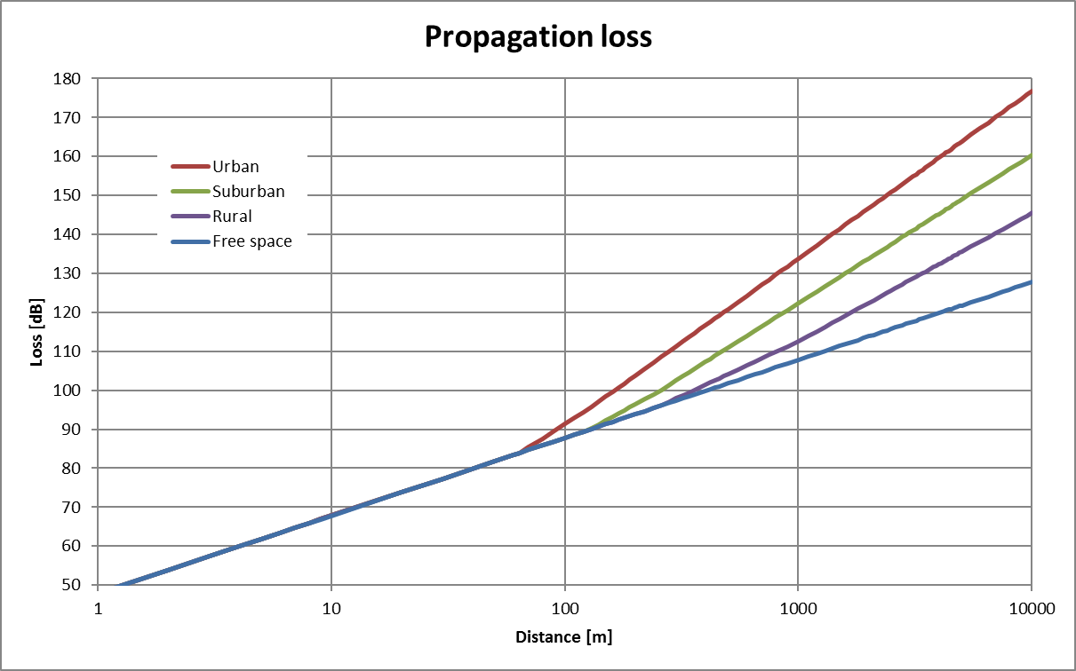

Figure 16: Attenuation of the propagation model used in the calculations

# Compatibility with road toll

## Introduction

The Commission Implementing Regulation 2016/799 [4] foresees that the remote interrogation of vehicles should not be done when closer than 200 m to a 5.8 GHz DSRC gantry (e.g. road tolling). In this section MCL calculations are performed to verify that the minimum distance of 200 m is enough. Because CEN DSRC use different frequencies for downlink and uplink within the same channel, there is no risk for interference from smart tachograph REDCR to road tolling RSU or vice versa. The major risks for interference are:

* The smart tachograph REDCR interfere the road tolling OBU receiver;
* The smart tachograph VU interfere the road tolling RSU receiver;
* The road tolling RSU interfere the VU receiver;
* The road tolling OBU interfere the REDCR receiver.

### Road tolling technical parameters

Table 6: Summary of characteristics of the road tolling (TTT/DSRC) systems

|  |  |  |
| --- | --- | --- |
|  | Road Side Units | On-board units |
| Frequency range (MHz) | 5795 and 5815 | |
| e.i.r.p. | 2 W (33 dBm) standard for -35° ≤ θ ≤ 35°  18 dBm for θ > 35°  8 W (39 dBm) optional  Note: TX power of 2 W e.i.r.p. ETSI EN 300 674.  TX power of 8 W e.i.r.p. road tolls in Italy ETSI ES 200 674-1 | Maximum re-radiated sub-carrier e.i.r.p.:    -14 dBm |
| Antenna gain | 10 – 20 dB (assumed side lobe 15 dB) | 1 – 10 dB  (assumed side lobe 5 dB) |
| Transmitter bandwidth | 1 MHz | 500 kHz |
| Receiver bandwidth | 500 kHz | 1 MHz (see Note 2) |
| Polarisation | Left circular | Left circular |
| Receiver sensitivity  (at the receiver input) | -104 dBm (BPSK) | -60 dBm |
| Receiver noise power  (at the receiver input) | -115 dBm |  |
| I/N (dB) | -6 |  |
| Note 1: The receiver parameters in the standard family ETSI Harmonised European Standard EN 300 674 (2016) may deviate from the values in .  Note 2: The baseband bandwidth of an OBU receiver is 1 MHz. OBUs normally use detector diodes for down conversion, therefore they are sensitive for interference not only in-band but also out-of-band. | | |

## MCL calculations

### Results of MCL calculations for interference from smart tachograph REDCR into road tolling OBU

MCL calculations are performed to derive separation distances between a REDCR and OBU using the propagation models described in Figure 16. The obtained results are depicted in .

Table 7: MCL calculations for interference from smart tachograph REDCR into road tolling OBU –   
separation distances

|  |  |  |
| --- | --- | --- |
| Parameter | Unit | Value |
| Emission part: smart tachograph REDCR | | |
| TX out (e.i.r.p.) | dBm | 33 |
| Reception part: road tolling OBU | | |
| Windscreen attenuation | dB | 3 |
| Sensitivity including antenna gain | dBm | -50 |
| Noise power | dBm | -63 |
| Protection Criterion I/N | dB | -6 |
| Allowable interfering power level 'I' at the receiver antenna | dBm | -69 |
| Main lobe REDCR - side lobe OBU | | |
| Side lobe attenuation | dB | 5 |
| Required attenuation | dB | 94 |
| Separation distance REDCR → OBU | | |
| Separation distance - Urban model | m | 119 |
| Separation distance - Suburban model | m | 171 |
| Separation distance - Rural model | m | 207 |

### Results of MCL calculations for interference from smart tachograph VU into road tolling RSUs

MCL calculations are performed to derive separation distances between a VU and RSU using the propagation models described in Figure 16. The obtained results are depicted in Table 8.

Table 8: MCL calculations for interference from smart tachograph VU into road tolling RSU –   
separation distances

|  |  |  |
| --- | --- | --- |
| Parameter | Unit | Value |
| Emission part: smart tachograph VU | | |
| TX out (e.i.r.p.) | dBm | -24 |
| Reception part: road tolling RSU | | |
| Windscreen attenuation | dB | 3 |
| Sensitivity including antenna gain | dBm | -118 |
| Noise power | dBm | -129 |
| Protection Criterion I/N | dB | -6 |
| Allowable interfering power level 'I' at the receiver antenna | dBm | -135 |
| Main lobe VU - side lobe RSU | | |
| Side lobe attenuation | dB | 15 |
| Required attenuation | dB | 93 |
| Separation distance VU → RSU | | |
| Separation distance - Urban model | m | 112 |
| Separation distance - Suburban model | m | 160 |
| Separation distance - Rural model | m | 184 |

### Results of MCL calculations for interference from road tolling RSU into smart tachograph VU

MCL calculations are performed to derive separation distances between a RSU and VU using the propagation models described in Figure 16. The obtained results are depicted in Table 9.

Table 9: MCL calculations for interference from road tolling RSU into smart tachograph VU –   
separation distances

|  |  |  |
| --- | --- | --- |
| Parameter | Unit | Value |
| Emission part: road tolling RSU | | |
| TX out (e.i.r.p.) | dBm | 33 |
| Reception part: smart tachograph VU | | |
| Windscreen attenuation | dB | 3 |
| Sensitivity including antenna gain | dBm | -50 |
| Noise power | dBm | -63 |
| Protection Criterion I/N | dB | -3 Note 1 |
| Allowable interfering power level 'I' at the receiver antenna | dBm | -66 |
| Side lobe RSU - main lobe VU | | |
| Side lobe attenuation | dB | 15 |
| Required attenuation | dB | 81 |
| Separation distance RSU → VU | | |
| Separation distance - Urban model | m | 47 |
| Separation distance - Suburban model | m | 47 |
| Separation distance - Rural model | m | 47 |
| Note 1: From ETSI Technical Report TR 103 441 [7] | | |

### Results of MCL calculations for interference from road tolling OBU into smart tachograph REDCRs

MCL calculations are performed to derive separation distances between an OBU and REDCR using the propagation models described in Figure 16. The obtained results are depicted in Table 10 .

Table 10: MCL calculations for interference from road tolling OBU into smart tachograph REDCR –   
separation distances

|  |  |  |
| --- | --- | --- |
| Parameter | Unit | Value |
| Emission part: road tolling OBU | | |
| TX out (e.i.r.p.) | dBm | -24 |
| Reception part: smart tachograph REDCR | | |
| Windscreen attenuation | dB | 3 |
| Sensitivity including antenna gain | dBm | -110 |
| Noise power | dBm | -121 |
| Protection Criterion I/N | dB | -3 |
| Allowable interfering power level 'I' at the receiver antenna | dBm | -124 |
| Side lobe OBU - main lobe REDCR | | |
| Side lobe attenuation | dB | 5 |
| Required attenuation | dB | 92 |
| Separation distance VU → RSU | | |
| Separation distance - Urban model | m | 105 |
| Separation distance - Suburban model | m | 149 |
| Separation distance - Rural model | m | 164 |

## Summary compatibility with road toll

The following MCL calculations between smart tachograph and road tolling were performed:

The smart tachograph REDCR interferes the road tolling OBU receiver;

The smart tachograph VU interferes the road tolling RSU receiver;

The road tolling RSU interferes the VU receiver;

The road tolling OBU interferes the REDCR receiver.

The worst-case interference was from smart tachograph REDCR into road tolling OBU with a needed separation distance of 200 m which is equal to minimum required distance between smart tachograph and road tolling according to Commission Implementing Regulation 2016/799 [4].

# Compatibility with ITS operating in the band 5855-5925 MHZ

## Introduction

In this section, the potential interference caused by ITS into smart tachograph, weight&dimension applications is investigated. Both in-band interference and blocking are considered. A similar approach adopted with ITS in ECC Report 228 [22] is considered.

The receiver of the road side unit (REDCR) has high sensitivity and high selectivity. This will result in high vulnerability for in-band interference but high robustness for out-of-band interference. It is the opposite case for the receiver of the vehicle unit (VU), it has a low sensitivity and a low selectivity. This will result in robustness for in-band interference but vulnerability for out-of-band interference.

Because of the different performance of the REDCR and VU receivers, studies were performed in two parts:

* Interference from ITS unwanted emissions within frequency range 5795 to 5815 MHz is studied in 5.5. As explained above only the receiver of the road side unit (REDCR) is considered because the vehicle unit has limited sensitivity.
* Impact of the ITS wanted emissions within frequency range 5855 to 5925 MHz into the VU blocking is studied in 5.6. As explained above only the receiver of the vehicle unit (VU) is considered because the REDCR has high selectivity.

## Method for interference calculations

The coexistence investigation takes into account both radio propagation performance and timing considerations in the following way.

CAM messages: According to ETSI TS 102 792 [13], for ITS the timing duty cycle is not based on the maximum allowed duty cycle. The ITS duty cycle is based on cooperative awareness messages (CAM) defined in ETSI European Standard EN 302 637-2 [15]. The use of CAM messages is considered more realistic than maximum allowed duty cycle which allows up to 20 times higher duty cycle (coexistence mode B) than the duty cycle given by the CAM generation rule.

Duty cycle limits: Calculations are based on the number of interferers and their transmission duty cycle. They indicate the maximum possible number of ITS transmissions allowed per time unit within the interference zone. The calculation method was developed in ETSI based on measurements and advanced simulations (see details in ETSI Technical Report TR 102 960 [14]).

Interference zone: The size of the interference zone has been estimated using MCL calculations. The MCL calculations include detailed models of typical antennas for the victim and the interferer.

Vehicle density: According to the studied scenario, different densities of vehicles are studied. With decreased vehicle speed, the density of vehicles increases.

Number of vehicles within interference zone: Based on the calculations on size of the interference zone and the density of vehicles, the number of vehicles within the interference zone is calculated.

Interference evaluation: If the number of vehicles within an interference area is higher than results from timing duty cycle calculations, it is considered a risk for interference on the smart tachograph, weight&dimension transactions.

## Studied use cases

In Section 3.1.3.1 two use cases are defined:

* Use case 1: A fixed REDCR is installed at the road side on a tripod, rotated 30 degrees in the azimuth plane;
* Use case 2: A REDCR is mounted on a moving car with antennas directed backwards.

To simplify the calculations, all antennas are assumed to be positioned at the same height above the road. Because of long distances and different antenna performances, a difference in height of 1 up to 2 meters does not have any significant influence.

As a typical scenario, it is assumed a road in a rural or suburban area with two lanes in both directions, see Figure 17.

The traffic density is calculated under the assumption that the vehicles are in 3 seconds driving distance away from each other. Depending on the vehicle speed, this results in different distances between the vehicles. In real traffic it could be imagined 2 seconds and in extreme cases 1 second driving time between vehicles even thought that this would result in a high collision risk. More than a typical 3 second distance is used when setting minimum distance with an automatic cruise control supported by radar in modern cars. On the other hand, no considerations have been taken into account for radio shadowing from vehicles which for a large truck could be significant. Therefore, as a compromise, an average distance of 3 seconds was used in the calculations. To simplify the calculations it is assumed that all vehicles have the same speed.

A special traffic scenario is platooning with trucks, see example in Figure 18. There are plans by the truck manufacturers to introduce platooning technologies that keep a constant distance between trucks of only some few meters. One critical path is a radio link between the trucks using ITS with the same parameters used in ECC Report 228 [22]. There is no standard available that defines how to use ITS for platooning at the time of preparation of this Report. In this study an average distance between trucks of 20 m (length of vehicle plus space to the next truck at 70 km/h speed) is assumed. Further, it is assumed to use a rate of 10 messages per second and an average vehicle speed of 70 km per hour. The calculations assume only one truck platooning lane; for the other 3 lanes a typical traffic scenario as described above is assumed.

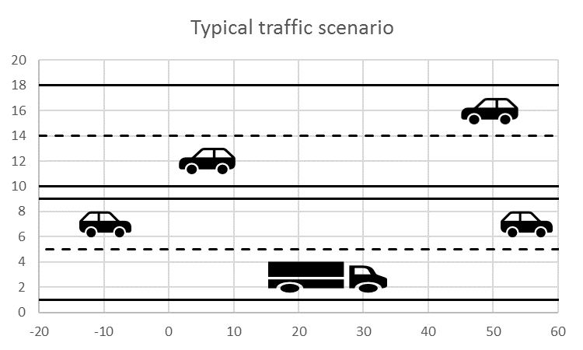

Figure 17: Typical scenario: a road in rural or suburban area with two lanes in both directions

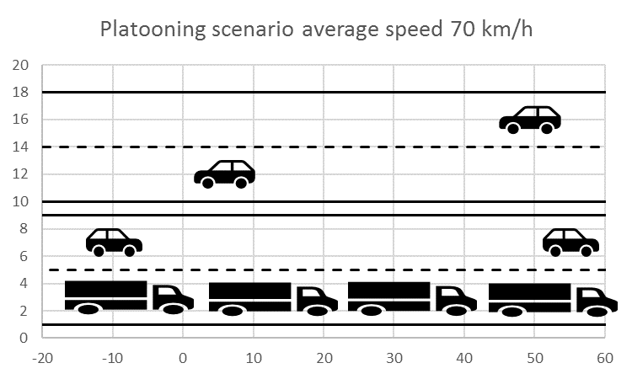

Figure 18: Example of truck platooning

## Duty cycle considerations

### The smart tachograph, weight&dimension protocol (CEN DSRC)

The communication protocol of the CEN DSRC system is based on a message exchange between the REDCR and the VU. In the protocol some degree of redundancy is built in by simple repetition in case a message has been disturbed by interference. In general the REDCR sends out a non-personalised request to all active VUs in its range. The first VU answering with its ID will then be processed further by sending out a personalised request only addressing this single VU. During this communication several messages are exchanged and at the end the transaction is closed.

In case an uplink message (VU to REDCR) is not received by the REDCR (interference into the REDCR), the REDCR will retransmit the request message after a certain waiting time in the range of some ms. This can be repeated several times. The transaction is defined as failed when the vehicle leaves the communication area before the transaction could be finished. Or in other words the maximum number of retrials is exceeded, which depends on the individual parameter settings in the REDCR. It can be seen in the following that a single interference event during a transaction can only delay the transaction but will not lead to a failure of the overall transaction. Only several interference events during a transaction might lead to a transaction failure.

A part of a typical transaction scheme is depicted in Figure 19. Here the transaction is not depicted for the complete time duration. The typical distribution of transaction durations is given in Figure 20. In Figure 19 an interference event occurs during a downlink (REDCR to VU) communication, thus the VU has not been able to receive the REDCR’s message. It can be seen that after a waiting time, the REDCR repeats the message transmission and then receives the answer from the VU with some delay. The timing given here is only tentative and might differ across various installations and systems.

Based on the presented protocol it can be assumed that an interfering system with properly chosen limitation of duty cycle will not harmfully interfere with the CEN DSRC system.

|  |
| --- |
|  |
| ITS frame interfering with DSRC transaction. LTE V2X frames looks similar |

Figure 19: Part of a typical transaction scheme between REDCR and VU in CEN DSRC



Figure 20: Typical DSRC transaction duration

### Consideration of the Duty Cycle limitations for ITS

The assumptions and calculations in the following are based on an extensive work performed in the Technical Committee of ETSI on ITS (ETSI TC ITS), documented in the ETSI Technical Report TR 102 960 [14].

The duty cycle limitations of an ITS system will lead to a significant mitigation factor to be taken into account in the interference evaluation process. The evaluation needs to be done by taking into account the number of vehicles, which could contribute to the interference towards the REDCR. Furthermore, the CEN DSRC communication protocol properties need to be taken into account. Basic principles of the protocol haven been presented in section 5.4.1 of this Report.

From Figure 21 to Figure 25, different traffic mobility scenarios are given for information.

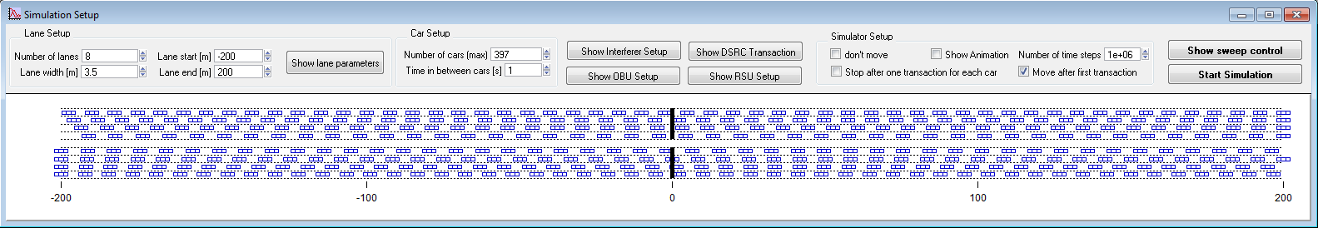

Figure 21: Slow traffic mobility scenario taken from ETSI TR 102 960 [14]

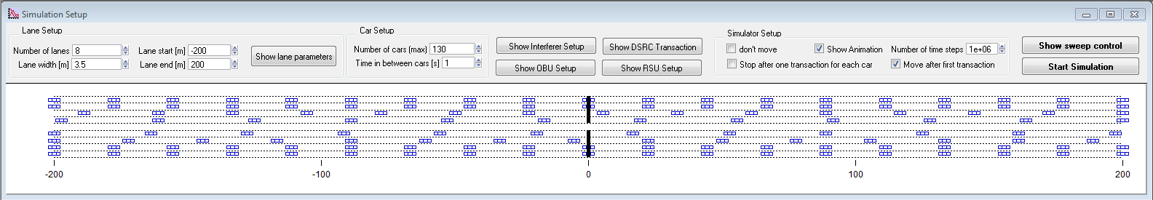

Figure 22: Fast traffic mobility scenario taken from ETSI TR 102 960 [14]

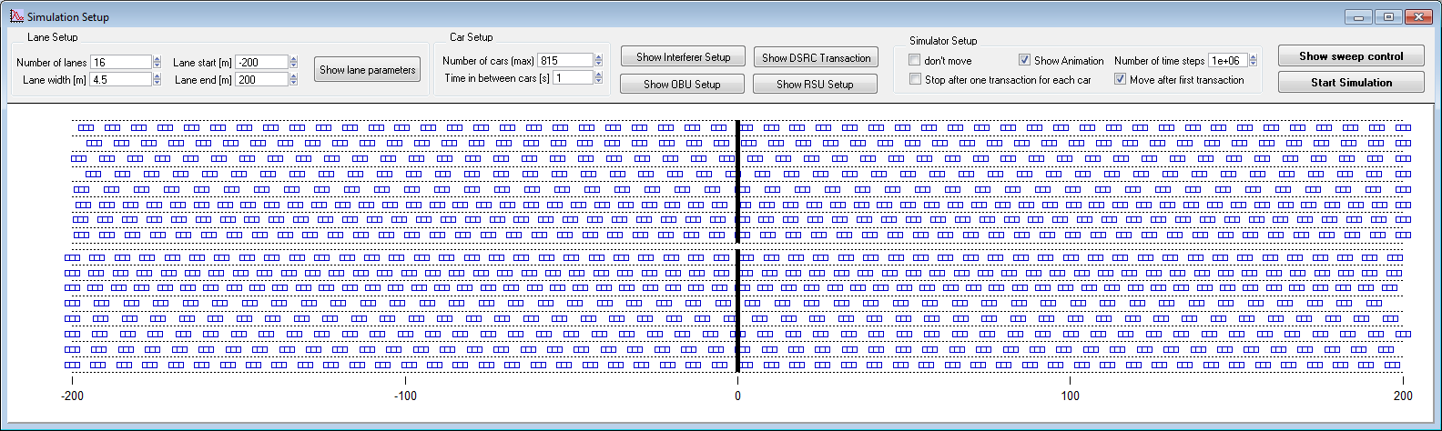

Figure 23: Slow moving mobility scenario taken from ETSI TR 102 960 [14]

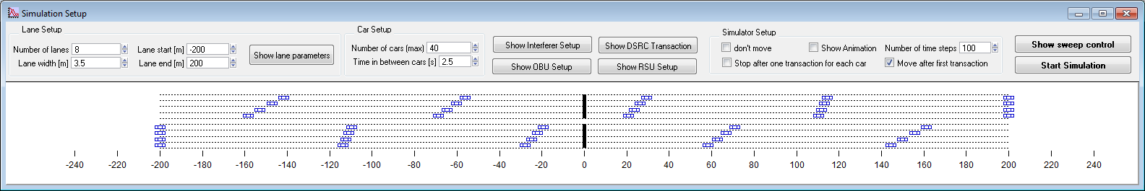

Figure 24: Light traffic mobility scenario taken from ETSI TR 102 960 [14]

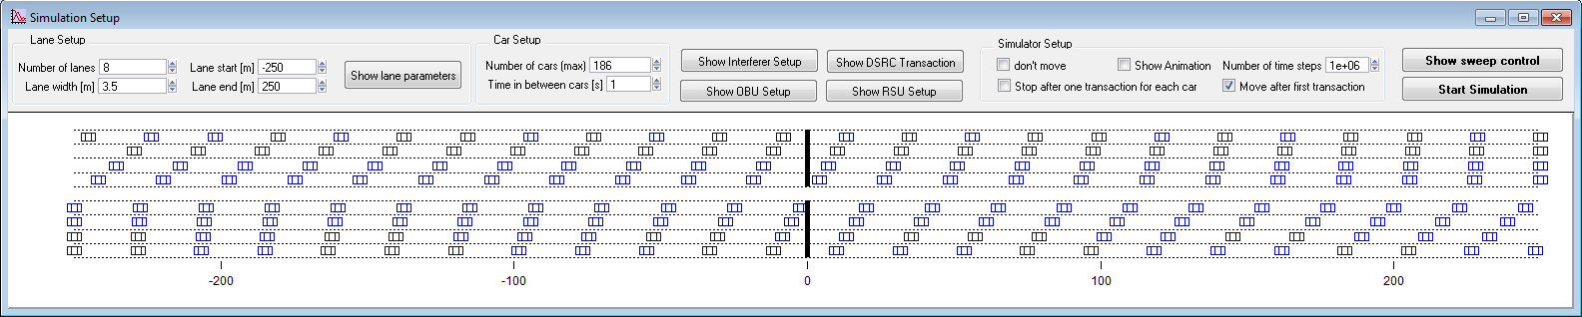

Figure 25: Truck mobility scenario taken from ETSI Technical Report TR 102 960 [14]

ETSI TR 102 960 [14] contains several compatibility investigations based on the protocol parameters of CEN DSRC and ITS systems. Some of these results are given in the following section.

For a given number of active ITS stations in the interference range a minimum Toff time between two consecutive frame transmissions can be evaluated. The worst-case results are given in Figure 26 taken from the ETSI TR 102 960 [14]. Here it can be seen that up to a number of 3 ITS stations in the interference range and a Toff time of 100 ms between two frames no harmful interference will occur to the CEN DSRC link. With an increased number of ITS stations in the interference range, the required minimum Toff time has to be increased.

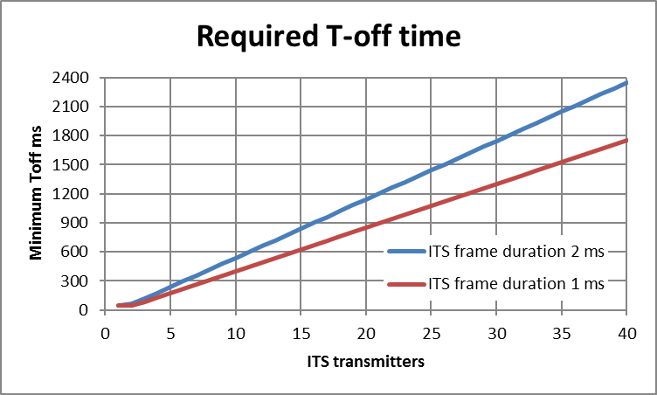

Figure 26: Required Toff time as of ETSI TR 102 960 [14] between two frames of 1 and 2 ms length for a given number of ITS stations for interference-free operation of REDCR

Taking into account the ITS frame duration of 1 and 2 ms, Figure 27 depicts the maximum allowed frame rate for each ITS station for a given number of ITS stations in the interference range. These values can be taken into account in the evaluation of the interference risk in the different scenarios.

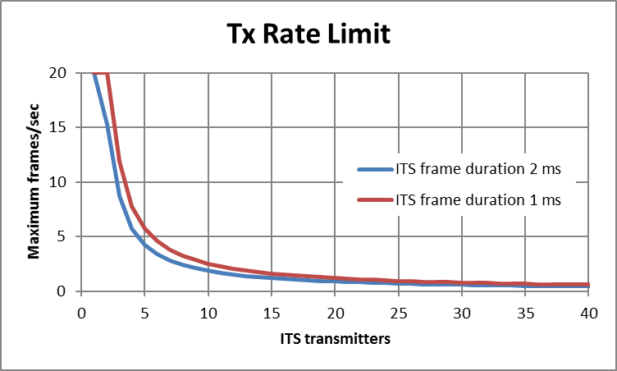

Figure 27: Maximum frame transmission rate limit as function of the ITS stations in the interference range, frame length 1 and 2 ms as of ETSI TR 102 960 [14]

The main message transmitted by an ITS system will be the so called CAM ETSI EN 302 637-2 [15]. ITS CAM generation takes place at facilities layer (which is above networking and transport layer) at a frequency between 1 and 10 Hz. According to ETSI EN 302 637-2 [15] the CAM generation rate is based on the dynamic behaviour of the vehicle, which includes speed, turn rate, and acceleration. The relation between speed and CAM generation rate is shown in Figure 28. Other vehicle movements including turns, acceleration and deceleration might result as well in increased CAM generation rates. For high dynamic vehicles (high speed > 140 km/h) the CAM generation rate can reach a maximum value of 10 Hz. The minimum CAM message rate of 1 Hz is reached below a vehicular speed of around 15 km/h.

For ITS, a CAM message is always transmitted within a single frame with an approx. duration of 1 ms.

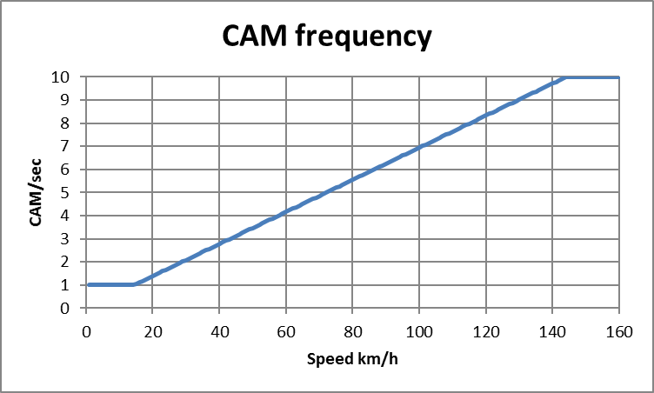

Figure 28: Specified CAM message rate with ITS as function of the vehicle speed

## Compatibility ITS unwanted emissions

ITS unwanted emissions within frequency range 5795 to 5815 MHz can create interference to DSRC receivers. For unwanted emissions, only the receiver of the road side unit (REDCR) is considered because the vehicle units have very limited sensitivity.

Table 11: Parameters used in MCL calculations

|  |  |  |
| --- | --- | --- |
| Parameter name | Unit | Parameter value |
| Unwanted emissions e.i.r.p. | dBm/MHz | -30 and -37 |
| Polarisation loss | dB | 3 |
| Frequency | MHz | 5800 |
| Victim communication link |  | Uplink (from vehicle to roadside) |
| Victim sensitivity including antenna gain in boresight | dBm | -110 |
| Victim receiver bandwidth | MHz | 0,5 |
| Victim modulation S/N | dB | 11 |
| Protection criteria I/N | dB | -3 Note 1 |
| Victim antenna performance in azimuth |  | Figure 8 |
| Note 1: From ETSI Technical Report TR 103 441 [7] | | |

Advanced MCL calculations including antenna diagrams were performed using parameters in Table 11. Figure 29 and Figure 30 shows results from use case 1 with unwanted emissions -30 and -37 dBm/MHz. Figure 31 and Figure 32 shows results from similar calculations with use case 2. In the figures the interference region is inside the red curve. Any ITS antenna transmitting inside the interference region introduces a risk of interference to the REDCR.

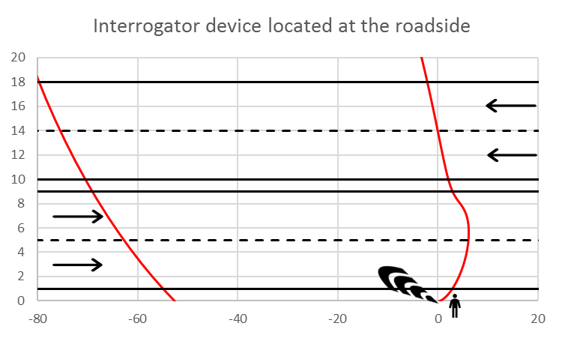

Figure 29: Interference region with -30 dBm/MHz interferer, use case 1

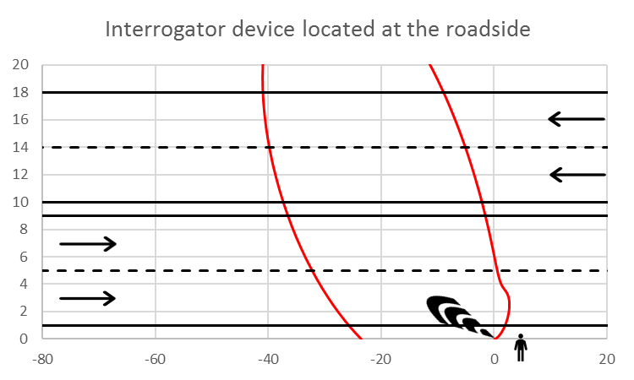

Figure 30: Interference region with -37 dBm/MHz interferer, use case 1

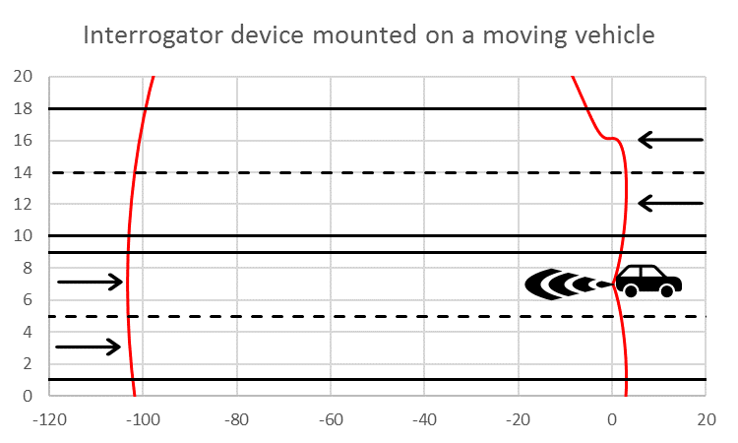

Figure 31: Interference region with -30 dBm/MHz interferer, use case 2

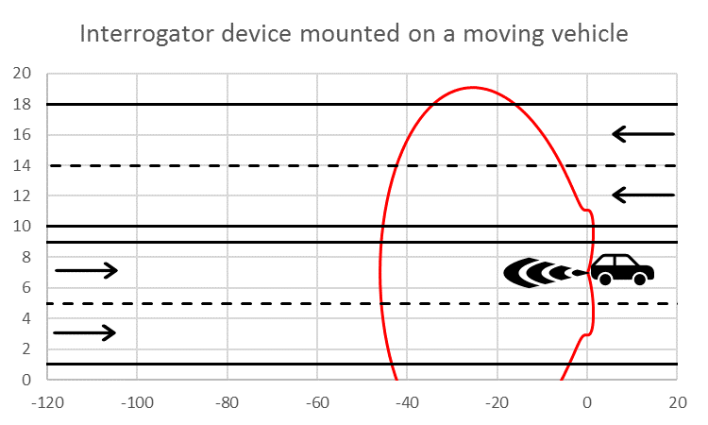

Figure 32: Interference region with -37 dBm/MHz interferer, use case 2

Taking into account the results of this interference study, depending on the vehicle density, it is evaluated how many vehicles are inside the interference region. The diagram in Figure 27 is then used to evaluate the maximum interference free rate of transmitted messages. This upper message rate limit is compared with the actual transmitted message rate.

The obtained results are summarised in Table 12. It is considered a risk for interference if the value in column "Generated CAM rate (Hz)" is higher than the value in column "CAM rate limit for no interference (Hz)".

Table 12: Summary interference calculations use case 1 and 2 with unwanted emissions   
-30 and -45 dBm/MHz

|  |  |  |  |  |  |
| --- | --- | --- | --- | --- | --- |
| Avg. traffic speed (km/h) | Avg. dist. between vehicles (m) | Vehicles in interference zone | Generated CAM rate (Hz) | CAM rate limit for no interference (Hz) | Interference |
| Interference calculation use case 1 with -30 dBm/MHz unwanted emissions | | | | | |
| 10 | 14 | 20 | 1.0 | 1.2 | No |
| 60 | 56 | 5 | 4.2 | 5.7 | No |
| 100 | 89 | 3 | 6.9 | 11.9 | No |
| 70 | 64 and 20 | 5 (7) (Note 2) | 10 (Note 1) | 5.7 | Yes |
| Interference calculation use case 1 with -37 dBm/MHz unwanted emissions | | | | | |
| 10 | 14 | 9 | 1.0 | 2.8 | No |
| 60 | 56 | 2 | 4.2 | 20 | No |
| 100 | 89 | 1 | 6.9 | 20 | No |
| 70 | 64 and 20 | 2 (3) (Note 2) | 10 (Note 1) | 20 | No |
| Interference calculation use case 2 with -30 dBm/MHz unwanted emissions | | | | | |
| 10 | 14 | 29 | 1.0 | 0.8 | No (almost) |
| 60 | 56 | 7 | 4.2 | 3.8 | No (almost) |
| 100 | 89 | 5 | 6.9 | 5.7 | No (almost) |
| 70 | 64 and 20 | 7 (10) (Note 2) | 10 (Note 1) | 3.8 | Yes |
| Interference calculation use case 2 with -37 dBm/MHz unwanted emissions | | | | | |
| 10 | 14 | 11 | 1.0 | 2.3 | No |
| 60 | 56 | 3 | 4.2 | 11.9 | No |
| 100 | 89 | 2 | 6.9 | 20 | No |
| 70 | 64 and 20 | 3 (4) (Note 2) | 10 (Note 1) | 11.9 | No |
| Note 1: Trucks in a platoon are assumed to use message rate of 10.  Note 2: Platoon trucks use a message rate of 10, different than ordinary vehicles. To simplify the calculations the number of vehicles in the zone is reduced and all vehicles are assumed to use a message rate of 10. | | | | | |

## Compatibility ITS wanted emissions

ITS wanted emissions within frequency range 5855 to 5925 MHz contribute to the blocking of VU receivers. Because the VU selectivity is limited and the short distance from ITS antenna typically mounted on top of vehicle, there is a risk for interference. For wanted emissions only the receiver of the vehicle unit (VU) is considered because the road side unit have high selectivity and have limited sensitivity for OOB signals. Use case 1 and 2 will result in the same interference scenario for the VU.

Table 13: Parameters used in MCL calculations

|  |  |
| --- | --- |
| Parameter name | Parameter value |
| Interferer transmission e.i.r.p. (dBm) | 33 and 30 |
| Polarisation loss (dB) | 3 |
| Wind screen loss (dB) | 3 |
| Frequency (MHz) | 5900 |
| Victim communication link | Downlink (from roadside to vehicle) |
| Victim sensitivity including antenna gain in boresight (dBm) | -50 |
| Victim receiver bandwidth (MHz) | 1 |
| Victim modulation S/N (dB) | 13 |
| Protection criteria I/N (dB) | -3 Note 1 |
| Victim antenna performance in azimuth | Figure 4 |
| Note 1: From ETSI Technical Report TR 103 441 [7] | |

Advanced MCL calculations including antenna diagrams were performed using parameters in Table 13. Figure 33 shows results from a typical road scenario. Figure 34 and Figure 35 show results from platooning scenario with ITS transmissions of 33 and 30 e.i.r.p. dBm. In the figures the interference region is inside the red curve. An ITS antenna transmitting inside the interference region indicates a risk for interference and if outside the interference region it is considered safe from interference.

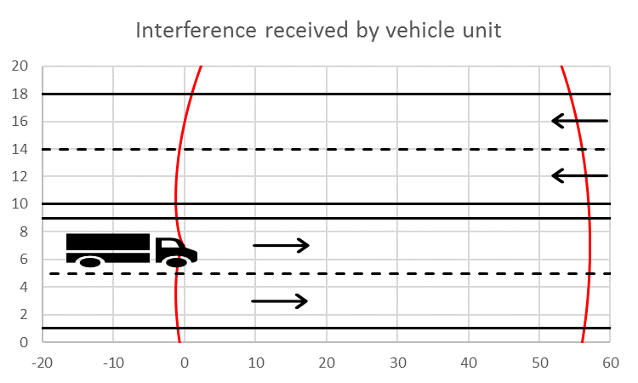

Figure 33: Interference region with 33 dBm interferer

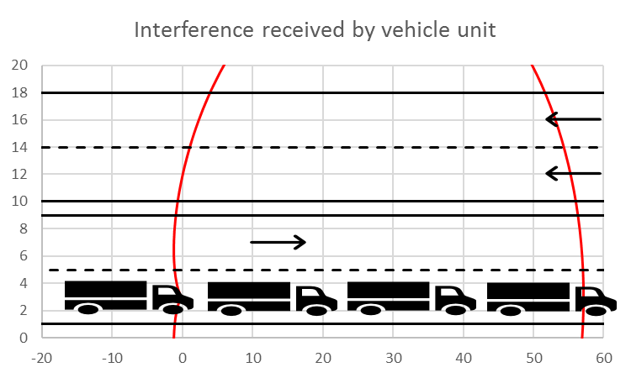

Figure 34: Interference region with 33 dBm interferer, platooning scenario

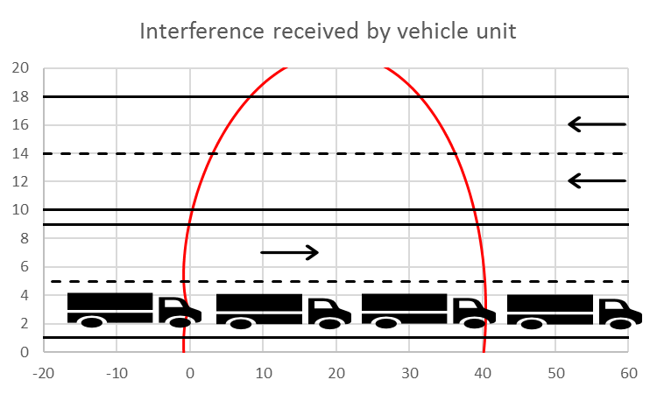

Figure 35: Interference region with 30 dBm interferer, platooning scenario

The results of the interference studies are summarised in Table 14. Depending on the vehicle density, it is measured how many vehicles are inside the interferer region. Based on how many vehicles inside the interference region, the diagram in Figure 27 is used to investigate the maximum possible rate of transmitted messages. This maximum possible message rate is compared with the actual transmitted message rate. It is considered a risk for interference if the value of column "Generated CAM rate (Hz)" is higher than the value of column "CAM rate limit for no interference (Hz)".

Table 14: Summary interference calculations ITS transmissions

|  |  |  |  |  |  |
| --- | --- | --- | --- | --- | --- |
| Avg. traffic speed (km/h) | Avg. dist. between vehicles (m) | Vehicles in interference zone | Generated CAM rate (Hz) | CAM rate limit for no interference (Hz) | Interference |
| ITS transmission e.i.r.p. 33 dBm | | | | | |
| 10 | 14 | 16 | 1.0 | 1.5 | No |
| 60 | 56 | 4 | 4.2 | 7.8 | No |
| 100 | 89 | 3 | 6.9 | 11.9 | No |
| 70 | 64 and 20 | 4 (5) (Note 2) | 10 (Note 1) | 7.8 | Yes |
| ITS transmission e.i.r.p. 30 dBm | | | | | |
| 70 | 64 and 20 | 3 (4) (Note 2) | 10 (Note 1) | 11.9 | No |
| Note 1: Trucks in a platoon are assumed to use message rate of 10.  Note 2: Platoon trucks use a message rate of 10, different than ordinary vehicles. To simplify the calculations the number of vehicles in the zone is reduced and all vehicles are assumed to use a message rate of 10. | | | | | |

## Summary compatibility with ITS

This section considered adjacent band compatibility between ITS with the same parameters as used in the ECC Report 228 [22] and smart tachograph, weight&dimension applications as well as VU receiver blocking. The interference probability from smart tachograph, weight&dimension applications into ITS receivers has not been studied and is considered low because of the high selectivity of the ITS receiver. The following conclusions are achieved:

* Compatibility regarding unwanted emissions can be achieved for ITS with an unwanted emissions limit of -30 dBm/MHz e.i.r.p. for vehicles transmitting CAM according to ETSI EN 302 637-2 [15];
* The VU receiver blocking from ITS wanted emissions with a maximum output power of 33 dBm e.i.r.p. for vehicles transmitting CAM according to ETSI European Standard ETSI EN 302 637-2 [15] is not considered as an issue;.
* Compatibility regarding truck platooning is achieved with unwanted emissions limit of -37 dBm/MHz e.i.r.p. and maximum output power of 30 dBm e.i.r.p. under worst-case conditions when each truck transmits 10 messages per second of length 1 ms independent of speed;
* Decentralised Environmental Notification Messages (DENM) were not included in the interference study. DENMs are transmitted sporadically by vehicles upon traffic incidents and regularly by roadside infrastructure including VMS trailers to broadcast road works warnings etc. It is only close to the REDCR where reduction of duty cycles or/and unwanted emission levels are needed to avoid harmful interference;

# Compatibility with radiolocation service

## Results from other ECC reports

ECC Report 250 [24] considered the impact from road tolling systems based on the same CEN DSRC technology as used by smart tachograph, weight&dimension applications on other systems. It was concluded that interference both into radars and mobile road tolling enforcement are significant in particular when the narrow main beam radar antenna is pointing towards the main beam of road tolling receiver.

## Technical characteristics of Radiolocation systems

Recommendation ITU-R M.1638-1 [27] provides characteristics of radars operating under the Radiolocation services in the frequency range 5250-5850 MHz. Within this range, the band between 5725 and 5850 MHz is used by many different types of radars on fixed land-based, ship borne and transportable platforms. It should be noted that most of these radars are designed to operate not only in the 5725-5850 MHz band but in a larger portion of the band 5250-5850 MHz.

## smart tachograph Impact on Radiolocation systems

### Worst-case MCL calculations

The below MCL calculations uses the propagation model from Figure 16 and the following assumptions for Radiolocation and smart tachographs:

* Radar Rx:

receiver bandwidth: 1 MHz;

receiver noise floor: -110 dBm;

I/N protection criterion: -6 dB;

Antenna gain main beam: 42 dBi;

Antenna gain side lobe: 0 dBi.

* Smart tachograph TX:

TX bandwidth: 0.5 MHz;

Conducted TX power: 20 dBm;

Antenna gain main beam: 13 dBi;

Antenna gain side lobe: -8 dBi.

For comparison the results for a non-specific SRD with 25 mW e.i.r.p. are shown.

Table 15: Separation distances between Smart tachograph (2 W) and Radiolocation

|  |  |  |  |  |  |  |  |  |
| --- | --- | --- | --- | --- | --- | --- | --- | --- |
|  | | | | | | Urban path loss model | Suburban path loss model | Rural path loss model |
| F (GHz) | | | | | | 5.8 | 5.8 | 5.8 |
| Separation distances (m) | | | | | | | | |
| Road Tolling | TX Interferer (dBm/BW1) | BW1 (MHz) | TX Interferer (dBm/BW2) | Gs Interferer (dBi) | Ge Victim  (dBi) | Urban path loss model | Suburban path loss model | Rural path loss model |
| main-main | 20 | 0.5 | 20 | 13 | 42 | 21481 | 64122 | 240173 |
| side-main | 20 | 0.5 | 20 | -8 | 42 | 6950 | 17900 | 55500 |
| main-side | 20 | 0.5 | 20 | 13 | 0 | 2266 | 5032 | 12817 |
| side-side | 20 | 0.5 | 20 | -8 | 0 | 740 | 1410 | 2950 |
| Comparison non-specific SRD | | | | | | | | |
| side-main | 14 | 1 | 14 | 0 | 42 | 7766 | 20277 | 63792 |
| side-side | 14 | 1 | 14 | 0 | 0 | 819 | 1591 | 3404 |

### Summary of Worst-case MCL calculations

Table 16: Summary MCL calculations

|  |  |  |
| --- | --- | --- |
|  | Radar main beam | Radar side lobe |
| REDCR main beam | Large separation distances are required. The probability for this scenario is low because of the small beamwidth of both the radar and the REDCR. | * urban: 2 km * suburban: 5 km * rural: 13 km |
| REDCR side lobe | * urban: 7 km * suburban: 18 km * rural: at least radio horizon | * urban: 0.7 km * suburban: 1.4 km * rural: 3 km |
| SRD 25 mW | separation distances   * urban: 8 km * suburban: 20 km * rural: at least radio horizon | separation distances   * urban: 0.8 km * suburban: 1.5 km * rural: 3.5 km |

Preliminary conclusions from MCL calculations:

* Main beam coupling between RSU and radars would require coordination between REDCR and radar when the radar has a fixed location. The probability of such interference is low because of the small beamwidth of both radar and REDCR antennas.
* The separation distances for the case when both radar and smart tachograph are within the antenna side lobe are in the order of 1 km
* The practical relevant scenario of the REDCR side lobe coupling to the radar main beam requires theoretically separation distances between 7 km up to the radio horizon (30 km);.;
* The above calculations are based on worst-case assumptions. In realistic scenarios the following considerations will improve the coexistence:

real radar antenna pattern;

real REDCR antenna pattern;

real REDCR installation;

topography of the environment;

Duty Cycle of REDCR TX;

azimuth/elevation scanning of radars.

### Mitigation measures

A mitigation measure would be to implement a sensing procedure (DFS/LBT) on the REDCR. However, it should be noted that a sensing approach could be only feasible for traditional monostatic radars where a radar receiver and transmitter are located at the same location. However, all DFS algorithms approved to-date have assumed a non-mobile RLAN infrastructure[1]. For bistatic radars (see Figure 1 of Recommendation ITU-R M.1638-1 [27]) this sensing procedure would not work and huge hidden nodes are expected where the potentially affected radar receiver could not be detected.

## Radiolocation systems Impact on smart tachograph

The following study is carried out for informative purposes only, smart tachographs operate under generic SRD regulation and are not subject to protection from incumbent services.

### Worst-case MCL calculations

The below MCL calculations uses the propagation model from Figure 16 and the following assumptions for road tolling and Radiolocation:

* REDCR Rx:

receiver bandwidth: 0.5 MHz;

receiver noise floor: -108 dBm;

I/N protection criterion: -3 dB; (Protection criteria taken from ETSI Technical Report TR 103 441 [7])

Antenna gain main beam: 13 dBi;

Antenna gain side lobe: -8 dBi;

Polarisation loss: 3 dB

* Radar TX:

TX bandwidth: 1 MHz;

Conducted TX power: 70/90 dBm;

Antenna gain main beam: 42 dBi;

Antenna gain side lobe: 0 dBi.

For comparison the results for a non-specific SRD with 25 mW e.i.r.p. are shown.

Table 17: Summary MCL calculations

|  |  |  |  |  |  |  |  |  |
| --- | --- | --- | --- | --- | --- | --- | --- | --- |
|  | | | | | | Urban path loss model | Suburban path loss model | Rural path loss model |
| F (GHz) | | | | | | 5.8 | 5.8 | 5.8 |
| Wall loss (dB) | | | | | | 0 | 0 | 0 |
| Other mitigation factors (dB) | | | | | | 0 | 0 | 0 |
| REDCR | | | | | | | | |
| Victim Noise floor (dBm/BW2) | | | | | | -108 | -108 | -108 |
| Margin (dB) | | | | | | 0 | 0 | 0 |
| Victim I/N (dB) | | | | | | -3 | -3 | -3 |
| Victim Imax (dBm/BW2) | | | | | | -111 | -111 | -111 |
| Victim BW2 (MHz) | | | | | | 0.5 | 0.5 | 0.5 |
| Separation distances | | | | | | | | |
| Radar | TX Interferer (dBm/BW1) | BW1 (MHz) | TX Interferer (dBm/BW2) | Gs Interferer (dBi) | Ge Victim (dBi) | Urban path loss model | Suburban path loss model | Rural path loss model |
| main-main | 70 | 1 | 67 | 42 | 13 | 175 km | 680 km | 3650 km |
| main-main | 90 | 1 | 87 | 42 | 13 | 520 km | 2300 km | 14800 km |
| main-side | 70 | 1 | 67 | 42 | -8 | 56 km | 190 km | 840 km |
| main-side | 90 | 1 | 87 | 42 | -8 | 164 km | 640 km | 3400 km |
| side-main | 70 | 1 | 67 | 0 | 13 | 18.2 km | 54 km | 194 km |
| side-main | 90 | 1 | 87 | 0 | 13 | 53 km | 179 km | 780 km |
| side-side | 70 | 1 | 67 | 0 | -8 | 6.3 km | 14.9 km | 45 km |
| side-side | 90 | 1 | 87 | 0 | -8 | 17.3 km | 50 km | 181 km |
| Comparison non-specific SRD | | | | | | | | |
| side-main | 14 | 0.5 | 14 | 0 | 13 | 1100 m | 2200 m | 4800 m |
| side-side | 14 | 0.5 | 14 | 0 | -8 | 350 m | 600 m | 1100 m |

From the worst-case calculations in section 6.4.1 huge separation distances are required to allow proper operation of smart tachograph, weight&dimension applications from radar transmissions.

The impact from Radar into smart tachograph, weight&dimension applications seems to much more severe as the other way around. But the smart tachograph protocol could be able to resist the short radar pulses. This will be considered in the following section.

## Radiolocation systems' impact on smart tachograph timing calculations

The smart tachograph communication is only interfered by radiolocation systems during receiving. Because the sensitivity is approximately 40 dB better for REDCR than VU we can exclude the downlink communication to the VU and it is only relevant to study interference during uplink communication when the REDCR is receiving. This analysis is also relevant for the mobile smart tachograph case.

Figure 19 in section 5.4.1 shows that an uplink packet is typically 5 ms long. Figure 20 shows that complete transaction duration is typically 50 ms however this can vary a lot with different tolling systems.

Recommendation ITU-R M.1638-1 [27] shows that a typical length of a radiolocation system pulse is some few µs with one exception of 100 µs. The same table shows that the pulse repetition rate (pps) is varying a lot, from approx. 100 up to several thousands.

A pulse repetition rate of 1000 means there will be a pulse every 1 ms. The probability that this pulse will impact the smart tachograph uplink message of typically 5 ms is very high. Even if the pulses are rather short it is very likely that the smart tachograph communication cannot work under these timing conditions. There is a retransmit function in the smart tachograph protocol however if each packet will be interfered, this will not solve the interference problem. One should note that given the fact that radars use a large tuning range (including frequency hopping) with Frequency Modulated Continuous Wave (FMCW) systems would improve the above timing estimation (e.g. tuning range 5350-5850 MHz), because here it is not expected that they will continuously transmitting in the 5795 to 5815 MHz band.

However, practical interference cases have not been reported from radar into road tolling systems which use same technology and frequency band as smart tachograph, weight&dimension applications.

## Summary Radiolocation systems

### Smart tachograph, weight&dimension applications impact on radars

Worst-case calculations lead to the following results:

* Main beam coupling between smart tachograph, weight&dimension applications and radars would require separation distances up to the radio horizon. But the probability for this scenario is low because of the small beam width of both radar and REDCR antennas and the fact that radars are continuously change direction;
* The practical relevant scenario for smart tachograph is the side lobe coupling to the radar main beam; this requires theoretically separation distances between 7 km in urban environment and the radio horizon (rural environment); however, the impact here is comparable to the impact of available SRD devices with up to 25 mW e.i.r.p.;
* The impact with side lobe to side lobe case was found to be smaller than for the main lobe and is comparable to the impact of available SRD with up to 25 mW e.i.r.p..

### Radar impact on smart tachograph, weight&dimension applications

* Worst-case calculations showing huge separation distances to protect smart tachograph from radar transmissions. The impact from radar into smart tachograph seems to be much more severe as the other way around presented above due to the huge TX power of radars. Although smart tachograph protocol contains some acknowledgement features, the timing parameters of radars from Recommendation ITU-R M.1638-1 [27] could be easily able to impact onto the smart tachograph system;
* It should be noted that no interference cases on road tolls from radar installations have been reported to the road tolling association ASECAP. Road tolls use similar technology and the same frequency band as smart tachograph.

### Mitigation measures

* A mitigation measure would be to implement a sensing procedure (DFS/LBT) on the mobile smart tachograph RSU. However, it should be noted that above sensing approach could only be feasible for traditional monostatic radars if the efficiency of DFS installed on mobile platform is demonstrated;
* Finally it should be noted that there may be some possibilities on national levels to ensure the coexistence between both systems since both applications (Radar and smart tachograph, weight&dimension applications) are often operated by an administration.

# Conclusions

This Report addresses the compatibility between smart tachograph, weight&dimension applications (TTT/DSRC) and the following radio systems within the frequency band 5795-5815 MHz and in the adjacent bands.

The following radio systems were studied:

* Road tolling CEN DSRC in the band 5795-5815 MHz;
* Intelligent transport systems (ITS) in the band 5850-5925 MHz;
* Radiolocation systems below 5850 MHz.

Starting from 2019, all new trucks must be equipped with a smart tachograph vehicle unit. The vehicle unit is read by a fixed or portable interrogator (REDCR) device located at the roadside which is directed towards the centre of the windscreen of the passing by vehicles to be inspected. The REDCR enforcement equipment, which is the equipment communicating with the vehicle units, is expected in a low volume, maybe some hundreds units in whole Europe. Taking into account the limited communication zone area, it is only a very small fraction of the European area that will be used for smart tachograph radio communication.

## Road tolling in the band 5795-5815 MHz

* The following minimum coupling loss (MCL) calculations between smart tachograph and road tolling were performed:

The smart tachograph REDCR interfere the road tolling on-board unit (OBU) receiver;

The smart tachograph vehicle unit (VU) interfere the road tolling RSU receiver;

The road tolling RSU interfere the VU receiver;

The road tolling OBU interfere the REDCR receiver.

* The worst-case interference was from smart tachograph REDCR into road tolling OBU with a needed separation distance of 200 m which is equal to minimum required distance between smart tachograph and road tolling according to Commission Implementing Regulation 2016/799 [4].

## **ITS in the band 5850-5925 MHz**

* Compatibility regarding unwanted emissions can be achieved for ITS parameters as those used in ECC Report 228 [22] with an unwanted emissions limit of -30 dBm/MHz e.i.r.p. for vehicles transmitting cooperative awareness messages (CAM) according to ETSI EN 302 637-2 [15];
* The VU receiver blocking from ITS wanted emissions with a maximum output power of 33 dBm e.i.r.p. for vehicles transmitting CAM according to ETSI EN 302 637-2 [15] is not considered as an issue;.
* Compatibility regarding truck platooning is achieved with unwanted emissions limit of -37 dBm/MHz e.i.r.p. and maximum output power of 30 dBm e.i.r.p. under Worst-case conditions when each truck transmits 10 messages per second of length 1 ms independent of speed;
* Decentralised Environmental Notification Messages (DENM) were not included in the study. DENMs are transmitted sporadically by vehicles upon traffic incidents and regularly by roadside infrastructure including variable message signs (VMS) trailers to broadcast road works warnings etc.;
* It is only close to the remote early detection communication reader (REDCR) where reduction of duty cycles or/and unwanted emission levels are needed to avoid harmful interference;
* The interference probability from smart tachograph, weight&dimension applications into ITS receivers is considered low because of the high selectivity of the ITS receiver and has not been studied.

## Radiolocation systems below 5850 MHz

Smart tachograph, weight&dimension applications impact on radars:

* Worst-case calculations lead to the following results:

Main beam coupling between smart tachograph, weight&dimension applications and radars would require separation distances up to the radio horizon. But the probability for this scenario is low because of the small beam width of both radar and REDCR antennas and the fact that radars are continuously changing direction;

The practical relevant scenario for smart tachograph is the side lobe coupling to the radar main beam; this requires theoretically separation distances between 7 km in urban environment and the radio horizon (rural environment); however, the impact here is comparable to the impact of available short range devices (SRD) with up to 25 mW e.i.r.p.;

The impact with side lobe to side lobe case was found to be smaller than for the main lobe and is comparable to the impact of available SRD with up to 25 mW e.i.r.p..

* Radar impact on smart tachograph, weight&dimension applications:

Worst-case calculations show huge separation distances to protect smart tachograph from radar transmissions. The impact from radar into smart tachograph seems to be much more severe as the other way around presented above, due to the huge TX power of radars. Although smart tachograph protocol contains some acknowledgement features, the timing parameters of radars from Recommendation ITU-R M.1638-1 [27] could be easily able to interfere onto the smart tachograph.

* Mitigation measures:

A mitigation measure would be to implement a sensing procedure (dynamic frequency selection (DFS) / listen before talk (LBT)) on the mobile road tolling road side unit (RSU). However, it should be noted that above sensing approach could only be feasible for traditional monostatic radars if the efficiency of DFS installed on mobile platform is demonstrated;

Finally, it should be noted that there may be some possibilities on national level to ensure the coexistence between both systems since both applications (radar and smart tachograph, weight&dimension applications) are often operated by an administration.

1. Compatibility with RLAN under national UK regulation
   1. Introduction

Recently in UK, there is a national spectrum decision to allow maximum 200 mW e.i.r.p (23 dBm) in the frequency range 5725 to 5850 MHz for RLAN use. In this section it is investigated the risk for interference with RLAN equipment in UK.

* + 1. Basic characteristics for WAS/RLAN in the band 5725 - 5850 MHz under UK national regulation

Table 18: Basic transmitter characteristics for WAS/RLAN in the band 5725-5850 MHz

under UK national regulation

|  |  |
| --- | --- |
| System parameter | Value |
| Maximum Transmit Power (e.i.r.p. - dBm) | 23 |
| Bandwidth (MHz) | 20 / 40 / 80 |
| Maximum Transmit Power Density (e.i.r.p. - dBm/MHz) | 10 / 7 / 6 |
| Typical AP Antenna Type | Omni (azimuth) |
| AP Antenna directivity gain (dBi) | 0 |

Table 19: Basic receiver characteristics for WAS/RLAN in the band 5725-5850 MHz

under UK national regulation

|  |  |  |  |
| --- | --- | --- | --- |
| System parameter | Value | | |
| Bandwidth (MHz) | 20 | 40 | 80 |
| kTB (dBm / bandwidth) | -101 | -98 | -95 |
| Typical Noise figure (dB) | 4 | | |
| Noise Power (dBm / bandwidth) | -97 | -94 | -91 |
| Typical Sensitivity for MCS0, BPSK (½ coding rate) (dBm) | -92 | -89 | -86 |
| C/N for MCS0, BPSK (½ coding rate) (dB) | 5 | | |
| I/N (dB) (Note 1) | -6 | | |
| C/I (dB) | 11 for I/N -6 dB; 5 for I/N 0 dB | | |
| Maximum antenna gain at the RLAN user device (dBi) | 1.3 (omni) | | |
| Note 1: As per ITU-R Recommendation M.1739 [27] the I/N ratio at the WAS/RLAN receiver should not exceed –6 dB, assuring that degradation to a WAS/RLAN receiver’s sensitivity will not exceed approximately 1.0 dB. Whilst it is designed to address interference from multiple sources, this criterion is also considered in this Report for single-entry analysis. | | | |

* 1. MCL calculations
     1. Results of MCL calculations for interference from RLAN into smart tachograph REDCR

MCL calculations are performed to derive separation distances between a RLAN and REDCR using the propagation models described in Figure 16. Only the maximum power density with RLAN was calculated. The obtained results are depicted in Table 20.

Table 20: MCL calculations for interference from RLAN into smart tachograph REDCR –   
separation distances

|  |  |  |  |
| --- | --- | --- | --- |
| Parameter | Unit | Outdoor / Indoor | |
| Emission part: RLAN | | | |
| Bandwidth | MHz | 20 | 20 |
| TX out (e.i.r.p.) | dBm | 23 | 23 |
| Building attenuation | dB | 0 | 15 |
| Net TX density of power e.i.r.p. | dBm/MHz | 10 | -5 |
| Reception part: smart tachograph REDCR | | | |
| Receiver bandwidth | MHz | 0.5 | 0.5 |
| Sensitivity including antenna gain | dBm | -110 | -110 |
| Noise power | dBm | -121 | -121 |
| Polarisation loss | dBi | 3 | 3 |
| Noise power per MHz at antenna | dBm/MHz | -115 | -115 |
| Protection Criterion I/N | dB | -3 | -3 |
| Allowable interfering power level 'I' at the receiver antenna | dBm/MHz | -118 | -118 |
| Required attenuation | dB | 128 | 113 |
| Separation distance RLAN → smart tachograph REDCR | | | |
| Separation distance - Urban model | m | 730 | 330 |
| Separation distance - Suburban model | m | 1400 | 570 |
| Separation distance - Rural model | m | 2940 | 1030 |

* + 1. Results of MCL calculations for interference from smart tachograph REDCR into RLAN

MCL calculations are performed to derive separation distances between a REDCR and RLAN using the propagation models described in Figure 16. Only RLAN bandwidth of 20 MHz was calculated. The obtained results are depicted in Table 21.

Table 21: MCL calculations for interference from smart tachograph REDCR into RLAN –   
separation distances

|  |  |  |  |
| --- | --- | --- | --- |
| Parameter | Unit | Outdoor / Indoor | |
| Emission part: smart tachograph REDCR | | | |
| Bandwidth | MHz | 0.5 | 0.5 |
| TX out (e.i.r.p.) | dBm | 33 | 33 |
| Building attenuation | dB | 0 | 15 |
| Net TX density of power e.i.r.p. | dBm/MHz | 36 | 21 |
| Reception part: RLAN | | | |
| Receiver bandwidth | MHz | 20 | 20 |
| Noise Power | dBm | -97 | -97 |
| Noise power per MHz | dBm/MHz | -84 | -84 |
| Antenna gain | dB | 1 | 1 |
| Polarisation loss | dBi | 3 | 3 |
| Noise power per MHz at antenna connector | dBm/MHz | -82 | -82 |
| Protection Criterion I/N | dB | -6 | -6 |
| Allowable interfering power level 'I' at the receiver antenna | dBm/MHz | -88 | -88 |
| Required attenuation | dB | 124 | 109 |
| Separation distance smart tachograph REDCR → RLAN | | | |
| Separation distance - Urban model | m | 590 | 265 |
| Separation distance - Suburban model | m | 1100 | 450 |
| Separation distance - Rural model | m | 2230 | 750 |

* 1. Summary compatibility RLAN under national UK regulation
* MCL calculations indicates a need for separation up to 3000 m when RLAN outdoor and 1000 m when RLAN indoor. Both the RLAN and the smart tachograph REDCR receivers shows about the same sensitivity for interference.
* RLAN is equipped with a LBT mechanism that might work as a mitigation mechanism because the RLAN will switch to another channel when detecting the smart tachograph signal. This needs to be further investigated. The impact on RLAN by the DSRC signal was studied in ECC Report 277 [26] for RLAN in cars and Road Toll installations.

1. List of References
2. Regulation (EU) 165/2014 of the European Parliament and of the Council (2014-02): “on tachographs in road transport, repealing Council Regulation (EEC) No 3821/85 on recording equipment in road transport and amending Regulation (EC) No 561/2006 of the European Parliament and of the Council on the harmonisation of certain social legislation relating to road transport”
3. Directive (EU) 2015/719: “Amending Council Directive 96/53/EC laying down for certain road vehicles circulating within the Community the maximum authorised dimensions in national and international traffic and the maximum authorised weights in international traffic”
4. Commission Implementing Decision (EU) 2017/1483: "Amending Decision 2006/771/EC on harmonisation of the radio spectrum for use by short-range devices and repealing Decision 2006/804/EC", August 2017
5. Regulation (EU) 2016/799 (2016-03): “implementing Regulation (EU) No 165/2014 of the European Parliament and of the Council laying down the requirements for the construction, testing, installation, operation and repair of tachographs and their components”
6. Directive 2014/53/EU of the European Parliament and of the Council of 16 April 2014 on the harmonisation of the laws of the Member States relating to the making available on the market of radio equipment and repealing Directive 1999/5/EC
7. Regulation (EU) 2018/502 (2018-02): “amending Implementing Regulation (EU) 2016/799 laying down the requirements for the construction, testing, installation, operation and repair of tachographs and their components”
8. ETSI Technical Report TR 103 441 V1.1.1 (2018-09): "System Reference document (SRdoc); Intelligent Transport Systems (TS); Pan-European harmonized communications equipment operating in the 5 GHz frequency range for regulated applications for commercial vehicles"
9. CEN EN 12253 (2004): "Road transport and traffic telematics - Dedicated short-range communication - Physical layer using microwave at 5,8 GHz"
10. CEN EN 13372 (2004): "Road Transport and Traffic Telematics (RTTT) - Dedicated short-range communication - Profiles for RTTT applications"
11. ETSI Harmonised European Standard EN 300 674-1 (2004): "Electromagnetic compatibility and Radio spectrum Matters (ERM); Road Transport and Traffic Telematics (RTTT); Dedicated Short Range Communication (DSRC) transmission equipment (500 kbit/s / 250 kbit/s) operating in the 5,8 GHz Industrial, Scientific and Medical (ISM) band; Part 1: General characteristics and test methods for Road Side Units (RSU) and On-Board Units (OBU)"
12. ETSI Harmonised European Standard EN 300 674-2-1 V2.1.1 (2016): “Transport and Traffic Telematics (TTT); Dedicated Short Range Communication (DSRC) transmission equipment (500 kbit/s / 250 kbit/s) operating in the 5 795 MHz to 5 815 MHz frequency band; Part 2: Harmonised Standard covering the essential requirements of article 3.2 of the Directive 2014/53/EU; Sub-part 1: Road Side Units (RSU)”
13. ETSI Harmonised European Standard EN 300 674-2-2 V2.1.1 (2016): “Transport and Traffic Telematics (TTT); Dedicated Short Range Communication (DSRC) transmission equipment (500 kbit/s / 250 kbit/s) operating in the 5 795 MHz to 5 815 MHz frequency band; Part 2: Harmonised Standard covering the essential requirements of article 3.2 of Directive 2014/53/EU; Sub-part 2: On-Board Units (OBU)”
14. ETSI Technical Specification TS 102 792 V1.2.1 (2015-06): “Intelligent Transport Systems (ITS); Mitigation techniques to avoid interference between European CEN Dedicated Short Range Communication (CEN DSRC) equipment and Intelligent Transport Systems (ITS) operating in the 5 GHz frequency range"
15. ETSI Technical Report TR 102 960 V1.1.1 (2012-11): “Intelligent Transport Systems (ITS); Mitigation techniques to avoid interference between European CEN Dedicated Short Range Communication (RTTT DSRC) equipment and Intelligent Transport Systems (ITS) operating in the 5 GHz frequency range; Evaluation of mitigation methods and techniques”
16. ETSI European Standard EN 302 637-2 V1.3.2 (2014): "Intelligent Transport Systems (ITS); Vehicular Communications; Basic Set of Applications; Part 2: Specification of Cooperative Awareness Basic Service"
17. ERC Recommendation 70-03 (2018): "Relating to the use of Short Range Devices (SRD)"
18. ERC Report 003: "Harmonisation of frequency bands to be designated for road transport information systems"
19. ECC Report 68: “Compatibility studies in the band 5725-5875 MHz between Fixed Wireless Access (FWA) systems and other systems”, June 2005
20. ECC Report 101: "Compatibility studies in the band 5855– 5925 MHz between Intelligent Transport Systems (ITS) and other systems", February 2007
21. ECC Report 206: "Compatibility studies in the band 5725-5875 MHz between SRD equipment for wireless industrial applications and other systems", January 2014
22. ECC Report 210: "Compatibility/sharing studies related to Broadband Direct-Air-to-Ground Communications (DA2GC) in the frequency bands 5855-5875 MHz, 2400-2483.5 MHz and 3400-3600 MHz", January 2014.
23. ECC Report 228: "Compatibility studies between Intelligent Transport Systems (ITS) in the band 5855-5925 MHz and other systems in adjacent bands", January 2015
24. ECC Report 244: "Compatibility studies related to RLANs in the 5725-5925 MHz band", January 2016
25. ECC Report 250: "Compatibility studies between TTT/DSRC in the band 5805-5815 MHz and other systems", April 2016
26. ECC Report 259: "Sharing and compatibility studies between Maritime Broadband Radio (MBR) in the 5850-5900 MHz frequency band and other systems", January 2017
27. ECC Report 277: "Use of SRD applications in cars in the band 5725-5875 MHz", April 2018
28. Recommendation ITU-R M.1638-1 (01/2015): "Characteristics of and protection criteria for sharing studies for radiolocation (except ground based meteorological radars) and aeronautical radionavigation radars operating in the frequency bands between 5 250 and 5 850 MHz"
29. ERC Report 25 (latest edition October 2018). Available: <https://www.ecodocdb.dk/document/593>
30. ECC Report 140: "Compatibility between RLAN on-board aircraft and radars in the frequency bands 5250-5350 MHz and 5470-5725 MHz"

1. ” Extract from ECC Report 140 [29]: “All DFS algorithms approved to-date have assumed a non-mobile RLAN infrastructure. While the 802.11 clients were expected to be mobile, the access points (APs), which serve as the connection point to a wired infrastructure, were expected to be fixed in location. As such, the architects of the DFS algorithm did not explicitly consider the case of RLANs installed within mobile platforms, such as trains, watercraft, or aircraft. Specifically, the notion of a Channel Availability Check, a test that is run by the AP to ensure the channel is clear of radars before the channel is used by the RLAN (discussed further in Section 3.2.1), is compromised if the AP is mobile. As RLAN equipment has become more popular for mobile installations, additional questions arise concerning the applicability and efficacy of DFS to a mobile platform.”