Feasibility studies of Person detection and collision avoidance applications in the 442.2-457.1 kHz rangeecc_logo

approved 14 September 2018

ECC Report 284

# Executive summary

The initial demand was to study the feasibility of introducing a new person detection and collision avoidance application in the range 446-457.1 kHz. The studies have shown that, in order to ensure the protection of the avalanche victim systems and of the receiver of Automatic Direction Finder and Non-Directional Beacons (ADF/NDB), the person detection and collision avoidance application should not be operated in frequencies above 450 kHz and should use a channel spacing of 150 Hz. To allow the application to operate with the required number of devices (up to 51), the person detection and collision avoidance application should operate in the band 442.2-450.0 kHz.

The new operational characteristics should thus be:

Table 1: New proposed operational characteristics

|  |  |
| --- | --- |
| Parameter | Value |
| Number of channels required | Up to 51 |
| Minimum channel spacing | 150 Hz |
| Magnetic field strength | 7 dBµA/m at 10 meters |
| Envisaged frequency range | 442.2-450.0 kHz |

TABLE OF CONTENTS

[0 Executive summary 2](#_Toc512946847)

[1 Introduction 5](#_Toc512946848)

[2 System description 6](#_Toc512946849)

[3 Technical parameters 7](#_Toc512946850)

[4 Incumbent systems/Applications 8](#_Toc512946851)

[5 Spectrum coexistence consideration 9](#_Toc512946852)

[5.1 Sharing with aeronautical radionavigation service 9](#_Toc512946853)

[5.1.1 Single interference case 9](#_Toc512946854)

[5.1.2 Multiple interference case 10](#_Toc512946855)

[5.1.3 Conclusion on the aeronautical service 10](#_Toc512946856)

[5.2 Sharing with military systems 10](#_Toc512946857)

[5.3 sharing with avalanche victim detection applications 10](#_Toc512946858)

[5.3.1 System characteristics 10](#_Toc512946859)

[5.3.1.1 Transmitter: 10](#_Toc512946860)

[5.3.1.2 Receiver 11](#_Toc512946861)

[5.3.2 Interference scenarios and separation distances 13](#_Toc512946862)

[5.3.2.1 Co-channel Interference 14](#_Toc512946863)

[5.3.2.2 Out-of-band interference 16](#_Toc512946864)

[5.3.3 Conclusions for avalanche victim detection applications 17](#_Toc512946865)

[5.4 Sharing with Maritime Mobile 17](#_Toc512946866)

[5.5 Considerations on unwanted emissions of the studied application 18](#_Toc512946867)

[5.5.1 Unwanted emissions consideration 18](#_Toc512946868)

[5.5.2 Consideration on the broadcasting service 18](#_Toc512946869)

[5.5.3 Summary of the impact on services in the adjacent bands 19](#_Toc512946870)

[5.5.4 Consideration on the coexistence studies results 22](#_Toc512946871)

[5.5.4.1 Requirement to protect avalanche receiver 22](#_Toc512946872)

[5.5.4.2 Requirements to protect the aeronautical service 22](#_Toc512946873)

[5.5.4.3 Requirement to satisfy the 51 needed channels while protecting both aeronautical service and avalanche receiver application 23](#_Toc512946874)

[6 Conclusion 24](#_Toc512946875)

[ANNEX 1: List of Reference 25](#_Toc512946876)

LIST OF ABBREVIATIONS

|  |  |
| --- | --- |
| Abbreviation | Explanation |
| ADF | Automatic Direction Finder (Radionavigation) |
| CEPT | European Conference of Postal and Telecommunications Administrations |
| DCA | Detection and Collision Avoidance |
| CW | Continuous wave |
| DSP | Digital Signal Processing |
| DUT | Device Under Test |
| EC | European Commission |
| ECA (Table) | European Table of frequency Allocations and applications |
| ECC | Electronic Communications Committee |
| ERC | European Radiocommunications Committee (since 2001 "ECC") |
| ETSI | European Telecommunications Standards Institute |
| ETS Lindgren | Company |
| FCC | Federal Communications Commission |
| FSMP | [Frequency Spectrum Management Panel](https://www.icao.int/safety/fsmp) of ICAO |
| ICAO | International Civil Aviation Organization |
| IF | Intermediate Frequency |
| LVS | Lawinen- Verschütteten Suchgerät (Avalanche Victim Detection System) |
| MSI | Maritime Safety Information |
| NATO | North Atlantic Treaty Organization |
| NDB | Non-Directional Beacons (Radionavigation) |
| NJFA | NATO Joint Civil/Military Frequency Agreement |
| Q | Quality factor |
| REC | Recommendation |
| RR | Radio Regulations |
| SNR | Signal to Noise Ratio |
| SRD/MG | Short Range Devices Maintenance Group of WG FM |
| VBW | Victim Bandwidth |
| WG FM | Working Group Frequency Management |
| WG SE | Working Group Spectrum Engineering |
| XTAL | Quartz crystal |

# Introduction

Prevention of accidents between machines and pedestrians is a problem that affects a large number of industries: waste collection, transportation, logistics, handling materials, construction, etc. A potential collision arises when pedestrians and machinery are in close proximity, hence the need for a person detection and collision avoidance application that would allow avoiding such accidents.

This Report considers the feasibility of introducing a new person detection and collision avoidance application in the range 442.2-457.1 kHz. It has been prepared upon proposal from SRD/MG and WG FM request.

The purpose of the proposed person detection and collision avoidance application is to detect up to 50 persons/objects at the same time. The number of devices cannot be implemented due to the current 457 kHz bandwidth limitation. This required additional studies for interference with existing services. The application can use the Harmonised Standard ETSI EN 300 330 [8].

Studies are conducted mainly with regard to sharing with the aeronautical radio-navigation service, the avalanche victim detection receiver but also with different services in the adjacent bands.

# System description

The system is composed of a group of transceivers working in the band 442.2-450.0 kHz and a receiver installed in the vehicle/machine. Each transceiver is carried on a worker. When pedestrians are near a machine within a predefined area (distance adjustable up to 30m), the operator is alerted by an alarm and a light located inside the cab. The operator is also informed of the number of detected pedestrians via a display in the cab (possible detection up to 50 pedestrians). The Detection and Collision Avoidance (DCA) device identifies pedestrians regardless of their position, no tracking is performed.



Figure 1: Detection and Collision Avoidance Principle

# Technical parameters

The characteristics depicted in Table 2 below were taken into account for the DCA system in this Report.

The requested band is 11.1 kHz wide, but each transmitter works with an ultra-narrow bandwidth, the transmitted signal is an unmodulated carrier (pure sinusoid). This spectral purity is essential for the system since the discrimination between parasitic and DCA signals is based on maximum likelihood estimation with a pure carrier; the number of simultaneous users is also maximised using orthogonal carriers.

It should be noted that the requested magnetic field intensity for in-band (7 dBµA/m at 10m) is not compliant with ETSI EN 300 330 section 4.3.4.3 Table 2: H-filed limits at 10 m, with a limit at -5 dBµA/m at 10 m for 148.5 kHz<f<30 MHz). Iteration is required at ETSI.

Table 2: DCA technical characteristics

|  |  |  |
| --- | --- | --- |
| Parameter | Value | Remark |
| Number of channels required | Up to 51 |  |
| Channel spacing | 93.8 Hz | Orthogonal |
| Modulation | Continuous wave (CW) | No Modulation |
| Duty cycle | 100% |  |
| Magnetic field strength | 7 dBµA/m at 10 metres |  |
| Device antenna | 2 orthogonal integral antennas | (ETSI EN 300 330 [8]: Product Class 1) |
| Envisaged frequency range | 446-457.1 kHz |  |

# Incumbent systems/Applications

According to the ECA Table (ERC Report 25 [6]), the band 415-495 kHz is allocated to Maritime Mobile (radiotelegraphy) on a primary basis and to Aeronautical Radionavigation on a secondary basis. Aeronautical Military Systems and Maritime Military Systems, but no land military systems, are also indicated as applications in the ECA Table in the range 255-526.5 kHz as these usages are harmonised by NATO and NATO members, and identified in the NATO Joint Civil/Military Frequency Agreement (NJFA).

In the ERC Recommendation 70-03 [1], the frequency range from 456.9 to 457.1 kHz is explicitly allocated for use by "emergency detection of buried victims and valuable items", i.e. to avalanche transceiver applications.

# Spectrum coexistence consideration

Existing studies and methodology in ECC Report 67 [3] (and possibly also ECC Report 107 [5]) are used as a starting point for considerations.

As explained in both ERC Report 69 [4] and ECC Report 67 [3] section A5.5, the distance limit between near field and far field is given by the following formula:

$$d_{r}=\frac{}{2π}$$

Below this distance limit, the field strength roll-off is 60 dB/decade; above this limit, the roll-off is 20 dB/decade assuming free space. With regard to the new detection and collision avoidance application, which operates around 446 kHz, the near field frontier is at 107 m.

## Sharing with aeronautical radionavigation service

As explained in section 3.2.1.4 of ECC Report 67, the 255-526.5 kHz band is used by ground-based Non-directional beacons (NDB) Automatic direction finder (ADF) receiver on board aircraft. The parameters for this system are depicted in Table 3:

Table 3: AFD/NDB Receiver characteristics according to ECC Report 067 [3]

|  |  |  |  |  |
| --- | --- | --- | --- | --- |
| Service | Frequency range | ADF/NDB receiver BW | E\_1kW at 1 km Land | Permissible Interference |
| MHz | kHz | dBµV/m | dBµV/m |
| Aeronautical Radionavigation | 0.225-0.495 | 2.7 | 147 | 21.9 |

### Single interference case

ECC Report 67 [3] provides also protection distances for this system for a range of magnetic field strength in dBµA/m at 10 m (from -25 dBµA/m to -5 dBµA/m at 10 m). This distance of 10 m is within the near field for the new detection and collision avoidance application.

Table 4: Extract from Table 2 in ECC Report 67

|  |  |  |  |  |  |  |
| --- | --- | --- | --- | --- | --- | --- |
| Service | Frequency  range | Protection distance in metres for a magnetic field strength limit expressed in dBµA/m at 10m, in 10 kHz,  for a 3 dB degradation at the victim receiver | | | | |
| kHz | -5 | -10 | -15 | -20 | -25 |
| Aeronautical  Radionavigation | 255-495 | 17 | 14 | 12 | 10 | 8 |

By applying the field strength roll-off of 60 dB/decade for near field, it is possible to derive the protection distance required for NDB with regard to a magnetic field strength of 7 dBµA/m at 10 m, which is requested by the new detection and collision avoidance application, using the equation below.

$$7-Hfield=60×\log_{10}\left(\frac{d_{7}}{d_{Hfield}}\right)$$

The protection distance required between the ADF receiver on board aircraft and the new detection and collision avoidance application is therefore 27.5 m for a single interferer.

### Multiple interference case

The multiple interference case consists in the case where multiple transmitters fall into the 2.7 kHz bandwidth of the ADF/NDB receiver. Considering the channel spacing depicted in Table 2, up to 30 incident waves could fall into the ADF/NDB receiver. The aggregate incident intensity would thus be:

$H_{agg}=7+20*\log{30}=36.5\frac{dBμA}{m}$.

By applying the field strength roll-off of 60 dB/decade for near field, the corresponding protection distance for such intensity is around 85.3 m (cf. Table 11).

### Conclusion on the aeronautical service

For the single interferer case scenario, the protection distance is 27.5 m. When considering a multiple interferers case, up to 30 interferers could fall into the aeronautical service bandwidth, leading to a required protection distance of 85.3 m. ICAO considers that a protection distance of 75 m should be respected to ensure the protection of the aeronautical service operating in this band. A solution is proposed in section 5.5.4.2 to satisfy this need.

## Sharing with military systems

Aeronautical Military Systems and Maritime Military Systems, but no land military systems, are indicated in the ERC Report 25 [6] (ECA Table) in the range 255-526.5 kHz as these usages are harmonised by NATO and NATO members, and identified in the NATO Joint Civil/Military Frequency Agreement (NJFA).

No characteristics for such type of systems have been found.

## sharing with avalanche victim detection applications

In the ERC Recommendation 70-03 [1], the frequency range from 456.9 to 457.1 kHz is explicitly allocated for use by "emergency detection of buried victims and valuable items", i.e. to avalanche transceiver applications.

### System characteristics

#### Transmitter

During normal wear, transmitters emit a signal with the following typical characteristics:

* Frequency: 457 kHz (±80 Hz);
* Pulse interval: 900 to 1200 ms;
* Pulse duration: 90 to 120 ms;
* Field strength: 1.5 to 2.23 μA/m at 10 m, the upper limit corresponding to 7 dBμA/m at 10 m;
* Modulation: none.

#### Receiver

In case of a person buried in an avalanche, survivors or rescue staff will switch their Lawinen-Verschütteten Suchgerät (Avalanche Victim Detection System) (LVS) from transmit mode to receive (search) mode with the following typical characteristics:

Sensitivity

The minimum receiver sensitivity for a distinguishable audio tone for analogue receivers, and for a change in indication for digital receivers with a SNR of 6 dB is 80 nA/m. At this sensitivity, the range is well below what users expect from a good LVS. Actual ranges of commercially available LVS are about 50 m to 70 m for digital LVS and up to 100 m for analogue LVS. Special systems that are used in organised rescue for searching avalanches by means of a helicopter achieve an even higher range of up to 120 m. So the sensitivities of high quality LVS are well below 10 nA/m.

The near field limit at 457 kHz is at 104.5 m. At this distance, the components of the magnetic field that rolls off at 1/r3, 1/r² and at 1/r are of equal strength. At this distance, the roll-off changes to 1/r2 for the coaxial component and to 1/r for the coplanar component. For rough estimations, a roll-off of 60 dB/decade is assumed if operating below the near field limit, and a roll-off of 20 dB/decade is assumed above the near field limit.

By means of advanced signal processing techniques for digital receivers, the minimum required signal to noise ratio for acceptable receiver performance can be as low as 6 dB. For analogue receivers, a minimum signal to noise ratio of 6 dB allows for the intended use of the LVS. The corresponding values for evaluated maximum receiver noise and maximum interference levels are shown in Table 5 below. A protection criterion I/N of –6 dB is assumed, which results in a signal to noise degradation of 1 dB.

Table 5: Avalanche receiver sensitivity and noise level

|  |  |  |  |  |
| --- | --- | --- | --- | --- |
| Receiver type | Range(m) | Minimum Signal level (dBμA/m) | Maximum Receiver Noise level (dBμA/m) | Maximum Interference level (dBμA/m) |
| Digital | 70 | -43.7 | -49.7 | -55.7 |
| Analogue | 100 | -53 | -59 | -65 |
| Helicopter | 120 | -57.8 | -63.8 | -69.8 |

Selection

The LVS perform selection at 3 levels;

* 1. Resonant antenna: The antennas are tuned to 457 kHz. The quality factor (Q) of the resonant circuit is about 80 to 100.

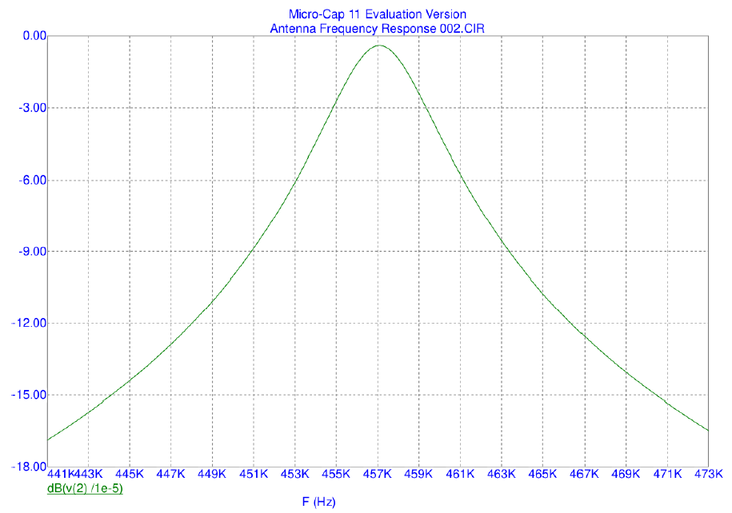

Figure 2: Avalanche receiver antenna circuit frequency response

* 1. Ceramic Filter: Since XTAL filters are too sharp, sensitive to shock and expensive, and since ceramic filters centred at 455 kHz have been available for intermediate frequency (IF) filtering in medium wave receivers, most LVS manufacturers have asked ceramic filter manufacturers to produce a ceramic filter centred at 457 kHz. These filters are configured into the front end after 1 to 3 amplification stages with switchable gain in order to avoid overdriving the filters.

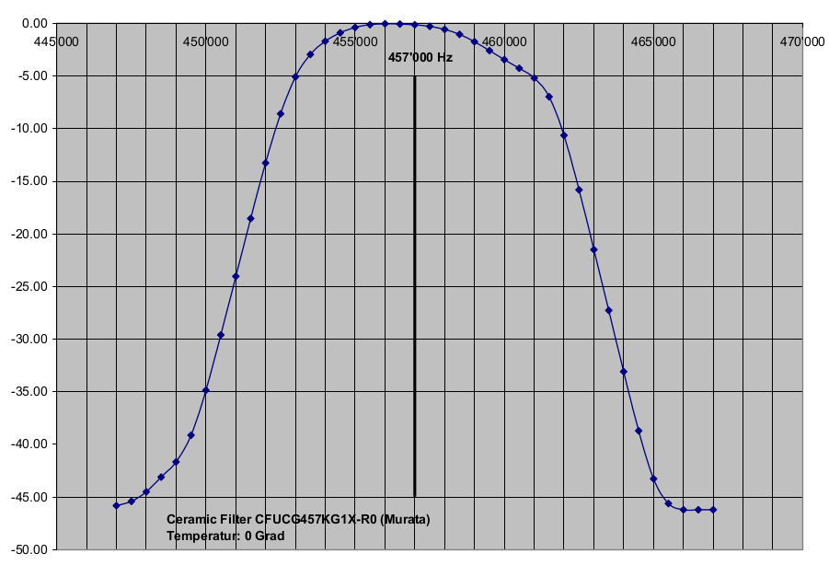

Figure 3: Avalanche receiver ceramic filter frequency response

* 1. DSP Filtering: A third level of filtering is applied after analogue to digital conversion of the received signal by means of Digital Signal Processing (DSP) algorithms. Typical sampling rates for the digital filters are around 16 kHz. Out-of-band signals that are offset by more than 8 kHz might therefore alias into the inner band. Note that such a filter would not accommodate signals from a transmitter operating at 457 kHz ±80 Hz. Manufacturers have therefore been using various proprietary methods to meet the requirements as stipulated in ETSI EN 300 718 [9].

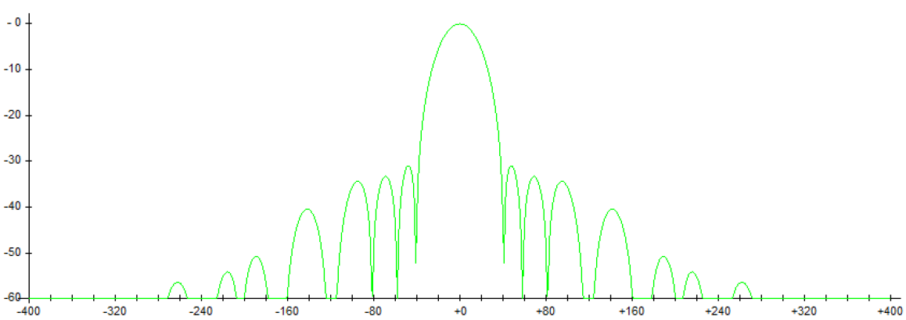

Figure 4: Avalanche receiver digital filter frequency response

* 1. Gain Control: Avalanche transceiver receivers must be capable of detecting pulsed signals ranging from about 5 nA/m to 2.23 A/m (at r = 0.1 meters), i.e. over a dynamic range of at least 170 dB. This is obviously not possible without some hardware gain control.

A typical receiver will have switchable gain stages in its front end circuitry, e.g. 5 levels separated by 24 dB of gain, for a total dynamic range of 96 dB. The signal is then usually converted to digital with a resolution of 15 plus 1 (sign) bits. Of these bits, about 12 can be used for an additional dynamic range of 72 dB, yielding a total dynamic range of 96 + 72 = 168 dB. Gain control is based on two criteria:

The Peak Level of Received Pulsed Signals: When the peak level of received pulsed signals is near the saturation limit of the front end hardware, then the hardware gain is reduced in order to avoid signal distortion and amplifier saturation;

The Mean Level of the Received Signal in Between Pulses: When the received signal in between pulses is above a given threshold, then the hardware gain is reduced in order to allow for optimum use of the dynamic range of the digitized signal.

* 1. Antennas: All LVS devices use ferrite rod antennas. The signal received by a single rod antenna depends heavily on the antenna orientation relative to the incident magnetic field. To avoid any black spots in orientation, LVS receivers use 3 orthogonal rod antennas. For providing a direction indication, the signals from the two antennas in the main plane of LVS devices are compared to each other in terms of amplitude and phase.

### Interference scenarios and separation distances

The possible effects of DCA signals on LVS receiver operation are:

* Co-channel interference may lead to incorrect measurement results;
* The receiver hardware may be driven into saturation by signals outside the LVS frequency band of about +/- 80 Hz;
* The signal in between pulses is elevated to a level where the LVS gain control will reduce the hardware gain, thus reducing the range where LVS signals can be detected. Because the IF filter has a larger bandwidth than the base band filter, this effect occurs also for interfering signals on adjacent channels.

The chances of survival for persons buried in an avalanche decrease exponentially with the burial time. Since the time for locating a buried victim is a substantial part of the total burial time, the achievable area search speed, which in turn depends on range, is very important. A reduction of the range by a factor of 2 causes a reduction of the area search speed by a factor of 4.

Any scenario where the collision detection device could be in the vicinity of an avalanche receiver is to be studied. In this section, the separation distances and the frequency guard band required to ensure a proper usage of the avalanche receiver are derived. The studies are conducted for single interferer and for multiple contiguous interferers.

Ground wave propagation is not considered. As outlined in ERC Report 69 [4], the minimum separation distances would be larger if ground wave propagation would be accounted for.

#### Co-channel Interference

The following minimum separation distances for co-channel interference have been calculated using either the coplanar or the coaxial value (whichever is higher) for the H field strength. Because the interference range is beyond the near field range of the interfering transmitter, roll-off has been calculated using all components of the formulas for H field strength.

* 1. Single interferer case

Because the interference range is beyond the near field range of the interfering transmitter, the near field propagation model is not applicable.

Table 6: Co-channel separation distances with the avalanche receiver for single interferer

|  |  |  |  |  |  |
| --- | --- | --- | --- | --- | --- |
| Receiver type | Transmitter level  (dBμA/m) | Maximum interference level | | Minimum required attenuation (dB) | Range (m) |
| **(dBμA/m)** | **(nA/m)** |
| Digital | 7 | -55.7 | 1.64 | 62.7 | 129 |
| Analogue | 7 | -65.0 | 0.56 | 72.0 | 207 |
| Helicopter | 7 | -69.8 | 0.32 | 76.8 | 298 |

The minimum separation distance for any co-channel interferer at 457.0 kHz is in the range from 129 metres to 298 metres, depending on the victim LVS receiver type under consideration.

In order to avoid any range loss due to gain reduction, the maximum interference level for the most sensitive receivers would be -69.8 + 24 = -45.8 dBμA/m. This corresponds to a minimum separation distance of about 50 meters following the propagation model.

* 1. Multiple interferer case

Although the proposed system consists of a single transmitter per carrier frequency, the signals from multiple (N) neighbouring transmitters at slightly different frequencies may aggregate within the passband of the ceramic front end filter. Such signals will produce a beat with amplitudes of up to N times the amplitude of an individual signal and thus cause saturation in the front end of the receiver or receiver desensitisation.

For the aggregated interference scenario of 10 interfering signals the minimum required separation distances are calculated. Those separation distances are calculated considering different guard band widths. The guard bands are centrally arranged to the LVS carrier. For the sake of simplicity it is assumed that the same separation distance applies to each interfering source and that the interfering signals are separated by 100 Hz to each other and symmetrically arranged on both sides of the LVS carrier.

For the minimum separation distance calculation for multiple interferers, the receiver desensitisation effect of aggregated adjacent channel interferers is considered. The separation distance is evaluated with the following method:

1. The attenuation / selectivity of the IF filter and the antenna is evaluated.
2. Based on desensitisation ratio, the receiver sensitivity level and the IF filter and antenna attenuation, the maximum interference level is calculated.
3. Based on the maximum interference level, the minimum separation distance for near field conditions is calculated.

The IF filter attenuation for the aggregated interference signals with respect to the guard band width is calculated as follows:

$$A_{agg}\left(BW\right)=20\log\left(N\right)-20\log{\sum_{n=1}^{N/2}{\left({10}^{\frac{A_{ZF}(f_{0}+n*f_{c}+\frac{BW}{2})}{20}}+{10}^{\frac{A_{ZF}(f_{0}-n*f_{c}+\frac{BW}{2})}{20}}\right)}}$$

where:

* $A_{agg}$: Attenuation of aggregated signals;
* $BW$: the guard band width in kHz;
* N: number of interferers;
* $A_{ZF}\left(f\right):$ attenuation /selectivity of the IF filter at the antenna at frequency f;
* $f_{0}:$ Central frequency 457 kHz;
* $f_{c}:$ Interferer frequency separation of 100 Hz.

The result for a calculation of 10 interferers is shown in Figure 5.



Figure 5: IF filter attenuation of 10 aggregated interference signals

As mentioned earlier in this Report, the receiver desensitisation can occur when the aggregated signal level exceeds the wanted signal by more than 24 dB (desensitisation ratio), in case of LVS signal levels well above the minimum sensitivity level. In that case the maximum aggregated interference signal level is calculated as follows:

$$I_{agg}=S_{MINLVS}+24dB-A_agg -20dB$$

This calculation is valued when the interfering signal sources are assumed to have all the same radiation level of 7 dBμA/m and are at the same distance to the victim receiver.

When the system operates at its maximum range, the desensitisation occurs at higher interference to signal - levels. As mentioned earlier, 12 bits of the ADC can be used for dynamic response of the receiver. This represents a dynamic range of 72 dB. A “head room margin” of 10 dB is considered to prevent the system from non-linear operation at those signal levels close to the threshold of front end gain reduction. The minimum S/N for the receiver is 6 dB. Accordingly 56 dB of dynamic range remain for operation at maximum system range. In that case the desensitisation ratio is 56 dB and the maximum aggregated interference signal level is calculated as follows:

$$I_{agg}=S_{MINLVS}+56dB-A_agg -20dB$$

Considering the minimum signal levels for the different receiver types of Table 5 a maximum aggregated interference level, $I_{agg}$*,* can be calculated. The corresponding values are shown in Table 7.

Table 7: Maximum aggregated interference to prevent receiver from desensitisation

|  |  |  |  |
| --- | --- | --- | --- |
| Receiver type | Range  *(*m*)* | Minimum Signal level *SMINLVS (*dBμA/m*)* | Maximum aggregated interference level Iagg *(*dBμA/m*)* |
| Digital | 70 | -43.7 | -7.7 - Aagg |
| Analogue | 100 | -53 | -17 -Aagg |
| Helicopter | 120 | -57.8 | -21.8 - Aagg |

The minimum separation distances D\_Separation\_Min calculated based on the interference level Iagg values given in the figure below are calculated as follows:

$D_{separation-Min}=10*{\left({10}^{I_{agg}-\frac{7dBuA}{m}}\right)}^{1/3}$ in metres.

The calculated separation distances for all three types of receivers – analogue, digital and helicopter – are shown graphically in Figure 6.



Figure 6: Minimum separation distances for 10 aggregated interferers   
with respect to guard band width

#### Out-of-band interference

In the following, only the most common receiver types are considered, i.e. digital receivers. For the analogue and helicopter receivers, the separation distances would even become larger. The required co-channel attenuation for signals from a single DCA interferer is

$$\frac{2.23 μA/m}{1.64 nA/m}=62.67 dB≈63dB$$

And so the required separation distances can be calculated from the required attenuation and from the typical filter characteristics as follows:

$$r=r_{10}{10}^{\frac{Att_{r}}{3×20}}$$

Although out-of-band signals that are offset by more than half the DSP sampling rate might alias into the inner band (see section 5.3.1.2), a minimum digital filter attenuation of at least 50 dB at frequencies that are separated by more than 1 kHz from 457.0 kHz is assumed for the estimations. This is based on the fact that at 457.0 – 8.0 kHz the attenuation provided by the antenna resonant circuit and by the ceramic filter will be at least 50 dB.

Considering the characteristics of all the receiver filters, result for a single interferer is obtained in Table 8.

Table 8: Out-of-band avalanche receiver separation distances for single interferer

|  |  |  |  |  |
| --- | --- | --- | --- | --- |
| Frequency (kHz) | Required Coupling Loss [dB] | | | r (m) |
| **Co-channel** | **(-) Filters** | **Total** |
| 457.0 | 63 | 0 | 63 | 129.0 |
| 455.0 | 63 | 53 | 10 | 14.7 |
| 453.0 | 63 | 61 | 2 | 10.8 |
| 451.0 | 63 | 83 | -20 | 4.6 |
| 449.9 | 63 | 103 | -40 | 2.2 |
| 447.0 | 63 | 108 | -45 | 1.8 |

### Conclusions for avalanche victim detection applications

The use of the proposed detection and collision avoidance application would seriously interfere with the widespread use of avalanche transceivers in many scenarios. This interference may increase the time for locating buried avalanche victims and thus cause unnecessary deaths.

The proposed detection and collision avoidance application is not an extension to applications for emergency detection of buried persons, but an interferer to these applications.

Many scenarios require that the applications can be used by the same person at the same time. The minimum separation distances required as per section 5.3 would definitely not permit such use.

A detection and collision avoidance system with the proposed characteristic should not be used in the frequency band 457 kHz +/- 7 kHz. Respecting a 14 kHz guard band protects the LVS receiver from interference at separation distances of 5 metres or more. It should be noted that the EC Decision 2017/1483 [11] limits the application of 7 dBµA/m field strength in the frequency band 456.9-457.1 kHz to the usage of emergency detection of buried victims and valuable goods.

## Sharing with Maritime Mobile

According to the ECA Table, the band 415-495 kHz is allocated to Maritime Mobile (radiotelegraphy) on a primary basis. Maritime safety information (MSI) systems operate on 424 kHz, mainly 490 kHz and 518 kHz (NAVTEX), and there is a common primary mobile service allocation across the three ITU Regions in the band 495-505 kHz. The targeted application in the band 446-457.1 kHz should not prejudice the MSI systems.

RR No. 5.79 stipulates that “The use of the band 415-495 kHz and 505-526.5 kHz (505-510 kHz in Region 2) by the maritime mobile service is limited to radiotelegraphy.” No ITU-R Recommendation or ETSI standard covering the radiotelegraphy characteristics in this band have been found. ITU-R Report M.910-1 [7] indicates: “There are no protection criteria in the radio Regulation governing the maritime service in the bands between 435 kHz and 526.5 kHz.”

## Considerations on unwanted emissions of the studied application

### Unwanted emissions consideration

Based on a commercialised version in the US, compliant with Federal Communications Commission (FCC) rules, which transmits at 0 dBµA/m at 10 m, emissions for all domains (in-band, out-of-band and spurious) have been measured. The setup used for these measurements is not based on ETSI EN 300 330 [8] setup. The antenna used is an ETS Lindgren Model 7604, with the device at 300 mm from the antenna. In order to extrapolate the measures to the version targeted in Europe, levels were extrapolated by adding 7 dB. This extrapolation is valid, because the system works not in linear mode but in blocked – saturated mode.

For the measured product, the fundamental power level is at 0 dBµA/m at 10 m, and the second and the third harmonics are less than -63 dBµA/m at 10 m. Extrapolated to the 7 dBµA/m at 10 m fundamentals, this gives harmonics with levels less than -56 dBµA/m at 10 m. It should be noted that during the measurement it was impossible to discriminate the DCA application spurious emissions from the ambient noise, because of their very low level. Figure 7 shows the emission level of the desired application, as well as the first and second harmonics. The curve in red dots materialise the measurement limits. Under this level, it’s not possible to distinguish the Device Under Test (DUT) signal from environment parasitic signals.

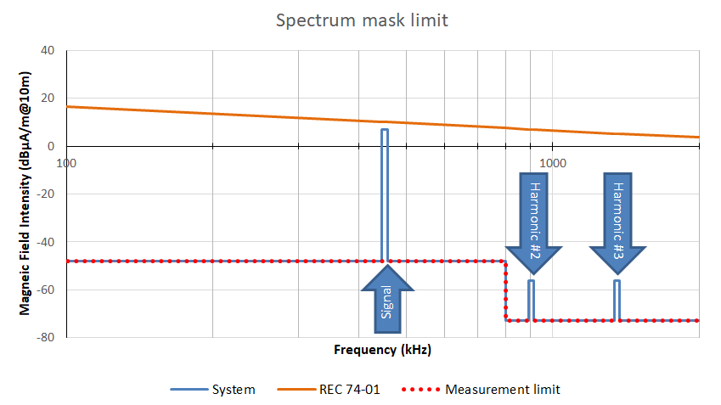

Figure 7: Spectrum mask limit

### Consideration on the broadcasting service

The new detection and collision avoidance application spurious emissions complies with the Harmonised Standard ETSI EN 300 330 [8], which specifies in Table 9 the following spurious emission limits between 9 kHz and 10 MHz.

Table 9: Extract from ETSI EN 300 330 on spurious emissions

|  |  |
| --- | --- |
| State | H-field in dBμA/m at 10 m |
| Operating | 27 dBμA/m at 9 kHz descending 3 dB/octave |
| Standby | 5.5 dBμA/m at 9 kHz descending 3 dB/octave |

This is in-line with ERC/REC 74-01 [2] Annex 2 reference 2.1.3 for the operating / transmit mode and 2.1.5 for the standby mode.

Regarding concerns with the broadcasting service, it is worth to be mentioned that the latter can be found in the two following bands, on each side of the frequency band 446-457.1 kHz proposed for the new detection and collision avoidance application:

* band 5 (LF): 148.5-283.5 kHz for AM broadcasting (long-wave);
* band 6 (MF): 526.5-1606.5 kHz for AM broadcasting.

ERC/REC 70-03 [1] has several inductive entries that overlap or are adjacent to these two frequency bands:

* Annex 4, entry ‘a’ : 984-7484 kHz, 9 dBµA/m at 10m, ≤ 1% duty cycle;
* Annex 9, entry ‘c’: 140-148.5 kHz, 37.7 dBμA/m at 10m;
* Annex 9, entry ‘d’ : 400-600 kHz, -8 dBµA/m at 10m;
* Annex 9, entry ‘k1’: 148.5-5000 kHz, -15 dBµA/m at10m;
* Annex 12, entry ‘a’ : 9-315 kHz, 30 dBµA/m at 10m, ≤ 10% duty cycle;
* Annex 12, entry ‘b’: 315-600 kHz, -5 dBµA/m at 10m, ≤ 10% duty cycle.

So far, no harmful interference case (co-channel, out-of-band or spurious) due to these entries has been reported with regard to the broadcasting service.

Considering the magnetic field requested (7 dBµA/m at 10 m), the low usage density expected and the compliance to ETSI EN 300 330 [8] spurious requirements, no interference is expected from this new detection and collision avoidance application to the broadcasting service.

### Summary of the impact on services in the adjacent bands

The protection distance for each service is assessed in Table 10. This evaluation is based on ECC Report 67 [3].

In Table 10, for each service described in ECC Report 67 [3] (radio navigation, broadcast and amateur), the extrapolated system maximum field intensity is considered. By applying the field strength roll-off of 60 dB/decade for near field the protection distance between one emitter and a potential victim for each service is estimated.

In Table 11, the worst case is considered where for each service multiple emitters are collocated inside a very small area. First step is to determine the maximum number of emitters (#TX) available inside the Victim bandwidth (VBW). Second step, the equivalent magnetic field intensity has to be calculated. To do so, it is considered that:

* All emitters are so close, that can be assimilated as located in a unique point;
* All emitters are oriented in the same orientation (azimuth and elevation);
* All available channels are used, with one different frequency for each (without overlap).

Table 10: Protection distance evaluation with each service, single entry

|  |  |  |  |  |  |  |  |  |  |  |  |  |  |  |  |  |  |  |
| --- | --- | --- | --- | --- | --- | --- | --- | --- | --- | --- | --- | --- | --- | --- | --- | --- | --- | --- |
| Frequency  sub-bands (kHz) | | | Extrapolated Magnetic field   (dBµA/m at 10m) | EN 300 330: Limit Rec ERC 74-01 (dBµA/m at 10m) | | Primary service protection (cf. ECC Report 67) | | | | | | | | | | | | |
| **Service** | **TX Bmax (dBµA/m at 10m)** | **Protection distance(m) (dBµA/m at 10m)** | | | | | **Extrapolated protection distance (m) (dBµA/m at 10m)** | | | | | |
| **Domain** | **Start** | **Stop** | **Start** | **Stop** | **-5** | **-10** | **-15** | **-20** | **-25** | **-5** | **-10** | **-15** | **-20** | **-25** | **Av. (m)** |
| Spurious | 9 | 446 | -48 | 27.0 | 10.1 | Broadcasting | -48.0 | 18 | 15 | 12 | 10 | 8 | 3.5 | 3.5 | 3.4 | 3.4 | 3.3 | 3.4 |
| Aeronautical Radio-navigation | 7.0 | 17 | 14 | 12 | 10 | 8 | 27 | 27 | 28 | 28 | 27 | 27.4 |
| In-band | 446 | 457 | 7 | 10.1 | 10.0 |
|
| Spurious | 457 | 800 | -48 | 10.0 | 7.6 |
| Broadcasting | -48.0 | 23 | 19 | 16 | 13 | 11 | 4.4 | 4.4 | 4.5 | 4.4 | 4.6 | 4.5 |
| 800 | 892 | -73 | 7.6 | 7.1 |
|
| Second Harmonic | 892 | 914 | -56 | 7.1 | 7.0 |
|
| Spurious | 914 | 1338 | -73 | 7.0 | 5.4 |
|
| Third Harmonic | 1338 | 1371 | -56 | 5.4 | 5.2 |
|
| Spurious | 1371 | 2000 | -73 | 5.2 | 3.6 |
| Amateur | -73.0 | 1101 | 643 | 362 | 203 | 114 | 81 | 57 | 39 | 27 | 18 | 44.4 |
| > 2000 | | < -73 | < 3.6 | |  | | | | | | | | | | | | |

Table 11: Protection distance evaluation with each service, worst case multiple interferer

|  |  |  |  |  |  |  |  |  |  |  |  |  |  |  |  |  |  |  |  |  |  |  |
| --- | --- | --- | --- | --- | --- | --- | --- | --- | --- | --- | --- | --- | --- | --- | --- | --- | --- | --- | --- | --- | --- | --- |
| Frequency  sub-bands (kHz) | | | Extrapolated Magnetic field   (dBµA/m at 10m) | EN 300 330: Limit Rec ERC 74-01 (dBµA/m at 10m) | | Primary service protection (cf. ECC Report 67) | | | | | | | | | | | | | | | | |
| **Service** | **TX Bmax (dBµA/m at 10m)** | **Cumulative effect** | | | | **Protection distance(m) (dBµA/m at 10m)** | | | | | **Extrapolated protection distance (m) (dBµA/m at 10m)** | | | | | |
| **Domain** | **Start** | **Stop** | **Start** | **Stop** | **VBW (kHz)** | **# TX** | **B Gain** | **B max** | **-5** | **-10** | **-15** | **-20** | **-25** | **-5** | **-10** | **-15** | **-20** | **-25** | **Av. (m)** |
| Spurious | 9 | 446 | -48 | 27.0 | 10.1 | Broadcasting | -48.0 | 9 | 100 | 40.0 | -8.0 | 18 | 15 | 12 | 10 | 8 | 16 | 16 | 16 | 16 | 15 | 15.8 |
| Aeronautical Radionavigation | 7.0 | 2.7 | 30 | 29.5 | 36.5 | 17 | 14 | 12 | 10 | 8 | 84 | 84 | 87 | 88 | 85 | 85.3 |
| In-band | 446 | 457 | 7 | 10.1 | 10.0 |
|
| Spurious | 457 | 800 | -48 | 10.0 | 7.6 |
| Broadcasting | -48.0 | 10 | 112 | 41.0 | -38.0 | 23 | 19 | 16 | 13 | 11 | 6.5 | 6.5 | 6.6 | 6.5 | 6.7 | 6.6 |
| 800 | 892 | -73 | 7.6 | 7.1 |
|
| Second Harmonic | 892 | 914 | -56 | 7.1 | 7.0 |
|
| Spurious | 914 | 1338 | -73 | 7.0 | 5.4 |
|
| Third Harmonic | 1338 | 1371 | -56 | 5.4 | 5.2 |
|
| Spurious | 1371 | 2000 | -73 | 5.2 | 3.6 |
| Amateur | -73.0 | 2.7 | 30 | 29.5 | -43.5 | 1101 | 643 | 362 | 203 | 114 | 252 | 178 | 121 | 83 | 56 | 138.0 |
| > 2000 | | < -73 | < 3.6 | |  | | | | | | | | | | | | | | | | |

### Consideration on the coexistence studies results

#### Requirement to protect avalanche receiver

As stated in section 5.3.3, “A detection and collision avoidance system with the proposed characteristic should not be used in the frequency band 457 kHz +/- 7 kHz”. The initial analysis referred to operation on the band 446-457.1 kHz, thus, to protect the avalanche receiver it is required to stop the upper limit frequency range of the person detection and collision avoidance application at (457.1 – 7)~ 450 kHz.

#### Requirements to protect the aeronautical service

ICAO states that a minimum required distance of 75 m would be appropriate to protect the DF/NDB receiver [10]. When studying the aggregate emitter scenario, it was shown that a worst case scenario, where 30 contiguous channels could fall into the 2.7 kHz bandwidth of the AFD/NDB, would lead to a separation distance of 85.3 m. Thus, the achieved distance of 85.3 m does not match ICAO’s requirement.

In order to fulfil this requirement, the aggregated field strength needs to be reduced. Two approaches can be considered:

1. To reduce the emitted magnetic field strength of the devices: the initial demand is of 7 dBµA/m at 10 metres, this value is already lower than the spurious domain level imposed by ERC Recommendation 74-01 [2] in that band. Further reduction would make the application signal difficultly detectable by the receiver unit, given the ambient noise.
2. To reduce the number of contiguous channels that could fall in the 2.7 kHz bandwidth of the ADF/NDB receiver: This can be achieved by increasing the inter-channel spacing. A higher inter-channel spacing, would lead to a lower number of contiguous channels incident in 2.7 kHz ADF/NDB bandwidth. This solution is the more attractive under a technological point of view. In the following, it is shown what value of inter-channel spacing would allow achieving the required protection distance.

By applying the field strength roll-off of 60 dB/decade for near field, it is possible to derive the magnetic field corresponding to a protection distance of 75 m, which is requested by ICAO, using the following equation:

$$H_{field2}-H_{field1}=60\log{(\frac{d_{2}}{d_{1}})}$$

Where Hfield2 is the maximum tolerable magnetic field associated with its distance d1=75 m, Hfield1 is one of the available values derived in Table 2 in ECC Report 67 [3] associated with it distance d1. Taking for example the couple (Hfield1,d1)=(-20,10), a value of 32.50 dBµA/m at 10 m can be achieved.

This value needs to be converted into a number of devices emitting with 7 dBµA/m at 10 m, such that:

$$32.5=7+20\log{N}$$

where N is the number of transceivers falling into the 2.7 kHz ADF/NDB receiver. Thus,

$N=floor[{10}^{\frac{32.5-7}{20}}]$ = floor[18.83]=18[[1]](#footnote-2)

Hence, the inter-channel spacing will be:

$Δf=\frac{2.7*{10}^{3}}{18}$ =150 Hz.

In order to meet the 75 m protection distance regarding the ADF/NDB receiver, a minimum channel spacing of 150 Hz is required.

#### Requirement to satisfy the 51 needed channels while protecting both aeronautical service and avalanche receiver application

Taking into account both requirements, the proposed application would have to operate in the band 446-450 kHz with channel spacing of 150 Hz. This would lead to the availability of (4\*10^3/150) = 26 channels. Considering the fact that the central channel is unusable due to the rejection of the local oscillator, only 25 channels are thus available.

The initial study asked for at least 51 channels. Again taking into account the rejection of the local oscillator, the required bandwidth would be (51+1)\*150=7.8 kHz.

Considering the fact that the operational frequency range of the application is upper bounded by the 450 kHz value, the new lower bound is (450-7.8)=442.2 kHz.

In order to allow the same usage possibility to the person detection and collision avoidance application, without causing harmful interference to incumbent services, the application should operate in the band 442.2-450 kHz.

In order to achieve the 51 channel requirement indicated by WG FM, the frequency range of the proposed application should be shifted to 442.2-450 kHz. No overlap with another incumbent service is achieved by shifting the lower frequency limit to 442.2 kHz. All the studies carried out up to now remain valid.

# Conclusion

The initial demand was to study the feasibility of introducing a new person detection and collision avoidance in the range 446-457.1 kHz. The studies have shown that, in order to ensure the protection of the avalanche victim application and of receiver of Automatic Direction Finder and Non-Directional Beacons (ADF/NDB), the person detection and collision avoidance application should not be operated in the frequencies above 450 kHz and should use a channel spacing of 150 Hz. To allow the application to operate with the required number of devices (up to 51), the person detection and collision avoidance application should operate in the band 442.2-450.0 kHz.

The new operational characteristics should thus be:

Table 12: New proposed operational characteristics

|  |  |
| --- | --- |
| Parameter | Value |
| Number of channels required | Up to 51 |
| Minimum channel spacing | 150 Hz |
| Magnetic field strength | 7 dBµA/m at 10 meters |
| Envisaged frequency range | 442.2-450.0 kHz |

1. List of ReferenceS
2. ERC Recommendation 70-03: "Relating to the use of Short Range Devices (SRD)"
3. ERC Recommendation 74-01: "Unwanted Emissions in the Spurious Domain"
4. ECC Report 67: "Compatibility study for generic limits for the emission levels of inductive SRDs below 30MHz"
5. ERC Report 69: "Propagation model and interference range calculation for inductive systems 10 kHz-30 MHz"
6. ECC Report 107: "Regulating Interoperability"
7. ERC Report 25: "The European table of frequency allocations and applications in the frequency range 8.3 kHz to 3000 GHz"
8. ITU-R Report M.910-1 "Sharing between the maritime mobile service and the aeronautical radio navigation service in the band 415-526.5 kHz"
9. ETSI EN 300 330: "Short Range Devices (SRD); Radio equipment in the frequency range 9 kHz to 25 MHz and inductive loop systems in the frequency range 9 kHz to 30 MHz; Harmonised Standard covering the essential requirements of article 3.2 of the Directive 2014/53/EU"
10. ETSI EN 300 718: "Avalanche Beacons operating at 457 kHz; Transmitter-receiver systems"
11. ICAO reply LS on the protection of the NDB receiver, Doc. [SE(18)063](https://www.cept.org/Documents/wg-se/42788/se-18-063_ndb-detection-and-collision-avoidance), April 2018
12. EC Decision 2017/1483, Commission Implementing Decision (EU) 2017/1483 of 8 August 2017 amending Decision 2006/771/EC on harmonisation of the radio spectrum for use by short-range devices and repealing Decision 2006/804/EC

1. For completeness, it is mentioned that with 18 channels falling into the 2.7 kHz ADF/NDB receiver bandwidth, the required separation distance is 73.9 m. [↑](#footnote-ref-2)