Satellite Solutions for 5G

Approved 18 May 2018

ECC Report 280

# Executive summary

ECC has recognised the importance of the fifth generation of mobile technology referred to as ‘5G’ (also known as IMT-2020). 5G aims to provide seamless coverage, high data rate, low latency, low power and highly reliable communications. Use cases under consideration include enhanced mobile broadband, massive machine type communications, Internet of Things (IoT), healthcare, home automation, industrial automation and sensors. Vertical dimension will be added from the user’s perspective.

This Report has been developed in the context of the CEPT Roadmap for 5G, which foresees a number of different technology solutions playing a role in the future 5G ecosystem. These different technological solutions will ensure that the benefits of 5G are ubiquitously available globally. The CEPT roadmap intends to take into consideration what satellite solutions can bring for 5G. This Report focuses on the role satellite systems can play in achieving this goal.

The introduction of 5G is expected to usher in a new era of mobile communications in three main areas: enhanced Mobile Broadband (eMBB), massive Machine Type Communications (mMTC) and ultra-reliable and low-latency communications (URLLC). Significant advances in data rate and density, latency, virtualisation, energy efficiency, security, resilience and other key performance indicators (KPIs) will enable new use cases and business models.

These areas have different requirements for coverage, latency and bandwidth. Different satellite network solutions are expected to play varying roles in addressing some of these use cases. Satellite has a role to play for certain use cases of the greater 5G ecosystem. Users of 5G networks should be able to access services anywhere, anytime. To achieve this goal, various access technologies, which might include different fixed, terrestrial and satellite networks, will be needed. Each technology should fulfil its own role, but also could be integrated together with other technologies to provide required coverage and capacity.

This Report gives an overview of the key capabilities of 5G systems and looks at the various 5G use cases reflecting their specific requirements.

This Report focuses also on the role that satellite-based solutions can play in deployment of 5G applications and networks, provides some background context and a number of representative use cases of satellite-based solutions and subsequently identifies the key areas where architecture and standardisation considerations are critical.

Four main use case categories are identified for satellite-based solutions in 5G:

1. Communications on the Move;
2. Hybrid Multiplay;
3. Trunking and Head-end Feed;
4. Backhauling and Tower Feed.

These cases are characterised by their scale: from Communications on the Move use cases with hundreds of millions of devices, to millions in the case of Hybrid Multiplay use cases, or a few hundred or thousand sites for the Trunking and Head-end Feed use cases.

The Communications on the Move use case is about high bit-rate backhaul connectivity to planes, trains, cars, and vessels (including cruise ships and other passenger vessels), with the ability to multicast the same content (e.g. video, HD/UHD TV, as well as other non-video data) across a large coverage (e.g. for local storage and consumption), or unicast to end user devices and applications. The same capability also allows for the efficient connection of aggregated IoT traffic to and from these moving platforms. It assumes that satellite radio access networks will connect directly with the end user device, or complement existing terrestrial connectivity, where available (such as, airports, harbours, train stations, connected cars, etc.).

The Hybrid Multiplay use case is about high bit-rate backhaul connectivity to individual homes and offices, with the ability to multicast the same content (video, HD/UHD TV, as well as other non-video data) across a large coverage (e.g. for local storage and consumption) or unicast to end user devices and application, as the need arises. The same capability also allows for an efficient broadband connectivity for aggregated IoT data. In­home distribution would be done via Wi-Fi, WiGig or small cell 3G/4G/5G.

Satellite can also meet the needs of the Trunking and Head-end Feed use case that is about high bit-rate trunking of video, IoT and other data to a central site.

The Backhauling and Tower Feed use case is about high bit-rate backhaul connectivity to individual terrestrial 5G cells, with the ability to multicast the same content (e.g. video, HD/UHD TV, as well as other non-video data) across a large coverage (e.g. for local storage and consumption). The same capability also allows for the efficient backhauling of aggregated IoT traffic from multiple sites. This use case assumes that satellite connectivity will complement existing terrestrial connectivity where it is viable to do so.

Both geostationary and non-geostationary satellite networks have specific characteristics that can contribute to satellite-based solutions in 5G deployment. For example, High Throughput Satellite (HTS) systems mark a significant advance in capability compared to the typical role satellite has played in telecommunications infrastructure due to the increase in capacity and associated improvement of bandwidth economics that this enables. HTS networks are operating on a global basis and can provide broadband service to end-users with bit rates in excess of 100 Mbit/s.

In addition to the developments in the space segment, there are technological developments in the satellite ground segment with evolutions both in the network platforms and satellite communication terminals. In terms of network platforms, satellite industry has adopted and will continue to implement the technology paradigms and standards of the 5G community including in the areas of service delivery, IP-based traffic, network-slicing, orchestration, mobile edge computing, security, interoperability and resource virtualisation in order to transparently support end-to-end service delivery to vertical and horizontal applications. In terms of communication terminals, a new wave of small and flat panel antenna technologies are emerging which have form factors that are conducive to mobile platform applications. A number of issues are addressed in the context of 5G architectural considerations for compatibility and integration of satellite networks with 5G. These are: multicast support, intelligent routing support, dynamic management and adaptive streaming support, latency, content/asset rights management and security, and persistent quality of service. .

As CEPT administrations consider how 5G networks will be implemented in the future, the information provided in this Report gives information on satellite-based solutions to address 5G use cases in the context of the greater 5G ecosystem.

TABLE OF CONTENTS

0 Executive summary 2

1 Introduction 7

2 Background and rationale 8

3 Overall 5G vision 10

3.1 Capabilities of 5G networks 10

3.2 5G use cases 10

4 Integration of satellite networks into 5G 13

4.1 Satellites within the global communications infrastructure 13

4.2 Architectural considerations 13

5 Satellite use cases 16

5.1 Communications on the Move 16

5.2 Hybrid Multiplay 19

5.3 Trunking and Head-end Feed 20

5.4 Backhauling and Tower Feed 22

6 Satellite technology 25

7 Innovation in the satellite sector 26

7.1 High Throughput Satellites (HTS) driving Innovation 26

7.2 Advanced satellite ground segment technology 27

7.3 Phased array antenna technology 27

7.4 Spectrum usage – high level overview 28

8 Relevant technical and standardisation issues 30

8.1 Multicast support 30

8.2 Unicast support 30

8.3 Intelligent routing support 30

8.4 Dynamic cache management and adaptive streaming support 30

8.5 Latency 30

8.6 Content / Asset Rights Management and Security 31

8.7 Persistent Quality of Service 31

8.8 NFV / SDN compatibility 31

8.9 Business model flexibility 31

9 Conclusions 32

ANNEX 1: List of Reference 33

LIST OF ABBREVIATIONS

|  |  |
| --- | --- |
| Abbreviation | Explanation |
| 3G, 4G, 5G | Third, Fourth, Fifth generation of mobile technology |
| ACM | Adaptive Coding and Modulation |
| AR | Augmented Reality |
| ARPU | Average Revenue per User |
| CDN | Content Delivery Network |
| CEPT | European Conference of Postal and Telecommunications Administrations |
| DTH | Direct-to-Home (satellite TV) |
| EC | European Commission |
| ECC | Electronic Communications Committee |
| ECUs | Electronic Control Units |
| eMBB | Enhanced Mobile Broadband |
| EPC | Evolved Packet Core |
| EU | European Union |
| FOTA | Firmware Over the Air |
| GEO | Geostationary Earth Orbit |
| GNSS | Global Navigation Satellite System |
| GSO | Geostationary Satellite Orbit |
| HD | High Definition |
| HTS | High Throughput Satellite |
| IoT | Internet of Things |
| IPTV | Internet Protocol Television |
| KPIs | Key Performance Indicators |
| LEO | Low Earth Orbit |
| M2M | Machine to Machine |
| MCN | Mobile Core Network |
| MEC | Mobile Edge Computing |
| MEO | Medium Earth Orbit |
| mMTC | Massive Machine Type Communications |
| MNO | Mobile Network Operator |
| MSAT | Metamaterials Surface Antenna Technology |
| NFV | Network Function Virtualisation |
| OEM | Original Equipment Manufacturer |
| P-MP | Point-to-Multipoint |
| POI | Point of Interest |
| SCADA | Supervisory Control And Data Acquisition |
| SDN | Software Defined Network |
| SOTA | Software Over the Air |
| TCU | Telematics Control Unit |
| TDMA | Time Division Multiple Access |
| TV | Television |
| UHD | Ultra High Definition |
| URLLC | Ultra-Reliable and Low-Latency communications |
| VHTS | Very High Throughput Satellite |
| VNF | Virtual Network Function |
| VR | Virtual Reality |
| VSAT | Very Small Aperture Terminal |
| Wi-Fi | Wireless Fidelity (see [Wi-Fi Alliance](https://www.wi-fi.org/)) |
| WiGig | Wireless Gigabit |

# Introduction

This Report has been developed in the context of the CEPT Roadmap for 5G, which foresees a number of different technology solutions playing a role in the future 5G ecosystem. These different technological solutions will ensure that the benefits of 5G are ubiquitously available. The CEPT roadmap intends to take into consideration what satellite solutions can bring for 5G. This Report focuses on the role satellite systems can play in achieving this goal. The introduction of 5G is expected to usher in a new era of mobile communications in three main areas:

1. Enhanced Mobile Broadband (eMBB);
2. Massive Machine Type Communications (mMTC);
3. Ultra-reliable and low-latency communications (URLLC).

Significant advances in data rate and density, latency, virtualisation, energy efficiency, security, resilience and other key performance indicators (KPIs) will enable new use cases and business models.

Users of 5G networks should be able to access services anywhere, anytime. To achieve this goal, various access technologies, which might include different fixed, terrestrial and satellite networks, will be needed. Each technology should fulfil its own role, but also could be integrated together with other technologies to provide required coverage and capacity.

The European Commission set a goal of access to connectivity offering at least 100 Mbit/s for all EU households by 2025. In addition, numerous EU member states have adopted the EC Broadband 2020 goals of 100 Mbit/s connectivity to 50% of EU citizens by the year 2020 and 30 Mbit/s connectivity to all EU citizens. Reaching these goals may require broadband satellites.

This Report provides information on the role satellites can play as part of the 5G concept. It also highlights the various aspects satellites could bring to 5G networks in terms of efficiency, coverage and resilience.

This Report focuses on the rationale for including satellite-based solutions as a part of 5G networks, provides background context for these and gives a number of representative use cases where satellite-based solutions can contribute to 5G. It subsequently identifies the key areas where architecture and standardisation considerations are critical.

# Background and rationale

Some of the new applications enabled by 5G will require wider bandwidths. The associated higher frequencies in this case, and their inherent propagation characteristics, would result in smaller cell sizes for coverage presenting potential new challenges in the associated infrastructure build-out. There are several categories of demand drivers expected in the future:

* Video is expected to be at the origin of more than 80% of global Internet traffic, including on mobile networks. This demand continues to grow with double digit numbers. Efficient cloud solutions based on multicasting, unicasting and caching will be required to support this demand;
* Navigational, weather, traffic and other environmental data;
* Ultra-low latency applications will be enabled by moving computing power away from a central server out to the edge of the network, much closer to the end user. Relocating servers and computing power to the edge of the network will mean that the backhaul network is not used to carry the latency-sensitive traffic, but is used to update the edge computer or cloud on an as-needed basis;
* Internet of Things (IoT) related data from sensors, devices, machines, connected and self-driving cars, etc. will become more prevalent and require ubiquitous coverage;
* Mobility where a large volume of communication is needed for high-speed platforms.

Satellites inherently cover a wide area. This has two main benefits::

* 1. Scalability by leveraging, across a wide area, multicast capabilities together with local caching in the cloud as close as possible to the end user, significant “statistical multiplexing benefits” can be gained, leading to a more efficient use of overall bandwidth and more reliable service;
  2. Satellites can instantaneously connect any place within their footprint, allowing rapid connection of cities, villages, businesses and homes with a predictable quality of service, providing ubiquitous coverage.

Also, by their nature, satellite networks are resilient to physical attacks and natural disasters.

By incorporating the use of satellites into the 5G ecosystem, the commercially viable development of 5G anywhere in the world can be accelerated, provided a number of satellite-specific issues are considered.

One of the advantages of satellites is their ability to provide reliable, ubiquitous coverage. High Throughput Satellite (HTS) solutions provide high speed network access across the globe and particularly to remote areas and to users on ships, land based vehicles and aircraft.

The new use cases and business models are underway and require substantial investments in new network infrastructure. In many cases this new network infrastructure is already being developed and is designed to leverage a broad and global user base, while also being highly scalable and resilient. Even more advanced satellite broadband technologies are also being researched and tested to be a part of the 5G future and beyond. Such scalability and resilience would benefit from 5G to be conceived from the ground up as a “network of networks” or “system of systems”[1], as envisaged in Recommendation ITU-R M.2083 [1] on the IMT2020 Vision.

5G is envisioned as a highly-advanced, ubiquitous network providing a wide range of services. In this context, the geographic coverage, network resilience, flexibility and efficiency of 5G networks could benefit from a wide range of networking technologies, particularly for mobile connectivity and Multiplay, as well as backhaul due to the large volume of traffic these networks are expected to carry. The complementary role and integration of satellite into 5G can contribute, inter alia, to provide:

* Improved connectivity for users on ships, airplanes, vehicles and trains;
* Direct services to end users and devices, including for IoT, and M2M;
* Temporary networks for concerts, sporting events;
* Satellite backhauling for base stations;
* To provide extra backhaul capacity in case of congestion;
* An option for delivery of streamed content to 5G end users and base stations;
* Wide coverage to complement and extend dense terrestrial cells;
* Disaster recovery and emergency response and backhaul communications;
* Seamless connectivity through hybrid networks.

# Overall 5G vision

## Capabilities of 5G networks

Users of 5G networks should be able to access services anywhere, anytime. To achieve this goal, various access technologies, which might include different fixed, terrestrial and satellite networks, will be needed. Each technology should fulfil its own role, but also could be integrated together with other technologies to provide required coverage and capacity.

Recommendation ITU-R M.2083 defines the capabilities of 5G networks.

A broad variety of capabilities, tightly coupled with intended usage scenarios and applications for IMT-2020 is envisioned. Different usage scenarios along with the current and future trends will result in a great diversity/variety of requirements. The key design principles are flexibility and diversity to serve many different use cases and scenarios, for which the capabilities of IMT-2020 will have different relevance and applicability.

The peak data rate of 5G networks for enhanced mobile broadband is expected to reach 10 Gbit/s. However under certain conditions and scenarios 5G networks would support up to 20 Gbit/s peak data rate. 5G networks would support different user experienced data rates covering a variety of environments for enhanced mobile broadband. For wide area coverage cases, e.g. in urban and suburban areas, a user-experienced data rate of 100 Mbit/s is expected. In hotspot cases, the user experienced data rate is expected to reach higher values (e.g. 1 Gbit/s indoor).

The spectrum efficiency is expected to be three times higher compared to earlier generation networks for enhanced mobile broadband. The achievable increase in efficiency from IMT-Advanced will vary between scenarios and could be higher in some scenarios (for example five times subject to further research). 5G networks are expected to support 10 Mbit/s/m2 area traffic capacity, for example in hot spots.

5G networks would be able to provide 1 ms over-the-air latency, capable of supporting services with very low latency requirements. 5G networks are also expected to enable high mobility up to 500 km/h with acceptable QoS. This is envisioned in particular for high speed trains.

Finally, 5G networks are expected to support a connection density of up to 106/km2, for example in massive machine type communication scenarios.

Whilst all these key capabilities may to some extent be important for most use cases, the relevance of each of these capabilities may be significantly different, depending on the use cases/scenario.

For example in the enhanced mobile broadband scenario, user experienced data rate, area traffic capacity, peak data rate, mobility, energy efficiency and spectrum efficiency all have high importance, but mobility and the user experienced data rate would not have equal importance simultaneously in all use cases. Whereas in hotspots, a higher user experienced data rate, but a lower mobility, would be required than in wide area coverage cases.

In some ultra-reliable and low latency communications scenarios, low latency is of highest importance, e.g. in order to enable the safety critical applications.

## 5G use cases

The visions of the potential applications that will be part of 5G generally include three key usage scenarios – (a) enhanced mobile broadband; (b) massive machine-type communications; and (c) ultra-reliable and low-latency communications [1]. These 5G usage scenarios are quite diverse in their technical characteristics, as illustrated by the following diagram:

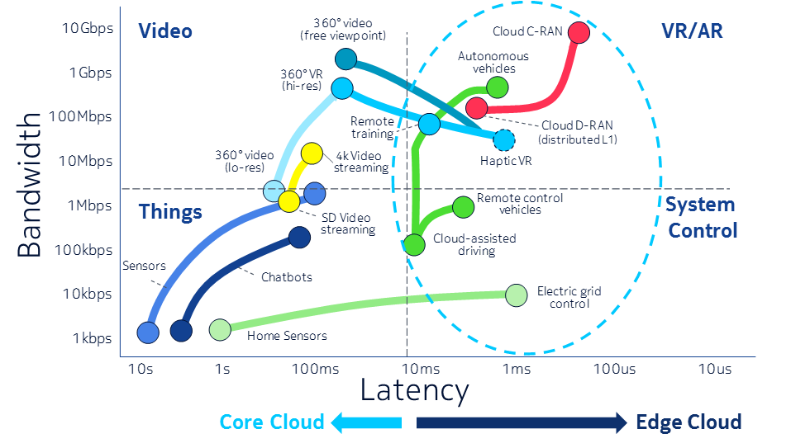

Figure 1: Bandwidth and latency requirements of potential 5G use cases (source: Nokia)

Notably, not all of the use cases identified in the figure have the extreme bandwidth and/or latency requirements that 5G technologies will enable. As a result, satellites – both geostationary and non-geostationary –could play important roles in supporting the key 5G usage scenarios, including emerging 5G applications (as explained below).

From the 5G PPP vision white paper of 2015 [2] the following points can be noted:

* “5G will be a key enabler of the future digital world, the next generation of ubiquitous ultra-high broadband infrastructure that will support the transformation of processes in all economic sectors and the growing consumer market demand”;
* “5G needs to support in an efficient way three different type of traffic profiles, namely high throughput for e.g. video services, lower energy for e.g. long-lived sensors and low latency for mission critical services”;
* “5G will also cover new services requiring a real-time reactivity such as Vehicle-to-Vehicle or Vehicle-to- Road services paving the way towards the self-driving car, factory automation or remote health services”;
* “5G will integrate telecom, computation and storage resources into one programmable and unified infrastructure which will allow for an optimised usage of all distributed resources”;

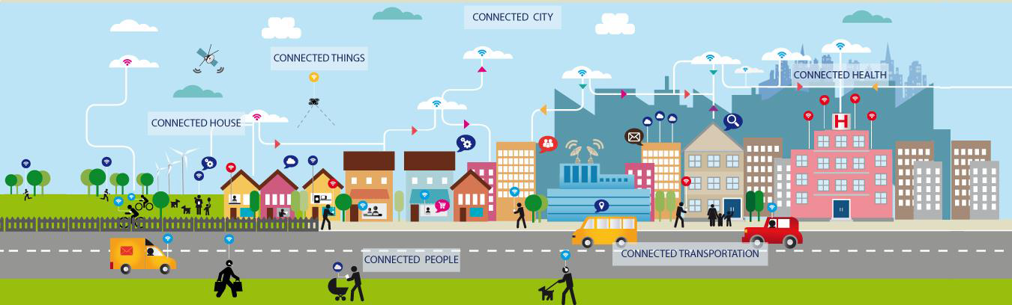

Figure 2: 5G aims to become the all-encompassing vision for the connected future

* “5G will cover services which were handled by specific networks for reliability reasons such as public safety”;
* “5G will ensure experience continuity in challenging situations. HD video or teleworking will be commonplace and available anywhere, regardless of if the user is in a dense area like a stadium or a city centre, or in a village or in a high-speed train or an airplane”;
* “5G infrastructure will cover the network needs and contribute to the digitalisation for vertical markets such as automotive, banking, education, city management, energy, utilities, finance, food and agriculture, media, government, healthcare, insurance, manufacturing, real estate, transportation and retail”;
* “5G will be a key enabler for the Internet of Things by providing the platform to connect a massive number of objects to the Internet”.

# Integration of satellite networks into 5G

## Satellites within the global communications infrastructure

Satellites already form a ubiquitous part of the global communications infrastructure, as shown in Figure 3, and as such they are well suited to play an active role in allowing global reach for relevant 5G use cases, including those resulting from the variety of applications and scenarios.

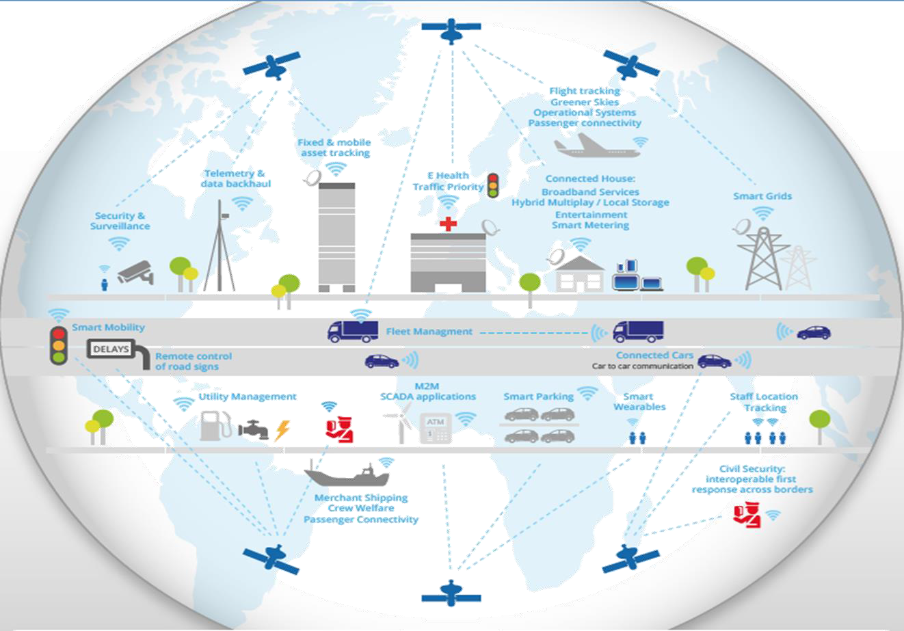

Figure 3: Satellites within the global communications infrastructure

## Architectural considerations

5G is about communication, storage and processing “anywhere-anytime” for people and things, targeting a broad range of vertical markets, use cases and business models with right-sized tools and capabilities.

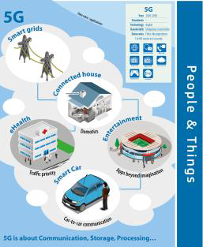

Figure 4: 5G is about communication, storage and processing (Source: European Commission)

In order to accomplish this, 5G must be a seamless integration of heterogeneous network elements, leveraging innovative tools such as NFV (Network Function Virtualisation), SDN (Software Defined Networks), Multicasting, Cloud/Local Storage, etc.

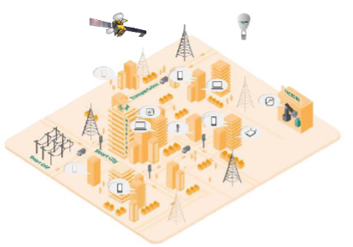

Figure 5: Seamless integration of heterogeneous network elements and innovative tools

The ability of satellites to support a variety of 5G usage scenarios can be extrapolated from present satellite capabilities and the trend of satellite technology developments:

* Enhanced mobile broadband (eMBB): Satellites can support multi-gigabit per second data rates envisaged for enhanced mobile broadband services. Satellites today are capable of carrying thousands of broadcast channels high-bandwidth HD and UHD content and that same high bandwidth is being used to support mobile connectivity to end users and the networks of tomorrow. Current- and next-generation High Throughput Satellites (HTS) in both geostationary and non-geostationary orbits will continue to provide end user and device connectivity;
* Massive Machine-Type Communications (mMTC): Satellites already support SCADA and global asset tracking applications, and can scale to support expanded M2M (Internet-of-Things (IoT)) communications – whether directly to or as a means of backhauling M2M communications from remote locations or connected planes, ships, or other vehicles. Investments in new ground segment technologies, such as smaller, lower cost, electronically steerable, and/or phased-array satellite transceivers are making ubiquitous deployment of the Internet-of-Things via satellite possible;
* Ultra-reliable and low-latency communications (URLLC): Satellite systems are known for their reliability. Institutional and commercial undertakings – such as international broadcasters, MNOs, governments – use satellite solutions as a means of reliable communications. Particularly latency-sensitive applications are expected to rely on servers located at the edge of the network, close to the user, which can be updated by satellite. More latency-sensitive applications can be supported by the new medium Earth orbit and low Earth orbit networks that have been (or which will soon be) deployed.

Some options for satellite architecture in 5G context have been presented in [3].

# Satellite use cases

Four main use case categories can be identified for satellite-based solutions in 5G:

1. Communications on the Move;
2. Hybrid Multiplay;
3. Trunking and Head-end Feed;
4. Backhauling and Tower Feed.

These cases are characterised by their scale of numbers of end user devices, from Communications on the Move use cases connecting hundreds of millions of end users and devices, to potentially millions in the case of Hybrid Multiplay use cases, to a few hundred or thousand sites for the Trunking and Head-end Feeds use cases. [4]

Table 1: Satellite 5G use cases

|  |  |
| --- | --- |
| Use cases | Examples |
| Communications on the Move | In Flight Connectivity for Aircraft; broadband to ships and land vehicles |
| Hybrid Multiplay | Video and broadband connectivity to home or multi-tenant building with 5G distribution in building |
| Trunking and Head-end Feed | Service to remote areas; special events |
| Backhauling and Tower Feed | Surge capacity to overloaded cells, plus content delivery (e.g. video) to local caches; efficient broadcast service to end users |

## Communications on the Move

This use case is about high speed connectivity to individual planes, trains and vessels (including cruise ships and other passenger vessels), with the ability to stream unicast on demand content (e.g., Over-the-Top IPTV) or multicast the same content (e.g. video, HD/UHD TV, as well as other non-video data) across a large coverage (e.g. for local storage and consumption), as shown in the graph below. The same capability also allows for the efficient direct connectivity to end user devices or sensor and aggregated IoT traffic from these moving platforms.

One example for this use case is air passenger connectivity. Millions of airline customers are connecting directly to aircraft enabled Wi-Fi systems for entertainment and information, as well as staying in communication. In addition, airline crews are also using Wi-Fi enabled broadband on aircraft for non-safety related communications. One satellite-based Inflight Connectivity network operator reports 3 million passengers connect to its service every month.[2] Satellite broadband is currently addressing a large portion of the aircraft Wi-Fi market and is expected to grow as the global aircraft fleet expand to meet passenger demand.

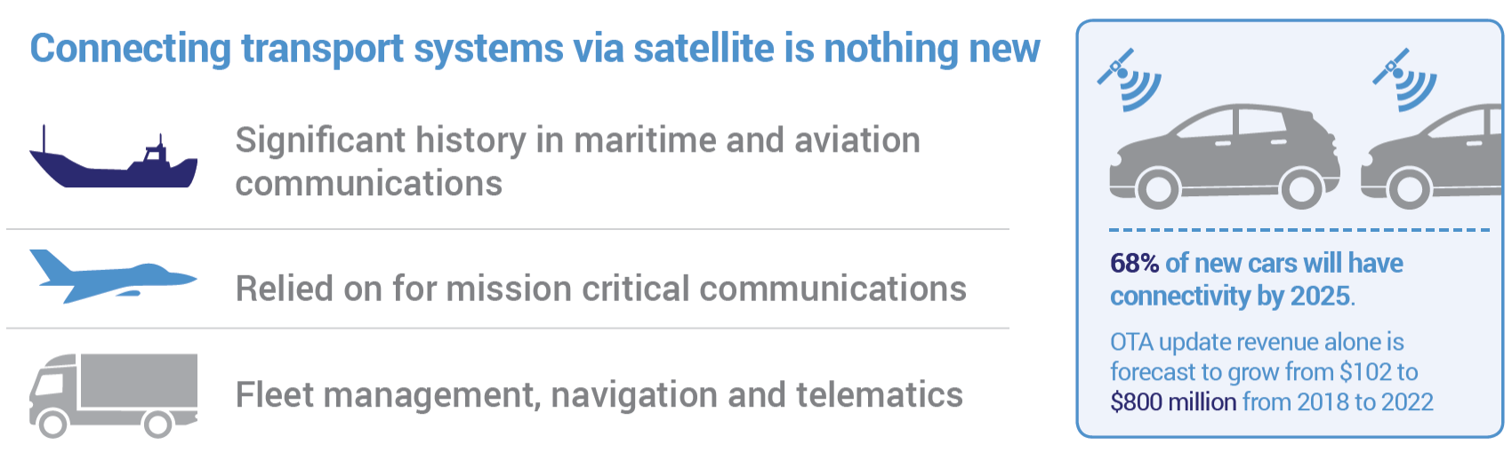

Figure 6: Communications on the Move

Very high speed, multicast-enabled, satellite links (up to Gigabit/s speed), direct to planes, vehicles, trains or vessels, from geostationary and/or non-geostationary satellites could enable connectivity everywhere.

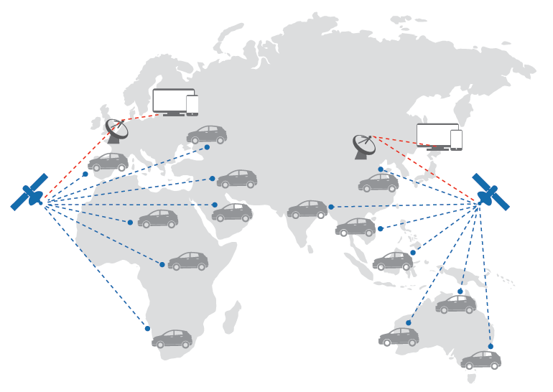

Figure 7: Connected Cars by Satellite

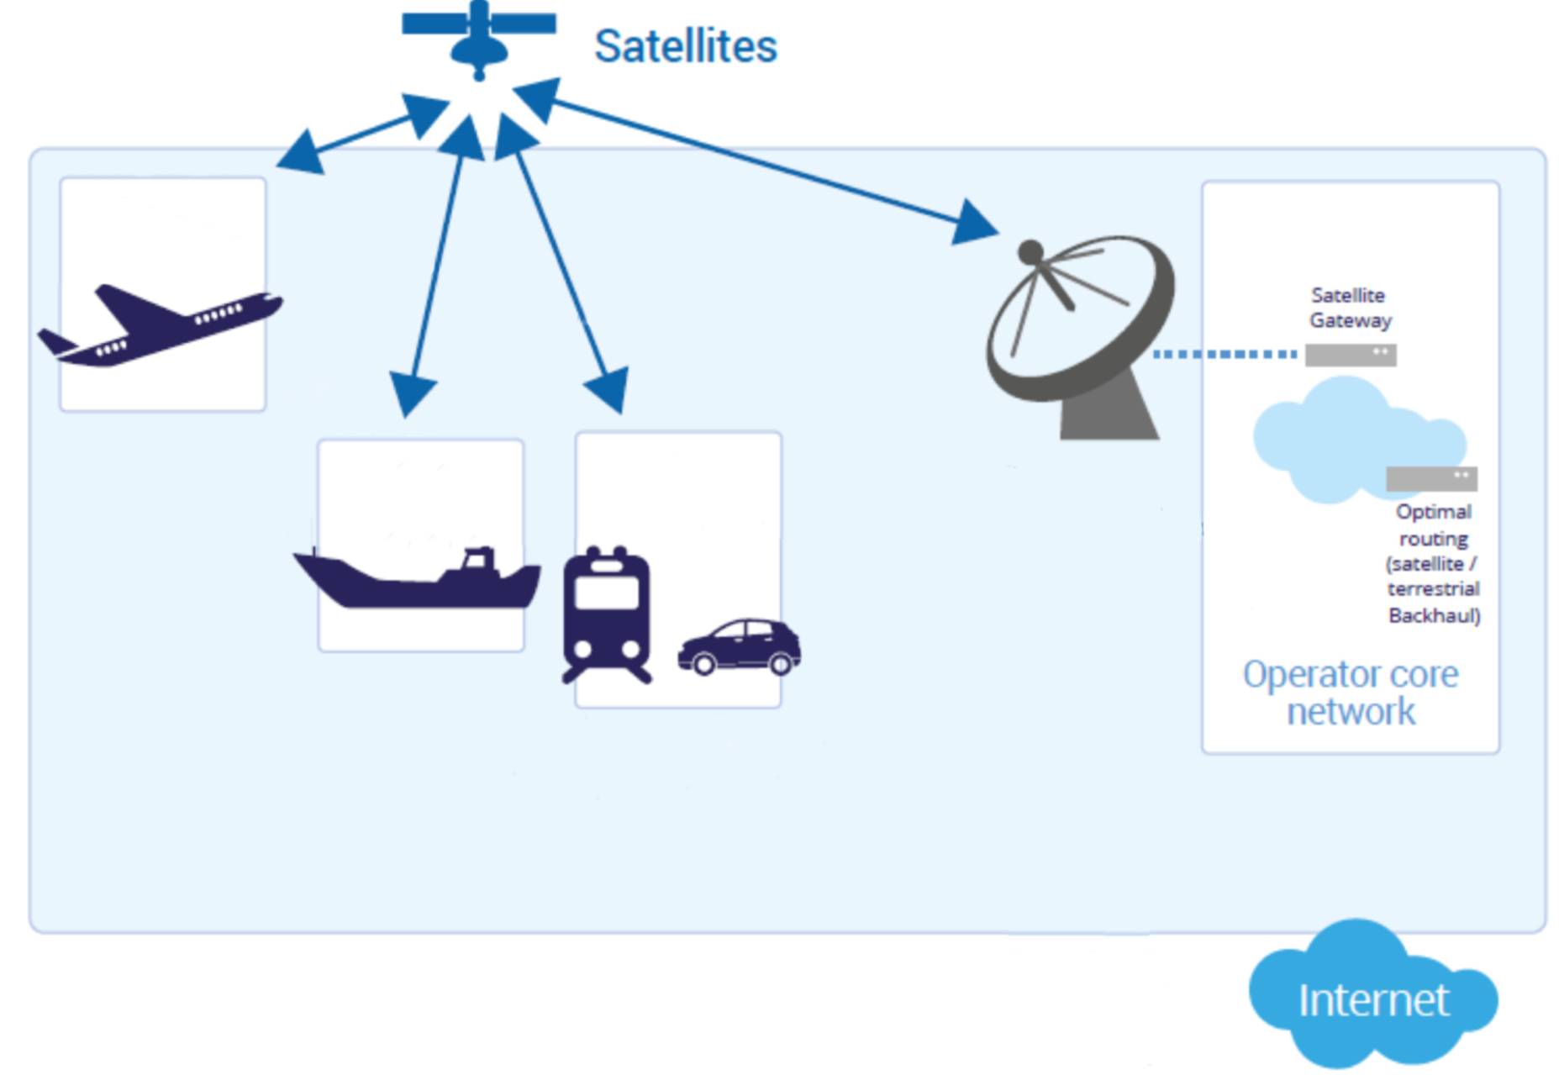

Figure 8: Communications on the Move

Examples of this use case include:

* Broadband connectivity to moving platforms, such as cars, airplanes or vessels[3];
* Connectivity complementing terrestrial networks: Broadband and content multicast connectivity to platforms on the move in conjunction with a terrestrial based connectivity link to base stations or relay on board moving platforms such as high-speed trains/buses and other road vehicles to ensure service reliability, and coverage of rural areas, and big events in ad-hoc built-up facilities;
* Connectivity for remotely deployed battery activated M2M/IoT sensors, or handset devices with messaging/voice capabilities via satellite (e.g. fleet management, asset tracking, livestock management, farms, substations, gas pipelines, digital signage, remote road alerts, emergency calls, mission critical/public safety communications, etc.);
* IoT devices on containers (e.g. for tracking and tracing) connected via a relay device on a transport vehicle such as a ship, train or truck;
* For connected cars, enabling Over the Air Firmware and Software (FOTA/SOTA) services, information updates such as map information including points of interest (POI), real-time traffic and parking availability (Telematics) as well as infotainment, increased coverage and reliability for e-Call services, vehicle tracking and remote diagnostics.

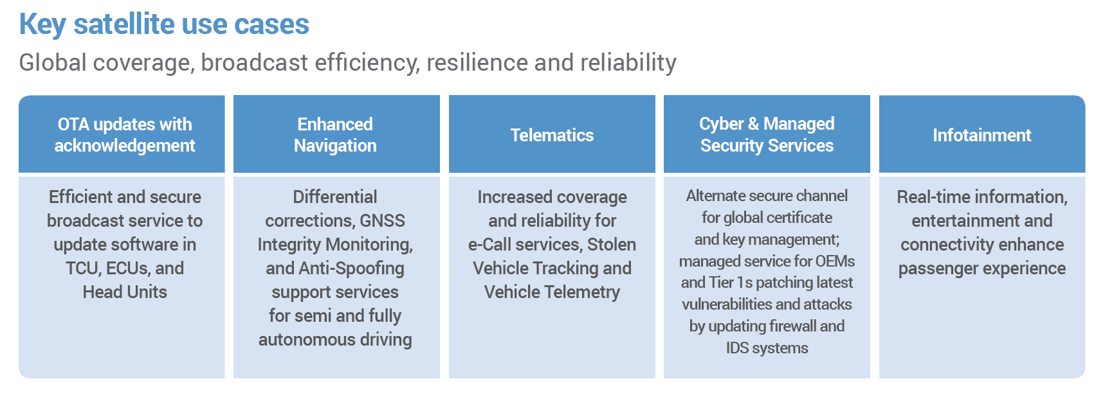

Figure 9: Key satellite use cases

## Hybrid Multiplay

This use case is about high speed connectivity to individual homes and offices, with the ability to multicast the same content (video, HD/UHD TV, as well as other non-video data) across a large coverage (e.g. for local storage and consumption) or unicast to individual users or devices. The same capability also allows for an efficient broadband connectivity for aggregated IoT data. In-home distribution via Wi-Fi, WiGig or very small cell 3G/4G/5G, is shown in the figure below.

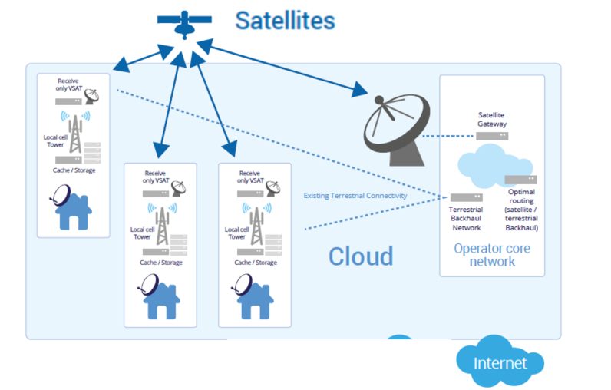

Figure 10: Hybrid Multiplay

A very high speed, multicast-enabled, satellite link (up to Gigabit/s speed), direct to the home or office, from geostationary and/or non-geostationary satellites can provide direct end user connectivity and can also serve as a complement to existing terrestrial connectivity. Direct-To-Home (DTH) satellite TV, integrated within the home or office IP network, will further add to this use case.

Examples of this use case include:

* Satellite connectivity and the use of the smart antennas with the help of hybrid network management which can add flexibility to networks by either providing a direct connection to end users or devices or an alternative route;
* Connectivity complementing terrestrial networks: Broadband connectivity to home/office small cell in underserved areas in combination with terrestrial wireless or wireline.

Figure 11 below provides the illustration of the satellite solutions to the case of link failure events.

|  |  |
| --- | --- |
|  |  |
|  | |

Figure 11: Deployment scenario demonstrating how satellite solution can resolve congestion problem[4]

## Trunking and Head-end Feed

This use case is about high-speed trunking of video, IoT and other data to a central site, with further terrestrial distribution to local cell sites (3G/4G/5G cellular), for instance in neighbouring villages, as shown in the figure below.

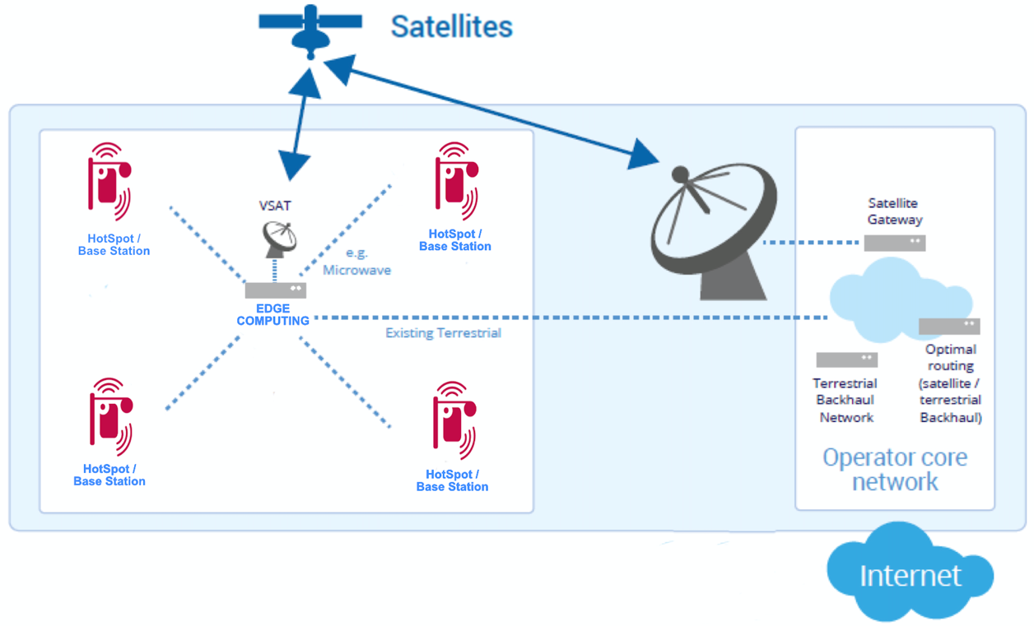

Figure 12: Trunking and Head-end Feed

A very high-speed satellite link (up to Gigabit/s speed) from geostationary and/or non-geostationary satellites will complement existing terrestrial connectivity.

The satellite user links are bidirectional since only broadband (i.e., unicast, e.g. VSAT terminals) communications are supported by this category (i.e., no broadcast/multicast). In particular, there is no use of multicasting to populate edge caches in this satellite use category, which makes it different from the use cases presented in sections 0, 5.2 and 5.4.

Examples of this use case include[5]:

* Broadband connectivity to remote areas. For example, coverage on lakes, islands, mountains, rural areas, isolated areas or other areas that can be efficiently served by satellites;
* Community 5G Wi-Fi where satellite-based 5G Wi-Fi services are provided to remote communities with limited or no broadband internet service. This solution can be an important component of the EU’s WiFi4EU project that has the goal to “promote free Wi-Fi connectivity for citizens and visitors in public spaces such as parks, squares, public building, libraries, health centres, and museums everywhere in Europe.”[6] The equipment is installed at a central location, usually a local business and, in some cases, extended to nearby areas through a point-to-multipoint Wi-Fi (P-MP) connection;
* Disaster relief: During natural disasters or other unforeseen events where satellites are the only option;
* Emergency response: in wide scale natural disasters, and other specific emergency situations. Secondary/backup connection (limited in capability) in the event of the primary connection failure. This example covers the resiliency use case in low ARPU regions to ensure service reliability;
* Remote cell connectivity: The following use cases can be considered as a part of the remote cell connectivity scenario:
  + Stand-alone cells;
  + Periodically occurring events;
  + Rarely repeated events (concerts/festivals, one-off sport events).

A general illustration of remote cell connectivity is presented in the Figure 13 below.

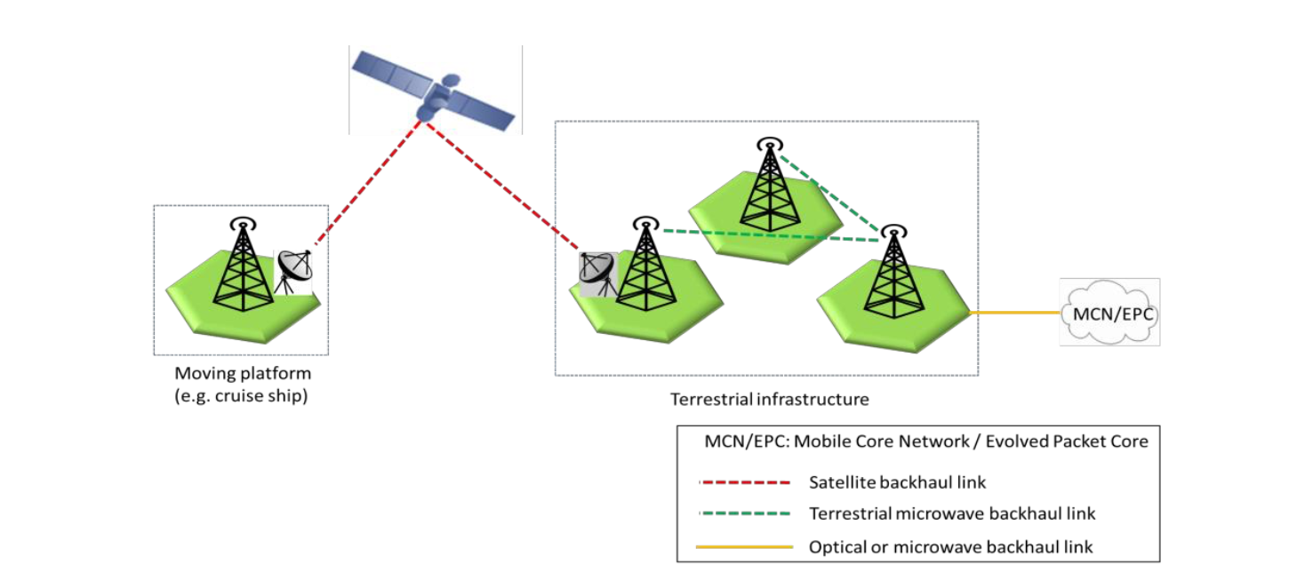

Figure 13: Example of remote or temporary cell

## Backhauling and Tower Feed

This use case is about high speed backhaul connectivity to individual cells, with the ability to multicast the same content (e.g. video, HD/UHD TV, as well as other non-video data) across a large coverage (e.g. for local storage and consumption), as shown in the figure below. The same capability also allows for the efficient backhauling of aggregated IoT traffic from multiple sites.

Ultra-low latency applications are expected to be enabled by moving computing power away from a central server out to the edge of the network, much closer to the end user. Moving servers to the edge of the network will mean that the backhaul network is not used to carry the latency-sensitive traffic, but rather to update the edge computer or cloud on an as-needed basis. The new edge-focused network infrastructure that IMT 2020 will demand means that satellites can play a role in connecting and updating the large number of edge servers that Next Generation Mobile Networks will require.

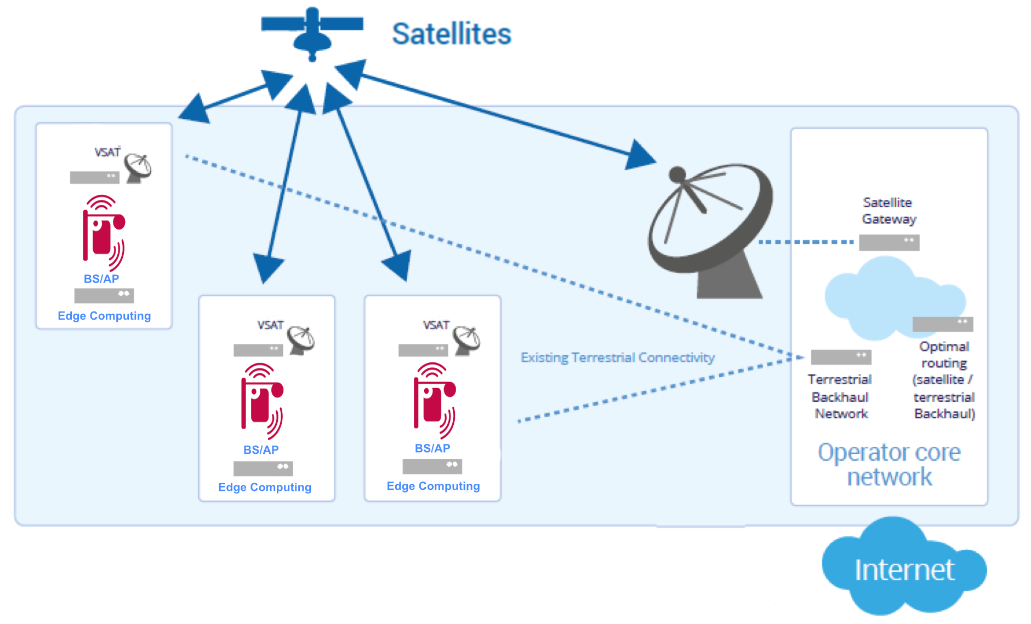

Figure 14: Backhauling and Tower Feed

A very high-speed, multicast-enabled, satellite link (up to Gigabit/s speed), direct to the cell towers, from geostationary and/or non-geostationary satellites can complement existing terrestrial connectivity.

Note that this use case assumes that satellite connectivity will complement existing terrestrial connectivity. Moreover, the satellite user links are either bidirectional and/or unidirectional since, depending on the case, broadband (i.e., unicast, e.g. VSAT) and/or broadcast/multicast (thus, receive only terminals) communications are supported by this category. In particular, the use of multicasting to populate edge caches is a major difference of this use case with respect to the one presented in section 0 above.

Examples of this use case include:

* Efficient broadcast service to end users, etc. (e.g. video, software download), support of low bit-rate broadcast service e.g. for emergency messages and synchronisation of remote sensors and actuators;
* Providing efficient multicast/broadcast delivery to network edges for content such as live broadcasts, ad-hoc broadcast/multicast streams, group communications, Mobile Edge Computing/Virtual Network Function (MEC/VNF) update distribution.

There is a need to support edge compute functions such as caching and content processing capabilities beyond the entry point of the Evolved Packet Core (EPC) and this need can be efficiently served by feeding a CDN edge network via satellite. The content is delivered to the cache either through the satellite or through the terrestrial connection depending on the deployment scenario. An example when all the content is sent to the edge Content Delivery Network via satellite in demonstrated in Figure 15.

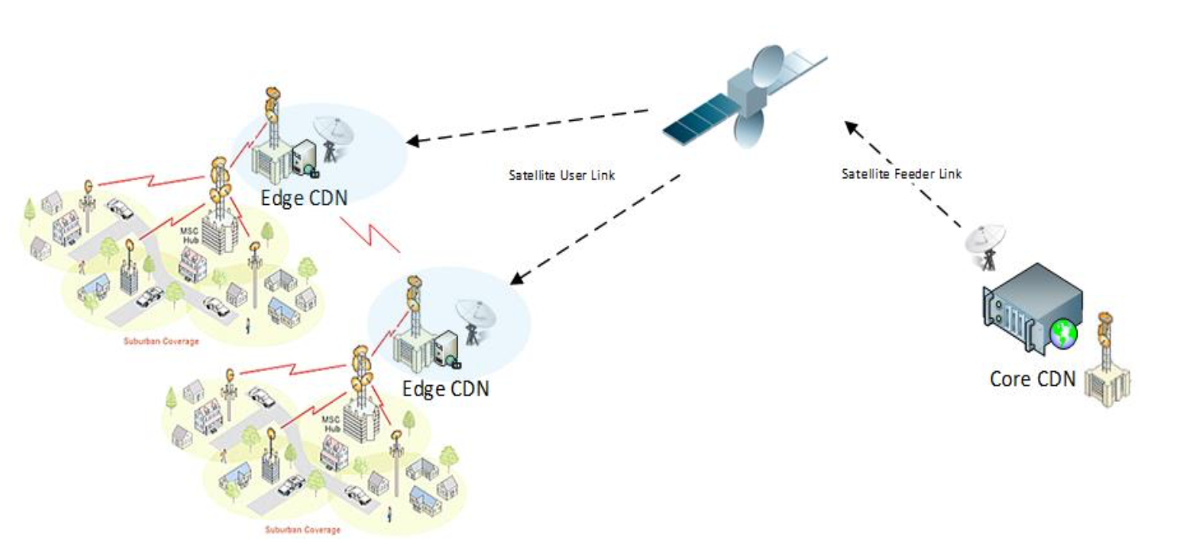

Figure 15: CDN Operation via Satellite Only

# Satellite technology

Geostationary (GEO) satellites provide efficient and instantaneous coverage for entire continents and countries from a fixed point with respect to the Earth. High Throughput (HTS) satellites are capable of providing an average bandwidth from hundreds of Gbit/s up to more than 1Tbit/s from each orbital location. The geostationary position at around 36 000 km from the Earth’s surface results in a propagation delay of approximately 250 ms (500 ms for the round trip delay), which needs to be taken into consideration for the end-to-end latency sensitive traffic assessment, however, hybrid networks (terrestrial/satellite networks) and other network management techniques are addressing these issues.

Non-geostationary satellites operate at much lower orbits than geostationary satellites, which reduce latency. As an example, Medium Earth Orbit (MEO) satellite systems operate at a quarter of the distance to the Earth as compared to geostationary satellites, and the propagation delay is therefore below 75 ms (150 ms for the round trip delay). Low Earth Orbit (LEO) satellite systems are closer to the Earth (between 700-2000 km) and typically offer a round-trip latency of less than 50 ms (which includes physical worst-case propagation delays and network processing delays). As such satellites are orbiting around the Earth, continuous coverage requires the deployment of a satellite constellation, composed of several satellites per constellation plane. Non-geostationary constellations provide hundreds of Gbit/s and even Tbit/s of aggregate bandwidth across the globe, with aggregate supply scalable with the number of satellites per constellation plane.

Both geostationary and non-geostationary satellite networks have their specific benefits for satellite-based solutions in 5G.

# Innovation in the satellite sector

## High Throughput Satellites (HTS) driving Innovation

HTS systems utilise concentrated spot beams, wideband payloads, increased frequency re-use and higher frequency bands to significantly increase capacity and speeds over wide areas. HTS networks are operating on a global basis and can provide broadband service to end-users with speeds in excess of 100 Mbit/s. These systems can support a wide variety of applications, including broadcast and multicast distribution of content, and help to bridge the digital divide by offering high speed, high capacity, anywhere, anytime services.



Figure 16: Difference between Traditional Satellite Beam and HTS Spot Beams

HTS offers higher throughput rates than traditional broad beam satellites. Enabling these advances on the hub side means that the platform infrastructure must handle higher aggregate symbol rates, deliver more efficient modulation and coding techniques, and saturate larger transponder sizes. The hub infrastructure must be able to manage increasingly more beams, more frequencies, more MHz and ultimately many more carriers on the service providers’ network. The other consideration for the hub side is achieved by Adaptive Coding and Modulation (ACM) and Adaptive TDMA to maximise data throughput and optimised traffic in changing weather conditions and satellite link degradations.

Future GEO systems will support significantly greater speeds and capacity. In service HTS spacecraft capacities of 100 Gbit/s and new platforms due to enter service in 2018 will offer 2-3 fold increases. Post 2020 Very High Throughput Satellite (VHTS) systems are expected to enter service offering Terabit/s capacities and payloads will become more flexible so that they can better match traffic distributions, accommodate more demand per beam and support dynamic service delivery. Key technologies will include improved interference mitigation, dynamic beam forming, flexible beam hopping, on-board processing and even greater frequency reuse.

At the same time, there is a resurgence in MEO and LEO HTS constellation approaches that will offer true global coverage, network wide uniform service delivery and substantially reduced latency. A variety of HTS constellation approaches are proposed which will offer connectivity ranging from fibre replacement services, through enterprise grade ultra-fast private wide area networks to converged global consumer broadband. These will allow the satellite industry to offer new classes of service in the 5G ecosystem.

All classes of HTS system will dramatically increase total throughput, allowing further significant reductions in bandwidth costs.

## Advanced satellite ground segment technology

Satellite broadband promises fast, flexible internet access from anywhere in the world with major satellite operators already deploying next-generation satellites with high data throughputs. Complementing developments in the space segment is development in the ground segment with evolutions both in the network platforms and satellite communication terminals.

Central technologies being adopted in 5G networks such as Software Defined Networking (SDN) and Network Function Virtualisation (NFV) are anticipated to become key technological enablers for improved and more flexible network hybridisation. The “smart” 5G architecture allows for network slicing serving various use cases. Satellite is adopting the technology paradigms and standards of the 5G community including in the areas of service delivery, IP-based traffic, network-slicing, orchestration, mobile edge computing, security, interoperability and resource virtualisation in order to transparently support end-to-end service delivery to the Verticals.

Hence, these technologies are expected to play a role in deploying a converged satellite-5G network infrastructure, where overall orchestration of services and resources will help a more efficient interaction between the various network players and also enable the creation of a plethora of virtual service providers. This will involve the adoption of satellite modems, network platforms and management systems which will be interoperable with broader 5G networks, supporting hybrid connectivity services whilst benefiting from the efficient radio architectures, resource sharing and multicast capabilities of current systems. Figure 17 below shows how services on end-to-end networks, traversing different operators can be organised.

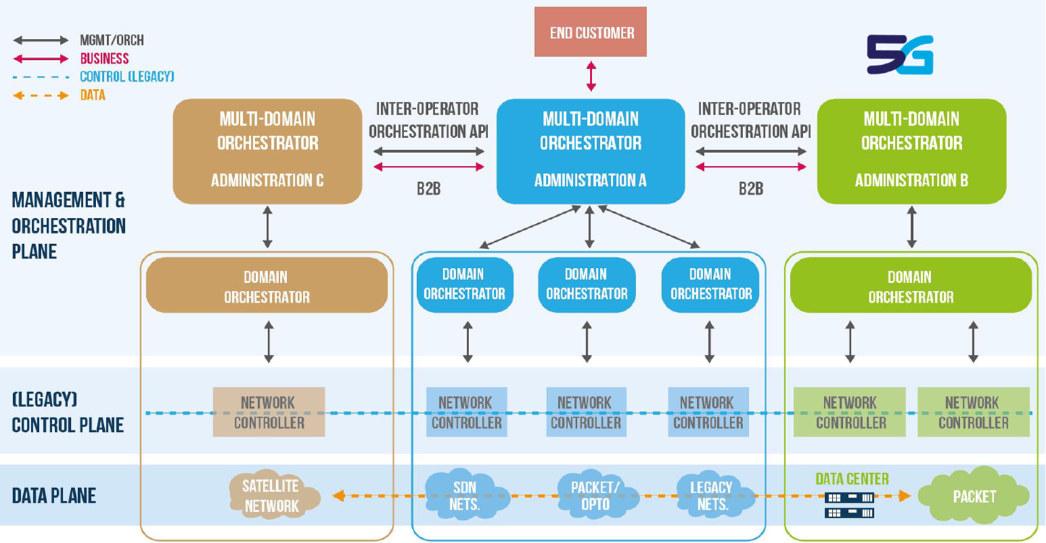

Figure 17: Satellite Service Delivery orchestrated as part of a multi-network (source: 5GIA [5])

## Phased array antenna technology

As satellite communication terminals continue to become cheaper, smaller and more power efficient, a wide variety of terminal technology is being made available. A new wave of flat panel antenna technology is emerging for satellite communications. These 'phased array' antennas have no mechanical components, relying on software and electronics for steering making them more suitable for mobile platforms like cars, boats, planes and more.

Phased array antennas rely on microprocessor technology and software algorithms for combining signals received by numerous antenna elements. In most cases, each antenna “panel” is populated with a collection of independent “patch” antennas and corresponding beam forming microchips. It is equivalent to one big antenna made up of multiple smaller antennas that receive signals that must be processed and combined. An example is the new reconfigurable antenna technology, known as Metamaterials Surface Antenna Technology (MSAT), shown in Figure 18.

To enable more widespread adoption of satellite broadband for mobile users, developments in new mobile satellite communications terminals using advanced materials to offer cost effective, low-profile phased array technologies are being introduced. This offers the electronic beam-steering performance of a typical phased array antenna, with much lower power consumption and a dramatic cost reduction compared to mechanical products and many of the size, weight and power challenges associated with the existing techniques are alleviated.

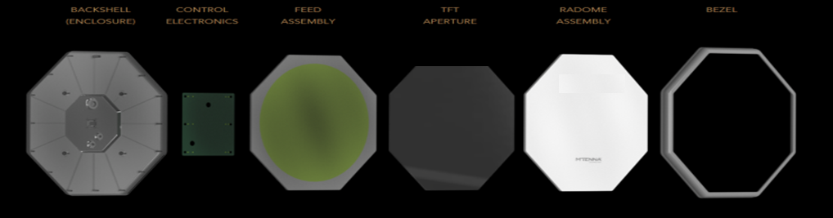

Figure 18: Antenna array and feed network antenna

At the same time new small cellular solutions combined with efficient energy generation and storage systems would allow satellite communications to better support cost-effective 5G service delivery to off-grid locations in remote regions and the developing world.

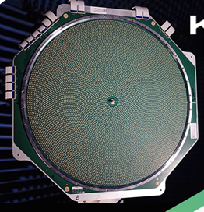

Figure 19: Typical flat panel satellite antenna solution

## Spectrum usage – high level overview

Satellite systems use a number of different frequency bands and satellite orbits to address a variety of markets. A summary of the types of applications and primary satellite usage in various broad frequency bands is given in the table below (for more details on the frequency bands allocates to satellite services, please refer to Article 5 of the ITU Radio Regulations)

Table 2: Overview on frequency bands with satellite allocations

|  |  |  |
| --- | --- | --- |
| Frequency Band | Usage / Market | Description |
| 1.5/1.6 GHz | Mobile satellite services | Some of these frequencies are used for mobile data and voice communications to small user terminals. Global satellite phones, Machine-to-Machine/IoT, asset tracking, as well as aeronautical and maritime safety communications are examples of satellite applications in this band. |
| 2GHz | Mobile satellite services | Some of these frequencies are used for mobile data and voice communications to small user terminals. Global satellite phones, Machine-to-Machine/IoT, asset tracking as well as aeronautical and maritime safety communications are examples of satellite applications in this band. |
| 4/6GHz | Cable head-end broadcasting/ Video Trucking/ VSAT | Portions of this band are used for video distribution, VSATs and data communications over a wide area. This band is primarily used by satellites for hemispheric or continental coverage. While used mainly for service to fixed locations, it is increasingly used for data communications for in-motion services. |
| 10/14 GHz | Direct to home broadcasting/ Broadband/VSAT/ In-motion services/ Mobile Backhaul | Some of these frequencies are used for data communications to fixed and in-motion services. Global networks serving maritime, aviation and land based services, as well as national and regional VSAT networks, Satellite News Gathering and video distribution. Recently used for High Throughput Satellite services for high speed capacity connections. |
| 20/30 GHz | Broadband applications/VSAT/ Mobile/ Mobile Backhaul/ Feeder links | Some of these frequencies are used to provide broadband communications. A number of national, regional and global networks have been put in place that can provide high-speed and capacity broadband connections to residential, commercial and mobile (cars, ships, trains, aircraft) customers. Used for High Throughput Satellite services with smaller antennas providing reduced cost and higher data rates. |
| 40GHz | Feeder links and broadband applications | Some of these frequencies are proposed for Future High Throughput Satellites |
| 50GHz | Feeder links and broadband applications | Some of these frequencies are proposed for Future High Throughput Satellites |

# Relevant technical and standardisation issues

This section addresses the key technical requirements that need to be considered in order to be able to provide efficient satellite solutions in 5G.

## Multicast support

There is a need to ensure that multicasting is defined, feasible and implemented across the whole network (cloud, core, access).

## Unicast support

There is a need to ensure that unicast is defined, feasible and implemented across the whole network (cloud, core, access).

## Intelligent routing support

There is a need to ensure that traffic always follows the optimal path through the network, with potential differentiation across user and control planes, “fat” and “thin” pipes, different use cases (e.g. low bandwidth M2M vs. high bandwidth video), different types of content (e.g. messages, images, video) and different latency requirements (e.g. high latency M2M vs low latency web browsing or store and forward IoT data). Other important aspect to be considered by the new to-be-developed routing algorithms includes link and energy costs or regional restrictions.

## Dynamic cache management and adaptive streaming support

There is a need to optimally store and stream content, regularly refreshed as appropriate, as close as possible to the end user, in order to enable the most scalable and cost-effective solution.

## Latency

Satellite networks are designed to ensure that protocols allow flexibility for the application layer to identify the latency requirement envisaged and the overall infrastructure path end-to-end, and to choose the appropriate physical layer path optimizing the overall network of networks performance. This is critical to ensure that communication paths with inherently longer propagation delays (e.g. geostationary satellite links) can be accommodated where that makes sense (e.g. backhaul in sparsely populated areas, content and use cases that do not require “very low latency”).

For 5G applications that have low latency requirements (e.g. tactile Internet, VR, autonomous driving), satellites can play a role in directly providing connectivity for/or helping terrestrial networks to deliver such applications. Latency is the result of the entire end-to-end connection to the destination user or server. It is likely that services requiring a very low delay time (e.g. less than 1 millisecond) will use some content served from a physical position close to the user’s device, possibly where the content is located at the edge of the network to fulfil the latency requirements.

Efficient, unicast and multicast distribution of commonly accessed content to data caches located at each satellite modem, cell and small cell could be effective if satellite and terrestrial 5G networks are to support applications that require very low latency.

## Content / Asset Rights Management and Security

This is defined as the ability to secure and monetise property rights of content and other assets and to maintain end to end network security, while ensuring that multicast and caching capabilities are preserved.

## Persistent Quality of Service

This is defined as the ability, in conjunction with local cache management, to adapt to the user’s connectivity parameters.

## NFV / SDN compatibility

These are satellite network elements to be implemented and managed based on the same Network Functions Virtualisation and Software Defined Networks philosophy as the rest of the network.

## Business model flexibility

The successful deployment of 5G may require new partnerships between horizontal and vertical sectors. Architecture and standards should allow for a wide variety of business models and partnerships.

# Conclusions

This Report provides information on the role satellites can play as part of the 5G concept. It also highlights the various aspects satellites could bring to 5G networks in terms of efficiency, coverage and resilience.

Four main use cases have been addressed:

1. Communications on the Move;
2. Hybrid Multiplay;
3. Trunking and Head-end Feed;
4. Backhauling and Tower Feed.

For each of these specific examples, use cases have been provided.

Satellite sector innovations, such as the development of High Throughput Satellites (HTS) in both GSO and non-GSO orbits, hybrid networks (terrestrial/satellite networks) as well as advances in ground segment technology by means of phased array antenna technology, have been addressed.

Further, a number of issues are addressed in the context of 5G architectural considerations for the integration of satellite networks within 5G.

With an ecosystem of technologies, including satellites in their multiple orbits and frequency ranges, 5G can achieve its vision of bringing next generation connectivity to all users across the globe.

As CEPT administrations consider how 5G networks will be implemented in the future, this Report provides information on satellite-based solutions to address relevant 5G use cases in the context of the greater 5G ecosystem.

1. List of Reference
2. Recommendation ITU-R M.2083-0 - IMT Vision - "Framework and overall objectives of the future development of IMT for 2020 and beyond"
3. 5G Vision Brochure V1, 5GPPP 2015
4. 3GPP TR 38.811 v0.3.0 "Study on New Radio (NR) to support non terrestrial networks (Release 15)"
5. 3GPP TR 22.822 "Technical Specification Group Services and System Aspects; Study on using Satellite Access in 5G" Stage 1 (Release 16)
6. 5G Innovations for New Business Opportunities, 5GPPP White Paper 2017
7. ITU Radio Regulations Edition of 2016

1. Recommendation ITU-R M.2083 [1] recognises that the relevant importance of these key characteristics varies greatly when applied to the three main use areas: “whilst all key capabilities may to some extent be important for most use cases, the relevance of certain key capabilities may be significantly different, depending on the use cases/scenario.”
2. <http://www.aviationtoday.com/2017/08/10/bandwidth-growth-becoming-urgent-connected-airplanes/>
3. Toyota Creates ”Connected Technologies” to Advance In-Car User Experience:

   <http://corporatenews.pressroom.toyota.com/releases/toyota+creates+connected+technologies+groupadvance+in+car+user+experience.htm>
4. Source: SANSA, research project under the HORIZON 2020 Framework Programme (Shared Access Terrestrial-Satellite Backhaul Network enabled by Smart Antennas)
5. Note that, if there is multicast need/opportunity and if there is existing terrestrial connectivity available, the provided use cases examples falling under the "Trunking and Head-end Feed" Category may fall under the "Backhauling and Tower Feed" Category as well.
6. <https://ec.europa.eu/digital-single-market/en/policies/wifi4eu-free-wi-fi-europeans>