Sharing and compatibility studies between   
Maritime Broadband Radio (MBR) in the 5850-5900 MHz frequency band and other systems

Approved 27 January 2017

ECC Report 259

# Executive summary

This ECC Report addresses sharing and compatibility studies between Maritime Broadband Radio (MBR) in the frequency bands 5852-5872 MHz and 5880-5900 MHz and incumbent services / systems. MBR operates in TDMA mode on a single frequency and the studies have included MBR operation on the carrier frequencies 5862 MHz and 5890 MHz.

MBR is a maritime mobile radio communication system providing broadband radio links between platforms and vessels as well as between vessels, engaged in coordinated off-shore activities. In this document, off-shore activities include exploration such as drilling and seismic operations and hydrographic operations such as mapping of the seabed.

The MBR system parameters are based on ETSI System Reference TR 103 109 v.1.1.1 [1]. However it should be noted that MBR terminals with linear vertical polarisation were not considered in this study.

Additional calculations were done for MBR systems with reduced maximum e.i.r.p. of 25 dBW (7 dB reduction).

Sharing and compatibility studies were conducted between MBR and the following services/systems in the above mentioned bands as well as in adjacent and neighbouring bands:

* Broadband Fixed Wireless Access (BFWA);
* Fixed Satellite Service (Earth-to-space) (FSS), including earth stations located on board vessels (ESVs) above 5925 MHz;
* Intelligent Transport Systems / Road Transport and Traffic Telematics (ITS/RTTT);
* Radiolocation Systems (adjacent band compatibility);
* Fixed Service (FS) above 5925 MHz.

The studies aim at defining the compatibility and sharing conditions between MBR terminals and equipment in the above mentioned services and systems. The studies are based on Minimum Coupling Loss (MCL) calculations and further consideration at national/bilateral level may give shorter protection distances than those given in Table 1 and Table 2, taking into account specific deployments.

It was concluded that compatibility studies and interference analysis between MBR and SRD are not necessary due to specific uses of SRD in this frequency band. Overview of the sharing conditions is shown in Table 1 and Table 2, further details can be found below.

Table 1: Overview of the sharing and compatibility conditions for MBR with e.i.r.p.=32 dBW

|  |  |  |  |  |  |
| --- | --- | --- | --- | --- | --- |
| Service/ system | MBR as Interferer at 5862 MHz | MBR as Interferer at 5890 MHz | MBR as Victim at 5862 MHz | MBR as Victim at 5890 MHz | Comments |
| BFWA  Note1 | Protection distances up to 118 km | | Protection distances up to 112 km | | Main lobe/Main lobe scenario |
| GSO FSS (Earth-to-space) | Both protection criteria for co-primary and secondary status systems are exceeded: ΔT/T>6% and ΔT/T>1% | | Protection distances up to 147 km | | Practical earth stations (ES) installations may give shorter protection distances for MBR Rx and ES Tx taking into account a real terrain model |
| ESV above 5925 MHz | N/A | | Protection distances up to 1 km | | Adjacent band compatibility |
| ITS | Protection distances up to 77 km | | Protection distance 11 km | | For ITS protection distances are considered from coast line (not between victim Rx and interfere Tx as in all other cases) |
| Radiolocation | Protection distance is 180 km for ground based radars and 20 km for ship borne radars | Protection distance is 12 km for ground based radars and 2 km for ship borne radars | Protection distance 180 km | | Adjacent band compatibility.  Low probability that MBR and radar is pointing at each other for long time |
| FS above  5925 MHz | Protection distance is 97 km for land FS station and 72 km for offshore FS station | Protection distance is 103 km for land FS station and 79 km for offshore FS station | Protection distance 13 km | Protection distance 13 km | Adjacent band compatibility |

Note 1: According to ECC/REC(06)04 [2] BFWA systems operate in the band 5725-5875 MHz. However ECC Report 173 [3] identified that there is a use of BFWA systems in the band 5850-5950 MHz. Therefore sharing studies considered both channels of the MBR system.

Table 2: Overview of the sharing and compatibility conditions for MBR with e.i.r.p.=25 dBW

|  |  |  |  |  |  |
| --- | --- | --- | --- | --- | --- |
| Service | MBR as Interferer at 5862 MHz | MBR as Interferer at 5890 MHz | MBR as Victim at 5862 MHz | MBR as Victim at 5890 MHz | Comments |
| BFWA Note1 | Protection distances up to 112 km | | Protection distances up to 112 km | | Main lobe/Main lobe scenario |
| GSO FSS (Earth-to-space) | Protection criteria for co-primary systems ΔT/T<6% is met. Protection criteria ΔT/T>1% is exceeded. | | Protection distances up to 147 km | | Practical ES installations may give shorter protection distances between MBR Rx and ES Tx taking into account a real terrain model |
| ESV above 5925 MHz | N/A | | Protection distances up to 1 km | | Adjacent band compatibility |
| ITS | Protection distances up to 77 km off the coast | | Protection distance 11 km from the coast | | For ITS protection distances are considered from coast line (not between victim Rx and interfere Tx as in all other cases) |
| Radiolocation | Protection distance is 80 km for ground based radars and 11 km for ship borne radars | Protection distance is  6 km for ground based radars and 1 km for ship borne radars | Protection distance 180 km | | Adjacent band compatibility. Low probability that MBR and radar is pointing at each other for long time |
| FS above 5925 MHz | Protection distance is 85 km for land FS station and 65 km for offshore  FS station | Protection distance is 99 km for land FS station and 74 km for offshore  FS station | Protection distance 13 km | Protection distance 13 km | Adjacent band compatibility |

Note 1: According to ECC/REC(06)04 [2] BFWA systems operate in the band 5725-5875 MHz. However ECC Report 173 [3] identified that there is a use of BFWA systems in the band 5850-5950 MHz. Therefore sharing studies considered both channels of the MBR system.

General considerations on MBR implementation:

As mentioned in the SRdoc (ETSI TR 103 109 V1.1.1 [1]), operations of MBR in TDMA in one frequency do not allow simultaneous implementation of such a system by two different networks or two different MBR applications in the same area. Even when considering high levels of antenna discrimination, the minimum separation distance to operate two different MBR networks are an order of magnitude of several tens of kilometres. This implies the need to allocate two different frequency carriers to allow MBR operations for distinct maritime activities in close geographical areas.

In that framework, it must be anticipated that even with two potential frequencies allocated for MBR implementation, radiocommunication coordination between maritime operators, off-shore maritime companies and administrations (coast guard activities) will be necessary to avoid interference and network outages specifically when considering SIMOPS (Simultaneous operations) and real time data links which are likely to require a high level of availability.

Compatibility between MBR and BFWA:

Considering MBR Maximum e.i.r.p.=32 dBW, MBR transmitters will not exceed the interference criterion for BFWA receivers at distances above 118 km when BFWA is placed at the coastline. In the case when BFWA is used on off-shore platforms MBR transmitters will not exceed the interference criterion for BFWA receivers at distances above 103.5 km.

Considering MBR Maximum e.i.r.p.=25 dBW, MBR transmitters will not exceed the interference criterion for BFWA receivers at distances above 112 km when BFWA is placed at the coastline. In the case when BFWA is used on off-shore platforms MBR transmitters will not exceed the interference criterion for BFWA receivers at distances above 96 km.

BFWA transmitters will not exceed the interference criteria for MBR receivers at distances above 112 km. In the case when BFWA is used on off-shore platforms BFWA transmitters will not exceed the interference criterion for MBR receiver at distance above 96.5 km.

Compatibility between MBR and GSO FSS (Earth-to-space) earth stations:

GSO FSS earth station transmitters will not exceed the interference criteria for MBR receivers at distances above 147 km. Practical earth station installations may give shorter protection distances taking into account a real terrain model.

Adjacent band compatibility between MBR and EVS above 5925 MHz:

The MBR receivers are in the spurious domain of ESV transmitters and will not be affected at distances greater than 1 km.

Coexistence with GSO FSS (Earth-to-space) space stations:

To assess impact of the MBR emissions on FSS space stations in shared frequencies, the ∆T/T method has been used. This approach is based on the concept that the noise temperature of a system subject to interference increases as the level of the interfering emission increases. In compliance with ITU-R S.1432 [4] provisions, a ∆T/T=6% criterion (systems having co-primary status) and ∆T/T=1% (all other sources of interference and generally applicable to interference from a non-primary service into FSS) has been considered.

It must be noted that in the studies, the ∆T/T criterion does not reflect any apportionment among potential sources of interference which can occur in these frequency bands due to radiation from other applications (ITS from 5855 MHz to 5905 MHz and BFWA from 5725 MHz to 5875 MHz).

The studies highlight that there is a realistic probability and consistent scenarios for MBR systems (one station or aggregate radiations from side lobes) to interfere on FSS space stations, specifically when considering secondary allocation for MBR. Furthermore, the lack of information on MBR deployment (statistical or factual data on number of MBR stations) makes it difficult to draw objective conclusions or set any e.i.r.p. mask with the view to define acceptable sharing conditions.

Calculations of signal interference from MBR stations to GSO FSS space stations showed that the ∆T/T protection criterion is not met both for 6% and 1% threshold, when MBR maximum e.i.r.p.=32 dBW. In case of reduction of the MBR maximum e.i.r.p. to 25 dBW, the GSO FSS space stations ∆T/T protection criterion is met for 6% threshold and is not met for 1% threshold.

Calculation of aggregate interference from MBR station side lobes on GSO FSS space stations showed that only a limited number of MBR stations can transmit at the same time in different areas without causing harmful interference to GSO FSS space stations. The maximum number of such MBR stations is 4 for ∆T/T=6% threshold and 0 for ∆T/T=1% threshold, considering MBR station maximum e.i.r.p.=32 dBW. In case of reduction of the MBR station maximum e.i.r.p. up to 25 dBW, the maximum number of such MBR stations is 23 for ∆T/T=6% threshold and 3 for ∆T/T=1% threshold.

Compatibility between MBR and ITS:

ITS transmitters will not interfere with MBR receivers at distances above 11 km from the coast.

For MBR coordinated activities further than 77 km off the coast, sharing between ITS and MBR seems feasible. For MBR transmitter antennas not directed towards the coast line, interference to ITS receivers is not expected.

Compatibility between MBR and Radiolocation service in adjacent band:

The MBR antenna beam width for 10 dB attenuation is 16°, so when both the radar and the MBR are within the same range, there is 16/360 = 4.5 % probability that an MBR receiver is pointing towards a radar.

Outside the main beam and the side lobes of the MBR, the radiation is attenuated 25 dB. Additionally, the antenna nulling facility of the MBR may vary the minima and maxima of the side lobes in order to avoid certain directions. This antenna nulling facility may introduce attenuation up to 25 dB.

When using Rec. ITU-R P.452 [11] with an associated time percentage of 10% criterion, the studies show the separation distance is up to 180 km between MBR and ground based radar and up to 21 km for shipborne radar when MBR maximum e.i.r.p.=32 dBW. Considering MBR maximum e.i.r.p.=25 dBW the protection distance from MBR transmitter to RLS receiver is up to 80 km for ground based radar and 11 km for shipborne radar.

To protect MBR receiver from RLS interference a protection distance of 180 km is required.

Only one type of radars was examined (shipborne radar with a relatively low antenna gain of 25 dBi), so the calculated protection distance is not representative for ground based radars.

Adjacent band compatibility between MBR and fixed service above 5925 MHz:

Fixed Services (point-to-point) in the 5925-6425 MHz band are deployed on land and on off-shore platforms 100s of kilometres out in the sea. Large separation distances of up to 103 km would be required for land based fixed links and up to 79 km for off-shore fixed service links, when MBR maximum e.i.r.p.=32 dBW. Considering MBR maximum e.i.r.p.=25 dBW separation distances of up to 99 km would be required for land based fixed links and up to 74 km for off-shore fixed service links. Taking into account that there is extensive fixed link use in this band in Europe and new fixed links are being installed, including on off-shore platforms, compatibility with fixed links in particular on offshore platforms would prove challenging, requiring large areas of exclusion zones as a result of multiple existing fixed links and new fixed link deployments in the sea, which is also the area being considered for operation of MBR.

To protect the MBR receiver from FS station interference a protection distance of 13 km is required.

The practical regulatory implementation and enforcement challenges associated with such separation distances in particular for the fixed links on off-shore platforms out in the sea have not been studied in this report.

TABLE OF CONTENTS

0 Executive summary 2

1 Introduction 11

2 Frequency Usage 12

3 MBR characteristics 13

3.1 General 13

3.2 Equipment design 14

3.3 Radiation characteristics 15

3.4 Transmitter parameters 16

3.5 Receiver parameters 17

3.6 RF signal characteristics 17

4 Off-shore operation scenarios 19

4.1 General off-shore scenarios 19

4.2 MBR off-shore scenarios 19

4.2.1 General 19

4.2.1.1 Coordinated offshore operations / Off-shore exploration, drilling operations 20

4.2.1.2 Off-shore exploration, seismic operations 21

4.2.1.3 Mapping of seabed, hydrographic operations 22

4.2.1.4 Coast-guard activities (Inspections, anti-pollution, distress, etc.) 23

4.3 MBR installations 23

4.3.1 General 23

4.3.2 Installation on ships 23

4.3.3 Installations on oilrigs/platforms 23

4.3.4 MBR transmitting e.i.r.p. 23

5 Compatibility, sharing and interference scenarios 25

5.1 Compatibility between MBR and BFWA 26

5.1.1 General 26

5.1.2 Technical characteristics of BFWA 27

5.1.3 Interference from MBR to BFWA 29

5.1.3.1 Methodology 29

5.1.3.2 Calculations 29

5.1.4 Interference from BFWA to MBR 30

5.1.4.1 Methodology 30

5.1.4.2 Calculations 30

5.1.5 Conclusions 30

5.2 Compatibility between MBR and FSS systems 31

5.2.1 General 31

5.2.2 Compatibility between MBR and n-GSO satellite systems 31

5.2.3 Compatibility between MBR and GSO FSS systems 31

5.2.3.1 Interference from FSS earth stations to MBR 31

5.2.3.2 Interference from ESV transmitter to MBR receiver 35

5.2.3.3 Interference from MBR transmitter to GSO FSS space station receiver 35

5.2.4 Conclusions 41

5.3 Compatibility between MBR and SRD 42

5.3.1 General 42

5.3.2 General non-specific SRD 42

5.3.3 Tank level probing radar 42

5.3.4 Conclusions 42

5.4 Compatibility between MBR and ITS 42

5.4.1 General 42

5.4.1.1 RTTT 42

5.4.1.2 ITS 43

5.4.2 System parameters for ITS 43

5.4.3 Interference from ITS to MBR 45

5.4.3.1 Methodology 45

5.4.3.2 Calculations 46

5.4.4 Interference from MBR to ITS 47

5.4.4.1 Methodology 47

5.4.4.2 Line of sight calculations 47

5.4.5 Conclusions 48

5.5 Compatibility between MBR and radiolocation systems 48

5.5.1 General 48

5.5.2 Technical characteristics of radar 49

5.5.3 Interference from MBR to radar 50

5.5.3.1 Technical parameters 50

5.5.3.2 Methodology 51

5.5.3.3 Calculations 52

5.5.4 Interference from radiolocation radar to MBR 53

5.5.4.1 Technical parameters 53

5.5.4.2 Methodology 53

5.5.4.3 Calculations 54

5.5.4.4 Considerations 54

5.5.5 Conclusions 54

5.6 Compatibility between MBR and FS 54

5.6.1 General 54

5.6.2 Spectrum considerations for FS 55

5.6.3 Spectrum considerations for MBR 55

5.6.4 Interference from MBR transmitter to FS receiver 55

5.6.4.1 Methodology 55

5.6.4.2 Parameter values 56

5.6.4.3 Calculations 58

5.6.4.4 Aggregate MBR interference 59

5.6.5 Interference from FS transmitter to MBR receiver 59

5.6.5.1 Methodology 59

5.6.5.2 FS transmitter technical parameters 59

5.6.5.3 Calculations 61

5.6.6 Conclusions on Compatibility of MBR and FS above 5925 MHz 61

6 Conclusions 62

ANNEX 1: Extracts of Characteristics of radiolocation (except ground based meteorological radars) and aeronautical radionavigation radars (ITU-R M.1638) 65

ANNEX 2: List of References 67

LIST OF ABBREVIATIONS

|  |  |
| --- | --- |
| Abbreviation | Explanation |
| AFA | Adaptive Frequency Agility |
| AP-MP | Any Point to Multipoint |
| BER | Bit Error Rate |
| BFWA | Broadband Fixed Wireless Access |
| BPSK | Binary Phase Shift Keying |
| CEPT | European Conference of Postal and Telecommunications Administrations |
| CPU | Central Processing Unit |
| CS | Central Station |
| CW | Continuous Wave |
| DA2GC | Direct Air to Ground Component |
| **DCC** | Dynamic Congestion Control |
| DFS | Dynamic Frequency Selection |
| ECC | Electronic Communications Committee |
| ECCM | Electronic-Counter-Counter-Measures |
| EFIS | European Freqency Information System |
| **e.i.r.p.** | equivalent isotropically radiated power |
| ERC | European Radiocommunications Committee |
| ES | Earth Station |
| ESV | Earth Stations on board Vessels |
| ETSI | European Telecommunications Standardisation Institute |
| FS | Fixed Service |
| FSR | Fixed Service Receiver |
| FSS | Fixed Satellite Service |
| GMDSS | Global Maritime Distress and Safety System |
| GMSK | Gaussian Minimum Shift Keying |
| GSO | Geosynchronous Orbit |
| HIPERLAN | High Performance Radio Local Area Network |
| I/N | Interference to Noise |
| IP | Internet Protocol |
| ISM | Industrial Scientific and Medical |
| ITS | Intelligent Transport Systems |
| ITU-R | International Telecommunication Union – Radiocommunication |
| LBT | Listen Before Talk |
| MBR | Maritime Broadband Radio |
| MCL | Minimum Coupling Loss |
| **NFD** | Net Filter Discrimination |
| **n-GSO** | Non-Geosynchronous |
| OBU | On-Board Unit |
| **PC** | Personal Computer |
| **P-MP** | Point to Multipoint |
| **P-P** | Point to Point |
| **QAM** | Quadrature Amplitude Modulation |
| **QPSK** | Quadrature Phase Shift Keying |
| **RF** | Radio Frequency |
| RLS | Radiolocation service |
| RSU | Road Side Units |
| **RTTT** | Road Transport and Traffic Telematics |
| **SIMOPS** | Simultaneous Operations |
| **SRD** | Short Range Device |
| **TDD** | Time Division Duplex |
| **TDMA** | Time Division Multiple Access |
| **TPC** | Transmit Power Control |
| **TLPR** | Tank Level Probing Radar |
| **TS** | Terminal Station |
| **UWB** | Ultra Wideband |
| **VSAT** | Very Small Aperture Terminal |
| **VTS** | Vessel Traffic Services |
| **WIA** | Wireless Industrial Applications |

# Introduction

In response to a request from ETSI for the designation of spectrum for Maritime Mobile Broadband Radiolink (MBR) for ships and fixed installations engaged in off-shore activities operating in the 5 GHz to 8 GHz range, the frequency bands 5852-5872 MHz and 5880-5900 MHz were identified by CEPT as possible candidate bands for the deployment of MBR. Studies have been conducted on sharing and compatibility between the proposed systems and the existing users.

An MBR system constitutes an application for various types of telecommunications services, where the main application field would be data communication between vessels and between vessels and off-shore platforms. The system is totally digital and may be used for voice, video and data communications.

Distress and safety relevant communications such as the Global Maritime Distress and Safety System (GMDSS) and other safety related services are not included in the MBR services.

Currently, there is no spectrum specifically allocated for MBR in Europe. Off-shore activities have an international nature and in order to profit from the implementation of such a radio application a harmonised spectrum designation within CEPT would be desirable.

# Frequency Usage

European services/systems currently operating in the bands and in adjacent bands, according to ERC Report 25 [6].

Table 3: Frequency usage in 5862 MHz and 5890 MHz band

|  |  |  |
| --- | --- | --- |
| Frequency range MHz | European common allocation | Utilisation |
| 5830 - 5850 | FIXED-SATELLITE (E-s)  RADIOLOCATION  Mobile  Fixed  Amateur  Amateur-satellite (s-E) | Non-specific SRDs  Radiolocation (military)  Weather radar  ISM  Amateur/Amateur-satellite  BFWA  Radiodetermination applications  WIA |
| 5850 - 5925 | FIXED-SATELLITE (E-s)  FIXED  MOBILE | BFWA  FSS Earth stations  ISM  ITS  Non-specific SRDs  Radiodetermination applications  DA2GC  WIA |
| 5925 - 6700 | FIXED  FIXED-SATELLITE (EARTH-TO-SPACE)  Earth Exploration-Satellite (passive) | Passive sensors (satellite)  FSS earth stations  ESV  UWB applications  Radiodetermination applications  Fixed |

# MBR characteristics

The characteristics of MBR are based on ETSI technical report TR 103 109 v.1.1.1: Broadband communication links for ships and fixed installations engaged in off-shore activities operating in the 5 GHz to 8 GHz range [1].

During ETSI’s work on preparing a harmonised standard for MBR, it has been discovered that the MBR transmitter spectrum mask needs to be slightly adjusted. The sharing and compatibility studies are therefore based on the mask given in Figure 5 of this report.

## General

MBR is a high speed broadband communication system that provides short range links between vessels and off-shore platforms engaged in complex, coordinated off-shore activities.

The communication system uses adaptive antenna arrays with beam forming that provides high directivity. The antennas have steerable fan shaped lobes that can be steered 360° around the horizon. The antenna lobes are cone shaped and can be steered ± 45° horizontally and ± 45° vertically.

The system is totally digital and may be used for voice, video and data communications. Data rates are typically of the order of 10 MBit/s or more. The communication content is typically different kinds of operational data, navigational data, administrative data, update of chart data, live video from cameras, etc.

The system operates in TDMA mode on a single frequency.

The MBR system uses highly directive adaptive antenna arrays with beam forming that provide high directivity to enable point to point communication between two units.

The modulation type is similar to GMSK modulation with high tolerance to clipping/saturation. The modulation type gives optimum spectral efficiency and power amplifier efficiency because of the large number of radios in the phased array antenna system. The MBR system uses a phase coherent modulated code-word as a start for each data frame. The code-word that indicates the start of each data frame is used for exact time and phase synchronisation.

The MBR units in the network negotiate a common time reference and have no need for a base station to operate. The MBR system is hence able to combine both highly efficient disciplined TDMA transmissions with guaranteed latency and use the rest of the link capacity for ad-hoc networking in a system with no defined base station or link master.

Whitening of the modulation data and forward error correction are applied as a part of the physical layer. The communication link employs a request for repetition technique that results in retransmission if corrupted data frames are received. The MBR wireless communication system is based on electronically steerable antenna beams implemented by phased array digital signal processing beam-forming. The antenna system consists of a large number of antenna elements that provides a high gain on both the transmitter and receiver system.

When communication is established, the transmitting antenna and the reception antenna are both aligned towards each other by software controlled antenna lobes. The transmission therefore takes place within a relatively small closed volume. The major part of the e.i.r.p. is in the direct line between the transmitting and receiving antenna. The use of beam-forming permits the production of shaped and dynamically steerable beams in several directions thereby enabling the desired system performance objectives to be maintained as the vessels move relative to each other and, at the same time, minimising interference for other co‑frequency systems. The tailored radiation patterns can be optimised to reduce interference and to allow operation at lower transmit powers than would otherwise be necessary if more conventional fixed antennas were deployed.

The available transmission output power in the narrow antenna lobe (e.i.r.p.) of the MBR system is designed to be high to achieve a communication range with sufficient link margin. The high peak power is achieved by coherent beam forming of a large number of antenna elements where each individual element has a low radiated power. In the far-field the phasing of the antennas form a narrow beam that focuses the energy and leads to a high e.i.r.p. in the direction of interest.

Two channels with bandwidth of 20 MHz are considered necessary to cope with the communication needs during an off-shore activity.

The MBR system optimises the link budget under different conditions and uses power control to regulate the output power to the minimum necessary for the communications.

## Equipment design

The MBR terminal is consisting of two basic elements where the Tx/Rx antennas, the RF units, the CPU (Central Processing Unit) and interfaces are mounted integrated in one unit for above deck installations.

The PC controller and interface for systems application units are mounted below deck. The system is an IP oriented system with Ethernet as the external interface.

A schematic block diagram of an MBR terminal is indicated in Figure 1.



Figure 1: Schematic block diagram of MBR terminal

The MBR radio unit consists of 60 transmitters/receivers controlled by individual CPU units. Each transmitter/receiver is connected to an individual, separate antenna.

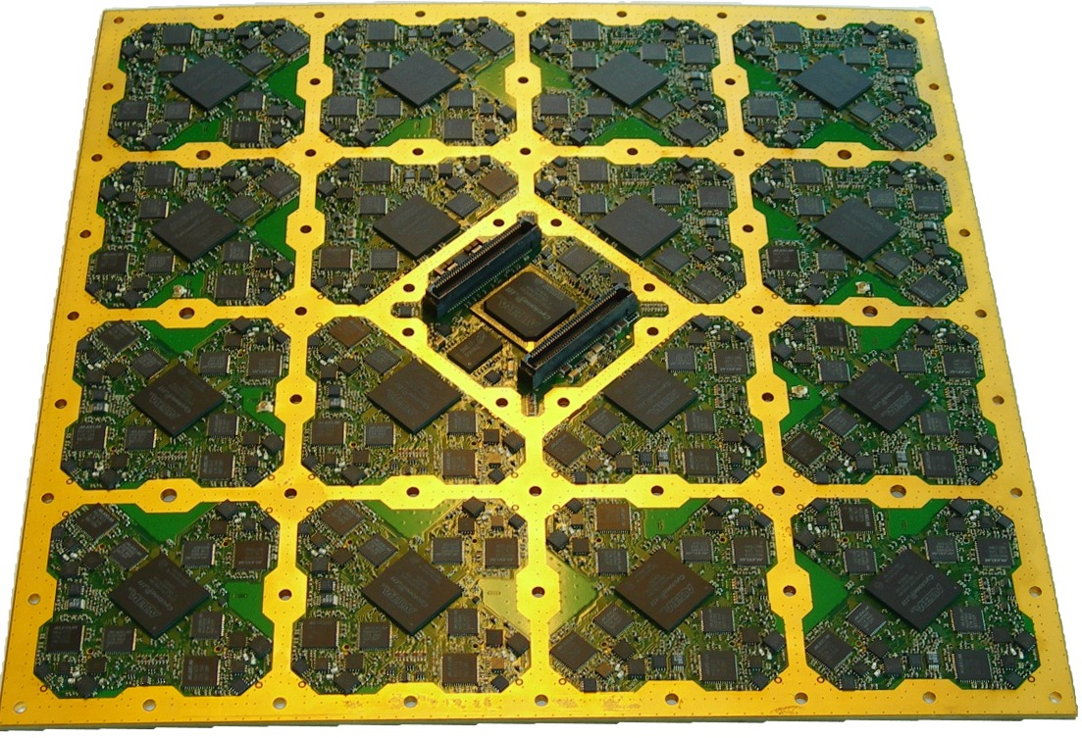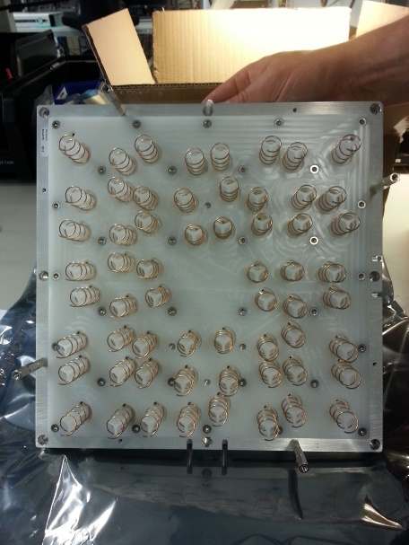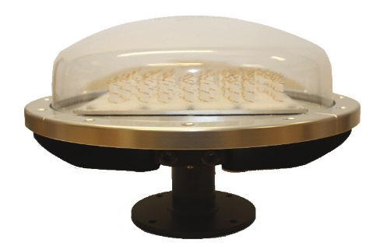

Figure 2: MBR transmitter/receiver board and antenna board with helical antennas

## Radiation characteristics

The MBR system utilises integral electronically phase steered antennas applicable for communications between vessels and between vessels and platforms engaged in coordinated off-shore activities. The MBR antennas have high gain and directivity by electronically combining each individual antenna and the total antenna gain is 24 dB.

The high directivity obtained with phasing of antenna arrays makes it possible to establish a dynamic locked link system between the transmitter and the receiver. The antenna directivity and pointing angle can be dynamically adjusted both in the azimuth and in the elevation directions.

The antennas have steerable fan shaped lobes that can be steered 360° around the horizon. The antenna lobes are cone shaped and can be steered ±45° horizontally and ±45° vertically.

The transmitting beams lock and stay locked to the corresponding receivers. The -3 dB width of the antenna pattern is less than 10° and the -10 dB width is less than 16°. This means that at the distance of 1 km between the MBR transmitter antenna and the victim receiver antenna the MBR beam width is approximately 250 m and at the distance of 5 km is about 1300 m for the -10 dB beam width.

Figure 3 indicates the nominal radiation pattern and Figure 4 indicates the maximum antenna gain as function of the off-axis angle.



Figure 3: Nominal radiation pattern in the vertical and horizontal plane (cone shaped)   
of the steerable antenna beam in a given direction

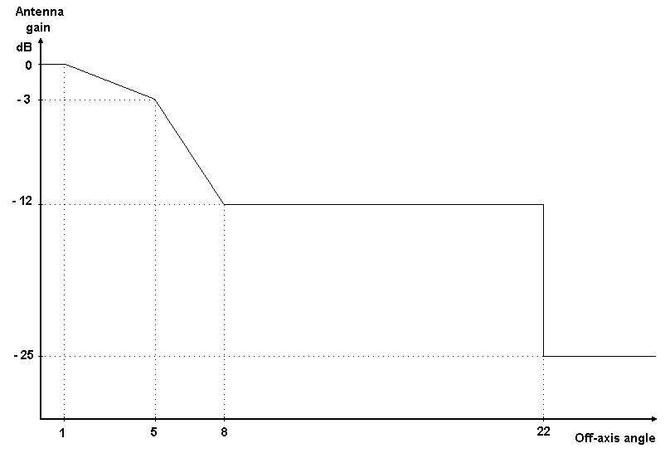

Figure 4: Maximum Radiation pattern envelope

## Transmitter parameters

The MBR consists of a number of transmitters, each with an individual antenna. The output power from each transmitter is maximum 20 dBm and by electronically combining the transmitters, the total output power is a maximum of 8 dBW. The radiation gain of the combined antennas is 24 dB and the total maximum e.i.r.p. of the MBR transmitter is 32 dBW.

The MBR has a power reduction facility where the output power of the transmitter is reduced until the lowest necessary level. Each transmitted package contains information on the transmitted power level, the receiver measures the received signal strength, calculates the quality of the link and indicates suitable power reduction. The output power may be reduced up to 25 dB.

The bandwidth of an MBR channel is 20 MHz. The output power spectrum mask is shown in Figure 5.

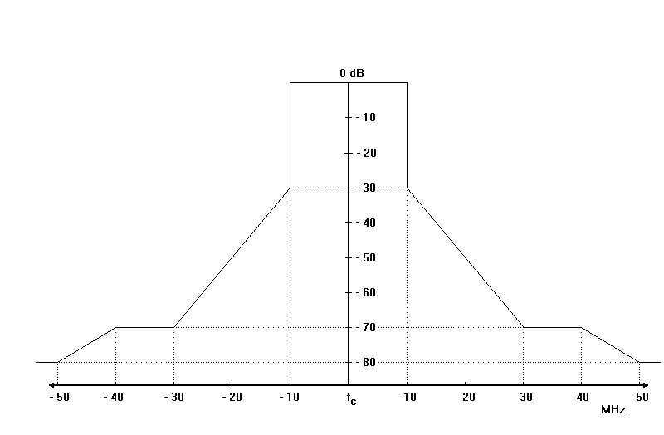

Figure 5: Transmitter output power spectrum mask

The transmitter spurious emissions level (2.5 times the channel bandwidth) outside the band fc ± 50 MHz is < -31 dBm/MHz.

## Receiver parameters

The MBR link operates satisfactorily when the received BER is less than 10-5.

The maximum usable receiver sensitivity of the MBR at the demodulator is -83 dBm. With antenna gain 24 dBi in the main lobe, the sensitivity at the antenna input is -107 dBm.

For a data bit rate of 3.75 Mbit/s, the co-channel rejection ratio between wanted and unwanted signal (C/I) is 6 dB. For the maximum data rate of 10 Mbit/s, the co-channel rejection C/I is 10 dB.

The adjacent channel selectivity of the receiver is 45 dB.

## RF signal characteristics

The MBR may operate on the frequencies 5862 MHz and 5890 MHz with e.i.r.p. less than 32 dBW. The channel bandwidth is 20 MHz.

Table 4: MBR   parameters used in studies

|  |  |  |
| --- | --- | --- |
| Parameter | MBR | |
| Carrier frequency | 5862 MHz and 5890 MHz | |
| Channel bandwidth | 20 MHz | |
| Maximum output power from each transmitter | 20 dBm | |
| Maximum total power by combining all transmitters | 8 dBW | |
| Antenna radiation gain | 24 dBi | |
| Polarisation (Note 1) | Left-hand circular (LHC) | |
| Maximum e.i.r.p. | 32 dBW | 25 dBW |
| Maximum transmitter power density | - 65 dBW/Hz | - 72 dBW/Hz |
| Maximum radiated power density (e.i.r.p.) | - 41 dBW/Hz | - 48 dBW/Hz |
| Maximum radiated power density (e.i.r.p.) | 49 dBm/MHz | 42 dBm/MHz |
| Receiver sensitivity at demodulator | - 83 dBm | |
| Receiver sensitivity at antenna input | -107 dBm | |
| Receiver sensitivity at antenna input | -120 dBm/MHz | |
| Receiver co-channel rejection C/I (10 Mbit/s) | 10 dB | |
| Maximum antenna height for platform installations | 75 m | |
| Maximum antenna height for installations on board ships | 25 m | |

Note 1: According to ETSI TR 103 109 [1] MBR equipment may operate with vertical or left-hand circular polarisation (LHCP). However MBR with vertical polarisation signal was not considered in this report.

The radiated power density spectrum mask is shown in Figure 6.

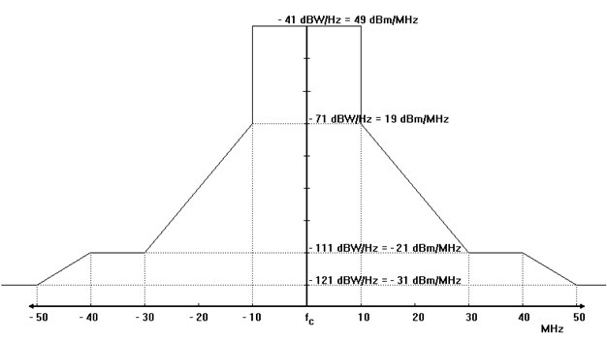

Figure 6: MBR radiated power density mask

# Off-shore operation scenarios

## General off-shore scenarios

Offshore operations may require ships to operate in a stationary position (specifically when using dynamic positioning) or at very low speed.

When a ship is cruising towards (or backwards) a fixed installation with constant heading it might be pointing towards the GSO for few minutes. The figure below shows an example of such scenarios:



Figure 7: Schematic scenario for supply to fixed platforms

## MBR off-shore scenarios

### General

MBR applications comprise operations of several moving elements where the MBR is the communications link providing real time information to the stations.

MBR is normally installed on ships, platforms and other offshore installations.

Typical MBR applications can be:

* Coordinated offshore operations. Figure 8;
* Offshore exploration, drilling operations. Figure 9;
* Offshore exploration, seismic operations. Figure 11;
* Mapping of the seabed, hydrographic operations. Figure 13.

#### Coordinated offshore operations / Off-shore exploration, drilling operations

Operations where several vessels are working in a coordinated operations and operational awareness is crucial for safety and efficient conduct of the operation.

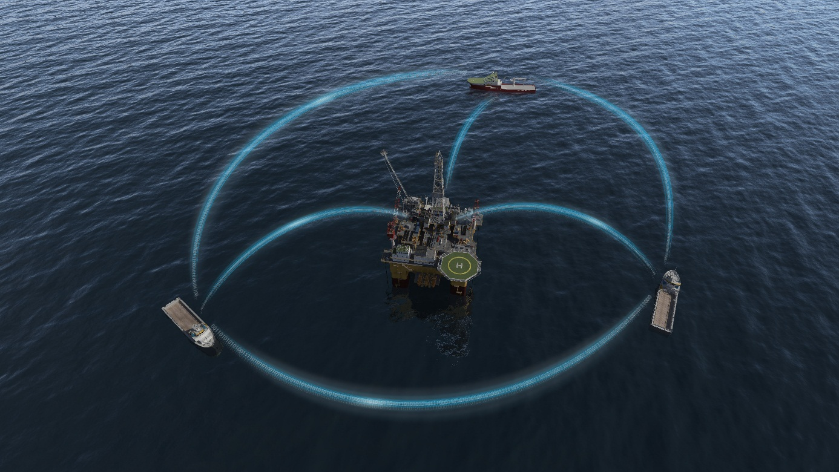

Figure 8: Coordinated simultaneous operations

During coordinated off-shore operations like exploration and drilling, the platform is stationary and communicates with the surrounding ships by MBR. The surrounding ships may be continuously moving or circling round the platform, normally within the 500 m safety zone of the platform. Even when the ship is anchored, it still moves around the fixed position, cf. in Figure 10. The MBR communication link is kept uninterrupted by the movements of the ship including movements due to waves, heave, etc. due to the electronical lock and phase steering of the transmitting and receiving beams, but the transmitting beam direction including the azimuth angle, may continuously change.

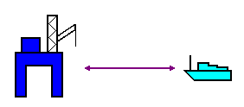

Figure 9: Principle MBR link between a ship and a platform

For an anchored ship, shows the average movement of the ship[1]. The time between the individual position updates is approximately 3 minutes.

During moving of platforms, ships are engaged in some sort of pull operation. The speed of the towed platform is generally between 2 and 5 knots.

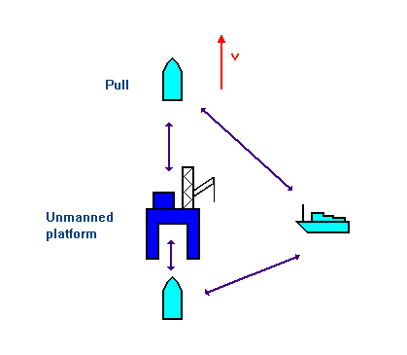

Figure 10: Principle sketch for moving of platforms

#### Off-shore exploration, seismic operations

Seismic operations consist of one or multiple vessels towing seismic cables with a large geographic extent. The operation usually consists of multiple vessels supporting the operation. Communication is crucial both for safety and for efficient seismic operations.



Figure 11: Seismic operations

During seismic operations, all vessels are moving. The speed of the main seismic vessel is generally 4 knots. Figure 12 shows a general principle scenario for a seismic operation.

The greatest length a seismic cable may have is 12 km, but these are very seldom used. A seismic operation is therefore always within 12 km.

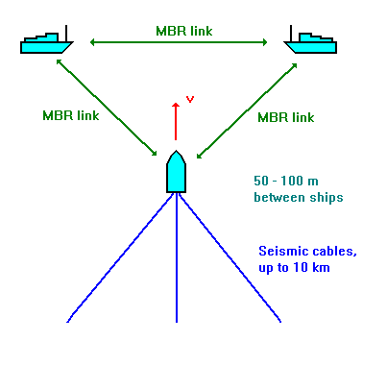

Figure 12: Principle scenario for seismic operations

#### Mapping of seabed, hydrographic operations

Mapping of seabed can consist of a mother vessel with one or multiple smaller vessels conducting hydrographic measurements. Control and data transfer to the mother vessel is possible by using MBR.

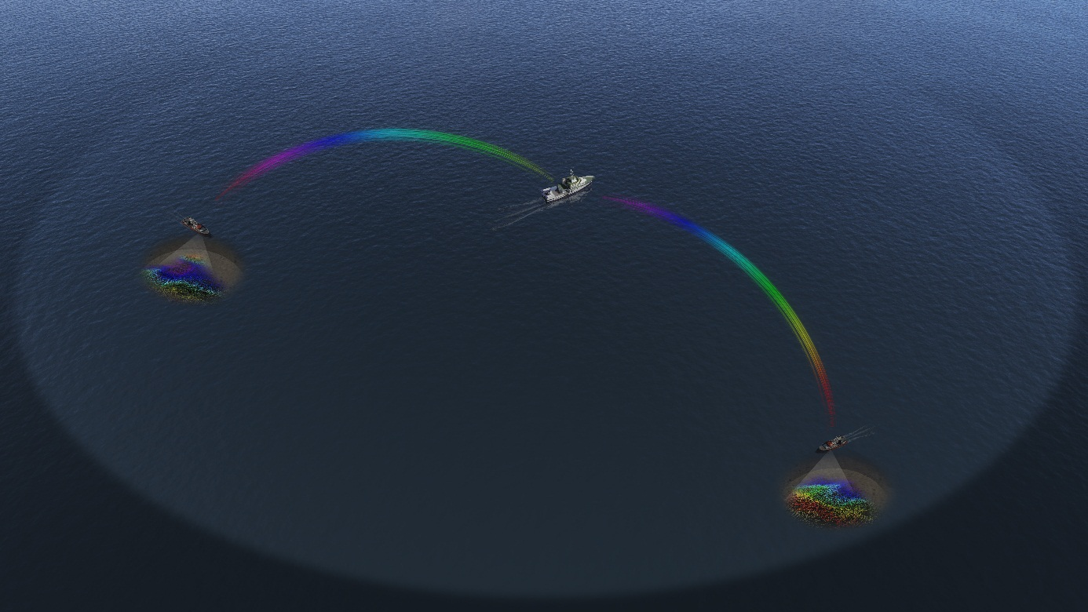

Figure 13: Sea bed mapping

During mapping of sea bed, the normal distance between the elements are 7 km. Since mapping is going to cover every km2 within the operation, sea bed mapping may not cover greater areas than 10 km between the units.

#### Coast-guard activities (Inspections, anti-pollution, distress, etc.)

Vessel to vessel communication is an important aspect in coast-guard activities, and with MBR it is possible to transfer reliable sensor data and video from vessel to vessel.

During these operations, all vessels are moving independently and the direction of an MBR link may have any azimuth direction in the horizontal plane.

## MBR installations

### General

The radio and antenna part of the MBR is generally mounted as high as possible above sea level and so that the radiation operating area is not obstructed.

### Installation on ships

On ships, the MBR is generally installed at heights below 25 metres.

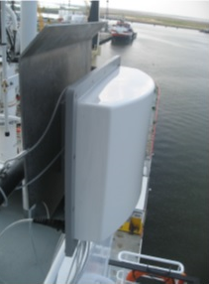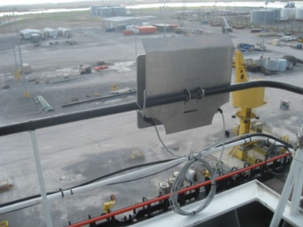

Figure 14: Example of MBR installations on board ships

### Installations on oilrigs/platforms

On platforms, the maximum height of MBR installations is approximately 75 metres.

### MBR transmitting e.i.r.p.

The MBR system optimises the link budget under different conditions and uses power control to regulate the output e.i.r.p. to the minimum necessary for the communications. In an established link, each transmitted package contains information on the transmitted e.i.r.p. level. The receiver measures the received signal strength, calculates the quality of the link and indicates suitable power reduction. The output power may be reduced up to 25 dB.

Figure 15 indicates a theoretical estimate of MBR e.i.r.p. versus distance between transmitter and receiver.

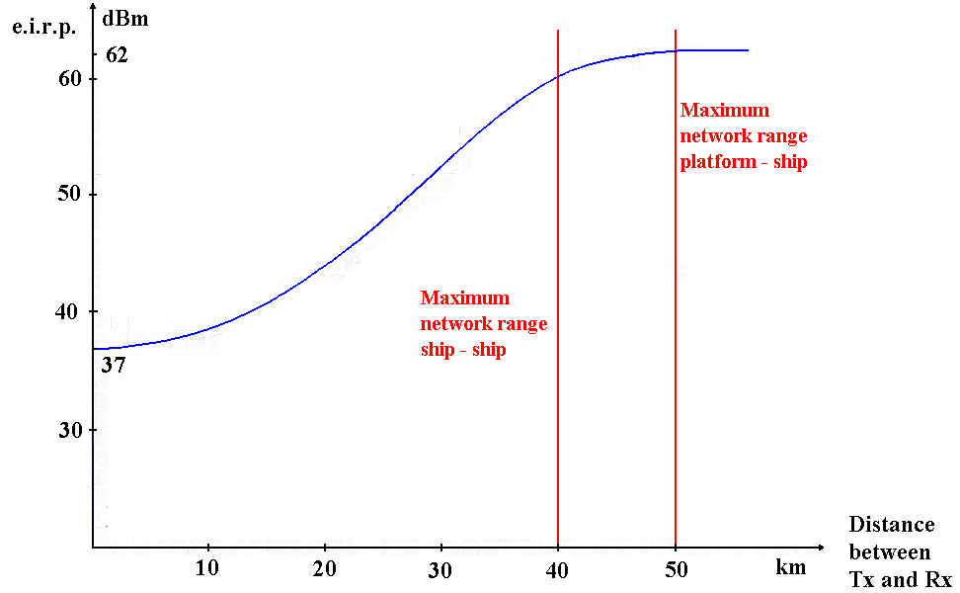

Figure 15: Estimated Tx e.i.r.p. vs. distance between Tx and Rx

During coordinated activities, the transmitting power adjusts to the lowest usable level, cf. Figure 15, mainly dependant on the link distance and the link quality. For scenarios within the line of sight, it is therefore a high probability that the MBR is operating at a power level at least 10 dB below the maximum.

# Compatibility, sharing and interference scenarios

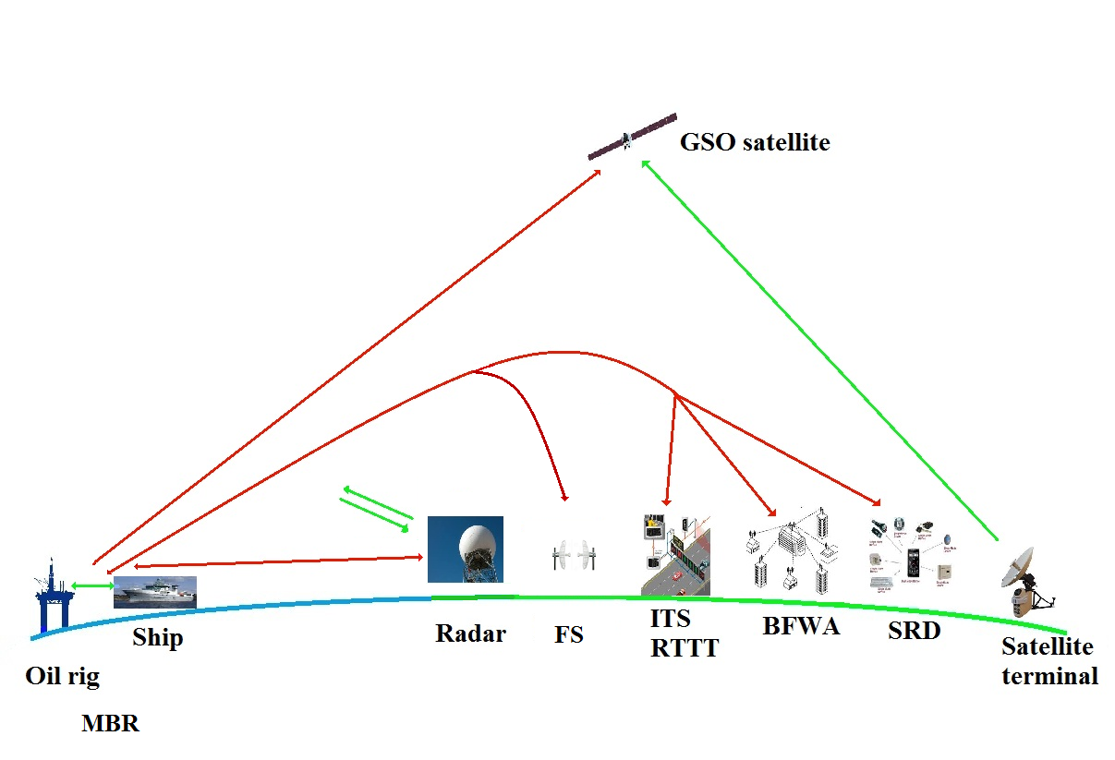

Figure 16: Interference scenario

During MBR operations, the transmitters and receivers are generally constantly moving. Although the antennas have highly directive radiation and are electronically locked to each other, during an operation they may point in any direction in the horizontal plane. Therefore, during interference calculations, maximum e.i.r.p. and receiver sensitivity are used, but the pointing direction may vary with short time constants.

Further, almost all coordinated off-shore operations take place within distances shorter than 15 km, with 40 km and 50 km as the maximum for ship-ship and platform-ship, respectively. For operations within 15 km separation distance, the MBR transmitting power is reduced 15-20 dB below maximum output power, though dependent on the radio technical propagation conditions.

The MBR antennas consist of 60 separate antenna elements, each individually electronically controlled. By phasing of the individual elements, the antenna radiation pattern can be controlled, creating nulls in directions which should not be illuminated with high e.i.r.p. and suppressing interfering signals from specific directions.

For systems with directional antennas, maximum mutual interference occurs only when the MBR station and other radio communication system station antennas are aligned to each other. In all other situations when the MBR and radio systems antennas are not pointing to each other there will be additional antenna discrimination.

## Compatibility between MBR and BFWA

### General

According to ECC/REC/(06)04 [2], Broadband Fixed Wireless Access (BFWA) systems are broadband radio communication systems, which can be deployed either inside or outside buildings, usually covering a geographically defined area.

BFWA systems enable a variety of architectures, including combinations of access as well as interconnection to some extent. BFWA architectures, which have been considered within ECC Report 68 [7], are point-to-multipoint (P-MP), point-to-point (P-P), mesh (Multipoint-to-Multipoint, directional or omnidirectional) and any point-to-multipoint (AP-MP, hybrid of mesh and P-MP).

According to ECC/REC(06)04 BFWA systems operate in the band 5725-5875 MHz and uses efficient DFS mechanism (Dynamic Frequency Selection) to protect radiolocation service RLS as well as Transmit Power Control (TPC) to protect FSS with at least 12 dB dynamic range with an average of -5dB. BFWA networks may have up 7 channels with 20 MHz bandwidth. MBR may operate on 2 channels and only the lowest shares the same frequency band as BFWA. However in ECC Report 173 [3] it is identified that there is some use of BFWA systems in the band 5850-5950 MHz, mostly for P-MP. Therefore it's necessary to consider the protection of BFWA systems with regard to both channels of the MBR system in   
5852-5872 MHz and 5880-5900 MHz bands.

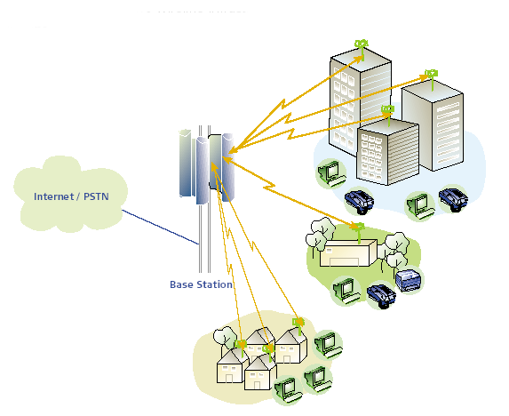

Figure 17: Typical P-MP deployment scenario

Point-to-Multipoint networks are typically characterised by user terminal stations being connected directly to a central station. Central stations can provide either omni-directional coverage or sectorised coverage. It is assumed that all the remote stations communicate with the central station only during the assigned time slot (in case of TDMA). This means that, within a cell, only one station is transmitting at any instant in time irrespective of the number of radios per cell.

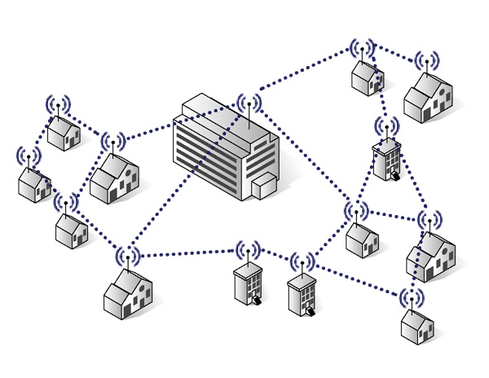

Figure 18: Mesh network example

In mesh networks, nodes are typically located at customers’ premises and provide both the customer traffic and act as repeaters forwarding traffic to other nodes in the network.

### Technical characteristics of BFWA

For BFWA, the system parameters as derived from ECC Report 68 [7], ECC Report 109 [8] and ETSI TR 102 079 (System Reference document for BFWA (HIPERLAN) [9] in the 5.8 GHz band have been used. Table 5 contains the technical parameters of a BFWA P-MP system. Ground height above mean sea level and antenna height above mean sea level were taken from assumptions made in Recommendation ITU-R SF.1650 [10].

Table 5: Technical parameters for BFWA transmitters and receivers

|  |  |
| --- | --- |
| Parameters \ Device | P-MP |
| Topology | Sectored Central Station (CS)  Terminal Stations (TS) |
| Antenna | Omnidirectional or sectorised |
| Polarisation | Vertical and Horizontal |
| Duplex/access scheme | TDD/TDMA |
| e.i.r.p. | 36 dBm |
| Channel Bandwidth | 20 MHz |
| Power density spectral e.i.r.p. | 23 dBm/MHz |
| Antenna Gain | 17 dBi |
| Antenna pattern CS | See Figure 19 |
| Antenna pattern TS | See Figure 20 |
| Receiver sensitivity (16 QAM) | -74 dBm (in 20 MHz BW) |
| Receiver sensitivity (64 QAM) | -68 dBm (in 20 MHz BW) |
| Interference protection ratio C/I (16 QAM) (dB @ 3 % PER) | 20 |
| Interference protection ratio C/I (64 QAM) (dB @ 3 % PER) | 30 |
| Interference protection level (16 QAM system) | -107 dBm/MHz |
| Interference protection level (64 QAM system) | -111 dBm/MHz |
| Ground height above mean sea level | 50 m |
| Antenna height above mean sea level | 120 m |

Figure 19: Typical P-MP Central station antenna pattern

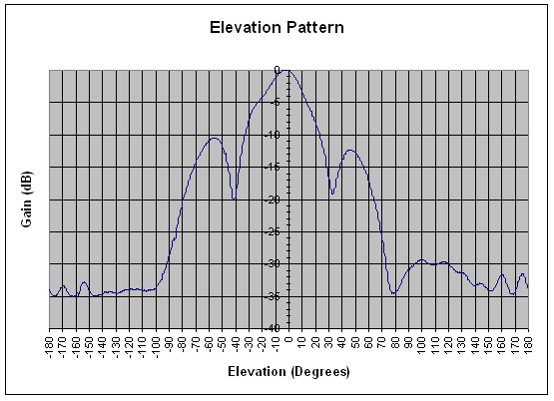

Figure 20: Terminal Station Elevation pattern (20 degree beam width)

### Interference from MBR to BFWA

#### Methodology

The protection distance is calculated based in the minimum permissible transmission loss:

The minimum required path loss (dB) = Tx power (dBm/MHz) + Tx antenna gain (dBi) + Rx antenna gain (dBi) – Interference protection level (dBm/MHz)

The minimum required distance to protect BFWA receivers is calculated based on propagation model in Recommendation ITU-R P.452 [11] for main lobe coupling scenarios proposed below:

* MBR transmitter on sea platform vs. BFWA receiver on off-shore platform;
* MBR transmitter on sea platform vs. BFWA receiver at 0 km from the coast;
* MBR transmitter on sea platform vs. BFWA receiver at 25 km from the coast.

For the calculations the BFWA antenna height is taken as 120 m above mean sea level. Although this is representative of most cases, in some countries fixed links can be located on mountains with higher altitudes.

#### Calculations

The calculations are done for MBR located on sea platform for two e.i.r.p. values (32 dBW and 25 dBW). Results of calculation of protection distance for frequency 5.8 GHz using Recommendation ITU-R P.452, latitude = 55° (ΔN = 45), time percentage p = 20% are presented in Table 6 and Table 7. Clutter losses were not taken into account.

Table 6: Required separation distances (BFWA victim) (MBR Maximum e.i.r.p.=32 dBW)

|  |  |  |
| --- | --- | --- |
| Parameter | BFWA (16-QAM) | BFWA (64-QAM) |
| The minimum required path loss (dB) | 156 | 160 |
| Required distance on the sea (km) | 99.5 | 103.5 |
| Required distance when BFWA at 0 km from the coast (km) | 114 | 118 |
| Required distance when BFWA at 25 km from the coast (km) (Note 1) | 75 | 82.5 |

NOTE 1: The required distance when BWFA at 25 km from the coast (km) = 25 (km) + required distance from the coast line (km).

Table 7: Required separation distances (BFWA victim) taking into account MBR power reduction (MBR e.i.r.p.=25 dBW)

|  |  |  |
| --- | --- | --- |
| Parameter | BFWA (16-QAM) | BFWA (64-QAM) |
| The minimum required path loss (dB) | 149 | 153 |
| Required distance on the sea (km) | 92.5 | 96 |
| Required distance when BFWA at 0 km from the coast (km) | 108 | 112 |
| Required distance when BFWA at 25 km from the coast (km) (Note 1) | 57.5 | 62.5 |

NOTE 1: The required distance when BWFA at 25 km from the coast (km) = 25 (km) + required distance from the coast line (km).

### Interference from BFWA to MBR

#### Methodology

The protection distance is calculated based in the minimum permissible transmission loss:

The minimum required path loss (dB) = Tx power (dBm/MHz) + Tx antenna gain (dBi) + Rx antenna gain (dBi) – Interference protection level (dBm/MHz)

The minimum required distance to protect MBR receivers is calculated based on propagation model in Recommendation ITU-R P.452 [11] for main lobe coupling scenarios proposed below:

* BFWA transmitter on off-shore platform vs. MBR receiver;
* BFWA transmitter at 0 km from the coast vs. MBR receiver;
* BFWA transmitter at 25 km from the coast vs. MBR receiver.

For the calculations the BFWA antenna height is taken as 120 m above mean sea level. Although this is representative of most cases, in some countries fixed links can be located on mountains with higher altitudes.

#### Calculations

Results of calculation of protection distance for frequency 5.8 GHz using Recommendation ITU-R P.452, latitude = 55° (ΔN = 45), time percentage p = 20% are presented in Table 8. Clutter losses and polarisation loss were not taken into account.

Table 8: Required separation distances (MBR victim, C/I = 10 dB)

|  |  |  |
| --- | --- | --- |
| Parameter | MBR on ships | MBR on platforms |
| The minimum required path loss (dB) | 153 | 153 |
| Required distance on the sea (km) | 75.5 | 96.5 |
| Required distance when BFWA at 0 km from the coast (km) | 90 | 112 |
| Required distance when BFWA at 25 km from the coast (km) (Note 1) | 25 | 62.5 |

NOTE1: The required distance when BWFA at 25 km from the coast (km) = 25 (km) + required distance from the coast line (km).

### Conclusions

The MBR antennas may point in any direction in the horizontal plane. The -3 dB beam width is 10°. It is therefore only 10/360 = 2.8% probability that the MBR transmitting main lobe is pointing in a specific direction. For a sectorised BFWA antenna, the beam width may be around 20°. Maximum mutual interference will occur when both the transmitter and the receiver are within each other’s beams.

Considering MBR Maximum e.i.r.p.=32 dBW, MBR transmitters will not exceed the interference criterion for BFWA receivers at distances above 118 km when BFWA is placed at the coastline. In the case when BFWA is used on off-shore platform MBR transmitters will not exceed the interference criterion for BFWA receivers at distances above 103.5 km.

Considering MBR Maximum e.i.r.p.=25 dBW, MBR transmitters will not exceed the interference criterion for BFWA receivers at distances above 112 km when BFWA is placed at the coastline. In the case when BFWA is used on off-shore platform MBR transmitters will not exceed the interference criterion for BFWA receivers at distances above 96 km.

BFWA transmitters will not exceed the interference criteria for MBR receivers at distances above 112 km. In the case when BFWA is used on off-shore platform BFWA transmitters will not exceed the interference criterion for MBR receiver at distance above 96.5 km.

## Compatibility between MBR and FSS systems

### General

C-band Fixed Satellite Service (FSS) may use the band 5725-7075 MHz for Earth-to-space deployments (uplink) and the band 3400-4200 MHz for space-to-Earth deployments (downlink). In these frequency bands, the satellite beams may cover large areas of the Earth (using global, hemispherical, zoned or regional beams). In the band 5925-6425 MHz earth stations located on board vessels may communicate with space stations of the FSS.

FSS includes both GSO and n-GSO satellite systems.

### Compatibility between MBR and n-GSO satellite systems

There are no operational n-GSO FSS system notified to ITU in the frequency band 5827-5925 MHz.

Compatibility studies with n-GSO systems are therefore not considered necessary.

### Compatibility between MBR and GSO FSS systems

#### Interference from FSS earth stations to MBR

C-band satellite networks have downlink (space-Earth) in the band 3400-4200 MHz and uplink (Earth-space) in the band 5725-7075 MHz.

C-band earth stations in the FSS may be located on shore and on fixed platforms.

Technical characteristics of FSS GSO earth station transmitter

C-band (3.625-4.2 GHz space-to-Earth direction and 5.850-6.725 GHz Earth-to-space direction) is currently used mainly for regional and intercontinental connections for various services such as public commuted network, audio-visual transport services or multimedia services, which require a high quality of services.

As far as Europe is concerned, the majority of transmitting FSS earth stations are “large” gateways in rural environment (medium-size to large antennas used to provide international connectivity with other countries or territories), even if there is also “small” gateways in rural and sub-urban environment (small to medium size antennas often used to connect remote areas to the Internet backbone and other telecommunications networks). VSAT networks in rural, suburban and even urban areas (e.g. corporate network) represent very few deployments in Europe.

FSS parameters considered in this study covers the various deployment that can be found in Europe. 2 representative earth station antenna diameters are considered: 4.6 and 32.5 m. Two types of elevation angle have been chosen, one representing a quite extreme case of 10°, where the earth station is pointing at satellite with low elevation angle, and the other representing a common one for Europe at 33°, where the earth station is pointing towards a satellite up to Europe.

Parameters for FSS earth stations as given in ECC Report 101 [12] are shown in Table 9.

Table 9: Assumed ES FSS parameters

|  |  |  |  |  |
| --- | --- | --- | --- | --- |
| Earth Station | ST1 | ST2 | ST3 | ST4 |
| Elevation (deg) | 10 | 10 | 33 | 33 |
| Antenna Diameter (m) | 4.6 | 32.5 | 4.6 | 32.5 |
| Power (dBW/MHz) | 21.3 | 2.0 | 21.3 | 2.0 |
| Power (dBW/Hz) | -38.7 | -58.0 | -38.7 | -58.0 |
| Max antenna gain (dBi) | 47.8 | 63 | 47.8 | 63 |
| Height (m) | 4.3 | 18.25 | 4.3 | 18.25 |
| Antenna pattern (dBi) | Recommendation ITU-R S.465 [13]  32 – 25log10φ | | | | |

Methodology

The C/I criteria and the sensibility enable to determine the maximum allowable interference into MBR as follows:

 (1)

where

Imax in dBm/MHz

Cmin in dBm/MHz, sensitivity at the output off the antenna, i.e. -96 dBm/MHz

C/I in dB, i.e. 6 dB/10 dB.

This value can be compared to the received interference from an FSS transmitting earth station with the following calculation:

 (2)

where

I in dBm/MHz;

Pe: Earth station transmitting power (dBm/MHz)

Ge(φ): Earth station antenna gain (dBi)

Gr(σ): MBR antenna gain (dBi)

Aff: Propagation loss (dB).

Satellite earth stations operating in the FSS are installed in areas with as little radio noise as possible and shielded by the terrain in all directions except for the small window towards the satellite. Indeed this terrain model, which has an important impact on sharing calculation, is too specific to each location for a general model to be prepared.

In order to be as generic as possible, a rural terrain model has been considered, however, in order to estimate the sensibility of the use of the terrain model, the improvement of the separation distances when an example of real terrain model is taken into account is provided below under Operational considerations.

(3)

Table 10: Parameters for the propagation model

|  |  |
| --- | --- |
| Parameter | Rural |
| Breakpoint distance d0 (m) | 256 |
| Pathloss factor n0 beyond the first break point | 2.8 |
| Breakpoint distance d1 (m) | 1024 |
| Pathloss factor n1 beyond the second breakpoint | 3.3 |

Calculations

Based on the earth station characteristics in Table 9 and the methodology described above, Table11 indicates calculated antenna gain for the rural case, necessary attenuation and protection distances.

Table 11: Calculated propagation loss and separation distances

|  |  |  |  |  |
| --- | --- | --- | --- | --- |
|  | Tx output power (dBm/MHz) | Antenna gain (dB) | Necessary attenuation (dB) | Protection distance (km) |
| ST1 | 51.3 | 7 | 184 | 147 |
| ST2 | 32 | 7 | 165 | 38 |
| ST3 | 51.3 | - 6 | 171 | 60 |
| ST4 | 32 | - 6 | 152 | 15 |

GSO FSS earth station transmitters will not exceed the interference criteria for MBR receivers at distances above 147 km. The calculated protection distances are between the MBR receiver and the earth station. FSS earth stations are not installed along the coastline and the protection distance from the coast will therefore be reduced with the earth station's distance from the coast.

Operational considerations

Maximum interference is happening when the earth station is pointing towards the MBR and the MBR receiver is pointing towards the earth station transmitter. This means that maximum interference may occur only when both MBR terminals are within the narrow main lobe of the earth station antenna and pointing towards the earth station.

For the earth station antennas in accordance with Recommendation ITU-R S.465 [13] and with elevation angle 10°, the maximum antenna gain for different azimuth angles is indicated in Figure 21.

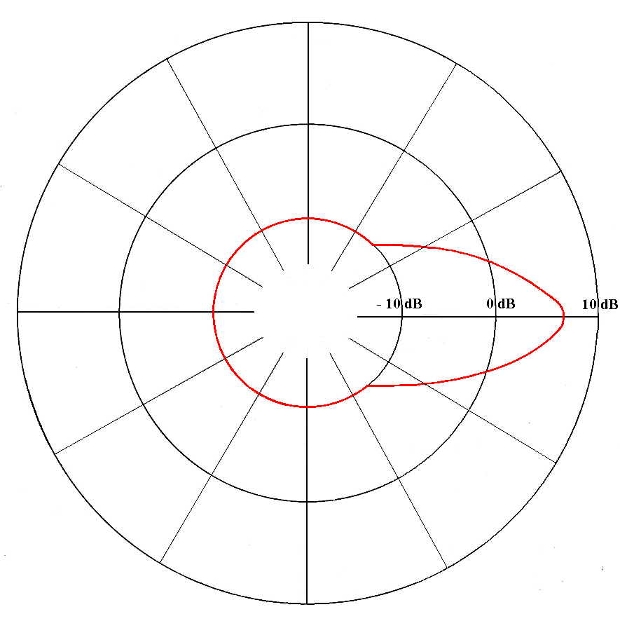

Figure 21: Maximum antenna gain in the horizontal plane for 10° antenna elevation angle

In specific coordination cases, a real terrain model will show the impact on separation distances, however, due to the specificity of the location, the results remain as an example.

The chosen location is the one of a C-Band FSS teleport in France. Figure 22 shows the representation of the associated terrain model of this location.

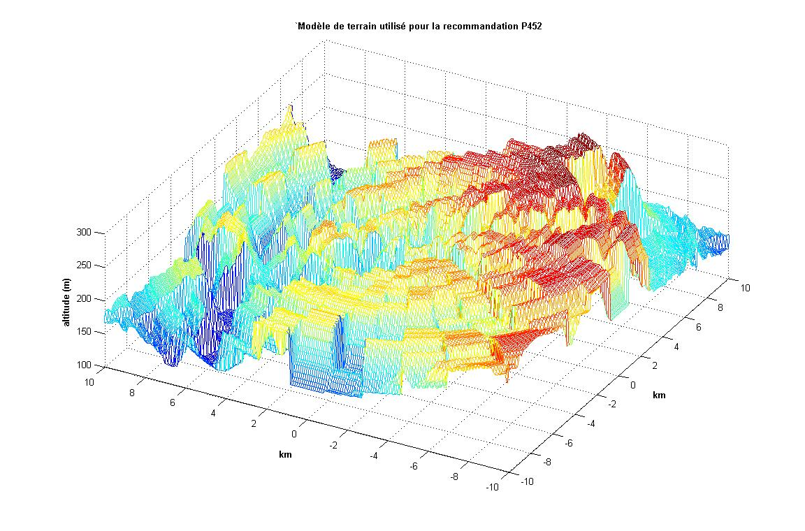

Figure 22: Representation of the used real terrain model

Using the real terrain model should reduce the separation distance compare to rural terrain model (see for example ECC Report 101 [12]).

Conclusions

GSO FSS earth station transmitters will not exceed the interference criteria for MBR receivers at distances above 147 km. Practical earth station installations may give shorter protection distances taking into account real terrain model.

#### Interference from ESV transmitter to MBR receiver

Technical characteristics for ESV

ESV operating in the C-band is transmitting in bands above 5925 MHz.

The maximum transmitter output of the ESV is 16.7 dBW, cf. Recommendation ITU-R SF.1650 [10] and the maximum e.i.r.p. towards the horizon is 17 dBW/MHz, cf. ITU Radio Regulations Res.902 (WRC-03) [14].

The reference bandwidth of ESV transmissions is 2.346 MHz, cf. Res.902 and Rec. SF.1650.

With minimum antenna diameter of 2.4 m, the -3 dB antenna beam width is less than 1.4° for C-band terminals, cf. ITU Radio Regulations Appendix 7, Annex 3 [14].

Methodology

According to the principles stated in Appendix 3 to the Radio Regulations, the spurious domain generally consists of frequencies separated from the centre frequency of the emission by 250% or more of the necessary bandwidth of the emission. The spurious attenuation for earth stations in the space services shall be less than 43 + 10 log10(P) or 60 dB which for ESV are identical.

Calculations

The spurious domain for 2.346 MHz bandwidth is ± 5.9 MHz. Both MBR channels are in the spurious domain of the ESV.

The ESV emissions in the spurious domain is less than 47 dBm/MHz – 60 dB = -13 dBm/MHz.

The necessary attenuation towards the MBR receiver is X dB:

- 13 dBm/MHz - X dB = - 120 dBm/MHz

where - 120 dBm/MHz is the sensitivity level at the antenna input of the MBR

X = 120 - 13 = 107 [dB].

Based on Recommendation ITU-R P.452 [11], this corresponds to a separation distance of about 1 km.

Conclusions

The MBR receivers are in the spurious domain of ESV transmitters and will not be affected at distances greater than 1 km.

#### Interference from MBR transmitter to GSO FSS space station receiver

General

In accordance with Recommendation ITU-R S.1432-1 "Apportionment of the allowable error performance degradations to fixed-satellite service (FSS) hypothetical reference digital paths arising from time invariant interference for systems operating below 30 GHz" [15] the error performance degradation due to interference at frequencies below 30 GHz should be allotted portions of the aggregate interference budget of 32% or 27% of the clear-sky satellite system noise in the following way:

* 25% for other FSS systems for victim systems not practising frequency re-use;
* 20% for other FSS systems for victim systems practising frequency re-use;
* 6% for other systems having co-primary status;
* 1% for all other sources of interference,

and that the sum of all of the interference sources should not cause violation of the error performance objectives (see Recommendations ITU-R S.522 [16], ITU-R S.614 [17], ITU-R S.1062 [18] and ITU-R S.1420 [19]).

In the System Reference document (SRdoc) on MBR (ETSI TR 103 109 [1]), it is mentioned that "… the preferred regulatory approach would be for this system to operate on a non-interference and unprotected basis within the higher end of the 5 GHz band", which from the regulatory point of view means that MBR needs be considered as a secondary service with respect to FSS.

Therefore, the error performance degradation of FSS due to interference from MBR in the bands under consideration should be estimated based both on the criterion ΔT/T ≤ 6% and ΔT/T ≤ 1% (i.e. interference should not be above 1 or 6% of thermal noise of the FSS system in the clear-sky conditions) for more objective analysis.

MBR terminals operating on the frequencies 5862 MHz and 5890 MHz transmit in the uplink band (Earth-space) for C-band satellite networks. There are a large number of geostationary satellites having uplink in the frequency band 5852–5900 MHz within the visible GSO arc of the MBR transmitter.

The technical threshold/conditions for triggering coordination between GSO networks could serve as an interference indicator where emission levels below this threshold may be regarded as tolerable.

Technical characteristics for satellite systems

Table 12: Technical parameters for satellite systems used in calculations

|  |  |  |  |  |
| --- | --- | --- | --- | --- |
|  | Satellite system | Orbital position | Satellite receiving antenna gain (dBi) | Satellite receiver noise (°K) |
| A | Telecom-3B/4B | 5° West | 34 | 773 |
| B | Express-2/2B | 14° West | 26.5 | 1200 |
| C | Intelsat 8/9 328.5E | 31.5° West | 32.5 | 700 |
| D | Telecom-3/4C | 3° East | 32.8 | 773 |
| E | Intelsat 8/9 342E | 18° West | 32.8 | 700 |
| F | Express-5/5B | 53° East | 26.5 | 1200 |
| H | Intelsat 9 66E | 66° East | 34.7 | 700 |
| I | Intelsat 9/10 359E | 1° West | 32.8 | 700 |
| K | Express 9B | 103° East | 30 | 900 |
| M | ENSAT 23E | 23° East | 32 | 500 |

Methodology

Appendix 8 of the Radio Regulations [14] describes the ΔT/T approach for determining the need for coordination between existing satellite networks and networks that are in the process of being registered. Although not directly suitable for use in the case of inter-service sharing, it does provide a very simple method of analysing the impact without much knowledge of the characteristics of the carriers used on the satellite network requiring protection. The method of calculation for determining if coordination is required under provision No. 9.7 is based on the concept that the noise temperature of a system subject to interference increases as the level of the interfering emission increases. It can, therefore, be applied irrespective of the modulation characteristics of these satellite networks, and of the precise frequencies used. In this method, the apparent increase in the equivalent satellite link noise temperature resulting from an interfering emission of a given system is calculated and the ratio of this increase to the equivalent satellite link noise temperature, expressed as a percentage.

Calculations

Impact of one MBR station on GSO FSS space stations

Table 13: Impact of one MBR main beam radiation on a satellite station (∆T/T =6%)   
(MBR Maximum e.i.r.p.=32 dBW)

|  |  |  |  |  |  |  |  |  |
| --- | --- | --- | --- | --- | --- | --- | --- | --- |
| Satellite | Satellite antenna gain  (dB) | Satellite receiver noise  (K) | 6%  (K) | Power density received by the satellite (dBW/Hz) from 1 MBR station  (Note 1) | Power density received by the satellite (K) | ∆T/T  (%) | Max allowable e.i.r.p density (dBW/Hz) (Note 2) | Necessary minimum attenuation (dB) |
| A | 34 | 773 | 46.38 | -207.7 | 123.03 | 15.92 | -45.24 | -4.24 |
| B | 26.5 | 1200 | 72 | -215.2 | 21.88 | 1.82 | -35.83 | 0 |
| C | 32.5 | 700 | 42 | -209.2 | 87.10 | 12.44 | -44.17 | -3.17 |
| D | 32.8 | 773 | 46.38 | -208.9 | 93.33 | 12.07 | -44.04 | -3.04 |
| E | 32.8 | 700 | 42 | -208.9 | 93.33 | 13.33 | -44.47 | -3.47 |
| F | 26.5 | 1200 | 72 | -215.2 | 21.88 | 1.82 | -35.83 | 0 |
| H | 34.7 | 700 | 42 | -207 | 144.54 | 20.65 | -46.37 | -5.37 |
| I | 32.8 | 700 | 42 | -208.9 | 93.33 | 13.33 | -44.47 | -3.47 |
| K | 30 | 900 | 54 | -211.7 | 48.98 | 5.44 | -40.58 | 0 |
| M | 32 | 500 | 30 | -209.7 | 77.62 | 15.52 | -45.13 | -4.13 |

Note 1: MBR e.i.r.p density: -41 dBW/Hz

Note 2: The results take into account a 0.5 dB attenuation due to atmospheric gases (as showed in ECC Report 68 [7])

Table 14: Impact of one MBR main beam radiation on a satellite station (∆T/T =6%)   
(MBR Maximum e.i.r.p.=25 dBW)

|  |  |  |  |  |  |  |  |  |
| --- | --- | --- | --- | --- | --- | --- | --- | --- |
| Satellite | Satellite antenna gain   (dB) | Satellite receiver noise  (K) | 6%  (K) | Power density received by the satellite (dBW/Hz) from 1 MBR station  (Note 1) | Power density received by the satellite  (K) | ∆T/T (%) | Max allowable e.i.r.p density (dBW/Hz) (Note 2) | Necessary minimum attenuation (dB) |
| A | 34 | 773 | 46.38 | -214.7 | 24.55 | 3.18 | -45.24 | 0 |
| B | 26.5 | 1200 | 72 | -222.2 | 4.37 | 0.36 | -35.83 | 0 |
| C | 32.5 | 700 | 42 | -216.2 | 17.38 | 2.48 | -44.17 | 0 |
| D | 32.8 | 773 | 46.38 | -215.9 | 18.62 | 2.41 | -44.04 | 0 |
| E | 32.8 | 700 | 42 | -215.9 | 18.62 | 2.66 | -44.47 | 0 |
| F | 26.5 | 1200 | 72 | -222.2 | 4.37 | 0.36 | -35.83 | 0 |
| H | 34.7 | 700 | 42 | -214 | 28.84 | 4.12 | -46.37 | 0 |
| I | 32.8 | 700 | 42 | -215.9 | 18.62 | 2.66 | -44.47 | 0 |
| K | 30 | 900 | 54 | -218.7 | 9.77 | 1.09 | -40.58 | 0 |
| M | 32 | 500 | 30 | -216.7 | 15.49 | 3.1 | -45.13 | 0 |

Note 1: MBR e.i.r.p density: -48 dBW/Hz

Note 2: The results take into account a 0.5 dB attenuation due to atmospheric gases (as showed in ECC Report 68 [7])

Table 15: Impact of one MBR main beam radiation on a satellite station (∆T/T=1%)   
(MBR Maximum e.i.r.p.=32 dBW)

|  |  |  |  |  |  |  |  |  |
| --- | --- | --- | --- | --- | --- | --- | --- | --- |
| Satellite | Satellite antenna gain  (dB) | Satellite receiver noise  (K) | 1%  (K) | Power density received by the satellite (dBW/Hz) from 1 MBR station (Note 1) | Power density received by the satellite (K) | ∆T/T  (%) | Max allowable e.i.r.p density (dBW/Hz) (Note 2) | Necessary minimum attenuation (dB) |
| A | 34 | 773 | 7.73 | -207.7 | 123.03 | 15.92 | -53.02 | -12.02 |
| B | 26.5 | 1200 | 12 | -215.2 | 21.88 | 1.82 | -43.61 | -2.61 |
| C | 32.5 | 700 | 7 | -209.2 | 87.10 | 12.44 | -51.95 | -10.95 |
| D | 32.8 | 773 | 7.73 | -208.9 | 93.33 | 12.07 | -51.82 | -10.82 |
| E | 32.8 | 700 | 7 | -208.9 | 93.33 | 13.33 | -52.25 | -11.25 |
| F | 26.5 | 1200 | 12 | -215.2 | 21.88 | 1.82 | -43.61 | -2.61 |
| H | 34.7 | 700 | 7 | -207 | 144.54 | 20.65 | -54.15 | -13.15 |
| I | 32.8 | 700 | 7 | -208.9 | 93.33 | 13.33 | -52.25 | -11.25 |
| K | 30 | 900 | 9 | -211.7 | 48.95 | 5.44 | -48.36 | -7.36 |
| M | 32 | 500 | 5 | -209.7 | 77.62 | 15.52 | -52.91 | -11.91 |

Note 1: MBR e.i.r.p density: -41 dBW/Hz

Note 2: The results take into account a 0.5 dB attenuation due to atmospheric gases (as showed in report 068)

Table 16: Impact of one MBR main beam radiation on a satellite station (∆T/T=1%)   
(MBR Maximum e.i.r.p.=25 dBW)

|  |  |  |  |  |  |  |  |  |
| --- | --- | --- | --- | --- | --- | --- | --- | --- |
| Satellite | Satellite antenna gain  (dB) | Satellite receiver noise  (K) | 1% (K) | Power density received by the satellite (dBW/Hz) from 1 MBR station (Note 1) | Power density received by the satellite (K) | ∆T/T (%) | Max allowable e.i.r.p density (dBW/Hz) (Note 2) | Necessary minimum attenuation (dB) |
| A | 34 | 773 | 7.73 | -214.7 | 24.55 | 3.18 | -53.02 | -5.02 |
| B | 26.5 | 1200 | 12 | -222.2 | 4.37 | 0.36 | -43.61 | 0 |
| C | 32.5 | 700 | 7 | -216.2 | 17.38 | 2.48 | -51.95 | -3.95 |
| D | 32.8 | 773 | 7.73 | -215.9 | 18.62 | 2.41 | -51.82 | -3.82 |
| E | 32.8 | 700 | 7 | -215.9 | 18.62 | 2.66 | -52.25 | -4.25 |
| F | 26.5 | 1200 | 12 | -222.2 | 4.37 | 0.36 | -43.61 | 0 |
| H | 34.7 | 700 | 7 | -214 | 28.84 | 4.12 | -54.15 | -6.15 |
| I | 32.8 | 700 | 7 | -215.9 | 18.62 | 2.66 | -52.25 | -4.25 |
| K | 30 | 900 | 9 | -218.7 | 9.77 | 1.09 | -48.36 | -0.36 |
| M | 32 | 500 | 5 | -216.7 | 15.49 | 3.1 | -52.91 | -4.91 |

Note 1: MBR e.i.r.p density: -48 dBW/Hz

Note 2: The results take into account a 0.5 dB attenuation due to atmospheric gases (as showed in ECC Report 68 [7])

Calculations of single interference from MBR station with maximum e.i.r.p.=32 dBW to GSO space stations showed that:

* According to the MBR antenna radiation pattern, an off axis angle of 5.56° is needed to obtain an attenuation of -5.37 dB for satellite H to be compliant with ∆T/T = 6% and there may be up to 6.18% (11.12/180) probability that one MBR is pointing towards a satellite station (for satellite H) and generating interference which exceeds the threshold (∆T/T>6%).
* According to the MBR antenna radiation pattern, an off axis angle of 22° is needed to obtain an attenuation of -13.15 dB for satellite H to be compliant with ∆T/T = 1% and there may be up to 24.4% (16.76/180) probability that one MBR is pointing towards a satellite station (for satellite H) and generating interference which exceeds the threshold (∆T/T>1%).

In case of reduction of MBR maximum e.i.r.p. up to 25 dBW calculations of single interference from MBR station to GSO FSS space stations showed that:

* the threshold ∆T/T>6% is met for all considered GSO FSS space stations;
* According to the MBR antenna radiation pattern, an off axis angle of 6.05° is needed to obtain an attenuation of -6.15 dB for satellite H to be compliant with ∆T/T = 1% and there may be up to 6.72% (12.1/180) probability that one MBR is pointing towards a satellite station (for satellite H) and generating interference which exceeds the threshold (∆T/T>1%).

Impact of several MBR stations side lobes on GSO FSS space stations

Considering the MBR antenna radiation pattern for side lobes, it can be seen that off axis angles between 8° and 22° lead to -12 dB attenuation.

The following table shows the number of MBR stations with -53 dBW/Hz (-41-12) which can operate simultaneously to comply with ∆T/T of 6% and 1%.

Table 17: Maximum number of MBR stations transmitting at the same time   
considering 22° off axis angles

|  |  |  |  |  |
| --- | --- | --- | --- | --- |
| Satellite | Max MBR stations with -12 dB attenuation  (8 to 22°)  ∆T/T = 6%  (MBR Maximum e.i.r.p.=32 dBW) | Max MBR stations with -12 dB attenuation  (8 to 22°)  ∆T/T = 6%  (MBR Maximum e.i.r.p.=25 dBW) | Max MBR stations with -12 dB attenuation  (8 to 22°)  ∆T/T = 1%  (MBR Maximum e.i.r.p.=32 dBW) | Max MBR stations with -12 dB attenuation  (8 to 22°)  ∆T/T = 1%  (MBR Maximum e.i.r.p.=25 dBW) |
| A | 5.97 | 29.95 | 1.00 | 4.99 |
| B | 52.16 | 261.42 | 8.69 | 43.57 |
| C | 7.64 | 38.3 | 1.27 | 6.38 |
| D | 7.88 | 39.48 | 1.31 | 6.58 |
| E | 7.13 | 35.75 | 1.19 | 5.96 |
| F | 52.16 | 261.42 | 8.69 | 43.57 |
| H | 4.61 | 23.08 | 0.77 | 3.85 |
| I | 7.13 | 35.75 | 1.19 | 5.96 |
| K | 17.47 | 87.58 | 2.91 | 14.59 |
| M | 6.13 | 30.69 | 1.02 | 5.12 |

With these values, it can be concluded that only few MBR stations transmitting at the same time in different off shore operations areas may impact fixed satellite stations when considering aggregate interferences from MBR side lobes.

Probability to impact the GSO

The MBR antennas may point in any direction in the horizontal plane. The -3 dB beam width is 10°. It is therefore only 10/360 = 2.8% probability that the MBR transmitting main lobe is pointing in a specific direction in the horizontal plane.

Technical summary

As the calculations show, for the case when MBR and FSS are considered as the services with equal status (i.e. ΔT/T = 6%) and MBR transmitter has e.i.r.p. = -41 dBW/Hz, the FSS protection criterion is satisfied only in three orbital positions, and for the scenario when MBR stations should work on non-interference and unprotected basis, the FSS protection criterion (i.e. ΔT/T= 1%) is exceeded for all considered FSS networks.

In case of a reduction of MBR maximum e.i.r.p. up to 25 dBW (e.i.r.p. density -48 dBW/Hz), the GSO FSS space station ∆T/T protection criterion is met for 6% threshold and is met only in two orbital positions for 1% threshold.

Another approach to ensure compatibility MBR and FSS in the considered frequency bands may be selection of the location of MBR in such a way that the main lobe of the MBR antenna is separated from the GSO arc on the angles provided in Table 18 (taking in to account the effect of atmospheric refraction, see Recommendation ITU-R SF.765 [20]).

Table 18: Minimum off axis angles for MBR to comply with ∆T/T=6% and 1%   
(MBR Maximum e.i.r.p.=32 dBW)

|  |  |  |
| --- | --- | --- |
| ΔT/T | Max allowable MBR e.i.r.p density (dBW/Hz) | Minimum off axis angles (deg)  for max MBR e.i.r.p. density  -41 dBW/Hz |
| 6% | - 46.37 | 5.56 |
| 1% | - 54.15 | 22 |

Interference assessment for the impact from side lobes from several MBR stations on FSS satellite stations also shows that fixed satellite stations may be impacted when considering aggregate interferences from MBR side lobes.

Calculation of aggregate interference from MBR station side lobes on GSO FSS space stations showed that only a limited number of MBR stations can transmit at the same time in different areas without causing harmful interference to GSO FSS space stations. The maximum number of such MBR stations is 4 for ∆T/T=6% threshold and 0 for ∆T/T=1% threshold, considering MBR station maximum e.i.r.p.=32 dBW. In case of a reduction of MBR station maximum e.i.r.p. to 25 dBW, the maximum number of such MBR stations is 23 for ∆T/T=6% threshold and 3 for ∆T/T=1% threshold.

Assessment of the probability of impact from MBR stations during typical operations in off shore activities gives us the observation that there are several realistic scenarios which may lead these transmitting MBR stations to point towards any satellite station in the GSO.

### Conclusions

GSO FSS earth station transmitters will not exceed the interference criteria for MBR receivers at distances above 147 km. Practical earth station installations may give shorter protection distances taking into account a real terrain model.

The MBR receivers are in the spurious domain of ESV transmitters and will not be affected at distances greater than 3 km.

To assess the impact of the MBR emissions on FSS space stations in shared frequencies, the ∆T/T method has been used. This approach is based on the concept that the noise temperature of a system subject to interference increases as the level of the interfering emission increases. In compliance with ITU-R S.1432 [4] provisions, a ∆T/T=6% criterion (systems having co-primary status) and ∆T/T=1% (all other sources of interference and generally applicable to interference from a non-primary service into FSS) has been considered.

It must be noted that in the studies, the ∆T/T criterion does not reflect any apportionment among potential source of interference which can occur in these frequency bands due to radiation from other application (ITS from 5855 MHz to 5905 MHz and BFWA from 5725 MHz to 5875 MHz).

The studies highlight that there is a realistic probability and consistent scenarios for MBR systems (one station or aggregate radiations from side lobes) to interfere on FSS space stations, specifically when considering secondary allocation for MBR. Furthermore, the lack of information on MBR deployments (statistical or factual data on number of MBR stations) makes it difficult to draw objective conclusions or set any e.i.r.p. mask with the view to define acceptable sharing conditions.

Calculations of signal interference from MBR station to GSO FSS space stations showed that the ∆T/T protection criterion is not met both for 6% and 1% threshold, when MBR maximum e.i.r.p.=32 dBW. In case of a reduction of MBR maximum e.i.r.p. up to 25 dBW, GSO FSS space stations the ∆T/T protection criterion is met for 6% threshold and is not met for 1% threshold.

Calculation of aggregate interference from MBR station side lobes on GSO FSS space stations showed that only a limited number of MBR stations can transmit at the same time in different areas without causing harmful interference to GSO FSS space stations. The maximum number of such MBR stations is 4 for ∆T/T=6% threshold and 0 for ∆T/T=1% threshold, considering MBR station maximum e.i.r.p.=32 dBW. In case of a reduction of MBR station maximum e.i.r.p. to 25 dBW, maximum number of such MBR stations is 23 for ∆T/T=6% threshold and 3 for ∆T/T=1% threshold.

## Compatibility between MBR and SRD

### General

The term Short Range Device (SRD) is intended to cover radio transmitters which provide either   
uni-directional or bi-directional communications and which have low capability of causing interference to other radio equipment. SRDs use either integral, dedicated or external antennas and all modes of modulation can be permitted subject to relevant standards.

There are no systemised channelling arrangements for non-specific SRD. The equipment provides Listen before talk (LBT) with Adaptive Frequency Agility (AFA) technique that gives flexibility when selecting working channel.

According to ERC/REC 70-03 [21], “SRD in general operate in shared bands and are not permitted to cause harmful interference to radio services. In general, SRDs cannot claim protection from radio services”.

### General non-specific SRD

According to ECC Report 68 [7], a typical SRD may have 20 MHz bandwidth, e.i.r.p. 25 mW, receiver sensitivity of -91 dBm. It is also assumed that the SRD antenna is omnidirectional. The SRD is typically used indoors, thus providing a 15 dB wall loss.

### Tank level probing radar

European usage of Tank level probing radar (TLPR) is given in ERC/REC 70-03, Annex 6. The technical characteristics of TLPR operation inside a tank, is given in EN 302 372 [22].

The intended usage of TLPR excludes any intended radiation into free space outside the tank. There is no need for sharing/compatibility/interference studies between MBR and TLPR.

### Conclusions

It is concluded that compatibility studies and interference analysis between MBR and SRD are not necessary.

## Compatibility between MBR and ITS

### General

#### RTTT

According to ECC/DEC/(02)01 "Frequency bands to be designated for the coordinated introduction of Road Transport and Traffic Telematic systems (RTTT)" [23] , RTTT systems in the 5 GHz band should operate at frequencies below 5815 MHz. Due to the large frequency separation, it is concluded that compatibility and interference analysis between MBR and RTTT is not necessary.

#### ITS

Considerations and calculations on MBR impact on ITS terminals are based on information from ECC Report 244 "Compatibility studies related to RLANs in the 5725-5925 MHz band" [24].

### System parameters for ITS

Table 19: System parameter of ITS

|  |  |  |
| --- | --- | --- |
| Parameter | Value | Comments |
| Frequency stability | 10 ppm | According to ETSI EN 302 571 [25] |
| Maximum radiated power (e.i.r.p.) | All channels  33 dBm, 23 dBm/MHz | According to ETSI EN 302 571 [25] and ETSI EN 302 663 [26].  There are no equipment classes anymore. |
| Antenna beam shape/gain | For RSU and OBU use antenna model ITU-R F.1336 [27] with parameters G0 5 dB, k 1.2, max gain in +10 deg elevation | See Figure 23 and Equation below. In ECC Report 101 [12] there were 2 possible antennas, one very directional and one omnidirectional ITU-R F.1336 [27]. However ITS systems development shows that the omnidirectional will be the dominant type and therefore only this should be used in these compatibility studies. |
| Polarization | Vertical linear | The antenna performance is not described in the ETSI ITS standard however the vertical linear polarisation is dominant. |
| Modulation scheme | BPSK, QPSK, 16QAM, 64QAM | According to ETSI EN 302 571 [25] and ETSI EN 302 663 [26]. |
| Data rates | 3/4.5 /6/9/12/18 /24/27 Mbit/s  Mandatory: 3/6/12 Mbit/s | According to ETSI EN 302 571 [25] and ETSI EN 302 663 [26]. |
| Channel Bandwidth | 10 MHz | According to ETSI EN 302 571 [25] and ETSI EN 302 663 [26]. |
| Communication mode | Half‑duplex, broadcast | Half‑duplex and broadcast are believed to be adequate for the applications considered to date. |
| Receiver noise power | -100 dBm | Typical performance. |
| Receiver sensitivity | -92 dBm/MHz | Based on -82 dBm for a bandwidth of 10 MHz. ETSI EN 302 571 [25] specifies minimum required sensitivity.. |
| Protection criterion | I/N = -6 dB | The three ITS-G5A channels (5880, 5890 and 5900 MHz) are decided by the European Commission to be used for road safety communication and therefore additional care should be given for the protection of these channels. |

Communication channels will be open for the applications within the respective usage category (either road safety related or not, i.e. used for traffic management).

The required power levels (e.i.r.p.) range from 3 dBm to 33 dBm to achieve communication distances of up to 1000 m.

To avoid collisions of radio messages in areas with a lot of vehicles, a mechanism DCC (dynamic congestion control) in ITS radios will when necessary reduce the output power and the available time to transmit.

There is a mechanism in ITS radios which will reduce the output power or available time to transmit when the radios are close to 5.8 GHz RTTT road tolling stations.

Unwanted emission levels are given by to ETSI EN 302 571 [25] for the out of band domain and SM.329 [28] and ERC/REC 74-01 [29] for the spurious domain.

Table 20: Spectrum mask of the 5 GHz ITS bands (e.i.r.p.)

|  |  |  |  |  |  |
| --- | --- | --- | --- | --- | --- |
| Power spectral density at the carrier center fc  (dBm/MHz) | ±4,5 MHz Offset  (dBm/MHz) | ±5,0 MHz Offset  (dBm/MHz) | ±5,5 MHz Offset  (dBm/MHz) | ±10 MHz Offset  (dBm/MHz) | ±15 MHz Offset  (dBm/MHz) |
| 23 | 23 | -3 | -9 | -17 | -27 |

Table 21: Minimum required receiver sensitivity; receivers typically have 10 dB better sensitivity

|  |  |  |
| --- | --- | --- |
| Modulation | Coding rate | Minimum sensitivity (dBm) |
| BPSK | 1/2 | –85 |
| BPSK | 3/4 | –84 |
| QPSK | 1/2 | –82 |
| QPSK | 3/4 | –80 |
| 16-QAM | 1/2 | –77 |
| 16-QAM | 3/4 | –73 |
| 64-QAM | 2/3 | –69 |
| 64-QAM | 3/4 | –68 |



Figure 23: OBU and RSU antenna pattern

 (4)

with

 (5)

 (6)

where

*G(θ):* gain relative to an isotropic antenna (dBi)

*G0*: the maximum gain in the azimuth plane (dBi)

*θ*: elevation angle relative to the angle of the maximum gain (degrees) θ

*θ3*: the 3 dB beamwidth in the elevation plane (degrees)

*k*: parameter which accounts for increased side-lobe levels above what would be expected

for an antenna with improved side-lobe performance.

Equation: Antenna model ITU-R F.1336 [27]; use G0=5 dB, k=1.2, max gain in +10 deg elevation.

### Interference from ITS to MBR

#### Methodology

The sensitivity of the MBR receiver and the required carrier-to-noise ratio for that service is used to determine the maximum allowable interference into the MBR.

 (7)

where

*Imax* is the maximum allowable interference in dBm/MHz

*Cmin* is the sensitivity at the output of the receiving antenna in dBm/MHz

*C/I* is the signal to noise ratio in dB.

The interference into the MBR receiver from an ITS transmitter may be calculated by the formula:

$I=P_{e}++G_{r}\left(φ\right)-LFS$ (8)

where

*I* is interfering power density, dBm/MHz

*Pe*  is interfering source transmitter output e.i.r.p. power, dBm/MHz

*Gr(φ*) is the MBR receiver antenna gain at angle of arriving φ, dBi

*LFS* is the propagation loss, dB.

According to ECC Report 101 [12], the BFWA transmitter is considered as a Terminal Station deployed at low elevations and the breakpoints exponents according to this should be used.

It means that propagation losses *LFS* are considered as the conventional expression up to *d0* and use the corrected expression beyond:

(9)

Breakpoints as specified by ETSI are used in the calculations.

Table 22: Parameters for the propagation model

|  |  |  |  |  |
| --- | --- | --- | --- | --- |
| Parameter | Urban | Suburban | Rural | ETSI |
| Breakpoint distance d0 (m) | 64 | 128 | 256 | 15 |
| Path loss factor n0 beyond the first break point | 3.8 | 3.3 | 2.8 | 2.7 |
| Breakpoint distance d1 (m) | 128 | 256 | 1024 | 1024 |
| Path loss factor n1 beyond the second breakpoint | 4.3 | 3.8 | 3.3 | 2.7 |

#### Calculations

The MBR may operate on the carrier frequencies 5862 MHz and 5890 MHz, however, both bands are within the operational band of ITS and the difference in propagation loss is negligible.

The e.i.r.p. from the ITS transmitter is 23 dBm/MHz.

The maximum allowable interference into the MBR receiver is:

Imax = Rx sensitivity - Rx antenna gain - Signal/interference

Imax = - 96 dBm - 24 dBi - 6 dB = - 126 dBm.

Max allowable interference = ITS e.i.r.p. - propagation loss (LFS)

-126 dBm/MHz = 23 dBm/MHz - LFS

LFS = 149 dB.

The minimum distance between MBR and ITS is D and the propagation loss, LFS, is:

149 dB = $20\log_{10}\left(\frac{0.05}{4∙15∙π}\right)-10∙2.7\log_{10}\left(\frac{1024}{15}\right)-10∙2.7 \log_{10}\left(\frac{D}{1024}\right)$

D = 11 km.

### Interference from MBR to ITS

#### Methodology

The sensitivity of the ITS receiver and the required carrier-to-noise ratio for that service is used to determine the maximum allowable interference into ITS.

$I_{max}=N+I/N$ (10)

where

*Imax* is the maximum allowable interference in dBm/MHz

*N* is the receiver noise power in dBm/MHz

*I/N* is the protection criterion in dB

The interference into the ITS receiver from an MBR may be calculated by the formula:

$I=P_{e}+G_{e}+G_{r}\left(φ\right)-LFS$ (11)

where

*I* is interfering power density, dBm/MHz

*Pe*  is interfering source transmitter output power, dBm/MHz

*Ge* is antenna gain of the interfering transmitter, dBi

*Gr(φ)* is the ITS receiver antenna gain at angle of arriving φ, dBi

*LFS* is the propagation loss, dB.

#### Line of sight calculations

The figure below shows the relation between the height over sea for the ITS receiver antenna and the line of sight based on equation LOS = 4.12(√h1 + √h2) with the height over sea level h1 for the MBR antenna and h2 for the ITS antenna. In the figure it was assumed h1 to be 75m.

Figure 24: Line of Sight calculation

In countries such as Norway it is common to have roads placed several hundreds of metres above sea level at distances of 10 to 20 km behind the coast line. To avoid the use of the most extreme cases, a compromise is to use the height over sea level of 160 m at a distance of 10 km from the coast line. Studying the graph above this results in a minimum distance between MBR and the coast line of 87–10 = 77 km. However, in Europe, there are very few roads in the coastal area with such heights. Additional, mutual interference may only take place when the MBR transmitter, the MBR receiver and ITS equipment are on the same straight line and the MBR transmitter is directed towards the coast. The 3dB beam width for the MBR transmitter antenna at a distance of 87km is less than 15km.

### Conclusions

As for the interference from MBR to ITS receivers the minimum distance depends on the line of sight and not on the attenuation of the radio waves. The line of sight is different for different coasts depending on how many mountains are inside the coast line, however as a compromise the minimum distance between MBR and the coast line is proposed to be 77 km even if this distance is too short for the more extreme topographic cases.

ITS transmitters will not interfere with MBR receivers at distances beyond 11 km from the coast.

For MBR coordinated activities further than 77 km from the coast, sharing between ITS and MBR seems feasible.

## Compatibility between MBR and radiolocation systems

### General

In the Radio Regulations [14], radiolocation has a primary allocation in the band 5250-5850 MHz. The band 5850-5925 MHz is allocated to radiolocation on a secondary basis in Region 2 and 3. Within this range, the band between 5725 and 5850 MHz is used by many different types of radars on fixed land-based, ship borne and transportable platforms. It should be noted that most of these radars are designed to operate not only in the 5725-5850 MHz band but in a larger portion of the 5250-5850 MHz band. Maritime radio navigation radars operates in the band 5470-5650 MHz. Ground based meteorological radars operate in the band 5600-5650 MHz.

The bands between 5250 and 5850 MHz are used by many different types of radars on land-based fixed, shipborne, airborne, and transportable platforms. According to the International Convention of Safety of Life at Sea (the SOLAS Convention) [30], ships in international trade are required to be fitted with radars operating in the 9 GHz band. Conventional ships do not generally carry radars operating in the 5 GHz bands.

MBR operating in the frequency bands 5852-5872 MHz and 5880-5900 MHz are not in the same frequency bands as radiolocation services in CEPT countries. Radars operating in the 5470-5620 MHz band are therefore operating on distant frequencies and are not included in this sharing study.

Within CEPT, radiolocation services are allocated in the 5250-5850 MHz band. Maritime radars in Europe (shipborne, VTS) are operating in bands up to 5725 MHz. In the 5852-5900 MHz band, there are no allocations or assignments for radiodetermination/radiolocation services in the European allocation table and EFIS[2].

Therefore this report considers MBR and RLS compatibility in adjacent channels.

### Technical characteristics of radar

Recommendation ITU-R M.1638 [5] provides characteristics of radars operating under the Radiolocation services in the frequency range 5250-5850 MHz.

Annex 1contains technical characteristics of representative systems deployed in this band. This includes a subset of the radars contained in Recommendation ITU-R M.1638, which are relevant for the frequency band 5725-5850 MHz and three additional radars operated by administrations within CEPT.

Frequency hopping is one of the most common Electronic-Counter-Counter-Measures (ECCM). Radar systems that are designed to operate in hostile electronic attack environments use frequency hopping as one of its ECCM techniques. This type of radar typically divides its allocated frequency band into channels. The radar then randomly selects a channel from all available channels for transmission. This random occupation of a channel can occur on a per beam position basis where many pulses on the same channel are transmitted or on a per pulse basis. This important aspect of radar systems should be considered and the potential impact of frequency hopping radar should be taken into account in sharing studies.

There are numerous radar types, accomplishing various missions, operating within the Radiolocation service throughout the whole range 5250-5850 MHz, and specifically within the 5725-5850 MHz band. Test range instrumentation radars are used to provide highly accurate position data on space launch vehicles and aeronautical vehicles undergoing developmental and operational testing. These radars are typified by high transmitter powers and large aperture parabolic reflector antennas with very narrow pencil beams. The radars have auto-tracking antennas which either skin-track or beacon-track the object of interest. Periods of operation can last from minutes up to 4 to 5 hours, depending upon the test program. Operations are conducted at scheduled times 24 hours/day, 7 days/week.

Shipborne sea and air surveillance radars are used for ship protection and operate continuously while the ship is underway as well as entering and leaving port areas. These surveillance radars usually employ moderately high transmitter powers and antennas which scan electronically in elevation and mechanically a full 360 degrees in azimuth. Operations can be such that multiple ships are operating these radars simultaneously in a given geographical area. Other special-purpose radars are also operated in the   
5250-5850 MHz band.

The table in Annex 1 present the characteristics of radiolocation (except ground based meteorological radars) and aeronautical radionavigation radars (from ITU-R M.1638).

### Interference from MBR to radar

#### Technical parameters

For the calculation, height above sea level is fixed at 25 m for MBR station, 25 m for shipborne radars and 50 m for ground radars. Ground radars are located on the coast line.

As can be seen in Figure 25 and Figure 26, the radiation from MBR is attenuated 53.1 dB and 77.5 dB in the 5830-5850 MHz band, for carrier frequencies 5862 MHz and 5890 MHz, respectively.

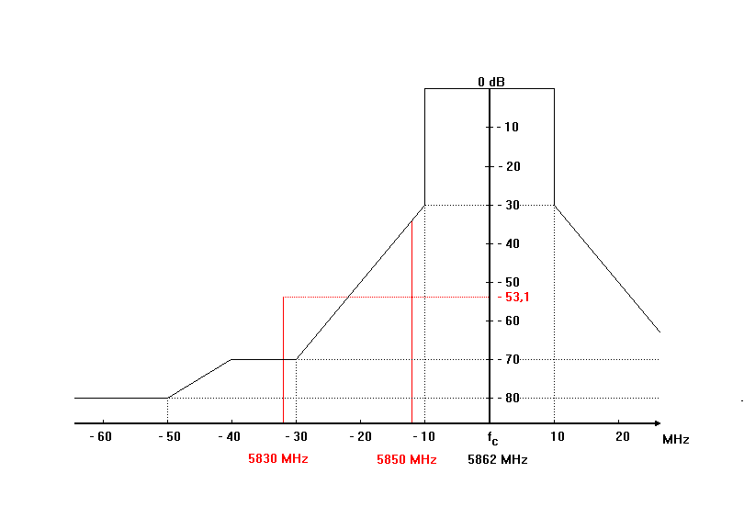

Figure 25: MBR operating on frequency 5862 MHz

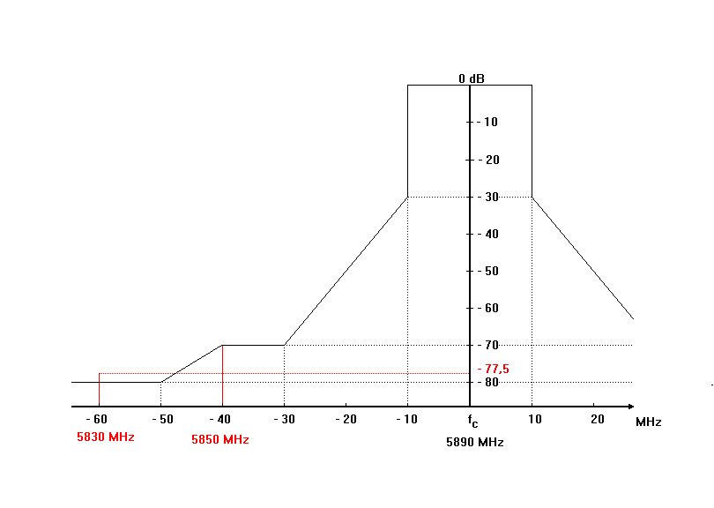

Figure 26: MBR operating at frequency 5890 MHz

#### Methodology

The desensitising effect on radars operated in this band from other services of a CW or noise-like type modulation is predictably related to its intensity. In any azimuth sectors in which such interference arrives, its power spectral density can simply be added to the power spectral density of the radar receiver thermal noise, to within a reasonable approximation. If power spectral density of radar-receiver noise in the absence of interference is denoted by N0 and that of noise-like interference by I0, the resultant effective noise power spectral density becomes simply I0 + N0. An increase of about 1 dB for the meteorological and radiolocation radars would constitute significant degradation. Such an increase corresponds to an (I+N) /N ratio of 1.26, or an I/N ratio of about -6 dB.

The effect of pulsed interference is more difficult to quantify and is strongly dependent on receiver/processor design and mode of operation. In particular, the differential processing gains for valid-target return, which is synchronously pulsed, and interference pulses, which are usually asynchronous, often have important effects on the impact of given levels of pulsed interference. Several different forms of performance degradation can be inflicted by such desensitisation. Assessing it will be an objective for analysis of interactions between specific radar types. In general, numerous features of radiodetermination radars can be expected to help suppress low-duty cycle pulsed interference, especially from a few isolated sources. Techniques for suppression of low-duty cycle pulsed interference are contained in Recommendation ITU-R M.1372: “Efficient use of the radio spectrum by radar stations in the radiodetermination service” [31].

The calculations presented are based on link budget analysis. The threshold is determined from a link budget analysis, assuming that this threshold must be reached when the radar can be interfered with by emissions of a MBR transmitter, that is, when the MBR signal at the radar receiver exceeds the radar tolerable interference level.

This method based on link budget is considered appropriate to study static cases which involve one MBR device and one radar. It is based on Recommendations ITU-R SM.337 [32] and ITU-R M.1461 [33].

This section provides results on separation distances according to the appropriate protection criterion for different kinds of radars presented in section 5.5.2.

The required protection range is estimated in two steps. First, the required propagation loss or attenuation is estimated with a link budget. The separation distance is then calculated. ITU-R P.452 [11] with an associated time percentage of 10% is used as propagation model in these simulations and, where required, a value of 3 dB is included to take into account polarisation losses between linear and circular polarisation.

The required propagation loss LFS is given by the following equation:

 (12)

where

*S = I/N* is the protection criterion for the radar (-6dB)

*e.i.r.p.* = e.i.r.p. of the MBR device in dBm in the radar passband

*Bradar* = the receiver bandwidth of the radar in MHz

*BMBR*= the MBR bandwidth in MHz

*Gradar* = the radar receiver antenna gain in dBi

*Lradar* = the radar receiver feeder loss in dB

*N* = the received noise on the radar in dBm.

#### Calculations

Table 23: Calculations of separation distances between MBR and radars (P452-10%)   
(MBR Maximum e.i.r.p.=32 dBW)

|  |  |  |  |  |
| --- | --- | --- | --- | --- |
| Characteristics | Unit | Radar 4 | Radar 5 | Radar 12 |
| Function |  | Instrumental | Instrumental | Radiolocation |
| Platform type |  | Ground | Ground | Shipborne |
| Receiver noise figure | dB | 11 | 5 | 4 |
| Receiver Noise | dBm/MHz | -103 | -109 | -110 |
| Protection criterion (I/N) | dB | -6 | -6 | -6 |
| Max. acceptable interference level | (dBm/MHz) | -109 | -115 | -116 |
| Antenna main beam gain | dBi | 46 | 42 | 25 |
| Polarisation losses | dB | 0 | 0 | 3 |
| Required propagation losses MBR  (5862 MHz) | dB | 149.9 | 152.9 | 133.9 |
| Required propagation losses MBR  (5890 MHz) | dB | 125.5 | 128.5 | 109.5 |
| Separation distances Main lobe/Main lobe (5862 MHz) | km | 130 | 180 | 21 |
| Separation distances Main lobe/Main lobe (5890 MHz) | km | 9 | 12 | 2 |

Table 24: Calculations of separation distances between MBR (LHC polarisation signal) and radars (P452-10%) (MBR Maximum e.i.r.p.=25 dBW)

|  |  |  |  |  |
| --- | --- | --- | --- | --- |
| Characteristics | Unit | Radar 4 | Radar 5 | Radar 12 |
| Function |  | Instrumental | Instrumental | Radiolocation |
| Platform type |  | Ground | Ground | Shipborne |
| Receiver noise figure | dB | 11 | 5 | 4 |
| Receiver Noise | dBm/MHz | -103 | -109 | -110 |
| Protection criterion (I/N) | dB | -6 | -6 | -6 |
| Max. acceptable interference level | (dBm/MHz) | -109 | -115 | -116 |
| Antenna main beam gain | dBi | 46 | 42 | 25 |
| Polarization losses | dB | 0 | 0 | 3 |
| Required propagation losses MBR  (5862 MHz) | dB | 142.9 | 145.9 | 126.9 |
| Required propagation losses MBR  (5890 MHz) | dB | 118.5 | 121.5 | 102.5 |
| Separation distances Main lobe/Main lobe (5862 MHz) | km | 60 | 80 | 11 |
| Separation distances Main lobe/Main lobe (5890 MHz) | km | 4 | 6 | 1 |

### Interference from radiolocation radar to MBR

#### Technical parameters

Radars and MBR do not operate in the same band and both MBR channels are in the spurious domain of the radar. According to the Radio Regulations [14], the spurious level from radio determination system shall be attenuated at least 43 + 10 log(P) or 60 dB, whichever is less stringent.

#### Methodology

The required attenuation between radar and MBR, is:

$L=P_{radar}-I$ (13)

where

*L* is the required attenuation (dB)

*Pradar* is the radar emission mean power in the MBR channel (dBm/MHz)

*I* is the maximum permissible interfering signal at the MBR receiving antenna (dBm/MHz)

Recommendation ITU-R P.452 with associated time percentage 10% is used as propagation model in these calculations.

#### Calculations

Table 25: Calculated attenuation for radar → MBR

|  |  |  |
| --- | --- | --- |
| Characteristics | Unit | Radar 12 |
| Required propagation attenuation | dB | 153.0 |
| Separation distances Main lobe/Main lobe | km | 180 |

#### Considerations

With the radar at the longest range, where the antenna rotating speed is slowest and may be 24 rotations per minute, the horizontal beam width of the radar radiation is between 0.4° and 1°.

At the slowest antenna rotation speed, an MBR receiver will be in the radiation angle of the radar for 7 ms every 2.5 second.

If the MBR link is pointing with off-axis angle above 22 degrees in the direction of the radar, the MBR antenna discrimination can be expected to be around 25 dB. The MBR antenna may point in any angle in the horizontal plane.

### Conclusions

The MBR antenna beam width for 10 dB attenuation is 16°, so when both the radar and the MBR are within the same range, there is 16/360 = 4.5 % probability that an MBR receiver is pointing towards a radar.

Outside the main beam and the side lobes of the MBR, the radiation is attenuated 25 dB. Additionally, the antenna nulling facility of the MBR may vary the minima and maxima of the side lobes in order to avoid certain directions. This antenna nulling facility may introduce an attenuation up to 25 dB.

When using Recommendation ITU-R P.452 [11] with an associated time percentage of 10% criterion, the studies show separation distance is up to 180 km between MBR and ground based radar and up to 21 km for shipborne radar when MBR maximum e.i.r.p.=32 dBW. Considering MBR maximum e.i.r.p.=25 dBW the protection distance from MBR transmitter to RLS receiver is up to 80 km for ground based radar and 11 km for shipborne radar.

To protect MBR receiver from RLS interference the protection distance of 180 km is required.

Only one type of radar was examined (shipborne radar with relatively low antenna gain of 25 dBi), so the calculated protection distance is not representative for ground based radars.

## Compatibility between MBR and FS

### General

The technical characteristics for FS receivers, relevant for sharing and compatibility studies, have been taken from Recommendations ITU-R F.758 [34], SF.1650 [10] and deployments in Europe.

Information on frequency arrangements for FS systems has been retrieved from EFIS, ERC/REC 14-01 [35], and ERC/REC 14-02 [36] and ECC/REC/(14)06 [37].

In this band FS stations are installed on both land and on board off-shore platforms for communications between platform to shore and platform to platform. These offshore FS stations are installed on platforms up to several hundred km out in the sea.

### Spectrum considerations for FS

According to EFIS, FS in Europe operate on frequencies above 5925 MHz, cf. ERC/REC 14-01: "Radio-frequency channel arrangements for high capacity analogue and digital radio-relay systems operating in the band 5925 to 6425 MHz" [35],



Figure 27: Occupied spectrum 5925-6425 MHz

ERC/REC 14-01 and ERC/REC 14-06 concern different frequency plans and different channel bandwidths, but all maintain the lower guard band of 5.375 MHz above the frequency 5925 MHz. ERC/REC 14-01 provides 8 x 29.65 MHz and 7 x 59.3 MHz channels. It is therefore assumed that the lowest high capacity FS channel with bandwidth 29.65 MHz is: 5930.375-5960.025 MHz, and with 59.3MHz bandwidth it is: 5930.375-5989.675 MHz.

### Spectrum considerations for MBR

MBR transmits in the bands 5852–5872 MHz and/or 5880–5900 MHz.

### Interference from MBR transmitter to FS receiver

#### Methodology

The methodology for calculating the interference from MBR transmitters to FS receivers (FSR) , is based on Recommendation ITU-R F.758-5: “System parameters and considerations in the development of criteria for sharing or compatibility between digital fixed wireless systems in the fixed service and systems in other services and other sources of interference” [34].

The recommendation notes the concepts of "long-term" and "short-term" interference and notes further that these concepts are not directly correlated with the “month” or “year” time basis. Both types of interference, depending on their time and level variability, may, in principle, affect the “error performance” (on a monthly basis), but only interference longer than 10 consecutive seconds may affect the “availability” (on a yearly basis) of FS systems.

When the interference into the FS victim is varying relatively fast, it is generally assumed that, due to uncorrelated wanted and unwanted paths, the acceptable interference level may be higher, so that the “error performance” degradation would predominate over the possible “availability” degradation. In this case, the “error performance” degradation study should be carried out on the “worst month” basis.

For long term interference from the intentional radiators that include unwanted emissions and radiations from adjacent bands, Recommendation ITU-R F.758 recommends I/N = -20 dB. This criterion is used in this study for long term interference analysis with FS.

The category of interference considered is emissions from systems other than those sharing the same band and may be considered in a similar way as unwanted emissions.

Once the interference criterion has been defined, the minimum permissible transmission loss is given by subtracting the FSR’s permissible interference power level from the MBR’s e.i.r.p. in the direction of the FSR and the FSR’s antenna gain. The level of interference falling into the FSR includes out-of-band attenuation of MBR and FSR receiver attenuation (net filter discrimination (NFD)) between MBR transmitting on 5890 MHz and 5862 MHz and FS receiving on 5945.2 MHz (29.65 MHz channels) and 5960.025 MHz (59.3 MHz channels). The minimum permissible transmission loss is therefore given by:

$L_{b}=P_{TxMBR}+G_{TxMBR}-NFD-L_{pol}+G_{FSRx}-F-I_{max}$ (14)

where

*Lb* : Minimum required basic transmission loss (dB)

*PTxMBR* : Maximum transmit power at the MBR antenna input flange (dBW)

*GTxMBR*: MBR antenna gain in the direction of the FS Rx (dBi)

*NFD*: Net Filter Discrimination between MBR Tx spectrum mask and FS Rx spectrum mask (dB)

*Lpol*: Polarisation loss (dB)

*GFSRx*: Gain of the FS Rx antenna (dBi)

*F*: Loss in the feed from FS Rx antenna to input amplifier (dB)

*Imax*: Maximum permissible interference power (dBW) at the receiver input.

#### Parameter values

The MBR may operate on the frequency 5862 MHz or 5890 MHz. For interference calculations with FS in the band above 5925 MHz, the highest MBR channel is the worst case. The output power spectrum mask for MBR transmitter operating on 5862 MHz and corresponding FSR receiving at 5945.2 MHz (29.65 MHz Channels) and 5960.025 MHz (59.3MHz channels) is shown in Figure 28 and Figure 29.

The NFD is derived taking into account the MBR transmit spectrum mask and the FS receiver mask (spectral efficiency class 5 (5HA)) derived based on guidance given in ETSI Harmonised EN 302 217 [38] and the NFD methodology given in ETSI TR 101 854 [39].

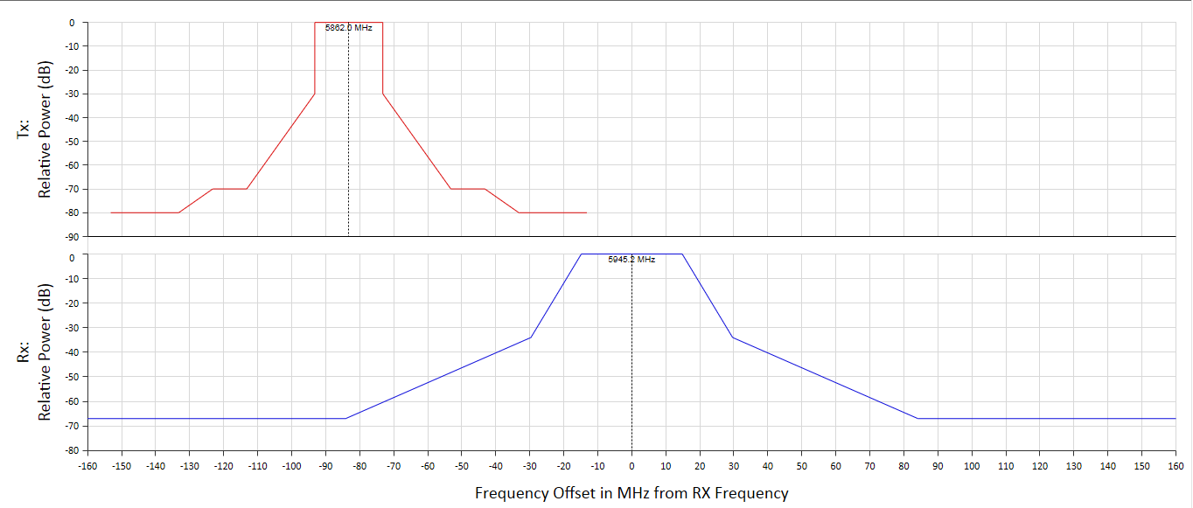

Figure 28: MBR Tx and FS Rx spectrum masks: MBR at 5862 MHz, FS at 5945.2 MHz for 29.65 MHz   
FS channels

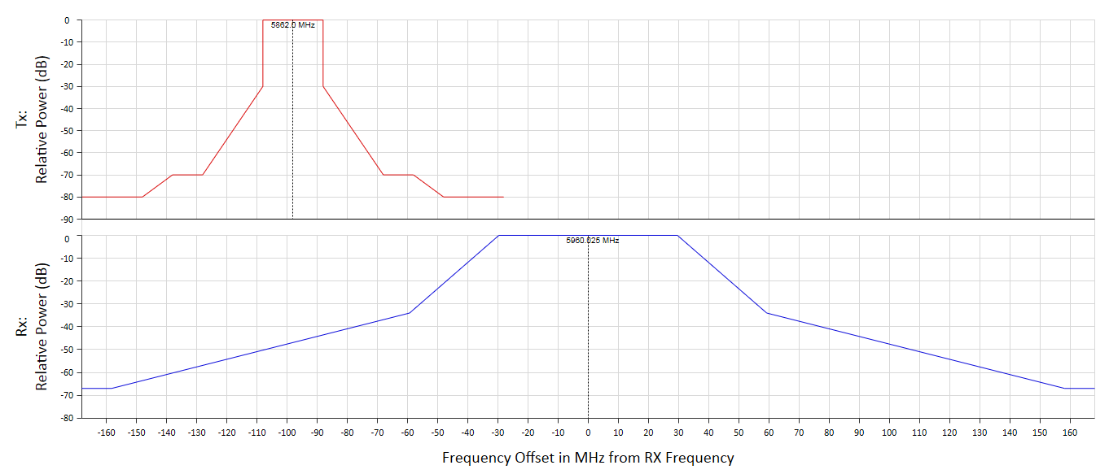

Figure 29: MBR Tx and FS Rx spectrum masks: MBR at 5862 MHz, FS at 5960.025 MHz for   
the 59.3 MHz FS channels

Table 26: MBR Transmitter and FS Receive NFD parameters

|  |  |  |
| --- | --- | --- |
| Parameter | Value | Comment |
| For MBR operating on 5890 MHz: the NFD | 48.2 dB for 29.65 MHz and 37.2 dB for 59.3MHz FS channels | Figure 29 |
| For MBR operating on 5 862 MHz: the NFD | 64.4 dB for 29.65 MHz FSR channels and 46.5 dB  for 59.3 MHz FS channels | Figure 28 |

Table 27: FS receiving technical parameters

|  |  |  |  |
| --- | --- | --- | --- |
| Parameter | Value for FS land station | Value for FS offshore station | Comment |
| Frequency of operation  (MHz) | 5 945.2, 5 960.025 | |  |
| Antenna height above ground,  hrg (m) | 70 | 47 |  |
| Ground height above mean sea level, hg (m) | 50 | 0 |  |
| Antenna height above mean sea level, hrs =  hg + hrg (m) | 120 | 47 |  |
| Channel spacing  (MHz) | 29.65, 59.3 | |  |
| Minimum feeder/multiplexer loss  (dB) | 3.3 | 1.6 |  |
| Antenna gain  (dBi) | 44 | 40 |  |
| Receiver noise bandwidth  (MHz) | 22.3 | |  |
| Receiver noise figure  (dB) | 4 | |  |
| Receiver noise power density  for 128-QAM (dBm/MHz) | -110 | |  |
| Nominal long-term interference threshold (dBm/MHz) for I/N = - 20 dB | - 130 | | not to be exceeded for more than 20 % of the time |
| Polarisation | Linear | |  |

#### Calculations

Calculations of the separation distance are based on propagation model in Recommendations ITU‑R P.452 [11]. The calculations are based on latitude 60°N with propagation over sea water and simulations were carried out to determine separation distances taking into account both 29.65 MHz and 59.3 MHz FS channels. In this analysis it is assumed that one MBR station is interfering with the FS receiver and the MBR is pointing towards the FS receiver. The average height of 50m above sea level was assumed for the MBR for all cases.

Table 28: Required separation distance for MBR, e.i.r.p. = 32 dBW

|  |  |  |
| --- | --- | --- |
| MBR channel | Protection distance to FS receiver (km) | |
| 5 880-5 900 MHz | 29.65 MHz FS channels | 59.3 MHz FS channels |
| 95 (land)  73 (offshore) | 103 (land)  79 (offshore) |
| 5 852-5 872 MHz | 74 (land)  69 (offshore) | 97 (land)  72 (offshore) |

Table 29: Required separation distance for MBR, e.i.r.p. = 25 dBW

|  |  |  |
| --- | --- | --- |
| MBR channel | Protection distance to FS receiver (km) | |
| 5 880-5 900 MHz | 29.65 MHz FS channels | 59.3 MHz FS channels |
| 83 (land)  67 (offshore) | 99 (land)  74 (offshore) |
| 5 852-5 872 MHz | 68 (land)  51 (offshore) | 85 (land)  65 (offshore) |

#### Aggregate MBR interference

During a coordinated off-shore activity, there may be several MBR links operating simultaneously on the same frequency within a time synchronised TDMA system and each link is given a dedicated time slot within the TMDA frame. This means that only one transmitter is operational at a time. Within an operational area, all transmitters will be pointing in different directions.

On one frequency, only one TDMA system can be operational in the same geographical area, or else mutual fatal interference will occur. An MBR channel may be reused at a distance longer than the interference protection area which basically is the line-of-sight. The line-of-sight for an MBR terminal is approximately   
50 km.

In special operations where a higher number of links are necessary, the other MBR channel may also be used.

During a coordinated off-shore operation, the MBR terminals may be located at any position within the area of operation, but it is highly unlikely that 2 links are pointing in the same direction, even if both MBR channels are used and it is additionally unlikely that these 2 transmitters operating in independent links should be so synchronised that similar time slots are used.

Therefore the probability of aggregated interference from two MBR stations on a FS receiver is considered negligible.

### Interference from FS transmitter to MBR receiver

#### Methodology

The minimum propagation loss, Lb (dB) is:

$L_{b}={e.i.r.p.}_{FS}-OoB-L_{pol}-{Int}_{MBR}$ (15)

where

e.i.r.p.*FS* = FS transmitter radiated power density (dBm/MHz)

*OoB* = Out-of-band attenuation (dB)

*Lpol* = Polarisation loss (dB)

*IntMBR* = Interference protection criteria for MBR receiver (dBm/MHz).

#### FS transmitter technical parameters

The lowest channel of operation for 29.65 MHz FS links is the channel 5930.375-5960.025 MHz (carrier 5945.2 MHz). The channel of 59.3 MHz was not considered.

The highest MBR channel is 5880–5900 MHz.

With reference to ECC Report 101 [12], the FS output power spectrum mask is indicated in Figure 30.

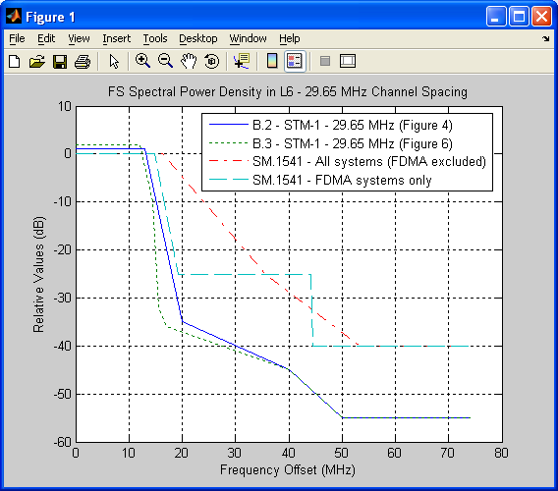

Figure 30: FS transmitter output power mask

The FS transmitting out-of-band emission are indicated in Figure 31.

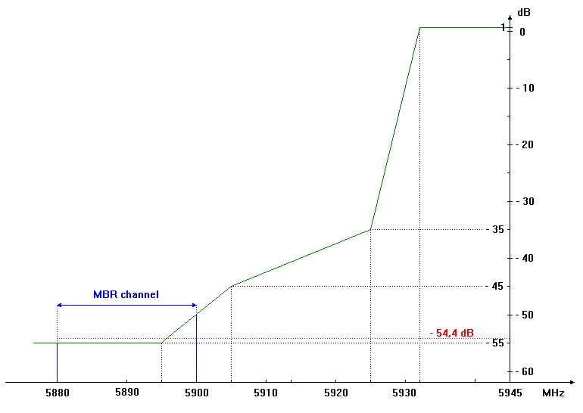

Figure 31: FS output power mask

Transmission from FS operating at frequency 5945.2 MHz the out-of-band attenuation towards MBR receivers in the band 5880-5900 MHz is 54.4 dB.

Towards MBR operating at the lower channel, 5852–5872 MHz, the out-of-band attenuation is 55 dB.

Table 30: FS transmitter technical parameters, cf. ECC Report 101 [12]

|  |  |  |
| --- | --- | --- |
| Parameter | Value | Comment |
| Frequency of operation  (MHz) | 5945.2 |  |
| Feeder loss  (dB) | 3.3 |  |
| Maximum transmitter output power (dBm) | 30 |  |
| Channel bandwidth  (MHz) | 29.65 |  |
| Maximum antenna gain  (dBi) | 45 |  |
| Maximum e.i.r.p. (dBm/MHz) in band 5 903.375 – 5 560.025 MHz | 57 |  |
| Out-of-band attenuation (dB) in the band in band 5 880 - 5 900 MHz | 54.4 | Figure 31 |

#### Calculations

Calculations of the corresponding distance are based on the propagation model in Recommendation ITU‑R P.452 [11]. The calculations are based on an FS transmitter located at the shore at latitude 60°N with propagation over sea water.

Table 31: Required separation distance

|  |  |  |  |
| --- | --- | --- | --- |
| MBR channel | Propagation attenuation  (dB) | Protection distance from the coast with FS transmitter at the coast (km) | Protecion distance from the coast with FS transmitter  25 km from the coast  (km) |
| 5 880-5 900 MHz | 129.6 | 13 | - |
| 5 852-5 872 MHz | 129.0 | 13 | - |

### Conclusions on Compatibility of MBR and FS above 5925 MHz

Fixed Services (point-to-point) in the 5925-6425 MHz band are deployed on land and off-shore platforms 100s of kilometres out in the sea. Large separation distances of up to 103 km would be required for land based fixed links and up to 79 km for off-shore fixed service links, when MBR maximum e.i.r.p.=32 dBW. Considering MBR maximum e.i.r.p.=25 dBW separation distances of up to 99 km would be required for land based fixed links and up to 74 km for off-shore fixed service links. Taking into account that there is extensive fixed link use in this band in Europe and new fixed links are being installed, including on off-shore platforms, compatibility with fixed links in particular on offshore platforms would prove challenging, requiring large exclusion zones as a result of multiple existing fixed links and new fixed link deployments in the sea, which is also the area being considered for operation of MBR.

To protect MBR receiver from FS station interference the protection distance of 13 km is required.

# Conclusions

This ECC Report addresses sharing and compatibility studies between Maritime Broadband Radiolink (MBR) in the frequency bands 5852-5872 MHz and 5880-5900 MHz and incumbent services / systems. MBR operates in TDMA mode on one frequency and the studies have included MBR operation on the carrier frequencies 5862 MHz and 5890 MHz.

MBR is a maritime mobile radio communication system providing broadband radio links between platforms and vessels as well as between vessels, engaged in coordinated off-shore activities. In this report, off-shore activities include exploration such as drilling and seismic operations and hydrographic operations such as mapping of the seabed.

The MBR system parameters are based on ETSI System Reference TR 103 109 v.1.1.1 [1]. However it should be noted that MBR terminals with linear vertical polarisation were not considered in this study.

Additional calculations were done for MBR systems with reduced maximum e.i.r.p. 25 dBW (7 dB reduction).

Sharing and compatibility studies were conducted between MBR and the following services/systems in the above mentioned bands as well as in adjacent and neighbouring bands:

* Broadband Fixed Wireless Access (BFWA);
* Fixed Satellite Service (Earth-to-space) (FSS), including earth stations located on board vessels (ESVs) above 5925 MHz;
* Intelligent Transport Systems / Road Transport and Traffic Telematics (ITS/RTTT);
* Radiolocation Systems (adjacent band compatibility);
* Fixed Services (FS) above 5925 MHz

The studies aim at defining the compatibility and sharing conditions between MBR terminals and equipment in the above mentioned services and systems.

The studies are based on Minimum Coupling Loss (MCL) calculations and further consideration at national/bilateral level may give shorter protection distances than those given in Table 1 and Table 2, taking into account specific deployments.

It was concluded that compatibility studies and interference analysis between MBR and SRD are not necessary due to specific uses of SRD in this frequency band (see 5.3).

Overview of the sharing conditions is shown in Table 1 and Table 2, further details can be found below.

General considerations on MBR implementation:

As mentioned in the SRdoc (ETSI TR 103 109 V1.1.1 [1]), operations of MBR in TDMA in one frequency do not allow simultaneous implementation of such a system by two different networks or two different MBR applications in the same area. Even when considering high levels of antenna discrimination, the minimum separation distance to operate two different MBR networks are an order of magnitude of several tens of kilometres. This implies the need to allocate two different frequency carriers to allow MBR operations for distinct maritime activities in close geographical areas.

In that framework, it must be anticipated that even with two potential frequencies allocated for MBR implementation, radiocommunication coordination between maritime operators, off-shore maritime companies and administrations (coast guard activities) will be necessary to avoid interference and network outages specifically when considering SIMOPS (Simultaneous operations) and real time data links which are likely to require a high level of availability.

Compatibility between MBR and BFWA:

Considering MBR Maximum e.i.r.p.=32 dBW, MBR transmitters will not exceed the interference criterion for BFWA receivers at distances above 118 km when BFWA is placed at the coastline. In the case when BFWA is used on off-shore platform MBR transmitters will not exceed the interference criterion for BFWA receivers at distances above 103.5 km.

Considering MBR Maximum e.i.r.p.=25 dBW, MBR transmitters will not exceed the interference criterion for BFWA receivers at distances above 112 km when BFWA is placed at the coastline. In the case when BFWA is used on off-shore platform MBR transmitters will not exceed the interference criterion for BFWA receivers at distances above 96 km.

BFWA transmitters will not exceed the interference criteria for MBR receivers at distances above 112 km. In the case when BFWA is used on off-shore platform BFWA transmitters will not exceed the interference criterion for MBR receiver at distance above 96.5 km.

Compatibility between MBR and GSO FSS (Earth-to-space) earth stations:

GSO FSS earth station transmitters will not exceed the interference criteria for MBR receivers at distances above 147 km. Practical earth station installations may give shorter protection distances taking into account a real terrain model.

Adjacent band compatibility between MBR and EVS above 5925 MHz:

The MBR receivers are in the spurious domain of ESV transmitters and will not be affected at distances greater than 1 km.

Coexistence with GSO FSS (Earth-to-space) space stations:

To assess impact of the MBR emissions on FSS space stations in shared frequencies, the ∆T/T method has been used. This approach is based on the concept that the noise temperature of a system subject to interference increases as the level of the interfering emission increases. In compliance with ITU-R S.1432 [4] provisions, a ∆T/T=6% criterion (systems having co-primary status) and ∆T/T=1% (all other sources of interference and generally applicable to interference from a non-primary service into FSS) has been considered.

It must be noted that in the studies, the ∆T/T criterion does not reflect any apportionment among potential source of interference which can occur in these frequency bands due to radiation from other applications (ITS from 5855 MHz to 5905 MHz and BFWA from 5725 MHz to 5875 MHz).

The studies highlight that there is a realistic probability and consistent scenarios for MBR systems (one station or aggregate radiations from side lobes) to interfere with FSS space stations, specifically when considering secondary allocation for MBR. Furthermore, the lack of information on MBR deployment (statistical or factual data on number of MBR stations) makes it difficult to draw objective conclusions or set any e.i.r.p. mask with the view to define acceptable sharing conditions.

Calculations of signal interference from MBR station to GSO FSS space stations showed that the ∆T/T protection criterion is not met both for 6% and 1% threshold, when MBR maximum e.i.r.p.=32 dBW. In case of reduction of MBR maximum e.i.r.p. to 25 dBW, the GSO FSS space stations ∆T/T protection criterion is met for 6% threshold and is not met for 1% threshold.

Calculation of aggregate interference from MBR station side lobes on GSO FSS space stations showed that only a limited number of MBR stations can transmit at the same time in different areas without causing harmful interference to GSO FSS space stations. The maximum number of such MBR stations is 4 for ∆T/T=6% threshold and 0 for ∆T/T=1% threshold, for MBR station maximum e.i.r.p.=32 dBW. In case of reduction of MBR station maximum e.i.r.p. to 25 dBW, the maximum number of such MBR stations is 23 for ∆T/T=6% threshold and 3 for ∆T/T=1% threshold.

Compatibility between MBR and ITS:

ITS transmitters will not interfere with MBR receivers at distances above 11 km from the coast.

For MBR coordinated activities further than 77 km off the coast, sharing between ITS and MBR seems feasible. For MBR transmitter antennas not directed towards the coastal line, interference to ITS receivers is not expected.

Compatibility between MBR and Radiolocation service in adjacent band:

The MBR antenna beam width for 10 dB attenuation is 16°, so when both the radar and the MBR are within the same range, there is 16/360 = 4.5% probability that an MBR receiver is pointing towards a radar.

Outside the main beam and the side lobes of the MBR, the radiation is attenuated 25 dB. Additionally, the antenna nulling facility of the MBR may vary the minima and maxima of the side lobes in order to avoid certain directions. This antenna nulling facility may introduce attenuation up to 25 dB.

When using Recommendation ITU-R P.452 [11] with an associated time percentage of 10% criterion, the studies show separation distance is up to 180 km between MBR and ground based radar and up to 21 km for shipborne radar when MBR maximum e.i.r.p.=32 dBW. Considering MBR maximum e.i.r.p.=25 dBW the protection distance from MBR transmitter to RLS receiver is up to 80 km for ground based radar and 11 km for shipborne radar.

To protect MBR receiver from RLS interference the protection distance of 180 km is required.

Only one type of radars was examined (shipborne radar with relatively low antenna gain of 25 dBi), so the calculated protection distance is not representative for ground based radars.

Adjacent band compatibility between MBR and fixed service above 5925 MHz:

Fixed Service (point-to-point) links in the 5925-6425 MHz band are deployed on land and on off-shore platforms 100s of kilometres out in the sea. Large separation distances of up to 103 km would be required for land based fixed links and up to 79 km for off-shore fixed service links, when MBR maximum e.i.r.p.=32 dBW. Considering MBR maximum e.i.r.p.=25 dBW separation distances of up to 99 km would be required for land based fixed links and up to 74 km for off-shore fixed service links. Taking into account that there is extensive fixed link use in this band in Europe and new fixed links are being installed, including on off-shore platforms, compatibility with fixed links in particular on offshore platforms would prove challenging, requiring large areas of exclusion zones as a result of multiple existing fixed links and new fixed link deployments in the sea, which is also the area being considered for operation of MBR.

To protect MBR receiver from FS station interference a protection distance of 13 km is required.

The practical regulatory implementation and enforcement challenges associated with such separation distances in particular for the fixed links on off-shore platforms out in the sea have not been studied in this report.

1. Extracts of Characteristics of radiolocation (except ground based meteorological radars) and aeronautical radionavigation radars (ITU-R M.1638)

|  |  |  |  |  |  |
| --- | --- | --- | --- | --- | --- |
| Characteristics | | Units | Radar 4 | Radar 5 | Radar 12 |
| Function | |  | Instrumentation | Instrumentation | Radiolocation |
| Platform type (airborne, shipborne, ground) | |  | Ground | Ground | Shipborne |
| Tuning range | | MHz | 5400-5900 | 5400-5900 | 5400-5900 |
| Modulation | |  | Pulse/chirp pulse | Chirp pulse | Coded Pulse |
| Tx power into antenna | | kW | 1 000 | 165 | 25 |
| Pulse width | | µs | 0.25-1 (unmodulated) 3.1-50 (chirp) | 100 | 0.32 |
| Pulse rise/fall time | | µs | 0.02-0.1 | 0.5 | .015/.035 |
| Pulse repetition rate | | pps | 20-1280 | 320 | 8000 |
| Chirp bandwidth | | MHz | 4.0 | 8.33 | N/A |
| RF emission bandwidth | –3 dB –20 dB | MHz | 0.9-3.6 6.4-18 | 4 12 20 at –40 dB | 4 12 20 at –40 dB |
| Antenna pattern type (pencil, fan, cosecant-squared, etc.) | |  | Pencil | Pencil | N/A |
| Antenna type (reflector, phased array, slotted array, etc.) | |  | Phased array | Phased array | Phased array |
| Antenna polarization | |  | Vertical/left-hand circular | Vertical/left-hand circular | Vertical |
| Antenna main beam gain | | dBi | 45.9 | 42 | 25 |
| Antenna elevation beamwidth | | degrees | 1.0 | 1.0 | 26 |
| Antenna azimuthal beamwidth | | degrees | 1.0 | 1.0 | 2 |
| Antenna horizontal scan rate | | degrees/s | N/A (Tracking) | N/A (Tracking) | N/A |
| Antenna horizontal scan type (continuous, random, 360°, sector, etc.) | | degrees | N/A (Tracking) | N/A (Tracking) | 360 |
| Antenna vertical scan rate | | degrees/s | N/A (Tracking) | N/A (Tracking) | N/A |
| Antenna vertical scan type (continuous, random, 360°, sector, etc.) | | degrees | N/A (Tracking) | N/A (Tracking) | Electronically Steered |
| Antenna side‑lobe (SL) levels (1st SLs and remote SLs) | | dB | –22 | –22 | N/A |
| Antenna height | | m | 20 | 20 | 30 |
| Receiver IF 3 dB bandwidth | | MHz | 2-8 | 8 | 7 |
| Receiver noise figure | | dB | 11 | 5 | 4 |
| Minimum discernable signal | | dBm | –107, –117 | –100 | –116 |

1. List of References
2. ETSI Technical Report TR 103 109 v.1.1.1: Broadband communication links for ships and fixed installations engaged in off-shore activities operating in the 5 GHz to 8 GHz range.
3. ECC Recommendation (06)04: Use of the band 5725-5875 MHz for Broadband Fixed Wireless Access (BFWA)
4. ECC Report 173: Fixed Service in Europe - Current use and future trends post 2011, March 2012
5. Recommendation ITU-R S.1432: Apportionment of the allowable error performance degradations to fixed-satellite service (FSS) hypothetical reference digital paths arising from time invariant interference for systems operating below 30 GHz
6. Recommendation ITU-R M.1638: Characteristics of and protection criteria for sharing studies for radiolocation, aeronautical radionavigation and meteorological radars operating in the frequency bands between 5 250 and 5 850 MHz
7. ERC Report 25: The European Table Of Frequency Allocations and Applications in the Frequency Range 8.3 KHz To 3000 GHz (ECA Table), June 2016
8. ECC Report 68: Compatibility studies in the band 5725-5875 MHz between Fixed Wireless Access (FWA) systems and other systems, June 2005
9. ECC Report 109: The aggregate impact from the proposed new systems (ITS, BBDR and BFWA) in the 5725-5925 MHz band on the other services/systems currently operating in this band, September 2007
10. ETSI TR 102 079:v1.1.2: System Reference Document for licence-exempt Fixed Wireless Access (HIPERMAN) for band C (5,725 GHz to 5,875 GHz)
11. Recommendation ITU-R SF.1650: The minimum distance from the baseline beyond which in-motion earth stations located on board vessels would not cause unacceptable interference to the terrestrial service in the bands 5 925-6 425 MHz and 14-14.5 GHz
12. Recommendation ITU-R  P.452: Prediction procedure for the evaluation of interference between stations on the surface of the Earth at frequencies above about 0.1 GHz
13. ECC Report 101: Compatibility studies in the band 5855– 5925 MHz between Intelligent Transport Systems (ITS) and other systems, Fenruary 2007
14. Recommendation ITU-R S.465: Reference earth-station radiation pattern for use in coordination and interference assessment in the frequency range from 2 to about 30 GHz
15. ITU Radio Regulations Edition of 2015
16. Recommendation ITU-R S.1432-1 "Apportionment of the allowable error performance degradations to fixed-satellite service (FSS) hypothetical reference digital paths arising from time invariant interference for systems operating below 30 GHz"
17. Recommendation ITU-R S.522: Allowable bit error ratios at the output of the hypothetical reference digital path for systems in the fixed-satellite service using pulse-code modulation for telephony
18. Recommendation ITU-R S.614: Allowable error performance for hypothetical reference digital path in the fixed-satellite service operating below 15 GHz when forming part of an international connection in an integrated services digital network
19. Recommendation ITU-R  S.1062: Allowable error performance for hypothetical reference digital path operating at or above the primary rate
20. Recommendation ITU-R S.1420: Performance for broadband integrated services digital network asynchronous transfer mode via satellite
21. Recommendation ITU-R SF.765: Intersection of radio-relay antenna beams with orbits used by space stations in the fixed-satellite service
22. ERC Recommendation 70-03: Relating to the use of Short Range Devices (SRD), May 2016
23. ETSI EN 302 372-1 v1.2.1: Equipment for Detection and Movement; Tanks Level Probing Radar (TLPR) operating in the frequency bands 5,8 GHz, 10 GHz, 25 GHz, 61 GHz and 77 GHz
24. ECC Decision (02)01: Frequency bands to be designated for the coordinated introduction of Road Transport and Traffic Telematic systems (RTTT)
25. ECC Report 244: Compatibility studies related to RLANs in the 5725-5925 MHz band, January 2016
26. ETSI EN 302 571 v1.1.1: Intelligent Transport Systems (ITS); Radiocommunications equipment operating in the 5 855 MHz to 5 925 MHz frequency band;
27. ETSI EN 302 663 v1.2.1: Intelligent Transport Systems (ITS); Vehicular Communications; GeoNetworking
28. Recommendation ITU-R F.1336: Reference radiation patterns of omnidirectional, sectoral and other antennas for the fixed and mobile service for use in sharing studies in the frequency range from 400 MHz to about 70 GHz
29. Recommendation ITU-R SM.329: Unwanted emissions in the spurious domain
30. ERC Recommendation 74-01: Unwanted Emissions in the Spurious Domain
31. SOLAS Convention: International Convention for the Safety of Life at Sea
32. Recommendation ITU-R M.1372 – Efficient use of the radio spectrum by radar stations in the radiodetermination service
33. Recommendation ITU-R SM.337: Frequency and distance separations
34. Recommendation ITU-R M.1461: Procedures for determining the potential for interference between radars operating in the radiodetermination service and systems in other services
35. Recommendation ITU-R F.758: System parameters and considerations in the development of criteria for sharing or compatibility between digital fixed wireless systems in the fixed service and systems in other services and other sources of interference
36. ERC Recommendation 14-01: Radio-frequency channel arrangements for high capacity analogue and digital radio-relay systems operating in the band 5925 to 6425 MHz, May 2015
37. ERC Recommendation 14-02: Radio-frequency channel arrangements for high, medium and low capacity digital fixed service systems operating in the band 6425 to 7125 MHz., September 2014
38. ECC Recommendation (14)06: Implementation of Fixed Service Point-to-Point narrow channels (3.5 MHz, 1.75 MHz, 0.5 MHz, 0.25 MHz, 0.025 MHz) in the guard bands and centre gaps of the lower 6 GHz (5925 to 6425 MHz) and upper 6 GHz (6425 to 7125 MHz) bands.
39. EN 302 217-2-1 v2.0.1: Fixed Radio Systems; Characteristics and requirements for point-to-point equipment and antennas; Part 2-1: System-dependent requirements for digital systems operating in frequency bands where frequency co-ordination is applied
40. ETSI TR 101 854 v1.3.1: Fixed Radio Systems; Point-to-point equipment; Derivation of receiver interference parameters useful for planning fixed service point-to-point systems operating different equipment classes and/or capacities
41. ETSI TR 101 127 v1.1.1: Transmission and Multiplexing (TM); Digital Radio Relay Systems (DRRS); Synchronous Digital Hierarchy (SDH); High capacity DRRS carrying SDH signals (1 x STM-1) in frequency bands with about 30 MHz channel spacing and using Co-Channel Dual Polarized (CCDP) operation

1. cf [www.marinetraffic.com](http://www.marinetraffic.com)
2. European Frequency Information System: [www.efis.dk](http://www.efis.dk)