ECC Report 241

Enhanced access to spectrum for FSS uncoordinated earth stations in the 17.7-19.7 GHz band
Approved 05 February 2016

Executive summary
The objective of this Report is to investigate possible options for enhanced operating conditions for uncoordinated FSS earth stations in the band 17-19.7 GHz and to study whether a regime of exemption from individual licensing could be developed within this band. Not all of the options may be available in some CEPT countries.
ECC Report 152[1] indicates the need for additional spectrum availability beyond the band 19.7-20.2 GHz to address FSS user uncoordinated terminals, and the requirement to address in particular traffic asymmetry (see chapter 5 of ECC Report 152).
This Report proposes that a clear identification for FSS uncoordinated use be introduced in ERC/DEC/(00)07 [2], together with provisions for exemption of individual licensing and free circulation. The FSS uncoordinated earth stations would remain unprotected for Fixed Service interference in the band 17.7-19.7 GHz.
CEPT technical studies as shown in ECC Report 232 [11] have shown that FSS earth stations deployed in very high FS density zone will be able to use more than 65% of the band at the worst location. In rural areas, 95% of the spectrum will be available at the worst location for the FSS earth stations. These results are marginally degraded when the considered FSS earth station is operating at low elevation. Therefore whenever an FSS earth station is interfered by a FS transmitter, there is sufficient available spectrum to reassign the FSS user to non-interfered frequencies in the long term.
Given the extensive use of the 17.7-19.7 GHz band by FS, the awareness of the deployment of the Fixed service is key for FSS system design and spectrum planning. This Report considers the benefits of using a set of possible methods including DCA (Dynamic Channel Assignment) and FS assignment information to determine spectrum suitable for FSS use on a local basis. For administrations not in a position to make available the relevant FS assignment information, the Report provides an approach by means of decentralised software to build FS interference awareness (or identification of FS white spaces) based on national FS assignment information. The proposed approach would safeguard FS information confidentiality. The proposed approach relies on proven technical development used by certain CEPT administrations for FS coordination and would not hinder future development of FS in this frequency band. Since the development, deployment and maintenance of such software represents a significant effort, it is suggested to implement a process to periodically analyse the extent to which FS information is made available by CEPT countries to identify any possible future needs for a software-based solution as described in §3.4.3.
As shown by a questionnaire (see Annex 1), the FS channelling arrangements of ERC/REC 12-03 [3] is widely implemented in CEPT, and this leaves about 40 MHz of unused spectrum in the FS duplex gap around 18.7 GHz in a large number of countries. This gap band could be used by FSS uncoordinated receiving earth station. It is proposed that administrations not making use of the duplex gap for FS promptly provide such information together with the boundaries of the duplex gap through EFIS. The same questionnaire showed that about half of the responding CEPT administrations make the use of Automatic Transmitter Power Control mandatory for fixed links. Given the interest of ATPC to enhance coexistence with FSS receive earth stations, it is recommended to maintain the current incentive for ATPC implementation and use.
It is expected that the above measures will promote frequency sharing in the band 17.7-19.7 GHz and will permit a wider use of FSS uncoordinated receive earth stations and associated satellite services and further enhance spectrum usage efficiency.

TABLE OF CONTENTS

0 Executive summary 2
1 Introduction 5
2 information on the use of fixed services in the band 17.7-19.7 ghz 6
3 Potential measures to enhance fss situation in 17.7-19.7 GHz band 9
3.1 Band segmentation and use of FS guard bands and duplex gap 9
3.1.1 Description 9
3.1.2 Discussion 9
3.2 Pre-coordinated areas 11
3.2.1 Description 11
3.2.2 Discussion 11
3.3 Dynamic interference avoidance 12
3.3.1 Description 12
3.3.2 Discussion 13
3.4 The use of FS assignment information 14
3.4.1 Description 14
3.4.2 Discussion 14
3.4.3 Functional description and requirements for a software approach for “FS white spaces”
(FS WS) which may be implemented by countries not providing FS assignment information: 16
3.4.4 Conclusions on the use of FS assignment information 18
3.5 Combination of methods to enhance provision of FSS service in the band 17.7-19.7 GHz on an uncoordinated and unprotected basis 19
4 regulatory considerations 20
4.1 Implementation of ERC/DEC/(00)07 20
4.2 Potential regulatory instruments for 17.7-19.7 GHz 21
4.3 Differences with the 10.7-11.7 GHz band situation 22
5 conclusion 23
ANNEX 1: Results of the questionnaire 24
ANNEX 2: INformation on the HCM agreement and associated software 37
ANNEX 3: Administrations publishing Fixed Service assignment information for the band 17.7-19.7 GHz 39
ANNEX 4: Information on the corasat EU FP7 project activities in relation to the 17.7-19.7 GHz band 40
ANNEX 5: List of reference 41

LIST OF ABBREVIATIONS

Abbreviation | Explanation
ARCEP | Autorité de Régulation des Communications Electroniques et des Postes (France)
ATPC | Automatic Transmitter Power Control
BSS | Broadcasting Satellite Service
CEPT | European Conference of Postal and Telecommunications Administrations
CoRaSat | COgnitiveRAdio for SATellite Communications; an European Commission 7th Framework Programme project funded under the ICT Call 8.
ECC | Electronic Communications Committee
DCA | Dynamic Channel Assignment
DLL | Dynamic Link Library
DVB | Digital Video Broadcasting
ECO | European Communications Office
EESS | Earth Exploration Satellite Service
EFIS | ECO Frequency Information System
e.i.r.p. | effective isotropically radiated power
ESOMPs | Earth Stations On-board Mobile Platforms
ETSI | European Telecommunications Standardisation Institute
EU | European Union
EU R&D FP7 | European Union Research&Development Framework Programme 7
FS | Fixed Service
FSS | Fixed Satellite Service
HCM | Harmonised Calculation Method
HCMFS | Harmonised Calculation Method Fixed Service
HEST | High e.i.r.p. Satellite Terminal
HTS | High Throughput Satellite
ITU | International Telecommunications Union
Ka | Ka-band is part of the K band of the microwave band of the electromagnetic spectrum (IEEE abbreviation)
LEST | Low e.i.r.p. Satellite Terminal
LSA | Licensed Shared Access
QoS | Quality of Service
R&D FP7 | Research & Development Framework Programme project # 7
RRS | Reconfigurable Radio Systems
SES | Satellite Earth Stations
SRS | Space Research Service
TC | Technical Committee
WS | White Space

Introduction
The objective of this Report is to investigate the options for enhanced operating conditions for uncoordinated FSS earth stations in the band 17-19.7 GHz and to study whether a regime of exemption from individual licensing could be developed within this band.
ECC Report 152 [1] highlighted that, with respect to decision ERC/DEC/(00)07 [2] (“Spectrum Designation Decision in the band 17.7-19.7 GHz”):
”In practice, this Decision means that uncoordinated FSS earth stations have a secondary status compared to the fixed service in the band 17.7-19.7 GHz and, as a consequence, have very limited possibilities to be deployed on a large scale in CEPT.
Using space-to-Earth spectrum available for end-user satellite terminals in addition to the exclusive FSS frequency bands (i.e. 19.7-20.2 GHz) would enable satellite operators to target a larger part of European households still beyond the range of terrestrial broadband networks or to offer them better throughputs (fast broadband).
However, under the above-mentioned conditions, the regulatory status of FSS earth stations in the band 17.7-19.7 GHz is considered not strong enough for an actual implementation in CEPT.”
ECC Report 152 indicates the need for additional spectrum availability (see chapter 3 of ECC Report 152), and the requirement to address traffic asymmetry (see chapter 5 of ECC Report 152). The asymmetry of spectrum needs for broadband access services requires more spectrum for downlink to the user segment (satellite to user terminals), than for uplinks (user terminals to satellite).
In the paired uplink band 27.5-29.5 GHz, the bands 27.5-27.8285 GHz, 28.4445-28.8365 GHz and 29.4525-29.5 GHz are identified for the use of uncoordinated FSS earth stations through ECC/DEC(05)01 [8]. This corresponds to a spectrum amount of 768 MHz. In addition, the band 28.8365-28.9485 GHz provides an additional 112 MHz. In this case, 880 MHz would be available for FSS uncoordinated uplinks, in addition to the existing 500 MHz in the band 29.5-30 GHz. In total, 1.38 GHz of spectrum could be available in Ka-band for uncoordinated uplinks.
Assuming that the 17.3-17.7 GHz band (400 MHz) becomes accessible for uncoordinated FSS downlinks, together with the already available 19.7-20.2 GHz band (500 MHz), there would still be a need for 480 MHz of uncoordinated FSS downlink spectrum in the band 17.7-19.7 GHz for fully symmetric spectrum. The additional requirement due to traffic asymmetry would also have to be accommodated in the band 17.7-19.7 GHz. Measures to ensure coexistence between uncoordinated FSS stations and FS systems are also investigated.
Regarding the sub-band 18.6-18.8 GHz, the protection requirements for the EESS and SRS passive services shall be met (see RR 5.522A and 21.16.2).This Report addresses FSS applications with earth stations at fixed locations, and does not consider the case of ESOMPs.
CEPT technical studies in ECC Report 232 [11] have shown that FSS earth stations deployed in very high FS density zone are able to use more than 65% of the band at the worst location. In rural areas, 95% of the spectrum is available at the worst location for the FSS earth stations. These results are marginally degraded when the simulated FSS earth station is operating at low elevation. Therefore, according to those CEPT studies, whenever an FSS earth station is interfered by a FS transmitter, there is sufficient available spectrum to reassign the FSS user to non-interfered frequencies.
Noting that the main business of the satellite operators will probably be located outside the most dense urban areas and also that the number of FS transmitters is related to the density of the population, the spectrum available today and in the future in those areas should in principle be higher than the result estimated by those CEPT studies in very high FS density areas. Therefore, spectrum availability for FSS earth stations in the band 17.7-19.7 GHz may be ensured in the long term.

information on the use of fixed services in the band 17.7-19.7 ghz
The FS channelling arrangements of ERC/REC 12-03 [3] for medium and high capacity systems are depicted below:

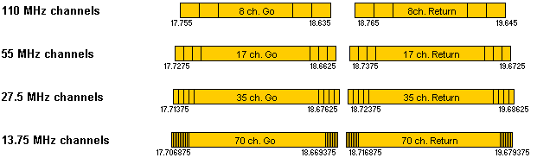
Figure 1: FS channeling arrangements of ERC/REC 12-03
ERC/REC 12-03 states that low capacity digital systems channel frequency arrangements may be accommodated, on a national basis, within any of the high capacity channels or guard band Recommendation ITU-R F.595-10 [4]. This is applicable to the 17.7-19.7 GHz band.
ECC Report 173 [5] provided further information:
- The number of FS links is about 90000 throughout CEPT, and this number is expected to grow significantly;
- The 17.7-19.7 GHz band is used not only in urban areas but also in sub-urban and rural areas.
- The channelling arrangements of ERC/REC 12-03 are widely implemented in CEPT;

ECC Report 173, section A.1.13 of Annex 1 provides the following information:
- Heavily used historical P-P FS band with about 90000 links appear on field in this range. 95% percentile of hop length indicated as “typical” is about 20 km (9.5 km for those indicated as “minimum”).
- The major utilisation is for high capacity links, with a comparable usage of medium and low capacity applications. Most links are individually licensed; majority is allocated to fixed and mobile infrastructure.
- The channel plan is based on the ERC/REC 12-03 for medium and high capacity; several national arrangements are used for low capacity.

Concerning the usage, significant increase expectations in next years are foreseen in about 21 countries, although a moderate situation of congestion is already reported.

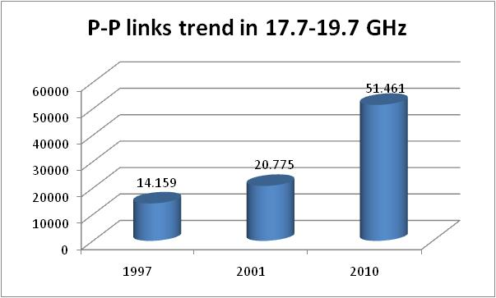
Figure 2: P-P links trend in 17.7-19.7 GHz
The spread sheet in Annex of ECC Report 173 [5] provides specific information by country:

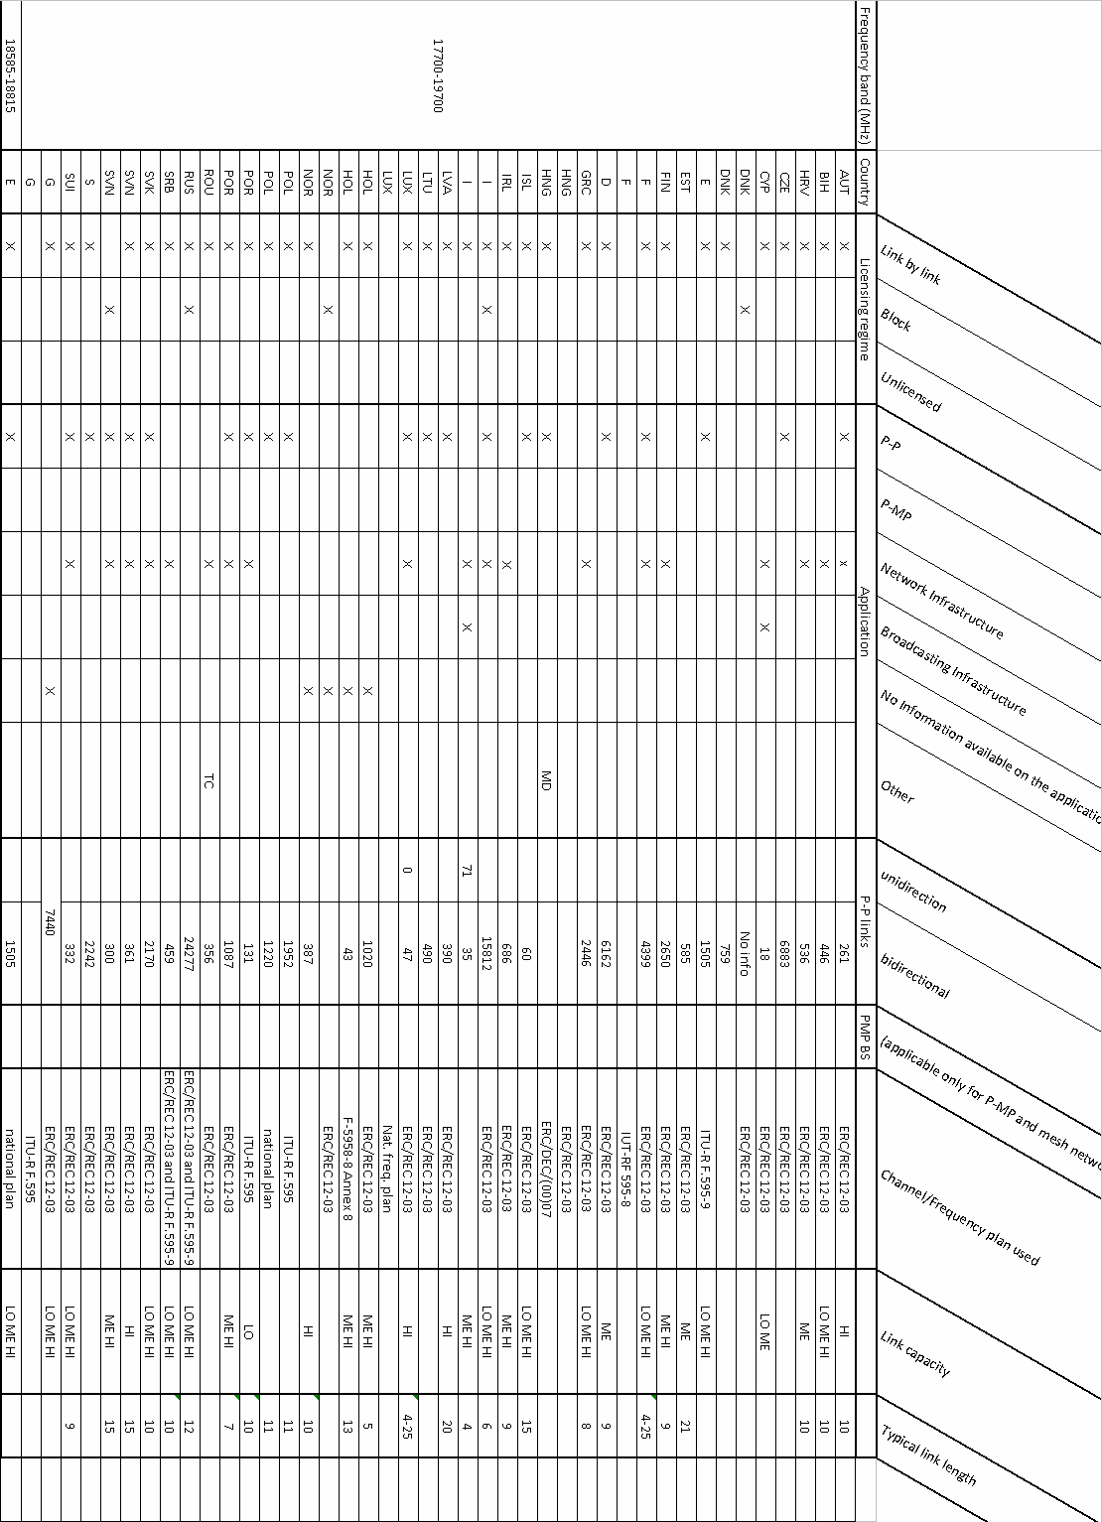
Figure 3: Country information

Potential measures to enhance fss situation in 17.7-19.7 GHz band
The following sections identify concepts for enhanced FSS operation in the 17.7-19.7 GHz band. According to specific situations, any of those concepts, or a combination of those might be implemented. For each case, advantages and disadvantages are identified.

Band segmentation and use of FS guard bands and duplex gap

Description
Under the band segmentation approach, certain portions of the band 17.7-19.7 GHz would be reserved for FSS exclusive use. The remainder of the 17.7-19.7 GHz would be used on a shared basis between uncoordinated FSS earth stations and the Fixed Service.

Discussion
Given the extent of use of the FS in the band 17.7-19.7 GHz, a practical band segmentation option on a large geographical scale would be to exploit the frequency band within or in the vicinity of the centre gaps of the FS channelling arrangements.
Centre gaps:
Table 1: Centre Gaps as in ERC/REC 12-03
Channel width (ERC/REC 12-03) | Centre gap width (MHz)
110 MHz | 130
55 MHz | 75
27.5 MHz | 47.5
13.75 MHz | 47.5

The centre gap width is much less than the spectrum requirements of FSS in 17.7-19.7 GHz discussed in section 2 above. However, it could provide access to some interference-free spectrum for FSS use in countries or areas where co-channel fixed links are not in operation or planned.
In certain countries different arrangements may be used with different duplex gaps according to ERC/REC 12-03 [3] (low capacity systems) and Recommendation ITU-R F.595-10 [4], which could make the use of such gaps by FSS uncoordinated stations difficult in practice in these countries.
ECC Report 173[5] indicate that most CEPT countries implement the FS channelling arrangements described in ERC/REC 12-03 and some implement national frequency arrangements.
ERC/REC 12-03 defines a duplex gap frequency band which use by FS might be limited across CEPT, and hence FSS receive earth stations might be able to operate within that duplex gap with less probability of being interfered by FS links. In order to precisely evaluate this situation, administrations were asked through a questionnaire to provide information about the duplex gap and its current and future usage.
ERC/DEC/(00)07 [2]refers to the implementation of automatic transmit power control (ATPC) by fixed links installed after 1st January 2003, information suggested that not all administrations currently require new fixed links to implement ATPC and information on this issue was also sought.
The detailed results of the questionnaire are provided in ANNEX 1:
It should be assumed that many countries (16) use only channel arrangements of ERC/REC 12-03, mainly 13.75 MHz, 27.5 MHz and 55 MHz channel arrangements, and for this the following minimum duplex gap without further guard bands can be assessed: 40.625 MHz from 18 676,25 MHz to 18 716,875 MHz. From frequency edge 18676.25 MHz to frequency edge 18723.75 MHz a minimum duplex gap width of 47.5 MHz is implemented, according to 27.5 MHz channel spacing (if 13.75 MHz channel arrangement is not implemented.
Among those countries having responded to the questionnaire, 26 countries in CEPT do not currently use nor plan to use the duplex gap. 4 countries have a partial usage, and 6 countries declare using the duplex gap, or having plans to do so.
Considering this situation, the FS duplex gap may be used in many areas by FSS receive earth stations without being interfered. It should be noted however that, due to its limited width compared to the reception bandwidth of a FSS receive earth station, the duplex gap does not constitute in itself a very significant spectrum resource, but might be considered as a safe spectrum when defining satellite frequency plans.
The table below summarises the advantages and disadvantages of the band segmentation approach, assuming the use of the duplex gap:
Table 2: Band Segmentation – Advantage and Disadvantages
Advantages | Disadvantages
- The FS duplex gap is a relatively harmonised band in CEPT.  - EFIS provides the required degree of information: FS duplex gap boundaries and FS use/non-use (if updated by administrations) | - Duplex gap is narrow, but still of interest to satellite operators

In consequence, a future evolution of the ECC/DEC/(00)07 [2] may contain a provision indicating that countries not having implemented FS in the duplex gap may be encouraged not do so in the future. This would provide an indication that on the long term this portion of spectrum may be used by FSS earth stations, as a “safe harbour” spectrum. However, to avoid constraints on FS deployment, administrations would only be required to provide information to ECO in this respect. The width of the duplex spectrum being dependent on the FS channelling implemented, administrations not using the duplex gap for FS should be mandated to provide through EFIS information on the duplex gap frequency boundaries relevant for their country. The ECO has implemented in the EFIS database a new section with FS implementation information from which one can see the available national implementation information for ERC/REC 12-03 [3] (see ECO Report 04 [12], especially http://www.efis.dk/recommendationMatrixViewer.jsp?sectionRowId=7).

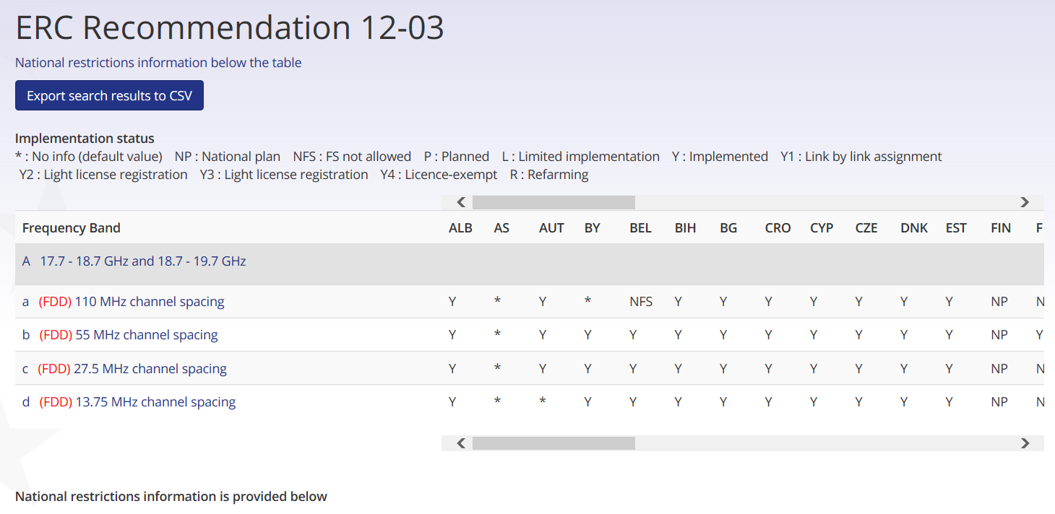
Figure 4: ERC/REC 12-03 implementation matrix in EFIS

Information on additional national channel arrangements as well as mixed national/international channel arrangement plans is also provided in EFIS.
This option would not be a constraint for the fixed service.

Pre-coordinated areas

Description
In urban areas, the 17.7-19.7 GHz range may be fully used by FS, or the prospect of reaching saturation is possible. While in more sparsely populated areas it is likely that the saturation will never be reached, even on the long term.
Regarding the FSS use of Ka-band: one of the major identified applications in ECC Report 152 [1] is broadband connectivity for users beyond the coverage of terrestrial services. Therefore, the areas where spectrum would be most needed for FSS would be those of less need for the FS. However, these rural areas may be where fibre deployments are less extensive and where new fixed links may be more likely to be deployed.
The concept of pre-coordinated areas consists in extending the principle of coordinated earth stations to wider geographical zones, and associated sub bands of 17.7-19.7 GHz, in which FSS earth stations could be deployed without further individual coordination. These zones would be located in less populated areas, and defined so that the spectrum remaining available for FS will cover its long term requirement.

Discussion
The pre-coordinated areas would have the advantage to give visibility on available spectrum for FSS use in certain zones.
This concept would restrict the frequency range in which new fixed links could be assigned, but provided that this remaining range is wide enough to accommodate the foreseeable FS growth in these less populated areas, FS would not suffer any capacity shortage.
One major expected difficulty is the definition of such zones and associated sub-bands. This definition would probably be done at the national level, since assignment for FS is a national matter and excluding licensed fixed links in favour of satellite receivers raises policy questions, such as spectrum pricing considerations. It is possible that in countries where block licensing applies, it may be difficult to identify such zones. Furthermore, this approach would have to address existing FS deployments which may be widespread geographically and over the whole band, by grandfathering existing FS links in those areas, or re-assigning them in other portions of the band 17.7-19.7 GHz.
Harmonisation is a desirable objective for FSS as regards:
- Sub-bands: these should be to the maximum extent possible similar throughout CEPT countries, and chosen to impact the least possible number of FS channels;
- Timing: pre-coordinated areas should be defined at the same time in all CEPT countries;
- Geographical extent: the concerned areas should represent a significant portion of the territory of each CEPT country interested by this approach.

The pre-coordinated areas concept would result in limiting a priori the frequencies accessible to FS in certain areas of less demand.
The table below summarises the advantages and disadvantages of the pre-coordinated area approach:

Table 3: Pre-coordinated areas – Advantage and Disadvantages
Advantages | Disadvantages
- Pre-coordinated bands and areas allows straightforward FSS protection  - FS spectrum needs are met in the long term | - FS Assignment flexibility would be restricted (although needs are met).  - Harmonisation of pre-coordinated bands may be difficult to achieve throughout CEPT.  - Other mitigation mechanisms will have to be developed anyway for non-pre-coordinated areas.  - Some workload for administrations to manage FS zoning

This option would constraint future flexibility of FS assignments in the country of administrations that want to implement it.

Dynamic interference avoidance

Description
Each FSS uncoordinated station would be capable to detect interference from sources located nearby, most likely FS but also potentially feeder stations for BSS in the lower part of the 17.7-19.7 GHz range. If the interference level is considered not acceptable, the FSS system assigns another channel to the user. This mechanism is known as DCA: Dynamic Channel Assignment.
Two types of DCA are identified:
- Permanent/Continuous DCA: From the commissioning and during the operations of an FSS terminal, an FSS system is able to assign and potentially modify the channel frequency allocated to the terminal, should that channel experience harmful interference, process which is repeated as many times as the evolving interference scenario requires;
- Protected DCA: At the commissioning of the FSS terminal, the FSS system is able to identify interference-free channels for that FSS terminal. From that point in time, that FSS earth station would receive regulatory protection from new FS links.

Discussion
In the case of permanent/continuous DCA, individual FSS terminals must be capable to feed-back information at the system level on interference level/QoS, so that reassignment can be made if necessary. Fall-back channels may be in the 17.7-19.7 GHz band, or in the exclusive band 19.7-20.2 GHz.
Compared to the “FS assignment database access” approach described below, the dynamic interference avoidance approach has the benefit that the assessment of the feasibility to operate is based on actual measurement of interference, avoiding the need for certain assumptions required to assess the possibility of interference in the database approach. For example, the actual propagation path between the FS station and FSS terminal could be obstructed by buildings or terrain features not otherwise predicted.
The dependence of the DCA efficiency on the density of deployment and spectrum usage by the FS should be studied.
In the case of protected DCA, FS links deployed after the newly commissioned FSS earth station would have to protect the FSS earth station. This earth station would be considered as a coordinated earth station. This concept would limit the deployment of new FS stations. Protected DCA will be a constraint for the fixed service.
The DCA concept in general is already identified among the mitigation techniques listed in Annex 2 of ERC/DEC/(00)07 [2].
The view was expressed that DCA may not work on the long term unless there was a freeze on deployment and licensing of new FS links in the relevant bands segments. If there is no freeze, eventually even if DCA works initially, it becomes progressively more constrained as time moves on an FS link numbers increase. This unpredictable situation is the justification for the “protected DCA” scheme.
The concept of protected DCA would limit the flexibility for frequency assignment to FS around the earth stations that are protected.
The ability of DCA to mitigate interference in the long term in areas of dense FS deployment and in the case of increase of the number of FS links is uncertain.
As regards the Protected-DCA scheme:
- The impact on FS could be minimised if the spectrum that is locally protected is limited to the spectrum effectively used by the receive earth station, i.e. a typical satellite carrier. However, such scenario limits the flexibility for the satellite operator to change or enlarge the frequency assigned to an individual user;

- An Earth-Station under protected DCA would need to be registered, for later protection.

An operational constraint on DCA was identified, given the way various Ka-band satellite systems currently provide operationally Ka-band capacity. When satellite capacity is used by distinct service providers, their Gateways in the system use different portions of the Ka-band to communicate with the users located in spot beams. In such situation, it is not practicable to hop FSS user terminal receive frequencies from one gateway to another serving the same Ka-band spot beam.
The CoRaSat EU R&D FP7 project investigates different sharing scenarios between satellites, and other terrestrial services or other satellite applications, using cognitive and database methods (see Annex 4). CoRaSat contributed to the development of an ETSI System Reference Document in ETSI TC SES for Cognitive solutions used by satellite services which is available under ETSI TR 103 263 [9].
The table below summarises the advantages and disadvantages of the dynamic interference avoidance method:

Table 4: Dynamic Interference Avoidance (DCA) – Advantage and Disadvantages
Advantages | Disadvantages
- No impact on FS current and future deployment  - No workload on administrations  - Spectrum efficiency: only those users effectively suffering interference would be reassigned a different frequency (take advantage of clutter losses not taken into account in a theoretical model).  - Greater flexibility to adapt to the changing environment due to the continuous deployment of the terrestrial FS networks | - Reactive approach to interference  - Some technical complexity

Continuous DCA would not be a constraint for the fixed service and should continue to be identified as a mitigation technique in the ERC/DEC/(00)07 [2].

The use of FS assignment information

Description
FSS operators would have access to information containing a list of characteristics of Fixed links assignments (eg. location, assigned frequencies, azimuth, e.i.r.p., dish size…). With that information, the FSS system configuration and channel allocation to FSS users could be made so as to anticipate and avoid interference into FSS earth stations.

Discussion
The use of geo-location databases, often in association with interference sensing, are often viewed as baseline techniques in cognitive radio systems. These techniques allow spectrum availability awareness, enabling licensing schemes such as LSA. In the context of the 17.7-19.7 GHz band for FSS, uncoordinated earth stations are operated in receive mode (no interference is generated by these stations on FS), and cannot claim protection from the Fixed Service. In that band, FSS uncoordinated earth stations operation is without impact on neighbouring FS stations, and therefore geo-located FS information would be used for the purpose of avoiding interference from the Fixed Service.
Specifically, the FS assignment information could be used:
- In FSS system design phases, as it would allow to accurately characterise FS interference in terms of geographical and spectral distribution, so that FSS system design could be optimised;
- During FSS system operation:
- The satellite system configuration may be adjusted (e.g. frequency used by each of the satellite beams, channel bandwidth adjustment)
- The assignment of FSS downlink frequencies to individual terminals could be optimised inside each beam.

An interference analysis software could be used in principle to conduct the above analyses, and identify the “Fixed Service white spaces” effectively usable by uncoordinated FSS earth stations, based on FS assignment information.
The availability of such information may depend on each country assignment policy for FS. For instance, where block assignment for FS is used, the detailed characteristics of individual Fixed Links may not be available. However, in the 17.7-19.7 GHz band, the link-by-link assignment method is implemented by almost all CEPT countries (see ECC Report 173 [5]), and therefore FS assignment information exists within administrations.
Depending on national circumstances, administrations may or may not be in a position to release FS assignment information, and this would impact the implementation of a FS white space analysis software.
- For administrations not in a position to release such FS characteristics, a software method to identify “FS white spaces” could be implemented at the administration premises. It permits to avoid requesting administrations to provide specific FS information.
- A software managed and used by FSS operators could process FS information made available by administrations without further involvement or actions required by administrations. The efficiency of this solution would depend on the content of the information and the number of administrations that would make it available.

Some CEPT countries may implement FS links whose existence and characteristics are classified. As this would concern a limited number of links, the absence of information on such links is considered as an acceptable risk for FSS and no specific measure would be needed.
For example, the CoRaSat EU R&D FP7 project investigates different sharing scenarios between satellites, and other terrestrial services or other satellite applications, using cognitive and database methods (see Annex 4). CoRaSat contributed to the development of an ETSI System Reference Document in ETSI TC SES for Cognitive solutions used by satellite services which is available under ETSI TR 103 263 [9]. This document has been used in the course of the development of this Report.
On the basis of the discussion above, the following high level concepts and requirements are identified :

- CEPT administrations generally maintain national FS assignment databases. As the format of such information differ for each administration, any software solution should take this into account;

- In countries where FS assignment information is or could be made publically available, FSS operators may use that information using their own tools to determine locally available spectrum for FSS use;
- This would not require further action from administrations as FSS operators would conduct the interference assessments with their own means;
- Some administrations highlighted that no liability on administrations should exist for the consequences of providing inaccurate FS assignment information;
- ECO may centralise the FS assignment information e.g. in the EFIS Right of Use section, without further action from administrations;
- In countries where FS assignment information could not be made publically available (for instance for confidentiality requirements), a commonly agreed software approach that would allow to determine locally available spectrum for FSS, without disclosing FS information may be implemented;
- Individual administrations may implement at their own discretion a software module to access national FS data, make interference calculations, and return information on the availability of spectrum for a specific location. Such module may be used by FSS operators/service providers from a web interface;
- In order to minimise the workload for administrations, the software system would have to be automated to the maximum extent possible;
- The ECO may host a list of hyperlinks to the national web-interfaces;
- It may be noted that some CEPT administration implement for their FS border coordination the HCM agreement. This agreement provides for predefined FS data format and programs to assess interference. The FS to FSS interference situation being technically similar to the FS to FS coordination, the technical approaches used by the HCM may be useful in this context (see Annex 2 for a summary description of the HCM framework);
- Implementation of software is subject to security regulations by each administrations.
- The FS assignments are relatively dynamic. FS information may be considered by FSS operators as exploitable if it were updated on a monthly basis for the purpose of deploying uncoordinated FSS earth stations.
- Such system should be of assistance to FSS uncoordinated earth station spectrum planning. The identification of available spectrum would give no right for protection from FS interference to these uncoordinated stations, even when taking into account future developments of the Fixed Service.

Functional description and requirements for a software approach for “FS white spaces”
(FS WS) which may be implemented by countries not providing FS assignment information:
Technically, the assessment of the interference from FS transmitters into FSS receiving earth stations is very similar to the calculation made under the HCM agreement between FS links. Therefore, it is feasible to envisage a software module able to provide the level of FS interference received by an FSS earth Station at a given location, in a defined frequency band, provided that the proper FS data can be used.
The FS WS software would be the same for all concerned administrations, and would be hosted and run on servers owned by each of these administrations. A web interface would allow users wishing to get information on available spectrum in the 17.7-19.7 GHz on the territory of an administration to submit requests, and get information on spectrum availability without having access to specific FS data.
The FS WS software would be able to retrieve the national FS information, if made available, to execute the necessary calculations.
A high-level diagram of the FS WS software implementation is provided below:
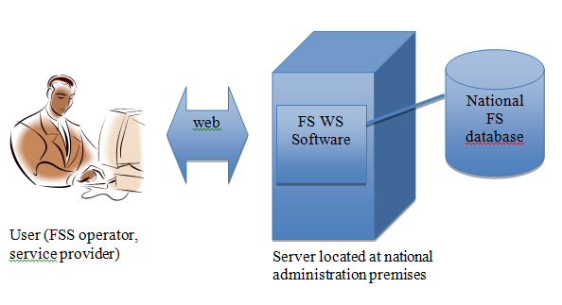
Figure 5: High level diagram of the FS WS software

With this architecture the requirements of administrations for preserving FS data confidentiality, and limited workload would be met through fully automated process.
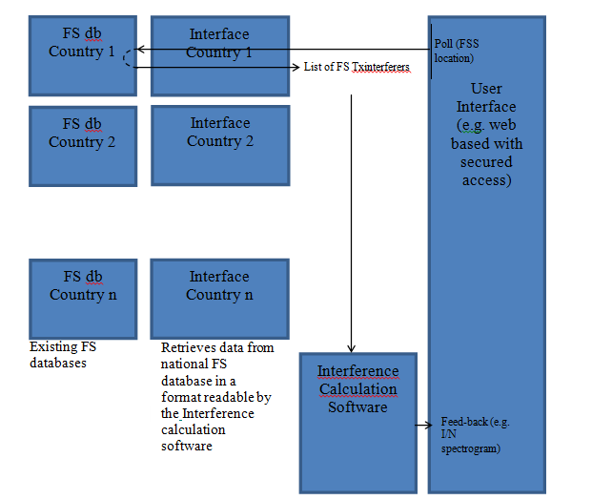
Figure 6: Detailed diagram

For the implementation of the FS WS software, the following requirements would apply:
- The FS database is in the native format currently used by the administration. This database is deemed to be maintained routinely up to date by the administration, independently from the FS WS software operation.
- The “Interface” module aims to get FS data from the database, and to convert it into a format that can be exploited by the Interference calculation software. Such format would be possibly as described in the Annex 2B of the HCM agreement.
- The “Interference Calculation Software” would fulfil the following three functions:
- Interacting with a web interface from which interference calculation would be requested.
- Managing calculations and configuration (e.g. paths to FS information files, sequencing requested calculations, constructing calculation reports). This can be compared functionally to the existing HCM CalcFiSH software.
- Doing interference calculations. The existing HCMFS_DLL library in the HCM software could be reused with minimal modifications.

This software module would be unique, i.e. all administration would run the same software version, as is the case for HCM.
- The web user interface: This interface could run on the administration website. This web interface would fulfil the following requirements:
- Provide a template to configure the calculations
- Inputs encompasses
- FSS earth stations information under a format closely derived from Annex 2B of the HCM agreement. Typically, this could be a list of FSS earth station locations with associated station characteristics:

- Height of antenna above ground
- Height of the station site above sea level
- Azimuth and elevation (or associated GSO orbital location)
- Antenna gain pattern
- Clutter losses per azimuth (if available)
- Frequency
- Geographical Coordinates
- Receiver selectivity mask
- Polarisation
- Receiver noise power level (FkTB)
- Calculation configuration: e.g. percentage of time for propagation calculations.
- Outputs: file (e.g. csv) containing spectrograms of a resolution typically of 1 MHz across the band 17.7-19.7 GHz of level of interference predicted.

The calculation results may be as described in the table below, depending on the information available to/from the FSS user:
Table 5: Calculation results
Input data from the user | Calculation results | Comment
Option1  Coordinates of the FSS victim station + pointing direction and antenna pattern | Spectrogram of FS interference across 17.7-19.7 GHz. | Permits identification of all possible frequencies for a given FSS terminal at a given location and pointing direction
Option 2  Coordinates of the FSS victim station + pointing direction + antenna pattern + interference threshold + desired FSS frequency assignment | OK / Not OK (above or below threshold –see below the table) | The deployment of an FSS network will necessitate a very large number of polls.  In this case a fully automated process is necessary.  The output could identify GREEN, YELLOW or RED location for FSS reception based on impact criteria, and provide suggestions about more favourable frequencies within the 2 GHz wide 17.7-19.7 GHz range.
Option 3  area of interest + pointing direction + antenna pattern + interference threshold + desired FSS frequency assignment | Mapping of available locations for the given frequency range | Allows visualising “FS white spaces” with a frequency granularity matching specific satellite systems frequency plans. This supposes that the software is able to handle a precise geographical resolution (of the order of 100m) which entail large calculation volumes

Conclusions on the use of FS assignment information
Two methods enabling the use of FS assignments information are envisaged. The first relies on the public availability of the relevant FS data, while the second method would rely on the implementation of software permitting the identification of the “FS white spaces” by those administrations not in a position to make the relevant FS information available.
Between the two methods, the first one requires less involvement for those administrations which already make the data available, and the FSS operators can conduct their own interference analyses according to their needs. It should be noted that certain administrations already publish FS assignment information (see Annex 3).
The second method requires software development (see Section 3.4.3), implementation and maintenance. The HCM example shows this is a feasible approach however there are associated costs and organisational issues, such as more involvement for administrations.
The first method is preferable from the perspective of FSS operators.
The table below summarises the advantages and disadvantages of the method based on the use of FS assignment information through dedicated software as described in Section 3.4.3:
Table 6: FS Information Access – Advantage and Disadvantages
Advantages | Disadvantages
- No impact on FS current and future deployment  - Established calculation models used for FS to FS coordination  - Allows efficient use of spectrum by FSS based on information made available by administrations. | - Connexion to national FS information to be established and deployment of a dedicated software, for administrations not in a position to release FS information.  - Depends on availability of FS information from administrations

It is noted that FS information may not be made available, or uniform in nature, across CEPT countries. Furthermore, software solutions to be implemented in administrations may be impractical due to security regulations of individual administrations.

Combination of methods to enhance provision of FSS service in the band 17.7-19.7 GHz on an uncoordinated and unprotected basis
Studies have demonstrated that extensive spectrum remains usable for reception by FSS uncoordinated earth stations in all locations, even in areas of dense FS deployment. To ensure FSS service to any specific user, the main requirement is for satellite systems to build awareness of local spectrum availability so that all users can be served.
All options investigated in the above sections contribute to this objective:
Band segmentation provides information on the long term use of the band, for example the FS duplex gap may be identified as a useful fall back spectrum for FSS users in many countries. Identifying portions of spectrum which may be used for FSS reception on the long term without significant risk of interference provides guidance for the design of satellite systems, e.g. for the definition of the frequency plan.
The approach based on FS assignment information also provides guidance on FS spectrum use and resulting availability for FSS, but on shorter time scales and on a very accurate geographical basis. FS assignment information allows to anticipate spectrum congestion at local and wider scales. If such information is regularly updated, individual FSS user assignment can be made by the operator.
Under the DCA approach, each terminal is able to evaluate its quality of service, and the satellite system can reassign a new channel as necessary in case of degradation due to interference. This is a “reactive” approach to interference situations which implies that the satellite system implements an adequate frequency plan. In this sense, the use of FS assignment information and the DCA approaches are complementary.

regulatory considerations

Implementation of ERC/DEC/(00)07
The status of implementation of ERC/DEC/(00)07 [2] with CEPT, and the allocation of the band 17.7-19.7 GHz in CEPT countries is summarised in table below (see the ECO web page for most recent information):
Table 7: Implementation of ERC/DEC/(00)07
Country | FSS (space-to-Earth) allocation in 17.7-19.7 GHz - Source EFIS | Implementation of ERC/DEC/(00)07
Albania | Yes | Yes
Andorra | - | No info
Austria | Yes | Yes
Azerbaijan | - | No info
Belarus | Yes | Under study
Belgium | None | Yes
Bosnia and Herzegovina | Yes | Yes
Bulgaria | Yes | Yes
Vatican City | - | No info
Croatia | Yes | Yes
Cyprus | Yes | Yes
Czech Republic | Yes | Yes
Denmark | Yes | Yes
Estonia | Yes | Yes
Finland | Yes | Yes
France | Yes | Yes
Georgia | Yes | Yes
Germany | Yes | Yes
Greece | Yes | Yes
Hungary | Yes | Yes
Iceland | Yes | Yes
Ireland | Yes | Yes
Italy | Yes | Yes
Latvia | Yes | Yes
Liechtenstein | Yes | Yes
Lithuania | Yes | Yes
Luxembourg | Yes | Yes
Macedonia | Yes | Yes
Malta | Yes | Yes
Moldova | Yes | Yes
Monaco | - | No info
Montenegro | None | Yes
Netherlands | 18.4-19.7 GHz only | Yes
Norway | None | Yes
Poland | Yes | Yes
Portugal | Yes | Yes
Romania | Yes | Yes
Russian Federation | Yes | Yes
San Marino | - | No info
Serbia | Yes | Yes
Slovakia | 17.7-18.1 GHz only | Yes
Slovenia | Yes | Yes
Spain | Yes | Yes
Sweden | Yes | Yes
Switzerland | Yes | Yes
Turkey | Yes | Yes
United Kingdom | Yes | Yes
Ukraine | Yes | Planned

The Decision ERC/DEC/(00)07 [2] is widely implemented in the CEPT. This is consistent with the widespread use of the band 17.7-19.7 GHz by the Fixed Service within CEPT.

Potential regulatory instruments for 17.7-19.7 GHz
The ERC/DEC/(00)07 [2] stipulates that uncoordinated earth stations shall operate on an unprotected basis, and requires both FS and FSS systems to implement interference mitigation measures. These technical mitigation measures are appropriate to protect FS, but the current regime is not sufficient to enable FSS uncoordinated stations to be massively deployed in the 17.7-19.7 GHz band, as there is uncertainty to provide FSS services in the band 17.7-19.7 GHz.
A Decision making spectrum available for uncoordinated FSS earth stations in the 17.7-19.7 GHz would therefore be necessary, as the current decision does not explicitly make this identification. It has been noted that in some countries, receivers are not subject to authorisation, and therefore the appropriateness of an ECC Decision for individual license exemption is questionable in those countries, in particular if those FSS receivers are unprotected. However, the Decisions ECC/DEC/(06)02 [6] and ECC/DEC/(06)03 [7] (LEST and HEST), encompass both uplinks and downlink bands: 29.5-30 GHz and 19.7-20.2 GHz, hence FSS receive earth stations are also addressed .A clear identification of the band 17.7-19.7 GHz for uncoordinated FSS earth stations is desirable in a updated version ERC/DEC/(00)07 [2]. This should be accompanied by provisions for individual licence exemption and free circulation of such uncoordinated earth stations.
Taking into account the methods discussed in section 3, the following regulatory provisions may be considered in an ECC Decision as appropriate:
- Band segmentation and use of FS guard bands and duplex gap: Administrations not using the duplex gap to promptly indicate so, and to inform about the boundaries of the duplex gap in their country, using EFIS.
- Use of FS assignment information:
- Using FS assignment information, where available, as a mitigation technique.
- Specify the desirable FS parameters required to conduct interference analysis with FSS uncoordinated receive earth stations.
- A process to periodically analyse the extent to which FS information is made available by CEPT Administrations to identify any possible future needs for a software-based solution as described in §3.4.3

The DCA technique is already identified in the current ERC/DEC/(00)07 and should continue to be promoted, but not as a sole solution.

Differences with the 10.7-11.7 GHz band situation
In the course of the development of this Report, the parallel was made between the sharing situation between terrestrial and satellite services in the Ku band, and the situation in the Ka-band studied in this Report.
A similar regulatory situation exists in the band 10.7-12.5 GHz with the widespread deployment of uncoordinated FSS and BSS receive earth stations. Some CEPT administrations decided to discontinue the FS development in 10.7-11.7 GHz to avoid interference problems with the FSS service.
That situation resulted from the fact that Ku band FSS/BSS subscribers could have their service disrupted because of a fixed link being installed in the vicinity.
While there are some parallels with the situation in the band 10.7-11.7 GHz, there are also some relevant differences. The band 10.7-11.7 GHz is extensively used throughout Europe for TV receive-only applications. Users of TV receive only systems typically require reception of emissions in a very large band (e.g. 1 GHz or more) and interference even on only a smaller range of frequencies could lead to certain TV channels being unavailable and hence be considered an unacceptable situation by the users. TV channels are transmitted on pre-determined central frequencies. In contrast, the band 17.7-19.7 GHz is planned to be used mostly for telecommunication services, in particular for broadband Internet access. For this and similar applications, the occurrence of interference on some frequencies can be overcome if other frequencies are available to accommodate the users traffic requirement within the band 17.7-19.7 GHz, and in the adjacent bands 19.7-20.2 GHz and 17.3-17.7 GHz. In this case, the user will be entirely unaware of interference being received on some frequencies, since service continuity can be ensured. The solutions investigated in chapter 3 aim precisely to avoid service disruptions for FSS end-users, under a wide spread and evolving FS environment.

conclusion
It is foreseen that Ka-band satellite systems, such as High Throughput Satellite systems (HTS), will make an extensive use of the Ka-band FSS allocations. The band 17.7-19.7 GHz represents a very significant portion of spectrum supplementing the FSS exclusive downlink spectrum 19.7-20.2 GHz. This Report investigates potential measures to enhance the access and use of the band 17.7-19.7 GHz band by FSS uncoordinated receive earth stations, while avoiding constraints in current and future development of the Fixed Service in this band. These measures supplements those already identified in ERC/DEC/(00)07 [2].
The current regulatory framework lacks a clear identification at CEPT level for use of the band 17.7-19.7 GHz by FSS uncoordinated earth stations. Therefore, the Report proposes that provisions for such identification be introduced in ERC/DEC/(00)07, together with provisions for exemption of individual licensing and free circulation. The FSS uncoordinated earth stations would remain unprotected for Fixed Service interference in the band 17.7-19.7 GHz.
Given the extensive use of the 17.7-19.7 GHz band by FS, the awareness of the deployment of the Fixed service is key for FSS system design and spectrum planning. This Report considers the benefits of using a set of possible methods including DCA (Dynamic Channel Assignment) and FS assignment information to determine spectrum suitable for FSS use on a local basis. For administrations not in a position to make available the relevant FS assignment information, the Report provides an approach by means of decentralised software to build FS interference awareness (or identification of FS white spaces) based on national FS assignment information. The proposed approach would safeguard FS information confidentiality. The proposed approach relies on proven technical development used by certain CEPT administrations for FS coordination and would not hinder future development of FS in this frequency band. Since the development, deployment and maintenance of such software represents a significant effort, it is suggested to implement a process to periodically analyse the extent to which FS information is made available by CEPT countries to identify any possible future needs for a software-based solution as described in §3.4.3.
As shown by a questionnaire (see Annex 1), the FS channelling arrangements of ERC/REC 12-03 [3] is widely implemented in CEPT, and this leaves about 40 MHz of unused spectrum in the FS duplex gap around 18.7 GHz in a large number of countries. This gap band could be used by FSS uncoordinated receiving earth station. It is proposed that administrations not making use of the duplex gap for FS promptly provide such information together with the boundaries of the duplex gap through EFIS. The same questionnaire showed that about half of the responding CEPT administrations make the use of Automatic Transmitter Power Control mandatory for Fixed links. Given the interest of ATPC to enhance coexistence with FSS receive earth stations, it is recommended to maintain the current incentive for ATPC implementation and use.
It is expected that the above measures will promote frequency sharing in the band 17.7-19.7 GHz and will permit a wider use of FSS uncoordinated receive earth stations and associated satellite services and further enhance spectrum usage efficiency.

- Results of the questionnaire

Table 8: A total of 36 countries (in bold) have provided an answer to the questionnaire (in bold)
Country name | Country name
Albania | Lithuania
Andorra | Luxembourg
Austria | Former Yugoslavian Republic of Macedonia (FYROM)
Azerbaijan | Malta
Belarus | Monaco
Belgium | Montenegro
Bosnia Herzegovina | Moldova
Bulgaria | Norway
Croatia | Poland
Cyprus | Portugal
Czech Republic | Romania
Denmark | Russian Federation
Estonia | San Marino
Finland | Serbia
France | Slovak Republic
Georgia | Slovenia
Germany | Spain
Greece | Sweden
Hungary | Switzerland
Iceland | The Netherlands
Ireland | The United Kingdom
Italy | Turkey
Latvia | Ukraine
Liechtenstein | Vatican City

Question 1

If your administration implements the channelling arrangements of ERC/REC 12-03, where the associated duplex gap width depends on the width of the FS channels being implemented, what is the minimum duplex gap size in your country? (Normally corresponding to the smaller FS channel width).
Table 9: Duplex Gap Size
Country | Duplex Gap Size
Austria | From frequency edge 18676.25 MHz to frequency edge 18723.75 MHz a minimum duplex gap width of 47.5 MHz is implemented, according to 27.5 MHz channel spacing.
Belarus | Duplex gap is implemented according to ERC/REC 12-03.
Belgium | Channels width of 13.75, 27.5 and 55 MHz are allowed. The resulting duplex gap without guard band is 40.625 MHz (see calculation under Norway).
Bosnia Herzegovina | The channel arrangements of ERC/REC 12-03 are implemented, in addition, it is theoretically possible to assign the narrowest channel of 3.5 MHz, 278 channels in total. In such a case the duplex gap 40.5 MHz.  In all practical assignments, there has not been a duplex gap narrower than 61.25 MHz (where the bandwidth was 13.75 MHz, as per the ERC/REC 12-03).
Croatia | Uses ERC/REC 12-03 channelling arrangements and smallest channel arrangement of 6.875 MHz. Minimal duplex gap size is 47.5 MHz (in 6.875, 13.75 and 27.5 MHz channel raster’s), but the edges of innermost channels defer from channel raster to channel raster. So, innermost channel edge from the lower sub band is at 18676.25 MHz (in 27.5 MHz channel raster), and innermost channel edge from the upper sub band is at 18713.4375 MHz (in 6.875 MHz channel raster). The “unused part” of the duplex gap is 37.1875 MHz wide.
Cyprus | Implements all 4 channel arrangements of REC 12-03, therefore the smallest duplex gap is indeed 40.625 MHz.
Czech Republic | The duplex gap ranges from 18.665 MHz to 18.7375 GHz. The minimum duplex gap size is 0.0725 GHz (i.e. 72.5 MHz). There are the radio channels which are placed inside the gap.
Denmark | Duplex gap without guard band is 40.625 MHz – Centre gap starts for 13.75 MHz channel plan on 18716.875 MHz. Centre gap stop with channel plan 27.5 MHz on 18676.25 MHz. Duplex gap = 18716.875 MHz – 18 676.25 MHz = 40.625 MHz. The combination results in the smallest duplex gap.
Estonia | Duplex gap: 40.625 MHz/ ch. arr.13,75 MHz and ch. arr. 27.5 MHz
France | For the 55 MHz channel arrangement, France is fully implementing the ERC/REC 12-03 arrangement. For the 27.5 MHz and the 13.75 MHz channel arrangements an offset of 13.75 MHz and 20.625 MHz respectively is applied in comparison to ERC/REC 12 03.  Conclusions on the minimal duplex gap (see question 2 for national plan details) :  - 47.5 MHz in Metropolitan France (18 690-18 737.5 MHz) corresponding to the 13.75 MHz channel plan,  - 27.5 MHz in overseas territories (18 688.8-18 716.3 MHz) corresponding to the 7.5 MHz channel plan.
Finland | ITU-R F.595 incorporated, modified to go along with the ERC/REC 12-03 in part of the band.  The channel arrangement in question is such that there in the lower part of the band on the upper band edge are 5 MHz channels according to the modified F.595, band edge at 18685 MHz; in the upper part of the band on the lower band edge are 55 MHz channels according to the ERC/REC12-03, band edge at 18737.5 MHz. Thus the duplex gap is 52.5 MHz.
Georgia | ERC/REC 12-03 channelling arrangements not formally implemented.  Duplex Gap 75 MHz for 27.5 MHz ch.arrangement.
Germany | Germany uses the 13.75 MHz, 27.5 MHz and 55 MHz channel arrangements of ERC/REC 12-03.  The minimum duplex gap is 40.625 MHz (combined at 13.75 MHz and 27.5 MHz channel arrangements).
Greece | Greece implements the channelling arrangements of ERC/REC 12-03, allowing the use of bi-directional digital links in the 17.7-19.7 GHz band with various FS channels’ width (1.75/ 3.5/ 7/ 13.75/ 27.5/ 55 MHz).  The minimum duplex gap size in Greece is 31.75 MHz corresponding to FS channel width of  1.75 MHz.
Hungary | In Hungary, systems with 27.5 MHz and 55 MHz carrier spacing can be used, according to the channel arrangements included in ERC/REC 12-03.  Hence the minimum duplex gap size is 47.5 MHz (according to the 27.5 MHz carrier spacing).
Iceland | Duplex gap: 40.625 MHz / ch. arr.13,75 MHz and ch. arr. 27.5 MHz (all ch. Arr. Used).
Italy | The existing duplex gap in Italy is 36.75 MHz (from 18676.25 to 18713.00 MHz).  18676.25 MHz is the upper band edge of the channel f35 of the 27.5 MHz channel raster.  18713.00 MHz is the lower band edge of the channel f'1 of the 1.75 and 3.5 MHz channel raster.
Ireland | ComReg has implemented the channelling arrangements of ERC/REC 12-03.  The 27.5 MHz raster is currently the smallest channel plan available.  The minimum duplex centre gap size in the 17.7 – 19.7 GHz band is 47.5 MHz.
Latvia | Our administration implements the channelling arrangements of ERC/REC 12-03.  For systems with carrier spacing of 55 MHz; associated duplex gap is 75 MHz.  For systems with carrier spacing of 27.5 MHz; associated duplex gap is 47.5 MHz.  For systems with carrier spacing of 13.75 MHz; associated duplex gap is 47.5 MHz.
Lithuania | Duplex gap: 40.625 MHz / ch. arr.13,75 MHz and 27.5 MHz
Luxembourg | All channelling arrangements of ERC/REC 12-03, i.e. 40.625 MHz.
Moldova | In the Republic of Moldova ERC/REC 12-03 is implemented and the minimum channel width is 27.5 MHz (at the moment used by fixed systems in operation).
Montenegro | Duplex gap: 40.625 MHz / ch. arr.13,75 MHz and 27.5 MHz
Netherlands | NL has implemented ERC/REC 12-03 together with channel plans for 3.5 and 7 MHz.  The duplex gap size is the difference between the highest frequency in the lower and the first in the upper part of the 18 GHz band.  The highest frequency with the smallest channel for a 3.5 MHz raster is channel number 85 (17998.700 MHz). This frequency is not involved in calculating the duplex gap.  The highest frequency with a 13.75 MHz raster is channel number 70 at 18662.500 MHz (A) in the lower band.  The start frequency for a 3.5 MHz raster in the upper band is 18714.750 MHz (D).  In order to calculate the gap the channel edges should be taken into account.  B = A + 13,75/2 = 18669.3875 MHz  C = D – 3,5/2 = 18713 MHz  The gap is C – B = 43,625 MHz
Norway | Duplex gap without guard band is 40.625 MHz – Centre gap starts for 13.75 MHz channel plan on 18716.875 MHz. Centre gap stop with channel plan 27.5 MHz on 18676.25 MHz. Duplex gap = 18716.875 MHz – 18 676.25 MHz = 40.625 MHz  The combination results in the smallest duplex gap.
Portugal | Portugal has implemented the following channel arrangements according to the Annex A of the Recommendation ERC/REC 12-03 (where fo =18700 MHz is the centre of the 17.7-19.7 GHz frequency band):  i) Systems with a carrier spacing of 55 MHz:  lower half of the band: fn = fo - 1000 + 55 x n  upper half of the band: fn’ = fo + 10 + 55 x n  where n = 1, … 17  ii) Systems with a carrier spacing of 27.5 MHz:  lower half of the band: fn = fo - 1000 + 27.5 x n  upper half of the band: fn’ = fo + 10 + 27.5 x n  where n = 1, … 35  iii) Systems with a carrier spacing of 13.75 MHz:  lower half of the band: fn = fo - 1000 + 13.75 x n  upper half of the band: fn’ = fo + 10 + 13.75 x n  where n = 1, … 70  The minimum duplex gap is 40.625 MHz (combining 13.75 MHz and 27.5 MHz channel arrangements).
Russian Federation | According to the Decision of the Russian State Radio Frequency Commission №07-21-02-001 of 25.06.2007, frequency plans for radio relay stations operating in the frequency band 17.7-19.7 GHz shall comply with the Recommendation ITU-R F.595-10.  Note: this includes 3.5 MHz and 7.0 MHz channel raster’s. But in practice such plans are not used.
Slovak Republic | 58,75 MHz  For medium and high capacity (ch.s. 27.5 MHz, 13.75 MHz and 55 MHz) according  ERC/REC 12–03.
Slovenia | Duplex gap: 40.625 MHz / ch. arr.13,75 MHz and 27.5 MHz
Spain | The Spanish Administration uses the radio frequency channel arrangements of the Recommendation ERC/REC 12-03. In the case of systems with carrier spacing of 13.75 MHz, the value allowed for “n” goes from 65 to 68.  Finally, the use of five bidirectional channels of 7 MHz is allowed too (see Question 2). Therefore the occupied band by the fixed service is 17713.75-18677 MHz paired with 18723.75-19687 MHz Consequently, the “duplex gap” is 46.75 MHz.  The following graphs show the complete radio frequency channel arrangements for 27.5 MHz, 55 MHz and 110 MHz.
Sweden | The channelling arrangements in accordance with ERC/REC 12-03 are implemented with the channel spacing’s 13.75 MHz, 27.5 MHz and 55 MHz.  The channel spacing of 6.875 MHz is also implemented in accordance with a Swedish channelling arrangement.  The minimum duplex gap size is between CH35 using 27.5 MHz channel bandwidth (band edge 18662.5+27.5 MHz) and CH1’ using 6.875 MHz channel bandwidth (band edge 18716.875-6.875/2 MHz).  The minimum duplex gap size is thus 37.188 MHz.
Switzerland and also Liechtenstein | Duplex gap: 18676.250 to 18716.875 MHz (40.625 MHz)
Ukraine | In Ukraine, the fixed service systems with capacity 280, 140, 70, 34, 16, 8 and 4 Мbit/s and channel bandwidth 220 MHz, 110 MHz, 55 MHz, 27,5 MHz, 13,7 MHz, 7,5 MHz and 5 MHz, respectively, are used in the frequency range 17,7-19,7 MHz.  The minimum duplex gap size is 20 MHz (for the cannels with emission bandwidth 5 MHz).
United Kingdom | There are a number of channel arrangements in use within the 17.7 – 19.7GHz band in the UK that include channel arrangements given in ERC/REC 12-03. The channel arrangements additional to those given in ERC/REC 12-03 also make use of the duplex gap given in ERC/REC12-03.  The details of channel arrangements in use are given below;  • 13.75 MHz, 27.5 MHz, 55 MHz and 110 MHz channel raster’s are in accordance with the arrangements set out in ERC/REC 12-03  • 3.5 MHz and 7.0 MHz channel raster’s are in accordance with the arrangements set out in Annex 3 to Recommendation ITU-R F.595.  • There are also other national/legacy channel arrangements in use including 7, 10, 20 and 55 MHz, which range from 17.7275 GHz to 19.5075 GHz.
Turkey | ERC/REC 12-03 E is implemented, and according to this recommendation, the gap between upper edge of transmitting frequency and the lower edge of receiving frequency (the duplex gap) is 47.5 MHz (between 18669.375 MHz and 18716.875 MHz when channel width is 13.75 MHz).

It should be assumed that many countries (16) use only channel arrangements of ERC/REC 12-03, mainly 13.75 MHz, 27.5 MHz and 55 MHz channel arrangements, and for this the following minimum duplex gap without further guard bands can be assessed: 40.625 MHz from 18 676,25 MHz to 18 716,875 MHz. From frequency edge 18676.25 MHz to frequency edge 18723.75 MHz a minimum duplex gap width of 47.5 MHz is implemented, according to 27.5 MHz channel spacing (if 13.75 MHz channel arrangement is not implemented.

Question 2
In ECC Report 173 [5], some administrations refer to "national plans" for the channelling arrangements implemented in lieu or in addition to ERC/REC 12-03. Does your administration implement a different plan than ERC/REC 12-03, and if this is the case, please describe such frequency plan?

22 countries have implementations with differences to ERC/REC 12-03 [3]. 14 countries have not.
Table 10: National Plans
Country | National Plans
Belarus | We are implementing the national plan for the channelling arrangements with the frequency spacing of 1,25 MHz in the frequency sub-bands of used equipment taking in account the necessary interchannel spacing (normally this spacing may be 13,75MHz; 27,5 MHz; 55 MHz).
Bosnia Herzegovina | For bandwidths less than 13.75 MHz, channel arrangement from Recommendation ITU-R F.595, Annex 5, rec 6 and formulas are applied:  7 MHz: fn=fo-997+7n, f’n=fo+13+7n, n=1, 2, 3,.....138  3.5 MHz: fn=fo-998.75+3.5n, f’n=fo+11.25+3.5n, n=1,2,3,.....278
Croatia | Yes, ERC/REC 12-03 channel plan is used with additional 6.875 MHz raster. Frequencies (MHz) of individual channels in that frequency raster are expressed by following relationship:  f0 = 18700  fn = f0 – 1000 + 6.875*n  fn’ = f0 + 10 + 6.875*n  n = 1….140  There are also some small adjustments in centre frequencies of 6.875 MHz frequency raster within operators block assignments but these adjustments don’t affect duplex gap in any way since those block assignments fall in middle part of the channel raster.
Czech Republic | The actual radio frequency channel arrangements are based on ERC/REC 12-03 and ITU-R Rec. F.595-9. The duplex gap is occupied by the radio channels with centre frequencies 18 705 MHz, 18 715 MHz, 18 725 MHz, 18 735 MHz and with the bandwidth of 10 MHz.  In addition, 7.5 MHz and 5 MHz channel arrangements are foreseen in  URL: http://www.ctu.eu/164/download/Measures/General_Nature/RSUP/CZE_RSUP-P-17-02-2010-03_eng.pdf
Finland | See answer to question 1, 5 MHz channel arrangements also incorporated.
France | French Metropolitan area (ARCEP decision n°03-1115)  70 channels of 13.75 MHz within:  - 17 727.5 MHz – 18 690 MHz,  - 18 737.5 MHz – 19 700 MHz,  - an +20.625 MHz offset in comparison to the ECC Recommendation.  35 channels of 27,5 MHz within:  - 17 727.5 MHz – 18 690 MHz,  - 18 737.5 MHz – 19 700 MHz,  - an +13.75 MHz offset in comparison to the ECC Recommendation.  17 channels of 55 MHz within:  - 17 741.25 MHz – 18 648.75 MHz,  - 18 751.25 MHz – 19 658.75 MHz,  - no offset in comparison to the ECC Recommendation.  French oversea territory (ARCEP decision n°05-0174)  As metropolitan France with an added channel plan from recommendation UIT-R F.595 (annex 4).  131 channels of 7.5 MHz within:  - 17 706.3 MHz – 18 688.8 MHz,  - 18 716.3 MHz – 19 698.8 MHz.
Georgia | In Georgia channelling arrangements are implemented in accordance with “national plan” in some cases with a little excursion from channel distribution described in ERC/REC12-03.
Greece | 1.75/ 3.5/ 7 MHz channel arrangements also implemented.
Italy | High and medium capacity fixed links  In Italy the channel arrangement in the 17.7-19.7 GHz band is compliant with ERC/REC 12-03 for high and medium capacity links (55 MHz, 27.5 MHz and 13.75 MHz).  Low capacity fixed links  In Italy we have adopted a national channel plan for law capacity fixed links with a channel raster of 7, 3.5 and 1.75 MHz in accordance to ERC/REC 12-03 as included in ITU-R F.596, Annex.  Low capacity links occupy hay capacity links and guard bands starting from the lower band edge of the band (17.7 GHz).  The channel raster is, with channel raster of 7, 3.5 and 1.75 MHz as follows:  The national plan provides  (fo = 18700 MHz)  a) channel raster of 7 MHz:  fn = fo – 1000 + 3 + 7 * n  fn’ = fo + 10 + 3 + 7 * n  where n = 1, …, 33  b) channel raster of di 3,5 MHz:  fn = fo – 1000 + 1,25 + 3,5 * n  fn’ = fo + 10 + 1,25 + 3,5 * n  where n = 1, …, 68  c) channel raster of 1,75 MHz:  fn = fo – 1000 + 2,125 + 1,75 * n  fn’ = fo+10 + 2,125 + 1,75 * n  where n = 1, …, 136  There are still in use links using a 2 MHz channel raster derived as follows:  d) channel raster of 2 MHz:  fn = fo – 1000 – 1 + 2 * n  fn’ = fo + 10 – 1 + 2 * n  where n = 1, …, 16
Latvia | National frequency plan also allows the use of systems with carrier spacing of 7 MHz in these channels.
Moldova | ERC/REC 12-03 and ITU-R F.595 is implemented and the minimum channel width is 27.5 MHz
Montenegro | Yes, first two channels from ERC/REC 12-03 channel plan for FS channel width 55 MHz are allocated for low capacity links (7 and 3.5 MHz FS channel width).  Channel Arrangement  a. for systems with a carrier spacing of 7 MHz:  lower half of the band: fn = fo - 1000 + 7 n  upper half of the band: fn’ = fo 10 + 7 n where n = 1, … 18  b. for systems with a carrier spacing of 3.5 MHz:  lower half of the band: fn = fo - 1000 + 3.5 n  upper half of the band: fn’ = fo 10 + 3.5 n where n = 1, … 38  f0 =18700 MHz
Netherlands | NL has implemented ERC/DEC 12-03 together with channel plans for 3,5 and 7 MHz (see under question 1)
Portugal | In addition Portugal has implemented the following channel arrangements according with the Recommendation ITU-R F.595-10 (where fo =18700 MHz is the centre of the 17.7-19.7 GHz frequency band):  iv) Annex 4 of the Recommendation ITU-R F.595-10  Systems with a carrier spacing of 7.5 MHz:  lower half of the band: fn = fo – 997.5 + 7.5 x n  upper half of the band: fn’ = fo + 12.5 + 7.5 x n  where n = 1, … 131  v) Annex 5 of the Recommendation ITU-R F.595-10  Systems with a carrier spacing of 3.5 MHz:  lower half of the band: fn = fo – 998.75 + 3.5 x n  upper half of the band: fn’ = fo + 11.25 + 3.5 x n  where n = 1, … 37  The minimum duplex gap is 24.125 MHz (combining 7.5 MHz and 3.5 MHz channel arrangements).
Russian Federation | According to the Decision of the Russian State Radio Frequency Commission №07-21-02-001 of 25.06.2007, channel bandwidth different from the specified in the ERC/REC 12-03 is allowed. But in practice such plans are not used.
Slovak Republic | For low capacity (ch.s. 5 MHz and 7.5 MHz) according ITU-R F.595-6, Annex 4, Figures 8c, 8d.
Spain | The Spanish radio frequency channel arrangements include 5 bidirectional channels of 7 MHz of spacing in the range of 18642-18677 MHz paired with 19652-19687 MHz.  The following graph show these channels as well as those previously mentioned with spacing of 13,75 MHz:
Sweden | The channel spacing 6.875 MHz is implemented in accordance with a Swedish channelling Arrangement:  - Channel 1, 17706.875/18716.875 MHz  - ......  - Channel 141, 18669.375/19679.375 MHz  The 17.7-19.7 GHz frequency band is heavily used for mobile backhaul and DVB-T/DVB-T2 distribution in Sweden. This frequency band has approximately 17% of all individually licenced microwave radio links in the frequency band 6-38 GHz.  The frequency band 17.7-19.7 GHz is shared between FS, earth stations and the Swedish Defence.  The earth stations are located in at the geographical sites of Stockholm/Kaknäs, Stockholm/Tegeluddsvägen, Farsta/Ågesta and Kiruna/Esrange with the following sub band;  - 17300-18150 MHz  The above defined sub band can be used for FS outside the above defined geographical areas (given an exclusion zone outside the sites).  Until the end of year 2016 the Swedish defence have exclusive allocation of the following sub bands;  - 17968.125-18043.750 MHz  - 18978.750-19053.750 MHz  - 18647-18700 MHz
Switzerland and also Liechtenstein | Channel centre frequencies according to:  7.5 MHz channelling:  ITU-R Rec. F.595, Annex 4,  (from 17743.750 MHz to 17796.250 MHz / 18753.750 MHz to 18806.250 MHz)  27.50 MHz channelling  ERC/REC 12-03, Annex A  (from 17796.250 MHz to 18676.250 MHz / 18806.250 MHz to 19686.250 MHz  13.75 MHz channelling (INTERLEAVED).  ERC/REC 12-03, Annex A  (from 17885.625 MHz to 17954.375 MHz / 18895.625 MHz to 18964.375 MHz  13.75 MHz channelling SUBDIVISION  ERC/REC 12-03, Annex A (SUBDIVISION of 27.5 MHz Channels).  (from 17961.250 MHz to 18676.250 MHz / 18971.250 MHz to 19686.250 MHz
Ukraine | In Ukraine, along with the channelling arrangement plans which are determined by ERC/REC 12-03, channelling arrangement plans for fixed service systems with low capacity and channel bandwidths 7.5 MHz and 5 MHz are implemented, in compliance with the Recommendation ITU-R F.595 (Annex 4). In this case the minimum duplex gap size is 20 MHz (for the cannels with emission bandwidth 5 MHz).
United Kingdom | 3.5 MHz and 7.0 MHz channel raster’s are in accordance with the arrangements set out in Annex 3 to ITU-R Recommendation F.595.  There are also other national/legacy channel arrangements in use including 7, 10, 20 and 55 MHz, which range from 17.7275 GHz to 19.5075 GHz.

Question 3
Is there any current or planned use of the duplex gap for FS in your country?
Table 11: Current or planned FS use in duplex gap
Current or planned FS use in duplex gap? | Countries
No (26) | Austria, Belgium, Bosnia Herzegovina, Croatia, Cyprus, Denmark, Estonia, Finland, France, Germany, Greece, Hungary, Iceland, Ireland, Latvia, Liechtenstein, Lithuania, Luxembourg, Montenegro, Netherlands, Norway, Portugal, Slovak Republic, Slovenia, Switzerland, Turkey
Yes, in some parts (4) | Belarus, Georgia, Italy, Spain
Country | Description
Georgia | Some parts of FS duplex gap are currently used by fixed link systems with specific technical characteristics.
Italy | Part of the duplex gap has been used for the national channel plan for low capacity links, as explained in question 2.
Spain | There are some old-established radio links with spacing of 10 MHz in the band 18585-18695 MHz paired with 18705-18815 MHz. The following graph shows the channelling. Currently, this kind of authorizations is not issued any more.
Belarus | Currently the 18690-18710 MHz frequency band is not used by FS systems and is not planned to use by FS in future.
Yes (6) | Czech Republic, Moldova, Russian Federation, Sweden, United Kingdom, Ukraine
Country | Description
Czech Republic | Information on the channels placed in the duplex gap includes Article 5(4) of Part No. PV-P/17/02.2010-3 of the Radio Spectrum Utilisation Plan for the frequency band 15.35–21.2 GHz. The Czech Telecommunication Office does not plan different use at this moment.  URL: http://www.ctu.eu/164/download/Measures/General_Nature/RSUP/  CZE_RSUP-P-17-02-2010-03_eng.pdf
Moldova | Yes, it is currently used.
Russian Federation | Yes, it is currently used.
Sweden | Usage of duplex gap is under consideration for all FS frequency bands. Actual investigation will start before end of year 2013.
Ukraine | Yes
United Kingdom | See answer question 1.

Figure 7: Current or planned use of the duplex gap for FS

Question 4
Is use of ATPC on fixed link assignments (in the range 17.7-19.7 GHz) in your country mandatory or not after 1 January 2003?

Table 12: Mandatory ATPC
Mandatory | Countries
Yes (17) | Austria, Bosnia Herzegovina, Czech Republic, Estonia, Finland, Germany, Hungary (database does not contain information regarding actual ATPC use), Lithuania, Luxembourg, Moldova, Montenegro, Slovenia, Spain, Switzerland (minimal 12 dB and maximal 20 dB), Turkey, Ukraine
No (19) | Belarus, Belgium, Croatia, Cyprus, Denmark, France (recommended), Georgia, Greece, Iceland, Ireland, Italy (envisaged but not mandatory), Latvia, Netherlands, Norway, Portugal, Russian Federation, Slovak Republic, Sweden, United Kingdom

Note: For the countries for which ATPC is mandatory, there is still some old equipment still working without ATPC (obligation is enforced with new licenses). Where use of ATPC on fixed link assignments (in the range of 17.7-19.7 GHz) is not mandatory, some administrations observed that transmit power control is however frequently used by operators. In addition, some administrations mentioned the observation that the 17.7-19.7 GHz FS usage has shown growth over the last years and will probably gain even more importance (FS use) over the next years

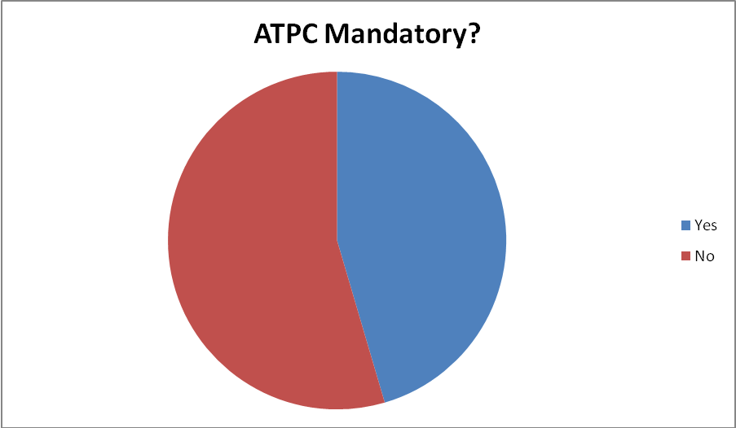
Figure 8: Number of countries where ATPC is mandatory
- INformation on the HCM agreement and associated software
In order to facilitate FS cross-border coordination, a number of CEPT administrations (17 in 2014) have entered into the so-called HCM agreement. HCM stands for Harmonised Coordination Methods. This agreement applies for Fixed and Land Mobile Services. As regards the Fixed Service, the HCM agreement sets procedures for bilateral coordination, and provides harmonised technical means to assess interference between FS links.
These means include:
- Harmonised FS data format, which shall be used by an administration seeking to coordinate a new FS assignment in order to send information on the assignments to be coordinated;
- Common software (available for download) to enable administrations with which coordination has been sought to calculate the interference potential from other FS stations, and to provide an answer to the administration requesting coordination for new FS links;
- A Register of frequency assignments for each country that is a party to the HCM agreement.

HCM Agreement webpage: www.hcm-agreement.eu
HCM Agreement software webpage:
http://www.hcm-agreement.eu/http/englisch/verwaltung/index_hcm_programs.htm
The software deals with fixed point-to-point links, which may include one passive back-to-back antenna repeater. The total threshold degradation (TD) in case of links with passive repeaters is a combination of direct and indirect (via repeater) propagation paths. Calculations for plane reflector repeaters are not covered by the HCM-Agreement.
HCM-FS software generally consists of two parts – the calculation library (HCMFS_DLL) and the program (CalcFiSH). All calculations are being made in the calculation library. CalcFiSH does not make HCM calculations by itself; instead it uses the library for calculations.
The propagation module of the library implements Recommendation ITU-R P.452-16 [10], and takes into account terrain profiles. Elevation and morphological files are available for download from the website. The software also considers frequency overlap of the interfering transmitter and victim receiver. The output is TD (Threshold Degradation equal to N+I/N).

The figure below is a schematic description of the HCM-FS software:

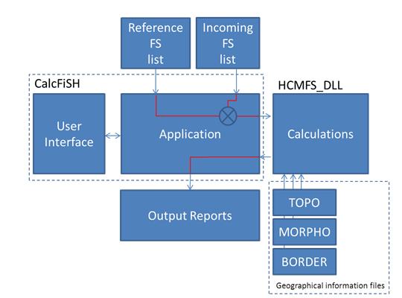
Figure 9: Schematic description of the HCM-FS software

The functionality of the various blocks is described below:
- FS lists: FS assignment in the format described in the Annex 2B of the HCM agreement.
- CalcFiSH:

- User interface
- Application:

- Specify paths to FS list files and Geographical information files
- Configure calculations (maximum distances, maximum frequency offset, etc)
- Parses input FS lists into individual FS to FS calculation, and append results in an output report
- Generates Google Earth compatible files
- Calls the HCMFS_DLL library for calculations

- Calculation (HCMFS_DLL):
- Test input data validity
- Calculate antenna gain coupling
- Calculate attenuation between FS stations considered using geographical information
- Calculate TD (Threshold degradation (N+I)/N)

- Geographical Information Files:
- TOPO: elevation data raster
- MORPHO: environment data raster (land, sea, trees, buildings, etc)
- BORDER: Border line data (used for distance to border calculations if needed)

- Administrations publishing Fixed Service assignment information for the band 17.7-19.7 GHz

The table below may be updated after the publication of this ECC Report. The latest updates of the table can be found at http://www.cept.org/ecc/topics/geolocation-databases/fixed-service-assignment-information-for-the-band-177-197-ghz.

Table 13: Fixed service assignment information for the band 17.7-19.7 GHz
Adm | Information source | Comment
Denmark | http://frekvensregister.erst.dk/Search/Search.aspx | Complete information
France | BR IFIC | Complete information
Slovenia | http://www.akos-rs.si/frequencies | Complete information
Poland | http://www.uke.gov.pl/pozwolenia-dla-stacji-linii-radiowych-4144 | Complete information
Spain | EFIS Rights of use section | Information not complete for the purpose of interference assessment
UK | http://spectruminfo.ofcom.org.uk/spectrumInfo/licences | Complete information.
Nether-lands | http://www.antenneregister.nl/Html5Viewer_Antenneregister/Index.html?viewer=antenneregister | Information not complete for the purpose of interference assessment

Other administrations may have made fixed service information available, but may not have been identified in this table.
- Information on the corasat EU FP7 project activities in relation to the 17.7-19.7 GHz band
This annex summarises work done within the EU FP 7 project CoRaSat on the use of data bases for frequency sharing between satellite FSS and terrestrial FS in the 17.7 to 19.7GHz band and provides references to relevant documents produced by the project.
The FP7 project CoRaSat has examined frequency sharing in the 17.3-17.7 GHz, 17.7-19.7 and 27.5-29.5 GHz bands. With respect to the 17.7-19.7 GHz band and the use of data bases, the project has calculated interference maps using the full Recommendation ITU-R P.452-16 propagation models from FS links to any point within several European countries. A complete FS data base supplied by OFCOM has been used in the UK and in other countries data from the ITU BR-IFIC used. For the case of Poland recent data was obtained from the regulator in that country. The major conclusions from the work are;
- The importance of using a full ITU model including diffraction rather than a free space model for the interference calculations.
- It was found that a large percentage (e.g. 93%) of the 2GHz band between 17.7 and 19.7 GHz was available for 90% of the FSS locations in the UK and even better for other European countries. However, unlike TV whitespace, the spectrum available varies a lot from location to location.
- The spectrum occupancy at FSS locations for given interference thresholds were calculated for various satellite orbit locations.
- The white spaces (free slots) are different for each FSS location making a data based allocation system particularly applicable.
- Using a data base driven resource allocation scheme at the satellite network gateway which is interference aware has been demonstrated to result in significantly increased capacity when using the shared band.

Further details are available in the CoraSat project website www.ict-corasat.eu, and in the following papers:
- Cognitive Spectrum Utilization in Ka-Band Multibeam Satellite Communications - Maleki S., Chatzinotas S., Evans B., Liolis K., Grotz J., Vanelli-Coralli A., Chuberre N. - IEEE Wireless Communication Magazine, 2015.
- Analysis of interference between terrestrial and satellite systems in the band 17.7 to 19.7GHz—Thompson P and Evans B— 2015 ICC conference, London June 2015 Workshop on Cognitive radio in satellite systems.
- A data base approach to extending the usable Ka-band spectrum for FSS satellite systems-Tang W, Thompson P and Evans B, SPACCOMM conference 2015, Barcelona April 2015.
- Frequency band sharing between satellite and terrestrial fixed links in Ka-band. Tang W, Thompson P and Evans B, 2014 Ka-band conference, Solerno Italy, October 2014
- List of reference
- ECC Report 152 on the use of the frequency bands 27.5-30.0 GHz and 17.30-20.2 GHz by satellite networks
- ERC Decision (00)07 on the shared use of the band 17.7 - 19.7 GHz by the fixed service and earth stations of the fixed satellite service (space-to-Earth)
- CEPT/ERC/REC 12-03 on harmonised radio frequency channel arrangements for digital terrestrial fixed systems operating in the band 17.7 GHz to 19.7 GHz
- Recommendation ITU-R F. 595-10: radio-frequency channel arrangements for fixed wireless systems operating in the 17.7-19.7 GHz frequency band
- ECC Report 173 on fixed service in Europe; current use and future trends post 2011
- ECC Decision (06)02 on exemption from individual licensing of Low e.i.r.p. Satellite Terminals (LEST) operating within the frequency bands 10.70–12.75 GHz or 19.70–20.20 GHz space-to-Earth and 14.00–14.25 GHz or 29.50-30.00 GHz Earth-to-Space
- ECC Decision (06)03 on exemption from individual licensing of High e.i.r.p. Satellite Terminals (HEST) with e.i.r.p. above 34 dBW operating within the frequency bands 10.70 - 12.75 GHz or 19.70 - 20.20 GHz space-to-Earth and 14.00 - 14.25 GHz or 29.50 - 30.00 GHz Earth-to-space
- ECC Decision (05)01 on the use of the band 27.5-29.5 GHz by the fixed service and uncoordinated earth stations of the fixed satellite service (Earth-to-space)
- ETSI TR 103 263: cognitive radio techniques for satellite communications operating in Ka-band.
- Recommendation ITU-R P.452-16 on prediction procedure for the evaluation of interference between stations on the surface of the Earth at frequencies above about 0.1 GHz
- ECC Report 232 on compatibility between fixed satellite service uncoordinated receive Earth Stations and the Fixed Service in the band 17.7-19.7 GHz
- ECO Report 04: Fixed Service in Europe – Implementation Status

This includes specific arrangements in use within the United Kingdom. Some legacy links also operate within the centre gap within the UK.

