ECC Report 208

Impact of RFID devices using the band at 13.56 MHz on radio services

**Approved 31 January 2014**

# Executive summary

ETSI has proposed the ETSI TR 103 059 [1] describing emission masks for two new RFID systems in the 13.56 MHz range which should be considered for ECC studies and approval. The two RFID applications described in ETSI TR 103 059 [1] are short range wideband systems and long range narrowband systems.

Market deployment data for the proposed new 13.56 MHz systems were compiled showing that the large majority of systems are using the short range wideband systems, while the long range narrowband systems are deployed in significant lower quantities and mainly used in industrial sites for indoor operations.

The new RFID systems were documented in field tests and measurements related to propagation and interference with regard to a short wave broadcasting receivers were made.

## RESULTS for short range wideband rfid systems

The proposed transmitter mask for short range wideband system (see Figure 3) complies with the present limits in EN 300 330 for small frequency offsets (+/- 900 kHz) and with the wideband limit from Recommendation 70-03 Annex 9 (i1 and i2) for larger frequency offsets. Therefore, no compatibility studies are provided in this report.

## RESULTS for long range narrowband rfid systems

Regarding the long range narrowband systems the Report covers compatibility calculations in the range of 13.360 MHz to 13.760 MHz where higher emission levels compared to the existing mask are requested (levels between -3.5 and 27 dBµA/m, see Figure 4). Protection distances were derived from theoretical calculations using the path loss model from ERC report 69 and from new performed field tests.

According to theoretical calculations the indoor operation of RFIDs yields the protection distances up to 120 m for a frequency offset (between RFID centre frequency and victim frequencies) of ≤100 kHz. Considering outdoor use of RFIDs also with a frequency offset of ≤100 kHz, the maximum protection distance is between 190 m (from the field testing) and 210 m (from theoretical calculations).

For higher frequency offsets (≥ 100 kHz) the distance becomes clearly less (e.g. 12 m for indoor operation) because the allowed limit of the RFIDs in the emission mask jumps from +27 dBµA/m down to -3.5 dBµA/m.

Although the new transmitter mask for long range narrowband RFID systems leads to higher protection distances compared to the existing mask, it may be concluded that the risk for interference is low because of the combination of the following operating and deployment conditions:

1. deployment usually in industrial sites;
2. predominant indoor operation;
3. expected low deployment rate;
4. low duty cycle;
5. it is expected that in most of the scenarios for long range RFID system the transmitted power will be less than the proposed maximum limit.

**TABLE OF CONTENTS**

0 Executive summary 2

0.1 RESULTS for short range wideband rfid systems 2

0.2 RESULTS for long range narrowband rfid systems 2

1 Introduction 6

2 RFID applications in the 13.56 MHz band 7

2.1 13.56 MHz RFID technology 7

2.2 RFID Reader systems 7

2.3 Present status of RFID’s in the 13.56 MHz band 8

2.4 New RFID Applications and Emission masks 10

2.4.1 Short range/wideband RFIDs 10

2.4.2 Long range / narrowband RFIDs 11

2.5 Market size scenario 12

2.5.1 Market overview 12

2.5.2 Overview of long range narrowband Reader systems and mitigation factors 13

3 Allocations in the band 13.36-13.76 MHz and present regulations 16

4 EXISTING ECC reports and studies 18

4.1 ECC Report 67 18

4.2 ERC Report 69 18

4.3 ERC Report 74 18

5 MEASUREMENTS for the protection of Short-Wave Broadcasting 20

5.1 RFID readers used for the measurements 20

5.2 Characterization of narrowband and wideband RFID reader signals 21

5.3 Field strength versus distance measurements 28

5.4 Interference measurements 31

5.4.1 Receiver 31

5.4.2 Wanted signal 31

5.4.3 Unwanted signal 32

5.4.4 Failure criterion 33

5.4.5 Measurement setup and procedure 33

5.4.6 Measurement results 34

5.4.7 Subjective test with skywave reception 35

5.5 Conclusion 36

6 Interference distance CALCULATIONS CONSIDERING Broadcasting radio service 37

6.1 Magnetic field strength as a function of distance 37

6.2 Magnetic field strength Limits of the long range reader 39

6.3 Calculation of the man made noise at the frequency of 13.56 MHz 39

6.4 Calculation of the acceptable Maximum interference level for broadcast RECEIVERS OR alike systems 40

6.5 Calculation of the magnetic field strength versus distance and protection distance for outdoor operation 41

6.6 Calculation of the magnetic field strength versus distance and protection distance for indoor operation 42

7 Conclusions 44

7.1 RESULTS for short range wideband rfid systems 44

7.2 RESULTS for long range narrowband rfid systems 44

ANNEX 1: List of reference 45

**LIST OF ABBREVIATIONS**

|  |  |
| --- | --- |
| **Abbreviation** | **Explanation** |
| **AS** | Amateur Service |
| **ASK** | Amplitude shift keying |
| **CEPT** | European Conference of Postal and Telecommunications Administrations |
| **DC** | Duty Cycle |
| **EAS** | Electronic Article Surveillance |
| **EC** | European Commission |
| **ECC** | Electronic Communications Committee |
| **e.i.r.p.** | equivalent isotropically radiated power |
| **ERP** | Effective Radiated Power |
| **I/N** | Interference-to-Noise Ratio |
| **ISM** | Industrial, Scientific and Medical |
| **ITU-R** | International Telecommunication Union-Recommendation |
| **Pk** | Peak |
| **QP** | Quasi-Peak |
| **RFID** | Radio Frequency Identification |
| **Rx** | Receiver |
| **SNR** | Signal to Noise Ration |
| **SRD** | Short Range Device |
| **Tx** | Transmitter |
| **WGFM** | Working Group Frequency Management |

# Introduction

This ECC Report deals with inductive RFIDs in the 13.56 MHz band and the compatibility to radio services.

ETSI has proposed the ETSI TR 103 059 [1] describing emission masks for two new RFID systems in the 13.56 MHz range which should be considered for ECC studies and approval. The two RFID applications described in ETSI TR 103 059 [1] are short range wideband systems and long range narrowband systems.

The market of 13.56 MHz inductive RFIDs in the HF range is established since early 1990’s and widely used in two different major applications and RFID technologies:

1. as short range high data range multipurpose applications better known as smart cards for the ISO 14443-2 [5] standard for operating ranges of 5 - 10 cm range, and
2. as medium and long range applications primarily for industrial applications according to ISO 18000-3 [7], ISO 15693 [6] and security related applications according to ISO 14443 [5].

The evolution of the technology and markets is for (a) type RFIDs for very high data rates requiring higher bandwidth to support security related applications, secondly for (b) type RFIDs for larger operating ranges.

This ECC report copes with the requirements for higher bandwidth as well as for the higher modulation sidebands for in both application types which are reflected by two spectrum emission masks.

This report also copes with the compatibility to the existing radio services primarily for long range narrowband applications of type (b) and considers the available ECC reports and new studies in the   
13.56 MHz range for the compatibility to the required spectrum masks.

# RFID applications in the 13.56 MHz band

## 13.56 MHz RFID technology

RFID technology is predominantly using passive tags or transponders. These passive tags are only activated when powered and addressed by a reader, emitting an inductive field.

Unlike RFIDs operating in the VHF, UHF and microwave domain, the HF type 13.56 MHz RFID systems operate on a single channel for the powering of the tag.

Several RFID systems can operate in a given small area and re-using the same 13.56 MHz channel because of the fast roll-off of the field strength of 60 dB/decade in the near field area limiting the activation area to 1–1.5 m range. The fast roll-off region ends off at the crossover point at λ/2π or approx. 3.5 m where the far-field region with a roll-off of 20 dB/decade starts.

Since the operating range of the 13.56 MHz RFID long range systems is in the order of 1.5 m, the frequency re-use and density of such systems makes the technology very spectrum efficient in comparison to e.g. electromagnetic field operation in the VHF and UHF where RFID systems operating in far-fields.

The 13.56 MHz RFID systems can be classified in two different groups / types as further explained in paragraph 2.4:

* 1.: Short range / wideband systems where the tags are very close to the reader antenna for 2 reasons;
  + These tags have a higher energy demand because of the high bandwidth of 14 MHz, the high clock rates for the needed calculation power and for running the security algorithms;
  + For providing privacy, the reading distance has to be confined to a few centimetres for protection against eavesdropping.
* 2.: Long range / narrowband systems which are optimized for maximum operating range at medium data speed. These systems require a high Q factor of the antennas for reader and tags which also limits the bandwidth.

## RFID Reader systems

An RFID system consists of an interrogator or a reader, a control unit with access to a data base and one or several tags as data carriers.

The tags are attached to objects like goods, Identification cards, (passports), bank cards, books / libraries, payment cards, public security or carried by human beings as smart cards or ticketing cards.

A large application field is developed for NFC (Near Field Communication) [8]. These applications are falling into the first group (Short range and wideband).

Applications of the second group RFID readers (Long range and narrowband) are mainly in libraries, in industrial areas for production, inventory control, ecology (as waste control), also in various medical areas, for logistics or in automotive applications, radio keys as well as in transportation for baggage tagging.

Tags are only active when interrogated by the reader. They are normally battery-less, passive and dormant until powered by the RF interrogation signal in order to respond with a data signal.

The transmit power level of the tag, that re-transmitting data back to the reader is typically 60-80 dB below the level of the received carrier from the reader.

In the past most of the RFID systems have been used in unidirectional transmissions as read-only type systems. They used passive tags which are upon receiving a powering signal from the reader, return a code that is stored in a memory of the tag.

Today the RFID systems have bidirectional communication functionality. The interrogation signal which is needed to power the tag is modulated e.g. by ASK (Amplitude Modulation) as downlink signal.

In RFID systems which have a large range and consequently can cover many tags in a given area, the reader has options for addressing tags or a family of tags, by sending certain commands for differentiating and singulation of tags for a number of tags which are within the reader illumination field. After the recognizing of the individual tags in range, tags can be called up individually.

The addressed tags will answer by transmitting the requested data or other read/write (to the memory) process.

A low level down- and uplink ASK modulation (e.g. ~10%) in combination with an optimized data transmission (by encoding) method is used in order to minimize the emitted spectrum with regard to amplitude and frequency.

Figure 1 shows a basic RFID system configuration.



**Chip,**

**RF & Memory Functions**

Control Unit

Interrogator Unit

RFID   
Antenna

RFID Tag



Figure 1: RFID system

## Present status of RFID’s in the 13.56 MHz band

The families of 13.56 MHz RFIDs have the highest turnover and also increase rate compared to other technologies at different frequencies. The 13.56 MHz technology is versatile in that very high data rates at low reading ranges for privacy as well as for longer reading ranges at low or medium data ranges can be realized.

The present transmitter mask from the EN 300 330 [2] as shown in Figure 2 allows large but read-only tags. This is because of the present poor ratio of downlink to uplink communication performance which is unbalanced so that effective bidirectional communication is only feasible at lower RFID carrier levels. Therefore the downlink modulation level needs to be enhanced.

The present modulation mask outside the 13.56 MHz SRD band allows + 9 dBµA/m up to +/- 150 kHz and – 3.5 dBµA/m at +/--450 kHz. These levels are in effect since nearly 10 years.



Figure 2: Present 13.56 MHz RFID emitter mask from EN 300 330

ERC/REC 70-03 allows such inductive systems in Annex 9 for bands f, f1 and i2 [3].

Table 1: Regulatory parameter for inductive applications according ERC/REC 70-03,   
Annex 9 for 13.56 MHz RFID systems (Excerpt from Annex 9)

| **Frequency Band** | | **Power / Magnetic Field** | **Spectrum access and mitigation requirements** | **Channel spacing** | **ECC/ERC Decision** | **Notes** |
| --- | --- | --- | --- | --- | --- | --- |
| **f** | 13.553-13.567 MHz | 42 dBµA/m at 10m | No requirement | No spacing |  |  |
| **f1** | 13.553-13.567 MHz | 60 dBµA/m at 10m | No requirement | No spacing |  | For RFID and EAS only |
| **l1** | 148.5 kHz - 5 MHz | -15 dBµA/m at 10 m | No requirement | No spacing |  | In case of external antennas only loop coil antennas may be employed.  The maximum field strength is specified in a bandwidth of 10 kHz. The maximum allowed total field strength is -5 dBµA/m at 10 m for systems operating at bandwidths larger than 10 kHz whilst keeping the density limit (-15 dBµA/m in a bandwidth of 10 kHz) |
| **l2** | 5 - 30 MHz | -20 dBµA/m at 10 m | No requirement | No spacing |  | In case of external antennas only loop coil antennas may be employed.  The maximum field strength is specified in a bandwidth of 10 kHz. The maximum allowed total field strength is -5 dBµA/m at 10 m for systems operating at bandwidths larger than 10 kHz whilst keeping the density limit (-20 dBµA/m in a bandwidth of 10 kHz) |

Note: only the relevant lines of Annex 9 of ERC/REC 70-03 are shown here

To cope with new intelligent and bidirectional technologies for wideband as well as for long range application the emission masks in sections 2.4.1 as well as 2.4.2 were defined.

## New RFID Applications and Emission masks

Ongoing development and requirements for higher data rates and operating range requires a higher upload signal speed which necessitates a wider modulation spectrum of the existing emission mask as well as higher modulation level.

Since both are not needed simultaneously, the proposal is for two different RFID systems with different emission masks.

### Short range/wideband RFIDs

These are low-power, wideband readers with a small internal loop antenna. It is intended to communicate with smart cards according to ISO 14443 [5] at very short distances of only a few centimetres. These applications cover primarily access security checks, money transactions, ticketing to secure the transactions (i.e. e-Passport, but also mass transportation tickets), authentication to provide secure identification mechanisms for persons and objects.

This short range operating range of a few centimetres is determined because of maintaining privacy and allowing a high degree of security. This also requires a high data rates for the authentication and crypto functions which are presently not feasible because of the limited bandwidth. This functionality is requested by the recent EC mandate M436.

The TX mask requirements of the new wideband applications are reflected in Figure 3.

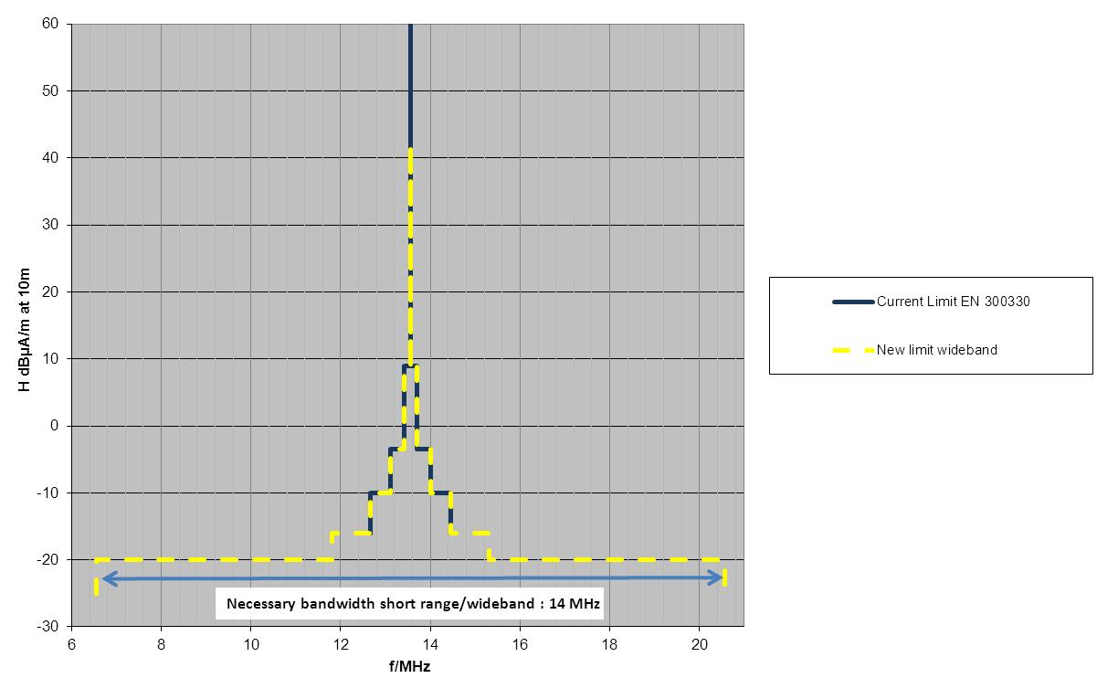

Figure 3: Short range / wideband RFID emitter mask

The only difference of the new proposed mask to the current mask in EN 300 330 (see Figure 2) is the explicit request for an intended usage over 14 MHz bandwidth. That means the new requested mask is a mix of the current mask in EN 300 330 and the wideband limit of -20 dBµA/m from 70-03 Annex 9 (i2). Compatibility studies for this mask are not conducted in this ECC Report.

### Long range / narrowband RFIDs

These are long range, narrow bandwidth and low data rate reader to be used with external loop antennas of different sizes (typically with around 30x30 cm and 80x60 cm). A larger antenna produces a stronger signal extending the usable range to about 1.5 meters. However, the achievable data rates are relatively low and typically below 100 kBit/s.

The Figure 4 presents the TX mask for the long-range narrowband application. The necessary bandwidth for this application is 200 kHz.

The modulation level extends from a +27 dBµA/m level within +/-100 kHz and is descending to -3.5 dBµA/m within a further 100 kHz width. This is followed by a further reduced level of -5 dBµA/m, starting from 450 kHz and reaching to 900 kHz from the carrier centre of 13.56 MHz where the spurious level starts.

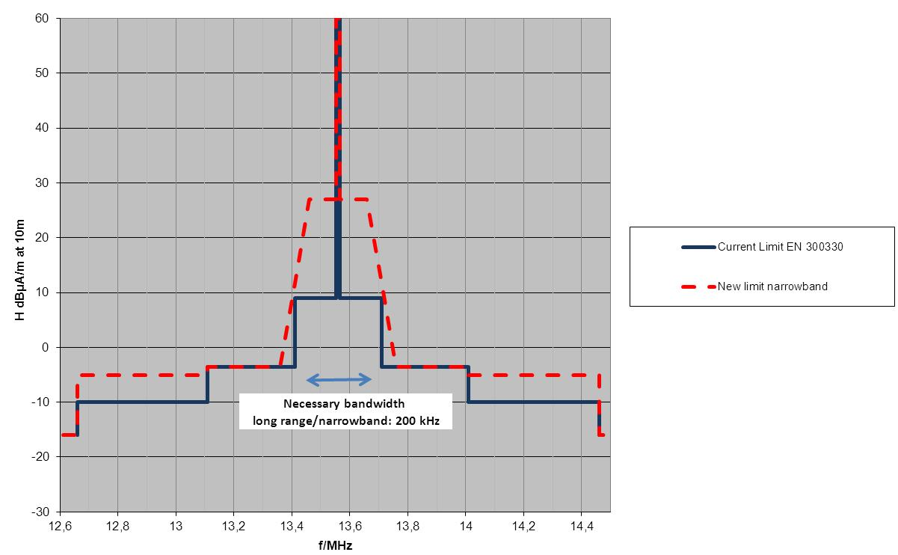

Figure 4: Long range / narrowband RFID emitter mask

Only this mask (Figure 4) has been considered in the compatibility studies of this report.

## Market size scenario

The Table 2 and Table 3 below provide the world-wide market and deployment and application details.

Table 2 identifies the long range narrowband market size of both new applications for the years from 2014 to 2020 and in relation to the already installed base of these systems which operate to the present TX mask.

The first part shows the present and future market for the long range narrowband application.

The second part of the Table 2 identifies the future and present market of the short range wideband applications also in relation to the installed base for the same applications.

### Market overview

Table 2: World-wide market for present and new 13.56 MHz RFID systems   
from the years 2014 to 2020

| **Forecast for RFID Systems**  **(given in 1000 units)** | **2014** | **2016** | **2020** |
| --- | --- | --- | --- |
| **Long range/narrowband systems (ISO 18000-3; ISO 15693)** | | | |
| Projected new reader systems for the long range TX mask | 1 | 5 | 10 (Note 1) |
| Installed base of all long range reader systems  *(which use the present 13.56 MHz TX mask)* | 20 | 30 | 50 |
| **Short range/wideband systems (ISO 14443)** | | | |
| Projected new reader systems for the short range TX mask | 30 | 100 | 300 (Note 1) |
| Installed base of all short range systems  *(Which use the present 13.56 MHz TX mask)* | 3000 | 3500 | 6000 |
|  |  |  |  |
| **Total units of 13,56 MHz RFID systems** | 3051 | 3635 | 6360 |
|  |  |  |  |
| Percentage of new long range systems using the TX mask of Figure 4 in relation to all 13,56 MHz RFID systems | 0.03% | 0.11% | 0.16% |

Note 1: In 2020 there will be 3.3 % of the proposed long range /narrowband readers related to all new short range and long range reader volume

### Overview of long range narrowband Reader systems and mitigation factors

Table 3 identifies the long range narrowband details about locations of installations and numbers and a figure for indicating the potential interference risk.

* **Columns 1-4** lists in the market segments, application type, the installation sites/ environments and percent of indoor installations.
  + **In Column 3**, the non-industrial sites indicate a possible higher interference potential because of the area for deployment locations. At industrial area installations the interference is less likely to occur. It is assumed that some of the concerned other services will not be collocated to an industrial RFID installation.
  + The bottom line of the table indicates that a slight minority of installations is situated in the more critical town centre and residential areas.
  + The bottom line of the table sums these probabilities and indicates that a slight majority of installations is situated in the less critical industrial sites (more important is that most of the green market applications are in-door deployments).
  + Moreover considering the industrial area versus the town centre installations, in column 8, the sum of the risk factor of additions of all applications indicate an approximately 4 times lower risk factor in the town centre applications.
  + **Column 4** **(A)** indicates the percent of indoor applications.
* **Column 5 (B)** analyses the percent of distribution of the individual market segments and applications of the total market for the new long range wideband RFID systems.
* **Column 6 (C)** defines the reduction of the magnetic field strength in the individual applications as a factor and in addition the field strength reduction in dB relative to the worse case maximum field strength of +27 dBµA/m. This reduction is given because a number of applications cannot use the maximum field strength since often there are system limitations inherent to the application like the predominant use of handheld readers with power consumption constraints dominate.
* **Column 7 (D),** the duty cycle of the individual applications is indicated. In many systems the reader is only activated when persons or goods are approaching the installation. Another reason is that the communication protocol for receive-transmit and processing is sequential and by definition reduces the DC to the indicated figures.
* **Column 8** **(E)** summarizes an interference risk factor E, calculated from the columns 4(A), 6(C) and 7(D) for the individual applications.

Table 3: Deployment details for long range RFID reader systems at 13.56 MHz

| **Market segment** | **Application Type** | **Installation sites & environment** | **Percent**  **of**  **In-door**  **Installat.** | **Percent of market segments** | **Max. operating magnetic field strength**  ***(Referenced to***  ***+ 27 dBμA/m )*** | **Duty cycle factor** | **Potential interference risk factor of installations**  **E** |
| --- | --- | --- | --- | --- | --- | --- | --- |
|  |  | ***(E = C x D)*** |
|  |  |  | [%]  **(A)** | [%]  **(B)** | **(C)** | **(D)** |
| Library | Security gates | Town centre | 100 | 15 | 1.0 | 0.4 | 0.4 |
| Library | Automatic sorter | Town centre | 100 | 8 | 0.2 ≙ -14 dB Note 1 | 0.1 | 0.01 |
| Health care | Manufacturing tracking | Industrial areas Manufacturing  Hospitals | 100 | 10 | 0.5 ≙ -6 dB Note 1 | 0.5 | 0.25 |
| Clothing industry | Manufacturing tracking | Industrial areas Manufacturing | 100 | 15 | 1 | 0.5 | 0.5 |
| Clothing industry | Laundry & Work coats | Industrial | 100 | 5 | 1 | 0.8 | 0.8 |
| Clothing industry | Apparel | Town centre, Trade, large warehouses | 100 | 6 | 0.5 ≙ -6 dB Note 1 | 0.5 | 0.25 |
| Waste management | Waste container | Town centre, residential & industrial areas | - | 4 | 0.3 ≙ -10.5 dB | 0.1 | 0.03 |
| Auto motive | Manufacturing logistics | Industrial areas | 100 | 8 | 1 | 0.5 | 0.5 |
| Trade & distribution facilities | Distribution of goods | Industrial areas distribution centre | 90 | 15 | 0.8 ≙ -1.9 dB Note 1 | 0.4 | 0.32 |
| Access control | Personnel | Large buildings | 70 | 8 | 0.5 ≙ -6 dB Note 1 | 0.3 | 0.15 |
| Cargo hand ling | Logistics | Industrial areas distribution centre | 20 | 4 | 1 | 0.5 | 0.5 |
| Sports | e.g. Runners events | Town sites | 100 | 2 | 0.8 ≙ -1.9 dB Note 1 | 0.2 | 0.16 |
| ∑ = 100 %  ∑ Industrial areas, manufacturing sites, etc. ≙ 59 %  ∑ Town centre, warehouses, residential areas, etc. ≙41 % | | | | |  |  | F Avg = 0.32  ∑ F Industrial area = 2.87  ∑ F Town centre =0.835 |

Note 1: Considering hand held readers which run with considerably lower field strength emissions.

Analysing the summary of the factors for the industrial areas versus the risk factors in town centre installations (see bottom line) reveals that the interference risk in town centre installations is over 3 times less than in the industrial installations, while radio receivers are more likely to be used outside industrial areas.

The following mitigation factors can be assumed:

* Shielding, Phase compensation, Building attenuation
  + Shielding of systems can be realized in a low percentage of all applications e.g. only in RFID readers in tunnels for baggage or other items control. These are mostly found in industrial and non-public areas.
  + Where large antennas for maximum range are installed, antennas mostly made in the form of an 8 shape where a phase compensation of the field occurs minimizing emissions.

This works from a few meters onwards and yields about 6 to 10 dB field strength reduction. This technique is widely used in EAS (Electronic Article Surveillance) - better known as Anti-theft systems.

* + Most of the 13.56 MHz systems in the town centres are installed in buildings, as multi-storage town buildings, industrial concrete or metal structured buildings where an attenuation factor of ~ 10 dB can be considered.
* Duty Cycle is considered in column 7 (D) of Table 3.

# Allocations in the band 13.36-13.76 MHz and present regulations

The frequency scenario for the two emission masks are defined under paragraph 2.3 of the present document for short range wideband RFIDs as well as for long range narrowband RFID applications.

The present regulation for inductive devices as RFIDs is given in ERC/REC 70-03 in Annex 9 [3] and the frequency ranges f1, f2, i1 and i2 apply.

These frequency ranges are also regulated in the EC Decision 2011/829/EU [10].

The ERC/REC 70-03 Annex 9 [3] also refers to the harmonized ETSI standard EN 300 330 where the present spectrum emission mask has been taken over from the previous version of the ERC/REC 70-03 at an earlier request from the EC. This spectrum mask defines the emissions for RFIDs in the range of 13.56 MHz +/- 900 kHz.

Considering the present regulations and the new requirements, the need for compatibility studies remains for the range of 13.36 MHz to 13.76 MHz.

The Table 4 identifies the services and frequency ranges 13.36 MHz to 13.76 MHz for the compatibility investigations.

Table 4: Allocations in the frequency band 13.36 to 13.76 MHz   
(European common table of allocations)

| **Frequency Range MHz** | **Allocation** | **Application** |
| --- | --- | --- |
| 13.360 – 13.410 | FIXED,  RADIO ASTRONOMY | Defence, Inductive applications, Active medical implants, Railway applications, Radio Astronomy (Note 1) |
| 13.410 – 13.450 | FIXED  Mobile except aeronautical mobile (R) | Defence, Inductive applications, Active medical implants, Railway applications, |
| 13.450 – 13.550 | FIXED  Mobile except aeronautical mobile (R)  Radiolocation | Defence, Inductive applications, Active medical implants, Railway applications, |
| 13.550 – 13.570 | FIXED,  Mobile except aeronautical mobile (R) | Defence, non-specific SRDs, Inductive applications, Active medical implants, Railway applications  ISM |
| 13.570 – 13.600 | BROADCASTING | Broadcasting, Inductive applications, Active medical implants, Railway applications |
| 13.600 – 13.800 | BROADCASTING | Broadcasting, Inductive applications, Active medical implants, Railway applications |

Note 1: receiving direction from space to earth, protection recommendations listed in ITU-R RA.769

The Figure 5 visualizes the long range narrowband reader emission mask in relation to the radio services concerning the frequency range of 13.36 MHz to 13.76 MHz for compatibility considerations.

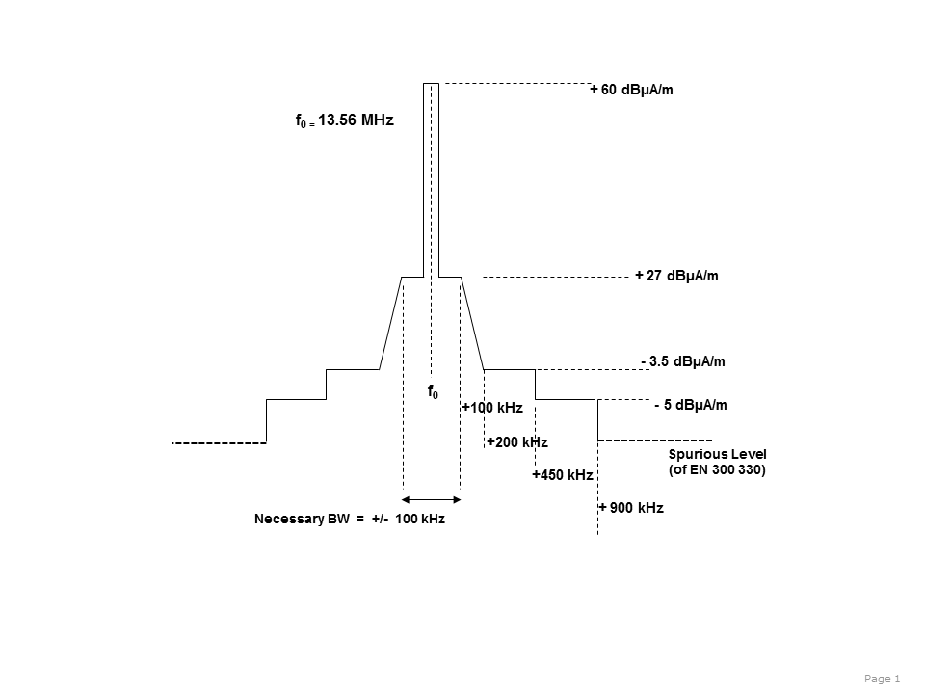

|  |  |
| --- | --- |
|  | 13.36 MHz - 13.41 MHz Radio Astronomy |
|  | 13.41 MHz - 13.57 MHz Mobile except aeronautical mobile (R) |
|  | 13.57 MHz - 13.6 MHz Broadcasting by 2007 (WARC-92) |
|  | 13.6 MHz - 13.8 MHz Broadcasting |

Figure 5: Long range / narrowband RFID emitter mask of Figure 3 with identification of the concerned frequency bands of 13.36 MHz to 13.800 MHz

# EXISTING ECC reports and studies

The following sections are summarising the relevant content of existing ECC and ERC Reports.

## ECC Report 67

The title of ECC Report 67 [11] is: “COMPATIBILITY STUDY FOR GENERIC LIMITS FOR THE EMISSION LEVELS OF INDUCTIVE SRDs BELOW 30 MHz”

This Report provides the background for the two general inductive limits contained in Annex 9 of ERC/REC 70-03 [3] in the frequency range 0.148 MHz to 30 MHz (i1 and i2, see Table 1).

ECC Report 67 was created due to the need for a regulation for inductive devices with a generic limit in the range of 148.5 kHz to 30 MHz in order to cover a multitude of SRDs otherwise needing a number of different compatibility studies for various new and existing applications.

The report recommended two generic limits for the frequency range 148.5 kHz to 5 MHz (-15 dBµA/m) and 5 MHz to 30 MHz (-20 dBµA/m).

## ERC Report 69

The title of ERC Report 69 is: “PROPAGATION MODEL AND INTERFERENCE RANGE CALCULATION FOR INDUCTIVE SYSTEMS 10 KHZ - 30 MHZ”.

ERC Report 69 [4] is the basis for the propagation models for inductive systems and the interference range calculation for use in compatibility studies in the frequency range 10 kHz to 30 MHz.

The report covers the near field and far field model and includes the ground wave propagation model from the ITU-R.

To assess the interference potential of inductive systems, the field strength at a given distance is calculated, the additional criteria for compatibility is the environmental noise which is also given from ITU-R recommendations for atmospheric and manmade noise.

## ERC Report 74

The title of ERC Report 74 is: “COMPATIBILITY BETWEEN RADIO FREQUENCY IDENTIFICATION DEVICES (RFID) AND THE RADIOASTRONOMY SERVICE AT 13 MHZ “.

ERC Report 74 [12] investigated compatibility between RFID reader systems operating at a maximum emission level of the carrier in the SRD band of 42 dBµA/m at 10m distance and with a modulation level in the 13.11 MHz to 13.41 MHz range of -3.5 dBµA/min the Radio Astronomy band.

The RFID system as interferer was positioned inside the Nancay observatory site but at a distance of 1.5 km from the centre of the antenna array field of 144 phased antennas. The antenna array extended over an area of 10.000 square meters.

The RFID system was directed with the main lobe of the antenna radiation towards the antenna array field. The astronomy receiver used an integration time of 300 seconds.

At the test distance of 1.5 km, no signal from the RFID system could be detected within the band 13.36 MHz to 13.41 MHz.

A reception test for the 13.56 MHz carrier frequency at the level of 42 dBµA/m was also negative. The carrier was not detectable at the astronomy receiver.

The carrier emission level is 45.5 dB higher than the emitted field strength from the modulation sideband emissions at -3.5 dBµA/m within the 13.36 MHz to 13.410 MHz range.

# MEASUREMENTS for the protection of Short-Wave Broadcasting

The aim of these measurements [13] was to provide data upon which tentative protection distances between RFID systems operating around 13.56 MHz and the HF broadcasting reception may be established, especially when the RFID spectrum mask is released considerably as currently discussed in this report.

A series of field and laboratory measurements were carried out to:

* Characterize the spectrum emitted by RFID systems around 13.56 MHz;
* Determine the interference effect and required distance, at which interference-free operation of HF broadcast receivers is possible.

## RFID readers used for the measurements

Three different RFID systems were available for the tests:

* A long range, low bandwidth and low data rate reader system with small and large external loop antennas;
* Two low-power, wideband card readers/writers with typical transmission speeds of 1.7 and 6.8 MBit/s.

Reader #1: This is a long range, low bandwidth and low data rate reader to be used with external loop antennas of different sizes (around 30x30 cm and 80x60 cm). The larger antenna produces a stronger signal extending the usable range to about 1.5 meters. However, the achievable data rates are relatively low (below 100 kBit/s).

Reader #2: This is a low-power, wideband reader with a small internal loop antenna. It is intended to communicate with smart cards according to ISO 14443 at distances around a few centimetres. It uses a data rate of 1.7 MBit/s, making the sideband emissions rather wide compared to Reader 1.

Reader #3: This reader is equal to Reader 2, except that its data rate is 6.8 MBit/s, producing the widest sideband emissions.

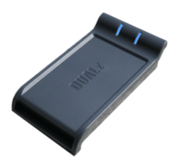

Figure 6: Short range wideband reader #2 and #3 for 13.56 MHz

## Characterization of narrowband and wideband RFID reader signals

In principle, the RFID Reader emits a carrier at 13.56 MHz that supplies the passive RFID Tags with energy. At certain time intervals, the carrier is modulated (AM) with pulses that carry the information (data) to be transmitted to the Tags. The pulsed nature of the modulating signal results in a number of “peaks” in the frequency domain. The exact frequencies of these peaks depend on the transmission speed determining the pulse length and repetition rate. The amplitude of the peaks relative to the carrier depends on the modulation depth.

The following figures show the spectra of the three readers in a measurement bandwidth of 10 kHz, recorded with a very fast FFT analyzer. The topmost (yellow) line is a MaxHold line of the spectrum. Below this line, the probability that a certain level occurs is represented by different colours (temperature scale): from red, representing levels that are always present down to blue, representing levels that only occur for short times (pulses).

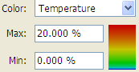

Figure 7: Explanation of used colours in spectrum analyzer

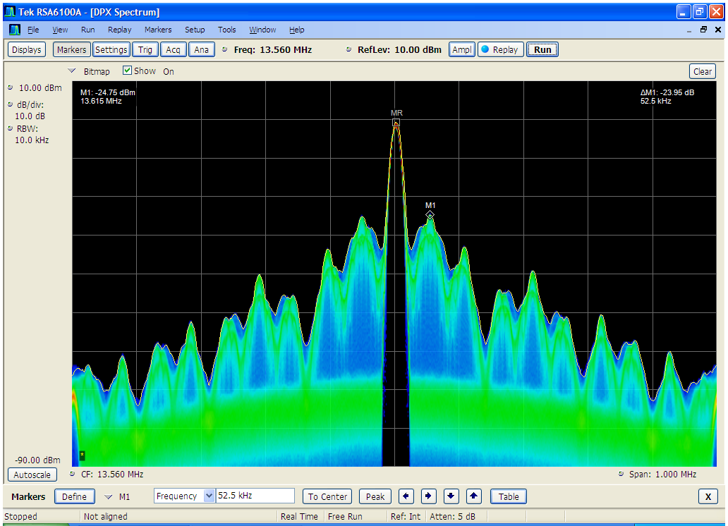

Figure 8: DPX spectrum of Reader 1 (high power, low bandwidth)

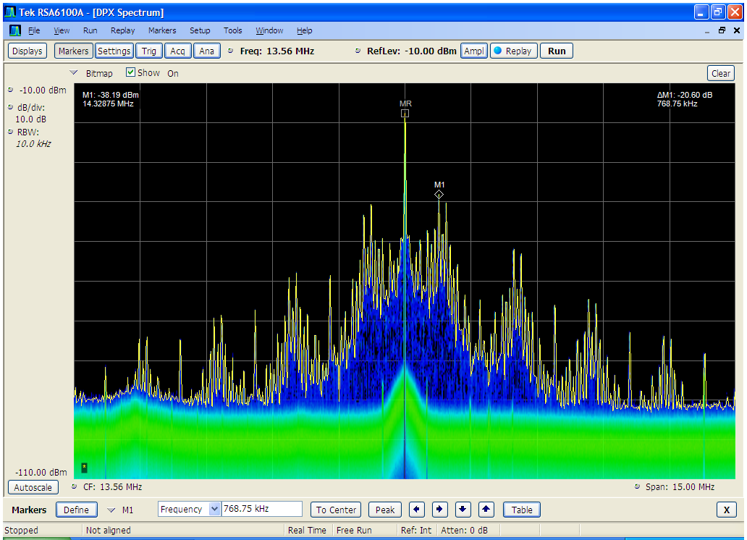

Figure 9: DPX spectrum of Reader 2 (low power, 1.7 MBit/s)

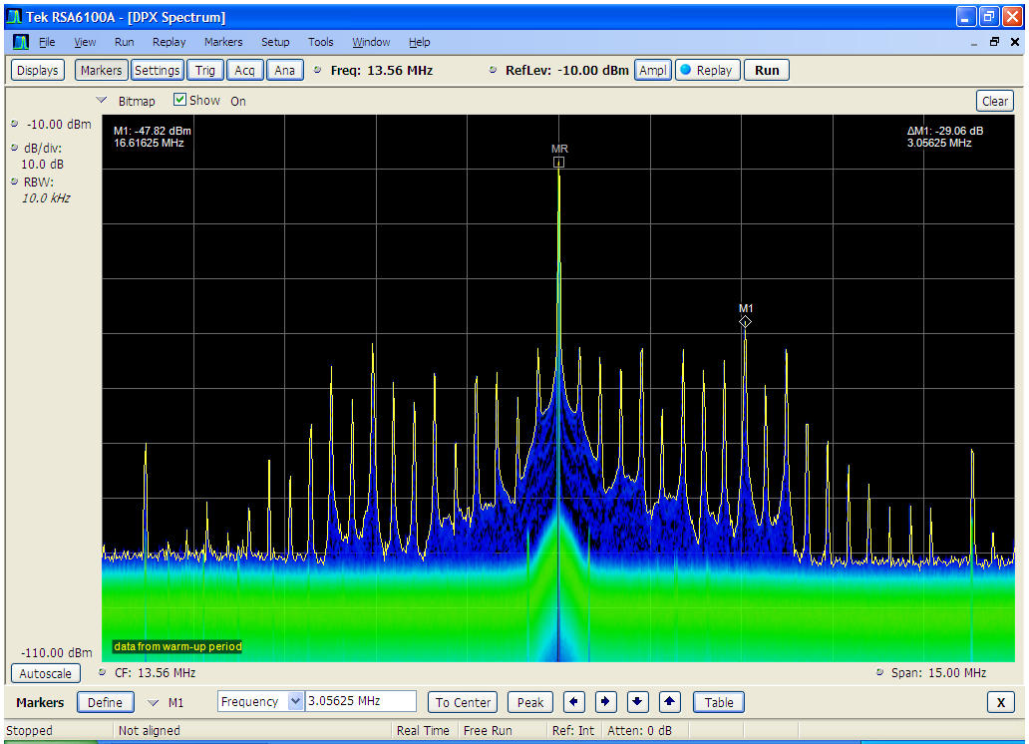

Figure 10: DPX spectrum of Reader 3 (low power, 6.8 MBit/s)

To compare the sideband emissions with the spectrum masks it is necessary to plot the Quasi-Peak (QP) values instead of the peak (Pk) values. To save time on the measurement process, the difference between Pk and QP for some peaks in the sideband emission range were measured individually. This difference was nearly equal for all peaks of one reader.

Table 5: Differences of the detectors for sideband peaks

| **Reader** | **Differences between Peak and  Quasi-Peak** |
| --- | --- |
| 1 | 2 dB |
| 2 | 4 dB |
| 3 | 9.5 dB |

On the carrier frequency itself, both Pk and QP detectors showed the same value. The detailed results of this measurement can be taken from the Annex 2 of [13].

Using the average correction values from the tables above, the following figures show the Reader QP spectra held against the old and new spectrum masks.



Figure 11: QP spectrum of Reader 1 and spectrum masks



Figure 12: QP spectrum of Reader 2 and spectrum masks close to the carrier



Figure 13: QP spectrum of Reader 2 and spectrum masks far from the carrier



Figure 14: QP spectrum of Reader 3 and spectrum masks close to the carrier



Figure 15: QP spectrum of Reader 3 and spectrum masks far from the carrier

It can be seen that the sideband emissions of the high-power Reader 1 reach up to the new mask at the frequencies of the first peak next to the carrier and even exceeds all masks at certain peaks above 200 kHz offset.

The spectra of the wideband readers 2 and 3 fall well below all limits (even below the old mask) at all frequencies.

To visualize the interfering effect of the sideband peaks to analogue reception such as AM broadcast, the following figures show the amplitude vs. time diagram of the reader signals on the frequency of the first peak next to the carrier, with a measurement bandwidth of 10 kHz.

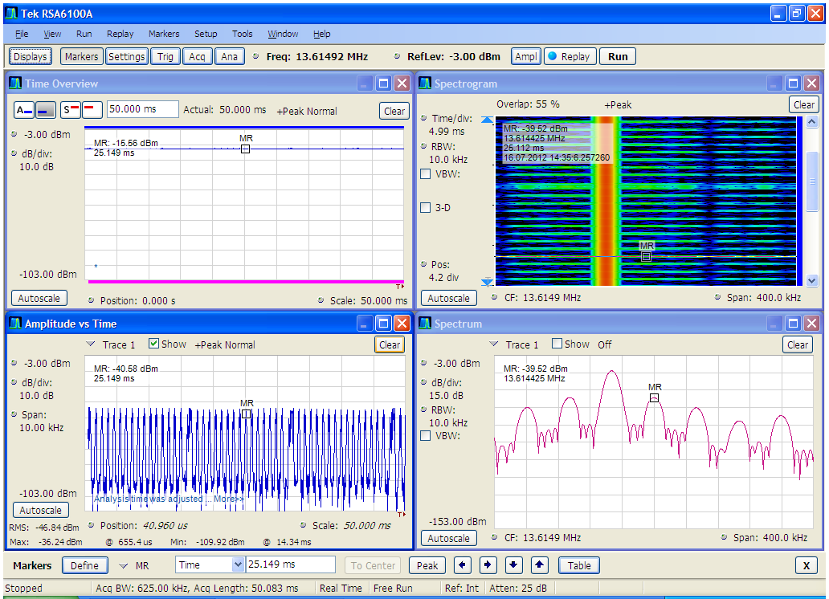

Figure 16: Time analysis of the Reader 1 signal

The upper left window of Figure 16 shows the total RF power over a time of 50 ms. It can be seen that this power is nearly constant as it lies in the carrier on 13.56 MHz.

The lower left window shows the power on the frequency of the first sideband peak on 13.6149 MHz (position of the marker in the spectrum window lower right) with a bandwidth of 10 kHz. This is the signal that a broadcast receiver would “see” if it was is tuned to that frequency. It shows as a series of short pulses appearing roughly every millisecond with a length of about 1/3 ms.

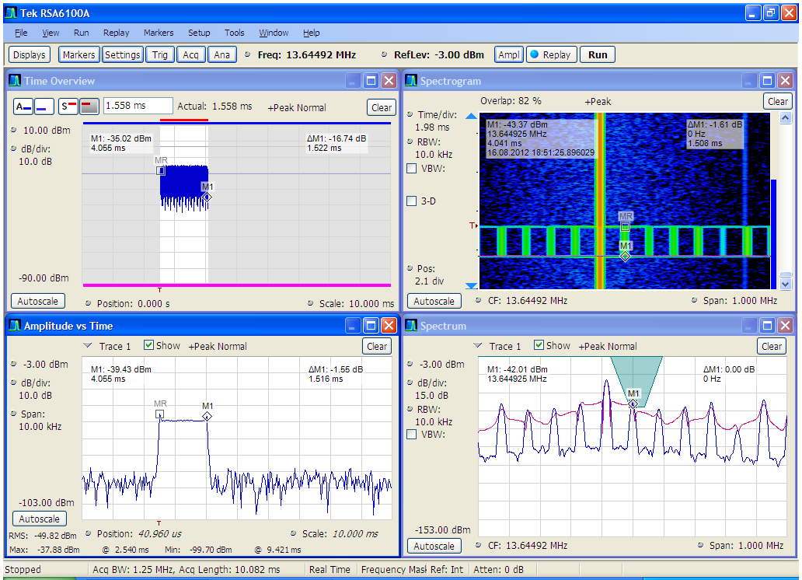

Figure 17: Time analysis of the Reader 2 signal for a 10 ms time interval

The lower left window of Figure 17 shows the signal as seen by a broadcast receiver tuned to the frequency of 13.64492 MHz which is the first sideband peak of Reader 2. It can be seen that the duration of the pulses is about 1.5 ms.

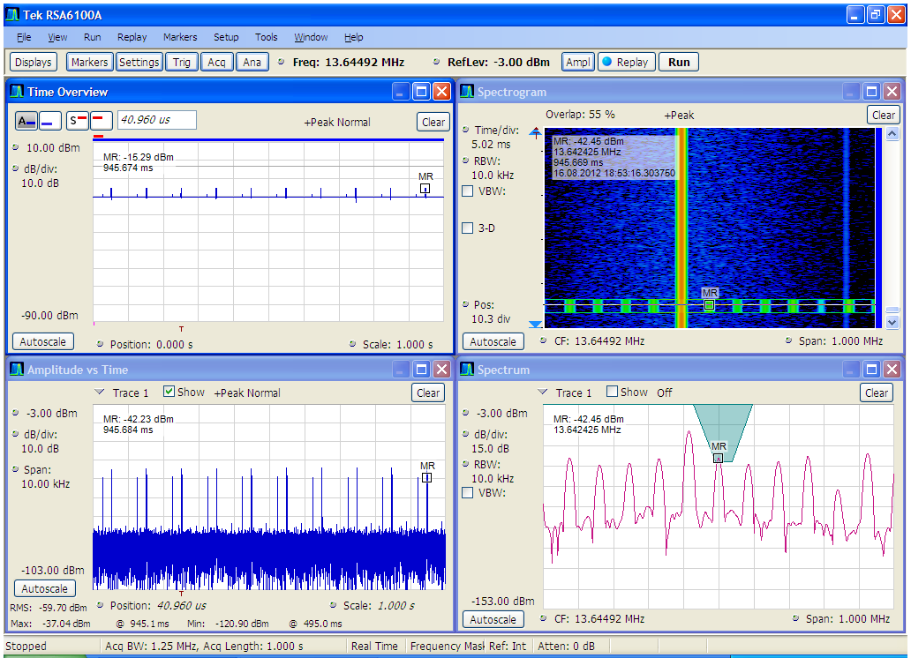

Figure 18: Time analysis of the Reader 2 signal for a 1 s time interval

In the lower left window of Figure 18 it can be seen that Reader 2 emits double-pulses occurring every 100 ms. The pulse/pause ratio of Reader 2 is much lower than of Reader 1, hence the larger difference between peak and QP (4 vs. 2 dB, see Table 5).

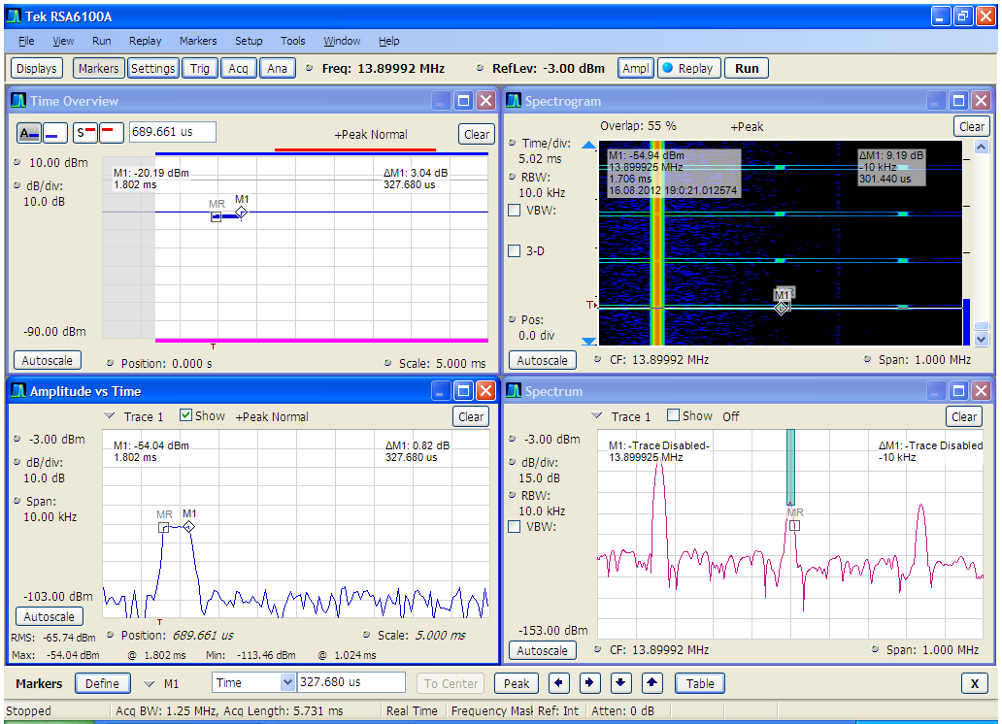

Figure 19: Time analysis of the Reader 3 signal for a 5 ms time interval

The lower left window of Figure 19 shows that the lengths of the pulses from Reader 3 are even shorter (about 330 µs) than of Reader 2.

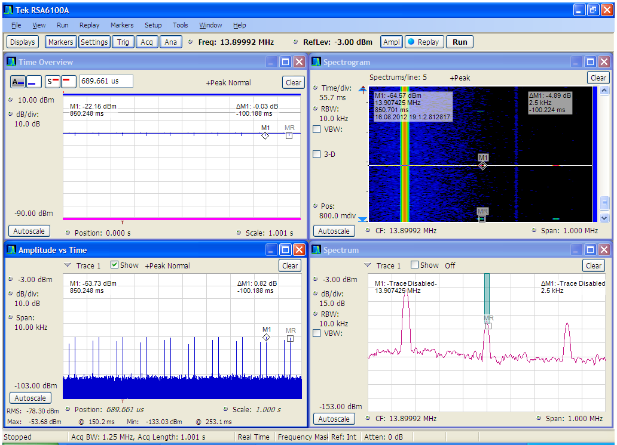

Figure 20: Time analysis of the Reader 3 signal for a 1 s time interval

Finally, the lower left window in Figure 20 shows that Reader 3 also emits one double-pulse every 100 ms. The pulse/pause ratio is nevertheless even lower than that of Reader 2 due to the shorter pulse length, hence the even higher difference between Pk and QP levels (9.5 vs. 4 dB, see Table 5).

## Field strength versus distance measurements

The expected interference range of RFID readers is at least partly in the near field, where the vectors of magnetic and electrical field strength are not necessarily orthogonal and the field strength may not drop at a rate of 20 dB per decade with distance, even under free space propagation conditions. Therefore, both electrical and magnetic field strength were measured for Reader 1 and Reader 2 at different distances between 5 and 100 m in an open test site near Munich. It was a lawn near “Kloster Schäftlarn”, Koordinates 47N58’27” / 11E28’09”.

The measurement antenna for the magnetic field was an active loop (EMCO 6502), mounted at 1.5 m height on a tripod and turned to the direction of maximum field strength. Its antenna factor is given by the manufacturer as 10 dB, so the calculation of the magnetic field strength from measured receiver input voltage can be made as follows:

H = Urx + 10 dB – 51.5 dB

with:

H = magnetic field strength in dBµA/m

Urx = voltage at the receiver input in dBµV

51.5 dB = conversion between electrical and magnetic field strength

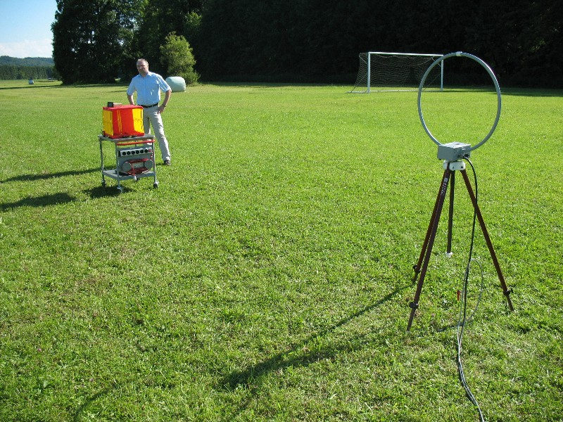

Figure 21: Magnetic loop measurement antenna

The measurement antenna for the electrical field strength was a short vertical monopole (R&S HFH2-Z2) with rods as a ground plane. Its antenna factor is given by the manufacturer as 20 dB, so the calculation of the electrical field strength from measured receiver input voltage can be made as follows:

E = Urx + 20 dB

with:

E = electrical field strength in dBµV/m

Urx = voltage at the receiver input in dBµV

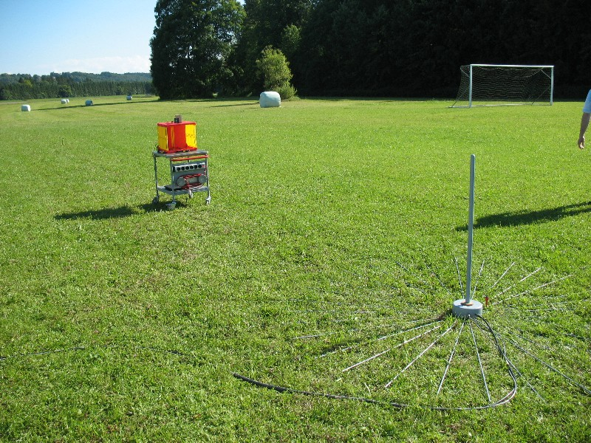

Figure 22: Electrical monopole measurement antenna

The measurements were done with a spectrum analyzer on the carrier frequency 13.56 MHz, RBW = 10 kHz, Detector = RMS. The following graphs show the resulting dependencies between field strength and distance. The detailed numerical results can be taken from Annex 2 of [13].



Figure 23: Magnetic field strength vs. distance



Figure 24: Electrical field strength vs. distance

It can be seen that especially the graphs for the magnetic field strength plot nearly as straight lines when the x-axis is scaled logarithmically.

This means that far field conditions may be applied as a good estimate even for distances as short as 5 m because the near-far field transition point is close to 3.52 meters distance from the reader Antenna.

The curves for electrical field strength bend slightly at a distance around 20 m, while the decay curves for the magnetic field strength are almost straight lines.

The magnetic field strength attenuation (e.g. from 5 m to 50 m points) in the measured distance range is approx. 23 dB /decade (5 m to 50 m points) being only 3 dB more than under free space conditions.

The electric field strength attenuation (5 m to 50 m points) is approx. 25 dB/decade thus 5 dB higher than under real free space conditions, the slope of 20 dB/decade however extends from 20 m onwards. The reason between the 25 and 20 dB/decade difference is the soft transition between the near to far field.

## Interference measurements

### Receiver

It was agreed that the only component of the RFID signal contributing to interferences into the broadcast band are the sideband emissions falling directly into the BC receive channel. In so far, it could be seen as a co-channel interference situation where the C/I usually depend on the properties of the victim radio system rather than on the performance of the specific receiver.

It was therefore also agreed that using only one common HF broadcast receiver for these measurements already provides a good estimate of the situation in general.

The portable receiver TECSUN PL600 [14] was used for the measurements. Annex 1 of [13] provides the available broadcast receiver information.

The receiver was battery-operated and placed at a height of approx. 1.2 m above the ground. The telescope antenna was fully extended and oriented vertically to provide an Omni-directional pattern in the horizontal plane.

The maximum achievable undistorted audio SINAD of the receiver was 28 dB.

### Wanted signal

The wanted signal consisted of an RF carrier 100% AM modulated with a 1 kHz sinewave tone. It was transmitted by a signal generator (HP 8648C) via a vertical rod antenna positioned at a distance of 20 m from the victim receiver.

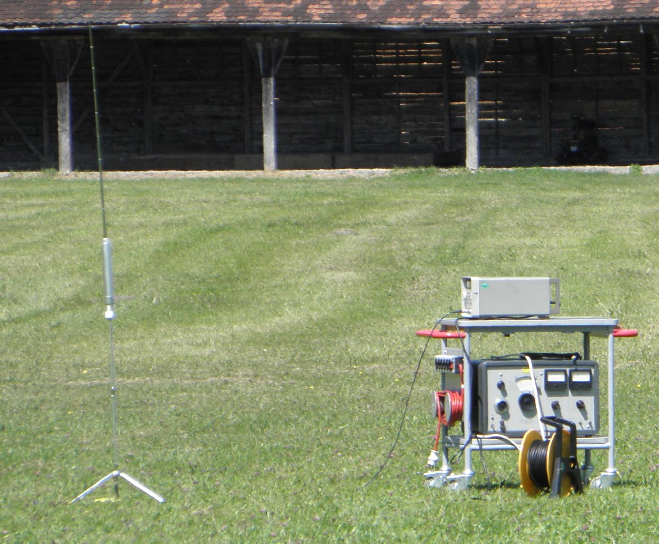

Figure 25: Broadcast transmitter and antenna

The wanted signal level was set to provide a field strength of 54 dBµV/m. This enabled the receiver to achieve an undistorted SINAD of 20 dB.

The frequency range around 13.700 MHz was the nearest range where during the test time, 3 adjacent broadcast channels were “free”. The frequency 13.700 MHz was therefore used as the wanted test frequency. This way it could be achieved that the receiver is not influenced by skywave signals on the tuned and/or adjacent channels.

### Unwanted signal

The field strength measurements under 5.3 have shown that the signal strength of the carrier from Readers 2 and 3 were far below the values from Reader 1. Therefore, it was agreed to perform the interference tests only with a signal comparable to that of the high-power, narrowband Reader 1.

The field strength of the carrier of Reader 1, even in 5 m distance to the victim receiver, does not create an input voltage driving the receiver into overload. Especially in the HF bands, broadcast receivers must be able to perform even in the presence of very strong signals on adjacent frequencies.

A measurement has shown that from a distance of 10 m on, the carrier from the reader was not even the strongest signal in the 22 m band. It could therefore be assumed that the only interference potential comes from the RFID sideband emissions.

To be able to adjust the interfering RFID signal freely in level and frequency, the actual signal from Reader 1 was recorded with a fast FFT analyzer (Tektronix RSA6114) and re-transmitted repeatedly with a vector signal generator (R&S SMU200A) over the large external loop antenna belonging to Reader 1. The level of the second peak of the sideband spectrum (offset +107 kHz, see Figure 11) was adjusted so that it produced a QP level of 27 dBµA/m in 10 m distance (matching the new mask) and 9.5 dBµA in 10 m distance (matching the old mask). This situation was reached at an indicated output reading at the generator of +15 dBm for the new mask level and -3 dBm for the old mask level.

The frequency of the RFID signal was slightly “mistuned” to 13.593 MHz to shift the second sideband peak exactly on the measurement frequency 13.700 MHz. This produces the maximum interfering effect as can be expected in reality.

Figure 26 shows the Pk and QP spectra of the RFID signal used for the interference measurements.



Figure 26: Interfering RFID signal used for the measurements

Note: Although the measurement frequency 13.7 MHz with its offset of 140 kHz from the RFID carrier is already in the range of the “slope” of the new spectrum mask (see Figure 4), it was treated as if it were inside the offset range of 100 kHz. This produces equal C/I results under the assumption that the RFID carrier itself does not contribute to the interference.

### Failure criterion

To have an objective measure for the quality of the broadcast reception, the SINAD measured at the audio output of the receiver was taken. A minimum of 20 dB SINAD was used as the failure criterion. This value is in accordance with ITU and CEPT Recommendations for various narrowband radio services transmitting audible signals. It is assumed to be the lowest value providing a reasonable copy of the speech transmitted.

The audio input of a communication tester (R&S CMS48) was connected to the audio output of the broadcast receiver in order to directly measure the SINAD.

Since the undistorted SINAD was adjusted to 20 dB, reception was regarded as distorted when the SINAD value drops to 19 dB or below. Subjective tests verified that this degradation was clearly audible even using the built-in speaker of the receiver.

### Measurement setup and procedure

The broadcast receiver was set up at a fixed location on the test site.

The wanted signal generator and antenna was also placed at a fixed location in 20 m distance to the victim receiver to ensure a constant receive level of the wanted signal (54 dBµV/m).

The interfering signal was emitted from the large loop antenna belonging to Reader 1 and located at varying distances from the victim receiver (10, 30 and 100 m) and with varying level.

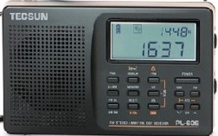

Tx

Tx

10, 30 or 100m

20m

RFID  
transmitter

BC   
receiver

BC   
transmitter

Figure 27: Measurement setup

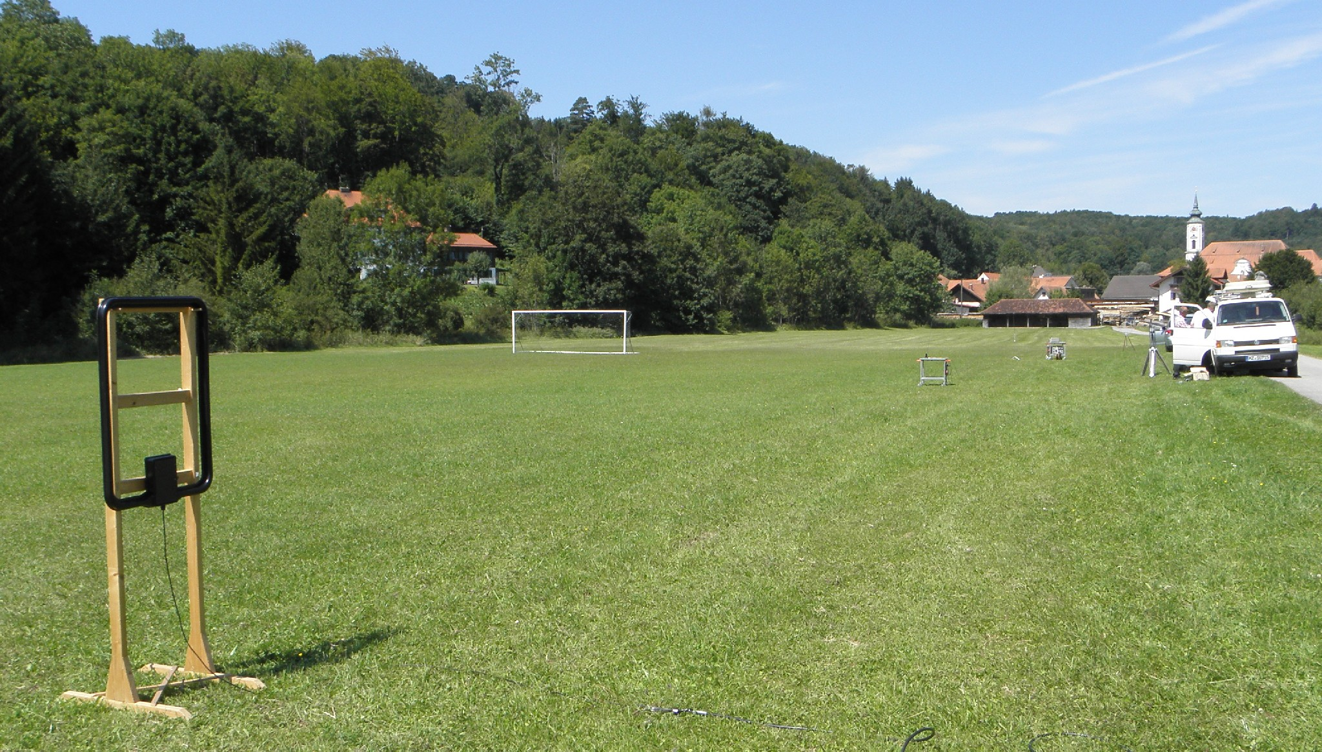

BC transmitter

BC receiver

RFID reader antenna

Figure 28: RFID reader antenna at 30 m distance to victim receiver

### Measurement results

At each of the three measurement distances, the level of the interfering RFID signal was raised until the SINAD from the victim receiver just dropped to 19 dB. Using the results from the field strength propagation measurement (Section 5.3) and knowledge of the required generator output setting to reach a sideband level matching the new and old mask (see Section 5.4.3), the resulting interference distance could be calculated for each of the measurement points (see Table 6).

Table 6: Results of the interference measurements

|  | **RFID level** | | |  |  |
| --- | --- | --- | --- | --- | --- |
|  | **SMU-output level at** | **X dB below output level required for** | | **Calculated interference  range with** | |
| **Distance** | **Interference begin** | **new mask** | **old mask** | **new mask** | **old mask** |
| 10 m | -14 dBm | 29.0 dB | 10.5 dB | 190 m | 25 m |
| 30 m | -3 dBm | 18.0 dB | -0.5 dB | 190 m | 27 m |
| 100 m | 8 dBm | 7.0 dB | -11.5 dB | 180 m | 26 m |

### Subjective test with skywave reception

To gain a subjective impression of the interference to true HF reception where the wanted field strength varies with the skywave propagation, the broadcast receiver was tuned to a station on 13.635 MHz. Reception was already impaired by the fact that more than one station was operating on that frequency, but this resembled a realistic situation. The total field strength of this signal was recorded over a sample time of 50 s.



Figure 29: Field strength vs. time of the wanted broadcast signal on 13.635 MHz

The average field strength was 64.5 dBµV/m.

The RFID antenna with the interfering signal was placed at a distance of 100 m and its level was adjusted at a generator output of 8 dBm which simulates a sideband level that is still 7 dB below the new mask (levels according to the last row in Table 6). The interfering RFID signal was repeatedly switched on and off (for about 1 s each) and its interfering effect was clearly noticeable in the built-in speaker of the broadcast receiver as a humming noise.

## Conclusion

The measurements have shown with a remarkable reproducibility that the interfering range of the long range, low bandwidth and low data rate RFID systems making use of the sideband limits according to the newly proposed mask to the adjacent broadcast reception is at most 190 m, under worse case conditions e.g. provided the path between interferer and victim is unobstructed and the victim frequency falls on one of the peaks in the sideband spectrum. Under the same conditions, the interfering range is around 25 m when the RFID signal complies with the old, more restrictive mask.

Compared to this, the interference range of the low-power, wideband RFID readers is not relevant, regardless of the mask applied.

# Interference distance CALCULATIONS CONSIDERING Broadcasting radio service

Interference calculations at 13.56 MHz are conducted in this section according to ERC Report 69 [4].

*Note: Since the noise and the usable signal levels are given in dBµV/m while the RFID emission levels are*

*given in dBµA/m, the conversion relation using the free field impedance of 377 Ω is the following:*

E (dBµV/m) – log 377 (Ω) = H (dBµA/m); where log 377 (Ω) = 51,5 dB.**/m]**

## Magnetic field strength as a function of distance

The roll-off regions of the magnetic field strength versus distance are:

* -60 dB/decade until a distance 3.52 m (lambda/2Phi), see Figure 7, Page 11, ERC Report 69 [4];
* -40 dB/decade from a distance of 3.52 m to 35.2 m (10*Lambda/2Phi), see Figure 7, Page 11, ERC Report 69 [4];
* -20 dB/decade from a distance 35.2 m to Roll-off distance;
* -40 dB/decade from 35,2 m distance for the transition from 20 to 40 dB/decade, Roll-off is 100 m, from ERC Report 69, Figure A2.

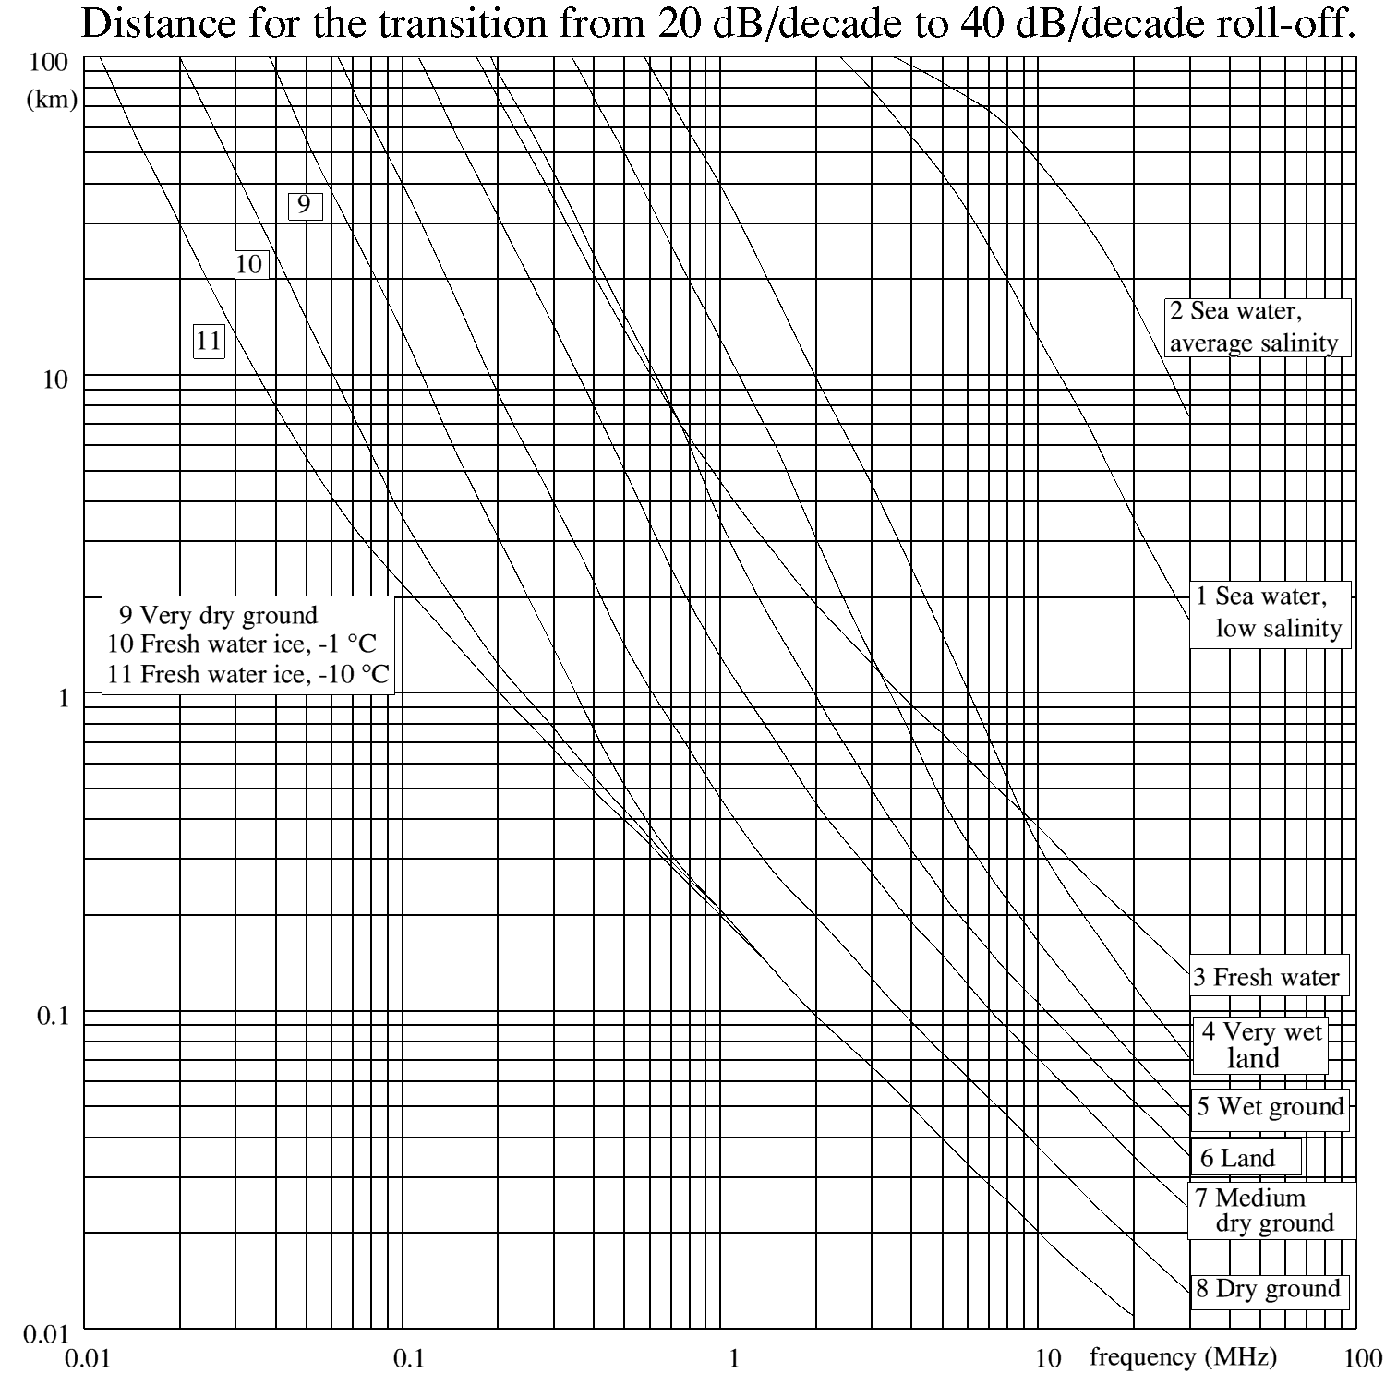

Figure 30: Roll-off distance determination for 13.56 MHz over wet ground

**20 dB to 40 dB roll-off distance at 13,56 MHz is ~ 100 m**

The curve “Wet ground” represents a worse case and intersects the line at 13.56 MHz at a distance of 100m.

## Magnetic field strength Limits of the long range reader

The transmitter modulation emissions frequency ranges are specified for the following field strength levels according to the TX mask of Figure 4,

Table 7: Limits of magnetic field strength for the long range reader at a distance of 10 m

| **Frequency range  [MHz]** | **Emission limit at a distance of 10 m [dBμA/m]** |
| --- | --- |
| 13.553 – 13.567 | 60 |
| 13.460 – 13.553; 13.567 – 13.660 | 27 |
| 13.360 – 13.460; 13.660 – 13.760 | transition range from 27 to -3.5 |
| 13.110 – 13.360; 13.760 – 14.010 | -3.5 |

## Calculation of the man made noise at the frequency of 13.56 MHz

Report ERC Report 69 [4] specifies the rural and business noise levels only at 1, 10 and 100 MHz intervals.

Therefore the interpolation of the data from Table 8 and Figure 31 yields the rural and business noise levels of 6.9 dBµV/m respectively 2.6 dBµV/m at 13.56 MHz.

The equivalent noise levels in magnetic field strength is given in a separate line below Table 8

Table 8: Determination of man-made noise for business and rural areas at 13.56 MHz

| **Frequency [MHz]** | **Business [ dBμV/m]** | **Rural [ dBμV/m]** |
| --- | --- | --- |
| 0.3 | 19.6 | 15.3 |
| 1 | 15.6 | 11.3 |
| 10 | 7.9 | 3.6 |
| **13.56** | **6.9** | **2.6** |
| 30 | 4.2 | -0.1 |

Business and rural noise levels in magnetic field strength:

|  |  |  |
| --- | --- | --- |
| **Frequency [MHz]** | **Business [ dBμA/m]** | **Rural [ dBμA/m]** |
| **13.56** | **-44.6** | **-48.9** |



Figure 31: Slope of Frequency dependent man-made noise level to   
determine noise levels at 13.56 MHz

## Calculation of the acceptable Maximum interference level for broadcast RECEIVERS OR alike systems

The acceptable maximum interference level is derived from a realistic scenario based on the broadcast reception field test and takes into account the manmade business and rural noise levels.

The average field strength from the SW Broadcast report was determined from field measurements to be 64.5 dBµV/m. (See section 5.4.7, Figure 29, SW reception level).

E = 64.5 dBµV/m is equivalent to H = +13 dBµA/m

The Acceptable maximum interference level considers the following:

20 dB for S/N (ITU, ECC defined reception level)

10 dB for 1/2 of the variation of the actual signal received via sky wave propagation, (Figure 29)

30 dB = total margin to be considered

The acceptable maximum interference level is:

Acceptable maximum interference level  **= +13 dBµA/m - 30 dB = -17 dBµA/m**

## Calculation of the magnetic field strength versus distance and protection distance for outdoor operation

Table 9 shows the magnetic field strength levels at different distances to the transmitter antenna for outdoor installations.

Table 9: Magnetic field strength versus distance for transmitter outdoor operation

| **Distance [m]** | **Noise Level Business [ dBμA/m]** | **Noise Level Rural [ dBμA/m]** | **Magnetic field strength of the modulation mask levels at D = 10 m, [ dBμA/m]** | | |
| --- | --- | --- | --- | --- | --- |
| **13.460 – 13.553**  **13.567 – 13.660 MHz** | **13.71 MHz** | **13.110 – 13.460**  **13.760 – 14.010 MHz** |
| 3.52 | -44.6 | -48.9 | 45.1 | 29.9 | 14.6 |
| 10 | -44.6 | -48.9 | 27 | 11.75 | -3.5 |
| 35.2 | -44.6 | -48.9 | 5.1 | -10.1 | -25.4 |
| 100 | -44.6 | -48.9 | -3.9 | -19.2 | -34.4 |
| 500 | -44.6 | -48.9 | -31.9 | -47.1 | -62.4 |
| 1050 | -44.6 | -48.9 | -44.8 | -60.0 | -75.3 |
| 1330 | -44.6 | -48.9 | -48.9 | -64.1 | -79.4 |
| 2000 | -44.6 | -48.9 | -56.0 | -71.2 | -86.5 |
| 3000 | -44.6 | -48.9 | -63.0 | -78.3 | -93.5 |
| 4000 | -44.6 | -48.9 | -68.0 | -83.3 | -98.5 |
| 5000 | -44.6 | -48.9 | -71.9 | -87.1 | -102.4 |
| 7000 | -44.6 | -48.9 | -77.7 | -93.0 | -108.2 |
| 10000 | -44.6 | -48.9 | -83.9 | -99.2 | -114.4 |
| 16000 | -44.6 | -48.9 | -92.1 | -107.3 | -122.6 |

Figure 32 shows the protection distances for SW BC for RFID systems considering indoor operation

Considering a margin of 30 dB to the BC field strength level of 13 dBµA/m, the protection distances are 210 m respectively 22 m depending on the modulation frequency position within the mask.



Figure 32: Magnetic field strength and protection distances for different emission levels of the TX mask (outdoor operation)

## Calculation of the magnetic field strength versus distance and protection distance for indoor operation

Table 10 shows the magnetic field strength levels at different distances to the transmitter antenna for indoor RFID installations. The only difference to section 6.5 with outdoor RFID usage is the consideration of 10 dB wall loss.

Table 10: magnetic field strength at different distances to the transmitter (Indoor)

| **Distance [m]** | **Noise Level Business [ dBμA/m]** | **Noise Level Rural [ dBμA/m]** | **Magnetic field strength of the modulation mask levels at D = 10 m [ dBμA/m]** | | |
| --- | --- | --- | --- | --- | --- |
| **13.460 – 13.553**  **13.567 – 13.660**  **MHz** | **13.71 MHz** | **13.110 – 13.460**  **13.760 – 14.010 MHz** |
| 3.52 | -44.6 | -48.9 | 35.1 | 19.9 | 4.6 |
| 10 | -44.6 | -48.9 | 17 | 1.75 | -13.5 |
| 35.2 | -44.6 | -48.9 | -4.9 | -20.1 | -35.4 |
| 100 | -44.6 | -48.9 | -13.9 | -29.2 | -44.4 |
| 500 | -44.6 | -48.9 | -41.9 | -57.1 | -72.4 |
| 1000 | -44.6 | -48.9 | -53.9 | -69.2 | -84.4 |
| 2000 | -44.6 | -48.9 | -66.0 | -81.2 | -96.5 |
| 3000 | -44.6 | -48.9 | -73.0 | -88.3 | -103.5 |
| 4000 | -44.6 | -48.9 | -78.0 | -93.3 | -108.5 |
| 5000 | -44.6 | -48.9 | -81.9 | -97.1 | -112.4 |
| 7000 | -44.6 | -48.9 | -87.7 | -103.0 | -118.2 |
| 10000 | -44.6 | -48.9 | -93.9 | -109.2 | -124.4 |
| 16000 | -44.6 | -48.9 | -102.1 | -117.3 | -132.6 |

Figure 33 shows the protection distances for SW BC for RFID systems considering indoor operation

Considering a margin of 30 dB to the BC field strength level of 13 dBµA/m. the protection distances are 120 m respectively 12 m depending on the modulation frequency position within the mask.



Figure 33: Magnetic field strength and protection distances for different emission levels   
of the TX mask (indoor operation)

# Conclusions

ETSI has proposed the ETSI TR 103 059 [1] describing emission masks for two new RFID systems in the 13.56 MHz range which should be considered for ECC studies and approval. The two RFID applications described in ETSI TR 103 059 [1] are short range wideband systems and long range narrowband systems.

Market deployment data for the proposed new 13.56 MHz systems were compiled showing that the large majority of systems are using the short range wideband systems, while the long range narrowband systems are deployed in significant lower quantities and mainly used in industrial sites for indoor operations.

The new RFID systems were documented in field tests and measurements related to propagation and interference with regard to a short wave broadcasting receivers were made.

## RESULTS for short range wideband rfid systems

The proposed transmitter mask for short range wideband system (see Figure 3) complies with the present limits in EN 300 330 for small frequency offsets (+/- 900 kHz) and with the wideband limit from Recommendation 70-03 Annex 9 (i1 and i2) for larger frequency offsets. Therefore, no compatibility studies are provided in this report.

## RESULTS for long range narrowband rfid systems

Regarding the long range narrowband systems the Report covers compatibility calculations in the range of 13.360 MHz to 13.760 MHz where higher emission levels compared to the existing mask are requested (levels between -3.5 and 27 dBµA/m, see Figure 4). Protection distances were derived from theoretical calculations using the path loss model from ERC report 69 and from new performed field tests.

According to theoretical calculations the indoor operation of RFIDs yields the protection distances up to 120 m for a frequency offset (between RFID center frequency and victim frequencies) of ≤100 kHz. Considering outdoor use of RFIDs also with a frequency offset of ≤100 kHz, the maximum protection distance is between 190 m (from the field testing) and 210 m (from theoretical calculations).

For higher frequency offsets (≥ 100 kHz) the distance becomes clearly less (e.g. 12 m for indoor operation) because the allowed limit of the RFIDs in the emission mask jumps from +27 dBµA/m down to -3.5 dBµA/m.

Although the new transmitter mask for long range narrowband RFID systems leads to higher protection distances compared to the existing mask, it may be concluded that the risk for interference is low because of the combination of the following operating and deployment conditions:

1. deployment usually in industrial sites;
2. predominant indoor operation;
3. expected low deployment rate;
4. low duty cycle
5. it is expected that in most of the scenarios for long range RFID system the transmitted power will be less than the proposed maximum limit.
6. List of reference
7. ETSI TR 103 059: Electromagnetic compatibility and Radio spectrum Matters (ERM); Short-Range Devices (SRD) for operation in the 13.56 MHz band; System Reference Document for Radio Frequency Identification (RFID) equipment.
8. ETSI EN 300 330v1.7.1: Electromagnetic compatibility and Radio spectrum Matters (ERM); Short Range Devices (SRD); Radio equipment in the frequency range 9 kHz to 25 MHz and inductive loop systems

in the frequency range 9 kHz to 30 MHz; Part 1: Technical characteristics and test methods

1. ERC RECOMMENDATION 70-03 (Tromsø 1997 and subsequent amendments) relating to the use of short range devices (SRD)
2. ERC Report 69: Propagation Model And Interference Range Calculation For Inductive Systems 10 KHz - 30 MHz;
3. ISO 14443: Identification cards – Contactless integrated circuit(s) cards – Proximity cards Part 1: Physical characteristics
4. ISO 15693-3: Identification cards — Contactless integrated circuit(s) cards — Vicinity cards
5. ISO 18000-3: Information technology — Radio frequency identification for item management — Part 3: Parameters for air interface communications at 13.56 MHz
6. NFC: 1) ECMA-340 “Near Field Communication – Interface and Protocol
7. CEPT/ERC/RECOMMENDATION 74-01 on Unwanted Emissions in the Spurious Domain
8. EC Decision: 2011/829/EU Commission Decision of 8 December 2011 amending Decision 2006/771/EC on the harmonisation of the radio spectrum for use by short-range devices
9. ECC Report 67: Compatibility Study For Generic Limits For The Emission Levels Of Inductive SRDs Below 30 MHz
10. ERC REPORT 74: Compatibility Between Radio Frequency Identification Devices (Rfid) And The Radioastronomy Service At 13 MHz
11. BNetzA report : Measurement Report G531/00675/12. Measurements to characterize HF RFID signals and to determine the interference to the HF broadcast service
12. Tecsun PL-600 AM/FM/LW SSB Shortwave Radio: <http://tecsunradio.com/2011/12/29/tecsun-pl210-english-manual-pdf-dowload/>