CEPT Report 72

Report from CEPT to the European Commission in response to the Mandate

“to review the harmonised technical conditions for certain EU-harmonised frequency bands and to develop least restrictive harmonised technical conditions suitable for next-generation (5G) terrestrial wireless systems”

Report A: Review of technical conditions in the paired terrestrial 2 GHz and the 2.6 GHz frequency bands, and the usage feasibility of the 900 MHz and 1800 MHz frequency bands

**Report approved on 5 July 2019 by the ECC**

# Executive summary

This Report is the first response (Report A) to Task 1 to 3 of the Mandate from the European Commission “to review the harmonised technical conditions for certain EU-harmonised frequency bands and to develop least restrictive harmonised technical conditions suitable for next-generation (5G) terrestrial wireless systems”.

According to the schedule set out in the Mandate, this Report addresses Task 1 and 3 in full (for 900 MHz, 1800 MHz, paired terrestrial 2 GHz, and 2.6 GHz), and Task 2 for the 2 GHz and 2.6 GHz frequency bands.

In response to the task 1 of this EC mandate, CEPT has performed a review of the EU-harmonised technical conditions for use of paired terrestrial 2 GHz, and 2.6 GHz frequency bands with view to their suitability for 5G terrestrial wireless systems and assessed the approach to adapting the EU-harmonised technical conditions for 5G use, if needed.

Based on the work in response to task 1, CEPT provides in Annexes 2 & 3 an update of the technical annex of the current EC Decisions in the relevant frequency bands:

* 2 GHz (1920-1980 MHz and 2110-2170 MHz) Decision 2012/688/EU [1];
* 2.6 GHz (2500-2690 MHz): Decision 2008/477/EC [2].

Concerning the channelling arrangements for those frequency bands, CEPT had made the following analysis and recommendations:

* 2 GHz: CEPT confirms the suitability of the FDD band plan in EC Decision 2012/688/EU for 1920-1980 MHz and 2110-2170 MHz for 5G. CEPT also concluded that the 300 kHz guard band at the lower and upper frequency boundaries of the band plan can be removed. It is up to each Member State to decide, based on its requirements, and consider the impact on existing authorisations in its country within the band and services in adjacent bands, whether and how to migrate from the band plan in EC Decision 2012/688/EU to the updated band plan, and any associated conditions. It is noted that the UMTS channel raster is 200 kHz, which means that the centre frequency must be an integer multiple of 200 kHz and therefore carriers would have to be offset 100 kHz from the centre of the blocks defined in the updated band plan. The bands 1920-1980 MHz and 2110-2170 MHz are divided into twelve paired blocks and the minimum block size should be in the range 4.8 MHz to 5.0 MHz. Moreover, for SUL operation, the frequency band 1920-1980 MHz may be used for NR uplink operation without a paired downlink NR channel in the frequency band 2110-2170 MHz. For SDL operation, the frequency band 2110-2170 MHz may be used for NR downlink operation without a paired uplink NR channel in the frequency band 1920-1980 MHz. CEPT requested ETSI to improve the relevant harmonized standards to ensure coherence with the updated band plan.
* 2.6 GHz: in this frequency band, CEPT noted that the EC framework Decision 2008/477/EC includes national flexibility outside of the TDD sub-band 2570-2620 MHz. According to this framework, outside these 50 MHz, TDD usage can be decided at national level and shall be in equal parts in both the upper part of the band starting at 2690 MHz (extending downwards) and the lower part of the band starting at 2570 MHz (extending downwards). ECO Report 03 [3] which provides information on licensing framework within MFCN bands indicates that national TDD flexibility has been implemented in two CEPT countries and this flexibility is expected to remain until the end of those authorisations.

CEPT recommends that the introduction of 5G in this band shall be based on the existing CEPT band plan (FDD 2x70 MHz + unpaired 50 MHz either for TDD or SDL). Any extension of the unpaired mode outside of the sub-band 2570-2620 MHz shall be subject to further harmonisation and coordinated timing at EU level, due to the risk of interference at national borders. At this stage, development of 5G in FDD mode is also foreseen in the 1.8 GHz and 2 GHz frequency bands and CEPT expects that, also in the 2.6 GHz frequency band, 5G will use the same duplex mode as 4G.

Concerning the LRTC (BEM), for the 2 GHz frequency band:

* the current BEM remains applicable for non-AAS MFCN and is based on Equivalent Isotropically Radiated Power (e.i.r.p);
* a new BEM is introduced for AAS MFCN and is based on Total Radiated Power (TRP).

Concerning the LRTC (BEM), for the 2.6 GHz frequency band:

* The BEM for non-AAS in the EC Decision should be aligned with ECC Decision (05)05. This simplifies the BEMs so that in the 5 MHz adjacent to the block there is a single transitional limit instead of three transitional limits; the existing baseline limit beyond 5 MHz would not be changed (Note: This change was provided in a previous update of ECC Decision (05)05 but was not reflected in the EC Decision);
* An additional baseline has been developed at 2690-2700 MHz for AAS FDD base stations to reduce the size of the coordination zone with radio astronomy sites where considered necessary by the concerned administration. The feasibility of implementation of wide area outdoor AAS base stations in the highest two 5 MHz blocks taking into account the additional baseline limit may require evolution of filtering capabilities for AAS. However, these two upper blocks would remain usable for BS with lower power;
* However, additional measures may be needed on a national basis in order to protect the RAS. Depending on the size of the necessary coordination zone to protect RAS cross border co-ordination may also be necessary. The additional baseline limit is not applicable in geographical areas outside the coordination zones (1) with RAS or other situations, including geographical areas inside the coordination zone, where an additional baseline limit is not considered necessary by the concerned administration. National measures may include geographical separation distances, coordination on a case by case basis, or compliance with the maximum pfd level at the radio astronomy sites;
* Moreover, measures applicable at national level, such as pfd limits in order to protect the various types of radars above 2700 MHz would remain applicable, noting that it may be more complex for operators to comply with the pfd limit since AAS systems cannot be fitted with additional external filters.

In response to task 3, CEPT confirmed that cross-border co-ordination can be sufficiently addressed through existing bilateral and multi-lateral procedures, supported by ECC Recommendations. CEPT will work to ensure that relevant ECC Recommendations are 5G compatible.

Concerning the 900 MHz frequency band (880-915 MHz and 925-960 MHz), in response to the task 1 of the EC mandate, this CEPT report provides also information on the usage feasibility of the 900 MHz and 1800 MHz frequency bands for 5G, including any limitations of the GSM Directive for 900 MHz.

* CEPT confirms that within 900 MHz, narrowband systems including GSM and various cellular IoT systems will continue to be in operation commercially for the foreseeable future. This issue will be carefully addressed when CEPT will develop LRTC (BEM in 900 MHz) in order to develop harmonised technical conditions taking into account the need for coexistence with narrow band systems including GSM and various cellular IoT systems;
* CEPT confirms, as per ECC Report 297 [5] and CEPT Report 40 [13], that when narrowband systems including GSM and various cellular IoT systems are in operation in 900 MHz and 1800 MHz bands there is a need for:
  + A frequency separation of 200 kHz or more between NR channel edge of one network and the nearest GSM channel edge of the neighbouring network when wideband and GSM systems are operating in an uncoordinated manner. No frequency separation is required for coordinated operation;
  + A frequency separation of 200 kHz or more between the standalone NB-IoT channel edge of one network and the NR channel edge of the neighbouring network.

This 200 kHz frequency separation requirement is already covered by the relevant ETSI standard due the channel characteristics of 5G NR (5 MHz or above channel bandwidth).

CEPT informs also the European Commission of the update of ECC technical framework for the 900 MHz and 1800 MHz frequency bands in March 2019, in order to reference the latest technical standards covering 5G New Radio. The CEPT plans to adopt during 2020 harmonised technical conditions on the basis of BEM for both frequency bands as the long-term regulatory approach.

**TABLE OF CONTENTS**

0 Executive summary 2

1 Introduction 8

2 Existing Regulatory framework 9

2.1 Existing regulatory framework for 900 and 1800 MHz 9

2.2 Existing regulatory framework for 2 GHz 9

2.3 Existing regulatory framework for 2.6 GHz 9

3 Suitability of the current technical framework for 5G and/or AAS 10

3.1 Suitability of the current technical framework for 900 MHz and 1800 MHz 10

3.1.1 Usage feasibility of the 900 MHz and 1800 MHz frequency bands for 5G and/or AAS 10

3.1.2 Update of 900 MHz and 1800 MHz harmonised technical conditions in response to 5G 10

3.2 Suitability of the current technical framework for 2 GHz 11

3.2.1 Channelling arrangements 11

3.2.2 LRTC (BEM) 11

3.3 Suitability of the current technical Framework for 2.6 GHz 11

3.3.1 Channelling arrangements 11

3.3.2 LRTC (BEM) 12

4 Results of coexistence studies 13

4.1 Coexistence studies for 900 and 1800 MHz 13

4.2 Coexistence studies for 2 GHz 13

4.3 Coexistence studies for 2.6 GHz 14

5 Recommended Framework 16

5.1 Recommended framework for 2 GHz 16

5.1.1 Recommended band plan 16

5.1.2 Applicable technical conditions 16

5.1.2.1 In-block power limits 16

5.1.2.2 Out-of-block power limits: Interference between FDD MFCNs 17

5.2 Recommended framework for 2.6 GHz 18

5.2.1 Recommended spectrum scheme 18

5.2.2 Applicable technical conditions 18

5.2.2.1 Unrestricted BEM for base stations 18

5.2.2.2 Restricted BEM for base stations 20

5.2.2.3 Restricted BEM for base stations with restrictions on antenna placement 21

5.2.2.4 Limits at 2690-2700 MHz for FDD AAS base station 21

5.2.2.5 Limits for terminal stations 21

5.2.2.6 Examples of combining BEM elements 22

5.2.2.7 Other conditions 27

6 Cross-border coordination 28

7 Conclusions 29

ANNEX 1: cept mandate 32

ANNEX 2: Updates to EC Decision 2012/688/EU (2 GHz) 38

ANNEX 3: Updates to EC Decision 2008/477/EC (2.6 GHz) 41

ANNEX 4: List of references 45

**LIST OF ABBREVIATIONS**

|  |  |
| --- | --- |
| **Abbreviation** | **Explanation** |
| **5G** | 5th Generation of mobile networks |
| **AAS** | Active Antenna System |
| **ATPC** | Automatic Transmitter Power Control |
| **BEM** | Block Edge Mask |
| **BS** | Base Station |
| **CBW** | Carrier Bandwidth |
| **CEPT** | European Conference of Postal and Telecommunications Administrations |
| **CGC** | Complementary Ground Component |
| **EC** | European Commission |
| **ECC** | Electronic Communications Committee |
| **e.i.r.p.** | Equivalent Isotropically Radiated Power |
| **ETSI** | European Telecommunications Standards Institute |
| **EU** | European Union |
| **FDD** | Frequency Division Duplex |
| **GSM** | Global System for Mobile Communication |
| **IoT** | Internet of Things |
| **LRTC** | Least Restrictive Technical conditions |
| **LTE** | Long Term Evolution |
| **MFCN** | Mobile/Fixed Communications Networks |
| **non-AAS** | non-Active Antenna Systems |
| **MSS** | Mobile Satellite Service |
| **NB-IoT** | Narrow Band-IoT |
| **NR** | New Radio |
| **OOB** | Out Of Band |
| **pfd** | Power flux density |
| **RAS** | Radio Astronomy Service |
| **SCS** | Sub-Carrier Spacing |
| **SDL** | Supplemental Downlink |
| **SUL** | Supplemental Uplink |
| **TDD** | Time Division Duplex |
| **TRP** | Total Radiated Power |
| **UE** | User Equipment |
| **UMTS** | Universal Mobile Telecommunications System |

# Introduction

In September 2018, the European Commission issued a Mandate to CEPT: “to review the harmonised technical conditions for certain EU-harmonised frequency bands and to develop least restrictive harmonised technical conditions suitable for next-generation (5G) terrestrial wireless systems” (see Annex 1).

This Report is the first response (Report A) to Task 1 to 3 of the Mandate:

1. Review the EU-harmonised technical conditions for use of the 900 MHz, 1800 MHz, paired terrestrial 2 GHz, and 2.6 GHz frequency bands with view to their suitability for 5G terrestrial wireless systems[1] which provide electronic communications services as well as other relevant services or applications, and assess the approach to adapting the EU-harmonised technical conditions for 5G use, if needed.

In particular, for the 900 MHz frequency band, such assessment should address any potential constraints (e.g. regarding efficient spectrum use), which result from the requirement to ensure co-existence with the GSM system, pursuant to the GSM Directive [4].

1. Based on the results under Task 1, develop channelling arrangements and common and minimal (least restrictive) technical conditions[2] for the aforementioned frequency bands, which are suitable for 5G terrestrial wireless systems in compliance with the principles of technology and service neutrality.

These conditions should be sufficient to mitigate interference and ensure co-existence with incumbent radio services/applications in the same band or in adjacent bands, in line with their regulatory status, including at the EU outer borders.

1. Develop guidance for cross-border coordination.

According to the schedule set out in the Mandate, this Report addresses Task 1 and 3 in full, and Task 2 for the 2 GHz and 2.6 GHz frequency bands.

CEPT has conducted relevant analysis to update the harmonised CEPT framework for 5G[3] in these bands:

* 900 MHz and 1800 MHz: ECC Report 297 [5] and corresponding amendments to ECC Decision (06)13 (8 March 2019) [6];
* 2 GHz: ECC Report 298 [7] and corresponding amendments to ECC Decision (06)01 (8 March 2019) [8];
* 2.6 GHz: amendments to ECC Decision (05)05 (July 2019) [9] and the draft ECC Report 308 [26].

The analysis in this CEPT Report is based on the results of these ECC Reports to provide corresponding recommendations to update the relevant EC framework for the 2 GHz frequency band (EC Decision 2012/688/EU [1]) and the 2.6 GHz frequency band (EC Decision 2008/477/EC [2]).

In the context of this Report the following definitions are applicable.

* Non-AAS (Non-Active Antenna Systems) refers to MFCN base stations that provide one or more antenna connectors, which are connected to one or more separately designed passive antenna elements to radiate radio waves. The amplitude and phase of the signals to the antenna elements is not continually adjusted in response to short term changes in the radio environment;
* AAS (Active Antenna Systems) refers to MFCN base stations and antenna systems where the amplitude and/or phase from the various antenna elements is continually adjusted resulting in an antenna pattern that varies in response to short term changes in the radio environment. This is intended to exclude long term beam shaping such as fixed electrical down tilt.

# Existing Regulatory framework

## Existing regulatory framework for 900 and 1800 MHz

The existing regulatory framework for the 900 MHz and 1800 MHz frequency bands are specified in EC Decision 2009/766/EC [10] amended by EC Decision 2011/251/EU [11] and EC Decision (EU) 2018/637 [12].

## Existing regulatory framework for 2 GHz

The existing regulatory framework for the 2 GHz band is specified in EC Decision 2012/688/EC [1] (see Tables 1 to 3).

## Existing regulatory framework for 2.6 GHz

The existing regulatory framework for the 2.6 GHz band is specified in EC Decision 2008/477/EC [2] (see Tables 1 to 6).

# Suitability of the current technical framework for 5G and/or AAS

## Suitability of the current technical framework for 900 MHz and 1800 MHz

### Usage feasibility of the 900 MHz and 1800 MHz frequency bands for 5G and/or AAS

Concerning the 900 MHz and 1800 MHz frequency bands, in response to the task 1 of the EC mandate, this CEPT Report provides information on the usage feasibility of the 900 MHz and 1800 MHz frequency bands for 5G, including any limitations of the GSM Directive for the 900 MHz band.

CEPT assessed the suitability of the current regulatory framework for the possible future usage of:

* 900 MHz band for 5G non-AAS technology including SUL mode of operation. AAS technology support is currently not considered for the 900 MHz frequency band and therefore it is not considered in this Report;
* 1800 MHz frequency band for 5G (AAS and non-AAS) including SUL mode of operation;
* 1800 MHz frequency band for LTE-AAS.

CEPT analysed and confirmed in ECC Report 297 [5] that the in-band compatibility conclusions from CEPT Report 40 [13] applicable to LTE non-AAS systems in 900/1800 MHz frequency bands are also applicable to both LTE/5G NR AAS systems in 1800 MHz frequency band and to 5G NR non-AAS systems in 900/1800 MHz frequency bands.

CEPT also concluded in ECC Report 297 [5] that the adjacent bands compatibility conclusions from CEPT Report 41 [14] and CEPT Report 42 [15] applicable to LTE non-AAS systems in 900/1800 MHz frequency band are also applicable to both 5G NR non-AAS 900/1800 MHz systems and to LTE/5G NR AAS 1800 MHz systems.

CEPT confirms that within 900 MHz, narrowband systems including GSM and various cellular IoT systems will continue to be in operation commercially for the foreseeable future. This issue will be carefully addressed when CEPT will develop LRTC (BEM in 900 MHz) in order to develop harmonised technical conditions taking into account the need for coexistence with narrowband systems including GSM and various cellular IoT systems.

### Update of 900 MHz and 1800 MHz harmonised technical conditions in response to 5G

CEPT will launch the study of BEM in 900 MHz and 1800 MHz in the second phase. CEPT will take into consideration the narrow band systems (GSM and various cellular IoT systems) which will continue to operate in 900 MHz. CEPT intends to develop BEM(s) addressing wideband systems only.

In 2018, CEPT assessed the suitability of the current harmonised ECC regulatory framework for the deployment of 5G based on New Radio (NR) with non-AAS BS in 880-915 MHz and 925-960 MHz frequency bands (i.e. '900 MHz band') and NR with non-AAS BS, NR AAS BS and LTE AAS BS in the 1710-1785 MHz and 1805-1880 MHz frequency bands (i.e. '1800 MHz band').

CEPT also assessed the suitability of the current ECC regulatory framework for the deployment of NR Supplemental Uplink (SUL) operation in the frequency bands 880-915 MHz and 1710-1785 MHz i.e. NR uplink operation without a paired downlink NR channel in the frequency bands 925-960 MHz and 1805-1880 MHz.

CEPT noted that the current EU framework Decision 2009/766/EC [10] (as amended in 2011/251/EU [11] and 2018/637/EU [12]) allows in 900/1800 MHz use of other systems, which are not listed in the annex of this EU framework, under the condition of ensuring coexistence with the GSM system and the systems: UMTS, LTE, and WiMAX and IoT cellular.

In consequence, the current update of the ECC harmonised framework (ECC Decision (06)13 updated in March 19 [6]) facilitates compliance with this current EU 900/1800 MHz framework in order to accommodate LTE AAS and 5G New Radio (Non-AAS and AAS) providing relevant harmonised technical conditions allowing the use in 900/1800 MHz of these new systems while ensuring coexistence with the technologies currently listed in that Decision.

This updated CEPT framework will help Member States willing to introduce 5G and/or AAS in 900 MHz and 1800 MHz prior to the update of the EC/ECC frameworks with BEM.

## Suitability of the current technical framework for 2 GHz

CEPT reviewed in ECC Report 298 the regulatory framework, including existing band plan and BEM requirements, for 5G in the 1920-1980 MHz and 2110-2170 MHz band and analysis of the existing BEM and identification of required amendments.

Two main areas were studied:

* Assessment of the suitability of existing band plan and BEM for 5G in the 1920-1980 MHz and 2110-2170 MHz frequency band;
* Coexistence with other services below 2110 MHz (space services in particular) and above 2170 MHz (MSS/CGC and space services);

### Channelling arrangements

CEPT concluded that the 300 kHz guard band at the lower and upper frequency boundaries of the band plan can be removed. It is up to each Member State to decide, based on its requirements, and considering the impact on existing authorisations in its country within the band and services in adjacent bands, whether and how to migrate from the band plan in EC Decision 2012/688/EU to the updated band plan, and any associated conditions. Some of the adjacent frequency bands have allocations to space services: space services are allocated in the adjacent bands below 2110 MHz (space services uplinks) and above 2200 MHz (space services downlinks). The sensitive coexistence issue is at 2110 MHz. It is also noted that the UMTS channel raster is 200 kHz, which means that the centre frequency must be an integer multiple of 200 kHz. It is further noted that for the UE the lowest carrier is specified to be placed on 1922.4 MHz and the highest on 1977.6 MHz. This corresponds to 2112.4 MHz (lowest) and 2167.6 MHz (highest) for the base station respectively. This is a relevant consideration for some Member States who are considering migrating to the updated band plan.

The bands 1920-1980 MHz and 2110-2170 MHz are divided into twelve paired blocks and the minimum block size should be in the range 4.8 MHz to 5.0 MHz.

Moreover, for SUL operation, the frequency band 1920-1980 MHz may be used for NR uplink operation without a paired downlink NR channel in the frequency band 2110-2170 MHz. For SDL operation, the frequency band 2110-2170 MHz may be used for NR downlink operation without a paired uplink NR channel in the frequency band 1920-1980 MHz.

### LRTC (BEM)

CEPT concluded on the need to update regulatory framework to support the introduction of 5G in the 1920-1980 MHz and 2110-2170 MHz band. Furthermore, CEPT confirms that the current BEM remains applicable for non-AAS systems and the need for a new BEM for AAS systems. AAS will not be implemented in 5G terminals in these bands.

## Suitability of the current technical Framework for 2.6 GHz

### Channelling arrangements

In this frequency band, CEPT notes that the EC framework Decision 2008/477/EC [2] includes national flexibility outside of the TDD sub-band 2570-2620 MHz. According to this framework, outside these 50 MHz; TDD usage can be decided at national level and shall be in equal parts in both the upper part of the band starting at 2690 MHz (extending downwards) and the lower part of the band starting at 2570 MHz (extending downwards). ECO Report 03 [3], which provides information on licensing framework within MFCN bands, does indicate that national TDD flexibility has been implemented in two CEPT countries and this flexibility is expected to remain until the end of those authorisations.

CEPT recommends that the introduction of 5G in this band shall be based on the existing CEPT band plan (FDD 2x70 MHz + unpaired 50 MHz either for TDD or SDL).

Any extension of the unpaired mode outside of the sub-band 2570-2620 MHz shall be subject to further harmonisation and coordinated timing at EU level, due to the risk of interference at national borders. At this stage, development of 5G in FDD mode is also foreseen in the 1.8 GHz and 2 GHz frequency bands and CEPT expects that, also in the 2.6 GHz frequency band, 5G will use the same duplex mode as 4G.

### LRTC (BEM)

Based on the observations for AAS in other frequency bands, suitable technical conditions (BEM in TRP) should be incorporated in the framework to account for the introduction of AAS MFCN base stations. For terminals the current regulatory technical conditions defined in the current framework are considered to be suitable to 5G terminals. AAS will not be implemented in 5G terminals in this band.

For non-AAS, the BEM in Decision 2008/477/EC should be updated to be aligned with ECC Decision (05)05. This simplifies the BEMs so that in the 5 MHz adjacent to the block there is a single transitional limit instead of three transitional limits; the existing baseline limit beyond 5 MHz would not be changed. The current BEM in the EC Decision contains three transitional limits in the first 5 MHz adjacent to the block, but equivalent compatibility can be provided with a BEM that defines a single transitional limit in this region and then continues with the existing baseline beyond 5 MHz. (Note: This change was provided in a previous update of ECC Decision (05)05 but was not reflected in the EC Decision).

For FDD/TDD coexistence: the restricted blocks are 2570-2575 MHz (except in UL mode operation in that block). This is applicable for all configurations of FDD AAS adjacent to TDD non-AAS and FDD non AAS adjacent to TDD AAS. It should also be noted that the 5 MHz TDD block (2615-2620 MHz) immediately adjacent to a FDD DL block may suffer an increased risk of interference due to the emissions from the FDD DL;

For Indoor AAS BSs or AAS BS with restrictions on antenna placement, alternative measures compared to Table 14 or Table 15 may be required on a case by case basis and on a national basis, see Section 5.2.4.

Concerning usage of 2570-2620 MHz under the LRTC, it shall be noted that CEPT has studied and developed a toolbox in 3400-3600 MHz to address the synchronised and unsynchronised operation and help administrations, operators and spectrum rights users understand coexistence topics and performance impacts related to synchronised and unsynchronised TDD operations. This could be reused for this band.

Concerning synchronised TDD operation, in addition to the unrestricted BEM developed for synchronised TDD blocks, a general framework could be defined at the national level, specifying technical parameters and the scope of their applicability, and administrations may facilitate the process to ensure fair and timely agreements in cases where agreements could be more challenging.

A possible alternative to the synchronised approach implies respecting the unrestricted BEM level for unsynchronised MFCN combined with 5MHz restricted block between 2 TDD unsynchronised blocks. Respecting the TRP baseline limit of -52 dBm/MHz between 2 unsynchronised blocks would imply the introduction of an additional internal filter within the AAS TDD base station. Since the implementation of such filter would depend on the operator's specific spectrum assignment, the filter (and the AAS base stations) would become operator-specific which would not be economically sustainable.

# Results of coexistence studies

## Coexistence studies for 900 and 1800 MHz

The compatibility of AAS technologies with current systems listed in the existing EC framework (GSM, UMTS, LTE, WiMAX and IoT cellular technologies) and adjacent band systems in 900/1800 MHz frequency bands have been evaluated in ECC Report 297 [5] and confirmed to be possible on similar basis as those concluded for LTE non-AAS in CEPT Report 40 [13], CEPT Report 41 [14], CEPT Report 42 [15] and CEPT Report 66 [16] and in ECC Report 266 [17]. The development of ECC Report 297 followed the methodology used in previous ECC and CEPT reports and in particular CEPT Report 40, CEPT Report 41 and CEPT Report 66.

The same technical conditions defined in ECC Decision (06)13 [6] for LTE can be extended for 5G NR non-AAS systems in 900/1800 MHz frequency bands including SUL mode of operation. The same applies for AAS (LTE/NR) in 1800 MHz frequency band.

To ensure coexistence with other systems operating in the 900/1800 MHz frequency bands, the following requirements apply to 5G NR (AAS or non-AAS) and for LTE-AAS:

* Frequency separation of 200 kHz or more between the 5G NR channel edge and the GSM carrier's channel edge when such networks are operated in an uncoordinated manner. This requirement is already covered by the ETSI standard due the channel characteristics of 5G NR (5 MHz or above channel bandwidth). The same applies to coexistence between NR system and EC-GSM-IoT systems;
* No frequency separation is required between 5G NR channel edge and the UMTS carrier's channel edge;
* No frequency separation is required between 5G NR channel edge and the LTE carrier's channel edge. The same applies to coexistence with LTE MTC/eMTC systems;
* No frequency separation is required between 5G NR channel edges between two neighbouring 5G NR networks;
* A frequency separation of 200 kHz or more is needed between the standalone NB-IoT channel edge of one network and the NR channel edge of the neighbouring network. This requirement is already covered by the ETSI standard due the channel characteristics of 5G NR (5 MHz or above channel bandwidth[4]).

## Coexistence studies for 2 GHz

ECC Report 298 [7] assessed the suitability of the existing band plan and BEM for 5G in the 1920-1980 MHz and 2110-2170 MHz band and studied the coexistence of 5G with other services below 2110 MHz (space services in particular) and above 2170 MHz (MSS and space services).

The ECC Report concluded that:

* the 300 kHz guard band at the lower and upper frequency boundaries of the band plan can be removed. It is up to each Member State to decide, based on its requirements, and considering the impact on existing authorisations in its country within the band and services in adjacent bands, whether and how to migrate from the band plan in EC Decision 2012/688/EU [1] to the updated band plan, and any associated conditions;
* the current BEM remains applicable for non-AAS;
* AAS will not be implemented in 5G terminals in this frequency band.

## Coexistence studies for 2.6 GHz

CEPT has assessed the suitability of the existing band plan and BEM for 5G in the 2500-2690 MHz band and studied the co-existence of 5G (NR/AAS) with existing non-AAS and AAS FDD/TDD in the band and with other services - namely the Radio Astronomy Service (RAS) from 2690-2700 MHz and radar above 2700 MHz.

For these adjacent services above 2690 MHz, Member States should review any established coordination distance at national level in order to assess the relevant impact of AAS systems.

CEPT concluded that:

* The BEMs for non-AAS based on e.i.r.p. should be simplified so that in the 5 MHz adjacent to the block there is a single transitional limit (16 dBm/5 MHz for unrestricted BEM transitional region, -6 dBm/5 MHz for restricted BEM transitional region – see Table 5) instead of the three transitional limits; the existing baseline limit beyond 5 MHz would not be changed (Note: This change was provided in a previous update of ECC Decision (05)05 [9] but was not reflected in the EC Decision);
* There is a need for a new BEM for AAS MFCN based on Total Radiated Power (TRP);
* An additional baseline has been developed at 2690-2700 MHz for AAS FDD base stations to reduce the size of the coordination zone with radio astronomy sites where considered necessary by the concerned administration. The feasibility of implementation of wide area outdoor AAS base stations in the highest two 5 MHz blocks taking into account the additional baseline limit may require evolution of filtering capabilities for AAS. However, these two upper blocks would remain usable for BS with lower power;
* However, additional measures may be needed on a national basis in order to protect the RAS. Depending on the size of the necessary coordination zone to protect RAS cross border co-ordination may also be necessary. The additional baseline limit is not applicable in geographical areas outside the coordination zones with RAS or other situations, including geographical areas inside the coordination zone, where an additional baseline limit is not considered necessary by the concerned administration. National measures may include geographical separation distances, coordination on a case-by-case basis, or compliance with the maximum pfd level at the radio astronomy sites;
* Moreover, measures applicable at national level, such as pfd limits in order to protect the various types of radars above 2700 MHz would remain applicable, noting that it may be more complex for operators to comply with the pfd limit since AAS systems cannot be fitted with additional external filters;
* For FDD/TDD coexistence: the restricted blocks are 2570-2575 MHz (except in UL mode operation in that block). This is applicable for all configurations of FDD AAS adjacent to TDD non-AAS and FDD non AAS adjacent to TDD AAS. It should also be noted that the 5 MHz TDD block (2615-2620 MHz) immediately adjacent to a FDD DL block may suffer an increased risk of interference due to the emissions from the FDD DL;
* For Indoor AAS BSs or AAS BS with restrictions on antenna placement, alternative measures compared to Table 6 or Table 8 may be required on a case by case basis and on a national basis, see Section 5.2.2.3;
* Concerning usage of 2570-2620 MHz under the LRTC, it shall be noted that CEPT has studied and developed a toolbox in 3400-3600 MHz to address the synchronised and unsynchronised operation and help administrations, operators and spectrum rights users understand coexistence topics and performance impacts related to synchronised and unsynchronised TDD operations. This could be reused for this band.

Concerning synchronised TDD operation, in addition to the unrestricted BEM developed for synchronised TDD blocks, a general framework could be defined at the national level, specifying technical parameters and the scope of their applicability, and administrations may facilitate the process to ensure fair and timely agreements in cases where agreements could be more challenging.

A possible alternative to the synchronised approach implies respecting the unrestricted BEM level for unsynchronised MFCN combined with 5 MHz restricted block between 2 TDD unsynchronised blocks. Respecting the TRP baseline limit of -52dBm/MHz between 2 unsynchronised blocks would imply the introduction of an additional internal filter within the AAS TDD base station. Since the implementation of such filter would depend on the operator's specific spectrum assignment, the filter (and the AAS base stations) would become operator-specific which would not be economically sustainable.

For terminals the current regulatory technical conditions defined in the ECC/DEC/(05)05 (rev.2015) [9] are considered to be suitable to 5G terminals. AAS will not be implemented in 5G terminals in this frequency band.

# Recommended Framework

Based on the analysis presented in the previous section, the following sections propose updates to some of the BEM elements.

## Recommended framework for 2 GHz

### Recommended band plan

The recommended band plan consists of the following elements:

1. The frequency band 1920-1980 MHz[5] is paired with 2110-2170 MHz[6];
2. The duplex direction for FDD carriers in these bands is uplink within the lower band and downlink within the upper band;
3. For licensing purposes, the bands 1920-1980 MHz and 2110-2170 MHz, are divided into twelve paired blocks and the minimum block size should be in the range 4.8 MHz to 5.0 MHz;
4. In Decision 2012/688/EU ,the band plan contained 300 kHz guard bands at the lower and upper band edge resulting in the block edge nearest to 1920 MHz starting at 1920.3 MHz or above, the block edge nearest to 1980 MHz ending at 1979.7 MHz or below, the block edge nearest to 2110 MHz starting at 2110.3 MHz or above and the block edge nearest to 2170 MHz ending at 2169.7 MHz or below;
5. It is up to each Member State to decide, based on its requirements, and considering the impact on existing authorisations in its country within the band and services in adjacent bands, whether and how to migrate from the band plan in Decision 2012/688/EU [1] to the following band plan, and any associated conditions:

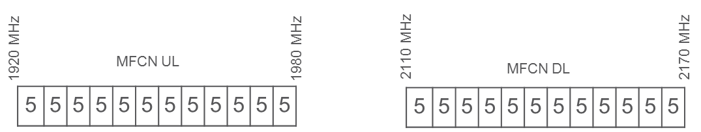

Figure 1: Updated band plan

### Applicable technical conditions

#### In-block power limits

BS In-block requirements

No mandatory limit was defined in the existing regulatory framework. The same approach will be used also in the updated regulatory framework. For the case of AAS base stations, it is proposed to convert the existing not obligatory in-block e.i.r.p. limit specified in EC Decision 2012/688/EU [1] to TRP for consistency with the out-of-block limits. This implies the conversion of the existing non-mandatory e.i.r.p. limit of 65 dBm/(5 MHz) per antenna for the non-AAS base station to a corresponding TRP limit (assuming a 17 dBi antenna gain) following guidelines given in 3GPP TS 38.104 [19]. Also, it is proposed to specify the in-block TRP limits to a value that correspond to a total of eight beam forming antenna elements (scaling factor of 9 dB):

65 dBm/(5 MHz) - 17 dBi + 9 dB = 57 dBm/(5 MHz).

Table 1: Updated in-block power limit

|  |  |  |  |
| --- | --- | --- | --- |
| BEM element | Frequency range | Non-AAS e.i.r.p limit | AAS TRP power limit |
| In-block | Block assigned to the operator | Not obligatory.  In case an upper bound is desired by a Member State, a value of 65 dBm/(5 MHz) per antenna may be applied. | Not obligatory.  In case an upper bound is desired by a Member State, a value of 57 dBm/(5 MHz) per cell (1) may be applied. |
| (1) In a multi-sector base station, the radiated power limit applies to each one of the individual sectors. | | | |

Terminal station In-block requirement

As for the technical condition for user equipment (UEs) it is recommended that the UE maximum mean in-block power (e.i.r.p. for fixed UEs, and TRP for nomadic/mobile UEs) is kept unchanged as per EC Decision 2012/688/EU.

Table 2: Proposed terminal station BEM in-block emission limit over 1920-1980 MHz frequencies

|  |
| --- |
| Maximum mean in-block power (1) |
| 24 dBm (2) |
| (1) This power limit is specified as e.i.r.p. for terminal stations designed to be fixed or installed and as TRP for terminal stations designed to be mobile or nomadic. e.i.r.p. and TRP are equivalent for isotropic antennas. It is recognised that this value may be subject to a tolerance defined in the harmonised standards to take account of operation under extreme environmental conditions and production spread.  (2) For the determination of out of band emissions of terminals in CEPT Report 39 the maximum conducted transmit power of 23 dBm has been used as a reference. |

Member States may relax the limit set out in Table 2 for specific deployments, e.g. fixed terminal stations in rural areas provided that protection of other services, networks and applications is not compromised and cross-border obligations are fulfilled.

#### Out-of-block power limits: Interference between FDD MFCNs

For AAS base stations, TRP is selected as the metric for specifying regulatory power limits. This corresponds to out-of-block power limits in the context of MFCN-to-MFCN interference in the case of FDD networks. In alignment with the specification of unwanted emission conducted power (TRP) for AAS base stations in 3GPP TS 38.104 [19] and the analysis made in ECC Report 281 [20], it is proposed to specify the out-of-block TRP limits to a value that correspond to a total of eight beam forming antenna elements. Table 3 shows the proposed out-of-block TRP limits for the update of ECC Decision (06)01 [8].

Table 3: Proposed out-of-block TRP limits for AAS MFCN Base Stations

|  |  |
| --- | --- |
| Frequency range | AAS TRP power limit per cell(1) |
| -5 to 0 MHz offset from lower block edge  0 to 5 MHz offset from upper block edge | 8 dBm/(5 MHz) |
| -10 to -5 MHz offset from lower block edge 5 to 10 MHz offset from upper block edge | 3 dBm/(5 MHz) |
| Other blocks | 1 dBm/(5 MHz) |
| (1) In a multi-sector base station, the radiated power limit applies to each one of the individual sectors. | |

See update to technical annex of EC Decision 2012/688/EU [1] in Annex 2.

## Recommended framework for 2.6 GHz

### Recommended spectrum scheme

* The frequency band 2500-2570 MHz is paired with 2620-2690 MHz for FDD operation with the mobile transmit within the lower band and base station transmit within the upper band
* Administrations may assign the unpaired frequency band 2570-2620 MHz either for TDD or for Supplemental Downlink. Any guard bands required to ensure adjacent band compatibility at 2570 MHz and 2620 MHz boundaries will be decided on a national basis and taken within the band 2570-2620 MHz;
* Assigned blocks shall be in multiple of 5 MHz.

### Applicable technical conditions

The existing framework in Decision 2008/477/EC contains a stepped BEM in the 5 MHz adjacent to the block. Equivalent compatibility can be provided in a revised BEM that specifies a single maximum mean e.i.r.p. of 4 dBm/MHz in the 5 MHz adjacent to the block for unrestricted spectrum blocks, and −6 dBm/(5 MHz) for base stations in restricted spectrum blocks.

#### Unrestricted BEM for base stations

The BEM for an unrestricted spectrum block is built up by combining Table 3 and Table 4 for non-AAS and Table 5 and Table 6 for AAS in such a way that the limit for each frequency is given by the higher value out of the baseline requirements and the block specific requirements.

Table 3: BS In-block non-AAS and AAS power limit

|  |  |  |  |
| --- | --- | --- | --- |
| BEM element | Frequency range | Non-AAS e.i.r.p limit | AAS TRP power limit |
| In-block | Block assigned to the operator | Not obligatory.  In case an upper bound is desired by a Member State, a value of  between 61 and 68 dBm/(5 MHz) per antenna may be applied. | Not obligatory.  In case an upper bound is desired by a Member State, a value  between 53 and 60 dBm/(5 MHz) per cell(1) may be applied. |
| Note: For locations where coordination procedure with adjacent services applies an upper bound on output power can be set by Member States  (1) In a multi-sector base station, the radiated power limit applies to each one of the individual sectors. | | | |

Table 4: BS Baseline requirement for non-AAS

|  |  |  |
| --- | --- | --- |
| BEM element | Frequency range | Maximum mean e.i.r.p |
| Baseline | FDD DL blocks (including SDL blocks), TDD blocks synchronised with the interfering TDD block (2), or used for downlink only operation. It further applies to 2615-2620 MHz | +4 dBm/MHz (1) |
| Baseline | Frequencies in the band 2500-2690 MHz not covered by the definition in the row above. | -45 dBm/MHz |
| (1) The BS baseline BEM elements calculated for protection of spectrum used for downlink transmissions is based on the assumption that the emissions come from a Macro BS. It should be noted that small cells may be deployed at lower heights and thus closer to UEs which can result in higher levels of interference if the above power limits are used.  (2) Synchronised operation in the context of this Decision means operation of TDD in two different systems, where no simultaneous UL reception and DL transmissions occurs. | | |

Table 5: BS Transitional region power limits for non-AAS

|  |  |  |
| --- | --- | --- |
| BEM element | Frequency range | Maximum mean e.i.r.p |
| Transitional region | -5 to 0 MHz offset from lower block edge | +16 dBm/(5 MHz) (1) |
| Transitional region | 0 to 5 MHz offset from upper block edge | +16 dBm/(5 MHz) (1) |
| (1) The BS transitional region BEM elements are based on the assumption that the emissions come from a Macro BS. It should be noted that small cells may be deployed at lower heights and thus closer to UEs which can result in higher levels of interference if the above power limits are used. For such cases, Member States could establish lower maximum mean e.i.r.p on a national level. | | |

Table 6: BS Baseline requirement for AAS

|  |  |  |
| --- | --- | --- |
| BEM element | Frequency range | AAS TRP power limit per cell(1) |
| Baseline | FDD DL blocks (including SDL blocks), TDD blocks synchronised with the interfering TDD block(2), or used for downlink only operation(3). It further applies to 2615-2620 MHz | +5 dBm/MHz (4) |
| Baseline | Frequencies in the band 2500-2690 MHz not covered by the definition in the row above. | -52 dBm/MHz |
| (1) In a multi-sector base station, the radiated power limit applies to each one of the individual sectors.  (2) Synchronised operation in the context of this Decision means operation of TDD in two different systems, where no simultaneous UL reception and DL transmissions occurs.  (3) Introduction of FDD AAS does not impact the SDL usage condition for non-AAS/AAS.  (4) The BS baseline BEM elements calculated for protection of spectrum used for downlink transmissions is based on the assumption that the emissions come from a Macro BS. It should be noted that small cells may be deployed at lower heights and thus closer to UEs which can result in higher levels of interference if the above power limits are used. | | |

Table 7: BS Transitional region power limits for AAS

|  |  |  |
| --- | --- | --- |
| BEM element | Frequency range | AAS TRP power limit per cell (2) |
| Transitional region | -5 to 0 MHz offset from lower block edge (1) | +16 dBm/(5 MHz) |
| Transitional region | 0 to 5 MHz offset from upper block edge (1) | +16 dBm/(5 MHz) |
| (1) The BS transitional region BEM elements are based on the assumption that the emissions come from a Macro BS. It should be noted that small cells may be deployed at lower heights and thus closer to UEs which can result in higher levels of interference if the above power limits are used. For such cases, Member States could establish lower maximum mean TRP on a national level.  (2) In a multi-sector base station, the radiated power limit applies to each one of the individual sectors. | | |

#### Restricted BEM for base stations

The BEM for a restricted spectrum block is built up by combining Table 4 and Table 8 (non-AAS/e.i.r.p.) and Table 6 and Table 8 (AAS/TRP) in such a way that the limit for each frequency is given by the higher value out of the baseline requirements and the block specific requirements.

The restricted blocks are 2570-2575 MHz (except in UL mode operation in that block) and any 5 MHz block between unsynchronised TDD networks. This is applicable for all configurations of FDD adjacent to TDD, both AAS and non-AAS.

Table 8: BS In-block power limit for restricted spectrum blocks for non-AAS and AAS

|  |  |  |  |
| --- | --- | --- | --- |
| BEM element | Frequency range | Non-AAS e.i.r.p limit | AAS TRP power limit per cell(2) |
| In-block | Restricted Block spectrum | + 25 dBm/5 MHz (1) | + 22 dBm/(5 MHz) (1) |
| (1) It is noted that in some deployment scenarios this in-block power limit may not guarantee interference free UL operation in adjacent channels, although this would typically be mitigated by building penetration loss and/or difference in antenna height. Other mitigation methods may also be applied.  (2) In a multi-sector base station, the radiated power limit applies to each one of the individual sectors. | | | |

#### Restricted BEM for base stations with restrictions on antenna placement

In cases where antennas are placed indoors or where the antenna height is below a certain height, a Member State may use alternative parameters in line with Table 9 for non-AAS, provided that at geographical borders to other countries Table 4 applies and that Table 8 remains valid nationwide.

For Indoor AAS BSs or AAS BS with restrictions on antenna placement, alternative measures compared to Table 6 or Table 8 may be required on a case by case basis and on a national basis.

It should be noted that restricted power use along with additional restrictions on the placement of antennas (such as being indoor or under a certain height) is applicable even if the channel bandwidth of the restricted power use is more than 5 MHz.

Table 9: BS BEM for restricted spectrum blocks with restrictions on antenna placement for non-AAS

|  |  |  |
| --- | --- | --- |
| BEM element | Frequency range | Maximum mean e.i.r.p |
| Baseline | Start of the band (2500 MHz) to -5 MHz (lower edge) | -22 dBm/MHz |
| Transitional region | -5 to 0 MHz offset from lower block edge | -6 dBm/(5 MHz) |
| Transitional region | 0 to 5 MHz offset from upper block edge | -6 dBm/(5 MHz) |
| Baseline | +5 MHz (upper edge) to end of band (2690 MHz) | -22 dBm/MHz |

#### Limits at 2690-2700 MHz for FDD AAS base station

Cases for an additional baseline which may be applied between 2690-2700 MHz for AAS BS in specific geographical areas with regard to RAS usage are provided in Table 10. There are two cases described in Table 10: Case A where the additional baseline limit is applied in order to reduce the necessary coordination zone with RAS station(s) and Case B where the additional baseline limit is not considered necessary by the concerned administration (e.g. where there is no nearby RAS station or situation where no coordination zone is required).

Table 10: Cases for additional baseline to be applied between 2690-2700 MHz for AAS BS in areas where necessary to reduce the size of the coordination zone with RAS

| **Case** | **BEM element** | **Frequency range** | **AAS TRP power limit per cell** |
| --- | --- | --- | --- |
| A | Additional Baseline | 2690-2700 MHz | 3 dBm/(10 MHz) |
| B | Additional Baseline | 2690-2700 MHz | Not applicable |
| Case A: This additional baseline limit yields a reduced coordination zone with respect to RAS stations (see Figure 12)  Case B: In situations where additional baseline is not considered necessary by the concerned administration (e.g. where there is no nearby RAS station or situation where no coordination zone is required).  Note: Additional measures may be needed on a national basis in order to protect the RAS station(s). Depending on the size of the necessary coordination zone to protect RAS station(s) cross border co-ordination may also be necessary. | | | |

Measures applicable at national level, such as (pfd limits) in order to protect the various types of radars would remain applicable, noting that it may be more complex for operators to comply with the pfd limit since AAS systems cannot be fitted with additional external filters.

#### Limits for terminal stations

Table 11: In-block power limits for terminal stations

| **BEM element** | **Maximum mean power**  (including Automatic Transmitter Power Control (ATPC) range**)** |
| --- | --- |
| In-block | 31 dBm/5 MHz (TRP) |
| In-block | 35 dBm/5 MHz (e.i.r.p.) |
| NB: e.i.r.p. should be used for fixed or installed terminal stations and the TRP should be used for the mobile or nomadic terminal stations. TRP is a measure of how much power the antenna actually radiates. The TRP is defined as the integral of the power transmitted in different directions over the entire radiation sphere. | |

#### Examples of combining BEM elements

The BEM elements as described above are combined to provide a BEM for a particular block. Figure 2 to Figure 11 provide examples of such combinations of BEM elements for TDD and FDD.

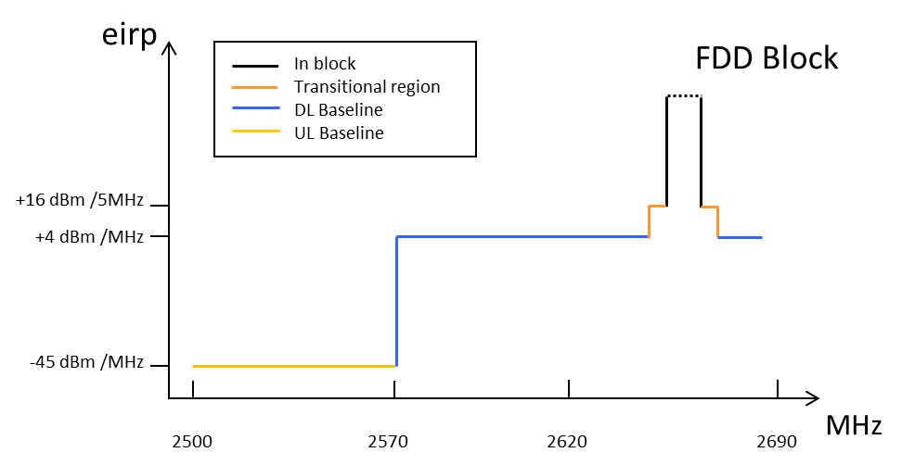

Figure 2: Combined BEM elements for an FDD block above 2620 MHz  
with downlink only operation within 2570-2620 MHz for non-AAS

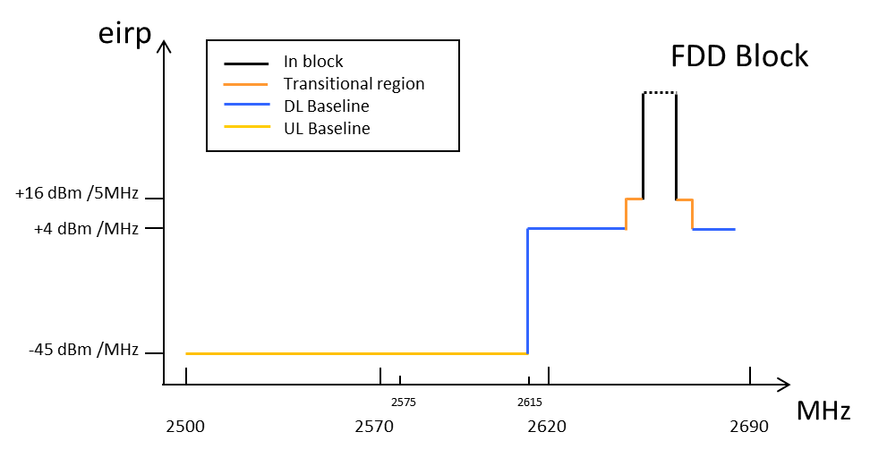

Figure 3: Combined BEM elements for an FDD block with TDD   
(synchronised/unsynchronised) networks within 2570-2620 MHz for non-AAS

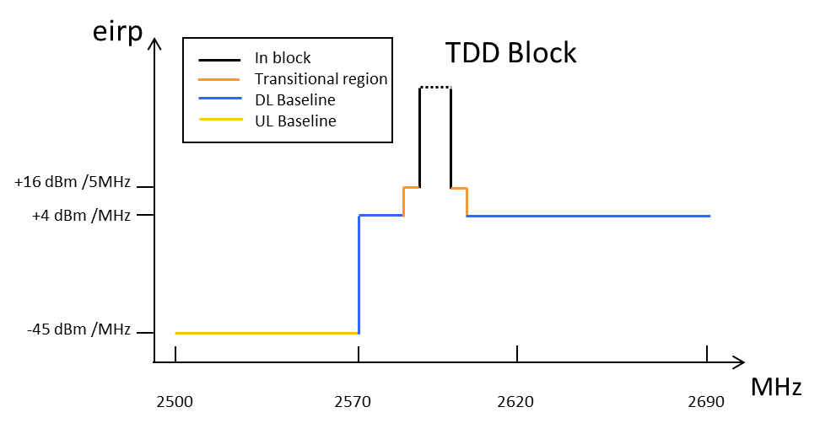

Figure 4: Combined BEM elements for synchronised TDD blocks / downlink only blocks for non-AAS

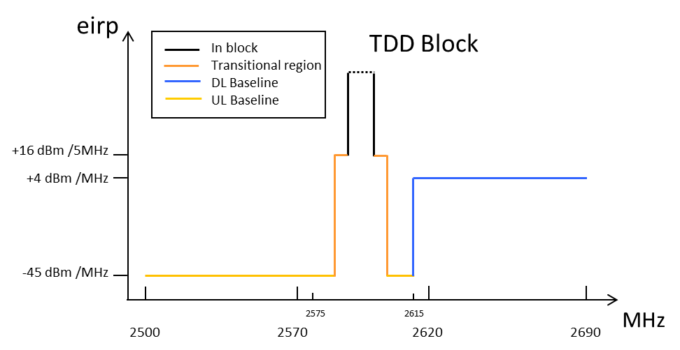

Figure 5: Combined BEM elements for unsynchronised TDD blocks for non-AAS

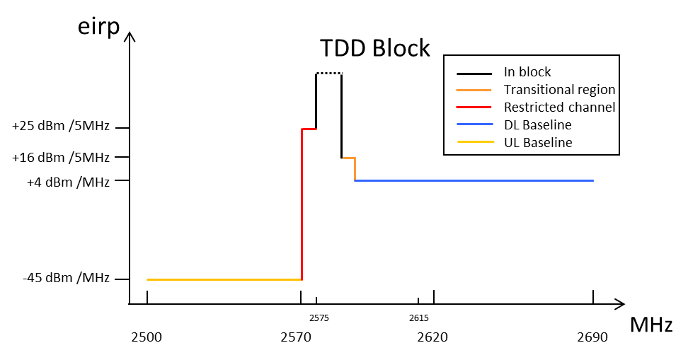

Figure 6: Combined BEM elements for synchronised TDD/downlink only blocks   
and a restricted spectrum block in 2570-2575 MHz for non-AAS

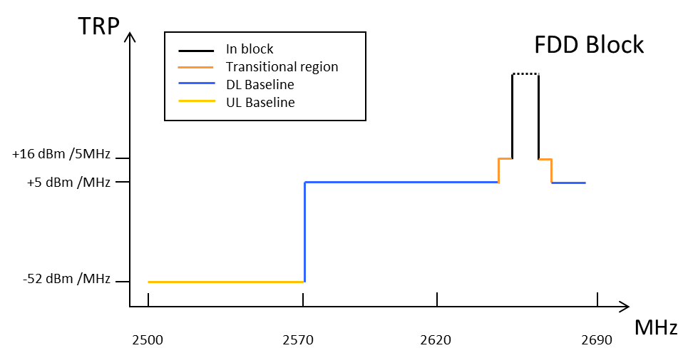

Figure 7: Combined BEM elements for an FDD block above 2620 MHz   
with downlink only operation within 2570-2620 MHz for AAS

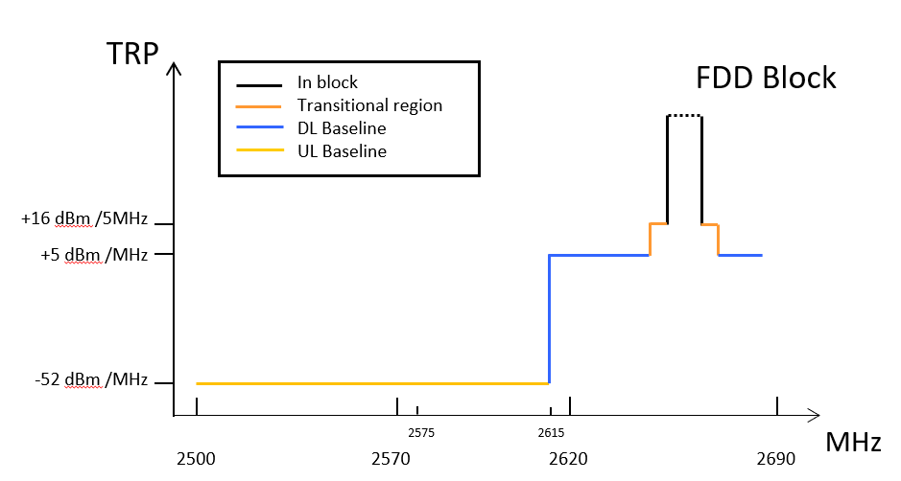

Figure 8: Combined BEM elements for an FDD block with   
TDD (synchronised/unsynchronised) networks within 2570-2620 MHz for AAS

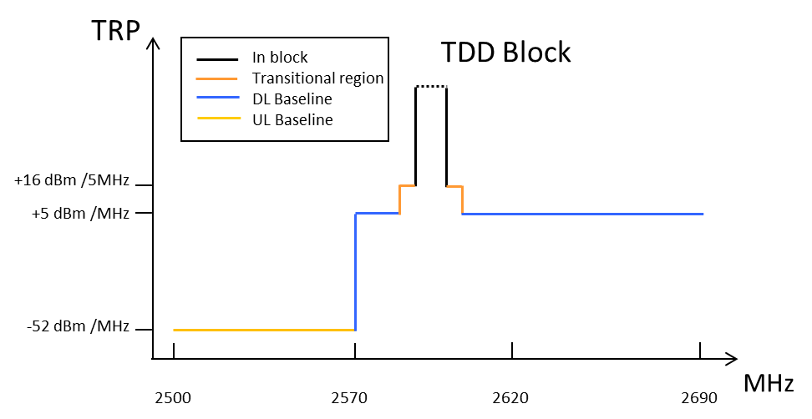

Figure 9: Combined BEM elements for synchronised TDD blocks/downlink only blocks for AAS

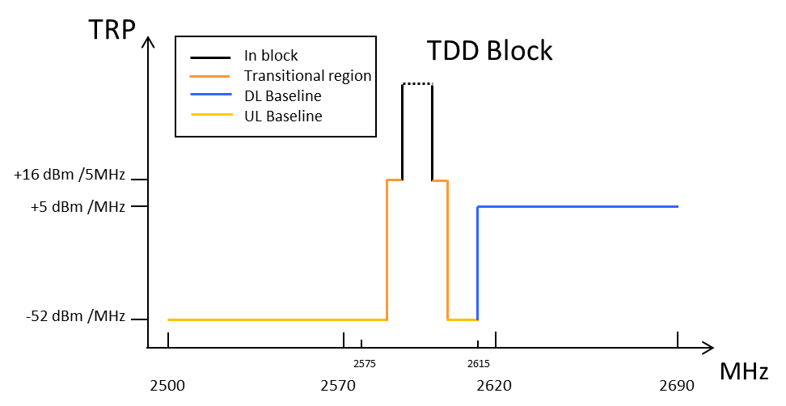

Figure 10: Combined BEM elements for unsynchronised TDD blocks for AAS

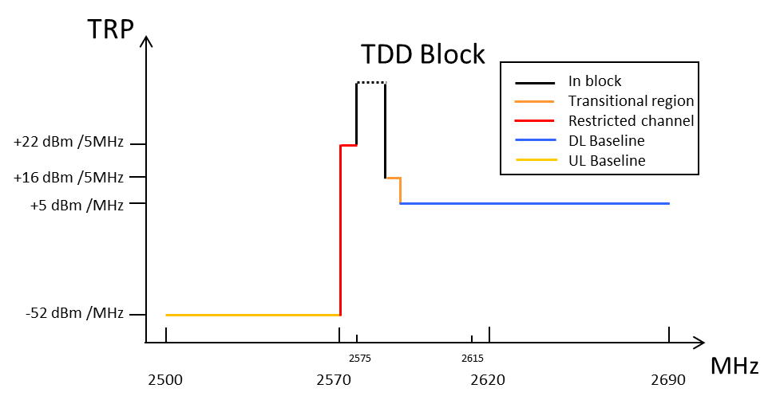

Figure 11: Combined BEM elements for synchronised TDD/downlink only blocks   
and a restricted spectrum block in 2570-2575 MHz for AAS

Figure : 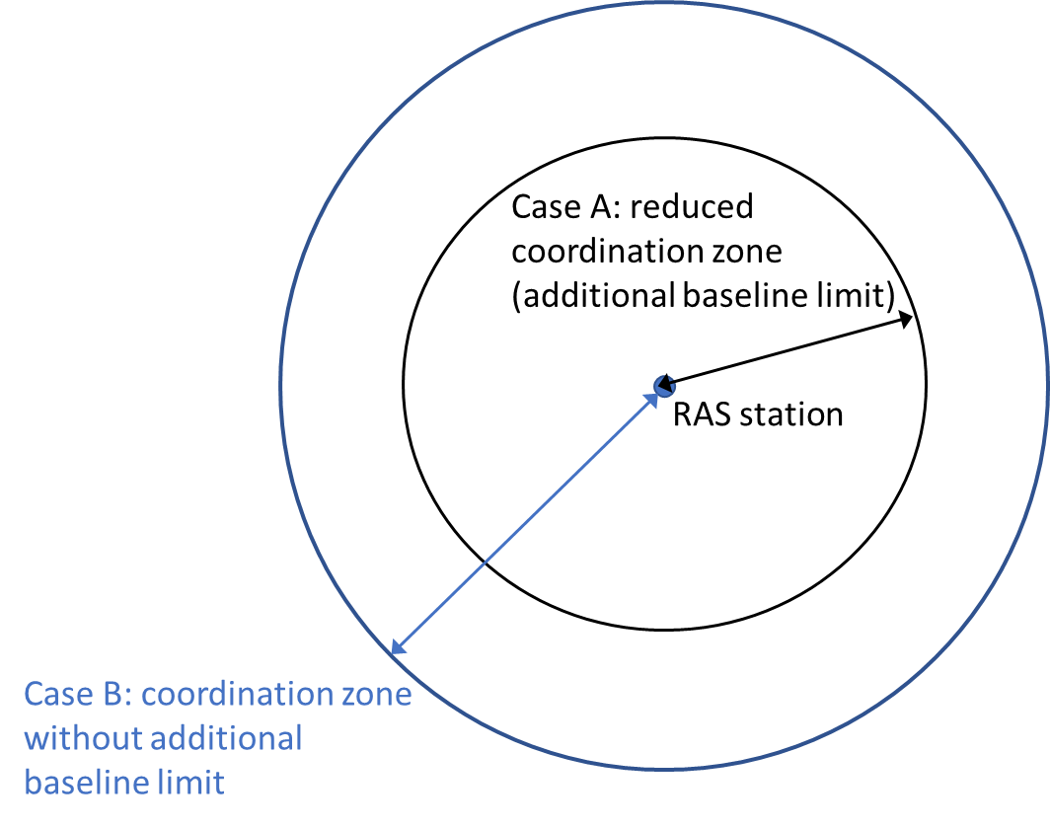Simplified example of coordination zones around RAS station for AAS base stations

#### Other conditions

The spurious domain for the base station in this frequency band starts 10 MHz from the band edge and the corresponding limits are defined in ERC Recommendation 74-01 [22].

In addition, that MFCN networks making use of AAS systems shall not be granted more protection from systems in adjacent and neighbouring bands than experienced with non-AAS systems. See update of the technical annex of the Decision 2008/477/EC [2] in Annex 3.

# Cross-border coordination

CEPT confirms that cross-border co-ordination can be sufficiently addressed through existing bilateral and multi-lateral procedures, supported by ECC Recommendations. CEPT will work to ensure Recommendations are 5G compatible.

ECC Recommendation (08)02 [23] addresses cross-border coordination in the 900 and 1800 MHz bands. This ECC Recommendation was updated in February 2019 to address 5G NR systems.

ECC Recommendation (01)01 [24] addresses cross-border coordination in the 2 GHz frequency band.

ERC Recommendation (11)05 [25] addresses cross-border coordination in the 2.6 GHz frequency band.

# Conclusions

CEPT has analysed the existing regulatory framework for the 2 GHz and 2.6 GHz frequency bands to assess their suitability for 5G systems, including AAS. The following conclusions were made.

For the 2 GHz frequency band (1920-1980 MHz and 2110-2170 MHz), based on the conclusions of ECC Report 298 [7]:

* CEPT confirms the suitability of the FDD band plan in EC Decision 2012/688/EU for 1920-1980 MHz and 2110-2170 MHz for 5G. Furthermore the 300 kHz guard band at the lower and upper frequency boundaries of the band plan can be removed. It is up to each Member State to decide, based on its requirements, and considering the impact on existing authorisations in its country within the band and services in adjacent bands, whether and how to migrate from the band plan in EC Decision 2012/688/EU to the updated band plan, and any associated conditions; It is also noted that the UMTS channel raster is 200 kHz, which means that the centre frequency must be an integer multiple of 200 kHz. It is further noted that for the UE the lowest carrier is specified to be placed on 1922.4 MHz and the highest on 1977.6 MHz. This corresponds to 2112.4 MHz (lowest) and 2167.6 MHz (highest) for the base station respectively. This is a relevant consideration for some Member States who are considering migrating to the updated band plan;
* the current BEM remains applicable for non-AAS MFCN;
* there is need for new BEM for AAS MFCN;
* AAS will not be implemented in 5G terminals in this frequency band.

For the 2.6 GHz frequency band (2500-2690 MHz), based on the findings of the draft ECC Report 308 [26]:

* An updated BEM is proposed for non-AAS MFCN (Note: This change was provided in a previous update of ECC Decision (05)05 but was not reflected in the EC Decision)];
* there is a need for a new BEM for AAS MFCN based on Total Radiated Power (TRP);
* CEPT recommends that the introduction of 5G in this band shall be based on the existing CEPT band plan (FDD 2x70 MHz + unpaired 50 MHz either for TDD or SDL). Any extension of the unpaired mode outside of the sub-band 2570-2620 MHz (as currently contained in the EU spectrum scheme) shall be subject to further harmonisation measure and coordinated timing at EU level, due to the risk of interference at national borders;
* There is no more need for block specific requirements for the 0-5 MHz range within the EC Decision - transitional region and baseline requirements for AAS TRP are sufficient;
* For restricted BEM for BS with restrictions on antenna placement, it is proposed not to add any specific AAS TRP values to the framework for AAS BS;
* Non-AAS and AAS in-block power limits are not obligatory. Adm**i**nistrations may specify such limits on a national basis if required;
* For adjacent services above 2690 MHz (radio astronomy service and radar), Member States should review any established coordination distance at national level in order to assess the relevant impact of AAS systems;
* An additional baseline has been developed at 2690-2700 MHz for AAS FDD base stations to reduce the size of the coordination zone with radio astronomy sites where considered necessary by the concerned administration;
* However, additional measures may be needed on a national basis in order to protect the RAS. Depending on the size of the necessary coordination zone to protect RAS cross border co-ordination may also be necessary. The additional baseline limit is not applicable in geographical areas outside the coordination zones (1) with RAS or other situations, including geographical areas inside the coordination zone, where an additional baseline limit is not considered necessary by the concerned administration. National measures may include geographical separation distances, coordination on a case by case basis, or compliance with the maximum pfd level at the radio astronomy sites;
* Moreover, measures applicable at national level, such as pfd limits in order to protect the various types of radars above 2700 MHz would remain applicable, noting that it may be more complex for operators to comply with the pfd limit since AAS systems cannot be fitted with additional external filters;
* For FDD/TDD coexistence: the restricted blocks are 2570-2575 MHz (except in UL mode operation in that block). This is applicable for all configurations of FDD AAS adjacent to TDD non-AAS and FDD non AAS adjacent to TDD AAS. It should also be noted that the 5 MHz TDD block (2615-2620 MHz) immediately adjacent to a FDD DL block may suffer an increased risk of interference due to the emissions from the FDD DL;
* For Indoor AAS BSs or AAS BS with restrictions on antenna placement, alternative measures compared to Table 14 or Table 15 may be required on a case by case basis and on a national basis, see Section 5.2.4;
* Concerning usage of 2570-2620 MHz under the LRTC, it shall be noted that CEPT has studied and developed a toolbox in 3400-3600 MHz to address the synchronised and unsynchronised operation and help administrations, operators and spectrum rights users understand coexistence topics and performance impacts related to synchronized and unsynchronized TDD operations. This could be reused in for this band.

Concerning synchronised TDD operation, in addition to the unrestricted BEM developed for synchronised TDD blocks, a general framework could be defined at the national level, specifying technical parameters and the scope of their applicability, and administrations may facilitate the process to ensure fair and timely agreements in cases where agreements could be more challenging.

A possible alternative to the synchronised approach implies respecting the unrestricted BEM level for unsynchronised MFCN combined with 5MHz restricted block between 2 TDD unsynchronised blocks. Respecting the TRP baseline limit of -52dBm/MHz between 2 unsynchronised blocks would imply the introduction of an additional internal filter within the AAS TDD base station. Since the implementation of such filter would depend on the operator's specific spectrum assignment, the filter (and the AAS base stations) would become operator-specific which would not be economically sustainable..

For terminals the current regulatory technical conditions defined in the ECC/DEC/(05)05 (rev. 2015) are considered to be suitable to 5G terminals. AAS will not be implemented in 5G terminals in this frequency band. Relevant updates to the existing framework for 2 GHz and 2.6 GHz are provided in Annex 2 and Annex 3 respectively.

For the 900 MHz frequency band (880-915 MHz and 925-960 MHz) and 1800 MHz frequency band (1710-1785 MHz and 1805-1880 MHz) the findings are based on ECC Report 297 [5], in response to the task 1 of the EC mandate, this CEPT report provides also information on the usage feasibility of the 900 MHz and 1800 MHz frequency bands for 5G, including any limitations of the GSM Directive for 900 MHz:

* CEPT confirms that within 900 MHz, narrowband systems including GSM and various cellular IoT systems will continue to be in operation commercially for the foreseeable future. This issue will be carefully addressed when CEPT will develop LRTC (BEM in 900 MHz) in order to develop harmonised technical conditions taking into account the need for coexistence with narrow band systems including GSM and various cellular IoT systems;
* CEPT confirms, as per ECC Report 297 and CEPT Report 40, that when narrowband systems including GSM and various cellular IoT systems are in operation in 900 MHz and 1800 MHz bands there is a need for:
  + A frequency separation of 200 kHz or more between NR channel edge of one network and the GSM channel edge of the neighbouring network, where wideband and GSM systems are operating in uncoordinated manner. No frequency separation is required for coordinated operation;
  + A frequency separation of 200 kHz or more between the standalone NB-IoT channel edge of one network and the NR channel edge of the neighbouring network.

This 200 kHz frequency separation requirement is already covered by the relevant ETSI standard due the channel characteristics of 5G NR (5 MHz or above channel bandwidth).

CEPT informs also the European Commission of the update of ECC technical framework for the 900 MHz and 1800 MHz frequency bands in March 2019, in order to reference the latest technical standards covering 5G New Radio. The CEPT plans to adopt during 2020 harmonised technical conditions on the basis of BEM for both frequency bands as the long-term regulatory approach.

1. cept mandate

|  |  |
| --- | --- |
|  | EUROPEAN COMMISSION  Communications Networks Content & Technology Directorate-General  Electronic Communications Networks & Services  **Radio Spectrum Policy** |

Brussels, 12 July 2018

DG CONNECT/B4

**RSCOM18-19rev1**

**PUBLIC**

**RADIO SPECTRUM COMMITTEE**

**Working Document**

**Subject: Draft Mandate to CEPT to review the harmonised technical conditions for certain EU-harmonised frequency bands and to develop least restrictive harmonised technical conditions suitable for next-generation (5G) terrestrial wireless systems**

*This is a Committee working document which does not necessarily reflect the official position of the Commission. No inferences should be drawn from this document as to the precise form or content of future measures to be submitted by the Commission. The Commission accepts no responsibility or liability whatsoever with regard to any information or data referred to in this document.*

**Mandate to CEPT**

**to review the harmonised technical conditions for certain EU-harmonised frequency bands and to develop least restrictive harmonised technical conditions suitable for next-generation (5G) terrestrial wireless systems**

1. **Purpose**

It is anticipated that next-generation (5G) terrestrial wireless systems will operate in frequency bands that have already been harmonised in the EU for electronic communications services. While this is already possible today based on technology and service neutrality principles, it is important that the existing harmonised technical conditions of use be reviewed to identify potential constraints, and optimised for next-generation systems. The latter would contribute to a leading Union role in 5G development and deployment.

This Mandate is a follow-up to the Commission's mandate regarding technology-neutral harmonised technical conditions suitable for next-generation (5G) use for the 3.6 GHz and 26 GHz pioneer bands[7]. It should deliver harmonised least restrictive technical conditions, including sharing conditions if needed, for next-generation (5G) terrestrial wireless systems in the EU-harmonised 880-915 and 925-960 MHz frequency bands ('900 MHz band), 1710-1785 MHz and 1805-1880 MHz frequency bands ('1800 MHz band'), 1920-1980 MHz and 2110-2170 MHz frequency bands ('paired terrestrial 2 GHz band'), and 2500-2690 MHz frequency band ('2.6 GHz band')[8]. These conditions should take into account relevant 5G usage scenarios related to wireless broadband and the Internet of Things, and meet the overarching purpose of ensuring efficient spectrum use.

1. **Policy context and inputs**

The ITU-R vision for the next-generation mobile telecommunications[9] outlines three major 5G usage scenarios – enhanced mobile broadband (eMBB), massive machine type communications (mMTC), and ultra-reliable and low latency communications (URLLC).

Deliverables of the 5G Public Private Partnership[10] Infrastructure Association indicate that 5G would offer both an evolution of mobile broadband networks ensuring continuous user experience, and new unique network and service capabilities. In particular, 5G would be a key enabler for the Internet of Things and mission-critical services requiring very high reliability, ubiquitous coverage and/or very low latency. In this regard, use cases originating from connectivity to 'verticals' (i.e. vertical sectors such as transport, healthcare or media) are considered as drivers of 5G requirements from the outset with high priority, in particular within frequency bands below 6 GHz.

In its 5G Action Plan[11], the Commission advances action on the EU-level identification and harmonisation of 5G spectrum regarding pioneer frequency bands as well as **additional** frequency bands, based on the opinion of the Radio Spectrum Policy Group (RSPG).

In its two Opinions on "Strategic Roadmap towards 5G in Europe"[12], the RSPG asserts the importance of existing EU-harmonised spectrum for the rollout of 5G terrestrial wireless systems in the Union as follows:

* 5G needs to be deployed also in bands already harmonized **below 1 GHz**, in particular the 700 MHz band, in order to enable nation-wide and indoor 5G coverage;
* there is a need to ensure that technical and regulatory conditions for **all bands already harmonized** for mobile networks are fit for 5G use.

In this regard, the 900 MHz and 1800 MHz, the 2.6 GHz and the paired terrestrial 2 GHz frequency bands are relevant EU-harmonised frequency bands for next-generation terrestrial wireless systems. In its 5G roadmap, the CEPT highlights the need to revise the technical conditions for these frequency bands with the goal to ensure their suitability for 5G use. Therefore, technical studies are necessary with view to enabling the use of these bands for next-generation terrestrial wireless systems, which use active antenna systems (AAS) and are capable of providing novel services or applications. These studies should consider terrestrial electronic communications services and other relevant use, and foster a European approach to 5G deployment, which benefits to the extent possible from global harmonisation. The CEPT also concludes in its 5G roadmap that the current technical conditions for the 700 MHz, 800 MHz and 1.5 GHz frequency bands are already suitable for 5G use in the context of technology neutrality and the anticipated lack of AAS deployment in those frequency bands.

In particular, for the 900 MHz and 1800 MHz frequency bands, it is relevant to consider a Block Edge Mask (BEM) approach to technical harmonisation, which is suitable for next-generation terrestrial wireless systems and achieves consistency with the existing minimal and least restrictive technical conditions for other EU-harmonised frequency bands for wireless broadband electronic communications services. Such an approach should replace in the long term the current technical framework based on references to ETSI standards for both bands. Furthermore, it should ensure coexistence with the GSM system in the 900 MHz frequency band, pursuant to the GSM Directive[13], while delivering a solution, which ensures availability and efficient use of the spectrum for next-generation terrestrial wireless systems in line with the Union’s spectrum policy priorities.

In this regard, the CEPT is considering an amendment of the current technical framework for the 900 MHz and 1800 MHz frequency bands in early 2019, in order to reference the latest technical standards covering 5G New Radio. The CEPT plans to adopt harmonised technical conditions on the basis of BEM for both frequency bands as the long-term regulatory approach[14]. Taking account of progressing 5G standardisation, a transition of the technical conditions to BEM in the 900 MHz and 1800 MHz frequency bands at the EU level, could be facilitated by the specific provision[15] in the Decision 2009/766/EC (as amended), which allows in both bands use of *other systems*, which are not listed in its Annex, under the condition of ensuring coexistence with the GSM system and the systems listed in that Annex. The aforementioned amendment of the CEPT technical framework will facilitate compliance with this provision in the EU context in order to accommodate evolving 5G standards.

1. **Justification**

Pursuant to Article 4(2) of the Radio Spectrum Decision[16] the Commission may issue mandates to the CEPT for the development of technical implementing measures with a view to ensuring harmonised conditions for the availability and efficient use of radio spectrum necessary for the functioning of the internal market. Such mandates shall set the tasks to be performed and their timetable. Pursuant to Article 1 of the Radio Spectrum Decision, activities under the Decision must facilitate policy making with regard to the strategic planning and harmonisation of radio spectrum use as well as ensure the effective implementation of radio spectrum policy in the EU while serving the aim of coordination of policy approaches. Furthermore, they shall take due account of the work of international organisations related to spectrum management such as ITU or 3GPP.

The Radio Spectrum Policy Programme (RSPP) requires Member States, in cooperation with the Commission, to take all steps necessary to ensure that sufficient spectrum for coverage and capacity purposes is available within the Union, in order to enable the Union to have the fastest broadband speeds in the world, thereby making it possible for wireless applications and European leadership in new services to contribute effectively to economic growth, and to achieving the target for all citizens to have access to broadband speeds of not less than 30 Mbps by 2020. Furthermore, the RSPP calls on Member States and the Commission to ensure spectrum availability for the Internet of Things (IoT) and to foster the development of standards and the harmonisation of spectrum allocation for IoT communications.

Advances in international standardisation at 3GPP and ITU, as well as rapid international developments regarding 5G trials and spectrum use until 2020, call for a swift and coordinated EU-level process on delivering sufficient and appropriate 5G spectrum in the Union according to anticipated deployment of 5G usage scenarios.

1. **Task order and schedule**

CEPT is herewith mandated to develop harmonised least restrictive technical conditions for the 900 MHz, 1800 MHz, the 2.6 GHz and the paired terrestrial 2 GHz and frequency bands in line with the principles of technology and service neutrality, suitable for *next-generation (5G) terrestrial wireless systems* in line with the policy priorities set out in this Mandate and taking into account relevant needs for shared spectrum use with incumbent uses. CEPT should give utmost consideration to overall EU spectrum policy objectives such as effective and efficient spectrum use and take utmost account of applicable principles established in EU law such as those relating to service and technological neutrality, non-discrimination and proportionality insofar as technically possible.

CEPT is requested to collaborate actively with the European Telecommunications Standardisation Institute (ETSI), which develops harmonised standards for conformity under the Radio Equipment Directive. In particular, CEPT should take into consideration emerging technologies and ETSI harmonised standards, which define 5G systems, facilitate shared spectrum use or foster economies of scale.

More specifically, CEPT is mandated to perform the following tasks with view to creating sufficiently precise conditions for the development of EU-wide equipment:

1. Review the EU-harmonised technical conditions for use of the 900 MHz, 1800 MHz, paired terrestrial 2 GHz, and 2.6 GHz frequency bands with view to their suitability for 5G terrestrial wireless systems[17] which provide electronic communications services as well as other relevant services or applications, and assess the approach to adapting the EU-harmonised technical conditions for 5G use, if needed.

In particular, for the 900 MHz frequency band, such assessment should address any potential constraints (e.g. regarding efficient spectrum use), which result from the requirement to ensure co-existence with the GSM system, pursuant to the GSM Directive13.

1. Based on the results under Task 1, develop channelling arrangements and common and minimal (least restrictive) technical conditions[18] for the aforementioned frequency bands, which are suitable for 5G terrestrial wireless systems in compliance with the principles of technology and service neutrality.

These conditions should be sufficient to mitigate interference and ensure co-existence with incumbent radio services/applications in the same band or in adjacent bands, in line with their regulatory status, including at the EU outer borders.

1. Develop guidance for cross-border coordination.

Overall, the CEPT should provide deliverables under this Mandate according to the following schedule:

|  |  |  |
| --- | --- | --- |
| **Delivery date** | **Deliverable** | **Subject** |
| March 2019 | Draft Report(s) from CEPT to the Commission[19] regarding the paired terrestrial 2 GHz frequency band, and the 2.6 GHz frequency band.  Information on the usage feasibility of the 900 MHz and 1800 MHz frequency bands, including any limitations of the GSM Directive. | Description of the work undertaken and the results. |
| July 2019 | Final Report(s) from CEPT to the Commission regarding the paired terrestrial 2 GHz frequency band, and the 2.6 GHz frequency band, taking into account the outcome of the public consultation. | Description of the work undertaken and the results. |
| July 2020 | Draft Report(s) from CEPT to the Commission19 regarding the 900 MHz and 1800 MHz frequency bands. | Description of the work undertaken and the results. |
| October 2020 | Final Report(s) from CEPT to the Commission regarding the 900 MHz and 1800 MHz frequency bands, taking into account the outcome of the public consultation. | Description of the work undertaken and the results. |

CEPT is requested to report on the progress of its work pursuant to this Mandate to all meetings of the Radio Spectrum Committee taking place during the course of the Mandate.

The Commission, with the assistance of the Radio Spectrum Committee and pursuant to Article 4 of the Radio Spectrum Decision, may consider applying the results of this mandate in the Union taking into account any relevant guidance of the RSPG.

1. Updates to EC Decision 2012/688/EU (2 GHz)

**ANNEX**

**Parameters referred to in Article 2(1)**

The technical conditions presented in this Annex are in the form of frequency arrangements and block-edge masks (BEMs). A BEM is an emission mask that is defined, as a function of frequency, relative to the edge of a block of spectrum for which rights of use are granted to an operator. It consists of in-block and out-of-block components which specify the permitted emission levels over frequencies inside and outside the licensed block of spectrum, respectively.

The BEM levels are built up by combining the values listed in the tables below in such a way that the limit at any frequency is given by the highest (least stringent) value of (a) the baseline requirements, (b) the transition requirements, and (c) the in-block requirements (where appropriate). The BEMs are presented as upper limits on the mean equivalent isotropically radiated power (EIRP) or total radiated power (TRP)[20] over an averaging time interval, and over a measurement frequency bandwidth. In the time domain, the EIRP or TRP is averaged over the active portions of signal bursts and corresponds to a single power control setting. In the frequency domain, the EIRP or TRP is determined over the measurement bandwidth specified in point B(2) , Tables 1, 2 and 3[21]. In general, and unless stated otherwise, the BEM levels correspond to the aggregate power radiated by the relevant device including all transmit antennas, except in the case of baseline and transition requirements for base stations, which are specified per antenna.

BEMs shall be applied as an essential component of the technical conditions necessary to ensure coexistence between services at national level. However, it should be understood that the derived BEMs do not always provide the required level of protection of victim services and additional mitigation techniques would need to be applied in a proportionate manner at national level in order to resolve any remaining cases of interference, also with respect to adjacent bands.

Member States shall also ensure that operators of terrestrial systems capable of providing electronic communications services can use less stringent technical parameters than those set out below in points A, B and C below provided that the use of these parameters is agreed among all affected parties and that these operators continue to comply with the technical conditions applicable for the protection of other services, applications or networks and with obligations resulting from cross-border coordination.

Equipment operating in this band may also make use of power limits other than those set out below provided that appropriate mitigation techniques are applied which comply with Directive 1999/5/EC and which offer at least an equivalent level of protection to that provided by these technical parameters.

**A. General parameters**

Within the paired terrestrial 2 GHz band, the frequency arrangement shall be as follows:

(1) The duplex mode of operation shall be Frequency Division Duplex (FDD). The duplex spacing shall be 190 MHz with terminal station transmission (FDD uplink) located in the lower part of the band starting at 1920 MHz and finishing at 1980 MHz and base station transmission (FDD downlink) located in the upper part of the band starting at 2110 MHz and finishing at 2170 MHz.

Base station and terminal station transmission within the paired terrestrial 2 GHz band shall be in compliance with the BEMs in this Annex.

**B. Technical conditions for FDD base stations**

(1) In-block requirements

Table 1

**Base station in-block power limit**

|  |  |  |
| --- | --- | --- |
| **Frequency range** | **Non-AAS e.i.r.p limit** | **AAS TRP limit** |
| Block assigned to the operator | Not obligatory.  In case an upper bound is desired by a Member State, a value of 65 dBm/(5 MHz) per antenna may be applied | Not obligatory.  In case an upper bound is desired by a Member State, a value of 57 dBm/(5 MHz) per cell[22] may be applied |

(2) Out-of-block requirements

Table 2

**Baseline requirements — base station BEM out-of-block limits**

|  |  |  |  |
| --- | --- | --- | --- |
| **Frequency range of out-of-block emissions of FDD downlink** | **Non-AAS Maximum mean out-of-block EIRP per antenna[23]** | **AAS Maximum mean out-of-block TRP per cell[24]** | **Measurement bandwidth** |
| Frequencies spaced more than 10 MHz from the lower or upper block edge | 9 dBm | 1 dBm | 5 MHz |

Table 3

**Transition requirements — base station BEM out-of-block limits**

|  |  |  |  |
| --- | --- | --- | --- |
| **Frequency range of out-of-block emissions of FDD downlink** | **Non-AAS Maximum mean out-of-block EIRP per antenna****[25]** | **AAS Maximum mean out-of-block TRP per cell[26]** | **Measurement bandwidth** |
| –10 to –5 MHz from lower block edge | 11 dBm | 3 | 5 MHz |
| –5 to 0 MHz from lower block edge | 16.3 dBm | 8 | 5 MHz |
| 0 to +5 MHz from upper block edge | 16.3 dBm | 8 | 5 MHz |
| +5 to +10 MHz from upper block edge | 11 dBm | 3 | 5 MHz |

**C. Technical conditions for FDD terminal stations**

Table 4

**In-block requirements — terminal station BEM in-block emission limit  
 over frequencies of FDD uplink**

|  |  |
| --- | --- |
| **Maximum mean in-block power**[27] | 24 dBm[28] |

Member States may relax the limit set out in Table 4 for specific deployments, e.g. fixed terminal stations in rural areas provided that protection of other services, networks and applications is not compromised and cross-border obligations are fulfilled.

1. Updates to EC Decision 2008/477/EC (2.6 GHz)

**ANNEX  
Parameters referred to in Article 2**

The following technical parameters called Block Edge Mask (BEM) shall be applied as an essential component of conditions necessary to ensure co-existence in the absence of bilateral or multilateral agreements between neighbouring networks, without precluding less stringent technical parameters if agreed among the operators of such networks. Member States should ensure that network operators are free to enter into bilateral or multilateral agreements to develop less stringent technical parameters and, if agreed among all affected parties, these less stringent technical parameters may be used.

The BEMs are presented as upper limits on the mean equivalent isotropically radiated power (EIRP) or total radiated power (TRP)[29] over an averaging time interval, and over a measurement frequency bandwidth.

Equipment operating in this band may also make use of e.i.r.p. or TRP limits other than those set out below provided that appropriate mitigation techniques are applied which comply with Directive 1999/5/EC and which offer at least an equivalent level of protection to that provided by these technical parameters.

**A) General parameters:**

1. The assigned blocks shall be in multiple of 5.0 MHz.

Within the band 2500 – 2690 MHz, the duplex spacing for FDD operation shall be 120 MHz with terminal station transmission (up link) located in the lower part of the band starting at 2500 MHz (extending to a maximum limit of 2570 MHz) and base station transmission (down link) located in the upper part of the band starting at 2620 MHz.

The sub-band 2570 – 2620 MHz can be used by TDD or for Supplemental Downlink. Any guard bands required to ensure adjacent band compatibility at 2570 MHz and 2620 MHz boundaries will be decided on a national basis and taken within the band 2570-2620 MHz;.

**B) Unrestricted BEM for Base Stations:**

The BEM for an unrestricted spectrum block is built up by combining Tables 1, 2 and 3 in such a way that the limit for each frequency is given by the higher value out of the baseline requirements and the block specific requirements.

|  |  |  |
| --- | --- | --- |
| **Frequency range in which out-of-block emissions are received** | **Non-AAS Maximum mean e.i.r.p.  (integrated over a 1 MHz bandwidth) per antenna** | **AAS Maximum mean TRP  (integrated over a 1 MHz bandwidth) per cell (3)** |
| FDD downlink blocks (including SDL blocks), TDD blocks synchronised with the interfering TDD block(2), or used for downlink only operation(4). It further applies to 2615-2620 MHz. | + 4 dBm/MHz | + 5 dBm/MHz (1) |
| Frequencies in the band 2500-2690 MHz not covered by the definition above. | – 45 dBm/MHz | – 52 dBm/MHz |
| (1) The BS baseline BEM elements calculated for protection of spectrum used for downlink transmissions is based on the assumption that the emissions come from a Macro BS. It should be noted that small cells may be deployed at lower heights and thus closer to UEs which can result in higher levels of interference if the above power limits are used.  (2) Synchronised operation in the context of this Decision means operation of TDD in two different systems, where no simultaneous UL reception and DL transmissions occurs.  (3) In a multi-sector base station, the radiated power limit applies to each one of the individual sectors.  (4) Introduction of FDD AAS does not impact the SDL usage condition for non-AAS/AAS. | | |

**Table 1: Baseline requirements - Base Station out-of-block BEM**

|  |  |  |
| --- | --- | --- |
| **Frequency range** | **Non-AAS e.i.r.p. limit** | **AAS TRP limit** |
| Block assigned to the operator | Not obligatory.  In case an upper bound is desired by a Member State, a value between 61 and 68 dBm/(5 MHz) per antenna may be applied. | Not obligatory.  In case an upper bound is desired by a Member State, a value between 53 and 60 dBm/(5 MHz) per cell (1) may be applied. |
| (1) In a multi-sector base station, the radiated power limit applies to each one of the individual sectors. | | |

**Table 2: Block specific requirements - Base Station in-block BEM**

|  |  |  |
| --- | --- | --- |
| **Offset from relevant block edge** | **Non-AAS Maximum mean e.i.r.p. per antenna** | **AAS Maximum mean TRP per cell (1)** |
| Start of band (2500 MHz) to -5 MHz (lower edge) | Baseline requirement level | Baseline requirement level |
| -5 to 0 MHz offset from lower block edge | + 16 dBm/5 MHz (2) | + 16 dBm/5 MHz (2) |
| 0 to 5 MHz offset from upper block edge | + 16 dBm/5 MHz (2) | + 16 dBm/5 MHz (2) |
| + 5.0 MHz (upper edge) to end of band (2690 MHz) | Baseline requirement level | Baseline requirement level |
| Where: ∆F is the frequency offset from the relevant block edge (in MHz)  (1) In a multi-sector base station, the radiated power limit applies to each one of the individual sectors.  (2) the BS transitional region BEM elements are based on the assumption that the emissions come from a Macro BS. It should be noted that small cells may be deployed at lower heights and thus closer to UEs which can result in higher levels of interference if the above power limits are used. For such cases, Member States could establish lower maximum mean TRP on a national level | | |

**Table 3: Block specific requirements - Base Station out-of-block BEM**

**C) Restricted BEM for Base Stations:**

The BEM for a restricted spectrum block is built up by combining Tables 1 and 4 in such a way that the limit for each frequency is given by the higher value out of the baseline requirements and the block specific requirements.

|  |  |  |
| --- | --- | --- |
| **Frequency range** | **Non-AAS e.i.r.p. limit per antenna** | **AAS TRP limit per cell (1)** |
| Restricted Block spectrum | + 25 dBm/5 MHz | + 22 dBm/(5 MHz) (2) |
| (1) In a multi-sector base station, the radiated power limit applies to each one of the individual sectors.  (2) It is noted that in some deployment scenarios this in-block power limit may not guarantee interference free UL operation in adjacent channels, although this would typically be mitigated by building penetration loss and/or difference in antenna height. Other mitigation methods may also be applied. | | |

**Table 4: Block specific requirements - Base Station in-block BEM for restricted block**

**D) Restricted BEM for Base Stations with restrictions on antenna placement:**

In cases where antennas are placed indoors or where the antenna height is below a certain height, a Member State may use alternative parameters for non-AAS in line with Table 5, provided that at geographical borders to other Member States Table 1 applies and that Table 4 remains valid nationwide. For Indoor AAS BSs or AAS BS with restrictions on antenna placement, alternative measures compared to Table 1 or Table 4 may be required on a case by case basis and on a national basis.

|  |  |
| --- | --- |
| **Offset from relevant block edge** | **Non-AAS Maximum mean e.i.r.p.** |
| Start of band (2500 MHz) to -5 MHz (lower edge) | – 22 dBm/ MHz |
| – 5.0 to –0.0 MHz (lower edge) | – 6 dBm/ 5 MHz |
| 0.0 to +5.0 MHz (upper edge) | – 6 dBm/ 5 MHz |
| + 5.0 MHz (upper edge) to end of band (2690 MHz) | – 22 dBm/ MHz |
| Where: ∆F is the frequency offset from the relevant block edge (in MHz) | |

**Table 5: Block specific requirements - Base Station out-of-block e.i.r.p. BEM for restricted block with additional restrictions on antenna placement**

**E) Limits at 2690-2700 MHz for FDD AAS Base Stations**

Cases for an additional baseline which may be applied between 2690-2700 MHz for AAS BS in specific geographical areas with regard to RAS usage are provided in Table 6. There are two cases described in Table 6: Case A where the additional baseline limit is applied in order to reduce the necessary coordination zone with RAS station(s) and Case B where the additional baseline limit is not considered necessary by the concerned administration (e.g. where there is no nearby RAS station or situation where no coordination zone is required).

|  |  |  |
| --- | --- | --- |
| **Case** | **Frequency range** | **AAS TRP power limit per cell** |
| A | 2690-2700 MHz | 3 dBm/10 MHz |
| B | 2690-2700 MHz | Not applicable |
| Case A: This additional baseline limit yields a reduced coordination zone with respect to RAS stations  Case B: In situations where additional baseline is not considered necessary by the concerned administration (e.g. where there is no nearby RAS station or situation where no coordination zone is required).  Note: Additional measures may be needed on a national basis in order to protect the RAS station(s). Depending on the size of the necessary coordination zone to protect RAS station(s) cross border co-ordination may also be necessary. | | |

**Table 6: Cases for additional baseline to be applied between 2690-2700 MHz for AAS BS in areas where necessary to reduce the size of the coordination zone with RAS**

**F) Limits for Terminal Stations:**

|  |  |
| --- | --- |
|  | **Maximum mean power** (including Automatic Transmitter Power Control (ATPC) range) |
| Total Radiated Power (TRP) | 31 dBm/5 MHz |
| E.i.r.p. | 35 dBm/5 MHz |
| Note: E.i.r.p. should be used for fixed or installed Terminal Stations and the TRP should be used for the mobile or nomadic Terminal Stations. TRP is a measure of how much power the antenna actually radiates. The TRP is defined as the integral of the power transmitted in different directions over the entire radiation sphere. | |

**Table 7: In-block power limits for Terminal Stations**

1. List of references
2. EC Decision 2012/688/EU: “Commission Implementing Decision of 5 November 2012 on the harmonisation of the frequency bands 1920-1980 MHz and 2110-2170 MHz for terrestrial systems capable of providing electronic communications services in the Union”
3. EC Decision 2008/477/EC: “Commission Decision of 13 June 2008 on the harmonisation of the 2500 - 2690 MHz frequency band for terrestrial systems capable of providing electronic communications services in the Community”
4. ECO Report 03: “The Licensing of "Mobile Bands" in CEPT”, updated June 2019
5. Council Directive 87/372/EEC as amended by Directive 2009/114/EC of the European Parliament and of the Council (GSM Directive)
6. ECC Report 297: “Analysis of the suitability and update of the regulatory technical conditions for 5G MFCN and AAS operation in the 900 MHz and 1800 MHz bands”, 8 March 2019
7. ECC Decision (06)13: “Designation of the bands 880-915 MHz, 925-960 MHz, 1710-1785 MHz and 1805-1880 MHz for terrestrial UMTS, LTE and WiMAX systems”, amended 8 March 2019
8. ECC Report 298: “Analysis of the suitability and update of the regulatory technical conditions for 5G MFCN and AAS operation in the 1920-1980 MHz and 2110-2170 MHz band” , 8 March 2019
9. ECC Decision (06)01: “Harmonised utilisation of the bands1920-1980 MHz and 2110-2170 MHz for mobile/fixed communications networks (MFCN) including terrestrial IMT”, amended 8 March 2019
10. ECC Decision (05)05: “Harmonised utilisation of spectrum for Mobile/Fixed Communications Networks (MFCN) operating within the band 2500-2690 MHz”, amended July 2019
11. EC Decision 2009/766/EC: “Commission Decision of 16 October 2009 on the harmonisation of the **900 MHz and 1800 MHz frequency bands** for terrestrial systems capable of providing pan-European electronic communications services in the Community”
12. EC Decision 2011/251/EU: “Commission Implementing Decision of 18 April 2011 amending Decision 2009/766/EC on the harmonisation of the 900 MHz and 1800 MHz frequency bands for terrestrial systems capable of providing pan-European electronic communications services in the Community”
13. EC Decision 2018/637/EU: “Commission Implementing Decision (EU) 2018/637 of 20 April 2018 amending Decision 2009/766/EC on the harmonisation of the 900 MHz and 1800 MHz frequency bands for terrestrial systems capable of providing pan-European electronic communications services in the Community as regards relevant technical conditions for the Internet of Things”
14. CEPT Report 40: “Compatibility study for LTE and WiMAX operating within the bands 880-915 MHz / 925-960 MHz and 1710-1785 MHz / 1805-1880 MHz (900/1800 MHz bands)”, November 2010
15. CEPT Report 41: “Compatibility between LTE and WiMAX operating within the bands 880-915 MHz / 925-960 MHz and 1710-1785 MHz / 1805-1880 MHz (900/1800 MHz bands) and systems operating in adjacent bands”, November 2010
16. CEPT Report 42: “Compatibility between UMTS and existing and planned aeronautical systems above 960 MHz”, November 2010
17. CEPT Report 66: “Report from CEPT to the European Commission in response to the Mandate to review the harmonised technical conditions for use of the 900 MHz and 1800 MHz frequency bands for terrestrial wireless broadband electronic communications services in support of the Internet of Things in the Union”, March 2018
18. ECC Report 266: “The suitability of the current ECC regulatory framework for the usage of Wideband and Narrowband M2M in the frequency bands 700 MHz, 800 MHz, 900 MHz, 1800 MHz, 2.1 GHz and 2.6 GHz”, June 2017”
19. ERC Report 65: “Adjacent band compatibility between UMTS and other services in the 2 GHz band”, November 1999
20. 3GPP TS 38.104: “NR; Base Station (BS) radio transmission and reception” (Release 15)
21. CEPT Report 39: “Report from CEPT to the European Commission in response to the Mandate to develop least restrictive technical conditions for 2 GHz bands”, June 2010
22. ECC Report 281: “Analysis of the suitability of the regulatory technical conditions for 5G MFCN operation in the 3400-3800 MHz band”
23. CEPT Report 19: “Report from CEPT to the European Commission in response to the Mandate to develop least restrictive technical conditions for frequency bands addressed in the context of WAPECS”, 30 October 2008
24. ERC Recommendation 74-01: “Unwanted emissions in the spurious domain”, amended January 2011
25. ECC Recommendation (08)02: “Cross-border coordination for Mobile/Fixed Communications Networks (MFCN) in the frequency bands 900 MHz and 1800 MHz excluding GSM vs. GSM systems”, amended February 2019
26. ERC Recommendation (01)01: “Cross-border coordination for mobile/fixed communications networks (MFCN) in the frequency bands: 1920-1980 MHz and 2110-2170 MHz”, amended February 2016
27. ECC Recommendation (11)05: “Cross-border Coordination for Mobile/Fixed Communications Networks (MFCN) in the frequency band 2500-2690 MHz”, amended February 2017
28. Draft ECC Report 308: “Analysis of the suitability and update of the regulatory technical conditions for 5G MFCN and AAS operation in the 2500-2690 MHz band”[30]

1. Such as based on the usage of active antenna systems.
2. Such as the definition of appropriate Block Edge Masks (BEMs).
3. In the context of this Report 5G includes both AAS and non-AAS. In addition LTE AAS is considered.
4. The available minimum guard band for each NR BS/UE CBW and sub-carrier spacing (SCS) is always larger than 200 kHz. This minimum guard band increases with the CBW and with SCS.
5. For SUL operation mode the frequency band 1920-1980 MHz may be used for NR uplink operation without paired downlink NR channel in the frequency band 2110-2170 MHz
6. For SDL operation mode the frequency band 2110-2170 MHz may be used for NR downlink operation without paired uplink NR channel in the frequency band 1920-1980 MHz
7. Document RSCOM16-40rev3 of 7 December 2016
8. Subject to Commission Decisions 2009/766/EC as amended by 2011/251/EC and (EU) 2018/637 (900/1800 MHz band), 2012/688/EU (paired terrestrial 2 GHz band), 2008/477/EC (2.6 GHz band)
9. In the ITU context of "International Mobile Telecommunications for 2020 (IMT2020)", s. ITU Recommendation: <https://www.itu.int/dms_pubrec/itu-r/rec/m/R-REC-M.2083-0-201509-I!!PDF-E.pdf>
10. See <https://5g-ppp.eu/>
11. See: <https://ec.europa.eu/digital-single-market/en/5g-europe-action-plan>
12. Documents RSPG16-032 final (9 November 2016) and RSPG18-005 final (30 January 2018)
13. Council Directive 87/372/EEC as amended by Directive 2009/114/EC of the European Parliament and of the Council
14. See CEPT 5G roadmap (document ECC(18)104 Annex 17) and ECC PT1 revised work programme (document ECC(18)104 Annex 19)
15. Article 5 of Decision 2009/766/EC (as amended)
16. Decision 676/2002/EC of the European Parliament and of the Council of 7 March 2002 on a regulatory framework for radio spectrum policy in the European Community, OJ L 108 of 24.4.2002
17. Such as based on the usage of active antenna systems
18. Such as the definition of appropriate Block Edge Masks (BEMs)
19. Subject to subsequent public consultation
20. TRP is a measure of how much power the antenna actually radiates. The TRP is defined as the integral of the power transmitted in different directions over the entire radiation sphere. EIRP and TRP are equivalent for isotropic antennas.
21. The actual measurement bandwidth of the measurement equipment used for purposes of compliance testing may be smaller than the measurement bandwidth provided in the tables.
22. In a multi-sector base station, the radiated power limit applies to each one of the individual sectors.
23. The non-AAS BEM level is defined per antenna and applicable to base station configuration with up to four antennas per sector.
24. In a multi-sector base station, the AAS radiated power limit applies to each one of the individual sectors.
25. The non-AAS BEM level is defined per antenna and applicable to base station configuration with up to four antennas per sector.
26. In a multi-sector base station, the AAS radiated power limit applies to each one of the individual sectors.
27. This power limit is specified as EIRP for terminal stations designed to be fixed or installed and as TRP for terminal stations designed to be mobile or nomadic. EIRP and TRP are equivalent for isotropic antennas. It is recognised that this value may be subject to a tolerance defined in the harmonised standards to take account of operation under extreme environmental conditions and production spread.
28. For the determination of out of band emissions of terminals in CEPT Report 39 the maximum conducted transmit power of 23 dBm has been used as a reference.
29. TRP is a measure of how much power the antenna actually radiates. The TRP is defined as the integral of the power transmitted in different directions over the entire radiation sphere. EIRP and TRP are equivalent for isotropic antennas.
30. This Report will be in public consultation from 8 July to 30 August 2019