Operational guidelines for spectrum sharing to support the implementation of the current ECC framework in the   
3600-3800 MHz range

Approved 18 November 2016

ECC Report 254

# Executive summary

In this Report operational guidelines on spectrum sharing between Mobile/Fixed Communication Networks (MFCNs) and the existing Fixed Satellite Service (FSS) and Fixed Service (FS) in the 3600-3800 MHz band are presented.

Two approaches are suggested below to enable administrations to protect the incumbents in the band   
3600-3800 MHz while allowing its use by MFCNs as new entrants. These approaches exploit the fact that the locations of the FS/FSS stations are known.

Within this Report the protection requirements are defined as maximum permitted interference powers at the input of the FS/FSS receivers. These can be derived in relation to the noise floor or the FS/FSS signal-to-noise ratio. The maximum permitted interference powers may be translated to maximum permitted electric field strengths[1] at the location of the FS/FSS receiver antennas.

The approaches presented for an Administration to communicate the protection requirements to the stakeholders include:

* Approach A: Specifying the maximum permitted interference powers or electric field strengths at the FS/FSS receivers and allowing full flexibility to the MFCN operators to comply with the specified limits. These may be expressed in terms of protection zones.
* Approach B: Specifying explicit restrictions on the frequency, or geographic location, or the e.i.r.p. levels (or a combination thereof) for the MFCN deployments. These restrictions can be expressed in terms of exclusion zones and/or restriction zones.

Based on national circumstances an Administration might apply any combination of Approach A and Approach B to set up its national sharing framework.

Two cases can be foreseen regarding the responsibility for performing the calculations to determine the MFCN deployment restrictions needed to fulfil the requirements associated with the specification of the sharing framework:

* Under Approach A: calculations are performed by the MFCN operators or by a third party acting on the MFCN operators’ behalf, with the possible involvement of the incumbents, with ex-ante qualification and/or ex-post regulatory oversight.
* Under Approach B: calculations are performed by the Administration or by a third party acting on the Administration's behalf, with the possible involvement of the MFCN operators and the incumbents, with ex-post regulatory oversight.

Administrations wishing to enable future deployments and therefore development of FS/FSS may consider implementing procedures allowing the introduction or removal of FS/FSS stations and/or changes to operational parameters of the existing stations, through revised/recalculated protection requirements.

A possible solution to allow for future deployment and therefore further development of the incumbent services (FS/FSS) is the adoption of the LSA framework. This would allow for the protection of existing incumbent receivers (FS/FSS) and also cover possible changes in the usage (e.g. link direction, new deployments, and used frequencies) of those services. The implementation of LSA framework implies the agreement of both the incumbent and of the MFCN operator on the conditions of use of the spectrum.

Section 6 of this Report discusses various approaches, which could assist administrations in establishing their national sharing frameworks in the 3600-3800 MHz band. Section 7 further addresses the implementation options of the LSA concept at a national level.

TABLE OF CONTENTS

0 Executive summary 2

1 Introduction 8

1.1 Situation in the band 8

1.2 Approach 8

2 Definitions 9

3 Background 10

3.1 ITU-R context 10

3.2 European context 10

4 Guiding principles 11

4.1 National spectrum policy objectives 11

4.2 Status of MFCN and other users in the 3600-3800 MHz 11

4.3 High-level approaches to the coexistence between the identified spectrum users 12

4.3.1 MFCN-BWA coexistence 12

4.3.2 MFCN - FS/FSS coexistence 12

4.3.3 Cross-border coordination 13

4.4 Setting up a sharing framework 13

4.5 Enhancement of existing regulatory regimes by implementing LSA 14

5 Assumptions and results from available sharing studies between FSS/ FS and MFCN systems 15

5.1 Interference from terminal stations 15

5.1.1 Compatibility between BWA and Point-to-Point fixed links 15

5.1.2 Compatibility between BWA and FSS (S-E) 15

6 Operational Guidelines for administrations on sharing between MFCN and FS/FSS 17

6.1 Criteria for the protection of the FS/FSS receivers 17

6.2 Approaches for an administration to communicate the protection requirements 18

6.2.1 APPROACH A 19

6.2.1.1 The Administration communicates the maximum permitted interference power 19

6.2.1.2 The Administration communicates maximum permitted electric field strength 19

6.2.1.3 Responsibilities and obligations for Approach A 19

6.2.1.4 Pros & Cons of Approach A 20

6.2.2 APPROACH B 20

6.2.2.1 Exclusion zones applied to MFCN base stations 20

6.2.2.2 Restriction zone applied to MFCN base stations 21

6.2.2.3 Responsibilities and obligations for Approach B 21

6.2.2.4 Pros & Cons of Approach B 21

6.3 Additional issues to be taken into account 21

6.3.1 Allowing changes to existing FS/FSS operations 21

6.3.2 Availability of information 22

6.3.2.1 Access to information on FS/FSS receivers 22

6.3.2.2 Access to information on MFCN deployments 22

6.3.2.3 Responsibilities for performing the calculations 23

6.3.3 Interference from MFCN UE 24

6.3.4 Interference from multiple MFCN base stations 25

6.4 Protection of non-registered FSS earth stations 25

7 Operational guidelines for administrations on implementation of Licensed Shared Access at national level 26

7.1 LSA as a regulatory approach 26

7.2 The concept of LSA sharing framework 26

7.2.1 Existing LSA sharing frameworks 27

7.3 APplication of LSA in 3600-3800 MHz at national level 27

7.3.1 Generalised step-by-step approach for LSA 27

7.3.2 Guidance on implementation of a LSA framework in 3600-3800 MHz 28

8 Conclusions 30

ANNEX 1: Case studies 31

ANNEX 2: Percentage of time in the propagation model 38

ANNEX 3: Limits on received interference power and electric field strength 39

ANNEX 4: Calculation to define exclusion zones 45

ANNEX 5: Calculation of e.i.r.p. restrictions applied within restriction zones 49

ANNEX 6: FSS earth station LNA and LNB overload 61

ANNEX 7: List of Reference 62

LIST OF ABBREVIATIONS

|  |  |
| --- | --- |
| Abbreviation | Explanation |
| **ACIR** | Adjacent Channel Interference Ratio |
| **ACLR** | Adjacent Channel Leakage Ratio |
| **ACS** | Adjacent Channel Selectivity |
| **BEM** | Block Edge Mask |
| **BS** | Base Station |
| **BWA** | Broadband Wireless Access |
| **CEPT** | European Conference of Postal and Telecommunications Administrations |
| **CS** | Central Station |
| **DL** | Downlink |
| **EC** | European Commission |
| **ECA** | European Common Allocation |
| **ECC** | Electronic Communications Committee |
| e.i.r.p. | equivalent isotropic radiated power |
| **ES** | Earth Station |
| **EU** | European Union |
| **FS** | Fixed Service |
| **FSS** | Fixed Satellite Service |
| **IMT** | International Mobile Telecommunications |
| **LNA** | Low Noise Amplifier |
| **LNB** | Low Noise Block |
| **LSA** | Licensed Shared Access |
| **MFCN** | Mobile/Fixed Communication Networks |
| **NRA** | National Regulatory Authority -- in most cases the Administration itself |
| **NTFA** | National Table of Frequency Allocation |
| **PFD** | Power Flux Density |
| **P-MP** | Point-to-Multi Point (links of the Fixed Services) |
| **P-P** | Point-to-Point (links of the Fixed Services) |
| **QoS** | Quality of Service |
| **RSPG** | Radio Spectrum Policy Group |
| **RSPP** | Radio Spectrum Policy Programme |
| **SEAMCAT** | Spectrum Engineering Advanced Monte Carlo Analysis Tool |
| **TS** | Terminal Station |
| **UE** | User Equipment |
| **UL** | Uplink |
| **VSAT** | Very Small Aperture Terminal |
| **WBB** | Wireless Broadband |

# Introduction

Based on the proposal from several CEPT administrations, which had identified a potential for more efficient spectrum sharing between MFCN and other users in the 3600--3800 MHz band, ECC decided to develop operational guidelines to support administrations in the implementation of the current ECC regulatory framework [1] in this band.

## Situation in the band

ECC/DEC/(11)06 [1] designates the 3400-3600 MHz and 3600-3800 MHz bands on a non-exclusive basis to MFCN, without prejudice to the protection and continued operation of other existing users in these bands.

In CEPT countries, the 3400-4200 MHz band has been used for many years by the FSS for space-to-Earth links (downlink), together with the 5850-6725 MHz frequency band for Earth-to-space links (uplink). The 3600-3800 MHz and 3800-4200 MHz are usually used more extensively by FSS earth stations than the lower part 3400-3600 MHz.

The 3600-4200 MHz band is also used in CEPT countries by the Fixed Service for low, medium and high capacity P-MP (point-to-multipoint) and P-P (point-to-point) systems.

In addition, in several CEPT countries BWA systems have been authorised to use spectrum within the 3400-3800 MHz band.

Further to this, the Implementing EC Decision [2014/276/EU [2]](http://eur-lex.europa.eu/legal-content/EN/TXT/?uri=uriserv:OJ.L_.2014.139.01.0018.01.ENG) for terrestrial systems capable of providing electronic communications services is to be taken into account.

## Approach

Based on the situation described above, the report focuses on the protection of existing Fixed Service (FS) and Fixed Satellite Service (FSS), while providing options of sharing with the Mobile/Fixed communication networks (MFCN).

In the case that FS systems are deployed in the band 3600-3800 MHz, there is the potential for interference from FS stations to MFCN base stations and UEs. Approaches to deal with this issue are not considered in this Report and may need to be considered separately.

This Report intends to provide operational guidelines for the implementation of national sharing frameworks to increase the efficiency of spectrum use in the band 3600-3800 MHz. The Licensed Shared Access (LSA) concept [3] is also considered.

# Definitions

|  |  |
| --- | --- |
| Term | Definition |
| Restriction zone | Geographical area within which licensees are allowed to operate radio transmitters, under certain restrictive conditions (e.g. maximum e.i.r.p. limits and/or constraints on antenna parameters). A restriction zone is normally applicable for a defined frequency range and time period. |
| Exclusion zone | Geographical area within which licensees are not allowed to have active radio transmitters. An exclusion zone is normally applicable for a defined frequency range and time period. |
| Protection zone | Geographical area within which victim receivers will not be subject to harmful interference caused by interferer transmissions. A protection zone is normally applicable for a defined frequency range and time period. |

# Background

## ITU-R context

Article 5 of the ITU Radio Regulations [4] allocates the band 3600-4200 MHz on a primary basis to the fixed and fixed satellite (space-to-Earth) services in all three ITU-R Regions, and on a secondary basis to the mobile service in Region 1.

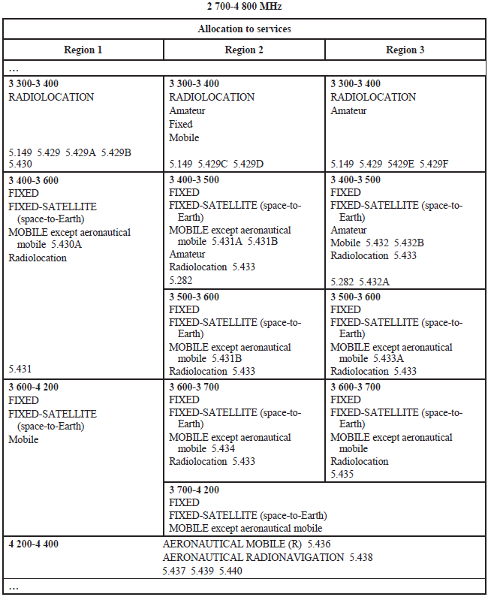

Figure 1: Extract from the ITU Radio Regulations [4]

## European context

According to the European Common Allocations Table (ECA Table) [5], the 3600-3800 MHz bands are used as follows:

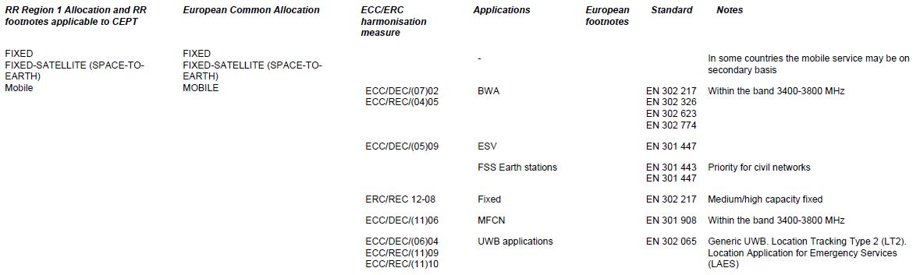

Figure 2: Extract from the European Common Allocation Table (ECA)[2]

In practice, in most European countries spectrum within the 3600-3800 MHz frequency range is currently predominantly used by both FSS earth stations (downlink space-to-Earth) and FS fixed links (low, medium and high capacity P-MP and P-P systems) [6]. In some countries, either only FSS ES or FS fixed links have been deployed within this band (see an example in Annex A1.1) and the actual operational bandwidth of either system may vary significantly across the countries.

Also, there are large territories in most European countries where no use of either FSS earth stations or FS fixed links is authorised, however it is assumed that in a number of countries multiple satellite receive-only earth stations and VSATs have been deployed, which are exempted from individual licensing. This signifies that there is no information available, either on the geographical location or the frequencies at which these devices operate.

In the year 2011, the 3600-3800 MHz band, together with the lower band 3400-3600 MHz, was designated in CEPT by ECC/DEC/(11)06 [1] for mobile fixed communications networks (MFCNs). This 400 MHz range is potentially available for mobile broadband services and applications to accommodate the rapidly growing mobile traffic, however without prejudice to the protection and continued operation of other existing users in these bands, subject to national policy objectives and spectrum demand.

Additionally, some administrations have issued authorisations for BWA systems in this frequency band in line with the framework established by ECC/DEC/(07)02 [7], however BWA deployment in the band is limited across CEPT countries, and new authorisations for BWA have not been issued approximately since the year 2010, when the work on the ECC/DEC/(11)06 designating the band for MFCN systems began. Most BWA licences issued to date will expire by the year 2020 [8]. At the same time ECC/DEC/(11)06 envisages a transitional phase within which the deployed BWA networks would be upgraded to meet the new technical conditions for MFCNs.

In the European Union, the 3400-3600 MHz and 3600-3800 MHz bands are harmonised by the Commission Implementing EC Decision [2014/276/EU](http://eur-lex.europa.eu/legal-content/EN/TXT/?uri=uriserv:OJ.L_.2014.139.01.0018.01.ENG) [2] (amending the Decision [2008/411/EC)](http://eur-lex.europa.eu/legal-content/EN/ALL/?uri=CELEX:32008D0411) for terrestrial systems capable of providing electronic communications services, and the technical conditions contained in this EU harmonisation measure are identical to those provided in ECC/DEC/(11)06.

# Guiding principles

## National spectrum policy objectives

The use of radio spectrum is harmonised within CEPT by means of ECC Decisions, and also noting that some of the CEPT members are also Member States of the EU bound by harmonisation measures such as the Radio Spectrum Policy Programme (RSPP) [9] and EU Decisions addressing the provision of electronic communications networks and services; national administrations maintain a certain degree of flexibility with respect to defining the policy objectives in individual frequency bands, in particular when the bands in question are envisaged to be used on a shared basis.

National administrations will decide, based on their national circumstances, which existing applications need to be considered as incumbent uses within the sharing framework with other applications and maintained in the long term taking into account sovereign interests, market demand, international obligations and community law in the case of EU Member States.

In addition the Administration, at national level, is independent to decide on the measures of protection and or the implementation of sharing frameworks. However, at CEPT level common incumbent FS and FSS services characteristics and respective protection criteria could be used as a reference at national level by administrations.

## Status of MFCN and other users in the 3600-3800 MHz

In the context of this report the FSS earth stations and FS fixed links operating in the 3600-3800 MHz band are assumed to be incumbent users, however the decision on this status remains under the responsibility of national administrations.

MFCN systems, which can be deployed in CEPT countries in accordance with ECC/DEC/(11)06 [1] (updated in 2014), and are considered in this report according to ECA as having a co-primary status with respect to incumbent users which means that their deployment can take place subject to successful national coordination with the incumbent users, based on the respective sharing frameworks established by national administrations.

Other users of the 3600-3800 MHz band considered in this report are Broadband Wireless Access systems deployed in some CEPT countries in accordance with ECC/DEC/(07)02 [7].

## High-level approaches to the coexistence between the identified spectrum users

### MFCN-BWA coexistence

As mentioned in the previous section, the whole 3400-3800 MHz band remains formally designated in CEPT to BWA systems in accordance with ECC/DEC/(07)02. However new authorisations for BWA have not been issued in European countries approximately since the year 2010, when the work on the ECC/DEC/(11)06 [1] designating the band for MFCN systems began, and most issued BWA licences will expire by the year 2020 [8].

ECC/DEC/(11)06 assumes that BWA systems are technically similar to MFCN systems and that BWA can coexist under the new Block Edge Mask (BEM) licensing regime. This regime implies that BWA UL needs to be protected from MFCN DL transmissions in the same way as MFCN UL is protected. This can be achieved by either frequency separation or by applying the appropriate BEM elements as described in ECC/DEC/(11)06.

ECC/DEC/(11)06 also envisages a transitional phase during which both old and new technical conditions may be applicable, but only in those countries where BWA networks have been effectively deployed. But since the 3600-3800 MHz band can be seen as an integral part of the wider band 3400-3800 MHz as identified for IMT, administrations may wish to create incentives for the BWA (P-MP) licensees in this frequency range to migrate from BWA to MFCN systems meeting the new technical conditions defined in ECC/DEC/(11)06. Such a change might be possible from the regulatory perspective under the “Flexible Usage Mode” specified in ECC/DEC/(07)02; which includes Mobile Wireless Access (MWA). This may be a way forward for those CEPT countries which implemented ECC/DEC/(07)02 in its full scope, i.e. allowing BWA licensees to provide Fixed Wireless Access, Nomadic Wireless Access and Mobile Wireless Access, and therefore this issue remains a fully national matter.

In all scenarios involving the coexistence between BWA and IMT networks, no additional regulatory measures or mitigation techniques are proposed in this report in addition to those mentioned in Annex 5 of ECC/DEC/(11)06.

### MFCN - FS/FSS coexistence

The key principles for coordination at a national level (or between neighbouring countries if there is a need to do so) of MFCN stations with FSS earth stations and fixed links in the 3400-3800 MHz band are provided in Annex 5 of ECC/DEC/(11)06 where it is proposed that the coordination should be carried out on a case-by-case basis since no single separation distance, guard band or signal strength limit can be established.

There is also a policy related issue in taking a national decision on the current relative statuses of FS/FSS systems on the one hand and MFCN systems on the other hand in the 3600-3800 MHz band, and on the long term usage of this band.

Assuming that in most European countries the primary FSS and FS users will continue to operate in the 3600-3800 MHz band and require protection in the foreseeable future, while MFCN networks will need to be deployed based on individual authorisations in order to provide a certain Quality of Service (QoS), administrations may develop regulatory and technical conditions to ensure and enhance the coexistence of these users within the band. These regulatory and technical conditions can be defined by the Administration itself or by the Administration in conjunction with the incumbent and the MFCN operator.

### Cross-border coordination

While this report focuses on coexistence with other systems in the same country, the deployment of terrestrial MFCN systems would require consideration of potential cross-border interference to MFCNs, FS systems and FSS earth stations in neighbouring countries. ECC/REC/(15)01 [10] addresses the needed cross-border coordination with respect to other MFCNs in several bands, including 3600-3800 MHz. In addition, cross-border coordination of MFCNs with respect to receiving FSS earth stations is addressed by the provisions of the Radio Regulations [4] (RR 9.17 and RR 9.18).

## Setting up a sharing framework

A spectrum sharing framework can be understood as a set of sharing rules and conditions and its development will require the involvement of all relevant stakeholders, including the incumbents. Such rules would be incorporated in the relevant national licence conditions, as is common practice today, and may include procedures to be followed during the roll-out of the MFCN.

In setting up a sharing framework, administrations may take into account:

* continued FS/FSS operation and possible introduction of new FS/FSS users;
* possible changes to existing FS/FSS operations (e.g. a change in frequency, change in antenna pointing direction, addition of radio frequency shielding around FSS earth stations), subject to the national decisions;
* improvement of the performance of mobile networks concerning its mitigation techniques;
* need for transparent and non-discriminatory sharing regulation, ensuring efficient use of the available spectrum resource;

and

* national constraints, as well as international obligations.

All of the above will impact the setup of a national sharing framework providing the base for the further considerations on the appropriate sharing measure.

This may be carried out using a step-by-step approach, as described in Figure 3, by the Administration itself or in consultation with the incumbent and/or the MFCN operator.

In Step 1, the Administration considers the incumbent use and their usage pattern in terms of spectrum utilisation across a certain geographic area. The knowledge on how spectrum is actually used is essential and this information might be available only to administrations. Thus, it will be possible to determine the availability of spectrum resources that can be shared on a frequency and regional basis.

In Step 2, the rules and conditions for sharing are determined. For this, there is a need to identify technical characteristics of the incumbent users and to define the protection criteria, as well as the mechanisms that need to be implemented in order to fulfil the protection of the incumbent services. The definition of the sharing rules may rely on the analysis of coexistence between the incumbent and the additional users/new entrants (i.e. MFCNs in the case of this Report). Coexistence may be investigated by means of predictive tools, as well as on-field assessment via measurement campaign.

In Step 3, the Administration sets the authorisation process in a fair, transparent and non-discriminatory manner, in accordance with the sharing framework. Different national administrations might adopt different approaches in defining the licence conditions, depending on their available resources and national circumstances.

In Step 4, the Administration may adopt methods to verify that spectrum is used in compliance with the sharing rules. All the possible approaches might be complemented by ex-ante measures and/or ex-post monitoring of the additional users’/new entrants’ deployments and appropriate regulatory action (e.g. enforcement measures already provided in the licence) in response to cases of possible interference. These include, for instance, field monitoring systems or the adoption of specific validation process to be applied before a new installation enters in operation. Challenges to the effectiveness of field monitoring methods arise from low incumbent protection levels, time dependency as well as aggregate interference from multiple base stations. This needs to be considered and may require regulatory oversight.

**STEP 1.** Identify incumbent use

**STEP 2.** Determine the rules and conditions for sharing

**STEP 3.** Authorise the use of the spectrum by other users/new entrants

**STEP 4.** Verify compliance   
with sharing rules

Figure 3: Step by step approach to set up a sharing framework

## Enhancement of existing regulatory regimes by implementing LSA

The Licensed Shared Access (LSA) approach [3] may be considered as a suitable option by some administrations, according to the national situations, to enhance the existing coexistence of MFCNs and BWA/FS/FSS (see sections 4.3.1 and 4.3.2). In order to analyse the applicability and the implementation options of the LSA approach to developing the coexistence conditions for the users in the 3600-3800 MHz band, it is worth recalling the definition of the LSA as provided in the RSPG Opinion on LSA [11]:

“A regulatory approach aiming to facilitate the introduction of radiocommunication systems operated by a limited number of licensees under an individual licensing regime in a frequency band already assigned or expected to be assigned to one or more incumbent users. Under the Licensed Shared Access (LSA) approach, the additional users are authorised to use the spectrum (or part of the spectrum) in accordance with sharing rules included in their rights of use of spectrum, thereby allowing all the authorised users, including incumbents, to provide a certain Quality of Service (QoS)”.

LSA aims to ensure a certain level of guarantee in terms of spectrum access and protection against harmful interference for both the incumbent(s) and LSA licensees, thus allowing them to provide a predictable Quality of Service.

In the context of identifying additional spectrum for MFCNs, LSA offers to administrations a complementary regulatory approach to the traditional exclusive authorised access for MFCNs, noting that the traditional approach will obviously continue to be essential to meet the future demand for mobile broadband.

# Assumptions and results from available sharing studies between FSS/ FS and MFCN systems

ECC Report 100 [12] concludes that coexistence of BWA and FS/FSS systems in the 3400-3600 MHz can only be achieved through case-by-case coordination and that coexistence is possible if FS/FSS systems are a) not deployed ubiquitously and/or b) are individually licensed. Sharing between BWA and FS systems is possible when sufficient frequency separation is provided, which depends on the characteristics of and geographic separation between the stations. Sharing between BWA and FSS systems is possible if enough geographic separation between the systems is available, which varies based on the assumed input parameters from 8.5 km up to 320 km in the worst case.

CEPT Report 49 [13]: concludes that coexistence of BWA systems with FS/FSS systems in the 3400-3800 MHz band can be achieved only through case-by-case coordination and is possible if FS/FSS spectrum usage is not ubiquitous and/or exempted from individual licensing. Overlapping channel sharing between BWA and FS systems in the same geographic area is not possible and sharing between BWA and FSS systems requires separation distances, which vary depending on system specification and can be large in some cases.

Report ITU-R M.2109 [14]: provides that sharing between IMT-Advanced systems and FSS networks in the bands 3400-4200 MHz and 4500-4800 MHz is possible on a case-by-case basis, if FSS systems are a) not deployed ubiquitously and/or b) are individually licensed. Coexistence of IMT-Advanced and FSS networks requires separation distances between the services, which depend heavily on the deployment and parameters of both services and range from hundreds of metres up to 430 km in the worst case.

ECC Report 203 [15]: draws conclusions from ECC Report 100 and ITU-R M.2109 and reiterates that coexistence of MFCNs with FS/FSS systems in 3400-3600 MHz and 3600-3800 MHz requires case-by-case coordination and is possible if FS/FSS spectrum usage is not ubiquitous and the location of stations are known. Co-channel sharing is not possible between FS/FSS and MFCNs in the same geographic area and sharing between FS/FSS and MFCNs is possible if sufficient separation distance is available between the services, which varies considerably depending on system specifications.

Report ITU-R S.2368 [16]: concludes that sharing between IMT-Advanced and FSS in the bands   
3400-4200 MHz and 4500-4800 MHz is possible on a case-by-case coordination basis, if the FSS earth stations are deployed at known specific locations. If the FSS earth stations are deployed in a ubiquitous manner or without individual licensing, sharing is not feasible in the same geographical area since no minimum separation distance can be guaranteed. The magnitude of the separation distance depends on the deployment and system specifications of both services and ranges from hundreds of meters up to 525 km in the worst case.

## Interference from terminal stations

This section addresses the protection from possible interference into fixed links and FSS earth stations from terminal stations of BWA network as studied in ECC Report 100. The following conclusions were agreed as a result of this study.

### Compatibility between BWA and Point-to-Point fixed links

The coordination process will have to ensure that there is no BWA system in the main lobe of the P-P system and that the separation distance between the P-P system and the BWA Central Stations (CS) is such that the interference between BWA Terminal Stations (TS) and the P-P is limited.

### Compatibility between BWA and FSS (S-E)

BWA TSs generally impact less than the CS. In addition, it has been demonstrated that the coordination of the BWA CS will generally be sufficient to ensure the coexistence with BWA TSs. Furthermore, TSs may benefit from the additional clutter loss which is available in some environments, particularly urban environments.

Given the similarity in the mechanisms of interference from BWA networks and IMT networks and the fact that both systems can be regarded as "MFCNs", the principle conclusions of ECC Report 100 [12] with regard to the interference from terminal stations (or UEs in case of IMT) to Fixed Links and FSS earth stations can be regarded as appropriate. Any further studies of this matter may be decided on a national level.

In addition, CEPT Report 49 [13] and ECC Report 203 [15] conclude that:

* MFCN UEs and BWA TSs have similar characteristics, which justifies that the conclusions of the ECC Report 100 on the coexistence of BWA TS with Fixed Service can be extended to MFCN UEs. With that understanding, while coordinating MFCNs and FS/FSS it is sufficient to ensure that MFCN BSs do not interfere with the FS, since that will also guarantee the protection of the FS from MFCN UEs;
* UEs impact earth stations less than BSs do, so a separation that prevents interference from BSs will also protect earth stations from UE interference. The coordination of MFCN BSs and the FSS will ensure that MFCN UEs do not interfere with the FSS, based on the analysis conducted in ECC Report 100 and ITU-R Report M.2109 [14].

# Operational Guidelines for administrations on sharing between MFCN and FS/FSS

This chapter aims to assist administrations in deciding the national framework for the sharing of spectrum between Mobile/Fixed Communication Networks (MFCNs) and the existing Fixed Satellite Service (FSS) and Fixed Service (FS) in the 3600-3800 MHz band. The guidelines given in this section relate mainly to Step 2 of the overall sharing framework given in Section 4.4.

The CEPT administrations will need to specify the provisions necessary to enable and facilitate coexistence between MFCNs and the existing incumbent services (FS/FSS) in the 3600-3800 MHz band. This may be done as shown below.

|  |
| --- |
| Within this report the protection requirements are defined as the maximum permitted interference powers IFSS,T and IFS,T in units of dBm/(BFSS MHz) and dBm/(BFS MHz) at the input of FSS and FS receivers. These will be derived based on the I/N or C/(I+N) protection criteria (see section 6.1).  The maximum permitted interference powers may be translated to maximum permitted electric field strengths[3] EFSS,T and EFS,T in units of dBμV/m/(BMFCN MHz) at the input of the FSS and FS receiver antennas.  An Administration may communicate the protection requirements to the stakeholders by:   1. Specifying the maximum permitted interference powers or electric field strengths and allow full flexibility for MFCN operators to comply with these limits. These requirements may be expressed in terms of:    * + protection zones (see Section 6.2.1). 2. Specifying explicit restrictions on the frequency, or geographic location, or the e.i.r.p. level (or a combination thereof) for the MFCN deployments. These restrictions may be expressed in terms of:    * + exclusion zones (see Section 6.2.2.1) and/or      + restriction zones (see Section 6.2.2.2).   Based on national circumstances an Administration might apply any combination of A and B. |

## Criteria for the protection of the FS/FSS receivers

The National Administration would specify the criteria for the protection of the incumbent users in terms of the maximum permitted (target) interference levels IFSS,T and IFS,T at the input of FSS and FS receivers, respectively.

The maximum permitted interference power level at the input to the receiver, IFS/FSS,T, may be specified according to one of two criteria:

* “I/N” criterion. Here, the value of the maximum permitted interference is defined in relation to the thermal noise floor, N. For example, for a target rise of 1 dB in the noise floor, the value of IFSS,T or IFS,T would need to be 6 dB below the thermal noise floor.
* **“C/(I+N)”** criterion. Here, the value of the maximum permitted interference is defined in relation to a target reduction in the receiver’s signal-to-interference-plus-noise ratio. This criterion might be appropriate where the receiver operates at some margin above its minimum sensitivity. The C/(I+N) criterion is applicable only in cases where information on the link budgets of the FSS or FS receivers is available. As the carrier power typically varies within a limited range over time (for example due to propagation variations), in using the C/(I+N) criterion, the percentage time used for the value of I requires more careful consideration.

It should be noted that the value of the maximum permitted interference is a function of the bandwidth of the FS/FSS channel and of the percentage of time used in the propagation model. In the case of FSS earth stations, the wanted signal bandwidth typically ranges from 40 kHz to 72 MHz (according to ITU-R Report S.2368 [16]) and interference is typically assessed against both "short-term" and "long-term" percentage of time. See A1.2.6 for further details on how to account for the percentage of time in the propagation model.

In addition to the evaluation of the I/N allowance of FSS systems due to co-channel and out-of-band emissions from MFCN systems, interference based on FSS earth station low-noise amplifier (LNA) and low-noise block down-converter (LNB) overload should also be considered. Recent reports, such as ITU-R Report M.2109 [14] and ITU-R Report S.2368 [16], have considered the LNA/LNB overload effect. One study in ITU-R M.2109 has shown that emissions from one IMT-Advanced station can overload the FSS receiver LNA, or bring it into non-linear operation, if the separation distance is less than some kilometres or some hundreds of metres with respect to base stations and user terminals respectively. Another study in ITU-R Report S.2368 shows the protection distance is between 0.9 and 9 km depending on different assumptions. Further details on LNA/LNB overload can be found in ANNEX 6:.

## Approaches for an administration to communicate the protection requirements

Figure 4 illustrates the two approaches for the incumbent protection as presented in the beginning of the Section 6.

In the case that Approach A is used, the Administration will specify the maximum permitted interference power or the maximum permitted electric field strength, either at the location of a specific FS/FSS receiver or within a protection zone. The MFCN operator will take this information into account in the network planning to make sure that these limits are met.

In Approach B an Administration will establish the necessary restrictions on the MFCN deployment either for individual base stations (or base station sectors) or specify an area where these restrictions apply. These restrictions are communicated directly to the MFCN operators.

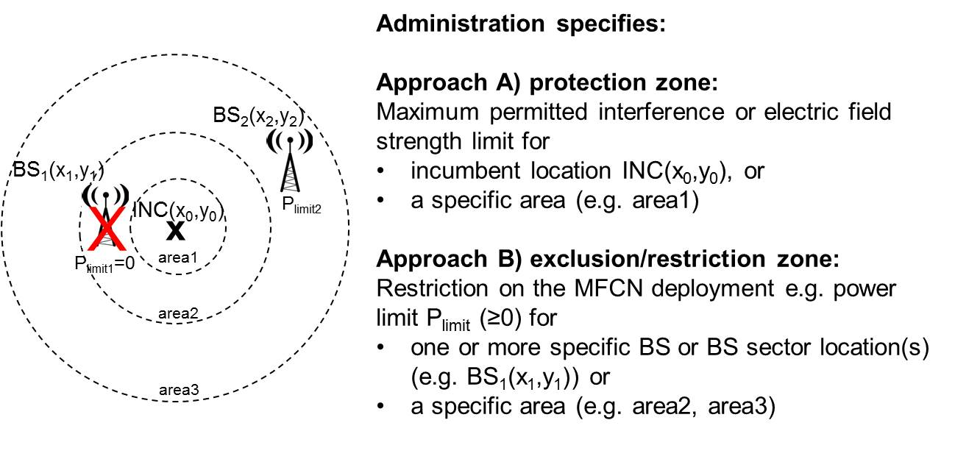

Figure 4: Approaches A) and B) for the incumbent protection

### APPROACH A

#### The Administration communicates the maximum permitted interference power

The protection requirements defined as maximum permitted interference power at the input of FSS and FS receivers, in units of dBm/(BFSS MHz) and dBm/(BFS MHz) respectively need to be specified and communicated by the Administration directly to the stakeholders.

The maximum permitted interference level at the input of FSS receivers is not necessarily the same as that permitted at the input of FS receivers. Furthermore, different maximum permitted interference levels may be specified for different receivers of the same service category on a case-by-case basis. This might be appropriate, for example, where a certain FS receiver operates at a large margin above its minimum sensitivity, and can therefore tolerate greater levels of interference compared to another FS receiver.

Therefore the lowest level of permitted interference may be taken into account. It should be noted that a protection measure based on the most stringent criterion will protect all incumbent receivers, although this would result in technical conditions which may not be least restrictive for the operation of MFCN.

In all cases, it is the obligation of the national administration(s) to ensure the appropriate protection of the incumbents – based on national circumstances – when considering a national sharing framework to allow for additional users. This signifies that the maximum permitted interference levels at the input of the FSS and FS receivers may vary in different countries (as decided by the national administrations), hence in practice these variations correspond to different national factors (e.g. interference margin in the link budgets of individual links, different technologies, etc.).

Further details and examples on the specification of the protection requirements in terms of maximum permitted interference power is given in ANNEX 3:

#### The Administration communicates maximum permitted electric field strength

The criterion for the protection of the FS/FSS receivers may be based also on the maximum permitted electric field strength (which can be defined separately for the co-channel, adjacent and alternate channel cases) caused by a MFCN (covering both BSs and UEs) in dBμV/m/(BMFCN MHz) at the location of FS/FSS receiver antennas specified at a given height above ground.

Maximum permitted electric field strength is typically used when the characteristics of the receiver antenna (gain, directionality, and pointing angle) are not known for each individual victim receiver or cannot be disclosed. As such, instead of specifying an interference power limit at the input to a receiver, the Administration specifies a maximum permitted electric field strength at the input of the receiver, thereby avoiding the need for considering the receiver’s antenna characteristics.

Further details and examples of the specification of the protection requirements in terms of maximum permitted electric field strength are given in ANNEX 3:

#### Responsibilities and obligations for Approach A

Under this approach the Administration will specify regulatory limits in the form of the maximum permitted interference power or the maximum permitted electric field strength, either at the location of a specific FS/FSS receiver or within a protection zone.

The MFCN operator(s) are expected to comply with the protection requirements. The calculations needed to achieve this (see ANNEX 3:) will be performed by the MFCN operator(s) and/or a trusted third party acting on its behalf.

The Administration might additionally specify the type of calculations to be used by the MFCN operator(s), possibly in consultation with the stakeholders. Furthermore, the Administration might also specify parameters to be used in the calculations (e.g. ACIR, propagation model, antenna heights, terrain models etc. see ANNEX 5: for full list of parameters used in the calculations), again possibly in consultation with stakeholders. Well-defined rules for interference calculation may avoid later disputes between stakeholders, as a number of different input parameters are required for interference modelling.

These technical specifications need to be taken into account by the Administration in the relevant national MFCN licence conditions defining the rights of the MFCN operators to use the spectrum.

Within the framework provided by the Administration, MFCN operator(s) are free to choose the most appropriate deployment in order to meet the regulatory limits.

Transparency has to be provided to the administrations in order to allow for a regulatory oversight in the form of ex-ante qualification and possible ex-post measures, e.g. to check for compliance or enforcement in case of reported interference. A policy to make available the required information to perform and ensure traceability of the calculations should be set up by the administrations in order to deal with issues of confidentiality.

#### Pros & Cons of Approach A

MFCN operators are well placed to perform detailed calculations with regard to their network deployments.

An advantage of using maximum permitted interference or field strength level as a protection criterion is that it does not dictate the possible MFCN deployments. The operator can plan the MFCN in a way that best serves its needs while protecting the incumbents. For example, in a certain area this may lead to deployment of macro cells, whereas in some other areas, there may be need for multiple small cells. It is also more flexible in that it allows an operator’s own network planning and self-configuration tools to be used as a new cell is added to the network. To overcome the challenge that the location of the victim receiver needs to be known by the MFCN operator, masking can be used, e.g. by indicating a larger area around the victim receiver as a protection zone. However, this would lead to a certain degree of inefficiency in spectrum use.

Administrations which might allow changes to existing FS/FSS operations may specify procedures for the recalculation and implementation of any protection criterion to protect the incumbents as their systems may develop over time.

### APPROACH B

Exclusion zones and restrictions on the maximum permitted e.i.r.p. (leading to a restriction zone) are very much interrelated. Both ensure that the interference at the input of FSS and FS receivers does not exceed the levels specified by the Administration, and both can be described with the same type of calculations.

#### Exclusion zones applied to MFCN base stations

The principle of exclusion zones is based on the calculation of “protection distances”[4]. A protection distance refers to the minimum geographical separation between a MFCN base station and a FS/FSS receiver at which the interference at the input of the FS/FSS receiver would not exceed the protection criteria as specified by the Administration.

Examples of these can be also found in ECC Report 100 [12], ITU-R Report M.2109 [14] and ITU-R Report S.2368 [16]. These documents are described in Section 5. Further to these references, an example of the calculation of the needed protection distance can be found in ANNEX 4:

Depending on the amount of information available to perform the calculation of the exclusion zones (such as local terrain, clutter, the specific operational bandwidth of the FS/FSS receiver and the gain, radiation pattern and orientation and its antenna), circular or non-circular exclusion zones could be considered. Additionally, composite exclusion zones which take into account multiple FSS and FS receivers could be considered. (see ANNEX 4:).

#### Restriction zone applied to MFCN *base stations*

In the case of a restriction zone, one or more of the MFCN operational parameters (e.g. e.i.r.p., height, sectorisation pattern/orientation, and transmission frequency) are subject to restrictions.

Base stations that are at sufficiently large geographic separations from a FSS or FS receiver do not need to be taken into account in the calculation of the aggregate interference at the input of FS/FSS receivers. In defining this distance, it should be noted that base stations which individually do not exceed the criterion may contribute to the aggregate interference.

A case study on calculating restriction zones for e.i.r.p. of the MFCN BS is presented in A1.1. Further elaboration can be also found in ANNEX 5:.

#### Responsibilities and obligations for Approach B

Under this approach the Administration will specify and communicate to the MFCN operator(s) explicit restrictions on their deployment (via exclusion zones and/or restriction zones) including guidance on the implementation of those restrictions. The Administration or a trusted third party on its behalf will perform all the calculations. A policy on provision of information used in the calculations may also need to be set up in order to provide transparency to incumbents and MFCN operator(s). The MFCN operators are required to plan (or re-plan) the coverage/deployment in order to meet the limitations.

For the definition of the restriction and/or exclusion zones, publication of technical parameters used by the Administration might be necessary to ensure reproducibility of the calculations.

The necessary technical specifications are usually defined in consultation with all relevant stakeholders, including the incumbents (FSS and FS operators) and the MFCN operators.

These technical specifications will be incorporated in the relevant national MFCN licence conditions defining the rights of the MFCNs to use the spectrum.

#### Pros & Cons of Approach B

The key benefit of exclusion zones is their implementation simplicity. They have proven to be a robust protection mechanism for avoiding harmful interference to fixed receivers at known geographic locations.

One of the key advantages of restriction and exclusion zones is that the location of the FS/FSS receiver does not need to be known by MFCN operator.

The disadvantage is that the burden of performing the calculations falls on the Administration or on the third party acting on its behalf. Also, the evolution and flexibility of the deployment of MFCNs is restricted to the deployment scenario assumed in the initial calculations of the technical conditions for the use of the band, although re-calculations can be agreed between the licensee(s) and the Administration.

## Additional issues to be taken into account

### Allowing changes to existing FS/FSS operations

Administrations wishing to enable future deployments and therefore development of FS/FSS may consider implementing procedures allowing the introduction or removal of FS/FSS stations and/or changes to operational parameters[5] of the existing stations, through revised/recalculated protection requirements. The scope of such possible changes should be defined by the administrations in the authorisation of spectrum use by the MFCN operators to ensure sufficient predictability of the future sharing conditions. The provision of this flexibility is subject to national decision.

A possible solution to allow for future deployment and therefore further development of the incumbent services (FS/FSS) is the adoption of the LSA framework. This would allow for the protection of existing incumbent receivers (FS/FSS) and also cover possible changes in the usage (e.g. link direction, new deployments, and used frequencies) of those services - see Section 7.

In all cases, the administrations should provide all parties with predictable operating conditions.

### Availability of information

In order to deal with possible issues of confidentiality, administrations need to consider a policy to make available information which might be required to perform the calculations and to facilitate the cooperation between stakeholders.

The national decision on the responsibility for performing the calculations may vary from one country to another. This will depend on the following factors:

* the extent to which information on the FS/FSS receivers can be shared with the MFCN operators;
* the extent to which it is necessary for information on MFCN deployments to be shared among the MFCN operators;

#### Access to information on FS/FSS receivers

In certain jurisdictions, there may be restrictions on MFCN operators regarding access to information on the FSS and FS receivers. This might be for commercial, legal, or security reasons. In cases where the location of the FSS or FS receiver cannot be revealed, the MFCN operators themselves cannot perform the calculations. The relevant calculations will then need to be performed under Approach B, either by the Administration or a trusted third party acting on its behalf, and the resulting restrictions on the MFCN deployment are then communicated to the MFCN operators. Alternatively, the Administration may, for example, define a larger geographic area where a maximum permitted electric field strength applies in order not to reveal the exact locations of the FS/FSS receivers.

#### Access to information on MFCN deployments

The way in which the restrictions account for the deployments of multiple MFCN operators affects the nature of the entity which can perform the required calculations. This is the case, for example, where the derivation of the restrictions explicitly aggregates interference from base station sectors of multiple MFCN operators (see for instance approach 3 in ANNEX 5:)[6]. The entity which performs the required calculations will need information on the deployments of all MFCN operators. For reasons of confidentiality, this entity is unlikely to be one of the MFCN operators, but is more likely to be i) a third party acting on behalf of all the MFCN operators (Approach A), or ii) the Administration or a third party on the behalf of the Administration (Approach B).

#### Responsibilities for performing the calculations

Two scenarios can be foreseen regarding the responsibility for performing the calculations to allow the MFCN operator to plan and deploy the network adjusting transmission powers of each its BS/BS sector flexibly in such way that limits of the maximum permitted interference power or maximum permitted electric field strength at the receiver are met:

* Under Approach A: Calculations are performed by the MFCN operators or by a third party acting on the MFCN operators’ behalf, with the possible involvement of the incumbents, with ex-ante qualification and/or ex-post regulatory oversight;
* Under Approach B: Calculations are performed by the National Administration or by a third party acting on the National Administration’s behalf, with the possible involvement of the MFCN operators and the incumbents, with ex-post regulatory oversight.

Note that in the case of Approach A, the Administration may wish to verify that the necessary calculations are performed correctly. This could be achieved through a pre-licensing qualification process and/or a post-licensing pre-deployment qualification process as described in the licence conditions. The Administration may carry out its own calculations as a baseline reference for regulatory oversight.

The responsibilities under the above approaches are illustrated in the figures below.

In Figure 5, the calculations are performed independently by the MFCN operators (Approach A). Here, the MFCN operators receive information regarding the FSS and FS receivers.

In Figure 6, the calculations are performed by a third party, either on behalf of all the MFCN operators (Approach A) or on behalf of the Administration (Approach B). Here, the third party receives information on the FS/FSS receivers and the MFCN deployments. Following the relevant calculations, the third party communicates the restrictions to each of the MFCN operators.

In Figure 7, the calculations are performed by the Administration (Approach B). Here, the Administration receives information on the FS/FSS receivers and the MFCN deployments. Following the relevant calculations, the Administration communicates the restrictions to each of the MFCN operators.

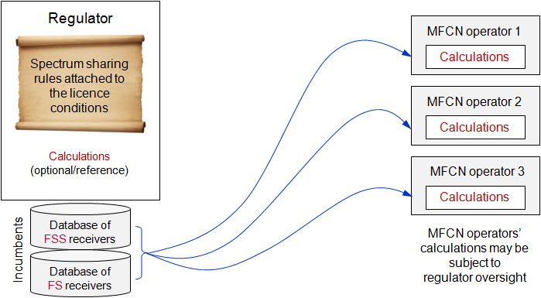

Figure 5: Calculations are performed independently by the MFCN operators   
(with the possible involvement of the incumbents), with regulatory oversight

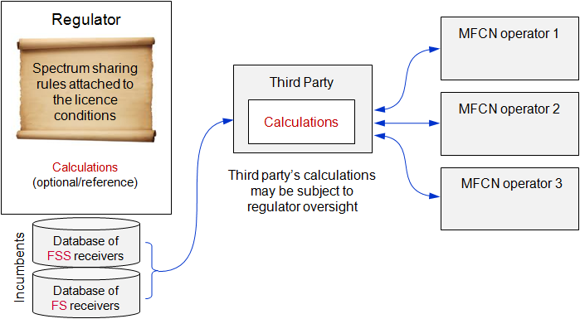

Figure 6: Calculations are performed by a third party on behalf of the Administration   
(with the possible involvement of the MFCN operators and the incumbents) or on behalf of   
all MFCN operators (with the possible involvement of the MFCN operators and the incumbents),   
with regulatory oversight

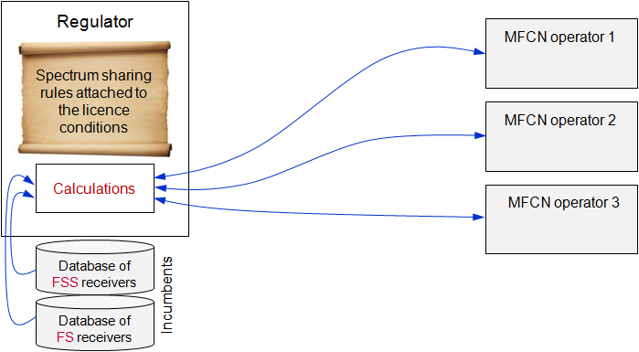

Figure 7: Calculations are performed by the National Administration   
(with the possible involvement of the MFCN operators and the incumbents)

### **Interference from MFCN UE**

In addition to the possible interference from MFCN base stations, the UEs might also be a source of interference if they operate close to the location of the incumbent receiver station. This may happen when the BS is at the border of an exclusion/restriction zone, and the UE is still able to connect to it. The reason for this is the omnidirectional emissions of UE signals, which could be strong enough to reach the relevant MFCN BS in one direction, but also to interfere with the incumbent’s receiver (overspill) in another.

Note that this scenario would also expose the MFCN UE to any emissions from the incumbent transmitters if the UE moves too close to the incumbent

Both issues can be solved by consequent coordination between the incumbent services and MFCNs.

### Interference from multiple MFCN base stations

The specification of the maximum permitted interference power or maximum permitted electric field strength at the receiver for the protection of the incumbents (Approach A) allows the MFCN operator to plan the network and adjust the emissions of each of its BSs or sectors flexibly in such way that these regulatory limits are met. In the case where there are multiple MFCN operators present, the Administration may:

* Take into account the emissions from all MFCN networks in the definition of the limits, or
* Allow MFCN operators, or a third party acting on their behalf, to coordinate transmissions among themselves to ensure these limits are met.

In case an Administration decides to use either exclusion or restriction zones (Approach B), there are several ways to take into account of multiple BSs, by:

* Introducing a generic aggregation margin in the calculations. This margin may be derived by assuming an appropriate network layout e.g. an existing macro BS network deployment;

or

* Calculating the specific contribution of each individual BS or sector to the aggregate interference.

Administrations need to decide on the appropriate trade-off between the complexity of the calculations (e.g. taking into account detailed propagation characteristics) and the efficiency of spectrum sharing (i.e. the restrictions on MFCN deployments).

Examples of how to account for aggregated interference in the case of e.i.r.p. restrictions are given in ANNEX 5:.

## Protection of non-registered FSS earth stations

At national level, the protection of FSS earth stations can only be ensured in the way discussed in previous sections if the characteristics and locations of these are known. Otherwise, the procedures and calculations presented in this document cannot be performed and/or implemented to ensure their protection.

Most of the receive-only FSS usage within Europe falls under licence exempt authorisation. Therefore, in most cases Administrations do not have any information about the location or parameters of any of those receiver stations. Each Administration might consider how to handle the existing non-registered stations and also those which might be deployed in the future, for example, how to identify locations and offer protection if it is considered necessary. It should be noted that some Administrations have already decided that only the existing registered and coordinated FSS earth stations are to be protected, while the non-registered earth stations cannot claim any protection.

# Operational guidelines for administrations on implementation of Licensed Shared Access at national level

## LSA as a regulatory approach

The Licensed Shared Access (LSA) approach [3] may be considered by some administrations as a suitable option for authorisation, according to their national circumstances.

In the context of identifying additional spectrum for MFCNs, LSA offers administrations a complementary regulatory approach to the traditional exclusive authorised access, noting that the traditional approach will continue to be essential to meet future demand for mobile broadband.

As underlined in ECC Report 205 [3], LSA licensee(s) and incumbent(s) can operate different applications subject to different regulatory constraints. They would each have exclusive individual access to spectrum at a given location and time, as long as the incumbent does not receive harmful interference.

The implementation of LSA is consistent with fundamental practices in frequency management, where access to spectrum relies on a 2 step regulatory process:

* Frequency allocation;
* Frequency authorisation.

## The concept of LSA sharing framework

According to ECC Report 205, the sharing framework can be understood as a set of sharing rules or sharing conditions that will materialise the change, if any, in the spectrum rights of the incumbent(s) and define the spectrum, with corresponding technical and operational conditions, that can be made available for alternative usage under LSA. In addition this Report states that LSA should be implemented on a voluntary basis. On the other hand the RSPG [11] considers that "LSA could be initiated on a voluntary basis, but it also may be imposed by the Administration in order to ensure efficient spectrum use. The policy on this matter can be contingent upon national circumstances.

The implementation of LSA relies on the concept of a sharing framework that is under the responsibility of the Administration/NRA. Its development requires the involvement of all relevant stakeholders; the incumbent(s), the additional user(s) classed as LSA licensee(s) and the Administration/NRA.

According to ECC Report 205, the sharing framework can be understood as a set of sharing rules or sharing conditions that will materialise the change, if any, in the spectrum rights of the incumbent(s) and define the spectrum, with corresponding technical and operational conditions, that can be made available for alternative usage under LSA.

The Administration/NRA would set the authorisation process with a view to delivering, in a fair, transparent and non-discriminatory manner, individual rights of use of spectrum to LSA licensees, in accordance with the sharing framework defined and agreed beforehand.

LSA does not prejudge the modalities of the authorisation process to be set by administrations/NRAs taking into account national circumstances and market demands. An LSA implementation may use different mechanisms of transmission of information on spectrum availability (e.g. databases). National administrations will therefore have a degree of flexibility in the national implementation of the LSA concept in the 3600-3800 MHz band to enable the required protection of the incumbent services.

### Existing LSA sharing frameworks

It should be noted that the ECC in response to the EC Mandate on LSA in frequency band 2300-2400 MHz [17] has developed a LSA regulatory framework for the frequency band. See CEPT Report 55 [18], CEPT Report 56 [19] and CEPT Report 58 [20]. This was supported by the relevant standardisation activities in ETSI. ECC/DEC/(14)02 [21] provides the regulatory and technical conditions for the use of the 2300-2400 MHz by MFCNs. CEPT Report 55 is aligned with ECC/DEC/(14)02 and contains the common and minimal (least restrictive) technical conditions for WBB operation in the 2300-2400 MHz band while CEPT Report 56 describes the sharing options between WBB and the incumbent users, such as implementation of exclusion, protection and restriction zones for establishing the relevant LSA frameworks. CEPT Report 58 contains a step-by-step approach for the implementation of the LSA sharing framework for administrations for this band.

The relevant ETSI system requirement specification [22], and the system architecture and high level procedures [23] for LSA in the 2300-2400 MHz band are finalised.

## APplication of LSA in 3600-3800 MHz at national level

Prior studies on the LSA sharing framework have focused on the 2300-2400 MHz band and developed a step-by-step approach for administrations to implement the LSA sharing framework. Below in Figure 8 a generalised version of the developed approach is presented together with the mapping to the general sharing framework presented in Section 4.4.

### Generalised step-by-step approach for LSA

In Phase 1, the extent of the incumbent usage in order to evaluate the applicability of LSA and the availability of spectrum resources on a frequency and regional basis is determined. The information could include type, scenarios and applications of the incumbent usage. This phase corresponds to the Step 1 of setting up a sharing framework presented in Section 4.4 of this report.

In Phase 2, technical characteristics of the incumbent usage as well as appropriate protection measures should be identified.

In Phase 3,a the mechanisms needed by the additional user to implement in order to fulfil the protection of the incumbent services as well as the provision of the required information should be determined. Future development of the incumbent usage is to be taken into account as well, where considered appropriate.

Phases 2 and 3 correspond to the Step 2 of setting up a sharing framework presented in Section 4.4.and the approaches for incumbent protection presented in Section 6.

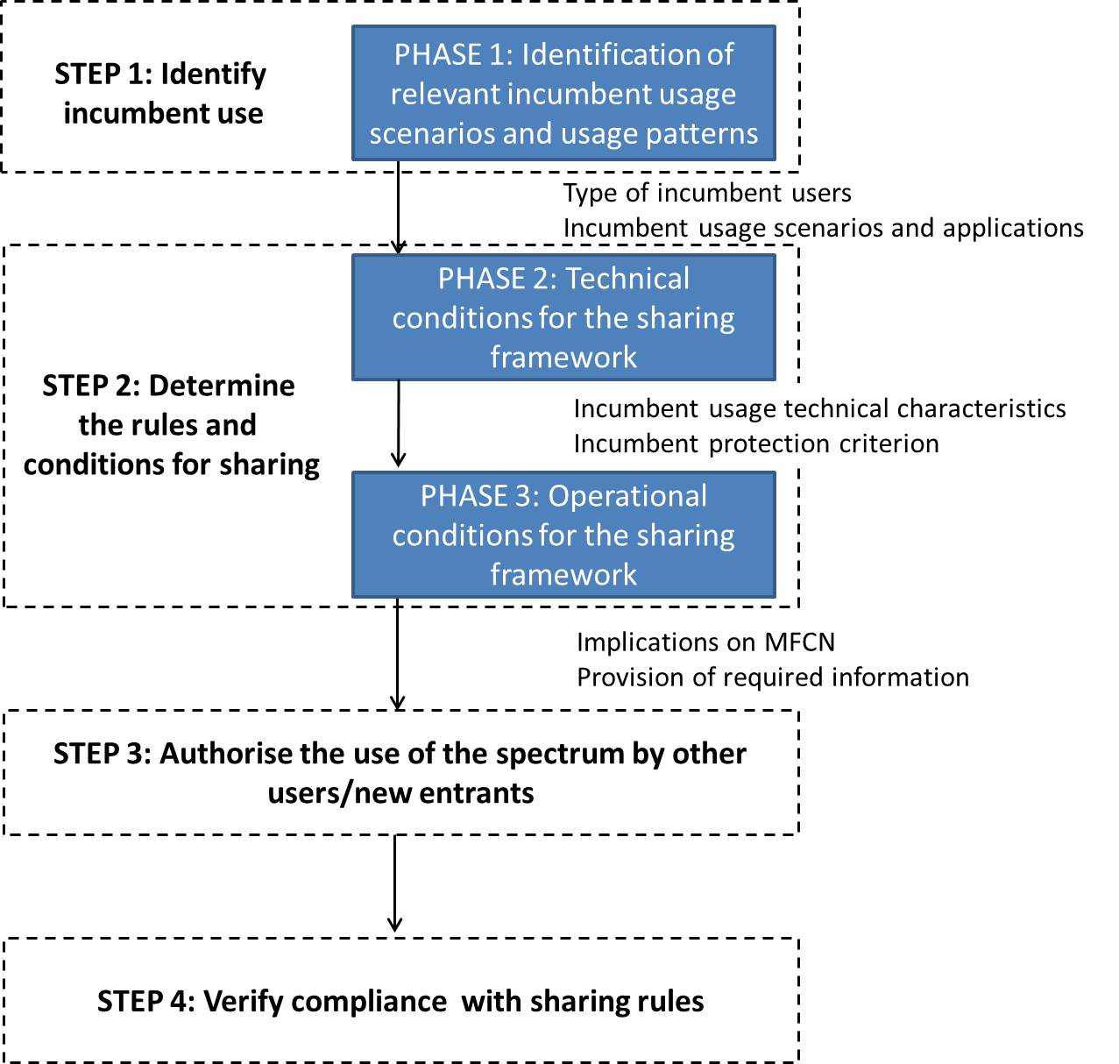

Figure 8: Generalised step-by-step approach for implementation of LSA

### Guidance on implementation of a LSA framework in 3600-3800 MHz

Based on the step-by-step approach above, the following guidance is provided

Phase 1: Identification of incumbent use patterns and relevant sharing scenarios

The use patterns of both FS links and FSS earth stations are generally stable. Furthermore, the relevant characteristics of the FS links and FSS earth stations (used frequencies, bandwidths and antenna parameters) of the incumbents should be available within the Administration interested in the implementation of the LSA concept. The portion of non-registered FSS receivers might be considered as well on a national basis. Based on this information the spectrum resource that could be made available for MFCNs through LSA can be determined. The applicability of LSA may vary between different geographical locations and portions of the band depending on the existing usage. The LSA could be initiated on a voluntary basis, in which case the incumbent user may decide locations and bands suitable for sharing using LSA, however LSA may also be imposed by the Administration in order to ensure efficient spectrum use.

A concept of handling the possible confidentiality of information used in the calculations (e.g. due to competition or safety reasons) needs to be established on national level.

Phase 2: Definition of technical conditions

Under this phase, the protection criteria of the FS/FSS incumbent uses need to be translated into an appropriate approach for incumbent protection presented in Section 6.2 of this Report, applying Approach A and/or Approach B.

Phase 3: Definition of operational conditions

As the incumbent usage on the 3600-3800 MHz band can be considered to be relatively static, it can be anticipated that the mechanisms such as dynamic adjustment of the network or dynamic exchange of information are not needed. Therefore, there might not be a need for specific frequency management tools (e.g. the implementation of the LSA Controller by MFCN operators) and the implications on the MFCNs will occur in most cases while planning the deployment. On the other hand, dynamic network planning, allowing for any changes of the incumbents use, including new earth stations, change of frequencies and bandwidth, and link directions (for FS), may also be considered by an Administration, provided that sufficient visibility is given on the availability of spectrum for MFCNs. Static incumbent usage guarantees the LSA band availability in the licence area for a known period of time, which could allow the MFCN to operate its network without additional frequency resource or infrastructure to support dynamic handover.

The information required by the MFCNs varies between the approaches to protect incumbents chosen in Phase 2. If an Administration chooses to calculate the exclusion or restriction zones for the MFCN deployment (Approach B), limitations to the MFCN deployment (e.g. the maximum e.i.r.p. at a certain area or for a specific BS or sector location) will be provided. A transmission power limit of zero corresponds to an exclusion zone. An example of how the protection of FS links has been accomplished by an Administration through definition of restriction zones is given in ANNEX 1:. Use of restriction/exclusion zones will allow an Administration not to reveal the details of the incumbent receivers to the MFCN operators, if considered necessary. Another alternative for an Administration is to provide the MFCNs with the maximum interference power or maximum permitted electric field strength at a certain location (or within a certain area) (Approach A). This information may be coupled with the required calculations and parameters to be used. This information will be used by the MFCNs to plan the transmission powers of its BSs accordingly. The MFCN operator may be requested to provide the Administration with insight on the calculations for these limits as well as on the resulting MFCN deployment.

Additionally, the following guidance is given on Step 3 "Authorise the use of the spectrum by other users/new entrant" and Step 4 "Verify compliance with sharing rules" of the general sharing framework shown in Section 4.4 of this report:

**Authorise the use of the spectrum by other users or a new entrant**:

After the conditions have been defined in accordance to the step-by-step approach above for LSA sharing framework at national level, the NRA will provide a fair, transparent and non-discriminatory authorisation, in order to enable the introduction of MFCNs in the 3600-3800 MHz band.

The LSA licence granted by the Administration will provide the necessary legal certainty to the parties. The procedure for the assignment of individual LSA rights of use should be objective, transparent, non-discriminatory and proportionate. The LSA concept does not prejudge the modalities of the authorisation process to be set by administrations/NRAs taking into account national circumstances and market demand. Authorisation under the LSA concept may happen locally, based on market demand and incumbents' activities. In order for a MFCN to be able to provide services with predictable QoS and to provide the MFCN operator control over the interference it faces, a LSA licence should be given on an exclusive basis to a single MFCN operator for a given spectrum resource at a given location, at a given time. Other MFCN operators could be assigned LSA licences in other occurrences. Subject to the national decision, the NRA (together with the key stakeholders) needs to negotiate the terms of the LSA licence in such way that a balance is found between providing the MFCN operator an adequate amount of predictability in their future access to the band on one hand, and allowing the future development of the incumbent service on the other hand. This may have an effect on the contents and/or duration of the sharing framework..

Verify compliance with sharing rules

The exclusivity among LSA licensees guarantees that the NRA can identify in a straightforward manner the MFCN with rights to access the band at a certain location, at a certain time. As the geographical area considered for a single LSA licence (and for a single MFCN) decreases, the complexity of the interference calculations increases, as multiple geographically adjacent MFCN operators need to be considered. The way to verify compliance with sharing rules is different based on the incumbent protection approach selected in Step 2 of the sharing framework. Using Approach A the compliance can be determined by measuring the interference power level or electric field strength (PFD) at the incumbent receiver location. In case interference occurs, determining the cause is easier if the required calculations and related parameters have been determined by the NRA. For Approach B, verifying the compliance may be more straightforward as explicit restrictions on the MFCN usage are given by the NRA.

# Conclusions

This report provides guidelines for administrations willing to implement the ECC framework for MFCN [1] in the band 3600-3800 MHz and to protect the incumbent uses in this band. The measures considered in this report rely on knowledge of the locations and technical characteristics including frequency ranges used by the FS/FSS stations.

The administrations may choose to adopt an appropriate approach from Section 6, subject to national circumstances and decisions. The approaches are considered suitable to protect the incumbents under consideration and to allow for various MFCN deployments and usages in the band. It has to be noted that the presented approaches may differ in their level of flexibility, efficiency of spectrum sharing, complexity and required implementation effort, but all fulfil the administrations’ obligation to provide a reliable sharing framework.

Administrations wishing to enable future deployments and therefore development of FS/FSS may consider implementing procedures allowing the introduction or removal of FS/FSS stations and/or changes to operational parameters of the existing stations, through revised/recalculated protection requirements. The scope of such possible changes should be defined by the administrations in the authorisation of spectrum use by the MFCN operators to ensure sufficient predictability of the future sharing conditions. The provision of this flexibility is subject to national decision.

A possible solution to allow for future deployment and therefore further development of the incumbent services (FS/FSS) is the adoption of the LSA framework. This would allow for the protection of existing incumbent receivers (FS/FSS) and would also cover possible changes in the usage (e.g. link direction, new deployments, and used frequencies) of those services - see Section 7.

In all cases, the administrations should provide all parties with predictable operating conditions.

1. Case studies
   1. UK Case Study

A report into geographic sharing within the UK is available in [24]. The assumptions, conclusions and recommendations expressed in this report are entirely those of the consultants.

The key findings of the report are as follows:

“The principal conclusion is that there is scope for sharing spectrum in this band. The reason we believe this is that, as Figure 9 shows, even in the baseline case, 80% of the 3.6 - 4.2 GHz spectrum band is available to 50% of the urban+ population (urban+ means areas that are classified as urban, dense urban or hotspot). This represents a massive potential economic value.

Half the existing spectrum is available to 65% of the urban+ population, and this increases to around 90% if 20 dB of mitigation is applied.

On the other hand, even on the application of 20 dB of mitigation, potential interference cannot be ruled out in some populous areas.

Whether 20 dB mitigation is possible in all cases is not clear, but our simulations indicate that improved modelling based on higher resolution surface data could, in most cases, result in an additional 10 dB. The additional loss due to more accurate modelling depends on the details of the local environment, 10 dB is a conservative figure for the cases we have studied and for a built-up environment.

The implication is that a managed approach to shared access of the band based on geographic sharing has great merit. Spectrum is available but the possibility of interference remains in some locations under all assumptions.

The constraint on operation of mobile in C-band is dominated by the need to protect fixed links. Protection of satellite earth stations is much less constraining. Fixed links in general present a more difficult geometry and, in addition, some fixed links are deployed across urban areas. In particular, we see that the fixed links across central London cover large, densely populated areas, hence potential deny use of the spectrum to a large number of mobile users. Some earth stations may also experience interference from large areas, but, generally speaking, these earth stations are in less populated areas, and the impact is consequentially lower”.

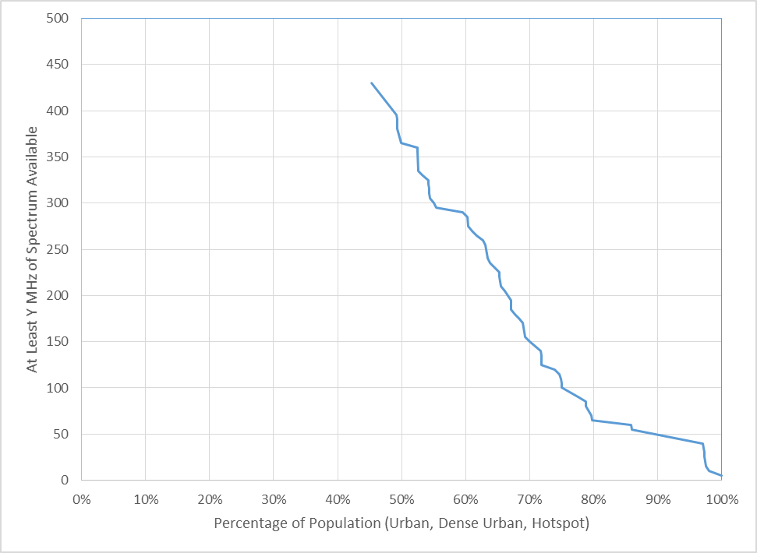

Figure 9: Availability of Spectrum in MHz by Percentage of “Urban+” Population under Baseline Assumptions

* 1. Italian LSA Pilot - Protection of the Fixed Service

In a pilot implementation of the LSA concept in Italy in the 2.3-2.4 GHz band [25] the FS has been taken into account as a national incumbent, hence the 2.3-2.4 GHz band is mostly used for the Fixed Service, as numerous incumbent users operate their links under an individual licensing regime. PMSE authorisations have also been granted, while the governmental use affects only a very small portion of the band, but the protection of these incumbents has been granted according to different approaches.

In the following sections the approach to protect the FS incumbent in the 2.3-2.4 GHz bands is introduced. This approach might be considered suitable also to facilitate coexistence between FS links and MFCN in the 3.6-3.8 GHz band.

* + 1. Setting up of the sharing framework

The sharing framework is the main element for the implementation of LSA, as it defines, for a given frequency band, the spectrum that can be available for LSA with the corresponding technical and operational conditions.

As highlighted in the ECC Report 205 [3], administrations play a fundamental role in the definition of the sharing framework and have to consider a number of key issues in granting LSA rights of use and defining the associated sharing rules (see Section 4.4).

* + 1. Access to information on FS receivers

In Italy the information on how the incumbents actually use the spectrum at their disposal is considered as sensitive and confidential and is not available in the public domain.

Therefore the Administration decided to identify a trusted third party acting on its behalf to perform the calculations to derive the restrictions to apply for the pilot purposes to the MFCN deployments. Restrictions are then communicated to the MFCN operator.

* + 1. Approaches to protect the incumbent

The specific approaches to protect the different incumbent users are defined, based on specific needs or national circumstances (e.g. confidentiality issues). For the protection of the Fixed Service an approach based on restriction and exclusion zones is applied. This approach is more suitable to cope with the confidentiality requirements posed by the Italian Administration on the locations of the fixed links.

* + 1. Protection criterion and requirements for the protection of the FS

The Administration guarantees the protection to the incumbent users specifying the maximum permitted interference level at the input of the victim FS receivers in relation to the thermal noise floor (I/N criterion).

The protection requirements may be also expressed in terms of the maximum permitted interference levels at the input of the victim receiver antenna, as shown in the table below.

Table 1: Protection requirements for FS

|  |  |  |
| --- | --- | --- |
| Parameter | Value | Note |
| Boltzmann’s constant, k [Joule/°K] | 1.38*10-23 |  |
| Absolute receiver temperature, T [K°] | 290 |  |
| Frequency, f [MHz] | 2340 |  |
| Receiver bandwidth, B [MHz] | 2 |  |
| Receiver noise, NF [dB] | 3.5 |  |
| Noise power, N [dBm] | -107.47 | N = -174+10*log10(B[Hz])+NF* |
| Receiver antenna gain, G [dBi] | 32 |  |
| I/N [dB] | -10 (1) | Derived from ITU-R F.758-5 |
| Maximum permitted interference power [dBm] | -117.47 | IFS,T |
| Maximum permitted electric field strength [dBμV/m] | -4.87 | E FS,T = 77.21 + IFS,T + 20*log10(f[MHz]) - G |
| Measurement bandwidth [MHz] | 2 |  |
| Measurement height [m] | At victim Rx height |  |

* + 1. Communication of the protection requirements for the FS

The protection of the incumbent fixed links is achieved through the application of the restriction/exclusion zone concept as depicted in Figure 10.

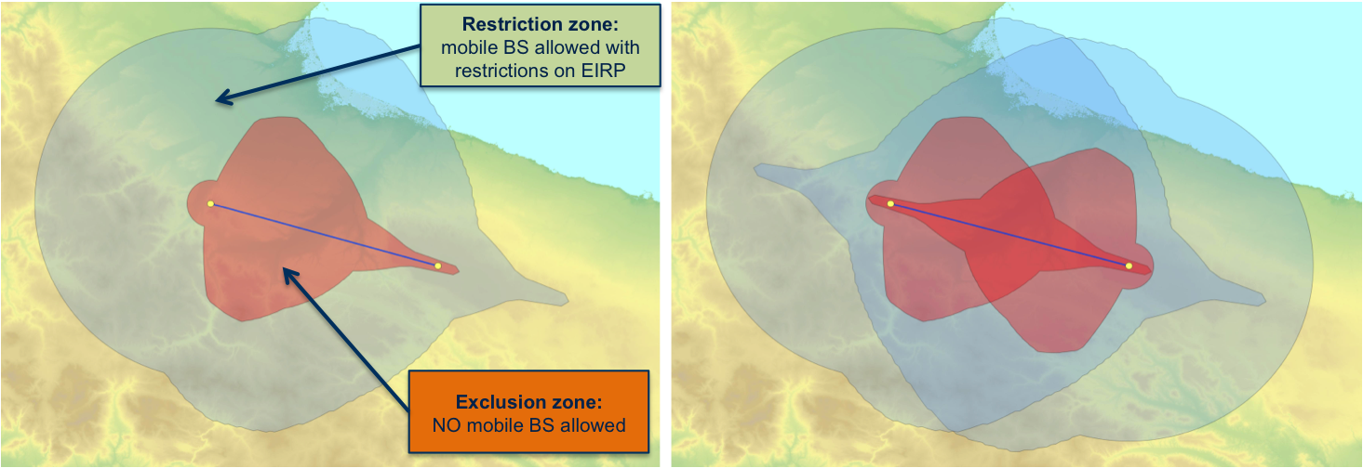

Figure 10: Restriction/Exclusion zone concepts

The definition of the restriction and exclusion zones is based on the coexistence analysis between the incumbent fixed links and the mobile service operated under the LSA approach.

In the scenario of the pilot, the interferer is the mobile base station, while the victim is the FS receiver (P-P).

The interference level, I (dBm), is calculated by assessing the amount of interference generated by the mobile service, which falls within the victim receiver operational bandwidth:

$\left(I-N\right)\left(∆f,d,Θ_{1},Θ_{2}\right)=P_{t}+Att\left(∆f\right)+G_{t}\left(Θ_{1}\right)+G_{r}\left(Θ_{2}\right)-PL\left(d\right)-N$ (1)

where

* ∆f is the frequency separation between the carriers of the incumbent and the LSA users;
* Pt (dBm) is the power transmitted by the interferer;
* Att(∆f) is the Net Filter Discrimination (NFD) computed according to Figure 11, where ∆f is the difference (in MHz) between the carriers of the interferer and the victim systems;



Figure 11: Net Filter Discrimination

* Gt(Θ1) is the gain (dBi) of the interfering antenna along the azimuth angle Θ1, that is the direction under which the FS victim receiver is seen by the BS antenna (see Figure 12);
* Gr(Θ2) is the gain (dBi) of the victim receiver along the azimuth angle Θ2, that is the direction under which the BS interferer is seen by the FS receiver antenna (see Figure 12);
* PL(d) is the path loss (dB) due to the propagation along distance d. PL is calculated over a geographical area modelled with pixels of 100 m x 100 m, taking the effect of the terrain into account;
* N is the noise level (dBm) of the victim receiver.



Figure 12: Geometrical layout for coexistence assessment

By imposing a maximum admitted value of (I-N), the above formula allows computing the maximum allowed e.i.r.p. that the mobile system can transmit in a given location (i.e. a pixel) in the considered area. As the outcome of the computation, there might be identified areas (i.e. pixels) where no mobile BS transmission is admitted, that are exclusion zones.

The assessment of the restriction/exclusion zones has been investigated considering all the FS links affecting the area of interest for the pilot. In other words, the maximum allowed e.i.r.p. that a mobile system can transmit in a given pixel is computed so that the protection of any possible incumbent fixed link deployed over the landscape is guaranteed; computations are referred to square pixels 100 m x 100 m in size.

The mobile base stations parameters considered in the computation of exclusion and restriction zones are shown in Table 2, whereas for the FS victim receivers the actual parameters (e.g. channel bandwidth, gain, antenna height, etc.) have been taken into account.

Table 2: LTE base station parameters

|  |  |
| --- | --- |
| Parameter | Description |
| Scenario | Macro |
| Bandwidth | 20 MHz |
| Height | 33 m |
| Pattern | Omnidirectional |

For the Path Loss computation the effect of the terrain is taken into account, applying the diffraction model in Recommendation ITU-R P.526 [26]:

$PL={PL}_{FreeSpace}+{PL}_{526}$ (2)

The cumulative effect of multiple base stations in terms of potential interference at the victim receivers is disregarded so far.

Figure 13 shows an example of restriction zones computed according to the described method; different colours correspond to different values of maximum allowed e.i.r.p. for the mobile system. The computed restrictions are communicated to the LSA Repository for storage.

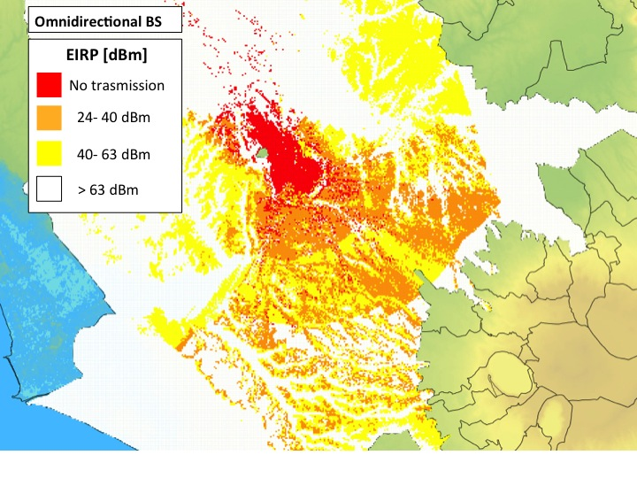

Figure 13: Example of e.i.r.p. constraints on the mobile service developed under   
the restriction/exclusion zone concept. e.i.r.p. restrictions become more stringent   
as colours from yellow turn to red

* + 1. Increasing sharing opportunities under the restriction/exclusion zone concept

In a general case, to save computation effort and reduce the burden for the Administration, the restrictions on the maximum permitted e.i.r.p. allowed to be transmitted in each given pixel might be computed referring to omnidirectional antennas at the mobile BS and considering macro-cellular layout. However, these conservative assumptions might be refined in calculations to increase sharing opportunities. The computation on the maximum permitted e.i.r.p. admitted in each pixel, for instance, might be refined and specifically performed for any particular base station sector. This would lead to more flexibility in the deployment of the mobile system, as well as to a likely relaxation of the restrictions for sectors with a limited impact on the victim receivers, due to the antenna discrimination. This might increase sharing opportunities.

Figure 14 shows an example of the restriction/exclusion zones computed over the same area, considering two different antenna orientations for the interfering BS sector. The figure on the left shows the maximum e.i.r.p. permitted in each pixel for a BS sector with an antenna orientation of 300 degrees, while the figure on the right refers to a BS sector with an orientation of 120 degrees. In the first case, the e.i.r.p. restrictions are more stringent than in the second one. This is due to the different antenna discrimination between the mobile BS and the victim receiver, which is more affected by the sector with a 300 degree orientation. It is evident that BS sectors with a larger angular separation with respect to the FS victim receiver are subject to less stringent EIRP restrictions as their contribution to the overall interference is less significant.

Restrictions computed for different orientation of the BS/BS sector antenna are stored in the LSA Repository. In case a BS/BS sector is deployed with sector orientations different from those assumed in the calculations, proper e.i.r.p. restrictions may be derived, for instance, by interpolation.

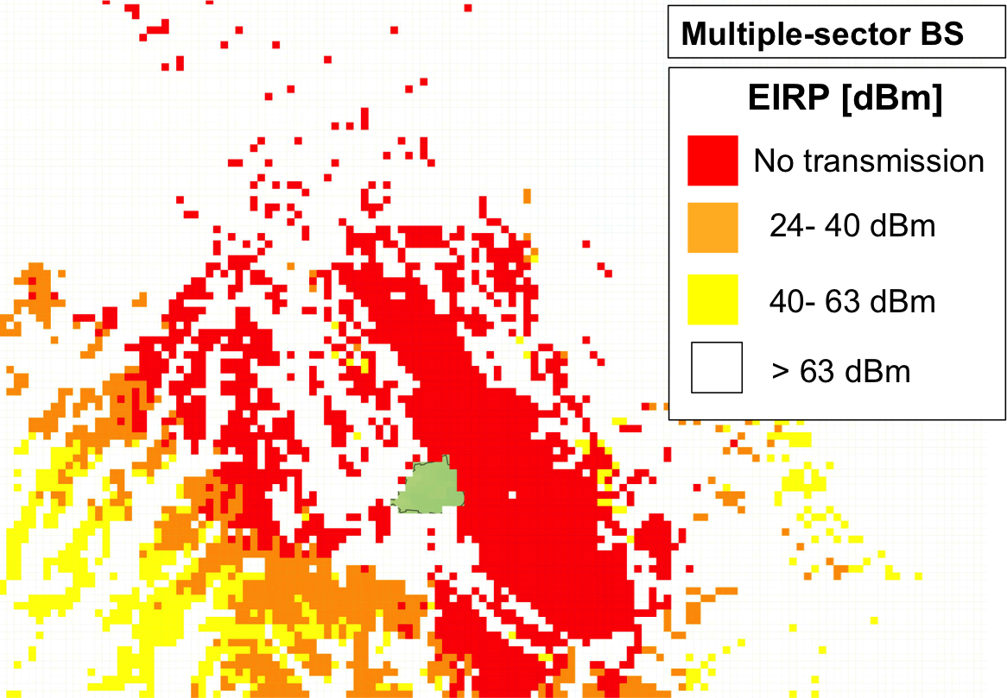 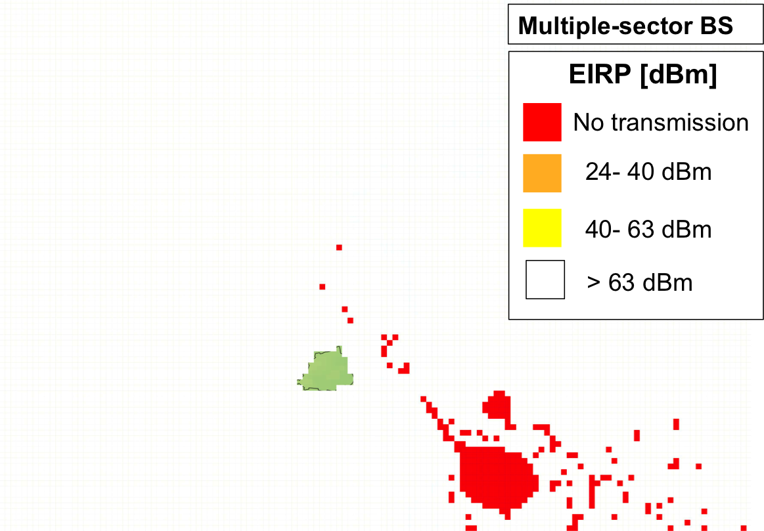

Figure 14: e.i.r.p. restrictions on the deployment of the mobile service, developed under   
the restriction / exclusion zone concept considering two different antenna orientation   
of 300 and 120 degrees (wrt North)

To increase sharing opportunities, similar considerations can be applied to different assumptions on the layout of the mobile network (e.g. macro-, micro-, femto-cells), which means that parameters considered in Table 2 for calculations might change (e.g. in terms of maximum admitted antenna height, outdoor vs indoor, etc.).

In general, sharing opportunities may be improved by increasing computational efforts as well therefore the Administration has to identify a proper trade-off.

* 1. Italian COEXISTENCE FIELD TRIALS in the 3600-3800 MHz band

The Italian Administration has opened the 3600-3800 MHz band to MFCN, while maintaining the current incumbent uses for FSS and FS[7].

In order to derive elements to determine the optimal sharing model for the band in the use cases of interest (e.g. inside/outside cities), the Italian Ministry of Economic Development (MiSE) has undertaken a series of field trials. These trials are considered as extremely valuable to complement the theoretical studies and simulations on coexistence between incumbents and new MFCN uses with reference to sharing in the spectral and spatial domain.

This would allow determining the parameters and constraints that should apply in the event of the 3600-3800 MHz band being shared between new MFCN and the incumbent FS and FSS systems. The proper and accurate definition of the sharing rules and, more in general, the full setup of the sharing framework is essential to define the auction rules for the future assignment of individual usage rights to MFCN operators in the 3600-3800 MHz band.

The activity has involved various stakeholders including MFCN suppliers as well as FSS and FS incumbent operators.

The Italian Administration is planning to publish the outcomes from this activity once available.

1. Percentage of time in the propagation model

Long-range propagation is often subject to atmospheric phenomena which can occasionally enhance radio propagation and hence interference. This is commonly accounted for in propagation models, whereby the propagation gain is greater at lower percentage times. For example, the propagation gain might be -180 dB at 50% time, but -170 dB at 1% time[8]. Propagation models that might be considered in this scenario require as an input the percentage of time for which the minimum transmission loss is not exceeded.

For this reason, and irrespective of the criterion used for specifying the maximum permitted interference IT, the Administration may wish to associate the value of IT with a time percentage.

It should be noted that this approach can result in complexities when interference from multiple sources is aggregated. This is because the percentage time requirement is accounted for via the propagation gain of individual links. The way in which the percentage time of individual links translates to the percentage time of the composite interference is not trivial and depends on the number of signals aggregated, their relative strengths, and their statistical distributions.

In coordination between point-to-point radio relay systems and FSS earth stations, the traditional approach taken is to assume that in the case of "long-term interference", the interference from each source occurs simultaneously, and the aggregate interference is simply the power summation of interference from each source. In the case of "short-term interference", it is assumed that interference from each source occurs at different times, and hence the percentage of time associated with the aggregate criterion must be divided by the assumed number of interferers. This is the approach taken to derive the interference criteria for FSS earth stations in Recommendation ITU-R SF.1006 [27] and a similar approach could be considered for interference from MFCN base stations (BSs).

Recent studies considering coexistence between MFCN and FSS, such as ITU-R Report M.2109 [14] and ITU-R S.2368 [16], separately evaluate interference between the services based on long-term and short-term interference conditions. Consequently, two separate interference criteria are derived for this purpose, whereby interference is negligible when compliance to both of these values is achieved, as specified in   
ITU-R SF.1006. The specific permitted interference values used in the above mentioned studies are indicated below.

Long-term interference criterion is based on Recommendation ITU-R S.1432 [28] and depending on the type of scenario studied, the following values are used:

* In-band sharing studies: I/N = ‑12.2 dB corresponding to the aggregate interference from all other   
  co-primary allocations, not exceeded for a time percentage of 100% of the worst month or I/N= -10 dB corresponding to the aggregate interference from co-primary allocation, not exceeded for a time percentage of 20% of any month;
* Adjacent band sharing studies: I/N=-20 dB corresponding to the aggregate interference from all other sources of interference, not exceeded for 100% of the time.

Short-term interference criterion is based on ITU-R SF.1006 and the following value is used:

* I/N=-1.3 dB that may be exceeded up to 0.001667% of the time from a single interference source.

In the interference allowances above, "N" is the clear-sky satellite system noise power as described in recommendation ITU-R S.1432 and "I" is the total maximum permitted interference power emitted into a FSS system. The apportionment of the interference criterion in the presence of multiple interference sources (e.g. FSS may experience interference from both FS and FSS links) is addressed in the same Recommendation and studies ITU-R Report M.2109 [14] and ITU-R S.2368 [16] can also be used for guidance.

Administrations may adopt these criteria or choose other criteria for sharing between MFCNs and the FS/FSS receivers, according to their national circumstances.

1. Limits on received interference power and electric field strength
   1. maximum permitted interference power

As introduced in Section 6.2.1, under Approach A, an Administration specifies and communicates to the MFCN operators the maximum permitted interference power at the input of FSS and FS receivers.

These limits are specified as IFSS,T and IFS,T, in units of dBm/(BFSS MHz) and dBm/(BFS MHz) respectively, and are effectively the maximum tolerable co-channel interference levels at the input to the receivers. It is then the responsibility of the MFCN operators to ensure compliance with the above limits.

This means that the actual total interference levels IFSS and IFS at the input of FSS and FS receivers must not exceed the target interference limits IFSS,T and IFS,T. In other words,

(3)



Figure 15 illustrates this for the case of FSS, and an FSS channel bandwidth of BFSS = 4 MHz.

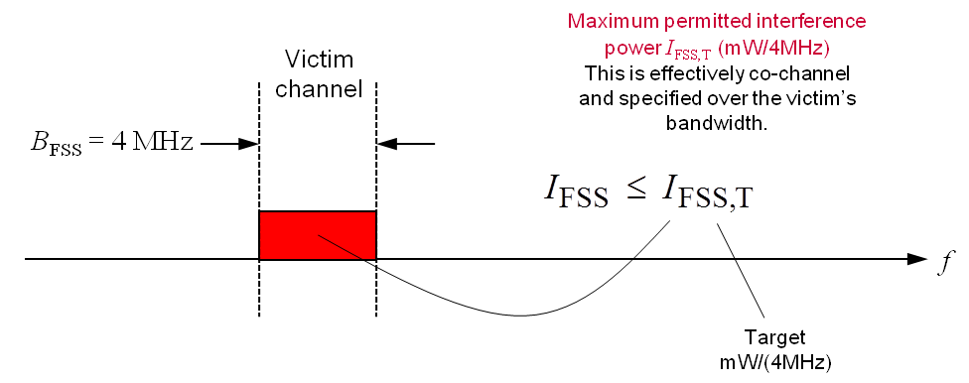

Figure 15: Maximum permitted interference power IFSS,T at the input to the receiver as specified by the Administration for the example of FSS

The specified limits IFSS,T and IFS,T can then be used by MFCN operators for the deployment of their networks and avoiding harmful interference to the incumbent users. These limits would typically be the basis for the calculation of the maximum permitted e.i.r.p. using coupling gain (explained in section A5.1.1) in units of dBm/(BMFCN MHz) to be radiated from any given MFCN base station (BS) sector. In order to calculate the coupling gain, information on the FS/FSS station antenna is required. ANNEX 5: presents examples of the types of calculations involved.

In addition to specification of the IFSS,T and IFS,T regulatory limits, the Administration may wish to specify additional parameters which can be used by MFCN operators for the purposes of their calculations. For example, the Administration may prescribe the propagation model which should be used in these calculations, as well as values of adjacent channel interference ratio (ACIR) for a number of interferer-victim frequency separations. The latter is of importance and is described next.

* + 1. Examples of specified ACIR

Note that the ACIR translates the received co-channel “interference” IFSS or IFS (over BFSS or BFS MHz) to the received “interferer” power PRx (over BMFCN MHz). This is illustrated in Figure 16 below.

As an example, assume that the interferer and victim bandwidths are BMFCN = 10 MHz and BFSS = 4 MHz, respectively. This means that ACIR(0) ~ 10/4 = 2.5 (4 dB)[9]. In other words, only a fraction (4/10) of the received co-channel “interferer” power is experienced as “interference”. Where BMFCN = BFSS, then ACIR(0) = 1 (0 dB), since the whole of the received "interferer" power is experienced as "interference".

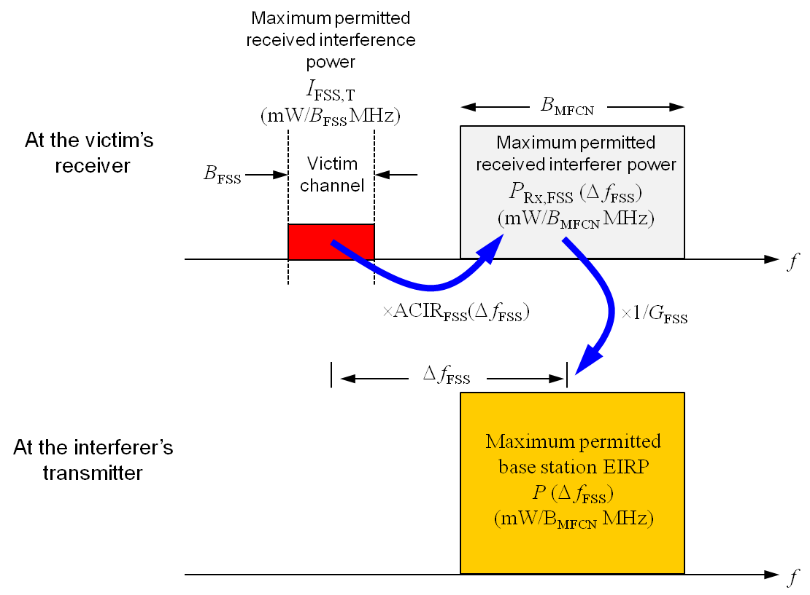

Figure 16: From maximum permitted received interference power (protection requirement),   
to maximum permitted received interferer power, to maximum permitted e.i.r.p..   
The same applies for a co-channel scenario (full or partial overlap with the victim),   
where the maximum permitted interferer levels will be more stringent

ACIR values capture the combined influence of the interfering transmitter’s spectral emission mask (spectral leakage), as well as the selectivity of the victim receiver (both blocking and overload) and are, in practice, derived via laboratory measurements. In cases where it is not possible to establish the ACIR values for all the incumbents' networks, one option is to apply the same maximum permitted interference power over the entire 3600-3800 MHz frequency band. This would also allow for changes in the frequencies used by the incumbent receiver.

The ACIR values might be specified by the Administration as shown in Table 3. In this example, the Administration has decided that the impact of the interferer remains unchanged after the 3rd adjacency (n > 3). If the Administration did not wish to impose any restrictions on MFCNs after the 1st adjacency, then it would set ACIR(n) = ∞ dB (or a very large number) for n > 1.

Table 3: Example ACIR values (purely illustrative) for a 4 MHz victim and a 10 MHz   
interferer as might be measured in a laboratory

|  |  |  |
| --- | --- | --- |
| Adjacency n | Frequency separation Δf (MHz) | ACIR(Δf) (dB) |
| 0 | 0 | 4 |
| 1 | 7 | 30 |
| 2 | 17 | 40 |
| ≥ 3 | ≥ 27 | 50 |

As explained above, the ACIR values are a function of the interferer’s bandwidth BMFCN. For this reason, the National Administration may wish to specify ACIR values for a number of BMFCN values (e.g., 10, 20, 40 MHz or more). The National Administration may specify that for intermediate frequency separations that are not specified in the tables, the ACIR values may be derived via appropriate interpolation (step-wise, linear, etc.) of the values in the tables.

* 1. maxiMum permitted electric field strength

As described above, under Approach A the Administration may specify the maximum permitted interference powers IFSS,T and IFS,T in units of dBm/(BFSS MHz) and dBm/(BFS MHz) at the input of FSS and FS receivers respectively. In this case, a MFCN operator will need to convert these via ACIR(Δf) to the maximum permitted interferer power PRx(Δf) at the input of a victim receiver, and then finally convert this via coupling gain G, to the maximum permitted e.i.r.p. P(Δf) of individual MFCN BS sectors.

Alternatively, under Approach A the Administration may specify the protection requirements in the form of maximum permitted electric field strengths[10] EFSS,T(Δf) and EFS,T(Δf) in units of dBμv/m/(BMFCN MHz) at the locations of FSS and FS receiver antennas respectively, or at any location within a defined area for one or more interferer-victim frequency separations Δf.

Electric field strengths are typically used in circumstances where the characteristics of the receiver antenna (gain, directionality, and pointing angle) are not known for each individual victim receiver or where these cannot be disclosed. As such, instead of specifying an interference power limit at the input to a receiver, the Administration specifies an Electric Field Strength limit at the input of the receiver antenna, thereby avoiding the need for considering the receiver’s antenna characteristics when compliance with the limit is being assessed. See below.

Electric field strengths are also used in circumstances where the geographic location of the victim receivers cannot be disclosed. For this reason, Electric field strengths are often applied over a protection zone, which represents the geographic area over which the victim receivers might be located.

Figure 17 shows the relationship between received interference IT, received interferer power PRx(Δf), received electric field strength E(Δf), and BS sector e.i.r.p. P(Δf).

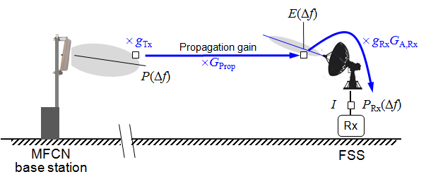

Figure 17: Interference power limit IT, and electric field strength limit E

* P(Δf) is the MFCN BS sector e.i.r.p.;
* gTx is the MFCN BS sector’s antenna angular discrimination;
* GProp is the radio propagation (including building penetration loss if appropriate) gain;
* E(Δf) is the received electric field strength;
* GA,Rx is the FS/FSS receiver antenna’s maximum gain (incl. cable loss);
* gRx is the FS/FSS receiver’s antenna angular discrimination, relative to the antenna maximum gain;
* I is the received interference;
* PRx(Δf) is the received interferer power.

Conversion from the maximum permitted interference power IT to the maximum permitted received electric field strength ET(Δf) can be performed using the standard formula[11] below (in the linear domain),

 (4)

where 10log10(a) = 77.25 dB, f is the centre frequency of the victim channel in Hz, and gRx and GA,Rx are the victim receiver’s antenna angular discrimination and antenna gain (including cable loss), respectively[12].

Note that to derive appropriate values for the maximum permitted electric field strengths from the maximum permitted interference power levels, an Administration will need to assume a value for the receiver antenna angular discrimination and gain. Absent such information, an Administration will need to assume nominal values for these parameters.

The assumed antenna gain of an FS station would be the peak antenna gain, as is necessary if the pointing direction of the FS antenna is not known. The assumed antenna gain of the FSS earth station would be the maximum horizon antenna gain, which for an earth station with a minimum elevation angle of 5° is typically 14.5 dBi (see Rec ITU-R S.465 [29]).

In addition to the specified electric field strengths, an Administration may wish to specify additional parameters, which will be used by MFCN operators for the purposes of their calculations. For example, the Administration may prescribe the propagation model, which should be used in these calculations.

Finally, considering the need to provide appropriate protection from the MFCN interferers transmitting at different frequencies, the Administration may specify the values of EFSS,T(Δf) and EFS,T(Δf) for a number of frequency separations Δf.

* + 1. Example of specified electric field strength limits

The electric field strength limits for a number of interferer-victim frequency separations may be communicated by the Administration as shown in Table 4. In this example, the National Administration has decided that the impact of the interferer remains unchanged after the 3rd adjacency (n > 3). Alternatively, a National Administration may wish to specify electric field strength limits for only two adjacencies, one for n = 0 (co-channel) and one for n ≥ 1.

The electric field strength limits will be a function of the interferer’s bandwidth BMFCN. For this reason, the National Administration may wish to specify such limits for a number of typical BMFCN values (e.g., 10, 20, 40 MHz or more).

The National Administration may specify that for frequency separations that are not specified in the tables, the electric field strength limits may be derived via some form of interpolation (step-wise, linear, etc.) of the limits in the tables.

Table 4: Example electric field strength limits (purely illustrative)

for a 4 MHz victim and a 10 MHz interferer

|  |  |  |
| --- | --- | --- |
| Adjacency n | Frequency separation  Δf (MHz) | Electric Field strength EFSS(Δf)  (dBμv/m/10 MHz) |
| 0 | 0 | 150 |
| 1 | 7 | 180 |
| 2 | 17 | 190 |
| ≥ 3 | ≥ 27 | 200 |

Figure 18 shows an example of what the electric field strength limits might look like based on a step-wise interpolation as a function of frequency offset, and a 10 MHz MFCN channel raster.

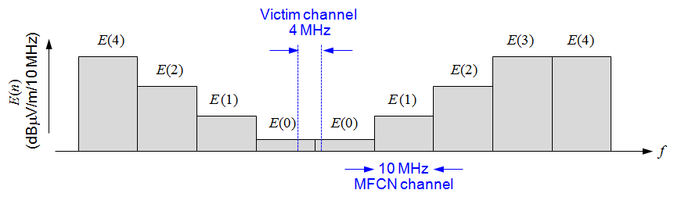

Figure 18: An illustration of electric field strength limits for a 4 MHz victim channel,   
and a 10 MHz MFCN channel raster

1. Calculation to define exclusion zones

This annex provides insights into the type of calculations administrations may need to perform under Approach B in order to define exclusion zones applied to the deployment of MFCNs and the protection of FS/FSS receivers. See Section 6.2.2 for a description of Approach B.

An exclusion zone describes a geographic area within which the deployment of MFCN base stations is not permitted, as this would result in a risk of harmful interference to certain FS/FSS receivers.

* 1. Circular exclusion zones

Figure 19 shows an illustrative example of a circular exclusion zone surrounding a FS/FSS receiver. The exclusion zone identifies the geographic area where the deployment of MFCN BSs with active transmitter in the shared band is not permitted.

A circular exclusion zone does not account for the angular pattern and orientation of the FS/FSS receiver antennas. This is because such information may not be available for some FSS receivers, and therefore a cautious approach is adopted, whereby it is assumed that the main lobes of the MFCN transmitter and FS/FSS receiver antennas always point towards each other[13]. Under this assumption, FS/FSS receivers are simply modelled as having omni-directional antenna patterns, but with the maximum gain of the station’s antenna. The MFCN transmitters are also effectively modelled as having omni-directional antenna patterns.

This situation would represent the worst case scenario in terms of antenna coupling.

Furthermore, a circular exclusion zone does not account for the details of the local terrain and clutter, both of which would impact radio propagation in different ways along different radials from the FS/FSS receivers.

A circular exclusion zone may then be derived by calculating the appropriate protection distance assuming a specific BS e.i.r.p., a nominal BS antenna height, an omni-directional BS antenna pattern, a specific frequency separation (which can be zero in case of co-channel operation) from the channel used by the FS/FSS receiver, an omni-directional FS/FSS receiver antenna pattern (i.e., with the maximum antenna gain applied in all directions), and a radio propagation model which does not include the effects of local terrain and clutter.

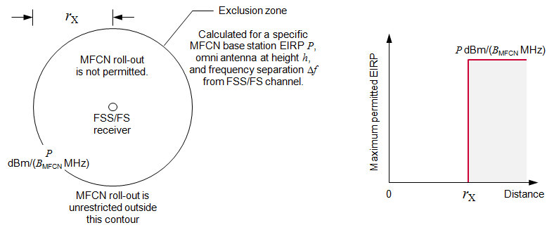

Figure 19: Example of a circular exclusion zone surrounding a FS/FSS receiver   
calculated for a BS e.i.r.p. of P[14].

The protection or exclusion distance rX may be calculated as described below.

Let the maximum permitted (target) interference at the FSS or FS receiver be specified as IT in units of dBm/(B MHz), where B is the FS/FSS receiver channel bandwidth. If I is the actual interference, in order to avoid harmful interference, the following condition needs to be met (in the logarithmic domain):

 (5)

or re-arranging

 (6)

where

* P is the MFCN BS e.i.r.p. in units of dBm/(BMFCN MHz);
* GProp is the propagation gain;
* GA,Rx is the FS/FSS receiver antenna gain;
* ACIR is the adjacent channel interference ratio;

and

* Δf is the frequency separation between the MFCN transmitter and FS/FSS receiver.

According to the assumed propagation model, Equation 6 defines the appropriate exclusion distance. Using free-space path loss, for example:

 (7)

or

(8)



The above expression shows that in order to protect the FS/FSS receiver the distance between the MFCN BS sector and the relevant receiver must be greater than the exclusion distance rX.

The derivation of a circular exclusion zone may also include a margin to account for aggregation of interference from multiple BSs.

* 1. Non-circular exclusion zones

Alternatively, non-circular exclusion zones may be defined by using propagation models which account for the local terrain and clutter, and also by accounting for the specific pointing direction of the FS/FSS receiver antenna[15]. This is illustrated in Figure 20. It has to be noted that the boundary of the exclusion zone is no longer smooth, and the exclusion zone may not even be contiguous due to the specific structure of the local terrain.

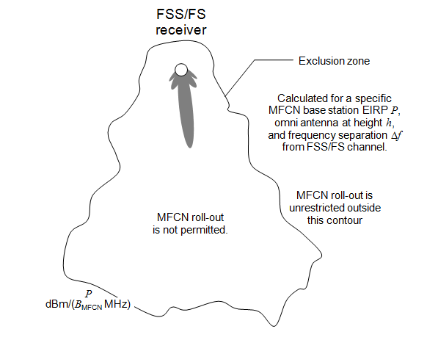

Figure 20: Example of an exclusion zone contour surrounding a FS/FSS receiver,   
accounting for the FS/FSS receiver antenna pattern and orientation   
as well as the impact of terrain and/or clutter on radio propagation

To derive such exclusion zones, a hypothetical BS with a given e.i.r.p., an omni-directional antenna installed at a given height, and a specific frequency separation (which can be zero in case of co-channel operation) from the FS/FSS channels is repeatedly placed on a grid of geographic locations. Those locations where the BS causes harmful interference to the FS/FSS receiver are considered to be inside the exclusion zone. Otherwise, they are considered to be outside the exclusion zone. The exclusion zone can be displayed as a map for illustrative purposes.

As for the case of a circular exclusion zone, a margin to account for interference from multiple base stations may be included in the derivation of a non-circular exclusion zone.

It is worth noting that the assumed frequency separation between the MFCN BS transmitter and FS/FSS receiver plays a major role in the size of the exclusion zone. Co-channel exclusion zones are significantly larger than the adjacent channel exclusion zones. For this reason, administrations may choose to specify exclusion zones for a number of frequency separations.

In summary, the size and shape of an exclusion zone depends on the assumed:

* maximum permitted interference at the FS/FSS receiver;
* maximum e.i.r.p. of the MFCN BS transmitter;
* frequency separation between the MFCN BS transmitter and FS/FSS receiver;
* clutter environment at the MFCN transmitter and FS/FSS receiver;
* terrain profile between MFCN transmitter and FS/FSS receiver;
* antenna height of the MFCN transmitter;
* antenna gain of FS/FSS receiver;
* antenna pattern and horizontal/vertical antenna orientation of FS/FSS receiver.

Composite exclusion zone

Where multiple FSS and FS receivers exist in a geographic area, the composite exclusion zone is the combination (super set) of the exclusion zones (either circular or non-circular) required for the protection of the FSS and FS receivers. This is illustrated in Figure 21.

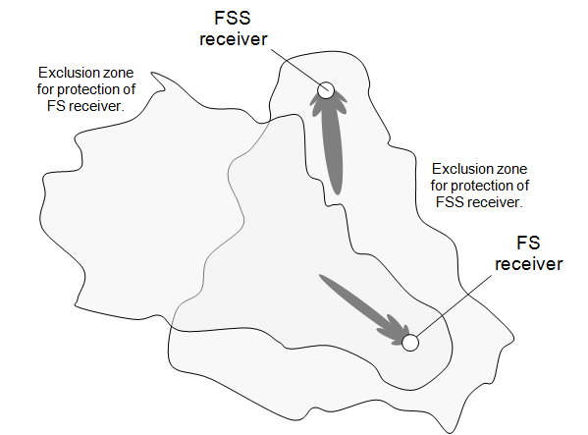

Figure 21: Example of exclusion zone for the protection of a FSS receiver and a FS receiver.   
The composite exclusion zone is the superset of the individual non-circular exclusion zones

1. Calculation of e.i.r.p. restrictions applied within restriction zones

This annex provides insights into the type of calculations administrations may need to perform under Approach B in order to calculate e.i.r.p. restrictions for MFCN base stations (BSs) applied within restriction zones and the protection of FS/FSS receivers. See Section 6.2.2 for a description of Approach B.

MFCN operators may wish to perform similar types of calculations themselves when complying with maximum permitted interference power or electric field strength at the FS/FSS receivers, which are specified by administrations under Approach A.

For any particular BS or BS sector, the maximum permitted e.i.r.p. might be constrained by a FSS receiver or a FS receiver. The maximum permitted e.i.r.p. will depend on the assumed:

* maximum permitted interference (power or electric field strength) at the FS/FSS receiver;
* geographic separation between the MFCN transmitter and FS/FSS receiver;
* frequency separation between the MFCN transmitter and FS/FSS receiver;
* clutter environment at the MFCN transmitter and FS/FSS receiver;
* site shielding of the FS/FSS receiver;
* terrain profile between the MFCN transmitter and FS/FSS receiver;
* antenna height of the MFCN transmitter and FS/FSS receiver;
* antenna gain of the FS/FSS receiver;

and

* antenna patterns and horizontal/vertical antenna orientations of the MFCN transmitter and FS/FSS receiver.

For the above, an Administration may use parameter values associated with actual MFCN transmitters and FS/FSS receivers. Where such information is not readily accessible, an Administration may choose to use appropriate nominal values.

Furthermore, three possible approaches can be identified to account for interference from multiple MFCN BS sectors (i.e., for the aggregation effect):

* **Approach 1:** Single-sector calculations with inclusion of a specific generic margin to account for the actual existence of multiple sectors.

The maximum permitted e.i.r.p.s of BS sectors are calculated by explicitly accounting for only a single BS sector at a time; i.e., by assuming no other sectors exist. However, the calculations must include a margin to account for the fact that in practice there will be multiple sectors present. The margin will need to be “future-proof” in the sense that it should be sufficient to account for the possibility of increasing BS deployment densities over time.

* **Approach 2:** Single-operator (multi-sector) calculations with inclusion of a margin to account for the actual existence of multiple sectors from other operators.

The maximum permitted e.i.r.p.s of BS sectors are calculated by explicitly accounting for all planned BS sectors of a single MFCN operator at a time. The calculations must include a margin to account for the fact that in practice there may be multiple networks present. The margin will be expected to be smaller than that used in Approach 1. In the general case, MFCN operators may be allocated different individual interference budgets (for details, see Section A5.2.2). For example, in the presence of 3 MFCN operators, each being allocated an equal interference budget, the margin would be 4.7 dB (a factor of 3).

* **Approach 3**: Multi-operator (multi-sector) calculations with no specific margin.

Through this approach the maximum permitted e.i.r.p.s of BS sectors are calculated by explicitly and jointly accounting for all BS sectors of all operators. No additional margin would be required here.

In this approach a possible risk of unfairly constraining one MFCN operator compared to the others should be taken into account, since the total interference allowance could be used up by one operator, effectively preventing another operator from deploying base stations in the vicinity of the FS/FSS station. The scenario would clearly need to be appropriately managed by the entity, which performs the calculations. This is further discussed in Section A5.2.2

The three approaches above represent different trade-offs between simplicity of implementation and efficient spectrum sharing.

* 1. interference from a single MFCN base station sector

The example in Figure 22 illustrates a tri-sector MFCN BS deployed in the proximity of a FSS earth station receiver and a FS link. Multiple FSS and FS receivers may exist in the same geographic area, however, the receivers depicted in the figure are those that are most susceptible and determine the restrictions on the operation of the MFCN BS transmitter.

The following text describes the calculations required to derive the maximum permitted e.i.r.p., P in units of dBm/(BMFCN MHz), of a single MFCN BS sector based on various MFCN and FS/FSS parameters and the maximum permitted interference levels at the FS/FSS receivers. Calculations would need to be repeated for each sector.

Approaches to account for the aggregation of interference from multiple sectors are further addressed in Section A5.2.

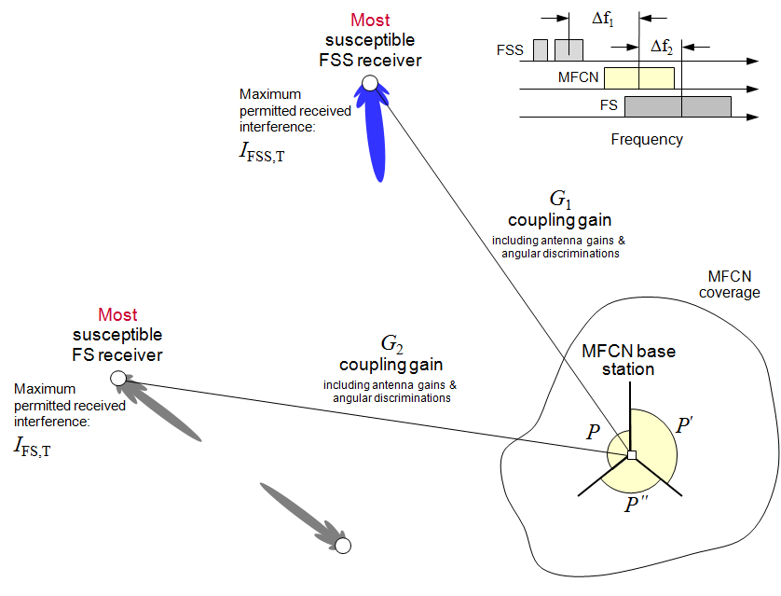

Figure 22: Example of a coexistence scenario for a specific MFCN BS sector

Let the maximum permitted (target) interference at the FSS and FS receivers be specified as IFSS,T and IFS,T, in units of dBm/(BFSS MHz) and dBm/(BFS MHz), respectively. Also let the actual interference at the FSS and FS receivers be denoted as IFSS and IFS. In order to avoid harmful interference, the following conditions need to be met:

(6)



Then, following the conventional approach for the calculation of interference this can be written as follows (in the linear domain):

(9)



where GFSS/GFS are the coupling gains from the BS sector to the FS/FSS receivers, ACIRFSS/ACIRFS are the relevant adjacent channel interference ratios, ΔfFSS/ΔfFS are the relevant carrier-to-carrier frequency separations, and M ≥ 1 is an ‘aggregation’ margin. Note that the above equations refer to individual links.

It should be noted that the value of ACIR is a function of the frequency separation ∆ƒ and the bandwidths of the wanted and unwanted signals.

The value of the ‘aggregation’ margin, M, will depend on the approach used to account for interference from multiple MFCN BS sectors[16]. This may mean that the aggregation margin M might be different for different sectors and MFCN operators.

For example, in the case of Approach 1, the maximum e.i.r.p. of each individual BS sector is defined by accounting for the presence of other base stations' sectors through an aggregation margin M. For example, in the case where the portion of interference contributed by all other base stations' sectors is assumed to be 0.9 of the total target interference IT, then the interference contributed from the sector under examination must not exceed 0.1 of the target IT. This means M=10 (10 dB).

The values of M in approaches 2 and 3 are discussed later in Section A5.2.1, in the context of explicit aggregation of interference from multiple sectors.

To derive the restricted BS sector e.i.r.p. P in units of dBm/(BMFCN MHz), equations 9 can be rearranged as:

(10)



where Pmax,FSS and Pmax,FS are the maximum permitted e.i.r.p. levels for the avoidance of harmful interference to the FSS and FS receivers, respectively. Then, the condition for the joint avoidance of harmful interference to both the FSS and FS receivers is given as

(11)



Harmful interference can therefore be avoided so long as the sector’s e.i.r.p. does not exceed the lower of the two limits required for the protection of FSS and FS receivers individually.

Note that the calculation of exclusion zones can be performed by interpreting equation 11 in a different way. In this case it is assumed that a BS has an actual e.i.r.p. PBS, an omni-directional antenna installed at a given height, and specific frequency separations from the FS/FSS channels. Then, if PBS is greater than the value P calculated in equation 11, then the BS cannot be deployed; i.e., it effectively falls within an exclusion zone and its deployment is prohibited. If required, the above analysis can be repeated over a grid of geographic locations, and the result displayed as a map of an exclusion zone for a given BS e.i.r.p. PBS.

In the above it was shown how the maximum permitted e.i.r.p. of a MFCN BS’s sector can be calculated as a function of the maximum permitted interference at the receiver station, the coupling gain from the different MFCN BS sectors to the FS/FSS station, and the adjacent channel interference ratios. These parameters are described in more detail in the following sections.

* + 1. Coupling gain

Coupling gain is the ratio of the MFCN BS signal power at the input to the FS/FSS receiver over the power radiated by the MFCN BS. In other words, if P is the e.i.r.p. of the BS, and G is the coupling gain, then the power arriving at the input to the FS/FSS receiver is GP (in the linear domain). This is illustrated below.

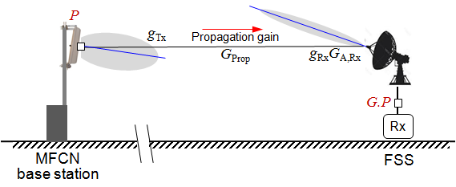

Figure 23: Illustration of coupling gain as the combined effect of propagation, antenna gain (including cable loss) and angular discrimination

Specifically, the coupling gain, G, can be expressed (in dB) as

(12)



where:

* gTx is the MFCN BS sector’s antenna angular discrimination;
* GProp is the radio propagation (including building penetration loss if appropriate) gain;
* GA,Rx is the FS/FSS receiver antenna’s maximum gain (including cable loss);
* gRx is the FS/FSS receiver’s antenna angular discrimination, relative to the antenna maximum gain;
* θ, ϕ are relevant horizontal and vertical angles of the interference link w.r.t. the antenna  
   boresights.

Note that the FS/FSS receiver antenna is characterised by the combination of two separate elements[17]. The first element is the antenna gain GA,Rx, which represents the maximum antenna gain of the receiver (including cable loss). The second element is the antenna angular discrimination gRx which identifies the angle-dependent gain of a directional antenna.

Propagation gain

The propagation gain can be modelled in a variety of ways. These could range from flat earth free-space path loss in one extreme, to empirical models such as extended Hata (e.g., as specified in SEAMCAT) complemented by clutter databases[18], and to more elaborated advanced models, which account for both clutter and terrain profiles, and might even utilise high-resolution 3D maps of buildings and structures. If required, these propagation models can also include an allowance for percentage time (see Section 6.1). Compatibility studies between MFCN and other services have used Recommendation ITU-R P.452 [29] as the propagation model and this could also be used to assess the interference for deployment of MFCN base stations.

In all cases, the propagation gain will be a function of the geographic locations and heights of the MFCN BS and the FS/FSS receiver, as well as the frequency of operation.

It stands to reason that more accurate and elaborate (computationally complex) modelling of the propagation gain would result in more efficient spectrum sharing between the MFCN and the FS/FSS. This is particularly the case in urban areas with dense building clutter and where some of the antennas may be located below the height of local clutter. However, it should be noted that there is always a discrepancy between interference modelling and practical interference. For example, parameters such as clutter or building penetration loss can have values that range from zero to tens of decibels of loss based on the deployment type and are therefore modelled to provide only a certain level of confidence to minimising interference. Therefore, in the presence of victim receivers, especially ones that require a high degree of availability, administrations may choose to use conservative values.

The propagation gain is one of the most important parameters to establish coexistence conditions. administrations may specify a propagation model for the calculation of the path losses. Alternatively, the entity performing the calculations/interested parties (MFCN, satellite operators) may use other propagation models subject to the approval of the administrations.

MFCN BS (sector) antenna angular discrimination

The Administration may use default values for this. Alternatively, this might be specified by the MFCN operator based on the deployed BS sector antenna pattern and horizontal/vertical antenna orientation.

FS/FSS receiver antenna gain and angular discrimination

These will be specified by the Administration based on information provided by the incumbents, accounting for the actual antenna pattern and horizontal/vertical antenna orientation of the FS/FSS receiver. In the absence of such information, the Administration may specify a default antenna pattern and maximum antenna gain as well as a nominal orientation. The angular discrimination depends on the pointing direction of the FS/FSS antenna (usually specified as azimuth and elevation angles) and the direction relative to the interference source.

Earth stations are sometimes required to change their pointing from one satellite to another and in some cases, earth stations may be authorised to operate with satellites located within a portion of the geostationary arc, for example, for any satellite above 5° in elevation. In such a case, it is necessary to consider the full range of pointing directions so that the minimum angular discrimination towards the interference source is determined. Appendix 3 to Annex 1 of Recommendation ITU-R SM.1448 [32] provides a methodology to determine the minimum angular separation in such cases. The provision of this flexibility is subject to the decision of the Administration.

Building penetration loss

This applies to cases where the MFCN BS is located indoors, and where its radiated signals are attenuated by the building’s structure. The building penetration loss can vary significantly (by tens of dBs) from building to building, depending on the architecture and the construction materials used (see, for example Recommendation ITU-R P.2040 [33]).

The Administration may specify a default value to be used for the building penetration loss taking into account the recommended ITU-R values. In addition, the Administration may allow the parties/entity in charge of performing the calculations to use different building penetration loss for specific indoor BSs on a case-by-case basis. This would need to be subject to some level of regulatory oversight.

As an example, when developing the ITU-R Report ITU-R S.2368 [16], applicable in the band 3600-3800 MHz, the ITU-R assumed average building loss values of 0, 10 and 20 dB (to account for various types of buildings).

* + 1. Adjacent channel interference ratio

The adjacent channel interference ratio relates the received in-block (carrier) power, PU, of an adjacent channel interferer to the interference power, I, experienced by a receiver. This is illustrated in Figure 24 below. Note that in the absence of any channelisation rasters (as in the current instance), adjacent channel simply refers to adjacent frequencies. In our example, PU is in units of dBm/(BMFCN MHz), while I is in units of dBm/(BFSS MHz) or dBm/(BFS MHz).

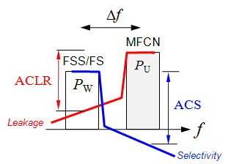

Figure 24: Adjacent channel interferer, ACLR and ACS

By definition, the interference power experienced by a receiver can be written as

(13)



where

* ACS is the adjacent channel selectivity of the receiver;
* POOB is the interferer’s out-of-block emissions at the receiver;

and

* Δf is the frequency separation between the wanted and unwanted signals.

Dividing through by PU gives

(14)



so that

(15)



where ACLR is the interferer adjacent-channel leakage ratio.

In scenarios where the interferer is co-channel with the wanted signal, and they are both of the same bandwidth, ACIR = 1. Where the bandwidths of the wanted and interferer signals are not equal, appropriate bandwidth corrections should be applied.

The ACLR is defined by the spectrum emission mask of the MFCN BS transmitter. This is usually subject to regulatory limits defined in the form of block edge masks (BEM).

Note that the ACS describes the susceptibility of a receiver to an adjacent channel interferer. The ACS can be measured in the laboratory by injecting spectrally clean adjacent channel interferers into a receiver, and measuring the rise in the interference-plus-noise floor.

In practice, the value of ACS reduces as the receiver begins to overload due to increased input signal powers and becomes more susceptible to adjacent channel interferers. Such non-linear behaviour can be captured by modelling the ACS as a function of both the frequency separation Δf, and the received wanted signal power PW. This means that the issue of LNA and LNB overload can be readily accounted for within the proposed framework (in cases where the corresponding ACIR level is used for the interference analysis) and there is no need for a separate analysis. This approach has been used in CEPT in recent years in the context of interference from MFCNs in the 800 MHz band to Digital Terrestrial TV (DTT).

* 1. Interference from multiple MFCN base stations/sectors

In the previous section the focus was on the calculation of the maximum permitted e.i.r.p. of an individual MFCN BS sector, subject to the avoidance of harmful interference to the FS/FSS. This section addresses the issue of interference from multiple base stations and sectors. Specifically, the issues of aggregation are discussed and also the partitioning/distribution of the interference budget among multiple base stations and sectors.

Note that explicit aggregation of interference from multiple base stations and sectors is not essential. As described earlier, it is possible for each BS sector to be examined independently, subject to the inclusion of a margin to account for the presence of other radiating base stations (see Approach 1 above)[19]. The margin would need to account for the existence of multiple base stations and multiple sectors with different geometrical configurations with respect to the FS/FSS receiver, and may also account for the possibility of future BS deployments.

* + 1. Aggregation

In approaches 1, 2 and 3 the interference I from base station sector(s) can be explicitly calculated, such that the criterion for the avoidance of harmful interference can be written as

(16)



where K is the number of sectors that are explicitly modelled, Ik is the interference from the kth sector, IT is the relevant maximum permitted interference at the FSS or FS receiver and M is the aggregation margin. The value of M will depend on the approach used to account for interference from multiple MFCN BS sectors.

In Approach 1, K = 1, and the aggregation of interference from multiple BSs and sectors is accounted for via a single margin M.

In Approach 2, K is the number of BS sectors belonging to a single MFCN operator. Where each operator might be, for example, allocated an equal share of the total target interference IT, M is equal to the number of the operators, and in the case of 2 operators M=2 (3 dB). The matter of non-equal partitioning of the interference budget (to achieve equal partitioning of utility) across multiple operators is discussed in Section A5.2.2.

In Approach 3, K is the number of BS sectors belonging to all MFCN operators, Here the maximum e.i.r.p. of each individual BS sector is set based on the explicit calculation of the interference from all other base stations’ sectors, M =1 (i.e. 0 dB).

Following the previous notation, Ik can be expressed as

(17)



where

* Gk is the coupling gain between the kth sector and FS/FSS receiver;
* Pk is the e.i.r.p of the kth sector;
* ACIR is the adjacent channel interference ratio;

and

* Δfk is the (carrier-to-carrier) frequency separation between the kth sector and the FS/FSS receiver.

The aggregation process is illustrated in Figure 25 below. Note that it is common practice in spectrum engineering to add the sources of interference in descending order of power, and terminate the aggregation once the last added source contributes less than ε dB (e.g., 0.1 dB, 0.5 dB) to the total level of interference and then add a further ε dB to account for all remaining lower power sources of interference. In the example of Figure 25 the aggregation is terminated after the 5th interferer (sector).

It should be noted that where interference time percentage is used and interference is assessed against short-term and long-term interference criteria, then this approach is only applicable for interference aggregation when considering long-term interference criteria, but is not applied when assessing short-term interference, where the aggregate interference is a summation of signals in the time domain.

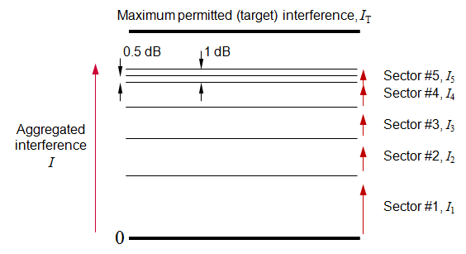

Figure 25: Aggregation of interference from multiple MFCN BS sectors

* + 1. Partitioning/distribution of the interference budget

From the point of view of mitigating the risk of harmful interference, it is essential that the total interference at the FS/FSS receiver does not exceed the maximum permitted limit, IT; i.e., that the total received interference does not exceed the pre-defined interference budget.

Under Approach B, the partitioning of the total interference budget among the MFCN operators is a matter for the Administration. Under Approach A, where different MFCN operators independently manage[20] their interference to the FS/FSS, the partitioning of the total interference budget among the operators might also be a regulatory issue.

Note that the utility and economic value of a block of spectrum for use by a MFCN will depend on the restrictions that are imposed on the maximum permitted e.i.r.p. levels of the MFCN's BSs for the protection of the incumbents. These restrictions will by definition, vary geographically as a function of the separation between the operating frequencies of the MFCN and the relevant incumbents.

This means that, if multiple MFCNs in a geographic area are allocated equal interference budgets for the protection of a specific incumbent receiver, then the utility/value of the respective MFCN spectrum blocks will be inevitably different. This is because the MFCN that operates closest in frequency to the incumbent will be subject to more stringent e.i.r.p. restrictions. This also means that a MFCN spectrum block might have lower utility in one geographic area, but higher utility in another. This phenomenon is experienced even today in the context of restrictions for the protection of services in adjacent bands.

If required, it is possible to equalise the utility/value of the MFCN spectrum blocks in a given geographic area by allocating non-equal interference budgets to the respective MFCNs. For example, a MFCN that operates closest in frequency to the incumbent might be allocated a greater proportion of the total interference budget in order to relax the corresponding e.i.r.p. restrictions. The profile of the non-equal allocations would vary geographically as a function of the operating frequencies of the incumbents.

Figure 26 illustrates the case in which each operator is allocated with an equal fraction of the total interference budget.

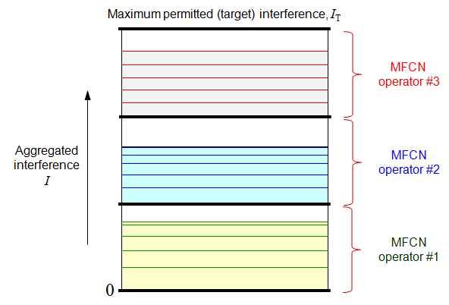

Figure 26: Interference budget equally allocated to three MFCN operators, each of   
which in turn distributes its allocation among its BS sectors as required

Note that under Approach A, the way in which an MFCN operator’s allocated interference budget can be partitioned among individual sectors of the same operator’s base stations need not be specified and can be under the full control of the operator.

There might be a number of reasons why an operator might wish to have control over the partitioning of its allocated interference budget among its base stations (sectors). One reason might be for the purpose of adjusting (shaping) of the maximum permitted e.i.r.p. profile across the sectors of different base stations (or even sectors of the same BS). The objective of this might be to provide the required levels of capacity/coverage at key locations. Another reason might be for the purpose of allocating different amounts of the total interference budget to different layers of a heterogeneous network. For example, it stands to reason that high-tower macro base stations are more likely to cause harmful interference to a FS/FSS receiver than low-height pico base stations, and that the former category would be subject to greater restrictions in their maximum permitted e.i.r.p. level. This can be remedied by allocating a greater proportion of the total interference budget to high-tower macro base stations.

The key point is that while the specification of the total interference budget (maximum permitted interference) and the partitioning of that interference budget among MFCN operators might be regulatory issues[21], the way in which a MFCN operator’s allocated interference budget is distributed among its own BS sectors is a matter for the operator alone subject to regulatory oversight to confirm operator's interference calculations.

This method is best applied in conjunction with well-defined rules for MFCN BS operation (i.e. antenna height, power) and interference calculation methods, to avoid different results from stakeholders due to different assumption made during interference calculations increasing the ease of regulatory oversight.

* 1. Reduction of computational burden Through the use of calculation zones

The above sections described possible approaches for calculating the maximum permitted e.i.r.p. of a MFCN base station’s sector for the avoidance of harmful interference to FS/FSS receivers.

It is evident that base stations that are at sufficiently large geographic separations from a FSS or FS receiver will not be subject to any reduction in e.i.r.p. as they are unlikely to add significantly to the total interference at the input of the FS/FSS receivers. Accordingly, it would be wasteful to perform the e.i.r.p. calculations for such distant base stations.

Such calculations can be avoided through the use of calculation zones. These are defined as geographic areas which surround a FS/FSS receiver, within which MFCN base stations are permitted to operate but are likely to be subject to restrictions for the avoidance of harmful interference to the FS/FSS receiver, but outside of which MFCN base stations would not be subject to any such restrictions. This means that for base stations that are located outside calculation zones, calculations for reduced e.i.r.p. are not required.

Calculation zones might be applied under both Approaches A and B, in order to reduce the burden of calculations on the Administration, the MFCN operators, or a trusted third party. In all cases it is likely that the calculation zones will be prescribed by the Administration. Figure 27 shows an illustrative example where the calculation zones are in the form of circles centred on the FS/FSS receiver. The radii of these circles might be derived by assuming a cautious MFCN BS e.i.r.p., cautious antenna heights, a cautious radio propagation model which might not including local terrain and clutter, omni-directional antennas (both at the MFCN BS transmitter and FS/FSS receiver) with a cautious antenna gain at the receiver. In this example, different calculation zones are defined for co-channel (∆ƒ=0) and non-co-channel (∆ƒ≠0) cases. In defining the radius for the calculation zone the aggregate interference from all base stations surrounding the incumbent's network should be taken into consideration. The radius can be calculated based on the initial MFCN network deployment plans, but possibility of changes in network deployment might need to be taken into account.

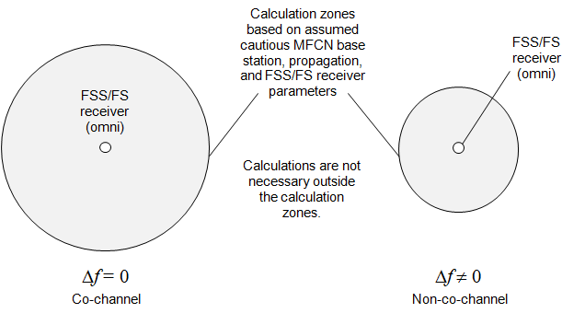

Figure 27: Cautious calculation zones for the reduction of computational burden

* + 1. Possible combination of exclusion and restriction zones

It is possible to use a combination of exclusion and restriction zones, in order to reduce the risk of harmful interference to the incumbents. An example of this is shown in Figure 28 subject to the assumption that the maximum permitted e.i.r.p. of a MFCN BS is P dBm/(BMFCN MHz). Here MFCN base stations are not permitted to be deployed within a distance rX of the FS/FSS receiver (inside the exclusion zone) irrespective of their actual e.i.r.p.. MFCN base stations outside the exclusion zone, but within the zone defined by the radius rC (within the calculation zone) can be deployed subject to the results of appropriate calculations which may or may not restrict their maximum e.i.r.p. level. The restrictions themselves (shown as multiple curves) are a function of the actual BS antenna location and height, antenna pattern and orientation, and frequency separation from the used FS/FSS channels. MFCN base stations outside the calculation zone may be deployed with no additional restrictions if their contribution to the aggregate interference can be assumed to be negligible.

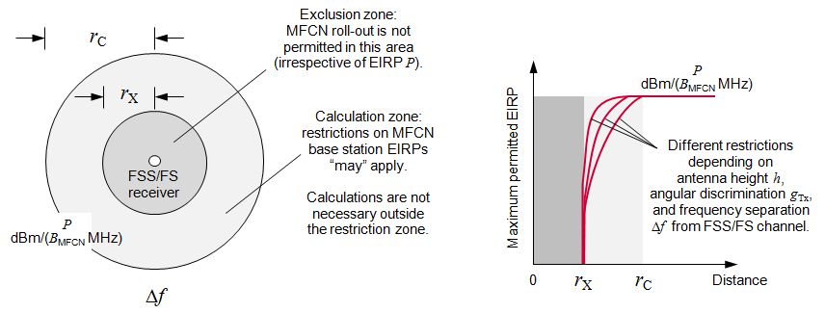

Figure 28: Example of combined use of exclusion and calculation zones

1. FSS earth station LNA and LNB overload

FSS earth station low-noise amplifiers (LNAs) and low-noise block down-converters (LNBs) are optimised for reception of very low levels of incoming satellite signals, and hence have a very high sensitivity. Incoming MFCN signals using much higher power can drive the LNA/LNB out of its dynamic range to where it exhibits non-linear behaviour, which can distort or prevent FSS signal reception.

Typically 3600-3800 MHz band FSS earth station LNAs/LNBs operate over the entire 3400-4200 MHz frequency band and start to show non-linear behaviour at LNA/LNB input level equal to -60 dBm. In addition, LNAs and LNBs normally have a flat frequency response in their band of operation and since bandwidth defining filtering is only applied at intermediate frequency stage, any MFCN emission in the 3600-3800 MHz band able to generate a signal level of -60 dBm at LNA/LNB input will interfere with FSS signal reception in the entire 3400-4200 MHz frequency range.

Administrations should therefore consider using protection distances between MFCN operating in the   
3600-3800 MHz band and any FSS earth station in the 3400-4200 MHz frequency band. Recent reports, such as ITU-R Report M.2109 [14] and ITU-R S.2368 [16], have considered the LNA/LNB overload effect. One study in M.2109 has shown that emissions from one IMT-Advanced station can overload the FSS receiver LNA, or bring it into non-linear operation, if the separation distance is less than some kilometres or some hundreds of metres with respect to base stations and user terminals respectively. Another study in Report ITU-R S.2368 shows the protection distance is between 0.9 and 9 km depending on different assumptions.

1. List of Reference
2. ECC Decision (11)06: Harmonised frequency arrangements for MFCN operating in the bands 3400-3600 MHz/3600-3800 MHz.
3. EC Decision 2014/276/EU: Commission Implementing Decision of 2 May 2014 on amending Decision 2008/411/EC on the harmonisation of the 3400-3800 MHz frequency band for terrestrial systems capable of providing electronic communications services in the Community (notified under document C(2014) 2798)
4. ECC Report 205: Licensed Shared Access (LSA), 2014
5. ITU Radio Regulations Edition of 2012
6. ERC Report 25: The European table of frequency allocations and applications in the frequency range 8.3 kHz to 3000 GHz, May 2015
7. ECC Report 173: Fixed Service in Europe, March 2012.
8. ECC Decision (07)02: Availability of frequency bands between 3400-3800 MHz for the harmonised implementation of BWA.
9. ECO Report 03: The licensing of ‘Mobile bands’ in CEPT
10. Decision 243/2012/EU of the European Parliament and of the Council of 14 March 2012 establishing a multiannual radio spectrum policy programme
11. ECC Recommendation (15)01: Cross-border coordination for mobile/fixed communications networks (MFCN) in the frequency bands: 694-790 MHz, 1452-1492 MHz, 3400-3600 MHz and 3600-3800 MHz
12. RSPG Opinion on Licensed Shared Access, 2013 (document RSPG 13-528)
13. ECC Report 100: Compatibility studies in the band 3400-3800 MHz between Broadband Wireless Access (BWA) systems and other services, Bern, February 2007.
14. CEPT Report 49: Technical conditions regarding spectrum harmonisation for terrestrial wireless systems in the 3400-3800 MHz frequency band, November 2013 and corrected in March 2014.
15. ITU-R Report M.2109: Sharing studies between IMT‑Advanced systems and geostationary  
    satellite networks in the fixed-satellite service in the 3400-4200 and 4500-4800 MHz frequency bands, 2007.
16. ECC Report 203: Least Restrictive Technical Conditions suitable for MFCN, including IMT, November 2013 and corrected in March 2014.
17. ITU-R Report S.2368: Sharing studies between International Mobile Telecommunication-Advanced systems and geostationary satellite networks in the fixed-satellite service in the 3400-4200 MHz and 4500-4800 MHz frequency bands in the WRC study cycle leading to WRC-15, June 2015.
18. Mandate to CEPT “To develop harmonised technical conditions for the 2300-2400 MHz ('2.3 GHz') frequency band in the EU for the provision of wireless broadband electronic communications services”.
19. CEPT Report 55: Technical conditions for wireless broadband usage of the 2300-2400 MHz frequency band (Part A in response to the ‘2.3 GHz’ Mandate)
20. CEPT Report 56: Technological and regulatory options for sharing between WBB and the relevant incumbent services/applications in the 2.3 GHz band.
21. CEPT Report 58: Technical sharing solutions for the shared use of the 2300-2400 MHz band for WBB and PMSE
22. ECC Decision (14)02: Harmonised technical and regulatory conditions for the use of the band 2300-2400 MHz for Mobile/Fixed Communications Networks (MFCN).
23. TS 103 154 System requirements for operation of Mobile Broadband Systems in the 2300 MHz - 2400 MHz band under Licensed Shared Access (LSA) in the 2300 MHz-2400 MHz band
24. TS 103 235 V1.1.1: System Architecture and High Level Procedures for operation of Licensed Shared Access (LSA) in the 2300-2400 MHz band, October 2015.
25. Geographic Sharing in C-band Final Report, Ofcom, June 2015:  
    <http://stakeholders.ofcom.org.uk/market-data-research/other/technology-research/2015-reports/c-band-sharing>
26. Licensed Shared Access (LSA) Pilot, Italian Ministry of Economic Development, November 2015: <http://www.sviluppoeconomico.gov.it/index.php/en/2014-06-27-15-06-15/2033594-licensed-shared-access-lsa-pilot>
27. ITU-R Recommendation P.526: Propagation by diffraction
28. ITU-R Recommendation SF.1006: Determination of the interference potential between earth stations of the fixed-satellite service and stations in the fixed service
29. ITU-R Recommendation S.1432: Apportionment of the allowable error performance degradations to fixed-satellite service (FSS) hypothetical reference digital paths arising from time invariant interference for systems operating below 30 GHz.
30. ITU-R Recommendation S.465: Reference radiation pattern of earth station antennas in the fixed-satellite service for use in coordination and interference assessment in the frequency range from 2 to 31 GHz
31. ETSI EN 302 217-4-2 V1.1.3: Fixed Radio Systems; Characteristics and requirements for point-to-point equipment and antennas; Part 4-2: Harmonized EN covering essential requirements of Article 3.2 of R&TTE Directive for antennas
32. ITU-R Recommendation P.452: Prediction procedure for the evaluation of interference between stations on the surface of the Earth at frequencies above about 0.1 GHz
33. ITU-R Recommendation SM.1448: Determination of the coordination area around an earth station in the frequency bands between 100 MHz and 105 GHz
34. ITU-R Recommendation P.2040: Effects of building materials and structures on radiowave propagation above about 100 MHz

1. This value can be also expressed in terms of PFD limits (dBW/m2).
2. This extract is from the ECA in the May 2015 version of ERC Report 25 [5]. For the most up-to-date ECA information please visit [www.efis.dk](http://www.efis.dk)
3. These values can be also expressed in terms of pfd limits (dBW/sqm).
4. Referred to as “separation distances” in ITU-R
5. Such as: change in the frequency, change in pointing direction if satellite orbital locations are altered or new satellites are added to the network, possible new Earth stations, change due to the periodical switch of VSAT corporate provision contracts from one satellite operator to another.
6. Note that where the presence of multiple MFCN operators is accounted for implicitly via an aggregation margin, there is no need to share information on MFCN deployments among the MFCN operators, and the problem does not arise.
7. FS uses will be maintained only in the 3600-3700 MHz band
8. That is to say, for 1% of time over a long time interval of say a month or a year, the propagation gain would exceed -170 dB.
9. This is because ACIR is the ratio of received interferer power PRx over the experienced (effectively co-channel) interference power
10. These may also be specified in the form of power flux densities, in units of dBm/m2 .
11. E(dBμV/m) = P(dBm) + 20log10 f(MHz) + 77.25 – G(dBi)
12. The overall coupling gain is given by G(dB) = gTx(dB) + GProp(dB) + GA,Rx (dB) + gRx (dB)
13. The assumed antenna gain of an FS station would be the peak antenna gain, as is necessary if the pointing direction of the FS antenna is not known. The assumed antenna gain of the FSS earth station would be the maximum horizon antenna gain, which for an earth station with a minimum elevation angle of 5° is typically 14.5 dBi. (see Rec ITU-R S.465 [29])..
14. For different values the size of the exclusion zone varies
15. For fixed service worst case approximation of the receiver antenna directivity can be taken from harmonised standard EN 302 217 part 4.2 [30].
16. The value of the aggregation margin specified by administrations may also depend on other factors, such as the degree of averseness to the risk of harmful interference.
17. Given the relatively large separations (likely at least hundreds of metres) between the MFCN base stations and the FS/FSS receivers, it is unlikely that accounting for polarisation discrimination would provide material benefits in efficient coexistence.
18. Several clutter databases are commercially available.
19. This approach might, for example, be adopted for the case of small cells, where the explicit aggregation of interference from a large number of base stations and sectors can be avoided, and aggregate interference can instead be accounted for via a gross aggregation margin.
20. Where a third party manages the interference to the incumbents on behalf of all MFCN operators, this can be treated as if only a single MFCN operator is involved. The partitioning of the interference budget among the different MFCN operators is then an issue for the MFCN operators (and not the administration).
21. Assuming that the different MFCN operators manage their interference to the FS/FSS independently.