ECC Report 203

Least Restrictive Technical Conditions suitable for Mobile/Fixed Communication Networks (MFCN), including IMT, in the frequency bands 3400-3600 MHz and 3600-3800 MHz

**Approved 8 November 2013  
  
Corrected 14 March 2014**

# Executive summary

A block edge mask (BEM) for the bands 3400-3600 MHz and 3600-3800 MHz was introduced through ECC Recommendation ECC/REC/(04)05 [1], followed by ECC Decision ECC/DEC/(07)02 [2] and EC Decision 2008/411/EC [3]. However it is recognised that this BEM was derived primarily to ensure co-existence between systems intended for fixed services, e.g. Fixed Wireless Systems. In addition, the harmonized technical conditions contained in EC Decision 2008/411/EC do not establish a harmonised frequency arrangement. Consequently, as stated in a Mandate from the European Commission on the 3.5 GHz band [42], CEPT was requested to investigate the modification of the BEM of the EC Decision 2008/411 in view of the possibility to introduce harmonised frequency arrangements, in order to take into account the developments in wireless communications technology and to facilitate the spectrum-efficient deployment of broadband fixed, mobile and nomadic communications systems.

CEPT has thus carried out studies to determine appropriate least restrictive technical conditions (LRTC) for MFCN. The BEM was derived through minimum coupling loss (MCL) analysis and simulations.

For the purposes of this report the term Broadband Wireless Access (BWA) refers to legacy BWA systems licenced under the existing 3400-3600 MHz licencing regimes as described in ECC/DEC/(07)02 [2] or 2008/411/EC [3]. In the compatibility studies between MFCN and the Fixed Service, it was assumed that the FS systems were also of legacy character. The term MFCN includes IMT and other communications networks in the mobile and fixed services and for the purposes of this report refers to radio communication systems which should comply with the BEM defined below.

The base station BEM requirements as described below may be relaxed whenever there are bilateral agreements between operators. For the spectrum 3400 – 3800 MHz, the BEM has not been developed to protect other services or applications, and only applies in blocks that have been licensed to MFCN according to the new harmonized frequency arrangement. In the figures below it is assumed for simplicity that all blocks have been licensed to MFCN. The BEM incorporates protection of military radiolocation below 3400 MHz.

The BEM consists of several elements. In-block power limit is applied to a block owned by an operator. The out-of-block elements consist of a baseline level, designed to protect the spectrum of other MFCN operators, and transitional levels enabling filter roll-off from in-block to baseline levels. Additionally levels are provided for guard bands and for protection of radar operation below 3400 MHz. The BEM applies to macro, micro, pico and femto base stations.

Figure 1 describes a general BEM.

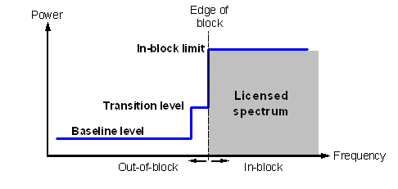

1. Illustration of a general block-edge mask

Table 1 contains the different elements of the BEM for the 3400-3600 MHz and 3600-3800 MHz bands. Tables 2 to 5 contain the power limits for the different BEM elements. PMax is the maximum carrier power for the base station in question, measured as e.i.r.p. Synchronised operation in the context of this Report means operation of TDD in two different systems, where no simultaneous UL and DL transmissions occur.

To obtain a BEM for a specific block, the BEM elements that are defined in Table 1 are used as follows:

1. In-block power limit is used for the block assigned to the operator;
2. Transitional regions are determined, and corresponding power limits are used. The transitional regions may overlap with guard bands, in which case transitional power limits are used;
3. For remaining spectrum assigned to MFCN FDD or TDD, baseline power limits are used;
4. For remaining guard band spectrum, guard band power limits are used;
5. For spectrum below 3400 MHz, one of the “additional baseline” power limits is used.

Frequency ranges in the tables depend on the frequency arrangement chosen (FDD or TDD in 3400-3600 MHz).

1. BEM elements

|  |  |
| --- | --- |
| **BEM elements** | |
| In-block | Block for which the BEM is derived |
| Baseline | Spectrum used for TDD and FDD UL and DL, except from the operator block in question and corresponding transitional regions |
| Transitional region | For FDD DL blocks, the transitional region applies 0 to 10 MHz below and above the block assigned to the operator.  For TDD blocks, the transitional region applies 0 to 10 MHz below and above the block assigned to the operator. Transitional regions do not apply to TDD blocks allocated to other operators, unless networks are synchronised.  The transitional regions do not apply below 3400 MHz or above 3800 MHz. |
| Guard bands | The following guard bands apply in case of an FDD allocation:  3400-3410, 3490-3510 (duplex gap) and 3590-3600 MHz  In case of overlap between transitional regions and guard bands, transitional power limits are used. |
| Additional baseline | Below 3400 MHz |

1. In-block power limit

|  |  |  |
| --- | --- | --- |
| **BEM element** | **Frequency range** | **Power limit** |
| In-block | Block assigned to the operator | Not obligatory.  In case an upper bound is desired by an administration, a value of 68 dBm/5 MHz per antenna may be applied. |

Note: For femto base stations, power control should be applied to minimize interference to adjacent channels.

1. Baseline power limits

| **BEM element** | **Frequency range** | **Power limit** |
| --- | --- | --- |
| Baseline | FDD DL (3510-3590 MHz).  Synchronised TDD blocks with the same UL/DL configuration (3400-3800 or 3600-3800 MHz). | Min(PMax – 43, 13) dBm/5 MHz  e.i.r.p. per antenna |
| Baseline | FDD UL (3410-3490 MHz).  Unsynchronised TDD blocks (3400-3800 or 3600-3800 MHz). | -34 dBm/5 MHz e.i.r.p. per cell |

1. Transitional region power limits

|  |  |  |
| --- | --- | --- |
| **BEM element** | **Frequency range** | **Power limit** |
| Transitional region | -5 to 0 MHz offset from lower block edge  0 to 5 MHz offset from upper block edge | Min(PMax – 40, 21) dBm/5 MHz  e.i.r.p. per antenna |
| Transitional region | -10 to -5 MHz offset from lower block edge 5 to 10 MHz offset from upper block edge | Min(PMax – 43, 15) dBm/5 MHz  e.i.r.p. per antenna |

Note: For TDD blocks the transitional region applies in case of synchronised adjacent blocks, and in-between adjacent TDD blocks that are separated by 5 or 10 MHz. The transition region does not extend below 3400 MHz or above 3800 MHz

1. Guard band power limits for the FDD frequency arrangement

| **BEM element** | **Frequency range** | **Power limit** |
| --- | --- | --- |
| Guard band | 3400-3410 MHz | -34 dBm/5 MHz e.i.r.p. per cell |
| Guard band | 3490-3500 MHz | -23 dBm/5 MHz per antenna port(1) |
| Guard band | 3500-3510 MHz | Min(PMax – 43, 13) dBm/5 MHz  e.i.r.p. per antenna |
| Guard band | 3590-3600 MHz | Min(PMax – 43, 13) dBm/5 MHz  e.i.r.p. per antenna |

(1) The power limit for the frequency range 3490-3500 MHz is based on the spurious emission requirement of -30 dBm/MHz at the antenna port, converted to 5 MHz bandwidth.

1. Base station baseline power limits below 3400 MHz for country specific cases

|  |  |  |  |  |
| --- | --- | --- | --- | --- |
| **Case** | | **BEM element** | **Frequency range** | **Power limit** |
| A | CEPT countries with military radiolocation systems below 3400 MHz | Additional Baseline | Below 3400 MHz for both TDD and FDD allocation(1) | -59 dBm/MHz e.i.r.p.(2) |
| B | CEPT countries with military radiolocation systems below 3400 MHz | Additional Baseline | Below 3400 MHz for both TDD and FDD allocation(1) | -50 dBm/MHz e.i.r.p.(2) |
| C | CEPT countries without adjacent band usage or with usage that does not need extra protection | Additional Baseline | Below 3400 MHz for both TDD and FDD allocation | Not applicable |

(1) Administrations may choose to have a guard band below 3400 MHz. In that case the power limit may apply below the guard band only.

(2) Administrations may select the limit from case A or B depending on the level of protection required for the radar in the region in question.

Cases A, B and C can be applied per region or country so that the adjacent band may have different levels of protection in different geographic areas, depending on the deployment of the adjacent band systems.

In the following paragraphs the different BEM elements are described further.

**In-block limits**

The in-block power limit, as defined in Table 2 above, is not obligatory. The requirement on power control for femto base stations results from the need to reduce interference from equipment that may be deployed by consumers and may thus not be coordinated with surrounding networks.

Different licencing methodologies might be chosen by administrations to license TDD spectrum. One example for a regulation methodology could be the definition of restricted blocks, where the in-block limit could be restricted and would be different than the one as defined in Table 2.

**Baseline limits**

There are two different types of baseline levels. The first is defined for FDD downlink spectrum and for the case when two TDD blocks are synchronised, i.e. when there is no BS – BS interference. This BEM element is expressed by combining attenuation relative to the maximum carrier power with a fixed upper limit. The stricter of the two requirements applies. The fixed level provides an upper bound on the interference from a BS, see Figure 2. The values are derived from BS – UE interference analysis, and are expressed as e.i.r.p. limits per antenna.

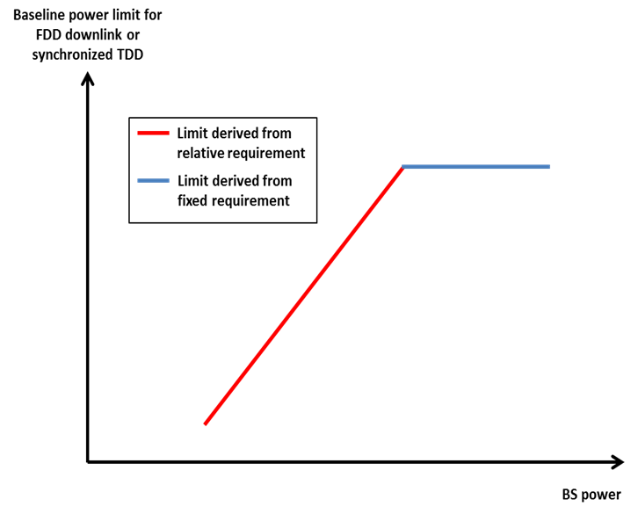

1. Combining the relative and the fixed limit for the baseline applying to FDD DL spectrum and to synchronised TDD spectrum

The second type of baseline is defined for FDD UL and TDD spectrum without synchronisation, and is expressed as a fixed limit only, calculated based on BS – BS interference. The e.i.r.p. limit is given per cell. An exception for this type of baseline can be negotiated between adjacent operators for femto base stations in the case when there is no risk for interference to macro base stations. In that case -25 dBm/5MHz e.i.r.p. per cell may be used.

In Figure 3 the baseline levels are presented for a TDD-only allocation and in Figure 4 for an allocation with both FDD (3400-3600 MHz) and TDD (3600-3800 MHz). In the figures it is assumed that the TDD blocks are either all synchronised or all unsynchronised. In-block and transitional power limits have not been included in the figures.

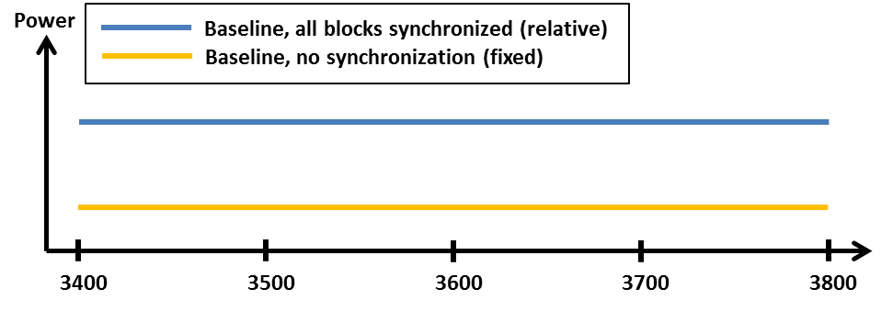

1. Schematic description of baseline levels for a TDD-only allocation. In the case of synchronised TDD, it is assumed that all blocks are synchronised.

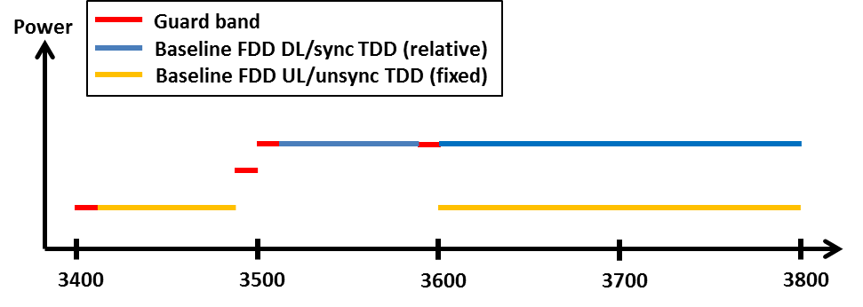

1. Schematic description of baseline and guard band power levels for a mixed FDD and TDD allocation. In the case of synchronised TDD, it is assumed that all blocks are synchronised.

**Transitional region power limits**

The transitional region power limits are defined to enable the reduction of power from the in-block level to the baseline or guard band levels, and is defined as in Table 4 above. The general shape of the transitional region is presented in Figure 5 below.

The requirements are defined for 0–5 MHz and 5–10 MHz offset from the upper and lower edges of an operator’s block (see Table 1 for further details) They are expressed as attenuation relative to the maximum carrier power, combined with a fixed upper limit, as for the baseline requirement in the FDD DL. The stricter of the two requirements applies.

**Guard band limits**

In the case of an FDD allocation there will be guard bands below the FDD UL, above the FDD DL, and in-between the FDD UL and DL, see Figure 4 above. For the guard band 3400-3410 MHz, the power limit is chosen to be the same as the baseline in the adjacent FDD UL spectrum, 3410-3490 MHz. Similarly, the baseline defined for 3510-3590 MHz band is also used in the guard band regions 3500-3510 MHz and 3590-3600 MHz. Finally, spurious requirements converted to 5 MHz bandwidth are used in the 3490-3500 MHz band.

**Additional baseline limits**

The additional baseline limits have been introduced to reflect the need for protection for military radiolocation in some countries. For further details can be found in the paragraph “Coexistence with other services than MFCN” below.

**Combination of BEM elements**

The BEM elements as described above are combined to provide a BEM for a particular block following the five steps listed above. Figure 5 provides an example of such a combination of BEM elements for a FDD block in the lower part of the FDD DL spectrum. Note in particular that different baseline levels are defined for different parts of the spectrum and that the power limit of the lower transitional region is used in a part of the guard band 3490-3510 MHz. Spectrum below 3400 MHz has not been included in this figure, although the BEM element “additional baseline” may be applied to protect military radiolocation.

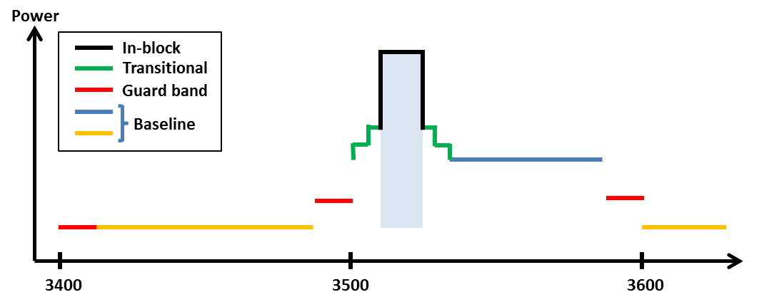

1. Combined BEM elements for an FDD block starting at 3510 MHz

**Licensing approaches for unsynchronised TDD networks**

In the case of unsynchronised TDD networks, different licensing approaches may be applied to avoid interference between adjacent operators. Examples are provided below.

Figure 6 depicts the case where there is no frequency separation between the block edges of two adjacent operators. The baseline should then be met starting from the block edge of the other operator.

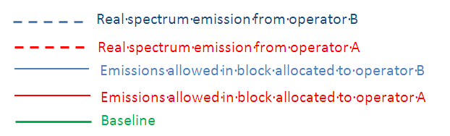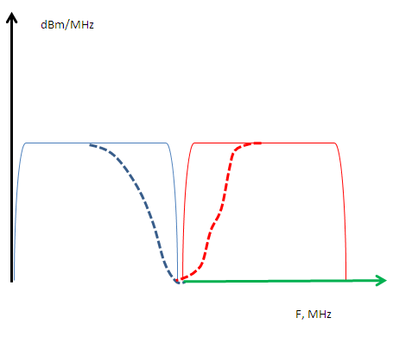

1. Licensing approach with no frequency separation between the block edges of two adjacent unsynchronised TDD networks

Spectrum usage could be increased by bilateral agreements, for instance by sharing an internal guard band as indicated in Figure 7.

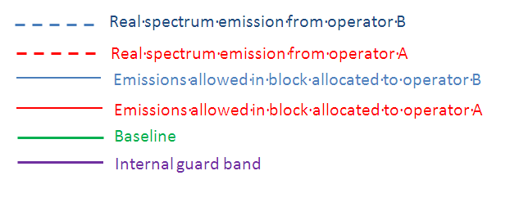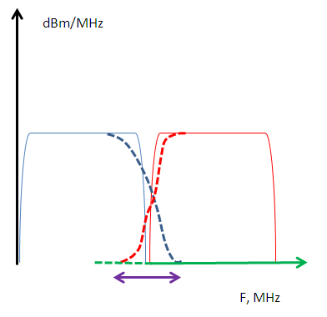

1. Licensing approach with no frequency separation between the block edges of two adjacent unsynchronised TDD networks

Figure 8 shows a case where the regulator has introduced a separation between the block edges of the two adjacent operators, to enable sufficient roll-off of filters to meet the baseline.

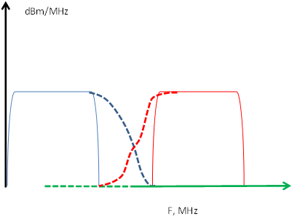

1. Licensing approach with separation between the block edges of the two adjacent operators

Figure 9 displays the case without frequency separation of adjacent operators’ blocks, but where the operators are required to limit the power used in the upper or lower part of their assigned spectrum. The level that will ensure the protection of an adjacent operator block is equal to 4.1 dBm/5MHz e.i.r.p. per cell.

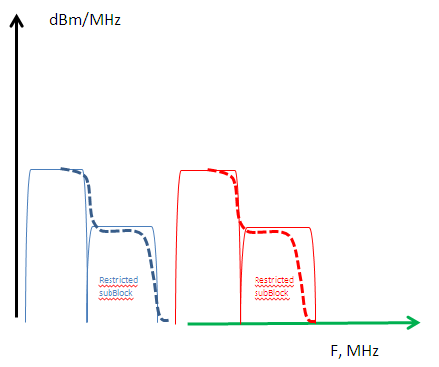

1. Licensing approach with restricted blocks

**UE In-block requirement**

This report provides a recommended upper limit of 25 dBm for the in-block power of the terminals.

This power limit is specified as e.i.r.p. for terminal stations designed to be fixed or installed and as TRP[1] for terminal stations designed to be mobile or nomadic.

A tolerance of up to +2 dB has been included in this limit, to reflect operation under extreme environmental conditions and production spread.

**UE to UE interference**

The interference between UEs belonging to different FDD operators will be very limited due to the duplex gap and the associated filters for both transmitters and receivers.

Similarly, interference from TDD UEs to FDD UEs and vice versa will also be limited due to the guard band between FDD and TDD spectrum.

On the contrary, there could be UE to UE interference between UEs of unsynchronised TDD networks, in case a UE is transmitting in the vicinity of another UE using an adjacent channel.

**Co-existence with other services than MFCN**

Co-existence studies for other services than MFCN have been carried out for both in-band and out-of-band scenarios. The in-band services considered are FSS, FS and BWA and the out-of-band services are civil and military Radiolocation.

The conclusions are as follows:

BWA

For the purpose of co-existence, it is assumed that BWA systems as defined above are similar to MFCN systems. Therefore no studies were carried out for MFCN – BWA co-existence.

Care should be taken to avoid interference from MFCN systems to BWA systems compliant with the former BEM (as defined in ECC/REC/(04)05). The BWA UL needs to be protected from MFCN DL interference in the same way as a MFCN UL is protected. This can be achieved by frequency separation, or by applying the appropriate BEM elements as described above.

Fixed Service

Due to the varying characteristics of different types of FS systems and their deployment, no single separation distance, guard band or signal strength limit can be provided to guarantee co-existence with mobile systems. Co-existence can be achieved through coordination on a case-by-case basis. Based on the results of analysis of both directions of interference (mobile service interfering into P-P and vice-versa) some general observations can be made. Overlapping channel sharing, i.e. a scenario with any amount of overlap between spectrum of interfering and interfered signals, is not feasible in the same geographical area. Consequently if spectrum is used ubiquitously by the FS it cannot be used by the mobile service in the same region. With larger frequency separation and distances coordination is needed, depending on the characteristics of the mobile and the P-P services.

The studies in this report take into account a single interferer. In the case of multiple interferers co-existence could be more difficult to achieve.

Also interference from FS systems to mobile systems may exceed the acceptable interference level.

The similarities between Mobile Systems and P-MP Fixed Systems indicate that the results for mobile – mobile adjacent channel co-existence largely apply to the mobile – P-MP scenario as well. In case of BS – BS interference additional measures may thus be necessary, such as frequency separation and/or additional filters, whereas otherwise co-existence is expected to be possible without such measures.

MFCN UEs and BWA terminal stations have similar characteristics, which justifies that the conclusions of the ECC Report 100 on the coexistence of BWA TS with Fixed Service can be extended to MFCN UEs. With that understanding while coordinating MFCN BS and FS it is sufficient to ensure that MFCN BS do not interfere with FS, since that will also guarantee the protection of the FS from MFCN UEs.

Fixed Satellite Service

Due to the varying characteristics of different types of FSS earth stations and their deployment, no single separation distance, guard band or signal strength limit can be provided to ensure co-existence with MFCN. Co-existence should be achieved through co-ordination on a case-by-case basis, assuming FSS earth stations locations are known. This has been studied in ECC Report 100 [16], as referenced by ECC/DEC/(07)02, and in ITU-R Report M.2109 [18].

Some general observations about MFCN – FSS co-existence can also be made. Separation distances for co-existence vary considerably depending on type of equipment and deployment (e.g. tilt and clutter), but can be large. User equipment impact earth stations less than base stations, so separation that prevents interference from base stations will also protect earth stations from UE interference. There are several mitigation techniques that can be applied, in particular site shielding of earth stations. Interference from FSS satellites to MFCN may exceed the acceptable interference level, but in most cases only by a small margin.

The coordination of MFCN BS and FSS will ensure that MFCN UEs do not interfere with FSS, based on the analysis conducted in ECC Report 100 [16] and ITU-R Report M.2109 [18].

Radiolocation

Due to the varying characteristics of different types of radar stations and their deployment, no single separation distance, guard band or signal strength limit can be provided to ensure co-existence with MFCN. Co-existence should be achieved through co-ordination on a case-by-case basis. However, some general observations can be made. Separation distances due to interference from MFCN to radars can be large, but may be limited to a few km in case of sufficient frequency separation to enable roll-off for MFCN unwanted emissions and good selectivity of radars.

There are mitigation techniques which can reduce the separation distance or frequency separation required. In particular, for adjacent channel/adjacent band interference, improved receiver performance and decreased unwanted emissions can be efficient.

With regard to blocking of radars by mobile systems, additional isolation on the separation distance could be required between the mobile service base station and the radar. The actual impact should be determined on a case-by-case basis. One way to address this issue would be to improve the radar adjacent channel rejection capability through enhancing receiving chains where needed. Non-linear responses could be dominant for some radar frequencies, but this would be subject to further studies on a case-by-case basis.

Regarding interference from radars to MFCN networks, it is concluded that adjacent channel interference may be perceived by MFCN stations at distances of up to tens of kilometres. The analysis did however not take into account the fact that interference from radars are of an intermittent nature (pulsed interference and rotating antenna), which means that the results may be pessimistic.

If the separation distance based on base station interference is smaller than the size of the cell, UE interference to the radar may occur. In this case UE interference must be taken into account and mitigated by e.g. increasing the separation distance to at least the size of the cell.

Adjacent band limit in the case of adjacent band usage by military systems

In some CEPT countries military radiolocation systems that are deployed below 3400 MHz need a fixed limit for protection from base station interference (cases A and B in Table 6). Other mitigation measures like geographical separation, coordination on a case by case basis or an additional guard band may be necessary for a TDD allocation.

For UEs other mitigation measures will be necessary such as e.g. geographical separation or an additional guard band for both FDD and TDD allocation.

**TABLE OF CONTENTS**

0 Executive summary 2

1 Introduction 15

2 Definitions 16

2.1 MFCN (including IMT) 16

2.1.1 Base station parameters 16

2.1.2 User equipment parameters 17

2.1.3 Deployment parameters 17

2.1.4 Additional parameters for statistical studies and MCL calculations 18

2.1.5 Base Station antenna model for MFCN networks 18

2.1.6 Synchronisation of TDD-networks 20

2.2 Fixed Satellite Service 20

2.3 Fixed Service 20

2.4 Radiolocation 21

2.5 Propagation Models 21

3 DERIVATION OF the BS BLOCK EDGE MASK 22

3.1 Interference scenarios 22

3.2 BS to BS interference 22

3.2.1 MCL analysis 22

3.2.2 Simulation Analysis 23

3.2.3 Interference generated in-between two unsynchronised TDD blocks 23

3.3 BS to UE interference 24

3.3.1 Simulation Methodology 24

3.3.2 Macro - macro 24

3.3.3 Macro – micro 25

3.3.3.1 Macro - outdoor micro 25

3.3.3.2 Macro – indoor micro 27

3.3.4 Macro – pico/femto 28

3.3.5 Micro – micro 29

3.3.5.1 Outdoor micro – outdoor micro 29

3.3.5.2 Indoor micro – indoor micro 30

3.3.6 Indoor micro – indoor pico/femto 31

3.3.7 Pico/femto – pico/femto 32

3.3.8 Requirements on BEM due to BS - UE interference 32

3.4 Base station BEM 34

3.4.1 Block Edge Mask elements 34

3.5 Licensing approaches for unsynchronised TDD networks 42

4 UE BEM AND UE TO UE INTERFERENCE 44

4.1 UE BEM 44

4.2 UE TO UE INTERFERENCE 44

5 BS filter aspects for TDD blocks 46

6 Mitigation techniques for intra-mfcn interference 49

6.1 Synchronisation and alignment of UL/DL transmissions in TDD spectrum 49

6.2 Additional filtering 49

6.3 Restricted blocks / Guard bands 49

6.4 Site coordination 49

7 Inter-service interference 51

7.1 Co-existence between MFCN and existing BWA systems 52

7.2 Co-existence between MFCN and FSS systems 52

7.2.1 Conclusion on FSS co-existence 52

7.3 Co-existence between mobile systems and fs systems 53

7.3.1 Conclusion on MFCN and FS co-existence 53

7.4 Co-existence between MFCN and Radiolocation systems 54

7.4.1 Conclusion on MFCN and Radiolocation co-existence 54

7.5 Protection of adjacent band services 55

8 Cross-border coordination 56

9 Conclusion 57

ANNEX 1: Propagation models 68

ANNEX 2: MCL ANALYSIS OF BS TO BS INTERFERENCE 77

ANNEX 3: INTRA-MFCN INTERFERENCE ANALYSIS – SIMULATION SET 1 85

ANNEX 4: UE BEM DISCUSSION FROM CEPT REPORT 39 100

ANNEX 5: co-existence between Mfcn and fss 101

9.1 IMT In-band parameters 106

9.2 IMT Out-of-Band parameters 108

9.3 Results 108

ANNEX 6: co-existence between MFCN and RADIOLOCATION services 110

ANNEX 7: co-existence between MFCN and FS (P-P and P-MP) 116

ANNEX 8: co-existence between mfcn and FS (P-P) 119

ANNEX 9: Co-existence between MFCN and FS (P-MP) 131

ANNEX 10: List of references 133

**LIST OF ABBREVIATIONS**

|  |  |
| --- | --- |
| **Abbreviation** | **Explanation** |
| **BEM** | Block Edge Mask |
| **BS** | Base Station |
| **BWA** | Broadband Wireless Access |
| **CEPT** | European Conference of Postal and Telecommunications Administrations |
| **DEC** | Decision |
| **DL** | Downlink |
| **EC** | European Commission |
| **ECC** | Electronic Communications Committee |
| **ECN** | Electronic Communication Network |
| **e.i.r.p.** | equivalent isotropically radiated power |
| **FDD** | Frequency division duplex |
| **FS** | Fixed Service (ex. Radio Link) |
| **FSS** | Fixed Satellite Service |
| **IMT** | International Mobile Telecommunications |
| **LOS** | Line-of-sight |
| **LTE** | Long Term Evolution |
| **MFCN** | Mobile/Fixed Communications Networks |
| **NLOS** | Non-line-of-sight |
| **NFD** | Net Filter Discrimination |
| **OOB** | Out-of-band |
| **P-MP** | Point to multipoint (fixed services) |
| **P-P** | Point to point (fixed services) |
| **r.a.** | Respected Area |
| **REC** | Recommendation |
| **REP** | Report |
| **Rx** | Receiver |
| **SDO** | Standards Developing Organization |
| **SEM** | Spectrum Emission Mask |
| **TDD** | Time Division Duplex |
| **Tx** | Transmitter |
| **UE** | User Equipment |
| **UL** | Uplink |
| **UMTS** | Universal Mobile Telecommunications System |
| **WRC-07** | World Radio Conference in 2007 |

# Introduction

In 2004 ECC adopted ECC/REC/(04)05 [1] on “Guidelines for accommodation and assignment of Multipoint Fixed Wireless systems in frequency bands 3400-3600 MHz and 3600-3800 MHz” and in 2007 ECC/DEC/(07)02 [2] on “availability of frequency bands between 3400-3800 MHz for the harmonised implementation of Broadband Wireless Access systems (BWA)”. In 2008 the Block Edge Masks (BEM) contained in ECC/REC/(04)05 [1] were included in the European Commission Decision 2008/411/EC [3] (on the harmonisation of the 3400-3800 MHz frequency band for terrestrial systems capable of providing electronic communications services in the Community).

WRC-07 identified the band 3400-3600 MHz for IMT, and subsequently ECC adopted ECC/DEC/(11)06 [4] which contains the harmonised frequency arrangements for MFCN systems including IMT for 3400-3600 and 3600-3800 MHz as shown in the following figures.



1. Frequency arrangement for the 3400-3600 MHz band based on TDD



1. Frequency arrangement for the 3400-3600 MHz band based on FDD

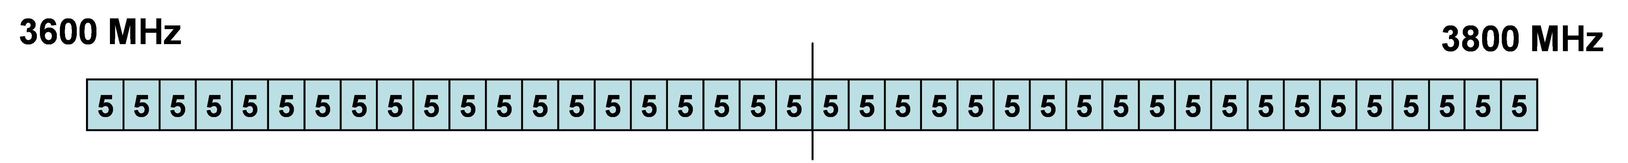

1. Frequency arrangement for the 3600-3800 MHz band based on TDD

As the BEM contained in ECC/REC/(04)05 [1] was developed for P-MP FWS systems in 2004 it is not suitable for the introduction of MFCN systems including IMT in the 3400-3600 MHz and 3600-3800 MHz band. Consequently ECC proposed in 2011 to develop a new Report on suitable BEM for this frequency range. CEPT subsequently received a Mandate from the European Commission [42] to undertake studies on technical conditions, including BEM, in the 3400-3600 and 3600-3800 MHz bands. The mandate also requested CEPT to consider co-existence with existing systems in the same band and adjacent bands.

Co-existence with other services, co-channel or adjacent channel and applications is not necessarily guaranteed by the BEM for MFCN, as other methods may be more efficient depending on co-existence scenario, such as frequency or distance separation, or specific site engineering.

The BEM is a ‘regulatory mask’, and should not be confused with Spectrum Emission Masks (SEM) for base stations and user equipment employed by SDOs. The BEM concept does not in itself define the means by which the equipment in an operator’s network meets the BEM.

For user equipment, the BEM proposed by this ECC Report is restricted to in-block power, which is in line with previous decisions of the European Commission on UE BEMs. UE aspects are taken into consideration however when deriving the BS BEM and in the analysis of interference to and from other services.

# Definitions

This section provides the parameters and characteristics of the systems that are deployed in the 3400-3800 MHz band or whose deployment is foreseen in the near future and which have been included in the compatibility studies in section 3.

## MFCN (including IMT)

The term MFCN includes IMT and other communications networks in the mobile and fixed services. The parameters presented below represent typical characteristics for MFCN equipment and deployments. Examples of specific technologies that may be deployed are LTE [32] [33] [34] [35] and WiMAX. Relevant for the analysis in this report is also the Multi Standard Radio specification of 3GPP [36], [37].

### Base station parameters

The following table includes parameters for macrocell, microcell, picocell and femtocell base stations for typical mobile base stations.

1. Base station parameters

|  | **Macrocell (Wide area BS)** | **Microcell (Medium range BS)** | **Picocell (Local area BS)** | **Femtocell(1) (Home area BS)** |
| --- | --- | --- | --- | --- |
| Output power per antenna port | 43 dBm for 5MHz, 46 dBm for 10 and 20 MHz | 35dBm for 5, 10 and 20 MHz | 24 dBm for 5, 10 and 20 MHz | 20 dBm for 5, 10 and 20 MHz |
| ACS | 45 dB | 45 dB | 45 dB | 45 dB |
| ACLR for first and second adjacent channels (same bandwidth as assigned channel) | 45 dB | 45 dB | 45 dB | 45 dB |
| BS feeder loss | 0 dB | 0 dB | 0 dB | 0 dB |
| Signal/Channel bandwidth | 5 MHz, 10 MHz, 20 MHz, 40 MHz | 5 MHz, 10 MHz, 20 MHz, 40 MHz | 5 MHz, 10 MHz, 20 MHz, 40 MHz | 5 MHz, 10 MHz, 20 MHz, 40 MHz |
| Noise figure (BS)(2) | 5 dB | 8dB | 13 dB | 13 dB |
| N=F.k.T.B(BS) | -102 dBm/5MHz  -99 dBm/10 MHz  -96 dBm/20 MHz  -93 dBm/40 MHz  =-109 dBm/MHz | -99 dBm/5MHz  -96 dBm/10 MHz  -93 dBm/20 MHz  -90 dBm/40 MHz  =-106 dBm/MHz | -94 dBm/5MHz  -91 dBm/10 MHz  -88 dBm/20 MHz  -85 dBm/40 MHz  =-101 dBm/MHz | -94 dBm/5MHz  -91 dBm/10 MHz  -88 dBm/20 MHz  -85 dBm/40 MHz  =-101 dBm/MHz |
| I/N protection criterion for MCL analysis | -6 dB | -6 dB | -6 dB | -6 dB |

(1) It is assumed that in interference scenarios involving femto base stations there is always wall penetration loss included.

(2) Extracted from 3GPP TR 36.824 for LTE macro BS (5 dB) andfrom 3GPP TR 36.931 for LTE pico BS (13 dB)

### User equipment parameters

The following table includes parameters for mobile user equipment in macrocell, microcell, picocell and femtocell environments of a typical mobile network. Compatibility studies assume that MFCN UEs operate under the control of a MFCN BS, i.e. do not transmit outside of the coverage zone of the MFCN network.

1. User equipment parameters

| **Parameter** | **Value** |
| --- | --- |
| Maximum output power | 23 dBm |
| ACS | 33 dB (for 5 and 10 MHz channel), 27dB (for 20 MHz channel BW) |
| Antenna Type | Isotropic |
| Antenna height | 1.5m |
| Signal/Channel bandwidth | 5 MHz, 10 MHz, 20 MHz |
| Noise figure | 9 dB |
| N=F.k.T.B | -98 dBm/5 MHz  -95 dBm/10 MHz  -92 dBm/20 MHz  -89 dBm/40 MHz  =-105 dBm/MHz |

### Deployment parameters

The following table includes typical mobile deployment parameters for macrocell, microcell, picocell and femtocell base stations.

1. Deployment parameters

|  | **Macrocell (Wide area BS)** | **Microcell (Medium range BS)** | **Picocell(Local area BS)** | **Femtocell(Home area BS)** |
| --- | --- | --- | --- | --- |
| Intersite distance within the same network for an urban scenario | 350m | - | - | - |
| Cell radius for omnicells | - | defined per simulation case | defined per simulation case | defined per simulation case |
| Antenna Type | ITU-R F.1336-3 Sector antenna with peak side lobes for worst-case analysis (k = 0.7), and with average side lobes for statistical analysis (k = 0.2) | ITU-R F.1336-3  Omni antenna with peak side lobes for worst-case analysis (k = 0), and with average side lobes for statistical analysis (k = 0) | isotropic | isotropic |
| BS max antenna gain | 17 dBi | 6 dBi | 0 dBi | 0 dBi |
| e.i.r.p. | 60 dBm for 5 MHz and 63 dBm for 10 and 20 MHz. | 41 dBm | 24 dBm | 20 dBm |
| Antenna downtilt | 6° | 0° | 0° | 0° |
| 3dB horizontal beamwidth | 65° | N.A. | N.A. | N.A. |
| Antenna height (BS) | 30 m | 6 m | 3 m | 1 m |

### Additional parameters for statistical studies and MCL calculations

The following table includes additional parameters that are needed for statistical studies.

1. Additional parameters for statistical studies

|  | **Macrocell (Wide area BS)** | **Microcell (Medium range BS)** | **Picocell(Local area BS)** | **Femtocell(Home area BS)** |
| --- | --- | --- | --- | --- |
| Minimum number of interfering BSs | 57 | 19 | 20 | 20 |
| Number of active users on the uplink (transmitting at the same time) | 3 | 3 | 3 | 3 |
| Pathloss correlation- standard deviation | 8 dB | 8 dB | - | - |
| MCL between BS to UE | 70 dB | 53 dB (3m Free Space) | 50 dB (2m Free Space) | 50 dB |
| Bit rate mapping | As defined in TR 36.942 | As defined in TR 36.942 | As defined in TR 36.942 | As defined in TR 36.942 |
| Handover margin | 3dB | 3dB | Not applicable | Not applicable - |

The minimum transmit power of a mobile UE is considered to be -40 dBm.

The following table includes the minimum horizontal distance between two base stations of different networks that were used in the MCL calculations.

1. Minimum horizontal distance between two BS of different networks for   
   the MCL calculation

|  |  |  |  |  |
| --- | --- | --- | --- | --- |
| **Direct Horizontal Distance** | **MACRO** | **MICRO** | **PICO** | **FEMTO** |
| MACRO | 70 m | 30 m | 30 m | 30 m |
| MICRO | 30 m | 30 m | 15 m | 15 m |
| PICO | 30 m | 15 m | 10 m | 10 m |
| FEMTO | 30 m | 15 m | 10 m | 10 m |

### Base Station antenna model for MFCN networks

Recommendation ITU-R F.1336-3 [8] is used for the macro and micro base station antenna patterns. For micro base stations the antenna pattern is assumed to be omnidirectional in the horizontal plane (Section 2 of F.1336-3), whereas for macro base stations three sector base stations are assumed (Section 3 of   
F.1336-3).

For statistical analysis the antenna patterns representing average side lobes are used, whereas for worst-case analysis (Minimum Coupling Loss), the antenna patterns representing peak side lobes are used.

The parameter *k* determines the side-lobe levels, and is set to different values depending on frequency and antenna type (sector vs omni) as follows:

* *k* = 0 for average and peak side lobe patterns for omni antennas (valid for 3 to 70 GHz);
* for sectoral antennas and peak side lobe patterns *k* = 0.7 ( valid for 1 to 6 GHz);
* for sectoral antennas and average side lobe patterns *k* = 0.2 ( valid for 1 to 6 GHz).

The vertical antenna patterns (average and peak side lobes) of a 3.5 GHz omni antenna with peak gain 6 dBi are presented in Figure 9. The horizontal and vertical antenna patterns (average and peak side lobes) of a 3.5 GHz sector antenna with 3 dB beam width of 65 degrees and 17 dBi antenna gain derived from Recommendation ITU-R F.1336-3 [8] are plotted in Figure 10.

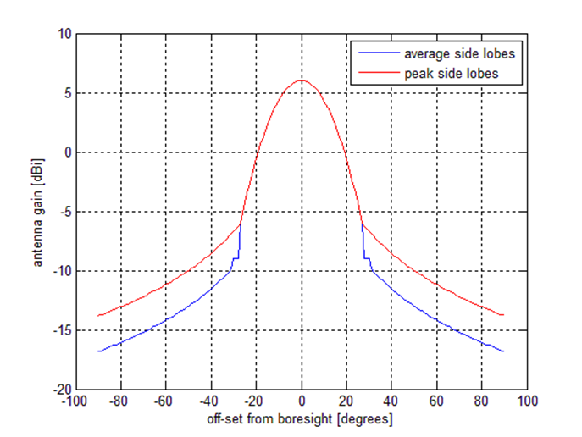

1. ITU-R Recommendation F.1336-3 omni antenna patterns, vertical dimension, for 6 dBi maximum gain. Average (blue) and peak (red) side lobes

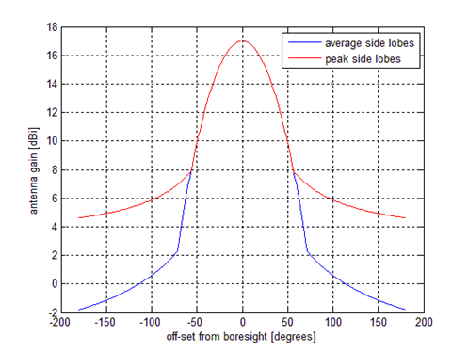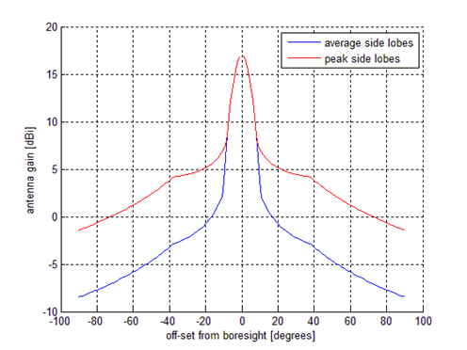

Horizontal pattern Vertical pattern

1. ITU-R Recommendation F.1336-3 sector antenna patterns, 17 dBi maximum gain,   
   65 degrees 3 dB beamwidth. Average (blue) and peak (red) side lobe patterns

### Synchronisation of TDD-networks

Synchronised operation in the context of this Report means operation of TDD in two different systems, where no simultaneous UL and DL transmissions occur [51].

## Fixed Satellite Service

The parameters for FSS systems can be found in ECC Report 100 [16] and ITU-R Report M.2109 [18]. For further details on co-existence with FSS, including FSS parameters, see Section 7.2 and Annex 5, which contains a summary of previous studies.

## Fixed Service

The parameters for FS systems has been derived from ECC Report 100, having updated some technical parameters of P-P type2, to make them more adherent to a typical SDH 128 QAM STM-1 radio link in 3,6-4,2 GHz band, in respect of ERC/REC 12-08 30 MHz channel arrangement. For the P-P studies an antenna that was modelled with the Recommendation ITU-R F.699.5 (see Figure 15) has been used. For Net Filter Discrimination function (NFD), estimating the BWA interfering power that reaches the P-P type 2 interfered receiver when increasing frequency separation between the two carriers, it has been used the receiver selectivity mask of ETSI TR 101 127 [43] for a system based on 128 QAM modulation scheme (system A), and the calculation method of ETSI TR 101 854 [44] (see Figure 16). P-P type 1 was not taken into account.

1. Fixed service P-P links parameters used in the sharing studies

|  |  |
| --- | --- |
|  | **P-P type 2** |
| Bandwidth | 30 MHz |
| Channel raster | 30 MHz |
| Antenna gain | 39 dBi |
| Transmitter output power | 30 dBm |
| Feeder loss | 3 dB |
| Noise figure F | 2 dB |
| Noise level N (kTBF) | -97 dBm |
| Antenna height | 30-50 m |
| Tilt | 0° |

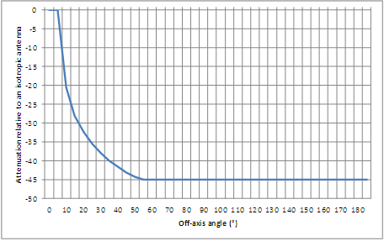

1. P-P systems antenna diagram with 39 dBi antenna gain modelled with the Recommendation ITU-R F.699.5. This is a typical antenna 3 meter diameter



1. NFD function used in the sharing studies with BWA interfering a P-P type 2 system

## Radiolocation

The parameters for radiolocation systems can be found in ECC Report 100 [16], ECC Report 174 [19] and ITU-R Report M.2111 [20]. For further details on co-existence with radiolocation, including radiolocation parameters, see Section 7.4 and Annex 6, which contains a summary of previous studies.

## Propagation Models

Annex 1 contains a detailed description of the propagation models used in this report. Each particular study refers to one or more of the propagation models from this annex.

# DERIVATION OF the BS BLOCK EDGE MASK

This section contains summaries of the Intra-MFCN interference studies that were taken as the basis for the BEM. Detailed information on the analysis can be found in Annexes 2 and 3. Co-existence with other services is considered separately in Section 7.

## Interference scenarios

For the derivation of the BEM, interference was considered between base stations and from base stations to UEs for all combinations of macro, micro, pico and femto cells.

## BS to BS interference

In this section interference from one base station to another is investigated. This type of interference needs to be considered for the FDD uplink band and for the TDD band(s), except from the case of two synchronised base stations.

### MCL analysis

Table 13 below contains a summary of the results of the BS to BS MCL analysis that are presented in detail in Annex 2. For each type of base station the most restrictive scenario has been highlighted in bold. The e.i.r.p. value for each scenario corresponds to the acceptable e.i.r.p. level that can be transmitted in the interfered base stations uplink channel. It has been assumed that receiver selectivity is sufficient to make transmitter leakage the dominant source of interference. The values are derived per cell. It is noted that a micro base station may be placed indoors, in which case there is no wall attenuation between it and other indoor base stations. The micro BS – micro BS interference scenario will nevertheless remain the limiting case for the micro BS.

For all BSs but for the femto BS, the strictest requirement results from interference to a BS of the same type. For the femto BS however, the strictest requirement results from interference to a macro BS. In the case where it can be guaranteed that no macro BSs are in the vicinity of the femto BS, an e.i.r.p. level of   
-25 dBm/5MHz as baseline may be applied. This corresponds to a relaxation of 1.5 dB in relation to the limits derived from interference to other pico and femto base stations, but would enable deployment of femto BSs in such areas without additional filtering in comparison with the unwanted emission limits specified in Table 6.6.3.4B-3 in [34]. Due to the limited size of a femto BS, such additional filtering may be difficult. Therefore an exception for the baseline could be negotiated between adjacent operators for femto base stations in the case where macro base stations are not used in its proximity.

1. Acceptable e.i.r.p. levels per cell to avoid BS-BS interference, dBm/5MHz e.i.r.p.

| **Victim**  **Interferer** | **MFCN outdoor macro BS** | **MFCN outdoor micro BS** | **MFCN indoor pico BS** | **MFCN indoor femto BS** |
| --- | --- | --- | --- | --- |
| **MFCN**  **outdoor macro BS** | **-34.9** | -6.7 | -8.9 | -8.9 |
| **MFCN**  **outdoor micro BS** | -20.7 | **-37.9** | -8.9 | -8.9 |
| **MFCN**  **indoor pico BS** | -33.9 | -26.0 | **-36.5** | -26.5 |
| **MFCN indoor femto BS** | **-33.9** | -26.0 | -26.5 | -26.5 |

### Simulation Analysis

Table 14 below shows the UL throughput degradation for the average and cell edge (5% level) for BS-to-BS interference. The need for significant additional isolation is clearly visible. Detailed information about the simulations can be found in Annex 3.

1. BS-to-BS scenario, UL throughput degradation

| **Additional Isolation  (dB)** | **BS-to-BS case** | |
| --- | --- | --- |
| **Average throughput**  **degradation** | **5% degradation** |
| **0** | 100 % | 100 % |
| **2** | 100 % | 100 % |
| **7** | 100 % | 100 % |
| **12** | 99.9 % | 100 % |
| **17** | 87.5 % | 100 % |
| **22** | 61.7 % | 53.2 % |
| **27** | 35.2 % | 23.3 % |
| **32** | 15.4 % | 8.5 % |
| **37** | 5.5 % | 2.7 % |

### Interference generated in-between two unsynchronised TDD blocks

It is assumed in this section that the adjacent TDD blocks are not synchronised. The MCL and simulation analysis above provide results for transmitter leakage into the interfered block. To ensure sufficiently low interference it is also necessary to limit the unwanted emissions in the transitional region (sometimes referred to as restricted channel) between two adjacent blocks. The interference from this region depends on both the transmitter leakage and the selectivity of the receiver.

Assuming that the selectivity of the receiver is aligned with e.g. 3GPP TS 37.104 [36], in the order of 45 dB, and that the suppression of the transmitter leakage is in the same range, also aligned with 3GPP TS 37.104, the interference generated in the receiver from emissions in-between the two blocks will be suppressed by about 90 dB in relation to the interfering carrier power. In the case of a typical macro base station as interferer, this is equivalent to 43 dBm + 17 dBi – 90 dB = - 30 dBm/5 MHz e.i.r.p. co-channel interference. According to the results from the MCL BS-to-BS interference analysis, this is roughly 5 dB too high. In the case of unsynchronised adjacent TDD blocks, as assumed here, there is a need for additional filtering for the base stations, in the range of 50 dB, or other mitigation techniques such as increased separation distances providing the same additional protection. These additional mitigation techniques will prevent excessive interference for this interference scenario.

Figure 17 below shows the interference region in the frequency domain considered in this section.

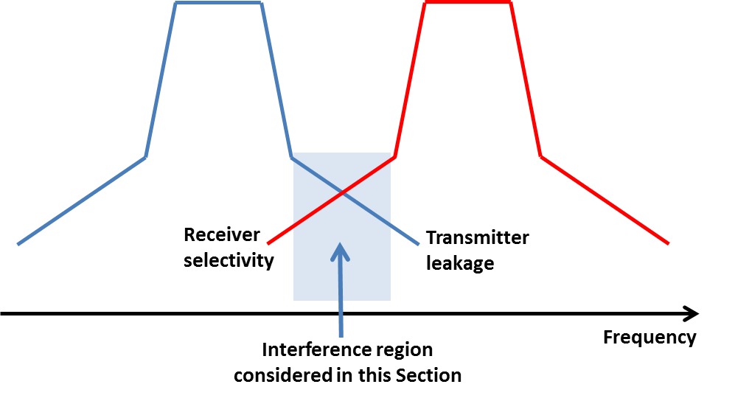

1. Interference as a result of limited ACLR and ACS

## BS to UE interference

### Simulation Methodology

Simulations are performed using the well-known Monte-Carlo simulation methodology elaborated in 3GPP TR 36.942 [6]. In general, the simulations are performed using the following procedure:

1. Run the system under observation (interfered system) independently without the impact of any interfering system in the adjacent band with the simulation parameters as discussed in Section 2. This provides the baseline performance of the system (SINR, throughput, etc.);
2. Introduce the interfering system in the adjacent band with more or less additional isolation and evaluate the impact on the interfered system in terms of performance (throughput) degradation of the link.

Negative additional isolation represents simulations where the requirements on transmitter and receiver side are further relaxed (e.g. lower ACS/ACLR as compared to the 3GPP requirements). This means that the interfering transmitter allows higher emission levels (i.e. interference) in the adjacent band and the interfered receiver has a lower selectivity. This has been included to provide a complete picture of how the isolation affects throughput degradation, not to reflect a real scenario. The scenario with 0 dB additional isolation is the baseline reference where two systems are operating in adjacent blocks.

### Macro - macro

Figure 18 illustrates the deployment scenario for macro-to-macro investigations. It is observed that two systems are simulated in a configuration where base stations belonging to the interfered system (in blue) are deployed at the cell edge of the BS in interfering system (in red). The results in this section are presented in detail in Annex 3.

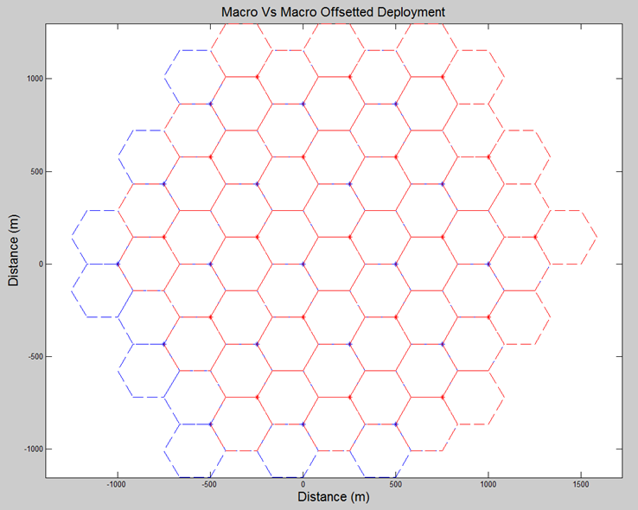

1. Macro - macro deployment scenario

For uplink and downlink interference when two macrocellular systems are operated in the same geographical area on adjacent channels, the throughput degradations are calculated with reference to the baseline scenario where the interfered system is operating independently without any impact from the interfering system as explained in Section 3.3.1,

where

* average throughput degradation is the reduction in throughput averaged over all the users (dropped randomly) in the simulation area, irrespective of user location;
* while the 5th percentile (5%) throughput degradation is a representative of the users having the least (or worst) throughput in the system. In general, these users can be considered as cell edge users and are (generally) the users affected the most by adjacent channel interference (due to the interfering system).

The following table shows the average and 5% level throughput degradation.

1. Downlink throughput degradation

| **Additional  isolation  (dB)** | **DOWNLINK** | |
| --- | --- | --- |
| **Average throughput**  **degradation** | **5% throughput**  **degradation** |
| **-13** | 9.5 % | 52.9 % |
| **-8** | 4.8 % | 26.2 % |
| **0** | 1.2 % | 6.4 % |
| **2** | 0.8 % | 3.5 % |
| **7** | 0.2 % | 1.1 % |
| **12** | 0.1 % | 0.6 % |
| **17** | 0 % | 0.4 % |

### Macro – micro

#### Macro - outdoor micro

The results in this section are presented in detail in Annex 3.

In this section results are presented for an interference scenario where a macro and a Manhattan type micro system are operating in the same geographical area on adjacent channels.

Macro as interferer:

The results presented in this section are for the case when the macro system is operating as the interferer and the microcells placed outdoors in the Manhattan grid (as shown in the figure below) are interfered.

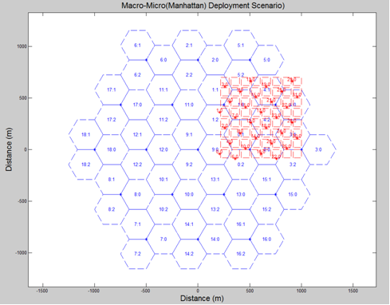

1. Macro - micro (Manhattan) deployment scenario
2. Downlink throughput degradation

| **Additional  isolation  (dB)** | **DOWNLINK** | |
| --- | --- | --- |
| **Average throughput**  **degradation** | **5% throughput**  **degradation** |
| **-13** | 4.0 % | 5.8 % |
| **-8** | 1.5 % | 2.6 % |
| **0** | 0.6 % | 1.5 % |
| **2** | 0.1 % | 0.06 % |
| **7** | 0.05 | 0.02 |
| **12** | 0.017 % | 0.006 % |
| **17** | 0.005 % | 0.002 % |

Micro as interferer:

This section presents the results for the macro - micro scenario where the micro system is operating outdoors as the interferer and the macro system is interfered.

One important thing to note here is that the results contained in Table 17 are for one reference cell in the macro system, which is overlapped completely by the micro (Manhattan) grid (see Figure 19). For the DL, only the UEs in this reference macrocell are considered and for the UL case, the BS of this reference cell is considered for evaluation.

1. Downlink Throughput degradation

| **Additional  Isolation  (dB)** | **DOWNLINK** | |
| --- | --- | --- |
| **Average throughput**  **Degradation** | **5% throughput**  **Degradation** |
| **-13** | 3.1 % | 33.8 % |
| **-8** | 1.6 % | 31.7 % |
| **0** | 0.4 % | 12.2 % |
| **2** | 0.3 % | 7.6 % |
| **7** | 0.1 % | 2.5 % |
| **12** | 0.03 % | 0.8 % |
| **17** | 0.01 % | 0.2 % |

#### Macro – indoor micro

In this section results are presented for an interference scenario where a macro and a Manhattan type micro system are operating in the same geographical area on adjacent channels. However, the micro base stations are located indoors with building size of (75x75 m), and propagation model ITU-R Report M.2135 [7] (presented in Annex A1.2) is employed.

Two cases were studied for macro – indoor micro interference. In case 1 all interfered micro UEs are located indoors, whereas in case 2 only 50% of the interfered micro UEs are located indoors (see also the following Figures 20 and 21 for the configurations of the two cases). Table 18 shows the average throughput loss in relation to additional isolation. The details of the simulations can be found in Annex A3.2.3.

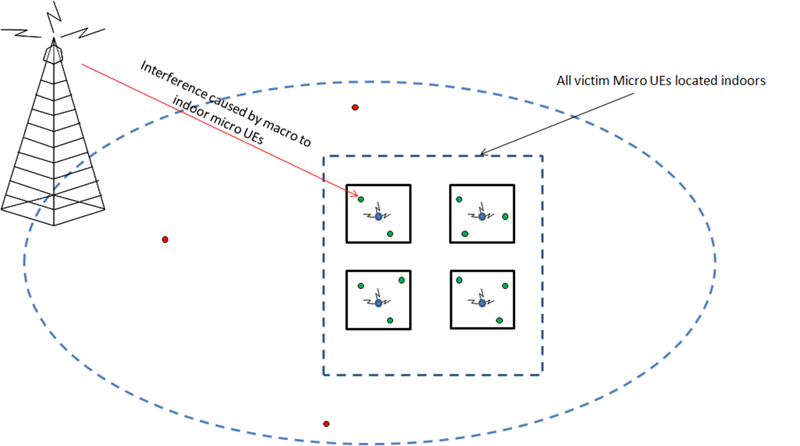

1. Macro - micro/pico BS – case 1

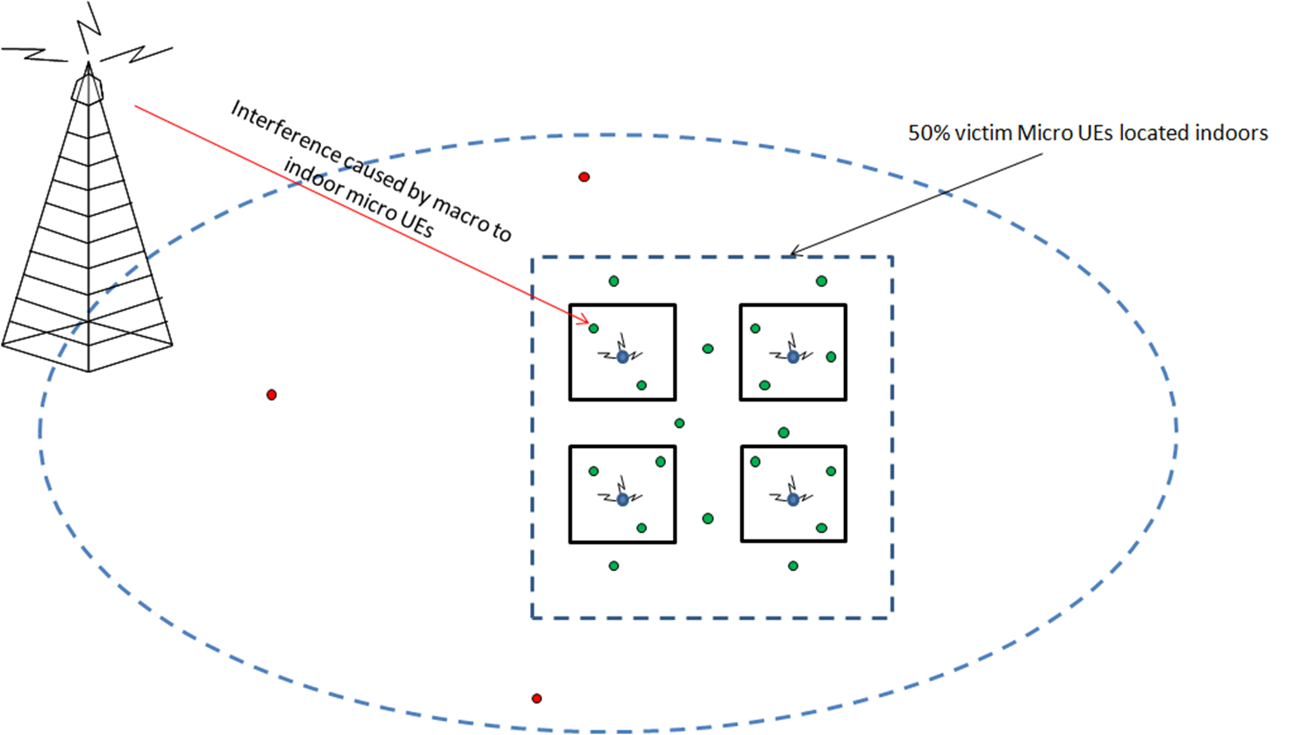

1. Macro micro/pico BS – case 2
2. Average throughput degradation

| **Additional isolation (dB)** | **Macro – micro case 1** | **Macro - micro case 2** |
| --- | --- | --- |
| -13 | 0.3 % | 12 % |
| -8 | 0.05 % | 9 % |
| 0 | 0 % | 5.6 % |
| 3 | 0 % | 5 % |
| 8 | 0 % | 2 % |
| 13 | 0 % | 1.6 % |
| 18 | 0 % | 1 % |

### Macro – pico/femto

The macro - pico scenario is essentially the same as the macro - indoor micro scenario, where the BS is located indoors in a Manhattan structure, with BS parameters adjusted to that of a pico BS. In this case, the pico BS are placed indoors (as shown in Figure 20) and the impact of macro BS transmission in DL is observed on the interfered UEs connected to pico BS. The following table shows the average throughput degradation for the macro – pico scenario.

1. Average throughput degradation

| **Additional isolation  (dB)** | **Macro – pico** |
| --- | --- |
| -13 | 2.5 % |
| -8 | 1.3 % |
| 0 | 0.5 % |
| 3 | 0.1 % |
| 8 | 0 % |
| 13 | 0 % |
| 18 | 0 % |

### Micro – micro

#### Outdoor micro – outdoor micro

The results in this section are presented in detail in Annex 3.

The micro - micro case governs the scenario where two systems are being operated (in adjacent channels) outdoors in a Manhattan structure. Figure 22 illustrates this scenario, where the BS for the two systems are shown (in red and blue). Moreover, the UEs in this scenario are also located outdoors on the horizontal or vertical streets. Recursive street level propagation model (as elaborated in Annex A1.3) is employed.

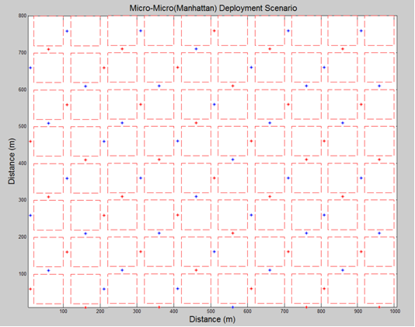

1. Micro – micro deployment scenario (Manhattan)
2. Downlink throughput degradation

| **Additional  isolation  (dB)** | **DOWNLINK** | |
| --- | --- | --- |
| **Average throughput**  **degradation** | **5% throughput**  **degradation** |
| **-13** | 2.159 % | 6.210 % |
| **-8** | 0.763 % | 2.093 % |
| **0** | 0.138 % | 0.242 % |
| **2** | 0.0828 % | 0.188 % |
| **7** | 0.0264 % | 0.102 % |
| **12** | 0.0083 % | 0.101 % |
| **17** | 0.0026 % | 0.084 % |

#### Indoor micro – indoor micro

The results in this section are presented in detail in Annex 3. The indoor micro - micro scenario represents the case when two operators place BS in the same building. A Manhattan deployment structure was employed in the simulation analysis with varying building sizes, where both the BS and UEs were placed indoors. In particular, four different cases were studied:

* Case 1: Non-co-located scenario, with size of building (75x75 m) – as shown in Figure 23;
* Case 2: Non-co-located scenario, with size of building (50x50 m) – as shown in Figure 23;
* Case 3: Co-located scenario, with size of building (75x75 m) – as shown in Figure 24;
* Case 4: Co-located scenario, with size of building (50x50 m) – as shown in Figure 24.

The following two figures show the configurations for the non-co-located (1&2) and the co-located cases (3&4).

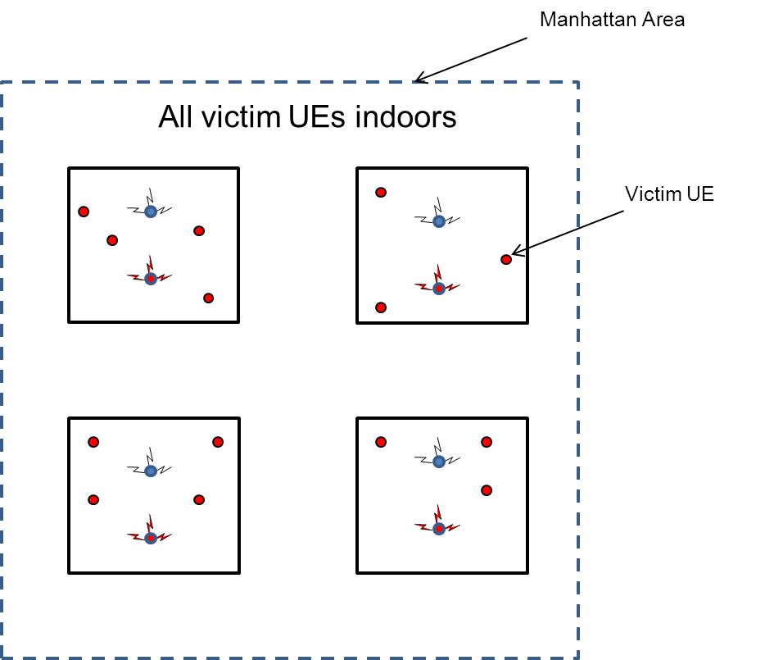

1. Configuration for the non-co-located cases 1 & 2

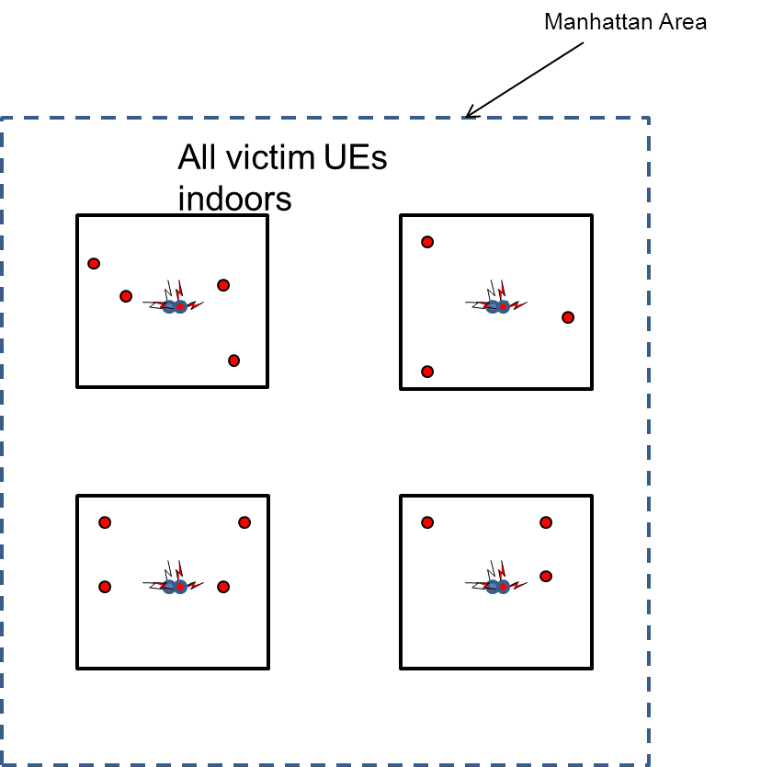

1. Configuration for the co-located cases 3 & 4

The following table shows the results of the simulations for the average throughput degradation.

1. Average throughput degradation

| **Additional isolation (dB)** | **Non-co-located (75x75m)  case 1** | **Non-co-located (50x50m)  case 3** | **Co-located (75x75m)  case 2** | **Co-located (50x50m)  case 4** |
| --- | --- | --- | --- | --- |
| -13 | 21 % | 16.4 % | 16 % | 12 % |
| -8 | 13 % | 8.5 % | 7.4 % | 4.07 % |
| 0 | 5.4 % | 2.7 % | 1.9 % | 0.73 % |
| 3 | 3.8 % | 1.6 % | 1.1 % | 0.34 % |
| 8 | 1.4 % | 0.28 % | 0.2 % | 0 % |
| 13 | 0.3 % | 0 % | 0 % | 0 % |
| 18 | 0 % | 0 % | 0 % | 0 % |

### Indoor micro – indoor pico/femto

The micro - pico scenario is essentially the same as the indoor micro - micro scenario (in Section 3.3.5.2), where the BS are located indoors in a Manhattan structure, with interfered BS parameters adjusted to that of a pico BS. Table 22 below shows the results for average throughput degradation for the two cases that were studied for the micro – pico/femto scenario. The details of the simulations can be found in Annex A3.2.7.

1. Average throughput degradation

| **Additional isolation (dB)** | **Co-located (50x50m) case 1** | **Co-located (40x40m) case 2** |
| --- | --- | --- |
| -13 | 50.6 % | 45.6 % |
| -8 | 35.4 % | 29.4 % |
| 0 | 13.3 % | 8 % |
| 3 | 8.83 % | 4.4 % |
| 8 | 3.55 % | 1 % |
| 13 | 1.48 % | 0.25 % |
| 18 | 0.39 % | 0 % |

### Pico/femto – pico/femto

Analysis presented in Section 3.3.6 covers the scenario where the users connected to pico/femto BS are being interfered by indoor micro BSs. This scenario represents the case where the interference generated towards the pico/femto UEs is higher than what would be the case with pico/femto BS interferers. Specifically, an indoor micro BS causes 11 dB higher interference than a pico BS (35 dBm – 24 dBm).

Since it is noted that the performance of pico/femto UEs does not suffer from significant degradation when exposed to interference from an indoor micro BS (located in the same building), it can be concluded that an interfering pico/femto BS will not cause significant degradation either. Hence, no simulation analysis is conducted for this scenario.

### Requirements on BEM due to BS - UE interference

From the simulations carried out in Sections 3.3.1 – 3.3.6, the conclusion can be drawn that the interference in the downlink is sufficiently low in the adjacent channels. It is thus possible to use the unwanted emissions applied in the simulations to derive BEM requirements to protect the UEs from BS interference. Such requirements will also be sufficient to avoid BS to UE interference in the case of synchronised TDD systems.

An ACLR of 45 dB cannot be applied directly for interference to 5 MHz channels, as it is valid only in the case of interferer and interfered of the same bandwidth (3GPP TS 36.104, Section 6.6.2.1, Table 6.6.2.1-1) [5]. For instance, it does not apply for an interferer of 10 MHz interfering with a channel of 5 MHz bandwidth. ACLR from different bandwidths to UMTS channels, however, applies for the first and second carriers with 2.5 and 7.5 MHz offset from the interfering block edge (3GPP TS 36.104, Section 6.6.2.1, Table 6.6.2.1-1) [5]. The ACLR value of 45 dB must be corrected for the UMTS bandwidth of 3.84 MHz, and also for the RRC filter assumed for the measurements instead of a square filter (0.246 dB, 3GPP TS 36.104, Section 3.1) [5]. Furthermore the ACLR into the first UMTS channel is not valid for the first 0.58 MHz ((5-3.84)/2 MHz), where only the spectrum mask applies. Table 23 below contains the suppression relative to the interferer’s carrier power. The calculation process is as follows:

1. The SEM is integrated in the interval 0 – 0.58 MHz.
2. Between 0.58 and 5 MHz, the integrated SEM is compared with the value obtained from the ACLR. This ACLR is modified based on the increased bandwidth, from 3.84 MHz to 5 – 0.58 = 4.42 MHz, and based on conversion from RRC filter to square filter, resulting in 44.1 dB. In order to compare with the integrated SEM, this modified ACLR is subtracted from the BS power, to obtain an absolute interference level. The minimum of these two values is then assigned to this frequency interval.
3. The values from 0 – 0.58 MHz and 0.58 – 5 MHz are added up, and the resulting absolute value is then converted to a suppression level for 0 – 5 MHz relative the base station power.
4. For 5 – 10 MHz, the integrated SEM is converted to a suppression value relative the base station power, and is then compared with the ACLR (converted from 3.84 MHz to 5 MHz). The strictest value is chosen.
5. For 5 MHz intervals beyond 10 MHz offset, the SEM is integrated between 10 and 15 MHz as it remains constant beyond 10 MHz offset. It is then compared with the calculated relative suppression for 5 – 10 MHz and the strictest is chosen. This is based on the observation that suppression increases with the off-set.

The SEMS are from the MSR specification (3GPP TS 37.104, Section 6.6.2) [36], except from the femto SEM which is from the LTE specification (3GPP TS 36.104, Section 6.6.3) [5].

1. Calculation of relative suppression from spectrum masks and ACLR

|  |  |  |  |  |  |  |  |  |  |  |  |  |  |  |  |
| --- | --- | --- | --- | --- | --- | --- | --- | --- | --- | --- | --- | --- | --- | --- | --- |
| BS type | Power | Integrated SEM 0 - 0.58 MHz (dBm) | Integrated SEM 0.58 - 5 MHz (dBm) | ACLR (dB) | Absolute power from ACLR (dBm) | Min of integrated SEM and ACLR for 0.58 - 5 MHz (dBm) | Sum of 0 - 0.58 MHz and 0.58 - 5 MHz | Sum converted to relative value for 0-5 MHz | Integrated SEM 5-10 MHz (dBm) | Integrated SEM converted to suppression (dB) | ACLR | Strictest of SEM and ACLR for 5-10 MHz | Integrated SEM 10-15 MHz (dBm) | Integrated SEM converted to suppression (dB) | Strictest of SEM and value for 5-10 MHz |
| macro | 49 | -2,6 | -5,5 | 44,1 | 4,9 | -5,5 | -0,8 | **49,8** | -6,0 | 55,0 | 43,6 | **49,8** | -8,0 | 57,0 | **57,0** |
|  | 43 | -2,6 | -5,5 | 44,1 | -1,1 | -5,5 | -0,8 | **43,8** | -6,0 | 49,0 | 43,6 | **43,8** | -8,0 | 51,0 | **51,0** |
|  | 39 | -2,6 | -5,5 | 44,1 | -5,1 | -5,5 | -0,8 | **39,8** | -6,0 | 45,0 | 43,6 | **43,6** | -8,0 | 47,0 | **47,0** |
| micro >31 dBm | 38 | -7,6 | -6,9 | 44,1 | -6,1 | -6,9 | -4,3 | **42,3** | -11,0 | 49,0 | 43,6 | **43,6** | -11,0 | 49,0 | **49,0** |
|  | 32 | -13,6 | -12,5 | 44,1 | -12,1 | -12,5 | -10,2 | **42,2** | -17,0 | 49,0 | 43,6 | **43,6** | -17,0 | 49,0 | **49,0** |
| micro<31 dBm | 31 | -14,8 | -13,4 | 44,1 | -13,1 | -13,4 | -11,2 | **42,2** | -18,0 | 49,0 | 43,6 | **43,6** | -18,0 | 49,0 | **49,0** |
|  | 27 | -14,8 | -13,4 | 44,1 | -17,1 | -17,1 | -12,8 | **39,8** | -18,0 | 45,0 | 43,6 | **43,6** | -18,0 | 45,0 | **45,0** |
| pico | 24 | -22,8 | -17,1 | 44,1 | -20,1 | -20,1 | -18,3 | **42,3** | -20,0 | 44,0 | 43,6 | **43,6** | -20,0 | 44,0 | **44,0** |
|  | 21 | -22,8 | -17,1 | 44,1 | -23,1 | -23,1 | -20,0 | **41,0** | -20,0 | 41,0 | 43,6 | **43,6** | -20,0 | 41,0 | **43,6** |
| femto | 20 | -28,7 | -22,6 | 44,1 | -24,1 | -24,1 | -22,9 | **42,9** | -25,0 | 45,0 | 43,6 | **43,6** | -25,0 | 45,0 | **45,0** |
|  | 12 | -28,7 | -22,6 | 44,1 | -32,1 | -32,1 | -28,9 | **40,9** | -25,0 | 37,0 | 43,6 | **43,6** | -25,0 | 37,0 | **43,6** |

These suppression values are thus in some cases slightly lower than what was assumed in the simulations of BS-to-UE interference (ACLR = 45 dB). Noting that the limiting factor for the interference in that analysis is the selectivity of the UE, in the range of 30 dB, it is clear that a relaxation of the transmitter leakage requirements of a few dB will not result in any noticeable increase in interference for the UEs. The suppression according to the table above is consequently sufficient to prevent interference from BSs to UEs.

## Base station BEM

The base station BEM requirements as described below may be relaxed whenever there are bilateral agreements between operators.

For the spectrum 3400-3800 MHz, the BEM has not been developed to protect other services or applications, and only applies in blocks that have been licensed to MFCN according to the new harmonized frequency arrangement. In the figures below it is assumed for simplicity that all blocks have been licensed to MFCN. The BEM incorporates protection of military radiolocation below 3400 MHz.

### Block Edge Mask elements

The BEM consists of several elements. In-block power limit is applied to a block owned by an operator. The out-of-block elements consist of a baseline level, designed to protect the spectrum of other MFCN operators, and transitional levels enabling filter roll-off from in-block to baseline levels. Additionally levels are provided for guard bands and for protection of radar operation below 3400 MHz. The BEM applies to macro, micro, pico and femto base stations.

Figure 25 describes a general BEM.

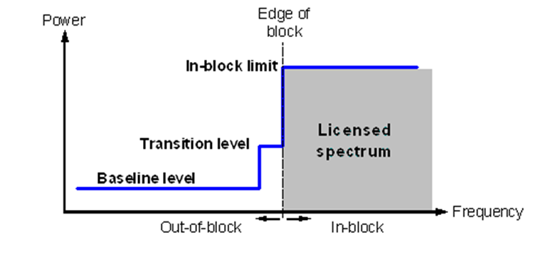

1. Illustration of a general block-edge mask

Table 24 contains the different elements of the BEM for the 3400-3600 MHz and 3600-3800 MHz bands. Tables 25 to 29 contain the power limits for the different BEM elements. PMax is the maximum carrier power for the base station in question, measured as e.i.r.p. Synchronised operation in the context of this Report means operation of TDD in two different systems, where no simultaneous UL and DL transmissions occur.

To obtain a BEM for a specific block, the BEM elements that are defined in Table 1 are used as follows:

1. In-block power limit is used for the block assigned to the operator;
2. Transitional regions are determined, and corresponding power limits are used. The transitional regions may overlap with guard bands, in which case transitional power limits are used;
3. For remaining spectrum assigned to MFCN FDD or TDD, baseline power limits are used;
4. For remaining guard band spectrum, guard band power limits are used;
5. For spectrum below 3400 MHz, one of the “additional baseline” power limits is used.

Frequency ranges in the tables depend on the frequency arrangement chosen (FDD or TDD in 3400-3600 MHz).

1. BEM elements

|  |  |
| --- | --- |
| **BEM elements** | |
| In-block | Block for which the BEM is derived |
| Baseline | Spectrum used for TDD and FDD UL and DL, except from the operator block in question and corresponding transitional regions |
| Transitional region | For FDD DL blocks, the transitional region applies 0 to 10 MHz below and above the block assigned to the operator.  For TDD blocks, the transitional region applies 0 to 10 MHz below and above the block assigned to the operator. Transitional regions do not apply to TDD blocks allocated to other operators, unless networks are synchronised.  The transitional regions do not apply below 3400 MHz or above 3800 MHz. |
| Guard bands | The following guard bands apply in case of an FDD allocation:  3400-3410, 3490-3510 (duplex gap) and 3590-3600 MHz  In case of overlap between transitional regions and guard bands, transitional power limits are used. |
| Additional baseline | Below 3400 MHz |

1. In-block power limit

|  |  |  |
| --- | --- | --- |
| **BEM element** | **Frequency range** | **Power limit** |
| In-block | Block assigned to the operator | Not obligatory.  In case an upper bound is desired by an administration, a value of 68 dBm/5 MHz  per antenna may be applied. |

Note: For femto base stations, power control should be applied to minimize interference to adjacent channels.

1. Baseline power limits

| **BEM element** | **Frequency range** | **Power limit** |
| --- | --- | --- |
| Baseline | FDD DL (3510-3590 MHz).  Synchronised TDD blocks with the same UL/DL configuration (3400-3800 or 3600-3800 MHz). | Min(PMax – 43, 13) dBm/5 MHz  e.i.r.p. per antenna |
| Baseline | FDD UL (3410-3490 MHz).  Unsynchronised TDD blocks (3400-3800 or 3600-3800 MHz). | -34 dBm/5 MHz e.i.r.p. per cell |

1. Transitional region power limits

|  |  |  |
| --- | --- | --- |
| **BEM element** | **Frequency range** | **Power limit** |
| Transitional region | -5 to 0 MHz offset from lower block edge  0 to 5 MHz offset from upper block edge | Min(PMax – 40, 21) dBm/5 MHz  e.i.r.p. per antenna |
| Transitional region | -10 to 5 MHz offset from lower block edge 5 to 10 MHz offset from upper block edge | Min(PMax – 43, 15) dBm/5 MHz  e.i.r.p. per antenna |

1. Guard band power limits for the FDD frequency arrangement

| **BEM element** | **Frequency range** | **Power limit** |
| --- | --- | --- |
| Guard band | 3400-3410 MHz | -34 dBm/5 MHz e.i.r.p. per cell |
| Guard band | 3490-3500 MHz | -23 dBm/5 MHz per antenna port(1) |
| Guard band | 3500-3510 MHz | Min(PMax – 43, 13) dBm/5 MHz  e.i.r.p. per antenna |
| Guard band | 3590-3600 MHz | Min(PMax – 43, 13) dBm/5 MHz  e.i.r.p. per antenna |

(1) The power limit for the frequency range 3490-3500 MHz is based on the spurious emission requirement of -30 dBm/MHz at the antenna port, converted to 5 MHz bandwidth.

1. Base station baseline power limits below 3400 MHz for country specific cases

|  |  |  |  |  |
| --- | --- | --- | --- | --- |
| **Case** | | **BEM element** | **Frequency range** | **Power limit** |
| A | CEPT countries with military radiolocation systems below 3400 MHz | Additional Baseline | Below 3400 MHz for both TDD and FDD allocation(1) | -59 dBm/MHz e.i.r.p.(2) |
| B | CEPT countries with military radiolocation systems below 3400 MHz | Additional Baseline | Below 3400 MHz for both TDD and FDD allocation(1) | -50 dBm/MHz e.i.r.p.(2) |
| C | CEPT countries without adjacent band usage or with usage that does not need extra protection | Additional Baseline | Below 3400 MHz for both TDD and FDD allocation | Not applicable |

(1) Administrations may choose to have a guard band below 3400 MHz. In that case the power limit may apply below the guard band only.

(2) Administrations may select the limit from case A or B depending on the level of protection required for the radar in the region in question.

Cases A, B and C can be applied per region or country so that the adjacent band may have different levels of protection in different geographic areas, depending on the deployment of the adjacent band systems.

In the following paragraphs the different BEM elements are described further.

**In-block limits**

The in-block power limit, as defined in Table 25 above, is not obligatory. The requirement on power control for femto base stations results from the need to reduce interference from equipment that may be deployed by consumers and may thus not be coordinated with surrounding networks.

Different licencing methodologies might be chosen by administrations to license TDD spectrum. One example for a regulation methodology could be the definition of restricted blocks, where the in-block limit could be restricted and would be different than the one as defined in Table 25.

**Baseline limits**

Baseline levels apply to emissions in other operators’ blocks. In a frequency arrangement with FDD in 3400-3600 MHz, the baseline levels are thus defined in 3410-3490 MHz, 3510-3590 MHz and 3600-3800 MHz, and for a TDD-only arrangement the baseline levels are defined for 3400-3800 MHz.

There are two different types of baseline levels. The first is defined for FDD downlink spectrum and for the case when two TDD blocks are synchronised, i.e. when there is no BS – BS interference. This BEM element is expressed by combining attenuation relative to the maximum carrier power with a fixed upper limit. The fixed limit is based on integration of the MSR wide area base station spectrum mask beyond 10 MHz offset from the block edge, and adding the corresponding antenna gain of 21 dBi. The fixed level prevents interference from increasing in the region where the limit derived from the relative requirement is less stringent. The values are derived from BS – UE interference analysis, and are expressed as e.i.r.p. limits per antenna. The stricter of the two requirements applies.

When two TDD blocks are synchronised, there will be no BS – BS interference. In this case, the same baseline as for the FDD DL region is used.



1. Combining the relative and the fixed limit for the baseline applying to FDD DL spectrum and to synchronised TDD spectrum

Consider an example for an offset of 5 to 10 MHz, thus with a relative limit of 43 dB and an upper bound of 13 dBm e.i.r.p. per antenna. For a 35 dBm base station with a 6 dBi antenna, the relative limit is 35 + 6 – 43 = -2 dBm/5 MHz e.i.r.p., which is lower than the upper bound. The requirement thus becomes -2 dBm/5 MHz e.i.r.p.. For a 46 dBm base station with a 17 dBi antenna, the relative limit is 46 + 17 – 43 = 20 dBm/5 MHz e.i.r.p., which is higher than the upper bound. The requirement thus becomes 13 dBm/5 MHz e.i.r.p.. As a matter of fact, this analysis shows that actually the upper level will only apply to macro base stations.

To perform BEM compliance measurements for the baseline consisting of a relative value combined with a fixed upper bound, first determine which of the two requirements applies, as described above. An absolute limit e.i.r.p. per antenna is then obtained. For measurements incorporating the antenna(s), the allowed power must be multiplied by the number of antennas. For measurements at an antenna connector, the BS antenna gain should be subtracted from the e.i.r.p. limit obtained.

The second type of baseline is defined for FDD UL and TDD spectrum without synchronisation, and is expressed as a fixed limit only, calculated based on BS – BS interference. The e.i.r.p. limit is given per cell. An exception for this type of baseline can be negotiated between adjacent operators for femto base stations in the case when there is no risk for interference to macro base stations. In that case -25 dBm/5MHz e.i.r.p. per cell may be used.

In Figure 27 the baseline levels are presented for a TDD-only allocation and in Figure 28 for an allocation with both FDD (3400-3600 MHz) and TDD (3600-3800 MHz). In the figures it is assumed that the TDD blocks are either all synchronised or all unsynchronised. In-block and transitional power limits have not been included in the figures.



1. Schematic description of baseline levels for a TDD-only allocation. In the case of synchronised TDD, it is assumed that all blocks are synchronised.



1. Schematic description of baseline and guard band power levels for a mixed FDD and TDD allocation. In the case of synchronised TDD, it is assumed that all blocks are synchronised.

**Transitional region power limits**

The transitional region power limits are defined to enable the reduction of power from the in-block level to the baseline or guard band levels. In the case of transitional regions for FDD downlink blocks, the size of the transitional region is 10 MHz, which may thus be outside the FDD DL band. For TDD blocks, the transitional region applies 0 to 10 MHz below and above the block assigned to the operator, in spectrum that is not assigned to another operator, including the guard band 3590-3600 MHz, or in case of synchronised blocks with the same UL/DL configuration. Thus it applies only out-of-block, and not in the case where a “guard band” is created within the block of an operator in order to meet the baseline requirements in the adjacent block. TDD transition regions do not extend below 3400 MHz or above 3800 MHz. The general shape of the transitional region is presented below in Figures 29 and 30.

The requirements are defined for 5 MHz bandwidth, 0 to 5 MHz and 5 to 10 MHz offset from the upper and lower edges of an operator’s block. They are expressed as suppression relative the maximum carrier power, combined with a fixed upper limit, as for the baseline requirement in the FDD DL. The fixed upper bound is based on integration of the MSR wide area base station spectrum mask for these 5 MHz channels, and adding the corresponding antenna gain, 21 dBi. The stricter of the two requirements applies. Calculations are carried out as for the DL baseline above. As for the DL baseline, the upper level will only apply to macro base stations.

In the example in Figure 29, the frequency separation to the adjacent block below is 10 MHz, whereas the frequency separation to the block above is 5 MHz, leading to transitional regions of 10 and 5 MHz respectively, assuming that band edges are no closer than that.

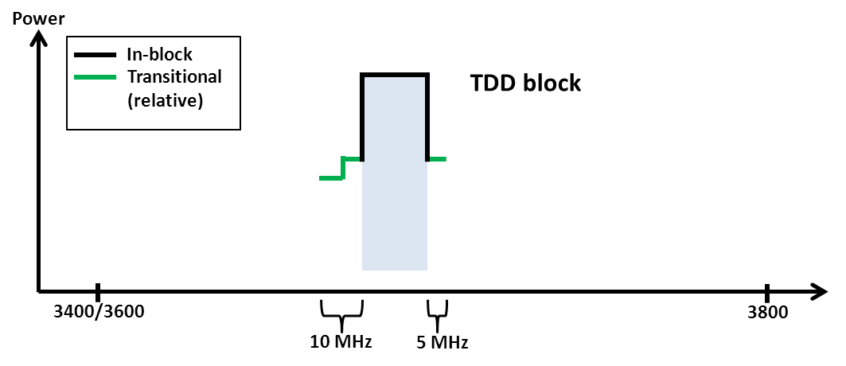

1. In-block and transitional regions for a TDD block with 10 MHz transitional region below and 5 MHz transitional region above

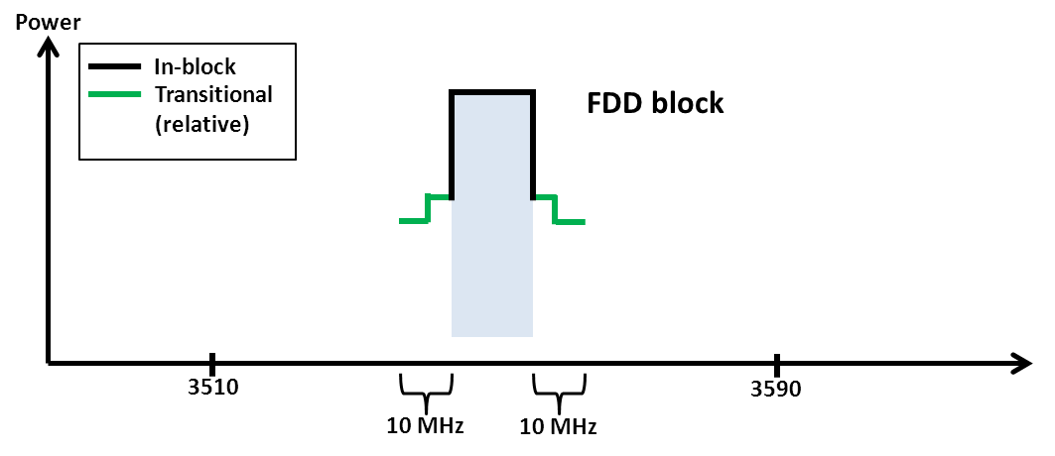

1. In-block and transitional regions for an FDD block

**Guard band limits**

In the case of an FDD allocation there will be guard bands below the FDD UL, above the FDD DL, and in-between the FDD UL and DL, see Figure 31 below. For the guard band 3400-3410 MHz, the power limit is chosen to be the same as the baseline in the adjacent FDD UL spectrum, 3410-3490 MHz. Similarly, the baseline defined for 3510-3590 MHz band is also used in the guard band regions 3500-3510 MHz and 3590-3600 MHz. Finally, spurious requirements converted to 5 MHz bandwidth are used in the 3490-3500 MHz band.

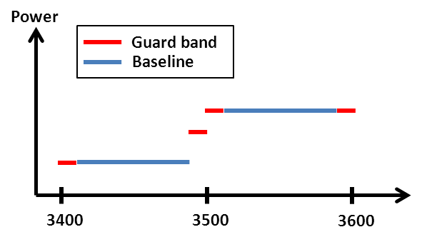

1. Guard bands in an FDD allocation

**Additional baseline limits**

The additional baseline limits have been introduced to reflect the need for protection for military radiolocation in some countries. Further details can be found in section 7.5.

**Combination of BEM elements**

The BEM elements as described above are combined to provide a BEM for a particular block following the five steps listed above. Figure 32 provides an example of such a combination of BEM elements for an FDD block in the lower part of the FDD DL spectrum. Figures 33-35 contain examples of such combinations of BEM elements, for TDD and FDD blocks. Note in particular that different baseline levels are defined for different parts of the spectrum and that the power limit of the lower transitional region is used in a part of the guard band 3490-3510 MHz in Figure 35. Spectrum below 3400 MHz has not been included in the figures, although the BEM element “additional baseline” may be applied to protect military radiolocation.

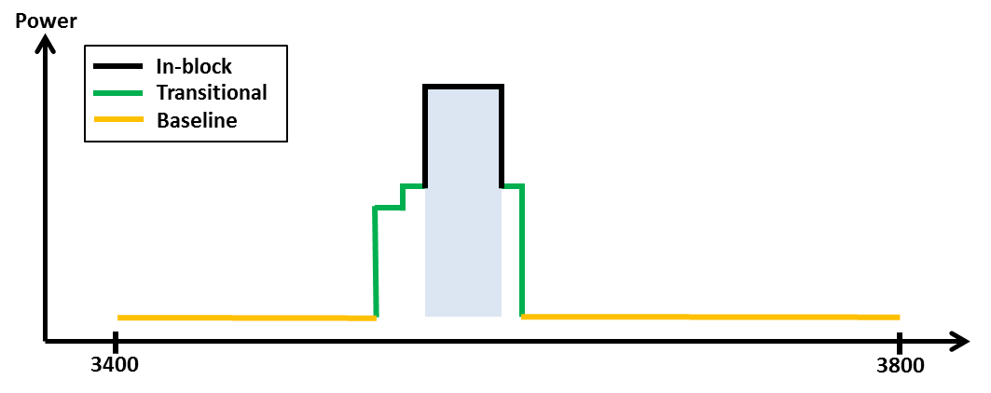

1. Combined BEM elements for a TDD block in a TDD only allocation without synchronisation, 10 MHz transitional region below and 5 MHz transitional region above

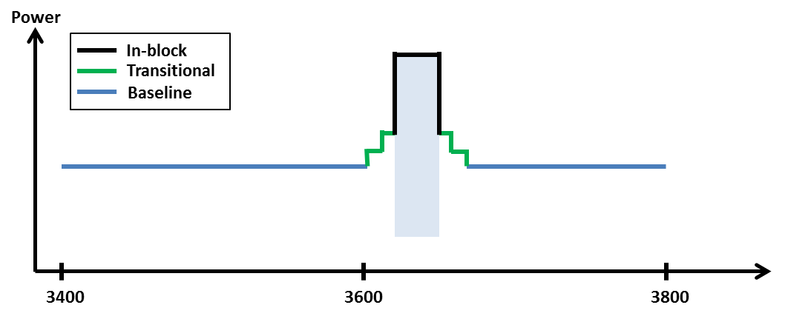

1. Combined BEM elements for a TDD block in a TDD only allocation with synchronisation between all the operators

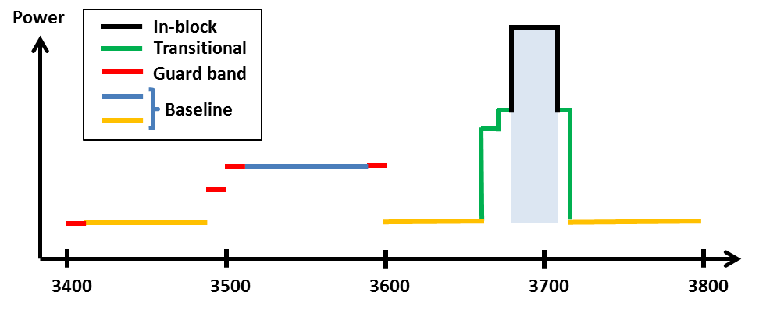

1. Combined BEM elements for a TDD block in an FDD and TDD allocation   
   without synchronisation



1. Combined BEM elements for an FDD block starting at 3510 MHz

## Licensing approaches for unsynchronised TDD networks

In the case of unsynchronised TDD networks, different licensing approaches may be applied to avoid interference between adjacent operators. Examples are provided below.

Figure 36 depicts the case where there is no frequency separation between the block edges of two adjacent operators. The baseline should then be met starting from the block edge of the other operator.



1. Licensing approach with no frequency separation between the block edges of two adjacent unsynchronised TDD networks

Spectrum usage could be increased by bilateral agreements, for instance by sharing an internal guard band as indicated in Figure 37.



1. Licensing approach with no frequency separation between the block edges of two adjacent unsynchronised TDD networks

Figure 38 shows a case where the regulator has introduced a separation between the block edges of the two adjacent operators, to enable sufficient roll-off of filters to meet the baseline.



1. Licensing approach with separation between the block edges of the two adjacent operators

Figure 39 displays the case without frequency separation of adjacent operators’ blocks, but where the operators are required to limit the power used in the upper or lower part of their assigned spectrum. The level that will ensure the protection of an adjacent operator block is equal to 4.1 dBm/5MHz e.i.r.p. per cell.



1. Licensing approach with restricted blocks

# UE BEM AND UE TO UE INTERFERENCE

## UE BEM

This ECC Report provides a recommended upper limit of 25 dBm for the in-block power of the terminals.

This power limit is specified as e.i.r.p. for terminal stations designed to be fixed or installed and as TRP[2] for terminal stations designed to be mobile or nomadic.

A tolerance of up to +2 dB has been included in this limit, to reflect operation under extreme environmental conditions and production spread.

Since any possible additional requirements on UEs are not included in the relevant EC Decisions, these requirements have to be taken into account by ETSI when developing harmonised standards. Close cooperation between ETSI and CEPT as well as SDOs may be necessary to ensure that any additional requirements on UEs are taken into account in the harmonized standards.

CEPT Report 39 [38] contains a more detailed discussion about responsibilities of different organizations regarding UE BEMs, which is also provided in Annex 4.

## UE TO UE INTERFERENCE

The interference between UEs belonging to different FDD operators will be very limited due to the duplex gap and the associated filters for both transmitters and receivers.

Similarly, interference from TDD UEs to FDD UEs and vice versa will also be limited due to the guard band between FDD and TDD spectrum.

For instance, 3GPP has defined an additional requirement of -50 dBm/MHz as inter-band protection level (Table 6.6.3.2-1 in 3GPP TS 36 101 [32]):

1. Band 22 (FDD 3410-3590 MHz) UE is specified with the following requirements:

* -50 dBm/MHz for the protection of band 43 (TDD 3600-3800 MHz)
* -50 dBm/MHz over 3525-3590 MHz and -40 dBm/MHz over 3510-3525 MHz for the protection of other operators in the band 22.

1. Band 42 (TDD 3400-3600 MHz) UE is specified with the following requirements:

* -50 dBm/MHz for the protection of band 43 (TDD 3600-3800 MHz) with some exceptions due to technical feasibility constraint.

1. Band 43 (TDD 3600-3800 MHz) UE is specified with the following requirements:

* -50 dBm/MHz for the protection of band 42 and/or band 22 with some exceptions due to technical feasibility constraint.

On the contrary, there could be UE to UE interference between UEs of unsynchronised TDD networks, in case a UE is transmitting in the vicinity of another UE using an adjacent channel. There is no additional requirement on UE OOB emissions. The table below provides the UE OOB emission levels for various frequency offsets (the 20 MHz channel spectrum mask). A mitigating effect is that such scenarios may be relatively rare, except for in hot spots.

1. UE OOB emission levels

| **Frequency offset (MHz)** | **dBm/MHz** |
| --- | --- |
| 0 - 1 | -5,8 |
| 1 - 5 | -10 |
| 5 - 10 | -13 |
| 10 - 15 | -13 |
| 15 - 20 | -13 |
| 20 - 25 | -25 |
| > 25 | -30 |

This ECC Report only provides the in-block power for UEs, and the UE to UE interference is not studied further here. See also Annex 4 for a further discussion on this issue.

# BS filter aspects for TDD blocks

From Section 3 above one may conclude that in case of unsynchronised TDD blocks, it is necessary to apply additional base station filters to achieve the required baseline performance in adjacent blocks. To be effective, these filters will need a roll-off region, which can be either in the operator’s own block, or in a region separating the two adjacent TDD blocks. Expected filter performance and the size of the associated roll-off regions are studied below. Both metal and ceramic filters are investigated. The results do not incorporate all details such as temperature drift, and should be seen only as a basic indication of what can be achieved. Macro and micro base stations are treated separately, as the smaller size of the micro base will restrict which filter solutions are possible.

The figures indicate that for a macro base station, a ceramic filter with bandwidth of 20 MHz can achieve   
50 dB suppression within 5 MHz offset from the channel edge. An advanced ceramic filter may also achieve this for a channel of 100 MHz bandwidth, although there may be complexity issues associated with such a filter.

For a micro base station, a ceramic filter of bandwidth 20 MHz can achieve 40 dB suppression within 5 MHz offset from the channel edge, although with some additional complexities compared to the macro base station. For 100 MHz channel bandwidth, 10 MHz of roll-off region is required to achieve this suppression, as filters achieving 40 dB suppression within 5 MHz too strongly affect the in-block signal.

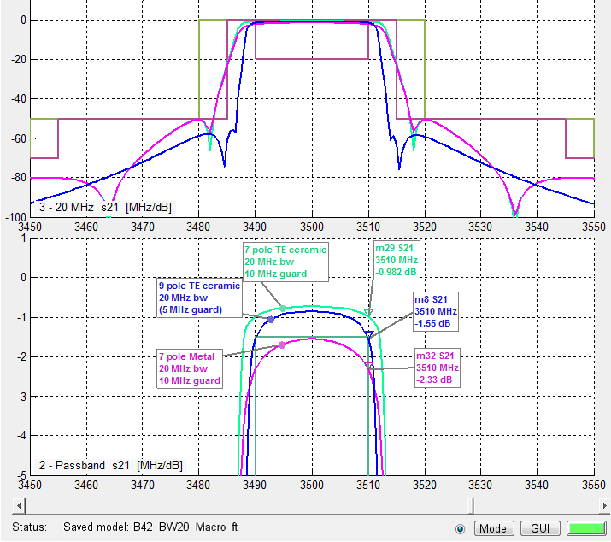

1. Macro base station, 20 MHz bandwidth

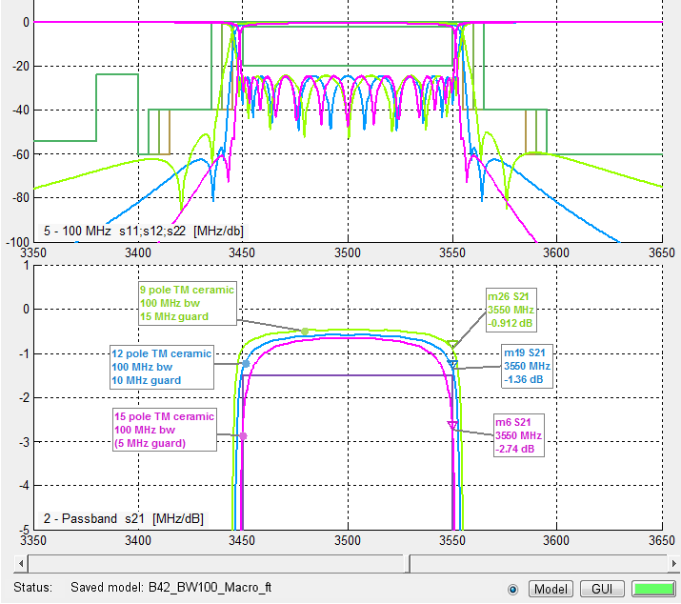

1. Macro base station 100 MHz BW

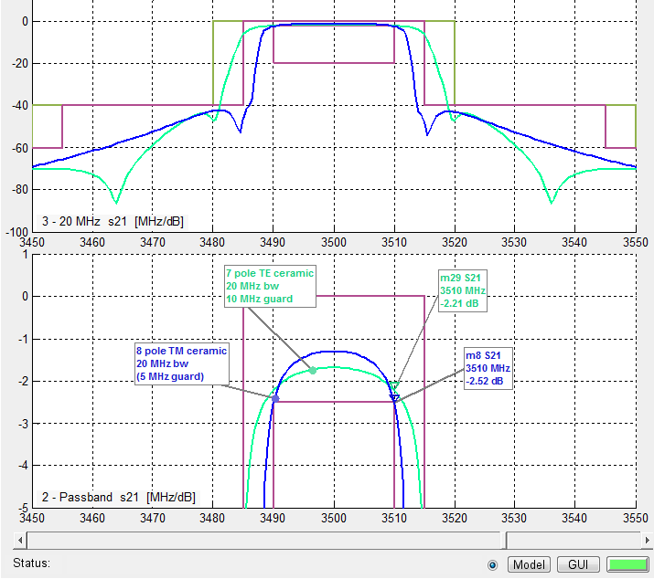

1. Micro base station 20 MHz bandwidth

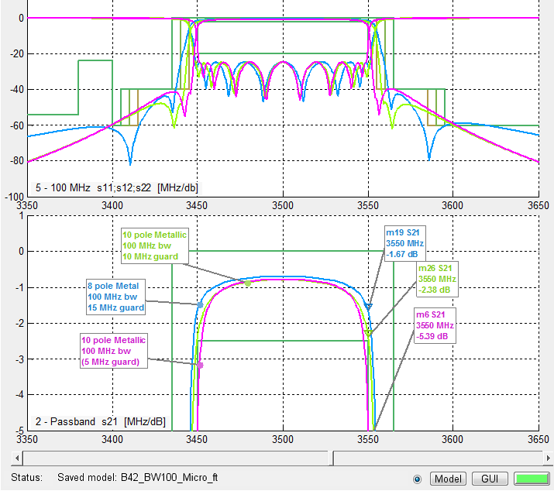

1. Micro base station 100 MHz bandwidth

# Mitigation techniques for intra-mfcn interference

There are a number of ways to reduce interference between MFCN networks deployed in the same or adjacent geographical areas. These mitigation techniques may be used to meet the requirements of the block edge masks or to obtain additional interference reduction when the block edge masks do not provide sufficient protection.

## Synchronisation and alignment of UL/DL transmissions in TDD spectrum

When TDD spectrum is used without synchronisation and alignment of UL/DL transmission, there could be BS to BS and UE to UE interference. In particular BS to BS interference is known to require special treatment, as is also obvious from Sections 3.2 above, containing MCL and simulation analysis of such scenarios for different types of base station deployments. Indeed, additional filtering is required, and due to the roll-off region of such filters, it is not possible to allocate adjacent full-power blocks without a certain separation, see further Section 5 (filter requirements). Usage of unsynchronised TDD systems thus has two drawbacks, additional equipment and loss of spectrum for full-power deployment.

These drawbacks can be removed by synchronisation of TDD operator’s networks, and by alignment of UL/DL transmissions. The interference will then only be from BS to UE and from UE to BS. These are the same interference scenarios as for an FDD allocation, and consequently no additional filters or frequency separation is necessary, provided that Tx and Rx leakage characteristics of the TDD equipment is similar to that of FDD systems.

Synchronisation is technically feasible for outdoor cells (using GNSS like GPS), and the main technical challenge comes from indoor femtocells cases. However for this kind of scenario, it may be that synchronisation between operators is not necessary, considering the expected average distance, probability of interference (i.e. two femtocells on adjacent channel close to each other, wall penetration loss, etc.).

The one remaining drawback of such an arrangement is the lack of flexibility in terms of split between UL and DL transmissions. Unless substantial geographical separation between different deployment areas is available, this UL/DL alignment between operators may also be necessary between different geographical areas.

## Additional filtering

Additional filtering can be applied to base stations on both the transmitter and the receiver side to reduce leakage to and from adjacent channels. Indeed, the solution with 5 or 10 MHz separation between FDD and TDD blocks or unsynchronised full-power TDD blocks requires such additional filtering for the kind of typical MFCN characteristics presented in Section 2.1.1.

## Restricted blocks / Guard bands

In the case of unsynchronised adjacent band networks or between FDD and TDD networks, all kind of interference scenario may occur. The scenarios that are not dealt with by standardisation are the BS to BS interference and the UE to UE interference. For BS to BS interference, the situation requires additional filters, but also a frequency separation between full-power blocks of different operators, to allow filter roll-off. This separation may be achieved by specifically assigned channels in-between full-power blocks, or by operator-internal assignment of spectrum that is used with lower power or not at all.

## Site coordination

Site coordination enables limitation of BS to BS interference in the case where the base stations are deployed in close proximity to each other. Measures that can be applied are for instance choice of antenna tilt or azimuthal direction, horizontal or vertical antenna separation (see [8]), and general selection of antenna placement.

The BEM power limits have been calculated based on specific assumptions regarding physical separation of interfering and interfered antennas, which are not necessarily always satisfied in reality. Deriving BEM conditions from an absolute worst case would place unrealistically strict requirements on all BS equipment. For deployment scenarios where the BEM assumptions do not hold, site coordination may provide effective measures to ensure sufficiently low interference.

# Inter-service interference

Table 31 contains the allocations for 3300-4200 MHz in the ITU Radio Regulations (edition of 2012) for Regions 1-3, with footnotes concerning Europe summarized in the table below. The services present in 3400-3800 MHz or in adjacent bands considered for co-existence analysis in this report are thus Radiolocation, Fixed Service and Fixed Satellite Service.

1. ITU Radio Regulations

|  |  |  |
| --- | --- | --- |
| Allocation to services | | |
| Region 1 | Region 2 | Region 3 |
| 3 300-3 400  RADIOLOCATION | 3 300-3 400  RADIOLOCATION  Amateur  Fixed  Mobile | 3 300-3 400  RADIOLOCATION  Amateur |
| 5.149  5.429  5.430 | 5.149 | 5.1495.429 |
| 3 400-3 600  FIXED  FIXED-SATELLITE (space-to-Earth)  Mobile 5.430A  Radiolocation  5.431 | 3 400-3 500  FIXED  FIXED-SATELLITE (space-to-Earth)  Amateur  Mobile 5.431A  Radiolocation 5.433  5.282 | 3 400-3 500  FIXED  FIXED-SATELLITE (space-to-Earth)  Amateur  Mobile 5.432B  Radiolocation 5.433  5.282 5.432 5.432A |
| 3 500-3 700  FIXED  FIXED-SATELLITE (space-to-Earth)  MOBILE except aeronautical mobile  Radiolocation 5.433 | 3 500-3 600  FIXED  FIXED-SATELLITE (space-to-Earth)  MOBILE except aeronautical mobile 5.433A  Radiolocation 5.433 |
| 3 600-4 200  FIXED  FIXED-SATELLITE (space-to-Earth)  Mobile | 3 600-3 700  FIXED  FIXED-SATELLITE (space-to-Earth)  MOBILE except aeronautical mobile  Radiolocation  5.435 |
|  | 3 700-4 200  FIXED  FIXED-SATELLITE (space to-Earth)  MOBILE except aeronautical mobile | |

Footnote 5.429 is an additional allocation of 3300-3400 MHz to fixed and mobile on a primary basis for some countries in Regions 1 and 2, however none of those in Europe. It concerns European countries only in the sense that countries bordering the Mediterranean shall not claim protection for their fixed and mobile services from the radiolocation service and is therefore not studied any further in this report.

Footnote 5.430 A states that the band 3400-3600 MHz is allocated to the mobile, except aeronautical mobile, service on a primary basis for a number of European and other countries including subject to agreement obtained under No. 9.21 with other administrations and is identified for International Mobile Telecommunications (IMT). However this identification does not preclude the use of this band by any application of the services to which it is allocated and does not establish priority in the Radio Regulations. “Before an administration brings into use a (base or mobile) station of the mobile service in this band, it shall ensure that the power flux-density (pfd) produced at 3 m above ground does not exceed −154.5 dB(W/(m2 ⋅ 4 kHz)) for more than 20% of time at the border of the territory of any other administration. This limit may be exceeded on the territory of any country whose administration has so agreed.”

Footnote 5.431 provides an additional allocation in Germany, Israel and the United Kingdom, where the band 3400-3475 MHz is also allocated to the amateur service on a secondary basis. It does thus not require protection and is not studied in this report.

Service with allocations on secondary basis, such as amateur radio and radiolocation above 3.4 GHz, are not studied here. Furthermore ECC Report 100 [16] contains an analysis of co-existence between BWA and ENG/OB.

The co-existence analysis is in general not based on the BS BEM, but rather the basic characteristics of the MFCN networks, see Section 2.2, in order to provide the appropriate information for those cases when due to bilateral operator agreements the requirements on base stations have been relaxed.

## Co-existence between MFCN and existing BWA systems

For the purpose of co-existence, it is assumed that BWA systems are similar to MFCN systems. Therefore no studies were carried out for MFCN – BWA co-existence.

## Co-existence between MFCN and FSS systems

Co-existence between the existing BWA/Mobile Services and FSS has been studied in ECC Report 100 [16] and ITU-R Report M.2109 [18], noting that maximum e.i.r.p. for base stations was limited to 53 dBm/MHz only in ECC Recommendation(04)05. These reports are summarized in Annex 5, and conclusions are drawn below.

### Conclusion on FSS co-existence

Due to the varying characteristics of different types of FSS earth stations (e.g. bandwidths, antenna diameter, antenna gain) their deployment (antenna height, elevation angle) and the terrain surrounding them, as well as differences in characteristics of different BWA or MFCN systems (there is no e.i.r.p. limit for MFCN base stations but the indicative e.i.r.p. is 68 dBm/5 MHz which is 8 dB higher than the 53 dBm/MHz limit included in ECC Recommendation(04)05), no single separation distance, guard band or signal strength limit can be provided to guarantee co-existence with MFCN. Successful co-existence should be achieved through co-ordination on a case-by-case basis. However, some general observations can be made:

* Co-channel co-existence is not possible when FSS earth stations are deployed ubiquitously since then no minimum separation distance can be guaranteed.
* Separation distances for co-existence vary considerably depending on type of equipment and deployment (e.g. tilt and clutter), but can be large.
* BWA TS/MFCN UE impact earth stations less than CS/BS, so separation that prevents interference from CS/BS will also protect earth stations from TS/UE interference.
* LNB of satellite receivers need to be considered for adjacent frequency band operation.
* There are several mitigation techniques that can be applied, in particular site shielding of earth stations.
* Interference from FSS satellites to MFCN may exceed the acceptable interference level, but in most cases only by a small margin.

It is noted that the results above are primarily based on co-existence with MFCN macrocells only. Micro, pico and femto cell co-existence will result in considerably lower separation distances due to lower power and shielding offered by houses in the vicinity of the base stations.

## Co-existence between mobile systems and fs systems

MFCN UEs and BWA terminal stations have similar characteristics, which justifies that the conclusions of the ECC Report 100 on the coexistence of BWA TS with Fixed Service can be extended to MFCN UEs. With that understanding while coordinating MFCN BS and FS it is sufficient to ensure that MFCN BS do not interfere with FS, since that will also guarantee the protection of the FS from MFCN UEs. Additional considerations are provided in Annex 8.

Co-existence between MFCN BSs and FS systems has been studied and results are summarized in Annexes 7, 8 and 9. The method used is the same of ECC Report 100 [16], apart from some input parameters provided in Section 2.3. Conclusions are drawn below.

### Conclusion on MFCN and FS co-existence

Due to the varying characteristics of different types of FS systems and their deployment, no single separation distance, guard band or signal strength limit can be provided to guarantee co-existence with mobile systems. Co-existence can be achieved through coordination on a case-by-case basis.

Based on the results of analysis of both directions of interference (mobile service interfering into P-P and vice-versa) some general observations can be made. Overlapping channel sharing, i.e. a scenario with any amount of overlap between spectrum of interfering and interfered signals, is not feasible in the same geographical area. Consequently if spectrum is used ubiquitously by the FS it cannot be used by the mobile service in the same region. With larger frequency separation and distances coordination is needed, depending on the characteristics of the mobile and the P-P services.

The studies in this report take into account a single interferer. In the case of multiple interferers co-existence could be more difficult to achieve.

Annex 7 shows how separation distances may vary depending on the scenario.

Annex 9 contains analysis of interference between the Mobile Service and FS P-MP systems. The conclusion is that the similarities between Mobile Systems and P-MP Fixed Systems indicate that the results for mobile – mobile adjacent channel co-existence largely apply to the mobile – P-MP scenario as well. In case of BS – BS interference additional measures may thus be necessary, such as frequency separation and/or additional filters, whereas otherwise co-existence is expected to be possible without such measures.

Also interference from FS systems to mobile systems may exceed the acceptable interference level.

The similarities between Mobile Systems and P-MP Fixed Systems indicate that the results for mobile – mobile adjacent channel co-existence largely apply to the mobile – P-MP scenario as well. In case of BS – BS interference additional measures may thus be necessary, such as frequency separation and/or additional filters, whereas otherwise co-existence is expected to be possible without such measures.

MFCN UEs and BWA terminal stations have similar characteristics, which justifies that the conclusions of the ECC Report 100 on the coexistence of BWA TS with Fixed Service can be extended to MFCN UEs. With that understanding while coordinating MFCN BS and FS it is sufficient to ensure that MFCN BS do not interfere with FS, since that will also guarantee the protection of the FS from MFCN UEs.

## Co-existence between MFCN and Radiolocation systems

Co-existence between MFCN and Radiolocation has been studied in ECC Reports 100 [16] and ECC Report 174 [19] and ITU-R Report M.2111 [20]. The results from these studies are summarized in Annex 6 and conclusions are drawn below.

### Conclusion on MFCN and Radiolocation co-existence

Due to the varying characteristics of different types of radar stations, their deployment (antenna height, elevation angle) and the terrain surrounding them, as well as differences in characteristics of different MFCN systems, no single separation distance, guard band or signal strength limit can be provided to guarantee co-existence with MFCN. Co-existence should be achieved through co-ordination on a case-by-case basis. However, some general observations can be made.

Sharing studies of MFCN interference to different types of radars, assuming non-overlapping adjacent channel analysis and with IMT-Advanced unwanted emissions of -17 dBm/MHz, have shown the following:

* For airborne radars the required separation distance is approximately 0 km, depending on the radar type and antenna type.
* For land-based/shipborne radars the required separation distance is less than 1 km, depending on the radar type and antenna type.

A frequency separation analyses concludes that for a 5 km separation, and considering IMT-Advanced interference to radars, the required frequency separation varies between 14 and 65 MHz, depending on radar type and scenario.

There are mitigation techniques which can reduce the separation distance or frequency separation required. In particular, for adjacent channel/adjacent band interference, improved receiver performance and decreased unwanted emissions can be efficient.

Regarding interference from radars to MFCN networks, the following observations have been made:

* Installation of BWA systems closer than ca. 5 km from the radar should be coordinated;
* In order to guarantee a limited C/I degradation of the P-MP BWA system, it is necessary to establish a protection distance of approximately 11 km in some areas (this value may be much less in some directions);
* Considering the degradation for blocking effect, the radar can have impact in the BWA systems until 30 km (this value may be much less in some directions).

The studies in Annex 6 indicate that a separation of less than 1 km would require coordination between Radar and BWA systems to ensure coexistence. If the separation distance based on base station interference is smaller than the size of the cell, UE interference to the radar may occur. In this case UE interference must be taken into account and mitigated by e.g. increasing the separation distance to at least the size of the cell. Further studies would be required in the case of implementation of MFCN BSs in close proximity to radiolocation stations.

Regarding interference from radars to MFCN networks, it is concluded that adjacent channel interference may be perceived by MFCN stations at distances of up to tens of kilometres. The analysis did however not take into account the fact that interference from radars are of an intermittent nature (pulsed interference and rotating antenna), which means that the results may be pessimistic.

Measurements of continuous versus intermittent interference indicate that radar pulses cause less considerably less damage than a continuous wave interference with the same power.

With regard to blocking of radars by mobile systems, additional isolation on the separation distance could be required between the mobile service base station and the radar. The actual impact should be determined on a case-by-case basis. One way to address this issue would be to improve the radar adjacent channel rejection capability through enhancing receiving chains where needed. Non-linear responses could be dominant for some radar frequencies, but this would be subject to further studies on a case-by-case basis.

## Protection of adjacent band services

In some CEPT countries military radiolocation systems that are deployed below 3400 MHz need a fixed limit for protection from base station interference (cases A and B in Table 29). Other mitigation measures like geographical separation, coordination on a case by case basis or an additional guard band may be necessary for a TDD allocation.

For UEs other mitigation measures will be necessary such as e.g. geographical separation or an additional guard band for an FDD or a TDD allocation.

# Cross-border coordination

This section describes the basic idea of how to manage interference between MFCN networks across borders (or between different regions within one country), i.e. interference between operators using overlapping frequencies in adjacent geographical areas.

For the case when networks on either side of a boundary are coordinated in the sense that the same frequency arrangement is used, cross-border coordination between MFCN networks is a well-known problem. For detailed descriptions of how cross-border coordination is managed in CEPT see the relevant cross-border Recommendations ERC/REC/(01)01 [27], ECC/REC/(05)08 [28], ECC/REC/(08)02 [29], ECC/REC/(11)04 [30], ECC/REC/(11)05) [31]. Considering the system characteristics of the MFCN networks, see Section 2.2, expected to be deployed in 3400-3800 MHz, the general methodology should apply also for this frequency range:

* Apply the appropriate field strength (or pfd) trigger levels from the appropriate CEPT cross-border Recommendation. These field strengths are typically defined for a height 3 meters above ground level, at the borderline and possibly also some distance into the adjacent country/region;
* A propagation model is selected, e.g. ITU-R Recommendation P.1546, and the field strength at the borderline (and/or some distance into the other country/region) is calculated for e.g. 10% time and 50% of locations. Coordination is then required when base stations cause field strengths exceeding the trigger levels;
* A detailed field strength analysis can then be carried out to incorporate more details from the deployment and the detailed topography of the region in question.

Modifications are introduced to the interfering network to ensure that the field strength (pfd) levels are sufficiently low on the other side of the border. Cross-border coordination requires special care when different frequency allocations (FDD vs TDD) are used on either side of a border or when TDD operators on either side of the border do not synchronise their systems and choose the same uplink-downlink configuration, due to BS-BS interference. Such interference may appear in the 3400-3800 MHz range due to the multiple frequency arrangements and the TDD allocations. Although the same principles apply as for the case above, trigger levels are considerably lower and may lead to substantially increased separation distances, leading to important geographical zones in border area without coverage.

Part of this band is allocated to BWA systems without frequency arrangement harmonisation between neighbouring countries. In addition in some countries, there are regional licenses. The border coordination rules are applied at the cross borders between neighbouring countries, as well as between different regions within the same country.

FDD frequency arrangement exhibit no BS to BS co-channel interference. If TDD network synchronisation with coordinated UL/DL configuration, over all networks present in the cross-border area, the situation will be similar to FDD frequency arrangement situation with the additional constraint to ensure synchronisation of the networks on both sides of the border.

It should be noted that at the moment of finalisation of this report there were on-going studies within CEPT which will detail the various field strength values that may be used for technology neutral co-ordination of dissimilar systems. Cross-border coordination in the band 3400-3800 MHz will be subject to an ECC Recommendation and national agreements as for other cross-border coordination in other bands.

# Conclusion

WRC-07 identified the band 3400-3600 MHz for IMT, and subsequently ECC adopted ECC/DEC/(11)06 [4] which contains the harmonised frequency arrangements for MFCN systems including IMT for 3400-3600 MHz and 3600-3800 MHz as shown in the following figures.



1. Frequency arrangement for the 3400-3600 MHz band based on TDD



1. Frequency arrangement for the 3400-3600 MHz band based on FDD



1. Frequency arrangement for the 3600-3800 MHz band based on TDD

A base station BEM has been derived for these harmonised frequency arrangements. The BEM requirements as described below may be relaxed whenever there are bilateral agreements between operators. The BEM has not been constructed to protect other services or applications in the band, and only applies in blocks that have been licensed to MFCN according to the new harmonized frequency arrangement. In the figures below it is for simplicity assumed that all blocks have been licensed to MFCN.

The base station BEM requirements as described below may be relaxed whenever there are bilateral agreements between operators. For the spectrum 3400-3800 MHz, the BEM has not been developed to protect other services or applications, and only applies in blocks that have been licensed to MFCN according to the new harmonized frequency arrangement. In the figures below it is assumed for simplicity that all blocks have been licensed to MFCN. The BEM incorporates protection of military radiolocation below 3400 MHz.

The BEM consists of several elements. In-block power limit is applied to a block owned by an operator. The out-of-block elements consist of a baseline level, designed to protect the spectrum of other MFCN operators, and transitional levels enabling filter roll-off from in-block to baseline levels. Additionally levels are provided for guard bands and for protection of radar operation below 3400 MHz. The BEM applies to macro, micro, pico and femto base stations.

Figure 47 describes a general BEM.



1. Illustration of a general block-edge mask

Table 32 contains the different elements of the BEM for the 3400-3600 MHz and 3600-3800 MHz bands. Tables 33 to 37 contain the power limits for the different BEM elements. PMax is the maximum carrier power for the base station in question, measured as e.i.r.p. Synchronised operation in the context of this Report means operation of TDD in two different systems, where no simultaneous UL and DL transmissions occur.

To obtain a BEM for a specific block, the BEM elements that are defined in Table 1 are used as follows:

* + 1. In-block power limit is used for the block assigned to the operator;
    2. Transitional regions are determined, and corresponding power limits are used. The transitional regions may overlap with guard bands, in which case transitional power limits are used;
    3. For remaining spectrum assigned to MFCN FDD or TDD, baseline power limits are used;
    4. For remaining guard band spectrum, guard band power limits are used;
    5. For spectrum below 3400 MHz, one of the “additional baseline” power limits is used.

Frequency ranges in the tables depend on the frequency arrangement chosen (FDD or TDD in 3400-3600 MHz).

1. BEM elements

|  |  |
| --- | --- |
| **BEM elements** | |
| In-block | Block for which the BEM is derived |
| Baseline | Spectrum used for TDD and FDD UL and DL, except from the operator block in question and corresponding transitional regions |
| Transitional region | For FDD DL blocks, the transitional region applies 0 to 10 MHz below and above the block assigned to the operator.  For TDD blocks, the transitional region applies 0 to 10 MHz below and above the block assigned to the operator. Transitional regions do not apply to TDD blocks allocated to other operators, unless networks are synchronised.  The transitional regions do not apply below 3400 MHz or above 3800 MHz. |
| Guard bands | The following guard bands apply in case of an FDD allocation:  3400-3410, 3490-3510 (duplex gap) and 3590-3600 MHz  In case of overlap between transitional regions and guard bands, transitional power limits are used. |
| Additional baseline | Below 3400 MHz |

1. In-block power limit

|  |  |  |
| --- | --- | --- |
| **BEM element** | **Frequency range** | **Power limit** |
| In-block | Block assigned to the operator | Not obligatory.  In case an upper bound is desired by an administration, a value of 68 dBm/5 MHz per antenna may be applied. |

Note: For femto base stations, power control should be applied to minimize interference to adjacent channels.

1. Baseline power limits

| **BEM element** | **Frequency range** | **Power limit** |
| --- | --- | --- |
| Baseline | FDD DL (3510-3590 MHz).  Synchronised TDD blocks with the same UL/DL configuration (3400-3800 or 3600-3800 MHz). | Min(PMax – 43, 13) dBm/5 MHz  e.i.r.p. per antenna |
| Baseline | FDD UL (3410-3490 MHz).  Unsynchronised TDD blocks (3400-3800 or 3600-3800 MHz). | -34 dBm/5 MHz e.i.r.p. per cell |

1. Transitional region power limits

|  |  |  |
| --- | --- | --- |
| **BEM element** | **Frequency range** | **Power limit** |
| Transitional region | -5 to 0 MHz offset from lower block edge  0 to 5 MHz offset from upper block edge | Min(PMax – 40, 21) dBm/5 MHz  e.i.r.p. per antenna |
| Transitional region | -10 to -5 MHz offset from lower block edge 5 to 10 MHz offset from upper block edge | Min(PMax – 43, 15) dBm/5 MHz  e.i.r.p. per antenna |

Note: For TDD blocks the transitional region applies in case of synchronised adjacent blocks, and in-between adjacent TDD blocks that are separated by 5 or 10 MHz. The transition region does not extend below 3400 MHz or above 3800 MHz

1. Guard band power limits for the FDD frequency arrangement

| **BEM element** | **Frequency range** | **Power limit** |
| --- | --- | --- |
| Guard band | 3400-3410 MHz | -34 dBm/5 MHz e.i.r.p. per cell |
| Guard band | 3490-3500 MHz | -23 dBm/5 MHz per antenna port(1) |
| Guard band | 3500-3510 MHz | Min(PMax – 43, 13) dBm/5 MHz  e.i.r.p. per antenna |
| Guard band | 3590-3600 MHz | Min(PMax – 43, 13) dBm/5 MHz  e.i.r.p. per antenna |

(1) The power limit for the frequency range 3490-3500 MHz is based on the spurious emission requirement of -30 dBm/MHz at the antenna port, converted to 5 MHz bandwidth.

1. Base station baseline power limits below 3400 MHz for country specific cases

|  |  |  |  |  |
| --- | --- | --- | --- | --- |
| **Case** | | **BEM element** | **Frequency range** | **Power limit** |
| A | CEPT countries with military radiolocation systems below 3400 MHz | Additional Baseline | Below 3400 MHz for both TDD and FDD allocation(1) | -59 dBm/MHz e.i.r.p.(2) |
| B | CEPT countries with military radiolocation systems below 3400 MHz | Additional Baseline | Below 3400 MHz for both TDD and FDD allocation(1) | -50 dBm/MHz e.i.r.p.(2) |
| C | CEPT countries without adjacent band usage or with usage that does not need extra protection | Additional Baseline | Below 3400 MHz for both TDD and FDD allocation | Not applicable |

(1) Administrations may choose to have a guard band below 3400 MHz. In that case the power limit may apply below the guard band only.

(2) Administrations may select the limit from case A or B depending on the level of protection required for the radar in the region in question.

Cases A, B and C can be applied per region or country so that the adjacent band may have different levels of protection in different geographic areas, depending on the deployment of the adjacent band systems.

In the following paragraphs the different BEM elements are described further.

**In-block limits**

The requirement on power control for femto base stations results from the need to reduce interference from equipment that may be deployed by consumers and may thus not be coordinated with surrounding networks.

Different licencing methodologies might be chosen by administrations to license TDD spectrum. One example for a regulation methodology could be the definition of restricted blocks, where the in-block limit could be restricted and would be different than the one as defined in Table 33.

**Baseline limits**

There are two different types of baseline levels. The first is defined for FDD downlink spectrum and for the case when two TDD blocks are synchronised, i.e. when there is no BS – BS interference. This BEM element is expressed by combining attenuation relative to the maximum carrier power with a fixed upper limit. The fixed limit is based on integration of the MSR wide area base station spectrum mask beyond 10 MHz offset from the block edge, and adding the corresponding antenna gain of 21 dBi. The fixed level prevents interference from increasing in the region where the limit derived from the relative requirement is less stringent. The values are derived from BS – UE interference analysis, and are expressed as e.i.r.p. limits per antenna. The stricter of the two requirements applies.

When two TDD blocks are synchronised, there will be no BS – BS interference. In this case, the same baseline as for the FDD DL region is used.



1. Combining the relative and the fixed limit for the baseline applying to FDD DL spectrum and to synchronised TDD spectrum

The second type of baseline is defined for FDD UL and TDD spectrum without synchronisation, and is expressed as a fixed limit only, calculated based on BS – BS interference. The e.i.r.p. limit is given per cell. An exception for this type of baseline can be negotiated between adjacent operators for femto base stations in the case when there is no risk for interference to macro base stations. In that case -25 dBm/5MHz e.i.r.p. per cell may be used.

In Figure 49 the baseline levels are presented for a TDD-only allocation and in Figure 50 for an allocation with both FDD (3400-3600 MHz) and TDD (3600-3800 MHz). In the figures it is assumed that the TDD blocks are either all synchronised or all unsynchronised. In-block and transitional power limits have not been included in the figures.



1. Schematic description of baseline levels for a TDD-only allocation. In the case of synchronised TDD, it is assumed that all blocks are synchronised.



1. Schematic description of baseline and guard band power levels for a mixed FDD and TDD allocation. In the case of synchronised TDD, it is assumed that all blocks are synchronised.

**Transitional region power limits**

The transitional region power limits are defined to enable the reduction of power from the in-block level to the baseline or guard band levels, and is defined as in Table 35 above. The general shape of the transitional region is presented in Figure 51 below.

The requirements are defined for 0–5 MHz and 5–10 MHz offset from the upper and lower edges of an operator’s block (see Table 32 for further details) They are expressed as attenuation relative to the maximum carrier power, combined with a fixed upper limit, as for the baseline requirement in the FDD DL. The stricter of the two requirements applies.

**Guard band limits**

In the case of an FDD allocation there will be guard bands below the FDD UL, above the FDD DL, and in-between the FDD UL and DL, see Figure 50 above. For the guard band 3400-3410 MHz, the power limit is chosen to be the same as the baseline in the adjacent FDD UL spectrum, 3410-3490 MHz. Similarly, the baseline defined for 3510-3590 MHz band is also used in the guard band regions 3500-3510 MHz and 3590-3600 MHz. Finally, spurious requirements converted to 5 MHz bandwidth are used in the 3490-3500 MHz band.

**Additional baseline limits**

The additional baseline limits have been introduced to reflect the need for protection for military radiolocation in some countries. For further details can be found in the paragraph “Coexistence with other services than MFCN” below.

**Combination of BEM elements**

The BEM elements as described above are combined to provide a BEM for a particular block following the five steps listed above. Figure 51 provides an example of such a combination of BEM elements for a FDD block in the lower part of the FDD DL spectrum. Note in particular that different baseline levels are defined for different parts of the spectrum and that the power limit of the lower transitional region is used in a part of the guard band 3490 – 3510 MHz. Spectrum below 3400 MHz has not been included in this figure, although the BEM element “additional baseline” may be applied to protect military radiolocation.



1. Combined BEM elements for an FDD block starting at 3510 MHz

**Licensing approaches for unsynchronised TDD networks**

In the case of unsynchronised TDD networks, different licensing approaches may be applied to avoid interference between adjacent operators. Examples are provided below.

Figure 52 depicts the case where there is no frequency separation between the block edges of two adjacent operators. The baseline should then be met starting from the block edge of the other operator.



1. Licensing approach with no frequency separation between the block edges of two adjacent unsynchronised TDD networks

Spectrum usage could be increased by bilateral agreements, for instance by sharing an internal guard band as indicated in Figure 53.



1. Licensing approach with no frequency separation between the block edges of two adjacent unsynchronised TDD networks

Figure 54 shows a case where the regulator has introduced a separation between the block edges of the two adjacent operators, to enable sufficient roll-off of filters to meet the baseline.



1. Licensing approach with separation between the block edges of the two adjacent operators

Figure 55 displays the case without frequency separation of adjacent operators’ blocks, but where the operators are required to limit the power used in the upper or lower part of their assigned spectrum. The level that will ensure the protection of an adjacent operator block is equal to 4.1 dBm/5MHz e.i.r.p. per cell.



1. Licensing approach with restricted blocks

**UE In-block requirement**

This report provides a recommended upper limit of 25 dBm for the in-block power of the terminals.

This power limit is specified as e.i.r.p. for terminal stations designed to be fixed or installed and as TRP[3] for terminal stations designed to be mobile or nomadic.

A tolerance of up to +2 dB has been included in this limit, to reflect operation under extreme environmental conditions and production spread.

**UE to UE interference**

The interference between UEs belonging to different FDD operators will be very limited due to the duplex gap and the associated filters for both transmitters and receivers.

Similarly, interference from TDD UEs to FDD UEs and vice versa will also be limited due to the guard band between FDD and TDD spectrum.

On the contrary, there could be UE to UE interference between UEs of unsynchronised TDD networks, in case a UE is transmitting in the vicinity of another UE using an adjacent channel.

**Co-existence with other services than MFCN**

Co-existence studies for other services than MFCN have been carried out for both in-band and out-of-band scenarios. The in-band services considered are FSS, FS and BWA and the out-of-band services are civil and military Radiolocation.

The conclusions are as follows:

BWA

For the purpose of co-existence, it is assumed that BWA systems as defined above are similar to MFCN systems. Therefore no studies were carried out for MFCN – BWA co-existence.

Care should be taken to avoid interference from MFCN systems to BWA systems compliant with the former BEM (as defined in ECC Recommendation (04)05). The BWA UL needs to be protected from MFCN DL interference in the same way as a MFCN UL is protected. This can be achieved by frequency separation, or by applying the appropriate BEM elements as described above.

Fixed Service

Due to the varying characteristics of different types of FS systems and their deployment, no single separation distance, guard band or signal strength limit can be provided to guarantee co-existence with mobile systems. Co-existence can be achieved through coordination on a case-by-case basis. Based on the results of analysis of both directions of interference (mobile service interfering into P-P and vice-versa) some general observations can be made. Overlapping channel sharing, i.e. a scenario with any amount of overlap between spectrum of interfering and interfered signals, is not feasible in the same geographical area. Consequently if spectrum is used ubiquitously by the FS it cannot be used by the mobile service in the same region. With larger frequency separation and distances coordination is needed, depending on the characteristics of the mobile and the P-P services.

The studies in this report take into account a single interferer. In the case of multiple interferers co-existence could be more difficult to achieve.

Also interference from FS systems to mobile systems may exceed the acceptable interference level.

The similarities between Mobile Systems and P-MP Fixed Systems indicate that the results for mobile – mobile adjacent channel co-existence largely apply to the mobile – P-MP scenario as well. In case of BS – BS interference additional measures may thus be necessary, such as frequency separation and/or additional filters, whereas otherwise co-existence is expected to be possible without such measures.

MFCN UEs and BWA terminal stations have similar characteristics, which justifies that the conclusions of the ECC Report 100 on the coexistence of BWA TS with Fixed Service can be extended to MFCN UEs. With that understanding while coordinating MFCN BS and FS it is sufficient to ensure that MFCN BS do not interfere with FS, since that will also guarantee the protection of the FS from MFCN UEs.

Fixed Satellite Service

Due to the varying characteristics of different types of FSS earth stations and their deployment, no single separation distance, guard band or signal strength limit can be provided to ensure co-existence with MFCN. Co-existence should be achieved through co-ordination on a case-by-case basis, assuming FSS earth stations locations are known. This has been studied in ECC Report 100 [16], as referenced by ECC Decision (07)02, and in ITU-R Report M.2109 [18].

Some general observations about MFCN – FSS co-existence can also be made. Separation distances for co-existence vary considerably depending on type of equipment and deployment (e.g. tilt and clutter), but can be large. User equipment impact earth stations less than base stations, so separation that prevents interference from base stations will also protect earth stations from UE interference. There are several mitigation techniques that can be applied, in particular site shielding of earth stations. Interference from FSS satellites to MFCN may exceed the acceptable interference level, but in most cases only by a small margin.

The coordination of MFCN BS and FSS will ensure that MFCN UEs do not interfere with FSS, based on the analysis conducted in ECC Report 100 [16] and ITU-R Report M.2109 [18].

Radiolocation

Due to the varying characteristics of different types of radar stations and their deployment, no single separation distance, guard band or signal strength limit can be provided to ensure co-existence with MFCN. Co-existence should be achieved through co-ordination on a case-by-case basis. However, some general observations can be made. Separation distances due to interference from MFCN to radars can be large, but may be limited to a few km in case of sufficient frequency separation to enable roll-off for MFCN unwanted emissions and good selectivity of radars.

There are mitigation techniques which can reduce the separation distance or frequency separation required. In particular, for adjacent channel/adjacent band interference, improved receiver performance and decreased unwanted emissions can be efficient.

With regard to blocking of radars by mobile systems, additional isolation on the separation distance could be required between the mobile service base station and the radar. The actual impact should be determined on a case-by-case basis. One way to address this issue would be to improve the radar adjacent channel rejection capability through enhancing receiving chains where needed. Non-linear responses could be dominant for some radar frequencies, but this would be subject to further studies on a case-by-case basis.

Regarding interference from radars to MFCN networks, it is concluded that adjacent channel interference may be perceived by MFCN stations at distances of up to tens of kilometres. The analysis did however not take into account the fact that interference from radars are of an intermittent nature (pulsed interference and rotating antenna), which means that the results may be pessimistic.

If the separation distance based on base station interference is smaller than the size of the cell, UE interference to the radar may occur. In this case UE interference must be taken into account and mitigated by e.g. increasing the separation distance to at least the size of the cell.

Adjacent band limit in the case of adjacent band usage by military systems

In some CEPT countries military radiolocation systems that are deployed below 3400 MHz need a fixed limit for protection from base station interference (cases A and B in Table 37). Other mitigation measures like geographical separation, coordination on a case by case basis or an additional guard band may be necessary for a TDD allocation.

For UEs other mitigation measures will be necessary such as e.g. geographical separation or an additional guard band for both FDD and TDD allocation.

1. **Propagation models**
   1. Free Space model

This is a basic propagation model, which describes the theoretical minimum propagation path loss between transmitter and receiver antennas in free space, when direct line of sight (LOS) is assumed. For the calculation of Free Space Attenuation, see Recommendation ITU-R P.525-2 [50]. This propagation model is valid for all frequencies above 30 MHz:



where:

ƒ = frequency [MHz],

*d* = distance between transmitter and receiver [km].

* 1. ITU-R Report M.2135

The propagation models in Report ITU-R M.2135-1 [7] are based on the work in Winner II (Wireless World Initiative New Radio phase II), and are valid for the frequency range 2 - 6 GHz.

The models cover different propagation scenarios for indoor and outdoor environments in urban, suburban and rural settings. The upper limit on distance (5 km) does not prevent it from being used in this context due to the small cell radius used in the simulations.

The full description of the propagation models in Report ITU-R M.2135-1, Section 1.3.1, is included below.

***Extract from Report ITU-R M.2135-1 (12/2009)***

“Path loss models for the various propagation scenarios have been developed based on measurement results carried out in references[4]* [Dong et al., 2007; Fujii, 2003; Lu et al., 2007; Xinying et al., 2007; Xu et al., 2007; Zhang et al., 2007 and 2008], as well as results from the literature. The models can be applied in the frequency range of 2-6 GHz and for different antenna heights. The rural path-loss formula can be applied to the desired frequency range from 450 MHz to 6 GHz. The path loss models have been summarized in Table 35. Note that the distribution of the shadow fading is log-normal, and its standard deviation for each scenario is given in the following table.

TABLE A1-2

Summary table of the primary module path loss models

|  |  |  |  |  |
| --- | --- | --- | --- | --- |
| Scenario | | Path loss (dB) Note: fc is given in GHz and distance in m! | Shadow fading std (dB) | Applicability range, antenna height default values |
| Indoor Hotspot (InH) | LoS | *PL* = 16.9 log10(*d*) + 32.8 + 20 log10(*fc*) | σ= 3 | 3 m < *d* < 100 m *hBS* = 3-6 m *hUT* = 1-2.5 m |
| NLoS | *PL* = 43.3 log10(*d*) + 11.5 + 20 log10(*fc*) | σ = 4 | 10 m < *d* < 150 m *hBS* = 3-6 m *hUT* = 1-2.5 m |

TABLE A1-2 (*continued*)

|  |  |  |  |  |
| --- | --- | --- | --- | --- |
| Scenario | | Path loss (dB) Note: fc is given in GHz and distance in m! | Shadow fading std (dB) | Applicability range, antenna height default values |
| Urban Micro (UMi) | LoS | *PL* **=** 22.0 log10(*d*) + 28.0 + 20 log10(*fc*)   *PL* = 40 log10(*d1*) + 7.8 – 18 log10(*h*′BS) –18 log10(*h*′UT) + 2 log10(*fc*) | σ= 3  σ= 3 | 10 m < *d*1 < *d*′*BP* (1)  *d*′*BP* < *d*1 < 5 000 m(1) *hBS* = 10 m(1), *hUT*= 1.5 m(1) |
| NLoS | **Manhattan grid layout:**  where:    and    *PLLOS:* path loss of scenario UMi LoS and   *k,l* ∈ {1,2}.  **Hexagonal cell layout:**  *PL* = 36.7 log10(*d*) + 22.7 + 26 log10(*fc*) | σ = 4    σ = 4 | 10 m < *d*1 + *d*2  < 5 000 m,  *w*/2 < min(*d*1,*d*2 )(2)  *w* = 20 m (street width)  *h′BS* = 10 m, *hUT*= 1.5 m.  When 0 *<* min(*d*1,*d*2 ) *< w*/2 , the LoS PL is applied.  10 m < *d* < 2 000 m  *hBS* = 10 m *hUT* =1-2.5 m |
|  | O-to-I | **Manhattan grid layout (θ known):**    **For hexagonal layout (θ unknown):**  *PLtw* **=** 20, other values remain the same. | = 7 | 10 m < *dout + din*< 1 000 m,  0 m < *din*< 25 m,  *hBS* = 10 m, *hUT* = 3(*nFl* -1) + 1.5 m,  *nFl* = 1  *Explanations*: see (3) |
| Urban Macro (UMa) | LoS | *PL* **=** 22.0 log10(*d*) + 28.0 + 20 log10(*fc*) | σ= 4  σ= 4 | 10 m < *d* < *d′BP* (1)  *d′BP* < *d* < 5 000 m(1)  *hBS* = 25 m(1), *hUT* = 1.5 m(1) |
| NLoS | *PL* = 161.04 – 7.1 log10 (*W*) + 7.5 log10 (*h*)  – (24.37 – 3.7(*h*/*hBS*)2) log10 (*hBS*)  + (43.42 – 3.1 log10 (*hBS*)) (log10 (*d*) − 3) +  20 log10(*fc*) – (3.2 (log10 (11.75 *hUT*))2 − 4.97) | σ= 6 | 10 m < *d* < 5 000 m  *h* = avg. building height *W* = street width  *hBS* = 25 m, *hUT*  = 1.5 m, *W* = 20 m, *h* = 20 m.  The applicability ranges: 5 m < *h* < 50 m 5 m < *W* < 50 m  10 m < *hBS* < 150 m  1 m < *hUT* < 10 m |

TABLE A1-2 (*end*)

|  |  |  |  |  |
| --- | --- | --- | --- | --- |
| Scenario | | Path loss (dB) Note: fc is given in GHz and distance in m! | Shadow fading std (dB) | Applicability range, antenna height default values |
| Suburban Macro (SMa, optional) | LoS | *PL*1 = 20 log10(40 *d fc*/3) + min(0.03*h*1.72,10) log10(*d*)  – min(0.044*h*1.72,14.77) + 0.002 log10(*h*)*d*  *PL*2 = *PL*1  (*dBP*) + 40 log10(*d/dBP*) | σ = 4  σ = 6 | 10 m < *d* < *dBP* (4)  *dBP* < *d* < 5 000 m  *hBS* = 35 m, *hUT* = 1.5 m, *W* = 20 m, *h* = 10 m  (The applicability ranges of *h*, *W*, *hBS*, *hUT* are same as in UMa NLoS) |
| NLoS | *PL* = 161.04 – 7.1 log10 (*W*) + 7.5 log10 (*h*)  – (24.37 – 3.7(*h*/*hBS*)2) log10 (*hBS*)  + (43.42 – 3.1 log10 (*hBS*)) (log10 (*d*) −3) +  20 log10(*fc*) – (3.2 (log10 (11.75 *hUT*))2 − 4.97) | σ= 8 | 10 m < *d* < 5 000 m  *hBS* = 35 m, *hUT*= 1.5 m, *W* = 20 m, *h* = 10 m  (Applicability ranges of *h*, *W*, *hBS*, *hUT* are same as in UMa NLoS) |
| Rural Macro (RMa) | LoS | *PL1* = 20 log10(40 *d fc*/3) + min(0.03*h*1.72,10) log10(*d*)  – min(0.044*h*1.72,14.77) + 0.002 log10(*h*)*d*  *PL*2 = *PL*1  (*dBP*) + 40 log10(*d/dBP*) | σ= 4  σ = 6 | 10 m < *d* < *dBP* (4)  *dBP* < *d* < 10 000 m, *hBS* = 35 m, *hUT* = 1.5 m, *W* = 20 m, *h* = 5 m  (Applicability ranges of *h*, *W*, *hBS*, *hUT* are same as UMa NLoS) |
| NLoS | *PL* = 161.04 – 7.1 log10 (*W*) + 7.5 log10 (*h*)  – (24.37 – 3.7(*h*/*hBS*)2) log10 (*hBS*)  + (43.42 – 3.1 log10 (*hBS*)) (log10 (*d) −* 3*)* +  20 log10(*fc*) – (3.2 (log10 (11.75 *hUT*)) 2 − 4.97) | σ= 8 | 10 m < *d* < 5 000 m,  *hBS* = 35 m, *hUT* = 1.5 m, *W* = 20 m, *h* = 5 m  (The applicability ranges of *h*, *W*, *hBS*, *hUT* are same as UMa NLoS) |

|  |
| --- |
| *Notes to Table A1-2:*  (1) Break point distance *d′BP*= 4 *h′BS* *h′UT* *fc*/*c*, where *fc* is the centre frequency (Hz), *c* = 3.0 × 108 m/s is the propagation velocity in free space, and *h′BS* and *h′UT* are the effective antenna heights at the BS and the UT, respectively. The effective antenna heights *h′BS* and *h′UT* are computed as follows:  *h′BS* = *hBS* – 1.0 m, *h′UT* = *hUT* – 1.0 m  where: *hBS* and *hUT* are the actual antenna heights, and the effective environment height in urban environments is assumed to be equal to 1.0 m.  (2) The distances *d*1 and *d*2 are defined below in Fig. 12.  (3) *PLb*: basic path-loss, *PL B1*: loss of UMi outdoor scenario, *PLtw*: loss through wall, *PLin*: loss inside, *dout*: distance from BS to the wall next to UT location, *din*: perpendicular distance from wall to UT (assumed evenly distributed between 0 and 25 m), θ: angle between LoS to the wall and a unit vector normal to the wall.  (4) Break point distance *dBP*= 2π *hBS* *hUT* *fc*/*c*, where *fc* is the centre frequency in Hz, *c* = 3.0 × 108 m/s is the propagation velocity in free space, and *hBS* and *hUT* are the antenna heights at the BS and the UT, respectively. |

The LoS probabilities are given in Table A1-3. Note that probabilities are used only for system level simulations.

TABLE A1-3

|  |  |
| --- | --- |
| Scenario | LoS probability as a function of distance, *d* (m) |
| InH |  |
| UMi | *PLOS* = min (18/*d*,1) ⋅ (1 – exp (–*d* / 36)) + exp (–*d* / 36)  (for outdoor users only) |
| UMa | *PLOS* = min (18/*d*,1) ⋅ (1 – exp (–*d* / 63)) + exp (–*d* / 63) |
| SMa |  |
| RMa |  |

The NLoS path loss model for scenario UMi is dependent on two distances, *d1* and *d2* in the case of the Manhattan grid. These distances are defined with respect to a rectangular street grid, as illustrated in Fig. 12, where the UT is shown moving along a street perpendicular to the street on which the BS is located (the LoS street). *d*1 is the distance from the BS to the centre of the perpendicular street, and *d*2 is the distance of the UT along the perpendicular street, measured from the centre of the LoS street.

Figure 8

Geometry for *d*1 - *d*2 path-loss model



**1.3.1.1 Autocorrelation of shadow fading**

The long-term (log-normal) fading in the logarithmic scale around the mean path loss *PL* (dB) is characterized by a Gaussian distribution with zero mean and standard deviation. Due to the slow fading process versus distance *x*, adjacent fading values are correlated. Its normalized autocorrelation function *R*(*x*) can be described with sufficient accuracy by the exponential function (Recommendation ITU-R P.1816 – The prediction of the time and the spatial profile for broadband land mobile services using UHF and SHF bands):

(6)



with the correlation length *dcor* being dependent on the environment, see the correlation parameters for shadowing and other large scale parameters in Table A1-7.

TABLE A1-7

Channel model parameters

*In Table A1-7*: DS: rms delay spread, ASD: rms azimuth spread of departure angles, ASA*:* rms azimuth spread of arrival angles, SF: shadow fading, and *K:* Ricean *K*-factor.

The sign of the shadow fading is defined so that positive SF means more received power at UT than predicted by the path loss model.

|  |  |  |  |  |  |  |  |  |  |  |  |  |
| --- | --- | --- | --- | --- | --- | --- | --- | --- | --- | --- | --- | --- |
| **Scenarios** | | **InH** | | **UMi** | | | **SMa** | | **UMa** | | **RMa** | |
| **LoS** | **NLoS** | **LoS** | **NLoS** | **O–to–I** | **LoS** | **NLoS** | **LoS** | **NLoS** | **LoS** | **NLoS** |
| Delay spread (DS)log10(s) | μ | –7.70 | –7.41 | –7.19 | –6.89 | –6.62 | –7.23 | –7.12 | –7.03 | –6.44 | –7.49 | –7.43 |
| σ | 0.18 | 0.14 | 0.40 | 0.54 | 0.32 | 0.38 | 0.33 | 0.66 | 0.39 | 0.55 | 0.48 |
| AoD spread (ASD) log10(degrees) | μ | 1.60 | 1.62 | 1.20 | 1.41 | 1.25 | 0.78 | 0.90 | 1.15 | 1.41 | 0.90 | 0.95 |
| σ | 0.18 | 0.25 | 0.43 | 0.17 | 0.42 | 0.12 | 0.36 | 0.28 | 0.28 | 0.38 | 0.45 |
| AoA spread (ASA) log10(degrees) | μ | 1.62 | 1.77 | 1.75 | 1.84 | 1.76 | 1.48 | 1.65 | 1.81 | 1.87 | 1.52 | 1.52 |
| σ | 0.22 | 0.16 | 0.19 | 0.15 | 0.16 | 0.20 | 0.25 | 0.20 | 0.11 | 0.24 | 0.13 |
| Shadow fading (SF)(dB) | σ | 3 | 4 | 3 | 4 | 7 | 4 | 8 | 4 | 6 | 4 | 8 |
| *K*–factor (*K*) (dB) | μ | 7 | N/A | 9 | N/A | N/A | 9 | N/A | 9 | N/A | 7 | N/A |
| σ | 4 | N/A | 5 | N/A | N/A | 7 | N/A | 3.5 | N/A | 4 | N/A |
| Cross–correlations* | ASD vs DS | 0.6 | 0.4 | 0.5 | 0 | 0.4 | 0 | 0 | 0.4 | 0.4 | 0 | –0.4 |
| ASA vs DS | 0.8 | 0 | 0.8 | 0.4 | 0.4 | 0.8 | 0.7 | 0.8 | 0.6 | 0 | 0 |
| ASA vs SF | –0.5 | –0.4 | –0.4 | –0.4 | 0 | –0.5 | 0 | –0.5 | 0 | 0 | 0 |
| ASD vs SF | –0.4 | 0 | –0.5 | 0 | 0.2 | –0.5 | –0.4 | –0.5 | –0.6 | 0 | 0.6 |
| DS vs SF | –0.8 | –0.5 | –0.4 | –0.7 | –0.5 | –0.6 | –0.4 | –0.4 | –0.4 | –0.5 | –0.5 |
| ASDvs ASA | 0.4 | 0 | 0.4 | 0 | 0 | 0 | 0 | 0 | 0.4 | 0 | 0 |
| ASD vs *K* | 0 | N/A | –0.2 | N/A | N/A | 0 | N/A | 0 | N/A | 0 | N/A |
| ASA vs *K* | 0 | N/A | –0.3 | N/A | N/A | 0 | N/A | –0.2 | N/A | 0 | N/A |
| DS vs *K* | –0.5 | N/A | –0.7 | N/A | N/A | 0 | N/A | –0.4 | N/A | 0 | N/A |
| SF vs *K* | 0.5 | N/A | 0.5 | N/A | N/A | 0 | N/A | 0 | N/A | 0 | N/A |
| Delay distribution | | Exp | Exp | Exp | Exp | Exp | Exp | Exp | Exp | Exp | Exp | Exp |
| AoD and AoA distribution | | Laplacian | | Wrapped Gaussian | | | Wrapped Gaussian | | Wrapped Gaussian | | Wrapped Gaussian | |
| Delay scaling parameter *rτ* | | 3.6 | 3 | 3.2 | 3 | 2.2 | 2.4 | 1.5 | 2.5 | 2.3 | 3.8 | 1.7 |
| XPR(dB) | μ | 11 | 10 | 9 | 8.0 | 9 | 8 | 4 | 8 | 7 | 12 | 7 |
| Number of clusters | | 15 | 19 | 12 | 19 | 12 | 15 | 14 | 12 | 20 | 11 | 10 |
| Number of rays per cluster | | 20 | 20 | 20 | 20 | 20 | 20 | 20 | 20 | 20 | 20 | 20 |
| Cluster ASD | | 5 | 5 | 3 | 10 | 5 | 5 | 2 | 5 | 2 | 2 | 2 |
| Cluster ASA | | 8 | 11 | 17 | 22 | 8 | 5 | 10 | 11 | 15 | 3 | 3 |
| Per cluster shadowing std ζ (dB) | | 6 | 3 | 3 | 3 | 4 | 3 | 3 | 3 | 3 | 3 | 3 |
| Correlation distance (m) | DS | 8 | 5 | 7 | 10 | 10 | 6 | 40 | 30 | 40 | 50 | 36 |
| ASD | 7 | 3 | 8 | 10 | 11 | 15 | 30 | 18 | 50 | 25 | 30 |
| ASA | 5 | 3 | 8 | 9 | 17 | 20 | 30 | 15 | 50 | 35 | 40 |
| SF | 10 | 6 | 10 | 13 | 7 | 40 | 50 | 37 | 50 | 37 | 120 |
| *K* | 4 | N/A | 15 | N/A | N/A | 10 | N/A | 12 | N/A | 40 | N/A |

***End of extract from Report ITU-R M.2135-1 (12/2009)***

* 1. Recursive Street level propagation

This propagation model is used between microcell base stations and outdoor UEs. The model is presented in [49] and is also used in 3GPP TR 25.942 [9].

The proposed model is a recursive model that calculates the path loss as a sum of LOS and NLOS segments. The shortest path along streets between the BS and the UE has to be found within the Manhattan environment.

The path loss in dB is given by the formula:



where:

* dn - is the "illusory" distance;
* λ - is the wavelength;
* n is the number of straight street segments between BS and UE (along the shortest path).

The illusory distance is the sum of these street segments and can be obtained by recursively using the expressions  and  where c is a function of the angle of the street crossing. For a 90° street crossing the value c should be set to 0,5. Further, sn-1 is the length in meters of the last segment. A segment is a straight path. The initial values are set according to: k0 is set to 1 and d0 is set to 0. The illusory distance is obtained as the final dn when the last segment has been added.

The model is extended to cover the microcell dual slope behavior, by modifying the expression to:

.



where:

.

Before the break point xbr the slope is 2 [unit missing], after the break point it increases to 4 [unit missing]. The break point xbr is set to 300 m. x is the distance from the transmitter to the receiver.

To take into account effects of propagation going above rooftops it is also needed to calculate the pathloss according to the shortest geographical distance. This is done by using the COST Walfish-Ikegami Model and with antennas below rooftops:

L = 24 + 45 log (d+20).

where:

* d is the shortest physical geographical distance from the transmitter to the receiver in metros.

The final pathloss value is the minimum between the path loss value from the propagation through the streets and the path loss based on the shortest geographical distance, plus the log-normally distributed shadowing (LogF) with standard deviation of 10 dB should be added:

Pathloss_micro = min (Manhattan pathloss, macro path loss) + LogF.

* 1. Indoor propagation: Recommendation ITU-R P.1238

Section 3 of Recommendation ITU-R P.1238 [41] [41] contains models for indoor propagation, and is included in its entirety below.

***Extract from Recommendation ITU-R P.1238-7 (02/2012)***

**3 Path loss models**

The use of this indoor transmission loss model assumes that the base station and portable terminal are located inside the same building. The indoor base to mobile/portable radio path loss can be estimated with either site-general or site‑specific models.

**3.1 Site-general models**

The models described in this section are considered to be site-general as they require little path or site information. The indoor radio path loss is characterized by both an average path loss and its associated shadow fading statistics. Several indoor path loss models account for the attenuation of the signal through multiple walls and/or multiple floors. The model described in this section accounts for the loss through multiple floors to allow for such characteristics as frequency reuse between floors. The distance power loss coefficients given below include an implicit allowance for transmission through walls and over and through obstacles, and for other loss mechanisms likely to be encountered within a single floor of a building. Site-specific models would have the option of explicitly accounting for the loss due to each wall instead of including it in the distance model.

The basic model has the following form:

*Ltotal*  20 log10 *f*  *N* log10 *d*  *Lf*  (*n*) – 28                   dB (1)

where:

*N* : distance power loss coefficient;

*f* : frequency (MHz);

*d* : separation distance (m) between the base station and portable terminal (where *d*  1 m);

*Lf*  : floor penetration loss factor (dB);

*n* : number of floors between base station and portable terminal (*n* ≥ 1).

Typical parameters, based on various measurement results, are given in Tables 2 and 3. Additional general guidelines are given at the end of the section.

TABLE 2

Power loss coefficients, *N*, for indoor transmission loss calculation

|  |  |  |  |
| --- | --- | --- | --- |
| Frequency | Residential | Office | Commercial |
| 900 MHz | – | 33 | 20 |
| 1.2-1.3 GHz | – | 32 | 22 |
| 1.8-2 GHz | 28 | 30 | 22 |
| 2.4 GHz | 28 | 30 |  |
| 3.5 GHz |  | 27 |  |
| 4 GHz | – | 28 | 22 |
| 5.2 GHz | 30 (apartment)  28 (house) (2) | 31 | – |
| 5.8 GHz |  | 24 |  |
| 60 GHz(1) | – | 22 | 17 |
| 70 GHz(1) | – | 22 | – |
| (1) 60 GHz and 70 GHz values assume propagation within a single room or space, and do not include any allowance for transmission through walls. Gaseous absorption around 60 GHz is also significant for distances greater than about 100 m which may influence frequency reuse distances (see Recommendation ITU-R P.676).  (2) Apartment: Single or double storey dwellings for several households. In general most walls separating rooms are concrete walls.  House: Single or double storey dwellings for a household. In general most walls separating rooms are wooden walls. | | | |

TABLE 3

Floor penetration loss factors, *Lf* (dB) with *n* being the number of floors  
penetrated, for indoor transmission loss calculation (*n* ≥ 1)

|  |  |  |  |
| --- | --- | --- | --- |
| Frequency | Residential | Office | Commercial |
| 900 MHz | – | 9 (1 floor) 19 (2 floors) 24 (3 floors) | – |
| 1.8-2 GHz | 4 n | 15 + 4 (n – 1) | 6 + 3 (n – 1) |
| 2.4 GHz | 10(1) (apartment) 5 (house) | 14 |  |
| 3.5 GHz |  | 18 (1 floor) 26 (2 floors) |  |
| 5.2 GHz | 13(1) (apartment) 7(2) (house) | 16 (1 floor) | – |
| 5.8 GHz |  | 22 (1 floor) 28 (2 floors) |  |
| (1) Per concrete wall.  (2) Wooden mortar. | | | |

For the various frequency bands where the power loss coefficient is not stated for residential buildings, the value given for office buildings could be used.

It should be noted that there may be a limit on the isolation expected through multiple floors. The signal may find other external paths to complete the link with less total loss than that due to the penetration loss through many floors.

When the external paths are excluded, measurements at 5.2 GHz have shown that at normal incidence the mean additional loss due to a typical reinforced concrete floor with a suspended false ceiling is 20 dB, with a standard deviation of 1.5 dB. Lighting fixtures increased the mean loss to 30 dB, with a standard deviation of 3 dB, and air ducts under the floor increased the mean loss to 36 dB, with a standard deviation of 5 dB. These values, instead of *Lf*, should be used in site-specific models such as ray-tracing.

The indoor shadow fading statistics are log-normal and standard deviation values (dB) are given in Table 4.

TABLE 4

Shadow fading statistics, standard deviation (dB),  
for indoor transmission loss calculation

|  |  |  |  |
| --- | --- | --- | --- |
| Frequency (GHz) | Residential | Office | Commercial |
| 1.8-2 | 8 | 10 | 10 |
| 3.5 |  | 8 |  |
| 5.2 | – | 12 | – |
| 5.8 |  | 17 |  |

Although available measurements have been made under various conditions which make direct comparisons difficult and only select frequency bands have been reported upon, a few general conclusions can be drawn, especially for the 900-2 000 MHz band.

– Paths with a line-of-sight (LoS) component are dominated by free-space loss and have a distance power loss coefficient of around 20.

– Large open rooms also have a distance power loss coefficient of around 20; this may be due to a strong LoS component to most areas of the room. Examples include rooms located in large retail stores, sports arenas, open‑plan factories, and open-plan offices.

– Corridors exhibit path loss less than that of free-space, with a typical distance power coefficient of around 18. Grocery stores with their long, linear aisles exhibit the corridor loss characteristic.

– Propagation around obstacles and through walls adds considerably to the loss which can increase the power distance coefficient to about 40 for a typical environment. Examples include paths between rooms in closed-plan office buildings.

– For long unobstructed paths, the first Fresnel zone breakpoint may occur. At this distance, the distance power loss coefficient may change from about 20 to about 40.

– The decrease in the path loss coefficient with increasing frequency for an office environment (Table 2) is not always observed or easily explained. On the one hand, with increasing frequency, loss through obstacles (e.g. walls, furniture) increases, and diffracted signals contribute less to the received power; on the other hand, the Fresnel zone is less obstructed at higher frequencies, leading to lower loss. The actual path loss is dependent on these opposing mechanisms.

**3.2 Site-specific models**

For estimating the path-loss or field strength, site-specific models are also useful. Models for indoor field strength prediction based on the uniform theory of diffraction (UTD) and ray-tracing techniques are available. Detailed information of the building structure is necessary for the calculation of the indoor field strength. These models combine empirical elements with the theoretical electromagnetic approach of UTD. The method takes into account direct, single‑diffracted and single-reflected rays, and can be extended to multiple diffraction or multiple reflection as well as to combinations of diffracted and reflected rays. By including reflected and diffracted rays, the path loss prediction accuracy is significantly improved.

***End of extract from Recommendation ITU-R P.1238-7 (02/2012)***

1. MCL ANALYSIS OF BS TO BS INTERFERENCE

OOB e.i.r.p. = acceptable out-of-block e.i.r.p. emissions, i.e. emissions into the frequency block of the interfered base station measured after the transmitting antenna in the direction of the antenna boresight.

The requirements calculated here are based on Minimum Coupling Loss analysis for interference between base stations belonging to different operators, reflecting the need for worst-case analysis in the BS-BS interference scenarios. For each type of base station, such an MCL analysis is carried out for all other types of base stations. The strictest requirement obtained for each type of base station is then used.

Protection levels based on I/N = -6 dB:

* Macro BS (NF 5 dB): -108 dBm/5 MHz
* Micro BS (NF 8 dB): -105 dBm/5 MHz
* Pico BS (NF 13 dB): -100 dBm/5 MHz
* Femto BS (NF 13 dB): -100 dBm/5 MHz.

Using the acceptable interference as defined above, OOB e.i.r.p. can be determined from the following equations:

Iacc = OOB e.i.r.p. – Tx tilt/Tx antenna decoupling – Propagation Loss – wall penetration loss + Grx – Rx tilt/Rx antenna decoupling

OOB e.i.r.p. = Iacc + Tx tilt/Rx antenna decoupling + Prop loss + wall penetration loss – Grx + Rx tilt/Rx antenna decoupling

No feeder loss is assumed. All calculations are done for a bandwidth of 5 MHz. Table 35 shows the minimum horizontal distance between different types of base stations. See Section 2.1.3 for antenna heights for different base stations.

1. Minimum horizontal distance between two Base Stations of different networks   
   for the MCL calculations

| **Minimum horizontal distance** | **MACRO** | **MICRO** | **PICO** | **FEMTO** |
| --- | --- | --- | --- | --- |
| MACRO | 70 m | 30 m | 30 m | 30 m |
| MICRO | 30 m | 30 m | 15 m | 15 m |
| PICO | 30 m | 15 m | 10 m | 10 m |
| FEMTO | 30 m | 15 m | 10 m | 10 m |

* 1. INTERFERENCE FROM MACRO BS
     1. Macro BS to macro BS

It is assumed that the antennas of the two macro base stations are on the same level, and that there is an antenna decoupling loss of 4.8 dB at each antenna due to downtilt, 6 degrees, of the antennas.

1. Macro BS to macro BS OOB e.i.r.p. analysis

| **F (MHz)** | **3600** |
| --- | --- |
| Protection level (dBm) at BS Rx | -108.0 |
| Tx Downtilt Loss (dB) | 4.8 |
| PL (dB) | 80.5 |
| Wall penetration loss (dB) | 0 |
| - Rx Ant. Gain (dBi) | - 17 |
| Downtilt Loss (dB) | 4.8 |
| **OOB e.i.r.p. Level (dBm/5MHz)** | **-34.9** |

* + 1. Macro BS to micro BS

In the co-existence scenario between macro BS and micro BS, macro BS antenna height is 30m and micro BS antenna height is 6m. As a consequence of this height difference there is an additional antenna decoupling loss at both antennas, which is calculated with the Recommendation ITU-R F.1336 [8] sector antenna and omni antenna models, peak side lobes in both cases.

1. Macro BS to micro BS OOB e.i.r.p. analysis

| **F (MHz)** | **3600** |
| --- | --- |
| Protection level (dBm) at BS Rx | -105.0 |
| Tx antenna decoupling (dB) | 12.9 |
| PL (dB) | 75.2 |
| Wall penetration loss (dB) | 0 |
| - Rx Ant. Gain (dBi) | - 6 |
| Rx antenna decoupling (dB) | 16.2 |
| **OOB e.i.r.p. Level (dBm/5MHz)** | **-6.7** |

* + 1. Macro BS to pico/femto BS

In the calculation for the co-existence scenario from macro BS to pico/femto BS, it is supposed that the pico/femto BS is placed roughly level with the base station, so that there is a worst case assumption of the main lobe of the macro BS antenna pointing directly at the pico/femto base station. It is assumed that there is a wall in-between the macro base station antenna and the antenna of the pico/femto cell.

1. Macro BS to pico/femto BS OOB e.i.r.p. analysis

| **F (MHz)** | **3600** |
| --- | --- |
| Protection level (dBm) at BS Rx | -100.0 |
| Tx antenna decoupling (dB) | 0 |
| PL (dB) | 73.1 |
| Wall penetration loss (dB) | 18 |
| - Rx Ant. Gain (dBi) | - 0 |
| Rx antenna decoupling (dB) | 0 |
| **OOB e.i.r.p. Level (dBm/5MHz)** | **-8.9** |

* 1. interference from Micro BS
     1. Micro BS to macro BS

Similarly to the macro – micro case, antenna decoupling due to the vertical antenna diagrams of macro and micro have been applied.

1. Micro BS to macro BS OOB e.i.r.p. analysis

| **F (MHz)** | **3600** |
| --- | --- |
| Protection level (dBm) at BS Rx | -108.0 |
| Tx antenna decoupling (dB) | 16.2 |
| PL (dB) | 75.2 |
| Wall penetration loss (dB) | 0 |
| - Rx Ant. Gain (dBi) | - 17 |
| Rx antenna decoupling (dB) | 12.9 |
| **OOB e.i.r.p. Level (dBm/5MHz)** | **-20.7** |

* + 1. Micro BS to micro BS

The calculation of the baseline OOB e.i.r.p. level for micro BS for the co-existence scenario micro BS to micro BS is summarized in the table below. As seen from simulations, there is an “interference margin” in the UL of microcells, so we can assume there is an additional margin which has not been taken into account in the table below.

1. Micro BS to micro BS OOB e.i.r.p. analysis

| **F (MHz)** | **3600** |
| --- | --- |
| Protection level (dBm) at BS Rx | -105.0 |
| Tx Downtilt Loss (dB) | 0 |
| PL (dB) | 73.1 |
| Wall penetration loss (dB) | 0 |
| - Rx Ant. Gain (dBi) | -6 |
| Downtilt Loss (dB) | 0 |
| **OOB e.i.r.p. Level (dBm/5MHz)** | **-37.9** |

* + 1. Micro BS to pico/femto BS

The calculation of the baseline OOB e.i.r.p. level for micro BS for the co-existence scenario micro BS to pico/femto BS is summarized in the following table. For this co-existence scenario, since pico/femto BS antennas are placed inside of building, an indoor penetration factor of 18 dB is used in the calculation of potential interference from the outdoor micro BS to the indoor pico/femto BS. No antenna decoupling has been assumed in these calculations, although there is a minor difference in micro and pico/femto BS antenna height even if the pico/femto base stations are located on the ground floor of the building.

1. Micro BS to pico/femto BS OOB e.i.r.p. analysis

| **F (MHz)** | **3600** |
| --- | --- |
| Protection level (dBm) at BS Rx | -100.0 |
| Tx antenna decoupling (dB) | 0 |
| PL (dB) | 73.1 |
| Wall penetration loss (dB) | 18 |
| - Rx Ant. Gain (dBi) | - 0 |
| Rx antenna decoupling (dB) | 0 |
| **OOB e.i.r.p. Level (dBm/5MHz)** | **-8.9** |

* 1. INTERFERENCE FROM pico bs
     1. Pico BS to macro BS

The calculation of the baseline OOB e.i.r.p. level for pico BS with the co-existence scenario pico BS to macro BS is summarized in the table below. In the calculation, by considering pico BS is inside of the building and the macro BS is in an outdoor area, an indoor penetration factor of 18 dB is used. No antenna decoupling loss is assumed, as the pico BS may be on the same level as the macro BS antenna.

1. Pico BS to macro BS OOB e.i.r.p. analysis

| **F (MHz)** | **3600** |
| --- | --- |
| Protection level (dBm) at BS Rx | -108.0 |
| Tx Downtilt Loss (dB) | 0 |
| PL (dB) | 73.1 |
| Wall penetration loss (dB) | 18 |
| - Rx Ant. Gain (dBi) | -17 |
| Downtilt Loss (dB) | 0 |
| **OOB e.i.r.p. Level (dBm/5MHz)** | **-33.9** |

* + 1. Pico BS to micro BS

The calculation of the baseline OOB e.i.r.p. level for pico BS with the co-existence scenario pico BS to micro BS is summarized in the following table. In the calculation, by considering that the pico BS is inside the building and the micro BS is in an outdoor area, an indoor penetration factor of 18 dB is used.

1. Pico BS to micro BS OOB e.i.r.p. analysis

| **F (MHz)** | **3600** |
| --- | --- |
| Protection level (dBm) at BS Rx | -105.0 |
| Tx Downtilt Loss (dB) | 0 |
| PL (dB) | 67.0 |
| Wall penetration loss (dB) | 18 |
| - Rx Ant. Gain (dBi) | -6 |
| Downtilt Loss (dB) | 0 |
| **OOB e.i.r.p. Level (dBm/5MHz)** | **-26.0** |

* + 1. Pico BS to pico BS

The calculation of the baseline OOB e.i.r.p. level for pico BS with the co-existence scenario pico BS to pico/femto BS is summarised in Table 44. In the calculation, free space propagation model is used in the pathloss calculation. It is assumed that there is no wall between the base stations.

1. Pico BS to Pico BS OOB e.i.r.p. analysis

| **F (MHz)** | **3600** |
| --- | --- |
| Protection level (dBm) at BS Rx | -100.0 |
| Tx Downtilt Loss (dB) | 0 |
| PL (dB) | 63.5 |
| Wall penetration loss (dB) | 0 |
| - Rx Ant. Gain (dBi) | 0 |
| Downtilt Loss (dB) | 0 |
| **OOB e.i.r.p. Level (dBm/5MHz)** | **-36.5** |

* + 1. Pico BS to femto BS

For the pico – femto scenario it is assumed that there is a wall of indoor type in-between the base station antennas, corresponding to 10 dB penetration loss.

1. Pico BS to femto BS OOB e.i.r.p. analysis

| **F (MHz)** | **3600** |
| --- | --- |
| Protection level (dBm) at BS Rx | -100.0 |
| Tx Downtilt Loss (dB) | 0 |
| PL (dB) | 63.5 |
| Wall penetration loss (dB) | 10 |
| - Rx Ant. Gain (dBi) | 0 |
| Rx Downtilt Loss (dB) | 0 |
| **OOB e.i.r.p. Level (dBm/5MHz)** | **-26.5** |

* 1. INTERFERENCE FROM Femto BS
     1. Femto BS to macro BS

The calculation of the baseline OOB e.i.r.p. level for femto BS with the co-existence scenario femto BS to macro BS is summarized in the following table. In the calculation, an 18 dB indoor penetration loss is used.

1. Macro BS to macro BS OOB e.i.r.p. analysis

| **F (MHz)** | **3600** |
| --- | --- |
| Protection level (dBm) at BS Rx | -108.0 |
| Tx Downtilt Loss (dB) | 0 |
| PL (dB) | 73.1 |
| Wall penetration loss (dB) | 18 |
| - Rx Ant. Gain (dBi) | -17 |
| Downtilt Loss (dB) | 0 |
| **OOB e.i.r.p. Level (dBm/5MHz)** | **-33.9** |

* + 1. Femto BS to Micro BS

The calculation of the baseline OOB e.i.r.p. level for femto BS with the co-existence scenario femto BS to micro BS is summarised in Table 50.

1. Femto BS to micro BS OOB e.i.r.p. analysis

| **F (MHz)** | **3600** |
| --- | --- |
| Protection level (dBm) at BS Rx | -105.0 |
| Tx Downtilt Loss (dB) | 0 |
| PL (dB) | 67.0 |
| Wall penetration loss (dB) | 18 |
| - Rx Ant. Gain (dBi) | -6 |
| Downtilt Loss (dB) | 0 |
| **OOB e.i.r.p. Level (dBm/5MHz)** | **-26.0** |

* + 1. Femto BS to pico/femto BS

The calculation of the baseline OOB e.i.r.p. level for femto BS with the co-existence scenario femto BS to femto/pico BS is summarised in the table below.

1. Femto BS to pico/femto BS OOB e.i.r.p. analysis

| **F (MHz)** | **3600** |
| --- | --- |
| Protection level (dBm) at BS Rx | -100.0 |
| Tx Downtilt Loss (dB) | 0 |
| PL (dB) | 63.5 |
| Wall penetration loss (dB) | 10 |
| - Rx Ant. Gain (dBi) | 0 |
| Downtilt Loss (dB) | 0 |
| **OOB e.i.r.p. Level (dBm/5MHz)** | **-26.5** |

* 1. SUMMARY

The following table contains a summary of the results from the sections above. The most restrictive scenario for each type of base stations is in bold letters.

1. OOB e.i.r.p. levels based on BS-BS interference, dBm/MHz e.i.r.p.

| **Victim**  **Interferer** | **MFCN outdoor macro BS** | **MFCN outdoor micro BS** | **MFCN indoor pico BS** | **MFCN indoor femto BS** |
| --- | --- | --- | --- | --- |
| **MFCN**  **outdoor macro BS** | **-34.9** | -6.7 | -8.9 | -8.9 |
| **MFCN**  **outdoor micro BS** | -20.7 | **-37.9** | -8.9 | -8.9 |
| **MFCN**  **indoor pico BS** | -33.9 | -26.0 | **-36.5** | -26.5 |
| **MFCN indoor femto BS** | **-33.9** | -26.0 | -26.5 | -26.5 |

* 1. Restricted blocks level calculation between TDD unsynchronised adjacent networks

When two adjacent TDD networks are unsynchronised, the calculation of the restricted block level of the interferer requires taking two interference components into account:

* Interference within the receiver bandwidth, (calculated from the Interferer parameter: ACLR);
* Interference out of the receiver bandwidth, (calculated from the Receiver parameter: ACS).

which leads to the following expression:

IB e.i.r.p[5]. = Iacc[6] + ACS+ ACLR + Prop loss + wall penetration loss – Grx + (antenna tilts or decoupling loss)[7].

Using the previous assumptions made on antenna decoupling, Prop loss and wall penetration loss from Annex 2.1 to 2.4 and ACLR and ACS values from Table 9, we can derive the associate Restricted Block level (e.i.r.p.) in dBm.

1. Calculated Inband Power limit for Restricted Blocks

| **Victim**  **Interferer** | **MFCN outdoor macro BS** | **MFCN outdoor micro BS** | **MFCN indoor pico BS** | **MFCN indoor femto BS** |
| --- | --- | --- | --- | --- |
| **MFCN**  **outdoor macro BS** | **7.1** | 35.3 | 35.6 | 33.1 |
| **MFCN**  **outdoor micro BS** | 21.3 | **4.1** | 33.1 | 33.1 |
| **MFCN**  **indoor pico BS** | 8.1 | 16 | **5.5** | 15.5 |
| **MFCN indoor femto BS** | **7.1** | 4.1 | 5.5 | 15.5 |

These values show which restricted block level is required for each category of base station regarding the nature of the interfering base station. Since the restricted block level requires the knowledge of the interfered/interfering Base Stations couple, the regulator would then need to process any interference claim raised by the operator with Base Station notification lists which could be difficult to manage.

For that reason, if an administration wants to guarantee no interference for all scenarios, 4.1 dBm should be taken as restricted block level. If an administration considers other scenarios as the MFCN indoor femto BS vs. MFCN outdoor micro BS as the dominating usage, it could allow a higher restricted block level.

1. INTRA-MFCN INTERFERENCE ANALYSIS – SIMULATION SET 1
   1. Simulation Methodology

Simulations are performed using the well-known Monte-Carlo simulation methodology elaborated in [6]. The MFCN simulation parameters employed can be found in section 2. In general, the simulations are performed using the following procedure:

1. Run the system under observation (interfered system) independently without the impact of any interferer in the adjacent band with the simulation parameters as mentioned in the Table below. This provides the baseline performance of the system (SINR, throughput, etc.);
2. Introduce the interfering system in the adjacent band without any additional isolation and evaluate the impact on the victim system in terms of performance (throughput) degradation of the link;
3. Introduce (additional isolation in between the two systems and repeat step 2 to identify the required additional isolation for acceptable performance of the interfered system.

Table 50 below summarizes the parameters used in the simulation analysis.

1. Simulation Parameters

| **Simulation Parameters** | |
| --- | --- |
| **Parameter** | **Value** |
| Bandwidth | 10 MHz |
| Frequency | 3.5 GHz |
| Handover margin | 3 dB |
| **Parameters for Macro Deployment** | |
| Nr. of sites | 19 |
| Nr. of cells per site | 3 cells/site |
| Nr. of active users per cell | 3 |
| Inter-Site Distance (ISD) | 500 m (3GPP Case 1) |
| Propagation Model | ITU-R Report M.2135 |
| Inter-site fading correlation | 0.5 |
| Maximum Coupling Gain | -70 dB (i.e. ~= 30m from BS) |
| BS antenna type | ITU-R F.1336 [8] sectorized, with K=0.7 and averaged side-lobes |
| BS antenna gain | 17 dBi |
| BS antenna height | 30 m |
| BS noise figure | 5 dB |
| BS antenna tilt | 6 degrees |
| Horizontal 3 dB beam-width | 65 degrees |
| UE antenna type | Omni (3 dimensional) |
| UE antenna gain | 0 dBi |
| UE antenna height | 1.5 m |
| Max BS transmit power | 46 dBm |
| Max UE transmit power | 23 dBm |
| UE noise figure | 9 dB |
| Uplink Power Control | Pset 1 (from [6] in section 5.1.1.6, Table 5.3) |
| **Parameters for Micro Deployment** | |
| Model | Manhattan Structure [9] |
| Nr. of city blocks | 8 |
| Block size | 80 m |
| Road width | 20 m |
| Nr. of sites | 32 |
| Nr. of cells per site | 1 cell/site |
| Nr. of active users per cell | 3 |
| Propagation Model | Manhattan Propagation (section 5.1.4.3 in [9]) and for detailed modeling [10] |
| Maximum Coupling Gain | -53 dB (i.e. ≅ 3m from BS) |
| Max BS transmit power | 35 dBm |
| BS noise figure | 8 dB |
| BS antenna type | ITU-R F1336 Omni, with K=0 and averaged side-lobes |
| BS antenna gain | 6 dBi |
| BS antenna height | 6 m |
| UE Parameters | Same as for macro deployment |
| Uplink Power Control | Pset1 for microcells [11] Plxile = 105, Gamma = 1 |

* 1. Simulation Results
     1. Macro - macro Scenario

The figure below shows the deployment structure for the macro - macro scenario, where the interferer and the interfered system are off-set by a distance that is equal to the cell radius.

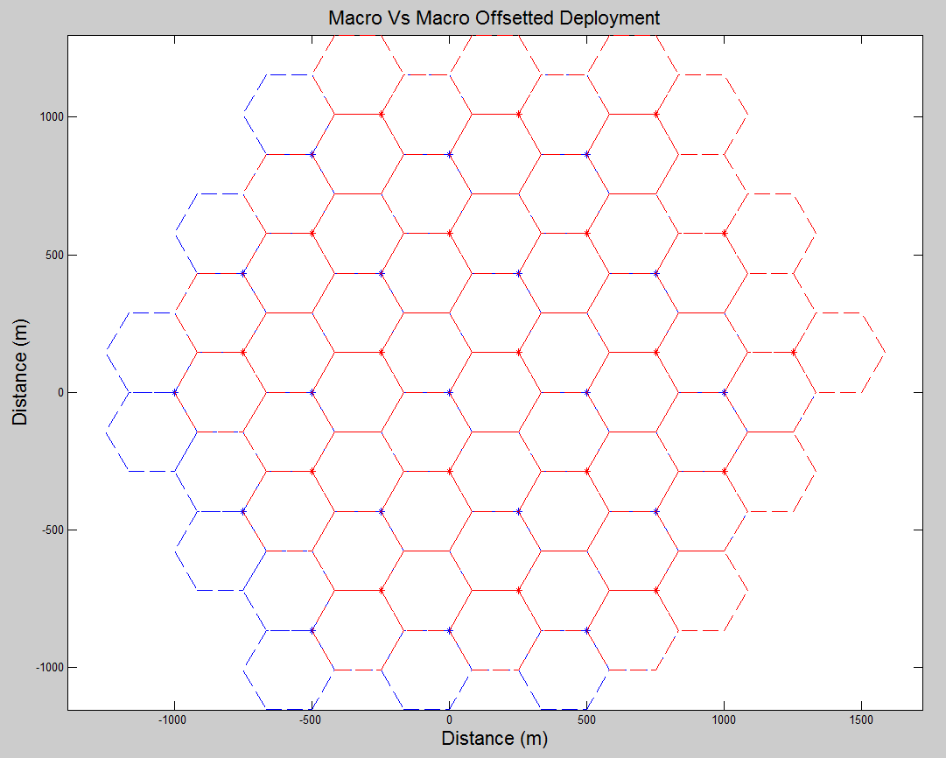

1. Macro - macro deployment scenario

The table below shows the average throughput degradation for

1. Uplink: when the uplink transmissions of the interfering system’s UEs cause interference to the uplink transmissions of the interfered links;
2. Downlink: when the downlink transmissions of the interfering system’s BS cause interference to the downlink transmissions of the interfered links.
3. Uplink and downlink UE throughput degradation

| **Additional  isolation  (dB)** | **UPLINK** | | **DOWNLINK** | | |
| --- | --- | --- | --- | --- | --- |
| **Average throughput**  **degradation** | **5% throughput degradation** | **Average throughput**  **degradation** | **5% throughput**  **degradation** | |
| **-13** | 13.143 % | 31.240 % | 9.502 % | | 52.995 % |
| **-8** | 5.704 % | 10.941 % | 4.829 % | | 26.280 % |
| **0** | 0.891 % | 1.683 % | 1.263 % | | 6.406 % |
| **2** | 0.316 % | 0.607 % | 0.811 % | | 3.515 % |
| **7** | 0.185 % | 0.185 % | 0.282 % | | 1.131 % |
| **12** | 0.105 % | 0.010 % | 0.093 % | | 0.650 % |
| **17** | 0.067 % | 0.001 % | 0.029 % | | 0.411 % |

For the UL scenario, the transmit power of the UEs is based on the power control algorithm previously agreed in 3GPP in [6] for macro UEs and is illustrated in the following figure:

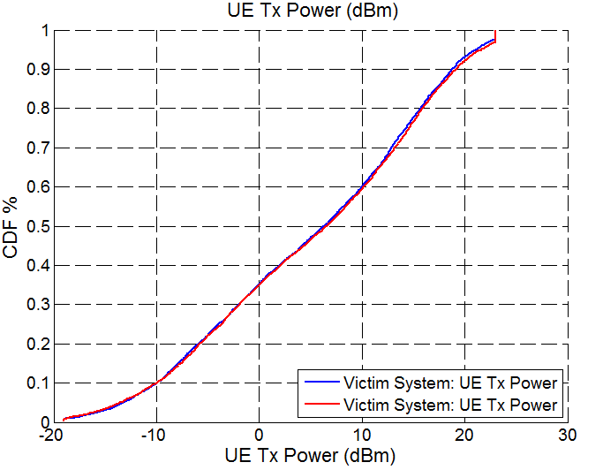

1. Uplink transmit power of the UEs

Table 56 articulates the throughput degradation for the average and cell edge UEs. For BS-BS type of interference, the significant need for additional isolation is clearly visible.

1. BS-to-BS scenario, UL throughput degradation

| **ACLRl  offset X  (dB)** | **BS-to-BS case (victim uplink)** | |
| --- | --- | --- |
| **Average throughput**  **degradation** | **5% degradation** |
| **0** | 100 % | 100 % |
| **2** | 100 % | 100 % |
| **7** | 100 % | 100 % |
| **12** | 99.927 % | 100 % |
| **17** | 87.548 % | 100 % |
| **22** | 61.755 % | 53.232 % |
| **27** | 35.215 % | 23.355 % |
| **32** | 15.422 % | 8.547 % |
| **37** | 5.577 % | 2.768 % |

* + 1. Marco - outdoor Manhattan micro scenario

This section imparts the simulation analysis for a macro - micro deployment, where the microcells are placed in a Manhattan grid (see [9] and [10] for details).

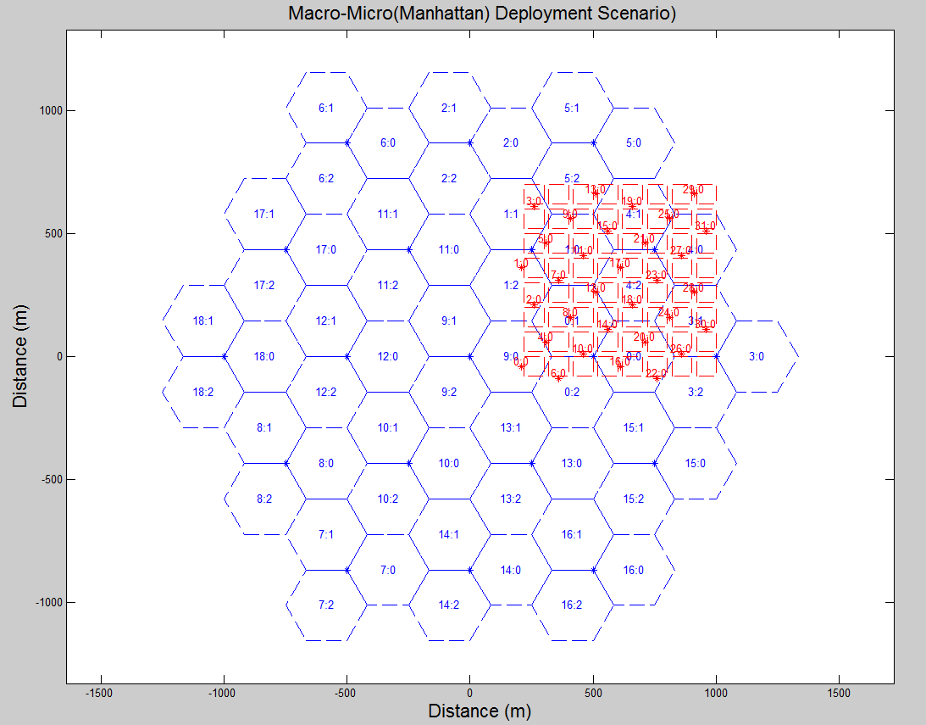

1. Macro – micro (Manhattan) deployment scenario

It is to be noted that, for the uplink scenario, the power control of the UEs previously agreed in 3GPP in [6] (for macro UEs) and in [11] (for micro UEs) has been employed and the power transmitted by the UEs and is illustrated in the following figure:

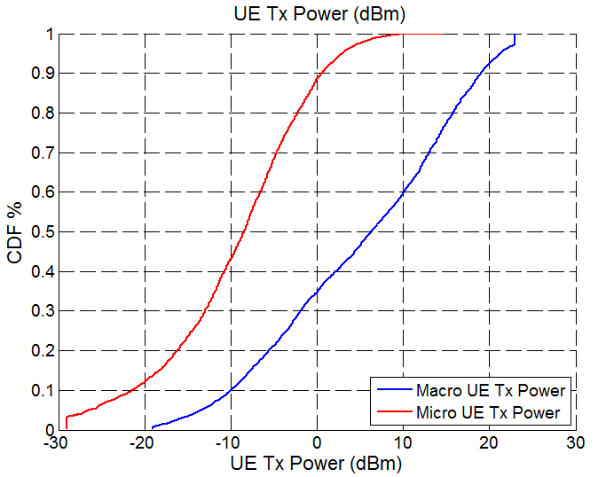

1. Uplink transmit power of the UEs

It can be observed that the transmit power of victim UEs (connected to micro BS) is much lower than the maximum available transmit power and there is room for increasing the transmit power to cater for high adjacent channel interference.

Macro as interferer

The results presented in this section are for the case when the macro system is operating as the interferer and the microcells placed in the Manhattan grid as shown in Figure 58 is the interfered system.

1. Uplink and downlink UE throughput degradation

| **Additional  isolation  (dB)** | **UPLINK** | | | **DOWNLINK** | | |
| --- | --- | --- | --- | --- | --- | --- |
| **Average throughput**  **degradation** | **5% throughput degradation** | | **Average throughput**  **degradation** | **5% throughput**  **degradation** | |
| **-13** | 19.50 % | | 30.119 % | 4.096 % | | 5.892 % |
| **-8** | 10.146 % | | 11.746 % | 1.523 % | | 2.630 % |
| **0** | 3.022 % | | 1.900 % | 0.627 % | | 1.572 % |
| **2** | 2.029 % | | 1.337 % | 0.168 % | | 0.0647 % |
| **7** | 0.796 % | | 0.0407 % | 0.0536 | | 0.0204 |
| **12** | 0.281 % | | 0.008 % | 0.0169 % | | 0.0064 % |
| **17** | 0.092 % | | 0.0027 % | 0.0053 % | | 0.002 % |

Micro as interferer

This section presents the results for the macro-micro scenario where the micro system is operating as the interferer and the macro system is the interfered system.

One important thing to note here is that the results contained in the table below is for one reference cell in the macro system, which is overlapped completely by the micro (Manhattan) grid see Figure 49. For the DL, only the UEs in this reference macrocell are considered and for the UL case, the BS of this reference cell is considered for evaluation.

1. Uplink and downlink UE throughput degradation

| **Additional  isolation  (dB)** | **UPLINK** | | | **DOWNLINK** | | |
| --- | --- | --- | --- | --- | --- | --- |
| **Average throughput**  **degradation** | **5% throughput degradation** | | **Average throughput**  **degradation** | **5% throughput**  **degradation** | |
| **-13** | 1.838 % | | 0.1991 % | 3.122 % | | 33.88 % |
| **-8** | 0.6703 % | | 0.0630 % | 1.617 % | | 31.73 % |
| **0** | 0.3766 % | | 0.0106 % | 0.468 % | | 12.278 % |
| **2** | 0.0729 % | | 0.0063 % | 0.314 % | | 7.665 % |
| **7** | 0.0232 % | | 0.0019 % | 0.1168 % | | 2.558 % |
| **12** | 0.0073 % | | 0.0006 % | 0.0393 % | | 0.823 % |
| **17** | 0.0023 % | | 0.0002 % | 0.0127 % | | 0.261 % |

* + 1. Macro – indoor micro (Manhattan grid layout)

This section provides more details on the scenario where the macro BS (in downlink) interferes with the UEs connected to micro or pico BS that are deployed indoors. A Manhattan deployment structure is employed for the simulations where one micro BS is placed inside each building. Under such a scenario, the performance of the UEs connected to the micro BS can vary depending on their location. For instance, if the UEs are located indoors, they will have better signal strength from the micro BS and incur lower interference from the macro BS at the same time. Thus, to investigate these varying constraints, two scenarios were simulated as follows:

* Case 1: All interfered micro UEs are located indoors (see Figure 60).
* Case 2: 50% of interfered micro UEs are located indoors (see Figure 61).



1. Case 1 configuration



1. Case 2 configuration

Figure 62 illustrates the deployment scenario where the micro system (in red) is placed in a Manhattan structure that is encapsulated within interfering (macro) system (in blue). The figure shows a zoomed in version for the deployment to illustrate the Manhattan grid, in the simulations: 57 macrocells were simulated.

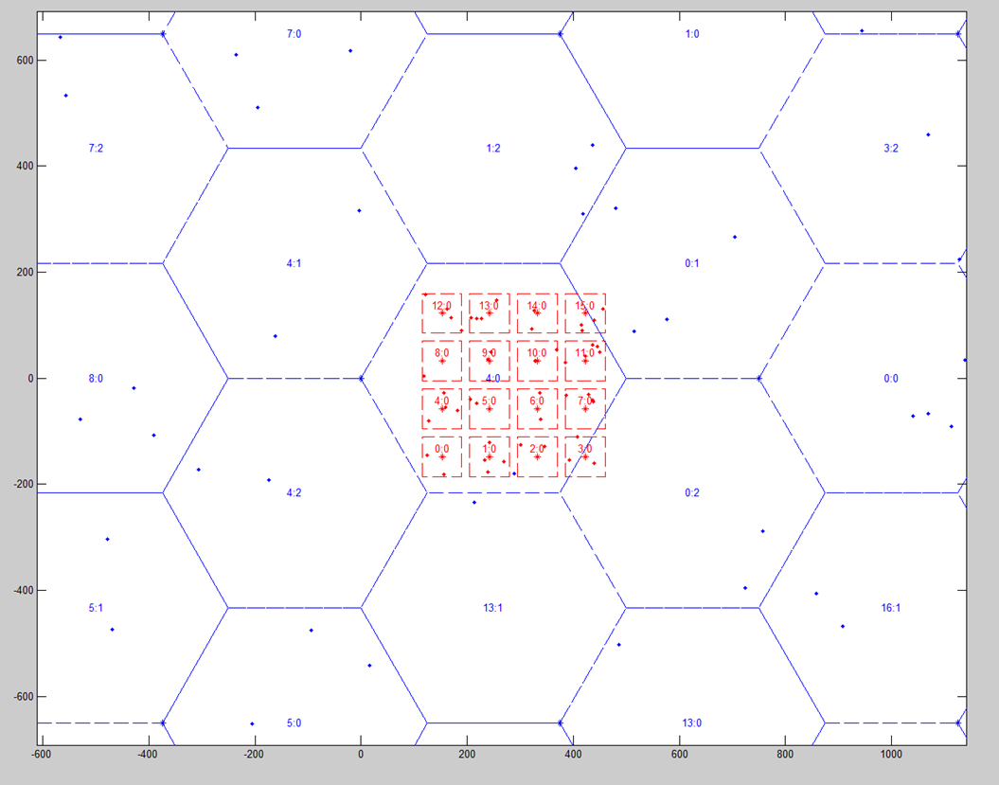

1. Deployment for macro-to-indoor micro scenario

The following figures illustrate the average throughput degradation in relation to the additional isolation between the two systems. The baseline throughput degradation is observed with additional isolation of 0 dB when two systems are operating in adjacent channel without any restricted channel between them.

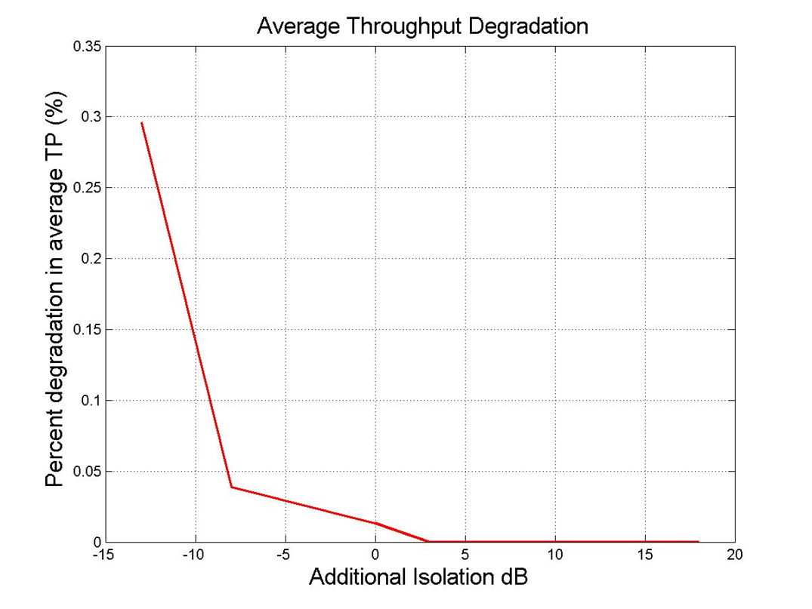

1. Average throughput degradation - additional isolation - case 1 (100% indoor UEs)

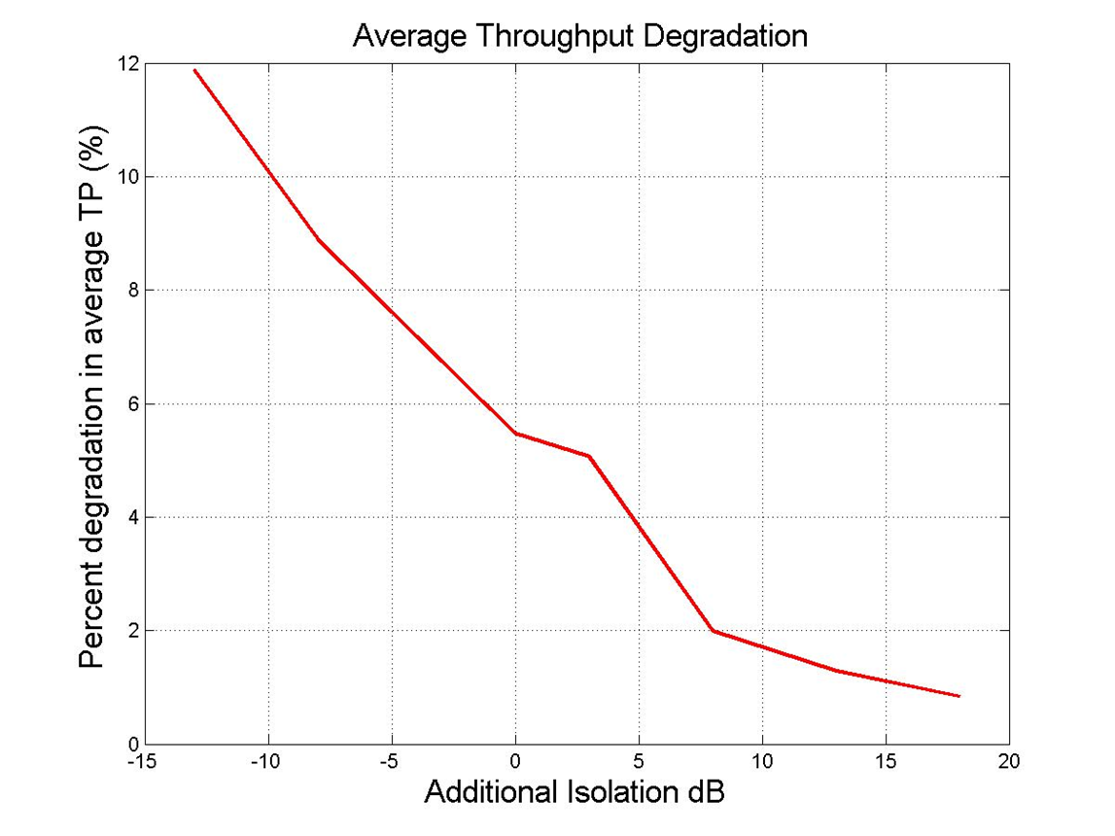

1. Average throughput degradation - additional isolation - case 2 (50% indoor UEs)
2. Average throughput degradation

| **Additional isolation (dB)** | **Macro – micro case 1** | **Macro - micro case 2** |
| --- | --- | --- |
| -13 | 0.3 % | 12 % |
| -8 | 0.05 % | 9 % |
| 0 | 0 % | 5.6 % |
| 3 | 0 % | 5 % |
| 8 | 0 % | 2 % |
| 13 | 0 % | 1.6 % |
| 18 | 0 % | 1 % |

* + 1. Macro – Indoor pico (Manhattan grid layout)

The macro - indoor pico scenario is essentially the same as the macro - indoor micro scenario, where both the interfered BS and UEs are located indoors in a Manhattan structure, with BS parameters adjusted to that of a pico BS. In this case, the impact of macro BS transmission in DL is observed on the interfered UEs connected to pico BS.

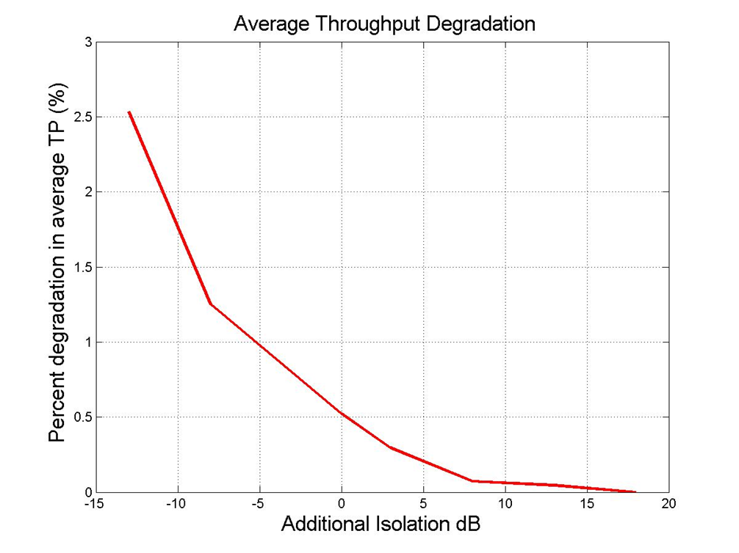

1. Average throughput degradation: macro-to-indoor pico (100% indoor UEs)
2. Average throughput degradation

| **Additional isolation**  **(dB)** | **Macro – pico** |
| --- | --- |
| -13 | 2.5 % |
| -8 | 1.3 % |
| 0 | 0.5 % |
| 3 | 0.1 % |
| 8 | 0 % |
| 13 | 0 % |
| 18 | 0 % |

* + 1. Outdoor micro (Manhattan) - outdoor micro (Manhattan) Scenario

The micro - micro case governs the scenario where two systems are being operated in a Manhattan structure as shown in the figure below (the dots in the Figure 66 below represent BS). The recursive street level propagation model (elaborated in Annex A1.3) is employed for this scenario. It is to be noted that the UEs in this scenario are also placed outdoors, on the vertical or horizontal streets.

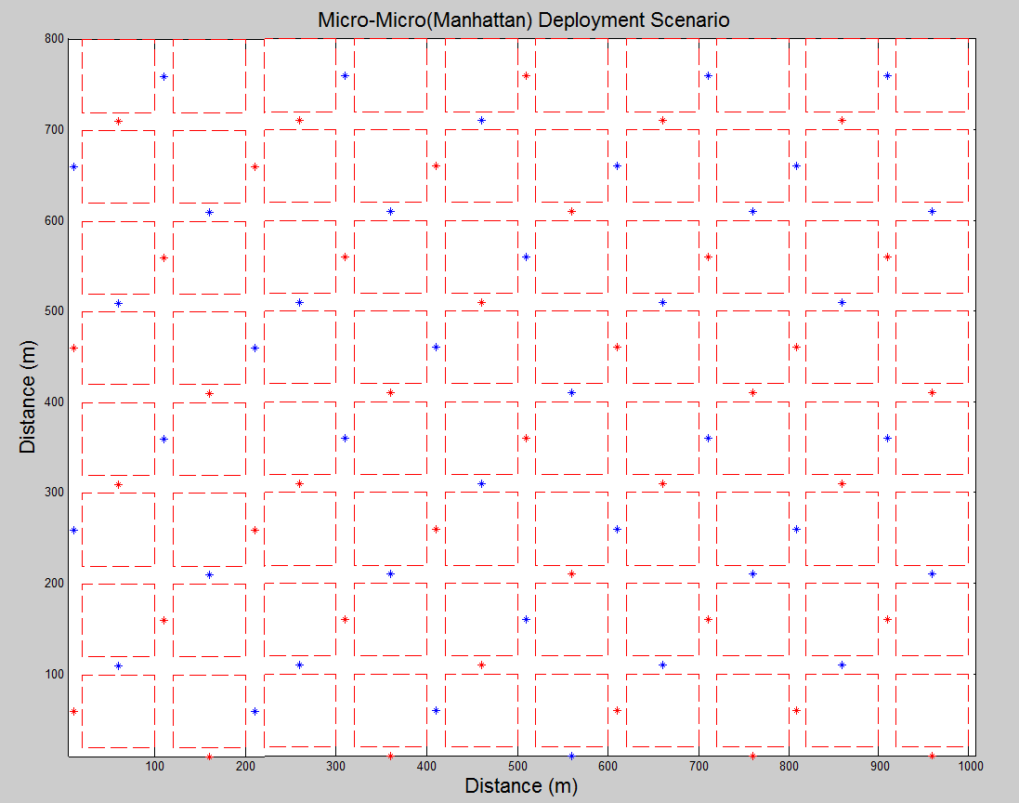

1. Micro - micro (Manhattan) deployment scenario

The transmit powers for the UL scenario are illustrated in Figure 67.

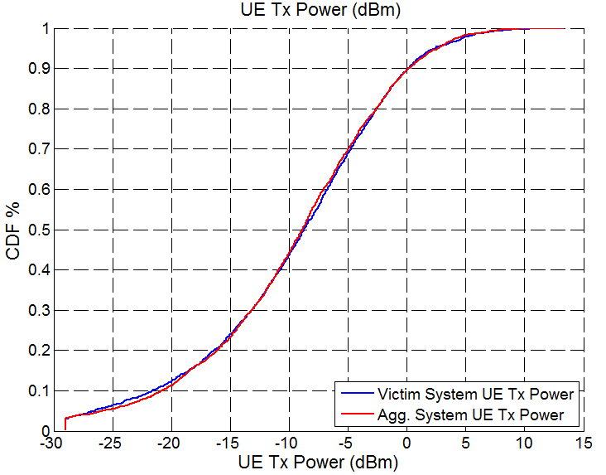

1. Transmit power for the UL scenario
2. Uplink and downlink UE Throughput degradation

| **Additional  Isolation  (dB)** | **UPLINK** | | **DOWNLINK** | |
| --- | --- | --- | --- | --- |
| **Average throughput**  **Degradation** | **5% throughput Degradation** | **Average throughput**  **Degradation** | **5% throughput**  **Degradation** |
| **-13** | 3.193 % | 1.277 % | 2.159 % | 6.210 % |
| **-8** | 1.299 % | 0.445 % | 0.763 % | 2.093 % |
| **0** | 0.289 % | 0.142 % | 0.138 % | 0.242 % |
| **2** | 0.182 % | 0.084 % | 0.0828 % | 0.188 % |
| **7** | 0.062 % | 0.026 % | 0.0264 % | 0.102 % |
| **12** | 0.020 % | 0.008 % | 0.0083 % | 0.101 % |
| **17** | 0.006 % | 0.002 % | 0.0026 % | 0.084 % |

* + 1. Indoor micro - indoor micro (Manhattan grid layout)

The indoor micro - micro scenario represents the case when two operators place BS in the same building. A Manhattan deployment structure was employed in the simulation analysis with varying building sizes, where both the BS and UEs were placed indoors. The propagation model employed is Report ITU-R M.2135 [7] propagation (as elaborated in Annex A1.2). Furthermore, the performance of the interfered system can vary between the co-located and non-collocated scenario. Thus four different cases were considered to investigate the interfered system performance, as follows:

* Case 1: Non-co-located scenario, with size of building (75x75 m) – Figure 68;
* Case 2: Non-co-located scenario, with size of building (50x50 m) – Figure 68;
* Case 3: Co-located scenario, with size of building (75x75 m) – Figure 69;
* Case 4: Co-located scenario, with size of building (50x50 m) – Figure 69.



1. Non-co-located indoor scenario



1. Co-located indoor scenario

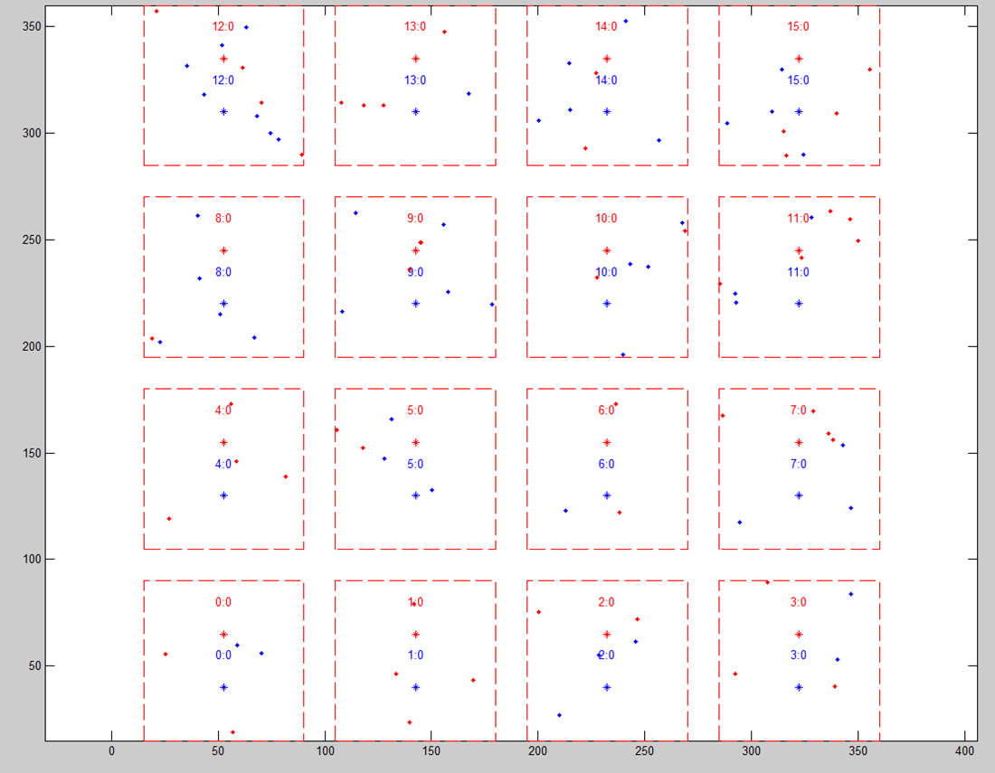

1. Deployment non-co-located scenario

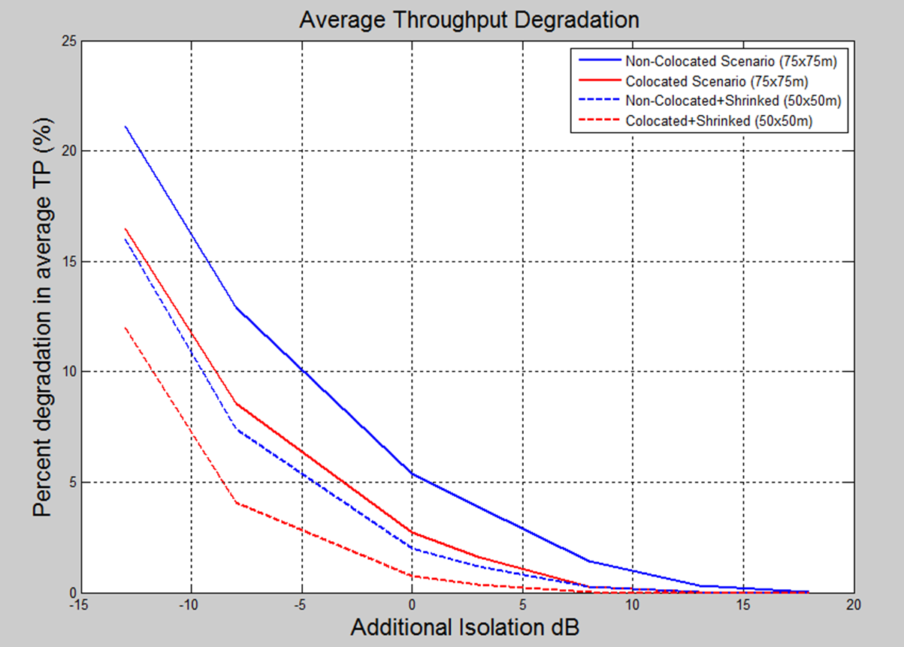

1. Average throughput degradation
2. Average throughput degradation for indoor micro - indoor micro scenario

|  | **Non-Colocated (75x75m)** | **Colocated (75x75m)** | **Non-Colocated (50x50m)** | **Colocated (50x50m)** |
| --- | --- | --- | --- | --- |
| Add. Isolation = -13 dB | 21% | 16.4% | 16% | 12% |
| Add. Isolation = -8 dB | 13% | 8.5% | 7.4% | 4.07% |
| Add. Isolation = 0 dB | 5.4% | 2.7% | 1.9% | 0.73% |
| Add. Isolation = 3 dB | 3.8% | 1.6% | 0.2% | 0.34% |
| Add. Isolation = 8 dB | 1.4% | 0.28% | 0.2% | 0% |
| Add. Isolation = 13 dB | 0.3% | 0% | 0% | 0% |
| Add. Isolation = 18 dB | 0% | 0% | 0% | 0% |

* + 1. Indoor micro - indoor pico (Manhattan grid layout)

The micro - pico scenario is essentially the same as the indoor micro - micro scenario as elaborated in the previous section, where the BS are located indoors in a Manhattan structure, with interfered BS parameters adjusted to that of a pico BS. However, having only collocated BS deployment was considered for the simulations as the comparison between co-located and non-co-located BS deployment for micro-to-micro BS showed the benefits of co-location for indoor scenarios. Moreover, the size of the buildings was reduced to suite the coverage area for a pico BS. In summary, the following two scenarios were simulated:

* Case 1: Micro-to-pico co-located scenario, with size of building (50x50 m) – Figure 72;
* Case 2: Micro-to-pico co-located scenario, with size of building (40x40 m) – Figure 72.

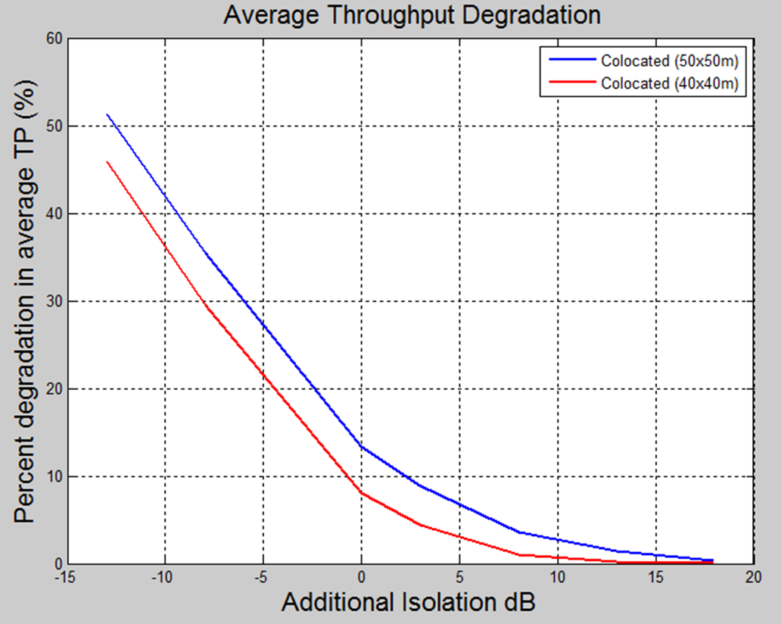

1. Average throughput degradation (Micro – pico scenario)
2. Average throughput degradation for indoor Micro- indoor pico scenario

|  | **Colocated  (50x50m)** | **Colocated  (40x40m)** |
| --- | --- | --- |
| Add. Isolation = -13 dB | 50.6% | 45.6% |
| Add. Isolation = -8 dB | 35.4% | 29.4% |
| Add. Isolation = 0 dB | 13.3% | 8.0% |
| Add. Isolation = 3 dB | 8.83% | 4.4% |
| Add. Isolation = 8 dB | 3.55% | 1% |
| Add. Isolation = 13 dB | 1.48% | 0.25% |
| Add. Isolation = 18 dB | 0.39% | 0% |

1. UE BEM DISCUSSION FROM CEPT REPORT 39

The following is an excerpt from CEPT Report 39 [38], Section 2.4, discussing the BEM in relation to ETSI harmonised standards.

**Technical conditions applying to terminal equipment**

Another concern is about the management within the EU of interference between terminals. Since they are not included in the relevant EC decisions, CEPT assumes that these conditions have to be taken into account with care when developing harmonised standards by ETSI. There may be an issue because within the EU, mobile terminals are generally exempted from individual licensing and also because network operators are required to connect terminal stations having an appropriate interface and meeting the essential requirements of Article 3 of the R&TTE Directive [48] (in the context of spectrum masks, the relevant provision is Article 3.2, relating to harmful interference). To ensure that interference between terminals is managed effectively it is therefore extremely important that ETSI takes account of relevant ECC work on WAPECS bands – amending their harmonised standards as necessary. It has to be noted that some administrations assume that interference between terminals will be successfully handled by ensuring conformity to the R&TTE Directive – if ETSI does not take this issue into account in the development of harmonised standards then this may not be a safe assumption.

The R&TTE Directive relates to both placing equipment on the market and putting it into service. In the past, there has generally been a one-to-one correspondence between harmonized standard, application/technology and frequency band (i.e., one applicable harmonized standard for an application or technology in a particular frequency band), and the national measures for license exemption have almost always been based on this standard. In other words, the spectrum emission mask for the terminal relative to the nominal channel edge will be the same as the block edge mask relative to the block edge, or more stringent.

However, this one-to-one correspondence may not necessarily apply under the WAPECS concept. There might be different criteria for putting equipment into service, associated with different operational restrictions. Without the appropriate directions given in the harmonised standards to ensure compliance, this could lead to a non-compliance with the CEPT sharing criteria. Therefore it is important to ensure that the development of harmonised standards takes account of the sharing criteria developed by CEPT for terminals in order to avoid such non-compliances.

* Only few administrations referred to additional technical conditions for terminal equipment on the basis of CEPT or ECC reports.
* One administration refers explicitly to these technical conditions even in the licensing process.

This is clearly an area for which the RSPG Opinion on streamlining of regulatory environment [47] is particularly relevant. CEPT should cooperate with ETSI to ensure that development of harmonised standards will include instructions on how the CEPT sharing criteria can be met by equipment.”

1. co-existence between Mfcn and fss
   1. SUMMARY OF FSS CO-EXISTENCE ANALYSIS IN ECC REPORT 100

The following is a summary of Section 5.4 of ECC Report 100 [16].

The BWA system characteristics in the analysis are as follows (Table 5.4.1 of Report 100):

1. Basic BWA characteristics used for the sharing with FSS

|  | **BWA CS** | | **BWA TS** | | |
| --- | --- | --- | --- | --- | --- |
| **CS-1 (critical case)** | **CS-2 (typical)** | **TS-1  (critical case)** | **TS-2 (typical)** | **TS-3 (“Omni”)** |
| TX peak output power (dBm) | 43  (for nomadic) | 35 | 30 | 22 | 20 |
| Channel bandwidth  (MHz) | 7 | 7 | 7 | 7 | 7 |
| Feeder loss  (dB) | 1 | 1 | 1 | 1 | 1 |
| Power control (dB) | 0 | 0 | 0-30 dB  (12 dB) | 0-30 dB  (12 dB) | 0-30 dB  (12 dB) |
| Peak antenna gain  (dBi) | 17 | 17 | 20 | 10 | 0 |
| Antenna gain pattern | Rec. ITU-R F.1336 | Rec. ITU-R F.1336 | Rec. ITU-R F.1336 | Rec. ITU-R F.1336 | Omni |
| Antenna elevation  (deg) | 0 | 0 | 0 | 0 | 0 |
| Antenna height a.g.l.  (m) | 50 | 30 | 20 | 10 | 1.5 |
| Noise figure  (dB) | 5 | 5 | 7 | 7 | 7 |
| Receiver noise in reference bandwidth of 4 kHz  (dBW) | -163.0 | -163.0 | -161.0 | -161.0 | -161.0 |
| Number of co-channel TSs per CS | n/a | n/a | 16 with 25% activity factor | 16 with 25% activity factor | 16 with 25% activity factor |

The characteristics are not identical to those expected for the MFCN networks studied, but similar enough to make the results relevant. CS-1 bandwidth is 7 MHz and the antenna height is 50 m instead of 30 m, but is otherwise the same as for a MFCN base station according to Tables 7 and 9. CS-2 also has 7 MHz bandwidth and 35 dBm output power, but is otherwise the same as a MFCN base station. As for the TSs, the bandwidth and TX output power is slightly lower than for a MFCN UE, but the distance is very small.

Earth Station parameters for six different types are presented in Table 65 below (Table 5.4.2 from ECC Report 100 [16]).

1. ES parameters

|  | **ST-1** | **ST2** | **ST3** | **ST4** | **ST5** | **ST-6** |
| --- | --- | --- | --- | --- | --- | --- |
| Antenna Diameter (m) | 4.5 | 4.5 | 8 | 8 | 32 | 32 |
| Gain (dBi) | 42.6 | 42.6 | 47.7 | 47.7 | 59.8 | 59.8 |
| Antenna Diagram | ITU-R S.465 | ITU-R S.465 | ITU-R S.465 | ITU-R S.465 | ITU-R S.465 | ITU-R S.465 |
| Antenna Height (m) | 3 | 3 | 5 | 5 | 25 | 25 |
| Noise temperature (K) | 70 | 70 | 82 | 82 | 70 | 70 |
| Elevation angle (°) | 4 | 33 | 4 | 33 | 4 | 33 |
| Azimuth (°) | 104 | 190 | 104 | 190 | 104 | 190 |

Interference from BWA CSs into FSS ES receivers is summarized in Table 66 (Table 5.4.3 of ECC Report 100). The results are expressed as mitigation distances, “which is defined as the geographical area delimited by the distance on a given azimuth and elevation from an ES, sharing the same frequency band with terrestrial stations, within which there is a potential for the level of permissible interference to be exceeded and co-ordination is necessary to ensure successful operation between terrestrial stations and ES.”

The results are for co-channel interference, from a single MFCN BS, and for a “generic scenario” without terrain profile included in the propagation calculations. The separation distances correspond to I/N values no lower than -10 dB for 20% of the time. No short-term interference has been considered here. For such an analysis a terrain model must be incorporated (see further below)

Based on the comparison between the BWA parameters in this study and those expected for MFCN BSs, mitigation distances for MFCN can be expected to be somewhere in-between those of CS-1 and CS-2. Note that in reality operation of BWA stations within the mitigation distances may be possible due to the influence of the terrain and clutter.

1. Summary of mitigation distances

| **Type of FSS ES** | **Interfering BWA station**  **CS-1** | **Interfering BWA station**  **CS-2** |
| --- | --- | --- |
| Distance (km) | Distance (km) |
| ST 1 | 122 | 71 |
| ST 2 | 53 | 43 |
| ST 3 | 119 | 68 |
| ST 4 | 55 | 44 |
| ST 5 | 128 | 76 |
| ST 6 | 67 | 56 |

Sensitivity to variations in three different parameters are presented in Figure 5.4.4 of Report 100 [16]: off-axis angle, elevation angle and ES antenna diameter. Off-axis angle and elevation angle of the ES may influence mitigation distances considerably.



1. Influence of the FSS ES and BWA CS parameters on the mitigation area

Examples of ES co-existence based on propagation with terrain profile and incorporating short-term interference are also provided. The parameters and results from two of those are presented in Tables 67 and 68 respectively (from Section 5.4.2.4 of Report 100 [16]).

1. Details of two combined ES sites used in detailed analysis

| **Brookmans Park** |  |
| --- | --- |
| Location | N51:43:44, W0:10:39 |
| Antenna height a.g.l. (m) | 5 |
| Antenna gain (dBi) | 47.7 |
| Antenna elevation (deg) | 31 |
| Antenna azimuth (deg) | 180 |
| Delta N | 45 |
| **Goonhilly** |  |
| Location | N50:02:55, W5:10:46 |
| Antenna height a.g.l. (m) | 25 |
| Antenna gain (dBi) | 59.8 |
| Antenna elevation (deg) | 32 |
| Antenna azimuth (deg) | 173 |
| Delta N | 45 |

1. Maximum mitigation distances (in km) required to protect site specific FSS ES receivers without the additional clutter loss

| **Type of interfering BWA/BWA station** | **FSS ES Antenna 8 m diameter (47.7 dBi gain) at Brookmans Park** | | | **FSS ES Antenna1 32 m diameter (59.8 dBi gain) at Goonhilly** | | |
| --- | --- | --- | --- | --- | --- | --- |
| **Long Term Propagation** | **Short Term Propagation** | **Maximum mitigation distance** | **Long Term Propagation** | **Short Term Propagation** | **Maximum mitigation distance** |
| CS-1 | 100 | 3002 | **300** | 115 | 3202 | **3202** |
| CS-2 | 80 | 2252 | **2252** | 100 | 2702 | **2702** |

Aggregation of interference to ESs by multiple base stations has also been studied, with the result that depending on BWA deployment, the increase in distance may be between 15 and 25%.

The analysis of BWA TS interference to ESs show that in all cases a co-ordination between the CS and the ES is sufficient to protect the FSS ES from both the BWA CS and the BWA TS, due to the considerably shorter separation distance required for TSs.

Two types of adjacent band interference mechanisms were studied, unwanted emissions from BWA stations and saturation of ES LNBs, assuming that they have been made to receive in the entire 3400-4200 MHz band. Separation distances due to the first type of interference are summarized in Table 69 below (Table 5.4.10 of ECC Report 100) and those due to the second type in Tables 70 and 71 (Tables 5.4.11 and 5.4.12 of ECC Report 100 [16]).

1. Summary of required separation distance between BWA CS or TS and FSS ES

| **Type of BWA Station** | **FSS ES antenna off-axis angle** | **Required Separation Distance  (km)** |
| --- | --- | --- |
| CS-1 and CS-2 | 5° | 1.087-4.33 |
| 15° | 0.277-1.1 |
| 30° | 0.117-0.464 |
| TS-1 | 5° | 13.7 |
| 15° | 3.48 |
| 30° | 1.47 |
| TS-2 (Indoor)(1) | 5° | 0.77 |
| 15° | 0.196 |
| 30° | 0.083 |
| TS-3 (Mobile) | 5° | 1.37 |
| 15° | 0.348 |
| 30° | 0.147 |

(1) For indoor TS (TS-2), an additional excess path loss of 15 dB for building penetration is taken into account in calculating separation distances given in table 5.4.10. (this note is from ECC Report 100 [16])

1. Required separation distance between BWA CS and FSS ES to avoid LNB saturation

|  | **CS-1** | | | **CS-2** | | |
| --- | --- | --- | --- | --- | --- | --- |
| Arrival angle of BWA signal at FSS E/S | 5 | 15 | 30 | 5 | 15 | 30 |
| FSS E/S antenna off-axis gain (dBi)1 | 14.5 | 2.6 | -4.9 | 14.5 | 2.6 | -4.9 |
| BWA e.i.r.p. (dBm) | **60** | | | **52** | | |
| LNB Saturation Level (dBm) | **50** | | | | | |
| Excess over LNB Saturation Level (dB) | 124.5 | 112.6 | 105.1 | 116.5 | 104.6 | 97.1 |
| Frequency (MHz) | **3700** | | | | | |
| Required Separation Distance (km) | 10.89 | 2.76 | 1.16 | 4.33 | 1.10 | 0.46 |

1. Required separation distance between BWA TS and FSS ES to avoid LNB saturation

|  | **TS-1** | | | **TS-2 (Indoor)2** | | | **TS-3 (Mobile)** | | |
| --- | --- | --- | --- | --- | --- | --- | --- | --- | --- |
| Arrival angle of BWA signal at FSS E/S | 5 | 15 | 30 | 5 | 15 | 30 | 5 | 15 | 30 |
| FSS E/S antenna off-axis gain (dBi)1 | 14.5 | 2.6 | -4.9 | 14.5 | 2.6 | -4.9 | 14.5 | 2.6 | -4.9 |
| BWA e.i.r.p.  (dBm) | 50 | | | 32 | | | 20 | | |
| LNB Saturation Level (dBm) | 50 | | | | | | | | |
| Excess over LNB Saturation Level (dB) | 114.5 | 102.6 | 95.1 | 96.5 | 84.6 | 77.1 | 84.5 | 72.6 | 65.1 |
| Frequency  (MHz) | 3700 | | | | | | | | |
| Required Separation Distance  (km) | 3.44 | 0.87 | 0.37 | 0.43 | 0.11 | 0.05 | 0.11 | 0.03 | 0.01 |

Interference from FSS spacecraft into BWA stations may exceed the required interference criterion by a few dB in few cases however the probability of such cases is expected to be low.

* 1. Summary of FSS co-existence analysis in ITU-R Report M.2109

This Report provides a summary of the sharing studies between IMT‑Advanced systems and geostationary satellite networks in the fixed-satellite service (FSS) in the 3400-4200 and 4500-4800 MHz bands.

The table below contains the FSS parameters used in the analysis. In addition, the following parameters were used:

* Antenna diameters: 2.4 m and 11m (feeder link);
* Antenna heights: 30 m (urban case) and 3m (rural case).

1. Typical downlink FSS parameters in the 4 GHz band

| **Parameter** | **Typical value** | | | | | | |
| --- | --- | --- | --- | --- | --- | --- | --- |
| Range of operating frequencies | 3400-4200 MHz, 4500-4800 MHz | | | | | | |
| Earth station off-axis gain towards the local horizon (dBi)(1) | Elevation Angle(2) | 5° | 10° | 20° | 30° | 48° | >85° |
| Off-axis gain | 14.5 | 7.0 | –0.5 | –4.9 | –10 | 0 |
| Antenna reference pattern | Recommendation ITU‑R S.465 (up to 85°) | | | | | | |
| Range of emission bandwidths | 40 kHz – 72 MHz | | | | | | |
| Receiving system noise temperature | 100 K | | | | | | |
| Earth station deployment | All regions, in all locations (rural, semi-urban, urban)(3) | | | | | | |
| (1) The values were derived by assuming a local horizon at 0° of elevation.  (2) 5° is considered as the minimum operational elevation angle.  (3) FSS antennas in this band may be deployed in a variety of environments. Smaller antennas  (1.8 m-3.8 m) are commonly deployed on the roofs of buildings or on the ground in urban, semi-urban or rural locations, whereas larger antennas are typically mounted on the ground and deployed in semi‑urban or rural locations. | | | | | | | |

## IMT In-band parameters

The table below contains the IMT-Advanced parameters used in the analysis.

1. IMT-Advanced base station parameters

| Parameter | Value | Value considered in the simulations |
| --- | --- | --- |
| e.i.r.p. density range: macro base station scaled to 1 MHz bandwidth | 39 to 46 dBm/MHz | 46 dBm/MHz |
| e.i.r.p. density range: micro base station scaled to 1 MHz bandwidth | 15 to 22 dBm/MHz | 22 dBm/MHz |
| Maximum e.i.r.p.(1)  (Transmitter output power + antenna gain – feeder loss) | 59 dBm (macro base station) 35 dBm (micro base station) |  |
| Antenna type (Tx/Rx)  (the gain is assumed to be flat within one sector) | Sectored for macrocell omni for microcell |  |
| Receiver thermal noise (including noise figure) | –109 dBm/MHz |  |
| Protection criterion (*I*/*N*) interference to individual base station | –6 dB or –10 dB(2) |  |
| Protection criterion (*I*/*N*) vs satellite systems | –10 dB |  |
| (1) e.i.r.p. range of values assume range of frequency bandwidth between 20 and 100 MHz.  (2) This value has to be used when assessing compatibility between a non primary allocated system and a primary allocated system (e.g. between UWB and IMT-Advanced). | | |

1. IMT-Advanced mobile station parameters

| Parameter | Value | Value to be considered in the simulations | |
| --- | --- | --- | --- |
| Maximum Tx PSD range output power(1) | 4 to 11 dBm/MHz | 7.5 dBm/MHz(2) | |
| Maximum e.i.r.p. | 24 dBm |  | |
| Receiver thermal noise (dBm/MHz) (Including noise figure) | –109 to –105 dBm/MHz |  | |
| Protection criterion (*I*/*N*) | –6 dB |  | |
| (1) With reference signal bandwidth between 20 and 100 MHz.  (2) A median value is selected considering the effect of automatic transmit power control (ATPC). | | | |

1. IMT-Advanced network parameters

| Parameter | Value |
| --- | --- |
| Macrocell antenna gain | 20 dBi |
| Microcell antenna gain | 5 dBi |
| Macrocell feeder loss | 4 dB |
| Microcell feeder loss | 0 dB |
| Antenna pattern for vertical sharing | Rec. ITU-R F.1336 |
| Mobile station antenna gain | 0 dBi |
| Base station Antenna downtilt (Micro) | 0 degree |
| Base station Antenna downtilt (Macro) | 2 degrees |
| Base station antenna height (Micro) | 5 m |
| Base station antenna height (Macro) | 30 m |
| Mobile station antenna height (mobile station) | 1.5 m |
| Intersite distance (Micro) | 600 m |
| Intersite distance (Macro) | 5 km |
| Intersite distance (Macro) for urban case | 1,5 km |
| Active users density (Dense Urban/Macro) | 18/km² |
| Active users density (Dense Urban/Micro) | 115/km² |
| Active users density (Suburban/Macro) | 15/km² |
| Active users density (Suburban /Micro) | 19/km² |
| Frequency reuse pattern | 1 and 6 |

## IMT Out-of-Band parameters

The following values were assumed to define the spectrum mask, valid for the bandwidths between 20 MHz and 100 MHz, where the 3rd adjacent channel and above has been calculated based on spurious emission:

1. IMT-Advanced out-of-band parameters

| Offset | ACLR limit |
| --- | --- |
| 1st adjacent channel | 45 dB |
| 2nd adjacent channel | 50 dB |
| 3rd adjacent channel and above | 66 dB |

## Results

11 different studies were carried out with varying assumptions on propagation, single vs aggregate interference and compliance with FSS and IMT parameters above. The table below presents the results in terms of required separation distances for both long-term and short-term interference for the case of flat terrain (generic study). Upper and lower bounds are provided, based on the different studies. The differences in results depend on assumptions about FSS ES antenna elevation angles, propagation models, interference apportionment, BS downtilt, etc.

Analysis was also carried out for specific cases, i.e. with terrain information included in the propagation calculations. The results are similar to those for the generic case, but, as expected, with a somewhat higher variance in separation distances, as terrain may both shelter from interference and reduce the propagation loss.

1. Separation distances (km) for generic (flat terrain) interference analysis

|  | **Macro BS** | **Micro BS** | **Mobile Station** |
| --- | --- | --- | --- |
| Co-channel Long-term Single interferer | 33 – 70 | 15 – 50 | 0 – 1.5 |
| Co-channel Long-term Aggregate interference | 51 – 61 | 46 – 58 | 0 – 1.5 |
| Co-channel Short-term Single interferer | 34 – 430 | N.A. | 1.5 |
| Adjacent channel Long-term Single interferer | 0.07 – 80 | 2 – 51 | 0.5 – 32.5 |
| Adjacent channel Long-term Aggregate interference | 0.35 – 45 | 4 – 35 | N.A. |
| LNA/LNB saturation Long-term Single interferer | 10 – 30 | 0.6 – 2 | 0.17 – 0.55 |

Different mitigation techniques were also investigated:

1. Sector disabling: One way to reduce the transmitting output power level could be to disable the antenna sector that points towards the FSS earth station, noting that such an area would be covered through the use of other frequency bands by IMT-Advanced systems. Compared with normal full active sector mode, the application of this mitigation technique has shown that the separation distance ranges are reduced by between 0 and 49% in generic studies (without terrain horizon profile) and between 0 and 83% for one specific site (with terrain horizon profile).
2. MIMO: By using this technique, a gain reduction in the base station transmit antenna diagram is generated towards the interfered FSS earth station. By using the MIMO technique, the minimum separation distance is 35 m in case of an IMT-Advanced base station and single FSS receiving earth station under the assumption of 0o direction of earth station (DOE) estimation error which implies that null beam to the FSS receiving earth station is formulated perfectly. In the case of an IMT-Advanced base station and 3 FSS receiving earth stations, the minimum separation distance increases up to 3.5 km under the same assumptions. Other results have shown that under the assumption of 8° DOE estimation error, the minimum separation distances is 22 km, but this still reduces the minimum separation distance by approximately 50% in the considered case.As for the sector disabling technique, this approach would require the use of other frequencies to cover the area where the base transmit antenna gain is reduced.
3. Site shielding: In Recommendation ITU-R SF.1486 [23], interference attenuation effect, in a range about 30 dB, due to the site shielding isolation obtained by providing physical or natural shielding at the FSS earth stations is described. If such shielding isolation is taken into account, the required separation distance to protect FSS earth station receivers from IMT-Advanced transmitters can be reduced. However, the required distance separation between IMT-Advanced transmitter and a FSS receiving earth station using site shielding has to be evaluated on a site-by-site basis and is dependent on characteristics and location of each site. The possibility of applying site shielding may not be guaranteed for all sites.
4. Antenna downtilting: A possible mitigation technique to improve sharing is antenna downtilting at the IMT-Advanced base stations. One study shows that for one specific site in urban macro environment, the required separation distance is decreased by approximately 30% and 50% for the long-term and short-term interference criteria, respectively, when the antenna downtilt at IMT-Advanced transmitter is changed from 2° to 7°. However, the impact of this technique may vary for different locations and results may be different at other locations.
5. Dynamic spectrum allocation: If information can be made available to IMT-advanced networks what FSS channels are used at a specific point in time, free spectrum may be used dynamically. This may be achieved with a database that is updated dynamically.
6. Usage of beacon: A beacon that is transmitted from the FSS earth station locations may provide dynamic information on its spectrum usage, and could thus provide information to IMT-Advanced systems on unused spectrum.

With respect to co-channel interference from FSS into IMT-Advanced, studies have provided a range of margins relative to the required *I*/*N* criterion (from 9 to –11 dB) depending on the assumptions (particularly the type of IMT-Advanced base station considered and the FSS space station e.i.r.p. density). As a result, the IMT-Advanced base and mobile stations may experience interference from emissions of authorized satellite networks.

1. co-existence between MFCN and RADIOLOCATION services

The sections below summarize results obtained in previous studies of ECC and ITU-R related to adjacent band co-existence between MFCN/BWA above 3400 MHz and Radiolocation, which in Region 1 has a primary allocation in 3300-3400 MHz.

According to the EFIS database, the Radiolocation band below 3400 MHz is used for military and civil (including airborne) Radiolocation. Furthermore it may be used for meteorological purposes, although there is no allocation for that in the Radio Regulations. Although the radar and MFCN parameters may not be identical to what was assumed in the studies below, the results should give a good overall view of co-existence characteristics between MFCN networks and the Radiolocation service.

* 1. Summary of Radiolocation co-existence analysis in ECC Report 100

The following is a summary of Section 5.5 and Annexes 6 and 7 of ECC Report 100 [16].

For the purpose of studies, representative characteristics of radar systems can be found in Recommendation ITU-R M.1465 [24] “Characteristics of, and protection criteria for radars operating in the radiodetermination service in the frequency band 3100-3700 MHz”. These typical characteristics are provided in the table below.

1. Table of characteristics of radiolocation systems in the band 3100-3700 MHz

| **Parameter** | **Land-based systems** | | **Ship systems** | | | **Airborne system** | |
| --- | --- | --- | --- | --- | --- | --- | --- |
| A | B | A | **B** | | **A** | |
| Use | Surface and air search | Surface search | Surface and air search | | | Surface and air search | |
| Modulation | P0N/Q3N | P0N | P0N | Q7N | | Q7N | |
| Tuning range (GHz) | 3.1-3.7 | | 3.5-3.7 | 3.1-3.5 | | 3.1-3.7 | |
| TX power into antenna (kW) (Peak) | 640 | 1000 | 850 | 4000 | | 1000 | |
| Pulse width (s) | 160-1000 | 1.0-15 | 0.25, 0.6 | 6.4-51.2 | | 1.25(1) | |
| Repetition rate (kHz) | 0.020-2 | 0.536 | 1.125 | 0.152-6.0 | | 2 | |
| Compression ratio | 48000 | Not applicable | Not applicable | 64-512 | | 250 | |
| Type of compression | Not applicable | Not applicable | Not applicable | CPFSK | | Not applicable | |
| Duty cycle (%) | 2-32 | 0.005-0.8 | 0.28, 0.67 | 0.8-2.0 | | 5 | |
| TX bandwidth (MHz) (–3 dB) | 25/300 | 2 | 4, 16.6 | 4 | | > 30 | |
| Antenna gain | 39 | 40 | 32 | 42 | | 40 | |
| Antenna type | Parabolic | | Parabolic | PA | | SWA | |
| Beamwidth (H,V) (degrees) | 1.72 | 1.05, 2.2 | 5.8, 4.5 | 1.7, 1.7 | | 1.2, 3.5 | |
| Vertical scan type | Not applicable | Not applicable | Not applicable | Random | | Not applicable | |
| Maximum vertical scan (degrees) | 93.5 | Not applicable | Not applicable | 90 | | 60 | |
| Vertical scan rate (degrees/s) | 15 | Not applicable | Not applicable | | | Not available | |
| Horizontal scan type | Not applicable | Rotating | Rotating | | Random | Rotating | |
| Maximum horizontal scan (degrees) | 360 | | 360 | | | 360 | |
| Horizontal scan rate (degrees/s) | 15 | 25.7 | 24 | | Not applicable | 36 | |
| Polarization | RHCP | V | H | | V | Not available | |
| Rx sensitivity (dBm) | Not available | -112 | -112 | | Not available | Not available | |
| *S*/*N* criteria (dB) | Not available | 0 | 14 | | Not available | Not available | |
| Rx noise figure (dB) | 3.1 | Not available | 3 | | Not available | 3 | |
| Rx RF bandwidth (MHz) (–3 dB) | Not available | 2.0 | Not available | | | Not available | |
| Rx IF bandwidth (MHz) (–3 dB) | 380 | 0.67 | 8 | | Matched to emission | 1 | |
| Deployment area (1 000 km2) | 32 | 1468 | 188 | | 511 | Worldwide | |
| Number of systems per area | 1 | 6 | 1-2 | | 7 | 36 | |
| (1) 100 ns compressed.  Note: CPFSK: continuous-compression FSK; PA: phased array; SWA: slotted waveguide array. | | | | | | |

This study includes the assessment on the impact from radar systems operating below 3.4 GHz on BWA operating in the band 3400-3800 MHz. The results are from a detailed case study that represents a specific case of co-existence of radars vs. BWA, summarized below.

The main results of the studies are:

* From the co-ordination study results it appears that the installation of BWA systems closer than ca.   
  5 km from the radar should be coordinated;
* In order to guarantee a limited C/I degradation of the P-MP BWA system, it is necessary to establish a protection distance of approximately 11 km in some areas (this value may be much less in some directions);
* Considering the degradation for blocking effect, the radar can have impact in the BWA systems until 30 km (this value may be much less in some directions).

A radar system radiates directional beams and, for instance, a victim BWA CS in a rotation period of the radar will only be affected x percentage of time. This probability was not considered in the main studies and in this manner the minimum separation distances obtained between the systems are somewhat pessimistic.

Separate measurements of continuous versus intermittent interference indicate that radar pulses cause less considerably less damage than a continuous wave interference with the same power.

From the various discussions in this issue it is clear that the principal way for assuring co-existence of radars vs. BWA is the co-ordination on a case-by-case basis, but then some additional (generic) case studies could be used to illustrate the extent of the problem.

* 1. Summary of Radiolocation co-existence analysis in report ITU-R M.2111

The scope of this study is co-existence between IMT-Advanced and Radiolocation, using the same band, 3400-3700 MHz. Adjacent channel analysis is carried out, providing results that are relevant for the scenario with Radiolocation MFCN in adjacent bands, below and above 3.4 GHz.

* + 1. IMT-Advanced parameters

Major parameters such as antenna gains and heights are based on Report ITU-R M.2039, and the required parameters for calculation of aggregated path loss, such as deployment density at each zone, are introduced and listed in Table 79 below. Mobile terminal parameters are listed in Table 80.

1. IMT-Advanced base station parameters

| **Attribute** | **Value** | |
| --- | --- | --- |
| Macrocell | Microcell |
| Cell size (radius) (m) | Suburban 2 000(1) Rural 3 000(1) | Urban 1 000(1) |
| Base station density for aggregate interference calculation (km2) | Suburban 0.08(1) Rural 0.035(1) Airborne radar: 0.052(1) | Urban 0.32(1) |
| Transmission bandwidth (MHz) | 25 | 25 |
| Transmitter power (dBm) | 43 | 38 |
| Transmission spectrum density (dBm/MHz) | 29 | 24 |
| Antenna gain (dBi) | 17 | 5 12(2) |
| Cell configuration | 120° sector | 120° sector |
| Antenna height (M) | 30 | 10 20(2) |
| Tilt of antenna (degree down) | 2.5 7(2) | 0 20(2) |
| Receiver noise figure (dB) | 5(1) | 5(1) |
| Allowable interference level (*I*/*N* = –6 dB) (dBm/MHz) | –115 | –115 |
| OOB emission level (dBm/MHz) | –17(3) | –17(3) |

Note: Picocell was not used in this assessment because Picocell is usually used as an indoor solution and it is not expected to cause significant outdoor interference due to building penetration loss.

(1) Parameters for aggregated interference assessment.

(2) Includes optimization.

(3) With regard to OOB emission level, additional attenuation of 10 dB is assumed.

|  |
| --- |
| . |

1. IMT-Advanced mobile terminal parameters

| Attribute | Value |
| --- | --- |
| Typical transmission spectrum density (dBm/MHz) | 13 |
| Antenna gain (dBi) | 0 |
| Antenna height (m) | 1.5 |
| Receiver noise figure (dB) | 9 |
| Allowable interference level (Primary to primary or secondary to secondary *I*/*N* = –6 dB) (dBm/MHz) | –113 |
| OOB emission level (dBm/MHz) | –17 |

* + 1. Radiolocation Parameters

Recommendation ITU-R M.1465 [24] – Characteristics of and protection criteria for radars operating in the radiodetermination service in the frequency band 3100-3700 MHz, contains technical characteristics of radar systems. Radar parameters are listed in Table 77.

1. Radar parameters

| **Attribute** | **Value** | | | |
| --- | --- | --- | --- | --- |
| Land-based radar B | Shipborne radar A | Airborne radar | |
| Tuning range (GHz) | 3.1 ~ 3.7 | 3.1 ~ 3.5 | 3.1 ~ 3.7 | |
| Tx power into antenna (peak) (MW) | 1 | 0.85 | 1 | |
| Antenna gain (dBi) | 40 | 32 | 40 | |
| Antenna type | Parabolic | Parabolic | SWA | |
| Beamwidth (H,V) (degree) | 1.05, 2.2 | 1.5/5.8 ~ 45 | 1.2, 3.5 | |
| Horizontal scan type | Rotating | Rotating | Rotating | |
| Maximum vertical scan (degree) | Not applicable | Not applicable | ± 60 | |
| Antenna height (m) | 10 | 30 | >7 000 | |
| Receiver IF bandwidth (MHz) | 0.67 | 8 | 1 | |
| Receiver noise figure (dB) | Not available | 3 | 3 | |
| Estimated allowable interference level (*I*/*N* = –6 dB) (dBm/MHz) | –117 | –117 | –117 | |
| Deployment area (1 000 km2) | 1 468 | 188 | Worldwide | |
| Number of systems per area (Integer) | 6 | 1-2 | 36 | |
| Note 1: Total deployment area of all radars excluding airborne radar is 2 199 000 km2. It takes only 0.4% of the total earth surface. This deployment density was based upon a previous version of Recommendation ITU-R M.1465 however the in force version does not provide the information to derive the conclusion of 0.4%.  Note 2: Line of sight distance between airborne radar and macro base station antenna is 365 km. Total deployment area including the interfering area to the airborne radar would be at most 3% of the total earth surface when all radars listed in Recommendation ITU-R M.1465 [24] are activated simultaneously. This deployment density was based upon a previous version of Recommendation ITU-R M.1465 however the in force version does not provide the information to derive the conclusion of 3%. | | | |

Since both Recommendations ITU-R M.1461 [26] and ITU-R M.1465 [24] note that signal from other service resulting in an *I*/*N* ratio of –6 dB or below is acceptable to the radar systems, an *I*/*N* of is used for the protection criteria for the radars analysed.

* + 1. Antenna radiation pattern estimation

ITU-R Recommendations which describe the antenna radiation patterns used in this assessment are listed in Table 78 below.

Because Recommendation ITU-R M.1465 [24] defines only technical characteristics of radar systems, and there is no existing radar antenna reference pattern currently available in ITU-R, the pattern in Recommendation ITU-R M.1652 [25], Annex 6, Appendix 1 is used in this analysis.

1. ITU-R Recommendations for antenna pattern estimation

| Antenna type | RPE referenced Rec. |
| --- | --- |
| IMT-Advanced base station sector antenna | F.1336-1, *K* = 0 Sector |
| IMT-Advanced mobile terminal antenna | F.1336-1, *K* = 0 Omni |
| Land-based radar B parabolic | M.1652, Annex 6, Appendix 1 |
| Shipborne radar A fan beam | M.1652, Annex 6, Appendix 1 |
| Airborne radar SWA antenna | M.1652, Annex 6, Appendix 1 |

* + 1. Results

Table 83 below lists required separation distances for adjacent channel interference scenarios where IMT-Advanced is interfering radars. OOB emission levels listed in Tables 71 and 72 were used.

1. Separation distances required to protect radar receivers for adjacent channel interference

| Transmitting | Required separation horizon distance *R*0 (km) | | |
| --- | --- | --- | --- |
| Land-based radar B | Shipborne radar A | Airborne radar |
| Base station M.2039  Antenna | 3.3 | 1.1 | 0 |
| Antenna  tilt etc. | 1.4 | <1 | 0 |
| Mobile terminal | <1 | <1 | 0 |

Another set of results provides information on required frequency separation between radar and IMT-Advanced channels, given a certain distance separation. Assuming a 5 km separation distance and a   
25 MHz IMT-Advanced channel, this frequency separation is 14 to 21 MHz for the airborne radar studied, and 28 to 65 MHz for the shipborne radars. It should be noted that the assumptions in this ITU-R Report about adjacent channel performance for IMT-Advanced differs considerably from the specifications of e.g. LTE, and that the results thus may be pessimistic.

The analysis for radar interference to IMT-Advanced equipment does not incorporate the aspect of intermittent radar interference. Furthermore the IMT-Advanced characteristics are not up to date. The results are thus omitted here.

A number of different mitigation techniques were also studied. The technique that would be most relevant for the scenario with adjacent band interference would be additional filtering to improve receiver performance and decrease unwanted emissions. The possible improvements are not quantified in the report.

* + 1. Conclusion

Sharing studies between IMT-Advanced and different radars assuming non-overlapping adjacent channel analysis, with IMT-Advanced unwanted emissions of -17 dBm/MHz, the following holds:

* For airborne radar the required separation distance is approximately 0 km, depending on the radar type and antenna type.
* For land-based/shipborne radar the required separation distance is less than 1 km, depending on the radar type and antenna type.

The frequency separation analyses concluded that for IMT-Advanced interference to radars, the frequency separation varies between 14 and 65 MHz, depending on radar type and scenario.

There are mitigation techniques which can reduce the separation distance or frequency separation required. In particular, for adjacent channel/adjacent band interference, improved receiver performance and decreased unwanted emissions can be efficient.

1. co-existence between MFCN and FS (P-P and P-MP)

The following tables present the results of the calculation of separation distances (km) between MFCN and P-P (Table 84) and P-MP (Table 85). For both tables, worst case propagation (Free Space) and main lobes of antennas directed towards each other are assumed.

1. Separation distances between MFCN and P-P

| **P-P** | **Macrocell co-channel (full e.i.r.p.)** | **Macrocell In block e.i.r.p. (restricted)** | **Macrocell OOB e.i.r.p.** | **Microcell   In block e.i.r.p. (restricted)** | **Microcell OOB e.i.r.p.** | **Picocell In block e.i.r.p. (restricted)** | **Picocell OOB  e.i.r.p.** | **Femtocell In block e.i.r.p.  (restric ted)** | **Femtocell OOB  e.i.r.p.** |
| --- | --- | --- | --- | --- | --- | --- | --- | --- | --- |
| FS BW (MHz) | 10 | 10 | 10 | 10 | 10 | 10 | 10 | 10 | 10 |
| Interfering BW (MHz) | 20 | 20 | 20 | 20 | 20 | 20 | 20 | 20 | 20 |
| correction factor | -3.010 | -3.01 | -3.01 | -3.01 | -3 | -3.01 | -3.01 | -3.010 | -3.010 |
| max interfering level (dBW/MHz) | -141 | -141 | -141 | -141 | -141 | -141 | -141 | -141 | -141 |
| max interfering level (dBm/MHz) | -111 | -111 | -111 | -111 | -111 | -111 | -111 | -111 | -111 |
| max interfering level (dBm) | -101 | -101 | -101 | -101 | -101 | -101 | -101 | -101 | -101 |
| frequency (MHz) | 3600 | 3600 | 3600 | 3600 | 3600 | 3600 | 3600 | 3600 | 3600 |
| Free space loss (dB) | -203.5 | -154.2 | -109 | -144.4 | -103 | -140 | -94.41 | -135.5 | -91.48 |
| Wall attenuation (dB) | 0 | 0 | 0 | 0 | 0 | 10 | 10 | 10 | 10 |
| Total Path loss (dB) | -203.5 | -154.2 | -109 | -144.4 | -103 | -150 | -104.4 | -145.5 | -101.4 |
| e.i.r.p. (interferer) (dBm/MHz) |  | 3.4 | -41.8 | -6.1 | -48 | -0.6 | -45.8 | -5.3 | -49.3 |
| e.i.r.p. in the BW | 63 | 13.4 | -31.8 | 3.9 | -38 | 9.4 | -35.8 | 4.7 | -39.3 |
| Antenna Gain FS (Gr) (dBi) | 42 | 42 | 42 | 42 | 42 | 42 | 42 | 42 | 42 |
| Rx signal (@FS) | -101.5 | -101.8 | -101 | -101.5 | -102 | -101 | -101.2 | -101.8 | -101.8 |
| **Distance (km)** | **100000** | **340** | **1.8** | **110** | **0,9** | **65** | **0.35** | **40** | **0.25** |

1. Separation distances between MFCN and P-MP

| **P-MP** | **Macrocell co-channel (full e.i.r.p.)** | **Macrocell In block e.i.r.p. (restricted)** | **Macrocell OOB  e.i.r.p.** | **Microcell In block e.i.r.p. (restricted)** | **Microcell OOB  e.i.r.p.** | **Picocell In block e.i.r.p. (restricted)** | **Picocell OOB  e.i.r.p.** | **Femtocell In block e.i.r.p. (restricted)** | **Femtocell OOB e.i.r.p.** |
| --- | --- | --- | --- | --- | --- | --- | --- | --- | --- |
| FS BW (MHz) | 10 | 10 | 10 | 10 | 10 | 10 | 10 | 10 | 10 |
| Interfering BW (MHz) | 20 | 20 | 20 | 20 | 20 | 20 | 20 | 20 | 20 |
| Correction factor | -3.010 | -3.01 | -3.01 | -3.01 | -3 | -3.01 | -3.01 | -3.010 | -3.010 |
| Max interfering level (dBW/MHz) | -141 | -141 | -141 | -141 | -141 | -141 | -141 | -141 | -141 |
| Max interfering level (dBm/MHz) | -111 | -111 | -111 | -111 | -111 | -111 | -111 | -111 | -111 |
| Max interfering level (dBm) | -101 | -101 | -101 | -101 | -101 | -101 | -101 | -101 | -101 |
| Frequency (MHz) | 3600 | 3600 | 3600 | 3600 | 3600 | 3600 | 3600 | 3600 | 3600 |
| Free space loss (dB) | -179.0 | -129.5 | -85.1 | -120.4 | -78 | -116 | -70.37 | -111.4 | -67.04 |
| Wall attenuation (dB) | 0 | 0 | 0 | 0 | 0 | 10 | 10 | 10 | 10 |
| Total Path loss (dB) | -179.0 | -129.5 | -85.1 | -120.4 | -78 | -126 | -80.37 | -121.4 | -77.04 |
| e.i.r.p. (interferer) (dBm/MHz) |  | 3.4 | -41.8 | -6.1 | -48 | -0.6 | -45.8 | -5.3 | -49.3 |
| e.i.r.p. in the BW | 63 | 13.4 | -31.8 | 3.9 | -38 | 9.4 | -35.8 | 4.7 | -39.3 |
| Antenna Gain FS (Gr) (dBi) | 18 | 18 | 18 | 18 | 18 | 18 | 18 | 18 | 18 |
| Rx signal (@FS) | -101.1 | -101.2 | -102 | -101.5 | -102 | -101 | -101.2 | -101.8 | -101.3 |
| **Distance (km)** | **6000** | **20** | **0.12** | **7** | **0.06** | **4** | **0.022** | **2.5** | **0.015** |

1. co-existence between mfcn and FS (P-P)
   1. Introduction

The scope of this Annex is to describe the study about co-existence between MFCN and P-P services.

* 1. Calculation method

The method consists in calculating the resulting I/N and then comparing it with the necessary I/N at the interfered (I/N=-10 in case of P-P victim, I/N=-6 in case of the interfered MFCN system).

The interferer level I(dBm) is calculated by assessing the level of emissions from the interferer falling within the interfered receiver bandwidth frequency, having their carriers at ∆f separation:

I/N (∆f, d, Θ1, Θ2) = Pt + Att(∆f) + Gt(Θ1) + Gr(Θ2) – FsAtt(d) - N

where:

* Pt: transmitted power (dBm) of the interferer;
* Att(∆f):
  + NFD(∆f) described in Figure 12 in the case of MFCN interfering P-P type 2;
  + NFD(∆f) described in Figure 70, with a corrective factor of band ratio = - 10*log(BWinterferer / BWvictim) in the case of P-P type 2 interfering MFCN;

where:

* ∆f is the difference (MHz) between the carriers of the interferer and the interfered systems;
* Gt(Θ1): gain (dBi) of the interferer antenna at angle Θ1 between the main axis of interfering system and the axis between the interfering system site and interfered system site (see Figure 65 below);
* Gr(Θ2): gain (dBi) of the victim antenna of the interfered system antenna at angle Θ2 between the main axis of interfered system and the axis between the interfering system site and interfered system site (see Figure 65 below);
* FsAtt(d): Free space attenuation (dB) due to the propagation along the distance d (km) for both P-P link to MFCN BS and MFCN UE;
* N = noise level (dBm) of the interfered receiver.

**Victim**

**Interferer**

θ2

θ1

*d*

1. Explanation of angles between interferer and victim

It is also assumed that both MFCN and P-P system have the same antenna height, which is a worst case assumption.

* 1. Interference from MFCN to P-P links
     1. Interference from an MFCN macrocell BS to a P-P link

In this section, we consider MFCN as the interfering system and P-P type 2 as the interfered system, studying the co-existence in the worst case, that is macrocell (Pt =43dBm) and sector antenna (Gt =17dBi) pointing directly into the interfered system site direction (θ1=0).

The curves provided below give, at a defined distance, the resulting I/N according to the frequency difference between the carriers and at different values of parameter θ2. The frequency separation equal to the half-sum of bandwidths, which corresponds to a null guard band, would be depicted as a vertical line.

Each figure in this section gives three curves corresponding to the values of θ2=0 (blue), θ2=30° (red) and θ2=50° (green) respectively.

The resulting I/N is to be compared with the I/N required by the P-P link (-10dB).

In particular in the following Figures 75 and 76 the co-existence worst case regarding a MFCN macrocell BS (Pt=43dBm) with a sector antenna (Gt=17dBi), pointing towards P-P receiving site, respectively at 2 and   
20 km distance is represented.

A scenario corresponding to a better situation is represented in Figure 77, where a P-P link is in the back lobe of the MFCN BS sector antenna (Θ1=180°)

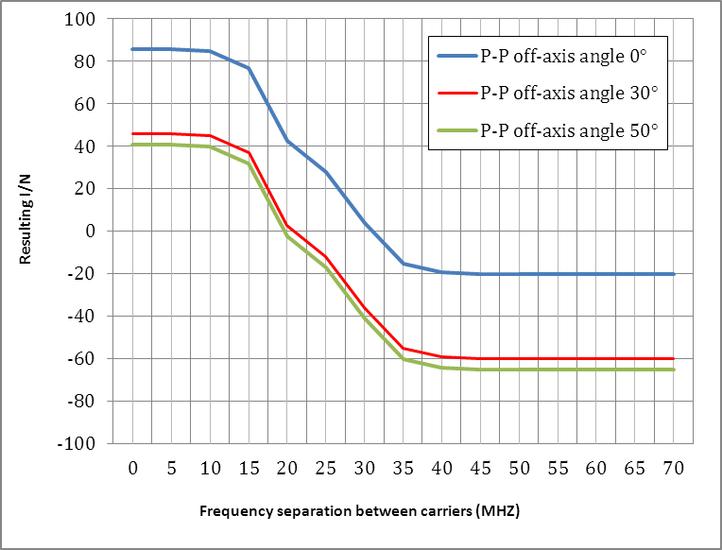

1. Interference from an MFCN macrocell BC to a P-P receiving site with a 2 km separation distance. P-P is in the main lobe of the MFCN BS sector antenna



1. Interference from an MFCN macrocell BS to a P-P receiving site with a 20 km separation distance. P-P is in the main lobe of the MFCN BS sector antenna

Now we will consider a better case, where P-P is in the back lobe of the MFCN macrocell BS sector antenna (θ1=180°). For simplicity, we present only the case with 20 km separation distance.



1. Interference from an MFCN macrocell BS to a P-P receiving site with a 20 km separation distance. P-P is in the back lobe of the MFCN BS sector antenna ( Gt=-2dBm)

There are other possible configurations of the MFCN BS:

* macrocell with omni-directional antenna (Pt=43dBm, Gt=6dBm);
* microcell with omni-directional antenna (Pt=35dBm, Gt=6dBm).

In both cases e.i.r.p. is bigger than that in the scenario represented in Figure 77. Furthermore we assume that a typical scenario is based on a 3-sector antenna for MFCN macrocell base stations, meaning that Figures 75 and 76 represent a very typical co-existence scenario.

**Analysis of the results**

In all cases, the P-P system will be interfered with in its main axis by the MFCN macrocell BS. Out of this axis, the resulting I/N is below the required I/N with a certain frequency separation.

Overlapping-channel sharing (meaning any overlapping between spectrum of interfering and interfered signals) between MFCN and P-P links is not feasible in the same geographical area (∆f>17.5 MHz, d=20 km and any θ1 and θ2).

Some mitigation could be obtained through BS antennas using low gain omnidirectional or directional sector antennas with large angular separation with a P-P receiving site. But considering that a typical BS antenna configuration is a 3-sector antenna, it appears that the typical scenario is the worst one represented in Figures 67 and 68 above.

With larger frequency separation and distances, coordination is needed depending on the MFCN BS and P-P characteristics. It should be noted that the chosen configuration, with both systems facing each other at the same height without taking into account any elevation discrimination is a worst case scenario.

In any case, the transmitter power from an MFCN macrocell BS is so high (43 dBm) that achieving the co-existence between MFCN BS and fixed service P-P links appears to be very difficult within the same spectrum and in the same geographical area.

* + 1. Interference from a User Equipment to a P-P link

In this section, we study the case where the interferer is a User Equipment (Pt=23dBm, Gt=0dBi).

In Figure 78 it is represented the resulting I/N of a P-P system interfered by a UE at 2 km distance form a P-P receiving site at different angles θ2 between interferer direction and the P-P main axis.



1. Interference from a UE to a P-P receiving site with a 2 km separation distance.

From Figure 78 it is evident that when a UE is in the area close to a P-P receiving site (d<2 km), overlapping-channel sharing is not possible, while when an UE is far from a P-P, we can consider the previous co-existence study between BS and P-P as preeminent in the co-existence between MFCN and P-P links.

* 1. Interference from P-P links to MFCN

In this section, we evaluate the situation where P-P link is the interferer and the MFCN is the interfered system.

It is also assumed that both MFCN and P-P system have the same antenna height, which is a worst case assumption.

The analysis is similar to the previous, but with roles reversed. In Figure 79 it is represented the Net Filter Discrimination curve used in the case of MFCN as the interfered system and a P-P type 2 as the interfering system.

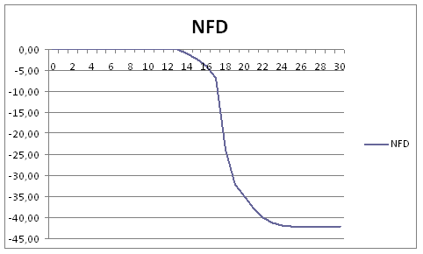

1. NFD function used in the sharing studies with P-P type 2   
   (30 MHz) interfering MFCN macrocell BS
   * 1. Interference from a P-P link to an MFCN macrocell BS

In this section, we can start with the co-existence worst scenario: (Pt=30dBm), P-P antenna is 3 meter (Gt=39dBi), θ2=0.

The curves provided in Figures 80-82 below give, at a defined distance, the resulting I/N according to the frequency difference between the carriers and at different values of parameter θ1. The frequency separation equal to the half-sum of bandwidths, which corresponds to a null guard band, would be depicted with a vertical line (not shown on the pictures).

Each figure in this section gives three curves corresponding to the values of θ1=0 (blue), θ1=30° (red) and θ1=50° (green) respectively.

The resulting I/N is to be compared with the I/N required by the MFCN BS (-6dB).



1. Interference from P-P link to an MFCN macrocell BS with a 2 km separation distance.   
   P-P is in the main lobe of the MFCN BS sector antenna.



1. Interference from a P-P link to an MFCN macrocell BS with a 20 km separation distance.   
   P-P is in the main lobe of the MFCN BS sector antenna

Also in this situation, we will consider a better case when a P-P link is in the back lobe of a MFCN macrocell BS sector antenna.



1. Interference from a P-P link to a MFCN macrocell BS with a 20 km separation distance.  
   P-P is in the back lobe of the MFCN BS sector antenna

There are other possible configurations of MFCN BS:

* macrocell with omni-directional antenna (Pt=43dBm, Gt=6dBm);
* microcell with omni-directional antenna (Ptt=35dBm, Gt=6dBm).

In both cases the e.i.r.p. value is bigger than that in the scenario represented in Figure 82. Further we assume that a typical scenario is based on a 3-sector antenna for the MFCN macrocell base stations, meaning that Figures 80 and 81 represent a very typical co-existence scenario.

**Analysis of the results:**

In all cases, the P-P system will interfere the MFCN macrocell BS when it is in its main axis. Out of this axis, the resulting I/N is below the required I/N with a certain frequency separation.

Overlapping-channel sharing (meaning any overlapping between spectrum of interfering and interfered signals) between MFCN and P-P links is not feasible in the same geographical area (∆f>17.5 MHz, d=20 Km and any θ1 and θ2).

Some mitigation could be obtained through MFCN macrocell BS antennas, using low gain omnidirectional or directional sector antennas with large angular separation with a P-P receiving site. But considering that a typical BS antenna configuration is a 3-sector antenna, it appears that the typical scenario is the worst one represented in Figures 75 and 76.

With larger frequency separation and distances, coordination is needed depending on the MFCN BS and P-P links characteristics. It should be noted that the chosen configuration, with both systems facing each other at the same height without taking into account any elevation discrimination is a worst case scenario.

* + 1. Interference from a P-P link to a User Equipment

In this section, we study the case where the interferer is a P-P link and the interfered is a User Equipment. The main different parameters are the isotropic receiver antenna (Gr=0 dBi) and the Noise Figure = 9 dB. Also the NFD diagram is a bit different. We assume the attenuation of the first adjacent channel is 33 dB. For either of the second and third adjacent channels the attenuation is 39 dB.

So for a UE we have a NFD diagram worse in the part above 20 MHz of frequency separation between carriers (about 11 dB) compared to the case with a BS (see Figure 79 above).



1. Interference from a P-P link to a UE with a 2 km separation distance

From Figure 83 it is evident that when a UE is in the area close to a P-P site (d<2 km), overlapping-channel sharing is not possible, while when a UE is far from a P-P, we can consider the previous co-existence study (see Figures 81 and 82 above) with a P-P interfering an MFCN macrocell BS as preeminent in the co-existence between MFCN and FS (P-P).

* 1. Analysis of the results and conclusion for the compatibility study P-P link versus MFCN

Due to the varying characteristics of different types of FS systems and their deployment, no single separation distance, guard band or signal strength limit can be provided to ensure the co-existence with MFCN. Co-existence can be achieved through coordination on a case-by-case basis.

Based on the results of the analysis of both directions of interference (MFCN interfering into P-P and vice-versa) some general observations can be made:

* overlapping-channel sharing (with that meaning any overlapping between spectrum of interfering and interfered signals) between MFCN and P-P links is not feasible in the same geographical area (d<20 km, any θ);
* with larger frequency separation and distances, coordination is needed depending on the MFCN and P-P characteristics;
* also, interference from a fixed service P-P system to MFCN (both BS and EU) may exceed in some cases the acceptable interference levels.

The above studies take into account a single interferer.

Co-existence between an MFCN network and a high capacity FS (P-P) network, using adjacent channels and many hops, can be very difficult to achieve (see the case study in section A8.6).

*A case study of the Italian radio link network in the 3600-4200 MHz*

Below a case study of a P-P 30 MHz network and its co-existence with an MFCN network in Italy is described.

In Figure 84 below it is plotted the area to be respected (referred to below as “respected area” or “r.a.”) to protect a P-P receiver from an interfering MFCN macrocell BS in the case of co-channel sharing. As it can be seen from the picture, the co-channel respected area is very large. In Figures 85, 86 and 87 the r.a. is mapped onto different FS P-P hops installed in some Italian regions. It is clear that in this case co-channel sharing is not feasible.

In the case of adjacent channel sharing (guard band = 0 and ∆f=17.5 MHz) the respected area is reduced to take into account the NFD attenuation (see Figures 88 and 89 below), and mapping these r.a. onto a real MFCN network suggests that the adjacent channel sharing should be possible through coordination.

In the regions where P-P networks use many 30 MHz adjacent channels and many hops, the coordination between MFCN and FS service could be very difficult, and the co-existence in some cases would not be possible to achieve.



1. Respected area to protect a P-P type 2 interfered receiver from   
   an interfering MFCN macrocell BS in the case of co-channel sharing   
   (on the left) and in the case of ∆f =17.5 MHz (on the right)



1. Respected area to protect a P-P type 2 interfered receiver near Rome (Lazio region)   
   in the case of co-channel sharing (on the left) and in the case of ∆f =17.5 MHz (on the right)



1. Respected area to protect a P-P type 2 receiver near Milan (Lombardia region)   
   in the case of co-channel sharing (on the left) and in the case of ∆f =17.5 MHz (on the right)



1. Respected area to protect a P-P type 2 receiver in Sicily in the case of co-channel sharing (on the left) and in the case of ∆f =17.5 MHz (on the right)

The situation is completely different with a small guard band, for example of 5 MHz (i.e. ∆f =22.5 MHz). In practice in this case the co-existence is quite easy to achieve (see Figures 79 and 80 below).



1. Respected area to protect a P-P type 2 receiver from an interfering MFCN macrocell BS in the case of guard band = 5MHz (∆f=22.5 MHz)



1. Respected area to protect a P-P type 2 receiver near Rome (Lazio region)   
   in the case in the case of ∆f =22.5 MHz
2. Co-existence between MFCN and FS (P-MP)
   1. Comparison of MFCN and P-MP characteristics

The main characteristics of MFCN (macro deployments) and P-MP systems are collected in Table 86 below. The MFCN parameters are detailed in Section 2.1 and the parameters for P-MP systems can be found in Recommendation ITU-R F.758-5 [39].

1. Key characteristics of MFCN and P-MP

|  | **P-MP CS** | **MFCN BS (Macro)** | **P-MP TS** | **MFCN UE** |
| --- | --- | --- | --- | --- |
| Output power [dBm] | 35 – 43 | 43 – 46 | 24 – 30 | 23 |
| ACLR [dB] | 40 – 50 | 45 | 40 – 50 | 30 |
| ACS [dB] | 30 – 40 | 45 | 30 – 40 | 33 |
| Bandwidth [MHz] | 1.75 – 14 | 1.4-20 | 1.75 – 14 | 1.4-20 |
| Antenna gain [dBi] | 10 (OMNI) 18 (sector) | 17 | 8 (indoor) 18 (outdoor) | 0 |
| Feeder loss [dB] | 2 | 0 | 0 | 0 |
| Receiver noise figure typical [dB] | 3 | 5 | 3 | 9 |

It is clear from the table that the values are in the same range, possibly with the exception of the TS/UE antenna gain and receiver selectivity (ACS) of the BS/CS.

* 1. BS to UE interference and UE to BS interference

For the interference cases with two downlinks adjacent to each other it is reasonable to conclude that the interfering system has roughly the same characteristics regardless if it is a PMP system or MFCN system. Thus the impact on the victim system will be similar. Since the systems are designed for operating in adjacent channels co-existence should be possible.

As an example consider two MFCN systems operating in adjacent channels. As long as a FDD arrangement is used co-existence is possible due to the design of the system. If the second MFCN system is replaced by a P-MP system the impact on the first system should be the same if the characteristics of P-MP are similar to MFCN. From Table 80 it can be seen that it is indeed the case and thus co-existence should be possible.

The differences for UE/TS receiver selectivity and antenna gain were noted previously. For the antenna gain it is noted that this may cause more interference to a victim BS in the main antenna lobe when the TS is transmitting conversely the TS may be more susceptible to interference if the interfering BS is in the main antenna lobe when the TS is receiving.

For the difference in receiver selectivity for the BS/CS it is noted that for the UL in the MFCN system the total adjacent interference is dominated by the UE emissions and the total ACIR (adjacent channel interference ratio) is around 30 dB. For the P-MP system it is the CS receiver selectivity which is dominating resulting in an ACIR of roughly 30-40 dB. Thus even if there is a notable difference in receiver selectivity the total adjacent channel interference is similar between the systems and thus it can be concluded that both P-MP and MFCN behave in a similar way.

* 1. BS to BS interference

For the case where a BS is generating interference to another BS, co-existence in the same geographical area is challenging. However since the parameters for MFCN and P-MP are similar the same conclusions outlined in Section 3.2 (BS to BS interference) apply for this case as well.

1. List of references
2. ECC Recommendation (04)05 “Guidelines for accommodation and assignment of Multipoint Fixed Wireless systems in frequency bands 3.4 - 3.6 GHz and 3.6 - 3.8 GHz”
3. ECC Decision (07)02 “Availability of frequency bands between 3400-3800 MHz for the harmonised implementation of Broadband Wireless Access systems (BWA)”
4. Commission Decision 2008/411/EC on the harmonisation of the 3400-3800 MHz frequency band for terrestrial systems capable of providing electronic communications services in the Community
5. ECC Decision (11)06 “Harmonised frequency arrangements for mobile/fixed communications networks (MFCN) operating in the bands 3400-3600 MHz and 3600-3800 MHz”
6. 3GPP TS 36.104 “Evolved Universal Terrestrial Radio Access (E-UTRA); Base Station (BS) radio transmission and reception”
7. 3GPP TR 36.942 “Evolved Universal Terrestrial Radio Access (E-UTRA); Radio Frequency (RF) system scenarios”
8. Report ITU-R M.2135-1, “Guidelines for evaluation of radio interface technologies for IMT-Advanced”
9. Recommendation ITU-R F.1336-3 ”Reference radiation patterns of omnidirectional, sectoral and other antennas in point-to multipoint systems for use in sharing studies in the frequency range from 1 GHz to about 70 GHz”
10. 3GPP TR 25.942 ” Radio Frequency (RF) system scenarios”
11. IEEE: “A recursive method for street microcell path loss calculation”, Jan-Erik Berg, Ericsson
12. 3GPP TR 37.809 “Evolved Universal Terrestrial Radio Access (E-UTRA) medium range and Multi-Standard Radio (MSR) medium range / local area Base Station (BS) class requirements”
13. WMF-T23-005-R015v05 (Releases 1.0 and 1.5)
14. WMF-T23-005-R020v01 (Release 2)
15. ETSI EN 302 774 “Broadband Wireless Access Systems (BWA) in the 3 400 MHz to 3 800 MHz frequency band; Base Stations; Harmonized EN covering the essential requirements of article 3.2 of the R&TTE Directive”
16. Draft ETSI EN 301 908-20 ”IMT cellular networks; Harmonized EN covering the essential requirements of article 3.2 of the R&TTE Directive; Part 20: OFDMA TDD WMAN (Mobile WiMAX) TDD Base Stations (BS)”
17. ECC Report 100 on the compatibility studies in the band 3400-3800 MHz between Broadband Wireless Access (BWA) systems and other services
18. ETSI Standard EN 302 326-2 “Fixed Radio Systems; Multipoint Equipment and Antennas; Part 2: Harmonized EN covering the essential requirements of article 3.2 of the R&TTE Directive for Digital Multipoint Radio Equipment”
19. ITU-R Report M.2109 “Sharing studies between IMT Advanced systems and geostationary satellite networks in the fixed-satellite service in the 3400-4200 and 4500-4800 MHz frequency bands”
20. ECC Report 174 “Compatibility between the mobile service in the band 2500-2690 MHz and the radiodetermination service in the band 2700-2900 MHz”
21. ITU Report M.2111 “Sharing studies between IMT-Advanced and the radiolocation service in the 3 400-3 700 MHz bands”
22. IEEE 802.11 Standard for Information technology “Telecommunications and information exchange between systems. Local and metropolitan area networks - Specific requirements. Part 11: Wireless LAN Medium Access Control (MAC) and Physical Layer (PHY) Specifications”
23. ECC Report 131 “Derivation of a Block Edge Mask (BEM) for terminal stations in the 2.6 GHz frequency band (2500-2690 MHz)”
24. Recommendation ITU-R SF.1486 “Sharing methodology between fixed wireless access systems in the fixed service and very small aperture terminals in the fixed-satellite service in the 3400-3700 MHz band”
25. Recommendation ITU-R M.1465 “Characteristics of and protection criteria for radars operating in the radiodetermination service in the frequency band 3 100-3 700 MHz ”
26. Recommendation ITU-R M.1652 “Dynamic frequency selection in wireless access systems including radio local area networks for the purpose of protecting the radiodetermination service in the 5 GHz band”
27. Recommendation ITU-R M.1461 “Procedures for determining the potential for interference between radars operating in the radiodetermination service and systems in other services”
28. ERC Recommendation (01)01 “Border coordination of UMTS”
29. ECC Recommendation (05)08 “Frequency planning and frequency coordination for the GSM 900, GSM 1800, E-GSM and GSM-R Land Mobile Systems”
30. ECC Recommendation (08)02 “Frequency planning and frequency coordination for GSM /UMTS/LTE/WiMAX Land Mobile systems operating within the 900 and 1800 MHz bands”
31. ECC Recommendation (11)04 “Frequency planning and frequency coordination for terrestrial systems for Mobile/Fixed Communication Networks (MFCN) capable of providing electronic communications services in the frequency band 790-862 MHz”
32. ECC Recommendation (11)05 “Frequency planning and frequency coordination for terrestrial systems for Mobile/Fixed Communication Networks (MFCN) capable of providing electronic communications services in the frequency band 2500-2690 MHz”
33. 3GPP TS 36.101, 3rd Generation Partnership Project; Technical Specification Group Radio Access Network; Evolved Universal Terrestrial Radio Access (E-UTRA); User Equipment (UE) radio transmission and reception
34. ETSI TS 136 101, LTE; Evolved Universal Terrestrial Radio Access (E-UTRA); User Equipment (UE) radio transmission and reception
35. 3GPP TS 36.104, 3rd Generation Partnership Project; Technical Specification Group Radio Access Network; Evolved Universal Terrestrial Radio Access (E-UTRA); Base Station (BS) radio transmission and reception
36. ETSI TS 136 104, LTE; Evolved Universal Terrestrial Radio Access (E-UTRA); Base Station (BS) radio transmission and reception
37. 3GPP TS 37.104, 3rd Generation Partnership Project; Technical Specification Group Radio Access Network; E-UTRA, UTRA and GSM/EDGE; Multi-Standard Radio (MSR) Base Station (BS) radio transmission and reception
38. ETSI TS 137 104, Digital cellular telecommunications system (Phase 2+); Universal Mobile Telecommunications System (UMTS); LTE; E-UTRA, UTRA and GSM/EDGE; Multi-Standard Radio (MSR) Base Station (BS) radio transmission and reception
39. CEPT Report 39 Report from CEPT to the European Commission in response to the Mandate to develop least restrictive technical conditions for 2 GHz bands
40. Recommendation ITU-R F.758-5 (03/2012), “System parameters and considerations in the development of criteria for sharing or compatibility between digital fixed wireless systems in the fixed service and systems in other services and other sources of interference”
41. ETSI EN 302 326-2 V1.2.2 (2007-06) “Fixed Radio Systems; Multipoint Equipment and Antennas; Part 2: Harmonized EN covering the essential requirements of article 3.2 of the R&TTE Directive for Digital Multipoint Radio Equipment”
42. Recommendation ITU-R P.1238-7 “Propagation data and prediction methods for the planning of indoor radiocommunication systems and radio local area networks in the frequency range 900 MHz to 100 GHz”
43. European Commission Mandate to CEPT to undertake studies on amending the technical conditions regarding spectrum harmonisation in the 3400-3800 MHz frequency band (doc RSCOM12-09 rev2 / ECC(12)INFO01)
44. ETSI TR 101 127 v1.1.1 “Transmission and Multiplexing (TM); Digital Radio Relay Systems (DRRS); Synchronous Digital Hierarchy (SDH); High capacity DRRS carrying SDH signals (1 x STM-1) in frequency bands with about 30 MHz channel spacing and using Co-Channel Dual Polarized (CCDP) operation”
45. ETSI TR 101 854 v.1.1.1 “Fixed Radio Systems; Point-to-point equipment; Derivation of receiver interference parameters useful for planning fixed service point-to-point systems operating different equipment classes and/or capacities”
46. Commission Decision 2008/477/EC on the harmonisation of the 2500-2690 MHz frequency band for –terrestrial systems capable of providing electronic communications services in the Community
47. Commission Implementing Decision 2012/688/EU on the harmonisation of the frequency bands 1920-1980 MHz and 2110-2170 MHz for terrestrial systems capable of providing electronic communications services in the Union
48. RSPG Opinion on “Streamlining the regulatory environment for the use of spectrum” (2008)
49. Directive 1999/5/EC of the European Parliament and of the Council of 9 March 1999 “on radio equipment and telecommunications terminal equipment and the mutual recognition of their conformity” (the R&TTE Directive)
50. “A Recursive Method for Street Microcell Path Loss Calculations”, publication at the “Personal, Indoor and Mobile Radio Communications” conference, 1995 (PIMRC'95)
51. Recommendation ITU-R P.525-2 “Calculation of free-space attenuation”
52. 3GPP TS 37.104, E-UTRA, UTRA and GSM/EDGE; Multi-Standard Radio (MSR) Base Station (BS) radio transmission and reception.

1. TRP is a measure of how much power the antenna actually radiates. The TRP is defined as the integral of the power transmitted in different directions over the entire radiation sphere. E.i.r.p. and TRP are equivalent for isotropic antennas.
2. TRP is a measure of how much power the antenna actually radiates. The TRP is defined as the integral of the power transmitted in different directions over the entire radiation sphere. E.i.r.p. and TRP are equivalent for isotropic antennas.
3. TRP is a measure of how much power the antenna actually radiates. The TRP is defined as the integral of the power transmitted in different directions over the entire radiation sphere. E.i.r.p. and TRP are equivalent for isotropic antennas.
4. * IST-WINNER II Deliverable 1.1.2 v.1.2. WINNER II Channel Models, IST-WINNER2, Tech. Rep., 2008 (<http://www.ist-winner.org/deliverables.html>).
5. in-band e.i.r.p.
6. acceptable Interference
7. depending on the scenario