ECC Report 190

Compatibility between Short-Range Devices (SRD) and EESS (passive) in the 122 to 122.25 GHz band
approved May 2013

Executive summary
This ECC Report deals with the compatibility analysis between Short-Range Devices (SRD) and EESS (passive) in the 122-122.25 GHz band.
Although the ERC/REC 70-03 [9] has contained for many years the band 122-123 GHz, there is no SRD application known at the time this report was prepared. In addition RR Footnote 5.138 mentions the designation of the band 122-123 GHz for industrial, scientific and medical (ISM) applications, but here also, no applications are known and the standard CISPR 11 does not contain limits for this frequency band.

Given the uncertainties around the applications foreseen at 122 GHz, it was agreed to base the studies on the following assumptions:
- 1 SRD/household (in the long term) over a European Capital
- 5% outdoor devices
- 100% activity factor (for some outdoor applications, activity factor is likely to be below 50%)
- Indoor/outdoor attenuation > 60 dB (this leads to the fact that indoor applications will not be source of interference to EESS spatial sensors and that hence 95% indoor applications are not considered)
- Power level up to 20dBm could be reached in standard
- Bandwidth likely to be above 500 MHz
- Antenna will more than likely be directive with a gain up to around 35dBi.

The calculations presented in this document show that SRDs operated with the currently regulated 20 dBm maximum e.i.r.p. are not compatible with EESS (passive) sensors operating in the 122-122.25 GHz band:
- the single entry scenario requires an additional limit of 10dBm/250 MHz e.i.r.p density.
- the aggregated (hot-spot) impact of 2100 SRD devices deployed outdoor in an area of 100 km² require a reduction to -25 dBm/200 MHz e.i.r.p. density (or -48 dBm/MHz).
Considering both single entry and hot spot scenario calculations, it is suggested that, in addition to the maximum e.i.r.p. of 20 dBm pertaining to the 122-123 GHz band, SRDs using the 122-122.25 GHz sub-band should comply with both of the following limitations:
- Maximum e.i.r.p. density : 10 dBm/250 MHz (rms) (Note)
- Maximum e.i.r.p. density above 30° elevation : -48 dBm/MHz (rms) (Note)
Note: These limits should be measured with a rms detector and an averaging time of 1 ms or less.

In addition, since the studies in this Report have been performed with theoretical assumptions related to SRDs in the 122 GHz frequency range these conclusions are therefore valid on a generic basis.
In case any future specific SRD applications aiming at operating in the 122-122.25 GHz were shown not being able to comply with these limits, it could be recommended to undertake new studies to take into any possible mitigation techniques that could provide relevant protection to EESS (passive) sensors for that specific SRD application.

TABLE OF CONTENTS

0 Executive summary 2
1 Introduction and background 5
2 Current situation 6
3 EESS (passive) characteristics 7
4 SRD technical and operational characteristics 10
4.1 Technical parameters 10
4.2 Description of applications 10
4.3 Deployment characteristics 10
5 Attenuation on the path 11
6 Compatibility Calculations 12
6.1 low density uniform scenario (dynamic) 12
6.2 Analysis with one single SRD (static) 14
6.3 Hot spot scenario (dynamic) 14
7 Conclusions 17
ANNEX 1: List of reference 18

LIST OF ABBREVIATIONS

Abbreviation | Explanation
CEPT | European Conference of Postal and Telecommunications Administrations
CISPR | Comité international spécial des perturbations radioélectriques
ECC | Electronic Communications Committee
EESS | Earth Exploration Satellite Service
e.i.r.p. | Equivalent isotropically radiated power
EUMETSAT | European Organisation for the Exploitation of Meteorological Satellites
ISM | industrial, scientific and medical (ISM) applications
LOS | Line of sight
NLOS | Non line of sight
SRD | Short Range Devices
TRP | Total Radiated Power

Introduction and background
This ECC Report deals with the compatibility analysis between Short-Range Devices (SRD) and EESS (passive) in the 122-122.25 GHz band.
CEPT Report 38 [1] suggested to the European Commission the mandatory harmonisation of the 122 to
123 GHz non-specific SRD with a 100 mW e.i.r.p.
Within this range, there is however an ITU-R allocation to EESS in the 122-122.25 GHz band for which compatibility with SRD was not considered. Therefore this report aims undertaking compatibility studies of the potential for interference from SRD into EESS (passive) in this spectrum, especially considering the cumulative effect of many SRD devices .

Current situation
The following table provides an overview of the allocations as given in the RR and in ECC Report 25 [2] for 119.98 - 122.25 GHz.
- Frequency allocations
RR Region 1 Allocation and RR footnotes applicable to CEPT | European Common Allocation | ECC/ERC  harmonisation  measures | Application | Notes
119.98 - 122.25 GHz  EARTH EXPLORATION-SATELLITE  (passive)  INTER-SATELLITE 5.562C  SPACE RESEARCH (passive)  5.138 | EARTH EXPLORATIONSATELLITE  (passive)  INTER-SATELLITE 5.562C  SPACE RESEARCH (passive)  5.138 | ERC/REC 70-03 | Non-Specific SRDs | Within the band 122-123 GHz
 |  |  | Passive sensors (satellite) | Passive sensing as part of the oxygen absorption band with peak at 118.75 GHz

5.138 The following bands:
6765-6 795 kHz (centre frequency 6 780 kHz),
433.05-434.79 MHz (centre frequency 433.92 MHz) in Region 1 except in the countries mentioned in No. 5.280,
61-61.5 GHz (centre frequency 61.25 GHz),
122-123 GHz (centre frequency 122.5 GHz), and
244-246 GHz (centre frequency 245 GHz)
are designated for industrial, scientific and medical (ISM) applications. The use of these frequency bands for ISM applications shall be subject to special authorization by the administration concerned, in agreement with other administrations whose radiocommunication services might be affected. In applying this provision, administrations shall have due regard to the latest relevant ITU-R Recommendations.

Although the ERC/REC 70-03 [9] has contained for many years the band 122-123 GHz, there is no SRD application known at the time this report was prepared. In addition RR Footnote 5.138 mentions the designation of the band 122-123 GHz for industrial, scientific and medical (ISM) applications, but here also, no applications are known and the standard CISPR 11 does not contain limits for this frequency band.

EESS (passive) characteristics
The band 114.25-122.25 GHz is of primary interest for atmospheric temperature profiling (O₂ absorption lines).
Table 2:, taken from Recommendation ITU-R RS.1861 [3], provides the parameters of limb sounding passive sensors that would be operating in this band.

- EESS (passive) sensor (Limb sounder) in the 114.25-122.25 GHz band
 | Sensor M1
Sensor type | Limb sounder
Orbit parameters
Altitude | 705 km
Inclination | 98.2°
Eccentricity | 0.0015
Repeat period | 16 days
Sensor antenna parameters
Number of beams | 2
Reflector diameter | 1.6 m × 0.8 m
Maximum beam gain | 60 dBi
Polarization | 2 orthogonal
–3 dB beamwidth | 0.19° × 0.245
Instantaneous field of view | 6.5 km × 13 km
Off-nadir pointing angle | Limb
Beam dynamics | Measurements from 2 to 60 km altitude
–3 dB beam dimensions | 3 km
Sensor receiver parameters
Sensor integration time | 0.166 s
Measurement spatial resolution
Horizontal resolution | 13 km
Vertical resolution | 6.5 km

In addition, a vertical/conical scanning radiometer is under development in Europe for the next generation of EUMETSAT polar meteorological satellites. It uses, among others, the frequency range 114.25-122.25 GHz in which several different channels will be used.
Some values are not frozen yet, since the design is on-going, but likely parameters necessary for the sharing studies are given in Table 3: below.

- EESS (passive) sensor (Conical scan) in the 114.25-122.25 GHz band
Sensor type | Conical scan
Orbit parameters
Altitude | 800-850 km
Inclination | 98.7 deg
Eccentricity | 0
Repeat period | 9 days
Sensor parameters
Minimum bandwidth of individual channels | 700 MHz
Number of beams | 1
Reflector diameter | 0.5- 0.6m
Maximum beam gain | 55dBi
Polarization | H, V
–3 dB beamwidth | 0.35deg
Sensor integration time | >1ms
Instantaneous field of view | 10km
Main beam efficiency | 95% - 99%
Incidence angle at Earth (from zenith) | 53deg (+/- 1.5)
Swath width | 1700km
Nadir angle (α) (for H =800 km and L=53°)(see figure 1 below) | 45.2 deg
Distance to field of view (or distance to Earth in the main beam) (for H =800 km and L=53°)(see figure 1 below) | 1219 km

Figure 1 below is taken from Recommendation ITU-R RS.1861 and provides an overview of the EESS (passive) conical scan geometry. It also provides the formulae between the incidence angle at Earth (L or i), the nadir angle (α) and the distance to field of view.

- EESS scanning configuration
For both Limb and vertical sounders, EESS (passive) protection criteria relevant to the present compatibility study in the 122-122.25 GHz band are given in Recommendation ITU-R RS.1029-2 [4] as follows (irrespective of the sensors’ integration time):

- Protection criteria for EESS (passive) sensors in the 122-122.25 GHz band
Frequency band(s)⁽¹⁾ (GHz) | Total bandwidth required (MHz) | Reference bandwidth (MHz) | Maximum interference level (dBW) | Percentage of area or time permissible interference level may be exceeded⁽²⁾ (%) | Scan mode (N, L)⁽³⁾
115.25-116P,  116-122.25p | 7 000⁽⁴⁾ | 200/10⁽⁵⁾ | -166/-189⁽⁵⁾ | 0.01/1⁽²⁾ | N, L

Note 1: P: Primary allocation, shared only with passive services (No. 5.340 of the Radio Regulations); p: primary allocation, shared with active services; s: secondary allocation.
Note 2: For a 0.01% level, the measurement area is a square on the Earth of 2 000 000 km², unless otherwise justified; for a 1% level, the measurement time is 24 h, unless otherwise justified.
Note 3: N: Nadir, Nadir scan modes concentrate on sounding or viewing the Earth’s surface at angles of nearly perpendicular incidence. The scan terminates at the surface or at various levels in the atmosphere according to the weighting functions. L: Limb, Limb scan modes view the atmosphere “on edge” and terminate in space rather than at the surface, and accordingly are weighted zero at the surface and maximum at the tangent point height.
Note 4: This bandwidth is occupied by multiple channels.
Note 5: Second number for microwave Limb sounding applications.

SRD technical and operational characteristics

Technical parameters
According to EC Decision 2011/829/UE [5] and EN 305 550 [6], the maximum e.i.r.p. for SRD in the 122- 123 GHz band is fixed to 100 mW (20 dBm). Although there is currently no detailed characteristic of SRD available in this band, the following assumptions were considered:
- Power level up to 20dBm could be reached in standard
- Bandwidth likely to be above 500 MHz
- The antenna will more than likely be directive with a gain up to around 35dBi; however, in the simulations in section 6 an omni directional antenna was assumed.

Description of applications
There are currently no SRD and ISM applications available. Various radar applications are foreseen at 122 GHz within research projects for vehicles (adaptive cruise control or ACC, blind spot detection, sensors), industry (distance and drill depth measurement, level metering, traffic jam detection), security (door openers, light switching, intrusion detection), medicine (position sensing, blind people assistance, breathing rate/heartbeat monitoring), consumers (mobile phone ruler, speed meters, sport sensors, …).
However all these applications are only at a “prospective stage” and, according to some manufacturers, there is no intention from the European (and worldwide) automotive industry to use the 122 GHz band for automotive radars. Indeed, for this purpose the frequency band 76-81 GHz offers a larger bandwidth (5 GHz), a much higher performance, and may be subject to a worldwide harmonization.

Deployment characteristics
Given the uncertainties around the applications foreseen at 122 GHz, it was agreed to base the studies on the following assumptions:
- 1 SRD/household (in the long term)
- 5% outdoor devices
- 100% activity factor (for some outdoor applications, activity factor is likely to be below 50%)
- Indoor/outdoor attenuation > 60 dB (this leads to the fact that indoor applications will not be source of interference to EESS spatial sensors and that hence 95% indoor applications are not considered)
Under these assumptions and a general assumption of 4 inhabitants per household, the following table provides calculation of SRD deployment densities in various areas in Europe.
- potential SRD deployment densities in the 122-122.25 GHz band
Scenario (area) | Area (km²) | Population (M) | Density (inhab/km²) | Household/km² | Outdoor SRD per km²
THE NETHERLANDS | 41526 | 16.2 | 390 | 98 | 5
France | 550030 | 66.7 | 121 | 30 | 2
PARIS | 105 | 2.234 | 21276 | 5319 | 266
PARIS AREA | 762 | 6.6 | 8661 | 2165 | 108
GREAT PARIS | 6096 | 10.4 | 1706 | 427 | 21

Attenuation on the path
The attenuation between SRDs and EESS (sensors) is related to free-space loss and gas attenuation. It varies depending on the geometry of the path, depending on the type of sensor.
The attenuation free space loss (from Recommendation ITU-R P.525 [7]):
Lbf = 32.4 + 20 log ƒ + 20 log dmmmmmmdB
where:
f : frequency (MHz)
d : distance (km)
The gas attenuation is provided in Recommendation ITU-R P.676 [8]. The nearest peak is at 118.75 GHz. At typical European latitude and conditions of temperature and pressure (10°C and 1013 psi) the atmospheric attenuation in the nadir direction is about 3.5 dB and the attenuation will range 3.4 to 38.7 dB for an elevation from 5 to 90° on the path between the SRD and the EESS satellite.
As a simplified approach, the values of attenuation versus elevation have been estimated using the following formula:
For Elevations >5° : A = 3.38/sin(elev)
For Elevations <5° : A = 3.38/sin(5°)

Compatibility Calculations
In order to determine the necessary compatibility conditions between SRD and EESS (passive) in the 122-122.25 GHz band, three different calculations were performed:
- A dynamic simulation over Europe with a “low density uniform” scenario (see chapter 6.1)
- A static analysis with one single SRD (see chapter 6.2)
- A dynamic simulation over Europe with a “hot spot” scenario (see chapter 6.3)

low density uniform scenario (dynamic)
A first calculation with a low uniform density of 0.01 SRD/km² (which is equivalent to 1 SRD/100 km²) was considered. This is equivalent to 87 340 outdoor devices over Europe (10°W-30°E, 37°N-65°N).
The simulation duration is 24 hours, with a time step of 1 second for the limb sounding sensor and 0.1 second for the conical scan sensor.

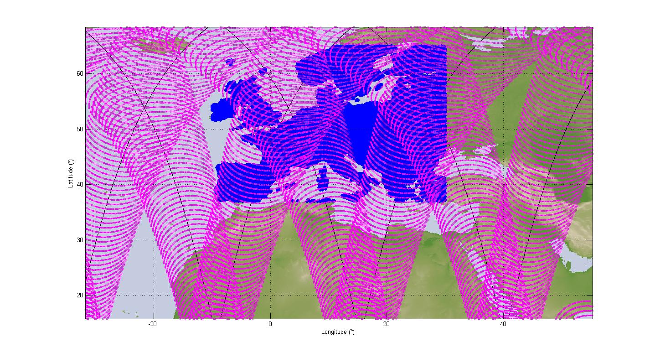
- Uniform SRD deployment over Europe
(in black: the satellite track on the Earth during a time interval of 24h and
in pink: the conical scan trace)

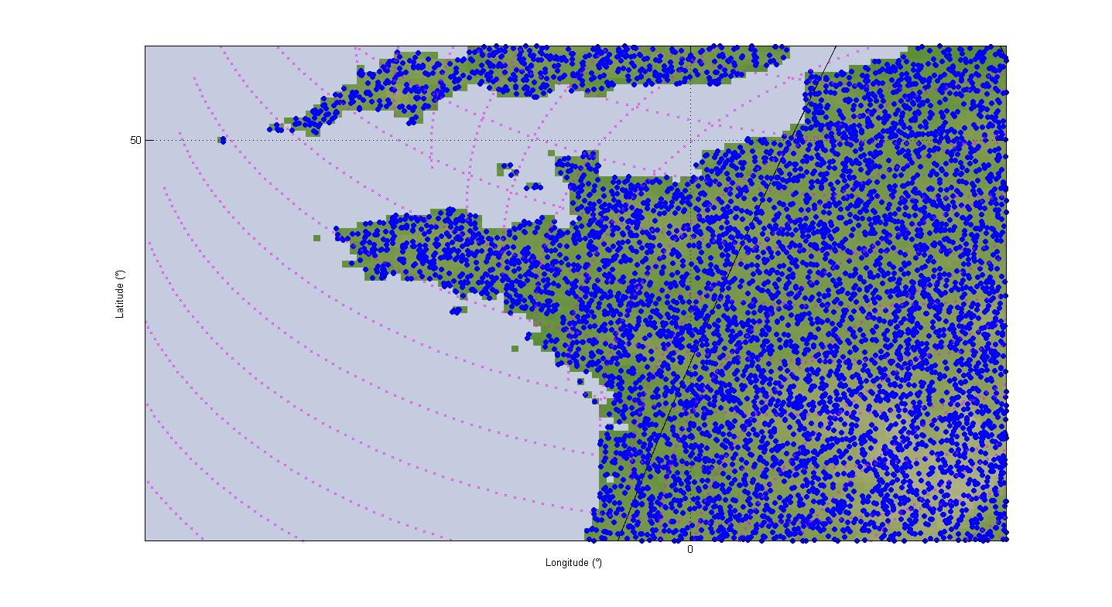
- Uniform SRD deployment over Europe
(zoom over part of France and UK)
Figure 4: below provides the corresponding interference distributions for both Limb sounder and Conical scan instruments and it can be seen that in both cases the protection criterion is largely exceeded (by 20 dB for the conical scan case, and by 6 dB for the limb sounding case).

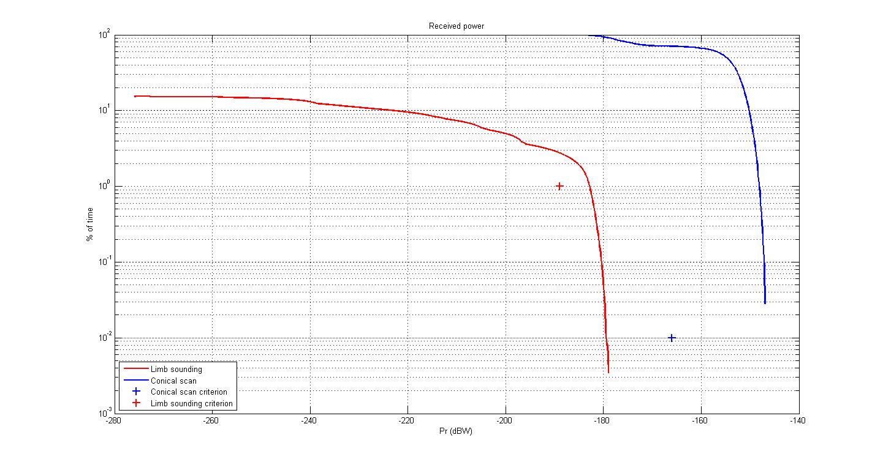
- Results for the uniform deployment scenario (conical scan and limb sounder)

These calculations show that even with a very low density, SRD using 20 dBm e.i.r.p. would not be compatible with EESS (passive) in the 122-122.25 GHz band.
It is therefore necessary to consider additional conditions to be applied to SRD within the 122-122.25 GHz band.

Analysis with one single SRD (static)
As mentioned in section 4 above, SRD in the 122-123 GHz band will use directive antennas. This means that their operations will in most cases be at relatively low elevation (few tens° maximum) and hence avoid main beam coupling with EESS (passive) sensors.
However any misapplication of SRD equipment that would be used at higher elevations would represent a threat to EESS (passive) service, mainly Conical Scan instrument and hence shall be banned.
This can be done by limiting the maximum e.i.r.p. density of one single SRD within the 122-122.25 GHz band (i.e. in a 250 MHz bandwidth) to a level that meets the required protection criteria. Those calculations are given in Table 6: below.
- maximum single entry SRD e.i.r.p. density in the 122-122.25 GHz band,
EESS conical scan instrument
Parameter | Unit | Value
Maximum SRD e.i.r.p. | dBW | -10
Distance SRD - EESS sensor in km  (see Table 3 and figure 1) | km | 1219
Space attenuation in dB | dB | 195.9
Atmospherical loss (Recommendation ITU-R P.676)  (at 53° elevation, in the EESS sensor main beam) | dB | 4.2
EESS antenna gain in dBi | dBi | 55
Received power at the EESS | dBW | -155.1
EESS interference threshold in a reference bandwidth of 200 MHz | dBW/200 MHz | -166
EESS interference threshold in the common band of 250 MHz | dBW/250 MHz | -165
Margin for 1 single SRD operating with 250 MHz bandwidth | dB | -9.9
Required SRD maximum e.i.r.p. density | dBW/250 MHz | -20
Required SRD maximum e.i.r.p. density | dBm/250 MHz | 10

Hot spot scenario (dynamic)
EESS (passive) protection criteria for “nadir” instruments (such as conical scans) are given for a 0.01% of area (or time) over a 2000000 km² reference area, hence representing a maximum of 200 km² in which permissible interference is exceeded.
With a 55 dBi antenna assumed for such conical scan instruments in the 122 GHz band, the size of the sensor pixel is roughly 100 km², hence allowing for only 2 pixels interfered over the reference area (representing about Western Europe).
To this respect, protection of EESS (passive) is hence an issue for “hot-spots” and not for uniform spreading density.
Thus, the scenario type “Great Paris” with a 21 outdoor SRD per km² (see Table 5: in Section 4) was assumed to be representative of a typical urban SRD deployment and used in the simulation below.

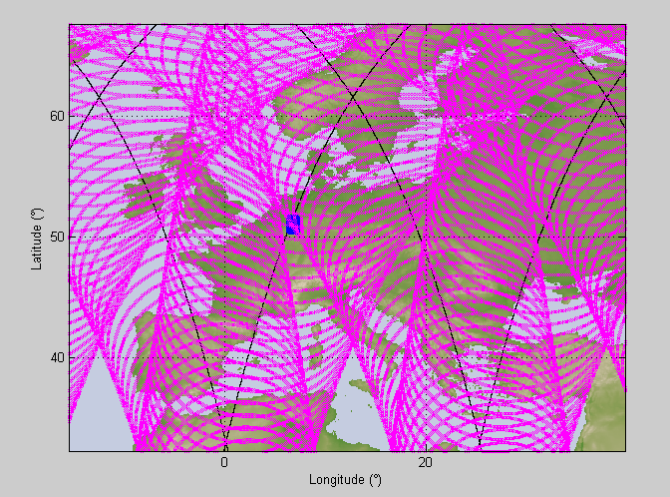
- Hot spot SRD deployment over Europe.
(In black: The satellite track on the Earth during a time interval of 24h
and in pink: The conical scan trace).
Figure 6:6 below provides the corresponding interference distribution for Conical scan instruments showing a maximum interference of -121 dBW within the 200 MHz EESS reference bandwidth, thus exceeding EESS (passive) protection by 45 dB.
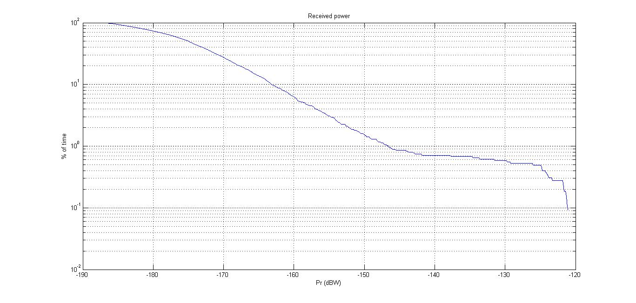
- Results for the “hot spot” scenario (conical scan only)
Considering this hot spot scenario, such result would hence lead to a -25 dBm/200 MHz maximum e.i.r.p. (or -48 dBm/MHz).
One can note that this calculation is consistent with a “static” calculation as follows:
- Required maximum e.i.r.p.for 1 single SRD (see section 6.2 above) = 10 dBm/250 MHz
- Required maximum e.i.r.p. for 1 single SRD (see section 6.2 above) = -14 dBm/MHz
- Number of SRD in the EESS pixel for hot spot = 21 (SRD/km²) * 100 (km²) = 2100 = 33.2 dB
- Required maximum e.i.r.p. for hot spot = -14 -33.2 =-47.2 dBm/MHz.

On the other hand, taking into account the geometry between EESS (passive) conical scan instruments and high atmospheric attenuation at low elevation, it can be expected that the interference mechanism of EESS (passive) from an aggregation of SRD in hot spot is more than likely controlled by the SRD e.i.r.p. at relatively high elevation (above 30°).
To this respect, one can assume that limiting the SRD e.i.r.p. to -48 dBm/MHz above 30° would be sufficient to avoid interference towards conical scan sensors from “hot spot” SRD deployment in the 122-122.25 GHz band.

Conclusions
The calculations presented in this document show that SRDs operated with the currently regulated 20 dBm maximum e.i.r.p. are not compatible with EESS (passive) sensors operating in the 122-122.25 GHz band:
- the single entry scenario requires an additional limit of 10dBm/250 MHz e.i.r.p density.
- the aggregated (hot-spot) impact of 2100 SRD devices deployed outdoor in an area of 100 km² require a reduction to -25 dBm/200 MHz e.i.r.p. density (or -48 dBm/MHz).
Considering both single entry and hot spot scenario calculations, it is suggested that, in addition to the maximum e.i.r.p. of 20 dBm pertaining to the 122-123 GHz band, SRDs using the 122-122.25 GHz sub-band should comply with both of the following limitations:
- Maximum e.i.r.p. density : 10 dBm/250 MHz (rms) (Note)
- Maximum e.i.r.p. density above 30° elevation : -48 dBm/MHz (rms) (Note)
Note: These limits should be measured with a rms detector and an averaging time of 1 ms or less.

- List of reference
- CEPT Report 38 in response to the EC Permanent Mandate on the ”Annual update of the technical annex of the Commission Decision on the technical harmonisation of radio spectrum for use by short range devices”, March 2011
- ECC Report 25 “Strategies for the European use of frequency spectrum for PMR/PAMR applications”, May 2003
- Recommendation ITU-R RS.1861 ”Typical technical and operational characteristics of Earth exploration-satellite service (passive) systems using allocations between 1.4 and 275 GHz”
- Recommendation ITU-R RS.1029-2 “Interference criteria for satellite passive remote sensing”
- EC Decision 2011/829/UE amending Decision 2006/771/EC on harmonisation of the radio spectrum for use by short-range devices, December 2011
- ETSI EN 305 550 Electromagnetic compatibility and Radio spectrum Matters (ERM); Short Range Devices (SRD); Radio equipment to be used in the 40 GHz to 246 GHz frequency range; Part 1: Technical characteristics and test methods
- Recommendation ITU-R P.525 “Calculation of free-space attenuation”
- Recommendation ITU-R P.676 “Attenuation by atmospheric gases”
- ERC Recommendation 70-03 relating to the use of Short Range Devices (SRD)

See for instance the FP7 funded project SUCCESS

