ECC Report 187

COMPATIBILITY STUDY BETWEEN MOBILE COMMUNICATION SERVICES ON BOARD AIRCRAFT (MCA) AND GROUND-BASED SYSTEMS
approved January 2013

Executive summary
This report considers the technical impact on ground-based systems of introducing a new Mobile Communication service onboard aircraft based on UMTS or LTE technologies operating at height of at least 3,000 meter above ground in the 1800 MHz (1710-1785 MHz for the uplink and 1805-1880 MHz for the downlink) and in the 2600 MHz (2500-2570 MHz for uplink and 2620-2690 MHz for downlink) as of LTE and in the 2100 MHz (1920-1980 MHz for uplink and 2110-2170 MHz for downlink) as of UMTS.
This report described additional studies on the compatibility of a MCA system with terrestrial networks, when the aircraft is at least 3000 m above ground. The studies demonstrated that harmful interference to terrestrial networks will not occur provided that the following technical conditions are met:
In the 1800 MHz connectivity (LTE technology): the e.i.r.p. defined outside the aircraft, resulting from the LTE UE transmitting at 5 dBm/5 MHz and LTE onboard nodeB inside the aircraft must not exceed the values as provided in the table below:
Table 1: Maximum permitted e.i.r.p levels for the onboard LTE at 1800 MHz
Minimum operational height above ground (m) | Maximum permitted e.i.r.p produced by the onboard LTE UE (dBm/5 MHz) | Maximum permitted e.i.r.p produced by the onboard nodeB (dBm/5 MHz)
3000 | 1.7 | 1.0
4000 | 3.9 | 3.5
5000 | 5 | 5.5
6000 | 5 | 7.1
7000 | 5 | 8.4
8000 | 5 | 9.6

In the 2100 MHz connectivity band (UMTS technology):
- The transmit power of the ac-Node B must not exceed the maximum e.i.r.p defined outside the aircraft as given in the ECC/DEC(06)07 [1]
- The transmit power of the ac-UE must not exceed -6 dBm/3.84 MHz and the maximum number of users should not exceed 20.
- The e.i.r.p. of the ac-UE defined outside the aircraft must not exceed the following values as shown in the table below:

Table 2: Maximum permitted e.i.r.p levels for the onboard UMTS at 2100 MHz
Height above ground (km) | Max permitted e.i.r.p. (dBm/channel)
3 | 3.1
4 | 5.6
5 | 7
6 | 7
7 | 7
8 | 7

In the 2600 MHz connectivity band (LTE technology):
Compatibility with the adjacent band Radio astronomy service primary allocation at 2690-2700 MHz can be achieved assuming that the out-of-band emission outside the aircraft is lower than – 66.4 dBm/10 MHz at 3000 metres. To achieve compatibility with the RAS secondary allocation in the shared band at 2655-2690 MHz would require the same limit on emissions.
It was found that in the 2600 MHz connectivity band, based on the basic analysis carried out in this report compatibility with adjacent band radar services could not be ensured, therefore without further analysis at this present time it is concluded that this band could not be made available for connectivity.

With respect to the controlled bands, the studies have shown that there is no change in power level defined outside the aircraft for the 1800 MHz, 2100 MHz and 2600 MHz in the ECC/DEC(06)07 [1].

In the 800 MHz band, the e.i.r.p. of the NCU defined outside the aircraft must not exceed the value contained in the below table:

Table 3: Maximum permitted NCU e.i.r.p. limits at 800 MHz
Height above ground (km) | 3 | 4 | 5 | 6 | 7 | 8 | 9 | 10
e.i.r.p. (dBm/10 MHz) | -0.87 | 1.63 | 3.57 | 5.15 | 6.49 | 7.65 | 8.68 | 9.59

TABLE OF CONTENTS

0 Executive summary 2
1 Introduction 7
2 SCOPE OF STUDIES 7
2.1 Frequency bands 7
2.2 Identification OF SHARING COMPATIBILITY STUDIES 8
2.3 IDENTIFICATION OF SCENARIOS 8
3 Aircraft height distribution 18
4 Ground- based public mobile network parameters used for modelling LTE at 800 MHz, 1800 MHz, 2100 MHz and 2600 mhZ 19
5 Ground- based public mobile network parameters used for modelling WIMAX at 1800 MHz 20
6 sYSTEM PARAMETERS OF THE CONSIDERED ADJACENT BANDS 21
6.1 RADIO ASTRONOMY SERVICE (RAS) PARAMETERS 21
6.2 RAS antennas and thresholds of interference 21
6.3 Radar parameters 22
7 compatibility analysis 24
7.1 Analysis related to onboard LTE connectivity at 1800 MHz 24
7.1.1 Scenario 1: Impact of g-base station on ac-UE at 1800 MHz 24
7.1.2 Scenario 2: Impact of ac-UE on g-base station at 1800 MHz 25
7.1.3 Estimation of the maximum power level emitted by the onboard nodeB in the 1800 MHz 25
7.1.4 Scenario 5 27
7.2 Analysis related to onboard connectivity at 2100 MHz 27
7.2.1 Parameters adopted for Scenario 4, 5 & 6 (SEAMCAT simulation) 28
7.2.2 SEAMCAT Simulation Results for Scenario 4 29
7.2.3 SEAMCAT Simulation Results for Scenarios 5 and 6 29
7.3 COMPATIBILITY ANALYSIS AT 800 MHZ 31
7.3.1 Scenario 1: Impact of g-NodeB on ac-UE 32
7.3.2 Scenario 2: Impact of ac-UE on g-NodeB at 800 MHz 33
7.3.3 Scenario 3: Impact of the NCU on g-UE at 800 MHz 33
7.3.4 Scenario 4: impact of multiple NCU on g-UE at 800 MHz 34
7.4 COMPATIBILITY ANALYSIS AT 900 MHZ 35
7.4.1 Scenario 1: Impact of g-NodeB on ac-UE at 900 MHz 35
7.4.2 Scenario 2: Impact of ac-UE on g-NodeB 35
7.4.3 Scenario 3: Impact of the NCU on g-UE 36
7.4.4 Scenario 4: Impact of the NCU on g-UE 37
7.5 COMPATIBILITY ANALYSIS AT 1800 MHZ 37
7.5.1 Scenario 1: Impact of g-base station on ac-UE at 1800 MHz 37
7.5.2 Scenario 2: Impact of ac-UE on g-base station at 1800 MHz 38
7.5.3 Scenario 3: Impact of the NCU on g-UE at 1800 MHz 38
7.5.4 Scenario 4: Impact of the NCU on g-WIMAX UE at 1800 MHz 39
7.6 COMPATIBILITY ANALYSIS AT 2100 MHZ 40
7.6.1 Scenario 1: Impact of g-NodeB on ac-UE at 2100 MHz 40
7.6.2 Scenario 2: Impact of ac-UE on g-NodeB at 2100 MHz 40
7.6.3 Scenario 3: Impact of the NCU on g-UE at 2100 MHz 41
7.6.4 Scenario 4: Impact of the NCU on g-UE at 2100 MHz 42
7.7 PROTECTION OF ADJACENT SERVICES 43
7.7.1 RADIO ASTRONOMY SERVICES IN THE 2690 – 2700 MHZ 43
7.7.2 RADAR SERVICES OPERATING ABOVE 2700 MHZ 43
8 Conclusions 45
ANNEX 1: Example of system activation 47
ANNEX 2: List of reference 49

LIST OF ABBREVIATIONS

Abbreviation | Explanation
ACLR | Adjacent Channel leakage ratio
ac-Node B/BTS | Aircraft base station
ac-UE/MS | Mobile terminal onboard an aircraft
BS | Base Station
e.i.r.p. | equivalent isotropic radiated power
FDD | Frequency division duplex
g-Node B/BTS | Ground base station
g-UE/MS | Ground mobile terminal
GSM | Global System for Mobile communication
GSMOBA | GSM onboard aircraft
ITU | International Telecommunication Union
LTE | Long Term Evolution
MCA | Mobile Communication services on board Aircraft
MCFN | Mobile/ Fixed Communication Network
MCL | Minimum Coupling Loss
NCU | Network Control Unit
PSD | Power Spectral Density
RAS | Radio Astronomy Service
RB | Resource block
SEAMCAT | Spectrum Engineering Advanced Monte-Carlo Analysis Tool
UE | User Equipment
UMTS | Universal Mobile Telecommunications System
WiMAX | Worldwide Interoperability for Microwave Access
WCDMA | Wideband Code Division Multiple Access

Introduction
ECC Report 093 [2] initially considered the technical compatibility between GSM equipment on board aircraft (GSMOBA) and ground-based public mobile networks. This report addresses the impact on ground-based systems and networks of introducing new Mobile Communication services on board Aircraft (MCA) systems based on UMTS or LTE connectivity operating at a height of at least 3000 m above ground level in the following frequency bands:
- 1710-1785 MHz for uplink (terminal transmit, base station receive) and 1805-1880 MHz for downlink (base station transmit, terminal receive);
- 1920-1980 MHz for uplink (terminal transmit, base station receive) and 2110-2170 MHz for downlink (base station transmit, terminal receive);
- 2500-2570 MHz for uplink (terminal transmit, base station receive) and 2620-2690 MHz for downlink (base station transmit, terminal receive).

This report provides an outline of the different operational scenarios considered with respect to the introduction of new MCA systems based on UMTS and LTE connectivity. MCA means public mobile services intended for the airline passengers independent of the technology (e.g. GSM, UMTS, LTE) implemented in the aircraft, defined in the EC Decision 2008/294/EC [6].

SCOPE OF STUDIES
ECC Report 093 [2] identifies the frequency bands and the expected operational scenarios for assessing compatibility issues of operating MCA systems based on the GSM technology with ground-based public mobile networks. When considering the compatibility issues arising from the operation of UMTS and LTE systems onboard aircraft, the analysis needs to be repeated assuming the UMTS or LTE base station onboard the aircraft. Similarly the impact on ground-based public LTE and UMTS networks are included in the study.
All other parameters relating to ground-based public networks as ‘victim’ links or ‘interfering’ links remain unchanged from the GSM case.

Frequency bands
The updated analysis includes the frequency bands as contained in the Table below when considering emissions from mobile terminals onboard aircraft as well as from onboard pico-cell (connectivity bands) and to prevent interaction with ground-based public mobile systems (controlled bands).
Table 4: Frequency bands
Connectivity bands: | 1710-1785 MHz (uplink)/ 1805-1880 MHz (downlink) (LTE1800)  1920-1980 MHz (Uplink)/ 2110-2170MHz (downlink) (UMTS2100)  2500-2570 MHz(uplink) / 2620-2690 MHz (downlink) (LTE 2600)
Controlled bands: | 791-821 MHz (LTE 800)  925-960 MHz (LTE 900)  1805-1880 MHz (LTE1800)  2500-2690 MHz (LTE 2600)

The reason for the analysis of those new connectivity bands is that they are seen as the primary bands for UMTS and LTE in Europe; hence such cellular technologies will be widely supported by the onboard customers’ terminals.

Identification OF SHARING COMPATIBILITY STUDIES
Tables 3 and 4 identifies the compatibility studies to be performed
Table 5: Identifications of sharing studies between onboard connectivity system and
ground-based systems
Band | Technology on board aircraft | In-band sharing with ground-based systems | Adjacent-band sharing with ground-based systems
1800 MHz | GSM* | GSM, LTE
1800 MHz | LTE | GSM, LTE
2100 MHz FDD | UMTS | UMTS
2600 MHz FDD  2600 MHz TDD | LTE | LTE  RAS (2655-2690 MHz) | Radio Astronomy Service (RAS) (2690-2700 MHz), Radars (2700-2900 MHz)

*This technology was already studied in ECC Report 093 [2].
Table 6: Identification of sharing studies between ground-based network and the NCU
Band | Sharing with ground based systems | Adjacent-band sharing with  groundbased systems
450 MHz | CDMA450, FlashOFDM
800 MHz | LTE
900 MHz | GSM, UMTS, LTE, WiMAX
1800 MHz | GSM, UMTS, LTE, WiMAX
2100 MHz FDD | UMTS, LTE
2600 MHz FDD | UMTS, LTE, RAS (2655-2690 MHz) | Radio Astronomy Service (RAS) (2690-2700 MHz), Radars (2700-2900 MHz)
2600 MHz TDD | UMTS, WiMAX, LTE, RAS (2655-2690 MHz)

The NCU (Network Control Unit) is a part of the MCA system designed to ensure by raising the noise floor inside the cabin that mobile terminals within the cabin cannot access to the ground-based public networks and that those compatible with the onboard technology do not transmit any signal without being controlled by the MCA system, i.e. the onboard Node B or onboard BTS.

IDENTIFICATION OF SCENARIOS
The considered MCA (UMTS / LTE) system is designed to ensure that a mobile terminal onboard an aircraft (ac-UE) is unable to communicate with ground-based public mobile networks, whilst providing onboard connectivity to ac-UE in the LTE1800, UMTS2100 or LTE 2600 frequency bands.
The new analysis studies the impact of the:
- Network control unit (NCU) emissions in the ground-based downlink (base station transmit → mobile station receive link) (the new bands for control) ;
- Aircraft base station (ac-NodeB) emissions in the ground-based downlink (base station transmit → mobile station receive link), at 1800 MHz (LTE) 2100 MHz (UMTS) and 2600 MHz (LTE) only;
- Mobile terminal on aircraft (ac-UE) emissions in the ground-based uplink (mobile station transmit → base station receive link), at 1800 MHz (LTE), 2100 MHz (UMTS) and 2600 MHz (LTE).

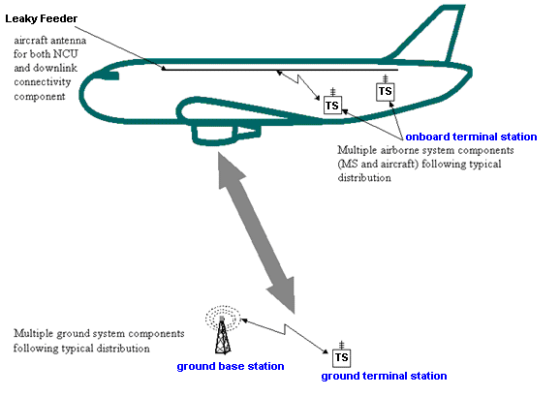
Figure 1: MCA and ground-based cellular system interference scenario
The following six scenarios are studied when needed:
- Scenario 1: Impact of ground base station (g-NodeB) to the ac-UE. This scenario, using a minimum coupling loss (MCL) approach, identifies the conditions in which the mobile terminal on aircraft (ac-UE) will have visibility of the ground-based networks. Note that the NCU and aircraft base station (ac-NodeB) are not taken into account in this scenario.
- Scenario 2: Impact of the ac-UE to g-NodeB. This scenario, using both MCL approach and SEAMCAT analysis, assessed in which conditions the ac-UE will have the ability to connect to ground-based networks, and in that case, the impact on other ground-based links. Note that the NCU and ac-NodeB are not taken into account in this scenario.
- Scenarios 3 and 4: Impact of onboard NCU and ac-NodeB emissions to the downlink of ground-based networks, for single (Scenario 3) and multiple (Scenario 4) aircraft respectively;
- Scenarios 5 and 6: Impact of ac-UE emissions to the uplink of ground-based networks, for single (Scenario 5) and multiple (Scenario 6) aircraft respectively.

Table 7: Modelling scenarios
Scenario # | Interferers | Interfered system
1 | g-NodeB | ac-UE
2 | ac-UE | g-NodeB
3 | NCU and ac-NodeB | Ground-based network downlink
4 | Multiple aircraft  NCU and ac-NodeB | Ground-based network downlink
5 | ac-UE | Ground-based network uplink
6 | Multiple aircraft  ac-UE | Ground-based network uplink

The SEAMCAT scenario definition and elements had been used to define the scenarios necessary to assess the impacts between the two systems (ground-based mobile network vs. MCA (UMTS or LTE)), as shown in Figure 2.
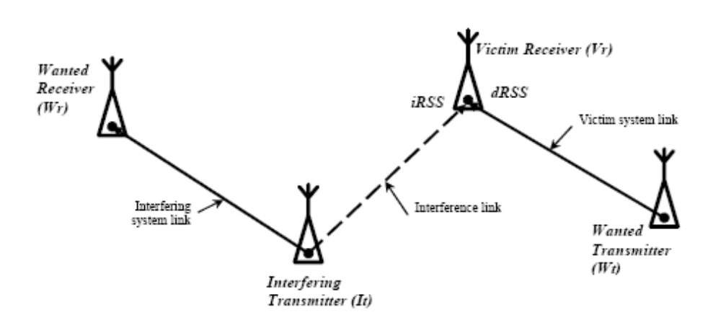
Figure 2: SEAMCAT Scenario Definition
Scenario 1: Impact of g-NodeB on ac-UE (MCA not active)
This scenario assesses in which conditions the ac-UE will have visibility of the ground-based networks, by using MCL calculations. It was identified as a starting point for the study and the results will be used as inputs for Scenarios 3 and 4.
The scenario assumes one g-NodeB (using various cellular bands), and the MCA systems are disregarded, i.e. both ac-NodeB and NCU are inactive.

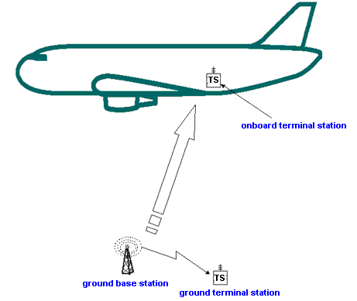
Figure 3: Scenario 1, where g-NodeB signal is received by onboard mobile terminals
Table 8: General summary of Scenario 1 (three new bands in addition to what is
already covered in ECC Report 093 [2])
Number of aircraft |  | 1
Altitude of the aircraft above ground level |  | 3000 m to 10000 m
Elevation |  | Various angles from g-NodeB
Interfering transmitter |  | Single g-NodeB
Position of transmitter |  | Static
Transmitter frequencies |  | 800 MHz, 1800 MHz, 2100 MHz, 2600 MHz
Technologies |  | LTE
Path loss between aircraft and ground networks |  | Free space path loss
Victim receiver |  | Single ac-UE
Criteria |  | Received power by ac-UE from g-NodeB compared to ac-UE sensitivity as function of height above ground level
Aim |  | Assess if an onboard terminal will have visibility of ground-based networks
Modelling approach |  | MCL
Cellular technology covered |  | - LTE 800  - LTE 1800  - LTE 2600  - LTE 2100  - LTE 900  - WiMAX 1800

Scenario 2: Impact of ac-UE on g-NodeB (UMTSOBA/LTEOBA not active)
This scenario assesses in which conditions the onboard ac-UE will have the ability to connect to ground-based networks, by using both MCL calculation and the resulting potential impact on other ground-based links. The scenario consists of one victim link (ground-based uplink), and a single onboard ac-UE, with MCA system disregarded, i.e. both ac-NodeB and NCU inactive.
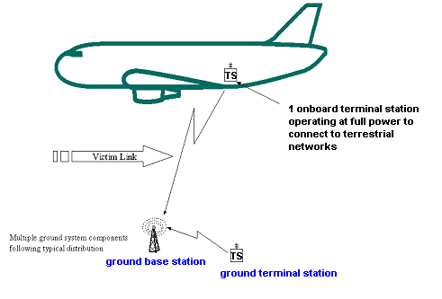
Figure 4: Scenario 2, where ac-UE signal is received by g-NodeB

Table 9: General summary of Scenario 2 (three new bands in addition to what is
already covered in ECC Report 093 [2])
Number of aircraft | 1
Altitude of the aircraft above ground level | 3000 m to 10000 m
Elevation | Various angles from a g-NodeB
Interfering Transmitter | Single ac-UE
Interfering Transmitter power | Full power depending on the frequency band
Transmitter frequency | 800 MHz, 1800 MHz, 2100 MHz, 2600 MHz
Technologies | UMTS (WCDMA), CDMA2000, LTE
Path loss between aircraft and ground networks | Free space path loss
Victim receiver | Single g- NodeB
Criteria | Received power by a g- NodeB from ac-UE compared to the g- NodeB’s sensitivity
Aim | Assess whether an ac-UE can communicate with the ground-based network
Modelling approach | MCL
Cellular technology covered | - LTE 800  - LTE 1800  - LTE 2600  - UMTS 2100  - LTE 2100  - LTE 900  - WiMAX 1800

Scenario 3: NCU/ac-NodeB impact on the ground-based communication link (g-BTS/NodeB to g-MS/UE (downlink)) from a single aircraft
This scenario assesses the impact of onboard NCU (and ac-NodeB) emissions on the ground-based UE receivers, by using both MCL calculations and SEAMCAT simulations. This scenario consists of a single interfering link (the NCU and ac-NodeB emissions directed to ac-UE) whose emissions could impact a single victim link (ground-based downlink). NCU is operating and there is onboard connectivity at 1800 MHz (LTE), 2100 MHz (UMTS) and 2600 MHz (LTE).

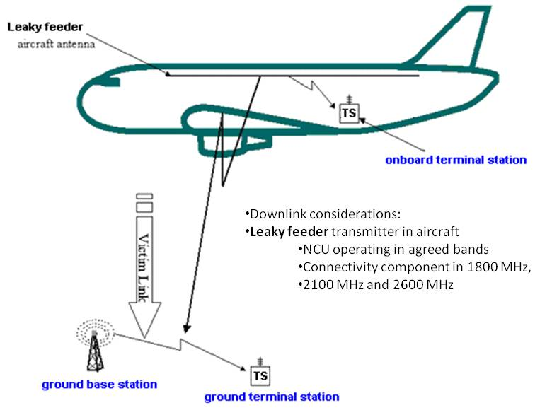
Figure 5: Scenario 3: NCU/ac-NodeB interfering ground-based victim downlink
(g-BTS/NodeB to g-MS/UE)

Table 10: General summary of Scenario 3 (NCU transmissions in three new bands (LTE) and
onboard LTE 1800, UMTS 2100 and LTE 2600 Node B)
Number of aircraft | 1
Altitude of the aircraft above ground level | 3000 m to 10000 m
Elevation | Various angles from ground-based link
Interfering Transmitter (1) | ac-NodeB (Leaky cable)
Transmitter frequency (1) | 1800 MHz, 2100 MHz and 2600 MHz
Interfering Transmitter (2) | NCU (Leaky cable)
Transmitter frequency (2) | 800MHz, 1800 MHz, 2100 MHz, 2600 MHz
Victim receiver | Single g-MS/UE
Wanted transmitter | Single g-BTS/NodeB
Victim link | g-BTS/NodeB to g-MS/UE
Position of victim receiver | Typical outdoor distribution illustrating noise-limited network (rural area)
Path loss between aircraft and ground networks | Free space path loss
Criteria | Interference criterion I: C/(N+I)  Interference criterion II: (I/N)
Aim | To determine the probability of the ac-NodeB/NCU interfering with the  g-BTS/NodeB to g-MS/UE communication link.
Modelling approach | MCL, SEAMCAT
Simulation cases | - NCU interferer → g-UE LTE 800  - NCU interferer → g-UE WiMAX 1800  - NCU interferer → g-UE LTE 2600  - NCU interferer → g-UE LTE 2100  - NCU interferer → g-UE LTE 900  - ac-NodeB UMTS 2100 interferer → g-UE LTE 2100  - ac-NodeB LTE 2600 interferer → g-UE LTE 2600

Scenario 4: NCU/ac-NodeB impact on the ground-based communications link (g-BTS/NodeB to g-MS/UE (downlink)) from multiple aircraft
This scenario assesses the impact of MCA in several aircraft, resulting from their onboard NCU (and ac-NodeB) emissions, on the ground-based UE receiver, by using SEAMCAT simulations.
The scenario consists of multiple MCA interfering links (multiple aircraft) where emissions of their NCU and/or ac-NodeB could impact a victim link (ground-based downlink). NCUs are operating and there is onboard connectivity (at 1800 MHz (LTE), 2100 MHz (UMTS) and 2600 MHz (LTE)) in all modelled aircraft.

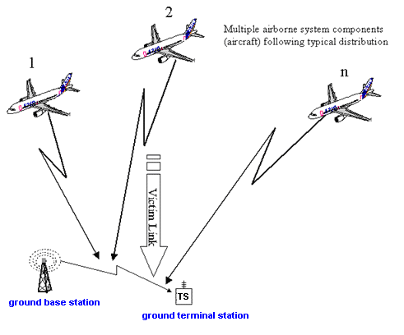
Figure 6: Scenario 4: NCU/ac-NodeB interfering ground-based victim downlink
(g-BTS/NodeB to g-MS/UE) from multiple aircraft

Table 11: General summary of Scenario 4 (NCU transmissions in three new bands (LTE) and onboard LTE 1800, UMTS 2100 and LTE 2600 Node B)
Number of aircraft | Airport distribution
Altitude of the aircraft above ground level | Altitude, position and direction distribution
Elevation | Various angles from ground-based link
Interfering Transmitter (1) | ac-NodeB (Leaky cable)
Transmitter frequency (1) | 1800 MHz, 2100 MHz and 2600 MHz
Interfering Transmitter (2) | NCU (Leaky cable)
Transmitter frequency (2) | 800 MHz, 1800 MHz, 2100 MHz, 2600 MHz
Victim receiver | Single g-MS/UE
Position of victim receiver | Typical MS/UE distribution
Wanted transmitter | g-BTS/NodeB
Position of wanted receiver | Typical outdoor distribution illustrating noise-limited network (rural area)
Victim link | g-BTS/NodeB to g-MS/UE
Path loss between aircraft and ground networks | Free space path loss
Criteria | Interference criterion I: C/(N+I)  Interference criterion II: (I/N)
Aim | To determine the probability of the ac-BTS interfering with the g-BTS/NodeB to g-MS/UE communication link for multiple aircraft.
Modelling approach | SEAMCAT
Simulation cases | - NCU interferer → g-UE LTE 800  - NCU interferer → g-UE WiMAX1800  - NCU interferer → g-UE LTE 2600  - NCU interferer → g-UE LTE 900  - NCU interferer → g-UE LTE 2100  - ac-NodeB interferer → g-UE UMTS 2100  - ac-NodeB interferer → g-UE LTE 2600

Scenario 5: ac-UE impact on the ground-based communications link (g-UE to g-NodeB (uplink)) from a single aircraft
This scenario assesses the impact of onboard ac-UE emissions on the ground-based BTS/NodeB receiver, by using both MCL calculations and SEAMCAT simulations.
This scenario considers ac-UE as an interferer whose emissions could have impact on a single victim link (ground-based uplink). NCU is operating and there is onboard connectivity (at 1800 MHz (LTE), 2100 MHz (UMTS) or 2600 MHz (LTE)).

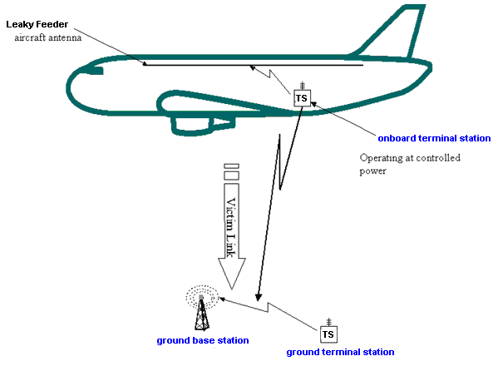
Figure 7: Scenario 5: ac-UE interfering ground-based uplink (g-MS/UE to g-BTS/NodeB)

Table 12: General summary of Scenario 5
Number of aircraft | 1
Altitude of the aircraft above ground level | 3000 m to 10000 m
Elevation | Various angles from ground-based link
Interfering Transmitter | Single ac-UE
Transmitter frequency | 1800 MHz, 2100 MHz and 2600 MHz
Victim receiver | 1 g-NodeB
Position of victim receiver | Fixed
Wanted transmitter | 1 g-UE
Position of wanted transmitter | Typical distribution illustrating noise-limited network (rural area)
Victim link | g-UE to g-NodeB
Path loss between aircraft and ground networks | Free space path loss
Criteria | Interference criterion I: C/(N+I)  Interference criterion II: (I/N)
Aim | To determine the probability of the ac-UE interfering with a g-MS to g-NodeB and g-UE to g-NodeB communication link
Modelling approach | MCL, SEAMCAT
Simulation cases | - ac-UE UMTS 2100 interferer on g-UE → g-NodeB UMTS 2100  - ac UE UMTS 2100 interferer on g-UE → g-NodeB LTE 2100  - ac-UE LTE 2600 interferer on g-UE → g-NodeB LTE 2600

Scenario 6: ac-UE impact on the ground-based communication link (g-UE to g-NodeB (uplink)) from multiple aircraft
This scenario assesses the impact of onboard ac-UE emissions on the ground-based BTS/NodeB receivers, by using SEAMCAT simulations.
The scenario consists of a multiple interfering links (multiple aircraft) where emissions of their ac-UEs could impact a victim link (ground-based uplink).

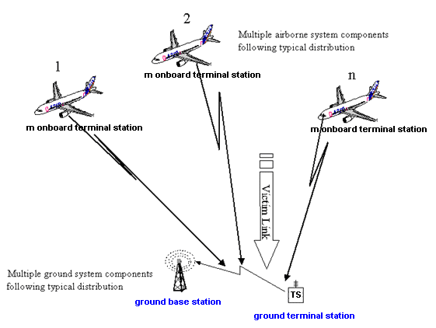
Figure 8: Scenario 6: ac-UE interfering ground-based uplink (g-UE to g-NodeB) from multiple aircraft

Table 13: General summary of Scenario 6
Number of aircraft | Airport distribution
Altitude of the aircraft above ground level | Altitude, position and direction distribution
Elevation | Various angles from ground-based link
Interfering Transmitters | Assumed average number of mobiles transmitting per aircraft: 6
Transmitter frequency | 1800 MHz (LTE), 2100 MHz (UMTS) and 2600 MHz (LTE)
Victim receiver | Single g-NodeB
Position of victim receiver | Fixed
Wanted transmitter | Single g-UE
Position of wanted transmitter | Typical distribution illustrating noise-limited network (rural area)
Victim link | g-UE to g-NodeB
Path loss between aircraft and ground networks | Free space path loss
Criteria | Interference criterion I: C/(N+I)  Interference criterion II: (I/N)
Aim | To determine the probability of the ac-UE interfering with the g-UE to g-NodeB communication links for multiple aircraft near an airport.
Suggested modelling approach | SEAMCAT
Simulation cases | - ac-UE Interferer on g-UE → g-NodeB UMTS 2100  - ac-UE Interferer on g-UE → g-NodeB LTE 2600

Aircraft height distribution
In the section 7.4.1.of the ECC Report 093 [2], the number of interferers was defined based on input data from two radar surveillance plots of the London area in busy air traffic hours. With respect to the NCU, the number of interferers to be considered is 18 for normal busy day while it is 33 for extreme busy day. The distribution of aircraft will be as defined in Table 14 (Table 14 of the ECC Report 093 [2]).
Table 14: Typical height distribution and total number of aircraft simultaneously present
Altitude above sea level  (m) | Percentage  during busy hours of busy days | Percentage  during busy hours of normal days
3000 – 4000 | 25% | 28%
4000 – 5000 | 12% | 21%
5000 – 6000 | 11% | 18%
6000 – 7000 | 8% | 6%
7000 – 8000 | 6% | 8%
8000 – 9000 | 9% | 5%
9000 – 10 000 | 11% | 5%
10 000 – 11 000 | 8% | 4%
11 000+ | 10% | 6%
Total | 100% | 100%
Total Number of aircraft simultaneously present | 146 | 80

Ground- based public mobile network parameters used for modelling LTE at 800 MHz, 1800 MHz, 2100 MHz and 2600 mhZ
The following table provides the parameters used in the studies:
Table 15: LTE parameters in the 800 MHz band
Parameter |  | LTE
Parameter |  | UE | BS
Transmit power | dBm/channel | 23 | 64
Receiver bandwidth | MHz | 4.5, 9, 13.5 and 18 | 4.5, 9, 13.5 and 18
Channel bandwidth | MHz | 5, 10, 15 and 20 | 5, 10, 15 and 20
Masking factor | dB
Reference system noise figure (taken from values quoted in standards) | dB | 9 | 5
Reference noise level (taken from values quoted in standards) | dBm / channel | -98 in 5 MHz  -95 in 10 MHz  -92 in 20 MHz | -102 in 5 MHz  -99 in 10 MHz  -96 in 20 MHz
Reference receiver sensitivity (taken from values quoted in standards) | dBm / channel | –100 in 5 MHz  –97 in 10 MHz  –94 in 20 MHz | -101.5
Interference criterion I (C/(N+I) ) | dB
Interference criterion II (I/N) | dB | -6
Channel spacing | MHz | 5,10,20 | 5,10,20
Maximum antenna gain | dBi | 0 | 15
Antenna height | m | 1.5 | 45
Feeder loss | dB | 0 | 3
Cell radius | km | 8.633

Table 16: LTE parameters in the 1800 MHz, 2100 MHz and 2600 MHz band
Parameter |  | LTE
Parameter |  | UE | BS
Antenna input Power | dBm / channel | 23 | 43 in 5 MHz  46 in 10, 15, 20 MHz
Receiver bandwidth | MHz | 4.5, 9, 13.5 and 18 | 4.5, 9, 13.5 and 18
Channel bandwidth | MHz | 5, 10, 15 and 20 | 5, 10, 15 and 20
Masking factor | dB
Reference system noise figure  (taken from values quoted in standards) | dB | 9 | 5
Reference noise level (taken from values quoted in standards) | dBm / channel | -98 in 5 MHz  -95 in 10 MHz  -92 in 20 MHz | -102 in 5 MHz  -99 in 10 MHz  -97 in 15 MHz  -96 in 20 MHz
Reference receiver sensitivity  (taken from values quoted in standards) | dBm / channel | –100 in 5 MHz  –97 in 10 MHz  –95.2 in 15 MHz  –94 in 20 MHz | -101.5
Interference criterion I (C/(N+I) ) | dB
Interference criterion II (I/N) | dB | -6
Channel spacing | MHz | 5,10,20 | 5,10,20
Maximum antenna gain | dBi | 0 | 17
Antenna height | m | 0 | 30
Cell radius | km | 8

Ground- based public mobile network parameters used for modelling WIMAX at 1800 MHz
The following table provides the parameters used in the studies:
Table 17: WIMAX parameters in the 1800 MHz band
Parameters |  | WIMAX 1800
Parameters |  | BS | UE
Carrier separation | MHz | 5, 10
Tx Power (Maximum) | dBm | 43 | 23
Antenna gain | dBi | 15 to 17 | 0
Feeder loss | dB | 3 | 1
Antenna height | m | 45 (Rural)  30 (Urban) | 1.5
Antenna down-tilt | ° | 3 | -
BS-UE MCL | dB | 80 (Rural)  70 (Urban) | -
Receiver Bandwidth (MHz) | MHz | 4.75 for 5 MHz channel  9.5 for 10 MHz channel | 4.75 for 5 MHz channel  9.5 for 10 MHz channel
Receiver Thermal Noise Level (dBm) | dBm | -102.2 for 5 MHz channel  -99.2 for 10 MHz channel | -99.2 for 5 MHz channel  -96.2 for 10 MHz channel
Receiver reference sensitivity (dBm) | dBm | -101.3 for 5 MHz channel  -98.3 for 10 MHz channel | -97.8 for 5 MHz channel  -94.8 for 10 MHz channel
ACLR_1 (dB)  (±5MHz for 5 MHz channel)  (±10MHz for 10 MHz channel)  ACLR_1 (dB)  (UTRA BW 3.84 MHz) | dB | 45  45 | 30  33
ACLR_2 (dB)  (±10 MHz for 5 MHz channel)  (±20 MHz for 10 MHz channel) | dB | 50 | 44

sYSTEM PARAMETERS OF THE CONSIDERED ADJACENT BANDS

RADIO ASTRONOMY SERVICE (RAS) PARAMETERS
Radio Astronomy is a passive service, so does not cause interference to other users of the radio spectrum. It uses state of the art receiver systems and is highly susceptible to interference from air and space borne transmitters. Developments over the last 20 years mean that radio astronomical observations are often made on a coordinated basis worldwide and, since radio astronomy is also dependent on naturally occurring phenomena, the operational frequencies it uses cannot be moved within the spectrum. Additionally, radio astronomy cannot operate effectively with levels of interference that would be tolerable in commercial systems. Consequently, its coexistence with other services in adjacent and shared bands needs careful management. From the RAS perspective, the bands near 2.7 GHz are important because it can produce receivers with extremely low noise characteristics and there is a low galactic background; they are mainly used for continuum observations in many European observatories either as single dish or for coordinated simultaneous measurements across Europe.

In view of deploying MCA systems on board aircraft, compatibility with RAS in the band 2690-2700 MHz should be examined. However, the RAS also has an allocation on a secondary basis in the band 2655-2690 MHz; an allocation to MCA will imply sharing with the existing RAS operations in this band.

The frequency bands 2655-2690 and 2690-2700 MHz are allocated to the Radio Astronomy Service supported by RR footnotes 5.149 and 5.340 respectively, which state that:
5.149: “In making assignments to stations of other services to which the bands: …., 2655-2690 MHz, .... are allocated, administrations are urged to take all practicable steps to protect the radio astronomy service from harmful interference. Emissions from space-borne or airborne stations can be particularly serious sources of interference to the radio astronomy service (see Nos. 4.5 and 4.6 and Article 29).”
5.340: “All emissions are prohibited in the following bands: 1 400-1 427 MHz, 2 690-2 700 MHz, except those provided for by No. 5.422, ...”

RAS antennas and thresholds of interference
The RAS uses very high gain antennas and unfiltered receivers having large fractional bandwidths in order to detect cosmic radio waves; observations of the highest sensitivity are obtained when radio astronomers make use of the widest possible bandwidth. In most cases, interference to the radio astronomy station will be received through the antenna side lobes, so the very narrow, high gain, main beam response to the interference is not usually considered. In fact for most interference calculation purposes it has become the practice to model the RAS observatory antenna is as having a gain of 0 dBi in all directions. This has been encapsulated in Recommendation ITU-R RA.769: “Protection criteria used for radio astronomical measurements”; the data in the tables in this Recommendation are regarded as the generally applicable interference threshold criteria for the protection of high sensitivity radio astronomy observations.
RAS protection requirements
Recommendation ITU-R RA.769-2 [4] provides the protection criteria for radio astronomical measurements. The appropriate value for the band 2690-2700 MHz is 207 dBW/10MHz or -177 dBm/10MHz, which also applies to all systems operated in the adjacent band 2655-2690 MHz at, or near the location of the radio telescope.

Parameters for radio astronomy stations
ECC Report 045 [12] provides the relevant parameters for the radio astronomy stations in Europe using the 2690-2700 MHz band.
Table 18: RAS stations operating at the 2690-2700 MHz band in Europe
Country | Place | Latitude  N | Longitude  E | Heigth above sea level  (m) | Diameter  (m) | Minimum elevation  (°)
Czech  Republic | Ondrejov¹ | 49°54'38" | 14°47'01" | 525 | 3  7,5 | 0  0
France | Nançay | 47°23'26" | 02°12'00" | 180 | 200 x 40 | 3.6
Germany | Effelsberg | 50°31'32" | 06°53'00" | 369 | 100 | 7
Netherlands | Westerbork | 52°55'01" | 06°36'15" | 16 | 14 x 25 | 0
Russia | Kalyazin  Pushchino  Zelenchukskaya | 57º 13'22"  54º 49'00"  43º 49'53" | 37º 54'01"  37º 40'00"  41º 35'32" | 195  200  1000 | 64  22  32 | 0  6  -5
Switzerland | Bleien¹) | 47°22'36" | 08°33'06" | 469 | 7 | 5
United  Kingdom | Cambridge | 52°09'59" | 00°02'20" | 24 | 60 x 5 | 0
United  Kingdom | Jodrell Bank | 53°14'10" | -02°18'26" | 78 | 76  32  13 | -1  0  0
Typical maximum antenna gain: 69.0 dBi
¹ solar observations

Radar parameters
The following table provides the technical characteristics of radars in the band above 2700 MHz.
Table 19: Radar parameters for the frequency band above 2700 MHz
Parameter | Unit | ATC and defense
Parameter | Unit | Type 1 | Type 2 |  | Type 3 |  | Type 4
Category |  | Frequency hopping | 2 to 4 frequencies |  |  |  | Single frequency
Maximum antenna gain | dBi | >40 | 34 |  |  |  | 43
Antenna pattern |  | Not given | Vertical pattern cosecant-squared (see figure 5) |  |  |  | Recommendation ITU-R F.1245-2 [10]
Antenna height | m | 5-40 (normal 12) |  |  |  |  | 7-21 (normal 13)
Polarization |  | Circular |  |  |  |  | H/V
Feeder loss | dB | <1 |  | Not given |  |  | 2
Minimum elevation angle | ° | Not given | 2 (see Recommendation  ITU-R M.1851 [11] ) |  |  |  | 0.5
Protection level (Note 1) | dBm/MHz | -122
1 dB compression point (Note 2) | dBm | -20 (see Recommendation ITU-R M.1464 [5]) |  |  |  |  | 10
Transmission power | kW | 1000 | 400 | 30 |  |  | 794
Reference bandwidth | kHz | 2500 | 1000 | 800 |  | 800 | 1000
40 dB bandwidth | MHz | 9.5 | 20 | 4 |  | 2 | 25
Out of band roll off | dB/decade | 20 | 20 | 20 |  |  | 40
Spurious level | dBc | -60 | -60 | -60 |  |  | -60 for old radars and -75 to -90 for new radars
Pulse repetition rate | Hz | <300 | ~1000 | 825 |  |  | 250 – 1200 (See Rec ITU-R M.1849 [7]
Pulse duration | µs | 20 and 100 | 1 | 1 |  | 100 | 0.8-2
Rise and fall time | % of pulse length | 1% | 10% | 0.169 |  | Not given | 10%
Antenna rotation | RPM | 6-12 | 12-15 | 15 |  |  | See Rec ITU-R M.1849 [7]
Scan in elevation |  | Not given | Fixed |  |  |  | See Rec ITU-R M.1849 [7]
Note 1: This protection level is derived from measurements as explained in Recommendation ITU-R M.1464-1 [5]).
Note 2: ECC Report 174 [3] gives blocking levels that can be more stringent than 1 dB compression point.

Figure 9 provides the ATC radar antenna pattern in elevation

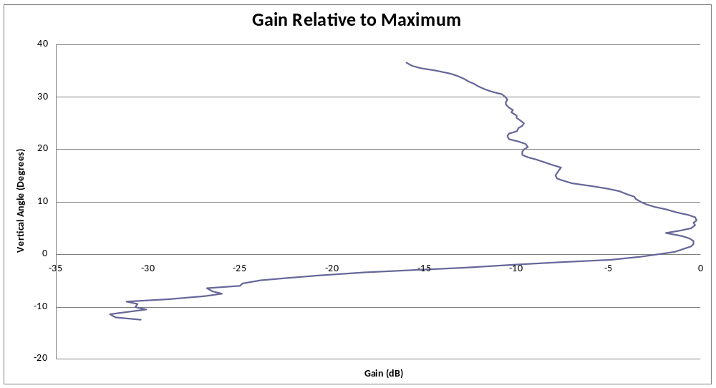
Figure 9: ATC radar antenna pattern in elevation

Figure 10 provides the typical elevation angle of meteorological radars over time. It shows that the elevation angle goes from 0.5° to about 37°. For the compatibility study, the elevation angle of 37° will be considered.
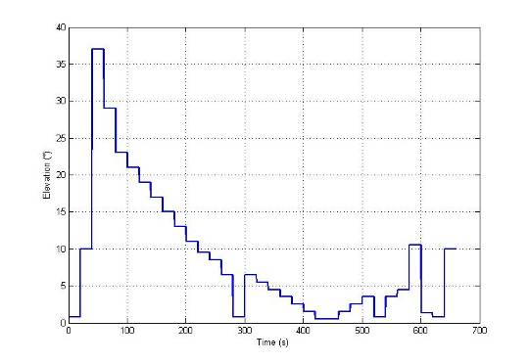
Figure 10: Meteorological radars, typical elevation variation over time

compatibility analysis
ECC Report 093 [2] considers the technical compatibility between GSM equipment on board aircraft and ground-based public mobile networks. The additional compatibility studies performed here address the impact on ground-based public mobile networks of introducing a MCA system based on the UMTS / LTE technology operating at a height of at least 3000 metres above ground level in the following frequency bands:
- 1710-1785 MHz for uplink (terminal transmit, base station receive) / 1805-1880 MHz for downlink (base station transmit, terminal receive);
- 1920-1980 MHz for uplink (terminal transmit, base station receive) / 2110-2170 MHz for downlink (base station transmit, terminal receive);
- 2500-2570 MHz for uplink (terminal transmit, base station receive) / 2620-2690 MHz for downlink (base station transmit, terminal receive).

It will as well develop the technical conditions to protect ground-based cellular systems operating in the frequency band 832-862 MHz / 791-821 MHz.

Analysis related to onboard LTE connectivity at 1800 MHz

Scenario 1: Impact of g-base station on ac-UE at 1800 MHz
This scenario assesses in which conditions the ac-UE will have visibility of the terrestrial LTE1800 networks, by using MCL calculations.
The worst case elevation angle is 48 °, corresponding to an antenna gain of -1.84 dBi.
Table 20: Impact of g-LTE base station on ac-UE at 1800 MHz
Aircraft height above ground (m) | Worst case elevation angle (deg) | Distance aircraft / base station (km) | Path loss (dB) | Ant. Gain (dBi) at given angle | LTE1800
 |  |  |  |  | e.i.r.p. (dBm) | Max. received power in aircraft, P_{max_rec:ac-MS} (dBm/ch) | Margin (dB)
3000 | 48 | 4.04 | 109.9 | -1.84 | 41.16 | -73.7 | -26.3
4000 | 48 | 5.38 | 112.4 | -1.84 | 41.16 | -76.2 | -23.8
5000 | 48 | 6.73 | 114.3 | -1.84 | 41.16 | -78.1 | -21.9
6000 | 48 | 8.07 | 115.9 | -1.84 | 41.16 | -79.7 | -20.3
7000 | 48 | 9.42 | 117.2 | -1.84 | 41.16 | -81.1 | -18.9
8000 | 48 | 10.76 | 118.4 | -1.84 | 41.16 | -82.2 | -17.8
9000 | 48 | 12.1 | 119.4 | -1.84 | 41.16 | -83.2 | -16.8
10000 | 48 | 13.45 | 120.3 | -1.84 | 41.16 | -84.2 | -15.8
A negative margin means that an extra isolation is necessary to remove the visibility of the ground networks.

Scenario 2: Impact of ac-UE on g-base station at 1800 MHz
This scenario assesses in which conditions the onboard ac-UE will have the ability to connect to terrestrial networks.
Table 21: impact of ac-UE on g-base station at 1800 MHz
Aircraft height above ground (m) | Worst case elevation angle (deg) | Distance aircraft / g_UE (km) | Path loss (dB) | Rx Ant. Gain (dBi) at given angle | LTE1800
 |  |  |  |  | UE e.i.r.p (dBm) | Max. received power on ground, P_{max_rec:_g_node} B (dBm/ch) | Margin (dB)
3000 | 48 | 4.04 | 109.9 | -1.84 | 23 | -93.7 | -7.8
4000 | 48 | 5.38 | 112.4 | -1.84 | 23 | -96.2 | -5.3
5000 | 48 | 6.73 | 114.3 | -1.84 | 23 | -98.1 | -3.4
6000 | 48 | 8.07 | 115.9 | -1.84 | 23 | -99.7 | -1.8
7000 | 48 | 9.42 | 117.2 | -1.84 | 23 | -101.1 | -0.4
8000 | 48 | 10.76 | 118.4 | -1.84 | 23 | -102.2 | 0.7
9000 | 48 | 12.1 | 119.4 | -1.84 | 23 | -103.2 | 1.7
10000 | 48 | 13.45 | 120.3 | -1.84 | 23 | -104.2 | 2.7
A negative margin shows that it is possible that an UE could connect to a ground-based mobile network.

Estimation of the maximum power level emitted by the onboard nodeB in the 1800 MHz
Based on the ECC/DEC/(06)07 [1] and taken into account the fact that the GSM mobile terminal will transmit 0 dBm, then it is possible to determine the minimum aircraft attenuation as shown in;
Table 22; aircraft attenuation
Height above ground (m) | Aircraft attenuation (dB)
3000 | 3.3
4000 | 1.1
5000 | -0.5
6000 | -1.8
7000 | -2.9
8000 | -3.8

From Table 22, it is possible to estimate the e.i.r.p. outside the aircraft with the following formula:
e.i.r.p. (dBm/Channel) = Max received signal + Radiation factor – aircraft attenuation + 5 dB (this value was used as initial assumption in the ECC Report 093 [2]).
Then, from the calculated e.i.r.p. the increase of noise level will be estimated.
Table 23: MCL calculation
height above ground (km) ⇒ | 3 | 4 | 5 | 6 | 7 | 8
Max received signal level (dBm/5MHz) | -73.7 | -76.2 | -78.1 | -79.7 | -81.1 | -82.2
Radiation Factor (Large Aircraft) (dB) | 70 | 70 | 70 | 70 | 70 | 70
Aircraft Attenuation (dB) | 3.3 | 1.1 | -0.5 | -1.8 | -2.9 | -3.8
Equivalent e.i.r.p.  (as point of source) (dBm/5MHz) | -20 | -2.3 | -2.6 | -2.9 | -3.2 | -3.4
Free Space Propagation Losses (dB) | 107.3 | 109.8 | 111.7 | 113.3 | 114.6 | 115.8
Maximum Received Noise by g-MS (dBm) | -109.3 | -112.1 | -114.4 | -116.2 | -117.8 | -119.2
System Noise Level, reference values (dB/bw) | -100 | -100 | -100 | -100 | -100 | -100
Increase of the noise floor at g-MS with respect to reference values (dB) | 0.48 | 0.26 | 0.15 | 0.10 | 0.07 | 0.05

From Table 23, it is then possible to calculate the required attenuation in order to get the 1 dB increase noise floor at the ground UE:
Table 24: Calculation of maximum e.i.r.p.
Height above ground (km) | MCL, 1 dB increased noise floor |  |  | Maximum e.i.r.p. produced by the ac-nodeB (dBm/5 MHz) | Maximum e.i.r.p. produced by the ac-nodeB (dBm/200 kHz)
Height above ground (km) | MS attenuation (dB) | Ac-nodeB power (dBm) | Required attenuation (dB) | Maximum e.i.r.p. produced by the ac-nodeB (dBm/5 MHz) | Maximum e.i.r.p. produced by the ac-nodeB (dBm/200 kHz)
3 | 3.3 | -1 | -2.43 | 1.43 | -12.55
4 | 1.1 | -1.3 | -5.22 | 3.92 | -10.06
5 | -0.5 | -1.6 | -7.50 | 5.9 | -8.08
6 | -1.8 | -1.9 | -9.36 | 7.46 | -6.52
7 | -2.9 | -2.2 | -10.94 | 8.74 | -5.24
8 | -3.8 | -2.4 | -12.36 | 9.96 | -4.02

Based on the result of the maximum e.i.r.p., defined outside the aircraft and produced by the ac-NodeB in 1800 MHz, it can be seen that the limit contained in the ECC/DEC/(06)07 [1] in the band 1800 MHz remains.

Scenario 5
Table 25: MCL calculation for ac-UE1800 MHz to terrestrial LTE networks
height above ground (km) | 3 | 4 | 5 | 6 | 7 | 8 | 9 | 10
Distance g-nodeB/ ac-UE (km) | 4.04 | 5.38 | 6.73 | 8.07 | 9.42 | 10.76 | 12.1 | 13.45
UE power level (dBm/5 MHz) | 5 | 5 | 5 | 5 | 5 | 5 | 5 | 5
Aircraft Attenuation (dB) | 3.3 | 1.1 | 0 | 0 | 0 | 0 | 0 | 0
e.i.r.p. outside the aircraft (dBm/5 MHz) | 1.7 | 3.9 | 5 | 5 | 5 | 5 | 5 | 5
Free Space Propagation Losses (dB) | 109.4 | 111.9 | 113.8 | 115.4 | 116.7 | 117.9 | 118.9 | 119.8
Terrestrial LTE antenna Gain (dBI) | -1.8 | -1.8 | -1.8 | -1.8 | -1.8 | -1.8 | -1.8 | -1.8
Maximum Received Noise by g-NodeB (dBm/5 MHz) | -109.5 | -109.8 | -110.6 | -112.2 | -113.5 | -114.7 | -115.7 | -116.6
System Noise Level, reference values (dBm/5 MHz) | -102 | -102 | -102 | -102 | -102 | -102 | -102 | -102
Increase of the noise floor at g-NodeB with respect to reference values (dB) | 0.71 | 0.67 | 0.56 | 0.40 | 0.30 | 0.23 | 0.18 | 0.15

Table 25 shows that the increase of noise remains below 1 dB.

Analysis related to onboard connectivity at 2100 MHz
The ECC Report 093 [2] already contains results for scenarios 1, 2 and 3. Those results are calculated using the same parameters as identified in Table 16. Therefore, those studies are not repeated for this report. The e.i.r.p. level used for the scenario 4 is the ECC limit (i.e 1 dBm / 3.84 MHz).

Parameters adopted for Scenario 4, 5 & 6 (SEAMCAT simulation)
Link parameters
Table 26: Interfering Link Parameters for Scenario 4
Ac-Node B | e.i.r.p. |  | 1dBm/3.84MHz
Ac-Node B | Antenna Height |  | Refer to Table 14
Ac-Node B | Antenna peak gain |  | 0 dBi
Ac-UE | Receiver Sensitivity |  | -119dBm/3.84MHz
Ac-UE | Antenna Height |  | Refer to Table 14
Ac-UE | Antenna peak gain |  | 0 dBi

Table 27: Victim Link Parameters for Scenario 4
Number of users per cell (defined by SEAMCAT) | 37
Cell Radius | 6 km
Handover margin | 4 dB
Minimum coupling loss | 70 dB
Radiation pattern | Recommendation ITU-R F.1336-3 Section 3.2
Antenna gain | 18 dBi
Simulation radius | 56 km

Table 28: Interfering Link Parameters for Scenario 5 and 6
Ac-UE |  | e.i.r.p. |  | -6 dBm/3.84MHz
 |  | Antenna Height |  | Refer to Table 14
 |  | Antenna peak gain |  | 0 dBi
Ac-BTS |  | Receiver Sensitivity |  | -121 dBm/3.84MHz
 |  | Antenna Height |  | Refer to Table 14
 |  | Antenna peak gain |  | 0 dBi

Table 29: Victim link Parameters for Scenario 5 & 6
Number of users per cell (defined by SEAMCAT) | 35
Cell Radius | 6 km
Handover margin | 4 dB
Minimum coupling loss | 70 dB
UE Maximum Transmit Power | 24 dBm
UE power Control Range | 72.0 dB
Radiation pattern | Recommendation ITU-R F.1336-3 Section 3.2
Antenna gain | 18dBi
Simulation radius | Scenario 5 : Refer to Error: Reference source not found  (Distance g-BTS to ac-UE)  Scenario 6 : 200km

Number of Interferers

In Section 7.4.1. of the ECC Report 093 [2], the number of interferers was defined based on the input data from two radar surveillance plots of the London area in busy air traffic hours. With respect to the NCU, the number of interferers to be considered is 18 for normal busy day while it is 33 for extreme busy day. The distribution of aircraft is as defined in Table 14 (Table 14 of the ECC Report 093 [2]). Considering frequency reuse and following the same development in page 30 of ECC Report 093[2], the number of interferers used in scenario 4 is calculated as followed:
Number of UMTS channel available onboard aircraft: 12 UMTS channels (assume full access to the whole 3G spectrum for connectivity)
Number of UMTS channel onboard narrow body aircraft: 2
Number of UMTS channel onboard wide body aircraft: 5

Weighted average frequency allocated (assuming 27% wide body aircraft)
= (0.27*5*5)+(0.73*2*5) MHz= 14.05 MHz

Frequency re-use factor = frequency allocated / spectrum pool available:
= 14.05/60=23.4 %

Therefore, for Scenario 4:
Number of ac-BTS for a normal day = 18*23.4%= 4
Number of ac-BTS for a busy day = 33*23.4% = 8

The numbers of interferers used in the simulations for a normal and busy day are 4 and 8 respectively.
For Scenario 5: The number of interferers for a single aircraft is the number of simultaneous ac-UE users we consider the case of 6.
For Scenario 6: The number of interferers for a single aircraft remains the same as Scenario 5, however, the number of interference links to the victim link is now 4 and 8 respectively for the normal day and busy day case.

SEAMCAT Simulation Results for Scenario 4
In this scenario, we study the impact of the ac-BTS on the terrestrial UMTS networks on the downlink communications link between the g-BTS and g-UE. The e.i.r.p. used is as defined in the ECC/DEC/(06)07, i.e. 1 dBm/ 3.84 MHz at 3000 metre. Table 30 provides the simulation results for Scenario 4.
Table 30: SEAMCAT simulation results for Scenario 4
Description of the case |  |  | Reference cell | CDMA system
 |  |  | Average capacity loss | Average capacity loss
Scenario 4  (2100 MHz) | Multiple ac-BTS to terrestrial UMTS network | Normal day  (4 interferers) | 0% | 3.72 %
Scenario 4  (2100 MHz) | Multiple ac-BTS to terrestrial UMTS network | Busy day  (8 interferers) | 0 % | 2.35%

Note: in the above Table, the aircraft distribution for a normal day is greater than that for a busy day at aircraft height above ground at 3000 to 5000 metres (see Table 14).

SEAMCAT Simulation Results for Scenarios 5 and 6
In the scenarios 5 and 6 it is studied the impact of the ac-UE (of one and multiple aircrafts) on the ground-based UMTS networks on the uplink communications link between the g-UE to the g-BTS.
In this scenario, the impact of the ac-UE (of a single aircraft) on the ground-based base station (g-Node-B) was studied. The e.i.r.p. values for ac-UE considered here is -6dBm and the numbers of ac-UE on board considered here are 20.

P_{rec_g-Node B} = e.i.r.p._{ac-UE} – L_{Aircraft} – L_{prop} + G_{g-Node B}

P_{rec_g-Node B} : Power received at the g-NodeB (dBm)
e.i.r.p._{ac-UE} : e.i.r.p. of the ac-UE when the NCU is active (dBm)
L_{Aircraft} : Attenuation due to aircraft (dB)
L_{prop} : Propagation loss between aircraft and g-UE (dB)
G_{g-Unode B}: Antenna gain of the g-Node B (dBi)
The increase in noise floor at the g-UE receiver is given by:
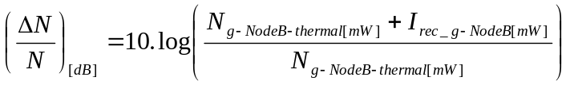 (dB)

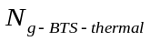: | Noise power level of the g-node B
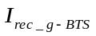: | Interference received by the g-node B

: Noise level of the g-Node B
: Interference received by g-Node B

The table below assesses the change to interference level of user terminal on board aircraft at different height above ground level.
For the purposes of this analysis the following assumptions are used:
- Number of simultaneous users: 20;
- ac-UE e.i.r.p.: -6dBm.
Table 31: Impact of onboard (UMTS 2100) terminal (ac-UE) on ground-based base
station (g-NodeB) noise level
Height above ground (km) ⇒ | 3 | 4 | 5 | 6 | 7 | 8 | 9 | 10
Distance g-node B / ac-UE (km) | 4 | 94.6 | 114.1 | 132.5 | 150.1 | 167 | 183 | 198.4
Power of onboard UE (dBm) | -6 | -6 | -6 | -6 | -6 | -6 | -6 | -6
UE Antenna Gain (dBi) | 0 | 0 | 0 | 0 | 0 | 0 | 0 | 0
Simultaneous Users (dB) | 13.0 | 13.0 | 13.0 | 13.0 | 13.0 | 13.0 | 13.0 | 13.0
ttenuation due to the aircraft (dB) | 5.00 | 5.00 | 5.00 | 5.00 | 5.00 | 5.00 | 5.00 | 5.00
Path Loss (dB) | 111.2 | 113.7 | 115.6 | 117.2 | 118.5 | 119.7 | 120.7 | 121.6
Terrestrial BTS Antenna Gain (dBi) | -1.8 | -1.8 | -1.8 | -1.8 | -1.8 | -1.8 | -1.8 | -1.8
Power Received at g-BTS (dBm) | -111.0 | -113.5 | -115.4 | -117.0 | -118.3 | -119.5 | -120.5 | -121.4
System Noise Level (typical operators) | -104 | -104 | -104 | -104 | -104 | -104 | -104 | -104
Increase of the noise floor at g-nodeB with respect to typical values (dB) | 0.80 | 0.47 | 0.30 | 0.21 | 0.16 | 0.12 | 0.10 | 0.08

Tables below show the SEAMCAT results for different values of e.i.r.p. of ac-UE for different number of ac-UE.
Table 32: SEAMCAT simulation results for Scenario 5 with number of ac-UE = 20
Height above ground (km) | Average Capacity Loss
Height above ground (km) | e.i.r.p. ac-UE= -6dBm
Height above ground (km) | Reference cell | CDMA system
3 | 3.74% | 0.00%
5 | 0.03% | 0.00%
8 | 0.03% | 0.00%

In this scenario, the impact of the ac-UE (of multiple aircrafts) on the terrestrial UMTS networks on the uplink communications link between the g-UE to the g-BTS was studied. Table 33 shows the SEAMCAT results for Scenario 6 with e.i.r.p. of ac-UE = -6dBm and with the number of ac-UE = 20.

Table 33: SEAMCAT results for Scenario 6 with the number of ac-UE = 20
Description of the case |  |  | Average Capacity Loss
 |  |  | e.i.r.p. ac-UE= -6dBm
 |  |  | Reference cell | CDMA system
Scenario 6  (2100 MHz) | Multiple ac-UE to terrestrial UMTS network | Normal day | 0.22% | 0 %
Scenario 6  (2100 MHz) | Multiple ac-UE to terrestrial UMTS network | Busy day | 0.38% | 0%

The results show that the average capacity loss remains below 5%.

Table 34: Maximum permitted e.i.r.p levels for the onboard UMTS at 2100 MHz
Height above ground (km) | MCL, 1 dB increased noise floor
Height above ground (km) | Aircraft attenuation (dB) | Ac-UE power (dBm) | Mulitple user factor (dB) | Required attenuation (dB) | Effective attenuation (dB) | Max permitted e.i.r.p. (dBm/channel)
3 | 5 | -6 | 13 | -1.1 | 3.9 | 3.1
4 | 5 | -6 | 13 | -3.6 | 1.4 | 5.6
5 | 5 | -6 | 13 | -5.5 | 0 | 7
6 | 5 | -6 | 13 | -7.1 | 0 | 7
7 | 5 | -6 | 13 | -8.5 | 0 | 7
8 | 5 | -6 | 13 | -9.6 | 0 | 7

COMPATIBILITY ANALYSIS AT 800 MHZ
The following parameters are used in the calculation:
  - Node B

- e.i.r.p.: 64 dBm/10 MHz
- The Node B sensitivity: -101.5 dBm
- Antenna gain : 15 dBi

  - UE

- e.i.r.p.: 23 dBm/10 MHz
- The sensitivity of the UE is -97 dBm/10 MHz
- Antenna gain of the UE is 0 dBi

  - Aircraft attenuation

- 5 dB

Scenario 1: Impact of g-NodeB on ac-UE
The worst case elevation angle considered for the study at 800 MHz is 48° whatever the height above ground of the aircraft. The antenna gain is -0.34 dBi.

Table 35: Margin for protection of ac-UE from terrestrial networks
Aircraft height above ground (m) | Worst case elevation angle (deg) | Distance aircraft / base station (km) | Path loss (dB) | Ant. Gain (dBi) at given angle | LTE 800
 |  |  |  |  | e.i.r.p. (dBm) | Max. received power in aircraft, P_{max_rec:ac-MS} (dBm/ch) | Margin  (dB)
3000 | 48 | 4.04 | 102.6 | -0.34 | 48.66 | -58.92 | -38.08
4000 | 48 | 5.38 | 105.1 | -0.34 | 48.66 | -61.42 | -35.58
5000 | 48 | 6.73 | 107.0 | -0.34 | 48.66 | -63.35 | -33.66
6000 | 48 | 8.07 | 108.6 | -0.34 | 48.66 | -64.94 | -32.06
7000 | 48 | 9.42 | 109.9 | -0.34 | 48.66 | -66.24 | -30.76
8000 | 48 | 10.76 | 111.1 | -0.34 | 48.66 | -67.44 | -29.56
9000 | 48 | 12.10 | 112.1 | -0.34 | 48.66 | -68.44 | -28.56
10000 | 48 | 13.45 | 113.0 | -0.34 | 48.66 | -69.34 | -27.66

A negative margin means that an extra isolation is necessary to remove the visibility of the ground networks.

Scenario 2: Impact of ac-UE on g-NodeB at 800 MHz
This scenario assesses in which conditions the onboard ac-UE will have the ability to connect to terrestrial networks.
Table 36: Impact of ac-UE on g-NodeB at 800 MHz
Aircraft height above ground (m) | Worst case elevation angle (deg) | Distance aircraft / g_UE (km) | Path loss (dB) | Rx Ant. Gain (dBi) at given angle | LTE 800
 |  |  |  |  | e.i.r.p. (dBm) | Max. received power on ground, P_{max_rec:_g_node} B (dBm/ch) | Margin  (dB)
3000 | 48 | 4.04 | 102.6 | -0.34 | 23 | -84.94 | -16.56
4000 | 48 | 5.38 | 105.1 | -0.34 | 23 | -87.44 | -14.06
5000 | 48 | 6.73 | 107.0 | -0.34 | 23 | -89.34 | -12.16
6000 | 48 | 8.07 | 108.6 | -0.34 | 23 | -90.94 | -10.56
7000 | 48 | 9.42 | 109.9 | -0.34 | 23 | -92.24 | -9.26
8000 | 48 | 10.76 | 111.1 | -0.34 | 23 | -93.44 | -8.06
9000 | 48 | 12.1 | 112.1 | -0.34 | 23 | -94.44 | -7.06
10000 | 48 | 13.45 | 113.0 | -0.34 | 23 | -95.34 | -6.16

A negative margin shows that it is possible that an UE could connect to a ground-based mobile network.

Scenario 3: Impact of the NCU on g-UE at 800 MHz
This scenario assesses the impact of onboard NCU emissions on the ground-based UE receivers, by using MCL calculations.
Table 37: Impact of a signal NCU to terrestrial LTE network
Height above ground (km) | 3 | 4 | 5 | 6 | 7 | 8 | 9 | 10
Max received Signal Level (dBm/channel) inside aircraft | -58.92 | -61.44 | -63.34 | -64.94 | -66.24 | -67.44 | -68.44 | -69.34
Radiation Factor (Large Aircraft) (dB) | 64 | 64 | 64 | 64 | 64 | 64 | 64 | 64
Aircraft Attenuation for leaky feeder transmission (dB) | 10 | 10 | 10 | 10 | 10 | 10 | 10 | 10
Equivalent e.i.r.p. (as point of source) (dBm/10 MHz) | -4.92 | -7.44 | -9.34 | -10.94 | -12.24 | -13.44 | -14.44 | -15.34
Free Space Propagation Losses (dB) | 100.00 | 102.50 | 104.44 | 106.02 | 107.36 | 108.52 | 109.55 | 110.46
Maximum Received Noise by g-UE (dBm/channel) | -104.92 | -109.94 | -113.78 | -116.96 | -119.60 | -121.96 | -123.99 | -125.80
System Noise Level, reference values (dBm/channel) | -95 | -95 | -95 | -95 | -95 | -95 | -95 | -95
Increase of the noise floor at g-UE with respect to reference values (dB) | 0.42 | 0.14 | 0.06 | 0.03 | 0.02 | 0.01 | 0.01 | 0.00
From the results of Table 37, it is then possible to calculate, for different height above ground of the aircraft what the equivalent e.i.r.p. of the NCU should be to get 1 dB increase of noise floor at ground UE. These values are contained in Table 38.
Table 38: maximum e.i.r.p. of the NCU
Height above ground (km) | 3 | 4 | 5 | 6 | 7 | 8 | 9 | 10
Equivalent e.i.r.p. (dBm/10 MHz) | -0.87 | 1.63 | 3.57 | 5.15 | 6.49 | 7.65 | 8.68 | 9.59

- SEAMCAT results

The following parameters used in SEAMCAT are as follow:

- the total number of resource blocks (RB) is fixed and depends on the LTE channel bandwidth. In the case of a 10 MHz channel bandwidth, the maximum number of RBs is 50
- the number of active users is 1 or 3
- the number of RB allocated to a terminal depends on the number of terminals operating at the same time within a cell/sector.
- the cell radius is 8.633 km.

Table 39: Average capacity loss
Situation |  | Reference Cell |  | OFDMA System
Description of the case |  | Average capacity loss | Average bitrate loss | Average capacity loss | Average bitrate loss
NCU transmitting  in the 800 MHz band over terrestrial LTE  networks | Transmitter placed randomly within a radius of 17 km at 3 km above ground | 0 % | 0.001 % | 0 % | 0 %
 | Transmitter placed randomly within a radius of 28 km at 5 km above ground | 0 % | 0.02 % | 0 % | 0.001 %
 | Transmitter placed randomly within a radius of 45 km at 8 km above ground | 0% | 0.002% | 0% | 0.001%
 | Transmitter placed randomly within a radius of 56 km at 10 km above ground | 0% | 0.002% | 0% | 0.001%

Scenario 4: impact of multiple NCU on g-UE at 800 MHz
The maximum number of resource blocks for a 10 MHz channel bandwidth is 50. In the simulation, 3 users were defined.
The cell radius for rural case is 8.66 km.

Table 40 provides the result for the scenario 4.
Table 40: simulation result for scenario 4
Description of the case |  |  | Reference cell |  | OFDMA system
 |  |  | Average capacity loss | Average bitrate loss | Average capacity loss | Average bitrate loss
Scenario 4  (800 MHz) | Multiple NCU to terrestrial LTE network | Normal day  (18 interferers) | 0% | 0.006% | 0 % | 0,003 %
Scenario 4  (800 MHz) | Multiple NCU to terrestrial LTE network | Extreme busy day  (33 interferers) | 0% | 0.01% | 0 % | 0,004 %

The result shows that the average capacity loss remains below 1%.

COMPATIBILITY ANALYSIS AT 900 MHZ

Scenario 1: Impact of g-NodeB on ac-UE at 900 MHz
This scenario assesses in which conditions the ac-UE will have visibility of the terrestrial networks, by using MCL calculations.
The excel file attached to this document provides details of calculation for elevation angles going from 0° to 90°.
From the calculation for different elevation angles, the worst case elevation angle considered for the study at 900 MHz is 48° whatever the height above ground of the aircraft. The relative antenna gain is -1.84dBi.

Table 41: Impact of g-NodeB on ac-UE at 900 MHz
Aircraft height above ground (m) | Worst case elevation angle (deg) | Distance aircraft / base station (km) | Path loss (dB) | Ant. Gain (dBi) at given angle | LTE 900
 |  |  |  |  | e.i.r.p. (dBm) | Max. received power in aircraft, P_{max_rec:ac-MS} (dBm/ch) | Margin  (dB)
3000 | 48 | 4.04 | 103.9 | -1.84 | 41.16 | -67.7 | -32.3
4000 | 48 | 5.38 | 106.4 | -1.84 | 41.16 | -70.2 | -29.8
5000 | 48 | 6.73 | 108.3 | -1.84 | 41.16 | -72.1 | -27.9
6000 | 48 | 8.07 | 109.9 | -1.84 | 41.16 | -73.7 | -26.3
7000 | 48 | 9.42 | 111.3 | -1.84 | 41.16 | -75.1 | -24.9
8000 | 48 | 10.76 | 112.4 | -1.84 | 41.16 | -76.2 | -23.8
9000 | 48 | 12.10 | 113.4 | -1.84 | 41.16 | -77.2 | -22.8
10000 | 48 | 13.45 | 114.3 | -1.84 | 41.16 | -78.1 | -21.9
A negative margin means that an extra isolation is necessary to remove the visibility of the ground networks.

Scenario 2: Impact of ac-UE on g-NodeB
This scenario assesses in which conditions the onboard ac-UE will have the ability to connect to terrestrial networks.
Table 42: impact of ac-UE on g-NodeB at 900 MHz
Aircraft height above ground (m) | Worst case elevation angle (deg) | Distance aircraft / g_UE (km) | Path loss (dB) | Rx Ant. Gain (dBi) at given angle | LTE 900
 |  |  |  |  | e.i.r.p. (dBm) | Max. received power on ground, P_{max_rec:_g_node} B (dBm/ch) | Margin  (dB)
3000 | 48 | 4.04 | 103.9 | -1.84 | 23 | -87.74 | -13.76
4000 | 48 | 5.38 | 106.4 | -1.84 | 23 | -90.24 | -11.26
5000 | 48 | 6.73 | 108.3 | -1.84 | 23 | -92.14 | -9.36
6000 | 48 | 8.07 | 109.9 | -1.84 | 23 | -93.74 | -7.76
7000 | 48 | 9.42 | 111.3 | -1.84 | 23 | -95.14 | -6.36
8000 | 48 | 10.76 | 112.4 | -1.84 | 23 | -96.24 | -5.26
9000 | 48 | 12.1 | 113.4 | -1.84 | 23 | -97.24 | -4.26
10000 | 48 | 13.45 | 114.3 | -1.84 | 23 | -98.14 | -3.36

A negative margin shows that it is possible that an UE could connect to a ground-based mobile network.

Scenario 3: Impact of the NCU on g-UE
In this frequency band, the ECC/DEC/(06)07 [1] provides the maximum e.i.r.p. defined outside the aircraft. At the first stage, the minimum value needed to screen the LTE ground network should be defined and calculate what the increase of noise floor will be.
Table 43: MCL result of impact of the NCU on g-UE
Height above ground (km) ⇒ | 3 | 4 | 5 | 6 | 7 | 8 | 9 | 10
Max received Signal Level (dBm/channel) inside aircraft | -67.7 | -70.2 | -72.1 | -73.7 | -75.1 | -76.2 | -77.2 | -78.1
Radiation Factor (Large Aircraft) (dB) | 64 | 64 | 64 | 64 | 64 | 64 | 64 | 64
Aircraft Attenuation for leaky feeder transmission (dB) | 10 | 10 | 10 | 10 | 10 | 10 | 10 | 10
Equivalent e.i.r.p. (as point of source) (dBm/channel) | -13.7 | -16.24 | -18.14 | -19.74 | -21.14 | -22.24 | -23.24 | -24.14
Equivalent e.i.r.p. (as point of source) (dBm/200 kHz) | -27.72 | -30.22 | -32.12 | -33.72 | -35.12 | -36.22 | -37.22 | -38.12
Free Space Propagation Losses (dB) | 100.00 | 102.50 | 104.44 | 106.02 | 107.36 | 108.52 | 109.55 | 110.46
Maximum Received Noise by g-UE (dBm) | -113.74 | -118.74 | -122.58 | -125.76 | -128.50 | -130.76 | -132.79 | -134.60
System Noise Level, reference values (dB/channel) | -98 | -98 | -98 | -98 | -98 | -98 | -98 | -98
Increase of the noise floor at g-UE with respect to reference values (dB) | 0.114 | 0.036 | 0.015 | 0.007 | 0.004 | 0.002 | 0.001 | 0.001

The above table shows that the increase of noise floor at ground UE remains below 1 dB. It also shows that the value needed to screen the ground LTE 900 cellular network is below the e.i.r.p. limit defined in the ECC/DEC/(06)06 [9].
Instead of performing all the SEAMCAT simulations starting from the result contained in the above table, it is proposed to use the e.i.r.p. limit as contained in the ECC/DEC/(06)07 [1] and to perform only the scenario 4 in which several interferers will be taken into account. The result of this simulation will indicate whether this e.i.r.p. will have an impact on the ground LTE 900 network.

Scenario 4: Impact of the NCU on g-UE
The e.i.r.p. used is the one as defined in the ECC/DEC/(06)07 [1], i.e.. -19 dBm/200 kHz at 3,000 MHz.
The maximum number of resource blocks for a 5 MHz channel bandwidth is 25, and a typical number of active users is 1 or 3.
The cell radius for rural case is 8.633 km.

Table 44 provides the result for the scenario 4.
Table 44: Simulation result for scenario 4
Description of the case |  |  | Reference cell |  | OFDMA system
 |  |  | Average capacity loss | Average bitrate loss | Average capacity loss | Average bitrate loss
Scenario 4  (900 MHz) | Multiple NCU to terrestrial LTE network | Normal day  (18 interferers) | 0% | 0.005% | 0 % | 0,003 %
Scenario 4  (900 MHz) | Multiple NCU to terrestrial LTE network | Extreme busy day  (33 interferers) | 0 % | 0.009% | 0% | 0.004%

COMPATIBILITY ANALYSIS AT 1800 MHZ

Scenario 1: Impact of g-base station on ac-UE at 1800 MHz
This scenario assesses in which conditions the ac-UE will have visibility of the terrestrial WIMAX networks, by using MCL calculations.

The excel file attached to this document provides details of calculation for elevation angles going from 0° to 90°. The worst case elevation angle is 48 °, corresponding to an antenna gain of -1.34 dBi.

Table 45: Impact of g-WIMAX base station on ac-UE at 1800 MHz
Aircraft height above ground (m) | Worst case elevation angle (deg) | Distance aircraft / base station (km) | Path loss (dB) | Ant. Gain (dBi) at given angle | WIMAX1800
 |  |  |  |  | e.i.r.p. (dBm) | Max. received power in aircraft, P_{max_rec:ac-MS} (dBm/ch) | Margin (dB)
3000 | 48 | 4.04 | 109.9 | -1.34 | 38.66 | -76.2 | -18.6
4000 | 48 | 5.38 | 112.4 | -1.34 | 38.66 | -78.7 | -16.1
5000 | 48 | 6.73 | 114.3 | -1.34 | 38.66 | -80.6 | -14.2
6000 | 48 | 8.07 | 115.9 | -1.34 | 38.66 | -82.2 | -12.6
7000 | 48 | 9.42 | 117.2 | -1.34 | 38.66 | -83.6 | -11.2
8000 | 48 | 10.76 | 118.4 | -1.34 | 38.66 | -84.7 | -10.1
9000 | 48 | 12.10 | 119.4 | -1.34 | 38.66 | -85.7 | -9.1
10000 | 48 | 13.45 | 120.3 | -1.34 | 38.66 | -86.7 | -8.1
A negative margin means that an extra isolation is necessary to remove the visibility of the ground networks.

Scenario 2: Impact of ac-UE on g-base station at 1800 MHz
This scenario assesses in which conditions the onboard ac-UE will have the ability to connect to terrestrial networks.
Table 46: impact of ac-UE on g-base station at 1800 MHz
Aircraft height above ground (m) | Worst case elevation angle (deg) | Distance aircraft / g_UE (km) | Path loss (dB) | Rx Ant. Gain (dBi) at given angle | WIMAX1800
 |  |  |  |  | UE e.i.r.p. (dBm) | Max. received power on ground, P_{max_rec:_g_node} B (dBm/ch) | Margin (dB)
3000 | 48 | 4.04 | 109.9 | -1.34 | 22 | -94.21 | -4.09
4000 | 48 | 5.38 | 112.4 | -1.34 | 22 | -96.70 | -1.60
5000 | 48 | 6.73 | 114.3 | -1.34 | 22 | -98.64 | 0.34
6000 | 48 | 8.07 | 115.9 | -1.34 | 22 | -100.22 | 1.92
7000 | 48 | 9.42 | 117.2 | -1.34 | 22 | -101.56 | 3.26
8000 | 48 | 10.76 | 118.4 | -1.34 | 22 | -102.72 | 4.42
9000 | 48 | 12.1 | 119.4 | -1.34 | 22 | -103.74 | 5.44
10000 | 48 | 13.45 | 120.3 | -1.34 | 22 | -104.66 | 6.36

A negative margin shows that it is possible that an UE could connect to a ground-based mobile network.

Scenario 3: Impact of the NCU on g-UE at 1800 MHz
In this frequency band, the ECC/DEC/(06)07 [1] provides the maximum e.i.r.p. defined outside the aircraft. At the first stage, the minimum value needed to screen WIMAX ground network should be defined and calculate what the increase of noise floor will be.
Table 47: MCL result of impact of the NCU on g-UE
Height above ground (km)  | 3 | 4 | 5 | 6 | 7 | 8 | 9 | 10
Max received Signal Level (dBm/channel) inside aircraft | -76.2 | -78.7 | -80.6 | -82.2 | -83.6 | -84.7 | -85.7 | -86.7
Radiation Factor (Large Aircraft) (dB) | 64 | 64 | 64 | 64 | 64 | 64 | 64 | 64
Aircraft Attenuation for leaky feeder transmission (dB) | 10 | 10 | 10 | 10 | 10 | 10 | 10 | 10
Equivalent e.i.r.p. (as point of source) (dBm/10 MHz) | -22.21 | -24.70 | -26.64 | -28.22 | -29.56 | -30.72 | -31.74 | -32.66
Free Space Propagation Losses (dB) | 107.29 | 109.78 | 111.72 | 113.31 | 114.65 | 115.81 | 116.83 | 117.74
Maximum Received Noise by g-UE (dBm/channel) | -129.50 | -134.48 | -138.37 | -141.53 | -144.21 | -146.52 | -148.57 | -150.40
System Noise Level, reference values (dB/9.5 MHz) | -96.2 | -96.2 | -96.2 | -96.2 | -96.2 | -96.2 | -96.2 | -96.2
Increase of the noise floor at g-MS with respect to reference values (dB) | 0.002 | 0.001 | 0.000 | 0.000 | 0.000 | 0.000 | 0.000 | 0.000

The above table shows that the increase of noise floor at ground UE remains below 1 dB.
Instead of performing all the SEAMCAT simulations starting from the result contained in the above table, it is proposed to use the e.i.r.p. limit as contained in the ECC/DEC/ (06)07 [1] and to perform only the scenario 4 in which several interferers will be taken into account. The result of this simulation will indicate whether this e.i.r.p. will have an impact on the ground WIMAX network.

Scenario 4: Impact of the NCU on g-WIMAX UE at 1800 MHz
The e.i.r.p. used is the one as defined in the ECC/DEC//(06)07 [1], i.e.. -13 dBm/200 kHz at 3000 m.
The distribution of aircraft is the same as contained in the section 5.5.4.of this report.
The cell radius for rural case is 6 km.
Table 48 provides the result for the scenario 4.
Table 48: simulation result for scenario 4
Description of the case |  |  | Reference
 |  |  | Irss mean (dBm) | iRSS 95th percentile (dBm) | Criterion I: P(C/(N+I)< 9 dB) (%) | Criterion II: P(I/N>-6 dB) (%)
Scenario 4  (1800 MHz) | Multiple NCU to terrestrial WIMAX network | Normal day  (18 interferers) | -106.4 | -102.9 | 0.08 | 2.51
Scenario 4  (1800 MHz) | Multiple NCU to terrestrial WIMAX network | Extreme busy day  (33 interferers) | -103.8 | -101.2 | 0.96 | 16.7

COMPATIBILITY ANALYSIS AT 2100 MHZ

Scenario 1: Impact of g-NodeB on ac-UE at 2100 MHz
This scenario assesses in which conditions the ac-UE will have visibility of the terrestrial networks, by using MCL calculations.

From the calculation for different elevation angles, the worst case elevation angle considered for the study at 2100 MHz is 48° whatever the height above ground of the aircraft. The relative antenna gain is -0.34 dBi

Table 49: Impact of g-NodeB on ac-UE at 2100 MHz
Height above ground (m) | Worst case elevation angle (deg) | Distance aircraft / base station (km) | Path loss (dB) | Aircraft height above ground (m) | LTE 2100
 |  |  |  |  | e.i.r.p.  (dBm) | Max. received power in aircraft, P_{max_rec:ac-MS} (dBm/ch) | Margin  (dB)
3000 | 48 | 4.04 | 111.2 | -1.84 | 44.16 | -72.0 | -25.0
4000 | 48 | 5.38 | 113.7 | -1.84 | 44.16 | -74.5 | -22.5
5000 | 48 | 6.73 | 115.6 | -1.84 | 44.16 | -76.4 | -20.6
6000 | 48 | 8.07 | 117.2 | -1.84 | 44.16 | -78.0 | -19.0
7000 | 48 | 9.42 | 118.5 | -1.84 | 44.16 | -79.4 | -17.6
8000 | 48 | 10.76 | 119.7 | -1.84 | 44.16 | -80.5 | -16.5
9000 | 48 | 12.1 | 120.7 | -1.84 | 44.16 | -81.5 | -15.5
10000 | 48 | 13.45 | 121.6 | -1.84 | 44.16 | -82.5 | -14.5

A negative margin means that an extra isolation is necessary to remove the visibility of the ground networks.

Scenario 2: Impact of ac-UE on g-NodeB at 2100 MHz
This scenario assesses in which conditions the onboard ac-UE will have the ability to connect to terrestrial networks.
Table 50: impact of ac-UE on g-NodeB at 2100 MHz
Aircraft height above ground (m) | Worst case elevation angle (deg) | Distance aircraft / g_UE (km) | Path loss (dB) | Rx Ant. Gain (dBi) at given angle | LTE 2100
 |  |  |  |  | e.i.r.p.  (dBm) | Max. received power on ground, P_{max_rec:_g_node} B (dBm/ch) | Margin  (dB)
3000 | 48 | 4.04 | 111.2 | -1.84 | 23 | -95.0 | -6.5
4000 | 48 | 5.38 | 113.7 | -1.84 | 23 | -97.5 | -4.0
5000 | 48 | 6.73 | 115.6 | -1.84 | 23 | -99.4 | -2.1
6000 | 48 | 8.07 | 117.2 | -1.84 | 23 | -101.0 | -0.5
7000 | 48 | 9.42 | 118.5 | -1.84 | 23 | -102.4 | 0.9
8000 | 48 | 10.76 | 119.7 | -1.84 | 23 | -103.5 | 2.0
9000 | 48 | 12.10 | 120.7 | -1.84 | 23 | -104.5 | 3.0
10000 | 48 | 13.45 | 121.6 | -1.84 | 23 | -105.5 | 4.0

A negative margin shows that it is possible that an UE could connect to a ground-based mobile network.

Scenario 3: Impact of the NCU on g-UE at 2100 MHz
In this frequency band, the ECC/DEC/(06)07 [1] provides the maximum e.i.r.p. defined outside the aircraft. At the first stage, the minimum value needed to screen the LTE ground network should be defined and calculate what the increase of noise floor will be.
Table 51: MCL result of impact of the NCU on g-UE
Height above ground (km) ⇒ | 3 | 4 | 5 | 6 | 7 | 8 | 9 | 10
Max received Signal Level (dBm/channel) inside aircraft | -72.0 | -74.5 | -76.4 | -78.0 | -79.4 | -80.5 | -81.5 | -82.5
Radiation Factor (Large Aircraft) (dB) | 71 | 71 | 71 | 71 | 71 | 71 | 71 | 71
Aircraft Attenuation for leaky feeder transmission (dB) | 10 | 10 | 10 | 10 | 10 | 10 | 10 | 10
Equivalent e.i.r.p. (as point of source) (dBm/channel) | -11.0 | -13.5 | -15.4 | -17.0 | -18.4 | -19.5 | -20.5 | -21.5
Free Space Propagation Losses (dB) | 108.6 | 111.1 | 113.0 | 114.6 | 116.0 | 117.1 | 118.1 | 119.0
Maximum Received Noise by g-UE (dBm) | -119.6 | -124.6 | -128.5 | -131.6 | -134.3 | -136.6 | -138.7 | -140.5
System Noise Level, reference values (dB/channel) | -95 | -95 | -95 | -95 | -95 | -95 | -95 | -95
Increase of the noise floor at g-UE with respect to reference values (dB) | 0.015 | 0.005 | 0.002 | 0.001 | 0.001 | 0.000 | 0.000 | 0.000
Equivalent e.i.r.p. (as point of source) (dBm/ 200 kHz) | -28.01 | -30.49 | -32.44 | -34.02 | -35.36 | -36.51 | -37.53 | -38.45

The above table shows that the increase of noise floor at ground UE remains below 1 dB. It also shows that the value needed to screen the ground LTE 2100 cellular network is below the e.i.r.p. limit defined in the ECC/DEC/(06)07 [1].
Instead of performing all the SEAMCAT simulations starting from the result contained in the above table, it is proposed to use the e.i.r.p. limit as contained in the ECC/DEC/(06)07 [1] and to perform only the scenario 4 in which several interferers will be taken into account. The result of this simulation will indicate whether this e.i.r.p. will have an impact on the ground LTE 2100 network.

Scenario 4: Impact of the NCU on g-UE at 2100 MHz
The e.i.r.p. used is the one as defined in the ECC/DEC/(06)07 [1], i.e. 1 dBm/ 3.84 MHz at 3000 m.
Table 52: victim link parameters
SINR minimum | -10 dB
Max subcarriers per base station | 48
Number of subcarriers per mobile | 16
Handover margin | 1dB
Minimum coupling loss | 80 dB
User per BS | 3
Antenna gain | 18 dBi
Radiation pattern | Recommendation ITU-R F.1336-3 section 3.2 [8]
Cell radius | 6 km

Table 53: interfering link parameters
Power level | 5.16 dBm/10 MHz
Antenna height | See Table 14
Number of interferer | 18 for normal day  33 for busy day
Simulation radius | 56 km

Table 54 provides the result for the scenario 4.
Table 54: simulation result for scenario 4
Description of the case |  |  | Reference cell |  | OFDMA system
 |  |  | Average capacity loss | Average bitrate loss | Average capacity loss | Average bitrate loss
Scenario 4  (2100 MHz) | Multiple NCU to terrestrial LTE network | Normal day  (18 interferers) | 0% | 0.005% | 0 % | 0.003 %
Scenario 4  (2100 MHz) | Multiple NCU to terrestrial LTE network | Extreme busy day  (33 interferers) | 0 % | 0.009% | 0% | 0.005%

PROTECTION OF ADJACENT SERVICES

RADIO ASTRONOMY SERVICES IN THE 2690 – 2700 MHZ
RAS protection requirements
For the bands in question, the appropriate threshold of interference level of spectral power flux density taken from Table 1 (continuum observations) of Recommendation ITU-R RA.769-2 [4] is -247 dB(W/m².Hz), which equates to a maximum interference power level in a notional 10 MHz bandwidth of -177 dBm. This threshold of interference level is also based on an assumed observational integration time of 2000 s. Continuum observations made with single-dish telescopes commonly undertaken in European observatories are well characterised by these parameters.
With the assumptions noted, the worst case scenario for interference at the RAS observatory will be from an aircraft flying directly over the observatory at the minimum height at which the system is allowed to operate; from ECC Report 093 [2] this is assumed to be 3000 m.
ECC Report 093 [2] considers the possibility of obtaining an equivalent emitted power from the aircraft treated as a point source – i.e. effectively the power level ‘outside the aircraft’. This is useful in the RAS situation; the path loss between the aircraft and the observatory can be calculated and the threshold level of interference detrimental to RAS operation is given in the paragraph above.
Since the aircraft is in line of sight of the observatory, at these frequencies the path loss ‘L’ may be calculated to a reasonable approximation based on the free space path loss equation (i.e. For 3000 m Height above ground at 2695 MHz, L = 110.6 dB). For the scenario stated, the power ‘P_{ext}’ outside the aircraft at 3000 m falling into the band must therefore be less than:
P_{ext} = -177 + 110.6 = -66.4 dBm/10 MHz
This is the ‘single entry’ worst case and requires modification subject to the likely density of aircraft around the observatory, which could produce a significant continuous additional background noise level. This situation is under consideration.

RADAR SERVICES OPERATING ABOVE 2700 MHZ
The impact of MCA system operating in 2500-2690 MHz band on radar system above 2700 MHz band was assessed. This analysis assumes radar performance parameters identical to ECC Report 174 [3]. Those parameters are presented in Table 19.
AC-nodeB

The AC-nodeB related technical characteristics are gathered from ECC Report 093 [2]

According to ECC Report 093 [2], there are 3 suggested aircraft attenuation levels as shown in Table 55.
Table 55: Values of "attenuation due to the aircraft"
Case | Ac-BTS/NCU signal attenuation (dB)
A (low) | 5
B (medium) | 10
C (high) | 15

In this report, the worst case scenario applies with the least attenuation due to the aircraft, i.e. 5 dB.

- Compatibility study between ac-node B (LTE 2600) and Radar system in the band 2700-2900 MHz

In this scenario, the impact of the ac-node B on the Radar systems was studied. Table 19 provides the parameters needed for the radio frequency interference analysis. Here, the increase in noise floor at the victim receiver (radar) is calculated for the different types (Type 1 – 4) of radar.

where,
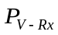 : Power spectral density (dBm/MHz) received at victim receiver
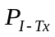 : Power spectral density (dBm/MHz) transmitted at interfering transmitter (1.9 dBm/4.75 MHz)

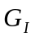 : Antenna gain at the interfering transmitter (dBi) – this value is not considered as it is already contained in the

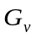 : Antenna gain at the victim receiver (dBi)
: Adjacent Channel Leakage Ratio (45 dB, 3GPP TS 36.104)
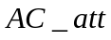: Aircraft attenuation
: Free space path loss
CB : 4G channel bandwidth (4.75 MHz, worst case)

Further,

where,

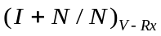 : I+N/N ratio at victim receiver
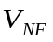 : Reference noise floor at victim receiver (dBm/MHz)

The power spectral density (PSD) (dBm/MHz) received at the victim receiver, is calculated for distance between interfering transmitter (ac-BTS) and victim receiver (radar) for aircraft heights from 3000 m to 10000 m.
The results are summarised in Table 56 and the respective (I+N)/N ratios at the victim receiver are summarised in Table 57 taking into account = -122 dBm/MHz (from Table 19).

Results

Table 56: Power Spectral Density at victim receiver (radar) from 3000 m to 10000 m and (I+N)/N
Aircraft  height (m) | Free Space Path Loss (from onboard equipment to victim receiver)  (dB) | Power received by the radar  ^{P}_{v-Rx}  (dBm/MHz) | Increase in noise level (I+N)/N  (dB) | Power received by the radar  ^{P}_{v-Rx}  (dBm/MHz) | Increase in noise level (I+N)/N  (dB)
Aircraft  height (m) |  | Type 1 |  | Type 2 and 3
3000 | 110.36 | -141.3 | 0.051 | -147.3 |  | 0.013
4000 | 112.86 | -143.8 | 0.029 | -149.8 |  | 0.007
5000 | 114.80 | -145.7 | 0.018 | -151.7 |  | 0.005
6000 | 116.38 | -147.3 | 0.013 | -153.3 |  | 0.003
7000 | 117.72 | -148.6 | 0.009 | -154.6 |  | 0.002
8000 | 118.88 | -149.8 | 0.007 | -155.8 |  | 0.002
9000 | 119.90 | -150.8 | 0.006 | -156.8 |  | 0.001
10000 | 120.82 | -151.7 | 0.004 | -157.7 |  | 0.001

With respect to the radar type 4, the worst case is when the aircraft is at 37° elevation angle from the radar, and the elevation angle of the radar antenna is at 37°.
Table 57: Power Spectral Density at victim receiver (radar) from 3000 m to 10000 m and
(I+N)/N for radar type 4
Aircraft height  (m) | Free Space Path Loss (from onboard equipment to radar)  (dB) | Power received by the radar  P_{v-Rx} (dBm/MHz) | Increase in noise level (I+N)/N  (dB)
3000 | 114.81 | -128.68 | 0.84
4000 | 117.31 | -131.18 | 0.50
5000 | 119.25 | -133.12 | 0.32
6000 | 120.83 | -134.70 | 0.23
7000 | 122.17 | -136.04 | 0.17
8000 | 123.33 | -182.19 | 0.00
9000 | 124.35 | -138.22 | 0.10
10000 | 125.26 | -139.13 | 0.08

From the protection criteria for Radar I/N = -10dB (Recommendation ITU-R M.1464-1) [5] it is derived the criterion (I+N)/N = 0.41dB. The results in Table 57 indicate that the increase in noise floor at the victim receiver is exceeding the protection level for Radar type 4, i.e. > 0.41dB, whereas the other type of radars are compliant with the protection level.

Based on the basic analysis carried out, compatibility with adjacent band radar services could not be ensured, therefore without further analysis at this present time it is concluded that this band could not be made available for connectivity.

Conclusions
This report described additional studies on the compatibility of a MCA system with terrestrial networks, when the aircraft is at least 3000 m above ground. The studies demonstrated that harmful interference to terrestrial networks will not occur provided that the following technical conditions are met:

In the 1800 MHz connectivity (LTE technology): the e.i.r.p. defined outside the aircraft, resulting from the LTE UE transmitting at 5 dBm/5 MHz and LTE onboard nodeB inside the aircraft must not exceed the values as provided in the table below:
Table 58: Maximum permitted e.i.r.p levels for the onboard LTE at 1800 MHz
Minimum operational height above ground (m) | Maximum permitted e.i.r.p produced by the onboard LTE UE (dBm/5 MHz) | Maximum permitted e.i.r.p produced by the onboard nodeB (dBm/5 MHz)
3000 | 1.7 | 1.0
4000 | 3.9 | 3.5
5000 | 5 | 5.5
6000 | 5 | 7.1
7000 | 5 | 8.4
8000 | 5 | 9.6

In the 2100 MHz connectivity band (UMTS technology):
- The transmit power of the ac-Node B must not exceed the maximum e.i.r.p defined outside the aircraft as given in the ECC/DEC(06)07
- The transmit power of the ac-UE must not exceed -6 dBm/3.84 MHz and the maximum number of users should not exceed 20.
- The e.i.r.p. of the ac-UE defined outside the aircraft must not exceed the following values as shown in the table below:
Table 59: Maximum permitted e.i.r.p levels for the onboard UMTS at 2100 MHz
Height above ground (km) | Max permitted e.i.r.p.(dBm/channel)
3 | 3.1
4 | 5.6
5 | 7
6 | 7
7 | 7
8 | 7

In the 2600 MHz connectivity band (LTE technology):
Compatibility with the adjacent band Radio astronomy service primary allocation at 2690-2700 MHz can be achieved assuming that the out-of-band emission outside the aircraft is lower than – 66.4 dBm/10 MHz at 3000 metres. To achieve compatibility with the RAS secondary allocation in the shared band at 2655-2690 MHz would require the same limit on emissions.

It was found that in the 2600 MHz connectivity band, based on the basic analysis carried out in this report compatibility with adjacent band radar services could not be ensured, therefore without further analysis at this present time it is concluded that this band could not be made available for connectivity.

With respect to the controlled bands, the studies have shown that there is no change in power level defined outside the aircraft for the 1800 MHz, 2100 MHz and 2600 MHz in the ECC/DEC(06)07 [1].

In the 800 MHz band, the e.i.r.p. of the NCU defined outside the aircraft must not exceed the value contained in the below table:
Table 60: Maximum permitted NCU e.i.r.p. limits at 800 MHz
Height above ground (km) | 3 | 4 | 5 | 6 | 7 | 8 | 9 | 10
e.i.r.p. (dBm/10 MHz) | -0.87 | 1.63 | 3.57 | 5.15 | 6.49 | 7.65 | 8.68 | 9.59
- Example of system activation
The ECC/DEC/(06)07 [1] provides the technical parameters related to the MCA system. Such onboard service could only be provided to airline passengers during the cruise phase and, above 3.000 meter above the ground, as represented in Figure 11.


Descent
Taxi out & take-off
Cruise
Climb
Approach
Landing & taxi in
Service active
Min 3,000m above ground
Figure 11: Provision of GSM/GPRS services to passengers onboard aircraft

The height above sea level (i.e. altitude), the actual position (longitude and latitude) of the aircraft is given to the MCA system via input from the aircraft avionics.
The MCA system had access to a geographical database where the ground elevation height is registered according to GPS locations. The granularity of the ground height elevation map is a square of 10 km * 10 km and each square provides the highest elevation point (height above sea level).
Based on the information (GPS location and altitude) received from the avionics system, the MCA system will subtract the altitude parameter from the avionics input with the ground elevation height corresponding to the map location in order to calculate the effective height above ground for that 10 km * 10 km area.
An example is shown in the diagram below:
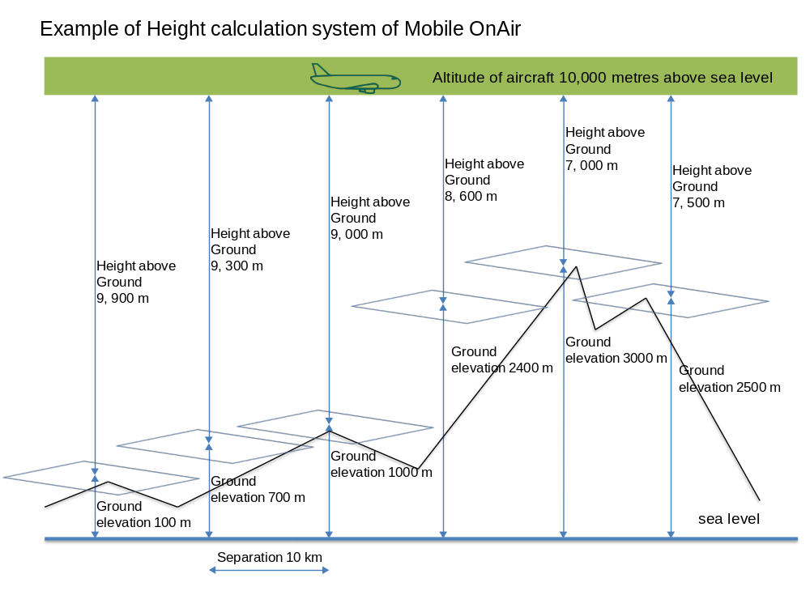
Figure 12: Example of Height Calculation of “Mobile OnAir” system over mountainous terrain

This approach ensures that the MCA system does not transmit lower than 3,000 metres height above ground. The 10 km granularity taking the highest point smoothes out variations in terrain whilst ensuring conformance to height limits.

On comparing this approach to the actual height elevation of Austria, for example, this actually means that in some places where Alp mountains reach 3,200 metres elevation above the sea level, the minimum altitude to activate the system would be at above 6,200 metres above sea level.

- List of reference
- ECC Decision (06)07 on the harmonised use of airborne GSM systems in the frequency bands 1710-1785 and 1805-1880 MHz
- ECC Report 093 on Compatibility between GSM equipment on board aircraft and terrestrial networks”
- ECC Report 174 on Compatibility between the mobile service in the band 2500-2690 MHz and the radiodetermination service in the band 2700-2900 MHz”
- Recommendation ITU-R RA.769-2 on Protection criteria used for radio astronomical measurements
- Recommendation ITU–R M.1464-1 on Characteristics of radiolocation radars, and characteristics and protection criteria for sharing studies for aeronautical radionavigation and meteorological radars in the radiodetermination service operating in the frequency band 2 700-2 900 MHz”
- Commission Decision 2008/294/EC on harmonised conditions of spectrum use for the operation of mobile communication services on aircraft (MCA services) in the Community
- Recommendation ITU-R M.1849 Technical and operational aspects of ground-based meteorological radars
- Recommendation ITU-R F.1336-3 Reference radiation pattern for omnidirectional, sectoral and other antennas in point-to-multipoint systems for use in sharing studies in the frequency range from 1 GHz to about 70 GHz
- ECC Decision (06)06 on the availability of frequency bands for the introduction of Narrow Band Digital Land Mobile PMR/PAMR in the 80 MHz, 160 MHz and 400 MHz bands
- Recommendation ITU-R F.1245-2 Mathematical model of average and related radiation patterns for line-of-sight point-to-point fixed wireless system antennas for use in certain coordination studies and interference assessment in the frequency range from 1 GHz to about 70 GHz
- Recommendation ITU-R M.1851 Mathematical models for radiodetermination radar systems antenna patterns for use in interference analyses
- ECC Report 045 on Sharing and adjacent band compatibility between UMTS/IMT-2000 in the band 2500-2690 MHz and other services

