Coverage availability and performance aspects for 5G NR
approved 1 July 2022
ECC Report 341

Executive summary
This Report addresses the need to provide metrics that can be used to evaluate the 5G New Radio (NR) coverage availability and performance.
Mobile network technologies have evolved in recent years, making some of the previous techniques and metrics to assess coverage, in many cases, obsolete. This Report gives a theoretical background to understand the differences between 4G Long Term Evolution (LTE) signal strength-based metric (RSRP) and the 5G NR most typical signal strength metric (SS-RSRP). It can be summarised in two points:
- The nature of the measured reference signal is quite different (CRS in 4G LTE vs SSB in 5G NR), so their significance and implications differ;
- In 5G NR, common channels and data channels are decoupled from the antenna pattern perspective. The implementation approach on the different SSB patterns (fixed beam or multi beam with beam sweeping) will impact the SS-RSRP value without ultimately impacting the end user experience.
Since common channels and data channels transmissions are independent, two different concepts for coverage should be defined: IDLE mode coverage (availability) and CONNECTED mode coverage (integrity and retainability).
A list of different alternatives to assess coverage in 5G NR is provided, describing pros and cons for each of them, their applicability for assessing IDLE mode coverage and CONNECTED mode coverage, and whether the metric can be obtained with active methods, passive methods, or both. These methods are described, including planning tool predictions, scanners, performance management counters based KPIs, crowdsourcing and drive tests.
Finally, the Report introduces two different frameworks for network assessments, both using smartphone applications, one of which based on a methodology described in an ETSI technical report and the other one based on crowdsourcing.

TABLE OF CONTENTS

0 Executive summary 2
1 Introduction 8
2 Technical Background 9
2.1 Existing coverage metrics for 4G 9
2.2 Technological differences between 4G LTE RSRP and 5G NR RSRP 9
2.3 IDLE mode and CONNECTED mode coverage in 5G NR 11
2.3.1 IDLE coverage 11
2.3.2 CONNECTED mode coverage 12
2.4 Stand Alone and Non-Stand Alone deployments 12
3 Potential 5G NR coverage metrics 13
3.1 SS-RSRP 13
3.2 Adjusted SS-RSRP 14
3.3 SSB path loss 15
3.4 Adjusted SSB path loss 16
3.5 PDSCH SINR 16
3.6 SSB SINR 17
3.7 Throughput (UL and DL) 17
3.7.1 Application layer throughput 18
3.7.2 IP layer Throughput 18
3.7.3 MAC layer throughput 18
3.7.4 Physical Layer Throughput 18
3.8 CQI 18
3.9 BLER 19
3.10 MCS (UL and DL) 19
4 Practical options for measuring coverage metrics 21
4.1 Passive measurement methods: non UE-based 21
4.1.1 Scanner 21
4.1.2 Predictions 21
4.2 Active measurement methods: UE-based and UE-Assisted 21
4.2.1 Network tracing 21
4.2.2 PM Counters and KPIs 22
4.2.2.1 IDLE Mode related KPIs 22
4.2.2.2 Other commonly used KPIs 22
4.2.2.3 CONNECTED Mode related KPIs 22
4.2.3 Minimisation of Drive Test (MDT) 23
4.2.4 Crowdsourcing 23
4.2.5 Drive/walk test 25
5 Potential performance management metrics 26
5.1 ETSI methodology to score mobile network performance 26
5.1.1 Introduction 26
5.1.2 Basic structure 26
5.1.3 Voice telephony 27
5.1.4 Data services 27
5.1.4.1 Plain data transfer 27
5.1.4.2 Video streaming services 28
5.1.4.3 HTTP browsing and social media 28
5.1.4.4 KPI thresholds and weighting 28
5.2 UE based information and user experience information 29
6 Conclusions 30
ANNEX 1: Summary table of 5G NR coverage metrics 31
ANNEX 2: List of References 32

LIST OF ABBREVIATIONS

Abbreviation | Explanation
BEREC | Body of European Regulators for Electronic Communications
BLER | Block Error Rate
CDR | Call Drop Ratio
CEPT | European Conference of Postal and Telecommunications Administrations
CIR | Configuration Information Request
CPU | Central Processing Unit
CQI | Channel Quality Indicator
CRS | Cell-Specific Reference Signal
CSI-RS | Channel State Information - Reference Signal
CSSR | Call Setup Success Ratio
CST | Call Setup Time
DL | Downlink
DMRS | Demodulation Reference Signal
DSS | Dynamic Spectrum Sharing
ECC | Electronic Communications Committee
EcN0 | Received energy per chip divided by the power density in the band
EPRE | Energy per Resource Element
ETSI | European Telecommunications Standards Institute
GSM | Global System for Mobile Communications
HTTP | Hyper Text Transfer Protocol
IMEI | International Mobile Equipment Identity
IP | Internet Protocol
KPI | Key Performance Indicator
LTE | Long Term Evolution
MAC | Medium Access Control
MCS | Modulation and Coding Scheme
MDT | Minimisation of Drive Test
MFCN | Mobile/Fixed Communications Networks
MIB | Master Information Block
MIMO | Multiple Input Multiple Output
MOS | Mean Opinion Score
MSG | Message
NACK | Negative Acknowledgment
NPS | Network Performance Score
NR | New Radio
NSA | Non -Stand Alone
NW | Network
OFDM | Orthogonal Frequency Division Multiplexing
PBCH | Physical Broadcast Channel
PCI | Physical Cell ID
PDCP | Packet Data Convergence Protocol
PDSCH | Physical Downlink Shared Channel
PM | Performance Management
PMI | Pre-coding Matrix Indicator
PRB | Physical Resource Block
PSS | Primary Synchronisation Signal
PUSCH | Physical Uplink Shared Channel
QoE | Quality of Experience
RACH | Random Access Channel
RAN | Radio Access Network
RB | Resource Block
RI | Rank Indicator
RRC | Radio Resource Control
RS | Received Signal
RSCP | Received Signal Code Power
RSPG | Radio Spectrum Policy Group
RSRP | Reference Signal Received Power
RSRQ | Reference Signal Received Quality
SA | Stand Alone
SAR | Specific Absorption Rate
SDU | Service Data Unit
SIB | System Information Broadcast
SINR | Signal to Interference and Noise Ratio
SS-RSRP | Synchronization Signal Reference Signal Received Power
SSB | Synchronisation Signal Block
SS | Synchronisation Signal
SSS | Secondary Synchronisation Signal
UE | User Equipment
UL | Uplink
UMTS | Universal Mobile Telecommunications System
VoNR | Voice over NR
WCDMA | Wideband Code Division Multiple Access

Introduction
This Report provides an overview of the metrics that can be used to measure 5G NR coverage availability and performance. It also explains why the older coverage reporting methods for the previous generations of the mobile wireless technology, in particular purely signal strength metrics for 4G LTE, may not be relevant for 5G NR.
The Report contains:
  - The various aspects of 5G NR in the different frequency ranges (designated for Mobile/Fixed Communication Network (MFCN)) including beamforming of control and data channels to highlight differences with earlier generations of mobile technologies. It also provides a motivation to consider new metrics for coverage measurements of 5G NR including within MFCN network using DSS (Dynamic Spectrum Sharing).
  - The description of potential 5G NR coverage metrics and practical options for measuring these metrics including pros and cons of different options.
  - The description of potential performance management metrics including counters and options to provide meaningful user experience information.

Technical Background
This section covers the technical background to understand the need of the document, including a comparison with the 4G LTE approach. A further backwards comparison with 3G/WCDMA has not been considered due to the different nature and use of 3G/WCDMA systems. On the one hand, 3G/WCDMA is based on Code Division Multiplex Access where coverage metrics need EcN0 and other pollution metrics to complement pure signal strength metrics (RSCP). On the other hand, network services provided by 3G network were qualitatively different, with voice being carried through circuit switching and data services having a secondary role. The comparison with 4G LTE is fairer, but the coverage concepts must be reviewed to understand what metrics can still be used.
The meaning of coverage in 5G and the possibility to differentiate between IDLE coverage (access to the network) and CONNECTED coverage (user performance after accessing to the network) will be discussed.

Existing coverage metrics for 4G
In the past, questionnaires have been conducted by both ECC and RSPG/BEREC to understand the coverage reporting approaches, regulatory obligations, and the associated measurement criteria in different CEPT countries. It was revealed that different CEPT countries set up different coverage obligations in their territories based on their national requirements, such as an obligation to cover a specific area of a population or geographical coverage requirements [1].
Since the administrations have a keen interest in the enforcement of the coverage obligations put forth in their territories, the measurement of coverage becomes extremely important. ECC provides a broad range of reports on coverage measurements, e.g., ECC Report 103 [2]on Universal Mobile Telecommunications System (UMTS) coverage measurements, ECC Report 118 [3] with a monitoring methodology to assess the performance of Global System for Mobile Communications (GSM) networks, and ECC Report 256 [4] on LTE coverage measurements.
The mobile coverage is broadly measured using the voice coverage and data coverage within a certain geographic region and/or for a certain percentage of the population. Due to the different approaches established within CEPT countries, there is a wide range of parameters given in the ECC Report 256 for LTE coverage that can be measured to check a coverage obligation. The most common parameters are field strength, RSRP, CQI, and user throughput. It should be noted that there is a dependency between these parameters and therefore, one parameter can be derived indirectly from another. One typical parameter used in practice for 4G LTE networks is RSRP.
In 4G LTE, RSRP stands for reference signal received power. RSRP is defined as the linear average of the received power (in watts) of the downlink reference signals contained in one radio frame at the UE receiver input terminal expressed in dBm. The averaging contains at least the power of the received signal (RS)-carriers contained in the innermost subcarriers [1].
The use of RSRP in an IDLE mode has been a benchmark metric in 4G LTE to determine cell coverage (i.e., presence of service and its performance). The reason being a good correlation between the RSRP in IDLE mode and the user data channel in connected mode, specifically for equal conditions of load, noise, bandwidth and transmitted layers. Therefore, RSRP proved to be a simple and relatively satisfactory way to measure the extent of cell coverage. However, due to the possibility of beamforming the control channels in 5G NR, this correlation can no longer be guaranteed and consequently there is a need to evaluate the metrics for the measurement of 5G NR coverage. The rest of the Report covers the definition of 5G NR coverage metrics and their measurements.

Technological differences between 4G LTE RSRP and 5G NR RSRP
RSRP measurements in 4G LTE are referred to cell-specific reference signals (CRS) power, while RSRP in 5G NR is typically referred to Synchronisation Signal Block (SSB) power (also called in that case SS-RSRP). To understand the implication of using RSRP in 5G compared to 4G it is necessary to have a closer look at the difference of SSB and cell-specific reference signals (CRS).
5G NR supports an ultra-lean design, meaning that unlike previous generations, always-on reference signals in the network are not broadcast in every time slots. The aim is to increase the network's energy efficiency and reduce interference to the neighbouring sites. The reference signals are transmitted only when necessary. Unlike LTE, NR does not include CRS, instead it relies on a SSB for cell search, synchronisation, and mobility decisions. The SSB consists of a primary synchronisation signal (PSS), a secondary synchronisation signal (SSS), PBCH DMRS (Demodulation Reference Signal), and PBCH (data).
SSB is a fundamental part of initial NR access procedure. PSS and SSS are used for cell search procedure and cell identification thru PCI, while. PBCH carries the MIB (Master Information Block), containing key information for the UE to access the network. Figure 1 shows the time and frequency resources used for transmission of one SSB.
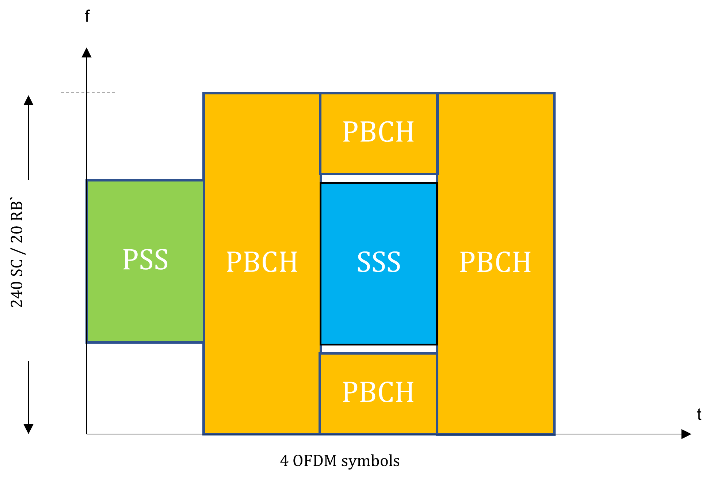
Figure 1: Time-frequency structure of the Synchronisation Signal Block
The SSB is transmitted over 4 consecutive OFDM symbols in the time domain and 240 contiguous subcarriers (20 RBs) in the frequency domain. The SSB is transmitted in a burst within a half frame (5 ms), each burst contains several SSB and the burst is periodically repeated by default every 20 ms. The periodicity can however be changed to a different value. The maximum number of SSBs in a burst depends upon the subcarrier spacing and transmission frequency. For example, in the frequency range below 1.88 GHz, there can be a maximum of 4 SSB in a half frame. There is a possibility to beamform SSB in a particular direction, also known as beam sweeping. However, the specification leaves it to the manufacturer on how to implement the SSB. This means that the actual number of SSB blocks in a burst and whether or not they are beamformed depends on the implementation. In the mm-wave frequencies, SSB beamforming is far more important than the mid-band frequencies below 7 GHz, to counterbalance the very challenging propagation conditions [5]. Figure 2 represents the SSB placement in the time domain for frequencies below 1.88 GHz.
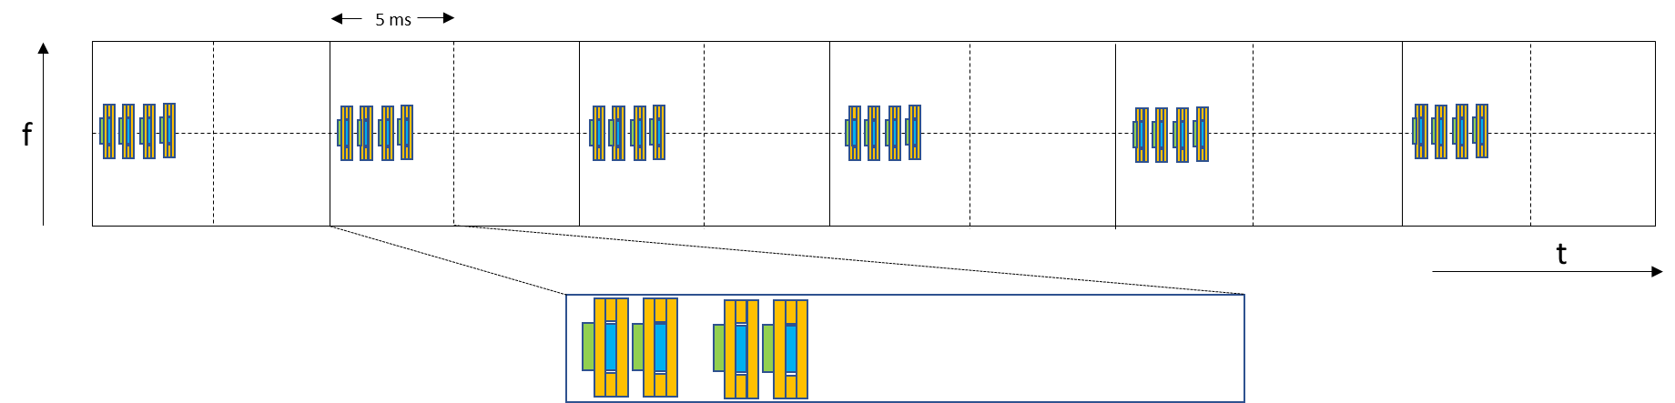
Figure 2: SS block positioning for the frequencies less than 1.88 GHz
It is up to the manufacturer to implement the SSB based on either beam sweeping (with a particular number of beams) or single beam solution. Figure 3 demonstrates the beam sweeping with 4 SSB beams and a single beam-based SSB implementation.
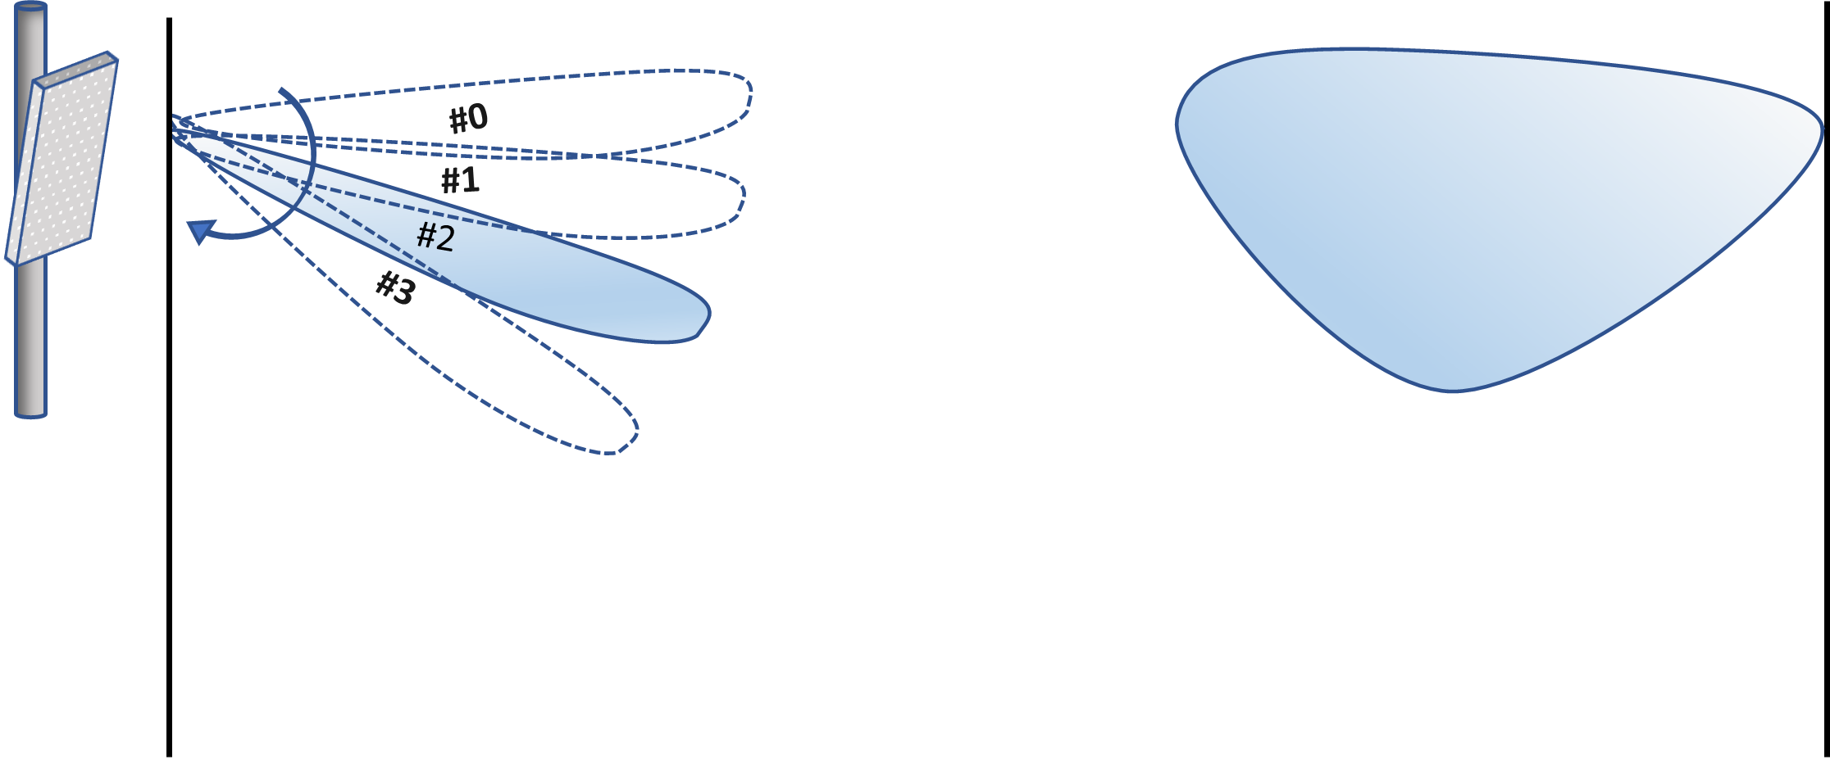
Figure 3: A representation of beam-sweeping and fixed beam based SSB implementation
Just as the 5G specification provides the flexibility to beamform the SSB, it also offers multiple options to beamform the 5G data channel; the data channel can either be beamformed in the same way as SSB, or it can be beamformed in an independent manner. SSB has a fixed power.
Therefore, due to the freedom provided by the specification, SSB and data channel correlation cannot be guaranteed in 5G NR. This different implementation on SSB and Data Channels can be considered the first important difference compared to 4G LTE, where correlation between CRS power and data channels is stronger. The second important difference between 4G and 5G RSRP is the nature of the signals that are being evaluated. While in 4G CRS is used for channel estimation, synchronisation and demodulation, 5G includes a different reference signal to accomplish each of these tasks (CSI-RS for channel estimation, SSB for synchronisation, DMRS for demodulation), making SSB less relevant during connected mode.
Using SS-RSRP as in 4G for performance requirement would lead to an inaccurate view of the coverage of one network. A network may not fulfil a certain SS-RSRP requirement while the data channel is meeting the performance requirements or, in other words, two networks with different SSB beamforming implementations may not be comparable against the same SS-RSRP requirement.
Consequentially, there is a need to re-assess the use of SS-RSRP and identify alternative coverage metrics in 5G to provide a more accurate view of the actual user experience based coverage.

IDLE mode and CONNECTED mode coverage in 5G NR
To better asses what kind of metrics can be used to evaluate 5G coverage it is imperative to differentiate between IDLE (mode) coverage and CONNECTED (mode) coverage.

IDLE coverage
IDLE coverage is applicable to UEs in RRC_IDLE or RRC_INACTIVE states and can be defined by the ability of a UE to successfully perform the initial access to a 5G network. It is commonly referred to as network availability.
The first step in initial access is for the UE to sync in with the RAN and decode the Master Information Block (MIB). This is done by reading the SSB, so a certain SSB power level is needed to guarantee IDLE coverage. Nevertheless, it should be noted that most problematic cases in network access are due to uplink limitations. This means that, even with a fair SS-RSRP, connection to 5G network will fail if MSG1 (PRACH), MSG2 or MSG3 (PUSCH) cannot be decoded by RAN. A 5G initial access diagram can be observed in Figure 4.
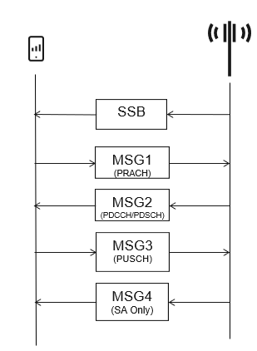

Figure 4: Simplified 5G initial access diagram

CONNECTED mode coverage
CONNECTED coverage is applicable to UEs in RRC_CONNECTED state and is defined by the ability of a UE to download or upload data at a certain target bit rate, which can be measured through the DL and UL data channels respectively. It is commonly referred to as network performance.
This CONNECTED mode performance will depend on multiple factors including bandwidth, MIMO layers, load and data channel Signal to Interference and Noise Ratio (SINR).
Similar to the IDLE coverage, the CONNECTED coverage is typically limited by UL transmissions as all data transfers (DL or UL) involve UL transmissions and rely on their success to complete positively.

Stand Alone and Non-Stand Alone deployments
SA (Stand Alone) and NSA (Non-Stand Alone) are two different approaches to deploy 5G NR. The main difference between them is the dependency on 4G LTE technology; while NSA relies on a 4G LTE anchor cell to provide basic signalling and connection towards the core network, SA works in an independent manner.
The 5G NR coverage metrics described in this document are relevant for both SA and NSA deployments. Nevertheless, some concepts should be considered when using a coverage metric for 5G NR:
- Voice service in 5G NR (VoNR, Voice over NR) can only be active on a SA deployment;
- In an NSA deployment a UE trying to access the 5G NR network has, by definition, a 4G LTE connection already established. This is not the case for SA;
- A UE using an NSA connection requires two independent set of metrics for assessing its coverage: 4G LTE metrics to assess its 4G LTE coverage and 5G NR metrics to assess its 5G NR coverage.

Potential 5G NR coverage metrics
The identified potential 5G NR coverage metrics are described in this section.
The following are presented for each metric :
- Description;
- Pros and Cons;
- Applicability.
Applicability will give information in terms of IDLE/CONNECTED coverage valid metric and whether the metric can be obtained by passive methods (i.e. usage of measurement equipment) or active methods (UE-based measurements).
It is important to note that some of these metrics, if UE based, have a dependency on the UE used to obtain them. Some metrics can only be obtained by some chipsets while others might give different results for different UEs even under the same circumstances. This can be seen as lack of reliability for that specific metric, but it can also be considered as a more realistic picture of the end user performance that actually depends on the different implementations of these UEs. The UE dependency of some metrics can in practice be removed if a sufficient amount of samples are taken from different UEs.
A summary table of the 5G NR coverage metrics described below is given in ANNEX 1:.

SS-RSRP
Description:
The general RSRP concept is described in section 2.1. For 5G NR in particular, this parameter is known as secondary synchronisation signal SS-RSRP and it is measured on the SSB. Refer to section 2.2 for a more detailed explanation of the differences of 4G LTE and 5G NR.
Pros:
A certain RSRP level is essential for network access (SSB reception required):
- SS-RSRP is generally the criteria for IDLE and CONNECTED mode mobility, so its measurement will define which cell is most likely to be serving the user;
- Easy to obtain through active and passive measurements;
- Measuring the synchronisation signal strength is a familiar concept commonly used in technologies up to 4G LTE.
Cons:
- Not sufficient to guarantee IDLE coverage metric since, even though a fair SSB RSRP level is needed for initial connection in IDLE mode coverage, for most of the problematic cases it is the Uplink control channels which limit the connection (see section 2.3.1);
- SS-RSRP interpretation will not be possible if several network vendors are present with different SSB patterns (fixed beam or multi-beam with beam sweeping) implementations. The side of the network giving a DL beamforming gain without UL beamforming gain would need to be normalised (see section 3.2);
- The SS-RSRP value also depends on the SSB transmitted power in downlink and carrier bandwidth. In IDLE, these factors affect the DL signal propagation limit but not UL, so in general this will not provide a better chance to access the network. To remove the influence of transmitted power and bandwidth, path loss is a more relevant metric (see section 3.3);
- There is no direct correlation between SS-RSRP and CONNECTED mode coverage (network performance) since SSB and data channels are totally independent. Although some correlation can be seen in practice for certain scenarios, an increase of SSB power alone (through e.g. higher power or beamforming gain) will not influence either DL or UL data performance in 5G NR. (see section 2.2).
Applicability:
It can be used for IDLE mode coverage only as a first approach and within the same network. It is not useful for assessing CONNECTED mode coverage unless focusing on homogeneous parts of a network, where field tests have shown certain correlation with DL throughput. Both passive and active measurements can obtain this metric.

Adjusted SS-RSRP
Description:
As discussed in section 2.2, SS-RSRP measured by the UE will vary significantly depending on the SSB pattern (single fixed beam or multiple beam sweeping) implementation without ultimately impacting on the reception of the remainder of the control and data channels, and hence without impacting end user experience. Adjusted SS-RSRP represents an alternative metric to SS-RSRP where the dependency on the number of SSB beams has been removed. By adjusting SS-RSRP values it becomes easier to compare networks with different SSB implementations. For example, when comparing RSRP in two networks, the RSRP adjustment may simply be calculated by taking into account the SSB antenna gain difference in the two networks at the location where RSRP is measured.
Alternatively, it may be of interest to adjust RSRP in a way that reflects better the data received signal strength e.g. by capturing the difference in the data antenna gain and SSB antenna gain in a given network at the location where RSRP is measured. Figure 5 shows an example of how RSRP and throughput from two different networks with different SSB implementations might look.
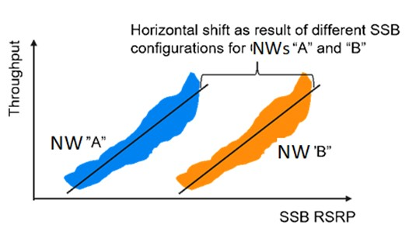
Figure 5: Illustration for adjustment required to compare networks with different SSB implementation
For this example, it is assumed that both networks (NW "A" and NW "B") share the same characteristics (bandwidth, signal to noise ratio figures, load…) except for the SSB pattern (single fixed beam or multiple beam sweeping) implementation. It is also important to remark that such correlation between SS-RSRP and throughput for each of these networks will only be possible if network load and interference are relatively constant throughout the measurement.
As Network (NW) “A” and “B” use different configurations for SSB, the relation between user throughput and signal strengths measured on the control channel in IDLE mode SSB-RSRP will have a shift. Measuring higher signal strength for Network “B” will not mean higher user throughput and to benchmark these two Networks, adjustment for measured signal strength needs to be implemented [6], [7].
Pros:
- It maintains the advantages described for SS-RSRP;
- For those cases where several network vendors are present with different SSB patterns (fixed beam or multi-beam with beam sweeping) implementations, dependency of SS-RSRP on the beamforming method used for SSB is removed. This makes it easier to compare between different networks or different parts of the network supplied by different infrastructure manufacturers.
Cons:
- Not sufficient to guarantee IDLE coverage metric since, even though a fair SSB RSRP level is needed for initial connection in IDLE mode coverage, for most of the problematic cases it is uplink control channels the ones limiting the connection (see section 2.3.1);
- The SS-RSRP value also depends on total transmitted power in downlink and carrier bandwidth. These factors affect the DL signal propagation limit but not UL, so in general this will not provide a better chance to access the network. To remove the influence of transmitted power and bandwidth influence, path loss is a more relevant metric (see section 3.3);
- There is no direct correlation between adjusted SS-RSRP and CONNECTED mode coverage since SSB and data channels are totally independent. Although removing the beamforming aspect from SS-RSRP may improve the correlation, an increase of SSB link budget alone (e.g. through higher power or beamforming gain) will not influence either DL or UL data performance in 5G NR (see section 2.2) .Only an indirect correlation exists, that is, through path loss;
- The adjustment values calculation needs to be carried out as described above.
Applicability:
This metric can be used for IDLE mode coverage as a first approach. It has limited value for CONNECTED mode coverage, in particular to make benchmarking between networks with different vendors less error-prone. Both passive and active measurements can obtain this metric.

SSB path loss
Description:
The path loss is the power reduction of the SSB signal from the RAN antenna to the UE. It is calculated from SS-RSRP and the transmitted power of the SSB. Some UEs directly provide this value, while for other cases it is necessary to do the calculation. A network scanner decoding the SIB messages can also calculate the path loss.
Some UEs directly provide this value. They do so by calculating the difference between SS-EPRE (Energy per Resource Element) and RSRP. For those cases where it is necessary to do the calculation, the downlink SS-EPRE can be derived from the SS/PBCH downlink transmit power given by the parameter SS-PBCH-BlockPower provided by higher layers [8]. A network scanner decoding the SIB messages can also calculate the path loss
Pros:
- Easily calculated when SS-RSRP and the transmit power are known or the UE reports the metric;
- Agnostic to antenna transmitted power and carrier bandwidth, which makes it more reliable to account for uplink limitations and predict uplink performance than SS-RSRP.
Cons:
- The calculation is implementation specific (transmitted power must be known) and can only be done, if the SSB transmit power (SS-PBCH) is broadcasted in the SIB message;
- Pathloss interpretation will not be possible if several network vendors are present with different SSB patterns (fixed beam or multi-beam with beam sweeping) implementations. The side of the network giving a DL beamforming gain without UL beamforming gain would need to be normalised (see section 3.4).
Applicability:
This metric can be used for IDLE mode coverage as a first approach and within the same network. It is not useful for assessing CONNECTED mode coverage unless focusing on homogeneous parts of a network, where field tests have shown certain correlation with DL throughput, giving also an indication of UL performance. Most UE-based measurements where RSRP is available also contain SSB path loss. This is also applicable to passive measurements with scanners decoding the SIB (system information broadcast) during the process.

Adjusted SSB path loss
Description:
SSB path loss can be adjusted across networks in a similar way as described in section 3.2 for SS-RSRP.
Pros:
- It maintains all advantages described for SSB path loss.
- For those cases where several network vendors are present with different SSB patterns (fixed beam or multi beam with beam sweeping) implementations. This makes it easier to compare between different networks or different parts of the network supplied by different mobile manufacturers.
Cons:
- The adjustment values calculation can only be done if the SSB transmit power (SS-PBCH) is broadcasted in the SIB message (transmitted power must be known). This is implementation specific.
Applicability:
This metric provides a good solution to assess IDLE coverage and is a good first approach for CONNECTED coverage, in particular for the UL. Most UE-based measurements where RSRP is available also contain SSB path loss. This is also applicable to passive measurements with scanners decoding the SIB (system information broadcast) during the process.

PDSCH SINR
Definition:
PDSCH SINR defines the signal quality of the downlink shared channel in 5G NR. It represents another approach for coverage metric in 5G by conducting measurements based on the signal-to-noise-plus-interference ratio in the dedicated mode.
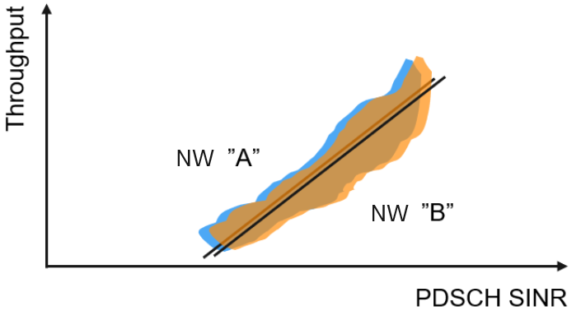
Figure 6: Illustration for PDSCH SINR based measurements between two networks
Pros:
- Accurately predicts downlink throughput. PDSCH SINR accurately captures the DL data beamforming capability, which directly affects the user performance. As shown in Figure 6 above, these measurements show good correlation with the throughput and, assuming the same power on the PDSCH resources, are well aligned between the different networks.
Cons:
- Only supported by certain UE chipsets;
- Does not give any information about ;uplink.

Applicability:
It is only applicable for active UE-based measurements. It is not applicable for IDLE mode coverage. It provides a good representation of CONNECTED mode coverage in downlink.

SSB SINR
Description:
This represents SINR measured on the SSB. It gives a view on the synchronisation signal quality in the downlink. It should not be mistaken with PDSCH SINR.
Pros:
- SS-SINR is available with network scanners and often available for every UE model;
- 3GPP specifications include the possibility of reporting SS-SINR in every measurement report, together with RSRP and RSRQ.
Cons:
- When SSB is not beamformed in the same way as PDSCH, correlation with throughput or PDSCH SINR is quite poor;
- SS-SINR will give an indication of how SSB signals interfere with each other, which is not representative of the inter-cell interference experienced by PDSCH. Depending on the implementation SSB may be placed in the same time-frequency location in neighbouring cells and thus experience a lower SINR than PDSCH that benefits from traffic demand variation;
- If the UE is scheduled with more than one MIMO layer, the throughput of each MIMO layer can be different, and so the throughput of multi-layer transmissions would have to be approximated.
Applicability:
This metric is applicable to both active and passive measurement methods. It is not representative of IDLE or CONNECTED coverage.

Throughput (UL and DL)
Definition:
Throughput represents the amount of data sent or received over a certain period of time. It needs to be defined at the layer at which data delivery is counted (application layer, IP layer, MAC layer or physical layer) and at which end of the communication (from UE perspective or from RAN perspective). Throughput on the UE side could be defined as the main performance indicator that reflects the actual end user experience when using mobile network services. Throughput on the RAN side gives an indication of how efficient the network is at handling data traffic.
Pros:
- Accurate snapshot of the real end user experiences at the time of the measurement;
- Particularly beneficial for the uplink, as it allows direct measurement of uplink performance rather than approximating UL performance from DL measurements.
Cons:
- The throughput measurements are more complex to conduct than signal strength based measurement;
- Network traffic level (load) at the time of measurement has an impact on the measurement results;
- Initial network ramp-up time influence varies depending on the kind of test (the shorter the test, the higher the influence) and might need to be excluded for certain comparisons.
In order to eliminate the network load dependency, the throughput value can be divided by the average number of PRBs (Physical Resource Blocks) assigned during the session. Since PRBs are a frequency domain resource unit, the result will give an insight on the spectral efficiency (for instance in kilobits/s/Hz).

Application layer throughput
Application layer throughput is the most user experience-oriented point of observation, but it will have a higher dependency on the server being accessed. Application layer throughput from UE perspective is usually available in drive test tools and crowdsourcing applications.

IP layer Throughput
Also referred to as PDCP SDU throughput, IP throughput layer Throughput is a common metric when using network performance management counters based KPIs, both from the RAN perspective and UE perspective (i.e., an average of all UEs in the cell). At IP level it is not possible to separate the contributions of different NR carriers in aggregation.

MAC layer throughput
MAC layer throughput is another common metric when using network performance management counters based KPIs, both from the RAN perspective and UE perspective (i.e., an average of all UEs in the cell). At MAC layer, it is possible to differentiate the contribution of different NR carriers in aggregation.

Physical Layer Throughput
The lowest layer throughput (PDSCH/PUSCH) is the point of observation with the highest correlation with other network metrics. It is important to note that this reference does not consider retransmissions at higher layers. Specifically, a typical Block Error Rate of 10% at MAC layer would make physical layer throughput appear 10% better than it actually is for higher layers. physical layer throughput from the UE perspective is typically available in Drive Test tools.
Applicability:
This metric is only applicable for active measurements. It is not applicable for IDLE mode coverage. It provides a good representation for CONNECTED mode coverage.

CQI
Description:
CQI stands for Channel Quality Indicator. The CQI index is a scalar value from 0 to 15. It provides the information about the highest modulation scheme and the code rate (MCS) suitable for the downlink transmission to achieve the required block error rate (BLER) for a given channel conditions. CQI is computed by UEs and reported to the network together with PMI (Pre-coding Matrix Indicator) and RI (Rank Indicator). CQI is computed based on the rank provided by the RI and it indicates the maximum throughput that the UE expects for a given PMI.
Pros:
- CQI is an accurate indication of the expected DL throughput for a given UE, if it is scheduled with a single MIMO layer.
Cons:
- CQI does not provide any information of the resource contention of the serving cell. High CQI can still result in low throughput if the load in the cell is high;
- This metric is not representative of multi-layer MIMO gains;
Applicability:
Applicable only for active measurements. Only valid as an input for CONNECTED mode coverage. The fact that CQI calculation is UE chipset implementation specific means that potential comparison between two different UEs is not possible. At network/country level the different UE approaches can be considered levelled out.

BLER
Description:
Block Error Ratio (BLER) measures the ratio of unsuccessfully decoded data transmission. It can be defined as the ratio between the number of packets replied with a NACK and the total number of packets sent, including both initial and successive transmissions. Typically, in mobile networks a given initial BLER value is targeted and the MCS is adapted to maintain that target.
Pros:
- Enables identification of when a data channel operates at a higher (or lower) error rate than the targeted error rate. If the BLER significantly exceeds the targeted error rate, this indicates that the data channel coverage limit is reached (modulation and coding scheme not being able to be reduced further). This can help find particularly problematic coverage locations.
Cons:
- Since there is generally a target BLER to be achieved, for most of the cases its behaviour will mostly depend on the system defined targeted value and will not be representative of network coverage;
- Other factors (e.g., load, traffic profile) may impact the BLER. This metric does not provide a highly granular level of information.
Applicability:
This metric is only applicable in active UE-based measurements. It is only valid as an input to complement other CONNECTED coverage metrics.

MCS (UL and DL)
Description:
Similarly to CQI, the used modulation and coding scheme (MCS) can be used as a proxy for throughput. While CQI indicates the MCS recommended by the UE, the used MCS indicates the MCS actually used during a transmission.
Pros:
- MCS is an accurate indication of the expected DL or UL throughput for a given UE;
- One of the few metrics to predict UL performance;
- Unlike CQI, MCS is not biased by UE calculations;
- No strong dependency on network load.
Cons:
- High MCS can still result in low throughput due to e.g. more retransmissions or high cell load. This metric is also traffic profile-dependent, e.g., in case of small data transmission the selected MCS may not be the highest possible MCS for a specific UE ;
- There is an implementation dependency since there are two different MCS tables that UEs can use (64 QAM table and 256 QAM table). Interpretation of average MCS will get lost if they do not refer to a specific table.
Applicability:
This metric is only applicable in active UE-based measurements. It is only valid for CONNECTED mode coverage, for both DL and UL. It is only valid as an input to complement other CONNECTED coverage metrics.

Practical options for measuring coverage metrics
This section describes practical coverage measurement methods of the metrics listed in the previous chapter. Detailed methodology is not the prime objective, but rather the higher-level principles and methods in general. The receiver used for the measurements can be active (called UE-based measurement) or passive (called non-UE-based measurement) as described in the following sections.

Passive measurement methods: non UE-based
Passive measurement methods can be based on receive-only equipment or tools that provide inside about the network behaviour so that the coverage can be predicted.

Scanner
- Scanner-based (SS-BCH-RSRP) measurements are simple to be performed. They provide a configurable per carrier view where many cellular technologies and many frequency bands and many signals/carriers can be measured and analysed in parallel without switching in-between. The scanners can decode MIB and SIBs to also identify and find e.g. 5G signals autonomously. For each received signal a list of KPIs (like RSRP, RSRQ, SINR, CIR, timing measurements to verify network synchronisation, and many more) can be measured and visualised. Measurements with scanner are passive and consequently do not consider service quality (e.g. bitrate, ability to make/receive a call). However, metrics like SS-SINR together with SS-RSRP give an indication of IDLE coverage.
- Network scanners are explicit test instruments with a very good level accuracy. A smartphone today passes the certification if the UE measured level accuracy is typically within a ±6 dB interval [9]. Although most smartphones used for Drive Testing have a good accuracy, it must be noticed that this worst case scenario can exist.
- Scanner measurements can give a good indication of service quality but may not always align with actual “service boundaries” and actual user experience in specific beamforming cases;
- Scanners can measure RSRP, SINR, RSRQ (not covered in this Report) and some may also measure pathloss via L3 SIB measurements.

Predictions
- Network access or performance predictions using planning tools are the most time and cost efficient method to provide a country wide view of coverage. However significant efforts are required to improve the accuracy of predictions;
- This can be calibrated with drive tests (by using scanners). Calibration of network planning tools can improve the performance of those tools, but the experience shows that network planning tools give a good guidance for many cases but may also be limited for some locations (e.g. urban to dense urban topologies);
- Link budget based studies are used to establish service contours;
- Network planning tools cannot replace field measurements completely. They should both be used complementarily;
- Several planning tools are available in the market with different features, propagation models, types of maps, etc. This means that, even with the same set of inputs, different results can be obtained depending on the specific tool used.

Active measurement methods: UE-based and UE-Assisted
These methods are based on a UE that actively establishes a connection with the network and allows the measurement of the coverage related parameters. They are considered UE-based when the UEs are actively and explicitly providing the measurement, and UE-assisted when UE normal behaviour and feedback is exploited for measurement purposes.

Network tracing
UE-assisted RAN equipment vendors usually supply tools to remotely trace User Equipment activity (either at cell level or at user level). These logs can be stored and processed to draw conclusions on network performance. Depending on the RAN vendor it can be registered, for instance, the signal level contained in every Measurement Report sent by 5G capable smartphones.

PM Counters and KPIs
UE-assisted PM (Performance Measurement) counters are included in RAN vendors software to remotely have visibility of the network performance. As the name suggests, these counters return a value equal to the number of times a specific event has taken place. It is not within the ambition of this document to go through the specifics of each counter since PM counters names and triggers are vendor specific.
KPIs (Key Performance Indicators) are formulas based on PM counters to assess an important facet of the network behaviour. There is generally a common understanding across RAN vendors on the basic KPIs needed for describing a network behaviour. Each RAN vendor has their own defined KPIs, under a general framework described in 3GPP specifications [10], [11], [12].
As an example, a short list of KPIs with generic (or 3GPP) PM Counter names, which would be relevant to understand the IDLE and CONNECTED coverage of a network, is presented in the following subsections.

IDLE Mode related KPIs
Usually referred to as "accessibility KPIs", they show the success rate to access the network. Some examples of basic KPIs to represent IDLE accessibility from 5G network perspective.
The main KPI in this regard is "Total DRB Accessibility for UE services" which is described in 3GPP 28.554 [10] as:
DRB Accessibility per 5QI [%] = 100 * (DRB.InitialEstabSucc.5QI + (DRB.EstabSucc.5QI-DRB.InitialEstabSucc.5QI) + DRB.ResumeSucc.5QI)/(DRB.InitialEstabAtt.5QI/((RRC connection setup success rate /100)*( UE-associated logical NG-connection success ratio/100)) + (DRB.EstabAtt.5QI-DRB.InitialEstabAtt.5QI) + DRB.ResumeAtt.5QI/( RRC Resume success rate/100))

Other commonly used KPIs
UE Context Setup Success Rate [%] = 100 * UE_Context_Setup_Success / UE_Context_Setup_Attempts
Random Access Success Rate [%] = 100 * RACH_Msg3_Received / RACH_Msg2_Sent

CONNECTED Mode related KPIs
Usually referred to as "Integrity KPIs", they give an indication of end user experience during a data session.
The main KPI in this regard is Downlink Throughput which is described at IP level by 3GPP 32.450 as:
IP Throughput in Downlink (kbits / s) = ThpVolDl / ThpTimeDl
where ThpTimeDl only considers time units where there is data in the buffer to be transmitted. Also, the last TTI for both numerator and denominator are excluded from the calculation as shown in Figure 7.
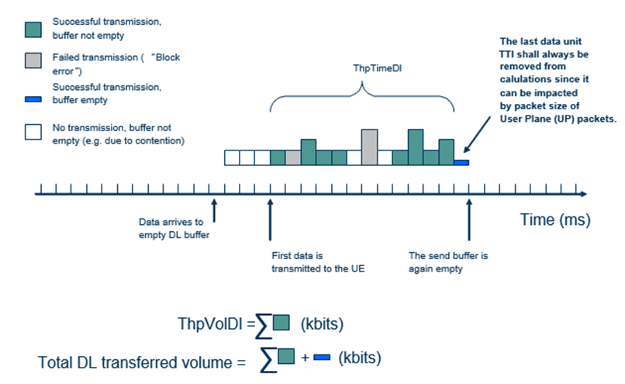
Figure 7: Downlink Throughput KPI calculation as per 3GPP [11]

Minimisation of Drive Test (MDT)
UE-based and UE-assisted MDT is a 3GPP defined procedure [12] to remotely collect UE activity. It differentiates two kinds of measurements:
- Immediate MDT: MDT functionality involving measurements performed by the UE in CONNECTED state. In Release 16, MDT relies on existing RRC Measurement configuration and reporting;
- Logged MDT: MDT functionality involving measurement logging by UE in other modes such as IDLE mode and INACTIVE state. An RRC message is sent to the UE to initiate the logged measurements;
- For CONNECTED mode, MDT is based on the already existing RRC measurement procedures with some extensions for location information;
- For IDLEIDLE mode, among other things, MDT can facilitate the following information in NR:
Best SS beam index;
Best SS beam RSRP/RSRQ;
Number of establishment procedure failures;
Location.

Crowdsourcing
UE-Based and UE-Assisted crowdsourcing is a fairly new concept that can be defined as the process of obtaining needed information by soliciting contributions from large group of people [13]. Crowdsourcing is a term used for any sorts of data collection from persons using an individual device in an individual setting. Crowdsourcing includes both passive data collection and active measurements. Passive data collection means that retrieving of information is done in the background (the user may not be aware of it) and may happen while other applications run. Active measurements imply that a user actively starts a performance test application (e.g. an app for measuring data throughput). Such an application could gather information of the network parameters and can provide the geographical location when the measurement was performed.
Crowdsourcing has several characteristics that make it stand out as an attractive method for administrations. Some of these are listed below:
- It is an operator independent measurement, carried out by a third party. There is no need to collect logs from multiple operators and network vendors with potentially different definitions;
- The data is collected where users move in reality, for instance; indoor, in the woods, on the roads, underground etc. Many of these places would not be possible to reach with measurement equipment. This will provide worse samples than conventional methods, but closer to real end-user experience;
- It provides a very cost-effective way to get nationwide statistics;
- Crowdsourcing data can be considered reliable in highly populated areas, whereas in rural areas the data can be scarce, of low quality or even absent. This is particularly relevant considering most coverage issues happen in low populated areas. For this reason, Crowdsourcing should be complemented by other approaches.
On the other hand, crowdsourcing results have many uncontrollable dependencies. Some of them can be argued to balance out when comparing operators/countries, and even reflect more accurately end-user perception, while others directly affect maximum performance assessment. Some of these dependencies are:
- Crowdsourcing relies on the end-user and their user equipment capability to run a specific smartphone app;
- There is dependency on individual data plans and subscriptions schemes. There might be limitations in data throughput or access to advanced technologies. Deriving individual subscriber information is limited or not permitted by privacy reasons;
- There is dependency on the uncontrolled load and temperature of the end user device, CPU performance might be throttled by high temperature or may be shared with other running applications;
- Crowdsourcing relies on consumer devices, requested information can be wrong, incomplete or not available. Consumer operating systems may become more restrictive accessing internal information by upcoming versions;
- The end user equipment might be running other applications at the same time, distorting the sample.
As a consequence, crowdsourced data is relevant mostly for network comparison (assuming there is enough data to ensure statistical significance) and, especially, end user information regarding the quality of service they can expect in areas where measurements have been performed.
In order to limit the impact of uncontrollable dependencies listed above, several best practices could be promoted. Regulators may identify some criteria for this purpose.
See for instance Arcep's "Code of conduct on quality of service" [14] , published in 2017 and updated in 2020, which lays out practices that measurement tools may follow in order to guarantee both the transparency of the data – so that any third party will be able to analyse the results produced by the tool – and the robustness of the practices employed – i.e. that they are reliable, representative and guarantee that the findings can be compared.
This code of conduct sets out the methodologies’ minimum transparency and robustness requirements when measuring download and upload speeds, latency, web browsing and video streaming. For instance, for speed tests carried out with an iOS or Android app to be considered robust, the default test length must be ≥ 5 seconds or the amount of data downloaded should be ≥ 50 MB. It should be noted that tests relying only on "passive measurements", i.e. signal strength measurements, do not comply with the code of conduct as they are not considered as "quality of service" measurements (this include speed and latency for web browsing or streaming in the current version of the code of conduct).
When it comes to coverage monitoring, and more specifically the verification of legal obligation, crowdsourced data, given the limitations mentioned above, may need to be complemented with other means. Crowdsourced data could for instance be used as a "first layer" of information, to identify areas that could then be examined further in detail with drive tests in more controlled conditions.
To augment the crowdsourcing with planning tool, predictions allow for:
- Coverage estimations in areas with very few users;
- Coverage estimations where the handset capability is low.
An example of a crowdsource-based application to provide UE based information on some indicators contributing to performance is given in section 5.2.

Drive/walk test
UE-based drive tests and walk tests consist of an active and planned measurement of a particular area of the network with a particular User Equipment. This kind of active testing is globally accepted and used as a way to assess network performance, although it is important to remark that they are commonly carried out on street level and during mobility. User experience from static and indoors locations are generally not reproduced.
The procedure for carrying out these tests usually include:
- UL and DL transfers of different durations and/or file sizes;
- Voice calls;
- Streaming;
- Web browsing.
The scoring for assessing a network based on these tests is open for discussion. Nonetheless, the score system presented in section 5 is generally accepted and described in detailed in ETSI documents.

Potential performance management metrics
This section describes the most common approach when benchmarking a network for IDLE and CONNECTED mode coverage evaluation. This framework is fully described in ETSI STQ TR 103 559 [14] and is used by several telecom companies to benchmark a mobile network.

ETSI methodology to score mobile network performance
The Network Performance Score (NPS) is a methodology for a single, integrated metric to characterise the overall mobile network performance in a single, transparent value [15], [16]. It evaluates and weights all Key Quality Indicators that impact end user QoE for voice, video and data services and applications, for example Voice MOS, Call Drop Rate and Time to first Picture, and combines them to produce a single number from 0 to 1000. This allows independent comparison of network performance locally, regionally and internationally.
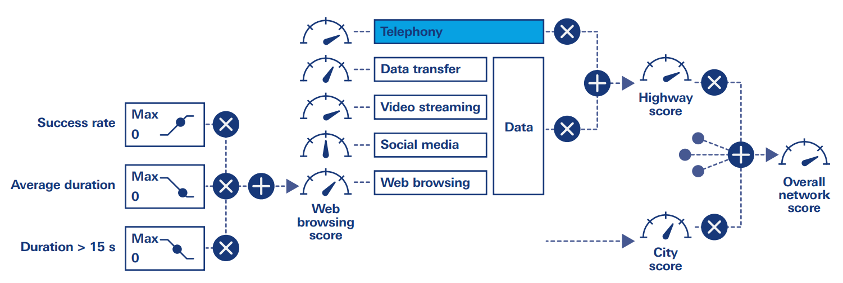
Figure 8: Network Performance Score (NPS)

Introduction
The maximum number of points for a KPI or a sub-score is defined by its weighting in the overall score based on the weighting of the service category, e.g. telephony or data, and the weighting of the regional category, e.g. city or road. All points are accumulated to determine the overall score in points. The point scale from 0 to 1000 can be considered a network optimisation tool, making it easy to identify the best place to improve overall performance.
The scoring mechanism allows very efficient comparison of operators in a market, different measurement campaigns in regions and countries, or before and after deployment of new technology or software. The transparent score structure allows efficient drilldown to the region, service or even the KPIs responsible for a non-optimal overall score.

Basic structure
The structure of the network performance score (NPS) is highly transparent and consists of different weighting and accumulation layers.
On the technical side, the score is based on telephony and data services sub-scores, contributing a maximum of 40% (telephony) or 60% (data services) to the maximum number of points and forming a complete network score.
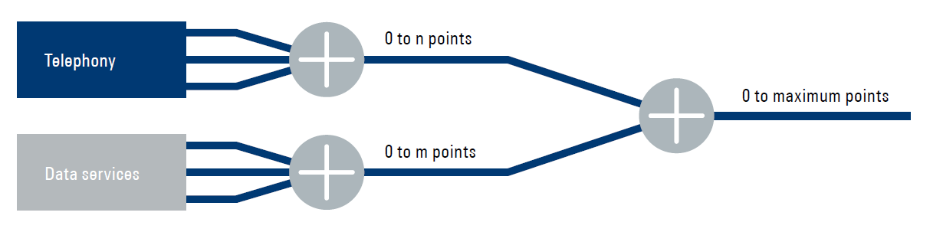
Figure 9: Network performance score basic structure

Voice telephony
The telephony sub-score is based on end user experience with telephony services. Service availability, accessibility, retainability and performance are evaluated to determine the score.
The contributors (KPIs) for telephony performance are:
- Call setup success ratio (CSSR)
- Call drop ratio (CDR);
- Call setup time (CST) average;
- CST excess ratio;
- CST 10th percentile;
- Voice mean opinion score (MOS) average;
- Voice MOS bad sample ratio;
- Voice MOS 90th percentile.

Data services
The data services sub-score consists of three contributor areas addressing different types of services and characterising different types of requests in a network:
- (Plain) data transfer (HTTP);
- Video streaming;
- HTTP browsing and social media.

Plain data transfer
The plain data transfer performance is calculated by HTTP download and upload. Availability/accessibility and transfer performance are separated.
For availability/accessibility, a file of a fixed size is completely downloaded.
For the transfer performance, multiple connections are opened, and the transfer rate is measured for a given time. This test is also known as the capacity test.
The individual contributors to this area are:
- HTTP UL/DL success ratio;
- HTTP DL throughput average;
- HTTP DL throughput 10th percentile;
- HTTP DL throughput 90th percentile;
- HTTP UL throughput average;
- HTTP UL throughput 10th percentile;
- HTTP UL throughput 90th percentile.

Video streaming services
Consideration of live video streams is best practice for network benchmarking today.
The contributors (KPIs) for video stream performance are:
- Video success ratio;
- Video setup average;
- Video setup excess ratio;
- Video MOS average;
- Video MOS 10th percentile.

HTTP browsing and social media
No matter what pages are used, all HTTP tests are considered equally by the contributors (KPIs) for HTTP browsing performance:
- Browsing success ratio;
- Browsing duration average;
- Activity duration > 6 s ratio.
Since most social media actions only transfer a minimal amount of data, the throughput is not an important indicator. Instead, the main results of the test are the durations of the individual actions and the entire session and the action success rates.
The contributions to the social media performance are:
- Social media success ratio;
- Social media duration average;
- Social media duration excess ratio.

KPI thresholds and weighting
The described contributors are scaled according to their original units, i.e. seconds for the CST, MOS for speech quality and percentage for all ratios. To ensure the transparency and comparability of the actual contribution of each contributor/KPI to the voice telephony sub-score, each contributor is also scaled on the same scale using points instead of technical units.
The transformation applies a linear weighting from 0 to the maximum number of points for the specific KPI or contributor and its category between a bad and good threshold. Scores outside of these boundaries remain saturated.
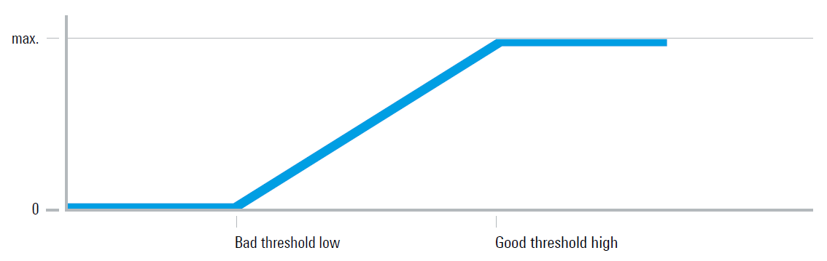
Figure 10: Linear weighting per contributor
ETSI STQ TR 103 559 [15] proposes thresholds for good and bad performance and weightings for best practice in conjunction with these scoring methods. In terms of KPI weights, it should be clear that failed or dropped calls or data sessions in particular are weighted strongly. These problems, i.e. the inability to establish a call or see a video in a reasonable time, represent the most negative experience a user can have. When weighting e.g. a setup time, there are often additional statistics such as “shorter than” to give extra points to fast delivery and implicitly punish extremely long waiting times.

UE based information and user experience information
Some crowdsource-based applications provide some UE based information to user contributing to the "user experience information".
For example, some mobile applications contribute to user experience among others to:
- User's tests on download data speed, network latency;
- User's tests on video streaming. This feature may impact the user data plan.
These applications are also collecting data on browsing history, IP address and IMEI (International Mobile Equipment Identity).
One application developed by an administration [15] contributes to gathering data linked to user experience on a national basis on:
- Radio signal strength received by the user equipment;
- Location of radio sites (available in open data);
- Other information is contributing to user experience as;
- Location of 5G sites, per operator or all operators, even with a 4G user equipment (weekly updates);
- Specific Absorption Rate (SAR) of the user equipment. It also recommends the user's behaviour to adopt to reduce absorption;
- public exposure to radio electromagnetic field.
Concerning radio signal strength, this app could collect and generate geolocated and time-stamped data on signal strength measurements by UE (user terminal equipment). Data are currently not publicly available but available on demand for non-commercial applications. (The signal strength measurements recorded by a user are of course available to the user, with, if desired, additional technical information such as channels, cell identifiers, signal quality indicators available with Android).
This offers an opportunity to identify areas where the signal strength is either low or insufficient. Those data could help to focus measurement campaigns on particular locations reducing cost and investments accordingly. Some limits are highlighted hereafter.
Pros
- Environment to collect data is not known by analysts;
- Operational reception conditions of a UE;
- UE location in rural and semi-rural areas has no impact on the quality of measurement due the type of collected data.
Cons
- Impact on UE power consumption (which differ according to type of UE);
- UE operating system: to be open to third party applications (API opens to developers);
- Need for large volume of measurements over different time intervals and diversity of UE;
- Need for UE diversity in order to generate a measurements average (reducing the impact of each UE receiver characteristics;
- If only signal strength information is measured by the app it may not be sufficient to define 5G coverage.
EU General Data Protection Regulation requirements
Making data publicly available data requires a large amount of data and a density of users to ensure that is impossible to identify each of them (EU GDPR requirement).

Conclusions
The Report highlights the main differences between 5G NR and previous generations that make the so far commonly used signal strength coverage metric insufficient to assess 5G coverage and may be misleading in some cases.
In 5G is, more than ever, necessary to differentiate between IDLE mode coverage (network availability) and CONNECTED mode coverage (network integrity and retainability).
An ideal single metric does not exist for both IDLE mode and CONNECTED mode coverage and this Report expresses pros and cons for all considered approaches. A combined approach of different metrics is recommended to have a clearer picture of 5G coverage. Administrations are also developing their own national approaches taking into consideration national coverage policies and objectives.
Different methods for collecting network metrics are suggested, including a way to consolidate all metrics into a single scoring system.
- Summary table of 5G NR coverage metrics
Table 1: Summary of 5G NR Coverage metrics
Metric | Main application mode IDLE / CONNECTED | Comments | UE-based/Scanner based
SS-RSRP (*) | IDLE | Useful only as first approach to assess coverage within the same network.  Not useful to assist benchmarking between networks with different vendors. | Both
Adjusted SS-RSRP (*) | IDLE | Useful as first approach to assess coverage.  Useful to assist benchmarking between networks with different vendors. Limitation in implementation may apply | Both
SSB Path loss | IDLE | Useful as first approach to assess coverage within the same network.  Not useful to assist benchmarking between networks with different vendors. | Both
Adjusted SSB path loss | IDLE | Good solution to assess coverage  Useful to assist benchmarking between networks with different vendors. Limitation in implementation may apply | Both
SSB SINR (*) | IDLE | Only valid in combination with other IDLE coverage metrics | Both
PDSCH SINR (*) | CONNECTED | Good representation for Downlink coverage | UE
Throughput (DL/UL) | CONNECTED | Good representation for Downlink/Uplink coverage | UE
CQI (*) | CONNECTED | Only valid in combination with other CONNECTED coverage metrics | UE
BLER | CONNECTED | Only valid in combination with other CONNECTED coverage metrics | UE
MCS (DL/UL) | CONNECTED | Only valid in combination with other CONNECTED coverage metrics | UE
*Only valid for DL

- List of References
- ECC Report 231: "Mobile coverage obligations", approved March 2015
- ECC Report 103: "UMTS coverage measurements", approved May 2007
- ECC Report 118: “Monitoring methodology to assess the performance of GSM networks”, approved February 2008
- ECC Report 256: "LTE coverage measurements", approved October 2016
- 3GPP TS 38.213 v15.14.0: "Physical Layer Procedures for Control”
- ECC Report 331: "Efficient usage of the spectrum at the border of CEPT countries between TDD MFCN in the frequency band 3400-3800 MHz", approved November 2021
- https://www.ericsson.com/en/blog/2020/8/benchmark-measurements-in-5g-networks
- 3GPP TS 38.214 v15.3: "Physical Layer Procedures for Data", Power Allocation for downlink
- 3GPP 38.133v17.3.0: "NR; Requirements for support of radio resource management" chap. 10.1.2. – 10.1.5.
- 3GPP TS 28.554 v15 “5G end to end Key Performance Indicators (KPI)”
- 3GPP TS 32.450 v15: “Key Performance Indicator (KPI) for Evolved Universal Terrestrial Radio Access Networks (E-UTRAN): Definitions”
- 3GPP TS 37.320 v16.6: “Radio measurement collection for Minimization of Drive Tests (MDT)”
- Merriam-Webster definition https://www.merriam-webster.com/dictionary/crowdsourcing
- Arcep: "2020 code of conduct on Internet quality of service", https://www.arcep.fr/uploads/tx_gspublication/code-of-conduct-QoS-Internet-2020_EN_sept2020.pdf
- ETSI STQ TR 103 559: "Best practices for robust network QoS benchmark testing and scoring"
- 3GPP TS 38.211 v16.4.0: "Physical channels and modulation"
- ANFR: "Open barres" https://www.anfr.fr/fr/toutes-les-actualites/actualites/de-nouvelles-fonctionnalites-disponibles-sur-lapplication-open-barres-pour-suivre-le-deploiement-de-la-5g/

