Sensing mechanism for uncoordinated FSS Earth stations in 28 GHz to protect fixed service

Complementary Report to ECC Report 304

approved 28 January 2022

ECC Report 335

# Executive summary

Due to the envisaged operation of a new generation of High Throughput Satellites (HTS) in the 28 GHz band, there is an interest to consider the possible use of the FS part of the band for uncoordinated FSS earth stations. According to ECC Decision (05)01 [3], the current segmentation of the band 27.5-29.5 GHz identifies the ranges 27.8285-28.4445 GHz and 28.9485-29.4525 GHz for use by FS. This ECC Decision also allows the FSS to access this 1120 MHz of spectrum on an individually licensed and coordinated basis.

ECC Report 304 [1] evaluates the possible interference scenarios between FS and uncoordinated FSS Earth Stations. It does not propose to change the band plan contained in ECC Decision (05)01. Instead, it assumes that the entry of one service into another service’s reserved spectrum is possible on a strictly handled non-interference basis, ensuring that the incumbent service in its reserved spectrum is protected from any interference also with respect to its future development.

The sharing and compatibility studies provided in ECC Report 304 indicate no sharing possibilities between the FS and the FSS without the implementation of additional mitigation techniques. Moreover, ECC Report 304 describes the mechanism of sense and avoid as theoretically feasible to ensure the proper protection of FS receivers against harmful interference from uncoordinated FSS earth station in the FS portion of the 28 GHz band without specific evaluation of the sensing mechanism itself. In this Report, the requirements for the sensor as well as the different factors which have an influence on the sensing mechanism are described.

The following assumptions are taken as the basis in this Report:

* A minimum elevation of 10° for an FSS antenna. A scenario where the angle of FSS Earth Station is lower might be envisaged specially for higher latitude where elevation angle can be just 5 degree;
* The VSAT highest gain towards a FS receiver antenna is 8.5 dBi for 10°elevation angle;
* The noise figure for the Fixed Service receiver is 6.5 dB;
* The noise figure for the sensor is 0 dB;
* For the estimation of the corresponding sensing threshold, the main beam gain of an 8x8 AAS (23.5 dBi) is used.

To ensure the protection of any FS station, the sensing mechanism needs to fulfil the following technical conditions:

* Detection of the FS signal in 360° full azimuth and some elevation range around the FSS earth station
* Detection of FS Tx with an output power down to -10 dBm, or equivalent to national, potentially neighbouring countries FS situation in a distance where there might be interference from transmitting FSS Earth Stations.

Further, it is only possible to detect FS transmitters, but the protection of the FS receivers from harmful interference has to be ensured. Therefore, the knowledge of the FS channel arrangement and implementation in the sensor is required. The report concludes that the sensor threshold for an emission from the FS transmitter station using a transmitter output power of -10 dBm, needs to be set around 30-40 dB below the noise floor and the calculations show that this level is reached at around 30 km (see Figure 2), for the considered example and assumptions. Therefore, additional measures are required to improve the sensors sensitivity.

According to the ECC Report 304, interfering distances from VSATs can range up to nearly 60 km using long term protection criteria. ECC Report 304, annex 3 shows that short term protection criteria would yield even larger separation distances.

The architecture of the sensor itself is a trade-off of different factors:

* Sensor antenna gain;
* Measurement time;
* Integration time;
* SNR of the sensor;
* Sensitivity of the sensor.

In reality, the extent of the improvement of the individual parameters could be limited due to effort, costs and physics and therefore a careful device assessment is necessary.

TABLE OF CONTENTS

0 Executive summary 2

1 Introduction 5

2 Sense and avoid mitigation technique 6

2.1 Description of the scenario 6

2.2 Cooperative sensing 7

3 Sensitivity of the Sensor 8

3.1 Example for the estimations of a sensing threshold 8

3.2 Factors that could improve the sensor 10

3.2.1 Integration time 10

3.2.2 Sensor antenna gain 12

4 Operational requirements for the sensor 13

4.1.1 Knowledge of FS channel arrangement 13

4.1.2 Detection time 13

4.1.3 Direction of the detection 13

5 Conclusions 14

ANNEX 1: minimum Tx power from FS to be detected by FSS 15

A1.1 FS links in France 15

A1.2 FS links in Lithuania 17

A1.3 FS links in Sweden 20

A1.4 FS links in Switzerland 26

A1.5 FS links in Germany 29

ANNEX 2: List of References 34

LIST OF ABBREVIATIONS

| **Abbreviation** | **Explanation** |
| --- | --- |
| AAS | Active Antenna System |
| ACM | Adaptive Coding and Modulation |
| ATPC | Automatic Transmit Power Control |
| BCA | Band and Carrier Aggregation |
| BW | Bandwidth |
| CDF | Cumulative Distribution Function |
| CEPT | European Conference of Postal and Telecommunications Administrations |
| CS | Channel Spacing |
| ECC | Electronic Communications Committee |
| **e.i.r.p.** | Equivalent Isotropic Radiated Power |
| ES | Earth station |
| FS | Fixed Service |
| FSS | Fixed Satellite Service |
| LOS | Line Of Sight |
| MCL | Minimum Coupling Loss |
| MS | Mobile Service |
| NLOS | Non Line Of Sight |
| NOC | Network Operations Center |
| PoP | Point of Presence (of optical fiber) |
| SAA | Sense And Avoid |
| SNR | Signal to Noise Ratio |
| VSAT | Very Small Aperture Terminal |
| XPIC | Cross Polar Interference Cancellation |

# Introduction

Due to the envisaged operation of a new generation of High Throughput Satellites (HTS) in the 28 GHz band, there is an interest to consider the possible use of the FS part of the band for uncoordinated FSS Earth stations. According to ECC Decision (05)01 [3], the current segmentation of the band 27.5-29.5 GHz identifies the ranges 27.8285-28.4445 GHz and 28.9485-29.4525 GHz for use by FS. This ECC Decision also allows the FSS to access this 1120 MHz of spectrum on an individually licensed and coordinated basis.

ECC Report 304 [1] evaluates the possible interference scenarios between FS and uncoordinated FSS Earth stations. It does not propose to change the band plan contained in ECC Decision (05)01. Instead, it assumes that the entry of one service into another service’s reserved spectrum is possible on a strictly handled non-interference basis, ensuring that the incumbent service in its reserved spectrum is protected from any interference also with respect to its future development.

The sharing and compatibility studies provided in ECC Report 304 indicate no sharing possibilities between the FS and the FSS without the implementation of additional mitigation techniques.

To address cases of potential interference, ECC Report 304 analyses the effectiveness of active and passive mitigation techniques in protecting existing FS links, such as sense and avoid, the use of geolocation databases and shielding.

In particular sense and avoid technique considers a sensing mechanism in order to detect possible interfered FS links by the FSS Earth station.

ECC Report 304 does not cover the issue of selecting an appropriate sensing threshold and the subsequent implementation of the sensor and states that the performance requirement of the sensor is a regulatory parameter that depends, inter alia, on the deployment scenario of the FS.

The target of this Report is to provide requirements that the sensor has to fulfil to ensure the protection of any FS station possibly interfered to operate on a non-interference basis. It should give guidance on the handling of the trade-off of parameters, which have influence on the sensor, as a complementary Report to ECC Report 304.

This information could be used as basis for administrations on their decision on implementation of uncoordinated FSS in the FS part of the 28 GHz band.

# Sense and avoid mitigation technique

In this section the technical requirements and feasibility of spectrum sensing are investigated, recalling the analysis done in ECC Report 304 [1].

## Description of the scenario

Spectrum sensing, also defined as Sense and Avoid (SAA), is an active cognitive technique based on the principle that the cognitive device, prior to using the spectrum, listen to emissions of potential victims. If their presence is detected, the device refrains from emitting.

In the case of a shared use of spectrum between FSS and FS considered in this Report, this in practice means that the FSS Earth Station will monitor the channels used by the FS and if they are occupied, it will not use them. More precisely, when one channel will be detected as used, the FSS will have to avoid transmitting on this channel or the corresponding receiving channel in the FS channel plan. Figure 1 helps understanding the situation.



Figure 1: Scenario for spectrum sensing

In Figure 1, the FS has two poles, situated in A and B. The antenna in A emits over frequency f1 and receives over frequency f2. The station in B does vice versa. The FSS Earth Station is located in C, it is equipped with the spectrum sensor and the antenna for the communication with the satellite.

In general, the following two approaches can be considered:

1. In order to protect a station (e.g. station A in Figure 1), the sensor listens to its emitting channel (frequency f1), if an emission is detected, the FSS will refrain from using its receiving channel (frequency f2). The same is simultaneously done for the protection of the station in B. In this approach, the stations are protected individually. In fact, in order to protect a station, the sensor must listen to its emitting frequency and decide not to use its receiving frequency. Obviously, the channel arrangement in the band must be known in advance.
2. In a slightly modified version of the algorithm, if the sensor detects activity over f1 (or f2) it precludes emission on both f2 and f1. This corresponds to the idea that in order to protect a station, say A, the sensor uses the information available not only from A but also from B. This approach is evidently more conservative.

For both cases, the channel arrangement of the FS must be known in advance.

It should be noted that ERC Recommendation T/R 13-02 [4] allows bandwidths between 3.5 MHz and 224 MHz for FS links which have to be taken into account when choosing the measurement bandwidth for the sensor.

The scenario described above shows that the key parameter for the detection of the FS station is its transmitter power. The FS transmitter power depends on link length and availability and the most critical scenario for sensing is a short FS link which results in a low FS output power.

Due to the common roll-out of fibre also for mobile backhauling it is expected that the FS will be more important to cover the last mile and therefore the probability of short links with low output power will increase.

A statistical analysis of the TX power distribution of the deployed FS stations at 28 GHz has been provided by several CEPT administrations and can be found in ANNEX 1. The result of such analysis indicates a minimum TX power to be detected of -10 dBm, depending on the specific national deployment scenario.

Beside the output power of the FS transmitter which is relevant for the detection of the signal further parameters, which are described in Chapter 3, have influence on the sensitivity of the sensor.

## Cooperative sensing

Sensing might be improved by combining the data of multiple sensors in a given area to improve the probability that an FS station in the area is detected. This technique (cooperative sensing) would require all the sensors in an FSS network to share their sensing data for analysis. Data from multiple sensors is gathered from multiple reference points and can be used to increase the probability that FS is detected. The mechanism and the requirements for cooperative sensing approach are not described in this Report and need further evaluation.

# Sensitivity of the Sensor

When determining a threshold for the FSS sensor, the following parameters are needed:

* FS transmit power;
* Real FSS antenna patterns in vertical and horizontal dimensions;
* The SNR that the sensor will have to achieve.

The required protection criterion, according to Recommendation ITU-R F.758-7 [5] for 80% of the time for the FS stations $\frac{I}{N}$ is assumed not to be exceeded -10 dB (see ECC Report 304, section 4.3.2 for further details [1]).

The value of the antenna gain of the FSS Earth station towards the FS can be estimated using Recommendation ITU-R S.465 [8]. For different elevations of the FSS Earth station it is possible to estimate, over all the possible azimuth relative to the FS station, the maximum gain that G FSS can have.

To be in line with the current regulation and the assumption that the uncoordinated FSS Earth stations will operate on a non-interference basis, all FS stations possibly interfered need to be detected and protected. To ensure the detection of all FS stations possibly interfered, the sensor dimensioning needs to be done on the basis of a minimum FS transmitter output power of -10 dBm representing the short link and low power configuration. Administrations might consider other values of FS transmitter output power as appropriate to define the requirements of the sensor, based on their national FS deployment scenarios.

## **Example for the estimations of a sensing threshold**

To derive a sensing threshold Pth ECC Report 304, equation 8 is solved for a minimum FS output power of ‑10 dBm:

|  |  |
| --- | --- |
| $$P_{th}={kTBF}_{LinkFS-Rx}+\frac{I}{N}-\left(P_{v,max}-P_{F}\right)-\left(G_{v}-G_{S}\right)-\underset{\begin{aligned}considered \\ to be equal\end{aligned}}{\underbrace{\left(L_{2}-L_{1}\right)}}$$ | (1) |

ECC Report 304 specifies a minimum elevation of 10° for an FSS antenna[1]. According to ECC Report 304, figure 3 the VSAT highest gain towards a FS receiver antenna is 8.5 dBi. It is assumed that the Noise Figure, F=6.5 dB (ETSI ETR 101 854 [2]).

For the estimation of the corresponding sensing threshold the main beam gain of an 8x8 AAS (23.5 dBi) is used. Furthermore all relevant parts of the equation above representing a power are transferred to power density S by relating it to the corresponding bandwidths:

|  |  |  |  |  |  |  |  |  |
| --- | --- | --- | --- | --- | --- | --- | --- | --- |
| |  |  | | --- | --- | |  | (2) | |  |  | |  | (3) | |  | (4) | |

The thermal spectral noise power density (noise figure F = 0 dB and T = 290 K) of a receiver $S_{kTB}=-113.9dBm/MHz$ represents a physical limitation of a (sensor) receiver sensitivity. It will constrain its detection capability if no further measure as e.g. cooling or integrated measurement is taken. From the two values, it can be drawn that an additional sensing gain of 33.5 dB has to be introduced by any measure to detect FS stations using a transmitter output power of -10 dBm.

Alternatively, the sensing threshold power density could be derived using the following equation often used in FS planning:

|  |  |
| --- | --- |
| $$S_{th}=\underset{\frac{-10 dBm}{28 MHz}}{\underbrace{S_{Tx}}}-92.4 dB-\underset{28.9 dB}{\underbrace{20log\left(\frac{f}{GHz}\right)}}-\underset{29.5 dB}{\underbrace{20log\left(\frac{d}{km}\right)}}+\underset{-5.15 dBi}{\underbrace{g_{Tx→FSS}}}+\underset{e.g. 23.5 dB}{\underbrace{G_{S}}}$$ | (5) |

|  |  |
| --- | --- |
|  | (6) |

The result from equation (6) predicts an even larger increase of the sensing gain of 43 dB necessary to be introduced by additional measures to be able to detect all FS transceiver stations.

The following diagram illustrates sensing limitations assuming

* a minimum FS transmitter output power of ‑10 dBm;
* a FS transmitter antenna gain of 38.6 dBi;
* a sensor antenna gain of 23.5 dBi;
* for simplicity free space propagation loss (keeping in mind that no propagation model predicts less loss).

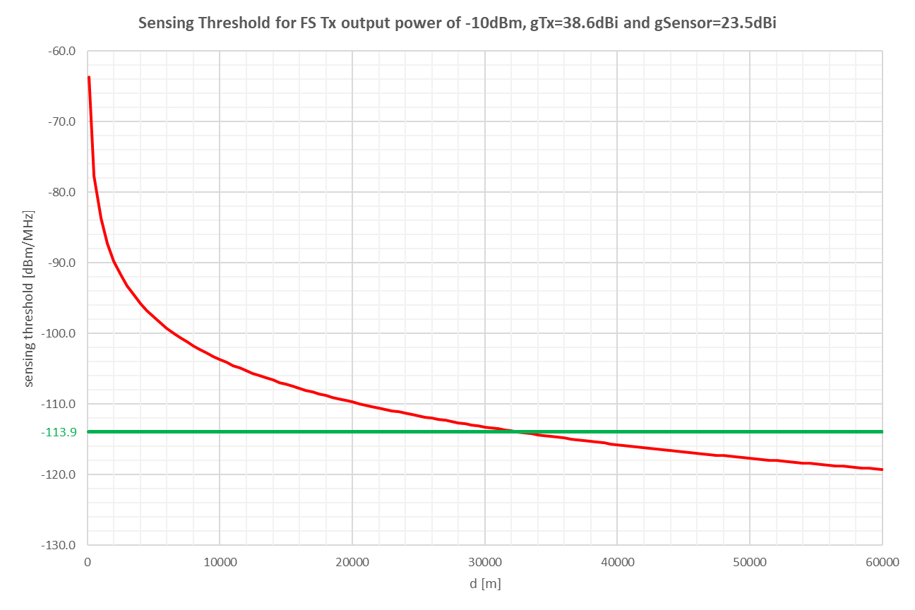

Figure 2: Sensor received power

Even from this simple illustration, it can be drawn that in a distance of about 30 km and beyond an emission from the FS transmitter station using a transmitter output power of ‑10 dBm could not be sensed without any additional measure to improve the sensors sensitivity (receiver cooling, integrated measurement, cooperative sensing, …). It shall be mentioned that propagation models as e.g. Recommendation ITU-R P.452‑16 [6] could lead to a lower detection distance.

According to ECC Report 304 [1], interfering distance from VSAT range up to nearly 60 km using long term protection criteria. ECC Report 304, annex 3 shows that short term protection criteria would give even bigger separation distances.

## Factors that could improve the sensor

The following factors should be considered further in setting the sensing threshold:

Factors that can improve sensing:

* Increasing integration time of sensing to improve sensitivity;
* Increasing the observation period to capture variations in power output of the FS;
* Higher sensor antenna gain;
* Better noise figure of the sensor;
* Knowledge of waveform and modulation of FS will help increasing SNR value (practical not possible without coordination or database).

### Integration time

As it has been seen in the implementation of the sensing mechanism, there is a trade-off between the sensor antenna gain and the minimum level of signal that the sensor can detect. The detection threshold the sensor will achieve depends on its implementation and, among other parameters, on the integration time[2].

Depending on the sensor sensitivity, two cases can be considered:

If the FS signal is received with a C/N below 0 dB, then integrated measurement time is required;

If the FS signal is received with a C/N above 0 dB, then a simple spectral analysis will allow to detect the difference between the signal and the noise, and to determine both its central frequency and bandwidth;

The proper design of the observation and integration time needs further consideration.

#### Theoretical consideration of integration time

The integrated measurement feature benefits from an increasing cancellation of noisy parts of the signal if measured multiply leaving the final measurement result more stable. Since no detailed technical information is available on "integrated measurement" some theoretical background might be considered.

Table 1 illustrates the standard deviation of a sample (size = 4096) decreasing by an increase of the number of measurement values integrated over [1]. The increasing stability of the result in the end allows to detect signals decreasingly small below the receiver noise floor.

Without integrated measurement (number = 1, standard deviation of the sample is 0.038 pW at 50Ω) a signal should be about 3 dB above the receivers noise floor, safely to be detected.

If the measurement is repeated 1024 times and integration is performed over all values, the standard deviation of the result is decreased to 0.0008 pW (number = 1024) allowing to detect signals being 16.5 dB below the receivers noise floor.

Table 1: Sensing gain

|  |  |  |  |  |  |  |  |  |  |  |  |
| --- | --- | --- | --- | --- | --- | --- | --- | --- | --- | --- | --- |
| Integration over  number of  measurement  values | 1 | 2 | 4 | 8 | 16 | 32 | 64 | 128 | 256 | 512 | 1024 |
| Standard deviation  [pW @ 50Ω] | 0.0375 | 0.0261 | 0.0184 | 0.0126 | 0.0091 | 0.0063 | 0.0045 | 0.0030 | 0.0025 | 0.0011 | 0.0008 |
| Receiver threshold  above kTBF [dB] | 3.010 | 2.290 | 1.732 | 1.261 | 0.939 | 0.673 | 0.495 | 0.332 | 0.282 | 0.122 | 0.096 |
| Sensing gain [dB] | 0.0 | -1.6 | -3.1 | -4.7 | -6.2 | -7.8 | -9.2 | -11.0 | -11.7 | -15.5 | -16.5 |

It shall be mentioned that this theoretical analysis presumes a complete stable measurement environment. If any other signal part is changing during the integration time the derived sensitivity gain is lost.

The efforts necessary to realise a certain sensitivity gain by an integrated measurement can be deduced from Figure 3. If e.g. an additional sensitivity gain of 20 dB is needed an integration over about 5000 sample measurement values are to be performed.

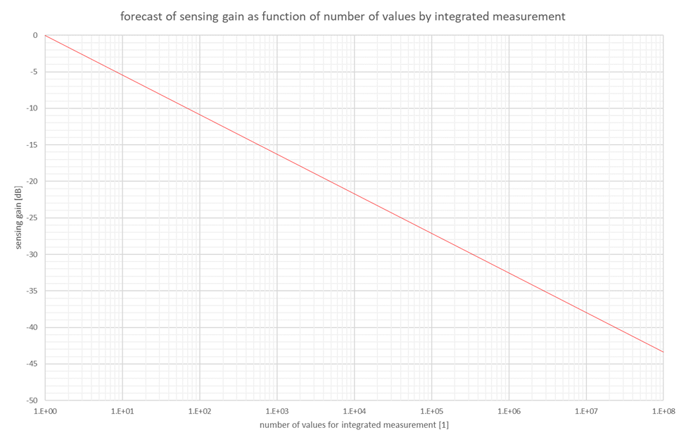

Figure 3: Sensitivity gain over number of measurements used for integrated measurement

It should be kept in mind that this large number of measurement values allow the detection of a low amplitude signal only in one direction.

### Sensor antenna gain

The antenna of the sensor is a very important part of the sensing system since it has to be able to scan the full area around the FSS station looking for possible FS stations.

As such, there are basically two possible strategies, which could be even combined: mechanical and electrical scanning.

In case of use of passive antennas, such as the traditional parabolic ones, mechanical rotation would be necessary because the main beam is fixed. Moreover the gain is deterministically related to the diameter of the antenna, where at 28 GHz typical diameters of 30 and 60 cm correspond to a typical gain of about 37 and 42 dBi respectively.

In case of use of active antennas, such as AAS ones, there is the possibility to steer the main beam within a limited interval and the gain is a growing function of the number of antenna elements (via the array factor) and a decreasing function of the steering angle (via the element factor).

In ECC Report 304 [1], an existing active antenna possibly used for sensing is described in Annex 8, with a scanning range of +- 60 degrees both in azimuth and in elevation. It is a phased array of 64 elements with a gain to noise temperature (G/T) of -7 dB/K, where G is the antenna gain in decibels at the receive frequency, and T is the equivalent noise temperature of the receiving system in kelvins.

In both cases in order to cover the full area around the FSS station, you would require either some mechanical rotation or several antennas.

In ECC Report 304 different values have been assumed for sensor antenna gain (see Annex 7, practical measurements on spectrum sensing):

* 45 dBi in the LOS measurements in Jackson County (US) with a parabolic antenna of 75 cm diameter;
* 30 dBi in the LOS measurements in St. Petersburg (Russian Federation) with a measurement instrumentation antenna HF906.

The idea of a rotating parabolic antenna might in practice be not feasible, because of the sophisticated mechanical installation and the required maintenance.

# Operational requirements for the sensor

Beside the sensitivity of the sensor, further requirements need to be fulfilled by the sensor to ensure proper detection of all possible interfered FS stations.

### Knowledge of FS channel arrangement

The algorithm is based on the knowledge of the channel arrangement of the FS. The current channel arrangement is presented in Figure 4, taken from ERC Recommendation T/R 13-02 [4]. Since the channel arrangement can vary over time, the sensor should be able to update regularly its knowledge of the channel plan.

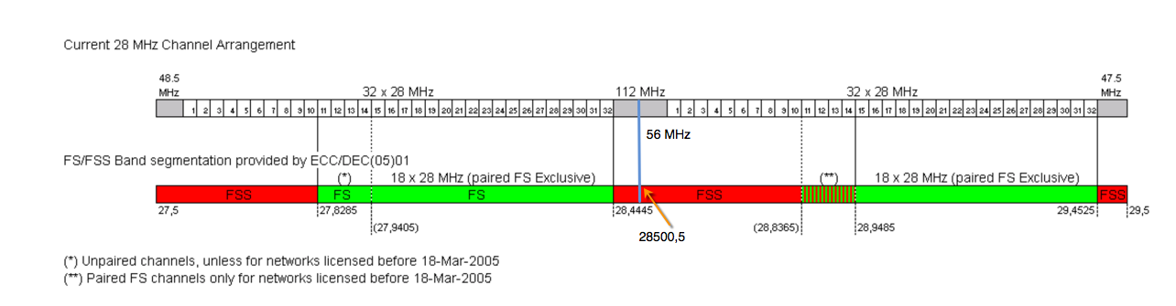Figure 4: Channel plan, ERC Recommendation T/R 13-02

In the studies within ECC Report 304 [1], a channel bandwidth of 28 MHz for the FS has been considered being the most commonly deployed value; nevertheless ERC Recommendation T/R 13-02 [4] and ECC Decision (05)01 [3] allow usage of wider channels, up to 224 MHz, and the implementation of the sensor has to take into account the need to detect also these wider channels if in use.

### Detection time

Since new links could be installed in the proximity of the FSS station, the sensor should periodically (for instance at least once per day) check for the availability of the channels.

Considering that the FSS station typically has a low duty cycle, it is expected that it will be possible to perform sensing during the idle time of the FSS. The sensor antenna, in fact, could be synchronised with the FSS Earth Station operation so that the sensor reception is active only when that earth station is not transmitting (e.g. between bursts). Taking into account that the duty cycle of the FSS Earth Station, according to Recommendation ITU-R S.1594 [7], is less than 20%, the sensor can ideally receive during 80% of the time, whereas the FS signal is supposed to be active all the time in P-P and P-MP systems. In practice, any analysis of a system’s compliance should take into account its actual duty cycle, therefore system with the lower duty cycle will have longer sensing time compared to the one with higher duty cycle.

### Direction of the detection

Beside the unknown technical parameters of the FS station which should be detected, also the location of the FS station is unknown. In consequence, the sensor has to detect in all directions (full azimuth and some elevation range), around the FSS station[3]. Even if the most critical direction in terms of interference distance between FSS and FS station is the main beam of the FSS antenna, the FSS antenna also radiates emissions in other directions than the main beam. This has to be taken into account for the practical dimensioning of the sensor antenna.

A 360° FS detection (full azimuth) might be either realised with several active antenna sectors, passive sector antennas or a kind of mechanical rotating antenna. The actual implementation of the sensor antennas is a trade-off between antenna gain, size of the antenna and practical installation restrictions.

# Conclusions

ECC Report 304 [1] evaluates the possible interference scenarios between FS and uncoordinated FSS Earth stations. It does not propose to change the band plan contained in ECC Decision (05)01 [3]. Instead, it assumes that the entry of one service into another service’s reserved spectrum is possible on a strictly handled non-interference basis, ensuring that the incumbent service in its reserved spectrum is protected from any interference also with respect to its future development.

The sharing and compatibility studies provided in ECC Report 304 indicate no sharing possibilities between the FS and the FSS without the implementation of additional mitigation techniques. Moreover, ECC Report 304 describes the mechanism of sense and avoid as theoretically feasible to ensure the proper protection of FS receivers against harmful interference from uncoordinated FSS earth station in the FS portion of the 28 GHz band without specific evaluation of the sensing mechanism itself.

The following assumptions are taken as the basis in this Report:

* A minimum elevation of 10° for an FSS antenna. A scenario where the angle of FSS Earth station is lower might be envisaged specially for higher latitude where elevation angle can be just 5 degree;
* The VSAT highest gain towards a FS receiver antenna is 8.5 dBi for 10°elevation angle;
* The noise figure for the Fixed Service receiver is 6.5 dB;
* The noise figure for the sensor is 0 dB; For the estimation of the corresponding sensing threshold, the main beam gain of an 8x8 AAS (23.5 dBi) is used.

To ensure the protection of any FS station, the sensing mechanism needs to fulfil the following technical conditions:

* Detection of the FS signal in 360° full azimuth and some elevation range around the FSS earth station;
* Detection of FS Tx with an output power down to -10 dBm, or equivalent to national, potentially neighbouring countries FS situation in a distance where there might be interference from transmitting FSS Earth Stations.

Further, it is only possible to detect FS transmitters, but the protection of the FS receivers from harmful interference has to be ensured. Therefore, the knowledge of the FS channel arrangement and implementation in the sensor is required. The report concludes that the sensor threshold for an emission from the FS transmitter station using a transmitter output power of -10 dBm, needs to be set around 30-40 dB below the noise floor and the calculations show that this level is reached at around 30 km (see Figure 2), for the considered example and assumptions. Therefore, additional measures are required to improve the sensors sensitivity (such as receiver cooling, integrated measurement, cooperative sensing, …).

According to the ECC Report 304, interfering distances from VSATs can range up to nearly 60 km using long term protection criteria. ECC Report 304, annex 3 shows that short term protection criteria would yield even larger separation distances.

The architecture of the sensor itself is a trade-off of different factors:

* Sensor antenna gain;
* Measurement time;
* Integration time;
* SNR of the sensor;
* Sensitivity of the sensor.

In reality, the extent of the improvement of the individual parameters could be limited due to effort, costs and physics and therefore a careful device assessment is necessary.

1. minimum Tx power from FS to be detected by FSS

In order for sensing mechanism to work properly, one of the most important parameters is the minimum TX power to be detected from the FS station, because it contributes to the definition of the detecting threshold by the sensing receiver of the FSS station.

The rationale in taking into account the minimum Tx power from FS is in the need to protect all FS stations, where the ones emitting lower levels of signal are the most difficult to be detected. Moreover the general trend in backhaul links, that are the most widespread application of FS, is towards shorter and shorter hop lengths, which implies lower Tx power, due to the penetration of fiber PoP and to the diffusion of small cells.

In order to establish a reasonable value for the minimum Tx power to be considered in the dimensioning of the sensor, it is useful to take into account the real situation of deployed FS links in some countries, as collected in the following sections.

It is worthwhile to consider that the provided data reflects only the current use of FS in the 28 GHz band in a limited number of CEPT countries.

For some administrations it is not possible to deliver data on the minimum Tx output power since their databases used for interference assessment contain the maximum Tx output power. Furthermore, for some administrations block assignment and spectrum award authorization approaches have been adopted and the information including the minimum output power level is not readily available.

Due to the ongoing development in telecommunications sector, changes in FS technology/topology and increasing need for higher capacity fixed wireless links to complement optical fibre infrastructure going along with an increasing number of short links with low Tx power is expected in the future. These future developments are not covered by the CDF based on current data.

Therefore these future requirements/changes in FS are to be considered when dimensioning sensing mechanism for uncoordinated FSS Earth stations.

* 1. FS links in France

In order to select a proper value for the minimum TX power of the FS links that the sensor must be able to detect it is useful to know the CDF (cumulative distribution function) of the TX power of real FS links.

In France, the band 28 GHz band is not currently heavily used for the FS service, but it is planned that it could be used for it in the near future.

For this reason, the 26 GHz band was considered instead, where the number of FS systems is high. It is assumed that the parameters of FS links in the band 26 GHz will not differ significantly from those in 28 GHz.

Around 8000 FS stations are registered in the 26 GHz band in France. Each FS station operates in the 26 GHz and is registered in a database that contains, inter alia, the clear sky e.i.r.p. of the stations and its antenna size. From these two parameters, assuming that the antenna efficiency equal to 0.8, the Tx power of the FS station can be easily derived.

Figure 5 shows the CDF of the Tx power of the stations.



Figure 5: CDF of the Tx power of FS stations

Figure 6 provides a detail of the left queue of the distribution.



Figure 6: Detail of the distribution (left queue) in Figure 3

As it can be seen, the Tx power of FS links can go as low as -35 dBW (-5 dBm), but this happens only in a very small percentage of cases. The value of -20 dBW (10 dBm) is exceeded in (100-0.4) = 99.6% of the cases.

* 1. FS links in Lithuania

Information provided comes from the latest license data (2020-05) when a total amount of 926 P-P stations (463 microwave links) were operating in the territory of Lithuania in 27.5-29.5 GHz band. Figure 7 displays nominal power distribution of those links. These are the duplex links, having the same transmitter’s power on both sides and operate under such power for most of the time (clear sky), except when the power is occasionally raised by the ATPC.

Figure 7: Nominal (clear sky) power distribution of microwave links in Lithuania in 28 GHz band

Power data of microwave links is taken from the licenses issued by Communications Regulatory Authority of the Republic of Lithuania and confirmed by the operators.

From Figure 7, it is seen that the lowest Tx power is -3 dBm and the highest is 19 dBm. There is 0.65% probability that the power of the station will be -3 dBm. Similarly, there is 49.89% probability that the power of station will be 10 dBm or below.

Table 2 illustrates the proportional division of occupied bandwidth in P-P stations. And following Figure 9 illustrates CDF of Tx power of the stations normalised to 1 MHz. From this figure it is seen that there is 0.86% probability, that the power of the station will be -17.47 dBm/MHz or below.

Table 2: Occupied bandwidth of microwave links in Lithuania in 28 GHz band

|  |  |
| --- | --- |
| Bandwidth, MHz | Percentage of the stations, % |
| 27.5 MHz | 3.89 |
| 28 MHz | 57.45 |
| 56 MHz | 38.66 |

Figure 8: Nominal (clear sky) power distribution per 1 MHz of microwave links in Lithuania in 28 GHz band

Table 3 illustrates the proportional division of antenna gain in P-P stations. The following figure illustrates CDF of e.i.r.p. of the stations normalised to 1 MHz. From Figure 8, it is seen that there is 0.86% probability that e.i.r.p. of the station will be 20.53 dBm/MHz or below.

Table 3: Antenna gain of microwave links in Lithuania in 28 GHz band

|  |  |
| --- | --- |
| "Stations (%)"  Percentage of the stations, % | Antenna gain, dBi |
| 10.04 | 36.9 dBi |
| 0.43 | 37.9 dBi |
| 86.39 | 38 dBi |
| 0.22 | 38.1 dBi |
| 0.54 | 41.9 dBi |
| 2.38 | 42.4 dBi |

Figure 9: e.i.r.p. (clear sky) distribution per 1 MHz of microwave links in Lithuania in 28 GHz band

Figure 10 presents CDF of length of the links operating in 28 GHz frequency band. The shortest link is 194 meters while the longest is 7077 meters.

Figure 10: Distribution of length of microwave links in Lithuania in 28 GHz band

Finally, Figure 11 gives a scatter-plot of the above mentioned links power versus the length of the links.

Figure 11: Scatter-plot of power versus length of microwave links in Lithuania in 28 GHz band

Rank correlation analysis showed ρ = 0,714 (there is a strong correlation between nominal transmit power and link length) and p =100% (the rank correlation result has a very high confidence level).

* 1. FS links in Sweden
     1. Link distance distribution in the 28 GHz band

Since the Swedish FS usage in the 27.5-29.5 GHz band is on block allowances, the administration (PTS) have no information on actual link details. However, during an internal PTS study regarding introduction of IMT in the 26 GHz band, some geographical data regarding existing 28 GHz FS usage was gathered from the licensees in order to also (beside impact on FS 26 GHz links) evaluate the possible impact of IMT 26 GHz (due to out-of-band properties) on FS 28 GHz link.

The average link distance is 3.6 km with typical bandwidths of 28 MHz or 56 MHz, with a high degree of XPIC usage (simultaneous use of both V and H polarisation), and typical modulation rates between 16 QAM and 256 QAM. Approximately 40% of all links are shorter than 2.5 km.

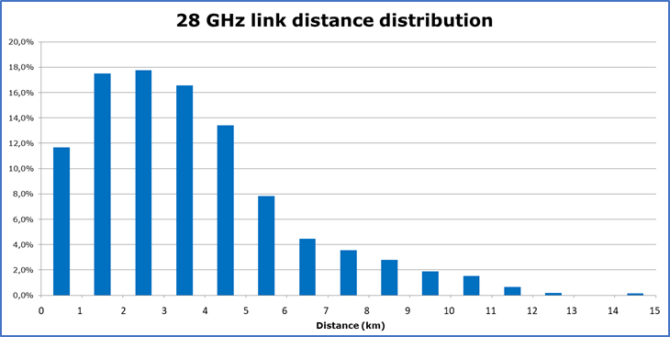

Figure 12: 28 GHz Link distance distribution in Sweden (in intervals of 1 km)

* + 1. System gain of typical 28 GHz links

Example of parameter values for typical 28 GHz links can be found in Table 4.

Table 4: Typical parameter values

|  |  |  |  |  |  |
| --- | --- | --- | --- | --- | --- |
|  |  | BER 10-6 receiver threshold (dBm) | | | |
| **Modulation (nQAM)** | **P (dBm)** | **28 MHz** | **56 MHz** | **112 MHz** | **224 MHz** |
| 4 | 22 | -88 | -85 | -82 | -79 |
| 16 | 20 | -81 | -78 | -75 | -72 |
| 32 | 20 | -78 | -75 | -72 | -69 |
| 64 | 19 | -75 | -72 | -69 | -66 |
| 128 | 19 | -72 | -69 | -66 | -63 |
| 256 | 18 | -69 | -66 | -63 | -60 |
| 512 | 18 | -66 | -63 | -60 | -57 |
| 1024 | 17 | -63 | -60 | -57 | -54 |
| 2048 | 16 | -60 | -57 | -54 | -51 |
| 4096 | 15 | -56 | -53 | -50 | -47 |
| min | -10 | - | - | - | - |

Typical antenna gain for parabolic antennas in the 28 GHz are as Table 5.

Table 5: Typical antenna gain

|  |  |
| --- | --- |
| Antenna Diameter (m) | Antenna Gain (dBi) |
| 0.2 | 35 |
| 0.3 | 38 |
| 0.6 | 43 |
| 0.9 | 47 |

An example of minimum system gain in the current installed 28 GHz population could be for a link using channel bandwidth 56 MHz, 256 QAM modulation, transmit power -10 dBm and 0.3 m antenna. The corresponding typical minimum system gain = Transmit power + 2 x Antenna Gain – Receiver threshold = -10 dBm + 2 x 38 dBi – (-66 dBm) = 132 dB.

The typical maximum system gain could be for a link using channel bandwidth 28 MHz, 16 QAM modulation, transmit power +20 dBm and 0.9 m antennas, corresponding to (20 dBm + 2 x 43 dBi –(-81 dBm) = 187 dB.

Typical system gains in the 28 GHz band could be regarded to be in the interval 130–190 dB.

* + 1. Link distance as a function of system gain in the 28 GHz band

The link distance as a function of system gain and availability targets (between 99% and 99.999%) have been calculated using a radio planning tool. Prediction model in Recommendation ITU-R P.530-16 with a rain intensity of 22 mm/h (which could be regarded to be low for continental European climate conditions) was used. The result is presented in Figure 13.

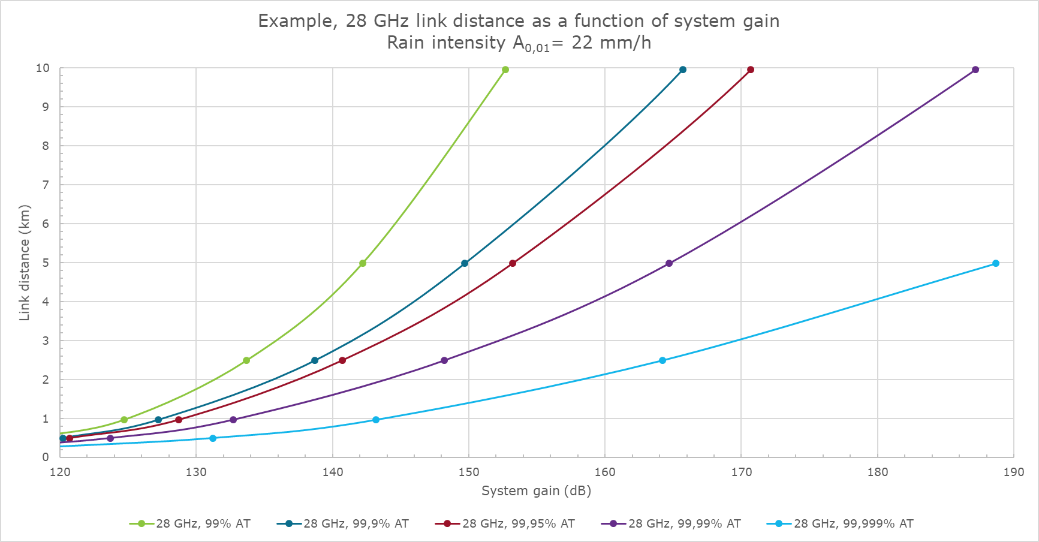

Figure 13: Link distance as a function of system gain at varoius availablity targets 99% to 99.999%

* + 1. Example of required Tx power

With reference to Figure 13, for a link distance of 2.5 km a system gain of about 164 dB is required for 99.999% availability. Given 0.6 m antennas and a receiver threshold of -62 dBm, the required transmit power is 17 dBm as given in Figure 14.

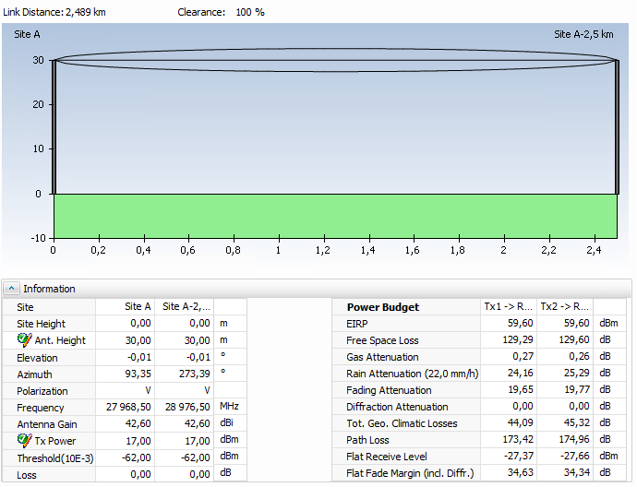



Figure 14: Link Budget 2.5 km, transmit power 17 dBm meeting 99.999% availablity

Another example with reference to Figure 13, for a link distance of 2.5 km a system gain of about 139 dB is required for 99.9% availability. Given 0.6 m antennas and a receiver threshold of -62 dBm, the required transmit power is -9.5 dBm as given in Figure 15.

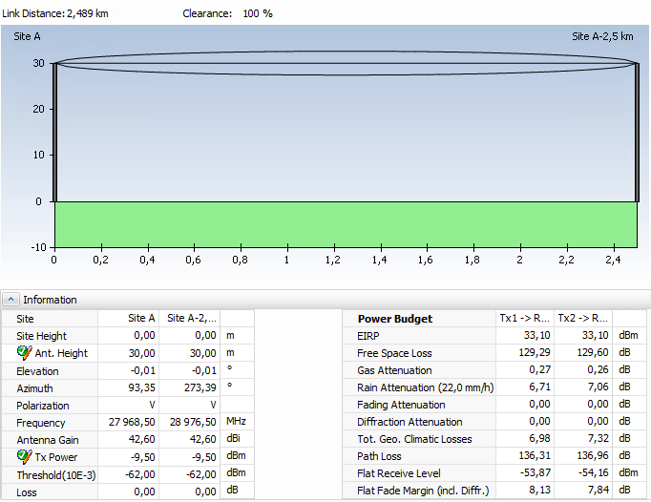



Figure 15: Link budget 2.5 km, transmit power -9.5 dBm meeting 99.9% availablity

* + 1. Estimated Tx power

During normal propagation conditions, the propagation loss off 28 GHz line-of-sight microwave links are depending on free space loss and some minor (around 0.1 dB/km) attenuation by atmospheric gases. The main contribution to fading in the 28 GHz band can be assumed to be due to rain attenuation.

During normal propagation conditions (in clear sky for > 99.x % of the time) the Receiver Signal Level (RSL) is assumed to have a 10 dB relative the BER 10-6 receiver threshold. During un-normal propagation conditions (less than 0.x% of the time) the radio link transmitter power will be increased in order to compensate for the additional rain loss. The nominal transmitter power can be calculated as (given Line-of-Sight between the end sites) as:

|  |  |
| --- | --- |
| $$Pnom = (Lth+10 dB) – (Gt + Gr) + [92.45 – 20log (f x d)] + ( x d)$$ | (7) |

Where:

* Pnom= nominal transmit output power (dBm);
* Lth = BER 10-6 receiver threshold (dBm);
* Gt, Gr = Antenna gain of the transmitter respectively receiver (dBi);
* f = frequency (GHz);
* d = link distance (km);
* γ = specific gaseous attenuation (dB/km).

Given that all existing links use 56 MHz channel bandwidth, BER 10-6 threshold of -69 dBm and 0.3 m antennas (antenna gain 38 dBi) the distribution of nominal transmit power can be found in Table 6.

Table 6: Sweden calculated nominal TX power

|  |  |  |  |
| --- | --- | --- | --- |
| **Percentiles of links covered** | **Link length (km)** | **Nominal TX power (dBm/MHz)** | **Nominal TX Power (dBm)** |
| Maximum | 14.26 | No data | No data |
| 99.00% | 11.05 | -8.8 | 8.8 |
| 97.50% | 10.05 | -9.7 | 7.9 |
| 95.00% | 8.78 | -11.0 | 6.5 |
| 90.00% | 7.16 | -12.9 | 4.6 |
| 50.00% | 3.16 | -20.5 | -3.0 |
| 40.00% | 2.59 | -22.3 | -4.8 |
| 30.00% | 2.04 | -24.4 | -6.9 |
| 20.00% | 1.42 | -27.5 | -10.0 |
| 10.00% | 0.9 | -27.5 | -10.0 |
| 5.00% | 0.55 | -27.5 | -10.0 |
| 2.50% | 0.38 | -27.5 | -10.0 |
| 1.00% | 0.28 | -27.5 | -10.0 |
| 0.50% | 0.23 | -27.5 | -10.0 |
| Minimum | < 0.1 | No data | No data |
| Number of links | around 3.000 |

The number of links are around 3.000, the maximum distance is 14.26 km and the minimum distance is shorter than 100 m (pending on coordinate accuracy). Some of the existing links are actually installed with 0.6 m antennas, especially at hub sites (in star topology networks) in order to minimize side lobes and improve frequency reuse.

Future upgrades might include expanding channel bandwidth from 56 MHz up to 224 MHz where possible. Modulation rate might also increase. It is also anticipated that Star topology networks/hub sites will become more common in next generation back haul networks and that ETSI class 4 antennas might be necessary to be able to reuse frequencies/deploy wider channels.

* + 1. Future use and overall conclusion

During upgrade of mobile back haul networks, E-band links could replace the shorter 28 GHz links, or the 28 GHz links could remain as a backup links in a BCA solution. Some existing 28 GHz paths could be reinvested/replaced with new radios in the 28 GHz band using wider channels (112 MHz and/or 224 MHz), adaptive functions and/or MIMO in order to maximize the overall spectrum efficiency.

It could be assumed that the link distance distribution in the 28 GHz band will remain the same as in the current situation, and that it is likely that a significant portion of FS links using adaptive functions in the 28 GHz band might use a transmit power close to the equipment’s typical minimum transmit power -10 dBm.

Furthermore, new energy saving functions may be implemented in next generation radio links, i.e. that the equipment minimise the modulation rate and transmit power during time periods with low traffic load, thus increasing the likelihood of low transmit power. A requirement to use a transmit power higher than required by actual link conditions would counter act “Green Energy saving objectives”.

The overall conclusion is that transmit power of -10 dBm might be necessary as a sensor detection criteria.

* 1. FS links in Switzerland
     1. Power and length distribution of Microwave links in 28 GHz

As of April 2020, Switzerland had 433 Microwave links operating in the frequency range 27.9405 to 29.4525 GHz. All the Swiss links use ATPC to minimise the transmit output power under clear sky conditions. On Swiss links, ATPC will increase transmit power mainly to compensate rain attenuation.

The CDF of the microwave links nominal transmit power is having following distribution:

Figure 16: Nominal transmit power distribution of the Swiss microwave links [dBm]

Or expressed in normalised 1 MHz units:

Figure 17: Nominal transmit power distribution of the Swiss microwave links [dBm/MHz]

Concerning the Swiss microwave links length, the CDF looks as follows:

Figure 18: Link Length CDF of Swiss microwave links [km]

The scatter plot of the nominal transmit power [dBm] in clear sky condition versus link length [km] looks as follows:

Figure 19: Scatter Plot Nominal Tx Power [dBm] versus Link Length [km] for Swiss links

The scatter plot for the nominal transmit power [dBm/MHz] in clear sky condition versus link length [km] looks as follows:

Figure 20: Scatter Plot Nominal Tx Power [dBm/MHz] versus Link Length [km] for Swiss links

In tabular form, the CDF summary looks as follow:

Table 7: Percentiles for links length and nominal transmit power

|  |  |  |  |
| --- | --- | --- | --- |
| Percentiles | Link Length (km) | Nominal Tx Power (dBm/MHz) | Nominal Tx Power (dBm) |
| 99.0% | 6.7 | -4.8 | 10.0 |
| 97.5% | 6.3 | -6.5 | 9.0 |
| 95.0% | 5.9 | -8.5 | 8.0 |
| 90.0% | 5.6 | -9.5 | 7.0 |
| 50.0% | 4.1 | -14.3 | 2.0 |
| 40.0% | 3.8 | -15.5 | 0.0 |
| 30.0% | 3.5 | -17.5 | 0.0 |
| 20.0% | 3.1 | -18.5 | -3.0 |
| 10.0% | 2.8 | -21.3 | -5.0 |
| 5.0% | 2.6 | -22.5 | -8.0 |
| 2.5% | 2.4 | -22.5 | -8.0 |
| 1.0% | 2.2 | -23.5 | -8.0 |
| 0.5% | 2.0 | -25.5 | -8.0 |
| 0.23% | 1.8 | -27.0 | -9.5 |

Table 8: Minimum, Mean, Median and Maximum values for the Swiss links

|  |  |  |  |  |  |
| --- | --- | --- | --- | --- | --- |
|  | Minimum | Mean | Median | Maximum | Units |
| Link Length | 1.8 | 4.1 | 4.1 | 7 | [Km] |
| Nominal Power | -27 | -14.6 | -14.3 | -4.5 | [dBm/MHz] |
| Nominal Power | -9.5 | 1.4 | 2 | 11 | [dBm] |

* + 1. Rank correlation between nominal Tx power and link length
  1. Nominal Transmit Power expressed in dBm/MHz

The correlation coefficient between Nominal Transmit Power and Link Length is ρ = 0.122

The confidence level p for the correlation is p = 98.9%

According these statistical results, there is a weak correlation between nominal transmit power and link length in Switzerland with a high confidence level.

* 1. Nominal Transmit Power expressed in dBm

The correlation coefficient between Nominal Transmit Power and Link Length is ρ = 0.141

The confidence level p for the correlation is p = 99.7%

Same conclusion as for section 2.1

* 1. Check for possible wrong data provisioning

The fact that the calculated Pearson correlation coefficient indicates no correlation between the link transmit Power and link length seems to put into question this statistical approach. It was therefore decided to make an additional test on data provisioning.

A Swiss database extract has more than 148 fields for describing 1 link. It is therefore possible that out of 433 links, a few links may have a wrong provisioning, which would possibly impact on the correlation coefficient. To check this, it has been assumed that 1% of the links may have some wrong parameter. Out of the 433 pairs of link length and Transmit Power values, 99% have been selected randomly for 1 million time and the corresponding Spearman correlation coefficient calculated to get the minimum and maximum correlation range.

* Case Transmit Power in dBm/MHz: correlation range: 0.099 .. 0.142 (exact value ρ = 0.122);
* Case Transmit Power in dBm: correlation range: 0.120 .. 0.161 (exact value ρ = 0.141).

As no big changes take place in the correlation range compared to the exact value, it is assumed that there is no hidden wrong data provisioning.

Table 9: Channel bandwidth repartition for the 433 Swiss links

|  |  |
| --- | --- |
| Channel bandwidth | Percentage of the 433 Swiss links |
| 28 MHz | 47.11% |
| 56 MHz | 52.89% |
| Note: In future a channel bandwidth of 112 MHz may be used | |

* 1. FS links in Germany
     1. Introduction

The basic requirement for the introduction of uncoordinated FSS earth station in the FS portion of the 28 GHZ band is a mitigation technique that ensures the protection of all FS links. Only in that case uncoordinated FSS earth station shall be allowed to take advantage of a use of the spectrum dedicated to the FS.

Furthermore ECC Report 304 [1] states that there is no intention to change the ECC Decision (05)01 [3] in order to allow uncoordinated FSS Earth station in the FS portion of the 28 GHz band.

ECC Decision (05)01 [3] makes the following consideration regarding uncoordinated FSS Earth stations: “the probability of interference to FS receiver stations by FSS uncoordinated transmitting Earth stations operating on the same frequency and in the same geographical area is generally regarded as being not acceptable”.

For the configuration of the sensor the combination of the max. interference distance and the min possible FS Tx output power describes the most critical scenario.

As FS receivers cannot be detected, an equivalent FS Tx is required. This equivalent FS Tx should cover the most critical of all possible configurations for FS links in the band, which seems to be the configuration with the lowest e.i.r.p..

* + 1. FS link deployment with different FS Tx output power values

To evaluate possible “realistic” minimum FS Tx output power values datasheets from different manufactures are evaluated.

The datasheets for FS equipment currently on the market provide values between -10 dBm and -5 dBm as minimum Tx output power. This option developed by the manufacturers allows to operate with an appropriate low transmitter output power in case of very short links which contributes to an improved efficiency in spectrum usage.

As ECC Report 304 [1] uses 47 dBi antenna gain for the studies to derive possible interference distances this antenna was used for the first evaluations.

For short links, such a high antenna diameter of 1.2 m might not be realistic, therefore calculations with a smaller diameter and a resulting gain of 38 dBi) were made in addition. The gain distribution of antennas used in 28 GHz PtP applications in Germany indicates that 38 dBi are the most common gain in the field.

Table 10 shows possible link lengths for different bandwidths and modulation schemes with a FS TX output power of – 10 dBm and a 47 dBi antenna for TX and Rx.

Table 10: Evaluation of possible link distance with a FS TX output power of -10 dBm and antenna gain of 47 dBi

|  |  |  |  |  |  |  |  |  |
| --- | --- | --- | --- | --- | --- | --- | --- | --- |
| **BW [MHz]** | **LoS maximum (vertical) link length for 26.3 min outage/year using different QAMs in 28 GHz, planning margin 10 dB** | | | | | | | |
| **4 PSK** | **8 PSK** | **16 QAM** | **32 QAM** | **64 QAM** | **128 QAM** | **256 QAM** | **512 QAM** |
| PTx [dBm] | -10.0 | -10.0 | -10.0 | -10.0 | -10.0 | -10.0 | -10.0 | -10.0 |
| gTx [dBi] | 47.0 | 47.0 | 47.0 | 47.0 | 47.0 | 47.0 | 47.0 | 47.0 |
| gRx [dBi] | 47.0 | 47.0 | 47.0 | 47.0 | 47.0 | 47.0 | 47.0 | 47.0 |
| PTx (e.i.r.p.,[dBW]) | 7.0 | 7.0 | 7.0 | 7.0 | 7.0 | 7.0 | 7.0 | 7.0 |
| 3.5 | 4.1 | 3.7 | 3.3 | 3.0 | 2.6 | 2.3 | 2.0 | 1.8 |
| 7 | 3.7 | 3.3 | 3.0 | 2.6 | 2.3 | 2.1 | 1.8 | 1.5 |
| 14 | 3.3 | 3.0 | 2.6 | 2.3 | 2.1 | 1.8 | 1.5 | 1.3 |
| 28 | 3.0 | 2.6 | 2.3 | 2.1 | 1.8 | 1.5 | 1.3 | 1.1 |
| 56 | 2.6 | 2.3 | 2.0 | 1.8 | 1.5 | 1.3 | 1.1 | 0.9 |
| 112 | 2.3 | 2.0 | 1.8 | 1.5 | 1.3 | 1.1 | 0.9 | 0.7 |
| 224 | 2.0 | 1.8 | 1.5 | 1.3 | 1.1 | 0.9 | 0.7 | 0.6 |

Table 10 shows that with this configuration (-10 dBm Tx output power, 47 dBi antenna gain) even with a fade margin of +10 dB, a link length between 0.6 km and 4.1 km is possible.

Based on a common modulation scheme of 64 QAM the impact of the FS Tx output power on the possible link length is evaluated (47 dBi antenna for TX and Rx.).

Table 11: Evaluation of possible link distance with -10 to 10 dBm FS TX output power for 64 QAM and 47 dBi Antenna

|  |  |  |  |  |  |
| --- | --- | --- | --- | --- | --- |
| **BW [MHz]** | **LoS maximum (vertical) link length for 26.3 min outage/year using 64 QAM in 28 GHz, planning margin 10 dB** | | | | |
| **64 QAM** | **64 QAM** | **64 QAM** | **64 QAM** | **64 QAM** |
| PTx [dBm] | -10.0 | -5.0 | 0.0 | 5.0 | 10.0 |
| gTx [dBi] | 47.0 | 47.0 | 47.0 | 47.0 | 47.0 |
| gRx [dBi] | 47.0 | 47.0 | 47.0 | 47.0 | 47.0 |
| PTx (e.i.r.p., [dBW]) | 7.0 | 12.0 | 17.0 | 22.0 | 27.0 |
| 3.5 | 2.6 | 3.2 | 3.8 | 4.5 | 5.2 |
| 7 | 2.3 | 2.9 | 3.4 | 4.1 | 4.8 |
| 14 | 2.1 | 2.5 | 3.1 | 3.7 | 4.3 |
| 28 | 1.8 | 2.2 | 2.8 | 3.3 | 3.9 |
| 56 | 1.5 | 2.0 | 2.4 | 3.0 | 3.6 |
| 112 | 1.3 | 1.7 | 2.1 | 2.6 | 3.2 |
| 224 | 1.1 | 1.5 | 1.9 | 2.3 | 2.9 |

Table 11 shows that links length between 3.8 and 1.1 km are applicable with a Tx output power between -10 dBm and 0 dBm depending on the channel bandwidth.

As for short links, such a high antenna diameter of 1.2 m might not be realistic, same calculations are therefore done with an antenna of 38 dBi.

Table 12: Evaluation of possible link distance with -10 to 10 dBm FS TX output power for 64 QAM and 38 dBi Antenna

|  |  |  |  |  |  |
| --- | --- | --- | --- | --- | --- |
| **BW [MHz]** | **LoS maximum (vertical) link length for 26.3 min outage/year using 64 QAM in 28 GHz, planning margin 10 dB** | | | | |
| **64 QAM** | **64 QAM** | **64 QAM** | **64 QAM** | **64 QAM** |
| PTx [dBm] | -10.0 | -5.0 | 0.0 | 5.0 | 10.0 |
| gTx [dBi] | 38.0 | 38.0 | 38.0 | 38.0 | 38.0 |
| gRx [dBi] | 38.0 | 38.0 | 38.0 | 38.0 | 38.0 |
| PTx (e.i.r.p., [dBW]) | -2.0 | 3.0 | 8.0 | 13.0 | 18.0 |
| 3.5 | 1.1 | 1.5 | 1.9 | 2.3 | 2.9 |
| 7 | 0.9 | 1.2 | 1.6 | 2.1 | 2.5 |
| 14 | 0.7 | 1.0 | 1.4 | 1.8 | 2.2 |
| 28 | 0.6 | 0.8 | 1.2 | 1.5 | 2.0 |
| 56 | 0.5 | 0.7 | 1.0 | 1.3 | 1.7 |
| 112 | 0.3 | 0.5 | 0.8 | 1.1 | 1.5 |
| 224 | 0.3 | 0.4 | 0.6 | 0.9 | 1.2 |

Table 12 show that links length between 1.9 and 0.3 km are applicable with a Tx output power between -10 dBm and 0 dBm depending on the channel bandwidth even with a 38 dBi antenna.

A snapshot of the current distribution of link lengths for a 28 MHz channel bandwidth in Germany shows that 4.1% of links with a 28 MHz bandwidth have distances of 1 km and below.

Table 13: Distribution of link length for a FS link with 28 MHz channel bandwidth in Germany

|  |  |  |  |  |
| --- | --- | --- | --- | --- |
| Link Length [km] | Number of links | Share of lengths in links | Distribution of links | Distribution of links [%] |
| 0.0 | 0 | 0.0% | 0 | 0.0% |
| 1 | 76 | 4.1% | 76 | 4.1% |
| 1.7 | 172 | 9.4% | 96 | 5.2% |
| 2 | 236 | 12.9% | 160 | 8.7% |
| 3 | 576 | 31.4% | 340 | 18.6% |
| 4 | 1080 | 59.0% | 504 | 27.5% |
| 5 | 1502 | 82.0% | 422 | 23.0% |
| 6 | 1692 | 92.4% | 190 | 10.4% |
| 7 | 1774 | 96.8% | 82 | 4.5% |
| 8 | 1794 | 97.9% | 20 | 1.1% |
| 9 | 1806 | 98.6% | 12 | 0.7% |
| 10 | 1814 | 99.0% | 8 | 0.4% |
| 11 | 1824 | 99.6% | 10 | 0.5% |
| 12 | 1824 | 99.6% | 0 | 0.0% |
| 13 | 1828 | 99.8% | 4 | 0.2% |
| 14 | 1832 | 100.0% | 4 | 0.2% |

Table 13 shows that link lengths of 1 km and less are at about 4% for a 28 MHz channel in Germany and therefore this links need to be taken into account for the evaluation of an appropriate FS TX for the dimensioning of a sensor for uncoordinated FSS Earth stations.

The tables in this chapter further show that link lengths of about 1km are feasible with a TX output power of less than 0 dBm.

Thereby output power strongly depends on the modulation scheme and the antenna gain.

Therefore an equivalent FS Tx to represent all possible FS configurations which should detected and protected from interference of uncoordinated FSS Earth stations should be carefully evaluated.

* + 1. Conclusion

The tables in A1.5.2 show that FS links with a length of 1 km and less are realistic in the deployment scenario of FS in 28 GHz. These links can be deployed with less than 0 dB, in case for low modulation scheme and small channel bandwidth even with an output power of ‑10 dBm.

To protect these FS links while introducing uncoordinated FSS earth station in the FS portion of the 28 GHz band, the detection of them is mandatory. Therefore, the sensor for the uncoordinated earth station needs to be capable to detect FS transmitters of 0 dBm and below.

Further assessment is needed to evaluate generic parameters for an equivalent FS transmitter to set requirements for the sensor of the uncoordinated Earth stations.

In this context, it should be noted that the ECC Decision (05)01 [3] makes the following consideration regarding uncoordinated FSS Earth stations: “the probability of interference to FS receiver stations by FSS uncoordinated transmitting earth stations operating on the same frequency and in the same geographical area is generally regarded as being not acceptable”.

For the dimensioning of the requirements, it should be further noted that it is expected that the FS link lengths will decrease due to the common roll-out of fibre and that the focus on parameters from current national databases may not cover this evolution.

1. List of References

1. [ECC Report 304](https://docdb.cept.org/document/12984) : “Advanced technologies for fixed GSO FSS Earth Stations in the 27.5-29.5 GHz band”, approved October 2019
2. ETSI ETR 101 854, “Fixed Radio Systems; Point-to-point equipment; Derivation of receiver interference parameters useful for planning fixed service point-to-point systems operating different equipment classes and/or capacities

1. [ECC Decision (05)01](https://docdb.cept.org/document/384): “The use of the band 27.5-29.5 GHz by the Fixed Service and uncoordinated Earth stations of the Fixed-Satellite Service (Earth-to-space)”, approved March 2005, amended on 8 March 2013 and amended on 8 March 2019

1. [ERC Recommendation T/R 13-02](https://docdb.cept.org/document/869): “Recommendation T/R of 1993 on preferred channel arrangements for fixed service systems in the frequency range 22.0-29.5 GHz, approved 1993, revised on 15 May 2010 and amended on 29 May 2019
2. Recommendation ITU-R F.758-7 (11/2019): “System parameters and considerations in the development of criteria for sharing or compatibility between digital fixed wireless systems in the fixed service and systems in other services and other sources of interference"
3. Recommendation ITU-R P.452-16 (07/2015): “Prediction procedure for the evaluation of interference between stations on the surface of the Earth at frequencies above about 0.1 GHz
4. Recommendation ITU-R S.1594: “Maximum emission levels and associated requirements of high density fixed-satellite service earth stations transmitting towards geostationary fixed-satellite service space stations in the 30 GHz range”
5. Recommendation ITU-R S.465: “Reference radiation pattern of earth station antennas in the fixed-satellite service for use in coordination and interference assessment in the frequency range from 2 to 31 GHz”

1. a scenario where the angle of FSS ES is lower might be envisaged specially for higher latitude where elevation angle can be just 5 degree.
2. To obtain the maximum sensitivity in the sensor, some calibration or other means of determining the true background noise will have to be done on a regular basis as there will be temporal variations in true noise.
3. See example in ECC Report 304, annex 8