Electronic Communications Committee (ECC)
within the European Conference of Postal and Telecommunications Administrations (CEPT)

ANALYSIS OF INCREASING THE EIRP OF TERRESTRIAL FIXED LINKS
AT AROUND 58 GHz

Stockholm, October 2004

EXECUTIVE SUMMARY

Presently the ERC Recommendation 12-09 (edition 1998) provides guidance for using FS systems in the band 57-59 GHz. It establishes a particular channels arrangement for FS links and sets the associated maximum EIRP of 15 dBW for FS links.
It was shown that the EIRP limit of 15 dBW set in ERC Rec. 12-09 limits the achievable hop lengths to 500…700 m for European environmental conditions, depending on rain statistics, when the maximum allowed interference level in ETSI EN 300 408 v1.3.1 is considered. According to a collected feedback from FS operators, the number of links that could be utilised in the mobile infrastructure networks in this band would be more than doubled if the hop lengths could reach about 1000 m in interference-limited conditions in all environmental and network setups. This would increase considerably the value of 58 GHz band for FS and also relieve congestion at lower frequency bands.
Therefore this report evaluates the impact of increasing the EIRP for FS in the band 57-59 GHz. The report considered the characteristics of FS systems in this band and evaluated the benefits of the increase of EIRP in terms of achievable density of FS links in this band. The report then considered sharing between FS and other services in this band and compatibility services in adjacent bands.
Based on the studies the report concluded that increase of the maximum EIRP for FS links by 10 dB (to 25 dBW) in the frequency range 57-59 GHz will allow applications requiring hop lengths up to about 1000 meters. This EIRP increase can be obtained by increasing either the FS output power or the FS maximum antenna gain.
In both cases, with the parameters assumed in this report, the coexistence with EESS (passive) or space research service is ensured. However, if increase of the EIRP would be achieved by an increase in the transmitter output power, this would reduce the EESS protection margin. Therefore it is recommended to increase the EIRP by increasing the antenna gain, but maintaining the transmit output power at the level presently fixed in ETSI EN 300 408 (10 dBm).
With regards to FS intra-service coexistence, the option consisting in increasing the EIRP by raising the output power leads to reducing the density of links deployable in a given area whereas. The other option of increasing the antenna gain allows higher FS deployments density, hence is more efficient. Moreover, the analysis shows that the overall probability of interference cases between intra-band FS-systems decreases if antenna gain is increased.
Therefore, it is proposed that the following new regulatory limits be adopted for FS in the band 57-59 GHz:
- maximum EIRP = +25 dBW;
- maximum output power = +10 dBm.
The lowest and highest 100MHz channels given in ERC Rec. 12-09 should be left as guard channels to avoid the excess interferences from 58 GHz uncoordinated band to the adjacent band receivers in extremely dense network environments.

INDEX TABLE

EXECUTIVE SUMMARY 2
1 INTRODUCTION 4
2 FIXED SERVICE IN THE FREQUENCY BAND 57 – 59 GHz 5
2.1 Description of Fixed Service applications in the band 57 – 59 GHz 5
2.2 Fixed Service systems characteristics 5
2.3 Calculation of maximum hop length 6
2.3.1 Hop length vs. system gain 6
2.3.2 Receiver threshold degradation due to interference 6
2.3.3 Maximum hop lengths 7
3 Intra-band coexistence of fs systems 8
3.1.1 System parameters used in the interference calculations 8
3.1.2 Interference calculation procedure 9
3.1.3 Interference probability comparison 9
3.2 Impact of increasing the EIRP on the density of links 11
3.2.1 Method to determine the Density of transmitters 11
3.2.2 Parameters used in the simulations 11
3.2.3 Results of simulations 12
3.2.3.1 Current situation 12
3.2.3.2 Increase the EIRP – option 1 – increase the power – keep the same maximum antenna gain 13
3.2.3.3 Increase the EIRP – option 2 – increase the maximum gain – keep the same maximum output power 14
4 SHARING BETWEEN THE FS AND THE EESS 14
4.1 CHARACTERISTICS OF EESS 14
4.2 ANALYSIS 16
4.3 CONCLUSION ON THE SHARING BETWEEN THE FS AND THE EESS 17
5 Impact of FS on services operating in adjacent bands 17
5.1 Impact of FS on FS operating in adjacent bands 17
5.2 Impact of FS on eess operating in adjacent bands 20
6 CONCLUSIONS 20
7 REFERENCES 21

ANALYSIS OF INCREASING THE EIRP OF TERRESTRIAL FIXED LINKS AT AROUND 58 GHz

INTRODUCTION
Radio Regulations [1] allocate the band 57.0 – 58.2 GHz on a primary basis for Earth Exploration Satellite (passive), Fixed, Inter-Satellite, Mobile and Space Research services, and 58.2 – 59.0 GHz on a primary basis for Earth Exploration Satellite (passive), Fixed, Mobile and Space Research (passive) services.
Preferred frequency bands for satellite passive sensors are provided in Recommendation ITU-R SA.515 [2].
Sharing with Fixed Service (FS) and EESS (Earth Exploration Satellite Service) at 58 GHz band was studied in detail during WRC-97 preparation and in solving the Resolution 726 about HDFS –bands. The conclusion of these studies was that no restrictions for HDFS-use are needed within the band 57-59 GHz to protect the EESS.
ERC Rec. 12-09 [3] provides recommendations for systems FS systems operating in the band 57-59 GHz, in particular channels arrangements.
Present EIRP-limit (15dBW) requested in ERC Rec. 12-09 for Fixed Service (FS) radio systems using the frequency band 57-59 GHz limits the achievable hop lengths to 500…700m in within Europe depending on rain statistics when the maximum allowed interference level (ETSI EN 300 408 v1.3.1[4]) is considered as non-correlating with the received signal level. According to collected operator feedback the number of links that could be utilized in mobile infrastructure nets would be more than doubled if the hop lengths could reach about 1000m also in interference-limited conditions in all environmental and network conditions with typical requirement limit for unavailability 0.002…0.005%. This would increase considerably the value of 58 GHz band and also relieve congestion at lower frequency bands.
About 10dB increase in EIRP-limit by allowing higher gain antennas would facilitate hop lengths of about 1000m. Besides allowing longer hops, it is expected that high-gain antennas would also reduce interferences at this frequency band.
The lowest and highest 100 MHz radio channels are reserved in the present ERC Rec 12-09 for “alignment and test purposes”. In fact they also act as guard bands between adjacent lower and upper bands. These extra guard-bands are needed to relieve the risk for interference situations over the band-edges
The object of this report is to provide an analysis of the impact of increasing the EIRP of the FS systems on:
- the deployment of FS systems within the band 57 – 59 GHz;
- passive sensors operating in the band 57 – 59 GHz;
- passive sensors operating in adjacent band;
- FS systems operating in the adjacent bands.

It should be noted that in the frequency range of 57.0 – 59.0 GHz:
- Oxygen gas absorption attenuation is about 10 to 14 dB/km at sea level. This high attenuation effectively limits the achievable path length and interference level.
- High antenna directivity is achievable even with small size antennas, further reducing the risk of co-channel interference.
- Equipments may listen for a free channel before transmission to recognize existing transmissions in order to minimize interference problems and to ensure continued operation of existing transmissions
All these parameters improve the coexistence of systems in this particular frequency range.

FIXED SERVICE IN THE FREQUENCY BAND 57 – 59 GHz

Description of Fixed Service applications in the band 57 – 59 GHz
ETSI Standard 300 408 described two equipment classes depending on the network requirements:
- Class A: Digital equipment for High Density Fixed Service (HDFS) applications typically connected to public Networks. Typical applications for Class A equipment are e.g. interconnection between cellular networks where there, in some cases, is a need for short length connections (up to about 500 meters).
- Class B: Equipment without requirements for quality of service, typically private network connections. Typical applications for Class B equipment are in private networks, such as video surveillance systems.

Frequency planning is not required in this band. ERC Rec. 12-09 [3] provides channels arrangements for systems operating in the band 57-59 GHz.
- The lowest and highest 100 MHz radio channels are reserved in this recommendation for “alignment and test purposes”. They are used only for temporary (or short term) use.
- Specified channels in ERC Rec. 12-09 (100 MHz or 50 MHz) are used for the automatic channel selection procedure and allow to place easily new systems since the width of the available or reserved block is known beforehand. This channelisation also leads to a “safe” situation when deploying links, considering e.g. stability of RF-frequency or tx-power.
A few thousand 58 GHz links already used the present CEPT channeling plan given in ERC Rec. 12-09.

Fixed Service systems characteristics
The following table provides typical characteristics of FS systems operating in this band.

Parameter | Value | Notes | Reference
Frequency band | 57-59 GHz | 50MHz or 100MHz channels
Transmit power | <=10 dBm | Max of averaged during bursts  (Burst ratio 0.5) | EN 300408
Channel width | 50/100 MHz |  | EN 300408 v1.3.1
Antenna gain | 36 dBi | Current value
Antenna gain | 42 to 45 dBi | Proposed antenna gain
EIRP limit | 45 dBm | Current value | Previous CEPT Rec. 12-09 edition (1998)
EIRP-limit | 55 dBm | Proposed new limit
Feeder attenuation | 0dB
Receiver noise BW | 20…26MHz
Duplex type | TDD
Noise figure | 14 to 12 dB
Modulation type | MSK
Rx threshold 10-3 | -75…-78 dBm
Rx threshold 10-6 | -73…-76 dBm | -74dBm used in calculations
Noise level | -101…-104 dBm/MHz | Noise level -89dBm/26MHz used
Pi limit (I/N=-6dB) | -94…-97 dBm
Pi limit ETSI | -81dBm/10MHz | Channel selection procedure limit | EN 300408v1.3.1
Table 1: Fixed Service System parameters

Calculation of maximum hop length

    - Hop length vs. system gain
In the following figure the rain limited hop lengths calculated using the simplified procedure of ITU-R Rec. P.530-10 [5]. Hop lengths are shown with typical rain rates in Europe and at middle-band frequency 58GHz. This calculation method applies according to ITU-R up to 40 GHz but some studies show that there are no remarkable deviations from measurements up to about 70 GHz (possibly small under-estimation of the rain attenuation with some drain –drop distributions). The results as hop length vs. system gain are shown in Figure 1 for some typical rain rates (0.01%) and fixed propagation unavailability of 0.005% (26 min/a) [6, 7].
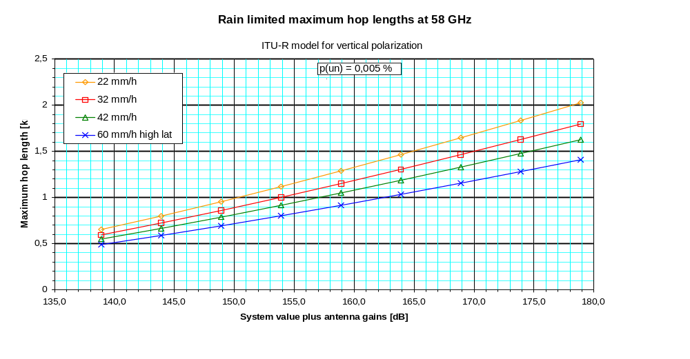
Figure 1: Maximum hop lengths vs. System Gain
    - Receiver threshold degradation due to interference
Receiver threshold degradation due to a single interferer and noise-like interference are shown in Figure 2. The single interferer-case is a measurement with MSK-modulated system (scaled for the shown initial values) and the the noise-like interference-case is calculated. The maximum ETSI EN 300 408 [4] interference limit for the automatic channel selection procedure is –81dBm/10MHz which leads to acceptance limit −77dBm in this case. From Figure 2 the degradations with maximum (non–correlating levels) interferences are 7 dB for single and 13 dB for noise-like interferences.

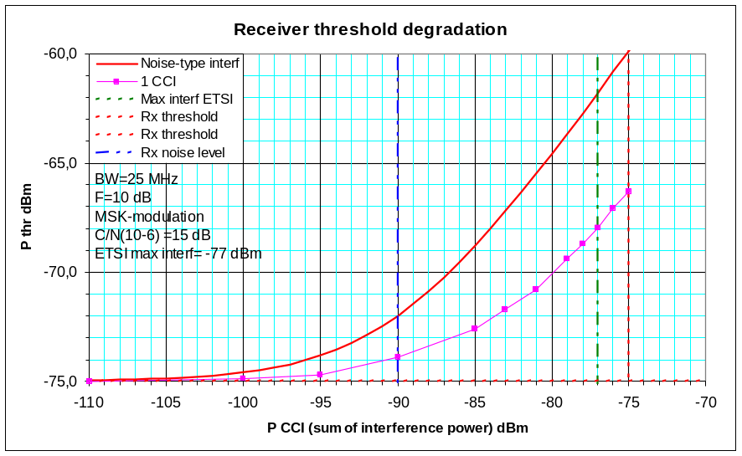
Figure 2: Receiver threshold degradation
    - Maximum hop lengths
Table 2 provides calculated examples with maximum system values which fulfil the present EIRP-limit +45 dBm (hop lengths for propagation unavailability of 0,005%):
- Ptx=8 dBm (Mean transmitted power during transmit periods)
- Ga1=Ga2=36dBi (Antenna gains)
- EIRP= 44dBm (max level minus 1 dB to allow for equipment instabilities, etc.)
- Rxthr= -75 dBm (Receiver threshold for selected BER-limit)

58 GHz | System Gain (dB) | 22 mm/h | 32 mm/h | 42 mm/h | 60 mm/h
No interferences | 155 | 1,155 | 1,034 | 0,944 | 0,827
Single interference (7dB) | 148 | 0,926 | 0,834 | 0,765 | 0,673
Equivalent interf (10dB ) | 145 | 0,833 | 0,752 | 0,691 | 0,610
Noise-like interf (13 dB) | 142 | 0,743 | 0,674 | 0,621 | 0,550
Table 2: Maximum hop lengths (in kilometres) based on current EIRP limit

Table 3 provides calculated examples with maximum system values which still fulfil 10 dB higher EIRP-limit +55dBm (hop lengths for UA=0,005%):
- Ptx=9 dBm
- Ga1=Ga2=45dBi
- EIRP= 54dBm (proposed max level minus 1 dB to allow for equipment instabilities, etc.)
- Rxthr= -75 dBm

58 GHz | SG | 22 mm/h | 32 mm/h | 42 mm/h | 60 mm/h
No interferences | 174 | 1,839 | 1,632 | 1,480 | 1,284
Single interference (7dB degr) | 167 | 1,578 | 1,404 | 1,275 | 1,109
Equivalent interf (10dB degr) | 164 | 1,469 | 1,309 | 1,190 | 1,036
Noise-like interf (13dB degr) | 161 | 1,362 | 1,216 | 1,106 | 0,965
Table 3: Maximum hop lengths (in kilometres)based based on a relaxed EIRP

In the interference-limited environment hop lengths may be increased from around 600 meters to above 1000 metres within European rain conditions.

Intra-band coexistence of fs systems
    - System parameters used in the interference calculations
In the following analysis antenna ports from ITU-R Recommendation F.1245 [8] has been applied. For the comparison ETSI E3 (maximum RPE) has also been considered. System parameters in these calculations are:

Parameter | Value
Transmit power | 10 dBm
Receiver threshold | -76 dBm
Receiver noise level | -89 dBm
Frequencies | 57 and 59 GHz
Oxygen attenuation [9] | 10 and 14 dB/km
Rain attenuation | 0 and10 dB/km
Antenna types: | F.1245 Gain=36 dBi
 | F.1245 Gain=42 dBi
 | F.1245 Gain=45 dBi
Division in angle | 1 degree
Division in distance | 10 meters
Interference case criterion: | Interference exceeds receiver noise level

Table 4: Parameters used to derive the intra-band interference probabilities

All the interesting antenna RPE-ports are shown in the following Figure 3.

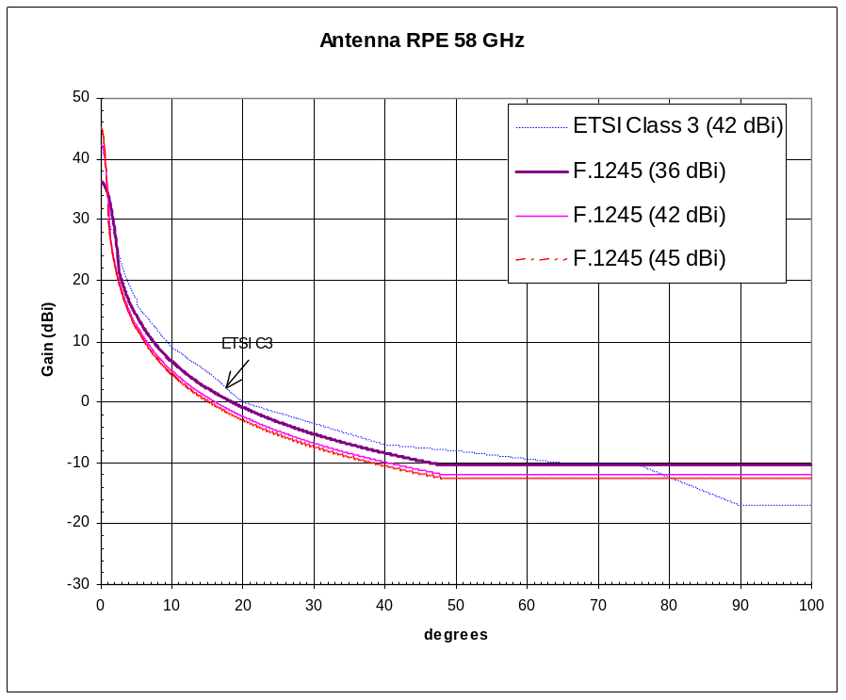

Figure 3: Antenna RPE curves for antennas used in the intra-band interference calculation
(ETSI Class 3 RPE only for reference)

    - Interference calculation procedure

The total area considered in this interference calculation was limited by a circle with the radius 3.8 km. This was selected because all the interference victim terminals are within this distance to the terminal in the circle center point with the parameters applied. Placing new terminals outside this distance does not increase new intererence situations. Two dimensional configurations were considered only.

The calculation procedure steps:
1) For every antenna angle pair -combination (transmitter, victim receiver) the interference level was calculated as a function of distance.
2) If the calculated level exceeded receive noise level the case was classified as interference occurrence case and the ratio of the sum of these cases was divided by all the possible combinations to get the probability for interference situation at certain distance.
3) The calculated probability was weighted by the area π⋅r² - π⋅(r-Δ)² which is the Δ-wide circular area representing distance r and the result was finally divided by the total area π⋅ d_{max} ² , where Δ is the distance step (10m)
4) These values, which may be called interference density values representing different distances, are presented in the figures to illustrate the distance dependence in different cases
5) The total probability of interference is the sum over all distances up to d_{max} shown in Tables 5 to 7.

    - Interference probability comparison

Figure 4 and Table 5 provide an example of results under clear sky conditions.

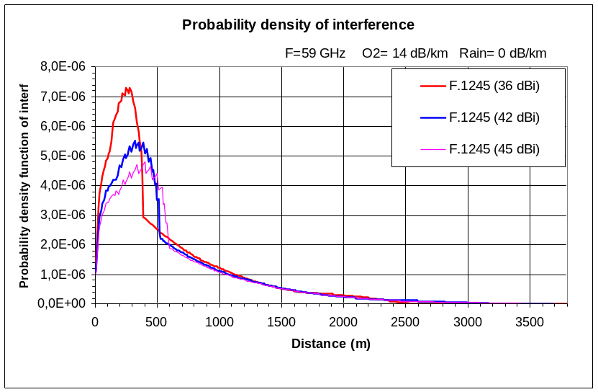
Figure 4: Typical probability density curves (clear air condition)

Standard | Gain | Interf probability | Relative values
ITU-R F.1245 | 36 | 0.00041 | 1
ITU-R F.1245 | 42 | 0.00037 | 0.92
ITU-R F.1245 | 45 | 0.00035 | 0.87
Table 5: Interference probability (clear air condition)

Figure 5 and Table 6 provide an example of results under rainy conditions.

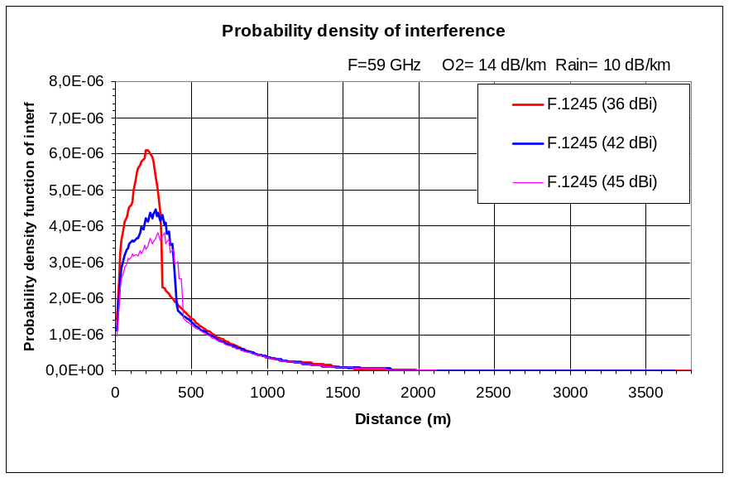
Figure 5: Typical probability density curves (rainy conditions)

Standard | Gain | Interf probability | Relative
ITU-R F.1245 | 36 | 0.00023 | 1
ITU-R F.1245 | 42 | 0.00021 | 0.90
ITU-R F.1245 | 45 | 0.00020 | 0.84
Table 6: Interference probability (rainy conditions)
Summary of the calculated interference probabilities is shown in Table 7.

 | F.1245  Gain=45 dBi | F.1245  Gain=42 dBi | F.1245  Gain=36 dBi
59GHz (A_{O2}=14dB/km):
Without rain | 0.00035 | 0.00037 | 0.00041
With rain (10dB/km) | 0.00020 | 0.00021 | 0.00023
57 GHz (A_{O2}=10dB/km):
Without rain | 0.00052 | 0.00055 | 0.00059
With rain (10dB/km) | 0.00025 | 0.00027 | 0.00029
Table 7: Total probability of interference for different scenarios inside circle with radius of 3.8km

Conclusions based on intra-band FS-interference calculations:
- Calculated interference probabilities decrease if antenna gain is increased. The decrease of this probability is about 9% when antenna gain is changed from 36dBi to 42 dBi. The same 9% decrease applies also for antenna gain change from 42dBi to 45dBi. The same result applies at both ends of the frequency band;
- If rain attenuation 10dB/km is added the resulting interference-case probabilities are roughly about half of the clear-air values in all cases;
- It can be concluded that about half of the interferences measured during clear-air are not effective during the rain (10dB/km);
- It can also be concluded from interference density figures that these “fading” interferences mainly come from longer distances and therefore near the boresight angle coincidences of thetransmitter and victim-receiver.

Impact of increasing the EIRP on the density of links
This section provides material on density of FS links depending on the mean used to increase the eirp.
    - Method to determine the Density of transmitters
To determine the mean density of transmitters the model the methodology provided in ECC Report 20 [10]:
Step 1: set up a first link
- Set up a first receiver in the considered area;
- Set up a transmitter at a distance lower than dmax (for simplification dmax is assumed to be 2km – noting that the software will check that the minimum required power is received at the receiver)
Step 2: set up a second link
- Set up a receiver in the considered area;
- Set up a transmitter at a distance lower than dmax;
- Calculate the interference levels at each receivers;
Step 3
- If the interference criterion is met for each receiver, then set up a new link;
- If the interference criterion is not met for one of the receiver then go back to step 2;
The simulation stops after 20 consecutive failures to set up a new link.
The interference criterion is based on Recommendation ECC-01-05 [11].
    - Parameters used in the simulations
Recommendation ITU-R F.1245 [8] is used for the antenna pattern. All links are assumed to use the horizontal polarisation.
The following parameters were used in the simulations (see Table 1):
- Availability of 99.99%
- Maximum distance (dmax of 2km) – minimum hop length 50m;
- F=58GHz;
- Attenuation: Recommendations ITU-R P.525 (free space loss) [12], P.676 (gaseous absorption) [9] and P.530 (rain – zone K) [5];
- No insertion loss;
- H=20m to 100 m;
- B=20 MHz (receiver bandwidth);
- F=12 dB;
- N=FKTB=-90dBm ;
- Required Power at the receiver: -76 dBm
The following figure 6 describes the simulation area.
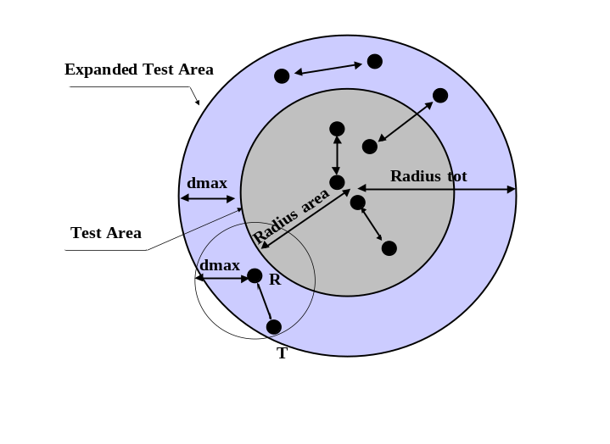
Figure 6: simulation area

The radius of the test area is taken equal to 10 km.
Note: compared to ECC Report 20 each transmitter is placed at a distance lower than dmax compared to the considered receiver, this allows saving computer time.

    - Results of simulations
An Interference criterion I=N (i.e. noise increase equals 3dB) is used in the following simulations when determining the density.

Current situation
In this section the following parameters are assumed:
- Pe=-20dBW=10 dBm;
- Gmax=35 dBi,
i.e. the EIRP is defined according to the CEPT ECC Rec 12-09 [3] which specifies maximum EIRP value +45 dBm.
After 50 simulations, it was found possible to set up:
- between 38 - 624 terminals on an area of about Pi*12^2=452km2;
- the mean number of terminals is 319 terminals;
- 13 - 223 receivers on an area of about 380km2 – mean number of terminals 111.
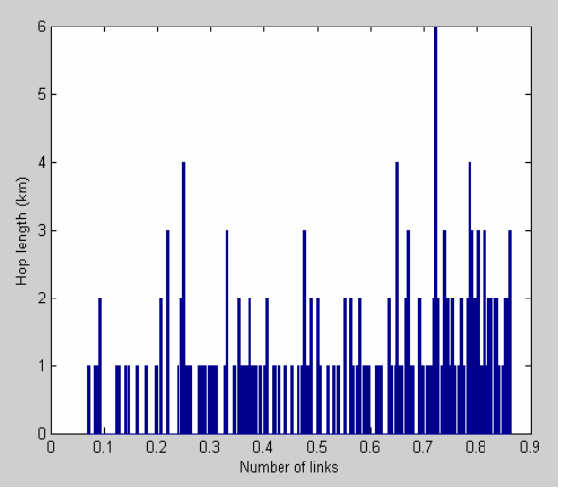
Figure 7: Distribution of hop lengths

The maximum achievable hop length using this set of assumptions is of the order of 1 km.

Increase the EIRP – option 1 – increase the power – keep the same maximum antenna gain
In this section the following parameters are assumed:
- Pe=-10dBW=20 dBm;
- Gmax=35 dBi
After 50 simulations, it was found possible to set up:
- between 64 - 550 terminals on an area of about Pi*12^2=452km2;
- the mean number of terminals is 295 terminals;
- 21 - 181 receivers on an area of about 380km2 – mean number of terminal 103.
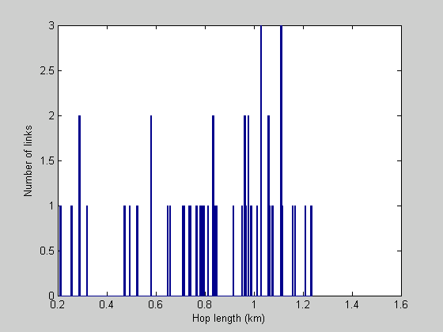
Figure 8: Distribution of hop length for option 1

This solution leads to increase the maximum hop length. However the number of links that may be deployed in the same area is slightly decreased since the level of interference is increased due to the increase of the output power.

Increase the EIRP – option 2 – increase the maximum gain – keep the same maximum output power
In this section the following parameters are assumed:
- Pe=-20dBW=10 dBm;
- Gmax=45 dBi.
After 50 simulations, it was found possible to set up:
- between 90 - 982 terminals on an area of about Pi*12^2=452km2;
- the mean number of terminals is 391 terminals;
- 27 - 351 receivers on an area of about 380km2 – mean number of terminal 137.
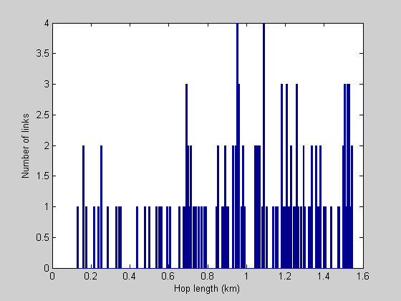
Figure 9: Distribution of hop length for option 2

SHARING BETWEEN THE FS AND THE EESS
With a view to protecting the Earth Exploration Satellite System, in the ITU Radio Regulations there is power density limit (−26dBW/MHz in footnote 5.557A-WRC-2000) up to 56.26 GHz but not above that. The clear air O2-absorption continues to increase above 56 GHz up to 60 GHz and the zenith attenuation increases accordingly (equivalent atmosphere height for O2 is 10 km).

CHARACTERISTICS OF EESS
EESS systems operating in this band are used for close-to-nadir atmospheric sounding in conjunction with the bands at 23.8 GHz, 31.5 GHz, 50.3 GHz and 52.7 GHz to characterize each layer of the atmosphere. The following Table 8 provides characteristics extracted from Recommendation ITU-R SM.1633 [13].

Parameter | Value
Altitude (km) | 850
Orbit | Sun-synchronous polar
Main lobe antenna gain (dBi) | 45
Antenna 3 dB beamwidth (degrees) | 1.1
FOV (re. sensor) (degrees) | ± 50 cross track re. nadir direction
FOV (re. Earth’s centre) (degrees) | ± 10.25 geocentric
Pixel diameter at nadir (km) | 16
Pixels per swath | 90
Swath width (km) | 2 300
Table 8: Parameters of the push-broom sensor

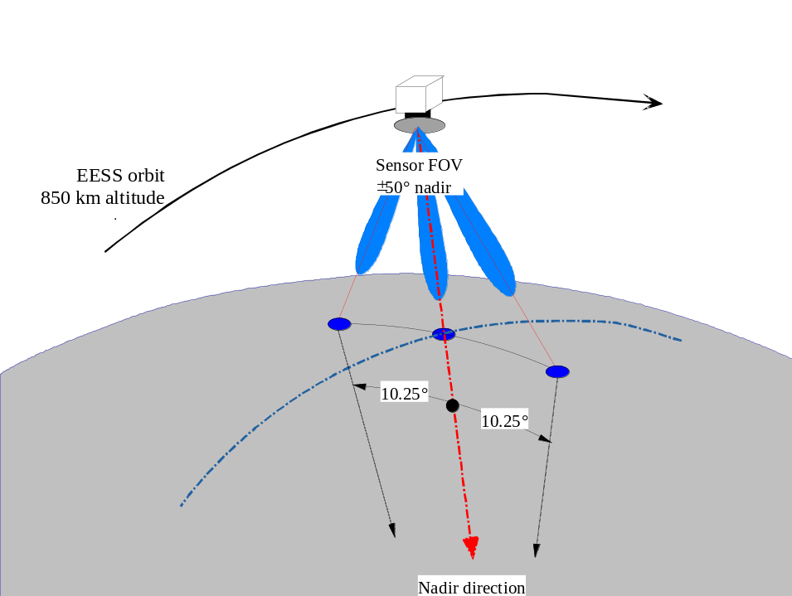

Figure 10: Characteristics of EESS sensor

The EESS sensor interference threshold is contained in Recommendation ITU-R SA.1029-02 [14] and extracted as follows:

Frequency (GHz) | Interference threshold (dBW) | Bandwith (MHz)
Near 55 | −161/−169^{(Note)} | 100
Table 9: Sensor interference thresholds

Note: First number is valid for sharing conditions circa 2003; second number for scientific requirements that are
technically achievable by sensors in next 5-10 years.

ANALYSIS
From a preliminary examination of the problem, it is concluded that the zenithal attenuation would give the worst-case scenario, bearing in mind that the atmospheric absorption at 58 GHz in the horizontal direction is about 15 dB/km.
The antenna of the victim EESS at an altitude of about 850 km is supposed to be pointed in the nadir direction. FS terminals are seen from the EESS satellite through the maximum antenna gain (45 dB). Taking into account the densities calculated in section 4.2.3, it is possible to assess the numbers of FS terminals that may operate in the EESS pixel. Then, assuming that the EESS satellite is seen in the side lobe of FS terminals, it is assumed that the FS mean antenna gain in the direction of the EESS may be estimated by using the antenna pattern of Recommendation ITU-R F.1245 for an off axis of 90°. Worst case assumptions are considered:
- max interference density -169 dBW/100MHz (i.e. to ensure protection of future EESS systems);
- gaseous absorption for 5 km altitude (derived from Fig. 7 in ITU-R Rec. P.676).
The following Table 10 allows assessing the impact of the deployment of FS terminals in the EESS pixel.

Table 10: Comparison between the EESS protection criterion and the maximum power resulting from the deployment of FS terminals
Frequency (GHz) | 58
Interference criteria (dB(W/100 MHz)) | –169
Altitude of the EESS system (km) | 850
Reference bandwidth (MHz) | 100
Gain EESS | 45
Free space loss | 186
Gaseous absorption at 5 km – minimum value at 57 GHz from Fig. 7 of ITU-R Rec. P.676 (dB) | 50dB
Aggregate on the Earth in the EESS pixel  (dB(W/100 MHz)) | 22
Option | Section 3.2.3.1 | Section 3.2.3.2 | Section 3.2.3.3
Channel spacing (MHz) | 100 | 100 | 100
FS antenna gain | 35 | 35 | 45
FS gain in the EESS direction (dB) | –10 | –10 | -12.5
FS output power (dBW) | -10 | 0 | -10
Power in the EESS direction (dB(W/100MHz)) per Tx | –20 | –10 | -22.5
Pixel size (km² ) | 201 | 201 | 201
Maximum density (number of transmitter per km² ) | 1.38 | 1.22 | 2.17
Maximum aggregate on the Earth in the whole pixel (dB(W/100MHz)) | 4.5 | 14 | 4
Margin (dB) | 17.5 | 8 | 18
Channel spacing (MHz) | 50 | 50 | 50
Maximum aggregate on the Earth in the whole pixel (dB(W/50MHz)) | 4.5 | 14 | 4
Maximum aggregate on the Earth in the whole pixel (dB(W/100MHz)) | 7.5 | 17 | 7
Margin (dB) | 14.5 | 5 | 15
It should be noted that the results provided in this table are based on very worst case assumptions since:
- the gaseous absorption corresponds to terminals located at 5000 m and for the worst case frequency ( around 57 GHz);
- the calculations assumed that the whole 100 MHz considered will be used by FS terminals, i.e no guard band included in the 100 MHz used by the EESS system;
- worst cases densities from section 3.2.3 are used for calculations.

CONCLUSION ON THE SHARING BETWEEN THE FS AND THE EESS
In both considered cases of increasing EIRP, with the parameters assumed in this report, the coexistence with EESS (passive) or space research service is ensured. However, if increase of the EIRP is done by increasing the transmitter output power, this reduces the protection margin. Therefore it is recommended to increase the EIRP by increasing the antenna gain, but maintaining the transmit output power at the level presently fixed in ETSI EN 300 408 (10 dBm).

The implementation of an higher EIRP based on an increase of the maximum antenna gain will lower the gain in the side lobes and therefore also lower interference potential outside main lobe. The radiated power towards zenith will also be lower reducing the aggregate interference power towards EESS.

Impact of FS on services operating in adjacent bands

Impact of FS on FS operating in adjacent bands
CEPT 12-09 [3] specifies 50 MHz and 100 MHz channelling plans, both starting from the band edge without any guard band specified. It is however commented in recommends 3 of the recommendations that first and last 100 MHz shall be left free or used only for test and alignment purposes until satisfactory co-existence studies with FS systems in adjacent bands are completed.
ETSI EN 300 408 [4] specifies spectrum mask limits for 50 MHz and 100 MHz channelling alternative which extends 250% of the channel centre-frequency, see Fig. 11.

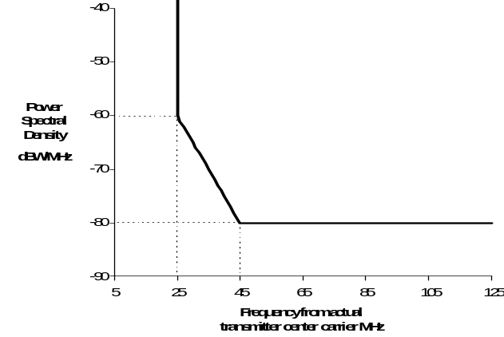
Figure 11: Limits of spectral power density for 50 MHz radio channels (EN 300 408)

For 100MHz channelling, ETSI EN 300 408 specifies the Out-Of-Band (OOB) limits for emissions from 45 MHz to 250 MHz from the carrier as absolute spectrum density -80 dBW/MHz (see Figure12).
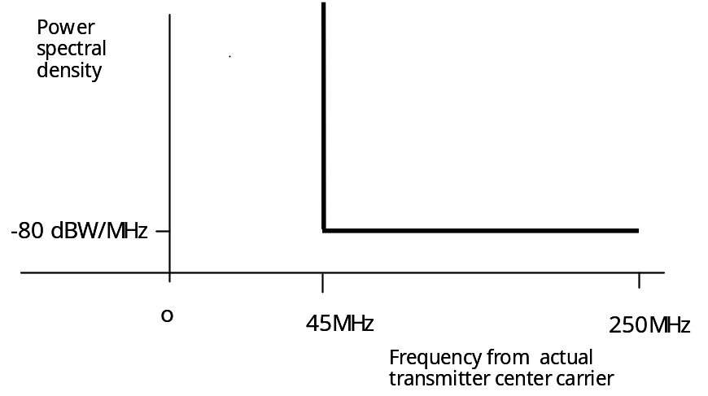

Figure 12: Limits of spectral power density for 100 MHz radio channels (ETSI EN 300 408)
At the band edge this mask extends over the highest channel(-s) of the lower band even if the first 100 MHz is left free as an additional guard-band. At lower band there is first 38 MHz guard-band after which the edge of the highest channel follows (see Figure 13).
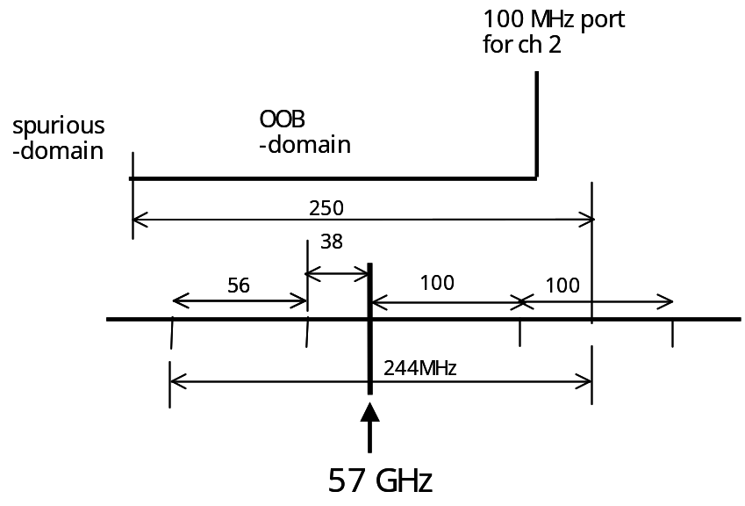
Figure 13: Description of the 55/58GHz band-edge situation

Spectrum mask limit for channel 2 of 58 GHz band covers highest 56 MHz channel and 6 MHz of the next. The channels below that are controlled by spurious emission limit.
58 GHz band spectrum mask limits the OOB-spectrum density within the OOB emissions domain to –80 dBW/MHz.
Real spectrum attenuation follows at OOB-domain roughly (1/fT)^{2n} where n depends on modulation type and signalling pulse-form. From some frequency the transmitter broadband noise starts to dominate. This noise level depends on the transmitter amplifier chain parameters and configuration.
The spectrum slope attenuation examples for some signalling cases:
- relative to ~ (1/fT)⁴ : rect. signalling, MSK
- relative to ~ (1/fT)⁶ : 1RC/2RC, MSK
- relative to ~ (1/fT)⁸: 1RC-signalling, CPM, CPFSK
- relative to ~ (1/fT)¹⁰ : e.g. 2RC signalling
The transmitter broadband noise is typically less than -100 dBW/MHz.
If the noise figure of the victim receiver is 11 dB, the power density level in the victim receiver is -133 dBW/MHz and the interference power density level should be about 6 dB lower, which means interference power density of about –140 dBW/MHz.
The attenuation requirement against spectrum mask OOB-level (-80dBW/MHz) is 60 dB which is too pessimistic for real systems for which spectrum is attenuated more than OOB-port.
If the transmit spectrum is scaled to fulfil the ETSI-mask limits at the edge-point the following power density values can be calculated at the 55 GHz band highest channel edge as shown in Table 11. Frequency separation 88 MHz corresponds to OOB-interference from channel 1 and separation 188 MHz from channel 2 respectively (see Figure 13).
Frequency slope | ~ (1/fT)⁴ | ~ (1/fT)⁶ | ~ (1/fT)⁸ | ~ (1/fT)¹⁰
Freq separation
88 MHz (dBW/MHz) | -91 | -97 | -103 | -109
Required attenuation (dB) | 49 | 43 | 37 | 31
188 MHz (dBW/MHz)) | -105 | -117 | -130 | -142
Required attenuation (dB) | 35 | 23 | 10 | 0
Table 11: Calculated interference power density values over the band-edge (55/58GHz)

 | Attenuation 10 dB
Ant gain, dBi | 36 | 42 | 45
deg/deg
0/0 | 5 | 18 | 35
0/2 | 2,1 | 2,3 | 2,9
0/15 | <1m | <1m | <1m
0/ >48 | <1m | <1m | <1m
 | Attenuation 20dB
Ant gain, dBi | 36 | 42 | 45
deg/deg
0/0 | 14 | 54 | 100
0/2 | 6 | 7 | 9
0/15 | <1m | <1m | <1m
0/ >48 | <1m | <1m | <1m
 | Attenuation 30dB
Ant gain, dBi | 36 | 42 | 45
deg/deg
0/0 | 44 | 150 | 257
0/2 | 18 | 20 | 28
0/15 | 1,0 | 1,6 | 2,1
0/ >48 | <1m | <1m | <1m
Table 12: Examples of separation distances (in metres) corresponding 10, 20 and 30-dB attenuations (antenna RPE from F.1245)
Explanations to Table 12:
“0/0”: antennnas pointing towards each other
“0/2”: one antenna 2 degrees from boresight to victim station
“0/15”: one antenna 15 degrees from boresight to victim station
“0/>48” one antenna more than 48 degrees from boresight to victim station

Conclusion:
Based on the discussions above it can be concluded that the lowest and highest 100 MHz channels should be left as guard channels to avoid the excess interferences from 58 GHz un-coordinated band to the adjacent band FS receivers. The 100 MHz guard channel helps to attenuate the band-edge OOB-interference by 20 to 30 dB which may be necessary for some systems and in extremely dense networks.

Impact of FS on eess operating in adjacent bands
According to Figures 11 and 12, if an FS system with 50 MHz channel spacing (a worst case situation) was operating without any guard band the power falling into the adjacent band will not exceed -60 dBW/MHz or -40 dBW/100MHz.
Noting that the gaseous absorption will be more than 30 dB (see Fig. 7 of ITU-R Rec. P.676 at 56 GHz), the margin given in Table 10 will be improved by 10 to 20 dB (the gaseous absorption is decreased by 20 dB, and the power falling into EESS reference bandwidth is decreased by 30 to 40 dB).
No compatibility problem is expected if the transmit output power is maintained at the level presently fixed in ETSI EN 300 408 (10 dBm).

CONCLUSIONS
An increase of the maximum Fixed Service EIRP by 10 dB (up to 55dBm) in the frequency range 57-59 GHz, will allow applications requiring hop lengths up to about 1000 meters. This EIRP-increase can be obtained by increasing either the FS output power or the FS maximum antenna gain.
In both cases, with the parameters assumed in this report, the coexistence with EESS (passive) or space research service is ensured. However, if increase of the EIRP is done by increasing the transmitter output power, this reduces the protection margin. Therefore it is recommended to increase the EIRP by increasing the antenna gain, but maintaining the transmit output power at the level of 10 dBm, as presently fixed in ETSI EN 300 408 [4].
With regard to FS intra-service coexistence, the option consisting in increasing the EIRP by raising the output power leads to reducing the density of links deployable in a given area whereas. The other option, that consist to increase the antenna gain, allows higher FS deployments density, hence being more efficient. Moreover, the proposed analysis using ITU-R F.1245 [8] antenna RPEs shows that at this frequency band the overall probability of interference cases between intra-band FS-systems decreases if antenna gain is increased.
Therefore, it is proposed that the following new regulatory limits be adopted for FS in the band 57-59 GHz:
- maximum EIRP = +55 dBm;
- maximum output power = +10 dBm.
The lowest and highest 100 MHz channels given in ERC Rec. 12-09 [3] should be left as guard channels to avoid the excess interferences from 58 GHz uncoordinated band to the adjacent band receivers in extremely dense network environments.

REFERENCES
[1]: ITU RADIO REGULATIONS
[2]: RECOMMENDATION ITU-R SA.515-4 ON FREQUENCY BANDS AND BANDWIDTHS USED FOR SATELLITE PASSIVE SENSING
[3]: ECC REC 12-09 ON RADIO FREQUENCY CHANNEL ARRANGEMENT FOR FIXED SERVICE SYSTEMS OPERATING IN THE BAND 57.0 – 59.0 GHZ WHICH DO NOT REQUIRE FREQUENCY PLANNING (EDITION 1998)
[4]: EN 300 408 V1.3.1 ON FIXED RADIO SYSTEMS; POINT-TO-POINT EQUIPMENT; PARAMETERS FOR DIGITAL RADIO SYSTEMS FOR THE TRANSMISSION OF DIGITAL SIGNALS AND ANALOGUE VIDEO SIGNALS OPERATING AT AROUND 58 GHZ, WHICH DO NOT REQUIRE CO-ORDINATED FREQUENCY PLANNING
[5]: RECOMMENDATION ITU-R P.530-10 ON PROPAGATION DATA AND PREDICTION METHODS REQUIRED FOR THE DESIGN OF TERRESTRIAL LINE-OF-SIGHT SYSTEMS
[6]: RECOMMENDATION ITU-R P.837-4 ON CHARACTERISTICS OF PRECIPITATION FOR PROPAGATION MODELLING
[7]: RECOMMENDATION P.838-2 ON SPECIFIC ATTENUATION MODEL FOR RAIN FOR USE IN PREDICTION METHODS
[8]: RECOMMENDATION ITU-R F.1245-1 ON MATHEMATICAL MODEL OF AVERAGE RADIATION PATTERNS FOR LINE-OF-SIGHT POINT-TO-POINT RADIO-RELAY SYSTEM ANTENNAS FOR USE IN CERTAIN COORDINATION STUDIES AND INTERFERENCE ASSESSMENT IN THE FREQUENCY RANGE FROM 1 TO ABOUT 70 GHZ
[9]: RECOMMENDATION ITU-R P.676-5 ON ATTENUATION BY ATMOSPHERIC GASES
[10]: ECC REPORT 20 ON METHODOLOGY TO DETERMINE THE DENSITY OF FIXED SERVICE SYSTEMS
[11]: RECOMMENDATION ECC-01-05 ON LIST OF PARAMETERS OF DIGITAL POINT TO POINT FIXED RADIO LINKS USED FOR NATIONAL PLANNING SERVICE
[12]: RECOMMENDATION ITU-R P.525-2 ON RADIOWAVE PROPAGATION
[13]: RECOMMENDATION ITU-R SM.1633-1 ON COMPATIBILITY ANALYSIS BETWEEN A PASSIVE SERVICE AND AN ACTIVE SERVICE ALLOCATED IN ADJACENT AND NEARBY BANDS
[14]: RECOMMENDATION ITU-R SA.1029-2 ON INTERFERENCE CRITERIA FOR SATELITE PASSIVE REMOTE SENSING

