ECC Recommendation (16)04

Determination of the radiated power from FM sound broadcasting stations through field strength measurements in the frequency band 87.5 to 108 MHz

**Approved 17 October 2016**

# INTRODUCTION

The radiated power of a transmitter is one of the most important parameters which characterise a transmitter and its emissions. Usually it is not possible to measure the radiated power directly. However, there are two different methods to determine the radiated power indirectly. The first method would measure the transmitter output power and calculate the radiated power by taking into account cable losses and antenna gain (equivalent to an isotropic radiator). The second method measures the field strength and calculates the radiated power by taking into account the measurement distance and the propagation loss.

The purpose of this Recommendation is to provide a common measurement method which will enable CEPT administrations to determine the radiated power of FM broadcasting transmitters in the frequency band from 87.5 MHz to 108.0 MHz through field strength measurements.

The measurement principle is already laid down in ECC/REC/(12)03 [3] but limited to the frequency band from 400 to 6000 MHz. However, under certain conditions, the method can also be applied to FM sound broadcasting transmitters working in the frequency band from 87.5 to 108 MHz.

# ECC Recommendation (16)04 of 17 October 2016 on determination of the radiated power from FM sound broadcasting stations through field strength measurements in the frequency band 87.5 to 108 MHz

“The European Conference of Postal and Telecommunications Administrations,

*considering*

1. that radiated power is one of the parameters which is specified in a license;
2. that the verification of radio stations emissions for compliance with the license conditions is an important task of the radio monitoring or inspection services;
3. that radiated power determination through measurements at the transmitter output are often impossible due to access problems or lacking test output, and require the agreement and thus knowledge of the measurement activity by the operator;
4. that these measurements can be substituted by field strength measurements with subsequent conversion to radiated power under certain conditions;
5. that ECC/REC/(12)03 [3] describes this measurement method for frequencies above 400 MHz;
6. that, under specific conditions, determination of the radiated power through field strength measurements is also possible for many FM sound broadcasting stations in the frequency band 87.5 to 108 MHz;

*recommends*

that the measurement method described in Annex 1 should be used to determine the radiated power of FM sound broadcasting stations based on field strength measurements in the frequency band 87.5 to 108 MHz.”

*Note:*

*Please check the Office documentation database* [*http://www.ecodocdb.dk*](http://www.ecodocdb.dk) *for the up to date position on the implementation of this and other ECC Recommendations.*

1. Determination of the radiated power from FM sound broadcasting stations through field strength measurements in the frequency band 87.5 to 108 MHz
   1. Abbreviations and symbols
2. Abbreviations and symbols

| **Abbreviation & symbol** | **Explanation** |
| --- | --- |
| ∞ | Infinity |
| ak | Cable loss, dB |
| AV | Average |
| D | Largest dimension of the transmitting antenna |
| d | Horizontal distance from transmitting antenna position to the measurement antenna position |
| dB | Decibel |
| dBW | Decibel watt |
| dmax | Maximum distance from transmitting antenna position to the measurement antenna position |
| dmin | Minimum distance from transmitting antenna position to the measurement antenna position |
| E | Field strength, dBµV/m |
| e.i.r.p. | Equivalent isotropically radiated power |
| e.r.p. | Effective radiated power |
| Emax | Maximum field strength |
| Emin | Minimum field strength |
| FM | Frequency modulation |
| GNSS | Global Navigation Satellite System |
| hmax | Maximal height of the measurement antenna above the ground |
| hmin | Minimal height of the measurement antenna above the ground |
| hrx | Height of the measurement antenna above the ground |
| htx | Height of the transmitting antenna above the ground |
| k | Antenna factor, dB/m |
| L | Distance from transmitting antenna to receiving antenna in meters |
| m | Metre |
| nk | Correction value |
| RMS | Root Mean Square |
| Rx | Receiver |
| Tx | Transmitter |
| Umax | Maximal signal voltage level, dBµV |
| Umin | Minimal signal voltage level, dBµV |
| URx | Input voltage, dBµV |
| W | Watt |
| ΔE | Difference between the maximum and the adjacent minimum field strength |
| λ | Wavelength |

* 1. introduction

Field strength measurements are one of the basic tasks of all radio monitoring services.

It is feasible for monitoring services to be able to determine the radiated power of a transmitter without the need to access the transmitter output and hence without the knowledge of the operator about the measurement activity.

ECC/REC/(12)03 [3] describes a method to determine the radiated transmitter power through field strength measurements. Although in principle the method is applicable for all frequencies, the lower frequency limit in ECC/REC/(12)03 is set to 400 MHz for practical reasons.

Low frequencies and high antenna vertical directivity of FM broadcast transmitters introduce additional restrictions when trying to determine their radiated power through field strength measurements. The procedure laid down in this Annex allows applying the described measurement method to many FM sound broadcast transmitters.

* 1. Scope of application and limitations

The measurement method relies on the correction of the influence of possible ground reflections from information gained through a height scan of the field strength at the location of reception which allows estimating the effective reflection coefficient. This method is basically frequency independent. However, there are several cautions to take into account in order to reduce external influence factors which may lead to errors in the measurement process.

The accuracy of the recommended measurement method highly depends on the transmit antenna design and can usually not be applied for antenna arrays with more than 4 bays. Even for simpler antenna designs, the applicability of the method may depend on an a priori knowledge of the vertical diagram.

In any case the field strength measurements have to be performed in the far field. The far field is usually defined as the range from 2D2/λ to ∞ with D being the largest dimension of the transmitting antenna. For example, if D=10 m (multi-element FM radio broadcasting antenna) and λ=3 m (100 MHz) the measurement distance between the transmitter and the receiving antenna has to be at least 67 m.

Cancellation of the ground reflections is based on a so called “height scan” of the measurement antenna. It has to be assumed that the reflection coefficient of the ground is equal inside a large distance range between transmitter and measurement location.

The measurement method further assumes free space propagation, i.e. a 20 dB path loss per decade of distance. Hence the method loses accuracy if this condition is not fulfilled, e.g. at larger measurement distances where the first Fresnel zone can be partly below the ground.

Finally it should be mentioned that measurement errors due to the aforementioned effects usually result in undervalued field strength or radiated power levels and not in overvalued levels.

* 1. Applicability of the measurement method

The applicability of the measurement method described in this Recommendation depends on several technical and practical conditions. The following flow chart provides guidance on the decision making whether the method, from the technical point of view, is applicable for a particular broadcast transmitter. Details and background information on the individual steps are provided in the Table 2: and following sections. From the practical point of view, the applicability of this measurement method may be restricted by lack of access to a suitable measurement location.

Collect available technical information about transmitter (Tx)

What is the Tx antenna type?

Is the Tx antenna pattern available?

Measurements are **not** possible according to this method

Measurements are possible according to this method

Inspect the Tx antenna installation on-site

≤ 4 bays

> 4 bays

Apply typical antenna pattern, corresponding to the antenna installation

Does Tx antenna pattern correspond to declaration?

Yes

No

Yes

No

Apply available (declared) antenna pattern

Determine minimum measurement distance “dmin”: **at main lobe – 1 dB**

Determine the maximum measurement distance “dmax”

Determine minimum measurement distance “dmin”: **at** **main lobe – 5 dB**

Determine the maximum measurement distance “dmax”

Which stipulation applies?

Compare distances “dmin” and “dmax”

“dmin” ≤ “dmax”

“dmin” > “dmax”

1. Decision making flow chart
2. Explanations for decision making flow chart elements

| **Element number** | **Explanation** |
| --- | --- |
|  | Obtain information about transmitter (Tx) antenna design. Determine of how many bays the antenna array consists. |
|  | Distinguish the Tx antenna type by the number of bays. |
|  | Obtain available information about Tx antenna pattern. |
|  | Inspect the Tx antenna installation on-site to determine if the declared Tx antenna pattern corresponds to the real installation. |
|  | Decide if declared Tx antenna pattern corresponds to the real installation. |
|  | For further calculations apply antenna pattern which was declared. |
|  | Determine minimum measurement distance “dmin” at main lobe – 5 dB according to the procedure in chapter A1.9 |
|  | Determine maximum measurement distance “dmax” according to the procedure in chapter A1.7 |
|  | For further calculations apply a typical antenna pattern, corresponding to the antenna installation. Typical antenna patterns can be obtained from manufacturer catalogues or other appropriate literature. |
|  | Determine minimum measurement distance “dmin” at main lobe – 1 dB according to the procedure in chapter A1.9 |
|  | Determine maximum measurement distance “dmax” according to the procedure in chapter A1.7 |
|  | Compare distances “dmin” and “dmax”. |
|  | Determine which situation applies: “dmin” > “dmax” or “dmin” ≤ “dmax” |
|  | If decision making process ends at this point, then measurements are not possible according to this method. |
|  | If decision making process ends at this point, then measurements are possible according to this method. |

* 1. Conversion from receiver input level to field strength

The field strength E is generally calculated from RF level measurements. The subsequent sections assume that field strengths are measured in the far field region under free space conditions using receiving antennas with known antenna factors, cables with known losses, with adequate receiver bandwidth and sufficient signal to noise ratio. The formulas further assume an antenna load resistance of 50 Ω.

For determination of the received field strength, the following relationship has to be used:

$E=U_{Rx}+k+a_{k}$ (dBµV/m)

where

E - field strength at receiving location in dBµV/m

URx – measured receiver input voltage in dBµV

k – antenna factor in dB/m

ak – cable loss in dB

Relation between field strength and equivalent isotropically radiated power (e.i.r.p.):

 (dBW)

where

L = distance between receiving and transmitting antenna in meters

Relation between field strength and effective radiated power (e.r.p.):

 (dBW)

Recommendation ITU-R P.525-2 [1] as well as sections 6.3 and 6.4 of the ITU Handbook on Spectrum Monitoring [2] contains more detailed explanations on the calculation of free-space attenuation and conversion formula.

* 1. The impact of ground reflections

Even in a clear and unobstructed path between transmitting and receiving antenna, ground reflection is always present and cannot be neglected. As described in ECC/REC/(12)03 [3], the amount of ground reflection is determined by varying the antenna height h and in the same time capturing changes of signal level during receiving antenna height scan. At least one minimum and one maximum of the measured field strength should be detected. This effect occurs more distinctive with horizontally polarised signals. An example of the dependence of the signal voltage on height, obtained in practical measurements, is shown in Figure 2:

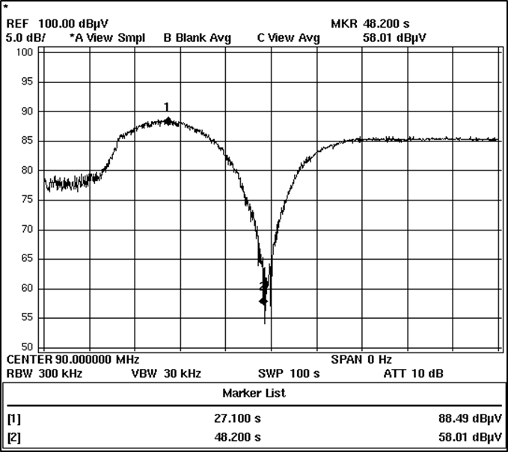

*Umax 88.5 dBµV*

*Umin 58.0 dBµV*

*Rx antenna height, m*

*hmax = 10 m*

*hmin = 3 m*

1. Example of the dependency of measured signal voltage on measurement antenna height

For the elimination of effects due to ground reflections a correction value nk has to be applied (see Figure 3:). It can be determined from the difference between the maximum field strength and the adjacent minimum field strength.



The result can also be taken from Figure 3:

1. Correction curve for nk

The free space field strength value E is determined by the following formula:



* 1. Determination of the maximum measurement location distance

The requirement to obtain at least one minimum and one maximum during a height scan between 3 and 10 m (typical range for a measurement vehicle) results in a maximum measurement location distance dmax. This distance depends on the height difference between transmit and measurement antenna. The following figure gives guidance on the determination of the maximum measurement location distance for a common height range.

1. Determination of the maximum measurement location distance
   1. Exception: Expanded maximum measurement location distance

Common heights and designs of FM broadcast antennas often lead to maximum measurement distances that are still out of the vertical main lobe, resulting in an underestimation of the calculated e.r.p. In the exceptional case where the transmitter uses a 4-bay antenna array and its vertical diagram is not known, the measurement method described here may also be applied at distances up to about 13 times transmit antenna height where the height scan will provide only a maximum and no minimum. In these cases, a general correction for the ground reflection is applied to the maximum field strength value according to the following table:

1. General correction for ground reflection

| **Polarisation** | **nk for general ground reflection** |
| --- | --- |
| Horizontal | -5 dB |
| Vertical | -2 dB |

Note that the value, specified in Table 3, originate from multiple measurements.

* 1. Determination of the minimum measurement location distance

Field strength measurements generally require that the receiving antenna is in the main lobe of the transmit antenna. This requirement results in a minimum measurement distance dmin that has to be determined. This distance depends on

* the vertical directivity of the transmit antenna;
* the height of the transmit antenna above ground;
* the downtilt of the transmit antenna.

The vertical diagram of the transmit antenna can either be obtained by the operator or general diagrams can be used for the specific design that was determined by visual inspection of the transmit site.

The height of the transmit antenna can be measured using distance/angle measurement devices.

The downtilt of the antenna may be obtained from the operator and may already be included in the specific vertical antenna diagram provided. If this information is not available, a typical downtilt of 0.5° may generally be assumed for antennas with 4 bays. For simpler antenna designs the downtilt can be assumed to be zero as its influence on the measurement result can be neglected.

To obtain a reasonable accuracy of the measurement, it is recommended to perform the measurement within an elevation angle range where the vertical antenna gain differs not more than 1 dB from the maximum gain (“1dB angle”). The following figure shows the determination of this range on the example of a typical 2-bay horizontal antenna:

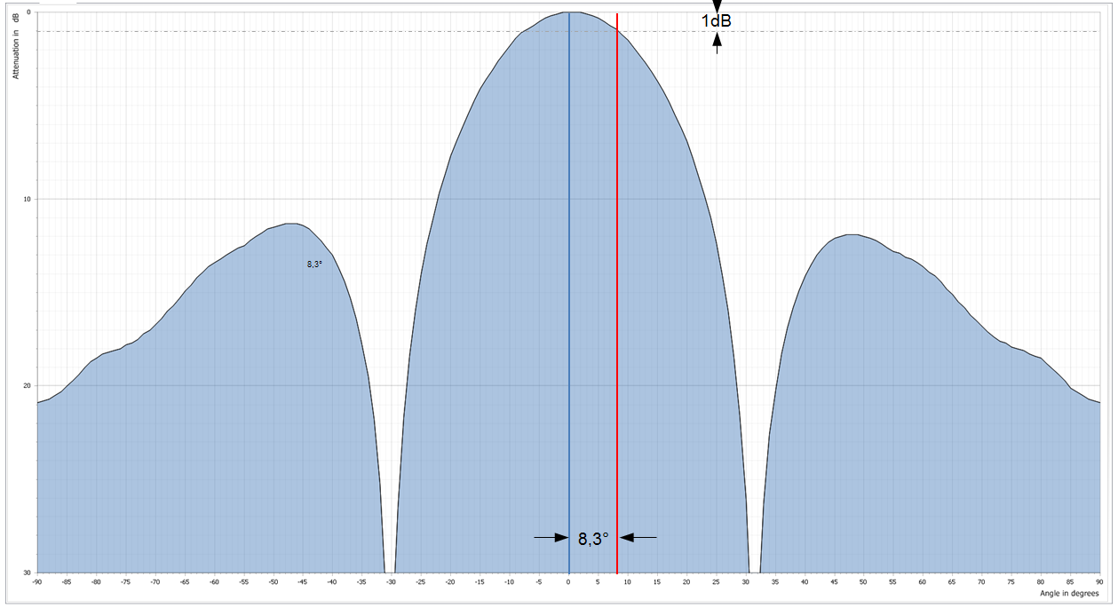

1. Determination of the 1 dB angle on a 2-bay antenna

When the 1 dB angle is determined, the minimum measurement distance can be calculated using trigonometric formulas.

htx

Downtilt

Measurement of

e.r.p.max

possible

1 dB-angle

MC900359509[1]

Measurement of

e.r.p.max – 1 dB possible

Minimum measurement distance (dmin)

1. Determination of the minimum measurement location distance

The following table provides guidance on the minimum measurement location distance, assuming a flat terrain between transmitter and receiver and a 0.5° downtilt of the transmit antenna.

1. Minimum measurement location distances

|  |  |  |  |
| --- | --- | --- | --- |
| **Antenna bays** | **single bay** | **2 bays** | **4 bays** |
| 1dB angle | 17° | 8.3° | 4.4° |
| Minimum measurement location distance | dmin ≈ 3.3 × htx | dmin ≈ 6.9 × htx | dmin ≈ 13 × htx |

* 1. Measurement equipment

A laser distance measuring device, a GNSS receiver, binoculars and a compass are usable tools for the visual inspection of the transmitter and the determination of the antenna height.

For the field strength measurement a spectrum analyser or measurement receiver with a calibrated directional measurement antenna should be used.

* 1. Inspection of the installation (transmitter check on-site)

Transmitter frequency, antenna height above ground, polarisation, directivity, maximum or minimum emission azimuth, and transmitter location geographical coordinates have to be checked before measurements.

* 1. Searching a suitable measurement location

The measurement location must be chosen at a distance that is between minimum and maximum distances according to calculations in Sections A1.7, A1.8 and A1.9. It must have a line of sight to the transmitter antenna. If directional transmit antennas are used, the measurement antenna has to be placed in the direction of the main horizontal lobe. It must be ensured that there are no obstacles in the first Fresnel zone. Geographical coordinates of the measurement location must be determined to calculate the distance from transmitter location to measurement location. For distance determination also a laser distance meter can be used, if its technical characteristics allow measurements in the respective distance.

* 1. Measurement and calculation procedure

1. *Measure the field strength at the predetermined location*

Using an appropriate measurement antenna mounted in the same polarisation as transmitting antenna on a retractable mast on the measurement vehicle, perform a height scan by smooth changing the measurement antenna height from minimum to the maximum (or vice versa), at the same time record the receiver input level changes.

If a swept spectrum analyser is used for the measurements, the recommended settings are:

1. Recommended settings for a swept spectrum analyser

|  |  |
| --- | --- |
| **Parameter** | **Value** |
| Centre frequency | corresponding FM broadcasting signal working frequency in MHz |
| Resolution bandwidth (RBW) | 300 kHz |
| Video bandwidth (VBW) | 3 MHz |
| Span | 0 Hz (Zero Span) |
| Sweep time | corresponding to approximate measurement antenna mast height change from 3 m to 10 m in seconds |
| Sweep mode | Single Sweep |
| Trace detector | RMS (root mean square) or AV (average) |
| Trace mode | Clear Write |

1. *Determine the maximum receiver input level value from the height scan*

The maximum receiver input level value is designated as Umax. Depending on reflections, especially from the ground, Umax must not necessarily be at the maximum antenna height. See also Figure 2:.

1. *Determine the minimum receiver input level value adjacent to the maximum identified in Step 2*

This local minimum is hereafter designated Umin. It is not the overall minimum of the complete height scan, but the minimum just next to the predetermined Umax. See also Figure 2:.

1. *Calculate the final value of the field strength*

Calculate field strength values Emax and Emin from obtained Umax and Umin values according to the formula in Section A1.5.

The final value of E is determined according to the Section A1.6. This cancels out the effect of the ground reflections that may have influenced the measurement result.

1. *Calculate the radiated power*

The radiated power is calculated by using the free space propagation formula, according to Section A1.5, from the measured field strength E and the measurement distance L.

If field strength measurements are performed at locations outside of the 1 dB angle of the transmitting antenna (see Section A1.9), and reliable information of the vertical antenna pattern is available, it is necessary to apply a correction value obtained from the technical specification of the transmitting antenna pattern.

* 1. Measurement UNCERTAINTY

The described method assumes that the main contributor to the measurement uncertainty is caused by reflections. Reflections from distant objects may be minimised by using a measurement antenna with high directivity or determining a horizontal field strength profile in addition to the vertical height scan as given in section A1.6.

The accuracy of this method depends mainly on the local circumstances in between the transmitter to be tested and the measurement location.

Practical measurements on several FM broadcasting radio transmitters with known technical parameters were done according to this recommendation. In practice, measurement results matched to theoretically calculated FM broadcasting transmitter effective radiated power within ± 3 dB interval.

Even though theoretical measurement uncertainty calculation methods exist, applying such methods is difficult or even impossible in the context of this recommendation due to several unknown factors which affect total measurement uncertainty and cannot be objectively evaluated. Thereby it is recommended to apply an uncertainty of 3 dB, which was obtained in practical measurements.

1. List of reference

This annex contains the list of relevant reference documents.

1. Recommendation ITU-R P.525-2: Calculation of Free-Space Attenuation
2. ITU Handbook Spectrum Monitoring Edition 2011
3. ECC Recommendation (12)03 “Determination of the radiated power through field strength measurements in the frequency range from 400 MHz to 6000 MHz”