ECC Recommendation (20)02

Method for calculating high intensity radiated field level, from high e.i.r.p. circular aperture fixed earth stations located close to an airfield
approved 23 October 2020

introduction
Currently there are several ECC Decisions related to the exemption from individual licensing of satellite terminal equipment operating in frequency bands such as 4-6 GHz, 12-18 GHz and 18-40 GHz. The location of the individual satellite terminals, covered by these ECC Decisions, is not normally known to the administration.
According to international aviation standards [1], it is clear that when these satellite terminals operate in the vicinity of aircraft, it needs to be ensured that the electric field produced at the aircraft would not exceed the high intensity radiated field (HIRF) aircraft protection criteria.
ECC Report 272 [2], published in January 2018, examined earth stations operating in the vicinity of aircraft and their ability to comply with HIRF levels, as established by the European Aviation Safety Agency (EASA), in order to protect aircraft safety systems. The maximum earth station e.i.r.p. levels were calculated and published in order to ensure compliance of an earth station with aircraft HIRF protection criteria.
The elements provided by EASA were used in the above mentioned ECC Report 272 to calculate maximum earth station e.i.r.p. levels, for various earth station deployments communicating with GSO or NGSO satellites, for which there will be no impact to the aeronautical safety of aircraft during any phase of the flight (take off, landing, cruising, taxiing). Νo further restrictions on operations in the proximity of or within airfields were required for earth station terminals, fixed or mobile on land, located within or outside an airport or helipad or within a surrounding wedge shaped area, according to aviation experts.
In order to calculate the maximum earth station e.i.r.p. levels to meet the specific HIRF levels, two calculation methods were defined, one for the far-field and one for the near-field region surrounding the earth station.
EASA noted, as reflected in ECC Report 272, that in order to determine a maximum e.i.r.p. level for an earth station, a conservative approach should be applied in order to keep safety margins to maintain the HIRF levels generated by the transmitters below the threshold of equipment susceptibility.
Following that, a modified power density calculation (based on the far-field equation) was chosen, for the calculation of maximum earth station e.i.r.p. levels for which there will be no impact to aeronautical safety for distances that fall within the near-field region of the antenna.
In ECC Report 272, it was also recognised that if it is desired to conduct a more refined analysis for specific earth stations that would exceed the e.i.r.p. values in the report, then both far-field and near-field calculations should be carried out, which would lead to less conservative results.
In the satellite ecosystem other earth stations types than satellite terminals are also deployed, usually referred to as hubs, gateways or teleports. Such stations are used as feeder links for high capacity emissions (hereafter “high e.i.r.p. earth stations”) and transmit with higher e.i.r.p. values than those maximum values shown in ECC Decisions which exempt from individual licensing earth stations operating either with GSO or NGSO satellite networks.
The location of these high e.i.r.p. earth stations is known to the administration, and usually an application form is submitted to the regulatory authority, in order for a license to be issued.
The purpose of this Recommendation is to provide a common method which will enable CEPT administrations to authorise a high e.i.r.p. earth station in a vicinity of an airfield. Also due to the fact that there are civil and military airfields with a different wedge-shaped area for every airfield (due to different national circumstances and operational requirements), usually the authorities with knowledge on these wedge shaped areas are the Civil Aviation Authority or/and Military Aviation Authority. It is recommended to involve these Authorities in the process.

ECC recommendation 20(02) of 23 October 2020 on Method for calculating the High Intensity Radiated Field level, from high e.i.r.p. circular aperture Earth Station, located close to an AIRFIELD
“The European Conference of Postal and Telecommunications Administrations,
considering
- that there are ECC Decisions which exempt from individual licensing earth stations, operating either with GSO or NGSO satellite networks, for a specific e.i.r.p. value;
- that ECC Report 272 [2], published in January 2018, examined earth stations operating in the vicinity of aircraft and their compliance with high intensity radiated field (HIRF) levels, as established by the European Aviation Safety Agency (EASA), in order to protect aircraft safety systems;
- that in the ECC Report 272 [2] the maximum earth station e.i.r.p. levels were calculated in order to ensure compliance with aircraft HIRF protection criteria;
- that there is a need for high capacity earth stations with higher e.i.r.p. values (hubs or gateways) than those shown in ECC Report 272 [2], operating as feeder links in frequency bands such as 4-8 GHz, 12-18 GHz and 18-40 GHz (hereafter “high e.i.r.p. earth stations”);
- that there is a need to distinguish whether a high e.i.r.p. earth station is located outside or within the wedge shaped area of an airfield, and to verify the HIRF level that is produced;
- that this recommendation refers to high e.i.r.p. fixed earth stations, with circular aperture antenna, which are used as hubs or gateways or teleports;
- that ECC Report 272 [2], section 3.4 indicates that far-field based formulas overestimate the HIRF levels within the near-field region of the antenna, but it significantly simplifies the calculation process to determine the maximum allowed e.i.r.p. for earth stations;
- that the distance from the antenna to the various near-field radiation regions close to the antenna is a function of e.i.r.p., frequency and antenna dimensions;
- that according to International Civil Aviation Organization (ICAO) experts, it is very difficult to define a generic wedge-shaped area for every airport (civil or military) due to different national circumstances and operational requirements, and usually the only competent authorities with knowledge on the wedge shaped area of their airfields could be the Civil Aviation Authority or/and Military Aviation Authority.
recommends
- that administrations authorising circular aperture fixed earth station with e.i.r.p. greater than the maximum e.i.r.p. defined in ECC Decisions which exempt earth stations from individual licensing, are advised to follow the procedure described below in order to estimate HIRF immunity level threshold:
  - Step 1. Calculate the near-field and far-field regions with the characteristics of the high e.i.r.p. earth station;
  - Step 2. Calculate the minimum separation distance (Slant range) with the equation 17 of ECC Report 272 [2] for inside and outside wedge shaped area corresponding minimum flight altitudes (i.e. at 152.4 m and 304.8 m);
  - Step 3. Calculate the near-field using the methodology described in section 3.2.2.2 of ECC Report 272 [2], also shown in Annex 2, for the above separation distance;
  - Step 4. Examine whether the calculated HIRF level is above or below the aircraft immunity level for the frequency band under examination according to the threshold levels shown in ECC Report 272 [2] (see section 2.2, Table 2);
  - Step 5. In case the calculated HIRF level is below the threshold immunity level, operation of the earth station is considered to be HIRF compliant with respect to protection of aircraft safety systems, and there is no need for further actions by the relevant Civil Aviation Authority and/or Military Aviation Authority;
In case the calculated HIRF level is above the threshold immunity level, the application could be forwarded and be further studied by the relevant Civil Aviation Authority and/or Military Aviation Authority, and communicate its findings to the Regulatory Authority;
  - Step 6. The Regulatory Authority makes a licensing decision according to the outcome of the examination in the steps above;
- that administrations may use the examples shown in Annex 1, applicable for common high e.i.r.p. circular aperture earth stations.
Note:
Please check the Office documentation database https://docdb.cept.org/home for the up to date position on the implementation of this and other ECC Recommendations.
- EXAMPLE OF following the recommended APPROACH
To assist the implementation of the recommended methodology, the following examples can be considered for a common earth station, regardless of whether the location of an airfield is known or not.
Example 1: ES located outside the wedge shape area and generating HIRF levels below protection levels
Assume an earth station with the following technical characteristics:
Table 1: Technical characteristics of an earth station
Parameter | Value
e.i.r.p. (dBW) | 95
Antenna diameter (m) | 13.2
Antenna Beamwidth (º) | 0.056
Frequency (MHz) | 28000
Azimuth (º) | 145
Elevation (º) | 45

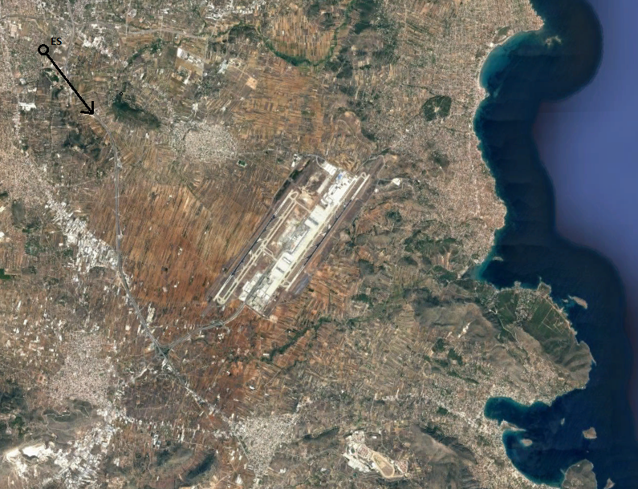
Figure 1: Example location of an earth station (4.8 nautical miles from the airfield edge) depicted as “o” in the figure – the arrow is the direction of the main beam

The earth station for this frequency band has an e.i.r.p. value above the value of the relevant ECC Decisions for fixed earth station related to the exemption from individual licensing of satellite terminal equipment. The regulatory authority makes the following calculations.
The near-field and far-field regions are calculated as follows:
Table 2: Near-field and far-field regions
Parameter | Distance (m) | Region
Non-Radiative (Reactive) near-field (m) | 0–287.26 | Near-field
Radiative near-field or Fresnel Region (m) | 287.26–32524.8
Far-field or Fraunhofer Region (m) | > 32524.8 | Far-field

By applying the equation 17 of ECC Report 272 [2] for inside and outside wedge shaped area corresponding minimum flight altitudes (i.e. 152.4 m and 304.8 m), the minimum separation distances are calculated:
Table 3: Minimum separation distances
Location | Minimum separation distance
Within wedge shaped area | 216 m Slant range
Outside wedge shaped area | 431 m Slant range

By applying the equations of section 3.2.2.2 of ECC Report 272, the following values are calculated for separation distances, within the near-fields of the antenna:
Table 4: Parameters used for near-field calculations
Distance (r) from the antenna in the direction of main beam axis (m) | Circular aperture normalised distance (Δc) | Illumination Distribution constant (Ιd) | Near-field gain reduction factor (Xc) | Power Density (W/m²) | E (V/m)
216 | 0.007 (≅ 0.01) | 1.208 (≅ 1.21) | 26 | 6.2 | 48.3
431 | 0.013 (≅ 0.01) | 1.208 (≅ 1.21) | 26 | 6.2 | 48.3

The electric field strength produced by the antenna (in the main beam axis), in the near-field region at distance r, is 48.3 V/m which is lower than 150 V/m (HIRF protection criteria for 28 GHz according to ECC Report 272).

For the scenario and earth station characteristics used in Example 1, the calculated HIRF level is below the threshold immunity level.
Example 2: Earth station located outside the wedge shape area and generating HIRF levels above protection levels
Assume an earth station with the following technical characteristics:
Table 5: Technical characteristics of an earth station
Parameter | Value
e.i.r.p. (dBW) | 88
Antenna diameter (m) | 6
Antenna Beamwidth (º) | 0.248
Frequency (MHz) | 14000
Azimuth (º) | 145
Elevation (º) | 45

Figure 2. Example location of an earth station (4.8 nautical miles from the airfield edge) depicted as “o” in the figure – the arrow is the direction of the main beam
The earth station for this frequency band has an e.i.r.p. value above the value of the relevant ECC Decisions for fixed earth station related to the exemption from individual licensing of satellite terminal equipment. The regulatory authority makes the following calculations.
The near-field and far-field regions are calculated as follows:
Table 6: Near-field and far-field regions
Parameter | Distance (m) | Region
Non Radiative (Reactive) near-field(m) | 0-62.25 | Near-field
Radiative near-field or Fresnel region (m) | 62.25-3360
Far-field or Fraunhofer region (m) | > 3360 | Far-field

By applying the equation 17 of ECC Report 272 [2] for inside and outside wedge shaped area corresponding minimum flight altitudes (ie.152.4 m and 304.8 m), the minimum separation distances are calculated.
Table 7: Minimum separation distances
Location | Minimum separation distance
Within wedge shaped area | 216 m Slant range
Outside wedge shaped area | 431 m Slant range

By applying the equations of section 3.2.2.2 of ECC Report 272, the following values are calculated for separation distances, within the near-fields of the antenna:
Table 8: Parameters used for near-field calculations
Distance (r) from the antenna in the direction of main beam axis (m) | Circular aperture normalised distance (Δc) | Illumination Distribution constant (Ιd) | Near-field gain reduction factor (Xc) | Power Density (W/m²) | E (V/m)
216 | 0.064 (≅ 0.06) | 1.216 (≅ 1.22) | 26 | 115.7 | 208.8
431 | 0.128 (≅ 0.13) | 1.216 (≅ 1.22) | 24.8 | 110.4 | 204.0

The electric field strength produced by the antenna (in the main beam axis), in the near-field region at distance r, is 204.0 V/m and 208.8 V/m respectively, which are higher than 190 V/m (HIRF protection criteria for 14 GHz according to ECC Report 272).

For the scenario and earth station characteristics used in Example 2, the calculated HIRF level is above the threshold immunity level. The application and above-mentioned examination could be forwarded and further studied by the relevant Civil Aviation Authority and/or Military Aviation Authority.

Example 3: Earth station located inside the wedge shape area and generating HIRF levels below protection levels
Assume an earth station with the following technical characteristics:
Table 9: Technical characteristics of an earth station
Parameter | Value
e.i.r.p. (dBW) | 95
Antenna diameter (m) | 13.2
Antenna Beamwidth (º ) | 0.056
Frequency (MHz) | 28000
Azimuth (º) | 164
Elevation (º) | 45

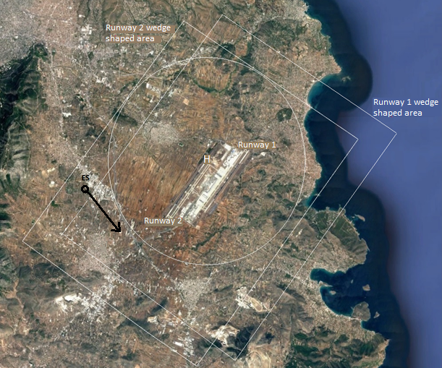
Figure 3: Example location of an earth station within a wedge shaped area of an airfield (depicted as “o” in the figure – the arrow is the direction of the main beam)
The earth station for this frequency band has an e.i.r.p. value above the value of the relevant ECC Decisions for fixed earth station related to the exemption from individual licensing of satellite terminal equipment. The regulatory authority makes the following calculations.
The near-field and far-field regions are calculated as follows:
Table 10: Near-field and far-field regions
Parameter | Distance (m) | Region
Non-Radiative (Reactive) near-field (m) | 0–287.26 | Near-field
Radiative near-field or Fresnel region (m) | 287.26–32524.8
Far-field or Fraunhofer region (m) | > 32524.8 | Far-field

By applying the equation 17 of ECC Report 272 [2] for inside and outside wedge shaped area corresponding minimum flight altitudes (i.e. 152.4 m and 304.8 m), the minimum separation distances are calculated.
Table 11: Minimum separation distances
Location | Minimum separation distance
Within wedge shaped area | 216 m Slant range
Outside wedge shaped area | 431 m Slant range

By applying the equations of section 3.2.2.2 of ECC Report 272 [2], the following values are calculated for separation distances, within the near-fields of the antenna:
Table 12: Parameters used for near-field calculations
Distance (r) from the antenna in the direction of main beam axis (m) | Circular aperture normalized distance (Δc) | Illumination Distribution constant (Ιd) | Near-field gain reduction factor (Xc) | Power Density (W/m²) | E (V/m)
216 | 0.007 (≅ 0.01) | 1.208 (≅ 1.21) | 26 | 6.2 | 48.3
431 | 0.013 (≅ 0.01) | 1.208 (≅ 1.21) | 26 | 6.2 | 48.3

The electric field strength produced by the antenna (in the main beam axis), in the near-field region at distance r, is 48.3 V/m which is lower than 150 V/m (HIRF protection criteria for 28 GHz according to ECC Report 272).

For the scenario and earth station characteristics used in Example 3, the calculated HIRF level is below the threshold immunity level.

Example 4: Earth station located inside the wedge shape area and generating HIRF levels above protection levels
Assume earth station with the following technical characteristics:
Table 13: Technical characteristics of an earth station
Parameter | Value
e.i.r.p. (dBW) | 88
Antenna diameter (m) | 6
Antenna Beamwidth (º) | 0.248
Frequency (MHz) | 14000
Azimuth (º) | 164
Elevation (º) | 45

Figure 4: Example location of an earth station within the wedge shaped area of an airfield (depicted as “o” in the figure – the arrow is the direction of the main beam)
The earth station for this frequency band has an e.i.r.p. value above the value of the relevant ECC Decisions for fixed earth station related to the exemption from individual licensing of satellite terminal equipment. The regulatory authority makes the following calculations.
The near-field and far-field regions are calculated as follows:
Table 14: Near-field and far-field regions
Parameter | Distance (m) | Region
Non-Radiative (Reactive) near-field (m) | 0-62.25 | Near-field
Radiative near-field or Fresnel region (m) | 62.25-3360
Far-field or Fraunhofer region (m) | > 3360 | Far-field

By applying the equation 17 of ECC Report 272 [2] for inside and outside wedge shaped area corresponding minimum flight altitudes (i.e. 152.4 m and 304.8 m), the minimum separation distances are calculated.
Table 15: Minimum separation distances
Location | Minimum separation distance
Within wedge shaped area | 216 m Slant range
Outside wedge shaped area | 431 m Slant range

By applying the equations of section 3.2.2.2 of ECC Report 272, the following values are calculated for separation distances, within the near-fields of the antenna:
Table 16: Parameters used for near-field calculations
Distance (r) from the antenna in the direction of main beam axis (m) | Circular aperture normalised distance (Δc) | Illumination Distribution constant (Ιd) | Near-field gain reduction factor (Xc) | Power Density (W/m²) | E (V/m)
216 | 0.064 (≅ 0.06) | 1.216 (≅ 1.22) | 26 | 115.7 | 208.8
431 | 0.128 (≅ 0.13) | 1.216 (≅ 1.22) | 24.8 | 110.4 | 204.0

The electric field strength produced by the antenna (in the main beam axis), in the near-field region at distance r, is 204.0 V/m and 208.8 V/m respectively, which are higher than 190 V/m (HIRF protection criteria for 14 GHz according ECC Report 272).

For the scenario and earth station characteristics used in Example 4, the calculated HIRF level is above the threshold immunity level. The application and above-mentioned examination could be forwarded and further studied by the relevant Civil Aviation Authority and/or Military Aviation Authority.
- Near-field and far-field boundaries
The approximations of the boundaries of the reactive near-field, the radiating near-field or Fresnel region and the far-field or Fraunhofer region are defined in equations 1 through 3:

${NF}_{reac}≤0.62 x \sqrt{(\frac{d^{3} x f}{300})}$ reactive near–field boundary (1)

$0.62 x \sqrt{(\frac{d^{3} x f}{300})} ≤$ ${NF}_{rad}≤ \frac{{2 x d}^{2} x f}{300}$ radiating near-field boundaries (2)

$r_{ff}>\frac{{2 x d}^{2} x f}{300}$ far-field boundary (3)

Where:
- ${NF}_{reac}$ = Reactive near-field region (m);
- ${NF}_{rad}$ = Radiating near-field region (m);
- $r_{ff}$ = Far-field region (m);
- f = Transmitter carrier frequency (MHz);
- d = Antenna diameter (m).

- List of references
- ED-107A “Guide to Certification of Aircraft in a High-Intensity Radiated Field (HIRF) Environment”, July 2010
- ECC Report 272: “Earth Stations operating in the frequency bands 4-8 GHz, 12-18 GHz and 18-40 GHz in the vicinity of aircraft”, approved January 2018

Airport or/and helipad
A Simplified methodology that can significantly overestimate the HIRF levels within the near-field region, but can be advantageous since it does not require detailed knowledge of the antenna characteristics for the calculation
In some countries, the civil and military aviation authority may be the same entity.
Based on an application submitted for individual licensing to the regulatory authority. The application may include the calculation from steps 1,2,3 and 4.
Interpolation value for Δc = 0.13 using Table 6 of ECC Report 272 [2]
For this example, suppose that Civil Aviation Authority and Military Aviation Authority define the wedge shaped area as: - for the airport, as the rectangular created by extending the takeoff and landing perimeter of the runway to 5.56 km - for the helipad, as a circle with radius of 5.56 km from the approach and take off perimeter of the helipad
For this example, suppose that the Civil Aviation Authority and Military Aviation Authority define the wedge shaped area as: - for the airport, as the rectangular created by extending the takeoff and landing perimeter of the runaway to 5.56 km - for the helipad, as a circle with radius of 5.56 km from the approach and take off perimeter of the helipad
Interpolation value for Δc = 0.13 using Table 6 of ECC Report 272 [2]

